January 2023

From the Technical Coordinator | From the Section Emergency Coordinator
From the Public Information Coordinator | From the Section Youth Coordinator
From the Section Traffic Manager | ARES Training Update
From the Affiliated Clubs Coordinator | National News
Club Corner | Contest Corner
DX This Week | One Question Questionnaire
Special Events | Final.. Final..

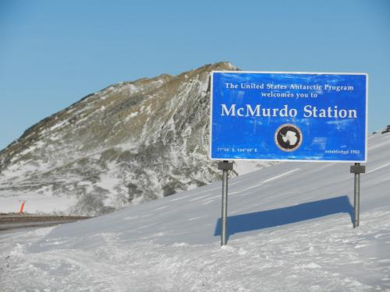

Every Day is Winter Field Day!
__________________________________________________________________

From the Technical Coordinator
Jeff Kopcak – K8JTK TC
K8JTK@arrl.net

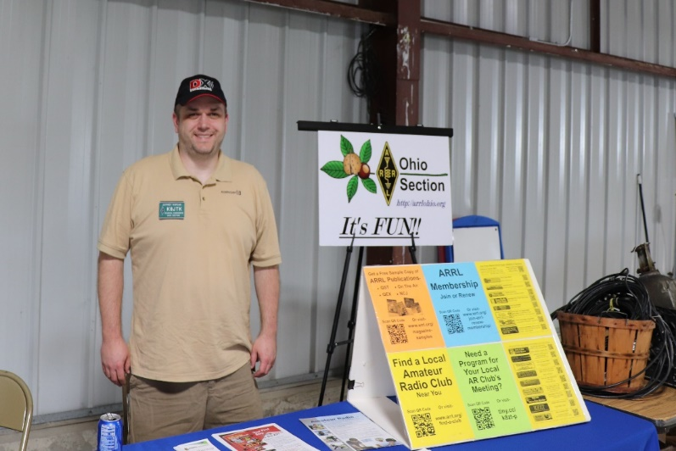
Hey gang,
I’ve traveled for work to our other facilities and taken advantage of training related travel. We were thinking I would have more travel opportunities. However, due to business need, sequestered to our homes for 2 years, and the freaking economy - it hasn’t happened. I had the opportunity to attend a work conference earlier this month and it gave me ideas to promote ham radio.
Work conferences are an opportunity to attend sessions and talks to gain skills, education, knowledge, keep current with industry trends, and network with others. If you’ve been to forums at Dayton, work conferences are 2/3/4 days of forums focused on an industry or segment. These could be: sales, information technology, manufacturing, human resources, C-Suite topics, project management, or general trends - like how work-from-home has changed and challenged work in the last 3 years. Similar to indoor vendors at Dayton, companies will sponsor booths with giveaways, swag, and maybe an opportunity to find a new job.
A number of co-workers and myself attended a conference called CodeMash in Sandusky at the Kalahari Resort (near Cedar Point if you’ve never been). This year was CodeMash 10000 (binary for 16). It was my first time at this conference. The conference is developer (programmer) focused but had tracks for information security, data, and career development. There were fun things to do including board games, laser tag, a maker space, evening events including casino night, and access to the resort’s indoor waterpark. The full conference runs four days in two halves. The first two days are called the “Pre-Compiler” consisting of two four-hour sessions per day. These are deep dive table-top exercises, discussions, and hands-on labs. Second two days are more byte-sized (see what I did there?) one-hour talks.
For work-related conferences, travel and accommodations are often paid for by the employer because these are training and educational sessions related to employment, job description, or a particular project. The employer hopes attendees return with new ideas and out-of-the-box thinking.
Depending on conference, cost can be way above beyond one’s means to attend on their own. CodeMash tries to be reasonable allowing individuals to attend at their own expense, if desired. A full 4-day ticket is between $800-$1,100 and the 2-day between $400-$550. Booking rooms through the conference at Kalahari offers discounted rates over normal nightly rates, though attendees can opt to stay at near-by hotels to be more economical. Kids have their own events called KidzMash, free with a registered adult.
Presenters for this conference are chosen by submitting abstracts to the CodeMash committee. If chosen, presenters get a free ticket to the conference as compensation for presenting. Sponsored sessions are hosted by companies sponsoring the event – these are listed as such and were on the last day. Presenters can plug their business and/or employer as their company is likely covering remaining costs. At least one presenter said they were there on their own dime as their employer “didn’t see the benefit” – and yet their lab session was standing room only.
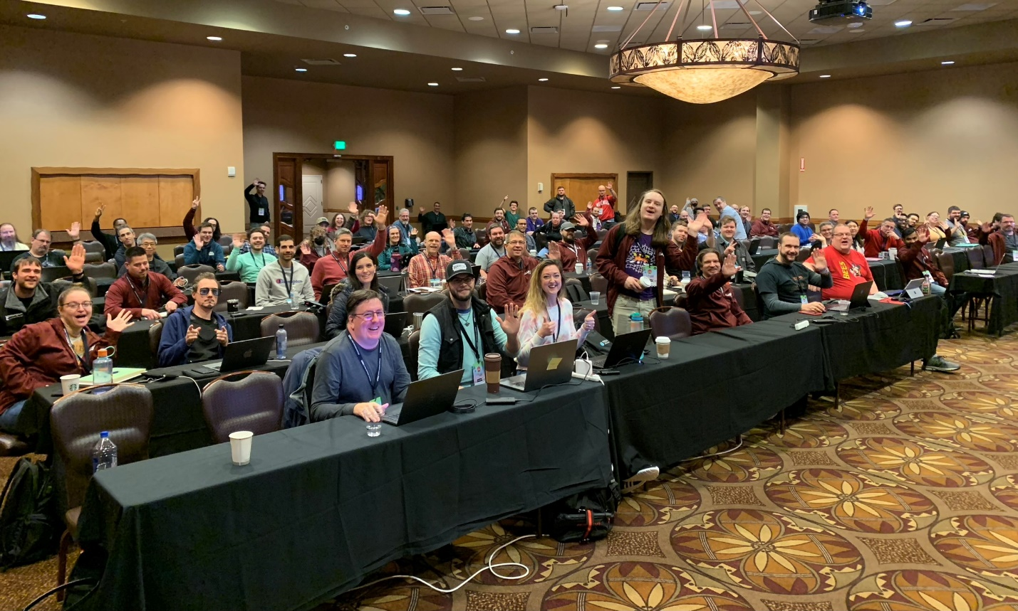
I figured I wouldn’t have much time to play radio as the schedule was pretty grueling with breakfast at 7 am and sessions wrapped up around 5 pm each day – not including evening activities. In the past, I’ll bring at least one radio, a mobile radio if I’m driving and know I’ll
Intro to Docker session. I’m way in the back row on the right. Twitter: @OtherDevOpsGene
have extra time. Though I was driving and staying at the resort for this conference, I brought an HT, hotspot, and a couple RTL-SDR dongles because I like monitoring the Ohio MARCS-IP public service system. I was not expecting to have ham radio interaction during the conference.
First day of the conference at breakfast, this guy sits down at my table. It looks like he’s got a Yaesu Fusion radio with a whip antenna. I asked him “ham radio?” He says “yep, you?” “Oh yeah.” Talked with Dan – AD8FY about ham activities and his experiences as a pilot. He informed me there was an unofficial UHF simplex frequency and there would be a number of hams at the conference. This did surprise me as I wasn’t expecting it but again, first time. Feeling pretty good about the conference and some connection to ham radio.
During one of the Pre-Complier sessions, learned there was a Slack instance for the conference. Slack is an instant messaging platform available on just about every device. Slack started out as a professional communications platform (like Microsoft Teams or Google Chat) but became accepted as a community platform for things such as this conference. In addition to messaging, Slack can do VoIP calls, video calls, file sharing, and text messaging in channels (like a conference room) or to individual users. A feature I like is persistent messaging allowing people to see prior messages after joining. For example, I joined the Slack instance on the second day of the conference but I was able to see messages from the previous day. This is different from other chat services which only show messages sent after one has joined the channel.
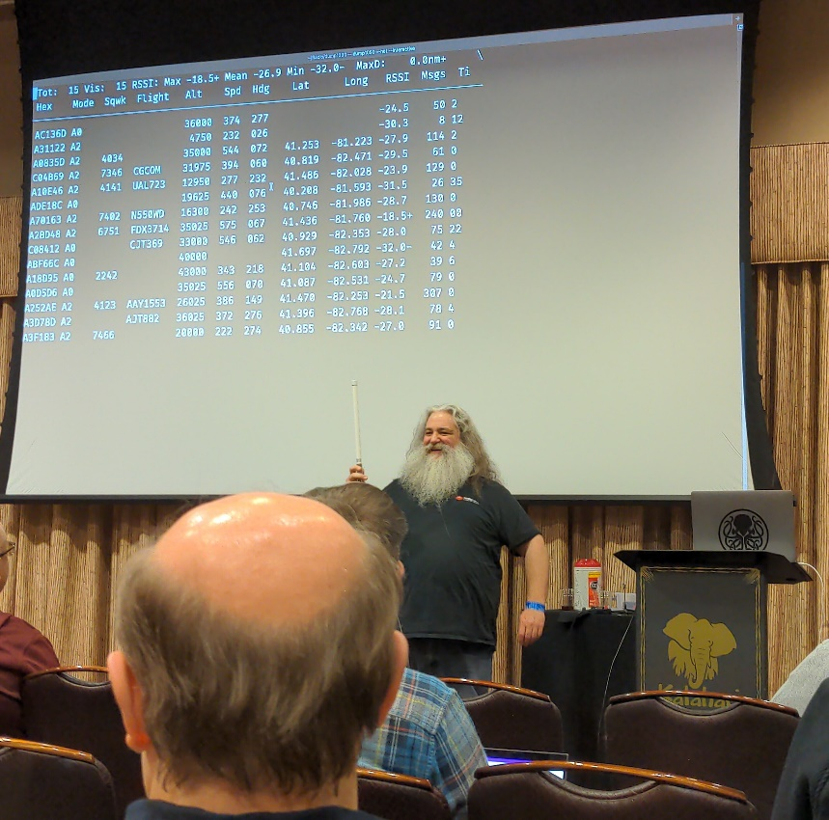
CodeMash’s Slack had many different channels: events taking place during the conference, discussions around hotel reservations, and water park. Announcements – changes, cancellations, updates, and general information. General discussions. Major cities had channels for attendees from those areas to network, such as #cleveland. Pre-Complier portion of the conference had a channel for presenters to post their slide-decks and labs. Slides channel for presenters from the second-half of the conference. Hobby channels included beer, wine, music jam sessions, and ham radio. Oh, really?
Guy – KE8VIY SDR live demo, receiving ADS-B broadcasts
KE8VIY asked to have a #ham-radio Slack channel. Ten people conversed about radio and when they were monitoring the simplex frequency. Call signs seen: WX8TOM, WX8NRD, KD8NCF, KE8VIY, and myself. I found out later KD8NCF gave a presentation at the conference on Real-Time Web Applications.
Thursday afternoon, while heading to an afternoon one-hour session, saw this guy (that’s his name too) outside one of the conference rooms pointing an antenna around. Figured he was doing Wi-Fi hunting or something. He too had a HT with him. This was Guy – KE8VIY. He was preparing for his presentation later that afternoon using software-defined radio to decode ADS-B (aircraft broadcasts). Though he was unsure there would be any aircraft to track as all flights were grounded earlier due to a possible cyber-attack.
I told him I would be attending his presentation. Knowing a ham was doing this session helped swing my decision in his favor because there was another equally interesting session on another hobby of mine, homelabbing. That decision paid off because not only was Guy’s presentation excellent, it got the wheels turning on more ways to promote ham radio. “Tracking Aircraft with Redis & Software-Defined Radio” (GitHub repo) was the presentation.
I’ve never used Redis. Reading up on it, the technology works mostly in-memory as a structured data store, often as a caching service (session, page, message queue) or key-value database. According to Wikipedia, Twitter uses Redis and Redis is offered by the big-name cloud providers AWS, Azure, and Alibaba.
Guy’s slides were professionally done and visually appealing. Coupled with the slides, his personality, humor, and live demos, (if I didn’t know anything about it) he made ham radio seem fun and interesting. He stated he is a new ham and excited about what he’s been able to do processing radio signals. The audience was highly engaged asking questions and feedback was positive from hams that saw the presentation.
Most maybe thinking: you don’t need a license to receive ADS-B, how is this related to ham radio? That’s the tie-in. He worked in history of digital signals, formats, and all the things rooted in ham radio: Morse Code, RTTY, and APRS. Then demonstrated how he used a modern technology platform and a radio to capture and process digital signals, all at a developer conference. Well done!
There are a lot of slides in his deck. Due to the one-hour time limit, the first 30 slides and some diagrams were covered. He utilized Dump1090 for turning signals into raw data. Then used Redis (also his employer) to process, store, and make data available to consumers.
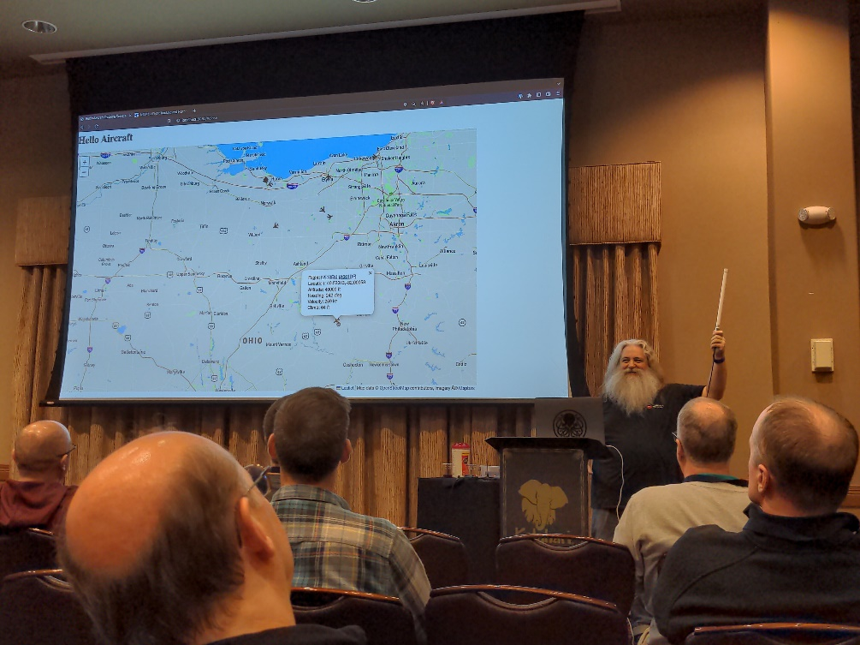
These things fit my thinking of how ham radio should be promoted. Promoting to kids is admirable and exposing them to activities early in life is a great way to maybe hook them later in life. Credit to my parents because ham radio was one of those activities and it happened to stick. Though, I seem to be the exception rather than the norm. There are other things my parents had me join in school that didn’t stick and I really don’t miss those activities. A way kids get their license is part of a school program or curriculum. How many carry on and renew their license after 10 years is up? Retention needs work. Chances are better if family members are active and involved.
Guy – KE8VIY SDR live demo, ADS-B broadcasts shown on a map
I have been a huge fan of initiatives by the ARRL and clubs to use Makerspaces as a way to breathe new life into the hobby. Makers are like-minded people whom like to learn, create, and invent as does the experimentation side of ham radio.
Gainfully employed individuals would be my next target audience - you know, if I were on a committee. Somewhere in the neighborhood of 25-45-year-olds – those looking to keep themselves busy - whether they’re single, don’t yet have a family, or had their kids graduate college. These individuals have disposable income for equipment and time that can be devoted to learning and operating.
A conference like CodeMash is a near perfect match for promoting ham radio to technically minded individuals, including kids. Not having any statistical data, I would say the median age was probably mid-30’s, early 40’s. Obviously, there were younger and older individuals. With few exceptions from my interactions, participants were gainfully employed as their companies were picking up the tab for them to attend the conference. There were an estimated 1,400 attendees at this year’s conference. (attendance was still down from previous years, close to half). That’s 1,400 technical people, a great audience to promote ham radio.
Does a conference you attend offer a communications platform like Slack? Ask for a ham radio group to be created. Post a simplex frequency for general chit-chat. Maybe organize a meetup during meal time or after events that day to network with other hams. Maybe non-licensed people will drop into the channel or drop in at the meetup. Maybe they’ll get bit by the bug and be looking for an Elmer.
Think about current job responsibilities, technologies or services your company provides. Guy, in the spirit of ham radio, took an existing technology, re-purposed it to receive signals and turn the data into events, maps, and an API (application programming interface, used for integrating with other applications) from aircraft broadcasts.
How can a technology you’re created, are familiar with, maintain, or work with become an interesting presentation that ties in ham radio? Figure that out and maybe you’ll get a free ticket to a conference with the employer picking up the tab for travel expenses!
I brainstormed examples using technologies seen at the conference to do radio related things:
- Real-time data processors like Kafka for mapping propagation
- Networking skills and technology to improve resiliency and security of mesh networks
- Table-top-exercise to recover from a disaster. Assume all existing connection and authentication methods are non-existent.
- Receive signal data from a distributed radio network
- APIs to administer digital systems with many connections
- Automate test-cases and frequent software updates with GitHub pipelines
- Incident response to handle compromises of repositories or stolen credentials
- Docker & Kubernettes to build simple, easily deployable applications
- Can the “cloud” fit the general directive of not relying on other technology? How to handle and recover from outages?
- Designing web apps to replace multi-platform applications
- Write the next white-paper
- Create technical documentation standards
Development work isn’t part of my daily responsibilities since I changed jobs a number of years ago. Initially wasn’t too sure about the conference. In reality, I learned a lot about technologies I hadn’t yet explored on my own. Ham radio connections made it a much better experience and hope to attend next year. Let me know if you’ve done something to promote ham radio in a similar conference-type setting to like-minded (non-ham) individuals or used modern technology platforms to improve and better ham radio.

Bob - K8MD is one of my Technical Specialists. He wrote up a portable operation he did recently while traveling for work.

Motorola sent me to Fort Lauderdale, FL for training. I brought along some ham equipment with the intention of activating a local park for POTA. I found a few other hams in my training and invited them to join me. KE0WJU from Missouri and W5WES from Texas.

We three successfully activated K-1882 Hugh Taylor Birch State Park. I used my QDX transceiver which is a 5 watt SDR digital only transceiver. I also used a Chromebook, that I modified to run a regular desktop linux. My antenna was a 20m dipole. The 20m band was wide open and the FT8 portion of the band was completely swamped with signals across the waterfall. I quickly made 18 contacts.

W5WES attempted to use an IC-705 to make a few contacts via SSB, but was not able to raise anyone. Perhaps band conditions were not sufficient for QRP SSB operations.

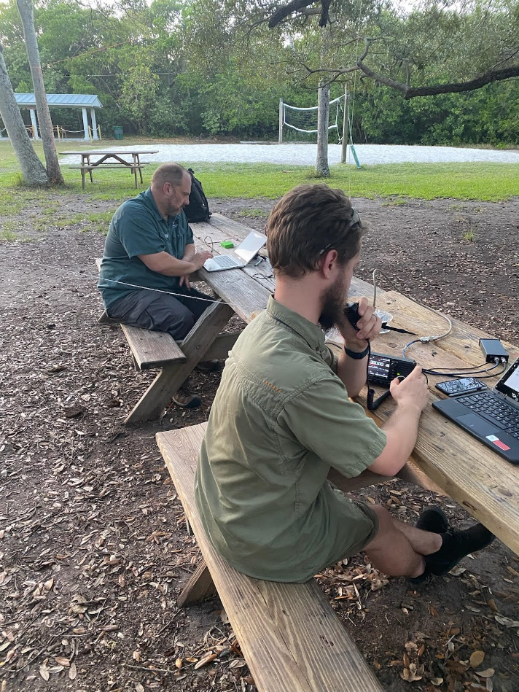
We arrived at the park at 5pm and was informed by the rangers that the park closed at 6:15! d'oh! We quickly got the antenna up and was able to quickly bang out 18 contacts using WSJT-X and FT8 mode. Near 6pm the the park ranger asked us to start packing up.

The QDX is available as a kit for $69 and is capable of 20m, 30m, 40m, 60m, and 80m. I designed and 3d printed my own enclosure for the QDX. It is about the size of a pack of cigarettes. I ran the QDX with a chromebook that I got for $79 at MicroCenter. ChromeOS only works when connected to the internet, which does not fit my requirements at all. So I removed the OEM ChromeOS and also removed the standard Google bios from the computer. I installed an open source UEFI bios and also installed the latest version of Ubuntu Desktop Linux as the Operating system. WSJT-X is available to download as a .deb file, making it simple to install using Synaptic in Ubuntu. The computer also has FLdigi installed making it quite capable for it's $79 price tag.

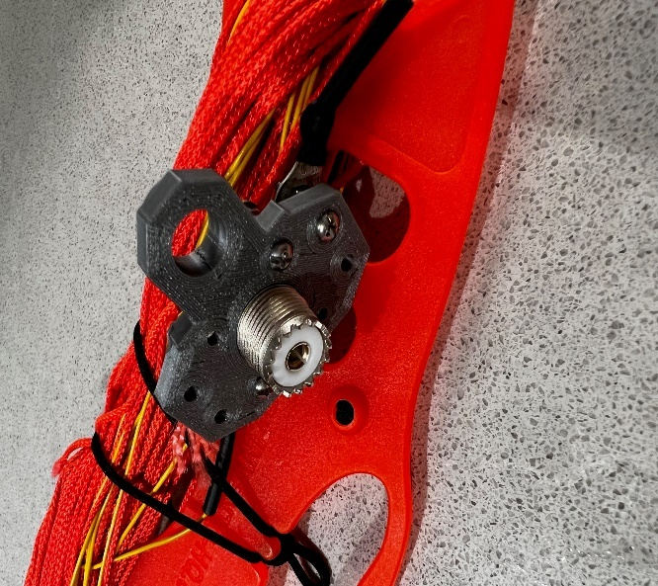
The dipole was made from wire that I stripped from a large bundle of wires. I 3d printed the center insulator and added a SO-239 bulkhead that I had in my junk box. I used masonry string to suspend the dipole in a tree. I like using masonry string as it's very inexpensive and very lightweight. Total cost for the entire rig (including laptop computer) was easily less than $200. The entire kit is packed into a small briefcase that also holds the laptop. This doesn't have to be an expensive hobby to have fun!

First contact after setting up the station was Australia. Then 17 additional contacts were from the lower 48. Days like this really make me love this hobby!

https://qrp-labs.com/qdx.html
https://www.printables.com/model/240058-qdx-enclosure-by-k8md
https://www.thingiverse.com/thing:894073
https://www.microcenter.com/product/636109/asus-chromebook-c423na-wb04-14-laptop-computer-refurbished-silver
Bob Mueller
K8MD
bob@k8md.com

Thanks for reading and 73… de Jeff – K8JTK

From the Section Emergency Coordinator
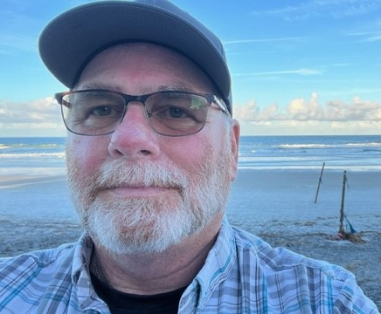
Bret Stemen – KD8SCL EC
KD8SCL@gmail.com

ARES Simplex Contest

The 2023 ARES Simplex Contest is in the books and the results are in. I am pleased with the results, but at the same time a little disappointed that there weren’t more participants in the contest. But I understand with scheduling conflicts and personal reasons, family comes first. Maybe next year.

This contest is a great way to test your equipment for proper operations and what your equipment is capable of, be sure to map out your QSO’s to check your longest distance within your county and surrounding counties. This information can be important for your county in the event of an actual emergency in your county and you need to get information out. Think about setting up an exercise for your local group to test your simplex capabilities in your county.

Thank you to those of you that took the time out of your busy schedule to participate in the contest and your comments.

Here are the results so far.
Participants: 35
ARES Leaders: 11
Counties: 19
QSO Points: 2,364
Contacted Counties: 214
Hours of Operation: 133
ARES Leader Contacts: 73
EOC Contacts: 75
APRS Ops: 7
Portable Ops: 5
Rover Ops: 8
Total QSO Points: 24,600

Top 10 points:
- KD8EZI, Medina Co. 4,769
- W8Z, Rover. 2,966
- N8XC, Preble Co. 2,774
- W8MAL, Rover. 2,200
- N8ESG, Rover. 1,792
- WD8LEI, Wood Co. 1,099
- WO3X, Summit Co. 1,043
- AB8M, Cuyahoga Co. 826
- KE8QEP, Portage Co. 800
- KD8TJB, Geauga Co. 784

Thanks again for everyone’s support and contribution to the Ohio Section ARES and amateur radio, your contribution is a valuable asset to the section.

In other news:
NVIS Day will be April 22nd, Mark your calendars and start planning with your local clubs and ARES groups, we are planning on activating the SARGE. More information coming soon.
NVIS Day, 2023
It’s coming! Ohio NVIS Day 2023 will be held Saturday April 22, from 10AM until 4PM EDT.
The purpose of NVIS day is to construct and try various antenna ideas, all working as NVIS (Near Vertical Incident Skywave) antennas. These antennas are low to the ground and provide coverage generally within a 400 mile radius- extremely important for regional HF communications in an emergency.
Take a big step forward and build upon the concept to answer the question, “How would we actually use these antennas?”
For 2023, we have added a couple operating scenarios that will make your day more fun and be a learning event for actual disaster communications. We propose a commercial power blackout, with the need to communicate within your ARES district and to ‘The Sarge” at the Ohio EOC in Columbus. Here’s the deal:
- The event runs from 10 AM until 4 PM local time.
- Stations will construct and test NVIS antennas.
- Transmit power is limited to 100 watts.
- Power for the station will be any form of “off-grid” supply: typically, generator, battery or solar or whatever form you might have in an emergency setup. (Optional, but preferred)
- Stations may test antenna coverage as in the past by contacting as many different locations as possible.
- Stations will originate a message to their ARES District net and to W8SGT reporting their location.
  - This message may take any form: ARRL message form or any other can be used, doesn’t matter. If you’re going to use the traffic system, ARRL message form is recommended.
  - The message should contain the call sign, operating location (include county) and number of operators. Any other brief antenna information is optional but appreciated!
  - Contact with the District net may take place on VHF or HF (Repeaters OK).
  - WinLink may also be used as long as it sent via RF, local node (VHF, UHF) or an HF node. For more information on node locations, visit WinLink.org.
- Operating frequencies are proposed to be in the 80 and 40 meter bands. Voice is preferred for testing. Digital messages may be passed to OHDEN or Buckeye Net as available.
  - Optimum frequencies centered around but not limited to: 3.902 and 7.240
  - Digital OHDEN frequency: 3585 (typical is Olivia 8/500)
  - If additional exercise is desired, try 60 meters, Channel 5493.5 for voice and digital
You can create your own log (Excel preferred) or use the attached format. Be sure to include a photo of your group or your antenna! Submit your results to contest@n8ara.org
Have fun! Take a lunch break! I hope to hear you!!

______________________________________________

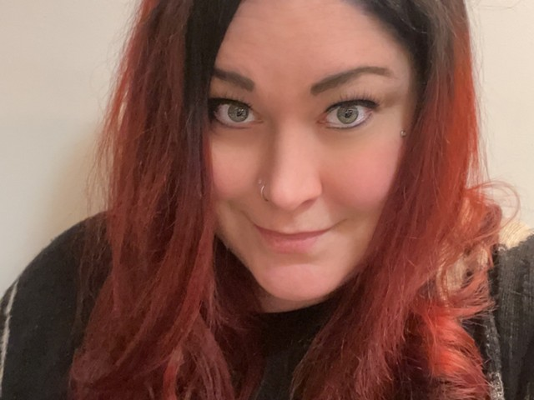
Elizabeth Klinc, KE8FMJ
OHIO Section Public Information Coordinator
ke8fmj@gmail.com

Happy 2023! It is a new year and with it comes a new Section newsletter contest! We love to see those newsletters and are looking for the best. So put those special touches on your club’s and send it on over to be part of the fun! Go to http://www.arrl-ohio.org/pic_page/pic.html to see a list of rules for the contest.

Speaking of it being a new year, how about a resolution to have amateur radio build a positive relationship with local and state media outlets? It would be an opportunity to get our voices heard and bring awareness to all the great aspects of our fabulous hobby. Hamfests, Field Day or Public Service Events are all great examples of having the media drop by and together help bring awareness to the community.

Ham Radio is a extraordinary hobby and service that brings people, communication and electronics together. We use amateur radio to talk across town, all over the world or even into space, all without cell phones or even the Internet. It’s fun, social, educational, and can be life saving during emergencies or other times of need. We all know this and it is well past time to share it all with the rest of the world. Let’s tell our story.

73

Elizabeth KE8FMJ
ke8fmj@gmail.com
______________________________________________
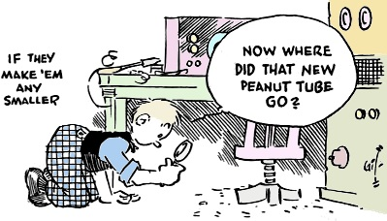

__________________________________________________________________
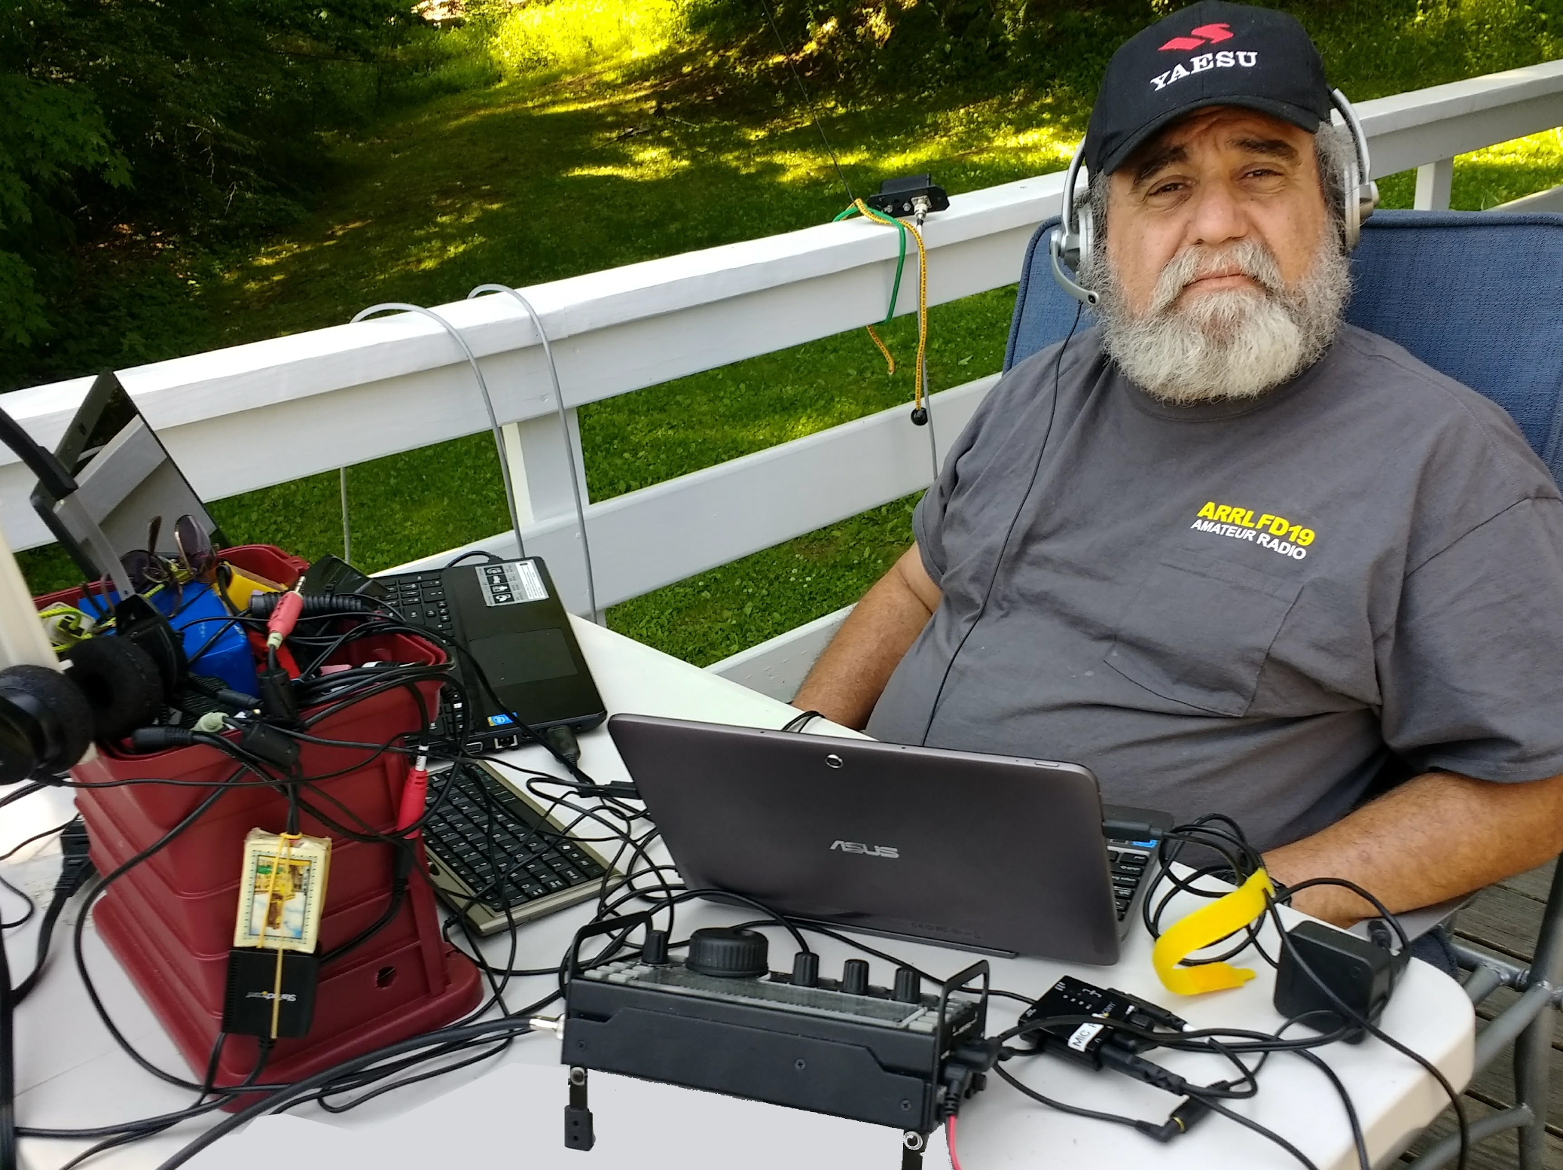
From the Section Youth Coordinator
Anthony Luscre, K8ZT - SYC
k8zt@arrl.net

Amateur Radio Charts & Maps

This month I want to share a document I have used in some of my group presentations.
Here is a collection of many Amateur Radio Charts, including Band Plans, Frequency Guides, Zone Maps, and more from around the web. You can print them for your walls, reference notebook, or wallet. Some are online computer maps that you can view on your screen. Link to this tiny.cc/chart-maps
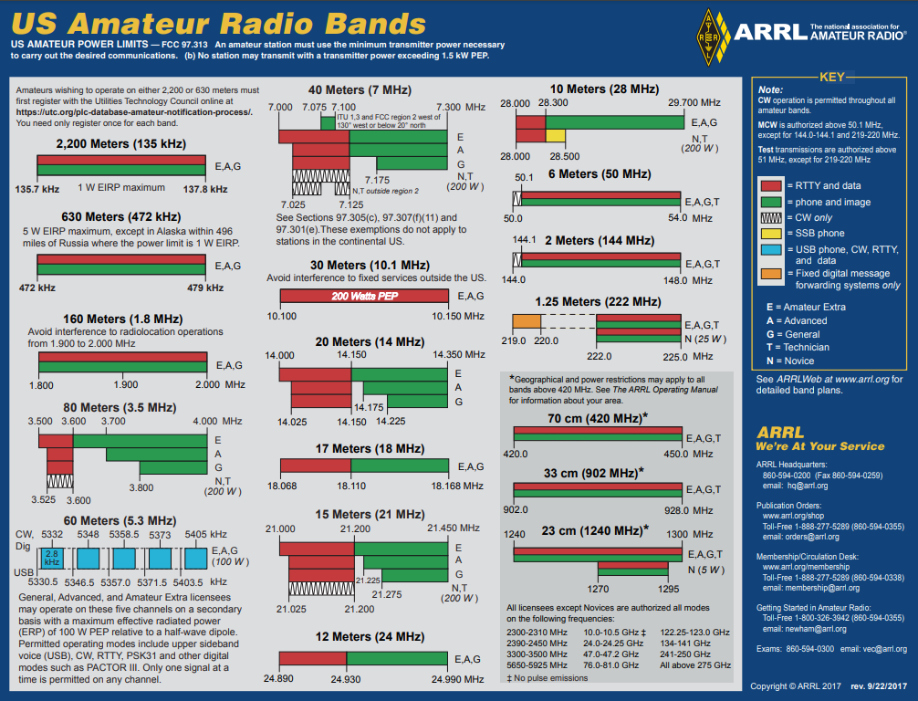
Band Plans- ARRL Versions

- Frequency Charts (Landscape)
  - Frequency Bands Chart [PDF] (8.5 X 11; grayscale)
  - Frequency Bands Chart [PDF] (8.5 X 11; black/white)
  - Frequency Bands Chart [PDF] (8.5 X 11; color)
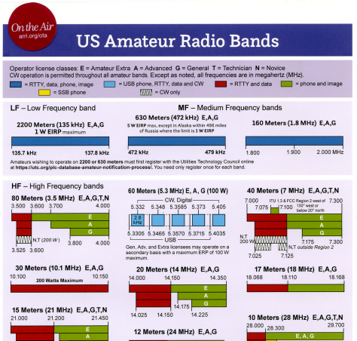
  - Frequency Bands Chart [PDF] (11X17; color)
- Frequency Charts (Portrait)
  - On The Air Version- Frequency Bands Chart [PDF] VERTICAL (8.5 X 11; color)
- Complete Band Plan Reference
- The Considerate Operator’s Frequency Guide- www.arrl.org/files/file/conop.pdf

Band Plans- Bite-Sized US Amateur Radio Band Plans from K4ICY

“Here are two Wallet-sized chart cards containing the FCC allocated band privileges for amateur radio operators. They contain frequency edges and designated frequency-based allocations set apart by "gentlemen's agreement.” Other primary operators’ license-classed base privileges are included as well.
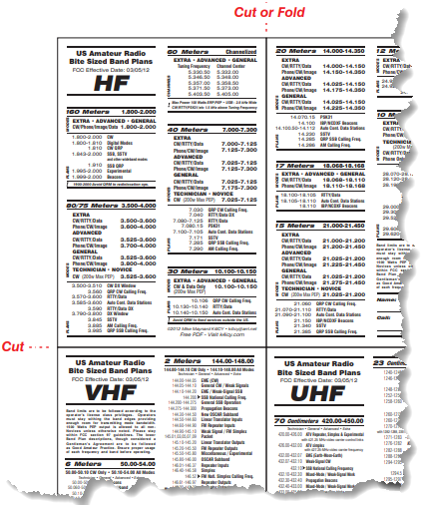
These cards include plans for HF (1.8-30 MHz), VHF (50-225 MHz), & UHF (420 MHz-1.3 GHz) - Also the amateur EHF bands. Take them with you anywhere- Field Day, emergency deployments, mobile, or just out having fun. Keep them in your wallet, purse, or even the Altoids® mint tin that houses your QRP rig! Never be caught without knowing your frequency privileges again!

With your laser or high-dpi inkjet printer, you can download and print for yourself. Simply go to your local Office Depot or copier store and have the card cut and encapsulated in thick-mil license card lamination for just a few bucks. It comes with two cards for your wallet; one for the HF bands and one for VHF on one side and UHF+EHF on the back. Download at k4icy_bite_sized_band_plans.pdf.
If there are any font issues, contact me, Mike Maynard K4ICY at k4icy@arrl.net, via email to get an .EPS "vector" for Adobe Illustrator®, based version with all fonts converted, which is 2.5Mb.”

ICOM “Amateur Tool Kit”

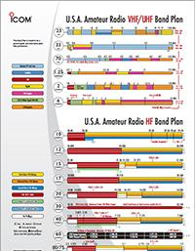
The U.S.A. Amateur Band Plan: With your license comes operational privileges! So, to make sure you operate within your licensed spectrum, download the color-coded chart of the US ham radio bands and country codes and get started today! Download at https://www.icomamerica.com/ en/amateur/amateurtools/ US-BandPlan-Update-1-2020.pdf

The U.S.A. Amateur Grid Square Map: An invisible grid, based on 1° latitude by 2° longitude, encompasses the globe and is used for geographic location and identification during communications using your VHF and UHF radios. As HF operators collect QSL cards worldwide, VHF/UHF operators collect grid squares. Download the grid square map and mark up your QSOs! https://www.icomamerica.com/ en/amateur/amateurtools/ US-Grid-Square-Map-03-05-2019.pdf
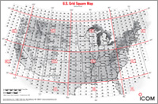

Ham Radio Terms: The amateur radio hobby has a language of its own and is not always easy to understand. For new and experienced operators alike, this glossary contains general definitions of typical amateur radio terms for reference on-the-go. https://www.icomamerica.com/en/amateur/ amateurtools/HamRadioTerms-2011.pdf

New Rules for the 60 Meter (5 MHz) Band: On November 18, the FCC released a Report and Order (R&O), defining new rules for the 60 meter (5 MHz) band. In the R&O, the FCC replaced one of the channels in the band, increased the maximum authorized power amateur stations may transmit in this band and authorized amateur stations to transmit three additional emission designators in the five channels in the 5330.6-5406.4 kHz band (60 meters).

https://www.icomamerica.com/en/amateur/amateurtools/new-rules-60-meter-band.aspx
Download Now
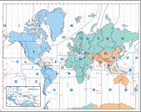
- CQ DX Zones of the World: This is a double-sided world map showing the CQ DX Zones and the ITU Zones. Each map uses an Albers Equal Area projection. With color-coded regions and a list of country codes, this map serves as an illustrative tool to help you in any DX adventure! https://www.icomamerica.com/ en/amateur/ amateurtools/ 2013_ITU_CQ_WorldMaps.pdf

Kenwood
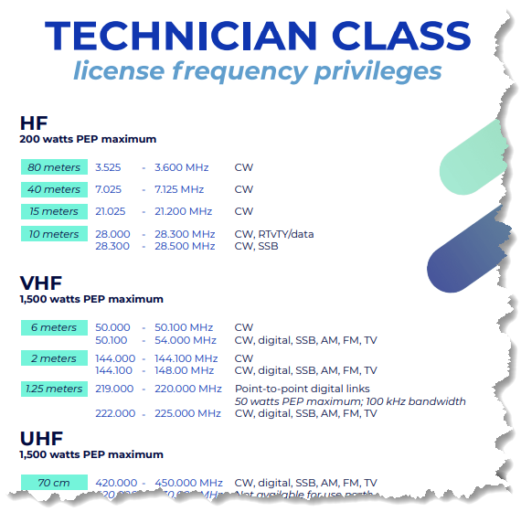
- HF & VHF/UHF Band Plans- https://www.w5yi.org/downloads/FreqChart.pdf
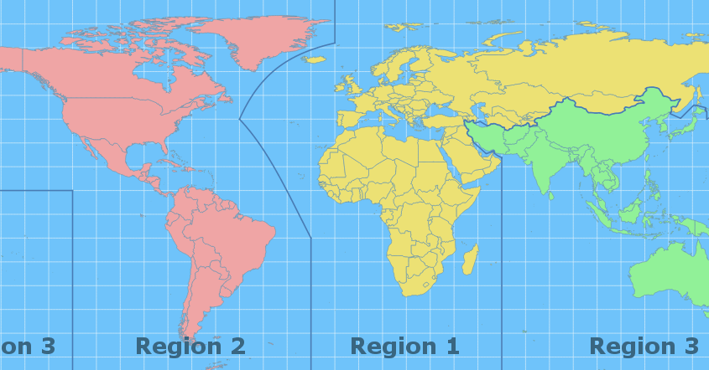
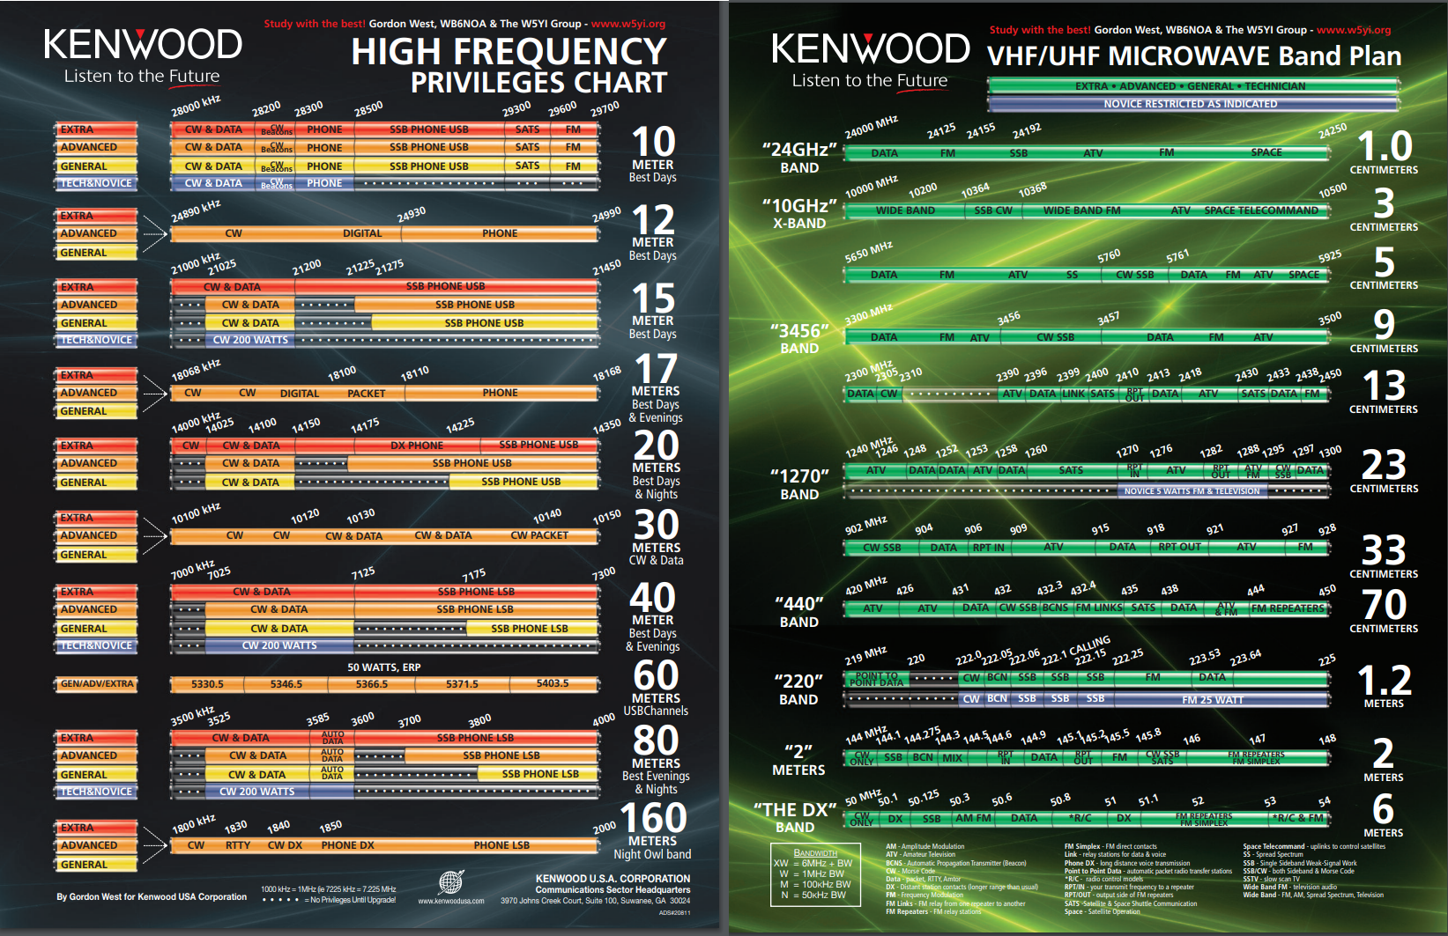

Ham Radio Prep
- Technician License Frequencies

IARU- Region 1 (Europe)
- IARU Regions- Map, Region 2 Band Plan (this is our region in the USA) & Region 1, Band Plan (for reference only, does not apply to the USA)

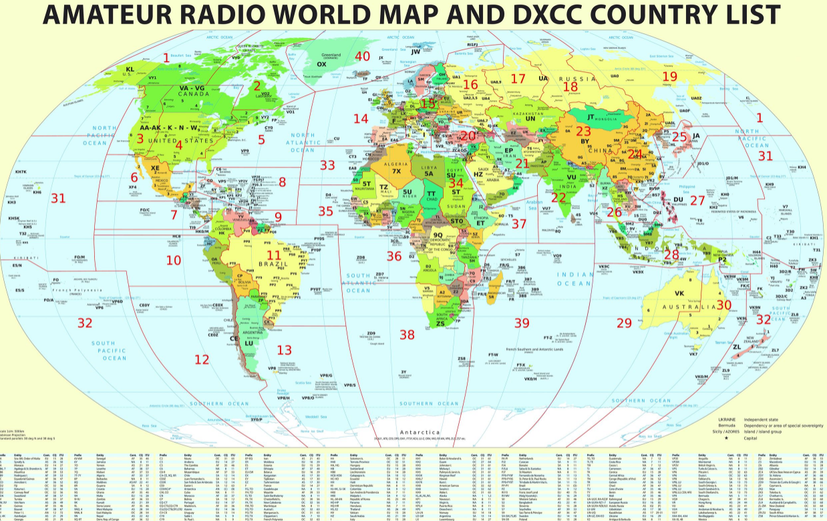
HamWaves Maps
- DXCC & Zones Map
- Russia Map
- Radio Map of Europe
- IOTA (Islands On The Air) interactive computer map
- Mexican Call Areas by State- interactive map

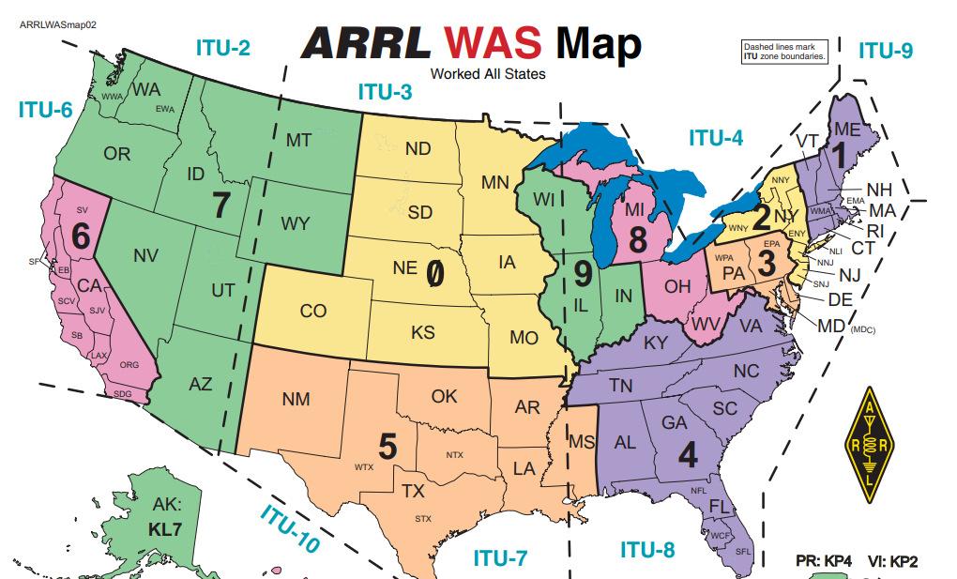
ARRL
- Worked All States (WAS) Map
- ARRL Divisions Map and Webpage
- ARRL Sections- Webpage
- National Parks On The Air- Maps
- Maps for purchase- link

K8ZT Website
- K8ZT Maps & Charts Page- www.k8zt.com/operating/maps-charts there are way too many resources there to highlight them all here, so visit the page for more resources
- Create and print an Azimuthal Map centered on your location- an interactive website
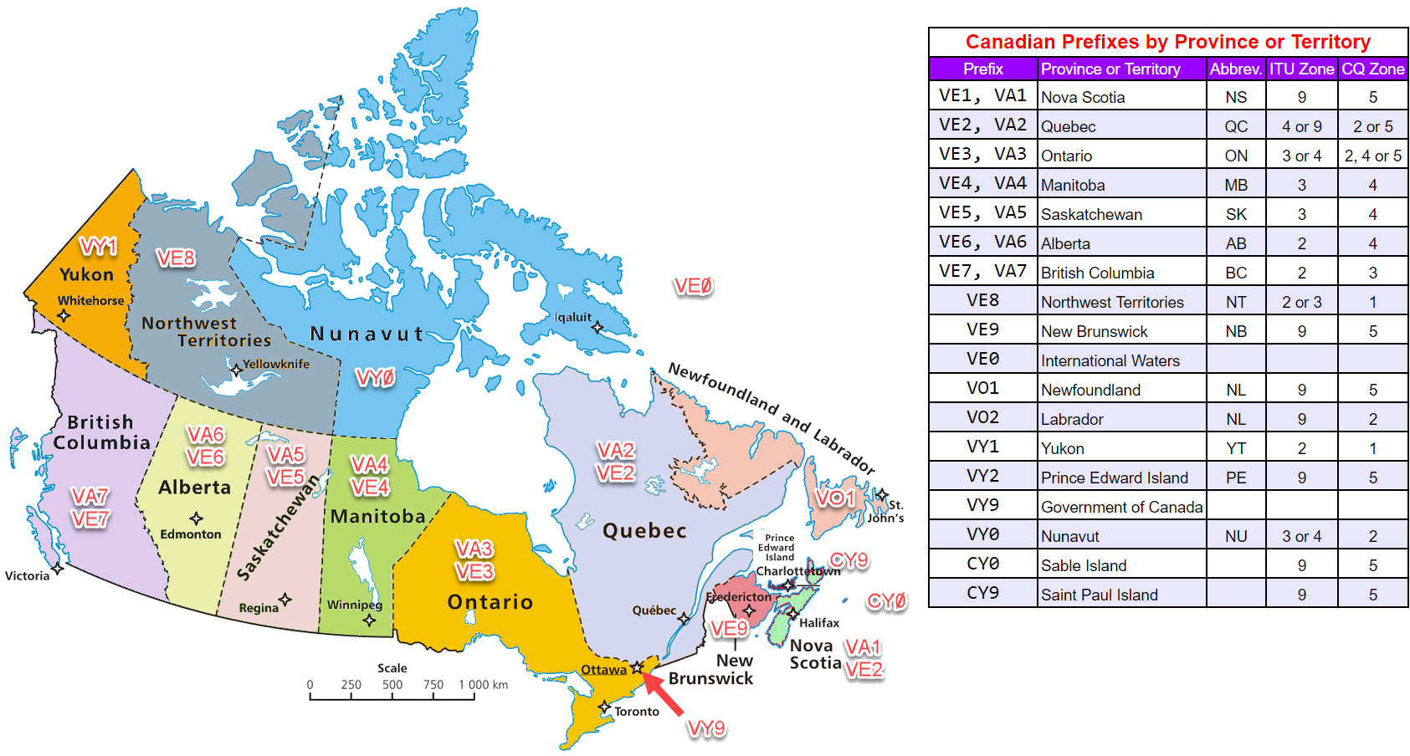
- Canadian Prefixes by Province or Territory- Map
- Mexican Call Areas by State- Map
- The Number Eight in 14 Languages- link
- Numbers in 13 Languages- link
- Ten Meter Band Guide
- ARRL Sections, sorted by number and alpha- tiny.cc/arrl-sections & ARRL/RAC Sections Map

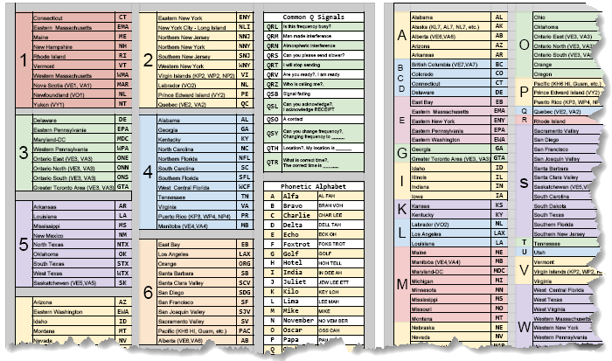
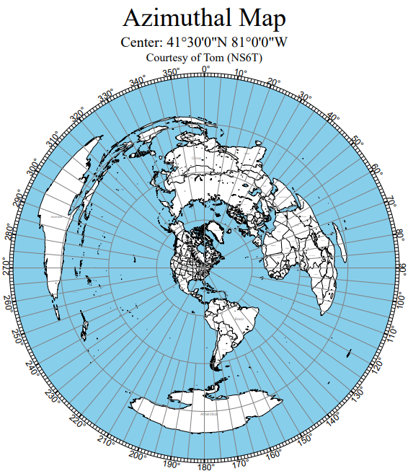

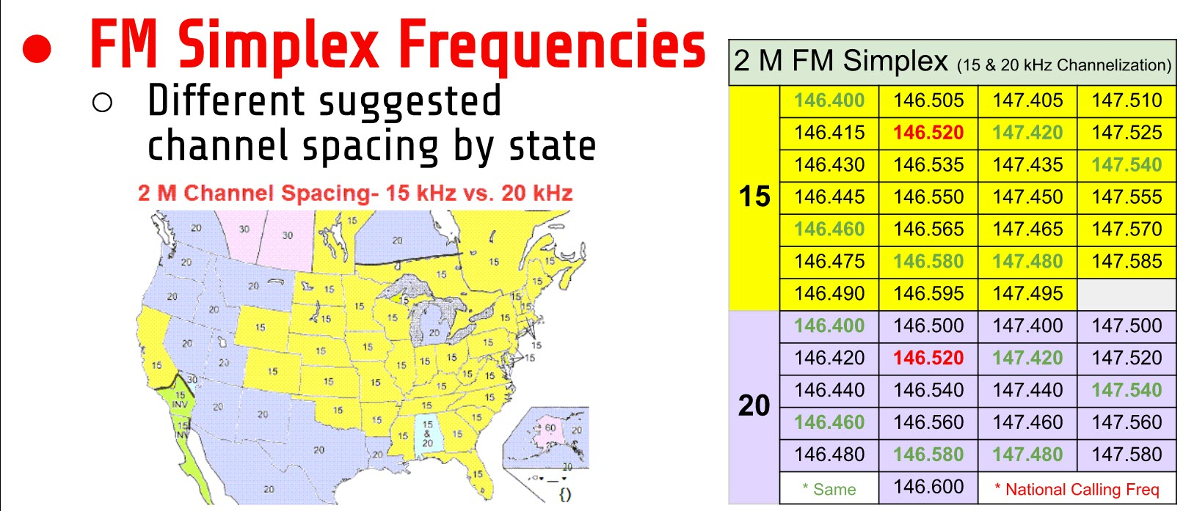

Kuysokov
- European Grid Map
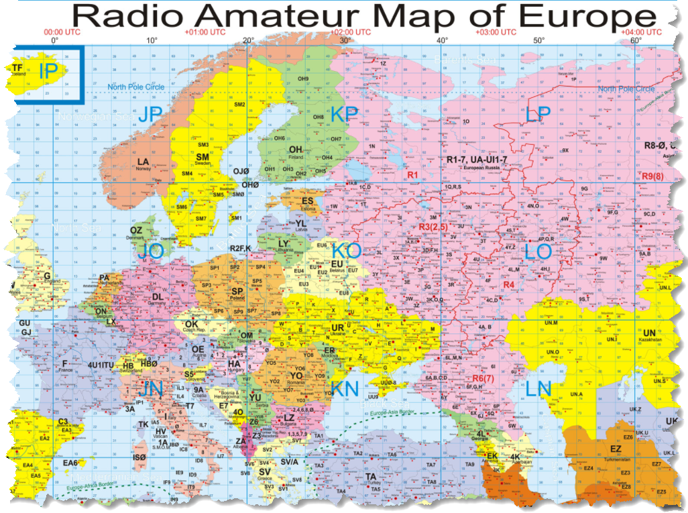
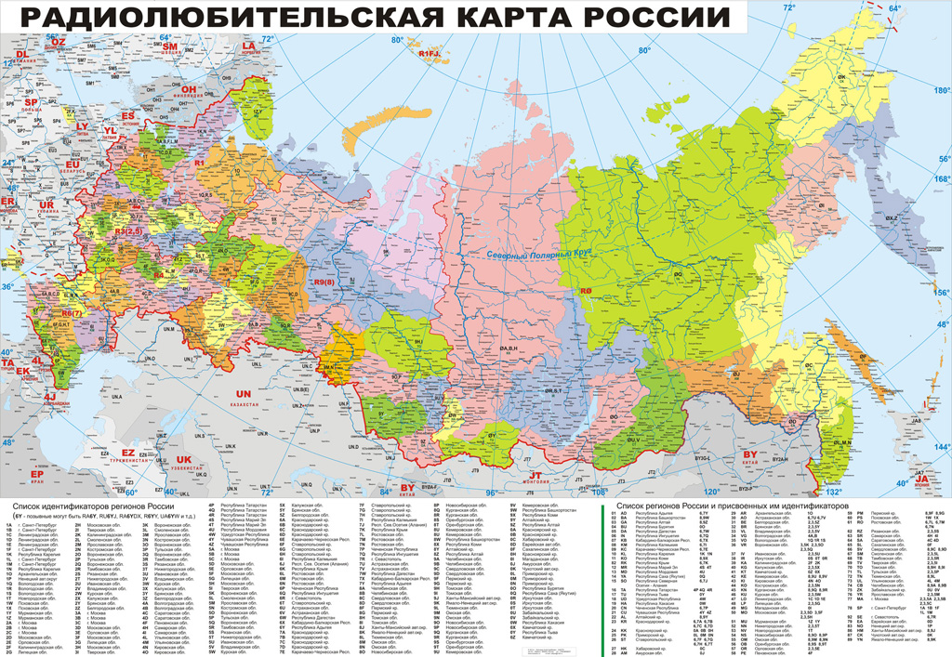
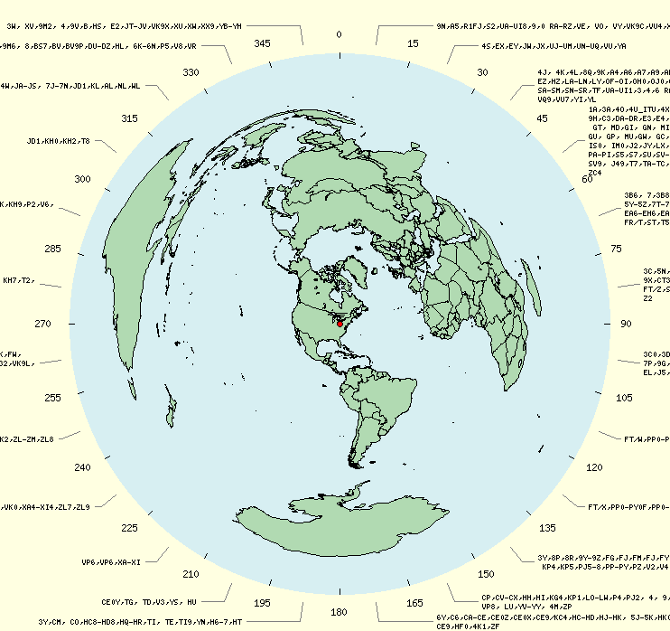
- Russian Regions Map

Software Programs
- Create My Amateur Radio Map- OK2PBQ
- Afreet Software, Inc.- DXAtlas
- DXLab
- https://www.g4eli.com/blog/world-map-2019
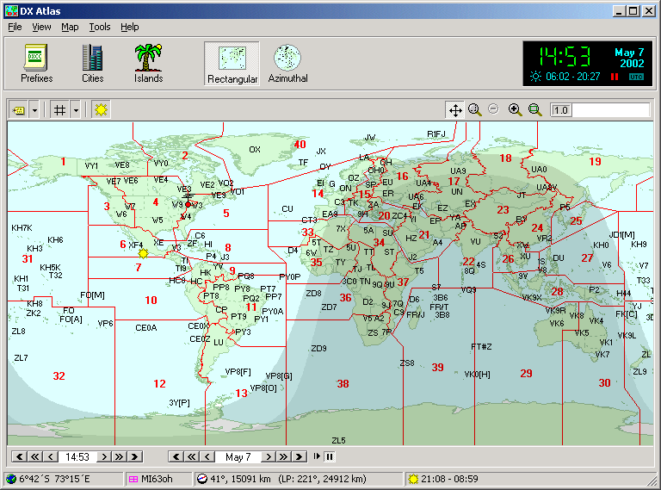
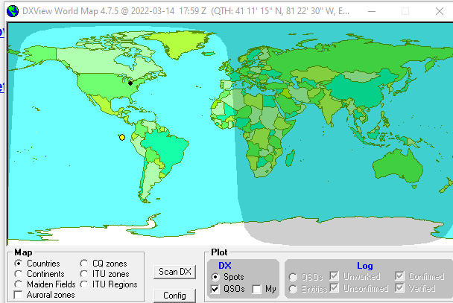

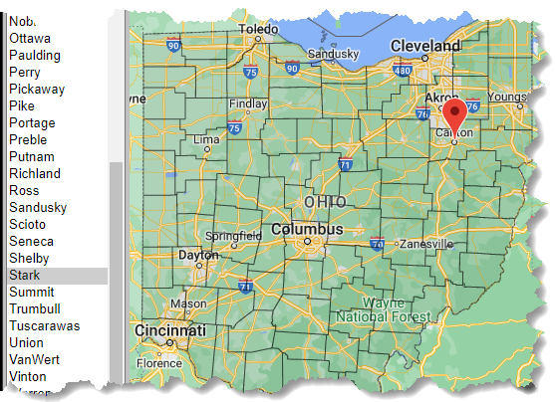
County Maps for State QSO Parties
- Mult Chaser is a free add-on program for N1MM Logger+ that displays contest multis on a map as they are worked
- US Census- State Outline Maps with county borders
- NO5W County Overlay Maps
- Mob-Rule- interactive online county maps (Mob-Rule is a County Visiting Competition)

Grid Squares
- Finding Your Grid Square & Other Hams in Your Area- tiny.cc/findham
- Map Grids Confirmed on LoTW
- Map your grid squares worked using WG7J Gridmapper
- WorkedGrids is a Windows application that displays a map showing the amateur radio grid squares contacted and logged in using a third-party logging program.

Ten Meter Considerate Operator Guide
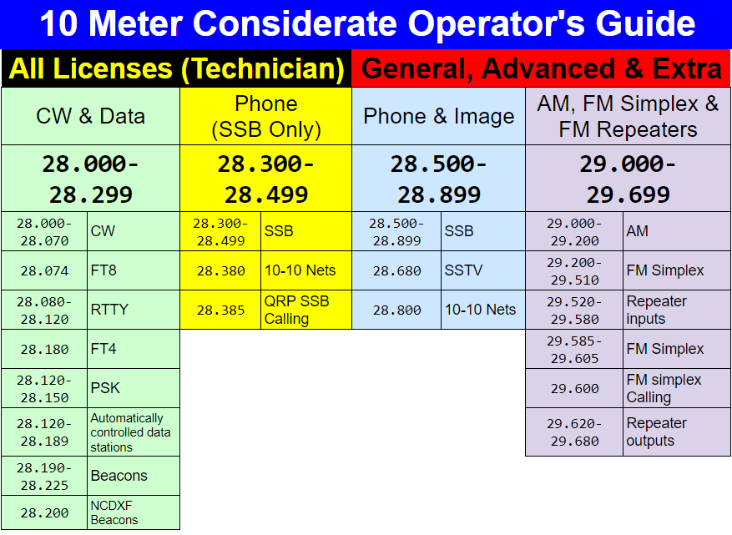
- tiny.cc/10mguide

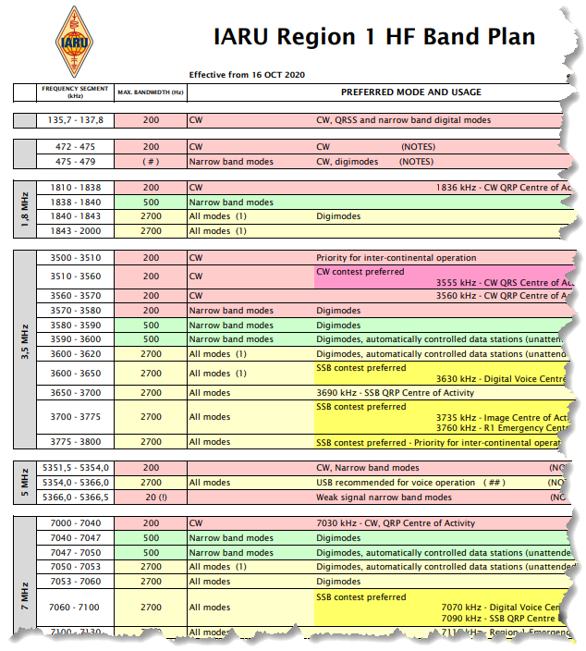
IARU Region 1
- Region 1 Bandplan
- Region 1 Band Plan List
- RSGB Band Plan

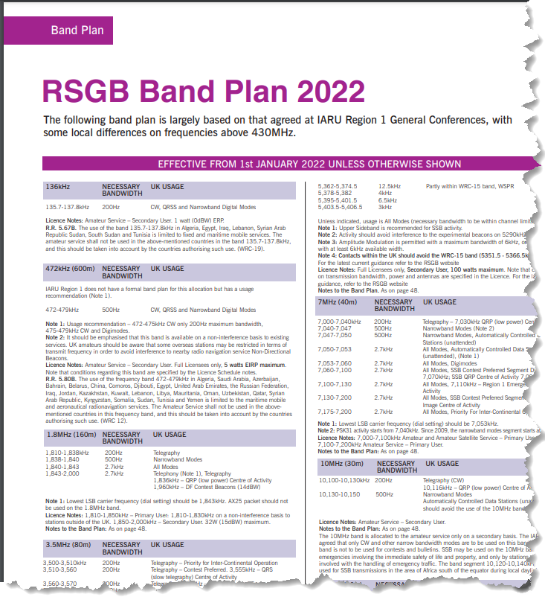

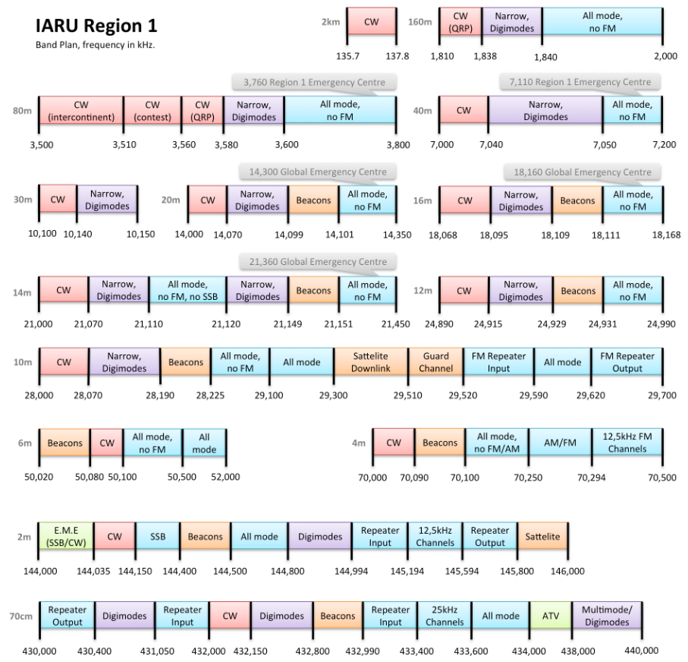

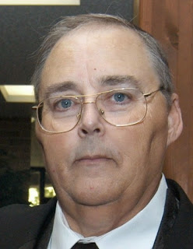
From the Section Traffic Manager
David Maynard, WA3EZN – STM
wa3ezn@att.net

The new net manager for Burning River Traffic Net (BRTN) is Keith Cook KD8GXL. He reports that the net has been in operation for over 40 years and has become a tradition in local ham radio.
A thank you goes out to David Gulyas W8DJG for his service as net manager of BRTN for many years. David is also one of the Ohio Digital Relay Station who brings traffic to Ohio from the Digital network.
The Semi-Annual OSSBN Meeting will be/or was held on February 4th at Wesley Woods 4588 Wesley Woods Blvd, New Albany, OH 43054. Meeting starts/started promptly at 10 am. If you plan to attend please let Mike KC8WH know that you are coming so proper preparation are made. Directions to Wesley Woods at New Albany are located at the bottom of this article. Until then you can meet with us on the air at 3972.5 at 10:30 am, 4:15 pm and 6:45 pm.
Once again I hear the question “I'm a digital station why can't I be the digital station called for by the OSSBN. The simplest reason is that you are NOT an NTSD digital station. In most cases you need to show your Section Traffic Manager that you meet the qualifications of an NTSD station.
To qualify for appointment to be an NTSD station you must have the capability of connecting to the digital hub (MBO) and send traffic to and receive traffic from the digital hub. If you are using a signal link or doing FLdigi via a sound card you do not have the capability needed. You must have the capability in using PACTOR and Airmail. For the most part PACTOR is a proprietary program and will not run on a signal link.
PACTOR is a form of data transmission that combines two prior methods called packet radio and AMTOR, a form of radio teletype messaging. PACTOR enables wireless transmissions and uses a frequency shift keying (FSK) method. Various updated versions of PACTOR include PACTOR-I, PACTOR-II and PACTOR-III. PACTOR is used by amateur radio NTSD bulletin boards. It is also commonly used for transferring data, including email, from marine stations.
Similar to PACTOR-I and PACTOR-II, PACTOR-III is a half-duplex synchronous ARQ system. In the standard mode, the initial link setup is performed using the FSK (PACTOR-I) protocol, in order to achieve compatibility to the previous systems. If both stations are capable of PACTOR-III, automatic switching to this highest protocol level is performed. While PACTOR-I and PACTOR-II were developed for operation within a bandwidth of 500 Hz, PACTOR-III is designed specifically for the commercial market to provide higher throughput and improved robustness utilizing a complete SSB channel. A maximum of 18 tones spaced at 120 Hz is used in optimum propagation conditions.
Yes, there are a number of automated digital systems called MBO's using PACTOR that hold and forward radiograms. I have found that I can send radiograms to several MBO's but of course only one MBO will have radiograms for Ohio. The MBO's have a list of set frequencies that they operate on. You can only connect to them on one of these preset frequencies that the MBO is scanning unless it is connected to another station.
There are several programs that claim to monitor PACTOR I but most of the digital relay station are using PACTOR II and PACTOR III which may be hard for PACTOR I to copy. There is a program called WinMor that will send and receive Pactor I but at a real slow speed. You probable could use it to send radiograms to an MBO but its use as a digital relay station might be frowned upon because it could tie up the MBO. Also win2000 is supposed to have PACTOR capabilities but I couldn't find anyone using it for NTSD traffic.
There are a number of controllers or TNC's on the market, although the SCS PTC-II and the Kantronics KAM+ are the most popular with mobile users (and currently the only ones supported by AirMail). Both are small and relatively low-powered. The KAM+ is a second-generation controller, with a simple micro-controller and programmable analog filters, and does a good job with all of the basic modes including PACTOR I. The SCS modems are available for several hundred dollars to over 1000 dollars. A word of caution, the PACTOR IV modem is not legal because its use exceeds US allowed bandwidth requirements.
The SCS PTC-II is a third-generation controller with a powerful DSP (digital signal processor) to handle the modem functions plus a 32-bit microprocessor for the digital chores. All the basic modes are supported plus the Pactor-II mode. If the choice is economic, the SCS PTC-II is offering much faster and more robust connections at a significantly higher cost. There are other controllers that support Pactor also, such as the PK-232MBX and MFJ-1278, so if you've got one you may want to try it. If you want to go this route we will need to discuss TNC's before you make an investment. Software upgrades generally are expensive and are needed for these TNC to work PACTOR I properly.
The SCS PACTOR modems were selected because of their speed, accuracy, error correction and weak signal capabilities. Mine is a PACTOR III and works very well. I have worked with the MBO when I could not hear the MBO and have had solid copy even when multiple stations come in on top of us. This was accomplished by the modem combining and using many transmissions with its error correction technology.
Airmail is a free program that is required to send and receive NTSD radiograms. It is a free program for amateur use and can be downloaded.
As far as being a Digital Relay Station you must be appointed to the position. You will not be able to connect to an MBO and receive Ohio radiograms unless so appointed. The reason for this is to control the operation of the MBO and make sure the radiograms are handled properly on the MBO. Improper handling of radiograms causes the generation of duplicate radiograms. This causes much frustration and would give the digital system even more haters then it has now. Some voice traffic handler look for any excuse to bad mouth a more efficient and effective method of handling radiograms. Presently we (the Ohio DRS stations) are receiving about 35 radiograms a month via the digital relay system so I would say you may want to think twice about making a big money purchase.
But wait, there is a new kid on the block and its called VARA. Here is the scoop.

How to Set up VARA to Access DTN Hub Stations
The following document was written by Jim Kutsch KY2D, Assistant Digital Coordinator for Eastern Area and used by permission.
The Digital Traffic Network (DTN) operates parallel to the National Traffic System of manual nets (NTS). This network is accessible 24/7 for the movement of message traffic anywhere in the US, Canada and beyond. Hub stations in each region are accessed by digital relay stations in each region for incoming and outgoing message traffic. These hub stations both auto-forward and auto-call within the narrow automatic control sub bands on multiple bands. While these hubs have been operating using Pactor III, they can now be accessed using VARA HF sound card modem, thus not requiring the need for expensive modems to take advantage of higher speeds. The following Word document was written by Jim Kutsch KY2D, Assistant Digital Coordinator for Eastern Area to help those interested in operating VARA to access the DTN. Jim operates the Second Region MBO including NY and NJ. The hub for 1RN including all New England is KW1U. I hope you will find this information useful in setting up to access the Digital Traffic Network. For further information contact KW1U or KY2D. We look forward to seeing your call in the log.
For those without HF capability, KW1U can also be reached throughout most of Eastern Massachusetts via VHF Packet on 145.090 Mhz.
Jim Kutsch KY2D
Version 2.1 October, 2021
INTRODUCTION
How to Set up VARA to Access DTN Hub Stations
Some RRI Eastern Area Digital Traffic Network (DTN) HF hub stations are offering experimental access through the VARA digital mode in addition to the traditional Pactor I, II, and III modes. Typically, all frequencies scanned by hub stations offering VARA listen for either Pactor or VARA calls and respond accordingly. The advantage of VARA is that it does not require a hardware modem. VARA is a digital communications mode generated and decoded using a computer sound card. As with other sound card modes such as FT8, audio and PTT connections need to be made between the computer and the transceiver. Other than that, accessing the DTN hub only requires two software packages on the station computer.
This document describes how to set up an HF Digital Traffic Station (DTS) and send digital radiograms over the DTN using VARA. Also, those stations that normally retrieve traffic from a hub station over HF can use VARA to pick up any traffic in their message queues. Based on feedback from those stations accessing KY2D via VARA, VARA access has moved from experimental to a standard offering on the KY2D hub. Further, other DTN hub stations are adding VARA access. The remaining portion of this document explicitly references use of the KW1U hub in the examples but access to any other VARA-equipped DTN hub station should be the same except for changing KW1U to the callsign of the other hub.
SOFTWARE
To access the KW1U hub via VARA requires the VARA HF modem software. It can be downloaded from https://rosmodem.wordpress.com. Look for the VARA HF modem. The software runs at slower speed for free, which is fine for testing. Paying the license fee unlocks high speed. KW1U will accept both slow and high-speed connections and automatically negotiates speed with the other station.
At the time of writing this document, the VARA software is not integrated with the software typically used by DTN stations, Airmail or Outpost PMM. To use VARA, Winlink Express is needed. A download for Winlink Express can be found at https://downloads.winlink.org/User%20Programs.
A Winlink email account is not needed to use Winlink Express to send radiograms over HF VARA in DTN. Winlink Express is only used as the message display and input mechanism. The messages will all be sent over the air.
HARDWARE AND CONNECTIONS
The only hardware that is needed is a computer sound card. It can be a simple USB external sound card or something like the SignaLink. It’s important not to use the computer’s built-in sound card. Doing so can far too easily result in Windows sounds or other computer audio being inadvertently sent over the air.
The audio output from the sound card needs to be connected to the radio’s mic input. Even better is using AUX-in or line-in if either of those are available on the radio. The radio’s speaker or line-out output needs to be connected to the sound card’s input. Finally, a CAT control cable is the preferred way to connect the PTT signal although VOX can work if the VOX delay is set short enough to quickly drop out of transmit.
Computer control of the radio via CAT is also useful if you wish to put the needed frequencies in Winlink Express. But, entering the frequency manually on the radio works fine.
SETUP
Instructions for setting sound card and rig audio levels are given on the Winlink and VARA web pages and won’t be repeated here. In the Winlink Express setup, select the VARA modem option.
FREQUENCIES
The KW1U MBO scans several frequencies listening for both Pactor and VARA calls. Each frequency is monitored for 3 seconds before moving to the next frequency in the list. If a call comes in, KW1U stays on that frequency until the communication is complete then the connection is dropped and frequency scanning resumes. The KW1U frequencies are: : 3.5904, 3.5924, 7.0989, 10.1394, 14.0964, 14.1089, 14.1109, and 21.0919.
Note these are stated as “dial” frequencies. The Airmail software table states DTN hub frequencies as center frequencies which are 1500 HZ higher. If Airmail is using CAT control, it automatically sets your rig to 1500 Hz lower than the specified center frequency. Thus, when using VARA with Winlink Express, pay attention to the difference between dial and center frequency.
All frequencies are USB and require a bandwidth setting of at least 2.8 KHz. Set your radio to USB or “audio data” if your radio has a data mode and set bandwidth accordingly. A receive or transmit bandwidth that is too narrow seriously limits data speed and can even completely prevent connections.
PICKING UP MESSAGES
To receive messages, initiate a Winlink VARA call to KW1U on any of the scanned frequencies noted above. If there are messages queued for your station, they will be transferred to your PC and will be marked for deletion on the MBO. Note that connecting to KW1U only retrieves RRI DTN messages in your station’s queue. Winlink.org messages are not in that queue. Also note that what messages are to be placed in your queue must be prearranged and configured in the MBO. Thus, unless you already pick up messages from KW1U by Pactor, you do not have a defined message queue and one will need to be set up.
SENDING OUTGOING RADIOGRAMS TO THE DTN
Before sending an outgoing radiogram, it must be entered in Winlink Express. Although there are radiogram templates in Winlink Express, it is better not to use them. They are intended for sending messages via the Winlink network, not the DTN.
Outgoing messages must be addressed in NTS:zip@NTSxx format. Unlike Airmail or Outpost, the address must start with “NTS:” to indicate it’s going to the DTN. Then the usual zip code atsign “NTS” followed by the two-letter state or province is given. For example, a message to KW1U would use “NTS:01754@NTSMA” in the “to” field. Note that there are no blanks in the address string. International messages are addressed as NTS:call@-xxx where “call” is the call sign of the addressee and “xxx” is the 3 letter ISO country code. Note the minus sign preceding the country code. For example, Peter’s address is NTS:DL4FN@-DEU.
In the subject line, specify one of:
- City followed by callsign of the addressee (e.g. “MAYNARD KW1U”
- City followed by area code followed by NNX of the addressee, e.g. “MAYNARD 508 314”
- City followed by – – if no phone is available, e.g, “NEW YORK – -”
Then place the actual radiogram, all in upper case, in the Winlink Express message text area, starting with the usual preamble, e.g.
NR 123 R KW1U 12 MAYNARD MA MAR 29
Several radiograms can be entered before connecting to the MBO and sending them. However, each radiogram should be entered as a separate message. Once outgoing radiograms have been entered, initiate a connection to the KW1U MBO.
If you are using Winlink Express to connect to the Winlink network as well as to DTN, be careful. Unlike Airmail, Winlink Express does not have any way too indicate what gateway should be used to inject the message into the network. When a Winlink Express connection is established over the air, all messages waiting to be sent will go out to that station. If you have entered messages for Winlink.org and for DTN, they both will go out over the next connection. That can put DTN messages into Winlink.org or Winlink messages into DTN. Thus, be careful to enter messages for DTN then connect to a DTN hub station like KW1U and send them before making any other Winlink Express connection.
INTRODUCTION
How to Set up VARA to Access DTN Hub Stations
Some RRI Eastern Area Digital Traffic Network (DTN) HF hub stations are offering experimental access through the VARA digital mode in addition to the traditional Pactor I, II, and III modes. Typically, all frequencies scanned by hub stations offering VARA listen for either Pactor or VARA calls and respond accordingly. The advantage of VARA is that it does not require a hardware modem. VARA is a digital communications mode generated and decoded using a computer sound card. As with other sound card modes such as FT8, audio and PTT connections need to be made between the computer and the transceiver. Other than that, accessing the DTN hub only requires two software packages on the station computer.
This document describes how to set up an HF Digital Traffic Station (DTS) and send digital radiograms over the DTN using VARA. Also, those stations that normally retrieve traffic from a hub station over HF can use VARA to pick up any traffic in their message queues. Based on feedback from those stations accessing KY2D via VARA, VARA access has moved from experimental to a standard offering on the KY2D hub. Further, other DTN hub stations are adding VARA access. The remaining portion of this document explicitly references use of the KW1U hub in the examples but access to any other VARA-equipped DTN hub station should be the same except for changing KW1U to the callsign of the other hub.
SOFTWARE
To access the KW1U hub via VARA requires the VARA HF modem software. It can be downloaded from https://rosmodem.wordpress.com. Look for the VARA HF modem. The software runs at slower speed for free, which is fine for testing. Paying the license fee unlocks high speed. KW1U will accept both slow and high-speed connections and automatically negotiates speed with the other station.
At the time of writing this document, the VARA software is not integrated with the software typically used by DTN stations, Airmail or Outpost PMM. To use VARA, Winlink Express is needed. A download for Winlink Express can be found at https://downloads.winlink.org/User%20Programs.
A Winlink email account is not needed to use Winlink Express to send radiograms over HF VARA in DTN. Winlink Express is only used as the message display and input mechanism. The messages will all be sent over the air.
HARDWARE AND CONNECTIONS
The only hardware that is needed is a computer sound card. It can be a simple USB external sound card or something like the SignaLink. It’s important not to use the computer’s built-in sound card. Doing so can far too easily result in Windows sounds or other computer audio being inadvertently sent over the air.
The audio output from the sound card needs to be connected to the radio’s mic input. Even better is using AUX-in or line-in if either of those are available on the radio. The radio’s speaker or line-out output needs to be connected to the sound card’s input. Finally, a CAT control cable is the preferred way to connect the PTT signal although VOX can work if the VOX delay is set short enough to quickly drop out of transmit.
Computer control of the radio via CAT is also useful if you wish to put the needed frequencies in Winlink Express. But, entering the frequency manually on the radio works fine.
SETUP
Instructions for setting sound card and rig audio levels are given on the Winlink and VARA web pages and won’t be repeated here. In the Winlink Express setup, select the VARA modem option.
FREQUENCIES
The KW1U MBO scans several frequencies listening for both Pactor and VARA calls. Each frequency is monitored for 3 seconds before moving to the next frequency in the list. If a call comes in, KW1U stays on that frequency until the communication is complete then the connection is dropped and frequency scanning resumes. The KW1U frequencies are: : 3.5904, 3.5924, 7.0989, 10.1394, 14.0964, 14.1089, 14.1109, and 21.0919.
Note these are stated as “dial” frequencies. The Airmail software table states DTN hub frequencies as center frequencies which are 1500 HZ higher. If Airmail is using CAT control, it automatically sets your rig to 1500 Hz lower than the specified center frequency. Thus, when using VARA with Winlink Express, pay attention to the difference between dial and center frequency.
All frequencies are USB and require a bandwidth setting of at least 2.8 KHz. Set your radio to USB or “audio data” if your radio has a data mode and set bandwidth accordingly. A receive or transmit bandwidth that is too narrow seriously limits data speed and can even completely prevent connections.
PICKING UP MESSAGES
To receive messages, initiate a Winlink VARA call to KW1U on any of the scanned frequencies noted above. If there are messages queued for your station, they will be transferred to your PC and will be marked for deletion on the MBO. Note that connecting to KW1U only retrieves RRI DTN messages in your station’s queue. Winlink.org messages are not in that queue. Also note that what messages are to be placed in your queue must be prearranged and configured in the MBO. Thus, unless you already pick up messages from KW1U by Pactor, you do not have a defined message queue and one will need to be set up.
SENDING OUTGOING RADIOGRAMS TO THE DTN
Before sending an outgoing radiogram, it must be entered in Winlink Express. Although there are radiogram templates in Winlink Express, it is better not to use them. They are intended for sending messages via the Winlink network, not the DTN.
Outgoing messages must be addressed in NTS:zip@NTSxx format. Unlike Airmail or Outpost, the address must start with “NTS:” to indicate it’s going to the DTN. Then the usual zip code atsign “NTS” followed by the two-letter state or province is given. For example, a message to KW1U would use “NTS:01754@NTSMA” in the “to” field. Note that there are no blanks in the address string. International messages are addressed as NTS:call@-xxx where “call” is the call sign of the addressee and “xxx” is the 3 letter ISO country code. Note the minus sign preceding the country code. For example, Peter’s address is NTS:DL4FN@-DEU.
In the subject line, specify one of:
- City followed by callsign of the addressee (e.g. “MAYNARD KW1U”
- City followed by area code followed by NNX of the addressee, e.g. “MAYNARD 508 314”
- City followed by – – if no phone is available, e.g, “NEW YORK – -”
Then place the actual radiogram, all in upper case, in the Winlink Express message text area, starting with the usual preamble, e.g.
NR 123 R KW1U 12 MAYNARD MA MAR 29
Several radiograms can be entered before connecting to the MBO and sending them. However, each radiogram should be entered as a separate message. Once outgoing radiograms have been entered, initiate a connection to the KW1U MBO.
If you are using Winlink Express to connect to the Winlink network as well as to DTN, be careful. Unlike Airmail, Winlink Express does not have any way too indicate what gateway should be used to inject the message into the network. When a Winlink Express connection is established over the air, all messages waiting to be sent will go out to that station. If you have entered messages for Winlink.org and for DTN, they both will go out over the next connection. That can put DTN messages into Winlink.org or Winlink messages into DTN. Thus, be careful to enter messages for DTN then connect to a DTN hub station like KW1U and send them before making any other Winlink Express connection.
https://ema.arrl.org/how-to-set-up-vara-to-access-dtn-hub-stations/
Note: slow speed VARA is available downloaded, high speed will cost $70.00.

OHIO SINGLE SIDEBAND NET
If you have traffic you need to move take it to a VHF net or if it is going out of Ohio you can take it to the OSSBN. Here is WHERE TO FIND AN HF OR VHF TRAFFIC NET IN OHIO
Morning session | 10:30 AM | 3972.5 KHz | every day
Afternoon session | 4:15 PM | 3972.5 KHz | every day
Evening session | 6:45 PM | 3972.5 KHz | every day

OHIO HF CW TRAFFIC NETS

HF CW NETS | NET TIMES | FREQUENCY | NET MANAGERS
Buckeye Early | 6:45 PM | 3.580 | N2LC
Buckeye Late | 10:00 PM | 3.590 | WB9LBI
Ohio Slow Net | 6:00 PM | 3.53535 | N2LC
All CW net frequencies plus or minus QRM

OHIO LOCAL VHF TRAFFIC NETS

VHF NETS | NET TIMES | FREQUENCY | NET MANAGERS
BRTN | 9:30 PM DAILY | 145.230 PL 110.9 | KD8GXL
COTN | 7:15 PM DAILY | 146.970 PL 123.0 | KV8Z
NWOHARES | 6:30 PM DAILY | 147.375 PL 103.5 | N8TNV
TCTTN | 9 PM Sun, Tues, Fri | 147.015 | WB8YYS
TATN | 8:00 PM DAILY | 146.670 PL 123.0 | WG8Z

OHIO VHF TRAFFIC NETS
BRTN Burning River Traffic Net serving Cleveland and North Central Ohio
COTN Central Ohio Traffic Net serving Columbus and Central Ohio
NWOH ARES Northwest Ohio ARES Net serving Toledo and surrounding counties
TATN Tri-State Amateur Traffic Net
TCTTN Tri-County Traffic and Training Net serving North East Ohio
Travel direction to the Semi-Annual OSSBN Meeting February 4th at Wesley Woods
Directions to Wesley Woods at New Albany
The secret to finding Wesley Woods is to get on Ohio 161. From the North via I-71, US-23, or US-33: Get on I-270 eastbound to Ohio 161 eastbound towards New Albany.
From the South via I-71, US-23, or US-33: Get on i-270 northbound towards Cleveland but exit at Ohio 161 eastbound towards New Albany.
From the East or West via I-70: Get on i-270 northbound towards Cleveland but exit at Ohio 161 eastbound towards New Albany.
Once you are on Ohio 161 Exit at Hamilton Road. (If 161 narrows to 2 lanes going east, you’ve missed the exit by 100 yards). Turn right (south) on Hamilton Road. On the left is the OSU Wexner hospital. Continue about ¼ mile to a roundabout. On your left is the OhioHealth Emergency Room, on the right is a harvested soybean field and big piles of dirt.
Come out of the roundabout on Hamilton Rd. and turn left on Wesley Boulevard, the entrance to Wesley Woods. If you get lost:
Stan Sutton cell: (614) 284-6846
Wesley Woods front desk (614) 656-4100
Local repeater is 146.97 tone 123.0
Website: https://lec.org/communities/wesley-woods
Parking: Parking is available along the main entrance road and at the front of the building. Extra parking is also available at the rear of the building. Take the driveway on the left side of the building to get to the lot. Enter by the main entrance not the Assisted Living/Skilled Nursing entrance.
https://www.mycaringplan.com/senior-living/wesley-woods-at-new-albany/

73

David
WA3EZN
Ohio Section Traffic Manager

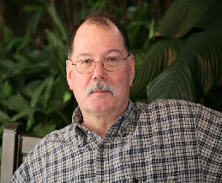
ARES Training Update
Jim Yoder, W8ERW – ARES Data Manager
w8erw@arrl.net

ARES Training Update
The woes of living out in the “Pucker Brush”. Let me translate that. Since I packed up last Fall and relocated to rural Leesburg, Ohio, my efforts to secure decent internet service have been fruitless. Frontier offers their DSL service which works only when and if it chooses to do so. I have neighbors within a mile on Spectrum, but they have not yet chosen to extend their service where I am. There are at least a couple of Wi-Fi internet services. They say it doesn’t work where I am. Of course, there is satellite service which works, but has the dreaded latency that precludes much of what I do with the internet. Hamshack Hotline is an example of what does not work.
What I use now is a service from T-Mobile that works on their Cellular Service. It does work fairly well although prone to intermittent lapses and variable speeds keyed to the number of active users at any given time. The more serious problem comes from the hardware they use to provision their service. The device is both a modem and a router that cannot be uncoupled. That causes all manner of problems with IP addressing. My firewall appliance does not like it at all and doesn’t know how to work in this environment. Many other issues arise when a service or device is interactive. The AREDN MESH network does not fully operate in this mashup of IP addresses. None of the commonly associated options on a router are available or accessible on the T-Mobile device. Port forwarding is required on The AREDN MESH Network to be able to use the tunneling arrangement.
I have been looking for a device that would be essentially be a cellular hotspot without the router function. So far, I have not found such a device. So here I am looking for answers. Spectrum is all around me, but not right where I am. Supposedly I am on a list of future expansion with no promises or sign of any activity to do so. It’s like a piece of candy that lies just out of reach with no means to otherwise grab onto it. Shucks!
On a much brighter note, the AREDN MESH is growing. Our friends in Lucas and Wood Counties are active in pursuing a working AREDN network and have already established some high-profile nodes to support an operational AREDN MESH environment. Seneca County is also getting started and have extended across county lines towards the northwest. Personally, I have an errant MESH node in Fremont that needs my attention when I make my next trip back to Fremont. Getting that back online will reestablish connections to Fremont locations as well as into Seneca County and to our Section Technical Coordinator in Westlake as well as myself here in Leesburg.
I’ve also been working in my new shack in an effort to get back on the air with HF. This Wintery weather of late is not any help. Surely, it’s my age and the chemo that I am on that seems to slow me down as I can hardly keep warm. Now my dear XYL Kim is just the opposite and she is like a furnace complaining of excessive heat. So, I keep my hands off the thermostat and retreat often to my shack where I can adjust the heat to my liking.
Our ARES training numbers have already awakened out of the cold weather and holiday season. I have gotten quite a few certificates this year and a couple of new registrations. We have 1109 active ARES members pursuing NIMS and beyond. Level 1 includes 894 members while Level 2 is at 751 and Level 3 at 222. We have 81 who have completed AUXCOMM and 71 who have completed the Professional Development Series. I have a total of 10,388 certificates on file at this time.
Again, I must say, Ohio Amateurs are leading the way in both activity and training. I wish to thank everyone who has made this all happen. Please don’t hesitate to contact me if you have any questions.

Jim W8ERW w8erw@arrl.net

__________________________________________

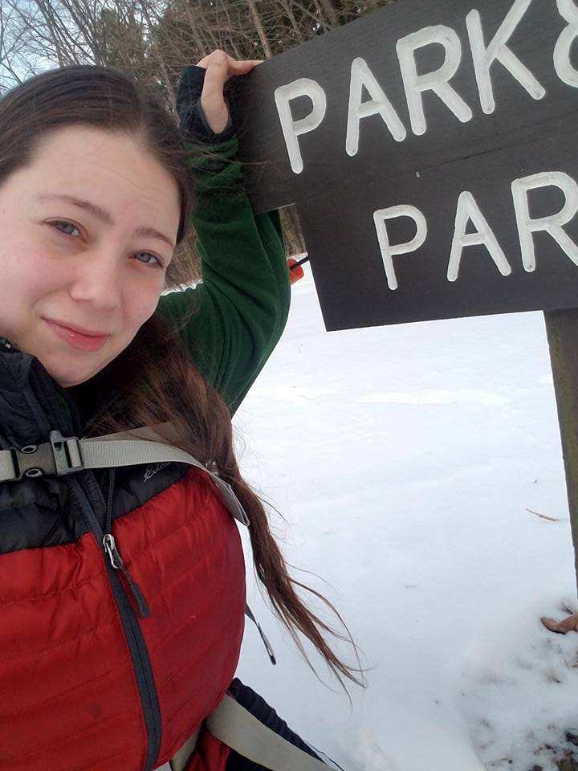
From the Section Affiliated Clubs Coordinator - ACC
Amanda Farone – KC3GFU
Afrone926@gmail.com
330-509-4095

It’s the start of a new year with new opportunities. This month, I have a few things on my mind that I would like to touch base on. Firstly, I want to congratulate Michael Mastro KD8QDL and Scott Yonally N8SY on receiving the Allan Severson Memorial Award. Well deserved! I attended the Seneca Radio Club monthly meeting, and I can’t say enough good things about this club and the members. My biggest takeaway from the night was how often the members were reminded that they are an ASSET to the club and every single one of them had something to contribute. If you get a chance to attend one of their meetings, don’t sleep on it!
Since we are on the topic of monthly meetings, I’d like to bring up the ARRL Speakers Bureau. This is a great resource if your club is struggling to find a program for their monthly meeting. It is a combination of in-person speakers, virtual meeting speakers, and pre-recorded presentations. A variety of presentations are available for clubs to use at their meetings and events. Information on the Speakers Bureau can be found at www.arrl.org/speakers-bureau.

January is a great time to make sure your annual report has been updated on the ARRL website. Some of you may have received an email from me reminding you to update. Thank you to those that have responded! Should you need any help, please reach out to me and I can guide you through the process. It is also that time of year that your club members may be renewing their ARRL memberships. Please remember to utilize the Club Commission Program and earn your club some extra funds.

Speaking of funds, as Tom WB8LCD pointed out in the last edition, hamfests often provide a good portion of funding to the sponsoring club. I encourage you all to get out there and attend as many hamfests as you can. Not only is it fun for you, but it supports a great cause. I will be attending the majority of the hamfests in the Ohio Section and hope to see you there!

As I sit here writing this, I am preparing for Winter Field Day. Winter Field Day is a great way to practice portable emergency communications in winter environments. It is also a great opportunity to get your club members together for a fun outing and to promote the hobby. If you did participate, don’t forget about the WFD Club Challenge. Even if you were not able to operate with your club, you can still help them rank higher in the Club Challenge. I hope I got you on the log this weekend!

Amanda Farone, KC3GFU
ARRL Ohio Section | Affiliated Club Coordinator
afarone926@gmail.com
__________________________________________

National News
(from arrl and other sources)

Volunteers On The Air

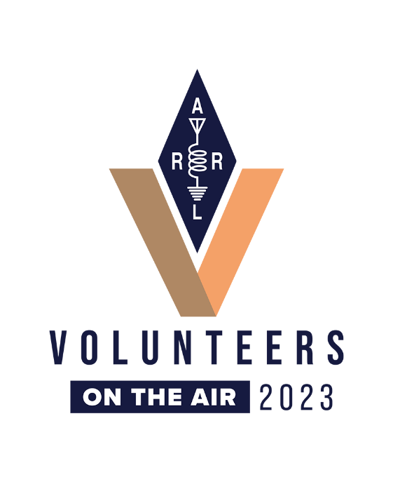
As announced in the January 2023 issue of QST, ARRL is holding the year-long operating event, Volunteers On The Air (VOTA), honoring all ARRL volunteers.
In similar fashion to the 2014 ARRL Centennial QSO Party and the 2018 International Grid Chase, this event will be exclusively driven by contacts uploaded to Logbook of The World (LoTW).
Highlights of the event include:
Earning points for contacting W1AW portable stations: There will be week-long activations of portable W1AW/# stations in all 50 states, and in several US possessions/territories, which will generate on-air activity to earn points. Each state will be activated twice. The schedule of when each state will be activated will be updated as changes and additions occur. See the Points Table at www.arrl.org/volunteers-on-the-air for the full list of points.
Contacting ARRL volunteers or members on the air: ARRL Officers, Directors, Section Managers (and their appointees), staff, and even domestic and DX members, can be contacted for points.
Using LoTW (http://www.arrl.org/logbook-of-the-world) as the contacts data source, the Volunteers On The Air event features W1AW activations from all 50 states (twice) and several territories during 2023. Weeks will begin on a Wednesday and end on a Tuesday. Some weeks will be shown as off weeks to avoid other major operating events.
Participants will work W1AW portable stations and ARRL volunteers to earn contact points.
Participants do not need to upload to, or participate in, LoTW. Uploads to LoTW by W1AW portable stations and by the volunteers will feed the points scoring system.
A leaderboard will be activated after the event ramps up, and certificates will be available during and after the event concludes. Once the year is completed, an annual summary will be released.
If you review the state activations list and notice your state is not yet indicating a host, and you have interest in activating your state, consider reaching out to your Division Director to express your club's interest.
For information and continued updates, visit the VOTA website at www.arrl.org/vota.
______________________________________________

NASA astronaut and Expedition 68 Flight Engineer Nicole Mann makes her first spacewalk.

She and fellow spacewalker Koichi Wakata (out of frame) of the Japan Aerospace Exploration Agency installed a modification kit on the International Space Station's starboard truss structure. The kit will enable the future installation of the lab's next roll-out solar array.

______________________________________________

ARDC Welcomes New Committee Members
Amateur Radio Digital Communications (ARDC) has announced new 2023 volunteers serving on the Grants Advisory Committee (GAC) and Technical Advisory Committee (TAC).
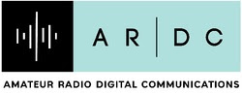
The GAC reviews and advises the ARDC Board of Directors on eligible proposals and helps identify potential grant-making opportunities, while the TAC advises the board and staff on 44Net technology, architecture, and policy. Volunteers commit to serving at least a year and may serve up to a maximum of 3 years. The term starts in January and runs through December.
The volunteers joining the GAC:
- Katie Allen, WY7YL
- Judi Clark, KK6ZCU
- Dennis Derickson, AC0P
- Jim Idelson, K1IR
- Kristin Paget, KJ6GCG
- William Thomas, WT0DX
- Randy Wilkinson, W4LKS
Joining the 2023 TAC are:
- Dave Gingrich, K9DC
- Rich Gopstein, KD2CQ
- Randy Neals, VE3RWN/W3RWN
- Alvaro Prieto, KC2VVE
- Ian Redden, VA3IAN
"It's always exciting to bring on new members to these committees," says ARDC Executive Director Rosy Schechter, KJ7RYV. "This year, I'm delighted to see more women and a variety of technical skills brought to the table. I'm [looking forward] to seeing what these committees do in 2023."
ARDC provides support for ARRL programs and initiatives including the ARRL Foundation Club Grant Program and Scholarship Program. Read more about the new volunteers, their backgrounds, and their committees at the ARDC website.

__________________________________________________________________

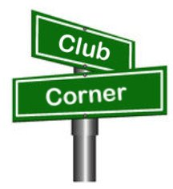
Club Corner

This is YOUR corner of the newsletter. Send us what your club is doing, and we’ll make sure that it gets in. Got a special event or club project that you want everyone to know about? Send it to us!. Need help with a project? Send it to us.

Let us know what you club is up to. Are you going to have a special guest at your meeting or are you having a special anniversary?

Send it to: webmaster@arrl-ohio.org

__________________________________________________________

New Award Program In Canton ARC

A new Canton ARC award program was announced at the recent club banquet last week. Your club's board met in December of last year to debate a proposal for this award. The response was overwhelmingly positive, so now we launch!
Canton ARC now recognizes one member from time to time who contributes above and beyond. In some years, a nominee does not emerge. Possibly the potential candidate has already earned the recognition... possibly the potential candidate has but a year or two of outstanding service.
We like to see recipients who demonstrate multiple years of service. In 2022, this was the position we found ourselves in.
Many organizations recognize legacy members who have departed. The intent of this award is to recognize former (SK) Canton ARC members for their contributions. We feel that by doing so, we will accomplish at least two goals: Demonstrate to the survivors of the departed how much the club valued their contributions; Provide a bridge to the past for new members who might be curious about the club's history.
The club officers came to agreement on most of the details. Names of hams who receive the award will be engraved on a brass plate and become a part of the permanent award plaque. A small business near Hartville was located, someone who has access to modern laser
engraving equipment. An image of the award is in this post. We expect the physical award to be available at the February meeting.
By near unanimous agreement of the board, Wilson E. Weckel W8AL is the first recipient. Our February program will contain a brief biography of Mr. Weckel and his contributions to the club. Anyone with information to contribute is requested to contact the club's officers in order for it to be incorporated in a small ceremony. Nominations for future recipients will also be entertained. One thing I will mention is that we'll have no trouble filling up the first half-dozen
or so badges. This club has a history of members who have given so much. At this time, we anticipate this being an annual award. It does not replace the existing recognition, it is something new.
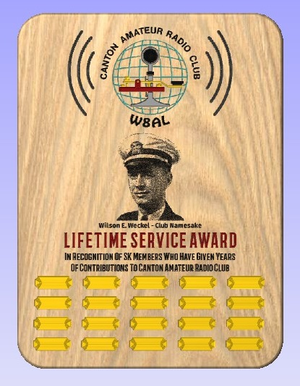
__________________________________________________________

VE Sessions

All Things Amateur Radio Association (ATARA)
We host testing sessions every second Tuesday of the month in Lancaster. To sign up please visit our website https://atara-w8atr.fun and contact us at hamexams@atara-w8atr.fun.

CARS
VE testing from CARS - Cuyahoga Amateur Radio Society - at Elmwood Recreation Center, 6200 Wisnieski Parkway in Independence, Ohio 44131 Time: 9:15 AM (Walk-ins allowed) Always the 2nd Sunday of the odd month. Go to CARS www.2cars.org for detailed map of location. Call Metro W8MET 216-520-1320 for details

Dayton Amateur Radio Association (DARA)
If you are interested in testing for a new or upgraded license, please come see us at the DARA Clubhouse. If you have questions about testing, please email exams.w8bi@gmail.com

Huber Heights Amateur Radio Club
Huber heights amateur radio club does ARRL VE testing the second Saturday of each even numbered month. Feb, Apr, Jun, Aug, Oct, Dec. 9:30-11:00 For more information contact Jim Storms – AB8YK at ab8yk@hotmail.com

The Lake County Amateur Radio Association
The Lake County Amateur Radio Association is holding its 2023 Amateur Radio license exams at the Kirtland Library, 9267 Chillicothe Road, on the following dates:

Saturday, February 4 Saturday, August 5

Saturday, April 1 Saturday, October 7

Saturday, June 3 Saturday, December 2

This bi-monthly schedule is the first Saturday of every even-numbered month (e.g., February being the second month, etc.). They are held at the Kirtland Library, 9267 Chillicothe Road. It is 1.7 miles south of I-90 on Route 306 (Chillicothe Rd). The library is on the left, just beyond the Marathon gas station.

The tests will start at 12 noon. Please arrive a few minutes earlier.

To register, you will need a NCVEC 605 Form, which will be available at the test. If you would like to complete one ahead of time, be sure it is the Sept 2017 version or later. You can find it by Googling “NCVEC quick-form 605” and clicking on the url for a pdf of the form. Please note the FCC requires you to provide a FRN (FCC Registration Number). Social Security Numbers are no longer accepted. If you are new to ham radio and don’t have a FRN, Google “New FRN” and follow the fcc.gov link.

If you are currently licensed, be sure to bring a copy of your license to the exam. The cost of the exam itself is $15.00, and if you wish to pay by check, it should be made out to the ARRL/VEC. Identification with your picture is also necessary, such as a driver’s license. If you have any questions, please contact Scott Farnham, KO8O, at (440) 256-0320, or scottfarnham@roadrunner.com

In addition to the $15 test fee, the FCC now charges $35 to add you to the Amateur Radio database. The FCC will e-mail successful candidates instructions for payment directly to them. Payment must be made within 10 days of the e-mail. This charge does not apply to upgrades.

The Lancaster and Fairfield County Amateur Radio Club (LFCARC) hosts exam sessions at the FAIRFIELD County EMA, 240 Baldwin Dr in Lancaster Ohio, 43130, on the first Saturday each month at 10:00 am. Please visit our website at http://www.k8qik.org for exam dates on our calendar and navigate to our Learning Center/Taking the Exam link for information and requirements. Our experienced VE team looks forward to serving the Amateur Radio community in Central Ohio. Contact me at ve_testing@k8qik.org to register.
Lisbon Area Amateur Radio Association Beginning Feb 11, 2023 Testing on the 2nd Saturday of each month at the Columbiana County EMA located at 215 S Market St. Lisbon, OH 44432. Walk-ins OK. Check in at 1:00PM. For more information go to www.K8GQB.com or contact NN8B at nn8b.oh@gmail.com
Madison County The Laurel testing group will offer testing on the first Thursday of January, March, May, July, September and November. Tests are held at 7:00PM at the Madison County EMA located at 271 Elm St. London, OH. No fee.

The Milford Amateur Radio Club (MARC)
VE testing is held the third Thursday of each month at 6:00 PM. Location; Miami Township Civic Center located at 6101 Meijer Drive, Milford, OH 45150.
Please pre-register at www.milfordhamradio.org

Northern Ohio Amateur Radio Society (NOARS) VE sessions are held the first Saturday of odd-numbered months (EXCEPT FOR March and July) at 10 AM in the North Olmsted Library, 27403 Lorain Rd., North Olmsted. Registration is preferred, but walk-ins are welcome. For more information or to register, contact Elaine, KC8FOS at ewilkinson1951@gmail.com. There will be a VE session held March 12th at the NOARS Winterfest held at Lorain County Community College in the John A Spitzer Conference Center, 1005 Abbe Rd N, Elyria, OH 44035. Please email Elaine – KC8FOS at ewilkinson1951@gmail.com to register.

Portage County Amateur Radio Service (PCARS)
The first Saturday of every even numbered month -10 am – at the PCARS club site in Ravenna. Please visit the PCARS web site and check out the information about VE testing in the latest newsletter at www.portcars.org .
If you have any questions, don’t hesitate to contact me at KB8UUZ@gmail,com

______________________________________________________________

Important Links
ARRL Home: www.arrl.org
Find an ARRL Affiliated Club: www.arrl.org/clubs
Find your ARRL Section: www.arrl.org/sections
Find a License Class in your area: www.arrl.org/class
Find a License Exam in your area: www.arrl.org/exam
Find a Hamfest or Convention: www.arrl.org/hamfests
Email ARRL Clubs: clubs@arrl.org

____________________________________________________________________________

The Ohio Section Youth Net

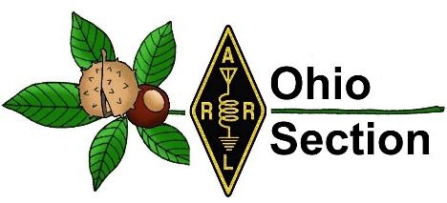
Youth Net
When: The second Sunday of every month at 7:30 PM EST
Where: The K8IV repeater located in Kent, Ohio (Echolink node K8BF-L) RF: 146.895 Mhz with PL 118.8
Who: Any licensed amateur radio operator who wishes to participate. Priority will be given to youth stations and those located in Ohio.
The purpose of this net is to encourage youth activity in amateur radio and to help new hams get more comfortable on the air.

***Next Net is Sunday February 8th ***

______________________________________________________________________

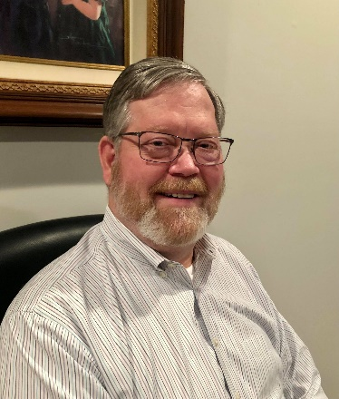
DX This Week – CQWW – WPX RTTY

Bill AJ8B (aj8b@arrl.net, @AJ8B, or www.aj8b.com)
CWOPs Member #1567

This week, the main topic is the CQWW RTTY WPX contest. Holding an AJ8 prefix makes all of the WPX contests quite a bit of fun! If you are new to RTTY, or want to give it a try, this could be a lot of fun for you. The challenge of RTTY is working the stations “on the fringe”. I am not able to slug it out with the big guns, so I skirt around looking for CQs and then pouncing on them, hence the name Spot and Pounce (S&P). You might check this out for some assistance if this is a first time or you want to sharpen your skills: https://www.contestuniversity.com/wp-content/uploads/2018/05/9.-W0YK-Having-Fun-with-RTTY-Contesting-2018.pdf

Keep me informed of new equipment or new countries you have worked, or achievements you have earned.

DAH DIT DIT DIT DAH DAH DIT DIT DIT DAH

SWODXA Announces Major New Prize Raffle at the DXDinner®

The Southwest Ohio DX Association (SWODXA) in conjunction with the owners of Harbour Rock Villa announces a Major Prize Raffle to raise funds to support DXPeditions.
The Prize is a week at Harbour Rock Villa in the Turks & Caicos Islands. This gorgeous villa has room for 6, a well-equipped amateur radio station, multiple antennas, including the use of a vehicle, and assistance in obtaining a VP5 license. The winner will provide their own transportation to the island and meals.
This prize is worth approximately $5000 and will be awarded at the 2023 DX Dinner held in conjunction with the Dayton Hamvention®.
Please visit https://www.harbourrockvilla.com/vp5-ham-radio-2 to view the Villa layout, the amenities, and other details. For updates and more ham information search VP5M on QRZ.com.
Chance tickets can be purchased at www.swodxa.org/vp5m. Ticket sales will be capped at 500. The cost is $25 each or 5/$100.
More information can be found at www.swodxa.org/VP5M, by emailing thedxmentor@gmail.com, or by calling 1-513-855-3980.

Don’t Just Work DX – Be DX at Harbour Rock, Turks & Caicos – VP5!

DAH DIT DIT DIT DAH DAH DIT DIT DIT DAH

This is a fun contest if you are in to RTTY or you want to sharpen your skills. Give it a try and let me know how you do! I also included some comments from the contest Soapbox to give you an idea as to how the participants felt about the contest.

The 2023 CQ World Wide WPX RTTY
February 11-12, 2023 0000Z Saturday – 2359Z Sunday

Rule Differences from WPX SSB/CW Contest
Other rules and info at www.cqwpxrtty.com
Identical wording is used for both the RTTY and CW/SSB rules where the intent is the same. However, there are some key differences for the RTTY mode:
- No 1.8 MHz operation
- Single-Op 30-hour limit (vs. 36)
- Contact points:
- Different-country contacts within any continent (not just North America) get 2 or 4 points
- Same-country contacts get 2 points on the low bands
Soapbox

KE3K - Wow! That was a lot of fun. Haven't worked that many EU stations in years. Glad to see the cycle is active once again. Looking forward to many contests ahead
KF5MU - Had lots of fun. All bands were active
KH6AQ - Worked all S&P with the FTdx-10 in standalone RTTY mode. Antennas were a Hexbeam at 33' and a 40-meter vertical
KI2D - This being my first RTTY contest, I wasn't expecting much. Plus, I had family commitments and was not going to be at the shack this weekend and had a flight to take Sunday afternoon, So I set up for operation with all the apps running on a Windows 10 computer at the shack with remote access. I ended up operating from my laptop accessing the shack computer while watching TV with the family, from the dining room, from the car while waiting for my son to take the ACT exam, from a restaurant in Terminal 5 of JFK airport, from the floor in front of the gate, from the airplane while at the gate, from my phone while the plane was being de-iced and even two QSOs on the air using the in-flight Wi-Fi. Maybe next year I should plan a serious effort. FlexRadio 6600 on a couple of wire antennas hanging from trees: a 160m Loop and a 130' EFHW. First License granted on 4/22/2020
N9TF - A personal best in score and in butt-in-chair time! All accomplished with less than 100 watts, and 130' of wire and gutters 17'above ground at the apex! Tough to get a run going on any band when most of the RF on the wire and gutters is burning a hole in the ground! Was surprised to work as many different (41) DX entities with less than optimum station conditions. Also, hard to tell what band propagation was really like, hi hi. Just moved to new QTH in TN from IL and have not had a chance yet to put up any antennas. Made more contacts than I thought I would make, especially DX. The wire worked great on 15 and 40 for DX. Mostly stateside on 20m. Happy to see some activity on 10 as well. Had lots of fun in this one even if my rates were poor and I had to mostly S&P my way up and down the bands and take a number when fresh meat showed up!! 73 and thanks for a fun contest. Gene, N9TF Clarksville, TN. Rig, K3S 100 Watts, ran 75 watts RTTY. Antenna, 160m dipole made with 130' of 14ga wire strung between house and shed roof, and shield tied to 120' of continuous connected house gutter system
NQ4J - Really enjoy WPX and RTTY. I had coached a new ham with getting setup for the contest. He worked over 300 stations LP. I was really proud of him doing so well on his first effort. I think conditions were good for working Europe on both Saturday and Sunday morning. Maybe better on Sunday. I never looked at 10M I probably should have looked at 10M. I used a club call better than my K8 call. I think the NQ4 prefix did help along with my new solid state RFKit full legal limit amplifier. My sights are on the NAQP RTTY at the end of the month
W1HS - I really enjoy operating RTTY and CQ WPX RTTY is rapidly becoming one of my favorite contests. It is nice having the ability to work US stations to keep things moving along when the DX fizzles out. 10m never really opened here, but I was pleasantly surprised during a very short run to get a call from a station in New Zealand. Conditions on 15m were pretty good and it was my best performing band this contest. My rate really slowed down for a while Saturday afternoon, which gave me incentive to take advantage of the abnormally warm weather here to shovel the snow off the roof of the RV and then get out cross country skiing for a while. Came back to much better conditions. Up early Sunday morning for a good few hours until the FlexRadio crashed. Troubleshooting resulted in a PC reboot which caused me to spend too much time reconfiguring things in order to get everything working again. Need to improve my internal documentation a little so that I can deal with the inevitable Flex/Windows crash faster next time. Station improvements since last contest really paid off, most notably the addition of the tuner genius and power genius which allowed me to operate high power (400w vs 100) and more than double my previous score. Antennas: 10m, 15m and 20m: SteppIR Urban beam on a 35-foot mast 20m, 40m: 61' G5RV Dipole at 40 feet 80m: 102' G5RV Dipole at 50 feet Radio: Flex 6700 Power Genius XL Amp running 400w Antenna Genius TGXL tuner Windows 10 w/N1MM+ logger, Fldigi and GRTTY
W1RPG - This is the first RTTY event I've operated in over a decade and learning the new Fldigi was a challenge, but I got it going and had some fun
W2NTN - I operated part of this contest period. The operation was QRP with a dipole antenna on 10 meters only. Once again, thanks to those who worked to pull my small signal out of the noise

DAH DIT DIT DIT DAH DAH DIT DIT DIT DAH

Here is an update from Bernie, W3UR, of the DailyDX and the WeeklyDX, the best source for DX information. http://www.dailydx.com/ . Bernie has this to report:
Here is the latest CY0S DXpedition update: A very busy time for the CY0S DXpedition team. DX Engineering, one of our major sponsors, was able to locate and ship a Cushcraft A3WS 12–17-meter Yagi. We received the A3WS this past week and assembly and testing will begin this week. After a period of testing, the Hygain LJ- 203-BA, Hygain LJ-153-BA and the Hygain LJ-105 CA monoband Yagi's were disassembled and placed in their respective ski bags. The Yagi antennas were only disassembled enough to be able to fit in the long bags. Once the Cushcraft A3WS is assembled and checked out, it too will be placed in its own ski bag.
The CY0S team has been working closely with both Sable Aviation and Vision Air Services on the plans for the flights to Sable Island on the morning of March 20. The team member assignments were made for each aircraft. Five of the team members will fly to Sable on the Sable Aviation Britten Norman Islander and three team members will fly on the Vision Air Services Sikorsky helicopter. The team lost some of its payload capacity due to requirement of wearing immersion suits and the need to add one extra bench seat to the Islander. We now have an absolute payload capacity limit of 2930 lbs (this includes the weight of the operators) and we are over that weight limitation. We are identifying areas where we can reduce weight. The team had previously committed to eating lightweight freeze-dried meals for the duration of the DXpedition.
The CY0S team has now reached the 60% level of our fundraising goal of $37,500. The total cost of the DXpedition is estimated at $75,000. Both Sable Aviation and Vision Air Services added fuel surcharges due to the continued high cost of fuel. Donations are very much appreciated and can be made from our website @ www.cy0s.com
The team has been in contact with Jason, the Operations Manager for Parks Canada - Sable Island. Jason has advised we may need some flexibility on the departure date from the island. The DXpedition is currently scheduled to conclude on March 29. Due to the operational requirements of the Sable Station, the CY0S team may need to depart the island on March 28, or we may be extended to March 30.
The team continues to prepare for the weather conditions on Sable in March. The average temperature in March is 2 C with winds of 20-30 knots with gusts to 40 knots. These are the averages. I personally have experienced winds exceeding 60 knots and the Visitor Quarters structure would shudder in the strong winds. We may be forced to lower antennas if strong winds occur.
73,
Murray WA4DAN - 2023 Sable Island CY0S DXpedition Team Leader

T8 – Palau - JH7IPR, Ichi, and JF6CHA are heading to the VIP Guest Hotel, which hosts the Palau Radio Club. They plan to operate T88UW and T88CH respectively from February 24 to March 2. Due to local noise they will be mostly on FT8, however when conditions warrant they will be on CW and SSB. They will be on the HF bands and will also be paying attention to 6 meters.

3Y0J QSL Manager M0OXO, Charles, lists the following helpful Bouvet
Island DXpedition links.
3Y0J Main Website (Editor's note: As a reminder this one is not expected to be updated during the DXpedition) https://www.3y0j.no/
GPS Travel Tracker - https://share.garmin.com/3y0j
Weather on Bouvet - https://www.windy.com/-54.422/3.357?-54.445,3.357,12,m:8saggK
Club Log Logsearch - https://clublog.org/charts/?c=3Y0J
3Y0J Facebook Group - https://www.facebook.com/groups/3093983840726129
QSL Policy (QRZ.Com) - https://www.qrz.com/db/3Y0J
3Y0J QSL Policy & Instructions - https://www.m0oxo.com/3y0j-bouvet.../3y0j-bouvet-qsl-policy/
QSL Card requests - https://www.m0oxo.com/oqrs/logsearch.php?dxcallsign=3y0j

CE0Y - Easter Island - CE0YHO, Jose, is currently off the island for a few months.

The CQ DX Marathon - Some of you are aware that the program known as TBDXC has shut down after a very short time in operation. It was formed to attract DXers who believed that the only DXing in the world today was through the use of CW and SSB. The program purportedly allowed DX contacts in those modes only but after their investigations, they found out that so many of their participants were in fact working digital modes including FT8. WC3W, Mark Wohlschlegel, the current Program Administrator of the CW DX Marathon Program stated that "hams like all people like to have free choices. FT8, RTTY and other digital modes are part of ham radio which for years has prided itself in innovation".
Mark is reaching out to any past participant in the TBDXC program to come join the CQ DX Marathon Program. He further states, "We give DXers choices. If you wish to work SSB or CW, or Digital, or all them you can compete on that basis, no problem. We welcome with open arms any past participants in the TBDXC program to join our DX Marathon Program. If you remain focused on CW or SSB, you can enter using these modes only."
The CQ DX Marathon Program is the fastest growing program in DX in the world realizing a +32% increase in participation in 2022. If you have any questions, feel free to email wc3w@dxmarathon.com or visit the website at https://www.dxmarathon.com

DAH DIT DIT DIT DAH DAH DIT DIT DIT DAH

Below is a list of upcoming contests in the “Contest Corner”. I think this is important for someone who is trying to move up the DXCC ladder since entities that are on the rarer side and easiest to work in contests. Some of my best “catches” have been on the Sunday afternoon of a contest when the rarer entities are begging for QSOs. Of course, the gamble is that if you wait until Sunday, conditions may change, or they simply won’t be workable. However, it is not a bad gamble. Of course, why not work the contest and have some fun!
Check out the WA7BNM Contest Calendar page (https://www.contestcalendar.com/) and CQ Magazine for more contests or more details. I also have a comprehensive list that can be imported to your calendar at www.aj8b.com/files
The contests in red are those that I plan to spend some significant participation time on. PLEASE let me know if you are working contests and how you fared.
Thanks!

Date(s) | Event | Info
Feb. 1 | UKEICC 80m Contests SSB | https://ukeicc.com/80m-rules.php
Feb. 1 | VHF-UHF FT8 Activity | www.ft8activity.eu/index.php/en
Feb. 4 | AGCW Straight Key Party | www.agcw.de/contest/htp/htp-en
Feb. 4 | FYBO Winter QRP Sprint | https://qrper.com/tag/fybo
Feb. 4 | Minnesota QSO Party | www.w0aa.org/mn-qso-party
Feb. 4-5 | 10-10 Int’l Winter Contest | http://bit.ly/1FrFeBc
Feb. 4-5 | British Columbia QSO Party | www.orcadxcc.org/bcqp_rules.html
Feb. 4-5 | European Union DX Contest | https://eudxcc.altervista.org/eu-dx-contest
Feb. 4-5 | Mexico RTTY International Contest | www.rtty.fmre.mx/index.html
Feb. 4-5 | North American CW Sprint | http://ncjweb.com/north-american-sprint
Feb. 4-5 | Vermont QSO Party | www.ranv.org/ranv.html
Feb. 6 | RSGB 80m Club Championship, SSB | http://bit.ly/3TxCrxl
Feb. 8 | VHF-UHF FT8 Activity | www.ft8activity.eu/index.php/en
Feb.11 | FISTS Winter Saturday Sprint | www.fistsna.org/operating.html
Feb. 11 | Asia-Pacific Spring Sprint (CW) | http://jsfc.org/apsprint
Feb. 11 | RSGB 1st 1.8 MHZ Contest CW | http://bit.ly/3TxCrxl
Feb. 11-12 | CQWW RTTY WPX Contest | www.cqwpxrtty.com
Feb. 11-12 | Dutch PACC Contest | http://pacc.veron.nl
Feb. 11-12 | KCJ Topband Contest | www.kcj-cw.com/e_index.htm
Feb. 11-12 | OMISS QSO Party | www.omiss.net/Facelift/qsoparty.php
Feb. 11-12 | SARL Field Day Contest | http://bit.ly/H0IqQf
Feb. 11-13 | YL OM Contest | https://ylrl.org/wp/yl-om-contest
Feb. 12 | CQC Winter QSO Party | http://bit.ly/2Qayte1
Feb. 13-17 | ARRL School Club Roundup | www.arrl.org/school-club-roundup
Feb. 14 | PODXS 070 Club Valentine Sprint | http://bit.ly/2Rp8LTk
Feb. 15 | AGCW Semi-Automatic Key Evening | www.agcw.de/contest/sta
Feb. 15 | RSGB 80m Club Championship, DATA | http://bit.ly/3TxCrxl
Feb. 15 | VHF-UHF FT8 Activity | www.ft8activity.eu/index.php/en
Feb. 18-19 | ARRL CW DX Contest | www.arrl.org/arrl-dx
Feb. 19 | FISTS Winter Sunday Sprint | www.fistsna.org/operating.html
Feb. 22 | UKEICC 80m Contests CW | https://ukeicc.com/80m-rules.php
Feb. 23 | RSGB 80m Club Championship, CW | http://bit.ly/3TxCrxl
Feb. 24-26 | CQWW 160M SSB Contest | www.cq160.com/rules.htm
Feb. 25-26 | Hiroshima Worked All Squares | www.hs-contest.org
Feb. 25-26 | REF SSB Contest | https://tinyurl.com/p4bbva92
Feb. 25-26 | South Carolina QSO Party | http://scqso.com
Feb. 25-26 | UBA CW DX Contest | http://bit.ly/W0gZiE
Feb. 25-26 | North American RTTY QSO Party | http://ncjweb.com/naqp
Feb. 26 | High Speed Club CW Contest | www.highspeedclub.org
Feb. 26-27 | North Carolina QSO Party | http://ncqsoparty.org/rules
Feb. 27 | RSGB FT4 Contest Series | http://bit.ly/3TxCrxl

ARLD004 DX news
This week's bulletin was made possible with information provided by
GU4YOX, The Daily DX, 425 DX News, DXNL, Contest Corral from QST and
the ARRL Contest Calendar and WA7BNM web sites. Thanks to all.
BOUVET, 3Y. A large group of operators will be QRV as 3Y0J. Activity will be on 160 to 10 meters using CW, SSB and FT8. QSL via M0OXO.
SRI LANKA, 4S. Peter DC0KK and Wolfgang DK9DR will be QRV as 4S7KKG and 4S7DRG, respectively, from the Sri Lanka Broadcast SLBC transmitting site from January 29 to February 7. Activity will be in their spare time on 80 to 10 meters using mostly SSB with FT8 and FT4. QSL to home calls.
TIMOR-LESTE, 4W. Satoshi, JH2EUV is QRV as 4W/JH2EUV. Activity of late has been on 17, 15, and 10 meters using FT8. QSL via LoTW.
TOGO, 5V. Filippo, IK4ZHH is QRV as 5V22FF. Activity is on 40 to 10 meters using mainly CW with some SSB. QSL to Club Log.
KENYA, 5Z. Rick, M0LEP is QRV as 5Z4/M0LEP from Nairobi until January 30. Activity is in his spare time on 20 to 6 meters using CW and SSB. QSL to home call.
LESOTHO, 7P. Yuris, YL2GM is QRV as 7P8WW until February 4. Activity is on 160 to 10 meters using CW, SSB, RTTY, and FT8. QSL via YL2GN.
THE GAMBIA, C5. Andre, ON7YK is QRV as C5YK from Bijilo until February 24. Activity is on 20 to 10 meters using all modes. QSL direct to home call.
WALLIS AND FUTUNA ISLANDS, FW. Jean-Gabriel, F4CIX, is QRV as FW1JG and expects to be here until January 2024. He is active on 40 to 6 meters using SSB and FT8. QSL via LoTW.
FRENCH GUIANA, FY. Contest station FY5KE will be QRV as TO1A in the CQ World Wide 160-Meter CW and French CW contests. QSL via operators' instructions.
PANAMA, HP. Members of the Panama Canal Amateur Radio Association will be QRV as 3E30PCARA from February 1 to 28 to celebrate the club's 30th anniversary. QSL direct.
ALASKA, KL. Brandon, KL7BSC will be QRV from Denali State Park, POTA K-1641, during Winter Field Day. QSL via LoTW.
ANTARCTICA. Juan, LU8DBS is QRV as LU1ZV until February from the Argentine Esperanza Antarctica Base located at Hope Bay, Trinity Peninsula while on work assignment. Activity is in his spare time on 40, 20, and 10 meters using SSB, and soon with CW and FT8. QSL via LU4DXU.
PAPUA NEW GUINEA, P2. Alberto, P29LL has been QRV on 20 meters using CW around 0800z, and then around 1400z. QSL via EA7FTR.
SEYCHELLES, S7. Kazik, DL2SBY is QRV as S79/DL2SBY until February 4. Activity is on 160 to 10 meters using some CW, FT8, and possibly SSB. QSL to home call. In addition, Peter, G4HSO will be QRV as S79/G4HSO from February 1 to 21 as a holiday operation from three different locations. QSL via LoTW.
ST. KITTS AND NEVIS, V4. John, W5JON will be QRV as V47JA from St, Kitts, Calypso Bay, IOTA NA-104, from January 31 to February 15. Activity will be on 160 to 6 meters using SSB and FT8. QSL direct to home call.
CANADA, VE. Special event station VB3CAM50 will be QRV from February 1 to 15 to celebrate the 50th anniversary of the city of Cambridge in Ontario. QSL via operator's instructions.
MEXICO, XE. Garcia, XE1CIC will be QRV from Bicentenario State Park, POTA XE-0252, on January 28 and 29. Activity will be on 20 to 10 meters using SSB. QSL direct to home call.
ALBANIA, ZA. Ron, NS5K is QRV as ZA15K from Lushnje until November 15 while performing missionary work. Activity is in his spare time on 40 and 20 meters. QSL via operator's instructions.
The K1USN Slow Speed CW Test, QCX CW Challenge, ICWC Medium Speed CW
Test, OK1WC Memorial, Worldwide Sideband Activity Contest, QRP
40-Meter CW Fox Hunt, Phone Weekly Test, A1Club AWT, CWops CW Test,
VHF-UHF FT8 Activity Contest, Mini-Test 40, Mini-Test 80 and the
UKEICC 80-Meter Contest are on tap for January 30 to February 1.
Please see January 2023 QST, page 74, February QST, page 69, and the
ARRL and WA7BNM Contest web sites for details.

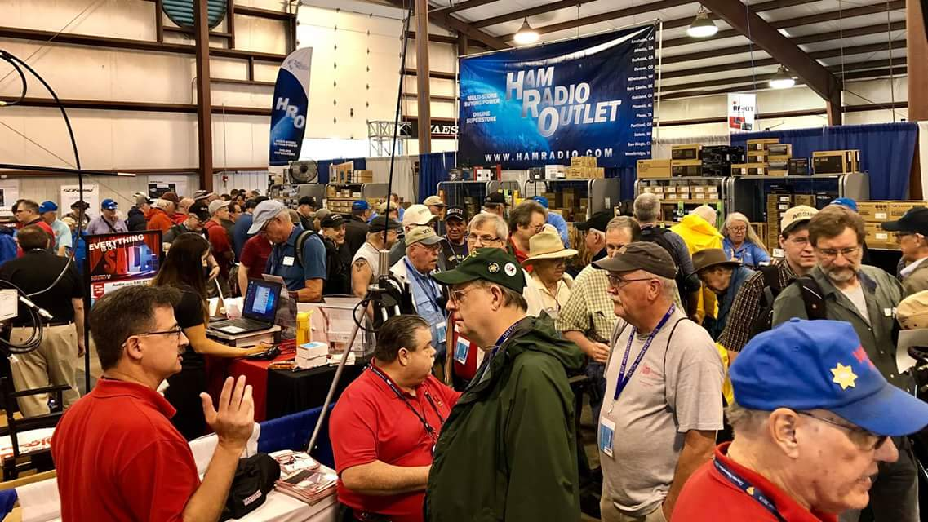
Upcoming Hamfests

We DO have some hamfests scheduled for 2023!! Yes, take a good look at the list, it’s growing every day!

03/11/2023 - MOVARC Hamfest  Location: Bidwell, OH 45614, OH  Sponsor: Mid-Ohio Valley Amateur Radio Club  Learn More | 03/12/2023 - Winter Hamfest  Location: Elyria, OH  Sponsor: Northern Ohio Amateur Radio Society  Website: http://winterhamfest@noars.net  Learn More
03/19/2023 - Toledo Mobile Radio Association Hamfest Location: Perrysburg, OH  Sponsor: Toledo Mobile Radio Association  Website: http://www.tmrahamradio.org  Learn More | 04/15/2023 - Cuyahoga Falls Amateur Radio Club Hamfest  Location: Cuyahoga Falls, OH  Sponsor: Cuyahoga Falls Amateur Radio Club, Inc.  Website: http://www.cfarc.org  Learn More
04/22/2023 - Tusco Amateur Radio Club Hamfest, Electronics, and Computer Show  Location: Dover, OH  Sponsor: Tusco Amateur Radio Club W8ZX  Website: http://www.w8zx.net  Learn More | 04/30/2023 - Athens Hamfest  Location: Athens, OH  Sponsor: Athens County Amateur Radio Association  Website: http://www.ac-ara.org/  Learn More
05/07/2023 - Lucas County Amateur Radio Emergency Service Trunk Sale and Swap Meet  Location: Toledo, OH  Sponsor: Lucas County Amateur Radio EmergencyService  Website: http://swap.lucasares.org  Learn More | 05/13/2023 - 05/17/2023 RV Radio Network  Location: Berlin, Ohio, OH  Type: ARRL Operating Specialty Convention  Sponsor: RV Radio Network  Learn More
05/19/2023 - 05/21/2023 Dayton Hamvention  Location: Xenia, OH  Sponsor: Dayton Amateur Radio Association  Website: http://Hamvention.org  Learn More | 05/27/2023 - Scioto Valley Amateur Radio Club Hamfest  Location: Piketon, OH  Sponsor: Scioto Valley Amateur Radio Club  Learn More
07/08/2023 - Mansfield Trunkfest 2023  Location: Mansfield, OH  Sponsor: Intercity Amateur Radio Club  Website: http://iarc.club  Learn More | 07/16/2023 - Van Wert Hamfest  Location: Van Wert, OH  Sponsor: Van Wert Amateur Radio Club  Website: http://w8fy.org  Learn More
08/12/2023 - Cincinnati Hamfest  Location: Owensville , OH  Sponsor: Milford ARC  Website: https://CincinnatiHamfest.org  Learn More | 08/20/2023 - WARA Tailgate Swap Meet  Location: Cortland, OH  Sponsor: Warren Amateur Radio Association  Website: http://w8vtd.org  Learn More

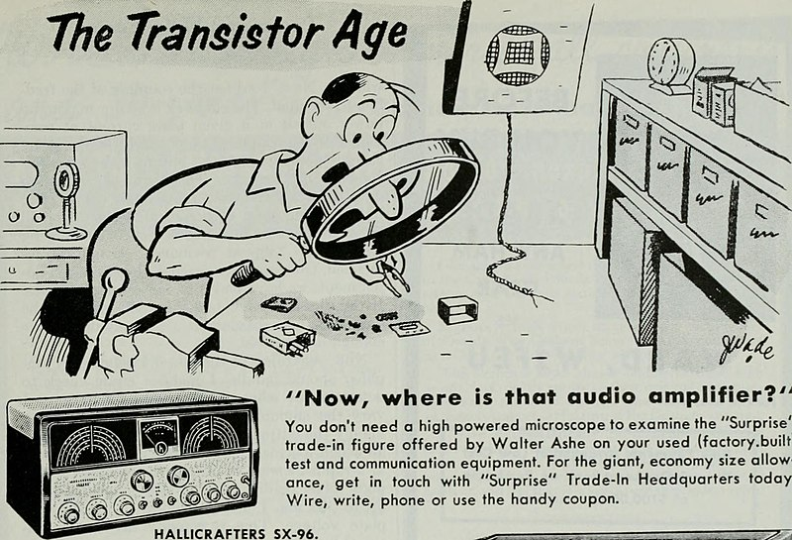
__________________________________________________________________

Print an Official or Unofficial Copy of Your Amateur Radio License
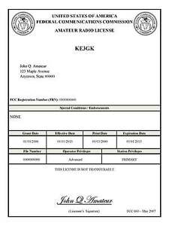
(By Anthony Luscre, K8ZT)

As of February 17, 2015, the FCC no longer routinely issues paper license documents to Amateur Radio applicants and licensees. The Commission has maintained for some time now that the official Amateur Radio license authorization is the electronic record that exists in its Universal Licensing System (ULS). The FCC will continue to provide paper license documents to all licensees who notify the Commission that they prefer to receive one.

Licensees also will be able to print out an official authorization — as well as an unofficial “reference copy” — from the ULS License Manager. I’ve created a set of instructions on how you can request an “official” printed copy of your license*

Click here to download the instructions

One Question Questionnaire

Hey Gang,

Last weeks question Have you made hotel reservations for HamVention Yet?
- YES?
- NO?

Survey Says A) 12 (17.65%) Yes, and B) 56 (82.35%) No.

The new question is:

Do you plan to work cy0s this time?
a) Yes?
b) No?

You’ll find the “One Question” questionnaire on the Ohio Section Website! http://arrlohio.org It’s all for fun and it’s not a scientific survey in any way, but we are learning some things that we didn’t know from these questions. I hope that you are enjoying answering these “One Question” questionnaires.

Nex week I’ll announce January’s handbook winner! Good luck!

The BIG RED ARROW is on the webpage – get your entry in!

V.E. Test Sessions

Many V.E.’s have decided to start testing once again, but with restrictions that need to be adhered to for sure. Here’s the link to find that V.E. Test session and what is expected of YOU before going. http://www.arrl.org/find-an-amateur-radio-license-exam-session

Final… Final

Just a couple quick comments. I’ve had a report from an Ohio Section ham operator:

“ Dear Tom.

Today I noted on HamAlert that my callsign had been used, and I was not on the air at all. It showed the following:

"DX de XX5XX: 7.031 XX8XX Test Test..."

Further research showed that XX5XX, had, instead of spotting a real station that he heard, created fictitious transmissions with my callsign, XX8XX, to test his Log4OM logger. He created bogus spots using his callsign XX5XX as the spotting station and XX8XX as the DX station. He also put fictitious comments that I was sending a "test." Lastly, he did not ensure that the bogus spots would not go out to the cluster.”

While no actual On Air transmissions had taken place, and there are no laws against fictitious spots, this is a perfect example of poor judgement on the part of the 5 call station. Don’t be a LID – on or off the air!

Hamfests are popping up on Ohio this year – While I can’t be everywhere, I hope you’ll stop and say HI when I can be there. If I miss a PostScript or two this year, it’s probably because I was out and about, or maybe even just wanted to take part in a weekend event! Early next week I’ll have some Ham Gear listed for sale on the Swap & Shop page from the estate of Neil Gerren – N8IL, on behalf of his wife. I’ve seen too often that hams have not taken any special future planning for an event towards which we are all headed. More on that later. If you made it this far into this newsletter you’re doing pretty good. I give my thanks to all of the awesome contributors who make this happen every week!

73,
Tom WB8LCD

“Swap & Shop” on the website

Hey Gang,

Have you taken a look at the Swap & Shop page on the Ohio Section webpage yet?? Here’s a link that will take you there…
http://arrl-ohio.org/sm/s-s.html

Do you have equipment that you just don’t need or want anymore? Here’s a great venue to advertise it, and it’s FREE!!

Is your club doing a fund raiser to help raise money? After a lot of thought, it was decided that the Swap & Shop webpage could also contain these types of items as well.

The same rules will apply as do for the For Sales and Give-A-Ways and will only be posted for a month at a time. Please see the Terms & Conditions on the webpage.

If your club is doing a fund raiser and wants more exposure, please forward the information to me and I’ll advertise it on the Swap & Shop webpage for you. Now, I still want to remind you that it won’t be listed in this newsletter because it would take up way too much space, so your ad will only appear on the website. It is there for any individual to post equipment Wanted / For Sale or Give-Away as well as for Club Fund Raisers. No licensed vehicles/trailers or business advertising will be posted.

Postings are text only (no pictures or graphics) will be posted for a maximum of 1 month from date posting and require a contact phone number or email within the posting. Send your Wanted / For Sale or Give-Away post to: swap@arrlohio.org

Back Issues of the PostScript and Ohio Section Journal

Hey, did you know that PostScript and Ohio Section Journal (OSJ) are archived on the website? You can go back and look at any edition simply by clicking:
http://arrl-ohio.org/news/index.html

Ohio Section Cabinet
Section Manager – Tom Sly, WB8LCD | Section Emergency Coordinator – Bret Stemen, KD8SCL
Technical Coordinator – Jeff Kopcak, K8JTK | Section Traffic Manager – David Maynard, WA3EZN
State Government Liaison – Bob Winston, W2THU | Affiliated Clubs Coordinator –  Amanda Farone, KC3GFU
Section Youth Coordinator – Anthony Lascre, K8ZT | Public Information Coordinator – E;izabeth Klinc – KE8FMJ

Chit – Chat, and All That!

Do you know someone that’s not getting these Newsletters? Please, forward a copy of this Newsletter over to them and have them “Opt-In” to start receiving them. Heck just have them send an email to: webmaster@arrl-ohio.org to be added.

We now have many thousands of readers receiving these newsletters weekly. Quite impressive, I’d say! I urge all of you to make sure that everyone, regardless of whether they are a League member or not, get signed up to receive these weekly Newsletters.

You can always “Opt-Out” at any time if you feel this is not what you were expecting. It’s fun and very informative. All of your favorite past newsletters are now archived too.
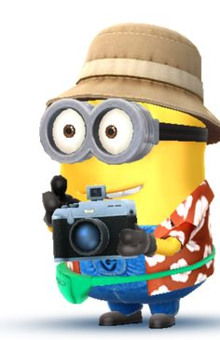
You can go back at any time and read them. Just go to: http://arrl-ohio.org/news/

The pictures on the front page and throughout this newsletter are from various newsletters, Facebook posts and/or were sent directly to me in recent weeks. Take a good look at them, you just might be in one of the pictures! “SMILE… you’re in the Ohio Section News!!”

The Ohio Section Journal (OSJ) is produced as a comprehensive look at all the programs within the Ohio Section. I sincerely hope that you have enjoyed this edition of the OSJ and will encourage your friends to join with you in receiving the latest news and information about the Ohio Section, and from around the world!

TOP^

