[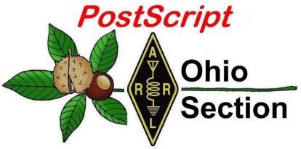](http://arrl-ohio.org/news/)

***“******May 27th, 2024”***

→ National News → [Club Corner](bookmark://club)

→ DX This Week → Contest Corner

→ Upcoming Hamfests → One Question Questionnaire

→ VE Testing → South 40

**CQ CQ CQ de WB8LCD**

Please pause whatever you are doing and think seriously about the day we are celebrating this Monday – Memorial Day. However you and I got here, we are very lucky to live in the greatest nation that has ever existed on this planet! Today we remember and memorialize those who gave the ultimate sacrifice so that we could live in Freedom, Prosperity and Peace! From the time of the American Revolution through today, the American Soldier has fought for all people to live under their God Given Rights – among these life, liberty and the pursuit of happiness.

Never forget.

It’s been a couple of weeks since an issue of PostScript has been released. A LOT has happened in the world of Amateur Radio. To start with on May 16th it was reported that some of the ARRL web services had experienced a “Serious Incident” involving access to their data network and systems. While I don’t have any more information than most of you do, I can assure you that this “incident” is being taken very seriously and a reasonable solution is being sought for the membership’s benefit. Per the latest release on the ARRL website: “This story will be updated with new developments.” I will pass along any information that I’m given as I receive it.

Just completed was the 2024 edition of the DARA Hamvention! I’ve commented on Hamvention many times over the years. I’ve implored you to attend. And the 2024 event was certainly one that met all of my expectations. It’s still the biggest and best I’ve ever been to. “Hamvention” General Chairman, Jim Storms, is proud to announce the 2024 event had a record setting official attendance of 35,877.” That’s a BIG number! I want to personally thank DARA, Jim Storms and the approximately 700 volunteers who made this year’s show a success.

If I remember the facts correctly, the origins of Hamvention go back to 1952. It has operated continuously ever since. My first visit was in 1968. I can’t say I’ve been every year since, but I’m sure it’s more than 90%. In and across all those years, I’ll bet there has been a time or two when the membership of DARA has said “maybe it’s about time we just let it go”. Especially in recent years with the implosion of Wampler Arena, then COVID. It could have been very easy to say the time was now. Well, thank goodness there are still folks involved who aren’t just trying to find the “easy” path through life! That’s not how you draw 35,000+ people to Dayton / Xenia, Ohio for the Biggest and the Best Ham Radio Show on Earth. It takes a lot of work and perseverance to make something like this happen. Thank You to All involved.

Now I want to say to you and your club – have you decided to “pack it in”, take the “easy” path? Where does that put you? Pretty much nowhere. It takes a lot of work and effort to do something more than just exist. The All Things Amateur Radio Association (ATARA) was recognized at the ARRL Forum as a club that is DOING the activities of Amateur Radio, and spreading the word across the Ohio Section! They obtained an ARRL grant, purchased and outfitted a trailer to be an interactive STEM resource and a great introduction to Amateur Radio for those who aren’t (yet) involved. I know it’s work – not always easy. But they have something very worthwhile to show for their efforts and they are out in the community spreading the Ham Radio word! I know they truly believe that the only way to fail is to quit. Check them out when you get the chance.

In other Hamvention news, Tim Duffy – K3LR was inducted into the CQ Amateur Radio Hall of Fame. Although a member of the CQ Contest Hall of Fame since 2006, his lifetime achievements and contributions to Amateur Radio have been far more extensive than just contesting! Both personally, and professionally, Tim has been an outstanding resource for Hams in the Ohio Section (and beyond) and dedication to the hobby is greatly appreciated by all. Congratulations Tim! <https://www.onallbands.com/tim-duffy-k3lr-inducted-into-the-cq-amateur-radio-hall-of-fame/>

Field day is coming up. I will be traversing the state again this year, making as many stops as I possibly can. I’ll admit I usually start falling behind my schedule at my first stop, and I continue falling further behind every stop thereafter. The point is, there are just so many great set-ups to see (not to mention a lot of Fantastic People!) I can’t just say “Hello” and get back on the road. I appreciate the welcoming spirit I have always received. This year the plan is to have my daughter, Jenny – KD8LIR riding along with me. Thank you to Bob Winston – W2THU for obtaining the Governor’s Field Day Proclamation! This is an important document to include with your Field Day publicity materials sent out, and I would also suggest a copy be displayed at your Field Day operations site. This will be posted on the Section Website shortly so you can download a copy for your use.

**2024 K3Y Special Event – Scheduled for July 26-28**

The Dave Kalter Memorial Youth DX Adventure plans to participate in a 2024 Special Event as K3Y on July 27, 2024. K3LR Contest Group is hosting us at their station for this event. They will participate in the RSGB IOTA contest as a team of youth operators.

This is the second time a Youth DX Adventure event is being hosted in the USA. As K3LR is one of the largest stations in the world this adventure was truly special for the David Kalter kids and their parents. There were housing issues for our anticipated international trip.

The trip is sponsored by the Dayton Amateur Radio Association, K3LR Contest Superstation and DX Engineering.

Please get on the air and give them a QSO!

Share the Magic of Radio.

73,

Tom Sly - WB8LCD

Ohio Section Manager

[wb8lcd@arrl.org](mailto:wb8lcd@arrl.org)

330-554-4650

***National News***

*(from ARRL and other sources)*

**Dayton Hamvention 2024 - Videos to Watch**

***Anthony Luscre, K8ZT*** [*k8zt@cfarc.org*](mailto:k8zt@cfarc.org)

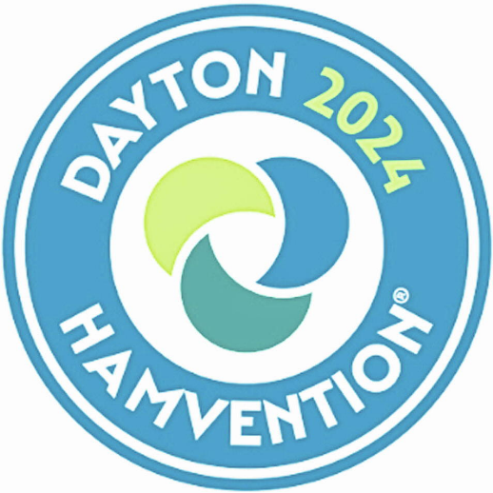The Dayton Hamvention, a significant event in our amateur radio community, has just concluded. Linda, KA8ODP and I were fortunate to attend for what we believe was our 38th or 39th time (we've lost count!). It was a memorable four days filled with presentations, catching up with old friends, meeting new ones, exploring vendor booths, and making a few purchases.

Now, you might be thinking to yourself, “Anthony is just rubbing this in as Hamvention is already over.” But no, I am writing this to share some items you can still enjoy from the comfort of your home.

**Contest University-** [*www.contestuniversity.com*](https://www.contestuniversity.com/)

Contest University streamed and recorded over a fourth of the presentations, which you can watch at the links below. You can also view the slideshows from the remaining sessions and past years at this link: [*www.contestuniversity.com/files*](https://www.contestuniversity.com/files).

* Full live stream recording- [*youtu.be/JdlozWlGstM*](https://youtu.be/JdlozWlGstM)
  + Contesting Ethics- Randy Thompson, K5ZD
  + Optimizing the Use of Waterfall Displays for Contesting – N6TV
  + How to Integrate Youth Operators in Multiop Contesting – KE8LQR and K8LG
  + Next Level Contesting; Making the Move to SO2R – K5ZD
  + The Road to WRTC2026 in the United Kingdom – M0DXR
  + HF Propagation Tips to Improve your Competitiveness in Contests – W3LPL
  + QRP & Low Power Operating, K8ZT
  + SO2R and Station Design Q&A – K5ZD
  + Are you Considering a New Radio? Is My TX Clean? – Rob Sherwood, NC0B
* Busting Contesting Myths to Get Started in Radio Sport – K8ZT- [*youtu.be/yCcw7KG6Dgo*](https://youtu.be/yCcw7KG6Dgo)
* A black and white logo

  Description automatically generatedQRP & Low Power Operating- Anthony Luscre, K8ZT- [*youtu.be/JdlozWlGstM?t=21901*](https://youtu.be/JdlozWlGstM?t=21901)

**Four Days In May (FDIM) QRP-ARCI-** [*https://qrparci.org/fdim*](https://qrparci.org/fdim)

FDIM is the original Thursday before Dayton activity. You can watch the videos of their presentations at [*www.youtube.com/playlist?list=PLOreRxAQ1qvGYpQAysjYBA_0VaLzAPXH4*](https://www.youtube.com/playlist?list=PLOreRxAQ1qvGYpQAysjYBA_0VaLzAPXH4)

* The Construction and Use of a WhosZat by Jack Purdum W8TEE
* Top 10 Junkbox Projects by Han Summers G0UPL
* zBitx - Bringing CW into the 21st Century by Asher Farhan VU2ESE
* Adventures of a QRP Evangelist by Cliff Batson N4CCB
* Amplifying Your Adventures, Minimizing Your Power by Thomas Witherspoon K4SWL
* Designing the Elecraft KH1 - From Vision to Reality by Wayne Burdick N6KR
* The Amazing Thermionic Valve by Greg Latta AA8VI- [*www.youtube.com/watch?v=OWMqxncRoIQ*](https://www.youtube.com/watch?v=OWMqxncRoIQ)

The Dayton Hamvention

The Hamvention has 3 days of forums and most are recorded and available for your viewing at [www.youtube.com/playlist?list=PLM_NXI3v5F_z2HUGadVzbgOMgAvh22iDX](http://www.youtube.com/playlist?list=PLM_NXI3v5F_z2HUGadVzbgOMgAvh22iDX)

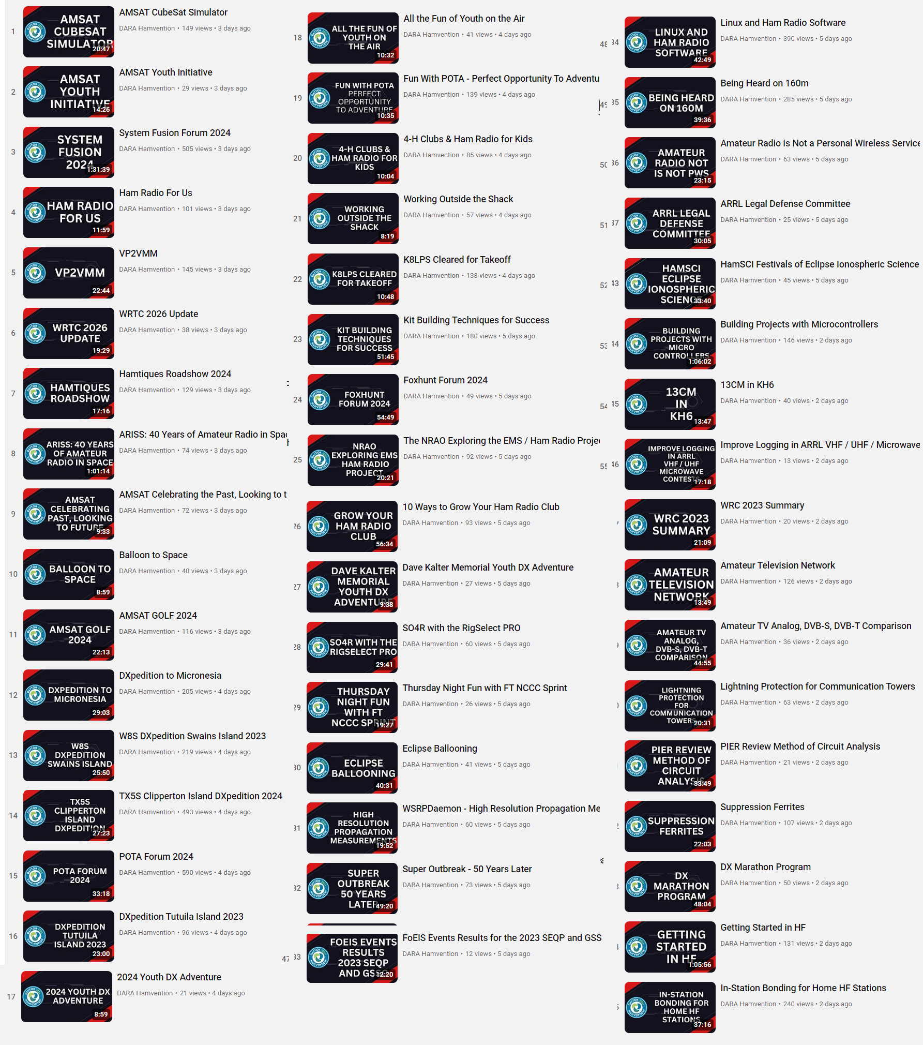

RRL National Convention Forums- [www.youtube.com/playlist?list=PLuapIzKwhZN8LFSdPtmLRv8BLhhAVIkId](http://www.youtube.com/playlist?list=PLuapIzKwhZN8LFSdPtmLRv8BLhhAVIkId)

____________________________________________________________________________

**NASA’s Juno Provides High-Definition Views of Europa’s Icy Shell**

**Jet Propulsion Laboratory**

**MAY 15, 2024**

[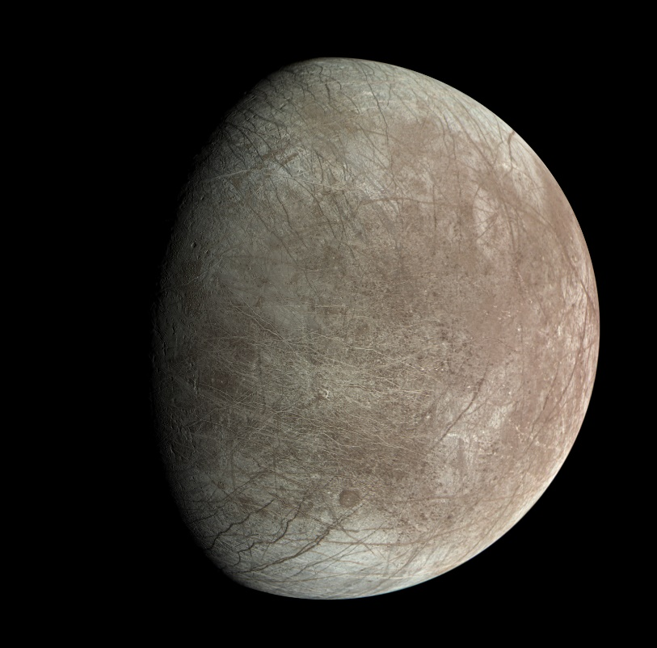](https://www.nasa.gov/wp-content/uploads/2024/05/1-pia26331-europa-junocam-1.png)

Jupiter’s moon Europa was captured by the JunoCam instrument aboard NASA’s Juno spacecraft during the mission’s close flyby on Sept. 29, 2022. The images show the fractures, ridges, and bands that crisscross the moon’s surface.

Image data: NASA/JPL-Caltech/SwRI/MSSS. Image processing: Björn Jónsson (CC BY 3.0)

*Imagery from the solar-powered spacecraft shows some intriguing features on the ice-encased Jovian moon.*

Images from the JunoCam visible-light camera aboard NASA’s Juno spacecraft supports the theory that the icy crust at the north and south poles of Jupiter’s moon Europa is not where it used to be. Another high-resolution picture of the icy moon, by the spacecraft’s Stellar Reference Unit (SRU), reveals signs of possible plume activity and an area of ice shell disruption where brine may have recently bubbled to the surface.

The JunoCam results recently appeared in the [Planetary Science Journal](https://iopscience.iop.org/article/10.3847/PSJ/ad24f4) and the SRU results in the journal [JGR Planets](https://agupubs.onlinelibrary.wiley.com/doi/full/10.1029/2023JE008105).

On Sept. 29, 2022, Juno made its [closest flyby of Europa](https://www.jpl.nasa.gov/news/nasas-juno-shares-first-image-from-flyby-of-jupiters-moon-europa), coming within 220 miles (355 kilometers) of the moon’s frozen surface. The four pictures taken by JunoCam and one by the SRU are the first high-resolution images of Europa since Galileo’s last flyby in 2000.

**True Polar Wander**

Juno’s ground track over Europa allowed imaging near the moon’s equator. When analyzing the data, the JunoCam team found that along with the expected ice blocks, walls, scarps, ridges, and troughs, the camera also captured irregularly distributed steep-walled depressions 12 to 31 miles (20 to 50 kilometers) wide. They resemble large ovoid pits previously found in imagery from other locations of Europa.

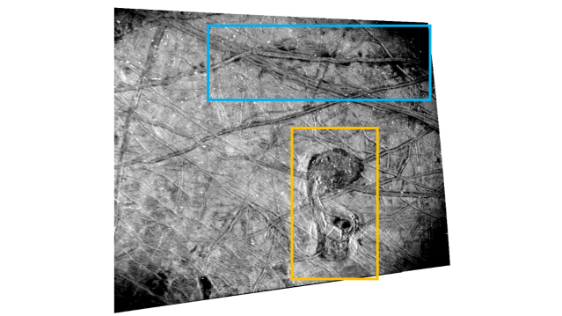

This annotated image of Europa’s surface from Juno’s SRU shows the location of a double ridge running east-west (blue box) with possible plume stains and the chaos feature the team calls “the Platypus” (orange box). These features hint at current surface activity and the presence of subsurface liquid water on the icy Jovian moon.

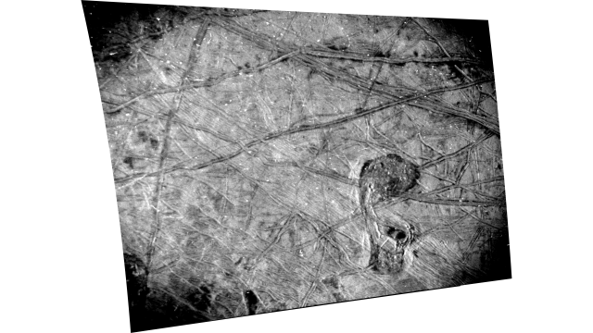

This black-and-white image of Europa’s surface was taken by the Stellar Reference Unit (SRU) aboard NASA’s Juno spacecraft during the Sept. 29, 2022, flyby. The chaos feature nicknamed “the Platypus” is seen in the lower right corner.

NASA/JPL-Caltech/SwRI



This annotated image of Europa’s surface from Juno’s SRU shows the location of a double ridge running east-west (blue box) with possible plume stains and the chaos feature the team calls “the Platypus” (orange box). These features hint at current surface activity and the presence of subsurface liquid water on the icy Jovian moon.



This black-and-white image of Europa’s surface was taken by the Stellar Reference Unit (SRU) aboard NASA’s Juno spacecraft during the Sept. 29, 2022, flyby. The chaos feature nicknamed “the Platypus” is seen in the lower right corner.

NASA/JPL-Caltech/SwRI



This annotated image of Europa’s surface from Juno’s SRU shows the location of a double ridge running east-west (blue box) with possible plume stains and the chaos feature the team calls “the Platypus” (orange box). These features hint at current surface activity and the presence of subsurface liquid water on the icy Jovian moon.

A giant ocean is thought to reside below Europa’s icy exterior, and these surface features have been associated with “[true polar wander](https://www.jpl.nasa.gov/news/study-finds-ocean-currents-may-affect-rotation-of-europas-icy-crust),” a theory that Europa’s outer ice shell is essentially free-floating and moves.

“True polar wander occurs if Europa’s icy shell is decoupled from its rocky interior, resulting in high stress levels on the shell, which lead to predictable fracture patterns,” said Candy Hansen, a Juno co-investigator who leads planning for JunoCam at the Planetary Science Institute in Tucson, Arizona. “This is the first time that these fracture patterns have been mapped in the southern hemisphere, suggesting that true polar wander’s effect on Europa’s surface geology is more extensive than previously identified.”

The high-resolution JunoCam imagery has also been used to reclassify a formerly prominent surface feature from the Europa map.

“Crater Gwern is no more,” said Hansen. “What was once thought to be a 13-mile-wide impact crater — one of Europa’s few documented impact craters — Gwern was revealed in JunoCam data to be a set of intersecting ridges that created an oval shadow.”

**The Platypus**

Although all five Europa images from Juno are high-resolution, the image from the spacecraft’s black-and-white SRU offers the most detail. Designed to detect dim stars for navigation purposes, the SRU is sensitive to low light. To avoid over-illumination in the image, the team used the camera to snap the nightside of Europa while it was lit only by sunlight scattered off Jupiter (a phenomenon called “Jupiter-shine”).

This innovative approach to imaging allowed complex surface features to stand out, revealing intricate networks of cross-cutting ridges and dark stains from potential plumes of water vapor. One intriguing feature, which covers an area 23 miles by 42 miles (37 kilometers by 67 kilometers), was nicknamed by the team “the Platypus” because of its shape.

Characterized by chaotic terrain with hummocks, prominent ridges, and dark reddish-brown material, the Platypus is the youngest feature in its neighborhood. Its northern “torso” and southern “bill” — connected by a fractured “neck” formation — interrupt the surrounding terrain with a lumpy matrix material containing numerous ice blocks that are 0.6 to 4.3 miles (1 to 7 kilometers) wide. Ridge formations collapse into the feature at the edges of the Platypus.

For the Juno team, these formations support the idea that Europa’s ice shell may give way in locations where pockets of briny water from the subsurface ocean are present beneath the surface.

About 31 miles (50 kilometers) north of the Platypus is a set of double ridges flanked by dark stains similar to features found elsewhere on Europa that scientists have hypothesized to be cryovolcanic plume deposits.

“These features hint at present-day surface activity and the presence of subsurface liquid water on Europa,” said Heidi Becker, lead co-investigator for the SRU at NASA’s Jet Propulsion Laboratory in Southern California, which also manages the mission. “The SRU’s image is a high-quality baseline for specific places NASA’s Europa Clipper mission and ESA’s (European Space Agency’s) Juice missions can target to search for signs of change and brine.”

[Europa Clipper](https://europa.nasa.gov/)’s focus is on Europa — including investigating whether the icy moon could have conditions suitable for life. It is scheduled to launch on the fall of 2024 and arrive at Jupiter in 2030. [Juice](https://science.nasa.gov/mission/juice/) (Jupiter Icy Moons Explorer) launched on April 14, 2023. The ESA mission will reach Jupiter in July 2031 to study many targets (Jupiter’s three large icy moons, as well as fiery Io and smaller moons, along with the planet’s atmosphere, magnetosphere, and rings) with a special focus on Ganymede.

Juno executed its 61st close flyby of Jupiter on May 12. Its 62nd flyby of the gas giant, scheduled for June 13, includes an Io flyby at an altitude of about 18,200 miles (29,300 kilometers).

**More About the Mission**

JPL, a division of Caltech in Pasadena, California, manages the Juno mission for the principal investigator, Scott Bolton, of the Southwest Research Institute in San Antonio. Juno is part of NASA’s New Frontiers Program, which is managed at NASA’s Marshall Space Flight Center in Huntsville, Alabama, for the agency’s Science Mission Directorate in Washington. The Italian Space Agency (ASI) funded the Jovian InfraRed Auroral Mapper. Lockheed Martin Space in Denver built and operates the spacecraft.

More information about Juno is available at:

[**https://www.nasa.gov/juno**](https://www.nasa.gov/juno)

Club Grant Program to Return

The [ARRL Foundation Club Grant Program](https://www.arrl.org/club-grant-program) is returning for 2024. After receiving additional funding from Amateur Radio Digital Communications (ARDC), the next round of grants will be available later this year. More than $500,000 in grants have been awarded to clubs across the country. This program centers around club projects that are transformational in nature (i.e., projects that have the greatest impact on the local community). Previously successful grants concentrated on the recruitment and training of new hams, STEM programs, emergency preparedness, and amateur radio technology development. ARRL Director of Development Kevin Beal, K8EAL, said, "ARRL is proud to partner with ARDC to administer the Club Grant Program. These grants offer an opportunity to have a significant impact on amateur radio's future."

More information will be announced on all ARRL news outlets in the coming weeks. Now is the time for your club to consider if you have a project that could qualify for a grant. Start thinking just how your club can impact amateur radio, today and in the future. Grants will be available for up to $25,000 and will include reporting and media requirements. Stay tuned for additional information, and get ready for the next round of the Club Grant Program.

|  |  |  |
| --- | --- | --- |
| |  |  | | --- | --- | | |  | | --- | | **Central States VHF Society 2024 Conference Registration is Open!!!**  Hello everybody,  The Central States VHF Society Conference in Cedar Rapids, IA on July 25-27, 2024 is open for registration. A great technical program provides time to see operating rovers and microwave dishes, measure low noise amplifiers, measure your antenna gain, and learn through one and a half days of classroom style presentations.  Our family program shows off three historic facilities in the Cedar Rapids area. The National Czech and Slovak Museum showcases our Czech heritage in Cedar Rapids. The Brucemore Mansion tells the stories of two influential families in Cedar Rapids whose legacy still impacts our community. The Amana Colonies visit begins with a bus tour of the colonies including stops at a communal kitchen, a church, and museum. Lunch and shopping are on your own.  The Friday and Saturday luncheons provide an opportunity to dine with your new and old friends and listen to a very interesting speaker. The banquet provides a great meal, award presentations, keynote speaker, and a prize drawing with thousands of dollars worth of prizes. Amateurs and family members leave with something. We are pleased to announce our luncheon and banquet presentations.  Friday Luncheon: “902 MHz EME Roving October 2023 - 27 States in 21 Days + WAS #1”, by Peter Van Horne, K6AU  In September 2023, I decided to make a 902 MHz EME roving trip starting October 1, 2023.  The goals included Al, W5LUA, completing WAS #1 on 902 and helping the other active 902 EME operators complete as many states as possible.  Saturday Luncheon: “A DXer’s Gridpedition to EN67. Or What’s a Guy Like YOU doing in a place like this?” by Tom Vinson, NY0V  In this presentation, Tom will take you through his journey from HF DXing until he went on his first solo Gridpediton to EN67 in June 2023. Topics will include how he decided which grid to activate, the equipment and system used, how it turned out, and the lessons he learned.  Saturday Evening Banquet Keynote:  "Sights Along the Way or Snorkel and Bounce" by Karen Orzech and Lance Collister, W7GJ  Lance and Karen will share their adventures in visiting exotic locations that Lance activated on 6 meter EME while Karen pursued photography and snorkeling hobbies.  You may wonder what happens at a Central States VHF Society Conference. The following paragraphs describe the highlights of a conference. When you attend, you can experience all of these functions. You also meet many people who enthusiastically embrace activating the higher bands. There are many propagation and communication modes to experience.    Two antenna ranges provide an opportunity for members to measure the gain performance of their antennas. In past years, new designs performed well. Sometimes, a quick adjustment provided improved performance. Antennas ranging from 144 MHz to 10 GHz can be evaluated.    Low noise amplifiers extend range in weak signal environments. For many bands, amateur radio operators homebrew their own low noise amplifiers. The noise figure measurement bench provides an opportunity for the measurement of noise figure on a world class noise figure analyzer.    Since amateur radio operators rarely experience the show and tell of operational stations, many amateur radio operators bring rovers and microwave dishes to Central States VHF conferences to show other enthusiasts how simple or complex these stations can be. Weather permitting, we will be herded down the line of stations. Each owner then discusses the unique features of their stations.    Vendors display and sell their products in our vendor room. Some products are brand new. Some used. Some vendors salvage test equipment and commercial products to provide items that are useful in the VHF and higher bands.    Members share innovations, adventures, technological advancements, and operating practices in a series of presentations on Friday afternoon and all day Saturday. The hospitality suites provide an informal opportunity to interact with each other.    The registration link is: [56th Annual CSVHFS Society Conference-Annual Conference](https://www.csvhfs.org/index.php/annual-conference/2024-annual-conference-registration)  The Room Reservation link is: <https://www.choicehotels.com/reservations/groups/G9668829>  Note that we have a special conference room rate when you use the link.  Updated information on the convention can be found on our web site at <https://2024.csvhfs.org/>  We look forward to seeing you in Cedar Rapids.  Thank you,  Bill Caldwell, N0LNO                                Rod Blocksome, K0DAS  President                                                          Vice President  Central States VHF Society                   Central States VHF Society | | |

***Club Corner***

******This is YOUR cornner of the newsletter. Send me what your club is doing and I’ll make sure that it gets in. Got a special event or club project that you want everyone to know about? Send it to me! Need help with a project? Send it to me.

Let me know what you club is up to. Are you going to have a special guest at your meeting or are you having a special anniversary?

Just send it to: [webmaster@arrl-ohio.org](mailto:webmaster@arrl-ohio.org)

Please! Format as below:

If you want me to publish your club information, or even an article you have written, please send it in WORD format (.docx). Please use Times New Roman font size 12 for the body of the aritcle. Any photos please include as a .jpg or .bmp – the time you save me in doing all the conversions will be greatly appreciated.

How to Plan and Apply for an ARRL Hamfest or Convention

If your amateur radio club is planning to host a convention, hamfest, tailgate, or swapfest, please consider applying for ARRL sanctioned status for your event. To learn what it means to be an ARRL sanctioned event, and to get some ideas on how to prepare for and conduct a hamfest or convention, visit [www.arrl.org/arrl-sanctioned-events](http://www.arrl.org/arrl-sanctioned-events).

To apply for ARRL sanctioned status for your event, go to [www.arrl.org/hamfest-convention-application](http://www.arrl.org/hamfest-convention-application).

The ARRL Hamfests and Conventions Calendar can be found online at [www.arrl.org/hamfests](http://www.arrl.org/hamfests). In addition, the Convention and Hamfest Calendar that runs in *QST* each month also presents information about upcoming events.

**____________________________________________________**

**VE Sessions:**

**The following information is for *ALL* exam sessions:**

It is now an FCC requirement to have an FCC FRN; active email address and active phone number before taking any exam. Please bring your FCC FRN, original license, a copy of your license (if a licensed ham), a valid photo ID and $15.00 - Cash preferred.

Effective April 19, 2022, the FCC will charge a $35.00 application fee for amateur radio licenses. The fee will apply to new, renewal, rule waiver, and modification applications that request a new vanity call sign. License upgrades will not have a fee applied. The fee will be per application. *VE's will not collect the fees at exam sessions.*

**AE8FP Amateur Radio Test Team** administers ARRL-VEC testing in the Central Ohio area. Our test dates for 2024 are as follows: Januray 20, April 27, July 20, and October 19. Time and location for these dates are 10:00am at the Westerville Fire Station #111, 400 W. Main St in Westerville, Ohio. The listed dates are co-sponsored by the Central Ohio Radio Club (CORC).  
  
Pre-Registration is required, and open the 1st of each testing month. All information is available at [www.ae8fp.net](http://www.ae8fp.net/) <<http://www.ae8fp.net/>>

**Alliance Amateur Radio Club** The Alliance Amateur Radio Club holds quarterly VE testing, at the Christ UInited Methodist Church in Alliance. The address is 470 E. Broadway St, Alliance, OH (<https://maps.app.goo.gl/prDyEPp6siJun2ibA>).

Upcoming Exam Dates are

Saturday, March 16th, 2024  
Saturday, June 15th, 2024  
Saturday, August 10th, 2024  
Saturday, October 19th, 2024

We begin registration at 8 AM, with testing at 9am.

More information can be found at [www.w8lky.org/licensing/ve-exams/](http://www.w8lky.org/licensing/ve-exams/).

**All Things Amateur Radio Association (ATARA)** We host testing sessions every second Tuesday of the month in Lancaster. To sign up please visit our website <https://atara-w8atr.fun> and contact us at [hamexams@atara-w8atr.fun](mailto:hamexams@atara-w8atr.fun).

**CARS**

VE testing from CARS - Cuyahoga Amateur Radio Society - at Elmwood Recreation Center, 6200 Wisnieski Parkway in Independence, Ohio 44131  Time: 9:15 AM (Walk-ins allowed) Always the 2nd Sunday of the odd month. Go to CARS  [www.2cars.org](http://www.2cars.org/) for detailed map of location.  Call Metro W8MET 216-520-1320 for details

**Clark County Amateur Radio Association (CLARA)**  What: CLARA sponsored A.R.R.L. VE Testing - Walk-ins allowed. Pre-Register via email preferred. When: On every second Saturday of each even numbered month starting at 10:00 AM Feb  
10th; Apr 13th; Jun 8th; Aug 10th; Oct 12th; and Dec 14th, 2024.Where: Springview Government Center - Emergency Operations Center; 3130 E Main St; Springfield OH 45503 This is US-40 aka "old national road". From Route 40 enter Old Columbus Road, at the fork stay left driving straight onto Ogden Rd, then immediately turn left into the parking lot behind the EMA. Walk to the door with the "Employees Only" sign.

For more information contact Roland W. Ude, W8BUZ, (937) 605-4951 Email: [buzz@baylorhill.com](mailto:buzz@baylorhill.com)

**Dayton Amateur Radio Association (DARA)** If you are interested in testing for a new or upgraded license, please come see us at the DARA Clubhouse. If you have questions about testing, please email [exams.w8bi@gmail.com](mailto:exams.w8bi@gmail.com)

**The Findlay Radio Club**

The Findlay Radio Club sponsors an Exam Session the second Saturday of  
every month except September when we have our Hamfest. The Exam Session  
takes place at the Findlay Radio Club, 1333 West Sandusky St., Findlay  
Ohio  45839. The session begins at 9 AM. Pre-registration is  
recommended, but not required. You can pre-register at [hamstudy.org](http://hamstudy.org/). We  
can also give Exams remotely on-line on your schedule if you can't make  
to a session.

The club has meetings on the first and third Thursdays at the clubhouse at 7:30 PM. The meetings are also available on Zoom. Contact N8ET if you would like to log in. All are welcome.

We also meet at the club on Sunday afternoon from 2 until 5 (or later!) to talk about anything Ham Radio. The sessions are geared toward new Hams. Everyone brings their questions and equipment they would like to show off or learn how to use. This Sunday we are going to install and learn to use Flgigi, Flmsg, and Flamp. In past sessions we have built antennas, fired up new rigs, and generally had a good time!

The next meeting (Feb 15) will cover the same topic. Bring your laptop!

**Geauga Amateur Radio Association (GARA)**

Amateur License exam sessions are offered for all license classes (Technician, General, Extra). Walk-ins are always welcome - no prior registration is required. No fee for the exam.

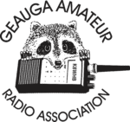The GARA schedule of exams are these Sundays at 2pm. Dates for 2024 are Jan 14, March 10, May12, July 14, Sept 15, and Nov 17, 2024. All sessions are at 2:00PM each month

Exams are held at the Geauga County Department of Emergency Services and Emergency Operations Center, 12518 Merritt Road, Chardon, Ohio 44024. The EOC is located just south of the University Geauga Hospital and just east of the Geauga County Safety Center (Sheriff's Office), off of State Route 44 between State Route 322 and State Route 87 on Merritt Road.

Please arrive a few minutes before 14:00 to allow adequate time to process the necessary paper work and take your test. Bring your 1) photo ID, 2) email address, 3) FCC FRN, 4) a printout of your current license if taking the General or Extra exam.

Additional info may be obtained from Jackie Welch, N8JMW by email [n8jmw2@gmail.ccom](mailto:n8jmw2@gmail.ccom) or calling at 440-228-2716. More information is available from the Geauga Amateur Radio Association website <https://geaugaara.org>

**Huber Heights Amateur Radio Club**

Huber heights amateur radio club does ARRL VE testing the second Saturday of each even numbered month. Feb, Apr, Jun, Aug, Oct, Dec. 9:30-11:00 For more information contact Jim Storms – AB8YK at [ab8yk@hotmail.com](mailto:ab8yk@hotmail.com)

**The Lake County Amateur Radio Association**

The Lake County Amateur Radio Association is holding its **2024** Amateur Radio license exams at the **Kirtland Library**, 9267 Chillicothe Road, on the following dates:

Saturday. February 3 Saturday, August 3

Saturday, April 6 Saturday, October 5

Saturday, June 1 Saturday, December 7

This bi-monthly schedule is the first Saturday of every even-numbered month (e.g., February being the second month, etc.). They are held at the Kirtland Library, 9267 Chillicothe Road. It is 1.7 miles south of I-90 on Route 306 (Chillicothe Rd). The library is on the left, just beyond the Marathon gas station. The tests will start at **12 noon.** Please arrive a few minutes earlier.

To register, you will need a NCVEC 605 Form, which will be available at the test. If you would like to complete one ahead of time, be sure it is the Sept 2017 version or later. You can find it by Googling “NCVEC quick-form 605” and clicking on the url for a pdf of the form. Please note **the FCC requires you to provide a FRN** (FCC Registration Number). Social Security Numbers are no longer accepted. If you are new to ham radio and don’t have a FRN, Google “New FRN” and follow the fcc.gov link.

If you are currently licensed, be sure to **bring a copy of your license to the exam.** The cost of the exam itself is $15.00, and if you wish to pay by check, it should be made out to the ARRL/VEC. Identification with your picture is also necessary, such as a driver’s license. If you have any questions, please contact Scott Farnham, KO8O, at (440) 256-0320, or [scottfarnham@roadrunner.com](mailto:scottfarnham@roadrunner.com)

**In addition** to the $15 test fee, the FCC now charges $35 to add you to the Amateur Radio database. The FCC will e-mail successful candidates instructions for payment directly to them. Payment must be made within 10 days of the e-mail. This charge does not apply to upgrades.

**The Lancaster and Fairfield County Amateur Radio Club (LFCARC**) The Lancaster and Fairfield County Amateur Radio Club (LFCARC) hosts exam sessions on the first Saturday each month at 10:00 am in Lancaster Ohio at the Fairfield County EMA, 240 Baldwin Dr., Lancaster Ohio.

To register for an exam, [Click Here.](https://hamstudy.org/sessions/LFCARC/all)

Questions: Contact me at ve_testing@k8qik.org.

**Lisbon Area Amateur Radio Association**

LISBON AREA AMATEUR RADIO ASSOCIATION (LAARA) 2024 SCHEDULE.  
  
VE TESTING IS AT THE COLUMBIANA COUNTY EMERGENCY MANAGEMENT AGENCY  
AT 215 SOUTH MARKET STREET, LISBON, OH 44432.  
  
SIGN IN AT 1 PM AND TESTING AT 1:30 PM.  
  
VE TESTING DATES FOR 2024  
  
JAN 13; FEB 10; MAR 9; APR 13; MAY 11;  
JUN 8; AUG 10; SEP 14; OCT 12; NOV 9; DEC 14.  
  
WE CAN ALSO GIVE THE TEST AT OUR REGULAR MEETINGS  
THAT ARE NORMALLY ON THE 3RD THURSDAY OF EACH MONTH.  
LAARA MEETINGS ARE HELD AT THE COLUMBIANA COUNTY  
EMERGENCY MANAGEMENT AGENCY AT THE SAME ADDRESS AS ABOVE. SEE THE [K8GQB.COM](http://k8gqb.com/) WEB SITE FOR UPDATES.  
MEETING TIME IS 6:30 PM.  
WE HAVE ACTIVITY MEETINGS ON THE ODD MONTHS AND  
BUSINESS MEETINGS ON THE EVEN MONTHS.

**Madison County**

The Laurel testing group will offer testing on the first Thursday of January, March, May, July, September and November. Tests are held at 7:00PM at the Madison County EMA located at 271 Elm St. London, OH. No fee.

**The Milford Amateur Radio Club (MARC)**

VE testing is held the third Thursday of each month at 6:00 PM.  Location;  Miami Township Civic Center located at 6101 Meijer Drive, Milford, OH  45150.

 Please pre-register at [www.milfordhamradio.org](http://www.milfordhamradio.org/)

**Northern Ohio Amateur Radio Society (NOARS)**

Six VE testing sessions in 2024.  Registration is appreciated but walk-ins are welcome.  Contact Elaine, KC8FOS for more information or to register.  [ewilkinson1951@gmail.com](mailto:ewilkinson1951@gmail.com) or 216-337-4235

Saturday, Jan 6.  Fairview Park Library.  21255 Lorain Rd., Fairview Park.  10 AM.

Sunday, March 10.  NOARS Hamfest.  Lorain County Community College.  1005 Abbe Rd. N., Elyria.  9 AM.

Saturday, May 4.  Fairview Park Library.  21255 Lorain Rd., Fairview Park.  10 AM.

Saturday, July 20.  NOARSfest.  Lorain County Community College.  1005 Abbe Rd. N., Elyria.  9 AM.

Saturday, September 7.  Fairview Park Library.  21255 Lorain Rd., Fairview Park.  10 AM.

Saturday, November 2.   Fairview Park Library.  21255 Lorain Rd., Fairview Park.  10 AM.

**Portage County Amateur Radio Service (PCARS)**

The first Saturday of every even numbered month -10 am – at the PCARS club site in Ravenna. Please visit the PCARS web site and check out the information about VE testing in the latest newsletter at [www.portcars.org](http://www.portcars.org) .

If you have any questions, don’t hesitate to contact me at KB8UUZ@gmail,com

**Tusco Amateur Radio Club W8ZX**

VE Testing sessions are held on the second Saturday of every even numbered month at the Dover Faith Church, 420 N Wooster Ave, Dover, OH 44622. Pre-registration is not necessary. Doors open at 0830 for registration, exams begin at 0900. Cost is $15. You are required to have an email address and a copy of your FRN or current ham radio license. For more information please go to [www.w8zx.net/exam](http://www.w8zx.net/exam) or email [VETEAM@N8BAG.NET](mailto:VETEAM@N8BAG.NET).

**Silvercreek ARA (SARA)**

Hold six exam sessions per year for all license classes. Pre-registration requested but not required. Exam sessions for 2024:

Saturday, February 3rd - Wayne County Justice Center (Wooster)

Saturday, April 6th - Sharon Center UMC (Wadsworth/Medina)

Saturday, June 1st - Sharon Center UMC (Wadsworth/Medina)

Saturday, August 3rd - Wayne County Justice Center (Wooster)

Saturday, October 5th -Sharon Center UMC (Wadsworth/Medina)

Saturday, December 7th -Sharon Center UMC (Wadsworth/Medina)

All sessios begin at 10:00am. For directions and test information visit <https://w8wky.org/license-exams/>. Pre-Registration to expedite paperwork is requested, but not required at <https://w8wky.org/sara-ve-registration-form/>. Sign up and if you aren't ready or can't make it, just notify the VE team lead.

**West Chester Amateur Radio Association (WC8VOA)**Exam sessions are held one Saturday each month at 10:00 AM-Noon at the VOA Bethany Relay Museum located at *8070 Tylersville Rd, West Chester, Ohio 45069.*For more information and links to register, please see our website: <https://wc8voa.org/licensing/>

**___________________________________________________**

# **Alliance ARC Rig Raffle is Underway**

The Alliance ARC (W8LKY.org) rig raffle is underway for its 5th year. Each year, the club chooses a HF Rig, and raffles it off with a portion of the profits being donated to local charities. Since 2020, over $5000 has been donated to charities in the Alliance, Ohio area.

We will be at several Ohio, and Western PA Hamfests over the next few months

You can learn more (and buy tickets) by going to <https://www.w8lky.org/hf_rig_raffle/>

73 DE WG8X (Fundraiser Chair, Alliance ARC)

**Your Club news should be listed here!**

I know you’re out there doing things! Send me a write-up (MSWord please) and some photo’s (.jpg please) and we’ll get your club hi-lited here for the other OH Section Clubs to see! Send to [WB8LCD@ARRL.ORG](mailto:WB8LCD@ARRL.ORG)

**ARLD DX news**

(None Issued this week)  
  
_____________________________________________________________________________

[**Upcoming *Hamfests***](http://arrl-ohio.org/hamfests.html)

|  |  |
| --- | --- |
|  |  |

|  |  |
| --- | --- |
|  |  |

|  |  |
| --- | --- |
| ***Ohio Hamfests*** | |
|  | |
| ***2024*** | |
| **06/01/2024 -**[**FCARC Summer Hamfest**](https://www.arrl.org/hamfests/fcarc-summer-hamfest-3)  **Location:**Wauseon, OH **Type:** ARRL Hamfest **Sponsor:** Fulton County Amateur Radio Club **Website:** <https://k8bxq.org/hamfest> [**Learn More**](https://www.arrl.org/hamfests/fcarc-summer-hamfest-3) | **07/06/2024 -**[**Mansfield Mid Summer Trunkfest**](https://www.arrl.org/hamfests/mansfield-mid-summer-trunkfest-2)  **Location:**Mansfield, OH **Type:** ARRL Hamfest **Sponsor:** Intercity Amateur Radio Club **Website:** [http://W8WE.ORG](http://w8we.org/) [**Learn More**](https://www.arrl.org/hamfests/mansfield-mid-summer-trunkfest-2) |
| **07/20/2024 -**[**Ashtabula County Hamfest 2024**](https://www.arrl.org/hamfests/ashtabula-county-hamfest-2024)  **Location:**Pierpont, OH **Type:** ARRL Hamfest **Sponsor:** Amigos Radio Club Ashtabula **Website:** <https://sites.google.com/view/arca-home/> [**Learn More**](https://www.arrl.org/hamfests/ashtabula-county-hamfest-2024) | **07/20/2024 -**[**NOARSFEST**](https://www.arrl.org/hamfests/noarsfest-11)  **Location:**Elyria, OH **Type:** ARRL Hamfest **Sponsor:** Northern Ohio Amateur Radio Society **Website:** [http://www.noars.net](http://www.noars.net/) [**Learn More**](https://www.arrl.org/hamfests/noarsfest-11) |
| **07/21/2024 -**[**Van Wert Hamfest**](https://www.arrl.org/hamfests/van-wert-hamfest-8)  **Location:**Van Wert, OH **Type:** ARRL Hamfest **Sponsor:** Van Wert Amateur Radio Club **Website:** [http://w8fy.org](http://w8fy.org/) [**Learn More**](https://www.arrl.org/hamfests/van-wert-hamfest-8) |  |
| **08/03/2024 -**[**2024 Columbus Hamfest**](https://www.arrl.org/hamfests/2024-columbus-hamfest)  **Location:**Grove City, OH **Type:** ARRL Hamfest **Sponsor:** Aladdin Shrine Audio Unit **Website:** [http://www.columbushamfest.com](http://www.columbushamfest.com/) [**Learn More**](https://www.arrl.org/hamfests/2024-columbus-hamfest) | **08/10/2024 -**[**Cincinnati Hamfest**](https://www.arrl.org/hamfests/cincinnati-hamfest-3)  **Location:**Owensville, OH **Type:** ARRL Hamfest **Sponsor:** Milford ARC **Website:** [https://CincinnatiHamfest.org](https://cincinnatihamfest.org/) [**Learn More**](https://www.arrl.org/hamfests/cincinnati-hamfest-3) |
| **08/18/2024 -**[**Warren Hamfest**](https://www.arrl.org/hamfests/warren-hamfest-1)  **Location:**Cortland, OH **Type:** ARRL Hamfest **Sponsor:** Warren Amateur Radio Association **Website:** <https://www.w8vtd.com/> [**Learn More**](https://www.arrl.org/hamfests/warren-hamfest-1) | **09/08/2024 -**[**Findlay Hamfest**](https://www.arrl.org/hamfests/findlay-hamfest-11)  **Location:**Findlay, OH **Type:** ARRL Hamfest **Sponsor:** Findlay Radio Club **Website:** [http://w8ft.org](http://w8ft.org/) [**Learn More**](https://www.arrl.org/hamfests/findlay-hamfest-11) |
| **09/22/2024 -** [**Cleveland Hamfest**](https://www.arrl.org/hamfests/cleveland-hamfest-4) **Location:** Berea, OH **Type:** ARRL Hamfest **Sponsor:** Hamfest Association of Cleveland **Website:** [https://www.hac.org](https://www.hac.org/) [**Learn More**](https://www.arrl.org/hamfests/cleveland-hamfest-4) | **10/05/2024 -** [**Northwest Ohio Amateur Radio Club (NWOARC) Hamfest**](https://www.arrl.org/hamfests/northwest-ohio-amateur-radio-club-nwoarc-hamfest) **Location:** Lima, OH **Type:** ARRL Hamfest **Sponsor:** Northwest Ohio Amateur Radio Club, Inc. **Website:** [http://www.nwoarc.com](http://www.nwoarc.com/) [**Learn More**](https://www.arrl.org/hamfests/northwest-ohio-amateur-radio-club-nwoarc-hamfest) |
| **10/27/2024 -** [**2024 MARC Hamfest at MAPS**](https://www.arrl.org/hamfests/2024-marc-hamfest-at-maps) **Location:** N. Canton, OH **Type:** ARRL Hamfest **Sponsor:** Massillon Amateur Radio Club **Website:** [https://www.w8np.net](https://www.w8np.net/) [**Learn More**](https://www.arrl.org/hamfests/2024-marc-hamfest-at-maps) | **12/07/2024 -** [**Winter Hamfest**](https://www.arrl.org/hamfests/winter-hamfest-11) **Location:** Archbold, OH **Type:** ARRL Hamfest **Sponsor:** FCARC **Website:** <https://k8bxq.org/hamfest>[**Learn More**](https://www.arrl.org/hamfests/winter-hamfest-11) |

Plenty of Ohio Section Hamfests on tap for 2024! If you haven’t got yours submitted to ARRL as of yet – go back up a couple pages to the top of the “Clubs” section for complete instructions on how to get your fest ARRL Sanctioned!

DX This Week

Bill - AJ8B **(**[**thedxmentor@gmail.com**](mailto:thedxmentor@gmail.com) **/** [**www.aj8b.com**](http://www.aj8b.com) **)**

I received an email from Teresa, KA9IFQ. Teresa wanted to know what my process was for hunting down needed entities in a contest. With the CQWPX CW contest coming up at the end of the month, I thought that this would be a good time to chat about this.

Briefly, here is what I do. Let’s say that I need Singapore, 9V. The first thing I would do is to check the DailyDX and the NG3K.com website. That will tell me if there are any upcoming DXpeditions planned during the contest weekend. If so, I would then go to their website for operating plans and details.

If not, I would then check my Logbook/Spotting Cluster client. Spot-collector, which is the spotting cluster client for DX Suite which is my station software package, allows me to search for spots over a time period to try to find operating trends. I usually choose a 2-week window. I may gain some knowledge by examining all of this data. Information such as the time the spot first appeared, the band, the mode, and when the last spot of that day appeared are all valuable pieces of data. Of course, that doesn’t mean they are contest operators.

Next, I will search the archives of the results of previous CQ contests. In this case, I found that Singapore averaged 4.5 stations a year for the past 4 years who had logged 300 QSOs or more. You could email those stations to ask if they are going to be in the contest this year and what their strategy might be. And remember, that most likely won’t be all of the stations that are participating from Singapore, just the ones that turned in logs.

DX Suite also has a propagation prediction program. You enter the coordinates of the DX Station, 9V in this case, the dates that you are looking for and the software will give you a Maximum Usable Frequency chart to help you find the time when propagation will most likely be usable between your QTH and Singapore.

Of course, you still have to work them and get the exchange correct!

Hope that helps Teresa. Thanks for the question.

# DAH DIT DIT DIT DAH DAH DIT DIT DIT DAH

**Here is what is happening in the World of DX:**

# This section of DX News comes from Bernie, W3UR, editor of the DailyDX, the WeeklyDX, and the How’s DX column in QST. If you would like a free 2-week trial of the DailyDX, just drop me a note at [thedxmentor@gmail.com](mailto:thedxmentor@gmail.com)

We have an update on FT#G, **Glorioso Islands**/FH, Mayotte

F5IRO, Freddy said last week this “this is a week of final preparations, including PC configurations, receipt of the latest F5CYS band filters," and packing items from DX Engineering. F4IPL, Nicolas, from the F4KLW radio club is making some “common mode filters,” written up in a technical article by GM3SEK, Ian.

F5RQQ, Jean-Marc and F5TVL, also Jean-Marc, are in Mayotte for one week to get ready, and will be met there by FH4VVK, Marek.

F8FKI, Manu, is the “pilot” back at home, stepping aside from his job to be available full-time from the start (May 24) of the operation until June 3. OQRS will be available for QSLs. More information will follow.

Between May 17-27, MWØBRO, Martin, will be staying in Red Cliffs on the southwest coast of Dhekelia, which qualifies as the **U.K. Sovereign Bases on Cyprus**. While there, he will operate sporadically holiday-style as ZC4GW using a Yaesu FT-891 at 100W. He plans to be on CW only on 40-6M. Martin will be using DX Commander Expedition and JNCRadio MC-750 portable antennas.

He may also operate from Cyprus as 5B4/MWØBRO. QSL details have not been worked out, but he will eventually upload to Club Log, LoTW, QRZ.com, and eQSL. Paper confirmations will also be available. The U.K. Sovereign Bases on Cyprus, officially known as “The U.K. Sovereign Bases of Akrotiri and Dhekelia,” are a British Overseas Territory on the island of Cyprus, in the Eastern Mediterranean Sea.

Ahead of schedule, the Canadian Department of Fisheries and Oceans (DFO) has issued the written permit for the **CY9C DXpedition to St. Paul Island** August 26-September 5. This permit covers the small Northeast Island of St. Paul. The main island of St. Paul is now under the jurisdiction of the Canadian Wildlife Service where many previous DXpeditions have taken place. The St. Paul Island permit has been sent to the ARRL for DXCC pre-approval. Since the permit was received, the CY9C team has begun a host of other activities. The team has spent almost 30 years building relationships and working with the Canadian DFO, and is very appreciative of the DFO in issuing the permit and working with the DXpedition effort.

K4ZW, Ken, is once again in Addis Ababa, working at ET3AA, the **Ethiopian Amateur Radio Society** (EARS) station, “repairing the Reverse Beacon Network, hooking up a KiwiSDR node, installing a new computer, and testing RM Noise to deal with the local noise.” RM Noise routes audio through AI and neural networks to help reduce noise. Ken says that local operators “took a 30-minute noise sample from ET3AA and generated a filter specific to the noise there.” Ken and the students will also be on the air, including 6M. They are considering “a couple of overnight operations, which require advance approval from campus security.”

Clive Woodlock, A DX Legend is Winding Down by N4GNR, Dan Cisson.

When thinking about some of the great DX operators of the last many decades, 3B8CW fits that definition. Clive has been on the air from Mauritius since 2010, offering 3B8 as a new country on many modes.

Clive's ham radio career started way back in 1963 in the United Kingdom high school and college were the priority. In 1966-1970 Clive moved to Barbados and operated as 8P6AP. Then in 1977-1980 he made a stop in Bermuda as VP9JP. 1983-1987 he was S79CW in Seychelles. A 23 year stop in Hong Kong from 1987-2010 as VS6CW & VR2CW. Then 2010 until this date he has put Mauritius on the air as 3B8CW.

Clive's plans are to be back in the U.K. for total retirement with his wife Jennifer and he will be G0UDE. Please give Clive thanks for the decades of Ham Radio service by either an email, a letter to him, or tell him on the air. He has made many thousands of Q's from all over the world. It has been an honor to know and serve Clive.

KC4 – **Antarctica** - FT4YM (F4FKT), David, says he is ready for another "Antarctic campaign," returning there with better gear this year.  He seems to do CW and SSB in addition to digital modes.  This appears to be at least his third trip there.

**9M2 - West Malaysia** - A group will put callsign 9M4VM on the air from Pulau Besar, IOTA AS-097, May 31 to June 2, CW and SSB on 40, 20, 15 and 10.  They will have two stations on the air.  QSL to 9M2HUS direct, no LoTW or Club Log.

# DAH DIT DIT DIT DAH DAH DIT DIT DIT DAH

 Below is a list of upcoming contests in the “Contest Corner”. I think this is important for someone who is trying to move up the DXCC ladder since entities that are on the rarer side and easiest to work in contests. Some of my best “catches” have been on the Sunday afternoon of a contest when the rarer entities are begging for QSOs. Of course, the gamble is that if you wait until Sunday, conditions may change, or they simply won’t be workable. However, it is not a bad gamble. Of course, why not work the contest and have some fun!

CQ World-Wide WPX Contest, SSB: The results posted in record time. The final results of the 2024 CQ World-Wide WPX SSB Contest are now available. A record 8,247 logs were received and processed within 40 days. Thanks to AA3B, Bud, and his team!

Remember, the next big contest is the CQ World-Wide WPX CW contest, the weekend of May 25th and 26th.

The purpose of the contest is to work as many different prefixes as you can in the contest period. Remember me, AJ8!!! Contacts between stations on different continents are worth 3 points on 10, 15, and 20 meters and 6 points on 40, 80, and 160. Historically, 40 meters is my “go-to” band for this contest.

Contacts between stations in the same country are worth 1 point, regardless of band.

This is a contest with a “target rich environment” and whether you are new to contesting or experienced, give this one a try.

The great thing about this contest, and any of the CQWW contests, is that many hams travel to DX locations to be in the contest. This gives you a chance to work stations that you may not normally get access to. So, if you have not given these contests a try, please do so and let me know how it goes.

|  |  |  |
| --- | --- | --- |
| **Contest** | **Start Date** | **End Date** |
| SWODXA DXDINNER | 5/17/2024 |  |
| SWODXA DXForum | 5/18/2024 |  |
| Arkansas QSOP | 5/18/2024 | 5/19/2024 |
| CQ WW WPX Contest, CW | 5/25/2024 | 5/26/2024 |
| ARRL International Digital Contest | 6/1/2024 | 6/2/2024 |
| Kentucky QSOP | 6/1/2024 | 6/2/2024 |
| ARRL June VHF Contest | 6/8/2024 | 6/10/2024 |
| All Asian DX Contest, CW | 6/15/2024 | 6/16/2024 |
| West Virginia QSOP | 6/15/2024 | 6/16/2024 |
| IARU HF World Championship | 7/13/2024 | 7/14/2024 |
| North American QSO Party - CW | 8/3/2024 | 8/4/2024 |
| 10-10 Intl. Summer Contest, SSB | 8/3/2024 | 8/4/2024 |
| WAE DX Contest - CW | 8/10/2024 | 8/11/2024 |
| Maryland-DC QSOP | 8/10/2024 | 8/11/2024 |
| North American QSO Party - SSB | 8/17/2024 | 8/18/2024 |
| World Wide Digital DX Contest | 8/24/2024 | 8/25/2024 |
| Hawaii QSOP | 8/24/2024 | 8/25/2024 |
| Ohio QSOP | 8/24/2024 | 8/25/2024 |
| Kansas QSOP | 8/24/2024 | 8/25/2024 |

**__________________________________________________________**

**

For most of my 60+ years as a ham I’ve considered Hamvention as Ohio’s unofficial kick off of the ham radio year. I attended my first one in the early 70s and haven’t missed one since. But this year was a tad different. For the first time in over 20 years **Highland ARA** did not have a flea market presence this year and I did not have a Saturday commitment to be at a booth. Therefore I was able to sleep in, have a good breakfast, wander the flea market and inside vendor area, attend a forum and spend valuable time chatting with ham friends I haven’t seen in some time. Thus enforcing my thoughts that those who passed up on attending Hamvention, for whatever reason, missed an important part of ham radio’s enjoyment.

Although Hamvention is now in the rearview mirror, allow me to give some of my take a ways. Although Hamvention got off to a wet start, the crowd and excitement of about 35,000 people gathered in a single location to celebrate one of the world’s greatest hobbies was any thing but all wet. I assisted with exams on Friday when about 80 exams were given. There were around 150 on Saturday. Many were for their first license and several others going for the Extra. In fact, at one time they ran out of Extra test booklets! I noted over 50% of those testing were from out of state. We learned that well over 50% of the ham population have a Tech license and many become inactive after one year. It was also noted many hams are not members of nor support their local clubs. Many believe that if ham radio is to survive, it is important for ham radio clubs to reach out, embrance those non-members and make them feel welcome and accepted-regardless even if the reason they got licensed is not the same as those who have been licensed forever.

Again, this year’s Hamvention was another great one. It was good seeing so many old friends and meeting some I didn’t know I had. One special meeting was with an friend from school days who journeyed from Northern Wisconsin to attend his first Hamvention. And thanks to those who stopped me to comment about reading the column. Now let’s move on to upcoming items and news.

Amateur radio communications assistance is needed for a couple Southern Ohio events. The Ironton/Lawrence County Memorial Day parade is said to be the oldest continuously held such event in the nation and the **Southern Ohio ARA** is needing some additional volunteers to assist their communications and line-up efforts. Information Officer Mike Love, WB8YKS, and parade coordinator Dave Bruce, KD8NYN, ask for more members to step forward and assist. The sponsors of the Southern Ohio Forest Rally are looking for radio amateurs to assist with this year’s three day event. On Thursday, June 6, a single event will take place at Chillicothe’s Yochtangee Park. The following day events move to the Shawnee State Forest where several stages will happen. Then on the 8th things get lively at the Zaleski State Forest where all the action is. Besides the need for radio operators, there are other non-radio opportunities to assist. Check the [www.southernohioforestrally.com](http://www.southernohioforestrally.com) website for more information and how to apply to become a volunteer.

A special tip of the cap to the **All Things ARA** from Lancaster. They were recognized at the ARRL forum for their inovatative use of an ARRL grant to purchase a cargo trailer and convert it to a mobile showroom to promote amateur radio. With this unit they are able to take ham radio to places where people gather and inform more people about ham radio and its benefits. A neat idea.

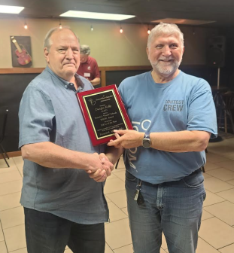The **Southwestern Ohio DX Association** recently announced the winner of its prestigious “W8OK Award” as Dwight Kelly, K4YJ. Dwight is an active CW operator and can be heard almost daily on the bands looking for that new one to add to his amazing list of countries worked as he gets closer to the DXCC Honor Roll. Besides the honor of receiving this well deserved award, Dwight is an all around good guy. The photo is of he receiving the award from K8DV, Dave Vest, at a recent SWODXA meeting. He and his wife Eileen, K3YJ, live near Lucasville. Congrats Dwight.

Because of the free testing opportunities during Hamvention, an increase in the number of new licenses issued to people living in the South 40 Region is expected. However this year clubs in the region have been active providing more testing opportunities. This week we again note more new Technician ham licenses issued to folks in the Western counties of the South 40 Region. Scott Saluga from Bethel is now KF8BGI while Goshen picks up KF8BGK, Gary Stiffler. Charles Kuntz and Karyn Talmadge passed their tests to become KF8BHE and KF8BHF. Charles is from Batavia and Karyn from Loveland. The FCC entered Mount Orab’s Matthew Patterson, KF8AUY call sign in the data base on April 4. During Hamvention he upgraded to General. According to our eyes on the FCC data base-Ted Jacobson, W8KVK,-licenses issued during the Hamvention are beginning to be posted. Among them are ones issued to Caleb Parks hailing from Jackson who is now KF8BHV, Nathanael Trimm from Sabina who is KF8BIF and Terence Logsdon, Jr., KF8BII from Loveland. In Guernsey County Zachary Simmons of Cambridge has become KF8BIO.

Heavy rains in Highland County along with Hamvention caused the **Highland ARA** a week’s delay assisting the local cemetery association with decorating the graves of the 1,200 military veterans buried there. Members will return to the cemetery following July 4 to remove the flags for storage. This non-radio event caught the attention of amateur radio’s media last year and brought attention to the Club through the print media, podcasts, YouTube and even a German radio magazine.

A lot of people attend Hamvention only to see what new goodies and other products are being introduced to the amateur radio market and to pick up information and catalogs about those items. It was noted a lot of activity this year was on the POTA booth and with the solar and field portable stations, supplies and antennas. However for us who enjoy the instruction and testing processes that bring new people into the hobby, N8ZNR and I discovered a new source of test preparation books with a bit of an interesting twist. Fast Track Ham Radio Education has a complete learning system for all three license classes consisting of paperbacks, e-books and audio courses. Each license class manual contains all questions with each possible answer in the pool. The correct answer is in bold print and each question is immediately explained why the answer is correct. Chapters are devoted to each subject appearing on the appropriate test and each concludes with the major concept of the chapter. Workbooks for the math are even available. AF7KB and KC7YL have put a lot of thought into each book. They are available through the major on-line book sellers. More info can be found at [www.fasttrackham.com](http://www.fasttrackham.com).

The **Portsmouth RC** and **Highland ARA** are gearing up to represent Ohio in the upcoming June 1 through 16 Lewis and Clark Trail On The Air operating event. The Portsmouth club has participated since the event was organized, while this year marks the first adventure for HARA. The objective of the event is to work at least one of the participating club station in each of the 16 states along the Trail to earn a certificate of achievement. More information is available at [www.info.lctota.org](http://www.info.lctota.org).

Although the biggie is now in the history books, there are a number of smaller club shows taking place in our region in the coming months. On August 3 the Columbus Hamfest will be held at the Shrine Center in Grove City. The **Milford ARA** sponsored Cincinnati Hamfest is the following Saturday, August 10, at the Clermont County Fairgrounds in Owensville. On the 17th, the annual **Portsmouth RC** Hamfest will take place in New Boston. The **Buffalo 10 Meter Net**’s 4th annual swap meet is Saturday, September 21. It is held in conjunction with the annual Leavitt Funeral Home’s Festival and Car Show. The **Scioto Valley ARA**’s hamfest will be October 5 at the Pike County Fairgrounds at Piketon. A new hamfest entry this year is the W8VCO **Vinton County ARA** swap fest on October 26 at the community building in McArthur.

The 2024 version of the ever popular ARRL Field Day is right around the corner. Some of the region’s clubs have already announced their intents to participate and locations. **All Things ARA** will operate from the Alley Park, Old Logan Road, in Lancaster. This year the **Athens County ARA** will operate as K8V from the Athens County Fairgrounds. The **Cambridge ARA** returns to the Grove Park north of New Concord. The **Clinton County ARA** returns to last year’s K8GO site at 1020 Farmer’s Road outside of Wilmington. The **Highland ARA** is relocating this year and will operate K8HO from the historic Scott House at 335 West Main Street at the edge of Hillsboro’s business district. In the London area, the **Madison County ARC** will set up shop at 75 Middle Street in London. The **Milford ARA** will only operate Field Day on Saturday from 2 pm until the park closes at dusk. Their operation will take place at the Clepper Pike Pavillion A on Summerside Road. Another club making a location change is the **OH-KY-IN ARS**. This year they are changing their FD location to the Masonic Lodge on West Fork Road. The **Tri-State ARA** is looking forward to the event and will be testing some Eagle One antennas in preparation for the event. A look at the ARRL Field Day Locator indicates a lot of clubs in the region have not registered their participation on the site. Please do that so others will know your club intends to be active.

**Highland ARA** Vice President John Willis, KE8JEM, reminds HARA members of a change of location for the Club’s June 8 Brunch Bunch and the June 11 business meeting. Both gatherings will be at the historic Hillsboro Scott House on West Main Street-the new site for the Club’s Field Day operation. The Brunch starts at 10 AM and the business meeting on the 11th at 7 PM.

Here’s wishing all an enjoyable and safe Memorial Day weekend and the start of summer.

John Levo, W8KIW

[jlevo@cinci.rr.com](mailto:jlevo@cinci.rr.com) or [highlandara@gmail.com](mailto:highlandara@gmail.com) or 937-393-4951 (landline-leave a message)

**__________________________________________________________**

**Print an Official or Unofficial Copy of Your Amateur Radio License**

*(By Anthony Luscre, K8ZT)*

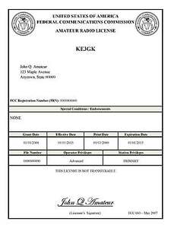

As of February 17, 2015, the **FCC no longer routinely issues paper license documents** to Amateur Radio applicants and licensees. The Commission has maintained for some time now that the official Amateur Radio license authorization is the electronic record that exists in its Universal Licensing System (ULS). The FCC will continue to provide paper license documents to all licensees who notify the Commission that they prefer to receive one.

Licensees also will be able to print out an official authorization — as well as an unofficial “reference copy” — from the ULS License Manager. I’ve created a set of instructions on how you can request an **“official” printed copy of your license\***

[**Click here to download the instructions**](http://arrl-ohio.org/news/2020/print_your_license.pdf)

Bottom of Form

Ohio Section Cabinet

|  |  |
| --- | --- |
| Section Manager – Tom Sly, WB8LCD | Section Traffic Manager – David Maynard, WA3EZN |
| Section Emergency Coordinator – Bret Stemen KD8SCL | Section Youth Coordinator – Anthony Luscre, K8ZT |
| Technical Coordinator – Jeff Kopcak, K8JTK | Affiliated Clubs Coordinator – Amanda Farone – KC3GFU |
| State Government Liaison – Bob Winston, W2THU | Public Information Coordinator – Elizabeth Klinc - KE8FMJ |



Hey Gang,

Have you taken a look at the **Swap & Shop** page on the Ohio Section webpage yet?? Here’s a link that will take you there… <http://arrl-ohio.org/sm/s-s.html>

Do you have equipment that you just don’t need or want anymore? Here’s a great venue to advertise it, and it’s FREE!! Is your club doing a fund raiser to help raise money? After a lot of thought, it was decided that the Swap & Shop webpage could also contain these types of items as well. The same rules will apply as do for the For Sales and Give-A-Ways and will only be posted for a month at a time. Please see the Terms & Conditions on the webpage.

If your club is doing a fund raiser and wants more exposure, please forward the information to me and I’ll advertise it on the Swap & Shop webpage for you.

Now, I still want to remind you that it won’t be listed in this newsletter because it would take up way too much space, so your ad will only appear on the website. It is there for any individual to post equipment Wanted / For Sale or Give-Away as well as for Club Fund Raisers. You might want to list your location so that prospective buyers know where you’re at. No licensed vehicles/trailers or business advertising will be posted. Postings are text only (no pictures or graphics) will be posted for a maximum of 1 month from date posting and require a contact phone number or email within the posting. Send your Wanted / For Sale or Give-Away post to:  [swap@arrlohio.org](mailto:swap@arrlohio.org)

***Back Issues of the PostScript and Ohio Section Journal***

Hey, did you know that PostScript and Ohio Section Journal (OSJ) are archived on the website? You can go back and look at any edition simply by clicking:

<http://arrl-ohio.org/news/index.html>

***Want to Share your Club Newsletter With Others?***

We have a webpage where you can download and read all of the newsletters that I get from around the state and even other sections!

Here’s the link to the page…. <http://arrl-ohio.org/club_news/index.html>

Please, if you don’t see your club newsletter posted, it’s because I’m not receiving it. Just have your newsletter editor contact me and I’ll get your club’s newsletter listed on the site!!

We all learn and steal (I mean, share) from each other’s work. So, get me your newsletter!!! Send it to: [webmaster@arrl-ohio.org](mailto:webmaster@arrl-ohio.org)

***Chit – Chat, and All That!***

Do you know someone that’s not getting these Newsletters? Please, forward a copy of this Newsletter over to them and have them “[Opt-In](mailto:Opt-In)” to start receiving them. Heck, just have them send an email to: [webmaster@arrl-ohio.org](mailto:webmaster@arrl-ohio.org) and we’ll get them added to the Ohio Section Emailing list.

We now have many thousands of readers receiving these newsletters weekly. Quite impressive, I’d say! I urge all of you to make sure that everyone, regardless of whether they are a League member or not, get signed up to receive these weekly Newsletters.

You can always “Opt-Out” at any time if you feel this is not what you were expecting. It’s fun and very informative. All of your favorite past newsletters are now archived too.

You can go back at any time and read them.

Just go to: <http://arrl-ohio.org/news/>

*PostScript is produced as a weekly newsletter. I want to thank everyone that has contributed articles and ideas to make this an even better news source. I sincerely hope that you have enjoyed this edition and will encourage your friends to join with you in receiving the latest news and information about the Ohio Section, and news and events happening around the world! Occasionally you may find and error or two in this newsletter – be assured, they were put there on purpose to make sure you’re reading the newsletter carefully!*