July 2024

From the Technical Coordinator | From the Section Emergency Coordinator
From the Public Information Coordinator | From the Section Youth Coordinator
From the Section Traffic Manager | ARES Training Update
From the Affiliated Clubs Coordinator | National News
Club Corner | Contest Corner
DX This Week | One Question Questionnaire
Special Events | Final.. Final..

Happy 4th of July!

In Congress, July 4, 1776
The unanimous Declaration of the thirteen united States of America, When in the Course of human events, it becomes necessary for one people to dissolve the political bands which have connected them with another, and to assume among the powers of the earth, the separate and equal station to which the Laws of Nature and of Nature's God entitle them, a decent respect to the opinions of mankind requires that they should declare the causes which impel them to the separation.
We hold these truths to be self-evident, that all men are created equal, that they are endowed by their Creator with certain unalienable Rights, that among these are Life, Liberty and the pursuit of Happiness.--That to secure these rights, Governments are instituted among Men, deriving their just powers from the consent of the governed, --That whenever any Form of Government becomes destructive of these ends, it is the Right of the People to alter or to abolish it, and to institute new Government, laying its foundation on such principles and organizing its powers in such form, as to them shall seem most likely to effect their Safety and Happiness.

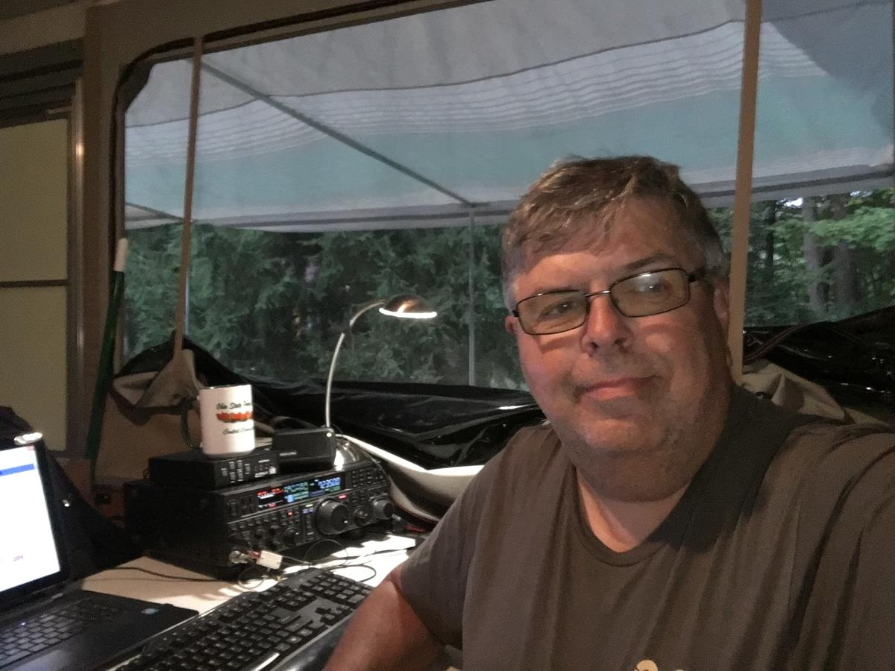
Ohio Section
Web-Site
Hi, I'm John, WG8X; the new webmaster for the Oho section website; arrl-ohio.org. While my training & experience lie in the long-forgotten field of Consumer Electronics (TV-Repair), I have some experience in the field of web design & editing. I manage a number of websites, including OSPOTA.org, and W8LKY.org. I formerly managed Portcars.org.
Kudos to Scott, N8SY for the work he has done on arrl-ohio.org over the last several years. The further I dig into this site, the more of his work I find. When I volunteered to work with the section website, I knew it would be a big job, so I drug my feet for an appropriate amount of time before getting to work.
My goals for the site over these last couple months have been
- To get the site transferred to its own hosting as soon as possible. It had been residing on Scott’s personal account for several years.
- To keep the site up to date as much as possible while getting used to where everything is located.
- To begin a major re-design of the site, while keeping most of the same content. The new site will be responsive; looking good no matter the screen size, or platform being used to view it.
That being said, I should have the upgrades online by August 1st. If all goes as planned, you’ll see elements of the new design on quite a few pages, and elements of the older site on others. This is because I’m working through the pages, one at a time. It’ll take a bit of time for me to get it all done. You might find some broken links (not many, I hope!) as you navigate the site, but I hope to have everything updated over the next month or so.
If you have suggestions, feel free to reach out to me. My e-mail is webmaster@arrl-ohio.org
With that said, I hope you will enjoy the updated site.

______________________________________________________________________________

Paul Gehringer WB8ZZR - Silent Key

Today with very heavy heart today we inform you, Paul Gehringer,WB8ZZR has passed away Saturday June 15, 2024. Paul was a key figure in the Amature radio community previously held the positions as President, Vice President and Director of the Clinton County Radio Association. Paul was most active with the National Weather Service, one of the initial founders of the Skywarn System Net operators working with the National Weather Service Office in Wilmington, OH

More information will be forthcoming. We will pass along any details regarding public plans to honor him.

Paul William Gehringer | Littleton Funeral Home

Please keep him and his family in your prayers.

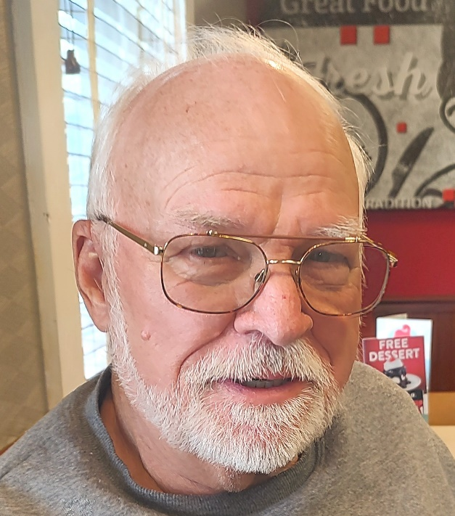
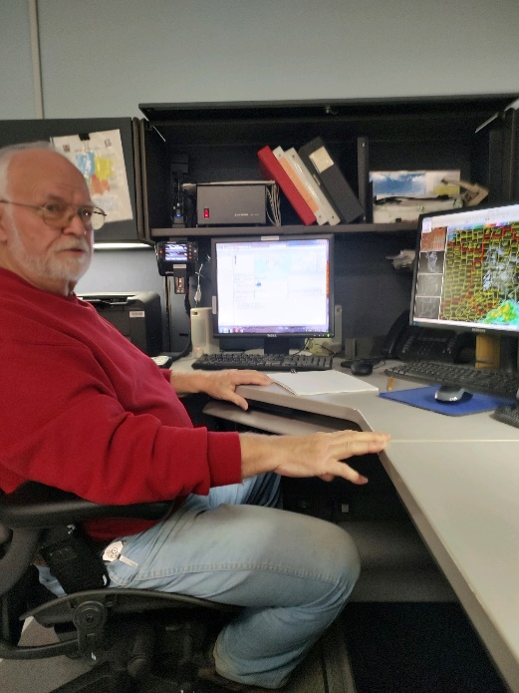

_____________________________________________________________________________

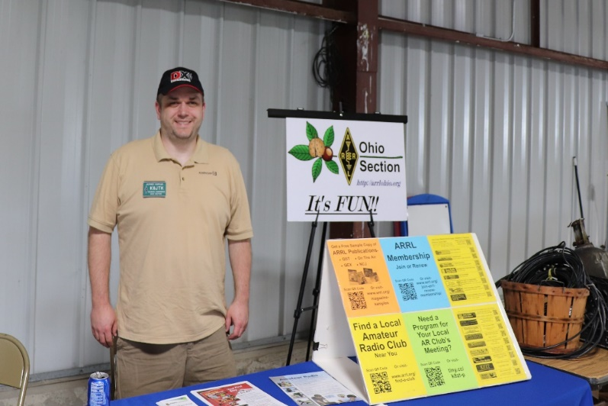
From the Technical Coordinator
Jeff Kopcak – K8JTK TC
K8JTK@arrl.net

Hey gang,
As if I needed another reason to talk about computers in here. Our Great Lakes Division Director, Scott – N8SY, informed me that ARRL HQ added items to the Technical Specialists responsibilities. In particular, ones beneficial to clubs needing direction with their website, E-mail, and storage. The new responsibilities are to:
3. Serve as an advisor to local clubs on web design and maintenance.
4. Serve as an advisor to clubs on web storage and email.
Many in the section’s technical crew have the knowledge or already do these things for their own club. Some ideas for storage and E-mail would be things like: how do we share files, collaborate and coordinate projects and activities. Next year’s Field Day perhaps? Maybe a way to keep in touch with the membership – such as a mailing list or Google Groups. Maybe the previous person responsible for these activities abandoned it, moved away, or otherwise left the club. We can work with and advise another member on ideas to revive that activity.
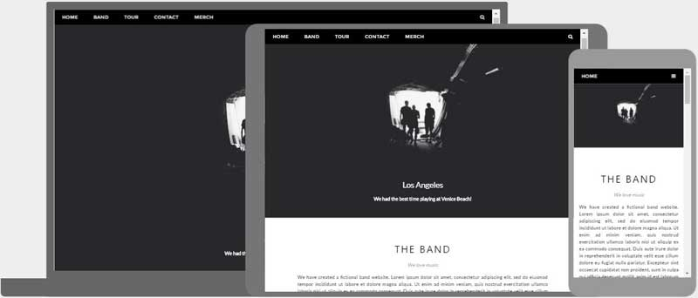
A solution many might be familiar with and use at work, SharePoint, is not something available to clubs for free or nearly free. There are Development (DEV) tenants for free but have limited lifetime and functionality. A solution such as groups.io has nearly all the features of a SharePoint site (up to 100 members for free) and not nearly as bulky. A club might decide to “roll their own” - self hosting services while retaining full control of their data – at a provider already available to the club.
Responsive website automatically adjusts to different screen sizes and viewports (W3Schools)
Web sites can be beneficial to clubs. They are often the first interaction with potential new members and they keep existing members updated with the latest happenings, activities, and repeater information. A site with outdated information can leave potential members seeking a club that pays more attention to those details. With Content Management Systems (CMS), it’s easier than ever to build and maintain a website.
According to BuiltWith, WordPress accounts for 44% of the 77.5 million sites running a CMS and Wix is second at 10.5%. Choosing a CMS has become a popular option because little to no coding is required. Hosting providers offer easy one-click installation solutions, too. One can easily make a site with WordPress by inputting some information and selecting a good template to display information in an attractive manner.
Get in touch with myself or one of the Technical Specialists to advise a club on any of these areas.
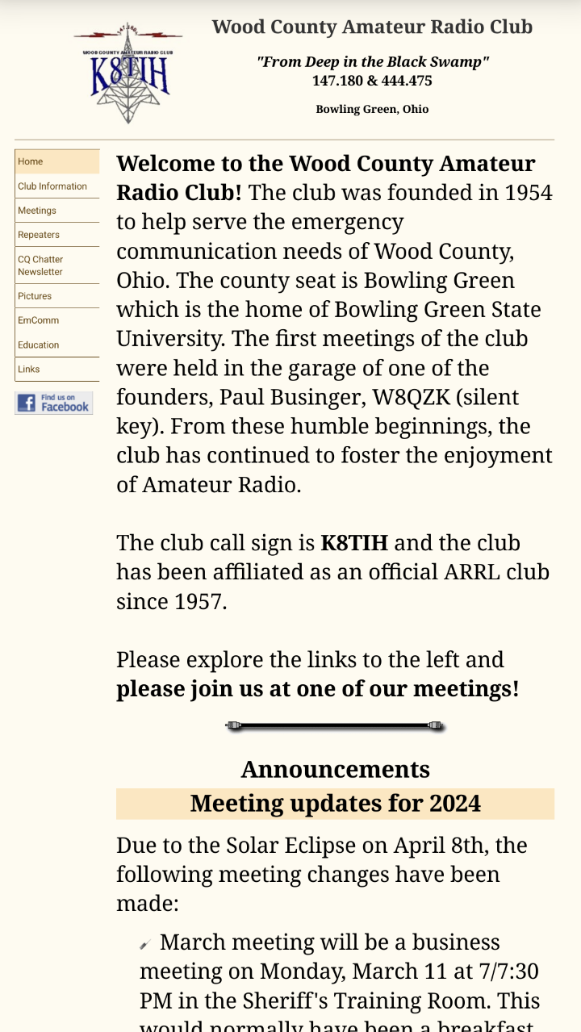
Personally, I use WordPress for my personal site and HamNationDSTAR.net - which I still maintain though no longer involved with the show.
Previous look of the Wood County Amateur Radio Club site with left navigation on a mobile device
Back in my day, I learned to use FrontPage to maintain websites. Though, schools were showing how to “build” web pages, and doing so, by exporting pages through Word. After taking a college class on HTML & CSS and working professionally as a programmer, I eventually realized the quality of code generated by that company’s products was (and still is) an abomination and entirely too bloated.
The Wood County Amateur Radio Club site started out as and remains my project to keep my web page skills going. It was first a FrontPage site. Then about 2008-2009, I rewrote the entire website by hand. To use buzzwords: “I optimized code.” Took out things that were generally being frowned upon in web design. The navigation pane and content pages were two iframes (pages within a page). Landing directly on a content page would not display the navigation iframe. As a workaround, I redirected the visitor to the homepage, which then loaded everything.
However, portable devices became much more popular. While WCARC pages would still work on smaller screens, it did require a lot of pinch-and-zooming because the navigation was static on the left side of the page. I knew about “responsive” websites because WordPress and other CMS’ I’ve used automatically render differently depending on screen size (phone, tablet, computer screen, TV, etc.) and orientation (vertical vs horizontal). I finally had some time to dig in around the beginning of this year.
When I rewrote the site the first time in ‘08-09, I converted the site to use CSS (Cascading Style Sheets, a way to stylize and display elements within a web page). That saved a lot of time making the site responsive. If I wanted to make a different font selection or choose a different default size, that change is made in one place – while not having to edit a bunch of files/pages individually. With some exceptions for one-off style differences, all the styles are defined in the CSS.
I started out, as I often do, at W3Schools. They have a ton of how-to’s for different programming languages and real-time-editors to see modifications. The How TO - Responsive Top Navigation got things in motion. I took their idea and added my own touches to it. I changed the coloring to match the previous navigation, showing different colors to indicate when an item is hovered over and the current page the visitor is on. Then added icons to beautify the menu items. A camera for pictures, newspaper for the newsletter, people for meetings, and so on. The club has a Facebook presence and kept an “f” logo present in the navigation as well.
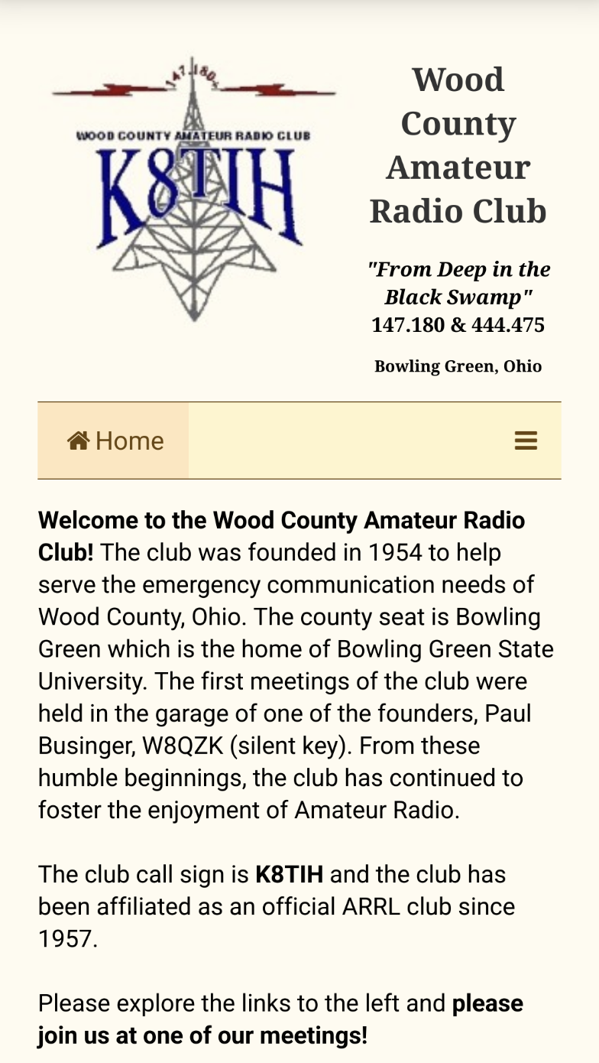
A program that helped me render pages on my portable devices is called Cx File Explorer. My phone and tablet are Android devices. Using that app, I could save the file to my Network Attached Storage (NAS), then refresh Firefox or Brave browser on the Android device and see my changes instantly. I did not have to continuously upload the file a remote web server, for example. Cx creates a local web server on the device to serve up files as web pages to browsers on the device.
New look of the Wood County Amateur Radio Club site with collapsed navigation bar on a mobile device
After the navigation changes were completed, moved on to sizing elements differently based on screen size and screen orientation. Font size on the header was too big when the navigation bar collapsed. I added font size changes for the header when the navigation bar is collapsed.
I wanted a way to have multiple elements that were spread out on a large computer screen to automatically display vertically when viewed on a mobile. On the home page, for example, these are the radar image, current time, solar activity and propagation near the bottom. On a computer screen, they are one next to the other, spread out horizontally. On a mobile, they stack themselves vertically such that they are one on top of the other.
The club calendar on the home page caused me the most grief. I like the monthly layout to note when events are happening and I want event titles to be seen. After many hours were spent futzing trying to get a one-size-fits-all, I couldn’t. The calendar size on a larger screen would not render well on a mobile device and vice-versa.
After fighting with the calendar for quite some time, came across an old post that gave me ideas. Have the monthly calendar displayed on larger screens and agenda view on a mobile screens. My prayers had been answered! That was the idea I needed.
Google Calendars offer different views (week, month, agenda) when embedded into a web page. Their helper generates different code based on the chosen options. That post gave me the idea to display the monthly view and hide agenda view on larger screens. Hide monthly view and display agenda view on smaller screens. Voilà.
After some weeks working on all the changes, I uploaded them and made them live. They’ve been running for about six months. The Wood County ARC site will render on a screen size as small as 450 pixels wide and renders to a max size of 3000 pixels wide and, of course, everything in between. Many people have thanked me for making the WCARC site work quite well and not crash their computer – meaning it doesn’t load an ungodly number of external resources and useless plugins. The site loads very little from external sources and most things needed to render pages are hosted on the Wood County Amateur Radio Club server itself.
Thanks for reading and 73… de Jeff – K8JTK

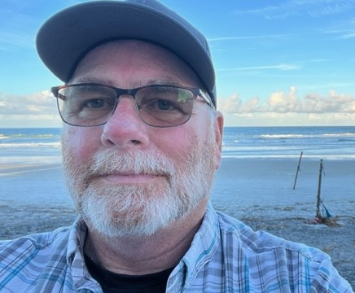
From the Section Emergency Coordinator Bret Stemen – KD8SCL EC
KD8SCL@gmail.com

Editor’s note:

Bret has been travelling back and forth between his Ohio QTH and Florida for the last few weeks. Bret’s mother-in-law has had some health issues as a result of a couple of falls, and his brother-in-law has recently been diagnosed with cancer and is currently hospitalized. Please remember Bret, his wife and her family in your thoughts and prayers as he “commutes” between Ohio and Florida to attend to their needs.

______________________________________________________________

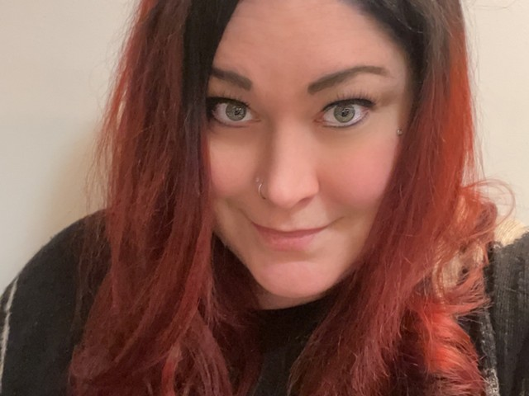
Elizabeth Klinc, KE8FMJ
OHIO Section Public Information Coordinator
ke8fmj@gmail.com

The Ohio Section Newsletter Contest

The winners will be announced and presented their plaques at the Columbus Hamfest in Grove City on Saturday, August 3rd, 2024.
Hope to see you there!

------------------------------------------------------------------
Elizabeth Klinc, KE8FMJ AUXC

OHIO Section Public Information Coordinator
District Emergency Coordinator, D3 Ohio ARES
Assistant Emergency Coordinator, Greene County
ARRL - The National Association For Amateur Radio™

__________________________________________

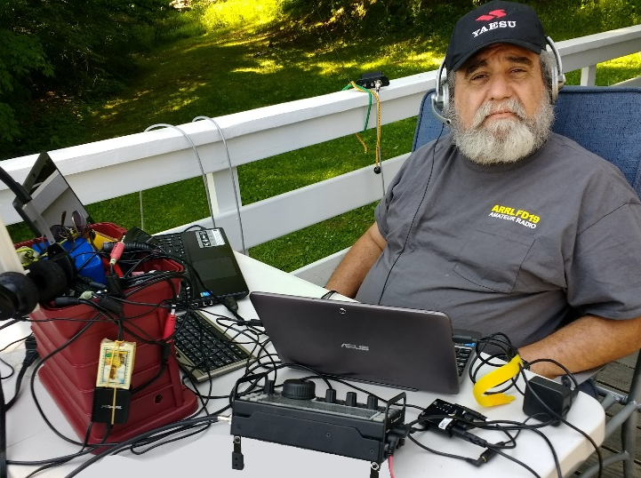
From the Section Youth Coordinator
Anthony Luscre, K8ZT - SYC
k8zt73@gmail.com

Dayton Hamvention 2024 - Videos to Watch
Anthony Luscre, K8ZT k8zt@cfarc.org

It’s a Pity Field Day is Just Once a Year,
So Plan a QSO or POTA Party for Your Club
[Note: there is a video presentation of this by me at youtu.be/RVkqQM6WBPA]
Many clubs have a strong tradition of avid ARRL Field Day activity. Enthusiasm and energy run high. Based on reports from clubs around Ohio, this year was no exception! It is often one of the most significant club events of the year, but it is often the only on-air operating event for most clubs! I have some ideas for your local club to remedy this. I have three main ideas plus a few more extras:
- POTA Party
- Ohio State QSO Party (If not in Ohio, substitute your local state or regional party here)
- Ohio State Parks On The Air Party
First, Why is It a Pity
Many clubs and members invest enormous amounts of time, effort, and money into one activity a year: FD.
- They also often put in anxiety, complaining, poor operating practices, starts of life-long club feuds and other issues
- Many hams come away with the wrong idea that FD is what EmComm is all about
- Why Does This Happen Every Year?
Why I Think This Happens Every Year:
- Most clubs do not put enough time & effort into operating events during the rest of the year.
- Most clubs do not spend enough time training members with on-air operations during the year.
- Most clubs do not spend enough time training (mentoring) newly licensed hams on setting up stations, getting on the air & operating.
- Many of the operators are not actually involved in the planning and/or familiar with the rules, procedures, etc.
- Many hams do not (or cannot have) home HF stations often because they are overwhelmed (or restricted by HOAs) with HF Antennas.
- Many hams do not get on the air and operate (especially on HF) frequently during the year.
- Many hams are unfamiliar with on-air contacts beyond nets & repeaters, especially with contest-type HF contacts.
- Many hams do not keep electronic logs.
- Many hams do not have their radios interfaced to computers for CAT & Logging.
- Many Hams come away from FD with the idea that this is what EmComm is like because they keep hearing that FD is a demonstration of Emergency Communication.
- This last one is an outlier from the others, so we will address it first…
Is This EmComm ? FD is Not EmComm; let me repeat: FD is Not EmComm. Until we break this cycle of confusion & misinformation, neither individual hams or EmComm will benefit. We need to ensure that those interested in Emergency Communications get better information about the bigger picture of EmComm, know where to get training, etc. But that is a subject for another discussion.
Let’s Have a POTA Party
The first is a “POTA Party.” POTA stands for Parks On The Air. It involves the activation of National or State Parks around the world. Most POTA operations consist of one or two operators setting up in a park and making contacts. But POTA can be fun with more participants, and that’s where a POTA Party comes in. A club or group sets up one or more stations in a park and involves as many members as possible in operation. Like FD, it's a great learning experience for new and seasoned hams. Whether it is putting up antennas, providing portable power, setting up stations or operating, it is a great way to gain new skills.
As I write this, I know of two local clubs, the Cuyahoga Falls ARC (www.cfarc.org) and Northern Ohio Amateur Radio Society (NOARS), recently having club POTA activations- Cuyahoga National Park (POTA # K-0020) and Findley State Park (POTA K-1950t).
Your club can plan your own POTA Party:
- Pick a nearby State or National Park
- Check out the POTA website for details on park activations and park designations.
- Register your activity on the POTA website under the scheduling section.
- Plan your equipment needs for the event (similar to how you do FD). Remember, some parks have restrictions on generators, using trees to support antennas, etc., so check ahead to avoid problems. You may also need to make reservations, especially if using a park pavilion or other structure.
- Publicize the event to club members. You may also want to invite non-club members.
- Create a way for interested hams to sign up for the event. I used a simple Google Form to create an online signup mechanism for our POTA Party (click here to make a copy you can customize for your club’s event- link.)
Let’s Support Our State’s QSO Party
The Ohio State QSO Party (OQP) will be held on August 24th this year. It is an excellent opportunity to be an in-demand multiplier station without the trouble and expenses of a DXpedition. Your club can take multiple tracks to an OQP entry:
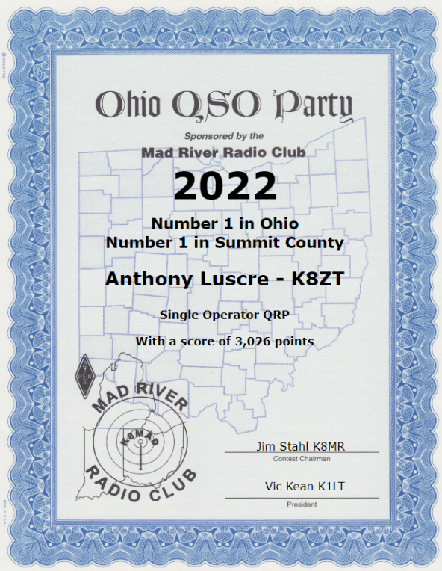
- If you have a club station in place, make sure that one or more members have it on the air for OQP
- You can set up portable style, just like FD, with one or more stations
- You can plan a Rover activity. Rovers move from county to county during the OQP. Operating can take place while in motion or at planned stops along the way. For safety, a team of driver(s) and operators is preferable.
- You can use existing station(s) of club members to operate
- You can encourage individual club members to get on the air as Single Operators (you might even want to have a friendly interclub competition)
The most important thing is to make plans. Don’t just announce it to club members; you must actively plan and schedule operations, follow through, and get on the air for the OQP.
Let’s Have a Statewide POTA Party
Ohio State Parks On The Air (OSPOTA) is held each September- link. Sponsored by Portage County Amateur Radio Service (PCARS), this groundbreaking event is in its 16th year and undoubtedly was one catalyst to ARRL NPOTA and the whole POTA movement.
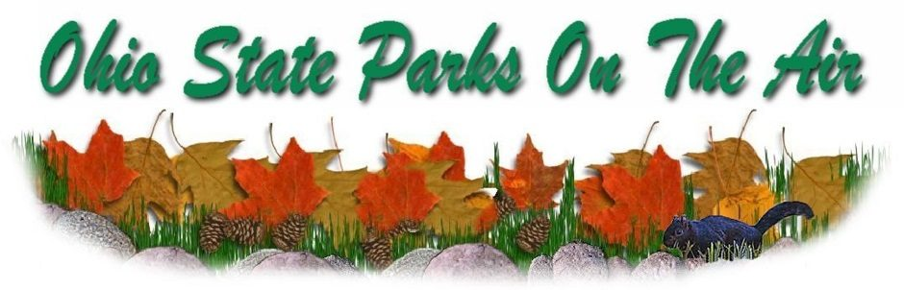
This year’s event with take place Sept 7, 2023, from 1400 UTC to 2200 UTC (10 am to 6 pm ET). Your club can pick from one or more of the 76 Ohio State Parks. This contest places a premium on working stations located in the Ohio State Parks. That means that it is critical to have as many parks activated as possible. The challenge for Ohio stations will be to work HF in the 50 to 300-mile range. OSPOTA is the perfect opportunity to learn more about the design and deployment of Near Vertical Incident Skywave (NVIS) antennas. You can find numerous designs online and in various Amateur Radio antenna manuals.
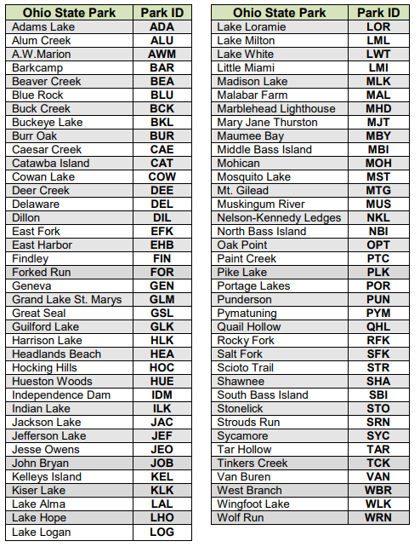
Along with your operating skills, it will also be a chance to showcase your antenna-building skills. Individuals and multiple operators can operate Ohio State Park stations. Non-park stations in Ohio, as well as stations outside of Ohio, can also compete. Contacts can be made on 80, 40, 20, 15 and 10 meters using SSB. All contacts have the same point values. Make sure you read the Rules, FAQs and get your forms for the contest posted on the OSPOTA website: www.ospota.org, before the contest.
Other Events to Turn Into a Club Operating Party
In addition to the above events, consider other possibilities. Here are some suggestions:
Other State QSO Parties. With 47 events held between February and October, there are plenty of dates to choose from; see the calendar of parties at www.contestcalendar.com/stateparties.html. Although you will not be a rare multiplier as in OH QSO Party, it is still a great way to have fun on the air.
ARRL VHF/UHF Party (in Ohio, especially the June or September events) – link. These are exceptionally well suited to Technician class licensees as they have full operating privileges on these bands.
CQ WW VHF Contest in July is similar but limited to 6 and 2 Meters
Winter Field Day In January is similar to ARRL FD
Set up a Special Event station to commemorate a historical or local event. Plan it early enough to submit details to QST and CQ magazines for inclusion in upcoming issues (lead time is usually at least three months). Also, don’t forget the Ohio Section Journal!
Pick almost any other contest with a multi-operator category and have fun with fellow club members from your club’s station or a willing member that will loan their home station to the cause.
Tips for making the most of your club’s operating party
Here are some suggestions for making the event successful:
- If it is an HF Event, familiarize members with working HF (see below). Many hams, especially Technician licensees, are more familiar with VHF/UHF Repeater contacts, not HF.
- Train your members on contest-style operations.
- Plan, plan, and plan some more. A well-planned event can mean success and a good time for the participants.
- We often underestimate contest competition when recruiting youth. Youth participate in many sports and can relate to contesting.
- Online real-time contest scoreboards (Contest Online ScoreBoard, Contests | Live Score and Real-time competition: online scoreboards) can greatly enhance the experience.
- Make it a fun time for participants- refreshments, interclub or intraclub (with nearby clubs) competition, photos and articles in the club newsletter, etc.
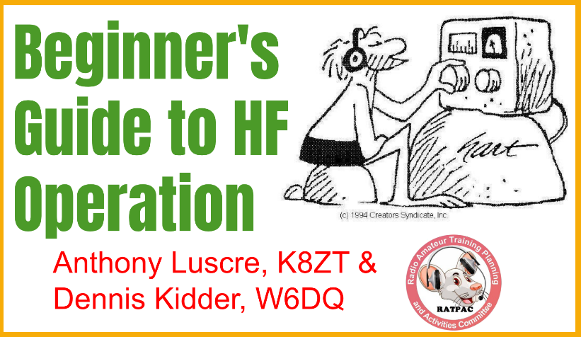
I recently completed a four-week series, “Beginner’s Guide to HF Operation,” with Dennis Kidder, W6DQ, and you can watch the four recorded sessions and view the composite slideshow:
- Week 1- The HF Bands, Operating & Making Contacts- https://youtu.be/cjZZjfKYPak
- Week 2- Equipment & Antennas- https://youtu.be/dH5gsA1CZSc
- Week 3- Putting It All Together https://youtu.be/eG3kFbCZEM8
- Week 4- Operating HF- https://youtu.be/FOgoAYkKveA
- Slideshow from the presentations, including clickable links and resources, is available at tiny.cc/bghf.
If your club’s members are not frequent contesters, I have a presentation, “Introduction to Contesting.” You can access it three ways- via the slideshow at tiny.cc/arcontest via a recorded presentation on YouTube, “Intro to Amateur Radio Contesting- Not Just for competitive, but anyone who wants to make more QSOs!“ or I would be happy to do a live presentation for your club either in person or via Zoom, depending on location and date. If you are interested in this live presentation, one on contesting software or any of my other topics (tiny.cc/k8zt-p), email me at k8zt73@gmail.com (make sure you include a phone number where I can contact you). Also, do not worry about not being seasoned contesters, as most suggested events are more laid-back than major contests.
For some members, contest logging software may be unfamiliar. Although many logging programs exist for MS Windows, I suggest either N1MM Logger+ (free) or N3FJP’s Amateur Radio Software (paid). I have also done presentations and videos on using contest logging software.
Consider running multiple modes during your party- SSB, CW and/or Digital (FT8 or FT4 if included in contest rules) to give members with different interests and skills a chance to operate and even learn new modes.
Please consider opening your event to non-club members. You can send your information to Tom Sly for inclusion in the “Club Section” of the monthly Ohio Section Journal and/or weekly Postscript.
If your event is in a public location, consider having information available on Amateur Radio and your local club in particular. Here are some examples of this with a youth and teacher slant from FD planning—tiny.cc/fd-res. Most of these can be used at any public operating event or information booth.

73, and please feel free to contact me with any questions/suggestions
Anthony, K8ZT (k8zt@arrl.net)
330-650-1110

________________________________________________

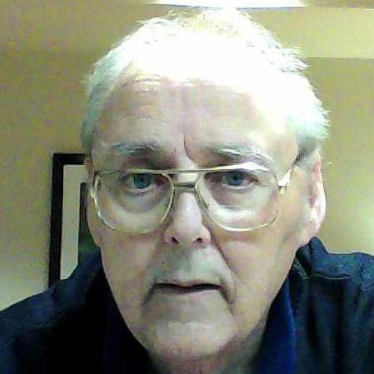
From the Section Traffic Manager David Maynard, WA3EZN – STM
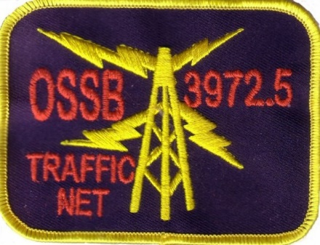
wa3ezn@att.net

The OSSBN will be having their next business meeting July 6 during the InterCity Amateur Radio Clubs Mansfield Mid-Summer Trunkfest at the Richland County Fairgrounds. Location is 750 North Home Road Mansfield OH 44901. The Intercity Club website is http://w8we.org/ and Danny Bailey w8dlb60@gmail.com . Talk-In: 146.940 PL 71.9.

Field day has come and gone for this year. I hope you were able to find a field day sight and participate. The annual field day operation is always the last full weekend of June every year.
This year some outdoor field day activities were canceled because of the extreme heat. I don’t recollect any other years where 100 degree temperatures affected field day like this.

The American Radio Relay League was founded by Hiram Percy Maxim, who found that messages could be sent more reliably over long distances if relay stations were organized. On April 6, 1914, Hiram Percy Maxim proposed the formation of the American Radio Relay League. The ARRL is the national association for Amateur Radio in the United States. It was incorporated under the laws of the State of Connecticut in 1914, and it is a non-profit organization. The ARRL is governed by an elected board of directors, which conducts the business of the organization and sets policies for it. The league represents the interests of its members before the Federal Communications Commission (FCC) and other government agencies, and it promotes the advancement of Amateur Radio.
Is ARRL membership worth it? When you join ARRL, you'll have access to information, learning, programs & services to help you get (and stay) active and on the air. Your membership supports ARRL's work to promote and protect amateur radio and provides you with benefits to do more with your amateur radio license. There are many factions out there that want to gobble up the frequencies amateurs use and replace them with commercial interests like garage door openers, cell phones and similar usages. Our only defense is the ARRL.
People use ham radio to talk across town, around the world, or even into space, all without the Internet or cell phones. It's fun, social, educational, and can be a lifeline during times of need. You can set up a ham radio station anywhere! Here is a link to an old video about radio history: https://www.youtube.com/watch?v=z_orAwRnzhw

Each year ham operators send, receive and deliver thousands of messages called radiograms. The radiograms are “carried” from origination to delivery through one of two national traffic systems. There is the ARRL National Traffic System and the Radio Relay International system. Both of these systems have nets at published times. These nets are used to receive and forward radiograms by volunteer radio operators.

HOW ABOUT TRAFFIC HANDLING IN OHIO

Concentrating on Ohio there are several ways to get involved and enjoy this part of amateur radio. Whether you're a newly licensed ham or a seasoned ham with years of experience you can participate in a net and be prepared to step up and handle messages during an event or disaster. So when there is a storm or tornado and the electric and internet is down there still is a viable way to communicate, Amateur Radio.

OHIO SINGLE SIDEBAND NET

Morning session | 10:30 AM | 3972.5 KHz | every day
Afternoon session | 4:15 PM | 3972.5 KHz | every day
Evening session | 6:45 PM | 3972.5 KHz | every day

The Ohio Single Sideband net (OSSBN) is a statewide phone (voice) net on the frequency and times listed above. The net is open to check-ins from all licensed amateurs and it is a directed net. It will have a net control station who will call for check-in and direct the passage of traffic. You will need an HF radio to check in but anyone with a radio can listen in. Tune in, listen and learn. https://ossbn.org/about/about.html

The other statewide traffic nets are Morse Code (CW) nets. If you can send or receive Morse Code join in and have fun. The times and frequencies of these nets are listed in a chart below. If you are adventurous you might search the internet and find programs to help you learn CW. You might even find a program to help decode the CW signals so you can see what is being sent.
OHIO HF CW TRAFFIC NETS

HF CW NETS | NET TIMES | FREQUENCY | NET MANAGERS
Buckeye Early | 6:45 PM | 3.580 | N2LC
Buckeye Late | 10:00 PM | 3.590 | WB9LBI
Ohio Slow Net | 6:00 PM | 3.53535 | N2LC

If you don’t have an HF radio yet all is not lost. There are “local” traffic nets that you can participate in. Most of the local traffic nets operate on two meters. No experience is needed to participate in these VHF nets and most of the two meter nets are training nets and will welcome your participation and help you learn.

OHIO LOCAL VHF TRAFFIC NETS

VHF NETS | NET TIMES | FREQUENCY | NET MANAGERS
BRTN | Monday, Thursday Saturday 9:30 PM | 145.230 PL 110.9 | KD8GXL
COTN | 7:15 PM DAILY | 146.970 PL 123.0 | KV8Z
TCTTN | 9 PM Sun, Tues, Fri | 147.015 PL 110.9 | WB8YYS
TATN | 8:00 PM DAILY | 146.670 PL 123.0 | WG8Z

OHIO VHF TRAFFIC NETS

BRTN Burning River Traffic Net serving Cleveland and North Central Ohio
COTN Central Ohio Traffic Net serving Columbus and Central Ohio
TATN Tri-State Amateur Traffic Net
TCTTN Tri-County Traffic and Training Net serving Northeast Ohio

IDEAS TO HELP YOU GENERATE A RADIOGRAM

We all know that bulk traffic is ok and it helps with keeping us busy practicing, but how about initiating some new radiograms ourselves to help keep the NTS more active. I think this would be a lot of fun, just to see how many make it through and the response we get.

Don’t worry too much if you cannot get a phone number try it without one. Try Dex Knows and the White Pages online. If they are not listed you will not get it. The nets would very much appreciate all of you sending a radiogram. Try using one or more of the following suggestions. I hope the below statements will help you do that. The following are some ideas you can use to help you put your radiograms together.

1. I know that many of you do a little rag-chewing, how about sending a radiogram to the one you talked to and thanking him or her. This works very well and traffic handlers like this type of message.
2. How about after reading an article in QST or CQ you send a radiogram to the author and thank them.
3. Thanking someone for a QSL Card, and letting them know one is on the way. This is another good one. try it, it will make someone very happy.
4. Thanking someone for any help they may have given you. No matter what the help was this will definitely cheer them up.
5. Ask someone a Question about anything, (logging software, nets, radios, antennas, ect.)
6. Congratulate someone for upgrading, and the various awards that you may read about.
7. Don’t forget Happy Birthdays, Anniversaries, Weddings, any other occasion, and there are many, such as Thanksgiving, Christmas, ect.
8. Invite other ARRL officials to reply with a radiogram. They are listed in QST and on the ARRL website.
9. Making a sked with someone you want to talk to, maybe for a WAS, County, QSO Party, Grid, ect.
10. Invite them to your club meeting and or a Ham breakfast.
11. Invite back a former Net member or visitors. You may know of some past members that you can contact.
13. Asking another Ham to send you a radiogram to help keep the NTS active.

Included here is a list of stations that send out large quantities of messages with common texts. Print a copy of this file and keep it handy for ready reference. The originating station may have more than one common text message. The differences in messages are distinguished by the check count.
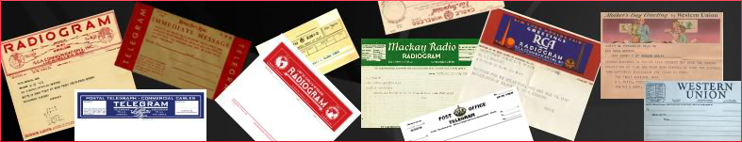

R HXC N1IQI 25 PEMBROKE MA (date)
BT
A FRIENDLY REMINDER YOUR AMATEUR
RADIO LICENSE EXPIRES (month) (day)
(yr) HOPE YOU WILL RENEW
IF NOT DONE SO ALREADY
WE NEED YOUR PARTICIPATION 73
BT
LOREN N1IQI
R HXE K6HTN 23 PASADENA CA MAR 10
BT
GREETINGS BY AMATEUR RADIO X
CONGRATS ON YOUR NEW AMATEUR
RADIO LICENSE X ASK DELIVERING
HAM FOR MORE INFO ABOUT
THIS MESSAGE 73
BT
KATE HUTTON K6HTN
R K6HTN 25 PASADENA CA NOV 20
BT
CONGRATS ON YOUR SUCCESS IN
CW ACADEMY X RADIOGARAMS ARE
A LONG TRADITION AND GOOD
PRACTICE X WE LOOK FORWARD
TO YOU CHECKING IN 73
KATE HUTTON/K6HTN

R HXG NX9K 19 NEKOOSA WI
BT
WELCOME TO THIS GREAT HOBBY
X PLEASE JOIN YOUR LOCAL
ARES GROUP TO HELP YOUR
LOCAL COMMUNITY X 73
BT
KRIS NX9K AND JIM N9VC

R HXG NX9K 21 NEKOOSA WI
BT
A BELATED WELCOME TO THIS
GREAT HOBBY X PLEASE JOIN
YOUR LOCAL ARES GROUP TO
HELP YOUR LOCAL COMMUNITY X
73
BT
KRIS NX9K AND JIM N9VC

R HXG NX9K 22 NEKOOSA WI
BT
WELCOME TO AMATEUR RADIO X
CONSIDER JOINING YOUR LOCAL ARES
GROUP TO HELP YOUR LOCAL
COMMUNITY X ABOVE ALL HAVE
FUN 73
BT
KRIS NX9K AND JIM N9VC
R HXG NX9K 25 NEKOOSA WI
BT
WELCOME TO AMATEUR RADIO X
GIVE SOME THOUGHT TO JOINING
YOUR LOCAL ARES GROUP TO
HELP YOUR COMMUNITY X ABOVE
ALL HAVE FUN X 73
BT
KRIS NX9K AND JIM N9VC
R HXG NX9K 16 NEKOOSA WI
BT
WELCOME TO AMATEUR RADIO X
YOUR EFFORTS WILL BE REWARDING
X PREPARE TO HAVE FUN
73
BT
KRIS NX9K AND JIM N9VC
R HXG NX9K 20 NEKOOSA WI
BT
WELCOME TO AMATEUR RADIO X
THIS IS THE WORLDS GREATEST
HOBBY X GET ON THE
AIR AND HAVE FUN 73
BT
KRIS NX9K AND JIM N9VC
R HXF# W2PAX ARL 15 NAPLES, FL (DATE)
BT
ARL FORTY SIX FROM THE
75 METER ISBN JOIN US
AT 0100Z 3985 KHZ 73
BT
THE 75 METER INTERSTATE SIDEBAND NET
R HXC WG7FRD 21 RED ROCK AZ
BT
RECEIVING OR SENDING RADIOGRAMS IS
ALWAYS FUN X HAM OPERATORS
NEED PRACTICE TO BE READY
IN CASE OF AN EMERGENCY
73
BT
FRED WG7FRD

R HXC WG7FRD ARL 22 RED ROCK AZ
ARL FIFTY X THANKS VERY
MUCH FOR THE NICE CONVERSATION
X HOPE TO HEAR YOU
SOON AGAIN ON THE BANDS
X 73
BT
FRED WG7FRD

R HXG VE1IJ 17 METEGHAN NS DATE
BT
WELCOME TO AMATEUR RADIO THE
ORIGINAL SOCIAL NETWORK X ENJOY
ALL THE HOBBY HAS TO
OFFER 73
BT
GLENN VE1IJ

R HXG VE1IJ 20 METEGHAN NS MAR 9
BT
UPGRADING YOUR LICENSE GIVES YOU
ACCESS TO MANY NEW ACTIVITIES
X ENJOY THEM ALL AND
BT
GLENN VE1IJ

What to do with undelivered radiograms

Sometimes the radiogram cannot be delivered. This is when the delivering ham is supposed to
“Service the message back” by sending a radiogram to the originating station informing them. Here are a few addresses of stations that send a lot of radiograms.

N1IQI LOREN S PIMENTEL
5 EVAN RD
Pembroke MA 02359
781 293 3861

Laura (Kate) Hutton K6HTN
969 E Mountain St
PASADENA CA 91104
626 485 5977
626-797-5178

KRISTINE J BATKA NX9K
8271 HOLLYWOOD RD
NEKOOSA WI 54457
715 886 4111

DICK JONES, W0PZD
9509 EAST KOKOPELLI CIRCLE
TUCSON, AZ 85748-7407
OPS NOTE: W0PZD@JUNO.COM

ABOVE ALL HAVE FUN and send me a radiogram.
73
DAVID WA3EZN
Hilliard Ohio – no address needed
OHIO SECTION TRAFFIC MANAGER

___________________________________________

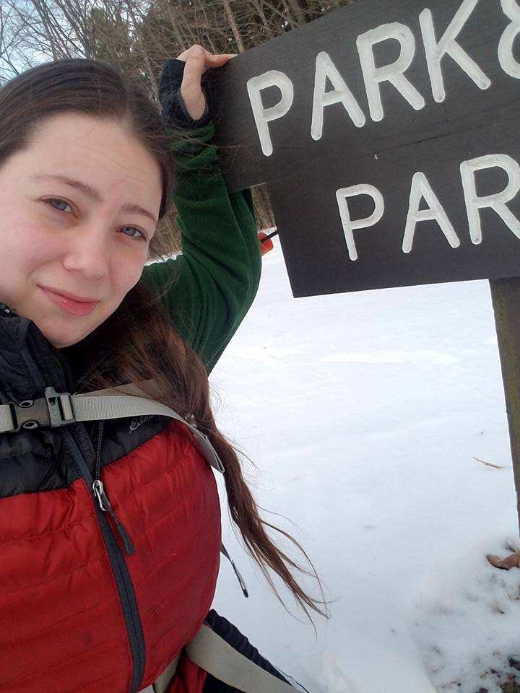
Amanda Farone, KC3GFU
ARRL Ohio Section | Affiliated Club Coordinator
Afrone926@gmail.com
330-509-4095

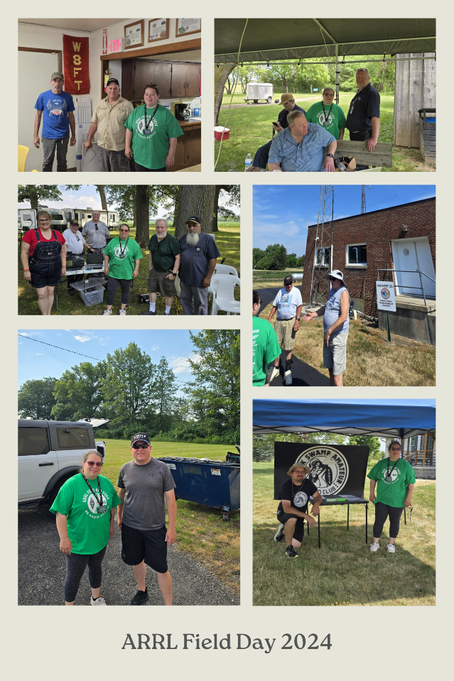
First, I want to give a HUGE shoutout to the Ohio Section for the fantastic job with Field Day 2024! I visited several clubs on Saturday and came out of the weekend feeling extremely proud of our clubs here in Ohio. You should be proud, too! I started my journey on Saturday morning in Lima, OH. My first visit was to Northwest Ohio ARC in Elida, where they set up at their local church. It was still very early (9 am), so unfortunately, we could not see their full setup, but their plans for the day sounded like a good turnout. Next, we visited Van Wert ARC, which they hosted at their local EMA office. I was given an impressive tour of the EMA building and the shack located within. The field day captains were eager to get things started and look forward to the event every year. One drove from Indiana and has participated with the club for many years. Our third stop was Fulton County ARC, with a beautiful location! We got to meet a newer ham who was in the process of being Elmered when we walked up, this was great to see. It was clear they were going to have a fun-filled day. Our next stop was Black Swamp ARC. This is a newer club that has surely hit the ground running! They had many stations set up and many operators roaring and ready to roll. They gave us a grade-A tour of their site via golf cart, and it was definitely a sight to be seen. Then, we headed to check out Wood County ARC set up at the Wood County Museum. When I arrived, the club president was interviewing with the local media. Of course, this is always fantastic to see. The young lady also interviewed me, and I was able to talk a bit about ARRL and how we support amateur radio. I witnessed a 92-year-old operator out there setting up antennas in the heat enthusiastically. On to our next stop, Findlay ARC, which operated from their clubhouse. Upon entering, we were greeted by a young boy calling out to a CQ. Another young, new operator showed up, and they were quick to get him on the air and join in on the fun. Our last stop before returning to our local area was Seneca Radio Club. They were set up at a public park and were not skimping on Field Day dinner! We chatted with the CW operators and the Vice President before hitting the road again. We returned local around 9:30 pm and stopped by Mahoning Valley ARA. Plenty of operating still going on, and quite the turnout for them as always. Our last and final stop was our “home” club, Western Reserve ARC, set up at Lake Milton SP. We ended up operating until around 5 am and were impressed to see operators awake and participating throughout the night.
Overall, I'm again impressed by Ohio! You guys all do a fantastic job welcoming everyone, making sure everyone has fun, and representing what Field Day is all about. If I missed you this year, hopefully next year! Thank you to everyone who greeted me so generously and took the time to give me tours of your sites and also welcoming my husband, hihi.

A Rock and a Hard Place – Part 1
Bill Salyers – AJ8B
I am not an ARRL “apologists” nor am I someone who normally enters the “fray” just to be heard. However, after reviewing the comments in various locations such as groups.io forums, eHam forums, Facebook comments, and twitter information that has been spread, I felt it was time to at least provide some potential insight surrounding the recent ARRL situation. I have no inside information but quite a bit of knowledge can be gleaned from what was said and what was NOT said. Anyone who thinks that they took this lightly or were non-chalant about it doesn’t realize what was at stake or the people involved. There are some folks at the league that I have not agreed with, but I never questioned their dedication to the league or the hobby.
I am not a White Hat hacker and not an expert. I have learned things the hard way and then spent considerable time and energy to learn after the fact. In 2019 we suffered a Ransomware attack at one of our locations shutting down a district office for several days while we dealt with getting 20+ users back online in a way that we felt confident we could move forward.
Since then, we have received a top rating from our Cyber Insurance provider, been asked to speak at several conferences and to be a reference for some of the products that we use. If learning the hard way makes you a bit more of an expert, then I am the guy to share some information.
As soon as the ARRL announced that there was an issue with most of the services and systems, one had to conclude that this was a complex and wide-spread attack. As they listed most of the services that had been shutdown, LoTW was not on that list. As a very active and popular service, I assumed that some sort of nefarious activity was ongoing such as Ransomeware. The idea behind Ransomeware is that your files are rendered useless when the attacker applies some sort of encryption to them. Often times you can open them, but they are filled with gibberish. You are then contacted by the attackers, either via email or in a pop up window when you attempt to open an infected file, to supply some sort of payment (typically bitcoin) and the attackers will supply the reverse encryption key. (You hope.)
We immediately contacted our cyber insurance provider for guidance. We had already isolated the office from the rest of our network. Our provider directed us to contact the FBI who assigned a special agent. The first order of business was to minimize our exposure to the public. We were told not to use terms such as Cyber attack or Ransomeware even to our users. We notified our users that we had a network component failure. The FBI’s reasoning was simple. The attackers would be less likely to negotiate if they knew the entire picture and knew that they had you “over a barrel.” Rock and Hard place #1 - presumably the ARRL identified a ransomeware attack and had notified the FBI. I am confident that they were told not to mention anything about the severity of the attack. So, ARRL members wanted a full and accurate update and the ARRL could not provide one lest they compromise their bargaining position. When they ARRL did not give an LoTW update, wild speculation filled the void. Never helpful, but it happens.
The second step involves identifying the attack vector. Was it social engineering? (via email or a text message for instance) Was it a website drive by attack when someone visited a rogue website? Was it something brought in from the outside via a non-approved laptop, tablet, or a USB device? Perhaps a terminated employee was taking revenge!
There is a scarier situation than we have already discussed – what if something that was loaded on to a PC months ago and was part of the objects that were backed up? Now when you restore from backup, you could be starting all over again. Rock and Hard place #2 – All of this takes time. The more time you take, the more frustrated the user community gets – I know, I have been there!
Assuming it is a Ransomeware attack, while you are going through the evaluation of how you were attacked, the extent of the attack, and what the state of your backups are, you are also performing a business analysis. I have no idea if a demand was made or what it was, but the average starting demand in 2023 was approximately $568,000.¹ So now, you are comparing your lost business, functionality, and risk versus the demand. You might set up a test evironment and restore your backups to see how quickly you can get things up and running. How stale is the latest backup? Conducting a forced rebuilt is not the time to learn that you no longer have the correct tape drives, back up drives, software, or Code Words!
Rock and Hard place #3 – Money! It always comes down to money. Most organizations don’t have unlimited funds and I am sure that the ARRL is no exception. In fact, with all of the anguish and gnashing of teeth that recently occurred during the membership dues increase, the thought of buying new hardware, cloud services, new software, Cyber Engineers etc. would be the last thing on the league’s mind.
A practice that some companies employ, is to relegate old servers to the data center. In many cases, a large server running windows will do a find job running UNIX even as the hardware ages. It allows companies to avoid the capital expense that would be needed and is a common practice in non-profit organizations. They are hoping that they will never be a critical point of failure. “If it isn’t broke, don’t fix it!” Once these servers are set aside for a specific task, they are often times neglected. It is easy to see how any company might use old hardware to support a project and then forget about it. Suddenly, it becomes a liability that only shows up during an audit or an attack.
We had one such server that we had to physically remove from the network. The software that ran on it was used by our HR department and the last version of Windows server that it could run on was Server 2007! That is no longer supported and is a huge liability. Once we identified the issue, we took it completely off of the network and mothballed it.
In part 2, I will present an overview of what you might do to protect your personal PC at home. This article first ran in the National Contest Journal, Sept/Oct. 2020, and I have updated it.
As I mentioned, I have no “inside” knowledge of what the league was facing. I do know that these problems are complex, difficult, and are not aided by sages and “experts” who seem to know better. As I mentioned, I am not an “apologist” but I thought another viewpoint my help clarify what the league may have been going through.
Your thoughts and input are appreciated via the Groups.IO groups ARRL-Groups and LOTW-groups.
See you in the pileups.

¹ https://www.statista.com/statistics/1409510/ransom-payment-us-quarterly-amount/

National News
(from ARRL and other sources)

______________________________________________________

ARRL and Momobeam Introduce Dual-band Beam Antenna for 6- and 10-Meters

ARRL The National Association for Amateur Radio® has a new product to help radio amateurs get active and on the air.

As Solar Cycle 25 continues to increase HF radio propagation on the upper bands, ARRL has partnered with the Italian antenna manufacturer Momobeam to design a dualband beam antenna to help take full advantage of the exciting opportunities for distant contacts. The ARRL Dual-band Momobeam 6/10 Antenna is an easy-to-use antenna with a small footprint and a big reach. The beam features a 10 meter Moxon (28 MHz) and 6 meter Yagi (50 MHz).

At just over 10 pounds and with a turning radius of approximately 6.5 feet, the design is compact enough to fit places that otherwise wouldn’t have space for a beam antenna. It comes with two sets of hardware for both permanent installation and portable use for temporary deployments such as 2024 ARRL Field Day or park activations.

The ARRL Dual-band Momobeam 6/10 Antenna is ideal for Technician-class operators to be able to work DX. “This is a great ‘first’ beam antenna for every ham,” said ARRL Director of Marketing and Innovation Bob Inderbitzen, NQ1R. “If you’ve ever been intimidated by the prospect of owning a beam antenna, this one will allay your fears and give you a whole lot of fun. Radio clubs will want to add this beam to their deployment gear, as it’s a great fit for field operating and special event stations. College radio clubs that don’t have room for a large beam, or another beam, will enjoy adding this antenna for some gain on 6- and 10-meters. It is lightweight and can be turned with a simple TV rotator.”

The 10-meter Moxon is an effective design for this dual-band antenna, as it’s around 30% smaller than a traditional Yagi and uses no traps or other shortening techniques that reduce performance. A Moxon antenna includes a number of antenna configurations that were referred to by Les Moxon, G6XN (SK), and have received attention over the years in QST and editions of The ARRL Antenna Book.

The feed system uses an open sleeve feed method, coupling the driven element of the 50 MHz section by proximity and length to the 10-meter driven element with minimal loss. “Just attach a single coaxial cable to included SO-239 equipped coaxial pigtail, and you’re ready to go on two bands!” said Inderbitzen.

The antenna debuted at the 2024 ARRL National Convention hosted at Dayton Hamvention® in May. The first run sold out at the show, but ARRL has taken delivery of more units, available now.

“It’s surprising how few amateurs have experience with antennas beyond basic wire designs,” said Inderbitzen. “Our interest in introducing this antenna is to increase the depth and breadth of knowledge and experience among our members.” Inderbitzen added that members should watch for more content, including video tutorials, coming from ARRL about the antenna. More information about the antenna can be found at www.arrl.org/beam where future content will also be published.

While this antenna was produced exclusively for ARRL, Momobeam offers many of its popular antenna designs in the US through its partnership with Ham Radio Outlet.

The ARRL Dual-band Momobeam 6/10 Antenna is available from the ARRL Store at www.arrl.org/shop (ARRL Item No. 0084, $299.95 retail plus shipping, handling, and sales tax where applicable. Available to ship in the US, only. Call 860-594-0355 or, toll-free in the US, 888-277-5289).

ARRL Club Grant Program — Application Deadline Approaching

Now is the time to gather your club members and start thinking about how you can make your community a better place through amateur radio — and we have funding available to help!

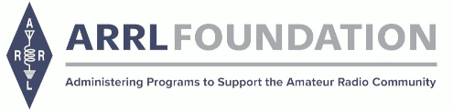

The ARRL Foundation is pleased to announce the return of the Club Grant Program for 2024. This is an opportunity for clubs to apply for grants up to $25,000 to fund projects in their community, with an emphasis given to projects that are of a “transformational” nature. Consider applying TODAY to support a project or activity from which your club and community would benefit.

Can your club create a plan to improve the community through education and training in, recruiting for, and promotion of amateur radio? This is for you! The application period is NOW OPEN and runs through Friday July 26, 2024 at 4:00PM Eastern Time. Clubs across the country are encouraged to apply, even if your club is not an ARRL Affiliated Club or not a 501(c)(3) organization—all are welcome to apply.

Grant recipients will be required to share progress reports and updates with ARRL. Information about the Club Grant Program can be found at:
www.arrl.org/club-grant-program.

ARRL Club Grant Application
Submission Deadline: July 26, 2024
Apply now at www.arrl.org/club-grant-program

______________________________________________________________________________

Central States VHF Society 2024 Conference Registration is Open!!!

Hello everybody,
The Central States VHF Society Conference in Cedar Rapids, IA on July 25-27, 2024 is open for registration. A great technical program provides time to see operating rovers and microwave dishes, measure low noise amplifiers, measure your antenna gain, and learn through one and a half days of classroom style presentations.
Our family program shows off three historic facilities in the Cedar Rapids area. The National Czech and Slovak Museum showcases our Czech heritage in Cedar Rapids. The Brucemore Mansion tells the stories of two influential families in Cedar Rapids whose legacy still impacts our community. The Amana Colonies visit begins with a bus tour of the colonies including stops at a communal kitchen, a church, and museum. Lunch and shopping are on your own.
The Friday and Saturday luncheons provide an opportunity to dine with your new and old friends and listen to a very interesting speaker. The banquet provides a great meal, award presentations, keynote speaker, and a prize drawing with thousands of dollars worth of prizes. Amateurs and family members leave with something. We are pleased to announce our luncheon and banquet presentations.
Friday Luncheon: “902 MHz EME Roving October 2023 - 27 States in 21 Days + WAS #1”, by Peter Van Horne, K6AU
In September 2023, I decided to make a 902 MHz EME roving trip starting October 1, 2023. The goals included Al, W5LUA, completing WAS #1 on 902 and helping the other active 902 EME operators complete as many states as possible.
Saturday Luncheon: “A DXer’s Gridpedition to EN67. Or What’s a Guy Like YOU doing in a place like this?” by Tom Vinson, NY0V
In this presentation, Tom will take you through his journey from HF DXing until he went on his first solo Gridpediton to EN67 in June 2023. Topics will include how he decided which grid to activate, the equipment and system used, how it turned out, and the lessons he learned.
Saturday Evening Banquet Keynote: "Sights Along the Way or Snorkel and Bounce" by Karen Orzech and Lance Collister, W7GJ
Lance and Karen will share their adventures in visiting exotic locations that Lance activated on 6 meter EME while Karen pursued photography and snorkeling hobbies.
You may wonder what happens at a Central States VHF Society Conference. The following paragraphs describe the highlights of a conference. When you attend, you can experience all of these functions. You also meet many people who enthusiastically embrace activating the higher bands. There are many propagation and communication modes to experience.

Two antenna ranges provide an opportunity for members to measure the gain performance of their antennas. In past years, new designs performed well. Sometimes, a quick adjustment provided improved performance. Antennas ranging from 144 MHz to 10 GHz can be evaluated.

Low noise amplifiers extend range in weak signal environments. For many bands, amateur radio operators homebrew their own low noise amplifiers. The noise figure measurement bench provides an opportunity for the measurement of noise figure on a world class noise figure analyzer.

Since amateur radio operators rarely experience the show and tell of operational stations, many amateur radio operators bring rovers and microwave dishes to Central States VHF conferences to show other enthusiasts how simple or complex these stations can be. Weather permitting, we will be herded down the line of stations. Each owner then discusses the unique features of their stations.

Vendors display and sell their products in our vendor room. Some products are brand new. Some used. Some vendors salvage test equipment and commercial products to provide items that are useful in the VHF and higher bands.

Members share innovations, adventures, technological advancements, and operating practices in a series of presentations on Friday afternoon and all day Saturday. The hospitality suites provide an informal opportunity to interact with each other.

The registration link is: 56th Annual CSVHFS Society Conference-Annual Conference
The Room Reservation link is: https://www.choicehotels.com/reservations/groups/G9668829
Note that we have a special conference room rate when you use the link.
Updated information on the convention can be found on our web site at https://2024.csvhfs.org/
We look forward to seeing you in Cedar Rapids.
Thank you,
Bill Caldwell, N0LNO Rod Blocksome, K0DAS
President Vice President
Central States VHF Society Central States VHF Society

____________________________________________________

The 13 Colonies Special Event will take place July 1-7, 2024. Operating times are July 1,1300 UTC to July 8, 0400 UTC. Thirteen special call signs will be on the air, each one representing one of the original 13 British colonies that were established in 1607. Three additional bonus call signs will be on the air representing Great Britain, France, and Philadelphia. All HF bands can be used, including the WARC bands, with the exception of 60 meters. Simplex on 2 meters and 6 meters is encouraged. The southeastern stations on the east coast are very close to each other. It will be harder for these states to contact each other so, use of 40-160 meters is encouraged. All modes of operation may be used, including SSB, CW, RTTY, and digital. The mode of operation is up to the individual colony state station. More information about logs, call signs, and QSL certifications can be found at The Annual 13 Colonies Special Event.
_______________________________________________

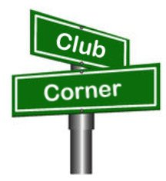
Club Corner

This is YOUR corner of the newsletter. Send us what your club is doing, and we’ll make sure that it gets in. Got a special event or club project that you want everyone to know about? Send it to us!. Need help with a project? Send it to us.

Let us know what you club is up to. Are you going to have a special guest at your meeting or are you having a special anniversary?

Send it to: webmaster@arrl-ohio.org

VE Sessions

The following information is for ALL exam sessions:
It is now an FCC requirement to have an FCC FRN; active email address and active phone number before taking any exam. Please bring your FCC FRN, original license, a copy of your license (if a licensed ham), a valid photo ID and $15.00 - Cash preferred.
Effective April 19, 2022, the FCC will charge a $35.00 application fee for amateur radio licenses. The fee will apply to new, renewal, rule waiver, and modification applications that request a new vanity call sign. License upgrades will not have a fee applied. The fee will be per application. VE's will not collect the fees at exam sessions.
AE8FP Amateur Radio Test Team administers ARRL-VEC testing in the Central Ohio area. Our test dates for 2024 are as follows: Januray 20, April 27, July 20, and October 19. Time and location for these dates are 10:00am at the Westerville Fire Station #111, 400 W. Main St in Westerville, Ohio. The listed dates are co-sponsored by the Central Ohio Radio Club (CORC).
Pre-Registration is required, and open the 1st of each testing month. All information is available at www.ae8fp.net <http://www.ae8fp.net/>

Alliance Amateur Radio Club The Alliance Amateur Radio Club holds quarterly VE testing, at the Christ UInited Methodist Church in Alliance. The address is 470 E. Broadway St, Alliance, OH (https://maps.app.goo.gl/prDyEPp6siJun2ibA).
Upcoming Exam Dates are
Saturday, March 16th, 2024
Saturday, June 15th, 2024
Saturday, August 10th, 2024
Saturday, October 19th, 2024
We begin registration at 8 AM, with testing at 9am.
More information can be found at www.w8lky.org/licensing/ve-exams/.
All Things Amateur Radio Association (ATARA) hosts testing sessions every second Tuesday of the month in Lancaster. Our testing sessions use Examtools, a digital testing platform, and administers the exams on tablets. Simply sign up for a free account at https://hamstudy.org/register and then search for our session and register through the Hamstudy website. Reach out with any questions to Jarrod – KE8MBL at hamexams@atara-w8atr.fun.
CARS
VE testing from CARS - Cuyahoga Amateur Radio Society - at Elmwood Recreation Center, 6200 Wisnieski Parkway in Independence, Ohio 44131 Time: 9:15 AM (Walk-ins allowed) Always the 2nd Sunday of the odd month. Go to CARS www.2cars.org for detailed map of location. Call Metro W8MET 216-520-1320 for details

Clark County Amateur Radio Association (CLARA) What: CLARA sponsored A.R.R.L. VE Testing - Walk-ins allowed. Pre-Register via email preferred. When: On every second Saturday of each even numbered month starting at 10:00 AM Feb
10th; Apr 13th; Jun 8th; Aug 10th; Oct 12th; and Dec 14th, 2024.Where: Springview Government Center - Emergency Operations Center; 3130 E Main St; Springfield OH 45503 This is US-40 aka "old national road". From Route 40 enter Old Columbus Road, at the fork stay left driving straight onto Ogden Rd, then immediately turn left into the parking lot behind the EMA. Walk to the door with the "Employees Only" sign.
For more information contact Roland W. Ude, W8BUZ, (937) 605-4951 Email: buzz@baylorhill.com

Dayton Amateur Radio Association (DARA)
If you are interested in testing for a new or upgraded license, please come see us at the DARA Clubhouse. If you have questions about testing, please email exams.w8bi@gmail.com

The Findlay Radio Club
The Findlay Radio Club sponsors an Exam Session the second Saturday of
every month except September when we have our Hamfest. The Exam Session
takes place at the Findlay Radio Club, 1333 West Sandusky St., Findlay
Ohio 45839. The session begins at 9 AM. Pre-registration is
recommended, but not required. You can pre-register at hamstudy.org. We
can also give Exams remotely on-line on your schedule if you can't make
to a session.

The club has meetings on the first and third Thursdays at the clubhouse at 7:30 PM. The meetings are also available on Zoom. Contact N8ET if you would like to log in. All are welcome.

We also meet at the club on Sunday afternoon from 2 until 5 (or later!) to talk about anything Ham Radio. The sessions are geared toward new Hams. Everyone brings their questions and equipment they would like to show off or learn how to use. This Sunday we are going to install and learn to use Flgigi, Flmsg, and Flamp. In past sessions we have built antennas, fired up new rigs, and generally had a good time!

The next meeting (Feb 15) will cover the same topic. Bring your laptop!

Geauga Amateur Radio Association (GARA)
Amateur License exam sessions are offered for all license classes (Technician, General, Extra). Walk-ins are always welcome - no prior registration is required. No fee for the exam.

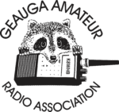
The GARA schedule of exams are these Sundays at 2pm. Dates for 2024 are Jan 14, March 10, May12, July 14, Sept 15, and Nov 17, 2024. All sessions are at 2:00PM each month

Exams are held at the Geauga County Department of Emergency Services and Emergency Operations Center, 12518 Merritt Road, Chardon, Ohio 44024. The EOC is located just south of the University Geauga Hospital and just east of the Geauga County Safety Center (Sheriff's Office), off of State Route 44 between State Route 322 and State Route 87 on Merritt Road.

Please arrive a few minutes before 14:00 to allow adequate time to process the necessary paper work and take your test. Bring your 1) photo ID, 2) email address, 3) FCC FRN, 4) a printout of your current license if taking the General or Extra exam.

Additional info may be obtained from Jackie Welch, N8JMW by email n8jmw2@gmail.ccom or calling at 440-228-2716. More information is available from the Geauga Amateur Radio Association website https://geaugaara.org

Huber Heights Amateur Radio Club
Huber heights amateur radio club does ARRL VE testing the second Saturday of each even numbered month. Feb, Apr, Jun, Aug, Oct, Dec. 9:30-11:00 For more information contact Jim Storms – AB8YK at ab8yk@hotmail.com

The Lake County Amateur Radio Association
The Lake County Amateur Radio Association is holding its 2024 Amateur Radio license exams at the Kirtland Library, 9267 Chillicothe Road, on the following dates:
Saturday. February 3 Saturday, August 3
Saturday, April 6 Saturday, October 5
Saturday, June 1 Saturday, December 7

This bi-monthly schedule is the first Saturday of every even-numbered month (e.g., February being the second month, etc.). They are held at the Kirtland Library, 9267 Chillicothe Road. It is 1.7 miles south of I-90 on Route 306 (Chillicothe Rd). The library is on the left, just beyond the Marathon gas station. The tests will start at 12 noon. Please arrive a few minutes earlier.
To register, you will need a NCVEC 605 Form, which will be available at the test. If you would like to complete one ahead of time, be sure it is the Sept 2017 version or later. You can find it by Googling “NCVEC quick-form 605” and clicking on the url for a pdf of the form. Please note the FCC requires you to provide a FRN (FCC Registration Number). Social Security Numbers are no longer accepted. If you are new to ham radio and don’t have a FRN, Google “New FRN” and follow the fcc.gov link.

If you are currently licensed, be sure to bring a copy of your license to the exam. The cost of the exam itself is $15.00, and if you wish to pay by check, it should be made out to the ARRL/VEC. Identification with your picture is also necessary, such as a driver’s license. If you have any questions, please contact Scott Farnham, KO8O, at (440) 256-0320, or scottfarnham@roadrunner.com

In addition to the $15 test fee, the FCC now charges $35 to add you to the Amateur Radio database. The FCC will e-mail successful candidates instructions for payment directly to them. Payment must be made within 10 days of the e-mail. This charge does not apply to upgrades.

The Lancaster and Fairfield County Amateur Radio Club (LFCARC) The Lancaster and Fairfield County Amateur Radio Club (LFCARC) hosts exam sessions on the first Saturday each month at 10:00 am in Lancaster Ohio at the Fairfield County EMA, 240 Baldwin Dr., Lancaster Ohio.
To register for an exam, Click Here.
Questions: Contact me at ve_testing@k8qik.org.

Lisbon Area Amateur Radio Association
LISBON AREA AMATEUR RADIO ASSOCIATION (LAARA) 2024 SCHEDULE.
VE TESTING IS AT THE COLUMBIANA COUNTY EMERGENCY MANAGEMENT AGENCY
AT 215 SOUTH MARKET STREET, LISBON, OH 44432.
SIGN IN AT 1 PM AND TESTING AT 1:30 PM.
VE TESTING DATES FOR 2024
JAN 13; FEB 10; MAR 9; APR 13; MAY 11;
JUN 8; AUG 10; SEP 14; OCT 12; NOV 9; DEC 14.
WE CAN ALSO GIVE THE TEST AT OUR REGULAR MEETINGS
THAT ARE NORMALLY ON THE 3RD THURSDAY OF EACH MONTH.
LAARA MEETINGS ARE HELD AT THE COLUMBIANA COUNTY
EMERGENCY MANAGEMENT AGENCY AT THE SAME ADDRESS AS ABOVE. SEE THE K8GQB.COM WEB SITE FOR UPDATES.
MEETING TIME IS 6:30 PM.
WE HAVE ACTIVITY MEETINGS ON THE ODD MONTHS AND
BUSINESS MEETINGS ON THE EVEN MONTHS.
Madison County
The Laurel testing group will offer testing on the first Thursday of January, March, May, July, September and November. Tests are held at 7:00PM at the Madison County EMA located at 271 Elm St. London, OH. No fee.
The Milford Amateur Radio Club (MARC)
VE testing is held the third Thursday of each month at 6:00 PM. Location; Miami Township Civic Center located at 6101 Meijer Drive, Milford, OH 45150.
Please pre-register at www.milfordhamradio.org

Northern Ohio Amateur Radio Society (NOARS)
Six VE testing sessions in 2024. Registration is appreciated but walk-ins are welcome. Contact Elaine, KC8FOS for more information or to register. ewilkinson1951@gmail.com or 216-337-4235
Saturday, Jan 6. Fairview Park Library. 21255 Lorain Rd., Fairview Park. 10 AM.
Sunday, March 10. NOARS Hamfest. Lorain County Community College. 1005 Abbe Rd. N., Elyria. 9 AM.
Saturday, May 4. Fairview Park Library. 21255 Lorain Rd., Fairview Park. 10 AM.
Saturday, July 20. NOARSfest. Lorain County Community College. 1005 Abbe Rd. N., Elyria. 9 AM.
Saturday, September 7. Fairview Park Library. 21255 Lorain Rd., Fairview Park. 10 AM.
Saturday, November 2. Fairview Park Library. 21255 Lorain Rd., Fairview Park. 10 AM.

Portage County Amateur Radio Service (PCARS)
The first Saturday of every even numbered month -10 am – at the PCARS club site in Ravenna. Please visit the PCARS web site and check out the information about VE testing in the latest newsletter at www.portcars.org .
If you have any questions, don’t hesitate to contact me at KB8UUZ@gmail,com

Tusco Amateur Radio Club W8ZX

VE Testing sessions are held on the second Saturday of every even numbered month at the Dover Faith Church, 420 N Wooster Ave, Dover, OH 44622. Pre-registration is not necessary. Doors open at 0830 for registration, exams begin at 0900. Cost is $15. You are required to have an email address and a copy of your FRN or current ham radio license. For more information please go to www.w8zx.net/exam or email VETEAM@N8BAG.NET.

Silvercreek ARA (SARA)
Hold six exam sessions per year for all license classes. Pre-registration requested but not required. Exam sessions for 2024:

Saturday, February 3rd - Wayne County Justice Center (Wooster)
Saturday, April 6th - Sharon Center UMC (Wadsworth/Medina)
Saturday, June 1st - Sharon Center UMC (Wadsworth/Medina)
Saturday, August 3rd - Wayne County Justice Center (Wooster)
Saturday, October 5th -Sharon Center UMC (Wadsworth/Medina)
Saturday, December 7th -Sharon Center UMC (Wadsworth/Medina)

All sessios begin at 10:00am. For directions and test information visit https://w8wky.org/license-exams/. Pre-Registration to expedite paperwork is requested, but not required at https://w8wky.org/sara-ve-registration-form/. Sign up and if you aren't ready or can't make it, just notify the VE team lead.

West Chester Amateur Radio Association (WC8VOA)Exam sessions are held one Saturday each month at 10:00 AM-Noon at the VOA Bethany Relay Museum located at 8070 Tylersville Rd, West Chester, Ohio 45069. For more information and links to register, please see our website: https://wc8voa.org/licensing/

____________________________________________________

Your Club news should be listed here!
I know you’re out there doing things! Send me a write-up (MSWord please) and some photo’s (.jpg please) and we’ll get your club hi-lited here for the other OH Section Clubs to see! Send to WB8LCD@ARRL.ORG

Important Links
ARRL Home: www.arrl.org
Find an ARRL Affiliated Club: www.arrl.org/clubs
Find your ARRL Section: www.arrl.org/sections
Find a License Class in your area: www.arrl.org/class
Find a License Exam in your area: www.arrl.org/exam
Find a Hamfest or Convention: www.arrl.org/hamfests
Email ARRL Clubs: clubs@arrl.org

2024 K3Y Special Event – Scheduled for July 26-28

The Dave Kalter Memorial Youth DX Adventure plans to participate in a 2024 Special Event as K3Y on July 27, 2024. K3LR Contest Group is hosting us at their station for this event. They will participate in the RSGB IOTA contest as a team of youth operators.

This is the second time a Youth DX Adventure event is being hosted in the USA. As K3LR is one of the largest stations in the world this adventure was truly special for the David Kalter kids and their parents. There were housing issues for our anticipated international trip.

The trip is sponsored by the Dayton Amateur Radio Association, K3LR Contest Superstation and DX Engineering.
This program is a Very Big Deal! Thank you to the sponsors and supporters. Please get on the air and give them a QSO!

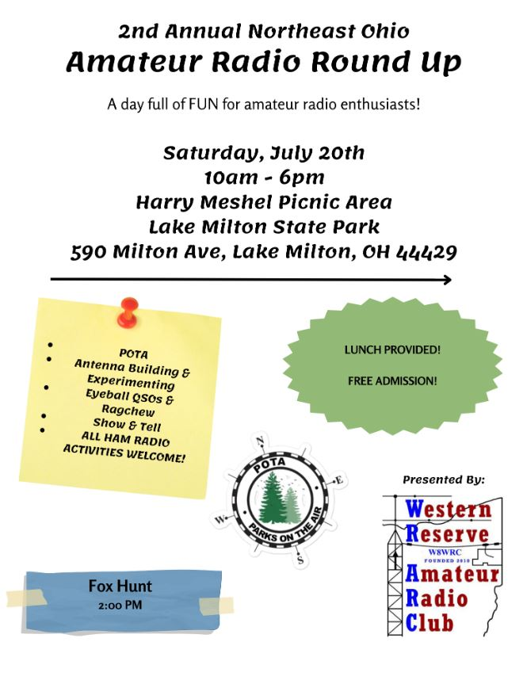

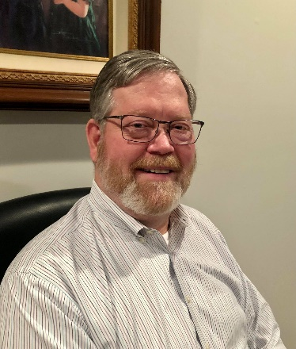
DX This Week – 6/29/2024
Bill - AJ8B (thedxmentor@gmail.com / www.aj8b.com )

Well, I have ended my first week of operating on 6M with 13 states and 8 DXCC entities. I did hear E51EME for a few minutes and THOUGHT I had Alaska worked. However, that station was an Alaskan transplant to Texas. Oh well. Have to keep digging.
There many hams who enjoy POTA and SOTA

DAH DIT DIT DIT DAH DAH DIT DIT DIT DAH
Here is what is happening in the World of DX:
This section of DX News comes from Bernie, W3UR, editor of the DailyDX, the WeeklyDX, and the How’s DX column in QST. If you would like a free 2-week trial of the DailyDX, the only source of real-time
DX information, just drop me a note at thedxmentor@gmail.com
We can start with an update on CY9C, St. Paul Island. Per WA4DAN, Murray, final preparations are being made for the August 26-September 5 CY9C DXpedition. A $1 million liability insurance policy has been secured, thanks to Fisheries and Oceans Canada. The team thanks the Northern California DX Foundation for its support, and also thanks DX Engineering for providing many of the items needed for a large DXpedition. WW2DX, Lee has set up and tested a six-element 6M Yagi, as well as EME gear and antennas. Packing is underway, with all antennas in ski bags. This is a “tent and generator” DXpedition; the team will have two 12-foot by 12-foot heavy duty tents and two 10-foot by 10-foot tents. All four tents are packed and ready for transport to Nova Scotia. Eight new Honda EU-2200i generators have been tested and are ready for transport. Final preparations are being made for backup antennas. N2TU, Lou, has done a great job with the CY9C Facebook page. Many photos have been posted of the final preparations. Last week, each operator on the team made the first of two financial commitments to the DXpedition. This will be the most expensive CY9 DXpedition ever. Donations are welcome to help offset this cost.
Much more information is on the CY9C website. (https://t-rexsoftware.com/cy9c/)

By this time, American Samoa, K8K, should be QRV until July 10. K8K, American Samoa. Fresh off his VK9LA operation, YL2GM, Yuris, will be in American Samoa to operate as K8K. The Northern California DX Foundation is providing financial support, saying that Yuris is one of the most prolific DXpeditioners today, and “wherever he goes with a radio, he can be counted upon to create quite a commotion on the bands.” QSL via Club Log OQRS or via YL2GN. Yuris will upload his logs to LoTW six months from now. More information is on his website.
Separately, it was reported that the alleged VK9LA 6M operation on June 22 around 0900 UTC was a pirate.
The 3D2Z Rotuma DXpedition team is looking for an additional youth operator participant because one of the “senior” operators of the DXpeditions six-member team has had to step down. They would like to take this opportunity to fill the operating position with a third “Next Generation” operator, age 21-35. Please contact W6IZT, Greg, if you, or someone you know, is interested in being a part of this November 2024 DXpedition or if you have any questions. (https://rotuma2024.com/ )
Get this one on the calendar. “The 7163 Group is pleased to announce our DXpedition to the Faroe Islands for June 1-10, 2025,” says WB2REM, Jim. They will be signing OY/home call, and plan to be active in the 2025 ARRL VHF Contest. In addition, they will be operating on 1.8 through 50 MHz on CW, SSB, and FT8/FT4. They will be running 100W with high-gain antennas. Some of the operators will use low power rigs for SOTA operations. QSL via WB2REM; each operator will use Club Log to post their QSOs. Additional details can be found at their website. (https://7163net.com/ )
ZL2KE and ZL4CZ, both named Steve, will operate from the South Cook Islands July 20-August 1. They will be on Rarotonga (OC-013) for the RSGB IOTA Contest, then on Aitutaki (OC-083) August 1-6. ZL2KE will sign E51KEE, while ZL4CZ will sign E51CZZ. There is some overlap between their schedules; E51KEE will arrive on Rarotonga one week before E51CZZ and will go to Aitutaki three days before E51CZZ. They say that they will mainly be on 20, 15 and 10M CW and SSB, and secondarily on 40, 30, 17 and 12M. Both 160 and 80M are “possible” depending on interest from DXers and local static levels. They will have two 100W transceivers, and their antenna setup will include verticals on the beach near a saltwater lagoon, end-fed long wires, and a two-element Yagi for 10M. This is a holiday trip, primarily for snorkeling, socializing, and sightseeing, and not a full-time DXpedition. QSL via IK2DUW.
JW – Svalbard - JW/WE9G from Longyearbyen, Rikk Lewis, with an IC-7100 and IC-7300, 100 watts, will be on the air July 8-20. This will be grid JQ78tf.
Some of his operations will be at the local club and others out on his own. Rikk expects to give it a go on 80-10 FT4/8, CW and phone. QSL direct to WE9G or go through LoTW, QRZ, eQSL and Club Log. This is IOTA EU-026, Spitsbergen Island.

VP6 - Pitcairn Islands - G0VDE, Bill, goes on a Pitcairn Island DXpedition in September, active between September 5-15. He starts by traveling to Tahiti August 31, stopping for a couple days, then taking Air Tahiti to Margareva Island (Gambier) September 3, then the "Silver Supporter,' the Pitcairn Island boat, for the 30-hour voyage to Pitcairn. He goes back to Mangareva September 17, and the next flight to Tahiti is the following Saturday, the 21st.

On July 9th, NL7RR, Tom, is heading back to Wake Island for a work assignment. He will be there for 14 days. It may take a day or two before he gets on the air. He will be QRV as NL7RR/KH9 in his spare time. Listen for him on or near 14.220 MHz on SSB between 0600 and 0930Z, provided he does not "have to work overtime".
F6ITS, Jean Louis, who is currently in The Gambia until the end of the year gives us a few more details about his currently activity as C5GM. He has updated his QRZ.com page. Jean Louis will only be operating from his boat, where he lives, and therefore the operations will not count for DXCC or the CQ Marathon.
K6ZO (aka 7Q6M), Don Jones, gives us some very good news from Malawi. First 16-year-old Malawian Blessings Msimuko (KC3ZHE) will be issued the callsign 7Q5BM later this week. Next 17-year-old Malawian Urgent Jere (KC3ZHC) will be issued 7Q6UJ by the end of the week. And finally, another Malawian teen Abraham Moyo (KC3ZHD), will be issued the call 7Q4AM by weeks end. This all thanks to the hard work of the teens along with support and encouragement of Don. K6ZO says the young men will be QRV breaking in their new calls either this Friday or Saturday. Thanks to the support of the Yasme Foundation all three will be attending YOTA Camp in Prague, Czech Republic August 16-23.

DAH DIT DIT DIT DAH DAH DIT DIT DIT DAH

Below is a list of upcoming contests in the “Contest Corner”. I think this is important for someone who is trying to move up the DXCC ladder since entities that are on the rarer side and easiest to work in contests. Some of my best “catches” have been on the Sunday afternoon of a contest when the rarer entities are begging for QSOs. Of course, the gamble is that if you wait until Sunday, conditions may change, or they simply won’t be workable. However, it is not a bad gamble. Of course, why not work the contest and have some fun!

Next week I will have more details on the upcoming IARU HF World Championship. However, here is a glimpse.
The purpose of this contest is to support amateur self-training in radiocommunications including improving amateur operating skills, conducting technical investigations, and intercommunicating with other amateurs around the world, especially IARU member society headquarters stations, using the 160, 80, 40, 20, 15 and 10 meter bands. (https://www.arrl.org/iaru-hf-world-championship )
Dates: The second full weekend of July (July 13-14, 2024).
Contest Period: Begins 1200 UTC Saturday and runs through 1159 UTC Sunday. Both Single and Multioperator stations may operate the entire 24-hour period.
Exchange: All stations send a signal report and ITU zone.

There is another contesting event that will be kicking off next week. That is the 13 Colonies event. The dates are July 1st through the 7th. The purpose is to work as many of the original 13 colonies states as possible. There are also 3 bonus stations that can be used to reach 13. One is in Pennsylvania, one is in England, and one is in France. The 13 colony states are Virginia, Rhode Island, Connecticut, Delaware, Maryland, Georgia, Massachusetts, New Jersey, North Carolina, New Hampshire, South Carolina, and Pennsylvania.
All HF bands will be in play, including the WARC bands, with the exception of 60 meters. Simplex on 2 meters and 6 meters is encouraged.
The SE stations are on the east coast and, are very close to each other. It will be harder for these states to contact each other so, use of 40m-160m is encouraged.
All modes of operation may be represented - SSB, CW, RTTY, Digital, Etc. The exchange is Callsign, Signal Report, and State.

The website is http://13colonies.us/ . Check it out, it is a lot of fun!

The latest episode of The DX Mentor has been posted and is now available wherever you get your podcasts and on the DX Mentor YouTube channel. The discussion this week is with K6TD, Kevin, and is focused on the Northern California DX Foundation.

Contest | Start  Date | End  Date
IARU HF World Championship | 7/13/2024 | 7/14/2024
North American QSO Party - CW | 8/3/2024 | 8/4/2024
10-10 Intl. Summer Contest, SSB | 8/3/2024 | 8/4/2024
WAE DX Contest - CW | 8/10/2024 | 8/11/2024
Maryland-DC QSOP | 8/10/2024 | 8/11/2024
North American QSO Party - SSB | 8/17/2024 | 8/18/2024
World Wide Digital DX Contest | 8/24/2024 | 8/25/2024
Hawaii QSOP | 8/24/2024 | 8/25/2024
Ohio QSOP | 8/24/2024 | 8/25/2024
Kansas QSOP | 8/24/2024 | 8/25/2024
Colorado QSOP | 8/31/.2024 | 9/1/2024
Tennessee QSOP | 9/1/2024 | 9/2/2024
All Asian DX Contest, SSB | 9/7/2024 | 9/8/2024
ARRL September VHF Contest | 9/14/2024 | 9/16/2024
Texas QSOP | 9/21/2024 | 9/22/2024
New Jersey QSOP | 9/21/2024 | 9/22/2024
CQ WW DX Contest, RTTY | 9/28/2024 | 9/29/2024
Maine QSOP | 9/28/2024 | 9/29/2024

OHIO’S 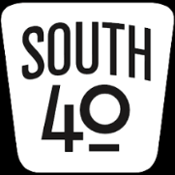

When during WWll the “Stimmen aus Amerika” (Voices From America-now known as the VOA) first signed on they stated “the news may be good or it may be bad, but it’s the truth”. And thus it is with that we start this column with a piece of bad, but quickly follow it with a lot of good.

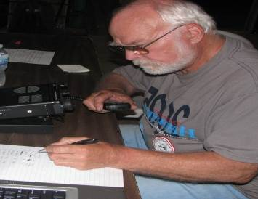
Paul Gehringer, WB8ZZR, of Wilmington was known throughout South Western Ohio not only for his knowledge and years of firefighting experience locally and at WPAFB, but for his years of dedicated service to the ham radio community. Clinton County ARA President Mark Atwell, WX8A, called him a key figure in the Club since its early days as he had held most of the offices, was involved with the Club’s repeaters and almost every other aspect of the Club. Paul was instrumental working with the newly relocated National Weather Service Office to Wilmington and helped reorganize SkyWarn to cover the newly created Wilmington coverage area in Ohio, Indiana, West Virginia and Kentucky. He was a great gentleman and friend. Field Day will be different without him this year. Services have been held in Wilmington. This year’s Clinton County ARA Field Day was dedicated to his memory.

It’s reported that Marilyn Brady, ex-K8MJB, of Wellston became a silent key on June 12. She was a member of the Jackson County ARA for many years.

Now for the happy stuff, and just in time to participate in Field Day, three individuals in the South 40 region now have been issued their Technician Licenses. In Brown County Christian Hipp from Mt. Orab is now KF8BOP. At the other end of the region Sharon Parr from Thornville is KF8BQG. Randy Sherman hailing from Stockport made the trip to participate in the joint Athens County ARA/Sunday Creek ARS test session at Athens and happily left with a CSCE earning showing he was KF8BQJ a few days later. We note Pickaway County has a new ham. Robert McNamara of Circleville is now KF8BRL.

The hamfest calendar for the South 40 indicates no hamfests or swap meets during July, but almost every August weekend shows there is one within an easy driving distance. The Columbus Hamfest will be held at the Shrine Center in Grove City on August 3. Then on Saturday, August 10, the Milford ARA sponsored Cincinnati Hamfest will be held at the Clermont County Fairgrounds in Owensville. On the 17th the action moves to Scioto County when the annual Portsmouth RC Hamfest takes place in New Boston. The Buffalo 10 Meter Net’s 4th annual swap meet is Saturday, September 21 and is held in conjunction with the annual Leavitt Funeral Home’s Festival and Car Show. The Pike County Fairgrounds at Piketon again hosts the Scioto Valley ARA’s hamfest on October 5. A new hamfest entry this year is the W8VCO Vinton County ARA swap fest on October 26 at the community building in McArthur. Now we can add Georgetown’s return on November 9.

Another fantastic piece of news is the return of the Grant RC’s hamfest at Georgetown. According to Ken Klosterman, KD8FKU, and Al Norris, W8UJM, the event will be held in Georgetown on Saturday, November 9. Until it was discontinued because of COVID, this hamfest marked the final one in the Southern Ohio-Northern Kentucky area for the year and was well attended with several vendor tables.

An interesting educational experience was given at the Athens County ARC’s Field Day on Saturday evening. Two ACARC members, KC8JRV and W8NZB gave an interesting introduction to fox hunting presentation. VHF fox hunting is an activity the ACARC and the Hocking Valley ARC enjoy.

Hamvention VE Testing Chair Chris Jebens, KZ8XU, informs us that 229 license elements were given during the two days of testing at this year’s Hamvention. 67 of those walked away with a new Tech license as a sovenier of Hamvention. Also a good number of others walked away with an Extra upgrade. One fellow walked in with no license and left with his Extra!

After several years at the Nazarene Church in Lockland, effective July 2 the OH-KY-IN ARS is relocating their monthly meetings to the Arlington Heights Town Hall, 601 Elliott Avenue. The Club also announces their July 13 Brunch Bunch gathering will be at the Pig Candy BBQ in California, OH, located at 5901 Kellogg Avenue on Cincinnati’s East Side and not far from the I-275/Kellogg Exit.

At February’s Highland ARA meeting, the starting time for the Club’s Monday Night Net was changed in anticipation an early starting time would increase participation. However that time change had the reverse happen with a decrease in check ins. Therefore at the recent June Club meeting, it was voted to revert the net’s starting time back to 9 PM year around. The new starting time will begin with the July 1 net.

Although the recent Lewis and Clark Trail event was not a contest, the upcoming September 7 Ohio State Parks on the Air is. The Portage County ARS is the sponsor for this popular event now approaching its 17th anniversary. A look at the OSPOTA.org website indicates only 25 of the 75 parks plan to be activated as of this date. 2023 saw 50 parks activated which was down from 60 the previous year. There are a good number of parks in the South 40 not showing activity. This means a good opportunity for a club or just an individual to spend some time in one of our state parks and make park chasers happy while you enjoy the out of doors. Ohio’s newest state park (Great Council) does not qualify this year for chasing. My recent observations during the L&CTOTA found a lot of people participating in the POTA and SOTA programs. Therefore I anticipate a lot of activity. You do not have to be in a park to participate. You can make contacts with parks from the comfort of your own shack. Or you can even operate as a rover and make contacts from a number of parks as your time and travel allows. It is a fun event. All kinds of good information and tips are available at the OSPOTA.org website. Also, if your club has already decided to participate by activating a park, please go ahead and list it on the website.

Members of the Athens County ARA will assist with communications at the Athens Gravel Challenge on July 20. It will be held at the Bailey’s Trail location. Contact Jeff Slattery, N8SUZ, at 740-541-0972 for information about how you can assist.

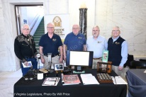
The West Virginia Museum of History and Technology was invited to have a display at the State Capital Building in Charleston during the recent West Virginia History Day. The Museum also held their annual Summer Swap Meet on Saturday, July 20 at the Museum with an outside trunk sale in addition to a large one inside and an auction of old radios that afternoon. A lot of information about the organization is at the www.mrtwv.org website.

The Jackson County ARA is in need of a certified tower climber. They are anticipating a new repeater site and they have no member who is a certified climber. If you know of someone who has the certification and is insured, please contact Julie Angle, KF8AJK at 304-445-1293.
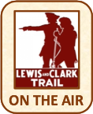
Ohio made a decent showing in the recent Lewis and Clark Trail on the Air operating activity. Between the two Ohio activators (the Portsmouth RC and Highland ARA) a total of 125 hours was spent on the air resulting in 3,099 contacts. Over 2,000 contacts were on SSB and about 650 on FT8/FT4. The balance were on CW. The two Kentucky activator participates logged 1,834 contacts and the sole West Virginia activator had 506 log entries. The 28 state activators recorded a record 36,740 contacts during 2,100 hours on the air. FT8/FT4 contacts exceeded SSB ones by around 200 QSOs. It’s noted the sponsoring Clark County (WA) ARA is looking for a second West Virginia activator club for next year’s event.

Athough Field Day is meant to be a training activity on how to prepare for the unexpected, the safety and well-being of those being trained is most important. Therefore the unusual heat wave that hit the South 40 caused some clubs to react and revise their Field Day locations to those more favorable to the health and welfare of those participating. The Athens County ARA relocated their operating site from the county fairgrounds to the comfort of air conditioning inside the Red Cross Building in Athens. The Portsmouth RC also moved from an outside activation into a cool building. The Vinton County ARA decided to pull the plug and not operate as did the Southern Ohio ARA. After my listing of planned FD activations had already gone to press, I learned the Jackson County ARC was holding Field Day at the Hammertown Lake and a non-club group of ham friends gathered at the N8BAP QTH near Highland.

Hat’s off to our elected ARRL officials whom became “road warriors” during FD Weekend. I haven’t heard what direction N8SY took, but both Roy Hook, W8REH, and Tom Sly, WB8LCD, made it into the hills of Southern Ohio’s South 40 region plus visited some Northern Kentucky sites. I understand some of their site visits were exceptional.

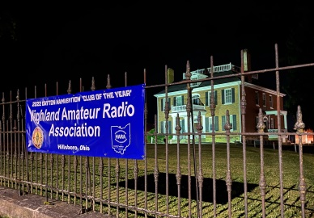
One of the stops those two “road warriors” made was at the Highland ARA’s set up in Hillsboro. After many years at a site near New Vienna, HARA relocated to a new location at the edge of Hillsboro’s entertainment/shopping area. Co-chairs John Willis, KE8JEM, and Jeff Collins, KD8VUY, stated that with some refinements next year, the site should serve the purposes well. They bet they were the only Field Day site in the nation to have a concert across the parking lot that sometimes even drowned out headphone use. Besides the “road warriors” they welcomed visiting hams from the Vinton County ARA, the Cincinnati and Sidney areas as well as a fellow ham from Connecticutt. (W8REH Photo)

Let’s finish up this week with a bit of history with a remote link to the world of ham radio. It concerns something each of us comes in contact with almost daily, but never pay attention to. It’s the bar code.

According to the current Smithsonian Magazine the bar code was first used on June 26, 1974 not that far from Ohio’s South 40. A customer at the Marsh Supermarket in Troy, Ohio purchased a pack of Wrigley’s Juicy Fruit chewing gum imprinted with a bar code. The idea for the development of the bar code was that of Norman Woodland and Bernard Silver. The code “was formulated from elongating Morse code’s vocabulary of dots and dashes, creating a system inspired by Woodland’s deep love of Morse as a Boy Scout”. The article does not indicate whether either of the creators ever held a ham license, but it would be rather understandable if they did. Who would have ever thought the bar code was inspired by the Morse Code?

That’s it for this week. Until next time don’t forget to keep cool, hydrated and radio active.
John Levo, W8KIW
jlevo@cinci.rr.com or highlandara@gmail.com or 937-393-4951 (landline-leave a message)

__________________________________________________________

ARLD024 DX news

This week's bulletin was made possible with information provided by The Daily DX, 425 DX News, DXNL, Contest Corral from QST and the ARRL Contest Calendar and WA7BNM web sites. Thanks to all.

MALAWI, 7Q. Marc, M0CMC is QRV as 7Q5MLV while working at Mzuzu University. He is active on 80 to 10 meters using CW and SSB. QSL via operator's instructions.

WEST MALAYSIA, 9M2. A large group of operators will be QRV as 9M4TOTA throughout the state of Terengganu on June 28 and 29. Activity will be on 80 to 10 meters using CW, SSB, and FT8. QSL direct.

PHILIPPINES, DU. Christian, F4EBK is QRV as DU3/F4EBK from Luzon Island, IOTA OC-042, until early 2025. Activity is on 20, 15 and 10 meters typically around 0900 and then after 2100z. QSL via F4EUO.

BOSNIA AND HERZEGOVINA, E7. Special event station E7100RADIO is the special call sign for the Bosnia and Herzegovina IARU member society ARAuBiH to celebrate 100 years of amateur radio innovation, community, and advocacy. QSL via operators' instructions.

ESTONIA, ES. Timo, OH1NOA will be QRV as ES0NO on Saaremaa Island, IOTA EU-034, Grid Square KO08, from June 30 to July 2. QSL to home call.

FRANCE, F. Special event station TM62FLAM will be QRV between June 29 and July 3 during the Olympic Torch relay. QSL via F5KAI.

ST. PIERRE AND MIQUELON, FP. Eric, KV1J will be QRV as FP/KV1J from Miquelon Island, IOTA NA-032, on July 2 to 16. He plans to operate on 80 to 6 meters using primarily SSB and FT8, plus some CW, RTTY, and FT4. This includes being an entry in the upcoming IARU HF contest. QSL to home call.

SAINT MARTIN, FS. Gregg, W6IZT and Hal, W8HC are QRV as FS/W6IZT and FS/W8HC, respectively, until July 2. QSL FS/W6IZT via KL7OR and FS/W8HC to home call.

WALLIS AND FUTUNA ISLANDS, FW. A group of operators are QRV as FW7JV from Wallis Island, IOTA OC-054, until July 2. Activity is on 160 to 20 meters. QSL via HA7RY.

ITALY, I. Members of ARI Genova will be QRV with special event station II1IALA from La Lanterna, the Lighthouse of Genoa, from June 29 to July 3. Activity will be on the HF bands approximately between 0700 and 1600z on a daily basis. QSL via IQ1GE.

MINAMI TORISHIMA, JD1. Take, JG8NQJ is QRV as JG8NQJ/JD1 from Marcus Island, IOTA OC-073, and here for about three months while working at the weather station. Activity is in his limited spare time on the HF bands using CW and some FT8. QSL direct to JA8CJY.

AUSTRIA, OE. Special event station OE70VIE is active until September 30 to commemorate the 70th anniversary of the Vienna International Airport. QSL via OE6VIE.

UKRAINE, UR. Special event station EM100WJZ will be QRV from July 1 to December 31 to commemorate the 100th anniversary of the first amateur radio activity from the ancient city of Lwow, now known as Lviv. QSL via UR4WWE.

TURKS AND CAICOS ISLANDS, VP5. Adrian, AA5UK is QRV as VP5/AA5UK Providenciales, IOTA NA-002, until July 5. Activity is holiday style on 40 to 6 meters using SSB, with RTTY, Olivia, and FT8. This includes some activity on various Satellites. QSL direct to home
call.

INDONESIA, YB. Operators YB9MKF, YC9MFD and YD9LAU will be QRV as home calls/P from Semau Island, IOTA OC-241, from July 4 to 7. Activity will be on the HF bands. QSL via operators' instructions.

CAMBODIA, XU. Tom, DL7BO is QRV as XU7GNY until July 21. Activity is on 160 to 6 meters using CW, SSB, and FT8. QSL via DL4WK.

THIS WEEKEND ON THE RADIO. The QRP 20-Meter CW Fox Hunt, NCCC FT4 Sprint, Weekly RTTY Test, NCCC CW Sprint, K1USN Slow Speed CW Test and the UFT QRP CW Contest are on tap for this upcoming weekend.

The RAC Canada Day Contest, K1USN Slow Speed CW Test, ICWC Medium Speed CW Test, OK1WC Memorial, RSGB 80-Meter Club CW Championship, ARS Spartan CW Sprint, Worldwide Sideband Activity Contest, ZL
Sprint, Phone Weekly Test, A1Club AWT, CWops Test, VHF-UHF FT8 Activity Contest, Mini-Test 40 CW and the Mini-Test 80 CW are scheduled for July 1 to 3.

The 13 Colonies Special Event runs from July 1 to July 8.

Please see June QST, page 28, July QST, page 81, and the ARRL and WA7BNM contest websites for details.
_________________________________________

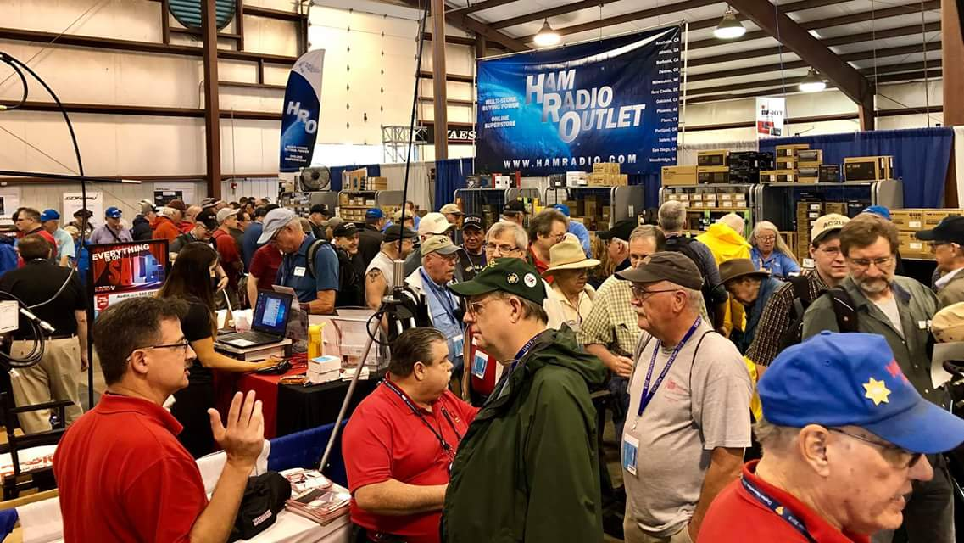
Upcoming Hamfests

We DO have hamfests scheduled for 2024!!

 | Ohio Hamfests
 | 2024
07/06/2024 - Mansfield Mid Summer Trunkfest  Location: Mansfield, OH  Type: ARRL Hamfest  Sponsor: Intercity Amateur Radio Club  Website: http://W8WE.ORG  Learn More |  | 07/20/2024 - NOARSFEST  Location: Elyria, OH  Type: ARRL Hamfest  Sponsor: Northern Ohio Amateur Radio Society  Website: http://www.noars.net  Learn More
07/20/2024 - Ashtabula County Hamfest 2024  Location: Pierpont, OH  Type: ARRL Hamfest  Sponsor: Amigos Radio Club Ashtabula  Website: https://sites.google.com/view/arca-home/  Learn More |  | 07/21/2024 - Van Wert Hamfest  Location: Van Wert, OH  Type: ARRL Hamfest  Sponsor: Van Wert Amateur Radio Club  Website: http://w8fy.org  Learn More
08/03/2024 - 2024 Columbus Hamfest  Location: Grove City, OH  Type: ARRL Hamfest  Sponsor: Aladdin Shrine Audio Unit  Website: http://www.columbushamfest.com  Learn More |  | 08/10/2024 - Cincinnati Hamfest  Location: Owensville, OH  Type: ARRL Hamfest  Sponsor: Milford ARC  Website: https://CincinnatiHamfest.org  Learn More
08/18/2024 - Warren Hamfest  Location: Cortland, OH  Type: ARRL Hamfest  Sponsor: Warren Amateur Radio Association  Website: https://www.w8vtd.com/  Learn More |  | 09/08/2024 - Findlay Hamfest  Location: Findlay, OH  Type: ARRL Hamfest  Sponsor: Findlay Radio Club  Website: http://w8ft.org  Learn More
09/22/2024 - Cleveland Hamfest  Location: Berea, OH  Type: ARRL Hamfest  Sponsor: Hamfest Association of Cleveland  Website: https://www.hac.org  Learn More |  | 10/05/2024 - Northwest Ohio Amateur Radio Club (NWOARC) Hamfest  Location: Lima, OH  Type: ARRL Hamfest  Sponsor: Northwest Ohio Amateur Radio Club, Inc.  Website: http://www.nwoarc.com  Learn More
10/27/2024 - 2024 MARC Hamfest at MAPS  Location: N. Canton, OH  Type: ARRL Hamfest  Sponsor: Massillon Amateur Radio Club  Website: https://www.w8np.net  Learn More |  | 12/07/2024 - Winter Hamfest  Location: Archbold, OH  Type: ARRL Hamfest  Sponsor: FCARC  Website: https://k8bxq.org/hamfest  Learn More

__________________________________________________________________

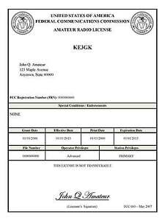
Print an Official or Unofficial Copy of Your Amateur Radio License
(By Anthony Luscre, K8ZT)

As of February 17, 2015, the FCC no longer routinely issues paper license documents to Amateur Radio applicants and licensees. The Commission has maintained for some time now that the official Amateur Radio license authorization is the electronic record that exists in its Universal Licensing System (ULS). The FCC will continue to provide paper license documents to all licensees who notify the Commission that they prefer to receive one.

Licensees also will be able to print out an official authorization — as well as an unofficial “reference copy” — from the ULS License Manager. I’ve created a set of instructions on how you can request an “official” printed copy of your license*

Click here to download the instructions

Final… Final

Because of continuing issues at ARRL, the list server is not available to send this out! So, if you’re seeing this, please send it along so that others will know that it’s now out.

Hamvention seemed to blur into Field Day weekend. Two really big Ham Radio events in rapid fire succession. Now we are moving into the “Hamfest” season! Lots of good events coming up in the Ohio Section, and beyond! Get yourself out there, see what everyone else is doing and pick up some new toys. This issue of OHIO Section Journal has covered a lot of ground, but, I’ll be covering FD over the next few weeks of PostScript. Send me your PICTURES and a short writeup of your event.
As Section Manager I received A LOT of Radio-grams over Field Day Weekend. The final step in the process is the delivery, and I want to thank everyone who made sure that delivery was made. It’s interesting to note that there is a whole system in place to make sure those messages get to the point of delivery, regardless of the destination – near or far. I’m talking about the National Traffic System (NTS). A strong, effective and efficient NTS is just one of the ways that Amateur Radio can justify it’s existence according to the Section 79 requirements. Unfortunately, it is not participated in by a large number of us hams, and it is virtually unknown to the public as a service that we can provide in times of distress.

Here's something I want you to think about: Get involved with the NTS. It doesn’t need to take over your amateur radio activities, once a week, (even once a month!), get involved, learn how it works, send some traffic. It’s simple and it’s easy. All you gotta do is “Do It”! An easy way to get started is to “originate” some traffic and put it into the system. I’m going to suggest that you put some traffic in addressed to someone who is not a Ham. That way we get some “contact” with a portion of the population that may not even know that we exist. Who could you send Birthday Wishes to? Anyone you know who deserves a Congratulations on something? Want to make contact with someone in government or media? Depending on who or what the correspondence is about, it could be followed up with an email or a letter giving a more detailed explanation of amateur radio and our ability to be an asset when things go bad. Don’t forget that when things are bad, “Health & Welfare” traffic could be a welcome message for those outside of the affected area.

I want you to think outside of the box on this one, but most importantly, familiarize yourself with the NTS and how it works. Gain some proficiency in traffic handling so when necessary YOU can be a part of a solution to the problem!

73,
Tom WB8LCD

“Swap & Shop” on the website
Hey Gang,

Have you taken a look at the Swap & Shop page on the Ohio Section webpage yet?? Here’s a link that will take you there…
http://arrl-ohio.org/sm/s-s.html

Do you have equipment that you just don’t need or want anymore? Here’s a great venue to advertise it, and it’s FREE!!

Is your club doing a fund raiser to help raise money? After a lot of thought, it was decided that the Swap & Shop webpage could also contain these types of items as well.

The same rules will apply as do for the For Sales and Give-A-Ways and will only be posted for a month at a time. Please see the Terms & Conditions on the webpage. You might want to list your location so that prospective buyers know where you’re at.

If your club is doing a fund raiser and wants more exposure, please forward the information to me and I’ll advertise it on the Swap & Shop webpage for you. Now, I still want to remind you that it won’t be listed in this newsletter because it would take up way too much space, so your ad will only appear on the website. It is there for any individual to post equipment Wanted / For Sale or Give-Away as well as for Club Fund Raisers. No licensed vehicles/trailers or business advertising will be posted.

Postings are text only (no pictures or graphics) will be posted for a maximum of 1 month from date posting and require a contact phone number or email within the posting. Send your Wanted / For Sale or Give-Away post to: swap@arrlohio.org

Back Issues of the PostScript and Ohio Section Journal

Hey, did you know that PostScript and Ohio Section Journal (OSJ) are archived on the website? You can go back and look at any edition simply by clicking:
http://arrl-ohio.org/news/index.html

Ohio Section Cabinet
Section Manager – Tom Sly, WB8LCD | Section Emergency Coordinator – Bret Stemen, KD8SCL
Technical Coordinator – Jeff Kopcak, K8JTK | Section Traffic Manager – David Maynard, WA3EZN
State Government Liaison – Bob Winston, W2THU | Affiliated Clubs Coordinator –  Amanda Farone, KC3GFU
Section Youth Coordinator – Anthony Lascre, K8ZT | Public Information Coordinator – E;izabeth Klinc – KE8FMJ

Chit – Chat, and All That!

Do you know someone that’s not getting these Newsletters? Please, forward a copy of this Newsletter over to them and have them “Opt-In” to start receiving them. Heck just have them send an email to: webmaster@arrl-ohio.org to be added.

We now have many thousands of readers receiving these newsletters weekly. Quite impressive, I’d say! I urge all of you to make sure that everyone, regardless of whether they are a League member or not, get signed up to receive these weekly Newsletters.
You can always “Opt-Out” at any time if you feel this is not what you were expecting. It’s fun and very informative. All of your favorite past newsletters are now archived too.
You can go back at any time and read them. Just go to: http://arrl-ohio.org/news/

The pictures on the front page and throughout this newsletter are from various newsletters, Facebook posts and/or were sent directly to me in recent weeks. Take a good look at them, you just might be in one of the pictures! “SMILE… you’re in the Ohio Section News!!”

The Ohio Section Journal (OSJ) is produced as a comprehensive look at all the programs within the Ohio Section. I sincerely hope that you have enjoyed this edition of the OSJ and will encourage your friends to join with you in receiving the latest news and information about the Ohio Section, and from around the world!

TOP^

