April 2024

From the Technical Coordinator | From the Section Emergency Coordinator
From the Public Information Coordinator | From the Section Youth Coordinator
From the Section Traffic Manager | ARES Training Update
From the Affiliated Clubs Coordinator | National News
Club Corner | Contest Corner
DX This Week | One Question Questionnaire
Special Events | Final.. Final..

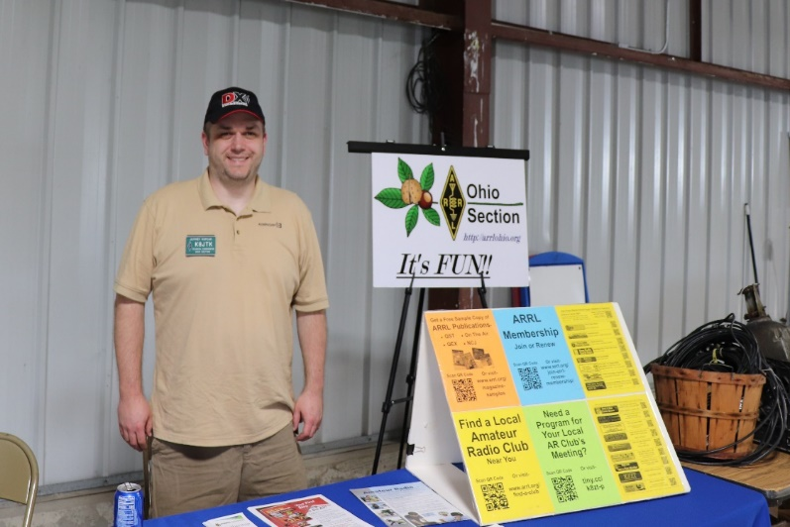
From the Technical Coordinator
Jeff Kopcak – K8JTK TC
K8JTK@arrl.net

Hey gang,
A couple months ago, the ARRL published news regarding the FCC amending Amateur Service rules. This change, which went into effect on December 7, 2023, removed the symbol rate (baud rate) restriction replacing it with a 2.8 kHz bandwidth limit on many HF bands. This change allows for greater flexibility, faster communication speeds, and greater options for digital modes on the low bands. Waivers are no longer needed in times of emergency temporarily granting faster communications such as later PACTOR modes.
Replacing the baud rate restriction with a bandwidth limitation on digital transmissions has brought more activity to the bands. More hams are experimenting with PACTOR. Winlink stations are utilizing the bandwidth to send in even more weekly net check-ins.
With the additional activity, there have been some unintended consequences. Stations are not checking to see if the frequency slice is available before transmitting. Other fly-by-night stations are not minding the volume level delivered to the radio leading to over modulated signals. To be fair, these have been happening for a long time and are not new challenges to efficient digital operators.
The problem with digital operation has gotten so bad the FCC is stepping in and considering a competency test for operating. Passing the test will result in issuance of digital endorsement for existing, valid, Ham Radio licensees. “This initiative will clean up the digital ham bands” according to Polly Ester at the FCC.
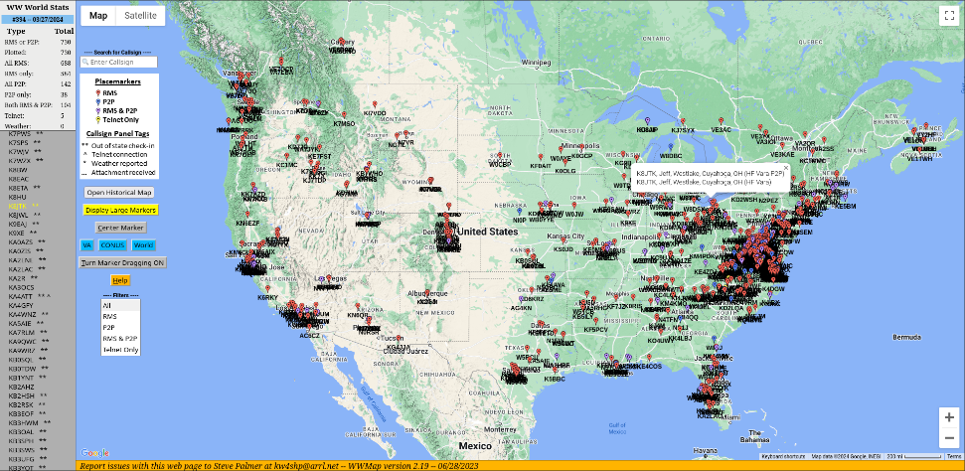The proposed rulemaking will involve candidates completing a written exam – similar to licensing exams given for Technician, General, or Extra. A second portion will involve a lab demonstrating the candidate can operate a station within accepted limits.
Winlink Wednesday check-ins (KW4SHP)
Written exam is expected to be taken from a question pool of 255 questions. The randomly selected 25 question multiple choice exam can be taken at any existing VE test session. Lab portion will be administered through FCC contracted testing companies that will be able to accommodate their testing requirements.
Debate was had if the FCC was going to administer the lab on their own or contract that portion out. Prior to the VE program, exams were administered when the FCC came to town. Restarting that program was explored. However, it was decided testing centers will conduct the lab portion.
Lab portion consists of using different software, computers, and radios – demonstrating operating ability to configure popular software applications on Windows, MAC, and Linux machines. Radios by common vendors will be selected at random. Radios could be anything from modern SDR radios to boat anchors - with none of the common connectors for digital operation. Proficiencies demonstrated include: adjusting sound levels from the computer, checking audio and transmit levels using radio meters and indicators, listen and check for other signals nearby, what to do when another station does not check if the segment is clear, selecting power output appropriate for the radio and duty cycle. Finally, operating in a crowded band. Details have not been released by the NCVEC if software simulating these activities will be available for practice.
Licensed operators whom have passed the written and lab portion will receive their digital operating endorsement and can operate digital at legal limit. Operators will be required to re-test every three years to refresh skills and demonstrate proficiency.
Stations without the endorsement will be able to operate digital at a maximum of 5 watts ERP. A second option of 10 watts will be available provided the station pars with a “monitoring” station. The monitoring station provides timestamped screen shots showing the segment on the waterfall which the station was operating. This screenshot of the waterfall and textual output of the segment will show there is no monkey business at a place called shenanigans. This evidence will prove stations are who they say they are and are following regulations.
Fines for stations operating without an endorsement or those with an endorsement, but not following proper protocols, will be based on frequency. For example, operating on without an endorsement on 14.233 will be $14,233 in fines.
These new regulations should lead to less interference, more contacts, and not blowing up equipment because someone is running full power at 100% duty cycle.
Thanks for reading, April Fools, and 73… de Jeff – K8JTK

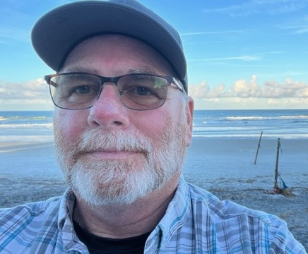
From the Section Emergency Coordinator Bret Stemen – KD8SCL EC
KD8SCL@gmail.com

Spring has Sprung
WOW! What a spring we have had so far and it’s just getting started. There have been 16 confirmed tornados so far in the State of Ohio since February. On March 14th, the severe weather event resulted in extensive damage across various counties in the State. Local communities and buildings were impacted, leading to ongoing assessments of the damage and the exchange of plans for managing debris at the local level. Recovery efforts are currently underway, with state and local initiatives focusing on debris removal. On March 17, 2024, the Governor of Ohio declared a state of emergency in 11 affected counties: Auglaize, Crawford, Darke, Delaware, Hancock, Licking, Logan, Mercer, Miami, Richland, and Union. The Ohio Department of Health has reported storm-related fatalities and injuries. Our thoughts and prayers go out to those who were impacted by the recent storms.

Are You Ready?
Are you prepared for the event that may happen at any time?
Most of the events are weather related and as we all know can happen at any time, from severe thunderstorms that cause power outages, tornados that can cause massive damage to towns, cities and counties (think of Logan Co) for example, this also includes severe winter weather.
Do you have an evacuation plan?
Do you run back-up power with a generator? Do you have extra gas for the generator?
Do you have an emergency kit?
What about a 72 hour food and water supply?
Do you have a go-kit?
For more information, you can visit:
https://www.ready.gov
https://www.redcross.org/get-help/how-to-prepare-for-emergencies.html

Again, the most important thing we can do is TRAIN! Our recent activations include several tornado outbreaks and severe storms across the state showed that it ~can~ happen to you and when it does it’ll come quickly! Our county EC’s and volunteers did a great job, ham radio was absolutely a star in this real-life event. The NWS Wilmington and Cleveland gave the amateur radio community a huge shout out thanking us for our service and commitment for our communities. I also want to thank everyone for their continued support to the Ohio Section ARES groups as well as all other amateur radio operators that were involved with communications during the recent storms, especially the Net Control operators. As I was running NC for Licking Co. I was also monitoring Columbus Weather N8WX on the 146.760 repeater, the NC did an awesome job keeping up with all of the reports that were pouring in as another operator was relaying the information to Wilmington.

April 8th is the Solar Eclipse event for about half of the Ohio Section! Most of the counties along the I-71 corridor and 3-4 counties wide are preparing for an influx of visitors into their county before, during and after the eclipse, we must keep in mind that there will be major traffic issues after the eclipse as everyone will want to head back home afterwards.

April 27th is another great day in the Ohio Section! That is the Ohio NVIS antenna day. You should know the drill by now- put together your concepts of what a good NVIS antenna should be like, and get together to actually try them out! Starting at 10AM, this is not exactly a contest, but it’s designed to get as many counties in Ohio on the air at once, all testing antennas and communications with each other. Since we’ve been written up in ARRL’s national news, I have received numerous inquiries from as far away as Texas! I think this is going to be just a fun way to get together, play and test in our hobby, and munch some great burgers!

I sincerely appreciate all you do for your neighbors, and for the Ohio Section!

______________________________________________________________

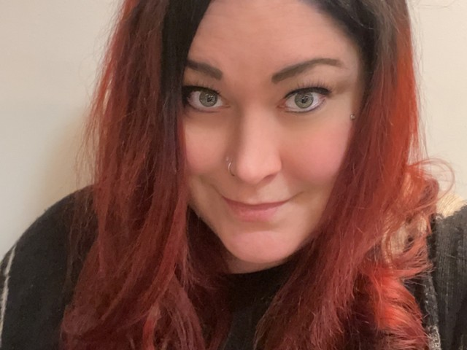
Elizabeth Klinc, KE8FMJ
OHIO Section Public Information Coordinator
ke8fmj@gmail.com

ing Media Relationships is another item on the list that a PIO should do. Five tips to develop better relationships with Media are:

- Personalize Your Pitch.
- Communicate Consistently.
- Share Your Hits.
- Follow and Interact on Social Media.
- Show Your Gratitude.

An exert from the ARRL PIO Handbook:

Knowing and Using Your Resources

When a PR opportunity knocks, your challenge is to organize your resources quickly so
that you will be able to use them and respond most effectively.

What do we mean by "resources"? What kinds are there and how do we use them? We
need to think of resources on the Amateur Radio side as "sources" of information, while resources on the media side can carry that information for you to the public you want to
reach. These media resources are the "purveyors" of news.

While your role may at times be that of a broker or middleman in the process of
conveying information across from one side to the other, there are other times when you will yourself be the source of the story.

Let's look at the resources you have available to you as a public information specialist.
How well you are able to use these resources will determine how effective you will be.

The Media “Toolbox”

For most of us, learning the news business is not all that difficult. Most towns, except for
the largest, have a local newspaper, possibly one or more radio stations and maybe even one or more TV stations or cable outlets. Getting to know who is who at each one is usually a simple matter of paying attention or making a phone call.

Newspapers list their editorial staffs on the editorial page. Individual reporters often have
by-lines. Also, a simple phone call to the local radio or TV station will almost always
produce this information easily. Unless you enjoy working under the handicap of a cold
start, don't wait until a story hits to uncover that information and cultivate these resources
whenever and however possible.

The Internet is a newer outlet, and chances are your community is served by web sites that
are central repositories for information. If your club maintains a web site, it is a great
place to send reporters for information about your organization and its activities. And of
course, there's the ARRL web site, which has a storehouse of information and background material for the media as well as the general public. Don't overlook these valuable resources.

Picture yourself with a hot story, trying to explain it to an editor who has never heard of
Amateur Radio. You will be expecting him to absorb a lot all at once and he is likely to
think that it is all just too complicated and esoteric to catch his readers, listeners or
viewers.

It is better to start earlier by feeding him articles whenever you can on more mundane
things like the election of officers at your club, a ham flea market or an annual banquet.
These will help open a channel of communication as well as establish you in his mind as
a source of information. Then, when you need him, you will be able to call on a reservoir of knowledge and good will you have helped to build.

News people and editors are not strange gnomes hidden away in unapproachable recesses of their offices or studios. They cannot afford to be and, in fact, they probably need news
sources like you more than you need them. Their livelihoods depend upon being able to
tap knowledgeable and credible sources of information on a wide variety of subjects. The
idea is to make yourself one!

What do you do if a reporter calls on you for information or even an interview? The
answer probably depends to some extent on the type of media involved and how much notice you get.

With a little notice, it is probably a good idea to prepare a statement or a press release in
advance. This will give you focus during the interview and help channel your thinking,
and the reporter’s, so that you cover all the points you want to make. Reporters appreciate people who make their jobs easier by giving them handouts, especially on subjects about
which they may have only a partial understanding.

If the reporter plans to bring along a photographer, he or she will usually tell you that in
advance. If he does, dress for the occasion, clean up the shack or do whatever else is appropriate so that you will present yourself and Amateur Radio in the best light. The
same considerations apply to radio or TV coverage but the emphasis changes subtly. In
radio for example, the focus is on voice timbre, vocabulary, elocution and the like, while on TV, personal appearance, expression and mannerisms are added dimensions. Each is important and each should be considered carefully, even to the point of selecting spokespersons or settings whose images will be conveyed best in the particular medium. The task of getting yourself known, and respected, is obviously simpler in a small town and it is not a bad idea to call at the local newspaper office to introduce yourself to the editor. Take along some information on Amateur Radio and explain what we do, who you are and the kind of activities you, your club or group conducts. Ask him for his support and how you can help him: He may tell you how he would prefer you to submit stories, what the paper's deadlines are and provide you with other information which could make both your jobs easier.

Amateur Radio Resources

You need to develop your own resources, on the Amateur Radio side of things. This
requires quite a bit of effort. Your experience and knowledge of other hams and clubs in
the area will need to be tapped. A little attention here - before an actual need arises – can be a godsend when a story does break.

Years of experience do not necessarily invest any of us with all- encompassing knowledge. If a story were to develop involving packet radio, for instance, would your understanding be comprehensive enough to answer questions intelligently? If it is, how about other aspects of Amateur Radio such as UHF, space communications, DX or traffic handling? Could you speak with equal expertise on each?

Few of us are competent in all the diverse areas of Amateur Radio and, for that reason,
you need to develop a list of resources available to you in covering the broad range of our interests.

There are many ways to develop an "inventory" of experts. A good place to start is to
prepare a list of subjects which you might be called on to cover. You can proceed from
there by trying to match each subject with the name of an individual who is expert in that area. At the same time, get the name of a backup to call on in case your first choice is not available. Develop a skills inventory list for members of your club.

Be sure to get telephone numbers and any other information you might need to work with
your resource people so that you will be able to reach them on short notice. You may
need quick access to your contacts at unpredictable times. Be ready.

Be sure to let the people you pick know that they are on your list of experts so they might be better prepared when a story develops and, just as importantly, to let them know of
your interest.

Pick people who are knowledgeable, of course, but be mindful, too, that they may
become spokespeople for Amateur Radio when a story breaks. Whenever possible, pick
people who will be seen as articulate and responsible and who will be as agreeable-
sounding and -appearing as possible.

Give some thought, too, to the settings used for your stories. Invite the media to meet with you at a well-organized, photogenic shack where the background is going to help you convey the image you want to project.

At first thought, it may seem that you cannot always control location but, even on a Field Day story, which is going to be set in whatever spot the group happens to have selected or the activity, there are a number of things you can do. You can clean up the site before the news people arrive, steer them to the best-looking setups and away from ones establishing new lows in unsafe wiring, which will probably show up with remarkable clarity in the background of any photos taken. (And clear out any beer cans, too. Same reason). At the same time, don't make it seem like you're hiding something, or that may quickly become the focus of the story.

The whole idea here is to go about your task with as much prior preparation and as much professionalism as possible. The more work you do "up front," the easier it will be to
react quickly and effectively when the need arises.

For most people, "meeting the press" is a stressful situation which is confronted rarely in
their lives and thorough preparation is a certain way to remove most of this stress from
these encounters. If you can accomplish that, you will be able to deal more effectively with the opportunities presented and make the most of them. You will be shaping the
reporting rather than simply being part of it.

------------------------------------------------------------------
Elizabeth Klinc, KE8FMJ

OHIO Section Public Information Coordinator
District Emergency Coordinator, D3 Ohio ARES
Assistant Emergency Coordinator, Greene County
ARRL - The National Association For Amateur Radio™
__________________________________________
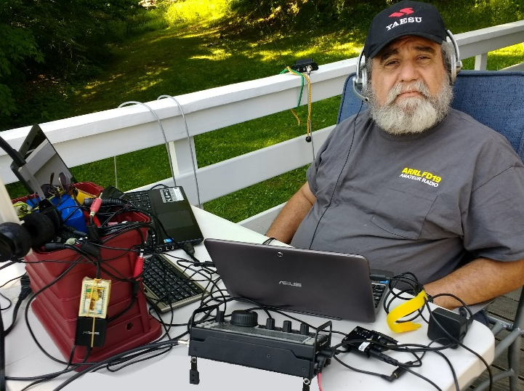
From the Section Youth Coordinator
Anthony Luscre, K8ZT - SYC
k8zt73@gmail.com

Amateur Radio Quick Start Guide

I teach many license classes and am also involved with VE license tests. But some of the most interesting questions I get are after individuals have received their licenses. They typically involve something along the lines of “I got my license, but how do I get on the air?” After a recent phone call along these lines, I gathered some new materials and some of my previous resources. I focused mainly on VHF/UHF, as that is what most Technician licensees usually start with, but I have also included some links to HF tips. It also fits in well with Easter and its Rabbit Logo this weekend.

My column might seem short this month, but rest assured there are hours of reading and videos in the “Amateur Radio Quick Start Guide.” It is packed with resources, and you will need to follow this link to read it—tiny.cc/arqsg. I also need you to share the link with your friends, especially those not receiving this newsletter, who are not members of a local Amateur Radio Club, or who are not yet licensed Amateur Radio Operators.
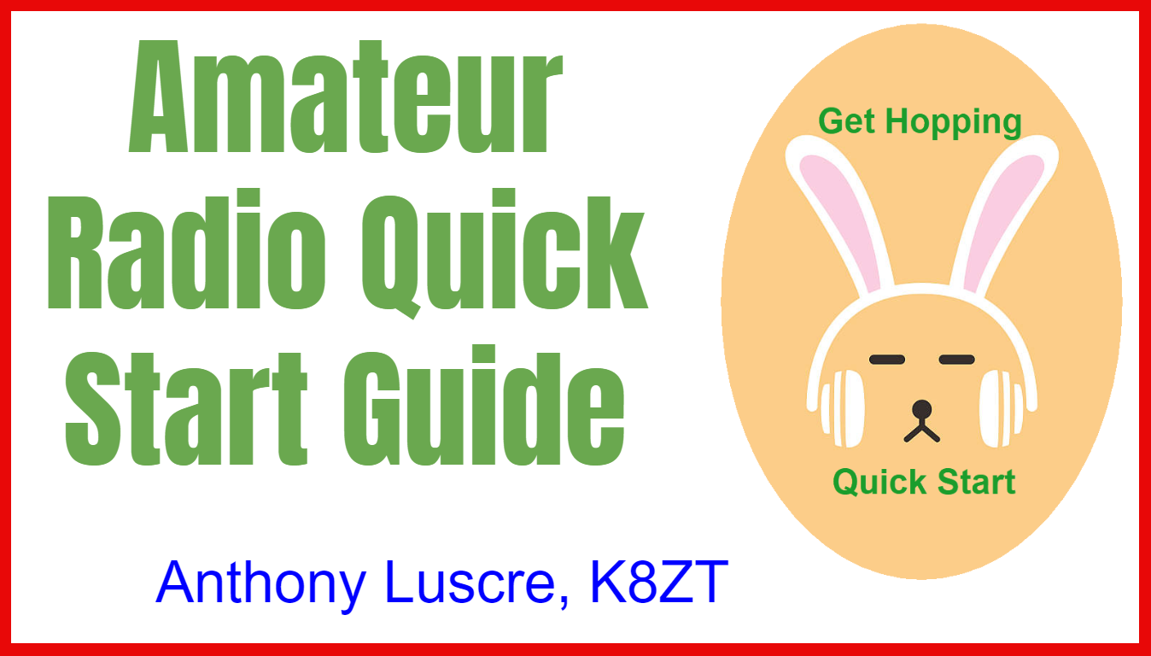
ARRL Teachers Institute on Wireless Technology

Now Accepting Applications for ARRL's Teachers Institute 2024- for more information or to apply, visit this link.

That’s it for this month; I hope to work you on the air soon!
73,
Anthony

________________________________________________

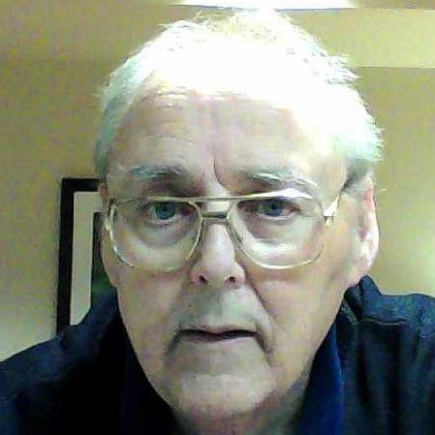
From the Section Traffic Manager David Maynard, WA3EZN – STM
wa3ezn@att.net

If you looked for my news article in the March 2024 Ohio Section Journal and couldn’t find it here is why. There wasn’t one. I was locked out of the internet because of that AT&T fiasco. I went for almost six weeks without home internet and they said it was a wide area outage and they would let me know when it was fixed. Well, that just didn’t happen. Finally got someone on the phone who said the line was all clear to my DSL modem so my modem must be bad. Fat chance of that because as soon as they hung up a miracle happened, I mysteriously had internet access. It sill is intermittent and I can’t change sources or I will loose all the picture and videos on their system sent to me by family members. Moving on…

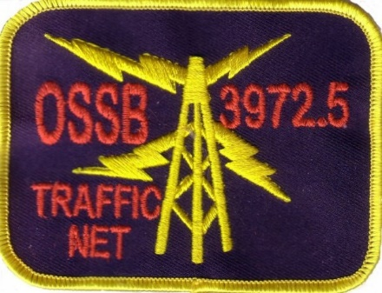

OHIO SINGLE SIDEBAND NET
The affairs of the OSSBN shall be under the control of the net manager and an advisory board comprised of three members. The net manager and one advisory board member shall be elected each year.

On March 1st the net manager appointed a nomination committee of three members with the second-year advisory board member as chairman. A slate of nominees for advisory board and net manager were presented to the net on March 23. On March 22 the net manager appointed a teller (Ray KB8GUN) who announced the candidates and will call for nominations from March 23 through March 31. Nominees must be members of OSSBN and agree to serve if elected. The teller shall call for votes from the members of the net from April 1st through April 7th and shall on April 8th announce the results of the election. The winner in each case shall be that nominee who has received the most votes for each position. Duties of the elected net manager shall commence on May 1st. Voting may be by radiogram, email or phone call. Check into the net for further voting information.

NOMINATION COMMITTEE REPORT

Candidates for Net Manager
KC8WH
N8OD

Candidates for Advisory Board
KE4RS
KD8UUB

Current Net Manager – KC8WH
Current Assistant Net Manager – K8MDA

Current Advisory Board
K8KRA 2021
W8GSR 2022
KB8GUN 2023

If you wandered if you are an OSSBN member you can find the membership roster on their website, www.OSSBN.ORG.

If you have traffic you need to move, take it to a VHF net or if it is going out of Ohio you can take it to the OSSBN. Here is WHERE TO FIND AN HF OR VHF TRAFFIC NET IN OHIO
OHIO SINGLE SIDEBAND NET

Morning session | 10:30 AM | 3972.5 KHz | every day
Afternoon session | 4:15 PM | 3972.5 KHz | every day
Evening session | 6:45 PM | 3972.5 KHz | every day

OHIO HF CW TRAFFIC NETS
HF CW NETS | NET TIMES | FREQUENCY | NET MANAGERS
Buckeye Early | 6:45 PM | 3.580 | N2LC
Buckeye Late | 10:00 PM | 3.590 | WB9LBI
Ohio Slow Net | 6:00 PM | 3.53535 | N2LC
All CW net frequencies plus or minus QRM

OHIO LOCAL VHF TRAFFIC NETS
VHF NETS | NET TIMES | FREQUENCY | NET MANAGERS
BRTN | Monday, Thursday Saturday 9:30 PM | 145.230 PL 110.9 | KD8GXL
COTN | 7:15 PM DAILY | 146.970 PL 123.0 | KV8Z
TCTTN | 9 PM Sun, Tues, Fri | 147.015 PL 110.9 | WB8YYS
TATN | 8:00 PM DAILY | 146.670 PL 123.0 | WG8Z

OHIO VHF TRAFFIC NETS

BRTN Burning River Traffic Net serving Cleveland and North Central Ohio
COTN Central Ohio Traffic Net serving Columbus and Central Ohio
TATN Tri-State Amateur Traffic Net
TCTTN Tri-County Traffic and Training Net serving Northeast Ohio

TORNADO AWARENESS

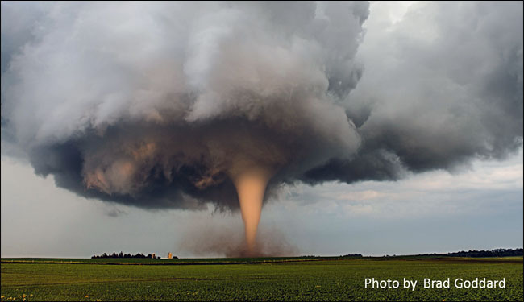

There were ten confirmed tornadoes already this year in Ohio. A significant early spring tornado outbreak occurred in the Midwest and into Ohio in the month of March. More than two dozen tornadoes occurred, eight of them strong-to-intense. Tornadoes produced heavy damage in the Ohio communities of Wapakoneta, Lakeview and Plymouth. At least three people were killed in Logan County, Ohio in the Lakeview tornado, and dozens were left injured or missing,
The Spring Severe Weather Awareness Week and the Ohio Statewide Tornado Drill were held in March. Here is a source of some information from this website http://www.weathersafety.ohio.gov/TornadoFacts.aspx.
If you need more information just Google Tornado and you can also be overwhelmed with the information available, the stories being told and the pictures of the total destruction of businesses, homes and communities. Final Words: PREPARE NOW!!
More useful links to preparedness info:
http://www.eham.net/articles/7176
http://www.kidney.org/atoz/pdf/DisasterBrochure.pdf

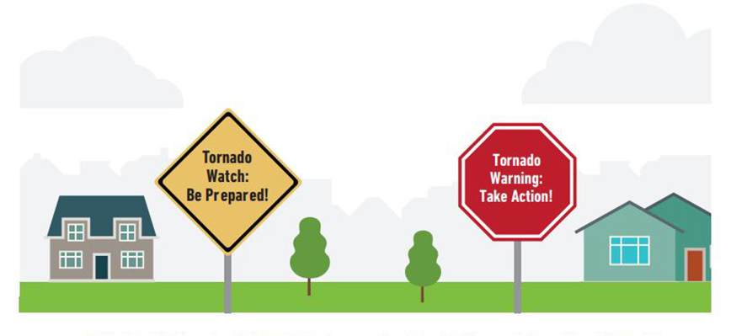
>>Tornado Facts..
As the severe weather season approaches, take some time during to make a safety plan for your family, friends, neighbors and co-workers. Planning will lower the chance of injury or death in the event severe weather strikes.
Tornadoes develop from severe thunderstorms. They are usually preceded by very heavy rain and/or large hail. A thunderstorm accompanied by hail indicates that the storm has large amounts of energy and may be severe. In general, the larger the hailstones, the more potential there is for damaging winds and/or tornadoes.
The most violent tornadoes are capable of tremendous destruction with wind speeds of 250 mph or more. Damage paths have exceeded the width of one mile and 50 miles long. Tornadoes generally move from southwest to northeast but have also been recorded traveling in any direction. The forward speed of a tornado varies from 30 mph to 70 mph.
Peak tornado season in Ohio is generally April through July, and they usually occur between 2 p.m. and 10 p.m. However, this year in March there were already four tornadoes in Ohio on March 3, one each west of Hillsboro, south of New Vienna, west of Bethal and northwest of Frankford which proves that tornadoes can happen at any time, during any season.

>>Fujita Tornado Damage Scale - By Category
The Enhanced Fujita Scale is a set of wind estimates (not measurements) based on damage. It uses three-second gusts estimated at the point of damage based on a judgment of eight levels of damage.
Enhanced Fujita Scale
OPERATIONAL EF SCALE
EF # = 3-Second Gust (MPH)
0 = 65-85
1 = 86-110
2 = 111-135
3 = 136-165
4 = 166-200
5 = Over 200
NOTE: Prior to February 1st, 2007, tornadoes were rated according to the “F” (Fujita) scale rather than the newer “EF” (Enhanced Fujita Scale). Click on the Storm Prediction website http://www.spc.noaa.gov/efscale/ for additional information regarding the “F” and “EF” scales.
> Tornado Safety Tips
Whether practicing in a tornado drill or sheltering during a warning, the Ohio Committee for Severe Weather Awareness encourages Ohioans to DUCK!
D - Go DOWN to the lowest level
U - Get UNDER something
C - COVER your head
K - KEEP in shelter until the storm has passed
* Take responsibility for your safety and be prepared before a watch or warning is issued. Meet with household members to develop a disaster plan to respond to tornado watches and warnings. Conduct regular tornado drills. When a tornado watch is issued, review your plan – don't wait for the watch to become a warning. Learn how to turn off the water, gas and electricity at the main switches or valves.
* Despite Doppler radar, tornadoes can sometimes occur without any warning, allowing very little time to act. It is important to know the basics of tornado safety. Know the difference between tornado watches and tornado warnings.
* Tune in to one of the following for weather information: NOAA Weather Radio, local cable or television (Ohio News Network or the Weather Channel), or local radio stations.
* If you are a person with special needs, register your name and address with your local emergency management agency, police and fire departments before any natural or man-made disaster.
* NOAA Weather Radio has available an alerting tool for people who are deaf or have hearing impairments. Some weather radio receivers can be connected to an existing home security system, much the same as a doorbell, smoke detector or other sensor. For additional information, visit:

https://search.usa.gov/search?v%3Aproject=firstgov&query=SPECIAL+NEEDS&affiliate=nws.noaa.gov

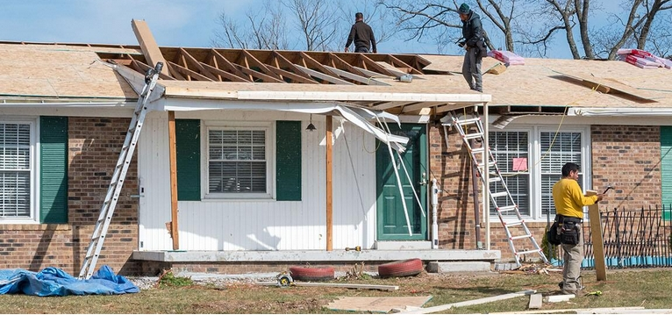
* The safest place to be during a tornado is a basement. If the building has no basement or cellar, go to a small room (a bathroom or closet) on the lowest level of the structure, away from windows and as close to the center of the building as possible.
* Be aware of emergency shelter plans in stores, offices and schools. If no specific shelter has been identified, move to the building's lowest level. Try to avoid areas with large glass windows, large rooms and wide-span roofs such as auditoriums, cafeterias, large hallways or shopping malls.
* If you're outside or in mobile home, find shelter immediately by going to the lowest level of a nearby sturdy building. Sturdy buildings are the safest structures to be in when tornadoes threaten. Winds from tornadoes can blow large objects, including cars and mobile homes, hundreds of feet away.
* If as a last resort you cannot quickly get to a shelter, get into your vehicle, buckle your seat belt and try to drive to the nearest sturdy shelter.
* If you experience flying debris while driving, pull over and park. Choose to either stay in your vehicle, stay buckled up, duck down below the windows and cover your head with your hands, or find a depression or ditch, exit your vehicle and use your arms and hands to protect your head. Never seek shelter under highway overpasses and bridges.
Tornado Loss Prevention Tips
The following steps are suggestions that homeowners should take before a tornado or other natural disaster occurs to assure speedy and hassle-free recovery. Catalog your belongs, room by room. Once completed, you can add items and photos to a thumb drive for easy access. Maintaining a comprehensive inventory will come in handy, should you need to file a claim or reevaluate the amount of insurance you carry. It's good for renters, too.
> Home Coverage and Preparedness Tips
* Tornado losses are most often covered by the "windstorm peril" under the homeowner's insurance policy.
* Check with your homeowner insurance agency to assure adequate coverage is provided by the policy. Notify the insurance agency of any additions or improvements to the home.
* Consider purchasing the replacement cost coverage endorsement for the home and its contents. It would give the option to rebuild or replace damaged property at current costs rather than depreciated values.
* If you experience a storm-related loss to your home that is covered by your insurance, notify your insurer in a timely manner, as required by your policy.
* Home Inventories Assist in Settling Claims
* Videotape, photograph or compile a written inventory of your home and belongings.
* Keep the inventory off premises in a bank safe deposit box. The inventory will provide a record for you and the insurance company, should a loss occur.
* Update your inventory every time you move or every two to three years.
> Written Inventory Tips
* Go through each room of the home and list every item. Include the purchase date, price and model numbers.
* Include professional, written appraisals of antiques, jewelry and other costly possessions.
> Video or Photo Inventory Tips
* Pan the camera around the room to capture all items. Obtain close-ups of expensive items such as jewelry, china and furs.
* Consider grouping items for easier inventory.
* Narrate the video by noting purchase costs and dates. Include model and serial numbers for appliances and electronic devices.
> Auto Coverage and Preparedness Tips
* If there is threatening weather, shelter vehicles to prevent damage from winds, flying debris and hail.
* Vehicles are protected under the "other than collision" (comprehensive) portion of an auto insurance policy, if damaged by windstorms or hail.
> After the Loss - Insurance Tips
* Photograph any damage and inventory losses. Photos will assist when settling claims.
* Secure property from further damage or theft and save related receipts, since many insurers will reimburse for these expenses.
*If required to seek temporary housing due to a covered loss such as a tornado, check your policy for "loss of use" coverage. Many policies cover such expenses up to a stated amount.
http://www.weathersafety.ohio.gov/TornadoFacts.aspx
www.Weather.gov/safety/tornado

www.Weather.gov/safety/tornado-prepare

What about your family? Here are some items you can do now to be prepared in the future.

Sit down with your family members and decide how you will get in contact with each other in an emergency.
Once you figure this out, document the contact information on both a master sheet and on wallet sized cards to be carried by all family members. This document will become your “Family Communication Plan” and it will form the cornerstone of your family emergency plan. It will list all family members, their date of birth, and other important information. Include a photo for each person as well as any important medical information. Also include a contact number for an out-of-town contact person.

Determine a meeting place where you will meet in the event you can not get home. This may be your workplace, the home of a parent or relative, your church or even at a school if there are children involved. Whatever you decide, you will need at least three possible locations.

Determine the best evacuation routes from your home or workplace to the safe meeting places. Then take the route and make sure it is accurate and that you understand the directions.

Prepare a list of all workplaces along with the address, telephone number, and closest evacuation location in the event getting to the pre-designated meeting place is not possible. Also prepare a list of all schools that are attended by your children along with the address, contact names, and telephone numbers. Contact the schools now to learn about their own emergency evaluation policies and procedures.

Prepare a list of your doctors and your veterinarian along with their telephone numbers. Include a list of medical conditions and prescription medications that are being taken.

Prepare a list of your insurance policies, including the carrier, the telephone number for claims, and the policy number itself. Include health insurance, homeowners or rental insurance, life insurance policies.

Be aware, however, that phone lines and cell service may not be functional following a catastrophic disaster. Although a valuable tool, do not count on your phone to be the sole mode of communication following a disaster. If you text, you might want to consider a “texting tree”. Texting is usually available even when cell service is down.

Store all the information you have carefully compiled in multiple locations. For example, in a preparedness binder, on a flash drive that you carry with you, In your desk drawer at work or in an email attachment sent to yourself at one of the email services that you use.

73
David, WA3EZN
Ohio Section Traffic Manager

___________________________________________

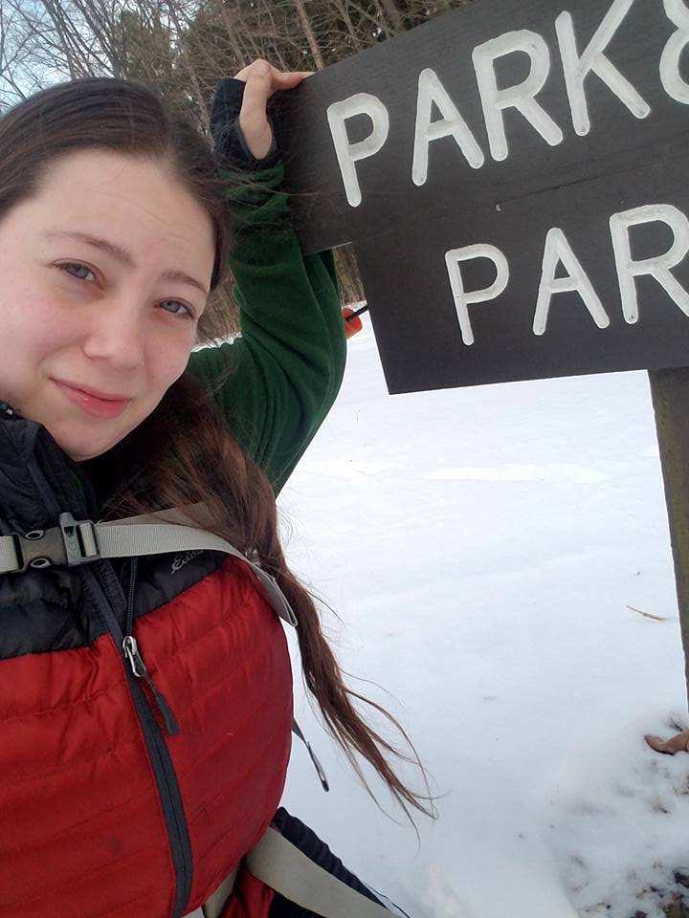
Amanda Farone, KC3GFU
ARRL Ohio Section | Affiliated Club Coordinator
Afrone926@gmail.com
330-509-4095

This month I would like to spotlight another FANTASTIC club in the great Ohio Section, Highland Amateur Radio Association!

After the founding of the Clinton County ARA, many Highland County hams joined that club and within a couple years the members from Highland County exceeded those living in Clinton County. Therefore some CCARA members suggested they felt that

Highland County could support their own organization and the CCARA would support an attempt to form such. Thus in 1977 20 Highland County amateurs met in Hillsboro and the Highland ARA was born. Five of those charter members survive.

Club Name: Highland Amateur Radio Association
Location: Hillsboro, Highland County, OH
Established: 1977
# of Members: End of 2023. 119. Currently 89.
Officers:
Ken Lightner, KE8JEL, President
John Willis, KE8JEM, Vice President
Kathy Levo, N8ZNR, Secretary/Treasurer
Dan Carruthers, KE8NPS; Tom Archibald, K8TDA; and Jeff Collins, KD8VUY – Trustees

Meeting Time & Location: Second Tuesday evening of each even numbered month. Summer meetings occur at the Hillsboro City Park or at other locations as announced. Winter meetings are at the Highland County EMA Office in Hillsboro.

Q: What is your favorite thing about your club?
A: The warmness of the members to new hams and visitors plus a willingness to assist those new to the hobby.

Q: What is one event your club does that you are proud of or sets you apart from other clubs?
A: For the past several years, prior to Memorial Day HARA has assisted the Hillsboro Cemetery Association place flags on the graves of the Veterans who are buried in the cemetery and then return following July 4 to remove them. This event has gotten the club national exposure.

Q: How do you attract new members?
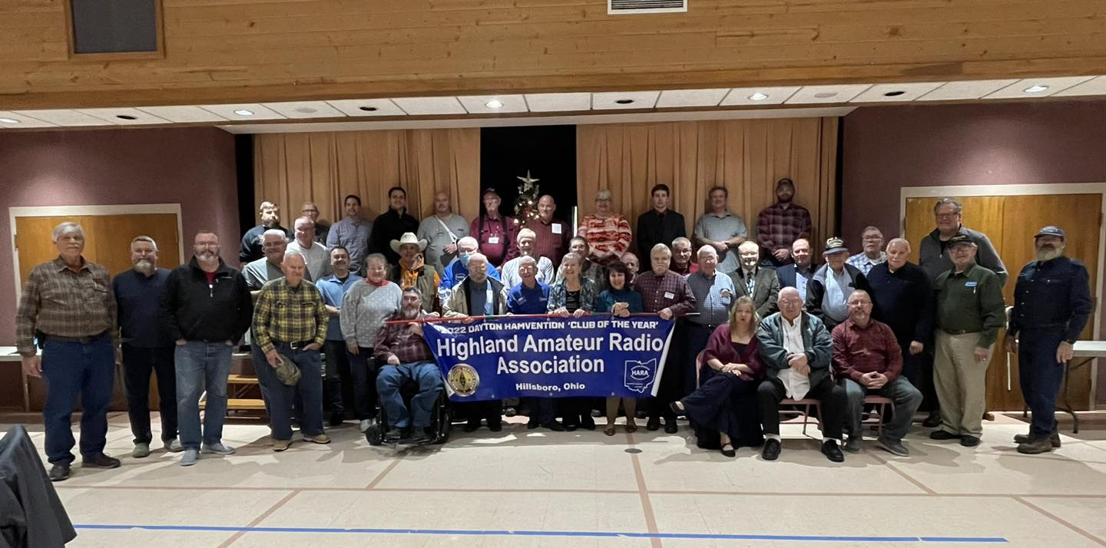
A: We use the media to advise the community of our activities. We periodically hold an “Introduction to Ham Radio” in advance of license classes to let the public know exactly what amateur radio is about.

Q: Do you have any current projects the club is working on?
A: We recently were honored to be asked to represent Ohio as an authorized activator during the upcoming June Lewis and Clark Trail on the Air.

Q: What is your favorite or most fruitful way of fundraising?
A: HARA has long had a program to assist widows and families of deceased hams dispose of their equipment. This is a free benefit to members and a commission is charged for non-members. Often equipment is donated to the club to offer to new hams or is sold at hamfests.

Q: Does your club host any Special Event Stations?
A: Over the years HARA has participated in many special events as well as organized regional events calling attention to Southern Ohio Courthouses and Covered Bridges. Recent events took place at the World’s Largest Horseshoe Crab and in a community established prior to the Civil War for freed Virginia slaves. This year HARA becomes the second Ohio club authorized to represent Ohio in the upcoming June Lewis and Clark Trail on the Air special event recognizing the 16 states the expedition passed through.

Q: Does your club do any training? If so, what?
A: The Club has long had an Elmer program in addition to providing programs at meetings. HARA urges members to participate in the National Weather Service Storm Spotters Program and attend that training.

Q: How does your club support the local community?
A: The most noted event is not radio related. Prior to Memorial Day, we assist the local cemetery association by placing flags on the graves of the approximate 1,100 Veterans buried in the local cemetery. Then following July 4 we return to remove the flags and prepare them for storage. Since prior to the founding of the Club, local amateurs have provided communications and line up assistance for the annual community holiday parade as well as for other parades in the city. We not only provided communications for a former Soapbox Derby race, but ran radar to track the racers speed. We have provided city and county officials with communications support during major snowfalls, ice storms, power outages and tornados.

Q: What operating events does your club participate in?
A: Local amateurs participated in the ARRL Field Day prior to the founding of the Club. A favorite event is the annual Ohio State Parks on the Air when we operate from our local Rocky Fork State Park. Members have activated as many as five parks during the event. In addition to several special event operations, several members also participate in operating events as the Ohio QSO Party, Sweepstakes, DX contests, the Ohio Simplex Test and NVIS Day.

Q: Is there anything else you’d like us to know about your club?
A: HARA is an ARRL Special Service Club. In 2021 our public information officer was honored by the ARRL Board of Directors with the McGan Silver Antenna Award. HARA is the home club for the Ohio Section Journal’s “Ohio’s South 40”. However the biggest honor was the nomination and selection of HARA as the 2022 Dayton Hamvention Club of the Year. Considering we are a rural club located in Appalachia this was quite an honor.

I encourage you that if you are ever out-and-about in the Highland County area, be sure to stop by and check out the Highland ARA! I can speak from experience that this is a great group of amateur radio operators!

_______________________________________
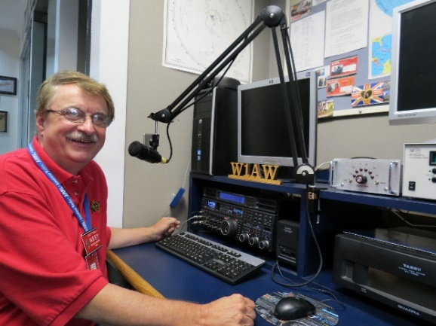
Hi Gang,

The Great Lakes Division Newsletter is now on-line!
There’s lots of great information for you to read. So, grab your
favorite beverage, a sweet snack to munch on and sit back in your easy
chair and have a great read!!
>> https://arrl-greatlakes.org/glnews/2024/04-gldnews.pdf <<
73,
Scott, N8SY

National News
(from ARRL and other sources)

______________________________________________________

World Amateur Radio Day is April 18, 2024
World Amateur Radio Day (WARD) is celebrated each year on April 18.
The theme for 2024 is, "A Century of Connections: Celebrating 100 Years of Amateur Radio Innovation, Community, and Advocacy." The global event covers all of the International Amateur Radio Union (IARU) regions and spans 2 days: Thursday, April 18, 2024, 0000 UTC to Friday, April 19, 2024, 0000 UTC.
On April 18, 1925, the IARU was formed in Paris and will celebrate its centenary in 2025. American Radio Relay League (ARRL) Co-Founder Hiram Percy Maxim was the organization's first president.
All radio amateurs are invited to take to the airwaves to enjoy the global friendship with other amateurs and to show their skills and capabilities to the public. WARD is not a contest but rather an opportunity to talk about the value of amateur radio to the public and fellow amateur colleagues. It is also a great opportunity to talk about local radio clubs and amateur radio in local media as a lead-up to ARRL Field Day, which is held each year during the fourth full weekend in June. You can also promote your personal WARD activities on social media platforms like X and Facebook by using the hashtag #WorldAmateurRadioDay.

ARES Update

We will be releasing the first 2 new EmComm courses April 1. Basic EmComm and Intermediate EmComm will be live in the ARRL Learning Center April 1. With the new courses being released the legacy courses will be removed April 1. Anyone who is currently enrolled in EC-001 or EC-016 will need to complete these courses by April 1 to receive credit for them. We hope to have Advanced EmComm and ARES Leadership courses complete by early summer.

And finally, we have a new project to assist local ARES groups in recruiting for their local ARES team. We are going to be launching Advertising in ARRL publications and other national publications to recruit new members to ARES. This campaign will lead them to a webpage where they can enter their location and it will provide the contact information for a local ARES team. We want this to provide a much quicker and easier process for them to get plugged in locally. To make this work we need your help. We are now collecting ARES group registrations on our website. This is a one-page form to be filled out by the EC or ARES team leader in each local community. This is very similar to the Club Registration we have been using for some time and will work very similarly to the club look up function we currently have but will be for ARES EmComm groups. The link to the page is: http://www.arrl.org/ares-group-registration Please share this link with each of your EC’s and local ARES groups to get them to register. Your help in this will benefit each local group and help to support growth in the local community.

Josh Johnston, KE5MHV
Director of Emergency Management
ARRL The National Association for Amateur Radio®
225 Main Street, Newington, CT 06111-1400 USA
Tel: (860) 594-0333 FAX: (860) 594-0303
jjohnston@arrl.org
www.arrl.org

Club Corner

This is YOUR corner of the newsletter. Send us what your club is doing, and we’ll make sure that it gets in. Got a special event or club project that you want everyone to know about? Send it to us!. Need help with a project? Send it to us.

Let us know what you club is up to. Are you going to have a special guest at your meeting or are you having a special anniversary?

Send it to: webmaster@arrl-ohio.org

Northwest Ohio Amateur Radio Club (NWOARC) – Lima, Ohio

The Northwest Ohio Amateur Radio Club helped to support a well-attended special Space and Eclipse event which was held at the Allen County Museum on Saturday, March 23, 2024. Club members demonstrated various aspects of the hobby and how Amateur Radio can assist public officials with communications during an emergency. Numerous young people were able to speak to amateur operators on several local repeaters as well as worldwide utilizing various analog and digital formats.

For additional information please visit the club website at: https://www.nwoarc.com/ or email the club at: NWOARC@gmail.com.

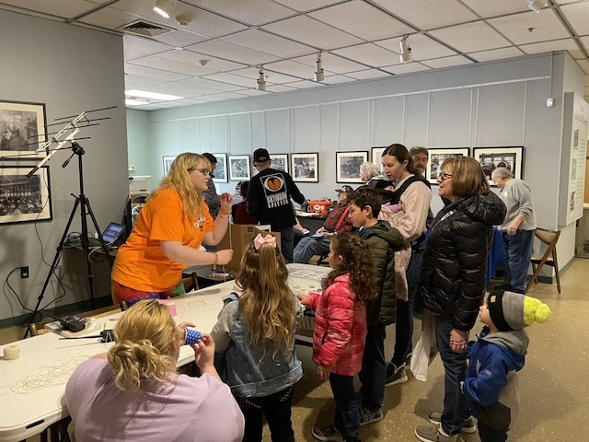
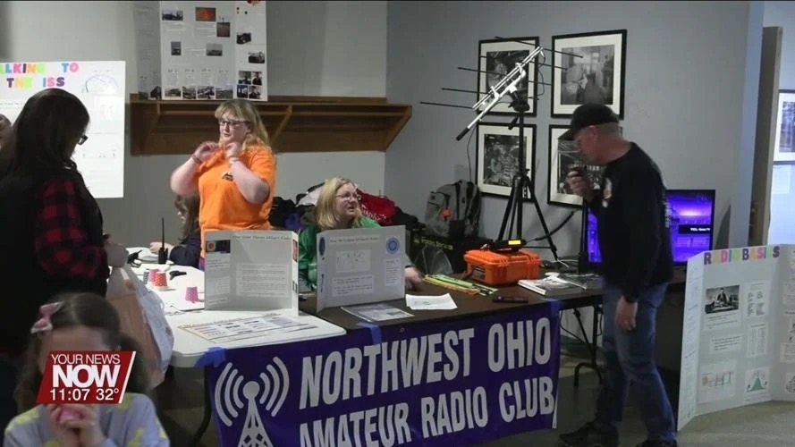
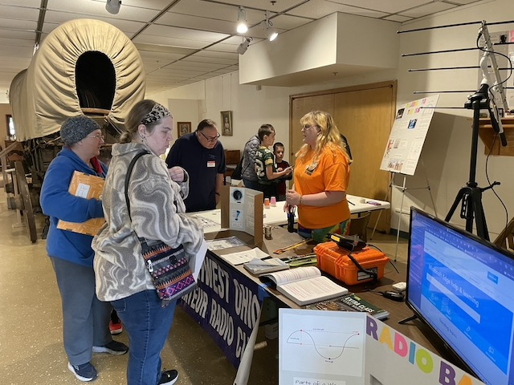
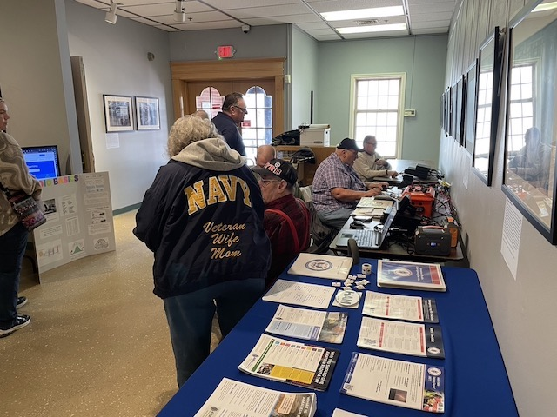

VE Sessions

The following information is for ALL exam sessions:
It is now an FCC requirement to have an FCC FRN; active email address and active phone number before taking any exam. Please bring your FCC FRN, original license, a copy of your license (if a licensed ham), a valid photo ID and $15.00 - Cash preferred.
Effective April 19, 2022, the FCC will charge a $35.00 application fee for amateur radio licenses. The fee will apply to new, renewal, rule waiver, and modification applications that request a new vanity call sign. License upgrades will not have a fee applied. The fee will be per application. VE's will not collect the fees at exam sessions.
AE8FP Amateur Radio Test Team administers ARRL-VEC testing in the Central Ohio area. Our test dates for 2024 are as follows: Januray 20, April 27, June 22, July 20, and October 19. Time and location for these dates are 10:00am at the Westerville Fire Station #111, 400 W. Main St in Westerville, Ohio. The listed dates are co-sponsored by the Central Ohio Radio Club (CORC).
Pre-Registration is required, and open the 1st of each testing month. All information is available at www.ae8fp.net <http://www.ae8fp.net/>

Alliance Amateur Radio Club The Alliance Amateur Radio Club holds quarterly VE testing, at the Christ UInited Methodist Church in Alliance. The address is 470 E. Broadway St, Alliance, OH (https://maps.app.goo.gl/prDyEPp6siJun2ibA).
Upcoming Exam Dates are
Saturday, March 16th, 2024
Saturday, June 15th, 2024
Saturday, August 10th, 2024
Saturday, October 19th, 2024
We begin registration at 8 AM, with testing at 9am.
More information can be found at www.w8lky.org/licensing/ve-exams/.
All Things Amateur Radio Association (ATARA) We host testing sessions every second Tuesday of the month in Lancaster. To sign up please visit our website https://atara-w8atr.fun and contact us at hamexams@atara-w8atr.fun.
CARS
VE testing from CARS - Cuyahoga Amateur Radio Society - at Elmwood Recreation Center, 6200 Wisnieski Parkway in Independence, Ohio 44131 Time: 9:15 AM (Walk-ins allowed) Always the 2nd Sunday of the odd month. Go to CARS www.2cars.org for detailed map of location. Call Metro W8MET 216-520-1320 for details

Clark County Amateur Radio Association (CLARA) What: CLARA sponsored A.R.R.L. VE Testing - Walk-ins allowed. Pre-Register via email preferred. When: On every second Saturday of each even numbered month starting at 10:00 AM Feb
10th; Apr 13th; Jun 8th; Aug 10th; Oct 12th; and Dec 14th, 2024.Where: Springview Government Center - Emergency Operations Center; 3130 E Main St; Springfield OH 45503 This is US-40 aka "old national road". From Route 40 enter Old Columbus Road, at the fork stay left driving straight onto Ogden Rd, then immediately turn left into the parking lot behind the EMA. Walk to the door with the "Employees Only" sign.
For more information contact Roland W. Ude, W8BUZ, (937) 605-4951 Email: buzz@baylorhill.com

Dayton Amateur Radio Association (DARA)
If you are interested in testing for a new or upgraded license, please come see us at the DARA Clubhouse. If you have questions about testing, please email exams.w8bi@gmail.com

The Findlay Radio Club
The Findlay Radio Club sponsors an Exam Session the second Saturday of
every month except September when we have our Hamfest. The Exam Session
takes place at the Findlay Radio Club, 1333 West Sandusky St., Findlay
Ohio 45839. The session begins at 9 AM. Pre-registration is
recommended, but not required. You can pre-register at hamstudy.org. We
can also give Exams remotely on-line on your schedule if you can't make
to a session.

The club has meetings on the first and third Thursdays at the clubhouse at 7:30 PM. The meetings are also available on Zoom. Contact N8ET if you would like to log in. All are welcome.

We also meet at the club on Sunday afternoon from 2 until 5 (or later!) to talk about anything Ham Radio. The sessions are geared toward new Hams. Everyone brings their questions and equipment they would like to show off or learn how to use. This Sunday we are going to install and learn to use Flgigi, Flmsg, and Flamp. In past sessions we have built antennas, fired up new rigs, and generally had a good time!

The next meeting (Feb 15) will cover the same topic. Bring your laptop!

Geauga Amateur Radio Association (GARA)
Amateur License exam sessions are offered for all license classes (Technician, General, Extra). Walk-ins are always welcome - no prior registration is required. No fee for the exam.

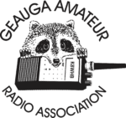
The GARA schedule of exams are these Sundays at 2pm. Dates for 2024 are Jan 14, March 10, May12, July 14, Sept 15, and Nov 17, 2024. All sessions are at 2:00PM each month

Exams are held at the Geauga County Department of Emergency Services and Emergency Operations Center, 12518 Merritt Road, Chardon, Ohio 44024. The EOC is located just south of the University Geauga Hospital and just east of the Geauga County Safety Center (Sheriff's Office), off of State Route 44 between State Route 322 and State Route 87 on Merritt Road.

Please arrive a few minutes before 14:00 to allow adequate time to process the necessary paper work and take your test. Bring your 1) photo ID, 2) email address, 3) FCC FRN, 4) a printout of your current license if taking the General or Extra exam.

Additional info may be obtained from Jackie Welch, N8JMW by email n8jmw2@gmail.ccom or calling at 440-228-2716. More information is available from the Geauga Amateur Radio Association website https://geaugaara.org

Huber Heights Amateur Radio Club
Huber heights amateur radio club does ARRL VE testing the second Saturday of each even numbered month. Feb, Apr, Jun, Aug, Oct, Dec. 9:30-11:00 For more information contact Jim Storms – AB8YK at ab8yk@hotmail.com

The Lake County Amateur Radio Association
The Lake County Amateur Radio Association is holding its 2024 Amateur Radio license exams at the Kirtland Library, 9267 Chillicothe Road, on the following dates:
Saturday. February 3 Saturday, August 3
Saturday, April 6 Saturday, October 5
Saturday, June 1 Saturday, December 7

This bi-monthly schedule is the first Saturday of every even-numbered month (e.g., February being the second month, etc.). They are held at the Kirtland Library, 9267 Chillicothe Road. It is 1.7 miles south of I-90 on Route 306 (Chillicothe Rd). The library is on the left, just beyond the Marathon gas station. The tests will start at 12 noon. Please arrive a few minutes earlier.
To register, you will need a NCVEC 605 Form, which will be available at the test. If you would like to complete one ahead of time, be sure it is the Sept 2017 version or later. You can find it by Googling “NCVEC quick-form 605” and clicking on the url for a pdf of the form. Please note the FCC requires you to provide a FRN (FCC Registration Number). Social Security Numbers are no longer accepted. If you are new to ham radio and don’t have a FRN, Google “New FRN” and follow the fcc.gov link.

If you are currently licensed, be sure to bring a copy of your license to the exam. The cost of the exam itself is $15.00, and if you wish to pay by check, it should be made out to the ARRL/VEC. Identification with your picture is also necessary, such as a driver’s license. If you have any questions, please contact Scott Farnham, KO8O, at (440) 256-0320, or scottfarnham@roadrunner.com

In addition to the $15 test fee, the FCC now charges $35 to add you to the Amateur Radio database. The FCC will e-mail successful candidates instructions for payment directly to them. Payment must be made within 10 days of the e-mail. This charge does not apply to upgrades.

The Lancaster and Fairfield County Amateur Radio Club (LFCARC) hosts exam sessions at the FAIRFIELD County EMA, 240 Baldwin Dr in Lancaster Ohio, 43130, on the first Saturday each month at 10:00 am. Please visit our website at http://www.k8qik.org for exam dates on our calendar and navigate to our Learning Center/Taking the Exam link for information and requirements. Our experienced VE team looks forward to serving the Amateur Radio community in Central Ohio. Contact me at ve_testing@k8qik.org to register.
Lisbon Area Amateur Radio Association
LISBON AREA AMATEUR RADIO ASSOCIATION (LAARA) 2024 SCHEDULE.
VE TESTING IS AT THE COLUMBIANA COUNTY EMERGENCY MANAGEMENT AGENCY
AT 215 SOUTH MARKET STREET, LISBON, OH 44432.
SIGN IN AT 1 PM AND TESTING AT 1:30 PM.
VE TESTING DATES FOR 2024
JAN 13; FEB 10; MAR 9; APR 13; MAY 11;
JUN 8; AUG 10; SEP 14; OCT 12; NOV 9; DEC 14.
WE CAN ALSO GIVE THE TEST AT OUR REGULAR MEETINGS
THAT ARE NORMALLY ON THE 3RD THURSDAY OF EACH MONTH.
LAARA MEETINGS ARE HELD AT THE COLUMBIANA COUNTY
EMERGENCY MANAGEMENT AGENCY AT THE SAME ADDRESS AS ABOVE. SEE THE K8GQB.COM WEB SITE FOR UPDATES.
MEETING TIME IS 6:30 PM.
WE HAVE ACTIVITY MEETINGS ON THE ODD MONTHS AND
BUSINESS MEETINGS ON THE EVEN MONTHS.
Madison County
The Laurel testing group will offer testing on the first Thursday of January, March, May, July, September and November. Tests are held at 7:00PM at the Madison County EMA located at 271 Elm St. London, OH. No fee.
The Milford Amateur Radio Club (MARC)
VE testing is held the third Thursday of each month at 6:00 PM. Location; Miami Township Civic Center located at 6101 Meijer Drive, Milford, OH 45150.
Please pre-register at www.milfordhamradio.org

Northern Ohio Amateur Radio Society (NOARS)
Six VE testing sessions in 2024. Registration is appreciated but walk-ins are welcome. Contact Elaine, KC8FOS for more information or to register. ewilkinson1951@gmail.com or 216-337-4235
Saturday, Jan 6. Fairview Park Library. 21255 Lorain Rd., Fairview Park. 10 AM.
Sunday, March 10. NOARS Hamfest. Lorain County Community College. 1005 Abbe Rd. N., Elyria. 9 AM.
Saturday, May 4. Fairview Park Library. 21255 Lorain Rd., Fairview Park. 10 AM.
Saturday, July 20. NOARSfest. Lorain County Community College. 1005 Abbe Rd. N., Elyria. 9 AM.
Saturday, September 7. Fairview Park Library. 21255 Lorain Rd., Fairview Park. 10 AM.
Saturday, November 2. Fairview Park Library. 21255 Lorain Rd., Fairview Park. 10 AM.

Portage County Amateur Radio Service (PCARS)
The first Saturday of every even numbered month -10 am – at the PCARS club site in Ravenna. Please visit the PCARS web site and check out the information about VE testing in the latest newsletter at www.portcars.org .
If you have any questions, don’t hesitate to contact me at KB8UUZ@gmail,com

Tusco Amateur Radio Club W8ZX

VE Testing sessions are held on the second Saturday of every even numbered month at the Dover Faith Church, 420 N Wooster Ave, Dover, OH 44622. Pre-registration is not necessary. Doors open at 0830 for registration, exams begin at 0900. Cost is $15. You are required to have an email address and a copy of your FRN or current ham radio license. For more information please go to www.w8zx.net/exam or email VETEAM@N8BAG.NET.

Silvercreek ARA (SARA)
Hold six exam sessions per year for all license classes. Pre-registration requested but not required. Exam sessions for 2024:

Saturday, February 3rd - Wayne County Justice Center (Wooster)
Saturday, April 6th - Sharon Center UMC (Wadsworth/Medina)
Saturday, June 1st - Sharon Center UMC (Wadsworth/Medina)
Saturday, August 3rd - Wayne County Justice Center (Wooster)
Saturday, October 5th -Sharon Center UMC (Wadsworth/Medina)
Saturday, December 7th -Sharon Center UMC (Wadsworth/Medina)

All sessios begin at 10:00am. For directions and test information visit https://w8wky.org/license-exams/. Pre-Registration to expedite paperwork is requested, but not required at https://w8wky.org/sara-ve-registration-form/. Sign up and if you aren't ready or can't make it, just notify the VE team lead.

West Chester Amateur Radio Association (WC8VOA)Exam sessions are held one Saturday each month at 10:00 AM-Noon at the VOA Bethany Relay Museum located at 8070 Tylersville Rd, West Chester, Ohio 45069. For more information and links to register, please see our website: https://wc8voa.org/licensing/
____________________________________________________

Your Club news should be listed here!
I know you’re out there doing things! Send me a write-up (MSWord please) and some photo’s (.jpg please) and we’ll get your club hi-lited here for the other OH Section Clubs to see! Send to WB8LCD@ARRL.ORG

Important Links
ARRL Home: www.arrl.org
Find an ARRL Affiliated Club: www.arrl.org/clubs
Find your ARRL Section: www.arrl.org/sections
Find a License Class in your area: www.arrl.org/class
Find a License Exam in your area: www.arrl.org/exam
Find a Hamfest or Convention: www.arrl.org/hamfests
Email ARRL Clubs: clubs@arrl.org
____________________________________________________________________________

The Ohio Section Youth Net

*** Sunday April 14, 2024 ***

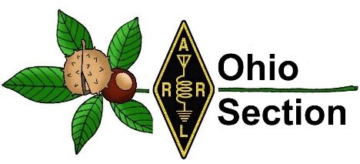
Youth Net
When: The second Sunday of every month at 7:30 PM EST
Where: The K8IV repeater located in Kent, Ohio (Echolink node K8BF-L) RF: 146.895 Mhz with PL 118.8
Who: Any licensed amateur radio operator who wishes to participate. Priority will be given to youth stations and those located in Ohio.
The purpose of this net is to encourage youth activity in amateur radio and to help new hams get more comfortable on the air.

If you are a young ham, in the Ohio Section or elsewhere, please check in and say “Hello”!
Even if you’re far away from OHIO you can check in via Echo-Link. Echo-Link is a good tool to have, and it can be accessed from your laptop, tablet or cellphone. But there is a process to get validated to the Echo-link system. It’s simple to do, but you need to get it done before the day of the net! Go to Introducing EchoLink for more information on getting started. If you’re an “Old Guy” (a gender neutral term meaning not a youthful operator) and you have some kids, grandkids, nieces, nephews or even some neighborhood kids who you would like to give a chance to talk to other kids about Ham Radio, this might be an excellent opportunity to give them that small nudge that could be the start of something positive they will carry with them through life!

The SouthWest Ohio DX Association (SWODXA), in conjunction with Icom® America, Inc., has announced a DX Mentor Recognition Program to recognize and reward amateur radio operators who have helped others achieve DXCC. An application form is now available for those who wish to nominate their DX mentor. Amateurs who have received mentoring from a nominee must be under 30 years of age during the calendar year of the award; targeting this age group is meant to keep such amateurs engaged in the hobby after they achieve DXCC. The judging committee will comprise SWODXA representatives and a representative from both the Northern California DX Foundation (NCDXF) and the International DX Association (INDEXA). The awards will be presented at the DX Dinner, held annually in conjunction with Dayton Hamvention®. More information and the entry form can be found at www.swodxa.org/DX-Mentor-Program or by emailing thedxmentor@gmail.com.

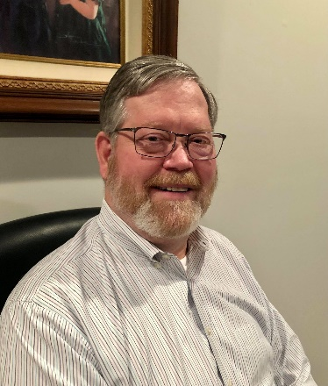
DX This Week – Zones 36 through 40
Bill - AJ8B (thedxmentor@gmail.com / www.aj8b.com )

Hope you have remained active. Even with the CME that occurred earlier this week, the bands have been active. There is so much coming up that I find myself listening every night!

This week we wrap up the review of the CQ Zones. These are most useful for the CQWW contests and the CQ Marathon. You can learn all about the CQ Marathon by listening to the DX Mentor podcast or YouTube channel, episode entitled the CQ Marathon Challenge Special Episode. (https://www.youtube.com/watch?v=dtgrInCw2r0&t=132s)

I received a nice note from Howard, N8HO. I always appreciate feedback as it reminds me that folks really are reading this every week! Howard’s note is below as well as the QSL cards he recently received. Thanks Howard.

Bill,
Here are a few cards I recently received. Bouvet was very difficult to work due to the DQRM. I managed to get lucky on 15-meter SSB and was only one of forty-five SSB contacts they made with NA.

73, Howard N8HO

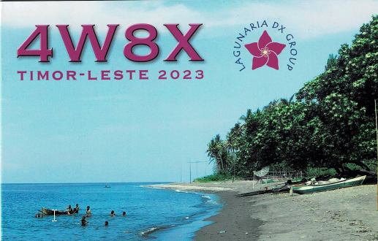 | 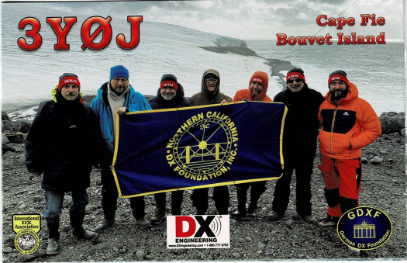

DAH DIT DIT DIT DAH DAH DIT DIT DIT DAH

This week we will continue our investigation of the various CQ Zones.

So far this year, we have covered CQ zones 1 through 35. This week we will wrap up our review by covering the final group, Zones 36 through 40.

Zone 36. Equatorial Zone of Africa: D2 (Angola), S9 (Sao Tome Principe), TJ (Cameroon), TL (Central African Rep.), TN (Congo), TR (Gabon), TT (Chad), ZD7 (St. Helena Is.), ZD8 (Ascension Is.), 3C (Equatorial Guinea), 3C0 (Annobon Is.), 9J (Zambia), 9Q (Democratic Rep. of Congo), 9U (Burundi) and 9X (Rwanda).

Zone 37. Eastern Zone of Africa: C9 (Mozambique), ET (Ethiopia), E3 (Eritrea), J2 (Djibouti), T5 (Somalia), 5H - (Tanzania), 5X (Uganda), 5Z (Kenya), 7O (Socotra and Abd al Kuri islands ONLY) and 7Q (Malawi).

Zone 38. South African Zone: A2 (Botswana), V5 (Namibia), ZD9 (Tristan da Cunha Gough Is.), Z2 (Zimbabwe), ZS – (South Africa) and ZS8 (Marion Is), 3DA (Swaziland), 3Y (Bouvet Is.), 7P (Lesotho), and some Antarctic stations.

Zone 39. Madagascar Zone: D6 (Comoros), FH (Mayotte), FR (Reunion), FT-G (Glorioso), FT-J&E (Juan de Nova and Europa), FT-T (Tromelin), FT W (Crozet Is.), FT-X (Kerguelen Is.), FT Z (Amsterdam St. Paul Is.), S7 (Seychelles), VK0 (Heard Is.), VQ9 (Chagos), 3B6/7 (Agalega St.Brandon Is.), 3B8 (Mauritius Is.), 3B9 (Rodriguez Is.), 5R (Madagascar) and some Antarctic stations.

Zone 40. North Atlantic Zone: JW (Svalbard), JX (Jan Mayen), OX (Greenland), RI1FJ (Franz Josef Land), and TF (Iceland).

As part of our discussion in the last segment, Zone 36 contains many of the “Terrible T’s” we mentioned last week. These countries appeared randomly and without any announced schedules for years. DXPeditions help to make them more accessible, but not as accessible as many of us would like!
Zone 37 has a couple of active representatives including 5H – Tanzania and 5Z – Kenya. The other entities are typically available during contests or DXPeditions.
Zone 38 is well represented by ZS – South Africa.

Zone 39 is a collection of Island entities. There is some really great DX in this group.
Zone 40, the Ice group, is fairly easy to work over the course of the year.

I hope you found this glimpse of the Zones and entities interesting!
Good Hunting in these Zones

DAH DIT DIT DIT DAH DAH DIT DIT DIT DAH

Here is an update from Bernie, W3UR, of the DailyDX and the WeeklyDX, and the How’s DX Column in QST. The DailyDX the best source for real-time DX information. http://www.dailydx.com/ . Bernie has this to report:

This one is a bit in the future, but mark your calendars for September 5-21. Pitcairn and Mangareva Islands will be activated by GØVDE, Bill. He will travel to the Pacific from August 31-September 23. He will operate as VP6WR September 5-15, and as FO/GØVDE from Mangareva Island, French Polynesia September 17-21. Bill will have ICOM IC-705 and IC-7300 radios and a Juma PA1000 amplifier, and vertical and wire antennas. Listen for him on 80-10M SSB and FT8, and “some CW.” He is currently working on QSL manager arrangements. Visit his website for updates.

As reported last week, FH4VVK, Marek, will operate as FT4GL May 24-June 19 from Glorioso Island, which ranks as #8 on the Club Log DXCC Most Wanted List. According to the FT4GL Facebook page, this DXpedition was made possible by agreement of the French Southern and Antarctic Lands. A new blog has been launched; it appears to be in French with multiple translation options. The FT4GL Facebook page, linked above, The Daily DX, and The Weekly DX will carry updates, or you can check here every week.

In Mid-April, VU3OQK, Santhilal, plans to activate VU7, Lakshadweep Islands from several island locations by mid mid-April. Santhilal will mostly be on SSB And FT8 On 40, 20, And 10M. He Hopes to have his LoTW Account up and running by the first week of April.

As reported in the previous issues of The Weekly DX, the Dateline DX Association has received permission from the U.S. Fish and Wildlife Service (USFWS) for a DXpedition to Jarvis Island National Wildlife Reserve during the first part of August. This will be the first Jarvis Island activation in 34 years. Four operators will set up the six RIBs and operate from the ship. There will also be 25 remote operators from Asia, Europe, and North America. They will be on CW and FT8 (F/H) on all bands. As this issue went to press, we learned that the callsign N5J has been authorized for August 5-20, 2024

Six-meter enthusiast CE3SX (aka CE3SAD), Felipe (“Pipe”), is operating as CBØZIX from Juan Fernandez Island, March 22-April 4. He will be on the “Magic Band” primarily, with some HF mixed in. Pipe will have an ICOM IC-7300 running 100W into either a directional or vertical antenna. Watch for him on SSB and FT8 (F/H). Depending on internet availability, he will use Club Log. QSL only via LoTW as there will be no paper confirmations.

Dates are confirmed and transportation has been secured for the four-man team heading to OJØ, Market Reef, April 27-May 4. The team of LA1UW, Bjorn; LA3WAA, Tor; LB5SH, Stian; and LB0VG, Kristof will now be signing OJØT instead of OJØ/home calls. “We will also do some antenna upgrades for this DXpedition, still mainly verticals and probably some monobanders, but hopefully be able to reach out to the most distant operators out there.” The team will be open to “distant and/or low power/QRP operators.”

We have a Mauritius Watch for 3B8/DM7CW, Johann, who began his Quatre Bornes, Mauritius operation on March 18 and plans to continue through April 10. He is using a Yaesu FT-897 at 100W into a 40-10M vertical on CW, SSB, and digital modes. QSL via eQSL, LoTW, or direct with SASE or PayPal.

The Lesotho 7P8EI, DXpedition is most likely QRT by now. As of March 25th, they had over 30,000 QSOs. This operation was by the EI DX Group. QSL via MØOXO OQRS.

With the help of A2NEW, Johan, HB9SHD, Remo, was able to secure his A255HD license for operation from Botswana. “Yes, the call really is A255HD,” Remo says. He will be on a safari April 30 through May 13, Operating holiday-style from “different locations within Botswana.” He will be using an Yaesu FT-891 and an end-fed antenna. He plans to be on SSB but is not yet sure about FT8. He will not send paper QSLs and has not yet decided which online service he will use. “Don't expect too much; ham activities are not my main focus,” he concludes.

DAH DIT DIT DIT DAH DAH DIT DIT DIT DAH

Below is a list of upcoming contests in the “Contest Corner”. I think this is important for someone who is trying to move up the DXCC ladder since entities that are on the rarer side and easiest to work in contests. Some of my best “catches” have been on the Sunday afternoon of a contest when the rarer entities are begging for QSOs. Of course, the gamble is that if you wait until Sunday, conditions may change, or they simply won’t be workable. However, it is not a bad gamble. Of course, why not work the contest and have some fun!
Check out the WA7BNM Contest Calendar page (https://www.contestcalendar.com/) for more contests or more details.
The contests in red are those that I plan to spend some significant participation time on. PLEASE let me know if you are working contests and how you fared.

I mentioned this one last week, but excitement is building for the Israel Holyland Contest, April 19-20. The Israel Amateur Radio Club will hold its annual Worldwide Holyland DX Contest April 19-20. The rules have been updated from 2023 and are available in Adobe PDF. More information is available on the IARC website.

You should also check out the Worked All Britain’s, WAB data contest to be held on April 7th. There are 2 different time slots for this one. If you need some of lesser available DX entities such as Jersey, Guernsey, of the Isle of Mann, the WAB contests are the place to work them. Check out the WA7BNM webpage for all of the details.

Thanks!

Contest | Start  Date | End  Date
SP DX Contest | 4/6/2024 | 4/7/2024
Louisiana QSOP | 4/6/2024 | 4/7/2024
Missouri QSOP | 4/6/2024 | 4/7/2024
Georgia QSOP | 4/13/2024 | 4/14/2024
New Mexico QSOP | 4/13/2024 | 4/14/2024
Holyland DX Contest | 4/19/2024 | 4/20/2024
Michigan QSOP | 4/20/2024 | 4/21/2024
Ontario QSOP | 4/20/2024 | 4/21/2024
SP DX RTTY | 4/27/2024 | 4/28/2024
10-10 Intl. Spring Contest, Digital | 4/27/2024 | 4/28/2024
Florida QSOP | 4/27/2024 | 4/28/2024
10-10 Intl. Spring Contest, CW | 5/4/2024 | 5/5/2024
Arizona QSOP | 5/4/2024 | 5/5/2024
Connecticut QSOP | 5/4/2024 | 5/5/2024
Delaware QSOP | 5/4/2024 | 5/5/2024
Idaho QSOP | 5/4/2024 | 5/5/2024
Indiana QSOP | 5/4/2024 | 5/5/2024
Maine QSOP | 5/4/2024 | 5/5/2024
Massachusetts QSOP | 5/4/2024 | 5/5/2024
Montana QSOP | 5/4/2024 | 5/5/2024
Nevada QSOP | 5/4/2024 | 5/5/2024
New Hampshire QSOP | 5/4/2024 | 5/5/2024
Oregon QSOP | 5/4/2024 | 5/5/2024
Rhode Island QSOP | 5/4/2024 | 5/5/2024
Utah QSOP | 5/4/2024 | 5/5/2024
Vermont QSOP | 5/4/2024 | 5/5/2024
Washington QSOP | 5/4/2024 | 5/5/2024
Wyoming QSOP | 5/4/2024 | 5/5/2024
SWODXA DXDINNER | 5/17/2024
SWODXA DXForum | 5/18/2024
Arkansas QSOP | 5/18/2024 | 5/19/2024
CQ WW WPX Contest, CW | 5/25/2024 | 5/26/2024
______________________________________

OHIO’S 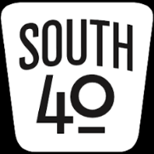

2024 seems to be flying along at full throttle. It feels like March just started and already we are looking at Easter on the 31st and the beginning of April. However for many hams, April marks the beginning of the Ham Radio Year with hamfests becoming more frequent, serious planning for Field Day and the Ohio Parks event starting, plus club plans for club functions like special event operations and picnics and individual plans for POTA or SOTA activations.

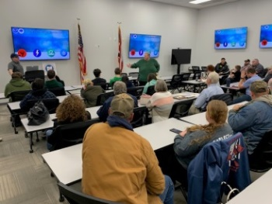
As a rather unique addition to their ‘Introduction to Ham Radio’ presentation to the local scouts, the Southern Ohio ARA made the Charleston NWS Storm Spotter training a part of the program.This allowed the scouts to see the importance ham radio plays in the Storm Spotter program.Mike Love, WB8YKS, stated the event was well attended by not only the scouts, but by first responders, amateurs, Red Cross and the general public.One individual even stated he intends to sit for a license at the upcoming April 15 SOARA test session.

Speaking of the Storm Spotter training sessions, those of the Wilmington NWS Office have for the most part wrapped up for the year. On the 21st the Highland County Administration Building conference room was packed and on March 28 the Fayette County site in Washington, CH was much the same. On April 28 a joint session for Fairfield and Pickaway Counties will be presented at the Liberty Center in Lancaster to wrap up the sessions in Southern Ohio. On May 13 the Belmont County Library in Martins Ferry is the location for the Pittsburgh Office to hold an in person training session. For further information where to find on-line training or other storm spotter information check www.weather.gov/iln for those in the Wilmington Office service area or Tony.Edwards@noaa.gov in the Charleston Office.

The latest edition of Southwest Ohio DX Association “the exchange” newsletter is just off the press and available for your reading enjoyment at www.swodxa.org/newsletters/. A lot of good general information is in the current edition in addition to good articles about DXpeditions and QRP operating. President Bill Salyers, AJ8B. reminds us that tickets for the annual Hamvention DX Banquet are now on sale. The banquet is May 17 at the Dayton Marriott beginning with a cash bar at 5:30 and the program and awards presentation beginning at 7. Tickets usually go fast for the event so it’s advised to go on line at www.swodxa.org and order them ASAP. Dozens of great prizes are already committed to be awarded during the evening.

The monthly Clinton County ARA “Last Saturday” breakfast happens at Sam’s Meats and Deli in Wilmington on March 30 at 8:30. While attending why not purchase some tickets for a rather unique fund raiser? Some lucky person will be enjoying a $550 package of meat. Tickets are $5 each or 5 for $20 and are available from club members or at the upcoming ‘Last Saturday Brunch’. Only 500 tickets are being sold. The prize drawing will be during the April 27 Last Saturday Brunch, or sooner should all tickets sell quickly, at Sam’s Meats in Wilmington. Contact any CCARA member for tickets or more info.

A new round of meetings begin on April Fool’s Day when the Portsmouth RC meets at the Portsmouth American Legion Hall. A test session is at 5 pm with the meeting to follow. At the conclusion of the meeting there is a group that normally retire to a local restaurant to continue the conversations and in this case, pull some April Fool’s pranks. On April 2 the Hocking Valley ARA will meet at 7 pm at the Hocking County 911/EOC Building in Logan. Then on the 4th the Clinton County ARC will meet at 7:30 pm at the Boyd Cancer Center in Wilmington. On the 9th the calendar gets crowded when the DeForest ARC, the Greater Mason County ARC and the Highland ARA each meet. The West Union and Maysville clubs will meet at their normal locations; however HARA will have their meeting at the Historic Scott House on West Main Street in downtown Hillsboro. This will be the location the Club will operate from for Field Day. Then on the 13th HARA will meet at the Hillsboro Burger King at 10 am and the Bainbridge Ham Group will meet at 8:30 am at the Dutch Restaurant near Bainbridge.

The Tri-State ARC will hold a test session on Saturday, April 13 at the Museum of Radio and Technology in Huntington. It will begin at 9 am. VE Team Manager Bud Cyr, KB8KMH, states pre-registration is not necessary and walk-ins are accepted. All test elements will be offered. There is a $15 fee.

The hamfest season in the South 40 Region gets fully underway in April. It kicks off on April 13 when the Mid-Ohio Valley ARC holds their annual hamfest at the Fellowship of Faith Church in Bidwell. Then on Sunday the 28th, the Athens County ARA will hold their hamfest at the recreation center in Athens. Both are great warm up events to get everyone in the mood for all the events during HamVention©. Starting on May 16 and continuing through the 19th, the annual “Four Days In May” has grown to be a very popular and well attended event. Although mostly geared towards the QRP operator, the event offers a lot of good advice and operating pointers any amateur can use. It takes place at the Holiday Inn in Fairborn. Then on the 17th the world known and respected Dayton ARA HamVention© gets underway at the Greene County Fairgrounds in Xenia. The Bidwell and Athens events are each good events for a new ham to attend in order to gain an idea what hamfests are all about. However for a new ham “Four Days In May” and Hamvention can be overwhelming. Therefore I suggest a ‘newbie’ team with a Hamvention veteran to attend. Your attendance also supports of the efforts of local clubs to maintain repeaters, provide programs and pay the bills to keep the club and its equipment functioning. For many clubs, this is their largest source of income to keep the treasury in the black. They are also a great place to put faces with the voices and call signs of those you hear on the air as well as get a great price on some nice equipment.

A look at the calendar shows that August is several weeks away. But at the speed this year is going, it won’t be long before it’s just around the corner. We have learned of three hamfests in a row during the month. On August 3 the Columbus area Aladdin Shrine hamfest will happen at the Shrine Temple in Grove City. Then on the 10th the Milford ARC sponsored Cincinnati Hamfest will take place at the Clermont County Fairgrounds in Owensville. On the following Saturday the annual Portsmouth RC hamfest will be held on the 17th in New Boston. They return to the New Boston City Building with an extended space for the flea market area.

Bill Garringer, N8SBT, reminds hams within the reach of the Fayette ARA’s Washington CH 147.27 repeater of the Tuesday evening FARA net at 8 pm.

Springtime brings a number of different activities. And a popular one is the restart of races and marathons. The Athens County ARA has issued the call for volunteers to assist with such events happening in April. On April 6 the Club will provide communications for the annual Iron Furnace Trail Run at Lake Hope and Zaleski State Forest. Then on April 14 the Athens Marathon/Half Marathon will take place on the bikeway between Athens and Nelsonville. The Club needs at least 6 operators to staff the Lake Hope event and at least 10 for the Athens one. If you can assist, please contact Jeff Slattery, N8SUZ, at 740-541-0972.

The Scioto Valley ARC will hold their next monthly Elmer’s Night on April 4. It begins at 7 pm and is held at the Pike County EMA Building at the Pike County Airport near Waverly. President Jesse Stanley, KD8CHP, lets us know the Club has set the date for their annual hamfest as Saturday, October 5. It will return to the Pike County Fairgrounds in Piketon.

Perhaps you saw the recent mention in the ‘ARRL Letter’ about the upcoming June Lewis and Clark Trail on the Air. But did you know the Portsmouth RC and the Highland ARA are the two clubs selected by the Vancouver, Washington based Clark County ARA. to represent Ohio during the 16 day special event activity. The event’s objective is for individual operators to contact one authorized club station in each of the 16 states the Lewis and Clark Trail or Eastern Legacy passes through in order to earn a certificate recognizing their accomplishment. More information is available on the www.lctota.org website and will be updated as the event start nears. Both the Clark County ARA and the Highland ARA have been recognized as a Dayton Hamvention Club of the Year.

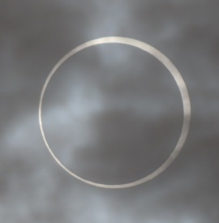
Thanks to the Queen City Emergency Net’s “The Listening Post” for reminding us of the upcoming April 8 Solar Eclipse. Listen for a lot of ham activity as experiements are conducted before, during and following this once in a lifetime opportunity for us in the Buckeye State. The article reminded us of Manfred Mann’s song ‘Blinded By The Light’ and cautioned us all not to look directly at the eclipse unless you are wearing certified sun viewing glasses. Highway traffic is expected to be high. Have fun and enjoy the experience, but be safe while viewing and when on the road.

Judy Taylor, WD8EOP, tells us that Tri-State ARA members attending the May club meeting will be treated to a ‘hobo stew” meal. Those planning to attend the upcoming April 16 meeting are asked to contribute some kind of a can of veggies that evening.

The April QST notes the passing of K4QYK, Roger Castle, of Greenup, KY. We give our thoughts and prayers to his family and friends.

Do you need an inexpensive and easy way to run underground radials, coax or similar items? The “Lovesick Moles”, Max and Mary, have a special deal for those contacting them on April 1. Plus they can provide you with details about their newest venture, “Owl’s Aerials”. The thought behind this venture is to use trained hoot and barn owls to lift leader lines to the tops of trees and other high objects so you can lift your dipoles, long wires, and other similar antennas to heights not able to be accomplished by sling shots, potato guns, fishing poles or bows. A phone call to BR4-6789 will provide all the information.

An announcement appearing in the March 20th Wilmington News Journal regarding the Clinton County ARA’s receipt of a construction permit to establish a low power FM radio station to serve Clinton County was met with a lot of excitement. The Club has already held an open house to hear the public’s thoughts on programing and the necessary fund raising to raise the capital to make it happen.

Marietta/Parkersburg area amateurs are reminded of the upcoming monthly Parkersburg ARK meeting on April 8. The meeting is at the Western Sizzlin’ Streakhouse just off US 50 in Ravenswood. Those wishing to eat prior to the meeting should arrive around 6 pm with the meeting getting underway at 6:30.

At the upcoming April Athens County ARA meeting, there will be two concurrent antenna building programs. One led by Kirk Groeneveld, KC8JRV, will be on building a 2 meter tape measure antenna and the at the other Jeff Slattery, N8SUZ, will assist in building a 2 meter copper J-Pole. Each build will get underway to 1 pm at the Red Cross Building in Athens on April 21. Those interested in attending one of the builds should contact the appropriate program leader in order for the appropriate materials to be on hand.

As mentioned last time out, I like to end my column on a happy note and this one will be no exception. The Batavia area of Clermont County now has a new ham. He is Robert Raub who has become KF8AQC. In the same part of the State, William Dankworth of Loveland is now KF8AQT. The Athens area welcomes Judith Winner who has become KE8AQL. The photo shows Highland ARA VE Manager Tom Mongold, Jr., KD8LDS, presenting an Extra CSCE upgrade to John Duncan, KE8URZ, of Leesburg following their recent test session. The Clinton County ARA conducted its Spring VE session recently with 11 candidates. VE Team Leader Mike Boyle, WF8B, reports Thomas Dunn, W8DTN, of New Holland successfully upgraded and now holds an Extra license. Boyle also states nine individuals came in with no license and three left with a General CSCE and six with a new Technician. As this goes to press, only one has been posted to the Commission’s data base. It is to David Johnson of Orgonia whose General License bears the call sign of KF8ARO. Congrats to each.

While listening to the minister’s Easter sermon I realized I learned a lot over the years from the Easter Bunny. Some things are:
Be willing to compromise and try to not split hares.
God meant for some things to be floppy.
Don’t put all your eggs in one basket.
It’s good to have a friend who is all ears.
Anyone can have a bad hare day.
All work and no play can make you a basket case.

So until next time, 73.

John Levo, W8KIW

jlevo@cinci.rr.com or highlandara@gmail.com or 937-393-4951 (landline-leave a message)

__________________________________________________________

ARLD013 DX news

This week's bulletin was made possible with information provided by
AA3B, HA7VK, K6EI, The Daily DX, 425 DX News, DXNL, Contest Corral
from QST and the ARRL Contest Calendar and WA7BNM web sites. Thanks
to all.
MONACO, 3A. Jim, K6EI will be QRV as 3A/K6EI from April 1 to 6.
Activity will be on 40 to 10 meters using primarily FT8, FT4, and
some CW, with QRP power. QSL direct to home call.
MAURITIUS, 3B8. Johann, DM7CW is QRV as 3B8/DM7CW from Condos
Quatre Bornes until April 10. Activity is on 40 to 10 meters using
CW, SSB, and various digital modes. QSL via LoTW.
FIJI, 3D2. Dom, 3Z9DX is QRV as 3D2AJT from Nadi until April 30.
QSL via Club Log.
VIET NAM, 3W. Alex, KU1CW plans to be QRV as 3W9A in the CQ World
Wide WPX SSB contest. QSL via LoTW.
CHILE, CE. Members of the Antofagasta DX Group will be QRV as CB7H
in the Los Lagos region during the CQ World Wide WPX SSB contest.
QSL via XQ1KN.
JUAN FERNANDEZ ISLAND, CE0. Felipe, CE3SX is QRV as CB0ZIX until
April 4. Activity is mainly on 6 meters, but also on the HF bands
using SSB and FT8 in DXpedition mode. QSL via LoTW.
MOLDOVA, ER. Special event station ER30ARM is QRV until April 30 to
celebrate the 30th anniversary of the Amateur Radio Society of
Moldova. QSL via bureau.
GUADELOUPE, FG. Bert, FG8OJ and Jean-Luc, F1ULQ are QRV as TO1Q
from Sainte-Anne until April 8. Activity is on 80 to 6 meters,
including some Satellite activity. They will be a Multi Op/Single
Band on 10 meter entry in the CQ World Wide WPX SSB contest. QSL
via LoTW.
MAYOTTE, FH. Operators Ros, 4Z5LA, Ruben, 4Z5FI and Slava, 4Z5MU
are QRV as TO5LA until April 2. This includes being an entry in the
CQ World Wide WPX SSB contest. QSL via 4Z5FI.
AUSTRAL ISLANDS, FO. Haru, JA1XGI is QRV as TX5XG from Raivavae,
IOTA OC-114, until April 3. Activity is on 160 to 6 meters using
CW, SSB and various digital modes. This includes being active on
Satellite IO-117. QSL via LoTW.
HUNGARY, HA. Special call sign HG24TISZA will be QRV as a Single
Op/All Band/High Power entry in the CQ World Wide WPX SSB contest.
QSL via HA7VK.
VATICAN, HV. Look for HV0A to be QRV on March 30 beginning around
0800z. Activity will be on several HF bands using only CW. QSL
direct to IK0FVC.
SURINAME, PZ. Ren, PY8WW will be QRV as PZ5TW until April 6.
Activity is on the HF bands using CW, SSB, and various digital
modes. This includes being an entry in the CQ World Wide WPX SSB
contest. QSL to home call.
ANTIGUA AND BARBUDA, V2. Bud, AA3B is QRV as V26K from Antigua,
IOTA NA-100, until April 3. Activity is on the HF bands with an
emphasis on CW. This includes being an entry in the CQ World Wide
WPX SSB contest. QSL to home call.
TURKS AND CAICOS ISLANDS, VP5. Operators AF3K, KH6M and W2TT are
QRV as VQ5P from Providenciales, IOTA NA-002, until April 2.
Activity is on 160 to 6 meters using CW, SSB, FT8, and FT4. This
includes being an entry in the CQ World Wide WPX SSB contest. QSL
via N2OO.
MEXICO, XE. A group of operators are QRV as 4A5D from Maria Madre
Island, a possible new IOTA, until March 30. Activity is on 20, 15,
and 10 meters using SSB and FT8. It is also POTA MX-0171. QSL via
EA5GL.
LAOS, XW. Vincent, XW4KV is QRV from Vang Vieng until June 1. QSL
via F4BKV.
VANUATU, YJ. Operators VK3HJ, VK3QB, VK6CQ and K0BBC are QRV as
YJ0VK until April 11. Activity is on 40 to 6 meters using CW, SSB,
and FT8. QSL via M0OXO.
UK SOVEREIGN BASE AREAS ON CYPRUS, ZC. Adrian, G0KOM is QRV as
ZC4MK from Avdimou until April 1. Activity is on the HF bands.
This includes being an entry in the CQ World Wide WPX SSB contest.
QSL to home call.
Please see March QST, page 78, April QST, page 76, and the ARRL and
WA7BNM contest websites for details.
_________________________________________

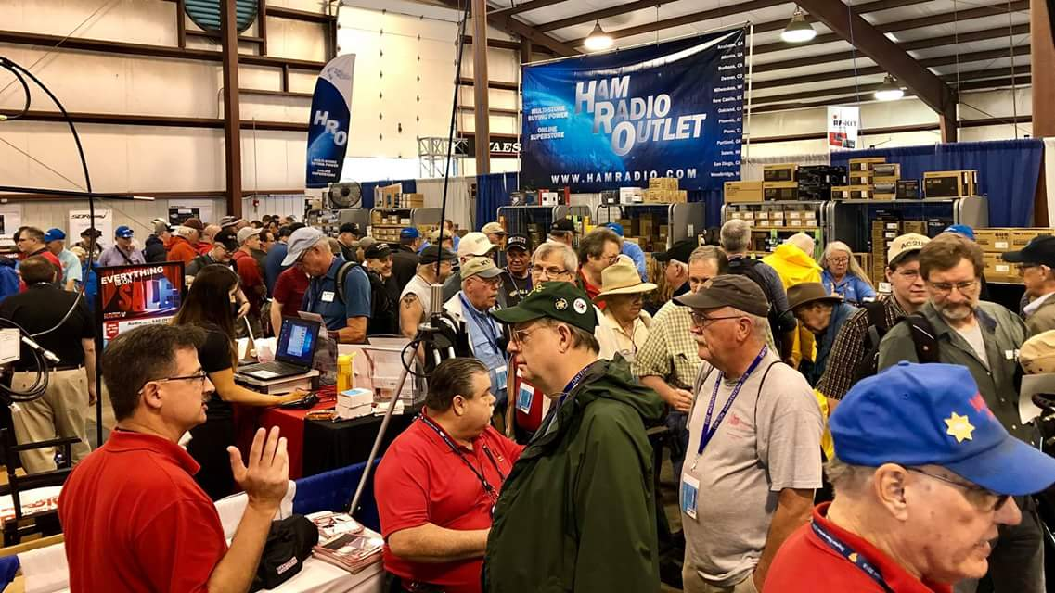
Upcoming Hamfests

We DO have hamfests scheduled for 2024!!

 | Ohio Hamfests
 | 2024
04/13/2024 - Cuyahoga Falls Amateur Radio Club 68th Hamfest  Location: Cuyahoga Falls, OH  Type: ARRL Hamfest  Sponsor: Cuyahoga Falls Amateur Radio Club, Inc.  Website: http://www.w8vpv.org/hamfest  Learn More |  | 04/13/2024 - Mid-Ohio Valley Amateur Radio Club  Location: Bidwell, OH  Type: ARRL Hamfest  Sponsor: Mid-Ohio Valley Amateur Radio Club  Learn More
04/27/2024 - Tusco Amateur Radio Club Hamfest, Electronics, and Computer Show  Location: Dover, OH  Type: ARRL Hamfest  Sponsor: Tusco Amateur Radio Club W8ZX  Website: http://www.w8zx.net/hamfest  Learn More |  | 04/28/2024 - Athens Hamfest  Location: Athens, OH  Sponsor: Athens County Amateur Radio Association  Website: https://www.ac-ara.org/  Learn More
05/05/2024 - Lucas County ARES Trunk Sale & Swap Meet  Location: Toledo, OH  Type: ARRL Hamfest  Sponsor: Lucas County ARES  Website: http://lucasares.org  Learn More |  | 05/11/2024 - 05/16/2024  RV Radio Network  Location: Millersburg, OH  Type: ARRL Convention  Sponsor: RV Radio Network  Learn More
05/16/2024 - 05/19/2024  Four Days In May  Location: Fairborn, OH  Type: ARRL Convention  Sponsor: QRP Amateur Radio Club International  Website: http://qrparci.org/fdim  Learn More |  | 05/17/2024 - 05/19/2024  Dayton Hamvention, ARRL National Convention  Location: Xenia, OH  Type: ARRL Convention  Sponsor: Dayton Amateur Radio Association  Website: https://hamvention.org  Learn More
06/01/2024 - FCARC Summer Hamfest  Location: Wauseon, OH  Type: ARRL Hamfest  Sponsor: Fulton County Amateur Radio Club  Website: https://k8bxq.org/hamfest  Learn More |  | 07/06/2024 - Mansfield Mid Summer Trunkfest  Location: Mansfield, OH  Type: ARRL Hamfest  Sponsor: Intercity Amateur Radio Club  Website: http://W8WE.ORG  Learn More
07/20/2024 - Ashtabula County Hamfest 2024  Location: Pierpont, OH  Type: ARRL Hamfest  Sponsor: Amigos Radio Club Ashtabula  Website: https://sites.google.com/view/arca-home/  Learn More |  | 07/21/2024 - Van Wert Hamfest  Location: Van Wert, OH  Type: ARRL Hamfest  Sponsor: Van Wert Amateur Radio Club  Website: http://w8fy.org  Learn More
08/03/2024 - 2024 Columbus Hamfest  Location: Grove City, OH  Type: ARRL Hamfest  Sponsor: Aladdin Shrine Audio Unit  Website: http://www.columbushamfest.com  Learn More |  | 08/10/2024 - Cincinnati Hamfest  Location: Owensville, OH  Type: ARRL Hamfest  Sponsor: Milford ARC  Website: https://CincinnatiHamfest.org  Learn More
08/18/2024 - Warren Hamfest  Location: Cortland, OH  Type: ARRL Hamfest  Sponsor: Warren Amateur Radio Association  Website: https://www.w8vtd.com/  Learn More |  | 09/08/2024 - Findlay Hamfest  Location: Findlay, OH  Type: ARRL Hamfest  Sponsor: Findlay Radio Club  Website: http://w8ft.org  Learn More
09/22/2024 - Cleveland Hamfest  Location: Berea, OH  Type: ARRL Hamfest  Sponsor: Hamfest Association of Cleveland  Website: https://www.hac.org  Learn More |  | 10/05/2024 - Northwest Ohio Amateur Radio Club (NWOARC) Hamfest  Location: Lima, OH  Type: ARRL Hamfest  Sponsor: Northwest Ohio Amateur Radio Club, Inc.  Website: http://www.nwoarc.com  Learn More
10/27/2024 - 2024 MARC Hamfest at MAPS  Location: N. Canton, OH  Type: ARRL Hamfest  Sponsor: Massillon Amateur Radio Club  Website: https://www.w8np.net  Learn More |  | 12/07/2024 - Winter Hamfest  Location: Archbold, OH  Type: ARRL Hamfest  Sponsor: FCARC  Website: https://k8bxq.org/hamfest  Learn More

__________________________________________________________________

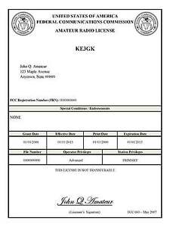
Print an Official or Unofficial Copy of Your Amateur Radio License
(By Anthony Luscre, K8ZT)

As of February 17, 2015, the FCC no longer routinely issues paper license documents to Amateur Radio applicants and licensees. The Commission has maintained for some time now that the official Amateur Radio license authorization is the electronic record that exists in its Universal Licensing System (ULS). The FCC will continue to provide paper license documents to all licensees who notify the Commission that they prefer to receive one.

Licensees also will be able to print out an official authorization — as well as an unofficial “reference copy” — from the ULS License Manager. I’ve created a set of instructions on how you can request an “official” printed copy of your license*

Click here to download the instructions

Final… Final

I'd like to wish you all a wonderful Easter! Easter is normally considered a time of renewal I hope that you experience renewal in your own life I'd like to point out I believe amateur radio is beginning to experience renewal after the COVID shut down. I'm certainly happy to see it. Look through this newsletter and look at all the great contributions that have been made by our Ohio Section officers, lots of great articles. Look at the list of VE sessions that go on in the Ohio Section. If someone wants to become a new ham in the Ohio Section they certainly have plenty of opportunity. And don't forget moving up to the general class ticket is probably one of the most important things that you can do as an amateur radio operator. It will allow you operating privileges on all amateur radio bands, where lots of fun can be had! Don't miss out on that. Especially considering where we are in the sunspot cycle.

Looking a little further in the newsletter you'll see the listing of all the Ohio section hamfests for the coming year (not counting those which have already occurred). We certainly have a lot of them in the Ohio Section. Get out there and support the local clubs, take advantage of the opportunity to meet and greet your fellow amateurs in the Ohio Section and check out some of the good deals on used equipment in the flea market. While I believe your local amateur radio clubs are your most important influence for your involvement in the hobby, ham fests certainly come in at a close second. It seems like “social interaction” is becoming a lost art in our society. Club meetings and hamfests are two important events where these skills can be improved upon.

I hope you're all making your plans and preparations for Hamvention. Hamvention is undeniably the greatest gathering of ham radio operators in the world. There's so much going on there, it's a great opportunity to meet people and see things up close and personal that you may never have another chance for. I hope to see you there in May.

Finally, I truly appreciate all the kind words and prayers I've received over the past several weeks. My arm and hand are getting better and I hope to be back to 100% by the time hamvention comes around.

Get on the air and enjoy the greatest hobby in the world!

73,
Tom WB8LCD

“Swap & Shop” on the website

Hey Gang,

Have you taken a look at the Swap & Shop page on the Ohio Section webpage yet?? Here’s a link that will take you there…
http://arrl-ohio.org/sm/s-s.html

Do you have equipment that you just don’t need or want anymore? Here’s a great venue to advertise it, and it’s FREE!!

Is your club doing a fund raiser to help raise money? After a lot of thought, it was decided that the Swap & Shop webpage could also contain these types of items as well.

The same rules will apply as do for the For Sales and Give-A-Ways and will only be posted for a month at a time. Please see the Terms & Conditions on the webpage. You might want to list your location so that prospective buyers know where you’re at.

If your club is doing a fund raiser and wants more exposure, please forward the information to me and I’ll advertise it on the Swap & Shop webpage for you. Now, I still want to remind you that it won’t be listed in this newsletter because it would take up way too much space, so your ad will only appear on the website. It is there for any individual to post equipment Wanted / For Sale or Give-Away as well as for Club Fund Raisers. No licensed vehicles/trailers or business advertising will be posted.

Postings are text only (no pictures or graphics) will be posted for a maximum of 1 month from date posting and require a contact phone number or email within the posting. Send your Wanted / For Sale or Give-Away post to: swap@arrlohio.org

Back Issues of the PostScript and Ohio Section Journal

Hey, did you know that PostScript and Ohio Section Journal (OSJ) are archived on the website? You can go back and look at any edition simply by clicking:
http://arrl-ohio.org/news/index.html

Ohio Section Cabinet
Section Manager – Tom Sly, WB8LCD | Section Emergency Coordinator – Bret Stemen, KD8SCL
Technical Coordinator – Jeff Kopcak, K8JTK | Section Traffic Manager – David Maynard, WA3EZN
State Government Liaison – Bob Winston, W2THU | Affiliated Clubs Coordinator –  Amanda Farone, KC3GFU
Section Youth Coordinator – Anthony Lascre, K8ZT | Public Information Coordinator – E;izabeth Klinc – KE8FMJ

Chit – Chat, and All That!

Do you know someone that’s not getting these Newsletters? Please, forward a copy of this Newsletter over to them and have them “Opt-In” to start receiving them. Heck just have them send an email to: webmaster@arrl-ohio.org to be added.

We now have many thousands of readers receiving these newsletters weekly. Quite impressive, I’d say! I urge all of you to make sure that everyone, regardless of whether they are a League member or not, get signed up to receive these weekly Newsletters.
You can always “Opt-Out” at any time if you feel this is not what you were expecting. It’s fun and very informative. All of your favorite past newsletters are now archived too.
You can go back at any time and read them. Just go to: http://arrl-ohio.org/news/

The pictures on the front page and throughout this newsletter are from various newsletters, Facebook posts and/or were sent directly to me in recent weeks. Take a good look at them, you just might be in one of the pictures! “SMILE… you’re in the Ohio Section News!!”

The Ohio Section Journal (OSJ) is produced as a comprehensive look at all the programs within the Ohio Section. I sincerely hope that you have enjoyed this edition of the OSJ and will encourage your friends to join with you in receiving the latest news and information about the Ohio Section, and from around the world!

TOP^

