March 2024

From the Technical Coordinator | From the Section Emergency Coordinator
From the Public Information Coordinator | From the Section Youth Coordinator
From the Affiliated Clubs Coordinator | National News
Club Corner | Contest Corner
DX This Week | Final.. Final..

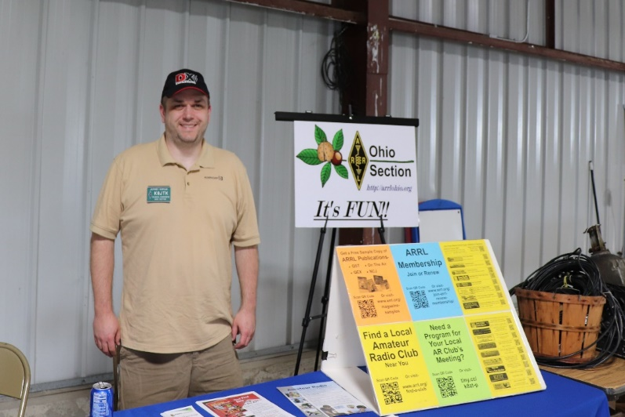
From the Technical Coordinator
Jeff Kopcak – K8JTK TC
K8JTK@arrl.net

Hey gang,
Imagine you own a 200 foot AM broadcast tower. Then one day - it’s gone – and no one listening to the station noticed. That’s right, the whole tower was stolen. Or was it? Earlier this month, a story spread through international news about WJLX-AM in Jasper, Alabama. A posting on the station’s website recounts this tall tale. WJLX is primarily an AM station on 1240 with an FM translator on 101.5 at a separate location.
The article published in Radio World notes a lawn mowing crew was sent to the transmitter site to do cleanup ahead of a new shed being built. When the crew arrived, they noticed something odd. There was no radio tower. Vandals stole everything in the building, cut guy-wires and managed to make off with 200 feet of radio tower. The incident was reported to police on February 2nd.

Many of us Hams have radio towers and know they are not easy to put up much less take down and remove. There’s a lot of time and coordination involved. This story already sounds kind of crazy.
For those not familiar with how broadcast translators are licensed, translators are commonly used for AM stations to simulcast audio on an FM frequency, ‘translating’ the AM signal to FM. A translator is tied to a primary (or parent) station. A 50,000 watt AM station in Cleveland – WTAM 1100 - is translated to 106.9 FM locally. The AM transmitter must be operational for the FM translator to remain on the air. Translators also have weird callsigns. WTAM’s FM translator is W295DE. If the AM station went off the air, so goes the FM translator.
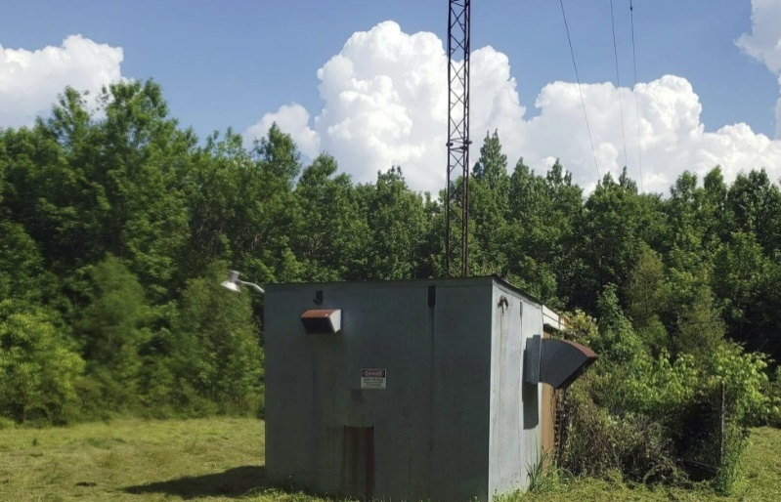These lower power FM translators help fill-in where coverage maybe lacking or as a way to gain more listeners on FM. They help lower power AMs fill in when the station is required to change antenna pattern at night or go completely off the air in the evening. It’s an additional way to generate revenue from advertising when the station would normally be silent.
WJLX AM transmitter site, photo “taken within the last two years” (Radio World)
FCC rules state the FM translator must be shut down when signals from the primary station are not being re-transmitted. Exceptions are daytime-only Class D AM stations which must have had an operational transmitter in the past 24 hours. WJLX is a Class C AM station (classes explained).
Even if vandals truly downed the tower, there would be evidence of the tower falling (landing) in any one direction or activity in one area from it being brought down vertically. To transport the tower, there would be evidence of cutting torches, saws, or disassembly. A good broadcast engineer will know their transmitter is off the air through remote monitoring before listeners call up complaining they can’t hear their favorite station. The post to the station’s website says the tower was “stolen without a trace.” The tower was reportedly steel, not copper which is what thieves desire at transmitter sites. This story is becoming very bazaar. That’s when I started poking around the Internet.
First came across Geerling Engineering’s video. They are in my subscriptions list because they had an informative tour of the KMOX-AM tower (St. Louis, Missouri). It’s a father/son YouTube channel where the father (Joe) has been in broadcast engineering for a lot of years.
Some points made in their video: the WJLX website and branding lists only the FM frequency and no mention of the AM frequency. Weird if the primary station is supposed to be AM. The dad goes on to make similar points about downing the tower, removing it, and the improbability of someone stealing an entire tower. In addition, he found filings noting the station was not well maintained.
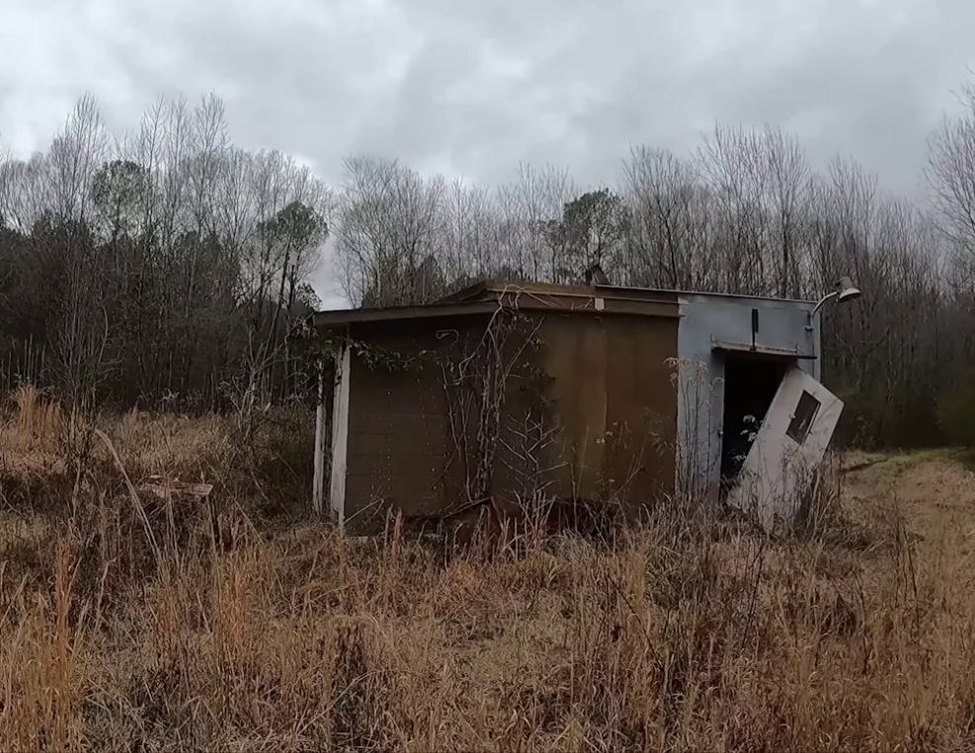Another video points out broadcast engineers in the area knew the AM signal had been off the air for some time. One user looked at Google Street View and noticed in October, 2022 there were two towers – one for WJLX-AM and a nearby tower for another station. The Street View car went by again in March, 2023. One of the towers is gone, WJLX-AM. The General Manager claims power was installed and operational until the theft. He provided power bills as evidence to the police. This video too mentions that logo/branding only includes the FM frequency.
WJLX AM transmitter site after the alleged theft. Tower pedestal to the left of the building. (William Collier)
Both reference this video posted 11 years ago showing the station “operating questionably.” It’s someone in their car on the property of the AM transmitter. They are listening to the FM translator, then switch to the AM station and the signal is completely silent. Per the FCC rules, with the AM offline, the FM translator must be offline as well.
Lastly, but probably most importantly, is a video posted by William Collier. This video is NSFW (not safe for work) – due to language. With his friend, they documented the state of the transmitter site on February 10, 2024 – about one week after the supposed theft. In 4K video, they document lots of evidence the site is in disrepair and has been abandoned or unused for a long time. In another video on the topic, someone sent William satellite images showing the tower shadow being visible in 2019 and 2021. There is no tower shadow visible in October, 2023.
William’s video shows the doghouse (transmitter building) being dirty with muddy floors and the door hanging off the hinge. There’s no evidence of someone or some people walking around inside to remove the seemingly heavy transmitter where brush would be trampled in front of the door. Same goes for the base of the tower. Many guy-wires are underneath overgrown weeds and brush. If the supposed landscapers came out to cut down brush, they did a pretty poor job as it’s clearly still overgrown. Nothing indicates a tower existed or was “downed” a week earlier. Required fencing to keep people away from the tower is overgrown in parts, missing in others. Probably the most telling, the power meter connection looks as though it hasn’t been used in months, if not years
Radio World wrote a follow up article to William’s video but the General Manager stands by his version of the story. This whole thing stinks. No one reported the AM signal being off the air because it had been off for months to years. The thread at Radio Discussions is quite entertaining and has even more speculation.
The station is seeking $60K through a go-fund-me campaign for a new AM tower and transmitter as it was uninsured. This is one campaign I’ll not be donating. I discourage and recommend others do not donate as well. Of course, the legacy media was all giddy about the station being back on the air after the FCC

denied the request to remain on the air solely using the FM translator. Someone at iHeart Media in New York heard the story and is leasing the station one of their HD signals out of Birmingham.
Thanks for reading and 73… de Jeff – K8JTK

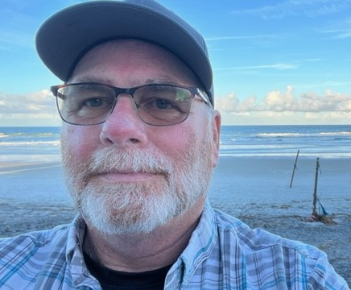
From the Section Emergency Coordinator Bret Stemen – KD8SCL EC
KD8SCL@gmail.com

ARES Simplex Contest

Spring is on the way!
I offer that to counter the mid-winter blah’s that we often get in this part of the country. But it’s true-
spring is coming with a lot to offer ARES in Ohio!

April 8 th is the Solar Eclipse event for about half of the Ohio Section! Most of the counties along
the I-71 corridor and 3-4 counties wide are preparing for an influx of visitors into their county
before, during and after the eclipse, we must keep in mind that there will be major traffic issues
after the eclipse as everyone will want to head back home afterwards.

April 27 th is another great day in the Ohio Section! That is the Ohio NVIS antenna day. You should
know the drill by now- put together your concepts of what a good NVIS antenna should be like,
and get together to actually try them out! Starting at 10AM, this is not exactly a contest, but it’s
designed to get as many counties in Ohio on the air at once, all testing antennas and
communications with each other. Since we’ve been written up in ARRL’s national news, I have
received numerous inquiries from as far away as Texas! I think this is going to be just a fun way to
get together, play and test in our hobby, and munch some great burgers!

The most important thing we can do until spring breaks, is TRAIN! Our past activations when the
911 service dropped for six Ohio counties, several tornado outbreaks, derechos and severe
storms showed that it ~can~ happen to you and when it does it’ll come quickly! Our county EC’s
and volunteers did a great job, ham radio was absolutely a star in this real-life event that
paralleled our last SEC almost to the letter. So, bring in your EMA Directors, Red Cross
managers, LEPC, safety officers and get some training in stuff that happens when there is a
disaster! We should know how to operate radios, but we’ll be much more useful if we are familiar
with NIMS, ICS, and our local officials.
This is also a great time to make contact with the representatives of the public service activities
that we cover. Make sure you have email, telephone and other contact information up to date, get
the right dates for when your activities will be held this year, and make an early contact to get in
on their planning process!

Here&#39;s a reminder to get your severe weather spotter training in! Sessions are being held online,
and generally require you to register. Check on your local NWS office website for details. It’s
nearly time to get serious about participating in your local Skywarn net this Spring!

Training Ideas

We all have had numerous discussions about making ARES meaningful and making it a viable resource to
EMA and other served agencies, and retaining/growing our teams. Understand that when our volunteers

leave a training meeting with the attitude that they learned something important, they can apply what they
learned and they know where they fit into the “big picture”. Your volunteers will return, and your meeting
attendance will increase. More important, your team will be able to function well.

I recommend you ask your EMA Director for their 10 worst headaches (There a FEMA required list of the top
hazards for their county) and shape your training around that list. Ask your local officials to train on some of
these topics, use your comms director to learn MARCS, use your police/fire officers, use your health
department planners! I will offer to find folks or deliver it from SEC/ASEC/DEC/ADEC people. With outside
speakers you can even consider multiple county joint training. It will all work to improve ARES across Ohio.
We can’t afford to languish and “think” we’re qualified. We need to train and practice to “show” we’re qualified.

Here is a list of training ideas:

1. FEMA 100, 200, 700, 800
2. ARES EC-001 &amp; EC-016
3. Ham radio fundamentals (operating radios, repeaters, frequencies, etc.)
4. MARCS operation and other types of radios (FRS, GMRS, DMR, etc.)
5. Net procedures and operation
6. EOC operation
7. OSERP and local response plan
8. Traffic and message handling
9. CERT nature, structure, operation and cooperation.
10. Missing persons behavior, patterns and search procedure
11. Shelter operations (Red Cross)
12. FEMA message forms, application to messaging
13. Digital modes and/or MESH
14. SAR procedures and building markings
15. Mass Casualty basics and/or Triage concepts
16. Health emergency preparation
17. Flood basics and/or coverage pre-plans
18. Terror awareness (Fusion Center)
19. Civil unrest preparations
20. NVIS and antennas
21. Portable operations
22. Power Batteries, Generators and alternate power sources
23. Public Service Events
24. HIPPA and patient tracking
25. Disaster Recovery – typical concerns (messaging, debris, health, sanitation, water, power)
26. Tabletop exercises

I sincerely appreciate all you do for your neighbors, and for the Ohio Section!

______________________________________________________________

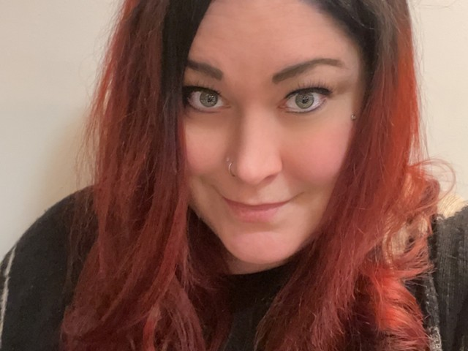
Elizabeth Klinc, KE8FMJ
OHIO Section Public Information Coordinator
ke8fmj@gmail.com

Developing an attractive news release form is one of the first things a PIO should do. These forms will be used to convey information to a wide variety of people and often present the first impression to members of the media. So, spend some time to come up with a neat but conservative design that implies a professional image.

An exert from the ARRL PIO Handbook:

THE MEDIA - What is News Anyway?

"The Media" is an overused term which conjures up this image of a monolithic beast
feeding on a never-ending stream of news stories. While there may be some truth to this
image (especially the appetite part), a more fitting image is the cartoon of the small fish
eating a plant, with a line of ever-larger fish behind it, each waiting to eat the next-
smaller one. For our purposes, though, this media "food chain" is good.

Before we "meet the media," though, let's take a look at its basic "food" -- news itself.

What is news, anyway?

News, in its most basic definition, is anything important or unusual that happens,
especially anything that can directly affect the lives of the people reading, watching or
listening to a particular news source. And the more people affected, the bigger the news
is.

People ask why there's so much bad news in the papers. Mostly because something that
goes right usually isn't news. If you go to work in the morning and get there on time, in
one piece, that's not news, that's normal.

If you get into an accident on the way to work, that's news to your family and co-workers,
but not to too many other people. If you're part of a 20-car pileup and 20,000 people are
late to work because of it, that's real news.

A newspaper that's full of only bad news won't sell. So most editors are actively looking
for "good news" stories to balance out some of the bad. If your story is important or
unusual, it also qualifies as news.

The public service provided by hams during emergencies is important. The fact that we
communicate via radio waves in the age of the internet is unusual (use this to our
advantage).

One other type of story that often makes the news -- even if it isn't especially important or
unusual -- is the interesting story, what journalists call a human interest story.

Most of the time, ham radio activities in and of themselves aren't news, especially beyond
a local area. However, you can get ham radio into the news by showing how hams are
involved in a local or national news story, or by looking for a human interest "angle."
We'll cover these in more detail in later chapters.

If a ham contacts the International Space Station, that's news in that ham's home town. If
a current or former astronaut comes to your town and talks with the space station, that's
statewide news and good material for some of the TV news magazine shows. If there's a
breakdown in NASA's communications system and ham radio is the only contact the
crew members have with earth -- and a ham in your town is at the center of it -- you're on
the evening news and in newspapers across the country.

OK, now let's "meet the media." Remember the fish-feeding analogy. There is no huge
beast called "the news media." In fact, the word "media" is actually a plural noun, and
you should say/write "the media are" rather than "the media is..." There are several categories and even sub-categories within the news media. Let's start with...

Newspapers

The bottom of the food chain in the newspaper category is the local weekly, followed by
regional daily newspapers (Hartford Courant, Baltimore Sun), specialized national
newspapers (Education Week, Baseball Weekly), national daily newspapers (NY Times,
Washington Post, USA Today), and while not newspapers themselves, the wire services
(Associated Press, Reuters and United Press International). Wire service stories are sent to newspapers and broadcast stations across an entire state or nationwide.

Magazines & Newsletters

This category includes local neighborhood newsletters, company newsletters, regional magazines (New Jersey Monthly), specialized national magazines (Road & Track, QST, CQ), and general national magazines (Time, Newsweek, Women's Day, McCall's).

Radio & Television

Here, you start with local radio & TV stations, including local cable stations, moving up to regional radio & TV stations and the national radio & TV networks (CBS, NBC, ABC, CNN, Fox), including cable and satellite channels (Discovery Channel, Nickelodeon, The Learning Channel).

Internet

This includes just about every news source reachable via the internet, from a local radio club web page to websites of traditional media outlets and so-called "new media" sources that are found only online.

Each of these categories has a different set of criteria for determining what's newsworthy.
Generally speaking, the larger and broader the audience, the greater the number of people
who must be affected for a story to be considered "news."

Here's how the media "food chain" works, starting with local weeklies: The folks at the
regional dailies read the local weeklies and pick up stories of broader interest. The regional dailies share their stories with the wire services and are read by people at the metropolitan newspapers and broadcast stations. They, in turn, pick out stories of even broader interest to share with their audiences. Finally, the people at the networks and the national newspapers read the wires and the metropolitan newspapers, and they watch and listen to local newscasts -- and THEY pick out stories of very broad general interest.

A story that affects only your home town will be likely to be covered by the local
weeklies, but not by NBC Nightly News -- UNLESS it illustrates a trend in society and
can be used as an example. How would NBC find out about your hometown story? Two
ways: the "food chain" described above or ... somebody (you) tells them about it!

Who Decides What's News?

Who decides what runs and on what basis? At a newspaper or magazine, the decisions are usually made by one or more editors; at a radio or TV station, the titles might also include producers or news directors.

Fact of life: The contents of a newspaper or newscast are selective... and subjective. You
have either a set amount of space or a set amount of time, and you nearly always have more material than you can possibly use. So you have to choose. The criterion they all use is something called news judgment. Here are the questions most often used in making those choices:

How does your story compare with others competing for the same space or time, in terms of importance or interest?

- How does your story fit into the overall "mix" or "balance" of articles that an
editor or producer likes to achieve in each issue or program?
- Another fact of life: When two stories of equal importance or interest are competing for the same space or time, the one that has that special something to catch the editor's interest generally wins.
- One more fact of life: An editor can't print or broadcast what he or she doesn't
know about.

Inside the News

Let's take a closer look at the different areas within a newspaper, magazine, or broadcast that may offer opportunities for publicizing amateur radio. We'll start with the print media. This category actually includes quite a variety of slightly different printed media. You need to expand your thinking a bit to appreciate the array of options available.

Newspapers, for example, consist of a number of sections and cover everything from
local to international news. Newspapers contain sports articles, feature stories,
advertisements, want ads, editorials, letters to the editor, advice columns, "how-to" articles, obituaries, comics, puzzles, and more. Many of them contain supplements and magazine sections and publish Sunday editions.

The point is that newspapers are not monolithic wholes but consist of a great many parts,
some of which present excellent opportunities for you to get your story in print in other than a straight "news" context, as discussed above.

The only item they have in common, of course, is that they all rely on the printed word.
Because they do, you need to reduce your message to words, present it with a natural
"angle" which makes it interesting and perhaps plan to supplement it with one or more photographs. Try to get your story there two or three days before the date when the event will actually occur.

Magazines are quite similar in that there's more than one approach. Most magazines
consist of a mix of feature articles, often written by freelancers (you?), and columns,
generally written by regular contributors, often called Contributing Editors. Even if you
can't land a feature article, you might get your story covered by one of a magazine's columnists.

Radio and TV

As with newspapers, you need to consider that the radio and TV media also consist of
parts. Their news programs cover everything from international to local news and many "news" programs routinely include feature sections which present opportunities for covering a story on a local Amateur Radio event like Field Day. Some stations have "news magazines" which, like their print media cousins, offer similar opportunities. The advice on timing discussed in the print media section above, applies equally well to the electronic media, although here, because of the more cumbersome logistics involved in assigning camera crews, for example, two or three weeks' notice may work a lot better.

Editors tend to know a lot more about things like parades, bridge collapses, political campaigns, automobile collisions and the like than they do about Amateur Radio. Lace your efforts with some information educating them about the basics of Amateur Radio.

In making your presentation, for example, you may want to supplement a Field Day story idea and request coverage with a good quality audio tape as possible background sound from the prior year's on-air operations to provide a "feel" for the event in the editor's mind. You could also consider adding "still" photographs to further help him visualize the story's potential and capture his imagination.

And, if you have not planned that far ahead, tape some current on-the-air activity and use
that, along with some still photos of a few typical radio shacks.

Cable TV & Cable Radio

Cable TV offers additional, and sometimes easier, ways of getting your story out to the
public. Some cable systems have full-scale local news operations that you'd approach in
the same way you'd approach a local TV station. Virtually every cable system provides one or more "access" channels for community programming. These channels are the "price of admission" that the cable company pays for having monopoly access to your town or neighborhood. In most cases, cable systems provide free training and use of their studios for community groups wanting to produce programs.

An often-overlooked cable programming resource is cable radio. While text-based cable
programming is most often accompanied by a rebroadcast of selected radio stations, some systems lease the audio channels to cable-only radio stations. Often, these cater to specific ethnic groups or other small communities.

Internet

While newspapers and magazines use printed words and still photos, and broadcasters rely on
the spoken word and (in TV) live-action video, internet websites offer the possibility of using any or all of these "modes," to use a ham term, plus interactive features such as live "chats" and links to additional information sources. Today, it's hard to find a daily newspaper, broadcast station or even community organization that doesn't have at least a simple website. See what's out there in your community and what possibilities they may offer in spreading the word about amateur radio.

Knowing and Using Your Resources

Now that you have a general idea of what makes news, what makes up "the media," and
how news decisions are made, it's time to look at how you can make use of the media
resources available in your community.

------------------------------------------------------------------
Elizabeth Klinc, KE8FMJ

OHIO Section Public Information Coordinator
District Emergency Coordinator, D3 Ohio ARES
Assistant Emergency Coordinator, Greene County
ARRL - The National Association For Amateur Radio™

______________________________________________

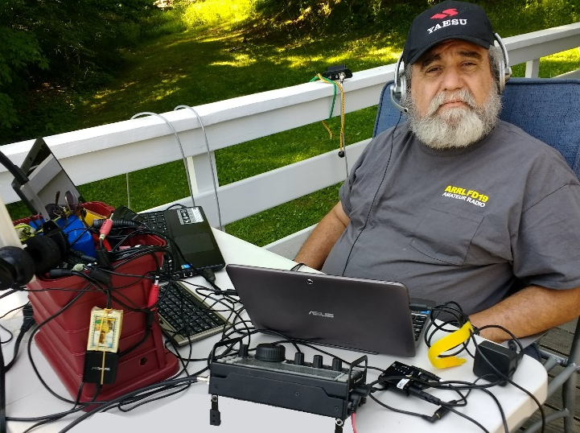
From the Section Youth Coordinator
Anthony Luscre, K8ZT - SYC
k8zt73@gmail.com

Code Practice Oscillator & Teacher Institute

Before we get into the Code Practice Oscillator (CPO) discussion, let’s talk a little about Morse Code. Although Morse Code is no longer required for Amateur Radio licensing, many hams enjoy using it. I have also found that students are intrigued with “secret codes” and hands-on activities. Because of this interest, I like to include Morse Code in my classroom activities, Ham Radio public demos, etc. These demos aim not to teach CW proficiency but to expose the viewers to the simple exercise of sending and receiving Morse Code with visual charts (definitely not the suggested method for actually learning code). The handout (below) is available at tiny.cc/mcinfo.
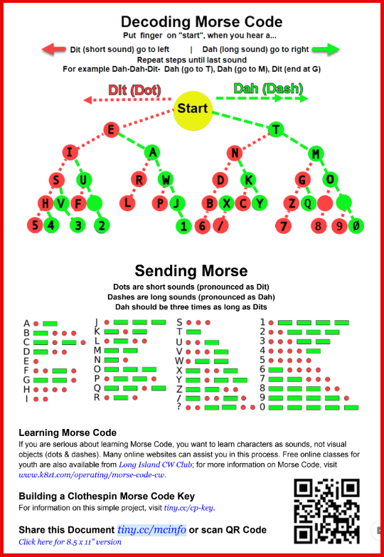
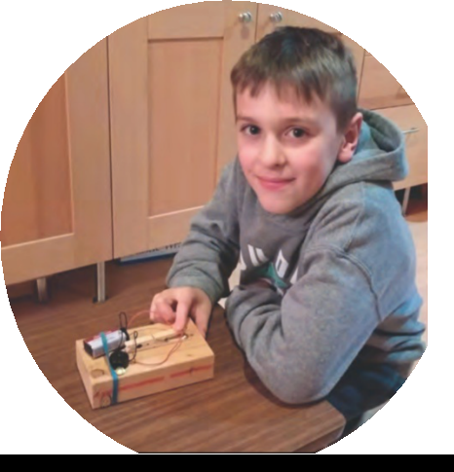
I was recently looking for inexpensive Code Practice Oscillators for use with students and scouts for these demos. I did not have much success. Even on eBay, the cheapest I could find was $14.99, but most were over $25. I could use cheap Piezo Active Buzzers meant for computer motherboards (I have done this with my Clothes Pin Key- tiny.cc/cp-key). The problem with these is there is no way to adjust the tone.

Searching the Internet for ideas, I found many older ideas on DIY CPOs. Most used discrete components would require more parts and a considerable amount of soldering. I then found an article, “The Quick and Dirty Code Practice Oscillator” by Bob Hill KG5WRY. Bob’s article used a 555 Timer Chip-based module with just one capacitor and speaker. He even provided a fuzzy schematic and links for the parts on Amazon.

Bob’s circuit is what I was looking for; it had a low parts count and could easily and inexpensively be kitted as a hands-on student project. I ordered the modules and speakers but had the other parts in my junk box, so my total cost per CPO was $2.42. I have compiled a complete parts list for those who may not have stock junk boxes or simply can’t locate the parts they know they have squirreled away. I have added a few extra items to the list to make construction more kid and school-friendly. The addition of breadboard connectors allows you to connect parts to the module easily without the need for soldering (soldering is not permitted in many locations due to safety and liability concerns). I have also included Button Cable UY Butt Splice Connectors to connect the components. If you want a completely solder-free assembly process, you must pre-solder wires to the 3.5 mm jack ahead of time.
Below is a price list including everything, even the battery. The price for twenty units is based on 20 of each component (you will have extra capacitors and breadboard connectors). Links and prices are from Amazon, but you can choose your vendors, dip into the junk box, etc., for even lower prices.
Parts | Price | # in Package | Price per item | Price for 20
NE555 Signal Generator Module | 7.59 | 5 | 1.52 | 30.36
Speaker | 8.99 | 10 | 0.90 | 17.98
Capacitor 10 μF | 7.99 | 150 | 0.05 | 7.99
3.5mm Stereo Jack Panel Mount | 7.99 | 10 | 0.80 | 15.98
9V Battery Clip Connector | 6.55 | 20 | 0.33 | 6.55
9 Volt Battery | 7.18 | 20 | 0.36 | 7.18
Button Cable UY Butt Splice Connector | 5.99 | 100 | 0.30 | 5.99
Breadboard Jumper Wires (Female to Female) | 6.98 | 120 | 0.06 | 6.98
TOTALS | 59.26 |  | 4.31 | 99.01

Because the schematic is a little challenging to read, and you don’t need to worry about components in the module, I have prepared a pictorial assembly diagram.
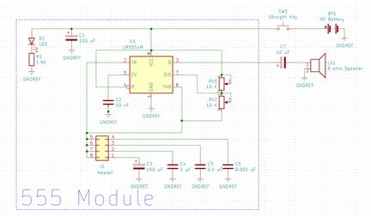
I also had to change the location of the jumper on the module to the third set of contacts (from the right) instead of the author’s suggestion of the second set. Your module may vary, so if you do not get a tone, try changing the position of the jumper.

To prepare the components for assembly by students, here are things you need to do ahead of time.
- Pick three different colors of the breadboard connectors (these will used to connect to the three pins on the end of the module [OUT- Output, GND- Ground and VCC Plus Voltage Input])
  - Cut each one in half (you can use each half for a separate kit)
  - Strip the insulation from the cut end
- Pre-solder leads onto a 3.5mm jack
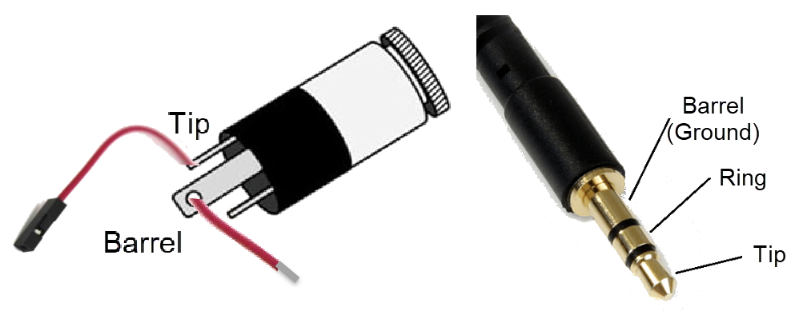
  - Solder one of the above wires to pin on the 3.5 mm jack’s pin connection
  - Strip both ends of a one-inch length of hookup wire
  - Solder one end of the one-inch piece of wire to the barrel connection of the jack
- Make sure at least ¼ of the insulation is stripped from the leads on
  - Speaker
  - Battery Connector
- Move module jumper to 3rd position (from right)
- Optional- you can pre-tune the 555 Generator modules
  - Temporarily attach a set of completed cables and components to the module
  - Key the circuit
  - Use two small brass screws on the blue variable resistors to adjust the tone
  - Alternatively, this could also be done after the assembly of each unit
- After completing the above steps, you can use the button solderless connectors to make the remainder of the connections, or you can solder instead of button connectors.
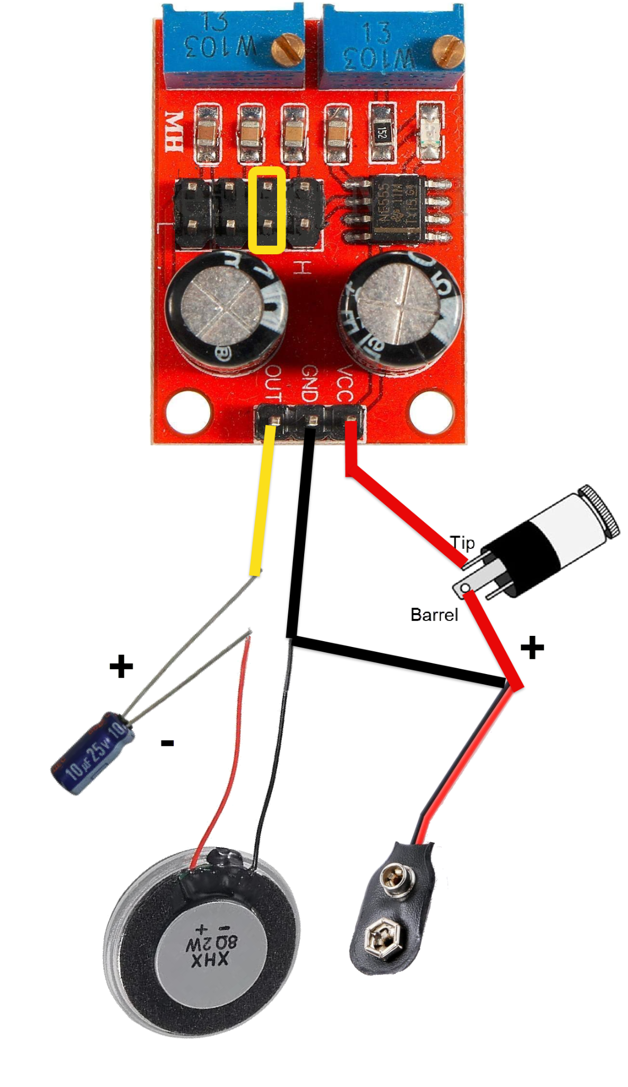
Assembly Instructions

- Put the three ends of stripped wires (the part with shiny metal) into one of the button connectors.
  - Black wire from the Speaker
  - Black wire from the Battery Connector
  - One of the three breadboard connector wires (one end has a square black plastic end; use the other end)
- Crimp or squeeze the yellow button onto the three conductors inside with pliers or a crimping tool.
- Put two ends of the stripped wire into another button connector
  - Red wire from the speaker
  - Wire lead from the Capacitor (the one with the gray strip on the side of the case)
- Crimp or squeeze the yellow button
- Put two ends of the stripped wire into another button connector
  - Second Wire lead from the Capacitor
  - Last of the three breadboard connector wires (one end has a square black plastic end; use the other end)
- Crimp or squeeze the yellow button
- Put two ends of the stripped wire into another button connector
  - Black wire from the speaker
  - One of the three breadboard connector wires (one end has a square black plastic end; use the other end)
- Crimp or squeeze the yellow button
- Put two ends of the stripped wire into another button connector.
  - Wire attached to the round headphone jack that has stripped end
  - Red wire from the Battery Connector
- Crimp or squeeze the yellow button
- Attach the three square breadboard connectors to the three pins [OUT, GND and VCC] on the end of the small circuit board, as shown in the picture
- Plug the key’s cable into the jack
Connect the 9-volt battery

ARRL Teachers Institute on Wireless Technology

Now Accepting Applications for ARRL's Teachers Institute 2024- for more information or to apply, visit this link.

That’s it for this month; I hope to work you on the air soon, maybe on HF!
73,
Anthony, K8ZT (k8zt@arrl.net)

____________________________________________________

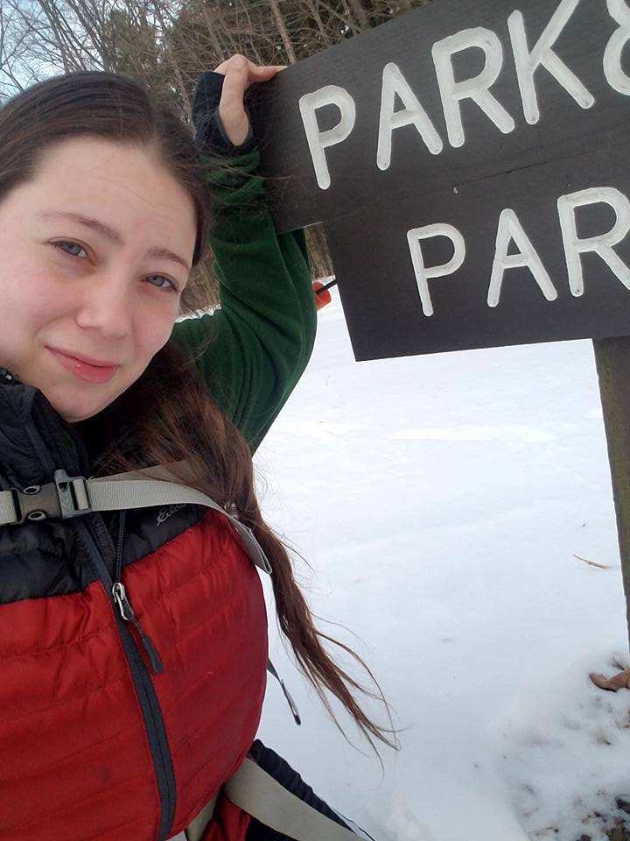
Amanda Farone, KC3GFU
ARRL Ohio Section | Affiliated Club Coordinator
Afrone926@gmail.com
330-509-4095

We’ve finally made it to March, what I consider the start of Hamfest “season”. I really enjoy Hamfests for many reasons: 1) It’s a great way to support other amateur radio clubs! 2) It’s a great way to put faces to call signs! 3) It’s a great way to find new treasures! Who doesn’t love to find a new toy at a good price? I will be attending as many Hamfests as possible this year and hope to see you all out there as well. Most times you can find me hanging out at the ARRL table. I encourage you to stop by and chat, even if it’s just to say hello. If you are looking for a way to raise funds for your club and you don’t already host a Hamfest, why not? If you get creative, you can put one together using very little funds (if any) and a few volunteers. If this is something you have thought about, what’s keeping you from bringing it life?
Spring and warm weather also brings the start of community events. Have you or your club looked into local events that you can showcase amateur radio and/or your club and services? Community events are a great way to get the word out and invite prospective operators to join in on the fun. It is also a great way to teach people about the importance of amateur radio and amateur radio services. Growing your club and your opportunities is often a result of showcasing amateur radio in a positive light and connecting with the “right” people. Getting your club’s name out there is vital to it’s growth.
Field Day will soon be upon us. Has your club started preparing? Do you have your location secured? Maybe a Field Day Captain in place? The sooner you start preparing the smoother the day will go for everybody involved. I plan to travel the state again this year, however I will be hitting a different area. I wish that I had enough time to visit every single club during Field Day weekend, unfortunately, Ohio is just too big, and we have too many great clubs out there! I really enjoyed my visits last year and ended the weekend feeling extremely proud of the entire Ohio section. I learned a lot, met a ton of great people, and had fun!
I am going to conclude this article with something I repeat often and sound like a broken record…it is VERY IMPORTANT to update your club information. Over the last 2 months I have reached out to several clubs for a few different reasons and have had no luck. I have tried using the contact email listed on the ARRL, I have tried using contact information from websites, I have tried filling out forms on “contact us” buttons, and I have tried looking up club officers on QRZ to find their personal emails. Clubs have missed out on opportunities for the good of the club simply because I was unable to contact them. What other opportunities might you be missing out on? The reason I stress updated information is not for “standard protocol” or alike, it is so your club does not miss out on opportunities or the chance to gain new membership. You never know who or what might be knocking at your door.

_
_________________________________________
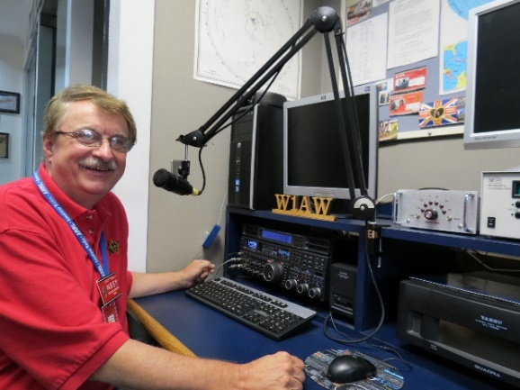
Hi Gang,

The Great Lakes Division Newsletter is now on-line!
There’s lots of great information for you to read. So, grab your
favorite beverage, a sweet snack to munch on and sit back in your easy
chair and have a great read!!
>> https://arrl-greatlakes.org/glnews/2024/03-gldnews.pdf <<
73,
Scott, N8SY

National News
(from ARRL and other sources)

__________________________________________________________

NASA Science Operating on the Moon

For the first time in more than 50 years, new NASA science instruments and technology demonstrations are operating on the Moon following the first successful delivery of the agency’s Commercial Lunar Payload Services initiative.

On Feb. 22, 2024, Intuitive Machines’ Odysseus lunar lander captured a wide field of view image of Schomberger crater on the Moon approximately 125 miles uprange from the intended landing site, at approximately 6 miles altitude. Credit: Intuitive Machines

NASA Technology Contributes to Soft Moon Landing
Intuitive Machines’ Nova-C lander, Odysseus, completed a seven-day journey to lunar orbit and executed procedures to softly land near Malapert A in the South Pole region of the Moon at 6:24 p.m. EST on Thursday, Feb. 22. The lander is healthy, collecting solar power, and transmitting data back to the company’s mission control in Houston. The mission marks the first commercial uncrewed landing on the Moon.

Odysseus carried six NASA science research and technology demonstrations, among other customer payloads. All NASA science instruments completed transit checkouts en route to the Moon. A NASA precision landing technology demonstration also provided critical last-minute assistance to ensure a soft landing. As part of NASA’s Artemis campaign, the lunar delivery is in the region where NASA will send astronauts to search for water and other lunar resources later this decade.

New Lunar Science
NASA’s Navigation Doppler Lidar for Precise Velocity and Range Sensing guidance system for descent and landing ultimately played a key role in aiding the successful landing. A few hours ahead of landing, Intuitive Machines encountered a sensor issue with their navigation system and leaned on NASA’s guidance system for an assist to precisely land. NASA’s instrument operates on the same principles of radar and uses pulses from a laser emitted through three optical telescopes. It measures speed, direction, and altitude with high precision during descent and touchdown.

Learn More

ARES Update

We will be releasing the first 2 new EmComm courses April 1. Basic EmComm and Intermediate EmComm will be live in the ARRL Learning Center April 1. With the new courses being released the legacy courses will be removed April 1. Anyone who is currently enrolled in EC-001 or EC-016 will need to complete these courses by April 1 to receive credit for them. We hope to have Advanced EmComm and ARES Leadership courses complete by early summer.

And finally, we have a new project to assist local ARES groups in recruiting for their local ARES team. We are going to be launching Advertising in ARRL publications and other national publications to recruit new members to ARES. This campaign will lead them to a webpage where they can enter their location and it will provide the contact information for a local ARES team. We want this to provide a much quicker and easier process for them to get plugged in locally. To make this work we need your help. We are now collecting ARES group registrations on our website. This is a one-page form to be filled out by the EC or ARES team leader in each local community. This is very similar to the Club Registration we have been using for some time and will work very similarly to the club look up function we currently have but will be for ARES EmComm groups. The link to the page is: http://www.arrl.org/ares-group-registration Please share this link with each of your EC’s and local ARES groups to get them to register. Your help in this will benefit each local group and help to support growth in the local community.

Josh Johnston, KE5MHV
Director of Emergency Management
ARRL The National Association for Amateur Radio®
225 Main Street, Newington, CT 06111-1400 USA
Tel: (860) 594-0333 FAX: (860) 594-0303
jjohnston@arrl.org
www.arrl.org

_________________________________________________________

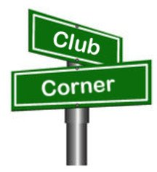
Club Corner

This is YOUR corner of the newsletter. Send us what your club is doing, and we’ll make sure that it gets in. Got a special event or club project that you want everyone to know about? Send it to us!. Need help with a project? Send it to us.

Let us know what you club is up to. Are you going to have a special guest at your meeting or are you having a special anniversary?

Send it to: webmaster@arrl-ohio.org

OH ARES District 10 Conference

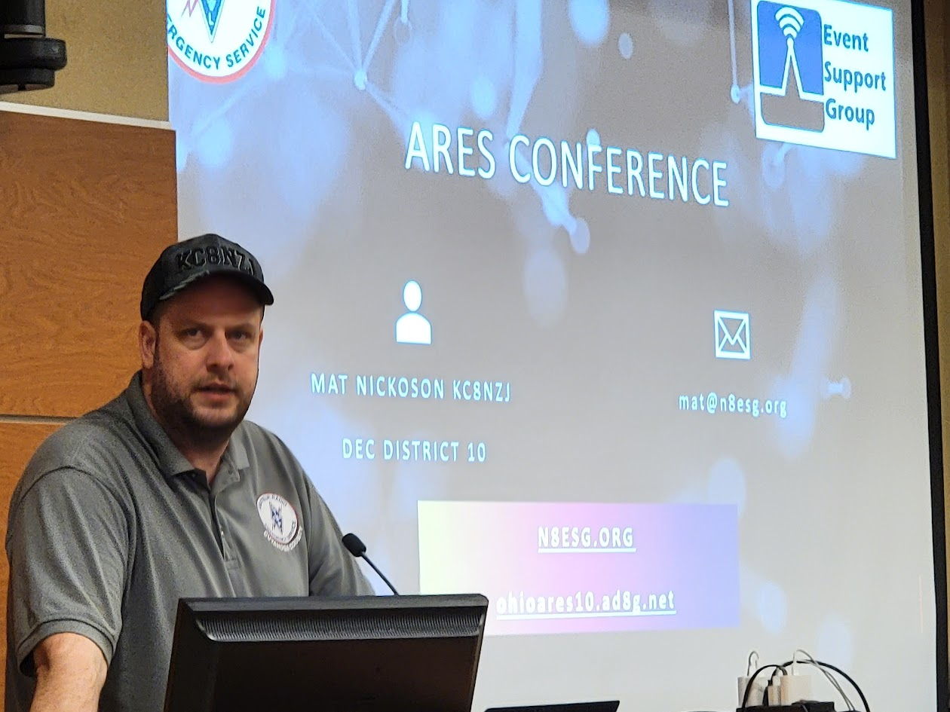
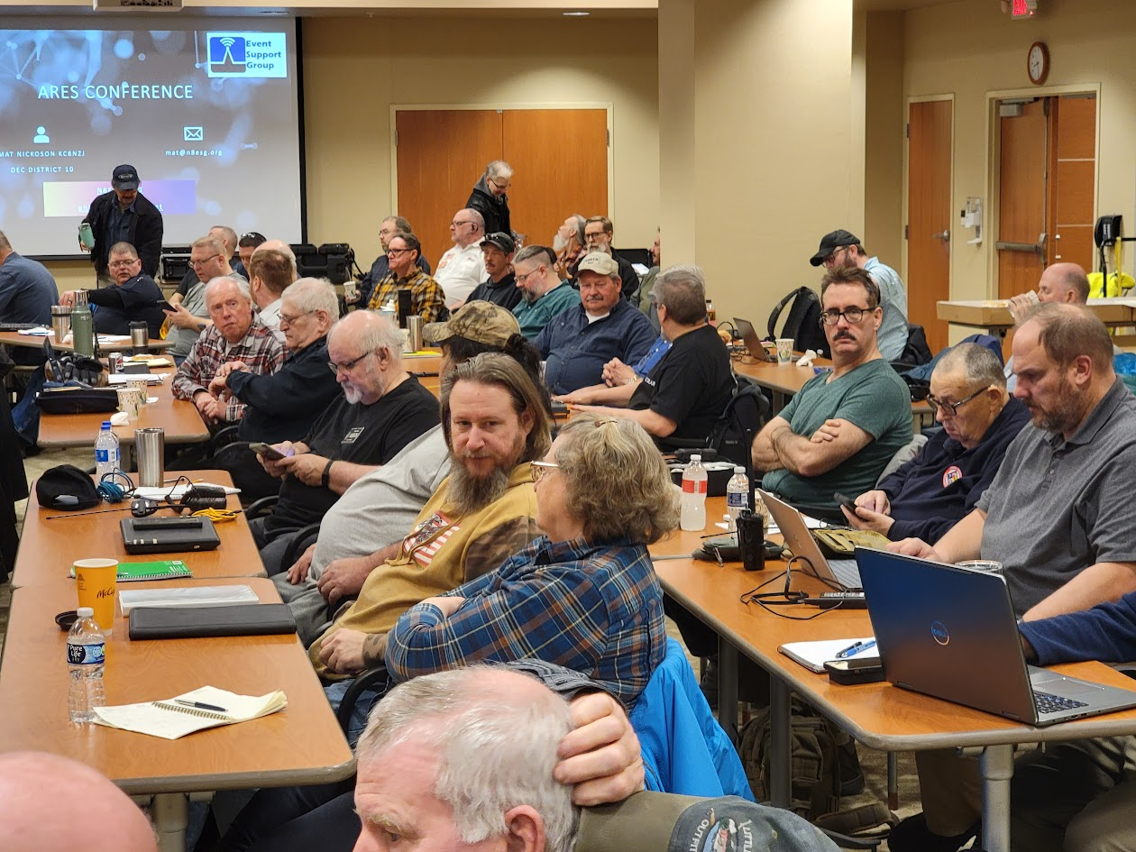

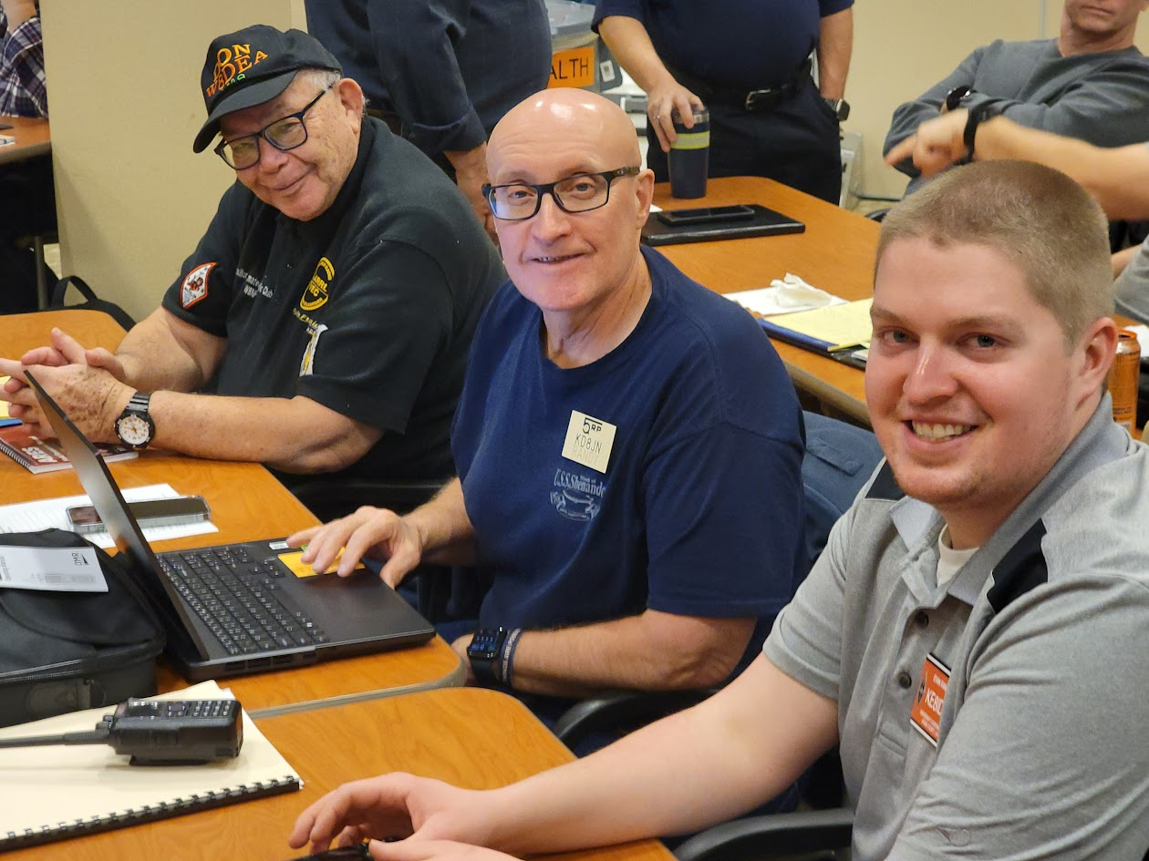

All Things Amateur Radio Association’s (ATARA) VE Team Goes Digital

ATARA’s VEs wanted to create a better testing experience and help lead the way to paperless sessions by going digital. After a couple of team training sessions in the summer of 2023 utilizing Examtools sandbox utility, the ATARA team ran their first live digital session in September. Mary – KE8UOS, an ATARA club member, was our first candidate to test with us using Examtools. She earned her Extra ticket and provided us with our first real-world experience using the software. Mary, also a team VE, allowed the team to begin to see the potential efficiency gained by making the switch from paper to electronic format. Utilizing the new digital format, candidates and VE’s of all ages have expressed the ease in which testing takes place. One candidate stated that since they had studied using digital platforms, taking their exam on a tablet made them feel very comfortable, like being at home studying.

Here's what Jarrod – KE8MBL had to say about using ExamTools:

From a liaison standpoint, Examtools has greatly reduced the level of effort to run an exam. I can refer candidates to the Hamstudy site to create an account and register for an exam session which greatly reduces the coordination that I have to manage for a session. When candidates show up to the exam, every step of the process is streamlined. They’ve already filled in all their information online so check-in is reduced to accepting payment for the exam fee and checking their I.D. The testing portion of the session is also easier. All that the candidates have to focus on is, well, taking the exam. There’s no paperwork to complete to get started at this point. Taking the exam is like taking a practice exam at home on Hamstudy.org. Grading is probably the one
area where we saw the most improvement in reducing the time needed. Examtools automatically grades the exams leaving the only thing remaining for the 3 VEs to do is verify the results and apply their digital signature.
The Certificate of Successful Completion of Examination (CSCE), once formerly a manual paper process, is also automatically generated once the VE’s sign off. We ‘click’ to email the CSCE to the candidate so that they have it electronically before they leave the session. All of these time savings allow us more time to talk with the candidates about RF safety and the benefits of joining a club to get the most out of their hobby. Finally, wrapping up a session and uploading the documents to the ARRL went from a paper laden task that I would take home and do late in the evening to a few clicks that I complete before I leave the testing session location.

Overall, the team finds that candidates test faster and are more comfortable with the electronic format. Additionally the VE team enjoys the fact that the whole exam process is much quicker than using the paper exams. Most importantly each candidate’s experience is a critical concern to our team as we may be the first interaction they have with members of the hobby. Our team takes pride in the friendliness, professionalism, and efficiency that we feel we have always brought to our sessions. Hamstudy/Examtools certainly has taken the experience of all parties involved to a higher level. Hamstudy/Examtools has a lot of great information to support clubs making the switch from paper to electronic format utilizing their software. Further, any clubs wishing to make the switch are also welcome to reach out to ATARA to talk about the process we went through to get ready and our experiences.

For candidates wanting to test, simply sign up for a free account at https://hamstudy.org/register and then search for an ATARA session (Lancaster, OH, 43130) and register through the Hamstudy website. Reach out with any questions to Jarrod – KE8MBL at
hamexams@atara-w8atr.fun .

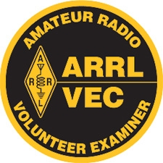

VE Sessions

The following information is for ALL exam sessions:
It is now an FCC requirement to have an FCC FRN; active email address and active phone number before taking any exam. Please bring your FCC FRN, original license, a copy of your license (if a licensed ham), a valid photo ID and $15.00 - Cash preferred.
Effective April 19, 2022, the FCC will charge a $35.00 application fee for amateur radio licenses. The fee will apply to new, renewal, rule waiver, and modification applications that request a new vanity call sign. License upgrades will not have a fee applied. The fee will be per application. VE's will not collect the fees at exam sessions.
AE8FP Amateur Radio Test Team administers ARRL-VEC testing in the Central Ohio area. Our test dates for 2024 are as follows: Januray 20, April 27, June 22, July 20, and October 19. Time and location for these dates are 10:00am at the Westerville Fire Station #111, 400 W. Main St in Westerville, Ohio. The listed dates are co-sponsored by the Central Ohio Radio Club (CORC).
Pre-Registration is required, and open the 1st of each testing month. All information is available at www.ae8fp.net <http://www.ae8fp.net/>

Alliance Amateur Radio Club The Alliance Amateur Radio Club holds quarterly VE testing, at the Christ UInited Methodist Church in Alliance. The address is 470 E. Broadway St, Alliance, OH (Enter through door ONE A off North parking lot.) (https://maps.app.goo.gl/prDyEPp6siJun2ibA).
Upcoming Exam Dates are
Saturday, March 16th, 2024
Saturday, June 15th, 2024
Saturday, August 10th, 2024
Saturday, October 19th, 2024
We begin registration at 8 AM, with testing at 9am.
More information can be found at www.w8lky.org/licensing/ve-exams/.
All Things Amateur Radio Association (ATARA) All Things Amateur Radio Association (ATARA) hosts testing sessions every second Tuesday of the month in Lancaster. Our testing sessions use Examtools, a digital testing platform, and administers the exams on tablets. Simply sign up for a free account at https://hamstudy.org/register and then search for our session and register through the Hamstudy website. Reach out with any questions to Jarrod – KE8MBL at hamexams@atara-w8atr.fun .
CARS
VE testing from CARS - Cuyahoga Amateur Radio Society - at Elmwood Recreation Center, 6200 Wisnieski Parkway in Independence, Ohio 44131 Time: 9:15 AM (Walk-ins allowed) Always the 2nd Sunday of the odd month. Go to CARS www.2cars.org for detailed map of location. Call Metro W8MET 216-520-1320 for details

Clark County Amateur Radio Association (CLARA) What: CLARA sponsored A.R.R.L. VE Testing - Walk-ins allowed. Pre-Register via email preferred. When: On every second Saturday of each even numbered month starting at 10:00 AM Feb
10th; Apr 13th; Jun 8th; Aug 10th; Oct 12th; and Dec 14th, 2024.Where: Springview Government Center - Emergency Operations Center; 3130 E Main St; Springfield OH 45503 This is US-40 aka "old national road". From Route 40 enter Old Columbus Road, at the fork stay left driving straight onto Ogden Rd, then immediately turn left into the parking lot behind the EMA. Walk to the door with the "Employees Only" sign.
For more information contact Roland W. Ude, W8BUZ, (937) 605-4951 Email: buzz@baylorhill.com

Dayton Amateur Radio Association (DARA)
If you are interested in testing for a new or upgraded license, please come see us at the DARA Clubhouse. If you have questions about testing, please email exams.w8bi@gmail.com

DeForest Amateur Radio Club
VE test sessions on the second Thursday of every even numbered month. Upcoming dates include April 11, June 13, August 08, October, 10, and December 12. 2024. These sessions begin at 6:00 pm and are held at the Adams County EMA office, 31 Logans Ln., West Union OH 45693. Walk-ins are welcome, but to pre-register or for additional information please contact William E. Hablitzel at K8WEH@arrl.net.

Geauga Amateur Radio Association (GARA)
Amateur License exam sessions are offered for all license classes (Technician, General, Extra). Walk-ins are always welcome - no prior registration is required. No fee for the exam.

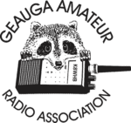
The GARA schedule of exams are these Sundays at 2pm. Dates for 2024 are Jan 14, March 10, May12, July 14, Sept 15, and Nov 17, 2024. All sessions are at 2:00PM each month

Exams are held at the Geauga County Department of Emergency Services and Emergency Operations Center, 12518 Merritt Road, Chardon, Ohio 44024. The EOC is located just south of the University Geauga Hospital and just east of the Geauga County Safety Center (Sheriff's Office), off of State Route 44 between State Route 322 and State Route 87 on Merritt Road.

Please arrive a few minutes before 14:00 to allow adequate time to process the necessary paper work and take your test. Bring your 1) photo ID, 2) email address, 3) FCC FRN, 4) a printout of your current license if taking the General or Extra exam.

Additional info may be obtained from Jackie Welch, N8JMW by email n8jmw2@gmail.ccom or calling at 440-228-2716. More information is available from the Geauga Amateur Radio Association website https://geaugaara.org

Huber Heights Amateur Radio Club
Huber heights amateur radio club does ARRL VE testing the second Saturday of each even numbered month. Feb, Apr, Jun, Aug, Oct, Dec. 9:30-11:00 For more information contact Jim Storms – AB8YK at ab8yk@hotmail.com

The Lake County Amateur Radio Association
The Lake County Amateur Radio Association is holding its 2024 Amateur Radio license exams at the Kirtland Library, 9267 Chillicothe Road, on the following dates:
Saturday. February 3 Saturday, August 3
Saturday, April 6 Saturday, October 5
Saturday, June 1 Saturday, December 7

This bi-monthly schedule is the first Saturday of every even-numbered month (e.g., February being the second month, etc.). They are held at the Kirtland Library, 9267 Chillicothe Road. It is 1.7 miles south of I-90 on Route 306 (Chillicothe Rd). The library is on the left, just beyond the Marathon gas station. The tests will start at 12 noon. Please arrive a few minutes earlier.
To register, you will need a NCVEC 605 Form, which will be available at the test. If you would like to complete one ahead of time, be sure it is the Sept 2017 version or later. You can find it by Googling “NCVEC quick-form 605” and clicking on the url for a pdf of the form. Please note the FCC requires you to provide a FRN (FCC Registration Number). Social Security Numbers are no longer accepted. If you are new to ham radio and don’t have a FRN, Google “New FRN” and follow the fcc.gov link.

If you are currently licensed, be sure to bring a copy of your license to the exam. The cost of the exam itself is $15.00, and if you wish to pay by check, it should be made out to the ARRL/VEC. Identification with your picture is also necessary, such as a driver’s license. If you have any questions, please contact Scott Farnham, KO8O, at (440) 256-0320, or scottfarnham@roadrunner.com

In addition to the $15 test fee, the FCC now charges $35 to add you to the Amateur Radio database. The FCC will e-mail successful candidates instructions for payment directly to them. Payment must be made within 10 days of the e-mail. This charge does not apply to upgrades.

The Lancaster and Fairfield County Amateur Radio Club (LFCARC) hosts exam sessions at the FAIRFIELD County EMA, 240 Baldwin Dr in Lancaster Ohio, 43130, on the first Saturday each month at 10:00 am. Please visit our website at http://www.k8qik.org for exam dates on our calendar and navigate to our Learning Center/Taking the Exam link for information and requirements. Our experienced VE team looks forward to serving the Amateur Radio community in Central Ohio. Contact me at ve_testing@k8qik.org to register.
Lisbon Area Amateur Radio Association
LISBON AREA AMATEUR RADIO ASSOCIATION (LAARA) 2024 SCHEDULE.
VE TESTING IS AT THE COLUMBIANA COUNTY EMERGENCY MANAGEMENT AGENCY
AT 215 SOUTH MARKET STREET, LISBON, OH 44432.
SIGN IN AT 1 PM AND TESTING AT 1:30 PM.
VE TESTING DATES FOR 2024
JAN 13; FEB 10; MAR 9; APR 13; MAY 11;
JUN 8; AUG 10; SEP 14; OCT 12; NOV 9; DEC 14.
WE CAN ALSO GIVE THE TEST AT OUR REGULAR MEETINGS
THAT ARE NORMALLY ON THE 3RD THURSDAY OF EACH MONTH.
LAARA MEETINGS ARE HELD AT THE COLUMBIANA COUNTY
EMERGENCY MANAGEMENT AGENCY AT THE SAME ADDRESS AS ABOVE. SEE THE K8GQB.COM WEB SITE FOR UPDATES.
MEETING TIME IS 6:30 PM.
WE HAVE ACTIVITY MEETINGS ON THE ODD MONTHS AND
BUSINESS MEETINGS ON THE EVEN MONTHS.
Madison County
The Laurel testing group will offer testing on the first Thursday of January, March, May, July, September and November. Tests are held at 7:00PM at the Madison County EMA located at 271 Elm St. London, OH. No fee.
The Milford Amateur Radio Club (MARC)
VE testing is held the third Thursday of each month at 6:00 PM. Location; Miami Township Civic Center located at 6101 Meijer Drive, Milford, OH 45150.
Please pre-register at www.milfordhamradio.org

Northern Ohio Amateur Radio Society (NOARS) Northern Ohio Amateur Radio Society (NOARS) VE sessions are held the first Saturday of odd-numbered months (EXCEPT FOR March and July) at 10 AM in the Fairview Park Library, 21255 Lorain Rd., Fairview Park. Registration is preferred, but walk-ins are welcome. For more information or to register, contact Elaine, KC8FOS at ewilkinson1951@gmail.com. There will be a VE session held Sunday, March 10 at the NOARS Winterfest held at Lorain County Community College in the College Center, 1005 Abbe Rd N, Elyria, OH 44035. Please email Elaine, KC8FOS at ewilkinson1951@gmail.com for more information or to register.

Portage County Amateur Radio Service (PCARS)
The first Saturday of every even numbered month -10 am – at the PCARS club site in Ravenna. Please visit the PCARS web site and check out the information about VE testing in the latest newsletter at www.portcars.org .
If you have any questions, don’t hesitate to contact me at KB8UUZ@gmail,com

Tusco Amateur Radio Club W8ZX

VE Testing sessions are held on the second Saturday of every even numbered month at the Dover Faith Church, 420 N Wooster Ave, Dover, OH 44622. Pre-registration is not necessary. Doors open at 0830 for registration, exams begin at 0900. Cost is $15. You are required to have an email address and a copy of your FRN or current ham radio license. For more information please go to www.w8zx.net/exam or email VETEAM@N8BAG.NET.

Silvercreek ARA (SARA)
Hold six exam sessions per year for all license classes. Pre-registration requested but not required. Exam sessions for 2024:

Saturday, February 3rd - Wayne County Justice Center (Wooster)
Saturday, April 6th - Sharon Center UMC (Wadsworth/Medina)
Saturday, June 1st - Sharon Center UMC (Wadsworth/Medina)
Saturday, August 3rd - Wayne County Justice Center (Wooster)
Saturday, October 5th -Sharon Center UMC (Wadsworth/Medina)
Saturday, December 7th -Sharon Center UMC (Wadsworth/Medina)

All sessios begin at 10:00am. For directions and test information visit https://w8wky.org/license-exams/. Pre-Registration to expedite paperwork is requested, but not required at https://w8wky.org/sara-ve-registration-form/. Sign up and if you aren't ready or can't make it, just notify the VE team lead.

West Chester Amateur Radio Association (WC8VOA)Exam sessions are held one Saturday each month at 10:00 AM-Noon at the VOA Bethany Relay Museum located at 8070 Tylersville Rd, West Chester, Ohio 45069. For more information and links to register, please see our website: https://wc8voa.org/licensing/
____________________________________________________

__________________________________________________________

Your Club news should be listed here!
I know you’re out there doing things! Send me a write-up (MSWord please) and some photo’s (.jpg please) and we’ll get your club hi-lited here for the other OH Section Clubs to see! Send to WB8LCD@ARRL.ORG

Important Links
ARRL Home: www.arrl.org
Find an ARRL Affiliated Club: www.arrl.org/clubs
Find your ARRL Section: www.arrl.org/sections
Find a License Class in your area: www.arrl.org/class
Find a License Exam in your area: www.arrl.org/exam
Find a Hamfest or Convention: www.arrl.org/hamfests
Email ARRL Clubs: clubs@arrl.org
____________________________________________________________________________

The Ohio Section Youth Net

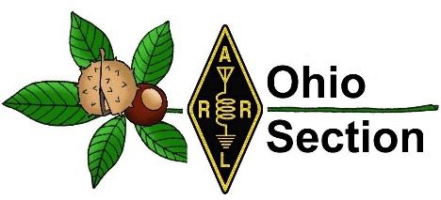
Youth Net
When: The second Sunday of every month at 7:30 PM EST
Where: The K8IV repeater located in Kent, Ohio (Echolink node K8BF-L) RF: 146.895 Mhz with PL 118.8
Who: Any licensed amateur radio operator who wishes to participate. Priority will be given to youth stations and those located in Ohio.
The purpose of this net is to encourage youth activity in amateur radio and to help new hams get more comfortable on the air.

***Next Net is Sunday March 10, 2024 ***

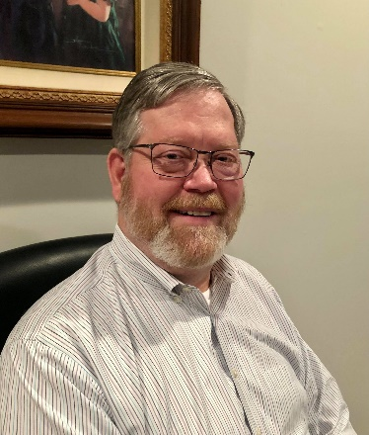
DX This Week – Zones 27,28, and 29
Bill - AJ8B (thedxmentor@gmail.com / www.aj8b.com )

So much activity on the air. I hope 2 things: I hope you are in the chair and working this AND I hope you can remember just a few years ago when you had to check to see if the coax was actually attached due to the bottom of the previous solar cycle being present.

DAH DIT DIT DIT DAH DAH DIT DIT DIT DAH

This week we will continue our investigation of the various CQ Zones. So, let’s get started.

So far this year, we have covered CQ zones 1 through 26. This week we will review Zones 27,28, and 29.

Zone 27. Philippine Zone: BS7 (Scarborough Reef), DU (Philippines), JD1 (Minami Torishima), JD1 (Ogasawara), T8 (Palau), KH2 (Guam), KH0 (Mariana Is.), V6 (Fed. States of Micronesia).
Zone 28. Indonesian Zone: H4 (Solomon Is.), P2 (Papua New Guinea), V8 (Brunei), YB (Indonesia), 4W (East Timor), 9M (West and East Malaysia) and 9V (Singapore).
Zone 29. Western Zone of Australia: VK6 (Western Australia), VK8 (Northern Territory), VK9X (Christmas Is.), VK9C (Cocos Keeling Is.) and some Antarctic stations. Antarctic notes:
The boundaries of CQ zones 12, 13, 29, 30, 32, 38 and 39 converge at the South Pole.
Stations KC4AAA and KC4USN are at the South Pole and will count for any one of the listed zones. Most Antarctic stations indicate their zone on the QSL card.
These zones can be very difficult at times and you need to understand and use the gray line. Zone 27 is most easily workable by chasing DU stations. I was fortunate to work both JD1 entities in 1991 as part of a DXPedition. I only have those QSOs to date. I have worked KH0, KH2, and V6 during CQWW contests several times.
Zone 28 is well represented by the YB hams. P2 is active and 9V1YC is on weekly representing Singapore.
Your best shot at Zone 29 are the VK6 hams and the two KC4 stations.
Good Hunting in these Zones

DAH DIT DIT DIT DAH DAH DIT DIT DIT DAH

Here is an update from Bernie, W3UR, of the DailyDX and the WeeklyDX, and the How’s DX Column in QST. The DailyDX the best source for real-time DX information. http://www.dailydx.com/ . Bernie has this to report:

The Intrepid DX Group H4ØWA DXpedition is now QRV on Pigeon Island, Temotu Province (the easternmost province of Solomon Islands), and will be on the air through March 7. The team reports that it took two and one-half days of arduous work in extreme heat and humidity to set up; they had to deal with heat exhaustion and very difficult conditions. At times, they had to hack clearings in the jungle to allow for antennas. H4ØWA operators are N7QT, Rob; N6PSE, Paul; NE9U, Scott; K4ZLE, Jay; AC7DC, Jay; K3NQ, Bruce; N6JRL, Don; and AH6HY, David. They will be on 160-6M, including 60M, on all modes. FT8 operation will be Fox/Hound, except on 60M, where they will revert to standard mode for United Kingdom stations. The team cautions that they are running on generators and will have refueling outages from time to time. Follow H4ØWA on Facebook. QSL via MØURX’s OQRS, and see the DXpedition website for the detailed QSL policy. Pilots are W6AER, Lucas and EA5RM, Tony; contact them as needed. No log corrections will be made while they are operating.

March 2-29: TY5C, Benin - F5NVF, Gerard; F5RAV, Luc; and MØNPT (7X2TT), Abdel, will be active as TY5C from Cotonou, Benin March 2-29. They will operate CW, SSB, and FT8 on various bands, including 6M, and will also be QRV via satellite (QO-100). QSL direct to F5RAV or via LoTW.

CBØZA, CBØZEW, CBØZW ends with 109K QSOs!
The Juan Fernandez Island DXpedition ended on February 24. The seven operators at CBØZA and CBØZW and many more operators worldwide on the remote station CBØZEW made over 109,000 QSOs. Team members flew back to mainland Chile yesterday, and from there made their way home.

IOTA Honor Roll and Annual Listing now available

The IOTA Honor Roll and Annual Listing includes a total of 1,540 entries, while 22 chasers chose to not be listed, compared to 1,511 and 36 in 2023. There are 237 record-holders with scores of 1,000 or more IOTA groups, and 553 with scores of at least 750 groups, the number required for the IOTA Plaque of Excellence. Scores at the top show 62 record-holders breaking through the 1,100 mark and 19 of them within 10 of the top score of 1,133 out of 1,137 groups activated to date. The VHF/UHF listing now includes 41 entries, continuing the increase reported last year. Congratulations to all who have joined the IOTA family or updated in the last year. Following a brief break, checkpoints have started processing applications again.

A5 – Bhutan - In preparation for their April 19-May 4 DXpedition as A52P and A52CI, SP9FIH, Janusz, and SP6CIK, Les, make three requests: Do not make duplicate contacts; Please listen before you call. Do not ask for our callsigns; and when calling, give your full callsign, not two or three letters.
XU - Cambodia
DL7BO, Thomas will have the XU7GNY callsign on the air February 26 to March 15, planning 160-6M CW, SSB and FT8, and focus on the low bands.

Memories of Bob Allphin K4UEE by Ralph Fedor – K0IR
I met Bob Allphin on Easter Island in 1995 and asked him to join the VK0IR DXpedition to Heard Island. That trip spawned a life-long friendship.
Peacefully and with dignity, Bob Allphin – K4UEE, died on the morning of February 10, 2024. He was not only my friend, but the friend of the whole community of amateur radio. He embraced our hobby with passion; served on advisory boards, won contests, shared his adventures, and did what he loved most – DXing and DXpeditions.
Bob was a wellspring of optimism blended with diplomacy, charisma, and confidence. No matter triumph or disaster, he calmly dealt with each and then was on to the next challenge.
He did it all, from the blistering heat of Malpelo to the blizzards on Peter I. He could slowly and deliberately hand out QSOs through the noise on 160 or zip through a roaring pileup on 20 CW.
For over two decades, Bob served as an officer or board member of INDEXA and helped to vet dozens of DXpeditions. If I had to pick the one thing most important to Bob in this vetting process, I would have to say, ethics.
Bob left a loving family with a treasure trove of memories. He leaves us with an example of how to do things right. Though he’s no longer among us, the impact that this good and decent man had on us and amateur radio will live on for a very long time.
Bob Allphin – K4UEE SK
Now a legend.

DAH DIT DIT DIT DAH DAH DIT DIT DIT DAH

Below is a list of upcoming contests in the “Contest Corner”. I think this is important for someone who is trying to move up the DXCC ladder since entities that are on the rarer side and easiest to work in contests. Some of my best “catches” have been on the Sunday afternoon of a contest when the rarer entities are begging for QSOs. Of course, the gamble is that if you wait until Sunday, conditions may change, or they simply won’t be workable. However, it is not a bad gamble. Of course, why not work the contest and have some fun!
Check out the WA7BNM Contest Calendar page (https://www.contestcalendar.com/) for more contests or more details.
The contests in red are those that I plan to spend some significant participation time on. PLEASE let me know if you are working contests and how you fared.

Thanks!

Contest | Start  Date | End  Date
ARRL Inter. DX Contest, SSB | 3/2/2024 | 3/3/2024
YB DX RTTY Contest | 3/9/2024
Idaho QSOP | 3/9/2024 | 3/10/2024
Oklahoma QSOP | 3/9/2024 | 3/10/2024
Wisconsin QSOP | 3/10/2024 | 3/11/2024
Virginia QSOP | 3/16/2024 | 3/17/2024
CQ WW WPX Contest, SSB | 3/30/2024 | 3/31/2024
SP DX Contest | 4/6/2024 | 4/7/2024
Louisiana QSOP | 4/6/2024 | 4/7/2024
Missouri QSOP | 4/6/2024 | 4/7/2024
Georgia QSOP | 4/13/2024 | 4/14/2024
New Mexico QSOP | 4/13/2024 | 4/14/2024
Holyland DX Contest | 4/19/2024 | 4/20/2024
Michigan QSOP | 4/20/2024 | 4/21/2024
Ontario QSOP | 4/20/2024 | 4/21/2024
SP DX RTTY | 4/27/2024 | 4/28/2024
10-10 Intl. Spring Contest, Digital | 4/27/2024 | 4/28/2024
Florida QSOP | 4/27/2024 | 4/28/2024
______________________________________

OHIO’S 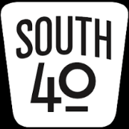
It’s kind of hard to believe the shortest month of the year is now history. So what will usher March in? A lion or lamb? Anyhow, the snow and cold temperatures have kept many Southern Ohio region hams home and gave them an opportunity to “play radio” and chat with old friends. Perhaps even put a new one in the log book or to work on a project that had been moved to a back burner. Or maybe they even dug out the study guides and are making a serious effort to upgrade that license or explore a new operation mode.
The OH-KY-IN ARS and Queen City Emergency Net are joining forces and now have a six week series of instruction under way to help folks earn their first license or upgrade. I understand over 20 have signed up for the sessions. All sessions are at 7 PM at the Red Cross Building on Dana Avenue in Cincinnati. Plans are to have the final session for all elements on April 1 with testing to occur on Saturday, April 6. For more information or to sign up for the course, send an email to hamtutor@ohkyin.org.

On March 2 the Fayette ARA will conduct a Laurel test session at the Washington CH Public Library. On March 18 the Red Cross Building in Athens is the site where the Athens County ARA will conduct an ARRL test session. Then on March 23 the Highland ARA will hold a Laurel test at the Highland County EMA Office in Hillsboro. All test elements will be given at these test sessions-each to begin at 10 AM. There are no test fees charged at the Laurel sessions; but a fee is charged at the ARRL one. Also remember the FCC $35 fee for a new license does apply for any new license issued, but it is not collected at the time of testing and is paid directly to the FCC. Any questions for the Washington Court House session should be
directed to Jim Scott, N8ORJ, at 740-463-9234; for the HARA test to Tom Mongold, Jr., KD8LDS at 937-272-4207 and to the ACARA one to Jeff Slattery, N8SUZ, at 740-541-0972.

Speaking of license classes and test sessions, it is only fitting to recognize some individuals living in theSouth 40 Region who have recently taken the plunge to take a test, passed the examinations and now proudly hold an amateur radio license and call sign. Ted Jacobson, W8KVK, informs us of the new license issued to Teresa Porter from Washington County’s Beverly, OH. Teresa is now KF8ADF. With only a letter difference, the FCC has granted Isaac Bernhardt the General ticket bearing a KF8ACF call sign. Isaac lives near Mount Orab. Also with a Mount Orab address is Ryan Fitzgerald who now has a General ticket bearing the KF8AGB call sign. Ted also tells us Christopher Ferris from Scottown passed his Technician and is now KF8AFF. Should you hear these folks on the air, be sure to give them a warm welcome. (ed note: Before my own license in 1963 one of the first hams I ever knew was New Vienna’s K8AFF. Bob Thompson (sk) was known as “ants, flies and fleas”. It was interesting hearing him chat with fellow New Vienna ham John Ross (sk), K8BST-“bedbugs, spiders and ticks”. Those hearing their QSOs were usually bugged by them.

Mike Love, WB8YKS, tells us of a good attendance at the recent Southern Ohio ARA meeting. Besides a successful VE session seeing some new license qualifications and upgrades, plans for a special event station later in the year were discussed as well as the start of planning for the annual Memorial Day Parade.

The Wilmington NWS Office announces that those who wish to qualify as storm spotters, but are unable to attend in-person training sessions, may register to attend a virtual class on February 29. The Wilmington region’s first annual in-person trainings were on February 26 and 28 in Adams County followed by a session in Georgetown. March 18 finds training at the Valley Fire Department near Lucasville for Scioto County. The new Clinton County Administration Building near the Airpark and NWS building at Wilmington hosts the Clinton County training on March 20. The 21 st sees the training move to neighboring Highland County and the County Administration Building conference room in downtown Hillsboro. Then on March 28 the
Fayette County training site will be the Opportunity Center in Washington, CH. On April 28 a joint session for Fairfield and Pickaway Counties will be presented at the Liberty Center in Lancaster. For further information on starting times, exact location addresses and other information check the NWS site at www.weather.gov/iln. The Charleston WV NWS office will conduct an in-person training session on March 18 at the Lawrence County Joint Response Center at Coal Grove. Then on March 21 Charleston will hold virtual training at 6:30. For more information, contact Tony.Edwards@noaa.gov. The Pittsburgh Office will have training on May 13 at the Belmont County Library in Martins Ferry.

The Highland ARA had two guest speakers at their February meeting. Mike and Jennifer Bailey, N8MRB and N8JEN, spoke about the Portsmouth RC’s participation as the sole authorized Ohio club in the annual Lewis and Clark Trail on the Air. Following their presentation, Paul Jellison, K8IO, told the club about the plans for the Clinton County ARA sponsored low power FM broadcast station that on the previous day received a construction permit from the FCC. The 100 watt station will broadcast on 95.9. After participating for more than 20 years in the HamVention flea market, the Club voted to give up its flea market spots. It was learned the local historical society had given HARA permission to use the lawn of its downtown Hillsboro Scott House for their 2024 Field Day location. Other than the Courthouse lawn, there probably is no more publically visible location in the city.

WOUB is the radio and television station Ohio University operates in Athens. Over the years it has served as the training ground for many respected news reporters, technical people and sports broadcasters around the nation. Recently the station did a feature on the Athens County ARA’s efforts to attract more and younger hams into our hobby. Not only did it receive local notice, but also was reprinted in the recent ARRL Letter for some national exposure. It can be viewed on the WOUB website at www.woub.org. It is great publicity for our hobby and well worth a read.
Just a reminder that Daylight Saving Time begins on Sunday, March 10. Athough there has been discussion about doing away with DST, it has not become the law of the land. So unless you want to be late for church or another function or checking into a net, be sure to change your clock and/or alarm settings before retiring on Saturday evening.

The Tri-State ARA is forming a committee of volunteers to do antenna work in the coming months. If you have an interest learning how you might be able to assist, contact Judy Taylor, WD8EOP.

The “Knights of the Round Table” (aka the Marietta ARA) will be gathering on Tuesday morning, March 26 at the Bob Evans Restaurant in Marietta at 9. All members and others in the Washington County area are invited to attend and experience a fun filled morning with your ham radio friends.

This weekend finds N8ZNR and me on a roadtrip to Cave City, KY for Saturday’s annual Mammoth Cave ARC hamfest at the Cave City Convention Center. Over the years we’ve attended the event which is said to be the largest single day hamfest in the Bluegrass State. I notice that it continuously draws a good number of hams from the Ohio South 40 Region. It’s a good addition to your hamfest attendance bucket list.
Don’t fail to mark your calendar for a couple of upcoming local club hamfests occurring in the South 40 during April. On April 13 the Mid-Ohio Valley ARC will hold their annual hamfest at the Fellowship of Faith Church in Bidwell. Then on Sunday the 28 th , the Athens County ARA will hold their hamfest at the recreation center in Athens. Both are great warm up events to get everyone in the mood for the biggie- HamVention-in May. Each are also good events for a new ham to attend in order to gain an idea what hamfests are all about. Your attendance also supports of the efforts of local clubs to maintain repeaters, provide programs and pay the bills to keep the club and its equipment functioning. For many clubs, this is their largest source of income to keep the treasury in the black. They are also a great place to put faces with the voices and call signs of those you hear on the air as well as get a great price on some nice equipment.

Springtime brings a number of different activities. And a popular one is the restart of races and marathons. The Athens County ARA has issued the call for volunteers to assist with two such events happening inApril. On April 6 the Club will provide communications for the annual Iron Furnace Trail Run at Lake Hope. Then on April 14 the Athens Marathon/Half Marathon will take place on the bikeway between Athens and Nelsonville. The Club needs at least 6 operators to staff the Lake Hope event and at least 10 for the Athens one. If you can assist, please contact Jeff Slattery, N8SUZ, at 740-541-0972.

The February and March QSTs list the following hams as Silent Keys: W4DHT, Drexel Turner,
Fayetteville; KB8BXI, Mercedes Hance, Milford; W8INO, Robert Gunderman, Columbus/Hillsboro; AE8P, Jack Travis, Lancaster; K8PSK, Glenn Easterling, Coolville: WB4N, Barry Jackson, Maysville, KY; WA8DTU, Donald Urschel, Franklin and WD8KOU, Forester Ferguson, Lebanon. Our condolences are extended to each family and friend.

The start of a new months restarts the cycle of monthly meetings, coffee gatherings, lunches and other recurring activities. The Portsmouth RC kicks off the month with their meeting on Monday the 4 th at the American Legion Post in Portsmouth. Now that the FCC has approved the Clinton County ARA’s application to build a low-power FM broadcast station, their meeting on March 7 should be an interesting one to attend. On Saturday the 9 th the Bainbridge Area Ham Group will meet at the Dutch Restaurant for breakfast and the Highland ARA gathers at 10 AM at the Hillsboro Burger King.

As indicated above, it’s a fact of life that many of our older licensed hams are passing away. By itself that is sad, but what is perhaps even sadder is they are taking their memories and the history of the “early days of radio” with them. Many of them cut their radio teeth during the haydays of amateur radio from the 30s to the 60s. At some future point in time some historian will want to learn what all this radio racket was about but will have little information to go on unless we take action now. So why not make it a club project to interview and record those memories as provided by the older and/or longest licensed amateur in your community or county? Don’t overlook any photos they may have. But be sure to identify people, equipment
and approximate dates. And when completed, provide the information to your local historical organization or library. And while at it, try to find QSL cards from not only those you interview, but other local hams who have signed their final 73.

Last year I was asked by a local newspaper reporter if I knew who the first person in Highland County to have a radio. Unfortunately I didn’t know the first person in the county, but do in the area. This led to undertaking a project to document the history of radio in or affecting our county. I started with the railroads bringing the telegraph into the county in the 1850s and uncovered a lot of interesting information leading to the present. The most surprising was of the FCC issuing a construction permit and call sign (WEYE) for a full power television station on channel 64 that went unbuilt because of finances. I’m certain all of us in the South 40 Region wish Section Manager Tom Sly, WB8LCD, a speedy healing of the broken wrist. So until next time, 73. John Levo, W8KIW jlevo@cinci.rr.com or highlandara@gmail.com or 937-393-4951 (landline-leave a message)

__________________________________________________________

ARLD009 DX news
This week's bulletin was made possible with information provided by
KC1XX, The Daily DX, 425 DX News, DXNL, Contest Corral from QST and
the ARRL Contest Calendar and WA7BNM web sites. Thanks to all.
AZERBAIJAN, 4J. Special event station 4JT0SFR is active from Baku
and has been QRV on 12 meters using CW around 1345z. QSL to home
call.
MALDIVES, 8Q. Sergey, RX3APM is QRV as 8Q7BB from Baa Atoll until
March 8. Activity is holiday style on 80 through 10 meters using CW
and SSB. QSL to home call.
BAHAMAS, C6. Operators N1GN and NE1B are QRV as C6ANM from New
Providence Island, IOTA NA-001, until March 4. Activity is on 80 to
6 meters using CW, SSB, FT8, and FT4. This includes being an entry
in the ARRL International DX SSB contest. QSL via LoTW.
CUBA, CO. Team T42T is QRV until March 4. Activity is on 160 to 6
meters. This includes being an entry in the ARRL International DX
SSB contest. QSL direct to WB2REM.
FRENCH POLYNESIA, FO. Geri, DK8KW is QRV as TX0QRP from Tahiti,
IOTA OC-046, until March 3. Activity is on the HF bands using CW,
and possibly FT8, with QRP power. QSL to home call.
WALLIS AND FUTUNA ISLANDS, FW. Operators LZ1GC and LZ5QZ are QRV as
FW8GC and TX8GC, respectively, from Wallis Island, IOTA OC-054,
until March 9. Activity is on 160 to 10 meters using CW, SSB, RTTY,
FT8, and FT4. QSL via LoTW.
TEMOTU PROVINCE, H40. A large group of operators are QRV as H40WA
from Pigeon Island, IOTA OC-065, until March 7. Activity is on 160
to 6 meters using CW, SSB, and FT8, with five to six stations
active. QSL via M0URX.
HAITI, HH. Yuri, N2TTA will be QRV as HH2AA as a Single Op/Low
Power entry in the ARRL International DX SSB contest. QSL via LoTW.
COLOMBIA, HK. Matt, KC1XX will be QRV as 5K4X as a Single Op/Low
Power entry in the ARRL International DX SSB contest. QSL via LoTW.
ITALY, I. Special event station IY9MM is QRV until March 31 to
memorialize the experiments conducted by Guglielmo Marconi from the
ship Regina Elena in the port of Augusta. QSL direct to IT9MRM.
GRENADA, J3. Operators ON4MA, ON5NT and ON5TN will be QRV as J38W
from March 2 to 16. Activity will be on 160 to 10 meters. QSL via
operators' instructions.
SAINT LUCIA, J6. Dan, W0CN is QRV as J68CN. He will be active as
J62K in the ARRL International DX SSB contest. QSL J68CN via LoTW
and J62K via K9HZ.
HAWAII, KH6. Fred, NA2U is QRV as KH6/NA2U until March 4. He will
be active as KH7M in the ARRL International DX SSB contest. QSL via
LoTW.
SABA, ST. EUSTATIUS, PJ5. Janusz, SP9FIH will be QRV as PJ5/SP9FIH
from St. Eustatius, IOTA NA-145, in the ARRL International DX SSB
contest. QSL to home call.
SINT MAARTEN, PJ7. Tom, AA9A will be QRV as PJ7AA from March 2 to
30. Activity will be on 40 to 6 meters using CW, SSB, FT8, and FT4.
QSL direct to home call.
COSTA RICA, TI. A group of operators will be QRV as TI1T as a Multi
Single/All Band/High Power entry in the ARRL International DX SSB
contest. QSL via LoTW.
BENIN, TY. Operators F5NVF, F5RAV and M0NPT will be QRV as TY5C
from Cotonou from March 2 to 29. Activity will be on the HF bands
using CW, SSB, and FT8. This includes being active on Satellite
QO-100. QSL direct to F5RAV.
BERMUDA, VP9. Les, N1SV is QRV as VP9/N1SV. He will be active as
VP9I in the ARRL International DX SSB contest. QSL to home call,
and VP9I to WW3S.
CAMBODIA, XU. Tom, DL7BO and Jose, EA1CS are QRV as XU7GNY until
March 15. Activity is on 160 to 6 meters using CW, SSB, and FT8.
QSL via DJ6TF.
REPUBLIC OF NORTH MACEDONIA, Z3. Al, DJ0LZ is QRV as Z36T until
March 25. QSL direct to home call.
CAYMAN ISLANDS, ZF. Operators W9KKN, K6JO and K7ZO will be QRV as
ZF1A as a Multi Single/High Power entry in the ARRL International DX
SSB contest. QSL via LoTW.
The Novice Rig Roundup runs from March 2 to 10.
Please see March QST, page 78, and the ARRL and WA7BNM contest
websites for details.
_________________________________________

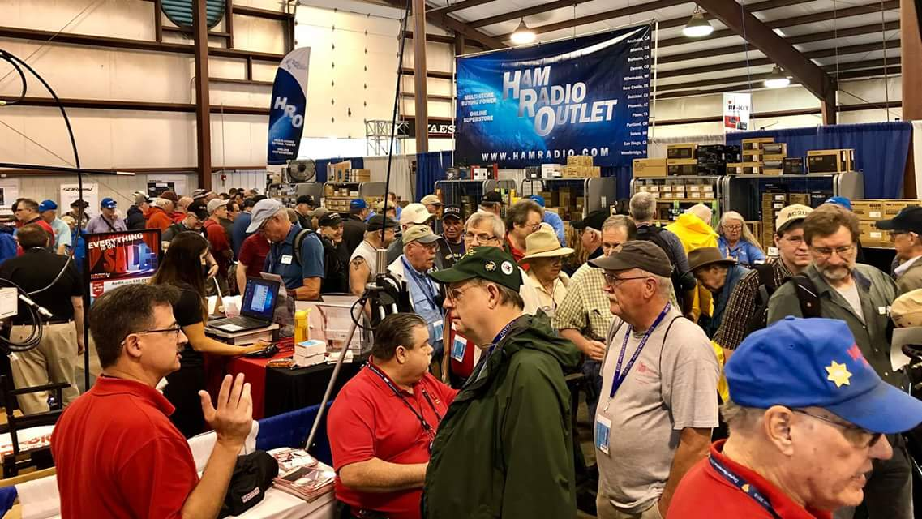
Upcoming Hamfests

We DO have hamfests scheduled for 2024!!

 | Ohio Hamfests
 | 2024
 | 03/10/2024 - WINTERHAMFEST  Location: Elyria, OH  Sponsor: Northern Ohio Amateur Radio Society  Website: http://winterhamfest@noars.net  Learn More |  | 03/17/2024 - Toledo Mobile Radio Association Hamfest and Computer Fair  Location: Perrysburg, OH  Type: ARRL Hamfest  Sponsor: Toledo Mobile Radio Association  Website: http://www:w8hhf.org  Learn More
04/13/2024 - Cuyahoga Falls Amateur Radio Club 68th Hamfest  Location: Cuyahoga Falls, OH  Type: ARRL Hamfest  Sponsor: Cuyahoga Falls Amateur Radio Club, Inc.  Website: http://www.w8vpv.org/hamfest  Learn More |  | 04/13/2024 - Mid-Ohio Valley Amateur Radio Club  Location: Bidwell, OH  Type: ARRL Hamfest  Sponsor: Mid-Ohio Valley Amateur Radio Club  Learn More
04/27/2024 - Tusco Amateur Radio Club Hamfest, Electronics, and Computer Show  Location: Dover, OH  Type: ARRL Hamfest  Sponsor: Tusco Amateur Radio Club W8ZX  Website: http://www.w8zx.net/hamfest  Learn More |  | 04/28/2024 - Athens Hamfest  Location: Athens, OH  Sponsor: Athens County Amateur Radio Association  Website: https://www.ac-ara.org/  Learn More
05/05/2024 - Lucas County ARES Trunk Sale & Swap Meet  Location: Toledo, OH  Type: ARRL Hamfest  Sponsor: Lucas County ARES  Website: http://lucasares.org  Learn More |  | 05/11/2024 - 05/16/2024  RV Radio Network  Location: Millersburg, OH  Type: ARRL Convention  Sponsor: RV Radio Network  Learn More
05/16/2024 - 05/19/2024  Four Days In May  Location: Fairborn, OH  Type: ARRL Convention  Sponsor: QRP Amateur Radio Club International  Website: http://qrparci.org/fdim  Learn More |  | 05/17/2024 - 05/19/2024  Dayton Hamvention, ARRL National Convention  Location: Xenia, OH  Type: ARRL Convention  Sponsor: Dayton Amateur Radio Association  Website: https://hamvention.org  Learn More
07/06/2024 - Mansfield Mid Summer Trunkfest  Location: Mansfield, OH  Type: ARRL Hamfest  Sponsor: Intercity Amateur Radio Club  Website: http://W8WE.ORG  Learn More |  | 07/21/2024 - Van Wert Hamfest  Location: Van Wert, OH  Type: ARRL Hamfest  Sponsor: Van Wert Amateur Radio Club  Website: http://w8fy.org  Learn More
08/03/2024 - 2024 Columbus Hamfest  Location: Grove City, OH  Type: ARRL Hamfest  Sponsor: Aladdin Shrine Audio Unit  Website: http://www.columbushamfest.com  Learn More |  | 08/10/2024 - Cincinnati Hamfest  Location: Owensville, OH  Type: ARRL Hamfest  Sponsor: Milford ARC  Website: https://CincinnatiHamfest.org  Learn More
08/18/2024 - Warren Hamfest  Location: Cortland, OH  Type: ARRL Hamfest  Sponsor: Warren Amateur Radio Association  Website: https://www.w8vtd.com/  Learn More |  | 10/05/2024 - Northwest Ohio Amateur Radio Club (NWOARC) Hamfest  Location: Lima, OH  Type: ARRL Hamfest  Sponsor: Northwest Ohio Amateur Radio Club, Inc.  Website: http://www.nwoarc.com  Learn More

10/27/2024 - 2024 MARC Hamfest at MAPS
Location: N. Canton, OH
Type: ARRL Hamfest
Sponsor: Massillon Amateur Radio Club
Website: https://www.w8np.net
Learn More

__________________________________________________________________

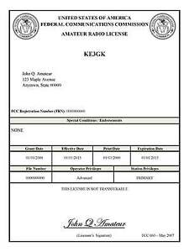
Print an Official or Unofficial Copy of Your Amateur Radio License
(By Anthony Luscre, K8ZT)

As of February 17, 2015, the FCC no longer routinely issues paper license documents to Amateur Radio applicants and licensees. The Commission has maintained for some time now that the official Amateur Radio license authorization is the electronic record that exists in its Universal Licensing System (ULS). The FCC will continue to provide paper license documents to all licensees who notify the Commission that they prefer to receive one.

Licensees also will be able to print out an official authorization — as well as an unofficial “reference copy” — from the ULS License Manager. I’ve created a set of instructions on how you can request an “official” printed copy of your license*

Click here to download the instructions

- One Question Questionnaire

Sorry Folks, due to a technical glitch the One Question Questionnaire and Handbook Give Away are not available right now. We hope to have them back soon.

Tom…

Final… Final

I want to thank you all for the Get Well wishes I’ve received. I go to the surgeon again this week to see if there is anything else that will need to be done. The pain is tolerable, the disability is aggravating. I’ll survive and hope to see you all out at a fest soon!

Wishing you all a Fantastic March! Get on the air, and spread the “magic of radio”.

73,
Tom WB8LCD

“Swap & Shop” on the website

Hey Gang,

Have you taken a look at the Swap & Shop page on the Ohio Section webpage yet?? Here’s a link that will take you there…
http://arrl-ohio.org/sm/s-s.html

Do you have equipment that you just don’t need or want anymore? Here’s a great venue to advertise it, and it’s FREE!!

Is your club doing a fund raiser to help raise money? After a lot of thought, it was decided that the Swap & Shop webpage could also contain these types of items as well.

The same rules will apply as do for the For Sales and Give-A-Ways and will only be posted for a month at a time. Please see the Terms & Conditions on the webpage. You might want to list your location so that prospective buyers know where you’re at.

If your club is doing a fund raiser and wants more exposure, please forward the information to me and I’ll advertise it on the Swap & Shop webpage for you. Now, I still want to remind you that it won’t be listed in this newsletter because it would take up way too much space, so your ad will only appear on the website. It is there for any individual to post equipment Wanted / For Sale or Give-Away as well as for Club Fund Raisers. No licensed vehicles/trailers or business advertising will be posted.

Postings are text only (no pictures or graphics) will be posted for a maximum of 1 month from date posting and require a contact phone number or email within the posting. Send your Wanted / For Sale or Give-Away post to: swap@arrlohio.org

Back Issues of the PostScript and Ohio Section Journal

Hey, did you know that PostScript and Ohio Section Journal (OSJ) are archived on the website? You can go back and look at any edition simply by clicking:
http://arrl-ohio.org/news/index.html

Ohio Section Cabinet
Section Manager – Tom Sly, WB8LCD | Section Emergency Coordinator – Bret Stemen, KD8SCL
Technical Coordinator – Jeff Kopcak, K8JTK | Section Traffic Manager – David Maynard, WA3EZN
State Government Liaison – Bob Winston, W2THU | Affiliated Clubs Coordinator –  Amanda Farone, KC3GFU
Section Youth Coordinator – Anthony Lascre, K8ZT | Public Information Coordinator – E;izabeth Klinc – KE8FMJ

Chit – Chat, and All That!

Do you know someone that’s not getting these Newsletters? Please, forward a copy of this Newsletter over to them and have them “Opt-In” to start receiving them. Heck just have them send an email to: webmaster@arrl-ohio.org to be added.

We now have many thousands of readers receiving these newsletters weekly. Quite impressive, I’d say! I urge all of you to make sure that everyone, regardless of whether they are a League member or not, get signed up to receive these weekly Newsletters.
You can always “Opt-Out” at any time if you feel this is not what you were expecting. It’s fun and very informative. All of your favorite past newsletters are now archived too.
You can go back at any time and read them. Just go to: http://arrl-ohio.org/news/

The pictures on the front page and throughout this newsletter are from various newsletters, Facebook posts and/or were sent directly to me in recent weeks. Take a good look at them, you just might be in one of the pictures! “SMILE… you’re in the Ohio Section News!!”

The Ohio Section Journal (OSJ) is produced as a comprehensive look at all the programs within the Ohio Section. I sincerely hope that you have enjoyed this edition of the OSJ and will encourage your friends to join with you in receiving the latest news and information about the Ohio Section, and from around the world!

TOP^

