February 2024

From the Technical Coordinator | From the Section Emergency Coordinator
From the Public Information Coordinator | From the Section Youth Coordinator
From the Section Traffic Manager | Club Corner
From the Affiliated Clubs Coordinator | National News
DX This Week | Contest Corner
Final.. Final.. | One Question Questionnaire

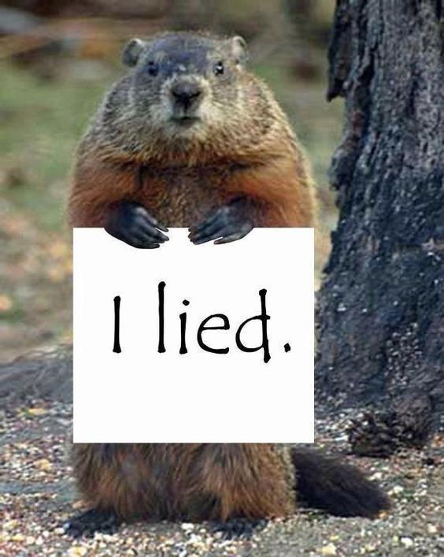
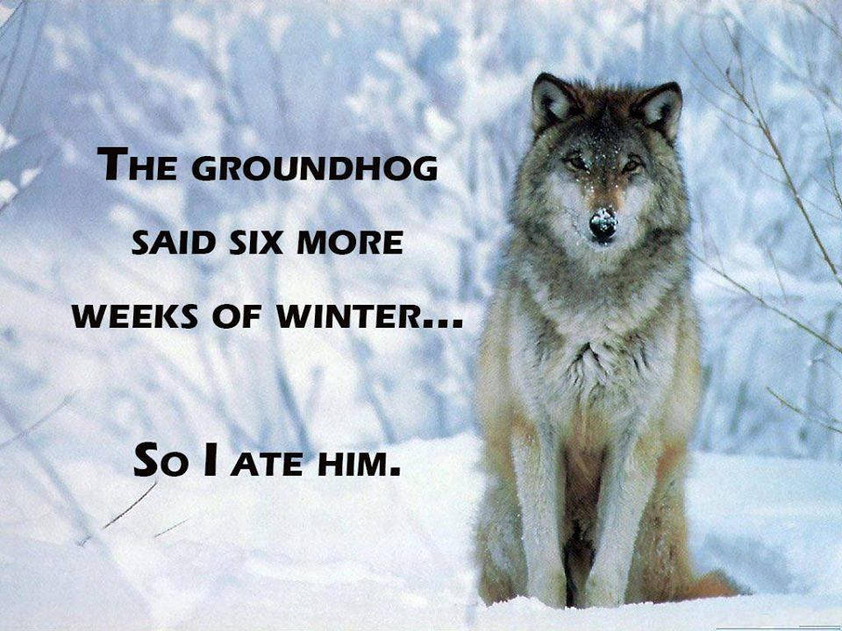

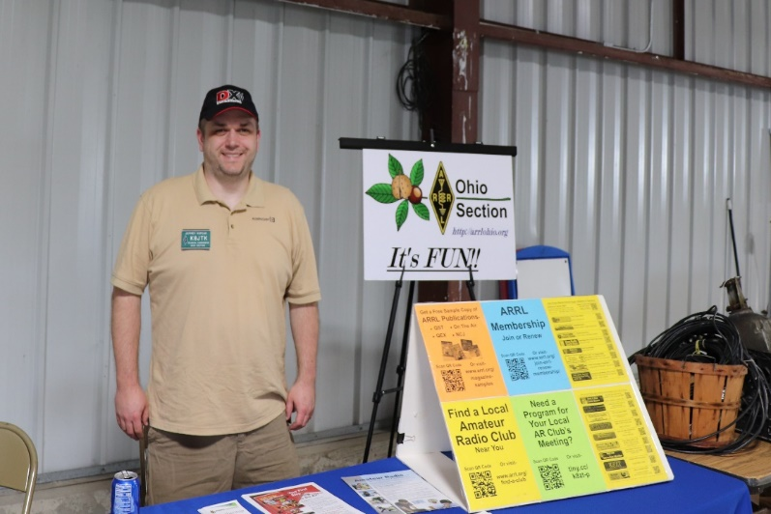
From the Technical Coordinator
Jeff Kopcak – K8JTK TC
K8JTK@arrl.net

Hey gang,
This is, by all accounts, my 100th article for the Ohio Section Journal! It’s coming a month late as I didn’t count the announcement of my father’s passing in September of 2023 as an article. I’ve been thinking about doing something special for my 100th. As per usual, short on ideas. I thought back and remembered being asked a question by fellow Volunteer Examiner, Tom – W8KYZ. He asked me some time ago ‘how long does it take for you to write an article for the Ohio Section Journal?’ I didn’t have a good answer because I really hadn’t paid attention. At the time I recall saying “probably 6 hours.” In reality, it’s double that. After Tom’s question, I started taking notes and being self-aware of my writing process to put together an article. Here is my 100th article on how I write for the Ohio Section Journal.
In the beginning. Dating back to middle school (or as some call it, intermediate or junior high school), I liked to write. I had some good English teachers. Mr. Holland in 6th grade and Mrs. Mann in 7th grade. Mr. Holland had his own library of Reader’s Digests. We were encouraged to read articles, write summaries and include our own thoughts. Mrs. Mann did the school newspaper as an extracurricular. I did activities and layout. Her teaching style in class also made it fun to learn. Have to give credit to mom because she was my proofreader in elementary and middle school. I think writing is one of her traits I inherited.
Sophomore year of high school I had a very strict English teacher, Mr. Scherma. I could do common MLA (Modern Language Association) citations and punctuation structure, though college, in my sleep because of his class.
I’ve always believed if I don’t understand it, I can’t explain it to others. Another credit to Dr. Vernon for my International Business grad school class. We did a lot of writing in his class. He took that philosophy a step further. Be able to make arguments both for and against something, then provide alternative solutions proves you really understand a topic.
I’ve read a number of PC magazines over the years starting probably not much before middle school. Some of my favorite writers were Steve Bass (PC World) who was always a fun read and interjected a good level of humor and sarcasm in his articles. Another would be John C. Dvorak (PC Magazine). I can’t say he’s been right about a lot of his predictions, “… experimental pointing device called a ‘mouse’. There is no evidence that people want to use these things” (Dvorak Uncensored). I do share a level of skepticism over tech hype - as does John. He’s given great writing advice which stays in the back of my mind. John is also a master troll (one whom posts causing maximum disruption and argument, particularly online). I wish I could pull off some of his schemes.
Before I started writing for the Ohio Section Journal, the previous Technical Coordinator, Jim – W8ERW (SK) saw my writings in club newsletters. I was doing a series on Raspberry Pi and RTL-SDR dongles called “Dongle Bits” in 2014 – 2015.
Ohio Section Journal. When I was appointed to be the Technical Coordinator by our previous Section Manager, Scott – N8SY (now Tom – WB8LCD), it was stated section articles had to be something ‘ham radio related.’ Mine started out ham radio related but took liberties doing articles on things closely related to ham radio such as computers, Windows, and Linux. In the same way a club meeting might include topics or announcements on useful smartphone apps, space and plants, and other electronics, I reach into my background for other technical topics. I’ve done System Support for Windows and Linux environments, System Administration of Linux systems, programming on a Linux platform, and currently networking and security.
(Technologizer)
My thought is, well, I have to do 12 of these per year. Even that’s way too much ham radio for me. In branching out to cover Information Technology or Information Security topics, maybe an IT or InfoSec professional might come across an article and check into this ham radio thing. As it turns out, readers like the variety too.
Post Script is released the weeks when a Section Journal is not published. It consists of mostly articles from other publications and submissions received by the Section Manager. Articles are summoned from Section Cabinet members for the Section Journal on a monthly basis
How do I find a topic? They start out as things I’m interested in or working on – things others might find interesting as well. Brainstorm sessions happen anywhere: while I’m at work browsing the internet, working on something in the shack, watching a presentation on a topic, giving a presentation and a question was asked, watching an online video, new or different technology I’m playing with and experiences (good and bad), heard a different perspective on a subject, current topics or events, etc. Some months I didn’t do that much ham radio and rather talk about a computing project I’ve been working on. I always promote anything the Technical Specialists are working on or doing.
As the month rolls along, I’ll make a note to myself ‘this would be an interesting OSJ article.’ I do have a backlog of topics but rarely do I pull one from that list. As I’m learning new things, I rarely write about them immediately because I don’t care for “initial impression” (aka unboxing) type material. I would rather provide insights from (at least) a couple months of using something to find quarks, see how bugs and updates are handled.
I do bump articles. I planned to do topic X, but Y seemed more interesting and pertinent at the time. A recent example, I was planning to do my February 2023 article on my Windows 10 shack upgrade for January. After attending a conference, which included some ham radio topics, that became the published article for January. I wrote a new article and bumped the original to February.
On occasion, I’ll do a collaboration. Ones that come to mind are the write up of the Wood County Amateur Radio Club and the BG Fab Lab (I’m a WCARC member). I coordinated a trip out to Bowling Green to coincide with their breakfast meeting and ham radio training class. I talked with club members about the partnership, took pictures, and observed the training class. Unfortunately, the partnership has since dissolved between the WCARC and the BG Fab Lab.
During National Parks on the Air, Technical Specialist Bob – K8MD wrote the article on the Perry’s Monument activation. I did an article on Winlink nets where I solicited input from net control stations for details they would like to share about their net and let them review a final draft before publication.
If someone poses a question to me, that is often the basis for an article (October 2019 on Line A). I’ll confirm with them I can publish their name and call sign as part of the article. Most people don’t mind. I do want to be respectful of those whom may think their question is silly, stupid, don’t want the attention, or just wish to remain private.
I’ll revisit topics. Two years is the minimum between publication and republication, unless there is a development or someone poses a question. It’s never the same article. It will be changed, if only slightly, in favor of better wording, include more details, or latest updates.
John C. Dvorak
One evergreen is “writing a newsletter article for your club or the Section Journal” (July 2017 & November 2019). A reason for revisiting this topic is because it encourages the sharing of advances and learning, which is one of my responsibilities as Technical Coordinator. Another exception is every June, I feature and highlight the skills of our Technical Specialists to remind readers they are an available resource for club meetings and hamfests. This is another responsibility of mine.
Learning time is hard to quantify and not included in my time estimates. My article on the WPSD Pi-Star replacement includes over a decade experience in digital modes when I started using them in 2009, using Pi-Star since 2018 when I bought a ZumSpot, and learning about WPSD in January 2023 when I saw the segment on AmateurLogic. Anything HF or digital HF has been learned since I built my shack in 2014.
Timelines. This, of course has changed over the years as different editors have taken over or has been adjusted to meet their demands. Currently, the Ohio Section Journal comes out the last weekend of the month. Articles can be submitted anytime during the month. Deadline is few days or so before publication, more if the SM is traveling.
When do I start? This depends. A collaboration or I have free time to get a draft written could be a month or more. Collaborations are worked on earlier in order to have enough time for those involved to review a final draft for changes. It’s rare for me to have a finished product turned in more than a few days ahead of the deadline. Normally, I start a few weeks ahead. Sometimes the week of. On a couple occasions, the night before it’s due.
Getting in mine in “early” is a phrase that does not exist in my vocabulary. Section Managers can probably count on one hand how many times I’ve been early. I am the worst at getting my article in early and even hours past the deadline at like 2am. I’m terrible and I know it. I apologize to them when we talk about the OSJ. I do try to make my article an easy drop-in for their template.
Writing process. I don’t consider myself a good writer. I don’t. From draft to published edition, the flow rarely changes. Wording, clarity, and phrasing are another story. I will post an example in the online version of this article. I saved all six revisions of the second paragraph in my September 2022 article. This article was on running multiple copies of Fldigi and Flmsg at the same time. It shows progression from initial draft to published version and changes made during each revision.
My writing process starts out as a stream of consciousness style of writing. Get in front of the keyboard for about 4 – 8 hours and just type. Not often in one sitting, broken up over some days. Less so when a deadline is looming. While brainstorming, I often have an organizational structure thought out ahead of time. A large portion of wiring time is due to reading things like Notice of Proposed Rule Making (NPRMs), looking up details, supporting information, and validating my recollection. My style, especially early on, follows the same form as the Five-Paragraph Essay format taught in grade school.
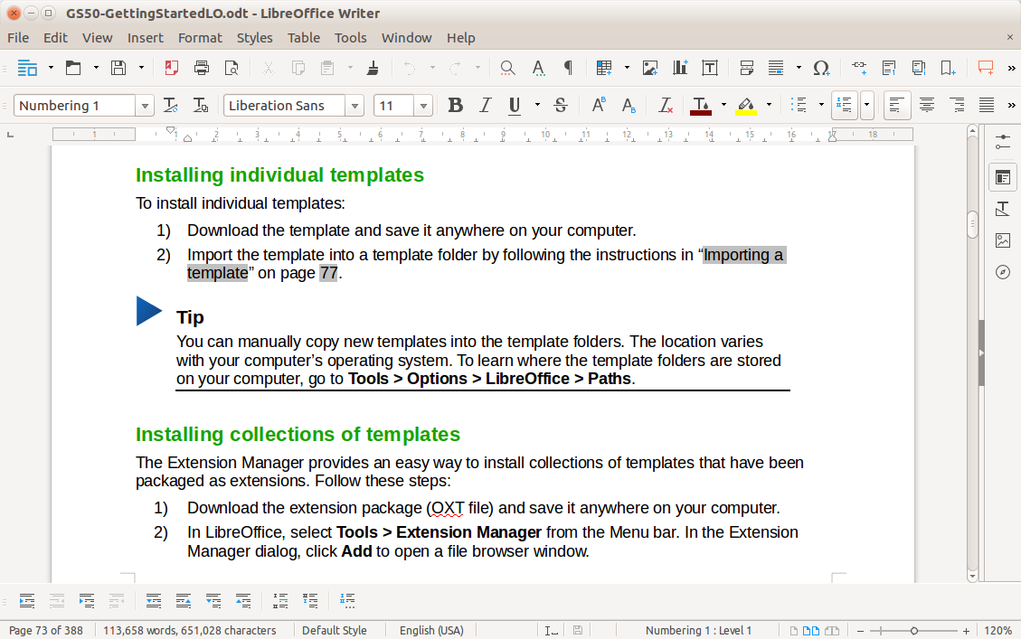Once my thoughts are down, I’ll start to revise the article. Depending how I feel for editing, 2 – 3 revisions are done on the computer. The rest are on paper. I’ll print the article, do a read-through marking changes, input those changes into the computer, print the article again, rinse and repeat 4 – 6 more times. 2 – 3 read-troughs are in my head, another 2 – 3 verbally.
LibreOffice Writer (libreoffice.org)
I’m not well versed in proper sentence structure. I remember the big things like avoiding run-on sentences, sentence fragments, don’t begin sentences with conjunctions or “so,” or ending sentences with prepositions. The conjunction one goes out the window if it makes a point. Whatever seems natural is published. Editing process is about 4 – 6 hours.
OMG! Who is printing things in the current year? Me. If you go back and read through some of my early OSJ articles, they are really rough. I was doing all writing, revisions, and editing at the computer. I got complaints about editing, wording, and spelling. I am my own worst critic. The comments were not unfounded because those articles were hard to re-read and sucked. I needed to make a change. Went back to what worked for me in school. Printing and proofreading – over and over and over and over - again. Now when I re-read my articles later, I think “there’s no way I wrote this, it’s too good!”
I start writing in LibreOffice Writer, except when I start writing in the shack which has Microsoft Word. I start in LibreOffice because my primary desktop and laptop run Fedora. All writing, links, and editing are done using Writer. No graphics are included at this point. When editing is done, I use a Windows virtual machine with a local copy of Microsoft Word. Word Doc is the format requested by the Section Manager in Times New Roman, 12-point font.
Text is pasted into Word using “keep text only” or unformatted text. This removes any unnecessary formatting from Writer. I never directly convert Writer to Word using the Save As option. I’ve used Writer and predecessors, there have always been conversion (formatting) problems going directly to Word. The Document Foundation states a lot has been accomplished solving formatting issues. I still see conversion problems around image sizing, positioning, and cropping.
Word’s spelling and grammar checker is far superior and I use it for final touchups. That is to say, Writer has a spell checker that’s not very good and completely lacks grammar checking. I’ve noticed quarks (bugs) in Writer’s spell checker that hinder my editing process. For example, a misspelled word will not be underlined with the standard wavy red line to visually indicate a word not recognized. Copy and paste that exact same sentence into a blank Writer document and the wavy red line appears for the misspelled word. Haven’t figured out why that happens and I don’t ever use the ‘ignore/ignore all’ option.
Though I may gather images during brainstorming, I don’t go looking for graphics or images until everything is formatted in Word. During the writing and editing process, I only work with text and links. Inserting images at the end doesn’t waste space in the printouts and I avoid any conversion issues going from Writer to Word. When media from other sites is used, I’ll caption it with the domain or username as it is not my work. Most often, Size and Position Text → Alignment is Square. Then group the caption and image together.
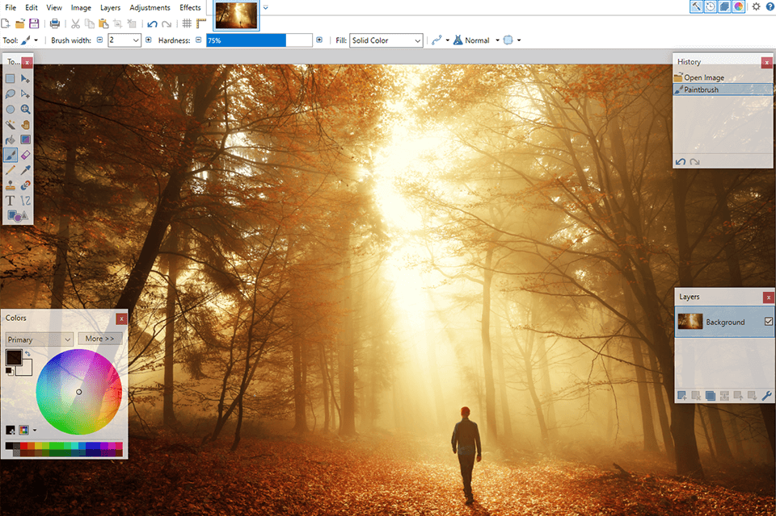Taking my own pictures, I’m a huge fan of Cannon imaging products since I started using them at our high school TV station. I use a Cannon Rebel SL2 primarily. When I don’t want to use the nice camera, an old Canon PowerShot SX210 or my Google Android Pixel phone does the job at places like Hamvention. Don’t think I’ve included too many scanned items, but an Epson Perfection V100 Photo is used. Editing, cropping, resizing, bluing parts of images and pictures, I use a free program called Paint.Net and, on occasion the Linux equivalent, Pinta.
Paint.net interface (fixthephoto.com)
The inclusion of hyperlinks in articles has been amazing for me. Instead of having to cite something or take additional time explaining, I link the reader to a place they can read or research something I’ve mentioned. It takes about 30 minutes to an hour to convert, do final spell/grammar checking, insert and caption images, and verify links work correctly.
In total, it takes me an average of 12 – 16 hours to do an OSJ article. The quickest one in recent history was six hours on Spam Campaigns, draft to final version. Normally, this process is spread out a few hours per day over at least three days. I E-mail the article and images to the Section Manager. Then it magically appears is the published version of the Ohio Section Journal. I don’t know much about the processes once I send my submission.
Web Edition. After the OSJ is published and emails go out to members and subscribers, I publish my article to my site. From Word, I do a Save As → Plain Text. The key to this conversion: in the File Conversion box, checking “Allow character substitution.” This removes “smart quotes,” apostrophes, multiple periods, and dashes Word likes to insert - substituting them with web friendly characters for online publishing.
I don’t use the HTML Save As option because my method keeps the online version clean from the needless formatting and useless tags inserted by Office products. December’s article was 6 KB of plain text. After formatting the article and creating links for my website, 8 KB. Comparing exporting to HTML in Word weighs in at 54 KB – of needless crap and highly inefficient rendering, if you ask me.
My site is a WordPress content management system (CMS). I have boilerplate text at the beginning of each post (article) describing how to subscribe and links to the full edition. Then paste the exported text, recreating text formatting and links in the CMS. I upload and caption the same images. Always after the OSJ is released is when I hit the “Publish” button to make the version live on my site too.
After publication. Generally, I receive no feedback on a per article basis. That is fine because people still call me out when I do make mistakes. I receive comments when people see me in person at hamfests, presentations, and occasionally over the air. Readers generally enjoy the stuff I write and topics covered.
Ironically, the most feedback I receive are from the non-ham topics. Some of you complained about my series on preserving legacy media (August, September, and October 2021). I received more messages from readers who wanted to share their tips, experiences, and services used to rescue data from legacy media. It was under ten messages but more than any other article or series I published.
I’m likely blacklisted with a vendor or two. They’ve messaged me displeased about one thing or another. When asked what they had an issue with, they don’t respond. Manufactures have never given me anything anyway because I do, and have, refuse units for review. If a product is worth purchasing or is something a lot of hams are using and might have technical questions, I purchase the product on my own. Representatives often come across as jags but I remain professional. Seriously though, make better products.
I receive a lot of “I don’t understand it, but it’s interesting” feedback, even from my own dad. I attempt to grab attention in some way. It’s a balancing act though. Many readers are not all very technical, others want me to do deep dives including all kinds of technical specifications. I shoot for a middle ground of knowledge an average user might need. At least a basic understanding of computers helps to understand my articles. If someone walks away with a piece of knowledge they keep in the back of their mind for the future, my job here is done.
When I did longer articles, I make an effort to shorten them. This is not one of those articles. A friend suggested splitting longer ones across multiple months. Depends how I feel. I try to keep them shorter (2-3 pages, before graphics). Some want even longer articles. Thank you and I’m flattered, but this takes up a considerable amount of time as-is.
Not that all feedback isn’t humbling, a couple stick out. My brother shared a story where someone at his company messaged him asking if he knew me (same last name). Obviously, he did. They told him they enjoyed reading my Section Journal articles. Unfortunately, I don’t know the name of this person. Ralph – K8HSQ messaged the Section Manager and myself saying "I enjoy your articles in the OSJ newsletter very much. Whenever I see your article being announced in the email, I read it immediately. If it's not listed, the newsletter gets put on the "read later" pile." Roy – K8RWH always says he is “your #1 fan in Ohio.”
I don’t even know how to react to that other than to say - thank you! I always ended my articles the same: thanks for reading. I’m always honored you take time out of your busy schedule to read anything I have to say. This also comes from another teacher I had and talked about recently, Mr. Hoty. ‘No matter what the viewers say or complain about - your audio stinks, the picture sucks, wrong about this - just let them vent and calmly say “thank you for watching” because at least their watching.’ With that…
Thanks for reading and 73… de Jeff – K8JTK

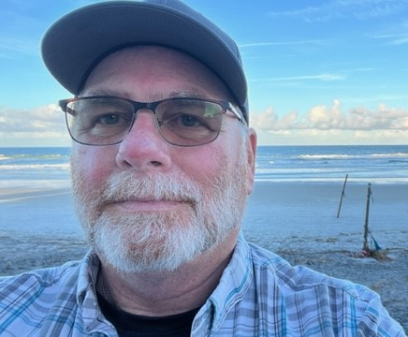
From the Section Emergency Coordinator Bret Stemen – KD8SCL EC
KD8SCL@gmail.com

ARES Simplex Contest

The 2024 ARES Simplex Contest is in the books and the results are in. I am pleased with the results, but at the same time a little disappointed that there weren’t more participants in the contest. But I understand with scheduling conflicts and personal reasons, family comes first. Maybe next year.

This contest is a great way to test your equipment for proper operations and what your equipment is capable of, be sure to map out your QSO’s to check your longest distance within your county and surrounding counties. This information can be important for your county in the event of an actual emergency in your county and you need to get information out. Think about setting up an exercise for your local group to test your simplex capabilities in your county.

Thank you to those of you that took the time out of your busy schedule to participate in the contest and your comments.

Here are the results as of February 1, 2024.
Participants: 38
ARES Leaders: 13
QSO Points: 8,535
Contacted Counties: 203
Hours of Operation: 137
ARES Leader Contacts: 135
EOC Contacts: 54
APRS Ops: 6
Portable Ops: 5
Rover Ops: 0
Total QSO Points: 73,683

Top 10 points:
- K9GQB, Columbiana Co. 13,685
- W8WOO, Wayne Co. 12,010
- N8RKE, Cuyahoga Co. 5,050
- N8EI, Summit Co. 4,800
- KC8NZJL, Cuyahoga Co. 3,855
- KB8VBR, Cuyahoga Co 3,280
- K8ZT, Summit Co. 2,730
- N8CD, Wayne Co. 2,709
- K8BF, Portage Co. 2,560
- KD8JJF, Summit Co. 2,440

Thanks again for everyone’s support and contribution to the Ohio Section ARES and amateur radio, your contribution is a valuable asset to the section.

In other news:

Solar Eclipse is April 8th, most of the counties in the path are preparing for this event.
EC’s have been and continue to be in contact with their EMA’s planning for the event, this includes manning their local EOC’s and key areas throughout their county. The State EOC will be open as will the SARGE.

Here is link to a YouTube video that I found interesting, please note the “time and speed” as the eclipse travels across. https://www.youtube.com/watch?v=sOpYoO_SK7o

I also checked out the website that the YouTube video came from.
https://www.greatamericaneclipse.com/april-8-2024/

NVIS Day will be April 27th, Mark your calendars and start planning with your local clubs and ARES groups, we are planning on activating the SARGE. More information coming soon.

2023 Totals:

I wanted to take a minute to thank everyone for their hard work and contributions to ARES, amateur radio and clubs.

Here are the total ARES numbers for 2023 as reported to me, there were a few that missed submitting reports or did not report at all.

- Members: 1,526
- Net Sessions: 7,982
- Net Hours: 46,590
- Test/Drill: 9,884
- Test/Drill Hrs: 24,288
- Total Hours: 70,818
- Public Svr Event: 924
- Public Srv Hrs: 23,066
- Emergency Ops: 161 (This includes Skywarn)
- Emergency Ops Hrs: 2,929
- Total ARES Events: 10,969
- Total ARES Hrs: 98,813

Our volunteer contribution to the citizens of Ohio was an estimated $3,078,637.

______________________________________________________________

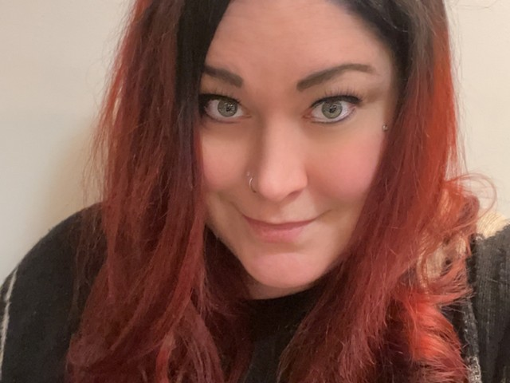
Elizabeth Klinc, KE8FMJ
OHIO Section Public Information Coordinator
ke8fmj@gmail.com

The primary role of a Public Information Officer includes the advancement of a positive public picture via any type of media. The Public Information Officer also is tasked with giving critical information during an emergency. They gather facts and disperse them to the media, and coordinate some occasions like honorable functions or a booth at a ham fest. They work for large associations and coordinate with government offices. Keeping up their online presence can be important for keeping the public in the loop on important data. PIOs can work for extended periods on an unsteady timetable, particularly when the efforts are influenced by the situation.

An exert from the ARRL PIO Handbook:

What's So Important About Public Relations?

As radio amateurs, we have three basic goals in promoting our hobby: recognition of the
good things we do and our value to the community; protection of our current and future operating privileges; and recruiting the next generation of hams. You might even call it CPR -- Community recognition, Protection and Recruitment. Let's take a quick look at
each of these goals:

Community Recognition

- When we do something good, or when people we're associated with do something
good, we like to have it recognized. It feels good.
- One of the reasons ham radio exists is to provide service to the public. Providing
this service, and having it recognized locally, helps promote our other two goals,
protection and recruitment.

Protection of Operating Privileges

- Amateur radio faces ongoing threats at all levels of regulation -- local
governments are pressured to restrict "ugly" antenna towers and find solutions for
RF interference problems; Congress, the FCC and the International
Telecommunications Union are under constant pressure to provide more spectrum
to existing and emerging wireless services.
- A positive perception of amateur radio translates into allies in our neighborhoods,
on city councils and in state legislatures, in Congress and on the FCC.

Recruitment

- Amateur radio is now one of many choices available to people interested in
electronics and electronic communication. In order to maintain our ranks and
improve our growth, we must make sure people are aware of amateur radio and
the unique opportunities it offers.
- The exploding growth of "wireless" communication and computer networking is
feeding a growing need for engineers and technicians who understand RF.
Engineering and technical schools today concentrate almost exclusively on digital
technology, leaving amateur radio as the primary source of hands-on learning for
these careers.
- Amateur radio in the schools can help students in all areas of learning. Bringing
amateur radio into schools requires a positive and up-to-date image of the hobby
among teachers and administrators.
In recent years, the largest growth area in amateur radio has been among retirees.
We need to enhance this growth by creating a positive impression of ham radio
that will help persuade officials of retirement communities to permit amateur
radio operation.

The Power of Perception

A positive perception of amateur radio helps build support for us among neighbors, educators, corporate leaders and government officials. This support is vital in meeting any or all of the goals above.

On the other hand, a negative perception works in the other direction and can harm ham radio. And no perception -- because people aren't hearing anything good or bad about amateur radio -- is just as bad as a negative perception. People who don't know amateur radio exists, or who feel it is obsolete, will not be our "friends" when we need support.

Your Role as a PIO or PIC

It matters what people think of amateur radio, and you, as a Public Information Officer or Public Information Coordinator, are in a position to influence that thinking. It's a very important job, and it's very important that it be done well. Some PR is better than none, but poorly done PR can be worse. We recognize that many people take on this job with more enthusiasm than experience, and more understanding of the need for good PR than training in how to provide it.

------------------------------------------------------------------
Elizabeth Klinc, KE8FMJ

OHIO Section Public Information Coordinator
District Emergency Coordinator, D3 Ohio ARES
Assistant Emergency Coordinator, Greene County
ARRL - The National Association For Amateur Radio™

______________________________________________

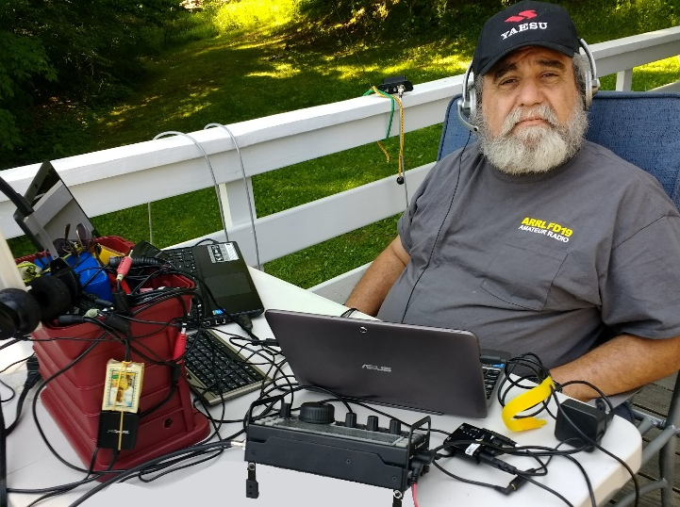
From the Section Youth Coordinator
Anthony Luscre, K8ZT - SYC
k8zt73@gmail.com

K-12th Student & Teacher Amateur Radio Ideas

I was recently asked to put together information for a radio club that had an opportunity to work with a local radio. As I started putting together the information, I realized I needed to make this available for other hams and clubs working on similar projects. This list is a big project, and I am still working on it, but I did not want to wait to share it with you, so I have created a shared document that I will keep updating over time. I will also happily add ideas and resources from others with experience in Youth in Amateur Radio. The document might be helpful to you, but I suggest you also contact me to work with you on your project. I will be happy to provide a club presentation, work with club members or individual hams and work with teachers and other school personnel. Because the document is constantly changing, putting a copy here would not be the best way to provide the information, so even though you will see a screenshot of it, you need to use this link- tiny.cc/k12ar-ideas to access the entire document and stop back periodically to see updates.
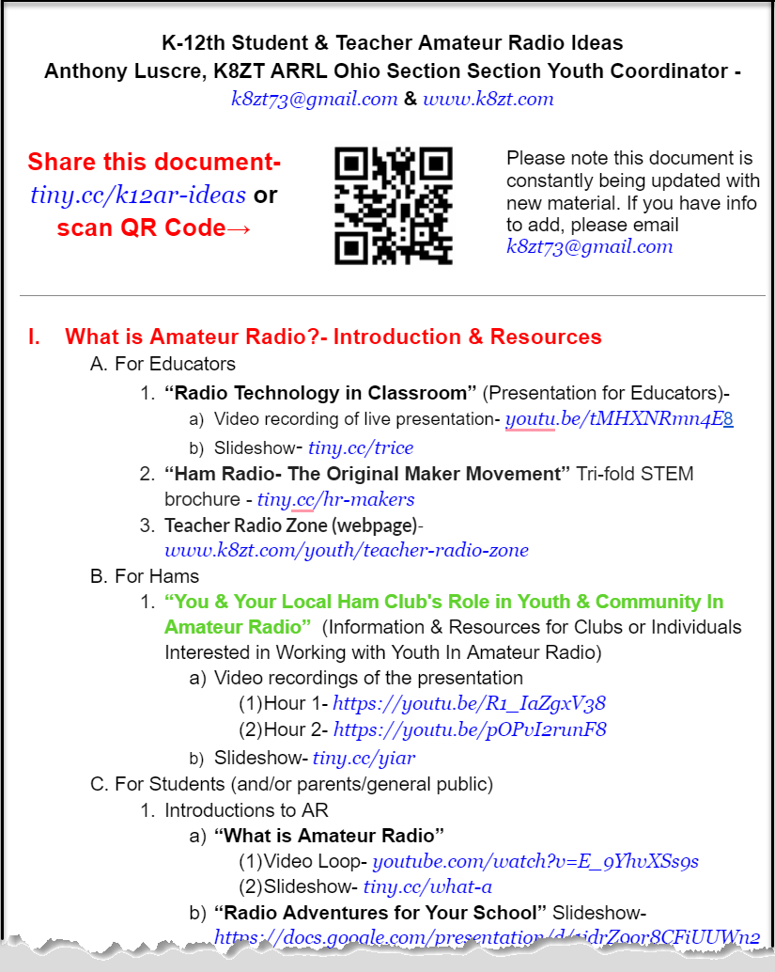
ARRL Teachers Institute on Wireless Technology

Now Accepting Applications for ARRL's Teachers Institute 2024- for more information or to apply, visit this link.

ARRL School Club Roundup
The ARRL February School Club Roundup runs from 1300 UTC on Monday, February 12, through 2359 UTC on Friday, February 16. School Club Roundup is co-sponsored by ARRL and the Long Island Mobile Amateur Radio Club (LIMARC). For full details on the event, visit www.arrl.org/school-club-roundup.

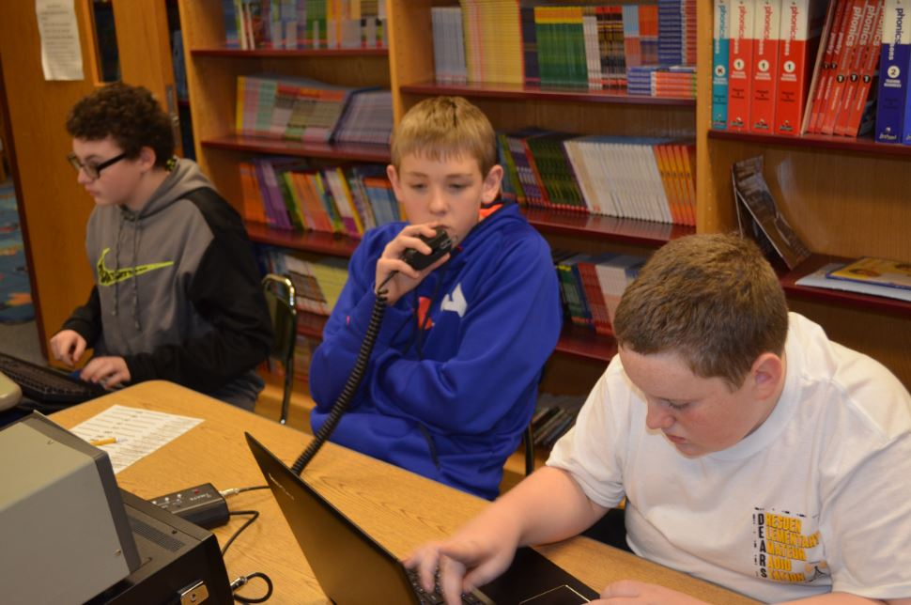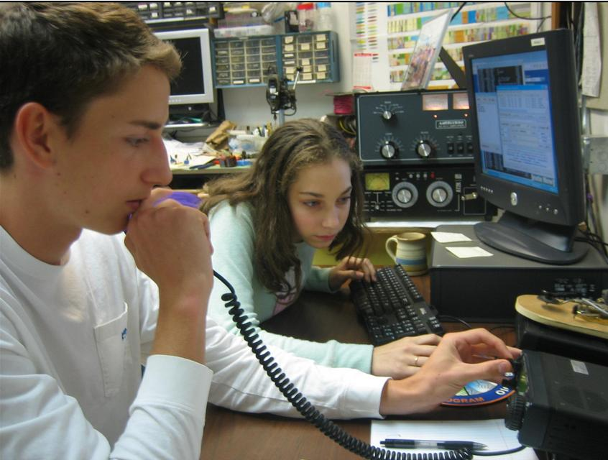

That’s it for this month; I hope to work you on the air soon, maybe on HF!
73,
Anthony, K8ZT (k8zt@arrl.net)

____________________________________________________

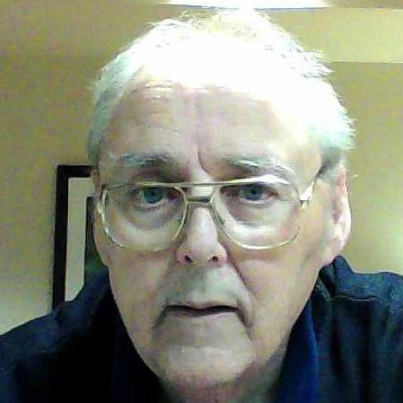
From the Section Traffic Manager David Maynard, WA3EZN – STM
wa3ezn@att.net

By the sound of the number of new ham radio license welcoming messages on the nets one could assume we have new hams in the state. My advice to them is to find a radio club and look for an elmer if you don’t already have one.

Radio equipment is expensive and if you don’t have access to a transceiver you will have to get one to get on the HF frequencies. If you as a new licensee are going to go to a hamfest looking for a radio please have a more experienced ham assist you. Remember if the radio is tested and the lights come on that doesn’t mean it will transmit once you get it home. I speak from experience as that is exactly the condition of one of my radio purchases.

Ok, so let's say you now have a transceiver but you need the proper antenna. After all, you can’t just hook any piece of wire to your radio and expect it to transmit. You can buy ready made antennas at an additional cost but you can also make your antenna. By making your own antenna you can save some money and gain some experience too.

One of the easiest antennas to make is a dipole. Some insulators, some wire and some coax is needed. You will also need two supports for the antenna and will also need an SWR meter which you can buy or perhaps someone will be helping you and they have a meter. You don’t necessarily need this meter but one that will do the job.

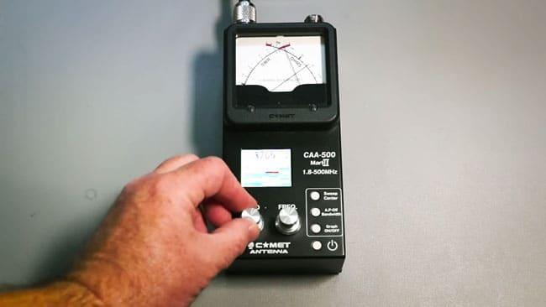

An antenna analyzer runs $100-300, but it is a really good long term investment for your shack. If money is an issue, check with a local club or elmer to see if they have a loaner.

The Best First Antenna, Hands Down
I hear new hams asking all the time, "What's the best antenna for HF?" Some are thinking of buying "no radial" verticals. Others are thinking of a three element beam that's being sold on-line, or the so-called "Wondertenna Deluxe" they've heard so much about. These new hams are dazzled by the claims of the manufacturers and purveyors of these antennas, which are claimed to be the greatest thing since sliced bread, usable on all bands from 160 meters to 2 meters, and great for both DX and NVIS. Many of these new hams seem to think, "Well, I just bought my rig...I'd better buy my antenna, too!"

Don't do it! Just say no! There is a BETTER antenna out there! It is the very, very best antenna for a new ham--and for many old-timers, too. You've probably even heard about it before, either in QST or eHam or from your friends, but it bears repeating. This antenna is...wait for it...an antenna YOU make yourself! A wonderful first antenna is a coax-fed dipole. If you were to feel really adventurous, you could feed the antenna with a ladder line and, using a tuner, use it on 80-10 meters.
But I digress. For the sake of simplicity, and because most new hams are most comfortable using coax as a feedline, this short article will describe a dipole. The feedline is coax. If your rig has an internal tuner, or you're using a tube-type vintage radio, this antenna will also work FB ("fine business") on 15 meters as a 3/2 wave dipole.
Why should you roll your own antenna? There are many reasons, but the best reason is that it's far more fun to make a contact on your own homebrew antenna.
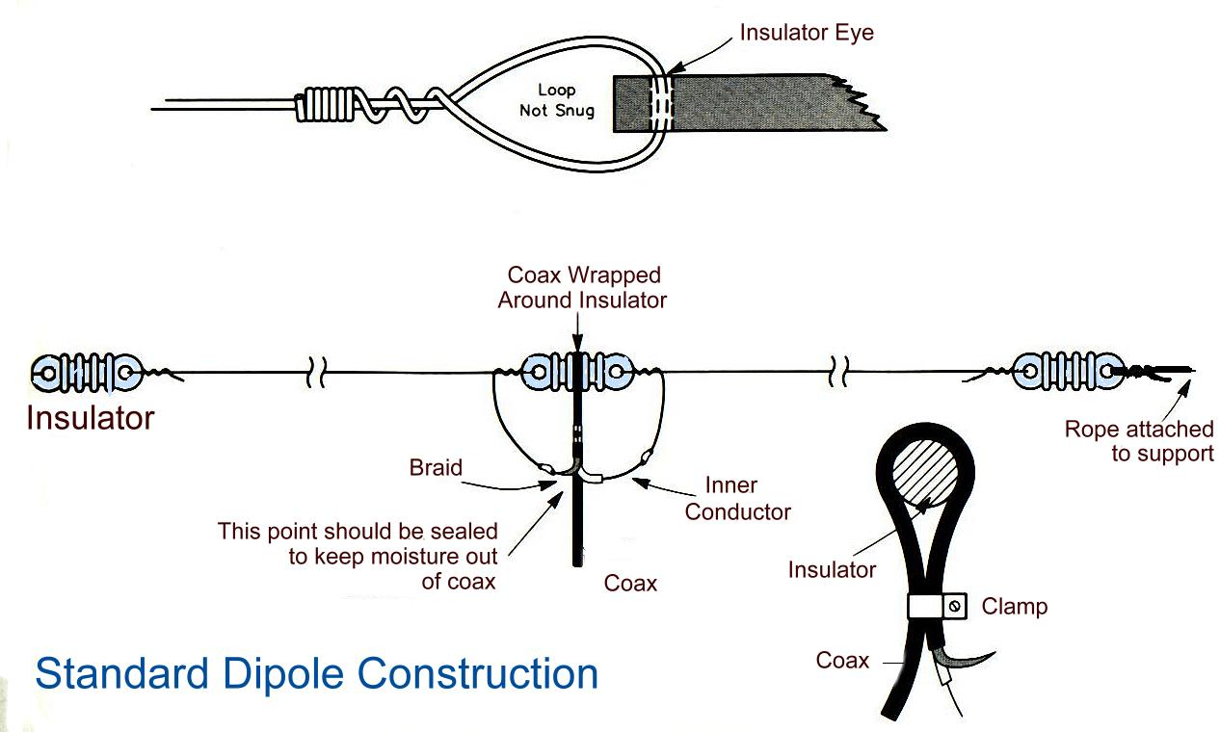
Fumbling around for what to talk about after you exchange signal reports? Wow the other operator by telling him or her about your homebrew antenna! Are today's propagation conditions less than ideal? Don't sweat it--I'm convinced that any signal is at least one S-unit better when you're using your own wire antenna! Other good reasons for building your own are: it's cheap; it's a wonderful learning experience; it will inspire you to learn more about the technical aspects of our hobby and go on to build even more wire antennas; the components are reusable; the components are easy to find; and you will feel the pride that stems from doing something so true to our amateur heritage. There is absolutely nothing new about what I'm saying here. Here is a link to a $4 antenna: http://www.hamuniverse.com/fourdollarspecialw1gfh.html. I heartily recommend you read it! There are similar articles on eHam and the internet.

You can use 14 gauge wire (but anything from 12 ga to 18 ga is common) from a ham store, from the wireman.com, from Lowe's or Home Depot, or from Radio Shack. It can be insulated or uninsulated, solid or stranded. I usually prefer 14 ga, stranded, and insulated--but you can use whatever is on hand. If the length of your coax is less than 100 feet and you're running no more than 200 watts on HF, RG-8X is the way to go. If you're running more power than that, or really want to minimize power loss at the higher frequencies, then use a better quality coax, such as RG-213. RG-213 is thicker, heavier, more expensive, and less flexible, but is generally preferable for use from 10-20 meters. For a barefoot HF rig, though, RG-8X will be just fine. There are plenty of "how-to" guides on building your first dipole on-line. Here is a good one that I just found: http://www.aa5tb.com/dipole.html.

You might install your new dipole as an inverted vee. The center support could be a tree branch, a flagpole, or a wooden or fiberglass pole. The legs of your inverted vee should each have an end insulator on them, and then some nylon, dacron or other guy rope leading out to a handy attachment point. That attachment point could be your fence post, a tree, or a tent stake shoved into your lawn. In this way, you only need one tall support, which is the center of your inverted vee. The center of your inverted vee won't sag when you attach your feedline, as would a horizontal dipole supported only at the ends. And, if you're using fiberglass tubing as the center support, the ave legs of your antenna do an admirable job of holding the center point. Just make sure that the enclosed angle of your inverted vee is at least 90 degrees. And, although plenty of purists might disagree with me, when you adjust the length of your new inverted vee for minimum SWR, anything less than 2.0:1 is fine at HF. Don't sweat the small stuff.

This is not a "how to" article. This is, instead, a "just build it" article. Take my word for it: Building your own antenna is loads of fun. In fact, you might just get so much satisfaction from your new antenna (not to mention those glowing signal reports!) that next weekend you'll want to tackle another wire antenna project. Hmm, is a multiband doublet on the program for the next sunny weekend?

DIPOLE ANTENNA LENGTH
When determining how long to make each leg of a Dipole antenna, dividing the frequency in MHz into 468 will give the overall length. To find the half wave, divide that number by two. This will give you the length of each leg of the antenna.
Example — 80 meters: If you are operating on 3.8 MHz, dividing 3.8 into 468 gives 123.16 feet over all. To find the half wave, dividing 123.16 feet by 2 gives 61.58 feet for each leg. Cut the wire two or three feet longer so you will have some to fold back on itself when adjusting the SWR. The part that folds back on itself does not affect anything. Connect the coax at the center point or middle of the antenna, the center lead of the coax to one leg and the braid to the other leg. When adjusting for minimum SWR, adjust each leg the same amount, current fed.
Example — 40 meters: If you are operating on 7.2 MHz, dividing 7.2 into 468 gives 65 feet over all. To find the half wave, dividing 65 feet by 2 gives 32.5 feet for each leg. Cut the wire two or three feet longer so you will have some to fold back on itself when adjusting the SWR. The part that folds back on itself does not affect anything. Connect the coax in the center point or middle of the antenna, one leg to the center lead of the co-ax and the braid to the other leg. When adjusting for minimum SWR, adjust each leg the same amount, current fed.
Example — 20 meters: If you are operating on 14.5 MHz, dividing 14.5 into 468 gives 32.28 feet over all. To find the half wave, dividing 32.28 by 2 gives 16.14 feet for each leg. Cut the wire two or three feet longer so you will have some to fold back on itself when adjusting the SWR. The part that folds back on itself does not affect anything. Connect the coax in the center point or middle of the antenna, one leg to the center lead of the co-ax and the braid to the other leg. When adjusting for minimum SWR, adjust each leg the same amount, current fed.
Example — 2 meters: If you are operating on 144.5 MHz, dividing 144.5 into 468 gives 3.24 feet over all. To find the half wave, dividing 3.24 feet by 2 gives 1.62 feet for each leg. When mounting on a vehicle, a quarter wave antenna MUST be mounted on a metal base. A half wave antenna can be mounted on a fiberglass or plastic body vehicle with the coax connected to one end of the antenna, center lead to antenna, braid grounded, voltage fed.
Adjust the wire connected to the center lead of the coax for max output and then adjust the wire connected to the braid of the coax for minimum SWR.

To adjust you raise the dipole up close to its operating position, then look at an analyzer. It will show you the SWR and impedance at that frequency. Take two measurements. One for your desired frequency and one for the “best” SWR nearby. If that best frequency is higher than your desired resonant frequency, your wire is too short. If the best frequency is lower, your wire is too long, and you need to trim it. We’ve discussed this among the elmers and getting below 1.5:1 on SWR is a good sweet spot.
Here is how to dress the antenna end of the coax in preparation for connecting to the dipole. The exposed wire and shield must be soldered to the antenna wire. Care must be taken so as not to melt the insulation and short the coax.

How to work with the coax.
https://eoceanic.com/sailing/tips/16/172/fitting_a_pl259_aerial_connector_to_coaxial_cable/

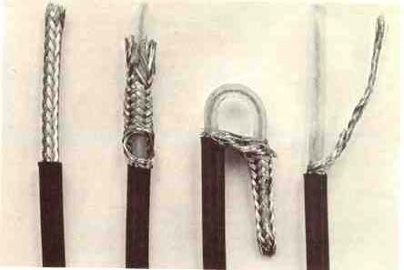
How to dress the antenna end of the coax

Fitting a PL259 aerial connector to coaxial cable
https://eoceanic.com/sailing/tips/16/172/fitting_a_pl259_aerial_connector_to_coaxial_cable/

There are many other types of antennas and systems to feed your antenna. Hopefully I can show some of these other antennas at a later date.

OHIO SINGLE SIDEBAND NET

Morning session | 10:30 AM | 3972.5 KHz | every day
Afternoon session | 4:15 PM | 3972.5 KHz | every day
Evening session | 6:45 PM | 3972.5 KHz | every day

OHIO HF CW TRAFFIC NETS

HF CW NETS | NET TIMES | FREQUENCY | NET MANAGERS
Buckeye Early | 6:45 PM | 3.580 | N2LC
Buckeye Late | 10:00 PM | 3.590 | WB9LBI
Ohio Slow Net | 6:00 PM | 3.53535 | N2LC
All CW net frequencies plus or minus QRM

OHIO LOCAL VHF FM TRAFFIC NETS

VHF NETS | NET TIMES | FREQUENCY | NET MANAGERS
BRTN | Monday, Thursday Saturday 9:30 PM | 145.230 PL 110.9 | KD8GXL
COTN | 7:15 PM DAILY | 146.970 PL 123.0 | KV8Z
TCTTN | 9 PM Sun, Tues, Fri | 147.015 PL 110.9 | WB8YYS
TATN | 8:00 PM DAILY | 146.670 PL 123.0 | WG8Z

OHIO VHF TRAFFIC NETS
BRTN Burning River Traffic Net serving Cleveland and North Central Ohio
COTN Central Ohio Traffic Net serving Columbus and Central Ohio
TATN Tri-State Amateur Traffic Net
TCTTN Tri-County Traffic and Training Net serving Northeast Ohio

Wishing you all the best for 2024,
73 for now,
David WA3EZN
Ohio Section Traffic Manager

__________________________________________

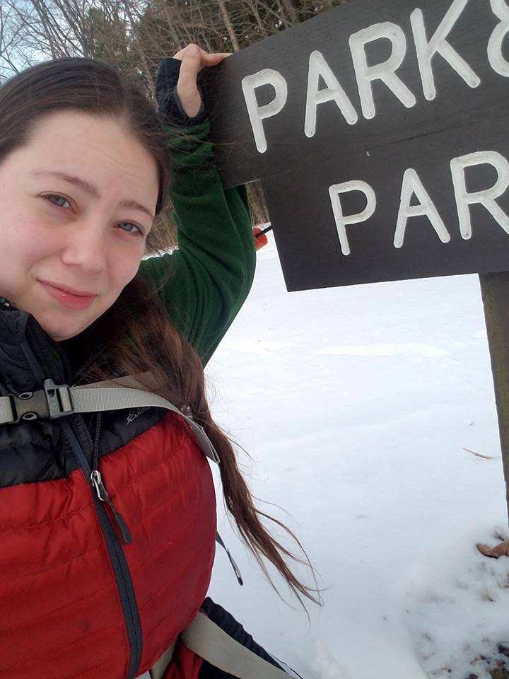
Amanda Farone, KC3GFU
ARRL Ohio Section | Affiliated Club Coordinator
Afrone926@gmail.com
330-509-4095

Winter Field Day is behind us and February is upon us. I know I have talked a lot about featuring a club each edition of the OSJ, however, things just didn’t line up this month. The chosen club was unable to participate and by the time I was notified, I was not able to secure another club to be featured. Hopefully we can get with them again down the line. Instead, I will grace you with some new information and possibly some rambling, hihi.
First and foremost, I want to encourage you to take a moment to check your club information that is listed on the ARRL website. This is generally where new or prospective hams will go to find local club information. Along with the general information such as meeting times and locations: please, please, please, be sure that the contact information listed is correct. More times than I’d like to admit, I have attempted to reach out to a club via the email provided, and either get no response at all or it gets kicked back as an invalid email address. If you have a website, please make sure the link is working. This can be invaluable to a club as you never know what potential might be seeking you out! If you need help updating the information, don’t hesitate to shoot me an email. I am more than willing and happy to assist.
The ARRL has made updates to the Club Commission Program. You can find new forms and a description of the program at www.arrl.org/affiliated-club-benefits. The Membership Application form can also be used at hamfests and events. ARRL has also added new Award Certificates that can be downloaded and used to recognize club members. These awards include Mentor Award, First Contact Award, and Rag Chewers’ Club. The awards are fillable PDF’s and can be printed out. Find them at www.arrl.org/awards. QST’s newest column “Club Station” is seeking authors! This column is a space for clubs to share their practical ideas about what has helped lead them to their success. If you feel your club has developed a creative way to get around a challenge, this is for you! You can find more information at www.arrl.org/QST. The ARRL Foundation is now accepting grant applications. Grants are given for eligible amateur radio related projects and initiatives, especially those that focus on educating, licensing, and activities. The ARRL Foundation grants program accepts proposals three times per year. The current cycle will accept grants through February 28th. You can find more information at www.arrl.org/amateur-radio-grants.
For assistance or more information on any of the above topics, please contact me via email at afarone926@gmail.com.

__________________________________________
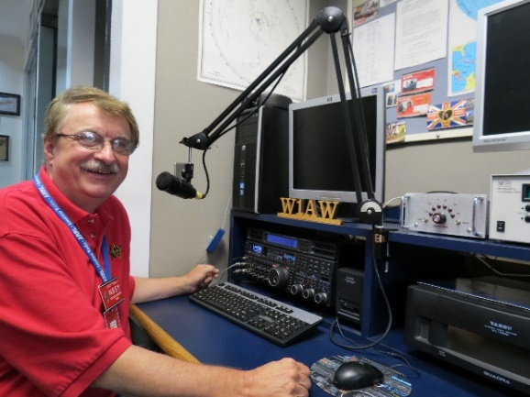
Hi Gang,

The Great Lakes Division Newsletter is now on-line!
There’s lots of great information for you to read. So, grab your
favorite beverage, a sweet snack to munch on and sit back in your easy
chair and have a great read!!
>> https://arrl-greatlakes.org/glnews/2024/02-gldnews.pdf <<
73,
Scott, N8SY

National News
(from ARRL and other sources)

National Aeronautics and Space Administration

In this week’s newsletter, we’re sharing highlights to help you prepare for your stargazing adventures, providing updates on the upcoming PACE mission launch, and taking a deep dive into NASA innovations that evolve into other technologies with broader use here on Earth, known as Spinoffs. Plus, stories you may have missed.

What’s Up for February?

Venus is still a brilliant beacon in the morning, rising a couple of hours before the sun. You can catch the bright planet together with a slim crescent moon on the morning of Feb. 6, just as the sky starts to brighten. On the evening of Feb. 14, look for the crescent moon near Jupiter, high in the southwest following sunset. They're just a couple of finger widths apart in the sky, meaning most binoculars will show them in the same field of view. February is a good time to view one of the famed "Messier objects," known as M81. It's located about 11.8 million light years away from us, which means, if you're able to observe it, those photons of light hitting your eye have been traveling through space for more than 11 million years to reach you.

﻿SKYWATCHING RESOURCES

Countdown to Launch

﻿NASA's PACE (Plankton, Aerosol, Cloud, ocean Ecosystem) mission is targeted for launch at 1:33 a.m. EST, Tuesday, Feb. 6. Once in orbit above Earth, PACE will shed light on the impact of tiny things—microscopic life in water and microscopic particles in the air.

LAUNCH COVERAGE

The Health of Earth’s Climate

PACE's data will help us better understand how the ocean and atmosphere exchange carbon dioxide. In addition, it will reveal how aerosols might fuel phytoplankton growth in the surface ocean. Novel uses of PACE data will benefit our economy and society.

READ MORE

NASA Podcasts  In this episode of Houston, We Have a Podcast, NASA experts discuss the considerations when looking at landing locations for future human missions to the Moon’s surface.  LISTEN | NASA Playlist  ﻿This Black History Month, we recognize the achievements of our Black workforce, who propel us into the future. Celebrate with our playlist of podcast episodes featuring Black scientists, engineers, and leaders in exploration.  LISTEN

Innovation for the Benefit of All

As NASA innovates for the benefit of all, what the agency develops for exploration has the potential to evolve into other technologies with broader use here on Earth. Many of those examples are highlighted in NASA’s annual Spinoff book, including dozens of NASA-enabled medical innovations as well as other advancements.

“As we continue to push new frontiers and do the unimaginable, NASA’s scientists and engineers are constantly innovating and advancing technologies,” said NASA Administrator Bill Nelson. “A critical part of our mission is to quickly get those advances into the hands of companies and entrepreneurs who can use them to grow their businesses, open new markets, boost the economy, and raise the quality of life for everyone.”

The book also features several technologies NASA has identified as promising future spinoffs and information on how to license agency tech. Since the 1970s, thousands of NASA technologies have found their way into many scientific and technical disciplines, impacting nearly every American industry.

READ MORE

NASA Shares Assignments for its SpaceX Crew-9 Space Station Mission

NASA, SpaceX Target NET Feb. 22 to Launch Crew-8

How the 2024 Total Solar Eclipse Is Different than the 2017 Eclipse

NASA Puts Next-Gen Exoplanet-Imaging Technology to the Test

From the Archives | Black History Month

Physicist Ronald E. McNair made his first space flight aboard the space shuttle Challenger 40 years ago in February 1984. During the STS-41B mission, McNair and his crewmates deployed two commercial satellites, and two of them tested the Manned Maneuvering Unit during the first two untethered spacewalks. McNair, an accomplished jazz saxophonist, became the first person to play a soprano sax in space. Space limitations in the shuttle precluded McNair’s favorite tenor sax, so he learned to play the smaller version of the instrument for his space flight.

﻿McNair’s next flight assignment was also on Challenger, the January 1986 STS-51L mission that included Christa McAuliffe, the first teacher in space. Tragically, the mission ended 63 seconds after liftoff when an explosion, caused by a faulty solid rocket booster O-ring, resulted in the loss of the seven-member crew and the space shuttle Challenger. McNair had planned to play a saxophone solo during the STS-51L mission for composer Jean-Michel Jarre’s album Rendez-Vous, including participation in a concert via a live feed. As a tribute to McNair, the album’s sixth and last piece is entitled “Last Rendez-vous (Ron’s Piece) — ‘Challenger’.”

THE FIRST BLACK ASTRONAUTS

NASA | 300 E Street SW, Washington, DC 20546

The First Amateur Radio Station on the Moon, JS1YMG, is Now Transmitting
The Japan Aerospace Exploration Agency (JAXA) successfully landed their Smart Lander for Investigating Moon (SLIM) on January 19, 2024. Just before touchdown, SLIM released two small lunar surface probes, LEV-1 and LEV-2.
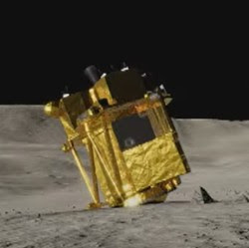
A rendering of the Smart Lander for Investigating Moon (SLIM) on the lunar surface. [Japan Aerospace Exploration Agency, image]
LEV-2 collects data while moving on the lunar surface, and LEV-1 receives the data.
The JAXA Ham Radio Club (JHRC), JQ1ZVI, secured amateur radio license JS1YMG for LEV-1, which has been transmitting Morse code on 437.41 MHz since January 19. The probe uses a 1 W UHF antenna with circular polarization and is transmitting "matters related to amateur business."
Radio amateurs have been busy analyzing JS1YMG's signal, with Daniel Estévez's, EA4GPZ, blog introducing the method and extraction results for demodulating Morse code from the signal, as well as extracting the code string.
It's unclear how long signals will be heard. JAXA has said that SLIM was not designed to survive a lunar night, which lasts about 14 days, and is due to return in a few days.
SLIM was launched on September 6, 2023, and landed on January 19, 2024, with the mission of analyzing the composition of rocks to aid research about the origin of the moon. SLIM's landing made Japan the fifth country to achieve a soft touchdown on the moon. The landing was achieved with exceptional precision -- within 180 feet of its targeted touchdown location.
__________________________________________________________

ARRL Foundation Accepting Grant Applications in February
The ARRL Foundation is now accepting grant applications from amateur radio organizations for eligible amateur radio-related projects and initiatives, particularly those focused on educating, licensing, and supporting amateur radio activities, to grow amateur radio's future, youth-based projects and initiatives are especially encouraged.
The ARRL Foundation grants program accepts proposals on a cyclical model three times a year: in February, June, and October. Proposals for the June grant period are accepted through February 29. Awardees will be notified approximately 1 month after the closing of each cycle.
The Foundation, which celebrated 50 years of service last year, carefully manages a portfolio of endowments where donors have provided specific goals for their gifts, and that portfolio is invested and managed in a way that it can continue to support those goals for many years to come.
Additional information and a link to the grant application can be found at http://www.arrl.org/amateur-radio-grants

February 17, 2024, marks the 160th anniversary of the sinking of the USS Housatonic by the H.L. Hunley submarine. The event took place in 1864 in Charleston, South Carolina, and was the first successful sinking of a warship by a submarine. The Trident Amateur Radio Club will commemorate the submarine by operating special event station N4HLH on Saturday, February 17, 2024, from Fort Moultrie on Sullivan's Island from 10:00 AM to 2:00 PM EST. Proposed frequencies are 7.117 (CW), 7.262, and 14.262, as well as 28.462 MHz for Technician-class licensees. A QSL card will be available for those who send a request with their contact information to N4HLH/Trident Amateur Radio Club, PO Box 60732 N. Charleston, SC 29419. A QSL card will be sent upon receipt of a SASE for US requests and a SAE with 2 USD for international requests.

_________________________________________________________

Club Corner

This is YOUR corner of the newsletter. Send us what your club is doing, and we’ll make sure that it gets in. Got a special event or club project that you want everyone to know about? Send it to us!. Need help with a project? Send it to us.

Let us know what you club is up to. Are you going to have a special guest at your meeting or are you having a special anniversary?

Send it to: webmaster@arrl-ohio.org

Winter Field Day a Success for Ohio Club
The Delaware Amateur Radio Association (DELARA) in Delaware, Ohio, was one of many clubs who participated in this year's Winter Field Day (WFD).
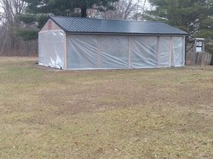
Shelter house wrapped and ready for DELARA's WFD activities. [Photo courtesy of Joe Papworth, K8MP]
This was the second year DELARA worked WFD. Club member Joe Papworth, K8MP, and three event station captains -- Ed Brady, AE8Q; Guy Merrill, KD8KWH, and Tom Foy, N4HAI -- provided support and helped set up for the event.
"We had 16 participants this year and over 1,100 contacts," said Papworth. "At least 200 more contacts than last year, and operators were on most modes and bands."
DELARA members wrapped a shelter house at Delaware State Park with plastic sheets to protect them from the winter weather, and the Elm Valley Joint Fire District loaned them a generator to provide power for the transceivers, as well as a few portable heaters. Three antennas and stations were set up inside.
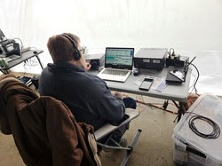
Guy Merrill, KD8KWH, makes contacts from inside the wrapped shelter house for the DELARA Winter Field Day event. [Photo courtesy for Joe Papworth, K8MP]
"WFD is a great experience and a chance to get on the air," added Papworth. "We're planning on participating next year and looking forward to [the] 2024 ARRL Field Day on June 22 - 23"
Winter Field Day (WFD), sponsored by the Winter Field Day Association, is open to participants worldwide. It's held on the last full weekend in January and is a communications exercise designed to help preparedness for disasters.

VE Sessions

The following information is for ALL exam sessions:
It is now an FCC requirement to have an FCC FRN; active email address and active phone number before taking any exam. Please bring your FCC FRN, original license, a copy of your license (if a licensed ham), a valid photo ID and $15.00 - Cash preferred.
Effective April 19, 2022, the FCC will charge a $35.00 application fee for amateur radio licenses. The fee will apply to new, renewal, rule waiver, and modification applications that request a new vanity call sign. License upgrades will not have a fee applied. The fee will be per application. VE's will not collect the fees at exam sessions.
AE8FP Amateur Radio Test Team administers ARRL-VEC testing in the Central Ohio area. Our test dates for 2024 are as follows: Januray 20, April 27, June 22, July 20, and October 19. Time and location for these dates are 10:00am at the Westerville Fire Station #111, 400 W. Main St in Westerville, Ohio. The listed dates are co-sponsored by the Central Ohio Radio Club (CORC).
Pre-Registration is required, and open the 1st of each testing month. All information is available at www.ae8fp.net <http://www.ae8fp.net/>

Alliance Amateur Radio Club The Alliance Amateur Radio Club holds quarterly VE testing, at the Christ UInited Methodist Church in Alliance. The address is 470 E. Broadway St, Alliance, OH (Enter through door ONE A off North parking lot.) (https://maps.app.goo.gl/prDyEPp6siJun2ibA).
Upcoming Exam Dates are
Saturday, March 16th, 2024
Saturday, June 15th, 2024
Saturday, August 10th, 2024
Saturday, October 19th, 2024
We begin registration at 8 AM, with testing at 9am.
More information can be found at www.w8lky.org/licensing/ve-exams/.
All Things Amateur Radio Association (ATARA) We host testing sessions every second Tuesday of the month in Lancaster. To sign up please visit our website https://atara-w8atr.fun and contact us at hamexams@atara-w8atr.fun.
CARS
VE testing from CARS - Cuyahoga Amateur Radio Society - at Elmwood Recreation Center, 6200 Wisnieski Parkway in Independence, Ohio 44131 Time: 9:15 AM (Walk-ins allowed) Always the 2nd Sunday of the odd month. Go to CARS www.2cars.org for detailed map of location. Call Metro W8MET 216-520-1320 for details

Clark County Amateur Radio Association (CLARA) What: CLARA sponsored A.R.R.L. VE Testing - Walk-ins allowed. Pre-Register via email preferred. When: On every second Saturday of each even numbered month starting at 10:00 AM Feb
10th; Apr 13th; Jun 8th; Aug 10th; Oct 12th; and Dec 14th, 2024.Where: Springview Government Center - Emergency Operations Center; 3130 E Main St; Springfield OH 45503 This is US-40 aka "old national road". From Route 40 enter Old Columbus Road, at the fork stay left driving straight onto Ogden Rd, then immediately turn left into the parking lot behind the EMA. Walk to the door with the "Employees Only" sign.
For more information contact Roland W. Ude, W8BUZ, (937) 605-4951 Email: buzz@baylorhill.com

Dayton Amateur Radio Association (DARA)
If you are interested in testing for a new or upgraded license, please come see us at the DARA Clubhouse. If you have questions about testing, please email exams.w8bi@gmail.com

Geauga Amateur Radio Association (GARA)
Amateur License exam sessions are offered for all license classes (Technician, General, Extra). Walk-ins are always welcome - no prior registration is required. No fee for the exam.

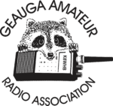
The GARA schedule of exams are these Sundays at 2pm. Dates for 2024 are Jan 14, March 10, May12, July 14, Sept 15, and Nov 17, 2024. All sessions are at 2:00PM each month

Exams are held at the Geauga County Department of Emergency Services and Emergency Operations Center, 12518 Merritt Road, Chardon, Ohio 44024. The EOC is located just south of the University Geauga Hospital and just east of the Geauga County Safety Center (Sheriff's Office), off of State Route 44 between State Route 322 and State Route 87 on Merritt Road.

Please arrive a few minutes before 14:00 to allow adequate time to process the necessary paper work and take your test. Bring your 1) photo ID, 2) email address, 3) FCC FRN, 4) a printout of your current license if taking the General or Extra exam.

Additional info may be obtained from Jackie Welch, N8JMW by email n8jmw2@gmail.ccom or calling at 440-228-2716. More information is available from the Geauga Amateur Radio Association website https://geaugaara.org

Huber Heights Amateur Radio Club
Huber heights amateur radio club does ARRL VE testing the second Saturday of each even numbered month. Feb, Apr, Jun, Aug, Oct, Dec. 9:30-11:00 For more information contact Jim Storms – AB8YK at ab8yk@hotmail.com

The Lake County Amateur Radio Association
The Lake County Amateur Radio Association is holding its 2024 Amateur Radio license exams at the Kirtland Library, 9267 Chillicothe Road, on the following dates:
Saturday. February 3 Saturday, August 3
Saturday, April 6 Saturday, October 5
Saturday, June 1 Saturday, December 7

This bi-monthly schedule is the first Saturday of every even-numbered month (e.g., February being the second month, etc.). They are held at the Kirtland Library, 9267 Chillicothe Road. It is 1.7 miles south of I-90 on Route 306 (Chillicothe Rd). The library is on the left, just beyond the Marathon gas station. The tests will start at 12 noon. Please arrive a few minutes earlier.
To register, you will need a NCVEC 605 Form, which will be available at the test. If you would like to complete one ahead of time, be sure it is the Sept 2017 version or later. You can find it by Googling “NCVEC quick-form 605” and clicking on the url for a pdf of the form. Please note the FCC requires you to provide a FRN (FCC Registration Number). Social Security Numbers are no longer accepted. If you are new to ham radio and don’t have a FRN, Google “New FRN” and follow the fcc.gov link.

If you are currently licensed, be sure to bring a copy of your license to the exam. The cost of the exam itself is $15.00, and if you wish to pay by check, it should be made out to the ARRL/VEC. Identification with your picture is also necessary, such as a driver’s license. If you have any questions, please contact Scott Farnham, KO8O, at (440) 256-0320, or scottfarnham@roadrunner.com

In addition to the $15 test fee, the FCC now charges $35 to add you to the Amateur Radio database. The FCC will e-mail successful candidates instructions for payment directly to them. Payment must be made within 10 days of the e-mail. This charge does not apply to upgrades.

The Lancaster and Fairfield County Amateur Radio Club (LFCARC) hosts exam sessions at the FAIRFIELD County EMA, 240 Baldwin Dr in Lancaster Ohio, 43130, on the first Saturday each month at 10:00 am. Please visit our website at http://www.k8qik.org for exam dates on our calendar and navigate to our Learning Center/Taking the Exam link for information and requirements. Our experienced VE team looks forward to serving the Amateur Radio community in Central Ohio. Contact me at ve_testing@k8qik.org to register.
Lisbon Area Amateur Radio Association
LISBON AREA AMATEUR RADIO ASSOCIATION (LAARA) 2024 SCHEDULE.
VE TESTING IS AT THE COLUMBIANA COUNTY EMERGENCY MANAGEMENT AGENCY
AT 215 SOUTH MARKET STREET, LISBON, OH 44432.
SIGN IN AT 1 PM AND TESTING AT 1:30 PM.
VE TESTING DATES FOR 2024
JAN 13; FEB 10; MAR 9; APR 13; MAY 11;
JUN 8; AUG 10; SEP 14; OCT 12; NOV 9; DEC 14.
WE CAN ALSO GIVE THE TEST AT OUR REGULAR MEETINGS
THAT ARE NORMALLY ON THE 3RD THURSDAY OF EACH MONTH.
LAARA MEETINGS ARE HELD AT THE COLUMBIANA COUNTY
EMERGENCY MANAGEMENT AGENCY AT THE SAME ADDRESS AS ABOVE. SEE THE K8GQB.COM WEB SITE FOR UPDATES.
MEETING TIME IS 6:30 PM.
WE HAVE ACTIVITY MEETINGS ON THE ODD MONTHS AND
BUSINESS MEETINGS ON THE EVEN MONTHS.
Madison County
The Laurel testing group will offer testing on the first Thursday of January, March, May, July, September and November. Tests are held at 7:00PM at the Madison County EMA located at 271 Elm St. London, OH. No fee.
The Milford Amateur Radio Club (MARC)
VE testing is held the third Thursday of each month at 6:00 PM. Location; Miami Township Civic Center located at 6101 Meijer Drive, Milford, OH 45150.
Please pre-register at www.milfordhamradio.org

Northern Ohio Amateur Radio Society (NOARS) Northern Ohio Amateur Radio Society (NOARS) VE sessions are held the first Saturday of odd-numbered months (EXCEPT FOR March and July) at 10 AM in the Fairview Park Library, 21255 Lorain Rd., Fairview Park. Registration is preferred, but walk-ins are welcome. For more information or to register, contact Elaine, KC8FOS at ewilkinson1951@gmail.com. There will be a VE session held Sunday, March 10 at the NOARS Winterfest held at Lorain County Community College in the College Center, 1005 Abbe Rd N, Elyria, OH 44035. Please email Elaine, KC8FOS at ewilkinson1951@gmail.com for more information or to register.

Portage County Amateur Radio Service (PCARS)
The first Saturday of every even numbered month -10 am – at the PCARS club site in Ravenna. Please visit the PCARS web site and check out the information about VE testing in the latest newsletter at www.portcars.org .
If you have any questions, don’t hesitate to contact me at KB8UUZ@gmail,com

Tusco Amateur Radio Club W8ZX

VE Testing sessions are held on the second Saturday of every even numbered month at the Dover Faith Church, 420 N Wooster Ave, Dover, OH 44622. Pre-registration is not necessary. Doors open at 0830 for registration, exams begin at 0900. Cost is $15. You are required to have an email address and a copy of your FRN or current ham radio license. For more information please go to www.w8zx.net/exam or email VETEAM@N8BAG.NET.

Silvercreek ARA (SARA)
Hold six exam sessions per year for all license classes. Pre-registration requested but not required. Exam sessions for 2024:

Saturday, February 3rd - Wayne County Justice Center (Wooster)
Saturday, April 6th - Sharon Center UMC (Wadsworth/Medina)
Saturday, June 1st - Sharon Center UMC (Wadsworth/Medina)
Saturday, August 3rd - Wayne County Justice Center (Wooster)
Saturday, October 5th -Sharon Center UMC (Wadsworth/Medina)
Saturday, December 7th -Sharon Center UMC (Wadsworth/Medina)

All sessios begin at 10:00am. For directions and test information visit https://w8wky.org/license-exams/. Pre-Registration to expedite paperwork is requested, but not required at https://w8wky.org/sara-ve-registration-form/. Sign up and if you aren't ready or can't make it, just notify the VE team lead.

West Chester Amateur Radio Association (WC8VOA)Exam sessions are held one Saturday each month at 10:00 AM-Noon at the VOA Bethany Relay Museum located at 8070 Tylersville Rd, West Chester, Ohio 45069. For more information and links to register, please see our website: https://wc8voa.org/licensing/
____________________________________________________

The Geauga Amateur Radio Association Offering Classes 2024

Classes are as follows:
Gen: starts- Friday Feb 16, 2024
Ends- Friday April 12, 2024
Extra: Starts- Friday April 19, 2024
Ends- FridayJuly 5, 2024
***All Classes are Fridays from 6:00PM- 8:00PM

Location for sessions and classes are:
Geauga County EOC
12518 Merritt Rd
Chardon, Ohio 44024

Information can be obtained by emailing or calling:
Jackie Welch, N8JMW n8jmw2@gmail.com 440-228-2716

Ham License Classes

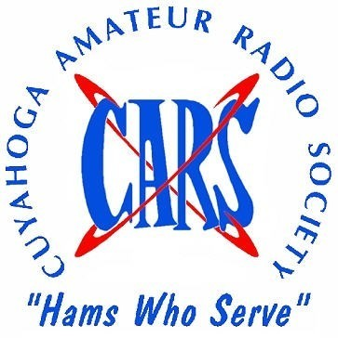
The Cuyahoga Amateur Radio Society will be offering ham radio licensing classes beginning Thursday, February 29th, 2024 at 6:30 PM. There will be six sessions held each Thursday and a special VE testing session on the seventh week - April 11th, 2024.

There will be three separate classes -Technician, General, and Amateur Extra.

Classes will be held at the Seven Hills Community Room, 7325 Summit View Drive, Seven Hills, OH 44131.

Cost of the classes is $20.00. The General class is free to all CARS members.

Anyone interested in registering for a class should contact Toby Kolman, WT8O, at wt8o@att.net or 440-525-6109.

Massillon ARC Amateur Radio Classes For Technician, General and MORSE CODE

Begin Wednesday, Feb 8 and run weekly for 8 weeks. 7-9 p.m. At Massillon, OH ARC. Location: R.G. Klein Museum, corner of Erie St & Federal Ave, NE.
Exams at conclusion (except Code)
For information and registration call or email at these addresses:
330-705-8449 or w8au@arrl.net
__________________________________________________________

OH-KY-IN and QCEN announce the next round of classes for amateur radio licenses and upgrades. We will start with Extra Class instruction, which will go for 7 weeks because of the nature of the material to be covered. That class will start on Monday, February 19th, at 7 p.m. in the Red Cross building, 2111 Dana Ave. in Cincinnati. It will run until April 1st.
Starting the next week, Monday February 26th, also at 7 p.m. in the Red Cross building, instruction for the General Class, and the Technician Class (the entry-level ham radio license) will be offered. These classes will go for 6 weeks, ending on April 1st as well.
A testing session will be held on Saturday, April 6th, at 10 a.m. in the Red Cross building.
To sign up for these sessions, or to get more information, please send an email to hamtutor@ohkyin.org.

ARES CONFERENCE
Hosted by District 10

Come Join us for the D10 ARES Conference
- Go-Box Displays
- Informative Presentations
- DMR Programming Workshop
  - Lunch Provided
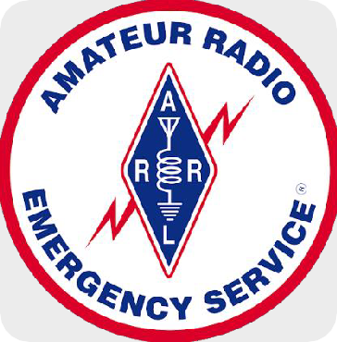
FEB 17
8am-4pm
Presentation topics include: MARCS, Red Cross, National Weather Service, Tabletop Exercises, Winlink
Tri-Point Medical Center | 7590 Auburn Rd Painesville, OH 44077

www.n8esg.org/conference For information and to register

__________________________________________________________

Your Club news should be listed here!
I know you’re out there doing things! Send me a write-up (MSWord please) and some photo’s (.jpg please) and we’ll get your club hi-lited here for the other OH Section Clubs to see! Send to WB8LCD@ARRL.ORG

Important Links
ARRL Home: www.arrl.org
Find an ARRL Affiliated Club: www.arrl.org/clubs
Find your ARRL Section: www.arrl.org/sections
Find a License Class in your area: www.arrl.org/class
Find a License Exam in your area: www.arrl.org/exam
Find a Hamfest or Convention: www.arrl.org/hamfests
Email ARRL Clubs: clubs@arrl.org
____________________________________________________________________________

The Ohio Section Youth Net

Youth Net
When: The second Sunday of every month at 7:30 PM EST
Where: The K8IV repeater located in Kent, Ohio (Echolink node K8BF-L) RF: 146.895 Mhz with PL 118.8
Who: Any licensed amateur radio operator who wishes to participate. Priority will be given to youth stations and those located in Ohio.
The purpose of this net is to encourage youth activity in amateur radio and to help new hams get more comfortable on the air.

***Next Net is Sunday February 11th, 2024 ***

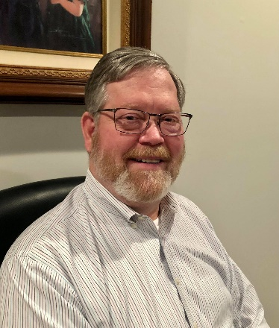
DX This Week – Zones 15, 16, & 17
Bill - AJ8B (thedxmentor@gmail.com / www.aj8b.com )

What a week for DX. I hope you were in the chair this week. I AVERAGED 13 Asian QSOs per night from Sunday through Wednesday on 12 meters. It was a combination of CW, FT8, and FT4. It was all between 2300Z and 0130Z. It was Great hunting. I even worked my first ever JA station, JA1BWA. I had not worked Toshio since October of 78!
Let me know what you have been working – thedxmentor@gmail.com

DAH DIT DIT DIT DAH DAH DIT DIT DIT DAH

This week we will continue our investigation of the various CQ Zones. So, lets get started.

So far this year, we have covered CQ zones 1 through 14. This week we will review Zones 15, 16, and 17. The following is a list of the entities in each zone.

Zone 15: Central European Zone: E7 (Bosnia Herzegovina), ES (Estonia), HA (Hungary), HV (Vatican), I (Italy), IS0 (Sardinia), LY (Lithuania), OE (Austria), OH (Finland), OH0 (Aland Is.), OJ0 (Market Reef), OK (Czech Rep.), OM (Slovakia), S5 (Slovenia), SP (Poland), T7 (San Marino), TK (Corsica), UA2,F,K, RA2,UB2-UI2 (Kaliningrad), YL (Latvia), YU (Serbia), ZA (Albania), Z3 (Macedonia), 1A0 (SMOM), 4O (Montenegro), 9A (Croatia), 9H (Malta).

Zone 15 – The challenges for me in Zone 15 have been: HV – Have worked the Vatican station 3 times, OJ0 –Have worked Market Reef 3 times, and 1A0 – Have worked them twice. The first time I worked 1A0 was in 2015. Fortunately, I came down with the flu the very day they were operating a special event station.

Zone 16: Eastern Zone of Europe: EW (Belarus), ER (Moldova), UA1, UA2(except for RA2 and UA2-UI2), UA3. UA4, UA5, UA6, UA7, UA9, UA9 (S, T, W), and UR (Ukraine).

Zone 16 – Most of these entities I have worked during the CQWW contests. Some of the Ukrainian ops I have worked have been among the nicest guys and are happy to chat about their “working conditions.”

Zone 17: Western Zone of Siberia: EX (Kirgizstan), EY (Tajikistan), EZ (Turkmenistan), UA8,9 (A, B,C,D, F, G, J. K, L, M, N, Q,R, X), UK (Uzbekistan), UN (Kazakhstan).

Zone 17 – This zone has been a challenge for me. I have worked EX, EY, EZ, and UK 3 times each on different bands or modes, all between June of 1990 and August of 1991. In forty years, I have not worked them before or after that.

One of the easier ways to pick up zones is during the CQWW contests. The exchange between stations is a signal report and your zone. If you are tuning across the band and hear “599 16”, you will automatically know that this station is operating in zone 16. As the adage goes, work them first and worry about the zone later.
Good Hunting in these Zones

DAH DIT DIT DIT DAH DAH DIT DIT DIT DAH

Here is an update from Bernie, W3UR, of the DailyDX and the WeeklyDX, and the How’s DX Column in QST. The DailyDX the best source for real-time DX information. http://www.dailydx.com/ . Bernie has this to report:

The TX5S DXpedition to Clipperton Island (NA-011) has come to an end. The statistics are staggering: as of Monday, January 28, they have documented 113,774 QSOs with 23,856 unique calls and a 2.7 percent duplicate QSO rate. The team was on 160M through 23CM, with the highest number of contacts on 20, 12, 17, 15, and 40M. There were 29,532 QSOs on CW, 25,333 on SSB, and 57,946 on FT8. Club Log offers a full tabular and graphic breakdown, including QSOs by band/mode, DXCC by band/mode, daily QSO counts, multiband QSOs, breakdown by continent, and more. Nearly all TX5S logs have been uploaded to Club Log and MØURX.com. K5GS, Gene, asks again that DXers not send messages to team members’ personal email addresses or the DXpedition address, or directly to the PayPal email address. Also, he notes that many DXers sent log screenshots, spreadsheets, and
other files. These messages and their attachments were deleted immediately. TX5S did not use QRZ.com logging. Gene notes that “All busted calls and not-in-log issues will be resolved by submitting the form on the MØURX OQRS application.”
The team is now on its way back to San Diego. We wish them safe passage, calm seas, and favorable weather! Several team members will present at Visalia, Dayton, and Friedrichshafen.
More information is available at the TX5S website.

A Pacific trifecta!
YT1AD, Hrane, and his team will operate from three Pacific entities between February 7 and March 1, as follows: 3D2, Fiji, February 7-10 and February 27-March 1, 5W, Samoa, February 10-19 and A3, Tonga, February 20-27.

These is a 6O3T, Somalia DXpedition in the works.
An Italian-led team plans a DXpedition to Somaliland, one of the five states that make up Somalia which is #53 on the Club Log DXCC Most Wanted List, on the Horn of Africa. This is “a difficult territory that has never been spared from war and famine; an exciting and complicated DXpedition, in a turbulent territory, and not always easy to activate.” The dates have not yet been determined. A website is under construction, and news will be reported there and on major DX news sites, including The Daily DX and The Weekly DX. In the meantime, follow the group on Facebook for real-time updates, Q&A sessions, and much more.
8R7X is the callsign for the February 14-24 DXpedition to Guyana by four young operators: DJ4MX, DK6SP, HA8RT, and MØSDV. They will operate CW, SSB, RTTY, and FT8 on 160-6M. 8R7X is now approved by the ARRL for DXCC credit, and a Logbook of the World certificate has been issued to QSL manager MØOXO.
The team will upload their logs to LoTW and OQRS as often as possible throughout their DXpedition free of charge. Any outstanding logs will be uploaded immediately upon the team’s return home. The team also intends to utilize Club Log’s Live Stream feature through the duration of the DXpedition, depending on internet connectivity.

Here is one that I worked before I heard about it. A2 – Botswana. John Green has been living in Botswana since 2011 and has recently been licensed as A2NEW. While in
Australia back in 2018, he was licensed as VK2NEN. He has a Kenwood TS-480HX and SG-230 ATU. He plans to be QRV daily during his evenings, from 1600 1900 UTC.

Callsign TC6EQ will be used from February 1-29 to remember the earthquake that hit Turkey February 6, 2023. Almost 51,000 people were killed. TA8DX,
Mustafa Ezer is being particularly remembered. A certificate for working TC6EQ is available. https://tadx.org/awards

Alan, G3XAQ and Don, G3XTT will be in Uganda and QRV as 5X1XA on CW only between 12th and 20th February 2024, including a 10 metres SOSB entry in the ARRL DX Contest (17/18 February).
QSL via G3SWH, direct only or OQRS via www.g3swh.org.uk. No bureau cards. The logs will be uploaded to LoTW, ClubLog and the G3SWH web site after the activity.

DAH DIT DIT DIT DAH DAH DIT DIT DIT DAH

Below is a list of upcoming contests in the “Contest Corner”. I think this is important for someone who is trying to move up the DXCC ladder since entities that are on the rarer side and easiest to work in contests. Some of my best “catches” have been on the Sunday afternoon of a contest when the rarer entities are begging for QSOs. Of course, the gamble is that if you wait until Sunday, conditions may change, or they simply won’t be workable. However, it is not a bad gamble. Of course, why not work the contest and have some fun!
Check out the WA7BNM Contest Calendar page (https://www.contestcalendar.com/) for more contests or more details.
The contests in red are those that I plan to spend some significant participation time on. PLEASE let me know if you are working contests and how you fared.

Thanks!

The CQWW RTTY WPX contest will be held the weekend of February 10th to February 11th.
The OBJECTIVE is for amateurs worldwide to contact as many amateurs and prefixes as possible during the period of operation.
The PERIOD OF OPERATION is 48 hours. Single Operator stations may operate 30 of the 48 hours – off times must be a minimum of 60 minutes during which no QSO is logged. Multi-operator stations may operate the full 48 hours.
The BANDS are Only the 3.5, 7, 14, 21, and 28 MHz bands. Observance of established band plans is strongly encouraged.

Contest | Start  Date | End  Date
ARRL Inter. DX Contest, CW | 2/17/2024 | 2/18/2024
CQ 160M Contest, SSB | 2/23/2024 | 2/25/2024
North Carolina QSOP | 2/25/2024 | 2/26/2024
ARRL Inter. DX Contest, SSB | 3/2/2024 | 3/3/2024
YB DX RTTY Contest | 3/9/2024
Idaho QSOP | 3/9/2024 | 3/10/2024
Oklahoma QSOP | 3/9/2024 | 3/10/2024
Wisconsin QSOP | 3/10/2024 | 3/11/2024
Virginia QSOP | 3/16/2024 | 3/17/2024
CQ WW WPX Contest, SSB | 3/30/2024 | 3/31/2024

_______________________________________

ARLD005 DX news
This week's bulletin was made possible with information provided by The Daily DX, 425 DX News, DXNL, Contest Corral from QST and the ARRL Contest Calendar and WA7BNM web sites. Thanks to all.
ESWATINI (KINGDOM OF), 3DA. Hans, 3DA0AQ has been QRV on 15 meters using digital modes between 1800 and 2000z. QSL via EA5GL.
MADAGASCAR, 5R. Eric, F6ICX is QRV as 5R8IC until March 31. Activity is holiday style on 40 to 10 meters using mainly CW with low power. The last two weeks here will be spent being active on Satellite QO-100. QSL direct to home call.
SENEGAL, 6W. Willy, ON4AVT will be QRV as 6W7/ON4AVT from Warang from February 3 to April 16. Activity is on 80 to 10 meters using SSB and various digital modes, and on Satellite QO-100. QSL to home call.
YEMEN, 7O. Vlad, OK2WX is QRV as 7O2WX from Socotra Island, IOTA AF-028, until February 12. Activity is on 160, 80, and 40 meters. QSL via IZ8CCW.
FEDERAL REPUBLIC OF GERMANY, DA. Special event station DG22SISTY is QRV until December 31 to celebrate 60 years of the national organization DARC's Ortsverband Gemund. QSL via bureau.
PHILIPPINES, DU. BJ, WA7WJR will be QRV as DU3/WA7WJR from February 4 to 9. He plans to activate the POTA references Governor Macario Amedo Park and Mount Arayat National Park. QSL direct to home call.
REUNION ISLAND, FR. Thierry, FY4JI will be QRV as FR4AV from February 4 to March 11. Activity will be on 40 to 10 meters using CW and SSB. QSL via EA5GL.
ECUADOR, HC. Rick, NE8Z is QRV as HC1MD/2. He is generally active from 0100 to 0300z and will soon be QRV on 160 meters using FT8. QSL via K8LJG.
GUINEA-BISSAU, J5. Station J52EC is usually QRV on 10 meters SSB around 1500 to 1600z. QSL direct to IZ3BUR.
ST. VINCENT, J8. Franco, J88BTI is generally QRV on 160 to 10 meters using mostly CW. QSL via LoTW.
TURKEY, TA. Special event station TC6EQ is QRV until February 29 to commemorate the devastating earthquake that struck Turkey on February 6, 2023. QSL via LoTW.
ANTIGUA AND BARBUDA, V2, Chuck, KG9N will be QRV as V26CV from Antigua, IOTA NA-100, from February 6 to 20. Activity will be on the HF bands using only CW. QSL to home call.
AUSTRALIA, VK. Andrey, VK5MAV will be QRV as VK5MAV/4 from Magnetic Island, IOTA OC-171, from February 6 to 11. QSL to homecall.
NORFOLK ISLAND, VK9N. Bob, GM4DLG is QRV as VK9N/GM4DLG until February 7. Activity is on 80, 40, and 20 meters using SSB. QSL direct to home call.
CAMBODIA, XU. Yoshi, XU7AKJ is QRV from Phnom Penh and has been active on 10 meters using FT8 from 0200 to 0700z. QSL via JA3ULS.
VANUATU, YJ. Takio, JH3QFL and Mamoru, JH3VAA will be QRV as YJ0AA and YJ0MN, respectively, from February 4 to 11. Activity will be on the HF bands using mostly FT8, and on Satellite IO-117. QSL via LoTW.
SOUTH SUDAN (REPUBLIC OF), Z8. Ken, K4ZW will be QRV as Z81Z from Juba from February 4 to 7. Activity will be in his spare time depending on his work schedule. QSL direct to home call.
_________________________________________

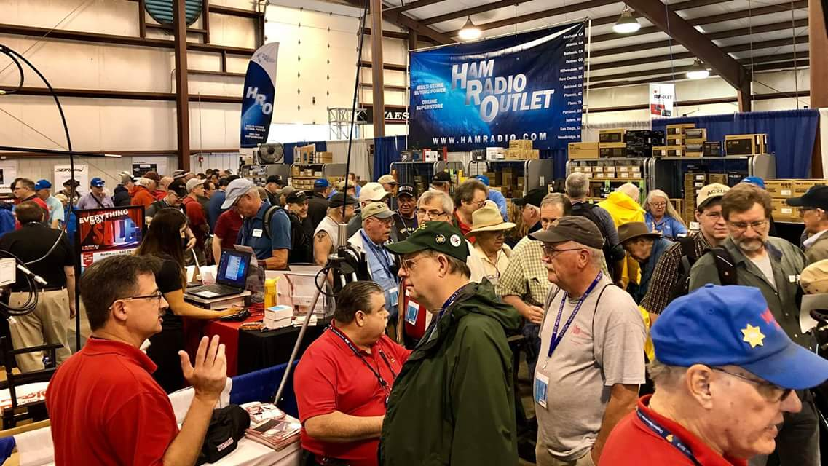
Upcoming Hamfests

We DO have hamfests scheduled for 2024!!

 | Ohio Hamfests
 | 2024
 | 03/10/2024 - WINTERHAMFEST  Location: Elyria, OH  Sponsor: Northern Ohio Amateur Radio Society  Website: http://winterhamfest@noars.net  Learn More |  | 03/17/2024 - Toledo Mobile Radio Association Hamfest and Computer Fair  Location: Perrysburg, OH  Type: ARRL Hamfest  Sponsor: Toledo Mobile Radio Association  Website: http://www:w8hhf.org  Learn More
04/13/2024 - Cuyahoga Falls Amateur Radio Club 68th Hamfest  Location: Cuyahoga Falls, OH  Type: ARRL Hamfest  Sponsor: Cuyahoga Falls Amateur Radio Club, Inc.  Website: http://www.w8vpv.org/hamfest  Learn More |  | 04/13/2024 - Mid-Ohio Valley Amateur Radio Club  Location: Bidwell, OH  Type: ARRL Hamfest  Sponsor: Mid-Ohio Valley Amateur Radio Club  Learn More
04/27/2024 - Tusco Amateur Radio Club Hamfest, Electronics, and Computer Show  Location: Dover, OH  Type: ARRL Hamfest  Sponsor: Tusco Amateur Radio Club W8ZX  Website: http://www.w8zx.net/hamfest  Learn More |  | 04/28/2024 - Athens Hamfest  Location: Athens, OH  Sponsor: Athens County Amateur Radio Association  Website: https://www.ac-ara.org/  Learn More
05/05/2024 - Lucas County ARES Trunk Sale & Swap Meet  Location: Toledo, OH  Type: ARRL Hamfest  Sponsor: Lucas County ARES  Website: http://lucasares.org  Learn More |  | 05/11/2024 - 05/16/2024  RV Radio Network  Location: Millersburg, OH  Type: ARRL Convention  Sponsor: RV Radio Network  Learn More
05/16/2024 - 05/19/2024  Four Days In May  Location: Fairborn, OH  Type: ARRL Convention  Sponsor: QRP Amateur Radio Club International  Website: http://qrparci.org/fdim  Learn More |  | 05/17/2024 - 05/19/2024  Dayton Hamvention, ARRL National Convention  Location: Xenia, OH  Type: ARRL Convention  Sponsor: Dayton Amateur Radio Association  Website: https://hamvention.org  Learn More
07/06/2024 - Mansfield Mid Summer Trunkfest  Location: Mansfield, OH  Type: ARRL Hamfest  Sponsor: Intercity Amateur Radio Club  Website: http://W8WE.ORG  Learn More |  | 07/21/2024 - Van Wert Hamfest  Location: Van Wert, OH  Type: ARRL Hamfest  Sponsor: Van Wert Amateur Radio Club  Website: http://w8fy.org  Learn More
08/03/2024 - 2024 Columbus Hamfest  Location: Grove City, OH  Type: ARRL Hamfest  Sponsor: Aladdin Shrine Audio Unit  Website: http://www.columbushamfest.com  Learn More |  | 08/10/2024 - Cincinnati Hamfest  Location: Owensville, OH  Type: ARRL Hamfest  Sponsor: Milford ARC  Website: https://CincinnatiHamfest.org  Learn More
08/18/2024 - Warren Hamfest  Location: Cortland, OH  Type: ARRL Hamfest  Sponsor: Warren Amateur Radio Association  Website: https://www.w8vtd.com/  Learn More |  | 10/27/2024 - 2024 MARC Hamfest at MAPS  Location: N. Canton, OH  Type: ARRL Hamfest  Sponsor: Massillon Amateur Radio Club  Website: https://www.w8np.net  Learn More

__________________________________________________________________

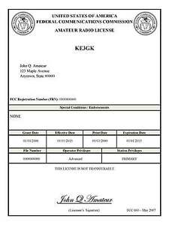
Print an Official or Unofficial Copy of Your Amateur Radio License
(By Anthony Luscre, K8ZT)

As of February 17, 2015, the FCC no longer routinely issues paper license documents to Amateur Radio applicants and licensees. The Commission has maintained for some time now that the official Amateur Radio license authorization is the electronic record that exists in its Universal Licensing System (ULS). The FCC will continue to provide paper license documents to all licensees who notify the Commission that they prefer to receive one.

Licensees also will be able to print out an official authorization — as well as an unofficial “reference copy” — from the ULS License Manager. I’ve created a set of instructions on how you can request an “official” printed copy of your license*

Click here to download the instructions

One Question Questionnaire

Here we go!,

Last weeks question: Did you operate Winter Field Day last weekend?
Out of 62 RESPONSES:
30 YES
70 NO

The new question is: If Several “RARE ONES” announced that they would be on the air, looking for US Stations ONLY, during the Super Bowl, would you:

a) GET on the air!
b) watch the super bowl?

You’ll find the “One Question” questionnaire on the Ohio Section Website! http://arrlohio.org It’s all for fun and it’s not a scientific survey in any way, but we are learning some things that we didn’t know from these questions. I hope that you are enjoying answering these “One Question” questionnaires.

Look for the RED ARROW on the website – After your vote ENTER out Handbook giveaway contest! You’ve got just a few more days to get in on the October drawing…

And, the winner of the January 2024 Handbook is: Mike Burg – N8QQN. Congratulations Mike! There were 175 entries for January – your odds of winning are a whole lot better than the lottery or going to a casino!

Final… Final

I want to thank everyone who contributes to and assists with getting the Ohio Section Journal and PostScript out to you (almost) every week. It takes time, effort and aggravation to get this out and I certainly appreciate all the help I’ve received. My weekly goal is to make it better. I would ask you all, let me know if there is something you would like to see here. I would also ask you to submit articles on almost any topic of an Amateur Radio nature. What are you doing in the hobby? What’s your club doing? What technical expertise do you have to share? Are you a new op – why did you choose Amateur Radio for your hobby? Do you repair and restore old radios – how about some tips? Most of us find it interesting to see what the folks in our area are doing and how they are being successful with the hobby. All I ask is that you submit it to me in a .doc (Word) format, Times New Roman font size 12, and include some photos in a .JPG format (it saves me a LOT of time not having to reformat everything). Doing this has given me a whole lot of appreciation for the club newsletters that I see, most of which are done to a very high standard!

I want to share an obituary with you:

From the Akron Beacon Journal

Joseph Hillman Carron, 80, died January 31, 2024. A native of Akron and always having lived within a 15-mile radius of where he was born, Joe experienced a full life, ultimately settling in 1989 as a resident of Twin Lakes. As an enthusiastic amateur radio operator (a “ham” since age 12, (K8HTB - “The Happy Teddy Bear”), he achieved the FCC’s highest licensed level and had a penchant for all things mechanical and technical. Joe was also a member of the Portage County Amateur Radio Service. After marriage and two young boys at home, as well as a short stint with the railroad, he settled into a successful 16-year career as a first responder, serving as an Akron Police Officer. While in training, he was selected for a personality feature in the Akron Beacon Journal as one of the new officer cadets in the academy. It was with ease for him to qualify through the police academy weapons training since he was a state championship marksman while on the rifle team at Garfield High School. Also, while with the department, Joe testified as an expert witness for the successful felony prosecution of the first computerized racketeering/gambling case in the nation, (again featured in the Akron Beacon Journal), and was an essential member of a project team that implemented a computerized criminal search engine for the Akron Police Department that has been used for decades. During his tenure on the APD, Joe raced motorcycles as a hobby, attained multiple FAA pilot ratings, and founded Carron’s Flying Service for charter, instruction, and airplane rides at the Kent State Airport. He was an immensely passionate and skilled aviator - never compromising safety in the thousands of hours he logged. Finally leaving the department with his newly developed skill set in the 1980s, Joe became a self-made software and hardware engineer for a variety of companies, founded his own consulting firm, (CFS & Associates), and lastly, retired from a successful engineering tenure with The Timken Company in Canton. More than interests, hobbies, and vocations, Joe enjoyed his family and friends, and over the years with a faith in Christ, (John 3:16), regularly attended The Chapel in Akron as well as Faith Baptist Church in Streetsboro. He was loved and will be truly missed by us all. Preceded in death by his parents, James and Josephine Caughron; daughter, Teresa Caughron, and sister, Mary-Jo Bohnert. He is survived by his wife of 50 years, Marie Carron; sons, James (Deborah), and Tod Carron; stepsons, Michael (Cathalynn), and Stephen (Dawn) Thompson; grandchildren, Sophia and Olivia Carron, Noah and Gena Thompson, Rose, Magdalene, James, and Sarah Carron; sisters, Carol and Marlene Caughron; brother-in-law, Henry Bohnert; nephew, Adam Bohnert, and niece, Katie (Jake) Neptune. Pastor Don Workman will conduct service, 1 PM, Monday, February 5, 2024, at Redmon Funeral Home 3633 Darrow Road, Stow 44224. Friends may call from 11 AM to service time Monday. Burial Silver Springs Cemetery in Stow. (REDMON, STOW, 330-688-6631)

I share this because I believe that Joe was a “typical” kind of guy, an older ham in our club that came to the meetings and some of our activities, never said too much, asked for help when he needed it (and the club responded helping him with tower work). Just a typical guy, until you read his bio in the above obituary!

Our ham radio clubs are filled with guys like Joe. Older hams, they attend when they can, don’t say too much, ask for help when they need it, they represent a large, but disappearing, faction of the Amateur Radio hobby. In a lot of cases, they are HERO’s among us, but we may not even recognize them as such because they aren’t vocal about it. I want to ask you to get to know these hams better, spend some time with them, give them some help when they need it. They are an outstanding resource of knowledge and experience!

Wishing you all a Fantastic February! Get on the air, and spread the “magic of radio”.

73,
Tom WB8LCD

“Swap & Shop” on the website

Hey Gang,

Have you taken a look at the Swap & Shop page on the Ohio Section webpage yet?? Here’s a link that will take you there…
http://arrl-ohio.org/sm/s-s.html

Do you have equipment that you just don’t need or want anymore? Here’s a great venue to advertise it, and it’s FREE!!

Is your club doing a fund raiser to help raise money? After a lot of thought, it was decided that the Swap & Shop webpage could also contain these types of items as well.

The same rules will apply as do for the For Sales and Give-A-Ways and will only be posted for a month at a time. Please see the Terms & Conditions on the webpage. You might want to list your location so that prospective buyers know where you’re at.

If your club is doing a fund raiser and wants more exposure, please forward the information to me and I’ll advertise it on the Swap & Shop webpage for you. Now, I still want to remind you that it won’t be listed in this newsletter because it would take up way too much space, so your ad will only appear on the website. It is there for any individual to post equipment Wanted / For Sale or Give-Away as well as for Club Fund Raisers. No licensed vehicles/trailers or business advertising will be posted.

Postings are text only (no pictures or graphics) will be posted for a maximum of 1 month from date posting and require a contact phone number or email within the posting. Send your Wanted / For Sale or Give-Away post to: swap@arrlohio.org

Back Issues of the PostScript and Ohio Section Journal

Hey, did you know that PostScript and Ohio Section Journal (OSJ) are archived on the website? You can go back and look at any edition simply by clicking:
http://arrl-ohio.org/news/index.html

Ohio Section Cabinet
Section Manager – Tom Sly, WB8LCD | Section Emergency Coordinator – Bret Stemen, KD8SCL
Technical Coordinator – Jeff Kopcak, K8JTK | Section Traffic Manager – David Maynard, WA3EZN
State Government Liaison – Bob Winston, W2THU | Affiliated Clubs Coordinator –  Amanda Farone, KC3GFU
Section Youth Coordinator – Anthony Lascre, K8ZT | Public Information Coordinator – E;izabeth Klinc – KE8FMJ

Chit – Chat, and All That!

Do you know someone that’s not getting these Newsletters? Please, forward a copy of this Newsletter over to them and have them “Opt-In” to start receiving them. Heck just have them send an email to: webmaster@arrl-ohio.org to be added.

We now have many thousands of readers receiving these newsletters weekly. Quite impressive, I’d say! I urge all of you to make sure that everyone, regardless of whether they are a League member or not, get signed up to receive these weekly Newsletters.
You can always “Opt-Out” at any time if you feel this is not what you were expecting. It’s fun and very informative. All of your favorite past newsletters are now archived too.
You can go back at any time and read them. Just go to: http://arrl-ohio.org/news/

The pictures on the front page and throughout this newsletter are from various newsletters, Facebook posts and/or were sent directly to me in recent weeks. Take a good look at them, you just might be in one of the pictures! “SMILE… you’re in the Ohio Section News!!”

The Ohio Section Journal (OSJ) is produced as a comprehensive look at all the programs within the Ohio Section. I sincerely hope that you have enjoyed this edition of the OSJ and will encourage your friends to join with you in receiving the latest news and information about the Ohio Section, and from around the world!

TOP^

