[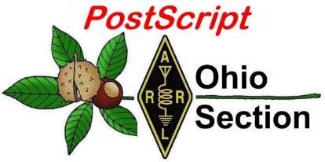](http://arrl-ohio.org/news/)

***“******March 06, 2023”***

🡪 National News 🡪 Club Corner

🡪 DX This Week 🡪 Contest Corner

🡪 Upcoming Hamfests 🡪 One Question Questionnaire

🡪 VE Testing 🡪 South 40

**CQ CQ CQ de WB8LCD**

I’ve received several questions in the past week about Field Day rules for 2023. To make a long story short, it appears that CW Q’s will retain their two point-value. You may have already seen this, but I first received it on March 3rd – I’ve made one small edit to the email so it reads correctly, but hear it is so you can all start making your FD plans for 2023!

Hello,

The 2023 Field Day rules are now posted at the following address:

[https://contests.arrl.org/ContestRules/Field-Day-Rules.pdf](https://contests.arrl.org/ContestRules/Field-Day-Rules.pdf?fbclid=IwAR1iscBeF3ubjMmm4LEbZIds9lVrcLtWq3KYaBe3md1CeBRJDE9Ai3WQ2T4)

This is the rules packet only. The complete packet will be posted soon and the logo is not the final logo. We wanted to get the rules out.

Thanks

Mike

Mike Walters, W8ZY

Field Services Manager

ARRL - The national association for Amateur Radio®

225 Main Street

Newington CT 06111-1400

860-594-0305

I was talking with the folks at the Lancaster & Fairfield County ARC last week and I thanked then for being a “Special Service Club” (SSC). If you review the requirements your club needs to meet to be an SSC, you’ll find that they’re really not to stringent, and most importantly, if you are doing the things required to be an SSC, than you’re also doing the things that are required to be a *successful* club in anyone’s view. It appears right now, that if you are an SSC, you get a nice certificate from the ARRL (suitable for framing), and a sincere Thank-You from the Section Manager and the Affiliated Clubs Coordinator. I’m hoping for, and *expecting* to see some changes to that in the foreseeable future. And what I am expecting to see are some more “tangible” benefits to being an SSC. If you have some ideas of things that might be appreciated by your club, and others, send your thoughts to your Division Director and/or Vice-Director (wherever you live, they are listed in the front pages of every issue of QST) If you send your thoughts to me, I’ll deliver them to your Director/Vice-Director, but since I don’t sit on the Board of the ARRL, I can only express your thoughts to those that do, and I’m happy to do so.

All that said, I would like to point out that your clubs that ARE SSC’s, are held in high esteem by the BoD of the ARRL for all the reasons previously given. Now let me set the table here for you: As of February 27, 2023, there were 2856 ARRL Affiliated Clubs through-out the organization. The Great Lakes Division has a total of 269 affiliated clubs, of which 128 are Ohio Section Clubs. (Remember, the Ohio Section is the largest Section in the ARRL!) Currently, 19 Ohio Section Clubs are SSC’s - so that’s just a little less than 20%. If your club is not an SSC, check it out at http://www.arrl.org/ssc-application - you might already be qualified and all you need to do is have your club officers fill out the application and hit “SUBMIT”. Ohio (and the Ohio Section by default) are already LEADER’S in all things Amateur Radio. We should be in clubs qualifying as SSC’s too. Could we hit 50%? That should be a walk in the park (complete with all equipment necessary for a POTA activation).

Speaking of clubs, have you been travelling around, attending some clubs meetings that you’ve never been to before? I put that out as a challenge, and I haven’t gotten much response yet (as in Zero, nada, zilch, nil, Butkus) Get out there and meet some hams in the Ohio Section you might not have met yet. You’ll be glad you did! Why, you could even write an article about it!

Just a quick blurb about ARES – we’ve got a few counties with no Emergency Coordinator in them. If you’re in one of those counties and want to step up, please contact either me or SEC Bret Stemen – KD8SCL. Maybe you’re an inactive ARES member, not an ARES member, or just someone who thinks they might have an interest in EmComm, The ARRL offers two Emergency Communications courses – EC-001 and EC-016, and the EMA offers many courses on NIMS – the National Incident Management System – these are the NIMS courses and many can be taken online. Look for more information on the NIMS courses sponsored by the EMA in the clubs section a little further down this newsletter.

To end with this month, I’ll go back to the meeting of the Lancaster & Fairfield County ARC – there was a short presentation on RF Safety and safe limits of exposure to RF energy. The book on this is provided to us by the FCC in OET Bulletin 65. The bulletin information can be found here:

**OET Bulletin No. 65 (August 1997)**

* *Evaluating Compliance With FCC Guidelines for Human Exposure to Radio frequency Electromagnetic Fields*
* **Note**: OET Bulletin Number 65 is currently under review to provide updated guidance regarding the rule changes of FCC 19-126 that became effective May 3, 2021.  
  This revised OET Bulletin 65 has been prepared to provide assistance in determining whether proposed or existing transmitting facilities,operations or devices comply with limits for human exposure to radio frequency (RF) fields adopted by the Federal Communications Commission (FCC) The bulletin offers guidelines and suggestions for evaluating compliance. However, it is not intended to establish mandatory procedures, and other methods and procedures may be acceptable if based on sound engineering practice.
* Download:
  + Bulletin (currently under review to provide updated guidance concerning recent rule changes)
    - [OET65.pdf](https://transition.fcc.gov/oet/info/documents/bulletins/oet65/oet65.pdf) (PDF)
  + Supplement A (currently under review to provide updated guidance concerning recent rule changes)
    - [OET65a.pdf](https://transition.fcc.gov/oet/info/documents/bulletins/oet65/oet65a.pdf)(PDF)
  + Supplement B (currently under review to provide updated guidance concerning recent rule changes)
    - [OET65b.pdf](https://transition.fcc.gov/oet/info/documents/bulletins/oet65/oet65b.pdf) (PDF)
  + Supplement C
    - [OET65c](https://apps.fcc.gov/oetcf/kdb/forms/FTSSearchResultPage.cfm?switch=P&id=20676) (Supplement C has been superseded by [KDB Publication 447498 D03](https://apps.fcc.gov/oetcf/kdb/forms/FTSSearchResultPage.cfm?switch=P&id=20676))
    - Previous revisions of supplement C
      * [OET65c.docdocument download](https://transition.fcc.gov/oet/info/documents/bulletins/oet65/oet65c.doc)  Revised (6-29-01) (Word)
      * [OET65c.pdf](https://transition.fcc.gov/oet/info/documents/bulletins/oet65/oet65c.pdf) (PDF)
  + Public Notices
    - [Supplement C to Bulletin 65 Revision](https://docs.fcc.gov/public/attachments/DA-01-1557A1.pdf)  
      (Supplement C has been superseded by [KDB Publication 447498 D03](https://apps.fcc.gov/oetcf/kdb/forms/FTSSearchResultPage.cfm?switch=P&id=20676))

Anything you need to know is found here! I would encourage you all to spend some time reviewing this information. While I hope you would never need it, but it might be useful to know if you needed to defend yourself against any accusations. More importantly, it might be useful information to point out when seeking a permit for an antenna support structure or any other permission that you might need in order to enjoy your hobby!

Get out there and have some Ham Radio Fun!

73,

Tom Sly - WB8LCD

Ohio Section Manager

[wb8lcd@arrl.org](mailto:wb8lcd@arrl.org)

330-554-4650

**Youth Net**

**When:** The second Sunday of every month at 7:30 PM EST

**Where:** The K8IV repeater located in Kent, Ohio (Echolink node K8BF-L) RF: 146.895 Mhz  with PL 118.8

**Who:** Any licensed amateur radio operator who wishes to participate. Priority will be given to youth stations and those located in Ohio.

The purpose of this net is to encourage youth activity in amateur radio and to help new hams get more comfortable on the air.

***Next Net is Sunday March 12th***

If you are a young ham, in the Ohio Section or elsewhere, please check in and say “Hello”!

Even if you’re far away from OHIO you can check in via Echo-Link. Echo-Link is a good tool to have, and it can be accessed from your laptop, tablet or cellphone. But there is a process to get validated to the Echo-link system. It’s simple to do, but you need to get it done before the day of the net! Go to [Introducing EchoLink](https://www.echolink.org/) for more information on getting started. If you’re an “Old Guy” (a gender neutral term meaning not a youthful operator) and you have some kids, grandkids, nieces, nephews or even some neighborhood kids who you would like to give a chance to talk to other kids about Ham Radio, this might be an excellent opportunity to give them that small nudge that could be the start of something positive they will carry with them through life!

***National News***

*(from ARRL and other sources)*

**2023 Hamvention Awards**

The Hamvention Awards committee is delighted to announce the 2023 Hamvention

award winners. Please join us in congratulating these outstanding Amateurs.

Michael Kalter (W8CI), Awards Chair

**Special Achievement Award**

Jason McDonald MD, (N2TPA) is an active, well known Amateur Extra Class operator who earned his license in 2003. Dr. McDonald began as an RF engineer before changing careers to become a trauma surgeon. Dr. McDonald’s amateur radio interests range from operating to international disaster response, with his true passion working with youth to promote amateur radio.

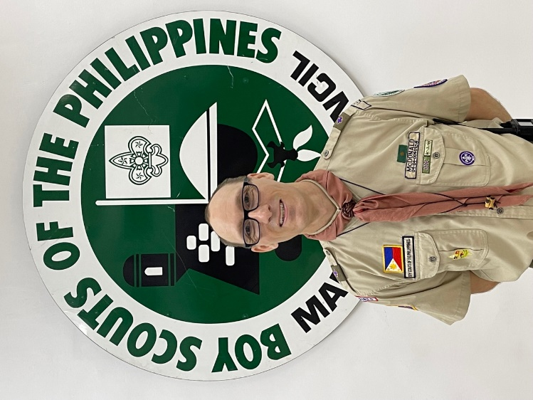Dr. McDonald brings amateur radio to the world through youth projects and Scouting, particularly through Radio Scouting. Empowering youth through education is the goal of clubs he has helped to form. W1PTG is a testing group that Dr. McDonald helped create to offer exams in under-served areas and to get more people into the hobby. This team of VEs graciously donate their time and money to ensure each licensee in the program receives mentor support and a radio.

Dr. McDonald has been instrumental in promoting international friendship and community through Amateur Radio by forming scouting clubs in Canada (VA7RSI), the Philippines (W1PTG and DX1MC), and Florida (KQ4GCK). To date, more than five hundred youth in these clubs have been licensed and are on the air.

**Amateur Radio Club of the Year**

The Delaware Valley Radio Association (DVRA), an ARRL affiliated club formed in 1930, serves the Trenton, New Jersey metropolitan area. The club has tripled in size over the last six years due to the wide range of amateur radio activities and events they offer. An all-purpose club, the DVRA’s activities include public service events, operator training/mentoring, Scouting events, informational monthly meetings, POTA events, and the operation of a world class club station.

The DVRA center of activity is club station W2ZQ, which operates a regular schedule. The station was renovated six years ago and currently houses two complete HF stations, a VHF repeater, an APRS digipeater and a WinLink VHF-RMS node. The recent addition of 1296 MHz EME capability has been optimized with the assistance of member Joe Taylor (K1JT). Station activities include an open house, hands-on seminars, contesting, and special event activations. Most importantly, the exchange of ideas that occurs within the walls of the building is priceless.

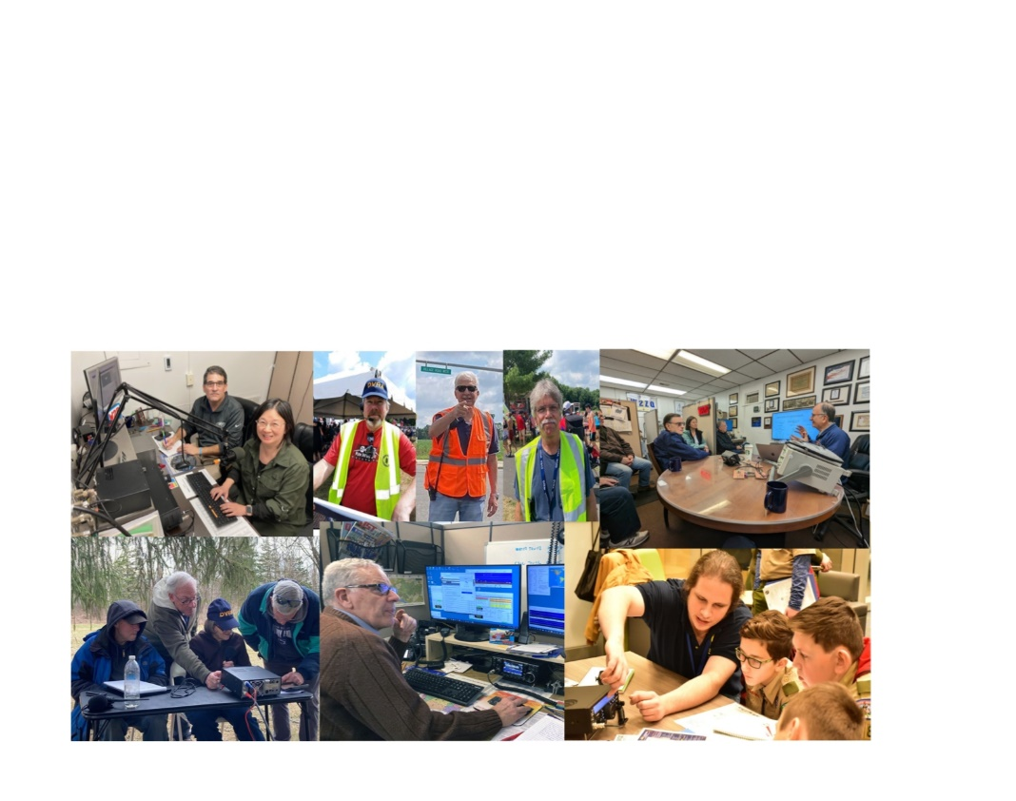The DVRA’s focus on training and its diversification of projects attract new and prospective hams and engage radio amateurs at all levels and with widely varying interests.

**Technical Achievement Award**

Dr. James Breakall’s work has been instrumental in amateur radio antenna technology development for decades. He has teamed with many experts in the field to develop state of the art advancements with a wide range of applications, including the Numerical Electromagnetic Code (NEC). As a professor of electrical engineering at Penn State University from 1989 to 2022, Dr. Breakall (WA3FET) developed cutting edge antenna technology and mentored his students in amateur radio, resulting in 700 new licensees. Now a retired Professor Emeritus, he serves as a consultant to the Army, Air Force and Navy on many antennas related projects.

Nittany Scientific, a company initiated with his students, developed some of the first optimization methods applied to NEC in a package called NECOPT, a design he called Optimized Wideband Antenna (OWA) Yagi. The optimization had the goals of minimum peak SWR in a band, maximizing the lowest gain in a band, and maximizing the minimum front-to-back ratio in the band. These OWA Yagi designs have been used in numerous contest and DX stations around the world. Because he wanted this technology to be readily available worldwide, he has never pursued patent licensing. He also was the first to use helicopter measurements and Geometrical Theory of Diffraction (GTD) techniques for antennas in terrain at HF that led to software such as TA and HFTA.

In 2010, Dr. Breakall in conjunction with Joe Taylor (K1JT), Angel Vazquez (WP3R) and Pedro Piza, Jr. (NP4A) collaborated to use the Arecibo 1000 ft. dish to do moonbounce (EME). He worked on many antenna designs at Arecibo Observatory in Puerto Rico and at the HAARP facility in Alaska. Dr. Breakall has been a frequent forum presenter at Hamvention sharing his expertise on antenna design and enthusiasm for amateur radio.

As an avid amateur radio contester, Dr. Breakall has built contest stations in Pennsylvania and Puerto Rico and participated in over 100 contests, winning a fair amount of them. Dr. Breakall has authored numerous peer-reviewed scientific articles and books.

**Amateur of the Year 2023**

Carsten Dauer (DM9EE) has been active in European amateur radio through WRTC and YOTA for 30 years. Recently, he has spearheaded *DM9EE-Helping Hands*, a movement to provide amateur radio equipment to war torn Ukraine by collecting donations and delivering them personally to communities in Ukraine. Approximately 5000 kg of radios, power banks, solar packs, and first aid have been shipped to Ukraine along with the donation of countless hours of planning, packing, documentation, and accessing permits have gone into this endeavor. On the return trip from Ukraine Carsten transports war refugees to havens in Germany, including his own hotel.

Supporting amateur radio friends and inspiring youth involvement is Carsten’s passion. On his website <http://dm9ee.de/dm9ee-ukraine-help/>, he states, “Ham radio gave me a lot and I try to give back to our great hobby. The world is very small when you have a radio license. You talk to the world, and eventually you also visit people in other countries… and you always learn more about culture, when you know people there. Ham radio is great to learn languages, even if it is only a few friendly phrases.”

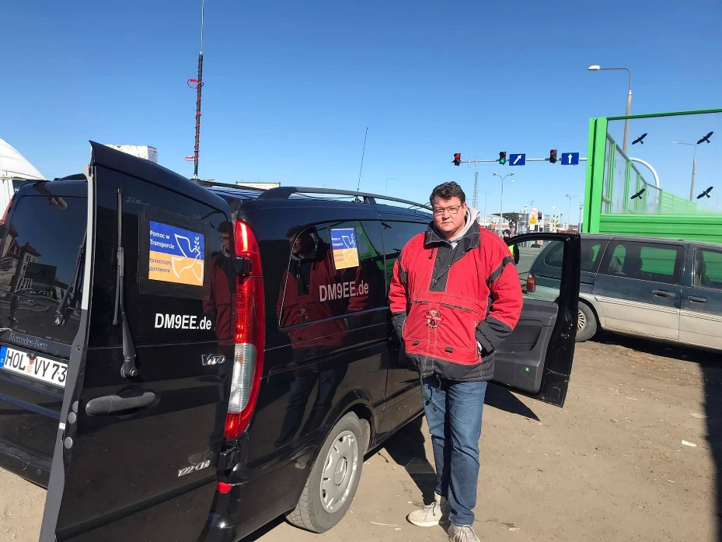

***_________________________________***

|  |  |
| --- | --- |
| |  | | --- | |  | |

|  |  |
| --- | --- |
| |  | | --- | | **NASA’s SpaceX Crew-6**  **﻿Mission Takes Flight** | |

|  |  |
| --- | --- |
| |  | | --- | | This week NASA astronauts, mission commander [Stephen Bowen](https://r20.rs6.net/tn.jsp?f=001-Xznko3X25wxRMKR5J2WSq-6SQ-nf3uERJ-IrEzzbpSCB33wd1j3ZPZaYEh8XJLL1m73VCBi-gv68MOwWixTsheO_ZcMVwkKtz0FNKbFcYl9efprtpyZssUL1WSh3P7LgB8n8ox9x_9aLt6th3-22qhZL0AzlfPTtySDffYKg5VPZVCRQDn9hXL-SCGhSY67hc8e_RvVzys=&c=oRbQ8amjpUg1zKAN-58blubHLrBxaqEOtZrIvj9J5FxpktPT8psEeg==&ch=yK7ekEFPN8FLfypcUGinNcilenep4Wf8i_dwXfVp18OBSOGeAkgtxA==) and pilot [Woody Hoburg](https://r20.rs6.net/tn.jsp?f=001-Xznko3X25wxRMKR5J2WSq-6SQ-nf3uERJ-IrEzzbpSCB33wd1j3ZPZaYEh8XJLLuM3MBHPFM3tBBsDlsdMAYhKSGMnpbXwa358IWBRZcJN28RyB3BUpUKxzeldwrCim1_gPnKOxJgMLgZRjR-yjc8Mw2b1BIJ0yeWIW1Kc4DUmzi5p8jdDjNDz1NuTellpD&c=oRbQ8amjpUg1zKAN-58blubHLrBxaqEOtZrIvj9J5FxpktPT8psEeg==&ch=yK7ekEFPN8FLfypcUGinNcilenep4Wf8i_dwXfVp18OBSOGeAkgtxA==), along with United Arab Emirates astronaut Sultan Alneyadi, and Roscosmos cosmonaut Andrey Fedyaev arrived at the International Space Station aboard the SpaceX Dragon Endeavour.  Crew-6 joins the [Expedition 68](https://r20.rs6.net/tn.jsp?f=001-Xznko3X25wxRMKR5J2WSq-6SQ-nf3uERJ-IrEzzbpSCB33wd1j3ZOHbcCpug0pWXfX8rxFyAsIxM7Qu8gZIP5jVlrWZ67G83z7l3aasQha8dajGLbkqHlRjp01UE5CRWQe9_Ar1KSThiwLZeOBGJA0UUwYRcjG6NMEE3vwNJhIjafFEp-NUa6QqDpCd1v3lTgnqgY4patMqA3cNL9YK6WkO_EC5ybug&c=oRbQ8amjpUg1zKAN-58blubHLrBxaqEOtZrIvj9J5FxpktPT8psEeg==&ch=yK7ekEFPN8FLfypcUGinNcilenep4Wf8i_dwXfVp18OBSOGeAkgtxA==) crew of NASA astronauts Frank Rubio, Nicole Mann, and Josh Cassada, as well as astronaut Koichi Wakata of the Japan Aerospace Exploration Agency, and Roscosmos cosmonauts Sergey Prokopyev, Dmitri Petelin, and Anna Kikina.  Crew-6 will conduct new and exciting [scientific research](https://r20.rs6.net/tn.jsp?f=001-Xznko3X25wxRMKR5J2WSq-6SQ-nf3uERJ-IrEzzbpSCB33wd1j3ZLxUvHpMKcaOoLcb8Sfx7umrHKeD4d8is88TmsF90ofGJgZFJmfx1h4k7Amu4GSS8PGIEEG7t3lUVj9yNZCgYKvSBWI7TxG3w-CM8o5iDGpt0Yw1nQjESZdPAwiljEkhy7SUAlk_9c6nxFTfOygq_C8=&c=oRbQ8amjpUg1zKAN-58blubHLrBxaqEOtZrIvj9J5FxpktPT8psEeg==&ch=yK7ekEFPN8FLfypcUGinNcilenep4Wf8i_dwXfVp18OBSOGeAkgtxA==) to prepare for human exploration beyond low-Earth orbit and to benefit life on Earth. Experiments will include studies of how particular [materials burn](https://r20.rs6.net/tn.jsp?f=001-Xznko3X25wxRMKR5J2WSq-6SQ-nf3uERJ-IrEzzbpSCB33wd1j3ZPZaYEh8XJLLNsEMA0mNhlh2MeF0tg9yaCsLawNSYIVJtU3n_UHsyliaofed43rQs3xxB2maTJmsu5MCCahaZwCTaIoMoi-WmZGSnYdodo_li9rHMLvXbGRkzp8CdO3k8AaRGJyyQya05lE5e0ImTBtQpiJRxa3L-2veJ_E9utvMoR7Ha5xRwA0dRcNkba9AAnvesSw3u5F6v_pjHEKdL74=&c=oRbQ8amjpUg1zKAN-58blubHLrBxaqEOtZrIvj9J5FxpktPT8psEeg==&ch=yK7ekEFPN8FLfypcUGinNcilenep4Wf8i_dwXfVp18OBSOGeAkgtxA==) in microgravity, [tissue chip](https://r20.rs6.net/tn.jsp?f=001-Xznko3X25wxRMKR5J2WSq-6SQ-nf3uERJ-IrEzzbpSCB33wd1j3ZPZaYEh8XJLLkdCN3VJdDNFrs8y6SHaKOJPxkrkGOYbKq1a2x5qjpjezhZW9iNuE03VyOLwBQh5rB1tReUoMZMr_j6rvdN2w5iStsk0bAP7A&c=oRbQ8amjpUg1zKAN-58blubHLrBxaqEOtZrIvj9J5FxpktPT8psEeg==&ch=yK7ekEFPN8FLfypcUGinNcilenep4Wf8i_dwXfVp18OBSOGeAkgtxA==) research on heart, brain, and cartilage functions, and an investigation that will collect microbial samples from the outside of the space station. | |

|  |  |  |  |
| --- | --- | --- | --- |
| |  |  |  | | --- | --- | --- | | |  |  | | --- | --- | | |  | | --- | | [Follow the Crew-6 Blog](https://r20.rs6.net/tn.jsp?f=001-Xznko3X25wxRMKR5J2WSq-6SQ-nf3uERJ-IrEzzbpSCB33wd1j3ZH0vx970R0EjqqzFUQL3OOXhVuMolrBduz-5vqVWy1n5bAa3Stc1659pzvaMxfKjJL4UQCTAmML9cM7bdTy8s09dTenZEEm3NvKLBnNTvDSh&c=oRbQ8amjpUg1zKAN-58blubHLrBxaqEOtZrIvj9J5FxpktPT8psEeg==&ch=yK7ekEFPN8FLfypcUGinNcilenep4Wf8i_dwXfVp18OBSOGeAkgtxA==) | | | |

|  |  |
| --- | --- |
| |  | | --- | |  | |

**Dave Kalter Memorial Youth DX Adventure**

**ANNOUNCING THE 2023 TRIP TO CURACAO, July 13-18.  
Applications now being accepted.**

The Caribbean Contest Consortium and Geoff Howard have once again agreed to let us use the PJ2T site for our 2023 trip. The support we give us is greatly appreciated. Especially thanks go to Uli DL8OBQ for being our on site representative. His travel and use of vacation to help the youth is noticed and allows us to make the trip. We will be once again applying for the call sign of PJ2Y.

***Team applications for the 2023 trip are***[***NOW being accepted, click to download the PDF form***](https://www.qsl.net/n6jrl/TeamApplication.pdf)  
[Click to download the Word form](https://www.qsl.net/n6jrl/TeamApplication.docx)

***_____________________________________________***

Youth on the Air Camp 2023 Application Period Now Open

Applications are now being accepted for campers interested in attending Youth on the Air (YOTA) Camp 2023.

Licensed amateur radio operators ages 15 through 25 are encouraged to apply online at [YouthOnTheAir.org](https://youthontheair.org/). The Radio Amateurs of Canada will be the local host for the 2023 YOTA Camp. It is scheduled to take place July 16 − 21, 2023, at the Carleton University campus in Ottawa, Ontario, Canada.

Applications will be accepted through May 31, 2023, but for the best chance at being selected, applications should be submitted by 2359 UTC on January 15, 2023.

The application process is free. However, a $100 deposit is required upon acceptance. If a camper is unable to pay the deposit, they may be able to apply for a scholarship or waiver. Camp Director, Neil Rapp, WB9VPG, said campers are responsible for their transportation to the camp location, though some assistance may be available. Travel during camp events is provided.

Campers will be selected by the working group and notified by February 1. To encourage attendance from across the Americas, allocations for campers are being held open for various areas of North, Central, and South America. If countries do not use their allocation, or should someone within an allocation decline acceptance, those positions will be filled from the remaining pool of applicants. As this will be an ongoing process, everyone will not receive notification of acceptance at the same time. Preference will be given to first-time attendees.

COVID-19 guidelines are still in effect and may have an impact on offering the camp. Currently, the outlook on offering the camp in July 2023 is positive. If the camp cannot be hosted, or would need to reschedule, all applicants will be notified as soon as possible. Appropriate requirements on masking and vaccination statuses will be announced as needed.

A [YouTube](https://www.youtube.com/watch?v=V7nJn6QFxF0) video is now available about the 2023 YOTA Camp. For details and additional information, contact the Camp Director Neil Rapp, WB9VPG, at [director@youthontheair.org](mailto:director@youthontheair.org).

Radio Merit Badge Sees Biggest Gain in Scouting

According to a *Scouting* magazine study of Merit Badges earned in 2022, Radio had the biggest jump.

|  |
| --- |
| Special event station K4S in Jasper, Tennessee, 2018 photo; Radio Scouting. |

It is now the 81st most popular Merit Badge, up from being 98th in 2021. Trailing just behind it on the biggest gains list is the Electronics Merit Badge, which jumped 15 spots, from 80th to 65th. To earn the rank of Eagle Scout, members must earn 21 badges, 14 of which are standard. The Scout gets to choose the remaining badges based on personal interests.

Many Scouts take part in Jamboree on the Air, which is being held October 20 - 23, 2023.

**Registration Open for the 2023 QSO Today Virtual Ham Expo**

The 2023 QSO Today Virtual Ham Expo will be held on March 25 - 26, and registration is now open.

The event is a fully interactive virtual ham radio convention offering new content, networking opportunities, and more than 50 amateur radio presentations on a wide variety of subjects.

Tickets are $15, and registration information can be found at the [QSO Today Virtual Ham Expo](http://www.qsotodayhamexpo.com/?mc_cid=cfa50a6bb8&mc_eid=d3e32f2624)website**.**

*-- ARRL is a QSO Today Expo Partner.*

***Club Corner***

******This is YOUR cornner of the newsletter. Send me what your club is doing and I’ll make sure that it gets in. Got a special event or club project that you want everyone to know about? Send it to me! Need help with a project? Send it to me.

Let me know what you club is up to. Are you going to have a special guest at your meeting or are you having a special anniversary?

Just send it to: [webmaster@arrl-ohio.org](mailto:webmaster@arrl-ohio.org)

Please! Format as below:

If you want me to publish your club information, or even an article you have written, please send it in WORD format (.docx). Please use Times New Roman font size 12 for the body of the aritcle. Any photos please include as a .jpg or .bmp – the time you save me in doing all the conversions will be greatly appreciated.

**Sandusky Radio Esperimental League Spring Fox Hunt**

W8LBZ Sandusky Radio Experimental League is excited to announce our spring Fox Hunt! Come test your Radio Direction finding skills and find the Fox! **SUNDAY, MARCH 12, 2023 AT 1 PM.** 2909 W Perkins Ave, Sandusky, OH 44870-1926, United States.

**___________________________________________**

**The MVARA Spring Tech Class** will offer online training in partnership with Hamradioprep.com.  All the lessons and resources are located in one place–no hopping from study books to numerous websites for materials. A study plan will guide you through the process, and you can do lessons 24/7 at your convenience. No rigid class schedule. In addition, you’ll have access to a group of experienced ham radio mentors to support your efforts. These MVARA members will meet with you during the time leading up to your exam to answer your questions and act as coaches to help you prepare. The first meeting will be in person, held at Boardman Library, 7680 Glenwood Ave, Boardman, OH 44512, on March 7, 6:30 pm. It will also be available as a Zoom conference.

For further information, contact:

[mvaravoicecoil@gmail.com](mailto:mvaravoicecoil@gmail.com)

Mark Haverstock, K8MSH    [mh@zoominternet.net](mailto:mh@zoominternet.net)

Frank Sole, WB8YHD [younghotdog@yahoo.com](mailto:younghotdog@yahoo.com)

Dave Brett, KD8NZF [dbrett100@gmail.com](mailto:dbrett100@gmail.com)

**Want to know where to go to get the courses you need? It’s all Right Here!**

* [Ohio EMA Training Calendar](https://webeoctraining.dps.ohio.gov/TrainingAndExercise/courselist.aspx)
* [Login to the DPS Training Campus](https://learning.dps.ohio.gov/PSTC/)
* [Create a new account on the DPS Training Campus](https://learning.dps.ohio.gov/PSTC/)

**NOTE:**

* Most courses are in-person but some course may be hosted virtually (this will be noted).
* Seats available listed are as of the release of this update and will change quickly.
* All classes will be posted on the DPS training campus at least 60 days prior to the start of the course.
* Please read the [Training Policy & Catalog](https://ema.ohio.gov/documents/training/ema0201.pdf) for more information on Ohio EMA trainings.

_._,_._,_

How to Plan and Apply for an ARRL Hamfest or Convention

If your amateur radio club is planning to host a convention, hamfest, tailgate, or swapfest, please consider applying for ARRL sanctioned status for your event. To learn what it means to be an ARRL sanctioned event, and to get some ideas on how to prepare for and conduct a hamfest or convention, visit [www.arrl.org/arrl-sanctioned-events](http://www.arrl.org/arrl-sanctioned-events).

To apply for ARRL sanctioned status for your event, go to [www.arrl.org/hamfest-convention-application](http://www.arrl.org/hamfest-convention-application).

The ARRL Hamfests and Conventions Calendar can be found online at [www.arrl.org/hamfests](http://www.arrl.org/hamfests). In addition, the Convention and Hamfest Calendar that runs in *QST* each month also presents information about upcoming events.

**____________________________________________________**

VE Sessions

**The following information is for *ALL* exam sessions:**

It is now an FCC requirement to have an FCC FRN; active email address and active phone number before taking any exam. Please bring your FCC FRN, original license, a copy of your license (if a licensed ham), a valid photo ID and $15.00 - Cash preferred.

Effective April 19, 2022, the FCC will charge a $35.00 application fee for amateur radio licenses. The fee will apply to new, renewal, rule waiver, and modification applications that request a new vanity call sign. License upgrades will not have a fee applied. The fee will be per application. *VE's will not collect the fees at exam sessions.*

**All Things Amateur Radio Association (ATARA)**

We host testing sessions every second Tuesday of the month in Lancaster. To sign up please visit our website <https://atara-w8atr.fun> and contact us at [hamexams@atara-w8atr.fun](mailto:hamexams@atara-w8atr.fun).

**Butler County Amateur Radio Association W8WRK**

Laurel VE Testing Session - hosted by DIAL amateur radio club

Amateur Radio License Examinations at 9:00AM on Sunday April 29th at Fairfield Township Administration Building 6032 Morris Rd. Hamilton, OH 45011. Pre-Registration is required, go to: www.qsl.net/w8blv click on Exams and follow the instructions. Additional info may be obtained from Thurl Golden, KD8VLU (513) 939-4891 [tgolden@fuse.net](mailto:tgolden@fuse.net) or Ron Spaulding, N8QF, (513) 617-6181 or [n8qf@roadrunner.com](mailto:n8qf@roadrunner.com) . There are no Exam Fees!

**CARS**

VE testing from CARS - Cuyahoga Amateur Radio Society - at Elmwood Recreation Center, 6200 Wisnieski Parkway in Independence, Ohio 44131  Time: 9:15 AM (Walk-ins allowed) Always the 2nd Sunday of the odd month. Go to CARS  [www.2cars.org](http://www.2cars.org/) for detailed map of location.  Call Metro W8MET 216-520-1320 for details

**Clark County Amateur Radio Association (CLARA)**  What: CLARA sponsored A.R.R.L. VE Testing - Walk-ins allowed. Pre-Register via email preferred. When: On every second Saturday of each even numbered month starting at 10:00 AM

Feb 11th; Apr 8th; Jun 10th; Aug 12th; Oct 14th; and Dec 9th, 2023. Where: Springview Government Center - Emergency Operations Center; 3130 E Main St; Springfield OH 45503 This is US-40 aka "old national road". From Route 40 enter Old Columbus Road, at the fork stay left driving straight onto Ogden Rd, then immediately turn left into the parking lot behind the EMA. Walk to the door with the "Employees Only" sign.

For more information contact Roland W. Ude, W8BUZ, (937) 605-4951 Email: [buzz@baylorhill.com](mailto:buzz@baylorhill.com)

**Dayton Amateur Radio Association (DARA)** If you are interested in testing for a new or upgraded license, please come see us at the DARA Clubhouse. If you have questions about testing, please email [exams.w8bi@gmail.com](mailto:exams.w8bi@gmail.com)

**Dial Radio Club, Middleton, OH**

Will offer Amateur Radio License Examinations at 6:00PM on Wednesday March 1st at St. John XXIII Elementary School, 3806 Manchester Rd., Middletown, OH 45042. Pre-Registration is required, go to: www.qsl.net/w8blv click on Exams and follow the instructions. Additional info may be obtained from Dave Williamson, KD8W, (513) 424-5819 or [kd8w@ARRL.net](mailto:kd8w@ARRL.net) or Ron Spaulding, N8QF, (513) 617-6181 or [n8qf@roadrunner.com](mailto:n8qf@roadrunner.com) . There are no Exam Fees!

**Huber Heights Amateur Radio Club**

Huber heights amateur radio club does ARRL VE testing the second Saturday of each even numbered month. Feb, Apr, Jun, Aug, Oct, Dec. 9:30-11:00 For more information contact Jim Storms – AB8YK at [ab8yk@hotmail.com](mailto:ab8yk@hotmail.com)

**The Lake County Amateur Radio Association**

The Lake County Amateur Radio Association is holding its **2023** Amateur Radio license exams at the **Kirtland Library**, 9267 Chillicothe Road, on the following dates:

Saturday, February 4 Saturday, August 5

Saturday, April 1 Saturday, October 7

Saturday, June 3 Saturday, December 2

This bi-monthly schedule is the first Saturday of every even-numbered month (e.g., February being the second month, etc.). They are held at the Kirtland Library, 9267 Chillicothe Road. It is 1.7 miles south of I-90 on Route 306 (Chillicothe Rd). The library is on the left, just beyond the Marathon gas station.

The tests will start at **12 noon.** Please arrive a few minutes earlier.

To register, you will need a NCVEC 605 Form, which will be available at the test. If you would like to complete one ahead of time, be sure it is the Sept 2017 version or later. You can find it by Googling “NCVEC quick-form 605” and clicking on the url for a pdf of the form. Please note **the FCC requires you to provide a FRN** (FCC Registration Number). Social Security Numbers are no longer accepted. If you are new to ham radio and don’t have a FRN, Google “New FRN” and follow the fcc.gov link.

If you are currently licensed, be sure to **bring a copy of your license to the exam.** The cost of the exam itself is $15.00, and if you wish to pay by check, it should be made out to the ARRL/VEC. Identification with your picture is also necessary, such as a driver’s license. If you have any questions, please contact Scott Farnham, KO8O, at (440) 256-0320, or [scottfarnham@roadrunner.com](mailto:scottfarnham@roadrunner.com)

**In addition** to the $15 test fee, the FCC now charges $35 to add you to the Amateur Radio database. The FCC will e-mail successful candidates instructions for payment directly to them. Payment must be made within 10 days of the e-mail. This charge does not apply to upgrades.

**The Lancaster and Fairfield County Amateur Radio Club (LFCARC**) hosts exam sessions at the FAIRFIELD County EMA, 240 Baldwin Dr in Lancaster Ohio, 43130, on the first Saturday each month at 10:00 am. Please visit our website at <http://www.k8qik.org> for exam dates on our calendar and navigate to our Learning Center/Taking the Exam link for information and requirements. Our experienced VE team looks forward to serving the Amateur Radio community in Central Ohio. Contact me at [ve_testing@k8qik.org](mailto:ve_testing@k8qik.org) to register.

**Lisbon Area Amateur Radio Association**  Beginning Feb 11, 2023 Testing on the 2nd Saturday of each month at the Columbiana County EMA located at 215 S Market St. Lisbon, OH 44432. Walk-ins OK. Check in at 1:00PM. For more information go to [www.K8GQB.com](http://www.K8GQB.com) or contact NN8B at [nn8b.oh@gmail.com](mailto:nn8b.oh@gmail.com)

**Madison County**  The Laurel testing group will offer testing on the first Thursday of January, March, May, July, September and November. Tests are held at 7:00PM at the Madison County EMA located at 271 Elm St. London, OH. No fee.

**The Milford Amateur Radio Club (MARC)**

VE testing is held the third Thursday of each month at 6:00 PM.  Location;  Miami Township Civic Center located at 6101 Meijer Drive, Milford, OH  45150.

 Please pre-register at [www.milfordhamradio.org](http://www.milfordhamradio.org/)

**Northern Ohio Amateur Radio Society (NOARS)**  VE sessions are held the first Saturday of odd-numbered months (EXCEPT FOR March and July) at 10 AM in the North Olmsted Library, 27403 Lorain Rd., North Olmsted. Registration is preferred, but walk-ins are welcome. For more information or to register, contact Elaine, KC8FOS at [ewilkinson1951@gmail.com](mailto:ewilkinson1951@gmail.com). There will be a VE session held March **12th** at the NOARS Winterfest held at Lorain County Community College in the John A Spitzer Conference Center, 1005 Abbe Rd N, Elyria, OH 44035. Please email Elaine – KC8FOS at [ewilkinson1951@gmail.com](mailto:ewilkinson1951@gmail.com) to register.

**Portage County Amateur Radio Service (PCARS)**

The first Saturday of every even numbered month -10 am – at the PCARS club site in Ravenna. Please visit the PCARS web site and check out the information about VE testing in the latest newsletter at [www.portcars.org](http://www.portcars.org) .

If you have any questions, don’t hesitate to contact me at KB8UUZ@gmail,com

Top of Form

Bottom of Form

C:\Users\Owner\Documents\My NASA photos\final asiss logo.tiff

**ARISS News Release No. 23-08**

**Dave Jordan, AA4KN**

**ARISS PR**

**FOR IMMEDIATE RELEASE**

*Message to US Educators*

Amateur Radio on the International Space Station

Contact Opportunity

*Call for Proposals:*

New Proposal Window is February 20, 2023 – March 31, 2023

February 15, 2023 --- The Amateur Radio on the International Space Station (ARISS) program is seeking formal and informal education institutions and organizations, individually or working together, to host an Amateur Radio contact with a crew member on board the ISS. ARISS anticipates that the contact would be held between January 1, 2024 and June 30, 2024. Crew scheduling and ISS orbits will determine exact contact dates. To maximize these radio contact opportunities, ARISS is looking for organizations that will draw large numbers of participants and integrate the radio contact into a well-developed education plan.

**The deadline to submit a proposal is March 31st, 2023.** Proposal information and more details such as expectations, proposal guidelines and the proposal form can be found at <https://www.ariss.org/apply-to-host-an-ariss-contact.html>. An ARISS Introductory Webinar will be held March 1st, 2023 at 8 PM Eastern Time.  **The Eventbrite link to sign up for the free webinar is:** <https://www.eventbrite.com/e/ariss-proposal-webinar-for-spring-2023-proposal-window-registration-515706320487>

*The Opportunity*

Crew members aboard the International Space Station will participate in scheduled Amateur Radio contacts. These radio contacts are approximately 10 minutes in length and allow students to interact with the astronauts through a question-and-answer session.

An ARISS contact is a voice-only communication opportunity via Amateur Radio between astronauts aboard the space station and classrooms. ARISS contacts afford education audiences the opportunity to learn firsthand from astronauts what it is like to live and work in space and to learn about space research conducted on the ISS. Students also will have an opportunity to learn about satellite communication, wireless technology, and radio science. Because of the nature of human spaceflight and the complexity of scheduling activities aboard the ISS, organizations must demonstrate flexibility to accommodate changes in dates and times of the radio contact.

Amateur Radio organizations around the world with the support of NASA and space agencies in Russia, Canada, Japan and Europe present educational organizations with this opportunity. The ham radio organizations’ volunteer efforts provide the equipment and operational support to enable communication between crew on the ISS and students using Amateur Radio.

Please direct any questions to [ariss.us.education@gmail.com](mailto:ariss.us.education@gmail.com).

**About ARISS:**

Amateur Radio on the International Space Station (ARISS) is a cooperative venture of international amateur radio societies and the space agencies that support the International Space Station (ISS). In the United States, sponsors are the American Radio Relay League (ARRL), Radio Amateur Satellite Corporation (AMSAT), Amateur Radio Digital Communications (ARDC), NASA’s Space Communications and Navigation program (SCaN), and the ISS National Lab-Space Station Explorers. The primary goal of ARISS is to promote exploration of science, technology, engineering, the arts, and mathematics topics. ARISS does this by organizing scheduled contacts via amateur radio between crew members aboard the ISS and students. Before and during these radio contacts, students, educators, parents, and communities take part in hands-on learning activities tied to space, space technologies, and amateur radio. For more information, see http://www.ariss.org

Media Contact:

Dave Jordan, AA4KN

ARISS PR

Find us on social media at:

Twitter: ARISS_Intl

Facebook: facebook.com/ARISSIntl

Instagram: ariss_intl

Mastodon: ariss_intl@mastodon.hams.social

Check out ARISS on Youtube.com.

**__________________________________________________________**

Club Commission Program

One of the benefits of being an ARRL Affiliated Club is having access to the Club Commission Program. Affiliated clubs can use this program to receive a commission for promoting membership in ARRL. When you sign a new member, the club gets $15, and when a member renews through the club, you get $5.

Members can renew anytime without losing any of their membership time. Details and forms are available on the ARRL website, at [www.arrl.org/affiliated-club-benefits](http://www.arrl.org/affiliated-club-benefits). FAQs are also available to help explain the program. It does take some effort and a bit of paperwork, but the club reaps the reward in cash. If your affiliated club is not participating in this program, ask them to investigate it.

**Your Club news should be listed here!**

I know you’re out there doing things! Send me a write-up (MSWord please) and some photo’s (.jpg please) and we’ll get your club hi-lited here for the other OH Section Clubs to see! Send to [WB8LCD@ARRL.ORG](mailto:WB8LCD@ARRL.ORG)

**______________________________________________________________________________**

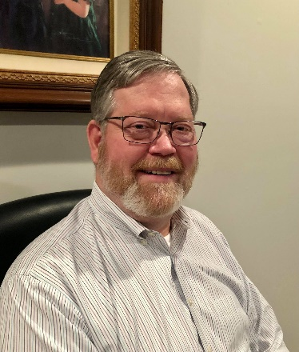**DX This Week – CE3ERM Interview**

Bill AJ8B (aj8b@arrl.net, @AJ8B, or www.aj8b.com)

CWOPs Member #1567

Boy, it is starting to sound like the “old days” on the bands. I have filling in band slots right and left on CW and there is plenty of DX there for those using FTx. What about you? Any ATNOs recently? (All Time New Ones?)

This week I have reprinted an interview with Eduardo, CE3ERM. Great person and a great operator. I hope you enjoy this.

See you in the pileups!

DAH DIT DIT DIT DAH DAH DIT DIT DIT DAH

I worked Eduardo and reviewed his qrz.com page. He certainly is accomplished and has varied interests. He can be reached at CE3ERM@GMAIL.COM

**AJ8B:** How did you first get interested in amateur radio?  
**CE3ERM:** My first steps in amateur radio were in the 80s , to my 10 years old approx., thanks to an uncle, who was a radio operator, he taught me about radios and antennas. He broadcast from Brazil, Argentina and Chile.

**AJ8B:** Do you have a favorite band or mode?  
**CE3ERM:** My favorite band is 12 meters, very good contacts in SSB and FT8. but the 40-meter band can interact more with new radio amateurs

**AJ8B:** What time of day and days do you like to operate?  
**CE3ERM:** I work the bands on HF during the day, depending on the state of propagation in my region.

**AJ8B:** Any secrets to your success?  
**CE3ERM:** A lot of experimentation, a lot of patience, open to new platforms and being a good radio amateur.

**AJ8B:** Any tips that you can share?  
**CE3ERM:** Read and learn as much as you can about antennas, build your own antennas.

**AJ8B:** Describe what you are currently using:  
**CE3ERM:** In my QTH, I use a Kenwood model TS-430s transceiver (I love analog equipment), G5RV wjre antenna, multiband vertical antenna, 4-band linked dipole, and a dipole fan antenna or “bigote de gato” as we call it here. For my POTA, SOTA or BOTA activations, a XIEGU G90 brand QRP plus a G5RV antenna or an endfed antenna.

**AJ8B:** What advice do you have for those of us trying to break pileups to work DX?  
**CE3ERM:** First, the operator is the one who must maintain the order of the activity, he is the one who sets the pace, the chaos is due to lack of experience. There are several strategies to deal with a pileup, it has worked for me not to use filters to avoid losing distant stations, to operate a short contact style CW call, to use the split mode, to call only QRP stations, etc. Only experience gives us that affinity for handling a pileup.

**AJ8B:** What is your favorite contest?   
**CE3ERM:** My favorite contest is CQ WW CW, ARRL DX CW and IARU2G HF SSB Regional Contest

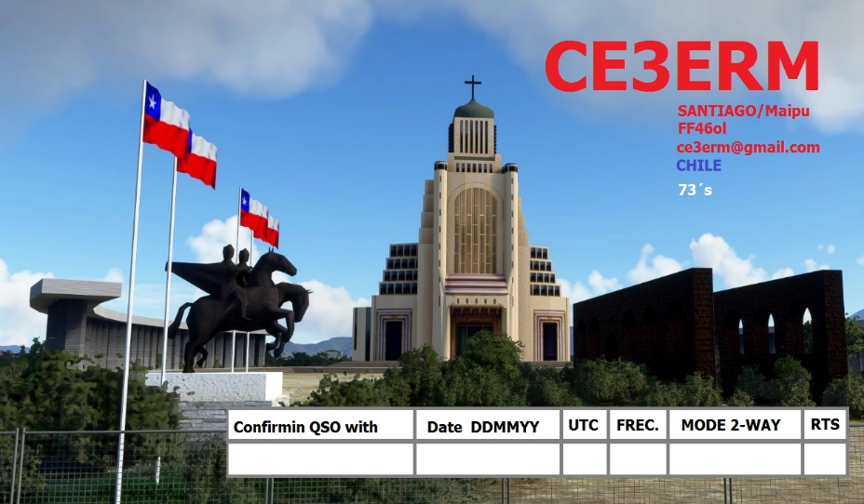**AJ8B:** I can see you are a veteran of many DXpeditions. Which was your favorite? Why?  
**CE3ERM:** My favorite place to make activations and contacts is in the south of Chile, a place called Radal 7 Tasas, where there is no electrical contamination or cell phone signals, communications are very clear day and night, with little power I can do impressive DX, a place where my two hobbies come together, doing radio and being in the wild nature.

**AJ8B:** Where are you going next?  
**CE3ERM:** For now, my path is to help new radio amateurs, within my radio club Eternautas, I have the mission of giving introductory talks to amateur radio and good practices. Despite this, I will continue to activate parks and beaches within my country.

**AJ8B:** Any QSLing hints?  
**CE3ERM:** Although we miss paper QSLs, waiting for them to arrive at our bureau, today we have digital QSLs, so we help nature, and they don't take so long.

**AJ8B:** What coaching/advice would you give new amateurs?  
**CE3ERM:** Do not be afraid to experiment, learn about antennas, equipment, propagation, different modes, on the radio you will find great satisfaction as friends for life.

**AJ8B:** If I were to stop by for a visit, what local place would you want us to visit?  
**CE3ERM:** In the north of CHILE, in San Pedro de Atacama, in the desert at 5,000 meters above sea level, we have one of the largest telescopes in the world, the ALMA astronomical observatory (Atacama Large Millimeter/submillimeter Array), with 66 synchronized antennas.

**AJ8B:** What local food would you want me to try?  
**CE3ERM:** We have many foods related to the sea, On the island of Chiloé, in southern Chile, they prepare an authentic dish for summer celebrations, called Curanto.

**AJ8B:** Thanks for taking the time to answer my questions. Is there anything you would like to share with us?   
**CE3ERM:** As a short-term project within the radio club, it is to create a vhf contest to promote the 2-meter band within South America, we also have projects to send micro balloons with aprs charge and the help of the youth center for contact with the international space station . In addition to continuing with the training academy for new Chilean radio amateurs.

Thank you for helping to spread more about amateur radio, for more information visit <https://www.qrz.com/db/CE3ERM>, RADIO CLUB ETERNAUTS : https://eternautas.cl/ and <https://potachile.cl/>

Here you can see an experiment that took place in the field, an antenna for the 2-meter band with a milk jar, an interview that SERGIO XQ2CG did to me for his YouTube channel  
<https://www.youtube.com/watch?v=6ClSIjETKrQ&t=38s>

DAH DIT DIT DIT DAH DAH DIT DIT DIT DAH

Here is an update from Bernie, W3UR, of the DailyDX and the WeeklyDX, the best source for DX information. <http://www.dailydx.com/> . Bernie has this to report:

**T8 Palau**

From the Palau Radio Club, August 30 to September 5, JA6UBY will have  
the T88RR callsign and JH6JWE is still waiting for his callsign there; They will be active in the All-Asia DX Contest CW.

JA0JHQ has acquired the T88PB call and plans to be active from June 13-19.   
  
**4K – Azerbaijan -** 4K7DK is the callsign for DK1DKE's next trip there, March 3-13.  Avoiding heavy QRN inside Baku City, Dirk will operate from a QTH "a little bit outside" the city, with an IC-7000, 100 watts SSB and 50 watts FT8.  He'll be on 80-10M.  The antenna is a dipole.  Dirk says QSL via DK1DKE and the DARC bureau for a traditional paper QSL; otherwise use Logbook of the World.  
  
**CY0S DXpedition** - The "Monks of the Holy Monastery of Docheiariou of the Holy Mountain" say a monk there has the last two logbooks from SV2ASP/A, Monk Apollo, and is happy to answer request for QSOs from January 1, 2015 until Apollo's passing.  The address for your QSL request is:  
  
Monk Chariton  
Holy Monastery of Docheiariou  
GR-63087 Agion Oros  
GREECE

**J8 - St. Vincent -** F4HPX (AG7JQ), Thomas, will be traveling through "St. Vincent and different islands within Grenadines" between approximately March 7th and 14th. He will be mainly a mobile, holiday style operation for a few hours per day. He'll have an FT-891 running up to 100 watts into "various simple wire antennas" as J8/AG7JQ. He will be on SSB, FT8 and try computer aided CW on 40 through 10 meters. QSL via F4HPX only or via the French QSL bureau. QSOs will be uploaded to Club Log, LoTW and eQSL. <https://www.qrz.com/db/j8/ag7jq>  
  
**FT#W - Crozet Islands -** "Log update, only FT8 yesterday. Poor propagation continues. Bad news : QO-100 equipment broken, no more satellite activity... 73", tweets the Crozet 2022 Twitter account.

**CY0S DXpedition** - All gear has been packed and is ready for transport to Halifax, Nova Scotia. The DXpedition team is working some last-minute details. All travel arrangements have been finalized. The team has now reached 90% of its fundraising goal. Many thanks to all of the new club and individual sponsors. Donations are still very much welcome and appreciated and can be made through our website at: [cy0s.com](http://cy0s.com/)

The team is still managing the critical weight allowance on the two aircraft. It's going to be extremely tight!

The team is working on their plans for arrival on Sable. The first day will see limited activity due to antenna construction. Weather always plays a big factor getting to the island and working on the island. The weather has been quite active in the Halifax area with a lot of snow and more snow forecast.   
  
73,  
Murray WA4DAN

DAH DIT DIT DIT DAH DAH DIT DIT DIT DAH

Below is a list of upcoming contests in the “Contest Corner”. I think this is important for someone who is trying to move up the DXCC ladder since entities that are on the rarer side and easiest to work in contests. Some of my best “catches” have been on the Sunday afternoon of a contest when the rarer entities are begging for QSOs. Of course, the gamble is that if you wait until Sunday, conditions may change, or they simply won’t be workable. However, it is not a bad gamble. Of course, why not work the contest and have some fun!  
Check out the WA7BNM Contest Calendar page (<https://www.contestcalendar.com/>) and CQ Magazine for more contests or more details. I also have a comprehensive list that can be imported to your calendar at [www.aj8b.com/files](http://www.aj8b.com/files)

The contests in red are those that I plan to spend some significant participation time on. PLEASE let me know if you are working contests and how you fared.

Thanks!

|  |  |  |
| --- | --- | --- |
| **Date(s)** | **Event** | **Info** |
| All Year | CQ DX Marathon | bit.ly/3FyPiui |
| Mar. 7 | AGCW YL-CW QSO Party | www.agcw.de/contest/yl-cw-party |
| Mar. 8 | VHF-UHF FT8 Activity | www.ft8activity.eu/index.php/en |
| Mar. 11 | YB DX RTTY Contest | https://rtty.ybdxcontest.com |
| Mar. 11 | QRP ARCI Spring Thaw SSB Sprint | www.qrpcontest.com/qrparci_thaw |
| Mar. 11-12 | EA PSK63 Contest | https://tinyurl.com/5awufshf |
| Mar. 11-12 | Idaho QSO Party | www.pocatelloarc.org/idahoqsoparty |
| Mar. 11-12 | Oklahoma QSO Party | http://k5cm.com/okqp.htm |
| Mar. 11-12 | North American RTTY Sprint | http://ncjweb.com/north-american-sprint |
| Mar. 11-12 | RSGB Commonwealth CW Contest | bit.ly/3TxCrxl |
| Mar. 11-12 | Stew Perry Topband Challenge | www.kkn.net/stew |
| Mar. 12 | AGCW QRP Contest | www.agcw.de/contest/qrp |
| Mar. 12 | FIRAC HF Contest | www.firac.de/html/contest.html |
| Mar. 12 | UBA Spring Contest 2m CW/Phone | http://bit.ly/2KKAtb9 |
| Mar. 12-13 | Wisconsin QSO Party | www.warac.org/wqp/wqp.htm |
| Mar. 15 | VHF-UHF FT8 Activity | www.ft8activity.eu/index.php/en |
| Mar. 15 | RSGB 80m Club Championship, CW | bit.ly/3TxCrxl |
| Mar. 18 | AGCW VHF/UHF Contest | www.agcw.de/contest/vhf-uhf |
| Mar. 18 | PODXS 070 Club St. Patrick’s Day Contest | http://bit.ly/38ugUiF |
| Mar. 18-19 | SARL VHF/UHF Analogue Contest | http://bit.ly/H0IqQf |
| Mar. 18-19 | Virginia QSO Party | https://bit.ly/3IeqHvl |
| Mar. 18-20 | BARTG HF RTTY Contest | http://bartg.org.uk/wp/contests |
| Mar. 19 | UBA Spring Contest 80m SSB | http://bit.ly/2KKAtb9 |
| Mar. 20 | Bucharest Digital Contest | https://yo3test201x.blogspot.com |
| Mar. 23 | RSGB 80m Club Championship, SSB | bit.ly/3TxCrxl |
| Mar. 25 | FOC QSO Party | www.g4foc.org/qsoparty |
| Mar. 25-26 | CQWW WPX SSB Contest | www.cqwpx.com/ |
| Mar. 26 | UBA Spring Contest 6m CW/ Phone | http://bit.ly/2KKAtb9 |
| Mar. 27 | RSGB FT4 Contest Series | bit.ly/3TxCrxl |
| Mar. 29 | UKEICC 80m Contests CW | https://ukeicc.com/80m-rules.php |
| May 27-28 | CQWW WPX CW Contest | www.cqwpx.com |

**ARLD009 DX news**  
  
This week's bulletin was made possible with information provided by G0TLE, WB2REM, The Daily DX, 425 DX News, DXNL, Contest Corral from QST and the ARRL Contest Calendar and WA7BNM web sites.  Thanks to all.  
  
AZERBAIJAN, 4K.  Dirk, DK1DKE is QRV as 4K7DK near Baku City until March 13.  Activity is on 80 to 10 meters using SSB and FT8.  QSL to home call.  
  
LESOTHO, 7P.  Schalk, ZS4Z is QRV as 7P8LL.  Activity is on 80 to 2 meters, including 70 and 23 centimeters.   QSL via EA7FTR.  
  
GHANA, 9G.  Alan, G3XAQ is QRV as 9G5XA until March 14.  Activity is on the HF bands using CW.  This includes being an entry in the upcoming BERU contest.  QSL direct to G3SWH.  
  
UNITED ARAB EMIRATES, A6.  Thomas, DL2RMC is QRV as A65CW until the end of September.  He is active on 80 to 6 meters using CW and FT8. This includes activity on Satellite QO-100.  QSL via LoTW.  
  
COMOROS, D6.  Hiro, JF1OCQ will be QRV as D67AA from March 9 to 22. Activity will be on 160 to 10 meters using CW, FT8, and FT4.  QSL to home call.  
  
BALEARIC ISLANDS, EA6.  Robert, OK2PYA is QRV as EA6/OK2PYA from Mallorca Island, IOTA EU-004, until March 10.  Activity is on 40 to 10 meters using CW.  QSL to home call.  
  
GUADELOUPE, FG.  Gildas, F6HMQ and Michel, F6GWV are QRV as FG/home calls until March 26.  They will be active as TO3Z in the ARRL International SSB DX contest and the upcoming CQ World Wide WPX SSB contest.  QSL to home calls, and TO3Z via F6HMQ.  
  
GALAPAGOS ISLANDS, HC8.  Operators WB2REM, KE2D, VO1IDX, and K4LT are QRV as HD8M from Santa Cruz, IOTA SA-004, until March 11. Activity is on 160 to 6 meters using CW, SSB, FT8, and FT4.  QSL direct to WB2REM.  
  
ST. VINCENT, J8.  Sandro, VE7NY, Allan, VE7SZ and Rob, N7QT are QRV as J8NY from the main island of St. Vincent, IOTA NA-109, until March 7.  Activity is on 160 to 10 meters using CW, SSB, and FT8..  QSL via LoTW.  
  
MALI, TZ.  Ulmar, DK1CE is QRV as TZ1CE and here for three weeks. Activity is on the HF bands using CW with some SSB and FT8.  QSL via LoTW.  
  
ST. KITTS AND NEVIS, V4.  Pete, G0TLE will be QRV as V4/G0TLE from St. Kitts, IOTA NA-104, from March 5 to 17.  Activity will be holiday style on 40 to 10 meters using CW.  QSL via LoTW.  
  
WILLIS ISLAND, VK9W.  Sands, VK9WX is here until April.  Activity is in his spare time on 80 to 10 meters.  QSL via M0OXO.  
  
CAMBODIA, XU.  Thomas, DL7BO is QRV as XU7GNY until March 9. Activity is on 80 to 6 meters using CW, SSB, and FT8.  QSL direct to DJ6TF.  
  
The ICWC Medium Speed CW Test, OK1WC Memorial, RSGB 80-Meter Club Data Championship, Worldwide Sideband Activity Contest, ARS Spartan CW Sprint, AGCW YL-CW Party, QRP 40-Meter CW Fox Hunt, Phone Weekly Test, A1Club AWT, CWops Test, VHF-UHF FT8 Activity Contest, Mini-Test 40 and the Mini-Test 80 are on tap for March 6 to 8.  
  
Please see March QST, page 71, and the ARRL and WA7BNM Contest web  
 ites for details.

______________________________________________________________________________

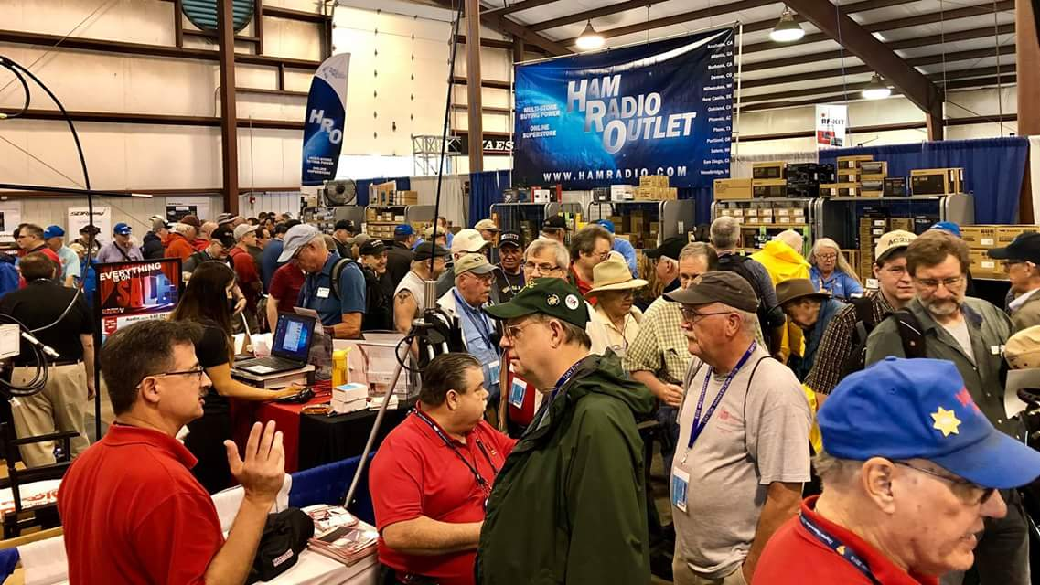

[**Upcoming *Hamfests***](http://arrl-ohio.org/hamfests.html)

We **DO** have some hamfests scheduled for 2023!! Yes, take a good look at the list. And YES! They are starting to book up for 2023 already!

|  |  |
| --- | --- |
|  |  |

|  |  |
| --- | --- |
|  |  |

|  |  |
| --- | --- |
| ***Ohio Hamfests*** | |
|  | |
| ***2023*** | |
| **03/11/2023 -**[**MOVARC Hamfest**](http://www.arrl.org/hamfests/movarc-hamfest-8)  **Location:**Bidwell, OH 45614, OH **Sponsor:** Mid-Ohio Valley Amateur Radio Club [**Learn More**](http://www.arrl.org/hamfests/movarc-hamfest-8) | **03/12/2023 -**[**Winter Hamfest**](http://www.arrl.org/hamfests/winter-hamfest-10)  **Location:**Elyria, OH **Sponsor:** Northern Ohio Amateur Radio Society **Website:** [http://winterhamfest@noars.net](http://winterhamfest@noars.net/) [**Learn More**](http://www.arrl.org/hamfests/winter-hamfest-10) |
| **03/19/2023 -** [Toledo Mobile Radio Association Hamfest](http://www.arrl.org/hamfests/toledo-mobile-radio-association-hamfest-and-computer-fair-1)**Location:**Perrysburg, OH **Sponsor:** Toledo Mobile Radio Association **Website:** [http://www.tmrahamradio.org](http://www.tmrahamradio.org/) [**Learn More**](http://www.arrl.org/hamfests/toledo-mobile-radio-association-hamfest-and-computer-fair-1) | **04/15/2023 -**[**Cuyahoga Falls Amateur Radio Club Hamfest**](https://www.arrl.org/hamfests/cuyahoga-falls-amateur-radio-club-67th-hamfest)  **Location:**Cuyahoga Falls, OH **Sponsor:** Cuyahoga Falls Amateur Radio Club, Inc. **Website:** [http://www.cfarc.org](http://www.cfarc.org/)  [**Learn More**](https://www.arrl.org/hamfests/cuyahoga-falls-amateur-radio-club-67th-hamfest) |
| **04/22/2023 - [Tusco Amateur Radio Club Hamfest, Electronics, and Computer Show](http://www.arrl.org/hamfests/tusco-amateur-radio-club-hamfest-electronics-and-computer-show" \o "Tusco Amateur Radio Club Hamfest, Electronics, and Computer Show)**  **Location:**Dover, OH **Sponsor:** Tusco Amateur Radio Club W8ZX **Website:** [http://www.w8zx.net](http://www.w8zx.net/) [**Learn More**](http://www.arrl.org/hamfests/tusco-amateur-radio-club-hamfest-electronics-and-computer-show) | **04/30/2023 -**[**Athens Hamfest**](http://www.arrl.org/hamfests/athens-hamfest-10)  **Location:**Athens, OH **Sponsor:** Athens County Amateur Radio Association **Website:** <http://www.ac-ara.org/> [**Learn More**](http://www.arrl.org/hamfests/athens-hamfest-10) |
| **05/07/2023 -**[**Lucas County Amateur Radio Emergency Service Trunk Sale and Swap Meet**](http://www.arrl.org/hamfests/lucas-county-amateur-radio-emergency-service-trunk-sale-and-swap-meet-1)  **Location:**Toledo, OH **Sponsor:** Lucas County Amateur Radio EmergencyService **Website:** [http://swap.lucasares.org](http://swap.lucasares.org/) [**Learn More**](http://www.arrl.org/hamfests/lucas-county-amateur-radio-emergency-service-trunk-sale-and-swap-meet-1) | **05/13/2023 - 05/17/2023**[**RV Radio Network**](http://www.arrl.org/hamfests/rv-radio-network-1)  **Location:**Berlin, Ohio, OH  **Type:** ARRL Operating Specialty Convention **Sponsor:** RV Radio Network [**Learn More**](http://www.arrl.org/hamfests/rv-radio-network-1) |
| **Great Lakes Division Convention!!**    **05/19/2023 - 05/21/2023**[**Dayton Hamvention**](http://www.arrl.org/hamfests/dayton-hamvention-8)  **Location:**Xenia, OH **Sponsor:** Dayton Amateur Radio Association **Website:** [http://Hamvention.org](http://hamvention.org/) [**Learn More**](http://www.arrl.org/hamfests/dayton-hamvention-8) | |
| **05/27/2023 -**[**Scioto Valley Amateur Radio Club Hamfest**](http://www.arrl.org/hamfests/scioto-valley-amateur-radio-club-hamfest-1)  **Location:**Piketon, OH **Sponsor:** Scioto Valley Amateur Radio Club [**Learn More**](http://www.arrl.org/hamfests/scioto-valley-amateur-radio-club-hamfest-1) | **06/03/2023 -**[**FCARC Summer Hamfest**](https://www.arrl.org/hamfests/fcarc-summer-hamfest-2)  **Location:**Wauseon, OH **Sponsor:** Fulton County Amateur Radio Club **Website:** <https://k8bxq.org/hamfest> [**Learn More**](https://www.arrl.org/hamfests/fcarc-summer-hamfest-2) |
| **07/08/2023 -**[**Mansfield Trunkfest 2023**](http://www.arrl.org/hamfests/mansfield-trunkfest-2023)  **Location:**Mansfield, OH **Sponsor:** Intercity Amateur Radio Club **Website:** [http://iarc.club](http://iarc.club/) [**Learn More**](http://www.arrl.org/hamfests/mansfield-trunkfest-2023) | **07/16/2023 -**[**Van Wert Hamfest**](http://www.arrl.org/hamfests/van-wert-hamfest-7)  **Location:**Van Wert, OH **Sponsor:** Van Wert Amateur Radio Club **Website:** [http://w8fy.org](http://w8fy.org/) [**Learn More**](http://www.arrl.org/hamfests/van-wert-hamfest-7) |
| **08/12/2023 -**[**Cincinnati Hamfest**](http://www.arrl.org/hamfests/cincinnati-hamfest-2)  **Location:**Owensville , OH **Sponsor:** Milford ARC **Website:** [https://CincinnatiHamfest.org](https://cincinnatihamfest.org/) [**Learn More**](http://www.arrl.org/hamfests/cincinnati-hamfest-2) | **08/20/2023 -**[**WARA Tailgate Swap Meet**](http://www.arrl.org/hamfests/wara-tailgate-swap-meet-1)  **Location:**Cortland, OH **Sponsor:** Warren Amateur Radio Association **Website:** [http://w8vtd.org](http://w8vtd.org/) [**Learn More**](http://www.arrl.org/hamfests/wara-tailgate-swap-meet-1) |
| **09/10/2023 -**[**Findlay Hamfest**](https://www.arrl.org/hamfests/findlay-hamfest-10)  **Location:**Findlay, OH **Sponsor:** Findlay Radio Club **Website:** [http://findlayradioclub.org](http://findlayradioclub.org/) [**Learn More**](https://www.arrl.org/hamfests/findlay-hamfest-10) | **09/24/2023 -**[**Cleveland Hamfest**](http://www.arrl.org/hamfests/cleveland-hamfest-3)  **Location:**Berea, OH **Sponsor:** Hamfest Association of Cleveland **Website:** [http://www.hac.org](http://www.hac.org/) [**Learn More**](http://www.arrl.org/hamfests/cleveland-hamfest-3) |

**OHIO’S**

Happy March. As you read this N8ZNR and I are either at or returning from our first hamfest of the year. This week finds us in Cave City, KY at the annual **Mammoth Cave ARC** hamfest. We’ve been attending it for several years and find it to be one of the better mid-sized hamfests that we attend. I’ve been told it’s currently the largest hamfest in Kentucky. Additionally we notice more hams from Southern Ohio attend it each year. Since it’s in the Great Lakes Division it’s always nice to chat with people and learn what the clubs South of the Mason and Dixon Line are up to.

The storms that rolled through Southwestern Ohio the other day resulted in confirmed tornado sightings and touchdowns in Butler and Pickaway Counties. It’s interesting these storms were only hours following the first virtual National Weather Service Severe Storm Spotting training session on February 22. According to the Wilmington NWS Office over 280 people participated. The next virtual session will be on Tuesday, March 7 from 6 until 8 PM. Check the Wilmington NWS website to learn more about the session as well as to register. If you want to attend an in-person training class, there will be a class in Lancaster on March 15 and one in Washington Court House on March 16. On March 23 there will be an afternoon class in Wilmington and Hamilton County’s class will be an evening one on April 10.

According to Ohio Affiliated Clubs Manager Amanda Farone, KC3GFU, congratulations are extended to the **Highland ARA** on their Special Service Club renewal.

Health issues caused the **Grant ARA** to postpone its annual Christmas dinner during the past holiday season. President Steve Neal, K8CWC, tells us it has now been re-scheduled to take place on March 16 at the County Inn Restaurant in Mt. Orab. Things will start at 6 PM.

The **Scioto Valley ARA**’sJohn Hartmus III, WB8GRX, tells us the FCC’s hang up with issuing a license to Deshauwn Sommers has been resolved and his license bearing the KE8WRI has been issued. Deshauwn is a resident of Frankfort. Although it took a bit longer to have a ticket issued than the others who took the test at the recent test session I believe Deshauwn will find it well worth the wait.

For those folks who are looking for test sites, here a some to consider. On Monday, March 6 the **Portsmouth RC** will conduct a test session prior to the club’s monthly meeting. It gets underway at 5 PM at the Portsmouth American Legion Post. Then at 6 PM on March 16 the **Milford ARC** will hold a test session prior to their meeting at the Miami Township Civic Center, Meijer Drive, Milford. March 18 marks the **Highland ARA**’s first test session for the new year. It will be a 10 AM Laurel session at the Highland County EMA Office in Hillsboro. Pre-registration is requested at <https://www.10C0D48ADAC23A7FEC16-hara9>, but walk-ins will be accepted if space is available.

Jeff Slattery, N8SUZ, reports the **Athens County ARA**’s license class has several students working towards the March 20 ARRL test session at the Red Cross Building in Athens. The test is not restricted to only those in the class and is open to anyone wishing to try for a first license or an upgrade. Contact Jeff Slattery, N8SUZ, at 740-592-6124 for further information.

The **Tri-State ARA** will hold a test session on April 8 at the Museum of Radio and Techology in Huntington. Registration will begin at 9 AM. Walk ins are welcome and pre-registration is not necessary. VE Team Manager Bud Cyr, KB8KMH, states this is an ARRL exam and a $15 fee is required.

Bill Salyers, AJ8B says tickets for the 38th annual **Southwest Ohio DX Association** DX dinner are now on sale in addition to raffle tickets for a chance to win a stay at the Harbour Rock Villa in the Turks and Caicos Islands. During the stay, the winner will have an opportunity to become DX through access to a fully equipped station. The raffle drawing for the trip will happen during the Friday, May 19 DX dinner at the Dayton Marriott. A cash bar starts the evening’s activities at 5:30 PM with dinner served at 7. This year’s keynote speaker will be Adrian Ciuperca, KO8SCA who was a part of the just concluded 3Y0J activation of Bouvet. Check out the [www.swodxaevents.org](http://www.swodxaevents.org) website for more information and how to order your tickets for either or both events.

Gallia County’s **Mid Ohio Valley ARC’s** hamfest will be on March 11 at the Fellowship of Faith Church at Bidwell. To the moment there has not been much publicity, an update to their website or other information regarding it, so it might be best to contact [docdiesel@hotmail.com](mailto:docdiesel@hotmail.com) or phone 740-339-1025 for an update.

**Highland ARA** President Ken Lightner, KE8JEL, reminds HARA members and others in the Highland County area of the upcoming monthly Brunch Bunch gathering on March 11. It will be at the Hillsboro Burger King. Folks start gathering around 10 AM. Ken invites folks from other clubs to attend and become familiar with the HARA members. He might even buy your coffee!

Starting with the end of this month it becomes the busy time of the year for the **Athens County ARA.** On March Paul Schulz, WD8SVC will have an antenna building session where those attending can build a 40 meter end-feed halfwave antenna. For information regarding the costs, materials needed to be self supplied, etc. contact Paul via an email to [luhrigian@yahoo.com](mailto:luhrigian@yahoo.com). On April 1 they start the month by providing communications for the annual Lake Hope Iron Furnance Run. On April 16 the will provide communications for the annual Athens Marathon/Half Marathon. They then will conclude the month with sponsoring the popular **Athens County ARA** Hamfest at the Athens Community Center. If you would like additional information on any of these events or see how you can help, please contact Jeff Slattery, N8SUZ, at 740-592-6124.

Leading into the column I mentioned I am presently “South of the Mason Dixon” in the state of fast horses, good looking women, usually good basketball, long revivals and bourbon. One of Kentucky’s most popular tourist attractions is the Kentucky Bourbon Trail. This year the **Bluegrass Amateur Radio Society** is calling attention to the bourbon aspect with a special event station dedicated to promoting the very popular tourist attraction. They will conduct a 40 meter operation running from 8 AM until 4 PM on March 19. Here’s to ya!

The next meeting of the **Cambridge ARA** will be on Saturday, March 25 and begin at 10 AM at the Guernsey County Administration Building. Then on Saturday, April 1 the Club’s Waller-McMunn WEBE Radio Museum will hold an open house between 1 and 4 at the Museum’s site East of Cambridge on US 40.

The Adams County **DeForest ARA** will have its next meeting on Tuesday evening, April 11. The meeting starts at 7 PM at the downtown West Union ABCAP Senior Nutrition Center which is directly across the street from the Adams County Courthouse. Following the meeting there will be a presentation by KE8GAD, Jared Shupert, about batteries and solar charge controllers.

Sad news has been received of the passing of Bill Maness of Hillsboro. Although he did not hold a license (and swore he never would) he was a very devoted **Highland ARA** member. Bill had a number of scanners and other radios and probably listened to the local repeaters more than most licensed hams. He checked into the weekly net via the telephone and was known to call people to put his 2¢ into discussions being discussed over the air. Plus he missed very few HARA activities and meetings until health issues got in the way. The 93 year old was a veteran of WWII, Korea and VietNam. As this column is written, services are pending at Hillsboro’s Turner Funeral Home.

It appears there was a decent attendance at the recent **Clinton County ARA** “Last Saturday Breakfast” in Wilmington although sickness and other events kept the number down. Mark Atwell, WX8A, says the next one will be March 25 at Sam’s Meats in Wilmington. Up the road in Washington Court House the **Fayette ARA**’s monthly gathering had a sparse attendance. However what it lacked in quantity they made up in quality. Jeff Dreher, KE8DVH, reminds area amateurs of the next one that will be on March 18 at the Tim Horton’s.

On April 22 there will be a Federal EMA Training Institute ‘Emergency Management Radio Resources’ workshop at the Wellston Fire Department. The purpose is to educate State and local EMA officials about the communications resources the amateur radio community can provide during an emergency. Emphasis will be placed on the RACES program. Along the same lines, some **Highland ARA** members have again been invited by the county EMA director to be a part of the Core Planning Committee for the upcoming review of the Highland County 5-Year All Hazard Mitigation Plan. This is the second time HARA has been invited to participate.

That’s it for another column. Here’s hoping everyone remains safe and healthy and radio active.

John Levo, W8KIW, [jlevo@cinci.rr.com](mailto:jlevo@cinci.rr.com) or highlandara@gmail.com, 937-393-4951

**____________________________________________________**

**Print an Official or Unofficial Copy of Your Amateur Radio License**

*(By Anthony Luscre, K8ZT)*

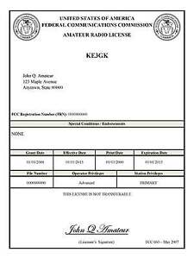

As of February 17, 2015, the **FCC no longer routinely issues paper license documents** to Amateur Radio applicants and licensees. The Commission has maintained for some time now that the official Amateur Radio license authorization is the electronic record that exists in its Universal Licensing System (ULS). The FCC will continue to provide paper license documents to all licensees who notify the Commission that they prefer to receive one.

Licensees also will be able to print out an official authorization — as well as an unofficial “reference copy” — from the ULS License Manager. I’ve created a set of instructions on how you can request an **“official” printed copy of your license\***

[**Click here to download the instructions**](http://arrl-ohio.org/news/2020/print_your_license.pdf)

***One Question Questionnaire***

!!!!! I would really like to hear from as many of you as possible. How about going to <http://arrl-ohio.org> and giving me a click? (It’s in the bottom left corner of the page) While you’re there, you can click the Big Red Arrow to enter into this months Handbook Giveaway!

This weeks Question: DO YOU EVER OPERATE QRP?

1. **Yes, Of Course, or B) No Way**

From last weeks question:

**HAVE YOU EVER BEEN AN OFFICER IN YOUR LOCAL CLUB?** OUT OF A TOTAL OF 91 VOTES – 62.5% Yes (57); AND 37.5% No (34); AND 54.5%

Outstanding! I Thank you All!

And the winner of the February Handbook is:

The owner of email address – [Dklowder@aol.com](mailto:Dklowder@aol.com)

I need your name and callsign!

(**This is a subliminal message:** Go to the Ohio Section Website, on the bottom left of the landing page answer this week’s question. AND DON’T FORGET – look for the Big Red Arrow and sign up for the Feb Handbook give away!)

Bottom of Form

Ohio Section Cabinet

|  |  |
| --- | --- |
| Section Manager – Tom Sly, WB8LCD | Section Traffic Manager – David Maynard, WA3EZN |
| Section Emergency Coordinator – Bret Stemen KD8SCL | Section Youth Coordinator – Anthony Luscre, K8ZT |
| Technical Coordinator – Jeff Kopcak, K8JTK | Affiliated Clubs Coordinator – Amanda Farone – KC3GFU |
| State Government Liaison – Bob Winston, W2THU | Public Information Coordinator – Elizabeth Klinc - KE8FMJ |



Hey Gang,

Have you taken a look at the **Swap & Shop** page on the Ohio Section webpage yet?? Here’s a link that will take you there… <http://arrl-ohio.org/sm/s-s.html>

Do you have equipment that you just don’t need or want anymore? Here’s a great venue to advertise it, and it’s FREE!! Is your club doing a fund raiser to help raise money? After a lot of thought, it was decided that the Swap & Shop webpage could also contain these types of items as well. The same rules will apply as do for the For Sales and Give-A-Ways and will only be posted for a month at a time. Please see the Terms & Conditions on the webpage.

If your club is doing a fund raiser and wants more exposure, please forward the information to me and I’ll advertise it on the Swap & Shop webpage for you.

Now, I still want to remind you that it won’t be listed in this newsletter because it would take up way too much space, so your ad will only appear on the website. It is there for any individual to post equipment Wanted / For Sale or Give-Away as well as for Club Fund Raisers. No licensed vehicles/trailers or business advertising will be posted. Postings are text only (no pictures or graphics) will be posted for a maximum of 1 month from date posting and require a contact phone number or email within the posting. Send your Wanted / For Sale or Give-Away post to:  [swap@arrlohio.org](mailto:swap@arrlohio.org)

***Back Issues of the PostScript and Ohio Section Journal***

Hey, did you know that PostScript and Ohio Section Journal (OSJ) are archived on the website? You can go back and look at any edition simply by clicking:

<http://arrl-ohio.org/news/index.html>

***Want to Share your Club Newsletter With Others?***

We have a webpage where you can download and read all of the newsletters that I get from around the state and even other sections!

Here’s the link to the page…. <http://arrl-ohio.org/club_news/index.html>

Please, if you don’t see your club newsletter posted, it’s because I’m not receiving it. Just have your newsletter editor contact me and I’ll get your club’s newsletter listed on the site!!

We all learn and steal (I mean, share) from each other’s work. So, get me your newsletter!!! Send it to: [webmaster@arrl-ohio.org](mailto:webmaster@arrl-ohio.org)

***Chit – Chat, and All That!***

Do you know someone that’s not getting these Newsletters? Please, forward a copy of this Newsletter over to them and have them “[Opt-In](mailto:Opt-In)” to start receiving them. Heck, just have them send an email to: [webmaster@arrl-ohio.org](mailto:webmaster@arrl-ohio.org) and we’ll get them added to the Ohio Section Emailing list.

We now have many thousands of readers receiving these newsletters weekly. Quite impressive, I’d say! I urge all of you to make sure that everyone, regardless of whether they are a League member or not, get signed up to receive these weekly Newsletters.

You can always “Opt-Out” at any time if you feel this is not what you were expecting. It’s fun and very informative. All of your favorite past newsletters are now archived too.

You can go back at any time and read them.

Just go to: <http://arrl-ohio.org/news/>

*PostScript is produced as a weekly newsletter. I want to thank everyone that has contributed articles and ideas to make this an even better news source. I sincerely hope that you have enjoyed this edition and will encourage your friends to join with you in receiving the latest news and information about the Ohio Section, and news and events happening around the world! Occasionally you may find and error or two in this newsletter – be assured, they were put there on purpose to make sure you’re reading the newsletter carefully!*