[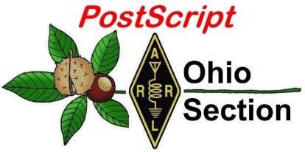](http://arrl-ohio.org/news/)

***“******January16, 2023”***

🡪 National News 🡪 Club Corner

🡪 DX This Week 🡪 Contest Corner

🡪 Upcoming Hamfests 🡪 One Question Questionnaire

🡪 VE Testing 🡪 South 40

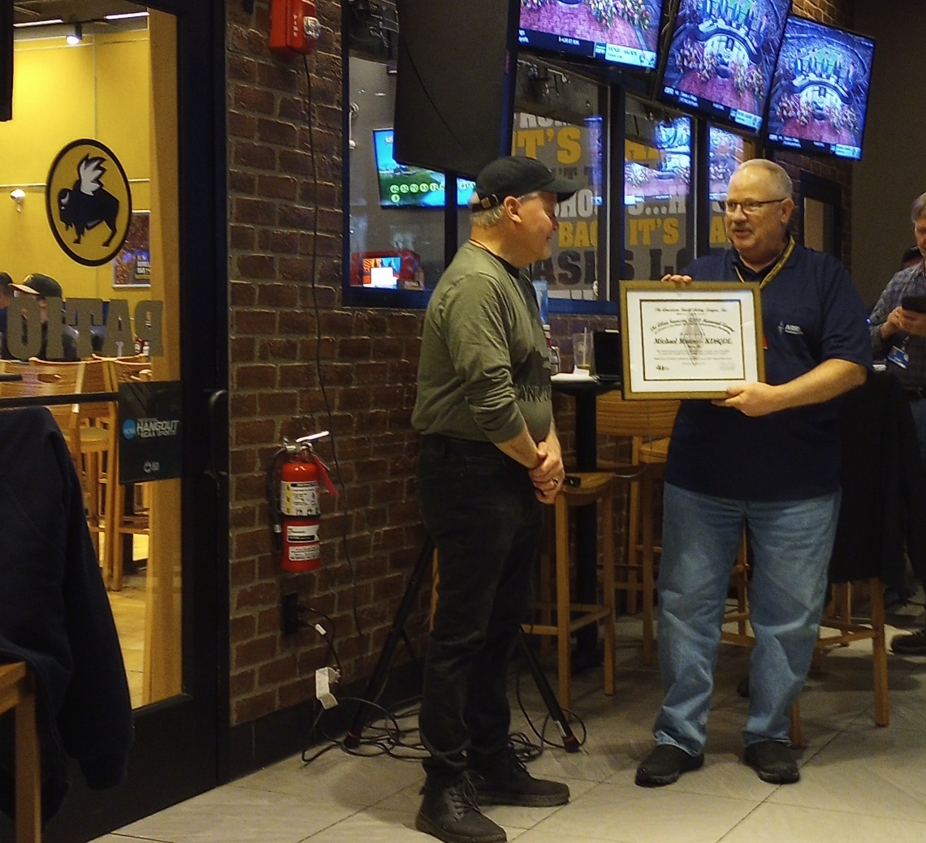

**CQ CQ CQ de WB8LCD**

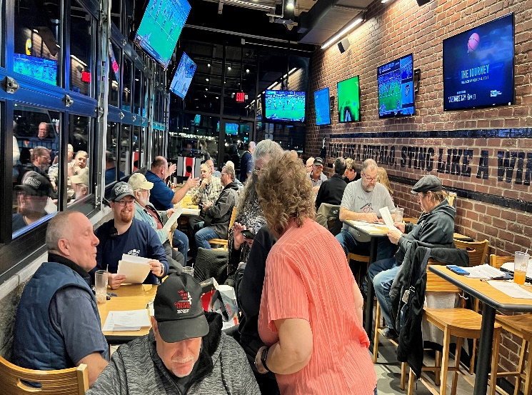The photo above was taken at the January 9th meeting of the Seneca Radio Club in Tiffin, Oh. Michael Mastro – KD8QDL – was installed as the clubs new President that evening. This was a club meeting like no other! To get the meeting started, there was clapping, loud music (with a little bit of Karaoke added in) and an overall feeling that this was going to be FUN! All the members were very accommodating to all the guests, everyone was welcomed and greeted by many of the members of the club. The business part of the meeting was all business. It was said many times that this was a club where everyone had a part to play, and everyone was expected to pitch in, in one way or another. And everyone did.

I was joined at the meeting by Ohio Section Affiliated Club Coordinator Amanda Farone – KC3GFU, Ohio Section Emergency Coordinator Bret Stemen – KD8SCL, and Great Lakes Division Vice Director Scott Yonally – N8SY. We were there to present Michael Mastro – KD8QDL – with “The Allan Severson, AB8P Memorial Award”. In the Ohio Section that would be the equivalent to the “Ham of the Year” award. As I said that night, you can tell where a person’s heart and priorities are by how he spends his time and his money. Mike has been most generous with both, not only to the Seneca Radio Club, but to Amateur Radio in a much broader sense. Michael Mastro – KD8QDL is truly deserving of this honor.

When I became the Ohio Section Manager, I was given a lot of leeway as to how I wanted to run things. I presume there are some complaints out there, probably well deserved, BUT – I hope that you will all agree with me when I decided that it would be appropriate to “double-up” the Severson award for 2022, especially after all we’ve been through together these past couple of years. I’ve had a look into the inner workings of the Ohio Section in a way that most of you will never really get a chance to see. If I could dust it for fingerprints, Scott – N8SY’ s would be everywhere. It was two years ago (January 2021) that I stepped in as the Ohio Section Manager position so Scott could move up to the Vice Director’s position. Since then Scott has really had 1 foot in the Division and 1 foot in the section. Without Scott’s assistance and advice I would have probably been ready to retire. Scott deserves to be recognized and I took the opportunity at the Seneca Radio Club to award two certificates – the second one going to Scott Yonally – N8SY.

I also thought it would be very appropriate to recognize Mike and Scott at the beginning of the “Year of the Volunteer” because both of these guys are the epitome of what anyone could want in a volunteer leader of our Fantastic Hobby!

Back to “Clubs”. The last week of December I visited and presented at the ATARA club in Lancaster, OH. Once again, a group of very nice, welcoming folks who have a lot of “Ham Radio” activities on the books and are promoting the hobby in lots of different ways. I hope to have a whole bunch more of club visits on the books by the time 2023 is over, but I can tell you this already – I have not been anywhere where I have not been made to feel welcome and a part of what was going on. I get the impression that most of you would be welcomed in the same way. When we don’t get out beyond our own club, we tend to grow “Clique-ish” and we pull in. When we get out, see how others are doing things, and most importantly meet the other hams in our section, we build relationships and embrace new ideas. So here’s my challenge: Visit other clubs for their regular club meetings. Between the 5th and 10th of every month, send me an email with your callsign, the name of your Home Club, the names and dates of the clubs you have visited, and the miles (round-trip) you drove to see them. If you visit an out of state club, just give me the name and date, that’ll be some kind of bonus. I’ll put a “Leader’s Board” up every month in the Ohio Section Journal for the prior month. Who knows, there might be some kind of a prize at the end. There are a lot of Great Clubs in the Ohio Section – check them out!

73,

Tom Sly - WB8LCD

Ohio Section Manager

[wb8lcd@arrl.org](mailto:wb8lcd@arrl.org)

330-554-4650

**Youth Net**

**When:** The second Sunday of every month at 7:30 PM EST

**Where:** The K8IV repeater located in Kent, Ohio (Echolink node K8BF-L) RF: 146.895 Mhz  with PL 118.8

**Who:** Any licensed amateur radio operator who wishes to participate. Priority will be given to youth stations and those located in Ohio.

The purpose of this net is to encourage youth activity in amateur radio and to help new hams get more comfortable on the air.

***Next Net is Sunday February 12th***

If you are a young ham, in the Ohio Section or elsewhere, please check in and say “Hello”!

Even if you’re far away from OHIO you can check in via Echo-Link. Echo-Link is a good tool to have, and it can be accessed from your laptop, tablet or cellphone. But there is a process to get validated to the Echo-link system. It’s simple to do, but you need to get it done before the day of the net! Go to [Introducing EchoLink](https://www.echolink.org/) for more information on getting started. If you’re an “Old Guy” (a gender neutral term meaning not a youthful operator) and you have some kids, grandkids, nieces, nephews or even some neighborhood kids who you would like to give a chance to talk to other kids about Ham Radio, this might be an excellent opportunity to give them that small nudge that could be the start of something positive they will carry with them through life!

***National News***

*(from ARRL and other sources)*

**Dave Kalter Memorial Youth DX Adventure**

**ANNOUNCING THE 2023 TRIP TO CURACAO, July 13-18.  
Applications now being accepted.**

The Caribbean Contest Consortium and Geoff Howard have once again agreed to let us use the PJ2T site for our 2023 trip. The support we give us is greatly appreciated. Especially thanks go to Uli DL8OBQ for being our on site representative. His travel and use of vacation to help the youth is noticed and allows us to make the trip. We will be once again applying for the call sign of PJ2Y.

***Team applications for the 2023 trip are***[***NOW being accepted, click to download the PDF form***](https://www.qsl.net/n6jrl/TeamApplication.pdf)  
[Click to download the Word form](https://www.qsl.net/n6jrl/TeamApplication.docx)

***_____________________________________________***

Youth on the Air Camp 2023 Application Period Now Open

Applications are now being accepted for campers interested in attending Youth on the Air (YOTA) Camp 2023.

Licensed amateur radio operators ages 15 through 25 are encouraged to apply online at [YouthOnTheAir.org](https://youthontheair.org/). The Radio Amateurs of Canada will be the local host for the 2023 YOTA Camp. It is scheduled to take place July 16 − 21, 2023, at the Carleton University campus in Ottawa, Ontario, Canada.

Applications will be accepted through May 31, 2023, but for the best chance at being selected, applications should be submitted by 2359 UTC on January 15, 2023.

The application process is free. However, a $100 deposit is required upon acceptance. If a camper is unable to pay the deposit, they may be able to apply for a scholarship or waiver. Camp Director, Neil Rapp, WB9VPG, said campers are responsible for their transportation to the camp location, though some assistance may be available. Travel during camp events is provided.

Campers will be selected by the working group and notified by February 1. To encourage attendance from across the Americas, allocations for campers are being held open for various areas of North, Central, and South America. If countries do not use their allocation, or should someone within an allocation decline acceptance, those positions will be filled from the remaining pool of applicants. As this will be an ongoing process, everyone will not receive notification of acceptance at the same time. Preference will be given to first-time attendees.

COVID-19 guidelines are still in effect and may have an impact on offering the camp. Currently, the outlook on offering the camp in July 2023 is positive. If the camp cannot be hosted, or would need to reschedule, all applicants will be notified as soon as possible. Appropriate requirements on masking and vaccination statuses will be announced as needed.

A [YouTube](https://www.youtube.com/watch?v=V7nJn6QFxF0) video is now available about the 2023 YOTA Camp. For details and additional information, contact the Camp Director Neil Rapp, WB9VPG, at [director@youthontheair.org](mailto:director@youthontheair.org).

**______________________________________________________________________**

***Club Corner***

This is YOUR cornner of the newsletter. Send me what your club is doing and I’ll make sure that it gets in. Got a special event or club project that you want everyone to know about? Send it to me! Need help with a project? Send it to me.

Let me know what you club is up to. Are you going to have a special guest at your meeting or are you having a special anniversary?

Just send it to: [webmaster@arrl-ohio.org](mailto:webmaster@arrl-ohio.org)

Please! Format as below:

******If you want me to publish your club information, or even an article you have written, please send it in WORD format (.docx). Please use Times New Roman font size 12 for the body of the aritcle. Any photos please include as a .jpg or .bmp – the time you save me in doing all the conversions will be greatly appreciated.

**Free Amateur Radio License Update Classes**

**General Class**

The Cuyahoga Falls Amateur Radio Club will again offer online classes to pass the FCC General Class Exam. The classes will be held via Zoom on six Sunday afternoons from 1:30 to 4:00 PM. The first class will start on Jan 15th. The classes are free and available to all interested hams with Tech licenses or studying to complete their Tech license by the end of the classes. Class materials will be distributed via Google Classroom, and the suggested book is “[*General License Course Study Guide*](https://hamradioschool.square.site/product/general-license-course-2019-2023/8?cs=true&cst=custom)” (2019-2023 edition), available from HamRadioSchool.com.

For more information and to register for the class, visit- [*tiny.cc/cfarcgeneral*](http://tiny.cc/cfarcgeneral) or scan the barcode --------->>>

Please share this information with your friends.

**Extra Class**

“A free, weekly, live [*Amateur Radio Extra Class Licensing*](https://www.k3nem.org/?p=335) course on Zoom will begin on Thursday, January 12, 2023, and run through Thursday, March 23. Sessions will start at 6:30 PM Eastern Time. Sessions will be recorded. Those attending should hold the General Class Amateur Radio License. These classes have been held for years and are sponsored by the National Electronics Museum.

The text for the course is *"*[*The ARRL Extra Class License Manual*](https://home.arrl.org/action/Store/Product-Details/productId/120286),” 12th Edition, and students are asked to purchase and begin reading before the first class. As of Dec 2022, this text is $32.95 from ARRL or the [*Kindle Edition for $19.95. from Amazon.com*](https://www.amazon.com/ARRL-Extra-Class-License-Manual-ebook/dp/B089ZXCDWC/ref=tmm_kin_swatch_0?_encoding=UTF8&qid=&sr=)*.*

For those who don't know Rol Anders (K3RA), he may be the premiere instructor for this course anywhere. Rol Anders chairs the committee that selects questions for the question pools for all classes of Amateur Radio License in the USA. Along with his assistant instructor Tom Christovich (K3YH), Rol Anders has helped hundreds of amateurs achieve Amateur Extra class licenses over the years.

To pre-register for the course (preferred) or obtain more information, you can email Rol Anders (K3RA) at roland.anders@comcast.net or reach him by phone at 410-796-4792”.

**Free Live Online Class to get your**

**General License**

Sundays, Jan 15 to Feb 19, 1:30 to 4:00 PM

Cuyahoga Falls Amateur Radio Club- *www.cfarc.org*

**DARA Tech Class**

The next DARA Technician License Class starts Saturday 18 Feb 2023 at  
09:00 to 12:00 in the DARA Clubhouse.  
  
The sessions are 4 Saturdays (18, 25 Feb, and 4, 11 Mar) with the Exam  
on Wednesday evening 15 Mar.  
  
Here is the URL for the book <https://www.amazon.com/dp/1625951558>  
  
The application fee for the new license holder is $35 and is payable to  
the FCC upon successful completion of the exam. Details of the fee and  
how to pay are provided by the Examiners upon passing the test.  
  
Please feel free to distribute widely!  
  
Thanks for the help,  
  
73 de N8NMG – John

**QCEN and OHKYIN are teaming up to offer instruction for ham radio licenses.**

Ham Radio License Instruction

For February and March 2023

What: Sessions each Monday evening from 7 to 9 p.m. starting Feb 6th

Feb 6th and 13th in person at the Red Cross building, 2111 Dana Ave., Cincinnati, OH 45207

Feb 20th and 27th on-line

March 6th in person at the Red Cross

March 13 on-line

Instruction for two license levels –for Technician (entry level) and for General (upgrade)

Materials: Course material will be from either the ARRL Ham Radio License Manual, 5th Edition, or the ARRL General Class License Manual, 9th edition, depending on the class of license desired.

Cost: Free, except for the book, which should be purchased by the individual student.

Sponsors: The OHKYIN Amateur Radio Society, and the Queen City Emergency Net.

**Want to know where to go to get the courses you need? It’s all Right Here!**

* [Ohio EMA Training Calendar](https://webeoctraining.dps.ohio.gov/TrainingAndExercise/courselist.aspx)
* [Login to the DPS Training Campus](https://learning.dps.ohio.gov/PSTC/)
* [Create a new account on the DPS Training Campus](https://learning.dps.ohio.gov/PSTC/)

**NOTE:**

* Most courses are in-person but some course may be hosted virtually (this will be noted).
* Seats available listed are as of the release of this update and will change quickly.
* All classes will be posted on the DPS training campus at least 60 days prior to the start of the course.
* Please read the [Training Policy & Catalog](https://ema.ohio.gov/documents/training/ema0201.pdf) for more information on Ohio EMA trainings.

_._,_._,_

How to Plan and Apply for an ARRL Hamfest or Convention

If your amateur radio club is planning to host a convention, hamfest, tailgate, or swapfest, please consider applying for ARRL sanctioned status for your event. To learn what it means to be an ARRL sanctioned event, and to get some ideas on how to prepare for and conduct a hamfest or convention, visit [www.arrl.org/arrl-sanctioned-events](http://www.arrl.org/arrl-sanctioned-events).

To apply for ARRL sanctioned status for your event, go to [www.arrl.org/hamfest-convention-application](http://www.arrl.org/hamfest-convention-application).

The ARRL Hamfests and Conventions Calendar can be found online at [www.arrl.org/hamfests](http://www.arrl.org/hamfests). In addition, the Convention and Hamfest Calendar that runs in *QST* each month also presents information about upcoming events.

**____________________________________________________**

VE Sessions

**All Things Amateur Radio Association (ATARA)**

We host testing sessions every second Tuesday of the month in Lancaster. To sign up please visit our website <https://atara-w8atr.fun> and contact us at [hamexams@atara-w8atr.fun](mailto:hamexams@atara-w8atr.fun).

**CARS**

VE testing from CARS - Cuyahoga Amateur Radio Society - at Elmwood Recreation Center, 6200 Wisnieski Parkway in Independence, Ohio 44131  Time: 9:15 AM (Walk-ins allowed) Always the 2nd Sunday of the odd month. Go to CARS  [www.2cars.org](http://www.2cars.org/) for detailed map of location.  Call Metro W8MET 216-520-1320 for details

**Dayton Amateur Radio Association (DARA)** If you are interested in testing for a new or upgraded license, please come see us at the DARA Clubhouse. If you have questions about testing, please email [exams.w8bi@gmail.com](mailto:exams.w8bi@gmail.com)

**Huber Heights Amateur Radio Club**

Huber heights amateur radio club does ARRL VE testing the second Saturday of each even numbered month. Feb, Apr, Jun, Aug, Oct, Dec. 9:30-11:00 For more information contact Jim Storms – AB8YK at [ab8yk@hotmail.com](mailto:ab8yk@hotmail.com)

**The Lake County Amateur Radio Association**

The Lake County Amateur Radio Association is holding its **2023** Amateur Radio license exams at the **Kirtland Library**, 9267 Chillicothe Road, on the following dates:

Saturday, February 4 Saturday, August 5

Saturday, April 1 Saturday, October 7

Saturday, June 3 Saturday, December 2

This bi-monthly schedule is the first Saturday of every even-numbered month (e.g., February being the second month, etc.). They are held at the Kirtland Library, 9267 Chillicothe Road. It is 1.7 miles south of I-90 on Route 306 (Chillicothe Rd). The library is on the left, just beyond the Marathon gas station.

The tests will start at **12 noon.** Please arrive a few minutes earlier.

To register, you will need a NCVEC 605 Form, which will be available at the test. If you would like to complete one ahead of time, be sure it is the Sept 2017 version or later. You can find it by Googling “NCVEC quick-form 605” and clicking on the url for a pdf of the form. Please note **the FCC requires you to provide a FRN** (FCC Registration Number). Social Security Numbers are no longer accepted. If you are new to ham radio and don’t have a FRN, Google “New FRN” and follow the fcc.gov link.

If you are currently licensed, be sure to **bring a copy of your license to the exam.** The cost of the exam itself is $15.00, and if you wish to pay by check, it should be made out to the ARRL/VEC. Identification with your picture is also necessary, such as a driver’s license. If you have any questions, please contact Scott Farnham, KO8O, at (440) 256-0320, or [scottfarnham@roadrunner.com](mailto:scottfarnham@roadrunner.com)

**In addition** to the $15 test fee, the FCC now charges $35 to add you to the Amateur Radio database. The FCC will e-mail successful candidates instructions for payment directly to them. Payment must be made within 10 days of the e-mail. This charge does not apply to upgrades.

**The Lancaster and Fairfield County Amateur Radio Club (LFCARC**) hosts exam sessions at the FAIRFIELD County EMA, 240 Baldwin Dr in Lancaster Ohio, 43130, on the first Saturday each month at 10:00 am. Please visit our website at <http://www.k8qik.org> for exam dates on our calendar and navigate to our Learning Center/Taking the Exam link for information and requirements. Our experienced VE team looks forward to serving the Amateur Radio community in Central Ohio. Contact me at [ve_testing@k8qik.org](mailto:ve_testing@k8qik.org) to register.

**Lisbon Area Amateur Radio Association**  Beginning Feb 11, 2023 Testing on the 2nd Saturday of each month at the Columbiana County EMA located at 215 S Market St. Lisbon, OH 44432. Walk-ins OK. Check in at 1:00PM. For more information go to [www.K8GQB.com](http://www.K8GQB.com) or contact NN8B at [nn8b.oh@gmail.com](mailto:nn8b.oh@gmail.com)

**Madison County**  The Laurel testing group will offer testing on the first Thursday of January, March, May, July, September and November. Tests are held at 7:00PM at the Madison County EMA located at 271 Elm St. London, OH. No fee.

**The Milford Amateur Radio Club (MARC)**

VE testing is held the third Thursday of each month at 6:00 PM.  Location;  Miami Township Civic Center located at 6101 Meijer Drive, Milford, OH  45150.

 Please pre-register at [www.milfordhamradio.org](http://www.milfordhamradio.org/)

**Northern Ohio Amateur Radio Society (NOARS)**  VE sessions are held the first Saturday of odd-numbered months at 10 AM in the North Olmsted Library, 27403 Lorain Rd., North Olmsted. Registration is preferred, but walk-ins are welcome. For more information or to register, contact Elaine, KC8FOS at [ewilkinson1951@gmail.com](mailto:ewilkinson1951@gmail.com).

**Portage County Amateur Radio Service (PCARS)**

The first Saturday of every even numbered month -10 am – at the PCARS club site in Ravenna. Please visit the PCARS web site and check out the information about VE testing in the latest newsletter at [www.portcars.org](http://www.portcars.org) .

If you have any questions, don’t hesitate to contact me at KB8UUZ@gmail,com

Top of Form

Bottom of Form

**__________________________________________________________**

**2023 Amateur Radio Activity Challenge List**

**Anthony Luscre, K8ZT**

Happy New Year! As we begin a new year of Amateur Radio, I wanted to pass on a few suggestions to both new and seasoned hams across the state. Over my 40+ years of AR, I have always been overwhelmed by the wide variety of activities available to us as licensed amateurs. But I am often disappointed to see most hams get stuck in a rut of only doing one thing. New hams often feel limited by their license privileges to try new modes or bands. Even though there are limitations, Tech licensees have a wide variety of things they can try “beyond the local FM repeater.” For more on this, look at my slideshow “**Technicians, Life Beyond Repeaters… & Activities Not Just for Technicians**” at [*tiny.cc/btech*](http://tiny.cc/btech) or watch the video recording at [*https://youtu.be/-m8tOFBYl4E*](https://youtu.be/-m8tOFBYl4E).

Even more confounding to me are seasoned hams with General or Extra class licenses that don’t exercise their license privileges and band allocations. Unlike Techs, there is no problem with license restrictions and, in most cases, definitely not for lack of equipment! Many of us have radios on which we have not used all the available bands and/or modes. Maybe the lack of an antenna for a specific band is holding you back. Don’t let this stop you; a temporary or non-resonate antenna with a wide-range tuner may work fine, so give it a try. Maybe you are just not comfortable with HF yet; if so, look at the three-part series that Dennis, W6DQ, and I did recently, “**Beginner's Guide to HF**.” The slideshow is [*tiny.cc/bghf*](http://tiny.cc/bghf), and the three videos at [*https://youtu.be/cjZZjfKYPak*](https://youtu.be/cjZZjfKYPak), [*https://youtu.be/dH5gsA1CZSc*](https://youtu.be/dH5gsA1CZSc) and [*https://youtu.be/eG3kFbCZEM8*](https://youtu.be/eG3kFbCZEM8).

If you are interested in learning about Contesting, Logging, QSLing Online, etc. I have a list of dozens of slide presentations and recorded videos I have done at [*tiny.cc/k8zt-p*](http://tiny.cc/k8zt-p) (by the way, if your local club would like a meeting presentation, I would be happy to do one in person or via Zoom; just email me).

To help you try some new things in AR this year, I have put together a checklist for you to track your progress. You can use this for ideas to try. It works even better when you use it with a friend or group as a friendly competition. It would be a great club project your group could track over the year and maybe provide recognition of accomplishments with newsletter articles, certificates, or even prizes.

Some are very easy, some harder. Some may also have a profound effect on helping others in AR. If you are interested in learning CW in 2023 look at my “Having Fun with Morse”- [*tiny.cc/fwm*](http://tiny.cc/fwm). Please feel free to add extra activities to my list (I’m sure I missed many ideas).

|  |  |  |
| --- | --- | --- |
| **Band Worked** | **Mode Worked** | **Activity (or mode of op)** |
| ☐ - 2,200 M (135 kHz) | ☐ - SSB | ☐ - Repeater QSO (2 M and up) |
| ☐ - 630 M (472 kHz) | ☐ - CW | ☐ - Repeater QSO (10 or 6 M) |
| ☐ - 160 M (1.8 MHz) | ☐ - AM | ☐ - Simplex FM QSO (VHF/UHF) |
| ☐ - 80/75 M (3.5/3.8 MHz) | ☐ - FM | ☐ - SSB QSO (VHF/UHF) |
| ☐ - 60 M (5.3 MHz) | ☐ - PSK (31, 63) | ☐ - CW Contact |
| ☐ - 40 M (7 MHz) | ☐ - FT4 | ☐ - Contest Contact |
| ☐ - 30 M (10.1 MHz) | ☐ - FT8 | ☐ - Satellite Contact |
| ☐ - 20 M (14 MHz) | ☐ - Other WSJT- X Modes (FSK441, JT6M, JT65, etc.) | ☐ - Fox Hunt (ARDF) |
| ☐ - 17 M (18 MHz) | ☐ - [JS8cal](http://js8call.com/)l | ☐ - WinLink Contact |
| ☐ - 15 M (21 MHz) | ☐ - Packet radio (AX25)/APRS | ☐ - EchoLink Contact |
| ☐ - 12 M (24.9 MHz) | ☐ - SSTV or Fast Scan ATV | ☐ - WAS (work all 50 states) |
| ☐ - 10 M (28 MHz) | ☐ - Digital FM- DMR, D-Star, Fusion, etc.) including Hotspots | ☐ - Work 50 countries |
| ☐ - 6 M (50 MHz) | ☐ - Work 100 countries |
| ☐ - 2 M (144 MHz) | ☐ - Pactor, Clover, Olivia, Throb, DominoEX, MT63, Thor, AMTOR, etc. | ☐ - WAC- Work All Continents |
| ☐ - 1.25 M (222 MHz) | ☐ - POTA (Parks On The Air) or SOTA (Summits On The Air) Chaser Contact |
| ☐ - 75 cm (440 MHz) | ☐ - FAX or Hellschreiber |
| ☐ - 33 cm (902 MHz) | **Club** | ☐ - POTA or SOTA Activation |
| ☐ - Higher Microwave Bands | ☐ - Attend an ARC meeting | ☐ - POTA Activator |
| **Build or Install** | ☐ - Present at ARC meeting | ☐ - Work you State QSO party |
| ☐ - New VHF/UHF Antenna | ☐ - Head a committee | **Build/Test/Repair** |
| ☐ - New HF Antenna | ☐ - Attend a Hamfest | ☐ - Electronics Kit or Homebrew |
| ☐ - New Mobile Radio | ☐ - Teach a Licensing Class or be a VE | ☐ - Use an Antenna Analyzer or nano-VNA to measure |
| ☐ - New Mobile Antenna | ☐ - Mentor a new ham | ☐ - Fix non-working Radio |
| ☐ - Computer/Radio Interface | ☐ - Write a newsletter article | ☐ - Aurdino, Rasp Pi or other microprocess Proejct or Program |
| ☐ - Club building project | ☐ - ARRL Membership |

**Your Club news should be listed here!**

I know you’re out there doing things! Send me a write-up (MSWord please) and some photo’s (.jpg please) and we’ll get your club hi-lited here for the other OH Section Clubs to see! Send to [WB8LCD@ARRL.ORG](mailto:WB8LCD@ARRL.ORG)

**______________________________________________________________________________**

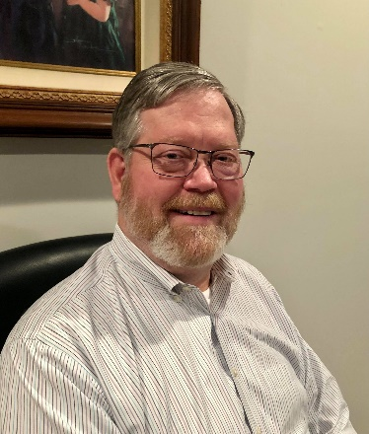DX This Week – 9A5N Interview

Bill AJ8B (aj8b@arrl.net, @AJ8B, or www.aj8b.com)

CWOPs Member #1567

I hope you have Crozet and The Republic of the Congo confirmed and are filling band slots. The solar numbers are continuing to rise, faster than anticipated and we may have a longer stretch than we thought of excellent propagation.

This week we have an announcement about a program to recognize those DX Mentors that have been helping young DXers move up the DX ladder. Icom America is supporting this program. We also have input from the NCDXF and INDEXA.

We start off the new year with our first interview, 9A5N. If you have been on the air for any length of time, you have probably worked Neno.

Keep me informed of new equipment or new countries you have worked.

DAH DIT DIT DIT DAH DAH DIT DIT DIT DAH

SWODXA Announces the DX Mentor Recognition Program

The Southwest Ohio DX Association (SWODXA) in conjunction with ICOM® America, Inc. is announcing a program to recognize and reward amateur radio operators who have played a key role in helping other amateur radio operators achieve DXCC. The purpose of this program is not to bring recognition to those that achieve DXCC but rather to recognize those amateurs that assist others in achieving their first 100 confirmed entities.

There is an application form and a judging committee staffed by SWODXA representatives and a representative from both the NCDXF and INDEXA. Those amateurs receiving the mentoring must be under 30 years of age during the calendar year for the award. The intent of targeting this audience is to attract and retain those amateurs that are most likely to remain engaged in the hobby after achieving DXCC.

SWODXA is uniquely positioned to bestow this award at the annual SWODXA DX Dinner®. The DX Dinner, held annually in conjunction with the Dayton Hamvention®, is arguably the largest gathering of active DXers in the world. We present the DXpedition of the Year Award®, the DXpeditioner of the Year Award, when applicable, and host the DX Forum there. CQ Magazine announces their CQ DX Hall of Fame inductees at the DX dinner as well.

As a technology leader in our hobby, there is no better partner to promote and celebrate this award than ICOM. Ray, N9JA, has been a constant promoter of ham radio, even coining the phrase “For the Love of Ham Radio”. ICOM has selflessly supported amateur radio over the years and is taking this opportunity to promote the mentors of DX. Thanks to ICOM for their support!

More information and the entry form can be found at [www.swodxa.org/DX-Mentor-Program](http://www.swodxa.org/DX-Mentor-Program), by emailing [thedxmentor@gmail.com](mailto:thedxmentor@gmail.com) or by calling 1-513-855-3980.

DAH DIT DIT DIT DAH DAH DIT DIT DIT DAH

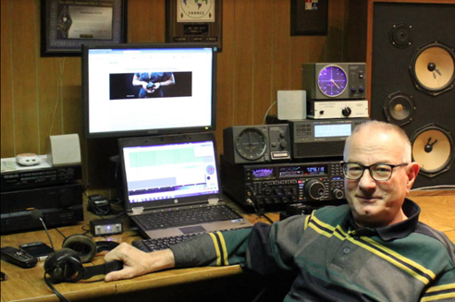Interview with 9A5N—Neno

*I worked Neno and checked out his information on QRZ.com. I sent him an email to see if he would be willing to answer our questions. The answer was a resounding “YES” ! You can contact him at neno.9a5n@gmail.com.*

**AJ8B**: How did you first get interested in amateur radio?  
**9A5N**: It's all my late father's fault, hi! Electronics was one of his hobbies. In 1971, he bought the CB station. As I really enjoyed talking to people on the CB band who were mostly radio amateurs, my father enrolled me in a radio club. in 1973, at the age of 13 I passed the exam for amateur radio operator. I mostly worked from the radio club until I finished electrical engineering. My main hobby then became electronics and programming, and radio amateurism became abandoned. Thanks to YL Gita OM5MF, after a long break, in 2004 I returned to amateur radio with the call 9A5ANR. Two years later I got a 9A5AN. In April 2013, after 40370 QSO’s and 310 DXCC confirmed, I took actual call.

**AJ8B**: Do you have a favorite band or mode?  
**9A5N**: No real favorite band. I work them all up to 6m with some limitations on 160 and 80m. I live in the city and working on 160 and 80m is difficult because of high QRM and because of the limited space to set up good antennas for real DXing on these bands. Plan to prepare a 4m setup as soon as possible as well. I hope that the solar cycle 25 will have a good maximum. I do SSB, all DIGI modes and sometimes CW. In recent years, everything has been reduced to FT8 / FT4, however, I still prefer SSB as the mode that achieves the best interaction between interlocutors. Even the color of the voice itself carries a lot of information.

**AJ8B**: What time of day and days do you like to operate?  
**9A5N**: Since last year I am retired and now I can operate whenever as much as I want.

**AJ8B**: Any secrets to your success?  
**9A5N**: There are no secrets. If you want to do a new DXCC, you need to be persistent, follow how the expedition operates and study the propagation. That will all result in you being on the right frequency at the right moment. Certainly, the QTH and equipment you have is important as well.

**AJ8B**: Any tips that you can share?  
**9A5N**: Success in any hobby is proportional to the effort invested and the desire to acquire knowledge about it.

**AJ8B**: Describe what you are currently using:

**9A5N**: Using Yaesu FTdx5000MP transceiver, SPE Expert 1.3K-FA linear, Hex beam for 20-10m, dipole for 30m, dipole for 60m, Windom for 40, 80 and 160m (with tuner) and homemade 5 element Yagi for 6m.

**AJ8B**: What advice do you have for those of us trying to break pileups to work DX?

**9A5N**: Now days FT8 Fox/Hound mode makes everything much easier. “Barefoot” with average antenna, QSO’s with rare stations and/or DXpeditions you will do without problem. You just need to be patient; PC will do the rest. For CW and SSB mode, good antenna, linear and transceiver with two receivers will reduce time spent for every QSO a lot.

**AJ8B**: What is your favorite contest?

**9A5N**: As I like to work from Croatian islands, my favorite contest is IOTA contest.

**AJ8B**: I can see you are a veteran of many DXpeditions. Which was your favorite? Why?

**9A5N**: IOTA expedition to Palagruza island, EU-090, with my friends from OM was real challenge. Palagruža is the most remote Croatian island, in the middle of the Adriatic Sea. The island is uninhabited, without drinking water, electricity and out of reach of mobile networks. The island can be reached by speedboat which runs only on Saturdays if the weather is good. In addition to all the radio amateur equipment and private belongings, it was necessary to bring drinks and food for 5 people as well as fuel for the generator needed for the seven days of operation. We were housed in a lighthouse at the top of the island, 105 m above sea level, with a lighthouse keeper and a donkey named Mercedes. Before the freight cable car was built, Mercedes carried all things, food and drinking water from the seashore up to the lighthouse. Now Mercedes is retired and spends his days walking freely around the island. On the last day of the expedition, Friday, the weather deteriorated sharply, and tomorrow's arrival of the speedboat was canceled due to strong wind and rough sea. Since we no longer had food for one day more, two members of the expedition went with a lighthouse keeper and a boat to catch fishes and squids for extra lunch and dinner. Luckily, in 24 hours the weather improved, and we were finally able to leave Palagruza.

**AJ8B**: Where are you going next?

**9A5N**: During the summer I will certainly operate from some Croatian islands where I have not been before. Croatia has 1244 islands, islets, and rocks. So far, I have operated from 500 islands exactly for the IOCA (Islands Of Croatia Award) and there is still a lot to activate in the years to come.

**AJ8B**: Any QSLing hints?  
**9A5N**: I love QSL cards. All 333 worked DXCC I have confirmed with QSL cards. I received most of the QSL cards through the bureau and the rest by sending a directs. It is best to use OQRS whenever possible and in most of the cases you can get QSL cards via bureau. I reply to all QSL cards received. For 9A5N/P, I have OQRS via bureau for all those who need faster confirmation for IOTA/IOCA award. All my logs are on ClubLog, LoTW, eQSL and QRZ.

**AJ8B**: What coaching/advice would you give new amateurs?  
**9A5N**: Amateur radio is a hobby and should be treated that way. There is no “I have to”, just pleasure.

**AJ8B**: If I were to stop by for a visit, what local place would you want us to visit?  
**9A5N**: Zagreb is a city that has something for everyone. Big, not too big. Loud, but calm. A place for partygoers, punks and stylists, posh ladies and hardworking godmothers. He never excludes, he rejoices in everyone. The strict center of Zagreb is divided into Upper and Lower City where there are many churches, museums, theaters and concert halls as well as restaurants, cafes and shops. After the catastrophic earthquake in 1880, the city center was rebuilt in the Art deco style. After a fine lunch in one of the restaurants with national cuisine in the Upper Town you should take a walk through the so-called Green Horseshoe in the Lower Town and end the walk with coffee in one of the cafes on Cvjetni Square. You should also visit Maksimir Park with Zoo, Lakes Jarun and Bundek, Mirogoj Cemetery, the medieval castle Medvedgrad and take the cable car to Sljeme (1033m), the top of the mountain Medvednica from where you can see the whole city and its surroundings.

**AJ8B**: What local food would you want me to try?  
**9A5N**: The most famous Zagreb dishes are Zagreb steak, turkey with mlinci (a type of pasta) and Štrukle (a type of cake). But you should also try Baranjski Kulen (a type of salami), sea food from the Adriatic Sea and dishes with Istrian truffles, as well as try the wines Traminac (white) and Dingac (red).

**AJ8B**: Thanks for taking the time to answer my questions. Is there anything you would like to share with us?

**9A5N**: Thanks to my friends, top class telegraphists, Bero 9A5KR and Daki 9A2WJ (both SK) and endless discussions about the shortcomings of mechanical CW keys and paddles, I invented 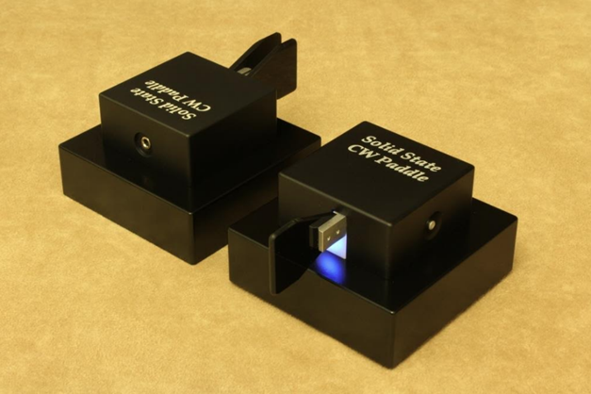the Solid-State CW Paddle 10 years ago. As the paddle has no moving parts and bearings, no contacts and no springs / magnets, it is completely immune to dust, oxidation and temperature changes, requires no maintenance and keying with it is completely silent. Only the batteries change after a year or two. Instead of with a spring / magnet, the keying pressure is software adjustable in the range of 10 to 50 grams. In the last 10 years I have made a lot of twin and single lever versions of Solid-State CW Paddles and hundreds and hundreds of owners around the world enjoy CW keying with it.

DAH DIT DIT DIT DAH DAH DIT DIT DIT DAH

Here is an update from Bernie, W3UR, of the DailyDX and the WeeklyDX, the best source for DX information. <http://www.dailydx.com/> . Bernie has this to report:

**3Y - Bouvet Island -** From the 3Y0J team, DX-World, together with the Daily DX, have been selected as the official media publishers for the 3Y0J Dxpedition. The pilot stations will be working with these two, and N2AJ, the team's media officer, to "keep us up to date with accurate information."  LA7GIA notes it's only a few days before the team begins the long trip.  The team will be in satellite communication with N2AJ throughout the trip.  Also, in the loop will be chief pilot LA3MHA.  Every day at 17Z they will speak by sat phone.  Departure from Stanley in the Falklands will be "after bunkering," late evening on January 14.  We can track them on this site: <https://share.garmin.com/3y0j>

N2AJ met at KO8SCA's home in New York with him and VE3LYC.  They had lunch, then N2AJ drove them and their luggage to the airport to see them off for London, where they are meeting up with the rest of the team.  The entire group arrive safely in the Falklands on January 12.  
  
**ET – Ethiopia -** K4ZW, Ken, says it's good news; the ET3AA group have permission to operate overnight during their upcoming visit.  With an all-night noise source a major problem in the past, they are equipped with "an arsenal of RX antennas" this time.  But it could "very rough if not impossible."  The trip is dedicated to K3ZO, Fred Laun, who passed recently.  Ken notes that Fred is responsible for the ET3AA IC-7300 radio and has funded some of the travel for youth at ET3AA in the past, to attend the YOTA summer conferences in Europe.  Ken says "The legacies of Sid, ET3SID, and Fred, K3ZO, live on through these youth."

This upcoming ET3AA activity is January 14-21, with K4ZW, W9XY and  
EY8MM, as well as local ops.  QSL via N2OO.

**FO - French Polynesia -** FO/M0NSI, Brian, says his upcoming trip is a long one with "lots of other DX opportunities for me."  He will start by going to New Zealand and Australia, the first leg of his trip, but has apparently been denied permission to operate from the ship, the cruise ship, the "Celebrity Eclipse."  Along with him he will have a 10-watt IC-705 and a quarter-wavelength vertical (the MFJ 1979) to be able to set up and operate from beach locations.

Over the following weeks he will hopefully be able to operate from New Caledonia, Tahiti, Hawaii, Bora Bora, Japan and Kenya.  The trip is January 22 to April 1.  He is currently busy working out flights and visas.  Brian says the cruise has been booked for a long time and he figured it was a great opportunity to take the radio along, a holiday, with some fun on the radio.  The trip starts with 12 nights on the ship leaving from Auckland, followed by nine nights cruising around Australia and four days in Sydney starting February 16.  To get on the air he is primarily looking at an hour in the morning and another hour in the afternoon, "weather and wife permitting."  QSL via EA5GL.  
  
More details on the dates:  
  
January 26-February 7, when off the ship, if possible, in New Zealand  
February 7-16, Hobart, Australia when off the ship if possible.  
February 16-20, Sydney, Australia  
February 20-25, Noumea, New Caledonia  
February 25-28, Papeete, Tahiti and a day trip to Moorea island  
February 28 to March 7, Bora Bora, Matira Beach, Nune.  
March 8-13, Hawaii, Waikiki Beach.  
March 14-17, Tokyo, Japan  
March 18-22, Tasivo East/West National Park, Nairobi, Kenya.  
March 22 to April 1, Diani Beach, Mombasa, Kenya.  
  
Brian is still waiting for his Kenya and Japan licenses.

DAH DIT DIT DIT DAH DAH DIT DIT DIT DAH

Below is a list of upcoming contests in the “Contest Corner”. I think this is important for someone who is trying to move up the DXCC ladder since entities that are on the rarer side and easiest to work in contests. Some of my best “catches” have been on the Sunday afternoon of a contest when the rarer entities are begging for QSOs. Of course, the gamble is that if you wait until Sunday, conditions may change, or they simply won’t be workable. However, it is not a bad gamble. Of course, why not work the contest and have some fun!  
Check out the WA7BNM Contest Calendar page (<https://www.contestcalendar.com/>) and CQ Magazine for more contests or more details. I also have a comprehensive list that can be imported to your calendar at [www.aj8b.com/files](http://www.aj8b.com/files)

The contests in red are those that I plan to spend some significant participation time on. PLEASE let me know if you are working contests and how you fared.

Thanks!

|  |  |  |
| --- | --- | --- |
| **Date(s)** | **Event** | **Info** |
| Jan. 18 | VHF-UHF FT8 Activity | [www.ft8activity.eu/index.php/en](http://www.ft8activity.eu/index.php/en) |
| Jan. 21-22 | Hungarian DX Contest | [www.ha-dx.com/en/contest-rules](http://www.ha-dx.com/en/contest-rules) |
| Jan. 21-22 | North American SSB QSO Party | <http://ncjweb.com/naqp> |
| Jan. 21-23 | ARRL January VHF Contest | [www.arrl.org/january-vhf](http://www.arrl.org/january-vhf) |
| Jan. 25 | UKEICC 80 Meter Contest CW | <https://ukeicc.com/80m-rules.php> |
| Jan. 25-26 | AWA Linc Cundall Memorial Contest | <https://bit.ly/3iDUm34> |
| Jan. 27-29 | CQWW 160M CW Contest | <http://cq160.com/rules.htm> |
| Jan. 28-29 | AWA Linc Cundall Memorial Contest | <https://bit.ly/3iDUm34> |
| Jan. 28-29 | BARTG RTTY Sprint | <http://bartg.org.uk/wp/contests> |
| Jan. 28-29 | REF CW Contest | <https://tinyurl.com/p4bbva92> |
| Jan. 28-29 | UBA SSB Contest | <http://bit.ly/W0gZiE> |
| Jan. 28-29 | Winter Field Day | [www.winterfieldday.com](http://www.winterfieldday.com) |
| Feb. 11-12 | CQWW WPX RTTY Contest | [www.cqwpxrtty.com](http://www.cqwpxrtty.com) |
| Feb. 24-26 | CQWW 160M SSB Contest | <http://cq160.com/rules.htm> |

**ARLD002 DX news**

This week's bulletin was made possible with information provided by  
W2APF, The Daily DX, 425 DX News, DXNL, Contest Corral from QST and  
the ARRL Contest Calendar and WA7BNM web sites.  Thanks to all.  
  
UGANDA, 5X.  Anders, SM0HPL is QRV as 5X7W from Kampala until January 23.  Activity is on the HF bands using QRP power.  QSL via M0OXO.  
  
ALGERIA, 7X.  Members of radio club 7X2VFK are QRV with special event call sign 7U7C during the Africa Cup of Nations football tournament.  QSL direct.  
  
QATAR, A7.  Tony, RN1B is QRV as A75GC from Doha until the end of January.  QSL via RW3RN.  
  
CAPE VERDE, D4.  Harald, DF2WO is QRV as D44TWO from Sao Tiago, IOTA AF-005, until January 21.  Activity is on 160 to 6 meters using CW, SSB, FT8, and FT4, as well as on Satellite QO-100.  QSL via M0OXO.  
  
FEDERAL REPUBLIC OF GERMANY, DA.  Special event station DR100XRAY is QRV until June 30 to commemorate the 100th anniversary since the death of Wilhelm C. Roentgen, the physicist whose discovery of X-rays revolutionized diagnostic medicine.  QSL via bureau.  
  
ETHIOPIA, ET.  Ken, K4ZW, Bob, W9XY, and Nodir, EY8MM plan to be QRV from the Ethiopian Amateur Radio Society's club station ET3AA from January 14 to 21.  As part of their activity, they will also try to mentor newcomers to amateur radio.  QSL via N2OO.  
  
GUADELOUPE, FG.  Herve, F5HRY will be QRV as FG/F5HRY from Marie Galante Island from January 19 to February 2.  Activity is holiday style on 80 to 10 meters, including 30, 17, and 12 meters, using CW, with SSB on request.  QSL direct to home call.  
  
SAINT BARTHELEMY, FJ.  Phil, K2LIO is QRV as FJ4WEB until August 15. Activity is on 40 to 10 meters using SSB.  QSL to home call.  
  
CROZET ISLAND, FT/W.  Station FT8WW is QRV until January 26.  QSL via OQRS.  
  
THAILAND, HS.  Jack, F5LIT will be QRV as HS0ZPU from January 17 to February 6.  From January 17 to 20, he will be active from Krabi Island, IOTA AS-053.  QSL direct to home call.  
  
PAPUA NEW GUINEA, P2.  David, VK4FABN is QRV as P29DT from Tabubil in the Star Mounts in the North Fly District of the Western Province.  Activity is holiday style on 40, 20, 15, and 10 meters using CW and SSB.  QSL via LoTW.  
  
ARUBA, P4.  Jeff, VA3QSL is QRV as P4/VA3QSL until February 8. Activity is holiday style on 40 to 6 meters using CW, SSB, and various digital modes.  QSL via LoTW.  
  
PALAU, T8.  Operators Mike, JA6EGL, Kuzo, JH6WDG, and Mune, JR6DRH are QRV as T88SM, T88AQ, and T88RH, respectively, from Koror Island, IOTA OC-009, until January 19.  Activity is on 160 to 6 meters using CW, SSB, and various digital modes.  QSL to home calls.  
  
CONGO, TN.  A group of operators are QRV as TN8K until January 21. Activity is on 160 to 6 meters using CW, SSB, RTTY, PSK, FT8, and FT4.  This includes being active on Satellite QO-100.  QSL via OK6DJ.  
  
MONTSERRAT, VP2M.  Thaire, W2APF is QRV as VP2MDX until March 28. Activity is on 80, 40, and 30 meters using CW and SSB.  QSL direct  
   
UK SOVEREIGN BASE AREAS on CYPRUS, ZC4.  Garry, 2M1DHG is QRV as ZC4GR.  Activity is on 40, 30, and 10 meters using FT8.  QSL via EB7DX.  
  
The K1USN Slow Speed CW Test, ICWC Medium Speed CW Test, OK1WC Memorial, Worldwide Sideband Activity Contest, QRP 40-Meter CW Fox Hunt, Phone Weekly Test, A1Club AWT, CWops Test, VHF-UHF FT8 Activity Contest, Mini-Test 40 and the Mini-Test 80 are on tap for January 16 to 18.  
  
Please see January 2023 QST, page 74, and the ARRL and WA7BNM Contest web sites for details.  
  
______________________________________________________________________________

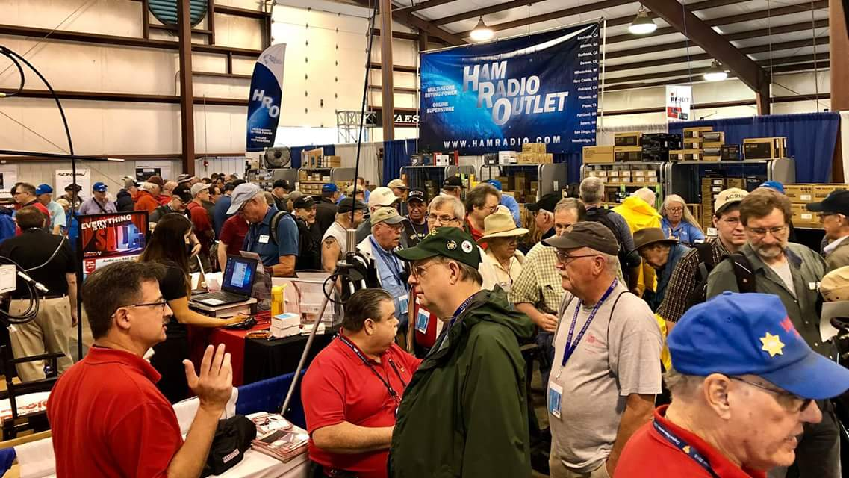[**Upcoming *Hamfests***](http://arrl-ohio.org/hamfests.html)

We **DO** have some hamfests scheduled for 2022!! Yes, take a good look at the list. And YES! They are starting to book up for 2023 already!

**__________________________________________________________**

|  |  |
| --- | --- |
|  |  |

|  |  |
| --- | --- |
|  |  |
|  |  |
| ***2023*** | | | | |
| **03/11/2023 -**[**MOVARC Hamfest**](http://www.arrl.org/hamfests/movarc-hamfest-8)  **Location:**Bidwell, OH 45614, OH **Sponsor:** Mid-Ohio Valley Amateur Radio Club [**Learn More**](http://www.arrl.org/hamfests/movarc-hamfest-8) | | | | **03/12/2023 -**[**Winter Hamfest**](http://www.arrl.org/hamfests/winter-hamfest-10)  **Location:**Elyria, OH **Sponsor:** Northern Ohio Amateur Radio Society **Website:** [http://winterhamfest@noars.net](http://winterhamfest@noars.net/) [**Learn More**](http://www.arrl.org/hamfests/winter-hamfest-10) |
|  | | | |  |
| **03/19/2023 -**[**Toledo Mobile Radio Association Hamfest and Computer Fair**](http://www.arrl.org/hamfests/toledo-mobile-radio-association-hamfest-and-computer-fair-1)  **Location:**Perrysburg, OH **Sponsor:** Toledo Mobile Radio Association **Website:** [http://www.tmrahamradio.org](http://www.tmrahamradio.org/) [**Learn More**](http://www.arrl.org/hamfests/toledo-mobile-radio-association-hamfest-and-computer-fair-1) | | | | **04/15/2023 -**[**Cuyahoga Falls Amateur Radio Club Hamfest**](https://www.arrl.org/hamfests/cuyahoga-falls-amateur-radio-club-67th-hamfest)  **Location:**Cuyahoga Falls, OH **Sponsor:** Cuyahoga Falls Amateur Radio Club, Inc. **Website:** [http://www.cfarc.org](http://www.cfarc.org/)  [**Learn More**](https://www.arrl.org/hamfests/cuyahoga-falls-amateur-radio-club-67th-hamfest) |
| **05/13/2023 - 05/17/2023** [**RV Radio Network**](http://www.arrl.org/hamfests/rv-radio-network-1)  **Location:**Berlin, Ohio, OH **Type:** ARRL Operating Specialty Convention **Sponsor:** RV Radio Network [**Learn More**](http://www.arrl.org/hamfests/rv-radio-network-1) | | | | **05/19/2023 - 05/21/2023**[**Dayton Hamvention**](http://www.arrl.org/hamfests/dayton-hamvention-8)  **Location:**Xenia, OH **Sponsor:** Dayton Amateur Radio Association **Website:** [http://Hamvention.org](http://hamvention.org/) [**Learn More**](http://www.arrl.org/hamfests/dayton-hamvention-8) |
|  | | | |  |
| **07/08/2023 -**[**Mansfield Trunkfest 2023**](http://www.arrl.org/hamfests/mansfield-trunkfest-2023)  **Location:**Mansfield, OH **Sponsor:** Intercity Amateur Radio Club **Website:** [http://iarc.club](http://iarc.club/) [**Learn More**](http://www.arrl.org/hamfests/mansfield-trunkfest-2023) | | | | **07/16/2023 -**[**Van Wert Hamfest**](http://www.arrl.org/hamfests/van-wert-hamfest-7)  **Location:**Van Wert, OH **Sponsor:** Van Wert Amateur Radio Club **Website:** [http://w8fy.org](http://w8fy.org/) [**Learn More**](http://www.arrl.org/hamfests/van-wert-hamfest-7) |
| **08/12/2023 -**[**Cincinnati Hamfest℠**](http://www.arrl.org/hamfests/cincinnati-hamfest-2)  **Location:**Owensville , OH **Sponsor:** Milford ARC **Website:** [https://CincinnatiHamfest.org](https://cincinnatihamfest.org/) [**Learn More**](http://www.arrl.org/hamfests/cincinnati-hamfest-2) | | | | **08/20/2023 -**[**WARA Tailgate Swap Meet**](http://www.arrl.org/hamfests/wara-tailgate-swap-meet-1)  **Location:**Cortland, OH **Sponsor:** Warren Amateur Radio Association **Website:** [http://w8vtd.org](http://w8vtd.org/) [**Learn More**](http://www.arrl.org/hamfests/wara-tailgate-swap-meet-1) |

**OHIO’S**

**Editor’s Note:**

John is taking a “well deserved” break this week. South of Rt 40 is an important part of the Ohio Section. Lots of good Ham Radio activity takes place there, and I thank John for keeping us all up to date on what’s going on. And I thank ALL of you hams south of Rt 40 for your activities and involvement in this fantastic hobby! 73 to you all de WB8LCD

**Print an Official or Unofficial Copy of Your Amateur Radio License**

*(By Anthony Luscre, K8ZT)*

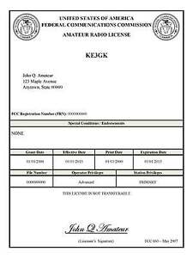

As of February 17, 2015, the **FCC no longer routinely issues paper license documents** to Amateur Radio applicants and licensees. The Commission has maintained for some time now that the official Amateur Radio license authorization is the electronic record that exists in its Universal Licensing System (ULS). The FCC will continue to provide paper license documents to all licensees who notify the Commission that they prefer to receive one.

Licensees also will be able to print out an official authorization — as well as an unofficial “reference copy” — from the ULS License Manager. I’ve created a set of instructions on how you can request an **“official” printed copy of your license\***

[**Click here to download the instructions**](http://arrl-ohio.org/news/2020/print_your_license.pdf)

***One Question Questionnaire***

!!!!! I would really like to hear from as many of you as possible. How about going to <http://arrl-ohio.org> and giving me a click? (It’s in the bottom left corner of the page) While you’re there, you can click the Big Red Arrow to enter into this months Handbook Giveaway!

This weeks Question:

**When you travel, do you ever visit the local club meetings?**

1. **YES**
2. **NO**

From last weeks question:

**Have you been making VOTA contacts yet??** OUT OF A TOTAL OF 65 VOTES – 23% YES (15) AND 77% NO (50)

The BIG RED ARROW will be back on the page this week and next for your entry in the Handbook Giveaway – you can’t win it if you don’t enter! I still don’t have a response from the winner of last month’s handbook! If you use the email address [4bz@att.net](mailto:4bz@att.net) send me an email so I can get it out to you! If I don’t hear by next weeks PostScript I’ll consider it not claimed.

Bottom of Form

Ohio Section Cabinet

|  |  |
| --- | --- |
| Section Manager – Tom Sly, WB8LCD | Section Traffic Manager – David Maynard, WA3EZN |
| Section Emergency Coordinator – Bret Stemen KD8SCL | Section Youth Coordinator – Anthony Luscre, K8ZT |
| Technical Coordinator – Jeff Kopcak, K8JTK | Affiliated Clubs Coordinator – Amanda Farone – KC3GFU |
| State Government Liaison – Bob Winston, W2THU | Public Information Coordinator – Elizabeth Klinc - KE8FMJ |



Hey Gang,

Have you taken a look at the **Swap & Shop** page on the Ohio Section webpage yet?? Here’s a link that will take you there… <http://arrl-ohio.org/sm/s-s.html>

Do you have equipment that you just don’t need or want anymore? Here’s a great venue to advertise it, and it’s FREE!! Is your club doing a fund raiser to help raise money? After a lot of thought, it was decided that the Swap & Shop webpage could also contain these types of items as well. The same rules will apply as do for the For Sales and Give-A-Ways and will only be posted for a month at a time. Please see the Terms & Conditions on the webpage.

If your club is doing a fund raiser and wants more exposure, please forward the information to me and I’ll advertise it on the Swap & Shop webpage for you.

Now, I still want to remind you that it won’t be listed in this newsletter because it would take up way too much space, so your ad will only appear on the website. It is there for any individual to post equipment Wanted / For Sale or Give-Away as well as for Club Fund Raisers. No licensed vehicles/trailers or business advertising will be posted. Postings are text only (no pictures or graphics) will be posted for a maximum of 1 month from date posting and require a contact phone number or email within the posting. Send your Wanted / For Sale or Give-Away post to:  [swap@arrlohio.org](mailto:swap@arrlohio.org)

***Back Issues of the PostScript and Ohio Section Journal***

Hey, did you know that PostScript and Ohio Section Journal (OSJ) are archived on the website? You can go back and look at any edition simply by clicking:

<http://arrl-ohio.org/news/index.html>

***Want to Share your Club Newsletter With Others?***

We have a webpage where you can download and read all of the newsletters that I get from around the state and even other sections!

Here’s the link to the page…. <http://arrl-ohio.org/club_news/index.html>

Please, if you don’t see your club newsletter posted, it’s because I’m not receiving it. Just have your newsletter editor contact me and I’ll get your club’s newsletter listed on the site!!

We all learn and steal (I mean, share) from each other’s work. So, get me your newsletter!!! Send it to: [webmaster@arrl-ohio.org](mailto:webmaster@arrl-ohio.org)

***Chit – Chat, and All That!***

Do you know someone that’s not getting these Newsletters? Please, forward a copy of this Newsletter over to them and have them “[Opt-In](mailto:Opt-In)” to start receiving them. Heck, just have them send an email to: [webmaster@arrl-ohio.org](mailto:webmaster@arrl-ohio.org) and we’ll get them added to the Ohio Section Emailing list.

We now have many thousands of readers receiving these newsletters weekly. Quite impressive, I’d say! I urge all of you to make sure that everyone, regardless of whether they are a League member or not, get signed up to receive these weekly Newsletters.

You can always “Opt-Out” at any time if you feel this is not what you were expecting. It’s fun and very informative. All of your favorite past newsletters are now archived too.

You can go back at any time and read them.

Just go to: <http://arrl-ohio.org/news/>

*PostScript is produced as a weekly newsletter. I want to thank everyone that has contributed articles and ideas to make this an even better news source. I sincerely hope that you have enjoyed this edition and will encourage your friends to join with you in receiving the latest news and information about the Ohio Section, and news and events happening around the world!*