November 2023

From the Technical Coordinator | From the Section Emergency Coordinator
From the Public Information Coordinator | From the Section Youth Coordinator
From the Section Traffic Manager | National News
From the Affiliated Clubs Coordinator | Contest Corner
Club Corner | One Question Questionnaire
DX This Week | Final.. Final..

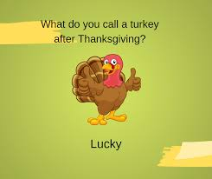

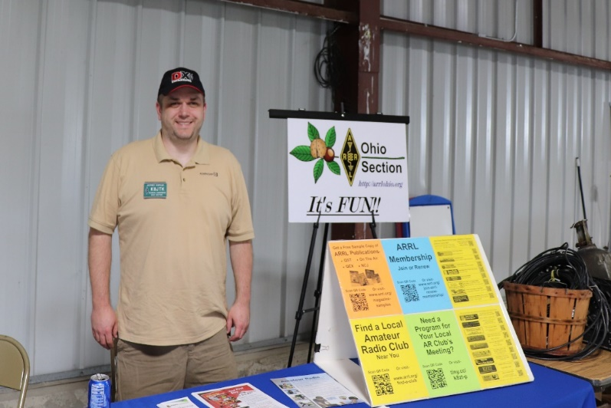
From the Technical Coordinator
Jeff Kopcak – K8JTK TC
K8JTK@arrl.net

Hey gang,
Pi-Star was great. It solved big problems for hams wanting to use VHF and UHF digital modes around 2016-2017. Personal hotspots were becoming popular. Consisting of a digital interface (modem) board capable of transmitting and receiving digital modes such as DMR, D-STAR, and System Fusion. These transceiver options are low power at about 10mW. The modem interfaced with software to manage network connections. Many devices were created for the popular Raspberry Pi or Arduino single-board computers using the GPIO headers. Others were USB-based devices that could be used with a desktop computer running any operating system or plugged into a Raspberry Pi.
The hardware was pretty solid. Software, not so much. Nearly each group attempted to make their own software distribution. In general, this failed as users couldn’t get the software to work consistently and settings didn’t work as expected - even across users with similar setups. Many didn’t have monitors connected. VNC, a remote desktop sharing application, was used. VNC generally works well desktop-to-desktop, but not desktop-to-mobile. These problems weren’t helping promote digital modes and personal hotspots.
Then along came Pi-Star. Created and maintained by Andy – MW0MWZ, it solved nearly all those problems. On the hardware site, Pi-Star supported every digital modem in a single platform. MMDVM is the software capable of “speaking” different digital mode protocols and managing network connections. It came with a web front-end that did everything needed to configure and manage devices, update network settings, update device firmware, and have a nice usable dashboard. Ultimately, the Pi-Star platform superseded all previous attempts at a viable interface for digital ham radio hotspots.
On the Pi-Star site, version 4.1.5 dated October 2021 is the latest image available for Raspberry Pi. However, 4.1.6 is available through the update sequence pistar-update then pistar-upgrade at the command line, both prefixed with sudo. Pi-Star 4.1.5/6 release is based on Raspbian 10 (buster) which has reached end-of-life. Raspbian, the standard Raspberry Pi operating system, follows the Debian release schedule. Debian 10 is out of standard security updates and into LTS (long term support). Raspbian does not offer LTS.
If you’ve read my column long enough, you know the majority of vulnerability issues can be avoided by keeping systems updated and patched. I’m also reminded of the time when I went searching and found there are Pi-Star’s accessible directly from the Internet, with the default password. What could possibly go wrong?
By all accounts, and as of this writing, Andy is no longer maintaining Pi-Star. Looking at his post count in the forums: zero in 2023 and ten in 2022. There are very few updates to GitHub repositories in the last two years, which are used to update Pi-Star devices. I’ve seen references to lack of updates due to lack of interest. Pi-Star is also lacking the latest additions to MMDVM including M17 and FM for boards that support those modes (usually through firmware updates).
The next iteration of Pi-Star (or fork) comes to us via W0CHP, called “W0CHP-PiStar-Dash (WPSD).” I learned about WPSD when AmateurLogic ran a segment in January on this new offering. I started using it shortly after. Though it was early on in the project, WPSD was labeled “not for the faint of heart” by the author.
It was really rough around the edges. I had to debug scripts in order for updates to run successfully. The dashboard would show the modem in “TX D-STAR” when only P25 was enabled. There were issues with the configuration file manual editor too.
Regardless, development is very active. WPSD has become much more stable and now considered the Pi-Star replacement. Alot has changed in the time I’ve been using WPSD and presume things will continue to evolve.
One such change, there was an option for installing WPSD on top of an existing Pi-Star installation. That option is no longer available or supported. The distribution must be flashed directly to an SD card (flash memory), exactly like Pi-Star.
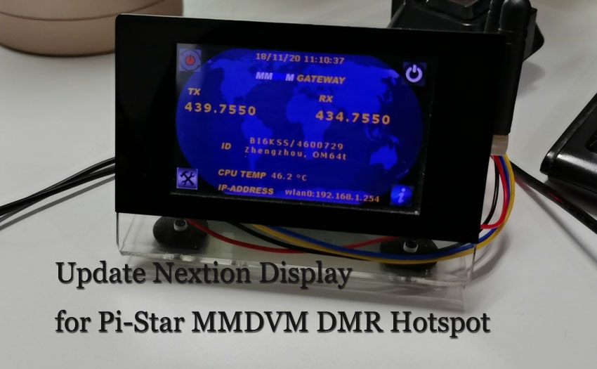
I always recommend using a new card or different SD card from the current, existing installation until everything is working as the user expects. Having the old (original) card available allows switching back easily in case of problems or need to reference something from the previous installation.
Pi-Star with Nextion display (ailunce.com)
A recent blog post by the author called out people who claim WPSD is an “overlay.” At one point, it could have been installed on top of an existing Pi-Star installation. WPSD is not an overlay. It is its own software distribution.
WPSD works with most Raspberry Pi offerings (Zero, Zero 2, 2, 3, 4, …) including the Orange Pi and Nano Pi Neo variants. The Raspberry Pi Zero W 1.1 is not really recommended for use but it will work. The Zero W 2 is recommended instead. A Zero W 1.1 needs extra configuration steps after flashing the SD card. These include: creating a wpa_supplicant.conf and placing it in the /boot partition. Waiting at least 30 minutes for the image to boot and configure itself before accessing the dashboard. Steps are detailed in the link above.
While using WPSD with my Pi Zero W 1.1 it is quite a bit quicker, taking about a minute to save changes on the configuration page of the dashboard. Compared to the Pi-Star which took two to three minutes to save changes. Pi Zero W 2s are still very hard to find. If you can find one, a male header strip still needs to be soldered to the GPIO. Pre-soldered ones are nonexistent.
Not only is WPSD on a supported operating system (bullseye, Debian 11) but there are a TON of enhancements and updates over Pi-Star. Though the visual layout has changed, it’s intuitive enough for any existing Pi-Star user. Changes I noted right away were the addition of M17 support (though I don’t have any capable devices) and Nextion support built-in. Nextions are displays and/or touchscreens that can be attached to the modem or added through a TTL serial converter, such as those based on the CP2102 chipset. Adding Nextion support to the original Pi-Star was a terrible experience using hacky scripts that had to be run a couple times before the drivers and software could be usable.
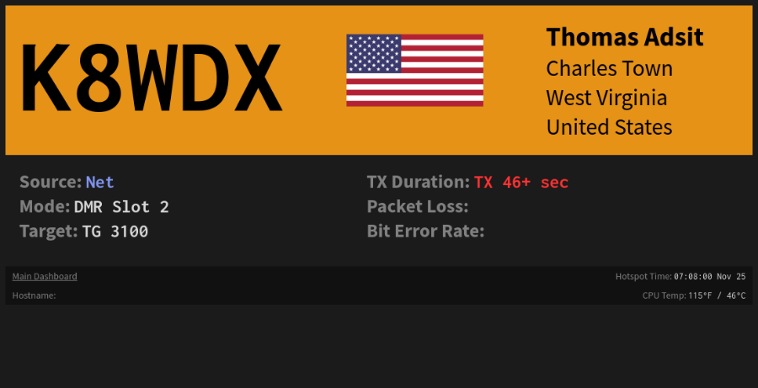
Non-exhaustive list of enhancements: full APRSGateway support. DGId support. DMR Roaming Beacon Support for repeaters. Caller details include name and location. Talkgroup names are populated. On the fly changes of talkgroups/rooms/reflectors/networks including ability to pause networks for attending nets or quieting a busy mode. Live Caller mode which is a browser based (virtual) version of a Nextion display. Ability to disable cron (scheduled) updates. Updated dashboard including wider, bigger, updated fonts, user configurable options including CSS styling and fonts. Full dashboard display or Simple View with only RF and gateway activity. Configurable number of last heard stations. Configuration/Profile Manager, similar to OpenSpot, where the user can save multiple versions of a setup and restore them based on use.
WPSD Live Caller mode
A Profile Manager feature was added to WPSD, which did not exist in Pi-Star but exists in the OpenSpot devices. This allows the user to save device settings into a profile to be recalled later. These could be travelling profiles, or ones specific to a mode, network, or configuration for a net. Initial implementation of this feature did not backup saved profiles when using the Backup/Restore feature. Only the current active profile would be backed up or restored. Now, within the last two months, Backup/Restore saves ALL device profiles in the backup archive.
That is an example of the constantly evolving nature of this new WPSD distribution. Updates happen quite frequently. WPSD was updated nearly daily for a long time. Updates still happen quite frequently but at the pace of about once a week, maybe more.
Speaking of backups, it’s not recommended to use migrated configuration files or backups from Pi-Star, due to differences. If Pi-Star files are used with WPSD and there are issues, the user will be required to begin configuration from scratch.
One change I do not particularly care for is the requirement to use DMRGateway. In Pi-Star, I used Direct Mode which is the selection of a single DMR Master. For example: select BM_3104_United_States for Brandmeister and TGIF_Network for TGIF as the DMR Master. I liked this for two reasons: this functionality is similar to how a repeater would operate and it simplifies codeplug programming for talkgroups with the same TG ID across different networks. Ohio Statewide is 3139 on multiple networks meaning I only had to setup Ohio Statewide once. Though it seemed most users did use DMRGateway in Pi-Star.
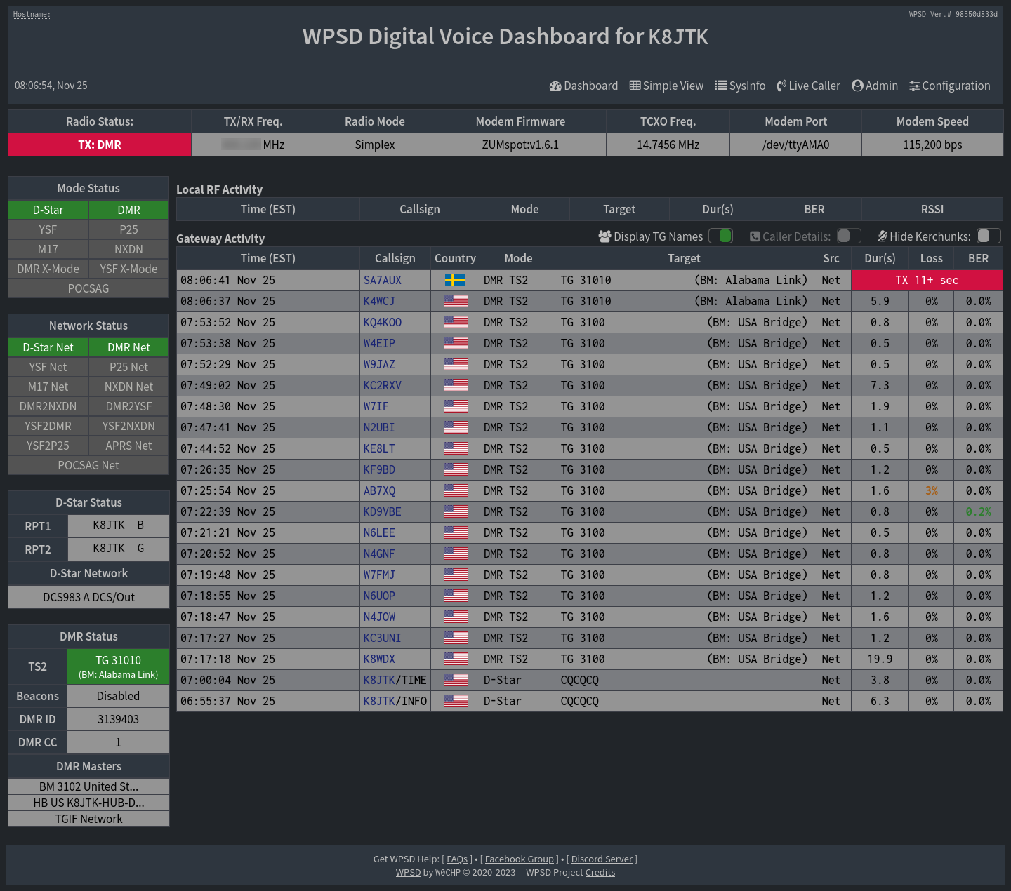
DMRGateway supports simultaneous connections to six networks. With all those network connections there must be a way to differentiate which network is to receive a transmission. That way is through “prefixes,” a single number prepended to the talkgroup number. DMRGateway doesn’t appear to use a prefix for Brandmeister, 3139 would remain 3139. TGIF talkgroups are prefixed with a 5. 3139 would become 53139. HBLink prefix is 8. My HBLink would be 831983 instead of 31983.
WPSD Dashboard
If you’ve programmed a codeplug for a DMR radio, it’s not as easy as just making a new contact with the prefix. Adding the contact to an RX group, creating new channels, and reorganizing or creating new zones are all needed. Maybe I’ll purge the ‘nice to haves’ in my codeplug as I typically only use a handful of talkgroups or just make a new simplified codeplug for use with WPSD.
Changes have been made to the scripts and tools. Commands rpi-rw and rpi-ro have been removed. These were used to switch between a read/write file system and a read-only file system. There has been debate whether a read only file system corrupts any less or shortens the lifespan of the SD card when left in read/write mode. Pi-Star was constantly changing from read only to read/write during settings changes, updates, and hostfile update cycles. Mine seemed as though it could never successfully change from read/write back to read only after an update. Eliminating those scripts just ‘fixed’ those resource busy messages.
Pi-Star scripts that began with pistar- have all been removed and replaced with a smaller set of wpsd- scripts. It was great because all WPSD updates were taken care of by going to Admin -> Update. Though, a recent change has removed operating system updates from that feature. Admin Update only updates WPSD currently (probably due to those lengthy Raspbian kernel updates). To update the operating system, SSH to WPSD or go Admin -> Advanced -> Tools -> SSH Access. After logging in (same credentials used to login to the Admin or Configuration dashboards), at the command line, enter (capitalization is important):
sudo UP_OS=1 wpsd-update
As with Pi-Star, if an update fails or installation becomes borked, re-flashing the SD card with the latest available image will bring the device to a known working state. Remember to save a new backup before updating! WPSD images are updated more frequently than Pi-Star. Updates released since the image was published won’t take quite as long to apply.
There is a lot to read, including some edge features that have been removed, on the WPSD page (linked above). Comparing WPSD to Pi-Star (‘this used to work on Pi-Star,’ ‘when I revert back to Pi-Star this thing works,’ etc.) is verboten when asking for support. The main page on W0CHP’s site is a blog detailing direction and state of the project as well as reasons for changes. I recommend Pi-Star users update to W0CHP-PiStar-Dash - if nothing else, for the supported operating system and OS package updates though there are many improvements and welcome features.
Thanks for reading and 73… de Jeff – K8JTK

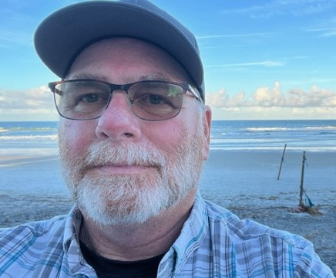
From the Section Emergency Coordinator Bret Stemen – KD8SCL EC
KD8SCL@gmail.com

November 2023

I am deeply saddened by the tragic event that took place on November 14th in Licking Co. On behalf of the Ohio Section, our deepest sympathies go out to the families, friends and Tusky Valley Schools that were and are impacted by this tragic event, our thoughts and prayers are with you all. Please remember the first responders, 911 dispatchers and others this upcoming holiday season as they will be working to keep us all safe as they answer the calls and respond to emergencies.

On a brighter note:
Hope everyone had a great Thanksgiving with family and friends. Remember to give thanks for the family and or friends and the provisions that you have.
Congratulations Scott Yonally, N8SY on the recent election for the director of the Great Lakes Division. We look forward to have you as the GLD Director and your continued support for the ham radio community.

Congratulation Roy Hook, W8REH for be elected as Great Lakes Division Vice-Director and looking forward to work with you.

I would like to say a Heartfelt “Thank You” to Director Dale Williams, WA8EFK for his service to ARRL and Amateur Radio. Your 10 years of service to the ARRL Great Lakes Division as Director are greatly appreciated. I wish you Success, Peace and Happiness in your future!

Something that I thought about while writing this article, we all know that we never know what could happen to us at any time, it could be a sudden illness, sudden hospitalization or even worse sudden death. The reason I am bringing this up is due to events that I witnessed recently and has been on my mind ever since.

Are you mentoring your replacement? It doesn’t matter what you are involved in, it could be that you are an SM, SEC, EC, etc. or even an officer of your local club or even on a committee (Repeater, Field Day, etc). We need to think about mentoring the younger generation to step up in the event that you are not able to complete a task or work that needs to be taken care of, or even to help you with the “work load” so you are not so stressed trying to take care of your duties.

I have witnessed this myself, please allow me to explain my history briefly. I was first licensed in 2012 and joined the local ARES group. A few months later, the derecho rolled into the state and I ended up as NC due to power outages across the county, not long after that I was asked by the then EC if I would be net manager and he would make me an AEC. A few years later, he asked me if I would consider replacing him as EC, I accepted. The then EC had mentored and trained me to cover for him while he was out of town. A few years later while attending an ARES Conference, I was approached by the then D-7 DEC asking if I would consider become an Assistant DEC for D-7 as he was a member of a response team that got called out for emergencies (Task Force One), again he trained and mentored me to help and cover for him while he was out of town. I was later asked if I would replace him as he was becoming ill and I accepted the position as DEC for D-7. Little did I know, I was being mentored and trained by the then SEC as was later asked if I would replace him as he was going to retire and I accepted the position as Ohio Section SEC. I am also an AEC for Licking Co. (EMA Liaison) as this was the condition set by the EMA Director, I also continue to help the current EC for Licking Co. with various tasks.

As many of you may know, we suddenly lost our ARES database manager and he did not have an assistant/helper, this is why our ARES database is temporarily down. We are currently working on getting this database back up and running.

This is the reason I feel strongly about mentoring and training an assistant for replacement, because life events do happen.

Think about finding a helper/assistant, mentor that person, teach that person what you know as well as learn from them as they may have a better way or easier way of accomplishing that task with the same results. We need to keep the younger generation engaged to keep them interested in amateur radio and share your wealth of knowledge. I know that some of us already do.

If you are a member of an ARES group or a club and you have an interest in a specific area and would like to learn more! All you have to do is ASK! I’m sure that the club or group will be able and willing to direct you to the right person or committee, they may even form a new committee and put you in charge of that specific committee. You may be asked to be a part of a committee or to become an officer of the local club or even an assistant EC, DEC, SEC or even SM.

I think of this as “Generational Knowledge” where we must teach our knowledge to the younger generation and we must receive and learn their knowledge as they may have a different view and or updated training on a specific area. I also think of it as “Old School” vs “New School” and they should come together and work as a TEAM and not by themselves, There’s no I in team. We must tear down that wall and put our differences aside and come together as a team/group, clubs and ARES or any volunteer organization that you may belong to. I realize that there may be a few bad apples within our clubs and or groups and may even be a member of the leadership/board, but we must try to work with them and iron out the differences and come together.

Thank you to all your participation and support.

______________________________________________________________

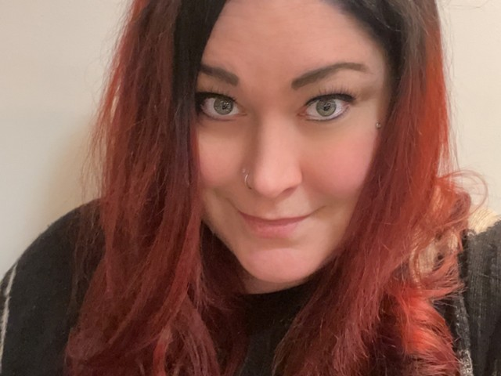
Elizabeth Klinc, KE8FMJ
OHIO Section Public Information Coordinator
ke8fmj@gmail.com

Top 5 Challenges for Public Information Officers (+ How to Overcome Them)

Emergency management, incident response, election details, program announcements, updates to transportation routes, event promotions, funding decisions, and town hall management. These are just some of the many areas of responsibility that public information officers (PIOs) can be expected to manage. No matter the government agency they work for, PIOs are essential in fostering trust between communities and the government on a federal, state, and local level.

The Public Information Officer (PIO): A Vital Role in Government
Public information officers (PIOs) are the go-to people for journalists seeking information about government agencies and managing all communication channels for outbound messaging. They play an important role in communicating with the public and the media and often act as the face of the agency they work for.

Various government agencies employ PIOs to support their communications and public relations. For example, when natural disasters occur, PIOs need to distribute clear guidelines on emergency preparedness to the public. They must also coordinate with regional agencies to share the most up-to-date information on emergency response and disaster recovery efforts.
The scope of this role goes beyond just publishing press releases. And with the PIO’s wide variety of responsibilities come many unique obstacles that can significantly impact their professional success and, most importantly, the communities they serve.

5 PIO Challenges and Best Practices for Solving Them
In increasingly complicated times, where misinformation and disinformation run rampant in social media channels and other online platforms, PIOs need to be proactive and thorough in their efforts.
Here are five of the most significant challenges PIOs face, along with best practices for overcoming each challenge.

PIO Challenge No. 1: Lacking Resources to Complete Their Tasks
As with many roles in government agencies, PIOs often have limited resources to manage their daily responsibilities. Time, personnel, and budget are often tight, so several teams may struggle to manage communications effectively.
Limitations are magnified as city budgets remain uncertain during unsteady economic times. As the Pew Charitable Trusts found, city officials are coming out of the financial uncertainty related to COVID-19. Fortunately, as federal aid is injected into cities, there is hope for more stability.
The impact of limited resources is especially notable as government communications are scrutinized as distrust builds in many communities. For example, in the wake of COVID-19, there was a lot of public distress and uncertainty, and plenty of misinformation was disseminated across various media channels. Fortunately, many discerning PIOs used best practices for effectively managing COVID-19 communications in an effort to keep communities safe.
PIOs often have to decide how to allocate their limited resources to communicate effectively with the public. For example, a PIO may need to decide whether to spend more time developing materials for a social media campaign or working on a traditional media outreach strategy. In either case, the PIO must be strategic with regard to what will have the biggest impact on their role.

Best Practice: Prioritize Communication Campaigns Based on Impact
The most important tip to follow is to focus on priorities based on each task's impact on a community. Departments may need to hold internal communication meetings to establish deadlines for specific campaigns and plan for flexibility when it comes to scheduling.

PIO Challenge No. 2: Use the Right Technologies and Establish KPIs
Data drives everything as the public and private sectors alike are investing in technologies that provide visibility on the impact and productivity of their efforts. PIOs can leverage several platforms to measure the success of their campaigns, as well as track public sentiment and much more.
However, several agencies are either behind the times in building the appropriate tech stack for their teams, or they’re not using their technology to the best of their ability. Additionally, they may be misguided on how they’re defining their success.

Best Practice: Audit Current Tech and Set Clear KPIs for Communication Strategies
Compiling a list of all technologies is a great starting point because it outlines all the tools that are being used and defines use cases for each tool.

PIO Challenge No. 3: Dealing With the Same Repeated Complaints
As we’ve established, PIOs consistently deal with an increasing number of complaints that span all aspects of government agencies. Citizens have access to more information than ever, and that access is only growing, which can contribute to confusion. This also leads to a multitude of complaints that may be repetitive. PIOs can take advantage of repetitive complaints to make a case to policymakers when it becomes clear that policy needs to change.

Best Practice: Leverage Repetitive Complaints to Become a Hero for Your Agency
Categorizing complaints and keeping records of those that are more common can help your organization address citizens’ most important concerns.

PIO Challenge No. 4: Social Media Feedback Loops
Social media feedback loops are a PIO’s nightmare. Feedback is subtle. It is difficult to regulate, and it tends to multiply. A single social media post can be the trigger for myriad comments—and comments upon comments. Once started, these loops can maintain themselves. Control the feedback, and you control the news. Collecting social media feedback, making timely decisions, and routing negative feedback to the right person is critical.

Best Practice: Have Standard Operating Social Media Policies in Place
Having a clear strategy in place to address negative feedback loops in a timely manner is an important aspect of your organization’s social media strategy. Using website and social media archiving tools can help PIOs as a part of that strategy by documenting all web activity and making it searchable in case there is a need to review previous comments.

PIO Challenge No. 5: Addressing the “Silent Majority”
Where there is a negative feedback loop on your organization’s social media posts, you can be sure there are a lot of people reading those messages without commenting or engaging. That’s why you don’t want to let comments spiral out of control and cause a vocal minority to confuse and upset other constituents.

Best Practice: Shut Down Negative Comments With Positive Information
If your organization is experiencing negative comments, negative feedback loops, and trolling in general, try to use positive information and empower users with accurate knowledge. Without engaging in negative confrontations, providing your constituents with true information, and giving them data to prove policy results can help to minimize negative comments or feedback and at the same time, minimize the number of complaints your PIOs receive.

Reprinted from https://blog.pagefreezer.com/challenges-public-information-officers-how-overcome by George van Rooyen

73,

Elizabeth, KE8FMJ
OHIO Section PIC
OHIO District 3 Emergency Coordinator
ke8fmj@gmail.com

______________________________________________

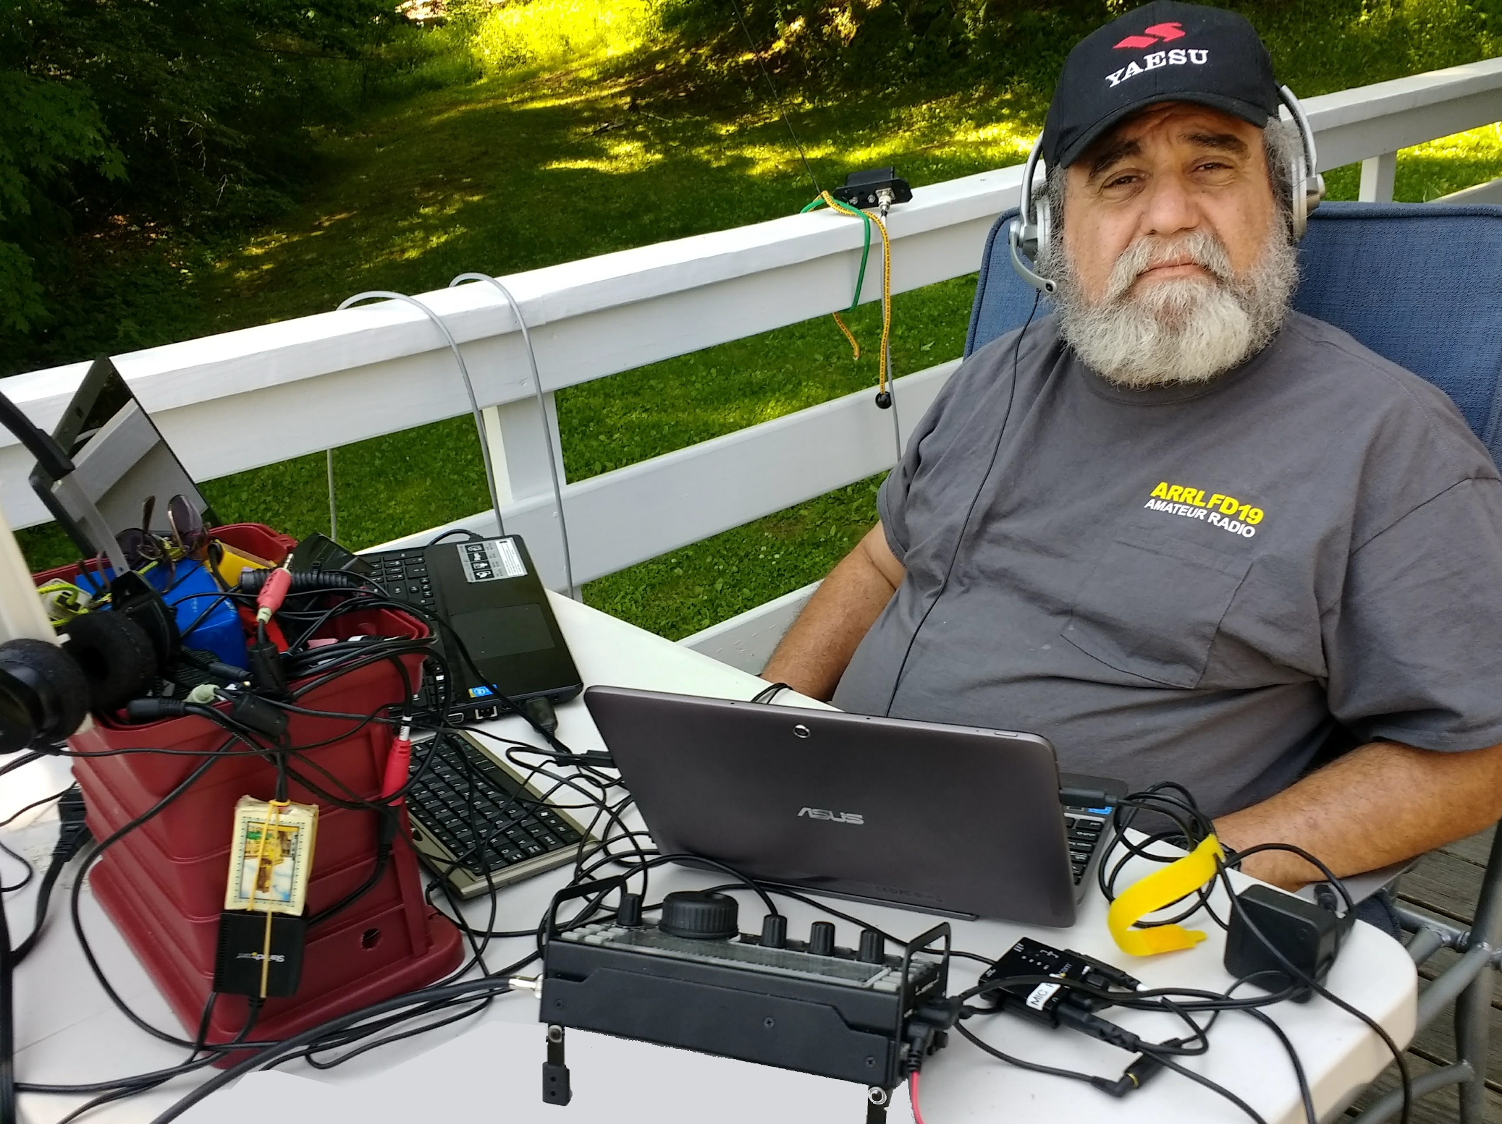
From the Ohio Section Youth Coordinator
Anthony Luscre, K8ZT - SYC k8zt@arrl.net

Holiday Gift Ideas

1. General Ideas
I recently did the annual “Holiday Gifts for Amateur Radio Operators” presentation for the RATPAC Group (www.ratpac.us). You can view the one-hour recording at https://youtu.be/lugofAJvTCQ and view the slideshow at http://tiny.cc/argifts23.

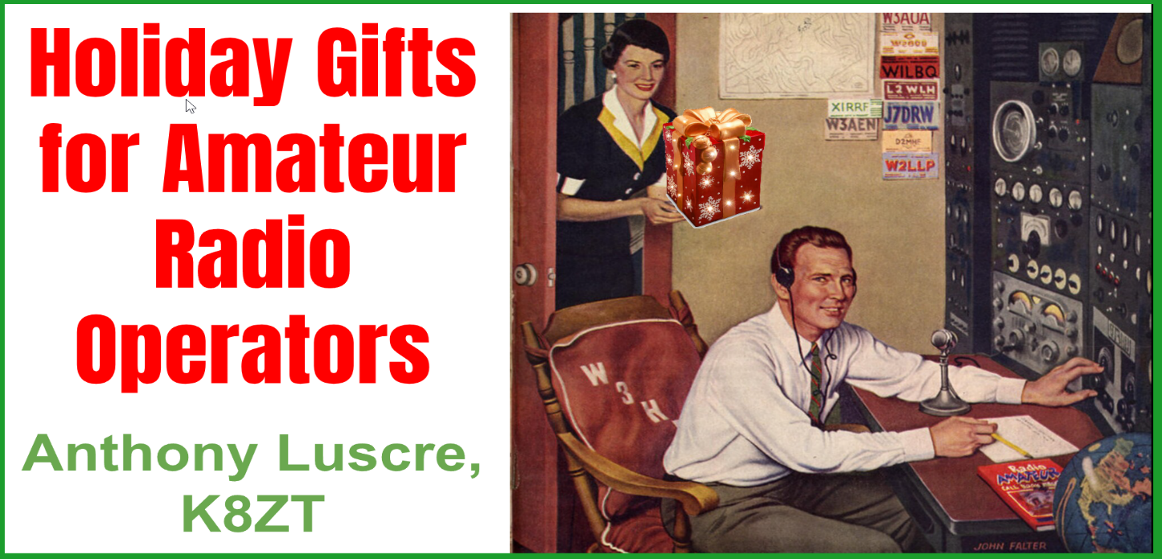

2. Introducing Youngsters to Amateur Radio- Ideas for Interesting Youth in AR
Recently, I received an email and subsequent phone call from a ham asking how he could get his kids interested in Amateur Radio. He currently has a Technician license, so I designed some of these ideas to allow him to share some communication experiences with his kids.
-------------------------------------------------------------------------
Ideas & Gifts for Involving Youngsters in Radio | Share this doc
Anthony Luscre, K8ZT- k8zt73@gmail.com | tiny.cc/yri

- Receiving - Listening to Amateur & Broadcast Radio
  - Online Software Defined Receivers- tiny.cc/freerx. No Radio or Antenna is needed. High-performance radios are capable of SSB reception with sites around the world. Links are also provided to receive commercial broadcasting.
  - Cheap Shortwave Radios
    - Ensure it has SSB (Singlesideband) receiver capability to listen to Amateur Radio voice communication.
    - You will need a wire antenna, preferably outside, to get good reception from amateurs. It does not need to be fancy.
    - Commercial Radios (I suggest one with knobs, not up/down buttons for tuning)
      - C. Crane CC Skywave SSB AM, FM, Shortwave
      - Eton - Elite Executive AM/FM/Aircraft/SSB/Shortwave Radio

Tecsun Digital PL330 AM/FM/LW/SW Worldband Radio with SSB

Tecsun PL-600 AM/FM/LW SSB Shortwave Radio, Black

Tecsun PL880 Portable Digital PLL Dual Conversion AM/FM, Longwave & Shortwave Radio with SSB
    - Si4732 Based Radio (It is basically a microprocessor combined with an Integrated Circuit)
      - ATS-20 all Band Si4732 Portable Shortwave Radio Receiver (This is just one example on eBay there are 100s of vendors with similar models in $40 to $65 price range)
      - ATS-25 Si4732 Full Band Radio Receiver FM LW MW SW with 2.4 inch Touch Screen (This is just one example on eBay of vendors with models in $60 to $125 price range. Improved version of ATS-20 with touch screen and larger display)
  - An SDR (Software Defined Receiver) Note that many of the cheap SDR Dongles are VHF/UHF only check to ensure frequency coverage includes HF (3.5 to 28 MHz). You will also need a computer, software and antenna.

RTL-SDR Blog R820T2 RTL2832U 1PPM TCXO SMA Software Defined Radio- link ~$30
    - SDRPlay- RSP1A ~$110
    - Nooelec NESDR Smart HF Bundle: 100kHz-1.7GHz Software Defined Radio Set for HF/UHF/VHF Including RTL-SDR, Assembled Ham It Up Upconverter, Balun, Adapters- link
  - Ham Radio Transceiver (used as a receiver). You will also need a power supply and antenna.
    - There are many HF Transceivers available used for a few $100s for a listing of a variety of models- link
    - A few of the cheapest new HF radios
      - QRP Labs Kits (Single HF band CW Transceiver $55 QCX+ or QCX Mini) not great for SSB due to narrow filtering but include on-screen CW decoder)
      - Xiegu G106 Sdr Hf Transceiver | 5W QRP Radio | SSB CW ~ $300
      - Xiegu G90 Hf Radio | Sdr | Qrp | Auto Antenna Tuner | 20W | SSB CW ~ $450
      - Yaesu FT-891 HF/50MHz 100 Watt All Mode ~$695
      - Yaesu FT-818 HF/VHF/UHF All-Mode Portable QRP (5 watts) Transceiver ~$650 (has 2M & 440 in addition to HF)
  - Crystal Radios
    - Power Crystal Set: No soldering required. New, boxed kit
    - Grandad Bob's Crystal Radio Set Electronics Project Kit Whizzkits Cat Whisker

Portable Crystal Set Radio Kit of Electronic Parts, Solderless
    - United Nuclear Standard Crystal Radio Kit

- Two-Way Radio (without a license)
  - Handhelds
    - FRS (Family Radio Service- License Free)

BAOFENG BF-88ST Pro Walkie Talkies 3 Pack

BAOFENG FRS Radio, USB Rechargeable Walkie Talkies

RADIODDITY FS-T3/PR-T3 [4 PACKS]

- Morse Code (CW)
  - Key
    - $2 Clothespin Key
  - Complete all-in-one Morse tutor, keyer, paddles, local two-way license free connections, etc. (would require two kits to “talk to each other”)
    - Morserino
  - Morse Code Classes
    - Long Island CW Club
      - Adults $30 Membership
      - Kids under 18 - Free
  - Morse Code Decoders
    - Apps for Arduino or iPhone

- Cheap Soldering Kits
  - Pixie 40 Meter Transceiver
  - Electric Piano DIY Kits, NE555 DIY Electronic Organ Module Electronics Soldering
  - 16-Tone Board Components Accessory Electronic Parts DIY Kit
  - DIY Metal Detector Electronic Parts Kit 60mm Non-contact Sensor Board
  - DIY Kit Mini Tesla Coil Plasma Speaker Set Electronic Field Music
  - FM Stereo Radio Module With Microphone DIY Kit
  - AM/FM AM Radio Kit Parts CF210SP
  - AM/FM Radio - DIY Solder Kit - Soldering Required

- Satellites (You can work these with your Tech License or just listen with no license). See Technicians, Life Beyond Repeaters… (starting around slide #31)
  - Required
    - Radio or radios capable of receiving and transmitting on 2 Meters and 440. FM is fine for many of the satellites, including the ISS) Dual Band HT will work fine
    - Dual Band Antenna
      - Arrow Antenna
      - Elk Antennas
      - Moxon-Yagi Dual band VHF-UHF antenna- link
      - Vertical dipole, with crossed full-wave loops- link
      - VE2ZAZ Arrow-Style Portable Sat. Antenna- link
      - $4.00 Ham Radio Satellite Antenna- link
      - $4.00 Ham Satellite Antenna Modifications- link
      - WA5VJB- Cheap Antennas for the AMSAT LEO's- link
    - Way to track Satellites
      - Free Online sites
        - Heavens Above
        - N2YO.com

- Even More Ideas
  - Ham Radio Youth Resources Website- www.k8zt.com/youth
  - RATPAC Holiday Gift Guide- includes youth including books & other ideas
    - Video Recording tiny.cc/ratpac-list
    - Slideshow- tiny.cc/argifts23

-------------------------------------------------------------------------

That’s it for this month; I hope to work you on the air soon, maybe on HF!
73,
Anthony, K8ZT (k8zt@arrl.net)

____________________________________________________

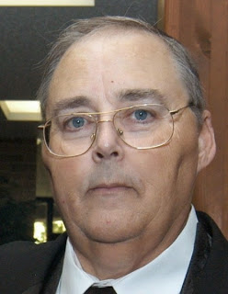
From the Section Traffic Manager David Maynard, WA3EZN – STM
wa3ezn@att.net

Two down and two more holidays to go:

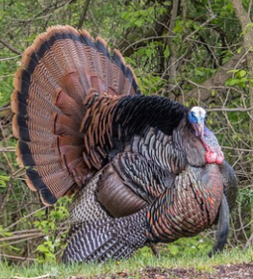

My apology to BRTN, I seemed to have had some difficulty updating the net information so here goes.

The B R T N
The Burning River Traffic Net meets every Monday, Thursday and Saturday at 9:30 PM local time on the W8HF repeater*. The remaining days of the week this net is called up on an as needed basis. The purpose of this net is to handle formal written traffic to and from the Cleveland area and all of North Central Ohio. Also to provide training in traffic handling procedures. They welcome all radio amateurs regardless of your level of traffic handling experience. You do not need to be a proficient traffic handler to check into the net, they will train you. The net controls for these evening nets are;

Monday - Dave, -W8DJG
Thursday - Mike, -K8MWF
Saturday - Net Control Station needed

* Primary; W8HF /R - 145.230 MHz Minus offset. PL 110.9
* Secondary; KC8BED /R - 147.150 MHz Plus offset. PL 110.9
* Really bad days; 146.490 MHz Simplex

The Burning River Traffic Net (BRTN) was started in the mid to late 70's by Will Wilson, -WA8HED (SK) and others. Records indicate that Will was the Net Manager from 1979 until 1997. In 1997 both Will and Ron West, N8OD, formerly N8RBE shared the Net Manager role. In December of 1997 Lew Parsons, N8IXF (SK) took over the Net Manager position until only his health no longer allowed him to do so in June of 2012. At that time, he appointed Dave, -W8DJG to be Net Manager. The BRTN is over forty years old and still going strong.

TIS THE SEASON FOR LISTS
Not to spoil the mood but shortly after Thanksgiving comes Christmas. I think a review of my Christmas Hint list is in order. Here is a list of places to leave that hint so your significant other will be sure to find it.
I doubt that many of you will get them to buy you that $2000 HF rig but maybe a new mobile rig or a Hiel headset with microphone or an ARRL membership. How are they going to know what you want if you don’t “hint” them?
If I understood the email from the ARRL there would be no more QST magazines mailed starting in January.
Here are a few suggestions where to leave him or her you hint so you get the ham radio items you want for Christmas. You can use a page from a catalog or magazine to be:
Taped to their car steering wheel.
Taped on their cereal box or coffee cup
Taped on the bathroom mirror
Leave the store catalog on the coffee table open to the right page
Clipped to the lamp on the nightstand
Taped to the door going to the garage or outside
Put a hint in her underwear drawer. Note: this doesn’t work for men
Put one on his or her computer monitor
Pin one to their pillow
Talk about it every chance you get
I am sure that if you think real hard you can come up with some good “HINT” places of your own.
If you're not going anywhere on New Years, here is something fun to try. The ARRL Straight Key Night is coming up on January 1, 2024. Why not dust off that old straight key and give it a try. Who knows you may like it and have some fun. Straight Key night starts at 0000Z and ends at 2359Z (UTC). The ARRL says that every day is a good day to send CW, but January 1 is reserved for Straight Key Night. Enjoy CW as it has been sent and enjoyed since the earliest days of Amateur Radio. This 24-hour event is not a contest; rather it is a day dedicated to celebrating our CW heritage. Participants are encouraged to get on the air and simply make enjoyable, conversational CW QSOs. The use of straight keys or bugs to send CW is preferred. There are no points scored and all who participate are winners. More details can be found at www.arrl.org/straight-key-night .
Another fun things to do:
ARRL10 Meter Contest: Second full weekend of December. Starts 0000 UTC Saturday; runs through 2359 UTC Sunday (December 9-10, 2023).
More information and contest rules can be found on the ARRL website at http://www.arrl.org/contest-calendar.
Another fun thing to do is to check into one of these traffic nets and send friends and family a nice holiday radiogram.
As an additional traffic handling note the OSSBN is in need of stations to receive and deliver traffic from their net into the Dayton, Chillicothe, Portsmouth, southern Ohio and several other areas. If you have HF privileges and can help please check into the OSSBN on 3972.5 at one of these net times: 10:30 AM, 4:15 PM and 6:45 PM. You will meet a great group of operators and will learn a skill that will be valuable in times of emergencies.

OHIO SINGLE SIDEBAND NET

Morning session | 10:30 AM | 3972.5 KHz | every day
Afternoon session | 4:15 PM | 3972.5 KHz | every day
Evening session | 6:45 PM | 3972.5 KHz | every day

OHIO HF CW TRAFFIC NETS

HF CW NETS | NET TIMES | FREQUENCY | NET MANAGERS
Buckeye Early | 6:45 PM | 3.580 | N2LC
Buckeye Late | 10:00 PM | 3.590 | WB9LBI
Ohio Slow Net | 6:00 PM | 3.53535 | N2LC
All CW net frequencies plus or minus QRM

OHIO LOCAL VHF FM TRAFFIC NETS

VHF NETS | NET TIMES | FREQUENCY | NET MANAGERS
BRTN | Monday, Thursday Saturday 9:30 PM | 145.230 PL 110.9 | KD8GXL
COTN | 7:15 PM DAILY | 146.970 PL 123.0 | KV8Z
TCTTN | 9 PM Sun, Tues, Fri | 147.015 PL 110.9 | WB8YYS
TATN | 8:00 PM DAILY | 146.670 PL 123.0 | WG8Z

OHIO VHF TRAFFIC NETS
BRTN Burning River Traffic Net serving Cleveland and North Central Ohio
COTN Central Ohio Traffic Net serving Columbus and Central Ohio
TATN Tri-State Amateur Traffic Net
TCTTN Tri-County Traffic and Training Net serving Northeast Ohio
WHAT IS A DIRECTED NET
A directed net like the OSSBN has a net control station that is in charge of the net. He or she calls for check-ins in a specific order. Therefore all stations should do like we were told as children; you do not speak until spoken to. And by that I mean you check in with your call sign when the net control station asks for check-in. That goes for the evening net where check-in is by area. If you miss the time to check in during the call for your area check in when the net control says “any other stations inside the state.”
And now on the more serious side of traffic handling, here is a list of things that I hear on the OSSBN that are just wrong. We all need to make improvements and become more efficient.
Please roger my traffic…just say “number”
Please copy number…. just say “number”
Today’s date…just give the date
Going to…..is not an NTS pro-word don’t use it
Going to your station….just give them the call
Break for text…. just say “break”
Break for signature…just say “break”
End number………just say “end”
Roger number…..just say “roger”
Roger your traffic... just say “roger”
Common text…. Is not used anymore it is “BOOK”
Common parts…. is not an NTS pro-word just say “BOOK of”
On the phone nets the pro-word that the receiving operator uses to signify that he/she has copied the radiogram 100% correctly is “Roger”. QSL is used on CW nets and NOT on phone nets. The proper way to end a radiogram is “end” unless it is the last radiogram in a book. Then it is “end book.” In between radiograms in a book you should use “break” to signify the end of that particular radiogram in the book. Wait for the receiving station to say “roger” before continuing. It is redundant, and not efficient to say, “I roger your number 2364, routine.” Just say, “Roger.”
Ok, why all the fuss? Why are we pushing these rules? There is a very simple answer. If we all follow these rules it simplifies the net and makes the net move faster. It also helps the other stations on the net and the net control station by saying what they expect to hear. Like I have often heard, use the KISS system, Keep It Simply Simple.
And not to return replies to received messages.
I would like to remind our traffic handlers about handling instruction HXC. If you deliver a radiogram to the addressee with this handling instruction you are to send the originating station a delivery report. This can best be done by using ARRL routine messages forty seven and sixty seven.
In ARRL sixty seven you are to report the message number and the reason for non delivery. It is also very helpful when reporting non delivery to include the phone number if it was not a good number. This allows the sending station to know that the correct number was received by the delivering station
I also want to remind those sending traffic reports or responding to HXC requests that brevity is the best policy. Your message should only contain the necessary words to convey your meaning.
ARL SIXTY SEVEN states:
“YOUR MESSAGE ______ UNDELIVERABLE BECAUSE OF ________. PLEASE ADVICE”
Therefore your message TEXT should look like this:
ARL SIXTY SEVEN 123 NO OUTLET
When reading the message text to a recipient it would be read:
Your message 123 is undeliverable because of no outlet Please advise.
Here are examples of poor HXC messages.
Your message 123 to John Henry was undeliverable because no one would take the message and I tried four times, sorry
In ARRL forty seven you are to report the message number, who it was to and the date and time of delivery.
An HXC message text should be as simple as this text.
ARL FORTY SEVEN states:
Reference your message number ____ to ____ delivered on ____ at ____ UTC.
Therefore a good message would be:
ARL FORTY SEVEN 123 KE8XXX OCTOBER 31 1713 73
If you are not going anywhere on New Years here is something fun to try. The ARRL Straight Key Night is coming up on January 1, 2024. Why not dust off that old straight key and give it a try. Who knows you may like it and have some fun. Straight Key night starts at 0000Z and ends at 2359Z (UTC). More details can be found at www.arrl.org/straight-key-night .

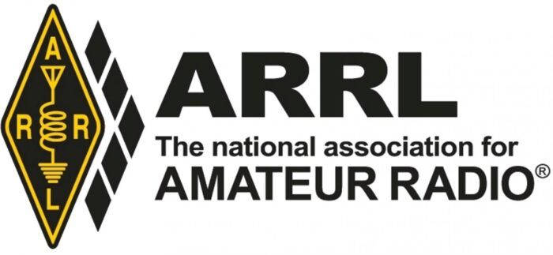

Wishing you all the best for the holidays

73
David WA3EZN
Ohio Section Traffic Manager
wa3ezn@att.net

__________________________________________

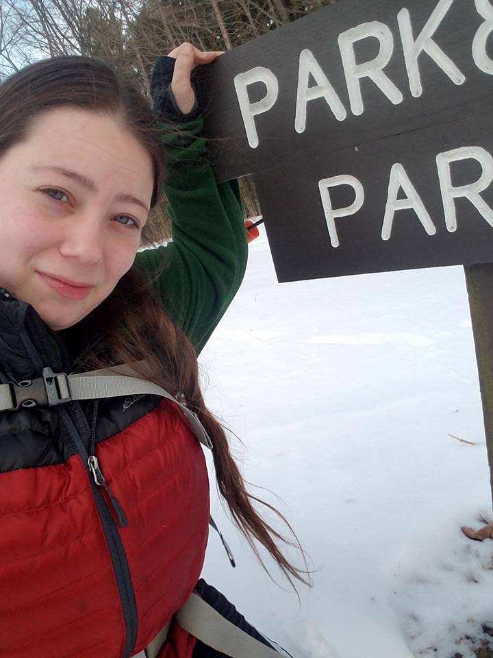
From the Section Affiliated Clubs Coordinator - ACC
Amanda Farone – KC3GFU
Afrone926@gmail.com
330-509-4095

With Thanksgiving behind us, our clubs should be turning their focus towards their annual holiday parties. The holiday party should be a time for FUN and a time to look back on all the great accomplishments your club has made over the last year. I see a common theme with clubs right now, stuck in a rough patch but finally starting to see a rise in things. Covid took a toll on many clubs within our section, like everything else in the world. I see many clubs working hard to revive themselves, coming up with innovative ideas to attract members and participation, and I think most clubs are going through some changes. If this sounds like your club, you are not alone! As we end this year, take a look back to where you started the year versus now. Do you see improvement? Do you see new faces at your events or meetings? If so, great job! You are making progress toward becoming a thriving club again and if you continue making those small steps, soon enough you’ll be where you want to be. For now, appreciate those that are going above and beyond their volunteer duties to make your club exactly what you want it to be.
As the year comes to an end, I want to remind everyone to please take a look at your affiliation status and your ARRL listed Club Information. If you need help renewing your affiliation, please reach out to me and I will gladly assist with that. Most clubs just held their elections for the upcoming term, please be sure to update all club information on the ARRL so that anyone interested can easily find your club information. You must be an ARRL member as well as a current listed Officer of the club in order to edit the information. Should you need assistance updating, again, please reach out to me. After the first of the year, I will be reaching out to those who have not updated, so please at least make sure the contact information listed is correct. If you are unable to update the information yourself but see that your club information is not correct, shoot me an email.
I want to remind everyone about the 16th Annual Santa Net. This is a great resource to use for members to get their younger relatives on the air and create a memorable experience. It is also a great tool to use for clubs to interact with their communities in a positive way. The Santa Net runs every evening from Thanksgiving until Christmas. Beginning at 7:00pm CT on 3.916 MHz you can check in 30 minutes before the Net begins. The voice of Santa will respond to each check in. The Santa Net is a team effort by the 3916 Nets members, and they’re expecting over 1,000 contacts this year. It is also streamed live on YouTube.
As a final piece of information…if you read the PostScript regularly, you have seen Tom (Section Manager) say time and time again, 2024 is the year of the Club! Starting with the first OSJ in 2024 I would like to feature an Ohio Section Club. By doing this, I will be reaching out to the chosen Club’s President (or other officers) and asking for a brief interview so I can showcase all of the fantastic things your club does. Club’s will be chosen at complete random, however only ARRL Affiliated Club’s will be eligible. As part of this, the chosen club will also have me at their disposable to help accomplish any task needed, get questions answered that they have been letting sit on the back burner, etc. Anything I can personally do to help your club, within reason, I will do my best to accomplish. Of course, I am ALWAYS available to help your club with whatever is needed or to answer questions, but if your club is the featured one for that month, I will force myself upon you, hihi.

__________________________________________

National News
(from ARRL and other sources)

Giving Tuesday: The Future of Amateur Radio Needs You
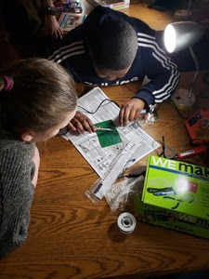
Giving Tuesday is a great day to join others in their support of amateur radio and ARRL by giving back!
Donations made to ARRL on GivingTuesday provide vital support in all that we do for amateur radio, including reaching the next generation of amateur radio.
Education and outreach are at the heart of what we do.
The future of amateur radio depends on the next generation getting introduced to these principles, and ARRL is committed to reaching and inspiring the next generation of amateur radio--our youth.
Your generous donation will help enable programs that provide pathways into successful science, technology, engineering, and mathematics (STEM) careers for young people through radio communications and radio technology.
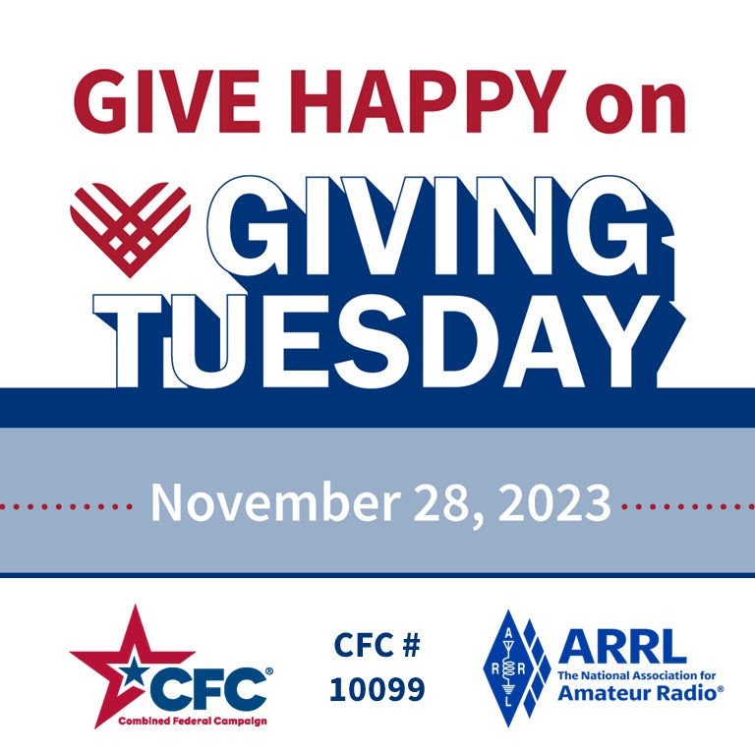

Tucson Amateur Packet Radio, Inc. (TAPR) will hold an online Mini-Digital Communications Conference on December 9, 2023, from 1700 to 2230 UTC (1200 to 1730 EST, 0900 to 1430 PST).
Log in details for the conference will be available at https://tapr.org prior to December 9. TAPR is an international amateur radio organization that was founded in Tucson, Arizona, in 1981 by a group of amateurs interested in developing a terminal node controller (TNC) for amateur use. Presentations during the conference will include:
- TAPR Software Defined Radio (SDR) Development Progress and Challenges by David Larsen, KV0S
- Developments in KA9Q Radio by Phil Karn, KA9Q
- An Open Source Wideband HF Receiver Design by David Witten, KD0EAG
- An Inexpensive Global Positioning System Disciplined Oscillator (GPSDO) for HF Receivers by John Ackermann, N8UR
- Current Open Source Digital Voice Techniques by Walter Holmes, K5WH
- A Low Cost FreeDV-based ESP32 Radio Interface by Mooneer Salem, K6AQ
- ESP32 Automatic Packet Reporting System (APRS) and Long Range (LoRa) Hardware by Jason Rausch, K4APR
____________________________________________________

The 2023 SKYWARN Recognition Day (SRD) is December 2 from 0000z to 2400z.
The event honors all SKYWARN storm spotters and amateur radio operators for their contributions to the National Weather Service (NWS) during severe weather. Amateur radio operators also provide vital communication to the NWS and emergency management when normal communications fail.
The National Oceanic and Atmospheric Administration (NOAA) website is now updated with the SKYWARN registration form, mapping form, and rules and information you'll need to check in for this year's event. Information can be found at,
https://www.weather.gov/crh/skywarnrecognition .
It's important to review the following event resources on the NOAA website:
+ Operating procedures
+ Participant registration lists
+ SRD 2023 contact log sheet
+ SRD 2023 NWS office contact log sheet
+ SRD 2023 NWS operational details
+ Social media planning document
SRD was developed in 1999 by the NWS and ARRL. Amateur stations exchange contact information with as many NWS stations as possible on 80, 40, 20, 15, 10, and 6 meters, plus the 2-meter and 70-centimeter bands. Contacts are also permitted using repeaters. Non-amateur radio spotters can exchange information with NWS offices using social media.
To learn how to become a trained NOAA storm spotter visit Spotter Training at, https://www.weather.gov/pdt/spotterTraining .
In 2022, more than 5,000 spotters participated in SKYWARN Recognition Day.

__________________________________________________________

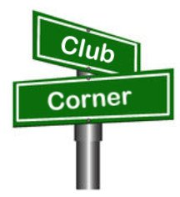
Club Corner

This is YOUR corner of the newsletter. Send us what your club is doing, and we’ll make sure that it gets in. Got a special event or club project that you want everyone to know about? Send it to us!. Need help with a project? Send it to us.

Let us know what you club is up to. Are you going to have a special guest at your meeting or are you having a special anniversary?

Send it to: webmaster@arrl-ohio.org

__________________________________________________________

Free Amateur Radio License Upgrade Classes
Jim Grover, N8PZL
Frank Tompkins, W8EZT
Anthony Luscre, K8ZT

General Class

The Cuyahoga Falls Amateur Radio Club will again offer online classes to pass the FCC General Class Exam. The classes will be held via Zoom on six Sunday afternoons from 1:30 to 4:00 PM. The first class will start on Jan 14th. The classes are free and available to all interested hams with Tech licenses or studying to complete their Tech license by the end of the
classes. Class materials will be distributed via Google Classroom, and the suggested book is “General License Course Study Guide” (2023-2027 edition), available from HamRadioSchool.com. If you have your Tech license, this is a great way to expand the bands and modes you have access to. It will also provide a lot of practical information on Amateur Radio.

We need you to spread the word if you already have your General or higher license. Please contact friends, relatives, etc., who have Tech licenses and invite them to this class. Please feel free to print out the following page and send it to them, post it at your nearby library or any other spot around town that may have interested viewers.

We will have just completed our fall Tech Class with 20 attendees on Nov
12th. We will have another Tech Class next fall or if we have enough
demand before then.
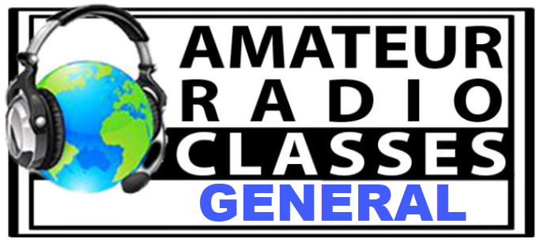

The Cuyahoga Falls Amateur Radio Club
offers free live online classes to get your
Amateur (Ham) Radio General Class
License. Classes start on Jan. 14, 2024.
For information, visit-

tiny.cc/beahamg

What is Amateur (Ham) Radio?- tiny.cc/wiar

VE Sessions

The following information is for ALL exam sessions:
It is now an FCC requirement to have an FCC FRN; active email address and active phone number before taking any exam. Please bring your FCC FRN, original license, a copy of your license (if a licensed ham), a valid photo ID and $15.00 - Cash preferred.
Effective April 19, 2022, the FCC will charge a $35.00 application fee for amateur radio licenses. The fee will apply to new, renewal, rule waiver, and modification applications that request a new vanity call sign. License upgrades will not have a fee applied. The fee will be per application. VE's will not collect the fees at exam sessions.
If you are applying for your first license, please go to http://apps.fcc.gov/cores/userlogin.do and obtain an FRN. This website is self-explanatory and the FRN registration is free.
All Things Amateur Radio Association (ATARA)
We host testing sessions every second Tuesday of the month in Lancaster. To sign up please visit our website https://atara-w8atr.fun and contact us at hamexams@atara-w8atr.fun.

Butler County Amateur Radio Association W8WRK
Laurel VE Testing Session - hosted by DIAL amateur radio club
Amateur Radio License Examinations at 9:00AM on Sunday April 29th at Fairfield Township Administration Building 6032 Morris Rd. Hamilton, OH 45011. Pre-Registration is required, go to: www.qsl.net/w8blv click on Exams and follow the instructions. Additional info may be obtained from Thurl Golden, KD8VLU (513) 939-4891 tgolden@fuse.net or Ron Spaulding, N8QF, (513) 617-6181 or n8qf@roadrunner.com . There are no Exam Fees!

CARS
VE testing from CARS - Cuyahoga Amateur Radio Society - at Elmwood Recreation Center, 6200 Wisnieski Parkway in Independence, Ohio 44131 Time: 9:15 AM (Walk-ins allowed) Always the 2nd Sunday of the odd month. Go to CARS www.2cars.org for detailed map of location. Call Metro W8MET 216-520-1320 for details

Clark County Amateur Radio Association (CLARA) What: CLARA sponsored A.R.R.L. VE Testing - Walk-ins allowed. Pre-Register via email preferred. When: On every second Saturday of each even numbered month starting at 10:00 AM Feb 11th; Apr 8th; Jun 10th; Aug 12th; Oct 14th; and Dec 9th, 2023. Where: Springview Government Center - Emergency Operations Center; 3130 E Main St; Springfield OH 45503 This is US-40 aka "old national road". From Route 40 enter Old Columbus Road, at the fork stay left driving straight onto Ogden Rd, then immediately turn left into the parking lot behind the EMA. Walk to the door with the "Employees Only" sign.
For more info contact Roland Ude, W8BUZ, (937) 605-4951 Email buzz@baylorhill.com
Central Ohio Radio Club (CORC)

VE TESTING PRE-REGISTRATION ONLY
Date: Saturday October 21, 2023
Time: 10:00 AM (Registration Opens 10-1-2023)
Location: Westerville Fire Dept Station 111

Training Room
400 W. Main St
Westerville OH 43081-1436

Go to: www.ae8fp.net for complete registration information
Dayton Amateur Radio Association (DARA)
If you are interested in testing for a new or upgraded license, please come see us at the DARA Clubhouse. If you have questions about testing, please email exams.w8bi@gmail.com

Dial Radio Club, Middleton, OH
Will offer Amateur Radio License Examinations at 6:00PM on Wednesday March 1st at St. John XXIII Elementary School, 3806 Manchester Rd., Middletown, OH 45042. Pre-Registration is required, go to: www.qsl.net/w8blv click on Exams and follow the instructions. Additional info may be obtained from Dave Williamson, KD8W, (513) 424-5819 or kd8w@ARRL.net or Ron Spaulding, N8QF, (513) 617-6181 or n8qf@roadrunner.com . There are no Exam Fees!

Geauga Amateur Radio Association (GARA)
Amateur License exam sessions are offered for all license classes (Technician, General, Extra). Walk-ins are always welcome - no prior registration is required. No fee for the exam.

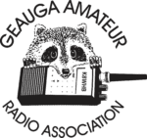
The GARA schedule of exams are these Sundays at 2pm. Dates for 2023 are January 15th, March 19th, May 21st, July 9th, September 10th, and November 12th.

Exams are held at the Geauga County Department of Emergency Services and Emergency Operations Center, 12518 Merritt Road, Chardon, Ohio 44024. The EOC is located just south of the University Geauga Hospital and just east of the Geauga County Safety Center (Sheriff's Office), off of State Route 44 between State Route 322 and State Route 87 on Merritt Road.

Please arrive a few minutes before 14:00 to allow adequate time to process the necessary paper work and take your test. Bring your 1) photo ID, 2) email address, 3) FCC FRN, 4) a printout of your current license if taking the General or Extra exam.

Additional info may be obtained from Jim Mekeel, KE8EMP, email KE8EMP@gmail.com or the Geauga Amateur Radio Association website https://geaugaara.org

Huber Heights Amateur Radio Club
Huber heights amateur radio club does ARRL VE testing the second Saturday of each even numbered month. Feb, Apr, Jun, Aug, Oct, Dec. 9:30-11:00 For more information contact Jim Storms – AB8YK at ab8yk@hotmail.com

The Lake County Amateur Radio Association
The Lake County Amateur Radio Association is holding its 2024 Amateur Radio license exams at the Kirtland Library, 9267 Chillicothe Road, on the following dates:
Saturday. February 3 Saturday, August 3
Saturday, April 6 Saturday, October 5
Saturday, June 1 Saturday, December 7

This bi-monthly schedule is the first Saturday of every even-numbered month (e.g., February being the second month, etc.). They are held at the Kirtland Library, 9267 Chillicothe Road. It is 1.7 miles south of I-90 on Route 306 (Chillicothe Rd). The library is on the left, just beyond the Marathon gas station. The tests will start at 12 noon. Please arrive a few minutes earlier.
To register, you will need a NCVEC 605 Form, which will be available at the test. If you would like to complete one ahead of time, be sure it is the Sept 2017 version or later. You can find it by Googling “NCVEC quick-form 605” and clicking on the url for a pdf of the form. Please note the FCC requires you to provide a FRN (FCC Registration Number). Social Security Numbers are no longer accepted. If you are new to ham radio and don’t have a FRN, Google “New FRN” and follow the fcc.gov link.

If you are currently licensed, be sure to bring a copy of your license to the exam. The cost of the exam itself is $15.00, and if you wish to pay by check, it should be made out to the ARRL/VEC. Identification with your picture is also necessary, such as a driver’s license. If you have any questions, please contact Scott Farnham, KO8O, at (440) 256-0320, or scottfarnham@roadrunner.com

In addition to the $15 test fee, the FCC now charges $35 to add you to the Amateur Radio database. The FCC will e-mail successful candidates instructions for payment directly to them. Payment must be made within 10 days of the e-mail. This charge does not apply to upgrades.

The Lancaster and Fairfield County Amateur Radio Club (LFCARC) hosts exam sessions at the FAIRFIELD County EMA, 240 Baldwin Dr in Lancaster Ohio, 43130, on the first Saturday each month at 10:00 am. Please visit our website at http://www.k8qik.org for exam dates on our calendar and navigate to our Learning Center/Taking the Exam link for information and requirements. Our experienced VE team looks forward to serving the Amateur Radio community in Central Ohio. Contact me at ve_testing@k8qik.org to register.
Lisbon Area Amateur Radio Association Beginning Feb 11, 2023 Testing on the 2nd Saturday of each month at the Columbiana County EMA located at 215 S Market St. Lisbon, OH 44432. Walk-ins OK. Check in at 1:00PM. For more information go to www.K8GQB.com or contact NN8B at nn8b.oh@gmail.com
Madison County The Laurel testing group will offer testing on the first Thursday of January, March, May, July, September and November. Tests are held at 7:00PM at the Madison County EMA located at 271 Elm St. London, OH. No fee.
The Milford Amateur Radio Club (MARC)
VE testing is held the third Thursday of each month at 6:00 PM. Location; Miami Township Civic Center located at 6101 Meijer Drive, Milford, OH 45150.
Please pre-register at www.milfordhamradio.org

Northern Ohio Amateur Radio Society (NOARS) VE sessions are held the first Saturday of odd-numbered months (EXCEPT FOR March and July) at 10 AM in the North Olmsted Library, 27403 Lorain Rd., North Olmsted. Registration is preferred, but walk-ins are welcome. For more information or to register, contact Elaine, KC8FOS at ewilkinson1951@gmail.com. There will be a VE session held March 12th at the NOARS Winterfest held at Lorain County Community College in the John A Spitzer Conference Center, 1005 Abbe Rd N, Elyria, OH 44035. Please email Elaine – KC8FOS at ewilkinson1951@gmail.com to register.

Portage County Amateur Radio Service (PCARS)
The first Saturday of every even numbered month -10 am – at the PCARS club site in Ravenna. Please visit the PCARS web site and check out the information about VE testing in the latest newsletter at www.portcars.org .
If you have any questions, don’t hesitate to contact me at KB8UUZ@gmail,com
Tusco Amateur Radio Club W8ZX

VE Testing sessions are held on the second Saturday of every even numbered month at the Dover Faith Church, 420 N Wooster Ave, Dover, OH 44622. Pre-registration is not necessary. Doors open at 0830 for registration, exams begin at 0900. Cost is $15. You are required to have an email address and a copy of your FRN or current ham radio license. For more information please go to www.w8zx.net/exam or email VETEAM@N8BAG.NET.

West Chester Amateur Radio Association (WC8VOA)Exam sessions are held one Saturday each month at 10:00 AM-Noon at the VOA Bethany Relay Museum located at 8070 Tylersville Rd, West Chester, Ohio 45069. For more information and links to register, please see our website: https://wc8voa.org/licensing/

______________________________________________________________

Important Links
ARRL Home: www.arrl.org
Find an ARRL Affiliated Club: www.arrl.org/clubs
Find your ARRL Section: www.arrl.org/sections
Find a License Class in your area: www.arrl.org/class
Find a License Exam in your area: www.arrl.org/exam
Find a Hamfest or Convention: www.arrl.org/hamfests
Email ARRL Clubs: clubs@arrl.org

____________________________________________________________________________

The Ohio Section Youth Net

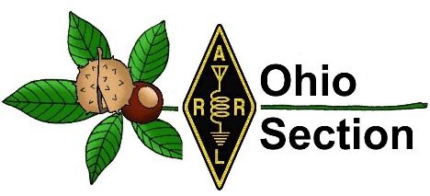
Youth Net
When: The second Sunday of every month at 7:30 PM EST
Where: The K8IV repeater located in Kent, Ohio (Echolink node K8BF-L) RF: 146.895 Mhz with PL 118.8
Who: Any licensed amateur radio operator who wishes to participate. Priority will be given to youth stations and those located in Ohio.
The purpose of this net is to encourage youth activity in amateur radio and to help new hams get more comfortable on the air.

***Next Net is Sunday January 14th, 2024 ***

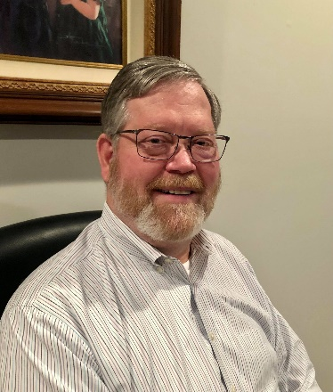
DX This Week – Hex Beam
Bill - AJ8B (thedxmentor@gmail.com or www.aj8b.com )

I hope that you had a restful and fun Thanksgiving Holiday. I hope you filled several band slots and worked a couple of All Time New Ones in the CQWW CQ DX Contest.
I received some QSL cards this past week including 9Q2WX, Vlad from the Democratic Republic of the Congo, PJ4RF, Rinse Visser from Bonaire, 7P8WW, YL2GN DXpedition to Lesotho, and BW2/JP1RIW, Kenichi from Taiwan. Let me know what you received.

 | 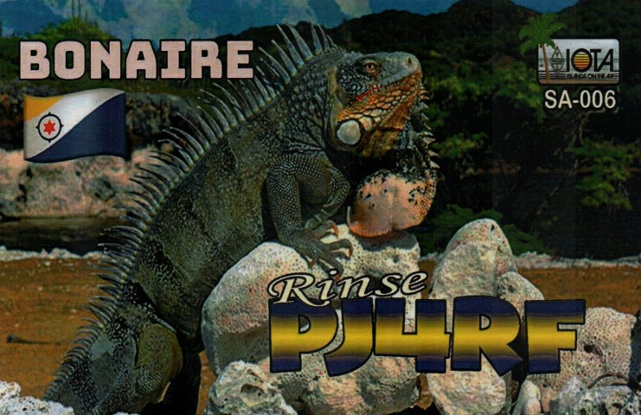
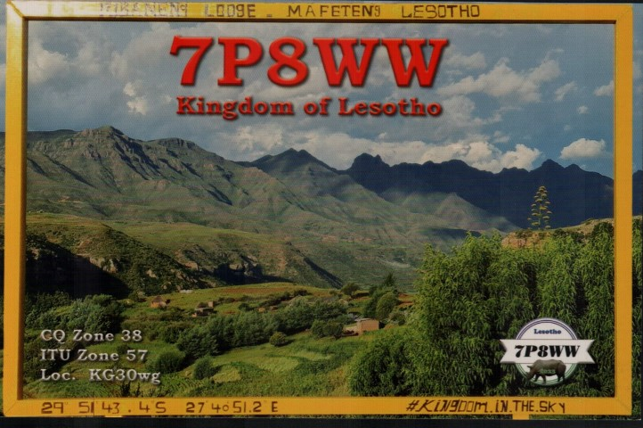 | 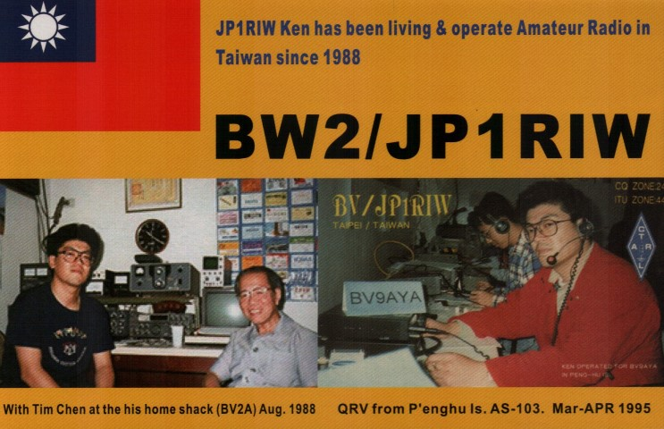

I received an email from Teresa, KA9IFQ. She said that she read about a “Hex Beam” that I was putting up. She wondered what that was and if I had finished the project.
Well Teresa, instead of my normal rambling, I found the following definition on the Karinya.net website. “The Hexbeam is a great little antenna! It should be high on your list of options if you want a design that can be "multi-banded", exhibits useful gain and directivity, is very lightweight, has a small turning radius, all of which lends itself readily to "Do It Yourself" construction.”
It is called a HEX beam as it has 6 sides to it. It is a 2-element beam on 20 through 6 meters. Putting it together brought back memories of helping my dad with his 20-meter quad. The antenna that I have is the K4KIO hex beam. DXEngineering, MFJ, and others have antennas and kits.
I was able to finish it completely two weeks ago in time for the CQWW CW DX contest. Normally I wait until the weather turns cold and wet before working on an outside project. However, this time, I finished a day before the first real cold front moved in. As the saying goes, “If your antenna didn’t blow down last winter, it wasn’t big enough.:”Thanks for that question, Teresa.
If you have a question that you would like to have answered, just send an email to me at thedxmentor@gmail.com

DAH DIT DIT DIT DAH DAH DIT DIT DIT DAH

Here is an update from Bernie, W3UR, of the DailyDX and the WeeklyDX, and the How’s DX Column in QST. The DailyDX the best source for real-time DX information. http://www.dailydx.com/ . Bernie has this to report:

Moise, F4EZG, has announced plans to go to Nosy Faly, Madagascar which has the IOTA designator of AF – 057, as 5R8VE from November 11th to December 3rd which means he should be QRV as you are reading this. Activity is expected on SSB and FT8 on 20-10 meters. QSL via F4EZG.

I have mentioned for several weeks that I am anticipating this one and here it is. The team arrived in Vientiane, Laos, with all their equipment. They were unable to get all the antennas set before sunset on the first day. However, they have them up now.
The antennas are now installed, and the antenna farm is set up of:
- Hexbeam #1 10-15-20m @15m (with triplexer)
- Hexbeam #2 12-17 @14m
- VDA 17m
- VDA 12m
- Quad 1el 15-10m
- 4square 40m
- Vertical 160m
- BOG RX

I hope to get them in the log soon.

The PR0T DXpedition to Trindade and Martim Vaz Islands which began on November 16th finished on November 20th @ 0600z.
They were active for a total of 84 hours or 3 days and 12 hours of full on-the-air operation. The team, consisting of 3 on the island operators and 13 remote ops made a total of 18,702 QSOs.
On the last night the team delivered a surprise for all chasers, showing up on 80m SSB and CW! The team is already onboard and headed home.
They want to express their gratitude for all QSO´s, Sponsors and Supporters.
This was an amazing experience, and the results are well expressed by the numbers, including a great number of uniques worked – almost 50% of all QSO´s.!
QSL Manager is M0OXO. The full log has already been uploaded to Clublog.

Here is a quick update on the current DXpedition to the H44, Solomon Islands. They posted "It was a successful first day on 160M, but we will probably have to stick mostly with FT8 due to noise. CW is possible on 80m, and we will continue 80M CW. We have also started 60M F/H.
Going forward we will look for frequencies in the General/Advanced portion of the bands. At times we will be listening up in those bands. "

How about an example of some good will and DX teamwork. Rolf, DL7VEE, says the six-man team from T2C has donated some antenna parts to Antoine, 3D2AG, as they traveled through Fiji. Antoine has ordered parts for his broken 18M Spiderbeam pole from Germany. Spiderbeam is donating the parts, but shipping from Europe is expensive.

I also have an update on the upcoming DXpedition to FW, Wallis and Futuna Island. Jacky, ZL3CW, arrived in Noumea yesterday afternoon and departed for FW early today. He is now QRV as FW2CW from Wallis until November 30th, CW only, focusing on the WARC bands, and then getting in the CQWW CW. It will be callsign FW2CW before and after the weekend and FW5N on the weekend. QSL through OQRS and LoTW.

I have some sad news to pass along. One of my first rare DX contacts was with 3B8CF, Jacky, on Mauritius Island. He was very kind, and we had some excellent QSOs over time. I worked Jacky 13 times between 1987 and 2017. He passed away on November 17th. He had been a regular presence on CW from 3B8. He was almost 80 years old.
For years he was prominent in the local 3B8 club but
due to illness, he had slowed down in recent years. His son 3B8GL, Ashwin, carries on. Jacky, born in 1943, was first licensed in 1967 as VQ8CF. Other calls he held were 3B6CF, 3B7CF, 3B9CF, 3B8CF/3B7, VQ9SM and KB1PR. He will be missed.

DAH DIT DIT DIT DAH DAH DIT DIT DIT DAH

Below is a list of upcoming contests in the “Contest Corner”. I think this is important for someone who is trying to move up the DXCC ladder since entities that are on the rarer side and easiest to work in contests. Some of my best “catches” have been on the Sunday afternoon of a contest when the rarer entities are begging for QSOs. Of course, the gamble is that if you wait until Sunday, conditions may change, or they simply won’t be workable. However, it is not a bad gamble. Of course, why not work the contest and have some fun!
Check out the WA7BNM Contest Calendar page https://www.contestcalendar.com/) and CQ Magazine for more contests or more details. I also have a comprehensive list that can be imported to your calendar at www.aj8b.com/files .

The contests in red are those that I plan to spend some significant participation time on. PLEASE let me know if you are working contests and how you fared.

Below is a list of upcoming contests:

Date(s) | Event | Info
All Year | CQ DX Marathon | http://bit.ly/3FyPiui
Nov. 25-26 | CQ WW DX CW Contest | http://www.cqww.com/index.htm
Nov. 25-26 | ARRL EME Contest | http://www.arrl.org/eme-contest
Nov. 27 | RSGB FT4 Contest Series | http://bit.ly/3TxCrxl
Nov. 29 | UKEICC 80 Meter Contest CW | https://ukeicc.com/80m-rules.php

_______________________________________

ARLD047 DX news
This week's bulletin was made possible with information provided by HA7VK, VU2DSI, XQ7UP, The Daily DX, 425 DX News, DXNL, Contest Corral from QST and the ARRL Contest Calendar and WA7BNM web sites. Thanks to all.
TANZANIA, 5H. Ferdy, HB9DSP will be QRV as 5H3FM from Zanzibar Island, IOTA AF-032, from November 24 to December 5. Activity will be on the HF bands using SSB, FM, and FT8. QSL to home call.
YEMEN, 7O. Dima, RA9USU is QRV as 7O73T from the Diksam Plateau on Socotra Island, IOTA AF-028, until November 28. Activity is on the HF bands using mainly CW with some FT8. He plans to be active in the CQ World Wide DX CW contest. QSL via UA3DX.
MALAWI, 7Q. Don, 7Q6M is QRV from Embangweni until May 13, 2024 and has been active on 160 meters. He will be a Single Op/Single Band on 10 meters entry in the CQ World Wide DX CW contest. QSL via LoTW.
SIERRA LEONE, 9L. Shabu, M0KRI will be QRV as 9L5M from Freetown from November 24 to December 5. Activity will be on 80 to 6 meters using CW, SSB, and FT8. This includes being active on Satellite QO-100. QSL via LoTW..
CHILE, CE. A large group of operators will be QRV using the prefixes 3G, CB, and XR with numbers 1 to 8, and all with the suffix EW, from November 24 to 27. Activity will be on all HF bands and 6 meters using all modes, included EME. This includes being entries in the CQ World Wide DX CW contest. QSL via LoTW.
EASTER ISLAND, CE0. Jorge, CE0YHF is QRV until December 10 while working at a hospital on Pascua Island, IOTA SA-001. Activity is in his spare time on 30 to 6 meters using some CW and SSB, but mostly FT8. QSL direct to home call.
SAINT BARTHELEMY, FJ. Operators KC9SNM and KB9DVC are QRV as FJ/homecalls until November 29. QSL to home calls.
OGASAWARA, JD1. Nan, JH1HST will be QRV as JH1HST/JD1 from Chichijima, IOTA AS-031, from November 26 to 29. Activity will be on 80 to 6 meters using mainly FT8 with some CW and SSB. QSL via LoTW.
SWAINS ISLAND, KH8. Station K8R is QRV until November 30. QSL via
HA7RY.
NAMIBIA, V5. Gunter, DK2WH is QRV as V51WH from Omaruru until the end of April 2024. Activity is on 160 to 10 meters, including 60 meters. QSL to home call.
CHRISTMAS ISLAND, VK9X. Yuris, YL2GM and Eugene, EA5EL are QRV as VK9XY until November 27. Activity is on 160 to 6 meters using CW, SSB, and FT8. QSL direct to YL2GN.
INDIA, VU. Operators VU2DSI, VU2EVU, and VU2XPN are QRV with special event callsigns AU2JCB, AU3JCB, and AU5JCB, respectively, until December 11 to celebrate the 165th birthday of the well-known scientist Jagadish Chandra Bose. QSL direct to home calls.

__________________________________________

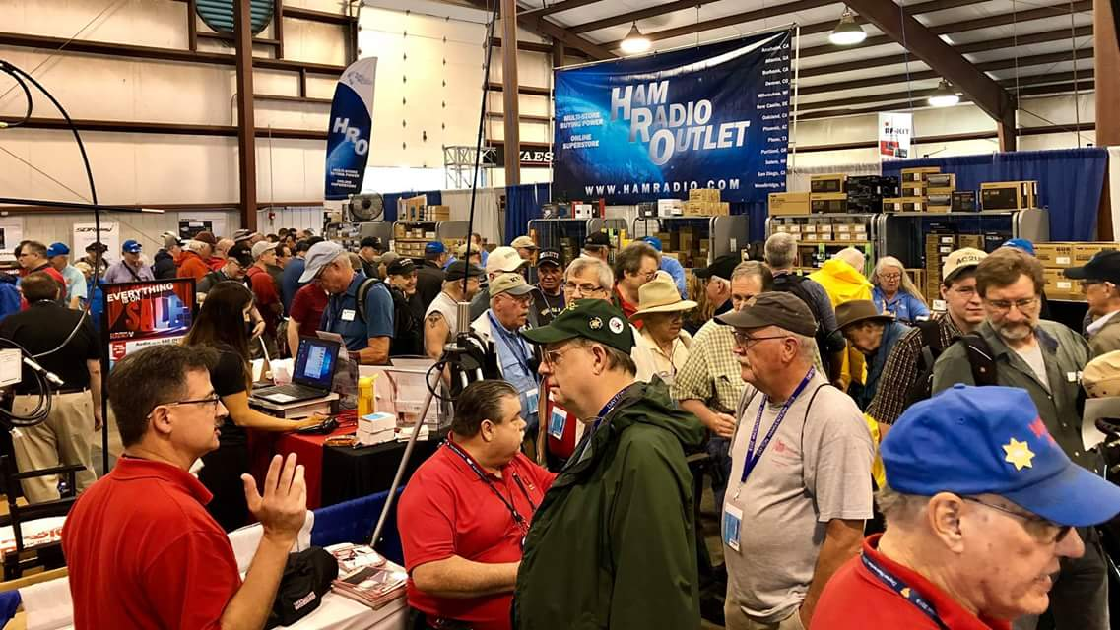
Upcoming Hamfests

We DO have some hamfests scheduled for 2023!! We’re just about to the end of the list, but I’ll start adding the 2024 Fests that have already been approved soon!

Ohio Hamfests
2023

Sp12/03/2023 - FCARC WinterFest
Location: Archbold, OH
Type: ARRL Hamfest
Sponsor: Fulton County Amateur Radio Club
Website: https://k8bxq.org/hamfest
Learn More

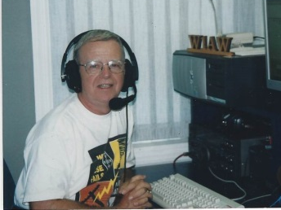
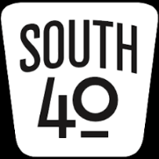
OHIO’S

One of the things I expressed thanks for on Thanksgiving was the fact that I like turkey and mashed potatoes. I think I will be eating turkey hot shots, pot pies and meat loaf along with other dishes needing turkey gravy or dressing for days to come. And I suspect N8ZNR will serve up a breakfast featuring potato pancakes at least once. But since I do like turkey, who’s to complain. I hope your gathering with family and friends was a good one.

Now that Thanksgiving and Black Friday are in the rear view mirror we are on the downhill path towards Christmas and the New Year. For many hams this past weekend’s annual running of the ARRL’s Phone Sweepstakes will end their out of the routine on-the-air activities. Except for nets, casual contacts and the traditional year end club holiday parties and dinner, their ham activities will become rather dormant until the restart of hamfests, Field Day planning and POTA activations after the first of the new year.

So let’s take a look at the reported events that will be happening in the South 40 region through the end of the year.

NOVEMBER 25 What might be the last November event happens on Saturday morning November 25 when the Clinton County ARA will hold their monthly ‘Last Saturday of the Month’ breakfast. It all takes place at Sam’s Meats and Deli in Wilmington with the coffee drinking and story telling begining at 8:30. Often someone brings a show and tell project they have been working on. All amateurs in the area are invited to attend what is a fun time.

NOVEMBER 27 Members of the Southern Ohio ARA will assist the Ironton Lions Club with communications, line-up and safety assistance during the annual Ironton Christmas Parade. Those able to assist are asked to meet at the Railroad and Fourth Street parking lot at 5 PM to receive their assignment. This is a rain or shine event with no rain date. Those assisting are asked to wear highly visible clothing.

DECEMBER 2 will mark a special afternoon for the Cambridge ARA because it is on that day it holds their annual awards dinner. Although the event is a highlight of the club year, it has special meaning this year because the ARRL’s Phil McCann Silver Antenna Award will be presented to Lynn Altman, N8IMW. The ARRL Board of Directors has chosen to present Lynn with his honor because of her efforts to promote amateur radio throughout the East Central and Southeastern Ohio areas. The event will start at 2 pm in the Green Room at Mr. Lee’s Restaurant in Cambridge. The CARA’s Amateur Operator of the Year will also be announced. Also on the 2nd, the Hocking Valley ARA requests member assistance to help line up Logan’s Christmas themed Chamber of Commerce parade. Although the parade does not start until 2 PM, those able to assist are asked to be at the county fairgrounds shortly before 10 AM. This year FRS radios will be used to enable communications with the CC volunteers. The parade starts at the fairgrounds and will wind its way through the streets of Logan to the Logan Mall. Later in the day Highland ARA members are asked to meet at the county fairgrounds at 4 PM to assist the City of Hillsboro with that community’s Christmas Parade. Besides providing event communications, members undertake the lining up of the parade floats and walking units.
DECEMBER 5 Following a short business meeting the Hocking Valley ARC annual club carry-in dinner will take place at the Antioch Alliance Church near Logan. Prior to the meeting and the dinner a social hour will begin at 5 PM. All interested in ham radio are invited regardless of a HVARC membership.

DECEMBER 7 Wilmington’s Foster Boyd Cancer Center is the site for the Clinton County ARA’s annual Christmas meeting and dinner on December 7. President Mark Atwell, WX8A, is providing the turkey with the other dishes and deserts provided by the members. Besides electing 2024 officers, the Club has a number of important items to discuss.

DECEMBER 9 Jesse Stanley, KD8CHP, tells us that at noon on December 9, the Scioto Valley ARA will hold their Christmas dinner at the Chillicothe Evening Lions Club Building in Chillicothe. That evening talk about good food and a good time. That’s what you will experience when you attend the Portsmouth RC’s Christmas dinner and fund raising auction. It takes place at the River Road Gathering Place in Wheelersburg on the evening of the 9th.

DECEMBER 9 is when the Highland ARA will make its tradional visitation to R & L Electronics in Hamilton. Besides providing the trip to purchase raffle and door prizes for the Club’s Christmas Party, it also is an opportunity for new hams or others who have not been to the store to visit the store, ask questions and get advice from experienced hams whom they know. It also serves as a social event as those making the trip usually break bread at the across the parking lot Hydes Restaurant before returning to Hillsboro. Past trips have even resulted in other clubs meeting and joining with the HARA group that day.

DECEMBER 12 The Highland ARA holds their Christmas dinner party at the Hillsboro Methodist Church on December 12. The reputation of the traditional catered meal, gift exchange and raffle and door prizes draws hams from throughout Southern Ohio. And just $10 per person. You do not have to be a HARA member or even a ham to attend. But please contact highlandara@gmail.com in advance to let N8ZNR know you intend to attend.

DECEMBER 15 The Queen City Emergency Net is inviting members of the Cincinnati FM Club to their December 15th Christmas Party at the Red Cross Building on Dana Avenue in Cincinnati. According to QCEN President Tom Delaney, W8WTD it starts at 6:30.

DECEMBER 16 The Lancaster Fairfield County ARA will have their Christmas gathering on December 16 at the Pizza Cottage on Fair Avenue. It starts at 6 PM.

DECEMBER 19 marks the date for the Athens County ARA’s annual Christmas dinner at a location yet to be determined. According to Mark Killen, KD8QIG, the Tri-State ARA will have their annual Christmas dinner gathering starting at 7 PM at the Radio Museum in Huntington.

DECEMBER 31 The Highland ARA’s annual New Year’s Net is to take place on the Hillsboro 147.21repeater (100 tone) It starts with the ringing of the giant CS Bell at the local historical museum that is used to ring in the New Year. Anyone within the footprint of the repeater is invited to throw your call sign in and wish all the best for the New Year.

The Southwest Ohio DX Association is awaiting the confirmation of the date and location where their Christmas celebration will be held.

Michael Love, WB8YKS, considers the Southern Ohio ARA’s “Christmas in November” to have been a huge success. Those attending enjoyed good food, a lot of good fellowship and some nice door prizes for some lucky people to take home. There was even live music provided by Barbara Crockett, KE8SRN. The keynote address was by Vice Divison Director Scott Yonally, N8SY. South Point Mayor Jeff Gaskin, K8SDY, and ARES Section 8 Coordinator Jeff Slattery, N8SUZ, also provided comments.

In non-Christmas related news, although it’s a few weeks away, the 2024 hamfest season will begin with the Sunday Creek ARF’s hamfest on January 14. It will be at the Community Center in Shade, Ohio with the doors opening at 8 AM.

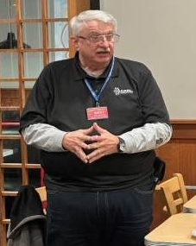
It’s now official. We have a new Great Lakes Division Director who will replace the retiring Dale Williams, WA8EFK, as of January 1, 2024. Let us congratulate Scott Yonally, N8SY, who earned 2,175 votes to the 2,023 votes for Michael Kalter, W8CI. Actually both candidates should be congratulated for an excellent and cleanly fought campaign. I know both candidates and fully believe the Division would have been the overall winner regardless of which one was victorious. Roy Hook, W8REH, will assume the Vice Director office being vacated by Mr. Yonally as of January 1. He ran unopposed.

The Athens County ARC’s Jeff Slattery, N8SUZ, reminds us of the upcoming December 2 National Weather Service’s SKYWARN Recognition Day. Spotters and those interested in learning more about the event are urged to check the https://www.gov/crh/skywarnrecognition web site. And while there, spotters are invited to fill out the brief form to register their spotter location on the interactive map. Over 5,000 spotters participated in the 2022 event.

You may have seen the article concerning Al Ward, W5LUA, achieving the first ARRL award for working all states on the 33-centimeter band. I’m informed our area’s own Bob Mathews, K8TQK, gave Al his first Ohio contact towards the award. Mathews lives on a high point in Ross County near Bainbridge.

For the first time in a couple years, I was able to squeeze a few hours operating the recent Phone Sweepstakes. Although I’m not a contest operator, the Sweeps is one of a handful I try to put some time into. I know I’m never going to win or even show up in the top 10, but I like to compete against myself and try to better last years score and perhaps stumble into a clean sweep. The bands and activity seemed down this year and I actually ended up with fewer sections than in the past. I missed Alabama, Delaware and Utah and even was into the contest about 100 deep before Ohio entered the log. When I reviewed my log at the conclusion of the contest I noted one thing that’s kind of bothersome. The newest precedence exchanged was a single 2022 date! Where are the hams with the new licenses and why weren’t there more Ohio stations on the air? I’m certain there are all kinds of reasons (excuses).

That’s it for another week. Here’s hoping everyone is able to survive Black Friday, has a great upcoming week and finds a bit of time to get on the air. Until next time, 73.

John Levo, W8KIW, jlevo@cinci.rr.com or highlandara@gmail.com, 937-393-4951

__________________________________________________________________

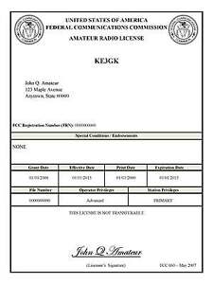
Print an Official or Unofficial Copy of Your Amateur Radio License
(By Anthony Luscre, K8ZT)

As of February 17, 2015, the FCC no longer routinely issues paper license documents to Amateur Radio applicants and licensees. The Commission has maintained for some time now that the official Amateur Radio license authorization is the electronic record that exists in its Universal Licensing System (ULS). The FCC will continue to provide paper license documents to all licensees who notify the Commission that they prefer to receive one.

Licensees also will be able to print out an official authorization — as well as an unofficial “reference copy” — from the ULS License Manager. I’ve created a set of instructions on how you can request an “official” printed copy of your license*

Click here to download the instructions

One Question Questionnaire

Here we go!,

Last weeks question: Will you be on the air thanksgiving day??
Out of 61 RESPONSES:
40 YES
21 NO

It’s a nice casual day to get on the air for a ragchew! Glad to see so many of you taking advantage of that.

The new question is: Is all of your antenna work for 2023 done?

a) YES
b) NO

You’ll find the “One Question” questionnaire on the Ohio Section Website! http://arrlohio.org It’s all for fun and it’s not a scientific survey in any way, but we are learning some things that we didn’t know from these questions. I hope that you are enjoying answering these “One Question” questionnaires.

Look for the RED ARROW on the website – After your vote ENTER out Handbook giveaway contest! You’ve got just a few more days to get in on the October drawing…

Final… Final

Eleven out of 12 months this year are gone! That leaves 1 left to finish up all you had planned for 2023. December could be a very busy month……. I want to make you aware, I’ll be out of town on a last minute trip from November 29 through December 4th. Due to this I will not have a PostScript out next weekend. I’ll resume the following weekend.

If you are an ARRL member (and you should be), you would have received a Thanksgiving message from ARRL. I noticed in the small print, at the bottom of the email the following:

“ARRL is the national membership association for amateur radio operators. We provide opportunities to discover radio, to develop new skills, and to serve your local community. No other organization works harder than ARRL to promote and protect amateur radio!”

That last sentence is what I want to comment on. It’s a fact. No-one else out there is looking out for us, but believe me, there are lots of interests that would like to see us gone! I’m thankful that they have been there for the past 100+ years working on our behalf. I want to be a part of their continued success into the future – for the benefit of the hobby. I want to thank all of you who voted in our GLD elections. I don’t think it was a fantastic turnout, but it was still good, relatively speaking. Getting more people involved in Ham Radio, and more people involve in ARRL are the two things that will keep us going into the future.

Looking to the future, I can only be certain of one thing – it will be different. Change is happening, and it’s happening at an accelerating rate. As humans, many of the things we find most aggravating are the changes that affect our daily lives. Well, buckle up, because it’s going to keep on coming!

73,
Tom WB8LCD

“Swap & Shop” on the website

Hey Gang,

Have you taken a look at the Swap & Shop page on the Ohio Section webpage yet?? Here’s a link that will take you there…
http://arrl-ohio.org/sm/s-s.html

Do you have equipment that you just don’t need or want anymore? Here’s a great venue to advertise it, and it’s FREE!!

Is your club doing a fund raiser to help raise money? After a lot of thought, it was decided that the Swap & Shop webpage could also contain these types of items as well.

The same rules will apply as do for the For Sales and Give-A-Ways and will only be posted for a month at a time. Please see the Terms & Conditions on the webpage. You might want to list your location so that prospective buyers know where you’re at.

If your club is doing a fund raiser and wants more exposure, please forward the information to me and I’ll advertise it on the Swap & Shop webpage for you. Now, I still want to remind you that it won’t be listed in this newsletter because it would take up way too much space, so your ad will only appear on the website. It is there for any individual to post equipment Wanted / For Sale or Give-Away as well as for Club Fund Raisers. No licensed vehicles/trailers or business advertising will be posted.

Postings are text only (no pictures or graphics) will be posted for a maximum of 1 month from date posting and require a contact phone number or email within the posting. Send your Wanted / For Sale or Give-Away post to: swap@arrlohio.org

Back Issues of the PostScript and Ohio Section Journal

Hey, did you know that PostScript and Ohio Section Journal (OSJ) are archived on the website? You can go back and look at any edition simply by clicking:
http://arrl-ohio.org/news/index.html

Ohio Section Cabinet
Section Manager – Tom Sly, WB8LCD | Section Emergency Coordinator – Bret Stemen, KD8SCL
Technical Coordinator – Jeff Kopcak, K8JTK | Section Traffic Manager – David Maynard, WA3EZN
State Government Liaison – Bob Winston, W2THU | Affiliated Clubs Coordinator –  Amanda Farone, KC3GFU
Section Youth Coordinator – Anthony Lascre, K8ZT | Public Information Coordinator – E;izabeth Klinc – KE8FMJ

Chit – Chat, and All That!

Do you know someone that’s not getting these Newsletters? Please, forward a copy of this Newsletter over to them and have them “Opt-In” to start receiving them. Heck just have them send an email to: webmaster@arrl-ohio.org to be added.

We now have many thousands of readers receiving these newsletters weekly. Quite impressive, I’d say! I urge all of you to make sure that everyone, regardless of whether they are a League member or not, get signed up to receive these weekly Newsletters.
You can always “Opt-Out” at any time if you feel this is not what you were expecting. It’s fun and very informative. All of your favorite past newsletters are now archived too.
You can go back at any time and read them. Just go to: http://arrl-ohio.org/news/

The pictures on the front page and throughout this newsletter are from various newsletters, Facebook posts and/or were sent directly to me in recent weeks. Take a good look at them, you just might be in one of the pictures! “SMILE… you’re in the Ohio Section News!!”

The Ohio Section Journal (OSJ) is produced as a comprehensive look at all the programs within the Ohio Section. I sincerely hope that you have enjoyed this edition of the OSJ and will encourage your friends to join with you in receiving the latest news and information about the Ohio Section, and from around the world!

TOP^

