May 2023

From the Technical Coordinator | From the Section Emergency Coordinator
From the Public Information Coordinator | From the Section Youth Coordinator
From the Section Traffic Manager | ARES Training Update
From the Affiliated Clubs Coordinator | National News
Club Corner | Contest Corner
DX This Week | One Question Questionnaire
South 40 | Final.. Final..

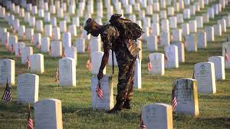

Please take time this weekend to remember why we have a 3-day weekend!

From the Technical Coordinator
Jeff Kopcak – K8JTK TC
K8JTK@arrl.net

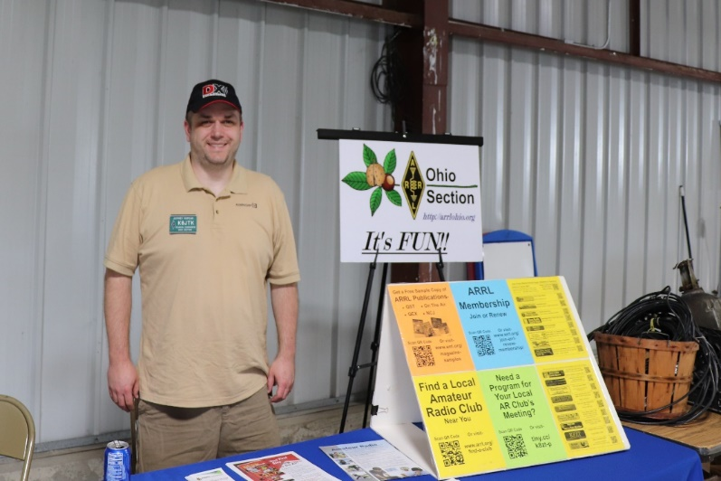
Hey gang,

Another Hamvention has come and gone. Unfortunately, my dad, N8ETP, didn’t make it as he is recovering from a medical procedure from earlier this year. I was flying solo again. As most of the OSJ readers are in Ohio, Dayton is a few-hour drive for most of us. It’s almost exactly 3 hours from my QTH to the hotel.
After dinner Thursday night, I went searching for digital repeaters – NXDN and P25 in particular. RepeaterBook didn’t have NXDN repeaters in the Dayton area. Guess I didn’t need to bring that radio. There was a P25 repeater I found last year and could hit from my hotel. Listening to conversations, there was mention of a P25 repeater at the Xenia site but I wasn’t able to find the details for it last year. This year, I found the Miami Valley P25 Ham Radio Network website. Their site lists repeaters on the network, including the information I needed for the Xenia site.
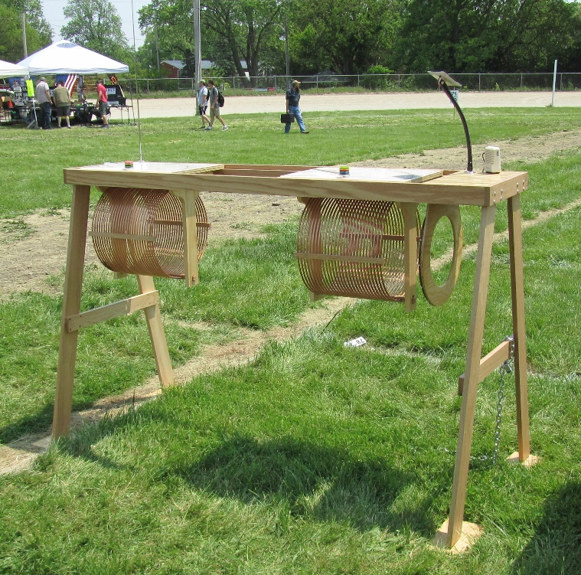
P25 is another digital standard used mostly by public safety agencies. It’s similar to DMR in that there are 7-digit IDs, talkgroups, and zones. Instead of a color code, P25 has NAC or network access code. Like DMR, P25 was also developed for commercial use and then adopted to ham radio. The statewide MARCS system, Greater Cleveland Radio Communications Network (GCRCN), and Northwest Ohio Regional Public Safety System are all P25 systems. There aren’t many “ham friendly” P25 radio options. Most are repurposed/used commercial radios from Motorola, Harris, or EF Johnson.
According to their programming guide, Miami Valley P25 sites have been upgraded to “version 2” programming of their repeaters. This may be why the talkgroups I had from last year were completely different for the Dayton repeater.
With tower sites in Shelby, Miami, Champaign, Montgomery, Greene, and Warren counties, the “MVP25” is an interconnected network of UHF (440) P25 repeaters. Each site has backup power and each repeater can operate independently when a network link failure occurs. Sites are linked with direct network connections that presumably don’t use the internet. No cloud services of any kind are utilized. The network can only be accessed via RF. No hotspot and no MMDVM connections are possible.
Reading and programming my Motorola XTS radio for the MVP25 network, I learned more about options in the software. One example is “selective squelch” which will only unmute the radio for transmissions on the selected talkgroup. Their programming template and examples helped me understand their objective and made programming easy.
Each repeater has an “MVL” (Miami Valley Link) talkgroup which is heard on all MVP25 linked repeaters and a “STE” (site) talkgroup for conversations on the local repeater. MVL is the primary talkgroup on the repeater. Users wanting to carry on a conversation locally can override the MV talkgroup by using the STE talkgroup.
They recommended using the bank switch (A-B-C switch) for switching talkgroups on a single repeater site. In the context of my radio, Bank A = Zone 1, Bank B = Zone 2, Bank C = Zone 3. This was a neat idea because, for example, channel 5 in zone A & B would be the Xenia Hamvention repeater site. Zone A would be the programming for linked communication using the MVL talkgroup. Zone B would be the local site talkgroup for each repeater. Selecting channel 5 (Xenia) using the channel knob, then selecting bank A would be Xenia MVL talkgroup configuration, Bank B would be Xenia STE talkgroup configuration. Channel 8 would be the Dayton site. Switching to A would be the MVL talkgroup and B would be STE Dayton local.
Since my radio is front panel programming capable, Zone A was the FPP (I didn’t see a way to change this). In their programming guide, bank A became B. Bank B became bank C. Their template had the same exact “UCOM1” (UHF P25 simplex frequency) frequency for every channel in bank C. I took this to mean it’s a ‘flex’ bank in cases of radios that have a reserved bank. I didn’t lose anything because “UCOM1” was also channel 1 in the MVL and STE banks.
Previously, I had only used my P25 radio with my MMDVM hotspots. Programming multiple sites on the same network was a new experience. I learned about copying the current selected entry and export/import to make copies of zones. Kudos to the admins, designers, and those whom wrote the programming guide. It is well thought out and the guide made a lot of sense.
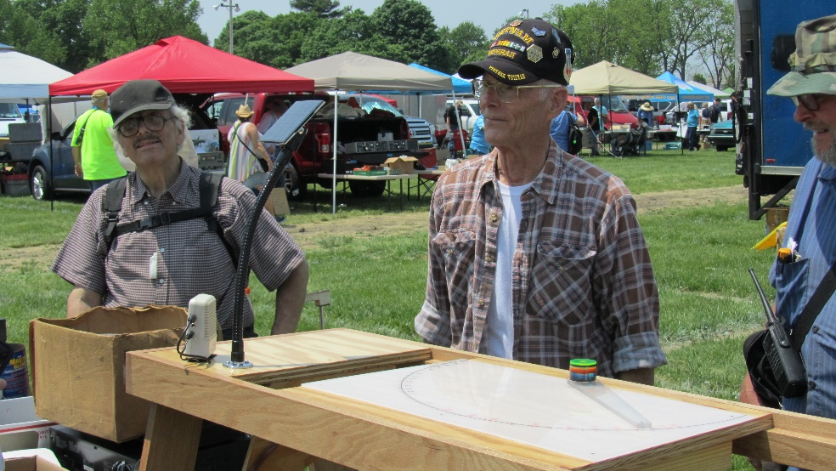
Friday, I hit the flea market. I wasn’t looking for too much this year – either new or used. I was in the market for a second set of Motorola CDM radios. I am using a UHF CDM for an AllStar node and I have a VHF model too. I would like to pick up a second set for spare radios. Also was looking for a second UHF XTS and a new to me VHF. No one was giving them away.
In the “coolest thing I’ve ever seen at a hamfest” category was the life-sized crystal set someone built and had on display in the flea market. There were no plans, no diagrams, no anything. It was all in his head. Nothing written up. Nothing diagrammed. The only thing powered was a solar powered amplifier for received audio. If you didn’t see this thing in the flea market, you missed out. The builder didn’t have a name or call displayed unfortunately.
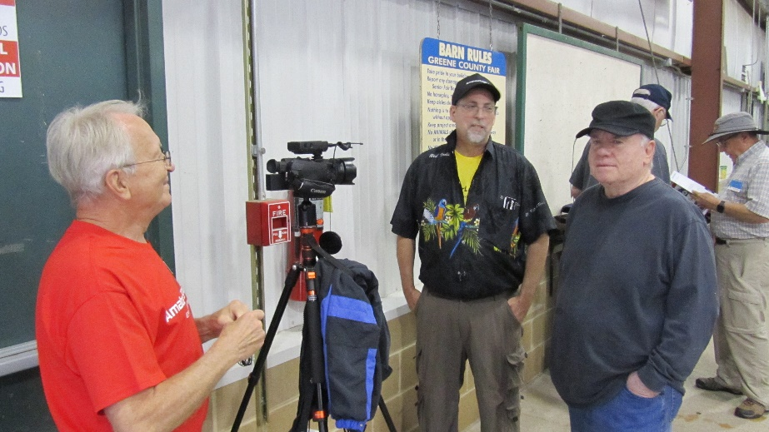
I wanted to hit the inside stuff on Saturday, but instead ran into George – W5JDX and Mike – VE3MIC from AmateurLogic in front of the ICOM booth. Helped them do some recording for their latest episode (which should be out by the time this is published, episode 181). Then we all hung out with Chip – K9MIT of “Chip Stick” fame from Ham Nation and Mike’s cousin (forget the call). A good time was had by all.
Didn’t spend a lot of money this year at Hamvention. Emile would approve (joke for ALTV viewers). Talking with groups and vendors got the wheels turning on some ideas – such as devices to use with my MESH node. On my way home, I stopped by the secondary hamfest called MicroCenter and spent some money there on some deals they had.

Thanks for reading and 73… de Jeff – K8JTK

From the Section Emergency Coordinator
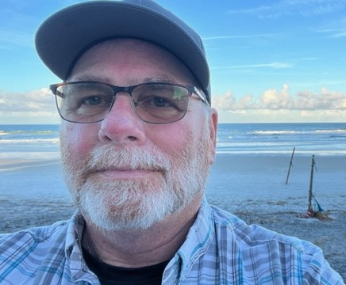
Bret Stemen – KD8SCL EC
KD8SCL@gmail.com

Hamvention 2023

Hamvention 2023 was my first time to be able to visit. I had a great time meeting new hams and being able to see everyone face to face and to be able to spend a few minutes getting to know them. I was aw struck at the line to get in to Hamvention on Friday and Saturday, but I had expected it as well. A special Thanks goes out to all of the volunteers that made Hamvention possible and to Liz KE8FMJ, Ohio Section Public Information Coordinator and District 3 DEC for her hard work.

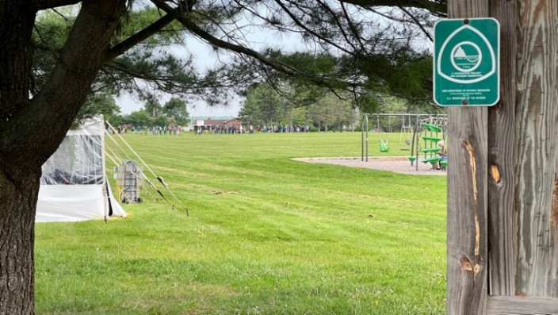
I had a chance to visit the vendors and was able to speak with them about certain items that I wanted more information about. Actual hands on of a product was what I was looking forward to. As we all know, looking at descriptions and pictures on a website are not the same as hands on and being able to ask questions and getting answers right then and there.
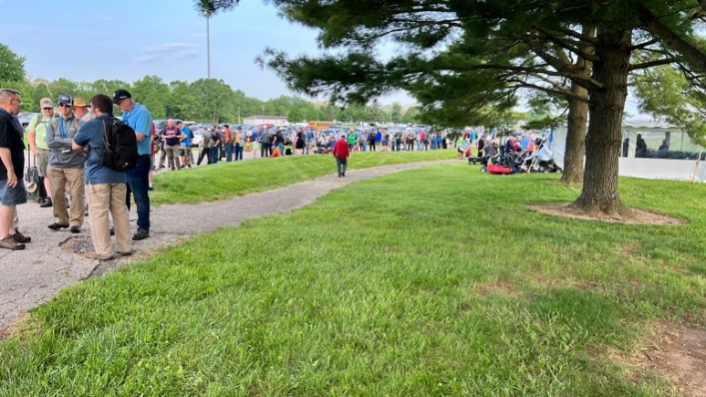

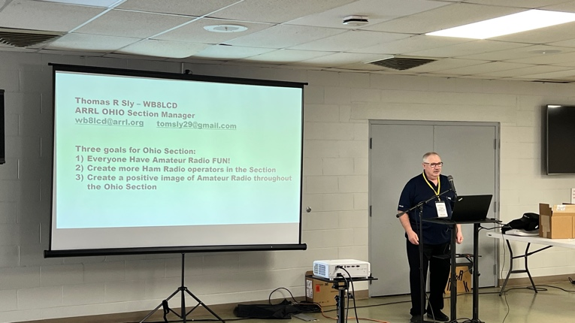
I was able to sit in a few forums and was glad I did as I walked away with new ideas and information to be able to pass along to others that did not make it this year. Tom Sly SM, WB8LCD did a great job with his presentation

Josh Johnson KE5MHV, ARRL Director of Emergency Management gave a great presentation as well talking about AUXCOMM and SAFECOM as well as other upcoming changes that are in the works, that the ARRL has signed and MOU with FEMA for the next 5 years.
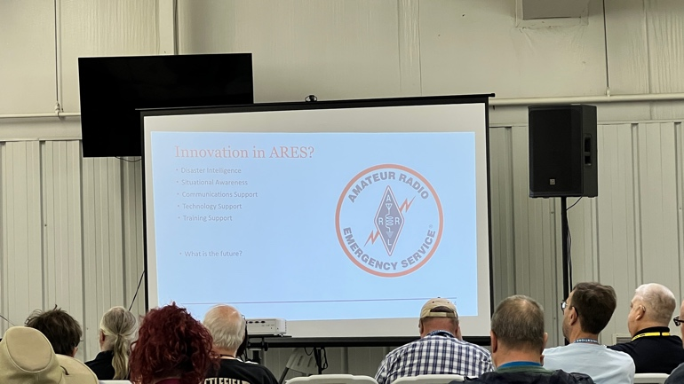

At the Amateur Radio Emergency Service (ARES®) forum, Josh Johnston, KE5MHV, ARRL Director of Emergency Management, addressed an enthusiastic crowd. He rolled out a variety of strategic partnerships pursued on behalf of ARRL and ARES volunteers. Some had been in the works for over a year. Partnerships included Memoranda of Understanding (MOUs) with the Federal Emergency Management Agency (FEMA) and the National Weather Service. Johnston highlighted, in particular, the inclusion of amateur radio in SAFECOM, whose emergency communication’s division, “leads the nation’s public safety, national security, secure and resilient.” They are a major stakeholder behind the scenes in emergency management.
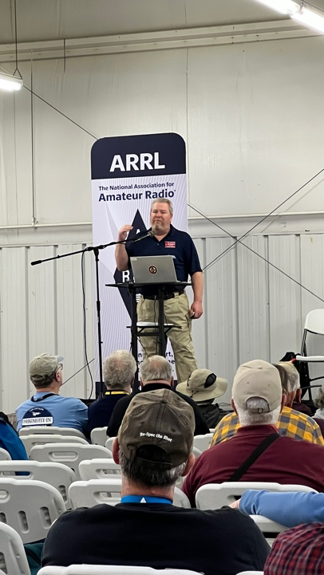

The following is from J.M. Rowe N5XFW, Arkansas ARRL SEC

Hello all:

What a great time in Xenia at the Greene County Fairgrounds! The vendor area was full, and the flea market was jam-packed with everything you can imagine. Bargains galore. There were several food trucks and trailers, turning out several varieties of "fair food". I had one of the best corn dogs I've ever eaten, and that is a large endorsement! The forums were mostly standing room only! The Hamvention provides an opportunity to see equipment you didn't even know existed, talk to experts about almost any ham radio technology or topic, and touch that new radio. Make plans to go if you are able, and bring your friends.

Speaking of the forums, I was able to attend the ARES forum to hear Josh Johnston KE5MHV speak. As you remember, Josh was the Emergency Manager for Johnson County (Clarkesville) for, I think, 17 years. Now he is the Emergency Management Director for the ARRL. The crowd was interested to hear what direction the ARRL would be taking and how they fit into the overall scheme of EMCOMMM. Josh made several excellent points:

1. The ARRL has signed a new MOU with FEMA for the next 5 years.
2. The ARRL has been elected as an association member of SAFECOMM.
3. There is no conflict between ARES and AUXCOMM.

I'd like to expand on the last item, if you'll indulge me please. I wrote the following four paragraphs a while back and Josh said really close to the same thing.

I think some of you believe the ARRL is a Response Organization with a duty to act. This is not correct. The ARRL is much better thought of as a Resource. There are go-kits, there is some training, there is advice, there are lists of potential volunteers at hand. There are no Type 1, 2, or 3 ARESMATs available to Newington.

That in no way diminishes the League. They simply have a different purpose than what most of you are thinking. Local EM's need control of volunteers to satisfy the Stafford Act, which effectively ends the question about who works for who. Jeopardizing Relief Funds by not being NIMS-compliant is not an option anymore.

AUXCOMM does not teach soldering, message handling, WinLink, radio programming, or any other of the many skills thought to be included in an Amateur Radio Operator. Rather it teaches the operators how to integrate into an already existing management structure and not make fools of themselves by trying to assume command.

As you can plainly see, there is no one stop shop when it comes to EMCOMM, and it is not likely to change in the foreseeable future. Instead of having a contest on who can holler loudest about the virtues of one system over another, why don't we do training that satisfies whatever entity where you want to volunteer? Then you can be the best you can be.

Fellow hams, won't you join me in working toward our common goal of helping our served agencies?

Let me know how I can help and 73,
J.M. Rowe N5XFW
Arkansas ARRL SEC

Looking ahead!

June is fast approaching. Have you started to make plans for Field Day 2023?
I know of several clubs and groups have start their planning for Field Day 2023 June 24th & 25th by making reservations at local parks and or venues. For more information about Field Day, please visit the ARRL website at http://www.arrl.org/field-day . I am looking forward to hear from your group on Field Day. Remember to have fun and enjoy the fellowship and good food, get the word out to your local officials and invite them to your location so they can see your operation, advertise it in your local newspaper or on a local radio station. Offer to let the visitors of get on the air to name a few.

Switching gears!

I had a chance to speak with Josh Johnson at length at the Hamvention about the new Form 2, I was told by Josh that they are still working on the IT side as well as updating the software to meet our needs, the integrations include the carrying over of information from form 2 to form 4. He could not give me an exact time as to when form 2 will be released, but hopes it will be soon.

Bret, KD8SCL

______________________________________________________________

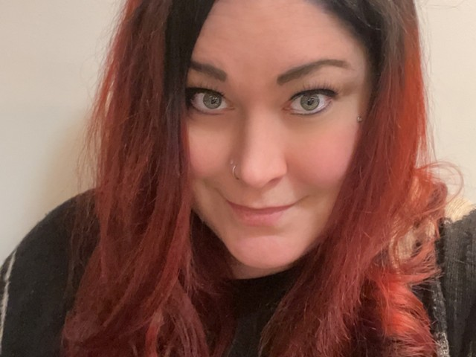
Elizabeth Klinc, KE8FMJ
OHIO Section Public Information Coordinator
ke8fmj@gmail.com

Don’t forget the 2023 Section newsletter contest. We love to see those newsletters and are looking for the best. I’ve started to get a couple directly from the clubs. Please add ke8fmj@gmail.com to your mailing list. You do not want to miss out on the contest, so please be sure to add me to your mailing list.

______________________________________________

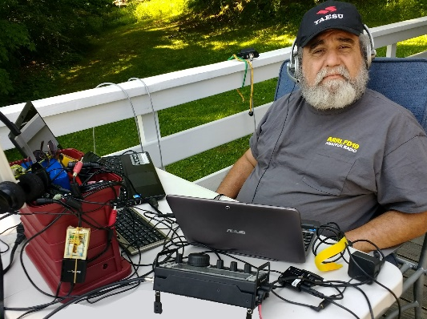
From the Ohio Section Youth Coordinator
Anthony Luscre, K8ZT - SYC k8zt@arrl.net

Just-In-Time Training for June Activities

June Operating Opportunities
Many of you who read my articles or attend my presentations know I love a twofer. In my case, a twofer is “an action that accomplishes two goals but requires only one action.” What is better than a twofer? A Threefer, of course! So this month, I present ideas for June activities that can accomplish three things:
- Get youth on the air
- Get Technician Licensees on the air
- Get inactive hams of any license class on the air
I will focus on two events that can help accomplish all of these goals and provide some just-in-time training to help even newcomers. The two activities are the following:
- ARRL June VHF Contest - June 10 & 11
- ARRL Field Day- June 23 & 24
VHF/UHF Bands
When someone says VHF or UHF, many of us only think of 2M/70cm Repeaters, but there is so much more available. First, remember that Technicians (the beginner license in Amateur Radio) have full privileges on all bands from 50 MHz (6 Meters) and above! These bands can be used for simplex FM, SSB activity, Satellite communication, Digital modes (FT8/FT4) and more. Also, with the majority of youth operators having Tech licenses, this all applies to them. The ARRL June VHF Contest is obviously an activity that includes this, but Field Day also has two major activities, a VHF station that does not count toward the total number of transmitters and bonus points for satellite contacts.
But, Anthony, I Don’t Have the Equipment to Operate These VHF Modes
You might be surprised that you already have radios to work many of these modes, or you may be able to borrow equipment from your local club or a friend. If you want to buy equipment, there are many options, including some reasonably priced new radios or used bargains. Below is a chart I have put together on what you can do in VHF Contests with different types of radios. As you can see, even an FM-only HT can be used to make simplex FM contacts in a contest. A dual-band FM-only HT can be used to make contacts on LEO (Low Earth Orbit) FM Satellites. Going with an FM-only Mobile will give you the same capabilities plus more power than an HT. FM Simplex contacts are not as common as other modes in the ARRL VHF contests but with a little effort and a good antenna (ditch the rubber duck for a better, longer and higher antenna (more on this later), you can make contest contacts. Most contacts in VHF contests have traditionally been SSB, but FT8 & FT4 have recently claimed a significant share. You will need a radio capable of SSB for either mode.
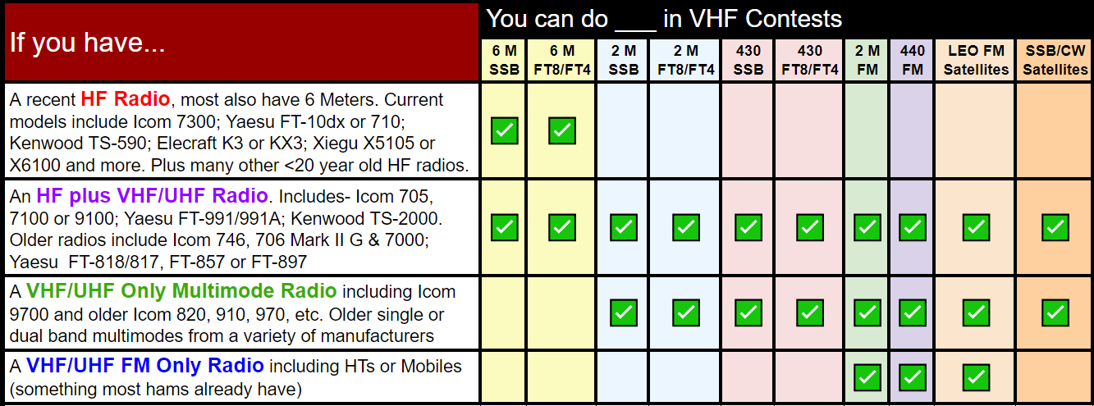
How to Operate These VHF Contests/Activities
I will have more detailed information on this below, but here is a quick startup guide.
- Check the contest calendar for detailed rules on individual contests, including date, time, exchange and categories.
- Know your exchange! In most VHF contests, this is your 4-digit Grid Square (here is information on Grid Square and how to find yours- tiny.cc/findexc.
- Decide if you want to operate from home or a portable location.
  - If you have antenna restrictions at home, your home is in a low spot in terrain, etc., consider a portable location. For more info on portable operations- tiny.cc/portop.
- Setup antennas
  - Gain antennas are usually used on VHF/UHF, typically beams, but you can get away with even a simple dipole on 6 Meters.
  - Typically SSB/Digital operators use horizontally oriented antennas, and FM operators use vertical orientation. Although you will have a significant signal loss, you can still make contacts with the opposite orientation.
  - Even a simple 2M/440 fiberglass vertical up and in the clear can make contacts on SSB or Digital in a pinch.
  - Use low loss and short runs of coax to the antenna(s).
  - For more information on antennas- tiny.cc/portant.
- Setup your station
  - Make things easy to use. For example, a boom headset and foot switch for SSB can be beneficial to keep hands free for logging.
  - Use a computer for logging. I suggest either N1MM or N3FJP contest logging software.
  - If using FT8/FT4, set up the computer and radio to operate
    - See tiny.cc/ft8ft4 and www.youtube.com/watch?v=0m9zV6jjb78
    - Set WSJT-X special modes to “NA VHF” or “FD.”
    - If only using FT8/FT4, you do not need other logging software as you can easily export your log after the contest.
- Operating
  - Keep contacts short and quick
  - Use standard NATO Phonetics on SSB/Phone
  - Understand “QSYing”
    - The other station might ask what other bands you are operating and then ask you to QSY (move) to a specific frequency on that band.
  - Frequencies
    - Follow band guidelines for operating frequencies for specific modes
    - If operating FM
      - You cannot use repeaters; all contacts must be simplex
      - Most contacts exclude operation on national calling frequency (i.e., 146.520 on 2 Meters)
    - Use other designated calling frequencies
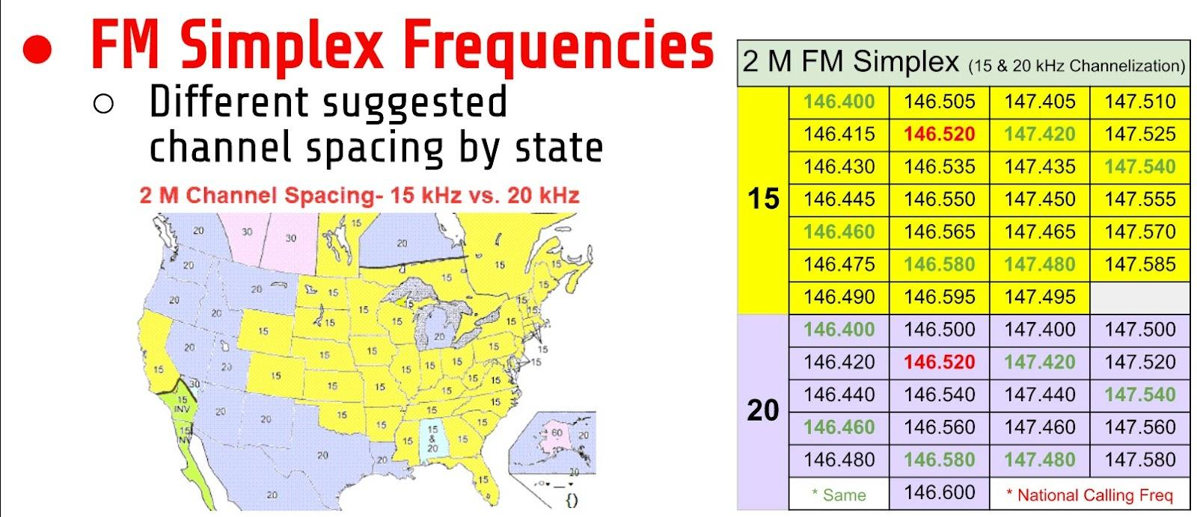
    - SSB- The standard SSB calling frequencies are:
      - 50.125 MHz
      - 144.200 MHz
      - 432.100 MHz

As usual, I have some homework for you with more help to get you started:
- “Beginners Introduction to VHF Operations”-Co-presenters Marty Woll, N6VI and Anthony Luscre, K8ZT, present a series of three sessions covering almost all aspects of getting on VHF/UHF for new hams. The sessions are recorded for viewing:
- Week 1- youtu.be/mUXQg_9cDPU
- Week 2- youtu.be/23mBr3wMqxs
- Week 3- youtu.be/wiGISL1E0b8
- Week 4- youtu.be/1CEzFauXmJI
- Slideshow from the presentations, including clickable links and resources, is available at tiny.cc/bgvhf.
- “Introduction to AR Contesting”
  - Video- https://youtu.be/-n5CLG0I1Yw
  - Slideshow- tiny.cc/arcontest
- “Technicians, Life Beyond Repeaters”
  - Video- https://youtu.be/-m8tOFBYl4E
  - Slideshow- tiny.cc/btech
- From K0NR- “How to Work A VHF Contest”
- From K5ND- “VHF Contesting Resources”
- From VE3SMA “A VHF Contest Primer”
- From Pacific Northwest VHF- “FM Contesting”
Field Day Resources for Operating, Youth & Public Outreach
Here are a few resources to aid your FD Operations
- ARRL Sections, sorted by number and alpha- tiny.cc/arrl-sections
- ARRL/RAC Sections Map
- Ham Radio Resources for Visitors, Youth, Students & Teachers- tiny.cc/hryc
- SDRs to listen to FD stations- link

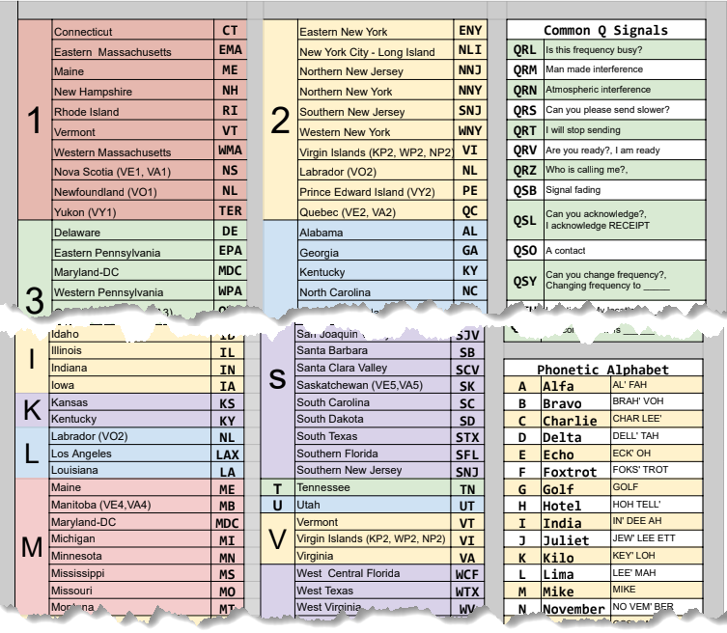
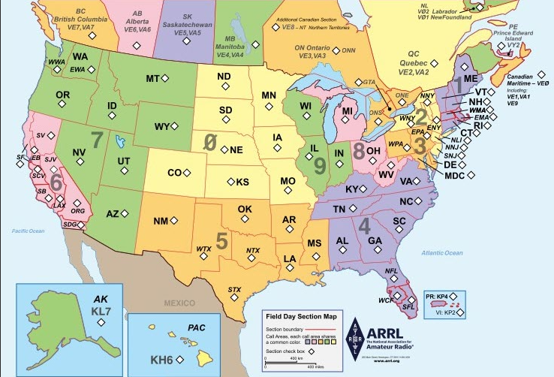
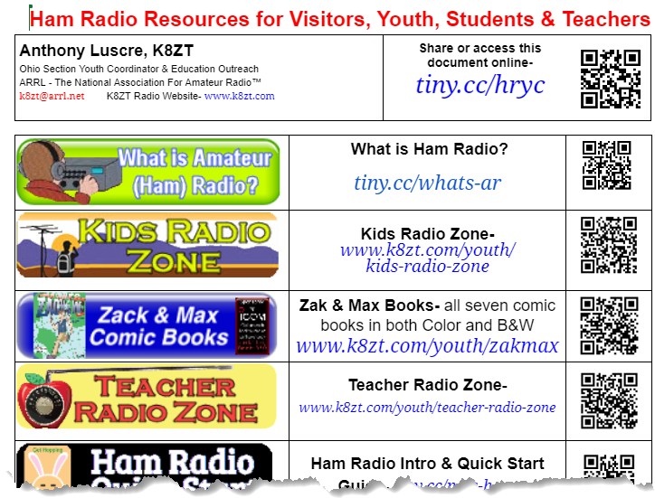
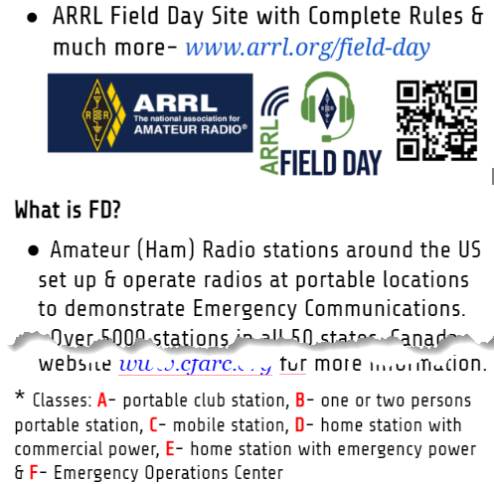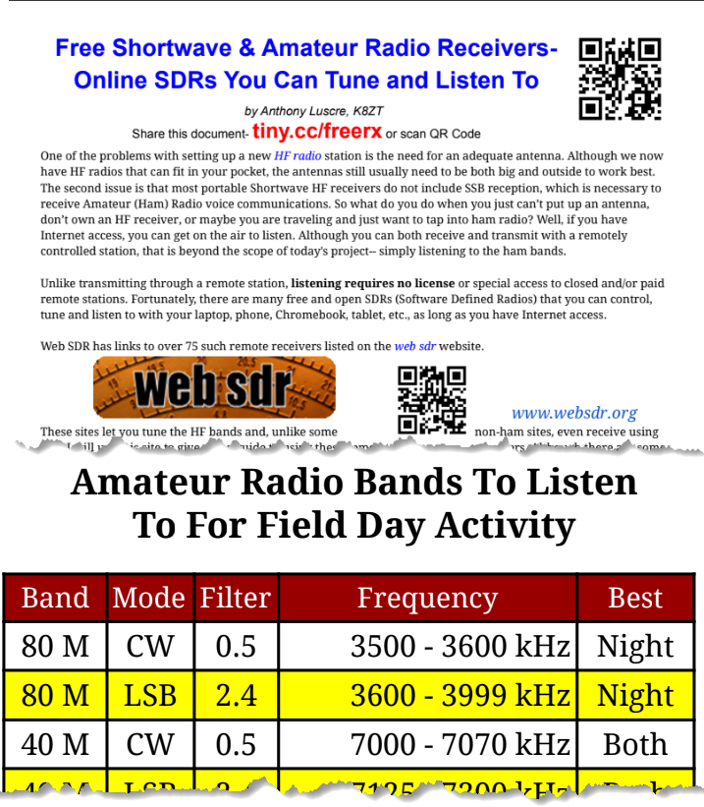
Help Someone Get On The Air
Here is where I make my appeal to those that already take part in these activities. Go through your club's roster and identify Tech licensees, new hams, youth, inactive hams, etc. Once you have identified your target audience, contact them personally and invite them to take part in activities with you. Alternatively, your club may want to put together some group activities.

That’s it for this month. I hope to hear you on the air operating VHF!
73,
Anthony, K8ZT (k8zt@arrl.net)

____________________________________________________

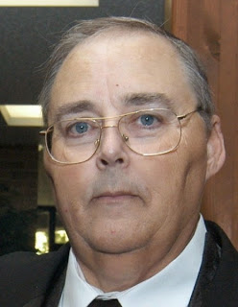
From the Section Traffic Manager
David Maynard, WA3EZN – STM
wa3ezn@att.net

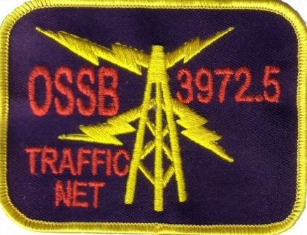

MAY 2023

The next big ham event after Hamvention will be Field Day. Field Day is always the fourth full weekend of June, beginning at 1800 UTC Saturday and running through 2059 UTC Sunday. Field Day 2023 is June 24-25.
Field day logistics and location is an area where good planning really pays off. If you have not reserved your favorite room, shelter or spot for operating it should be done soon before someone reserves you spot for a birthday party. I know this happened to a club once so get cracking.
Field Day not only will test and challenge an individual operator’s communication skills, but it also will test and challenge the participants ability and flexibility in mounting a major effort on the magnitude that would be encountered in a major disaster.
Learn more about Field Day rules at these ARRL websites:
http://www.arrl.org/field-day
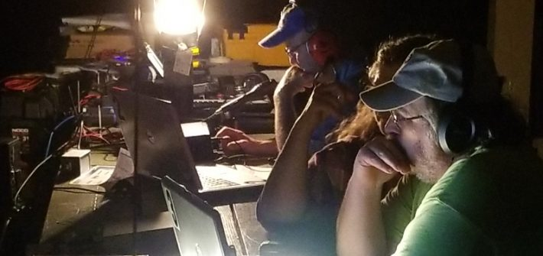
http://www.arrl.org/field-day-locator

New to Field Day? START HERE!
Field Day is ham radio's open house. Every June, more than 40,000 hams throughout North America set up temporary transmitting stations in public places to demonstrate ham radio's science, skill and service to our communities and our nation. It combines public service, emergency preparedness, community outreach, and technical skills all in a single event. Field Day has been an annual event since 1933, and remains the most popular event in ham radio.
"What Is Field Day" (Printable PDF Flier)
Welcome the public to come learn more about ham radio! Use our Field Day Locator to search for a Field Day site near you.

Field Day on Social Media!
Click below to join the ARRL Field Day Facebook Group. Share your plans, tips and tricks to a successful Field Day. When posting content from Field Day, use hashtag #ARRLFD on all social media to receive 100 bonus points! https://www.facebook.com/groups/arrlfd/

Field Day Resources and Rules
- Objective-
To contact as many stations as possible on the 160-, 80-, 40-, 20-,15- and 10-Meter HF bands, as well as all bands 50 MHz and above, and to learn to operate in abnormal situations in less than optimal conditions.
Field Day is open to all amateurs in the areas covered by the ARRL/RAC Field Organizations and countries within IARU Region 2. DX stations residing in other regions may be contacted for credit, but are not eligible to submit entries.
Each claimed contact must include contemporaneous direct initiation by the operator on both sides of the contact. Initiation of a contact may be either locally or by remote.
- Dates (Always the 4th Weekend in June)+
- Bands and modes+
- Field Day Entry/Results Submission Deadline+
- Terms Of Entry+
- Contact Information+
- Awards+
- Rules, Entry Forms and Information Packets+
- Field Day Site Locator+
- Field Day Logos+
- Results+
- Field Day Logging Software+
- Field Day Supplies & Promo Posters+
- Formas y Reglas en Español+
- Media, Public Relations, & Public Service Announcements

Check out this link: http://www.arrl.org/field-day
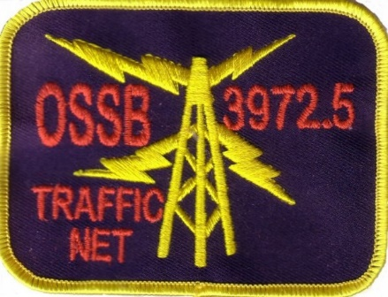

If you have traffic you need to move take it to a VHF net or if it is going out of Ohio you can also take it to the OSSBN. Here is WHERE TO FIND AN HF OR VHF TRAFFIC NET IN OHIO. More information and useful links can be found on the OSSBN website www.ossbn.org.

OHIO SINGLE SIDEBAND NET
Morning session | 10:30 AM | 3972.5 KHz | every day
Afternoon session | 4:15 PM | 3972.5 KHz | every day
Evening session | 6:45 PM | 3972.5 KHz | every day

OHIO HF CW TRAFFIC NETS
HF CW NETS | NET TIMES | FREQUENCY | NET MANAGERS
Buckeye Early | 6:45 PM | 3.580 | N2LC
Buckeye Late | 10:00 PM | 3.590 | WB9LBI
Ohio Slow Net | 6:00 PM | 3.53535 | N2LC
All CW net frequencies plus or minus QRM

OHIO LOCAL VHF TRAFFIC NETS
VHF NETS | NET TIMES | FREQUENCY | NET MANAGERS
BRTN | 9:30 PM DAILY | 145.230 PL 110.9 | KD8GXL
COTN | 7:15 PM DAILY | 146.970 PL 123.0 | KV8Z
NWOHARES | 6:30 PM DAILY | 147.375 PL 103.5 | N8TNV
TCTTN | 9 PM Sun, Tues, Fri | 147.015 PL 110.9 | WB8YYS
TATN | 8:00 PM DAILY | 146.670 PL 123.0 | WG8Z

OHIO VHF TRAFFIC NETS
BRTN Burning River Traffic Net serving Cleveland and North Central Ohio
COTN Central Ohio Traffic Net serving Columbus and Central Ohio
NWOH ARES Northwest Ohio ARES Net serving Toledo and surrounding counties
TATN Tri-State Amateur Traffic Net
TCTTN Tri-County Traffic and Training Net serving North East Ohio

I bought my new radio at the Dayton Hamvention. What do I do now?
With a 100 watt transceiver and a simple wire antenna you can start to communicate and make friends with other hams all over the country or the world.
HF is different than FM repeaters.
• No “machine” or infrastructure is used.
• Allows communication beyond line of sight. Contacts are generally a couple of hundred miles to over several thousand miles.
• Propagation is strongly affected by solar activity.
• Several communication modes are available to use.
SSB, CW, RTTY, SSTV, Digital, AM
When most people hear the term “ham radio” they generally think of HF or shortwave and long-distance communications.
HF stands for HIGH FREQUENCY. These are the frequencies from 1.8 to 30 MHz or the 160 meters to 10-meter bands. HF is also known as shortwave. 160 meters is a Mid Frequency (MF) band, but it is included in the Amateur HF bands for ease of discussion.
SKYWAVE IMAGE
The sun charges particles (ions) in the upper atmosphere. Radio waves change direction when they enter the ionosphere.
The Layers of the Ionosphere
NVIS - Radio Waves that take off at very high angles are reflected straight back to Earth.
The gray line or terminator is a transition region between daylight and darkness. One side of the Earth is coming into sunrise, and the other is just past sunset.
Building a Station
There are basically two main components involved:
1. A 100-watt Transceiver and
2. An antenna system. The antenna system consists of the radiator, feedline and matching network.
The Transceivers
- What makes a good radio?
• Scanning, memories and other “bells & whistles” are not the important features
that make a good HF rig.
• The receiver’s ability to hear weak signals and separate the incoming signals are
what makes a good HF rig.
• The numbers to look at when selecting a transceiver are:
1. sensitivity (ability to hear signals) and
2. selectivity (ability to distinguish signals)
Remember, you can’t work them if you can’t hear them.
Physical Safety
NEVER attempt to erect antennas near power lines. You will be killed.
When it comes to getting the most enjoyment out of Amateur Radio, there is nothing more important than your antenna system. You can purchase the best ham transceiver on the planet, but if your antenna system is poor, your investment will largely go to waste.
Check out these resources to arm yourself with important facts when shopping for an antenna.
Feed Lines
You have your license and now you are ready to set-up your first radio station. Besides choosing a radio and antenna, you should explore the different options available to you regarding Feed Lines. Learn More

No Free Lunch

Antennas come in a variety of sizes, shapes and styles. Several claim they can do it all! Before you buy that "fancy" antenna, read this article. Learn More

Antennas for the HF Bands

HF antennas come in a variety of shapes and sizes. They can range from a simple wire thrown into a tree or a complex quad beam on a 40' crank-up tower. This article helps to explain the differences between them. Learn More

Antennas
An antenna system consists of:
1. The antenna or radiator
2. The feedline
3. The matching network or tuner
SWR
• A good SWR is not an indicator of an effective antenna system.
• Think of a dummy load; it has a good SWR, but it is not an effective antenna.
•
The dipole
• The dipole is the simplest antenna that any amateur can use on HF.
• Whether fed with coax or open wire, dipoles are cheap and easy to build and install.
• A dipole can be made for a single band. The total length of the antenna can be
calculated by using the formula: 468 ÷ freq (MHz) = length in feet
• Each side, or leg, of the dipole is going to be one half of the total length.
• Fed with 50 or 75 ohm coax, this antenna will be resonant on a single band that it was cut for.
• A dipole fed with balanced line (twin lead) and a matching network can be used on multiple bands.
468
f (MHz)
Feedline
The Dipole
Radiator, Feedline and matching network matching network
It is not necessary to install dipoles in a horizontal straight line.

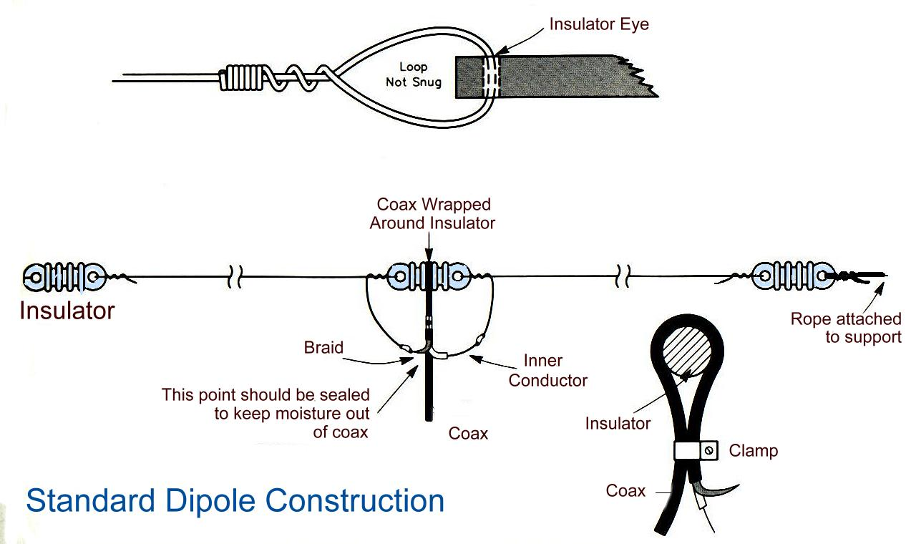

73
David, WA3EZN
Ohio Section Traffic Manager

______________________________________________
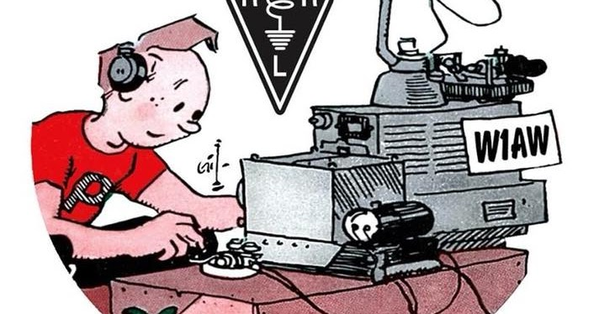

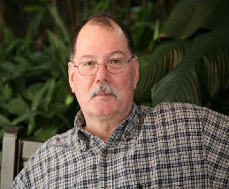
ARES Training Update
Jim Yoder, W8ERW – ARES Data Manager
w8erw@arrl.net

ARES Training Update
We don’t talk about leadership much and perhaps we should. Any well run and functional group is the result of good leadership. The following are my thoughts on this subject. Leadership begins with listening. Take a moment to remember when you recognized a good leader. Perhaps the most important element of good leadership is listening to those you lead. This applies to business, to social groups, the pastor of a congregation and any group or team with a mission or objective including radio club leaders. Being a good listener is fundamental to good leadership. As a leader you might hear just about anything from problems in the group to personal difficulties and pain. People don’t always want answers. Often, they just need to be heard as they unload what’s on their mind. A good leader cares about people and demonstrates it by listening.
Recognition and affirmation are also the traits of a good leader. No leader can expect success without the respect of the team. Respect comes from paying attention, spending time with your team and getting to know them. You will soon recognize the strengths and weaknesses within your team. When you do so, you’ll understand the importance of the individual contribution of each member. Recognize and celebrate both team and individual contributions. Every team member deserves to be appreciated.
In the team environment, a leader ensures his team has everything it takes to perform the job correctly and efficiently. This may include materials, tools and procedures required. A good leader keeps a close eye on those elements that can and do stifle the mission. A good leader recognizes that his team performs their work on a daily basis and they know much more about the job than you do. Listening plays a critical role here also. Listen to your team when they have questions and suggestions. Answer both with sincerity and the detail required so that your team members can appreciate why something is done the way it is. They will appreciate and respect you for it. When a team member presents a good idea, run with it and make them a part of it.
Your team has all day to observe you and how you handle situations. In most cases they will know more than you do. A good leader knows and respects this. Your role is to build a solid foundation and to develop your team. Challenge your team to do better and recognize their success when it happens. Nothing happens without people. You as a leader can’t do it all, it’s done by your people.
Good leadership is the foundation for success and it inspires your team to greatness allowing each member to make one more measure of greatness, the individual contribution. It’s all about people and it takes a team with a great leader. As you lead your team and follow the rules of good leadership, you will soon realize the value in people. Each member has the potential to lead and provide their own significant contribution. When you can step back and see that all these elements are in play, your job becomes much easier and you’ll have a team than can do it all. When it happens, you and your team will be recognized by all for your success. This however is no time to stop doing all those things that brought you the success you are now enjoying. Remember, it all begins with listening.
Here are our training numbers which reflect our continued success throughout the Ohio Section. There are now 10,476 training certificates on file. Our members continue to submit their certificates and advance to higher levels. We have 892 at level 1, 752 at level 2 and 224 at level 3. 70 have completed the Professional Development Series and 82 have completed Aux Com. Many have gone well above the level requirements with several submitting 100+ certificates and yes, we do have one member who has completed 348 courses, virtually everything that FEMA offers online. Thank you to each of you who has taken the time to complete training and submit your certificates. Ohio Amateurs do shine and we are widely recognized for this excellent effort.
Please feel free to contact me if you have any questions or concerns. You may submit your certificates to me directly. w8erw@arrl.net
Thank you and 73,
Jim W8ERW

__________________________________________

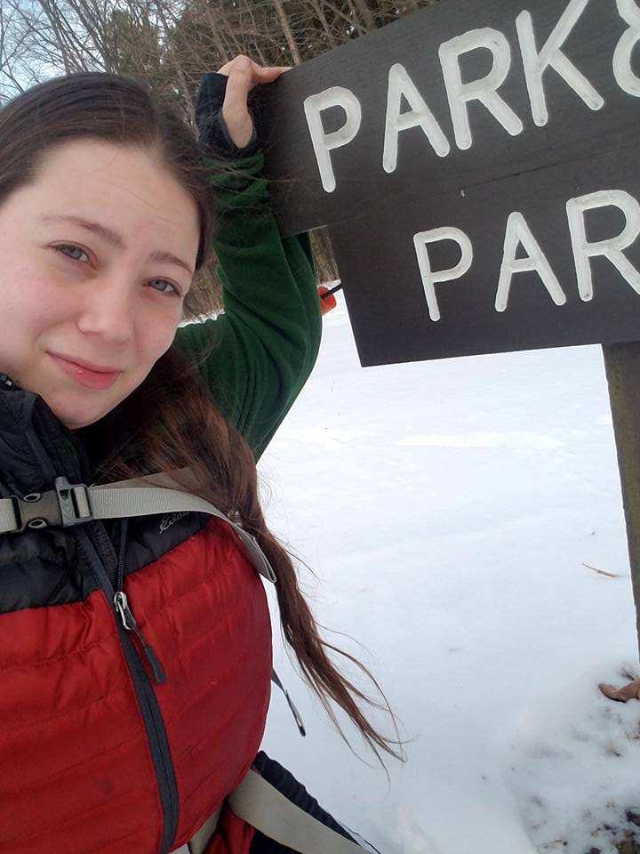
From the Section Affiliated Clubs Coordinator - ACC
Amanda Farone – KC3GFU
Afrone926@gmail.com
330-509-4095

Hamvention
Hamvention 2023 is in the books. What an incredible way to showcase the Ohio Section hams! I am fascinated by the amount of equipment available to utilize in our hobby. There are so many different passions you can find within amateur radio and every single bit of it you can find at Hamvention. My OM and I left with our hands, arms, and backpacks full of treasures from both the flea market and the big-name distributors and manufacturers. We didn’t get to attend any forums this year but heard a lot of great things about several of them. I hope to attend quite a few of them next year. My goal for Hamvention next year is to purchase my very first CW Key. This will be my motivation to finally take the time to sit down and learn CW. Did you attend Hamvention this year? If so, what are the things you enjoyed most and the things you could do without? I’d love to hear your story!

ARRL Kids Day (June 17th)
Twice a year, ARRL offers an event designed to promote Amateur Radio to our youth. Kids Day is coming up on Saturday, June 17th. This is a great opportunity to give on-the-air experience to younger kids and to give older hams a chance to share their love of Amateur Radio with their kids and grandkids. I encourage you to host a club event and use this day to foster interest. Just for an idea, I am personally hosting a Kids Day event at our local library. We will have an on-air station set up and each child that makes a contact will receive a certificate. We will also have different learning tables set up such as: Make Your Own QSL Card, Crack the Codes (Morse Code), Tracking Satellites, Shortwave Listening, and The Adventures of Zack and Max Coloring. In addition, there will be an “Educators Station” set up for all types of educators with resources for how to implement Amateur Radio into their classrooms. If you think your club may be interested in hosting a Kids Day event, head over to arrl.org/kids-day for resources and ideas.

Field Day
Field Day 2023 is fast approaching. Is your club prepared? As I write this, there are only 30 station locations entered into the ARRL Station Locator database. This tool is widely used by hams all over the country to find Field Day locations near them. If you haven’t entered your clubs station information yet, I highly recommend you do so! If you need help entering the information, please send me an email and I can assist. I will be out and about visiting locations and I am excited to see your set-ups! Statistics show that Field Day is the most popular club activity. Club members look forward to this event every year. Keep that in mind and have fun!

Webinar Series
The ARRL has been hosting a series of webinar series related to club positions and information surrounding club development. So far, they have covered the Secretary, Treasurer, and Developing a Club Website. These are great informational presentations. You can view the recorded presentations at learn.arrl.org. If you’d like to attend the live presentation or would like to know about upcoming topics, please send me an email or keep an eye on the Club News at arrl.org/club-news.
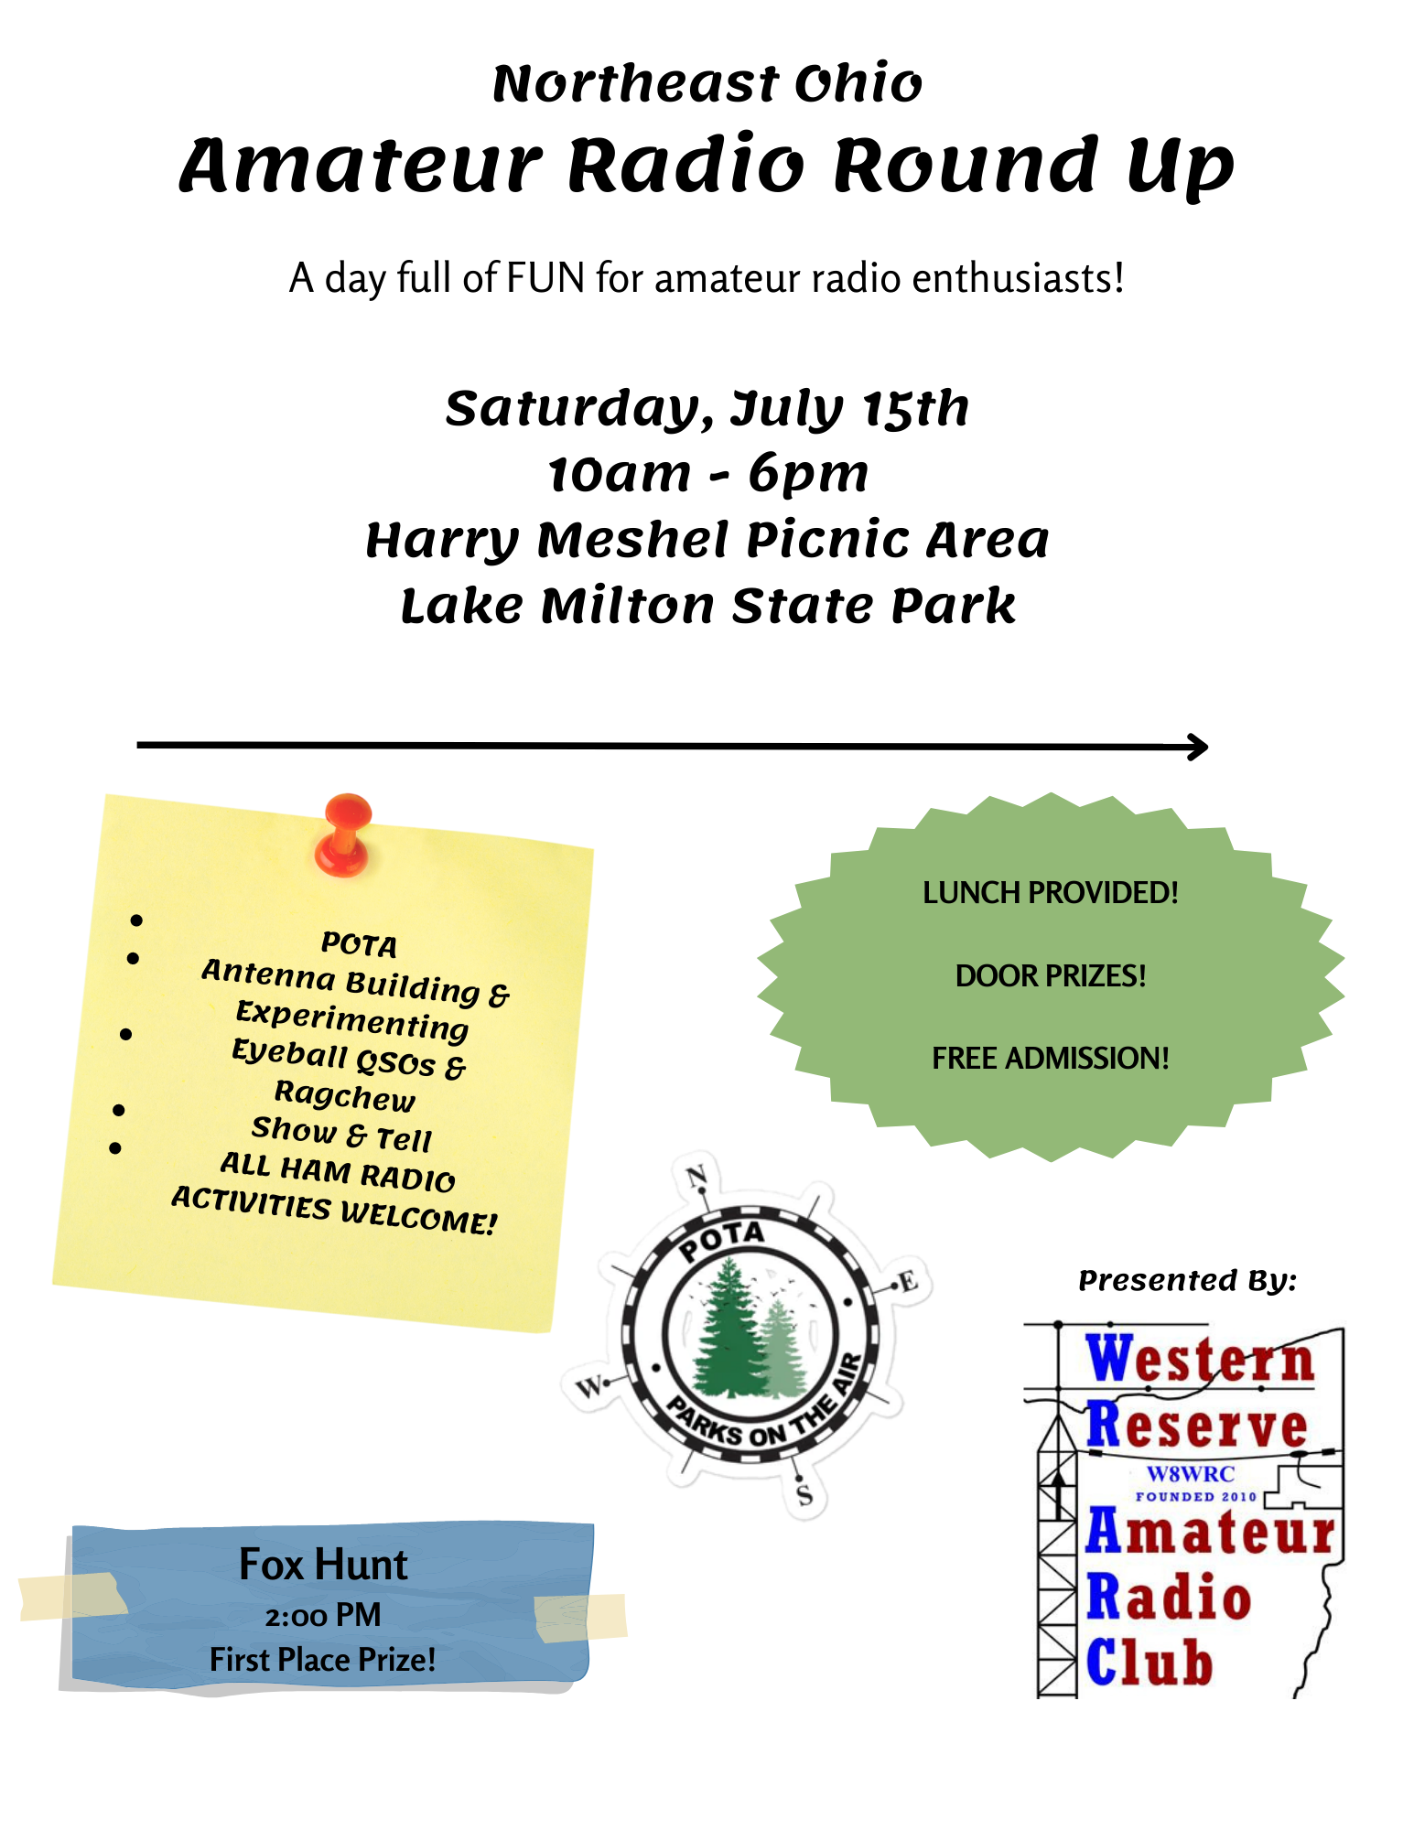
__________________________________________

National News
(from arrl and other sources)

NASA Continues Collaborative Efforts with U.S. Department of Education

NASA and the U.S. Department of Education signed a memorandum of understanding on Wednesday, May 24, 2023, strengthening the collaboration between the two agencies, including efforts to increase access to high-quality STEM and space education to students and schools across the nation.

﻿The agreement enhances and expands the agencies’ longstanding partnership that promotes science, technology, engineering, and math to students from diverse backgrounds to pursue an interest and a career in STEM and space industries. It reinforces the importance of Biden-Harris Administration and NASA priorities for STEM, climate, space exploration, and Diversity, Equity, Inclusion, and Accessibility.

Learn More

_____________________________________________

2023 ARRL Field Day Gear is Now Shipping!
ARRL Field Day is June 24 - 25. Get ready for amateur radio's largest on-air operating event with official 2023 ARRL Field Day merchandise available for order now. T-shirts, hats, pins, patches, and stickers are great ways to show off your involvement in this annual event. This year's colorful design features a globe centered on North America and the words, "Tune In The World." The back of the t-shirt includes a check-off list of ARRL and RAC Sections - a fun way to keep track of your Field Day contacts.
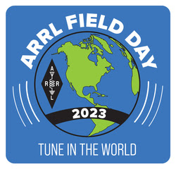
Encourage club members, family, friends, and prospective hams to take part with ARRL Field Day recruitment posters and attractive "Get on the Air" (GOTA) pins for newcomers.
Get your 2023 ARRL Field Day supplies from the ARRL online store or by calling the toll-free number 1-888-277-5289, from Monday through Thursday, 8 AM to 7 PM and on Friday from 8 AM to 5 PM Eastern Time. If you are outside of the US, call 1-860-594-0355.
The complete 2023 ARRL Field Day packet is online. ARRL encourages participants to register their Field Day operations with the Field Day Site Locator.

__________________________________________________________________

ARLX003 ARRL and FEMA Sign Agreement: Ham Radio is as Relevant as Ever
The agreement emphasizes the importance of skilled Amateur Radio Operators in times of crisis and the role of ARES leadership within the emergency communications space.
ARES (see the ARES fact sheet at, www.arrl.org/ares) is a network of trained Amateur Radio Service licensees organized across the country to provide communications and other support to served agencies, such as local governments, hospitals, and disaster response charities. More than 20,000 ARES volunteers actively participate in the ARRL program. In 2022, they provided more than 420,000 labor hours of service saving local officials $13.4 million in personnel costs.
Each member of ARES has specialized training in emergency communications. Many have also completed training in the National Incident Management System (NIMS) in order to integrate with local officials during an emergency response.
In March 2023, FEMA released the final version of the NIMS Information and Communications Technology (ICT) Functional Guidance, which includes radio amateurs in the response ecosystem and national emergency preparedness.
"The agreement is representative of the continued commitment and cooperation between FEMA and ARRL," said ARRL Director of Emergency Management Josh Johnston, KE5MHV. "Serving our country during emergencies is an important service provided by ARES volunteers and a principal purpose of our Amateur Radio Service. Our well-equipped volunteers bring their training, use of innovative technologies, and community partnerships together to serve before and during disasters."
FEMA announced the new agreement on Twitter stating, "We recently signed a new MOA with ARRL -- establishing our partnership with licensed, voluntary amateur radio operators to support response (and) recovery efforts. We're honored to work side-by-side to meet the needs of millions in the wake of disasters."
Former FEMA Administrator and ARRL member Craig Fugate, KK4INZ, led the agency when the previous MOA with ARRL was signed in 2014. Fugate said the agreement underscores the importance of ham radio. "By incorporating amateur radio into their emergency plans, FEMA ensures that they have access to a network of trained operators who can establish and maintain communication links when traditional infrastructure fails. This collaboration between FEMA and Amateur Radio Operators allows for more robust and resilient emergency communication capabilities, ultimately contributing to effective disaster response and recovery," said Fugate.
"The ARRL Board and the Emergency Communications and Field Services Committee are committed to strengthening our resourcefulness to the EmComm (emergency communications) community," said ARRL President Rick Roderick, K5UR. "Our partnership with FEMA helps further ARRL's work to better serve our volunteers, partner agencies, and the country."

ARLX004 Gomez Nominated for Vacant FCC Seat, Two Commissioners Renominated
President Joe Biden announced three nominees for the Federal Communications Commission (FCC) on May 22, 2023. The President will nominate Anna M. Gomez for a vacant FCC seat. Two sitting Commissioners, Geoffrey Starks and Brendan Carr, will be nominated for new terms at the same time.
Gomez is an attorney with decades of experience in domestic and international communications law and policy. Gomez currently serves as a Senior Advisor for International Information and Communications Policy in the State Department's Bureau of Cyberspace and Digital Policy, where she has been leading US preparations for the monthlong WRC-23 conference that will commence on November 20 in Dubai. ARRL The National Association for Amateur Radio has represented the interests of US radio amateurs in preparation for the conference, and ARRL Technical Relations Specialist Jon Siverling, WB3ERA, has been appointed to the US delegation to WRC-23. ARRL also actively supports the work of the International Amateur Radio Union (IARU), which, as a member of the ITU Radiocommunication Sector, participates in conference preparatory work and whose representatives will also attend WRC-23 by invitation as observers
in an advisory capacity.
Earlier in her career, Gomez served for 12 years in various positions at the FCC, including Deputy Chief of the International Bureau and Senior Legal Advisor to then-Chairman William E. Kennard. From 2009 to 2013, she served as the National Telecommunications and Information Administration Deputy Administrator. Gomez also briefly served as Counsel on the Senate Committee on Commerce, Science, and Transportation Subcommittee on Communications, as well as Deputy Chief of Staff of the National Economic Council during the Clinton Administration. Prior to joining the State Department in 2023, Gomez was a partner in the Washington, D.C. law firm Wiley LLP. Gomez also was Vice President for Federal and State Government Affairs at Sprint Nextel and an Associate at the Arnold (AND) Porter law firm.
Senate hearings on all three nominees are expected to be held in June.

______________________________________________

Marconi's yacht will be on the air from June 10 - 11, 2023, with the special event call sign IY4ELE

For the past 9 years, the A.R.I. Fidenza (Italian Amateur Radio Association), has celebrated a technical and cultural event for the Guglielmo Marconi Foundation at Villa Griffone in Pontecchio Marconi, Bologna, Italy (Guglielmo Marconi's birthplace). The purpose of the event is to highlight, at an international level, the historical value and meaning of Marconi's yacht, Elettra, which was the moving laboratory of the great Italian scientist. Several important radiocommunications experiments were conducted on board the yacht by Marconi during the interwar period. Over the event weekend, amateur radio operators from around the world will have a chance to contact IY4ELE, which will be operated by A.R.I. Fidenza club members via a radio station located near the keel of the Elettra. For more information, visit www.arifidenza.it.

__________________________________________________________

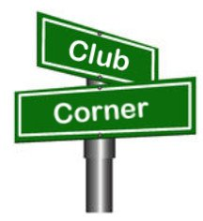
Club Corner

This is YOUR corner of the newsletter. Send us what your club is doing, and we’ll make sure that it gets in. Got a special event or club project that you want everyone to know about? Send it to us!. Need help with a project? Send it to us.

Let us know what you club is up to. Are you going to have a special guest at your meeting or are you having a special anniversary?

Send it to: webmaster@arrl-ohio.org

__________________________________________________________

Patrick Henry High School Student Appreciation Day to Feature Impressive Ham Radio Operation Demonstration by North East Indiana Amateur Radio Association (NIARA)
Hamler, Ohio - [May 19, 2023] - Patrick Henry High School (PHHS) in Hamler, Ohio, hosted an exciting event during its annual Student Appreciation Day, where students will had the opportunity to witness the wonders of ham radio in action. Spearheaded by the North East Indiana Amateur Radio Association (NIARA), this demonstration showcased the remarkable capabilities of amateur radio through the use of NIARA's communication trailer.
The NIARA communication trailer, is a state-of-the-art mobile radio station, and served as the centerpiece of the demonstration. Operated by NIARA members, including the PHHS Engineering Technology instructor Mr. Gabe Oberlin AF8GO, students had the opportunity to gain hands-on experience with ham radio equipment and witness its practical applications in various scenarios. PHHS is the home of the KE8VNL Student Radio Club. NIARA and KE8VNL are both affiliated with the American Radio Relay League (ARRL).
Students succeeded in communicating with local hams in real-time conversations using area repeaters, highlighting the importance of reliable communication during emergencies and community events. Students had the unique opportunity to observe the intricate process of establishing connections with nearby operators, expanding their understanding of the vital role amateur radio plays in supporting local communities.
The demonstration the students to tap into the High Frequency (HF) bands to communicate with operators nationally and even internationally. This global reach emphasizes the wide-ranging capabilities of amateur radio, fostering connections and cultural exchange across borders.
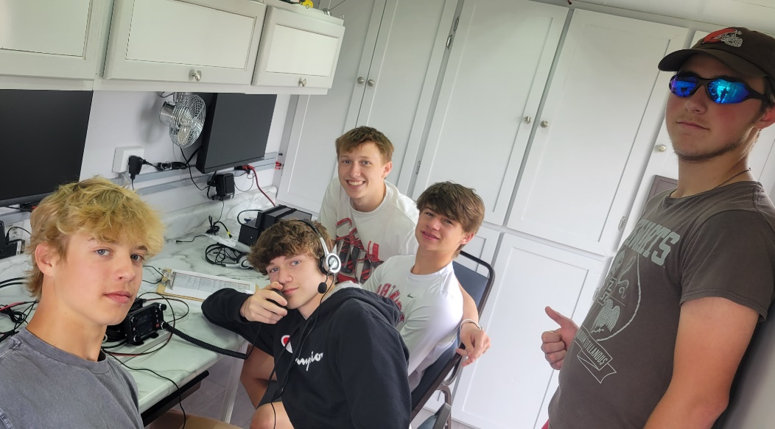
"Patrick Henry High School's Student Appreciation Day provides an ideal platform for us to demonstrate the exciting world of amateur radio to the next generation," expressed Mr. Gabe Oberlin AF8GO, instructor at Patrick Henry High School and an active member of NIARA. "We are thrilled to collaborate with NIARA and showcase the remarkable reach and impact of ham radio operations. It is our hope that students will be inspired by this demonstration and discover the vast opportunities within the amateur radio community."
By showcasing the versatility and significance of amateur radio, NIARA and Patrick Henry High School aim to encourage students' interest in science, technology, engineering, and mathematics (STEM) fields, while also nurturing valuable communication skills that will benefit them throughout their lives.
Patrick Henry High School's Student Appreciation Day is an annual celebration that recognizes the accomplishments and dedication of its students. The addition of the NIARA ham radio operation demonstration provides an engaging and educational element, allowing students to explore new technologies and expand their knowledge beyond the classroom.
For further information about NIARA and its activities, please visit [website URL].
About North East Indiana Amateur Radio Association (NIARA)
The North East Indiana Amateur Radio Association (NIARA) is a dedicated group of amateur radio operators based in northeastern Indiana. Committed to promoting the amateur radio hobby, NIARA organizes educational programs, community events, and emergency communication drills. With a focus on fostering technical knowledge and community involvement, NIARA aims to inspire and support amateur radio enthusiasts of all ages.

Pictured: Calvin Schroeder, Mitch Prigge, Lincoln Creager, Lane Jackson, Austin Lammers
Media Contact:
Gabe Oberlin
PHHS & NIARA
goberlin@phpatriots.org
419-553-6372

__________________________________________________________

May 3rd Foxhunt

After a successful Fox hunt in Hocking county this Saturday morning, W8NZB Phil Stanley won with a time of 1:01 and the last hunter was in at 1:25. Most finish within 90 minutes.Next Hocking Co foxhunt is likely to be the first weekend of June.

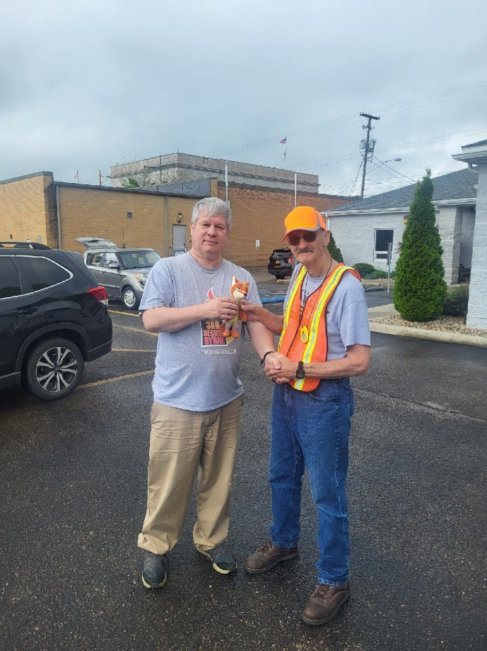
Fox KC8JRV Kirk Groeneveld was found hiding inside the Hocking County EMA meeting room where the club maintains K8LGN and all the necessary materials for a FoxHunt at his fingertips. In addition to throwing the hunters A curve, Kirk had prepared 8 clues which he dispensed during the second half hour, allowing the hunters
Some ability to think outside the box to find him.

The exercise also demonstrated to all that if necessary, simplex operations would work for the majority of the Logan valley,
At least where the majority population for Hocking County resides. One hunter remarked that while on the books as a
Back-up plan, it had never been tested until today.

Many thanks to Hocking Co. EMA Director Mark Edgar for his assistance in staging this hunt Saturday, May 13th during his off hours.

Photo credit: KC8JRV Kirk Groeneveld (left) congratulates winner Phil Stanley K8NZB with the rotating stuffed Fox doll/trophy.

VE Sessions

The following information is for ALL exam sessions:
It is now an FCC requirement to have an FCC FRN; active email address and active phone number before taking any exam. Please bring your FCC FRN, original license, a copy of your license (if a licensed ham), a valid photo ID and $15.00 - Cash preferred.
Effective April 19, 2022, the FCC will charge a $35.00 application fee for amateur radio licenses. The fee will apply to new, renewal, rule waiver, and modification applications that request a new vanity call sign. License upgrades will not have a fee applied. The fee will be per application. VE's will not collect the fees at exam sessions.
If you are applying for your first license, please go to http://apps.fcc.gov/cores/userlogin.do and obtain an FRN. This website is self-explanatory and the FRN registration is free.

All Things Amateur Radio Association (ATARA)
We host testing sessions every second Tuesday of the month in Lancaster. To sign up please visit our website https://atara-w8atr.fun and contact us at hamexams@atara-w8atr.fun.

Butler County Amateur Radio Association W8WRK
Laurel VE Testing Session - hosted by DIAL amateur radio club
Amateur Radio License Examinations at 9:00AM on Sunday April 29th at Fairfield Township Administration Building 6032 Morris Rd. Hamilton, OH 45011. Pre-Registration is required, go to: www.qsl.net/w8blv click on Exams and follow the instructions. Additional info may be obtained from Thurl Golden, KD8VLU (513) 939-4891 tgolden@fuse.net or Ron Spaulding, N8QF, (513) 617-6181 or n8qf@roadrunner.com . There are no Exam Fees!

CARS
VE testing from CARS - Cuyahoga Amateur Radio Society - at Elmwood Recreation Center, 6200 Wisnieski Parkway in Independence, Ohio 44131 Time: 9:15 AM (Walk-ins allowed) Always the 2nd Sunday of the odd month. Go to CARS www.2cars.org for detailed map of location. Call Metro W8MET 216-520-1320 for details

Clark County Amateur Radio Association (CLARA) What: CLARA sponsored A.R.R.L. VE Testing - Walk-ins allowed. Pre-Register via email preferred. When: On every second Saturday of each even numbered month starting at 10:00 AM
Feb 11th; Apr 8th; Jun 10th; Aug 12th; Oct 14th; and Dec 9th, 2023. Where: Springview Government Center - Emergency Operations Center; 3130 E Main St; Springfield OH 45503 This is US-40 aka "old national road". From Route 40 enter Old Columbus Road, at the fork stay left driving straight onto Ogden Rd, then immediately turn left into the parking lot behind the EMA. Walk to the door with the "Employees Only" sign.
For more information contact Roland W. Ude, W8BUZ, (937) 605-4951 Email: buzz@baylorhill.com

Dayton Amateur Radio Association (DARA)
If you are interested in testing for a new or upgraded license, please come see us at the DARA Clubhouse. If you have questions about testing, please email exams.w8bi@gmail.com

Dial Radio Club, Middleton, OH
Will offer Amateur Radio License Examinations at 6:00PM on Wednesday March 1st at St. John XXIII Elementary School, 3806 Manchester Rd., Middletown, OH 45042. Pre-Registration is required, go to: www.qsl.net/w8blv click on Exams and follow the instructions. Additional info may be obtained from Dave Williamson, KD8W, (513) 424-5819 or kd8w@ARRL.net or Ron Spaulding, N8QF, (513) 617-6181 or n8qf@roadrunner.com . There are no Exam Fees!

Findlay Radio Club

The club also sponsors exam sessions at 9AM the second Saturday of each month at the clubhouse. For more info on the club, check out our web page at www.findlayradioclub.org .

Geauga Amateur Radio Association (GARA)
Amateur License exam sessions are offered for all license classes (Technician, General, Extra). Walk-ins are always welcome - no prior registration is required. No fee for the exam.

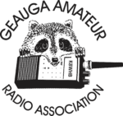
The GARA schedule of exams are these Sundays at 2pm. Dates for 2023 are January 15th, March 19th, May 21st, July 9th, September 10th, and November 12th.

Exams are held at the Geauga County Department of Emergency Services and Emergency Operations Center, 12518 Merritt Road, Chardon, Ohio 44024. The EOC is located just south of the University Geauga Hospital and just east of the Geauga County Safety Center (Sheriff's Office), off of State Route 44 between State Route 322 and State Route 87 on Merritt Road.

Please arrive a few minutes before 14:00 to allow adequate time to process the necessary paper work and take your test. Bring your 1) photo ID, 2) email address, 3) FCC FRN, 4) a printout of your current license if taking the General or Extra exam.

Additional info may be obtained from Jim Mekeel, KE8EMP, email KE8EMP@gmail.com or the Geauga Amateur Radio Association website https://geaugaara.org

Huber Heights Amateur Radio Club
Huber heights amateur radio club does ARRL VE testing the second Saturday of each even numbered month. Feb, Apr, Jun, Aug, Oct, Dec. 9:30-11:00 For more information contact Jim Storms – AB8YK at ab8yk@hotmail.com

The Lake County Amateur Radio Association
The Lake County Amateur Radio Association is holding its 2023 Amateur Radio license exams at the Kirtland Library, 9267 Chillicothe Road, on the following dates:

Saturday, February 4 Saturday, August 5

Saturday, April 1 Saturday, October 7

Saturday, June 3 Saturday, December 2

This bi-monthly schedule is the first Saturday of every even-numbered month (e.g., February being the second month, etc.). They are held at the Kirtland Library, 9267 Chillicothe Road. It is 1.7 miles south of I-90 on Route 306 (Chillicothe Rd). The library is on the left, just beyond the Marathon gas station.

The tests will start at 12 noon. Please arrive a few minutes earlier.

To register, you will need a NCVEC 605 Form, which will be available at the test. If you would like to complete one ahead of time, be sure it is the Sept 2017 version or later. You can find it by Googling “NCVEC quick-form 605” and clicking on the url for a pdf of the form. Please note the FCC requires you to provide a FRN (FCC Registration Number). Social Security Numbers are no longer accepted. If you are new to ham radio and don’t have a FRN, Google “New FRN” and follow the fcc.gov link.

If you are currently licensed, be sure to bring a copy of your license to the exam. The cost of the exam itself is $15.00, and if you wish to pay by check, it should be made out to the ARRL/VEC. Identification with your picture is also necessary, such as a driver’s license. If you have any questions, please contact Scott Farnham, KO8O, at (440) 256-0320, or scottfarnham@roadrunner.com

In addition to the $15 test fee, the FCC now charges $35 to add you to the Amateur Radio database. The FCC will e-mail successful candidates instructions for payment directly to them. Payment must be made within 10 days of the e-mail. This charge does not apply to upgrades.

The Lancaster and Fairfield County Amateur Radio Club (LFCARC) hosts exam sessions at the FAIRFIELD County EMA, 240 Baldwin Dr in Lancaster Ohio, 43130, on the first Saturday each month at 10:00 am. Please visit our website at http://www.k8qik.org for exam dates on our calendar and navigate to our Learning Center/Taking the Exam link for information and requirements. Our experienced VE team looks forward to serving the Amateur Radio community in Central Ohio. Contact me at ve_testing@k8qik.org to register.
Lisbon Area Amateur Radio Association Beginning Feb 11, 2023 Testing on the 2nd Saturday of each month at the Columbiana County EMA located at 215 S Market St. Lisbon, OH 44432. Walk-ins OK. Check in at 1:00PM. For more information go to www.K8GQB.com or contact NN8B at nn8b.oh@gmail.com
**** NO VE SESSION FOR JULY *****
Madison County The Laurel testing group will offer testing on the first Thursday of January, March, May, July, September and November. Tests are held at 7:00PM at the Madison County EMA located at 271 Elm St. London, OH. No fee.

The Milford Amateur Radio Club (MARC)
VE testing is held the third Thursday of each month at 6:00 PM. Location; Miami Township Civic Center located at 6101 Meijer Drive, Milford, OH 45150.
Please pre-register at www.milfordhamradio.org

Northern Ohio Amateur Radio Society (NOARS) VE sessions are held the first Saturday of odd-numbered months (EXCEPT FOR March and July) at 10 AM in the North Olmsted Library, 27403 Lorain Rd., North Olmsted. Registration is preferred, but walk-ins are welcome. For more information or to register, contact Elaine, KC8FOS at ewilkinson1951@gmail.com. There will be a VE session held March 12th at the NOARS Winterfest held at Lorain County Community College in the John A Spitzer Conference Center, 1005 Abbe Rd N, Elyria, OH 44035. Please email Elaine – KC8FOS at ewilkinson1951@gmail.com to register.

Portage County Amateur Radio Service (PCARS)
The first Saturday of every even numbered month -10 am – at the PCARS club site in Ravenna. Please visit the PCARS web site and check out the information about VE testing in the latest newsletter at www.portcars.org .
If you have any questions, don’t hesitate to contact me at KB8UUZ@gmail,com

Tusco Amateur Radio Club W8ZX

VE Testing sessions are held on the second Saturday of every even numbered month at the Dover Faith Church, 420 N Wooster Ave, Dover, OH 44622. Pre-registration is not necessary. Doors open at 0830 for registration, exams begin at 0900. Cost is $15. You are required to have an email address and a copy of your FRN or current ham radio license. For more information please go to www.w8zx.net/exam or email VETEAM@N8BAG.NET.

______________________________________________________________

Important Links
ARRL Home: www.arrl.org
Find an ARRL Affiliated Club: www.arrl.org/clubs
Find your ARRL Section: www.arrl.org/sections
Find a License Class in your area: www.arrl.org/class
Find a License Exam in your area: www.arrl.org/exam
Find a Hamfest or Convention: www.arrl.org/hamfests
Email ARRL Clubs: clubs@arrl.org

____________________________________________________________________________

The Ohio Section Youth Net

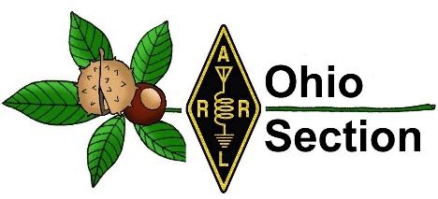
Youth Net
When: The second Sunday of every month at 7:30 PM EST
Where: The K8IV repeater located in Kent, Ohio (Echolink node K8BF-L) RF: 146.895 Mhz with PL 118.8
Who: Any licensed amateur radio operator who wishes to participate. Priority will be given to youth stations and those located in Ohio.
The purpose of this net is to encourage youth activity in amateur radio and to help new hams get more comfortable on the air.

***Next Net is Sunday June 11th ***

______________________________________________________________________

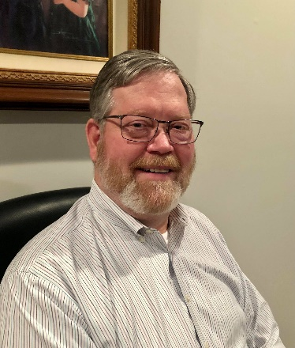
DX This Week – Why CW?

Bill AJ8B (aj8b@arrl.net, @AJ8B, or www.aj8b.com)
CWOPs Member #1567

What a two weeks it has been! Between working DX, preparing for the DXpedition of the Year award announcement, club elections and activities, and the DX Forum, there has been quite a bit of DX activity this week. What not join in the fun? The SWODXA meetings are virtual so you can join and converse with all of us. And you can vote for next years DXpedition of the Year!

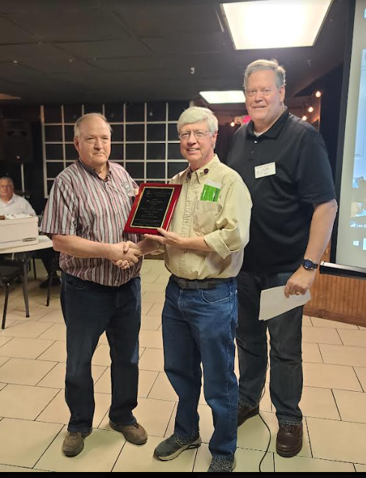
Last week during the Southwest Ohio DX Association (SWODXA) meeting members elected the following 2023-2024 officers:
President - AJ8B, Bill Salyers
Vice President - W8KJ, Kevin Jones
Secretary - KC8CKW, Mindi Jones
Treasurer - W8RKO, Mike Suhar

SWODXA also bestowed the prestigious W8OK Award to NR8Z, Tom Inglin. In the photo to the right, the plaque is being presented to Tom by the previous two winners, K8DV – Dave on the left and AJ8B – Bill on the right. Congrats to Tom! More information on the W8OK award can be found at W8OK Award – Southwest Ohio DX Association (swodxa.org).
Results of the SWODXA DX Contest were announced as follows:
First Place - K4YJ, Dwight Kelly
Second Place - W8EH, Ernie Howard
Third Place - AJ8B, Bill Salyers

We also held the annual DX Dinner last week and presented TN8K with the coveted DXpedition of the Year award. They made over 160,000 QSOs during the DXpedition to the Congo.
Finally, I received some great QSL cards the past two weeks including: HS4OFE – Wee in Thailand, VK2QR – Rob in Talbingo, Australia, JA1IOA – Shigeru in Tsuchiura-City, Japan, S500E – Special Event station to commemorate 500,000+ QSOs from S50E from Slovenia, SP9UPH – Bodgan in Poland, and J6/DF8AN Mike operating from St. Lucia. What did you get?

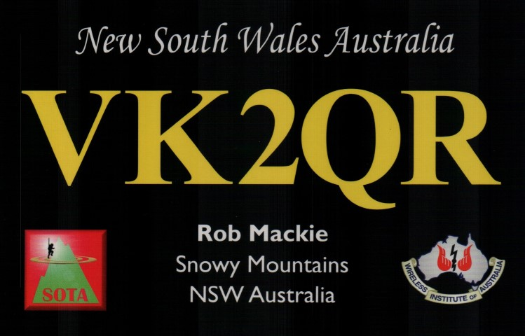
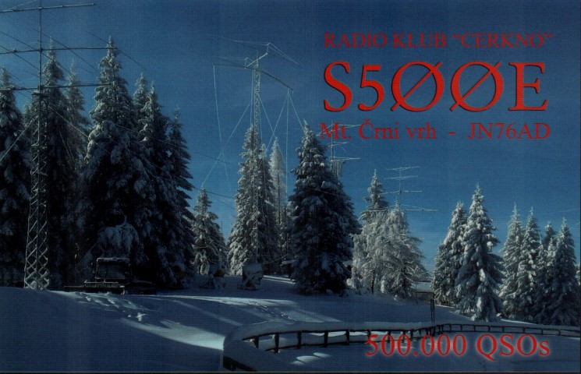

DAH DIT DIT DIT DAH DAH DIT DIT DIT DAH

Here is an update from Bernie, W3UR, of the DailyDX and the WeeklyDX, the best source for DX information. http://www.dailydx.com/ . Bernie has this to report:

T31 - Central Kiribati - As previously reported the Rebel DX Group is currently on their way to Kanton, Central Kiribati. The trip from 3D2 to Samoa is about 700 nautical miles. They will make a stop in Samoa to refuel and meet about another rare DXCC nearby. As of the 0000Z today they were about 80 miles from Samoa. Once they depart Samoa it is another 700 nautical miles and will take about 7 to 8 days to reach Kanton. The team plan to operate for 12-14 days as T31TT from Central Kiribati. After their operation from Kanton they plan to fly to Europe and spend two weeks work on their "200,000 QSL cards". They are also looking at going to Tuvalu and one more before their "main event by end of the year".
EK – Armenia - EK7PP, Karen, is QRV on 6 meters with an IC-7300 and 30 meters to a HyGain AV-640 HF vertical. He is located in Abovyan (grid locator LN20hg), some 16 kilometers northeast of the capital city of Yerevan.
3W – Vietnam - DL7BO, Tom, is currently operating as XV9K near Phan Thiet (grid locator OK40dv. He has an IC-7300 and 6 element Yagi for 6 meters at about 8 meters off the ground. He can operate FT8, SSB and CW on 6 meters.

As a reminder all ARRL members are encouraged to take the Dues Survey
at http://www.arrl.org/take-dues-survey

The Northern California DX Foundation (NCDXF) recognizes the negative impact deliberate QRM (DQRM) is having on our hobby. We believe this is a problem that can be mitigated by amateur radio operators applying their vast knowledge and creativity to the advanced receiving and direction finding technology currently available. In order to spur research into solving this problem the NCDXF Board of Directors at their April 2023 Board Meeting allocated $100,000 for grants to develop DQRM solutions.
NCDXF will entertain grant proposals from individuals or groups that specifically outline their approach to identify bad actors. A group of NCDXF Directors led by Craig Thompson, K9CT and Don Greenbaum, N1DG will weigh the probability of success of their proposals as well as monitor the progress of the grantees.
Funding will be available for R&D as well as implementation of technology proposals. It is hoped that manufacturers will also assist NCDXF and grantees with equipment and other resources.
NCDXF will shortly outline specifics for how to apply for these DQRM grants. We have created a webpage devoted to this project, DQRM Project - https://ncdxf.org/pages/dqrm.html

LZ1GC, Stan, has posted the A35GC story about his November 2022
DXpedition to Tonga at http://www.mdxc.org/a35gc-story/

DAH DIT DIT DIT DAH DAH DIT DIT DIT DAH

Below is a list of upcoming contests in the “Contest Corner”. I think this is important for someone who is trying to move up the DXCC ladder since entities that are on the rarer side and easiest to work in contests. Some of my best “catches” have been on the Sunday afternoon of a contest when the rarer entities are begging for QSOs. Of course, the gamble is that if you wait until Sunday, conditions may change, or they simply won’t be workable. However, it is not a bad gamble. Of course, why not work the contest and have some fun!
Check out the WA7BNM Contest Calendar page (https://www.contestcalendar.com/) and CQ Magazine for more contests or more details. I also have a comprehensive list that can be imported to your calendar at www.aj8b.com/files
The contests in red are those that I plan to spend some significant participation time on. PLEASE let me know if you are working contests and how you fared.
Thanks!

Date(s) | Event | Info
All Year | CQ DX Marathon | http://bit.ly/3FyPiui
June 3 | UKSMG Summer Es Contest Rules | https://uksmg.org/summer-contest-rules.php
June 3-4 | 10-10 Open Season PSK Contest | http://bit.ly/1FrFeBc
June 3-4 | ARRL Inter. Digital Contest | https://contests.arrl.org/dig/
June 3-4 | IARC Region 1 Field Day | http://bit.ly/3cC0HKf
June 3-4 | Kentucky QSO Party | http://www.kyqsoparty.org/
June 3-4 | RSGB CW Field Day | http://bit.ly/3TxCrxl
June 3-4 | Tisza Cup CW Contest | https://www.tiszacup.eu/index.php/en/contest-rules
June 5 | RSGB 80m Club Championship, Data | http://bit.ly/3TxCrxl
June 7 | VHF-UHF FT8 Activity Contest | http://www.ft8activity.eu/index.php/en/
June 10 | Asia-Pacific SSB Sprint | http://jsfc.org/apsprint/
June 10-11 | Portugal Day Contest | https://portugaldaycontest.rep.pt/rules.php
June 10-11 | REF DDFM 6M Contest | http://concours.r-e-f.org/index.php
June 10-11 | GACW WWSA CW DX Contest | http://bit.ly/425Ee23
June 10-11 | VK Shires Contest | http://www.wia.org.au/members/contests/wavks/
June 10-12 | ARRL June VHF QSO Party | http://www.arrl.org/june-vhf
June 14 | RSGB 80m Club Championship, CW | http://bit.ly/3TxCrxl
June 14 | VHF-UHF FT8 Activity Contest | http://www.ft8activity.eu/index.php/en/
June 17 | AGCW VHF-UHF Contest | https://www.agcw.de/contest/vhf-uhf/
June 17 | ARRL Kids Day Contest | http://www.arrl.org/kids-day
June 17 | FIRAC VHF Contest | http://www.firac.de/html/contest.html
June 17-18 | All Asian CW DX Contest | https://bit.ly/3HVjkra
June 17-18 | IARU Region 1 50 MHz Contest | https://bit.ly/3r1kqvT
June 17-18 | SMIRK Contest | http://www.smirk.org/contest.html
June 17-18 | Stew Perry Topband Challenge | https://www.kkn.net/stew/stew_rules.html
June 17-18 | West Virginia QSO Party | http://bit.ly/3l3K6Z7
June 18 | WAB 50 MHz Phone | http://bit.ly/31yE4kT
June 21 | VHF-UHF FT8 Activity Contest | http://www.ft8activity.eu/index.php/en/
June 22 | RSGB 80m Club Championship, SSB | http://bit.ly/3TxCrxl
June 24 | UFT QRP Contest | https://www.uft.net/concours-qrp-uft/
June 24-25 | ARRL Field Day | http://www.arrl.org/field-day
June 24-25 | His Maj. King of Spain SSB Contest | http://bit.ly/1cKAR5V
June 26 | RSGB FT4 Contest Series | http://it.ly/3TxCrxl
July 15-16 | CQ WW VHF Contest | http://www.cqww-vhf.com

ARLDO21 DX news
This week's bulletin was made possible with information provided by HA7VK, OZ2I, The Daily DX, 425 DX News, DXNL, Contest Corral from QST and the ARRL Contest Calendar and WA7BNM web sites. Thanks to all.
SVALBARD, JW. Rafal, SQ9CNN is QRV as JW/SQ9CNN from Spitsbergen Island, IOTA EU-026, until May 29. He will be active as JW5E on either 20 or 15 meters during the CQ World Wide WPX CW contest. QSL to home call and JW5E via OH6VDA.
ARUBA, P4. John, W2GD is QRV as P40W until May 30. Activity is in his spare time on 30, 17, and 12 meters. This includes activity in the CQ World Wide WPX CW contest. QSL via LoTW.
ST. KITTS AND NEVIS, V4. John, W5JON is QRV as V47JA from St. Kitts, IOTA NA-104, until June 7. Activity is on the HF bands and 6 meters using SSB and FT8. QSL direct to home call.
MARSHALL ISLANDS, V7. Bob, N7XR is QRV as V7/N7XR from Kwajalein, IOTA OC-028, and is here until the end of June. Activity is in his spare time on 160 to 10 meters using CW, SSB, and FT8. QSL via LoTW.
VIET NAM, XV. Tom, DL7BO is QRV as XV9K near Phan Thiet. Activity is on 6 meters using CW, SSB, and FT8. QSL to home call.
MYANMAR, XZ. Akio, JE2QIZ is QRV as XZ2B from Yangon until the end of September. Activity is on 15, 12, 10, and 6 meters using CW. QSL via JE3SIF.
REPUBLIC OF NORTH MACEDONIA, Z3. Henning, OZ2I is QRV as Z38EE from Tetovo until May 30. Activity is on 160 to 10 meters using CW. This includes being active in the CQ World Wide WPX CW contest. QSL to home call.
SOUTH SUDAN, Z8. Diya, YI1DZ is QRV as Z81D from Juba. Activity is in his spare time on 40 to 6 meters, and possibly 80 and 60 meters, using SSB and FT8. QSL via OM3JW.
The QCX CW Challenge, ICWC Medium Speed CW Test, OK1WC Memorial, Worldwide Sideband Activity Contest, Phone Weekly Test, A1Club AWT, CWops Test, Mini-Test 40 and Mini-Test 80 are on tap for May 29 to 31.
Please see May QST, page 73, and the ARRL and WA7BNM Contest web sites for details.

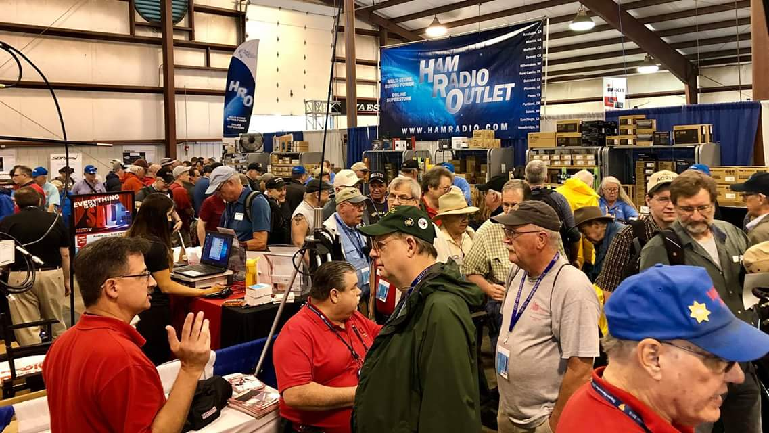
Upcoming Hamfests

We DO have some hamfests scheduled for 2023!! Yes, take a good look at the list, it’s growing every day!

Ohio Hamfests
2023
06/03/2023 - FCARC Summer Hamfest  Location: Wauseon, OH  Sponsor: Fulton County Amateur Radio Club  Website: https://k8bxq.org/hamfest  Learn More | 07/08/2023 - Mansfield Trunkfest 2023  Location: Mansfield, OH  Sponsor: Intercity Amateur Radio Club  Website: http://iarc.club  Learn More
07/15/2023 - NOARSFEST  Location: Elyria, OH  Sponsor: Northern Ohio Amateur Radio Society  Learn More | 07/16/2023 - Van Wert Hamfest  Location: Van Wert, OH  Sponsor: Van Wert Amateur Radio Club  Website: http://w8fy.org  Learn More
07/22/2023 - Ashtabula County Hamfest 2023  Location: Pierpont, OH  Sponsor: Amigos Radio Club Ashtabula  Website: https://sites.google.com/view/arca-home/  Learn More | 08/05/2023 - 2023 Columbus Hamfest  Location: Grove City, OH  Sponsor: Aladdin Shrine Audio Unit  Website: http://www.columbushamfest.com  Learn More
08/12/2023 - Cincinnati Hamfest  Location: Owensville , OH  Sponsor: Milford ARC  Website: https://CincinnatiHamfest.org  Learn More | 08/20/2023 - WARA Tailgate Swap Meet  Location: Cortland, OH  Sponsor: Warren Amateur Radio Association  Website: http://w8vtd.org  Learn More
09/10/2023 - Findlay Hamfest  Location: Findlay, OH  Sponsor: Findlay Radio Club  Website: http://findlayradioclub.org  Learn More | 09/24/2023 - Cleveland Hamfest  Location: Berea, OH  Sponsor: Hamfest Association of Cleveland  Website: http://www.hac.org  Learn More

10/29/2023 - Massillon (OH) Hamfest (& auction)
Location: North Canton, , OH
Sponsor: Massillon Amateur Radio Club
Website: http://www.w8np.net
Learn More

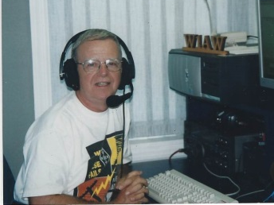
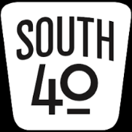
OHIO’S

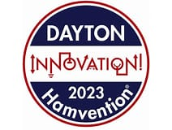
When you read this, the 2023 Hamvention will be just another of those fond memories. Here’s hoping those of you who were able to attend found the radio or other treasure you were looking for. Our hat is off to all of the Dayton ARA and the hundreds of volunteers it took to put on another great show and showcase amateur radio to the world. A personal thanks to those of you who took the time to stop at the Highland ARA’s booth to meet me and say “Hi”. It was rather mind boggling to realise this column has as many readers as it does and they reside in all parts of our great state-not just in Southern Ohio.

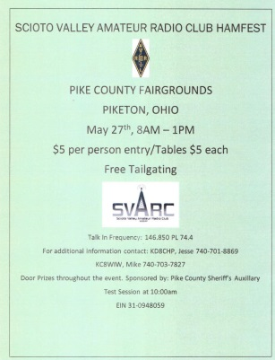
Unfortunately it might be over by the time you read this, the annual Scioto Valley ARA Hamfest at the Pike County Fairgrounds in Piketon is on May 27. The location is across the railroad tracks on the Eastern edge of the village off US 23 in the village. There is plenty of parking. The gate opens to the public at 8 AM with a $5 admission charge. An Anytone DMR will be awarded to some lucky attendee according to Club Vice President Travis Holden, WA6WTF. SVARA President Jesse Stanley, KC8CHP, states the Club is giving a free table to any club who displays a club banner. That table can be used to sell items or promote the club. Club VE Team Leader John Hartmus III, WB8GRX, reminds all of the upcoming July 1 change in the General License question pool. Therefore the Club will conduct a free Laurel VE test session for those wishing to try for a license upgrade while the current pool questions are valid. Registration begins at 9 AM.

Speaking of test sessions, I again assisted with the Hamvention VE session on Friday and was kept busy with the constant flow of applicants for new licenses as well as folks upgrading. It was exciting to see some South 40 Region folks receive new licenses or upgrades. Kevin Adams from Batavia went from no license to Extra in one setting. The Garringer Family welcomed a fourth family member to hold a ham license to the fold when Ruth earned her Technician ticket. She is from Washington Court House. Also from Fayette County, Steve Reeves, KE8YPE from Washington Court House, upgraded his recently earned license and has the Extra CSCE to show for it.

A bit of sadness surfaced when it was announced that long-time VE test coordinator Jerry Lockhart, W8HIC was unable to assist this year due to being at the Cleveland Clinic to undergo a medical procedure. Jerry is the Laurel VE Co-ordinator for the New England region as well as the VE team leader for the Southern Ohio ARA and Portsmouth RC. He is a resident of Scioto County.

Scioto County has been keeping the FCC busy issuing new licenses. Recent Portsmouth RC VE sessions have resulted in two new licenses being issued to county residents. Otway’s fire chief Guy Reynolds is probably crying “Yipee” because of his new Technician license and KE8YIP call sign. While down in Wheelersburg, the ham population has now grown to include Emily DeCamp who is KE8YJF. By the time you read this she may be sporting a new vanity call sign. Also from that ‘neck of the woods’ two Lawrence County area hams have recently upgraded their licenses. According to Michael Love and Jim Rowe of the Southern Ohio ARA Eric Kuhn, K8UHN, and James Adkins, KE4VAM, passed tests at a recent SOARA test session and now hold General Class licenses. A hardy CONGRATS to each and all.

Not all hams in the region were able to make Hamvention and for those some local clubs scheduled events to accommodate those members who still wanted to be around fellow hams and share knowledge and experiences. One such club holding an event was the Athens County ARA. Although President Eric McFadden, WD8RIF, was enjoying Hamvention, Jeff Slattery, N8SUZ, was holding the fort down and led a “Copper Cactus” fold-up j pole antenna building session that saw five antennas completed. Since the torches and other building supplies were out at the same time Kirk Groeveveld, KC8JRV, was giving instructions to those participating tips about building a “Mighty Wolf” antenna. The Club will have another antenna building session later in the year and will build a HF dipole antenna.

On Monday, May 29, we will take time out to honor those who have fallen giving their all to defend our nation and allow us to live our own lives freely as we choose. For several years two South 40 clubs have participated in activities honoring those heros. This past Wednesday evening a group of Highland ARA members assembled at the Hillsboro Greenwood Cemetery to place flags on the graves of the approximately 1,000 veterans who are buried there. Then on Memorial Day approximately 20 members the Southern Ohio ARA will provide communications for the annual Lawrence County/Ironton Memorial Day Parade. This particular event has taken place every year for 155 years and may be the oldest on in the nation.

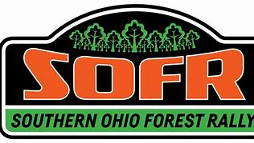
Another event that will be quickly upon us is the Southern Ohio Forest Rally. It will kick off in Chillicothe’s Yoctangee Park on Thursday evening, June 8. The activity then moves to the Zaleski State Forest on June 9 before shifting to the Shawnee State Forest (west of Portsmouth) on the following day-June 10. The last I knew was that Bill French, KE8AAL, was still requesting amateur radio operators to assist manning check points along the routes throughout the event. Contact ke8aal@yahoo.com to learn how you can assist.

It’s been mentioned in previous columns about the upcoming expiration of the current General License question pool happening at Midnight on June 30. A new test pool will over at 12:01 AM on July 1. Therefore if you are thinking of upgrading your current Technician Amateur Radio License to gain the General priviledges needed to work all the increased DX during this solar cycle, you need to quickly take action. Several South 40 clubs offer frequent testing sessions and some may even offer Elmering to those needing assistance as the June deadline draws nearer. Some of the clubs in the South 40 Region known to hold monthly exams are the Portsmouth RC, the Milford ARC, the Southern Ohio ARC, the Cambridge ARA and the Lancaster Fairfield County ARC.

Check out the Milford ARA’s website for some new information about the August 12 hamfest and test session at the Clermont County Fairgrounds in Owensville. www.cincinnatihamfest.org.

The Cambridge ARA has been asked to assist with directing parking at the annual Guernsey County Senior Citizens Picnic on May 31. The event is to be held at the Cambridge City Park from 10 until 1. If you are available to and would like a free meal in exchange, contact Sonny Alfman to volunteer.

Once again the Portsmouth RC (N8QA) will be one of 20 clubs in 16 states participating in the annual Lewis and Clark Trail On The Air Special Event. This year the event will be held from June 3 through the 19th. There is a lot of information available on the www.lctota.org website.

An interesting note in the June QST showed four of the six ARRL Affiliated Clubs recognized for completing the paperwork to renew their Special Service Club honors were from the Great Lakes Division. And three of those four are Ohio clubs including Hillsboro’s Highland ARA. Unfortunately the same issue also reported the passings of Chuck DeSantis, K8CR, from West Chester; Ron Creamer KD8ENJ, of Dayton and AB8KA, Don Sherman from Springfield. Our thoughts are with their families and friends.

With Hamvention now behind us many clubs in the Southern Ohio region have started making plans for Field Day. Once you know your FD location please post it on the ARRL’s Field Day Locator website. That site provides an excellent opportunity to let others know where you will be operating from. Plus it’s free! Already many clubs around Ohio, Kentucky and West Virginia have posted their information on this interactive map. www.arrl.org/field-day-locator

The Clinton County ARA will experiment totally using battery power for their Field Day operation from the K8IO estate near Lake Cowan. The Portsmouth RC will operate from the Spartan Stadium in Portsmouth. This will be an interesting and historic operation because what is now the Detroit Lions professional football team started their existence in Portsmouth as the Portsmouth Spartans. The Vinton County ARA is looking at operating from the Vinton County Airport.

Highland ARA President Ken Lightner, KE8JEL, reminds HARA members that the Club’s monthly Brunch Bunch breakfast gathering will move to the Hillsboro Liberty Park Harmony Shelter House on June 10 and meet there monthly through the Summer and Fall. The Brunch Bunch gathers on the second Saturday of each month at 10 AM. Lightner also reminds members of the June 13 business meeting at the Highland County EMA Office in Hillsboro at 7 PM.

The OH-KY-IN ARS needs assistance manning their fund raising beer booth during the July 4 “Red, White and Blue Ash”. Workers are needed from around 3:30 PM until the fireworks show begins about 10. Contact Bruce Vanselow, N8BV, at 513-251-1555 for more information or to offer your assistance.

As mentioned last time out, the Planned Ohio State Parks on the Air Activation list is now open for listing any planned activation of a state park during the September 9 event. It’s interesting to note that 14 parks already have activations indicated. And two of those have at least two different operations to take place. Email any planned activation to plannedparks@ospota.org. Although the event is not until early September, now is the time to start giving some thought to taking part in this growing activity. Unfortunately last year saw a number of Southern Ohio State Parks absent from the airwaves. Check the www.ospota.org website for more information, past activations and this year’s rules.

With a time of one hour and 11 minutes, Phil Stanley, W8NZB, was the winner of the recent Hocking County Fox Hunt. Phil found the fox hiding in the Hocking Valley ARA radio room at the Hocking County 911 Center. The next Hocking County Foxhunt is anticipated to be on the first weekend in June.

For a while the Tri-State ARA has asked members to bring canned goods to club events. Recently those efforts resulted with Bud Cyr, KB8KMH, serving a big pot of Hobo Stew to those who attended the May 16 club meeting at the radio museum in Huntington. A rather unique way to reward those who take the time to attend a meeting.

Although a bit of a drive for many in the Southern Ohio region, a really good hamfest to attend is Western Pennsylvania’s June 4 BreezeShooters Hamfest. This year marks its 66th year with the return to its home for decades at the Butler Farm Show Grounds in Butler, PA. Besides the usual large flea market there will be numerous forums, commercial vendors, demonstrations and prizes. Did I forget to say prizes? The gates open at 8 AM. The web site is http;//www.breezeshooters.org. Did I mention they will award some nice prizes? I’ve been to it in the past and always found it worth the drive. They’re going to give away some nice prizes this year with an IC-7610 and a Yaesu FTDX10D the top two of nine majors.

Although some time away, the Cambridge ARA is in need of some volunteers to assist with the planning and manning of their booth at the August 11-13 Salt Fork Arts and Crafts Festival in the Cambridge City Park. Their booth will celebrate the 110th anniversary of the Club’s founding. Contact Lyn Alfman for more information or to volunteer your services.

On Wednesday evening a contingent of Highland ARA members gathered at the Hillsboro Cemetery to assist the Friends of Greenwood and a local scout troop decorate the graves of the approximately 1,000 veterans buried in the cemetery. According to HARA Vice President John Willis, KE8JEM, the Club has been participating in this community project for a number of years. In 2022 the “Amateur Radio Newsline” reported on the activity on its report number 2325 that was heard by thousands of people around the world.

I’m certain everyone who attended Hamvention has some type of a take away. Mine turns out to be rather neat as well as personal. My wife N8ZNR and I were guests at the recent Hamvention Awards Banquet and got to rub shoulders with some of the movers and shakers in ham radio. Following our introduction as representing the 2022 Hamvention Club of the Year a lady at a nearby table approached Kathy and introduced herself. Fifty years ago this lady’s mother was our next door neighbor and long ago got married and relocated from the area. The daughter immediately made a phone call to her mother resulting in a great evening made even greater. The daughter is married to Neil Rapp, WB9VPG, who does a series of ham radio related YouTube videos. Walt Disney used to say “It’s a small world”. This experience shows ham radio makes it even smaller.

Some of the Hamvention license results are beginning to show in the FCC database. Let’s welcome Loveland’s Brian Culberson and Mathew Kraemer plus Ruth Garringer from Washington Court House to our hobby. Brian is now KE8YKX, Mathew is KE8YLP and Ruth is KE8YKZ. As the FCC processes the paperwork and license fees expect to see more newly licensed amateurs from the region posted in the coming days. But in the meantime, let’s support and give our encouragement to these newly licensed folks. Then let’s get them on the air and make them feel welcome.

This coming week we observe the traditional start of Summer with Memorial Day observations, parades, flag raisings, family picnics, high school reunions and all the other things the start of Summer brings. A common Memorial Day tradion is a cemetery visit to pay our repects to deceased family members and friends. Most cemeteries allow flags to be placed on the graves of our fallen veterans. Therefore, while paying respects to those family and others buried in the cemetery, please take a few moments to view those flags fluttering in the breeze and thank those who gave their all to protect our nation and allow us to maintain our freedoms.

That’s it for another column. Here’s hoping everyone remains safe, healthy and radio active during this first holiday of Summer.

John Levo, W8KIW, jlevo@cinci.rr.com or highlandara@gmail.com, 937-393-4951

__________________________________________________________________

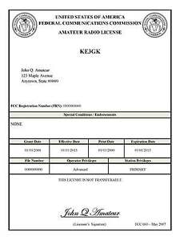
Print an Official or Unofficial Copy of Your Amateur Radio License
(By Anthony Luscre, K8ZT)

As of February 17, 2015, the FCC no longer routinely issues paper license documents to Amateur Radio applicants and licensees. The Commission has maintained for some time now that the official Amateur Radio license authorization is the electronic record that exists in its Universal Licensing System (ULS). The FCC will continue to provide paper license documents to all licensees who notify the Commission that they prefer to receive one.

Licensees also will be able to print out an official authorization — as well as an unofficial “reference copy” — from the ULS License Manager. I’ve created a set of instructions on how you can request an “official” printed copy of your license*

Click here to download the instructions

One Question Questionnaire

Hey Gang,

Last weeks question HAVE YOU EVER HELPED A YOUNG HAM GET ON THE AIR??

With a total of 99 Responses: 74(74.75%) said YES, and 25 (25.25%) said NO. This is one of the most meaningful things we can do as a ham. In fact, it’s imperative we do if we want out hobby to continue.

The new question is:

have you got your own copy of the 100th annivesary handbook?
a) Yes?
b) No?

You’ll find the “One Question” questionnaire on the Ohio Section Website! http://arrlohio.org It’s all for fun and it’s not a scientific survey in any way, but we are learning some things that we didn’t know from these questions. I hope that you are enjoying answering these “One Question” questionnaires.

Look for the RED ARROW on the website – After your vote ENTER out Handbook giveaway contest! Next week I’ll announce the May winner!

Final… Final

If you are an ARRL member, have you filled out the “Member Dues Survey” yet? If not, why not? This is your organization – and this is not just an exercise in BS! On May 24th, CEO David Minster – NA2AA - sent out a reminder and pointed out that at that time we have had 12,000+ responses. I’ll say it right here – that’s a horrible response rate! I’ve copied his letter here, you’ve got until May 31st to get this done. Let’s send a message by the number of responses from the Ohio Section that the best and most dedicated Hams in the country are right here in the OHIO SECTION!

Reminder:
Complete the ARRL Dues Survey Now
Dear member,
If you're among the nearly 12,000 members who have already completed the dues survey -- THANK YOU. If you haven't yet, please complete the survey now at www.arrl.org/take-dues-survey.
Since the survey launched on May 1, I have personally read each survey response for feedback. Many members have taken the opportunity to share with us what we're doing well, what they like, and what we could do better or improve. Many of you have shared ideas. A member who is blind even wrote to tell us that the survey was fully accessible for him -- reinforcing that we want participation from every member.
Some of your Division Directors have also sent you reminders -- setting up a healthy competition (which Division will have the highest participation rate?).
As I shared previously, this is only the second time in 22 years we are considering a dues increase. The survey is an essential step in this process.
If you haven't already participated, please follow these steps:
- Go to www.arrl.org/take-dues-survey. This is a member-only page. If you are already logged in to your account, the page will include the survey. If you already completed the survey, you may see a message indicating, "You have already voted in this poll."
- If you are NOT already logged in to your account, follow the instructions on the page to log in. Or, select the Login button at the top of the web page, and you will be prompted to enter your ARRL website username (usually your call sign) and password. If you have not logged in since April 2022, please use these Login Instructions.
- Complete the survey by May 31.
If you need additional help with your login, call us Monday - Thursday from 8 AM to 7 PM ET, and Friday from 8 AM to 5 PM ET at 860-594-0200 or email us at membership@arrl.org.
What happens next?
The survey results will be tabulated and shared with members on the ARRL website in June. The results will also be shared with the ARRL Board of Directors. Your responses will aid our analysis and discussions, and ultimately help ensure ARRL's future as an effective, strong, and influential membership association.
Again, thank you for being a member and collaborating on this big decision.
73
David A. Minster, NA2AA
Chief Executive Officer

On the Thursday afternoon before Hamvention, I had the opportunity to meet with a very small group of Section Managers and CEO David Minster. Many topics were discussed. The stand outs in my mind are the “Use it or Loose it” approach we need to take to our spectrum allocations. Sure, that includes everything, including a lot of real estate that has almost ZERO occupancy! Those are the allocations above 450Mhz. Not necessarily the easiest bands to get active on, BUT, we don’t know what the future holds for us, and those could be some very important allocations for us to have as we move forward. Hams have always been the tinkerers, the thinkers and the discoverers. Put some thought into this – it could be important for our future survival.

One last comment….David Minster talked about the Amateur Radio community as being one of the most “fraternal” and friendliest on the planet. He gave the example that if you found yourself in some far away country (or even state) and you woke up to find yourself beaten and robbed, if you looked up and saw a house with an Amateur Radio Antenna and got yourself there, almost without question you would be taken in and helped. If you’re a HAM, you belong to a very special community. And I’m glad you do!

73,
Tom WB8LCD

“Swap & Shop” on the website

Hey Gang,

Have you taken a look at the Swap & Shop page on the Ohio Section webpage yet?? Here’s a link that will take you there…
http://arrl-ohio.org/sm/s-s.html

Do you have equipment that you just don’t need or want anymore? Here’s a great venue to advertise it, and it’s FREE!!

Is your club doing a fund raiser to help raise money? After a lot of thought, it was decided that the Swap & Shop webpage could also contain these types of items as well.

The same rules will apply as do for the For Sales and Give-A-Ways and will only be posted for a month at a time. Please see the Terms & Conditions on the webpage.

If your club is doing a fund raiser and wants more exposure, please forward the information to me and I’ll advertise it on the Swap & Shop webpage for you. Now, I still want to remind you that it won’t be listed in this newsletter because it would take up way too much space, so your ad will only appear on the website. It is there for any individual to post equipment Wanted / For Sale or Give-Away as well as for Club Fund Raisers. No licensed vehicles/trailers or business advertising will be posted.

Postings are text only (no pictures or graphics) will be posted for a maximum of 1 month from date posting and require a contact phone number or email within the posting. Send your Wanted / For Sale or Give-Away post to: swap@arrlohio.org

Back Issues of the PostScript and Ohio Section Journal

Hey, did you know that PostScript and Ohio Section Journal (OSJ) are archived on the website? You can go back and look at any edition simply by clicking:
http://arrl-ohio.org/news/index.html

Ohio Section Cabinet
Section Manager – Tom Sly, WB8LCD | Section Emergency Coordinator – Bret Stemen, KD8SCL
Technical Coordinator – Jeff Kopcak, K8JTK | Section Traffic Manager – David Maynard, WA3EZN
State Government Liaison – Bob Winston, W2THU | Affiliated Clubs Coordinator –  Amanda Farone, KC3GFU
Section Youth Coordinator – Anthony Lascre, K8ZT | Public Information Coordinator – E;izabeth Klinc – KE8FMJ

Chit – Chat, and All That!

Do you know someone that’s not getting these Newsletters? Please, forward a copy of this Newsletter over to them and have them “Opt-In” to start receiving them. Heck just have them send an email to: webmaster@arrl-ohio.org to be added.

We now have many thousands of readers receiving these newsletters weekly. Quite impressive, I’d say! I urge all of you to make sure that everyone, regardless of whether they are a League member or not, get signed up to receive these weekly Newsletters.
You can always “Opt-Out” at any time if you feel this is not what you were expecting. It’s fun and very informative. All of your favorite past newsletters are now archived too.
You can go back at any time and read them. Just go to: http://arrl-ohio.org/news/

The pictures on the front page and throughout this newsletter are from various newsletters, Facebook posts and/or were sent directly to me in recent weeks. Take a good look at them, you just might be in one of the pictures! “SMILE… you’re in the Ohio Section News!!”

The Ohio Section Journal (OSJ) is produced as a comprehensive look at all the programs within the Ohio Section. I sincerely hope that you have enjoyed this edition of the OSJ and will encourage your friends to join with you in receiving the latest news and information about the Ohio Section, and from around the world!

TOP^

