March 2023

From the Technical Coordinator | From the Section Emergency Coordinator
From the Public Information Coordinator | From the Section Youth Coordinator
From the Section Traffic Manager | ARES Training Update
From the Affiliated Clubs Coordinator | National News
Club Corner | Contest Corner
DX This Week | One Question Questionnaire
South 40 | Final.. Final..

I want to wish you all a Happy and Joyous Easter next weekend! Enjoy time with your family and friends. The next issue of PostScript will be issued the weekend of April 15th so that everyone can have some time off.

From the Technical Coordinator
Jeff Kopcak – K8JTK TC
K8JTK@arrl.net

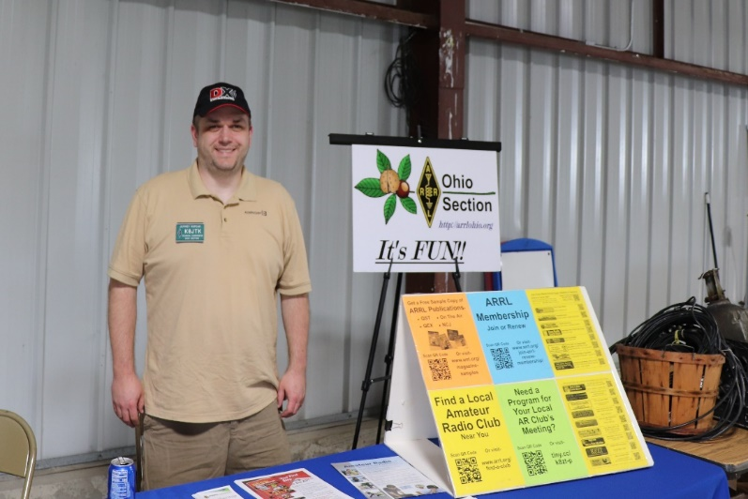
Hey gang,
Time is running out! No, not on some great offer but to complete station evaluations - if you were grandfathered and still haven’t completed one. I’ve covered this topic previously describing two different ways and methodologies for tackling this requirement. First using the exemption formula and math, second demonstrating online calculators and “worst case scenarios.” This time I’ll use available data for my station.
Remember:
- Any station built or modified (change in power, antenna, operating band/s, moving the antenna, changing the antenna, etc.) requires an evaluation to be performed at that time
- Stations built before May 3, 2021 (and not modified) have until May 2023 to perform an evaluation
- FCC exposure rules haven’t changed
- Hams are no longer categorically excluded from performing evaluations
- Nothing is submitted to the FCC. Calculations only need to be available when a station inspection is performed.
- Calculations for HTs are the responsibility of the manufacturer
A guided walkthrough calculator created by our own Technical Specialist Jason – N8EI is available on his site. The ARRL provides an online RF Exposure Calculator with detailed instructions. A Station Evaluation Worksheet is an alternative option to taking screenshots and printing online calculator results.
Information needed:
- Power at Antenna:
  - Determined by coax length, type of feedline, loss per 100 feet, and power into the line. Power out of the radio, less feedline loss, before antenna gain.
  - A Coax Cable Loss Calculator can help answer this question (same one on the ARRL instruction page)
- Mode duty cycle: while transmitting
  - FM, AM, RTTY, AFSK, FSK, etc. are 100% (on all the time)
  - SSB and CW are typically less than 50%
- Transmit duty cycle: time transmitting vs receiving
  - Example: typically transmit for 3 minutes, then listen for 5
  - Might have to time some conversations or do rough estimation. Modes like FT8, JT65, JT9, etc. are timed with defined TX/RX windows.
  - SSB is likely to be a fraction of the time transmitting as more time is spent listening (or hams should spend more time listening, LoL).
- Antenna Gain:
  - Use the gain rating in dBi from the manufacturer
  - Gain in dBi = gain in dBd + 2.15 dB
  - Gain in dBd = gain in dBi - 2.15 dB
  - Or round up to 2.2 dB for easier calculations
  - When the manufacturer lists gain in dB, it can generally be assumed this is dBd
  - Check the Antenna Gain Instructions for typical examples of antennas and gain
- Operating Frequency: frequencies transmitted
- Controlled/uncontrolled:
  - Controlled assumes the ham and their family know about radiation and the ham has informed family members to use caution
  - Uncontrolled is any unknowing person passing by an antenna installation
  - Uncontrolled provides a greater amount of safe distance between humans and antennas
On to my station...
Antenna #1 – HF: G5RV antenna, digital operations
- Coax attenuation per 100/ft:
  - 0.3dB @ 5MHz
  - 0.6dB @ 10MHz
  - 1.0dB @ 30MHz
  - 1.3dB @ 50MHz
  - 2.2dB @ 144MHz
  - 4.5dB @ 400MHz
- Using the Coax Cable Loss Calculator:
  - dB Loss Of Cable Per 100 Ft. At The Desired Operating Frequency. In HF calculations, I used the lesser loss value which slightly increases the safe distance in my calculations. Example: calculating 7 MHz, used 5 MHz rating of 0.3 dB.
  - Length of Cable in Feet: 144
  - Power into Cable in Watts (out of the radio): 40
  - Gain of Antenna in dBd is not important here as it’s used to calculate antenna ERP and not needed
  - Result: Power out of Cable in Watts, rounded
- Using the RF Exposure Calculator:
  - Power at Antenna, from the coax cable loss calculator
  - Mode duty cycle: digital or FM, 100%. Another mode is SSB but it will have a lower mode duty cycle.
  - Transmit duty cycle: 1 min transmit / 1 min receive – duty cycle for FT8, mode I operate most of the time
  - Antenna Gain (dBi): gain instructions page indicates a G5RV type antenna has 1.0dBi however, 20M is rated at 6.0dB. dBi = dB + 2.2.
  - Operating Frequency (MHz): frequencies operated listed in MHz, rounded to the nearest MHz
  - Results: un/controlled minimum safe distance in feet, rounded
Antenna #2 & 3 – UHF/VHF: omni antenna, FM operations
- Coax attenuation per 100/ft: same as above
- Using the Coax Cable Loss Calculator:
  - dB Loss Of Cable Per 100 Ft. At The Desired Operating Frequency
  - Length of Cable in Feet: 30
  - Power into Cable in Watts (out of the radio): 50
  - Gain of Antenna in dBd is not important here as it’s used to calculate antenna ERP and not needed
  - Result: Power out of Cable in Watts, rounded
- Using the RF Exposure Calculator:
  - Power at Antenna, from the coax cable loss calculator
  - Mode duty cycle: FM, 100%
  - Transmit duty cycle: 1 min transmit / 2 min receive – I would say worst-case for a rag chew net
  - Antenna Gain (dBi): antenna specifications rate the antenna as 3.0dBi
  - Operating Frequency (MHz): frequencies operated listed in MHz, rounded to the nearest MHz
  - Results: un/controlled minimum safe distance in feet, rounded
Antenna | Power at Antenna (watts) | Mode duty cycle | Transmit duty cycle (TX/RX minutes) | Antenna Gain (dBi) | Operating Frequency (MHz) | Uncontrolled environment – Minimum Safe Distance (feet)
#1 – HF: G5RV | 26 | 100% | 1/1 | 3.2 | 53 | 5.5
#1 – HF: G5RV | 33 | 100% | 1/1 | 3.2 | 28 | 5.7
#1 – HF: G5RV | 33 | 100% | 1/1 | 3.2 | 24 | 4.9
#1 – HF: G5RV | 33 | 100% | 1/1 | 3.2 | 21 | 4.3
#1 – HF: G5RV | 33 | 100% | 1/1 | 3.2 | 18 | 3.7
#1 – HF: G5RV | 33 | 100% | 1/1 | 8.2 | 14 | 5.1
#1 – HF: G5RV | 36 | 100% | 1/1 | 3.2 | 7 | 1.5
#1 – HF: G5RV | 36 | 100% | 1/1 | 3.2 | 3.5 | 0.7
#2 – UHF/VHF: dual band | 43 | 100% | 1/2 | 3.0 | 148 | 5.6
#2 – UHF/VHF: dual band | 37 | 100% | 1/2 | 3.0 | 450 | 4.2
#3 – UHF/VHF: dual band | 43 | 100% | 1/2 | 3.0 | 148 | 5.6
#3 – UHF/VHF: dual band | 37 | 100% | 1/2 | 3.0 | 450 | 4.2

Each compliant antenna/band combination is marked green, meaning actual distance exceeds the minimum safe distance for an uncontrolled environment in that situation. Overall rating: station is compliant.
It’s fairly easy to complete an evaluation following the detailed instructions and walkthroughs. The most time consuming for my shack was looking up antenna and coax specifications. I had documented coax lengths when setting up the shack.
Thanks for reading and 73… de Jeff – K8JTK

From the Section Emergency Coordinator
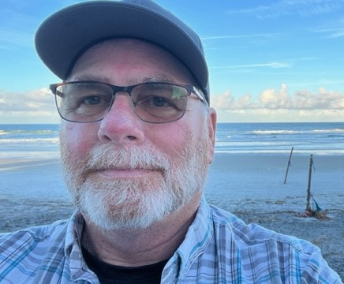
Bret Stemen – KD8SCL EC
KD8SCL@gmail.com

It’s That Time of Year!

ARES in Ohio is in the midst of starting off its active season. There are a lot of events- marathons with BIG crowds, large bicycle rides (Pan Ohio, and many more) in the planning stages. In addition, there are local parades, community events and more to keep even the modest counties active. For some, this can get old… the ‘been there, done that’ syndrome. But remember why we do these: first, to serve our neighbors and our communities! Second, because it’s great practice for transferring our communication abilities over to a real emergency situation. And there’s a new ‘third’: the harsh reality is we need to have eyes and ears at large public events to help safety forces with situational awareness. In other words, look for weird stuff and report it (If you see something, say something). These events can also serve as field tests for new technology- digital radio, video, etc., as we step up to new levels in communications. Most of all, they provide the opportunity for the experienced guys to lead by example and show how concise, professional communicating happens. EC’s- get with your local EMA’s or LEO’s to see if they will provide terror awareness training, brush up on what to look for.

EC’s you should be always on the lookout for activities in which amateur radio can be a benefit! The best way to keep your volunteers interested and excited is to ~stay active!~

Take some time to train!
I can’t say “Thank you!” enough for your time and interest! It’s great to see you’re ready to volunteer.

Now- there’s one thing that’s important to stress- that is the NIMS training. These courses are set to introduce people in all types of leadership roles to FEMA’s standard plan to handle almost any emergency situation. These courses are taken by emergency responders, volunteers, and people like us in ARES; they are also taken by government officials, mayors, commissioners, and more. The end result is ~everyone~ is on the same page when it comes to handling emergencies.

The “Incident Command System” presents an expandable, well thought out system of handling everything from a simple traffic stop or medic call to a major disaster spanning several states. It stresses “span of control” (not overloading a supervisor) consistent handling of resources, and concentration on task management to make sure our focus is correct.

ARES nationally (and here in Ohio) has three levels of training: volunteers who are welcome but have none of these certifications. They are applied to public service events and other disaster-type responses that are outside the government’s management system.

ARES Training Levels Explained

* Level 1 - This is our "Entry" Level. Some may not want to advance
beyond this level and that's OK. Level 1 persons are those
who have not completed the 4 basic NIMS (ICS) courses
(IS-100, 200, 700 & 800)
* Don't let this detour you from continuing on however.
Most of us will get to the next level if we just have some
patience and help each other.
* If you elect not to get any of this training there are
activities that you still be able to participate in
(parades, races and similar events.)
* Level 2 - This is where we hope that everyone will eventually land.
* This means that you have completed all of the above
courses, and you are competent operating within the
Incident Command Structure.
* Level 3 - This is our Management Level. This level will require you to
have completed all of the previous requirements in
Level 2, plus the additional NIMS (ICS) courses
(IS-300 & 400). This is mostly for management
(E.C.'s, D.E.C.'s and higher), but anyone can qualify.
* The extra courses IS 300/400 are the structure for
managing within the EMA office or at an incident scene
and they are not everyone's cup of tea.
* We do recognize that IS-300/400 requires multiple days
of actual classroom training that is not easily obtained.
So, if you just can't find the time to fit these class room
courses in, we do have an alternative method for getting
you to Level 3. Completing the following “FREE” and
“ONLINE” courses will act as substitute for you FEMA
Leadership Development Course requirements. You
absolutely will need to complete all 7 of these courses
to get your ICS 300/400 credit. Here are the courses
that you need to take:

IS-120, 230, 240, 241, 242, 244 & 288.

NOTE: If you are interested in obtaining a really nice looking
certificate for completing the entire Professional Series courses,
you will also need to complete IS-235.

Skywarn training is not mandatory,
but is highly recommended for all levels.
Our objective is to do our best to make sure
that you will always exceed the expectations.

You can find the above information on our website at
http://www.arrl-ohio.org/SEC/reference-training_materials.html

Level 2 is where all our members should be. In order to achieve level two, we need to go to the NIMS online pages https://training.fema.gov/nims/. Scroll down for a condensed list of courses, and you’ll find the four ‘’required” courses:
ICS-100
ICS-200
ICS-700
ICS-800

I can also recommend the “Professional Development” series of courses. Completing these, moves you to ARES LEVEL 3, which is expected in management or leadership positions.

These are not difficult! They are a bit dry since they deal with the theory of incident management and how that is implemented. I guarantee the first time you see an exercise or actual incident, it will all come to life!

Achieving Level 2 qualifies members to be deployed to EOC and other government locations, and to be deployed to other counties as a mutual aid team, or “ARESMAT”, when the need arises.

So please consider spending a couple hours on the computer to complete these courses before outside activities in the Spring take your attention! Forward your certificates of training to me and I’ll see that Jim, W8ERW, gets you in the state ARES training database!
There are all kinds of courses that FEMA offers for personal use, for example:
Animals in Disasters: Awareness and Preparedness
Livestock in Disasters
ABCs of Temporary Emergency Power
Workplace Security Awareness
Active Shooter: What You Can Do
For more information, you can find it at: https://training.fema.gov/is/crslist.aspx?lang=en

I hope you have seen reports of the massive flooding and tornados across the country. That type of situation can arise quickly- and it can (and did) happen in Ohio! The number one mantra is just like scouting, “Always Be Ready!”
Now this is all exciting- but the whole thing depends on one person: the ARES volunteer. If apathy, disinterest and unwillingness to invest time and energy remove our volunteers from being active the whole thing falls apart. You wouldn’t join a baseball team without expecting to practice, or a band without spending practice time at home. Likewise, ARES membership involves our time, and energy. We this year have said every member needs to have the four ‘magic’ NIMS courses. You’re all to be encouraged- the numbers look very good! I am extremely grateful for your work!
My constant concern is that we here in Ohio are ready for whatever decides to disrupt our lives. We cannot be ready by just assuming we are. We have to practice, develop plans and practice again!

First, obvious, is the service we provide to our communities. Many events still depend on amateurs to make their event run smoothly. In addition to the routine operational stuff, we these days have another larger responsibility- to watch for anything unusual and notify authorities. “See something, say something” starts with us. Has your ARES group trained with safety officials to study behaviors and actions that raise suspicion? We are effective as eyes and ears, but we can multiply our effectiveness with a little training.

Second, also obvious, is our ability to practice for real emergency situations. Will your radios work? Will the repeater actually cover that area? Can your net controls actually drive the net? One of the larger benefits is just to recognize each other on the radio.

The very thing that makes ham radio important in the aftermath of “the Big One” is what makes us important here at home. Ham operators should have the ability to cobble together an antenna, or temporarily repair one, find alternate power and get a radio on the air. Consider the kind of threat we need to overcome in Ohio. Obviously, tornado outbreaks with damage and power loss, derecho winds, Winter storms, Blizzards, and yes even a potential earthquake. Any of these can result in extended power loss which would bring communication failure. So, are you ready? Can you solder a coax connector, create an antenna with some wire (468 divided by frequency in MHz…) and find a battery or alternate power source? Your community could be depending on you to do just that!

It’s interesting that on the various nets, they face the same issue that we here in Ohio ARES face: where are all the people? Like most community service organizations ARES has seen a slight drop in active volunteers. We still have great numbers registered, but for many reasons those with the time, ability, health and willingness to deploy even for exercises has dropped. And with the last few years sitting in our recliners with masks on our faces hasn’t helped.

The good news is we’re seeing ARES activities starting to take off again, and with that some of the excitement of actually doing ‘stuff’ is resurfacing. I would like to invite you back into ARES to participate! If you’ve “been there done that” for twenty years, your expertise and skill is something to be passed on to the next generation! If you’re unsure that you want to try this stuff, jump on in! You’ll be welcomed, and you’ll be able to pick up on the training and skill that will make you a better all-around ham operator! So, get involved- get trained, and stay in practice. There are a lot of critical events that happen fast and won’t give you time to prepare.

Thanks to all for your support of The Ohio Section ARES.

Bret, KD8SCL

______________________________________________________________

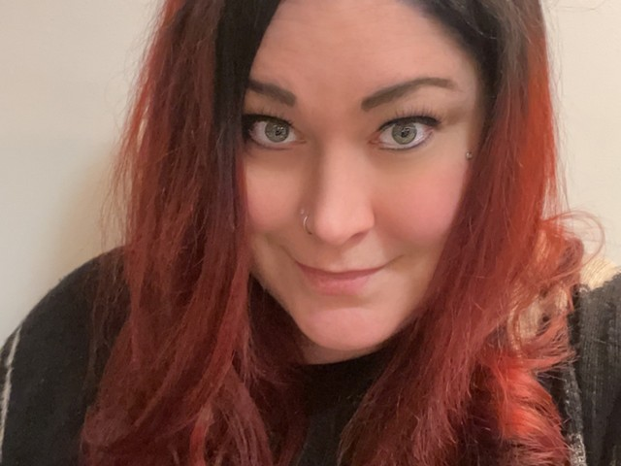
Elizabeth Klinc, KE8FMJ
OHIO Section Public Information Coordinator
ke8fmj@gmail.com

Don’t forget the 2023 Section newsletter contest. We love to see those newsletters and are looking for the best. Scott is still having to forward an awful lot of your newsletters. Please add ke8fmj@gmail.com to your mailing list. You do not want to miss out on the contest, so please be sure to add me to your mailing list.

To all the PIOs out there, did you know there was a PIO Go-Kit? I certainly didn’t know this until I took on the PIC position. But of course, it makes perfect sense. Opportunities for media coverage aren’t always planned.

What’s in your Press Folder?

From the ARRL:

A big part of your job is to make it EASY for media to report about us. So here’s the best way to do that… have a press folder ready to go at all times.

So how do you make up some press folders?

You can use any decent “presentation folder” like you get at Staples. I like the ones with a clear plastic cover. Often, I even use thin (1/2”), 3-ring binders. I then insert several papers for the media to use.

Cover – insert the new EmComm Brochure – that picture grabs attention

Inside cover – attach your business card here as it makes it easy for them to call you back

Main Page- the first thing you see when you actually open the cover, should be text about the event causing their initial interest. If you have this prepared, great! But if the event was a surprise to you, you still have the rest of the folder all set and can keep going.

The order of the following pages varies, dependent on what may be happening.

First – Use cardstock and glue on paper CD envelopes to insert disks

(Everyone likes free DVD’s and CD’s)

Next – Reporter/Media Information: What is Amateur Radio

Then – About ARRL

Amateur Radio Emergency Communication

News Gathering and Amateur Radio

Ham Radio Licenses

A page on how Amateur Radio contributes to technology

A copy of the current brochure(s)

Print the files onto nice paper, letterhead if possible.

Letterhead? Have you seen the awesome Ohio Section Letterhead?

What other items could be useful for a longer term kit? How about:

- Computers, power supply, mouse/trackball
- Phones/tablet devices with chargers
- Spare power packs/chargers
- Charging cables for devices
- Digital camera – Still and video
- Printed contact lists/media lists/password list
- Business cards
- Pens, highlighters, notebooks, printer paper
- Stapler, paper clips, post-it notes
- Flashlight & extra batteries
- Wireless external keyboard and mouse
- MiFi/Internet signal router/extender
- USB drives
- Flashlight/extra batteries
- Pre-printed fact sheets/backgrounders
- External USB hard drive with templates,
backgrounders, graphics, phone and contact lists
- Roll of caution tape
- Incident notebook
- Agency mobile radio
- Cell phone wired headphones
- AC extension cord – 10’ to 25’
- AC Multiple Outlet Strip w/device charging ports
- Personal hygiene kit/spare glasses/contact lenses
- PIO vest/hat/nametapes
- Personal medicines – 7 day supply
- AM/FM/NOAA Wx Radio
- First aid kit
- Cash

What if you deploy? Could even deploy to someplace that doesn’t have supplies. You would need personal items for daily use. Possibly some things like:

- Two-day indoor clothing change, including shoes
- Food you’ll eat and be willing to share
- Water – at least one gallon per day
- Water/personal water container
- Instant coffee/tea/water flavorings
- Cold weather gear (boots, coat, gloves, hat)
- Rain gear (boots, jacket/poncho, pants, towel)
- Work boots, leather gloves, protective goggles
- Hand sanitizer, surface sanitizer, antiseptic wipes
- Paper towels/disposable shop towels
- Duct tape
- Medium size tool kit
- Computer/small device tool kit
- Laser pointer
- Computer Presentation Remote (“Clicker”)
- Earplugs and eyeshade
- Binoculars
- First aid kit upgrade – Stop the bleed kit/tourniquets • Self-hanging easel pads/markers
- Sleeping bag, air mattress and pillow
- Folding knife/EMT Shears
- 100’ paracord, medium blue tarp
- Hardhat/helmet

Be ready. Be prepared. Consider your assigned position when packing emergency supplies and Go Kits. What do you need to keep on you at all times?

73,

Elizabeth, KE8FMJ
PIC, OHIO Section
District 3 Emergency Coordinator
ke8fmj@gmail.com

______________________________________________

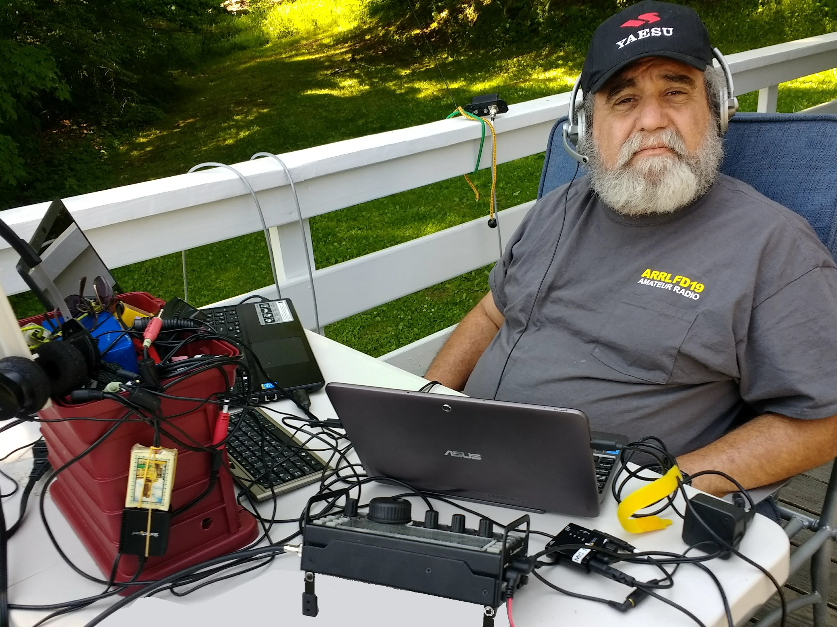
From the Section Youth Coordinator
Anthony Luscre, K8ZT - SYC
k8zt@arrl.net

Summer 2023 Youth Related

2023 ARRL Teachers Institute on Wireless Technology
As announced by ARRL-
“We are now accepting applications for the 2023 Teachers Institute on Wireless Technology! This program provides teachers with tools and strategies to introduce wireless technology in their classrooms and expand their horizons with a hands-on professional development experience! Download, complete, and submit your application today – applications are coming in fast!

Learn about: Electronics | Amateur Radio | Space Communications | Microcontroller Programming | Sensor Technology | Radio Direction Finding | and more!
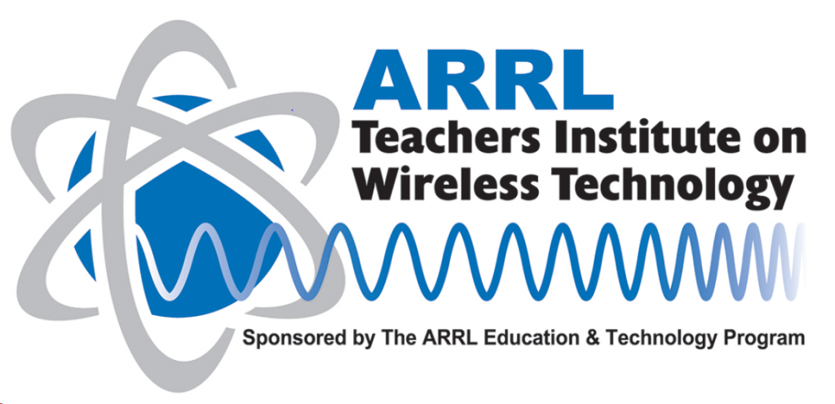
As part of our educational outreach to schools through our Education & Technology Program, each year, the ARRL offers multiple sessions of the Teachers Institute on Wireless Technology. The Teachers Institute is an expenses-paid professional development program filled with lectures, hands-on activities, and demonstrations that are intended to provide teachers with tools and strategies to introduce basic electronics, radio science, satellite communications, Amateur Radio, weather science, microcontrollers, and electronic sensors to their students. The curriculum is designed for motivated teachers and other school staff who want to learn more about wireless technology and bring that knowledge to their students.

2023 Applications and Brochure
Application submission deadline is May 1, 2023 for the Summer 2023 programs and by August 31, 2023 for the October 2023 program. ALL applicants must complete the appropriate full application below. Click the link for the appropriate application.
TI - 1 Introduction to Wireless Technology
TI - 2 Remote Sensing and Data Analysis
Program | Location | Dates
TI - 1 | Newington, CT | June 19 - June 23
TI - 1 | Newington, CT | July 10 - July 14
TI - 1 | Dayton, OH | July 17 - July 21
TI - 2 | Newington, CT | July 24 - July 28
TI - 1 | Newington, CT | Oct 23 - Oct 27

Travel and Reimbursement Guidelines
Cost: Teachers Institute opportunities are virtually free for the participants. The grant to attend a TI covers transportation, hotel, a modest per-diem to cover meals, instructional resources for the electronics, microcontroller, and robotics segments of the course, and a resource library of relevant ARRL publications. There is a $100 enrollment fee to attend Teachers Institute.
To qualify, applicants must be an active U.S. schoolteacher at an elementary, middle, high school or at a college or university, or in a leadership or enrichment instruction role in an after-school or collective homeschool program. An Amateur Radio license is NOT required for the introductory workshop (TI-1) but IS required for the advanced TI-2 program.
Graduate credits: Graduate credits are available through Fresno Pacific University upon completion of the TI-1 or TI-2 programs. These credits can be used to satisfy professional growth requirements to maintain teaching credentials. The class is self-contained and participants are expected to be able to complete all requirements during the class time. Graduate credit information may then be requested at the end of the Teachers Institute.”
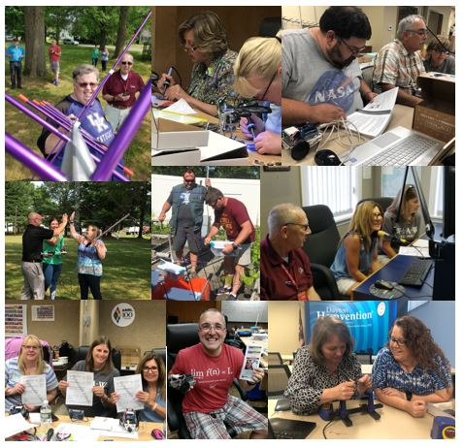

NEW! Teachers Institute Brochure

Revised Version of my “Ham Radio Resources for Visitors, Youth, Students & Teachers” Handout
The page I originally had a number of K-12 resources on (ztlearn.com) is no more if. Please do not use any resources with links to it!
I have revised one of the main handouts, “Ham Radio Resources for Visitors, Youth, Students & Teachers,” which I use at our local clubs FD and other events is available at this link- http://tiny.cc/hryc
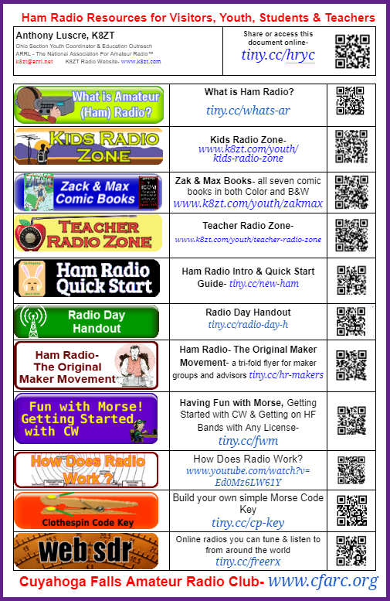
That’s it for this month; I hope to work you on the air soon, maybe on 10 Meters!
73,
Anthony, K8ZT (k8zt@arrl.net)

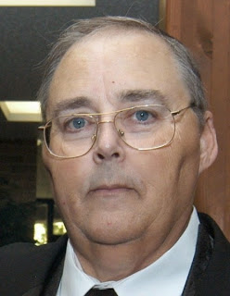
From the Section Traffic Manager
David Maynard, WA3EZN – STM
wa3ezn@att.net

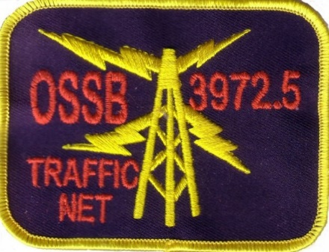
The affairs of the OSSBN shall be under the control of the net manager and an advisory board comprised of three members. .The net manager and one advisory board member shall be elected each year.

On March 1st the net manager appointed a nomination committee of three members with the second year advisory board member as chairman. A slate of nominees for advisory board and net manager were presented to the net on March 23. On March 22 the net manager appointed a teller (KE4RS) who announced the candidates and will call for nominations from March 23 through March 31. Nominees must be members of OSSBN and agree to serve if elected. The teller shall call for votes from the members of the net from April 1st through April 7th and shall on April 8th announce the results of the election. The winner in each case shall be that nominee who has received the most votes for each position. Duties of the elected net manager shall commence on May 1st. Voting may be by radiogram, email or phone call. Check into the net for further voting information.

NOMINATION COMMITTEE REPORT

Candidates for Net Manager
KC8WH
W8MAL

Candidates for Advisory Board
KB8GUN
KD8UUB

Current Net Manager – KC8WH
Current Assistant Net Manager – K8KRA

Current Advisory Board
AC8NP 2020
K8KRA 2021
W8GSR 2022

If you have traffic you need to move take it to a VHF net or if it is going out of Ohio you can take it to the OSSBN. Here is WHERE TO FIND AN HF OR VHF TRAFFIC NET IN OHIO
OHIO SINGLE SIDEBAND NET
Morning session | 10:30 AM | 3972.5 KHz | every day
Afternoon session | 4:15 PM | 3972.5 KHz | every day
Evening session | 6:45 PM | 3972.5 KHz | every day

OHIO HF CW TRAFFIC NETS
HF CW NETS | NET TIMES | FREQUENCY | NET MANAGERS
Buckeye Early | 6:45 PM | 3.580 | N2LC
Buckeye Late | 10:00 PM | 3.590 | WB9LBI
Ohio Slow Net | 6:00 PM | 3.53535 | N2LC
All CW net frequencies plus or minus QRM

OHIO LOCAL VHF TRAFFIC NETS
VHF NETS | NET TIMES | FREQUENCY | NET MANAGERS
BRTN | 9:30 PM DAILY | 145.230 PL 110.9 | KD8GXL
COTN | 7:15 PM DAILY | 146.970 PL 123.0 | KV8Z
NWOHARES | 6:30 PM DAILY | 147.375 PL 103.5 | N8TNV
TCTTN | 9 PM Sun, Tues, Fri | 147.015 PL 110.9 | WB8YYS
TATN | 8:00 PM DAILY | 146.670 PL 123.0 | WG8Z

OHIO VHF TRAFFIC NETS

BRTN Burning River Traffic Net serving Cleveland and North Central Ohio
COTN Central Ohio Traffic Net serving Columbus and Central Ohio
NWOH ARES Northwest Ohio ARES Net serving Toledo and surrounding counties
TATN Tri-State Amateur Traffic Net
TCTTN Tri-County Traffic and Training Net serving North East Ohio

The Spring Severe Weather Awareness Week and the Ohio Statewide Tornado Drill were held this March. Here is some information form this website http://www.weathersafety.ohio.gov/TornadoFacts.aspx.
If you need more information just Google Tornado and you can also be overwhelmed with the information available, the stories being told and the pictures of the total destruction of businesses, homes and communities. Final Words: PREPARE NOW!!
Useful links to preparedness info:
http://www.eham.net/articles/7176
http://www.kidney.org/atoz/pdf/DisasterBrochure.pdf

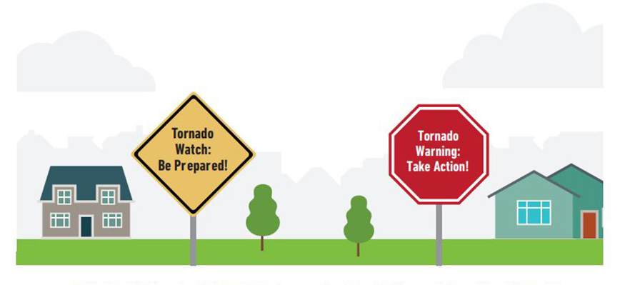
>>Tornado Facts..
As the severe weather season approaches, take some time during to make a safety plan for your family, friends, neighbors and co-workers. Planning ahead will lower the chance of injury or death in the event severe weather strikes.
Tornadoes develop from severe thunderstorms. They are usually preceded by very heavy rain and/or large hail. A thunderstorm accompanied by hail indicates that the storm has large amounts of energy and may be severe. In general, the larger the hailstones, the more potential there is for damaging winds and/or tornadoes.
The most violent tornadoes are capable of tremendous destruction with wind speeds of 250 mph or more. Damage paths have exceeded the width of one mile and 50 miles long. Tornadoes generally move from southwest to northeast, but have also been recorded traveling in any direction. The forward speed of a tornado varies from 30 mph to 70 mph.
Peak tornado season in Ohio is generally April through July, and they usually occur between 2 p.m. and 10 p.m. However this year in March there were already four tornadoes in Ohio on March 3, one each west of Hillsboro, south of New Vienna, west of Bethal and northwest of Frankford which proves that tornadoes can happen at any time, during any season. These was one EF1 and three EF0 tornadoes plus Straight-Line winds damage confirmed in Clermont and Brown Counties of Ohio

>>Fujita Tornado Damage Scale - By Category
The Enhanced Fujita Scale is a set of wind estimates (not measurements) based on damage. It uses three-second gusts estimated at the point of damage based on a judgment of eight levels of damage.
Enhanced Fujita Scale
OPERATIONAL EF SCALE
EF # = 3-Second Gust (MPH)
0 = 65-85
1 = 86-110
2 = 111-135
3 = 136-165
4 = 166-200
5 = Over 200
NOTE: Prior to February 1st, 2007, tornadoes were rated according to the “F” (Fujita) scale rather than the newer “EF” (Enhanced Fujita Scale). Click on the Storm Prediction website http://www.spc.noaa.gov/efscale/ for additional information regarding the “F” and “EF” scales.
> Tornado Safety Tips
Whether practicing in a tornado drill or sheltering during a warning, the Ohio Committee for Severe Weather Awareness encourages Ohioans to DUCK!
D - Go DOWN to the lowest level
U - Get UNDER something
C - COVER your head
K - KEEP in shelter until the storm has passed
* Take responsibility for your safety and be prepared before a watch or warning is issued. Meet with household members to develop a disaster plan to respond to tornado watches and warnings. Conduct regular tornado drills. When a tornado watch is issued, review your plan – don't wait for the watch to become a warning. Learn how to turn off the water, gas and electricity at the main switches or valves.
* Despite Doppler radar, tornadoes can sometimes occur without any warning, allowing very little time to act. It is important to know the basics of tornado safety. Know the difference between tornado watches and tornado warnings.
* Tune in to one of the following for weather information: NOAA Weather Radio, local cable or television (Ohio News Network or the Weather Channel), or local radio stations.
* If you are a person with special needs, register your name and address with your local emergency management agency, police and fire departments before any natural or man-made disaster.
* NOAA Weather Radio has available an alerting tool for people who are deaf or have hearing impairments. Some weather radio receivers can be connected to an existing home security system, much the same as a doorbell, smoke detector or other sensor. For additional information, visit:
https://search.usa.gov/search?v%3Aproject=firstgov&query=hearing+impairments&affiliate=nws.noaa.gov
https://search.usa.gov/search?v%3Aproject=firstgov&query=SPECIAL+NEEDS&affiliate=nws.noaa.gov

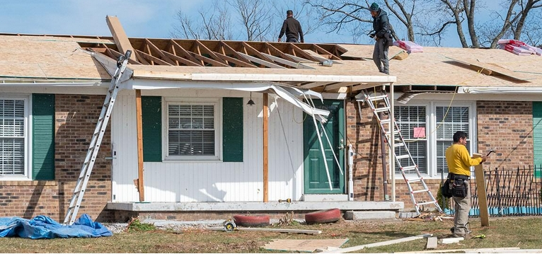
* The safest place to be during a tornado is a basement. If the building has no basement or cellar, go to a small room (a bathroom or closet) on the lowest level of the structure, away from windows and as close to the center of the building as possible.
* Be aware of emergency shelter plans in stores, offices and schools. If no specific shelter has been identified, move to the building's lowest level. Try to avoid areas with large glass windows, large rooms and wide-span roofs such as auditoriums, cafeterias, large hallways or shopping malls.
* If you're outside or in mobile home, find shelter immediately by going to the lowest level of a nearby sturdy building. Sturdy buildings are the safest structures to be in when tornadoes threaten. Winds from tornadoes can blow large objects, including cars and mobile homes, hundreds of feet away.
* If as a last resort you cannot quickly get to a shelter, get into your vehicle, buckle your seat belt and try to drive to the nearest sturdy shelter.
* If you experience flying debris while driving, pull over and park. Choose to either stay in your vehicle, stay buckled up, duck down below the windows and cover your head with your hands, or find a depression or ditch, exit your vehicle and use your arms and hands to protect your head. Never seek shelter under highway overpasses and bridges.
Tornado Loss Prevention Tips
The following steps are suggestions that homeowners should take before a tornado or other natural disaster occurs to assure speedy and hassle-free recovery. Catalog your belongs, room by room. Once completed, you can add items and photos to a thumb drive for easy access. Maintaining a comprehensive inventory will come in handy, should you need to file a claim or reevaluate the amount of insurance you carry. It's good for renters, too.
> Home Coverage and Preparedness Tips
* Tornado losses are most often covered by the "windstorm peril" under the homeowner's insurance policy.
* Check with your homeowner insurance agency to assure adequate coverage is provided by the policy. Notify the insurance agency of any additions or improvements to the home.
* Consider purchasing the replacement cost coverage endorsement for the home and its contents. It would give the option to rebuild or replace damaged property at current costs rather than depreciated values.
* If you experience a storm-related loss to your home that is covered by your insurance, notify your insurer in a timely manner, as required by your policy.
* Home Inventories Assist in Settling Claims
* Videotape, photograph or compile a written inventory of your home and belongings.
* Keep the inventory off premises in a bank safe deposit box. The inventory will provide a record for you and the insurance company, should a loss occur.
* Update your inventory every time you move or every two to three years.
> Written Inventory Tips
* Go through each room of the home and list every item. Include the purchase date, price and model numbers.
* Include professional, written appraisals of antiques, jewelry and other costly possessions.
> Video or Photo Inventory Tips
* Pan the camera around the room to capture all items. Obtain close-ups of expensive items such as jewelry, china and furs.
* Consider grouping items for easier inventory.
* Narrate the video by noting purchase costs and dates. Include model and serial numbers for appliances and electronic devices.
> Auto Coverage and Preparedness Tips
* If there is threatening weather, shelter vehicles to prevent damage from winds, flying debris and hail.
* Vehicles are protected under the "other than collision" (comprehensive) portion of an auto insurance policy, if damaged by windstorms or hail.
> After the Loss - Insurance Tips
* Photograph any damage and inventory losses. Photos will assist when settling claims.
* Secure property from further damage or theft and save related receipts, since many insurers will reimburse for these expenses.
*If required to seek temporary housing due to a covered loss such as a tornado, check your policy for "loss of use" coverage. Many policies cover such expenses up to a stated amount.
http://www.weathersafety.ohio.gov/TornadoFacts.aspx
What about your family? Here are some items you can do now to be prepared in the future.

Sit down with your family members and decide how you will get in contact with each other in an emergency.
Once you figure this out, document the contact information on both a master sheet and on wallet sized cards to be carried by all family members. This document will become your “Family Communication Plan” and it will form the cornerstone of your family emergency plan. It will list all family members, their date of birth, and other important information. Include a photo for each person as well as any important medical information. Also include a contact number for an out of town contact person.

Determine a meeting place where you will meet in the event you can not get home. This may be your workplace, the home of a parent or relative, your church or even at a school if there are children involved. Whatever you decide, you will need at least three possible locations.

Determine the best evacuation routes from your home or workplace to the safe meeting places. Then take the route and make sure it is accurate and that you understand the directions.

Prepare a list of all workplaces along with the address, telephone number, and closest evacuation location in the event getting to the pre-designated meeting place is not possible. Also prepare a list of all schools that are attended by your children along with the address, contact names, and telephone numbers. Contact the schools now to learn about their own emergency evaluation policies and procedures.

Prepare a list of your doctors and your veterinarian along with their telephone numbers. Include a list of medical conditions and prescription medications that are being taken.

Prepare a list of your insurance policies, including the carrier, the telephone number for claims, and the policy number itself. Include health insurance, homeowners or rental insurance, life insurance policies.

Be aware, however, that phone lines and cell service may not be functional following a catastrophic disaster. Although a valuable tool, do not count on your phone to be the sole mode of communication following a disaster. If you text, you might want to consider a “texting tree”. Texting is usually available even when cell service is down.

Store all of the information you have carefully compiled in multiple locations. For example in a preparedness binder, On a flash drive that you carry with you, In your desk drawer at work or in an email attachment sent to yourself at one of the email services that you use.

73
David, WA3EZN
Ohio Section Traffic Manager

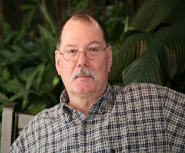
ARES Training Update
Jim Yoder, W8ERW – ARES Data Manager
w8erw@arrl.net

Here we are nearing the end of March and finally, feeling a little warmth along with some sunny days. Today was especially nice as that persistent wind took a rest as well. I managed to get my lawn equipment serviced and yes, I fired up the grill this evening for the first time this year. Let’s hope this recent sampling of Spring is going to continue and we will have no more frosty mornings. I do suspect that we will at least into mid-April. Our patience though with a lingering Winter has about run out I am sure for all of us.
Someone recently asked me what Amateur Radio was all about. How much time do you have to talk about it was my initial response. There is a lot of truth in that reply. If it is electronics, digital or analog, if it carries your voice, emits a signal or modifies your transmission in any way, we do that. You can’t leave out image either. We do video in several formats. Messaging, of course we do that also. Being a Ham opens an entire world of adventure and each of us is free to explore to the limits what ever interests us. What excites you? Computers and now almost a necessary part of the well equipped Hamshack. That subject leads in many directions of it’s own. There is little that we leave on the shelf while pursuing this wonderful and diversified hobby.
For me one of the joys of being a Ham is the opportunity to form new friendships and associate with my fellow amateurs. No wait, I don’t wish to exclude our Lady Hams here. Have you noticed? More and more we are seeing YLs join with us bringing new ideas and energy to our hobby. Look out guys, these gals will be spading up the ground behind you. I am pleased to see this happening. It’s not only our XYLs embracing the OM’s interest in radio. Many of our newer Hams are women young and old who have taken an interest in the many aspects of being an Amateur. Hoorah!
I dare not leave this subject without serious mention of ARES and the public service side of our hobby. I will delve into for a moment one of the areas that is or has been reserved as far as subject matter for discussion on the air at least. Weather and other natural phenomenon. Some will call it climate change which it certainly is. Can we make an impact upon it? Probably to some extent we can. However, I believe it’s more natural and it’s just going to happen anyway. I saw a video the other evening that talked about volcano activity. It was mentioned that the government agency responsible for tracking volcanic activity has stated that neither the frequency nor intensity has changed much. However researchers have analyzed the data created by the USGS. Their own data indicates otherwise as both the frequency and severity of volcanoes has been on a steady increase. We are also seeing an increase in tornadoes, hurricanes, flooding, forest fires and just about any other disastrous weather event. It is all predicted and biblical prophecy has much to say about it. So where am I going with this?
ARES and our public service mission as amateurs will likely play an ever- increasing part in the response to these events. We must find a means to attract our youth into this hobby of ours that is increasingly becoming an old man’s pastime. Folks, we are going to wither away to nothing if we cannot successfully bring our younger generation into Amateur Radio. ARES needs to address this and we need to do so now. That means we need to reach out to this latest generation of young folks. We can’t wait for them to find us. To be sure, we do have a lot of competition. Who doesn’t have a cell phone? The kids all have one and it consumes a huge amount of their free time. I don’t have all the answers. We must collectively address this and take the measures necessary to see to it that our youth can find reason to join with us. Being an Elmer has traditionally been an important part of our Amateur experience. I would suggest that it should become even more so. “Elmer” is a badge of honor and respect and a wonderful part of being a Ham.
Now for the numbers which have picked up the pace since last month. Much of the increase has been from new ARES members. I would expect this as we’ve been encouraging ARES training for several years now and most who are active ARES members have already taken advantage of the FEMA training offered. We are doing something right. Perhaps we can to do more of it. We have 893 Level 1 members, 751 at Level 2 and 223 Level 3. I am also receiving certificates for the Professional Development Series, AUX COM, the COM series courses, L, N and T and the ARRL course EC-001. Overall, I now have 10,494 training certificates on file. These are indeed great numbers that represent the commitment of Ohio Amateurs to our public service mission. However, let’s not be complacent. Now is not the time to rest. The need for Amateur involvement is great and I expect that to increase.
Thank you all for the fine work and please let me know if you have any questions or concerns,
Jim W8ERW
w8erw@arrl.net
Hamshack Hotline #4161

__________________________________________

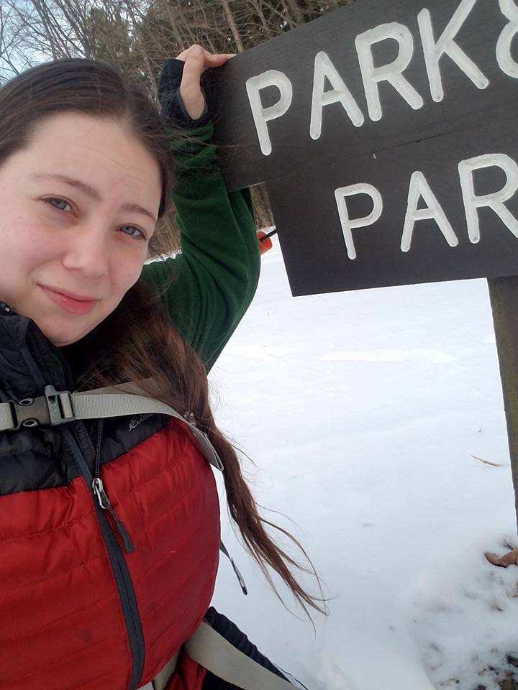
From the Section Affiliated Clubs Coordinator - ACC
Amanda Farone – KC3GFU
Afrone926@gmail.com
330-509-4095

Well, here we are, on the brink of Spring and warm weather. Warm weather brings more opportunities for club events. Now is the time to get creative and plan fun activities for your club to enjoy. Fox hunts, fundraisers, operating events, public service events, and of course, Field Day! Speaking of Field Day, I will be out and about this year visiting as many sites as I can. Be sure to list your site on the ARRL Field Day Site Locator to attract visitors. If you haven’t already started planning, I suggest you start soon. The more time you have to plan, the better you can execute.
Are you familiar with the benefits of being an Affiliated Club? One of the many benefits is the Club Commission Program. If you aren’t already participating in this, why not? This is a great way to add some extra funds into the club account while helping your members join or renew their ARRL membership. Each new membership will earn the club a commission of $15 while a renewed membership will earn the club $5. The ARRL is now offering an additional promotion: they will give the club a copy of The ARRL Handbook, for every 5 new members signed through the Club Commission Program, which can be used however the club sees fit. This promotion will last through the end of 2023.
The ARRL has launched a new Club Development Webinar series. This series is aimed at the various roles that exist in clubs. The first online webinar has already taken place, targeting the Secretary position. Future webinars will concentrate on roles such as; Treasurers, Newsletter Editors, Public Information Officers, Webmasters, and more! Each time that registration opens for these webinars, I will send the registration link via email to the listed email for your club. If you receive this email, please forward it along to your members. If you are unable to attend the webinar, all webinars will be recorded and available in the ARRL Learning Center.
Last but certainly not least, over the next month or so I will be focusing on Special Service Clubs. It has been noted that many clubs over the years have failed to renew their SSC status with the ARRL. I believe the Ohio Section is the strongest Section in the country and would like to point out that the Special Service Club Affiliation was born in Ohio. There are many clubs out there that qualify for this status and should rightfully hold that accomplishment. My goal is to put our section back at the top of the list on this and help the clubs that deserve this status obtain it. If you think your club qualifies for Special Service Affiliation, please reach out to me so we can get the process started.

Amanda Farone, KC3GFU
afarone926@gmail.com
ARRL Ohio Section | Affiliated Club Coordinator

__________________________________________

National News
(from arrl and other sources)

US Air Force Invests $75.5 Million in Creation of Largest Wireless Ad-Hoc Network in the World
By: Bianca | March 20th, 2023
Share
Photo by Spring Fed Images on Unsplash
The US Air Force is leading the charge by exploring the practical application of ad-hoc wireless networks. The air service has recently awarded a whopping $75.5 million contract to Persistent Systems, a New York-based company, to develop the world’s largest wireless ad-hoc network.
Persistent Systems is renowned for being at the forefront of wireless communication technology. The network is set to provide unprecedented levels of communication, enabling military personnel to stay connected in even the most challenging and remote areas without infrastructure-based setup.
The Infrastructure-based Regional Operation Network (IRON) offering, an integrated MANET antenna system, will allow the US Air Force to connect 75 operations centers and over 1,000 security force vehicles, covering an area of 25,000 square miles (64,750 square kilometers).
This incredible feat will play a critical role in helping to secure the country’s nuclear arsenal, especially in remote areas of the United States, where connectivity has been a significant challenge. But the IRON system’s capabilities go beyond this – it also allows for the complete digitization of a combat space and the connection of multiple weapons systems and programs in an integrated network.
Ad hoc networks are expected to become a radio revolution, complementing traditional network models such as Wifi or satellite. The coming network lays the foundation for building the Joint All Domain Command and Control (JADC2) system. JADC2 is a concept of a unified network that connects all branches of the armed forces, including the Air Force, Army, Marine Corps, Navy, and Space Force.
The ROP program has already begun deploying the IRON system to US missile sites. A completed deployment is set for the next 36 months. The news comes when the market for missiles and nuclear bombs is rapidly growing and expected to reach $126 billion by 2030, indicating the US’s ongoing commitment to expanding its nuclear arsenal.
(The above is from Online Elec News – volume 214)

______________________________________________

World Amateur Radio Day is April 18
In less than a month, 2023 World Amateur Radio Day (WARD) will be celebrated, literally, around the world!
WARD is held on April 18 every year and is celebrated by radio amateurs and their national associations which are organized as member-societies of the International Amateur Radio Union (IARU). It was on this day in 1925 that the IARU was formed in Paris. American Radio Relay League (ARRL) Co-Founder Hiram Percy Maxim was its first president.
The IARU announced previously that Human Security for All (HS4A) will be this year's World Amateur Radio Day theme. The day is being celebrated with a 2-week operating event occurring April 11 - 25. Special event stations will be operating from around the world, making two-way radio contacts to call attention to the HS4A campaign. The United Nations Trust Fund for Human Security describes 'human security' as "a more powerful, lasting approach to the most difficult deficits in peace and development," such as poverty, war, and natural disasters.
ARRL encourages all radio amateurs to take to the airwaves for WARD, to enjoy our global friendship with other amateurs, and to show our skills and capabilities to the public.
More information about 2023 World Amateur Radio Day is available at www.arrl.org/world-amateur-radio-day and www.iaru.org/on-the-air/world-amateur-radio-day.

______________________________________________

NASA's Curiosity Finds Surprise Clues to Mars' Watery Past

When NASA’s Curiosity rover arrived at the “sulfate-bearing unit” last fall, scientists thought they’d seen the last evidence that lakes once covered this region of Mars. That’s because the rock layers here formed in drier settings than regions explored earlier in the mission. The area’s sulfates – salty minerals – are thought to have been left behind when water was drying to a trickle.
Rippled Rock Textures: Billions of years ago, waves on the surface of a shallow lake stirred up sediment at the lake bottom. Over time, the sediment formed into rocks with rippled textures that are the clearest evidence of waves and water that NASA’s Curiosity Mars rover has ever found. Credits: NASA/JPL-Caltech/MSSS. Download image ›
So Curiosity’s team was surprised to discover the mission’s clearest evidence yet of ancient water ripples that formed within lakes. Billions of years ago, waves on the surface of a shallow lake stirred up sediment at the lake bottom, over time creating rippled textures left in rock.
“This is the best evidence of water and waves that we’ve seen in the entire mission,” said Ashwin Vasavada, Curiosity’s project scientist at NASA’s Jet Propulsion Laboratory in Southern California. “We climbed through thousands of feet of lake deposits and never saw evidence like this – and now we found it in a place we expected to be dry.”
Layers of History
Since 2014, the rover has been ascending the foothills of Mount Sharp, a 3-mile-tall (5-kilometer-tall) mountain that was once laced with lakes and streams that would have provided a rich environment for microbial life, if any ever formed on the Red Planet.
Curiosity Rover Finds New Clues to Mars' Watery Past: NASA’s Curiosity rover recently found surprising clues to Mars’ watery past, including while exploring a region called the “Marker Band.” Credits: NASA/JPL-Caltech/MSSS/University of Arizona. Download video ›
Mount Sharp is made up of layers, with the oldest at the bottom of the mountain and the youngest at the top. As the rover ascends, it progresses along a Martian timeline, allowing scientists to study how Mars evolved from a planet that was more Earth-like in its ancient past, with a warmer climate and plentiful water, to the freezing desert it is today.
Having climbed nearly a half-mile above the mountain’s base, Curiosity has found these rippled rock textures preserved in what’s nicknamed the “Marker Band” – a thin layer of dark rock that stands out from the rest of Mount Sharp. This rock layer is so hard that Curiosity hasn’t been able to drill a sample from it despite several attempts. It’s not the first time Mars has been unwilling to share a sample: Lower down the mountain, on “Vera Rubin Ridge,” Curiosity had to try three times before finding a spot soft enough to drill.
Scientists will be looking for softer rock in the week ahead. But even if they never get a sample from this unusual strip of rock, there are other sites they’re eager to explore.
Martian Clues
Far ahead of the Marker Band, scientists can see another clue to the history of Mars’ ancient water in a valley named Gediz Vallis. Wind carved the valley, but a channel running through it that starts higher up on Mount Sharp is thought to have been eroded by a small river. Scientists suspect wet landslides also occurred here, sending car-size boulders and debris to the bottom of the valley.
Because the resulting debris pile sits on top of all the other layers in the valley, it’s clearly one of the youngest features on Mount Sharp. Curiosity got a glimpse of this debris at Gediz Vallis Ridge twice last year but could only survey it from a distance. The rover team hopes to have another chance to view it later this year.
One more clue within the Marker Band that has fascinated the team is an unusual rock texture likely caused by some sort of regular cycle in the weather or climate, such as dust storms. Not far from the rippled textures are rocks made of layers that are regular in their spacing and thickness. This kind of rhythmic pattern in rock layers on Earth often stems from atmospheric events happening at periodic intervals. It’s possible the rhythmic patterns in these Martian rocks resulted from similar events, hinting at changes in the Red Planet’s ancient climate.
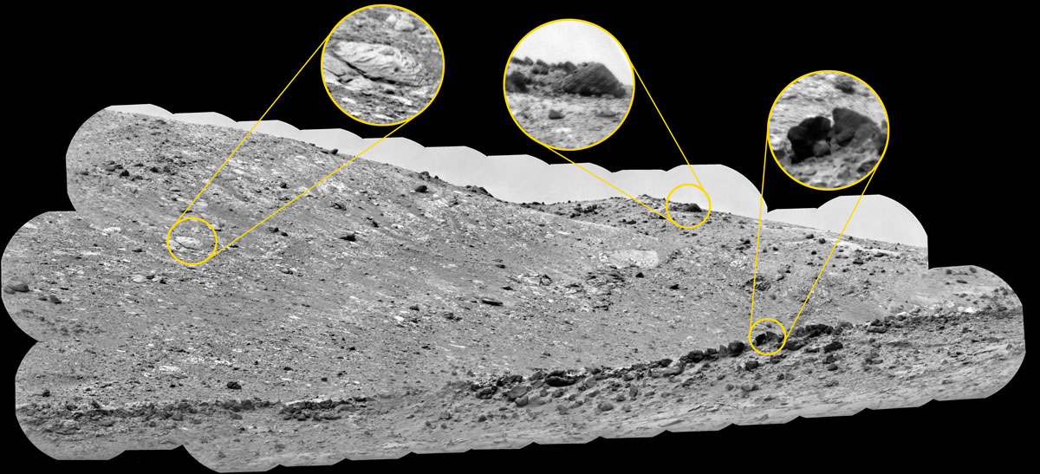
ChemCam Mosaic of Gediz Vallis Ridge: NASA’s Curiosity Mars rover used its ChemCam instrument to view boulders on Gediz Vallis Ridge Nov. 15 to 17, 2022, the 3,653rd to 3,655th Martian days, or sols, of the mission. Credits: NASA/JPL-Caltech/LANL/CNES/CNRS/IRAP/IAS/LPG. Download image ›
“The wave ripples, debris flows, and rhythmic layers all tell us that the story of wet-to-dry on Mars wasn’t simple,” Vasavada said. “Mars’ ancient climate had a wonderful complexity to it, much like Earth’s.”
More About the Mission
The Curiosity mission is led by NASA’s Jet Propulsion Laboratory, which is managed by Caltech in Pasadena, California. JPL leads the mission on behalf of NASA’s Science Mission Directorate in Washington. Malin Space Science Systems in San Diego built and operates Mastcam.
For more about Curiosity, visit:
https://mars.nasa.gov/msl

__________________________________________________________________

Club Corner

This is YOUR corner of the newsletter. Send us what your club is doing, and we’ll make sure that it gets in. Got a special event or club project that you want everyone to know about? Send it to us!. Need help with a project? Send it to us.

Let us know what you club is up to. Are you going to have a special guest at your meeting or are you having a special anniversary?

Send it to: webmaster@arrl-ohio.org

__________________________________________________________

Alliance ARC HF Rig Raffle

We've started up our 2023 HF Rig Raffle. Our 2023 prize will be a Yaesu FT-DX10.
This is our 4th year doing this. A portion of the money raised goes back into our community in the form of donations to local service groups at Christmas Time.
Since 2020, we’ve donated over $3500 to Charities in the Alliance, OH area.
tickets can be purchased via our website at https://www.w8lky.org/fundraisers/2023-hf_rig_raffle/, or in person at our monthly club meetings. We will also be set up at several Ohio/Western PA Hamfests in the next few months.
The prize will be drawn on July 12, 2023. The winner need not be present to win.

73,

John Myers, WG8X
kd8mq1@gmail.com
330-936-5021
___________________________________________
NVIS Day, 2023
It’s coming! Ohio NVIS Day 2023 will be held Saturday April 22, from 10AM until 4PM EDT.
The purpose of NVIS day is to construct and try various antenna ideas, all working as NVIS (Near Vertical Incident Skywave) antennas. These antennas are low to the ground and provide coverage generally within a 400 mile radius- extremely important for regional HF communications in an emergency.
Take a big step forward and build upon the concept to answer the question, “How would we actually use these antennas?”
For 2023, we have added a couple operating scenarios that will make your day more fun and be a learning event for actual disaster communications. We propose a commercial power blackout, with the need to communicate within your ARES district and to ‘The Sarge” at the Ohio EOC in Columbus. Here’s the deal:
- The event runs from 10 AM until 4 PM local time.
- Stations will construct and test NVIS antennas.
- Transmit power is limited to 100 watts.
- Power for the station will be any form of “off-grid” supply: typically, generator, battery or solar or whatever form you might have in an emergency setup. (Optional, but preferred)
- Stations may test antenna coverage as in the past by contacting as many different locations as possible. This year, we are adding collecting Grid Squares and S-Meter readings as part of the exchange .
  - Stations are to originate a message to their ARES District, local net, OHDEN, OSSBN and to W8SGT reporting their location and county, stating if you are “Participating or Not Participating”.
  - This message may take any form: ARRL message form ICS 213 or radiogram must be used. If you’re going to use the traffic system, ARRL message radiogram is recommended.
  - Each county is to send a message to the SARGE with a sitrep of their operation.
  - The message should contain the call sign, operating location (include county) and number of operators. Any other brief antenna information is optional but appreciated!
  - Contact with the District net may take place on VHF or HF (Repeaters OK).
  - WinLink may also be used as long as it sent via RF, local node (VHF, UHF) or an HF node to KD8SCL and or W8SGT.
  - For more information on node locations, visit WinLink.org.

- Operating frequencies are proposed to be in the 80 and 40 meter bands. Voice is preferred for testing.
  - Optimum frequencies centered around but not limited to: 3.902 and 7.240
  - Digital messages may be passed to OHDEN Net as available.
  - Digital OHDEN frequency: 3584.5 (typical is Olivia 8/500)
  - OSSBN frequency: 3972.5, Net Times: 10:30, 16:15, 18:45
You can create your own log (Excel preferred) or Word format. Be sure to include a photo of your group or your antenna! Submit your results to contest@n8ara.org
Have fun! Take a lunch break! I hope to hear you!!

__________________________________________________________

Glass City Marathon April 23rd – Help Wanted

Hello everyone! It's coming up on that time again and we've been asked to help with the Glass City Marathon. Race day is Sunday, April 23rd and it begins at 6:30 AM. Everything should be finished by 1:00 PM. I've got lots of spots to fill some which only last a couple hours and some which are all day. If you'd like to help or or would like more information please contact me at either k8rks@arrl.net or 419-471-0573.

__________________________________________________________

Mahoning Valley ARA

We're trying something new this time around for our spring Tech Class. We're using the online Ham Prep classes and doing our "Elmering" via zoom every Tuesday evening doing a Q&A session to help the student over any sticking points.

Currently, we are about 3 weeks into a scheduled 8 week course. Since Ham Prep is self paced we'll see how many are ready for testing at that time, and schedule a VE session on week 9 for those that are ready. Contact Andy – WA8ZLK ajaybee92@gmail.com if you would like more information on joining the Tuesday evening sessions.

VE Sessions

The following information is for ALL exam sessions:
It is now an FCC requirement to have an FCC FRN; active email address and active phone number before taking any exam. Please bring your FCC FRN, original license, a copy of your license (if a licensed ham), a valid photo ID and $15.00 - Cash preferred.
Effective April 19, 2022, the FCC will charge a $35.00 application fee for amateur radio licenses. The fee will apply to new, renewal, rule waiver, and modification applications that request a new vanity call sign. License upgrades will not have a fee applied. The fee will be per application. VE's will not collect the fees at exam sessions.
If you are applying for your first license, please go to http://apps.fcc.gov/cores/userlogin.do and obtain an FRN. This website is self-explanatory and the FRN registration is free.

All Things Amateur Radio Association (ATARA)
We host testing sessions every second Tuesday of the month in Lancaster. To sign up please visit our website https://atara-w8atr.fun and contact us at hamexams@atara-w8atr.fun.

Butler County Amateur Radio Association W8WRK
Laurel VE Testing Session - hosted by DIAL amateur radio club
Amateur Radio License Examinations at 9:00AM on Sunday April 29th at Fairfield Township Administration Building 6032 Morris Rd. Hamilton, OH 45011. Pre-Registration is required, go to: www.qsl.net/w8blv click on Exams and follow the instructions. Additional info may be obtained from Thurl Golden, KD8VLU (513) 939-4891 tgolden@fuse.net or Ron Spaulding, N8QF, (513) 617-6181 or n8qf@roadrunner.com . There are no Exam Fees!

CARS
VE testing from CARS - Cuyahoga Amateur Radio Society - at Elmwood Recreation Center, 6200 Wisnieski Parkway in Independence, Ohio 44131 Time: 9:15 AM (Walk-ins allowed) Always the 2nd Sunday of the odd month. Go to CARS www.2cars.org for detailed map of location. Call Metro W8MET 216-520-1320 for details

Clark County Amateur Radio Association (CLARA) What: CLARA sponsored A.R.R.L. VE Testing - Walk-ins allowed. Pre-Register via email preferred. When: On every second Saturday of each even numbered month starting at 10:00 AM
Feb 11th; Apr 8th; Jun 10th; Aug 12th; Oct 14th; and Dec 9th, 2023. Where: Springview Government Center - Emergency Operations Center; 3130 E Main St; Springfield OH 45503 This is US-40 aka "old national road". From Route 40 enter Old Columbus Road, at the fork stay left driving straight onto Ogden Rd, then immediately turn left into the parking lot behind the EMA. Walk to the door with the "Employees Only" sign.
For more information contact Roland W. Ude, W8BUZ, (937) 605-4951 Email: buzz@baylorhill.com

Dayton Amateur Radio Association (DARA)
If you are interested in testing for a new or upgraded license, please come see us at the DARA Clubhouse. If you have questions about testing, please email exams.w8bi@gmail.com

Dial Radio Club, Middleton, OH
Will offer Amateur Radio License Examinations at 6:00PM on Wednesday March 1st at St. John XXIII Elementary School, 3806 Manchester Rd., Middletown, OH 45042. Pre-Registration is required, go to: www.qsl.net/w8blv click on Exams and follow the instructions. Additional info may be obtained from Dave Williamson, KD8W, (513) 424-5819 or kd8w@ARRL.net or Ron Spaulding, N8QF, (513) 617-6181 or n8qf@roadrunner.com . There are no Exam Fees!

Findlay Radio Club

The club also sponsors exam sessions at 9AM the second Saturday of each month at the clubhouse. For more info on the club, check out our web page at www.findlayradioclub.org .

Geauga Amateur Radio Association (GARA)
Amateur License exam sessions are offered for all license classes (Technician, General, Extra). Walk-ins are always welcome - no prior registration is required. No fee for the exam.

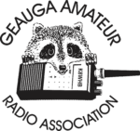
The GARA schedule of exams are these Sundays at 2pm. Dates for 2023 are January 15th, March 19th, May 21st, July 9th, September 10th, and November 12th.

Exams are held at the Geauga County Department of Emergency Services and Emergency Operations Center, 12518 Merritt Road, Chardon, Ohio 44024. The EOC is located just south of the University Geauga Hospital and just east of the Geauga County Safety Center (Sheriff's Office), off of State Route 44 between State Route 322 and State Route 87 on Merritt Road.

Please arrive a few minutes before 14:00 to allow adequate time to process the necessary paper work and take your test. Bring your 1) photo ID, 2) email address, 3) FCC FRN, 4) a printout of your current license if taking the General or Extra exam.

Additional info may be obtained from Jim Mekeel, KE8EMP, email KE8EMP@gmail.com or the Geauga Amateur Radio Association website https://geaugaara.org

Huber Heights Amateur Radio Club
Huber heights amateur radio club does ARRL VE testing the second Saturday of each even numbered month. Feb, Apr, Jun, Aug, Oct, Dec. 9:30-11:00 For more information contact Jim Storms – AB8YK at ab8yk@hotmail.com

The Lake County Amateur Radio Association
The Lake County Amateur Radio Association is holding its 2023 Amateur Radio license exams at the Kirtland Library, 9267 Chillicothe Road, on the following dates:

Saturday, February 4 Saturday, August 5

Saturday, April 1 Saturday, October 7

Saturday, June 3 Saturday, December 2

This bi-monthly schedule is the first Saturday of every even-numbered month (e.g., February being the second month, etc.). They are held at the Kirtland Library, 9267 Chillicothe Road. It is 1.7 miles south of I-90 on Route 306 (Chillicothe Rd). The library is on the left, just beyond the Marathon gas station.

The tests will start at 12 noon. Please arrive a few minutes earlier.

To register, you will need a NCVEC 605 Form, which will be available at the test. If you would like to complete one ahead of time, be sure it is the Sept 2017 version or later. You can find it by Googling “NCVEC quick-form 605” and clicking on the url for a pdf of the form. Please note the FCC requires you to provide a FRN (FCC Registration Number). Social Security Numbers are no longer accepted. If you are new to ham radio and don’t have a FRN, Google “New FRN” and follow the fcc.gov link.

If you are currently licensed, be sure to bring a copy of your license to the exam. The cost of the exam itself is $15.00, and if you wish to pay by check, it should be made out to the ARRL/VEC. Identification with your picture is also necessary, such as a driver’s license. If you have any questions, please contact Scott Farnham, KO8O, at (440) 256-0320, or scottfarnham@roadrunner.com

In addition to the $15 test fee, the FCC now charges $35 to add you to the Amateur Radio database. The FCC will e-mail successful candidates instructions for payment directly to them. Payment must be made within 10 days of the e-mail. This charge does not apply to upgrades.

The Lancaster and Fairfield County Amateur Radio Club (LFCARC) hosts exam sessions at the FAIRFIELD County EMA, 240 Baldwin Dr in Lancaster Ohio, 43130, on the first Saturday each month at 10:00 am. Please visit our website at http://www.k8qik.org for exam dates on our calendar and navigate to our Learning Center/Taking the Exam link for information and requirements. Our experienced VE team looks forward to serving the Amateur Radio community in Central Ohio. Contact me at ve_testing@k8qik.org to register.
Lisbon Area Amateur Radio Association Beginning Feb 11, 2023 Testing on the 2nd Saturday of each month at the Columbiana County EMA located at 215 S Market St. Lisbon, OH 44432. Walk-ins OK. Check in at 1:00PM. For more information go to www.K8GQB.com or contact NN8B at nn8b.oh@gmail.com
Madison County The Laurel testing group will offer testing on the first Thursday of January, March, May, July, September and November. Tests are held at 7:00PM at the Madison County EMA located at 271 Elm St. London, OH. No fee.

The Milford Amateur Radio Club (MARC)
VE testing is held the third Thursday of each month at 6:00 PM. Location; Miami Township Civic Center located at 6101 Meijer Drive, Milford, OH 45150.
Please pre-register at www.milfordhamradio.org

Northern Ohio Amateur Radio Society (NOARS) VE sessions are held the first Saturday of odd-numbered months (EXCEPT FOR March and July) at 10 AM in the North Olmsted Library, 27403 Lorain Rd., North Olmsted. Registration is preferred, but walk-ins are welcome. For more information or to register, contact Elaine, KC8FOS at ewilkinson1951@gmail.com. There will be a VE session held March 12th at the NOARS Winterfest held at Lorain County Community College in the John A Spitzer Conference Center, 1005 Abbe Rd N, Elyria, OH 44035. Please email Elaine – KC8FOS at ewilkinson1951@gmail.com to register.

Portage County Amateur Radio Service (PCARS)
The first Saturday of every even numbered month -10 am – at the PCARS club site in Ravenna. Please visit the PCARS web site and check out the information about VE testing in the latest newsletter at www.portcars.org .
If you have any questions, don’t hesitate to contact me at KB8UUZ@gmail,com

Tusco Amateur Radio Club W8ZX

VE Testing sessions are held on the second Saturday of every even numbered month at the Dover Faith Church, 420 N Wooster Ave, Dover, OH 44622. Pre-registration is not necessary. Doors open at 0830 for registration, exams begin at 0900. Cost is $15. You are required to have an email address and a copy of your FRN or current ham radio license. For more information please go to www.w8zx.net/exam or email VETEAM@N8BAG.NET.

______________________________________________________________

Important Links
ARRL Home: www.arrl.org
Find an ARRL Affiliated Club: www.arrl.org/clubs
Find your ARRL Section: www.arrl.org/sections
Find a License Class in your area: www.arrl.org/class
Find a License Exam in your area: www.arrl.org/exam
Find a Hamfest or Convention: www.arrl.org/hamfests
Email ARRL Clubs: clubs@arrl.org

____________________________________________________________________________

The Ohio Section Youth Net

Youth Net
When: The second Sunday of every month at 7:30 PM EST
Where: The K8IV repeater located in Kent, Ohio (Echolink node K8BF-L) RF: 146.895 Mhz with PL 118.8
Who: Any licensed amateur radio operator who wishes to participate. Priority will be given to youth stations and those located in Ohio.
The purpose of this net is to encourage youth activity in amateur radio and to help new hams get more comfortable on the air.

***Next Net is Sunday May 14th ***

______________________________________________________________________

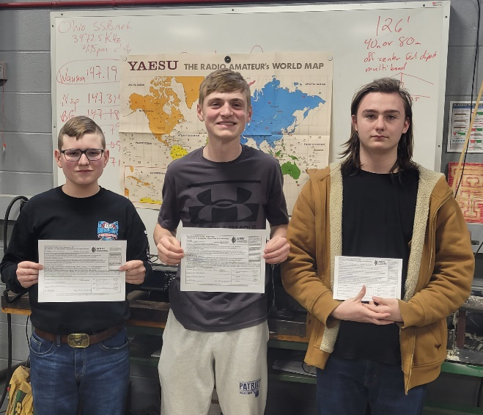
The Patrick Henry Technology Club (KE8VNL) has three members who passed their amateur radio license tests in March. Levi Johnson passed all 3 tests for his Amateur Extra license! Brian Scherdt upgraded to the General class, and Gunner McClure passed the Technician test. The school would like to thank all the Volunteer Examiners from around the country who helped with the online testing, the AmericanRadio Relay League, for covering the FCC fee & especially KD8JBS, Ben Murray, for setting up the session. Photo by advisor, Mr. Gabe Oberlin AF8GO.

__________________________________________________________

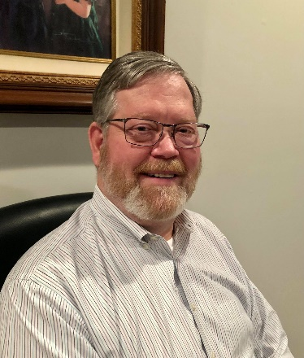
DX This Week – G0LUH Interview

Bill AJ8B (aj8b@arrl.net, @AJ8B, or www.aj8b.com)
CWOPs Member #1567

We are getting close to Hamvention. Hope you are planning on taking advantage of the forums and the flea market, or the bone yard as K8DV calls it. Should be well attended and lots of fun.
I have included an excellent interview with G0LUH – Doug. Doug met and spent time with Sir Arthur C. Clarke and is a traveler and a great DXer. This is reprinted with the permission of the Southwest Ohio DX Association.
As always, keep me in mind for questions, comments, new pieces of equipment, new antennas, or any other DX activity you have going on.

DAH DIT DIT DIT DAH DAH DIT DIT DIT DAH

Two or our readers and contributors received great QSL cards this week. The first 2 are from K8DV – Dave. The second are from Joe, W8GEX. Please send along cards that you receive.

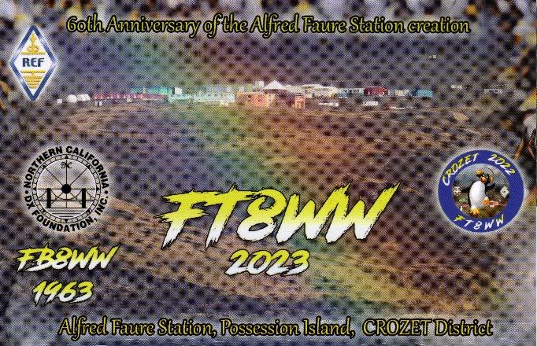
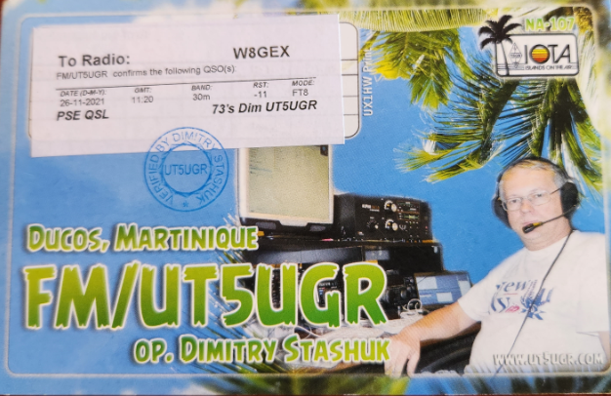
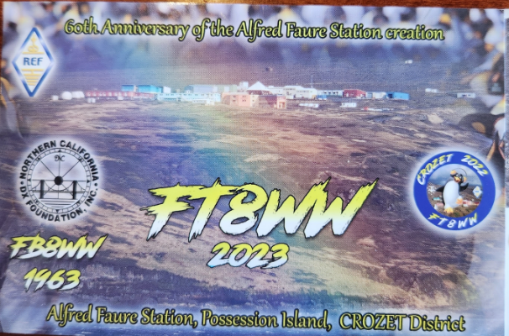

DAH DIT DIT DIT DAH DAH DIT DIT DIT DAH

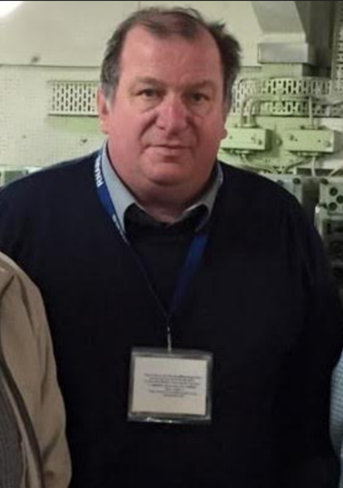
Interview with G0LUH—Doug Goodson
I worked Doug and reviewed his QRZ.com page. He spent some time with one of my favorite authors, Sir Arthur C. Clarke. This prompted me to investigate G0LUH further and Doug agreed to answer a few questions for us. Enjoy...
Hello Bill
Below are my answers as well as some pictures. Please let me know if you need more. Also, please review a YouTube documentary from the BBC (not copyrighted) called Arena-Tunning from 1994. I helped to make this, and I appear in it as well.

AJ8B: After I worked you, I immediately went to your QRZ.com page. I noticed that you had met one of my favorite authors, Sir Arthur C. Clarke. That must have been quite a thrill. Can you share a few details about that?
G0LUH: Arthur C Clarke was a friend of a friend in Sri Lanka who wanted to hear about my experiences of crop circles and dust circles or Whirrley gigs (dust whirlwind type storms in the UK) Nice guy, quite eccentric and strong-willed. I had a good day with him talking about his books and theories and space and his films, what he had achieved so far in life and what his future plans were. He asked about the amateur radio station I had in Colombo and what I was achieving considering that it was just weeks prior to the 1st Gulf war and that I had travelled through the war zone to get to Sri Lanka, but that's another story.

AJ8B: How did you first get interested in amateur radio?
G0LUH: I first got interested in radio at senior school (high school) aged 13 when the teacher Mr Davis (LT Col R Davis ex-Royal Signals) decide we should all build crystal sets. Not my idea of fun until I realized I could listen to Radio Luxemburg and rock and roll in1963.
AJ8B: Do you have a favorite band or mode?
G0LUH: No favorite band, I just go where the noise is.

AJ8B: What time of day and days do you like to operate?
G0LUH: Being retired, operating time is not an issue, but prefer as a UK station, I prefer to work radio 1800 hours to 0600 hours. That way I get the best USA and Asia

AJ8B: Any secrets to your success?
G0LUH: Always be nice to the other station and to other users. They will always, or most times, reciprocate and always QSL quickly.

AJ8B: Describe what you are currently using:
G0LUH: Kenwood TS590S, Yaesu FT950, my main antenna is a 26-meter EFHW direction west to east, Gap Eagle, MFJ 1788X Loop, Diamond V2000 for 2 meters, 70cms and 6 meters, UK AMP 572 tubes. 800w output rarely used as EFHW works well barefoot.

AJ8B: What advice do you have for those of us trying to break pileups to work DX?
G0LUH: Patience, Patience in big doses

AJ8B: You are a veteran of my DXPeditions. Is there one that really stands out and why?
G0LUH: In 1992, a Tornado ripped off the roof of the shack and we still carried on with radio work.

AJ8B: What was the worst experience you had?
G0LUH: Dropping a valve for one of the groups linear they were not pleased and blowing a TS940SAT motherboard.

AJ8B: Where are you going next?
G0LUH: Now I am leaving it to younger and richer people, I play electronic fly fishing these days where I can get a signal and get a bite (signal) I am pleased, I can visit the whole world from my shack and the coffee is better!

AJ8B: What coaching/advice would you give new amateurs?
G0LUH: Always join your national society and always use QRZ, EQSL, LOTW and update frequently.
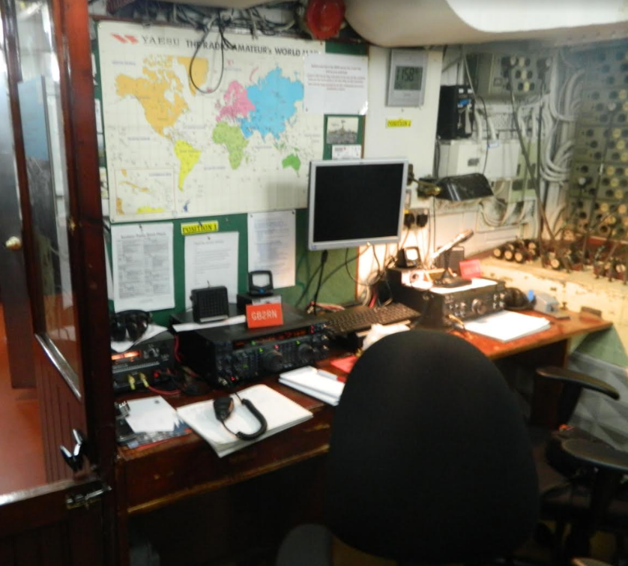
AJ8B: You are very involved in operating from the HSM Belfast as an Imperial War Museum Volunteer. What has that been like?
G0LUH: HMS Belfast a society rather than a radio club so the rules differ. It's an honor and privilege to be an operator on board such a historic WW2 ship, not only dealing with the radio pileups, but also with tourists. We have a system with a morse key and demonstrate morse. We then get the visitors to send their name while we write it on a certificate that's issued to them. We cater to children aged between 4 years and 94 years and they are all very grateful. In some cases people who have never held any kind of qualification in their lives, the people who are challenged such as sight and sound and physically are probably the most heart-tugging human beings but the satisfaction is overwhelming when they achieve that goal.
Also, when we have overseas visit ors who operate and find themselves in the middle of a pileup for that callsign, GB2RN.
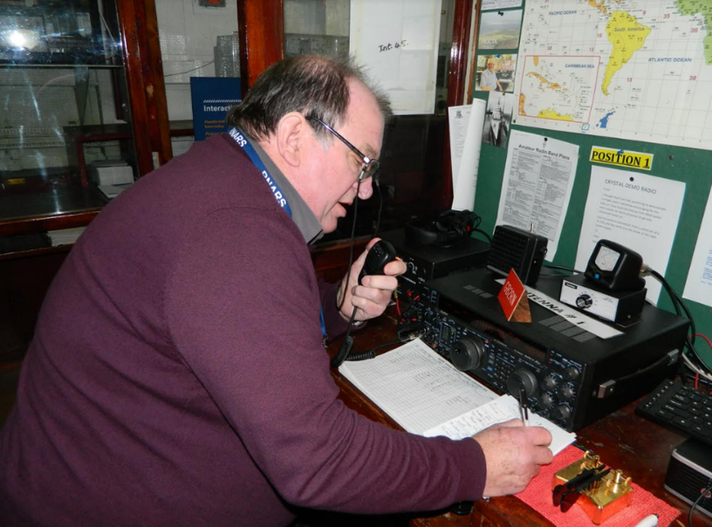
AJ8B: Thanks for taking the time to answer my questions. Is there anything you would like to share with us?
G0LUH: There is a floor and ceiling for all of us. Always listen to advice. Some will be good, and some will have to be left behind for now. Always be polite and sensible, when you fail, pick yourself up and get help if you need it

Doug Goodison G0LUH ex 4S7/G0LUH, 4S0UK, 4S7DGG, 8Q7AB
Treasurer and Membership Secretary RNARS(LG)

DAH DIT DIT DIT DAH DAH DIT DIT DIT DAH

Press Release

SWODXA DX DINNER® ANNOUNCEMENT

March 30th, 2023
AJ8B => Bill Salyers (aj8b@arrl.org)
Southwest Ohio DX Association

FOR IMMEDIATE RELEASE

The SouthWest Ohio DX Association (SWODXA) has announced that Adrian Ciupera, KO8SCA, will be the keynote speaker at the 36th annual DX Dinner®. Adrian has just returned from the 3Y0J, Bouvet Island DXpedition and is a veteran of 30 other DXpeditions. He will be sharing experiences from all of his DXpeditions.
The dinner, held in conjunction with the 2023 Dayton Hamvention®, will be on Friday, May 19th, at the University of Dayton Marriott Hotel.
Icom has graciously donated an IC-7610 as the DX Dinner grand prize. Icom has also donated an Icom IC-705 as the raffle prize to be awarded at the DX Forum on Saturday. There are also many other great DX Dinner prizes. You can see a list of prizes at https://swodxaevents.org/2022-dayton-dx-dinner/
There will be a cash bar starting at 5:30 p.m., with dinner served at 7:00. Following the event, there will be a separate room and cash bar available for more fellowship. This is an excellent opportunity to meet new hams and to renew old acquaintances as well as to learn about past DXpeditions and those in the planning stages.

As always, SWODXA will bestow the DXpedition of the Year Award and CQ will announce their 2023 DX Hall of Fame inductees.

We anticipate brisk ticket sales to continue, so don’t wait any longer. For more information and to order dinner tickets, visit WWW.SWODXAEVENTS.ORG.

DAH DIT DIT DIT DAH DAH DIT DIT DIT DAH

Here is an update from Bernie, W3UR, of the DailyDX and the WeeklyDX, the best source for DX information. http://www.dailydx.com/ . Bernie has this to report:

Z8 - South Sudan - Z81D, aka YI1DZ, Diya, says he will be on the bands from time to time. In the last couple days he has been on 10M and 6, but says he will be on other bands also, because of his work typically after 1300 or 1400Z. On 10M, Diya says the band has been wide open and hundreds of stations are calling him. He notes Z8 has been off the air for more than a year, but now he is slowly getting back on.

EX – Kyrgyzstan - EX0QKT, Artyom "Archie" Saralov, is active with a limited station from Bishkek on the shore of Issyk-Kul Lake. R3TKT got the license last month and began operating in mid-March. He is there on a "long business trip" and gets on SSB, CW and FT8 on HF. There are 150 licensed hams in the Kyrgyz Republic. He apparently accepts "skeds," r3tkt.ham@gmail.com QSL through the bureau to R3TKT.

FO/C - Clipperton Island - The "Perseverance DX Group" says it has been a challenge to get operating permission after 2016 when Clipperton was declared a protected marine reserve. A long dialogue ensued with the government of French Polynesia, with landing permits only issued for scientific research. They talked with the Office of the High Commissioner, the French Navy, the maritime security office and bio-security office in Papeete, and a landing permit came through on March 13th, along with the TX5SS callsign. This all took eight months. The Perseverance DX Group notes their VK9MT, TX3X, VP6D and VP8PJ boat/tent/generator expeditions since 2013, and their projects including with ZL9HR and VK0EK. They are looking to hire the "Shogun" ship, which has gone to Clipperton many times, including on French government contracts. Each of the ops is putting up 16,000 USD to book the Shogun and are looking for further financial support. KE4KY, Glenn Petri, is spokesman for the "Clipperton 2024 Team." TX5S.net.

DAH DIT DIT DIT DAH DAH DIT DIT DIT DAH

Below is a list of upcoming contests in the “Contest Corner”. I think this is important for someone who is trying to move up the DXCC ladder since entities that are on the rarer side and easiest to work in contests. Some of my best “catches” have been on the Sunday afternoon of a contest when the rarer entities are begging for QSOs. Of course, the gamble is that if you wait until Sunday, conditions may change, or they simply won’t be workable. However, it is not a bad gamble. Of course, why not work the contest and have some fun!
Check out the WA7BNM Contest Calendar page (https://www.contestcalendar.com/) and CQ Magazine for more contests or more details. I also have a comprehensive list that can be imported to your calendar at www.aj8b.com/files
The contests in red are those that I plan to spend some significant participation time on. PLEASE let me know if you are working contests and how you fared.
Thanks!

Date(s) | Event | Info
All Year | CQ DX Marathon | bit.ly/3FyPiui
Apr. 3 | RSGB 80m Club Championship, CW | https://bit.ly/3TxCrxl
Apr. 5 | UKEICC 80m Contests SSB | https://ukeicc.com/80m-rules.php
Apr. 5 | VHF-UHF FT8 Activity | www.ft8activity.eu/index.php/en
April 8 | QRP Spring QSO Party | www.qrpcontest.com
Apr.8-9 | FT8 DX Contest | https://europeanft8club.wordpress.com
Apr. 8-9 | Georgia QSO Party | https://gaqsoparty.com
Apr. 8-9 | IG-RY World Wide RTTY Contest | www.ig-ry.de/ig-ry-ww-contest
Apr. 8-9 | JIDX CW Contest | www.jidx.org
Apr. 8-9 | New Mexico QSO Party | www.newmexicoqsoparty.org/wp
Apr. 8-9 | North Dakota QSO Party | www.ndarrlsection.com/index.html
Apr. 8-9 | OK-OM DX SSB Contest | http://bit.ly/3ioS3Cl
Apr. 8-9 | Yuri Gagarin International DX Contest | http://gc.qst.ru/en/section/32
Apr. 9 | Hungarian Straight Key Contest | http://hskc.ha8kux.com
Apr. 9 | International Vintage Contest HF | www.iv3ehh.it/vintage.htm
Apr. 9 | WAB 3.5/7/14 MHz Data Modes | http://bit.ly/31yE4kT
Apr. 10 | 144 MHz Spring Sprint | http://bit.ly/3XM4RpW
Apr. 12 | VHF-UHF FT8 Activity | www.ft8activity.eu/index.php/en
Apr. 14-15 | Holyland DX Contest | www.iarc.org/iarc/#HolylandContest
Apr. 15 | DARC Easter Contest | http://bit.ly/3bOk9pd
Apr. 15 | ES Open HF Championship | www.erau.ee/en/es-open-contests
Apr. 15 | QRP to the Field | https://tinyurl.com/2s3zxah3
Apr. 15-16 | CQ Manchester Mineira DX Contest | www.cqmmdx.com/rules
Apr. 15-16 | Michigan QSO Party | https://miqp.org/index.php/rules
Apr. 15-16 | Ontario QSO Party | www.va3cco.com/oqp/rules.htm
Apr. 15-16 | Texas State Parks on the Air | www.tspota.org
Apr. 15-16 | Worked All Provinces of China DX Contest | www.mulandxc.com/index/index
Apr. 15-16 | YU DX Contest | http://yudx.yu1srs.org.rs
Apr. 16 | ARRL Rookie Roundup, SSB | www.arrl.org/rookie-roundup
Apr. 18 | 222 MHz Spring Sprint | http://bit.ly/3XM4RpW
Apr. 19 | RSGB 80m Club Championship, SSB | https://bit.ly/3TxCrxl
Apr. 19 | VHF-UHF FT8 Activity | www.ft8activity.eu/index.php/en
Apr. 22-23 | SP DX RTTY Contest | https://tinyurl.com/yckz49rm
Apr. 23 | BARTG Sprint75 Contest | http://bartg.org.uk/wp/contests
Apr. 23 | North American SSB Sprint | https://ssbsprint.com/rules
Apr. 24 | RSGB FT4 Contest Series | https://bit.ly/3TxCrxl
Apr. 26 | 432 MHz Spring Sprint | http://bit.ly/3XM4RpW
Apr. 26 | UKEICC 80m Contests CW | https://ukeicc.com/80m-rules.php
Apr. 27 | RSGB 80m Club Championship, Data | https://bit.ly/3TxCrxl
Apr. 29-30 | 10-10 Spring Digital Contest | http://bit.ly/1FrFeBc
Apr. 29-30 | Florida QSO Party | www.floridaqsoparty.org
Apr. 29-30 | Helvetia Contest | www.uska.ch
Apr. 29-30 | UK/EI DX Contest, CW | www.ukeicc.com/dx-contest-rules.php
May 27-28 | CQWW WPX CW Contest | www.cqwpx.com

ARLD013 DX news
This week's bulletin was made possible with information provided by The Daily DX, 425 DX News, DXNL, Contest Corral from QST and the ARRL Contest Calendar and WA7BNM web sites. Thanks to all.
MONACO, 3A. Special event station 3A8AB is QRV during April to commemorate the 100th anniversary of the first transatlantic contact between F8AB in Nice, France, and U1MO located in Hartford, Connecticut. QSL via LoTW.
MALDIVES, 8Q. Dejan, OE7MOP is QRV as 8Q7MO from Summer Island until April 10. Activity is on 40 to 10 meters using CW, SSB, and with an emphasis on RTTY. This includes being an entry in the EA RTTY contest. QSL via bureau.
CAPE VERDE, D4. Timo, OH1NOA is QRV as D4NA from Sal Island, IOTA AF-086, until April 6. Activity is in his spare time on 40 to 10 meters using mainly CW with some SSB. He plans to be active from World Wide Flora and Fauna sites D4FF-002 and D4FF-0003. QSL via
LoTW.
FEDERAL REPUBLIC OF GERMANY, DA. Special event station DA23WARD is QRV until April 18 to commemorate World Amateur Radio Day. QSL via bureau.
NIUE, E6. Janusz, SP9FIH and Leszek, SP6CIK are QRV as E6AF and E6CI, respectively, until April 9. Activity is on 40 to 10 meters using CW, SSB, RTTY, and FT8. QSL via Club Log.
KYRGYZSTAN, EX. Archie, EX0QKT is QRV with a limited license and is active from Bishkek on the shore of Issyk-Kul Lake. Activity is in his spare time on the HF bands using CW, SSB, and FT8. QSL via R3TKT.
MAYOTTE, FH. Dom, F4IFF will be QRV as FH/F4IFF from Boueni from April 1 to 9. Activity will be on 80 to 10 meters using SSB and FT8. QSL via EB7DX.
FRENCH POLYNESIA, FO. George, AA7JV and Mike, KN4EEI are QRV as FO/AA7JV from the Tuamotus Archipelago, IOTA OC-066, until April 5. Activity is on 160 to 10 meters using CW, SSB, and FT8 on 6 meters. QSL via HA7RY.
SOLOMON ISLANDS, H4. Michael, DL2GMI plans to be QRV as H44MI beginning April 2 and active for 7 to 10 days. Activity will be on 80 to 10 meters using some CW, SSB, and RTTY. This may include 5 meter EME from Grid Square RI01hp. QSL direct to home call.
PANAMA, HP. Josep, EA3BT and Nuria, EA3WL will be QRV as H31W and H31B, respectively, from Contadora Island from April 3 to 8. Activity will be on 40 to 6 meters using CW, SSB, and FT8. QSL via Club Log.
BELGIUM, ON. Special event station OT23WARD will be QRV from April 1 to 30 from various locations to commemorate World Amateur Radio Day. QSL via LoTW.
SEYCHELLES, S7. Ravi, S79VU is QRV as S76A until April 2 from the Inner Islands as part of World Autism Week. QSL direct to W2MTR.
WEST KIRIBATI, T30. Members of the Rebel DX Group, including Kam, T33KC, will be QRV as T30UN from North Tarawa, IOTA OC-017, for about five weeks the beginning of April. Activity will be on 160 to 6 meters using CW, SSB, and FT8 in DXpedition mode with multiple stations active. QSL via Club Log.
INDIA, VU. Special event station AU40NRO will be QRV from April 1 to June 30 to celebrate The 40th anniversary of the National Institute of Amateur Radio. QSL via VU2NRO.
MEXICO, XE. Enrique, XE2AA will be QRV as XF2A from Tamalcab Island, IOTA NA-200, from April 2 to 7. QSL via IT9EJW.
SOUTH SUDAN, Z8. Diya, YI1DZ is QRV as Z81D from Juba until April 22. Activity is in his spare time on the HF bands using FT8. QSL via OM3JW.
The K1USN Slow Speed CW Test, ICWC Medium Speed CW Test, OK1WC Memorial, RSGB 80-Meter Club CW Championship, ARS Spartan CW Sprint, Worldwide Sideband Activity Contest, ZL CW Sprint, Phone Weekly Test, A1Club AWT, CWops Test, VHF-UHF FT8 Activity Contest, Mini-Test 40, Mini-Test 80 and the UKEICC 80-Meter SSB Contest are
on tap for April 3 to 5.
Please see March QST, page 71, April QST, page 69, and the ARRL and WA7BNM Contest web sites for details.

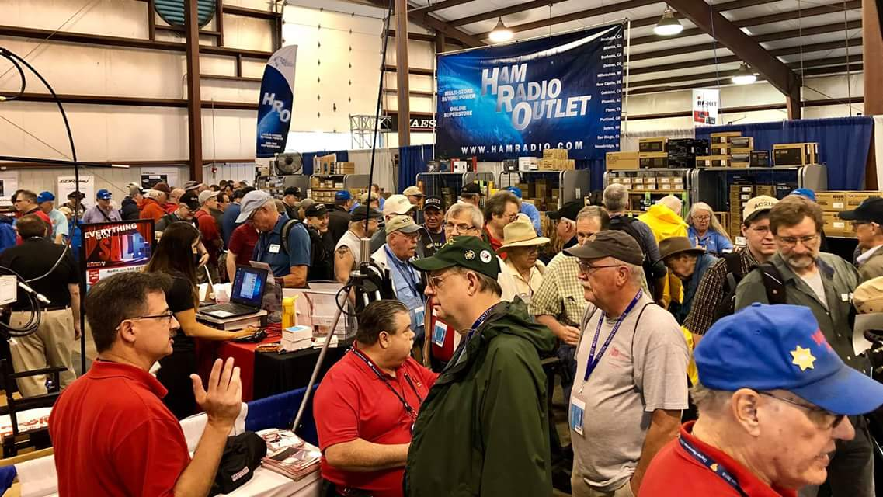
Upcoming Hamfests

We DO have some hamfests scheduled for 2023!! Yes, take a good look at the list, it’s growing every day!

Ohio Hamfests
2023

04/15/2023 - Cuyahoga Falls Amateur Radio Club Hamfest
Location: Cuyahoga Falls, OH
Sponsor: Cuyahoga Falls Amateur Radio Club, Inc.
Website: http://www.cfarc.org

Learn More

04/22/2023 - Tusco Amateur Radio Club Hamfest, Electronics, and Computer Show  Location: Dover, OH  Sponsor: Tusco Amateur Radio Club W8ZX  Website: http://www.w8zx.net  Learn More | 04/30/2023 - Athens Hamfest  Location: Athens, OH  Sponsor: Athens County Amateur Radio Association  Website: http://www.ac-ara.org/  Learn More
05/07/2023 - Lucas County Amateur Radio Emergency Service Trunk Sale and Swap Meet  Location: Toledo, OH  Sponsor: Lucas County Amateur Radio EmergencyService  Website: http://swap.lucasares.org  Learn More | 05/13/2023 - 05/17/2023 RV Radio Network  Location: Berlin, Ohio, OH  Type: ARRL Operating Specialty Convention  Sponsor: RV Radio Network  Learn More
Great Lakes Division Convention!!

05/19/2023 - 05/21/2023 Dayton Hamvention
Location: Xenia, OH
Sponsor: Dayton Amateur Radio Association
Website: http://Hamvention.org
Learn More

05/27/2023 - Scioto Valley Amateur Radio Club Hamfest  Location: Piketon, OH  Sponsor: Scioto Valley Amateur Radio Club  Learn More | 06/03/2023 - FCARC Summer Hamfest  Location: Wauseon, OH  Sponsor: Fulton County Amateur Radio Club  Website: https://k8bxq.org/hamfest  Learn More
07/08/2023 - Mansfield Trunkfest 2023  Location: Mansfield, OH  Sponsor: Intercity Amateur Radio Club  Website: http://iarc.club  Learn More | 07/15/2023 - NOARSFEST  Location: Elyria, OH  Sponsor: Northern Ohio Amateur Radio Society  Learn More
07/16/2023 - Van Wert Hamfest  Location: Van Wert, OH  Sponsor: Van Wert Amateur Radio Club  Website: http://w8fy.org  Learn More | 08/12/2023 - Cincinnati Hamfest  Location: Owensville , OH  Sponsor: Milford ARC  Website: https://CincinnatiHamfest.org  Learn More
08/20/2023 - WARA Tailgate Swap Meet  Location: Cortland, OH  Sponsor: Warren Amateur Radio Association  Website: http://w8vtd.org  Learn More | 09/10/2023 - Findlay Hamfest  Location: Findlay, OH  Sponsor: Findlay Radio Club  Website: http://findlayradioclub.org  Learn More
09/24/2023 - Cleveland Hamfest  Location: Berea, OH  Sponsor: Hamfest Association of Cleveland  Website: http://www.hac.org  Learn More | 10/29/2023 - Massillon (OH) Hamfest (& auction)  Location: North Canton, , OH  Sponsor: Massillon Amateur Radio Club  Website: http://www.w8np.net  Learn More

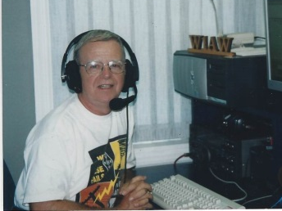
OHIO’S

The clock is ticking towards the start of the world’s largest gathering of ham radio operators, radio hobbiests and electronic tinkerers and historians. And it’s right here in our own backyard. Since 1952 when the first Dayton Hamvention was held at a downtown Dayton hotel, the event has grown and draws radio amateurs from throughout the world. This year the event will mark its fourth year happening at the Greene County Fairgrounds in Xenia on May 19, 20 and 21. If you haven’t made plans to attend, I urge you to go to the event’s website at www.hamvention.org and see what’s in store for those who attend this year. And while at the site, why not go ahead and order your ticket? I’m certain hams in other parts of the country and globe would give up their most valuable piece of equipment in order to attend.

I would be amiss if I didn’t also give a shout out about the world’s largest gathering of those interested in QRP operating. In-person registration for the “Four Days In May” QRP Convention starts at 7:30 PM on Wednesday evening May 17 at the Fairborn, Ohio Holiday Inn. The daily event schedule kicks off with a series of seminars and speakers on Thursday with the remaining days events built around the happenings at Hamvention. I have had people tell me this event by itself is well worth a trip to the Dayton area. But combining it with the Hamvention experience is overwhelming. Information including the names and calls of those who have pre-registured, the daily schedule of guest speakers and their topics plus a wealth of other good information can be found at www.qrparci.org/fdim.

On April 1 the Athens County ARA kicked off a busy month for the Club by providing communications for the annual Lake Hope Iron Furnance Run. Racing along to April 16 they will provide communications for the annual Athens Marathon/Half Marathon. Then on April 30 they will conclude the month with sponsoring the popular Athens County ARA Hamfest at the Athens Community Center. If you would like additional information on any of these events or see how you can help, please contact Jeff Slattery, N8SUZ, at 740-592-6124.
On Monday evening, April 3 the Portsmouth RC will conduct their monthly Laurel VE session at the American Legion Post in Portsmouth. Registration begins at 5 PM with all test elements available. Up river at Huntington’s Museum of Radio and Techology an ARRL VE session is planned for April 8. The Tri-State ARA’s VE Team Leader, Bud Cyr, KB8KMH, says registration begins at 9 AM. Per ARRL policy a testing fee is charged. Pre-registrtion is not needed at either test session. Jeff Slattery, N8SUZ, reminds us there will be a ARRL test session held during the April 30 Athens County ARA Hamfest. It starts at 10 AM.

As mentioned in previous columns a good number of clubs within the region have monthly gatherings for socializing and fellowship. Members of one club even gather weekly. Carolyn Mathews, N8JQR, reminds the hams in the Pike, Ross and Highland County area the Bainbridge Area Hams breakfast group is going to give the new Norm’s Restaurant, at the western edge of Bainbridge, a try on April 8 at 8 AM. Also on the same morning, Highland ARA’s monthly Brunch Bunch will take place at the Hillsboro Burger King. Up in Fayette County the Fayette ARA will gather on Saturday morning, April 15, at the Tim Horton’s in Washington CH at 10 AM. In Clinton County, the Clinton County ARA will gather for their “Last Saturday Coffee” at Sam’s Meats on Saturday morning, April 29.

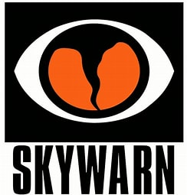
The Wilmington National Weather Service Office will hold Hamilton County’s annual in-person Spring Severe Weather Training seminar at the Globe Event Center on the evening of April 10 and the Charleston NWS will hold a free in-person session on May 13 in Vinton County. That seminar starts at 3 PM at the Vinton County Senior Citizens Center, SR 93, McArthur. The Wilmington and Charleston National Weather Service Offices are beginning to wrap up their yearly schedule of training session with the Wilmington Office’s final virtual session on May 2. The Wilmington office remains to have some other in-person sessions within its coverage area but outside of region this column covers. They are listed on the Wilmington NWS website.

Following the DeForest ARA meeting on Tuesday evening, April 11 there will be a program about batteries and solar charge controllers presented by KE8GAD, Jared Shupert. The meeting starts at 7 PM at the downtown West Union ABCAP Senior Nutrition Center which is directly across the street from the Adams County Courthouse.

According to their website (www.k8lgn.com ), the Hocking Valley ARA will resume their Foxhunts on Saturday, April 15. Checkin begins at 9:30 with the hunt commencing at 10. Bill Hopstetter, W8LGX, has the honor of being the year’s first fox.

Although not located in the South 40 coverage region, a number of hams living south of US 40 in the eastern reaches of this column will head up Interstate 77 to attend the 30th Tusco ARC Hamfest on April 22. This year’s event will take place at the fairgrounds in Dover. The gate opens at 8 AM. I hope to see you there!

The always well attended Athens County ARA will take place on Sunday, April 30 at the Athens Community Center, 701 East State Street in Athens. The gates open at 8 AM for what is a good sized indoor and outdoor radio and computer equipment flea market. Admission is $5 with non-ham spouses free. The event runs until noon. Indoor tables may be reserved by contacting Carl Denbow for $10 each at carl@n8vz.com. Outside set ups are free. General hamfest info is available through President Eric McFadden, at wd8rif@arrl.net.

Bill Salyers, AJ8B says tickets for the 38th annual Southwest Ohio DX Association DX dinner are now on sale in addition to raffle tickets for a chance to win a stay at the Harbour Rock Villa in the Turks and Caicos Islands. During the stay, the winner will have an opportunity to become DX through access to a fully equipped station. The raffle drawing for the trip will happen during the Friday, May 19 DX dinner at the Dayton Marriott. A cash bar starts the evening’s activities at 5:30 PM with dinner served at 7. This year’s keynote speaker will be Adrian Ciuperca, KO8SCA who was a part of the just concluded 3Y0J activation of Bouvet. Check out the www.swodxaevents.org website for more information and how to order your tickets for either or both events.

Ohio Section Manager Tom Sly has challenged each club to visit at least one other club’s business meeting during the year’s remainder. Doing so gives each club an opportunity to learn what the other is doing, to build a bond and personally meet the people you might hear on the air. April gives us an excellent chance to make a road trip and do a visitation since not that many major ham events are taking place. Some Southern Ohio club meetings are: April 3-Portsmouth RC, Portsmouth; April 4-Hocking Valley ARC, Logan: April 6-Clinton County ARA, Wilmington and Lancaster Fairfield County ARA, Lancaster; April 11-DeForest ARA, West Union; River Cities ARA, Ashland, KY and Highland ARA-Hillsboro; April 13-Butler County ARA, Hamilton; April 16-Milford ARA, Milford; April 17-Southern Ohio ARA-Coal Grove and Queen City Emerency Net-Cincinnati; April 18-Tri-State ARA, Huntington, WV; April 20-Scioto Valley ARA-Scioto Trails State Forest and Dial RC, Middletown and on April 29-Cambridge ARA, Cambridge. There are other clubs in the South 40 Southern Ohio and Ohio Valley regions whose meeting dates and frequencies have been unable to be verified. So why not get some fellow hams together for an enjoyable and educational time out? And be sure to let Tom know of your outing. The rules state attendance must be to a meeting. Visits to club conducted coffees, lunches, hamfests or other activities do not count. Visits across state lines will receive extra consideration.

On Saturday, May 27, the Scioto Valley ARA will hold a hamfest at the Pike County Fairgrounds in Piketon.

If you can image cars racing through the service roads in Southern Ohio’s state forests at speeds approaching 100 MPH, then the Southern Ohio Forest Rally might be something you have an interest volunteering your amateur radio skills for. Bill French, KE8AAL, says amateurs are needed to man check points along the routes through a city park and two state forests on June 8, 9 and 10. The courses will be through Chillicothe’s Yoctangee Park on Thursday evening and then through the Zaleski State Forest near McArthur and the Shawnee State Forest at Portsmouth on the following days. Contact ke8aal@yahoo.com to learn how you can assist.

I started this week’s column with comments about the upcoming May Dayton Hamvention hosted by the Dayton ARA at the Greene County Fairgrounds in Xenia. Therefore it is only fitting I conclude the column with another tid-bit about one of the happenings there. Our own Ohio Section Manager, Tom Sly, will host a forum devoted to the “Importance of Amateur Radio Clubs” on Friday morning at 9:15. Since taking the helm as the Section Manager Tom has traveled throughout all parts of Ohio to visit clubs, attend hamfests and attend other ham radio events. He has seen it all-the good, the bad and the downright ugly. And what he hasn’t personally seen he has heard about from Scott Yonally and others on his cabinet. From what he has told me, he intends to share his findings with those in attendance at the forum. If your local club is striving to become better, your take-aways from this forum alone might just be worth the price of your Hamvention ticket.

That’s it for another column. Here’s hoping everyone remains safe and healthy and radio active.

John Levo, W8KIW, jlevo@cinci.rr.com or highlandara@gmail.com, 937-393-4951

__________________________________________________________________

Print an Official or Unofficial Copy of Your Amateur Radio License
(By Anthony Luscre, K8ZT)
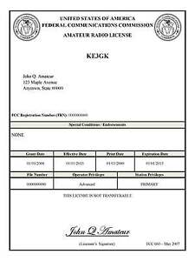
As of February 17, 2015, the FCC no longer routinely issues paper license documents to Amateur Radio applicants and licensees. The Commission has maintained for some time now that the official Amateur Radio license authorization is the electronic record that exists in its Universal Licensing System (ULS). The FCC will continue to provide paper license documents to all licensees who notify the Commission that they prefer to receive one.

Licensees also will be able to print out an official authorization — as well as an unofficial “reference copy” — from the ULS License Manager. I’ve created a set of instructions on how you can request an “official” printed copy of your license*

Click here to download the instructions

One Question Questionnaire

Hey Gang,

Last weeks question DID YOU LOSE POWER IN LAST WEEKS STORMS??

With a total of 82 Responses: 22 (26.83%) said YES, and 60 (73.17%) said NO. I know this is a small sample for OHIO, but lets say our numbers are representative, then a quarter of all Ohio residents lost power at some time in the last round of storms! We are not immune from events that could turn into a bona fide “Disaster”. It’s important to keep your EmComm skills sharp, and, have alternate sources of power available.

The new question is:

Do you still use radios with tubes in them?
a) Yes?
b) No?

You’ll find the “One Question” questionnaire on the Ohio Section Website! http://arrlohio.org It’s all for fun and it’s not a scientific survey in any way, but we are learning some things that we didn’t know from these questions. I hope that you are enjoying answering these “One Question” questionnaires.

Nex week I’ll announce March’s handbook winner! Good luck!

Final… Final

First off, Thank you to everyone who contributed to this month’s OHIO Section Journal – Outstanding contributions. I hope that if you got down this far you found something of interest in this issue, in fact I hope you find something of interest every week. Ham Radio is the Greatest Hobby in the World! And there’s always a lot to report on.

Did you read the “Member Spotlight” on page 13 of the April QST? Larnelle Harris – WD4LZC is an interesting guy. As a world renowned Gospel Singer, he shows that Ham Radio certainly attracts a diverse range of people, including folks from fields outside of electronics and other related industries. As he explains how he became interested in Ham Radio, he echoes the idea that inviting people, on a “one on one” basis, is still one of the best ways to create interest in our hobby and bring others in. Once they’re “in” the best way to keep them engaged and growing is through our clubs.

On Friday, May 19, 2023, I’ll be presenting one of the first Forums of this year’s Hamvention at 9:15 AM in Forum Room 4. My topic is the importance of Clubs to the Ham Radio Hobby and how to make your club a better club. We all have room to grow! I hope you will join me there and work to improve your club when you return home.

Finally, I want to thank you ALL! YOU make this the Greatest Hobby in the World!

73,
Tom WB8LCD

“Swap & Shop” on the website

Hey Gang,

Have you taken a look at the Swap & Shop page on the Ohio Section webpage yet?? Here’s a link that will take you there…
http://arrl-ohio.org/sm/s-s.html

Do you have equipment that you just don’t need or want anymore? Here’s a great venue to advertise it, and it’s FREE!!

Is your club doing a fund raiser to help raise money? After a lot of thought, it was decided that the Swap & Shop webpage could also contain these types of items as well.

The same rules will apply as do for the For Sales and Give-A-Ways and will only be posted for a month at a time. Please see the Terms & Conditions on the webpage.

If your club is doing a fund raiser and wants more exposure, please forward the information to me and I’ll advertise it on the Swap & Shop webpage for you. Now, I still want to remind you that it won’t be listed in this newsletter because it would take up way too much space, so your ad will only appear on the website. It is there for any individual to post equipment Wanted / For Sale or Give-Away as well as for Club Fund Raisers. No licensed vehicles/trailers or business advertising will be posted.

Postings are text only (no pictures or graphics) will be posted for a maximum of 1 month from date posting and require a contact phone number or email within the posting. Send your Wanted / For Sale or Give-Away post to: swap@arrlohio.org

Back Issues of the PostScript and Ohio Section Journal

Hey, did you know that PostScript and Ohio Section Journal (OSJ) are archived on the website? You can go back and look at any edition simply by clicking:
http://arrl-ohio.org/news/index.html

Ohio Section Cabinet
Section Manager – Tom Sly, WB8LCD | Section Emergency Coordinator – Bret Stemen, KD8SCL
Technical Coordinator – Jeff Kopcak, K8JTK | Section Traffic Manager – David Maynard, WA3EZN
State Government Liaison – Bob Winston, W2THU | Affiliated Clubs Coordinator –  Amanda Farone, KC3GFU
Section Youth Coordinator – Anthony Lascre, K8ZT | Public Information Coordinator – E;izabeth Klinc – KE8FMJ

Chit – Chat, and All That!

Do you know someone that’s not getting these Newsletters? Please, forward a copy of this Newsletter over to them and have them “Opt-In” to start receiving them. Heck just have them send an email to: webmaster@arrl-ohio.org to be added.

We now have many thousands of readers receiving these newsletters weekly. Quite impressive, I’d say! I urge all of you to make sure that everyone, regardless of whether they are a League member or not, get signed up to receive these weekly Newsletters.

You can always “Opt-Out” at any time if you feel this is not what you were expecting. It’s fun and very informative. All of your favorite past newsletters are now archived too.
You can go back at any time and read them. Just go to: http://arrl-ohio.org/news/

The pictures on the front page and throughout this newsletter are from various newsletters, Facebook posts and/or were sent directly to me in recent weeks. Take a good look at them, you just might be in one of the pictures! “SMILE… you’re in the Ohio Section News!!”

The Ohio Section Journal (OSJ) is produced as a comprehensive look at all the programs within the Ohio Section. I sincerely hope that you have enjoyed this edition of the OSJ and will encourage your friends to join with you in receiving the latest news and information about the Ohio Section, and from around the world!

TOP^

