July 2023

From the Technical Coordinator | From the Section Emergency Coordinator
From the Public Information Coordinator | From the Section Youth Coordinator
From the Section Traffic Manager | ARES Training Update
From the Affiliated Clubs Coordinator | National News
Club Corner | Contest Corner
DX This Week | One Question Questionnaire
Final.. Final..

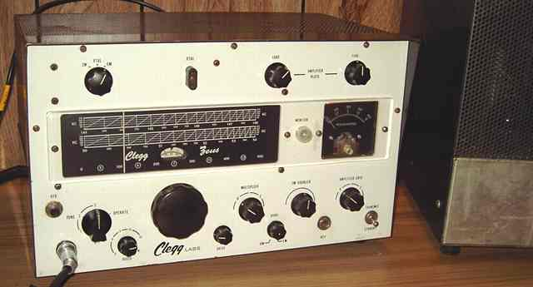

From the Technical Coordinator
Jeff Kopcak – K8JTK TC
K8JTK@arrl.net

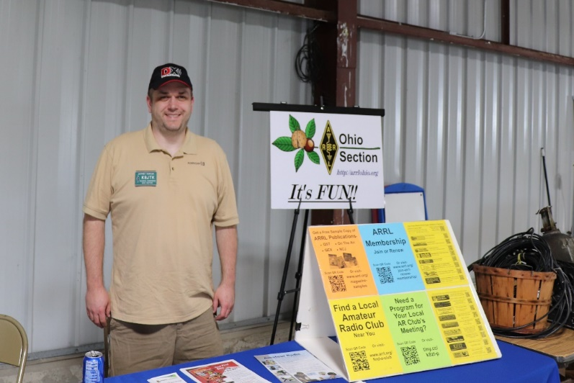
Hey gang,
Hamshack Hotline is a private free to use VoIP telecommunications phone service put together for the ham radio community by hams. It is a way to enhance communication between ham shacks and even Emergency Operation Centers. I, and other Technical Specialists, have written many articles in the OSJ about this service. It’s a great use of technology to enhance communication, even if it doesn’t use RF.
Cracks started to show problems when Hamshack Hotline had a falling out with members of their board and support platform moderators. It’s their project and they can run it however they want. I no longer recommend nor support this project. Unfortunately, they are the largest ham-based telco provider.
Hamshack Hotline has many features including “RF Links” which are extensions that dial into a AllStar Link node. Termed RF links typically because the ASL node is connected to a repeater or simplex radio.
After linking my multimode system to Hamshack Hotline, some HH users reported being disconnected after 30-40 seconds. I didn’t experience disconnects using my extension and neither did the majority of users. Doing some troubleshooting, I had those users try other RF link extensions to see if they were disconnected after the same length of time. Users confirmed the same experience on other RF links. It wasn’t only limited to my configuration.
Back in March 2021, I opened a ticket with the HHOPS helpdesk identifying symptoms my users were experiencing. This ended up being an exercise in futility. Included in my what-I-do-know details, I listed callsigns and extensions of users on HH whom experienced disconnects. Those details could possibly be correlated to a specific HH server, device type, device model, or manufacturer. It was like I traveled to another dimension. The support person thought I owned all those extensions (and callsigns? - I guess) experiencing the issue. What a total waste of time. Ticket was closed by the helpdesk as an issue with the devices experiencing the problem.
Fast forward to March 2023, I get a support ticket from Hamshack Hotline saying my node is sending out “SMS beacons” across the network. “This can cause all phones that are sms RFC compliant to drop the call after approximately 30-45 seconds into the call.” Guess they found the cause of what I originally reported two years earlier. SMS (same standard as SMS text messaging) beacons sent by AllStar Link nodes caused phones on HH to hangup. It went on to indicate changes on a HamVoIP based AllStar node is a two-line configuration change. Changes for other software, such as native AllStar Link, is more involved.
I run a hub on Virtual Private Servers (VPS) in the, so-called, cloud. My system runs native AllStar Link. I’m unable to run HamVoIP since that distribution is for Raspberry Pi/ARM processors only. Additionally, recent major updates have further separated HamVoIP from AllStar Link. They’re almost two different systems. Not to mention HamVoIP has been accused of license violations. These made me uneasy about the future of the HamVoIP project and I’ve contributed to the ASL project. As a result, I moved my personal node from HamVoIP to native ASL.
Following provided instructions by Hamshack Hotline, reached out to them because I’m not running HamVoIP on my hub. I was put in touch with another person that had the “fix” for ASL. Two things were needed to disable SMS beacons: (1) create a private node for Hamshack Hotline connections. A private node in ASL are the reserved node numbers 1000 through 1999. I did this anyway on my hub. (2) Disable pushing CALLERID to the RPT module. RPT is the module that handles ham radio functionality in Asterisk. As one would expect, CALLERID contains unique data about the caller. When used with RPT, this is typically extension, node, or callsign information.
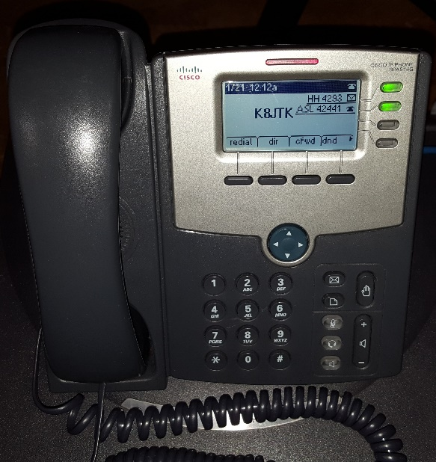
Having a decent level of experience working with Allstar configuring hubs, nodes, IAX clients, softphones, and desk phones, I knew messages were pushed to other connected nodes and devices. These exchanges show up as a list of connected nodes on a status page such as Allmon or Supermon, within apps, on a display, in logs, in the Asterisk CLI (command line interface), on the ASL website, etc. I didn’t have the need to know this exchange was done via SMS messages, but knew there was some mechanism used for reporting information to other connected nodes. I had seen references it was an “SMS message,” but never confirmed.
My former Hamshack Hotline extension
While working with the person provided by Hamshack Hotline, the comment was made: ‘this is ham radio, I don’t know why we’re using SMS text messages.’ Taken aback, said ‘that’s how the network knows about other connected nodes.’ This person, who came up with (at least) part of the solution to fix this SMS beacon issue, didn’t know or understand Asterisk clients exchanged information with other nodes. I’m always irked by required mandatory changes where they don’t understand what they are changing, the broader impact of said changes or to even ask the question and address concerns. I blew it off and gave their solution a whirl.
Below are Asterisk and AllStar Link extensions.conf examples. These are from various documentation sources showing different ways ID information is passed to the RPT module. 50394 is my hub node and used as an example node number.
AllStar Nodes:
- exten => ${NODE},1,rpt,${NODE}
VoIP clients (IAXrpt, DVSwitch, Zopier, phones):
- exten => ${NODE},n,Rpt,${NODE}|P|${CALLERID(name)}
- exten => ${NODE},1,rpt(${NODE}|X)
- exten=50394,1,Rpt,50394|X
- exten => 50394,n,Rpt,50394|S|${CALLERID(name)}
- exten => 50394,n,Rpt,50394|Pv|${CALLERID(name)}
As I’m working through the provided Hamshack Hotline configuration changes for ASL, I realize their proposed changes will cause problems. Omitting CALLERID means the connection exists but there is no indication of the call in RPT or facilities that use RPT. Users would will no longer see their connection on dashboards and sysops no longer have the control to disconnect individual HH users.
Lack of control and visibility is big problem for me as the sysop of a hub to see who is connected in case of problems. Users will dead key/forget to unmute, not press the # key when they are done talking, or some another innocent mistake - most of those happen during a single net – or someone is being a lid. I’ve used logs to validate reports and contacted users providing information about a situation which they’re likely unaware.
I raised my concerns to Hamshack Hotline about the solution not being good for sysops to control their systems. I was blamed (again) that my system ‘wasn’t working like the others’ because ‘no one else is having the same problems with these changes.’ My guess, results were confused with the HamVoIP distribution or that ASL v1 didn’t act the same as v2 (which I am using). Not having the time and being frustrated (but still respectful), I did not investigate further. Hindsight being 20/20, I had some false hope my feedback would be used to devise a better solution. I can’t be the only one voicing similar concern. In reality, they didn’t care.
Last day of Hamvention, traveling back home, I get a message from Hamshack Hotline that my RF link extension is in violation, been disabled, and in danger of termination if not corrected. Somewhere between March and mid-May, it became mandatory to participate as a HH RF link, I needed to provide a “clean” transmission (without SMS beacons). The insanity wheel began to spin all over again: here’s the solution. I’m on ASL. Contact this guy for the ASL workarounds. That doesn’t meet my requirements. Too bad. Ugggh.
Finally, a Hamshack Hotline Sr. Engineer provided some details but stopped short of offering alternative solutions or a middle ground compromise. He indicated specific issues were caused by different “flavors” and versions of AllStar Link. There can be multiple reasons that cause SMS messages to be sent, not only registering CALLERID with RPT. Admitted there was pushback from others complaining about call signs not showing up in “third party” software such as Allmon and Supermon.
Hamshack Hotline tracked the issue to “SMS RFC COMPLIANT” phones. “Newer phones are compliant.” Beacons being sent from Asterisk/ASL are (apparently) not RFC compliant. When a non-compliant SMS message is sent to a compliant phone, that phone simply hangs up or drops the call. “Older discontinued Cisco SPA phones are no longer RFC compliant” because the SMS RFC “changed” after the time those phone models were discontinued. Hamshack Hotline changed models of phones they support. Newer models follow the current SMS RFC specification. Lastly, did state I could submit a new RF link extension request if I ever change AllStar flavors.
It’s not only “third party” applications but the Asterisk RPT module doesn’t show the connection either. I provided examples of this. Presumably he is talking about HamVoIP being a working “flavor” of AllStar, which I cannot run on my servers. Hamshack Hotline admitted concerns were had by others and from all accounts, did nothing about those concerns. I mean at a minimum, reach out to the AllStar Link project in the hope of solving this problem globally for all current and future users whom want a HH RF link extension. ASL is open source and on GitHub. HH could even create a fix and do a pull request (request their code changes are brought into the main code repository) all on their own. I see no evidence this was attempted.
A middle ground solution could have been proposed to simply disconnect the ASL private node assigned to Hamshack Hotline extensions. It’s not great as other HH users could be confused as to why they no longer hear the net or conversations. I still lose logging. Suggest running HamVoIP on a separate Raspberry Pi and connect it over the Internet to the main ASL hub. Not great either as I am using VPS’ in a commercial datacenter for reliability, resiliency, and access to better resources. Though it wouldn’t be my first device not in the same datacenter. I’ve also heard of Raspberry Pi installations hosted in data centers for rent. Somehow, HH could make a note stating users may experience disconnects when using my node. Regardless, no alternatives were suggested or offered.
As I had family issues to tend after Dayton, my patience was razor thin but I don’t think it would have made one bit of difference. We came to an impasse. The Sr. Engineer stated my RF link extension would be reclaimed. I responded back to reclaim my phone extension as well. I have no desire to be a part of or further support Hamshack Hotline. This experience and complaints from users whom have received similar treatment, I do not recommend the use of Hamshack Hotline.
There are currently two alternative ham radio telco solutions, Hams Over IP and AmateurWire. Based on prior knowledge, I’d imagine these systems could encounter a similar situation. I reached out to both for comment. Roger from AmateurWire responded indicating users have not complained about any similar issue but they have a smaller userbase of about 200 extensions. He indicated the situation would not be handled the same as Hamshack Hotline.
Thanks for reading and 73… de Jeff – K8JTK

From the Section Emergency Coordinator
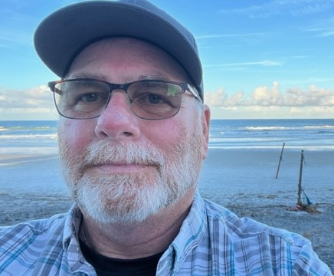
Bret Stemen – KD8SCL EC
KD8SCL@gmail.com

ARES of OHIO has lost a good friend with the passing
away of Jim Yoder last month.

After cremation, a memorial service for friends and
family will be held on Saturday, August 12, at
11 am at Grace Community Church, 900 Smith Rd,
Freemont, OH. A meal will follow at the church.
Pastor Nicholas Cleveland will officiate the services.

______________________________________________________________

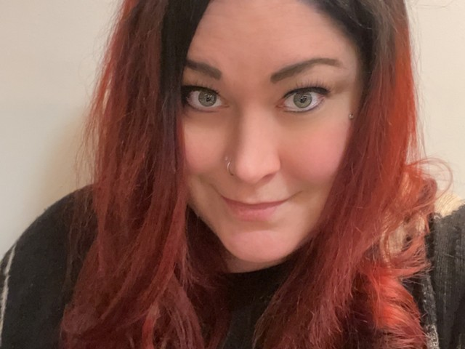
Elizabeth Klinc, KE8FMJ
OHIO Section Public Information Coordinator
ke8fmj@gmail.com

The 2023 Section Newsletter Contest is in the books. I greatly enjoyed reading all your hard work this year. There was a lot of good newsletters to compare, and the decision was not easy.

I devised a new system this year. I did research on what makes a newsletter good for the people they serve. Through my research, I came up with five categories. Each category was worth between zero and five points and include:

Content
Audience
Visual
Contact Info
Call to Action

Also, despite my monthly pleas here, many newsletters still need to be forwarded to me from Scott. So, there is a bonus category for “Following Directions!”

You all do outstanding work, and I am proud to say I am a member of the Ohio Section.

The 2023 Section Newsletter Contest may be over, but don’t forget to keep sending. Entries for the 2024 contest can start now! Please add ke8fmj@gmail.com to your mailing list if you haven’t already. You do not want to miss out on the bonus points, so please be sure to add me to your list. Don’t let not following directions be the reason you didn’t win!

In other news, I got a chance recently to talk with District 10’s DEC, several ECs, and an AEC or two about the PIO position. Did you know there is a downloadable list on ARRL.org of the PIO member for your county? In District 10’s case, they were all wrong or missing. Please check this website for your county’s listing(s): http://www.arrl.org/field-appointments. Set “Section:” to Ohio and set “Appointment:” to Public Information Officer. I would like to get this list cleaned up for Ohio by the end of the year. Email me with any info or changes you have, and I will also be contacting EC’s of the counties that I haven’t heard from yet.

Thank you for your attention on this matter.

73,

Elizabeth, KE8FMJ
OHIO Section PIC
OHIO District 3 Emergency Coordinator
ke8fmj@gmail.com

______________________________________________

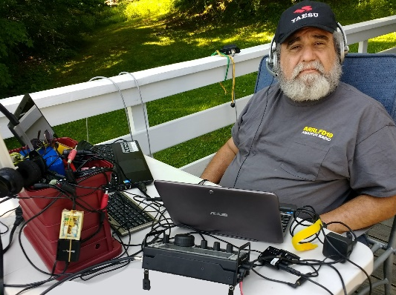
From the Ohio Section Youth Coordinator
Anthony Luscre, K8ZT - SYC k8zt@arrl.net

It’s a Pity Field Day is Just Once a Year, So Plan a QSO or POTA Party for Your Club
Club Operating Activities
Many clubs have a strong tradition of avid ARRL Field Day activity. Enthusiasm and energy run high. Based on reports from clubs around Ohio, this year was no exception! It is often one of the most significant club events of the year, but it is often the only on-air operating event for most clubs! I have some ideas to remedy this for your local club. I have three main ideas plus a few more extras:
- POTA Party
- Ohio State QSO Party (If not in Ohio, substitute your local state or regional party here)
- Ohio State Parks On The Air Party
Let’s Have a POTA Party
The first is a “POTA Party” POTA stands for Parks On The Air. It involves the activation of National or State Parks around the world. Most POTA operations consist of one or two operators setting up in a park and making contacts. But POTA can be fun with more participants, and that’s where a POTA Party comes in. A club or group sets up one or more stations in a park and involves as many members as possible in operation. Like FD, it's a great learning experience for new and seasoned hams. Whether it is putting up antennas, providing portable power, setting up stations or operating, it is a great way to gain new skills.
As I write this, I know of two local clubs, the Cuyahoga Falls ARC (www.cfarc.org) and Northern Ohio Amateur Radio Society (NOARS), recently having club POTA activations- Cuyahoga National Park (POTA # K-0020) and Findley State Park (POTA K-1950t).
Your club can plan your own POTA Party:
- Pick a nearby State or National Park
- Check out the POTA website for details on park activations and park designations.
- Register your activity on the POTA website under the scheduling section.
- Plan your equipment needs for the event (similar to how you do FD). Remember, some parks have restrictions on generators, using trees to support antennas, etc., so check ahead to avoid problems. You may also need to make reservations, especially if using a park pavilion or other structure.
- Publicize the event to club members. You may also want to invite non-club members.
- Create a way for interested hams to sign up for the event. I used a simple Google Form to create an online signup mechanism for our POTA Party (click here to make a copy you can customize for your club’s event- link.)
Let’s Support Our State’s QSO Party
The Ohio State QSO Party (OQP) will be held on August 26th this year. It is an excellent opportunity to be an in-demand multiplier station without the trouble and expenses of a DXpedition. Your club can take multiple tracks to an OQP entry:
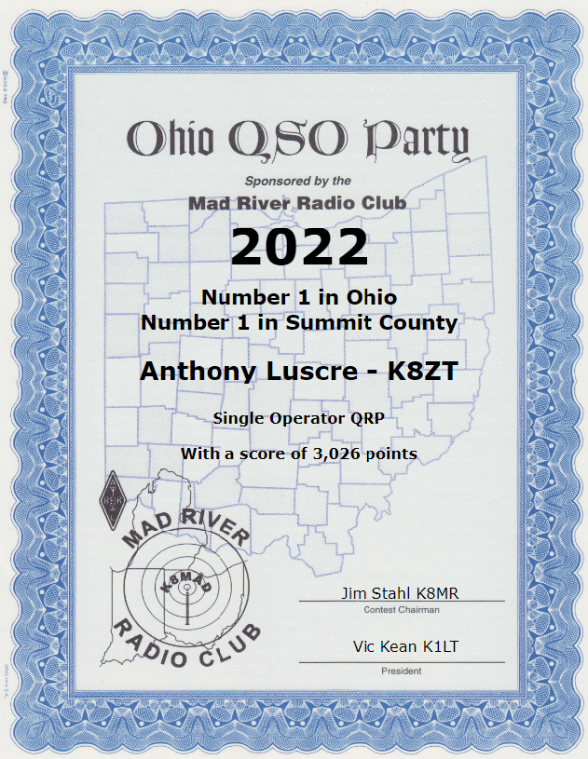
- If you have a club station in place, make sure that one or more members have it on the air for OQP
- You can set up portable style, just like FD, with one or more stations
- You can plan a Rover activity. Rovers move from county to county during the OQP. Operating can take place while in motion or at planned stops along the way. A team of driver(s) and operators is preferable for safety.
- You can use existing station(s) of club members to operate
- You can encourage individual club members to get on the air as Single Operators (you might even want to have a friendly interclub competition)
The most important thing is to make plans. Don’t just announce it to club members; you must actively plan and schedule operations, follow through, and get on the air for the OQP.
Let’s Have a Statewide POTA Party
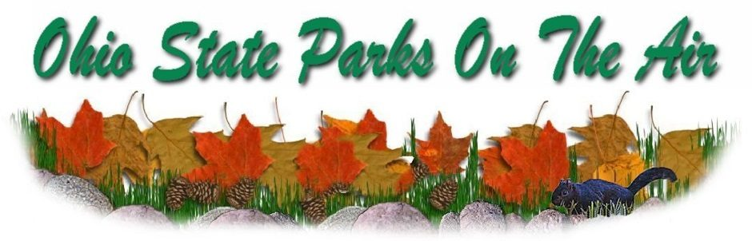
Ohio State Parks On The Air (OSPOTA) is held each September- link. Sponsored by Portage County Amateur Radio Service (PCARS), this groundbreaking event is in its 16th year and undoubtedly was one catalyst to ARRL NPOTA and the whole POTA movement.
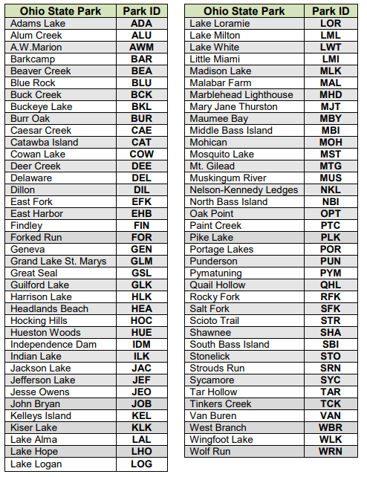
This year’s event with take place Sept 9, 2023, from 1400 UTC to 2200 UTC (10 am to 6 pm ET). Your club can pick from one or more of the 75 Ohio State Parks. This contest places a premium on working stations located in the Ohio State Parks. That means that it is critical to have as many parks activated as possible. The challenge for Ohio stations will be to work HF in the 50 to 300-mile range. OSPOTA is the perfect opportunity to learn more about the design and deployment of Near Vertical Incident Skywave (NVIS) antennas. You can find numerous designs online and in various Amateur Radio antenna manuals.
Along with your operating skills, it will also be a chance to showcase your antenna-building skills. Individuals and multiple operators can operate Ohio State Park stations. Non-park stations in Ohio, as well as stations outside of Ohio, can also compete. Contacts can be made on 80, 40, 20, 15 and 10 meters using SSB. All contacts have the same point values. Make sure you read the Rules, FAQs and get your forms for the contest posted on the OSPOTA website: www.ospota.org, before the contest.
Other Events to Turn Into a Club Operating Party
In addition to the above events, consider other possibilities. Here are some suggestions:
Other State QSO Parties. With 47 events held between February and October, there are plenty of dates to choose from; see the calendar of parties at www.contestcalendar.com/stateparties.html. Although you will not be a rare multiplier as in OH QSO Party, it is still a great way to have fun on the air.
ARRL VHF/UHF Party (in Ohio, especially the June or September events) – link. These are exceptionally well suited to Technician class licensees as they have full operating privileges on these bands.
CQ WW VHF Contest in July is similar but limited to 6 and 2 Meters
Winter Field Day In January is similar to ARRL FD
Set up a Special Event station to commemorate a historical or local event. Plan it early enough to submit details to QST and CQ magazines for inclusion in upcoming issues (lead time is usually at least three months). Also, don’t forget the Ohio Section Journal!
Pick almost any other contest with a multi-operator category and have fun with fellow club members from your club’s station or a willing member that will loan their home station to the cause.
Tips for making the most of your club’s operating party
Here are some suggestions for making the event successful:
- If it is an HF Event, familiarize members with working HF (see below). Many hams, especially Technician licensees, are more familiar with VHF/UHF Repeater contacts, not HF.
- Train your members on Contest style operations.
- Plan, plan, and plan some more. A well-planned event can mean success and a good time for the participants.
- We often underestimate contest competition when recruiting youth. Youth participate in many sports and can relate to contesting. Online real-time contest scoreboards (Contest Online ScoreBoard, Contests | Live Score and Real-time competition: online scoreboards) can greatly enhance the experience.
- Make it a fun time for participants- refreshments, interclub or intraclub (with nearby clubs) competition, photos and articles in the club newsletter, etc.
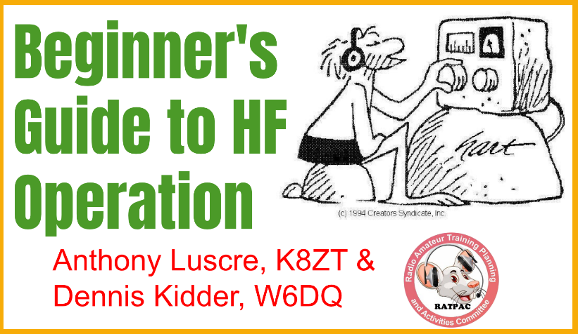
I recently completed a four-week series, “Beginner’s Guide to HF Operation,” with Dennis Kidder, W6DQ, and you can watch the four recorded sessions and view the composite slideshow:
- Week 1- The HF Bands, Operating & Making Contacts- https://youtu.be/cjZZjfKYPak
- Week 2- Equipment & Antennas- https://youtu.be/dH5gsA1CZSc
- Week 3- Putting It All Together https://youtu.be/eG3kFbCZEM8
- Week 4- Operating HF- https://youtu.be/FOgoAYkKveA
- Slideshow from the presentations, including clickable links and resources, is available at tiny.cc/bghf.
If your club’s members are not frequent contesters, I have a presentation, “Introduction to Contesting.” You can access it three ways- via the slideshow at tiny.cc/arcontest via a recorded presentation on youtube, “Intro to Amateur Radio Contesting- Not Just for competitive, but anyone who wants to make more QSOs!“ or I would be happy to do a live presentation for your club either in person or via Zoom, depending on location and date. If you are interested in this live presentation, one on contesting software or any of my other topics (tiny.cc/k8zt-p), email me at k8zt73@gmail.com (make sure you include a phone number where I can contact you). Also, do not worry about not being seasoned contesters, as most suggested events are more laid-back than major contests.
For some members, the use of contest logging software may be unfamiliar. Although many logging programs exist for MS Windows, I suggest either N1MM Logger+ (free) or N3FJP’s Amateur Radio Software (paid). I also have done presentations and videos on using contest logging software.
Consider setting running multiple modes during your party- SSB, CW and/or Digital (FT8 or FT4 if included in contest rules) to give members with different interests and skills a chance to operate and even learn new modes.
Please consider making your event open to non-club members. You can send your information to Tom Sly for inclusion in the “Club Section” of the monthly Ohio Section Journal and/or weekly Postscript.
If you are doing your event in a public location, consider having information available on Amateur Radio and your local club in particular. Here are some examples of this with a youth and teacher slant in from FD planning- tiny.cc/fd-res.

73, and please feel free to contact me with any questions/suggestions
Anthony, K8ZT (k8zt@arrl.net)
330-650-1110

____________________________________________________

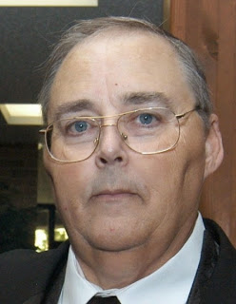
From the Section Traffic Manager
David Maynard, WA3EZN – STM
wa3ezn@att.net

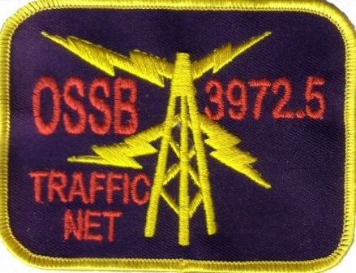

The OSSBN held a meeting at the InterCity ARC Mansfield Trunkfest on July 8 TH. The meeting began at 11 AM and the minutes are available at www.OSSBN.com During the meeting our assistant net manager Duane Meadows K8MDA received the Garlock award for his service to the net.

2023 COLUMBUS HAMFEST
Saturday, August 5, 2023 8:00 am – 1:00 pm
Talk-In W8FEZ 146.760 – PL 123.0
(Doors open at 6:00am for vendor set-up)
SAME HUGE LOCATION!
INDOOR TABLES, OUTDOOR SPACES
1801 Gateway Circle
Grove City, Ohio 43123
(Behind Tee Jayes restaurant, off of Stringtown Road at I-71)
ADMISSION $5.00 at the gate 12 and under FREE
INDOOR TABLES and OUTDOOR SPACE $10.00 each
NO ADVANCE TICKET, TABLE, OR SPACE SALES
Sponsored by: The Aladdin Shrine Audio Unit – W8FEZ
Proceeds are for the benefit of Aladdin Shriners Audio Unit. Payments are not deductible as charitable contributions)

If you have traffic you need to move take it to a VHF net or if it is going out of Ohio you can also take it to the OSSBN. Here is WHERE TO FIND AN HF OR VHF TRAFFIC NET IN OHIO. More information and useful links can be found on the OSSBN website www.ossbn.org.

OHIO SINGLE SIDEBAND NET

Morning session | 10:30 AM | 3972.5 KHz | every day
Afternoon session | 4:15 PM | 3972.5 KHz | every day
Evening session | 6:45 PM | 3972.5 KHz | every day

OHIO HF CW TRAFFIC NETS

HF CW NETS | NET TIMES | FREQUENCY | NET MANAGERS
Buckeye Early | 6:45 PM | 3.580 | N2LC
Buckeye Late | 10:00 PM | 3.590 | WB9LBI
Ohio Slow Net | 6:00 PM | 3.53535 | N2LC
All CW net frequencies plus or minus QRM

OHIO LOCAL VHF TRAFFIC NETS

VHF NETS | NET TIMES | FREQUENCY | NET MANAGERS
BRTN | 9:30 PM DAILY | 145.230 PL 110.9 | KD8GXL
COTN | 7:15 PM DAILY | 146.970 PL 123.0 | KV8Z
NWOHARES | 6:30 PM DAILY | 147.375 PL 103.5 | N8TNV
TCTTN | 9 PM Sun, Tues, Fri | 147.015 PL 110.9 | WB8YYS
TATN | 8:00 PM DAILY | 146.670 PL 123.0 | WG8Z

OHIO VHF TRAFFIC NETS
BRTN Burning River Traffic Net serving Cleveland and North Central Ohio
COTN Central Ohio Traffic Net serving Columbus and Central Ohio
NWOH ARES Northwest Ohio ARES Net serving Toledo and surrounding counties
TATN Tri-State Amateur Traffic Net
TCTTN Tri-County Traffic and Training Net serving North East Ohio

Resonance

First, let’s dispel the greatest myth in antenna theory: Antennas must be “resonant” to be efficient. Baloney! It just isn’t so!

Please recognize that an antenna need not be resonant in order to be an effective radiator. There is in fact nothing magical about having a resonant antenna, provided of course that you can devise some efficient means to feed the antenna. Many amateurs use non-resonant (even random-length) antennas fed with open-wire transmission lines and antenna tuners. They radiate signals just as well as those using coaxial cable and resonant antennas, and as a bonus they usually can use these antenna systems on multiple frequency bands.
—ARRL Antenna Book, Ch. 2

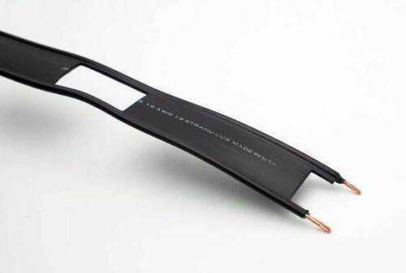

This is ladder line

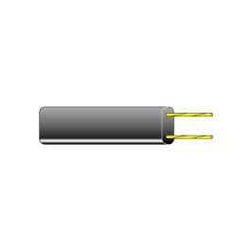This is 300-ohm twin lead

Here are some examples to get you started:
THE ALL-BAND H F DOUBLET
(Updated 03/2013
This antenna project will get you up and running with an all band HF antenna using one of the oldest and least expensive ham antennas around, the all band doublet. If you've got some TV twinlead or ladder line laying around and an antenna tuner, some wire, insulators and a bit of time then read on.......Project also includes a novel way of getting the rf to and from the shack using coax rather than ladder line.
ALL BAND DOUBLET DIAGRAM
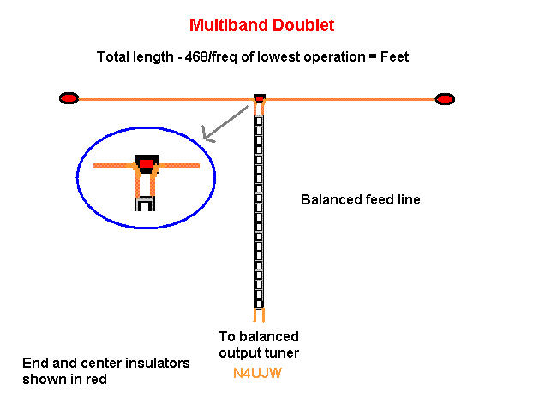
Shown using 450-ohm Ladder line
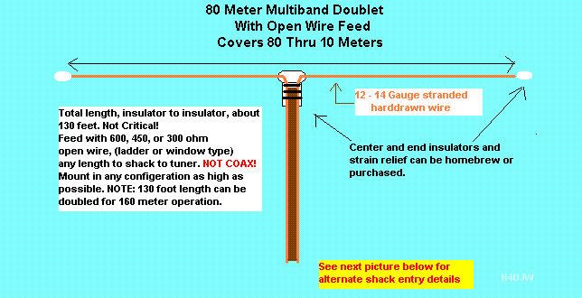
Shown with standard TV type 300-ohm ribbon line
Details and construction
The all-band doublet antenna is nothing more than a 1/2 wave dipole cut for your lowest operating frequency and fed with twinlead, ladder line, open wire, etc. to a tuner that will accept a balanced line connection. IT IS NOT FED WITH COAX!
It can be designed for use from 160 thru 10 meters very easily using the standard 1/2 wave dipole formula:
468/frequency in MHz = total length (feet) end to end
The exact length is not critical!
If you don't have room for the 160 or 80 meter version...then design, it for 40 meters and up! Just remember, don't operate it on a lower frequency than it was designed for...tuner damage may result! You can always tie the two ends together at the tuner and use it as a random wire antenna with the tuner and it may tune lower bands than it was designed for! Always check SWR at low power before attempting.
It can be installed in the horizontal fashion or inverted V style. Get it up as high as possible and have fun!
Remember when working with twinlead (Flat TV feed type) don't use over about 100 watts of power to be safe. For higher power, use the heavier, ladder, open or window type.
Construction:
The radiator:
After you have determined the total length of the horizontal section of the antenna, lay that amount of your antenna wire out and cut it in exactly in half. This will give you two identical lengths for each half of the antenna. It is suggested that you use #14 or #12 gauge wire. You can use smaller size wire, but it will tend to break easier with longer antennas due to weight of ice, snow, birds, wind loads, etc.
The Center insulator/strain relief:
Attach a center insulator between the two lengths of antenna wire. This center insulator can also provide strain relief for the twinlead, ladder line, antenna wire etc. Leave enough bare wire from each half of antenna wire exposed for soldering to the feedline and for strain relief at the center insulator. See example drawing below:
Ladder-Line Types
- Twin-lead is the 300-ohm TV antenna line.
- Ladder-line uses mostly air as the dielectric. The wires are separated with spreaders or window-punched plastic.
- Windowed ladder-line (WLL) is just that: 1-inch twin-lead with windows punched in it. Some call it window-line.
- The “true” ladder-line is best called “open-wire feed-line,” or simply open-line, to distinguish it from window-line. ...
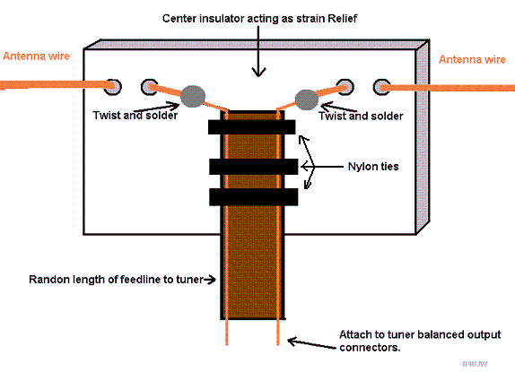
Using the drawing above as one example, the center insulator can be made from any non-conductive material such as sealed wood or Plexiglass, standard commercial insulators, etc. Use your imagination and ham engineering. It should be of a size that will allow the antenna wires to be attached to it from each half of the antenna with strain relief for each wire including the feedline. Your feedline also needs strain relief. It can be provided by using nylon ties going thru the center insulator (drill holes) and tightened on the other side so as to press the feed line against the center insulator. In the drawing above, they are the heavy black lines going across the twinlead. If you use TV type twinlead, this will be a must. TV twinlead is very fragile and can break easily from too much strain. The weakest point on the twinlead is where the conductors come out of it on the ends. The wires are very small inside and break easily.
Each half of the antenna can go thru holes drilled into the center insulator....use at least two holes on each side of the center insulator as in drawing...make certain there are no sharp angles on the edges of the holes to cut the wire. Thread each side of the antenna wire into the first hole near the side of the insulator and out the back....then back thru the other hole leaving enough wire to work with in soldering to the feedline. This type of arrangement provides some strain relief for the antenna wires using the mechanical pressure of the wire against the center insulator. It is important that there are no sharp edges where the wire enters or exits the holes. Use whatever method that works best for you.
The two bare wires from each half of the antenna are attached (soldered), one at a time to each side of the 2 conductor twinlead, ladder line, etc. (Meaning one side of antenna to one conductor of feedline and the other side of the antenna to the other conductor of the feedline.) Do not connect all together in the center!
You should end up with 2 continuous conductors side by side with one continuous conductor from the very end of one half of the antenna to the very end of your feedline at the tuner and the same thing with the other half of the antenna. Do yourself a big favor and do not get in a hurry and just twist the wires together at their junctions! They will soon corrode at the twist and create more problems for you than the time saved by not soldering them together! Believe me, it will take much more time in the long run to do it poorly than to do it properly with solder. You should provide some sort of weatherproof sealer to the solder joints after you are done soldering...and as a last resort...tape well and then tape again. If you "cut corners", sometimes a "temporary" installation tends to become permanent when forgotten about......then later it will remind you when it does not work!
Attach end insulators to both ends of the antenna. Attach the insulators to their supports with UV resistant rope, cord, etc. and make sure you have enough to extend to the outside support tie off points. As a further note for those that are not experienced with wire antenna building, there are many ways to build center and end insulators. Do a search on Google.com using their "images" section for more ideas.
Now assuming that you have plenty of feedline to run from the final operating position up in the air for the antenna after raising it.......get help if needed....tie off the end supports.....run the feedline away from the antenna preferably at a 90 degree angle and keep the feedline several inches from any metal conductor such as rain gutters, down spouts, metal house siding, metal windows, etc. With very long antennas, the weight of the wire and feedline, center insulator etc, causes some sizes of wire to sag in the center. If this is the case with yours, some support in the center may be needed by attaching another support rope to the center insulator.
(Another option for the center insulator/strain relief would be to take the feedline and wrap it OVER a "dog bone" type (round), insulator and then back down parallel with and touching the feedline making sure you have a couple of inches left over for attachment of the bare wires from the feedline to each half of the antenna. Then use nylon ties to secure it tightly against the main feedline.
By wrapping the feedline over the insulator and securing it to the feedline below the insulator, you will be adding a strain relief to help prevent the weight of the feedline from tearing apart the connections.)
After your antenna is up and secure....attach the feedline to your tuner's balanced output connectors....and you're done!
Use your tuner as per manufacturer’s instructions...have fun.
Added notes of information:
There are many methods of "hanging" an antenna like this one and various center supports can be used, like towers, metal pushup poles (masts), etc. The use of a small cross arm made from heavy PVC or other insulated material extending out a couple of feet or more from the tower or metallic pole will help to prevent the feedline or radiating parts of the antenna from touching any metal and shorting out. This also helps to prevent the feedline from rubbing against anything in the wind and eventually coming apart at that point.
When bringing the feedline down from the antenna to the radio, always keep it away from sharp corners that can cut it due to rubbing in the wind.
If you have a shingled roof, try to keep the feed line away from any edges that (from rubbing) will eventually cut into the feed line.
Remember to keep the feedline away from any metallic object by several inches.
Table 1 - Loss Comparisons for Belden 8214 Coaxial Cable and 450-ohm Ladder Line.
Frequency | Loss (in dB)
(MHz) | 8214 | Ladder line
1.9 | 26.9 | 8.62
3.8 | 13.7 | 1.37
7.15 | 0.19 | 0.07
10.14 | 2.85 | 0.07
14.27 | 5.30 | 0.15
18.14 | 6.96 | 0.31
21.40 | 0.78 | 0.12
24.90 | 3.94 | 0.13
28.50 | 5.69 | 0.18
Cable length: 50 feet.
Antenna: 66-foot dipole at a height of 30 feet.
Calculated by Dean Straw, N6BV, Senior Assistant Technical Editor
There are many methods of connecting your radio to your antenna. Doing this report has been overwhelming. Maybe I’ll get back to it at another time.
73
David, WA3EZN
Ohio Section Traffic Manager

______________________________________________

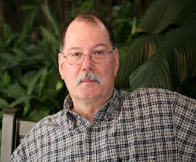
ARES Training Update
Jim Yoder, W8ERW – ARES Data Manager
w8erw@arrl.net

Please continue to hold Jim and his family in your thoughts and prayers as Jim became a silent key this month. He will be missed by many.
__________________________________________

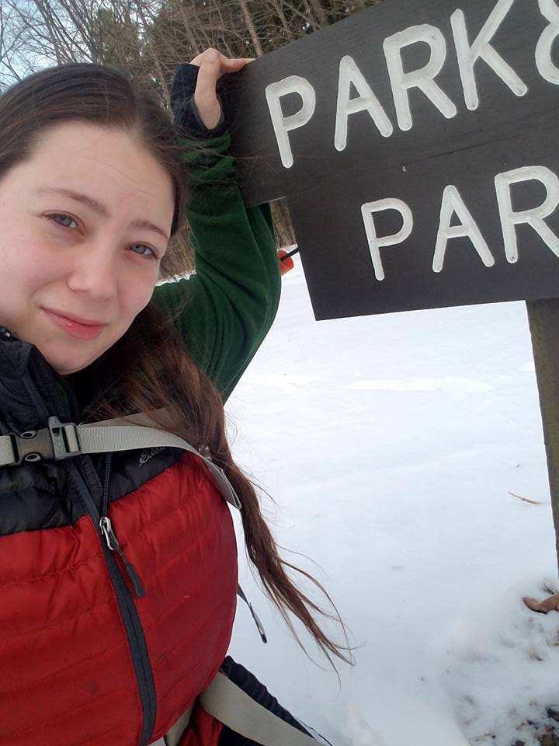
From the Section Affiliated Clubs Coordinator - ACC
Amanda Farone – KC3GFU
Afrone926@gmail.com
330-509-4095

Amanda Farone, KC3GFU
Affiliated Clubs Coordinator
AFarone926@gmail.com

With Field Day behind us, the next big event in Ohio that comes to mind is OSPOTA. Has your club started planning or thinking about participating this year? Ohio State Parks On The Air happens annually on the Saturday following Labor Day. OSPOTA was conceived with three main goals in mind: to promote public awareness of amateur radio and Ohio’s beautiful state parks system, to contribute to the recognition that Ohio has a very diverse and wonderful ecology, and to promote camaraderie within the ranks of Ohio’s Amateur Radio Operators. The objective is to have competing stations operating from as many of Ohio’s seventy-five state parks as possible. Making contacts from an Ohio State Park to other Ohio State Parks is the goal all stations should strive for. Non-Ohio stations may work only Ohio stations located in an Ohio State Park. Ohio stations not located in an Ohio State Park may only contact stations operating from inside an Ohio State Park. If you don’t already have plans to operate this event as a club, I strongly encourage you to do so! This event is a ton of fun and a great way to get your club together, you can even plan your summer/fall club picnic in conjunction with it! You can find more details at OSPOTA.org and be sure to send in your planned park activation.
On the topic of club picnics…I would like to showcase the efforts I have been seeing lately for “all-club” picnics. I think this is a great trend to hop on to. My home club hosted one just a few weekends ago and we were very satisfied with the turn out. It’s always great to meet new hams, get on the air, have some good food and good conversation. To those of you that have been organizing these types of events, I encourage you to keep up the steam! Your efforts are being noticed.
My “busier” time of year is starting to slow down a bit and I am hoping to make it out to some of your club events. If you have an upcoming event, please send me an email (afarone926@gmail.com) and let me know about it! If I can make it, I will!

__________________________________________

National News
(from arrl and other sources)

‌ ‌ ‌

Igniting the Future: ﻿Nuclear Engine to be Tested for Future Mars Missions

NASA and the Defense Advanced Research Projects Agency (DARPA) have announced Lockheed Martin as the prime contractor for the design, integration, and testing of a nuclear-powered rocket demonstration.

The Demonstration Rocket for Agile Cislunar Operations (DRACO) program will test a nuclear-powered rocket in space as soon as 2027. The partnership will advance the development of nuclear thermal rocket technology, supporting both agencies' goals.

﻿For NASA, nuclear propulsion is one of the primary capabilities on the roadmap for crewed missions to Mars. A nuclear-powered rocket would allow for a shorter, faster trip to the Red Planet, reducing the mission's complexity and risk for the crew. This type of rocket can be more than twice as efficient as conventional chemical rockets, meaning it requires significantly less propellant and could carry more equipment for scientific goals.
Read More

ARRL and NASA Team Up to Help Teachers
A radio experiment held on July 26, 2023, to decode a slow-scan TV (SSTV) message sent via the ham radio station on the International Space Station (ISS) was successful.
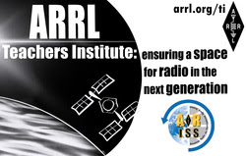
The image transmitted from NASA Goddard Space Flight Center to the ARRL Teachers Institute on Wireless Technology participants via the ISS repeater.
The image was received by a group of educators at ARRL Headquarters in Newington, Connecticut through the voice repeater on the ISS. Teachers from around the United States were on hand for the ARRL Teachers Institute on Wireless Technology, a program that empowers educators to incorporate amateur radio into their science, technology, engineering, and mathematics (STEM) curriculum. As part of the professional development program, the group received and decoded the image sent by volunteers with Amateur Radio on the International Space Station (ARISS). The transmitted image said, "ARRL Teachers Institute: ensuring a space for radio in the next generation."
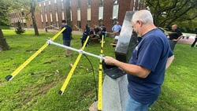
The teachers made tape measure Yagi antennas for the experiment. [Sierra Harrop, W5DX, photo]
The teachers thought it was cool. "Amateur radio is so important to the future of engineering and STEM in our country," said Kristen Kucko, KQ4ECP, one of the institute participants. The group gathered outside ARRL Headquarters with antennas they had made earlier in the day. As the pass happened, the educators tracked the ISS by hand. A warble of SSTV transmission filled the air, and the group was excited. After the pass, they used laptops to decode the audio stream into an image, while they sat on picnic tables and enjoyed pizza and wings.
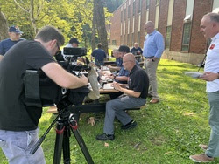
Teachers decode the SSTV image over a picnic of pizza and wings while a photojournalist from WFSB-TV shot video of them. [Sierra Harrop, W5DX, photo]
For ARRL Education and Learning Manager Steve Goodgame, K5ATA, the experiment was a way to allow teachers to engage with the power of radio. "When teachers can pull an image off the ISS via amateur radio, it gives a sense of accomplishment that gets them excited. We want to get them fired up about radio, so they can carry that energy back to their classrooms and do the same thing with their students," said Goodgame.
Each of the teachers on hand for the second phase of the institute, -- "TI-2: Remote Sensing and Data Analysis," -- have already been through the introductory course and they are all licensed radio amateurs. The institute costs teachers nothing to attend, thanks to funding from the ARRL Education & Technology Program.

The New Jersey QRP Club will hold their 12th annual Skeeter Hunt on August 27, 2023.

The objective is to get QRP operators out of their shacks and into the fresh air encouraging them to spread their wings and fill the airwaves with "Skeeters." While commercial equipment can be utilized, bonus points will be awarded to those who homebrewed or kit-built their own transceiver or separate transmitter/receiver. Equipment not built by the operator will not qualify for bonus points, as it will be considered commercial equipment. The event will be a 4-hour sprint beginning at 17:00 UTC and running until 21:00 UTC (1:00 to 5:00 PM EDT). The next event will be held on the third Sunday of August 2024. QRP operators who wish to be designated Skeeters can request a Skeeter number by sending an email with their name, call sign, and state/province from which they will be operating to w2lj@arrl.net. You do not have to operate portable to be a Skeeter. Please indicate if you intend to operate from a state other than your home state listed on QRZ. Skeeter numbers are being issued now, and will be issued until the day before the event. For more information and the official rules, visit the Official NJQRP Skeeter Hunt web page.

___________________________________

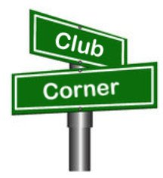
Club Corner

This is YOUR corner of the newsletter. Send us what your club is doing, and we’ll make sure that it gets in. Got a special event or club project that you want everyone to know about? Send it to us!. Need help with a project? Send it to us.

Let us know what you club is up to. Are you going to have a special guest at your meeting or are you having a special anniversary?

Send it to: webmaster@arrl-ohio.org

__________________________________________________________

Report Collection in Progress!
C. Matthew Curtin KD8TTE
kd8tte@pm.me

As mentioned in last week’s PostScript, an agency of the State of Ohio will be conducting a field exercise in the coming weeks and will be looking for observations "from the field." This is not a free-form or general request: it is information in a specific format that may be transmitted by voice or print (digitally). You can even participate via email. Act fast, though! To get in before state officials see the exercise results, your report will need to be in by August 5, 2023.

So far we have observations in the right format from WD8SDH, KM8V, KD8TTE, KC9TYA, K8BPW, K5MGK, KC3QVF, AB8JH, N3WS, W8KVK, KF4LXS, KB8GAE, KD8NZF, WS9J, KC8WMY, WD8IIJ, and N9NMR. These stations for agency purposes are identified as “trained” for this task. We’ve had a few more attempts that weren’t quite right, so we offered some constructive feedback for how to finish the task completely and accurately. We keep track of these stations in the status of “practicing” on this task and look forward to seeing their followup so they can join the ranks of “trained.”

Participation is easy, fun, and helps to develop and maintain critical emergency communications skills.
- Install the FLMSG application. You need this to organize the information, even if you are not going to transmit it digitally. FLMSG is available for MacOS, Windows, and Linux systems. https://sourceforge.net/projects/fldigi/files/flmsg/
- Install the FIELDSITREP Custom Form. You can get the FIELDSITREP Custom Form. Find the ZIP file with the form at https://www.blackswancomex.org/net/fieldsitrep. If you need help installing a custom form, you can get step by step instructions online. https://groups.io/g/QTC/message/987
- Send your FIELDSITREP. Step by step instructions are available online. https://groups.io/g/QTC/message/938 Address your FIELDSITREP to KD8TTE. You can send via BLACK SWAN Net or Winlink. If you do not have either option you may use Internet email addressed to KD8TTE@Winlink.org, with the subject:
//WL2K P/ FIELDSITREP.

We have an interactive map showing locations of observations, and you can click on the item to see the details of the report. Give it a try! https://www.blackswancomex.org/net/fieldsitrep Thank you for supporting the security and resilience of your communities and the State of Ohio.

VE Sessions

The following information is for ALL exam sessions:
It is now an FCC requirement to have an FCC FRN; active email address and active phone number before taking any exam. Please bring your FCC FRN, original license, a copy of your license (if a licensed ham), a valid photo ID and $15.00 - Cash preferred.
Effective April 19, 2022, the FCC will charge a $35.00 application fee for amateur radio licenses. The fee will apply to new, renewal, rule waiver, and modification applications that request a new vanity call sign. License upgrades will not have a fee applied. The fee will be per application. VE's will not collect the fees at exam sessions.
If you are applying for your first license, please go to http://apps.fcc.gov/cores/userlogin.do and obtain an FRN. This website is self-explanatory and the FRN registration is free.

All Things Amateur Radio Association (ATARA)
We host testing sessions every second Tuesday of the month in Lancaster. To sign up please visit our website https://atara-w8atr.fun and contact us at hamexams@atara-w8atr.fun.

Butler County Amateur Radio Association W8WRK
Laurel VE Testing Session - hosted by DIAL amateur radio club
Amateur Radio License Examinations at 9:00AM on Sunday April 29th at Fairfield Township Administration Building 6032 Morris Rd. Hamilton, OH 45011. Pre-Registration is required, go to: www.qsl.net/w8blv click on Exams and follow the instructions. Additional info may be obtained from Thurl Golden, KD8VLU (513) 939-4891 tgolden@fuse.net or Ron Spaulding, N8QF, (513) 617-6181 or n8qf@roadrunner.com . There are no Exam Fees!

CARS
VE testing from CARS - Cuyahoga Amateur Radio Society - at Elmwood Recreation Center, 6200 Wisnieski Parkway in Independence, Ohio 44131 Time: 9:15 AM (Walk-ins allowed) Always the 2nd Sunday of the odd month. Go to CARS www.2cars.org for detailed map of location. Call Metro W8MET 216-520-1320 for details

Clark County Amateur Radio Association (CLARA) What: CLARA sponsored A.R.R.L. VE Testing - Walk-ins allowed. Pre-Register via email preferred. When: On every second Saturday of each even numbered month starting at 10:00 AM
Feb 11th; Apr 8th; Jun 10th; Aug 12th; Oct 14th; and Dec 9th, 2023. Where: Springview Government Center - Emergency Operations Center; 3130 E Main St; Springfield OH 45503 This is US-40 aka "old national road". From Route 40 enter Old Columbus Road, at the fork stay left driving straight onto Ogden Rd, then immediately turn left into the parking lot behind the EMA. Walk to the door with the "Employees Only" sign.
For more information contact Roland W. Ude, W8BUZ, (937) 605-4951 Email: buzz@baylorhill.com

Dayton Amateur Radio Association (DARA)
If you are interested in testing for a new or upgraded license, please come see us at the DARA Clubhouse. If you have questions about testing, please email exams.w8bi@gmail.com

Dial Radio Club, Middleton, OH
Will offer Amateur Radio License Examinations at 6:00PM on Wednesday March 1st at St. John XXIII Elementary School, 3806 Manchester Rd., Middletown, OH 45042. Pre-Registration is required, go to: www.qsl.net/w8blv click on Exams and follow the instructions. Additional info may be obtained from Dave Williamson, KD8W, (513) 424-5819 or kd8w@ARRL.net or Ron Spaulding, N8QF, (513) 617-6181 or n8qf@roadrunner.com . There are no Exam Fees!

Findlay Radio Club

The club also sponsors exam sessions at 9AM the second Saturday of each month at the clubhouse. For more info on the club, check out our web page at www.findlayradioclub.org .

Geauga Amateur Radio Association (GARA)
Amateur License exam sessions are offered for all license classes (Technician, General, Extra). Walk-ins are always welcome - no prior registration is required. No fee for the exam.

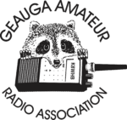
The GARA schedule of exams are these Sundays at 2pm. Dates for 2023 are January 15th, March 19th, May 21st, July 9th, September 10th, and November 12th.

Exams are held at the Geauga County Department of Emergency Services and Emergency Operations Center, 12518 Merritt Road, Chardon, Ohio 44024. The EOC is located just south of the University Geauga Hospital and just east of the Geauga County Safety Center (Sheriff's Office), off of State Route 44 between State Route 322 and State Route 87 on Merritt Road.

Please arrive a few minutes before 14:00 to allow adequate time to process the necessary paper work and take your test. Bring your 1) photo ID, 2) email address, 3) FCC FRN, 4) a printout of your current license if taking the General or Extra exam.

Additional info may be obtained from Jim Mekeel, KE8EMP, email KE8EMP@gmail.com or the Geauga Amateur Radio Association website https://geaugaara.org

Huber Heights Amateur Radio Club
Huber heights amateur radio club does ARRL VE testing the second Saturday of each even numbered month. Feb, Apr, Jun, Aug, Oct, Dec. 9:30-11:00 For more information contact Jim Storms – AB8YK at ab8yk@hotmail.com

The Lake County Amateur Radio Association
The Lake County Amateur Radio Association is holding its 2023 Amateur Radio license exams at the Kirtland Library, 9267 Chillicothe Road, on the following dates:

Saturday, February 4 Saturday, August 5

Saturday, April 1 Saturday, October 7

Saturday, June 3 Saturday, December 2

This bi-monthly schedule is the first Saturday of every even-numbered month (e.g., February being the second month, etc.). They are held at the Kirtland Library, 9267 Chillicothe Road. It is 1.7 miles south of I-90 on Route 306 (Chillicothe Rd). The library is on the left, just beyond the Marathon gas station.

The tests will start at 12 noon. Please arrive a few minutes earlier.

To register, you will need a NCVEC 605 Form, which will be available at the test. If you would like to complete one ahead of time, be sure it is the Sept 2017 version or later. You can find it by Googling “NCVEC quick-form 605” and clicking on the url for a pdf of the form. Please note the FCC requires you to provide a FRN (FCC Registration Number). Social Security Numbers are no longer accepted. If you are new to ham radio and don’t have a FRN, Google “New FRN” and follow the fcc.gov link.

If you are currently licensed, be sure to bring a copy of your license to the exam. The cost of the exam itself is $15.00, and if you wish to pay by check, it should be made out to the ARRL/VEC. Identification with your picture is also necessary, such as a driver’s license. If you have any questions, please contact Scott Farnham, KO8O, at (440) 256-0320, or scottfarnham@roadrunner.com

In addition to the $15 test fee, the FCC now charges $35 to add you to the Amateur Radio database. The FCC will e-mail successful candidates instructions for payment directly to them. Payment must be made within 10 days of the e-mail. This charge does not apply to upgrades.

The Lancaster and Fairfield County Amateur Radio Club (LFCARC) hosts exam sessions at the FAIRFIELD County EMA, 240 Baldwin Dr in Lancaster Ohio, 43130, on the first Saturday each month at 10:00 am. Please visit our website at http://www.k8qik.org for exam dates on our calendar and navigate to our Learning Center/Taking the Exam link for information and requirements. Our experienced VE team looks forward to serving the Amateur Radio community in Central Ohio. Contact me at ve_testing@k8qik.org to register.
Lisbon Area Amateur Radio Association
The Lisbon Area ARA has scheduled VE sessions for the remainder of the year on:
12 August
2 September
14 October
11 November
9 December
At the Columbiana County EMA at 215 South Market St., Lisbon, OH 44432
Sign in at 1 PM testing at 1:30 PM.
Contact info is Don Kemp, NN8B.
email: nn8b.oh@gmail.com
No phone calls.
Madison County The Laurel testing group will offer testing on the first Thursday of January, March, May, July, September and November. Tests are held at 7:00PM at the Madison County EMA located at 271 Elm St. London, OH. No fee.

The Milford Amateur Radio Club (MARC)
VE testing is held the third Thursday of each month at 6:00 PM. Location; Miami Township Civic Center located at 6101 Meijer Drive, Milford, OH 45150.
Please pre-register at www.milfordhamradio.org

Northern Ohio Amateur Radio Society (NOARS) VE sessions are held the first Saturday of odd-numbered months (EXCEPT FOR March and July) at 10 AM in the Greater Cleveland area. The July test will be held at 9 AM at the NOARSfest at Lorain County Community College. There will be no test in September. The test in November will be held at the Fairview Park Library, 21255 Lorain Rd, Fairview Park, OH 44126. For more information or to register, contact Elaine, KC8FOS at ewilkinson1951@gmail.com or phone 216-337-4235. Registration is preferred, but walk-ins are welcome.

Portage County Amateur Radio Service (PCARS)
The first Saturday of every even numbered month -10 am – at the PCARS club site in Ravenna. Please visit the PCARS web site and check out the information about VE testing in the latest newsletter at www.portcars.org .
If you have any questions, don’t hesitate to contact me at KB8UUZ@gmail,com

Tusco Amateur Radio Club W8ZX

VE Testing sessions are held on the second Saturday of every even numbered month at the Dover Faith Church, 420 N Wooster Ave, Dover, OH 44622. Pre-registration is not necessary. Doors open at 0830 for registration, exams begin at 0900. Cost is $15. You are required to have an email address and a copy of your FRN or current ham radio license. For more information please go to www.w8zx.net/exam or email VETEAM@N8BAG.NET.

______________________________________________________________

The Alliance Amateur Radio Club
has honored retiring Alliance Mayor Alan Andreani with: Life Time Honorary Membership in recognition of his support to the club and the community. The presentation took place in his office July 28, 2023. President Ron Rittenhouse KE8HCY and Vice President Doug Jimison KE80WD made the presentation.
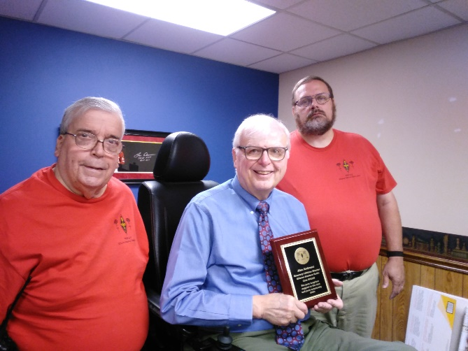
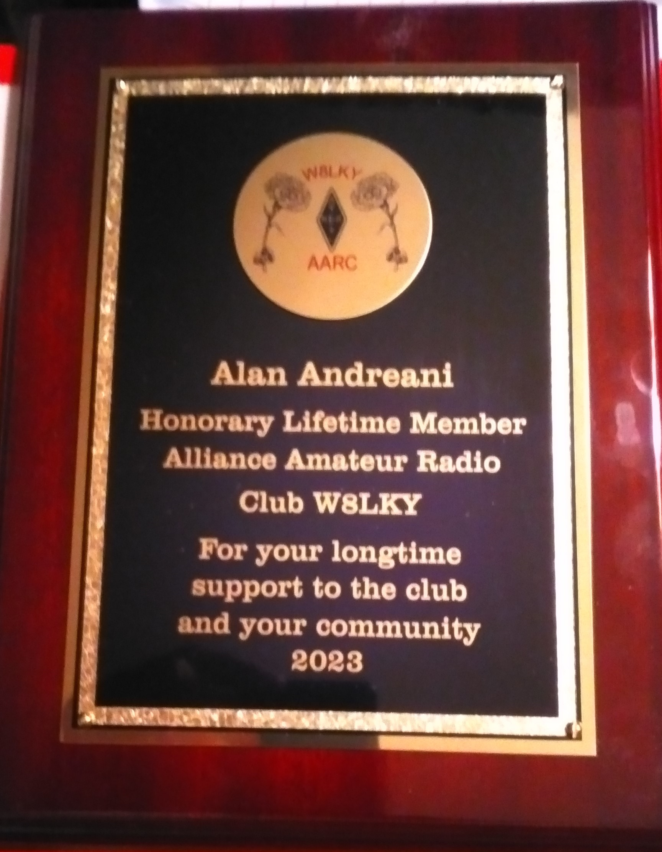

_________________________________________________________

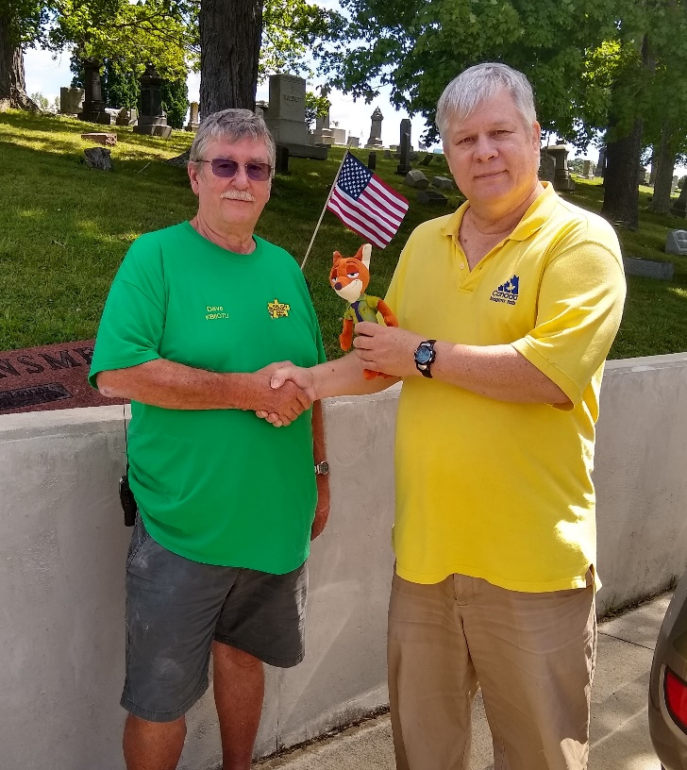
The Hocking County Amateur Radio Club
held a fox hunt Saturday, July 29th at 10 a.m. just prior to the high heat’s return.
Four hams competed and the winner, Dave Brimner KB8OTU won in just 17 minutes. Dave says he stepped out his back door and monitored the first fox transmission, noting it was “full quieting”. “He must be close,” he remarked to his wife. Ten minutes later Dave had triangulated the fox in the nearby Oak Grove Cemetry where Dave usually starts his hunt searches. Second place was Phil Stanley W8NZB, and third was Bruce KE8BEU. The next Hocking Co Foxhunt is not set, but may be in mid-August.

Important Links
ARRL Home: www.arrl.org
Find an ARRL Affiliated Club: www.arrl.org/clubs
Find your ARRL Section: www.arrl.org/sections
Find a License Class in your area: www.arrl.org/class
Find a License Exam in your area: www.arrl.org/exam
Find a Hamfest or Convention: www.arrl.org/hamfests
Email ARRL Clubs: clubs@arrl.org

____________________________________________________________________________

The Ohio Section Youth Net

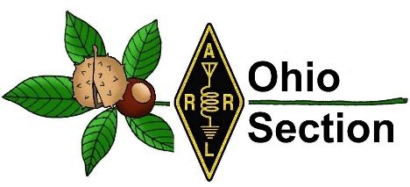
Youth Net
When: The second Sunday of every month at 7:30 PM EST
Where: The K8IV repeater located in Kent, Ohio (Echolink node K8BF-L) RF: 146.895 Mhz with PL 118.8
Who: Any licensed amateur radio operator who wishes to participate. Priority will be given to youth stations and those located in Ohio.
The purpose of this net is to encourage youth activity in amateur radio and to help new hams get more comfortable on the air.

***Next Net is Sunday August 13th ***

______________________________________________________________________

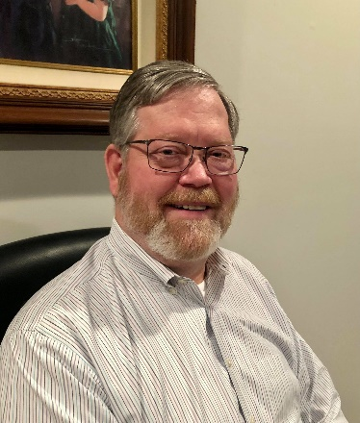
DX This Week – Listen, Listen, Listen
Bill AJ8B (aj8b@arrl.net, @AJ8B, or www.aj8b.com) CWOPs Member #1567

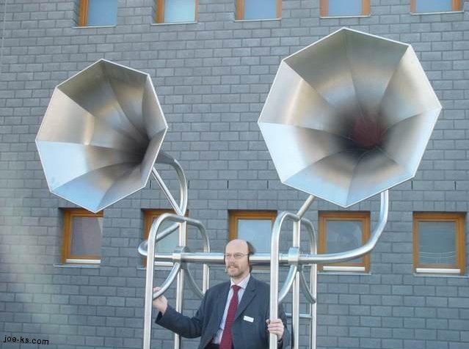
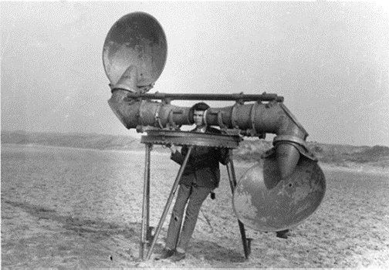
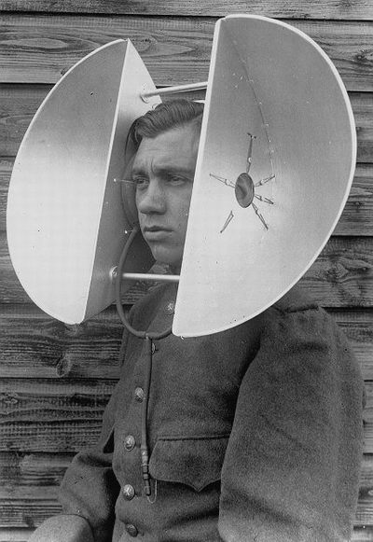
Until about 2 years ago, I had a Yaesu FT-857D in my car. I was able to work 10 – 40 Meters and I really enjoyed having that in my car. Between January of 2013 and May of 2017, I made almost a thousand QSOs, earned WAS, WAC, and confirmed 122 Countries to earn DXCC – Mobile. I continually heard operators calling a DX station while the DX station was working someone, I heard stations calling on frequency when the DX station specifically instructed them on how/where to call. I heard DX stations giving out QSL information and seconds later someone would ask who the manager was. I even heard DX stations ask that everyone QRX for 15 minutes while the operators changed shifts and stations kept calling!
Although I have been a licensed ham for over 45 years, I may have learned more during that driving time truly listening than all the previous air time I had accumulated. What lesson did I learn? To Listen! I have chatted with some excellent DXers and the number one lesson they passed on to me was to LISTEN. I know some very experienced DXPeditioners and the number one “hint” they give me is to LISTEN to the instructions that the DXer is passing along. I have interviewed dozens of DXers for the SWODXA Newsletter, The Exchange, and the best advice they always give is to make sure you LISTEN!
The pictures that I have included will emphasize the point. So, if you are going to listen to the DX station, what are you expecting them to say? That is a good question and a critical part of this discussion.
I keep notes about every DX operator I am trying to work. DX operators have a definite pattern and keeping detailed notes will help you get them in the log. For instance, I know of one “famous” DXer who listens “down 5” at the top and bottom of every hour to give those back home or in his club a chance to work him without competing in a huge pileup. He doesn’t announce it, he just sort of “disappears” for a few minutes. I have this on file and when he is on a DXPedition, I take advantage of that. Other things to take note of is the actual frequencies of the QSOs that he is logging. For instance, if he is working split (more on that next week) he might say “listening 14.175 up 5 to 15” meaning that he is listening somewhere between 14.180 and 14.190. Does he start at 14.190 and tune down? 14.180 and tune up? Does he move a standard amount after each QSO? You need to listen to him AND those that he is successfully working and take notes. My notes might look something like:
You can tell that this operator is moving 3 KC after each successful QSO. I will jump ahead to 14.189 and try to catch him. Remember, from his perspective, he may have thousands calling him, so, you need to get in the open, so he can hear you.
Tracking this information may also help you get an idea of propagation. One of things that really keeps me on the air is the uncertainty of what I am going to hear. For instance, recently Market Reef (OJ0A) was active. I could hear him, and I could hear the stations that he was working. So, why not jump in and start calling? The stations that OJ0A were working were JAs, VKs, and ZLs. It was obvious that although I could hear both stations, most of the propagation was between Market Reef and Asia – for now. I continued to listen to both sides of the contacts and take notes. Eventually propagation changed, and I was ready to get into the fray, working them on my 4th call. Running a vertical and 100W, you need all the help you can get!
Pay attention and get the rhythm of how they are making the exchanges and what information they are giving. For example, are they giving only their callsign and a 59-signal report? or are they giving their name and other details
You really have to listen and pay attention to what the DX station is passing along. He may be "running by the numbers" or areas, “8s only”, he may be directing you as to how to call him, “Full Calls Only”, or a particular part of the world -” WC” (West Coast), “EU” etc. I have heard a DXer announce that you should call him with your full call ONCE! He then compiles a list of 5 or so at a time and then calls them. If you call several times or call out of turn, you won’t work him no matter how loud you are. Some hams like to throw in a partial call or tailend. (Trying to sneak in immediately after the present station is signing.) These tactics may work, and they may not, depends on the operator. However, by listening, you can determine what behavior is acceptable to the operator.
The following excerpt is from all-around world-class operator and first-class gentleman, HK3C – John. Reprinted from his website – www.hk3c.ca – with his permission.
The key to breaking a pileup is listening and learning - before you call.
First - you need to hear them - Unless you can hear the DX station, and hear them well enough to tell exactly what they’re doing, there’s no point calling. And once you can hear the DX station well, you need to determine where they are listening. This is easy if they are operating simplex. But, more than likely, for any reasonably sized pile-up, they will be operating split.
Many modern transceivers allow listening on two frequencies at the same time, so the next step will be easy: listen to the DX station on their transmitting frequency, and find the station they’re working on their receiving frequency.
Depending on propagation however, you may not be able to hear who the DX station is coming back to, so keep listening and tuning - you’ll eventually determine whether the DX station is staying in one spot, or tuning around in the pileup. Of course, the best frequency to be when you start calling is on the exact spot where the DX station was listening for their last contact.
Only then is it time to call. BTW, if you need to tune up your amplifier, move somewhere else before doing so.
Keep your calls short: Give your full call sign - then go back to listening. Sometimes you’ll need to repeat this cycle two or three times. Once the DX station comes back to someone, there's no sense continuing to call - unless the station called is you.
And even if you start calling, don't stop listening. Who is the DX station working? Stations in your area, or another continent? Perhaps they’re working callers from all over. Listen closely.
Who are the stations the DX station responds to? Are they the earliest, or the strongest callers, or is the DX station picking callers later in the pileup when the calls die down? Are “tail-ender” callers being worked or ignored? Determine the pattern the DX station is using and use that information to adjust the timing and placement of your calls.
Be patient: Pileups can be huge random events, and if you keep listening and carefully calling, you'll likely get through. It may be on the first or second call, or it could take a half hour of calling. Don't get discouraged. And remember, despite your best efforts, some DX will get away. Propagation will change, or the station will switch bands or modes, or may even QRT. You have no control over that, so don't worry about it. Importantly - don't let it affect your performance.
Careful listening makes a big difference. It will tell you where to transmit, and when.
Get the Rhythm: Listen to get the rhythm of how exchanges are being made, and what information is being exchanged. Is the DX station giving only their call sign and a “5-9” signal report? Or, do exchanges include name and other details? Follow suit. If only call sign and signal report, refrain from giving your QTH and/or name.
Remember - listen, listen - and listen some more. You will pick up clues which will help you make the contact. The DX station may be "running by the numbers", or by areas. You might notice QSB on the band and be able to make the contact when the propagation fluctuations are on the rise. Learn by listening and take note. By listening to a DX station over time you’ll learn about propagation, not just to and from the DX station, but also to other areas of the world.
Listening will help you make the contact properly. You’ll hear good operating practices - and unfortunately, bad ones. Don't imitate the bad ones. Through close listening you’ll learn things from a perspective which might not otherwise be apparent.

DAH DIT DIT DIT DAH DAH DIT DIT DIT DAH

Here is an update from Bernie, W3UR, of the DailyDX and the WeeklyDX, the best source for DX information. http://www.dailydx.com/ . Bernie has this to report:

Sovereign Military Order of Malta - One of the more interesting, and coveted entities to confirm is 1A - Sovereign Military Order of Malta - The Order of Malta's Italian Relief Corps (CISOM) Amateur Radio Station - 1A0C will be activated from July 26th to August 2nd at the Magistral Villa on the Aventine in Rome, Italy. That means that by the time you are hearing this, there are only a few days left, but it will be well worth the time commitment. As a reminder this is a separate DXCC Entity and currently ranks number 77 on Club Log's DXCC Most Wanted List.
As a tradition, this activity will be connected to a charity project. All the proceeds and donations generated by the DXpedition will be utilized to support the reconstruction projects that the Order of Malta has for the flood in Romagna.
Activity is expected to be on 80 through 6 meters along with LEO satellites and QO-100. The 1A0C website is (http://www.1a0c.com).
Georgia – 4L - Georgia which has a prefix of 4L, will be activated by IW7EHC (aka W7EHC), Giovanni, plans to be active from Batumi along the Black Sea with his US call as 4L/W7EHC from September to December 2023. He’ll activate SSB and Digital modes on 40, 20, 15 and 10 meters. He will also be active on
QO-100. QSL via his Italian callsign IW7EHC.
Palau, T8 - I have previously reported on activity planned for Palau, T8 and here is an update. JA1RKL and JA1LRV are planning to go to operate from the Palau Radio
Club station at the Palau VIP Guest Hotel between September 26 and October 3. JA1LRV has received his callsign, T88LR, however JA1RKL is still waiting for his.
Sudan, ST - Every once in a while, a bit of reality sets in that causes me to calibrate by priorities. Sudan is an example of this.
ST2M, Magdi, reports that the Sudan Amateur Radio Union mailed out 109 QSL cards on April 13, two days before an armed conflict broke out between the military of Sudan and the paramilitary Rapid Support Forces. According to Magdi, the post office from which the cards were mailed has been destroyed. He hopes to resend the cards via someone who is leaving the country for Egypt. According to news reports, thousands of people were killed or injured and 2.6 million
people were displaced during the first 100 days of the war. Over 700,000 people have left the country altogether.
Syria – YK - On a more positive note, Paul, N6PSE and Dave, AH6HY stopped in at the Syrian Ministry of Communications in
Damascus last week. Like visits they have made to Iraq, Iran, Yemen, North Korea, Ethiopia, Eritrea and South Sudan, they say they are promoting goodwill and cooperation "toward effective communications."
They met officials at the telecom office Saturday morning and discussed how to help Syrians. N6PSE says it was a very positive meeting.
Thanks Paul, and Dave, for all your efforts.

Glorioso Island, FT/G. Finally, from the Top 10 Most wanted list, we can check in on Glorioso Island, FT/G. Glorioso is now #7 on Club Log's DXCC Most Wanted List. The last time on the air was October 7, 2009. F4VVJ/FH4VVK has been planning to go there in a few months from now, callsign FT4GL, but he is still waiting for final approval from the French administration of the island. His Twitter account is @FT4GL. F8CRS, F5IRO and F5RQQ will be supporting back in France. QSL via F4FTV.

Contest Updates

The weekend of August 5th and 6th will be a great opportunity to fill band slots on 10 meters. It is the weekend of the 10-10 International Summer contest, SSB. I have been a 10-10 member since about 1977 and each year I try to round out my needed countries. Ten meters is a challenge due to its cyclical nature. When it is hot, it is very hot. However, at the bottom of sunspot cycle, you will often think your antenna was disconnected! This should be a lot of fun.

Another contest that is a tremendous amount of fun is the North American QSO party. You can only operate 10 hours of this contest, so you won’t wear yourself out.

Check the WA7BNM website for other contests and details.

DAH DIT DIT DIT DAH DAH DIT DIT DIT DAH

Below is a list of upcoming contests in the “Contest Corner”. I think this is important for someone who is trying to move up the DXCC ladder since entities that are on the rarer side and easiest to work in contests. Some of my best “catches” have been on the Sunday afternoon of a contest when the rarer entities are begging for QSOs. Of course, the gamble is that if you wait until Sunday, conditions may change, or they simply won’t be workable. However, it is not a bad gamble. Of course, why not work the contest and have some fun!
Check out the WA7BNM Contest Calendar page (https://www.contestcalendar.com/) and CQ Magazine for more contests or more details. I also have a comprehensive list that can be imported to your calendar at www.aj8b.com/files
The contests in red are those that I plan to spend some significant participation time on. PLEASE let me know if you are working contests and how you fared.
Thanks!

Date(s) | Event | Info
All Year | CQ DX Marathon | http://bit.ly/3FyPiui
Aug. 2 | VHF-UHF FT8 Activity Contest | http://www.ft8activity.eu/index.php/en/
Aug. 5 | European HF Championship | https://euhf.s5cc.eu/euhfc_rules/
Aug. 5-6 | 10-10 Int’l Summer Contest SSB | http://bit.ly/1FrFeBc
Aug. 5-6 | ARRL 222 MHz and Up Distance Contest | http://bit.ly/2IJZcy9
Aug. 5-6 | Batavia FT8 Contest | https://batavia-ft8.com/
Aug. 5-6 | North American CW QSO Party | http://ncjweb.com/NAQP-Rules.pdf
Aug. 6 | SARL HF Phone Contest | http://bit.ly/H0IqQf
Aug. 9 | VHF-UHF FT8 Activity Contest | http://www.ft8activity.eu/index.php/en/
Aug. 12 | FISTS Summer Saturday Sprint | http://www.fistsna.org/operating.html
Aug. 12 | SARL Youth Sprint | http://bit.ly/H0IqQf
Aug. 12-13 | Maryland-DC QSO Party | https://www.w3vpr.org/node/325
Aug. 12-13 | Worked All Europe CW Contest | https://bit.ly/36ubggF
Aug. 16 | VHF-UHF FT8 Activity Contest | http://www.ft8activity.eu/index.php/en/
Aug. 19-20 | ARRL 10 GHz and Up Contest | http://www.arrl.org/10-ghz-up
Aug. 19-20 | International Lighthouse Lightship
 | Weekend – ILLW | https://illw.net/
Aug. 19-20 | SARTG RTTY Contest | http://www.sartg.com/index.html
Aug. 19-20 | North American SSB QSO Party | http://ncjweb.com/NAQP-Rules.pdf
Aug. 20 | ARRL Rookie Roundup RTTY | http://www.arrl.org/rookie-roundup
Aug. 20 | FISTS Summer Sunday Sprint | http://www.fistsna.org/operating.html
Aug. 25-27 | Hawaii QSO Party | http://hawaiiqsoparty.org/
Aug. 26-27 | ALARA Contest | http://www.alara.org.au/contests/
Aug. 26-27 | Kansas QSO Party | http://www.ksqsoparty.org/
Aug. 26-27 | Ohio QSO Party | http://www.ohqp.org/index.php/rules/
Aug. 26-27 | YO DX HF Contest | https://www.yodx.ro/en/
Aug. 26-27 | World Wide Digi DX Contest | https://ww-digi.com/
Aug 26-27 | W/VE Island QSO Party | https://usislands.org/qso-party-rules/
Aug. 27 | SARL HF CW Contest | http://bit.ly/H0IqQf
Sept. 23-24 | CQ WW RTTY DX Contest | http://www.cqwwrtty.com

_______________________________________

ARLD030 DX News
This week's bulletin was made possible with information provided by IK1QBT, M0GWD, The Daily DX, 425 DX News, DXNL, Contest Corral from QST and the ARRL Contest Calendar and WA7BNM web sites. Thanks to all.
SOVEREIGN MILITARY ORDER OF MALTA, 1A. A large group of operators are QRV as 1A0C from the Magistral Villa on the Aventine Hill until August 2. Activity is with five stations on 80 to 6 meters, including 60 meters, using CW, SSB, RTTY, and FT8. They also plan to be active on the LEO and QO-100 Satellites. QSL via EA5RM.
MOROCCO, CN. Special event station CN24M is QRV until August 6 while taking part in the annual Throne Day's celebrations that commemorate the enthronement of the incumbent monarch. QSL via CN8WW.
URUGUAY, CX. Special event station CX90RCU will be QRV from August 1 to 31 to celebrate the 90th anniversary of the Radio Club Uruguayo. QSL via bureau.
ASIATIC RUSSIA, UA0. Station RG0C/p is QRV from the Shantar Islands group, IOTA AS-044, until August 10. Activity is on 20 meters CW using low power, and between 1000 to 2200z, daily. QSL via RG0C.
TURKS AND CAICOS ISLANDS, VP5. Josiah, KI5UBT and John, N5VOF will be QRV as VP5/KI5UBT and VP5/N5VOF, respectively, from Providenciales, IOTA NA-002, from July 31 to August 14. Activity will be on 40 to 2 meters using SSB and FT8. QSL direct to home
calls.
INDIA, VU. Special event station AT3MOON is QRV to highlight the launch of Chandrayaan-3, the Indian moon mission. Activity is on various bands using some SSB and FT8 at various times. QSL via VU2UUU.
LAOS, XW. Simon, HS0ZIB is QRV as XW0LP from Luang Prabang. Activity is currently on 20 meters using FT8, but plans to be active soon on other bands. QSL via EA5GL.
MYANMAR, XZ. Akio, JE2QIZ is QRV as XZ2B from Yangon until the end of September. Activity is on 15, 12, 10, and 6 meters using CW. QSL via JH3SIF.
_______________________________________

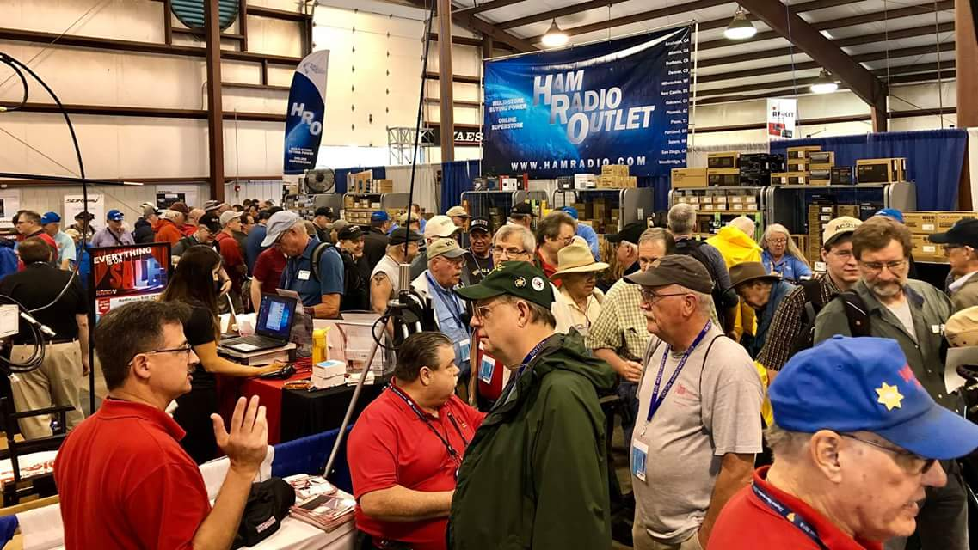
Upcoming Hamfests

We DO have some hamfests scheduled for 2023!! Yes, take a good look at the list, it’s growing every day!

Ohio Hamfests
2023
08/05/2023 - 2023 Columbus Hamfest  Location: Grove City, OH  Sponsor: Aladdin Shrine Audio Unit  Website: http://www.columbushamfest.com  Learn More | 08/12/2023 - Cincinnati Hamfest  Location: Owensville , OH  Sponsor: Milford ARC  Website: https://CincinnatiHamfest.org  Learn More
08/19/2023 - Portsmouth Radio Club Hamfest  Location: New Boston, OH  Sponsor: Jett Fire, Shawnee Computer,  Website: http://www.portsmouthradioclub.org  Learn More | 08/20/2023 - WARA Tailgate Swap Meet  Location: Cortland, OH  Sponsor: Warren Amateur Radio Association  Website: http://w8vtd.org  Learn More
09/10/2023 - Findlay Hamfest  Location: Findlay, OH  Sponsor: Findlay Radio Club  Website: http://findlayradioclub.org  Learn More | 09/24/2023 - Cleveland Hamfest  Location: Berea, OH  Sponsor: Hamfest Association of Cleveland  Website: http://www.hac.org  Learn More

10/29/2023 - Massillon (OH) Hamfest (& auction)
Location: North Canton, , OH
Sponsor: Massillon Amateur Radio Club
Website: http://www.w8np.net
Learn More

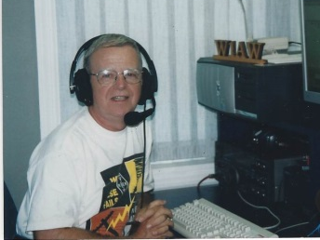
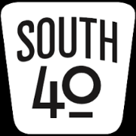
OHIO’S

It seems just days ago we were watching July 4 fireworks kicking off July and now we are looking at it in the rearview mirror and wondering where it went. Although July was slow for ham radio related events it was full of vacations, road trips, ball games, family cook outs, carnivals, lack of rain, hot temperatures and the other things making for a typical summer month. However it looks like August is not going to mirror July as already the calendar is full of a number of ham radio related events.

However before leaving July, there are a couple notable events taking place. One is across the Ohio River in neighboring Moundsville, WV. On July 29 the Northern Panhandle ARA will conduct a special event operation from what many may consider a weird tourist attraction-the Historic West Virginia State Penitentiary. Look for W8ZQ that day on 40 and 20 meters operating from the facility. The NPARA serves the far reaches of Ohio’s South 40 Southeastern Ohio’s amateur population in addition to hams in the West Virginia Panhandle and Western Pennsylvania.

Another late July activity is the popular Fox Hunt sponsored by the Hocking Valley ARA. It will be on Saturday, July 29. The hunt is not restricted to only HVARA members and anyone wishing to participate may check into the Logan 147.345 (PL 114.8) repeater starting at 9:45 AM. The actual hunt begins at 10 AM with the “fox” making his/her appearance on 147.495. The “fox den” will be located within sight of a public roadway somewhere in Hocking County. The complete rules for the hunt may be found on www.k8lgn.com/foxhunts.html. Usually the hunters and the fox will adjourn to a local restaurant for eats and drinks following the hunt. Bill, W8LGX, says they always prove to be a fun and educational time.

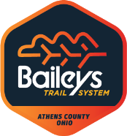
The Athens County ARA will assist with communications for the upcoming August 5 Athens Gravel Challenge that starts and ends at Chauncey and uses gravel trails and roads for the course. The Gravel Challenge is the only August event for the Club as the Bailey’s Run event has been cancelled for this year. Anyone wishing to assist the Club at the Gravel Challenge event is urged to contact Jeff Slattery, N8SUZ, (740-592-6124) for information about how to help.

July’s hamfests were few and far between but starting with the August 5 Columbus Hamfest August’s offerings provide you an opportunity to attend a Southern Ohio area show almost every Saturday morning. The Columbus Shrine Center in Grove City is the site for the annual Alladdian Shrine Audio Unit’s Columbus Hamfest. This hamfest has grown over the years and features both an inside and outside flea market, a food truck and testing opportunities. It’s located near the Stringtown exit from I-71 near the Tee Jay’s. It gets underway at 8 AM with a $5 admission charge at the gate.

On August 12 the scene shifts to the Clermont County Fairgrounds in Owensville where the Milford ARC will hold the Cincinnati Hamfest. This event too will have an inside and outside flea market and a free Laurel VE test session. Visit the www.cincinnatihamfest.org website for testing pre-registartion and more information about the event. The gates open to the public at 8 AM with a $10 admission fee.
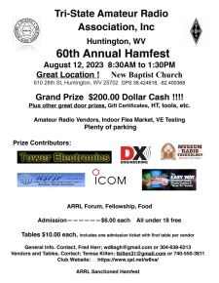
Also on the 12th, the Tri-State ARA will hold their 60th annual hamfest at the New Baptist Church, 610 28th Street in Huntington, WV. This ARRL sanctioned hamfest features an indoors flea market, an ARRL forum, food and plenty of parking. There will also be an ARRL VE session with all elements offered. Preregistration is not necessary and walkins are welcome. The event gets underway at 8:30 AM with a $6 admission charge.

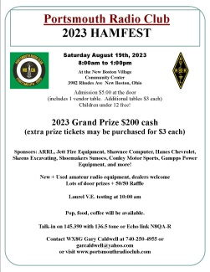
On the following Saturday morning (August 19) we move down river to New Boston where the Portsmouth RC hamfest will be held at the New Boston Community Center. Because it will be earlier in the year than in the past it’s hoped the weather will cooperate and allow for an outside tailgate sales area this year. Arrangements have been made with the adjoining Tractor Supply store for additional parking therefore opening up tailgating spaces. There will be a major prize drawing for cash plus loads of door prizes donated by local merchants. There will be a VE session at 10 AM. Walk-ins are welcome. The doors will open at 8 AM. The $5 admission charge gives you a free flea market space. Additional spaces are available for $3 each. Contact Gary Caldwell, WX8G, 740-250-4955 for more info.

On August 11 though the 13th the Cambridge ARA will commemorate the 110th anniversary of the Club’s founding by manning a club information booth at the Salt Fork Arts and Crafts Festival in the Cambridge City Park. Since the event draws thousands of visitors to the park, Lyn Alfman needs additional volunteers to assist with the manning of the Club’s booth during the three day event. Contact her for more information or to volunteer your services.

August brings several opportunities to earn a first license or upgrade the existing one. As previously mentioned, tests will be given at three of the upcoming hamfests in the South 40 Region. On the 12th the Highland ARA will conduct a free Laurel VE session at the Cincinnati Hamfest. Team Leader Tom Mongold, Jr. (KD8LDS) says registration begins at 9. Although pre-registration is preferred, walk-ins will be accommodated if space permits. The Tri-State ARA will conduct a test session during their August 12 hamfest at the New Baptist Church in Huntington, WV. Testing gets underway at 11:30. Check www.qsl.net/w8va for testing information. On the 19th, tests will be given at the Portsmouth Hamfest beginning at 10 AM with all elements available. The Athens County ARA will conduct an ARRL VE testing session on August 21 at the Red Cross Building in Athens. It will begin at 7 PM. Contact VE Coordinator Jeff Slattery, N8SUZ, for any updated information. A number of other clubs in the region offer testing opportunities and are listed elsewhere in this newsletter.

On September 16 the third annual Buffalo 10 Meter Net’s Ham Radio Swap Meet will be held in conjunction with the Leavitt Car Show in Belpre. The event is totally free and includes door prizes, music, food and drink. Visit the www.buffalo10meter.net website for details.

Our friends on the Kentucky side of the Ohio River will hold the Fourth Annual Kentucky State Parks on the Air on Saturday, August 12. Starting at 1400 UTC the eight hour event is open to any amateur using authorized frequencies and modes. The objective is to contact as many of the State’s fifty state parks as possible. Also included in the chase are the nine National Sites within the State who will count as multipliers. Event information and rules can be found on the Murry State University ARA’s website at https://k4msu.com/kypota.

Thanks to Michael and Jennifer Bailey, N8MRB and N8JEN, for providing us a recap on the recent Lewis and Clark Trail On The Air special event. The Baileys are members of the Portsmouth RC which has been the sole Ohio club officially activated to represent the State since the event started two years ago. According to the event’s organizer, the Clark County (IN) ARA, 28,573 contacts were made with activating stations. Eleven PRC members completed 2,509 contacts with 105.3 air hours. Only two other activating clubs logged more QSOs. Three fifths of the PRC QSOs were on SSB with the rest a mixture of CW and FT8. Congrats to the PRC on a well deserved representation of Ohio in the event.

Are you looking for a ham radio challenge from the comfort of your shack that won’t take up a weekend, a week or much longer? If that’s something that might catch your interest, check out the upcoming August 26 Mad River RC’s Ohio QSO Party. This 12 hour operating contest has an objective to work as many of Ohio’s 88 counties as possible on the various HF bands using phone and/or CW. A look at last years results show that thanks to some mobile, portable and rover stations all 88 Ohio counties were on the air at some time with 81 of those showing up on phone. Lorain County stations logged a 1,412 contest contact count to Huron’s 5. Just shy of 42,000 contacts were made by just shy of the 4,000 amateurs who submitted log entries. Almost 26,000 contacts were on 40 meters. So there are a lot of stations to work. And especially if you are in one of Ohio’s “Ham Radio Dessert” counties with few active hams you could find yourself the chased instead of the chasee by not only those in the contest, but those from outside of Ohio and the US who are chasing counties for their CQ Magazine USA-CA Award. The event rules can be found at www.ohqp.org. As of this writing, the list of planned county activations has not appeared on the website.

If the Ohio QSO Party is too long for you, an even shorter event is on September 9 when the 8 hour Ohio State Parks on the Air takes to the airwaves. The 16th annual OQP starts at 10 that morning and runs until 6 PM with the chief objectives to promote Ohio’s State Park System through ham radio. Possibly because it’s shorter than Field Day it has gained popularity with clubs and individual operators. Some clubs even activate more than one park and hold an intra-club competition between the parks activated. One club activated nine different parks last year! And several people take to the road as a Rover and activate multiple parks. Last years submitted logs showed 11,127 contacts made from 65 parks. Presently 27 parks show planned activity but sadly many of our regions parks indicate no activation plans. By activating one of these lesser activated parks you may find yourself very popular. There is a wealth of information on the www.ospota.org website about planned and past activations plus statisics dating to the first contest and this year’s rules. So grab an Ohio roadmap, check where a state park is that you might like to explore and operate from on September 9 and plan to take part in this fun and enjoyable event. Please note: Ohio’s newest State Park (between Xenia and Yellow Springs) is not included in the event this year.

It’s with sadness we report the passing of fellow Section Journal columnist Jim Yoder, W8ERW, this past Sunday in Hillsboro. Originally from Northern Ohio, Jim had relocated to Highland County within the year and had recently became active with the Highland ARA. Services will be at a later date in Greenfield.

August will bring a number of meetings and gatherings for our South 40 radio clubs. Some reported are:
August 1 Hocking Valley ARA, 7:00, EOC, Logan
August 7 Portsmouth Radio Club, 6:30, American Legion Hall, Portsmouth
August 8 DeForest ARA, 7:00, Senior Center, West Union
August 8 Highland ARA, 7:00, Liberty Park Harmony Lake shelter house, Hillsboro
August 10 Clinton County ARA, 7:30, Boyd Cancer Center, Wilmington
August 12 Bainbridge Area Hams Breakfast, 8:00, Dutch Restaurant, Bainbridge
August 12 Highland ARA Brunch Bunch, 10:00, Liberty Park, Hillsboro
August 12 Greater Mason Co. ARA, 7:00, Mason Co. EOC Training Room, Maysville
August 15 Tri-State ARA, 7:00, Radio Museum, Huntington
August 17 Scioto Valley ARA, 7:30, Clubhouse, Scioto State Forest, Chillicothe
August 17 Milford ARA, 7:30, Miami Twp. Civic Center, Milford
August 21 Southern Ohio ARA, 7:00, Lawrence Co. Operations Center, Coal Grove
August 26 Cambridge ARA, 10:00, Guernsey County Adm. Building, Cambridge

Some years ago the Highland ARA started holding an annual public oriented “What Is Ham Radio” ham radio informational program. Over the years it resulted in a large number of people learning about how amateur radio can help indivials and communities and many went on to earn a license. Thus the number of amateurs in the area grew and in time the Club’s membership grew to well over 100 members. Unfortunately many did not become active, but still are indicated as active on the FCC database. Realizing the Ironton/Lawrence County area could use a shot in the arm to increase the ham and club membership to offset declining numbers, the Southern Ohio ARA is taking a similar proactive step and going to have a “Let’s Talk Ham Radio” event promoting the hobby and service. It will be on Saturday, September 30 at the Patriot Park picnic shelter in South Point, Ohio. It will start at 10 AM and run until 2.

Is your club is located anywhere in Ohio that is South of I-70 and is planning an event, holding a meeting or participating in a community event yet this fall, but it has not been recognized in this column? If so, it is probably because we have not been sent the information or your club’s website or social media page has not been updated. If you want people to know your club exists and is active and doing something, please feel free to send the information to the contact information listed at the end of this column. We are happy to share the information with hundreds (and perhaps thousands) of readers each week.

Although the Leesburg area just lost a ham, I’m happy to close this week’s column on a happy note. I’ve been advised that Leesburg resident Ken Davis has earned his ham license and is now KE8YVO. What is even greater is that I’ve known Ken, his wife Christa and his parents for the better part of 50 years. He will be a fantastic addition to the amateur radio community. Welcome friend.

Until next time here’s hoping each of you have a great and safe week. Plus take some time to get on the air and talk to someone. You just might make their day.

John Levo, W8KIW, jlevo@cinci.rr.com or highlandara@gmail.com, 937-393-4951

__________________________________________________________________

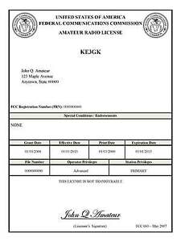
Print an Official or Unofficial Copy of Your Amateur Radio License
(By Anthony Luscre, K8ZT)

As of February 17, 2015, the FCC no longer routinely issues paper license documents to Amateur Radio applicants and licensees. The Commission has maintained for some time now that the official Amateur Radio license authorization is the electronic record that exists in its Universal Licensing System (ULS). The FCC will continue to provide paper license documents to all licensees who notify the Commission that they prefer to receive one.

Licensees also will be able to print out an official authorization — as well as an unofficial “reference copy” — from the ULS License Manager. I’ve created a set of instructions on how you can request an “official” printed copy of your license*

Click here to download the instructions

One Question Questionnaire

Hey Gang,

Last weeks question: IS YOUR CLUB PLANNING A CLUB OPERATION IN THE UPCOMING OHIO QSO PARTY??

With a total of 33 Responses: 11 (1/3) said Yes, and 22 (2/3) said No. That question has drawn the least number of votes since I’ve been Section Manager (January 2021). So, I’m surprised at the low amount of responses, but I’m also surprised at the low amount of clubs planning an OH QSO party operation. WOW!

The new question is:

Did you send a response to the ARRl dues survey?
a) Yes?
b) No?

You’ll find the “One Question” questionnaire on the Ohio Section Website! http://arrlohio.org It’s all for fun and it’s not a scientific survey in any way, but we are learning some things that we didn’t know from these questions. I hope that you are enjoying answering these “One Question” questionnaires.

Look for the RED ARROW on the website – After your vote ENTER out Handbook giveaway contest! And, the JULY 2021 Winner is: Don Hellen KX8K of Chillicothe, OH!

Final… Final

I want to address something that I think is missing in Amateur Radio. It wasn’t always that way, but times have sure changed! (Actually, it’s a bigger problem than just Amateur Radio.) I want to talk about compassion. I know that I live in a glass house so I shouldn’t throw stones, but this one I have to respond to.

I received an email from a fellow ham over the weekend. This ham’s email address was @ieee.org, so I’m assuming he’s a half-way intelligent person. It was an email I received regarding the YDXA operation this past weekend – W3Y. This email came to me under the subject line “ILKEGAL OOERATION W3Y” – off to a good start, aren’t we!
The text of the email (verbatim) follows:

“your CHILDREN OPERATING ILLEGALLY ON SSB ON 20 M CW 14010

.are you people THAT INCOMPETENT,??

Cant even read a digital freq display,??

this was reported to FCC

You are a disgrace”

Let me just point out: spelling is atrocious, can’t seem to string 2 complete sentences together, didn’t bother to figure out that he was emailing to the officers at PCARS, and obviously has no idea regarding punctuation. I’ll concede all are probably just simple errors in the heat of the moment.

A response was sent to him (not by me) as follows: “It seems that split was accidentally turned on. The issue was identified and corrected by one of our adult chaperones shortly after it occurred.”

I want to point out that I am an “all-in” supporter of the DXYA. What they had there was probably just a simple error in the heat of the moment. The response was short and factual – no name calling. What a difference in those two communications!

We all make mistakes. In my lifetime I’ve made several! One thing I am not mistaken about – we need to bring more people into Amateur Radio if we are to survive, and a lot of those new people also need to be young people. New, or young, maybe even both, if we want them to hang around, we need to treat them with compassion. Sure, they’re going to make mistakes, so am I. That’s just a part of life and learning new things.

I want to compare this to a story about the US military. The US military is known for the standard of “No Man Left Behind”. When a soldier is wounded on the battlefield, he knows that others will do all possible to be there for him and to return him to safety. That’s compassion. What is illustrated in the above email is basically the equivalent of a soldier on the battlefield, seeing his wounded comrade, fixing his bayonet and taking his comrade out of his misery. Please, treat others the way that you would like to be treated.

Finally, I hope to see many of you in Columbus next weekend. Along with Liz – KE8FMJ - we’ll be awarding the certificates for the Ohio Section Newsletter Contest!

73,
Tom WB8LCD

“Swap & Shop” on the website

Hey Gang,

Have you taken a look at the Swap & Shop page on the Ohio Section webpage yet?? Here’s a link that will take you there…
http://arrl-ohio.org/sm/s-s.html

Do you have equipment that you just don’t need or want anymore? Here’s a great venue to advertise it, and it’s FREE!!

Is your club doing a fund raiser to help raise money? After a lot of thought, it was decided that the Swap & Shop webpage could also contain these types of items as well.

The same rules will apply as do for the For Sales and Give-A-Ways and will only be posted for a month at a time. Please see the Terms & Conditions on the webpage.

If your club is doing a fund raiser and wants more exposure, please forward the information to me and I’ll advertise it on the Swap & Shop webpage for you. Now, I still want to remind you that it won’t be listed in this newsletter because it would take up way too much space, so your ad will only appear on the website. It is there for any individual to post equipment Wanted / For Sale or Give-Away as well as for Club Fund Raisers. No licensed vehicles/trailers or business advertising will be posted.

Postings are text only (no pictures or graphics) will be posted for a maximum of 1 month from date posting and require a contact phone number or email within the posting. Send your Wanted / For Sale or Give-Away post to: swap@arrlohio.org

Back Issues of the PostScript and Ohio Section Journal

Hey, did you know that PostScript and Ohio Section Journal (OSJ) are archived on the website? You can go back and look at any edition simply by clicking:
http://arrl-ohio.org/news/index.html

Ohio Section Cabinet
Section Manager – Tom Sly, WB8LCD | Section Emergency Coordinator – Bret Stemen, KD8SCL
Technical Coordinator – Jeff Kopcak, K8JTK | Section Traffic Manager – David Maynard, WA3EZN
State Government Liaison – Bob Winston, W2THU | Affiliated Clubs Coordinator –  Amanda Farone, KC3GFU
Section Youth Coordinator – Anthony Lascre, K8ZT | Public Information Coordinator – E;izabeth Klinc – KE8FMJ

Chit – Chat, and All That!

Do you know someone that’s not getting these Newsletters? Please, forward a copy of this Newsletter over to them and have them “Opt-In” to start receiving them. Heck just have them send an email to: webmaster@arrl-ohio.org to be added.

We now have many thousands of readers receiving these newsletters weekly. Quite impressive, I’d say! I urge all of you to make sure that everyone, regardless of whether they are a League member or not, get signed up to receive these weekly Newsletters.
You can always “Opt-Out” at any time if you feel this is not what you were expecting. It’s fun and very informative. All of your favorite past newsletters are now archived too.
You can go back at any time and read them. Just go to: http://arrl-ohio.org/news/

The pictures on the front page and throughout this newsletter are from various newsletters, Facebook posts and/or were sent directly to me in recent weeks. Take a good look at them, you just might be in one of the pictures! “SMILE… you’re in the Ohio Section News!!”

The Ohio Section Journal (OSJ) is produced as a comprehensive look at all the programs within the Ohio Section. I sincerely hope that you have enjoyed this edition of the OSJ and will encourage your friends to join with you in receiving the latest news and information about the Ohio Section, and from around the world!

TOP^

