[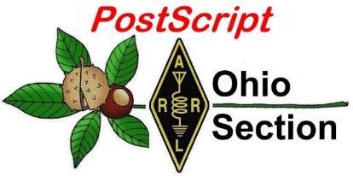](http://arrl-ohio.org/news/)

***“November 14th, 2022******”***

🡪 National News 🡪 Club Corner

🡪 DX This Week 🡪 Contest Corner

🡪 Upcoming Hamfests 🡪 One Question Questionnaire

🡪 VE Testing 🡪 South 40

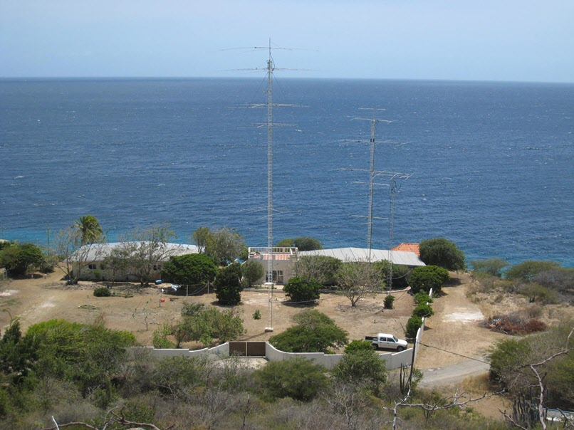

**CQ CQ CQ de WB8LCD**

**Youth Net**

**When:** The second Sunday of every month at 7:30 PM EST

**Where:** The K8IV repeater located in Kent, Ohio (Echolink node K8BF-L) RF: 146.895 Mhz  with PL 118.8

**Who:** Any licensed amateur radio operator who wishes to participate. Priority will be given to youth stations and those located in Ohio.

The purpose of this net is to encourage youth activity in amateur radio and to help new hams get more comfortable on the air.

***Next Net is Sunday November 13th***

If you are a young ham, in the Ohio Section or elsewhere, please check in and say “Hello”!

Even if you’re far away from OHIO you can check in via Echo-Link. Echo-Link is a good tool to have, and it can be accessed from your laptop, tablet or cellphone. But, there is a process to get validated to the Echo-link system. It’s simple to do, but you need to get it done before the day of the net! Go to [Introducing EchoLink](https://www.echolink.org/) for more information on getting started. If you’re an “Old Guy” (a gender neutral term meaning not a youthful operator) and you have some kids, grandkids, nieces, nephews or even some neighborhood kids who you would like to give a chance to talk to other kids about Ham Radio, this might be an excellent opportunity to give them that small nudge that could be the start of something positive they will carry with them through life!

You might recognize the photo on the front page – the Caribbean Contesting Consortium’s (CCC) PJ2T contest station, located on the island of Curacao. [PJ2T Station Home Page](http://www.pj2t.org/ccc/pj2t.station.home.page.htm) Almost 10 years ago now, I had the extreme pleasure of spending a few hours “on air” there on my 60th birthday, and I rank it as a “thrill of a lifetime”! It was an outstanding opportunity and I Thank them for it. BUT, PJ2T has also been one of the most visited locations for the Youth DX Adventure program. ([**YDXA**](https://www.qsl.net/n6jrl/)) The young ops go there and spend several days on the air. For them, I’m pretty sure that it’s the “thrill that may *never* be topped in a lifetime”!

I want to personally solicit your support of both the CCC and the YDXA. Both have strong ties to Amateur Radio in the Ohio Section, and both have played an important role in bringing Amateur Radio into the lives of young hams! Thank you to both organizations.

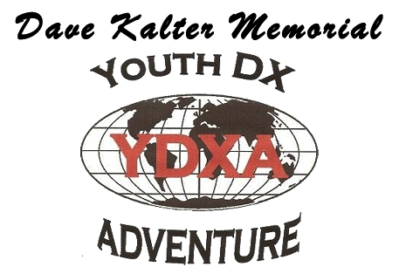

[**§ 97.1 Basis and purpose.**](https://www.ecfr.gov/current/title-47/section-97.1)

**The rules and regulations in this part are designed to provide an amateur radio service having a fundamental purpose as expressed in the following principles:**

**(a) Recognition and enhancement of the value of the amateur service to the public as a voluntary noncommercial communication service, particularly with respect to providing emergency communications.**

**(b) Continuation and extension of the amateur's proven ability to contribute to the advancement of the radio art.**

**(c) Encouragement and improvement of the amateur service through rules which provide for advancing skills in both the communication and technical phases of the art.**

**(d) Expansion of the existing reservoir within the amateur radio service of trained operators, technicians, and electronics experts.**

**(e) Continuation and extension of the amateur's unique ability to enhance international goodwill.**

Moving on to paragraph (D), I felt it was appropriate to high lite the groups I did. They are the embodiment of what this paragraph describes! For some reason, Amateur Radio has not been as successful in the recent past at attracting younger people into our ranks. We need to figure that out and get moving forward. Without attracting younger people into the hobby, we’ll cease to exist, and based on the Basis and Purpose of the Amateur Radio as stated in Part 97 of the rules, losing Amateur Radio would be a great loss to the citizens of the US of A. I’ll go so far as to say that it’s a Mandate from Congress that we are charged with accomplishing! We aren’t just playing around here. And why wouldn’t youth be interested in Ham Radio? Personal communications? Yeah, we do that. (with a lot of really cool options too!) International communications? Yeah, we do that. Space Communications? Yeah, we do that. (Where else could they possibly chat with the ISS or make contacts through satellites?) Robotics? Yeah, we do that, and we can offer all sorts of additional command and control options as well as data reporting options.) Computer hardware, software, coding? Yeah, we do that.

The whole point is, we have a lot to offer to our younger population. We need to present it in a way that is relative to their interests. We can play an important role in the education of our younger population – both in and outside of the school environment. We can supplement their formal education in the areas of Math, Science, Geography, Language, History and Art! We have a FANTASTIC story to tell, we just need to be relevant. Once we are, we will be sought out by Parents and Teachers as a gateway into the cutting edge of technology! It’s up to us to make it happen.

If you have good ideas – I’d like to hear them! Send me an email.

73,

Tom Sly - WB8LCD

Ohio Section Manager

[wb8lcd@arrl.org](mailto:wb8lcd@arrl.org)

330-554-4650

***National News***

*(from ARRL and other sources)*

|  |  |  |
| --- | --- | --- |
| |  | | --- | |  | | |
| |  |  | | --- | --- | | |  | | --- | | **[Illustration of the new, hard, round landing shield on Mars.](https://click.icptrack.com/icp/relay.php?r=7067822&msgid=62842&act=FC51&c=1862074&pid=122844&destination=https%3A%2F%2Fmars.nasa.gov%2Fnews%2F9283%2Fwhy-nasa-is-trying-to-crash-land-on-mars%2F%3Futm_source%3DiContact%26utm_medium%3Demail%26utm_campaign%3Dnasas-mars-public-engagement-team%26utm_content%3D20221109-MarsNewsletter&cf=57401&v=dfd49efa06820ff6e831fad385b01f1b53e49c83e4d41a4c65b49548f92ab439)** | |  |  | | --- | | [**Why is NASA Trying to Crash Land on Mars?**](https://click.icptrack.com/icp/relay.php?r=7067822&msgid=62842&act=FC51&c=1862074&pid=122844&destination=https%3A%2F%2Fmars.nasa.gov%2Fnews%2F9283%2Fwhy-nasa-is-trying-to-crash-land-on-mars%2F%3Futm_source%3DiContact%26utm_medium%3Demail%26utm_campaign%3Dnasas-mars-public-engagement-team%26utm_content%3D20221109-MarsNewsletter&cf=57401&v=dfd49efa06820ff6e831fad385b01f1b53e49c83e4d41a4c65b49548f92ab439)  Tests are underway on a new accordion-like, collapsible shield to absorb the energy of a hard landing.  [Read More](https://click.icptrack.com/icp/relay.php?r=7067822&msgid=62842&act=FC51&c=1862074&pid=122844&destination=https%3A%2F%2Fmars.nasa.gov%2Fnews%2F9283%2Fwhy-nasa-is-trying-to-crash-land-on-mars%2F%3Futm_source%3DiContact%26utm_medium%3Demail%26utm_campaign%3Dnasas-mars-public-engagement-team%26utm_content%3D20221109-MarsNewsletter&cf=57401&v=dfd49efa06820ff6e831fad385b01f1b53e49c83e4d41a4c65b49548f92ab439)‎ |[Watch Video](https://click.icptrack.com/icp/relay.php?r=7067822&msgid=62842&act=FC51&c=1862074&pid=122844&destination=https%3A%2F%2Fmars.nasa.gov%2Fresources%2F27071%2Fnasa-tests-ways-to-crash-land-on-mars%2F%3Futm_source%3DiContact%26utm_medium%3Demail%26utm_campaign%3Dnasas-mars-public-engagement-team%26utm_content%3D20221109-MarsNewsletter&cf=57401&v=deff84915562248bdc6cfa15c625fbf66079c5ac618429c7d668113edf07e5d6) | | |
|  | |
| [Join Us Online](https://r20.rs6.net/tn.jsp?f=001bUUHUbwKFISjwSj755T_ajrPvCWlStUw9LJKDFKFUoPEIz1aerP2xPNYVFXdtcmzTIP5IOtYf0sdVgbbVGvFKE7mE3RJfDelM3s_pFegJNCIZ7EpO4sS5w_GUY0lyiI97a1xQZVXyN-u8xeB8orFrsUamLlxLvHGeOLPH01VcFkXJ8A3ulvdNG8vo5SLus2TjMyPzVYdCAI=&c=v7961cv95RknIL_9jUaT-L3Smyxg5lnz-xe-g8cmDW70KyI2iirKaw==&ch=UAD8B1NUiukOykNpLiSZZnzIcXR1Ah9uDz2dZGeRjRUJ08Sb_qeGAA==) |

|  |  |
| --- | --- |
| |  | | --- | | **Explore NASA**  *A Weekly Bit of Space in Your Inbox* | |

|  |
| --- |
|  |

|  |
| --- |
|  |

|  |  |
| --- | --- |
| |  | | --- | | [[Facebook](https://r20.rs6.net/tn.jsp?f=001bUUHUbwKFISjwSj755T_ajrPvCWlStUw9LJKDFKFUoPEIz1aerP2xMr_FC1YRwjVcvOumakLuJj-XL6sakK7QyQrR4fCqn0PvSDwcKy5SMV3zIQg5HqtycQpJyr5WErAyWsPRjOgXPcdWzb0rXFnCg==&c=v7961cv95RknIL_9jUaT-L3Smyxg5lnz-xe-g8cmDW70KyI2iirKaw==&ch=UAD8B1NUiukOykNpLiSZZnzIcXR1Ah9uDz2dZGeRjRUJ08Sb_qeGAA==) ‌](https://r20.rs6.net/tn.jsp?f=001bUUHUbwKFISjwSj755T_ajrPvCWlStUw9LJKDFKFUoPEIz1aerP2xMr_FC1YRwjVcvOumakLuJj-XL6sakK7QyQrR4fCqn0PvSDwcKy5SMV3zIQg5HqtycQpJyr5WErAyWsPRjOgXPcdWzb0rXFnCg==&c=v7961cv95RknIL_9jUaT-L3Smyxg5lnz-xe-g8cmDW70KyI2iirKaw==&ch=UAD8B1NUiukOykNpLiSZZnzIcXR1Ah9uDz2dZGeRjRUJ08Sb_qeGAA==) [[Twitter](https://r20.rs6.net/tn.jsp?f=001bUUHUbwKFISjwSj755T_ajrPvCWlStUw9LJKDFKFUoPEIz1aerP2xMr_FC1YRwjVvU9WS1kzw0AM-IetA98-h8Ht3yI3GMH94jUzwlqmoD_1ZNilLZXOw0n50owk_Gs4nGP9hmzNveVZfrmUVoah0w==&c=v7961cv95RknIL_9jUaT-L3Smyxg5lnz-xe-g8cmDW70KyI2iirKaw==&ch=UAD8B1NUiukOykNpLiSZZnzIcXR1Ah9uDz2dZGeRjRUJ08Sb_qeGAA==) ‌](https://r20.rs6.net/tn.jsp?f=001bUUHUbwKFISjwSj755T_ajrPvCWlStUw9LJKDFKFUoPEIz1aerP2xMr_FC1YRwjVvU9WS1kzw0AM-IetA98-h8Ht3yI3GMH94jUzwlqmoD_1ZNilLZXOw0n50owk_Gs4nGP9hmzNveVZfrmUVoah0w==&c=v7961cv95RknIL_9jUaT-L3Smyxg5lnz-xe-g8cmDW70KyI2iirKaw==&ch=UAD8B1NUiukOykNpLiSZZnzIcXR1Ah9uDz2dZGeRjRUJ08Sb_qeGAA==) [[Instagram](https://r20.rs6.net/tn.jsp?f=001bUUHUbwKFISjwSj755T_ajrPvCWlStUw9LJKDFKFUoPEIz1aerP2xMr_FC1YRwjVeZ7XOcOnYvKcJ3LYsW7W0IhhsE-UZSyKkFBDm8gOgmVax75fCOCxzsT02VTzXQUswaSGuaDFOLWtF8YW_WkpUQ==&c=v7961cv95RknIL_9jUaT-L3Smyxg5lnz-xe-g8cmDW70KyI2iirKaw==&ch=UAD8B1NUiukOykNpLiSZZnzIcXR1Ah9uDz2dZGeRjRUJ08Sb_qeGAA==) ‌](https://r20.rs6.net/tn.jsp?f=001bUUHUbwKFISjwSj755T_ajrPvCWlStUw9LJKDFKFUoPEIz1aerP2xMr_FC1YRwjVeZ7XOcOnYvKcJ3LYsW7W0IhhsE-UZSyKkFBDm8gOgmVax75fCOCxzsT02VTzXQUswaSGuaDFOLWtF8YW_WkpUQ==&c=v7961cv95RknIL_9jUaT-L3Smyxg5lnz-xe-g8cmDW70KyI2iirKaw==&ch=UAD8B1NUiukOykNpLiSZZnzIcXR1Ah9uDz2dZGeRjRUJ08Sb_qeGAA==) [[YouTube](https://r20.rs6.net/tn.jsp?f=001bUUHUbwKFISjwSj755T_ajrPvCWlStUw9LJKDFKFUoPEIz1aerP2xMr_FC1YRwjVAsJf8f-wDMlGqdLLudrocM4La2qiW2wS1dYZ_6h0E1lNA9M36kIxJPIKQcJvf1KqEhRiGLNgJhrAx3ub-aNhMw==&c=v7961cv95RknIL_9jUaT-L3Smyxg5lnz-xe-g8cmDW70KyI2iirKaw==&ch=UAD8B1NUiukOykNpLiSZZnzIcXR1Ah9uDz2dZGeRjRUJ08Sb_qeGAA==) ‌](https://r20.rs6.net/tn.jsp?f=001bUUHUbwKFISjwSj755T_ajrPvCWlStUw9LJKDFKFUoPEIz1aerP2xMr_FC1YRwjVAsJf8f-wDMlGqdLLudrocM4La2qiW2wS1dYZ_6h0E1lNA9M36kIxJPIKQcJvf1KqEhRiGLNgJhrAx3ub-aNhMw==&c=v7961cv95RknIL_9jUaT-L3Smyxg5lnz-xe-g8cmDW70KyI2iirKaw==&ch=UAD8B1NUiukOykNpLiSZZnzIcXR1Ah9uDz2dZGeRjRUJ08Sb_qeGAA==) [[LinkedIn](https://r20.rs6.net/tn.jsp?f=001bUUHUbwKFISjwSj755T_ajrPvCWlStUw9LJKDFKFUoPEIz1aerP2xMr_FC1YRwjV9eKT5WlB_0UpcoFzy9C15x_74Z4jdsNvqgEGr3LqqCuQscuV1P61xMdzq4KVVe7ErCpfje5B2rGVAaIaPsDzrVkN6t4w4iRJdmQ3sum9iJM=&c=v7961cv95RknIL_9jUaT-L3Smyxg5lnz-xe-g8cmDW70KyI2iirKaw==&ch=UAD8B1NUiukOykNpLiSZZnzIcXR1Ah9uDz2dZGeRjRUJ08Sb_qeGAA==) ‌](https://r20.rs6.net/tn.jsp?f=001bUUHUbwKFISjwSj755T_ajrPvCWlStUw9LJKDFKFUoPEIz1aerP2xMr_FC1YRwjV9eKT5WlB_0UpcoFzy9C15x_74Z4jdsNvqgEGr3LqqCuQscuV1P61xMdzq4KVVe7ErCpfje5B2rGVAaIaPsDzrVkN6t4w4iRJdmQ3sum9iJM=&c=v7961cv95RknIL_9jUaT-L3Smyxg5lnz-xe-g8cmDW70KyI2iirKaw==&ch=UAD8B1NUiukOykNpLiSZZnzIcXR1Ah9uDz2dZGeRjRUJ08Sb_qeGAA==) | |

|  |  |  |  |
| --- | --- | --- | --- |
| |  |  |  | | --- | --- | --- | | |  |  | | --- | --- | | |  | | --- | | [Invite Friends to Subscribe](https://r20.rs6.net/tn.jsp?f=001bUUHUbwKFISjwSj755T_ajrPvCWlStUw9LJKDFKFUoPEIz1aerP2xGOZUIX9ipnXnx0iWp-GT6mzQ9lI-0FPx0hlS0E9l4XVRIACB9yERhJM8BAyTAxQ8OufgJIDJc6bQ3L6FQmhClOkuiiWGmJ12A==&c=v7961cv95RknIL_9jUaT-L3Smyxg5lnz-xe-g8cmDW70KyI2iirKaw==&ch=UAD8B1NUiukOykNpLiSZZnzIcXR1Ah9uDz2dZGeRjRUJ08Sb_qeGAA==) | | | |

***______________________________________________***

**ARLB020 W1AW 2022 Winter Operating Schedule**  
  
Morning Schedule:  
  
Time                  Mode     Days  
-------------------   ----     ---------  
1400 UTC (9 AM EST)   CWs      Wed, Fri  
1400 UTC (9 AM EST)   CWf      Tue, Thu  
  
Daily Visitor Operating Hours:  
  
1500 UTC to 2045 UTC - (10 AM to 3:45 PM EST)  
  
Afternoon/Evening Schedule:  
  
2100 UTC (4 PM EST)    CWf      Mon, Wed, Fri  
2100  "      "         CWs      Tue, Thu  
2200  "  (5 PM EST)    CWb      Daily  
2300  "  (6 PM EST)    DIGITAL  Daily  
0000  "  (7 PM EST)    CWs      Mon, Wed, Fri  
0000  "      "         CWf      Tue, Thu  
0100  "  (8 PM EST)    CWb      Daily  
0200  "  (9 PM EST)    DIGITAL  Daily  
0245  "  (9:45 PM EST) VOICE    Daily  
0300  "  (10 PM EST)   CWf      Mon, Wed, Fri  
0300  "      "         CWs      Tue, Thu  
0400  "  (11 PM EST)   CWb      Daily  
  
  
                         Frequencies (MHz)  
                         -----------------  
CW: 1.8025 3.5815 7.0475 14.0475 18.0975 21.0675 28.0675 50.350 147.555  
DIGITAL: - 3.5975 7.095 14.095 18.1025 21.095 28.095 50.350 147.555  
VOICE: 1.855 3.990 7.290 14.290 18.160 21.390 28.590 50.350 147.555  
  
Notes:  
  
CWs = Morse Code practice (slow) = 5, 7.5, 10, 13 and 15 WPM  
CWf = Morse Code practice (fast) = 35, 30, 25, 20, 15, 13 and 10 WPM   
CWb = Morse Code Bulletins = 18 WPM  
  
CW frequencies include code practices, Qualifying Runs and CW bulletins.  
  
DIGITAL = BAUDOT (45.45 baud), BPSK31 and MFSK16 in a revolving schedule.  
  
Code practice texts are from QST, and the source of each practice is given at the beginning of each practice and at the beginning of alternate speeds.  
  
On Tuesdays and Fridays at 2330 UTC (6:30 PM EST), Keplerian Elements for active amateur satellites are sent on the regular digital frequencies.  
  
A DX bulletin replaces or is added to the regular bulletins between 0100 UTC (8 PM EST) Thursdays and 0100 UTC (8 PM EST) Fridays.  
  
Audio from W1AW's CW code practices, CW/digital bulletins and phone bulletin is available using EchoLink via the W1AW Conference Server named "W1AWBDCT."  The monthly W1AW Qualifying Runs are presented here as well.  The audio is sent in real-time and runs concurrently with W1AW's regular transmission schedule.  
  
All users who connect to the conference server are muted.  Please note that any questions or comments about this server should not be sent via the "Text" window in EchoLink. Please direct any questions or comments to [w1aw@arrl.org](mailto:w1aw@arrl.org) .  
  
In a communications emergency, monitor W1AW for special bulletins as follows: Voice on the hour, Digital at 15 minutes past the hour, and CW on the half hour.  
  
All licensed amateurs may operate the station from 1500 UTC to 2045 UTC (10 AM to 3:45 PM EST).  Be sure to bring a reference copy of your current FCC amateur radio license.  
  
The weekly W1AW and monthly West Coast Qualifying Runs are sent on the normal CW frequencies used for both code practice and bulletin transmissions.  West Coast Qualifying Run stations may also use 3590 kHz.  
  
The W1AW Operating Schedule may also be found on page 28 in the November 2022 issue of QST or on the web at, <http://www.arrl.org/w1aw-operating-schedule> .

|  |
| --- |
|  |

**Reaching Youth Through Amateur Radio in the Classroom**

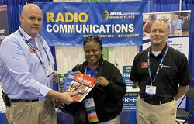ARRL Education and Learning Manager Steve Goodgame, K5ATA, attended the Georgia Educational Technology Conference, held November 2 - 4, 2022. The conference was the first part in a series of planned ARRL exhibits to meet with teachers and promote amateur radio in the classroom. Assisted by ARRL Teachers Institute Instructor Wayne Greene, KB4DSF, along with volunteers Cyndi Goodgame, K5CYN, and Betsey Greene, they spoke to hundreds of teachers, school administrators, and technology directors about the ARRL [Teachers Institute on Wireless Technology](http://www.arrl.org/teachers-institute-on-wireless-technology).

ARRL's participation at this conference, as well as future events, is meant to inform and network with educators looking to incorporate amateur radio into their curriculum.

"The level of interest among teachers was incredible!" said Goodgame. "Our booth enjoyed heavy traffic for the duration of the conference, much of the time with all four of us engaged in discussions with multiple people simultaneously. Except for a couple of teachers we met who were already hams, few teachers had heard of amateur radio before this conference. These teachers were absolutely amazed at the possibilities that exist when including amateur radio and related educational experiences in their schools."

"Teachers were especially excited at the connections between amateur radio and space. We shared information about the ARISS program -- [Amateur Radio on the International Space Station](http://www.arrl.org/amateur-radio-on-the-international-space-station) -- as well as communicating via amateur satellites. Enough teachers were interested in learning more about the relationship between amateur radio and satellites communications that we put together an impromptu live demonstration using two handhelds and an Arrow antenna we had for display in the booth. We gathered a crowd of teachers, along with a few students who were presenting their Student Showcase projects and headed outside. We enjoyed a good satellite pass and made contacts through AO-27. One of the students even got on the air!"

"Overall, it was a great conference and a great opportunity for ARRL to network with educators and work with them to help get more youth engaged in amateur radio."

***______________________________________________***

**Get ready for ARRL November Sweepstakes Phone (SSB), November 19-21, 2022.** In this popular annual contest, stations in the US and Canada (including territories and possessions) exchange information with as many other US and Canadian stations as possible. November Sweepstakes is the oldest domestic radiosport event (the first was in 1930). Read the contest rules at <http://arrl.org/sweepstakes>.

***______________________________________________***

***Club Corner***

This is YOUR cornner of the newsletter. Send me what your club is doing and I’ll make sure that it gets in. Got a special event or club project that you want everyone to know about? Send it to me! Need help with a project? Send it to me.

Let me know what you club is up to. Are you going to have a special guest at your meeting or are you having a special anniversary?

Just send it to: [webmaster@arrl-ohio.org](mailto:webmaster@arrl-ohio.org)

Please! Format as below:

******If you want me to publish your club information, or even an article you have written, please send it in WORD format (.docx). Please use Times New Roman font size 12 for the body of the aritcle. Any photos please include as a .jpg or .bmp – the time you save me in doing all the conversions will be greatly appreciated.

**Alliance Amateur Radio Club**

If you Google the ARRL 5 Pillars, you can read about the 5 principles upon which the ARRL is founded. They are **Public Service, Advocacy, Education, Technology, and Membership**.

Here in NE Ohio, our club has expanded on the Public service Pillar by donating to other Non-Profits each holiday season. We are the Alliance Amateur Radio Club ([www.w8lky.org](http://www.w8lky.org)). We are an ARRL affiliated club, and proud to be an ARRL Special service Club. We try to place emphasis on the word SERVICE. As such, we hold a Fundraiser each fall to help support some worthy charities in our hometown.

The process begins several months earlier with our annual HF rig raffle. We market it nationwide via Facebook. A portion of the profits are set aside to be donated along with money collected at our Fall Fundraiser.

Then each fall, our club members build, beg, or buy amateur radio/Electronic related items to be donated to the fundraiser. It’s all donated; no club funds are ever used to buy prizes. On the night of the fundraiser, all the prizes get set out for inspection, and have a ticket container in front of them.

We use the Chinese auction format. That’s where people purchase tickets, and place half of their stubs in the containers in front of the prizes they are most interested in winning. At the end of the night, we draw a winner from each container. The winning ticket holder gets that item.

Thanks to the generosity of local Hams, we were able to increase our 2022 donations to almost $1700! We support the programs run by the Local police & fire Departments, as well as the local Salvation Army.

There are clubs who are donating more to their community, but for a small club like ours, this is awesome. (WG8X, Fundraiser chairman, AARC)

**Winter Storm Severity Index (WSSI):**

Ted Jacobson (W8KVK) - [Athens Co. CoCoRaHS](https://climate.athens.oh.us/oh-at/)

NWS has implemented the 'WSSI' to provide the public with a tool that attempts to convey the  
complexities and hazards associated with winter storms as they relate to potential societal impacts.

The 'WSSI' has been developed to have a two-fold focus. The first is for use as a tool to assist NWS operational forecasters in maintaining situational awareness of the possible significance of weather-related impacts based upon the current official forecasts. The second is to enhance communication to external partners, media and the general public of the expected severity of potential societal impacts due to expected winter hazards and their distribution.

This product should be of interest to ARES/AuxComm, Skywarn and EMA interests .For detailed information, see [https:/www.wpc.ncep.noaa.gov/wwd/wssi/wssi.php](https://www.wpc.ncep.noaa.gov/wwd/wssi/wssi.php) See particularly, the short video tutorial, users guide, and new "rolling slider" display which shows the WSSI for a period of 24 hours. Each time-step forward is 6 hours. As you move forward in time using the slider bar you can see how the WSSI is changing every six hours out to the end of the day 3 timeframe.

You may also wish to bookmark the zoom-level display for your specific National Weather Service Forecast office coverage area. See the "Select Zoom Area" dropdown menu.

Finally, a reminder that **Skywarn Recognition Day** (SRD) is December 3, 2022 (00-24z).

Several NWS offices serving Ohio are expected to participate.

<https://www.weather.gov/crh/skywarnrecognition>

**OHIO SECTION TRAFFIC REPORT – OCTOBER 2022**

**OHIO SECTION NETS – OCTOBER 2022**

|  |  |  |  |  |  |
| --- | --- | --- | --- | --- | --- |
| NET | QNI | QTC | QTR | SESSIONS | N/M |
| BNE | 135 | 27 | 277 | 31 | N2LC |
| BNL | 47 | 39 | 189 | 31 | WB9LBI |
| OSN | 59 | 23 | 383 | 21 | N2LC |
| OSSBN | 1619 | 331 | 2105 | 93 | KC8WH |

**OHIO SECTION PSHR REPORTS – OCTOBER 2022**

|  |  |  |  |  |  |  |  |  |
| --- | --- | --- | --- | --- | --- | --- | --- | --- |
| WA3EZN | 40 | 40 | 30 | 375 | 0 | 20 | TOTAL | 505 |
| AD8CM | 30 | 23 | 10 | 285 | 0 | 0 | TOTAL | 348 |
| AC8NP | 40 | 40 | 10 | 215 | 0 | 20 | TOTAL | 325 |
| N2LC | 40 | 40 | 30 | 120 | 0 | 20 | TOTAL | 260 |
| N8SY | 40 | 20 | 30 | 20 | 0 | 60 | TOTAL | 170 |
| W8DJG | 40 | 40 | 30 | 30 | 5 | 20 | TOTAL | 165 |
| KV8Z | 40 | 40 | 10 | 65 | 0 | 10 | TOTAL | 165 |
| KM8V | 11 | 29 | 30 | 15 | 0 | 80 | TOTAL | 165 |
| KC8WH | 40 | 40 | 30 | 40 | 0 | 0 | TOTAL | 150 |
| KC8PBU | 40 | 40 | 20 | 10 | 30 | 0 | TOTAL | 140 |
| KE4RS | 40 | 40 | 10 | 45 | 0 | 0 | TOTAL | 135 |
| KD8UUB | 40 | 31 | 10 | 50 | 0 | 0 | TOTAL | 131 |
| KL7RF | 40 | 40 | 10 | 40 | 0 | 0 | TOTAL | 130 |
| WB8YYS | 40 | 19 | 20 | 40 | 0 | 10 | TOTAL | 129 |
| WB8SIQ | 40 | 40 | 10 | 35 | 0 | 0 | TOTAL | 125 |
| K8MDA | 40 | 24 | 30 | 5 | 0 | 20 | TOTAL | 119 |
| N8MRS | 40 | 40 | 10 | 25 | 0 | 0 | TOTAL | 115 |
| W8GSR | 40 | 40 | 10 | 20 | 0 | 0 | TOTAL | 110 |
| K8KRA | 40 | 40 | 10 | 20 | 0 | 0 | TOTAL | 110 |
| AC8RV | 40 | 40 | 10 | 10 | 0 | 0 | TOTAL | 100 |
| KB8GUN | 40 | 40 | 10 | 0 | 0 | 10 | TOTAL | 100 |
| KB8HJJ | 40 | 40 | 10 | 0 | 0 | 0 | TOTAL | 90 |
| KE8ANW | 40 | 6 | 0 | 30 | 0 | 0 | TOTAL | 76 |
| NC8V | 18 | 15 | 0 | 15 | 0 | 0 | TOTAL | 48 |

**OHIO SECTION TRAFFIC REPORTS – OCTOBER 2022**

|  |  |  |  |
| --- | --- | --- | --- |
| AC8NP-56 | KC8IDM-22 | KM8V-29 | W8DJG-75 |
| AC8RV-160 | KC8PBU-121 | KV8Z-54 | W8GSR-115 |
| AD8CM-23 | KC8WH-59 | N2LC-78 | W8MAL-28 |
| K8KRA-44 | KC8YTV-3 | N8BV- 48 | W8SAB-4 |
| K8MDA-24 | KD8GYI-60 | N8GBU-14 | WA3EZN-56 |
| K8MYF-18 | KD8HB-56 | N8MRS-108 | WB8PMG-24 |
| KA8BJA-48 | KD8UUB-31 | N8OD-23 | WB8SIQ-51 |
| KB8GUN-152 | KE4RS-106 | N8SY-20 | WB8YYS-19 |
| KB8HJJ- 51 | KL7RF-69 | N8TNV-123 | WB9LBI-79 |
|  |  | NC8V-15 | WD8SDH-33 |
|  |  |  |  |
|  | TOTALS | 38/2099 |  |

**OHIO SECTION LOCAL NETS – OCTOBER 2022**

|  |  |  |  |  |  |
| --- | --- | --- | --- | --- | --- |
| NET | QNI | QTC | QTR | SESSIONS | N/M |
| BRTN | 172 | 83 | 405 | 31 | W8DJG |
| COTN | 237 | 59 | 629 | 36 | KV8Z |
| NWOH ARES | 295 | 163 | 698 | 35 | N8TNV |
| TATN | 333 | 66 | 308 | 31 | WG8Z |
| TCTTN | 143 | 28 | 434 | 13 | WB8YYS |

**OHIO SECTION TRAFFIC REPORT – OCTOBER 2022**

**OHIO SECTION NETS** – **OCTOBER 2022**

NET QNI QTC QTR SESSIONS N/M

BNE 135 27 277 31 N2LC

BNL 47 39 189 31 WB8LBI

OSN 59 23 383 21 N2LC

OSSBN 1619 331 2105 93 KC8WH

**OHIO SECTION PSHR REPORTS – OCTOBER 2022**

WA3EZN 40 40 30 375 0 20 TOTAL 505

AD8CM 30 23 10 285 0 0 TOTAL 348

AC8NP 40 40 10 215 0 20 TOTAL 325

N2LC 40 40 30 120 0 20 TOTAL 260

N8SY 40 20 30 20 0 60 TOTAL 170

W8DJG 40 40 30 30 5 20 TOTAL 165

KV8Z 40 40 10 65 0 10 TOTAL 165

KM8V 11 29 30 15 5 80 TOTAL 165

KC8WH 40 40 30 40 0 0 TOTAL 150

KC8PBU 40 40 20 10 30 0 TOTAL 140

KE4RS 40 40 10 45 0 0 TOTAL 135

KD8UUB 40 31 10 50 0 0 TOTAL 131

KL7RF 40 40 10 40 0 0 TOTAL 130

WB8YYS 40 19 20 40 0 10 TOTAL 129

WB8SIQ 40 40 10 35 0 0 TOTAL 125

K8MDA 40 24 30 5 0 20 TOTAL 119

N8MRS 40 40 10 25 0 0 TOTAL 115

W8GSR 40 40 10 20 0 0 TOTAL 110

K8KRA 40 40 10 20 0 0 TOTAL 110

AC8RV 40 40 10 10 0 0 TOTAL 100

KB8GUN 40 40 10 0 0 10 TOTAL 100

KB8HJJ 40 40 10 0 0 0 TOTAL 90

KE8ANW 40 6 0 30 0 0 TOTAL 76

NC8V 18 15 0 15 0 0 TOTAL 48

**OHIO SECTION LOCAL NETS – OCTOBER 2022**

NET QNI QTC QTR SESSIONS N/M

BRTN 172 83 405 31 W8DJG

COTN 237 59 629 36 KV8Z

NWOH ARES 295 163 698 35 N8TNV

TATN 333 66 308 31 WG8Z

TCTTN 143 28 434 13 WB8YYS

**OHIO SECTION TRAFFIC REPORTS – OCTOBER 2022**

AC8NP-56 KC8IDM-22 KM8V-29 W8DJG-76

AC8RV-160 KC8PBU-121 KV8Z-54 W8GSR-115

AD8CM-23 KC8WH-59 N2LC-78 W8MAL-28

K8KRA-44 KC8YTV-3 N8BV-48 W8SAB-4

K8MDA-24 KD8GYI-60 N8GBU-14 WA3EZN-56

K8MWF-18 KD8HB-56 N8MRS-108 WB8PMG-24

KA8BJA-48 KD8UUB-31 N8OD-23 WB8SIQ-51

KB8GUN-152 KE4RS-106 N8SY-20 WB8YYS-19

KB8HJJ-51 KL7RF-69 N8TNV-123 WB9LBI-79

NC8V-15 WD8SDH-33

TOTALS 38/2099

**OHIO HF TRAFFIC NETS**

BN(E) Buckeye Net Early - CW

BN(L) Buckeye Net Late – CW

OSN Ohio Slow Net - CW

OSSBN Ohio Single Sideband Net – Phone

**OHIO VHF TRAFFIC NETS**

BRTN Burning River Traffic Net serving Cleveland and North Central Ohio

COTN Central Ohio Traffic Net serving Columbus and Central Ohio

MVTN Miami Valley Traffic Net serving the Dayton area

NWOH ARES Northwest Ohio ARES Net serving Toledo and surrounding counties

TATN Tri-State Amateur Traffic Net

TCTTN Tri-County Traffic and Training Net serving North East Ohio

**______________________________________________________________________________**

**Want to know where to go to get the courses you need? It’s all Right Here!**

* [Ohio EMA Training Calendar](https://webeoctraining.dps.ohio.gov/TrainingAndExercise/courselist.aspx)
* [Login to the DPS Training Campus](https://learning.dps.ohio.gov/PSTC/)
* [Create a new account on the DPS Training Campus](https://learning.dps.ohio.gov/PSTC/)

**NOTE:**

* Most courses are in-person but some course may be hosted virtually (this will be noted).
* Seats available listed are as of the release of this update and will change quickly.
* All classes will be posted on the DPS training campus at least 60 days prior to the start of the course.
* Please read the [Training Policy & Catalog](https://ema.ohio.gov/documents/training/ema0201.pdf) for more information on Ohio EMA trainings.

_._,_._,_

How to Plan and Apply for an ARRL Hamfest or Convention

If your amateur radio club is planning to host a convention, hamfest, tailgate, or swapfest, please consider applying for ARRL sanctioned status for your event. To learn what it means to be an ARRL sanctioned event, and to get some ideas on how to prepare for and conduct a hamfest or convention, visit [www.arrl.org/arrl-sanctioned-events](http://www.arrl.org/arrl-sanctioned-events).

To apply for ARRL sanctioned status for your event, go to [www.arrl.org/hamfest-convention-application](http://www.arrl.org/hamfest-convention-application).

The ARRL Hamfests and Conventions Calendar can be found online at [www.arrl.org/hamfests](http://www.arrl.org/hamfests). In addition, the Convention and Hamfest Calendar that runs in *QST* each month also presents information about upcoming events.

Go Fully Electronic in 2022!

By Maria Somma, AB1FM, ARRL VEC Manager

**Online Examinations and Remote Testing**

Your club's VE team can become part of the fun and excitement of remotely administered Online Examinations.  
  
The remote exam sessions are conducted using an online video conferencing platform and a web-based examination system with on-screen tests. ARRL VE teams have had the option to be completely electronic since June 2020 by using online exams. The online exams can also be utilized at in-person sessions automating most of the process, for a fully electronic in-person session experience.  
  
VE teams have been using the [Exam.Tools](https://exam.tools/) Online Examination system for remote video and in-person sessions. Over 25,000 applicants have been tested through the Online Examinations system in the past two years. The system works well for online or printed examinations and includes registering and tracking candidates throughout the session, on screen exams and grading, online signing of CSCE and 605 forms by the candidate and examiners, logging and compiling session stats and VE participation list (test report summary), and output files for upload to the coordinating VEC. The program manages and handles almost everything needed to conduct a test session. Time and experience with in-person exam sessions is invaluable when transitioning to remote video-supervised online exam sessions.  
  
Interested ARRL VE teams must contact the [VEC department](mailto:vec@arrl.org) to receive the online exams instructions and remote video session procedures.  
  
Not a VE? Become one today!  
  
Visit <http://www.arrl.org/become-an-arrl-ve>  
  
**Electronically File Exam Session Documents for Quicker Service**

After the session has concluded, VE teams can upload in-person documents or remote video session files via ARRL VEC's secure web page (program service option since 2018).

New and upgraded licenses are issued within 1 to 2 business days for weekend sessions and are usually issued on the same day for weekday sessions.

Please contact the [VEC department](mailto:VEC@arrl.org) for the information and instructions on electronically filing exam session documents through our upload page. Authorized VEs will be sent the upload page URL which, is hidden from the public.

**Resources for ARRL VEs**

The [ARRL VEC VE Resources](http://www.arrl.org/resources-for-ves) page offers the information you will need to help conduct exam session business. Our support page offers easy access to session forms and information, online examinations, remote video session instructions, VE Manual supplemental information, FCC rules, basic qualification question procedures, and much more. There is also some helpful information for the community, such as preparation resources for candidates, in-person and remote video exam session search, vanity call sign information, and more.

The ARRL VE Newsletter relays important updates relating to FCC rule or policy changes, exam session document or procedural changes, video sessions, and other topics. VEs can sign up for the newsletter at <https://reflector.arrl.org/mailman/listinfo/ve-list>

**__________________________________________________________**

VE Sessions

**All Things Amateur Radio Association (ATARA)** We host testing sessions every second Tuesday of the month in Lancaster. To sign up please visit our website <https://atara-w8atr.fun> and contact us at [hamexams@atara-w8atr.fun](mailto:hamexams@atara-w8atr.fun).

**CARS**

VE testing from CARS - Cuyahoga Amateur Radio Society - at Elmwood Recreation Center, 6200 Wisnieski Parkway in Independence, Ohio 44131  Time: 9:15 AM (Walk-ins allowed) Always the 2nd Sunday of the odd month. Go to CARS  [www.2cars.org](http://www.2cars.org/) for detailed map of location.  Call Metro W8MET 216-520-1320 for details

**Dayton Amateur Radio Association (DARA)** If you are interested in testing for a new or upgraded license, please come see us at the DARA Clubhouse. If you have questions about testing, please email [exams.w8bi@gmail.com](mailto:exams.w8bi@gmail.com)

**Huber Heights Amateur Radio Club**

Huber heights amateur radio club does ARRL VE testing the second Saturday of each even numbered month. Feb, Apr, Jun, Aug, Oct, Dec. 9:30-11:00 For more information contact Jim Storms – AB8YK at [ab8yk@hotmail.com](mailto:ab8yk@hotmail.com)

**The Lake County Amateur Radio Association**

The Lake County Amateur Radio Association is once again holding its **2022** Amateur Radio license exams at the **Kirtland Library**, 9267 Chillicothe Road, on the following dates:

Saturday, October 1, and December 3.

The tests will start at **12 noon.** Please arrive a few minutes earlier.

**The Lancaster and Fairfield County Amateur Radio Club (LFCARC**) hosts exam sessions at the FAIRFIELD County EMA, 240 Baldwin Dr in Lancaster Ohio, 43130, on the first Saturday each month at 10:00 am. Please visit our website at <http://www.k8qik.org> for exam dates on our calendar and navigate to our Learning Center/Taking the Exam link for information and requirements. Our experienced VE team looks forward to serving the Amateur Radio community in Central Ohio. Contact me at [ve_testing@k8qik.org](mailto:ve_testing@k8qik.org) to register.

**The Milford Amateur Radio Club (MARC)** is now doing VE testing on the third Thursday of each month at 6:00 PM.  Location;  Miami Township Civic Center located at 6101 Meijer Drive, Milford, OH  45150.

 Please pre-register at [www.milfordhamradio.org](http://www.milfordhamradio.org/)

**Northern Ohio Amateur Radio Society (NOARS)**

VE sessions are held the first Saturday of odd-numbered months at 10 AM in the North Olmsted Library, 27403 Lorain Rd., North Olmsted. Registration is preferred, but walk-ins are welcome. For more information or to register, contact Elaine, KC8FOS at [ewilkinson1951@gmail.com](mailto:ewilkinson1951@gmail.com).

**Portage County Amateur Radio Service (PCARS)**

The first Saturday of every even numbered month -10 am – at the PCARS club site in Ravenna. Please visit the PCARS web site and check out the information about VE testing in the latest newsletter at [www.portcars.org](http://www.portcars.org) .

If you have any questions, don’t hesitate to contact me at KB8UUZ@gmail,com

**__________________________________________________________**

The Massillon Amateur Radio Club

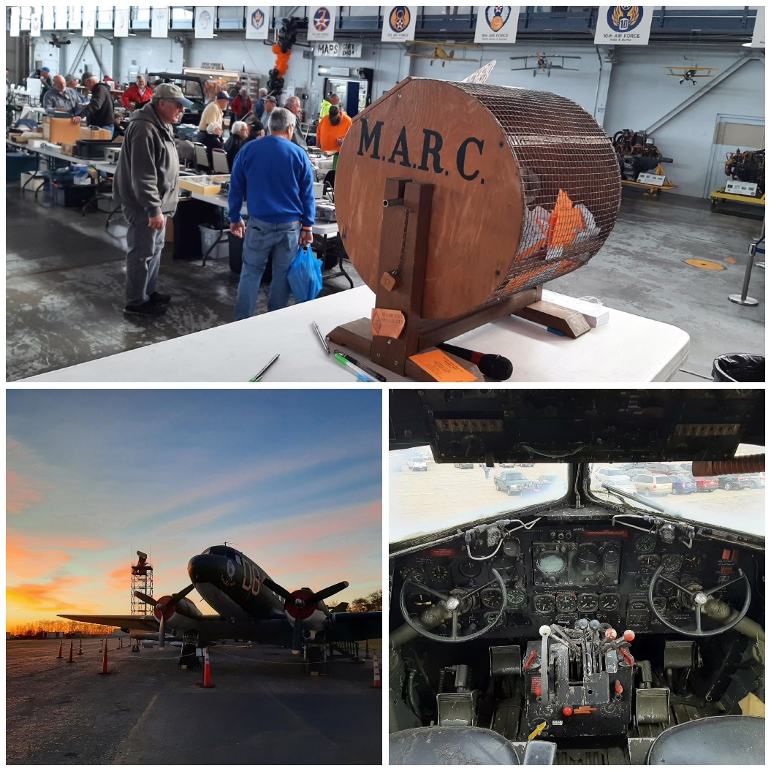

The October 30th MARC Hamfest at MAPS Air Museum was a tremendous success! A big “thank you” to all who joined us this year.

This year’s Hamfest was officially “sold out” a day before the event, although we were thankfully able to make last minute accommodations for some who arrived on the “day of…”

Again- thank you from the bottoms of our hearts and we’ll look forward to seeing you next year- same weekend!

Email- Club@W8NP.net

Contact- Gerry Sorensen, KG8RRY

The Massillon Amateur Radio Club is an ARRL Special Service Club

**Your Club news should be listed here!**

I know you’re out there doing things! Send me a write-up (MSWord please) and some photo’s (.jpg please) and we’ll get your club hi-lited here for the other OH Section Clubs to see! Send to [WB8LCD@ARRL.ORG](mailto:WB8LCD@ARRL.ORG)

**______________________________________________________________________________**

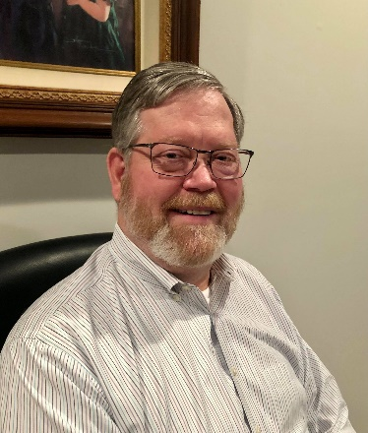**DX This Week – CQWW CW**

Bill AJ8B (aj8b@arrl.net, @AJ8B, or www.aj8b.com)

CWOPs Member #1567

I got a follow up from Mike, KC8WH. Every week I ask that you send along QSL cards received and Mike has done that. Check out the cards below. Mike said “Most of my QSLing has been on LoTW of late. But I did get a couple of cards in the mail this week. All of these were worked in September. The Zimbabwe (Z21ML) and New Caledonia (FK8HA) were on 10-meter FT8. The Mozambique (C91CCY) was on 20 phone and the very rare Ohio DX was on 30-meter FT8 in October.”

Thanks Mike!

|  |  |
| --- | --- |
|  |  |
|  |  |

DAH DIT DIT DIT DAH DAH DIT DIT DIT DAH

**CQWW CW -** At the end of the month, you will be able to participate in the CQWW CW Contest sponsored by CQ. The dates are November 27th and 28th. Details can be found at [www.cqww.com](http://www.cqww.com). Last year there was a record number of logs submitted. This is my favorite contest by far and I hope to work you in the contest.

The information below is reprinted from CQ Magazine of August, 2022, with their permission.

Join nearly 40,000 participants from over 200 DX entities and all 40 CQ Zones in the world’s largest DX contest.

The CQ World Wide DX Contest (CQWW) offers 48- hours of non-stop DX-chasing fun with activity taking place from virtually every part of the world! Whether you are competing for awards, looking for a few new band- countries, or simply filling up your logbook, the CQWW offers something for everyone. Check out the Classic and Rookie Overlay Categories for even more chances to enjoy ham radio’s premier operating event. Or perhaps the new Youth and Explorer Overlays may be for you. Regardless of your entry class, the bands magically light up in the CQWW with activity levels that are unlike any other radio competition.

Some Contest Basics

Each mode is a separate operating event that runs for 48 hours from 0000 UTC Saturday until 2359 UTC Sunday. SSB is the last full weekend of October. CW is the last full week- end of November.

Working stations is easy. Exchange and log a signal report and your CQ Zone number (e.g., 59 05 on SSB or 599 05 on CW). If you’re not sure which zone you’re in, visit <http://bit.ly/1BHtmsP> for more information. Generally speaking, for U.S. operators, the U.S. west coast is in Zone 3, the east coast is in Zone 5, and the rest of the lower 48 is in Zone 4. Western Europe is mostly Zone 14 and Japan is in Zone 25.

Contacts are valid only on the 1.8-, 3.5-, 7-, 14-, 21-, and 28-MHz amateur bands (No WARC bands or 60 meters).

Scoring

Your final score is based on QSO points earned for each contact times the number of multipliers worked. Contacts with other continents count three points each. Contacts with the same continent, but different country, count one point (except in North America where they count two points). Same-country contacts earn zero points but do count for multiplier credit.

Multipliers are the number of DXCC entities and Worked All Europe (WAE) countries, plus IG9/IH9, worked on each band plus the number of CQ Zones worked on each band.

Don’t worry about calculating your score; the CQWW Contest Committee’s contest log checking software will do that for you when you submit a log. Most participants are using readily available contest logging software to help as well (e.g., N1MM+, Win-Test, etc.)

Entry Categories

The competition is divided into Single Operator and Multi- Operator categories. There are also four additional Overlay sub-categories (see below).

Single Operator (all bands or any single band) – only one operator finds, makes, and logs all contacts in the following categories:

• High power: Up to 1,500 watts

• Low power: 100 watts or less

• QRP: 5 watts or less

Single Operator Assisted (all bands or any single band) – One operator may use DX spotting or other tools to help find contacts. Note that a CW decoder is considered assistance. The one operator must make and log all contacts in the fol- lowing power categories:

• High power: Up to 1,500 watts

• Low power: 100 watts or less

• QRP: 5 watts or less

Available Overlays

Classic Category – Allows the use of only one radio (e.g., Single Operator, Two-radio operation is not permitted), no QSO finding assistance, and only counts the first 24-hours of operating time. Off-times are a minimum of 60 minutes during which no QSO is logged. Single Operator Assisted entries are not eligible for this Overlay category.

Rookie Category – Open only to operators who are first licensed as radio amateurs less than three (3) years before the date of the contest.

Youth Category – Available to single operators who are 25 years old or younger at the start of the contest.

Explorer Category – Established to allow amateurs to participate in the CQWW Contest while experimenting creatively with internet-linked stations and other new technologies. The goal of this category is to encourage innovation in operating strategies, station design, and technology adaptation. Single- and Multi-operator entries are permitted. See <https://cqww.com/explorer.htm> for more information.

Multi-Operator – more than one person is involved in operating the station.

Single-Transmitter: This category allows one transmitter to work any station. It may only change bands after 10-minutes on a band. Note: A second transmitter may be used to work multipliers only. This category has some very specific restrictions so please read the full rules carefully.

• High power: Up to 1,500 watts

• Low power: 100 watts or less

Two-Transmitter: Allows the use of two simultaneously transmitted signals on two separate bands. Each station may change bands as many as 8 times per hour.

Unlimited: Allows the use of one transmitted signal on each band.

Awards

Electronic certificates will be made available for everyone who submits an entry, provided that entry is submitted before the log deadline. Plaques are awarded to top finishers in major categories.

Submitting Your Log

Electronic logs should be in the Cabrillo format. Most logging software generates this file automatically. Upload your log on the Web at <www. cqww.com/logcheck>. The website also includes a utility to convert an ADIF-formatted log file if needed. Please note that paper logs are no longer accepted.

All entries must be sent WITHIN FIVE (5) DAYS after the end of the contest: No later than 2359 UTC November 4, 2022, for SSB and 2359 UTC December 2, 2022, for CW. Resubmitting an entry after the deadline will result in it being considered as a late log.

Only one entry is permitted for each callsign. If you submit a log multiple times, the latest log submission will replace any previous attempts. No further action is required.

Full Rules

The complete rules of the CQWW DX Contest are available in English and 18 additional languages on the Web at <www.cqww.com/rules.htm> as well as the CQ magazine website at <www.cq-amateur-radio.com> (Look for link on home page or the CQWW DX Contest main page). In addition, there is a rules FAQ that provides additional answers to commonly asked questions.

You are strongly encouraged to review the rules and the frequently asked questions before the contest, especially for possible minor changes in some rule details from previous years. Any questions may be submitted via the online contact form at <http://cqww.com/contact>. The most important requirement for all competitors, however, is to have fun!

DAH DIT DIT DIT DAH DAH DIT DIT DIT DAH

Here is an update from Bernie, W3UR, of the DailyDX and the WeeklyDX, the best source for DX information. <http://www.dailydx.com/> . Bernie has this to report:

**TY – Benin -** The Finnish DX Team, TY5AF, with ops OH2TA, OH5BM and OH5LLR will be at Grand Popo Village November 21-29.  Within a few weeks afterwards they will upload the log to Logbook of the World.  Through Club Log OQRS with 3 USD/EUR per card you can get a traditional paper QSL.  Also, through Club Log OQRS you can get a bureau card, no charge.  If you can't do OQRS/PayPal, their preference, you can email QSL manager OH5LLR to get the mailing address.  Planned are spider beams for 20, 17, 15, 12, and 10M on a 12-meter pole, ZS6BKW antennas for 160-10 and other wire antennas for the low bands.  The radios are an FTDX10, FTDX3000 and KX2, plus SPE and RMA amplifiers.  They will be in the CQWW CW weekend event, probably multi-single.  
  
**3Y - Bouvet Island -** 3Y0J planning continues.  Press release 12 focuses on the budget, still $35,000 short of the target number.  $5,000 did come in, in response to this latest.  The money is going to the deposit on the vessel and deposit and cost of the container shipping, trucking, transport, and medications.  This week, four of the team members are going to a glacier in Norway, the Jostedal Glacier, the largest glacier in continental Europe, to practice the crossing of the Bouvet glacier to get to the camp.  Also, two ops went to a rock-climbing course to learn techniques for potential rescues.

**ZD7 - St. Helena -** As a reminder HB9FIY (aka M0ISF), Christopher, is now QRV, while vacationing, as ZD7CA for the next three weeks. Listen for him on 40 through 10 meters "when time allows" on SSB, PSK, RTTY, VARAC and CW. ZD7CA will also be on WSPR. QSOs will be uploaded (Editor's note: he did not say where) upon his return home, in December. QSL via EA5GL.  
  
**T8 – Palau -** Following up on the weather emergency news from the T88WA team they continue tweeting updates. In their latest tweet they report: "We are off the air for the rest of today. We had a very strong storm come through with heavy rains and strong wind which took out the shelter walls. Radios are at accommodations drying. Power is out. Happy everyone is ok. Antennas all still up when we left the site. Stay tuned." You can see photos and some short video clips at <https://twitter.com/T88WA>  
  
**KH8 - American Samoa -** After cancelling their T8YA and T8AR DXpedition to Palau W7YAQ, Bob, and K7AR, found an alternative Pacific location in Pago Pago, American Samoa. As a reminder the location they were going to had AC line noise problems. Bob and Al will be using one by one call K8H from November 18 to December 1. During the CQ World Wide CW DX Contest as a multi- single. They will have two Elecraft K3 stations and KPA500 amplifiers. Listen for them on 1.8 through 28 MHz. QSOs will be uploaded to Club Log "on a regular basis". QSL via OQRS, LoTW and W7YAQ.

DAH DIT DIT DIT DAH DAH DIT DIT DIT DAH

Below is a list of upcoming contests in the “Contest Corner”. I think this is important for someone who is trying to move up the DXCC ladder since entities that are on the rarer side and easiest to work in contests. Some of my best “catches” have been on the Sunday afternoon of a contest when the rarer entities are begging for QSOs. Of course, the gamble is that if you wait until Sunday, conditions may change, or they simply won’t be workable. However, it is not a bad gamble. Of course, why not work the contest and have some fun!  
Check out the WA7BNM Contest Calendar page (<https://www.contestcalendar.com/>) and CQ Magazine for more contests or more details. I also have a comprehensive list that can be imported to your calendar at [www.aj8b.com/files](http://www.aj8b.com/files)

The contests in red are those that I plan to spend some significant participation time on. PLEASE let me know if you are working contests and how you fared.

Thanks!

|  |  |  |
| --- | --- | --- |
| **Date(s)** | **Event** | **Info** |
| Nov. 16 | RSGB Autumn Series, SSB | <https://bit.ly/31qpcJl> |
| Nov. 16 | VHF-UHF FT8 Activity | [www.ft8activity.eu/index.php/en](http://www.ft8activity.eu/index.php/) |
| Nov. 18 | YO International PSK31 Contest | [www.yo5crq.ro/index.htm](http://www.yo5crq.ro/index.htm) |
| Nov. 19 | All Austrian 160M Contest | <https://bit.ly/3fgsiUo> |
| Nov. 19 | RSGB 2nd 1.8 MHZ Contest CW | <https://bit.ly/31qpcJl> |
| Nov. 19 | SARL Newbie Party | <http://bit.ly/H0IqQf> |
| Nov. 19-20 | LZ DX Contest | <http://lzdx.bfra.bg/rulesen.html> |
| Nov. 19-20 | REF 160-Meter Contest | <https://bit.ly/3iHzsQU> |
| Nov.19-20 | SARL Field Day Contest | <http://bit.ly/H0IqQf> |
| Nov. 19-21 | ARRL SSB Sweepstakes | [www.arrl.org/sweepstakes](http://www.arrl.org/sweepstakes) |
| Nov. 20 | FISTS Sunday Sprint | [www.fistsna.org/operating.html#sprints](http://www.fistsna.org/operating.html#sprints) |
| Nov. 24 | RSGB Autumn Series, CW | <https://bit.ly/31qpcJl> |
| Nov. 26-27 | CQWW DX CW Contest | [www.cqww.com/index.htm](http://www.cqww.com/index.htm) |
| Nov. 28 | RSGB FT4 Contest Series | <https://bit.ly/31qpcJl> |
| Nov. 30 | UKEICC 80 Meter Contest CW | <https://ukeicc.com/80m-rules.php> |

**ARRL DX news**  
  
SB DX ARL ARLD044  
  
This week's bulletin was made possible with information provided by LU5AG, ON3XI, The Daily DX, the OPDX Bulletin, 425 DX News, DXNL, Contest Corral from QST and the ARRL Contest Calendar and WA7BNM web sites.  Thanks to all.  
  
GHANA, 9G.  Dave, AB0GC is QRV as 9G1SD from the Wenchi, Brong Region.  Activity is on 17 to 6 meters using FT8 and FT4 at various times during the day.  QSL direct to home call.  
  
KUWAIT, 9K.  Members of the Kuwait Amateur Radio Society are QRV as 9K2F from Failaka Island, IOTA AS-118, until November 9.  Activity is on 80 to 10 meters using CW, SSB, and FT8.  QSL via 9K2HN.  
  
TONGA, A3.  Stan, LZ1GC and Ivan, LZ1PM are QRV as A35GC from Tongatapu, IOTA OC-049, until November 20.  Activity is on 160 to 6 meters using CW, SSB, RTTY, and FT8 with two stations.  QSL via LZ1GC.  
  
MOROCCO, CN.  Special event station CN47MS is QRV until November 10 and will commemorate the 47th anniversary of the Green March. Activity is on the HF bands using CW, SSB, and various digitalmodes.  This includes activity on Satellite QO-100.  QSL via CN8WW.  
  
URUGUAY, CX.  Special event station CX100B is QRV until November 30 to celebrate the 100th anniversary of Radio Paradizabal broadcasting for the first time beginning on November 2, 1922.  QSL via CX1AA.  
  
THAILAND, HS.  Lars, SM6NT is QRV as HS0ZME from Hua Hin and is here until April 2, 2023.  Activity is on 40 to 10 meters using mainly CW.  QSL to home call.  
  
ARGENTINA, LU.  Members of the Radio Club ARM Belgrano will be QRV with special event stations LU4AAO, LU4AAO/A and LU4AAO/D from November 5 to 13 for Tradition Day, which celebrates the birthday of Jose Hernandez.  Activity will be on the HF and V/UHF bands using CW, SSB, SSTV, and FT8.  Activity will include being on the FM Satellites.  QSL direct to LU4AAO.  
  
BRAZIL, PY.  Special event station ZW200ESQ is QRV until November 30 to celebrate the bicentennial of the Brazilian Navy.  Activity is on 80 meters to 70 centimeters using CW, SSB, various digital modes, and on the FM Satellites.  QSL via bureau.  
  
PAPUA NEW GUINEA, P2.  A large group of operators are QRV as P29RO from Loloata Island, IOTA OC-240, until November 10.  Activity is on all bands and modes.  QSL via DL4SVA.  
  
GREECE, SV.  A group of operators are QRV as SX22HAF until November 30 to celebrate Hellenic Air Force Day.  Activity is on all bands using CW, SSB, and various digital modes.  QSL via LoTW.  
  
BANABA ISLAND, T3.  Members of the Rebel DX Group are QRV as T33T until November 15.  Activity is on 160 to 6 meters using FT8 in DXpedition mode.  QSL via LoTW.  
  
PALAU, T8.  A group of operators are QRV as T88WA from Koror Island, IOTA OC-009, until November 14.  Activity is on 160 to 6 meters using CW, SSB, and FT8.  QSL via M0URX.  
  
MALI, TZ.  Jeff, TZ4AM is QRV from Bamako and is active on 40 to 6 meters using CW and SSB.  QSL via KX4R.  
  
ST. HELENA, ZD7.  Christopher, HB9FIY will be QRV as ZD7CA from November 5 to 26.  Activity will be in his spare time on 40 to 10 meters using SSB, PSK31, and RTTY.  QSL via EA5GL.  
  
THIS WEEKEND ON THE RADIO.  The ARRL CW Sweepstakes Contest,   
  
Please see November QST, page 77, and the ARRL and WA7BNM Contest  
web sites for details  
______________________________________________________________________________

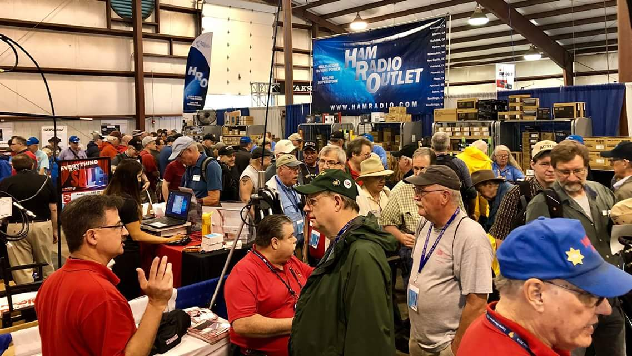[**Upcoming *Hamfests***](http://arrl-ohio.org/hamfests.html)

We **DO** have some hamfests scheduled for 2022!! Yes, take a good look at the list. And YES! They are starting to book up for 2023 already!

**__________________________________________________________**

|  |  |
| --- | --- |
|  |  |

|  |  |
| --- | --- |
|  |  |
|  |  |
| ***2022 & 2023*** | | | | |
| **12/03/2022 -**[**FCARC WinterFest**](http://www.arrl.org/hamfests/fcarc-winterfest-3)  **Location:**Archbold, OH **Sponsor:** Fulton County Amateur Radio Club **Website:** <https://k8bxq.org/hamfest> [**Learn More**](http://www.arrl.org/hamfests/fcarc-winterfest-3) | | | | **2022 is Done! I hope you made it to a**  **Fest or two. We had some pretty good**  **ones and I anticipate 2023 only getting**  **better! Hope to see you next year.** |
|  | | | |  |
| **01/15/2023 -**[**Sunday Creek Amateur Radio Federation Hamfest**](https://www.arrl.org/hamfests/sunday-creek-amateur-radio-federation-hamfest-2)  **Location:**Shade, OH **Sponsor:** Sunday Creek Amateur Radio Federation **Website:** [QRZ KC8AAV](https://www.arrl.org/QRZ%20KC8AAV) [**Learn More**](https://www.arrl.org/hamfests/sunday-creek-amateur-radio-federation-hamfest-2) | | | | **03/11/2023 -**[**MOVARC Hamfest**](http://www.arrl.org/hamfests/movarc-hamfest-8)  **Location:**Bidwell, OH 45614, OH **Sponsor:** Mid-Ohio Valley Amateur Radio Club [**Learn More**](http://www.arrl.org/hamfests/movarc-hamfest-8) |
| **05/13/2023 - 05/17/2023** [**RV Radio Network**](http://www.arrl.org/hamfests/rv-radio-network-1)  **Location:**Berlin, Ohio, OH **Type:** ARRL Operating Specialty Convention **Sponsor:** RV Radio Network [**Learn More**](http://www.arrl.org/hamfests/rv-radio-network-1) | | | | **05/19/2023 - 05/21/2023** [**Dayton Hamvention**](http://www.arrl.org/hamfests/dayton-hamvention-8)  **Location:**Xenia, OH **Type:** ARRL Hamfest **Sponsor:** Dayton Amateur Radio Association **Website:** [http://Hamvention.org](http://hamvention.org/) [**Learn More**](http://www.arrl.org/hamfests/dayton-hamvention-8) |
|  | | | |  |
| **07/08/2023 -**[**Mansfield Trunkfest 2023**](http://www.arrl.org/hamfests/mansfield-trunkfest-2023)  **Location:**Mansfield, OH **Sponsor:** Intercity Amateur Radio Club **Website:** [http://iarc.club](http://iarc.club/) [**Learn More**](http://www.arrl.org/hamfests/mansfield-trunkfest-2023) | | | | **07/16/2023 -**[**Van Wert Hamfest**](http://www.arrl.org/hamfests/van-wert-hamfest-7)  **Location:**Van Wert, OH **Sponsor:** Van Wert Amateur Radio Club **Website:** [http://w8fy.org](http://w8fy.org/) [**Learn More**](http://www.arrl.org/hamfests/van-wert-hamfest-7) |
| **08/12/2023 -**[**Cincinnati Hamfest℠**](http://www.arrl.org/hamfests/cincinnati-hamfest-2)  **Location:**Owensville , OH **Sponsor:** Milford ARC **Website:** [https://CincinnatiHamfest.org](https://cincinnatihamfest.org/) [**Learn More**](http://www.arrl.org/hamfests/cincinnati-hamfest-2) | | | |  |

**OHIO’S**  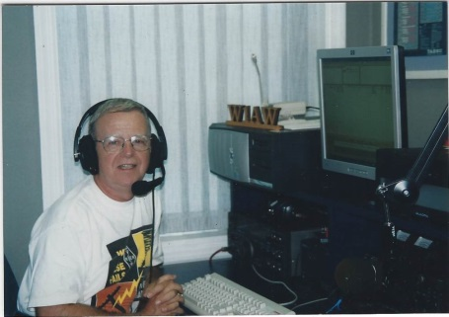

First I want to extend belated Veteran’s Day greetings to all of you who have served our nation in some form. Generally we think of those who served in one of our military services; however there are others who have served other branches such as the Peace Corps and VISTA. Thank you for your service!

Because most clubs in the South 40 region are winding down their activities for the remainder of the year, news is rather ‘Slim Pickins’. However the number of upcoming holiday meetings, parties, elections and gatherings and some community related Christmas activities are noteworthy.

Again CONGRADULATIONS are in order to the **Cambridge ARA** on their recent recognition by the ARRL’s Board of Directors marking the Club’s 75 years as an Affiliated Member Club of the League!

As you may have seen in the past Section Journal, all the ‘big wigs’ of the Great Lakes Division and Section gathered in Cambridge for an award presentation. Lyn notes that in 2023 the Club will observe its 110th year of existence which is longer than the ARRL has existed!

The results of the annual Ohio State Parks on the Air Contest are out. A big shout out goes to the **Sunday Creek ARF** for a first place finish in the Multi-op, Single Radio, High Power catergory. It was great to learn Mike Mullins, KN4COE, traveled across the Ohio River, activated Stonelick Lake and placed third in the Single Operator, Low Power, In a Park class. Another shout out goes to Marietta’s Ralph Matheny, K8RYU, who also did some traveling. He is now the proud holder of a first place certificate for his Rover activity as he went the extra mile to hit the road as a Rover and put four different parks in the logs of many people. I understand a few weeks later Ralph again hit the road again putting out a number of Pennsylvania counties in their state QSO Party. In a challenge of another type, it takes a lot of coordination for a single club to put stations on the air from multi-parks. And so it was with the **Highland ARA** which activated Lake Hope, Rocky Fork and Paint Creek. Although it was good to see the number of Southern Ohio clubs and individuals participating this year I couldn’t help but notice that at least six parks in our section of the State showed no activity or logs entered. As clubs face a new year, why not start planning on activating one of the parks that had no activity? A special thanks to the **Portage County ARA** for sponsoring this event.

Because of the annual Milford Christmas Parade, the **Milford ARC** will be unable to use their normal meeting location at the Milford Community Center for their November test session and business meeting. In order to take advantage of the lemon they ran into, they are going to convert it to lemonade and instead meet for a meal on the 17th at the Milford Bob Evans at 7:30 PM. Members are urged to spread the word.

The CW version of the ARRL November Sweepstakes took place this past weekend with the Phone version to happen on the 19th through the 21st. As mentioned in past columns this event is ideal for those wanting to add states, provinces, counties or parks to their collections. It also is a good contest where Technicians can cut their contest teeth because of all the recent ten meter propagation and activity. This is also an opportunity where clubs can hold member competitions to see who has club bragging rights. Speaking from experience, that by itself can be a lot of fun.

change.

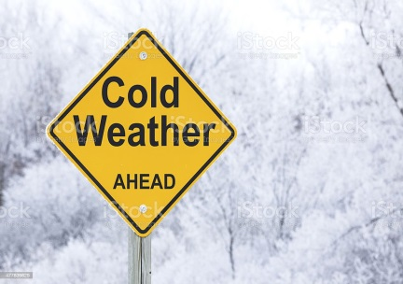

Thanks to the **Athens County ARC** and the **Tri-State ARA** we’ve learned the Charleston National Weather Service Office will have a virtual Winter Weather Storm Spotter Class to be held on November 17 at 6:30 PM. Registration for the session is requested at <https://attendee.gotowebinar/register/9121042016132322575>. If you are unable to attend the live presentation, it will be posted later on the Office’s weather spotter website .

**Athens County ARA** President Eric McFadden, WD8RIF, says all paid club members should have received their electronic ballots for the upcoming election of club officers. The deadline for members to cast their votes is Monday, November 14. The results will be announced at the Club’s meeting on November 15. Anyone who thinks they should have received a ballot should first check their spam mailbox. If nothing is found, then contact Eric. Nonminations for the 2023 officers of the **Clinton County ARA** will be open until November 30 on the Club’s website. Voting will begin on December 1 and end at the start of the December 8 meeting and Christmas dinner. The results of the vote will be announced at that time.

The **Southern Ohio ARA** will gather at the Ironton Frisch’s Big Boy on Monday evening, November 21 at 6 PM for their annual Christmas Dinner. The **Cambridge ARA**’s annual Awards Banquet will be on the afternoon of Saturday, December 3 at the Cambridge Denny’s from 2 until 4. Those attending either event will order their meal from the menu. The **Clinton County ARA**, **Athens County ARA** and **Hocking Valley ARC** have set the dates for their holiday gatherings but not yet determined firmed up the locations. The CCARA will meet on Thursday evening December 1, the HVARC will hold theirs on December 6 and the ACARA on December 20. Members and friends of the **Highland ARA** should mark their calendars and hold aside Tuesday evening, December 13 for the Club’s annual Christmas Dinner Party Extravagana at the Hillsboro Methodist Church. The **Portsmouth RC** will hold their annual holiday dinner on Saturday evening, December 17 at the Gathering Place in Wheelersburg. Attendance at these holiday events are a great time to support neighboring clubs and meet some really great people.

**Scioto Valley ARA** President Jesse Stanley, KC8CHP, has shared a writing with us called “my life adventure with radio”. It was written by Ross County native Bob Houf, K7ZB, who wrote it mostly to share with his grandchildren his involvement with technology and how it was the core of his life. The article is an interesting time travel about one man’s ham radio journey. The article is much too long to reproduce here. Therefore anyone wishing an enjoyable and interesting read of the article can contact Jesse. Or if more convenient, let me know and I will email a copy to you.

Two days after Thanksgiving (November 26) members of the **Cambridge ARA** will gather at 2 PM at the old railroad depot in Cambridge to assist with lineup and communications assistance for the annual Cambridge Christmas Parade. The parade starts at 5 PM. Then two days later the **Southern Ohio ARA** will help the Ironton Lions Club with communications and assistance in marshalling the parade for that city. Those helping are to meet at the 4th and Railroad Street Downtown Car Wash at 5 PM on Monday, November 28 for their assignments. The parade will happen regardless of the weather.

**Highland ARA** President and Net Manager Pat Hagen, N8BAP, reminds area hams the Club’s Monday evening net now starts at 8 PM due to the time change. The net occurs on the Hillsboro 147.21 (100 tone) and Greenfield 146.685 (118.8 tone) repeaters. He is the net control for the remainder of November and will turn the duties over to brother Richie, N8CUB, for December. Pat states the Sunday evening ten meter on 28.421 remains with Ron Bogart, WD8AIG, calling for check-ins at the 9 pm starting time.

Did you know that America’s first radio station, Pittsburgh’s KDKA made it’s first broadcast on November 2, 1920 with the broadcast of the results of the Harding-Cox presidential race?

A few weeks back we reported the passing of Neil Felheim, WA8AVM. It’s with deep sadness I now report the unexpected passing of his son Tony, K8TJF of Midland. Personally I knew Tony from our high school days over 50 years ago. Although we lived in ajoining Clinton County school districts it was ham radio was the common thread that brought us together. Tony was involved with the **Clinton County ARA**, the **Blanchester RC** and the **Highland ARA**. Tony was also well known throughout the Midwest for his trap shooting skills. Services were held in Wilmington on Wednesday.

The **Highland ARA**’s Brunch Bunch co-ordinator Ken Lightner, KE8JEL, states the **Highland ARA** held its November 12 gathering for the first time at the Hillsboro Burger King with a decent turnout. It’s expected the group will continue to meet there until warm weather allows them to return to the city park next Spring.

The **Lancaster Fairfield County ARA** will have its monthly club breakfast on Saturday morning, November 17 at the Lancaster Frisch’s, 1707 River Valley Circle North in Lancaster. The fun gets underway at 9 AM.

We all know emergencies don’t happen in just nice weather. Therefore training to operate during less than ideal weather conditions are important. Therefore a Winter Field Day was established to provide such an opportunity. This year finds the event on January 28 and 29. For those of you who have never participated in Winter Field Day, it is much like the June ARRL version, but colder. The **OH-KY-IN Radio Society** will operate from the Harvest Home Park and the **Athens County ARA** will operate from the Red Cross Building in Athens.

The **Tri-State ARA** will conduct a VE session on December 10 at the Museum of Radio and Technology in Huntington. Registration is not necessary and walk-ins will be accepted. All test elements will be given. Everything starts at 9 AM.

The National Weather Service office in Charleston, WV will celebrate the opening of its new offices and opertions center during Skywarn Recognition Day on December 3. Special event station W8W will be on the air from 00:00 to 24:00Z on that date. Electronic and/or snail mail QSL cards will be available to all making contacts with the station. The Charleston NWS Office serves the majority of West Virginia counties in addition to some northeastern Kentucky counties and the most of southeastern Ohio.

It’s always nice to leave the column on a positive note. And today is no exception as new ham licenses have been issued to Athens, Pickaway and Washington County residents. According to **Scioto Valley ARA** VE Coordinator John Hartmus II, WB8GRX, John Peters of Circleville journeyed to Chillicothe last Saturday with no license and left with not only his Technician, but a CSCE for General too! He is now KE8VYX. He is the son of Frankfort’s John Peters, KC8FAO. And based on information received from Ted Jacobson, W8KVK, the ham populations in Athens and Washington Counties grew with two individuals receiving their ham licenses. In addition to John Peters let’s welcome William White from Little Hocking and Vincent Keating of Coolville (actually closer to Torch) into the fold. William is now KE8VYN and Vincent is KE8VYW. Great going to all three. Now let’s make certain to get them on the air.

So with a good note in the rearview mirror I’m going to call it a wrap for another week. Until next time stay warm, healthy, safe and radio-active.

John Levo, W8KIW, [jlevo@cinci.rr.com](mailto:jlevo@cinci.rr.com) or highlandara@gmail.com, 937-393-4951

**Print an Official or Unofficial Copy of Your Amateur Radio License**

*(By Anthony Luscre, K8ZT)*

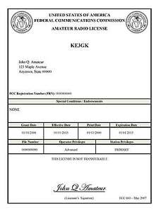

As of February 17, 2015, the **FCC no longer routinely issues paper license documents** to Amateur Radio applicants and licensees. The Commission has maintained for some time now that the official Amateur Radio license authorization is the electronic record that exists in its Universal Licensing System (ULS). The FCC will continue to provide paper license documents to all licensees who notify the Commission that they prefer to receive one.

Licensees also will be able to print out an official authorization — as well as an unofficial “reference copy” — from the ULS License Manager. I’ve created a set of instructions on how you can request an **“official” printed copy of your license\***

[**Click here to download the instructions**](http://arrl-ohio.org/news/2020/print_your_license.pdf)

***One Question Questionnaire***

!!!!! I would really like to hear from as many of you as possible on this one. While I know what I think the answer is going to be, the bigger the sample, the more accurate a survey like this is likely to be.

How about going to <http://arrl-ohio.org> and giving me a click? (It’s in the bottom left corner of the page)

**Did you make at least 5 QSOs in the last week?**

1. **Yes**
2. **No**

From last weeks question:

**Are you set up to run WinLink?**

1. **Yes**
2. **No**

**Out of 69 Responses: 23.2% (16) say Yess and 76.8% (53) say NO!**

Bottom of Form

Ohio Section Cabinet

|  |  |
| --- | --- |
| Section Manager – Tom Sly, WB8LCD | Section Traffic Manager – David Maynard, WA3EZN |
| Section Emergency Coordinator – Stan Broadway, N8BHL | Section Youth Coordinator – Anthony Luscre, K8ZT |
| Technical Coordinator – Jeff Kopcak, K8JTK | Affiliated Clubs Coordinator – Amanda Farone – KC3GFU |
| State Government Liaison – Bob Winston, W2THU | Public Information Coordinator – |



Hey Gang,

Have you taken a look at the **Swap & Shop** page on the Ohio Section webpage yet?? Here’s a link that will take you there… <http://arrl-ohio.org/sm/s-s.html>

Do you have equipment that you just don’t need or want anymore? Here’s a great venue to advertise it, and it’s FREE!! Is your club doing a fund raiser to help raise money? After a lot of thought, it was decided that the Swap & Shop webpage could also contain these types of items as well. The same rules will apply as do for the For Sales and Give-A-Ways and will only be posted for a month at a time. Please see the Terms & Conditions on the webpage.

If your club is doing a fund raiser and wants more exposure, please forward the information to me and I’ll advertise it on the Swap & Shop webpage for you.

Now, I still want to remind you that it won’t be listed in this newsletter because it would take up way too much space, so your ad will only appear on the website. It is there for any individual to post equipment Wanted / For Sale or Give-Away as well as for Club Fund Raisers. No licensed vehicles/trailers or business advertising will be posted. Postings are text only (no pictures or graphics) will be posted for a maximum of 1 month from date posting and require a contact phone number or email within the posting. Send your Wanted / For Sale or Give-Away post to:  [swap@arrlohio.org](mailto:swap@arrlohio.org)

***Back Issues of the PostScript and Ohio Section Journal***

Hey, did you know that PostScript and Ohio Section Journal (OSJ) are archived on the website? You can go back and look at any edition simply by clicking:

<http://arrl-ohio.org/news/index.html>

***Want to Share your Club Newsletter With Others?***

We have a webpage where you can download and read all of the newsletters that I get from around the state and even other sections!

Here’s the link to the page…. <http://arrl-ohio.org/club_news/index.html>

Please, if you don’t see your club newsletter posted, it’s because I’m not receiving it. Just have your newsletter editor contact me and I’ll get your club’s newsletter listed on the site!!

We all learn and steal (I mean, share) from each other’s work. So, get me your newsletter!!! Send it to: [webmaster@arrl-ohio.org](mailto:webmaster@arrl-ohio.org)

***Chit – Chat, and All That!***

Do you know someone that’s not getting these Newsletters? Please, forward a copy of this Newsletter over to them and have them “[Opt-In](mailto:Opt-In)” to start receiving them. Heck, just have them send an email to: [webmaster@arrl-ohio.org](mailto:webmaster@arrl-ohio.org) and we’ll get them added to the Ohio Section Emailing list.

We now have many thousands of readers receiving these newsletters weekly. Quite impressive, I’d say! I urge all of you to make sure that everyone, regardless of whether they are a League member or not, get signed up to receive these weekly Newsletters.

You can always “Opt-Out” at any time if you feel this is not what you were expecting. It’s fun and very informative. All of your favorite past newsletters are now archived too.

You can go back at any time and read them.

Just go to: <http://arrl-ohio.org/news/>

*PostScript is produced as a weekly newsletter. I want to thank everyone that has contributed articles and ideas to make this an even better news source. I sincerely hope that you have enjoyed this edition and will encourage your friends to join with you in receiving the latest news and information about the Ohio Section, and news and events happening around the world!*