[](http://arrl-ohio.org/news/)

***“October 17th, 2022******”***

🡪 [CQ WB8LCD](#lcd) 🡪 [National News](#national)

🡪 [DX This Week](#dx) 🡪 [Contest Corner](#contest)

🡪 [Upcoming Hamfests](#hamfest) 🡪 [One Question Questionnaire](#one)

🡪 [VE Testing](#ve) 🡪 [Club Corner](#club)

**The David Kalter Memorial Youth DX Adventure**

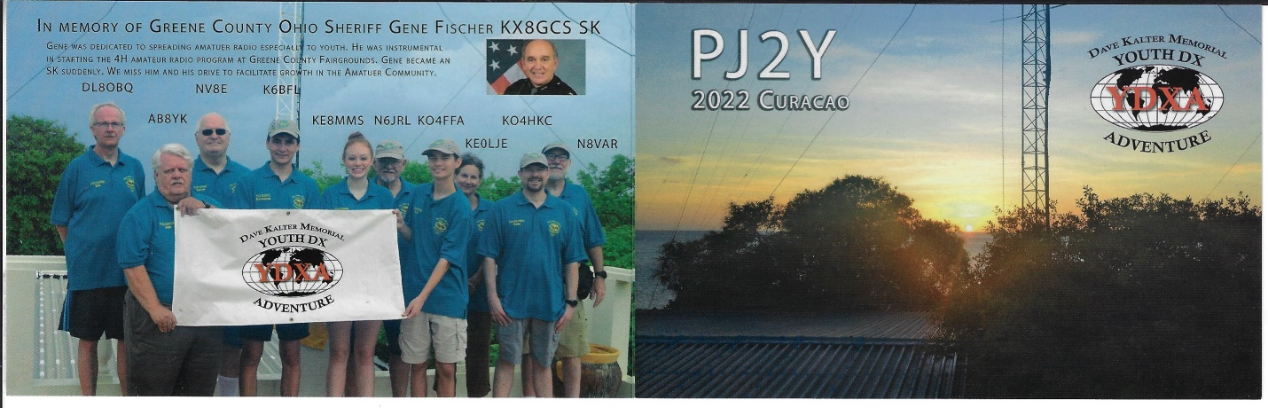

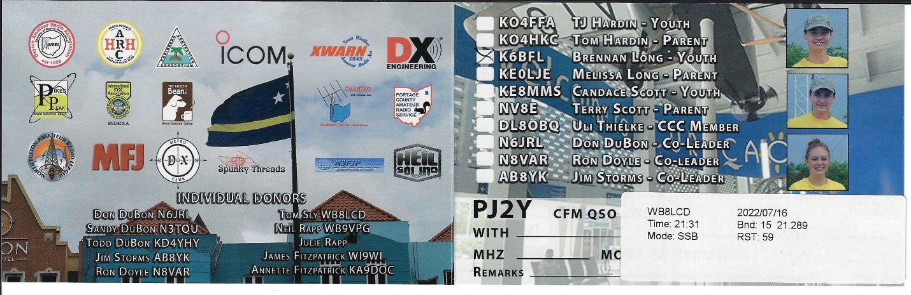

**CQ CQ CQ de WB8LCD**

We all know the importance of getting the younger generations involved and active in Amateur Radio. There really are many ways in which to do it, but it takes personal commitment and personal involvement to make it happen. I am a strong believer in, and supporter of the David Kalter Memorial Youth DX Adventure. It’s a program that I know makes a lasting impression on the young hams who are chosen to participate in it. Many thanks to Jim Storms - AB8YK and Don DuBon – N6JRL for their commitment to the program. Also to the Caribbean Contesting Consortium and Geoff Howard – W0CG (among others) for allowing them to participate from such beautiful and sought-after DX destinations. Please, before all us “Old Guys” are gone, participate in and support financially these types of programs! They can’t do it without us.

[**§ 97.1 Basis and purpose.**](https://www.ecfr.gov/current/title-47/section-97.1)

**The rules and regulations in this part are designed to provide an amateur radio service having a fundamental purpose as expressed in the following principles:**

**(a) Recognition and enhancement of the value of the amateur service to the public as a voluntary noncommercial communication service, particularly with respect to providing emergency communications.**

**(b) Continuation and extension of the amateur's proven ability to contribute to the advancement of the radio art.**

**(c) Encouragement and improvement of the amateur service through rules which provide for advancing skills in both the communication and technical phases of the art.**

**(d) Expansion of the existing reservoir within the amateur radio service of trained operators, technicians, and electronics experts.**

**(e) Continuation and extension of the amateur's unique ability to enhance international goodwill.**

Looking at (a) this week, I’m first off reminded of the Boy Scouts motto – Always Be Prepared. Back in May, 2011, in an [**FCC forum**](http://www.youtube.com/watch?v=bzx-kvo1i_Y) on earthquake communications preparedness, Federal Emergency Management Agency ([**FEMA**](http://www.fema.gov/)) Administrator Craig Fugate described the Amateur Radio operator as “the ultimate backup”. A few years later, in 2014, Fugate attended the 100th Anniversary of the ARRL in Hartford, CT. I was there too. Riding a bus from Hartford to Newington to visit W1AW, I started to talk to the guy sitting next to me and discovered that he was not a Ham, but was a FEMA employee who was part of the FEMA delegation at the event.

As we started talking, he told me that FEMA held “Emergency Preparedness” drills on a somewhat regular basis. They had an impeccable record for success. But when Craig Fugate became a FEMA administrator, he decided to try something different. Instead of having the “Emergency Drills” at the regular stated times and locations, he started having un-planned drills, at un-planned times. It was a failure.

At the FCC forum mentioned above, Fugate said that he thinks “we get so sophisticated, and we have gotten so used to the reliability and resilience in our wireless and wired and our broadcast industry and all of our public safety communications, that we can never fathom that they’ll fail. They do. They have. They will. I think a strong Amateur Radio community [needs to be] plugged into these plans. Yes, most of the time they’re going be bored, because a lot of the time, there’s not a lot they’re going to be doing that other people aren’t doing with Twitter and Facebook and everything else. But when you need Amateur Radio, you really need them.”

You need Amateur Radio when All Else Fails. But that statement is dependent on us (collectively and individually) being prepared. There are a few basic things you can do to prepare yourself for service:

1. Make sure your own household is as prepared as possible for an emergency.
2. Participate in Nets so that you know basic net procedures
3. Be a Net Control Station – that’s not really something you want to learn how to do in the heat of an emergency.
4. Learn how to pass formal radio traffic.
5. Join an ARES group in your area.
6. When you want to take it to the next level, take some NIMS courses (start with ICS 100/200/700 & 800 – and when you finish a course, be sure to submit your certificate to Jim Yoder – W8ERW at [w8erw@arrl.net](mailto:w8erw@arrl.net) ).
7. Participate in Public Service events.

Being prepared for Emergency Communications is not just a suggestion, it’s something we’ll be judged on when and if we must justify our existence. Everyone is capable of some role in emergency communications. Be prepared.

**Youth Net**

**When:** The second Sunday of every month at 7:30 PM EST

**Where:** The K8IV repeater located in Kent, Ohio (Echolink node K8BF-L) RF: 146.895 Mhz  with PL 118.8

**Who:** Any licensed amateur radio operator who wishes to participate. Priority will be given to youth stations and those located in Ohio.

The purpose of this net is to encourage youth activity in amateur radio and to help new hams get more comfortable on the air.

We’ve been running this net for several months now. Our first net in April had the largest participation, it went down and now seems to be coming back up. Help us spread the word and if you know a young operator please let them know about this opportunity to learn who the other young hams are.

Finally, I want to announce that I have appointed Amanda Farone – KC3GFU as the Affiliated Club Coordinator (ACC) for the Ohio Section. Please welcome and support Amanda as she begins her service to the Clubs in the Ohio Section.

73,

Tom Sly - WB8LCD

Ohio Section Manager

[wb8lcd@arrl.org](mailto:wb8lcd@arrl.org)

330-554-4650

***National News***

*(from ARRL and other sources)*

**October 15 - 16 is session three of the ARRL EME Contest, for frequencies between 50 MHz and 1296 MHz.**

It's never been easier to complete the Earth-moon-Earth circuit.Lance Collister's, W7GJ, "[6 Meter EME Array](http://www.bigskyspaces.com/w7gj/)" document from 2010 talks about the minimum frequency you'd need to decode signals from the moon, which can be boiled down to a good antenna, reasonable radio, and appropriate software. Activity also helps. With a "regular" 6-meter antenna, it should be possible to copy signals from the moon at moonrise, taking advantage of ground gain. -- *Thanks to ARRL Contest Program Manager Paul Bourque, N1SFE, for this information.*

***\_\_\_\_\_\_\_\_\_\_\_\_\_\_\_\_\_\_\_\_\_\_\_\_\_\_\_\_\_\_\_\_\_\_\_\_\_\_\_\_\_\_\_\_\_***

**Amateur radio operators are needed for the Marine Corps Marathon on October 30, 2022, in Washington, DC, and Arlington, Virginia.**

 The call is for 150 amateur radio operators to provide "eyes on the course" using the 144 and 420 MHz bands, with FM and Digital Smart Technologies for Amateur Radio (D-STAR), and a Medical Data Network using Amateur Radio Emergency Data Network (AREDN). Amateur radio will also be used as back-up communications in case all else fails. Operators will prepare themselves, supplies, and equipment to function in a large-scale, multi-jurisdictional, mass casualty-type event under real-world conditions. Training will be provided, and each operator will receive a commemorative T-shirt. Amateurs can sign up by following the link [www.mcmham.org](https://www.mcmham.org/). To learn more about the 2022 Marine Corps Marathon, visit their website at [Marine Corps Marathon](http://www.marinemarathon.com/events/marathon).

***\_\_\_\_\_\_\_\_\_\_\_\_\_\_\_\_\_\_\_\_\_\_\_\_\_\_\_\_\_\_\_\_\_\_\_\_\_\_\_\_\_\_\_\_\_\_***

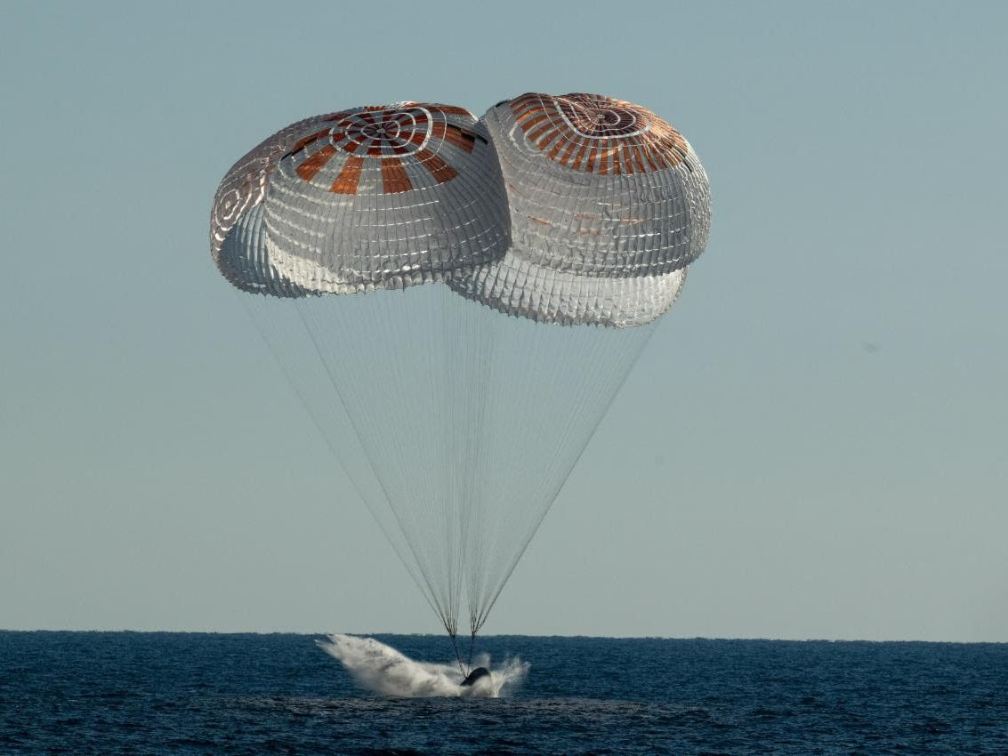

|  |  |
| --- | --- |
| |  | | --- | | [**Crew-4 Astronauts Return to Earth After Six Months in Space**](https://r20.rs6.net/tn.jsp?f=001vsO_vOXKTvo-XnkZC8mZMtFa_I37_hYtzzjJUduxXqHVRsUsTWHCkTP1p1oUV0Cd49mCoqXzFC7ymEr9rOOGxvkAZOXCF5Szzfukd4Aj5edNK_M6ru2RXOITt0FDd1NAcVrUjwVTpu2xr3eWaF0rq9c2SCQStzztf1TuIeGxXIqfcDdbaAGEKr0opz6vzhirzqte7ViMIaF48H8hD0iYg_U6_GwIf3vh9kfochgAlMUVysMtUeqx7Q==&c=9zi3GpEs7c-WnczFOV_sOD_VB9azIzH5Fm_J4Z-0ccXKkniY4zV6JA==&ch=I2WG0rKSJC6lvSfUVpCZMh8Fpyd5GX9YaATWCI_Iky2CQBbynu2Vag==) | |

|  |  |
| --- | --- |
| |  | | --- | | NASA’s SpaceX [Crew-4](https://r20.rs6.net/tn.jsp?f=001vsO_vOXKTvo-XnkZC8mZMtFa_I37_hYtzzjJUduxXqHVRsUsTWHCkcWzYLt9pyN-in89T9ScFtaOwpHlpYZ2kUJOifMI5qOJFwAT5whIyQGreetdlh-BofXQycGpECyRqPpX13Tl56nSW397NWJvHSybBzWKQ5sBSOBTXXDcSMpPb88DiOy4u-_JVF8on5_6mTSAfMkL1Vb-mdZlZqbGDkPEIf-scp83yJVWL0H7p0w=&c=9zi3GpEs7c-WnczFOV_sOD_VB9azIzH5Fm_J4Z-0ccXKkniY4zV6JA==&ch=I2WG0rKSJC6lvSfUVpCZMh8Fpyd5GX9YaATWCI_Iky2CQBbynu2Vag==) astronauts have returned home after their nearly six-month science mission aboard the International Space Station.  NASA astronauts [Bob Hines](https://r20.rs6.net/tn.jsp?f=001vsO_vOXKTvo-XnkZC8mZMtFa_I37_hYtzzjJUduxXqHVRsUsTWHCkTP1p1oUV0CdS6Rvacxml5WnLqK7E5Hygub9oSVUY0vdo2AHt3-al9hDhZqYo5CgMu2sBoDejK8xcsNH0Sz8OvzFc0VHoORULCcf4VWUqlUbuueNFOrtfjzuXU-9uasWI-7Yi5uhSyfj&c=9zi3GpEs7c-WnczFOV_sOD_VB9azIzH5Fm_J4Z-0ccXKkniY4zV6JA==&ch=I2WG0rKSJC6lvSfUVpCZMh8Fpyd5GX9YaATWCI_Iky2CQBbynu2Vag==), [Kjell Lindgren](https://r20.rs6.net/tn.jsp?f=001vsO_vOXKTvo-XnkZC8mZMtFa_I37_hYtzzjJUduxXqHVRsUsTWHCkcWzYLt9pyN-CFma6hUgISRrLZXqcveo9rO44SECAenVozm_TWZ98XoCUG3WhDOEbMkFfe7I80hAmjfqiN85wBDRZZ1jiftEq9mqcer25HuxvNAgIetQVQoNIj15DwBUu5Ii4pODSDPLbFZjLYVyvC2KMfYGFkafaw==&c=9zi3GpEs7c-WnczFOV_sOD_VB9azIzH5Fm_J4Z-0ccXKkniY4zV6JA==&ch=I2WG0rKSJC6lvSfUVpCZMh8Fpyd5GX9YaATWCI_Iky2CQBbynu2Vag==" \t "_blank), and [Jessica Watkins](https://r20.rs6.net/tn.jsp?f=001vsO_vOXKTvo-XnkZC8mZMtFa_I37_hYtzzjJUduxXqHVRsUsTWHCkb2FoHYLBU4bHaXMfZ_j1pY-CFEsxMCZ-EWp-ib7yClv4vbv6kAjLGX1zwAHPBjI8yYxftwgPJZfySyiyZWfzLOpWImiSi09Ty4tR73JUWdjIKnDe1wv06SDtxMQaDJsyEmGIt8oMO5Hi7e0tRg2EZk=&c=9zi3GpEs7c-WnczFOV_sOD_VB9azIzH5Fm_J4Z-0ccXKkniY4zV6JA==&ch=I2WG0rKSJC6lvSfUVpCZMh8Fpyd5GX9YaATWCI_Iky2CQBbynu2Vag==), as well as ESA (European Space Agency) astronaut [Samantha Cristoforetti](https://r20.rs6.net/tn.jsp?f=001vsO_vOXKTvo-XnkZC8mZMtFa_I37_hYtzzjJUduxXqHVRsUsTWHCkcWzYLt9pyN-tvUxzQVpNJTa-V82tvN29Bfnk1tJI9A70riNlfaCQPbXEpO7YAL95ebkM50yDdKMJhdJBZW3AQI1pTGtV3Lro-NVF07Fswn3thcGQcdUECnHwsWt2aKi909K5GsgYxG-HNtKKE2Fkhmmb6YmZ6GNOgZiugmnTw_ShrgurEBTB2PWk4tjP0gbWsRhizAIkNSj&c=9zi3GpEs7c-WnczFOV_sOD_VB9azIzH5Fm_J4Z-0ccXKkniY4zV6JA==&ch=I2WG0rKSJC6lvSfUVpCZMh8Fpyd5GX9YaATWCI_Iky2CQBbynu2Vag==), safely splashed down off the coast of Florida on Friday, Oct. 14.  The SpaceX Dragon Freedom crew ship carrying the Crew-4 astronauts undocked from the International Space Station’s Harmony module at 12:05 p.m. EDT (16:05 UTC) on Friday. After spending several hours in transit, the spacecraft re-entered Earth’s atmosphere and landed in the Atlantic Ocean at 4:55 p.m. EDT (20:55 UTC). Their departure leaves seven international crew members, including fellow NASA astronauts Nicole A. Mann, Frank Rubio, and Josh Cassada, aboard the orbital laboratory.  Crew-4, NASA's fourth Commercial Crew mission, launched April 27 on a SpaceX Falcon 9 rocket from the agency’s Kennedy Space Center in Florida. During their time aboard the orbiting laboratory, the crew members contributed to hundreds of ongoing and new [scientific investigations](https://r20.rs6.net/tn.jsp?f=001vsO_vOXKTvo-XnkZC8mZMtFa_I37_hYtzzjJUduxXqHVRsUsTWHCkTP1p1oUV0Cd6XEM4qxR3QyWiHt9_76qO7DpDWyAx_4IvBJhwtlrRrMuv5jDGQ2mEhTdPkI_eclI7oZPF4v9wQgO5uKCu2q8Stpd_e3zGyG9W_v7HPbJWruskfk0ETNqxy5DFdJAf5ouBihQgFEie-GeGzJQfBaGju0fPjesf-Oxjf-hh0yQ41Sdoqa_eBkHLw==&c=9zi3GpEs7c-WnczFOV_sOD_VB9azIzH5Fm_J4Z-0ccXKkniY4zV6JA==&ch=I2WG0rKSJC6lvSfUVpCZMh8Fpyd5GX9YaATWCI_Iky2CQBbynu2Vag==) and technology demonstrations, including studies on human immune cells, plant growth, and materials science.  Want to learn more about what’s happening at the orbital laboratory? Follow the International Space Station’s [Facebook](https://r20.rs6.net/tn.jsp?f=001vsO_vOXKTvo-XnkZC8mZMtFa_I37_hYtzzjJUduxXqHVRsUsTWHCkbgiCX0g0oOJ4KDV_G4nRtFqr0GC1G2ys2ajt9hFF9OGi4Wiv-1wuEsskpqY5EofyD4E21CalUbuiRLEAQpG5hOVWIcz2VXWPw==&c=9zi3GpEs7c-WnczFOV_sOD_VB9azIzH5Fm_J4Z-0ccXKkniY4zV6JA==&ch=I2WG0rKSJC6lvSfUVpCZMh8Fpyd5GX9YaATWCI_Iky2CQBbynu2Vag==) and [Instagram](https://r20.rs6.net/tn.jsp?f=001vsO_vOXKTvo-XnkZC8mZMtFa_I37_hYtzzjJUduxXqHVRsUsTWHCkYXp7ax7CE-w64FHgttvL-EjNiT9if_SWSHH2WyazAEx-UFHpBbetqg2S13l44dzMvEk_u-38clajvKXni0TUqFg_SdjBtdUrBf-4wT5CG5Z&c=9zi3GpEs7c-WnczFOV_sOD_VB9azIzH5Fm_J4Z-0ccXKkniY4zV6JA==&ch=I2WG0rKSJC6lvSfUVpCZMh8Fpyd5GX9YaATWCI_Iky2CQBbynu2Vag==) accounts, [@space\_station](https://r20.rs6.net/tn.jsp?f=001vsO_vOXKTvo-XnkZC8mZMtFa_I37_hYtzzjJUduxXqHVRsUsTWHCkYXp7ax7CE-waBHIx9ac8Xo68tv0cUaNB92Jv24jq0hLLsuulWNtdInlRSOsBvGZ0BiLlldVSMxyqm6DE9JZ3jZAF6lmgD9DVQLprXy_oFqC&c=9zi3GpEs7c-WnczFOV_sOD_VB9azIzH5Fm_J4Z-0ccXKkniY4zV6JA==&ch=I2WG0rKSJC6lvSfUVpCZMh8Fpyd5GX9YaATWCI_Iky2CQBbynu2Vag==) and [@ISS\_Research](https://r20.rs6.net/tn.jsp?f=001vsO_vOXKTvo-XnkZC8mZMtFa_I37_hYtzzjJUduxXqHVRsUsTWHCkbgiCX0g0oOJnBVNUwFnrvfFoqOLY3cjsqbd2z0_2WdubY0BucXszp5COSSmfU8AklNsLJyiZnlQZ20MtTdhyvwKVMBlJKBXOxM98MALFUxL&c=9zi3GpEs7c-WnczFOV_sOD_VB9azIzH5Fm_J4Z-0ccXKkniY4zV6JA==&ch=I2WG0rKSJC6lvSfUVpCZMh8Fpyd5GX9YaATWCI_Iky2CQBbynu2Vag==) on Twitter, or visit our [Commercial Crew Program](https://r20.rs6.net/tn.jsp?f=001vsO_vOXKTvo-XnkZC8mZMtFa_I37_hYtzzjJUduxXqHVRsUsTWHCkap5qx_3m_IckFw9srU7VU245vh9GI9RZZZqS5RpBJJZcl1j_kdrZR4-skHHQRoSSGKRP1yjRBCqLarsQ4Uw9o8QvqnaQivuX45idxewvBgHfXirW5RRSJg=&c=9zi3GpEs7c-WnczFOV_sOD_VB9azIzH5Fm_J4Z-0ccXKkniY4zV6JA==&ch=I2WG0rKSJC6lvSfUVpCZMh8Fpyd5GX9YaATWCI_Iky2CQBbynu2Vag==) blog. | |

|  |  |  |  |
| --- | --- | --- | --- |
| |  |  |  | | --- | --- | --- | | |  |  | | --- | --- | | |  | | --- | | [Get More Space Station Updates](https://r20.rs6.net/tn.jsp?f=001vsO_vOXKTvo-XnkZC8mZMtFa_I37_hYtzzjJUduxXqHVRsUsTWHCkf01e3tM_TDTjfxK7FjMKZMF8HCSupv6eRTxy4uybbW_mcs6Y8wmc-MtMSTqXVFZ7ioetuPT70sRDeOGP9KeJpItZdMxYi88LuwdIgewKIqSqvani7Ft18AceGEr0ZjfaCrmc-jVV5tZU8ZIwI-EjCWJ0JX2QHkzcw==&c=9zi3GpEs7c-WnczFOV_sOD_VB9azIzH5Fm_J4Z-0ccXKkniY4zV6JA==&ch=I2WG0rKSJC6lvSfUVpCZMh8Fpyd5GX9YaATWCI_Iky2CQBbynu2Vag==) | | | |

|  |
| --- |
|  |

Free General Class Course on Zoom starting Oct 27, 2022

A free, weekly, live, Amateur Radio General Class Licensing course on Zoom will begin on Thursday, Oct 27 and will run through Thursday, January 5.  There will be 9 sessions, with two breaks for holidays.  The three-hour sessions will start at 6:30 PM Eastern Time.  Sessions will be recorded. These are the classes that we have been holding for years sponsored by the National Electronics Museum.  Those wishing to sign up should email [roland.anders@comcast.net](mailto:roland.anders@comcast.net).

73, Rol Anders, K3RA

***\_\_\_\_\_\_\_\_\_\_\_\_\_\_\_\_\_\_\_\_\_\_\_\_\_\_\_\_\_\_\_\_\_\_\_\_\_\_\_\_\_\_\_\_\_\_***

**Beginner's Guide to HF**

***Anthony Luscre, K8ZT*** [*k8zt@cfarc.org*](mailto:k8zt@cfarc.org)

**Three One-Hour Sessions**

Co-presenters Dennis Kidder, W6DQ and Anthony Luscre, K8ZT, present a series of three sessions covering almost all aspects of getting on HF for new hams. The sessions will be held live via Zoom on three consecutive Wednesdays- Oct 12, 19 & 26th at 9 PM Eastern Time. Zoom link- [*https://us02web.zoom.us/j/2128884758?pwd=VTE0ajAraG0rMyticmtwN2ZCdHZ3Zz09*](https://us02web.zoom.us/j/2128884758?pwd=VTE0ajAraG0rMyticmtwN2ZCdHZ3Zz09)

Passcode: WEDNESDAY

The sessions will also be recorded for later viewing:

1. Week 1- The HF Bands, Operating & Making Contacts
2. Week 2- Equipment & Antennas
3. Week 3- Putting It All Together

* Slideshow from the presentations, including clickable links and resources, is available at [*tiny.cc/bghf*](http://tiny.cc/bghf).



Magic & Character of HF Bands

* The allure of talking with hams in far away & exotic sounding places around the world
* What are the HF Bands
* US Amateur HF Privileges
* FCC Rules vs. Gentlemen’s Agreements
* Traditional vs. WARC & Post WARC Bands
* 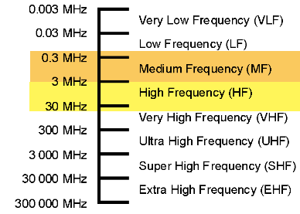Typical vs. Atypical HF Bands
* Personalities & Moods of Bands
* Propagation
* HF vs. VHF/UHF

Operating on HF

* Modes on HF
* Contacts
* How to Make QSOs- Techniques & Tips
* Increasing Chances of Contacts
* HF Activities
* Nets
* Contests

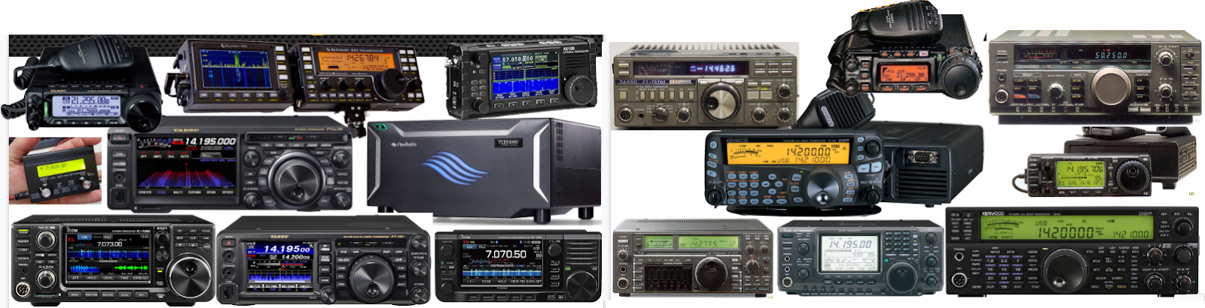Acquiring Equipment

* Choices to make
* Different types of radios
* Where/how to acquire
* Components of an HF Station
* Accessories
* Antennas

Setting Up your radio

* Radio Shack
* Safety & Compliance

HF Challenges

* Antennas
* Limited Mode & Frequency Allocations
* Outside Limitations (HOA, Interference, etc.)

Computer in Radio Shack

* CAT
* Sound Card Interface
* Software

These sessions are sponsored by the [*RATPAC group*](https://www.ratpac.us/), which has over 240 recorded previous sessions on a wide variety of Amateur Radio topics- [*tiny.cc/ratpac-list*](http://tiny.cc/ratpac-list). The Zoom link to attend future meetings is- [*https://us02web.zoom.us/j/2128884758?pwd=VTE0ajAraG0rMyticmtwN2ZCdHZ3Zz09*](https://us02web.zoom.us/j/2128884758?pwd=VTE0ajAraG0rMyticmtwN2ZCdHZ3Zz09)

Passcode: WEDNESDAY or THURSDAY.

***\_\_\_\_\_\_\_\_\_\_\_\_\_\_\_\_\_\_\_\_\_\_\_\_\_\_\_\_\_\_\_\_\_\_\_\_\_\_\_\_\_\_\_\_\_\_***

***Club Corner***

This is YOUR cornner of the newsletter. Send me what your club is doing and I’ll make sure that it gets in. Got a special event or club project that you want everyone to know about? Send it to me! Need help with a project? Send it to me.

Let me know what you club is up to. Are you going to have a special guest at your meeting or are you having a special anniversary?

Just send it to: [webmaster@arrl-ohio.org](mailto:webmaster@arrl-ohio.org)

Please! Format as below:

******If you want me to publish your club information, or even an article you have written, please send it in WORD format (.docx). Please use Times New Roman font size 12 for the body of the aritcle. Any photos please include as a .jpg or .bmp – the time you save me in doing all the conversions will be greatly appreciated.

Club Grant Application Period Open Until November 4

The ARRL Foundation Club Grant Program opened a second grant proposal period which began September 7, 2022, and runs until November 4, 2022, at 7 PM Eastern Time. Radio clubs can apply now, and information about the program can be found on the ARRL website at [www.arrl.org/club-grant-program](http://www.arrl.org/club-grant-program).

Following the first proposal period that ran earlier this year, 128 clubs applied for grants with a variety of outstanding projects. Emphasis is placed on projects that have a component of community involvement, training, new ham development, and club revitalization. Twenty-four clubs were chosen and nearly $270,000 was awarded.Clubs that applied in the first round and did not receive a grant are urged to reapply. The ARRL Foundation will award an additional $230,000 in grants at the end of the second application round.

An informational webinar was held on September 7, and a recording of that event can be seen on ARRL's YouTube channel at <https://youtu.be/ZNvc_eeIIwU>.

**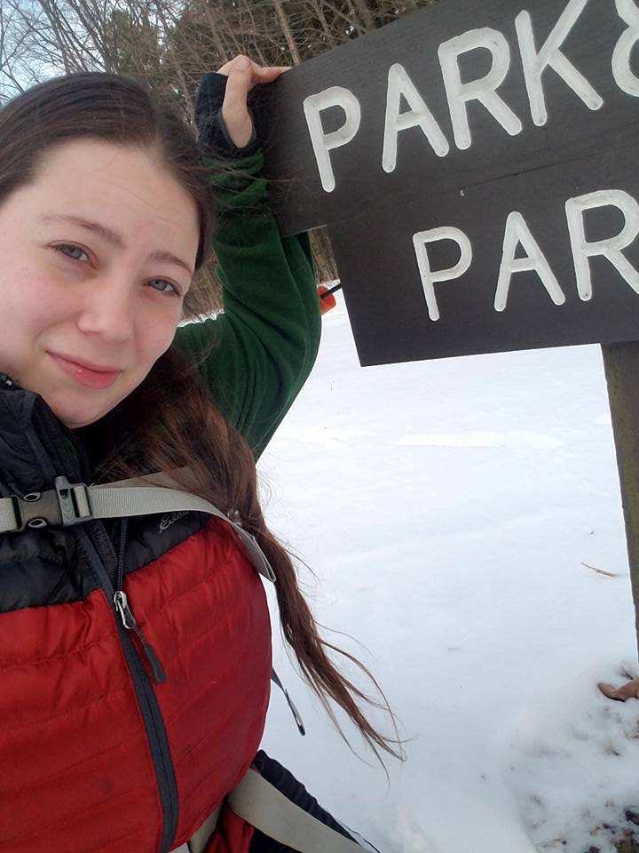New Ohio Section Affiliated Club Coordinator Appointed**

I want to start off by saying I am both honored and excited to start this journey as the Ohio Section’s Affiliated Club Coordinator (ACC). If we haven’t met yet, hello, my name is Amanda KC3GFU, and I hope to meet you soon. I was first licensed in 2015 but did not become super involved with amateur radio until this past year. I really enjoy POTA, Special Event Stations, Contesting, Public Service Events, Hamfests, collecting QSL cards, educational activities, and fun activities that bring us together to have fun, learn, and grow as operators.

As your ACC I am here to support your club in any way that I can. My goal is to see the clubs within the Ohio Section thriving and doing well. Over time, I plan to visit with as many clubs as possible and learn your strengths, needs, and interests. My focus will be on helping you execute your ideas utilizing the resources I have available to me and suggesting new ideas that may have been overlooked.

I have had successful experience with coordinating Public Service Events, participating in large scale Public Service Events, managing an on-going library program for licensing and workshops, coordinating and managing a Special Event Station, educating and demonstrating for the Boy Scouts, organizing and executing Field Day, promotion of club activities, Newsletter Editor, Secretary, social media managing, and finding/setting up for meeting Presenters. I am sure there is more that I am forgetting but these are the ones I am most proud of.

I don’t have much to report on as I am just getting started, but I hope to meet with you all soon. If you have any questions, things you would like to chat about, or are interested in becoming an ARRL Affiliated Club or Special Service Club, please reach out to me.

Amanda – KC3GFU afarone926@gmail/com

**Want to know where to go to get the courses you need? It’s all Right Here!**

* [Ohio EMA Training Calendar](https://webeoctraining.dps.ohio.gov/TrainingAndExercise/courselist.aspx)
* [Login to the DPS Training Campus](https://learning.dps.ohio.gov/PSTC/)
* [Create a new account on the DPS Training Campus](https://learning.dps.ohio.gov/PSTC/)

**NOTE:**

* Most courses are in-person but some course may be hosted virtually (this will be noted).
* Seats available listed are as of the release of this update and will change quickly.
* All classes will be posted on the DPS training campus at least 60 days prior to the start of the course.
* Please read the [Training Policy & Catalog](https://ema.ohio.gov/documents/training/ema0201.pdf) for more information on Ohio EMA trainings.

\_.\_,\_.\_,\_

How to Plan and Apply for an ARRL Hamfest or Convention

If your amateur radio club is planning to host a convention, hamfest, tailgate, or swapfest, please consider applying for ARRL sanctioned status for your event. To learn what it means to be an ARRL sanctioned event, and to get some ideas on how to prepare for and conduct a hamfest or convention, visit [www.arrl.org/arrl-sanctioned-events](http://www.arrl.org/arrl-sanctioned-events).

To apply for ARRL sanctioned status for your event, go to [www.arrl.org/hamfest-convention-application](http://www.arrl.org/hamfest-convention-application).

The ARRL Hamfests and Conventions Calendar can be found online at [www.arrl.org/hamfests](http://www.arrl.org/hamfests). In addition, the Convention and Hamfest Calendar that runs in *QST* each month also presents information about upcoming events.

Go Fully Electronic in 2022!

By Maria Somma, AB1FM, ARRL VEC Manager

**Online Examinations and Remote Testing**

Your club's VE team can become part of the fun and excitement of remotely administered Online Examinations.  
  
The remote exam sessions are conducted using an online video conferencing platform and a web-based examination system with on-screen tests. ARRL VE teams have had the option to be completely electronic since June 2020 by using online exams. The online exams can also be utilized at in-person sessions automating most of the process, for a fully electronic in-person session experience.  
  
VE teams have been using the [Exam.Tools](https://exam.tools/) Online Examination system for remote video and in-person sessions. Over 25,000 applicants have been tested through the Online Examinations system in the past two years. The system works well for online or printed examinations and includes registering and tracking candidates throughout the session, on screen exams and grading, online signing of CSCE and 605 forms by the candidate and examiners, logging and compiling session stats and VE participation list (test report summary), and output files for upload to the coordinating VEC. The program manages and handles almost everything needed to conduct a test session. Time and experience with in-person exam sessions is invaluable when transitioning to remote video-supervised online exam sessions.  
  
Interested ARRL VE teams must contact the [VEC department](mailto:vec@arrl.org) to receive the online exams instructions and remote video session procedures.  
  
Not a VE? Become one today!  
  
Visit <http://www.arrl.org/become-an-arrl-ve>  
  
**Electronically File Exam Session Documents for Quicker Service**

After the session has concluded, VE teams can upload in-person documents or remote video session files via ARRL VEC's secure web page (program service option since 2018).

New and upgraded licenses are issued within 1 to 2 business days for weekend sessions and are usually issued on the same day for weekday sessions.

Please contact the [VEC department](mailto:VEC@arrl.org) for the information and instructions on electronically filing exam session documents through our upload page. Authorized VEs will be sent the upload page URL which, is hidden from the public.

**Resources for ARRL VEs**

The [ARRL VEC VE Resources](http://www.arrl.org/resources-for-ves) page offers the information you will need to help conduct exam session business. Our support page offers easy access to session forms and information, online examinations, remote video session instructions, VE Manual supplemental information, FCC rules, basic qualification question procedures, and much more. There is also some helpful information for the community, such as preparation resources for candidates, in-person and remote video exam session search, vanity call sign information, and more.

The ARRL VE Newsletter relays important updates relating to FCC rule or policy changes, exam session document or procedural changes, video sessions, and other topics. VEs can sign up for the newsletter at <https://reflector.arrl.org/mailman/listinfo/ve-list>

Xenia Ramada Inn Closing

Anyone coming to Hamvention 2023 with plans to stay at the Ramada Inn in Xenia needs to find other accommodations.  According to an article in the Dayton Daily News the city of Xenia will take full possession of the Ramada Inn on Nov. 1.

The land occupied by the Ramada Inn has been owned by the city of Xenia since the 1974 tornado. According to the article, city officials said that AK Group Hotels, Inc., the operator of the Ramada Inn, has been operating under a month-to-month lease since 2017.

In August, the city of Xenia reportedly reached an agreement with Ramada Inn operators that allowed them to operate until Oct. 31 in order to liquidate the business. The land will be incorporated into the Xenia Towne Square revitalization project.

Hamvention management asks hams to share this information so that anyone with reservations at the Ramada Inn Xenia will be aware of it. Hamvention 2023 will be held May 19, 20 and 21, 2023 at the Greene County Fairgrounds and Expo Center in Xenia.

Respectfully submitted,

James Gifford KD8APT

Hamvention Media Chair

937-718-6126

**\_\_\_\_\_\_\_\_\_\_\_\_\_\_\_\_\_\_\_\_\_\_\_\_\_\_\_\_\_\_\_\_\_\_\_\_\_\_\_\_\_\_\_\_\_\_\_\_\_\_\_\_**

Oct. 9th Athens County Foxhunt

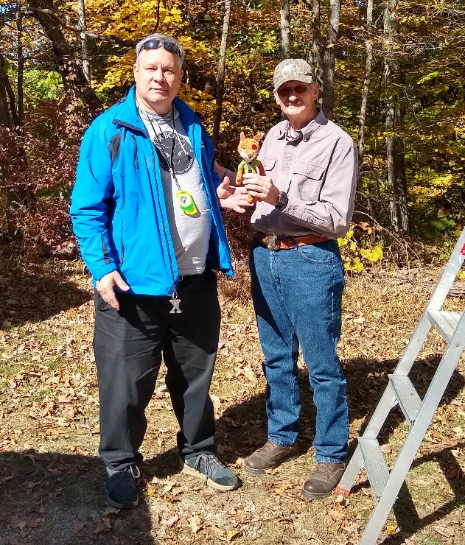The October 9th ACARA Athens County Fox Hunt was held at 1 p.m. and featured five Amateur Radio Operators. The Fox was W8NZB Phil Stanley from the Logan area.  He hid well and had twelve delightful clues to share during the 2 hours.

First to find the Fox was KC8JRV Kirk Groeneveld coming in at exactly one hour.  Kirk says he forgot his compass and had to double back home to pick it up after the first initial general bearing.   Had he had it from the first transmission, he might have been faster zeroing in on the fox, who was at the Strouds Run State Park Horseman’s camp in Canaan Township.

Coming in at 1 hr 24 minutes was the father/son team of  KD9KNC Miles and Eric McFadden WD8RIF. Another Ham operator was already at the Horsecamp and walked over to join the fun. At the conclusion of the hunt, the group adjourned to a local Mexican restaurant for refreshments.

The next Athens County foxhunt is likely to be on a Sunday in late October or early November.

There is no word on when the next Hocking County Fox Hunt will be held yet.

**\_\_\_\_\_\_\_\_\_\_\_\_\_\_\_\_\_\_\_\_\_\_\_\_\_\_\_\_\_\_\_\_\_\_\_\_\_\_\_\_\_\_\_\_\_\_\_\_\_\_\_\_\_\_\_\_\_\_**

VE Sessions

**All Things Amateur Radio Association (ATARA)** We host testing sessions every second Tuesday of the month in Lancaster. To sign up please visit our website <https://atara-w8atr.fun> and contact us at [hamexams@atara-w8atr.fun](mailto:hamexams@atara-w8atr.fun).

**CARS**

VE testing from CARS - Cuyahoga Amateur Radio Society - at Elmwood Recreation Center, 6200 Wisnieski Parkway in Independence, Ohio 44131  Time: 9:15 AM (Walk-ins allowed) Always the 2nd Sunday of the odd month. Go to CARS  [www.2cars.org](http://www.2cars.org/) for detailed map of location.  Call Metro W8MET 216-520-1320 for details

**Dayton Amateur Radio Association (DARA)** If you are interested in testing for a new or upgraded license, please come see us at the DARA Clubhouse. If you have questions about testing, please email [exams.w8bi@gmail.com](mailto:exams.w8bi@gmail.com)

**Huber Heights Amateur Radio Club**

Huber heights amateur radio club does ARRL VE testing the second Saturday of each even numbered month. Feb, Apr, Jun, Aug, Oct, Dec. 9:30-11:00 For more information contact Jim Storms – AB8YK at [ab8yk@hotmail.com](mailto:ab8yk@hotmail.com)

**The Lake County Amateur Radio Association**

The Lake County Amateur Radio Association is once again holding its **2022** Amateur Radio license exams at the **Kirtland Library**, 9267 Chillicothe Road, on the following dates:

Saturday, October 1, and December 3.

The tests will start at **12 noon.** Please arrive a few minutes earlier.

**The Lancaster and Fairfield County Amateur Radio Club (LFCARC**) hosts exam sessions at the FAIRFIELD County EMA, 240 Baldwin Dr in Lancaster Ohio, 43130, on the first Saturday each month at 10:00 am. Please visit our website at <http://www.k8qik.org> for exam dates on our calendar and navigate to our Learning Center/Taking the Exam link for information and requirements. Our experienced VE team looks forward to serving the Amateur Radio community in Central Ohio. Contact me at [ve\_testing@k8qik.org](mailto:ve_testing@k8qik.org) to register.

**The Milford Amateur Radio Club (MARC)** is now doing VE testing on the third Thursday of each month at 6:00 PM.  Location;  Miami Township Civic Center located at 6101 Meijer Drive, Milford, OH  45150.

 Please pre-register at [www.milfordhamradio.org](http://www.milfordhamradio.org/)

**Northern Ohio Amateur Radio Society (NOARS)**

VE sessions are held the first Saturday of odd-numbered months at 10 AM in the North Olmsted Library, 27403 Lorain Rd., North Olmsted. Registration is preferred, but walk-ins are welcome. For more information or to register, contact Elaine, KC8FOS at [ewilkinson1951@gmail.com](mailto:ewilkinson1951@gmail.com).

**Portage County Amateur Radio Service (PCARS)**

The first Saturday of every even numbered month -10 am – at the PCARS club site in Ravenna. Please visit the PCARS web site and check out the information about VE testing in the latest newsletter at [www.portcars.org](http://www.portcars.org) .

If you have any questions, don’t hesitate to contact me at KB8UUZ@gmail,com

**\_\_\_\_\_\_\_\_\_\_\_\_\_\_\_\_\_\_\_\_\_\_\_\_\_\_\_\_\_\_\_\_\_\_\_\_\_\_\_\_\_\_\_\_\_\_\_\_\_\_\_\_\_\_\_\_\_\_**

**OHIO SECTION TRAFFIC REPORT – SEPTEMBER 2022**

**OHIO SECTION NETS – SEPTEMBER 2022**

|  |  |  |  |  |  |
| --- | --- | --- | --- | --- | --- |
| NET | QNI | QTC | QTR | SESSIONS | N/M |
| BNE | 137 | 40 | 351 | 30 | N2LC |
| BNL | 39 | 18 | 168 | 30 | WB9LBI |
| OSN | 25 | 30 | 558 | 22 | N2LC |
| OSSBN | 1539 | 356 | 2046 | 90 | KC8WH |

**OHIO SECTION PSHR REPORTS – SEPTEMBER 2022**

|  |  |  |  |  |  |  |  |  |
| --- | --- | --- | --- | --- | --- | --- | --- | --- |
| WA3EZN | 40 | 40 | 30 | 355 | 0 | 20 | TOTAL | 485 |
| N2LC | 40 | 40 | 30 | 135 | 0 | 30 | TOTAL | 275 |
| AC8NP | 30 | 40 | 10 | 125 | 0 | 20 | TOTAL | 225 |
| N8SY | 40 | 15 | 30 | 50 | 0 | 60 | TOTAL | 195 |
| WB8YYS | 40 | 18 | 20 | 20 | 75 | 10 | TOTAL | 183 |
| KC8PBU | 40 | 40 | 20 | 80 | 0 | 0 | TOTAL | 180 |
| W8DJG | 40 | 40 | 30 | 35 | 5 | 20 | TOTAL | 170 |
| KV8Z | 40 | 36 | 10 | 65 | 0 | 10 | TOTAL | 161 |
| AD8CM | 17 | 11 | 10 | 115 | 0 | 0 | TOTAL | 153 |
| KD8UUB | 40 | 39 | 10 | 115 | 0 | 0 | TOTAL | 153 |
| KM8V | 7 | 12 | 30 | 15 | 5 | 80 | TOTAL | 149 |
| KE4RS | 40 | 40 | 10 | 25 | 0 | 0 | TOTAL | 115 |
| K8MDA | 40 | 31 | 20 | 0 | 0 | 20 | TOTAL | 111 |
| KC8WH | 40 | 40 | 30 | 0 | 0 | 0 | TOTAL | 110 |
| W8GSR | 40 | 40 | 10 | 15 | 0 | 0 | TOTAL | 105 |
| KL7RF | 40 | 40 | 10 | 0 | 10 | 0 | TOTAL | 100 |
| WB8SIQ | 40 | 40 | 10 | 10 | 0 | 0 | TOTAL | 100 |
| AC8RV | 40 | 40 | 10 | 10 | 0 | 0 | TOTAL | 100 |
| KB8GUN | 40 | 40 | 10 | 0 | 0 | 10 | TOTAL | 100 |
| WD8SDH | 40 | 40 | 10 | 10 | 0 | 0 | TOTAL | 100 |
| K8KRA | 40 | 40 | 10 | 0 | 0 | 0 | TOTAL | 90 |
| N8MRS | 40 | 40 | 10 | 0 | 0 | 0 | TOTAL | 90 |
| KB8HJJ | 40 | 40 | 10 | 0 | 0 | 0 | TOTAL | 90 |
| KE8ANW | 40 | 4 | 0 | 30 | 0 | 0 | TOTAL | 74 |
| NC8V | 19 | 15 | 0 | 0 | 0 | 0 | TOTAL | 34 |

**OHIO SECTION TRAFFIC REPORTS – SEPTEMBER 2022**

|  |  |  |  |
| --- | --- | --- | --- |
| AC8NP-49 | KB8GUN-143 | KL7RF-113 | NC8V-15 |
| AC8RV-100 | KB8HJJ- 57 | KM8V-12 | W8DJG-127 |
| AD8CM-11 | KC8IDM-20 | KV8Z-36 | W8GSR-113 |
| K3RC-31 | KC8PBU-102 | N2LC-81 | W8SAB-5 |
| K8JCR-72 | KC8WH-74 | N8BV- 42 | WA3EZN-40 |
| K8KRA-76 | KC8YTV-3 | N8GBU-6 | WB8SIQ-60 |
| K8MDA-31 | KD8GYI-59 | N8MRS-97 | WB8YYS-18 |
| K8MWF-11 | KD8HB-39 | N8SY-15 | WB9LBI-54 |
| KA8BJA-42 | KE4RS-53 | N8TNV-76 | WD8SDH-40 |
|  |  |  |  |
|  | TOTALS | 36/1923 |  |

**OHIO SECTION LOCAL NETS – SEPTEMBER 2022**

|  |  |  |  |  |  |
| --- | --- | --- | --- | --- | --- |
| NET | QNI | QTC | QTR | SESSIONS | N/M |
| BRTN | 145 | 82 | 376 | 28 | W8DJG |
| COTN | 173 | 58 | 389 | 30 | KV8Z |
| NWOH ARES | 299 | 110 | 553 | 30 | N8TNV |
| TATN | 324 | 91 | 404 | 30 | WG8Z |
| TCTTN | 121 | 22 | 348 | 13 | WB8YYS |

**OHIO SECTION TRAFFIC REPORT – SEPTEMBER 2022**

**OHIO SECTION NETS** – **SEPTEMBER 2022**

NET QNI QTC QTR SESSIONS N/M

BNE 137 40 351 30 N2LC

BNL 39 18 168 30 WB8LBI

OSN 25 30 558 22 N2LC

OSSBN 1539 356 2046 90 KC8WH

**OHIO SECTION PSHR REPORTS – SEPTEMBER 2022**

WA3EZN 40 40 30 355 0 20 TOTAL 485

N2LC 40 40 30 135 0 30 TOTAL 275

AC8NP 30 40 10 125 0 20 TOTAL 225

N8SY 40 15 30 50 0 60 TOTAL 195

WB8YYS 40 18 20 20 75 10 TOTAL 183

KC8PBU 40 40 20 80 0 0 TOTAL 180

W8DJG 40 40 30 35 5 20 TOTAL 170

KV8Z 40 36 10 65 0 10 TOTAL 161

AD8CM 17 11 10 115 0 0 TOTAL 153

KD8UUB 40 39 10 115 0 0 TOTAL 153

KM8V 7 12 30 15 5 80 TOTAL 149

KE4RS 40 40 10 25 0 0 TOTAL 115

K8MDA 40 31 20 0 0 20 TOTAL 111

KC8WH 40 40 30 0 0 0 TOTAL 110

W8GSR 40 40 10 15 0 0 TOTAL 105

KL7RF 40 40 10 0 10 0 TOTAL 100

WB8SIQ 40 40 10 10 0 0 TOTAL 100

AC8RV 40 40 10 10 0 0 TOTAL 100

KB8GUN 40 40 10 0 0 10 TOTAL 100

WD8SDH 40 40 10 10 0 0 TOTAL 100

K8KRA 40 40 10 0 0 0 TOTAL 90

N8MRS 40 40 10 0 0 0 TOTAL 90

KB8HJJ 40 40 10 0 0 0 TOTAL 90

KE8ANW 40 4 0 30 0 0 TOTAL 74

NC8V 19 15 0 0 0 0 TOTAL 34

**OHIO SECTION LOCAL NETS – SEPTEMBER 2022**

NET QNI QTC QTR SESSIONS N/M

BRTN 145 82 376 28 W8DJG

COTN 173 58 389 30 KV8Z

NWOH ARES 299 110 553 30 N8TNV

TATN 324 91 404 30 WG8Z

TCTTN 121 22 348 13 WB8YYS

**OHIO SECTION TRAFFIC REPORTS – SEPTEMBER 2022**

AC8NP-49 KB8GUN-143 KL7RF-113 NC8V-15

AC8RV-100 KB8HJJ-57 KM8V-12 W8DJG-127

AD8CM-11 KC8IDM-20 KV8Z-36 W8GSR-113

K3RC-31 KC8PBU-102 N2LC-81 W8SAB-5

K8JCR-72 KC8WH-74 N8BV-42 WA3EZN-40

K8KRA-76 KC8YTV-3 N8GBU-6 WB8SIQ-60

K8MDA-31 KD8GYI-59 N8MRS-97 WB8YYS-18

K8MWF-11 KD8HB-39 N8SY-15 WB9LBI-54

KA8BJA-42 KE4RS-53 N8TNV-76 WD8SDH-40

TOTALS 36/1923

**OHIO HF TRAFFIC NETS**

BN(E) Buckeye Net Early - CW

BN(L) Buckeye Net Late – CW

OSN Ohio Slow Net - CW

OSSBN Ohio Single Sideband Net – Phone

**OHIO VHF TRAFFIC NETS**

BRTN Burning River Traffic Net serving Cleveland and North Central Ohio

COTN Central Ohio Traffic Net serving Columbus and Central Ohio

MVTN Miami Valley Traffic Net serving the Dayton area

NWOH ARES Northwest Ohio ARES Net serving Toledo and surrounding counties

TATN Tri-State Amateur Traffic Net

TCTTN Tri-County Traffic and Training Net serving North East Ohio

**Your Club news should be listed here!**

I know you’re out there doing things! Send me a write-up (MSWord please) and some photo’s (.jpg please) and we’ll get your club hi-lited here for the other OH Section Clubs to see! Send to [WB8LCD@ARRL.ORG](mailto:WB8LCD@ARRL.ORG)

**\_\_\_\_\_\_\_\_\_\_\_\_\_\_\_\_\_\_\_\_\_\_\_\_\_\_\_\_\_\_\_\_\_\_\_\_\_\_\_\_\_\_\_\_\_\_\_\_\_\_\_\_\_\_\_\_\_\_\_\_\_\_\_\_\_\_\_\_\_\_\_\_\_\_\_\_\_\_**

DX This Week – K9LA

Bill AJ8B (aj8b@arrl.net, @AJ8B, or www.aj8b.com)

CWOPs Member #1567

This past week showed a marked increase in DX Activity. From early in the morning to late at night, there has been DX there to work. I hope you have stayed active, working your band slots and striving towards a large number in the CQ Marathon. In addition to the better sunspot numbers, another major factor are the upcoming contests. With CQWW SSB at the end of October, and CQWW CW at the end of November, there are DXPeditions all over the globe with the intent of activating something special just in time for the contests. Always look a week or two BEFORE the contest and a week after to work this great DX. Just let me know what you work.

I still get some questions about the K and A indexes. I have reprinted the excellent article from K9LA that will explain this. Carl has always allowed me access to anything he has published, and I really appreciate it.

I received a card 9K2KH, Khalid in Kuwait City, Kuwait. Let me know what you received. 73 and Gud DX Hunting

|  |
| --- |
|  |

DAH DIT DIT DIT DAH DAH DIT DIT DIT DAH

Propagation by Carl Luetzelschwab K9LA

Originally published in Worldradio October 2003

**Where Do the K and A Indices Come From?**

The K and A indices are readily available parameters (for example, they’re given at 18 minutes past the hour on WWV) that can give us an indication of how the high latitude ionosphere might be affecting propagation. Let’s take a look at where the K and A indices come from to hopefully gain a better understanding of these important propagation parameters.

It all starts with the K index. The K index is a 3-hour measurement of the variation of the Earth’s magnetic field relative to quiet day conditions. The K index is determined from the data taken by a magnetometer, which measures the variation of the magnetic field in nanoTeslas (nT). Table 1 shows the nT range versus the K index for the mid latitude Boulder magnetometer.

If we plot nT (using mid-range values of nT) versus K, we get the plot of Figure 1.

Note that nT is plotted on a logarithmic scale and that the curve is almost a straight line. Since it isn’t *exactly* a straight line, the K index is said to be quasi-logarithmic.

Before moving on, an important comment is in order. Each station has its own scale of nT versus K. This is done to try to make the K index from each station represent the same level of disturbance. For a given disturbance, the variation of the Earth’s magnetic field will be greatest at the high latitudes. Thus, at the high latitude College (Alaska) station, a K index of 9 is a variation greater than 2500nT. At the low latitude Kuyper (Sumatra) station, a K index of 9 is a variation greater than 300nT. Compare these nT values with the mid latitude Boulder nT value at K=9 in Table 1.

Now let’s look at a magnetometer record (which is called a magnetogram) to see how the K index is determined. Figure 2 is a snapshot of the magnetogram from Boulder on April16, 2003 (thanks to Dr. Christopher Balch at NOAA/SEC).

The solid line at the top of the plot is the variation of the H-Component (vector horizontal component) of the magnetic field. The dotted line about one vertical division below this solid line is the quiet day curve for the H Component.

The solid line at the bottom of the plot is the variation of the D-Component (magnetic declination) of the magnetic field. The dotted line running almost concurrent with this solid line is the quiet day curve for the D-Component.

The K index for any 3-hour period is determined by first finding the maximum positive and negative deviations of both components relative to their respective quiet day curves. Next these are added together for each component to determine the maximum fluctuation of each component. The component with the largest fluctuation is used to determine the K index. In the 1200-1500 UTC period of Figure 2, for example, the D-component exhibits the maximum deviation from the quiet day curve. This is easiest seen by mentally overlaying the H-component quiet day curve on the H-component data and noting that the H-component varies less about its quiet day curve than the D-component.

The maximum positive deviation for the D-component is +35nT around 1350 UTC. The maximum negative deviation is –10nT around 1440 UTC. The maximum fluctuation is therefore (+35nT) – (-10nT) = 45nT. Going to Table 1 says the K index for this period is 4, which is what Boulder reported. In a similar manner, the K indices for the other seven 3-hour time periods can be determined. Note that the magnetometer only measures the deviation from a quiet day curve, not an absolute value.

Now we have eight K indices for the entire day, and we’d like to come up with an average for the entire day. Since the K index is logarithmic, mathematically we shouldn’t simply add all eight K values and divide by eight to get an average. To do averaging, we need indices that are linear. This is where the A index comes in.

Table 2 shows the conversion between the K index and the a index (the little ‘a’ indicates it’s an equivalent 3-hour value – a big ‘A’ indicates it’s a daily average value).

If we now plot nT versus the a index we get Figure 3.

Note that nT is now plotted on a linear scale and that the resulting curve is for all intents and purposes a straight line. Thus the 3-hour a index (and the subsequent A index) is said to be linear.

Now we can simply add the eight 3-hour a indices, divide by eight, and come up with a daily average – which is the A index. We can also do this for many worldwide stations and come up with the daily average planetary A index, Ap. In a like manner, we can use many worldwide stations to come up with the 3-hour planetary K index, Kp.

Ok, now we know where K and A come from. But how do they tie to HF and VHF

propagation conditions? In general, as the K and A indices become elevated:

1. The high latitude E region ionization can increase significantly (VHFers like this)

2. Increased D region absorption can occur in and near the auroral oval (not good)

3. Usually the F region ionization at mid and high latitudes decreases (not good)

4. Sometimes, depending on how the geomagnetic storm evolves, the F region ionization at low and mid latitudes increases (this can be good)

The extent to which the above events occur on a specific path is hard to pin down. It depends on the geomagnetic storm itself, the geomagnetic latitude along the path, the level of solar activity, the season, and the local time along the path. Both W6ELProp and ICEPAC (the derivative of IONCAP that incorporates a high latitude ionosphere model) allow input of the K index to make a broad assessment of the impact of an active geomagnetic field.

One last ‘problem’ should be mentioned. The K index and thus the a and A indices are measurements of currents flowing at E region altitudes. Thus, they don’t really give us any indication of what’s going on at F region altitudes. Additionally, since the A index is the average of eight K indices, a spike in one or two of the eight 3-hour K indices may not show up very much in the daily average A index, even though the spike affected the ionosphere. So, the A index could be encouraging, but it may not indicate the effects of a short-term event. A good example of this ‘problem’ is what happened to 10m in the CQ WPX CW contest in 2002. See the March 2003 issue of CQ for details of this.

There you have it. You should now have a good understanding of how the K and A indices are determined.

DAH DIT DIT DIT DAH DAH DIT DIT DIT DAH

Here is an update from Bernie, W3UR, of the DailyDX and the WeeklyDX, the best source for DX information. <http://www.dailydx.com/> . Bernie has this to report:

**VQ9 - Diego Garcia** September 30 we reported that WB4GHY had made it to the island, but the government official authorized to dispense licenses was no longer there.  Steve updates us that things still do not look good.  He has hoped to get the VQ9SC callsign renewed, saying "The island has lost all ham radio licensing info.  They just haven't done it in a long time.  They say my 2016 license was the last issued here and nobody is still here from that time period."  He says they are very friendly and are trying to help "but just need guidance."  It seems they have asked the UK about it but Steve is not optimistic they will get the answer he needs "timely." He is there until November 16.

**5V – Togo / TY – Benin -** The TY0RU team from Benin October 14-26, so still upcoming, next goes to Togo, callsign 5V7RU, October 28 to November 11.  Ops R5EC, R7AL, R9LR, RA1ZZ, RW8A and RW9JZ will be on the QO-100 satellite and 160-6M CW, SSB and FT8.  QSL through Club Log OQRS, LoTW or send your card to R7AL.  <https://5v7ru.org/>

**5R – Madagascar -** October 11-22 5R8WP, 5R8WG, 5R8MM and 5R8CG by PA3EWP, DL2AWG, DK2AMM and PG4M respectively will all be on the air from Nosy Be Island, IOTA AF-057.  They will have two Elecraft K3 and Expert amp stations and be on CW, SSB, RTTY and FT8.  Backup radios are a SunSDR2 PRO and an IC- 7300.  They'll have a hexbeam to cover 20-6, a "DX Commander" on 40- 10, a 30M vertical, 80M vertical, and 160M vertical.  If they can, they'll upload the log to Club Log every day.  For a QSL for 5R8WP, 5R8WG and 5R8MM, send to DL2AWG, or use Club Log or LoTW sometime later.  The QSL for 5R8CG is via PG5M, or Club Log, or on a delayed schedule LoTW.

**ZD7 - St. Helena -** HB9FIY (aka M0ISF), Christopher, is planning to be on St. Helena Island from November 5 to 26. In his spare time he will be operating with a KX3 and KXPA100 using a vertical fan dipole. Activity will be on SSB, PSK31 and RTTY on 40, 20, 17, 15 and 10 meters. When not on the air he will have ZD7CA on WSPR. His station is very portable and may be set up occasionally at the beach.  
  
**T8 – Palau -** DX traveler JA0JHQ, Nobu, is making a short trip to Palau for the CQ WW DX CW Contest. He will be QRV as T88PB from November 25-29. The station will be an IC-756PRO or IC-7300- and 400-watt amplifier. At the station is a dipole and three element Yagi. Listen for him on CW on 160, 80, 40, 20, 15 and 10 meters. QSOs will be uploaded to LoTW. QSL direct or via LoTW.

**J2 – Djibouti -** With less than 20 days left to the Mediterranean DX Club's new venture to Djibouti, they have a renewed request to assist in funding. Soon they will be on the air as J28MD and as always will produce some serious noise on the bands fulfilling many of your band slots. With the huge increases in the cost of flights, accommodations and currency fluctuations they would like to access the DX community and friends to assist them with costs by way of donations. Any donation however small is welcome! Please check their website for further information [www.mdxc.org/j28md](http://www.mdxc.org/j28md)

DAH DIT DIT DIT DAH DAH DIT DIT DIT DAH

Below is a list of upcoming contests in the “Contest Corner”. I think this is important for someone who is trying to move up the DXCC ladder since entities that are on the rarer side and easiest to work in contests. Some of my best “catches” have been on the Sunday afternoon of a contest when the rarer entities are begging for QSOs. Of course, the gamble is that if you wait until Sunday, conditions may change, or they simply won’t be workable. However, it is not a bad gamble. Of course, why not work the contest and have some fun!  
Check out the WA7BNM Contest Calendar page (<https://www.contestcalendar.com/>) and CQ Magazine for more contests or more details. I also have a comprehensive list that can be imported to your calendar at [www.aj8b.com/files](http://www.aj8b.com/files)

The contests in red are those that I plan to spend some significant participation time on. PLEASE let me know if you are working contests and how you fared.

Thanks!

|  |  |  |
| --- | --- | --- |
| **Date(s)** | **Event** | **Info** |
| Oct. 17 | RSGB FT4 Contest Series | <https://bit.ly/31qpcJl> |
| Oct. 19 | AGCW Semi-Automatic Key Evening | <http://bit.ly/2WB74qy> |
| Oct. 19 | VHF-UHF FT8 Activity | [www.ft8activity.eu/index.php/en](http://www.ft8activity.eu/index.php/en) |
| Oct. 22-23 | Stew Perry Topband Distance Challenge | [www.kkn.net/stew/stew\_rules.html](http://www.kkn.net/stew/stew_rules.html) |
| Oct. 22-23 | UK/EI DX Contest | [www.ukeicc.com/dx-contest-rules.php](http://www.ukeicc.com/dx-contest-rules.php) |
| Oct. 22-24 | YLRL DX/NA YL Anniversary Contest | <https://ylrl.net/contests> |
| Oct. 23 | North American SSB Sprint Contest | <https://ssbsprint.com/rules> |
| Oct.23-24 | Fall Classic Exchange CW | [www.classicexchange.org](http://www.classicexchange.org) |
| Oct. 25-26 | Fall Classic Exchange CW | [www.classicexchange.org](http://www.classicexchange.org) |
| Oct. 26 | UKEICC 80m Contest CW | <https://ukeicc.com/80m-rules.php> |
| Oct. 27 | RSGB Autumn Series SSB | <https://bit.ly/31qpcJl> |
| Oct. 29-30 | CQWW DX SSB Contest | [www.cqww.com/index.htm](http://www.cqww.com/index.htm) |
| Nov. 1 | Silent Key Memorial Contest | <https://skmc.hu/en/rules.html> |
| Nov. 2 | UKEICC 80 Meter Contest SSB | <https://ukeicc.com/80m-rules.php> |
| Nov. 2 | VHF-UHF FT8 Activity | [www.ft8activity.eu/index.php/en](http://www.ft8activity.eu/index.php/en) |
| Nov. 5-6 | IPARC Contest | [www.iparc.de](http://www.iparc.de) |
| Nov. 5-7 | ARRL CW Sweepstakes | [www.arrl.org/sweepstakes](http://www.arrl.org/sweepstakes) |
| Nov. 6 | High Speed Club CW Contest | [www.highspeedclub.org](http://www.highspeedclub.org/) |
| Nov. 7 | RSGB Autumn Series, Data | https://bit.ly/31qpcJl |
| Nov. 9 | VHF-UHF FT8 Activity | [www.ft8activity.eu/index.php/en](http://www.ft8activity.eu/index.php/) |
| Nov. 12 | FISTS Saturday Sprint | [www.fistsna.org/operating.html#sprints](http://www.fistsna.org/operating.html#sprints) |
| Nov. 12-13 | 10-10 Digital Fall Contest | http://bit.ly/1FrFeBc |
| Nov. 12-13 | ARRL EME Contest | [www.arrl.org/eme-contest](http://www.arrl.org/eme-contest) |
| Nov. 12-13 | CQ-WE Contest | https://cqwe.cboh.org |
| Nov. 12-13 | JIDX Phone Contest | [www.jidx.org](http://www.jidx.org/) |
| Nov. 12-13 | OK/OM CW DX Contest | <http://bit.ly/19rrRjl> |
| Nov. 12-13 | Worked All Europe RTTY Contest | <https://bit.ly/36ubggF> |
| Nov. 12-14 | PODXS070 Club Triple Play Low Band Sprint | <http://bit.ly/2Cq2yUA> |
| Nov. 13 | FIRAC HF Contest | [www.firac.de/html/contest.html](http://www.firac.de/html/contest.html) |
| Nov. 13-14 | Fall Classic Exchange CW | [www.classicexchange.org](http://www.classicexchange.org/) |
| Nov. 15-16 | Fall Classic Exchange CW | [www.classicexchange.org](http://www.classicexchange.org/) |
| Nov. 16 | RSGB Autumn Series, SSB | <https://bit.ly/31qpcJl> |
| Nov. 16 | VHF-UHF FT8 Activity | [www.ft8activity.eu/index.php/en](http://www.ft8activity.eu/index.php/) |
| Nov. 18 | YO International PSK31 Contest | [www.yo5crq.ro/index.htm](http://www.yo5crq.ro/index.htm) |
| Nov. 19 | All Austrian 160M Contest | <https://bit.ly/3fgsiUo> |
| Nov. 19 | RSGB 2nd 1.8 MHZ Contest CW | <https://bit.ly/31qpcJl> |
| Nov. 19 | SARL Newbie Party | <http://bit.ly/H0IqQf> |
| Nov. 19-20 | LZ DX Contest | <http://lzdx.bfra.bg/rulesen.html> |
| Nov. 19-20 | REF 160-Meter Contest | <https://bit.ly/3iHzsQU> |
| Nov.19-20 | SARL Field Day Contest | <http://bit.ly/H0IqQf> |
| Nov. 19-21 | ARRL SSB Sweepstakes | [www.arrl.org/sweepstakes](http://www.arrl.org/sweepstakes) |
| Nov. 20 | FISTS Sunday Sprint | [www.fistsna.org/operating.html#sprints](http://www.fistsna.org/operating.html#sprints) |
| Nov. 24 | RSGB Autumn Series, CW | <https://bit.ly/31qpcJl> |
| Nov. 26-27 | CQWW DX CW Contest | [www.cqww.com/index.htm](http://www.cqww.com/index.htm) |
| Nov. 28 | RSGB FT4 Contest Series | <https://bit.ly/31qpcJl> |
| Nov. 30 | UKEICC 80 Meter Contest CW | <https://ukeicc.com/80m-rules.php> |

**ARRL DX news**  
  
This week's bulletin was made possible with information provided by The Daily DX, the OPDX Bulletin, 425 DX News, DXNL, Contest Corral from QST and the ARRL Contest Calendar and WA7BNM web sites.  Thanks to all.  
  
EQUATORIAL GUINEA, 3C.  Ersoy, TA2OM is now QRV as 3C3CA from Malabo, Bioko Island, IOTA AF-010.  He is here for one to two months.  Activity of late has been on the HF bands using FT8.  QSL to home call.  
  
KINGDOM OF ESWATINI, 3DA.  Hans, 3DA0AQ has been QRV on 10 meters using FT8 between 1555 and 1745z.  QSL via EA5GL.  
  
LIBERIA, EL.  Richmond, EL2BG is active most every day on 6 meters. He has HF capabilities as well.  QSL direct to home call.  
  
IRAN, EP.  Abbas, EP2ABS has been active using CW on 15 meters before 1800z, and then on 17 meters around 1830 to 1930z.  QSL via RW6HS.  
  
MARQUESAS ISLANDS, FO.  Didier, F6BCW is QRV as TX7G from Iva Oa, IOTA OC-027, until October 15.  Activity is on 80 to 10 meters using CW, SSB, RTTY, and FT8 if possible, daily from 0300 to 0700z, and then 1500 to 1700z, depending on band conditions.  QSL direct to  
home call.  
  
GUINEA BISSAU, J5.  Carlos, CT2GQA is QRV as J5JUA and is active until the end of 2022.  Activity is mostly using FT8, and as a mobile station.  He may also use J5GQA.  QSL to home call.  
  
BENIN, TY.  A group of operators will be QRV as TY0RU from October 14 to 26.  Activity will be on 160 to 6 meters, including 60 meters, and Satellite QO-100, using CW, SSB, and FT8 with nine stations active.  QSL via R7AL.  
  
FALKLAND ISLANDS.  Garry, ZC4GR is QRV as VP8DLB from Port Stanley, IOTA SA-002, and is here until December.  QSL via EB7DX.  
  
NEW ZEALAND, ZL.  Members of the Whangarei Amateur Radio Club are QRV as ZL75WARC until December 31 from North Island, IOTA OC-036, to celebrate the club's 75th anniversary.  QSL via operators' instructions.  
  
  
Please see October QST, page 70, and the ARRL and WA7BNM Contest web  
sites for details.  
\_\_\_\_\_\_\_\_\_\_\_\_\_\_\_\_\_\_\_\_\_\_\_\_\_\_\_\_\_\_\_\_\_\_\_\_\_\_\_\_\_\_\_\_\_\_\_\_\_\_\_\_\_\_\_\_\_\_\_\_\_\_\_\_\_\_\_\_\_\_\_\_\_\_\_\_\_\_

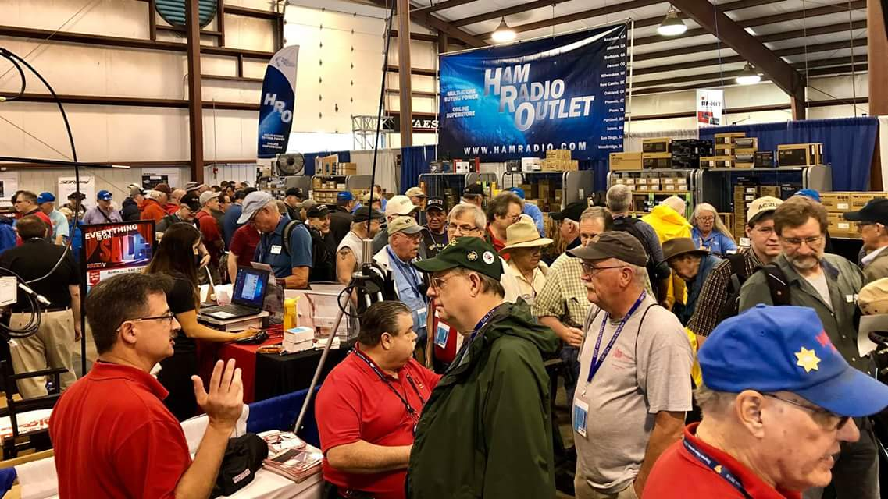[**Upcoming *Hamfests***](http://arrl-ohio.org/hamfests.html)

We **DO** have some hamfests scheduled for 2022!! Yes, take a good look at the list. And YES! They are starting to book up for 2023 already!

**\_\_\_\_\_\_\_\_\_\_\_\_\_\_\_\_\_\_\_\_\_\_\_\_\_\_\_\_\_\_\_\_\_\_\_\_\_\_\_\_\_\_\_\_\_\_\_\_\_\_\_\_\_\_\_\_\_\_**

|  |  |
| --- | --- |
|  |  |

|  |  |
| --- | --- |
|  |  |
|  |  |
| ***2022 & 2023*** | | | | |
| **10/30/2022 -**[**Massillon Hamfest (OH)**](http://www.arrl.org/hamfests/massillon-hamfest-oh)  **Location:**Green, OH **Sponsor:** Massillon Amateur Radio Club **Website:** [http://w8np.org](http://w8np.org/) [**Learn More**](http://www.arrl.org/hamfests/massillon-hamfest-oh) | | | | **12/03/2022 -**[**FCARC WinterFest**](http://www.arrl.org/hamfests/fcarc-winterfest-3)  **Location:**Archbold, OH **Sponsor:** Fulton County Amateur Radio Club **Website:** <https://k8bxq.org/hamfest> [**Learn More**](http://www.arrl.org/hamfests/fcarc-winterfest-3) |
|  | | | |  |
| **01/15/2023 -**[**Sunday Creek Amateur Radio Federation Hamfest**](https://www.arrl.org/hamfests/sunday-creek-amateur-radio-federation-hamfest-2)  **Location:**Shade, OH **Sponsor:** Sunday Creek Amateur Radio Federation **Website:** [QRZ KC8AAV](https://www.arrl.org/QRZ%20KC8AAV) [**Learn More**](https://www.arrl.org/hamfests/sunday-creek-amateur-radio-federation-hamfest-2) | | | | **03/11/2023 -**[**MOVARC Hamfest**](http://www.arrl.org/hamfests/movarc-hamfest-8)  **Location:**Bidwell, OH 45614, OH **Sponsor:** Mid-Ohio Valley Amateur Radio Club [**Learn More**](http://www.arrl.org/hamfests/movarc-hamfest-8) |
| **05/13/2023 - 05/17/2023** [**RV Radio Network**](http://www.arrl.org/hamfests/rv-radio-network-1)  **Location:**Berlin, Ohio, OH **Type:** ARRL Operating Specialty Convention **Sponsor:** RV Radio Network [**Learn More**](http://www.arrl.org/hamfests/rv-radio-network-1) | | | | **07/16/2023 -**[**Van Wert Hamfest**](http://www.arrl.org/hamfests/van-wert-hamfest-7)  **Location:**Van Wert, OH **Sponsor:** Van Wert Amateur Radio Club **Website:** [http://w8fy.org](http://w8fy.org/) [**Learn More**](http://www.arrl.org/hamfests/van-wert-hamfest-7) |
|  | | | |  |
| **08/12/2023 -**[**Cincinnati Hamfest℠**](http://www.arrl.org/hamfests/cincinnati-hamfest-2)  **Location:**Owensville , OH **Sponsor:** Milford ARC **Website:** [https://CincinnatiHamfest.org](https://cincinnatihamfest.org/) [**Learn More**](http://www.arrl.org/hamfests/cincinnati-hamfest-2) | | | |  |
|  | | | |  |

**Massillon Hamfest**

The Massillon Amateur Radio Club (MARC) is again proud to sponsor what has become on the nation's top hamfests. We are again inviting guests from all over the country to join us at MAPS air museum at the Canton-Akron Airport in Green, Ohio.

 Date:10/30/2022

Location: Military Air Preservation Hangar (MAPS)

2260 International Parkway  Green, OH 44232

Sponsor: Massillon Amateur Radio Club

Look for more details in the weeks ahead. Attendees and Vendors: For a brochure or for further information please contact MARC at [club@w8np.net.](mailto:club@w8np.net) *We Are looking forward to seeing you at MAPS this year!*

*Contact:*[*club@w8np.net*](mailto:club@w8np.net)

*Gerry Sorensen, KG8RRY*

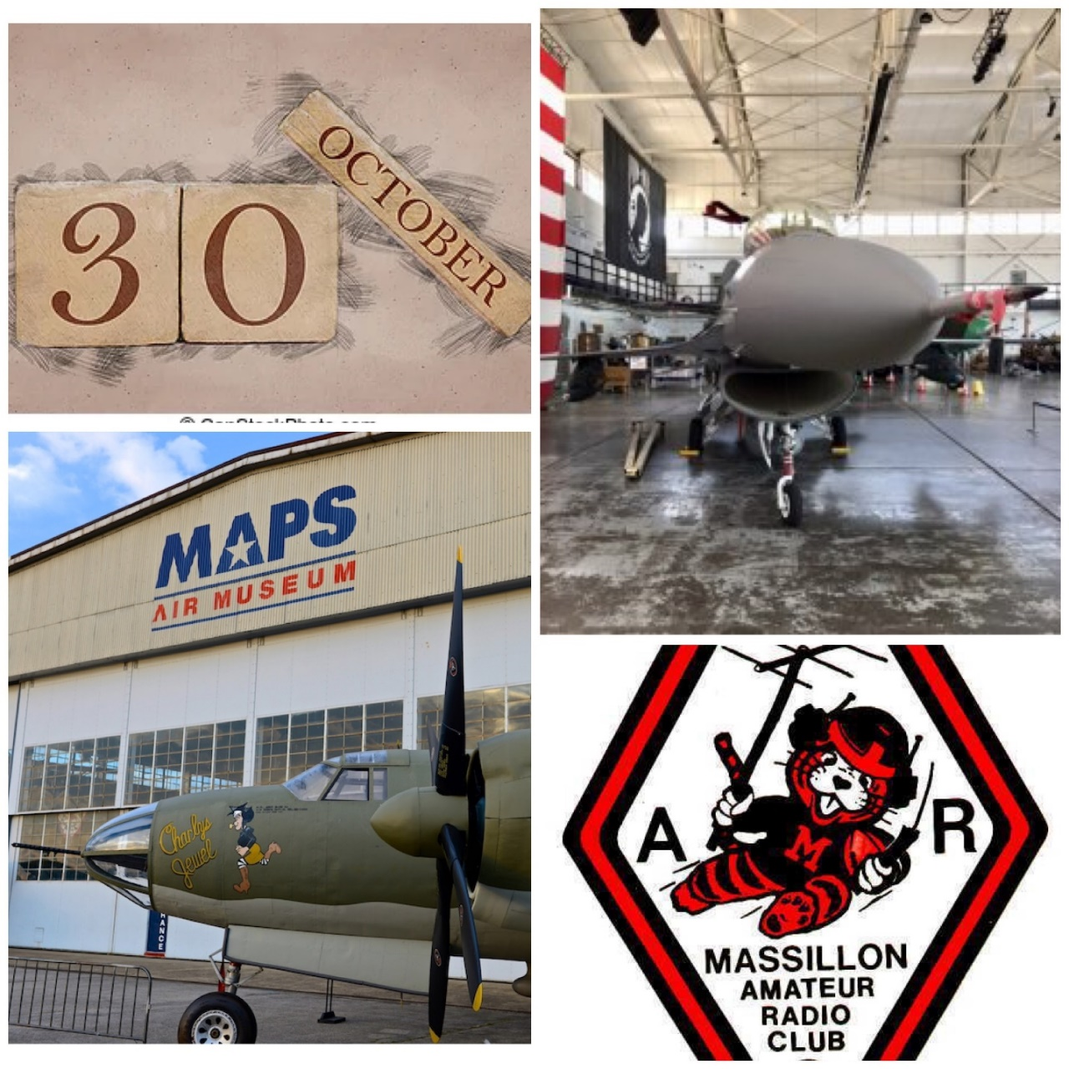

**Print an Official or Unofficial Copy of Your Amateur Radio License**

*(By Anthony Luscre, K8ZT)*

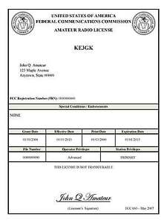

As of February 17, 2015, the **FCC no longer routinely issues paper license documents** to Amateur Radio applicants and licensees. The Commission has maintained for some time now that the official Amateur Radio license authorization is the electronic record that exists in its Universal Licensing System (ULS). The FCC will continue to provide paper license documents to all licensees who notify the Commission that they prefer to receive one.

Licensees also will be able to print out an official authorization — as well as an unofficial “reference copy” — from the ULS License Manager. I’ve created a set of instructions on how you can request an **“official” printed copy of your license\***

[**Click here to download the instructions**](http://arrl-ohio.org/news/2020/print_your_license.pdf)

***One Question Questionnaire***

!!!!! I would really like to hear from as many of you as possible on this one. While I know what I think the answer is going to be, the bigger the sample, the more accurate a survey like this is likely to be.

How about going to <http://arrl-ohio.org> and giving me a click? (It’s in the bottom left corner of the page)

**How many Handi-Talkies do you own?**

1. **0-2**
2. **3-5**
3. **6-10**
4. **11+**

**From the last Poll:**

* 1. **Do you own and drive an Electric Vehicle?**
  2. YES 6.33% 5 votes
  3. NO 93.67% 74 votes

I was surprised at these numbers! I thought Hams would have been early adaptors to electric vehicles……..

\*\*\*When you go to the website page to vote on this weeks question – you’ll notice the link has been added to submit your entry for the ARRL Handbook Giveaway. You will be able to submit this week and next and then the October winner will be selected and it will be announced in the October Section Journal.\*\*\*

Bottom of Form

Ohio Section Cabinet

|  |  |
| --- | --- |
| Section Manager – Tom Sly, WB8LCD | Section Traffic Manager – David Maynard, WA3EZN |
| Section Emergency Coordinator – Stan Broadway, N8BHL | Section Youth Coordinator – Anthony Luscre, K8ZT |
| Technical Coordinator – Jeff Kopcak, K8JTK | Affiliated Clubs Coordinator – Amanda Farone – KC3GFU |
| State Government Liaison – Bob Winston, W2THU | Public Information Coordinator – |



Hey Gang,

Have you taken a look at the **Swap & Shop** page on the Ohio Section webpage yet?? Here’s a link that will take you there… <http://arrl-ohio.org/sm/s-s.html>

Do you have equipment that you just don’t need or want anymore? Here’s a great venue to advertise it, and it’s FREE!! Is your club doing a fund raiser to help raise money? After a lot of thought, it was decided that the Swap & Shop webpage could also contain these types of items as well. The same rules will apply as do for the For Sales and Give-A-Ways and will only be posted for a month at a time. Please see the Terms & Conditions on the webpage.

If your club is doing a fund raiser and wants more exposure, please forward the information to me and I’ll advertise it on the Swap & Shop webpage for you.

Now, I still want to remind you that it won’t be listed in this newsletter because it would take up way too much space, so your ad will only appear on the website. It is there for any individual to post equipment Wanted / For Sale or Give-Away as well as for Club Fund Raisers. No licensed vehicles/trailers or business advertising will be posted. Postings are text only (no pictures or graphics) will be posted for a maximum of 1 month from date posting and require a contact phone number or email within the posting. Send your Wanted / For Sale or Give-Away post to:  [swap@arrlohio.org](mailto:swap@arrlohio.org)

***Back Issues of the PostScript and Ohio Section Journal***

Hey, did you know that PostScript and Ohio Section Journal (OSJ) are archived on the website? You can go back and look at any edition simply by clicking:

<http://arrl-ohio.org/news/index.html>

***Want to Share your Club Newsletter With Others?***

We have a webpage where you can download and read all of the newsletters that I get from around the state and even other sections!

Here’s the link to the page…. <http://arrl-ohio.org/club_news/index.html>

Please, if you don’t see your club newsletter posted, it’s because I’m not receiving it. Just have your newsletter editor contact me and I’ll get your club’s newsletter listed on the site!!

We all learn and steal (I mean, share) from each other’s work. So, get me your newsletter!!! Send it to: [webmaster@arrl-ohio.org](mailto:webmaster@arrl-ohio.org)

***Chit – Chat, and All That!***

Do you know someone that’s not getting these Newsletters? Please, forward a copy of this Newsletter over to them and have them “[Opt-In](mailto:Opt-In)” to start receiving them. Heck, just have them send an email to: [webmaster@arrl-ohio.org](mailto:webmaster@arrl-ohio.org) and we’ll get them added to the Ohio Section Emailing list.

We now have many thousands of readers receiving these newsletters weekly. Quite impressive, I’d say! I urge all of you to make sure that everyone, regardless of whether they are a League member or not, get signed up to receive these weekly Newsletters.

You can always “Opt-Out” at any time if you feel this is not what you were expecting. It’s fun and very informative. All of your favorite past newsletters are now archived too.

You can go back at any time and read them.

Just go to: <http://arrl-ohio.org/news/>

*PostScript is produced as a weekly newsletter. I want to thank everyone that has contributed articles and ideas to make this an even better news source. I sincerely hope that you have enjoyed this edition and will encourage your friends to join with you in receiving the latest news and information about the Ohio Section, and news and events happening around the world!*