[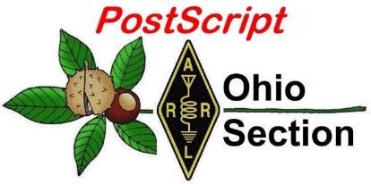](http://arrl-ohio.org/news/)

***“October 10th, 2022******”***

🡪 National News 🡪 Club Corner

🡪 DX This Week 🡪 Contest Corner

🡪 Upcoming Hamfests 🡪 One Question Questionnaire

🡪 VE Testing 🡪 South 40

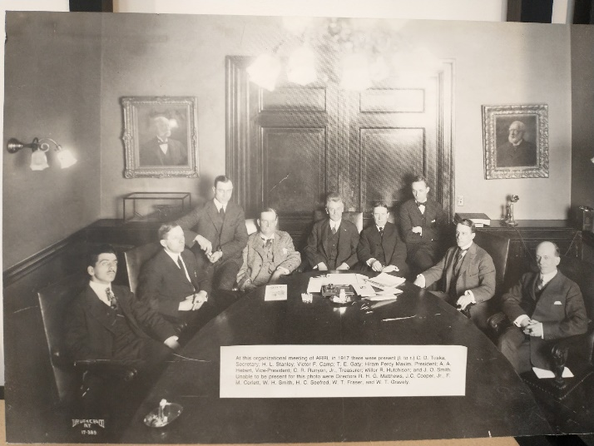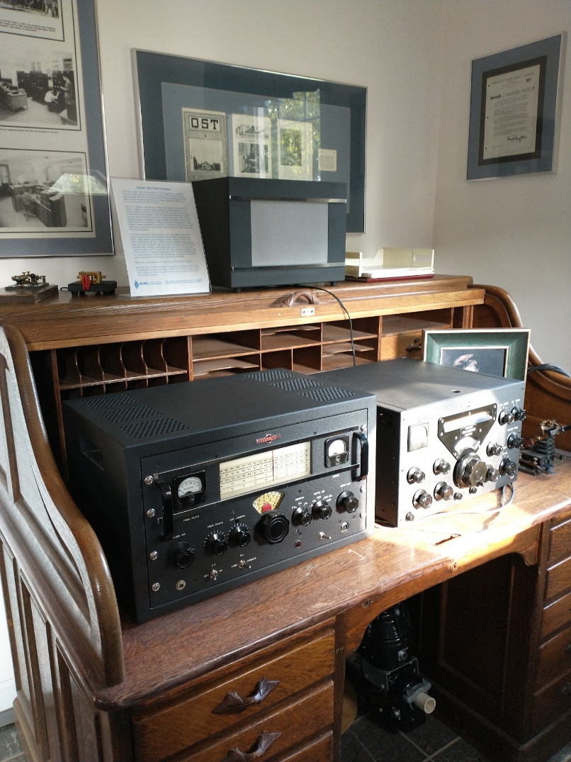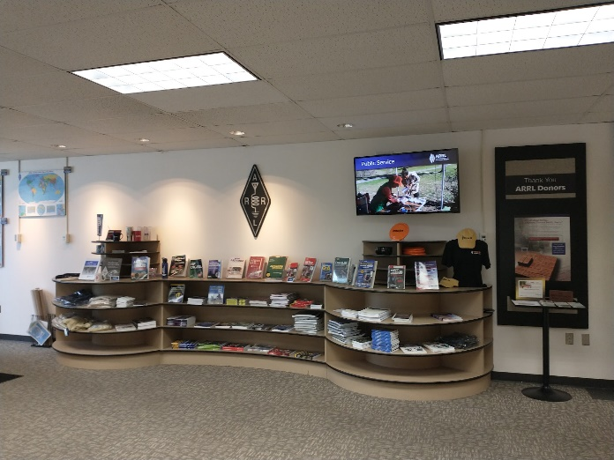

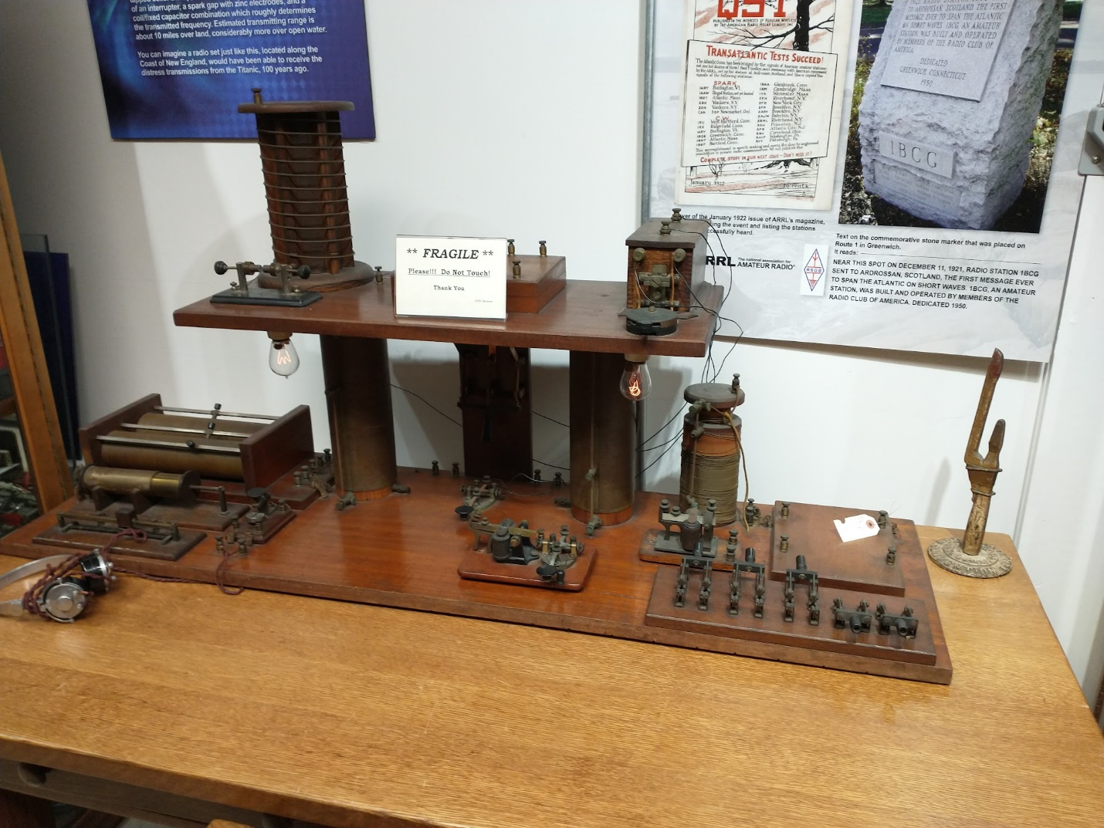

**CQ CQ CQ de WB8LCD**

On a recent trip to Newington I got to see a lot of things in the ARRL Headquarters that I think are pretty remarkable. The first photo (left side) is the first station display that you would normally see when walking into the W1AW Memorial Station, upper right is the lobby in the HQ building. While all day to day activities of ARRL take place in the HQ building, the place is also an amazing museum of Amateur Radio. The photo on the bottom right shows the group of hams at an organizational meeting in April 2017. Hiram Percy Maxim is in the center exactly between the two doors. The photo on this page is typical of the *many* displays around the building chronicling the history of not only Amateur radio, but radio in general. Most of the displays are behind glass and unfortunately hard to get good photos of. Note in this last photo the “Wouff-Hong” sitting on the right rear of the table. The “real” Wouff-Hong is on display, but in the 20’s and into the 30’s, items were made and sold that were replicas of the original Wouff-Hong. The one in the photo is probably one that was made and distributed at the ARRL National Convention in Chicago, IL, September 3rd, 4th and 5th, 1938. (editor’s note: if you ever see one of these for sale on E-Bay or at a garage sale LET ME KNOW! I would love to have one of these early pieces.)

I believe that Amateur Radio is the Greatest Hobby in the World! It’s been a life-long hobby for me and I have met and known many tremendous people who are hams. But, in the US, under Title 47 of the Code of Federal Regulations (CFR), part 97, we are defined as the “Amateur Radio *Service*.” You can find the complete rules here:

[Microsoft Word - March 8, 2018.docx (arrl.org)](http://www.arrl.org/files/file/Regulatory/March%208,%202018.pdf)

Let’s look at Subpart A –

[**Subpart A - General Provisions**](https://www.ecfr.gov/current/title-47/part-97/subpart-A)

[**§ 97.1 Basis and purpose.**](https://www.ecfr.gov/current/title-47/section-97.1)

**The rules and regulations in this part are designed to provide an amateur radio service having a fundamental purpose as expressed in the following principles:**

**(a) Recognition and enhancement of the value of the amateur service to the public as a voluntary noncommercial communication service, particularly with respect to providing emergency communications.**

**(b) Continuation and extension of the amateur's proven ability to contribute to the advancement of the radio art.**

**(c) Encouragement and improvement of the amateur service through rules which provide for advancing skills in both the communication and technical phases of the art.**

**(d) Expansion of the existing reservoir within the amateur radio service of trained operators, technicians, and electronics experts.**

**(e) Continuation and extension of the amateur's unique ability to enhance international goodwill.**

Amateur Radio is probably the only hobby that has this type of governmental recognition and responsibility. You won’t find Stamp Collecting, model railroading, bird watching, hiking, quilt making or just about any other hobby with these fundamentals. And while there are hundreds of activities we can participate in; we are obligated to these 5 requirements to maintain our “right” to the radio spectrum we occupy. At any time, by not meeting these 5 requirements, we could lose our right to the spectrum. We could officially become SWL’s through a simple act of Congress. Fortunately for us, we have an advocate. The American Radio Rely League. They are our *only* collective voice to government. I believe that without them we would cease to exist and part 97, along with our hobby would disappear. That’s why I belong to the ARRL and why I have taken the position of Ohio Section Manager. While I’m not the smartest guy out there (I won’t point any fingers, but I don’t think I’m the dumbest guy either) my commitment to the hobby, to the ARRL and to the Amateur Radio Service cannot be disproved. I’ll also point out, that until I reach “perfection” I am open to all comments and suggestions, although I may not agree with all of them…….

Over the next few weeks, I’ll talk about each of those 5 areas of our basis for existence and how we can fulfill our obligations not only to our hobby, but to the other citizens of the United States we exist to serve. Please don’t take this lightly, we all have the obligation to serve. I’ll also tie this into all my goals for my term(s) as Section Manager which are to increase the number of licensed hams in the section, increase the numbers of ARRL members in the section and to promote the hobby and make us more visible and respected in the communities which we are a part of.

**Youth Net**

**When:** The second Sunday of every month at 7:30 PM EST

**Where:** The K8IV repeater located in Kent, Ohio (Echolink node K8BF-L) RF: 146.895 Mhz  with PL 118.8

**Who:** Any licensed amateur radio operator who wishes to participate. Priority will be given to youth stations and those located in Ohio.

The purpose of this net is to encourage youth activity in amateur radio and to help new hams get more comfortable on the air.

Coming up, my last hamfest that I’ll make it to this year will be the Massillon fest at the MAPS Museum. But there are several fests already on the books for next year so I’m hoping we will continue to move back to something closer to “normal”. I’ll continue to visit, both in person and on ZOOM as many of your local club meetings as I can reasonably fit into my schedule. It’s looking like I’ll have some help in my business coming online for the new year, so that will help me devote more time to my duties as OSM and hopefully reduce my response time for all the section business that needs to be conducted. I might even get some more “on-air” time if I’m lucky!

We’re also coming up on that time of year where clubs go through the ritual of finding and electing new officers to take their clubs into the new year. Don’t let them think it’s a thankless job – tell them you appreciate all they do for you and your hobby. Clubs are where the “magic” of radio is brought to life and shared with their members, both young and old. Be a part of that. And don’t agree to it “if no-one else wants to do it”. Do it because you have something to offer for the good of us all. Yeah, it can be a lot of work, but anything worthwhile usually is. Lots of things you could waste your time on are easier, but you’re worth more than that! Step up and make a difference.

73,

Tom Sly - WB8LCD

Ohio Section Manager

[wb8lcd@arrl.org](mailto:wb8lcd@arrl.org)

330-554-4650

***National News***

*(from ARRL and other sources)*

Proposals Sought For Amateur Radio Crew Contacts From The International Space Station

Amateur Radio on the International Space Station (ARISS) is seeking formal and informal education institutions and organizations, individually or working together, to host an amateur radio contact with a crew member onboard the International Space Station (ISS) in 2023.

Organizations that want to participate will need to submit a proposal no later than November 13, 2022. ARISS is looking for proposals that will draw large numbers of participants and integrate into a well-developed education plan. To assist with the proposals, ARISS has posted information about expectations and guidelines on their [website](https://www.ariss.org/). In addition, an ARISS Proposal Webinar session will be held on October 13, 2022, at 8:00 PM ET. The Eventbrite link to sign up for thewebinaris [https://ariss-proposal-webinar-fall-2022.eventbrite.com](https://ariss-proposal-webinar-fall-2022.eventbrite.com/).

ARISS anticipates holding the contact between July 1 and December 31, 2023. Crew scheduling and ISS orbits will determine the exact radio contact dates. Crew members aboard the ISS will participate in scheduled amateur radio contacts approximately 10 minutes in length, and they'll allow students to interact with the astronauts through a question-and-answer session.

An ARISS contact is a voice-only communication opportunity via amateur radio. It takes place between astronauts and cosmonauts aboard the space station, and classrooms and communities. ARISS contacts afford education audiences an opportunity to learn firsthand what it's like to live and work in space. Such contacts provide the chance to learn about space research conducted on the ISS. Students will also have an opportunity to learn about satellite radio communication, wireless technology, and radio science.

Amateur radio organizations around the world, with the support of NASA and space agencies in Canada, Japan, Europe, and Russia, present educational organizations with this opportunity. The ham radio organizations' volunteer efforts provide much of the equipment and operational support that enables communication between the ISS crew and students around the world.  
  
ARISS is a cooperative venture of international amateur radio societies and the space agencies that support the ISS. In the US, sponsors are the Radio Amateur Satellite Corporation (AMSAT), ARRL The National Association for Amateur Radio®, the ISS National Laboratory Space Station Explorers, Amateur Radio Digital Communications (ARDC), and NASA's Space Communications and Navigation (SCaN) program. The primary goal of ARISS is to promote exploration of science, technology, engineering, the arts, and mathematics topics. For more information about ARISS, visit their website at [www.ariss.org](http://www.ariss.org/).

***_____________________________________________***

**Amateur radio operators are needed for the Marine Corps Marathon on October 30, 2022, in Washington, DC, and Arlington, Virginia.**

 The call is for 150 amateur radio operators to provide "eyes on the course" using the 144 and 420 MHz bands, with FM and Digital Smart Technologies for Amateur Radio (D-STAR), and a Medical Data Network using Amateur Radio Emergency Data Network (AREDN). Amateur radio will also be used as back-up communications in case all else fails. Operators will prepare themselves, supplies, and equipment to function in a large-scale, multi-jurisdictional, mass casualty-type event under real-world conditions. Training will be provided, and each operator will receive a commemorative T-shirt. Amateurs can sign up by following the link [www.mcmham.org](https://www.mcmham.org/). To learn more about the 2022 Marine Corps Marathon, visit their website at [Marine Corps Marathon](http://www.marinemarathon.com/events/marathon).

|  |  |  |  |  |  |  |
| --- | --- | --- | --- | --- | --- | --- |
| |  |  |  |  |  |  | | --- | --- | --- | --- | --- | --- | | |  |  |  |  |  | | --- | --- | --- | --- | --- | | |  |  | | --- | --- | | |  | | --- | | **NASA Mars Exploration at a Glance** | | | |  | | --- | | **October 2022** | | | |

|  |  |  |  |  |  |
| --- | --- | --- | --- | --- | --- |
| |  |  |  |  |  | | --- | --- | --- | --- | --- | | |  |  |  |  | | --- | --- | --- | --- | | |  |  | | --- | --- | | |  | | --- | | **[Mosaic image shows the Perseverance rover robotic arm and its shadow, against a backdrop of a rocky outcrop.](https://click.icptrack.com/icp/relay.php?r=7067822&msgid=61535&act=FC51&c=1862074&pid=119983&destination=https%3A%2F%2Fmars.nasa.gov%2Fnews%2F9261%2Fnasas-perseverance-rover-investigates-geologically-rich-mars-terrain%2F%3Futm_source%3DiContact%26utm_medium%3Demail%26utm_campaign%3Dnasas-mars-public-engagement-team%26utm_content%3D20221005-MarsNewsletter&cf=57401&v=0853f853ece2a4e79ee162f57a40ded008a3206e60346bdb2dcb42ad7b14f9ce)** | | | [**Mars River Delta Is a Treasure Chest of Surprises**](https://click.icptrack.com/icp/relay.php?r=7067822&msgid=61535&act=FC51&c=1862074&pid=119983&destination=https%3A%2F%2Fmars.nasa.gov%2Fnews%2F9261%2Fnasas-perseverance-rover-investigates-geologically-rich-mars-terrain%2F%3Futm_source%3DiContact%26utm_medium%3Demail%26utm_campaign%3Dnasas-mars-public-engagement-team%26utm_content%3D20221005-MarsNewsletter&cf=57401&v=0853f853ece2a4e79ee162f57a40ded008a3206e60346bdb2dcb42ad7b14f9ce)  While sampling Mars, the Perseverance rover is building a science treasure chest, and its latest rock samples may be the most valuable yet. Some have organic molecules – but from ancient biology, or another process? Sending them back to Earth in the future could help scientists figure it out | | | |

|  |  |
| --- | --- |
| |  | | --- | | [**NASA’s SpaceX Crew-5 Launches to International Space Station**](https://r20.rs6.net/tn.jsp?f=001GLKA-SCe5H16jzEkgWCtGeMutrZBW-QUvJoEH-t7TfS8COiIA2l2zvf50Moh8BZxLBdaKrzM5jaLRZI1X6EufRFCGr9z_-clqyj0qM1RFfyDV_zM3Bjbodq2C8c1C-1IXeo5nuVWih5uzeGjhwXFkIzIpQAk-D5i&c=rtjRQcz9tQY_IHrDfxg7pE1-GNdbeLMXMFh9jl2LwfzH7hF6kohF7g==&ch=ZDoLe4THqEsUbcmQOp4VyT6b4zydCepp2lsZOOC9IqknbSW2zfaiYw==) | |

|  |  |
| --- | --- |
| |  | | --- | | Welcome to the International Space Station, Crew-5!  During a sun-splashed afternoon on Florida’s Space Coast, NASA astronauts [Nicole Aunapu Mann](https://r20.rs6.net/tn.jsp?f=001GLKA-SCe5H16jzEkgWCtGeMutrZBW-QUvJoEH-t7TfS8COiIA2l2zkutyDjFUanJETZCU5xOK4JQE5oxdFWbkwMc_1AwGoaqQFAtuWYx18w6p_FfObI_UBFMbiVIEwHURreQ3ukxF8TKKfg2_fNDDw3e9UPEIozliYooUFLx0NL1bObLnEcNkjQaKQb4UDcD&c=rtjRQcz9tQY_IHrDfxg7pE1-GNdbeLMXMFh9jl2LwfzH7hF6kohF7g==&ch=ZDoLe4THqEsUbcmQOp4VyT6b4zydCepp2lsZOOC9IqknbSW2zfaiYw==) and [Josh Cassada](https://r20.rs6.net/tn.jsp?f=001GLKA-SCe5H16jzEkgWCtGeMutrZBW-QUvJoEH-t7TfS8COiIA2l2zkutyDjFUanJPvhgF5gke0Yni1LFDA9CslXQE8OLylsCLH6l8prNDdnX6zkBVwM1yaRJbwDtX4YoCR-Qr8EJWhEWJvXDQufHTFRejPYkbkSPMxVSZlbYYmuf9OuDrOipFZ8D0Im44sHi&c=rtjRQcz9tQY_IHrDfxg7pE1-GNdbeLMXMFh9jl2LwfzH7hF6kohF7g==&ch=ZDoLe4THqEsUbcmQOp4VyT6b4zydCepp2lsZOOC9IqknbSW2zfaiYw==), along with JAXA (Japan Aerospace Exploration Agency) astronaut [Koichi Wakata](https://r20.rs6.net/tn.jsp?f=001GLKA-SCe5H16jzEkgWCtGeMutrZBW-QUvJoEH-t7TfS8COiIA2l2zvf50Moh8BZxq9IOo5OxIr4hxW7V2JzOTR-eRQ6Wkd23-L_Sqbc2FWqriAol-Oo4uTsQue_GV9-HXL2nbc39jxbm16APIVUFwimItEx4IiQB1VluIzO4MLBhpWA9EVo0fSI8f-m0aGeaUra_jWhvXEI=&c=rtjRQcz9tQY_IHrDfxg7pE1-GNdbeLMXMFh9jl2LwfzH7hF6kohF7g==&ch=ZDoLe4THqEsUbcmQOp4VyT6b4zydCepp2lsZOOC9IqknbSW2zfaiYw==) and Roscosmos cosmonaut [Anna Kikina](https://r20.rs6.net/tn.jsp?f=001GLKA-SCe5H16jzEkgWCtGeMutrZBW-QUvJoEH-t7TfS8COiIA2l2zkutyDjFUanJlqpm69_tl5iSCmE8gz3meb0MKHeFnei7-dnt_hkqtO7AkJn-pTltWf3oY04eycY6WOdyMT20QxGsgTdVWsFiKyCjHORuzEKgpOEAeButqwU=&c=rtjRQcz9tQY_IHrDfxg7pE1-GNdbeLMXMFh9jl2LwfzH7hF6kohF7g==&ch=ZDoLe4THqEsUbcmQOp4VyT6b4zydCepp2lsZOOC9IqknbSW2zfaiYw==), blasted off from Kennedy Space Center at 12 p.m. EDT Wednesday, Oct. 5, for NASA’s SpaceX Crew-5 mission. After a 29-hour journey in orbit, the SpaceX Dragon Endurance spacecraft carrying the Crew-5 crewmates docked autonomously to the station’s Harmony module at 5:01 p.m. EDT Thursday, Oct. 6.  Missed the launch? Watch the highlights here: | |

|  |  |
| --- | --- |
| |  | | --- | | [NASA SpaceX Crew-5 Prelaunch and Launch Highlights](https://r20.rs6.net/tn.jsp?f=001GLKA-SCe5H16jzEkgWCtGeMutrZBW-QUvJoEH-t7TfS8COiIA2l2zvf50Moh8BZxMNKLAp5sb2YlMLwu3FuGJBacWcjNAlqkW3HhAOoRiWsSIIh1rUyU1E_-TlwDC8fQ5-eCCNl4rTklazXhxfV0lIbp_rDLG5s_o3ojYu_X7YOnUWE1E5uWtA==&c=rtjRQcz9tQY_IHrDfxg7pE1-GNdbeLMXMFh9jl2LwfzH7hF6kohF7g==&ch=ZDoLe4THqEsUbcmQOp4VyT6b4zydCepp2lsZOOC9IqknbSW2zfaiYw==) | |

|  |  |
| --- | --- |
| |  | | --- | | The Crew-5 mission marks the first spaceflight for Mann, Cassada, and Kikina, and the fifth for Wakata. This is the sixth SpaceX flight with NASA astronauts – including the [Demo-2 test flight](https://r20.rs6.net/tn.jsp?f=001GLKA-SCe5H16jzEkgWCtGeMutrZBW-QUvJoEH-t7TfS8COiIA2l2zvf50Moh8BZxEVRYAMFNx_8lkjjaWL47MkHOszsGiM5XRWxWgPT7gYsKQemxIJZbNqpU3fCiQVohHEC6sNKnHH2JXFpJWurBHUwsj4NznVYbXKSLk5PvNj-nT60ePGGVwnWgFtp_OW45E23D-I7KncHgvH6NA9L7jI3uBryRky_8bhJ8WWpRiq1jnr-7u4eIya_jMIES_X2kqGRcbfdxrFvRzzth2USmLg==&c=rtjRQcz9tQY_IHrDfxg7pE1-GNdbeLMXMFh9jl2LwfzH7hF6kohF7g==&ch=ZDoLe4THqEsUbcmQOp4VyT6b4zydCepp2lsZOOC9IqknbSW2zfaiYw==) in 2020 to the space station – as part of the agency’s [Commercial Crew Program](https://r20.rs6.net/tn.jsp?f=001GLKA-SCe5H16jzEkgWCtGeMutrZBW-QUvJoEH-t7TfS8COiIA2l2zih6IYeYriiETagBFtV3KZAnk1tEJDcJjlM1SHpcBc81Ze1XmyvYLp2ovD7AGbpNxfa3qmcbycbHrU8CYVwMguc6S5WxUaUcvK7IZcf3fVPJ_VZrBQPPUJDzUAJANGTyUfDU4gJqsbLuFgzPBESXk4o=&c=rtjRQcz9tQY_IHrDfxg7pE1-GNdbeLMXMFh9jl2LwfzH7hF6kohF7g==&ch=ZDoLe4THqEsUbcmQOp4VyT6b4zydCepp2lsZOOC9IqknbSW2zfaiYw==).  Crew-5 is scheduled for a long-duration stay of up to six months aboard the space station before returning to Earth in the spring of 2023. During their mission, the crew members will conduct scientific research in areas such as cardiovascular health, bioprinting, and fluid behavior in microgravity that will both benefit life on Earth and help us prepare for human exploration farther into space.  Want to learn more about what’s happening at the orbital laboratory? Follow the International Space Station’s [Facebook](https://r20.rs6.net/tn.jsp?f=001GLKA-SCe5H16jzEkgWCtGeMutrZBW-QUvJoEH-t7TfS8COiIA2l2zlFKwTEguV-1HQrTaLDs16t_l3lIfuMMAlvEA3AjinAC2tF86NjYAk-vBz-WfRyq0l2hOomyGWUkD8lAUqX_OykYIVWE1W9_ng==&c=rtjRQcz9tQY_IHrDfxg7pE1-GNdbeLMXMFh9jl2LwfzH7hF6kohF7g==&ch=ZDoLe4THqEsUbcmQOp4VyT6b4zydCepp2lsZOOC9IqknbSW2zfaiYw==) and [Instagram](https://r20.rs6.net/tn.jsp?f=001GLKA-SCe5H16jzEkgWCtGeMutrZBW-QUvJoEH-t7TfS8COiIA2l2zvf50Moh8BZxClSVgUqiez8ATNddILBZvC0S4Hz0PZkz8_EBfRCmsfkEYUeYwND0QdWzGZMZb6_zgMXv_azdZrt7c7H_U0QJfId_7x5Havjj&c=rtjRQcz9tQY_IHrDfxg7pE1-GNdbeLMXMFh9jl2LwfzH7hF6kohF7g==&ch=ZDoLe4THqEsUbcmQOp4VyT6b4zydCepp2lsZOOC9IqknbSW2zfaiYw==) accounts, [@space_station](https://r20.rs6.net/tn.jsp?f=001GLKA-SCe5H16jzEkgWCtGeMutrZBW-QUvJoEH-t7TfS8COiIA2l2zvf50Moh8BZxJdLZOmh-csPcS9zc4PxY0wFnm3dAtCtfv6et195lTUHV5LTlG8ksgH_eOWFEPTckkQxYVJmVt2aCZZ-KwEUKstfOGlQr5izQ&c=rtjRQcz9tQY_IHrDfxg7pE1-GNdbeLMXMFh9jl2LwfzH7hF6kohF7g==&ch=ZDoLe4THqEsUbcmQOp4VyT6b4zydCepp2lsZOOC9IqknbSW2zfaiYw==) and [@ISS_Research](https://r20.rs6.net/tn.jsp?f=001GLKA-SCe5H16jzEkgWCtGeMutrZBW-QUvJoEH-t7TfS8COiIA2l2zlFKwTEguV-1aGmLx2-uxh2fIW-qxAubGpigyHeQ6nPp30haHaZiLyR6VNOxutrBrLANt6C1dAVMe8v5cHmM_koVwWOOu1fyDPhIaUMJCAv0&c=rtjRQcz9tQY_IHrDfxg7pE1-GNdbeLMXMFh9jl2LwfzH7hF6kohF7g==&ch=ZDoLe4THqEsUbcmQOp4VyT6b4zydCepp2lsZOOC9IqknbSW2zfaiYw==) on Twitter, or visit our [Commercial Crew Program](https://r20.rs6.net/tn.jsp?f=001GLKA-SCe5H16jzEkgWCtGeMutrZBW-QUvJoEH-t7TfS8COiIA2l2zkkblMQnIPID8wX1ikPPPR488803EuRd8ZsYMmoPkgkCbZHOE6QohRzo3lNiY4s6emWnzubob3Ua_douxX_v9yhcswfSqzA5aYKlvks3COPWQnmHzsiZQYk=&c=rtjRQcz9tQY_IHrDfxg7pE1-GNdbeLMXMFh9jl2LwfzH7hF6kohF7g==&ch=ZDoLe4THqEsUbcmQOp4VyT6b4zydCepp2lsZOOC9IqknbSW2zfaiYw==) blog. | |

|  |  |  |  |
| --- | --- | --- | --- |
| |  |  |  | | --- | --- | --- | | |  |  | | --- | --- | | |  | | --- | | [Get More Space Station Updates](https://r20.rs6.net/tn.jsp?f=001GLKA-SCe5H16jzEkgWCtGeMutrZBW-QUvJoEH-t7TfS8COiIA2l2zmCi7xpIRQWTrB4AWp_3GYbGxjb_qmxOcFEpOhBSBuwKoua2VtPxXPqp5E6eSOxch69awMFiOyPvKvlvVE-F0Hk-H9gourrc3w9Rtg6AskmQ36AJopBIZpjCPSwuVTrF1R9U3h027tXfrQHT1md58OqwevixUrsQtg==&c=rtjRQcz9tQY_IHrDfxg7pE1-GNdbeLMXMFh9jl2LwfzH7hF6kohF7g==&ch=ZDoLe4THqEsUbcmQOp4VyT6b4zydCepp2lsZOOC9IqknbSW2zfaiYw==) | | | |

***Club Corner***

This is YOUR cornner of the newsletter. Send me what your club is doing and I’ll make sure that it gets in. Got a special event or club project that you want everyone to know about? Send it to me! Need help with a project? Send it to me.

Let me know what you club is up to. Are you going to have a special guest at your meeting or are you having a special anniversary?

Just sent it to: [webmaster@arrl-ohio.org](mailto:webmaster@arrl-ohio.org) Please! Format as below:

******If you want me to publish your club information, or even an article you have written, please send it in WORD format (.docx). Please use Times New Roman font size 12 for the body of the aritcle. Any photos please include as a .jpg or .bmp – the time you save me in doing all the conversions will be greatly appreciated.

Club Grant Application Period Open Until November 4

The ARRL Foundation Club Grant Program opened a second grant proposal period which began September 7, 2022, and runs until November 4, 2022, at 7 PM Eastern Time. Radio clubs can apply now, and information about the program can be found on the ARRL website at [www.arrl.org/club-grant-program](http://www.arrl.org/club-grant-program).

Following the first proposal period that ran earlier this year, 128 clubs applied for grants with a variety of outstanding projects. Emphasis is placed on projects that have a component of community involvement, training, new ham development, and club revitalization. Twenty-four clubs were chosen and nearly $270,000 was awarded.

Clubs that applied in the first round and did not receive a grant are urged to reapply. The ARRL Foundation will award an additional $230,000 in grants at the end of the second application round.

An informational webinar was held on September 7, and a recording of that event can be seen on ARRL's YouTube channel at <https://youtu.be/ZNvc_eeIIwU>.

**Want to know where to go to get the courses you need? It’s all Right Here!**

* [Ohio EMA Training Calendar](https://webeoctraining.dps.ohio.gov/TrainingAndExercise/courselist.aspx)
* [Login to the DPS Training Campus](https://learning.dps.ohio.gov/PSTC/)
* [Create a new account on the DPS Training Campus](https://learning.dps.ohio.gov/PSTC/)

**NOTE:**

* Most courses are in-person but some course may be hosted virtually (this will be noted).
* Seats available listed are as of the release of this update and will change quickly.
* All classes will be posted on the DPS training campus at least 60 days prior to the start of the course.
* Please read the [Training Policy & Catalog](https://ema.ohio.gov/documents/training/ema0201.pdf) for more information on Ohio EMA trainings.

_._,_._,_

How to Plan and Apply for an ARRL Hamfest or Convention

If your amateur radio club is planning to host a convention, hamfest, tailgate, or swapfest, please consider applying for ARRL sanctioned status for your event. To learn what it means to be an ARRL sanctioned event, and to get some ideas on how to prepare for and conduct a hamfest or convention, visit [www.arrl.org/arrl-sanctioned-events](http://www.arrl.org/arrl-sanctioned-events).

To apply for ARRL sanctioned status for your event, go to [www.arrl.org/hamfest-convention-application](http://www.arrl.org/hamfest-convention-application).

The ARRL Hamfests and Conventions Calendar can be found online at [www.arrl.org/hamfests](http://www.arrl.org/hamfests). In addition, the Convention and Hamfest Calendar that runs in *QST* each month also presents information about upcoming events.

Go Fully Electronic in 2022!

By Maria Somma, AB1FM, ARRL VEC Manager

**Online Examinations and Remote Testing**

Your club's VE team can become part of the fun and excitement of remotely administered Online Examinations.  
  
The remote exam sessions are conducted using an online video conferencing platform and a web-based examination system with on-screen tests. ARRL VE teams have had the option to be completely electronic since June 2020 by using online exams. The online exams can also be utilized at in-person sessions automating most of the process, for a fully electronic in-person session experience.  
  
VE teams have been using the [Exam.Tools](https://exam.tools/) Online Examination system for remote video and in-person sessions. Over 25,000 applicants have been tested through the Online Examinations system in the past two years. The system works well for online or printed examinations and includes registering and tracking candidates throughout the session, on screen exams and grading, online signing of CSCE and 605 forms by the candidate and examiners, logging and compiling session stats and VE participation list (test report summary), and output files for upload to the coordinating VEC. The program manages and handles almost everything needed to conduct a test session. Time and experience with in-person exam sessions is invaluable when transitioning to remote video-supervised online exam sessions.  
  
Interested ARRL VE teams must contact the [VEC department](mailto:vec@arrl.org) to receive the online exams instructions and remote video session procedures.  
  
Not a VE? Become one today!  
  
Visit <http://www.arrl.org/become-an-arrl-ve>  
  
**Electronically File Exam Session Documents for Quicker Service**

After the session has concluded, VE teams can upload in-person documents or remote video session files via ARRL VEC's secure web page (program service option since 2018).

New and upgraded licenses are issued within 1 to 2 business days for weekend sessions and are usually issued on the same day for weekday sessions.

Please contact the [VEC department](mailto:VEC@arrl.org) for the information and instructions on electronically filing exam session documents through our upload page. Authorized VEs will be sent the upload page URL which, is hidden from the public.

**Resources for ARRL VEs**

The [ARRL VEC VE Resources](http://www.arrl.org/resources-for-ves) page offers the information you will need to help conduct exam session business. Our support page offers easy access to session forms and information, online examinations, remote video session instructions, VE Manual supplemental information, FCC rules, basic qualification question procedures, and much more. There is also some helpful information for the community, such as preparation resources for candidates, in-person and remote video exam session search, vanity call sign information, and more.

The ARRL VE Newsletter relays important updates relating to FCC rule or policy changes, exam session document or procedural changes, video sessions, and other topics. VEs can sign up for the newsletter at <https://reflector.arrl.org/mailman/listinfo/ve-list>

Xenia Ramada Inn Closing

Anyone coming to Hamvention 2023 with plans to stay at the Ramada Inn in Xenia needs to find other accommodations.  According to an article in the Dayton Daily News the city of Xenia will take full possession of the Ramada Inn on Nov. 1.

The land occupied by the Ramada Inn has been owned by the city of Xenia since the 1974 tornado. According to the article, city officials said that AK Group Hotels, Inc., the operator of the Ramada Inn, has been operating under a month-to-month lease since 2017.

In August, the city of Xenia reportedly reached an agreement with Ramada Inn operators that allowed them to operate until Oct. 31 in order to liquidate the business. The land will be incorporated into the Xenia Towne Square revitalization project.

Hamvention management asks hams to share this information so that anyone with reservations at the Ramada Inn Xenia will be aware of it. Hamvention 2023 will be held May 19, 20 and 21, 2023 at the Greene County Fairgrounds and Expo Center in Xenia.

Respectfully submitted,

James Gifford KD8APT

Hamvention Media Chair

937-718-6126

**____________________________________________________**

**Cuyahoga Falls ARC Online Tech License Classes Start Oct 9th**

The Cuyahoga Falls ARC will be sponsoring Technician and General Licensing Classes this fall and winter. The Tech class starts on Oct 9 and will run for six weeks. Time is 1:30 to 4:00 PM, and the classes will be held online via Zoom and Google Classroom. For more information, you can visit [*tiny.cc/beaham*](http://tiny.cc/beaham).

I know what you are thinking “why would I be reading this if I didn’t already have my Tech License!” That’s partially true; we are running this article in the Ohio Section Journal because we need your help. Potential Hams do not know about licensing classes or how Amateur Radio Licensing works. So we need you to find potential new Hams and let them know about the class.

Here are some suggestions on how to do this:

1. **Tell someone**- give them this link - [*tiny.cc/beaham*](http://tiny.cc/beaham) (email it to them, print it out, text it to them, call them on the phone, send it in a letter or card, attach it to a small gift or snack, etc.) and if they ask, “What is Amateur Radio?” give them this link [*tiny.cc/wiar*](http://tiny.cc/wiar).
   1. Do you have a spouse, child, parent, or another family member interested in getting started in Amateur Radio?
   2. Do you have friends or neighbors interested in getting started in Amateur Radio?
   3. 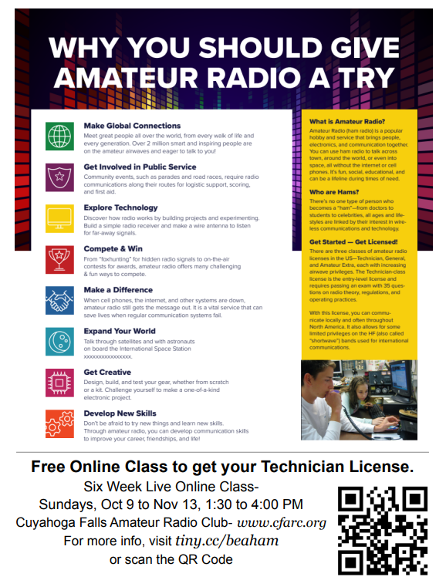Do you have co-workers interested in getting started in Amateur Radio?
2. **Do you have a place to put up a flyer** (work, school, library, restaurant, store, etc.)**?** Here are links to two printable flyers: [Flyer A](https://docs.google.com/document/d/1kwmRNEBYHhdL6gBY0tKj3P-Xm2NCFn6TuQCeqlvS-Ds/edit?usp=sharing) & [Flyer B](https://drive.google.com/file/d/1eToel7Q2KJZxRMGkEOqTobN9J-tzM_BH/view?usp=sharing)

This year we will be working in conjunction with the[*M.O.R.E. Project*](http://n2re.org/m-o-r-e-project). This will mean that students who complete the class and pass the license exam will be eligible to receive a GOTA (Get On The Air) package of free equipment, including a VHF/UHF HT and a SDR (Software Defined Receiver).

Because we draw attendees from around the country, we always recommend they join a local radio club in their area. If you recommend this class to someone, please let them know about your local club so they can find mentors in their area.

**__________________________________________________________**

VE Sessions

**All Things Amateur Radio Association (ATARA)** We host testing sessions every second Tuesday of the month in Lancaster. To sign up please visit our website <https://atara-w8atr.fun> and contact us at [hamexams@atara-w8atr.fun](mailto:hamexams@atara-w8atr.fun).

**CARS**

VE testing from CARS - Cuyahoga Amateur Radio Society - at Elmwood Recreation Center, 6200 Wisnieski Parkway in Independence, Ohio 44131  Time: 9:15 AM (Walk-ins allowed) Always the 2nd Sunday of the odd month. Go to CARS  [www.2cars.org](http://www.2cars.org/) for detailed map of location.  Call Metro W8MET 216-520-1320 for details

**Dayton Amateur Radio Association (DARA)** If you are interested in testing for a new or upgraded license, please come see us at the DARA Clubhouse. If you have questions about testing, please email [exams.w8bi@gmail.com](mailto:exams.w8bi@gmail.com)

**Huber Heights Amateur Radio Club**

Huber heights amateur radio club does ARRL VE testing the second Saturday of each even numbered month. Feb, Apr, Jun, Aug, Oct, Dec. 9:30-11:00 For more information contact Jim Storms – AB8YK at [ab8yk@hotmail.com](mailto:ab8yk@hotmail.com)

**The Lake County Amateur Radio Association**

The Lake County Amateur Radio Association is once again holding its **2022** Amateur Radio license exams at the **Kirtland Library**, 9267 Chillicothe Road, on the following dates:

Saturday, October 1, and December 3.

The tests will start at **12 noon.** Please arrive a few minutes earlier.

**The Lancaster and Fairfield County Amateur Radio Club (LFCARC**) hosts exam sessions at the FAIRFIELD County EMA, 240 Baldwin Dr in Lancaster Ohio, 43130, on the first Saturday each month at 10:00 am. Please visit our website at <http://www.k8qik.org> for exam dates on our calendar and navigate to our Learning Center/Taking the Exam link for information and requirements. Our experienced VE team looks forward to serving the Amateur Radio community in Central Ohio. Contact me at [ve_testing@k8qik.org](mailto:ve_testing@k8qik.org) to register.

**The Milford Amateur Radio Club (MARC)** is now doing VE testing on the third Thursday of each month at 6:00 PM.  Location;  Miami Township Civic Center located at 6101 Meijer Drive, Milford, OH  45150.

 Please pre-register at [www.milfordhamradio.org](http://www.milfordhamradio.org/)

**Northern Ohio Amateur Radio Society (NOARS)**

VE sessions are held the first Saturday of odd-numbered months at 10 AM in the North Olmsted Library, 27403 Lorain Rd., North Olmsted. Registration is preferred, but walk-ins are welcome. For more information or to register, contact Elaine, KC8FOS at [ewilkinson1951@gmail.com](mailto:ewilkinson1951@gmail.com).

**Portage County Amateur Radio Service (PCARS)**

The first Saturday of every even numbered month -10 am – at the PCARS club site in Ravenna. Please visit the PCARS web site and check out the information about VE testing in the latest newsletter at [www.portcars.org](http://www.portcars.org) .

If you have any questions, don’t hesitate to contact me at KB8UUZ@gmail,com

**Your Club news should be listed here!**

I know you’re out there doing things! Send me a write-up (MSWord please) and some photo’s (.jpg please) and we’ll get your club hi-lited here for the other OH Section Clubs to see! Send to [WB8LCD@ARRL.ORG](mailto:WB8LCD@ARRL.ORG)

**______________________________________________________________________________**

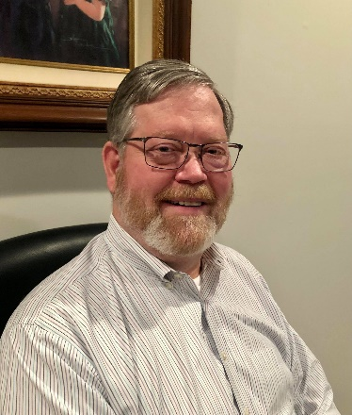

DX This Week – Trip to Jan Mayen, JX7GIA

Bill AJ8B (aj8b@arrl.net, @AJ8B, or www.aj8b.com)

CWOPs Member #1567

Did you happen to notice the “P5” – North Korean spot on the cluster 2 weeks ago? I imagine that spotting alarms were going off all over the world! It will be bad enough when Bouvet hits the air in a few months. Just imagine the pileups with P5 is finally active!

Speaking of Bouvet, the DXpedition is only about 100 days away. (<https://www.3y0j.no/>) This long anticipated DXpedition is anxiously awaited around the world. The co-leader is LA7GIA – Kenneth. Several years ago, Kenneth operated from JX7GIA and I thought it might be timely to print his account of that trip.

I really enjoyed the time spent at the W4DXCC convention put on by SEDCO. Great presentations and solid ham radio fellowship was really appreciated. If you have never gone, mark your calendars for next September. It was a great time in Gatlinburg.

I received a card from CT1EGW, Arlindo in Portugal, V51LZ, Andre’ in Namibia, and HL5FUA, Choi in South Korea. Let me know what you received. 73 and Gud DX Hunting

|  |  |
| --- | --- |
|  |  |
|  | |

DAH DIT DIT DIT DAH DAH DIT DIT DIT DAH

JX7GIA. Oslo, April 07th 2019 by Ken, LA7GIA/JX7GIA

I have been preparing for this trip for about 5 years. I really felt like winning a Powerball lottery when I was allowed a free seat at the 3-hour Military flight going from Oslo Military airport directly to Jan Mayen. In total this was a 16-hour daytrip. I have been discussing this possibility with the Military for about 5 years. They have regular flights going to Jan Mayen, but A person smiling for the camera
there are very rarely available seats both ways, and one also need a special invitation to be allowed to enter this military flight.

They let me know the day before that there was an opportunity. It was a big surprise to me as I almost had given up this possibility a long time ago. I had a full working day in the office, as well I made a TT8KO presentation in my local club in Oslo same evening. I arrived home at 2200 local time when I started packing and testing the gear for this trip. I made some very quick propagation forecast using Voacap. I could not make up my mind whether using the 20m or 30m band. I made several considerations on choosing the right band while packing. I wanted to offer everybody a fair chance working JX on CW. Hence, I wanted to run on a single band, and a band that offered the best propagation worldwide during my entire short stay as I did not intend to swap antenna. I thought I only was going to stay there for 4 hours, meaning maybe 2h operating. It was the day of departure I realized the aircraft would stay 5-6h at the airport. I considered 20m as the best overall band covering most parts of the world. Voacap predicted excellent propagation to Asia and NA.

Unfortunately, there is a mountain blocking signals to NA (20 degrees elevation!), propagation to JA is almost unblocked as it just goes clear of Mountain Beerenberg (2000 m ASL). Same with EU.

They day of departure I went to the Military airport 6 AM in morning. This is a 3h flight. It is common as I understand that they fly all the way to JX, just to discover that the fog or snow makes it impossible to land, and they go all the way back to Oslo. I was quite relieved when we landed very smoothly with the Hercules aircraft. My equipment was lightweight on this trip, about 17 kg in total, and all went as carry-on luggage to make an efficient operation. I went out of the aircraft and after some greetings, they explained I could operate from the airport restaurant close to the runway. I asked when the aircraft was leaving, but they did not know as it is no exact departure time as with commercial flights. I asked where to go, they pointed in the direction, and I started running with all my bags. I did a very quick recon and seeing a small antenna mast on top of the air traffic control tower, I agreed this was a good enough QTH. I climbed up 8m and attached one end of my 20+17m African fan dipole and strung it to a nearby flagpole. It was cold and windy but doing this quickly was no problem. From the dipole I run the lightweight Ultraflex 7 coax 35 meter to the airport restaurant – which was where I was going to operate. The African dipole is plug and play as it has a small coax and connector in the feeding point, so I can just plug in my PL259 quickly, se photo. It is made of recycled material and spare parts. It was also a nice moment to see the Norwegian Flag on the Island!

I ran the coax into the airport restaurant, and the window had to stay in open position to allow this. I also had to switch off one heater as I needed power for my amplifier and power supply. This was no problem the first hour, but after a couple of hours operating, I started freezing (but I know everybody would have done the same.).

The airport “restaurant” is really just a place where people can wait for the aircraft in case of delays, there are benches along the wall and a wooden oven in the middle. I would estimate about 10-12 m2. Perfect for my mini-DXpedition! From the airport restaurant I had a nice view to my antenna and the ocean and towards Mountain Beerenberg. As seen from previous photo, it is covered in fog. If I turned my head, I could also see down on the runway where the Hercules aircraft was parked. This was very convenient as I could see when they started preparing for take-off.

After completing the setup, I listened on the band, and when I heard a few station on 20m, I knew there was propagation. As Jan Mayen is located at 71 N it is very common that even small disturbances result in total blackout of propagation. The propagation is very sensitive to the K-index. I started working the South EU stations, running about 700W. They were quite strong with a nice clean tone. Also worked many Russian stations with aurora flutter. Very nice to listen too! I understood that my LA friends were in the skip zone. After I while I worked a few of them far south, but very weak. At some point in time all propagation almost disappeared, and I faired I had to go out and change the antenna. But propagation recovered and as time went on it improved even more. I could notice that soon most EU stations had a nice clean tone. I managed to work my friend Adrian KO8SCA for his ATNO as the first NA station at 1140 UTC. He was very weak but readable with a nice aurora flutter. After that it took many hours before I worked the next NA station. At about 1220UTC some very strong JA stations started to come in. I was hoping for a JA run and called for ASIA but no luck, only a few stations made it into the log.

At around 1400 UTC I started working a couple of NA stations (W0VTT, NE8Z and a couple of more). I also called for more NA stations, but no signals there, and I had a hard time getting the stronger EU stations to QRX – some people really don’t know how to standby! The NA stations were not too strong but workable and with that nice aurora flutter. By that time the EU station had started getting great signals with clear tone and I enjoyed working them as well! Many familiar callsigns went into the log. Some minutes later I also worked N7NR (Dave) from California. I think I work him on all my trips, he always has a great signal! Otherwise, I think most of the NA stations I worked were from the northern part of US/Canada. I also had some nice short QSOs with FY5KE, D2EB and A45XR, very nice to work those DX stations. Indeed, it was also very fun working my LA friends, not to mention some /M stations and other stations like EA8AXT, VE3VEE and NV9L. I tuned into 8AXT and immediately knew it was my friend Ed EA8AXT from Canary Island who I visited earlier this year, it was an ATNO to him as well. Valerie NV9L broke the EU pile when her aurora flutter signal hit Jan Mayen loud and clean enough to make it into the log quickly 10 minutes before QRT. I was also waiting for big gun Marvin VE3VEE to come in and was quite relieved to hear him solid at around 1510 UTC just 5 minutes before I went QRT, maybe that gave him a needed Marathon point? At that time, they had started preparing take-off at the runway. They had taken up the load limb, more and more people were gathering around the aircraft. I realized I had to start packing. The personnel started arriving in the air traffic control center as well. But I was hanging in an managed to work 7 more NA (K7BV, K3RA, K5OA etc.) all with a nice aurora signal. I went QRT and immediately started disassembling the station. I put all the gear quickly in the suitcases, climbed the tower - still cold and windy - and cut the dipole down. Less than 20 minutes later I arrived at the aircraft with a smile and with my coax and dipole hanging out of the bag as I was unable to put it in nicely. I told them I had a great time! This was an unbelievable opportunity, and I was very grateful they offered me this trip to JX. I thanked them, before I entered the aircraft hungry and thirsty. I had not had time for eating or drinking, but well into the aircraft I ate my dinner which was 4 bread slices with cheese. I was cold after 4 hours in the “restaurant” without heating, and wet because of running in the snow. 3h later I arrived back home in Oslo after a 16h roundtrip. The total cost of this mini DXpedition was 5 USD, the cost of a Coke I bought at the airport.

I made about 630 QSOs. I will upload all the QSOs to LoTW very soon. Paper QSL is via home call, direct only USD 3 + SAE.

There is no immediately plans to return to JX with flight, I never win in lotteries twice. I know many people want to go to JX with boat, maybe some larger group will announce it now or maybe later when the solar cycle improves?

73 Ken – LA7GIA

Listen to FY5KE working JX7GIA

<https://soundcloud.com/search?q=jx7gia>

QSO statistics, 630 Qs

EU 84%

Asia 9%

NA/SA 5%

OC 1 QSO

AF 3 QSOs

DAH DIT DIT DIT DAH DAH DIT DIT DIT DAH

Here is an update from Bernie, W3UR, of the DailyDX and the WeeklyDX, the best source for DX information. <http://www.dailydx.com/> . Bernie has this to report:

**TY – Benin -** The Russian DX Team's Benin operation is October 14-27, TY0RU.  This group has previous had on the air:  7P8RU, 7Q7RU, A25RU and E44RU.  For this trip they have nine radios and will be on 160-6 including 60, CW, SSB, FT8 and QO-100 satellite.  QSL via RA1ZZ, or Club Log for direct or bureau, and LoTW.  [https://ty0ru.org](https://ty0ru.org/)  
  
**5V – Togo -** The "Russian DXpedition Team," made up of RA1ZZ, R7AL, RW9JZ, RW8A, R9LR and R5EC fly there October 28 for their stay until, now, November 11, after the TY0RU Benin operation.  In Togo they plan to be on 160- 10 CW, SSB and FT8 normal mode.  They will have five 500-watt stations at their digital site and two more, each 1,000 watts, at the CW and SSB location.  Those are the Elecraft K3 and Expert amps.  The antennas are spider beams on 30, 20, 17, 15, 12 and 10 and a "DL2KQ" type antenna on those also, a pair of ground planes on 40, other GPs on 60, 80 and 160.  Clearly, they will be on all the HF bands, plus 6, and the QO-100 satellite too, CW, SSB and FT8.  QSL bureau or direct to R7AL, with Club Log and LoTW also available.  <https://5v7ru.org/>

**J5 - Guinea Bissau -** CT2GQA, Carlos, is back in the country and got on the air starting October 1, callsign J5JUA.  He is mostly on FT8 and mobile.  He is there through the end of this year and could also use J5GQA.  
  
**FO/M - Marquesas Islands -** FO/F6BCW got there October 1st at about 00Z.  Before that he was in the French Polynesia "DX entity."  VE3VEE, for one, worked him on 14031 and it was Marquesas at that point.  He was on SSB later.  Apparently before October 1 his TX7G callsign was not yet valid so he had to use the FO/ callsign, switching to TX7G once it officially became October, and considering the GMT-10 hours’ time difference to French Polynesia and GMT-9-1/2 hours in the Marquesas, potentially a little confusing.

**FO/A - Austral Islands -** TX5XG by JA1XGI, Haru, will be on Raivavae, OC-114, November 2-9.  Haru plans CW, SSB, RTTY and FT8 F/H on 160, 80, 40, 30, 20, 15 and 10M.  He will send out bureau cards for all QSOs and have the log on LoTW too.  You may also QSL through Club Log OQRS or direct to the JA1XGI home QTH.  [https://australvacation.amebaownd.com](https://australvacation.amebaownd.com/)

**5H – Tanzania -** "I will be doing mission work in Tanzania from Nov. 2-9", says K5DRJ, says Jeff Crawford. This will be Jeff's first time on the DX side of the pileup. He plans to be on the air as 5H2JC from Same, Tanzania (grid locator KI85vw) from November 3 to 6. This will most likely be in the 1300 to 1700Z time frame. He'll be running 20 watts from an Xiegu G90 into an EFRW, 53-foot wire to 9:1 unun. Activity will primarily be on 20 and 40 meters but will be able to go all the way up to 10 meters, on SSB. QSOs will be uploaded to LoTW and Club Log.

DAH DIT DIT DIT DAH DAH DIT DIT DIT DAH

Below is a list of upcoming contests in the “Contest Corner”. I think this is important for someone who is trying to move up the DXCC ladder since entities that are on the rarer side and easiest to work in contests. Some of my best “catches” have been on the Sunday afternoon of a contest when the rarer entities are begging for QSOs. Of course, the gamble is that if you wait until Sunday, conditions may change, or they simply won’t be workable. However, it is not a bad gamble. Of course, why not work the contest and have some fun!  
Check out the WA7BNM Contest Calendar page (<https://www.contestcalendar.com/>) and CQ Magazine for more contests or more details. I also have a comprehensive list that can be imported to your calendar at [www.aj8b.com/files](http://www.aj8b.com/files)

The contests in red are those that I plan to spend some significant participation time on. PLEASE let me know if you are working contests and how you fared.

Thanks!

|  |  |  |
| --- | --- | --- |
| **Date(s)** | **Event** | **Info** |
| Oct. 12 | RSGB Autumn Series Data | <https://bit.ly/31qpcJl> |
| Oct. 12 | VHF-UHF FT8 Activity | <http://www.ft8activity.eu/index.php/en/> |
| Oct. 15 | Feld Hell Spooky Sprint | <https://bit.ly/3g8gpxD> |
| Oct. 15-16 | 10-10 Intl. Fall CW Contest | <http://bit.ly/1FrFeBc> |
| Oct. 15-16 | New York QSO Party | [http://www.nyqp.org](http://www.nyqp.org/) |
| Oct. 15-16 | JARTS WW RTTY Contest | <http://jarts.jp/rules2022.html> |
| Oct. 15-16 | Worked All Germany Contest | <http://bit.ly/2uDQRSV> |
| Oct. 16 | Asia-Pacific CW Sprint | <http://jsfc.org/apsprint/> |
| Oct. 16 | UBA ON 2M Phone/CW Contest | <https://bit.ly/3kKYKzj> |
| Oct. 16 | Illinois QSO Party | <https://w9awe.org/ilqp/> |
| Oct. 17 | RSGB FT4 Contest | <https://bit.ly/31qpcJl> |
| Oct. 19 | VHF-UHF FT8 Activity | <http://www.ft8activity.eu/index.php/en/> |
| Oct. 22-23 | Stew Perry Topband Distance Challenge | <https://www.kkn.net/stew/stew_rules.html> |
| Oct. 22-23 | UK/EI DX Contest | <https://www.ukeicc.com/dx-contest-rules.php> |
| Oct. 22-23 | YLRL DX/NA YL Anniversary Contest | <https://ylrl.net/contests/> |
| Oct. 22-23 | North American SSB Sprint | <https://ssbsprint.com/rules/> |
| Oct. 26 | UKEICC 80m Contest CW | https://ukeicc.com/80m-rules.php |
| Oct. 27 | RSGB Autumn Series SSB | <https://bit.ly/31qpcJl> |
| Oct. 29-30 | CQ WW DX SSB Contest | <http://www.cqww.com/index.htm> |
| Nov. 26-27 | CQ WW DX CW Contest | <http://www.cqww.com/index.htm> |

**ARLD040 DX news**  
  
This week's bulletin was made possible with information provided by The Daily DX, the OPDX Bulletin, 425 DX News, DXNL, Contest Corral from QST and the ARRL Contest Calendar and WA7BNM web sites.  Thanks to all.  
  
EQUATORIAL GUINEA, 3C.  Ersoy, TA2OM is now QRV as 3C3CA from Malabo, Bioko Island, IOTA AF-010.  He is here for one to two months.  Activity of late has been on the HF bands using FT8.  QSL to home call.  
  
KINGDOM OF ESWATINI, 3DA.  Hans, 3DA0AQ has been QRV on 10 meters using FT8 between 1555 and 1745z.  QSL via EA5GL.  
  
MADAGASCAR, 5R.  Francesco, IK6QON will be QRV as 5R8FG from October 8 to 17 from Nosy Be, IOTA AF-57, Nosy Iranja, IOTA AF-57, and from Diego Suarez city.  Activity will be holiday style on the HF bands using CW and SSB.  QSL via IZ6BRJ.  
  
COMOROS, D6.  A large group of operators are QRV as D60AE until October 17.  Activity is on 160 to 10 meters, and on Satellite QO-100, using CW, SSB, RTTY, FT8, and FT4 with four stations active. QSL via F5GSJ.  
  
LIBERIA, EL.  Richmond, EL2BG is active most every day on 6 meters. He has HF capabilities as well.  QSL direct to home call.  
  
IRAN, EP.  Abbas, EP2ABS has been active using CW on 15 meters before 1800z, and then on 17 meters around 1830 to 1930z.  QSL via RW6HS.  
  
MARQUESAS ISLANDS, FO.  Didier, F6BCW is QRV as TX7G from Iva Oa, IOTA OC-027, until October 15.  Activity is on 80 to 10 meters using CW, SSB, RTTY, and FT8 if possible, daily from 0300 to 0700z, and then 1500 to 1700z, depending on band conditions.  QSL direct to  
home call.  
  
ISLE OF MAN, GD.  Members of the Scarlett Point Amateur Radio Society are active as GD6DX, GD2TT and GD5BDX until October 10. Activity is on 160 to 15 meters using CW, SSB, RTTY, FT8, FT4, and possibly SSTV.  QSL via LoTW.  
  
GUINEA BISSAU, J5.  Carlos, CT2GQA is QRV as J5JUA and is active until the end of 2022.  Activity is mostly using FT8, and as a mobile station.  He may also use J5GQA.  QSL to home call.  
  
MARIANA ISLANDS, KH0.  BJ, WA7WJR is QRV as AH0/WA7WJR from Rota Island, IOTA OC-086, until October 13.  He plans to also activate POTA references K-9713 and K-9716.  QSL direct to home call.  
  
SEYCHELLES, S7.  Dieter, DL5RDO is QRV as S79/DL5RDO from La Digue Island, IOTA AF-024, until October 15.  Activity is on 40 to 10 meters, and possibly the lower bands, using CW and SSB.  QSL direct to home call.  
  
BENIN, TY.  A group of operators will be QRV as TY0RU from October 14 to 26.  Activity will be on 160 to 6 meters, including 60 meters, and Satellite QO-100, using CW, SSB, and FT8 with nine stations active.  QSL via R7AL.  
  
ST. KITTS AND NEVIS, V4.  John, W5JON is QRV as V47JA from Calypso Bay, St. Kitts, IOTA NA-104, until October 12.  Activity is on 160 to 6 meters using SSB and FT8.  QSL direct to home call.  
  
FALKLAND ISLANDS.  Garry, ZC4GR is QRV as VP8DLB from Port Stanley, IOTA SA-002, and is here until December.  QSL via EB7DX.  
  
INDONESIA, YB.  Operators YB9IPY, YB9HF, YB9GWR, YB9JAJ, YD9GBX and YD9GBU plan to be QRV as homecalls/p from Sumbawa Island, IOTA OC-150, from October 13 to 16.  Activity will be on 160, 40, 20, 15 and 10 meters using CW and SSB.  QSL via IK2DUW.  
  
ALBANIA, ZA.  Peter, OE6PBD is QRV as ZA/OE6PBD from Lake Shkodra Resort until October 11.  Activity is holiday style on Satellite QO-100 and 2 meters EME.  QSL to home call.  
  
NEW ZEALAND, ZL.  Members of the Whangarei Amateur Radio Club are QRV as ZL75WARC until December 31 from North Island, IOTA OC-036, to celebrate the club's 75th anniversary.  QSL via operators' instructions.  
  
The 10-10 International 10-10 Day Sprint, K1USN Slow Speed CW Test,  
ICWC Medium Speed CW Test, OK1WC CW Memorial, Worldwide Sideband  
Activity Contest, RTTYOPS Weeksprint, NAQCC CW Sprint, Phone Weekly  
Test, A1Club AWT, CWops Test, VHF-UHF FT8 Activity Contest,  
Mini-Test 40, Mini-Test 80 and the RSGB 80-Meter Autumn Data Series  
are scheduled for October 10 to 12.  
  
Please see October QST, page 70, and the ARRL and WA7BNM Contest web  
sites for details.  
______________________________________________________________________________

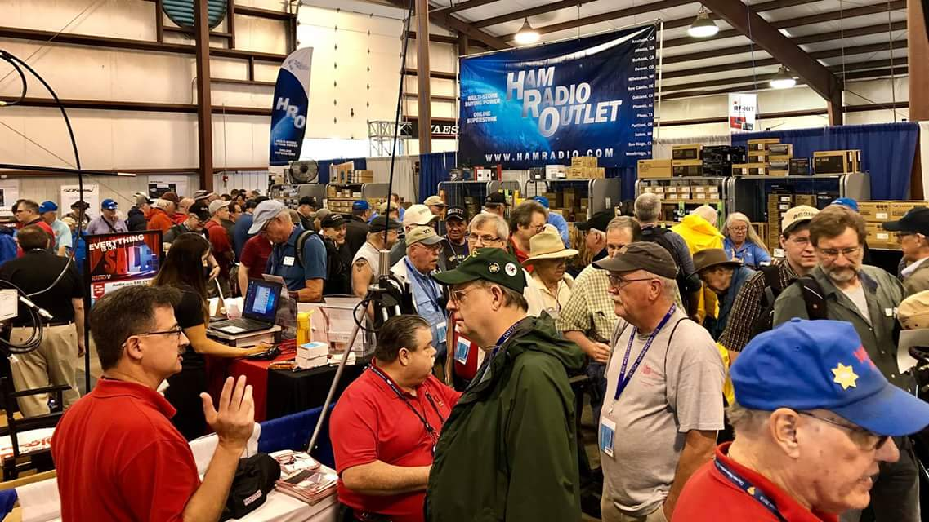[**Upcoming *Hamfests***](http://arrl-ohio.org/hamfests.html)

We **DO** have some hamfests scheduled for 2022!! Yes, take a good look at the list. And YES! They are starting to book up for 2023 already!

**__________________________________________________________**

|  |  |
| --- | --- |
|  |  |

|  |  |
| --- | --- |
|  |  |
|  |  |
| ***2022 & 2023*** | | | | |
| **10/15/2022 -**[**Portsmouth Radio Club Hamfest**](http://www.arrl.org/hamfests/portsmouth-radio-club-hamfest-7)  **Location:**New Boston, OH Sponsor: Portsmouth Rado Club, Jett Fire, Shawnee **Website:** [http://www.portsmouthradioclub.org](http://www.portsmouthradioclub.org/) [**Learn More**](http://www.arrl.org/hamfests/portsmouth-radio-club-hamfest-7) | | | | **10/30/2022 -**[**Massillon Hamfest (OH)**](http://www.arrl.org/hamfests/massillon-hamfest-oh)  **Location:**Green, OH **Sponsor:** Massillon Amateur Radio Club **Website:** [http://w8np.org](http://w8np.org/) [**Learn More**](http://www.arrl.org/hamfests/massillon-hamfest-oh) |
|  | | | |  |
| **12/03/2022 -**[**FCARC WinterFest**](http://www.arrl.org/hamfests/fcarc-winterfest-3)  **Location:**Archbold, OH **Sponsor:** Fulton County Amateur Radio Club **Website:** <https://k8bxq.org/hamfest> [**Learn More**](http://www.arrl.org/hamfests/fcarc-winterfest-3) | | | | **03/11/2023 -**[**MOVARC Hamfest**](http://www.arrl.org/hamfests/movarc-hamfest-8)  **Location:**Bidwell, OH 45614, OH **Sponsor:** Mid-Ohio Valley Amateur Radio Club [**Learn More**](http://www.arrl.org/hamfests/movarc-hamfest-8) |
| **05/13/2023 - 05/17/2023** [**RV Radio Network**](http://www.arrl.org/hamfests/rv-radio-network-1)  **Location:**Berlin, Ohio, OH **Type:** ARRL Operating Specialty Convention **Sponsor:** RV Radio Network [**Learn More**](http://www.arrl.org/hamfests/rv-radio-network-1) | | | | **07/16/2023 -**[**Van Wert Hamfest**](http://www.arrl.org/hamfests/van-wert-hamfest-7)  **Location:**Van Wert, OH **Sponsor:** Van Wert Amateur Radio Club **Website:** [http://w8fy.org](http://w8fy.org/) [**Learn More**](http://www.arrl.org/hamfests/van-wert-hamfest-7) |
|  | | | |  |
| **08/12/2023 -**[**Cincinnati Hamfest℠**](http://www.arrl.org/hamfests/cincinnati-hamfest-2)  **Location:**Owensville , OH **Sponsor:** Milford ARC **Website:** [https://CincinnatiHamfest.org](https://cincinnatihamfest.org/) [**Learn More**](http://www.arrl.org/hamfests/cincinnati-hamfest-2) | | | |  |
|  | | | |  |

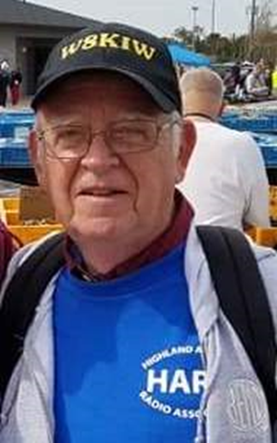**OHIO’S** 

Anyone reading Scott Yonally’s column in the recent Dale’s Tails Great Lakes Division newsletter probably got a chuckle from comments about venturing into his local Lowe’s and seeing all the Christmas decorating items on display. I too have seen those displays in our local Hillsboro Lowe’s and also think those in retail are rushing the season a bit. After all, you are probably reading this on what used to be called Columbus Day. It’s not like Thanksgiving when it would be more acceptable.

But we are here to let you know what is happening throughout the Southern part of Ohio and with our friends just across the Ohio River in West Virginia and Kentucky. So I’ll get off my soapbox and get to it!

We are just days away from what might be the final hamfest or swapfest in the Southern Ohio region for the year. That hamfest takes place at the New Boston Community Center, 3982 Rhodes Avenue in New Boston and is sponsored by the **Portsmouth Radio Club**. Since its humble beginnings in Friendship, OH this hamfest has grown to be one of the better attended ones with folks from several surrounding states attending. The fun gets underway at 8 AM and runs until 1 PM and has a Laurel VE test session at 10 AM. Food, refreshments, a 50/50 drawing and a lot of door prizes are a part of this ever popular hamfest. As for the door prizes, almost everyone there at closing time will go away with something. Contact Gary Caldwell, WX8G, at 740-240-4955 or [www.portsmouthradioclub.com](http://www.portsmouthradioclub.com) for more information.

The hurricane that hit Florida and South Carolina in recent days also played havoc on last Saturday’s two area special event station operations. Because each were outdoor events the sponsoring clubs decided to postpone each due to questionable weather predictions from their respective NWS Offices. Therefore the combined efforts of **Southern Ohio ARA** and the **Lawrence County ARES** at Ohio’s Southernmost point and that of the **Highland ARA**’s Gist Settlement special event station were postponed and now will happen on October 15. The date, times and frequencies of each remain the same as published in QST and on other sites.

Speaking of the Gist Settlement event, the **Highland ARA** received an email from a Florence, Oregon ham looking forward to a contact. In it he explained a distant ancestor was the person who freed the slaves and furnished the funds to buy the five tracts of land to establish the settlements. Another ancestor actually oversaw and did the legwork to make it happen. Such a neat story! Let’s hope 20 meters cooperates on the 15th and a contact is able to be made.

On October 11 the members of the **Highland ARA** will meet at the EMA Office in Hillsboro at 7 PM. President Pat Hagen, N8BAP, says several important items are on the agenda. The next **Athens County ARA** meeting will be on Tuesday evening October 18 at the Red Cross Building in Athens. The **Milford ARA** holds their annual elections at their upcoming October 20 meeting. Those elgible to cast votes are urged to attend. Additionally, any member in good standing interested in running for an office should let President Ron Brooks know ASAP. The meeting begins at 7:30.

Pat Hays, N8OOB, sadly informs us of the passing of a Southern Ohio “legend” who for years was a 75 meters institution. Larry Chapman, NE8V, has become a Silent Key. For years Larry and Bill “Vondon” Applegate, KJ8I, ran the weekly “Gator Trader Net” on 3.898. At other times you could usually find “the Pope of 3.898” with dozens of others “owning the frequency” on other evenings. For years Larry to be at larger hamfests throughout the Eastern United States mostly buying and selling Collins equipment. One summer he and KJ8I spent a month long road trip attending hamfests on weekends and fishing and eating BBQ on the weekdays. In 1986 Larry served as president of the **Highland ARA**. Most hams knew Larry from his phone activity, but his real love was the CW he learned during his Navy years. As a radioman during the Cuban Missle Crisus and was the go between government officials and ship commanders and personally met and honored by President Kennedy for his service. After leaving the service he entered education and taught in the Greenfield McClain School System. Along with his radio talents, he was an accomplished writer, loved fishing and became a certified BBQ judge. Services were held Sunday in Greenfield.

Mike Love, WB8YKS, tells us the sad of the passing of **Southern Ohio ARA** member Larry Tawney, K8TI, of South Point. Besides involvement with amateur radio, Larry was an active union member and involved in various community organizations. Services have been held in South Point.

For those potential new hams or those wanting to upgrade, but feel they are not ready to take on the challenge at the upcoming Portsmouth hamfest, the **Scioto Valley ARC** will hold conduct tests on November 5 in Chillicothe. According to John Hartmus, WB8GRX, the test session will be held in Conference Room A at the Ross County Service Center beginning at 9 AM. These sessions are Laurel VE sessions and therefore there is no charge to take an exam for a first license or for an attempt to upgrade. However the FCC license fee will still apply for anyone earning a first license. Also for those needing a little more preparation for earning their first license, the **Hocking Valley ARA** will hold a Technician Training Class on Saturday, October 29 and November 5 with the final session held just prior to the testing on November 12. Each class will be held at the EOC Building in Logan from 9 until noon. This will be an ARRL VE session therefore a $15 fee will be charged for each test or element taken in addition to the fee the FCC charges for each new license issued. The **Milford ARA** President Ron Brooks reminds us MARA holds a Laurel VE session prior to its monthy meeting. The next test will be on Thursday evening, October 20 at 6 pm at the Community Building in Milford. Pre-registration is requested and can be completed with a visit to the Club’s [www.milfordhamradio.org](http://www.milfordhamradio.org)

In the last column we welcomed Trevor Heery from Brown County’s Fayetteville into the wonderful world of ham radio. Today we go down the road and cross into Clermont County to welcome Batavia’s Eric Ross who is now KE8VTH. Backing up to Trevor, he has already been on the air with contacts through the Hillsboro/Greenfield repeater system and been welcomed to the airwaves by not only stations in his immediate area but with stations as far as Springfield. Nice going.

Club President Mark Atwell, WX8A, reports the popular **Clinton County ARA** ‘Last Saturday Breakfast’ returned last month with a good turnout for the first gathering in quite some time. He reported the food and service at the new location was good and he anticipates it will be the gathering place for the foreseeable future. All takes place at Sam’s Meats and Deli, 1209 West Locust Street in Wilmington. The October LSB will happen on October 29 at 8:30 AM. All amateurs in the area are invited. Paul Gehringer, WB8ZZR, reports the monthly CCARA mid-week breakfast at Bob Evans is now a thing of the past. He states continuing COVID concerns and everyone’s “busy” schedules were deciding factors.

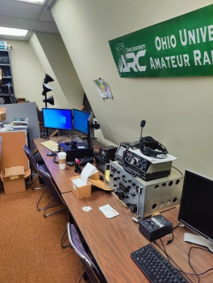

Blake Gall, KE8PAQ, took time away from his studies at Ohio University to let us know things are looking up at getting the **Ohio University Amateur Radio Club** back up and running. Although with only a handful of licensed hams on campus, those members are activity looking at ways to increase the number of licenses within the university population.

Although some weeks away, the **Cambridge ARA** wants members and area hams to know it has set the date for their annual Awards Banquet. Please mark your calendars for the afternoon of Saturday, December 3. It will take place from 2 until 4 in the smaller dining room at the Denny’s Southgate Parkway location in Cambridge. Food will be ordered from the menu. The **Clinton County ARA** has voted to hold a carry-in Holiday Dinner on Thursday evening, December 1 at a location yet to be determined. Members of the **Highland ARA** should mark their calendars for their annual Christmas Dinner Party. It will be on Tuesday evening, December 13 at the Hillsboro Methodist Church.

As mentioned earlier, holiday displays are beginning to appear in stores. Usually whenever I start seeing those, my thoughts turn not to the Christmas holidays but to the ARRL November Sweepstakes. This year’s CW Sweeps will run from November 5 to the 7th. The Phone portion starts on the 19th and ends on the 21st. I know I will never earn an award, but I enjoy competing against myself and improve my operation from previous years. Perhaps it’s trying to get all sections (why does it seem Quebec and South Carolina never are on), working all states, logging that sole station in the Northwest Territories or some other objective. For those wanting to work all states, it’s possible to do do so in a single weekend. And for our County Hunter friends, it is usually a place to picke up some of the harder to get counties. I often hear that Ohio can be a rather tough state to get. Here’s hoping to hear you on.

Some area stations report a fantastic ten-meter opening late last week. Ronnie Bogard, WD8AIG, reported contacts with stations in Australia and New Zealand and WD8ADU, Joe Holdren, reported contacts into France, Morraco and Italy plus South America. Paul Jellison, K8IO, not worked the previously mentioned countries, but also a Toyko station via long path while having fun giving contacts to stations operating the California QSO Party. At Thursday’s **Clinton County ARA** meeting he said it might have been the best ten-meter opening he has experienced in 40 years. Gary Poland, W8PU, stated all the excitement must have been confined to ten-meters because 15 and 6 were dead.

That’s it for another week. Until next time stay cool, healthy, safe and radio-active.

John Levo, W8KIW, [jlevo@cinci.rr.com](mailto:jlevo@cinci.rr.com) or highlandara@gmail.com, 937-393-4951

**Massillon Hamfest**

Only a few days away… The Massillon Amateur Radio Club (MARC) is again proud to sponsor what has become on the nation's top hamfests. We are again inviting guests from all over the country to join us at MAPS air museum at the Canton-Akron Airport in Green, Ohio.

Date:10/30/2022

Location: Military Air Preservation Hangar (MAPS)

2260 International Parkway

Green, OH 44232

Sponsor: Massillon Amateur Radio Club

Look for more details in the weeks ahead. Attendees and Vendors:For a brochure or for further information please contact MARC at [club@w8np.net.](mailto:club@w8np.net) *We Are looking forward to seeing you at MAPS this year!*

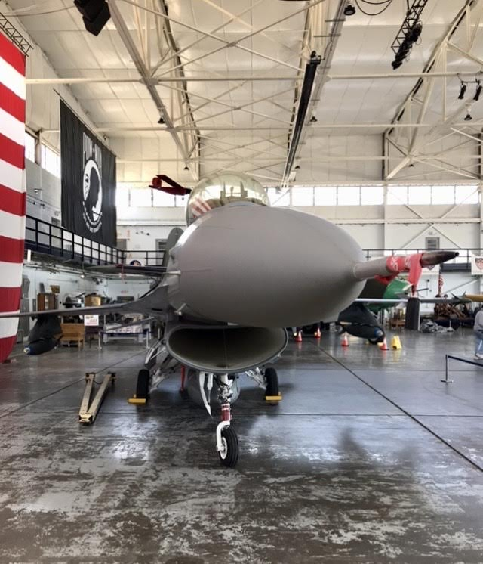

**_________________________________________________________**

**Print an Official or Unofficial Copy of Your Amateur Radio License**

*(By Anthony Luscre, K8ZT)*

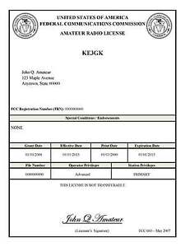

As of February 17, 2015, the **FCC no longer routinely issues paper license documents** to Amateur Radio applicants and licensees. The Commission has maintained for some time now that the official Amateur Radio license authorization is the electronic record that exists in its Universal Licensing System (ULS). The FCC will continue to provide paper license documents to all licensees who notify the Commission that they prefer to receive one.

Licensees also will be able to print out an official authorization — as well as an unofficial “reference copy” — from the ULS License Manager. I’ve created a set of instructions on how you can request an **“official” printed copy of your license\***

[**Click here to download the instructions**](http://arrl-ohio.org/news/2020/print_your_license.pdf)

***One Question Questionnaire***

!!!!! I would really like to hear from as many of you as possible on this one. While I know what I think the answer is going to be, the bigger the sample, the more accurate a survey like this is likely to be.

How about going to <http://arrl-ohio.org> and giving me a click? (It’s in the bottom left corner of the page)

**Do you own and drive an Electric Vehicle?**

1. **Yes**
2. **No**

**From the last Poll:**

***Are you a member of your local ARES Group?***

* 1. YES 43% 35 votes
  2. NO 57% 46 votes

Bottom of Form

Ohio Section Cabinet

|  |  |
| --- | --- |
| Section Manager – Tom Sly, WB8LCD | Section Traffic Manager – David Maynard, WA3EZN |
| Section Emergency Coordinator – Stan Broadway, N8BHL | Section Youth Coordinator – Anthony Luscre, K8ZT |
| Technical Coordinator – Jeff Kopcak, K8JTK | Affiliated Clubs Coordinator – Tom Sly, WB8LCD |
| State Government Liaison – Bob Winston, W2THU | Public Information Coordinator – |



Hey Gang,

Have you taken a look at the **Swap & Shop** page on the Ohio Section webpage yet?? Here’s a link that will take you there… <http://arrl-ohio.org/sm/s-s.html>

Do you have equipment that you just don’t need or want anymore? Here’s a great venue to advertise it, and it’s FREE!! Is your club doing a fund raiser to help raise money? After a lot of thought, it was decided that the Swap & Shop webpage could also contain these types of items as well. The same rules will apply as do for the For Sales and Give-A-Ways and will only be posted for a month at a time. Please see the Terms & Conditions on the webpage.

If your club is doing a fund raiser and wants more exposure, please forward the information to me and I’ll advertise it on the Swap & Shop webpage for you.

Now, I still want to remind you that it won’t be listed in this newsletter because it would take up way too much space, so your ad will only appear on the website. It is there for any individual to post equipment Wanted / For Sale or Give-Away as well as for Club Fund Raisers. No licensed vehicles/trailers or business advertising will be posted. Postings are text only (no pictures or graphics) will be posted for a maximum of 1 month from date posting and require a contact phone number or email within the posting. Send your Wanted / For Sale or Give-Away post to:  [swap@arrlohio.org](mailto:swap@arrlohio.org)

***Back Issues of the PostScript and Ohio Section Journal***

Hey, did you know that PostScript and Ohio Section Journal (OSJ) are archived on the website? You can go back and look at any edition simply by clicking:

<http://arrl-ohio.org/news/index.html>

***Want to Share your Club Newsletter With Others?***

We have a webpage where you can download and read all of the newsletters that I get from around the state and even other sections!

Here’s the link to the page…. <http://arrl-ohio.org/club_news/index.html>

Please, if you don’t see your club newsletter posted, it’s because I’m not receiving it. Just have your newsletter editor contact me and I’ll get your club’s newsletter listed on the site!!

We all learn and steal (I mean, share) from each other’s work. So, get me your newsletter!!! Send it to: [webmaster@arrl-ohio.org](mailto:webmaster@arrl-ohio.org)

***Chit – Chat, and All That!***

Do you know someone that’s not getting these Newsletters? Please, forward a copy of this Newsletter over to them and have them “[Opt-In](mailto:Opt-In)” to start receiving them. Heck, just have them send an email to: [webmaster@arrl-ohio.org](mailto:webmaster@arrl-ohio.org) and we’ll get them added to the Ohio Section Emailing list.

We now have many thousands of readers receiving these newsletters weekly. Quite impressive, I’d say! I urge all of you to make sure that everyone, regardless of whether they are a League member or not, get signed up to receive these weekly Newsletters.

You can always “Opt-Out” at any time if you feel this is not what you were expecting. It’s fun and very informative. All of your favorite past newsletters are now archived too.

You can go back at any time and read them.

Just go to: <http://arrl-ohio.org/news/>

*PostScript is produced as a weekly newsletter. I want to thank everyone that has contributed articles and ideas to make this an even better news source. I sincerely hope that you have enjoyed this edition and will encourage your friends to join with you in receiving the latest news and information about the Ohio Section, and news and events happening around the world!*