[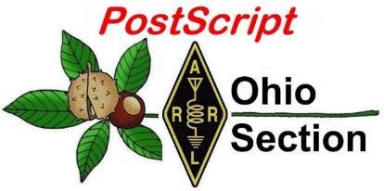](http://arrl-ohio.org/news/)

***“October 3rd, 2022******”***

🡪 National News 🡪 Club Corner

🡪 DX This Week 🡪 Contest Corner

🡪 Upcoming Hamfests 🡪 One Question Questionnaire

🡪 VE Testing 🡪 South 40

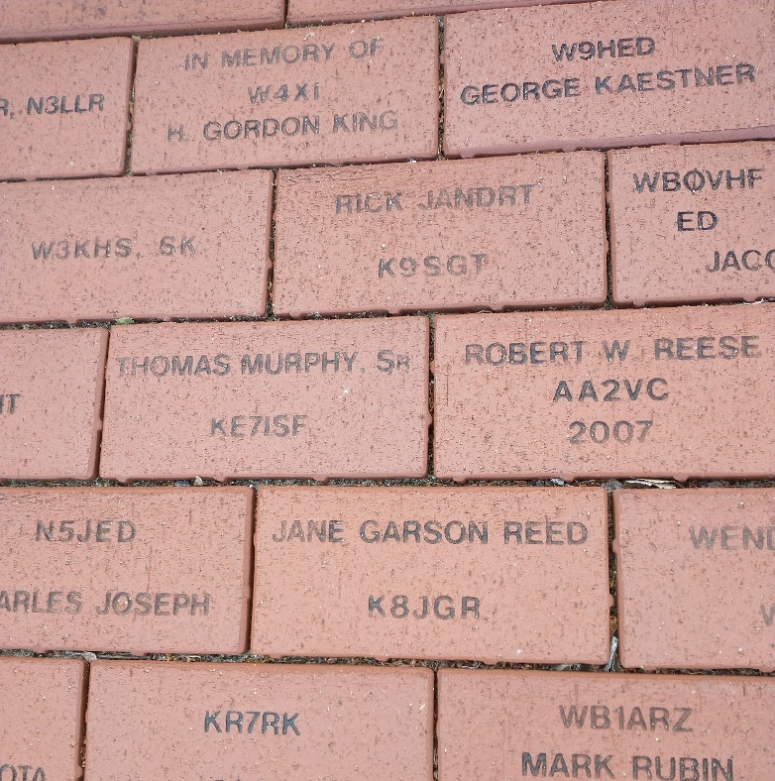

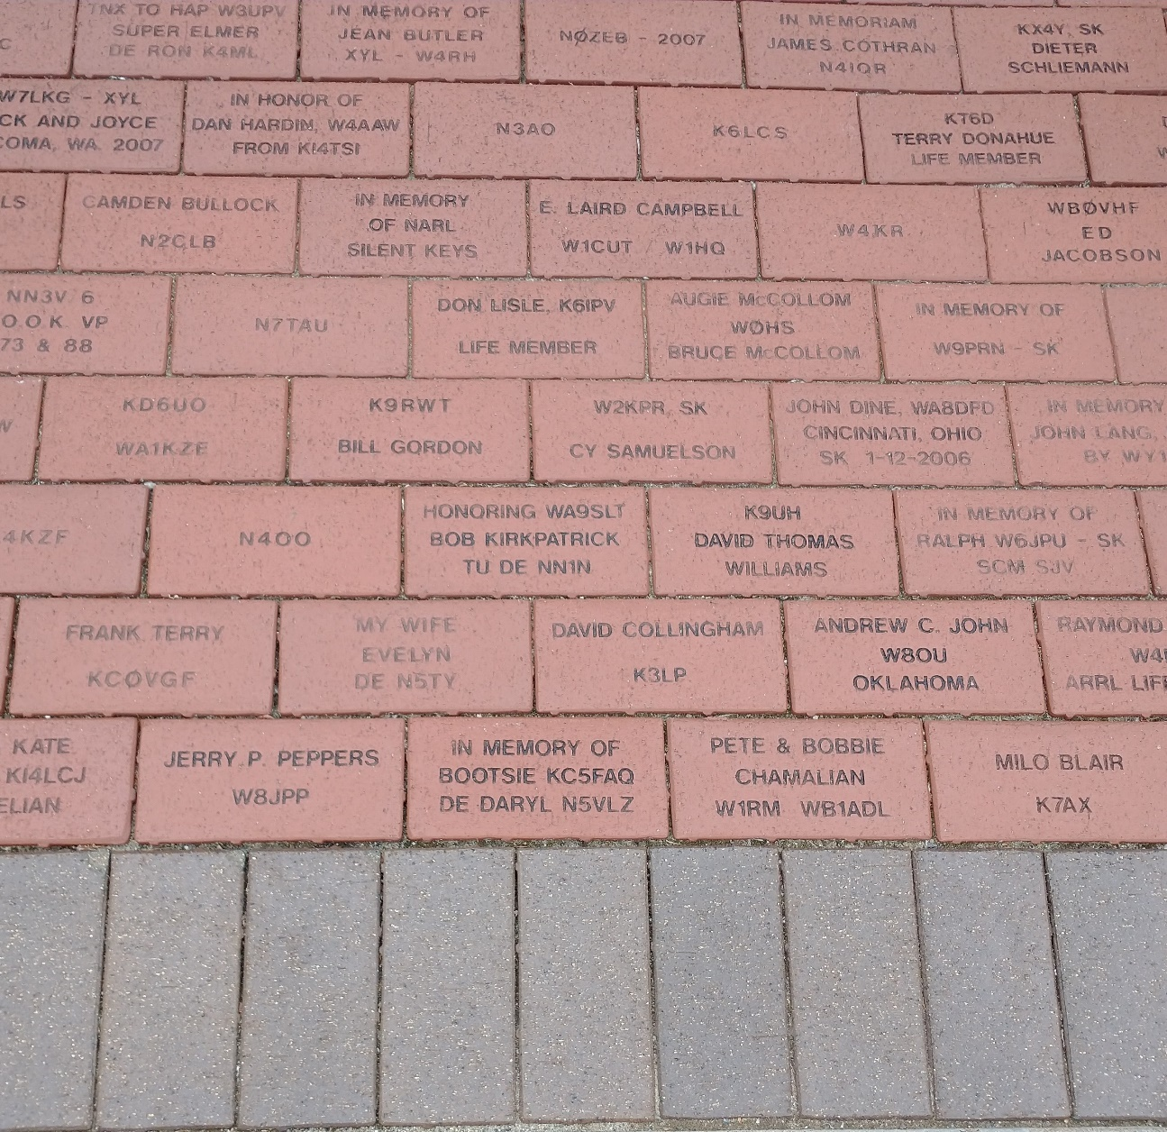

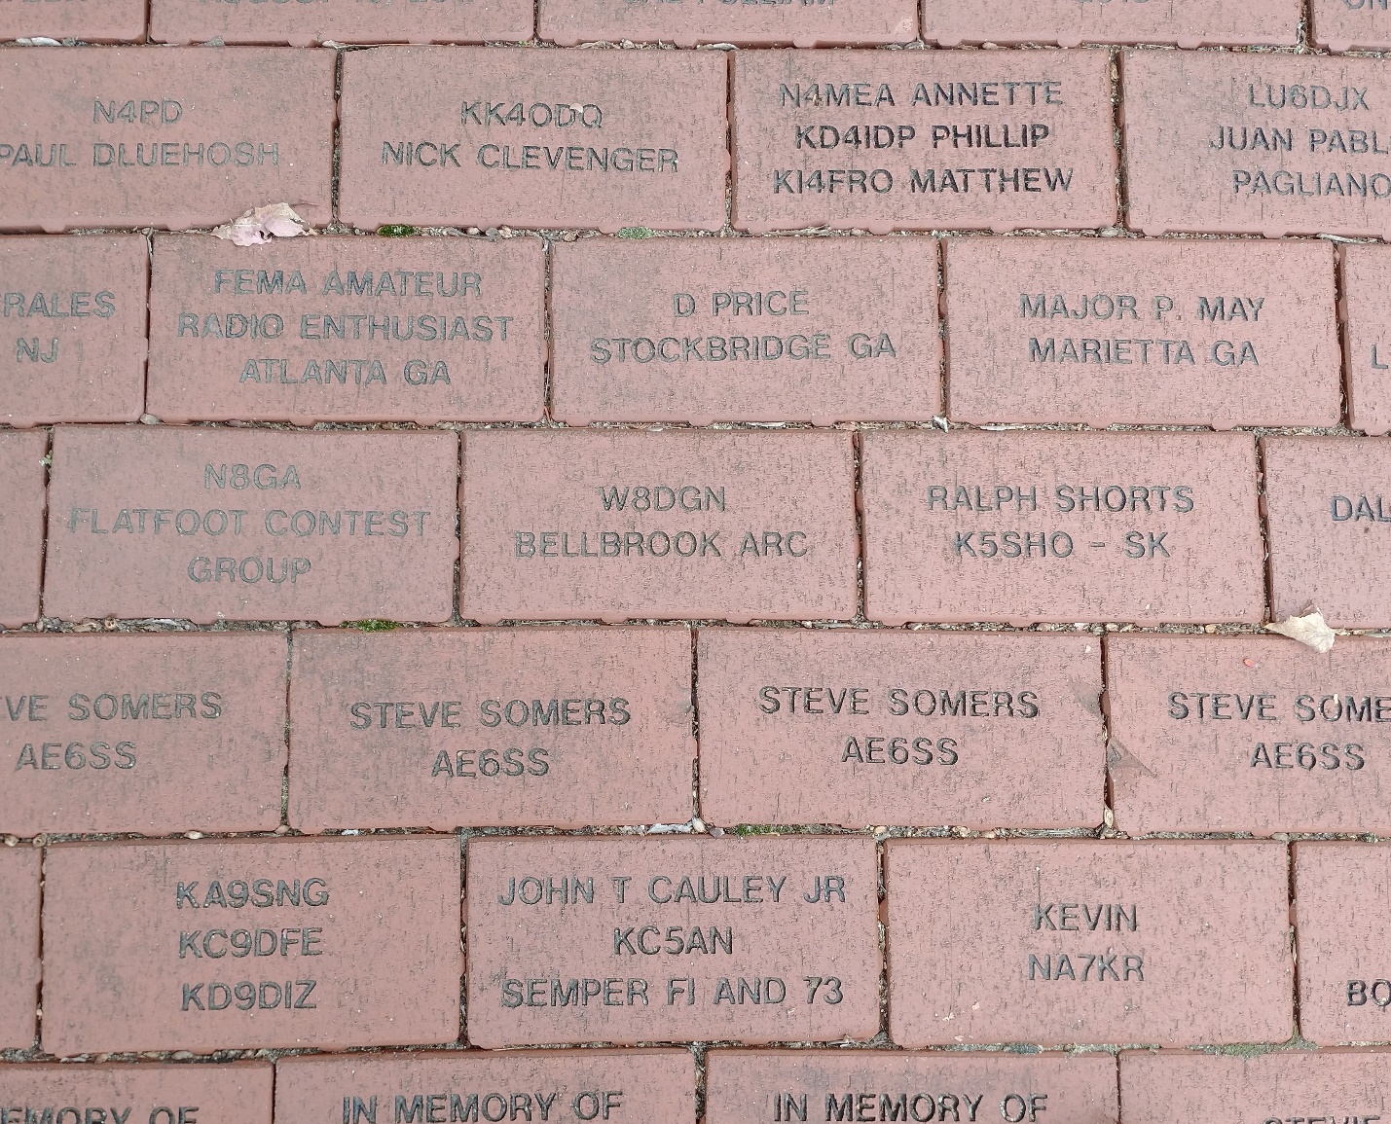

**CQ CQ CQ de WB8LCD**

I hope you took a few minutes to look at the bricks photos I’ve posted here. I’m sure you’ll find one or two bricks with names that you recognize. I’ve found quite a few from individuals and clubs representing the Ohio Section. This is one way, for not an overly large contribution, you can make a nice memorial for yourself, a loved one, your club or club members you would like to recognize in some meaningful way. I can immediately think of several bricks that I did not see there, but I believe I should have. I could have spent a lot more time than I had there just searching out hams and clubs I know or have known through the years. All of these bricks represent someone or some organization that has been a significant part of the hobby at some point in history. It’s a way they can be recognized even into the future.

ARRL Headquarters, and W1AW, are “bucket list” destinations for many hams. I was there, but I did not see “My” brick, or even my club’s brick. I didn’t see my Ham Radio Mentor’s brick. Some of those will be there the next time I make it there. And that will make me happy. I’ll be happy to know that people and organizations that have been important in my life are represented and memorialized there. And I’ll be especially happy to know that the contributions that accompany the bricks have made the ARRL a stronger organization to better represent our interests in many ways. Most importantly, ARRL represents out interest to the FCC and the Congress and “Government” in general to make sure that Amateur Radio exists on into the future. Not just in the US, but internationally also. It’s important work, and there is NO-ONE else that is doing it on our behalf. This is one way, in addition to your membership that almost anyone can be a supporter of something bigger than themselves.

If you would like to get more information on donating a brick, contact Melissa Stemmer – Development Manager at [mstemmer@arrl.org](mailto:mstemmer@arrl.org) or 860-594-0348.

One final comment on this topic: ARRL and your local club both need your support. Think beyond just your dues. It’s well worth it to both.

**Youth Net**

**When:** The second Sunday of every month at 7:30 PM EST

**Where:** The K8IV repeater located in Kent, Ohio (Echolink node K8BF-L) RF: 146.895 Mhz  with PL 118.8

**Who:** Any licensed amateur radio operator who wishes to participate. Priority will be given to youth stations and those located in Ohio.

The purpose of this net is to encourage youth activity in amateur radio and to help new hams get more comfortable on the air.

Our next net comes up on October 9th.

I want to encourage our Ohio Section clubs to offer your membership activities and programs that are both fun and will get your members on the air. One of the things that I hear as a stumbling block to activities is that it’s hard to pick a time that there’s not a contest going on or some other activity that we feel would be either interference or interfered with. Sure, that may happen, but so what? I think it’s really a testament to our hobby when there are so many activities going on that your members have to choose which one they want to participate in! Remember, not everyone wants to work in the contest – you may have some members who would rather be melting solder and building something. Not every activity has to engage all of your membership. Ham Radio is really a whole bunch of hobbies within a hobby. Give them choices, and they will come. And not every activity needs to be a big one. If you’ve got a project that is well done, but only draws 4 or 5 people to it, so what? You’ve given them something that is meaningful to them. If you aren’t meeting their needs, they may not want to continue with your club. And I would also remind club members that one club cannot be all things to all people! Belonging to more than one club might be the best way to keep you moving forward in the hobby while at the same time expanding your circle of friends. Win / Win!

73,

Tom Sly - WB8LCD

Ohio Section Manager

[wb8lcd@arrl.org](mailto:wb8lcd@arrl.org)

330-554-4650

***National News***

*(from ARRL and other sources)*

**NASA-Built Weather Sensors Capture Vital Data on Hurricane Ian**

*A pair of microwave radiometers collected data on the storm as they passed over the Caribbean Sea aboard the International Space Station.*

Two recently launched instruments that were designed and built at NASA’s Jet Propulsion Laboratory in Southern California to provide forecasters data on weather over the open ocean captured images of Hurricane Ian on Tuesday, Sept. 27, 2022, as the storm approached Cuba on its way north toward the U.S. mainland.

[COWVR](https://www.jpl.nasa.gov/news/5-things-to-know-about-a-pair-of-small-but-mighty-weather-instruments) (short for Compact Ocean Wind Vector Radiometer) and [TEMPEST](https://www.jpl.nasa.gov/news/5-things-to-know-about-a-pair-of-small-but-mighty-weather-instruments) (Temporal Experiment for Storms and Tropical Systems) observe the planet’s atmosphere and surface from aboard the International Space Station, which passed in low-Earth orbit over the Caribbean Sea at about 12:30 a.m. EDT.

Ian made landfall in Cuba’s Pinar del Rio province at 4:30 a.m. EDT, according to the National Hurricane Center. At that time, it was a Category 3 hurricane, with estimated wind speeds of 125 mph (205 kph).

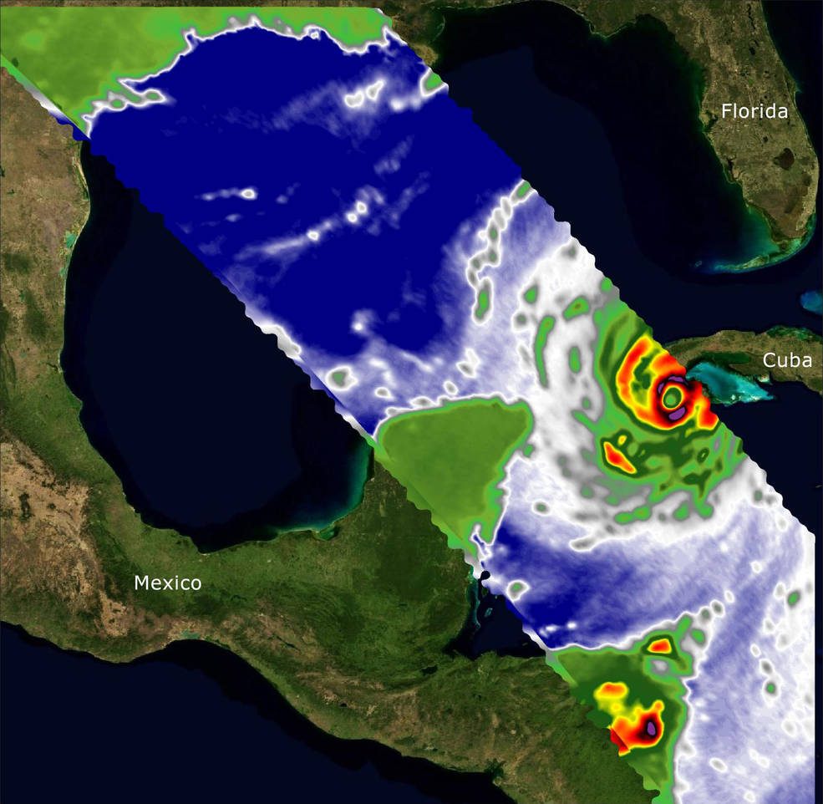The image above combines microwave emissions measurements from both COWVR and TEMPEST. White sections indicate the presence of clouds. Green portions indicate rain. Yellow, red, and black indicate where air and water vapor were moving most swiftly. Ian’s center is seen just off of Cuba’s southern coast, and the storm is shown covering the island with rain and wind.

From aboard the International Space Station, NASA-built instruments Compact Ocean Wind Vector Radiometer (COWVR) and Temporal Experiment for Storms and Tropical Systems (TEMPEST) captured wind and water vapor data from Hurricane Ian as the storm neared Cuba.

***Credits: NASA/JPL-Caltech***

COWVR and TEMPEST sent the data for this image back to Earth in a direct stream via NASA’s tracking and data relay satellite (TDRS) constellation. The data were processed at JPL and made available to forecasters less than two hours after collection.

About the size of a minifridge, COWVR measures natural microwave emissions over the ocean. The magnitude of the emissions increases with the amount of rain in the atmosphere, and the strongest rain produces the strongest microwave emissions. TEMPEST – comparable in size to a cereal box – tracks microwaves at a much shorter wavelength, allowing it to see ice particles within the hurricane’s cloudy regions that are thrust into the upper atmosphere by the storm.

Both microwave radiometers were conceived to demonstrate that smaller, more energy-efficient, more simply designed sensors can perform most of the same measurements as current space-based weather instruments that are heavier, consume more power, and cost much more to construct.

COWVR’s development was funded by the U.S. Space Force, and TEMPEST was developed with NASA funding. The U.S. Space Test Program-Houston 8 (STP-H8) is responsible for hosting the instruments on the space station under Space Force funding in partnership with NASA. Data from the instruments is being used by government and university weather forecasters and scientists. The mission will inform development of future space-based weather sensors, and scientists are working on mission concepts that would take advantage of the low-cost microwave sensor technologies to study long-standing questions, such as how heat from the ocean fuels global weather patterns.

***Andrew Wang / Jane J. Lee  
Jet Propulsion Laboratory, Pasadena, Calif.  
626-379-6874 / 818-354-0307***[***andrew.wang@jpl.nasa.gov***](mailto:andrew.wang@jpl.nasa.gov)***/***[***jane.j.lee@jpl.nasa.gov***](mailto:jane.j.lee@jpl.nasa.gov)

***_____________________________________________***

**Amateur radio operators are needed for the Marine Corps Marathon on October 30, 2022, in Washington, DC, and Arlington, Virginia.**

 The call is for 150 amateur radio operators to provide "eyes on the course" using the 144 and 420 MHz bands, with FM and Digital Smart Technologies for Amateur Radio (D-STAR), and a Medical Data Network using Amateur Radio Emergency Data Network (AREDN). Amateur radio will also be used as back-up communications in case all else fails. Operators will prepare themselves, supplies, and equipment to function in a large-scale, multi-jurisdictional, mass casualty-type event under real-world conditions. Training will be provided, and each operator will receive a commemorative T-shirt. Amateurs can sign up by following the link [www.mcmham.org](https://www.mcmham.org/). To learn more about the 2022 Marine Corps Marathon, visit their website at [Marine Corps Marathon](http://www.marinemarathon.com/events/marathon).

Amateur Radio Operators Continue Response to Hurricane Ian

As Hurricane Ian made its way across Florida, and now heads toward South Carolina, amateur radio operators have continued to provide communications support for weather updates and requests for assistance.

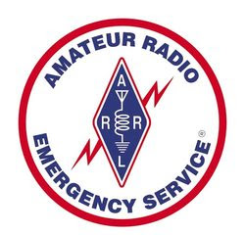The hurricane made landfall at 3:00 PM Eastern Time on Wednesday, September 28, 2022, just south of Tampa, Florida, as a Category 4 hurricane with winds of 150 miles per hour. Millions of residents are without power, and damage was reported as extensive along the storm's initial path. As of 5 PM ET on Thursday, the National Hurricane Center (NHC) reported that Ian is "taking aim at the Carolinas and Georgia with life-threatening flooding, storm surge, and strong winds."

ARRL Director of Emergency Management Josh Johnston, KE5MHV, has been in regular contact with ARRL Section Managers and Section Emergency Coordinators in Florida and throughout the southeastern US. Johnston said ARRL is also in touch with national-level partners, including FEMA and the Cybersecurity & Infrastructure Security Agency (CISA), should any requests for direct emergency communications via amateur radio be needed.

|  |
| --- |
| An ARES activation setup at Palm Harbor University High School, one of some 25 shelters in Pinellas County, Florida, providing communications in case of infrastructure failure. Radios communicate directly to the Pinellas County Emergency Operations Center. [ARRL member Stephen Foy, N4FOY, photo] |

Johnston said many ARRL [Amateur Radio Emergency Service](http://www.arrl.org/ares)® (ARES®) volunteers and their groups are involved across Florida, Georgia, and South Carolina. "Many ARES groups throughout Florida have been in a state of readiness since before the weekend," said Johnston. "These amateur radio volunteers are well-connected with their state and local emergency management partners in government and non-government organizations." Johnston also said that there are ARES members, at the request of the Florida Division of Emergency Management, serving in the state Emergency Operations Center. Many ARES groups are also operating in several shelter locations.

ARRL has previously deployed Ham Aid kits in the region. The kits include amateur radio equipment for disaster response when communications equipment is unavailable.

W1AW, the Maxim Memorial Station at ARRL's headquarters in Connecticut, has activated its Winlink station to handle PACTOR III and IV messages and traffic, as well as its SHARES station, NCS310.

|  |
| --- |
| Orange County (Florida) ARES at the Orange County Emergency Operations Center, providing backup communications. Pictured is Emergency Coordinator John Knott, N4JTK [Assistant Emergency Coordinator Michael Cauley, W4ORL, photo] |

"In our [ARRL's] experience, amateur radio's response will continue to play out, sometimes even more significantly, after the storm passes and communities enter a period of recovery," said Johnston. "As needs are assessed, such as disruptions to power and communications, our ARRL Section leaders and ARES groups may receive additional requests for more activations and deployments."

Bobby Graves, KB5HAV, Net Manager for the [Hurricane Watch Net](https://www.hwn.org/) (HWN), said the net is now transitioning from receiving weather data to gathering post-storm reports (read "[Hurricane Watch Net Update for Ian](https://www.arrl.org/news/hurricane-watch-net-update-for-ian)," ARRL News, 9/29/2022).

"These reports include damage and areas that are flooded," said Graves. "This gives the forecasters additional information they need. Also, since FEMA has an office in the National Hurricane Center, they look over these reports to get a bigger picture of what has happened, which in turn helps them to get help and humanitarian assistance where it is needed."

Graves added that the HWN will be assisting with emergency, priority, and any Health and Welfare Traffic. The net may continue operations for days. The HWN will issue an after-action report to detail the number of amateur radio operators who participated on the net.

Assistant HWN Net Manager Stan Broadway, N8BHL, said they have been filing reports since September 26, 2022, and over 125 specific reports have been filed to the NHC from stations in the area. "We have handled other reports, not included in the database, for damage and other storm-related situations," said Broadway. "One such call involved a relayed report of a woman trapped in her home with a collapsed wall in the Ft. Meyer area. That report was relayed to Lee County Emergency Communications to dispatch a rescue team."

The VoIP Hurricane Net has been active as well. Director of Operations for the VoIP Hurricane Net and ARRL Eastern Massachusetts ARES Section Emergency Coordinator Rob Macedo, KD1CY, said the net will remain active potentially through 11:00 PM EDT on Thursday evening, supporting WX4NHC, the Amateur Radio Station at the National Hurricane Center in Miami, Florida. WX4NHC will be active through this period for as long as needed.

Use these additional links for more information:

* [The Hurricane Watch Net - Useful Links](https://hwn.org/tools/useful-links.html)
* [VoIP Hurricane Net](https://voipwx.net/)

FCC Grants an ARRL Emergency Request to Permit Higher Data Rate Transmissions for Hurricane Relief Communications

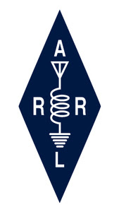The Federal Communications Commission (FCC) has granted an [ARRL](http://www.arrl.org/) emergency request for a 60-day temporary waiver intended to facilitate amateur radio emergency communications for hurricane relief. The waiver was adopted on Tuesday, September 27, 2022, and immediately permitted amateur radio operators supporting amateur data transmission for Hurricane Ian traffic to employ a higher symbol rate for data transmissions than the current limit of 300 baud.

In its *Order* ([DA 22-1011](https://www.fcc.gov/document/wtb-grants-arrls-temporary-waiver-hurricane-relief)), the FCC concluded "that granting the requested waiver is in the public interest. Puerto Rico was recently hit by Hurricane Fiona and Hurricane Ian is predicted to cause significant damage, including disruption to electricity and communications services. Thus, to accommodate amateur radio operators assisting in the recovery efforts, we grant the ARRL's waiver request for the period of 60 days from the date of this *Order* to operate in any parts of the United States and its territories impacted by hurricanes. The waiver is limited to amateur radio operators in the United States and its territories using publicly documented data protocols that are compatible with FCC rules, with the exception of the data rate limit waived here, for those directly involved with HF hurricane relief communications."

ARRL's request stated that trained amateur radio operators are working with emergency management officials and relief organizations to assist with disaster relief communications in anticipation of Hurricane Ian. ARRL sought the waiver for [Amateur Radio Emergency Service](http://www.arrl.org/ares)® (ARES®) volunteers, and other amateur radio support groups working with federal, state, and local emergency management officials to assist with disaster relief.

Pursuant to ARRL's request and similar to written waivers granted by the FCC in earlier years, three conditions must be met to qualify. A protocol or mode exceeding the 300 baud symbol rate limit must be publicly documented, use no more bandwidth than the currently permissible slower protocols (generally accepted to be the bandwidth of an SSB signal, or 2.8 kHz), and be used *solely* for communications related to hurricane relief.

ARRL also explained that radio amateurs using higher-speed emissions for hurricane-related messages in the US and its territories must be able to communicate with similar stations in the US. They may also need the ability to communicate with Caribbean-based stations directly involved with hurricane relief efforts. Additionally, amateurs must be able to communicate with federal stations on the five channels in the 5 MHz band involved with the SHARES network and other interoperability partners on those frequencies.

ARRL also pointed out that the past FCC temporary waivers have allowed such protocols in similar events, including hurricanes Maria, Dorian, Laura, and Ida, typhoon relief communications in Hawaii, and wildfires in the western areas of the US.

In 2016, in response to an ARRL petition for rulemaking, the FCC proposed to remove the symbol rate limitations. It concluded that such limitations had become unnecessary due to advances in modulation techniques, and they no longer served a useful purpose. That proceeding, WT Docket 16-239, is still pending.

***Club Corner***

This is YOUR cornner of the newsletter. Send me what your club is doing and I’ll make sure that it gets in. Got a special event or club project that you want everyone to know about? Send it to me! Need help with a project? Send it to me.

Let me know what you club is up to. Are you going to have a special guest at your meeting or are you having a special anniversary?

Just sent it to: [webmaster@arrl-ohio.org](mailto:webmaster@arrl-ohio.org) Please! Format as below:

******If you want me to publish your club information, or even an article you have written, please send it in WORD format (.docx). Please use Times New Roman font size 12 for the body of the aritcle. Any photos please include as a .jpg or .bmp – the time you save me in doing all the conversions will be greatly appreciated.

Club Grant Application Period Open Until November 4

The ARRL Foundation Club Grant Program opened a second grant proposal period which began September 7, 2022, and runs until November 4, 2022, at 7 PM Eastern Time. Radio clubs can apply now, and information about the program can be found on the ARRL website at [www.arrl.org/club-grant-program](http://www.arrl.org/club-grant-program).

Following the first proposal period that ran earlier this year, 128 clubs applied for grants with a variety of outstanding projects. Emphasis is placed on projects that have a component of community involvement, training, new ham development, and club revitalization. Twenty-four clubs were chosen and nearly $270,000 was awarded.

Clubs that applied in the first round and did not receive a grant are urged to reapply. The ARRL Foundation will award an additional $230,000 in grants at the end of the second application round.

An informational webinar was held on September 7, and a recording of that event can be seen on ARRL's YouTube channel at <https://youtu.be/ZNvc_eeIIwU>.

All Things Amateur Radio Association (ATARA) is very excited to announce that we received a grant from the ARRL Foundation to purchase and build a STEM trailer. Our project is to build out an enclosed trailer to be a mobile, hands-on exhibit to educate the youth and adult participants on science, technology, engineering, mathematics, history, and amateur radio. Imagine a science museum with interactive exhibits, but solely focused on our great hobby. Some of our exhibits will include a spark gap generator, Morse Code keyers, Software Defined Radio, a large TV displaying educational and interesting material relating to amateur radio, snap circuits, and much more. The STEM trailer will also have the equipment to host fox hunts for the youth. ATARA has reached out to local homeschool groups, scouts, and afterschool programs as well as the 14 planned community events already schedule on our calendar.

ATARA members would like to express their gratitude to the ARRL Foundation for the award of this grant. We are confident this project, made possible by their generous award, will greatly benefit the youth, communities, and the hobby by providing a captivating experience to educate on and entice people to the wonderful hobby of amateur radio.

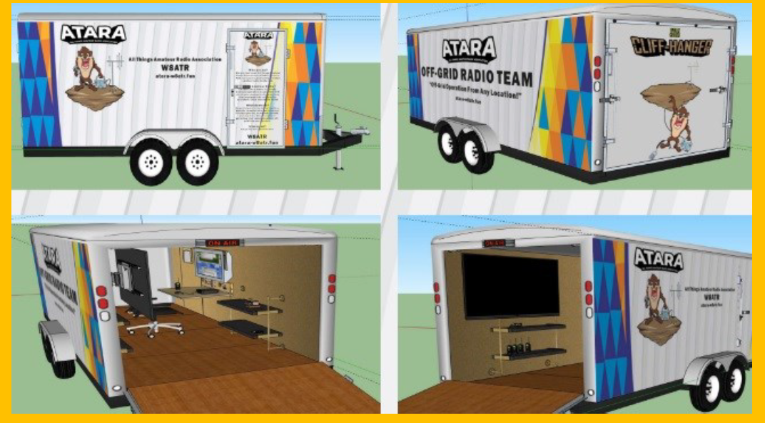

**Want to know where to go to get the courses you need? It’s all Right Here!**

* [Ohio EMA Training Calendar](https://webeoctraining.dps.ohio.gov/TrainingAndExercise/courselist.aspx)
* [Login to the DPS Training Campus](https://learning.dps.ohio.gov/PSTC/)
* [Create a new account on the DPS Training Campus](https://learning.dps.ohio.gov/PSTC/)

**NOTE:**

* Most courses are in-person but some course may be hosted virtually (this will be noted).
* Seats available listed are as of the release of this update and will change quickly.
* All classes will be posted on the DPS training campus at least 60 days prior to the start of the course.
* Please read the [Training Policy & Catalog](https://ema.ohio.gov/documents/training/ema0201.pdf) for more information on Ohio EMA trainings.

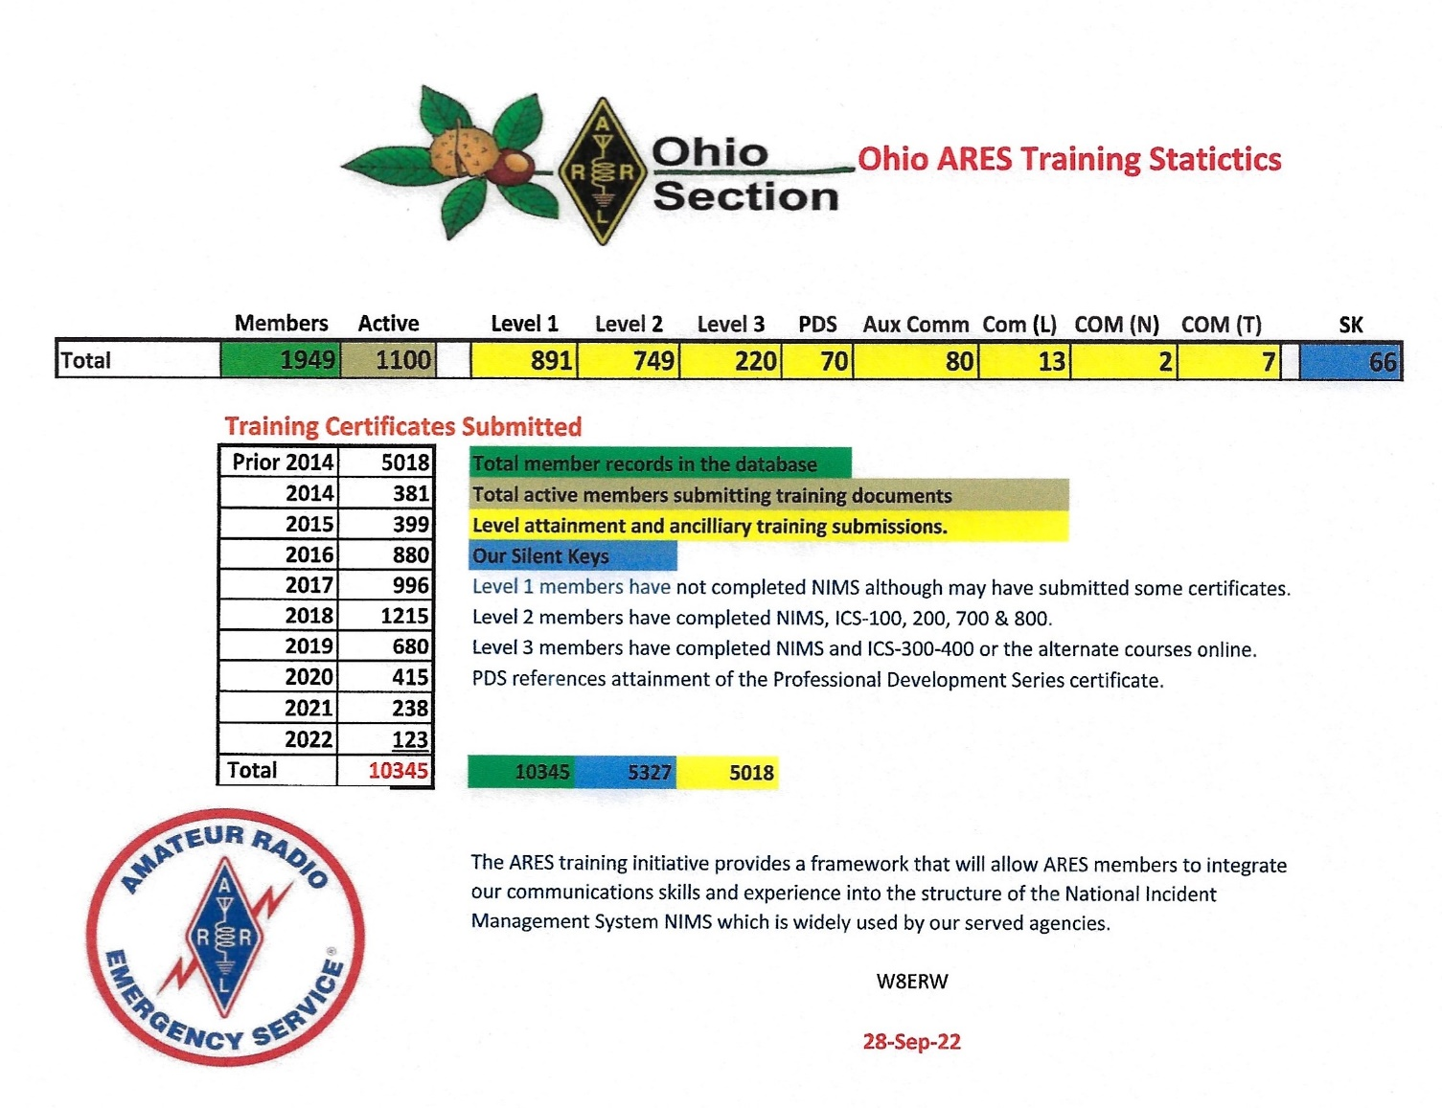

_._,_._,_

How to Plan and Apply for an ARRL Hamfest or Convention

If your amateur radio club is planning to host a convention, hamfest, tailgate, or swapfest, please consider applying for ARRL sanctioned status for your event. To learn what it means to be an ARRL sanctioned event, and to get some ideas on how to prepare for and conduct a hamfest or convention, visit [www.arrl.org/arrl-sanctioned-events](http://www.arrl.org/arrl-sanctioned-events).

To apply for ARRL sanctioned status for your event, go to [www.arrl.org/hamfest-convention-application](http://www.arrl.org/hamfest-convention-application).

The ARRL Hamfests and Conventions Calendar can be found online at [www.arrl.org/hamfests](http://www.arrl.org/hamfests). In addition, the Convention and Hamfest Calendar that runs in *QST* each month also presents information about upcoming events.

Go Fully Electronic in 2022!

By Maria Somma, AB1FM, ARRL VEC Manager

**Online Examinations and Remote Testing**

Your club's VE team can become part of the fun and excitement of remotely administered Online Examinations.  
  
The remote exam sessions are conducted using an online video conferencing platform and a web-based examination system with on-screen tests. ARRL VE teams have had the option to be completely electronic since June 2020 by using online exams. The online exams can also be utilized at in-person sessions automating most of the process, for a fully electronic in-person session experience.  
  
VE teams have been using the [Exam.Tools](https://exam.tools/) Online Examination system for remote video and in-person sessions. Over 25,000 applicants have been tested through the Online Examinations system in the past two years. The system works well for online or printed examinations and includes registering and tracking candidates throughout the session, on screen exams and grading, online signing of CSCE and 605 forms by the candidate and examiners, logging and compiling session stats and VE participation list (test report summary), and output files for upload to the coordinating VEC. The program manages and handles almost everything needed to conduct a test session. Time and experience with in-person exam sessions is invaluable when transitioning to remote video-supervised online exam sessions.  
  
Interested ARRL VE teams must contact the [VEC department](mailto:vec@arrl.org) to receive the online exams instructions and remote video session procedures.  
  
Not a VE? Become one today!  
  
Visit <http://www.arrl.org/become-an-arrl-ve>  
  
**Electronically File Exam Session Documents for Quicker Service**

After the session has concluded, VE teams can upload in-person documents or remote video session files via ARRL VEC's secure web page (program service option since 2018).

New and upgraded licenses are issued within 1 to 2 business days for weekend sessions and are usually issued on the same day for weekday sessions.

Please contact the [VEC department](mailto:VEC@arrl.org) for the information and instructions on electronically filing exam session documents through our upload page. Authorized VEs will be sent the upload page URL which, is hidden from the public.

**Resources for ARRL VEs**

The [ARRL VEC VE Resources](http://www.arrl.org/resources-for-ves) page offers the information you will need to help conduct exam session business. Our support page offers easy access to session forms and information, online examinations, remote video session instructions, VE Manual supplemental information, FCC rules, basic qualification question procedures, and much more. There is also some helpful information for the community, such as preparation resources for candidates, in-person and remote video exam session search, vanity call sign information, and more.

The ARRL VE Newsletter relays important updates relating to FCC rule or policy changes, exam session document or procedural changes, video sessions, and other topics. VEs can sign up for the newsletter at <https://reflector.arrl.org/mailman/listinfo/ve-list>

Xenia Ramada Inn Closing

Anyone coming to Hamvention 2023 with plans to stay at the Ramada Inn in Xenia needs to find other accommodations.  According to an article in the Dayton Daily News the city of Xenia will take full possession of the Ramada Inn on Nov. 1.

The land occupied by the Ramada Inn has been owned by the city of Xenia since the 1974 tornado. According to the article, city officials said that AK Group Hotels, Inc., the operator of the Ramada Inn, has been operating under a month-to-month lease since 2017.

In August, the city of Xenia reportedly reached an agreement with Ramada Inn operators that allowed them to operate until Oct. 31 in order to liquidate the business. The land will be incorporated into the Xenia Towne Square revitalization project.

Hamvention management asks hams to share this information so that anyone with reservations at the Ramada Inn Xenia will be aware of it. Hamvention 2023 will be held May 19, 20 and 21, 2023 at the Greene County Fairgrounds and Expo Center in Xenia.

Respectfully submitted,

James Gifford KD8APT

Hamvention Media Chair

937-718-6126

**____________________________________________________**

ARRL invites you to be part of “[Club Station](http://arrl.informz.net/z/cjUucD9taT0yNTA5NjcxJnA9MSZ1PTUyMDM5NjkwOCZsaT0yNTQyOTEyOA/index.html),” the newest column in QST. This column, written by clubs, for clubs, is a designated space to share specific and practical ideas about what has contributed to successful clubs to help others grow and thrive.

In each issue, a different club will share how they undertook a specific activity or project, how and why it was successful, and any challenges they may have had to overcome throughout the process. Some examples include successful community club projects, creative ways to attract new members, or getting youth involved with ham radio. Additionally, many clubs across the country are being creative in meeting the challenges of COVID-19 to figure out how to keep club members active and enthusiastic.

If your club has developed a creative way to get around common challenges, we want to hear from you! In order to help you tell your story, we have published a new version of the ARRL Author’s Guide that is geared toward “Club Station,” and includes a [club profile form](http://arrl.informz.net/z/cjUucD9taT0yNTA5NjcxJnA9MSZ1PTUyMDM5NjkwOCZsaT0yNTQyOTEyOQ/index.html). Both of these documents can be found [here](http://arrl.informz.net/z/cjUucD9taT0yNTA5NjcxJnA9MSZ1PTUyMDM5NjkwOCZsaT0yNTQyOTEyNw/index.html). You don’t have to have writing experience to be published in QST, and if your submission is accepted, our editorial staff will work with you to get your story ready for publication.

All ARRL Affiliated Clubs are welcome to participate. If you have any questions, contact us at [clubs@arrl.org](mailto:clubs@arrl.org).

We look forward to hearing from you and hearing your story!

**Cuyahoga Falls ARC Online Tech License Classes Start Oct 9th**

The Cuyahoga Falls ARC will be sponsoring Technician and General Licensing Classes this fall and winter. The Tech class starts on Oct 9 and will run for six weeks. Time is 1:30 to 4:00 PM, and the classes will be held online via Zoom and Google Classroom. For more information, you can visit [*tiny.cc/beaham*](http://tiny.cc/beaham).

I know what you are thinking “why would I be reading this if I didn’t already have my Tech License!” That’s partially true; we are running this article in the Ohio Section Journal because we need your help. Potential Hams do not know about licensing classes or how Amateur Radio Licensing works. So we need you to find potential new Hams and let them know about the class.

Here are some suggestions on how to do this:

1. **Tell someone**- give them this link - [*tiny.cc/beaham*](http://tiny.cc/beaham) (email it to them, print it out, text it to them, call them on the phone, send it in a letter or card, attach it to a small gift or snack, etc.) and if they ask, “What is Amateur Radio?” give them this link [*tiny.cc/wiar*](http://tiny.cc/wiar).
   1. Do you have a spouse, child, parent, or another family member interested in getting started in Amateur Radio?
   2. Do you have friends or neighbors interested in getting started in Amateur Radio?
   3. 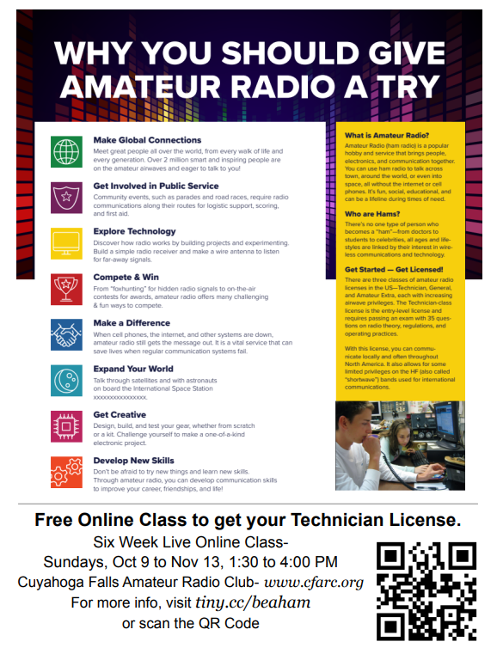Do you have co-workers interested in getting started in Amateur Radio?
2. **Do you have a place to put up a flyer** (work, school, library, restaurant, store, etc.)**?** Here are links to two printable flyers: [Flyer A](https://docs.google.com/document/d/1kwmRNEBYHhdL6gBY0tKj3P-Xm2NCFn6TuQCeqlvS-Ds/edit?usp=sharing) & [Flyer B](https://drive.google.com/file/d/1eToel7Q2KJZxRMGkEOqTobN9J-tzM_BH/view?usp=sharing)

This year we will be working in conjunction with the[*M.O.R.E. Project*](http://n2re.org/m-o-r-e-project). This will mean that students who complete the class and pass the license exam will be eligible to receive a GOTA (Get On The Air) package of free equipment, including a VHF/UHF HT and a SDR (Software Defined Receiver).

Because we draw attendees from around the country, we always recommend they join a local radio club in their area. If you recommend this class to someone, please let them know about your local club so they can find mentors in their area.

**__________________________________________________________**

VE Sessions

**All Things Amateur Radio Association (ATARA)** We host testing sessions every second Tuesday of the month in Lancaster. To sign up please visit our website <https://atara-w8atr.fun> and contact us at [hamexams@atara-w8atr.fun](mailto:hamexams@atara-w8atr.fun).

**CARS**

VE testing from CARS - Cuyahoga Amateur Radio Society - at Elmwood Recreation Center, 6200 Wisnieski Parkway in Independence, Ohio 44131  Time: 9:15 AM (Walk-ins allowed) Always the 2nd Sunday of the odd month. Go to CARS  [www.2cars.org](http://www.2cars.org/) for detailed map of location.  Call Metro W8MET 216-520-1320 for details

**Dayton Amateur Radio Association (DARA)** If you are interested in testing for a new or upgraded license, please come see us at the DARA Clubhouse. If you have questions about testing, please email [exams.w8bi@gmail.com](mailto:exams.w8bi@gmail.com)

**Huber Heights Amateur Radio Club**

Huber heights amateur radio club does ARRL VE testing the second Saturday of each even numbered month. Feb, Apr, Jun, Aug, Oct, Dec. 9:30-11:00 For more information contact Jim Storms – AB8YK at [ab8yk@hotmail.com](mailto:ab8yk@hotmail.com)

**The Lake County Amateur Radio Association**

The Lake County Amateur Radio Association is once again holding its **2022** Amateur Radio license exams at the **Kirtland Library**, 9267 Chillicothe Road, on the following dates:

Saturday, October 1, and December 3.

The tests will start at **12 noon.** Please arrive a few minutes earlier.

**The Lancaster and Fairfield County Amateur Radio Club (LFCARC**) hosts exam sessions at the FAIRFIELD County EMA, 240 Baldwin Dr in Lancaster Ohio, 43130, on the first Saturday each month at 10:00 am. Please visit our website at <http://www.k8qik.org> for exam dates on our calendar and navigate to our Learning Center/Taking the Exam link for information and requirements. Our experienced VE team looks forward to serving the Amateur Radio community in Central Ohio. Contact me at [ve_testing@k8qik.org](mailto:ve_testing@k8qik.org) to register.

**The Milford Amateur Radio Club (MARC)** is now doing VE testing on the third Thursday of each month at 6:00 PM.  Location;  Miami Township Civic Center located at 6101 Meijer Drive, Milford, OH  45150.

 Please pre-register at [www.milfordhamradio.org](http://www.milfordhamradio.org/)

**Northern Ohio Amateur Radio Society (NOARS)**

VE sessions are held the first Saturday of odd-numbered months at 10 AM in the North Olmsted Library, 27403 Lorain Rd., North Olmsted. Registration is preferred, but walk-ins are welcome. For more information or to register, contact Elaine, KC8FOS at [ewilkinson1951@gmail.com](mailto:ewilkinson1951@gmail.com).

**Portage County Amateur Radio Service (PCARS)**

The first Saturday of every even numbered month -10 am – at the PCARS club site in Ravenna. Please visit the PCARS web site and check out the information about VE testing in the latest newsletter at [www.portcars.org](http://www.portcars.org) .

If you have any questions, don’t hesitate to contact me at KB8UUZ@gmail,com

Canton ARC with other area ARCs activity on 9-24-22

After a few months of discussion, the Canton ARC went forward with a proposal to host a joint meeting of the three major clubs in Stark county and the single club in Tuscarawas county. We rented an outdoor shelter in a central location and divided up responsibilities for shopping, cooking, entertainment and publicity. Announcements of the joint meeting were made on all of the club's Facebook groups, mass emails and over-the-air mentions on weekly VHF nets. A four hour event was planned, starting at noon on a Saturday. The host club handled financial costs for the shelter and the main course of the meal (grilled meat sandwiches). Guests were asked to bring something to share. Our budget was $250 and we stayed well within it.

It took a half dozen host club members about 90 minutes to set up the shelter and begin food preparation. We were very pleased with the turnout, seeing a few hams that have not been active in a club for many months. After a nice cookout, we moved on to some pre-announced contests. The first was the classic high-speed Morse code elimination. Contestants were tasked with copying typical callsigns. After each callsign, the code generator speed was increased by a couple WPM till we got to 40 WPM. At that time, we increased the speed by a single WPM each round. Contestants put their pencils down when they could no longer copy the CW. The winner was able to exceed 50 WPM! Judges did check for at least 90% accurate copy.

Next, we did a variation on the popular QLF contest, that is, to send Morse code using one's left foot. One by one, contestants were given a short phrase and their job was to tap a J-38 key fixed to a board. Judges ranked the contestants 1-10 on speed and code quality. We took the average score of all judges and the highest was the winner.

Both contests were definitely crowd pleasers! A few hams brought along their portable station kits and shared experiences and even operated a bit.

Beyond a few large public service events, the area radio clubs don't have a chance to get together. We do have friendly competition with Field Day scores and local VHF QSO party scores, but we needed something to allow good old fashioned fellowship. You can get some of that at a large hamfest, but the time is precious and many people are more focused on making transactions.

There are pictures of our event in the Canton Amateur Radio Club Facebook group. Likely, the postings are now shared in the other club's group pages. We're hoping the event becomes an annual tradition, with the host responsibilities rotating among the clubs. All participants seemed pleased to attend and there was plenty of laughter to go around.

These things don't happen by themselves. Club members Justin, Tom, Linda, John, Mike and Roger all pitched in to make the event a success.

Dale Lamm NX8J

President, Canton ARC

**Your Club news should be listed here!**

I know you’re out there doing things! Send me a write-up (MSWord please) and some photo’s (.jpg please) and we’ll get your club hi-lited here for the other OH Section Clubs to see! Send to [WB8LCD@ARRL.ORG](mailto:WB8LCD@ARRL.ORG)

**______________________________________________________________________________**

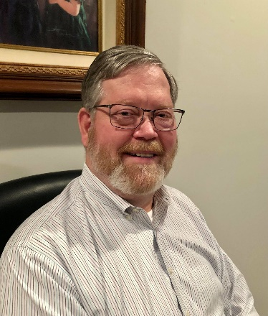

DX This Week – IOTA – Part 2

Bill AJ8B (aj8b@arrl.net, @AJ8B, or www.aj8b.com)

CWOPs Member #1567

As I am putting this together, I am preparing for a trip to the W4DXCC convention. Two days of presentations, amateur radio fellowship and vendor access. I call it vendor access because the vendors that are there are not trying to sell anything. One of the few times you can just try the radio and get questions answered. I will have an update soon. If you happen to be there, make sure you grab me to say help. I will be speaking on Friday and Saturday so you will have plenty of times to say hello, throw tomatoes, etc.

This week is part two of the IOTA introduction. Hope you enjoyed part 1.

I received 3 cards this week: CO7YS – Adys in Las Mercedes, Cuba; TF1EM – Eidur in Reykjavik, Iceland, and 5X3R – Elvira in Uganda. Let me know what you received. 73 and Gud DX Hunting

|  |  |
| --- | --- |
|  |  |
|  |  |
|  | |

DAH DIT DIT DIT DAH DAH DIT DIT DIT DAH

50+ Years of IOTA by Roger Ballister, G3KMA – Part 1

*The information presented here is a compilation information from https://www.iota-world.org/ I was given permission to use this information and to reprint it by Charles Wilmott, M0OXO.*

**1994-2004 -** By 1994, IOTA’s 30th anniversary, IOTA had made great strides towards becoming a mainstream program but had still some way to go to achieve general recognition. That year Yaesu had stepped in to become principal sponsor, later followed in 2006 by ICOM. Each in turn provided welcome financial assistance. In 1996 IOTA had been further boosted by the decision of the RSGB to take IOTA fully in-house in an arrangement whereby it provided some administrative support with payments and provision/dispatch of certificates etc. Sponsorship helped to finance a DOS-based system computerization that continued until 2007.

During these 10 years more than 200 IOTA groups were activated for the first time. Many of these were in countries totally untouched by IOTA, e.g. China and Vietnam, or rarely so, e.g. Indonesia’s remote islands, India and Colombia. China’s case was remarkable. Before 1994 only one of its islands, Hainan Island, had been briefly activated. Over the next seven years 15 previously un-activated Chinese IOTAs were aired for the IOTA Program …. and not just once, in most cases, there were several operations. Indonesia’s case is similar with an extraordinary number of new groups activated. In both cases the DXPeditioners were local operators, sometimes working in large teams, who systematically targeted the un-activated IOTAs in their’ patch’. This high level of activity in China and Indonesia continues to the present day.

The 1991 Directory revision achieved the twin objectives of strengthening the IOTA rule structure and of providing a definitive list of island groups.

However, in the absence of marine maps it had not been possible to specify all the islands that qualified for each group, but this was not seen as quite so important at the time since only the more accessible islands received visits by amateurs. The situation changed with the arrival on the scene of the new national island programs. Increasingly they encouraged DXPeditioners to activate small, often tiny, islands to satisfy both the demands of the award enthusiasts and also their own desire to activate a New One. In 2000 a major review was carried out, aided by Martin Atherton, G3ZAY, to tidy up and expand the list. In the end some 15,000 islands were listed, covering a high proportion of all countries with a coastline.

**2004-2014 -** The main event of the last 10 years was the launch in 2007 of an Internet-based module enabling on-line applications. This has made life very much easier both for applicants and management. An enhancement was added to allow applicants to match QSO information in IOTA Contests with contest logs, thereby avoiding the need to submit QSLs for these QSOs. A further enhancement was due to be rolled out in Spring 2014 to allow applicants to submit an ADIF log and receive back a listing of contacts potentially valid for IOTA. Selection of contacts on the list that are found to be supported by QSLs offers a saving in time in constructing an entry.

Within a few years the growth in popularity of IOTA has enabled it to become a mainstream program. It clearly complements DXCC since every IOTA contact counts for a DXCC entity and every island DXCC entity contact counts for an IOTA. Promotion of an operation for IOTA means promotion of it also for DXCC.

Where there is a difference is in the age profile of IOTA aficionados – it tends to be at the upper end of the scale. Many amateurs enter IOTA after they have had a long period chasing DX for DXCC, working mostly what they can, and now need a new challenge. They are often already well up the IOTA score ladder and have shoeboxes containing rare and much-cherished island cards which may well prove to count for IOTA. They relish the idea of trying out their skills in finding and working 50 Indonesian IOTAs or 100 groups in the Arctic. They have grown up with the stories of endeavor, heroism and bravery shown on rarer DXCC team operations. Now they are about to learn of similar exploits by single- or two-man operations to some of the remotest islands on earth. The two programs may complement each other in many ways but in one they don’t. The IOTA Most Wanted List is quite different from that which appears each year for DXCC. The DXCC island entities filling the top 50 positions do not, with barely an exception, figure on the IOTA Most Wanted List. In fact, fundraisers for operations to the top Most Wanted DXCCs often express amazement when told that their target island features more than half way down the IOTA Most Wanted List. For its part 95% of the top Most Wanted IOTAs are islands in DXCC’s easier entities. The most notable exceptions are the four North Korean IOTA groups!

**The Future -** IOTA has a robust rule structure that has been tested over many years and found to work well. Similarly, the on-line application module has done sterling work. Given adequate volunteer effort to run both, there is no reason why IOTA should not have a bright future. However, there are developments that could affect the program. Paperless QSLing is a concept that is fast gaining popularity, made even more attractive by the ever-increasing cost of postage in exchanging QSLs. There is also a detectable change in culture about continuing to send paper QSLs that is worrying. Consideration is being given to the introduction into IOTA of an application route based on paperless QSLing. However, changes to the existing software would be significant and potentially expensive to implement. We are open to offers of help.

**2014 – 2022 -** Islands On The Air (IOTA) Ltd, hereafter referred to as IOTA Ltd, was set up in early 2016 as a not-for-profit company, limited by guarantee in UK law, in partnership with the Radio Society of Great Britain (RSGB). Under a Memorandum of Understanding the RSGB ceded full responsibility to IOTA Ltd for all aspects of the IOTA program, its day-to-day management, strategy, policy, finance, development, promotion and marketing. The company was registered in the names of Roger Balister, G3KMA and Stan Lee, G4XXI who at the time were its only directors. IOTA enthusiasts should be assured that the new company is fully committed to maintaining IOTA on its well-established path as a major international program bringing increased activity to the amateur bands.

IOTA Ltd now has an extensive international management team of volunteers. The Board of Directors consists of Roger Balister G3KMA as General Manager and Program Coordinator, Cezar Trifu VE3LYC as Deputy General Manager and Operations Manager, Charles Wilmott M0OXO as Awards Manager, and Hans-Georg Goebel DK1RV, Jim Nakajima JA9IFF, Ghis Penny ON5NT and Dan Sullivan W4DKS as Board Members. Stan Lee G4XXI is Company Secretary and Treasurer, Johan Willemsen PA3EXX is IT Manager and Bob Cox K3EST is Deputy Operations Manager. We have 4 members on an IOTA Advisers Group, Michael Wells G7VJR, Mauro Pregliasco I1JQJ, Bob Barden MD0CCE and Donald Chamberlain W9DC. We have 23 card checkpoints in 20 countries. Together they form an IOTA Management Team of some 34 individuals committed to making a success of IOTA.

The current IT system was launched in 2016 on the IOTA website at www.iotaworld.org. Its most significant feature was the introduction of paperless QSLing through QSO matching with logs on Club Log and in 2020 on Logbook of the World (LoTW). It has come as an enriching experience to see it integrated on the new system. The IT Team led by Cezar Trifu VE3LYC has been working all hours to add operations that are valid for IOTA so that matching can take place and credits given. A huge vote of thanks goes to them and particularly to Johan Willemsen PA3EXX for developing the system and seeing it through to completion.

Friends of IOTA (FOI): To help raise the necessary funds, initially GBP 25,000, to meet the investment costs, the company launched FOI in June 2016 as a supporters’ group. Its aim was to give IOTA enthusiasts the opportunity not only to participate in one of the most active DX programs in the world but also to support it with donations to ensure its long-term future.

**The Performance Challenge -** There are two prestige awards: the 750 Islands Plaque of Excellence and the IOTA 1000 Islands Trophy. The IOTA Plaque of Excellence (below left), available for contacting 750 IOTA groups, takes the form of an attractively produced walnut wood shield, engraved with the recipient’s details and a number signifying the order in which it was presented. The shield is supplied with 9 blank metal mini-shields which can be replaced with shields, each signifying a score increment of 25 groups up to the 975 level.

The IOTA 1000 Islands Trophy (below right), available for contacting 1000 IOTA groups, is a beautiful diamond glass feature resting on a highly polished wooden base. The trophy is fitted with a metal plaque, which is engraved with the recipient’s details and a number signifying the order in which it was presented. There is space on this base for 8 metal mini-plates each signifying a score increment of 25 groups which can upgrade the trophy to the 1200 level.

IOTA is here to stay. It has had 50 years of ever-rising popularity. It is the second most popular international activity program after DXCC. It’s the choice of many amateurs who have now worked as much as they can in DXCC. It encourages many people who like DXPeditioning to go to islands the world over. It generates enthusiasm and passion. It breaks down barriers between peoples and races. But above all, it provides an ongoing source of activity on the bands and for many this means staying active in amateur radio.

DAH DIT DIT DIT DAH DAH DIT DIT DIT DAH

Here is an update from Bernie, W3UR, of the DailyDX and the WeeklyDX, the best source for DX information. <http://www.dailydx.com/> . Bernie has this to report:

**TN – Congo -** Members of the Czech DX Pedition group have announced their next DXpedition will be to Congo in early January of next year. The team includes OK1BOA, Petr; OK1FCJ, Petr; OK1CRM, Palo; OK1GK, Pavel; OK2ZA, Ruda; OK2ZC, Ludek; OK2ZI, Karel; and OK6DJ, David. The team expects to arrive on January 6th and begin setting up on the 7th through the 9th with full TN8K operation to run from January 10-19 and then dismantle the stations on the 19th and 20th and depart on the 21st. They will have two K3's, three TS-480HX, a SunSDR2DX, two IC-705's and five Juma PA-1000 amplifiers. They plan to emphasize activity on the low bands and will have the following antennas. Four element Yagi on 6 Meters, three Spiderbeams for 20, 15 and 10 meters as well WARC, two element Yagi for 17 and 12 Meters, two phased verticals on 30 Meters, two phased verticals on 40 Meters, a vertical with 10 radials on 80 Meters and a vertical on 160 Meters with 10 radials. For receive antennas on the low bands they will have three Beverages and a receive vertical. Activity will be on 1.8 through 50 MHz as well as QO-100 on SSB, CW, RTTY, FT4, FT8 and PSK. Their band plan will be as follows:  
  
CW - 1832, 3504 (JA), 3525, 5357, 7025, 10105, 14025, 18070, 21025,  
24890, 28005 and 50097 KHz  
SSB - 3790, 7170, 14240, 18150, 21300, 24950, 28470 and 50150 KHz  
FT8 - 1840, 3580, 5357, 7056, 10144, 14090, 18109, 21091, 24923, 28091  
and 50313 KHz  
RTTY - 10142 and 14080 KHz.

If they have a good Internet connection they will use Club Log Live Stream <https://clublog.org/livestream/tn8k> QSL via OK6DJ, OQRS, LOTW.  
  
**1S - Spratly Islands -** The Pilipino DXpedition to the Spratly Islands, DX0NE, which was originally expected sometime between August and December of this year and was then tentatively scheduled to depart on September 16th has been rescheduled. Due to complications the trip is now schedule for November 25. It seems the team is trying to get their earlier than the new date as they have been in contact with officials trying to work out getting the DX0NE team "on any available transport to the island". 4F2KWT, Gil, will keep us up to date with any "developments".

**VK9 - Cocos-Keeling -** VK9CM by VK3QB, VK6CQ, VK6SJ and VK6VY will be October 26 to November 3, on CW, SSB and FT8 F/H, 80-6M including the CQ WW DX SSB weekend event, callsign VK9C.  QSL through EB7DX.

DAH DIT DIT DIT DAH DAH DIT DIT DIT DAH

Below is a list of upcoming contests in the “Contest Corner”. I think this is important for someone who is trying to move up the DXCC ladder since entities that are on the rarer side and easiest to work in contests. Some of my best “catches” have been on the Sunday afternoon of a contest when the rarer entities are begging for QSOs. Of course, the gamble is that if you wait until Sunday, conditions may change, or they simply won’t be workable. However, it is not a bad gamble. Of course, why not work the contest and have some fun!  
Check out the WA7BNM Contest Calendar page (<https://www.contestcalendar.com/>) and CQ Magazine for more contests or more details. I also have a comprehensive list that can be imported to your calendar at [www.aj8b.com/files](http://www.aj8b.com/files)

The contests in red are those that I plan to spend some significant participation time on. PLEASE let me know if you are working contests and how you fared.

Thanks!

|  |  |  |
| --- | --- | --- |
| **Date(s)** | **Event** | **Info** |
| Oct. 3 | German Telegraphy Contest | <https://bit.ly/3xzuPjw> |
| Oct. 3 | RSGB Autumn Series CW | <https://bit.ly/31qpcJl> |
| Oct. 5 | 432 MHz Fall Sprint | <https://svhfs.org/2022VHFSprintRules.pdf> |
| Oct. 5 | UKEICC 80m Contest SSB | <https://ukeicc.com/80m-rules.php> |
| Oct. 5 | VHF-UHF FT8 Activity | <http://www.ft8activity.eu/index.php/en/> |
| Oct. 6 | SARL 80m QSO Party | <http://bit.ly/H0IqQf> |
| Oct. 7-9 | Nevada QSO Party | <http://nvqso.com/contest-rules/> |
| Oct. 8 | QRP ARCI Fall QSO Party | <http://www.qrparci.org/contests> |
| Oct. 8 | Microwave Fall Sprint | <https://svhfs.org/2022VHFSprintRules.pdf> |
| Oct. 8-9 | Arizona QSO Party | <https://www.azqp.org/> |
| Oct. 8-9 | Oceania CW DX Contest | <http://www.oceaniadxcontest.com/> |
| Oct. 8-9 | Pennsylvania QSO Party | <http://paqso.org/> |
| Oct. 8-9 | PODSX 070 Club 160M Great Pumpkin Sprint | <http://bit.ly/2RUkcE6> |
| Oct. 8-9 | Scandinavian SSB Activity Contest | <https://www.sactest.net/blog/> |
| Oct. 8-9 | South Dakota QSO Party | <https://sdqsoparty.com/> |
| Oct. 9 | UBA ON 80M CW Contest | <https://bit.ly/3kKYKzj> |
| Oct. 10 | 10-10 Intl. 10-10 Day Sprint | <http://bit.ly/1FrFeBc> |
| Oct. 12 | RSGB Autumn Series Data | <https://bit.ly/31qpcJl> |
| Oct. 12 | VHF-UHF FT8 Activity | <http://www.ft8activity.eu/index.php/en/> |
| Oct. 15 | Feld Hell Spooky Sprint | <https://bit.ly/3g8gpxD> |
| Oct. 15-16 | 10-10 Intl. Fall CW Contest | <http://bit.ly/1FrFeBc> |
| Oct. 15-16 | New York QSO Party | [http://www.nyqp.org](http://www.nyqp.org/) |
| Oct. 15-16 | JARTS WW RTTY Contest | <http://jarts.jp/rules2022.html> |
| Oct. 15-16 | Worked All Germany Contest | <http://bit.ly/2uDQRSV> |
| Oct. 16 | Asia-Pacific CW Sprint | <http://jsfc.org/apsprint/> |
| Oct. 16 | UBA ON 2M Phone/CW Contest | <https://bit.ly/3kKYKzj> |
| Oct. 16 | Illinois QSO Party | <https://w9awe.org/ilqp/> |
| Oct. 17 | RSGB FT4 Contest | <https://bit.ly/31qpcJl> |
| Oct. 19 | VHF-UHF FT8 Activity | <http://www.ft8activity.eu/index.php/en/> |
| Oct. 22-23 | Stew Perry Topband Distance Challenge | <https://www.kkn.net/stew/stew_rules.html> |
| Oct. 22-23 | UK/EI DX Contest | <https://www.ukeicc.com/dx-contest-rules.php> |
| Oct. 22-23 | YLRL DX/NA YL Anniversary Contest | <https://ylrl.net/contests/> |
| Oct. 22-23 | North American SSB Sprint | <https://ssbsprint.com/rules/> |
| Oct. 26 | UKEICC 80m Contest CW | https://ukeicc.com/80m-rules.php |
| Oct. 27 | RSGB Autumn Series SSB | <https://bit.ly/31qpcJl> |
| Oct. 29-30 | CQ WW DX SSB Contest | <http://www.cqww.com/index.htm> |
| Nov. 26-27 | CQ WW DX CW Contest | <http://www.cqww.com/index.htm> |

ARLD039 DX news  
  
This week's bulletin was made possible with information provided by The Daily DX, the OPDX Bulletin, 425 DX News, DXNL, Contest Corral from QST and the ARRL Contest Calendar and WA7BNM web sites.  Thanks to all.  
  
EQUATORIAL GUINEA, 3C.  Ersoy, TA2OM is now QRV as 3C3W from Malabo, Bioko Island, IOTA AF-010.  He is here for one to two months. Activity of late has been on the HF bands using FT8.  QSL to home call.  
  
MALDIVES, 8Q.  Gianpi, IK1TTD will be QRV as 8Q7TD from Fasmendhoo Island, IOTA AS-013, from October 2 to 17.  Activity will be holiday style on the HF bands.  QSL to home call.  
  
ANGOLA, D2.  Mikalai, UT6UY is QRV as D2UY from Cabinda and is active on 20 to 10 meters using FT8.  He has also been active on 6 meters using FT8.  QSL via LoTW.  
  
FEDERAL REPUBLIC OF GERMANY, DA.  Special call DR45HAAN will be QRV from October 1 to September 30, 2023 to celebrate DARC organization Ortsverband Haan's 45 years.  QSL direct to DL7FT.  
  
SOUTH COOK ISLANDS, E5.  Jim, E51JD is now QRV on 20 to 10 meters using SSB.  QSL to home call.  
  
MARQUESAS ISLANDS, FO.  Didier, F6BCW will be QRV as TX7G from Iva Oa, IOTA OC-027, from October 1 to 15.  Activity will be on 80 to 10 meters using CW, SSB, RTTY, and FT8 if possible, daily from 0300 to 0700z, and then 1500 to 1700z, depending on band conditions.  QSL direct to home call.  
  
MINAMI TORISHIMA, JD1.  Take, JG8NQJ/JD1 is QRV until December 15 and has been active using CW on 17 meters around 0900z.  QSL via JA8CJY.  
  
SVALBARD, JW.  Just, JW9DL, Erling, JW6VM and Halvard, JW7XK will be QRV from Spitsbergen, IOTA EU-026, from October 5 to 10.  QSL JW7XK via LA7XK, JW6VM via LA6VM, and JW9DL via LA9DL.  In addition, look for JW7XK to be QRV from Longyearbyen, Grid Square JQ78tf, on Satellite RS-44 between October 5 to 10.  Activity will be with CW and SSB.  
  
LITHUANIA, LY.  Special event station LY770CT is QRV until October 14 to celebrate the 770th anniversary of the city of Klaipeda.  QSL via LY1CT.  
  
TURKEY, TA.  Berkin, TA3J is QRV as TA3J/0 from Yassica Island, IOTA AS-099, until the end of October.  QSL to home call.  
  
MALI, TZ.  Jeff, TZ4AM has been active on 6 meters using SSB between 1800 and 1900z.  QSL via W0SA.  
  
ST. KITTS AND NEVIS, V4.  John, W5JON will be QRV as V47JA from Calypso Bay from October 2 to 12.  Activity will be on 160 to 6 meters using SSB and FT8.  QSL to home call.  
  
NAMIBIA, V5.  Hanspeter, HB9BFM is QRV as V5/HB9BFM until October 11.  Activity is generally from 1600 to 1900z on 20 meter Olivia frequencies.  QSL to home call.  
  
ANTARCTICA.  Warren, VK0WN is QRV from the Casey Research Base while on work assignment.  Activity is holiday style on 20 meters usually between 0500 to 0600z.  QSL via LoTW.  
  
NEW ZEALAND, ZL.  Members of the Whangarei Amateur Radio Club will be QRV as ZL75AWRC from October 1 to December 31 from North Island, IOTA OC-036, to celebrate the club's 75th anniversary.  QSL via operators' instructions.  
  
The K1USN Slow Speed CW Test, German Telegraphy CW Contest, ICWC Medium Speed CW Test, OK1WC CW Memorial, RSGB 80-Meter Autumn CW Series, ARS Spartan CW Sprint, Worldwide Sideband Activity Contest, RTTYOPS Weeksprint, Phone Weekly Test, A1Club CW AWT, CWops Test, VHF-UHF FT8 Activity Contest, Mini-Test 40, Mini-Test 80, 432 MHz  
Fall Sprint and the UKEICC 80-Meter SSB Contest run from October 3 to 5.  
  
Please see September QST, page 72, October QST, page 70, and the  
ARRL and WA7BNM Contest web sites for details.  
______________________________________________________________________________

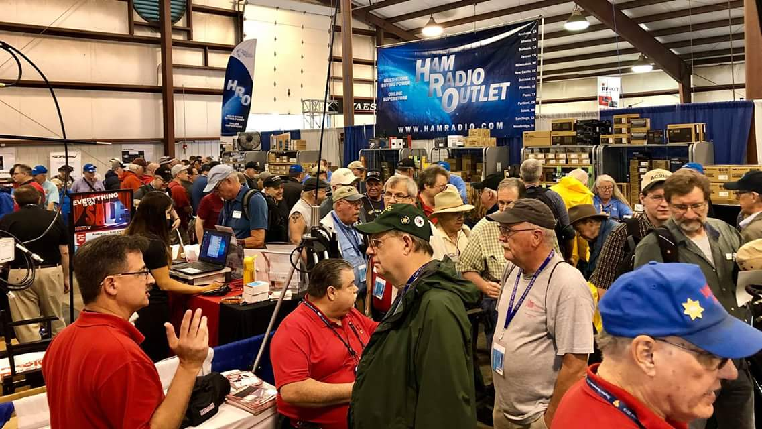[**Upcoming *Hamfests***](http://arrl-ohio.org/hamfests.html)

We **DO** have some hamfests scheduled for 2022!! Yes, take a good look at the list. And YES! They are starting to book up for 2023 already!

**__________________________________________________________**

|  |  |
| --- | --- |
|  |  |

|  |  |
| --- | --- |
|  |  |
|  |  |
| ***2022 & 2023*** | | | | |
| **10/15/2022 -**[**Portsmouth Radio Club Hamfest**](http://www.arrl.org/hamfests/portsmouth-radio-club-hamfest-7)  **Location:**New Boston, OH Sponsor: Portsmouth Rado Club, Jett Fire, Shawnee **Website:** [http://www.portsmouthradioclub.org](http://www.portsmouthradioclub.org/) [**Learn More**](http://www.arrl.org/hamfests/portsmouth-radio-club-hamfest-7) | | | | **10/30/2022 -**[**Massillon Hamfest (OH)**](http://www.arrl.org/hamfests/massillon-hamfest-oh)  **Location:**Green, OH **Sponsor:** Massillon Amateur Radio Club **Website:** [http://w8np.org](http://w8np.org/) [**Learn More**](http://www.arrl.org/hamfests/massillon-hamfest-oh) |
|  | | | |  |
| **12/03/2022 -**[**FCARC WinterFest**](http://www.arrl.org/hamfests/fcarc-winterfest-3)  **Location:**Archbold, OH **Sponsor:** Fulton County Amateur Radio Club **Website:** <https://k8bxq.org/hamfest> [**Learn More**](http://www.arrl.org/hamfests/fcarc-winterfest-3) | | | | **03/11/2023 -**[**MOVARC Hamfest**](http://www.arrl.org/hamfests/movarc-hamfest-8)  **Location:**Bidwell, OH 45614, OH **Sponsor:** Mid-Ohio Valley Amateur Radio Club [**Learn More**](http://www.arrl.org/hamfests/movarc-hamfest-8) |
| **05/13/2023 - 05/17/2023** [**RV Radio Network**](http://www.arrl.org/hamfests/rv-radio-network-1)  **Location:**Berlin, Ohio, OH **Type:** ARRL Operating Specialty Convention **Sponsor:** RV Radio Network [**Learn More**](http://www.arrl.org/hamfests/rv-radio-network-1) | | | | **07/16/2023 -**[**Van Wert Hamfest**](http://www.arrl.org/hamfests/van-wert-hamfest-7)  **Location:**Van Wert, OH **Sponsor:** Van Wert Amateur Radio Club **Website:** [http://w8fy.org](http://w8fy.org/) [**Learn More**](http://www.arrl.org/hamfests/van-wert-hamfest-7) |
|  | | | |  |
|  | | | |  |
|  | | | |  |

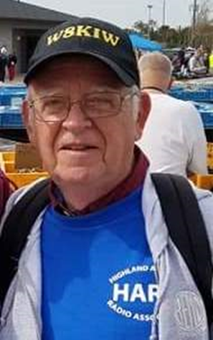**OHIO’S** 

Anyone who really knows me knows I love Hamfests and have attended them since the early 1960s! They also know I can’t understand why our newer hams plus a good number of long licensed hams do not attend Hamfests and causing some to cease to exist. However it appears not to be a recent problem as I recently ran across an article in the December 2006 *World Radio* that I will share at the end of the column. In the meantime, here is an update of what is taking place in the Ohio’s South 40 region:



With the cancellation of the annual November **Grant RC** Hamfest at Georgetown the upcoming **Portsmouth RC**’s October 15 hamfest at New Boston is perhaps the final Southern Ohio region hamfest or swapfest for 2022. That hamfest has a new location this year. It takes place at the New Boston Community Center, 3982 Rhodes Avenue in New Boston. The fun gets underway at 8 AM and runs until 1 PM. There will be a Laurel VE test session at 10 AM. Food, refreshments, a 50/50 drawing and a lot of door prizes are a part of this ever popular hamfest. As for the door prizes, almost everyone who is there at closing time will go away with something. Contact Gary Caldwell, WX8G, at 740-240-4955 or

[www.portsmouthradioclub.com](http://www.portsmouthradioclub.com) for more information.

The **Parkersburg/Wood County** Hamfest is this coming Saturday, October 8 at the Wood County 4-H Fairgrounds in Mineral Wells, WV. A biscuit and gravey breakfast starting at 6:30 kicks the day off. At 7 AM flea market vendors start their set ups for the gates opening at 8 AM kick off for the hamfest. There is a $5 admission fee. Outside flea market set ups are free. Registration for a W5YI VE session starts at 8 with testing at 9. Call Ken Harris, WA8LLM, at 304-679-3470 for more information.

This past Saturday was a busy day for several clubs in the region. The **Athens County ARA** provided communication for the annual Buckeye Trail runs taking place during the Blue Blaze Festival in Shawnee. We understand these runs are a major fund raiser for the non-profit group that supports and maintains the 1444-mile Buckeye “loop trail” that reaches into all corners of the State. Also happening on the 1st, a special event station took to the airwaves from Lawrence County.

Unfortunately the questionable weather conditions resulting from the hurricane caused both Southern Ohio special event operations to be postponed. The **Southern Ohio ARA** and the **Lawrence County ARES** combined efforts at Ohio’s Southernmost point along with the **Highland ARA**’s Gist Settlement special event station have been postponed and now will happen on the October 15 rain date.

The popular **Clinton County ARA** ‘Last Saturday Breakfast’ has returned to the Club’s monthly schedule of events. President Mark Atwell, WX8A, reports it happens at Sam’s Meats and Deli, 1209 West Locust Street in Wilmington. The October one will happen on October 29 at 8:30 AM.

Speaking of food, Bob Mathews, K8TQK, reminds hams in the Bainbridge, Ross, Pike and Highland County areas of the upcoming breakfast on Saturday morning, October 8 at the Dutch Restaurant, SR 41 near the Ross/Pike County Line and the Amish general store and bakery near Bainbridge. It begins around 8 AM and tries to conclude in time not to interfer with travel time to Hillsboro to attend the **Highland ARA**’s Brunch Bunch. According to Ken Lightner, KE8JEL, their October gathering will again be held at the Harmony Lake shelter house at Liberty Park and will probably be the last one held there for the year. He is currently looking for a new indoors site. The gathering starts around 10 AM.

*The* **Tri-State ARA** will hold a license test session on Saturday, October 8 at the Museum of Radio and Technology in Huntington beginning at 9 AM. All license elements will be available. Pre-registration is not necessary. A $15 charge is made for each element or test taken.

For those potential new hams or those wanting to upgrade, but feel they are not ready to take on the challenge at the Portsmouth hamfest or at one of the other opportunities, there will be an upcoming test session conducted by the **Scioto Valley ARC** on November 5 in Chillicothe. According to John Hartmus, WB8GRX, the test session will be held in Conference Room A at the Ross County Service Center beginning at 9 AM. Like the Portsmouth session this is a Laurel VE session and therefore there is no charge to take an exam for a first license or for an attempt to upgrade. However the FCC license fee will still apply for anyone earning a first license. Also for those needing a little more preparation for earning their first license, the **Hocking Valley ARA** will hold a Technician Training Class on Saturday, October 29 and November 5 with the final session held just prior to the testing on November 12. Each class will be held at the EOC Building in Logan from 9 until noon. This will be an ARRL VE session therefore a $15 fee will be charged for each test or element taken in addition to the fee the FCC charges for each new license issued. The **Milford ARA** holds a Laurel VE session prior to its monthy meeting. The next test will be on Thursday evening, October 20 at 6 pm. Pre-registration is requested and can be completed with a visit to the Club’s [www.milfordhamradio.org](http://www.milfordhamradio.org) website.

Several clubs will hold meetings in the coming days. On Monday, October 3 the **Portsmouth RC** will meet at the American Legion Post across the street from the Courthouse in downtown Portsmouth. Undoubtedly the upcoming hamfest will be the main topic discussed. The **Hocking Valley ARA** will meet on Tuesday evening, October 4, at the EOC Building in Logan. The nominating committee for the November elections will be appointed. The Clinton County ARA will meet on Thursday evening, October 6, at the Foster Medical Center in Wilmington. That meeting will begin at 7:30. Members of the **Highland ARA** will meet at the EMA Office in Hillsboro at 7 PM. Several important items are on the agenda. The next **Athens County ARA** meeting will be on Tuesday evening October 18 at the Red Cross Building in Athens. The **Milford ARA** will hold their annual election of officers for 2023 at their upcoming October 20 meeting. All members elgible to cast votes are urged to attend. Additionally, any member in good standing interested in running for an office is urged to let that fact be known to President Ron Brooks. The meeting begins at 7:30.

According to KC8JRV the next **Athens County ARA** Fox Hunt will be on Sunday, October 9. Registration begins on the Athens repeater at 12:45 with the hunt to begin at 1 PM. Information can be had by contacting Kirk at [breathOair@hotmail.com](mailto:breathOair@hotmail.com). Logan’s Phil Stanley, W8NZB, will be the fox.

The revived **Vinton County ARA** has recently placed a new repeater on the air that has a wide footprint throughout Southern Ohio from its location near McArthur. In fact some HARA members recently brought the repeater up from the former HARA Pike County repeater site with no problem. The VCARA has started a Sunday evening net on the repeater at 8 and is looking for more participation. The machine is on 147.105 with an 88.5 tone.

We want to welcome Trevor Heery from Brown County’s Fayetteville into the wonderful world of ham radio. Trevor recently passed his Technician license and is now KE8VRT. Just down the road in Clermont County’s Amelia Bruce Bideenharn now holds a Techician ticket and is KE8VRY.

As you read this several area hams and their spouses have returned from the Smoky Mountains where they had an enjoyable few days. While the wife’s shopped and did XYL things, the hams attended the **Ham Radio Bootcamp** and **W4DXCC Convention**. Historically those who attended this event in past years have always had glowing comments about the quality of the speakers and topics covered. And this year was no exception. Unfortunately one of those making the trip brought a case of COVID back.

Now the waiting has started as the log submission deadline for the recent Ohio State Parks On The Air Contest has passed. It’s hoped the final results will be able to be published in the November issue of the **Portage County ARC**’s “RadioGram” newsletter.

Although some weeks away, the **Cambridge ARA** wants members and area hams to know it has set the date for their annual Awards Banquet. Please mark your calendars for the afternoon of Saturday, December 3. It will take place from 2 until 4 in the smaller dining room at the Denny’s Southgate Parkway location in Cambridge. Food will be ordered from the menu.

I have mentioned several times about N8ZNR and my daughter recently passing her Tech test and exchanging her KK7EYJ call for my original WA8KIW call sign. Since then several other hams have informed me of their family members doing the same. Recently I learned New Vienna’s Seth Hawthorn has traded in his KE8RVO one to obtain the W8MVM his grandfather had decades ago.

As promised, here is the Hamfest article written by Ed Yeary, W4TEY, in the December 2006 World Radio. “I love Hamfests! I don’t care if anyone says they are down in attendance, they have too much computer crap or it costs too much for gas these days to get there. I love Hamfests, period, and I want to tell you why. Obviously, they are radio heaven for Amateur operators but my love for them comes from the camaraderie I have experienced in my attendance. It is wonderful to be able to meet new people and put faces with the voices you have been talking to on the air. A cup of coffee, a few jokes, handshakes and rubbing elbows with fellow hobbyists cannot be beat. This is the most often overlooked facet of the Hamfest. I hear people say “There really isn’t anything I need” or “I can’t afford anything right now.” We always need human contact and can always afford meeting the great people that enjoy the Amateur Radio hobby.” Well said! The recent cool mornings and evenings tell us the New Year is not that many months away. So why not go ahead and make it a resolution to attend at least one hamfest or swapfest this coming year? Even better, why not Portsmouth on the 15th?

That’s it for another week. Until next time stay cool, healthy, safe and radio-active.

John Levo, W8KIW, [jlevo@cinci.rr.com](mailto:jlevo@cinci.rr.com) or highlandara@gmail.com, 937-393-4951

**Massillon Hamfest**

Come one, come all to the Massillon Amateur Radio Club 2022 Hamfest at MAPS Air Museum, one of the nation’s premier WW2-era aircraft museums.

October 30th we will again be at MAPS,  2260 International Parkway, N. Canton, OH, 44720. MAPS is accessed easily from I-77.

Tables are on sale now at the club website ($15 again this year) as are tickets (still $5). This is a great value as your admission includes both the hamfest and a tour of the museum.

Information may be obtained at W8NP.net.

Vendor Info: Gerry Sorensen, KG8RRY

Email: [Club@w8np.net](mailto:Club@w8np.net)

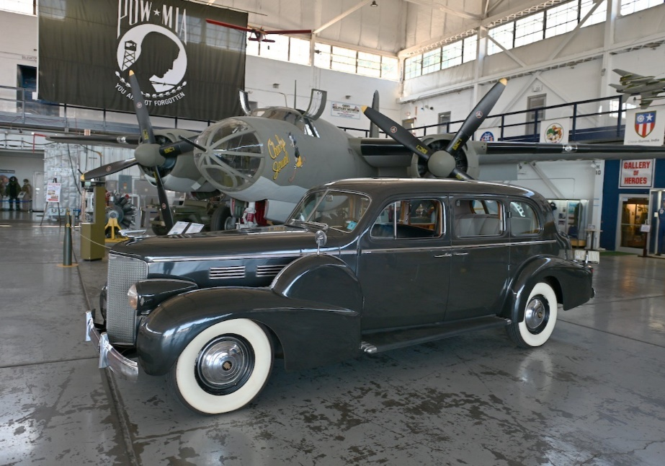

**_________________________________________________________**

**Hurricane Ian Actions**

Here is an ARRL update on our EmComm involvement with Hurricane Ian efforts as of early afternoon today, Sept 28.  
  
Communications with SM’s and SEC’s in FL began last week.  
Working with David Siddall to submit the Emergency Request for a Temporary Waiver for Symbol Rate Rules that has now been approved. Online Zoom meeting with Communications Leaders in FEMA Region 4 Florida ARES has been requested in several shelter locations. Florida Emergency Management requested ARES members to operate in the state emergency operations center.  They can fulfill this request at this time.

Arc Thames, W4CPD, SEC North Florida, has been designated the Florida Amateur Radio Liaison for Florida Emergency Management.

Zoom Calls held Monday 9/26, and Tuesday 9/27 included SEC’s, SM’s and ARRL HQ to go over the incident action plan for the event including the comm plan.  In those meetings Florida officials asked not to share the frequencies nationwide at this time due to past experience with intentional interference.  Discussions were very positive, and it is apparent that all 3 sections were working with members to prepare as much as possible.

Emergency Management has worked with the PR and News Team to get information out regarding response.  One important message is for volunteers not to self-deploy.

EM Staff are monitoring weather news outlets and online VOIP amateur radio net.

Our W1AW Winlink station has been switched to be able to handle PACTOR IV and our SHARES Station has been activated. Ham Aid kits are ready to ship if needed and FL has been briefed on what is available in addition to what they have pre-deployed.

Several meetings with CISA communications officials as well as RAC partners who have offered any support they can provide. Emails with National Hurricane Center with coordination for support (hams in place at the NHC).  
  
--------------------------------------------------------------------  
ARRL Great Lakes Division  
Director: Dale R Williams, WA8EFK  
[wa8efk@arrl.org](mailto:wa8efk@arrl.org)

**Print an Official or Unofficial Copy of Your Amateur Radio License**

*(By Anthony Luscre, K8ZT)*

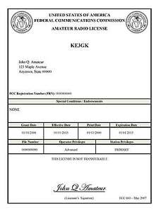

As of February 17, 2015, the **FCC no longer routinely issues paper license documents** to Amateur Radio applicants and licensees. The Commission has maintained for some time now that the official Amateur Radio license authorization is the electronic record that exists in its Universal Licensing System (ULS). The FCC will continue to provide paper license documents to all licensees who notify the Commission that they prefer to receive one.

Licensees also will be able to print out an official authorization — as well as an unofficial “reference copy” — from the ULS License Manager. I’ve created a set of instructions on how you can request an **“official” printed copy of your license\***

[**Click here to download the instructions**](http://arrl-ohio.org/news/2020/print_your_license.pdf)

***One Question Questionnaire***

!!!!! I would really like to hear from as many of you as possible on this one. While I know what I think the answer is going to be, the bigger the sample, the more accurate a survey like this is likely to be.

How about going to <http://arrl-ohio.org> and giving me a click? (It’s in the bottom left corner of the page)

***Are you a member of your local ARES Group?***

* 1. YES
  2. NO

**From the last Poll:**

***What is the main antenna at your station?***

1. Rubber Duck on HT - 2.9% 2 votes
2. Dipole - 30.43% 21 votes
3. Vertical 31.88% 22 votes
4. Yagi 14.49% 10
5. Something Else 20.29% 14 votes

Bottom of Form

Ohio Section Cabinet

|  |  |
| --- | --- |
| Section Manager – Tom Sly, WB8LCD | Section Traffic Manager – David Maynard, WA3EZN |
| Section Emergency Coordinator – Stan Broadway, N8BHL | Section Youth Coordinator – Anthony Luscre, K8ZT |
| Technical Coordinator – Jeff Kopcak, K8JTK | Affiliated Clubs Coordinator – Tom Sly, WB8LCD |
| State Government Liaison – Bob Winston, W2THU | Public Information Coordinator – |



Hey Gang,

Have you taken a look at the **Swap & Shop** page on the Ohio Section webpage yet?? Here’s a link that will take you there… <http://arrl-ohio.org/sm/s-s.html>

Do you have equipment that you just don’t need or want anymore? Here’s a great venue to advertise it, and it’s FREE!! Is your club doing a fund raiser to help raise money? After a lot of thought, it was decided that the Swap & Shop webpage could also contain these types of items as well. The same rules will apply as do for the For Sales and Give-A-Ways and will only be posted for a month at a time. Please see the Terms & Conditions on the webpage.

If your club is doing a fund raiser and wants more exposure, please forward the information to me and I’ll advertise it on the Swap & Shop webpage for you.

Now, I still want to remind you that it won’t be listed in this newsletter because it would take up way too much space, so your ad will only appear on the website. It is there for any individual to post equipment Wanted / For Sale or Give-Away as well as for Club Fund Raisers. No licensed vehicles/trailers or business advertising will be posted. Postings are text only (no pictures or graphics) will be posted for a maximum of 1 month from date posting and require a contact phone number or email within the posting. Send your Wanted / For Sale or Give-Away post to:  [swap@arrlohio.org](mailto:swap@arrlohio.org)

***Back Issues of the PostScript and Ohio Section Journal***

Hey, did you know that PostScript and Ohio Section Journal (OSJ) are archived on the website? You can go back and look at any edition simply by clicking:

<http://arrl-ohio.org/news/index.html>

***Want to Share your Club Newsletter With Others?***

We have a webpage where you can download and read all of the newsletters that I get from around the state and even other sections!

Here’s the link to the page…. <http://arrl-ohio.org/club_news/index.html>

Please, if you don’t see your club newsletter posted, it’s because I’m not receiving it. Just have your newsletter editor contact me and I’ll get your club’s newsletter listed on the site!!

We all learn and steal (I mean, share) from each other’s work. So, get me your newsletter!!! Send it to: [webmaster@arrl-ohio.org](mailto:webmaster@arrl-ohio.org)

***Chit – Chat, and All That!***

Do you know someone that’s not getting these Newsletters? Please, forward a copy of this Newsletter over to them and have them “[Opt-In](mailto:Opt-In)” to start receiving them. Heck, just have them send an email to: [webmaster@arrl-ohio.org](mailto:webmaster@arrl-ohio.org) and we’ll get them added to the Ohio Section Emailing list.

We now have many thousands of readers receiving these newsletters weekly. Quite impressive, I’d say! I urge all of you to make sure that everyone, regardless of whether they are a League member or not, get signed up to receive these weekly Newsletters.

You can always “Opt-Out” at any time if you feel this is not what you were expecting. It’s fun and very informative. All of your favorite past newsletters are now archived too.

You can go back at any time and read them.

Just go to: <http://arrl-ohio.org/news/>

*PostScript is produced as a weekly newsletter. I want to thank everyone that has contributed articles and ideas to make this an even better news source. I sincerely hope that you have enjoyed this edition and will encourage your friends to join with you in receiving the latest news and information about the Ohio Section, and news and events happening around the world!*