[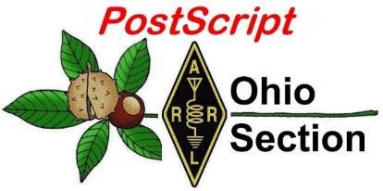](http://arrl-ohio.org/news/)

***“August 15th, 2022******”***

🡪 National News 🡪 Club Corner

🡪 DX This Week 🡪 Contest Corner

🡪 Upcoming Hamfests 🡪 One Question Questionnaire

🡪 VE Testing 🡪 South 40

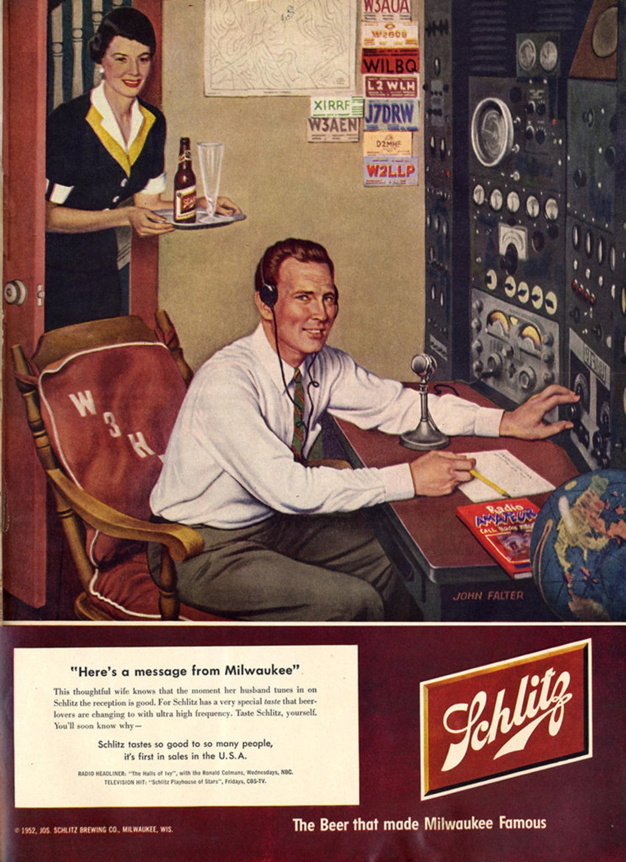

**CQ CQ CQ de WB8LCD**

I have been “Ranting” about clubs quite a bit lately. I’m going to continue that here because I truly believe that “CLUBS” are what can save Amateur Radio and make sure it exists into the future. But we’ve got some work to do.

From the Federal Register Title 47: Telecommunication, in part 97 you will find the rules and regulations that define the Amateur Radio Service. For this conversation we will look at part 97.1 – The Basis and Purpose of Amateur Radio:

**Subpart A—General Provisions**

**§97.1   Basis and purpose.**

The rules and regulations in this part are designed to provide an amateur radio service having a fundamental purpose as expressed in the following principles:

(a) Recognition and enhancement of the value of the amateur service to the public as a voluntary noncommercial communication service, particularly with respect to providing emergency communications.

(b) Continuation and extension of the amateur's proven ability to contribute to the advancement of the radio art.

(c) Encouragement and improvement of the amateur service through rules which provide for advancing skills in both the communication and technical phases of the art.

(d) Expansion of the existing reservoir within the amateur radio service of trained operators, technicians, and electronics experts.

(e) Continuation and extension of the amateur's unique ability to enhance international goodwill.

I’m probably going to be accused of committing some sacrilege here, but this is not exactly what we should use as a guideline as to how our clubs should operate! Not that these goals for the Amateur Radio Service will not be met, but the activities of our clubs will lead to the accomplishment of these goals by doing what *clubs* should have as their objectives. Following are Tom’s General Provisions for the Basis and Purpose of Amateur Radio Clubs:

1. Recognizing that there are no nobler members of our society than Amateur Radio operators, through our clubs we need to provide a venue for all Amateur Radio operators (Hams) to find relationships, activities, and opportunities to expand upon their knowledge and expertise of Amateur Radio communications so that none will be attracted to the next “shiny” object and desert our ranks.
2. Knowing that our entire hobby is predicated on the permission of our government to continue to exist, we need to continually add to our number New Hams and develop them into active members of our avocation. Although Amateur Radio is not political, we depend on politicians to maintain our status. Politicians are impressed by numbers, and we need to be a constituency that they will pay attention to.

Simply put, there are only 2 things clubs really need to do – make new hams and develop them into active and engaged members of our fraternity. In the process, all of the objectives of our “Basis and Purpose” can be met. Now there are lots of ways that clubs can do those 2 things. Whatever your clubs’ activities and programs are, ask yourselves, does this really move one or both of those 2 things forward? Don’t get me wrong, many things do, and that’s what we should be focusing on.

Last week I was at the Columbus Hamfest, this week the Cincinnati Hamfest. Both were really good opportunities to find some good flea market deals and talk to some very interesting people. Lots of clubs use their hamfest as a fundraiser. They always appreciate your being there and do their best to make it an enjoyable event!

The Ohio Section Newsletter Contest winners were announced last week at the Columbus Hamfest. From John Ross – KD8IDJ:

Another great year the Ohio Section Newsletter Contest. A lot of important amateur radio information to club members through their newsletters.

Here are the 2022 winners!

First Place

|  |  |
| --- | --- |
| OH-KY-IN Amateur Radio Society | Qfiver |

Second Place

|  |  |
| --- | --- |
| Mount Vernon Amateur Radio Club | MVARC Newsletter |

Third Place

|  |  |
| --- | --- |
| Portage County Amateur Radio Society | The Radiogram |

Fourth Place

|  |  |
| --- | --- |
| Alliance Amateur Radio Club | Zero Beat |

Honorable Mention

|  |  |
| --- | --- |
| Media County Amateur Radio Club | News Beacon |

The judges had some good tips and suggestions for any newsletter.

1. If your newsletter is on the club’s website, make sure it can be accessed easily…and early! A large red-colored “button” on the first page that says NEWSLETTER is a good idea. Make sure it takes them to the latest newsletter not an archive.
2. On the newsletter…LEAD WITH NEWS!!!! Many newsletters start with a list of officers and other administrative information. Move that information to another page. Also helpful, might be a CONTENTS box in the lower right-hand corner.
3. If you still mail your newsletter, consider finding help adding a link to your webpage…if you have a webpage…or exploring ways to help finance a website making all of your information available.
4. Take a look how your newsletter appears on all electronic screens…cellphones, I-Pads, and other screens big and small. You can alter your layout, so your newsletter appears more readable in all formats.
5. Be careful of too many type faces. Try to stick with one typeface for the body of the newsletter and any headlines. Using too many typefaces can make for difficult reading.

**CONGRATULATIONS to everyone!**

73

John

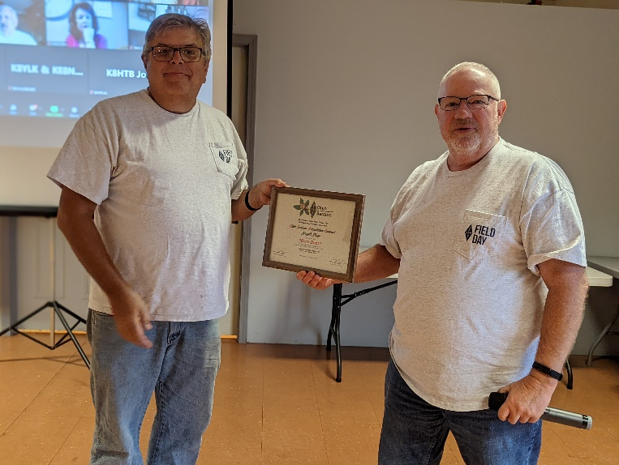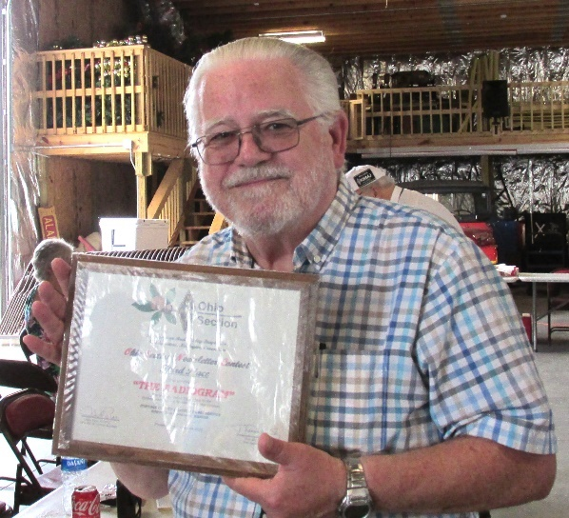

I’ll be making arrangements soon to deliver the plaque to the Medina “News Beacon”

soon and will get a real photo for an upcoming issue of PostScript. You can review all of these newsletters on the Ohio Section website ( [www.arrl-Ohio.org](http://www.arrl-Ohio.org) ) and I want to urge you to get working on next years “Award Winning Newsletter” for your club!

**Youth Net**

**When:** The second Sunday of every month at 7:30 PM EST

**Where:** The K8IV repeater located in Kent, Ohio (Echolink node K8BF-L) RF: 146.895 Mhz  with PL 118.8

**Who:** Any licensed amateur radio operator who wishes to participate. Priority will be given to youth stations and those located in Ohio.

The purpose of this net is to encourage youth activity in amateur radio and to help new hams get more comfortable on the air.

Our next net comes up on September 11th.

My next Hamfest trip will be on Sunday September 11th to Findlay and after that Sunday September 25th to the Cleveland Hamfest. Hope to see you there!

On September 16th – 18th I’ll be at the ARRL in Hartford (Newington) CT. for Section Manager Training and also some time at W1AW. I’m hoping to bring back a lot of good news from that trip!

73,

Tom Sly - WB8LCD

Ohio Section Manager

[wb8lcd@arrl.org](mailto:wb8lcd@arrl.org)

330-554-4650

***National News***

*(from ARRL and other sources)*

|  |  |
| --- | --- |
| |  | | --- | |  | |

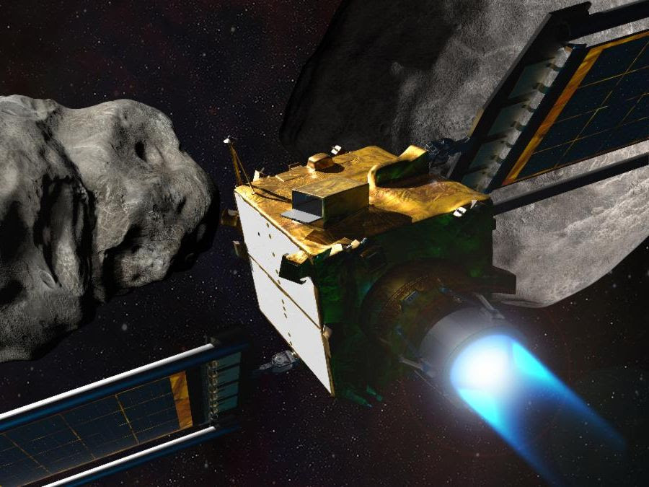

|  |  |
| --- | --- |
| |  | | --- | | **Apply to Join Our DART NASA Social** | |

|  |  |
| --- | --- |
| |  | | --- | | We’re attempting the world’s first mission to deflect an asteroid in space—and you’re invited! If your passion is sharing your love of space science and engaging the world via social media, then this is the event for you.  NASA’s Double Asteroid Redirection Test ([DART](https://r20.rs6.net/tn.jsp?f=001EVZhnmJzdzP7mF-OJFW_BmMJatSJJGnqPTA4qYb3gD1NAy66c9jiASzagdgYyNYjYLViB-Zr5JZJKALMrlmKi-Wj6McDWQmbn1svQQd_knDcDmiTstO-q7GI0vq5z69HRSTHGXvS-vI=&c=RGVPz7tXyr7d0jXdGjusUSZqYXQmBzspBDP3k7Ze8NkFxAe1HAjU7g==&ch=JjAq0us6cEcTSB4gXSSwQefvJgsUX3xOnVsXXzIx_jntn3XCJ9ShAA==))—built and managed by the Johns Hopkins Applied Physics Laboratory (APL) in Laurel, Maryland—will demonstrate and test asteroid deflection by kinetic impactor. The spacecraft will deliberately collide with a target asteroid—which poses no threat to Earth—to change its speed and path. If successful, DART’s kinetic impact method could be used in the future if a hazardous asteroid on a collision course with Earth were ever discovered.  The [NASA Social event](https://r20.rs6.net/tn.jsp?f=001EVZhnmJzdzP7mF-OJFW_BmMJatSJJGnqPTA4qYb3gD1NAy66c9jiASzagdgYyNYjJBQZ2DWNCfs2cChqwZ6Qp4gYDs6sB8qin-N0Y5fKIjtcjIcW-Q-eo_MMmOSml0sUC-YrUm3LCfaqEzj6uDD3Kz_UdjMwyiJNAoCeNKljOvJEYqpIOxL2dWdnaoolQw_IlIKeJko5dE-T8QvJCOoHIPQoGxSyH4J1dCOPgsX-uTLf1SRFklObFA==&c=RGVPz7tXyr7d0jXdGjusUSZqYXQmBzspBDP3k7Ze8NkFxAe1HAjU7g==&ch=JjAq0us6cEcTSB4gXSSwQefvJgsUX3xOnVsXXzIx_jntn3XCJ9ShAA==) will occur on Monday, Sept. 26, and will include a tour of facilities, interaction and Q&A with DART mission experts, and a special IMAX film screening.  NASA Social registration for the DART social opens on Aug. 10 and the deadline to apply is Aug. 15 at 9 a.m. EDT. All social applications will be considered on a case-by-case basis. | |

|  |  |  |  |
| --- | --- | --- | --- |
| |  |  |  | | --- | --- | --- | | |  |  | | --- | --- | | |  | | --- | | [Apply Now](https://r20.rs6.net/tn.jsp?f=001EVZhnmJzdzP7mF-OJFW_BmMJatSJJGnqPTA4qYb3gD1NAy66c9jiASzagdgYyNYjzTlsimwt1SMptnevum1o9HRy4cebgpHzCOGicdoUiWneNUaaCQoK1z9UsQz5xbtRaw_San0Jj9fFjKmX9vzQgQUIB5MzbD90FLXOBSNT5xAd7PoEF6GywvNeXVBq8yvN&c=RGVPz7tXyr7d0jXdGjusUSZqYXQmBzspBDP3k7Ze8NkFxAe1HAjU7g==&ch=JjAq0us6cEcTSB4gXSSwQefvJgsUX3xOnVsXXzIx_jntn3XCJ9ShAA==) | | | |

|  |  |
| --- | --- |
| |  | | --- | | **This Week at NASA** | |

ARRL and TAPR Digital Communications Conference Returns in September 2022

The 41st ARRL and TAPR Digital Communications Conference (DCC) will be held this September 16 - 18, 2022, in Charlotte, North Carolina. Last year's conference was held virtually due to COVID-19 concerns, but this year's 3-day event will be held at the Hilton Charlotte Airport Hotel.

The DCC is for everyone, beginners and experts alike, with an interest in all forms of digital communication.

The official call for technical papers has been issued and general topic areas include, but are not limited to:

* Software-defined radio (SDR)
* Digital voice
* Digital satellite communications
* Digital signal processing (DSP)
* HF digital modes
* Adapting IEEE802.11 systems for amateur radio
* Global Positioning System (GPS)
* Automatic Position Reporting System (APRS)
* Linux in amateur radio
* AX.25 updates
* Internet operability with amateur radio networks
* TCP/IP networking over amateur radio
* MESH and peer-to-peer wireless networking
* Emergency and homeland defense digital communications in amateur radio

Authors can submit their papers for this year's conference, by email, to ARRL Production Coordinator Maty Weinberg, KB1EIB, at [mweinberg@arrl.org](mailto:mweinberg@arrl.org). The deadline is September 1, 2022. The conference papers will be published exactly as submitted. The authors will retain all rights and do not need to be present at the conference, and all papers will be distributed to DCC attendees. Printed copies will be available for sale at Lulu [www.lulu.com](http://www.lulu.com/).

More information about [TAPR - Tomorrow's Ham Radio Technology Today](https://tapr.org/) can be found that their website.

Call for Papers for the 40th AMSAT Space Symposium

The first call for proposals for symposium presentations are invited for the 40th Annual AMSAT Space Symposium and General Meeting, which will held on October 21 - 22, 2022, in Bloomington, Minnesota.

Presentations can cover any topic of interest to the amateur satellite community. AMSAT is requesting a tentative title for each submission, which should be sent as soon as possible. A final copy must be submitted by October 14, 2022, to be included in the proceedings. Abstracts and papers should be sent to Dan Schultz, N8FGV, at [n8fgv@amsat.org](mailto:n8fgv@amsat.org).

According to the July 17 AMSAT News Service Weekly Bulletins, the annual AMSAT Space Symposium will feature:

* Space symposium with amateur satellite presentations
* Operating techniques, news, and plans from the amateur satellite world
* Board of Directors meeting open to AMSAT members
* Opportunities to meet Board members and officers
* AMSAT Annual General Membership Meeting
* Auction, annual banquet, keynote speaker, and door prizes

More information about the 2022 AMSAT Symposium will be posted on the [AMSAT website](https://www.amsat.org/) as it becomes available.

***_____________________________________________***

Upcoming Ham Radio Conventions Emphasize Learning and Youth

Two major ham radio events in August will host Division Conventions for [ARRL](http://www.arrl.org/hamfests) The National Association for Amateur Radio®. On August 20 - 21**,**the [Huntsville Hamfest](https://hamfest.org/) will be the host of the ARRL Southeastern Division Convention at the Von Braun Center in Huntsville, Alabama. On August 26 - 28, the[Northeast HamXposition](https://hamxposition.org/) will host the combined ARRL New England and Hudson Division Conventions at the Best Western Royal Plaza Hotel & Trade Center in Marlborough, Massachusetts.

"Both conventions include an exceptional amount of programming to encourage and instruct radio amateurs across a variety of interests," said ARRL Education and Learning Manager Steve Goodgame, K5ATA. Goodgame, who used his recent experience as a school teacher to help high school students earn their ham radio licenses, will participate in both events. He will lead forums to share ways for engaging youth and offer tools and tips for approaching schools about including amateur radio in their programs and curriculum.

|  |
| --- |
| Shape  Description automatically generated with low confidence  The Huntsville Hamfest will host of the ARRL Southeastern Division Convention at the Von Braun Center in Huntsville, Alabama, August 20 - 21, 2022. |

The Huntsville Hamfest will also include a Youth Lounge where young and prospective hams can participate in hands-on activities and demonstrations, including kit building, fox hunting (find the hidden transmitter), and opportunities to get on the air.

Other forums at the conventions will cover topics geared toward inspiring attendees to get more active and involved in amateur radio. Forums at the Huntsville Hamfest include "Arduino: The Next Generation," with ARRL author Glen Popiel, KW5GP; "Grounding and Bonding," with ARRL editor and author Ward Silver, N0AX; "Fox Hunting 101," with co-presenters Joe Domaleski, KI4ASK, and Mary Catherine Domaleski, KI4HHI, and "Kit Building Techniques for Success," presented by *ARRL Handbook* contributor Joe Eisenberg, K0NEB. Eisenberg is also the speaker for the Saturday Grand Banquet at the Northeast HamXposition.

|  |
| --- |
| TheNortheast HamXposition will host the combined ARRL New England and Hudson Division Conventions at the Best Western Royal Plaza Hotel & Trade Center in Marlborough, Massachusetts, August 26 - 28, 2022. |

A similar lineup of forums has been organized for the Northeast HamXposition, including "How to Solve Radio Frequency Interference," "Linux in Your Ham Shack," and "Playing Radio 'Outside'."

ARRL will have exhibits at both conventions, where attendees can connect with membership program representatives and elected volunteers from the Board of Directors and Field Organization. ARRL President Rick Roderick, K5UR, and CEO David Minster, NA2AA, will attend the Huntsville Hamfest. Minster will give the opening Keynote Address on Saturday morning at the Northeast HamXposition.

The convention exhibit halls will also include the participation of manufacturers and equipment resellers -- an opportunity for attendees to browse and shop in person for the latest in amateur radio equipment and accessories. Among the confirmed exhibitors for the Huntsville Hamfest are ABR Industries, BridgeCom Systems, Diamond® Antenna, DX Engineering, Elecraft, FlexRadio Systems, GigaParts, Ham Radio Outlet, Icom America, MFJ Enterprises, N3ZN Keys, RT Systems, SteppIR Communication Systems, and Yaesu USA. Exhibits at Northeast HamXposition will include, among others, Elecraft, Ham Radio Outlet, Momobeam, and Quicksilver Radio Products. Both conventions include a flea market.

|  |
| --- |
| Audrey McElroy, KM4BUN (right) will be awarded 2022 Young Ham of the Year at the Huntsville Hamfest. She's seen here with her brother, Jack McElroy, KM4ZIA, at convention in August 2021. [Bob Inderbitzen, NQ1R, photo] |

Audrey McElroy, KM4BUN, an 18-year-old student who recently started her studies at Georgia Institute of Technology (Georgia Tech), will be presented with the 2022 Bill Pasternak WA6ITF Memorial Amateur Radio Newsline Young Ham of the Year award at the Huntsville Hamfest. In July, the ARRL Foundation awarded McElroy a $25,000 scholarship, sponsored by Amateur Radio Digital Communications (ARDC).  
  
Proceeds from the Northeast HamXposition go to the FEMARA Scholarship fund, which helps students attend a college or trade school of their choice. Scholarships are administered by the [ARRL Foundation Scholarship Program](http://www.arrl.org/scholarship-program).

Visit the official convention websites for advance tickets and a complete listing of activities:

* [Huntsville Hamfest](http://www.arrl.org/hamfests/huntsville-hamfest-arrl-southeastern-division-convention-1), hosting the ARRL Southeastern Division Convention; Huntsville, Alabama | August 20 - 21, 2022
* [Northeast HamXposition](http://www.arrl.org/hamfests/northeast-hamxposition-arrl-new-england-and-hudson-division-convention), hosting the ARRL New England and Hudson Division Conventions; Marlborough, Massachusetts | August 26 - 28, 2022

***______________________________________________***

**Amateur radio operators are needed for the Marine Corps Marathon on October 30, 2022, in Washington, DC, and Arlington, Virginia.** The call is for 150 amateur radio operators to provide "eyes on the course" using the 144 and 420 MHz bands, with FM and Digital Smart Technologies for Amateur Radio (D-STAR), and a Medical Data Network using Amateur Radio Emergency Data Network (AREDN). Amateur radio will also be used as back-up communications in case all else fails. Operators will prepare themselves, supplies, and equipment to function in a large-scale, multi-jurisdictional, mass casualty-type event under real-world conditions. Training will be provided, and each operator will receive a commemorative T-shirt. Amateurs can sign up by following the link [www.mcmham.org](https://www.mcmham.org/). To learn more about the 2022 Marine Corps Marathon, visit their website at [Marine Corps Marathon](http://www.marinemarathon.com/events/marathon).

Young Amateurs Radio Club to Host Inaugural Special Event

The Young Amateurs Radio Club (YARC) will host their first annual youth-organized special event from September 1 - 15, 2022. Using their call sign, WY4RC, the event is known as "Worked All YARC Zones (WAYZ)." Operators will be activating WY4RC stations from all 10 US call zones. Different awards are available for youth operators who activate a station, and for A picture containing text, outdoor, blue, hitting
those who contact at least six WY4RC stations.

Any young amateur or club interested in operating during the event can find the rules and additional information at the [Young Amateurs Radio Club](https://yarc.world/index.php/events/2022/yarc-worked-all-yarc-zones-wayz-contest-event/) website.

YARC, founded in 2017, is an international amateur radio club with a focus on promoting adoption and innovation in amateur radio among young people. In 2018 the club was officially recognized by the FCC as an official amateur radio club under the call sign WY4RC.

YARC has over 1,000 members on their Discord server as of 2022, and has been changing its structure to bring back community events and increase engagement.

***______________________________________________***

***Club Corner***

This is YOUR cornner of the newsletter. Send me what your club is doing and I’ll make sure that it gets in. Got a special event or club project that you want everyone to know about? Send it to me! Need help with a project? Send it to me.

Let me know what you club is up to. Are you going to have a special guest at your meeting or are you having a special anniversary?

Just sent it to: [webmaster@arrl-ohio.org](mailto:webmaster@arrl-ohio.org) Please! Format as below:

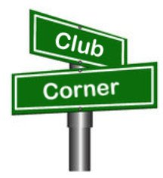If you want me to publish your club information, or even an article you have written, please send it in WORD format (.docx). Please use Times New Roman font size 12 for the body of the aritcle. Any photos please include as a .jpg or .bmp – the time you save me in doing all the conversions will be greatly appreciated.

**Your Help is Needed!**

Western Reserve ARC is gearing up for the annual Panerathon Public Service Event here in Youngstown. We are seeking volunteers. Thanks!

Western Reserve Amateur Radio Club is seeking operators who would like to volunteer for the 2022 Panerathon Race. The race will take place on Sunday, August 28th in Youngstown, OH. The meeting time and location are still TBD, however you can expect it to be very early morning in the area of Mill Creek Park. If you are interested in helping out or have any questions, please contact the club President, Chris Monske WF8U, via email ([kd8ely@gmail.com](mailto:kd8ely@gmail.com)) or phone (330.509.1086).

Thanks again!

Amanda Farone KC3GFU

WRARC Secretary

|  |  |
| --- | --- |
| |  | | --- | | [Text  Description automatically generated](https://r20.rs6.net/tn.jsp?f=0010vQtUUp9RD5WKWoxpD27MFcjfQOEnkLRMH_yaCum3I6BGZz7hKNys-SS595KkyyYty8iXx9_PwDAn9dZ-2vtfDZz6gi1QUmXc-2ey2LeuRrIsbfmU7jt6xqvooBmRdzuoObMW-nldYrm_uhad9khAA==&c=UlFnuVMY0KbJ_woDMvsBBn-aM0QnOOstF8ejof-FzovQtg4rt-c4Kg==&ch=pxrBXdecQMTImwwga2AlWhGoSPYs1ymTWi75sVMlqLMpULY4IXhGXg==) | |

|  |  |
| --- | --- |
| |  | | --- | | **Amateur Radio Mobile Cruise-In Night**  **Thursday, August 18th at 6 PM** | |

Come join us Thursday, August 18th at 6 PM, for the 13th Annual Amateur Radio Mobile Cruise-In Night at the A&W Restaurant - 769 East Main Street in Ravenna!

Enjoy some burgers and root beer, and check out all the mobile radio setups. We'll have prizes for the neatest installation and the most bands covered.

See you there!

Nick AC8QG

PCARS President

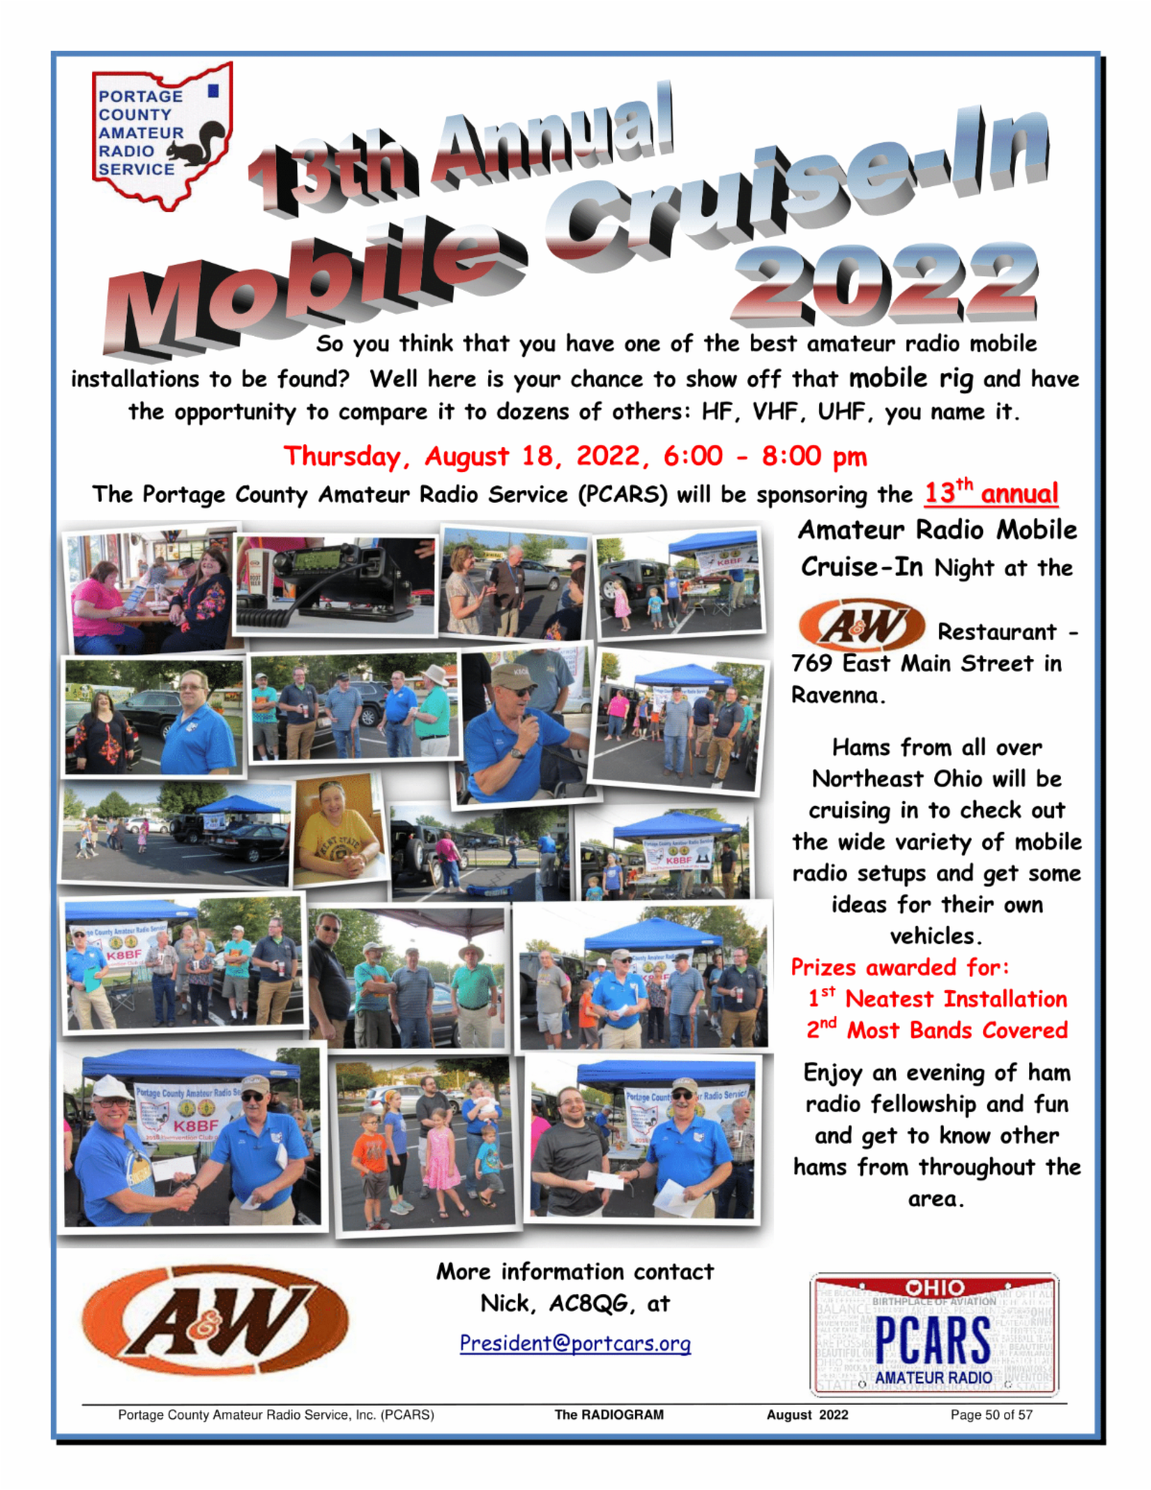

**A New Club You May Be Interested In**

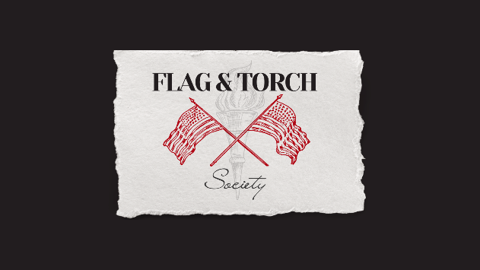We are a new organization composed of active, guard, reserves, and veterans looking to promote amateur radio use and licensing to service members across the world. We started a Facebook page "Military Amateur Radio" about a year ago and saw it skyrocket. There are A LOT of amateur radio operators that are prior service or currently serving. So now our mission is to bring that family together to help educate our future forces on the complexities of radio communication.

Robert Snyder, KD2UCJ

Flag and Torch Society President

K2FTS, Nonprofit, 501(c)3

Website: <https://www.flagandtorchsociety.com/>

Facebook: <https://www.facebook.com/flagandtorchsociety>

YouTube: <http://youtube.flagandtorchsociety.com/>

Discord: <https://discord.flagandtorchsociety.com/>

Military Amateur Radio:  <https://www.facebook.com/groups/1117033882428673/?ref=share>

Military Amateur Radio (US):  <https://www.facebook.com/groups/328781561605119/?ref=share>

**______________________________________________________________________**

**K4MIA / 8**

 On September 10 thru the 18th of 2022 We will honor and support our Veterans with a Special Event on the air as K4MIA/8. Linda N8LRS and Metro W8MET will be the sister-station from Ohio for our 7th year. This event originated from K4MIA, Mike from Florida with other sister-stations involved.Special Event Station K4MIA is put on the air every year to ensure that America remembers its responsibility to stand behind those who serve and have served our nation - and do everything possible to account for those who do not return. Thanks for being part of this event.

Details can be found on the ARRL website under “ON-THE-AIR” under SPECIAL EVENT under the call-letters of K4MIA. Also, this Special Event will be in the September QST. Please take part in this Special Event for our Veterans. QSL is available with SASE. We will be operating on 40 meter's SSB.

GOD BLESS AMERICA 73, Linda and Metro

**Want to know where to go to get the courses you need? It’s all Right Here!**

* [Ohio EMA Training Calendar](https://webeoctraining.dps.ohio.gov/TrainingAndExercise/courselist.aspx)
* [Login to the DPS Training Campus](https://learning.dps.ohio.gov/PSTC/)
* [Create a new account on the DPS Training Campus](https://learning.dps.ohio.gov/PSTC/)

**NOTE:**

* Most courses are in-person but some course may be hosted virtually (this will be noted).
* Seats available listed are as of the release of this update and will change quickly.
* All classes will be posted on the DPS training campus at least 60 days prior to the start of the course.
* Please read the [Training Policy & Catalog](https://ema.ohio.gov/documents/training/ema0201.pdf) for more information on Ohio EMA trainings.

_._,_._,_

How to Plan and Apply for an ARRL Hamfest or Convention

If your amateur radio club is planning to host a convention, hamfest, tailgate, or swapfest, please consider applying for ARRL sanctioned status for your event. To learn what it means to be an ARRL sanctioned event, and to get some ideas on how to prepare for and conduct a hamfest or convention, visit [www.arrl.org/arrl-sanctioned-events](http://www.arrl.org/arrl-sanctioned-events).

To apply for ARRL sanctioned status for your event, go to [www.arrl.org/hamfest-convention-application](http://www.arrl.org/hamfest-convention-application).

The ARRL Hamfests and Conventions Calendar can be found online at [www.arrl.org/hamfests](http://www.arrl.org/hamfests). In addition, the Convention and Hamfest Calendar that runs in *QST* each month also presents information about upcoming events.

Go Fully Electronic in 2022!

By Maria Somma, AB1FM, ARRL VEC Manager

**Online Examinations and Remote Testing**

Your club's VE team can become part of the fun and excitement of remotely administered Online Examinations.  
  
The remote exam sessions are conducted using an online video conferencing platform and a web-based examination system with on-screen tests. ARRL VE teams have had the option to be completely electronic since June 2020 by using online exams. The online exams can also be utilized at in-person sessions automating most of the process, for a fully electronic in-person session experience.  
  
VE teams have been using the [Exam.Tools](https://exam.tools/) Online Examination system for remote video and in-person sessions. Over 25,000 applicants have been tested through the Online Examinations system in the past two years. The system works well for online or printed examinations and includes registering and tracking candidates throughout the session, on screen exams and grading, online signing of CSCE and 605 forms by the candidate and examiners, logging and compiling session stats and VE participation list (test report summary), and output files for upload to the coordinating VEC. The program manages and handles almost everything needed to conduct a test session. Time and experience with in-person exam sessions is invaluable when transitioning to remote video-supervised online exam sessions.  
  
Interested ARRL VE teams must contact the [VEC department](mailto:vec@arrl.org) to receive the online exams instructions and remote video session procedures.  
  
Not a VE? Become one today!  
  
Visit <http://www.arrl.org/become-an-arrl-ve>  
  
**Electronically File Exam Session Documents for Quicker Service**

After the session has concluded, VE teams can upload in-person documents or remote video session files via ARRL VEC's secure web page (program service option since 2018).

New and upgraded licenses are issued within 1 to 2 business days for weekend sessions and are usually issued on the same day for weekday sessions.

Please contact the [VEC department](mailto:VEC@arrl.org) for the information and instructions on electronically filing exam session documents through our upload page. Authorized VEs will be sent the upload page URL which, is hidden from the public.

**Resources for ARRL VEs**

The [ARRL VEC VE Resources](http://www.arrl.org/resources-for-ves) page offers the information you will need to help conduct exam session business. Our support page offers easy access to session forms and information, online examinations, remote video session instructions, VE Manual supplemental information, FCC rules, basic qualification question procedures, and much more. There is also some helpful information for the community, such as preparation resources for candidates, in-person and remote video exam session search, vanity call sign information, and more.

The ARRL VE Newsletter relays important updates relating to FCC rule or policy changes, exam session document or procedural changes, video sessions, and other topics. VEs can sign up for the newsletter at <https://reflector.arrl.org/mailman/listinfo/ve-list>

**Athens County Fox Hunting**

The August 7th Athens County FoxHunt was held Sunday at 2pm.

Registration began at 1:45 p.m. on the ACARA club repeater and revealed a total of six hunters in five vehicles. (One pick-up had two Hams working together.)

Registered hunters included Phil Stanley (W8NZB) from Hocking Co.,  Eric McFadden (WD8RIF), Kirk Groeneveld (KC8JRV),  Nick Arnold  (KD8FKB),  James  Reed (KE8SIQ) and Justin Hellyer (KS8CA).

The Fox for this hunt was Miles McFadden (KD8KNC) who prepared a challenging list of hints and clues to encourage the hunters.

The day was accented with several downpours of 5 to 10 minutes during the first hour or so of the hunt.

Winning the hunt was W8NZB Phil Stanley, arriving  just about 3:10 p.m.  2nd place went to Nick Arnold  (KD8FKB) at 3:50,  and 3rd to WD8RIF Eric McFadden at 4:05.   Arriving last were KC8JRV Kirk G and the team of James Reed KE8SIQ and Justin Hellyer KS8CA, with minutes to spare before the five o'clock cut-off.

The group immediately adjourned for a hot meal at   Los Mariachis Mexican restaurant in Nelsonville, as the closest restaurant to the Fox's hideout at the end of Monk Road (adjacent to the Hocking Adena BikePath).  The den is also the closest access point to the turnaround for the Athens Marathon in April!

While the hunt provided a considerable challenge for some, all agreed that it was fun and that they learned a lot to improve their next hunt (TBA).

The next Athens Fox hunt will be jointly scheduled between Phil Stanley and the ACARA club, probably after September.

The next Hocking Valley Amateur Radio Club Foxhunt in Hocking County, is set for August 27th.

**____________________________________________________**

ARRL invites you to be part of “[Club Station](http://arrl.informz.net/z/cjUucD9taT0yNTA5NjcxJnA9MSZ1PTUyMDM5NjkwOCZsaT0yNTQyOTEyOA/index.html),” the newest column in QST. This column, written by clubs, for clubs, is a designated space to share specific and practical ideas about what has contributed to successful clubs to help others grow and thrive.

In each issue, a different club will share how they undertook a specific activity or project, how and why it was successful, and any challenges they may have had to overcome throughout the process. Some examples include successful community club projects, creative ways to attract new members, or getting youth involved with ham radio. Additionally, many clubs across the country are being creative in meeting the challenges of COVID-19 to figure out how to keep club members active and enthusiastic.

If your club has developed a creative way to get around common challenges, we want to hear from you! In order to help you tell your story, we have published a new version of the ARRL Author’s Guide that is geared toward “Club Station,” and includes a [club profile form](http://arrl.informz.net/z/cjUucD9taT0yNTA5NjcxJnA9MSZ1PTUyMDM5NjkwOCZsaT0yNTQyOTEyOQ/index.html). Both of these documents can be found [here](http://arrl.informz.net/z/cjUucD9taT0yNTA5NjcxJnA9MSZ1PTUyMDM5NjkwOCZsaT0yNTQyOTEyNw/index.html). You don’t have to have writing experience to be published in QST, and if your submission is accepted, our editorial staff will work with you to get your story ready for publication.

All ARRL Affiliated Clubs are welcome to participate. If you have any questions, contact us at [clubs@arrl.org](mailto:clubs@arrl.org).

We look forward to hearing from you and hearing your story!

VE Sessions

**All Things Amateur Radio Association (ATARA)** We host testing sessions every second Tuesday of the month in Lancaster. To sign up please visit our website <https://atara-w8atr.fun> and contact us at [hamexams@atara-w8atr.fun](mailto:hamexams@atara-w8atr.fun).

**Athens County Amateur Radio Assn. (ACARA**

Athens County Amateur Radio Association has an ARRL VE session scheduled for Monday, August 15, 7 PM at the Athens Red Cross Chapter, 100 South May, Avenue, Athens, Ohio 45701.

**CARS**

VE testing from CARS - Cuyahoga Amateur Radio Society - at Elmwood Recreation Center, 6200 Wisnieski Parkway in Independence, Ohio 44131  Time: 9:15 AM (Walk-ins allowed) Always the 2nd Sunday of the odd month. Go to CARS  [www.2cars.org](http://www.2cars.org/) for detailed map of location.  Call Metro W8MET 216-520-1320 for details

**Cambridge Area Maker Group**

Amateur Radio Exam Testing all Levels

Date: Saturday August 20, 2022

Time: 01:00 PM ( No Walk-ins / Call or Email to Register )

ARRL-VEC Exam Fee $15

Please Register Contact: Kathleen Frederico KB3RDR Phone: 484-459-3309

Email: [kb3rdr@arrl.net](mailto:kb3rdr@arrl.net)  
Location: St. John's Episcopal Church

[1025 Steubenville Ave](https://www.google.com/maps/search/1025+%0D%0ASteubenville+Ave+%0D%0A+Cambridge,+%0D%0AOH+43725,+USA?entry=gmail&source=g) [Cambridge, OH 43725, USA](https://www.google.com/maps/search/1025+%0D%0ASteubenville+Ave+%0D%0A+Cambridge,+%0D%0AOH+43725,+USA?entry=gmail&source=g)

**Dayton Amateur Radio Association (DARA)** If you are interested in testing for a new or upgraded license, please come see us at the DARA Clubhouse. If you have questions about testing, please email [exams.w8bi@gmail.com](mailto:exams.w8bi@gmail.com)

**The Lake County Amateur Radio Association**

The Lake County Amateur Radio Association is once again holding its **2022** Amateur Radio license exams at the **Kirtland Library**, 9267 Chillicothe Road, on the following dates:

Saturday, October 1, and December 3.

The tests will start at **12 noon.** Please arrive a few minutes earlier.

**The Lancaster and Fairfield County Amateur Radio Club (LFCARC**) hosts exam sessions at the FAIRFIELD County EMA, 240 Baldwin Dr in Lancaster Ohio, 43130, on the first Saturday each month at 10:00 am. Please visit our website at <http://www.k8qik.org> for exam dates on our calendar and navigate to our Learning Center/Taking the Exam link for information and requirements. Our experienced VE team looks forward to serving the Amateur Radio community in Central Ohio. Contact me at [ve_testing@k8qik.org](mailto:ve_testing@k8qik.org) to register.

**The Milford Amateur Radio Club (MARC)** is now doing VE testing on the third Thursday of each month at 6:00 PM.  Location;  Miami Township Civic Center located at 6101 Meijer Drive, Milford, OH  45150.

 Please pre-register at [www.milfordhamradio.org](http://www.milfordhamradio.org/)

**Portage County Amateur Radio Service (PCARS)**

The first Saturday of every even numbered month -10 am – at the PCARS club site in Ravenna. Please visit the PCARS web site and check out the information about VE testing in the latest newsletter at [www.portcars.org](http://www.portcars.org) .

If you have any questions, don’t hesitate to contact me at KB8UUZ@gmail,com

**Your Club news should be listed here!**

I know you’re out there doing things! Send me a write-up (MSWord please) and some photo’s (.jpg please) and we’ll get your club hi-lited here for the other OH Section Clubs to see! Send to [WB8LCD@ARRL.ORG](mailto:WB8LCD@ARRL.ORG)

**______________________________________________________________________________**

DX This Week – EL2BG Interview

Bill AJ8B (aj8b@arrl.net, @AJ8B, or www.aj8b.com)

CWOPs Member #1567

Don’t say I didn’t give you a heads up! There are a few cooler days coming up here in SW Ohio and I had a couple of CW QSOs on 160! They were stateside, but it was 160M. Hope you are getting ready for the fall/winter low band season. As always, keep me in the loop and let me know what you are doing.

I have reprinted, with the permission of the Southwest Ohio DX Association, a very enjoyable interview with EL2BG. Ishmael is a great operator and a really nice guy. Don’t hesitate to drop him a note if you need a sked or information.

DAH DIT DIT DIT DAH DAH DIT DIT DIT DAH

I received 2 nice QSL cards this week. The first was from VK6WB – Gusti in Western Australia, and the second was from one of the contributing authors, Jim, ZF2OO, in the Cayman Islands. What did you receive?

|  |  |
| --- | --- |
|  |  |

DAH DIT DIT DIT DAH DAH DIT DIT DIT DAH

Interview with EL2BG

*I worked EL2BG, Ishmael, and reviewed his QRZ.com page to find that he is a capable operator with a wealth of experience. I asked him if he would be interested in answering my questions and he immediately agreed! He can be contacted at* [*el2bg@comcast.net*](mailto:el2bg@comcast.net)*.*

AJ8B: How did you first get interested in amateur radio?

EL2BG: To be honest, it will be very difficult to pinpoint of an event that jilted my interest in amateur radio because I have been interested in electronics since I could remember. At a very early age, without any training or prior knowledge of basic electronics, I found myself building electronic gadgets. In my adult age, I was intrigued by security personnel talking through their walkie talkies and when I later read about mobile units in vehicles been used to contact DX stations far and wide, I was immediately hooked and was then determined to have such unit in my vehicle whenever I was able to own one.

AJ8B: Do you have a favorite band or mode?

EL2BG: When I finally got my ticket to get on the air in 1978 when I joined the Association, the Liberia Radio Amateur Association was very active with about 95% of its members being of different nationalities that worked in various places in Liberia and had licenses to operate; and by extension, were members of the Association. The Association had an organized Sunday morning net (The Eco Lima Net) on 7.060 MHz @ 0700 Zulu to encourage members of LRAA to check in exchange signal reports and other traffic, and since then, I fell in love with the 40 meter band. However, when I realized that Eco Lima (Liberia) was a needed DX sought out country, I made it my personal business to work all bands including 6M to give opportunities to stations seeking EL to be able to work me, EL2BG. Since propagation was an issue in 2019 from Liberia for voice operation, I operated mostly digital, FT8, after been introduced to digital and with the addition of my SignaLink USB sound card. I even attempted a few 6M contacts, which were very rare.

AJ8B: What time of day and days do you like to operate?

EL2BG: I have worked as a civil engineer for the past thirty-seven years and during those years, I tried to be on the radio on all bands every day of the week when I had the pleasure and opportunity of having electrical power. I have not had the pleasure of having such power at any 24/7, which dictated my time on the air after my official working hours. I have since retired, December 2020, and again my time on the air depends on the availability of electricity. I am available and will love to be on the air anytime I have or don't have available power. I was fortunate to have procured one of the Harbor Freight’s 80-Watt Solar Panel Kit with a 12V - 100 amp hour battery that I use daily to be on the air if the battery holds adequate charge after a good sunny day to keep me on the air.

AJ8B: Any secrets to your success?

EL2BG: Persistence, persistence, persistence. I am persistent in doing everything in my power to get on the air to give opportunities to all stations who want to work Eco Lima land. I consistently tune up my G5RV dipole to its peak performance to be able to get out of Liberia with approximately 100 watts and be professional and courteous during pileups. It is my hope that one of these days I will have the opportunity to have some shoes on and not keep working barefooted.

AJ8B: Any tips that you can share?

EL2BG: Apart from Eco Lima been a rare DX, I make it my business to operate a clean station and be very receptive to stations who email me and or WhatsApp me to set up schedules with me to operate during predicted peak propagation hours or times when they were available to operate. I am always opened to any operator who requests special favors as to set up a schedule during my off hours on the radio. I can be found on any band and on any day calling CQ at any hour of the Zulu time.

AJ8B: Describe what you are currently using:

EL2BG: My shack consists of a Yaesu FT-857, an AT-100ProII antenna tuner, a SignaLink USB integrated sound card, an Alinco DM-330FX power supply, a G5RV dipole antenna in an Inverted Vee configuration, a Lenovo laptop running Windows 10 and a Harbor Freight’s 80-Watt Solar Panel Kit with a 12V - 100-amp hour battery. A very modest station I will say. I am looking forward for the day when I can have a directional beam and about 500W output.

AJ8B: What advice do you have for those of us trying to break pileups to work DX?

EL2BG: My advice to stations trying to break pileups is to listen to the DX station for any instruction and to please give their full call signs and not only the suffix or the prefix. I can better pull out a station after hearing the full call sign than half a call sign. I am blessed with great hearing abilities that allow me to hear very low-power stations with about 30 dB of a whisper during pileups that sometimes astonishes me. I usually ask stations to call using the number system, meaning stations with ascending order numbers in their call signs, starting with “1”, e.g., AB1CD and so forth till we get to “0”. I will usually take up to seven stations at a time using the number system.

AJ8B: What is your favorite contest?

EL2BG: Due to my station's limited working condition, I have really not participated fully in any contest through its duration because of my limited electrical power situation. Because of that, I do not have any favorite contest at this time. I have participated in a number of DXpeditions that have taken place in Liberia by joining the DXPedition to work QSOs.

AJ8B: Any QSLing hints?

EL2BG: I make it my busy to return any and all QSL cards that I receive. I am very happy that I do receive some green stamps for some return cards, but green stamp or no green stamp, once I receive a card, I will return mine. The mail system in Liberia has not resumed to its pre-war condition; therefore, it is not possible to mail QSL cards directly from Liberia. As a result, I use the Florida address as noted on my qrz.com page as my official QSL address. Sometimes, my return cards are delayed but they are returned at the end of the day.

AJ8B: I noticed that you are also a pilot. Are you able to combine Ham Radio and Flying?

EL2BG: Negative, I am a student pilot for gratification. I started pilot school in Jacksonville, Florida some years back and I continue training only when I am in Jacksonville for a duration of one to two months within any one the year; as a result, I have not completed my training and it was because of my amateur radio hobby that drove me to the flying bug. I consider amateur radio, flying and photography as some of my many hobbies I have under my sleeves.

AJ8B: What coaching/advice would you give new amateurs?

EL2BG: My advice will be for new hams to continue to learn and advance to higher license classification and keep their hands dirty by building simple antennas and consider making schedules to be on the air a few hours a week to keep up their operational proficiency.

AJ8B: If I were to stop by for a visit to Liberia, what local place would you want us to visit?

EL2BG: You will be wholeheartedly welcomed, and we will visit all of the ruins of the city of Monrovia that bear the scars of the civil unrest that took place in Liberia from 1990 to 2003 and drive up to a waterfall to a place called Kpatawee, where we could camp and operate the radio.

AJ8B: What local food would you want me to try?

EL2BG: I hope you have a tolerance for hot or spicy foods. In that case, pepper soup will be the ideal food for you. If that is OK with you, then we will try the torborgee.

AJ8B: Thanks for taking the time to answer my questions. Is there anything you would like to share with us?

EL2BG: I am at present the president of the Liberia Radio Amateur Association (LRAA) and my core mission is to recruit and train as many local Liberians as possible to be part of the amateur radio world. Since the inception of amateur radio in Liberia, expatriates were the majority radio operators and I intend to change that trend. We have engaged in lecture series at several high schools especially the technical schools with electronic departments to talk about amateur radio and the benefits of being an amateur radio operator. The main preoccupation of the youths in Liberia is to find their daily bread and playing with radios is far from their radar, not mentioning the cost to purchase a rig. Therefore, it is my mission to solicit used rigs and other accessories to be donated to the club station to be used by the newly ticketed radio operators and to loan it out to individual hams to use at their various homes for a period to improve and appreciate their hobbies. A picture containing skating

DAH DIT DIT DIT DAH DAH DIT DIT DIT DAH

Here is an update from Bernie, W3UR, of the DailyDX and the WeeklyDX, the best source for DX information. <http://www.dailydx.com/> . Bernie has this to report:

**J2 – Djibouti -** J28RC is the callsign for the new Riverine Amateur Radio Club, Camp Lemonnier Djibouti a chapter of the U.S. Based Riverine Amateur Radio Club (KO4OXN). The members are either military service members (from any branch) or US contractors serving with the US forces. The station includes an IC-7610 and two IC7300's and capable of SSB, Digital and CW on 80 through 10 meters. There is also a WSPR beacon and Winlink gateway station both running 24 x 7. Antennas include a Chameleon Skyloop, 20-meter dipole, EFHW (80-10 meters), Chameleon MPAS Lite and coming soon a fan dipole for 40, 20 and 17 meters. QSL via EA5GL and LoTW.  
  
**7P – Lesotho -** KW4XJ, Mark, is now stationed and on the air in Maseru for a three-year assignment as he began operating as 7P8AB in late July. Many will remember Mark from his previous assignment in Freetown, Sierra Leona as 9L1YXJ. He is using an IC-7300 and Chameleon MPAS, a mil-whip vertical, which is on a 7-meter-high telescopic mast. He is also using an Elecraft KPA500 amplifier and KAT500 antenna tuner from his QTH located in the mountains at 1555 meters (5,100 feet) ASL. Mark enjoys operating the digital modes as well as SSB and CW. Also with him is his 13-year-old daughter Arina (KO4PZT), who is 7P8NB.  
  
**LY – Lithuania -** In celebration of the 770th anniversary of the founding of the city of Klaipeda, Lithuania special call sign LY770CT will be QRV starting August 15th through October 14th. Activity will be on CW, SSB, FM and Digital modes on 160 meters through 70 centimeters.

**OY - Faroe Islands -** MM0NDX, Col, and MM0OKG, Jonathan, are heading to Rituvik, Faroe Islands where they will be operating as OY/home calls from September 1-5. They are looking for one or two ops to join them. Activity is planned for assorted bands and modes. QSL via EB7DX.

**5B – Cyprus -** Look for G0KPH, Paul, to be operating from the Paphos Municipality locator (KM64es) holiday style as 5B/G0KPR from August 15-24. He could be on SSB, FT4 and FT8 and possibly on CW. He may be operating from other locations. QSL via G0KPH, LoTW and QRZ.com. DL7ZM, David Pommerenke, has posted a presentation of his most recent DXpedition to Socotra Island (7O/DL7ZM), Yemen titled "Investigation in VHF Radio Propagation on 50 MHz Socotra". Check out his 34-page document at <https://cloud.tugraz.at/index.php/s/PMnSANwiAGCMYg6>

**VU – India -** In celebration of the 75th anniversary or India's Independence the following stations are expected to be QRV.

VU2CW, Rajesh, will be QRV with special call AT75CW between September  
1 and October 2. But first Rajesh will operate AT75RADIO from August  
10-21. QSL both via VU2CW.  
  
VU2YYE, Jai, will operate AT75HGT (Har Ghar Tiranga) between August 13  
and 15.  
  
VU2RS (ex VU3RSB), Sarath, plans to be QRV as AT75RS in celebration of  
the 75th anniversary of India's Independence. QSL via home call.

DAH DIT DIT DIT DAH DAH DIT DIT DIT DAH

Below is a list of upcoming contests in the “Contest Corner”. I think this is important for someone who is trying to move up the DXCC ladder since entities that are on the rarer side and easiest to work in contests. Some of my best “catches” have been on the Sunday afternoon of a contest when the rarer entities are begging for QSOs. Of course, the gamble is that if you wait until Sunday, conditions may change, or they simply won’t be workable. However, it is not a bad gamble. Of course, why not work the contest and have some fun!  
Check out the WA7BNM Contest Calendar page (<https://www.contestcalendar.com/>) and CQ Magazine for more contests or more details. I also have a comprehensive list that can be imported to your calendar at [www.aj8b.com/files](http://www.aj8b.com/files)

The contests in red are those that I plan to spend some significant participation time on. PLEASE let me know if you are working contests and how you fared.

Thanks!

|  |  |  |
| --- | --- | --- |
| Aug. 13 | Kentucky State Parks on the Air | https://k4msu.com/kypota |
| Aug. 13 | SARL Youth Sprint | http://bit.ly/H0IqQf |
| Aug. 13-14 | Maryland-DC QSO Party | www.w3vpr.org/node/325 |
| Aug. 13-14 | 50MHz Fall Sprint | https://svhfs.org/2022VHFSprintRules.pdf |
| **Aug. 13-14** | **Worked All Europe CW Contest** | **https://bit.ly/36ubggF** |
| Aug. 20-21 | ARRL 10 GHz and Up Contest | www.arrl.org/10-ghz-up |
| Aug. 20-21 | CVA DX Contest CW | http://cvadx.org/regulamento.pdf |
| Aug. 20-21 | International Lighthouse Lightship Weekend - ILLW | https://illw.net |
| Aug. 20-21 | SARTG RTTY Contest | www.sartg.com/index.html |
| Aug. 20-21 | North American SSB QSO Party | http://ncjweb.com/NAQP-Rules.pdf |
| Aug. 21 | ARRL Rookie Roundup RTTY | www.arrl.org/rookie-roundup |
| Aug. 27-28 | ALARA Contest | www.alara.org.au/contests |
| Aug. 27-28 | CVA DX Contest SSB | http://cvadx.org/regulamento.pdf |
| Aug. 27-28 | Kansas QSO Party | www.ksqsoparty.org |
| **Aug. 27-28** | **Ohio QSO Party** | **www.ohqp.org/index.php/rules** |
| Aug. 27-28 | YO DX HF Contest | www.yodx.ro/en |
| Aug. 27-28 | World Wide Digi DX Contest | https://ww-digi.com |
| Aug 27-28 | W/VE Island QSO Party | https://usislands.org/qso-party-rules |
| Aug. 27-29 | Hawaii QSO Party | http://hawaiiqsoparty.org |
| Aug. 28 | SARL HF CW Contest | http://bit.ly/H0IqQf |
| **Sept. 24-25** | **CQWW RTTY DX Contest** | **www.cqwwrtty.com** |

__________________________________________________________

**ARLD032 DX news**  
  
This week's bulletin was made possible with information provided by The Daily DX, the OPDX Bulletin, 425 DX News, DXNL, Contest Corral from QST and the ARRL Contest Calendar and WA7BNM web sites.  Thanks to all.  
  
TANZANIA, 5H.  Eugen, DL8AAI will be active as 5H2JK/p during a hiking tour in Kilimanjaro National Park (5HFF-0005) until August 17, and some days after hiking, from Moshi.  Activity will be holiday style, mainly on SSB on 20 to 10 meters.  Check for WSPR beacon signals from 5H2JK/P on 15 meters which will be activated when the antenna is operational.  QSL via DL8AAI.  
  
MALAWI, 7Q.  Junior, 7Q7JN has been active as 7Q7EMH from the radio station at the Embangweni Mission Hospital in the Northern Region. Activity has been on 30, 15 and 12 meters using CW and FT8.  QSL via LoTW or ClubLog.  
  
INDONESIA, 8H7/8I7.  To celebrate the 77th anniversary of independence, amateurs will be using 8H7 and 8I7 call signs from August 13 to 21.  Activity will be on 80, 40, 20, 15 and 10 meters and on 2m/70cm for Satellites, as well VHF Terrestrial on 2 meters, using CW, SSB, RTTY, FT8 and FM (Satellite).  
  
MALDIVES, 8Q.  Giovanni, IZ2DPX will be active as 8Q7AG until August 20.  Activity will be on various HF bands as well as 6 meters.  QSL to IZ2DPX direct, via HE9ERA by the Bureau, LoTW or ClubLog's OQRS. Also, Stefan, EA5Q will be active as 8Q7QE from August 14 to 24.  
QSL via EA5Q.  All contacts will be confirmed via LoTW.  
  
USA, N.  Special event station N7C is commemorating the Navajo Code Talkers of World War II, until August 19.  Look for them on 7265, 14265 and 18130 kHz using CW, FT8 or phone.  QSL via Herb, N7HG. Herb's father, John V. Goodluck, was one of the US Marine Corps  
Navajo Code Talkers, serving in the South Pacific in WWII.  
  
PAKISTAN, AP75.  Members of the Pakistan Amateur Radio Society (PARS) will operate under special call sign AP75PAK and Pakistani hams may use the "AP75" prefix with their existing call sign suffixes for the month of August to celebrate the 75th anniversary of Pakistan's Independence.  Activity will be on various HF bands and modes, 6 meters and the satellites.  
  
INDIA, AT2.  Members of the West Bengal Radio Club, VU2WB, will activate the special call sign AT2AAM to commemorate the 75th anniversary of the Independence of India.  Activity will be on various HF Bands.  QSL via AT2AAM or VU2WB.  
  
CUBA, CO.  Lefty, CO2QU will be active until December 31 on 30 meters (FT8/FT4) and 6 meters (FT8).  QSL via CO2QU direct or LoTW.  
  
MAYOTTE, FH.  Marek, F4VVJ will be active as FH4VVK from August 20, 2022 to April 1, 2024.  Operations will be on various HF bands and modes.  QSL direct (see QRZ.com) or eQSL.  
  
SAUDI ARABIA, HZ.  Members of the Saudi Amateur Radio Society will be using the special call sign HZ1CPCF for the "Crown Prince Camel Festival" until September 4.  Activity has been on 20, 17, 15 and 6 meters using CW, SSB and FT8/FT4.  QSL via HZ1SAR.  
  
DJIBOUTI, J2.  Jeje, F8FKJ will be active as J20EE sometime this month and into September.  His activity will be on 40 to 10 meters using CW, SSB and FT8.  QSL via F4DXW direct only.  
  
GRENADA, J3.  Greg, N9GB will be active as J38GB from August 12 to 19.  He expects to be using CW and SSB on 40 to 6 meters including the newer bands.  QSL via his home call sign, LoTW, and possibly ClubLog.  
  
ISLE OF MAN, MD.  Dale, EI7HDB will be active as MD/EI7HDB from August 14 to 19.  Activity will be on various HF bands using CW, SSB and digital modes.  QSL EI7HDB via the Bureau.  
  
ALAND ISLAND, OG0.  Operators Alex, UT5UY/OH5UY, Pasi, OH2MZB, Jouni, OH2JIU, Niko, OH5CZ, Toni, OH5CY, Jere, OH5ELX and Juha, OH5CW will be active as OH5CW from August 20 to 27.  Activity will be on 160 to 2 meters with a focus on 6 meters and the newer bands, using CW, SSB, RTTY and FT8.  QSL via OH5C.  
  
SEYCHELLES, S7.  Operators EA3WL and EA3BT will be active as S79/EA3WL and S79/EA3BT until August 23.  The operation will be in SAT mode only, on QO-100, RS-44 and others, in a holiday style DXpedition, using SSB, CW and FT8.  QSL via EA3BT or OQRS.  
  
ST. KITTS, V4.  Jim, NT5V is active as V4/NT5V until August 18. Activity will be on various HF bands using CW, SSB and FT8.  QSL via home call sign, direct, by the Bureau or LoTW.  In addition, Gary, G0FWX will be active as V47FWX from August 21 to 30.  Activity will  
be holiday style on various HF bands using SSB only.  QSL via M0URX.  
  
The 4 States QRP Group Second Sunday Sprint is August 15 and the Worldwide Sideband Activity Contest is August 16.  Please see August 2022 QST, page 70 and the ARRL and WA7BNM contest websites for details.  
______________________________________________________________________________

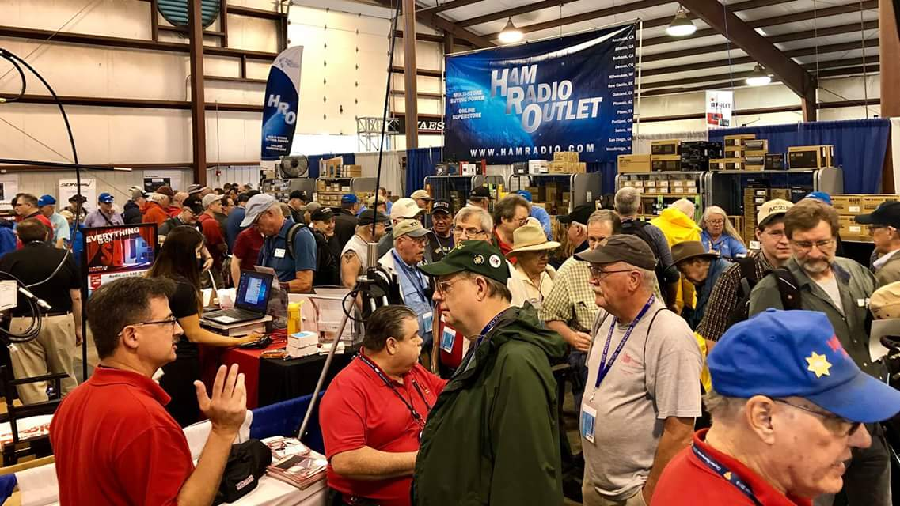[**Upcoming *Hamfests***](http://arrl-ohio.org/hamfests.html)

We **DO** have some hamfests scheduled for 2022!! Yes, take a good look at the list. **__________________________________________________________**

|  |  |
| --- | --- |
|  |  |

|  |  |
| --- | --- |
|  |  |
|  |  |
| ***2022*** | | | | |
|  | | | | **08/21/2022 -**[**Warren ARA Tailgate Swap Meet**](http://www.arrl.org/hamfests/warren-ara-tailgate-swap-meet-1)  **Location:**Cortland, OH **Sponsor:** Warren ARA **Website:** <http://facebook.com/w8vtd> [**Learn More**](http://www.arrl.org/hamfests/warren-ara-tailgate-swap-meet-1) |
|  | | | |  |
| **09/10/2022 -**[**Ashtabula County Hamfest**](https://www.arrl.org/hamfests/ashtabula-county-hamfest)  **Location:**Pierpont, OH **Sponsor:** Amigos Radio Club Ashtabula and Ashtabula County Amateur Radio Club [**Learn More**](https://www.arrl.org/hamfests/ashtabula-county-hamfest) | | | | **09/11/2022 -**[**Findlay Hamfest**](http://www.arrl.org/hamfests/findlay-hamfest-9)  **Location:**Findlay, OH **Sponsor:** Findlay Radio Club **Website:** <https://www.findlayradioclub.org/> [**Learn More**](http://www.arrl.org/hamfests/findlay-hamfest-9) |
| **09/17/2022 -** [**Mound Amateur Radio Assoc. Swap Meet**](http://www.arrl.org/hamfests/mound-amateur-radio-assoc-swap-meet-1)  **Location:**Miamisburg, OH **Sponsor:**MARA **Website:** [http://W8DYY.ORG](http://w8dyy.org/) [**Learn More**](http://www.arrl.org/hamfests/mound-amateur-radio-assoc-swap-meet-1) | | | | **09/25/2022 -**[**Cleveland Hamfest**](http://www.arrl.org/hamfests/cleveland-hamfest-2)  **Location:** Berea, OH **Sponsor:**Hamfest Association of Cleveland **Website:** [http://www.hac.org](http://www.hac.org/) [**Learn More**](http://www.arrl.org/hamfests/cleveland-hamfest-2) |
|  | | | |  |
| **10/15/2022 -**[**Portsmouth Radio Club Hamfest**](http://www.arrl.org/hamfests/portsmouth-radio-club-hamfest-7)  **Location:**New Boston, OH Sponsor: Portsmouth Rado Club, Jett Fire, Shawnee **Website:** [http://www.portsmouthradioclub.org](http://www.portsmouthradioclub.org/) [**Learn More**](http://www.arrl.org/hamfests/portsmouth-radio-club-hamfest-7) | | | | **10/30/2022 -**[**Massillon Hamfest (OH)**](http://www.arrl.org/hamfests/massillon-hamfest-oh)  **Location:**Green, OH **Sponsor:** Massillon Amateur Radio Club **Website:** [http://w8np.org](http://w8np.org/) [**Learn More**](http://www.arrl.org/hamfests/massillon-hamfest-oh) |
| **12/03/2022 -**[**FCARC WinterFest**](http://www.arrl.org/hamfests/fcarc-winterfest-3)  **Location:**Archbold, OH **Sponsor:** Fulton County Amateur Radio Club **Website:** <https://k8bxq.org/hamfest> [**Learn More**](http://www.arrl.org/hamfests/fcarc-winterfest-3) | | | |  |

**FINDLAY HAMFEST** is less than 5 weeks away!

Based on feedback from our guests and vendors, we’re implementing a few changes and additions (and keeping several popular features) to make the **2022 FINDLAY HAMFEST,** on Sunday, September 11, an even bigger success than last years amazing event!

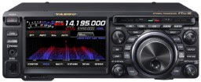

**PRIZES:**Yes - we’ll still offering the chance to win a popular HF rig (Yaesu FT DX-10) or a “handy” HT (FT-60R) - but we’ll also have prize drawings every half hour with hundreds of dollars in gift certificates to be given away so that you can pick up some nice “finds” at the Hamfest!

**ONSITE HAM LICENSE TESTING:**For the first time (at least in a very long time) we’re adding onsite, online, license testing. Pass your test on Saturday and have your license by Tuesday (typically). Find out more at [www.FindlayRadioClub.org](https://www.findlayradioclub.org/lists/lt.php?tid=eRhUD1dSUgVRVBUEAlpXH1dUBgBPDFJWAE5VVF1RAVUCXQBSUlFKVAZRDAACAVQfVVAGVU8AA1RUTlsHWwMUUgRUVARXBQZTB1NdHlZdBFdQA1NQT1UHUldOVwUMWRQAB1IBGlQCBwdXAQFQUwkEAw) (There’s a $14 fee for license testing, but we’ll throw in free admission to the Hamfest.) So upgrade your license and/or bring along your yet-to-be licensed friends.

**SPECIAL EVENT STATION:**Come work our special event station. If you hold a Technician license, here’s your chance to make some HF contacts!  Or bring along your unlicensed friends (or grandkids) and get them on the air for their first time. (And take home a nice certificate.)

**ADDITIONAL FOOD VENDOR:**We’re doubling our food vendors, and adding breakfast, to provide greater variety and faster service (and additional seating).

**SAME ADMISSION PRICE AS LAST YEAR:**We’re all faced with higher gasoline and diesel prices, but admission to the FINDLAY HAMFEST is still only $10 - with no additional parking fee. Admission for kids and youth under 18 years old is FREE! Likewise for Scout leaders in uniform. Bring along your kids, your grandkids, your neighbors, your Scout troop, your 4H club… Buy your tickets online at [www.FindlayRadioClub.org](https://www.findlayradioclub.org/lists/lt.php?tid=eRhUD1dSUgVRVBUEAlpXH1dUBgBPDFJWAE5VVF1RAVUCXQBSUlFKVAZRDAACAVQfVVAGVU8AA1RUTlsHWwMUUgRUVARXBQZTB1NdHlZdBFdQA1NQT1UHUldOVwUMWRQAB1IBGlQCBwdXAQFQUwkEAw) or at the gate on the day of the event.

**PERFECT WEATHER:** Just kidding… but we had great weather in 2021!  We’ll keep our fingers crossed.

**Hancock County Fairground: 8AM – 2PM SUNDAY 11 Sept 2022**

**1017 East Sandusky, Street, Findlay, Ohio 45840**

**Massillon Hamfest**

As we get closer to October 30th vendor tables are being sold for the Massillon Amateur Radio Club (MARC) Hamfest at the MAPS Air Museum at the Canton/Akron Airport (CAK).

At a time when everything is seemingly going up in price we are pleased to announce we have held this year’s admission and table prices to the same as last year. A 6’ table will again be $15, and admission is still $5.

This is a great value! Your $5 not only gets you admission to a great hamfest, but also allows you to tour the MAPS (Military Aviation Preservation Society) museum.

Make plans to join us 10/30 at MAPS! Vendor tables are available here: <https://w8np.net/index.php/current-area-hamfests/marc-2022-hamfest-vendor-tables>

**_________________________________________________________**

**

As indicated in last week’s column, N8ZNR and I put in an appearance at the August 6 Columbus Hamfest at Grove City. Although overnight showers and questionable weather for the morning might have kept attendance and the number of outside vendors down, those who were there indicated it was an enjoyable morning. Some of the flea market dealers stated their sales were decent, although people seem to be holding the wallet close to the chest. It was good to see a number of old friends from the Central Ohio area and meet some new folks. More than once I heard “you’re the guy who does the South 40”. Thanks to those for the kind words. Thanks to the **Aladdin Shrine Audio Unit-W8FEZ** for sponsoring the event.

When you read this the shows sponsored by the **Milford ARC** and the **Tri-State ARA** will be history. If what was seen at the Columbus Hamfest holds true for each of those events, both were successful and a lot of hams came away with a pleasing experience.

Although not a Southern Ohio hamfest one of the better attended Ohio hamfests has been the annual End of Summer Hamfest sponsored by the **Findlay ARC**. The event will return to the Hancock County Fairgrounds in Findlay on Sunday, September 11. This year they will give license tests for the first time in several years. Because they charge a $15 fee for taking a test, those taking a test will not be charged an admission fee. They also will have a station set up where new hams and those without HF licenses can get on the air and experience the enjoyment of HF. For additional information check out [hamfest@findlayradioclub.org](mailto:hamfest@findlayradioclub.org) website.

Additional noteworthy out-of-Ohio events requiring more than a single tank of gas and perhaps an overnight stay bear repeating from last week. They are growing events, easy to get to and worthy of the time, travel and expense to get to them. Please note: the W4DXCC is not a hamfest, but does have some product exhibitors.

Downtown Huntsville’s convention center hosts what many call the Nation’s Friendliest Hamfest. Although the two-day show is not the size of Hamvention or Hamcation, it is one of the “big three” in the Eastern US where many of the same well-known commercial exhibitors can be seen. I understand the totally inside flea market area has been expanded this year and will have 300-400 tables.

**Southwestern Ohio DX Association** newsletter editor and fellow OSJ columnist Bill Salyer, AJ8B, is a speaker at this year’s **W4DXCC** event on September 23-24 at the LeConte Hotel in Pigeon Forge, Tennessee. One of the outstanding parts of this event is the Friday Ham Radio Bootcamp where not only newer hams, but old-timers too can ask questions and take away a lot of good pointers from those who have been around the block. [www.w4dxcc.org](http://www.w4dxcc.org) for information.

The **Miamisburg ARA** will hold a swap meet at the city’s Mound Park on September 17 from 8 AM until noon. It is a free event.

Although a tad out of the South 40 coverage area, a hamfest seeing a growing number of Southern Ohio hams attending is the **Ky4ARC** hamfest in Paintsville, KY. It will be on Saturday, September 24 at the Rec Center in Paintsville. Contact Ron Grossl at 606-789-7767 or [nt4w@arrl.net](mailto:nt4w@arrl.net).

A really neat idea comes from our friends at the **Tri-State ARA**. They had their annual hamfest this past Saturday. But on Friday evening they had a dinner prepared by Teresa and Mark Killen for those who helped to set up for the show and those who would be assisting the following day.

From now into October there seems to be a hamfest on any given weekend somewhere in Ohio or surrounding state. Why not check the hamfest listings found elsewhere in the Postscript or check the hamfest listings on the ARRR [www.arrl.org](http://www.arrl.org) website and see if there is one close to you. Then call up some best ham buddies and make it an outing. If you have an open mind you may find a hamfest adventure a great way to explore ham radio history, meet new people, see some folks you talk with over the airwaves and just maybe find some goodie you didn’t know you could live without. And not only could you personally benefit, but often hamfest admissions, vendor fees and food sales are the year’s major income source for the sponsoring club. As it is said “Try It. You Might Like It!”

On Saturday morning, August 20, members of the **Lancaster Fairfield County ARA** will meet at the Lancaster Frisch’s for their monthly club breakfast. It starts around 9 and wraps up about 11.

Dodging raindrops was an interesting twist to the **Athens County ARA**’s Fox Hunt this past Sunday afternoon. Six individuals in five vehicles finally located fox Miles McFadden, KD8KNC, in his den at a remote area near the Hocking Adena Bike Path. Phil Stanley, W8NZB, was the first to find Miles after a bit over an hour searching. ACARA President Eric McFadden, WD8RIF, lets us know the next **Athens County ARA** will probably be on a September date yet to be determined. However in the meantime, the **Hocking Valley ARA** has one scheduled for August 27.

The **Highland ARA** has been notified their Pike County repeater at Elm Grove has now gone dark. It appears the company who rents the tower where the repeater is located cancelled their lease with the tower owner. Therefore the tower site owner has had all power to the site removed with the intent of removing the tower from the property. **Clinton County ARA** President Mark Atwell, WX8A, reports the repainting of the structure where the club’s repeaters are has yet to be completed and Wilmington city officials have yet to inform the club when they can expect to return the repeaters to the air. In the meantime, the club continues to use the backup 145.16 frequency with a 123 tone for the Sunday evening net and other communications.

Tom Holmes, N8ZM, lets us know the **Midwest UHF/VHF Society** will have its annual member picnic on Saturday, August 27 at the home of Dawn Yeagley, N8ASB, 1353 Gurneyville Road, Wilmington. The gathering starts around 11 with mostly a technical session where members will bring their equipment and projects to have measured and tested or troubleshot. Once they get tired of doing that then their thoughts turn to the furnished food and drink. Those wanting equipment tested should let Holmes know what they are bringing in order that the proper test equipment will be on hand. Let him know at [tholmes@woh.rr.com](mailto:tholmes@woh.rr.com). It’s suggested you bring a lawn chair.

Also on the 27th the Ohio QSO Party gets under way at 1600 and concludes at 0400 on the 28th. It’s a short laid back contest with the exchange between stations being a signal report and your county. Since several Southern Ohio counties do not have a large number of hams on HF (and you live in one) this could be your chance to be very popular and make a lot of contacts. Each time I have participated I find it interesting to see how many of Ohio’s 88 counties I can work. If you plan to operate, why not list your intent at [www.ohqp.org](http://www.ohqp.org). Not that many are currently listed for planned operations.

Several Southern Ohio clubs and individual operators are preparing for the upcoming September 10 Ohio State Parks on the Air operating event. As of a Friday morning email posting, John Myers, WG8X, indicates the planned activation list has 35 parks showing activity. Undoubtedly the list will continue to grow and show increased activations as we get closer to the date. But in the meantime why not check the [www.ospota.org](http://www.ospota.org) web site to see if there is a park near you that you can activate and can join in on all the fun. John also has some good pointers to make your day in a park enjoyable.

With the Dog Daze of Summer upon us it’s hard to realize some clubs already have their Christmas and Year End dinners planned. The **Cambridge ARA** has reserved a room at the Cambridge Denny’s for their annual year-end awards banquet on Saturday, December 3 from 2 until 4. The Hillsboro Methodist Church is the site for the annual **Highland ARA** Christmas gathering on Tuesday evening, December 13. A catered meal is to be followed by the announcement of 2023 officers, a gift exchange and door prize drawings. Over 80 people attended the 2021 event. The **Southern Ohio ARA** really got off to an early start and set the date and location for their holiday dinner some weeks ago.

Speaking of the **Highland ARA**, a delegation from the **Scioto Valley ARA** attended HARA’s business meeting on August 9. It’s neat to hear of clubs visiting and networking with other clubs, developing ties and friendships and exchanging ideas. Amateur radio seems to have a “what’s in it for me” culture creeping in. Therefore the ham radio community might be much better off if more visits and communications between clubs were to happen.

Many amateurs in Athens County and throughout Southern Ohio knew the late Dr. Joseph Berman, W9AON, of Ohio University fame. Jeff Slattery, N8SUZ, tells us there will be a memorial service for Dr. Berman on August 27 outside of 35 Park Place in Athens. The memorial begins at 8 am to be followed by a reception with a light breakfast. Those interested in attending are asked to register with the Honors College by August 8 at 740-593-2723.

As I previously mentioned, I attended the Columbus Hamfest this past Saturday. Besides the kind comments about the column I also had some constructive feedback regarding what clubs qualify to report happenings, plans and events in the South 40. Although there are a number of ham clubs south of Ohio’s East/West US 40 some apparently think they have to be in Southeastern Ohio, a certain size or an ARRL Affiliated Club to have mention. Nothing could be further from fact. Even if you are a specialized club with only a handful of members in the suburbs of one of our larger cities or a club with your own newsletter, Facebook page or web site, many readers want to hear about you and what you are doing. Tho we cover the clubs located below US 40, clubs bordering Ohio in West Virginia and Kentucky can also have news items and announcements reported. So if we have not heard from you, please reach out and let all know your club exists.

The **Cambridge ARA** will have their next business meeting on Saturday morning, August 27 at the Guernsey County Administration Building in Cambridge. The meeting starts at 10 AM. Mike Love reminds us the **Southern Ohio ARA** will have their monthly business meeting on Monday evening, August 8, at Coal Grove. There will be a test session at 6 pm with the meeting to begin at 7.

Pike County’s Doug Broyles, KE8ORQ, is getting a reputation of being the International Space Station repeater go to guy and is responsible for getting a growing number of hams in the western most part of the South 40 trying to make contacts through the repeater. The Cincinnati Enquirer reports that if weather conditions are good the ISS will be viewed on passes over the Midwest in the predawn skies on August 23 through the 26th. On the 23rd the pass will start around 6:25 and move from the SW to NE for an about seven minute pass. On the 24th face southeast starting about 5:38 for the 5 minute pass. Then on the 25th you can face northwest for a 7 minute pass starting at 6:24. Finally on the 26th look due north at 5:38 for a short four minute pass. Sounds like a neat opportunity to try to make a contact through the on-board repeater as you watch the ISS fly through the sky. Listen on 145.80.

That’s it for another week. Until next time stay cool, healthy, safe and radio-active.

John Levo, W8KIW, [jlevo@cinci.rr.com](mailto:jlevo@cinci.rr.com), 937-393-4951

**Print an Official or Unofficial Copy of Your Amateur Radio License**

*(By Anthony Luscre, K8ZT)*

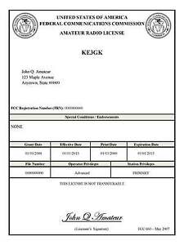

As of February 17, 2015, the **FCC no longer routinely issues paper license documents** to Amateur Radio applicants and licensees. The Commission has maintained for some time now that the official Amateur Radio license authorization is the electronic record that exists in its Universal Licensing System (ULS). The FCC will continue to provide paper license documents to all licensees who notify the Commission that they prefer to receive one.

Licensees also will be able to print out an official authorization — as well as an unofficial “reference copy” — from the ULS License Manager. I’ve created a set of instructions on how you can request an **“official” printed copy of your license\***

[**Click here to download the instructions**](http://arrl-ohio.org/news/2020/print_your_license.pdf)

***One Question Questionnaire***

!!!!! I would really like to hear from as many of you as possible on this one. While I know what I think the answer is going to be, the bigger the sample, the more accurate a survey like this is likely to be.

How about going to <http://arrl-ohio.org> and giving me a click? (It’s in the bottom left corner of the page) I’ll have more to say about this in the next OH Section Journal!

***How many Hamfests have you been to so far this year?***

1. ***2 or less/ B) 3 or more?***

From the last Poll: ***Would you like to see the random drawing of a Handbook returned to the One Question Questionnaire?***

***Yes / No***

Out of 103 responses, 90.29% yes and 9.71% no.

That looks pretty overwhelming to me! So, give me a couple weeks to figure out the logistics of how I want to handle this, and I’ll announce the new “Handbook Giveaway Program” to start up in September. I have it on pretty good authority that next year’s Handbook might be something special!

What’s on *your mind?*  Send me topics or questions regarding things that you would like to know and I’ll get them incorporated into future questions that I post.

Ohio Section Cabinet

|  |  |
| --- | --- |
| Section Manager – Tom Sly, WB8LCD | Section Traffic Manager – David Maynard, WA3EZN |
| Section Emergency Coordinator – Stan Broadway, N8BHL | Section Youth Coordinator – Anthony Luscre, K8ZT |
| Technical Coordinator – Jeff Kopcak, K8JTK | Affiliated Clubs Coordinator – Tom Sly, WB8LCD |
| State Government Liaison – Bob Winston, W2THU | Public Information Coordinator – John Ross, KD8IDJ |



Hey Gang,

Have you taken a look at the **Swap & Shop** page on the Ohio Section webpage yet?? Here’s a link that will take you there… <http://arrl-ohio.org/sm/s-s.html>

Do you have equipment that you just don’t need or want anymore? Here’s a great venue to advertise it, and it’s FREE!! Is your club doing a fund raiser to help raise money? After a lot of thought, it was decided that the Swap & Shop webpage could also contain these types of items as well. The same rules will apply as do for the For Sales and Give-A-Ways and will only be posted for a month at a time. Please see the Terms & Conditions on the webpage.

If your club is doing a fund raiser and wants more exposure, please forward the information to me and I’ll advertise it on the Swap & Shop webpage for you.

Now, I still want to remind you that it won’t be listed in this newsletter because it would take up way too much space, so your ad will only appear on the website. It is there for any individual to post equipment Wanted / For Sale or Give-Away as well as for Club Fund Raisers. No licensed vehicles/trailers or business advertising will be posted. Postings are text only (no pictures or graphics) will be posted for a maximum of 1 month from date posting and require a contact phone number or email within the posting. Send your Wanted / For Sale or Give-Away post to:  [swap@arrlohio.org](mailto:swap@arrlohio.org)

***Back Issues of the PostScript and Ohio Section Journal***

Hey, did you know that PostScript and Ohio Section Journal (OSJ) are archived on the website? You can go back and look at any edition simply by clicking:

<http://arrl-ohio.org/news/index.html>

***Want to Share your Club Newsletter With Others?***

We have a webpage where you can download and read all of the newsletters that I get from around the state and even other sections!

Here’s the link to the page…. <http://arrl-ohio.org/club_news/index.html>

Please, if you don’t see your club newsletter posted, it’s because I’m not receiving it. Just have your newsletter editor contact me and I’ll get your club’s newsletter listed on the site!!

We all learn and steal (I mean, share) from each other’s work. So, get me your newsletter!!! Send it to: [webmaster@arrl-ohio.org](mailto:webmaster@arrl-ohio.org)

***Chit – Chat, and All That!***

Do you know someone that’s not getting these Newsletters? Please, forward a copy of this Newsletter over to them and have them “[Opt-In](mailto:Opt-In)” to start receiving them. Heck, just have them send an email to: [webmaster@arrl-ohio.org](mailto:webmaster@arrl-ohio.org) and we’ll get them added to the Ohio Section Emailing list.

We now have many thousands of readers receiving these newsletters weekly. Quite impressive, I’d say! I urge all of you to make sure that everyone, regardless of whether they are a League member or not, get signed up to receive these weekly Newsletters.

You can always “Opt-Out” at any time if you feel this is not what you were expecting. It’s fun and very informative. All of your favorite past newsletters are now archived too.

You can go back at any time and read them.

Just go to: <http://arrl-ohio.org/news/>

[**Fifteenth Annual Ohio State Parks On The Air – Amateur Radio Contest**](https://ospota.org/uncategorized/eleventh-annual-ohio-state-parks-on-the-air-amateur-radio-contest/)

Make sure to mark your calendar for the 2022 Ohio State Parks On The Air (OSPOTA) contest – September 10, 2022. The contest is always held on the first Saturday following the Labor Day holiday. Each year this event has grown and we anticipate another year of growth with even more participating Amateur Radio Operators.

Let me remind you that the OSPOTA contest was conceived with three main goals in mind:

* To promote public awareness of amateur radio and Ohio’s beautiful state parks system;
* To contribute to the recognition that Ohio has a very diverse and wonderful ecology;
* To promote camaraderie within the ranks of Ohio’s Amateur Radio Operators

Your participation has allowed these goals to be achieved. We agree it is a lot of fun to get out in a natural setting with your radio and see how well you can do at working operators in the beautiful Ohio State Parks.

This will be the 15th annual OSPOTA – Make plans now to be active in OSPOTA 2022.

Don’t forget – we have an OSPOTA E-mail Group located at: <https://groups.io/g/OSPOTA>

The [OSPOTA IO Group page](https://groups.io/g/OSPOTA) is used for messaging and sharing of information about OSPOTA for all the fans and participants in the OSPOTA contest. The [E-mail Group](https://groups.io/g/OSPOTA) is where the action is.

Since we do allow spotting to encourage more contacts during OSPOTA, Facebook is being used before and during the contest for instant updates and to share stories and photos.

As the contest draws near, we’ll be posting on the OSPOTA E-mail Group page the anticipated ‘who’s going to be at what Ohio State Park’ or ‘Planned Park’ list as we have in past years. Send your planned park activation information to [PlannedParks@ospota.org](mailto:PlannedParks@ospota.org) . Please, include the call sign that will be used and the Ohio State Park you plan to be at. If your plans change, just let us know and we’ll update the list. Remember, more than one person or group can be at an Ohio State Park – there are no reserved State Parks.

Notes: Some Ohio State Parks are being managed by local park systems, but they are still listed and considered to be Ohio State Parks according to ODNR (Quail Hollow & Tinkers Creek).

So – pick a park and make your plans now for OSPOTA 2022 !!!!!! Take care & 73 from the entire OSPOTA contest Committee, KB8UUZ, WG8X, W8PT, W8KNO, KB8UHN

Tom, KB8UUZ OSPOTA Chairman OSPOTA

Questions? Email: [INFO@ospota.org](mailto:INFO@ospota.org)

When the OSPOTA contest is over, send Logs and Summary Sheets to: [Logs@ospota.org](mailto:Logs@ospota.org)

*PostScript is produced as a weekly newsletter. I want to thank everyone that has contributed articles and ideas to make this an even better news source. I sincerely hope that you have enjoyed this edition and will encourage your friends to join with you in receiving the latest news and information about the Ohio Section, and news and events happening around the world!*