[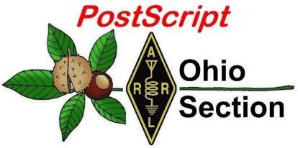](http://arrl-ohio.org/news/)

***“July 11th, 2022******”***

🡪 National News 🡪 Club Corner

🡪 DX This Week 🡪 Contest Corner

🡪 Upcoming Hamfests 🡪 One Question Questionnaire

🡪 VE Testing 🡪 South 40

**CQ CQ CQ de WB8LCD**

I want to remind you again about the Ohio Section Youth Net. The next net takes place on Sunday July 10th at 7:30 PM. Agnes, AD8IR, will be our net control operator. If you know any young hams in the Ohio Section, please invite them to check into the net. With Echo-Link the repeater is accessible from anywhere in the Section!

**Youth Net**

**When:** The second Sunday of every month at 7:30 PM EST

**Where:** The K8IV repeater located in Kent, Ohio (Echolink node K8BF-L) RF: 146.895 Mhz  with PL 118.8

**Who:** Any licensed amateur radio operator who wishes to participate. Priority will be given to youth stations and those located in Ohio.

The purpose of this net is to encourage youth activity in amateur radio and to help new hams get more comfortable on the air.

I received A LOT of Field Day messages to the Section Manager. Lots of clubs got their bonus points for that one! In fact, I’d be willing to bet that I received more Section Manager FD messages than any other SM in the country – you guys did an awesome job on Field Day again this year – congratulations to all who participated.

In the past couple of months, I’ve done several club meeting presentations where they wanted me to tell a little bit about myself. I’m going to do a little bit about that here, because it ties into a bigger point that I’d like to make about Hams in general. Coming up in the next two weeks I’m going to talk about clubs and what it takes to build a successful club program. I’ll be talking about club leadership and programming, and also about club membership and their responsibilities to a successful club.

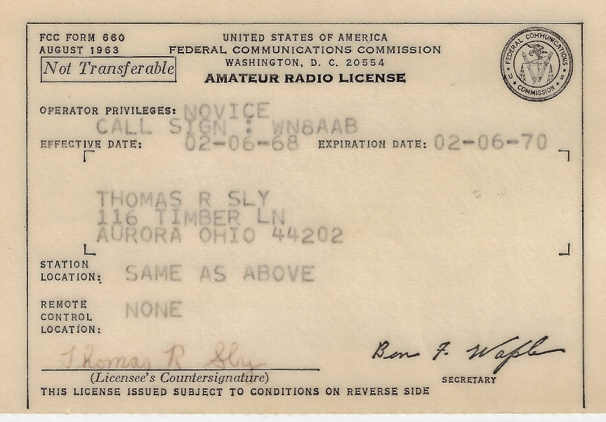I became interested in the “Magic of Radio” at a pretty young age, thanks to the neighbors that lived behind us. Stan Hillman – W8FZS (SK) and his family lived directly behind my family, and I spent a lot of time playing with their kids. At age 11, when I joined Boy Scouts, one of my first issues of Boy’s Life magazine had an article about building a crystal radio. I asked my dad if he would help me build one and he told me I should ask Mr. Hillman since he knew about that kind of stuff. That experience led to nurturing my interest in radio, especially Ham Radio. Mr. Hillman became a mentor to me and helped move me along to getting my Novice ticket in February 1968. (I took the exam as given by Mr. Hillman, and another ham in the neighborhood late in 1967 – but it all got mailed to the FCC and it was a long, agonizing process waiting for it to get back to me.) Mr. Hillman, along with some other adult Hams in the neighborhood worked with me, spent time teaching me the theory and the morse code. And got me to where I could successfully pass the Novice exam on my first try. This all happened between the ages (for me) of 11 and 14 – a time when kids, in general, can seem pretty obnoxious to adults!

When I was a kid, adults were *always* referred to as Mr./Mrs. whatever their surname was. That’s how it was with Mr. Hillman – it’s the only thing I had ever called him. But when I showed him my novice ticket, and addressed him as Mr. Hillman, he told me that from then on, anytime we were involved in anything that was Ham Radio related, I should call him “Stan” – he said, “because I was now one of them”. I’ve never forgotten that. It has shaped my whole outlook on being a Ham as *being a part of something much bigger than just being myself.*  I’ve never been in a Fraternity, but I consider my Ham Radio peers as being my brother/sister fraternity members.

And that’s how I feel about other Hams. I have an awe and respect for all of you. We all share the same fascination with the “Magic of Radio”. And I’ve experienced that same fraternal feeling any time I run into someone who I discover is a Ham. Near or far from home, I’ve always felt welcome and a part of any group of hams anywhere. That’s pretty unique in the world today, and actually the way it should be.

Finally, we all know that without appealing to the younger generations, ham radio is as good as dead. We all need to be a Mr. Hillman (or an Elmer in todays terms) to kids of all ages. We need to appeal to them in terms of their interests, and show them that Amateur Radio has a lot to offer them in helping them to not only enjoy their interests, but also to understand the underlying technologies that make it all possible. And when they show an interest, and get that license, we need to welcome them into the fraternity.

73,

Tom Sly - WB8LCD

Ohio Section Manager

[wb8lcd@arrl.org](mailto:wb8lcd@arrl.org)

330-554-4650

***National News***

*(from ARRL and other sources)*

|  |  |
| --- | --- |
| |  | | --- | |  | |

|  |  |
| --- | --- |
| |  | | --- | | [**Watch the Reveal of the First Images From the Webb Telescope**](https://r20.rs6.net/tn.jsp?f=001J8Y-VgYIRS96Ix8quhTX1bEaHXvy9MnKOCNbK3Igf3THG_rx9atFhqlmEG7oqPH7pOpUxwpPu0ov2ubia1Ke4FBXnxgH8xWtxb4CRXa92jd1KrTLOcWdT799h3urjbK5feURUTfL2Q_yBBxrw-w7Vk9wetwbfdsH1cAYIsHvqfebAkD161qLLgB6T-uDfXecxczIFQBm-54JRJiJ2J7jBLplPH40rDVg-FzTj8TBvke7wN-D8xf9fQ==&c=R8oiU1fMSEjXJwQl7geaH8QLOegkCAG6c4rCCwwRp0ni2pxByXDd0g==&ch=1K2D1ge6G889bbmhPu8ko0bsnhmUOBRYk_fdx0Qhah-zYUHZoZVrww==) | |

|  |  |
| --- | --- |
| |  | | --- | | NASA’s James Webb Space Telescope is finally ready to unfold the universe.  We’re days away from the reveal of the [first full-color images and spectroscopic data](https://r20.rs6.net/tn.jsp?f=001J8Y-VgYIRS96Ix8quhTX1bEaHXvy9MnKOCNbK3Igf3THG_rx9atFhqyYzTjrpTIdQH0Ydds7N-xp0p6GlYDiWcNFVJIzImjx1NtBsXZHiqE5o18PEQNsM8vJQyqmGuSDi6MaqxuyFov7lG_jeyj5EwTis0AouI28SE0mViXb-7r0W4PIfhYGiM-xVqE-G_9SpdsnjOxyCHA=&c=R8oiU1fMSEjXJwQl7geaH8QLOegkCAG6c4rCCwwRp0ni2pxByXDd0g==&ch=1K2D1ge6G889bbmhPu8ko0bsnhmUOBRYk_fdx0Qhah-zYUHZoZVrww==) taken by Webb, the largest and most powerful space science telescope ever constructed. These images will be unveiled for the first time during a live broadcast on Tuesday, July 12, at 10:30 a.m. EDT (14:30 UTC) on NASA TV, the NASA app, and the [agency’s website](https://r20.rs6.net/tn.jsp?f=001J8Y-VgYIRS96Ix8quhTX1bEaHXvy9MnKOCNbK3Igf3THG_rx9atFhq4NVIeC8I4M-f3thFUzcY_wSDzCVh2y53jIIQQzlMVH2TohhiVhfa4Tle45m1JVQyBYRIv2zX3L5vz-7kSDoeGRk4hEeMQfuQ==&c=R8oiU1fMSEjXJwQl7geaH8QLOegkCAG6c4rCCwwRp0ni2pxByXDd0g==&ch=1K2D1ge6G889bbmhPu8ko0bsnhmUOBRYk_fdx0Qhah-zYUHZoZVrww==). You can also can watch live on [Facebook](https://r20.rs6.net/tn.jsp?f=001J8Y-VgYIRS96Ix8quhTX1bEaHXvy9MnKOCNbK3Igf3THG_rx9atFhrGWughDsCwHa8nDwZrJ6IfTRMMj3UOmr-hpCE2GarvGcJ9zg0c8P7pXVB9zxo_f2NnJR0mhiwutIQwi2oy-3iJo50LJpJh_Og==&c=R8oiU1fMSEjXJwQl7geaH8QLOegkCAG6c4rCCwwRp0ni2pxByXDd0g==&ch=1K2D1ge6G889bbmhPu8ko0bsnhmUOBRYk_fdx0Qhah-zYUHZoZVrww==), [Twitter](https://r20.rs6.net/tn.jsp?f=001J8Y-VgYIRS96Ix8quhTX1bEaHXvy9MnKOCNbK3Igf3THG_rx9atFht8aQaWDA_5ApefP62NdbQuqCvS_tRWn2hUvZKjnPGSj48n0yJCqHi7MJJF-P1SWvP54rl1QlHg63jR7PLnK5zVft5TOlctVIg==&c=R8oiU1fMSEjXJwQl7geaH8QLOegkCAG6c4rCCwwRp0ni2pxByXDd0g==&ch=1K2D1ge6G889bbmhPu8ko0bsnhmUOBRYk_fdx0Qhah-zYUHZoZVrww==), [YouTube](https://r20.rs6.net/tn.jsp?f=001J8Y-VgYIRS96Ix8quhTX1bEaHXvy9MnKOCNbK3Igf3THG_rx9atFhqyYzTjrpTIdcZkvPVxIUwQrxRWJHGQh47g8qc3M2duFlEE05GXQjO9jod-ezFSntg95xSGU8LbKLYqHgu7VU0mPyvLDD7EiGQ==&c=R8oiU1fMSEjXJwQl7geaH8QLOegkCAG6c4rCCwwRp0ni2pxByXDd0g==&ch=1K2D1ge6G889bbmhPu8ko0bsnhmUOBRYk_fdx0Qhah-zYUHZoZVrww==), [Twitch](https://r20.rs6.net/tn.jsp?f=001J8Y-VgYIRS96Ix8quhTX1bEaHXvy9MnKOCNbK3Igf3THG_rx9atFht8aQaWDA_5AC4sGUrc5fanhKQAygqN4W-h_Coy7NH41uUGThIfDc948FTE2PObND-0tcTk_PZRFKg_WZIzaG5Y27REpCdx3CQ==&c=R8oiU1fMSEjXJwQl7geaH8QLOegkCAG6c4rCCwwRp0ni2pxByXDd0g==&ch=1K2D1ge6G889bbmhPu8ko0bsnhmUOBRYk_fdx0Qhah-zYUHZoZVrww==), and [Daily Motion](https://r20.rs6.net/tn.jsp?f=001J8Y-VgYIRS96Ix8quhTX1bEaHXvy9MnKOCNbK3Igf3THG_rx9atFht8aQaWDA_5Aw94OJwenOgl3wwyeZewCljZEt1VKL1XuBR6QI2ZEq47Q077T_Zo93-7vTcie2JcnQ86E61PprJ23B3db1ev5KnvAj9QvpnH5&c=R8oiU1fMSEjXJwQl7geaH8QLOegkCAG6c4rCCwwRp0ni2pxByXDd0g==&ch=1K2D1ge6G889bbmhPu8ko0bsnhmUOBRYk_fdx0Qhah-zYUHZoZVrww==), or join the [Virtual Platform](https://r20.rs6.net/tn.jsp?f=001J8Y-VgYIRS96Ix8quhTX1bEaHXvy9MnKOCNbK3Igf3THG_rx9atFhqlmEG7oqPH7UWNvN9z6v_2pM2lsAJCKQj44PRBRW5gzsoob1tGoOiOKuJz-rwH_RBCwxUmIzy4n5EkU3pqWlx5uuPHeGwjgVg==&c=R8oiU1fMSEjXJwQl7geaH8QLOegkCAG6c4rCCwwRp0ni2pxByXDd0g==&ch=1K2D1ge6G889bbmhPu8ko0bsnhmUOBRYk_fdx0Qhah-zYUHZoZVrww==).  On Wednesday, July 13 at 3 p.m. EDT (17:00 UTC), you can join the conversation as Webb experts answer questions about the first images and data during our NASA Science Live show. Ask your questions using the social media hashtag #UnfoldtheUniverse and you might see them answered on the live broadcast, airing on the NASA Science Live [website](https://r20.rs6.net/tn.jsp?f=001J8Y-VgYIRS96Ix8quhTX1bEaHXvy9MnKOCNbK3Igf3THG_rx9atFhqlmEG7oqPH75aCSOtajUTDWMdObGB4_iy8eGTwAV2kf9oCCQKxbLA6UYdsT01TY2iWzBf-CeJwmPTIVI79xmO1Km6tfKVItNfl3gxNiimWihB9LYMxSUmU=&c=R8oiU1fMSEjXJwQl7geaH8QLOegkCAG6c4rCCwwRp0ni2pxByXDd0g==&ch=1K2D1ge6G889bbmhPu8ko0bsnhmUOBRYk_fdx0Qhah-zYUHZoZVrww==), as well as [YouTube](https://r20.rs6.net/tn.jsp?f=001J8Y-VgYIRS96Ix8quhTX1bEaHXvy9MnKOCNbK3Igf3THG_rx9atFhqlmEG7oqPH7VmDx3EMNuyb7wXrrMISybjOxxRJirdhtadiMAmYdWqzQq4ZZg11_CvunXpzu7AgLhh1Y88Up7V1VxZYXxeBM7OrlPyVpy2Cuidh0m_Jy7xPDlEuR4Kt8tA==&c=R8oiU1fMSEjXJwQl7geaH8QLOegkCAG6c4rCCwwRp0ni2pxByXDd0g==&ch=1K2D1ge6G889bbmhPu8ko0bsnhmUOBRYk_fdx0Qhah-zYUHZoZVrww==), [Facebook](https://r20.rs6.net/tn.jsp?f=001J8Y-VgYIRS96Ix8quhTX1bEaHXvy9MnKOCNbK3Igf3THG_rx9atFht8aQaWDA_5AHoq79lPqJz-YtUSmTbbZ-GuIGni2PUovDuglqM-WoMpvxTa77G81Rb1iBkzjD9khAiAYNxy2T6yFZgWiFJ72a1tyynwq3355&c=R8oiU1fMSEjXJwQl7geaH8QLOegkCAG6c4rCCwwRp0ni2pxByXDd0g==&ch=1K2D1ge6G889bbmhPu8ko0bsnhmUOBRYk_fdx0Qhah-zYUHZoZVrww==), and [Twitter](https://r20.rs6.net/tn.jsp?f=001J8Y-VgYIRS96Ix8quhTX1bEaHXvy9MnKOCNbK3Igf3THG_rx9atFht8aQaWDA_5ApefP62NdbQuqCvS_tRWn2hUvZKjnPGSj48n0yJCqHi7MJJF-P1SWvP54rl1QlHg63jR7PLnK5zVft5TOlctVIg==&c=R8oiU1fMSEjXJwQl7geaH8QLOegkCAG6c4rCCwwRp0ni2pxByXDd0g==&ch=1K2D1ge6G889bbmhPu8ko0bsnhmUOBRYk_fdx0Qhah-zYUHZoZVrww==). | |

|  |  |
| --- | --- |
| |  | | --- | | [FIRST IMAGES - James Webb Space Telescope Mission Trailer](https://r20.rs6.net/tn.jsp?f=001J8Y-VgYIRS96Ix8quhTX1bEaHXvy9MnKOCNbK3Igf3THG_rx9atFhqlmEG7oqPH7FfRUMLKEhTxMaZ7hHuDbn294L8yNbE-nwwbwWsba0BgnyGhNbNdKEbRdTcb25CI-qaodMRaN3vvhK42O4K-ugLByWLDZTvni4ahj9sZxSUPDACh6hjsHKg==&c=R8oiU1fMSEjXJwQl7geaH8QLOegkCAG6c4rCCwwRp0ni2pxByXDd0g==&ch=1K2D1ge6G889bbmhPu8ko0bsnhmUOBRYk_fdx0Qhah-zYUHZoZVrww==) | |

|  |  |
| --- | --- |
| |  | | --- | | The James Webb Space Telescope mission is an international collaboration between NASA, the European Space Agency (ESA), and the Canadian Space Agency (CSA).  Using revolutionary technology, Webb will observe a part of space and time never seen before, providing a wealth of amazing views into an era when the very first stars and galaxies formed — over 13.5 billion years ago. Webb can explore our own solar system’s residents with new eyes, as well as study the atmospheres of distant worlds. | |

|  |  |  |  |
| --- | --- | --- | --- |
| |  |  |  | | --- | --- | --- | | |  |  | | --- | --- | | |  | | --- | | [All About the Webb Telescope](https://r20.rs6.net/tn.jsp?f=001J8Y-VgYIRS96Ix8quhTX1bEaHXvy9MnKOCNbK3Igf3THG_rx9atFhtvBVDoatSxWdWOZlXUWCNf9xgT7sshXNe8iMEa8E1Cq1yl95_vG6TPpaX9sm9CLHKNo5OkxZemPRCai3v6OKV8=&c=R8oiU1fMSEjXJwQl7geaH8QLOegkCAG6c4rCCwwRp0ni2pxByXDd0g==&ch=1K2D1ge6G889bbmhPu8ko0bsnhmUOBRYk_fdx0Qhah-zYUHZoZVrww==) | | | |

ARRL and TAPR Digital Communications Conference Returns in September 2022

The 41st ARRL and TAPR Digital Communications Conference (DCC) will be held this September 16 - 18, 2022, in Charlotte, North Carolina. Last year's conference was held virtually due to COVID-19 concerns, but this year's 3-day event will be held at the Hilton Charlotte Airport Hotel.

The DCC is for everyone, beginners and experts alike, with an interest in all forms of digital communication.

The official call for technical papers has been issued and general topic areas include, but are not limited to:

* Software-defined radio (SDR)
* Digital voice
* Digital satellite communications
* Digital signal processing (DSP)
* HF digital modes
* Adapting IEEE802.11 systems for amateur radio
* Global Positioning System (GPS)
* Automatic Position Reporting System (APRS)
* Linux in amateur radio
* AX.25 updates
* Internet operability with amateur radio networks
* TCP/IP networking over amateur radio
* MESH and peer-to-peer wireless networking
* Emergency and homeland defense digital communications in amateur radio

Authors can submit their papers for this year's conference, by email, to ARRL Production Coordinator Maty Weinberg, KB1EIB, at [mweinberg@arrl.org](mailto:mweinberg@arrl.org). The deadline is September 1, 2022. The conference papers will be published exactly as submitted. The authors will retain all rights and do not need to be present at the conference, and all papers will be distributed to DCC attendees. Printed copies will be available for sale at Lulu [www.lulu.com](http://www.lulu.com/).

More information about [TAPR - Tomorrow's Ham Radio Technology Today](https://tapr.org/) can be found that their website.

The ARRL Teachers Institute Program is growing! We have scheduled a fall 2022 session. Spread the word and let teachers and schools know about this opportunity! This session will be held October 24-28, 2022 at ARRL HQ in Newington, CT <http://ow.ly/jME350HMHNk> This program provides teachers with tools and strategies to introduce basic electronics, the science of radio, space technology and satellite communications, weather science, and microcontrollers to their students. To Qualify: Must be an active teacher at an elementary, middle, high school or at a community college or university, or in a leadership or enrichment instruction role in a homeschooling or after-school program. The grant to attend a TI covers transportation, hotel, a modest per diem for meals, instructional resources for electronics kits, and microcontrollers. $100 enrollment fee. If not elected for this years' program, it will be refunded Our goal for the TI-1 and TI-2 programs is to equip each teacher with the necessary foundational knowledge through hands-on learning and demonstrations to inspire teachers to continue exploring wireless technology and adapting relevant content into their classroom instruction.

***_____________________________________________***

***Club Corner***

This is YOUR cornner of the newsletter. Send me what your club is doing and I’ll make sure that it gets in. Got a special event or club project that you want everyone to know about? Send it to me! Need help with a project? Send it to me.

Let me know what you club is up to. Are you going to have a special guest at your meeting or are you having a special anniversary?

Just sent it to: [webmaster@arrl-ohio.org](mailto:webmaster@arrl-ohio.org) Please! Format as below:

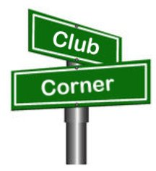If you want me to publish your club information, or even an article you have written, please send it in WORD format (.docx). Please use Times New Roman font size 12 for the body of the aritcle. Any photos please include as a .jpg or .bmp – the time you save me in doing all the conversions will be greatly appreciated.

**A plea -- ham radio support for bikeMS -- July 23-24**

The southwest Ohio amateur radio community has been providing support for bikeMS, a 2-day bike tour to benefit the National MS Society, since the 1980s, and we're still doing it.  
  
In the world after/with covid-19, we're seeing a radical drop-off in volunteer participation at events like this.  So is everyone else, in the context of all varieties of volunteer groups.  
  
Other types of volunteer groups are not necessarily expected to pay "sweat equity" for the privileges associated with their volunteer interests.  *We are*.  
  
This year's bike ride is Saturday-Sunday, July 23-24.  To complete the mission, we need the following:

* 1-2 net control ops (extensive experience not required, a good sense of direction and teamwork is)
* a Saturday volunteer at the northwest corner of Hueston Woods SP (Preble County is working on this)
* a Saturday volunteer at the Preble County YMCA (Preble County is working on this)
* a Saturday volunteer to "ride along" with a sag vehicle
* a Sunday volunteer at Morgan-Ross Athletic Association (2679 Chapel Rd. in Okeana)
* a Sunday volunteer at Wendel Farm (8134 State Line Rd.)
* a Sunday volunteer at the northwest corner of Hueston Woods SP (mountain bike trailhead)
* a Sunday volunteer to "ride along" with a sag vehicle

If you were to choose both days (absolutely not required), we'll put you up in campus housing at Miami U., if you choose it.

I am reachable at all times, if you'd like to ask questions about the event and how/why we support it.

-73- de N8TFD/Steve  
(513) 985-9844 "home"  
(513) 358-7835 "work"  
(859) 393-6563 cell

2022 Pro Football Hall of Fame Enshrinement Festival - Parade Ham Radio Volunteers

Greetings radio operators!  
  
It's time for me to ask you if you will be assisting with the 2022 Pro Football Hall of Fame Enshrinement Festival Community Parade on July 24th or the Canton Repository Grand Parade on August 6th. These events are the largest amateur radio public service event in Stark County each year!

For the Grand Parade, we will need about 35 operators along the parade route, and in the staging & de-marshaling areas. If you haven't worked it before, the parade route is Cleveland Ave, starting at 6th St S and running to about 25th St N. A radio operator, and usually 2 marshals are located in each of the blocks along the route. All you will need is a pair of khaki pants/shorts/capris, and a 2 meter HT. Training will be provided at one of 2 training sessions that will be held at the Sippo Lake library branch this summer (date to be announced later, usually a Tuesday and Thursday evening). Until then, you can view a generalized list of duties & responsibilities on the website below.

The Community Parade is a bit smaller, requiring around 15 operators, and runs south along Market Ave from around the Civic Center at 10th St N to 3rd St S.

I have made it to a few of the local radio club meetings in the past 2 weeks, and plan on attending more in coming weeks. Last year, I setup a new website, as well as a [groups.io](http://groups.io/) email list to make communication for both parades easier.

You can find the new website, including all of the information (including sign-up forms and contact information) for both parades at [https://hofhams.info](https://hofhams.info/)

This year for the Grand Parade, we are also looking for parade marshals to assist. If you have a friend, family member, or other non-licensed person that wants to work the same block/area as you; please have them get in touch (you can forward this email if you prefer), and I will forward it over to the appropriate person on the Grand Parade Committee.

If your schedule is open in late July/early August and you are willing to assist this year with either parade, please head over to the website, and click on the green sign-up button(s).  
  
If you're interested in attending or volunteering for any of the other Festival events (non ham radio), you can see the schedule at <https://www.profootballhoffestival.com/schedule> or sign-up at <https://www.profootballhoffestival.com/volunteers>

By volunteering, you will become one of over 5,000 volunteers that assist through 28 different committees needed to run the 2 week long festival, which places the focus of the football world on Canton, Ohio. You don't need to be a football fan, you just need to be willing to give of your time, talents, and resources. If you are age 21 or older, you will also receive a ticket to the annual volunteer appreciation party!

Thanks & 73,

Justin K. Corner  
W8JKC / WQKU709  
P.O. Box 122  
N. Industry, OH 44707-0122  
(330) 879-8552  
(330 87 W8JKC on your telephone's keypad)

**______________________________________________________________________**

***From the Section Youth Coordinator***

***Anthony Luscre, K8ZT - SYC***

[k8zt@arrl.net](mailto:k8zt@arrl.net)

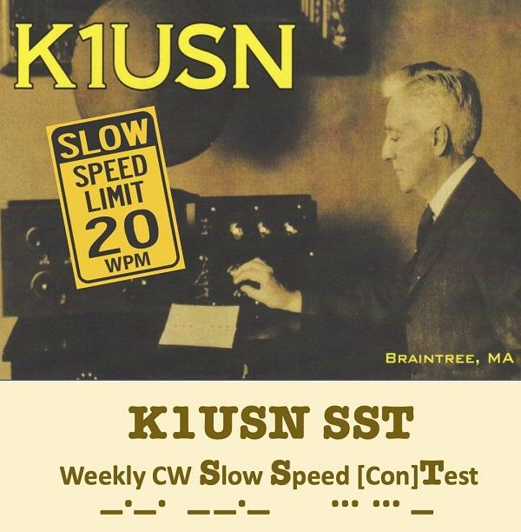

**Getting Started or Reacquainting With CW**

**Two Slower Speed Contests to Try**

A few years ago, a new slow-speed CW contest was started by members of [*K1USN Radio Club*](http://www.k1usn.com/), the[*CW Ops*](https://cwops.org/) & their [*CW Academy*](https://cwops.org/cw-academy/) group. The Weekly CW **S**low **S**peed [Con]**T**est (K1USN SST) encourages operators to use slower CW speeds in two short (one-hour) sprints each week:

* Fridays 20:00-21:00 UTC: 4-5 pm EDT
* Mondays 00:00-01:00 UTC: 8-9 pm EDT Sunday

Full rules are available at [*www.k1usn.com/sst.html*](http://www.k1usn.com/sst.html)*.*

The second slower speed contest is only a few months old. It is sponsored by the [*International CW Counci*l](https://internationalcwcouncil.org/) (an umbrella of various CW groups worldwide). The **MST** (Medium Speed Test) encourages speeds between 20 and 25 WPM.

* Monday: 1300-1400 (UTC) / 9-10 AM Eastern
* Monday: 1900-2000 (UTC) / 3-4 PM Eastern
* Tuesday: 0300-0400 (UTC) / 11-12 PM Eastern (Monday)

**_________________________________________________________**

**Want to know where to go to get the courses you need? It’s all Right Here!**

* [Ohio EMA Training Calendar](https://webeoctraining.dps.ohio.gov/TrainingAndExercise/courselist.aspx)
* [Login to the DPS Training Campus](https://learning.dps.ohio.gov/PSTC/)
* [Create a new account on the DPS Training Campus](https://learning.dps.ohio.gov/PSTC/)

**NOTE:**

* Most courses are in-person but some course may be hosted virtually (this will be noted).
* Seats available listed are as of the release of this update and will change quickly.
* All classes will be posted on the DPS training campus at least 60 days prior to the start of the course.
* Please read the [Training Policy & Catalog](https://ema.ohio.gov/documents/training/ema0201.pdf) for more information on Ohio EMA trainings.

**_______________________________________________________**

Hello All,  
  
I am looking for volunteers to work the Pan Ohio Hope Ride. This is a 4-day 328-mile bicycle ride from Cleveland to Cincinnati on July 21-24. I'm looking for people willing to drive along with the ride as SAG (support and gear) drivers. Ideally volunteers should have either a pickup truck or a vehicle with a bike rack and space to transport riders. Volunteers are strongly encouraged to sign up for all 4 days. All meals and lodging will be covered. Fuel can be reimbursed after the event. If you are unable to sign up for all 4 days, you are still welcome to come and help as much as you can. Net control each day will be run out of the Dayton Amateur Radio Association truck which will travel along with the event. We will primarily use UHF simplex and 700/800 MHz MARCS radios that will be signed out to volunteers each day. We strongly suggest each SAG vehicle have a driver and a co-pilot to help with navigation.  
  
If this sounds like something you are interested in, please click the link below. If you have any questions or difficulties with signing up, please contact me at [info@n8esg.org](mailto:info@n8esg.org) Please pass this notice along to all your various ARES and other amateur radio groups.  
  
**TO SIGN UP PLEASE VISIT THIS LINK**[**POHR SAG REGISTRATION**](https://volunteercommunity.cancer.org/s/acs-community-shift/a238X00000CBUt5QAH/endurance-events-driver-volunteer-cs51177?language=en_US&tabset-ca43c=1)

_._,_._,_

How to Plan and Apply for an ARRL Hamfest or Convention

If your amateur radio club is planning to host a convention, hamfest, tailgate, or swapfest, please consider applying for ARRL sanctioned status for your event. To learn what it means to be an ARRL sanctioned event, and to get some ideas on how to prepare for and conduct a hamfest or convention, visit [www.arrl.org/arrl-sanctioned-events](http://www.arrl.org/arrl-sanctioned-events).

To apply for ARRL sanctioned status for your event, go to [www.arrl.org/hamfest-convention-application](http://www.arrl.org/hamfest-convention-application).

The ARRL Hamfests and Conventions Calendar can be found online at [www.arrl.org/hamfests](http://www.arrl.org/hamfests). In addition, the Convention and Hamfest Calendar that runs in *QST* each month also presents information about upcoming events.

Go Fully Electronic in 2022!

By Maria Somma, AB1FM, ARRL VEC Manager

**Online Examinations and Remote Testing**

Your club's VE team can become part of the fun and excitement of remotely administered Online Examinations.  
  
The remote exam sessions are conducted using an online video conferencing platform and a web-based examination system with on-screen tests. ARRL VE teams have had the option to be completely electronic since June 2020 by using online exams. The online exams can also be utilized at in-person sessions automating most of the process, for a fully electronic in-person session experience.  
  
VE teams have been using the [Exam.Tools](https://exam.tools/) Online Examination system for remote video and in-person sessions. Over 25,000 applicants have been tested through the Online Examinations system in the past two years. The system works well for online or printed examinations and includes registering and tracking candidates throughout the session, on screen exams and grading, online signing of CSCE and 605 forms by the candidate and examiners, logging and compiling session stats and VE participation list (test report summary), and output files for upload to the coordinating VEC. The program manages and handles almost everything needed to conduct a test session. Time and experience with in-person exam sessions is invaluable when transitioning to remote video-supervised online exam sessions.  
  
Interested ARRL VE teams must contact the [VEC department](mailto:vec@arrl.org) to receive the online exams instructions and remote video session procedures.  
  
Not a VE? Become one today!  
  
Visit <http://www.arrl.org/become-an-arrl-ve>  
  
**Electronically File Exam Session Documents for Quicker Service**

After the session has concluded, VE teams can upload in-person documents or remote video session files via ARRL VEC's secure web page (program service option since 2018).

New and upgraded licenses are issued within 1 to 2 business days for weekend sessions and are usually issued on the same day for weekday sessions.

Please contact the [VEC department](mailto:VEC@arrl.org) for the information and instructions on electronically filing exam session documents through our upload page. Authorized VEs will be sent the upload page URL which, is hidden from the public.

**Resources for ARRL VEs**

The [ARRL VEC VE Resources](http://www.arrl.org/resources-for-ves) page offers the information you will need to help conduct exam session business. Our support page offers easy access to session forms and information, online examinations, remote video session instructions, VE Manual supplemental information, FCC rules, basic qualification question procedures, and much more. There is also some helpful information for the community, such as preparation resources for candidates, in-person and remote video exam session search, vanity call sign information, and more.

The ARRL VE Newsletter relays important updates relating to FCC rule or policy changes, exam session document or procedural changes, video sessions, and other topics. VEs can sign up for the newsletter at <https://reflector.arrl.org/mailman/listinfo/ve-list>

Great job from Brenda Krukowsli KB8IUP on Toledo TV with a ham radio boost!   <https://www.13abc.com/video/2022/07/08/ham-radio-still-has-role-our-modern-age/>

__________________________________________________

**ATARA**

ATARA, All Things Amateur Radio Association has been busy this past week. ATARA set up for Summer Field Day at Alley Park. Field Day marks the first anniversary of ATARA and the members celebrated with a potluck dinner on Saturday. Over 54 people participated during field day weekend with a special visit from Tom Sly, who joined us for dinner Saturday. Mike from DX Engineering and his wife stopped by after their son’s wedding at Alley Park and got on the air with us. They were a little overdressed!

Tuesday after field day, ATARA joined the Alley Park Survivor Camp for teens and taught NASAR’s Hug-A-Tree (what to do if you are lost in the wilderness), wilderness first aid, and primitive fire starting. It was a great experience working with the campers and the team really enjoyed teaching them. ATARA entered a float in the Lancaster Fourth of July parade with Afterschool Programs of Lancaster. The float displayed the Afterschool’s family survival day last May with canoeing, archery, and fire starting. This Saturday, ATARA’s Off-Grid Radio Team will be providing communication for the Hank Sarcoma 5K Walk/Run. This will be the second year the team has worked this event and a great training exercise for our newest team members.

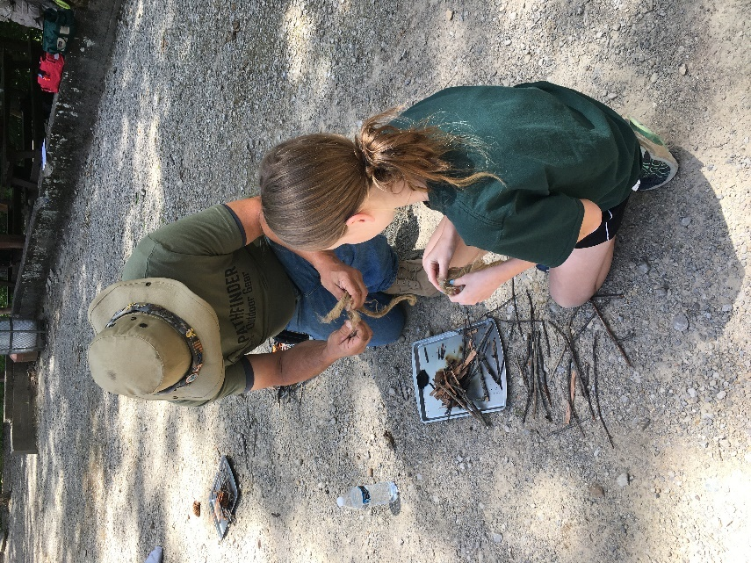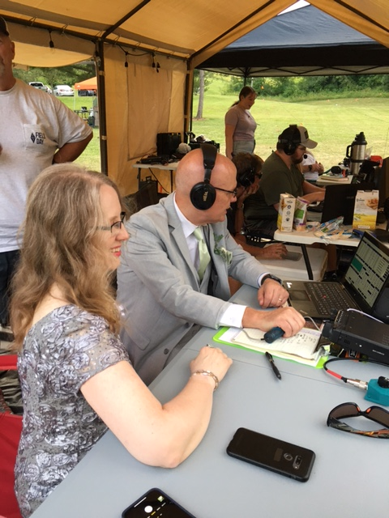

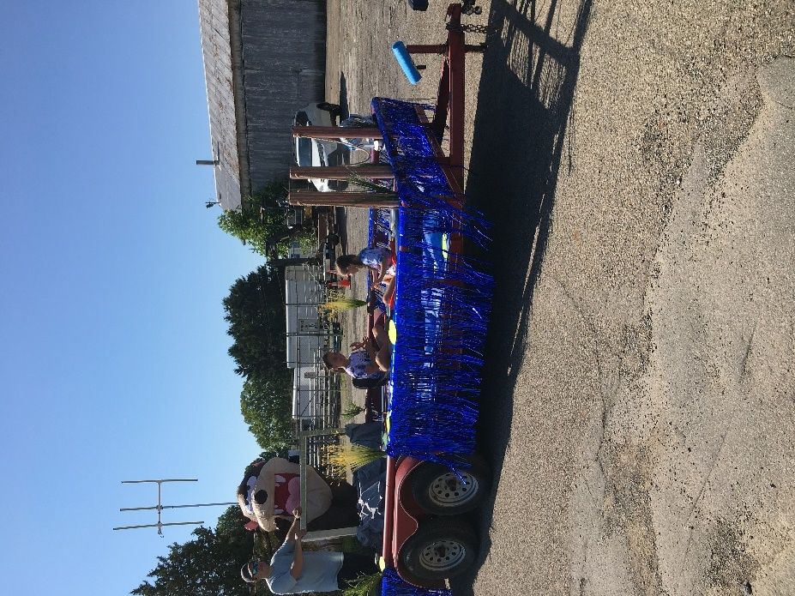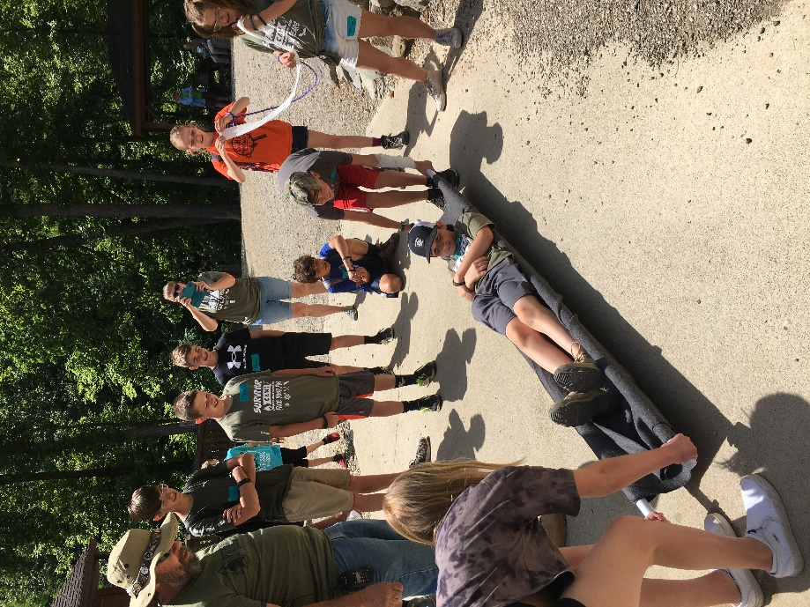

**____________________________________________________**

ARRL invites you to be part of “[Club Station](http://arrl.informz.net/z/cjUucD9taT0yNTA5NjcxJnA9MSZ1PTUyMDM5NjkwOCZsaT0yNTQyOTEyOA/index.html),” the newest column in QST. This column, written by clubs, for clubs, is a designated space to share specific and practical ideas about what has contributed to successful clubs to help others grow and thrive.

In each issue, a different club will share how they undertook a specific activity or project, how and why it was successful, and any challenges they may have had to overcome throughout the process. Some examples include successful community club projects, creative ways to attract new members, or getting youth involved with ham radio. Additionally, many clubs across the country are being creative in meeting the challenges of COVID-19 to figure out how to keep club members active and enthusiastic.

If your club has developed a creative way to get around common challenges, we want to hear from you! In order to help you tell your story, we have published a new version of the ARRL Author’s Guide that is geared toward “Club Station,” and includes a [club profile form](http://arrl.informz.net/z/cjUucD9taT0yNTA5NjcxJnA9MSZ1PTUyMDM5NjkwOCZsaT0yNTQyOTEyOQ/index.html). Both of these documents can be found [here](http://arrl.informz.net/z/cjUucD9taT0yNTA5NjcxJnA9MSZ1PTUyMDM5NjkwOCZsaT0yNTQyOTEyNw/index.html). You don’t have to have writing experience to be published in QST, and if your submission is accepted, our editorial staff will work with you to get your story ready for publication.

All ARRL Affiliated Clubs are welcome to participate. If you have any questions, contact us at [clubs@arrl.org](mailto:clubs@arrl.org).

We look forward to hearing from you and hearing your story!

VE Sessions

**All Things Amateur Radio Association (ATARA)** We host testing sessions every second Tuesday of the month in Lancaster. To sign up please visit our website <https://atara-w8atr.fun> and contact us at [hamexams@atara-w8atr.fun](mailto:hamexams@atara-w8atr.fun).

**CARS**

VE testing from CARS - Cuyahoga Amateur Radio Society - at Elmwood Recreation Center, 6200 Wisnieski Parkway in Independence, Ohio 44131  Time: 9:15 AM (Walk-ins allowed) Always the 2nd Sunday of the odd month. Go to CARS  [www.2cars.org](http://www.2cars.org/) for detailed map of location.  Call Metro W8MET 216-520-1320 for details

**Cambridge Area Maker Group**

Amateur Radio Exam Testing all Levels

Date: Saturday August 20, 2022

Time: 01:00 PM ( No Walk-ins / Call or Email to Register )

ARRL-VEC Exam Fee $15

Please Register Contact: Kathleen Frederico KB3RDR Phone: 484-459-3309

Email: [kb3rdr@arrl.net](mailto:kb3rdr@arrl.net)  
Location: St. John's Episcopal Church

[1025 Steubenville Ave](https://www.google.com/maps/search/1025+%0D%0ASteubenville+Ave+%0D%0A+Cambridge,+%0D%0AOH+43725,+USA?entry=gmail&source=g) [Cambridge, OH 43725, USA](https://www.google.com/maps/search/1025+%0D%0ASteubenville+Ave+%0D%0A+Cambridge,+%0D%0AOH+43725,+USA?entry=gmail&source=g)

**Dayton Amateur Radio Association (DARA)** If you are interested in testing for a new or upgraded license, please come see us at the DARA Clubhouse. If you have questions about testing, please email [exams.w8bi@gmail.com](mailto:exams.w8bi@gmail.com)

**The Lake County Amateur Radio Association**

The Lake County Amateur Radio Association is once again holding its **2022** Amateur Radio license exams at the **Kirtland Library**, 9267 Chillicothe Road, on the following dates:

Saturday, June 4, August 6, October 1, and December 3.

The tests will start at **12 noon.** Please arrive a few minutes earlier.

**The Lancaster and Fairfield County Amateur Radio Club (LFCARC**) hosts exam sessions at the FAIRFIELD County EMA, 240 Baldwin Dr in Lancaster Ohio, 43130, on the first Saturday each month at 10:00 am. Please visit our website at <http://www.k8qik.org> for exam dates on our calendar and navigate to our Learning Center/Taking the Exam link for information and requirements. Our experienced VE team looks forward to serving the Amateur Radio community in Central Ohio. Contact me at [ve_testing@k8qik.org](mailto:ve_testing@k8qik.org) to register.

**The Milford Amateur Radio Club (MARC)** is now doing VE testing on the third Thursday of each month at 6:00 PM.  Location;  Miami Township Civic Center located at 6101 Meijer Drive, Milford, OH  45150.

 Please pre-register at [www.milfordhamradio.org](http://www.milfordhamradio.org/)

**Portage County Amateur Radio Service (PCARS)**

The first Saturday of every even numbered month -10 am – at the PCARS club site in Ravenna. Please visit the PCARS web site and check out the information about VE testing in the latest newsletter at [www.portcars.org](http://www.portcars.org) .

If you have any questions, don’t hesitate to contact me at KB8UUZ@gmail,com

**Your Club news should be listed here!**

I know you’re out there doing things! Send me a write-up (MSWord please) and some photo’s (.jpg please) and we’ll get your club hi-lited here for the other OH Section Clubs to see! Send to [WB8LCD@ARRL.ORG](mailto:WB8LCD@ARRL.ORG)

**______________________________________________________________________________**

DX This Week – Year of DX Part 1

Bill AJ8B (aj8b@arrl.net, @AJ8B, or www.aj8b.com)

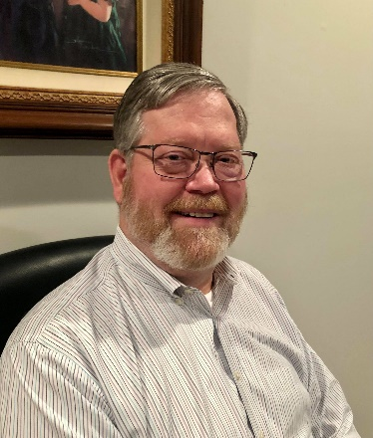 CWOPs Member #1567

Happy Post Fourth of July. Have you been attempting to complete the 13 Colonies event? If you did, let me know. Each year I try to focus on an endorsement such as CW only, 30 Meters, all worked on July 5th, etc. I enjoy the chase and the certificate.

Over the next two weeks, I have a real treat to share with you. Bob Locher, W9KNI, has given me permission to reprint one of the chapters of his legendary book, A Year of DX. The details follow the QSL card update.

DAH DIT DIT DIT DAH DAH DIT DIT DIT DAH

I received several nice cards this week including JJ0MPK – Saburi in Japan, JW0X – DXPedition to Svalbard. Let me know what you received.

|  |  |
| --- | --- |
|  |  |

DAH DIT DIT DIT DAH DAH DIT DIT DIT DAH

A Year of DX—Bob Locher—W9KNI

*I received a copy of “A Year of DX” as a Christmas present in 2010, a signed copy no less.! I have read it at least 3 times if not more. As recently as this spring, I spun through the pages as if it were the first time. What appeals to me is that I “feel” that I am in the shack with Bob as he pursues the DX Marathon.*

*At a few general ham club meetings, the SWODXA table at the Cincinnati Hamfest and at the Georgetown Hamfest, I was asked “Why do you like to talk to other countries? What is the appeal?” To be honest, I was at a loss to put together a succinct answer.*

*However, Bob provides the answer. I know that you will enjoy this excerpt and I hope you will use it to entice other non-DXers to give DXing a try!*

*I was able to contact Bob and he gave me permission to reprint this chapter. This book is available via Ham Supply. (https://www.hamsupply.com/) I might even consider loaning you my copy!*

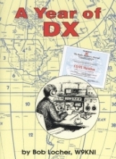**Question:** How do we amateurs explain the fascination of amateur radio DXing?

**Answer:** Very badly

As committed DXers, we know why we love DXing, right? Of course, we do but we invariably stumble badly when we try to put the reasons for our love into words, even in trying to explain it to ourselves. When we try to explain the fascination of DXing to non-DXers, generally we really screw up we rarely if ever get it right.   
 Now, up to a point, maybe this is a good thing if we did get it right in explaining it to outsiders our bands would be overrun. But on the other hand, most hams today would agree that we need more people using our bands, especially younger ones, and to help make this happen we must sell what we have. And to sell what we have we must first understand what we have.   
 So, what is it that makes us erect towers and antennas, structures we see as beautiful, but others see as eyesores? What gets us out of warm beds on cold mornings well before sunrise when we otherwise do not need to? What strange and special magic makes us study to take tests, learn an antiquated and otherwise essentially unused communication methodology, spend considerable sums of money. develop strange friendships world-wide, all-in hopes of accomplishing something that would appear to be child's play via a cell phone or the Internet?

But we do use the mails, phones, and Internet! We use them to communicate with people we first met over the air, and as tools for our pursuit of DX. Indeed, some of the best DXers in our amateur DXing community are extremely clever engineers; engineers who designed and implemented the cell phone concept. Other active DXers designed the equipment and protocols that make the Internet something taken for granted today. And these people among us, brilliant engineers, remain active DXers to this day. But of course, it is not only engineers that are DXers -far from it. As we know, DXers come from all walks of life, and you certainly need not be an engineer to be a successful DXer.   
 Using a cell phone or the Internet is like flying. Anyone can fly for the price of a ticket. You pay, get on the plane and it takes you there and lets you off. You flew. No fuss, no bother. No adventure.   
 Or you could be a pilot and fly your own plane. To do that, you need to study, and learn how to fly. You must pass tests. Being a private pilot is one of only two avocations that require a federal government issued license that is acquired by passing tests. And guess what the other one is? Right amateur radio!   
 Flying yourself somewhere becomes an adventure, very different indeed from sitting in row 17 in the middle seat.   
 In the front of the plane, you are alive; you control the plane, you see mountains, oceans, deserts. In row 17 you are asked to pull the shade for the viewing convenience of those passengers who paid for the headset to see the crummy movie. But yes, you indeed CAN use your cell phone to call Tibet - when the flight attendant tells you that use of cell phones is now permitted.   
 So, what then is the special magic of ham radio DXing? For active DXers, it is not about radios we do tend to love our radios, and comparing our gear with others, but our equipment, the towers and transceiver, the Yagis and the amps, are the tools we use for DXing, our portals to adventure and the world. And that is the real reason we love them.   
 DXing, if we will give it the chance to be, is adventure, high adventure. And how do we define "adventure"? One good definition is: "An adventure is an endeavor for which the outcome is uncertain." That is what can happen any time we turn on our rigs and start digging into the noise. We have no idea of what we are going to find.   
 Unlike telephones or the Internet, DXing is always an uncertain endeavor. We simply do not know what we will find when we put on the headphones. Bands may be unexpectedly dead, mediocre in one direction and better in another, or red hot in all directions. Spotting nets give hints and clues, but until we start listening for ourselves, we don't really know what we might find. The unknowing is a major part of what makes DXing an adventure.

We must give DX operating the chance to be adventure. When you turn on your rig you must at the same time open your mind to the possibilities, and not just those called out on the DX Spotting Nets. The ritual of putting on your headphones leaves behind the mundane world and its worries, and you take on a new mantle, indeed, a new persona. You become the stalker in the night, listening to the plaintive signals of a station on some island half a world away. No one knows you are listening on frequency, ready to call if you desire or not, instead deciding to move on to another frequency, another station, hunting for your prey.   
 Perhaps you are on Dawn Patrol, shivering in the half­ light of an early winter morning, sipping at that first cup of coffee, carefully tuning the band for signals expected and unexpected, picking through them, seeking for what you know not. But you will know it when you find it!   
 The radio waves of the world wash over you, bringing to your ears the thoughts and words of strange and exotic places, of great cities and remote settlements. Signals reach us from valleys surrounded by mighty snow-covered mountains, from atolls in mid ocean, Asian deserts, Antarctic islands, South American jungles.   
 An open band offers the possibility of adventure at every kilohertz. Shamelessly, we eavesdrop on the words and thoughts of stations in contact with other stations, both stations often thousands of miles away. Much of what we overhear is mundane, even boring, talk of weather and of equipment being used, of an operator's age, of years licensed. But we hear so much more of tropical monsoons while we sit snow-bound, of starry nights while we endure rain and fog. Reports of cholera or drought, of children born, of old friends lost. The world is calling us, talking to us, if only we are there to hear it.

(Sorry! Continued next week)

DAH DIT DIT DIT DAH DAH DIT DIT DIT DAH

Here is an update from Bernie, W3UR, of the DailyDX and the WeeklyDX, the best source for DX information. <http://www.dailydx.com/> . Bernie has this to report:

**1S - Spratly Islands -** 4F2KWT, Gil, gives us more details on the upcoming DX0NE Kalayaan, Spratly Island DXpedition, which could take place sometime between August 1st and December 31, 2022. The exact dates are dependent on a supply ship. This will be a four man team including DU1XX (AE6DG), Michael; DU3JA, Jong; 4F1OZ, Ed; and 4F2KWT, Gil. Plans are to have an IC-7300 and FT-991A running 100 watts into verticals (160, 80, 60 and 40 meters), VDA (30-10 meters) and a 6 Meter Yagi. Activity will be on SSB, CW and FT8 on 1.8 through 50 MHz. QSOs will be uploaded to Club Log and LoTW. QSL via 4F2KWT.  
  
**7Q – Mali -** After completing their successful Z21RU DXpedition the Russian DX Team (RDXT) are once again moving on for a second DXpedition. During the team's Zimbabwe DXpedition (June 17-28) the RDXT made 53,180 QSOs. Complete statistics can be found at <https://clublog.org/charts/?c=Z21RU#r> The RDXT are expected to be QRV later today as 7Q5RU until July 10th. <https://dxpedition.wixsite.com/z21ru>   
  
**3W – Vietnam -** Since 2019 F4BPO, Gregory, has been living in Ho Chi Minh and has recently been active with his XV9BPO callsign on CW and FT8. He has an FTDX-5000 and FTDX-3000 as well as a SunSDR2 DX. His current antennas include a Baby Loop by Ciro Mazzoni (40-10 meters) and DX Commander (40-10 meters). Gregory also has two amplifiers, a VL-1000 and 1.3K- FA. He uploads his QSOs to Club Log, LoTW and eQSL.

**3Y/B – Bouvet -** 3Y0J co-team leader LA7GIA, Ken Opskar, says them is preparing the shipping container to be shipped from Oslo. It will ship on September 11 and is expected to arrive in Port Stanley, Falkland Islands in late October. Once in VP8 some local hams will "check it" before the 3Y0J team arrive. The 3Y0J team made their second vessel deposit yesterday, with the next one "in a few months" due. Ken says the "payment milestones are coming fast" and they are "fully committed to go". <https://www.3y0j.no>

**The GM (Scotland) DX Group** has released four videos from their April convention. They include building a remote, the upcoming KH8 Swains Island DXpedition, the upcoming 3Y0J Bouvet DXpedition, Sporadic E developments and some awards. Check them out at  
<https://www.youtube.com/channel/UCAYFXRpWrumhZiqsSBOYH3g>

**TX5 - Austral Islands -** TX5XG is now the call for JA1XGI, not FO/W1XGI previously expected, for the November 2-9 operation.  Haru will be on 160-10 CW, SSB, RTTY and FT8/FT4 F/H.

Look for Haru on:  
CW, 1822.5, 3525, 7010, 10115, 14040, 21040 and 28040.  
SSB, 3790, 7090, 14170/14280, 21260, 28450.  
RTTY, 7035, 10140, 14085, 211085, 28085.  
FT8, 1842, 3567, 7051, 10131, 14090, 21090, 28040.

His station is an IC_7300 to Mini Ninjya 5-band vertical, and 160/80 vertical, the "Special Ninjya," with 25 radials.  QSL direct to JA1XGI.  A bureau card will take one year if you go that route.  Club Log OQRS and LoTW will also be uploaded daily, "no charge." <https://australvacation.amebaownd.com>

**Hamvention Announcement -** "The Board of The Dayton Amateur Radio Association is pleased to announce Jim Storms, AB8YK, is the General Chairman of Hamvention for 2023. Prior to this he has served as an officer of several local radio clubs including being DARA's Vice President for three years. Since 2017 he was the Dayton Hamvention Advanced Registration Chair.

“Additionally, Jim is one of the cofounders and co-lead for the Dave Kalter Youth DX Adventure (YDXA) where youth are introduced to DXing by going to a DX location and operating.

"The Board believes Jim will carry on the tradition of excellent General Chairs of Hamvention. Jim is a very active ham and enjoys chasing Dx. He is a retired IT expert.  
  
"The Board also approved Brian Markland, N8UDQ as Assistant General Chair.  
  
"Michael Kalter W8CI DARA Board Member"

.

DAH DIT DIT DIT DAH DAH DIT DIT DIT DAH

Below is a list of upcoming contests in the “Contest Corner”. I think this is important for someone who is trying to move up the DXCC ladder since entities that are on the rarer side and easiest to work in contests. Some of my best “catches” have been on the Sunday afternoon of a contest when the rarer entities are begging for QSOs. Of course, the gamble is that if you wait until Sunday, conditions may change, or they simply won’t be workable. However, it is not a bad gamble. Of course, why not work the contest and have some fun!  
Check out the WA7BNM Contest Calendar page (<https://www.contestcalendar.com/>) and CQ Magazine for more contests or more details. I also have a comprehensive list that can be imported to your calendar at [www.aj8b.com/files](http://www.aj8b.com/files)

The contests in red are those that I plan to spend some significant participation time on. PLEASE let me know if you are working contests and how you fared.

Thanks!

|  |  |  |
| --- | --- | --- |
| July 13 | RSGB 80m Club Championship, SSB | https://bit.ly/31qpcJl |
| July 13 | VHF-UHF FT8 Activity Contest | www.ft8activity.eu/index.php/en |
| July 16-17 | CQWW VHF Contest | www.cqww-vhf.com |
| July 16-17 | IARU Region 1 70 MHz Contest | https://bit.ly/3r1kqvT |
| July 16-17 | North American RTTY QSO Party | http://ncjweb.com/NAQP-Rules.pdf |
| July 17 | CQC Great Colorado Gold Rush | https://tinyurl.com/y8dh6xwy |
| July 17 | RSGB International Low Power Contest | https://tinyurl.com/yckwshsr |
| July 18 | RSGB FT4 Contest Series | https://bit.ly/31qpcJl |
| July 20 | VHF-UHF FT8 Activity Contest | www.ft8activity.eu/index.php/en |
| July 23 | YOTA Contest | www.ham-yota.com/contest |
| July 28 | RSGB 80m Club Championship, Data | https://bit.ly/31qpcJl |
| July 30 | WAB 144 MHz Low Power Phone | http://bit.ly/31yE4kT |
| July 30-31 | RSGB IOTA Contest | https://tinyurl.com/yc8dzhh7 |
| July 31 | ARS Flight of the Bumblebees | http://arsqrp.blogspot.com |
| Sept. 24-25 | CQWW RTTY DX Contest | www.cqwwrtty.com |

__________________________________________________________

**ARLD027 DX news**  
  
This week's bulletin was made possible with information provided by The Daily DX, the OPDX Bulletin, 425 DX News, DXNL, Contest Corral from QST and the ARRL Contest Calendar and WA7BNM web sites.  Thanks to all.  
  
MONACO, 3A.  Operators Paul, F6EXV and Flo, PB8DX are active as 3A/F6EXV and 3A/PB8DX, respectively, until July 17.  Also look for activity on 6 meters as 3A6M.  QSL 3A/F6EXV, 3A/PB8DX and 3A6M via F6EXV on ClubLog, direct or via the Bureau.  
  
UGANDA, 5X.  Elvira, IV3FSG is active as 5X3R until July 13. Activity will be in her spare time on 80 to 10 meters using SSB, RTTY and PSK31.  QSL via IK2DUW, direct, via the Bureau, ClubLog or LoTW.  
  
CUBA, CO9.  Operators Bladimir, CO6BM, Jose, CO6EC, Ernes, CO6ID, Delvys, CO6SRS, Enrique, CO6VO and CL6AFL will be active as CO9GNN on July 15 and 16, to commemorate the 333rd anniversary of the founding of Santa Clara City.  Activity will be on 160, 80, 40, 20,  
15, 10 and 2 meters using SSB and digital modes.  
  
ANGOLA, D2.  Mikalai, UT6UY is active as D2UY.  The length of his stay is unknown.  Activity has been mainly on 20 to 6 meters using FT8.  QSL via his home call.  
  
CAPE VERDE, D4.  Harald, DF2WO will be QRV as D44TWO sometime in September.  Activity will be holiday style on 160 to 6 meters using CW, SSB and digital modes.  He works mostly on the digital modes FT8, PSK31, JT65 and RTTY.  QSL via M0OXO OQRS.  
  
SPRATLY ISLANDS, DX0.  Gil, 4F2KWT has been issued the call sign DX0NE from the Republic of the Philippines National Telecommunications Commission.  The special call sign will be used during an operation from Kalayaan Spratly Island sometime between August 1 and December 31, 2022.  A four man team is expected which includes Gil, 4F2KWT, Ed, 4F1OZ, Jong, DU3JA and Mike, DU1XX/AE6DG. Activity will be on 160 to 6 meters using CW, SSB, FT8.  QSL via 4F2KWT, ClubLog or LoTW.  
  
UNITED KINGDOM, GB22.  Look for the following special event stations to be active between July 25 and August 21 to mark the XXII Commonwealth Games: GB22GD/Isle of Man, GB22GM/Scotland, GB22GE/England, GB22GU/Guernsey, GB22GI/Northern Ireland,  
GB22GW/Wales, GB22GJ/Jersey, GB22HQ/National Exhibition Centre, in Birmingham.  QSL all call signs via M0OXO OQRS or LoTW.  
  
SARDINIA, IS0.  Gianpi, IK1TTD will be active as ISO/IK1TTD during the RSGB IOTA Contest, July 30 and 31.  QSL via home call, direct or via the Bureau.  
  
UNITED STATES OF AMERICA, N.  John, N9EAJ will be active as N9EAJ/P from Okaloosa Island from July 24 to 31.  Activity will be on 40 to 10 meters using mainly SSB, with some CW.  There will be some activity in the RSGB IOTA Contest.  QSL via N9EAJ direct or  
ClubLog's OQRS.  
  
POLAND, SN89.  Special event station SN89LOT is active on various HF bands until August 31.  The station commemorates the 89th anniversary of the flight over Atlantic Ocean by two Lithuanian pilots Steponas Darius and Stasys Girenas, who flew from New York in the airplane Lituanica to Kaunas on July 15, 1933.  QSL via SP1PMY, direct or via the Bureau.  
  
DODECANESE, SV5.  Robert, OK2PYA is QRV as SV5/OK2PYA from Rhodes until July 13.  Activity is on 40, 30, 20, 17, 15 and 10 meters using CW and SSB.  QSL via the Bureau.  
  
FRANCE, TM109.  Michel, F8GGZ is active as TM109TDF to celebrate the 109th Tour de France.  Look for activity from July 7 to 9, 12 to 15 and 20 to 24.  QSL via the Bureau or direct to F8GGZ.  
  
AUSTRAL ISLANDS, TX5.  Haru, JA1XGI will be QRV as TX5XG from November 2 to 9.  Activity will be on 160 to 10 meters using CW, SSB, RTTY and FT8/FT4 (F/H).  QSL via JA1XGI direct, via the Bureau, ClubLog's OQRS or LoTW.  
  
VIETNAM, XV9.  Gregory, F4BPO is active as XV9BPO from Ho Chi Minh City.  Recent activity has been on 30, 20, 17, 15 and 10 meters using mostly FT8/FT4, with some SSB and CW.  QSL via ClubLog, eQSL or LoTW.  
  
MYANMAR, XZ.  Akio, JE2QIZ is active as XZ2B.  His length of stay is unknown.  Most of his activity has been on 15, 10 and 6 meter CW. QSL via JH3SIF.  
  
NEW ZEALAND, ZL90.  Members of the NZART Southland Branch 37 are celebrating their 90th anniversary and will be active as ZL90GQ during the month of July.  QSL direct to the address on QRZ.com.  
  
TAIWAN, BV.  Ken, BW2/JP1RIW will be QRV as BX0QSL from New Taipei City between July 11 and November 30, using mainly digital modes.  QSL via BM2JCC.  
  
CRETE, SV9.  David, OK6DJ and OK1-36573 will operate as SV9/OK6DJ between July 8 and 14 on the HF bands using CW, SSB and FT4.  QSL via ClubLog OQRS, LoTW or eQSL.  
  
INDONESIA, YH.  Look for YH0R from July 9 to 17, celebrating 54 years of ORARI, the national IARU member society.  Operations will be on 80, 40, 20, 15 and 10 meters using CW, SSB, FT8 and RTTY. They will upload the log to LoTW, eQSL and Club Log.

______________________________________________________________________________

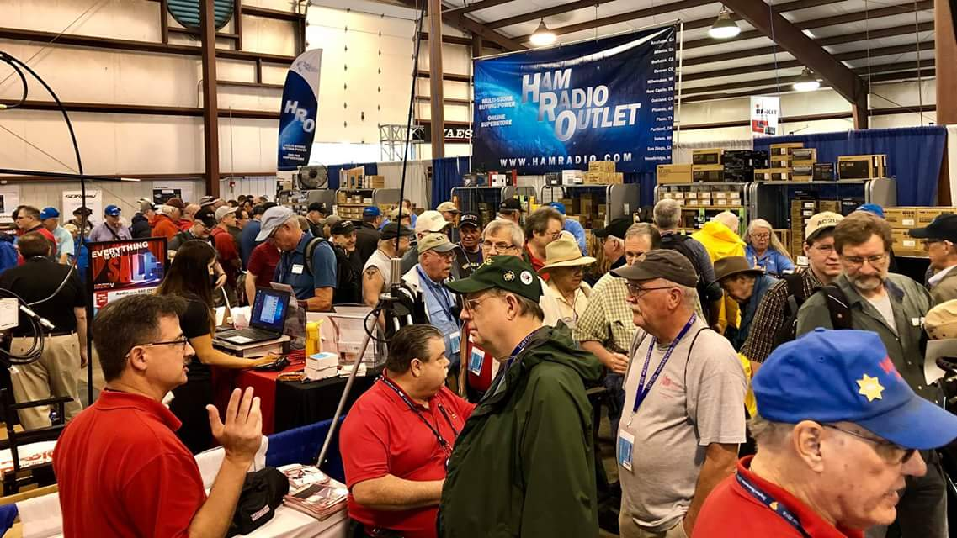[**Upcoming *Hamfests***](http://arrl-ohio.org/hamfests.html)

We **DO** have some hamfests scheduled for 2022!! Yes, take a good look at the list. **__________________________________________________________**

|  |  |
| --- | --- |
|  |  |

|  |  |
| --- | --- |
|  |  |
|  |  |
| ***2022*** | | | | |
|  | | | |  |
| **07/16/2022 -**[**NOARSFEST**](http://www.arrl.org/hamfests/noarsfest-9)  **Location:**Elyria, OH **Sponsor:** Northern Ohio Amateur Radio Society [**Learn More**](http://www.arrl.org/hamfests/noarsfest-9) | | | | **07/17/2022 -**[**Van Wert Hamfest**](http://www.arrl.org/hamfests/van-wert-hamfest-6)  **Location:**Van Wert, OH **Sponsor:** Van Wert Amateur Radio Club **Website:** [http://W8FY.ORG](http://w8fy.org/) [**Learn More**](http://www.arrl.org/hamfests/van-wert-hamfest-6) |
| **08/06/2022 -**[**Columbus Hamfest**](http://www.arrl.org/hamfests/columbus-hamfest-5)  **Location:**Grove City, OH **Sponsor:** Aladdin Shrine Audio Unit **Website:** [http://columbushamfest.com](http://columbushamfest.com/) [**Learn More**](http://www.arrl.org/hamfests/columbus-hamfest-5) | | | | **08/13/2022 -**[**Cincinnati Hamfest**](http://www.arrl.org/hamfests/cincinnati-hamfest-1)  **Location:**Owensville, OH **Sponsor:** Milford ARC **Website:** [https://CincinnatiHamfest.org](https://cincinnatihamfest.org/) [**Learn More**](http://www.arrl.org/hamfests/cincinnati-hamfest-1) |
|  | | | |  |
| **08/21/2022 -**[**Warren ARA Tailgate Swap Meet**](http://www.arrl.org/hamfests/warren-ara-tailgate-swap-meet-1)  **Location:**Cortland, OH **Sponsor:** Warren ARA **Website:** <http://facebook.com/w8vtd> [**Learn More**](http://www.arrl.org/hamfests/warren-ara-tailgate-swap-meet-1) | | | | **09/11/2022 -**[**Findlay Hamfest**](http://www.arrl.org/hamfests/findlay-hamfest-9)  **Location:**Findlay, OH **Sponsor:** Findlay Radio Club **Website:** <https://www.findlayradioclub.org/> [**Learn More**](http://www.arrl.org/hamfests/findlay-hamfest-9) |
| **09/17/2022 -**[**Mound Amateur Radio Assoc. Swap Meet**](http://www.arrl.org/hamfests/mound-amateur-radio-assoc-swap-meet-1)  **Location:**Miamisburg, OH **Sponsor:**MARA **Website:** [http://W8DYY.ORG](http://w8dyy.org/) [**Learn More**](http://www.arrl.org/hamfests/mound-amateur-radio-assoc-swap-meet-1) | | | | **09/25/2022 -**[**Cleveland Hamfest**](http://www.arrl.org/hamfests/cleveland-hamfest-2)  **Location:** Berea, OH **Sponsor:**Hamfest Association of Cleveland **Website:** [http://www.hac.org](http://www.hac.org/) [**Learn More**](http://www.arrl.org/hamfests/cleveland-hamfest-2) |
| **10/30/2022 -**[**Massillon Hamfest (OH)**](http://www.arrl.org/hamfests/massillon-hamfest-oh)  **Location:**Green, OH **Sponsor:** Massillon Amateur Radio Club **Website:** [http://w8np.org](http://w8np.org/) [**Learn More**](http://www.arrl.org/hamfests/massillon-hamfest-oh) | | | | **12/03/2022 -**[**FCARC WinterFest**](http://www.arrl.org/hamfests/fcarc-winterfest-3)  **Location:**Archbold, OH **Sponsor:** Fulton County Amateur Radio Club **Website:** <https://k8bxq.org/hamfest> [**Learn More**](http://www.arrl.org/hamfests/fcarc-winterfest-3) |
|  | | | |  |

2022 Findlay Radio Club 80th Annual Hamfest

Our 80th Findlay Hamfest will be held **Sunday, September 11, 2022**at the **Hancock County Fairgrounds** in Findlay Ohio. Come join the expected 1,500 hams from across the Midwest at this ARRL sanctioned event. Gates will open to the public at **8:00 AM**. Event parking is free. VEs will be offering license testing.

Details of this amateur radio and electronics event are posted at our [Hamfest website](https://www.findlayradioclub.org/lists/lt.php?tid=eRgGBgYBAAMAAxVTXg1XH1cDBlNPVVxRVk5UUAtUDQNTBwIGB1RKVAtXXFMCDAAfAFABAk8AVFMATlpTCAQUWlNTAgBSVgBWAFEBHlZdBFdQA1NQT1UHUldOVwUMWRQAB1IBGlQCBwdXAQFQUwkEAw) and the event is included in the ARRL's list of [Hamfests & Conventions](https://www.findlayradioclub.org/lists/lt.php?tid=eRgJAwEBVwEEVxVXA18EH1cAUQJPDVVZX05TCV4FDVAJV1MGVFZKVAtXXFMCDAAfAFABAk8AVFMATlpTCAQUWlNTAgBSVgBWAFEBHlZdBFdQA1NQT1UHUldOVwUMWRQAB1IBGlQCBwdXAQFQUwkEAw).  Guest [ticket sales](https://www.findlayradioclub.org/lists/lt.php?tid=eRgAUwZWAAMKBBVQBFhTH1deVgVPDQEHBE5UUF1RCgNQVgkPDwVKVAtXXFMCDAAfAFABAk8AVFMATlpTCAQUWlNTAgBSVgBWAFEBHlZdBFdQA1NQT1UHUldOVwUMWRQAB1IBGlQCBwdXAQFQUwkEAw) can be accomplished online or at the gate.

Prize drawings throughout the day will include not only new ham radios  – but also gift certificates that can be redeemed with onsite Hamfest vendors.  Watch our website for details.

We're looking forward to seeing many of you return to our event this year and hope to meet many new participants at our Findlay Hamfest.

](https://www.findlayradioclub.org/lists/lt.php?tid=eRhWVgUCUAZQUhVXVVoBH1dWVlNPVQEDAk5TAApSDFdQVlYEBwJKVAtXXFMCDAAfAFABAk8AVFMATlpTCAQUWlNTAgBSVgBWAFEBHlZdBFdQA1NQT1UHUldOVwUMWRQAB1IBGlQCBwdXAQFQUwkEAw)

Hi All,

Be advised one of the truly unique Hamfests in the USA will be taking place 10/30 at MAPS air museum.

The MARC Hamfest is the only hamfest we are aware of that takes place in a hangar dedicated to the preservation of military aircraft. It has grown each year and is recognized in Ohio are a “must attend” event.

Hamfest information may be obtained by visiting the club website at W8NP.net.

Club Info: Gerry Sorensen [KG8RRY@gmail.com](mailto:KG8RRY@gmail.com)

Don Rankl: [drankl@ranklllc.com](mailto:drankl@ranklllc.com)

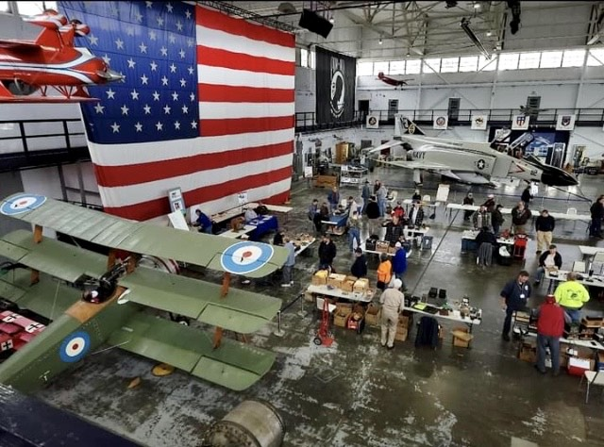

**_________________________________________________________**

A class EF2 tornado hit the Goshen area of Clermont County on Wednesday resulting in major damage to the village, including its fire station. Among those receiving damage was Dave Vest, K8DV. Dave lost his tower and antennas in addition to having damage to his home. Dave is well-known as a DXer and contester. He additionally is a past president of the **Milford ARA**, is associated with the **Southwest Ohio DX Association** and an ARRL QSL card checker.

It was interesting to listen to the just concluded 13 Colonies Week special event and to hear a good number of Ohio stations in the chase to get the 13 special event stations and the 3 bonus stations in their logs. It was observed some stations had really deep pileups while others seemed to go begging for a contact. However it amazes me that some people will not follow instructions for whatever reason. When an operator calls for only stations in the 3rd district to respond, why does a 7 call? Go figure! I was able to work all 13 plus the three bonus ones. It was a fun event.

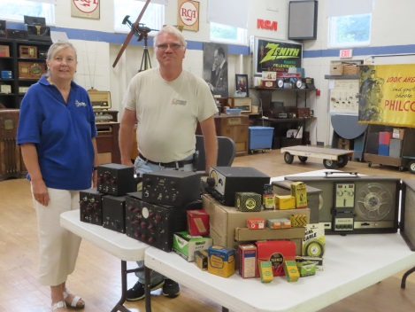A delegation of **Highland ARA** members recently traveled to the West Virginia Museum of Radio and Technology in Huntington where Museum President and Curator Geoff Bourne accepted a number of items to add to their collection of radios and other items preserving the history of ham and other forms of radio and the technologies arising from it. According to HARA Secretary Kathy Levo, the items donated to the Museum had been donated to HARA by Robert Gunderman, W8INO, with the request they find good homes where they would be preserved and displayed for future generations of hams and others interested in radio history to study and enjoy. Because it is a part of the mission of the Museum, the West Virginia museum was selected. We are fortunate to have two excellent museums close to us.

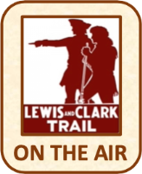Speaking of special event operations, during Tuesday evening’s **Portsmouth RC** meeting, Michael Bailey, N8MRB, reported the PRCwas the only Ohio club activation during the recent Lewis and Clark Trail Special Event and put 2,467 contacts in the log. Of the 16 clubs activating stations they were the third highest. He also recognized Gary Caldwell, WX8G, for making 1,016 of those contacts during the event. Bailey presented each participant with a plaque recognizing their involvement during the July 5 meeting.

Two Southern Ohio clubs are planning to activate their own special event stations on the first Saturday in October. The **Southern Ohio ARA** plans to operate a station from Ohio’s Southernmost point at South Point and the **Highland ARA** is going to operate from the Gist Settlement in Highland County. The **Portsmouth RC** has appointed a committee to explore the possibility of doing a special event station yet this year to recognize some aspect of Scioto County history.

During our visit to the Huntington Museum we learned of their annual Summer Swap Meet fund raiser on July 22-23 at the Museum. The swap starts around noon on Friday the 22nd and will continue until about 7 that evening. On Saturday the gates will open at 7 am and close following an auction-usually ending around 4. Inside tables and outside spaces are $10 for the first table/space and $5 for each additional one. There is no admission fee. A food truck will be on the grounds each day.

On August 13 the **Tri-State ARA** will hold their 59th annual hamfest at the New Baptist Church in Huntington, WV. It starts at 8:30 am and will run until 1:30. You can get further information at https//www.qsl.net/w8va/ or contacting Fred Herr, WD8AGH, at 304-736-2057. Admission is $6 and flea market spaces are $10 each which includes an admission ticket.

It’s official! After a couple years of not being held because of health concerns, the popular **Portsmouth RC**’s Hamfest will return this year. However the event will not be held at the “same old place” as in past years. The October 15 event is being moved to the New Boston Community Center at 3980 Rhoads Avenue in New Boston. More information will be announced as the date draws nearer.

Speaking of hamfests—the **Aladdin Shrine Audio Unit-W8FEZ** will sponsor the Columbus Hamfest on Saturday, August 6 at the Aladdin Shrine Center in Grove City. The Center is located just off the I-71 and Stringtown Road intersection near the Tee Jays Restaurant. The admission is $5 at the gate. Indoor and outdoor flea market tables and spaces are available at $10 each. The doors open at 8 am with a 1 pm closing.

A major source of income for the **Milford ARC** is the Cincinnati Hamfest. The Club is able to provide VE testing and operating events through the funds raised from this event. This year’s event will be on Saturday, August 13 at the Clermont County Fairgrounds in Owensville. This year MARC is raffling a Yaesu FTDX10. Tickets are available on-line at [www.CincinnatiHamfest.org](http://www.CincinnatiHamfest.org). You do not have to be present to win.

It’s been learned of the passing of John Eary, KE4EWS, of Ashland, KY. John was a well-known ham throughout the Ohio Valley and will be missed. Our thoughts and prayers go to his family and friends.

The **Cambridge ARC** has been asked to have a display at the upcoming August 12-14 Salt Fork Arts and Crafts Festival in the Cambridge City Park. The display will be in the Heritage tent and showcase the 109 year history of the CARA.

One Cool Transmitter—Mention an 807 to an old time ham and he immediately wonders if you are referring to a vacuum tube or a bottle of brew which was usually kept chilled in the refrigerator. But in 1953 Bernard Clark, W8PNR, built this transmitter in the shell of an old refrigerator. It is one of the many neat items on display at the radio museum in Huntington which is also the home of the West Virginia Radio and Television Hall of Fame. (Did you know that Don Knotts and Soupy Sales are both from West Virginia?) It is well worth a trip to visit this gem. Check out their website, [www.mrtwv.org](http://www.mrtwv.org) for their hours of operation and other information. Admission is free, but donations are appreciated.

Several Southern Ohio clubs and individual operators are already planning their operations for the September Ohio State Parks on the Air operating activity. Although a look at the OSPOTA.org website shows a decent number of Southern and Eastern Ohio parks already showing proposed activity during that day, there still are a number lacking activations. So why not check out the website and see how you might participate.

Just In—Hamvention Spokesman Michael Kalter, W8CI, reports of an article about the recent Hamvention appears in the just released July edition of CQ Magazine. He states the article contains information about the **Highland ARA** being named the Hamvention Club of the Year.

That’s it for another week. In the meantime, stay healthy, safe and radio-active.

John Levo, W8KIW, [jlevo@cinci.rr.com](mailto:jlevo@cinci.rr.com), 937-393-4951

**Print an Official or Unofficial Copy of Your Amateur Radio License**

*(By Anthony Luscre, K8ZT)*

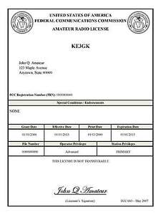

As of February 17, 2015, the **FCC no longer routinely issues paper license documents** to Amateur Radio applicants and licensees. The Commission has maintained for some time now that the official Amateur Radio license authorization is the electronic record that exists in its Universal Licensing System (ULS). The FCC will continue to provide paper license documents to all licensees who notify the Commission that they prefer to receive one.

Licensees also will be able to print out an official authorization — as well as an unofficial “reference copy” — from the ULS License Manager. I’ve created a set of instructions on how you can request an **“official” printed copy of your license\***

[**Click here to download the instructions**](http://arrl-ohio.org/news/2020/print_your_license.pdf)

***One Question Questionnaire***

!!!!! I would really like to hear from as many of you as possible on this one. While I know what I think the answer is going to be, the bigger the sample, the more accurate a survey like this is likely to be.

How about going to <http://arrl-ohio.org> and giving me a click? (It’s in the bottom left corner of the page) I’ll have more to say about this in the next OH Section Journal!

***Have you participated in at least 2 Amateur Radio Club activities in the past month?***

***Yes / No***

From the last Poll: ***Do you have a DXCC Certificate?***

***Yes / No***

Out of 50 responses, 40% yes and 60% no.

Ohio Section Cabinet

|  |  |
| --- | --- |
| Section Manager – Tom Sly, WB8LCD | Section Traffic Manager – David Maynard, WA3EZN |
| Section Emergency Coordinator – Stan Broadway, N8BHL | Section Youth Coordinator – Anthony Luscre, K8ZT |
| Technical Coordinator – Jeff Kopcak, K8JTK | Affiliated Clubs Coordinator – Tom Sly, WB8LCD |
| State Government Liaison – Bob Winston, W2THU | Public Information Coordinator – John Ross, KD8IDJ |



Hey Gang,

Have you taken a look at the **Swap & Shop** page on the Ohio Section webpage yet?? Here’s a link that will take you there… <http://arrl-ohio.org/sm/s-s.html>

Do you have equipment that you just don’t need or want anymore? Here’s a great venue to advertise it, and it’s FREE!! Is your club doing a fund raiser to help raise money? After a lot of thought, it was decided that the Swap & Shop webpage could also contain these types of items as well. The same rules will apply as do for the For Sales and Give-A-Ways and will only be posted for a month at a time. Please see the Terms & Conditions on the webpage.

If your club is doing a fund raiser and wants more exposure, please forward the information to me and I’ll advertise it on the Swap & Shop webpage for you.

Now, I still want to remind you that it won’t be listed in this newsletter because it would take up way too much space, so your ad will only appear on the website. It is there for any individual to post equipment Wanted / For Sale or Give-Away as well as for Club Fund Raisers. No licensed vehicles/trailers or business advertising will be posted. Postings are text only (no pictures or graphics) will be posted for a maximum of 1 month from date posting and require a contact phone number or email within the posting. Send your Wanted / For Sale or Give-Away post to:  [swap@arrlohio.org](mailto:swap@arrlohio.org)

***Back Issues of the PostScript and Ohio Section Journal***

Hey, did you know that PostScript and Ohio Section Journal (OSJ) are archived on the website? You can go back and look at any edition simply by clicking:

<http://arrl-ohio.org/news/index.html>

***Want to Share your Club Newsletter With Others?***

We have a webpage where you can download and read all of the newsletters that I get from around the state and even other sections!

Here’s the link to the page…. <http://arrl-ohio.org/club_news/index.html>

Please, if you don’t see your club newsletter posted, it’s because I’m not receiving it. Just have your newsletter editor contact me and I’ll get your club’s newsletter listed on the site!!

We all learn and steal (I mean, share) from each other’s work. So, get me your newsletter!!! Send it to: [webmaster@arrl-ohio.org](mailto:webmaster@arrl-ohio.org)

***Chit – Chat, and All That!***

Do you know someone that’s not getting these Newsletters? Please, forward a copy of this Newsletter over to them and have them “[Opt-In](mailto:Opt-In)” to start receiving them. Heck, just have them send an email to: [webmaster@arrl-ohio.org](mailto:webmaster@arrl-ohio.org) and we’ll get them added to the Ohio Section Emailing list.

We now have many thousands of readers receiving these newsletters weekly. Quite impressive, I’d say! I urge all of you to make sure that everyone, regardless of whether they are a League member or not, get signed up to receive these weekly Newsletters.

You can always “Opt-Out” at any time if you feel this is not what you were expecting. It’s fun and very informative. All of your favorite past newsletters are now archived too.

You can go back at any time and read them.

Just go to: <http://arrl-ohio.org/news/>

## [**3rd Annual Kentucky tate Parks On The Air – Amateur Radio Contest**](http://ospota.org/uncategorized/eleventh-annual-ohio-state-parks-on-the-air-amateur-radio-contest/)

Be sure to mark your calendar for the 2022 Kentucky Parks On The Air (KyPOTA) contest – August 13, 2022 Time: 1400 UTC to 2200 UTC (9 am - 5 pm CDT). The KyPOTA contest was conceived with three main goals in mind:

* To promote public awareness of amateur radio;
* To promote the recognition that Kentucky Parks have a very diverse and wonderful ecology;
* To promote camaraderie within the ranks of Kentucky’s Amateur Radio Operators

We agree it is a lot of fun to get out in a natural setting with our radios and see how well we can do at working operators in the beautiful Kentucky Parks.

This will be the 3rd annual KyPOTA – Make plans now to be active in KyPOTA 2022.

Don’t forget – we have a KyPOTA E-mail Group located at KyPOTA@murray-ky.net

Since we do allow spotting to encourage more contacts during KyPOTA, Facebook is being used before and during the contest for instant updates and to share stories and photos.

Notes: Some Kentucky Parks are being managed by local park systems, but they are still listed and considered to be Kentucky Parks. Please be considerate of others using the parks.

Questions? Email: [KyPOTA@murray-ky.net](mailto:KyPOTA@murray-ky.net). When the KyPOTA contest is over, send Logs to [KyPOTA@murray-ky.net](mailto:KyPOTA@murray-ky.net) by August 27, 2022 or 14 days following the event. Contest rules can be found at: [WWW.k4msu.com](http://WWW.k4msu.com)/kypota.

So – pick a park and make your plans now for KyPOTA 2022 !! Take care & 73 from the entire KyPOTA contest committee and the contest sponsor: Murray State University Amateur Radio Club, Box 2580 University Station, Murray, Ky 42071.

[**Fifteenth Annual Ohio State Parks On The Air – Amateur Radio Contest**](https://ospota.org/uncategorized/eleventh-annual-ohio-state-parks-on-the-air-amateur-radio-contest/)

Make sure to mark your calendar for the 2022 Ohio State Parks On The Air (OSPOTA) contest – September 10, 2022. The contest is always held on the first Saturday following the Labor Day holiday. Each year this event has grown and we anticipate another year of growth with even more participating Amateur Radio Operators.

Let me remind you that the OSPOTA contest was conceived with three main goals in mind:

* To promote public awareness of amateur radio and Ohio’s beautiful state parks system;
* To contribute to the recognition that Ohio has a very diverse and wonderful ecology;
* To promote camaraderie within the ranks of Ohio’s Amateur Radio Operators

Your participation has allowed these goals to be achieved. We agree it is a lot of fun to get out in a natural setting with your radio and see how well you can do at working operators in the beautiful Ohio State Parks.

This will be the 15th annual OSPOTA – Make plans now to be active in OSPOTA 2022.

Don’t forget – we have an OSPOTA E-mail Group located at: <https://groups.io/g/OSPOTA>

The [OSPOTA IO Group page](https://groups.io/g/OSPOTA) is used for messaging and sharing of information about OSPOTA for all the fans and participants in the OSPOTA contest. The [E-mail Group](https://groups.io/g/OSPOTA) is where the action is.

Since we do allow spotting to encourage more contacts during OSPOTA, Facebook is being used before and during the contest for instant updates and to share stories and photos.

As the contest draws near, we’ll be posting on the OSPOTA E-mail Group page the anticipated ‘who’s going to be at what Ohio State Park’ or ‘Planned Park’ list as we have in past years. Send your planned park activation information to [PlannedParks@ospota.org](mailto:PlannedParks@ospota.org) . Please, include the call sign that will be used and the Ohio State Park you plan to be at. If your plans change, just let us know and we’ll update the list. Remember, more than one person or group can be at an Ohio State Park – there are no reserved State Parks.

Notes: Some Ohio State Parks are being managed by local park systems, but they are still listed and considered to be Ohio State Parks according to ODNR (Quail Hollow & Tinkers Creek).

So – pick a park and make your plans now for OSPOTA 2022 !!!!!! Take care & 73 from the entire OSPOTA contest Committee, KB8UUZ, WG8X, W8PT, W8KNO, KB8UHN

Tom, KB8UUZ OSPOTA Chairman OSPOTA

Questions? Email: [INFO@ospota.org](mailto:INFO@ospota.org)

When the OSPOTA contest is over, send Logs and Summary Sheets to: [Logs@ospota.org](mailto:Logs@ospota.org)

*PostScript is produced as a weekly newsletter. I want to thank everyone that has contributed articles and ideas to make this an even better news source. I sincerely hope that you have enjoyed this edition and will encourage your friends to join with you in receiving the latest news and information about the Ohio Section, and news and events happening around the world!*