[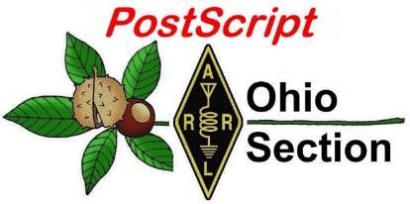](http://arrl-ohio.org/news/)

***“April 18th, 2022***

***Easter Ed******ition”***

🡪 National News 🡪 Club Corner

🡪 DX This Week 🡪 Contest Corner

🡪 Upcoming Hamfests 🡪 One Question Questionnaire

🡪 VE Testing 🡪 South 40

**CQ CQ CQ de WB8LCD**

I hope you all had a wonderful weekend with families and friends, enjoying the Easter holiday. The Easter holiday is all about “Resurrection”. There are many times in life where resurrection is necessary if we are to continue to have a meaningful life. I hope that you have had the opportunity to reflect on your life and actions, and apply the concept of “Resurrection” to your life as you deem necessary and appropriate.

Right after World War II, with the advances in technology that came about through the war, and especially with the influx of “Government Surplus” items being released to the public, Ham Radio was the King of all Hobbies! Ham Radio guys and gals could do amazing things that others appreciated and wished that they could understand. Ham Radio operators filled positions in every scientific and engineering program, firm and institution where technology continued to advance. After the 1970’s, Amateur Radio seems to have lost it’s charm with the general population. That’s not to say that Hams are still not at the forefront of lots of the technological advancements taking place, but there has been a disconnect. Perhaps we need a resurrection of sorts to bring Amateur Radio back to the forefront. Amateur Radio has a lot to offer to anyone who is interested in science and technology. We need to make that connection clearly visible in todays world.

**Ohio Section Youth Net**

The first OHIO Section Youth Net was held last Sunday evening. I would call it a successful first night out and a great start to a new program! There was a total of 14 check-ins. That included 11 check-ins between the ages of 8-16, and one check-in with his daughter who is in that age category and working towards getting licensed. Everyone introduced themselves, gave their age and just a little bit about there experience with Amateur Radio. At least 4 of those held an Amateur Extra license!

For now, the net is scheduled to run the second Sunday evening of each month. You’ll see reminders here and I hope you’ll extend the invitation to any young person you know to get involved with the net. Even if not yet licensed, we encourage youth who are interested to participate as a 3rd party with a parent, relative or friend who is a ham as the control station for that person. I want to especially thank Katherine – KE8LQR and Bernadette – KE8LWO who are the committee members in charge of this project. Well done!

73,

Tom Sly – WB8LCD

ARRL OHIO Section Manager

330-554-4650 cell pho

***National News***

*(from ARRL and other sources)*

**MORSLE?**

You've likely seen the New York Times Wordle of the day challenge, and perhaps the Canadian Canuckle ( a Canadian word of the day), but there's also something for us hams! The Morsle of the day! Listen to a word in Morse code and guess the word!  
  
Try it!  
  
[https://morsle.fun](https://morsle.fun/)

Philip / K8PJW

**The Importance of Being** **Earnest (in Working DX)**

***- Bob Bross, W8NFM***

Many of us work DX for the challenge of reaching out to others around the world; others enjoy contesting; then, there are the long-distance friendships made. Each, some, or all of these are worthwhile in their respective ways.

What about emergencies, where the only means of communication is amateur radio? In our technology-driven society, with satellites circling overhead, that doesn’t seem likely. So, here is your first question: what percentage of international communications is conducted via satellite? The answer is: one percent.

99% of international communications is conducted via subsea (submarine) cables.

While this number is surprising, it also makes sense: with newer cables able to handle 224 TBps (that’s 224 million Megabytes – try getting THAT speed from your local provider) and offering protection from most solar events - this is the route most of the world’s Internet, telephone, and most other types of communication take. Here is your second question: what could possibly damage an undersea cable?

Volcano Hunga Tonga-Hunga Ha’apei, in the South Pacific .

On January 14th, 2022 scientists noticed some venting from what was a mostly underwater volcano in the Pacific Ocean. A mild eruption was expected, consisting mostly of ash and smoke, so it was monitored by satellite. The next day, it exploded with a force equivalent to 1000 Hiroshima atomic bombs, creating a tsunami which caused significant damage to the 36 inhabited islands of the 170-island nation of Tonga. Massive ash added to the devastation – oh, and two underwater cables were severed.

There were only a few satellite phones on the island, and no active amateur radio operators; past HF communications mainly came from tourists. If there had been a HF station in operation, it would have handled a considerable amount of emergency traffic, as it took five weeks to restore an underwater cable connection. Of course, the other part to this is someone to receive communications from Tonga – and that would require multiple stations as band conditions changed throughout each day.

Closer to home, amateurs have been asked to keep certain HF frequencies open as a hurricane approaches U.S. or nearby territories. Listening in as operators take calls illustrates the importance of radio communications during these challenging situations. While certain emergency centers are activated, any of us could find ourselves on the receiving end of a catastrophic event with little or no warning.

The bottom line of all this: enjoy contesting and working DX stations. Make note of which antenna works best – and when - on each band. Challenge yourself to pull out weak stations. Explore those frequencies which may be outside ideal solar cycle conditions. Encourage other amateurs to work more HF. These activities will bring personal satisfaction, enjoyment, and confidence in your communications abilities and equipment capabilities. Should the time come for YOU to handle a disaster call, YOU will be ready.

*Used with permission of the author from the* April 2022 “Listening Post” *newsletter of the* *Queen City Emergency Net*

**Solar Cycle 25: The Overachiever**

Monday, 11 April 2022 17:17 UTC

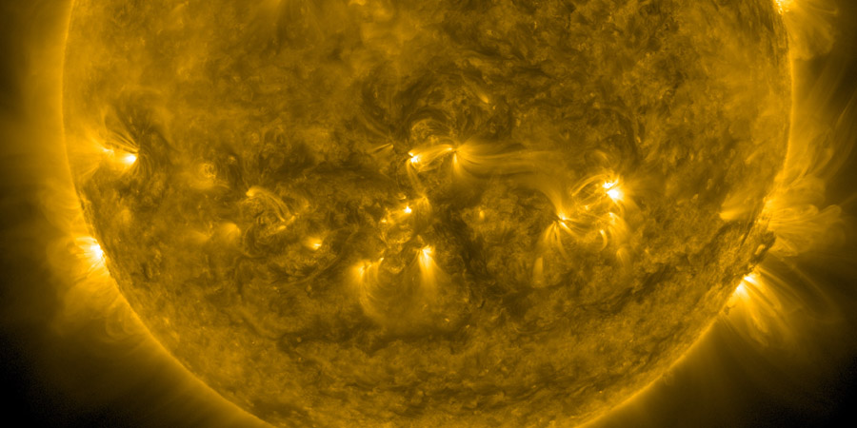

Today we have a really special news item for you! We have a guest post made by Christian Harris from Space Weather Trackers. Christian is a friend of the website and has some serious big brain knowledge about everything space weather related. I am sure many of you have heard of him before and we reached out to him to shed some light on the current Solar Cycle 25 and how it stacks up to previous Solar Cycles. Please read his article below and gain some fascinating insights on how SC25 is developing. It is well worth the read! If you are interested in Christian's work be sure to follow [him on Facebook](https://www.facebook.com/NuviremusX) and follow his [Space Weather Trackers Facebook page](https://www.facebook.com/spaceweathertrackers)

X-class solar flares, strong geomagnetic storming, CME after CME; all the telltale signs of our star during the midst of its peak in activity, generally known as solar maximum. A few years back we had finally entered the beginning of Solar Cycle 25, a cycle that NOAA initially forecasted to be similar in strength to our previous cycle, which wasn’t terrific in comparison to the cycles before it in terms of maximum sunspot numbers. So, this begs the question, “Why has solar and geomagnetic activity been so high the last few months?”

NOAA initially gave the forecast for Solar Cycle 25 (SC25) in April of 2019, stating a start time of late 2019 to early 2020, and a peak Sunspot Number (SSN) of 117 ± 23, peaking sometime in the middle of 2025. Compared with the peak of SC24, already a weak cycle in the grand scheme, it’s expected to be similar in strength.

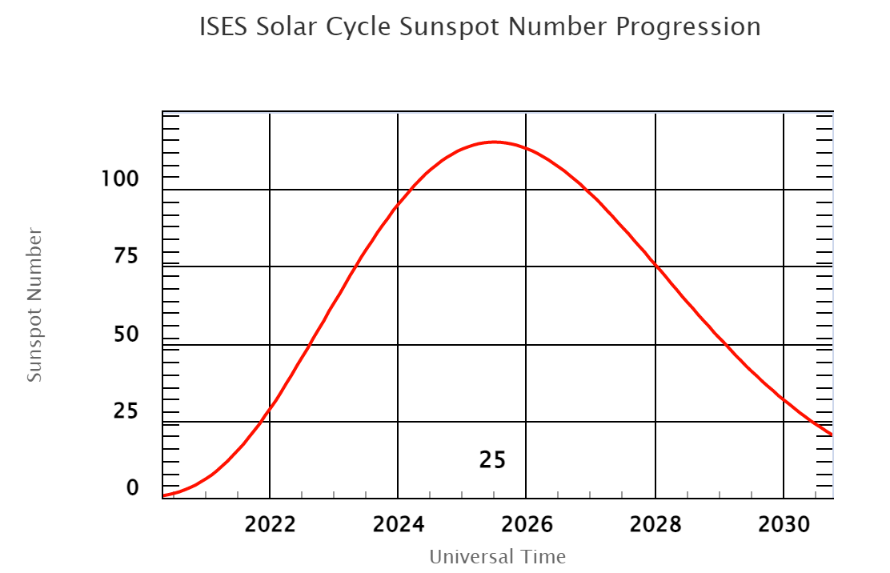NOAA’s forecast for the entirety of SC25.

In December of 2019, we officially crossed over into SC25 as new sunspots, with opposite leading polarities of the previous cycle’s, started forming more consistently at higher latitudes.

As the months went by, the surprises began, and the slow, steady increase we thought we’d see gave way to a rapidly increasing SSN. As early as October of 2020, the SSN was already nearly four times higher than forecasted, and it didn’t stop there. This acceleration continued until we started seeing numerous and potent sunspots, M and X class flares, and plenty of aurora for middle and upper latitudes. So why the sudden rapid and deviating levels of activity, only a few years after we officially entered SC25? Let’s talk about the numbers and compare them to where SC24 was at this point in its timeline.

We currently have smoothed values for this cycle up to September of 2021, which stand at a value of 40. With a forecasted smoothed SSN for the same month of 19.7, its clear the current progress is far ahead of what was initially expected. In the next photo, I’ve superimposed an image of SC25’s smoothed SSNs on top of SC24’s for the same timeframe, with NOAA’s forecast to detail the drastic differences.

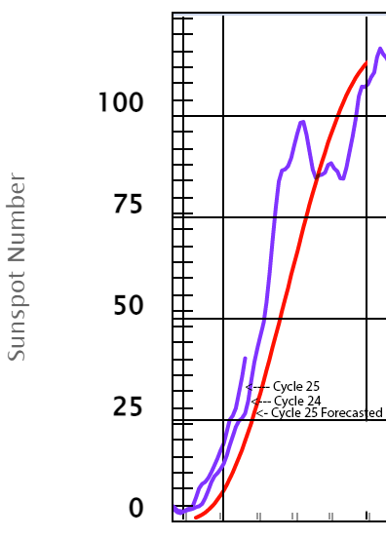

Cycle 25’s current Smoothed SSNs shown with Cycle 24’s, both in purple, as well as NOAA’s forecasted line in red

You can see the slope for SC25’s line is much higher than what SC24’s was at this point, and drastically different from NOAA’s forecast. So, it’s clear that Cycle 25 is blowing away expectations, but another question looms: “Does this imply the cycle will peak sooner, have a stronger peak, or something else?” One can only tell with time, but there are a few possibilities that might help track things a bit more accurately from this point on, such as in the next photo.

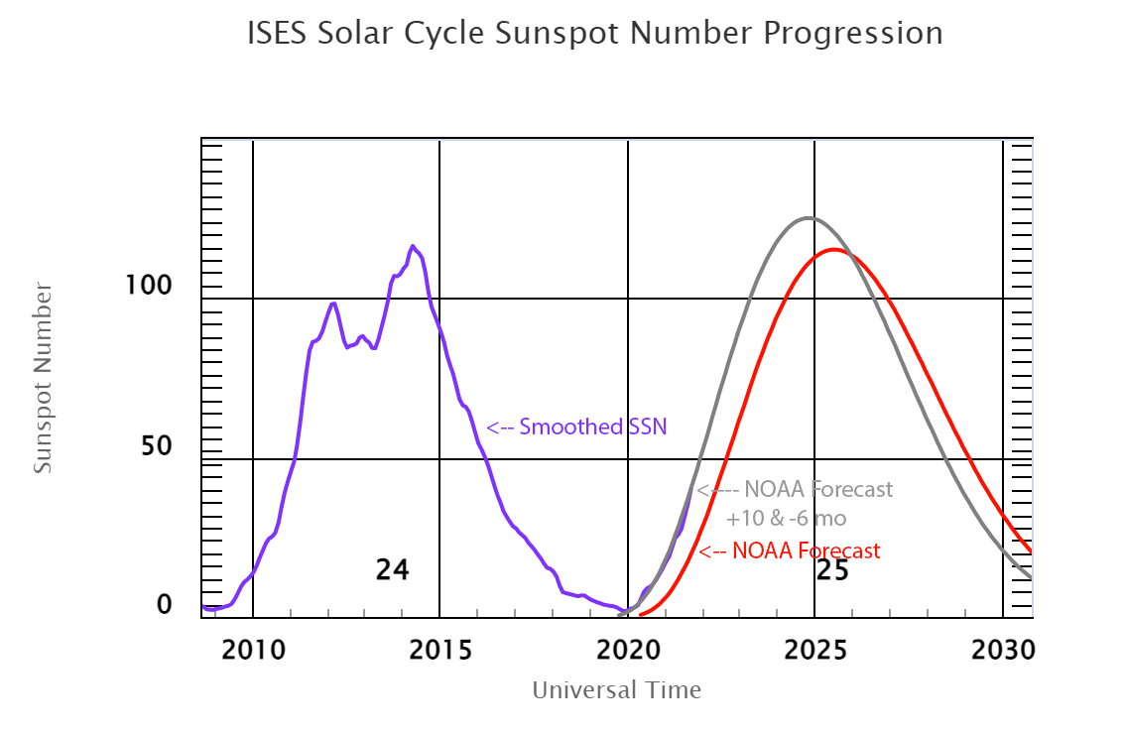Another look at Cycle 24 & 25, again with a smoothed SSN (purple line) and NOAA’s forecasted SSN (red line), but with the addition of a hypothetical scenario where the SSN peak comes 6 months earlier and has a value +10 higher (gray line).

NOAA’s Space Weather Prediction Center (SWPC) website on the progress of the solar cycle has some handy features, including the ability to test out numbers under different assumptions, such as if the peak of the cycle came 6 months earlier/later, or came at the forecasted time but had a higher/lower SSN. If you look at the scenario in which the cycle peak came six months earlier than forecasted, and had a higher value (+10), you’ll notice that the current smoothed SSN line is almost completely hidden behind the new scenario, implying a very strong agreement in terms of the SSNs, as well as timing. This also brings the forecasted smoothed SSN to be about 127, putting it slightly over SC24’s strongest peak. This is a good sign for implying that this cycle will be a bit stronger than what we had for SC24. However, there’s another theory running out there that could be a game-changer.

In June of 2020, McIntosh et al. put out a paper describing a pattern they found in the sun’s magnetic cycle when considering the exact time frame the toroidal magnetic fields of a specific cycle ended, noted as a “termination event,” to the time that the following cycle’s fields ended. A relationship was found that suggested an inverse correlation between the time elapsed between termination events and the severity of the following cycle. For example, a shorter time between cycle 1’s and cycle 2’s termination event, meant a higher sunspot number in cycle 3. When using this relationship, McIntosh and his team were able to recreate, with surprising accuracy, all the previous solar cycles’ peak sunspot numbers, including the Dalton minimum from the late 1700s-mid-1800s where hardly any sunspots showed up at all. The team then made a drastically different forecast from the rest: SC25 would have a peak SSN between 204 and 254! As a reference, these numbers are like what we saw in SC21 & SC22, which had several big events like the Quebec power outage of 1989, which was also a major aurora event for the world. This forecast wasn’t foolproof however and assumed that SC24’s termination event, which had not yet occurred, would occur in May of 2020.

Months after the paper came out, Cycle 24’s termination was detected in December of 2021, increasing the time frame between termination events by 19 months—which then decreased the forecasted SSN from 204-254 to 170-210! This now puts the forecast for SC25 to be on par with SC23, which gave us the famous Halloween storms of 2003, where aurora was seen for two nights in a row across the entire world.

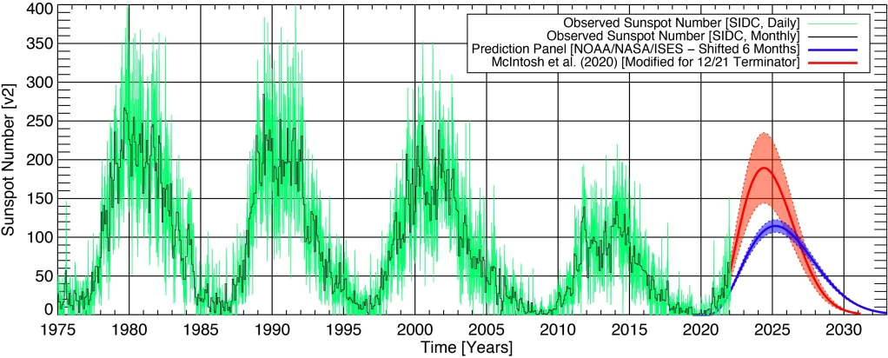Solar Cycles 21 – 25 and their observed SSNs from SIDC, as well as NOAA’s current estimate and error ranges (Blue line & shaded area) as well as the forecast by McIntosh et al. with the newly discovered SC24 termination event (Red line & shaded area.)

Will SC25 continue to defy current predictions of a weaker cycle and take us out of what appears to be an impending grand minimum, or is it just a quick rush into what will be a lackluster cycle like its predecessor? Either way, I’m just hoping for more aurora.

*Thank you for reading this article! Did you had trouble with some of the technical terms used in this article? Our help section is the place to be where you can find in-depth*[*articles*](https://www.spaceweatherlive.com/en/help.html)*, a*[*FAQ*](https://www.spaceweatherlive.com/en/faq.html)*and a list with common*[*abbreviations*](https://www.spaceweatherlive.com/en/acronyms-and-abbreviations.html)*. Still puzzled? Just post on our*[*forum*](https://community.spaceweatherlive.com/)*where we will help you the best we can! Never want to miss out on a space weather event or one of our news articles again? Subscribe to our*[*mailing list*](https://www.spaceweatherlive.com/en/aurora-alerts.html)*, follow us on*[*Twitter*](https://twitter.com/_SpaceWeather_)*and*[*Facebook*](https://www.facebook.com/SpaceWeatherLive/)*and download the SpaceWeatherLive app for*[*Android*](https://play.google.com/store/apps/details?id=com.spaceweatherlive.app)*and*[*iOS*](https://itunes.apple.com/us/app/spaceweatherlive/id1435501021?mt=8)*!*

The above was posted by Bob – KD8CGH and is used here with permission from the author Mr. Christian Harris and from the Space Weather Website. [www.spaceweatherlive.com](http://www.spaceweatherlive.com)

Announcements

The [Nashua Area Radio Society](http://n1fd.org/bootcamp) will hold their next online Ham Bootcamp on Saturday May 14 from 10 Am to 6 PM Eastern time. Ham Bootcamp includes a series of demonstrations and tutorials designed to help newly licensed Technician-, General-, and Amateur Extra-class license holders get on the air and use their amateur radio license. Bootcamp is also a great opportunity for prospective hams who are interested in seeing what the hobby has to offer. Ham Bootcamp activities are provided online via a series of sessions. Bootcamp participants will find all of this material interesting and fun no matter what their focus or license level.

The online Bootcamp program is available to all licensed and prospective hams in North America. You can register for the next Ham Bootcamp session in May 2022 by on the Nashua Area Radio Society website.

ARRL EXPO at Dayton Hamvention  
May 20 - 22, 2022

The ARRL, in partnership with the Dayton Hamvention**®**, will offer FREE EVENTS and forums every day at 2022's' Hamvention beginning on Friday, May 20.

**ARRL Booths**

**Radio Clubs.** Take the Radio Club Health Check!

**ARRL Development and ARRL Foundation.** Raising resources to extend the reach of ARRL programs and services beyond membership dues.

**ARES®**-**The ARRL Amateur Radio Emergency Service®**- and featuring ARRL Ham Aid.

**Meet the Authors.** Meet ARRL authors and editors who are inspiring today's radio experimenters, operators and innovators. (see schedule in the ARRL exhibit area)

**ARRL Collegiate Amateur Radio Initiative.** We Want U to help advance ham radio among college and university students: [**www.arrl.org/WeWantU**](http://www.arrl.org/WeWantU)

**ARRL Laboratory: Get Your Handheld Radio Tested!**

**ARRL Learning Center.**

**ARRL Teachers Institute.** Meet ARRL Education and Technology Program Instructors and explore the resources available for introducing radio science and wireless technology to everyone! Find ways to make, discover, experiment, explore, and build.

**ARRL Great Lakes Division** - Visit this gathering area for ARRL Field Organization networking, hosted by the ARRL Great Lakes Division and feature these ARRL Sections: Ohio, Kentucky, and Michigan.

**Radiosport and DXCC.** DXCC Card Checking, ARRL Contests and Awards, ARRL's Logbook of The World (LoTW), and QSL Bureau.

**ARRL VEC and ARRL Volunteer Monitor Program**.

**The International Amateur Radio Union (IARU) -**Meet representatives from the IARU.

ARRL-sponsored forums will begin on Friday May 20 including the 2022 ARRL Field Day and the ARRL Amateur Radio Emergency Service -- ARES Forums

**Friday May 20, 2022**  
Friday, 9:15 AM to 10:20 AM (Room 3)

**2022 ARRL Field Day**-- **Ready, Set, GO!**

ARRL Field Day, ham radio's most popular on-the-air event, is June 25 - 26, 2022. Field Day is fun whether you're participating from the great outdoors with your radio club, or from your home or backyard. It's also a terrific opportunity to practice your personal radio communications readiness, and to demonstrate amateur radio to the public. Hear from a panel of Field Day 'experts' who will cover the educational, operating, and public relations objectives of a successful and fun Field Day. The panel includes:

* Bart Jahnke, W9JJ, ARRL Radiosport and Regulatory Information Manager, who will cover rules recap and what's new.
* Bob Naumann, W5OV, ARRL Director of Operations, who will discuss Operating tips.
* Scott Roberts, KK4ECR, ARRL Public Relations Committee Member, who will explain how to get a boost by promoting your Field Day activation.

Friday, 1:15 PM to 2:25 PM (Room 3)

**ARRL Amateur Radio Emergency Service -- ARES Forum**Presenter: Josh Johnston, KE5MHV, ARRL Director of Emergency Management  
The Amateur Radio Emergency Service® (ARES®) consists of licensed amateurs who have volunteered their qualifications and equipment, with their local ARES leadership, for communications duty in the public service when disaster strikes. Come learn about opportunities to volunteer and train, and to hear stories about best-practices, the importance of building mutually beneficial relationships with local emergency management services, and the importance of our partnerships with served agencies. Sponsored by ARRL The National Association for Amateur Radio®.

A complete list of Hamvention forums can be found at **www.**[**hamvention.org**](http://hamvention.org/)**.**

***______________________________________________________________________________***

Annual Armed Forces Day Cross-Band Exercise Set for May 14

The 2022 running of the Armed Forces Day (AFD) Cross-Band exercise will be held on May 14, 1300 - 2200 UTC. A complete list of participating stations, modes, frequencies, times, and other details [will be announced](https://www.dodmars.org/mars-comex-information-website/armed-forces-day) on April 1. The event is open to all radio amateurs. Armed Forces Day is May 21, but the AFD Cross-band Military-Amateur Radio event traditionally takes place 1 week earlier in order to avoid conflicting with Dayton Hamvention®. During the exercise, radio Diagram
amateurs listen for stations on military operating frequencies and transmit on frequencies in adjacent amateur bands.

Military and amateur stations have taken part in this event for more than 50 years. It's an exercise scenario, designed to include ham radio and government radio operators alike.

Per previous announcements: "The AFD Cross-band Test is a unique opportunity to test two-way communications between military communicators and radio stations in the Amateur Radio Service, as authorized in 47 CFR 97.111. These tests provide opportunities and challenges for radio operators to demonstrate individual technical skills in a tightly controlled exercise scenario that does not impact any public or private communications."

Military stations in various locations will transmit on selected military frequencies and announce the specific ham band frequencies they are monitoring.

An AFD message will be transmitted utilizing the Military Standard (MIL-STD) serial PSK waveform (M110) followed by MIL-STD Wide Shift FSK (850 Hz RTTY), as described in MIL-STD 188-110A/B. The AFD message will also be sent in CW and RTTY.

Full details will be released on April 1.

***_____________________________________________***

***Club Corner***

This is YOUR cornner of the newsletter. Send me what your club is doing and I’ll make sure that it gets in. Got a special event or club project that you want everyone to know about? Send it to me! Need help with a project? Send it to me.

Let me know what you club is up to. Are you going to have a special guest at your meeting or are you having a special anniversary?

Just sent it to: [webmaster@arrl-ohio.org](mailto:webmaster@arrl-ohio.org) Please! Format as below:

******If you want me to publish your club information, or even an article you have written, please send it in WORD format (.docx). Please use Times New Roman font size 12 for the body of the aritcle. Any photos please include as a .jpg or .bmp – the time you save me in doing all the conversions will be greatly appreciated.

Skywarn Training Schedule for 2022

Portage, Trumbull & Mahoning Counties:

For those that may have missed the online Skywarn Training on April 14th, the National Weather Service is planning on spotter classes in the Fall for Portage, Trumbull and Mahoning counties.

Dates, time and location info as soon as I have it.

73,  
Gregg - WB8YYS

​**______________________________________________________________________**

**Help Desperately Needed!**

Hi all! I'm still in need of operators for the Glass City Marathon. Race day is Sunday, April 24th and the start time is 6:30 AM. The race starts and ends on the campus of the University of Toledo and the course runs west and north from there. If you'd like to sign up or get more information please contact me at either [k8rks@arrl.net](mailto:k8rks@arrl.net) or 419-471-0573.

Thanks!

Rick K8RKS

[k8rks@arrl.net](mailto:k8rks@arrl.net)

419-471-0573

**__________________________________________________________**

**Bus Trip to Hamvention!**

The Silvercreek Amateur Radio Association (SARA) will be sponsoring a bus trip to Hamvention in Xenia Ohio on Saturday, May 21, 2022. The bus will depart from Akron, Ohio at 5:30am on the 21st. The bus is planned to arrive by the start of Saturday’s event at 9:00am and will depart from the Hamvention bus area at 4:00pm for the return trip. The bus will make stops for breakfast (McDonald’s) and dinner (Cracker Barrel) with both meals at your own expense.

The trip package includes the **bus fare and entrance ticket** and is priced at $100. Reservations must be made by April 15th. *The bus requires a minimum purchase of 35 riders and SARA will cancel the event with full refund if 35 riders have not been scheduled and paid by April 15, 2022.* Except for the case of a cancellation of the trip, all purchases are non-refundable. If there are bus seats remaining after April 15th, **bus fare only** will be $74. Remaining seats will be filled on a first-come-first-serve basis.

Visit <https://w8wky.org/bustrip> for more information and to reserve your spot!

*****UPDATE*****

The Hamvention Bus Trip is a GO! Package sales for a bus seat + Hamvention ticket are still available through Thursday, April 20th for $100. After that, bus-only tickets will be $74 and on sale through the week before Hamvention or until all remaining seats are sold out.

**__________________________________________________________**

How to Plan and Apply for an ARRL Hamfest or Convention

If your amateur radio club is planning to host a convention, hamfest, tailgate, or swapfest, please consider applying for ARRL sanctioned status for your event. To learn what it means to be an ARRL sanctioned event, and to get some ideas on how to prepare for and conduct a hamfest or convention, visit [www.arrl.org/arrl-sanctioned-events](http://www.arrl.org/arrl-sanctioned-events).

To apply for ARRL sanctioned status for your event, go to [www.arrl.org/hamfest-convention-application](http://www.arrl.org/hamfest-convention-application).

The ARRL Hamfests and Conventions Calendar can be found online at [www.arrl.org/hamfests](http://www.arrl.org/hamfests). In addition, the Convention and Hamfest Calendar that runs in *QST* each month also presents information about upcoming events.

Go Fully Electronic in 2022!

By Maria Somma, AB1FM, ARRL VEC Manager

**Online Examinations and Remote Testing**

Your club's VE team can become part of the fun and excitement of remotely administered Online Examinations.  
  
The remote exam sessions are conducted using an online video conferencing platform and a web-based examination system with on-screen tests. ARRL VE teams have had the option to be completely electronic since June 2020 by using online exams. The online exams can also be utilized at in-person sessions automating most of the process, for a fully electronic in-person session experience.  
  
VE teams have been using the [Exam.Tools](https://exam.tools/) Online Examination system for remote video and in-person sessions. Over 25,000 applicants have been tested through the Online Examinations system in the past two years. The system works well for online or printed examinations and includes registering and tracking candidates throughout the session, on screen exams and grading, online signing of CSCE and 605 forms by the candidate and examiners, logging and compiling session stats and VE participation list (test report summary), and output files for upload to the coordinating VEC. The program manages and handles almost everything needed to conduct a test session. Time and experience with in-person exam sessions is invaluable when transitioning to remote video-supervised online exam sessions.  
  
Interested ARRL VE teams must contact the [VEC department](mailto:vec@arrl.org) to receive the online exams instructions and remote video session procedures.  
  
Not a VE? Become one today!  
  
Visit <http://www.arrl.org/become-an-arrl-ve>  
  
**Electronically File Exam Session Documents for Quicker Service**

After the session has concluded, VE teams can upload in-person documents or remote video session files via ARRL VEC's secure web page (program service option since 2018).

New and upgraded licenses are issued within 1 to 2 business days for weekend sessions and are usually issued on the same day for weekday sessions.

Please contact the [VEC department](mailto:VEC@arrl.org) for the information and instructions on electronically filing exam session documents through our upload page. Authorized VEs will be sent the upload page URL which, is hidden from the public.

**Resources for ARRL VEs**

The [ARRL VEC VE Resources](http://www.arrl.org/resources-for-ves) page offers the information you will need to help conduct exam session business. Our support page offers easy access to session forms and information, online examinations, remote video session instructions, VE Manual supplemental information, FCC rules, basic qualification question procedures, and much more. There is also some helpful information for the community, such as preparation resources for candidates, in-person and remote video exam session search, vanity call sign information, and more.

The ARRL VE Newsletter relays important updates relating to FCC rule or policy changes, exam session document or procedural changes, video sessions, and other topics. VEs can sign up for the newsletter at <https://reflector.arrl.org/mailman/listinfo/ve-list>

**Alliance Radio Club Raffle**

Each year since 2020, the Alliance Amateur Radio Club in alliance, OH has raffled off a HF Rig. With each year, the interest grows. A portion of the money raised goes back into the Alliance area in the form of donations to local service groups at Christmas Time.

In 2021, moneys from our raffle combined with proceeds from the fundraiser at our Annual meeting allowed us to donate over $1000 to Charities in the Alliance Ohio area.

This year, we’ve chosen as our raffle item, an Icom IC-7300 HF + 6M Radio.

The winning ticket will be drawn on July 13th. The winner need not be present to win. You can learn more, and purchase tickets at <https://www.w8lky.org/about-us/2022-fundraiser/>. Questions can be directed to <mailto:fundraiser@w8lky.org>

____________________________________________________

From the Parma Radio Club:

Our 8th Annual

EARTH DAY CELEBRATION

Special Event Station

Operating entirely on energy from Ol'Sol

At the historic, educational, [**Stearns Farm**](http://www.stearnshomestead.com/)

in the heart of Parma, Ohio

 April 23, 2022

1500Z - 2000Z using our club call call sign, W8PRC

10 AM to 3 PM EST

7.195 mHz   14.245  mHz  (approx.)

We'd like your QSL for our Earth Day album.

Send an SASE envelope large enough for our 4"x 6" QSL.

**Lancaster and Fairfiled County ARC**

Congratulations to the club on scoring a “Feature Article” in the Fairfield Towne Crier for their support of ARES – see the full article here: <http://www.fairfieldtownecrier.com/4-11-22-OTC.pdf?fbclid=IwAR3-YwdR-fq3su-3Ps3goJI8DY2FReO9Nf61f4K1ffZK_hHbGdIrogyEwQQ>

**OHIO SECTION TRAFFIC REPORT – MARCH 2022**

**OHIO SECTION NETS – MARCH 2022**

|  |  |  |  |  |  |
| --- | --- | --- | --- | --- | --- |
| NET | QNI | QTC | QTR | SESSIONS | N/M |
| BN(E) | 154 | 32 | 314 | 30 | N2LC |
| BN(L) | 42 | 22 | 195 | 31 | WB9LBI |
| OSN | 87 | 9 | 371 | 23 | N2LC |
| OSSBN | 1690 | 327 | 2020 | 93 | KC8WH |

**OHIO SECTION PSHR REPORTS – MARCH 2022**

|  |  |  |  |  |  |  |  |  |
| --- | --- | --- | --- | --- | --- | --- | --- | --- |
| WA3EZN | 40 | 40 | 30 | 365 | 0 | 20 | TOTAL | 495 |
| N2LC | 40 | 40 | 30 | 125 | 0 | 30 | TOTAL | 265 |
| AD8CM | 27 | 9 | 10 | 160 | 0 | 0 | TOTAL | 206 |
| KV8Z | 40 | 34 | 10 | 90 | 0 | 10 | TOTAL | 184 |
| KM8V | 7 | 22 | 30 | 0 | 0 | 80 | TOTAL | 139 |
| W8DJG | 31 | 40 | 30 | 15 | 0 | 20 | TOTAL | 136 |
| N8SY | 40 | 2 | 30 | 10 | 10 | 50 | TOTAL | 132 |
| KE4RS | 40 | 40 | 10 | 35 | 0 | 0 | TOTAL | 125 |
| K8MDA | 40 | 39 | 20 | 0 | 0 | 20 | TOTAL | 119 |
| KC8WH | 40 | 40 | 30 | 0 | 0 | 0 | TOTAL | 110 |
| AC8NP | 40 | 40 | 10 | 0 | 0 | 20 | TOTAL | 110 |
| KD8UUB | 40 | 26 | 10 | 30 | 0 | 0 | TOTAL | 106 |
| WB8YYS | 40 | 24 | 20 | 10 | 0 | 10 | TOTAL | 104 |
| WB8SIQ | 40 | 40 | 10 | 10 | 0 | 0 | TOTAL | 100 |
| K3RC | 40 | 40 | 20 | 0 | 0 | 0 | TOTAL | 100 |
| AC8RV | 40 | 40 | 10 | 10 | 0 | 0 | TOTAL | 100 |
| KC8PBU | 40 | 40 | 20 | 0 | 0 | 0 | TOTAL | 100 |
| KE8ANW | 40 | 4 | 0 | 50 | 0 | 0 | TOTAL | 94 |
| KL7RF | 40 | 40 | 10 | 0 | 0 | 0 | TOTAL | 90 |
| K8KRA | 40 | 40 | 10 | 0 | 0 | 0 | TOTAL | 90 |
| N8MRS | 40 | 40 | 10 | 0 | 0 | 0 | TOTAL | 90 |
| KB8HJJ | 40 | 40 | 10 | 0 | 0 | 0 | TOTAL | 90 |
| KB8GUN | 40 | 40 | 0 | 0 | 0 | 10 | TOTAL | 90 |
| W8GSR | 40 | 40 | 0 | 0 | 0 | 0 | TOTAL | 80 |
| N3VQW | 40 | 40 | 0 | 0 | 0 | 0 | TOTAL | 80 |
| WD8JMD | 40 | 11 | 0 | 0 | 0 | 0 | TOTAL | 51 |
| NC8V | 17 | 13 | 0 | 20 | 0 | 0 | TOTAL | 50 |
| K8OVO | 40 | 7 | 0 | 0 | 0 | 0 | TOTAL | 47 |
| KD8MSZ | 20 | 6 | 10 | 0 | 0 | 0 | TOTAL | 36 |

**OHIO SECTION TRAFFIC REPORTS – MARCH 2022**

|  |  |  |  |
| --- | --- | --- | --- |
| AC8NP-50 | KC8IDM-35 | KV8Z-34 | W8DJG-46 |
| AC8RV-60 | KC8PBU-65 | N2LC-60 | W8GSR-42 |
| AD8CM-9 | KC8WH-54 | N3VQW-40 | W8SAB-2 |
| K3RC- 42 | KD8GYI-21 | N8BV- 40 | WA3EZN-152 |
| K8KRA-69 | KD8HB- 65 | N8GBU- 40 | WB8SIQ-120 |
| K8MDA- 39 | KD8MSZ-6 | N8MRS-68 | WB8YYS-24 |
| K8MWF-38 | KD8UUB-26 | N8OD-20 | WB9LBI-98 |
| K8OVO- 7 | KE4RS-57 | N8SY-2 | WD8JMD-11 |
| KB8GUN-99 | KL7RF-67 | N8TNV-94 | WD8SDH-32 |
| KB8HJJ- 41 | KM8V-22 | NC8V-13 |  |
|  |  |  |  |
|  | TOTALS | 39/1810 |  |

**OHIO SECTION LOCAL NETS – MARCH 2022**

|  |  |  |  |  |  |
| --- | --- | --- | --- | --- | --- |
| NET | QNI | QTC | QTR | SESSIONS | N/M |
| BRTN | 142 | 85 | 394 | 28 | W8DJG |
| COTN | 229 | 60 | 431 | 30 | KV8Z |
| NWOH ARES | 309 | 108 | 456 | 31 | N8TNV |
| TATN | 349 | 86 | 392 | 31 | WG8Z |
| TCTTN | 148 | 21 | 378 | 13 | WB8YYS |

**OHIO SECTION TRAFFIC REPORT – MARCH 2022**

**OHIO SECTION NETS** – **MARCH 2022**

NET QNI QTC QTR SESSIONS N/M

BN(E) 154 32 314 30 N2LC

BN(L) 42 22 195 31 WB8LBI

OSN 87 9 371 23 N2LC

OSSBN 1690 327 2020 93 KC8WH

**OHIO SECTION PSHR REPORTS – MARCH 2022**

WA3EZN 40 40 30 365 0 20 TOTAL 495

N2LC 40 40 30 125 0 30 TOTAL 265

AD8CM 27 9 10 160 0 0 TOTAL 206

KV8Z 40 34 10 90 0 10 TOTAL 184

KM8V 7 22 30 0 0 80 TOTAL 139

W8DJG 31 40 30 15 0 20 TOTAL 136

N8SY 40 2 30 10 10 50 TOTAL 132

KE4RS 40 40 10 35 0 0 TOTAL 125

K8MDA 40 39 20 0 0 20 TOTAL 119

KC8WH 40 40 30 0 0 0 TOTAL 110

AC8NP 40 40 10 0 0 20 TOTAL 110

KD8UUB 40 26 10 30 0 0 TOTAL 106

WB8YYS 40 24 20 10 0 10 TOTAL 100

WB8SIQ 40 40 10 10 0 0 TOTAL 100

K3RC 40 40 20 0 0 0 TOTAL 100

AC8RV 40 40 10 10 0 0 TOTAL 100

KC8PBU 40 40 20 0 0 0 TOTAL 100

KE8ANW 40 4 20 50 0 0 TOTAL 94

KL7RF 40 40 10 0 0 0 TOTAL 90

K8KRA 40 40 10 0 0 0 TOTAL 90

N8MRS 40 40 10 0 0 0 TOTAL 90

KB8GUN 40 40 10 0 0 0 TOTAL 90

KB8HJJ 40 40 10 0 0 0 TOTAL 90

W8GSR 40 40 0 0 0 0 TOTAL 80

N3VQW 40 40 0 0 0 0 TOTAL 80

WD8JMD 40 11 0 0 0 0 TOTAL 51

NC8V 17 13 0 20 0 0 TOTAL 50

K8OVO 40 7 0 0 0 0 TOTAL 47

KD8MSZ 20 6 10 0 0 0 TOTAL 36

**OHIO SECTION LOCAL NETS – MARCH 2022**

NET QNI QTC QTR SESSIONS N/M

BRTN 142 85 394 28 W8DJG

COTN 229 60 431 30 KD8TTE

NWOH ARES 309 108 456 31 N8TNV

TATN 349 86 392 31 WG8Z

TCTTN 148 21 378 13 WB8YYS

**OHIO SECTION TRAFFIC REPORTS – MARCH 2022**

AC8NP-50 KC8IDM-35 KV8Z-34 W8DJG-46

AC8RV-60 KC8PBU-65 N2LC-60 W8GSR-42

AD8CM-9 KC8WH-54 N3VQW-40 W8SAB-2

K3RC-42 KD8GYI-21 N8BV-40 WA3EZN-152

K8KRA-69 KD8HB-65 N8GBU-40 WB8SIQ-120

K8MDA-39 KD8MSZ-6 N8MRS-68 WB8YYS-24

K8MWF-38 KD8UUB-26 N8OD-20 WB9LBI-98

K8OVO-7 KE4RS-57 N8SY-2 WD8JMD-11

KB8GUN-99 KL7RF-67 N8TNV-94 WD8SDH-32

KB8HJJ-41 KM8V-22 NC8V-13

TOTALS 39/1810

**OHIO HF TRAFFIC NETS**

BN(E) Buckeye Net Early - CW

BN(L) Buckeye Net Late – CW

OSN Ohio Slow Net - CW

OSSBN Ohio Single Sideband Net – Phone

**OHIO VHF TRAFFIC NETS**

BRTN Burning River Traffic Net serving Cleveland and North Central Ohio

COTN Central Ohio Traffic Net serving Columbus and Central Ohio

MVTN Miami Valley Traffic Net serving the Dayton area

NWOH ARES Northwest Ohio ARES Net serving Toledo and surrounding counties

TATN Tri-State Amateur Traffic Net

TCTTN Tri-County Traffic and Training Net serving North East Ohio

**____________________________________________________**

VE Sessions

**All Things Amateur Radio Association (ATARA)** We host testing sessions every second Tuesday of the month to sign up please visit our website <https://atara-w8atr.fun> and contact us at [hamexams@atara-w8atr.fun](mailto:hamexams@atara-w8atr.fun).

**CARS**

VE testing from CARS - Cuyahoga Amateur Radio Society - at Elmwood Recreation Center, 6200 Wisnieski Parkway in Independence, Ohio 44131  Time: 9:15 AM (Walk-ins allowed) Always the 2nd Sunday of the odd month. Go to CARS  [www.2cars.org](http://www.2cars.org/) for detailed map of location.  Call Metro W8MET 216-520-1320 for details

**Dayton Amateur Radio Association (DARA)** If you are interested in testing for a new or upgraded license, please come see us at the DARA Clubhouse. If you have questions about testing, please email [exams.w8bi@gmail.com](mailto:exams.w8bi@gmail.com)

**The Lake County Amateur Radio Association**

The Lake County Amateur Radio Association is once again holding its **2022** Amateur Radio license exams at the **Kirtland Library**, 9267 Chillicothe Road, on the following dates:

Saturday, June 4, August 6, October 1, and December 3.

The tests will start at **12 noon.** Please arrive a few minutes earlier.

**The Lancaster and Fairfield County Amateur Radio Club (LFCARC**) hosts exam sessions at the FAIRFIELD County EMA, 240 Baldwin Dr in Lancaster Ohio, 43130, on the first Saturday each month at 10:00 am. Please visit our website at <http://www.k8qik.org> for exam dates on our calendar and navigate to our Learning Center/Taking the Exam link for information and requirements. Our experienced VE team looks forward to serving the Amateur Radio community in Central Ohio. Contact me at [ve_testing@k8qik.org](mailto:ve_testing@k8qik.org) to register.

**The Milford Amateur Radio Club (MARC)** is now doing VE testing on the third Thursday of each month at 6:00 PM.  Location;  Miami Township Civic Center located at 6101 Meijer Drive, Milford, OH  45150.

 Please pre-register at [www.milfordhamradio.org](http://www.milfordhamradio.org/)

**Portage County Amateur Radio Service (PCARS)**

The first Saturday of every even numbered month -10 am – at the PCARS club site in Ravenna. Please visit the PCARS web site and check out the information about VE testing in the latest newsletter at [www.portcars.org](http://www.portcars.org) .

If you have any questions, don’t hesitate to contact me at KB8UUZ@gmail,com

**Your Club news should be listed here!**

I know you’re out there doing things! Send me a write-up (MSWord please) and some photo’s (.jpg please) and we’ll get your club hi-lited here for the other OH Section Clubs to see! Send to [WB8LCD@ARRL.ORG](mailto:WB8LCD@ARRL.ORG)

**______________________________________________________________________________**

DX This Week – EA6VQ

Bill AJ8B (aj8b@arrl.net, @AJ8B, or www.aj8b.com)

CWOPs Member #1567

The DX spots slowed down this week a bit. Entities spotted in the Midwest included Algeria, Argentina, Brazil, British Virgin Islands, Canada, Ceuta & Melilla, Chile, Croatia, Dominican Republic, El Salvador, England, Fed. Rep. of Germany, French Guiana, India, Indonesia, Iran, Ireland, Israel, Kenya, Malawi, Maldives, New Caledonia, Norfolk Island, Sri Lanka, Thailand, Wales and Zambia. I hope you are in the seat and listening. Let me know….

Last week, I started highlighting one of the groups that I joined that provide excellent awards for working stations that meet certain criteria. That was the Natal Digital Group (NDG) from Brazil. I hope you signed up. Next up, we will review the European Radio Club (ERC). The details are below.

It has been a while since I featured one of the many interviews that we conducted for the Southwest Ohio DX Association. Below is an interview with Gabriel, EA6VQ. It is reprinted here with the permission of SWODXA.

Keep me in the loop on what you are working, projects, antennas, new gear, etc. at AJ8B@arrl.net

DAH DIT DIT DIT DAH DAH DIT DIT DIT DAH

I received several nice cards this week including KL7J – Les in Alaska, S79KW – Kamil in the Seychelles Islands, and HC3RJ – Jack in Ecuador. Let me know what you received!

|  |  |
| --- | --- |
|  |  |
|  | |

DAH DIT DIT DIT DAH DAH DIT DIT DIT DAH

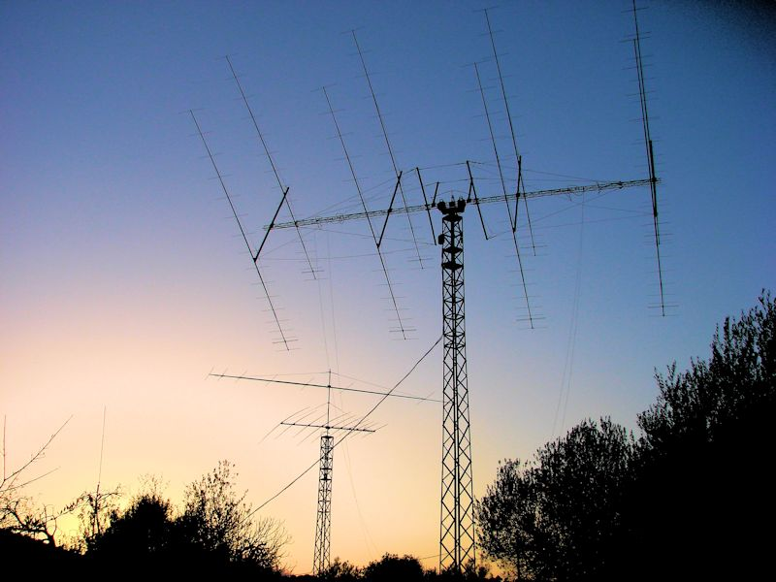***Interview with Gabriel, EA6VQ***

*I have worked Gabriel many times and just had to contact him for an interview. He agreed and answered my questions quickly.*

**AJ8B:** How did you first get interested in amateur radio?  
**EA6VQ:** I think that like many of the radio amateurs, listening to an old vacuum tube shortwave radio when I was a child. When I had the legal age, I got the beginner license (EB6KU) in 1983 and two years later I got the actual call.  
  
**AJ8B:** Do you have a favorite band or mode?  
**EA6VQ:** I have been always more interested in the higher HF bands, especially on 10m, and in the VHF bands, specially 6m and 2m EME.  However, I have equipment and antennas for all bands from 160m to 23cm and the QO-100 satellite.  I rarely work in SSB, but I like CW the most and I am also active a lot in FT8 mode lately.  
  
**AJ8B:** It looks like the only band we have not had a QSO on is 10 meters. I hope to catch you there when conditions improve. Do you spend much time on 10?  
**EA6VQ:** Yes, 10m band is one of my favorites; however, there is little propagation to the USA at this point of the solar cycle. I always monitor 10m looking for some good opening.  
   
**AJ8B:** What time of day and days do you like to operate?  
**EA6VQ:** For five years I work at home as a freelance computer systems engineer, so I can be QRV almost at any time any day, when there is something interesting on the bands.  My only restrictions are night times when you will hardly find me active.  
   
**AJ8B:** Any secrets to your success?  
**EA6VQ:** Just a good QTH by the countryside, with relatively low noise level and a lot of room for good antennas.  
  
**AJ8B:** Any tips that you can share?  
**EA6VQ:** Patience and perseverance are the keys in a successful hobby, plus having fun and enjoying what you are doing all the time.  
   
**AJ8B:** Describe what you are currently using:  
**EA6VQ:** For HF I use a 10 elements 5 band Log Yagi for 10-20m, plus a 1/4 wave vertical for 30m and inverted V dipoles for the lower bands. For 6m I use a 6M9KHW long Yagi and for 2m EME an array of eight 2M5WL antennas. I also have two reversible Beverages for reception, and I can run QRO on all bands.

**AJ8B:** What advice do you have for those of us trying to break pileups to work DX?  
**EA6VQ:** I am afraid I can't give any special advice, apart from the obvious: Good antennas and power, plus perseverance.  
   
**AJ8B:** What is your favorite contest?  
**EA6VQ:** When I was younger I used to be active in the CQ WW and WPX contests every year, but presently I don't work any contest seriously. May be with the exception of the IOTA contest when I try to be QRV in CW as many hours as I can.  
  
**AJ8B:** Any QSLing hints?  
**EA6VQ:** I answer all the paper QSL I receive, but I never send cards in advance unless I need the confirmation for DXCC or IOTA awards. I also upload the log weekly to LoTW.  My QSL policy is explained in detail in the [QRZ.COM](http://qrz.com/) page.  
   
**AJ8B:** What coaching/advice would you give new amateurs?  
**EA6VQ:** Don't get stressed trying to get a super station in weeks and work all DXCC in months. Improving the station year after year is an essential part of the fun.  
  
**AJ8B:** If I were to stop by for a visit, what local place would you want us to visit?  
**EA6VQ:** Mallorca has places for every taste, but I always recommend spending a day or two by the northern mountain chain (“Serra de Tramuntana”).  The road that goes along it offers nice landscapes, spectacular viewpoints and goes through charming villages.  
  
**AJ8B:** What local food would you want me to try?  
**EA6VQ:** There are too many to recommend one in particular.  "Arros Brut" (a tasty soup rice) and "Fitro Mallorquin" (fried pork mixed with vegetables and aromatic herbs) would be a good choice together with a local red wine.  
  
**AJ8B:** Thanks for taking the time to answer my questions. Is there anything you would like to share with  us?  
**EA6VQ:** Just my thanks for the chance to answer them and my best wishes to all readers of the SouthWest OHio DX Association newsletter.

***73. Gabriel - EA6VQ***[*WWW.DXMAPS.COM*](http://www.dxmaps.com/)[*WWW.VQLOG.COM*](http://www.vqlog.com/)

DAH DIT DIT DIT DAH DAH DIT DIT DIT DAH

Summary: The European Radio Group in Digital Modes (ERC)

Join at <https://europeanrosclub.com/registarse-en-erc/>

**Description:** EUROPEANROSCLUB (ERC) is a non-profit association created in 2010, it is legally constituted and registered in the National Registry of Associations with the number 602842.

ERC is the first Spanish association in DIGITAL MODES and is recognized and registered as an Amateur Radio Association in the Registry of the Secretary of State for Telecommunications and for the Information Society with number 280 and indicative EA5RKE.

We want the group to be always active, and for that we need the collaboration of all the members, contributing ideas or sending any information that you think may be interesting for everyone.

OVER 2,500,000 PRIZES HAVE BEEN AWARDED TO OUR OVER 8,500 MEMBERS WORLDWIDE. JOIN THE BIG ERC FAMILY TODAY, YOUR MEMBERSHIP AND ALL PRIZES ARE FREE!

How was ERC formed?

One day, twelve years ago, it occurred to me to set up a club (ERC) and thus spread a new modality called "ROS fashion" but it was not enough, I wanted more activity for ERC so I decided to take all the digital modes. Old PSK, RTTY and modern ROS, FT4, FT8. So, I got together with two great friends, EA3DCU and EA5DV and told them that I wanted to make a great club and that ERC would succeed.

The first years, like everything in life, were very hard, since all the documentation had to be prepared to legalize ERC in Spain. Our friend Enrique EA4DCU oversaw drawing up the ERC statutes for the National Registry of Associations, where they granted us the registration number 602842.

I, EB5AG, Manolo, oversaw registering the Radio Club ERC in the Jefatura Nacional de Telecomunicaciones, where they gave us the callsign EA5RKE. European Ros Club is a non-profit association.

What's the purpose?

The purpose of ERC is to encourage all of us who work with digital modes, not only to do DX, but also to create beautiful designs for diplomas from the different countries, entities and modes of transmission, such as mobile, portable and maritime mobile, and that all the operators of each country have access to the certificates that we design, that is why almost all the certificates are from stations of different countries.

Is there a charge?

ERC associates are not charged dues. ERC only receives voluntary donations made by members who want to help the Club and with this ERC expenses are covered.

Management team

We are a total of sixteen people who manage ERC, Board of Directors, Designers and Manager:

The Board of Directors is composed of:

President: EB5AG, Manolo Sanchez

Vice President and Secretary: EA4DCU, Enrique Ruiz

Database management, Partners: EA5DV, Juanma

Vocal of diplomas: EA8IM, Toño Saavedra

Web Designer: YCEFPI. Achmad Zens

<https://europeanrosclub.com/contacto/>

Designers - Most of the prizes are fantastic. Who creates them?

The friend TOÑO, EA8IM started with his fantastic designs. At present we have four great designers: EA8IM, Toño Saavedra; YB4FIK, Doni Nasution; YC4RWH, Syahadi; YC2XCD, Suryanto

Managers, people who are essential for checking diplomas:

EB5AG, Manolo; EA4D, Oscar; EA5DV, JuanMa; EA5WO, Pascual; EA5JAN, Victor; YV5EVA, Ydorca; YV5MBI, Andrés; YC3FPI, Zens

How did ERC join the UAAC and DK5UR?

I have to thank Heinz DK5UK for his patience with me, thank you very much. ERC joined UltimateAAC in the year 2018.

One day I decided to send an email to Heinz in 2017 to see what qualities were needed to enter UltimateAAC and that was how we spent time in contact preparing diplomas and preparing the website as well as the member database to synchronize it with UltimateAAC , in the month of July 2018 the first ERC diplomas were launched, very pleased with the great acceptance of the ERC members and until today we continue working with new diplomas and spectacular designs.

UltimateAAC is a great program!

What else should we know about ERC?

In order to obtain the ERC diplomas, it is necessary to be a member of the ERC.

At ERC all digital modes are valid for your diplomas.

At the time of writing these words at ERC we are close to 9,000 members and 2,700,000 diplomas have been awarded to our members since we have been working with UltimateAAC.

DAH DIT DIT DIT DAH DAH DIT DIT DIT DAH

Here is an update from Bernie, W3UR, of the DailyDX and the WeeklyDX, the best source for DX information. <http://www.dailydx.com/> . Bernie has this to report:

**TL - Central African Republic -** TL8AA and TL8ZZ are now scheduled for a November operation with eight operators, "all bands, all modes."  QSL via I2YSB.  Their webpage is: <http://www.i2ysb.com/idt/> and they plan an online OQRS log,  
<http://win.i2ysb.com/logonline/>  
  
**VP6 - Pitcairn Island -** VP6MW, a YL, Meralda Warren, reports that the British Royal Navy's HMS Spey and medical team visited to do covid-19 vaccinations.  There have been no covid cases on Pitcairn over the course of the pandemic.  Meralda says her FT891 will be back from repair in New Zealand soon and she plans to do some FT8 with it.  She has been using her FT991 and hexbeam in the meantime.  The HMS Spey is the first ship to visit Pitcairn since the pandemic started and the first Royal Navy visit since late 2018.  The Spey patrols the area to stop illegal fishing.  
  
**C5 - The Gambia -** C5C & C5B are an expedition May 22 to June 6.  The three operators, M0NPT, F5NVF and F5RAV, will be in Kololi with an IC705, IC7000 and TS2000, plus two Rig Expert amplifiers.  The antennas are dipoles that cover 60M through 6M and possibly a Windom for 80.  They will be on CW, SSB, FT8, FT4 and the QO-100 satellite.  On May 29 they hope to take a side trip to Bijol Island, AF-060, with the C5B callsign, 08- 16Z, 20-10M.  They are also trying to raise funds for a school nearby, for desks and chairs and other needs.  They started that effort with JH1AJT last October.  Here is the Go Fund Me page for that:  <https://gofund.me/6ad9d75d>  For a QSL it's LoTW, eQSL, or direct to F5RAV's home call.  To cover postage it now takes 3 USD minimum, or an IRC and SAE.

**JX - Jan Mayen -** JX/LB4MI began March 30 and continues to October.  He is there on a work assignment as an electronics engineer, only on the air in his spare time.  He took six months off from his normal job in the oil and gas industry to take this work trip to Jan Mayen.  He is not doing skeds because he never knows when he'll have time to get on, but he can do SSB and CW to his folded dipole.  On CW, he says he is still learning and sometimes answers CQs that are no more than 15 WPM, especially near the popular "QRS," slower Morse, hangout frequencies.  He may sometimes send at 20 WPM but would like the answers to be 15 WPM or less.  When trying to put a lot of stations in the log he says you only need to send 599 TU to him.  For QSLing, he will upload to LoTW and others.  For a paper QSL it's through the bureau, with a direct route set up later, probably via Club Log OQRS.  His gear is an IC-7300 to the Diamond WD-330 T2FD 20-30 MHz folded dipole.  When he goes portable it's an Elecraft KX2 and Elecraft AX1 or Sotabeam "bandhopper."

**3Y - Bouvet Island -** Since yesterday's 50 donations totaling $7,000, the 3Y0J group, a day later, is at 80 donations, totaling $14,500.  This is toward the $120,000 deposit on the ship, the next payment, due in June.  Some of these donors are individuals, clubs or groups who have already donated previously.  The total cost is $690,000.  All the donations given now go directly to the ship deposit and expenses, for the January 2023, expedition.  Each of the operators is putting up $20,000 of their own money.  NCDXF members may donate to 3Y0J through NCDXF, which may help it be tax deductible.  For donations via check, contact them, perhaps Kenneth Opskar, (LA7GIA), [kenneth@opskar.no](mailto:kenneth@opskar.no), to arrange that.  Summarizes Ken, "We have a solid plan, we have a vessel, we have a skilled team - let's make it together!"

**V4 - St. Kitts & Nevis -** WX4G, Bob, leaves for St. Kitts Tuesday, May 24, arriving at 2:28 PM.  He then goes to V47JA's QTH at Calypso Bay, for his V48A operation.  Bob plans to mostly do CW, FT8 and FT4 "on as many bands as possible," before the weekend CQ WPX CW event.  In the WPX he will try to beat his previous best 3,000 QSOs, hopefully reaching 4,000.  He will be single op all band high power.  Before and after the weekend he will be on the air with the K3 and KPA500.  Departure for his home in Florida is May 31.  He will upload the log to eQSL and LoTW.  You may also email him for any individual bands you need him on.  He did several of those by request on the last trip.

DAH DIT DIT DIT DAH DAH DIT DIT DIT DAH

Below is a list of upcoming contests in the “Contest Corner”. I think this is important for someone who is trying to move up the DXCC ladder since entities that are on the rarer side and easiest to work in contests. Some of my best “catches” have been on the Sunday afternoon of a contest when the rarer entities are begging for QSOs. Of course, the gamble is that if you wait until Sunday, conditions may change, or they simply won’t be workable. However, it is not a bad gamble. Of course, why not work the contest and have some fun!  
Check out the WA7BNM Contest Calendar page (<https://www.contestcalendar.com/>) and CQ Magazine for more contests or more details. I also have a comprehensive list that can be imported to your calendar at [www.aj8b.com/files](http://www.aj8b.com/files)

The contests in red are those that I plan to spend some significant participation time on. PLEASE let me know if you are working contests and how you fared.

Thanks!

|  |  |  |
| --- | --- | --- |
| Apr. 23-24 | 10-10 Spring Digital Contest | <http://bit.ly/1FrFeBc> |
| Apr. 23-24 | Helvetia Contest | <https://www.uska.ch/> |
| **Apr. 23-24** | **SP DX RTTY Contest** | <http://www.pkrvg.org/strona,spdxrttyen.html> |
| Apr. 24 | Bartg Sprint75 Contest | <http://bartg.org.uk/wp/contests/> |
| Apr. 24 | North American SSB Sprint | <https://ssbsprint.com/rules/> |
| Apr. 27 | 432 MHz Spring Sprint | <https://bit.ly/3Fazrjf> |
| **Apr. 27** | **UKEICC 80m Contests CW** | [**https://ukeicc.com/80m-rules.php**](https://ukeicc.com/80m-rules.php) |
| **Apr. 28** | **RSGB 80m Club Championship, Data** | [**https://bit.ly/31qpcJl**](https://bit.ly/31qpcJl) |
| Apr. 30- May 1 | UK/EI DX Contest, CW | <https://www.ukeicc.com/dx-contest-rules.php> |
| May 1 | AGCW QRP/QRP Party | http://bit.ly/3bwH1aZ |
| **May 28-29** | **CQWW WPX CW Contest** | **www.cqwpx.com** |

__________________________________________________________

ARLD015 DX news  
  
This week's bulletin was made possible with information provided by IK2DUW, The Daily DX, the OPDX Bulletin, 425 DX News, DXNL, Contest Corral from QST and the ARRL Contest Calendar and WA7BNM web sites.  
Thanks to all.  
  
GEORGIA, 4L.  Dariusz, SP9DLM is QRV as 4L/SP9DLM until April 19 while on work assignment from Telavi, and possibly Tbilisi and Kobuleti.  Activity is on 80 to 10 meters using SSB.  QSL to home call.  
  
MALDIVES, 8Q.  Braco, E77DX is QRV as 8Q7DX from Baa Atoll, IOTA AS-013, until April 27.  Activity is on 80 to 10 meters, and possibly 160 meters.  QSL via OE1EMS.  
  
CUBA, CO.  Look for Team T47C to be QRV from April 17 to 19. Activity will be on the HF bands.  QSL via IK2DUW.  
  
AZORES, CU.  Tony, CU8AS is QRV with special call CQ84AS from Flores Island, IOTA EU-089, until April 19.  Activity is on 30, 17, and 12 meters using mainly CW.  QSL via HB9CRV  
  
AUSTRAL ISLANDS, FO.  Rob, N7QT, Walt, N6XG, Heye, DJ9RR, Gene, K5GS, Steve, W1SRD, Melanie, N7BX and Doris, K0BEE plan to be QRV as TX5N from Raivavae Island, IOTA OC-144, from April 16 to 28. Activity will be on 160 to 10 meters using CW, SSB, and various digital modes.  QSL via M0URX.  
  
DJIBOUTI, J2.  Matt, KN9U and Paul, N7JDI are QRV as J20MR and J28JD, respectively, from the US Navy Base in Lemonnier.  Activity is in their spare time on 40 to 10 meters using SSB, various digital modes, and possibly CW.  QSL via operators' instructions.  
  
DOMINICA, J7.  Michael, DF8AN will be QRV as J79MN from April 19 to 24.  Activity will be on the HF bands.  QSL to home call.  
  
SVALBARD, JW.  A large group of operators will be QRV as JW0X and JW100QO from Spitsbergen Island, IOTA EU-026, from April 19 to 26. Activity will be on 160 to 6 meters using CW, SSB, RTTY, and FT8 with five stations active from three locations.  QSL via M0URX.  
  
JAN MAYEN, JX.  Helge, LB4MI is QRV as JX/LB4MI until early October. Activity is in his spare time on 20 and 17 meters using SSB.  QSL to home call.  
  
LITHUANIA, LY.  Special call sign LY100BBALL is QRV until the end of April to commemorate 100 years of basketball here.  QSL via LY2QT.  
  
  
  
  
POLAND, SP.  Special call sign 3Z80AK is QRV until May 31 to commemorate the 80th anniversary of the founding of the Armia Krajowa, the dominant underground resistance movement in Poland during World War II.  QSL via SP1PBW.  
  
  
MARSHALL ISLANDS, V7.  Stewie, WV7MS is QRV as V7/WV7MS from Kwajalein Atoll, IOTA OC-028, while working as a firefighter. Activity is in his spare time.  QSL via LoTW.  
  
INDONESIA, YB.  Special event station 8D97WARD will be QRV from April 16 to 18 to commemorate World Amateur Radio Day on April 18. Activity will be on 80, 40, 20, 15, and 10 meters using CW, SSB, RTTY, and FT8, and possibly on Satellite IO-86.  QSL via LoTW.  
  
The Run for the Bacon QRP CW Contest, K1USN Slow Speed Test, DARC  
Easter Contest, OK1WC CW Memorial, Worldwide Sideband Activity  
Contest, RTTYOPS Weeksprint, 222 MHz Spring Sprint, Phone Weekly  
Test, A1Club AWT, CWops Test, VHF-UHF FT8 Activity Contest,  
Mini-Test 40, Mini-Test 80, and the RSGB 80-Meter Club SSB  
Championship are on tap for April 18 to 20.  
  
Please see April QST, page 74, and the ARRL and WA7BNM Contest web  
sites for details.

______________________________________________________________________________

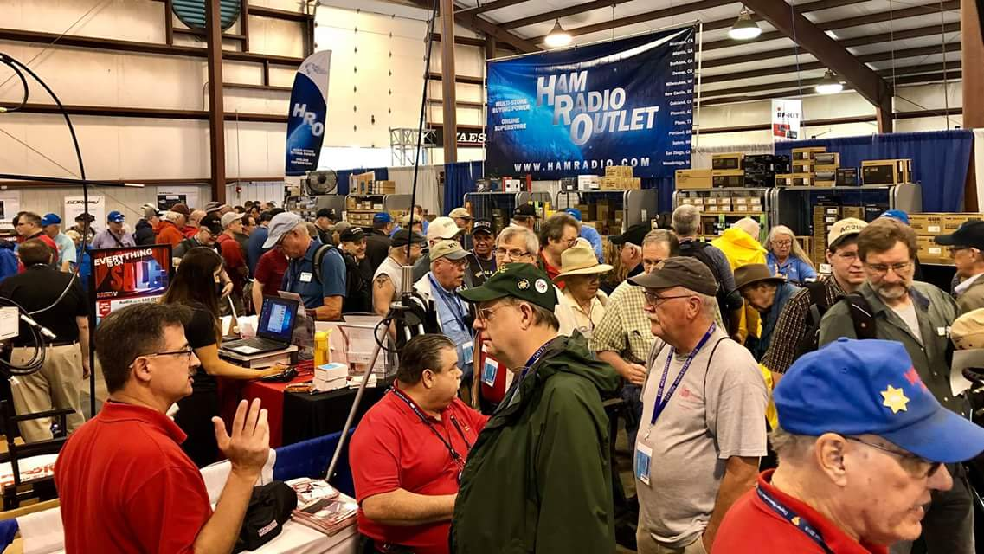[**Upcoming *Hamfests***](http://arrl-ohio.org/hamfests.html)

We **DO** have some hamfests scheduled for 2022!! Yes, take a good look at the list.

**__________________________________________________________**

|  |  |
| --- | --- |
|  |  |

|  |  |  |
| --- | --- | --- |
|  | |  |
|  | |  |
| ***Ohio Hamfests*** | | |
|  | | |
| ***2022*** | | |
| **04/09/2022 -**[**Sixty-Sixth Cuyahoga Falls Amateur Radio Club Hamfest**](http://www.arrl.org/hamfests/sixty-sixth-cuyahoga-falls-amateur-radio-club-hamfest)  **Location: Cuyahoga Falls, OH Sponsor: Cuyahoga Falls Amateur Radio Club, Inc. Website:**[**http://www.cfarc.org/hamfest.php**](http://www.cfarc.org/hamfest.php)  [**Learn More**](http://www.arrl.org/hamfests/sixty-sixth-cuyahoga-falls-amateur-radio-club-hamfest) | | **04/24/2022 -**[**Athens Hamfest**](http://www.arrl.org/hamfests/athens-hamfest-9)  **Location: Athens, OH Sponsor: Athens County Amateur Radio Association Website:**[**http://www.ac-ara.org/**](http://www.ac-ara.org/)  [**Learn More**](http://www.arrl.org/hamfests/athens-hamfest-9) |
|  | |  |
| **04/25/2022 - 04/29/2022**[**RV Radio Network Spring Rally**](http://www.arrl.org/hamfests/rv-radio-network-spring-rally)  **Location: Millersburg, OH Sponsor: RV Radio Network Website:**[**http://rvradionetwork.com**](http://rvradionetwork.com/)  [**Learn More**](http://www.arrl.org/hamfests/rv-radio-network-spring-rally) | | **05/01/2022 -**[**Lucas County Amateur Radio Emergency Service Trunk Sale and Swap Meet**](https://www.arrl.org/hamfests/lucas-county-amateur-radio-emergency-service-trunk-sale-and-swap-meet)  **Location: Toledo, OH Sponsor: Lucas County Amateur Radio Emergency Service Website:**[**http://tinyurl.com/lcaresswap**](http://tinyurl.com/lcaresswap)  [**Learn More**](https://www.arrl.org/hamfests/lucas-county-amateur-radio-emergency-service-trunk-sale-and-swap-meet) |
| **05/20-22/2022 -**[**Dayton Hamvention**](https://hamvention.org/)  **Location: Greene County Fairgrounds, OH**  **Sponsor: Dayton Amateur Radio Association**  **Website:**[**https://hamvention.org**](https://hamvention.org/)  [**Learn More**](http://www.arrl.org/hamfests/dayton-hamvention-7) | | **05/28/2022 -**[**Scioto Valley Amateur Radio Club Hamfest**](http://www.arrl.org/hamfests/scioto-valley-amateur-radio-club-hamfest)  **Location: Piketon, OH Sponsor: Scioto Valley Amateur Radio Club**  [**Learn More**](http://www.arrl.org/hamfests/scioto-valley-amateur-radio-club-hamfest) |
| **06/04/2022 -**[**FCARC Summer Hamfest**](http://www.arrl.org/hamfests/fcarc-summer-hamfest-1)  **Location: Wauseon, OH Sponsor: Fulton County Amateur Radio Club Website:**[**https://k8bxq.org/hamfest**](https://k8bxq.org/hamfest)  [**Learn More**](http://www.arrl.org/hamfests/fcarc-summer-hamfest-1) | | **07/09/2022 -**[**Mansfield Mid Summer Trunkfest**](http://www.arrl.org/hamfests/mansfield-mid-summer-trunkfest-1)  **Location: Mansfield, OH Sponsor: Intercity Amateur Radio Club Website:**[**http://www.w8we.org**](http://www.w8we.org/)  [**Learn More**](http://www.arrl.org/hamfests/mansfield-mid-summer-trunkfest-1) |
|  | |  |
| **07/17/2022 -**[**Van Wert Hamfest**](http://www.arrl.org/hamfests/van-wert-hamfest-6)  **Location: Van Wert, OH Sponsor: Van Wert Amateur Radio Club Website:**[**http://W8FY.ORG**](http://w8fy.org/)  [**Learn More**](http://www.arrl.org/hamfests/van-wert-hamfest-6) | | **08/13/2022 -**[**Cincinnati Hamfest**](http://www.arrl.org/hamfests/cincinnati-hamfest-1)  **Location: Owensville, OH Sponsor: Milford ARC Website:**[**https://CincinnatiHamfest.org**](https://cincinnatihamfest.org/)  [**Learn More**](http://www.arrl.org/hamfests/cincinnati-hamfest-1) |
|  | |  |
| **09/17/2022 -**[**Mound Amateur Radio Assoc. Swap Meet**](http://www.arrl.org/hamfests/mound-amateur-radio-assoc-swap-meet-1)  **Location: Miamisburg, OH Sponsor: MARA Website:**[**http://W8DYY.ORG**](http://w8dyy.org/)  [**Learn More**](http://www.arrl.org/hamfests/mound-amateur-radio-assoc-swap-meet-1) | | **09/25/2022 -**[**Cleveland Hamfest**](http://www.arrl.org/hamfests/cleveland-hamfest-2)  **Location: Berea, OH Sponsor: Hamfest Association of Cleveland Website:**[**http://www.hac.org**](http://www.hac.org/)  [**Learn More**](http://www.arrl.org/hamfests/cleveland-hamfest-2) |

|  |
| --- |
|  |

**__________________________________________________________**

**

**April 17, 2022**

This week’s column starts with reminding all readers the new FCC fees for issuing new licenses, renewing licenses and applying for vanity call signs start on April 19. It is my understanding applications must have been made prior to that date to avoid the fee. If I look at the calendar correctly, that means the final day to apply for something is this Monday, April 18. Some folks are unaware you can renew a license up to 90 days in advance of the expiration date. So anyone with an upcoming license renewal or considering a call sign change should move quickly if they wish to avoid the fee.

Four people who did move quickly to get newly licensed as Technicians are Randy McGladrie and Andrew Uhde from Wilmington, Ruth Wesley of Washington CH and Steven Smith of Chillicothe. Randy is now KE8UNL, Andrew is KE8UPK, Steven is KE8UPM and Ruth is KE8UNM. Welcome to each. I’m certain any assistance getting them on the air will be appreciated.

The Wilmington NWS Office will have a final Storm Spotter webinar on Monday evening April 18 at 7 pm. Then on April 30 they will conduct a virtual Advanced Spotter Training course from 9 am until Noon. The Basic Course and the Advanced Course are both free and are live webinars where questions can be asked and answers received. Reservations are required. Check the Wilmington NWS Office website to learn how to participate.

The **Southern Ohio ARA** will meet on April 18 at the Lawrence County EMA Building in Coal Grove. A 6 pm test session will be followed by the business meeting at 7 pm.

On April 19 the **Athens County ARA** will return to the Red Cross Building in Athens for their monthly meetings although teleconferencing will still be available for those reluctant to attend in person. Undoubtedly a lot of time will be given to the final preparations for the April 24 club sponsored hamfest.

On Thursday evening, April 21 the **Milford ARC** will conduct a Laurel VE testing session at the Miami Township Civic Center beginning at 6 pm. Pre-registration is requested, but walk-ins will be accepted if space allows. President Ron Brooks, AC8MA, invites those testing to attend the club’s business meeting that will start at 7:30. For the first time in many years a delegation of members of the **Highland ARA** will attend the meeting.

On April 25, Sonny Alfman, W8HFH, will present a program about amateur radio, the history of amateur radio in Guernsey County and the **Cambridge ARA** to members of the Cambridge Lions Club. It begins at noon at Mr. Lee’s Restaurant in Cambridge.

Clinton County ARA VE Coordinator Mike Boyle, WF8B, announces the club will conduct a test session on May 15 at the Wilmington Public Library. Registration begins at 1 pm.

The **Athens County ARA**’s annual hamfest is from 8 until noon on Sunday, April 24 at the Athens Community Center. Admission is still $5 and children and non-ham XYLs are free. Inside flea market spots are $10 per table while those free outside spots are on a first come basis. An ARRL testing opportunity to earn a new license or upgrade an existing one begins at 10 AM. It is an ARRL session and only the appropriate ARRL fee will be charged. It will be explained how the new FCC license fee will be taken care of. Ohio Section Manager, Tom Sly, has announced he will be in attendance. Additionally yours truly, N8ZNR and K9DOG will be in the flea market. So stop by and say “HI”.

On Saturday, April 30, Ashland, Kentucky’s **River Cities ARA** will hold their annual Spring hamfest in the parking lot of the Compton Civic Center and railroad museum located at 497 26th Street in Catlettsburg, KY. According to Mike Sullivan, KN4IMU, admission and set-ups are free. It gets underway at 10 am and will run until 4 pm. There will be a Laurel VE test given at 11. Contact [n4tna@yahoo.com](mailto:n4tna@yahoo.com) for additional information.

On Saturday May 28, the **Scioto Valley ARC** will sponsor a Scioto Valley Trunkfest at the Pike County Fairgrounds near Piketon. According to club officers it will get underway at 8 AM. Although there is no fee to set up to sell, there is a $5 per person admission charge.

Dr. Scot Wright, K0MD, will be the keynote speaker and share his experiences operating from South America, China and the Caribbean at the **Southwest Ohio DX Association**’s annual DX Banquet during HamVention weekend. This year the dinner will be the evening of May 20 at the Dayton Marriott Hotel with a cash bar opening the evening’s festivities at 5:30 pm. The banquet is a highlight of HamVention weekend and this year the grand prize for the banquet is an Icom IC-7610. Visit the [www.swodxaevents.org](http://www.swodxaevents.org) website to learn more about the evening and to order tickets. Bill Salyers, AJ8B, says tickets remain, but historically sales are brisk in the days leading to the event.

Forty-five years ago on April 17, 1977 the **Highland ARA** was officially formed. At the Club’s business meeting on the 12th the occasion was recognized with serving cake and punch to all in attendance. Especially noteworthy was five of the original 20 members were in attendance. They were Jim Hamilton, W8BDG; Harley Maines, K8HM; John Levo, W8KIW; Irma Marsh, WD8CVM and Ronnie Bogard, WD8AIG. Four other charter members also survive but were unable to attend.

They are Bill Mains, WD8AIL; Denver Conley, K8OGL; Bob Hodson, WA8KTU and Bill Wills, WD8CAU. Of those nine, seven are still Club members and licensed. Bill Wills is now an air personality on WTAM in Cleveland, but has let his license expire.

A major source of income to support the activities of the **Milford ARC** is the sponsorship of the Cincinnati Hamfest. This year the Club is selling chances on a Yaesu FTDX10 to be awarded at the Cincinnati Hamfest on August 13. You do not have to be present to win. Ticket information is available at [www.CincinnatiHamfest.org](http://www.CincinnatiHamfest.org).

The **Hocking Valley ARA** is looking for volunteers to assist with communications during the upcoming May 1 Nelsonville 5K Run. Any and all help during the 7:30 until noon event will be appreciated. Contact Dave, KD8PSB to offer your assistance or to ask questions.

For over 30 some of its 154 years the Lawrence County Memorial Day Parade has relied on amateur radio to help line up the parade and provide communications to assist those participating in the event or those watching to safely enjoy the event. According to officials with the **Southern Ohio ARA**, this parade which was first held in 1868 is considered the oldest in the United States. This year the parade will wind through the streets of Ironton on Memorial Day.

If foot type races and walks are not your style, but the combination of fast cars and ham radio appeal, then this event might be up your alley. Licensed ham radio volunteers are needed to assist with the Southern Ohio Forest Rally starting on Thursday, June 9 at the park in Chillicothe and concluding on June 11 at the Zaleski State Forest outside of McArthur. The event will also take place on June 10 in the Shawnee State Forest west of Portsmouth. Check [www.southernohioforestrally.com](http://www.southernohioforestrally.com) for information about the event and its history plus how you can become involved. Or contact Bill French, KE8AAL for information.

Mole activity in my yard for the past year has been bad. The first mowing of the year was a challenge. However it got me to wondering. What if someone captured a mole and taught it to put a line behind it allowing us to install grounds and radials? It might not meet the spouses approval, but it would be easier.

In non-ham news, depending upon when you read this let’s hope each of you had a good Easter and spent time with family and friends and gave some time to observing what this time is about. Also, be sure your state and federal income tax forms are filed this week. Prisons do not allow ham radio operations from within and future license renewals may be questionable.

That’s it for another week. So until next time, stay safe, healthy and ham radio active.

John Levo, W8KIW, [jlevo@cinci.rr.com](mailto:jlevo@cinci.rr.com), 937-393-4951

**Print an Official or Unofficial Copy of Your Amateur Radio License**

*(By Anthony Luscre, K8ZT)*

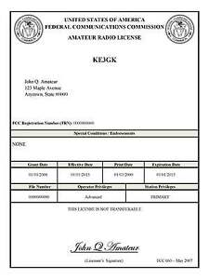

As of February 17, 2015, the **FCC no longer routinely issues paper license documents** to Amateur Radio applicants and licensees. The Commission has maintained for some time now that the official Amateur Radio license authorization is the electronic record that exists in its Universal Licensing System (ULS). The FCC will continue to provide paper license documents to all licensees who notify the Commission that they prefer to receive one.

Licensees also will be able to print out an official authorization — as well as an unofficial “reference copy” — from the ULS License Manager. I’ve created a set of instructions on how you can request an **“official” printed copy of your license\***

[**Click here to download the instructions**](http://arrl-ohio.org/news/2020/print_your_license.pdf)

***One Question Questionnaire***

!!!!! I would really like to hear from as many of you as possible on this one. While I know what I think the answer is going to be, the bigger the sample, the more accurate a survey like this is likely to be.

How about going to <http://arrl-ohio.org> and giving me a click? (It’s in the bottom left corner of the page) I’ll have more to say about this in the next OH Section Journal!

***Have you had a QSO on CW in the last week?***

***Yes / No ?***

From the last Poll: ***Have you bought your tickets yet for Hamvention?***

***Yes / No ?***

Out of 55 responses, 40% yes and 60% yes.

Ohio Section Cabinet

|  |  |
| --- | --- |
| Section Manager – Tom Sly, WB8LCD | Section Traffic Manager – David Maynard, WA3EZN |
| Section Emergency Coordinator – Stan Broadway, N8BHL | Section Youth Coordinator – Anthony Luscre, K8ZT |
| Technical Coordinator – Jeff Kopcak, K8JTK | Affiliated Clubs Coordinator – Tom Sly, WB8LCD |
| State Government Liaison – Bob Winston, W2THU | Public Information Coordinator – John Ross, KD8IDJ |



Hey Gang,

Have you taken a look at the **Swap & Shop** page on the Ohio Section webpage yet?? Here’s a link that will take you there… <http://arrl-ohio.org/sm/s-s.html>

Do you have equipment that you just don’t need or want anymore? Here’s a great venue to advertise it, and it’s FREE!! Is your club doing a fund raiser to help raise money? After a lot of thought, it was decided that the Swap & Shop webpage could also contain these types of items as well. The same rules will apply as do for the For Sales and Give-A-Ways and will only be posted for a month at a time. Please see the Terms & Conditions on the webpage.

If your club is doing a fund raiser and wants more exposure, please forward the information to me and I’ll advertise it on the Swap & Shop webpage for you.

Now, I still want to remind you that it won’t be listed in this newsletter because it would take up way too much space, so your ad will only appear on the website. It is there for any individual to post equipment Wanted / For Sale or Give-Away as well as for Club Fund Raisers. No licensed vehicles/trailers or business advertising will be posted. Postings are text only (no pictures or graphics) will be posted for a maximum of 1 month from date posting and require a contact phone number or email within the posting. Send your Wanted / For Sale or Give-Away post to:  [swap@arrlohio.org](mailto:swap@arrlohio.org)

***Back Issues of the PostScript and Ohio Section Journal***

Hey, did you know that PostScript and Ohio Section Journal (OSJ) are archived on the website? You can go back and look at any edition simply by clicking:

<http://arrl-ohio.org/news/index.html>

***Want to Share your Club Newsletter With Others?***

We have a webpage where you can download and read all of the newsletters that I get from around the state and even other sections!

Here’s the link to the page…. <http://arrl-ohio.org/club_news/index.html>

Please, if you don’t see your club newsletter posted, it’s because I’m not receiving it. Just have your newsletter editor contact me and I’ll get your club’s newsletter listed on the site!!

We all learn and steal (I mean, share) from each other’s work. So, get me your newsletter!!! Send it to: [webmaster@arrl-ohio.org](mailto:webmaster@arrl-ohio.org)

***Chit – Chat, and All That!***

Do you know someone that’s not getting these Newsletters? Please, forward a copy of this Newsletter over to them and have them “[Opt-In](mailto:Opt-In)” to start receiving them. Heck, just have them send an email to: [webmaster@arrl-ohio.org](mailto:webmaster@arrl-ohio.org) and we’ll get them added to the Ohio Section Emailing list.

We now have many thousands of readers receiving these newsletters weekly. Quite impressive, I’d say! I urge all of you to make sure that everyone, regardless of whether they are a League member or not, get signed up to receive these weekly Newsletters.

You can always “Opt-Out” at any time if you feel this is not what you were expecting. It’s fun and very informative. All of your favorite past newsletters are now archived too.

You can go back at any time and read them.



Just go to: <http://arrl-ohio.org/news/>

The pictures on the front page and throughout this newsletter are from various newsletters, Facebook posts and/or were sent directly to me in recent weeks. Take a good look at them, you just might be in one of the pictures! “SMILE… you’re in the Ohio Section News!!”

*PostScript is produced as a weekly newsletter. I want to thank everyone that has contributed articles and ideas to make this an even better news source. I sincerely hope that you have enjoyed this edition and will encourage your friends to join with you in receiving the latest news and information about the Ohio Section, and news and events happening around the world!*