September 2022

From the Technical Coordinator | From the Section Emergency Coordinator
From the Section Traffic Manager | From the Section Youth Coordinator
National News | Club Corner
DX This Week | From The South 40
Contest Corner | One Question Questionnaire
Final.. Final..

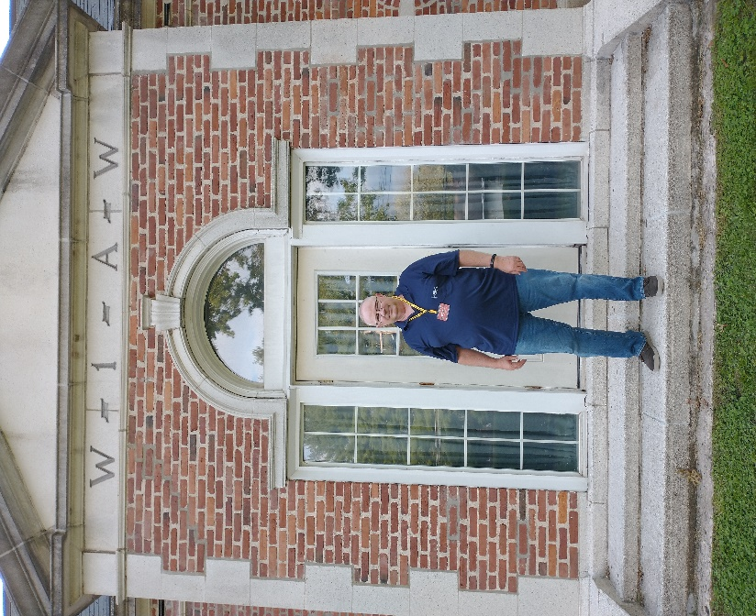

From the Technical Coordinator
Jeff Kopcak – K8JTK TC
k8jtk@arrl.net

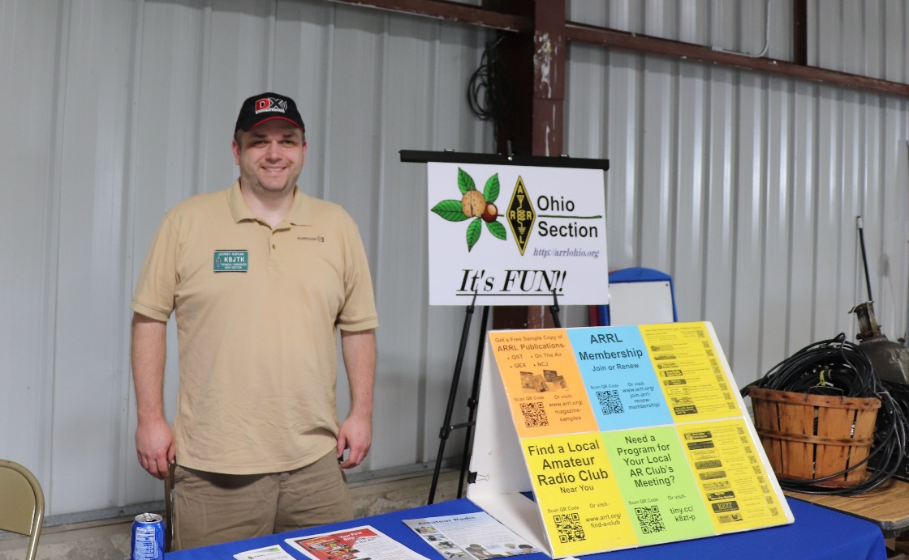

Hey gang,
I was cleaning out my E-mail inbox, apparently no one else does this, and came across a request from a couple years ago. Mike – AB8MW contacted me wanting to know if it was possible to run multiple copies of Fldigi at one time. The scenario would be one copy for HF and one for VHF/UHF. For example: an EmComm event where they might want to monitor HF frequencies in addition to local VHF/UHF using a single PC.
Starting multiple copies of Fldigi & Flmsg will open multiple windows. Regardless of how many windows can be opened, all use the same user configuration directory to store settings. Mike wanted Fldigi to retain settings for each use. Settings such as soundcard inputs/outputs and rig control (if used). One radio might be using a SignaLink/RIGblaster/other soundcard interface and have no rig control. Another radio maybe using virtual audio cables (typical for SDR radios) and Hamlib for rig control. When multiple Fldigi & Flmsg windows use the same settings directory, last window closed wins. When the program is restarted, those settings are loaded. Additional Fldigi & Flmsg windows have to be configured all over again. Not convenient, especially with many uses on a single PC, in a pinch, or during a real operating event.
Why would someone want to run multiple copies (or instances) of Fldigi programs? Some operators use HF and VHF/UHF differently, including sound interfaces and rig controls. Instead of switching around configurations depending on band, have two instances configured, one for each radio. Other reasons could be a single all-band all-mode radio is used but have very different operating styles, personalities, or users - like in a club setting. Operating styles could be EmComm and contesting, or using different macros. Monitoring multiple repeaters or multiple HF frequencies during an EmComm exercise would be desired or any combination of these examples. Creating separate instances will allow each to have its own configuration settings.
Keeping separate settings is very doable, but it takes some work. There are additional issues when adding Flmsg (or other Fldigi programs) to the mix as one would use for NBEMS. Flmsg & Fldigi use a local IP port (often referred to as a “socket”) to facilitate communications between programs. The default IP and port for Flmsg to Fldigi is 127.0.0.1:7362. 127.0.0.1, also referred to as loopback or localhost, is a reserved IP address. This IP address is used by programs to communicate with other programs and services running on the same system. In Flmsg, when the operator hits AutoSend, it’s a crapshoot which Fldigi window will transmit the message when multiple windows are open. A message intended for VHF could go out over the HF radio. Not good, as that causes unnecessary confusion to other stations. Each pairing of Fldigi & Flmsg needs a unique set of IP ports.
According to the author of the Fldigi suite, Dave – W1HKJ, port/socket parameters for Fldigi, Flarq, Flmsg and Flamp are specified on the command line. Other TCP ports are configured in the Fldigi Configuration options under Misc -> TCP-IP sessions. There is some overlap between command line options and graphical interface options including KISS, ARQ, and XML settings.
When AB8MW originally contacted me, we worked out the configuration details over E-mail and he was going to get it working. I, of course, said ‘I am going to write this up’ and never did. That is until I came across those messages and finally sat down to document a procedure. My procedure outlines changes needed to run multiple instances in a NBEMS operational situation for both Fldigi and Flmsg. This might be useful for those participating in the upcoming October SET. This will also work for Fldigi instances without the use of Flmsg. The posting is on my site: Running multiple instances of Fldigi and Flmsg.
My write up labels one instance for “HF,” a second instance for “VHF/UHF.” There is no limit on how many instances can be created. I’ve heard stations using as many as six. The problem becomes manageability. When a setting is to be changed universally, it has to be done independently for each separate instance. When a new version is installed, shortcuts must be
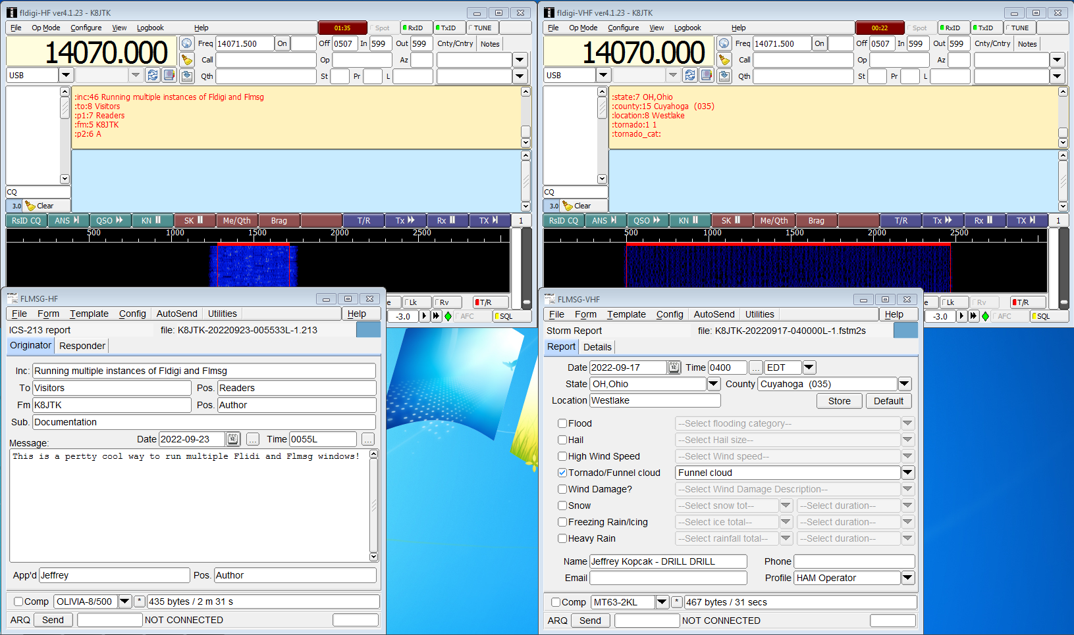
updated manually.
Multiple copies of Fldigi & Flmsg transmitting messages independently
My process creates separate directories for both Fldigi and Flmsg to save their settings. Copying of existing configuration settings is accomplished, if desired. Then creating and customizing shortcuts to use specific configuration directories. Finally, making unique configuration changes for each instance.
Running multiple instances of Fldigi programs is completely doable. It takes a little effort to configure the directories, IP ports, and settings. Once configured, clicking AutoSend in Flmsg will send that message to the paired Fldigi instance. I even show how to send messages received on HF to the VHF instance and vice-versa. No more guessing if it will go out over the correct radio!

If you were an early adopter of Hamshack Hotline and no longer have a green light for the HH extension, you probably need to make a configuration change. Another symptom, when the phone is rebooted, the phone gets stuck on “Checking DNS” and never moves past that screen.
Back when HH first started, the domain name wizworks.net was set by HH in the configuration file loaded onto everyone’s phones. The US server was hhus.wizworks.net. Since then, they transitioned to using the domain hamshackhotline.com, where the US server was changed to: hhus.hamshackhotline.com. The hhus.wizworks.net DNS record has been removed and is now invalid (NXDOMAIN). If a HH configured phone or device has stopped working around the end of August, check the registration domain.
- In a web browser, go to: http://<IP address of phone>/admin/advanced/
- Click the “Ext 1” tab – or whichever extension Hamshack Hotline is configured
- Under “Proxy and Registration” look for: (1) Proxy & (2) Outbound Proxy
- If they show: hhus.wizworks.net, change both to: hhus.hamshackhotline.com
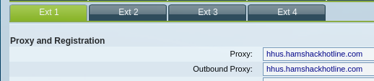
- Click Submit All Changes
Cisco SPA phone configuration changes for Hamshack Hotline
The phone will reboot and be back online again after about 60 seconds. Verify the Hamshack Hotline extension is now green. Green means the phone was able to register successfully with the Hamshack Hotline server. If that doesn’t work, having trouble, or not sure, open a ticket with the Hamshack Hotline Help Desk.
I discovered this issue after powering down the shack due to storms. When I powered the phone back on, it stayed on the “Checking DNS” screen. I figured something fried during power off or the power supply was dying. There was no change after changing network cables and power sources.
I found the phone was getting an IP address by looking at my router/firewall and seeing an IP address handed out by DHCP. This meant it was accessing the network and I could do a packet capture. Packet captures capture network data for analysis and troubleshooting. These shed light on network problems such as DNS issues, firewall blocked traffic, packet size/MTU, retransmissions, etc. A capture won’t show problems with the application itself because it just looks like regular traffic/packets on the wire. Captures are often run on routers or firewalls as they are passing the traffic to and from the Internet or other networks. A switch with ‘port mirroring’ can send copies of data to a separate Ethernet port. A device connected to the mirror port, such as a PC with Wireshark, captures the traffic.
For my phone not finishing its boot, I identified the issue immediately in the capture. The phone was requesting the record for hhus.wizworks.net. The DNS server responded with “no such name.” That means the DNS record for hhus.wizworks.net, which ties the name to an IP address, does not exist. It was removed, as my phone worked previously.
Packet capture: first line is the DNS query for hhus.wizworks.net. Second line is the response “not such name”
Since my phone had an IP address, I could access its web-based configuration making the changes above. I probably could have guessed the new domain name. However, I was even luckier. I setup Hamshack Hotline on my softphone a couple of months earlier and their documentation had the new server name. Simply changing domains from “wizworks.net” to “hamshackhotline.com” was the only change I made.
A while back they told everyone to re-provision their devices. I thought I did. Thinking later, I probably didn’t because I configured additional extensions on my phone. Either way, making that change resolved my issue and my phone is operational once again.
Thanks for reading and 73… de Jeff – K8JTK

______________________________________________________________________________

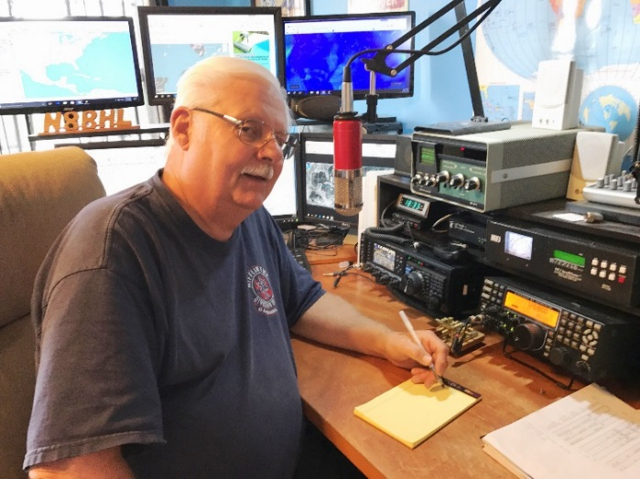
From the Section Emergency Coordinator
Stan Broadway, N8BHL - SEC
broadways@standi.com

By the time you read this, the October 1st “Simulated Emergency Test” will be concluded for Ohio. I hope your ARES organization participated. It’s a lot of fun when a full-scale exercise is held, and we always come away with ideas on how to do things better. This year we responded to many voices who wanted to take things back to a local level, by encouraging each EC to create his/her own exercise or at least join with neighbors for a more regional approach. Each EC knows best what is needed in that particular county, it’s not something we can dictate from the Section level. We are here to support your district and local level needs.

While October 1 was the official Section date, a county can create and carry out its own SET any time during the year. It should be reported on the Form A and Form B website as an SET. Please do report your activity! Ohio was number two or three in different categories last year and we have consistently been at the top. That’s due you YOUR reporting! Thank you!

The League changed and updated the SET reporting forms to an online form this year, so it should be even easier to report.

The Ohio Section has been involved in other important exercise activities as well this year, including the Perry Nuclear Plant full-scale exercise in northeast Ohio. Toledo area ARES members were activated as part of Michigan’s Davis-Besse exercise this past month as well. Amateurs went to area hospitals as part of the drill. These are important exercises! I understand that a failure in any category shuts the plant down… so every piece of the exercise is important.

It seems like activities in general are picking up around the state, with parades, runs and walks trying to get back to their previous level. ARES, like many other civic-minded organizations, has been a little difficult to ‘wake up’ from being in ‘neutral’ for a couple years. It takes a little energy to get your gear together and dedicate the time needed to serve but we have a responsibility to show how it’s done! There are a lot of newly licensed amateur operators who could become interested in the good feeling to be had from being in an important position to help when needed! It’s a key part of the “Service” side of amateur radio.

Another item we each should have on our agenda is continued training! We ALL need to work on the four “magic” NIMS courses online: IS 100, 200, 700 and 800. These take perhaps an hour each and will prepare you to recognize how an EOC works in an emergency. It also assures that our ARES members are properly certified to be activated into such a situation. This is important, as I have talked with several county Emergency Managers and Commissioners this month about training and certification issues. In order to stay relevant and stay in the plans, we MUST continue our training!

I can’t thank each of your enough for all you do! Let’s renew our efforts to keep ARES a vital part of Ohio’s emergency response!

__________________________________________________________________

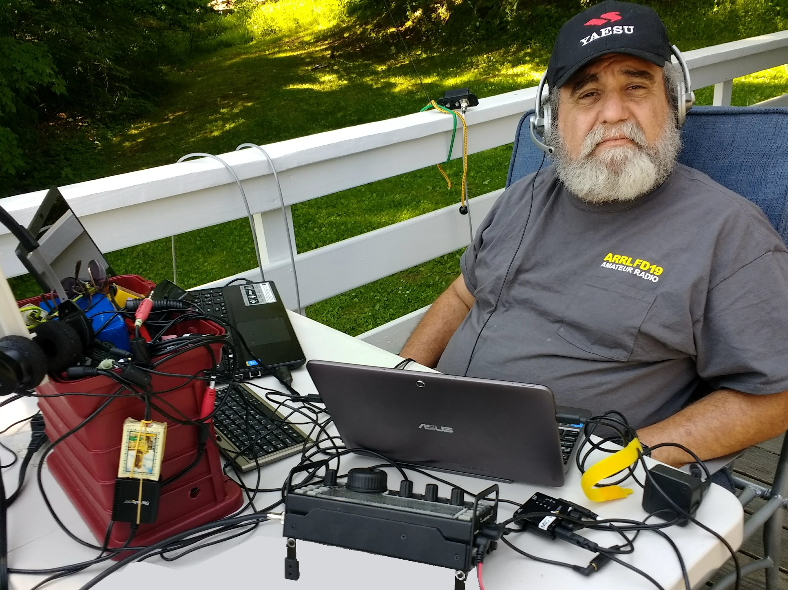
From the Section Youth Coordinator
Anthony Luscre, K8ZT - SYC
k8zt@arrl.net

QSO Today Expo, Tech Classes &
JOTA (Jamboree On The Air)

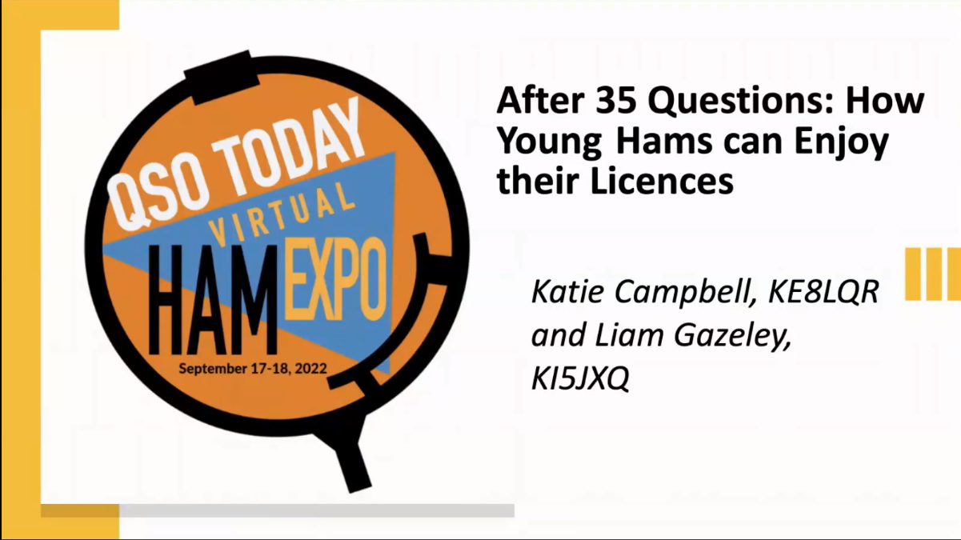
Ohio Youth Hams Present at QSO Today Expo
Katie Campbell, KE8LQR, Ohio Section Assistant Youth Coordinator from Columbiana, OH, along with Liam Gazeley, KI5JXQ of Las Cruces, NM, presented the session- “After 35 Questions: How Young Hams Can Enjoy Their License- Resources for Youth Hams” for last week's QSO Today Expo. Along with Katie and Liam, a Rittman, Ohio youth ham, Javan Miller, W8UA, was the moderator for their Q&A session. To view the session during the first 35 days, you need to have a ticket to the event, but in the past, the sessions are made public the month after the sessions.
Katie and Javan did a great job representing the Ohio Section at the Expo! I also did two presentations at the Expo- “How to Make That QSO- Get in the Rhythm, Know the Rhyme & Dance the Dance” and “Successful Operating- Assessing Effectiveness of Your Station”

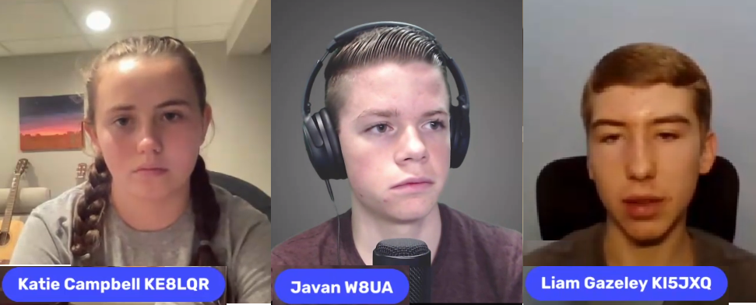

Online Free Technician License Classes

Elsewhere in this issue, there is an announcement for The Cuyahoga Falls ARC’s online Technician Class. This year they will be working with the M.O.R.E. Project of the David Sarnoff ARC. The M.O.R.E. Project’s focus is on getting youth and non-traditional groups into Amateur Radio. They have a grant that will enable students that take the class and pass the license exam to be eligible for a Get On The Air package, which includes a Yaesu Dualband HT, an SDR (Software Defined Receiver) and payment of FCC licensing fees. Detail on the class are available at tiny.cc/beaham.

Jamboree On The Air

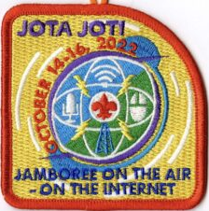
The 64th Annual Jamboree On The Air will be held on October 14-16, 2022. Jamboree-on-the-Air, or JOTA, is the largest Scouting event in the world. It is held annually on the third full weekend in October. JOTA uses amateur radio to link Scouts and hams around the world, around the nation, and in your community. This jamboree requires no travel other than to a nearby amateur radio operator’s ham shack. Many times you can find the hams will come to you by setting up a station at your Scout camporee, at the park down the block, or perhaps at a ham shack already set up at your council’s camp.

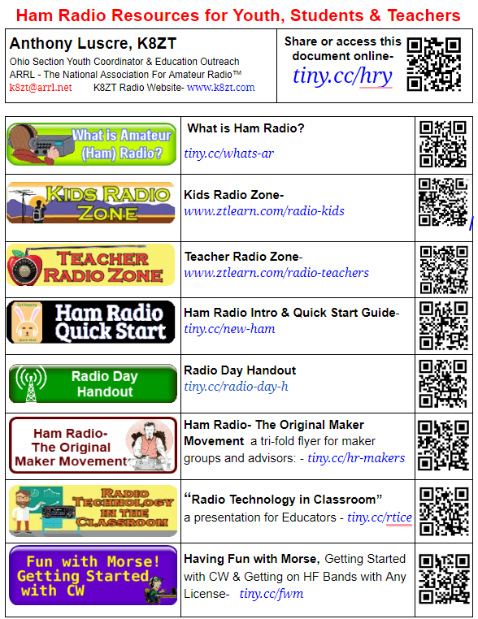
To find registered JOTA stations in your area, visit ttps://k2bsa.net/registered- jamboree-on-the-air-stations. If you or your local club is planning a JOTA operation, you can register it at https://k2bsa.net/jota-station-registration.

For additional information on planning your JOTA operations, visit:
- JOTA- www.scouting.org/jota
- JOTA- www.arrl.org/jamboree-on-the-air-jota
- JOTA- www.jotajoti.info
- JOTA- https://k2bsa.net/jota
- JOTA suggested frequencies
- JOTA sample questions
For additional information on Scouting and Amateur Radio, visit:
- Scouting & Amateur Radio- Ideas & Resources- tiny.cc/ar-scout
- Radio Merit Badge
- Girls Scouts Radio Patch
- Troop Program Feature: Radio

See one of my previous articles on JOTA & Scouting in AR at tiny.cc/ar-scout. A handout/scannable sheet of resources for JOTA attendees or any youth activity- tiny.cc/hry.

A Request for Assistance with JOTA from Jeff Voltz KE8BKP
“ Radio Merit Badge and Jamboree On The Air (JOTA), October 15 7:00 AM to 4:00 PM Setup October 13/14. Camp Tuscazoar, 6066 Boy Scout R, Dover, OH 44622
It is time again for our annual Merit Badge and Jamboree on the Air Event. We expect to have over 100 eager youth interested in learning more about our great hobby and we need your help to put on an event this large! Once again, Dale Lamm NX8J (Canton Club) will organize the classroom Radio Merit Badge portion, and Jeff Voltz KE8BKP (TUSCO Club) will organize the Jamboree On The Air portion. This event is so large that we are asking for volunteers from all local Amateur Radio Clubs. Our intention is to set up stations throughout camp and expose the Scouts to as big of a variety of the hobby as possible while making contacts with other Scouts and radio amateurs throughout the world.
We plan to have the following stations set up if possible:
- DX HF Station
- North American HF Station
- DMR Station
- UHF/VHF Repeater Station
- Digital Mode Station
- CW Station
- Fox Hunting Activity
- Parks On The Air (POTA North Country Trail) Station
- A Satellite Station
I have volunteers for DMR and Digital already. I am looking for volunteers to head up or assist with each station (or groups of stations) for each activity. We are also open to whatever other concepts you would like to demonstrate, the sky (or ionosphere) is the limit!
This is a great opportunity for your club to show off your club's Communications truck or trailer to the youth! The TUSCO club will have their truck and equipment there. You are welcome to bring your own radio gear, or we can have some set up for you. I will have the ability to hang wire antennas in the trees using an air launcher. The camp has many electrical outlets or you can run your generator or battery. There will be some cover options at the Museum, Stone Lodge, Kimble Hall, and TUSCO Communications Truck. You are welcome to bring a tent or operate in the open air weather dependent.
If any Scouts wish to participate (The event usually reaches capacity, so register early), they can register at the Camp Tuscazoar website: Learn more at http://tuscazoar.org/events/radio-merit-badge/
Lunch will be provided free of charge to all volunteers (you will not go home hungry, I assure you, Nancy will make sure you are well fed!)
Please help make this one of the biggest and best Youth Amateur Radio Events in the Nation! Please let me know if you can help out or if you have any questions.
Jeff Voltz KE8BKP- Jvoltzoilandgas@yahoo.com or 330-690-6072 (I work nights, so please call between 2 pm and 4:30 am)”
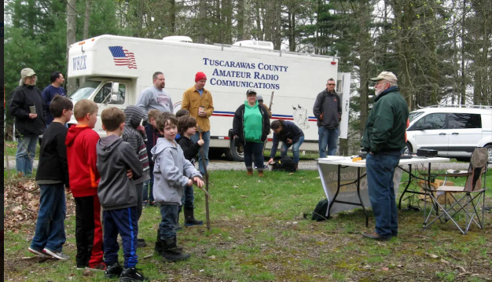

That’s it for this month; I hope to work you on the air soon.
73,
Anthony, K8ZT (k8zt@arrl.net)

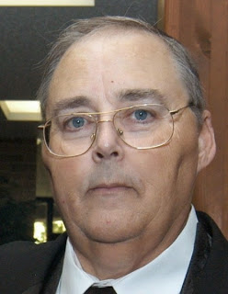
From the Section Traffic Manager
David Maynard, WA3EZN – STM
wa3ezn@att.net

Test Your Readiness during the 2022 Simulated Emergency Test on October 1 – 2.
ARRL’s Simulated Emergency Test (SET) is October 1 - 2, 2022, and this nationwide exercise is the chance to test your personal emergency-operating skills and the readiness of your communications equipment and accessories in a simulated emergency-like deployment.
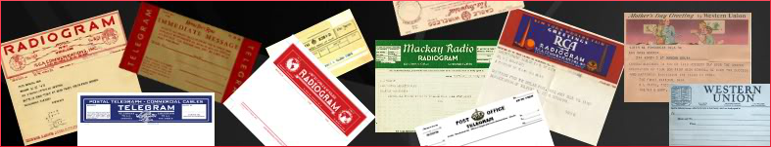
ARRL Field Organization Leaders at the section and local levels, and many other volunteers that are active in public service and emergency communications, are developing simulated emergency-like scenarios in consultation with a variety of agencies and organizations for whom radio amateurs are known to provide service during emergencies.

Please remember that station readiness and personal training and practice are tenets of the Amateur Radio Service. Any time we spend on the air will contribute to developing and practicing our personal radio communication capability.
This from the Section Emergency Coordinator Stan Broadway, N8BHL – SEC, broadways@standi.com . We are in the planning stages for the Ohio Simulated Emegency Test (SET) which is held traditionally on the first weekend of October.
I want to reach out to all amateurs (beyond just ARES) to be ready to volunteer as we develop our plans! Of course like a response to an emergency, our primary goal would be to pass messages between counties and to the state W8SGT station. A lot of that will be digital using IS-213 forms over fldigi on both VHF and HF frequencies. Thanks Stan for the heads up.
What can you do to participate?
Although a lot of the ARES traffic will go digital there is a chance that some of their traffic will come to a VHF net, CW net or the OSSBN Saturday morning. You may be needed to deliver traffic or be a laision to the OSSBN for a local net. If you are checkin in to a VHF net and the OSSBN then you are a laision station. Let the net control know you are a laision station.
Besides being a laision station you can initiate your own radiograms and send them via a radio net. In order to get points for your tword the SET score the radiograms must initially be sent by radio (RF) during SET. They do not however have to be relayed or delivered during to their final destination during SET. Each year we have had SET rediogram being received or relayed on OSSBN after SET is overwith. I will show some exambles here of radiograms to me delivered to Ohio destination but radiograms can be sent outside of Ohio also.
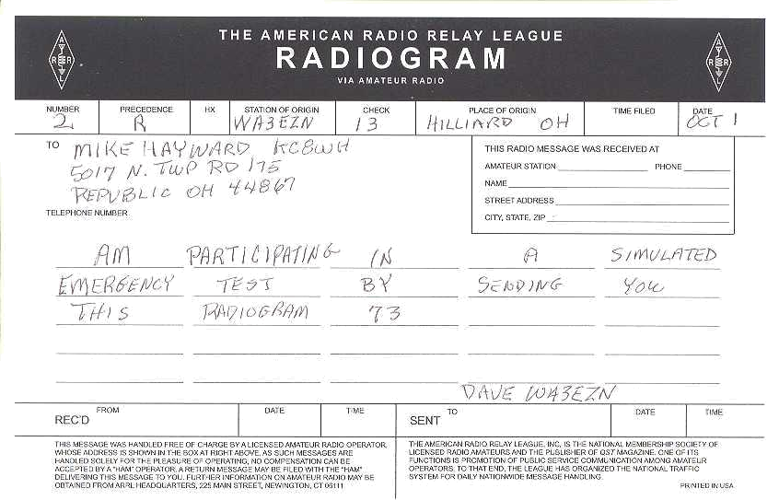
So you have decided to participate. Here is an example of how to notify someone you are participating in set. Send a radiogram to your Section Manage, your Net Manager or to me your Section Traffic Manager or anyone else.

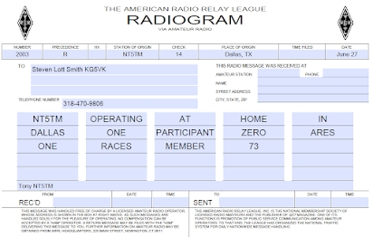
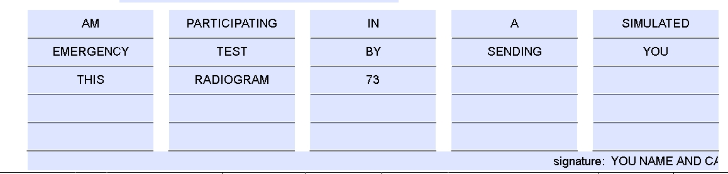

If you are working with a test sanario you may want to send a radiogram similar to this one. Just be sure to place the words TEST MESSAGE as the first two words in the text.
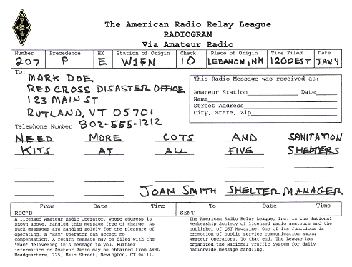

You may want to send this one similar to someone anytime:
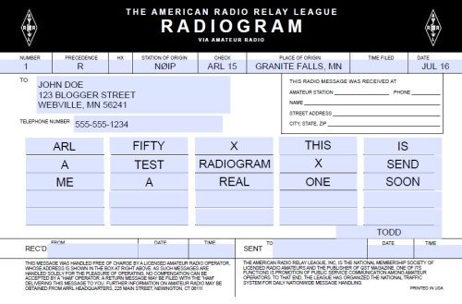
PURPOSE OF SET
1. To find out the strengths and weaknesses of ARES, NTS, RACES and other groups in providing emergency communications.
2. To provide a demonstration--to served and partner agencies such as the American Red Cross, the emergency management agency and through the news media--of the value to the public that Amateur Radio provides, particularly in time of need.
3. To help radio amateurs gain experience in communications using standard procedures and a variety of modes under simulated-emergency conditions.
Summary
One of the first steps on the way to a successful SET is to try to get as many people involved as possible. In a real emergency, we find amateurs with all sorts of varied interests coming out of the “woodwork.” Let's get them involved and informed through the SET so they will know more about how emergency communications can be and should be handled. Promote the SET on nets and repeaters ahead of time to sign up prospective participants.

Thanks to your efforts, the public service tradition in Amateur Radio continues!

WHERE TO FIND AN HF OR VHF TRAFFIC NET IN OHIO:

OHIO SINGLE SIDEBAND NET
Morning session | 10:30 AM | 3972.5 KHz | every day
Afternoon session | 4:15 PM | 3972.5 KHz | every day
Evening session | 6:45 PM | 3972.5 KHz | every day

OHIO HF CW TRAFFIC NETS
HF CW NETS | NET TIMES | FREQUENCY | NET MANAGERS
Buckeye Early | 6:45 PM | 3.580 | N2LC
Buckeye Late | 10:00 PM | 3.590 | WB9LBI
Ohio Slow Net | 6:00 PM | 3.53535 | N2LC
All CW net frequencies plus or minus QRM
OHIO LOCAL VHF TRAFFIC NETS
VHF NETS | NET TIMES | FREQUENCY | NET MANAGERS
BRTN | 9:30 PM DAILY | 145.230 PL 110.9 | W8DJG
COTN | 7:15 PM DAILY | 146.970 PL 123.0 | KV8Z
NWOHARES | 6:30 PM DAILY | 147.375 PL 103.5 | N8TNV
TCTTN | 9 PM Sun, Tues, Fri | 147.015 | WB8YYS
TATN | 8:00 PM DAILY | 146.670 PL 123.0 | WG8Z

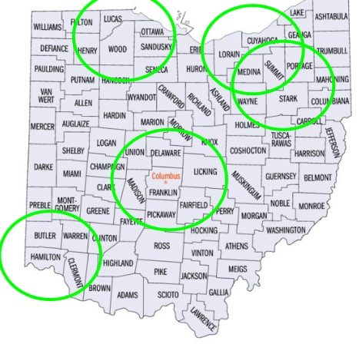

OHIO VHF TRAFFIC NETS

BRTN Burning River Traffic Net serving Cleveland and North Central Ohio
COTN Central Ohio Traffic Net serving Columbus and Central Ohio
MVTN Miami Valley Traffic Net serving the Dayton area
NWOH ARES Northwest Ohio ARES Net serving Toledo and surrounding counties
TATN Tri-State Amateur Traffic Net
TCTTN Tri-County Traffic and Training Net serving North East Ohio

Until next month, 73
David WA3EZN
Ohio Section Traffic Manager

National News
(from arrl and other sources)

______________________________________________________________________________

JOTA-JOTI 2022 (Jamboree-on-the-Air-Jamboree-on-the-Internet), the world's largest amateur radio Scout event, is set for October 14 - 16, 2022. The event connects millions of young people around the world for a full weekend of amateur radio and online activities that promote friendship and global citizenship. Using both the airwaves and the Internet, JOTA-JOTI enables young people and volunteers to participate in fun and engaging group activities focused on developing 21st century skills through Scouting. JOTA is one of World Scouting's longest-running global events, dating back to 1958. JOTA-JOTI aims to support young people of all ages to learn about communications technology, the values of global citizenship, and their role in creating a better world. To register and learn more about JOTA-JOTI, visit their website at www.jotajoti.info.

______________________________________________________________________________________

Special Bulletin 9 ARLX009
From ARRL Headquarters
Newington CT September 23, 2022
To all radio amateurs
SB SPCL ARL ARLX009
ARLX009 Amateur Radio Operators Track Hurricane Fiona
The National Hurricane Center (NHC), the Hurricane Watch Net (HWN), the Voice over Internet Protocol (VoIP) Hurricane Net, and the Salvation Army Team Emergency Radio Network (SATERN) all have been engaged in tracking Hurricane Fiona.
Amateur radio operators have been reporting weather conditions since Monday, September 19, 2022, and have received positive feedback on their assistance. The VoIP Hurricane Net was active for 14 continuous hours on Sunday, September 18, for Hurricane Fiona, as it pummeled the southern and southwestern portions of Puerto Rico with catastrophic rainfall and flooding with hurricane-force conditions.
In the ARRL Puerto Rico Section, Public Information Coordinator (PIC) Angel L. Santana-Diaz, WP3GW, who lives in Trujillo Alto, reported a widespread blackout as the hurricane made landfall on the island. Still, he explained, there were ham radio repeaters that remained on the air with amateurs sharing reports of damage,
including downed trees and power poles, and roofs ripped from homes.
ARRL Member Pedro S. Labayen, KP4DKE, of Utuado, was mentioned in a Miami Herald article for reporting the significant damage to his rural and mountainous region of the island.
The NHC has issued advisories for Hurricane Fiona and Tropical Storm Gaston. Marine warnings are also in effect for the Caribbean and the Southwest Atlantic. As of 2:00 PM EDT (1800 UTC) on Thursday, September 22, the NHC reported that Hurricane Fiona is forecast to pass just west of Bermuda by late Thursday evening, approach Nova Scotia on Friday, and move across Nova Scotia and into the Gulf of St. Lawrence on Saturday. Fiona is a category 4 hurricane with maximum sustained winds near 130 mph (215 km/h) with higher gusts.
In advance of the hurricane, the Radio Society of Bermuda activated their Emergency Measures Organization (EMO) on Wednesday, September 21, at 1:43 PM ET and plans to have 14 active amateurs monitoring the hurricane network. Plans are to use local repeaters, unless there's a power loss, then they'll switch to simplex. They're currently monitoring 14.283 MHz and will continue to monitor that frequency.
The HWN will be activated on Thursday, September 22, at 5:00 PM EDT/AST (2100 UTC) on the primary frequency of 14.325 MHz. Activation for the 40-meter net on 7.268 MHz will be at 7:00 PM EDT/AST (2300 UTC). The net will be on 20 meters for as long as propagation will allow and will remain active on 40 meters until it's no longer required, or propagation goes away.
However, should Hurricane Fiona make direct landfall, operations will resume on Friday, September 23, at 9:00 AM EDT/AST (1300 UTC) to assist with post-storm reports and any outgoing health and welfare traffic, which would be directed toward SATERN.
HWN Manager Bobby Graves, KB5HAV, offered some suggestions for amateur radio operators contacting the net.
"We look for reporting stations that can provide us with any measured or estimated weather information that we can relay directly to the forecasters at the National Hurricane Center in Miami. Such weather information we look for is maximum sustained winds, wind gusts, wind direction, barometric pressure, and rainfall amount -- how much over x-amount of time, storm surge, and damage," Graves said. "Also, should you have any outgoing health and welfare traffic before, during, or after this event, we are happy to assist as we work closely with the Salvation Army Team Emergency Radio Network."
Graves also said, as a reminder, the HWN is available to provide backup communications to official agencies, such as Emergency Operations Centers, American Red Cross officials, and storm shelters in the affected area. They also collect and forward significant damage assessment data to government and non-government officials.
Amateur radio operators who want to monitor or participate in the hurricane nets should visit these two useful and informative links:
The Hurricane Watch Net - Useful Links:
https://hwn.org/tools/useful-links.html
VoIP Hurricane Net:
https://voipwx.net/

Annual SET Exercise to Test Skills and Emergency Preparedness
The ARRL Simulated Emergency Test (SET) is scheduled for October 1 - 2, 2022. The SET is ARRL's annual national emergency exercise and is designed to assess the skills and preparedness of Amateur Radio Emergency Service® (ARES®) volunteers, as well as those affiliated with other organizations involved in emergency and disaster responses.
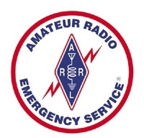
"The SET provides an opportunity to evaluate equipment and skills, and to gauge the level of preparedness," said ARRL Director of Emergency Management Josh Johnston, KE5MHV. "Additionally, it helps with interaction between other amateur radio operators and strengthens the level of training we all have."
The SET encourages maximum participation by all radio amateurs and partner organizations, as well as national, state, and local officials who typically engage in emergency or disaster responses. In addition to ARES volunteers, those active in the National Traffic System™ (NTS™), Radio Amateur Civil Emergency Service (RACES), National Weather Service (NWS) SKYWARN®, Community Emergency Response Team (CERT), and a variety of other allied groups and public service-oriented radio amateurs are needed to fulfill important roles in this nationwide exercise.
This year, ARRL introduces a new program of accessible online reporting forms that allow SET participants to report activity directly to ARRL Headquarters. The new forms allow Emergency Coordinators and Net Managers to report traffic and activity. Public Information Officers and Coordinators, as well as Section Emergency Coordinators and Section Managers, can also upload press releases and pictures online.
The SET offers volunteers an opportunity to assess equipment, modes, and skills under simulated emergency conditions and scenarios. Individuals can use the time to update a go-kit for use during deployments and to ensure their home station's operational capability during an emergency or disaster. To get involved, contact your local ARRL Emergency Coordinator or Net Manager.
SET guidelines and access to the forms can be found at www.arrl.org/public-service-field-services-forms.

__________________________________________________________________

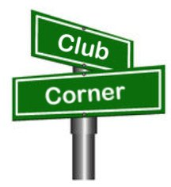
Club Corner

This is YOUR corner of the newsletter. Send us what your club is doing, and we’ll make sure that it gets in. Got a special event or club project that you want everyone to know about? Send it to us!. Need help with a project? Send it to us.

Let us know what you club is up to. Are you going to have a special guest at your meeting or are you having a special anniversary?

Send it to: webmaster@arrl-ohio.org

Hi Tom,

I am writing to you because I receive the monthly ARRL Ohio postscript. I am a member of the Long Island CW club which teaches morse code and other ham radio topics on Zoom. It also has a weekly Boat Anchor Zoom forum in which they have outside speakers present on vintage gear topics.

The weekly Boat Anchor Zoom forum is on Saturdays. We are currently looking for speakers. If any Ohio Section Hams are interested in presenting on any topic that inspires you, please contact, Ai, AI8AI at boatanchor@use.startmail.com

The Long Island CW club teaches morse code and other ham radio topics on Zoom with 75 classes. It has 3100 members in 50 states and 47 countries. More info can be found at https://longislandcwclub.org

Kindly let me know. The club would surely appreciate it.

Best and 73,
Ai - ai8ai

Dear Tom WB8LCD,

Please share the following information with PCARS and the Ohio Section. I know you are a strong proponent of demonstrating the fun of ham radio with kids, and I would like to share a great example.

A friend and local Ohio ham, Josh Reichard, K8KJR wrote a great article for QST highlighting the STEM camp he set up at the school where he works, Valley Christian Schools in Youngstown. He is very dedicated to teaching students about amateur radio and at camp he had them making satellite contacts! (Please read article)
I think it would be awesome to promote this article by having PCARS members and Ohio Section Hams voting for the QST Cover Plaque Award.

Please following these instructions to vote for Josh's QST article about the STEM camp:
1. Go to: www.Arrl.org & Login to your account.
2. On the right side go to the section: MEMBER QUICK LINKS & Click on QST
3. Scroll down to go to the section titled: Vote for Your Favorite Article & click on Go Now
4. In the section: QST Cover Plaque Award click on: Students Experience Amateur Radio in a Hands-On STEM Camp, Joshua Reichard, K8KJR then click SUBMIT
THANK YOU FOR SUPPORTING OUR LOCAL FRIEND JOSH!

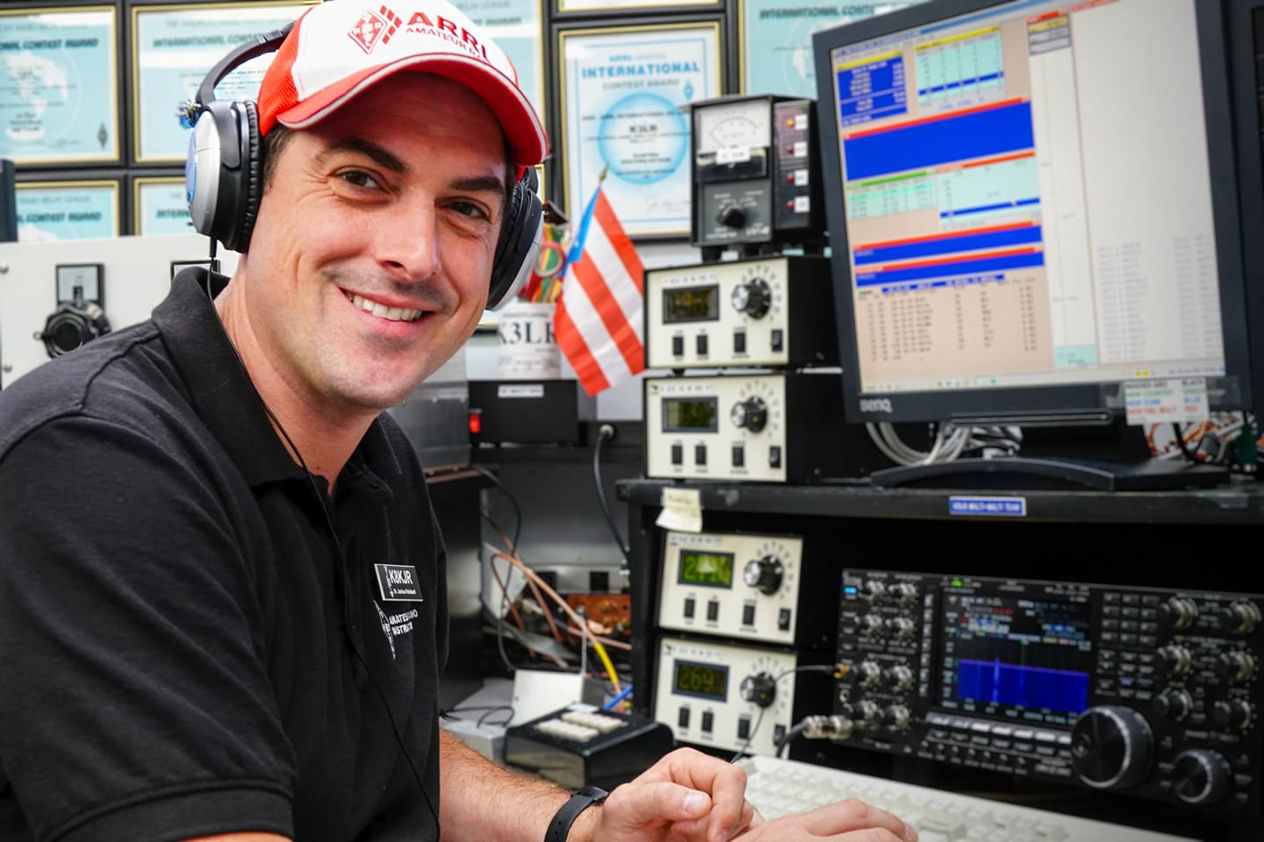
Dr. Joshua Reichard, K8KJR

Thank you,
Amy N8AMY
Hello Tom,

As you know I am one of three net controls at the NWS in Wilmington, Ohio. Lou Long KB8TCK, and I attended the NWS/SkyWarn fall coordinator’s meeting this morning. This was our first in person meeting for the past 3 years due to the pandemic. The recognition awards are for Dayton SkyWarn’s service to the community for the Memorial Day night tornado outbreak May 27, and 28. The Dayton SkyWarn net operators for the severe weather outbreak were Don Parker KB8PSL, south repeater, Gary Clark KC8TND, NWS radio, and Dave Crawford KF4KWW, north repeater.

Don Parker, sitting in the “hot seat” took the initial tornado reports as the tornadoes begun their destructive paths across Montgomery County. When we believed the severe weather was calming Don took a break and Dave Crawford moved to the south repeater “hot seat”. The tornado outbreak wasn’t finished. Dave took many reports as the tornadoes moved across the Dayton area moving East through the county. It was a very active weather event with 19 tornadoes affecting the Miami Valley area.

The NWS/SkyWarn trained weather spotters reporting to Dayton SkyWarn were the eyes on the ground. Their reports helped NWS provide valuable information to alert the public to these dangerous storms. Our trained SkyWarn spotters are an important part of the SkyWarn operations.

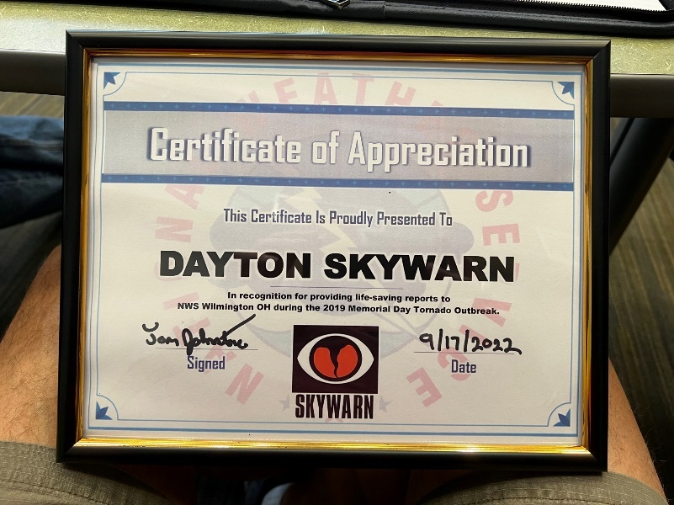
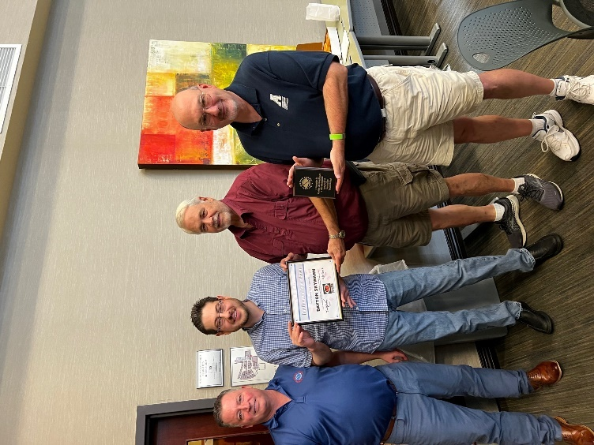

Pictured: Tom Johnstone – NWQ Meteorolgist in Charge, Brandon Peloquin – NWS Warning Coordinator, Don Parker – KB8PSL, and Lou Long KB8TCK.
73, Michael W8CI
Cuyahoga Falls ARC Online Tech License Classes Start Oct 9th

The Cuyahoga Falls ARC will be sponsoring Technician and General Licensing Classes this fall and winter. The Tech class starts on Oct 9 and will run for six weeks. Time is 1:30 to 4:00 PM, and the classes will be held online via Zoom and Google Classroom. For more information, you can visit tiny.cc/beaham.

I know what you are thinking “why would I be reading this if I didn’t already have my Tech License!” That’s partially true; we are running this article in the Ohio Section Journal because we need your help. Potential Hams do not know about licensing classes or how Amateur Radio Licensing works. So we need you to find potential new Hams and let them know about the class.

Here are some suggestions on how to do this:
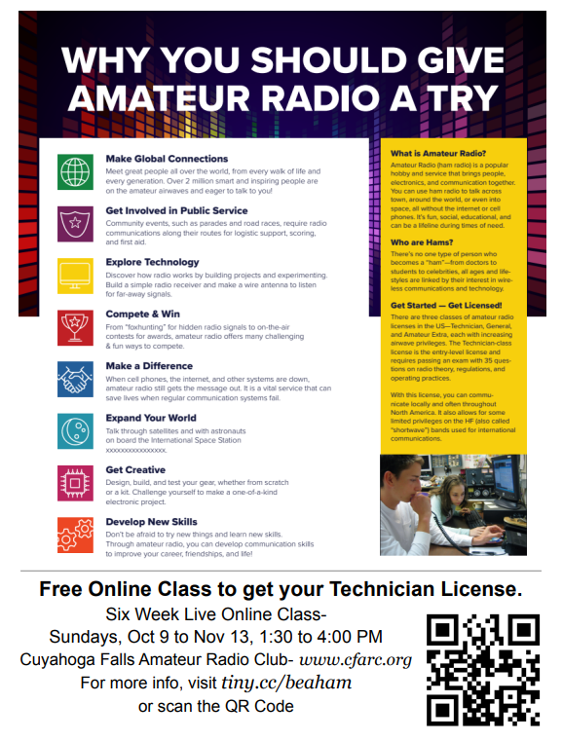
- Tell someone- give them this link - tiny.cc/beaham (email it to them, print it out, text it to them, call them on the phone, send it in a letter or card, attach it to a small gift or snack, etc.) and if they ask, “What is Amateur Radio?” give them this link tiny.cc/wiar.
  - Do you have a spouse, child, parent, or another family member interested in getting started in Amateur Radio?
  - Do you have friends or neighbors interested in getting started in Amateur Radio?
  - Do you have co-workers interested in getting started in Amateur Radio?
- Do you have a place to put up a flyer (work, school, library, restaurant, store, etc.)? Here are links to two printable flyers: Flyer A & Flyer B
This year we will be working in conjunction with the M.O.R.E. Project. This will mean that students who complete the class and pass the license exam will be eligible to receive a GOTA (Get On The Air) package of free equipment, including a VHF/UHF HT and a SDR (Software Defined Receiver).
Because we draw attendees from around the country, we always recommend they join a local radio club in their area. If you recommend this class to someone, please let them know about your local club so they can find mentors in their area.

__________________________________________________________

VE Sessions

All Things Amateur Radio Association (ATARA) We host testing sessions every second Tuesday of the month to sign up please visit our website https://atara-w8atr.fun and contact us at hamexams@atara-w8atr.fun.

CARS
VE testing from CARS - Cuyahoga Amateur Radio Society - at Elmwood Recreation Center, 6200 Wisnieski Parkway in Independence, Ohio 44131 Time: 9:15 AM (Walk-ins allowed) Always the 2nd Sunday of the odd month. Go to CARS www.2cars.org for detailed map of location. Call Metro W8MET 216-520-1320 for details

Dayton Amateur Radio Association (DARA)
If you are interested in testing for a new or upgraded license, please come see us at the DARA Clubhouse. If you have questions about testing, please email exams.w8bi@gmail.com

Huber Heights Amateur Radio Club
Huber heights amateur radio club does ARRL VE testing the second Saturday of each even numbered month. Feb, Apr, Jun, Aug, Oct, dec. 9:30-11:00 For more information contact Jim Storms – AB8YK at ab8yk@hotmail.com

The Lake County Amateur Radio Association
The Lake County Amateur Radio Association is once again holding its 2022 Amateur Radio license exams at the Kirtland Library, 9267 Chillicothe Road, on the following dates:
Saturday, June 4, August 6, October 1, and December 3.
The tests will start at 12 noon. Please arrive a few minutes earlier.
The Lancaster and Fairfield County Amateur Radio Club (LFCARC) hosts exam sessions at the FAIRFIELD County EMA, 240 Baldwin Dr in Lancaster Ohio, 43130, on the first Saturday each month at 10:00 am. Please visit our website at http://www.k8qik.org for exam dates on our calendar and navigate to our Learning Center/Taking the Exam link for information and requirements. Our VE team looks forward to serving the Amateur Radio community in Central Ohio and across our nation. We have an experienced team that has tested candidates from Alaska, Florida, Texas and points in between! Contact me at ve_testing@k8qik.org to register.
The Milford Amateur Radio Club (MARC) is now doing VE testing on the third Thursday of each month at 6:00 PM. Location; Miami Township Civic Center located at 6101 Meijer Drive, Milford, OH 45150.
Please pre-register at www.milfordhamradio.org

Northern Ohio Amateur Radio Society (NOARS)
VE sessions are held the first Saturday of odd-numbered months at 10 AM in the North Olmsted Library, 27403 Lorain Rd., North Olmsted. Registration is preferred, but walk-ins are welcome. For more information or to register, contact Elaine, KC8FOS at ewilkinson1951@gmail.com.

Portage County Amateur Radio Service (PCARS)
The first Saturday of every even numbered month -10 am – at the PCARS club site in Ravenna. Please visit the PCARS web site and check out the information about VE testing in the latest newsletter at www.portcars.org .
If you have any questions, don’t hesitate to contact me at KB8UUZ@gmail,com

Club Commission Program Update
One of the benefits of being an ARRL Affiliated Club is that you can receive a commission for recruiting new ARRL members and securing timely ARRL membership renewals. The commission structure for this program has been updated, and the process has changed to make things easier for the clubs. The new procedure involves all membership dues being sent to ARRL for processing, prior to the club receiving a commission payment directly from ARRL. The complication of adjusting funds around credit cards, checks, and cash has been eliminated. ARRL is now responsible for all of the processing. As a result, your club could earn money while promoting the many benefits and programs of ARRL, to help ensure that the amateur radio hobby is protected and continues to grow.
Additionally, the commission rate has changed. Now, clubs will receive $15 for each new membership or lapsed membership (of 2 years or more). For renewing members, clubs will now receive $5. There is no limit to the amount that a club can earn in this program.
Club leadership is encouraged to let their membership know that the club can benefit from this program. Only regular memberships are eligible for commission. Life, International, Family, Blind, and Student memberships are ineligible for commission.
The new Club Commission Program is available for all ARRL Affiliated Clubs and goes into effect on June 1. Additional information, as well as FAQs, can be found on the Affiliated Club Benefits web page.

Important Links
ARRL Home: www.arrl.org
Find an ARRL Affiliated Club: www.arrl.org/clubs
Find your ARRL Section: www.arrl.org/sections
Find a License Class in your area: www.arrl.org/class
Find a License Exam in your area: www.arrl.org/exam
Find a Hamfest or Convention: www.arrl.org/hamfests
Email ARRL Clubs: clubs@arrl.org

The Ohio Section Youth Net

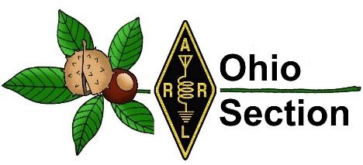
Youth Net
When: The second Sunday of every month at 7:30 PM EST
Where: The K8IV repeater located in Kent, Ohio (Echolink node K8BF-L) RF: 146.895 Mhz with PL 118.8
Who: Any licensed amateur radio operator who wishes to participate. Priority will be given to youth stations and those located in Ohio.
The purpose of this net is to encourage youth activity in amateur radio and to help new hams get more comfortable on the air.

Amateur Stations Support State Agency Exercises
C. Matthew Curtin, KD8TTE

From August 6 until September 15, amateur radio stations in Ohio and Florida provided support to Ohio’s 4th Civil Support & Sustainment Brigade (4CSSB), Ohio Military Reserve, in the IONIZED PARTICLES 22 exercise.

Making use of systems and spectrum available to licensed radio amateurs, 4CSSB issued a series of Requests for Information and collected responses from participating stations on 3.5 MHz, 5 MHz, and via Winlink Global Radio Email. The exercise built upon earlier work from previous years’ BLACK SWAN exercises and the County Information Report Project 20 (CIRP20) from two years ago.

Federal and state agencies increasingly include the collection of “ground truth” in emergency plans and exercises. CIRP20 provided a specific program of coordinating ARES counties, districts, and the Ohio Section to perform this function statewide, and was the basis for FEMA joining the exercise. The Military Auxiliary Radio System (MARS) likewise employed a model of collecting information from stations around the country in this year’s MARS COMEX 22-2.

The IONIZED PARTICLES 22 exercise was organized as a relatively “slow, regularly-paced” exercise like CIRP20 and MARS COMEX 22-2. On August 6 and 7, OHMR stations issued several requests for information and collected responses in the minutes and hours that followed. From August 8 until September 10, requests and responses were exchanged on the regularly-scheduled BLACK SWAN training nets held thrice weekly, Saturday and Sunday on 5 MHz at 1300 Ohio time, and Monday on 3.5 MHz at 1900 Ohio time. Specific frequencies are set forth in the net’s Signal Operating Instructions (SOI) available at https://www.blackswancomex.org/net/soi.

From September 11–15, OHMR stations worked with participating amateur stations on twice-daily nets to exchange requests for information and responses. The stations made use of the weekly training coordinated around the training net over the course of the past few years. Each week, we present a training video on the topic via the YouTube channel “Radio KD8TTE” (https://www.youtube.com/c/KD8TTE), followed by a discussion via Internet mailing list QTC, and at least three on-air sessions to practice. The nearby table shows tasks performed by title, number, and links to the discussion (which in turn have links to the training videos).

Task | Task Number | Link to Discussion
Net Activation | 2207, 2208, 2209 | https://groups.io/g/QTC/message/686 https://groups.io/g/QTC/message/693 https://groups.io/g/QTC/message/694
Control radio net | 21-42 | https://groups.io/g/QTC/message/637
Use of 5 MHz interop channels | 2216 | https://groups.io/g/QTC/message/738
Report into the net | 2210 | https://groups.io/g/QTC/message/697
Receive digital message with FLAMP | 21-30, 2210 | https://groups.io/g/QTC/message/564 https://groups.io/g/QTC/message/697
Gather information by radio | 2230 | https://groups.io/g/QTC/message/777
Originate Basic Message Format traffic | 2231 | https://groups.io/g/QTC/message/780
Originate amateur radiogram traffic | 21-50 | https://groups.io/g/QTC/message/657
Transmit digital message with FLAMP | 21-31, 2210 | https://groups.io/g/QTC/message/574 https://groups.io/g/QTC/message/697
Use fills to complete relay | 2237 | https://groups.io/g/QTC/message/805
Submit content to QSP editor with FLMSG | 21-28 | https://groups.io/g/QTC/message/539
Reporting in to QSP editor with Winlink form | 21-29 | https://groups.io/g/QTC/message/555
Station and message authentication | 2221 | https://groups.io/g/QTC/message/754

Collected information provided critical intelligence information such as road conditions, status of electric, water, Internet, broadcast TV and radio, HF noise floor on various bands, terrestrial weather, and signal strength from stations WWV and CHU on various frequencies.

Big thanks to W8KVK, N2LC, WD8SDH, and NH2KW for their Response to Request for Information messages. We are also grateful for the participation in training and radio newsletter activity from WB8TDG, W8PAB, KC9TYA, WD8SAB, WD8IIJ, W8JTW, WX8OH, KD8OSI, KV8Z, AD0TU, W8KVK, AD8CM, KE8FMJ, KD8UOT, NC8HF, KX4Z, K8ICV, N8WGE, KB8UNJ, KL7RF, KM4JTE, W8RIH, VE6LK, K7TMG, KJ7YVQ, KC8PUN, W1LEM, NN8B, W2PAX, N2JLF, W8WSE, and N9NMR.

Stations interested in learning agency-facing AUXCOMM operating skills and standards are welcome to join in the training and exercises. See the BLACK SWAN training net for more information. https://www.blackswancomex.org/net

______________________________________________________________________

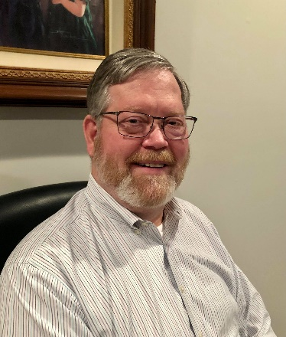
DX This Week – IOTA – Part 1

Bill AJ8B (aj8b@arrl.net, @AJ8B, or www.aj8b.com)
CWOPs Member #1567

What a week! Quite a bit of DX was on, but band conditions are still tough. Just got to get in and slug it out! Last year, I received emails almost weekly from readers letting me know what they were working. I have gotten very few this year. Just a reminder, the email address is aj8b@arrl.net – send me some thoughts on what you are hearing and working. As always, I would like to see what QSL cards you are receiving as well. Why not send me pics of your shack and/or antenna? Do not be shy. If I do not have your input, I am just on an island printing what I THINK you will be interested in.
Speaking of islands, one of the programs that I know little about is the Islands on the Air, or IOTA program. I decided to do some digging to learn about the program and I am glad that I did. Part 1 of the research is below with Part 2 to follow next week.
Below are the cards that I received this week. They are from 9K2YM – Yaser in Kuwait, JT1AA - Gantulga and JT1CO - Choi in Mongolia, and P29NO – a CW QSO from 2014 with Naohiro in Papua New Guinea. Took me a while to find the manager and then get the card. Coincidently, you will notice the IOTA emblem on the P29NOP card.
Finally, a word of thanks to Anthony, K8ZT, and Tom, WB8LCD. Anthony presented at the SWODXA club meeting last night and Tom gave us an update on the section and the league – Thanks to you both.
73 and Gud Hunting

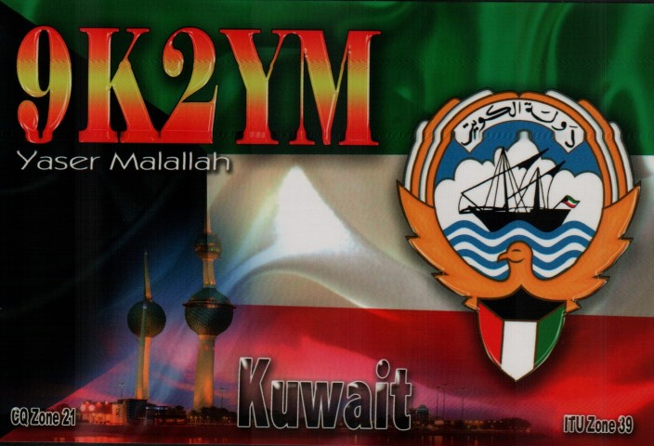 | 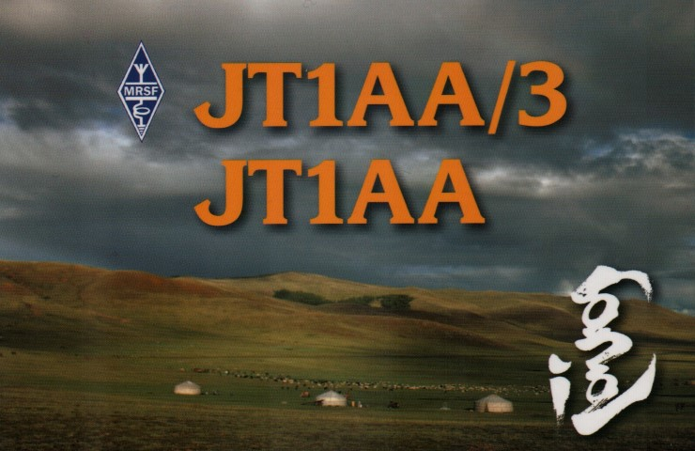
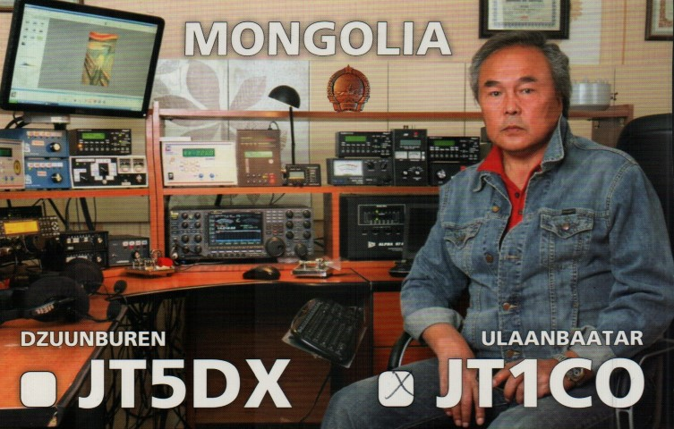 | 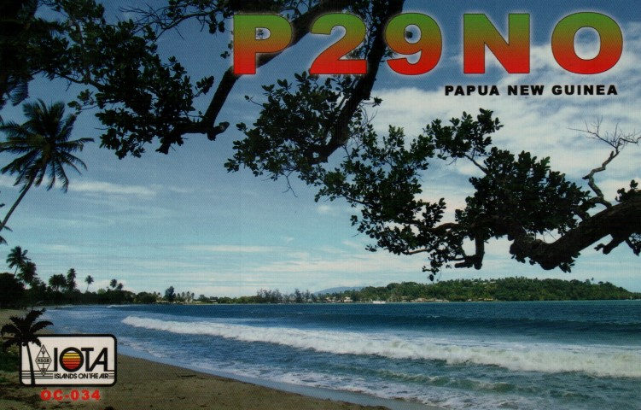

DAH DIT DIT DIT DAH DAH DIT DIT DIT DAH

50+ Years of IOTA by Roger Ballister, G3KMA – Part 1
The information presented here is a compilation information from https://www.iota-world.org/ I was given permission to use this information and to reprint it by Charles Wilmott, M0OXO
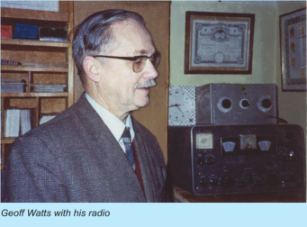
Much has been written in the detailed in-house stages of development, most recently in the 40th Anniversary Directory and in an article headed 25 Years as IOTA Manager in the 2011 Directory. There, mention was made of decision by Geoff Watts, March 1985 to ask the RSGB to over management of the IOTA Program that he himself had launched in ended the first phase and opened to three further ones. Let us look the effect it had on the amateur to the present day.

Mission Statement
IOTA Mission Statement: To increase activity on the amateur radio bands by encouraging operations from island locations, to keep a database of contacts made by IOTA program participants and to recognize high performance in the making of such contacts.

1964-1985
Geoff’s concept of working islands caught on immediately with a small number of amateurs, particularly in Europe and the USA, and equally with some SWLs as it was open to listeners also. His original Directory of Islands listed 500 island groups of which 194 had a reference number, indicating that they had been activated at some stage in the past. They were almost all recognized island groups such as the Canaries or were large islands deserving of a separate status. The focus was on the geography of islands rather than political affiliation – in fact, the lack of a political dimension meant the grouping of more than ten DXCC entities in the Caribbean into just two IOTA groups, Leeward and Windward Islands. The group concept was key because, with maybe a quarter of a million islands in the world, it was inconceivable that any island program could cope with recognizing them all or that more than a fraction would ever be visited by radio amateurs. Also, at a practical level in 1964 there was not the ready access to mapping information that we came to enjoy which would have allowed a much larger list. Many atlases were great on Europe and North America quite scanty on other continents. For most people, the list long enough!
So, at program launch IOTA had just 194 numbered IOTA groups. The aficionados to-be combed the bands for island stations but after the first few dozen groups worked, new ones were hard to find. Often it was only when the following week’s DX News Sheet, also written by Geoff, issued that we learned that a new island had appeared on the bands days earlier and that we were going to have to apply our efforts to tracking it down (same time, same day of the week was usually a starting point). Most stations were likely to be found on 40, 20, 15 and 10m as this was, for most of the period, before the WARC bands were allocated. When a ‘juicy’ island station appeared, there was invariably no pile-up, just a handful of stations on frequency to work it. In terms of performance the simple truth was that the folk who put in most effort listening were the ones to benefit most. In these early years IOTA was not sufficiently well-known on the bands to have any impact beyond the inner circle of devotees and island chasing was a largely relaxed pastime involving small disparate groups of like-minded friends. To glean up to the minute information it was necessary to be part of one of these groups. Towards the end of this period local VHF DX alert nets were springing up but these tended to be used for the passing of DX rather than IOTA information. In fact, there was very little IOTA- specific DXpedition activity although of course activity put on for DXCC helped IOTA aficionados to build their scores and more so those chasers following both programs! Towards the end of Geoff’s stewardship things began to change. Portable equipment had begun to appear on the market although there was still some way to go to improve functionality. In Europe, island stations found on the bands were being associated with IOTA more readily, especially where, as in the case of the Italian islands, they had an identifying island prefix or suffix. People were beginning to look at islands that had a regular ferry service from the mainland or were otherwise easy to reach to see if an operation was feasible. It was this that caused pressure to build for granting IOTA recognition to coastal islands that were not in any recognized group nor large enough to justify listing under Geoff’s previous practice. In short, the warmer climate of the Mediterranean was stirring the amateurs of that region to fall in love with IOTA.

1985-1994
The change of stewardship to the RSGB in March 1985 came as a jolt to the growing IOTA Community – Geoff had run the program for 20 years and it was difficult to see it without him. Although by 1985 the island list had grown to 560 groups, almost immediately requests came in for further additions or, for that matter, this or that rule change. It is perhaps natural to expect a change of manager to be seen as a good time to get a request in for consideration! Certainly, as a rookie manager it demanded a cautious response if management of the program were to remain firmly in control. A hard look at the program showed just what a challenge it would be to maintain that control. We could slide into an open-ended program unless there were clarity as to reasons for inclusion or exclusion of islands. This is not criticism of Geoff’s work but rather an acknowledgement that pressures were building to take forward his initiative, which had proved so popular, in a direction that might not be the best.
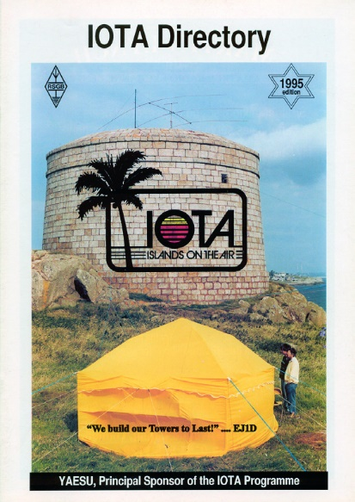
Over the next five years various ways of addressing expansion of the island list were tried to meet the aspirations of the growing IOTA community. With hindsight steps taken tended to be reactive rather than proactive. This had the unintended consequence of increasing the Europe list out of proportion with other continents. The only fair solution was a root and branch review of the list and the introduction of coastal island groups for every country with a seaboard. Each coastline was split into a series of boxes delineated by geographical co-ordinates taking account where possible of local administrative boundaries. This new system was introduced in a new Directory published in 1991.
Around the same time the then IOTA Committee took the decision to cap the current island list at 1200 groups and that remains to this day the key guiding principle.
Within weeks of the change of management in 1985 a group of IOTA aficionados started using 14260kHz as a meeting frequency and this evolved before long into a regular lunch time net promulgating the latest information about activity by island stations. When 14260 and other frequencies were nominated as IOTA meeting frequencies, they quickly gained a listening public keen on talking about all aspects of IOTA.
It was not long before island stations, brought to the net by IOTA friends, soon participated in list operations run by the MC. One way or another, for several years 14260 and 21260 were the frequencies to listen to for the chance island contacts. For so many a feeling belonging to a like-minded group was generated.
The running of an IOTA net and the issue of the 1991 Directory were the first steps in the development of IOTA as a serious worldwide program. I saw the fervor of so many activators to put on a New One for the program, a humbling experience since I had been responsible, with support from the IOTA Committee, for advocating every one of some 600 plus additions to Geoff’s original list.
(Continued Next Week – Stay Tuned)

DAH DIT DIT DIT DAH DAH DIT DIT DIT DAH

Here is an update from Bernie, W3UR, of the DailyDX and the WeeklyDX, the best source for DX information. http://www.dailydx.com/ . Bernie has this to report:

Sable Island CY0S DXpedition - By WA4DAN, Murray Adam
The 2023 Sable Island CY0S DXpedition team is very pleased to announce that DX Engineering is a major sponsor of the DXpedition. Many thanks to Tim K3LR, Teri K8MNJ and all the fine folks at DX Engineering for their most generous and overwhelming support for the CY0S DXpedition. DX Engineering is providing low band antennas, bandpass filters, coaxial cables, guying materials and many other items. Many thanks to the DX Engineering team! Planning continues to go well for the DXpedition. One of the unique aspects of the Sable DXpedition effort is the weight limits the team must meet. The team is allowed two flights to get team members, equipment, antennas, antenna mast, coaxial cables, food and personal gear to the island. One flight will be with Sable Aviation on their Britten Norman Islander twin engine aircraft. The other flight will be on the Vision Air Services Sikorsky SK-76A helicopter. The total weight allowance for the two aircraft is 2965 lbs. which includes the weight of each team member. This somewhat limits what the team is allowed to carry to the island. To conserve weight, team members will be bringing freeze dried meals and MRE's for the nine-day DXpedition. The team is continually fine tuning and prioritizing the gear that will be taken to the island. It's a challenge to be able to take all that is needed and come under the weight limits.

TT – Chad - F8FQX, Nicolas, is back in N'Djamena and QRV again as TT8SN. At the moment he only has beams for 10 and 6 meters. He expects to soon have a vertical for 40 and 30 Meters, as well a Spiderbeam for 20 through 10 Meters, but first he will wait for the storm season to end. Summer in Chad has been difficult with heavy winds and rain. There is a chance he may again try 60 Meters, but 160 and 80 Meters are not likely due to too much noise. This will be his last year in Chad as he expects to end his current work assignment by late July 2023.

S2 – Bangladesh - Ops are planning an island operation, IOTA AS-140, S21DX, December 10-16, with three stations with improved antennas from previous operations. This time they plan a beam, VDA and beverage and their multi-band vertical that does 80. They made 5,000 QSOs at the exciter level in a previous operation. This time they will have an amplifier on SSB and are looking for a larger generator to run everything. They are inviting more S2 ops who are interested and who have good operating experience. They plan an 80M beverage to cover NA and JA, a 40M four-square, triband Spiderbeam and a 3-element Yagi for EU and AF, and a small dish for QO-100, four stations, one on FT8 F/H, one on SSB with the amplifier, a second on SSB apparently without the high power, and one on QO-100 satellite, SSB. The current op list is S21RC, S21AM, S21D, S21TG, S2ABK and another op who appears to be waiting for his callsign. QSL via EB7DX, who has handled this group's QSLs for 15 years. They will also upload to LoTW and Club Log promptly, during the operation.

TL - Central African Republic - The Italian DX Team's TL8AA and TL8ZZ DXpedition is now scheduled for a November 12-26. This operation will have eight operators, "all bands, all modes." QSL via I2YSB. Their webpage is: http://www.i2ysb.com/idt/ and they plan an online OQRS log, http://win.i2ysb.com/logonline/

3Y - Bouvet Island - 3Y0J DXpedition co-leader LA7GIA, Ken, reports 700 raffle tickets were sold which "generated a much-needed support for [their] upcoming trip". The drawing will take place live at W9DXCC, which take place this weekend.
This past Sunday the 3Y0J shipping container was sealed in Oslo and is now on its way to Port Stanley, Falklands, via Montevideo, Uruguay. Some 4.8 tons of equipment is in the 20-foot container. "Ultimately the shipping was a major milestone", reports Ken, who also notes October 1st is the next vessel deposit.
The 3Y0J logistical team have made several recent "huge improvements" as they "focused on going onshore during short WX window". This includes a second zodiac allow them to "run 2 zodiacs in parallel during beach landing." They have also "added a fuel system" to allow pumping of 2000 liters of "diesel from the beach and into the IBC tanks located above the camp". All of this will allow a quicker setup of the camp.
In October a 3Y0J team member will visit Brazil to inspect the Marama to "close out the punch list", which was created in April. Discussions will also take place on the subject of landing the zodiac "to make it go smooth once at Bouvet".

OZ8X & OZ2I on the Balkan tour – By OZ2I
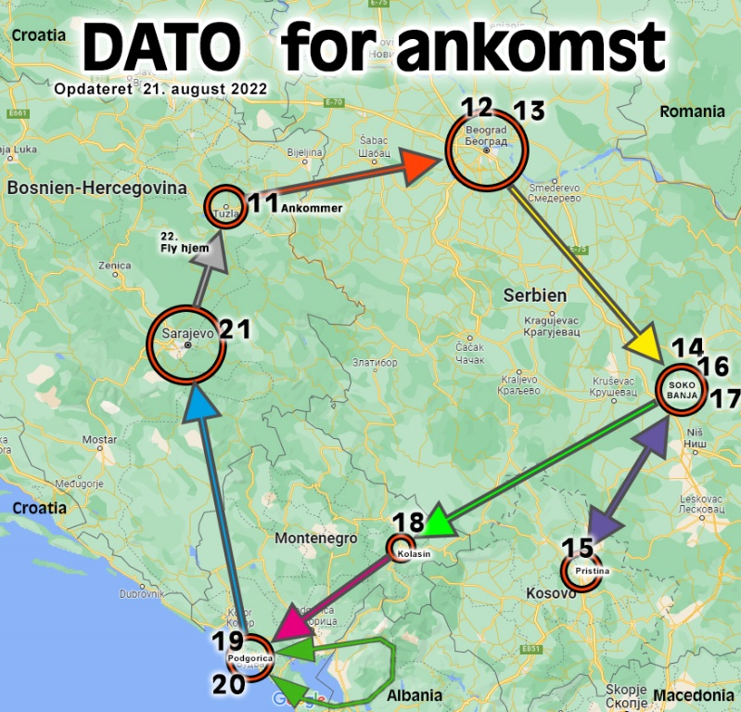
In July, we received an invitation from the Serbian Radio Amateur Association to participate in the annual IARU World Championship High Speed ​​Telegraphy event. The invitation applied to all Danish CW operators who wanted to participate either as a participant or as a guest.
I announced the invitation several times both here, on Facebook and in OZ without response, so when Harald contacted me and suggested that we take a tour to several of the Baltic countries, I was immediately on board with the idea. HST takes place from September 14 to September 18 in the town of Soko Banja, which is a few hours' drive south of Belgrade.
Above you can see the plan for our Tour.
We bring an Elecraft K3 and a shortened compromise antenna - HF-PRO-2-PLUS-T. Behind this nice name hides a 29-centimeter short HF antenna which can be tuned to all bands from 80m to 2 meters, handles 130W Max, weighs 425 grams and is 270 centimeters when it is extended to its full length.
In addition, a laptop Lenovo T450s with the UcxLog program, a Begali paddle and a switching power supply. Since we also bring a magnetic base for the antenna, we expect to be active from the car on some nice high mountains!
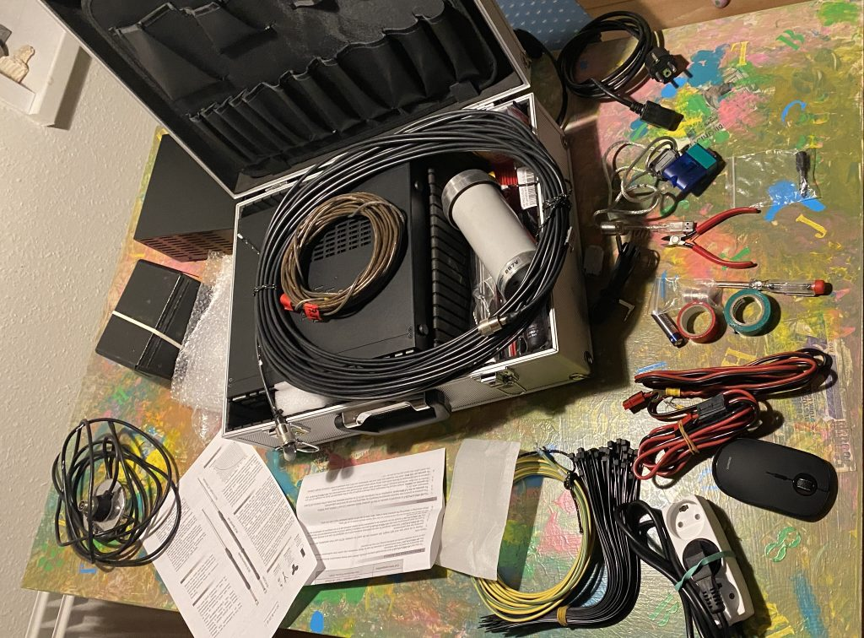
I have communicated a bit with the "Governments" in the various countries and the only country I could get a call sign was Kosovo, so there I now have Z68EE. In addition, I use YU/5Q6EE, E7/5Q6EE and 4O/5Q6EE. Maybe we will also be active from ZA Albania.
The radio equipment is collected in this aluminum case and in the regular case.
We of course hope to meet a lot of you on the HF bands with CW.
Our magnetic advertising sign to mount on the rental car ;o)

DAH DIT DIT DIT DAH DAH DIT DIT DIT DAH

Below is a list of upcoming contests in the “Contest Corner”. I think this is important for someone who is trying to move up the DXCC ladder since entities that are on the rarer side and easiest to work in contests. Some of my best “catches” have been on the Sunday afternoon of a contest when the rarer entities are begging for QSOs. Of course, the gamble is that if you wait until Sunday, conditions may change, or they simply won’t be workable. However, it is not a bad gamble. Of course, why not work the contest and have some fun!
Check out the WA7BNM Contest Calendar page (https://www.contestcalendar.com/) and CQ Magazine for more contests or more details. I also have a comprehensive list that can be imported to your calendar at www.aj8b.com/files
The contests in red are those that I plan to spend some significant participation time on. PLEASE let me know if you are working contests and how you fared.
Thanks!

Date(s) | Event | Info
Sept. 26 | RSGB FT4 Contest Series | https://bit.ly/31qpcJl
Sept. 27 | 222 MHz Fall Sprint | https://svhfs.org/2022VHFSprintRules.pdf
Sept. 28 | UKEICC 80m Contests CW | https://ukeicc.com/80m-rules.php
Oct. 1-2 | California QSO Party | http://www.cqp.org/Rules.html
Oct. 1-2 | Oceania Phone DX Contest | http://www.oceaniadxcontest.com/
Oct. 1-2 | SKCC QSO Party | http://bit.ly/2Xl2vyx
Oct. 1-2 | TRC DX Contest | https://trcdx.org/rules-trc-dx/
Oct. 1-2 | Worked all Provinces of China DX Contest | https://bit.ly/3AE4d5B
Oct. 2 | Peanut Power QRP Sprint | http://www.nogaqrp.org/
Oct. 2 | RSGB DX Contest | https://bit.ly/31qpcJl
Oct. 2 | UBA ON 80M SSB Contest | https://bit.ly/3kKYKzj
Oct. 3 | German Telegraphy Contest | https://bit.ly/3xzuPjw
Oct. 3 | RSGB Autumn Series CW | https://bit.ly/31qpcJl
Oct. 5 | 432 MHz Fall Sprint | https://svhfs.org/2022VHFSprintRules.pdf
Oct. 5 | UKEICC 80m Contest SSB | https://ukeicc.com/80m-rules.php
Oct. 5 | VHF-UHF FT8 Activity | http://www.ft8activity.eu/index.php/en/
Oct. 6 | SARL 80m QSO Party | http://bit.ly/H0IqQf
Oct. 7-9 | Nevada QSO Party | http://nvqso.com/contest-rules/
Oct. 8 | QRP ARCI Fall QSO Party | http://www.qrparci.org/contests
Oct. 8 | Microwave Fall Sprint | https://svhfs.org/2022VHFSprintRules.pdf

ARLD038 DX news
This week's bulletin was made possible with information provided by CT1DSV, The Daily DX, the OPDX Bulletin, 425 DX News, DXNL, Contest Corral from QST and the ARRL Contest Calendar and WA7BNM web sites. Thanks to all.
TANZANIA, 5H. Tev, TA1HZ is QRV as 5H8HZ while working in Tabor. Activity is in his spare time on the HF bands using CW, SSB, and FT8. He is here until the beginning of 2023. QSL via LoTW.
UNITED ARAB EMIRATES, A6. Tom, DL2RMS is QRV as A65/DL2RMC from Al Ain. Activity is on 30 to 10 meters using CW, SSB, and FT8. This may include 160 and 6 meters as well. QSL via LoTW.
FEDERAL REPUBLIC OF GERMANY, DA. Dieter, DF2SD is QRV with special call sign DR100RY until the end of 2022 to celebrate the centenary of Radioteletype. QSL to home call.
FRENCH POLYNESIA, FO. Vincent, K6VVK will be QRV as FO/K6VVK from Moorea, IOTA OC-046, from September 27 to October 5. Activity will be holiday style on 160 to 6 meters using CW, SSB, FT8, and FT4. QSL via LoTW.
SWITZERLAND, HB. Special event station HB175RAIL is QRV until the end of October to celebrate the first Swiss Rail Service of 1847. QSL via LoTW.
JAPAN, JA. Take, JI3DST will be QRV as JI3DST/5, JJ5RBH, JS6RRR/5, and JS6RRR/p from Shodo Island, IOTA AS-200, from September 25 to November 4. Activity will be on the HF bands using CW, SSB, and FT8, depending on call sign. QSL via LoTW.
NAMIBIA, V5. Hanspeter, HB9BFM will be QRV as V5/HB9BFM from September 28 to October 11. Activity will generally be from 1600 to 1900z on 20 meter Olivia frequencies. QSL to home call.
CHRISTMAS ISLAND, VK9X. Stephen, VK3SN is QRV as VK9XX and is here for a week. Activity will be on 80 to 10 meters during his afternoons, evenings, and some early mornings using mostly FT8 with some SSB. QSL via EB7DX.
FALKLAND ISLANDS, VP8. Nathan, 2E0HSV is a technician at Port Stanley's radio station and plans to be QRV as VP8AAE using SSB and various digital modes. He plans to activate some SOTA references
along the east and west coast. QSL via operator's instructions.
INDONESIA, YB. Members of the ORARI Daerah Jawa Timur, Lokal Pasuruan are QRV with special call sign 8A1093PAS from Java Island, IOTA OC-021, to celebrate the 1093rd anniversary of the Pasuruan
Regency. Their length of stay is unknown. Activity is on various HF and VHF bands. QSL via bureau.
VANUATU, YJ. Darren, VK4MAP is QRV as YJ0DA and YJ0DA/p from New Hebrides, IOTA OC-035, and Shepherd Island, IOTA OC-111, respectively, until October 2. Activity is on 80 to 10 meters using
SSB. QSL to home call.
The QCX CW Challenge, ICWC Medium Speed CW Test, OK1WC CW Memorial,
RSGB FT4 Contest, Worldwide Sideband Activity Contest, RTTYOPS
Weeksprint, 222 MHz Fall Sprint, SKCC CW Sprint, Phone Weekly Test,
A1Club AWT, CWops Test, Mini-Test 40, Mini-Test 80 and the UKEICC
80-Meter Contest are scheduled for September 26 to 28.
Please see September QST, page 72, and the ARRL and WA7BNM Contest
web sites for details.

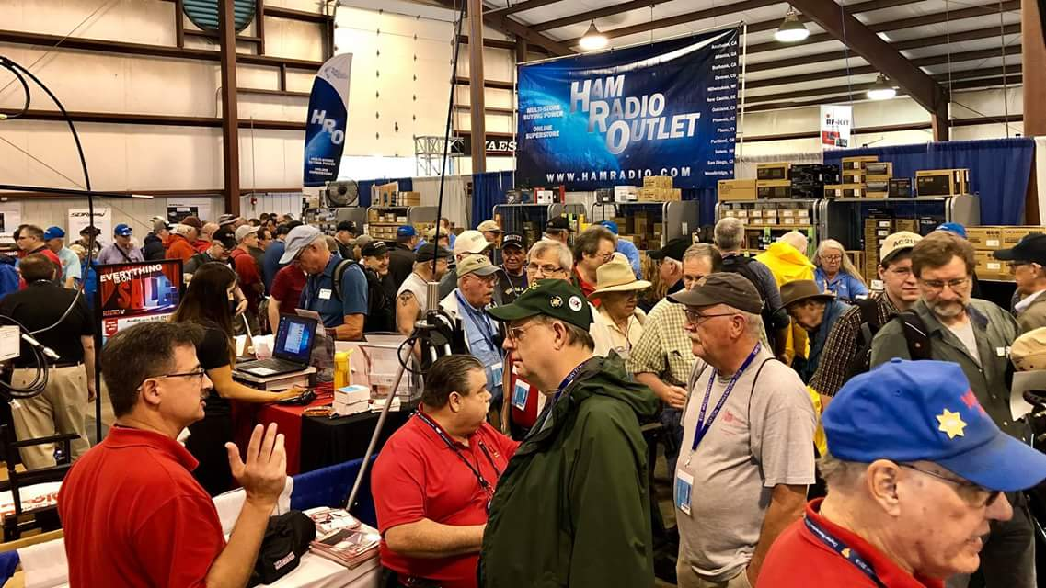
Upcoming Hamfests

We DO have some hamfests scheduled for 2021!! Yes, take a good look at the list, it’s growing every day!

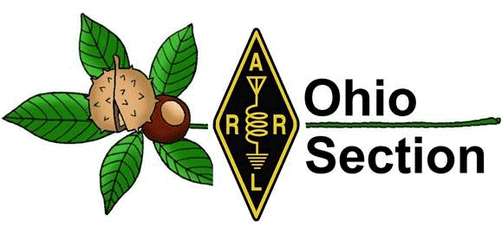
Be sure to keep your eyes on this schedule as that when things start getting better and the vaccine rolls out to more and more, hamfests will surely get back to their normal schedule. Don’t see your hamfest listed?? Did anyone register it with ARRL? It’s really easy to do and you get a lot of FREE publicity if you do.

Ohio Hamfests
2022

09/25/2022 - Cleveland Hamfest  Location: Berea, OH  Sponsor: Hamfest Association of Cleveland  Website: http://www.hac.org  Learn More | 10/15/2022 - Portsmouth Radio Club Hamfest  Location: New Boston, OH  Sponsor: Portsmouth Rado Club, Jett Fire, Shawnee  Website: http://www.portsmouthradioclub.org  Learn More
10/30/2022 - Massillon Hamfest (OH)  Location: Green, OH  Sponsor: Massillon Amateur Radio Club  Website: http://w8np.org  Learn More | 12/03/2022 - FCARC WinterFest  Location: Archbold, OH  Sponsor: Fulton County Amateur Radio Club  Website: https://k8bxq.org/hamfest  Learn More
05/13/2023 - 05/17/2023  RV Radio Network  Location: Berlin, Ohio, OH  Type: ARRL Operating Specialty Convention  Sponsor: RV Radio Network  Learn More | 07/16/2023 - Van Wert Hamfest  Location: Van Wert, OH  Sponsor: Van Wert Amateur Radio Club  Website: http://w8fy.org  Learn More

Massillon Hamfest
The Massillon Amateur Radio Club (MARC) is again proud to sponsor what has become one of the nation's top hamfests. We are again inviting guests from all over the country to join us at MAPS air museum at the Canton-Akron Airport in Green, Ohio.

Date:10/30/2022
Location: Military Air Preservation Hangar (MAPS) 2260 International Parkway Green, OH 44232
Sponsor: Massillon Amateur Radio Club
Look for more details in the weeks ahead. Attendees and Vendors:For a brochure or for further information please contact MARC at club@w8np.net. We Are looking forward to seeing you at MAPS this year! Tables are on sale on the website.

OHIO’S 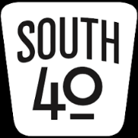
Let’s get right down to business and let all know what is happening and recap what has happened in the South 40 the past couple of weeks. But before that, here’s hoping you have a Happy Fall season.

Clinton County ARA President Mark Atwell, WX8A, informs the “South 40” the Wilmington 147.12 repeater is back on the air, although the UHF frequency is still dark. Atwell indicates he hopes the UHF machine will be back in operation within the coming weeks.

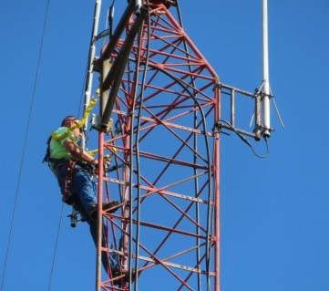
The Highland ARA is currently looking for a new site for their 146.745 machine that was located in Pike County. Recently the tower site hosting the repeater was sold and the new property owner and the tower user could not reach a lease renewal agreement. Thus electricity to the site was disconnected and the repeater went silent. The new property owner has made it plain the tower will be removed at some point in the near future in order for the construction of a building. Recently HARA members assisted Brent Wells, N4BDW, in removing antennas, sidearms and heliax from the tower. A big round of appreciation is expressed to Brent for his assistance and climbing ability.

As you read this several area hams and spouses are returning from the Smokey Mountains where they had an enjoyable couple of days. While the wife’s shopped and did XYL things, the hams attended the Ham Radio Bootcamp and W4DXCC Convention. Historically those who attended this event in past years have always had glowing comments about the quality of the speakers and topics covered.
Jennifer and Michael Bailey (N8JEN and N8MLB) have provided information about the upcoming Saturday, October 15 Portsmouth RC Hamfest at the New Boston Community Center, 3982 Rhodes Avenue in New Boston. The admission is $3. Inside sales tables are available for $5 each. $200 in hard green cash will be awarded as the grand prize. The event starts at 8 AM and will run until 1 PM. There will be a Laurel VE test session at 10 AM. Food, refreshments, a 50/50 drawing and a lot of door prizes are a part of this fun-filled and friendly hamfest. As for the door prizes, almost everyone who is there at closing time will go away with something. Contact Gary Caldwell, WX8G, at 740-240-4955 or
www.portsmouthradioclub.com for more information.

The Athens County ARA will provide communications for the annual various Buckeye Trail runs that will happen during the October 1 Blue Blaze Festival in Shawnee, OH. Anyone wishing information on how they can assist is urged to contact Jeff Slattery, N8SUZ.

A Laurel VE test session will be conducted at 10 AM during the October 15 Portsmouth RC Hamfest.

Unfortunately the information came too late to insert in the last “South 40”, but the Tri-State ARA held a Pancake Breakfast on a recent Saturday morning at the Museam of Radio and Technology in Huntington. West Virginia Section Manager Dan Ringer, K8WV, was the guest speaker for the program. The theme of the event was “good friends, good food and good fellowship”. This might be a good time to remind clubs that if you want to promote your club or event through this column, please provide me with the information at least two weeks prior to it. Like the next item, the further in advance the better.

For those potential new hams or those wanting to upgrade, but feel they are not ready to take on the challenge at the Portsmouth hamfest, there will be an upcoming test session conducted by the Scioto Valley ARC on November 5 in Chillicothe. According to John Hartmus, WB8GRX, the test session will be held in Conference Room A at the Ross County Service Center beginning at 9 AM. Like the Portsmouth session this is a Laurel VE session and therefore there is no charge to take an exam for a first license or for an attempt to upgrade. However the FCC license fee will still apply for anyone earning a first license.

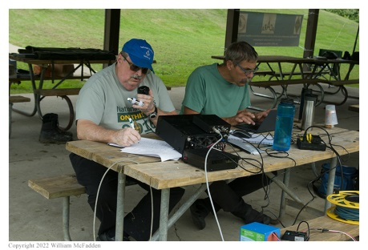
When you read this, the Ohio State Parks on the Air operating event will be in the books for another year. Personally I had intended to take a break this year and not participate. However I was pressed into service at the Highland ARA’s K8HO site due to an operator needing to leave early because of needing to take his wife out for her birthday. (Wise man). The logs and airwaves contained a number of familiar call signs. Some of the call signs recognized were those of the Fayette ARA, Vinton County ARA, Cambridge ARA, Athens County ARA, and Sunday Creek ARF clubs. And who can forget our friend Marietta Ralph, K8RYU, who provided a lot of people with his rover contacts from several of the parks that would otherwise not have had activity. Although it was good to see the number of Southern Ohio parks activated, a good number of parks still had no activity. Here’s the challenge for 2023. You have a year to step out of your comfort zone and plan to activate one of the parks that normally does not see any type of activity. I will be happy to help coordinate plans.

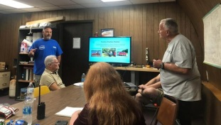
Two members of the Highland ARA recently provided an Elmering session on how to make successful contacts through satellites and the International Space Station to the members of the Scioto Valley ARA. Doug Broyles, KE8ORQ, and Sam Johnson, W8SKJ, provided those in attendance with a wealth of information. They were joined by some other HARA members who are now into making contacts through the birds.

I past columns I’ve referred to a couple special event stations to happen in the South 40 in the coming weeks. Michael Love, WB8YKS, has now provided the details on one. On Saturday, October 1, the Southern Ohio ARA and the Lawrence County ARES will combine their efforts with a special event operation from the Burlington Commons riverbank shelterhouse at Burlington, Ohio. Besides marking the southernmost point in Ohio, it also honors Burlington being the first county seat in Lawrence County and a station on the Underground Railroad. The special event operation will begin at 9 AM and continue until 2 PM.

The other special event station will be operated by the Highland ARA and it too has a remote connection with the Underground Railroad. HARA will operate from Highland County’s Gist Settlement near New Vienna. Upon his death in the early 1800s Virginia land barron Samuel Gist’s slaves were freed and resettled in five locations North of the Ohio River. The Highland County location was one of those. Plans are to operate around 7.225 and 14.275 from 10 AM until 4 PM. A QSL card will be available to confirm contacts. More information is available through highlandara@gmail.com.

Bob Mathews, K8TQK, reminds hams in the Bainbridge and Ross, Pike and Highland County areas of the upcoming breakfast on Saturday morning, October 8 at the Dutch Restaurant, SR 41 near the Ross/Pike County Line at Bainbridge. He says the numbers of people attending each month continues to grow. It begins around 8 AM and tries to conclude before interfering with travel time to Hillsboro to attend the Highland ARA’s Brunch Bunch which starts at 10 AM.

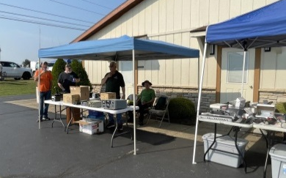
It was nice to hear from Joe Wigal, W8JTW, reporting on how the recent joint hamfest and car show on the grounds of the Leavitt Funeral Home in Belpre turned out. With perfect weather there were a good number of folks set up in the flea market as well as several folks displaying their cars. The Buffalo 10 Meter Group wants to thank the funeral home for providing not only the location, but the free food and drinks and entertainment to everyone who attended. Plans are already underway for a repeat of the event in 2023.

Congratulations to our friend and fellow OSJ columnist Bill Salyers, AJ8B, who as the editor of the Southwest Ohio DX Association’s newsletter, The Exchange is marking the sixth year of the publication of this splendid newsletter. If you haven’t read an issue lately, you must as it has a lot of very interesting news and interviews in addition to updates on what is happening in the world of DX. It is a fun newsletter to read. Bill is also the current SWODXA President.

It was an early and really dark and wet Sunday morning when N8ZNR, K9DOG and myself left Hillsboro the other Sunday morning bound for the Findlay hamfest. As we got closer to Lima the rain stopped and the promise of a good weather day took shape. Not only did the weather turn out to be splendid, but the folks at the Findlay ARC put on another great show. Attendance appeared to be good and the inside and outside flea market vendors were plentiful. There was a lot of new and old equipment as well as other items to look at. It was good to see and chat with our Division Director Dale Williams and his right hand man, Scott Yonally. Our past Vice Director Tom Delaney was even in attendance. Ohio Section Manager Tom Sly was there along with his wife. We bumped into several people from the South 40 region who made the trip north from places like Lancaster, Marietta, Vinton County, Chillicothe and the Cincinnati and Dayton areas. A special shout out to K8BCI, Grant Powell from Marion who identified himself as a weekly reader of the column. It’s nice to see folks North of the South 40 reading the column and seeing that ham radio does exist in the Southern Ohio region.

That’s it for another week. Until next time stay cool, healthy, safe and radio-active.

John Levo, W8KIW, jlevo@cinci.rr.com or highlandara@gmail.com, 937-393-4951

Print an Official or Unofficial Copy of Your Amateur Radio License
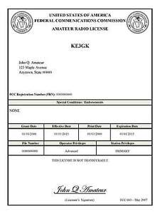
(By Anthony Luscre, K8ZT)

As of February 17, 2015, the FCC no longer routinely issues paper license documents to Amateur Radio applicants and licensees. The Commission has maintained for some time now that the official Amateur Radio license authorization is the electronic record that exists in its Universal Licensing System (ULS). The FCC will continue to provide paper license documents to all licensees who notify the Commission that they prefer to receive one.

Licensees also will be able to print out an official authorization — as well as an unofficial “reference copy” — from the ULS License Manager. I’ve created a set of instructions on how you can request an “official” printed copy of your license*

Click here to download the instructions

One Question Questionnaire

Hey Gang,

Last weeks question HOW MANY AMATEUR RADIO QSO’S DO YOU MAKE PER WEEK? (AVERAGE)?

Survey Says 32 (35.15%) 2 or less, 28 (30.77%) 2 to 10, and 31 (34.07%) 10 or more. I’m happy to see that Ohio Section Hams are active On The Air!

The new question is:

What is the main antenna at your station? a) Rubber duck on a handi-talkie, b) Dipole, c) vertical, D) Yagi, OR e) something else?

You’ll find the “One Question” questionnaire on the Ohio Section Website! http://arrlohio.org It’s all for fun and it’s not a scientific survey in any way, but we are learning some things that we didn’t know from these questions. I hope that you are enjoying answering these “One Question” questionnaires. Don’t forget – In next weeks PostScript I’ll be announcing the September winner of the HANDBOOK GIVE-A-WAY! Make sure you get on the board to be entered in Octobers give-a-way.

V.E. Test Sessions

Many V.E.’s have decided to start testing once again, but with restrictions that need to be adhered to for sure. Here’s the link to find that V.E. Test session and what is expected of YOU before going. http://www.arrl.org/find-an-amateur-radio-license-exam-session

Final… Final

Earlier this summer there was an election for the OHIO Section Manager. As the incumbent, I ran unopposed, and was elected to a new, two-year term beginning October 1st, 2022. No campaigning, no speeches, no fanfare. I had written a short item that would have gone out with the ballots, had that been necessary, but it did not. I do want to share that with you here:

“I am running for re-election to the position of Ohio Section Manager. I am running because I believe that Amateur Radio is the Greatest Hobby In The World and because I support the mission of, and the activities of the ARRL.
As Ohio Section Manager, I have three goals: to help all hams in the Ohio Section have Fun with and get the most out of the hobby; to increase the membership of the ARRL within the Ohio Section; and, to promote Amateur Radio to the general population of the Ohio Section. Together they have the potential to bring us more growth and visibility in our communities than any one alone could achieve.
Each of these three goals can be achieved by active and growing clubs in the Ohio Section. I will support Ohio Section Clubs by helping each individual club with meeting ideas and activities to get their membership involved and having fun. I will help clubs establish ways to promote their clubs and activities in their community. When the members of a community see their friends and neighbors having fun, serving their community and learning about cutting edge science and technology, some of them will be intrigued with the “magic of radio” just as all of us have, and they’ll want to know more about what we do.
I have been an active ham radio operator since 1968, when I got my Novice license at age 14. Today I hold an Extra class license and I’m still intrigued with the “magic of radio” and there are many more areas of the hobby that I would like to try. I’ve had a lot of fun along the way, and I’d like to share that with as many of you as possible.
73,
Thomas R Sly WB8LCD Ohio Section Manager”
I think it’s important that you know, I did not run for re-election as a “place-holder” for the position. I will continue to be active as a Ham, and as helpful to all of you, that I can be.
I’m guessing that everyone of you, before you became a Ham, saw what was going on and said to yourself “Wow! That looks like fun. I wish I could do that!” You and I might define fun differently, but we all had that thought and took the steps necessary to become a Ham. It’s important that you keep that attitude. Once it ceases to be fun, then you just become another old curmudgeon that’s lost his way and has to drain the fun out of everyone else that you come in contact with. We can’t grow that way.

Right now, you are living in the “Golden Age” of Amateur Radio. We’re moving up the charts on Cycle 25 (Sunspot Cycle) and this has all the makings of a really good one! Add to that all the changes and advancements in technology and there’s a whole bunch of really cool ways to participate and have a ball! Now, if you aren’t living with PASSION in your life, you sit down and watch TV or partake only in passive activities, then YOU are the problem! You have to get up and DO Something! And when you do, you’ll rediscover the fun and magic of radio. And with a little practice and learning, you’ll become an AWESOME Amateur Radio Operator! And that’s infectious. When other people see how much Fun you’re having, and how much you’re learning about and harnessing Science and Technology – they’ll want to be a part of what you’re involved in. Remember – people will do what you do, not what you tell them to do. So be a good example.
I’m dismayed that only about 20% of hams belong to the ARRL. I’m not going to go into a deep dive of everything the ARRL does for us here, but I will tell you, without the ARRL we don’t have our hobby. If you are a Ham, and you want our hobby to continue, you have to support ARRL! Instead of getting all caught up in one little issue, you really need to take a wide-angle view of Amateur Radio, not only in the US, but worldwide. ARRL has not been vocal enough about everything they do for the benefit of all licensed operators. You’ll be hearing more about that as we move forward.
Finally, when we’re active in our hobby – having fun – the folks in our communities will have to take notice of all we’re doing and all the fun we’re having. When the ARRL is supported both in numbers of membership and numbers of $$$ then they will have the ability to expand on all that they do for the benefit of the hobby and the individual members. When the people in our communities see us and know us, some of them will be intrigued enough to want to join us! If we want to keep the hobby moving forward, then we all have a part in accomplishing it.
So, only about 20% of hams are ARRL members, and less than ¼ of 1 percent of the US population are Hams, increasing those numbers should not be overly difficult. If we could convince just ¼ of 1 percent of the population to join us, then our numbers would double! The FCC, FEMA, Congress, the military, your local EMA, schools and colleges would all take notice! If at the same time the 20% of hams who are ARRL members grew to 40%, then ARRL membership would grow from approximately 170,000 to approximately 600,000. Wow! If we think we can, at the very least we’ll be moving the ball forward. If we think we can’t, we won’t.
I’ve shared these words of Winston Churchill before, and I’ll share them here now: “It’s not always good enough to do your best, sometimes it’s necessary to do what is required”. So now the balls in your court (and mine). At the end of the day we have to decide what we want and what we’re satisfied with – 1) a “participation” trophy; or 2) the satisfaction of achievement and knowing we were a part of something bigger than ourselves. Choose wisely.
73, de
Tom WB8LCD OH Section Manager
WB8LCD@ARRL.ORG
330-554-4650

“Swap & Shop” on the website

Hey Gang,

Have you taken a look at the Swap & Shop page on the Ohio Section webpage yet?? Here’s a link that will take you there…
http://arrl-ohio.org/sm/s-s.html

Do you have equipment that you just don’t need or want anymore? Here’s a great venue to advertise it, and it’s FREE!!

Is your club doing a fund raiser to help raise money? After a lot of thought, it was decided that the Swap & Shop webpage could also contain these types of items as well.

The same rules will apply as do for the For Sales and Give-A-Ways and will only be posted for a month at a time. Please see the Terms & Conditions on the webpage.

If your club is doing a fund raiser and wants more exposure, please forward the information to me and I’ll advertise it on the Swap & Shop webpage for you. Now, I still want to remind you that it won’t be listed in this newsletter because it would take up way too much space, so your ad will only appear on the website. It is there for any individual to post equipment Wanted / For Sale or Give-Away as well as for Club Fund Raisers. No licensed vehicles/trailers or business advertising will be posted.

Postings are text only (no pictures or graphics) will be posted for a maximum of 1 month from date posting and require a contact phone number or email within the posting. Send your Wanted / For Sale or Give-Away post to: swap@arrlohio.org

Back Issues of the PostScript and Ohio Section Journal

Hey, did you know that PostScript and Ohio Section Journal (OSJ) are archived on the website? You can go back and look at any edition simply by clicking:
http://arrl-ohio.org/news/index.html

Ohio Section Cabinet
Section Manager – Tom Sly, WB8LCD | Section Emergency Coordinator – Stan Broadway, N8BHL
Technical Coordinator – Jeff Kopcak, K8JTK | Section Traffic Manager – David Maynard, WA3EZN
State Government Liaison – Bob Winston, W2THU | Affiliated Clubs Coordinator – Tom Sly, WB8LCD
Section Youth Coordinator – Anthony Lascre, K8ZT | Public Information Coordinator – John Ross, KD8IDJ

Chit – Chat, and All That!

Do you know someone that’s not getting these Newsletters? Please, forward a copy of this Newsletter over to them and have them “Opt-In” to start receiving them. Heck just have them send an email to: webmaster@arrl-ohio.org to be added.

We now have many thousands of readers receiving these newsletters weekly. Quite impressive, I’d say! I urge all of you to make sure that everyone, regardless of whether they are a League member or not, get signed up to receive these weekly Newsletters.

You can always “Opt-Out” at any time if you feel this is not what you were expecting. It’s fun and very informative. All of your favorite past newsletters are now archived too.
You can go back at any time and read them. Just go to: http://arrl-ohio.org/news/

The pictures on the front page and throughout this newsletter are from various newsletters, Facebook posts and/or were sent directly to me in recent weeks. Take a good look at them, you just might be in one of the pictures! “SMILE… you’re in the Ohio Section News!!”

The Ohio Section Journal (OSJ) is produced as a comprehensive look at all the programs within the Ohio Section. I sincerely hope that you have enjoyed this edition of the OSJ and will encourage your friends to join with you in receiving the latest news and information about the Ohio Section, and from around the world!

TOP^

