October 2022

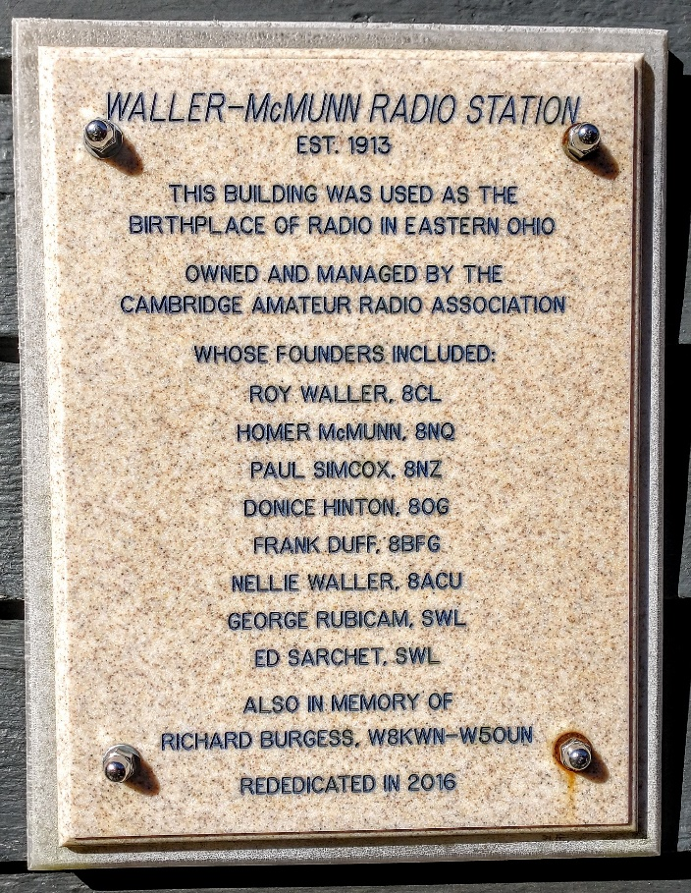
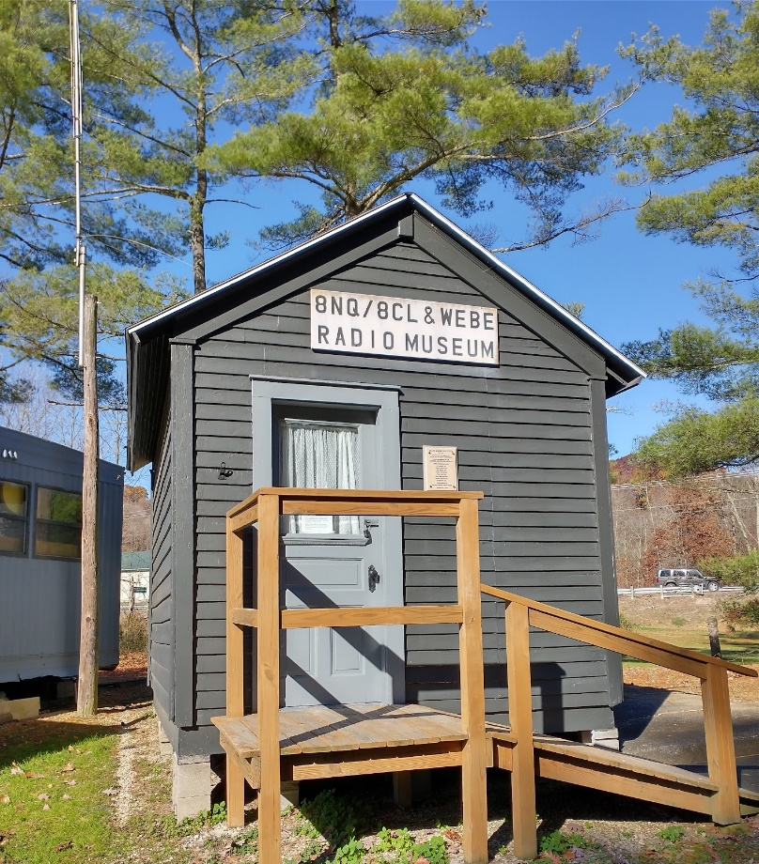
From the Technical Coordinator | From the Section Emergency Coordinator
From the Section Traffic Manager | From the Section Youth Coordinator
National News | ARES Training Update
DX This Week | Club Corner
From the Affiliated Clubs Coordinator | Contest Corner
From The South 40 | One Question Questionnaire
Final.. Final..

From the Technical Coordinator
Jeff Kopcak – K8JTK TC
k8jtk@arrl.net

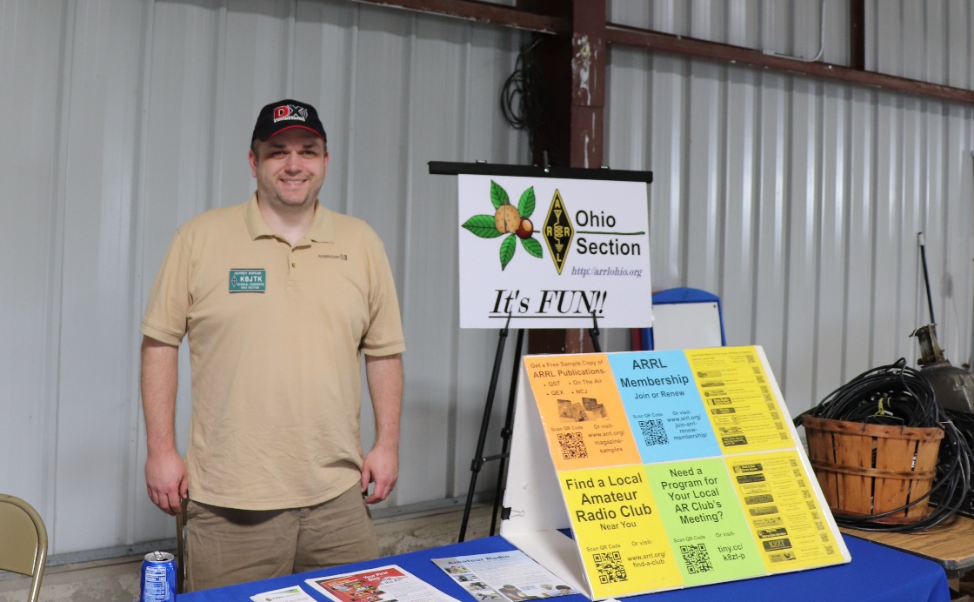
Hey gang,
Two years ago, I wrote an article for the OSJ dealing with "cyber hygiene" - practices and precautions users take to keep their data safe and secure from outside attacks. I didn’t rehash it last October since most of the article was still relevant. For this year’s “Cyber Security Month,” it’s time for an update. I still encourage everyone to re-read that article in the October 2020 OSJ or on my website as 95% of it is still best-practice for normal people.
The browser is still one of the most utilized pieces of software in modern computing and one of the most attacked. Users hanging on to Internet Explorer are finding it harder and harder to visit modern sites as new encryption standards are recognized and made industry standard. Using an End of Life browser, users are seeing a lot of “This page can’t be displayed” because it doesn’t support current methods of protecting communication.
Chrome, Firefox, Microsoft Edge, and Opera remain good choices. Brave browser is a good alternative if you don’t want to use a native Google browser. It’s based on the Chromium project for those who want a privacy-focused browser. Before jumping to Brave, some things to be aware of before you have a jarring first impression. There are ads – mostly for cryptocurrency. Why recommend an ad supported browser for crypto-what? Unlike Chrome, which makes money on user’s data, Brave pays the bills with safe ads (opposed to malicious ones that would infect your computer). They can be turned off. If ads in a browser are not your cup of tea, there are plenty of other browser options but note Brave took top spot for privacy in terms of phoning home:
Used “out of the box” with its default settings Brave is by far the most private of the browsers studied. We did not find any use of identifiers allowing tracking of IP address over time, and no sharing of the details of web pages visited with backend servers (Leith).
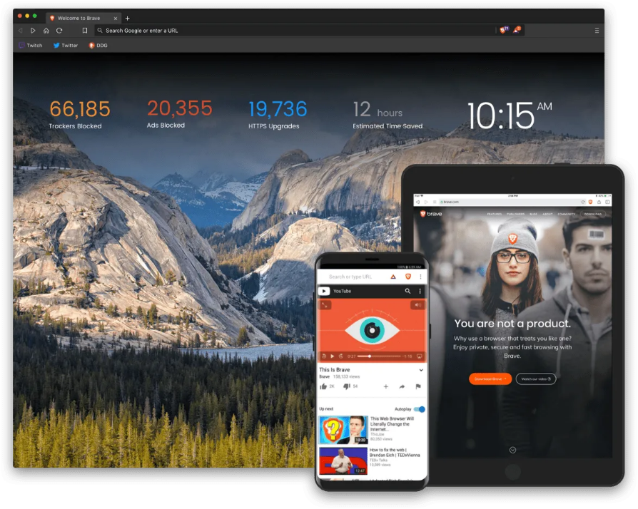
Pi-Hole and 3rd party DNS services, such as Quad 9, are good options for blocking ads, tracking, annoyances, and malicious content at the network level. To go a step further and block unwanted social media, games, messaging apps, dating sites, or streaming services or entire categories of sites, freemium services like NextDNS and AdGuard offer additional blocking options. Advanced features including newly registered domain blocking, typo-squatting domain blocking (domains registered by squatters taking advantage of type-o’s made when users are inputting a site’s URL), parked domains, and entire top-level domain blocking go above Pi-Hole and other free services.
Brave browser (brave.com)
Free tier gives you a limited number of DNS queries. With devices that freak out when they can’t phone home or heck, the cloud providers used by my workplace, you’ll blow through the free tier quickly. With a yearly plan, the price is around $1.75/month. OpenDNS has a completely free tier with basic blocking. Their blocking of services and categories is also a premium option.
Note devices with hard coded or manually entered DNS for other services (such as the popular Google DNS 8.8.8.8) will bypass these protections. A router/firewall with the ability to intercept and re-direct traffic (also called internal port-forward or inside NAT) will stop requests from reaching other DNS services and redirect them to the service of choice.
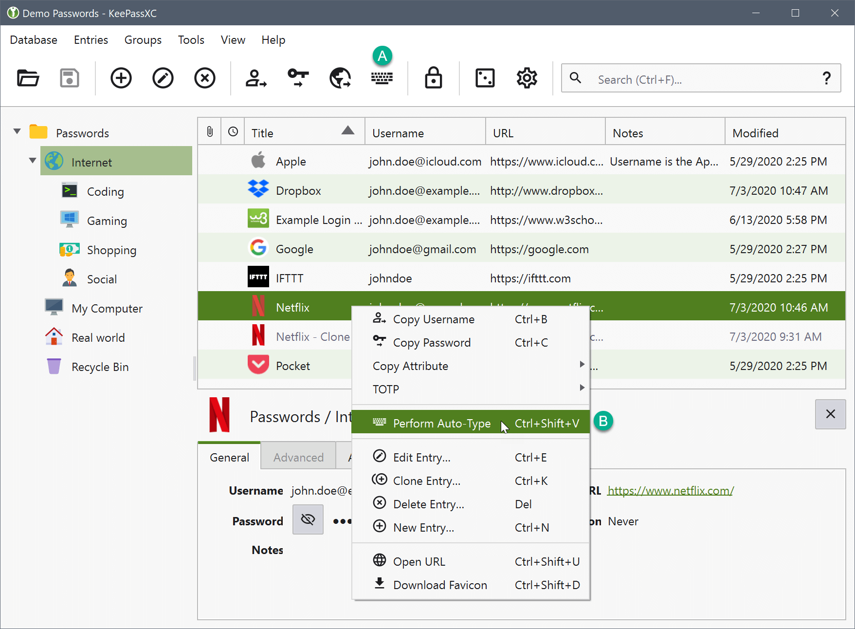
LastPass, in 2021, decided to make their free tier limited to a device of a single type. Mobile or desktop, not both. To sync between both, a premium account was needed. Granted $3/month isn’t a huge amount (you can give up one coffee), users opted for a service called Bitwarden. It is an open-source password manager offering unlimited devices for free and a family account for $3.33/month with unlimited sharing. An option that appeals to me is the self-hosted option where you are in-control of your data.
KeePassXC interface (keepassxc.org)
KeePass remains a strong choice for managing password databases, especially offline. I recently moved to a fork called KeePassXC. Its lineage came from KeePass in that KeePassX was a fork of KeePass, KeePassXC is a fork of KeePassX. It too is free, open source, and databases are compatible between KeePass and XC if you want to try or use both. I like KeePassXC better due to its cross-platform support and TOTP/2FA integration.
Beyond my 2020 article, I would like to address the issue of administering devices remotely. In particular, devices we leave at remote sites or have in “the cloud.” Whether that is an AllStar node, EchoLink/SVX, Wires-X, router, controller, mesh node, or digital mode reflector. Though I’m writing this in the context of ham radio devices, this applies to anything - including devices on home networks. I hate the idea of devices, which provide services to a very small group, being available to anyone on the Internet. It’s dumb, terrible security practice, hygiene, and there are better options.
‘Well, my device is password protected!’ Most don’t change the default password on their device. Ones that do many have purchased from a dud company that ignores vulnerabilities for 3 years that, in theory, would allow anyone access to their camera, Wyze.
For clarification, I’m not taking the ports needed for normal user access to the AllStar/Wires-X/EchoLink/reflector/whatever. I’m specifically talking about the ports needed for administrative access. Ones such as SSH and remote desktop. Admins that figured out OpenVPN or WireGuard tunnels or ones that only have local access to admin services, you’re good.
With common admin services open to the Internet, check the logs. Internet miscreants are trying common username and password combinations. Not to mention probes not seen in logs like fingerprinting to figure out which outdated version is running and looking up exploits against that version. Once they get in, they will configure that device to be a cryptocurrency miner (making money for the bad guy), another device in their bot army used for attacking other victims, figuring what other devices they can get into, not to mention backdoors allowing them access at any time. When this happens, that device can no longer be trusted.
Fail2Ban is a popular option that only slows down attackers, doesn’t provide distributed brute-force attack protection, and is not available on Windows. Doesn’t solve the issue of unnecessarily exposing admin services to the Internet. Changing ports is not secure, often called security through obscurity – which is not security. A quick scan of the IP address will reveal the new port. SSH keys with PasswordAuthentication set to “no” is about as good of protection as you can get when wide-open access is needed.
ZeroTier and Talescale are an easy-to-use middle ground between the options of wide-open access and creating your own VPN connections. Both services create secure connections to just about any device including: Windows, MacOS, Android, iOS, Linux (including Raspberry Pi), BSD, and some Network Attached Storage devices. The device reaches out to a central server or peer, establishing a private connection. Permitted users are then able to establish connections with that device. A club might have five administrators, all five would have provisioned accounts for access to their club’s remote site devices.
These services are freemium and proprietary (not open-source) but they do have self-hosted options. Once the service is up and running, close the administration service ports in the router. Configure the device to only accept connections for admin services on the ZeroTier or Talescale interfaces.
For web services, such as status pages or dashboards running on devices at remote sites, something to consider is a reverse proxy as an additional layer of protection. Normally: install and configure the device with a web server stack, install a dashboard or status page, port forward 80 & 443, then hand out an IP address to users or provide link on the club’s webpage to that device, maybe using a DNS/dynamic DNS entry. You’re off and running. The device remains exposed to the Internet. Miscreants could send random junk attempting to bypass authentication or flood the connection with bogus data, denying legitimate users’ access (denial of service).
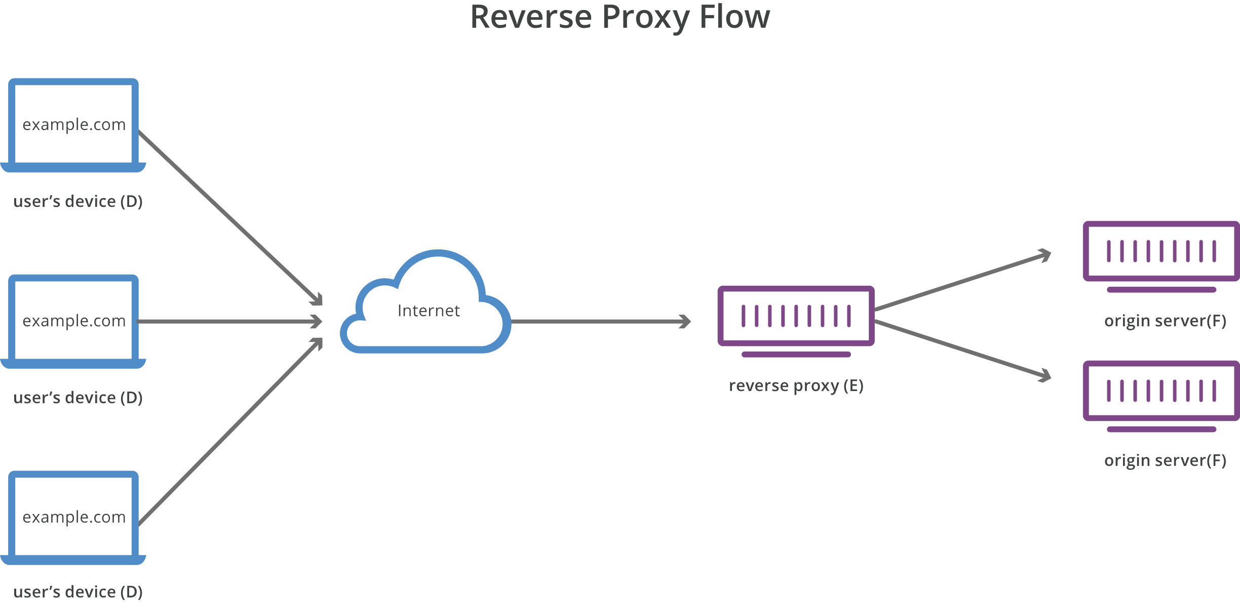
A reverse proxy works by being the point at which users access the site. Cloudflare is one such reverse proxy service and offers a free tier for personal/hobby sites. The proxy inspects traffic to determine if it is legitimate. Legitimate traffic is allowed to pass onto the server. Illegitimate traffic is dropped and never seen by the server, protecting it from possible malicious traffic. An additional benefit is the real IP address of the server or device, at a site or at home, is not easily determined, making the device less unlikely to be exploited.
(cloudflare.com)
This protects the device in a different way from that of a private link or VPN like ZeroTier or OpenVPN. The web site is still accessible to anyone on the internet. Having visitor’s setup private links or VPNs for commonly accessible web services is not practical and not something a majority of users will not opt into freely.
The Cuyahoga Amateur Radio Society (CARS) asked for one of our technical presentations at their meeting on October 11th. I was able to give a presentation put together by Technical Specialist, Bob – K8MD, on DMR. He was out-of-town but I was able to give his presentation. There was plenty of questions and good discussion after the presentation. I brought one of my hotspots and a DMR radio to demonstrate the AmateurLogic.TV Sound Check Net on my multimode system. The net got started about when the meeting wrapped up which was perfect timing. If your club is interested in this or another technical topic, let me know!
I heard from many hams that found my Hamshack Hotline tip useful in last month’s OSJ, including ones outside our section. Yes, they are reading THE OHIO Section Journal =) Some updates: even long after the DNS entry was removed, phones apparently cached the IP address. Some reported their phone still had green lights though the admin interface contained the old DNS entry. With this information, the phone will likely remain working until rebooted. Additionally, as suspected, other domains were seen. Replacing hhux.wizworks.net with hhux.hamshackhotline.com also worked. Some replaced the entire string with only hamshackhotline.com, leaving off subdomains like hhus (as was shown) or hhux. This won’t work either. The subdomain must remain intact.
Thanks for reading and 73… de Jeff – K8JTK

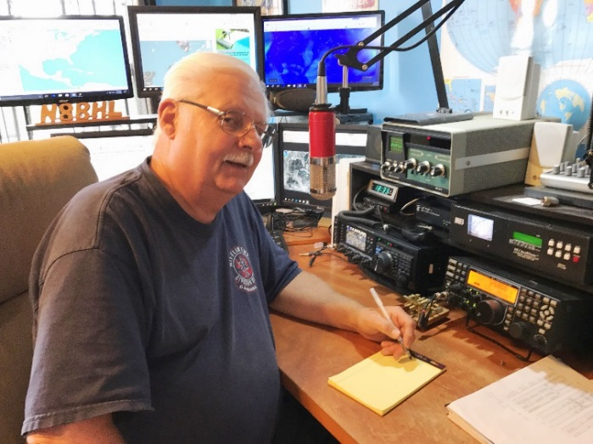
From the Section Emergency Coordinator
Stan Broadway, N8BHL - SEC
broadways@standi.com

Ohio SET 2022
Summary Report

The Ohio Simulated Emergency Test (SET) was conducted October 1, 2022 along with ARRL’s national SET. 21 counties (of Ohio’s 88) participated with several others operating on their own separate dates.

Responding to requests from numerous county Emergency Coordinators (EC) we reversed the planning process this year. Typically, we design a scenario at the state level and pass it down to the counties so that their response is more uniform. This year, we put the development and planning of county exercises back to the EC’s who could design drills that fit their own location or needs. We then offered our district level nets and the state station to coordinate all the communication. It seemed to be accepted and worked well. Exercises ranged from haz-mat and power outages to simulated events kicked off by the actual passage of Hurricane Ian into the Ohio Valley. Some groups practiced portable station setup.

The Ohio EMA’s ARES-Auxcomm station, W8SGT, was in operation handing over 45 messages and reports from various counties and stations. W8SGT was in operation on the 3.902 SSB frequency, the digital frequency of 3854.5 taking digital messages directly, as well as DMR, Fusion, and Winlink V/UHF frequencies. OHDEN, the digital statewide network, did not participate but did run an evening net on that date.

Licking County held two nets, one for SET and another “fox hunt” net to find a rogue operator. Cuyahoga county managed to participate while operators were actually working communications for a large public service event. Jefferson County operators went to the field where each operator set up a portable station. The locations included a soccer field, shelter, EOC and ARES Command Center. A couple Ohio Districts had nearly all counties online- District 9 and District 10. We looked good in front of several EMA Directors, including Mahoning. Frank Sole reports, “Thanks for being there. It was great being able to pass traffic to the Columbus EOC. Our local EMA rep (yes, they participated in a major way this year for the first time in a long time) was very impressed that we had a direct voice connection with Columbus EOC. You helped us look good! There was some confusion on the availability of W8SGT and OHDEN this year. Hope we can make adjustments on this for next year.”

All counties are able to conduct emergency exercises during the year and count them as SET but 25 counties participated October 1. Each county submits two reports to the ARRL online; a performance score is published next year. For 2021’s SET, Ohio ranked number 2 in the nation, and we hope to uphold the tradition.

Things that worked well: The EOC amateur station performed with excellence. Our ability to connect across many different bands and modes shows the capability that can be used when normal paths are broken. For the counties that exercised, messages were sent in some cases by new hams who had never done this type of activity. It was fun to hear them learn and become proficient. We received one message digitally from W8OMR, the Ohio Military Reserve station which was participating in a concurrent exercise involving MARS and military operatives. This shows our ability to maintain communications with those organizations.
Things that didn’t: OHDEN opted not to operate during that date. The NTS (Ohio’s traffic system) traditionally has not participated and was not heard from this year again. Our manpower to staff the EOC station is light, we need to recruit more trained operators and get them state access.

Things to improve: I would still like to increase the number of active counties on the specific date. It is also important that these exercises be more than just a “check in net” and actually deploy operators as many of our counties did.
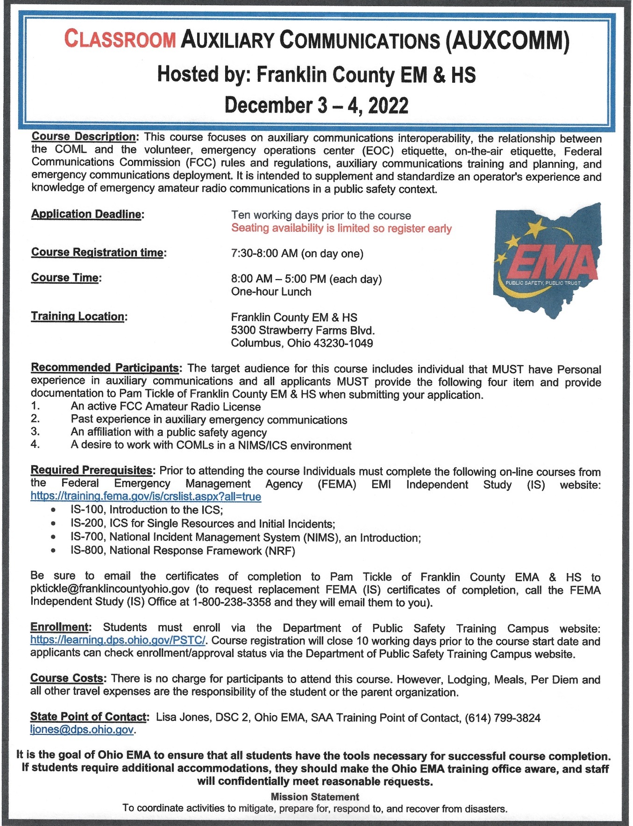

Good morning Community Partners, Faith-Based Leaders, Non-profits, ALVOAD members, and Friends. Here is a resource you may find of interest.

What: Active Shooter Preparedness Webinar – This is NOT a tactical training course.
When: Tuesday, November 8, 2022 12:00 p.m. CST/1:00 p.m. EST – Virtual Webinar
Who: Webinar hosted by the Department of Homeland Security (DHS)/Cybersecurity and Infrastructure Security Agency (CISA) R4
Details: The Cybersecurity and Infrastructure Security Agency (CISA), Region 4 (Alabama, Florida, Georgia, Kentucky, Mississippi, North Carolina, South Carolina, and Tennessee) invites you to join a two-hour security webinar to enhance your organization’s resilience in case of an active shooter incident. Preparing employees for a potential active shooter event is an integral component of an organization’s incident response planning. Because active shooter incidents are unpredictable and evolve quickly, preparing for and knowing what to do in an active shooter situation can be the difference between life and death. Every second counts.
Registration: Free. Register or visit: https://www.eventbrite.com/e/cisa-active-shooter-preparedness-webinar-region-4-alflgakymsncsctn-registration-422677037397
Limited to 350 participants and will close no later than 7 November 2022 at noon (12:00 p.m.) EST
Who Should Participate?
- Private and public organizations
- Corporate and facility security professionals
- Supervisory first responders
- Human resource managers
- Community response officials
- Health organizations
- Faith-based leaders
- School administrators and security officers
- Homeland security representatives

For more information and resources on Active Shooter Preparedness visit: cisa.gov/active-shooter-preparedness. Products and information can be requested by email at ASworkshop@cisa.dhs.gov.
__________________________________________________________________

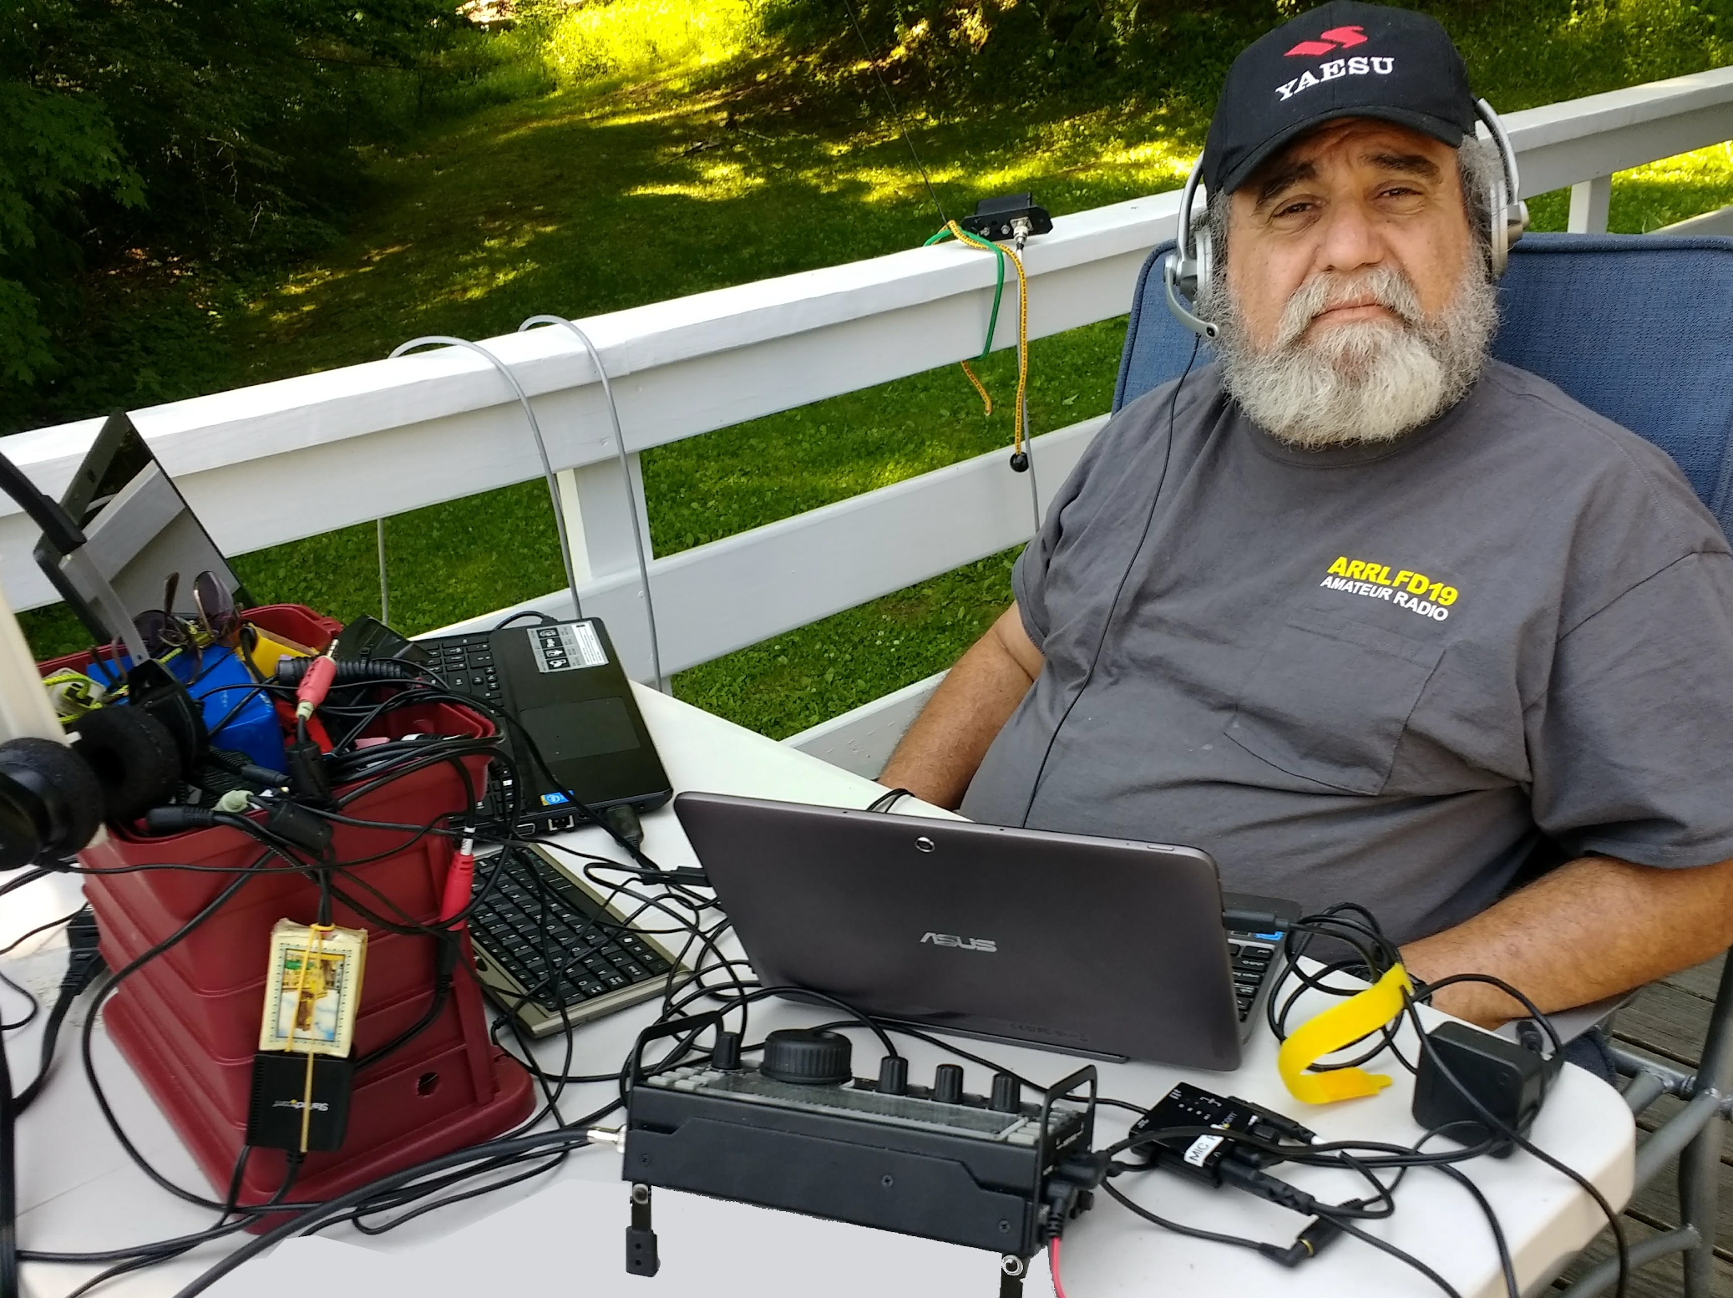
From the Section Youth Coordinator
Anthony Luscre, K8ZT - SYC
k8zt@arrl.net

Why You Should Care that Prime Contesting Season is Here Even if You Are Not Interested in Competition & Getting Started with VHF/UHF and/or HF

We are in the Midst of Prime Contesting Season
Fall and Winter are the prime contesting seasons for Amateur Radio. But if your answer is, “I don’t contest, and I’m not interested in competition.” My reply is you should be if you are interested in any of these:
- Working with Youth in Amateur Radio
- Making More On-Air Contacts
- Working toward Awards
- Testing Your Station
- Learning Operating Techniques that can be useful for other AR activities
- Practicing Accurately Exchanging Information On-Air
- Wanting to try bands like 160 or 10 Meters
Let’s look at some scenarios. During Contests…
- Contacts are short and very scripted. The perfect cure for mic fright on phone or new CW operators
- If you have any doubt about youngsters' interest in competition, take a look at traditional youth sports, and the new e-sports of gamers
- There is a lot more activity on the bands, thus increasing everyone’s opportunity to make contacts, even with low-power or less-than-optimum antennas
- There is often a wider variety of locations on the air, including rarer Counties, States and Countries. Many contesters travel specifically to these rarer spots to activate them for contests (many of these may not be on the air during other times)
- Many opportunities to test your station’s equipment, antennas and operation
- Ham’s are required to make rapid exchanges and accurately copy sent information. This skill can be invaluable during emergency communications
- Some bands that are not very active are filled with QSOs. This activity includes single band contests on 160 (Dec, Jan and Feb.) and 10 Meters (Dec.)

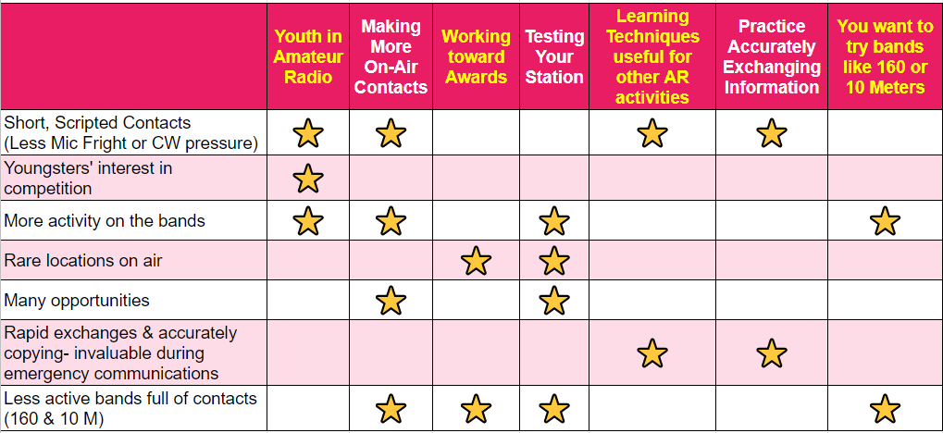

Are You New to Contesting or Want to Become More Competitive?
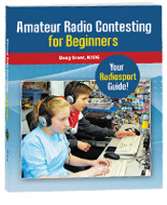
There are many ways to learn more about contesting.
- Reading- Books, Magazines & Mailing Lists
  - Book- ARRL Amateur Radio Contesting for Beginners
  - Extra Reading Material to Sign up for:
    - “ARRL Contest Update”
    - Contesting.com Ham Radio Mailing Lists
    - ARRL Online Group- ARRL-Contesting
    - Facebook group - Contesting and DX’ing
- Presentations (I would suggest starting here)
  - “Introduction to Contesting” - K8ZT
    - Slideshow- tiny.cc/ar-contest
    - Video Recording
- Course
  - Intro to AR Contesting-Class in ARRL Learning Center (ARRL Membership required)
- Contest University
  - Held the Thursday before Hamvention®
  - Video recordings of previous years are available for free on their website
  - Contest University Website- www.contestuniversity.com
- Mentors
  - Find a veteran contester in your local club
  - Join a Contesting Club- Contesting Clubs Around the World
Finding Contests Dates & Contest Rules
There are several websites with Contest listings and a monthly column in QST. Some popular ones include

www.contestcalendar.com
www.arrl.org/contest-calendar
sites.google.com/site/dl2nbycontestcalendar/
www.cq-amateur-radio.com/cq_contests/cq_annual_contest_calendar/cq_annual_contest_calendar.html

Two sets of recorded three one-hour sessions for new hams or those new to VHF/UHF or HF

The July 2022 RATPAC series “Beginner's Guide to VHF-UHF.” These live presentations were recorded and are available for you to watch on YouTube or Vimeo.

Co-presenters Marty Woll, N6VI and Anthony Luscre, K8ZT, present a series of three sessions covering almost all aspects of getting on VHF/UHF for new hams. The sessions are recorded for viewing:
- Week 1- youtu.be/mUXQg_9cDPU
- Week 2- youtu.be/23mBr3wMqxs
- Week 3- youtu.be/wiGISL1E0b8
- Slideshow from the presentations, including clickable links and resources, is available at tiny.cc/bgvhf.

Acquiring your radio-
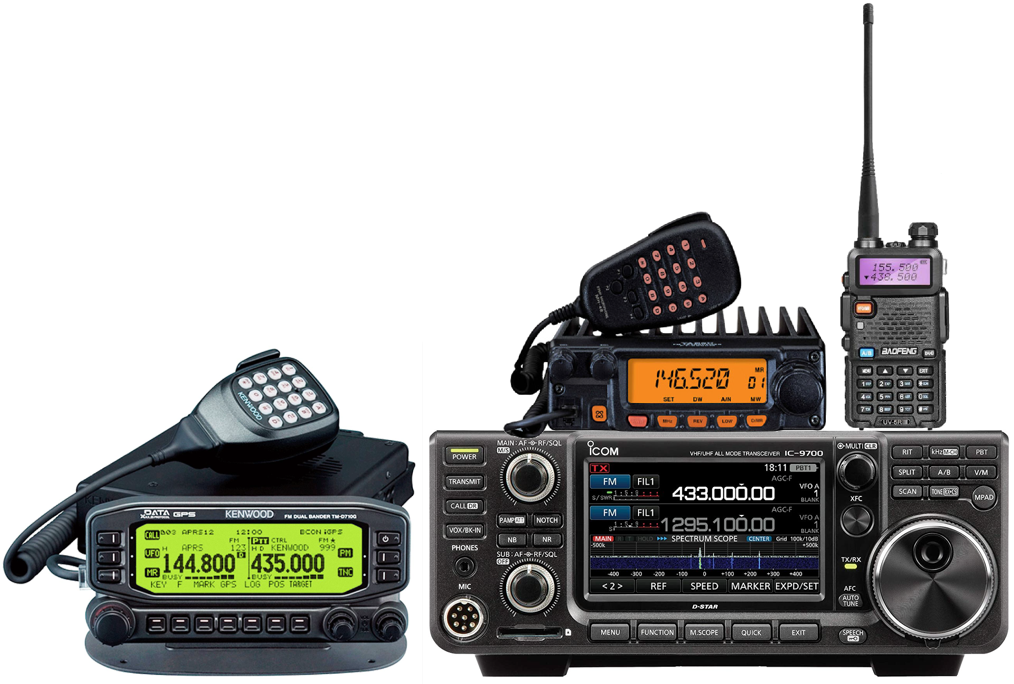
- Choices to make {Analog or Digital {DMR, D-Star, Fusion, Single Band {usually 2M} vs. Dual Band {2M/70 cm}, etc.)
- Different types of radios (Handheld {HT}, Mobile or Base, etc.)
- Where to acquire
Setting Up your radio
- Simplex contacts
- Repeater contacts
- Extending your range
Going Mobile
- Radios
- Antennas
- Installation
Base Stations
- Radios
- Antennas
- Feedlines
Life Beyond the Local Repeater
- Extending your range
  - Enhancing your HTs antenna
  - External antennas
- Modes beyond FM
  - SSB
  - CW
  - Digital Sound Card Modes (FT8/FT4)
  - Wi-Fi
  - Images
- Other Activities
  - Simplex
  - DMR
  - Other Bands (VHF, UHF, Microwaves)
  - Contesting
    - Home
    - Portable
    - Roving
  - SOTA/POTA
  - EmComm
  - VARA FM
  - EchoLink
  - Satellites
  - APRS
  - Fox Hunting
  - EME (Earth-Moon-Earth)
  - Repeaters
    - Crossband repeating
    - Simplex repeater
    - Setting up a duplex repeater
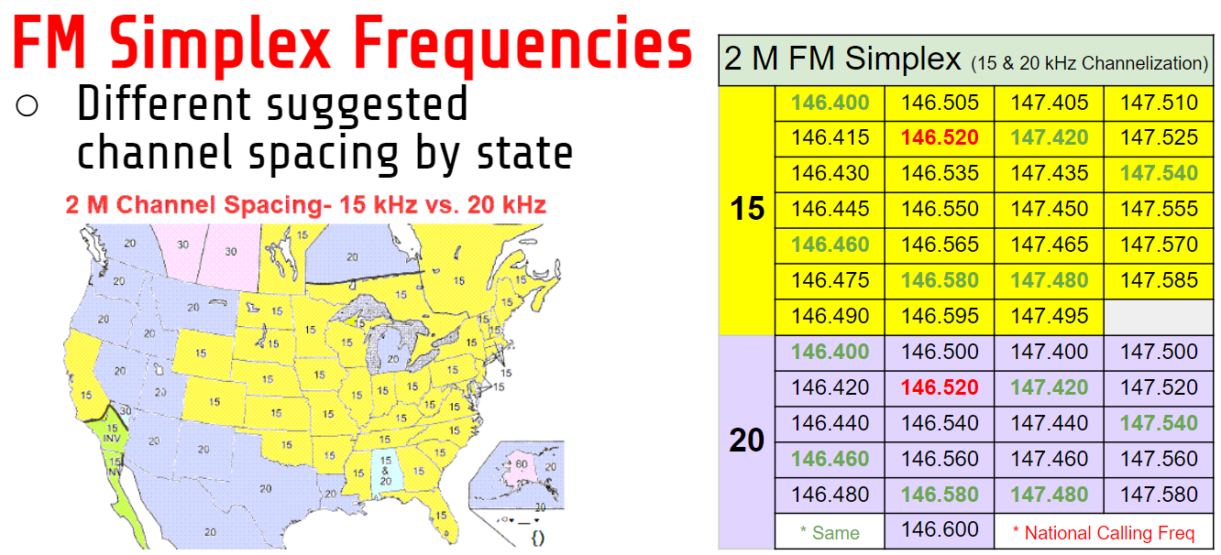
---------------------------------------------------------------------------------------------------------------------------
There was a similar series of three sessions held in October 2022 Beginner's Guide to HF Amateur Operation
Co-presenters Dennis Kidder, W6DQ and Anthony Luscre, K8ZT, presented a series of three sessions covering almost all aspects of getting on HF for new hams.
The sessions were also recorded for you to view:
- Week 1- The HF Bands, Operating & Making Contacts- https://youtu.be/cjZZjfKYPak
- Week 2- Equipment & Antennas- https://youtu.be/dH5gsA1CZSc
- Week 3- Putting It All Together https://youtu.be/eG3kFbCZEM8
- Slideshow from the presentations, including clickable links and resources, is available at tiny.cc/bghf.

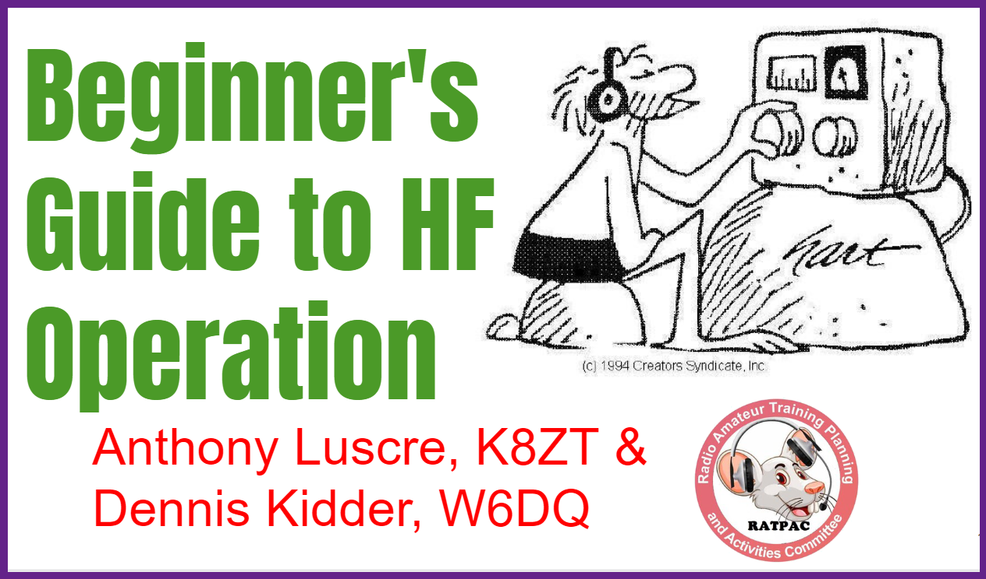

Magic & Character of HF Bands
- The allure of talking with hams in far away & exotic sounding places around the world
- What are the HF Bands
- Traditional vs. WARC & Post WARC Bands
- US Amateur HF Privileges
- FCC Rules vs. Gentlemen’s Agreements
- Typical vs. Atypical HF Bands
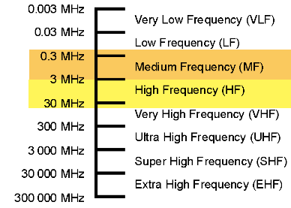
- Personalities & Moods of Bands
- Propagation
- HF vs. VHF/UHF

Operating on HF
- Modes on HF
- Contacts
- How to Make QSOs- Techniques & Tips
- Increasing Chances of Contacts
- Get in the Rhythm, Know the Rhyme & Dance the Dance
- Spotting
- Contesting- Not Just for the competitive, but anyone who wants to make more QSOs!
- Methods for Checking Your Signal
- HF Activities
- Nets & Round Tables
- HF Awards
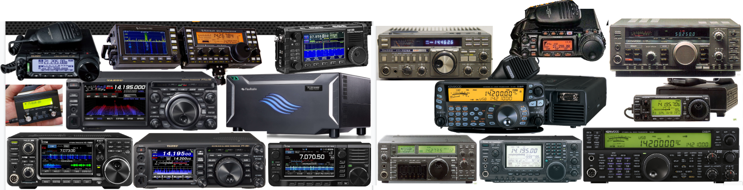

Acquiring Equipment
- Types of Radios & Choices to make
- Free Radio Receiver to Begin Listening Now
- Buying/Acquiring Radios
- Components of an HF Station
- Accessories & What Else Do you Need
Antennas
- Antennas
- Feedline
- Antenna Tuners
- SWR- what does it really mean?
Setting Up your radio
- Where to Put Shack
- Go-Box
- Radio Shack Ergonomics
- Our Shacks
- Safety & Compliance
HF Challenges
- Antennas
- Limited Mode & Frequency Allocations
- Outside Limitations (HOA, Interference, etc.)
Computer in Radio Shack
- CAT
- Sound Card Interface
- Computer Logging

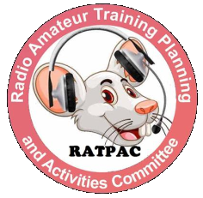
These sessions are sponsored by the RATPAC group, which has over 240 recorded previous sessions on a wide variety of Amateur Radio topics- tiny.cc/ratpac-list. The Zoom link to attend future meetings is available at www.ratpac.us/zoom.

I also personally have several presentations on a wide variety of Amateur Radio topics and would be happy to do a presentation for your local club. For a full list tiny.cc/k8zt-p.

That’s it for this month; I hope to work you on the air soon, maybe during a contest!.
73,
Anthony, K8ZT (k8zt@arrl.net)

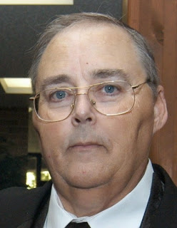
From the Section Traffic Manager
David Maynard, WA3EZN – STM
wa3ezn@att.net

You sent a radiogram to California or Alaska now you are wondering how it ever got there. Here is how your radiogram gets there.

NTS traffic nets operate in four cycles. Each cycle is timed to maximize the efficient transfer of traffic from one level to the next. In some sections and regions, there will not be a net in each cycle. This is determined by the available operators and average traffic amounts.
Sample of the cycles system follows:
Cycle One
10:00 am Section
10:45 am Region
11:30 am Area
12:30 pm Region
Cycle Two
1:00 pm Section
1:45 pm Region
2:30 pm Area
3:30 pm Region
Cycle Three
4:00 pm Section
4:45 pm Region
5:30 pm Area
6:30 pm Region
Cycle Four
7:00 pm Section
7:45 pm Region
8:30 pm Area
9:30 pm Region
10:00 pm Section
Generally speaking, nets in Cycles One through Three will be on voice and Cycle Four nets will be CW. There will always be exceptions to this, and as well there are wide-area nets which meet at different times to take advantage of early morning propagation for maximum coverage.
A chronological list of some of the traffic nets heard regularly in the Eastern Time zone, both NTS affiliated and wide-area. All times are Eastern.
Amateur Radio Telegraph Society (ARTS) daily 7:15 to 8:30 am on 7052 khz (CW) Wide Area
Hit and Bounce Slow Net (HBSN) daily 7:30 am on 7042 khz (CW) Wide Area
Hit and Bounce Net (HBN) daily 8:30 am (M-F 7042 khz and S-S 7114 khz CW) Wide Area
Eighth Region Net (8RN) daily 12:30 pm 3865 khz
Second Region Net (2RN) daily 1:45 pm 3925 khz
Fourth Region Net (4RN) daily 1:45 pm 7243 khz (again at 3:30 pm)
Eastern Area Net (EAN) daily 2:30 pm (M-F 7243 khz and S-S 7050 khz) Area Net
Central Area Net (CAN) daily 3:15 pm ( begins on 14345 khz and QSY's to 7240 and down at approx 3:25 pm)
First Region Net (1RN) daily 3:30 pm 3948 khz
Fifth Region Net (RN5) daily commencing approx 4:15 pm 7243 khz
Eighth Region Net (8RN) daily 4:30 pm 3865 khz
New York Public Operations Net (NYPON) daily 5:00 pm 3925 khz
Second Region Net (2RN) daily 6:30 pm 3925 khz (alternate 1840 khz)
Second Region Net (2RN) daily 7:45 pm 3576 khz (CW)
Eastern Area Net (EAN) daily 8:30 pm 3577 khz CW ( alternate 1812 khz)
Second Region Net (2RN) daily 9:30 pm 3576 khz
Remember that times and frequencies are subject to change. Each section will have nets operating at these or similar times with each time zone. This is only a partial list of the nets regularly heard.
Times and frequencies may be different than this example above with changes in times and frequencies possible like this change 8RN-2 Transition to Eastern Standard Time.
Eastern Standard Time, which occurs on Sunday, November 6 will mean changes to the 8RN-2 net schedules. The new net schedule will become:
2:00 PM 8RN-2 EARLY
2:30 PM EASTERN AREA NET
3:15 PM 8RN-2 LATE
Remember, EAN meets at the same time every day during Eastern Standard Time.
Marc
ND8W
If you have traffic you need to take it to a VHF net or if it is going out of Ohio you can take it to the OSSBN.
WHERE TO FIND AN HF OR VHF TRAFFIC NET IN OHIO
OHIO SINGLE SIDEBAND NET
Morning session | 10:30 AM | 3972.5 KHz | every day
Afternoon session | 4:15 PM | 3972.5 KHz | every day
Evening session | 6:45 PM | 3972.5 KHz | every day

OHIO HF CW TRAFFIC NETS
HF CW NETS | NET TIMES | FREQUENCY | NET MANAGERS
Buckeye Early | 6:45 PM | 3.580 | N2LC
Buckeye Late | 10:00 PM | 3.590 | WB9LBI
Ohio Slow Net | 6:00 PM | 3.53535 | N2LC
All CW net frequencies plus or minus QRM
OHIO LOCAL VHF TRAFFIC NETS
VHF NETS | NET TIMES | FREQUENCY | NET MANAGERS
BRTN | 9:30 PM DAILY | 145.230 PL 110.9 | W8DJG
COTN | 7:15 PM DAILY | 146.970 PL 123.0 | KV8Z
NWOHARES | 6:30 PM DAILY | 147.375 PL 103.5 | N8TNV
TCTTN | 9 PM Sun, Tues, Fri | 147.015 | WB8YYS
TATN | 8:00 PM DAILY | 146.670 PL 123.0 | WG8Z

OHIO VHF TRAFFIC NETS

BRTN Burning River Traffic Net serving Cleveland and North Central Ohio
COTN Central Ohio Traffic Net serving Columbus and Central Ohio
MVTN Miami Valley Traffic Net serving the Dayton area
NWOH ARES Northwest Ohio ARES Net serving Toledo and surrounding counties
TATN Tri-State Amateur Traffic Net
TCTTN Tri-County Traffic and Training Net serving North East Ohio

How To Be A Net Control
I’m sure if you are a ham you have been involved in a net at some point. But my question is, have you ever thought about being on the other side the radio? That’s where I talk about in this post. I am going to give you a list of items that will helped you to become a good net control operator.

Listen, Listen, Listen
Having a good radio ear is a key function of a good net control operator. Being able to listen to more than one radio is key to knowing where your people are, what’s going on, and if something major is about to happen.
Listening to multiple radios is something that you can’t just teach somebody how to do, you have to practice! When you are participating in a net and you were not net control, practice writing down the call signs that check into the net. Practice writing their names along with it and learning their voices. This will help you when you become a net control so that you can write fast and be able to read it, and you can recognize voices that correspond with call signs so you don’t necessarily have to write down the entire thing.

Taking Check-ins
When I am net control, I will often write down just the last three letters of their call sign. If it is someone that is regular to the net that should give you enough information to know who that person is and more than likely be able to figure it out.
Also probably about 90% of the time the number is going to correspond with the area that you’re in. Unless you have a vanity callsign the number in your callsign is going to match the area that you are in so you’re probably are not going to have someone that has a different number than what you do. So that information right there, will give you at least a major portion of the call sign that’s calling in.
On top of that if you learn people’s voices you might not even have to figure out what the call sign is you may hear the voice in automatically know the call sign.
Tone Of Voice
Many things can happen while running a net, it doesn’t matter whether it’s a training net or an actual traffic net, an emergency can happen at anytime! You could be in the middle of a traffic net and someone have an accident, or witness an accident, or even have a medical emergency. Anything can happen at any time so you have to be ready for it.
The tone of voice is often a major clue as to if a person’s traffic message is just a standard every day message or if it’s an emergency. Your job is net control is to make sure that emergency or priority traffic is handled in a timely manner. Once you get that information, it is also your responsibility to make sure that it gets to the correct person or entity to get it handled.
You can hear the stress in someone’s voice or their voice pitch will change if someone has an emergency and you will know immediately! That is when you need to leap into action and get it handled in a timely manner.
Net Control Tone of Voice
So we have talked about the tone of voice of those out in the field but let’s take a look now at the tone of voice that you should have as net control. First and foremost, you need to remain calm and show that in your voice. If you are excited or nervous it will show in your voice and often times will change the emotions of the operators on the net.
As far as what to say as net control just remember, you are in charge of that frequency! You are the one that has the final say so over who talks and who goes next and anything else to do with that net. You are the one that maintains the flow of information that’s passed from the operators to yourself and then on to whatever served agency you’re running the net for.
Make sure that you give clear and concise instructions for what information you’re looking for. If you are or net control for a skywarn net and you have one station that is seeing a rotation or a full-blown tornado make sure that you were clear to the operators in the field that the only traffic that you want at that time pertains to spotters that can see the tornado or rotation or any other emergency traffic. You don’t want to have an operator that is 20 miles away that can’t see the rotation or the tornado and gives you a report that they are only getting light rain and a calm breeze.
Knowing Where Everybody Is
Another major aspect of your “job“ of being net control is to know where all of your operators are. Whether you have an APRS system in your area or you have to rely on voice communications to tell where everybody is, you still need to make sure that you know where everybody is.
Being A Net Control Can Be Very Stressful Job
When you’re dealing with your own net not only will you have to hear and comprehend what is being said but you also have to log what you’re hearing for future records. Sometime times this can be too much for one person to handle. It is best to have somebody on the net you that can take notes or get callsign when they’re checking in or listening to a second frequency.
Remember To Take Care of Yourself
Because being a net control can be a stressful position, it’s a very good idea to make sure that you take care of yourself. If you don’t take care of yourself then you might make mistakes. It is never a good idea to be a net control for to long. The max that I would say that anybody should be in their control is one hours. In a high traffic net you should probably change net control stations at least every hour.
This of course is if you were net control for a major net that is going to be going over an extended period of time. Most of the nets you’ll probably be involved with are going be local nets such as training nets or traffic nets. Most of these nets only last an hour tops with most of them being 30 minutes or less depending on the number of check-ins and amount of traffic.
Make sure that you have something to drink preferably water and make sure you have some kind of healthy snack this will help keep your energy level up and your stress level down. You are going to be doing a lot of talking and will need something to “wet your whistle.” If you drink a soda or something carbonated, your mouth will get dry a lot faster than if you drink a non carbonated, such as water.
With that being said, you need to make sure you don’t drink too much because then you will need to use the restroom. It never fails that when something major happens, you will need to use the restroom and won’t be able to. This is also a good reason to have an assistant with you, so you can take a short break.
Have A Backup Net Control
While it is a good idea to have someone on frequency with you to assist you in getting things down, it is also a good idea to have a back up net control at a different location. Anything can happen during a net, including a power outage. If you lose power at your location and you don’t have a planned backup, the net will just stop until someone steps up to take over.
Something might happen to your radio or antenna and you might not know it. If you suddenly stopped hearing people talk or no one is answering you when you call someone, that is a major clue that something has happened. If you have a planned backup net control and they hear that you have suddenly disappeared, they can jump right in and not really miss a beat in the net operation.
Conclusion
Being a net control is not for everyone. Now don’t get me wrong, anybody CAN be a net control but it might not be something that they might want to do a lot of. Either way, being a net control is something that will take practice and experience to do it well. Remember that ACCURACY TRUMPS SPEED !!
Thanks to your efforts, the public service tradition in Amateur Radio continues!
Until next month, 73
David WA3EZN
Ohio Section Traffic Manager

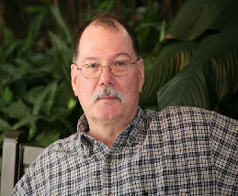
ARES Training Update
Jim Yoder, W8ERW – ARES Data Manager
w8erw@arrl.net

ARES Training Update

I must admit, fall is my favorite season. The trees are in full color here in Highland County and the countryside is just beautiful. If it were not for winter being right around the corner, fall would be perfect. It has been very dry with almost no rain and I’ve not had to mow for over a month now.

There is plenty to do however and I’ve been busy building my shack in the back portion of the Amish barn we had delivered last month. I’m making steady progress although my body has often expressed some displeasure and left me looking for the heating pad on a few evenings. I love a challenge and it keeps me out of trouble otherwise.

Jeff Klein KG8QP and I have exchanged a few emails regarding garnering more interest and participation in ARES as well as strengthening the relationship with our local county EMA offices. Jeff is the Wood County EMA Director and now heads up the Emergency Management Association of Ohio as their president. I had mentioned to him that I thought there were somewhere around eight EMA Directors in Ohio who were also licensed Amateurs. Jeff thought there were more so I went looking and as far as I can tell from the latest list, there are 16 including the State EMA office. I suspect I’ve missed some still. Jeff would like to see the number grow and further develop the relationship between ARES and the local county EMAs
throughout Ohio. Folks this is a great opportunity placed right in our laps. We should not let this slip by us. Thank you, Jeff and all of our EMA directors.

Now for some training status. We continue to add more certificates to the database and new members less frequently. I have 10,366 certificates recorded representing 890 Level 1, 749 Level 2 and 221 Level 3 members. These numbers are one of the ways Ohio Amateurs continue to shine by showing a commitment to training and the ARES mission. Thanks once again to all of you who helped the Ohio Section stand out.

If you have any questions or concerns, please feel free to contact me,

Jim W8ERW w8erw@arrl.net

__________________________________________

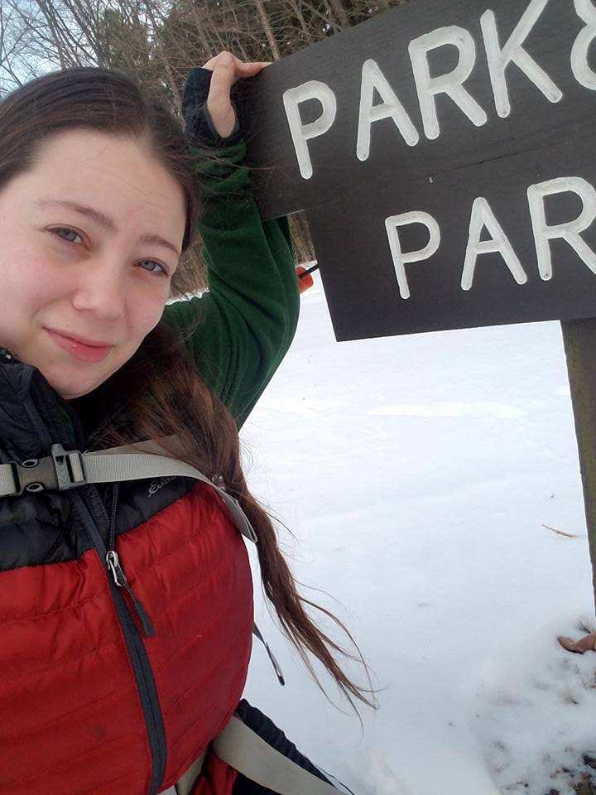
From the Section Affiliated Clubs Coordinator - ACC
Amanda Farone – KC3GFU
Afrone296@gmail.com
330-509-4095

Greetings! From recent experience I realize not all affiliated clubs are aware of the benefits and resources available to them. I would like to go over a few of them here, just as a reminder that they exist and they are great tools to help you along with your club’s endeavors. First and foremost, I would like to spotlight the Active Club Primer. It is a compilation of The Club President’s Workbook and the Special Service Club Manual. It is loaded with helpful links and ideas to freshen up your club. You can download the PDF at www.arrl.org/active-club-primer.
Another great resource is the ARRL Club News. This is a monthly newsletter that features club news and how they are working in the community and the hobby to advance amateur radio. If your club is participating in activities such as projects, supporting events, EmComm activations, or park activations, they want to hear about it! You can submit your newsletter article, along with photos, to clubs@arrl.org.
As an affiliated club you receive several great benefits. One of those benefits is the Club Commission Program. The Club Commission Program is a way for your club to earn commission for each new ARRL member recruited or each member renewal. What this means is that your members can renew their ARRL membership directly through the club. For each renewal, the club will receive $5 in commission, and for each new ARRL membership your club will receive $15 commission. This is an easy way to add funds to your club treasury and a great way your members can help support the club without effort. You can find more information on this process at www.arrl.org/affiliated-club-benefits under “Club Commission Program”. Another great benefit to utilize is the 50% Discount on Club Ads in QST. Your affiliated club may purchase advertising in QST at half the going rate. This is a great way to showcase your club. In my opinion though, the most important benefit is the referrals of prospective radio amateurs. In addition to providing a basic package of information to a prospective ham, the League Headquarters will refer prospects to your club for follow-up and recruitment. Most of us understand how important recruiting new hams are, so this is a wonderful benefit.
In conclusion, there are many other benefits to being an affiliated club and many other resources available to help a struggling club with new ideas. These are just a few that I find helpful. I encourage you to take the time and browse the arrl.net website to see what information you can find that may be beneficial to your club, whether your club is struggling or not, there’s always room for growth and new ideas.

National News
(from arrl and other sources)

______________________________________________________________________________

NASA Missions Detect Stunning Meteoroid Impact on Mars

On Dec. 24, 2021, our InSight Mars lander recorded a significant marsquake on the Red Planet. Only later did scientists discover the cause of the shaking: a meteoroid strike estimated to be one of the biggest seen on Mars since NASA began exploring the cosmos.

What’s more, the meteoroid’s impact kicked up boulder-size chunks of ice buried beneath the Martian surface–a discovery with big implications for NASA’s plans to send future astronauts to the Red Planet.

Data and images from two NASA spacecraft contributed to the discovery. InSight’s seismometer “heard” the quake that resulted from the meteoroid’s impact when it occurred last December, and the High-Resolution Imaging Science Experiment (HiRISE camera) aboard NASA’s Mars Reconnaissance Orbiter “saw” the new crater from orbit in February.

Subsurface ice will be a vital resource for future human explorers, who could use it for a variety of needs, including drinking water, agriculture, and rocket propellant. Buried ice has never been spotted this close to the Martian equator, which, as the warmest part of Mars, is an appealing location for astronauts.

“It’s unprecedented to find a fresh impact of this size,” said Ingrid Daubar, a planetary scientist who leads InSight’s Impact Science Working Group. “It’s an exciting moment in geologic history, and we got to witness it.”

Learn About the Discovery

______________________________________________________________________________________

FCC Seeks Electronic Engineers for Honors Program
The Federal Communications Commission (FCC) announced this week that it is opening a new window for applications under its Honors Engineer Program. The one-year developmental program may lead to a term or permanent appointment. The Commission is accepting applications from recent graduates with an engineering degree and current students graduating in December 2022.
Among the duties included in the job description is training to perform "propagation analysis of terrestrial, satellite and/or airborne systems or evaluating the emission characteristics of various transmitters to validate the co-existence with neighboring systems. Projects may also involve various computer software engineering and scientific applications."
"Engineers are deployed throughout the FCC, and from space innovation to new broadcast standards to 6G and beyond, the FCC's policy portfolio is filled with interesting and challenging engineering work," said FCC Chairwoman Jessica Rosenworcel. "Our Honors Engineer program is a unique opportunity for the newest engineers to work closely with experienced professionals in this field to ensure that the FCC is best prepared to face the challenges of next-generation communications networks."
The announcement will close once 175 applications have been received or on December 2, 2022; whichever occurs first. Visit USAJOBS for the complete position summary and to apply, at www.usajobs.gov/job/685101100.

Are You Doing It Correctly?

There is a Scientific International (SI) standard, called for by our National Institute of Standards and Technology (NIST), for the correct abbreviations for both MHz and kHz.
- mega (and larger) is always capitalized when abbreviated. MHz
Not mhz. Not mHz, unless you intend milliHz, used in frequency accuracy measurements for <1 Hz. 0.1% frequency accuracy = 1 mHz.
- kilo (and smaller) is not capitalized. kHz
Not KHz. Not Khz.
- all proper names, e.g., Hertz, are always capitalized when abbreviated. Always "Hz."
Not "hz".
- BUT, it is true the unit is spelled out as "hertz", no caps.
E.g., 60 hertz.

Please pass around to everyone. NIST source, below. There IS an international standard to go by.

From: https://www.nist.gov/pml/special-publication-811/nist-guide-si-preface

Thanks to Arnal Cook N9ACC

__________________________________________________________________

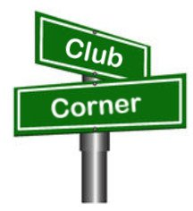
Club Corner

This is YOUR corner of the newsletter. Send us what your club is doing, and we’ll make sure that it gets in. Got a special event or club project that you want everyone to know about? Send it to us!. Need help with a project? Send it to us.

Let us know what you club is up to. Are you going to have a special guest at your meeting or are you having a special anniversary?

Send it to: webmaster@arrl-ohio.org

__________________________________________________________

VE Sessions

All Things Amateur Radio Association (ATARA) We host testing sessions every second Tuesday of the month to sign up please visit our website https://atara-w8atr.fun and contact us at hamexams@atara-w8atr.fun.

CARS
VE testing from CARS - Cuyahoga Amateur Radio Society - at Elmwood Recreation Center, 6200 Wisnieski Parkway in Independence, Ohio 44131 Time: 9:15 AM (Walk-ins allowed) Always the 2nd Sunday of the odd month. Go to CARS www.2cars.org for detailed map of location. Call Metro W8MET 216-520-1320 for details

Dayton Amateur Radio Association (DARA)
If you are interested in testing for a new or upgraded license, please come see us at the DARA Clubhouse. If you have questions about testing, please email exams.w8bi@gmail.com

Huber Heights Amateur Radio Club
Huber heights amateur radio club does ARRL VE testing the second Saturday of each even numbered month. Feb, Apr, Jun, Aug, Oct, dec. 9:30-11:00 For more information contact Jim Storms – AB8YK at ab8yk@hotmail.com

The Lake County Amateur Radio Association
The Lake County Amateur Radio Association is once again holding its 2022 Amateur Radio license exams at the Kirtland Library, 9267 Chillicothe Road, on the following dates:
Saturday, June 4, August 6, October 1, and December 3.
The tests will start at 12 noon. Please arrive a few minutes earlier.
The Lancaster and Fairfield County Amateur Radio Club (LFCARC) hosts exam sessions at the FAIRFIELD County EMA, 240 Baldwin Dr in Lancaster Ohio, 43130, on the first Saturday each month at 10:00 am. Please visit our website at http://www.k8qik.org for exam dates on our calendar and navigate to our Learning Center/Taking the Exam link for information and requirements. Our VE team looks forward to serving the Amateur Radio community in Central Ohio and across our nation. We have an experienced team that has tested candidates from Alaska, Florida, Texas and points in between! Contact me at ve_testing@k8qik.org to register.
The Milford Amateur Radio Club (MARC) is now doing VE testing on the third Thursday of each month at 6:00 PM. Location; Miami Township Civic Center located at 6101 Meijer Drive, Milford, OH 45150.
Please pre-register at www.milfordhamradio.org

Northern Ohio Amateur Radio Society (NOARS)
VE sessions are held the first Saturday of odd-numbered months at 10 AM in the North Olmsted Library, 27403 Lorain Rd., North Olmsted. Registration is preferred, but walk-ins are welcome. For more information or to register, contact Elaine, KC8FOS at ewilkinson1951@gmail.com.

Portage County Amateur Radio Service (PCARS)
The first Saturday of every even numbered month -10 am – at the PCARS club site in Ravenna. Please visit the PCARS web site and check out the information about VE testing in the latest newsletter at www.portcars.org .
If you have any questions, don’t hesitate to contact me at KB8UUZ@gmail,com

______________________________________________________________

Important Links
ARRL Home: www.arrl.org
Find an ARRL Affiliated Club: www.arrl.org/clubs
Find your ARRL Section: www.arrl.org/sections
Find a License Class in your area: www.arrl.org/class
Find a License Exam in your area: www.arrl.org/exam
Find a Hamfest or Convention: www.arrl.org/hamfests
Email ARRL Clubs: clubs@arrl.org

____________________________________________________________________________

The Ohio Section Youth Net

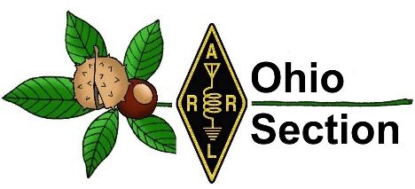
Youth Net
When: The second Sunday of every month at 7:30 PM EST
Where: The K8IV repeater located in Kent, Ohio (Echolink node K8BF-L) RF: 146.895 Mhz with PL 118.8
Who: Any licensed amateur radio operator who wishes to participate. Priority will be given to youth stations and those located in Ohio.
The purpose of this net is to encourage youth activity in amateur radio and to help new hams get more comfortable on the air.

FLdigi Workshop

TOLEDO MOBILE RADIO is presenting an FLdigi (EmComm Digital Sound Card) Workshop. It is open to the public.
This will be held at the Lucas County Maumee Branch Library, 501 River Rd. on November 5th between 9:00 am and 3:00 pm with a break for lunch.
Topics discussed will be proper setup/configuration, operation and use of the programs FLdigi, Narrow Band EMS, and SSTV.
Those attending should bring a two meter HT and a laptop that has a built in Microphone and speakers. The Operating System should be windows 7 or newer, or Linux, or Macintosh.
Contact: W8TER, w8ter@arrl.net or KC8TVW, kc8tvw@arrl.net if you have any questions or need more information.
73,
Steve/W8TER
419-367-1200
______________________________________________________________________________
Skywarn Recognition Day

We will be having Skywarn Recognition Day at the National Weather Service Station in Syracuse, Indiana the first weekend of December this year.

Allen, Defiance, Fulton, Henry, Paulding, Putnam, Van Wert, and Williams counties in Ohio are covered by the Northern Indiana National Weather Station, WX9IWX in Syracuse, Indiana. We are hoping to have representation from all 37 counties in the coverage area of WX9IWX.

We still have time but I want to get the time slots filled. Any questions can be directed to me.

Thank you and I look forward to working with fellow hams across state lines.

Brian P. Sexton, KD9EDR
District Emergency Coordinator
Amateur Radio Emergency Service (ARES)
Indiana District 2
2251 S. Old Ditch Rd.
Warsaw, IN 46580
cell: 574-377-9812

______________________________________________________________________

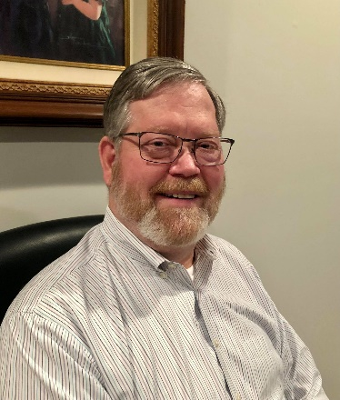
DX This Week – C31CT

Bill AJ8B (aj8b@arrl.net, @AJ8B, or www.aj8b.com)
CWOPs Member #1567

Greetings from Florida. By the time you read this, I will be back in Ohio and will have been active in the CQWW SSB contest. We are coming back early for my brother’s wedding, but I like to think that I am coming back early for the contest
1have been operating remotely every day and really appreciate the technology that allows this to happen with very little latency. Ironically, my first QSO was with a ham in the Orlando area. I drove from Waynesville, Ohio to Tampa to have a CW QSO with someone about 60 miles east of me via Waynesville! Oh well, it is the surprise and uncertainty that makes this fun.
Many of you have told me how you appreciate the interviews with DXers that I publish. I will continue to do that. This week, I have reprinted, with the permission of the SouthWest Ohio DX Association, an interview with C31CT. Sal is a very active ham and answered my questions completely.

DAH DIT DIT DIT DAH DAH DIT DIT DIT DAH

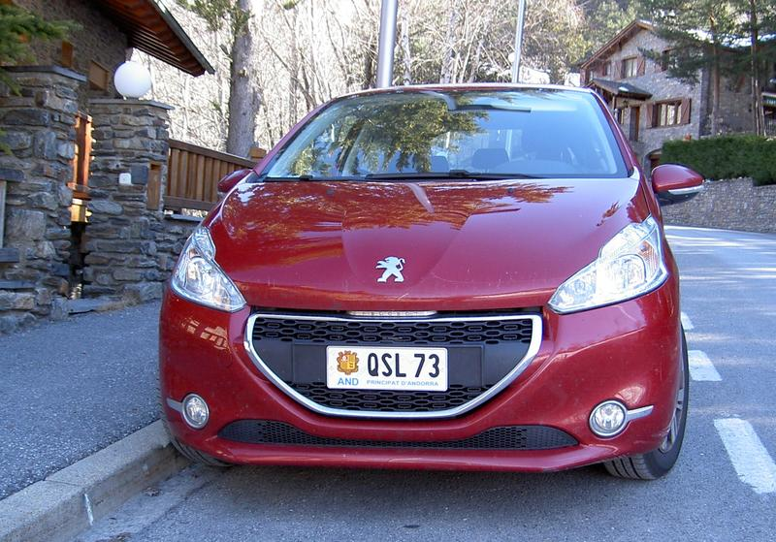

Interview with C31CT—Sal

I worked Sal several times on CW and was always impressed with his skill and courtesy. After confirming C31CT on 40, I thought he would be a very interesting person to participate in one of our interviews. I was NOT disappointed! He can be reached at carmenmanresa@hotmail.com

AJ8B: How did you first become interested in ham radio?
C31CT: Hi Bill, thanks for your interest and work for the good of amateur radio. The first thing is 73 to all. I am one more of many radio amateurs in the world who enjoy and spread the hobby, the circumstance of being very active from a DX country, produces that someone is interested in me, but "I am one more".
I am 75 years old and I have been active in radio since I was 15 years old (1962). At this age, my father bought a Telefunken living room radio and when he was not at home that device was a mystery for me to investigate. In the various bands of the O.C. I discovered that the dial said, Monte Carlo, Madrid, Moscow, Paris, BBC etc... they were those capitals studied at school and there I began to search and enjoy the discovery, the radio had a "magic eye" (called here the tuning lamp and greenish RX power, today s-meter) I spent hours slowly searching for other unmarked stations and writing down their frequency on a piece of paper, in order to find them again later. One day I heard private people speaking Spanish and French and there I was dumbstruck when I could, so I was unaware that this activity existed and that it was legal.
I had started a correspondence radio course "Radio Maymó" I did a galena radio, then a regenerative and a lesson came that was the construction of a simple station, so by studying and playing with the size of the coil, I managed to place myself where I listened to others, but without getting them to respond. A few days later, a very strong signal asked me where I was and said he wanted to meet me ( EA3UA great friend, now 84 years old ), he was a real radio amateur and from my city, Mataró (Barcelona) he met me in a bar and there I discovered that I could do it officially and that there were radio amateurs and several bands for them etc… I joined the URE (IARU of EA) and at 16 years old I obtained the callsign EA3-1181-U, then at 19 my call EA3QS (1966) which I still own for 56 years. I have always been active since qth, volunteer military service to transmissions, car, sailboat and later from C3.
The Argentine Handbook and close friends were the means to build my first AM radios, TX 8 W. with EL84, followed by 6V6, 807 and 2x6146. The receiver was a converter and an old musician with a long antenna. In 1974 I was able to travel to Lugano-Switzerland and buy a Sommerkamp TS-288, with which I already enjoyed SSB and CW. He continued to build a linear with 4x400A.

AJ8B: What has been your professional activity
C31CT: The city of Mataró ( Barcelona ) has always been dedicated to textiles, I started a small company producing something unique, covered elastic threads for corsets, socks and orthopedics, currently my son and I follow, I have been retired for years, being able to enjoy Radio.

AJ8B: So, how did you get licensed?
C31CT: I was aware that the Principality of Andorra was very close to my QTH EA3, a DX country with very little activity and that the entry of foreigners to operate from there was closed, the condition was to be a resident in the country. In 2002 I decided to obtain residence permits and shortly after my current callsign C31CT, it was difficult and complicated. Since then, I was able not only to enjoy myself, but also to give a lot of joy to radio stations around the world, since in addition to little DX activity on C3, the presence of CW was almost nil. In these 20 years, 95% of C3 QSOs on CW have been with me.

AJ8B: What do you like about operating in Andorra?
C31CT: Unfortunately, everything remains the same, without signing the CEPT it is still surely the most closed in Europe. The Principality of Andorra is a small country with everything one could wish for to live happily, democracy, security, healthy, and modern in all its aspects, the change experienced during my 20 years here, are of admiration for its administration and gratitude to the authorities, but as far as the radio is concerned, it is still closed and controlled at the request of URA (Iaru) and by the person who has been its president for more than 30 years. The legislation allows to obtain an indicative and URA is the one who must process the request and transfer it to the Government so that a call is granted, because in 20 years this has never happened, the only thing that has been allowed, (and as a great favor) has been let the club station operate or participate as an operator in the group of a URA contest.
As a result of this and other attitudes of control, 10 years ago some C3 radios decided to form a second association, ARDAM, later and after many difficulties and trips, we got our C37AC. Since its foundation I am the president. From here we have carried out many radio activities and strengthening personal friendships, also recovering some radios disillusioned by the situation. We have insisted to URA that at least temporary licenses be granted for foreigners in 50 Mhz and V-UHF, but without any success.

AJ8B: Describe what you are currently using:
C31CT: In 2014, in the ARDAM association we decided to install an SDR precisely in my particular QTH where there is very good RX and no local QRM, www.radioandorra.org
t has been a great favor to the radio because it allows self-control and especially many Spanish and French use it to be able to understand each other between great national wheels. It must be said that at www.websdr.org we are always among the top 6 of 170 SDRs. We have 3,100,000 visits and 205 countries. (Google statistics on the same page)
Due to the existence of this SDR, I cannot do radio directly from my house and I do it from the hut that ARDAM has in the mountains, or remotely from my QTH. There is a TS-2000, an IC-756-3, the Expert 1.3 Kw. and dipole antennas for all bands, except directional for 6 m. The permit we have is only for wire antennas.

AJ8B: Do you have a favorite band or mode?
C31CT: I mostly work HF, you can understand that I like the "difficult" and the "magical" so, the 160 and the 10 - 6 meters.

AJ8B: What time of day and days do you like to trade?
C31CT: Maybe I'm more of nights. Being aware that the normal thing will be to have a pile-up, so honestly, if I have little time I look for a band with little propagation knowing that at some point I will be able to do QRT without saddening anyone who wants C3, on the contrary, if I have time and encouragement, I go where there is more spread and in UP, the adrenaline and satisfaction skyrocket for both parties. When one has been to the other side of a DX station, one knows very well the joy that comes from obtaining a new country.

AJ8B: What advice do you have for those of us trying to break pileups to work DX?
C31CT: Do not call if you do not listen, it seems incredible, but it must be said. Discover the operation of the DX station and thus apply the way to proceed. As an example, in CW there are those who follow RX minutes on the same frequency, others go up from +1 to +2.5 and start again at +1 or... they go down the other way around. In SSB if the UP is 5 - 10 it does NOT mean that you hear 5 and 10, the good DX will look for BETWEEN 5 AND 10. Digital: If you do not receive RR73 or 73, do not give the QSO as good.

AJ8B: What is your favorite contest?
C31CT: Currently I only participate in some and what I like the most is to answer CQ and surprise the joy of the C3 multiplier. Many of my lists are just checklists.

AJ8B: I can see that you are a veteran of many DXpeditions. What was your favorite? Why?
C31CT: It has been one more activity within this world. Friends from Italy invited me to several expeditions and contests, I fondly remember the Order of Malta, Palestine, Benin, and Comoros. (2007-2012) It is an exciting experience in all aspects, it is a contest of 15-20 days, and unforgettable moments of complicity and friendship.
On the way back from D64K, due to immobility on the plane and sitting for so many hours, I suffered a thrombosis in one leg, from which I am fully recovered, but this served to decide that "I had already done it" and it was time to take better care of myself... 2012 my expedition is only C31CT and that of the club C37AC.

AJ8B: Any QSL suggestions?
C31CT: I answer all the QSLs by the same way they arrive, I use the Spanish mail because it is faster. My opinion regarding LotW and Eqsl confirmations etc… is to accept the new technologies, but I want to ask for an important reflection, the QSL on paper is necessary, the veterans in the radio remember the illusion of when we received them and we also see the eyes of joy of new radios, when they see ours or have a QSL DX in their hands.

AJ8B: What training/advice would you give to new fans?
C31CT: I can tell from what my behavior has been, do not be selfish, share your knowledge and help those who start or are interested in radio, when you are very old, you will roll your life and one of your personal satisfactions must be to think what you have added to the ham radio. I do it and I find it satisfactory. There are stupid, yes, like everywhere, leave them, forget about it.

AJ8B: Thank you for taking the time to answer my questions. Is there something you would like to share with us?
C31CT: Any radio amateur who visits the Principality of Andorra is invited to operate the ARDAM C37AC for several hours, they just have to notify in advance.

Vy 73 and DX….. and wishes for health. Alive and above is the spirit of Ham radio.
PSE: Visit SDR: www.radioandorra .org and get to know our diploma: ARDAM “Radio digital honor award” This way you will have a memory of the Principality of Andorra.

DAH DIT DIT DIT DAH DAH DIT DIT DIT DAH

Here is an update from Bernie, W3UR, of the DailyDX and the WeeklyDX, the best source for DX information. http://www.dailydx.com/ . Bernie has this to report:

VP5 - Turks and Caicos Islands - VA3DF and VE3RZ are heading to the Turks and Caicos Islands for the CQ WW DX CW Contest. They will be there and active as VP5/VA3DF and VP5/VE3RZ from November 22 to 29. During the CQ WW CW they will be using the call VP5Y as a multi-single. They will be running a K3 barefoot into verticals and an inverted L, steps from the ocean. Activity will be mainly on CW and possibly on SSB and FT8 on 1.8 through 28 MHz. QSOs will be uploaded to LoTW. QSL via M0URX.
VP2M – Montserrat - VA3WB, Dennis, is going to St. Peters, Montserrat for the CQ World Wide DX CW Contest. He will be there from November 24 to 29 and operating as VP2MJA. He'll have an IC-7300 and 1KW. Activity will be on CW, SSB and FT8 on 160 through 6 meters using a Mosley three element Yagi, dipoles and a vertical. QSOs will be uploaded to LoTW.

FO/M - Marquesas Islands - As a reminder F6BCW has been in French Polynesia operating as both FO/F6BCW and TX7G from both French Polynesia and the Marquesas Islands. While there he is also working on logistics for a November 2023 Marquesas Islands DXpedition for 10 operators on Hiva Oa.

9N – Nepal - S53R, Robert, is back in Kathmandu, Nepal. He has recently done some maintenance to his beam. Recently he has been very busy with work but plans to participate in the CQ World Wide DX SSB Contest. He's thinking single band either 10 or 15 meters because of lower noise level. During the CQ WW DX CW, at the end of next month, he'll do SOAB high power.

VK9/C - Cocos (Keeling) - On behalf of the VK9CM (VK9C in CQ WW DX SSB) team VK3QB, Chris, gives us the following update. "The team departed Perth on schedule at 1230 local time. Unfortunately, we got halfway to Cocos Keeling when the captain announced we were returning to Perth due to tropical storms to the north. The airline has advised that they'll try to reschedule our flight for Wednesday, 26 October. I'll update you tomorrow with further news. Hopefully good news. For now, we are drinking a beer in a Perth hotel bar".

9L - Sierra Leone - G0EWI, John, has been authorized to operate 9LYJD1 (yes that is correct) between October 11, 2022, through October 11, 2023. He can use that call from Banana Island and from a ship. He has been operating since October 15th and will go through November 3rd. Any operations from land should count for DXCC and other awards, pending accreditation. However, any operations from a ship will not count for DXCC and other awards. The ship stations license is good for both operating on a ship and land and including the Amateur Radio bands. You can see a copy of the license at https://www.qrz.com/db/G0EWI

DAH DIT DIT DIT DAH DAH DIT DIT DIT DAH

Below is a list of upcoming contests in the “Contest Corner”. I think this is important for someone who is trying to move up the DXCC ladder since entities that are on the rarer side and easiest to work in contests. Some of my best “catches” have been on the Sunday afternoon of a contest when the rarer entities are begging for QSOs. Of course, the gamble is that if you wait until Sunday, conditions may change, or they simply won’t be workable. However, it is not a bad gamble. Of course, why not work the contest and have some fun!
Check out the WA7BNM Contest Calendar page (https://www.contestcalendar.com/) and CQ Magazine for more contests or more details. I also have a comprehensive list that can be imported to your calendar at www.aj8b.com/files
The contests in red are those that I plan to spend some significant participation time on. PLEASE let me know if you are working contests and how you fared.
Thanks!

Date(s) | Event | Info
Nov. 1 | Silent Key Memorial Contest | https://skmc.hu/en/rules.html
Nov. 2 | UKEICC 80 Meter Contest SSB | https://ukeicc.com/80m-rules.php
Nov. 2 | VHF-UHF FT8 Activity | www.ft8activity.eu/index.php/en
Nov. 5-6 | IPARC Contest | www.iparc.de
Nov. 5-7 | ARRL CW Sweepstakes | www.arrl.org/sweepstakes
Nov. 6 | High Speed Club CW Contest | www.highspeedclub.org
Nov. 7 | RSGB Autumn Series, Data | https://bit.ly/31qpcJl
Nov. 9 | VHF-UHF FT8 Activity | www.ft8activity.eu/index.php/en
Nov. 12 | FISTS Saturday Sprint | www.fistsna.org/operating.html#sprints
Nov. 12-13 | 10-10 Digital Fall Contest | http://bit.ly/1FrFeBc
Nov. 12-13 | ARRL EME Contest | www.arrl.org/eme-contest
Nov. 12-13 | CQ-WE Contest | https://cqwe.cboh.org
Nov. 12-13 | JIDX Phone Contest | www.jidx.org
Nov. 12-13 | OK/OM CW DX Contest | http://bit.ly/19rrRjl
Nov. 12-13 | Worked All Europe RTTY Contest | https://bit.ly/36ubggF
Nov. 12-14 | PODXS070 Club Triple Play Low Band Sprint | http://bit.ly/2Cq2yUA
Nov. 13 | FIRAC HF Contest | www.firac.de/html/contest.html
Nov. 13-14 | Fall Classic Exchange CW | www.classicexchange.org
Nov. 15-16 | Fall Classic Exchange CW | www.classicexchange.org
Nov. 16 | RSGB Autumn Series, SSB | https://bit.ly/31qpcJl
Nov. 16 | VHF-UHF FT8 Activity | www.ft8activity.eu/index.php/en
Nov. 18 | YO International PSK31 Contest | www.yo5crq.ro/index.htm
Nov. 19 | All Austrian 160M Contest | https://bit.ly/3fgsiUo
Nov. 19 | RSGB 2nd 1.8 MHZ Contest CW | https://bit.ly/31qpcJl
Nov. 19 | SARL Newbie Party | http://bit.ly/H0IqQf
Nov. 19-20 | LZ DX Contest | http://lzdx.bfra.bg/rulesen.html
Nov. 19-20 | REF 160-Meter Contest | https://bit.ly/3iHzsQU
Nov.19-20 | SARL Field Day Contest | http://bit.ly/H0IqQf
Nov. 19-21 | ARRL SSB Sweepstakes | www.arrl.org/sweepstakes
Nov. 20 | FISTS Sunday Sprint | www.fistsna.org/operating.html#sprints
Nov. 24 | RSGB Autumn Series, CW | https://bit.ly/31qpcJl
Nov. 26-27 | CQWW DX CW Contest | www.cqww.com/index.htm
Nov. 28 | RSGB FT4 Contest Series | https://bit.ly/31qpcJl
Nov. 30 | UKEICC 80 Meter Contest CW | https://ukeicc.com/80m-rules.php

ARLD043 DX news
This week's bulletin was made possible with information provided by The Daily DX, the OPDX Bulletin, 425 DX News, DXNL, Contest Corral from QST and the ARRL Contest Calendar and WA7BNM web sites. Thanks to all.
TOGO, 5V. Andy, KB9IJI is QRV as 5V7JA. Activity is on 20, 15, and 12 meters using mostly FT8. His length of stay is unknown. QSL to home call.
MALAWI, 7Q. Don, K6ZO is QRV as 7Q6M until November 29. Activity is on 160 to 6 meters. QSL to home call.
DJIBOUTI, J2. Members of the Mediterraneo DX Club will be QRV as J28MD from October 29 to November 7. Activity will be on the HF bands, with a focus on the low and new bands, using CW, SSB, and various digital modes. QSL via IK2VUC.
ST. LUCIA, J6. Bill, K9HZ is QRV as J68HZ until November 5. Activity is on the HF bands. QSL via LoTW.
PAPUA NEW GUINEA, P2. A large group of operators are QRV as P29RO from Loloata Island, IOTA OC-240, until November 10. Activity is on all bands and modes. QSL via DL4SVA.
ST. EUSTATIUS, PJ5. John, W5JON is QRV as PJ5/W5JON until November
1. Activity is on the HF bands using SSB and FT8. QSL via LoTW.
MALI, TZ. Jeff, TZ4AM is QRV from Bamako and is active on 40 to 6 meters using CW and SSB. QSL via KX4R.
COCOS (KEELING) ISLANDS, VK9C. Operators VK6VY, VK6CQ, VK3QB and VK3HJ are QRV as VK9CM until November 3. QSL via EB7DX.
Please see October QST, page 70, November QST, page 77, and the ARRL
and WA7BNM Contest web sites for details.

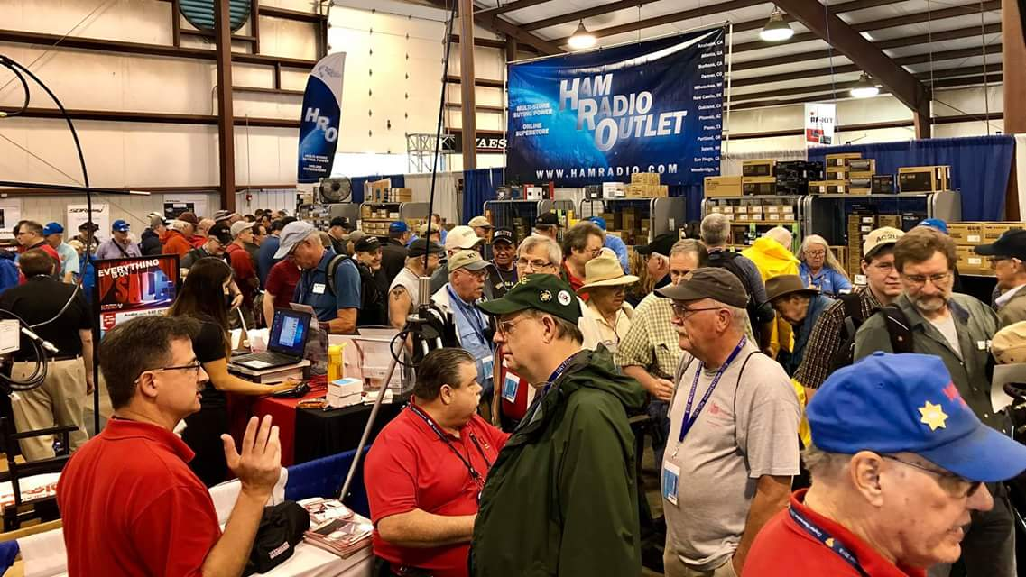
Upcoming Hamfests

We DO have some hamfests scheduled for 2021!! Yes, take a good look at the list, it’s growing every day!

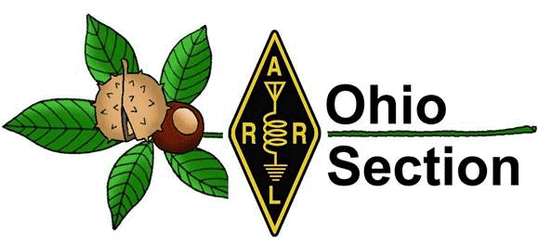
Be sure to keep your eyes on this schedule as that when things start getting better and the vaccine rolls out to more and more, hamfests will surely get back to their normal schedule. Don’t see your hamfest listed?? Did anyone register it with ARRL? It’s really easy to do and you get a lot of FREE publicity if you do.

Ohio Hamfests
2022

12/03/2022 - FCARC WinterFest  Location: Archbold, OH  Sponsor: Fulton County Amateur Radio Club  Website: https://k8bxq.org/hamfest  Learn More | 01/15/2023 - Sunday Creek Amateur Radio Federation Hamfest  Location: Shade, OH  Sponsor: Sunday Creek Amateur Radio Federation  Website: QRZ KC8AAV  Learn More
03/11/2023 - MOVARC Hamfest  Location: Bidwell, OH 45614, OH  Sponsor: Mid-Ohio Valley Amateur Radio Club  Learn More | 05/13/2023 - 05/17/2023  RV Radio Network  Location: Berlin, Ohio, OH  Type: ARRL Operating Specialty Convention  Sponsor: RV Radio Network  Learn More
05/19/2023 - 05/21/2023 Dayton Hamvention  Location: Xenia, OH  Sponsor: Dayton Amateur Radio Association  Website: http://Hamvention.org  Learn More | 07/16/2023 - Van Wert Hamfest  Location: Van Wert, OH  Sponsor: Van Wert Amateur Radio Club  Website: http://w8fy.org  Learn More
08/12/2023 - Cincinnati Hamfest℠  Location: Owensville , OH  Sponsor: Milford ARC  Website: https://CincinnatiHamfest.org  Learn More | THIS SPACE OPEN!  Get your event posted.

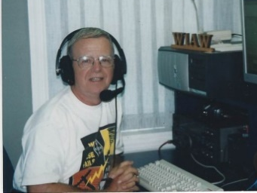
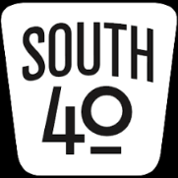
OHIO’S

I don’t know about you, but I think Mother Nature played a Trick or Treat on us with colder temperatures. The older I get the more I don’t like these already chilly mornings, evenings and nights. And as I anticipate the removal of another page from the shack calendar I only see them getting more so. As Kathy and my farm’s soybeans have been harvested and the corn is not too far behind, those too point out the fact Ole Man Winter is not too far away. Those facts plus knowing most ham radio activities in the Southern part of the State and elsewhere across the continent are pretty much over until Spring should cause each of us to take a good look at our outdoor antenna installations and do any routine maintenance while there still is a chance for some good outdoor days. Speaking from experience, it’s not pleasant trying to get an antenna back in the air during ice, snow, zero temperatures or during those gale winds of November.

Except for upcoming holiday meetings, parties, elections and gatherings, plus some community related Christmas activities, most club activities are mostly done for the year. So here are a few of the remaining and a few upcoming things for you to put on the calendar to draw your attention to.

Those of you who know persons wishing to try for their first license or attempt to upgrade let them know they have some opportunities in the coming weeks. The Hocking Valley ARC has started a Technician license class using the 2026 Gordon West Study Guide. The first class has been held, but there are two remaining. The second session is on November 5 with the third session prior to November 12’s 1 PM test date. The classes are from 9 AM until noon each day at Logan’s Hocking County EOC. The test session is an ARRL one with a fee charged for each element attempted. Test pre-registration is requested at hvarc.73@gmail.com. On Saturday morning, November 5 you have two opportunities to test. One sponsored by the Scioto Valley ARC will begin at 9 AM at the Ross County Service Center Conference Room A in Chillicothe. The second is in Hillsboro where the Highland ARA will conduct a session at the Highland County EOC with registration begining at 9 AM. Those wishing to test at Hillsboro are requested to pre-register at https://www.signupgenius.com/go/10C0D48ADAC23A7FEC16-hara8. The Laurel VE Program makes no charges. At all three sessions, the FCC fee does apply for a first license regardless of the VE format, but is not collected at that time. Walk-ins will be accepted at all locations if space permits. . On November 7 the Portsmouth RC will hold a session prior to their monthly meeting at the American Legion Post in Portsmouth. Their sessions begin at 5:30 PM.

Congratulations are in order to the Cambridge ARA on their recent recognition by the ARRL’s Board of Directors marking the Club’s 75 years as an Affiliated Member Club of the League! According to CARA Information Officer Lyn Alfman, N8IMW, the celebration began with a “meet and greet” on the morning of the 29th and was followed by the Club’s normal monthly meeting where Great Lakes Division and Ohio Section officials presented the award. Lyn notes that in 2023 the Club will observe its 110th year of existence which is longer than the ARRL has existed!

Last Monday evening, about 10 members of the Highland ARA met at the Hillsboro Cemetery to remove the flags decorating the graves of the Veterans who are buried in the cemetery. It took them approximately one hour to remove about 1,000 flags and sort them for storage or flag buring ceremonies by local scout or veteran’s organizations.

For a number of hams, the appearance of the November page on their calendar means only one thing--the upcoming ARRL November Sweepstakes. For those not familiar with this popular event, it is one of the few on-the-air events held over a two weekend period. The first is solely CW and the second is Phone. This year the CW Sweeps version starts on November 5 and the Phone edition is the 19th through the 21st. For those wanting to add states, provences, counties or parks to their collections, this event is taylor made because a lot of unusual and rare ones appear during those weekends. Just finding them can be a challenge by itself. As mentioned last week, this is a good contest where Technicians can cut their contest teeth because of all the recent ten meter propagation and activity. This is also an opportunity where clubs can hold member competitions to see who has club bragging rights. Speaking from experience, that by itself can be a lot of fun.

Those enjoying having breakfast or a morning coffee with their fellow hams have some opportunities to do so in the following weeks. Hams and their spouses from the Bainbridge, Ross, Pike and Highland County areas gather at the Dutch Restaurant on SR 41 monthly. Their next gathering will be on November 12 at 8 AM. According to K8TQM, Bob Mathews, they try to conclude in time for those wishing to get to Hillsboro for the Highland ARA’s Brunch Bunch to be able to do so. According to Ken Lightner, KE8JEL, the Highland ARA November 12 Brunch has been invited to move their gathering from the Hillsboro City Park and use the inside comforts of the Hillsboro Burger King as their gathering place.

Because of the annual Milford Christmas Parade, the Milford ARC will be unable to use their normal meeting location at the Milford Community Center for the usual November business meeting. Therefore they are going to meet for a meal at the Milford Bob Evans at 7:30 PM. Members are urged to spread the word of the change.

The honors for the first ham club in the region to hold a holiday gathering goes to the Southern Ohio ARA. Mike Love, WB8YKS, says members will gather at the Ironton Frisch’s Big Boy on Monday evening, November 21 at 6 PM. The Cambridge ARA’s annual Awards Banquet will be on the afternoon of Saturday, December 3 at the Cambridge Denny’s from 2 until 4. Those attending will order their food from the menu. The Clinton County ARA, Athens County ARA and Hocking Valley ARC have yet to determine the locations of their respective Christmas dinners and meetings, but know the dates. The CCARA will meet on Thursday evening December 1, the ACARA on December 20 and the HVARC will hold theirs on December 6. Members and friends of the Highland ARA should mark their calendars and hold aside Tuesday evening, December 13 for the Club’s annual Christmas Dinner Party Extravagana at the Hillsboro Methodist Church. The Portsmouth RC will hold their annual holiday dinner on Saturday evening, December 17 at the Gathering Place in Wheelersburg. Attendance at these holiday events are a great time to support neighboring clubs and meet some really great people.

Western Reserve Racing will again call upon the Athens County ARA to provide communications support for the annual Bobcat Trail Marathon and Half Marathon on November 12. The members of the newly rejuvenated Ohio University ARC have been invited to assist the ACARA at the event.

For decades two Southern Ohio county seat cities have treated their citizens to a community Christmas Holiday Parade. Ironton’s Lion’s Club has sponsored the event for years and for most of those years has called upon the Southern Ohio ARA for communications and assistance in marshalling the parade. Those helping are to meet at the 4th and Railroad Street Downtown Car Wash at 5 PM on Monday, November 28 for their assignments. The parade will happen regardless of the weather. On Saturday evening, December 3 the Hillsboro Holiday Parade will wind through the downtown Hillsboro streets. For over 40 years it was an afternoon event, but because of the growing popularity of lighted evening parades it was changed to an evening one about five years ago. The local amateur radio community has participated in this event since day one when the old Rocky Fork Emergency Net used six meters to communicate between mobiles stationed at given points around the parade route. Today the Highland ARA has it much easier with HTs and a repeater within three blocks of the parade route and fairgrounds.

Normally at this time of the year, many South 40 readers would be gearing up to attend the Grant RC Hamfest at Georgetown. Under usual circumstances this enjoyable hamfest marked the end of the year’s hamfest activities in Southern Ohio. But we live in unusual times and unfortunately the hamfest fell the victim of COVID concerns, members unable to put in the required time to pull the event off plus a change in the management of the event site. Therefore the event will not happen this year.

Speaking of the Georgetown Hamfest, one vendor you always saw at Georgetown and at many other hamfests in Ohio, Kentucky and Indiana was Cincinnati’s Debco Electronics. Nate Schneider, WD8MOI, informs our readers that Debi Case (the Deb in Debco) recently passed. In 1977 Debi and her husband Tom started selling electronic parts and supplies from the basement of their home. But the business grew and an Edwards Road storefront location in suburban Cincinnati was opened. According to Nate he well remembers sitting around the Cases’ kitchen table and helping them sort and bag parts during those early days in existance. Tom passed a couple years ago and the operation of the business has passed to the second generation.

In November many clubs select their slate of potential 2023 club officers for elections in December. However at least one club has already held theirs. The members of the Milford ARA are returning Ron Brooks, AC8MA, as Club President. Mike Murry, K8QBL will be Vice President with John Keener, KE8TEB serving as Secretary. Raleigh Sizemore, AB8GK, will guard the Club’s funds. The Hocking Valley ARC will hold elections for their 2023 officers at their upcoming November 1 meeting. It will be held at the Hocking County EOC, 52 East Second Street, Logan at 7 PM. The Highland ARA will hear the Nominating Committee’s report at the November 13 meeting. Any member wishing to be considered for an officer position or trustee should contact Sam Johnson, W8SKJ, to make their desire known. Nominations for the 2023 Athens County ARA officers have been made and voting this year will be electronically via a Qualtrics survey. This should enable more members to participate in the election process. The results will be announced at the November meeting.

We all know emergencies don’t happen in just nice weather. Therefore training to operate during less than ideal weather conditions are important. Therefore a Winter Field Day was established to provide such an opportunity. This year finds the event on January 28 and 29. For those of you who have never participated in Winter Field Day, it is much like the June ARRL version, but colder. The OH-KY-IN Radio Society will operate from the Harvest Home Park and the Athens County ARA will operate from the Red Cross Building in Athens.

With all the recent ten meter openings, several South 40 area Technicians are getting a taste of DX and giving thought to a license upgrade to experience all the opportunities a license with expanded HF privileges afford. In that vain the Lancaster-Fairfield County ARA newsletter editor Ralph Howes, W8BVH, tells us of a FREE 9 session General License Class that has just started via Zoom. The class is sponsored by the National Electronics Museum and will have weekly sessions through January 5 breaking twice for the holidays. For registration and information contact roland.anders@comcast.com.

I want to wrap up the column on a most happy note by welcoming another new ham to the South 40 region. Let’s give a big welcome to Steve Zanola of Batavia. Steve recently passed his Technician License and is now the holder of call sign KE8VWK.

That’s it for another week. Until next time stay cool, healthy, safe and radio-active.

John Levo, W8KIW, jlevo@cinci.rr.com or highlandara@gmail.com, 937-393-4951

Print an Official or Unofficial Copy of Your Amateur Radio License
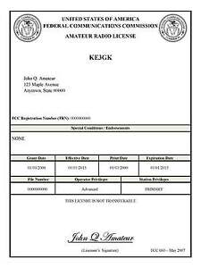
(By Anthony Luscre, K8ZT)

As of February 17, 2015, the FCC no longer routinely issues paper license documents to Amateur Radio applicants and licensees. The Commission has maintained for some time now that the official Amateur Radio license authorization is the electronic record that exists in its Universal Licensing System (ULS). The FCC will continue to provide paper license documents to all licensees who notify the Commission that they prefer to receive one.

Licensees also will be able to print out an official authorization — as well as an unofficial “reference copy” — from the ULS License Manager. I’ve created a set of instructions on how you can request an “official” printed copy of your license*

Click here to download the instructions

One Question Questionnaire

Hey Gang,

Last weeks question How many DXCC entities have you got verified?
- Less than 50?
- 51 – 150?
- 151 – 250?
- 251+

Survey Says A) 34 (41.98%) less than 50, B) 17 (20.99%) 51-150, C) 13 (16.05%) 151-250 or, D) 17 (20.99%) 251+.

The new question is:

Are you more likely to attend a Hamfest on a
a) Saturday or
b) sunday?

You’ll find the “One Question” questionnaire on the Ohio Section Website! http://arrlohio.org It’s all for fun and it’s not a scientific survey in any way, but we are learning some things that we didn’t know from these questions. I hope that you are enjoying answering these “One Question” questionnaires.

And the Winner is: Al – WB8LXT !

The first re-birth of the “Handbook Giveaway” for the month of October finally has everything back on track. Not without some issues, but we believe all issues are resolved now. The RED arrow will appear on the page for two weeks in November (you didn’t think I was going to tell you which weeks did you?? That would be too easy!) and you’ll have your chance to enter again. Good Luck to all!

V.E. Test Sessions

Many V.E.’s have decided to start testing once again, but with restrictions that need to be adhered to for sure. Here’s the link to find that V.E. Test session and what is expected of YOU before going. http://www.arrl.org/find-an-amateur-radio-license-exam-session

Final… Final
You won’t hear me say this often, but right now I’m pretty much out of words. October was a very busy month. I still have the OH Section PIC spot open. That is an important position to get filled, so if you would consider it – please let me know!

I know you constantly hear about our need to expand our hobby to younger generations. It’s necessary and must be done. We have a lot of what I’ll call “Seasoned Hams”, and I know most of you have done a lot for the hobby over the years. I was thinking about this the other day and it occurred to me that most of what I’ve learned through the years I’ve learned from older hams. My mind drifted back to a ham from Rock Creek in NE Ohio. Charlie – W8WEM. Charlie was an older guy, and I was in college when I met him on 2 meters. He was friendly enough, but he was always looking for someone to help him out with things. It was a pretty long ride, but I went up one day to help him out with a few things. I found out that Charlie was not only blind but had been badly burned in a house fire at some time and was disabled from his injuries. He never mentioned that part when I had talked with him. I discovered all that when I got to his place.

He didn’t have full use of his hands, and he told me my job for the day was to make some coax cables for him. He needed a 100’ piece and a couple of 20’s and maybe a 30’. He had a brand new 500’ spool of good Belden cable, all the connectors and tools necessary, but not the manual dexterity to get the job done. That’s what I was there for. Before we started to actually work on the cables, he gave me a lecture on HOW to install the connectors and why it was so important to do it correctly. Every step of the way, he told me exactly what to do. It took a while, but we finally got all of his cables finished. And by the time I was done, I knew more about transmission lines than I even wanted to. But in the years since, I have always been able to put connectors on cables and make them look good too! While I expected nothing more than the education I had received, when I was getting ready to head back home he told me that the rest of the cable on the spool (probably at least 250’) and any connecters left in the bag were mine and I should put them all in my car. That was pretty good pay for a couple hours of time spent learning some important ham radio skills.

As a young Ham I got some good experience and hardware from that afternoon. As an older ham now, I am starting to get to the point where I can’t do everything the way I used to. I’ll probably need some help with some things pretty soon. I hope that there is a pool of young men and women that will be willing to help me out. We need to start by getting them involved, and most importantly by letting them do the things that we need help with.

I’ve learned lots of stuff from “old guys” through my life. Old guys are actually pretty important and valuable to our hobby. Tnx es 73!

Tom WB8LCD

“Swap & Shop” on the website

Hey Gang,

Have you taken a look at the Swap & Shop page on the Ohio Section webpage yet?? Here’s a link that will take you there…
http://arrl-ohio.org/sm/s-s.html

Do you have equipment that you just don’t need or want anymore? Here’s a great venue to advertise it, and it’s FREE!!

Is your club doing a fund raiser to help raise money? After a lot of thought, it was decided that the Swap & Shop webpage could also contain these types of items as well.

The same rules will apply as do for the For Sales and Give-A-Ways and will only be posted for a month at a time. Please see the Terms & Conditions on the webpage.

If your club is doing a fund raiser and wants more exposure, please forward the information to me and I’ll advertise it on the Swap & Shop webpage for you. Now, I still want to remind you that it won’t be listed in this newsletter because it would take up way too much space, so your ad will only appear on the website. It is there for any individual to post equipment Wanted / For Sale or Give-Away as well as for Club Fund Raisers. No licensed vehicles/trailers or business advertising will be posted.

Postings are text only (no pictures or graphics) will be posted for a maximum of 1 month from date posting and require a contact phone number or email within the posting. Send your Wanted / For Sale or Give-Away post to: swap@arrlohio.org

Back Issues of the PostScript and Ohio Section Journal

Hey, did you know that PostScript and Ohio Section Journal (OSJ) are archived on the website? You can go back and look at any edition simply by clicking:
http://arrl-ohio.org/news/index.html

Ohio Section Cabinet
Section Manager – Tom Sly, WB8LCD | Section Emergency Coordinator – Stan Broadway, N8BHL
Technical Coordinator – Jeff Kopcak, K8JTK | Section Traffic Manager – David Maynard, WA3EZN
State Government Liaison – Bob Winston, W2THU | Affiliated Clubs Coordinator –  Amanda Farone, KC3GFU
Section Youth Coordinator – Anthony Lascre, K8ZT | Public Information Coordinator – John Ross, KD8IDJ

Chit – Chat, and All That!

Do you know someone that’s not getting these Newsletters? Please, forward a copy of this Newsletter over to them and have them “Opt-In” to start receiving them. Heck just have them send an email to: webmaster@arrl-ohio.org to be added.

We now have many thousands of readers receiving these newsletters weekly. Quite impressive, I’d say! I urge all of you to make sure that everyone, regardless of whether they are a League member or not, get signed up to receive these weekly Newsletters.

You can always “Opt-Out” at any time if you feel this is not what you were expecting. It’s fun and very informative. All of your favorite past newsletters are now archived too.
You can go back at any time and read them. Just go to: http://arrl-ohio.org/news/

The pictures on the front page and throughout this newsletter are from various newsletters, Facebook posts and/or were sent directly to me in recent weeks. Take a good look at them, you just might be in one of the pictures! “SMILE… you’re in the Ohio Section News!!”

The Ohio Section Journal (OSJ) is produced as a comprehensive look at all the programs within the Ohio Section. I sincerely hope that you have enjoyed this edition of the OSJ and will encourage your friends to join with you in receiving the latest news and information about the Ohio Section, and from around the world!

TOP^

