November 2022

From the Technical Coordinator | From the Section Youth Coordinator
From the Section Traffic Manager | ARES Training Update
National News | Club Corner
DX This Week | Contest Corner
From the South 40 | Final.. Final..
One Question Questionnaire

HAMVENTION 2023

Innovation!
This is an exciting theme because we are confident it encompasses in just one word the world of Amateur Radio today. There are so many exciting “Innovations!” world wide in Amateur Radio we want to capture the spirit and we expect to see many of these throughout the coming year and presented at HV23. Will you be involved in an Innovation! ?

From the Technical Coordinator
Jeff Kopcak – K8JTK TC
k8jtk@arrl.net

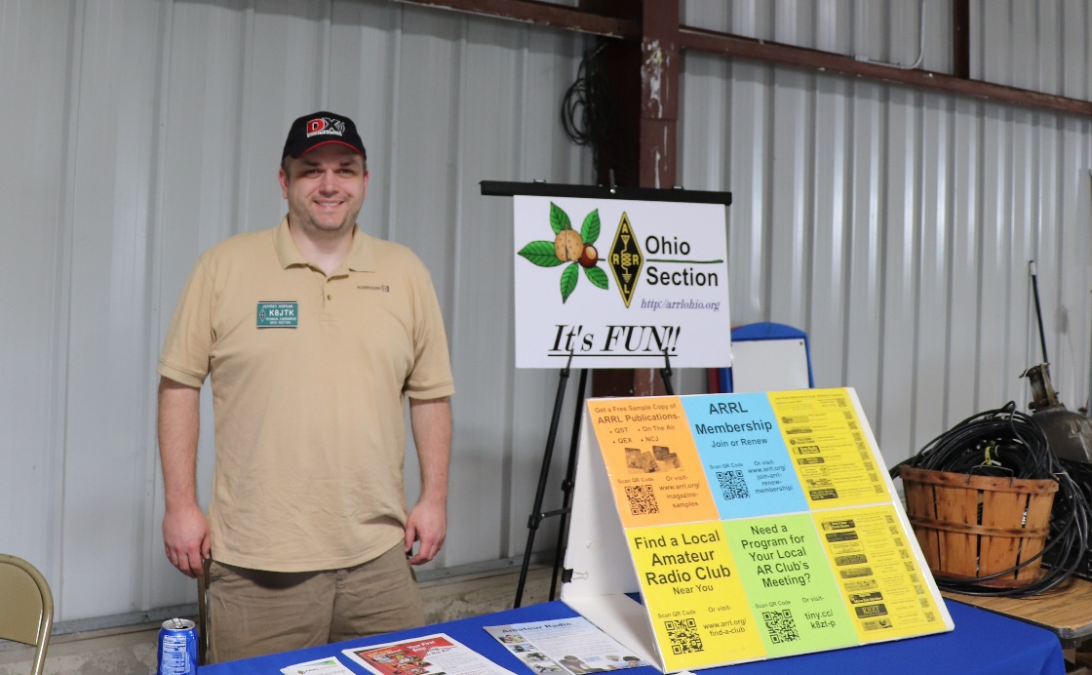
Hey gang,
Even though it happens once a month, Windows Updates are a pain. On “Patch Tuesday,” the second Tuesday of each month, Windows users hold their breath. Will my machine come back from the brink? Sometimes issues are bad enough where updates are released “out of cycle” or “out of band” meaning at other times during the month. This month was one example. An update caused more issues requiring a follow up patch to be released after 11/8. Depending on the operating system used, the pain came in different ways.
Performing a Windows 7 fresh install today, Windows Update will not work. It’s broken. The way updates were released and authenticated changed drastically from Service Pack 1 to the point Windows 7 went end-of-life. This installation procedure brings Windows Update to a working state, if you need to build a Windows 7 machine for some reason. Note: since Windows 7 has completely reached end-of-life, Microsoft is not releasing updates and it is recommended to use a supported operating system. Once you get past that, checking for updates 87.5 times and applying the 8,392 updates for the next 6 hours was always fun.
Windows 10 has streamlined updates where there aren’t nearly as many updates on a fresh install and the process doesn’t take nearly as long. Due to users putting off or just not applying updates on older versions of Windows, updates and reboots are now forced on users. Forced to the point where users claimed their machines rebooted while they were actively using it, loosing hours of work. Instead of the user choosing when to apply updates or do a reboot, they implemented a band-aid allowing the user to set when they’re likely to be using the computer. This does not help as options are severely limited. Then there’s the quality of updates. Crashes, Blue Screens of Death (BSOD), broken functionality, missing documents and files, printing problems, hardware and device issues are regular occurrences.
I heard on a podcast once, speaking of a botched Windows 10 update which removed ‘old files’ from users documents and pictures folders. Beta users reported the exact problem to Microsoft before the problem became widespread. The commentator made the remark that Microsoft’s attitude was: only a small number of users reported the problem, we’re not going further investigate or solve the problem. When Microsoft rolled out the update to all Windows users, the ‘small number of users’ became a very large angry mob of users. Microsoft didn’t invest the time to resolve, what they thought to be, a fringe case and resulted in a lot of negative press.
As hams, we often have Windows machines at remote locations (towers, buildings, club houses, shacks). Whether these are running Echolink, Winlink Express, Wires-X, or some other service that requires a Windows machine. An Echolink node can be run on a Linux-based solutions such as AllStar or SVX Link. Wires-X and RMS Express require Windows.
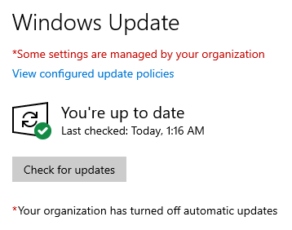
The out-of-control nature of forcing Windows Updates and reboots cases grief for the owner, admin, or Technical Committee. The machine will be left at a site logged in and running desired applications. When Windows Updates happen, often a reboot is required and the machine automatically reboots. If the admins follow good security practice and set a password for the account, after rebooting the machine will stop at the logon screen. Prompting someone to enter the correct password. While waiting for a log on, the service provided by the machine will remain offline until the program can be restarted. Nodes will be offline for any local users wanting to access those resources or remote users wanting to connect into the node.
Windows automatic updates disabled
The developer could create a Windows Service which are background programs able to start at boot. Services are not allowed to interact with the desktop since Windows Vista. Changing settings would be a problem if the program can’t interact with the desktop. Doing automatic logon isn’t a great option, even if the machine locks automatically after a minute. Need access to the machine? Just reboot it. Automatic logon would only be viable if the machine is secured in a locked cabinet or room.
Clubs have reached out and I’ve provided options for gaining control of Windows Update. One way is to disable Windows Update until someone is available to run updates manually. Disabling automatic updates will allow services to remain available while providing the flexibility of doing updates when an admin is available.
Disabling updates does not mean ‘never run updates.’ This is to control when updates happen and have scheduled downtimes. An admin must remember to run updates on a regular schedule – during a club meeting or site visit, for example. Not updating the system can have consequences including the network connection being disabled due to machine compromise in situations where the machine is on the site’s shared Internet, a corporate network, or school’s Internet connection.
The first place I search when looking for Windows suggestions, tips, and tricks is TenForums as they have good tutorials. There are SevenForums and ElevenForum for the respective OS versions. There one will find a tutorial How to Enable or Disable Automatic Updates for Windows Update in Windows 10. Windows 10 Home has no built-in way to disable automatic updates and requires a program like Wu10Man to manage settings. The program is open source.
The second option in the post is for clubs running Windows 10 Professional or Enterprise editions. In these versions there is a built-in way of disabling updates by way of the Local Group Policy Editor. No additional software required, my favorite.
- To open the Local Group Policy Editor, start by pressing the [Windows key] + [R]
- For Open, enter: gpedit.msc
- Click OK
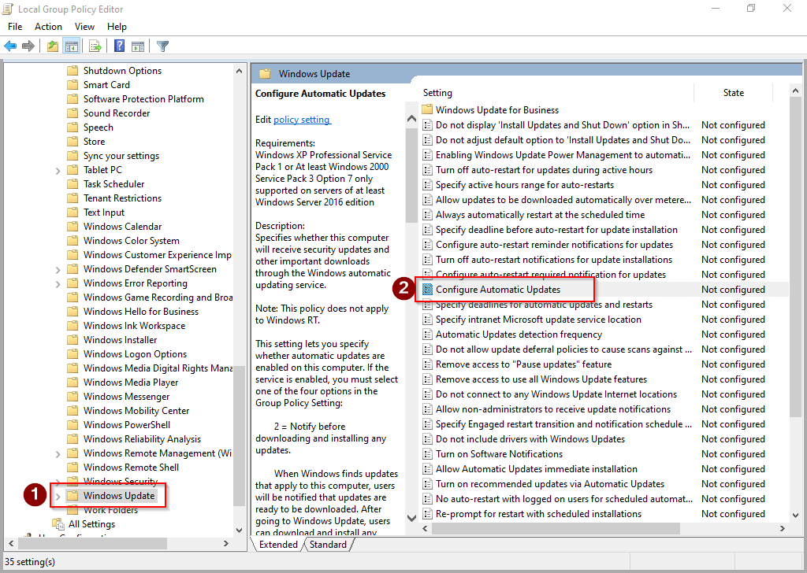
- In the Local Group Policy Editor left pane, navigate to: Computer Configuration → Administrative Templates → Windows Components → Windows Update
- On the right pane, double-click Configure Automatic Updates
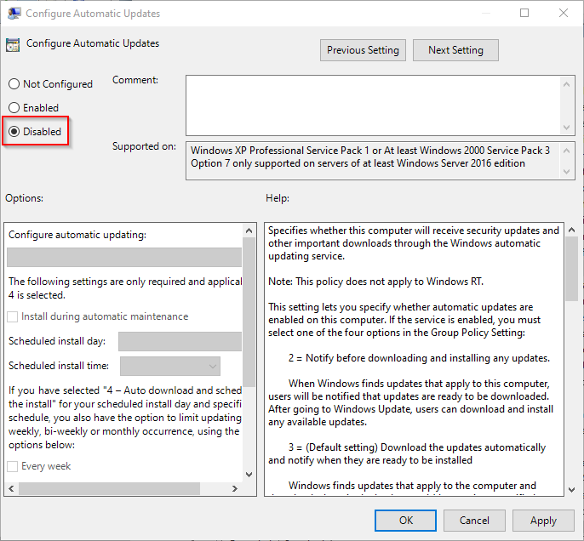
- To disable automatic updates, select Disabled
- Click OK
- Close the Local Group Policy Editor
For other configuration options of Automatic Updates, see steps 5 & 6 in option #2.
Going into Start → Settings → Update & Security, Windows Update will say in red “Some settings managed by your organization” and “Your organization has turned off automatic updates.” Though “Last Checked” will show a recent time, it will say “You’re up to date” regardless if updates are available for the system or not.
To manually update Windows, click Check for updates in that same Settings window. Windows Update will begin by checking for updates. Then download and install available updates.
Leave plenty of time for updates to finish. Reboot when required. Log on, apply other program updates, and restart necessary programs. Programs that should start after log on can be added to Startup Items. Machines with Solid-State Drives will apply updates in about a half-hour. Spinning drives, especially slower ones (4200/5400 RPM), will take much longer to apply. SSD and MVMe drives will apply updates quicker due to their much faster read/write speeds. Gain control over Windows Updates to gain control of nodes and services going down randomly until the Tech Committee can arrive on site.
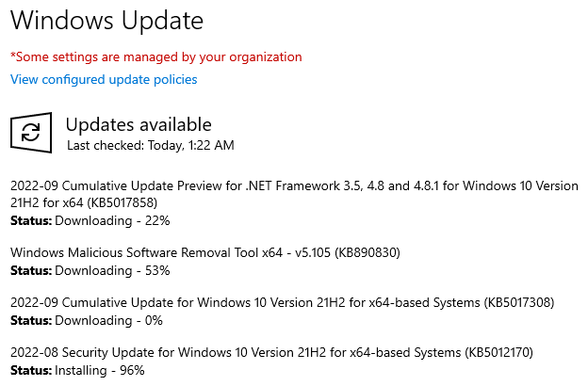
WTWW, a shortwave station run by hams, gained a following in the community for carrying ham radio related content – original programming, simulcasted live shows, and podcasts. As of November 9, 2022, it has gone silent. According to a report by Amateur Radio Newsline, “Ted Randall, WB8PUM, cited difficulties in meeting the station's ongoing expenses. Based in Lebanon, Tennessee, WTWW provided a wide range of programming at 5.83 MHz along with music and amateur-radio content at 5.085 MHz.”
Running Windows Update manually
The station went on the air in 2010. The flagship show “QSO Radio Show” broadcast live from Hamvention for many years going back to the Hara Arena days. The station ceased transmissions on shortwave but has plans to remain online with broadcasts available on their website. They hope followers make the transition from shortwave to web content.
I discovered another service like Hamshack Hotline and Hams Over IP, called AmateurWire. It was started around the same time as Hams Over IP. AmateurWire is available for general amateur use. In correspondence with the administrator, Roger – KE8LCM, this is an experiment for him learning how to run a VoIP service.
My direct extension on AmateurWire is 1140 if you would like to reach me. There is a trunk between AmateurWire and the Hams Over IP service, meaning users of each service can dial users on the other service. To reach a Hams Over IP user from AmateurWire, prefix the Hams Over IP extension number with 304. My DVMIS extension is 9004 which has links to Hamshack Hotline, Hams Over IP, and 12 other ham radio networks.
‘Tis the season for Santa nets! Get children, grandchildren, and neighborhood kiddos in touch with Santa! The Santa Net is held every evening between Thanksgiving and Christmas on 3.916 MHz at 8:00PM eastern time.
If HF is not available, the DoDropIn Echolink conference is hosting the Santa Watch Net on Christmas Eve! It begins at 6:00PM eastern on the 24th and runs about 4 hours.
Based in Colorado, and available on Echolink, is Santa on the Air. It runs now through December 9th. Times vary, see their QRZ post.
Third party traffic is always on the nice list for all Santa nets!
Thanks for reading. Happy holidays, Merry Christmas, and Happy New Year! 73… de Jeff – K8JTK

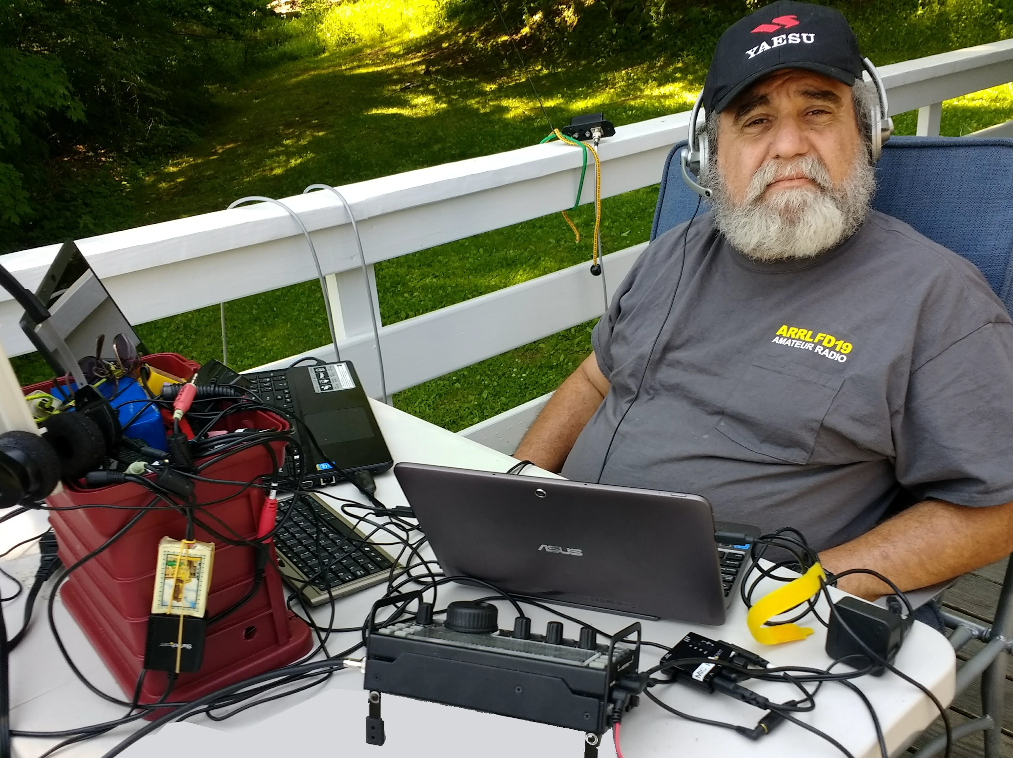
From the Section Youth Coordinator
Anthony Luscre, K8ZT - SYC
k8zt@arrl.net

Many of us have both year-end and New Year’s traditions. One of my Amateur Radio year-end activities is entering CQ Magazine's Annual DX Marathon and planning the next year’s strategy. These marathons are a different type of contest that runs all year, not just a single day or weekend. Competitors strive all year to work as many CQ Countries (similar to the ARRL DXCC Entities list with a few additions) and all of the 40 CQ Zones. It is like starting your DXCC chase anew each year, so you can consider it one of your New Year’s Resolutions!
THE 2022 DX MARATHON IS IN PROGRESS - GOOD LUCK!
Complete contest rules for 2022 can be found here
Submission information and the 2022 score sheet are available here
Helpful hints to improve your 2022 score are available here
The list of available awards and our plaque sponsors can be found here
The list of logs received for 2022 can be found here
CQ Magazine policy on QSOs with Russia and Belarus can be found here
DX Marathon policy on QSOs with Russia, Belarus and Ukraine is here
Complete set of questions & answers in our new FAQ here

Improving Your Score
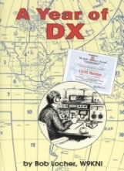
If you are serious about scoring highly, most competitors start at the beginning of the year. In fact, many serious operators devise plans to work specific countries by following DXpedition news, working specific contests, etc. Noted DXing author Bob Locher, W9KNI ("The Complete DX'er") wrote a book about his experience, “A Year of DX.”

A few resources that can be handy for planning your Marathon activities can be found on my website’s DX & DXing News page- www.k8zt.com/news/dx-dx-news including:
- NG3K Announced DX Operations (ADXO)- www.ng3k.com/Misc/adxo.html
- DX World.net- www.dx-world.net
- DX 425 News- www.425dxn.org
- QRZ Now.com DX News- http://qrznow.com/category/dxing
- A wide variety of DX Clusters
- The fine recurring articles in “DX This Week” by Bill AJ8B here in the Ohio Section Journal
- Weekly ARRL DX Bulletin - Sign Into ARRL Website, Edit your Profile and Edit your email Subscriptions. See article- “ARRL Publications, Website & Communications”- tiny.cc/arrl-info

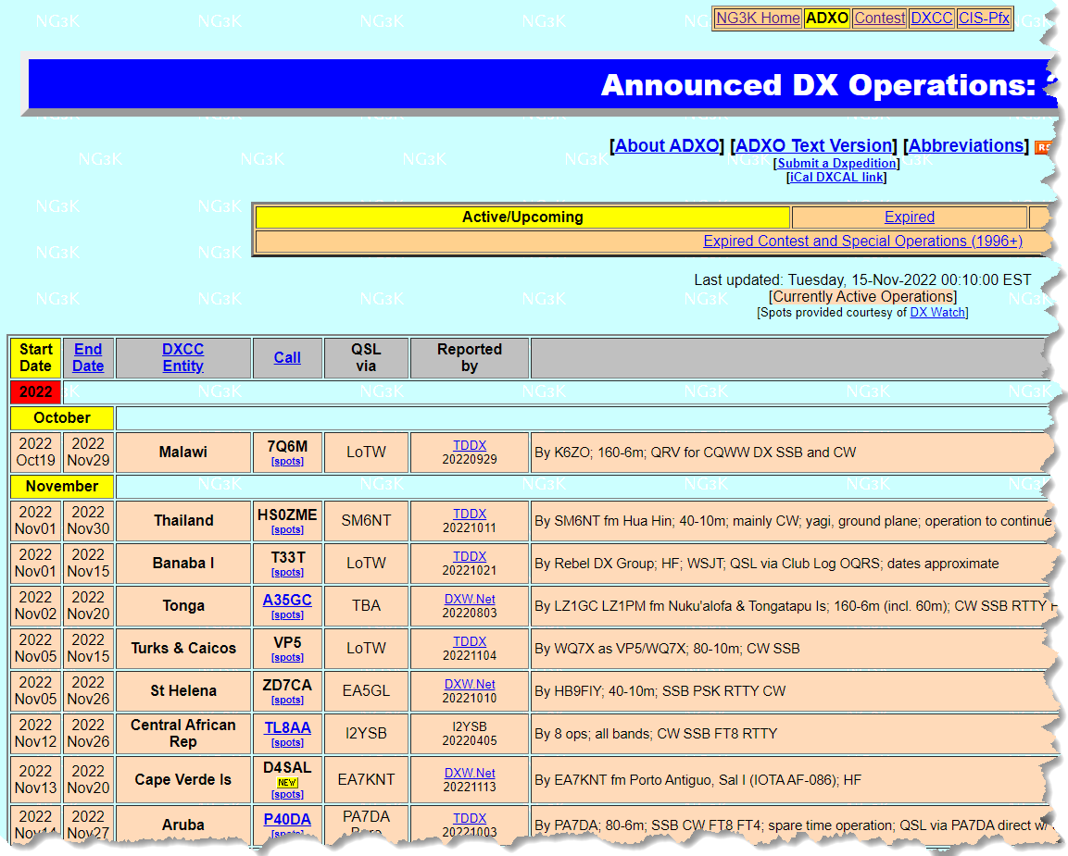
Submitting an Entry

If you keep your Amateur Radio Log in an electronic logbook entering the DX Marathon can be very easy using AD1C's free ADIF to DX Marathon software. The software will take almost any ADIF export file of your 2021 QSOs and convert it to the Excel spreadsheet format used in the Marathon.

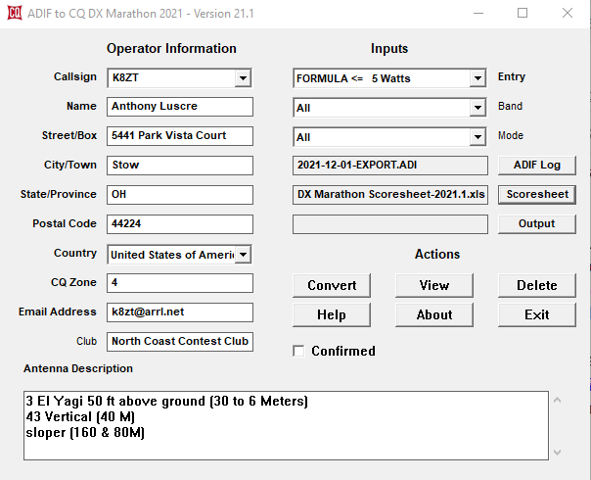

There is also a new convertor software in development by Sebastian Delmont - KI2D. It is currently being alpha tested and may or may not be available for use in this year's Marathon. You can find and test a copy at https://marathon.ham2k.net. Give it an ADIF file with all your QSOs, and it will help you figure out your score, select the best QSO for each entity and zone, validate them against AD1C Country File data, and export it in a way that can be used for your final submission. Please email Sebastian (sdelmont@gmail.com) with your results, impressions and/or questions.
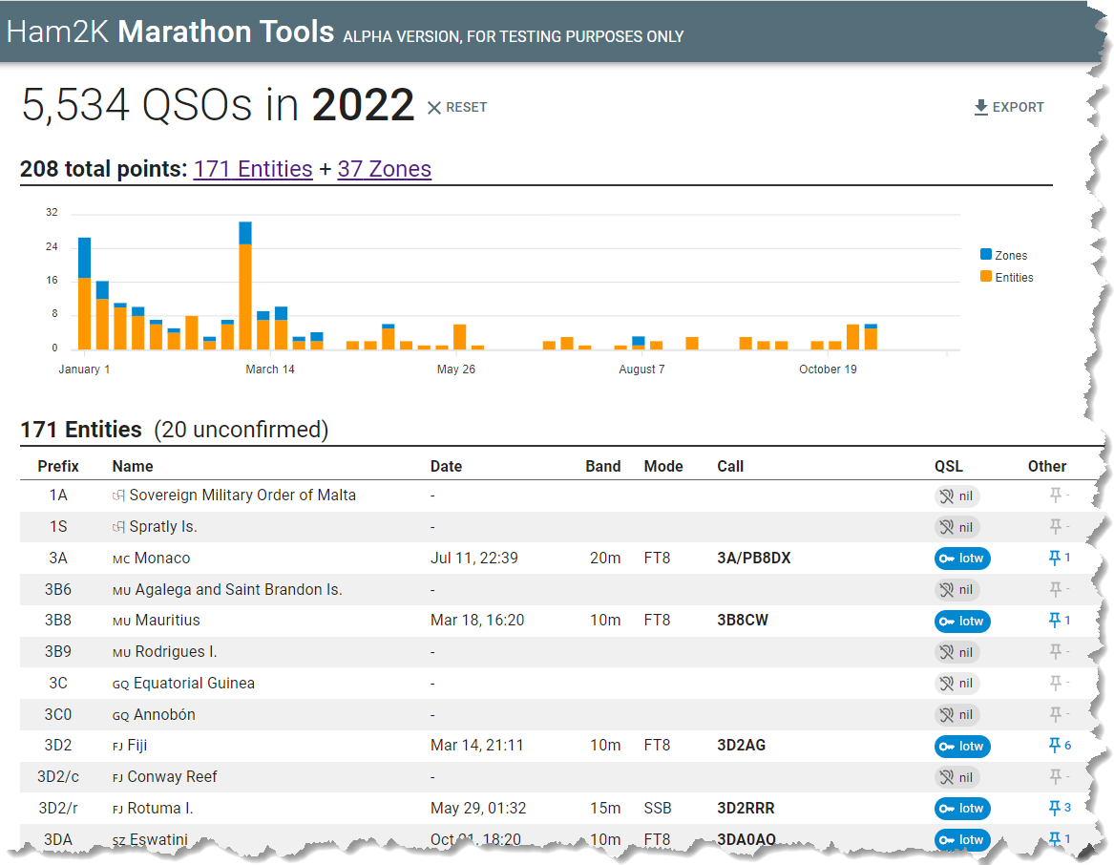

The final step, in any case, is submitting an Excel file to the CQ Marathon. You can use the above tool if you have an electronic logbook or if you are still paper-logging all of your contacts, you can download the Excel spreadsheet entry form and fill in the entries manually. Entries are due 2359Z, January 5, so you still have plenty of time to enter the current year's running of the Marathon. Start planning your next year's effort soon to take full advantage of all DXpeditions, Contests, etc.
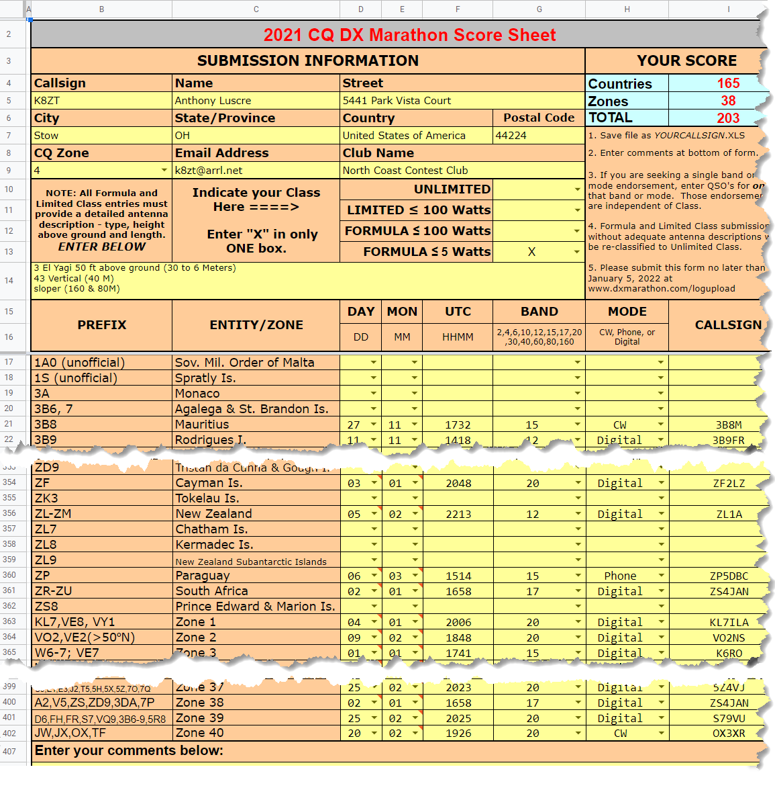
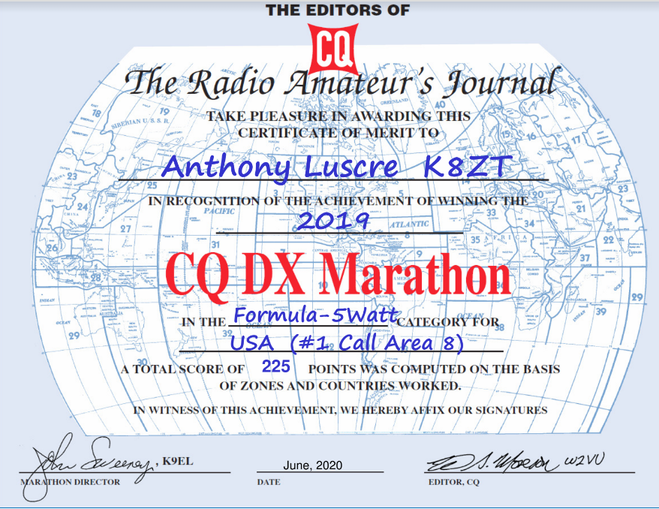

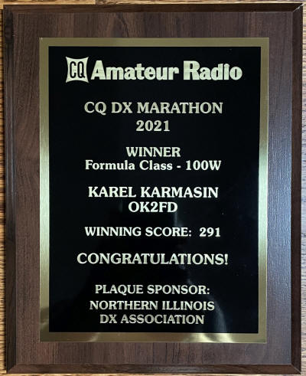
Live Zoom Presentation on CQ Marathon

You can join me for a live presentation on the CQ DX Marathon on Wednesday Dec 14.at 9 PM Eastern- Zoom link at www.ratpac.us/zoom.

Club Programs for 2023

Is your club planning its 2023 meetings? Do you need a presentation? I would be happy to do one. I have almost 25 different topics and can even customize one for your club. If you are located close enough I can present in person or I can use any online presentation tool such as Zoom, Google Meet, Microsoft Meetings, etc. Sin the beginning of pandemic I have done over 275 presentations for groups worldwide and would be happy to do one for your group. Here is list of presentations- tiny.cc/k8zt-p.

That’s it for this month; I hope to work you on the air soon.
73,
Anthony, K8ZT (k8zt@arrl.net)

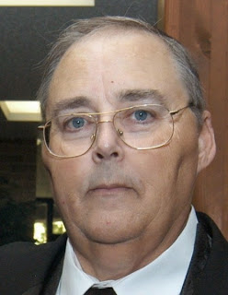
From the Section Traffic Manager
David Maynard, WA3EZN – STM
wa3ezn@att.net

Well here we are in November already. The October SET has been competed and we can settle back and wait for more white stuff. Don't forget to send in your SET report.
While the gasoline prices in Ohio are higher than last year the news reported there were many millions of Americans going on the road this first post Covid Thanksgiving. I can’t prove that they did because I stayed home for Thanksgiving. I hope each and everyone of you had a full and bountiful table on Thanksgiving. If you traveled for Thanksgiving I hope you have made it home safely.
While looking up stats I found this great image of our state flag that I wanted to share.

How about this November weather. First we have temperatures in the 70s then in the 50s followed by freezing temperatures with high and constant wind. It even threw snow at us in the northern part of the state. Talking about snow how much did your area get. Here in Hilliard and Columbus we had only a dusting of snow but from what I understand the northern sections of the state like Cleveland may have had as much a three inches of snow to deal with.
An extreme lake effect event that lasted from Wednesday into Sunday left snowfall totals of nearly seven feet in some places and generated several other fascinating stats that will probably go into the weather history books.
The lake-effect is fickle, the eastern suburbs of Cleveland recorded the highest Ohio amounts. The National Weather Service reported Lyndhurst with 8.5 inches, Richmond Heights had 7.8 inches by Sunday morning. Farther into the snow belt, Thompson Township in Geauga County had 6.4 inches as of 6 PM Sunday and Chardon had 5 inches.
Just east of Ohio Interstate 90 was closed because of the snow. Our son lives in Cranesville PA just east of Ohio line. He said schools were closed, roads were closed or impassable and he was getting sixteen inches of snow per hour. We lived in Fairview PA for years where you shoveled your way out in the morning and shoveled you way back into your driveway in the evening.
For lake-effect snow to occur, a 23-degree Fahrenheit difference is needed between the lake water and air temperature at about 5,000 feet above the ground. However, the temperature difference between Lake Erie and the air exceeded that requirement.
The water temperature in Lake Erie was 52 degrees, which is a shocking difference compared to the air temperature flowing over the lake. At nearly 5,000 feet above ground level, the air temperature was 12 degrees Fahrenheit, making for a 40-degree-Fahrenheit difference between the two.
"A 40-degree temperature difference is pretty major," AccuWeather Meteorologist Haley Taylor said.
Taylor also noted the direction of the wind is nearly as important as the temperature difference between the lake and the air.
"When the wind is blowing from the west or even the southwest, it's blowing over a larger portion of lakes Erie and Ontario, and more moisture is able to get into the atmosphere," Taylor said. "So the combination of the really high lake-air temperature differences and the wind direction [created a] situation [that] was really conducive for heavy snowfall rates."
But that's not all of the story. How about Buffalo being on the east end of Lake Erie.
Ralph Wilson Stadium is the stadium located in Orchard Park, New York. The stadium currently houses the Buffalo Bills NFL team. Orchard Park unofficially received 66 inches of accumulation over a 24-hour span. If confirmed by the New York state climatology office, this would set a new state record for the most snowfall in a 24-hour period. The current record stands at 50 inches and was measured in Camden, New York, in 1966. The national 24-hour snowfall record is 75.8 inches, which fell in Silver Lake, Colorado, in 1921.
It was reported on our local TV news that Buffalo fans got together and shoveled out the Buffalo players so they could go to Detroit and play the football game that was moved from Orchard Park to Detroit because of the snow. If you saw any of the game from Detroit the stands were full of Buffalo fans that traveled there in spite of the snow to support their team.
TIS THE SEASON FOR LISTS
After last months cold and snowstorms I thought something a bit lighter was appropriate for this month. By the time you read this we will be on the doorstep or very close to Christmas, like four weeks maybe. Shop early for those treasures to avoid the crowds. Since this is the season of list here is a list of places to leave that hint so your significant other will be sure to find it.

I doubt that many of you will get someone to buy you that $2000 HF rig but maybe a new mobile rig or a Hiel headset with microphone or an ARRL membership with subscription to QST. How are they going to know what you want if you don’t “hint” them?

Here are a few suggestions where to leave him or her you hint so you get the ham radio items you want for Christmas. You can use a page from a catalog or magazine to be:

- Taped to their car steering wheel.
- Taped on their cereal box or coffee cup
- Taped on the bathroom mirror
- Tape it to the refrigerator door
- Leave the store catalog on the coffee table open to the right page
- Circle the item of you desire in that catalog
- Clipped you hint to the lamp on the night stand
- Taped to the door going to the garage or outside
- Put a hint in her underwear drawer. Note: this doesn’t work for men
- Put one on his or her computer monitor
- Pin one to their pillow
- Talk about it every chance you get

I am sure that if you think real hard you can come up with some good “HINT” places of your own.

This is also a good time to think about winter safety. It doesn’t matter if you are just heading out the door to work or taking that trip to grandma’s house you should be thinking about car safety. Here are some things you should do to prepare for that winter weather.

For the car check your tire conditions, battery, anti-freeze and check your lights. Also have window scrapers, shovel, cat litter, flashlight and check that it lights. For personal safety you should have blankets, winter coats, boots, hats and gloves for everyone in case you get stuck and have to walk your way out. You should have food and water for everyone in the vehicle so if you can’t walk your way out you can at least wait comfortably for help to arrive. If you do get stuck and run you vehicle for heat make sure the exhaust pipe is open and clear and remains that way. It is also a good idea to keep your gas tank at least half full on a daily basis and to fill up before leaving on the ride to grandma’s house for Christmas. After all we need you and yours to remain safe and have a happy holiday.

STREIGHT KEY NIGHT

If you not going anywhere on New Years eve here is something fun to try. The ARRL Straight Key Night is coming up on January 1, 2023. This 24-hour event is not a contest; rather it is a day dedicated to celebrating our CW heritage. Participants are encouraged to get on the air and simply make enjoyable, conversational CW QSOs. The use of straight keys or bugs to send CW is preferred. There are no points scored and all who participate are winners.

Why not dust off that old straight key and give it a try. Who knows you may like it and have some fun. Straight Key night starts January 1 at 0000Z and ends at 2359Z (UTC). More details can be found at www.arrl.org/straight-key-night .

If you have traffic you need to move take it to a VHF net or if it is going out of Ohio you can take it to the OSSBN. Here is WHERE TO FIND AN HF OR VHF TRAFFIC NET IN OHIO

OHIO SINGLE SIDEBAND NET
Morning session | 10:30 AM | 3972.5 KHz | every day
Afternoon session | 4:15 PM | 3972.5 KHz | every day
Evening session | 6:45 PM | 3972.5 KHz | every day

OHIO HF CW TRAFFIC NETS
HF CW NETS | NET TIMES | FREQUENCY | NET MANAGERS
Buckeye Early | 6:45 PM | 3.580 | N2LC
Buckeye Late | 10:00 PM | 3.590 | WB9LBI
Ohio Slow Net | 6:00 PM | 3.53535 | N2LC
All CW net frequencies plus or minus QRM

OHIO LOCAL VHF TRAFFIC NETS
VHF NETS | NET TIMES | FREQUENCY | NET MANAGERS
BRTN | 9:30 PM DAILY | 145.230 PL 110.9 | W8DJG
COTN | 7:15 PM DAILY | 146.970 PL 123.0 | KV8Z
NWOHARES | 6:30 PM DAILY | 147.375 PL 103.5 | N8TNV
TCTTN | 9 PM Sun, Tues, Fri | 147.015 | WB8YYS
TATN | 8:00 PM DAILY | 146.670 PL 123.0 | WG8Z

OHIO VHF TRAFFIC NETS

BRTN Burning River Traffic Net serving Cleveland and North Central Ohio
COTN Central Ohio Traffic Net serving Columbus and Central Ohio
MVTN Miami Valley Traffic Net serving the Dayton area
NWOH ARES Northwest Ohio ARES Net serving Toledo and surrounding counties
TATN Tri-State Amateur Traffic Net
TCTTN Tri-County Traffic and Training Net serving North East Ohio

Check out the website www.arrl-ohio.org and look off to the left for the survey questions. While on the subject you should check out this website often as Tom does a good job and frequently changes his survey questions. There are also many reports for all of the Ohio Cabinet, more news and valuable links.

Thanks to your efforts, the public service tradition in Amateur Radio continues!
Until next month, 73

David WA3EZN
Ohio Section Traffic Manager

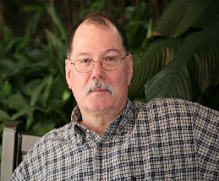
ARES Training Update
Jim Yoder, W8ERW – ARES Data Manager
w8erw@arrl.net

ARES Training Update
It does appear that our extended Fall season with warm temperatures and sunshine has come to an abrupt end. It was quite comfortable while I was working in the Amish barn building a room that I plan to call my shack and man cave. Now the addition of some heat, a propane heater, is required to warm the space enough to enjoy the project. Thankfully, much of it has been completed. Painting, trim work and adding the appropriate elements for an operating ham shack and a suitable man cave remain to be completed. My XYL has even begun to make some little contributions in addition to her support for my efforts. I have several nice and appropriate items for the walls that she has provided. If you are guessing that she’d also like to have my mess of electronics, gadgets and the like out of what was a nice sitting room, you are entirely correct.
I make no claim to being an experienced carpenter. However, I have managed to avoid mashing a finger or thumb with the hammer. I’ve also luckily been able to skip the painful dropping of a heavy object on my foot. This is indeed some sort of miracle and I am quite thankful for my good fortune. I have had some guidance also that must not go without mention. Mark N8OHO has provided armchair engineering support via several telephone conversations. All of which have be very helpful and effective in supporting my progress. I did also enlist some professional support to complete the ceiling. That simply was not a one-man effort. At least not for the shade tree carpenter that I am.
It's quite likely now that the antenna work will need to wait until warmer weather. I can’t see me attempting to auger holes in the frozen ground to erect either tower or masts. The cold really gets to me as well. The combination of my age and the chemo treatments surely have contributed to my constantly feeling cold. But I have plenty to do otherwise and by Spring, I hope the ether will be getting a regular and good parsing as a result.
Our training performance remains quite good. Although certificate submissions have slowed which is normal for the season, we are doing well and our numbers continue to grow. We have 10,369 certificates on file currently. 850 members are at Level 1, 748 are at Level 2 and 222 have risen to Level 3. Many have also completed several of the additional ancillary courses that we track.
Questions, comments and your suggestions are always welcome. Please do not hesitate to contact me if you have an issue that you would like to discuss. Thank you for your efforts and continued support.
As I write this on Thanksgiving Day, I would like to wish everyone a blessed holiday.

Jim W8ERW
w8erw@arrl.net

__________________________________________

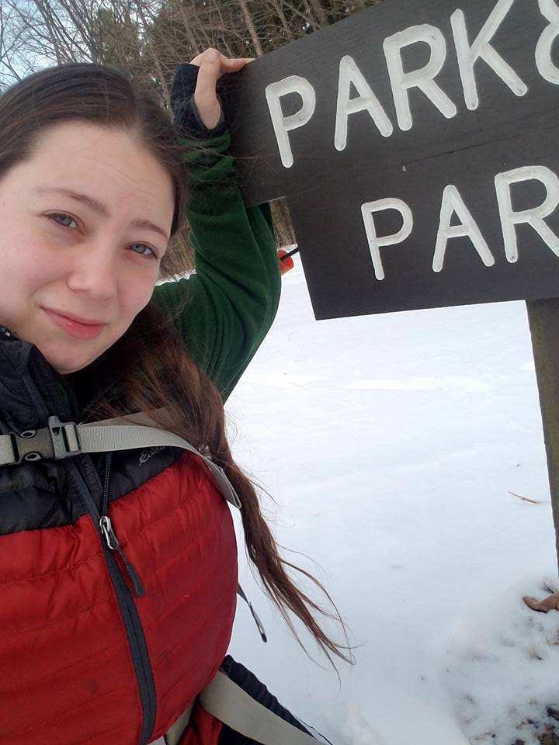
From the Section Affiliated Clubs Coordinator - ACC
Amanda Farone – KC3GFU
Afrone296@gmail.com
330-509-4095

With the weather changing and holiday season upon us, club events and activities seem to be slowing down. However, I won’t let this deter me from visiting clubs and showing my support for all that you do. I have recently gotten to meet with some great local clubs that have their hands in some positive endeavors. Through this, I have learned a few things that I would like to share. 1) Every club has areas they struggle with. Don’t let this discourage you or let you feel like you are “failing”. Instead, remain open to fresh ideas, approach things with a positive attitude, and don’t be afraid to reach out to mentors within the amateur radio community. 2) Clubs are very welcoming to new faces. If you see an event or activity that you may be interested in and are not a member of that particular club, don’t let that stop you from participating. Most all events and activities held by clubs are “open to the public”. In my experience, all clubs have been overly welcoming to a new face and in turn I have gotten to learn, meet new people, establish new connections, and participate in some really fun activities. It’s a win/win for both sides. We must remember; we all have some scale of passion for amateur radio. Automatically this gives us all something unique in common to use as a foundation.

National News
(from arrl and other sources)

Artemis I Spacecraft Set to Break Apollo Distance Record

Now 10+ days into its mission, NASA’s Artemis I Orion spacecraft is providing our mission control teams with a wealth of important data—and hitting a few space exploration milestones along the way.

On Saturday, Nov. 26, at 7:42 a.m. EST, Orion will break the record for farthest distance traveled by a spacecraft designed to carry humans to deep space and safely return them to Earth. Flying in distant retrograde orbit—‘distant’ in the sense that it’s at a high altitude from the lunar surface, and ‘retrograde’ because Orion will travel around the Moon opposite the direction the Moon travels around Earth—Orion will surpass the previous record of 248,655 statute miles, which was set by the Apollo 13 crew in 1970. Orion is expected to reach its maximum distance of more than 270,000 statute miles from Earth at 4:13 p.m. EST on Monday, Nov. 28.

Orion’s flight records, while impressive, serve an important purpose. By testing Orion in a variety of situations, NASA’s teams will better understand how the spacecraft performs in space and prepare for future missions with crew. Orion will spend an additional 15 days in flight on its 25.5-day journey before re-entering Earth’s atmosphere and splashing down in the Pacific Ocean on Sunday, Dec. 11.

Want the latest mission updates? Check out our Artemis I blog for daily reports on Orion’s progress, and see recent photos from Orion’s mission in our image gallery. Plus, you can follow along and track Orion via the Artemis Real-Time Orbit Website, or watch live footage from the spacecraft.

Get the Latest on Artemis I

________________________________________________________

Legion ham radio program to be handled locally

As reported on legion.org in October, the American Legion Amateur Radio Club (TALARC) is no longer operating as a national program, due mainly to a lack of licensed ham radio operators on staff. Legion ham radio clubs and programs, meanwhile, continue to operate successfully at the local level.
TALARC was created by resolution in 2011, and the club grew to become one of the largest in the nation. Both a hobby and a means of civil-defense communications during natural disasters, ham radio has long been an interest of veterans, many of whom served in communications roles in the military.
American Legion National Headquarters encourages continuation of ham radio programs at the local level but will no longer process memberships, manage the TALARC web page (https://www.legion.org/hamradio) – including posting net schedules and reports – or produce other promotional materials to operators. The page will continue to appear on legion.org until Dec. 31, giving time for local clubs and members to copy or download any resources they wish to use in the future on other platforms.
Clubs are also encouraged to submit stories that would appear on the website and in other national media through the Amateur Radio category (http://www.legiontown.org/ham-radio) on Legiontown.

Amateur radio operators who like to track balloons now have multiple targets. Earlier this week, three pico balloons were launched from Neumayer Station III in Antarctica, a German Antarctic research station of the Alfred-Wegener-Institut. Todd J. McKinney, KN4TPG, from the University of Alabama in Huntsville, is at the facility and will be launching a series of 20- and 10-meter Weak Signal Propagation Reporter (WSPR) balloons. Look for them on https://aprs.fi and https://amateur.sondehub.org under the call signs: K4UAH-1, -2, -3, -4, -5, -6, and -7, as well as W5KUB-114 and -115. Actual WSPR call signs on 20 meters are: KN4TPG, KW5GP, KM4LVC, WB8ELK, KM4YHI, KM4ZIA, and KD9UQB. On 10 meters, the WSPR call sign will be WB4VHF. Amateur radio operators with WSPR stations that have directional antennas, or Beverage-style antennas, are needed to monitor the 20-meter WSPR band and turn their antennas toward Antarctica. KN4TPG and KW5GP are approaching McMurdo Station to the south of Australia and New Zealand.

__________________________________________________________________

Club Corner

This is YOUR corner of the newsletter. Send us what your club is doing, and we’ll make sure that it gets in. Got a special event or club project that you want everyone to know about? Send it to us!. Need help with a project? Send it to us.

Let us know what you club is up to. Are you going to have a special guest at your meeting or are you having a special anniversary?

Send it to: webmaster@arrl-ohio.org

__________________________________________________________

VE Sessions

All Things Amateur Radio Association (ATARA) We host testing sessions every second Tuesday of the month to sign up please visit our website https://atara-w8atr.fun and contact us at hamexams@atara-w8atr.fun.

CARS
VE testing from CARS - Cuyahoga Amateur Radio Society - at Elmwood Recreation Center, 6200 Wisnieski Parkway in Independence, Ohio 44131 Time: 9:15 AM (Walk-ins allowed) Always the 2nd Sunday of the odd month. Go to CARS www.2cars.org for detailed map of location. Call Metro W8MET 216-520-1320 for details

Dayton Amateur Radio Association (DARA)
If you are interested in testing for a new or upgraded license, please come see us at the DARA Clubhouse. If you have questions about testing, please email exams.w8bi@gmail.com

Huber Heights Amateur Radio Club
Huber heights amateur radio club does ARRL VE testing the second Saturday of each even numbered month. Feb, Apr, Jun, Aug, Oct, dec. 9:30-11:00 For more information contact Jim Storms – AB8YK at ab8yk@hotmail.com

The Lake County Amateur Radio Association
The Lake County Amateur Radio Association is once again holding its 2022 Amateur Radio license exams at the Kirtland Library, 9267 Chillicothe Road, on the following dates:
Saturday, June 4, August 6, October 1, and December 3.
The tests will start at 12 noon. Please arrive a few minutes earlier.
The Lancaster and Fairfield County Amateur Radio Club (LFCARC) hosts exam sessions at the FAIRFIELD County EMA, 240 Baldwin Dr in Lancaster Ohio, 43130, on the first Saturday each month at 10:00 am. Please visit our website at http://www.k8qik.org for exam dates on our calendar and navigate to our Learning Center/Taking the Exam link for information and requirements. Our VE team looks forward to serving the Amateur Radio community in Central Ohio and across our nation. We have an experienced team that has tested candidates from Alaska, Florida, Texas and points in between! Contact me at ve_testing@k8qik.org to register.
The Milford Amateur Radio Club (MARC) is now doing VE testing on the third Thursday of each month at 6:00 PM. Location; Miami Township Civic Center located at 6101 Meijer Drive, Milford, OH 45150.
Please pre-register at www.milfordhamradio.org

Northern Ohio Amateur Radio Society (NOARS)
VE sessions are held the first Saturday of odd-numbered months at 10 AM in the North Olmsted Library, 27403 Lorain Rd., North Olmsted. Registration is preferred, but walk-ins are welcome. For more information or to register, contact Elaine, KC8FOS at ewilkinson1951@gmail.com.

Portage County Amateur Radio Service (PCARS)
The first Saturday of every even numbered month -10 am – at the PCARS club site in Ravenna. Please visit the PCARS web site and check out the information about VE testing in the latest newsletter at www.portcars.org .
If you have any questions, don’t hesitate to contact me at KB8UUZ@gmail,com

______________________________________________________________

Important Links
ARRL Home: www.arrl.org
Find an ARRL Affiliated Club: www.arrl.org/clubs
Find your ARRL Section: www.arrl.org/sections
Find a License Class in your area: www.arrl.org/class
Find a License Exam in your area: www.arrl.org/exam
Find a Hamfest or Convention: www.arrl.org/hamfests
Email ARRL Clubs: clubs@arrl.org

____________________________________________________________________________

The Ohio Section Youth Net

Youth Net
When: The second Sunday of every month at 7:30 PM EST
Where: The K8IV repeater located in Kent, Ohio (Echolink node K8BF-L) RF: 146.895 Mhz with PL 118.8
Who: Any licensed amateur radio operator who wishes to participate. Priority will be given to youth stations and those located in Ohio.
The purpose of this net is to encourage youth activity in amateur radio and to help new hams get more comfortable on the air.

***Next Net is Sunday December 11th***

______________________________________________________________________

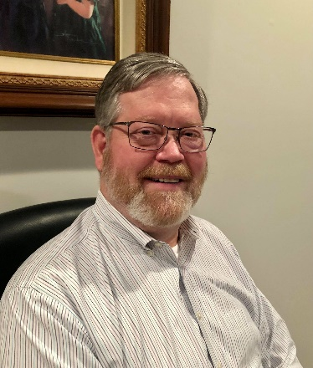
DX This Week – Searching and Podcasts

Bill AJ8B (aj8b@arrl.net, @AJ8B, or www.aj8b.com)
CWOPs Member #1567

There is quite a bit of DX activity going on. I was not able to work the T88WA DXpedition on Palau. I did get the others that were active in the log, but not those guys. I am running out of solar cycles and hope to get T8 next time!
I received nice cards from HB9CQK – Frederic in Switzerland and the contest club at KH7M in Hawaii. What did you get?

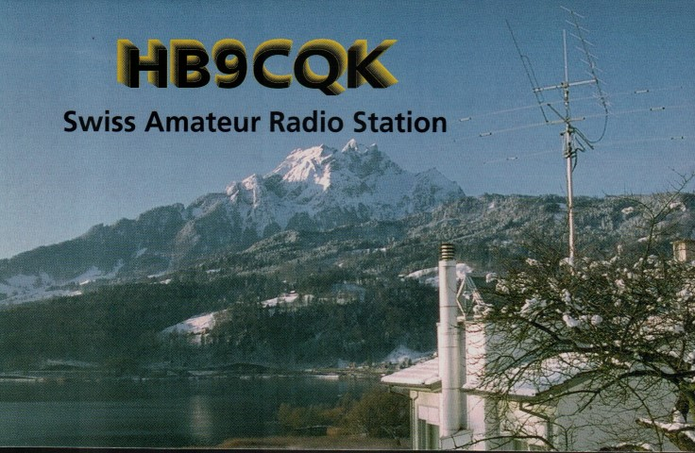 | 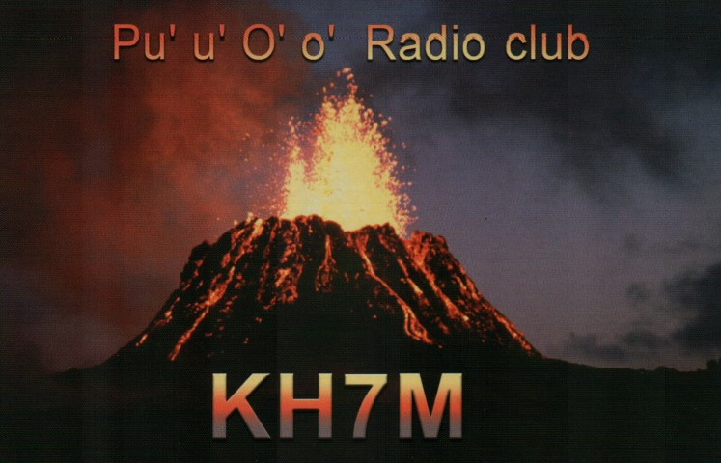

DAH DIT DIT DIT DAH DAH DIT DIT DIT DAH

This week we will discuss two often overlooked tools in the ham shack that can provide excellent free information, namely, a more efficient way to search the internet and podcasts. I was surprised that many hams don’t use podcasts as sources of information.
I know this may not seem directly related to chasing DX, but I have found these to be very helpful in the shack. I hope you do as well.
The first item to discuss is searching. Most people use the Google Chrome browser to search so I will use that in my examples. However, personally, I use duckduckgo.com as my search engine. Duckduckgo.com is completely ad free and is very fast. However, let’s take a look at some searching hints from https://www.lifehack.org/articles/technology/20-tips-use-google-search-efficiently.html.

#1 – Use the tabs – after you enter a search term, you can narrow the results by clicking on the tabs as shown below:

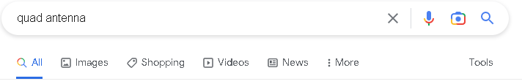

If you were searching on images of a cubical quad, you could just click the images button.

#2 – Use quotation marks to narrow the search. If you enter the search phrase quad antennas, you will receive 15,600,000 results. However, if you enter “quad antennas”, you will receive 19,100 results. That is still a huge amount of data to sift through, but you can see the difference.
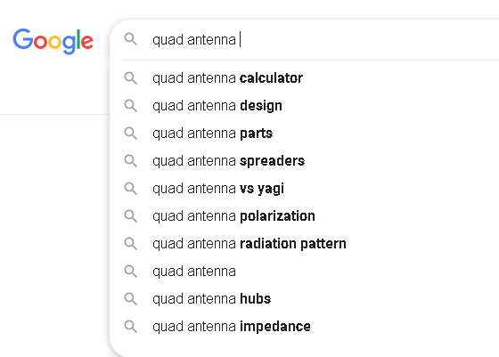

#3 – Use the google auto-complete when you can. It knows what has been searched for and chances are its suggestions are what you are looking for. An example is shown:

#4 - Sometimes you may find yourself searching for a word with an ambiguous meaning. An example is Mustang. When you Google search for Mustang, you may get results for both the car made by Ford and/or the horse. If you want to cut one out, use the hyphen to tell the engine to ignore content with one of the other. If you were only looking for returns about horses, you can enter it this way:

Mustang -cars

This tells the search engine to search for mustangs but to remove any results that have the word “car” in it. It can be wildly helpful when finding information about something without getting information about something else.

#5 - There may be an instance where you need to Google search for articles or content on a certain website. Let’s say we are looking for references to cubical quad antennas on the ARRL website. You could use this search term to achieve that: cubical quad site:arrl.org. That search returned 70 references.
To get more specific, you could enter “cubical quad” site:arrl.org. That search returned 61 references.

#6 – You add the file type that you are looking for and get even more specific. For instance, let’s say you are looking for a pdf file on the ARRL website that discusses cubical quad antennas. You could search in this way: “cubical quad” site:arrl.org filetype:pdf. This returns 21 references.

#7 – You can combine phrases to refine the results you are looking for. For instance, try a search like “cubical quad” OR “delta loop” site:arrl.org. You can also “AND” two phrases for better results such as “cubical quad” AND “homebrew”
#8 – There are a few built in functions such as weather and time. Just search on weather *Paris, France* to get the current weather in Paris. Time *Paris, France* will give the local time

#9 – You are having a QSO with G0LIH and he tells you that he drove 143 KM and spent 531 pounds on his newest rig. What is a quick way to convert those values? In the google search window, type “143 KM to miles and you will get 88.85 miles. Then enter 531 pounds to dollars and you will get $630.78.

I hope you will find some of that helpful. I know there are many other shortcuts. Please pass along the ones that I missed, and I will list them in this column.

My second topic has to do with podcasts. Many hams listen to podcasts, but many more do not. I have found them to be a wealth of information and very helpful. Another feature of podcasts is that you can go to previous versions, or back catalogues, to listen to prior episodes.
So, what is a podcast? A podcast is an audio session recorded that discusses a particular topic or trend. There are podcasts that cover cyber-attacks, world finance, ham radio, sewing, and thousands of other topics. They are typically1 hour in length, but there is no guarantee to that!
How do you get started? If you have a smart phone or tablet, you can find a podcast app that will allow you to access these stored podcasts. The one that I use is Stitcher. Just go to the app store on your device and search for Stitcher. Allow it to install on your device and you are almost ready to go. You will have to create a username and enter an email address. After that you can search for podcasts that you may want to listen to.
Another feature is that after you listen to a podcast, you will be notified when a new one is ready to be heard. There is no charge for this, other than data usage, and you really can open up a new horizon.
I have several amateur radio podcasts that I listen to including “QSO Today Podcast” (Episode 319 is my favorite), “Ham Nation”, “ARRL Audio News”, “Ham Radio Workbench”, “ARRL Eclectic Tech”, and “ARRL On the Air”.
I have heard a rumor of another that is being launched in January of 2023. You might listen to the trailer. Just search on “The DX Mentor”.

Good Listening

DAH DIT DIT DIT DAH DAH DIT DIT DIT DAH

Here is an update from Bernie, W3UR, of the DailyDX and the WeeklyDX, the best source for DX information. http://www.dailydx.com/ . Bernie has this to report:
2022 Crozet Island - The following news is from the 2022 Crozet Island website (translated by F6EXV, Paul) Here is the latest info as of today, following the signature of the agreement with the TAAF:
December 12: loading of equipment, passengers embarking on board the Marion Dufresne and leaving for Tromelin by the end of the day.
December 16: return to Reunion and disembarking by helicopter of the personnel coming back from Tromelin, and departure to Crozet. There will be no disembarking on Tromelin.
December 20: arrival on Crozet. Beginning of the transmitting window.
January 26: end of the window. I am allowed to transmit on HF bands for a duration of 3 weeks between December 20 and January 26. In addition, every day during a period of 5 hours, I will not be allowed to transmit so as to allow the Polar Institute to make some scientific measures.
There will be no limit on the QO-100 operation. Around March 25: departure from Crozet Stopping by Kerguelen then Amsterdam for the base supplying. I will not be allowed to disembark. Return to France in May.
As you can see, these represent significant changes to the initial permission, in particular on the HF side, given by the Prefect Giusti (replaced recently).
Only the info given on the Crozet2022 website, by F6EXV, F8TRT and of course Jean-Michel F6AJA on Les Nouvelles DX are reliable. Any other info (FT1W...) are pure speculation and fantasy. Don't waste your time or money.
Considering the short duration, I plan on concentrating on 2 or 3 bands in order to give ATNOs. I will adapt to the best band for W6s and choose 14 or 18 MHz, and 10 MHz during the night.
As of now, I have not chosen frequencies, this will be done along withthe scientists, except for 30m FT8 where, in agreement with the Bouvet team, I will be QRV on 10.131. I am aware of the US General' sub-bands on 20m.
All the team is working hard to secure permission for a longer period of TXing. I am in contact with the Paul-Emile Victor Institute (IPEV), but as of today, I have no confirmation of such an extension.
I am extremely sorry for all those, and I know there are many, that will look for Crozet. For me too, it is a great frustration to stay on Crozet for 3 months and be allowed only 3 weeks of HF activity. More info when available will be published on the website and on F6AJA's LNDX bulletin
Thank you and good luck de F6CUK.

3Y0 – Bouvet - LA7GIA, Ken, updates on the January-February 2023 3Y0J expedition, that "a great amount of donations" have been received in November, more than September and October combined. Now they just need another $22,000 to cover the costs. The container of gear has arrived in the Falklands. The budget goal of $705,000 currently is at 97 percent, at $683,000.

9M6 - East Malaysia - 9M6NA by JE1JKL, Saty, will be on Lebuan Island, IOTA OC-133, November 23-29 including the weekend CW CQWW. QSL through Club Log OQRS and LoTW.
A60FIFA - November 19 to December 19 is for the FIFA (soccer/futbol) World Cup being held in Qatar. The Emirates Amateur Radio Society, EARS, will be doing this A60FIFA activity. QSL to EA7FTR. Some ops may add /0, /1, etc. when they put the special callsign on the air.
D2/R - Rotuma Island - 3D2AG, Antoine, traveled to Rotuma Saturday, a 48-hour trip by boat. He hopes to be operational starting November 24 and continuing to December 20. It's a one-man operation, hoping to be on 160-10, focusing on 15, 12 and 10, CW, SSB, RTTY, and "some FT8." The 160M antenna will take some time to put up, so he'll listen on the band first and decide if it's worthwhile for him. Antoine will have an IC-7300 and IC-706MKIIG to an ACOM 600S amplifier, 650 watts maximum. Most of his FT8 operations on the higher bands will be 100 watts running on solar power. On lower bands he has a 3KW generator and the amplifier, for those bands all the way up to 6M. The 160M antenna will be an inverted L, 18M tall. On 80 and 40 it's an off center fed inverted V, the center at 15M. For 30 and 60 it's monoband inverted Vs. On 20, 17, 15, 12 and 10 it's a Spiderbeam. 6M will have a 5-element Cushcraft. When working the US on CW he will try to stay in the general class portion of the band to be able to work everyone, "unless the QRM is too high." On 160 he will try to be on 1822.5. 6M will be 50.102 and 50.115. 6M FT8 is 50.323. He will not have internet on Rotuma. Antoine's first task there will be to visit the grave of his son, Rehanisi, who passed on January 9, 2020.
T8 – Palau - T88PB by JA0JHQ, Nobu, is November 25-29, mostly for the CQWW CW Contest weekend. He prefers QSLing through LoTW, backed up by direct to his JA0JHQ QTH. After that operation, JH1FFW, Tony, will be there, November 30 to December 5, doing SSB and FT8 on 40, 20, 15, 17 and 10M, callsign T88RC. QSL via JH1FFW or use LoTW or eQSL.

DAH DIT DIT DIT DAH DAH DIT DIT DIT DAH

Below is a list of upcoming contests in the “Contest Corner”. I think this is important for someone who is trying to move up the DXCC ladder since entities that are on the rarer side and easiest to work in contests. Some of my best “catches” have been on the Sunday afternoon of a contest when the rarer entities are begging for QSOs. Of course, the gamble is that if you wait until Sunday, conditions may change, or they simply won’t be workable. However, it is not a bad gamble. Of course, why not work the contest and have some fun!
Check out the WA7BNM Contest Calendar page (https://www.contestcalendar.com/) and CQ Magazine for more contests or more details. I also have a comprehensive list that can be imported to your calendar at www.aj8b.com/files
The contests in red are those that I plan to spend some significant participation time on. PLEASE let me know if you are working contests and how you fared.
Thanks!

Date(s) | Event | Info
Nov. 24 | RSGB Autumn Series, CW | https://bit.ly/31qpcJl
Nov. 26-27 | CQWW DX CW Contest | www.cqww.com/index.htm
Nov. 28 | RSGB FT4 Contest Series | https://bit.ly/31qpcJl
Nov. 30 | UKEICC 80 Meter Contest CW | https://ukeicc.com/80m-rules.php
Dec. 1 | QRP ARCI Top Band Sprint | www.qrparci.org/contests
Dec. 2-4 | ARRL 160-Meter Contest | www.arrl.org/160-meter
Dec. 3-4 | PRO CW Contest | www.procontestclub.ro/PCC%20Rules.html
Dec. 3-4 | FT Roundup | www.rttycontesting.com/ft-roundup/rules
Dec. 7 | VHF-UHF FT8 Activity | www.ft8activity.eu/index.php/en
Dec. 10-11 | ARRL 10M Contest | www.arrl.org/10-meter
Dec. 10-12 | PODXS070 Club Triple Play Low Band Sprint | http://bit.ly/2Cq2yUA
Dec. 11 | CQC Great Colorado Snowshoe Run | www.coloradoqrpclub.org/contests/snow.htm
Dec. 11 | QRP ARCI Holiday Spirits Homebrew Sprint | www.qrparci.org/contests
Dec. 14 | VHF-UHF FT8 Activity | www.ft8activity.eu/index.php/en
Dec. 16 | AGB Party Contest | http://ev5agb.com/contest/contests_e.htm
Dec. 17 | RAC Winter Contest | www.rac.ca/contesting-results
Dec. 17-18 | Croatian CW Contest | www.9acw.org/index.php/rules/english
Dec. 17-18 | OK DX RTTY Contest | www.crk.cz/ENG/DXCONTE
Dec. 17-18 | Stew Perry Topband Challenge | www.kkn.net/stew/stew_rules.html
Dec. 18 | ARRL Rookie Roundup, CW | www.arrl.org/rookie-roundup
Dec. 21 | VHF-UHF FT8 Activity | www.ft8activity.eu/index.php/en
Dec. 25 | RAEM Contest | https://raem.srr.ru/rules
Dec. 26 | DARC Xmas Contest | https://www.darc.de/?id=820
Dec. 30 | YOTA Contest | www.ham-yota.com/contest
Dec. 31-Jan. 1 | Bogor Old and New Contest | https://contest.orari-bogor.org

ARLD047 DX news
This week's bulletin was made possible with information provided by HA7VK, SQ9FMU, W2GD, The Daily DX, the OPDX Bulletin, 425 DX News, DXNL, Contest Corral from QST and the ARRL Contest Calendar and WA7BNM web sites. Thanks to all.
ROTUMA, 3D2. Tony, 3D2AG plans to be active as 3D2AG/p until December 20. Activity is on 160 to 6 meters, with a focus on 15, 12, and 10 meters, using CW, SSB, RTTY, and FT8. QSL via operator's instructions.
MADAGASCAR, 5R. Operators PA3EWP, DL2AWG, DK2AMM, PG5M, and PA5X are QRV as 5R8WP, 5R8WG, 5R8MM, 5R8CG, and 5R8PA, respectively, from Nosy Be Island, IOTA AF-057, until December 3. Activity is on 160 to 6 meters using CW, SSB, RTTY, and FT8 with two stations active. QSL via DL2AWG.
PHILIPPINES, DU. Irek, SP3SUX is QRV as DV8/KH7EA until December 3. He will be active as DX8H in the CQ World Wide DX CW contest. QSL both calls via SP3SUX.
GUINEA BISSAU, J5. Carlos, CT2GQA is QRV as J5JUA until December 15 while on work assignment. Activity is in his spare time. QSL to home call.
AMERICAN SAMOA, KH8. Bob, W7YAQ and Al, K7AR are QRV as K8H from Pago Pago, IOTA OC-045, until December 1. Activity is on 160 to 6 meters using CW and SSB. This includes being a Multi/Single entry in the CQ World Wide DX CW contest. QSL via W7YAQ.
POLAND, SP. Special event call signs 3Z95PRK, HF95PRK, SN95PRK, SO95PRK, SP95PRK, and SQ95PRK will be QRV from November 26 to December 11 to celebrate the 95th anniversary of Poland's largest regional radio broadcasting station, Polskie Radio Katowice. QSL via bureau.
PALAU, T8. Tony, JH1FFW will be QRV as T88RC from November 30 to December 5. Activity will be on 40 to 10 meters using SSB and FT8. QSL via LoTW.
INDIA, VU. Operators VU2DSI, VU2EVU, and VU2XPN will be QRV as AU2JCB, AU3JCB, and AU5JCB, respectively, from November 25 to December 13 to commemorate the birthday of Jagadish Chandra Bose. Activity will be on 80 to 6 meters using SSB and FM. QSL direct to
home calls.
QCX CW Challenge, ICWC Medium Speed CW Test, OK1WC CW Memorial, RSGB
FT4 Contest, Worldwide Sideband Activity Contest and RTTYOPS
Weeksprint are all on tap for November 28 and 29.
Please see November QST, page 77, and the ARRL and WA7BNM Contest
web sites for details.

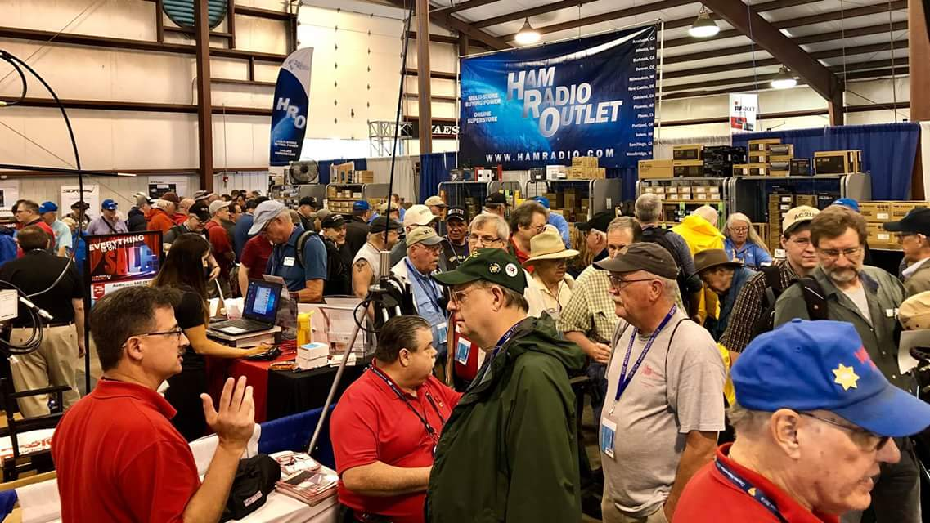
Upcoming Hamfests

We DO have some hamfests scheduled for 2023!! Yes, take a good look at the list, it’s growing every day!

Be sure to keep your eyes on this schedule as that when things start getting better and the vaccine rolls out to more and more, hamfests will surely get back to their normal schedule. Don’t see your hamfest listed?? Did anyone register it with ARRL? It’s really easy to do and you get a lot of FREE publicity if you do.

Ohio Hamfests
2023

12/03/2022 - FCARC WinterFest  Location: Archbold, OH  Sponsor: Fulton County Amateur Radio Club  Website: https://k8bxq.org/hamfest  Learn More | 01/15/2023 - Sunday Creek Amateur Radio Federation Hamfest  Location: Shade, OH  Sponsor: Sunday Creek Amateur Radio Federation  Website: QRZ KC8AAV  Learn More
03/11/2023 - MOVARC Hamfest  Location: Bidwell, OH 45614, OH  Sponsor: Mid-Ohio Valley Amateur Radio Club  Learn More | 05/13/2023 - 05/17/2023  RV Radio Network  Location: Berlin, Ohio, OH  Type: ARRL Operating Specialty Convention  Sponsor: RV Radio Network  Learn More
05/19/2023 - 05/21/2023 Dayton Hamvention  Location: Xenia, OH  Sponsor: Dayton Amateur Radio Association  Website: http://Hamvention.org  Learn More | 07/08/2023 - Mansfield Trunkfest 2023  Location: Mansfield, OH  Sponsor: Intercity Amateur Radio Club  Website: http://iarc.club  Learn More
07/16/2023 - Van Wert Hamfest  Location: Van Wert, OH  Sponsor: Van Wert Amateur Radio Club  Website: http://w8fy.org  Learn More | 08/12/2023 - Cincinnati Hamfest℠  Location: Owensville , OH  Sponsor: Milford ARC  Website: https://CincinnatiHamfest.org  Learn More

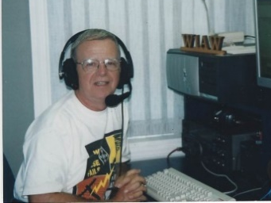
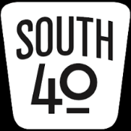
OHIO’S

Here’s hoping everyone had a good Thanksgiving and observed it in the company of family and/or friends. In my case, I think I overdid it as I am still feeling the effects of too much turkey and the resulting sleepiness caused by tryptophan from the “star of the meal”. However getting past this quickly does not look too promising. As N8ZNR is a retired home economics teacher, she uses every ounce of the leftovers. So my daily sleepiness is probably going to continue because of a continuation of turkey related dishes-turkey pot pie, turkey meat loaf and turkey hot shots to mention but a few of her creations. But in reality I’m not complaining?

As we count down the remaining hours in November, let’s take a look at the ham related events still remaining in the month and a peek at what’s coming in December.

The Cambridge ARA assisted with the City’s annual Christmas Parade this past Saturday and we haven’t yet had a report about how that went. Another club helping to usher in the Christmas season is the Southern Ohio ARA who will be assisting the Ironton Lions Club with the annual parade through the streets of downtown Ironton. The parade is always a large one and any and all amateurs in the Lawrence County area are asked to assist. Those wishing to give of their time and talents are asked to meet at the car wash at 4th and Railroad Streets of 5 PM on November 28. Assignments will be given at that time. Dress accordingly as it will happen regardless of the weather.

The Southern Ohio ARA had the honor of having the first Christmas Holiday gathering of the year. It was held on Monday evening at the Ironton Big Boy. Elections of club officers were also held.

Clinton County ARA President Mark Atwell, WX8A, reminds members that nominations for club officers remain open through November 30. Members may make their on-line nominations at the Club’s website. Elections will occur at the December 1 Christmas Dinner Meeting.

That wraps up the November happenings. So let’s open the book to see what is in store for December.

The Clinton County ARA will meet to celebrate the season with their annual Christmas dinner and meeting this Thursday evening, December 1. They will gather at 6:30 for a potluck dinner to be followed by their meeting. The event takes place at the Foster Boyd Cancer Center in Wilmington.

The Scioto Valley ARA is going to hold a social night gathering at the Scioto Ribber Restaurant in Portsmouth on the 1st. It starts at 6:30. Contact President Jesse Stanley, WD8CHP, if you intend to attend so he can arrange for seating. The Ribber is known nationwide for its menu featuring angus beef and is only outdone by a restaurant in the Dallas-Ft. Worth area.

The Cambridge ARA’s annual Awards Banquet will be held on December 3 at the Denny’s Restaurant. It will run from 2 until 4. Food will be ordered from the menu. Also on the 3rd members and friends of the Scioto Valley ARA will be treated to a catered meal served by the Chillicothe Evening Lions Club. It will begin at 1 PM at the Lion’s clubhouse in Chillicothe. Anyone wishing to attend should call or text David Coffey, N8RKC, at 740-253-4451.

December 3’s Skywarn Recognition Day will see the celebration of the opening of the new National Weather Service office and operation center in Charleston, WV. That office serves the majority of West Virginia counties, some northeastern Kentucky counties and the most of southeastern Ohio.Special event station W8W will be on the air from 00:00 to 24:00Z on that date. Electronic and/or snail mail QSL cards will be available to all making contacts with the station.

On December 6 the Hocking Valley ARA will hold their annual Christmas dinner at a location to be announced.

December 10 marks the day when the Tri-State ARA will conduct their last VE session for the year at the Museum of Radio and Technology in Huntington, WV. Club officials say things will get underway at 9 AM with all elements to be given. Pre-registration is not necessary, but to assure a seat you may pre-register at w8va@qsl.net. Walk-ins are welcome. However an FRN and appropriate identification is required.

On December 10 members of the Highland ARA will make their annual road trip to R&L Electronics. This annual trip not only is for buying Christmas party door prizes, but also provides an opportunity for newer hams visiting the “candy store” to ask questions and get advice about equipment and station set up from experienced hams. The group plans to leave Hillsboro around 9 AM and arrive in Hamilton around 10:30. They will eat at Hyde’s Restaurant before heading across the parking lot to R&L for what always has been a very enjoyable outing. Those in other clubs are invited to hook up with the group at R&L or the restaurant.

Hams in the Bainbridge and Ross, Highland and Pike County areas are reminded of the monthly breakfast gathering at the Dutch Restaurant on SR 41 south of Bainbridge. It gets underway at 8 AM on the 10th. Hams and spouses always seem to have a good time at the gathering.
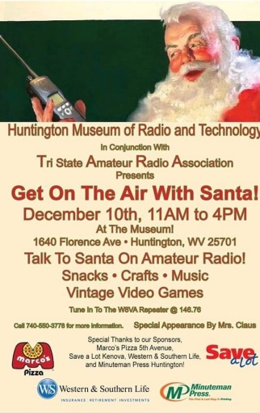
The West Virginia Museum of Radio and Technology in conjunction with the Tri-State ARA will hold its annual “Get On the Air With Santa” from 11 AM until 4 PM on Saturday, December 10 at the Museum at 1640 Florence Avenue in Huntington. Besides providing an opportunity for children and grandchildren to tell the jolly old fat man what they would like to see under the Christmas tree, there will be other activities including crafts, vintage video games, music and snacks for their enjoyment. It’s expected that Mrs. Claus will put in a guest appearance at the event too. Plus while the kids are engrossed with other ativities, this is an opportunity for adults to wander the various exhibit halls to reminisce and enjoy the many exhibits highlighting not only the history of radio in West Virgina and the Ohio Valley, but the nation. More information is available on www.wvmrt.org.

According to Highland ARA Secretary/Treasurer Kathy Levo, N8ZNR, a lot of people have plans to head to Hillsboro on Tuesday evening, December 13, for the annual HARA Christmas Dinner Meeting Extravaganza. She says the meal itself is reason to attend. Two meats, side dishes, desert and drinks for only $10! Plus door prizes and a chances in a raffle to win a large R&L gift certificate, ARRL publications and a host of other prizes. The doors will open at 5:30 PM at the Hillsboro Methodist Church. You don’t have to be a HARA member to attend. If you didn’t receive an invitiation, but are interested attending contact her at 937-393-4951 or text her at 937-760 -6070 by December 5.

The Gathering Place in Wheelersburg is the location for what is always a fun packed Portsmouth RC Christmas Party experience. Besides enjoying good food, their annual fund raising gift auction is a riot. The building is reserved from 4 until 10 PM. The food serving time will be announced in the coming days.

The Fayette ARA is testing holding monthly breakfast/coffee gatherings and will hold it’s second one at the Our Place Restaurant, 827 East Market Street in Washington CH around 10 AM on December 17. All amateurs in Fayette and surrounding counties are invited to attend. Please note the location for this month has changed because it was found the one used for the November gathering was too noisy and busy to allow relaxed conversations. Anyone wishing to be added to the Club’s mailing list is invited to contact Jeff Dreher, KE8DVH at feeling2old.sbcglobal.net. Jeff also reminds area hams of the Tuesday evening 8 PM net on the FARA 147.27 repeater.

The Athens County ARA has set December 20 for their annual Christmas dinner gathering. However since their normal gathering place closed, they are still trying to find a location.

While tuning across 75 meters this past Sunday I came across a group chatting on 3.885. So what’s so unusual about that you might ask? Well this group does not use CW, side band or any digital mode. Instead these hams from the Southern Ohio, Kentucky and West Virginia area are AM operators and use equipment commercially built during the pre-SSB days or equipment they designed and built themselves. They meet each Sunday on that frequency at noon for about an hour. So if you are interested in reliving those days of yesteryear when AM was about the only game in town, this might be your chance.

This year the Athens County ARC held their elections electronically via an electronic ballot with the results announced at their November 15th meeting. Eric McFadden, WD8RIF, will continue as the club president and also wear the hats of Secretary and Repeater Trustee. Paul Schulz, WD8SCV will serve as the Club’s Vice President with Drew McDaniel, W8MHV, handling Club finances. Jeff Slattery N8SUZ, will handle the dual role as Webmaster and Newsletter Editor as well as handle the club packet node.

Also from Athens we learn from Blake Gall, KE8PAQ, that his studies and other activites at Ohio University has prevented him from being as active in the University’s Ohio University ARA as hoped, but he’s encouraged with its rebirth. Although he has access to the station, he thinks there might be an issue antenna issue. He is aware the Athens County ARC has done an outreach offering their assistance in helping the club get restarted. Although classes will soon break for the holidays, he’s hoping to become more involved during the next quarter.

Thanks to the generous efforts of several members of the Milford ARA their Wires-X repeater has made the move to 146.76. Special recognition goes to K8DV, Dave Vest; Raleigh Sizemore, AB8KG; John Keener, KE8TEB; Ron Brooks, AC8MA and Jeff Allen, K4JXX for their assistance in making this happen.

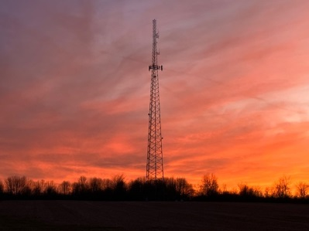
During a recent evening at the farm, N8ZNR snapped this beautiful sunset we suspect was caused by an incoming cold front weather condition. The tower is owed by Clinton County and stands almost upon the highest point in the county on land originally a part of the Levo Century Farm. Besides showcasing a gorgous sunset, it also highlights the repeater site for the Clinton County ARA’s 444.575 New Vienna/Snowhill repeater that is used for the Wilmington NWS district Skywarn program.

Speaking of the National Weather Service, we all know emergencies don’t happen in just nice weather. Therefore training to operate during less than ideal weather conditions is important. Therefore a Winter Field Day was established to provide such an opportunity. This year finds the event on January 28 and 29. For those of you who have never participated in Winter Field Day, it is much like the June ARRL version, but colder. The OH-KY-IN Radio Society will operate from the Harvest Home Park and the Athens County ARA will operate from the Red Cross Building in Athens.

A note from Athens County ARA President Eric McFadden, WD8RIF, reminded me that traditionally the final Field Day scores are published in the December QST. On Tuesday my copy arrived and between wife ordered duties on Thanksgiving Day I was able to quickly scan through the standings. It was great to learn of the 4,929 entries the ARRL received 209 were from Ohio! The fast scans through the list saw many South 40 region clubs represented. It was also noted that for whatever reason, a couple clubs that did participate weren’t listed.

I enjoy closing my column on a cheerful and positive note. And what could be more cheerful than announcing a birth? Congratulations go out to “Gabby” Pitzer and John Willis, KE8JEM, on the birth of their first child. The 8 pound Oliver Wendell Willis was born November 20. Mother and son are doing well, but we’re not certain about Dad. John is the incoming Highland ARA Vice President.

So on that note I’m going to say “73” and call it a wrap for another week. However before signing off the W8KIW/N8ZNR household hopes everyone had a wonderful Thanksgiving and was able to share it with family and friends. And to repeat what I wrote last week “ although there is a lot of division and turmoil in the nation along with personal issues and health problems, we still have tons of things to be thankful for. The next time you key your transmitter remember just being able to do that is one”. Until next time stay warm, healthy, safe and radio-active.

John Levo, W8KIW, jlevo@cinci.rr.com or highlandara@gmail.com, 937-393-4951

__________________________________________________________________

Print an Official or Unofficial Copy of Your Amateur Radio License
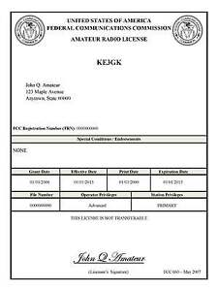
(By Anthony Luscre, K8ZT)

As of February 17, 2015, the FCC no longer routinely issues paper license documents to Amateur Radio applicants and licensees. The Commission has maintained for some time now that the official Amateur Radio license authorization is the electronic record that exists in its Universal Licensing System (ULS). The FCC will continue to provide paper license documents to all licensees who notify the Commission that they prefer to receive one.

Licensees also will be able to print out an official authorization — as well as an unofficial “reference copy” — from the ULS License Manager. I’ve created a set of instructions on how you can request an “official” printed copy of your license*

Click here to download the instructions

One Question Questionnaire

Hey Gang,

Last weeks question Did you take a nap after eating your Thanksgiving meal?
- YES?
- NO?

Survey Says A) 21 (47.73%) Yes, and B) 23 (52.27%) No.

The new question is:

Which would you like to see happen in the ohio section this year?
a) competitions between oh section clubs?
b) section educational programs on zoom?
c) OH section conVENTION (including a wouff Hong presentation)?
d) more “on air” operating events (like ospota)?

You’ll find the “One Question” questionnaire on the Ohio Section Website! http://arrlohio.org It’s all for fun and it’s not a scientific survey in any way, but we are learning some things that we didn’t know from these questions. I hope that you are enjoying answering these “One Question” questionnaires.

And the 2nd Handbook Winner is: AB8OU – Allan Zadiraka!

The “Handbook Giveaway” for the month of November has everything back on track. The RED arrow will appear on the page again, you need to enter to win. Good Luck to all!

V.E. Test Sessions

Many V.E.’s have decided to start testing once again, but with restrictions that need to be adhered to for sure. Here’s the link to find that V.E. Test session and what is expected of YOU before going. http://www.arrl.org/find-an-amateur-radio-license-exam-session

Final… Final

Big news for the Ohio Section!

Stan – N8BHL is retiring as Section Emergency Coordinator (SEC)! Stan has served exceptionally in this position for quite some time now, and we owe him a sincere “Thank You” for all the time and work he has put into the position. Stan leaves Ohio ARES in great shape to move on into the future for the benefit of the citizens of the Ohio Section. It was a job well done. Looking ahead, Bret Stemen – KD8SCL has accepted the position and will pick up where Stan leaves off. I ask you all to welcome Bret as the new SEC, and work with him to keep OH ARES and other EMCOMM functions fully operational throughout the state.

I also want to announce that effective January 1, 2023 that I have appointed Elizabeth Klink – KE8FMJ as the Ohio Section Public Information Coordinator (PIC). In addition to managing the Ohio Section Newsletter Contest, Liz will be making sure that Amateur Radio is well publicized within the Ohio Section and to that end will be working with the local PIO’s to help get the word out locally. All of this will increase the public awareness and appreciation of Amateur Radio and Amateur Radio operators in the Ohio Section. Please welcome Liz to this position and offer your support and assistance!

For all intents and purposes. 2022 is over. This is the time of year where we wrap-up everything, have our celebrations and parties, take a break and relax. Well, that’s what the average guy does. I’m proud to say that here in the OHIO Section most of the hams I know are somewhere between way above average and EXCEPTIONAL! I’ve heard it said that if you show up on time and you’re honest, you’ll beat 80% of the competition in almost any endeavor. That pretty much earns you the rank of “average”. That’s not where I want to spend my life. I want to be somewhere in that top 20%. It’ll wear you out – but it’s worth it!

Is Ham Radio one of those things where you just float along with the current and end up where you want to end up? No. And the guys (a generic term for “people of either sex”) who want to be at the top of their game are not sitting around doing a whole bunch of nothing in these last 31 days of 2022! They’re taking an introspective look, both individually and corporately, at what they have done in the past year, and more importantly what they want to accomplish in the coming year. You need to do it for yourself individually, your club, your section, your National Organization, your hobby as a whole. You have a part to play at each of those levels, and you are the only one who can define what your role will be. (You can also do this for your family, your business, your country.)

For your personal involvement in Ham Radio, here are a few things you might want to think about:
- What did I learn over the last year? What things do I want to learn about in the coming year and what am I willing to do to learn those things?
- What parts of the hobby have I participated in, what parts would I like to participate in and what do I need to do to be able to participate in them?
- In the past year what have I done with my hobby in the way of community service? What things could I do in the upcoming year that in addition to being an active participant in my hobby would also provide a service to my community?
- What parts of my personal station worked well this past year, what parts gave me mediocre results and what could I improve or add that would improve my overall performance as a Ham?
- Am I helping Ham Radio survive into the future by presenting it as attractive option to others (especially youthful others) or have I become the “Ham Radio” version of the old guy standing on his front porch yelling at the kids to “get off my yard”???
- Have I spent my time this past year doing the activities of Ham Radio (my self-proclaimed interest) or have I wasted precious minutes, hours, days even weeks on things that serve no useful purpose to anything I deem important? How will I improve on that in the coming year?

I’ll leave it up to you to extrapolate those kinds of questions into the other areas of your lives. You may even thing of a few more in ham radio terms. The important take away here is that it’s important to do this. It will either be an affirmation that you are doing all you can with something that is important to yourself, or it will serve as a “wake-up call” to bring you to the realization that you need to be true to yourself. There’s a term that I absolutely hate – “Killing Time”. Time has existed before you and it will exist after you – with no limit in either direction. You are powerless to Kill Time. However, people – you, me - come and go. Time is literally killing us. Use it or lose it!

Sorry to get a little heavy there. I know in a lot of areas of life, other hobbies and organizations, we all hear the same thing, it’s hard to get people involved and committed to doing anything. It’s almost like everyone is just living in the Matrix! Let’s wake up, get together, and knock it out of the ballpark with Ham Radio in the coming year. You’ll be glad you did.

Ohio House Bill 283 was moved out of the House a week or two ago. As it moved out, it DID contain a direct “carve out” for Amateur Radio. The amendment reads as follows: “An “electronic wireless communications device” does not include a two-way radio transmitter or receiver used by a person who is licensed by the federal communications commission to participate in the amateur radio service.” So far, it’s all good news. From the House it goes to the state Senate. They can 1) pass the bill and send it to the governor for signature, it is then law. 2) they can sit on it and the bill would expire. This does not change anything from the way it is right now – there are no “safe driving” laws that prevent our use of mobile 2-way radio. 3) they can change any part of the law they deem necessary, in which case it would have to go back to the house, and at this point the house could sit on it so it expires and would need to be redrafted in the next house session, they could pass it with whatever changes the Senate added to it in which case it would go to the governor for signature then becoming law, or, they could try to reconcile the differences between the House version and the Senate version of the bill, which would probably stall it, resulting in it’s expiration. Until the State Senate acts on it, we don’t know which scenario we will be facing. Keep your fingers crossed……

Finally, (and this IS the final final), there will be no PostScript next weekend! From early Saturday morning until late Monday evening (local time) I’ll be busy with Special Event Station W8A – celebrating the passage of the 21st amendment to the Constitution of the United States of America! The 21st amendment repealed the 18th amendment, effectively ending Prohibition on December 5th, 1933. This was the first time in our nations’ history that an amendment to the Constitution had been repealed. It was also the first time in our nations’ history that an amendment to the constitution was made not by Legislative action, but by the Convention of States! Upon passage by the Convention of States the 21st Amendment became effective immediately. Passage of the amendment required ratification by ¾ of the states. On December 5th, 1933, only 3 more states were needed for passage. Ohio and Pennsylvania both ratified it early in the day. Now only one more state was needed and it became a race between Utah and Maine to see who could get it done first and secure the passage. Utah became the 36th state to ratify the amendment at 5:32 PM (EST), the 21st Amendment became law immediately. The party started at about 5:33 PM (EST)!

73,
Tom WB8LCD

“Swap & Shop” on the website

Hey Gang,

Have you taken a look at the Swap & Shop page on the Ohio Section webpage yet?? Here’s a link that will take you there…
http://arrl-ohio.org/sm/s-s.html

Do you have equipment that you just don’t need or want anymore? Here’s a great venue to advertise it, and it’s FREE!!

Is your club doing a fund raiser to help raise money? After a lot of thought, it was decided that the Swap & Shop webpage could also contain these types of items as well.

The same rules will apply as do for the For Sales and Give-A-Ways and will only be posted for a month at a time. Please see the Terms & Conditions on the webpage.

If your club is doing a fund raiser and wants more exposure, please forward the information to me and I’ll advertise it on the Swap & Shop webpage for you. Now, I still want to remind you that it won’t be listed in this newsletter because it would take up way too much space, so your ad will only appear on the website. It is there for any individual to post equipment Wanted / For Sale or Give-Away as well as for Club Fund Raisers. No licensed vehicles/trailers or business advertising will be posted.

Postings are text only (no pictures or graphics) will be posted for a maximum of 1 month from date posting and require a contact phone number or email within the posting. Send your Wanted / For Sale or Give-Away post to: swap@arrlohio.org

Back Issues of the PostScript and Ohio Section Journal

Hey, did you know that PostScript and Ohio Section Journal (OSJ) are archived on the website? You can go back and look at any edition simply by clicking:
http://arrl-ohio.org/news/index.html

Ohio Section Cabinet
Section Manager – Tom Sly, WB8LCD | Section Emergency Coordinator – Stan Broadway, N8BHL
Technical Coordinator – Jeff Kopcak, K8JTK | Section Traffic Manager – David Maynard, WA3EZN
State Government Liaison – Bob Winston, W2THU | Affiliated Clubs Coordinator –  Amanda Farone, KC3GFU
Section Youth Coordinator – Anthony Lascre, K8ZT | Public Information Coordinator – John Ross, KD8IDJ

Chit – Chat, and All That!

Do you know someone that’s not getting these Newsletters? Please, forward a copy of this Newsletter over to them and have them “Opt-In” to start receiving them. Heck just have them send an email to: webmaster@arrl-ohio.org to be added.

We now have many thousands of readers receiving these newsletters weekly. Quite impressive, I’d say! I urge all of you to make sure that everyone, regardless of whether they are a League member or not, get signed up to receive these weekly Newsletters.

You can always “Opt-Out” at any time if you feel this is not what you were expecting. It’s fun and very informative. All of your favorite past newsletters are now archived too.
You can go back at any time and read them. Just go to: http://arrl-ohio.org/news/

The pictures on the front page and throughout this newsletter are from various newsletters, Facebook posts and/or were sent directly to me in recent weeks. Take a good look at them, you just might be in one of the pictures! “SMILE… you’re in the Ohio Section News!!”

The Ohio Section Journal (OSJ) is produced as a comprehensive look at all the programs within the Ohio Section. I sincerely hope that you have enjoyed this edition of the OSJ and will encourage your friends to join with you in receiving the latest news and information about the Ohio Section, and from around the world!

TOP^

