August 2022

From the Technical Coordinator | From the Section Emergency Coordinator
Special Event | From the Section Youth Coordinator
From the Section Traffic Manager | ARES Training Update
National News | Club Corner
DX This Week | Contest Corner
Final.. Final | One Question Questionnaire

From the Technical Coordinator
Jeff Kopcak – K8JTK TC
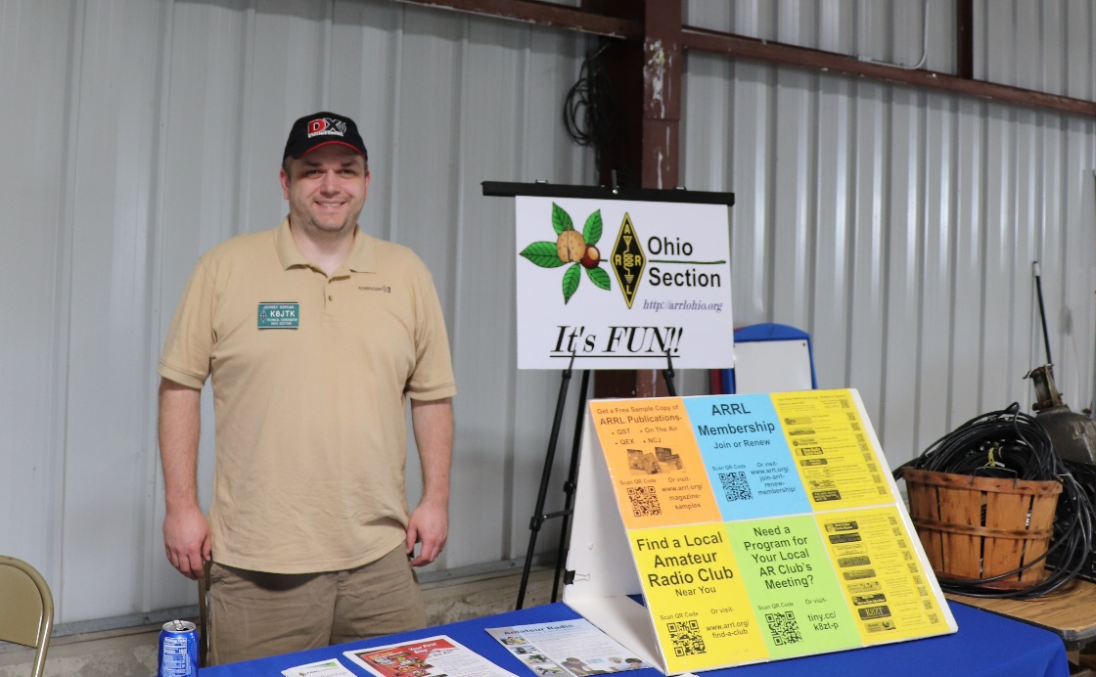
k8jtk@arrl.net

Hey gang,
When it comes to digital communications, especially in the Ohio Section, efforts have been focused on DMR. Repeaters are pricier than other digital modes. An abundance of end-user devices available from a variety of vendors, at fairly inexpensive prices, is a winner for users. DMR, being a commercial standard, was adopted to ham radio. Those that have not spent time to understand how a codeplug works and how to modify them ‘are just a bunch of appliance operators’ is a common argument. To link the majority of Ohio’s DMR repeaters, a network had to be chosen. Ohio standardized on Brandmeister.
What is BrandMeister? “BrandMaster/BrandMeister is an operating software for Master servers participating in a worldwide infrastructure network of amateur radio digital voice systems.” Stating that amateurs can and do use it for D-STAR and Wires-X, its main focus and selling points are related to DMR linking.
In the early days of DMR in ham radio, networks were setup identical to their commercial system counterparts. Repeaters had certain talk groups on specific time slots. Limited to 16 talk groups because that’s how many channels were available on the radio’s selector knob. Owners had little to no options for customizing talkgroup offerings. For example, if you were in eastern Ohio, a repeater might have Indiana statewide whether you wanted it or not. There were no such things as hotspots, at least as hams know and understand them. Like most new things, early adaptors did this for fun and no one really knew if DMR would take off and be accepted by the masses.
Three things helped DMR take off in ham radio: cheap radios, hotspots, and Brandmeister. Brandmeister turned commercially implemented DMR networks on their heads. Made it more like ham radio. A repeater owner could put any talkgroup on any time slot. Any user could make private calls to other users on any timeslot. Even make up a talkgroup number, hit transmit, and if another user was on that same talkgroup number, communication happened automatically. Later, simultaneous data messages and APRS were implemented. Being able to use ham developed gear, like the DV4mini and OpenSpot devices, was a huge draw. Hams familiar with commercial implementations of DMR were questioning ‘how could Brandmeister pull this off without causing chaos in the ham radio streets?’ Especially the ‘pick your own talkgroup number.’
With the explosion in popularity came use and abuse. Brandmeister had to start making decisions and decided to follow the strictest definitions of standards. You can still make up your own talkgroup but it is generally frowned upon. DV4Mini sticks were banned due to poor software – this was reversed after G4KLX wrote compatible software. There was a hissy fit Brandmeister threw about using DMR IDs starting with 1. Everybody and their mother, brother, and daughter requested talkgroups. No more 5-digit talkgroup numbers are assigned. Bridging to other digital modes, networks, and analog systems is verboten, explicitly forbidden on world-wide, regionals, and statewide talkgroups. Brandmeister considers 3, 4, and 5-digit talkgroup IDs under their control, as defined by the MCC numbering standard. 6-digit repeater IDs or 7-digit user IDs, the assigned owner can do whatever they want as Brandmeister sees themselves as “guests” for those IDs. There are more do’s and don’ts in the BM USA wiki.
For a good long time, development and, I would argue, interest by the development team was stagnant. There were long standing issues with many parts of the system, including the online audio web portal, Hoseline. For years it would not work correctly, had long audio delays or no audio at all, or the URL would simply be unavailable. Around June 2021, a new and much improved Hoseline appeared. Featuring a new and modern interface with the ability to monitor multiple talkgroups at a time.
Improvements in the name of security were made later the same year. Each Brandmeister hotspot user needed to generate a “hotspot password” for each DMR ID. This change impacted every Brandmeister user. I was contacted well into 2022 about users whom were unaware of this change.
Not-so-well-known changes affected some misconfigured hotspots and users of DVSwitch and MMDVM bridging. Master servers started checking parameters such as RXFrequency and TXFrequency in MMDVM. If the device was a hotspot, Brandmeister logic said if those two fields are not the same value, the device it must not be a hotspot because hotspots are simplex. If a hotspot (or DVSwitch/MMDVM Bridge) had RX Frequency not equal to TX Frequency, the device would be blocked from transmitting because it was deemed misconfigured. In order to work, they both had to be the same. Also, if either parameter was 0 – as in no RF output, such as an Internet link – also no work-y.
It’s their network and I really want to like them. Their decisions are making it hard for sysadmins to continue using Brandmeister. Communication regarding nearly all back-end changes have been poor to nonexistent. Changes affecting all users are publicized, even though a good percentage hit me up months later saying ‘all of a sudden my hotspot doesn’t work anymore.’ Sure, some changes might only “affect a small number of users,” post something in the groups.io. Instead admins are left to figure out, on their own, why the Brandmeister link is not functioning without being aware of changes on their end. Something about not peeving off your users, which they seem to be doing a lot lately. I get that they’ve had to make hard decisions and many policies are a result of the users whom abuse the system. Brandmeister probably received pressure from other network and talkgroup owners who want to quash analog cross linking. When the Brandmeister network was originally a ‘do-anything network,’ it’s not easy when they start pulling-back on those abilities.
August 19th, a major code upgrade was rolled out which implemented additional changes paving the way for better dashboard integrations, APIs, and hopefully more new features. If you setup your hotspots or applications with a Brandmeister API key prior to August 19, 2022, new keys are required. I was able to generate Brandmeister API v2 keys for Pi-Star: 4.1.6 / Dashboard: 20220819 and OpenSpot3 with firmware v62.
I was not able to save the API v2 key on an original OpenSpot (1) with the latest firmware available (0142). I was seeing the error message “Couldn’t save API key (Bad Request).” According to the support forums, they won’t be getting support for v2 either. New keys are supported on the 2, 3, and 4 OpenSpot models. If you had previously generated a v1 API key, it will continue to work for as long as Brandmeister allows.
I do not know if previous versions of Pi-STAR have been updated to support v2 API keys. To update a Pi-STAR to the latest revision, backup the existing configuration, download v4.1.4 on the Pi-Star site, flash to a new or the existing SD card. When configured, run update/upgrade and repeat, from the Configuration -> Expert option, until there are no more updates for both tasks. Pi-STAR cannot be upgraded version-to-version through the updater/upgrader.
Go to Configuration -> Expert -> under Full Edit, BM API. If you have an apikey entered these need to be updated, specifically apikeys that are 128-characters. It will look something like:
MWaztB3EcHWBEW@D$2gb89Y2kvvE4leSr.33Gey74d0IYVSKU58YGMSFmPHD.Q1fECUkIcj7E4leSr.33Getkjshdf987ywe2irligr908SFIdlsfkj08934sasdlveg
The 128-character API keys will continue to work for an undetermined amount of time. Follow the Brandmeister blog post to generate updated API keys. If you don’t have an apikey entered and don’t want one, you don’t need to do anything.
What alternatives are there to Brandmeister? Networks such as DMR+ and FreeDMR are popular in Europe/UK. HBLink reflectors are available but only offer a few select talkgroups. TGIF is a smaller DMR network implementation. They do not have many restrictions on device configuration. Though TGIF does have an “Ohio” talkgroup, it’s not the same everyone knows and loves on Brandmeister. As an admin, TGIF is much easier to work with. Running a linking system that has links to Brandmeister, TGIF, and HBLink, users don’t use alternative options, even though they complain about Brandmeister. Brandmeister is what they know and love. They won’t venture out to use other, more stable options, therefore remaining appliance operators.
Thanks for reading and 73… de Jeff – K8JTK

__________________________________________________________________________________________

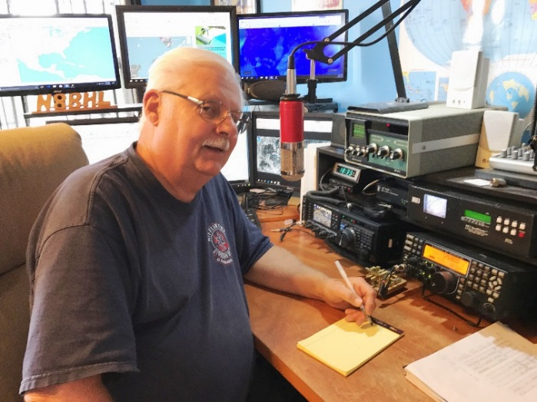
From the Section Emergency Coordinator
Stan Broadway, N8BHL - SEC
broadways@standi.com

Ohio was on standby for massive flooding relief efforts

(Now retired) Kentucky Section Manager Steve Morgan called the evening prior to the response to ask if we could round up some people willing to go… as in any massive disaster operation, actual information was sketchy at best. We can just expect that! Agencies, despite their plans and procedures, are made up of people- many of whom have not been involved in a massive disaster. Confusion reigns until the administrative people kick into gear and get things smoothed out. I put out a call to EC’s in District 4 and 8 along Ohio’s southern border to prepare a “ready list” of operators who might be available should we actually activate. Of 18 counties, we have EC’s in 11. I got TWO replies. There were some other volunteers willing to respond actually all over Ohio. This lack of return was disappointing. It was as close as we’ve come to “The Big One” as we may get for a long while and the lackluster readiness prompts us to reinvigorate our training and rebuild our enthusiasm.

Many with whom I’ve had this discussion offer that COVID killed us… the lack of events and personal contact took the wind from our sails and got us firmly ensconced in our recliners. It’s time to get over that, and get back to work!

In this environment, we have launched a new series of training emails aimed at our EC’s - the critical, heartbeat people of our organization. In addition we are gathering specific information with a series of “Surveymonkey” questionnaires. The first is still open, but confirms much of our conversation.

The job function most important to the majority of EC ‘s is encouraging fellow hams to participate. There is only a little difference with the other topics- serving our agencies, establishing trust with them, and planning. The runaway topic of those which produces the most difficulty is recruiting and maintaining active volunteers. The majority are satistifed with support from ARRL, from DEC’s and SEC… and the majority (65%) agree Ohio ARES is on the right track.

So that’s encouraging, and we plan to submit several more training notes to help both new and seasoned EC’s refresh their enthusiasm. We are on the “right track” but it’s time we ALL got back to actually running! We don’t have the luxury of picking and chosing our deployments, and our calls to duty- they will come, and they will demand a fast reaction! What we do is important, is NOT outmoded and can still be the working “last resort” that may not save the world but will certainly make a big difference! Are YOU ready??

Local EC’s are asked to prepare for the October 1 Simulated Emergency Test. This year we are turning the tables- instead of handing down a scenario we are asking EC’ to create their own SET goals and exercises (within some very general guidelines) so that they can associate with their EM’s and work up something that would be likely in their own area. EC’s can cooperate with other counties (especially in the case where there are low memberships) to boost their exercise.

An emailed guideline has these goals:

1. Activation. EC’s need to test and perform activating their volunteers, organizing their response and preparing for deployment.
2. Deployment. Volunteers enjoy activity- so to simulate your emergency, it’s a good thing to deploy as many as possible. Consider mobile units to agency locations. Or, consider placing units into and around a theoretical situation (think: Kentucky flooding or some type of storm outbreak). Something we did several years ago may spark your interest- we had our counties go all simplex- and find out through deployed mobile simplex stations where weak point and relay points should be located in your county. From that information you can create a county “Simplex” map to serve you in a real situation.
3. Messaging. Our most basic purpose is to send and receive information on behalf of our agencies. These messages can be formal IS-213 type messages, internal “radiogramma” forms, and yes, simple spoken messages. I recommend practicing the digital message formats- fldigi and Winlink. Keep careful track of ALL of these messages, they will add to your message count as you complete your ARRL report form. But in real life, we do need practice at sending and receiving information accurately! So this is a big part of how you would design your exercise. Don’t forget regular status reports and “exercise only” requests for service from the state. Please try to include the NTS system if available for sending messages upward. For Winlink, merely address to W8SGT and we’ll get it.
4. Adapt and Overcome. As you design your exercise, don’t hesitate to throw in some ‘surprise’ things… power has just dropped, you’re on batteries (for real) or in the middle of one thing, a severe storm moves in, that kind of surprise. It will challenge and make your volunteers better!
5. Timeframe. We are exercising that Saturday. You are free to work into both Saturday and Sunday (let me know if you need the state Sunday) but the primary goals can be handled in one day. This is NOT a ‘check-in and go home’ situation. You should have enough activity to last much of the day! We anticipate 10AM – 4PM as out hours at the Sarge.

So it’s up to YOU! If you’re an EC I hope you’re already working on developing your SET- time is rushing by. If you’re an ARES member- volunteer to help with planning and be ready to participate! We hope everyone gets involved!

_____________________________________________________________________________

****IMPORTANT NOTICE – PLEASE READ THIS SECTION****

FROM THE PIC / PIO and THE ACC

As you can see – there are no photos here! These are 3 section level positions which are now vacant, and I am actively looking for volunteers to fill them. These are important positions to the continued growth of the Ohio Section, making the Ohio Section and Amateur Radio in general a well-recognized entity among the citizens of Ohio, and finally, maintaining our image as one of the BEST Sections in the ARRL! If you would like to be considered for one of these positions, or, if you would like to “nominate” someone for one of these positions, please contact me directly. Tom Sly – WB8LCD 330-554-4650 WB8LCD@ARRL.org

Following are the “official” ARRL job descriptions for each one of the positions:

- PIC Job Description-
The ARRL Public Information Coordinator (PIC) is a section-level official appointed by and reports to the Section Manager (SM) as the section's expert on public information and public relations matters. The PIC is responsible for organizing, training, guiding and coordinating the activities of the Public Information Officers (PIOs) within the section. The overall goal of the PIC is to promote interest in Amateur Radio to the non-ham population within their section.
The Public Information Coordinator must be a full member of the ARRL and are recommended to have completed the ARRL’s PR-101 course or its successor. Preferably, PIC candidates will also have professional public relations or journalism experience or a significantly related background in dealing with the public media.
Responsibilities:
  - The PIC is the primary section level person to contact for information about knowledgeable and effective local speakers and representatives who are available to address community groups on the topic of Amateur Radio, and shall work with PIOs to promote interest among those groups.
  - Works with PIOs, SM and ARRL staff to identify and publicize League-related stories of local or regional interest, including election or appointment of ARRL leadership officials, scholarship winners/award winners, QST articles by local authors or local achievements noted or featured in QST.

Working with your PIOs
  - Works closely with the section Affiliated Club Coordinator and ARRL affiliated clubs in the section to recruit and train a team of Public Information Officers (PIOs). With the approval of the Section Manager, the PIC may be delegated to make PIO appointments within the section.
  - Works with the SM to motivate and encourage participation in PR training programs for themselves, PIOs and club publicity chairpersons.
  - Works with the PIOs to identify and recommend ways to disseminate stories through emerging media, such as social networks. Develops and maintains a current contact list of media outlets and reporters in the section for use in section-wide news and releases.
  - Helps local PIOs to recognize and publicize newsworthy stories in their areas. Monitors news releases sent out by the PIOs for stories of broader interest and offers constructive comments for possible improvement.
  - Helps local PIOs in dealing with, and minimizing, any negative publicity about Amateur Radio or to correct negative stories incorrectly ascribed to Amateur Radio operators.
  - Familiarizes self with ARRL Public Service Announcements (PSAs), brochures and audiovisual materials; assists PIOs in arranging air time for PSAs; helps PIOs and speakers choose and secure appropriate brochures and audiovisual materials for events
  - Works with PIOs to encourage activities that place Amateur Radio in the public eye, including demonstrations, Field Day activities, etc. and assures that sponsoring organizations are prepared to follow-up on interest generated by these activities.
  - Aids PIOs in holding PR forums and/or training events at ARRL hamfests.

Work in Emergencies
  - Helps local PIOs, and/or section designated ARES-PIOs, prepare emergency response media plans.
  - Is familiar with the protocols and establishes relations with the lead governmental response agency in the section and their requirements for the PIC’s participation in a Joint Information Center in a larger emergency.
  - Aids PIOs and clubs in preparation and contents of PR kits containing vetted information on Amateur Radio which may be distributed in advance to local Emergency Coordinators and District Emergency Coordinators for use in dealing with the media during emergencies.
  - Should complete appropriate ICS classes to have equivalent training as required of local or section ARES volunteers.

Working with section leadership
  - Advises the Section Manager on building and maintaining a positive public image for Amateur Radio in the section; keeps the SM informed of all significant events which would benefit from the SM's personal involvement and reports regularly to the SM on activities. At the request of the Section Manager, may assist with preparation of a section newsletter.
  - Encourages, organizes and will conduct a public relations forum at ARRL section conventions
  - Counsels the SM in dealing with the media and with government officials, particularly when representing the ARRL and/or Amateur Radio in a public forum.
  - Counsels the SM in dealing with the media and with government officials, particularly when representing the ARRL and Amateur Radio in a public forum.
  - Maintains contact with other section level League officials, particularly the Section Manager and others such as the State Government Liaison, Section Emergency Coordinator, Affiliated Club Coordinator and Bulletin Manager on matters appropriate for their attention and to otherwise help to assure and promote a coordinated and cohesive ARRL Field Organization.

Working with regional and HQ leaders
  - Coordinates public relations efforts for events and activities which involve more than one section, and provide input on issues of national significance before the League's Public Relations Committee for their discussion or action.
  - Informs the ARRL Media and PR Manager of any issue, which may either enhance or damage the reputation of the ARRL.

- PIO Job Description-
ARRL Public Information Officers (PIOs) are appointed by and report to the ARRL section Public Information Coordinator (PIC) with the approval of the Section Manager (SM). ARRL PIOs are usually chosen from club publicity chairpersons and must be full ARRL members and are recommended to have completed the ARRL’s PR-101 course or its successor. Additional training for PIOs should be provided regularly on a sectional or regional basis by the PIC and/or other qualified people
Responsibilities:
  - Establishes and maintains a list of media contacts in the local area; strives to establish and maintain personal contacts with appropriate representatives of those media (e.g., editors, news directors, science reporters, etc.). Understands how stories should be submitted to media outlets and knows the rules for successful media submissions by media type.
  - Be a contact for the local media and assures that editors/reporters who need information about Amateur Radio know where to find it.
  - Keeps informed of activities by local hams and identifies and publicizes those that are newsworthy or carry human interest appeal. (This is usually done through news releases or suggestions for interviews or feature stories).
  - Attempts to deal with and minimize any negative publicity about Amateur Radio and to correct any negative stories which are incorrectly ascribed to Amateur Radio operators.
  - Generates advance publicity through the local media of scheduled activities of interest to the general public, including licensing classes, hamfests, club meetings, Field Day operations.
  - Helps individual hams and radio clubs to develop and promote good ideas for community projects and special events to display Amateur Radio to the public in a positive light.
  - Keeps current and familiar with available materials including ARRL Public Service Announcements (PSAs), knows appropriate websites and social media to post viral media, brochures and audiovisual materials; contacts local radio and TV stations to arrange airing of Amateur Radio PSAs; secures appropriate brochures and audiovisual materials for use in conjunction with planned activities.
  - Seeks to constantly improve their skills by attending regional training sessions, PR Forums and other training activities endorsed by section PICs.
  - Submits articles and photographs to ARRL for QST and online applications.

Working with others:
  - Works with Local Government Liaisons to establish personal contacts with local government officials where possible and explain to them, briefly and non-technically, about Amateur Radio and how it can help their communities.
  - Works with the section PIC to identify and publicize League-related stories of local news interest, including election and appointment of local hams to leadership positions, QST articles by local authors or local achievements by amateurs.
  - Keeps the section PIC fully informed on their activities and places PIC on news release mailing list.
  - Assists the section PIC in recruiting hams for public speaking engagements and promotes interest among community and service organizations in finding out more about Amateur Radio.
  - Quickly informs the ARRL Media and PR Manager of any issue or significant event noted which may either enhance or damage the reputation of the ARRL.
  - Networks with other PIOs to facilitate coordination.

Work in Emergencies
Note: It is highly recommended that the PIO should not also be the Emergency Coordinator.
  - Is familiar with local emergency protocols and establishes relations with the lead governmental response agency in their home area and their requirements for the PIO’s participation in a Joint Information Center in an emergency.
  - Helps local clubs and/or section designated ARES-PIOs (PIOs who are specifically trained and tasked by the SM and/or PIC to work with ARES units) prepare emergency response media plans.
  - Provides aid to section appointed ARES-PIOs or assume that role if none is available.
  - Working with the PIC, aids clubs and others involved in emergency response operations in the preparation and contents of PR kits containing vetted information about Amateur Radio in their local area which may be distributed in advance to local Emergency Coordinators for use in dealing with the media during emergencies. During emergencies, these kits should be made available to reporters at the scene, the JIC or at a command post.
  - Maintains contact with the local Emergency Coordinator and/or District Emergency Coordinator and League officials (local stories often can quickly turn national).
  - Summarizes Amateur Radio activity in an ongoing situation, and follow up any significant emergency communications activities with accurate and prompt reporting to the media of the extent and nature of Amateur Radio involvement. They should NOT speak or give information for our served agencies.
  - Takes free online FEMA courses in the National Incident Management Structure/ICS/Disaster PIO or seeks similar training from the state emergency management office.

Affiliated Club Coordinator (ACC)
The ACC is the primary contact and resource person for each Amateur Radio club in the section, specializing in motivating, providing assistance and coordinating joint activities of radio clubs. The ACC is appointed by, and reports to, the Section Manager.
Requirement: Full ARRL membership
Responsibilities:
- Get to know the Amateur Radio clubs' members and officers person to person in his section. Learn their needs, strengths and interests and work with them to make clubs effective resources in their communities and more enjoyable for their members.
- Encourage affiliated clubs in the section to become more active and, if the club is already healthy and effective, to apply as a Special Service Club (SSC).
- Supply interested clubs with SSC application forms.
- Assist clubs in completing SSC application forms.
- Help clubs establish workable programs to use as SSCs.
- Approve SSC application forms and pass them to the SM.
- Work with other section leadership officials (Section Emergency Coordinator, Public Information Coordinator, Technical Coordinator, State Government Liaison, etc.) to ensure that clubs are involved in the mainstream of ARRL Field Organization activities.
- Encourage new clubs to become ARRL affiliated.
- Ensure that annual reports (updates officers, liaison mailing addresses etc.) are forthcoming from all affiliated clubs.

Recruitment of new hams and ARRL members is an integral part of the job of every ARRL appointee. Appointees should take advantage of every opportunity to recruit a new ham or member to foster growth of Field Organization programs, and our abilities to serve the public.

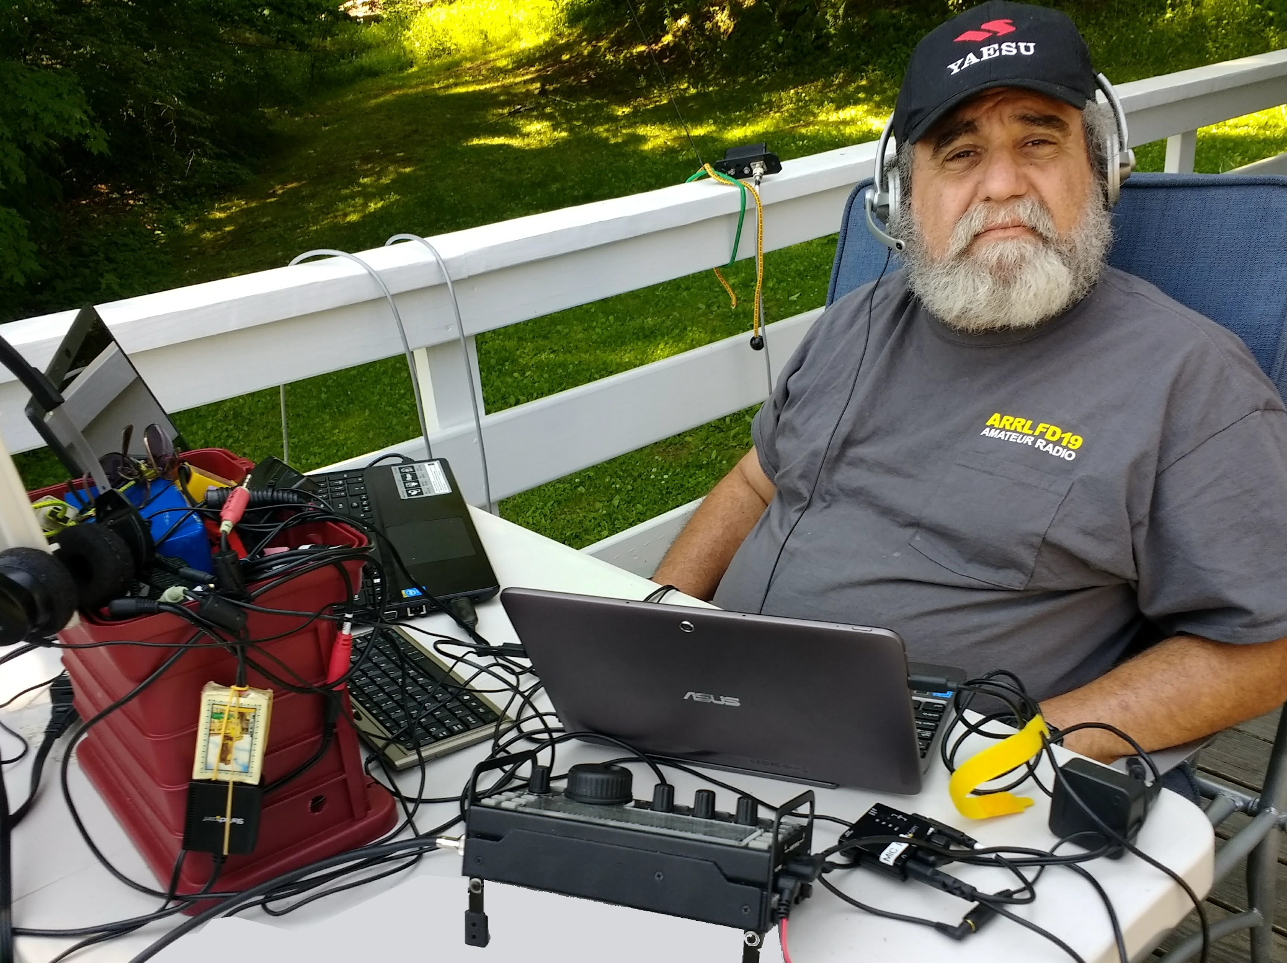
From the Section Youth Coordinator
Anthony Luscre, K8ZT - SYC
k8zt@arrl.net

Back To School

Its that time

Although the calendar says, there are still a few weeks left, summer for many students and teachers around Ohio is coming to an end with the beginning of the school year. Their laser-like focus is on school, so it is often a time when I sort of back off in pursuit of Amateur Radio activities for youth. This pause is just the time to think about upcoming activities and a few new ideas for youth in Amateur Radio. I will present some ideas for you, but if you are interested in more details, please contact me via email (k8zt@arrl.net), including your phone number, and I would be glad to chat further with you. I am also available for a presentation or planning session with your club.

Upcoming Events & Some Myths

Fall generally means gearing up for Amateur Radio, but it also marks the beginning of the Amateur Radio contesting season. It also brings the Jamboree On The Air (JOTA). It is an excellent time to remind you of myths of youth in Amateur Radio that we often assume are accurate but can decrease our chances of involvement. These myths are:
- All Youth will naturally be attracted to Amateur Radio because it is an excellent activity itself
- Contesting is for Amateur Radio veterans and not for youth or newcomers
- Voice is the mode of choice for youth in Amateur Radio

Let's take a look at these myths in order:
Looking at #1- no matter how great you think Amateur Radio is, to get youth involved, it is a great idea to tie it to other activities that youth already do and enjoy. Two of these are sports and scouting. Looking at Scouting, the opportunity of JOTA in October is one we should not miss to expose youth to Amateur Radio. Notice I said expose. That is the first step and probably the most important. I suggest you follow up with planned AR opportunities and lists of resources available after JOTA for those exposed youth that are interested in further pursuing AR. See one of my previous articles on JOTA & Scouting in AR at tiny.cc/ar-scout. More JOTA resources are below in this article.

Sports, another popular existing youth activity, actually addresses myths #1 and #2 (Contesting is for Amateur Radio veterans and not for youth or newcomers). Sports and competition are often strong interests for kids. If you have any doubt, look at Saturday soccer leagues, Little League Baseball, school sports teams and traveling teams. Even eSports are a big focus of many youths, which is reflected in High School and University eSports teams. How can we tie this into AR? First, get youth involved in AR Contesting- invite them to visit a contesting activity, let them give the mic a try with you as control operator, and help with one of the annual School Round Up week-long contests- October 17-21, 2022 and February 13-17, 2023. But in addition to demonstrating AR contesting, we need to make it more like the sports/esports activities they are used to. One step toward this is using Online Real-Time Contest Score websites for AR. In addition, visuals are significant- online maps that change color as we work new state, country or DX multipliers, live contest scores, rates, graphs, etc. More on this below.

Looking at #3, there are many reasons that this is a myth, including “mic fright,” prejudice upon hearing youthful voices on the air, lack of visual aspect and already ubiquitous cell phone use of youth (and texting, Snapchat, etc. are much more popular than phone calls!). There are two ways around this in AR- CW and Digital, both of which avoid that talking on the mic thing. Let's look at CW first; although youth do not know Morse Code, they are usually much better at learning it than us oldsters, and the idea of using a “secret code” is appealing. The Long Island CW Club also sponsors a great resource available for free Youth CW classes. If you have an interested youth for this program, please email them at: info@longislandcwclub.org for details. Turning to Digital, the visual nature, use of computers, point and click to make contacts, and instant feedback through PSKReporter of activity all make this attractive to today’s video game-playing youth.

Jamboree On The Air

The 64th Annual Jamboree On The Air will be held on October 14-16, 2022. Jamboree-on-the-Air, or JOTA, is the largest Scouting event in the world. It is held annually on the third full weekend in October. JOTA uses amateur radio to link Scouts and hams around the world, around the nation, and in your community. This jamboree requires no travel other than to a nearby amateur radio operator’s ham shack. Many times you can find the hams will come to you by setting up a station at your Scout camporee, at the park down the block, or perhaps at a ham shack already set up at your council’s camp.

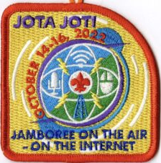
To find registered JOTA stations in your area, visit https://k2bsa.net/registered-jamboree-on-the-air-stations. If you or your local club is planning a JOTA operation, you can register it at https://k2bsa.net/jota-station-registration.

For additional information on planning your JOTA operations, visit:
- JOTA- www.scouting.org/jota
- JOTA- www.arrl.org/jamboree-on-the-air-jota
- JOTA- www.jotajoti.info
- JOTA- https://k2bsa.net/jota
- JOTA suggested frequencies
- JOTA sample questions

For additional information on Scouting and Amateur Radio, visit:
- Scouting & Amateur Radio- Ideas & Resources- tiny.cc/ar-scout
- Radio Merit Badge
- Girls Scouts Radio Patch
- Troop Program Feature: Radio

See one of my previous articles on JOTA & Scouting in AR at tiny.cc/ar-scout.

A handout/scannable sheet of resources for JOTA attendees or any youth activity- tiny.cc/hry
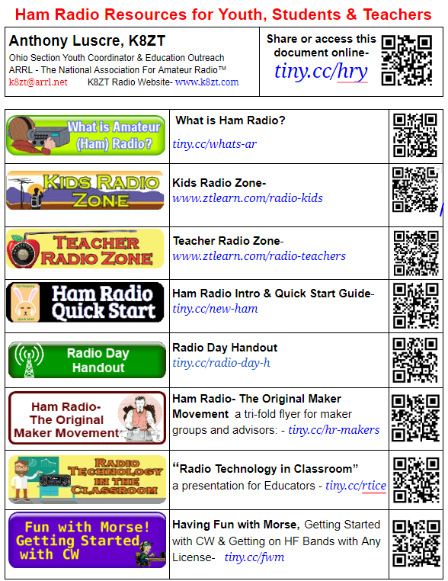
Contesting Resources

- Introduction to Contesting Slideshow- tiny.cc/arcontest & Video.
- Intro to AR Contesting- ARRL Classes- www.pathlms.com/arrl/courses/15065 (ARRL Membership required)
- Real-time competition: online scoreboards- link
- Contest Online ScoreBoard — Spectacular Insight- link
- N1MM+ And N3FJP Logging Software With Contest Online Scoreboard- video
- How we contest together virtually in real-time from our individual stations- video
- Ham Radio Contesting Ethics - To Livestream Or Not? YouTubers Bunch- video

Cuyahoga Falls Amateur Radio Club To The Field (CTTF)

I mentioned this last month, but it would be a great activity to include youth as observers/assistants or get them on the air.

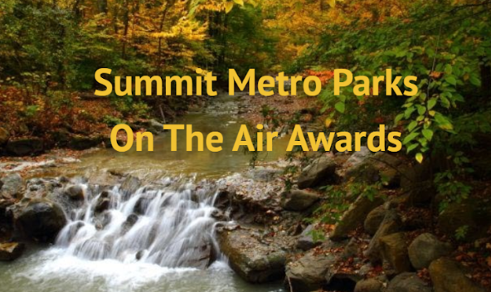
This activity is a much smaller and local event similar to OSPOTA. You may not be close enough to participate (basically, you need to be in or near Summit county as most of the contacts will be on VHF/UHF simplex). Still, even if you cannot participate, I want to let you know about the event as you may want to model something similar for your area or local club.

CTTF takes place from 4:30 to 7:30 PM Wednesday, September 14, 2022. This is the second running of this event, and everyone in the area is invited to participate. It uses the 16 Summit County Metro Parks plus many trailheads on the county hiking trails as locations/multipliers.
Below is a listing of frequencies used:
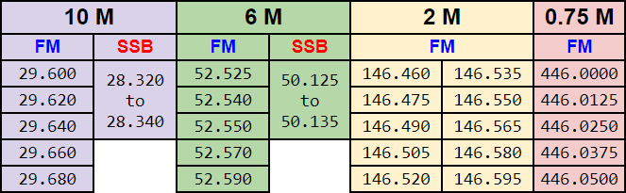

For further details on CTTF, here is a link to:
- A newsletter article and
- A slideshow

Also, if you are interested in participating or want further information on recreating a similar event for your club, feel free to contact me. We especially invite all hams in or near Summit county to participate in this activity either from home or from a park entity.

That’s it for this month; I hope to work you in the Ohio QSO Party, OSPOTA and/or CTTF.
73,
Anthony, K8ZT (k8zt@arrl.net)

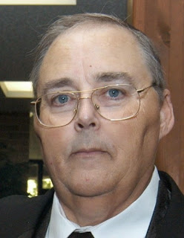
From the Section Traffic Manager
David Maynard, WA3EZN – STM
wa3ezn@att.net

This from last months OSJ and the Section Emergency Coordinator Stan Broadway, N8BHL – SEC, broadways@standi.com . We are in the planning stages for the Ohio Simulated Emegency Test (SET) which is held traditionally on the first weekend of October. This year would be October 1-2.
I want to reach out to all amateurs (beyond just ARES) to be ready to volunteer as we develop our plans! Of course like a response to an emergency, our primary goal would be to pass messages between counties and to the state W8SGT station. A lot of that will be digital using IS-213 forms over fldigi on both VHF and HF frequencies. Thanks Stan for the heads up!
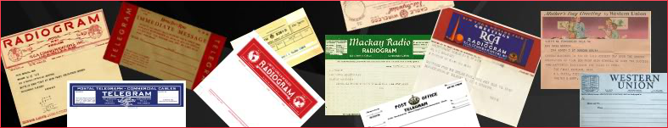
WHAT IS SET. The ARRL’s annual Simulated Emergency Test (SET) is a nationwide exercise that focuses on the amateur radio community’s commitment to being prepared and practicing how to respond before, during, and after a communications emergency. This is a great time to check readiness for yourself, as well as your home station and portable radio equipment, antennas, and accessories in a simulated emergency-like deployment. The ARRL SET is an invitation to get involved, practice your skills, and test your response plan.
To find out how to be involved in this year’s SET, please contact your local ARRL Emergency Coordinator or Net Manager. Check on upcoming planned activities through local, state or section wide nets. Contact your local club or other area clubs to find out who the Emergency Coordinator is and/or when and where the nearest ARES net or NTS net meets and their frequencies. In addition, refer to the ARRL Section Web pages at www.arrl.org/groups/sections. Your ARRL Section Manager can assist, too.
Whether it is providing service in a disaster or at a community public service event. Training in both net operating and message formatting can be found in several well-regarded publications, including The Amateur Radio Public Service Handbook, first edition; The ARRL Operating Manual, eleventh edition; and The ARES Field Resource Manual. Additionally, The National Traffic System's NTS Methods and Practices (http://www.arrl.org/files/file/NTS_MPG2014.pdf); and The NTS Manual (http://www.arrl.org/files/file/Public%20Service/NTS_Manual2015.pdf) are references for net and traffic handling procedures
Although most of the ARES SET traffic will be sent and receive by digital means there still is a chance that some of the last mile delivery may be on a voice net. Digital transmission of messages and data is not only more secure but also faster than relaying verbally. Here is an example of a simple IC213 message form. Printable ICS213 message forms can be found at many internet location. Here are two of those location:
http://www.ics213.com/downloads/ics213.pdf
http://www.ics213.com/downloads/ics213.doc

SECTIONS OF THE IC213 FORM
GENERAL MESSAGE
TO A |  | POSITION B
FROM C |  | POSITION D
SUBJECT E | DATE F |  | TIME G

A. Full names of recipient should be us
B. ICS always uses functional, incident position title
C. Full names of originator should be us
D. Originator’s Position
E. Subject should be concise and summarize topic of the message
F. Date when the Form was completed
G. Time when the Form was completed

MESSAGE:
Message text goes here....

SIGNATURE:  Originator signs message | POSITION:  Originator prints position title here

REPLY:
Reply goes here

Reply Signature Block
When you are done with your reply sign and print your position,then add date and time
DATE | TIME | SIGNATURE/POSITION

PURPOSE OF SET
1. To find out the strengths and weaknesses of ARES, NTS, RACES and other groups in providing emergency communications.
2. To provide a demonstration--to served and partner agencies such as the American Red Cross, the emergency management agency and through the news media--of the value to the public that Amateur Radio provides, particularly in time of need.
3. To help radio amateurs gain experience in communications using standard procedures and a variety of modes under simulated-emergency conditions.
Format
The scoring format reflects broad objectives and encourages use of digital modes for handling high-volume traffic and point-to-point Welfare reports out of the affected simulated disaster area. Participants will find SET an opportunity to strengthen the VHF-HF link at the local level, thereby ensuring that ARES and NTS are working in concert. The SET will give all levels of NTS the chance to handle exercise-related traffic. The guidelines also recognize tactical traffic on behalf of served agencies.
Test messages should carry the word "TEST" before the precedence; that is, "Test Priority" on phone and "TEST P" on cw. The text of such messages should also begin with the words "TEST MESSAGE."
ARES units and other groups are free to conduct their emergency exercises anytime until the end of the calendar year if an alternative date is preferred. The activity period should not exceed 48 hours.
Preparation is Important
Steps for the Emergency Coordinator and Net Manager

Adapt to the circumstances and situation at hand. Conducting a “tabletop” exercise via a combination of teleconferences, video conferences, and/or on-the-air meetings or even in-person meetings, too, would work well for the Simulated Emergency Test.
1. Sign up all available amateurs in the area under your jurisdiction and work them into your SET plans.
2. Call an on-the-air meeting or video/teleconference of all ARES members and prospective members to briefly outline the SET activities, and give general instructions. Do this in a socially-distant manner that is safe for everyone.
Do not divulge the exact time or nature of the test to participants at this time. Take this opportunity to register new ARES members and get up-to-date information on other participants.
3. Contact served and partner agencies and explain the intent and overall purpose of the SET. Offer to send test messages to other branches of their agencies. Contact should be conducted by telephone, or other virtual means with proper social distancing measures in place.
4. Contact officials of any adjacent communities having no active amateurs by telephone or virtual format. Offer to provide representation in amateur networks for them as well.
5. Arrange publicity in consultation with an ARRL Public Information Officer in local newspapers and radio/TV stations by preparing an announcement and/or inviting the press to observe your group's SET operation if there happens to be an in-person deployment as part of the exercise. Or, if it’s convenient or suitable, ask the media representative to conduct an interview via on-line video, or telephone.
6. Set up liaison with one or more NTS local/section nets (if you don't already have liaison) so you will have an outlet for all messages out of the local area.
7. Formulate your plans around a simulated disaster. Possible "plots" include: a flood, a serious fire, an ice storm, a missing person, a serious accident (automobile, bus, aircraft, for examples), a broken gas line, and so forth. Elaborate on the situation by developing a scenario, but please be realistic.
During the SET
1. Announce the simulated emergency situation. Activate the emergency net. Dispatch mobiles if necessary to the simulated emergency scene or to the area where the served agencies or partner organizations are situated. Feel free to adapt your exercise as necessary and as the situation or circumstances warrant in your community, area or state.
2. Have designated stations originate messages on behalf of served agencies. Test messages may be sent simulating requests for supplies. Simulated emergency messages (just like real emergency messages) should be signed by an authorized official even if the authorized officials are not physically in the area because of social-distancing requirements.
3. Emphasize tactical communications for served agencies and partner organizations.
4. As warranted by traffic loads, have liaison stations on hand to receive traffic on the local net and relay to your section net. You should also be sure that there is a representative on each session of the section net to receive traffic going to the local area.
5. Operate at least one session (or substantial segment of a session) of the local net on emergency-only basis. Or, if a repeater is on emergency power, allow only emergency-powered stations to operate through the repeater for a certain time period.
After the SET
An important post-SET activity is a critique session to discuss the test results. All SET participants may be invited to a virtual meeting using on-line meeting tools or a teleconference to review good points and weaknesses apparent in the drill. Emphasize ways to improve procedures, techniques, and coordination with all groups involved. Please report your group's effort using the appropriate forms and include any photos, clippings and other items of interest.

The Role of NTS
The main function of the National Traffic System in an emergency situation is to tie together all of the various local activities and to provide a means by which all traffic destined outside of a local area, section or region can be systematically relayed to the addressee.
Normal NTS routing should be followed. A valid exception is the handling of emergency traffic that should be routed as rapidly and efficiently as possible, bypassing various levels of nets when delivery can be expedited. Another exception is when one station is loaded down with traffic for one region or section. At the discretion of the Net Control Station (NCS), the station may be directed to bypass a normal channel and go directly to a lower (or higher) echelon net.
The interface between NTS and ARES lies in the liaison function between local nets and other NTS nets, particularly at the section level. Responsibility for representation of the local network on the section net lies with the local net manager who may or may not be the ARRL Emergency Coordinator. Although we usually think of ARES members being the representatives in section nets, it is equally valid to expect NTS personnel to act as liaison to local nets.
At least one net session or substantial segment of a session should be conducted on emergency power. Plan a surprise session or two. Advise the NCS just before net time. If the NCS is unable to operate on emergency power, then someone else must be net control. Only stations operating on emergency power may report in during this time.

Summary
One of the first steps on the way to a successful SET is to try to get as many people involved as possible. In a real emergency, we find amateurs with all sorts of varied interests coming out of the “woodwork.” Let's get them involved and informed through the SET so they will know more about how emergency communications can be and should be handled. Promote the SET on nets and repeaters ahead of time to sign up prospective participants.
Thanks to your efforts, the public service tradition in Amateur Radio continues!

WHERE TO FIND AN HF OR VHF TRAFFIC NET IN OHIO

OHIO SINGLE SIDEBAND NET
Morning session | 10:30 AM | 3972.5 KHz | every day
Afternoon session | 4:15 PM | 3972.5 KHz | every day
Evening session | 6:45 PM | 3972.5 KHz | every day

OHIO HF CW TRAFFIC NETS
HF CW NETS | NET TIMES | FREQUENCY | NET MANAGERS
Buckeye Early | 6:45 PM | 3.580 | N2LC
Buckeye Late | 10:00 PM | 3.590 | WB9LBI
Ohio Slow Net | 6:00 PM | 3.53535 | N2LC
All CW net frequencies plus or minus QRM

OHIO LOCAL VHF TRAFFIC NETS
VHF NETS | NET TIMES | FREQUENCY | NET MANAGERS
BRTN | 9:30 PM DAILY | 145.230 PL 110.9 | W8DJG
COTN | 7:15 PM DAILY | 146.970 PL 123.0 | KV8Z
NWOHARES | 6:30 PM DAILY | 147.375 PL 103.5 | N8TNV
TCTTN | 9 PM Sun, Tues, Fri | 147.015 | WB8YYS
TATN | 8:00 PM DAILY | 146.670 PL 123.0 | WG8Z

OHIO VHF TRAFFIC NETS

BRTN Burning River Traffic Net serving Cleveland and North Central Ohio
COTN Central Ohio Traffic Net serving Columbus and Central Ohio
MVTN Miami Valley Traffic Net serving the Dayton area
NWOH ARES Northwest Ohio ARES Net serving Toledo and surrounding counties
TATN Tri-State Amateur Traffic Net
TCTTN Tri-County Traffic and Training Net serving North East Ohio

Until next month, 73
David WA3EZN
Ohio Section Traffic Manager

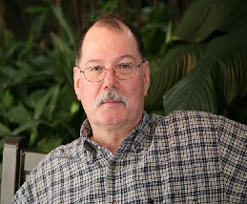
ARES Training Update
Jim Yoder, W8ERW – ARES Data Manager
w8erw@arrl.net

ARES Training Update

What’s on my mind this month? My move has progressed slower than I had hoped due to all manner of interruptions and little annoyances that could be expected. The realization has set in that there is truth in the old adage of, if it can go wrong, it will. Having said all this, I must also admit that nothing has been at all serious, just a bit more complicated and time consuming than I had hoped for. Perhaps the worst of it is my missing some great Amateur activities that I have always looked forward to and have had to skip because of some move related issue.
I also lament the difficulty we seem to be having in recruiting more members. Some of the contributing factors are that we are experiencing a slower population growth, the younger generation now appears to place a lessor importance in memberships overall, and generally, all of us are busy with many issues including the pandemic, keeping our families safe and the employment situation as a result of shutdowns etc. We do have more to be concerned with these days. The supply chain delays are impacting us in many ways in all areas of our daily lives. Lastly, the list of members who are now silent keys grows as we lose those seasoned amateurs who have made lasting contributions and have “Elmered” us all through our personal growth in this great hobby of Amateur Radio.

All of this is causing a lot of churn and disruption to our economy not only on the larger scale, but to our individual lives as well. You begin to realize it when you visit the grocery store and some of the small staple items that you enjoy are no on the shelves. Parts are also frequently not available. Many things. that you would take for granted can’t be found when you need them. And yet in the middle of all this, employers are having a very difficult time in finding people who want to work which only exacerbates the supply chain issues including items of particular interest to our Amateur Radio activities. It boggles the mind.
What is important for each of us is to remain positive. I recently watched a documentary “Secrets” which dealt with how much our attitude actually affects outcome. The message was that how you think and of what directly affects the results you can expect. Positive thinking produces the same result in your life. Negative thinking does the same and you will be feeding the negative results in your life. I believe this and it has been my own experience.
How does it relate then to us as Hams? Let’s embrace the positive and continue to do what we do best. Strive for excellence in what we do. Hold fast to the values we have and the good work that we can and do perform. Let’s never give up in our effort to promote our hobby. Each of us has certainly and often giving back by helping a new Ham get started. We’ve supported events and public service activities that demonstrate our value to the community we live in. Let’s continue all of this and reach out to those in the public that show an interest in Amateur Radio. And we cannot forget to include local public officials as well as politicians and others who we come in contact with. The “Home Runs” we seek here can came at any time and from anywhere. We can’t relent in our efforts to grow our hobby.
As for the rest of what’s going on in our world, I suggest, “Keep your faith and pray”.
Our training numbers have been relatively unchanged from last month. This is not unexpected for this time of year and the additional factors affecting our lives recently. Much of what I have seen is either an administrative issue or a small number of additional certificate submissions. I cannot complain. We in Ohio have been embracing training since we began the direction in doing so. You can be proud of your Ohio Section affiliation as we continue to lead in so many ways.
Finally, I am here to assist you. I would ask that you provide me those updates to call signs within your groups, let me know when one of our members becomes a Silent Key and let me know of any other administrative changes or corrections. And please let me know if I can help you in any way. I would be happy to do so especially if it helps make your job easier.
Thanks for all your effort,
Jim W8ERW
w8erw@arrl.net

National News
(from arrl and other sources)

__________________________________________________________________________________________

Masonic Lodges on the Air Event to Take Place on September 24
Masonic Lodges on the Air (MLotA), an amateur radio special event, will be on the air Saturday, September 24, 2022, from locations across the county. The event is open to all amateur radio operators, and the idea for the event grew out of the realization that many Freemasons also have a love for amateur radio.
The Fulton County Amateur Radio Club (FCARC) and the Fulton Lodge #248 in Ohio first hosted the event in 2021. Because of its success, the event has now been scheduled for the next 3 years.
The event will be operating K8BXQ from 10:00 AM - 6:00 PM ET, using SSB only on 80, 40, 20, 15, and 10 meters. Please honor all band plans. All contacts must be in the phone portion of the bands. Stations may be contacted once on each band.
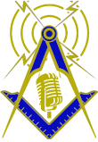
Full contest rules and information can be found at cqmorelight.com/rules.
Bob Holstrom, KD2BKD, said that masons in New York and New Jersey will be setting up stations at the historic museum grounds of The DeWint House, George Washington's Headquarters in Tappan, New York. The property is owned and operated by the Grand Lodge of Free and Accepted Masons of the State of New York. The special event call sign for that location will be W2QX, operating from 9:00 AM - 7:00 PM ET.
"Everyone is welcome to visit the historic DeWint house," said Holstrom. "The home has been restored and admission is free."
More information about Masonic Lodges on the Air can be found at their website, cqmorelight.com.

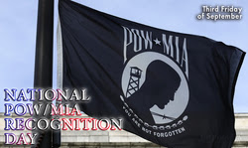
National POW/MIA Recognition Day 2022 will be observed on September 16, and special event station K4MIA will be operating from a restored Bell UH-1H Iroquois helicopter from September 10 - 18. The aircraft was the first generation of utility helicopters used in Vietnam and earned the nickname "Huey." In addition to K4MIA, there will be five other stations in operation on September 16: K4MIA/2, K4MIA/4, K4MIA/5, K4MIA/7, and K4MIA/8. The stations will operate on SSB, CW, FT8, and satellite. K4MIA will be on the air throughout the month using slow-scan television (SSTV) and EME. QSL cards will be available via a self-addressed stamped envelope sent to K4MIA Michael N. Bald, 6758 Hall Blvd., Loxahatchee, Florida 33470. National POW/MIA Recognition Day is observed every year on the third Friday in September. This day honors those who were prisoners of war and those who are still missing in action from all wars and conflicts, but it is most associated with those who were POWs during the Vietnam War. Visit the K4MIA listing on QRZ for further details, and the ARRL Special Event Stations database to find other on the air events and commemorations at www.arrl.org/special-event-stations.
JOTA-JOTI 2022 (Jamboree-on-the-Air-Jamboree-on-the-Internet), the world's largest amateur radio Scout event, is set for October 14 - 16, 2022. The event connects millions of young people around the world for a full weekend of amateur radio and online activities that promote friendship and global citizenship. Using both the airwaves and the Internet, JOTA-JOTI enables young people and volunteers to participate in fun and engaging group activities focused on developing 21st century skills through Scouting. JOTA is one of World Scouting's longest-running global events, dating back to 1958. JOTA-JOTI aims to support young people of all ages to learn about communications technology, the values of global citizenship, and their role in creating a better world. To register and learn more about JOTA-JOTI, visit their website at www.jotajoti.info.

ARRL 2021 Annual Report Now Available to Download
ARRL The National Association for Amateur Radio® has published its 2021 Annual Report. The report summarizes ARRL's program and fiscal activity for the year.
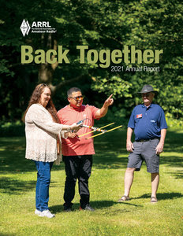
In his introductory remarks, ARRL President Rick Roderick, K5UR, said that the organization moved steadily forward in 2021, gaining momentum after the challenges that 2020 brought. "It began bit by bit in the early months of the year with Headquarters staff returning to the office, and reached a turning point on July 15, the day we rededicated ARRL Headquarters and reopened the building and W1AW to our members," Roderick said. He also noted that the rededication ceremony "gave all of us an opportunity to reflect on where ARRL has been, and affirm where we are headed," and expressed excitement for what's coming next.
ARRL CEO David Minster, NA2AA, dug into some of the organization's 2021 achievements in his opening remarks, citing the success of ARRL's End-Fed Half-Wave Antenna Kit; new forays into video content; and hiring, into key roles, Field Services Manager Mike Walters, W8ZY; Director of Emergency Management Josh Johnston, KE5MHV, and Education and Learning Manager Steve Goodgame, K5ATA.
The theme of the 2021 report -- "Back Together" -- referred to the many unions and reunions that occurred throughout the year, from being able to attend in-person hamfests once again, to partnering with Netherlands-based HF Kits to produce the antenna kit, as well as teaming up with the Radio Society of Great Britain at the end of the year to commemorate the centenary of the ARRL-sponsored Transatlantic Tests.
Included in the report is ARRL's Report to America, which highlights recent instances of ham radio operators serving their communities by providing emergency communications. These stories include amateur radio activations and response for storms, fire, and other disasters -- When All Else Fails®.
The 56-page Annual Report also recounts and summarizes the activities of all of ARRL's departments, and includes a complete 2021 fiscal report. ARRL ended 2021 with 158,238 members, a total that was slightly under the year-end goal of 160,084, but gained 29,027 new members, which represented an 11% increase from 2020.
The ARRL 2021 Annual Report is available for download at www.arrl.org/annual-reports.

The Ohio Amateur Radio Emergency Service (ARES®) just completed a dry-run exercise for the Perry Nuclear Power Plant in Lake County, Ohio.
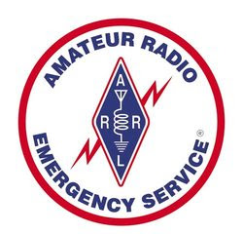
ARRL Ohio Section Emergency Coordinator Stan Broadway, N8BHL, said the drill was practice for the federally judged exercise scheduled for September. The Ohio Emergency Operations Center (EOC) amateur station, W8SGT, was utilized and on the air to communicate with several counties in northeast Ohio. Amateur radio serves in the emergency planning as a backup communications resource. The actual exercise is focused more on the power plant and its operation, but the state EOC is involved for the process. "In real life, this was a low-key type of exercise for us. It does not involve a lot of hams or activity, just establishes the line of communication," said Broadway. "It's satisfying to know, through many conversations during the planning stage, that amateur radio is a key ingredient to assure communication with the state." Ohio ARES is also working on a Simulated Emergency Test (SET) drill for October 1, 2022.

Online Elec News - Volume 200

On-Line Electronics, Inc. <news@onlineelec.com>

The Promise of the Battery Market
By: Bianca | August 22nd, 2022
Share
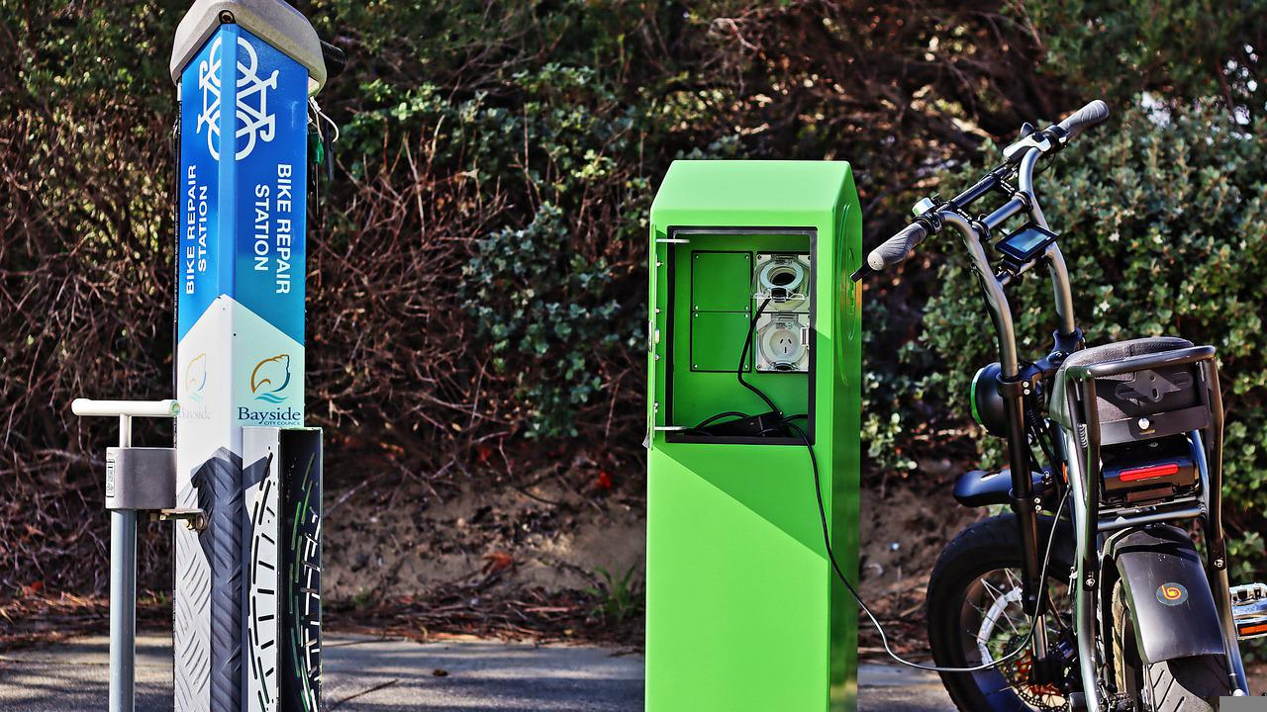
Image by Brian Sinclair from Pixabay
The battery sector has evolved in the last 10 years to fulfill the needs of manufacturers of consumer gadgets. Computers, cell phones, and electric vehicles are constantly evolving, as are energy storage and regenerative systems.
Batteries are not only developing as a crucial component on the path to a more sustainable future, but they also play a significant role in both energy transit and the grid.
The undeniable potential of the market, as well as the increasingly limited metal for battery production, have pushed several huge firms and manufacturers into the race to create breakthrough ways to build materials.
Earlier in August, electric truck manufacturer, Nikola reached an agreement to acquire battery manufacturer Romeo Power for a price of $144 million.
When Romeo first went public through SPAC 2020, the company had a valuation of $1.3 billion at the time. But since then, the company has suffered a loss of over $250 million, and it just issued a warning to investors that it may soon run out of funds.
In order for Romeo to keep producing batteries when the agreement closes, Nikola, Romeo’s major customer, has committed to providing Romeo with funding in the amount of $35 million. By taking this action, the corporation anticipates a cost savings of $350 million over the next four years.
Other manufacturers of electric vehicles including GM, Ford, Tesla, and Toyota are investing billions of dollars in battery plants with partners like LG and Panasonic.
Panasonic Energy, a key supplier of Tesla, recently announced that it will construct a battery facility in the state of Kansas, USA, with an investment of $4 billion. This will be Panasonic’s second electric vehicle battery plant in the United States, joining the company’s existing facility in Nevada.
By the year 2029, Panasonic intends to have tripled its production capacity for batteries, mostly in the North American market.
Last year, LG Energy Solution, a Korea-based battery manufacturer and battery supplier to Tesla, General Motors, and others, offered to acquire a 4.8% stake in Greatpower Nickel & Cobalt Materials for 350 billion KRW ($297.5 million) to secure a stable supply.
In addition, the corporation struck a six-year arrangement with Australian Mines to obtain 71,000 tonnes of nickel and 7,000 tonnes of cobalt starting from the end of 2024.

Lewis & Clark Trail OTA
Our first LCTOTA event was a bigger success than we thought it would be. We were happy with the activity and the results. As you know Lewis & Clark set out for a 2 year journey from Pennsylvania to Oregon in 1804. Thomas Jefferson sent them out to explore the land west of the Mississippi which was part of the Louisiana Purchase. All of us on the committee chose to honor Lewis & Clark for their expedition which helped to lead to Oregon and Washington becoming part of the USA.
We want to thank all the activating stations, the 20 stations in each of the 16 states from Pennsylvania to Oregon, that Lewis & Clark traveled though. The clubs involved were Oregon Tualatin Valley ARC (OR), Clark Co ARC (WA), Kootenai ARS (ID), Palouse Hills ARC (ID), Great Falls Area ARC (MT), Central Dakota ARC (ND), Souris Valley ARC (ND), Sioux Empire ARC (SD), Belview ARC (NE), Great River ARC (IA), Pilot Knob ARC (KS), Central Missouri RA (MO), Lewis & Clark RC (IL), Clark Co ARC (IN), Tri State ARS (IN), Bullitt ARS (KY), Amateur Radio Transmitting Society (KY), Portsmouth RC (OH), Eastern Panhandle ARC (WV), Steele City ARC (PA). Thank you to each of these clubs who’s members activated over a two week period to help make Lewis & Clark Trail OTA a success.
We had 25, 393 QSOs completed from June 4-19, 2022. 609 logs were uploaded and 1432 activation hours were scheduled. We see this as a big success. Expect us back again next year. Check out LCTOTA.org.

Watch the Launch of Our Artemis I Mission to the Moon

The first flight of the Artemis Generation is about to begin. Are you ready?

Artemis I is an uncrewed flight test that will lay the foundation for a sustained long-term presence on and around the Moon. This pioneering mission will be the first integrated flight of NASA’s Space Launch System (SLS) rocket and integrated Orion spacecraft, which will help us get a feel for what astronauts will experience on future flights.

The SLS rocket is targeted to launch during a two-hour window that opens at 8:33 a.m. EDT Monday, Aug. 29, from Launch Pad 39B at Kennedy Space Center.

You can watch a live broadcast starting Monday at 6:30 a.m. EDT on our website and on NASA TV, as well as YouTube and NASA’s App. (Stay tuned during the broadcast for celebrity appearances by Jack Black, Chris Evans, and Keke Palmer.) Additionally, we’re airing a Spanish-language broadcast starting at 7:30 a.m. EDT on NASA en español’s YouTube, Twitter, and Facebook accounts.

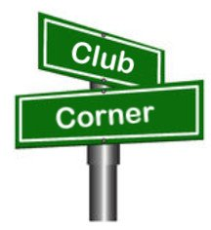
Club Corner

This is YOUR corner of the newsletter. Send us what your club is doing, and we’ll make sure that it gets in. Got a special event or club project that you want everyone to know about? Send it to us!. Need help with a project? Send it to us.

Let us know what you club is up to. Are you going to have a special guest at your meeting or are you having a special anniversary?

Send it to: webmaster@arrl-ohio.org

Programs & Activities for Your Local Radio Club  Anthony Luscre, K8ZT - k8zt73@gmail.com | Share this doc- tiny.cc/club-ideas or scan QR Code | 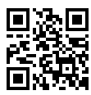

Planning & Scheduling

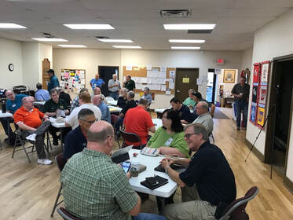
Fall generally means gearing up for Amateur Radio on-air activity and hopefully a higher number of attendees at your local club’s meetings. The task of providing presentations, guest speakers and other activities for club members often falls on the club Vice-President or another officer. This often onerous task alone can often scare many candidates away from running for this office!

Before we start, let me say upfront, “I am not an expert, and I have collected ideas from a large number of clubs around the country.” Some ideas are widely used, and others are waiting to be tried by adventurous groups.

Ask Your Members for Opinions & Ideas

To get started, you might want to consider asking your members for ideas, but don’t hold your breath because, in my experience, this often results in little to no feedback. A better way might be an online club survey. There are several ways to do this. I find Google Forms to be an easy-to-use, free tool (if you have no experience, there are many online how-tos and YouTube videos to help you). In addition to a one-time survey, you might want to add a link on your club website to allow members to suggest topics, activities, speakers, etc. easily. This link could be attached to a Google Form to quickly gather the needed info and have its results easily emailed to multiple officers. Even after these two ways of soliciting input, you may still be hunting for ideas on your own.

Increasing Your Options for Guest Speakers/Presentations

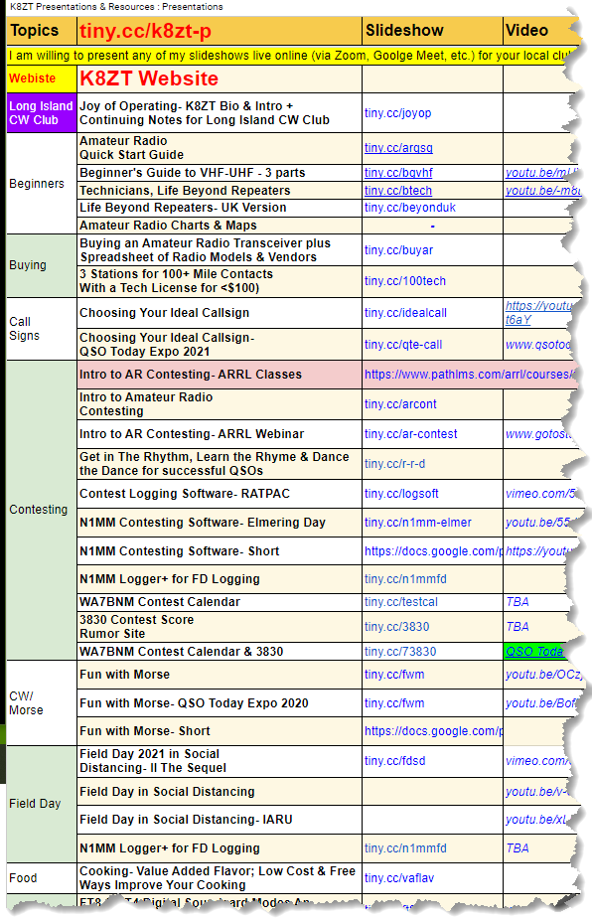
To increase your odds, I suggest you have an online presentation/meeting software set up to bring in distant speakers/presenters who may not be able to visit your club’s meeting physically. Many clubs have already utilized online meetings via Zoom or other tools during COVID-19. Don’t drop the idea as you move to live, in-person meetings. Maintaining a hybrid meeting process, both in-person and online, can have multiple benefits. Benefits can include allowing club members who cannot visit in person due to health, travel or other issues access to meetings. It also means you are open to inviting speakers/presenters from around the world (I’m doing my third presentation for a group in Norfolk, England, this month).

Finding Speakers/Presenters can often be tricky. A few suggestions include asking other clubs for either presenters or recommendations on those that have previously presented to them. Check out online presentations like QSO Today Expo, ARRL Webinars, Dayton Hamvention Forums, Hamcation Forums, Contest University, etc. for speaker ideas. The Ohio ARRL Section Cabinet also has several members that would be happy to present to your group. I have done over 200 presentations for US, Canada & UK clubs and would be glad to add your club to our list. For a complete list of my current presentations, some recordings and resources,
see tiny.cc/k8zt-p.

I suggest you follow up with your speakers/presenters to show appreciation for their time and effort. This can range from a simple email or written note of thanks to helping with travel expenses or providing a dinner for guest speakers. I have also received mugs, QSL cards, shirts, and other club memorabilia. This type of action can encourage repeat presentations and new presenters.

Sometimes Your Options Don’t Include a Live Presentation

Many recorded presentations, tours, how-tos, movies, documentaries and other videos on Amateur Radio, radio history, electronics and technology topics might interest your membership. Having a way to play online or other recorded videos at your meeting can be very helpful. Make sure you have a projector with adequate light and high enough resolution for public presentation, a large screen or area to project to, a decent sound system and other features. If you do not have a reliable, robust high-speed Internet connection at your club meeting location, consider downloading the recording to a storage device (laptop, USB drive, etc.) ahead of time and bring that to the meeting instead of relying on an iffy Internet connection. Don’t forget popcorn or snacks for the movie.

Some sources to check for videos include ARRL, YouTube, Ham Radio Groups, Local Libraries & Museums, etc. One source of recent recordings is from the RATPAC Group- www.ratpac.us. They have twice-weekly live Zoom presentations on a wide variety of AR topics and have over 200 video recordings available for your use. You can find a list of recordings and upcoming sessions at tiny.cc/ratpac-list.

Other Club Activities

Presentations can be good, but extending your meeting activities to hands-on activities can be great for your meetings. Hands-on activities can include (but are not limited to):
- Construction Projects
  - Introduction to soldering
  - Building a tape measure VHF beam
  - Making a simple ground plane 2-meter antenna
  - J-Pole antennas from twin lead line
  - Go-Boxes
- Kit Building- The scope is almost unlimited with many inexpensive small electronics kits available online.
  - Antenna Balun
  - QRP Transceiver
  - Soundcard<>Radio Interface
  - Test equipment
- Hands-On How-Tos
  - Using a VOM/Multimeter
  - Using an Oscilloscope
  - Setting Up HTs to work the repeater
  - Programming Radios
  - Computers (members bring laptops)
    - Installing and Configuring Software
      - WSJT-X
      - FLDigi
      - Logging Software
      - Contesting Software
    - Classes on Using Software
      - Spotting Software
        - RBN
        - PSKReporter
        - DX Clusters
      - Antenna Modeling
      - LoTW & eQSL
      - Productivity Software- Spreadsheets, Presentation, etc.
- Test Bench (members bring in equipment to be tested/adjusted)
  - HT testing
  - Antenna testing
  - Mobile Installations
- Competitions & Games
  - Fox Hunting
  - QSL Card Station Contest Game (a.k.a Eye-Ball-QSO-Party)- link
  - Antennas Shootouts
  - Radio Games
  - Ham Radio Trivia Game Night (DX prefixes, circuits, rules, components, historical events, etc.)
  - Ham Radio Bingo
  - Ham Radio Charades
  - Tech Pursuit
  - Talent Show
- Show & Tells
  - Go-Boxes
  - Equipment Projects
  - QSL Sharing & Stories
  - Awards & Stories
  - Shack Photos & Descriptions
  - Portable Operations- photos & videos
  - Cruise-In for sharing Mobile installations
- Education
  - Entry Level Technician Classes
  - Upgrade Classes General & Extra
  - EMComm Training
  - Formal Mentoring Programs for new hams or hams that want to learn about something new
- Ask the Experts Panels
  - Antenna advice
  - Pros & Cons of Digital FM Modes
  - Home station installation tips
  - Mobile station installation tips
- Auctions & Giveaway
  - Auction of donated gear
  - White Elephant Gift Exchange
  - Meeting prize drawing (could be from a pool of donated materials surplus to members, swag collected at hamfest, etc.
  - Junk Box Item Swap
  - Hamfest
  - Smaller swap events like trunkfests
- Small Groups or If Using Zoom or other Meeting Software
  - Breakout rooms to have small group discussions
  - Online Quiz Games like quizizz.com, Kahoot, etc.
  - SIGs (Special Interest Groups) cover one aspect of AR for a subset of club members, i.e., contesting, DXing, QRP, Antennas, etc.
- If your group is lucky to have its own location
  - Club station with one or more operating positions
    - It can be great for those that do not or cannot have a home station
    - It can be great for training new hams
    - Can be used for group contesting

Outside Activities

Sometimes getting out for an activity can be a fun diversion. Outside activities could include a field trip to a locale attraction- broadcast station, historical site, museum, local attraction, etc. Chartering a bus, using a van or multiple cars to visit a large hamfest as a group can be a great way to include those unable to drive or reluctant to go by themselves.

Getting on the air as an activity can be an excellent way for members to make contacts and try out new equipment. The activity could be a club entry in any of the many AR contests throughout the year. Popular choices include ARRL Field Day, ARRL VHF Contests (Jan, June or Sept), Winter Field Day, and State QSO Parties (including fixed county expeditions and rovers).

POTA (Parks On The Air), SOTA (Summits On The Air) & IOTA (Islands On The Air) activation can be great activities. Don’t forget to set up your club's own special events stations. Our local club has created a mini-POTA type event using our County Metroparks and opting for VHF/UHF activity days to be inclusive to all members with any license class and simple radio equipment- link.

If your local area has a historical event, notable location, famous resident, national event, etc., you can organize a one-day or longer special event station.

Sometimes food can be the draw. Club picnics, breakfasts, holiday dinners, parties, etc., can build camaraderie and include non-ham family members.

Sometimes thinking of others can be a great way to bring your group together. Many ham clubs provide communications for public events- parades, races, etc. but don’t forget about other volunteering activities your group could assist with. These might include a park or river cleanups, eldercare visitations, reading for blind or school children, other community projects, etc. Be aware that some places you might volunteer, like schools, may require registration, special child safety training and/or background checks. Other clubs choose to do fundraisers to support charitable organizations in their communities.

Nets

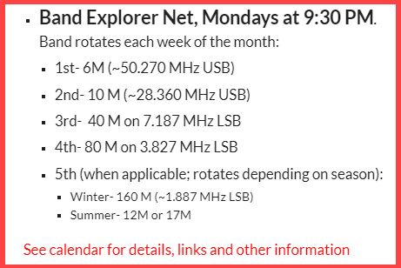
Another activity that many clubs already do are weekly VHF/UHF nets on their repeater. These are great but have you considered expanding on this? Ways you can branch out include trying simplex, new bands and new modes. These are excellent ways to help newcomers get more experience and even train long-time members on new operations. Our local club created a new evening net to replace our Monday evening 10M net- Band Exploration Net.
Each week we rotate to a different band. If the month has a fifth Monday, we use 160M during winter and 12 or 17M during the summer. You could also do something similar by rotating modes each week with SSB, AM, FM, CW and Digital. These activities also encourage members to add new antennas, upgrade licenses to have more allocations, etc.

Another net activity includes repeaters. I heard of a group in Michigan that does periodic Repeater Crawls (like Pub Crawls, but with no alcohol or hangovers). The group moves from one repeater to another in a pre-defined schedule. This encourages members to find new repeaters, test the accessibility of hitting repeaters from their home or vehicle, program new repeater frequencies, shifts and CTCSS (PL) Tones into their radios, etc. For more information, view document from Keith Armitage, KD8ZSK.

Final Thoughts

As you plan your new activities, consider inviting other hams, including members of other local clubs. Make sure you share upcoming events/activities with your membership and other hams- send out email announcements, publish them in your club newsletter, post them on your website, add them to your online club calendar, etc. A good idea would be for clubs to share upcoming club activities with each other. Consider holding joint meetings for special guests and/or programs. You might want to consider special daylong events for newcomers, on special topics, etc.

Inviting hams that are not members of any radio club is the hard part.
How do you reach them without sending a postcard or letter to their QRZ mailing addresses? What other activities for meetings is your group doing? What other ideas do you have for activities? If your group has any ideas, please share them with me, and I will do a follow-up article.

Don’t forget that once members, especially guests, show up for your meeting, make them feel welcome. Ideas include designated greeters. I especially like the method of one club, where I did a presentation. They start their meeting with this simple but powerful technique. Instead of asking, “are there any guests tonight?” They instead begin the meeting by going around the room asking everyone to give their name, callsign, hometown, if they are a guest, have just received or upgraded their license and finally, do they have any announcements or news for the good of the order. This very inclusive method identifies not only guests but gives a name, call, and location for all attendees so they can socialize at the end of the meeting. Asking members to wear name and callsign badges and providing visitors or those that have forgotten their badges with simple “my name is” tags.

73,
Anthony, K8ZT (k8zt@arrl.net)

Akron Marathon

Hi guys,

Summit County ARES is looking for volunteers for the Akron Marathon on September 24th . This is a 26 mile course through North, West and southern neighborhoods in the Akron area. While not all the mileposts need stations at them, what is needed are operators for 2 Aid Shuttles, SAG vehicle, Aid stations, Watering stations, Med tent and pivotal locations at intersections along the route..

This is a premier event that helps us amateur radio operators showcase our skills and equipment. Several of the public service agencies are more than impressed with the way we are able to assist in ways that they cannot and this is why amateur radio has been a part of the Akron Marathon in this, its' 20th year.

Sign up can be found on the Sumco ARES website at www.summitares.org and click the sidebar under Training/Events

Gregg Gary - WB8YYS
Asst. EC - Summit County
ARRL - The National Association for Amateur Radio
WB8YYS@ARRL.NET
330-357-6575
HSH-4341

VE Sessions

All Things Amateur Radio Association (ATARA) We host testing sessions every second Tuesday of the month to sign up please visit our website https://atara-w8atr.fun and contact us at hamexams@atara-w8atr.fun.
We have room in our next class to avoid the coming fees by the FCC!

Cambridge Area Maker Group Amateur Radio Exam Testing all Levels
Date: Saturday September 17, 2022 Time: 01:00 PM ( Walk-ins Allowed / Call or Email to Register )
ARRL-VEC Exam Fee $15
Please Register Contact: Kathleen Frederico KB3RDR Phone: 484-459-3309 Email: kb3rdr@arrl.net
Location: St. John's Episcopal Church 1025 Steubenville Ave Cambridge, OH 43725, USA

CARS
VE testing from CARS - Cuyahoga Amateur Radio Society - at Elmwood Recreation Center, 6200 Wisnieski Parkway in Independence, Ohio 44131 Time: 9:15 AM (Walk-ins allowed) Always the 2nd Sunday of the odd month. Go to CARS www.2cars.org for detailed map of location. Call Metro W8MET 216-520-1320 for details

Dayton Amateur Radio Association (DARA)
If you are interested in testing for a new or upgraded license, please come see us at the DARA Clubhouse. If you have questions about testing, please email exams.w8bi@gmail.com

The Lake County Amateur Radio Association
The Lake County Amateur Radio Association is once again holding its 2022 Amateur Radio license exams at the Kirtland Library, 9267 Chillicothe Road, on the following dates:
Saturday, June 4, August 6, October 1, and December 3.
The tests will start at 12 noon. Please arrive a few minutes earlier.
The Lancaster and Fairfield County Amateur Radio Club (LFCARC) hosts exam sessions at the FAIRFIELD County EMA, 240 Baldwin Dr in Lancaster Ohio, 43130, on the first Saturday each month at 10:00 am. Please visit our website at http://www.k8qik.org for exam dates on our calendar and navigate to our Learning Center/Taking the Exam link for information and requirements. Our VE team looks forward to serving the Amateur Radio community in Central Ohio and across our nation. We have an experienced team that has tested candidates from Alaska, Florida, Texas and points in between! Contact me at ve_testing@k8qik.org to register.
The Milford Amateur Radio Club (MARC) is now doing VE testing on the third Thursday of each month at 6:00 PM. Location; Miami Township Civic Center located at 6101 Meijer Drive, Milford, OH 45150.
Please pre-register at www.milfordhamradio.org

Portage County Amateur Radio Service (PCARS)
The first Saturday of every even numbered month -10 am – at the PCARS club site in Ravenna. Please visit the PCARS web site and check out the information about VE testing in the latest newsletter at www.portcars.org .
If you have any questions, don’t hesitate to contact me at KB8UUZ@gmail,com

Hocking County Fox Hunt Success
The Hocking Valley Amateur Radio Club held their monthly Fox Hunt on Saturday, August 27th. Five amateurs participated, with W8NZB Phil Stanley acting as Fox, hiding along a public thoroughfare in Hocking County. The Winning Hunter, Dave Brimner, KB8OTU came in just about an hour and a quarter into the hunt, but all three chase vehicles came extremely close to finding the fox. There is some discussion if hiding in a copse of trees constitutes being visible from the roadway, but a good time was had by all. The hunters adjourned for a noon meal at Los Amigos Mexican restaurant, which is the habit concluding a successful hunt. Due to club commitments in September, it is likely the next hunt will be held in October 2022.

Submitted by 2nd place winner,
Kirk Groeneveld KC8JRV
Athens, OH

Club Commission Program Update
One of the benefits of being an ARRL Affiliated Club is that you can receive a commission for recruiting new ARRL members and securing timely ARRL membership renewals. The commission structure for this program has been updated, and the process has changed to make things easier for the clubs. The new procedure involves all membership dues being sent to ARRL for processing, prior to the club receiving a commission payment directly from ARRL. The complication of adjusting funds around credit cards, checks, and cash has been eliminated. ARRL is now responsible for all of the processing. As a result, your club could earn money while promoting the many benefits and programs of ARRL, to help ensure that the amateur radio hobby is protected and continues to grow.
Additionally, the commission rate has changed. Now, clubs will receive $15 for each new membership or lapsed membership (of 2 years or more). For renewing members, clubs will now receive $5. There is no limit to the amount that a club can earn in this program.
Club leadership is encouraged to let their membership know that the club can benefit from this program. Only regular memberships are eligible for commission. Life, International, Family, Blind, and Student memberships are ineligible for commission.
The new Club Commission Program is available for all ARRL Affiliated Clubs and goes into effect on June 1. Additional information, as well as FAQs, can be found on the Affiliated Club Benefits web page.

How to Plan and Apply for an ARRL Hamfest or Convention
If your amateur radio club is planning to host a convention, hamfest, tailgate, or swapfest, please consider applying for ARRL sanctioned status for your event. To learn what it means to be an ARRL-sanctioned event, and to get some ideas on how to prepare for and conduct a hamfest or convention, visit www.arrl.org/arrl-sanctioned-events.
To apply for ARRL sanctioned status for your event, log on to www.arrl.org/hamfest-convention-application.
The ARRL Hamfests and Conventions Calendar can be found online at www.arrl.org/hamfests. In addition, the Convention and Hamfest Calendar that runs in QST each month also presents information about upcoming events.
Important Links
ARRL Home: www.arrl.org
Find an ARRL Affiliated Club: www.arrl.org/clubs
Find your ARRL Section: www.arrl.org/sections
Find a License Class in your area: www.arrl.org/class
Find a License Exam in your area: www.arrl.org/exam
Find a Hamfest or Convention: www.arrl.org/hamfests
Email ARRL Clubs: clubs@arrl.org

ARRL Youth Licensing Grant Program
As of April 19, 2022, ARRL covers the one-time $35 application fee for new license candidates younger than 18 years old that take tests administered under the ARRL Volunteer Examiner Coordinator (ARRL VEC) program. As part of the ARRL Youth Licensing Grant Program, the $35 FCC application fee will be reimbursed after the ARRL VEC receives the completed reimbursement form and the new license has been issued by the FCC. The reimbursement check will be mailed to the fee payer. Also, candidates younger than the age of 18 would pay the ARRL VEC team a reduced exam session fee of $5 at the time of the exam. The $5 fee is for all candidates under the age of 18, regardless of the exam level taken. Proof of age is required at the session.

The Ohio Section Youth Net

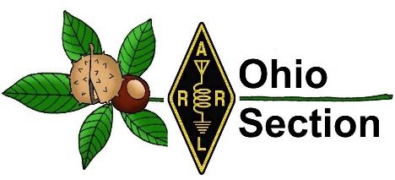
Youth Net
When: The second Sunday of every month at 7:30 PM EST
Where: The K8IV repeater located in Kent, Ohio (Echolink node K8BF-L) RF: 146.895 Mhz with PL 118.8
Who: Any licensed amateur radio operator who wishes to participate. Priority will be given to youth stations and those located in Ohio.
The purpose of this net is to encourage youth activity in amateur radio and to help new hams get more comfortable on the air.

_______________________________________________________________________

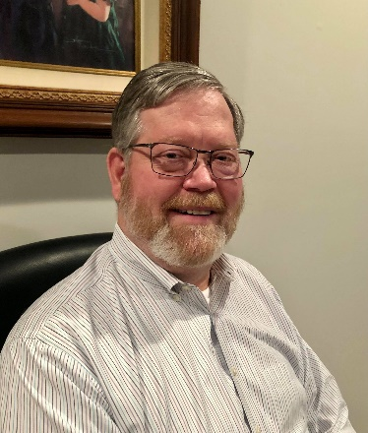
DX This Week – K9LA

Bill AJ8B (aj8b@arrl.net, @AJ8B, or www.aj8b.com)
CWOPs Member #1567

What great weather we have had. I hope you are taking care of any antenna work that needs to be done. Maybe replacing the old feedline or adding some radials? Let me know what you are up to!
Below are the two cards that I received this week. The first is a very artsy card from 9K2NO – Mohammad in Kuwait and the second is from Roland, TR8CR in Gabon.

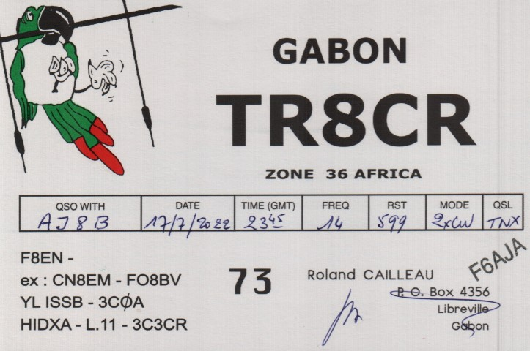

This week we have another entry from our Ft. Wayne friend, K9LA, Carl. I was happy to see Carl at Hamvention, just to chat and check in. What a great and knowledgeable guy! I have had a couple of emails from newer hams asking about skip. The question was “When I was on a CB radio, there were days when I could not talk to my friends in the next neighborhood and other days when I could talk a significant distance. What gives?” Carl is here to explain.
The W4DXCC convention is fast approaching. Some of us will be attending and some of us will be presenting. The Friday session is called the “Boot Camp”. There are presentations to assist new hams in getting more acclimated with DX and contesting. The Saturday session is more general topics. The day concludes with a great banquet. Let me know if you need any information or you can visit: www.w4dxcc.com.

DAH DIT DIT DIT DAH DAH DIT DIT DIT DAH

Ionospheric Absorption - Carl Luetzelschwab K9LA

For a QSO to occur, two parameters must be met. There must be enough ionization to refract (bend) the signal back to earth. This is expressed as an MUF (maximum usable frequency). Early manual prediction techniques (and even some predictions generated by early personal computers) only gave MUF. They left out the other half of the story – the amount of loss. In other words, the signal must be strong enough. [note 1]

I can think of nine parameters that determine the signal-to-noise ratio. They are transmitting power, antenna gains (including ground parameters), free space path loss (spreading of the wave), ionospheric absorption, ground reflection loss, the effect of multipath (short-term fading), polarization mismatch, above-the-MUF loss and the noise environment at the receiver in a designated bandwidth. This month’s column looks at ionospheric absorption.

What types of absorption are there?

There are two types of ionospheric absorption: non-deviative and deviative. Non-deviative absorption occurs in the D region during the day and in the lower E region during the night when the signal is pretty much following a straight-line path – minimal bending is occurring.
Deviative absorption occurs near the top of the trajectory (the peak altitude of the hop) or anywhere along the path where marked bending takes place. This can happen in the E region during the day and in the F region during both day and night. [note 2]

What causes absorption?

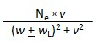
From equation 7.25 on page 216 in Ionospheric Radio by Kenneth Davies (Peter Peregrinus Ltd, 1990), ionospheric non-deviative absorption is dependent on the electron density and the collision frequency between electrons and neutral atmospheric constituents as follows:
absorption is proportional to (equation 1)
where Ne is the electron density (simplistically, it decreases with decreasing altitude)
v is the electron-neutral collision frequency (it increases with decreasing altitude)
w is the angular operating frequency
wL is the longitudinal component of the angular electron gyro-frequency
the plus sign is for the ordinary wave and the minus sign is for the extraordinary wave

How does absorption vary?

Let’s assume that the operating frequency is much greater than the electron gyro-frequency. This indicates that non-deviative absorption is inversely proportional to the square of the frequency – the lower the frequency, the higher the absorption. Here is a representative plot of the total monthly median absorption from Proplab Pro V3 for a one-hop east-west path in North America in October at 4 PM local time (daytime) during a moderate solar cycle.
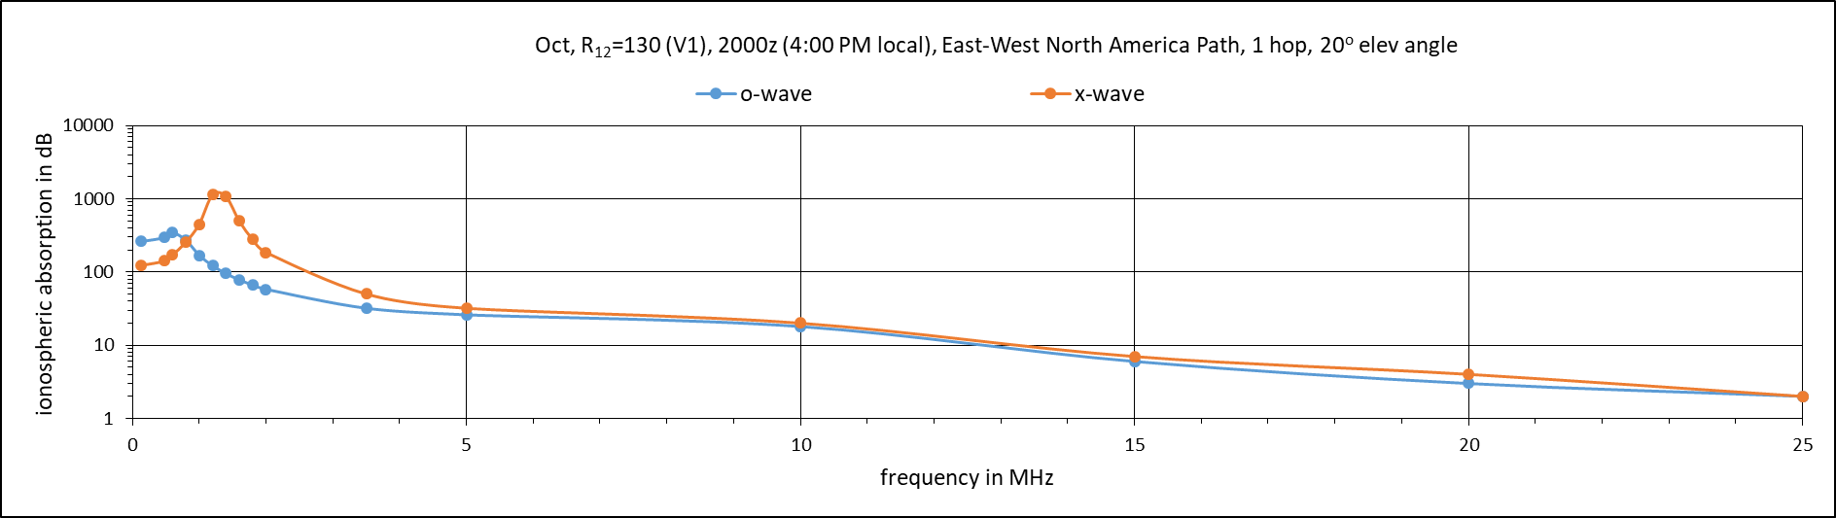
Indeed, absorption increases as we go lower in frequency. Absorption of the ordinary wave and the extraordinary wave are quite similar at the higher frequencies, but they diverge and peak at different frequencies as the operating frequency approaches the electron gyro-frequency [note 3]. If this graph went to 50 MHz, the absorption on 6 meters would only be around 1 dB for a long hop (assuming there is enough ionization to refract it back to earth, of course).
Now let’s look at non-deviative absorption versus deviative absorption. Here is the ray trace on 14 MHz
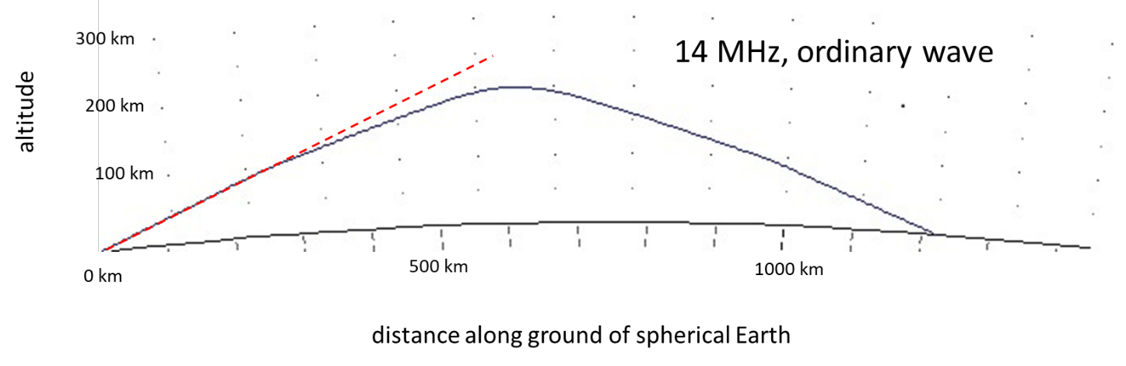

Note the dashed red line. I included it to determine when the ray starts deviating from a straight line to determine the deviative absorption. It appears to start deviating around 120 km as it goes through the E region. But if you look closely, after this small amount of bending it then goes straight again until it’s at the top of the trajectory. So where does deviative absorption occur? From the earlier definition of deviative absorption, it occurs near the top of the trajectory or anywhere along the path where marked bending takes place.
Does the slight amount of bending going through the E region qualify as ‘marking bending’? That’s a subjective call, so let’s assume the worst-case scenario and determine the deviative absorption when it slightly bends going through the E region (on the way up and on the way down) and when it’s at the top of the trajectory.
Using the Proplab Pro V3 detailed results from the ray trace, we determine the deviative absorption is 0.48 dB and the non-deviative absorption is 8.02 db. This adds up to the 8.5 dB from the earlier plot of absorption versus frequency at 14 MHz Thus, non-deviative absorption dominates and it’s due to the electron-neutral collision frequency being greater at the lower altitudes where bending doesn’t occur.

Now let’s do the ray trace on 7 MHz
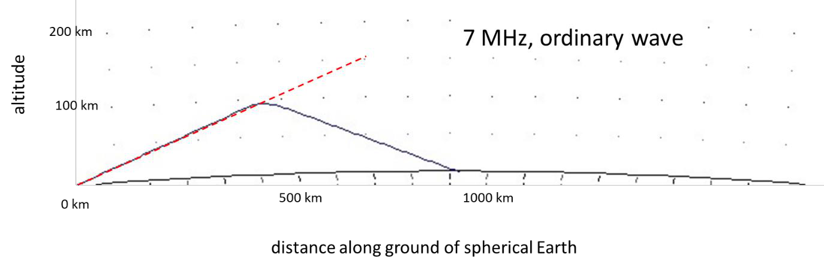

There’s enough ionization in the E region under the assumed conditions (daytime, moderate solar cycle) to make 7 MHz an E hop. The deviative absorption only occurs very near the peak of the trajectory (as indicated by the dashed red line).
The total absorption is 28.0 dB (again, from the earlier plot of absorption versus frequency at 7 MHz), which consists of 8.27 dB for the deviative portion and 19.73 dB for the non-deviative portion. Again, the non-deviative absorption dominates, but the deviative absorption is a greater percentage of the total absorption because it occurs at the lower altitudes where the electron- neutral collision frequency is greater.
For a much more detailed look at absorption, I recommend the paper Calculating the absorption of HF radio waves in the ionosphere. This paper is authored by K. A. Zawdie, D. P. Drob, D. E. Siskind, and C. Coker. It appeared in the American Geophysical Union journal Radio Science in June 2017. Visit https://agupubs.onlinelibrary.wiley.com/doi/full/10.1002/2017RS006256 for free access to this paper.

Summary

Absorption increases as frequency is decreased. Absorption is maximum near the electron gyro- frequency, which is anywhere from 0.7 to 1.7 MHz depending on where you are in the world. And non-deviative absorption dominates over deviative absorption at HF in the daytime – but by how much depends on the frequency. At night I would expect deviative absorption at HF to dominate due to the D and E regions minimizing at night (where non-deviative absorption occurs).

Notes

1) Knowing just the signal strength may not be enough. Is the signal strength adequate in relation to your noise level? In other words, it is best to determine the signal-to-noise ratio (SNR). The required SNR for a QSO to be completed depends on the mode being used. SSB requires the highest SNR and the digital modes require the lowest SNR. CW is in between.

2) There is nothing magical about the concept of deviative absorption. Non-deviative absorption is when the ionosphere’s index of refraction is near 1.0 (no bending) at the designated frequency, and the wave gets through the absorbing region quickly– it spends very little time in the absorbing region. Deviative absorption is when the ionosphere’s index of refraction at the designated frequency is approaching 0. The wave is bending, and its group velocity slows down. Thus, the wave spends more time in the absorbing region under deviative conditions.
3) The electron-neutral collision frequency also comes into play here.

DAH DIT DIT DIT DAH DAH DIT DIT DIT DAH

Here is an update from Bernie, W3UR, of the DailyDX and the WeeklyDX, the best source for DX information. http://www.dailydx.com/ . Bernie has this to report:

FT#Y – Antarctica - F4FKT, David, is heading back to Terre Adelie and Concordia, Antarctica. He was there between December 2021 and March 2022. Plans are to be there from late October of this year through the middle of February 2023. While there he will be QRV in his spare time as FT4YM on 20 Meters SSB and FT8.
3A – Monaco - F5LIT (aka VE2LIT), Emmanuel, is planning to be QRV as 3A/F5LIT from September 17 to 21. Do not QSL direct. QSL only via LoTW.
ZL7 - Chatham Islands - K5WE, Jeff, and his son KD5GEY, Scott, are heading to Kaingaroa on the northeast coast of Chatham Island where they will be QRV from September 9-21. Jeff is "aware that ZL7 is needed much more in Europe than in NA/SA or Asia". He is looking for input from European DXers "regarding which bands/modes you need" ZL7. He would also like to hear about "your experience with propagation to the ZL area, and on what bands, long path or short path?" Make sure you include time in UTC (Zulu). Details should be sent to DXpedition@k5we.com

A3 – Tonga - Callsign A35JP by JA0RQV, Masa, will be August 27 to September 30, the exact dates subject to change. Masa will have an IC-7300, 100 watts, to a ground plane with "antenna tuner," doing 40-6 meters. The QTH is Nuku'alofa, Tongatapu Island, which is IOTA OC-049. He plans to do CW, SSB, FT8 and FT4. This will, unfortunately, he says, be his last operation from A35. He has been going there since 2013. Masa operates casually in his spare time, being there primarily as part of a Japanese international cooperation project. QSL to his home QTH, JA0RQV, and he prefers we send through the bureau. He will also confirm through Club Log or LoTW. Or, send an SAE with 2 USD to:
Masato Tamura
891-r Tomitake
Nagano-City, 381-0006
JAPAN
https://www.qrz.com/db/A35JP

VK9/C - Cocos (Keeling) - This (VK9CM) DXpedition is in October-November, callsign VK9C during the CQWW SSB weekend October 29-30. On the team are VK6CQ, VK6SJ, VK3QB and VK6VY for the inclusive dates October 26 to November 3. They will be on 80-10, "some 6M." They decided 160 isn't worth the effort at this point in the solar cycle. QSL via EB7DX. The station is an Elecraft KX3 and FLEX 6600, verticals for 80-10 and an "Ultrabeam" vertical for 40-10.

DAH DIT DIT DIT DAH DAH DIT DIT DIT DAH

Below is a list of upcoming contests in the “Contest Corner”. I think this is important for someone who is trying to move up the DXCC ladder since entities that are on the rarer side and easiest to work in contests. Some of my best “catches” have been on the Sunday afternoon of a contest when the rarer entities are begging for QSOs. Of course, the gamble is that if you wait until Sunday, conditions may change, or they simply won’t be workable. However, it is not a bad gamble. Of course, why not work the contest and have some fun!
Check out the WA7BNM Contest Calendar page (https://www.contestcalendar.com/) and CQ Magazine for more contests or more details. I also have a comprehensive list that can be imported to your calendar at www.aj8b.com/files
The contests in red are those that I plan to spend some significant participation time on. PLEASE let me know if you are working contests and how you fared.
Thanks!

Sept. 3 | AGCW Straight Key Party | https://bit.ly/3ngQSpB
Sept. 3-4 | All Asian DX Phone Contest | https://bit.ly/3HVjkra
Sept. 3-4 | Colorado QSO Party | http://ppraa.org/coqp
Sept. 3-4 | RSGB SSB Field Day | https://bit.ly/31qpcJl
Sept. 3-4 | SARL Field Day | http://bit.ly/H0IqQf
Sept. 3-4 | PODXS 070 Club Jay Hudak Memorial 80M Sprint | http://bit.ly/2MkaaNt
Sept. 4-5 | Tennessee QSO Party | https://tnqp.org/rules
Sept. 5 | RSGB Autumn Series SSB | https://bit.ly/31qpcJl
Sept. 5-6 | MI QRP Labor Day CW Sprint | www.miqrp.net/contest
Sept. 7 | UKEICC 80m Contests SSB | https://ukeicc.com/80m-rules.php
Sept. 7 | VHF-UHF FT8 Activity Contest | www.ft8activity.eu/index.php/en
Sept. 10 | FOC QSO Party | www.g4foc.org/qsoparty
Sept. 10 | OSPOTA Contest | http://ospota.org
Sept. 10-11 | Alabama QSO Party | www.alabamaqsoparty.org
Sept. 10-11 | Veron SLP Contest | http://bit.ly/2L9eT1L
Sept. 10-11 | Worked All Europe SSB Contest | https://bit.ly/36ubggF
Sept. 10-12 | ARRL September VHF QSO Party | www.arrl.org/september-vhf
Sept. 11 | North American CW Sprint | http://ncjweb.com/Sprint-Rules.pdf
Sept. 14 | VHF-UHF FT8 Activity Contest | www.ft8activity.eu/index.php/en
Sept. 14 | RSGB Autumn Series CW | https://bit.ly/31qpcJl
Sept. 15 | Bavarian Contest Club QSO Party | https://bit.ly/2MDzviG
Sept. 16 | AGB NEMIGA Contest | https://bit.ly/2AWBbRK
Sept. 17 | Feld Hell Sprint | http://bit.ly/2JcbOwW
Sept. 17-18 | ARRL 10 GHz and UP Contest | www.arrl.org/10-ghz-up
Sept. 17-18 | ARRL EME Contest | www.arrl.org/eme-contest
Sept. 17-18 | Iowa QSO Party | www.w0yl.com/IAQP
Sept. 17-18 | New Hampshire QSO Party | www.w1wqm.org/nhqso
Sept. 17-18 | New Jersey QSO Party | http://bit.ly/1nDlf8V
Sept. 17-18 | QRP Afield | http://bit.ly/2QACxFu
Sept. 17-18 | SARL VHF/UHF Digital Contest | http://bit.ly/H0IqQf
Sept. 17-18 | Scandinavian CW Activity Contest | www.sactest.net/blog
Sept. 17-18 | Texas QSO Party | http://txqp.net
Sept. 17-18 | Washington State Salmon Run | http://salmonrun.wwdxc.org/rules
Sept. 18 | BARTG Sprint PSK63 | http://bartg.org.uk/wp/contests
Sept. 18 | North American RTTY Sprint | http://ncjweb.com/Sprint-Rules.pdf
Sept. 19 | 144 MHz Fall Sprint | https://svhfs.org/2022VHFSprintRules.pdf
Sept. 21 | VHF-UHF FT8 Activity Contest | www.ft8activity.eu/index.php/en
Sept. 22 | RSGB Autumn Series Data | https://bit.ly/31qpcJl
Sept. 24 | AGCW UHF/VHF Contest | https://bit.ly/3lw91PK
Sept. 24-25 | W4DXCC Convention | www.w4dxcc.com
Sept. 24-25 | CQWW RTTY DX Contest | www.cqwwrtty.com
Sept. 24-25 | AWA Amplitude Modulation QSO Party | bit.ly/3Qkdp4w
Sept. 24-25 | Maine QSO Party | www.ws1sm.com/MEQP.html
Sept. 26 | RSGB FT4 Contest Series | https://bit.ly/31qpcJl
Sept. 27 | 222 MHz Fall Sprint | https://svhfs.org/2022VHFSprintRules.pdf
Sept. 28 | UKEICC 80m Contests CW | https://ukeicc.com/80m-rules.php

ARLD034 DX news
This week's bulletin was made possible with information provided by IK5WWA, The Daily DX, the OPDX Bulletin, 425 DX News, DXNL, Contest Corral from QST and the ARRL Contest Calendar and WA7BNM web sites. Thanks to all.
WEST MALAYSIA, 9M2. Members of the Taiping Amateur Radio Club and Malaysian Amateur Radio Transmitter Society will be QRV with special callsign 9M65MA from Jalan Istana, Taiping between August 30 and September 1 to commemorate the 65th anniversary of the Independence of Malaysia. Operations will be on various HF bands using CW, SSB, FM and various digital modes. QSL direct to 9M2OHM.
EAST MALAYSIA, 9M6. Special event stations 9M65MQ and 9M65MS will be QRV from Sarawak and Sabah, respectively, between August 30 and September 1 to commemorate the 65th anniversary of the Independence of Malaysia. QSL via operators' instructions.
TRINIDAD AND TOBAGO, 9Y. Members of the Trinidad and Tobago Amateur Radio Society are QRV with special callsign 9Y60TT until September 2 to celebrate the 60th anniversary since Trinidad and Tobago gained
its independence from the United Kingdom. Activity is on all bands and modes with multiple operators active. QSL via LoTW.
TONGA, A3. Masa, JA0RQV will be QRV as A35JP from Nuku'alofa, Tongatapu Island, IOTA OC-049, from August 27 to September 30. Activity is in his spare time on 40 to 6 meters using CW, SSB, FT8, and FT4. QSL to home call.
MOROCCO, CN. Moroccan amateur radio operators may use the prefix 5E9 until August 29 to celebrate the 59th birthday of King Mohammed VI, and Youth Day.
ESTONIA, ES. Ed, ES2TT is QRV from Aegna Island, IOTA EU-149, until the end of August. Activity is on 40 and 30 meters using CW and SSB. QSL to home call.
JERSEY, GJ. Keith, GU6EFB will be QRV as GJ6EFB from August 29 to 31. Activity will be on Satellite QO-100. QSL to home call.
THAILAND, HS. Brad, VK2BY is QRV as HS0ZNR from Nam Yuen in the Province of Ubon Ratchathani until September 2. Activity is on 160 to 10 meters. QSL direct to home call.
SARDINIA, IS0. Giuseppe, IK5WWA will be QRV as IM0M from La Maddalena Island, IOTA EU-041, from September 1 to 13. Activity will be on 80 to 2 meters. QSL to home call.
BELGIUM, ON. Special event station OR1050HERZ will be QRV from September 1 to October 31 to mark the 1050th anniversary since the foundation of the town of Herzele in the Belgian province of East Flanders. Activity will be on all bands and modes. QSL via bureau.
NETHERLANDS, PA. Special event station PA22VUELTA is QRV until September 11 to draw attention to the 77th Vuelta a Espana bicycle race. QSL via PI4UTR.
MACQUARIE ISLAND, VK0. Matt, VK0MQ has been QRV on 30 meters using FT8 around 0900z. He is active until October 1. QSL via M0OXO.
MYANMAR, XZ. Simon, HS0ZIB plans to be QRV as XZ2A from Naypyitaw while working as a teacher in an orphanage. Activity will be in his spare time on all HF bands, excluding 60 meters. QSL via EA5GL.
ALBANIA, ZA. Nikolas, DG7PX is QRV as ZA/DG7PX. Activity of late has been on 20 and 15 meters using SSB. His length of stay is unknown. QSL to home call.
The QCX CW Challenge, ICWC Medium Speed Test, OK1WC CW Memorial,
Worldwide Sideband Activity Contest, RTTYOPS Weeksprint, Phone
Weekly Test, A1Club CW AWT, CWops CW Test, Mini-Test 40 and
Mini-Test 80 are on tap for August 29 to 31.
Please see August 2022 QST, page 70 and the ARRL and WA7BNM contest
websites for details.

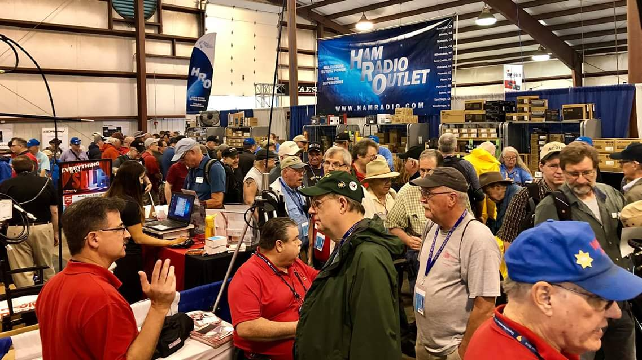
Upcoming Hamfests

We DO have some hamfests scheduled for 2021!! Yes, take a good look at the list, it’s growing every day!

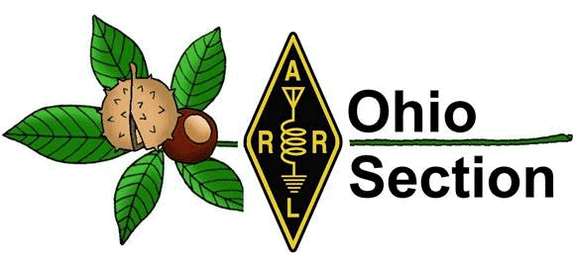
Be sure to keep your eyes on this schedule as that when things start getting better and the vaccine rolls out to more and more, hamfests will surely get back to their normal schedule. Don’t see your hamfest listed?? Did anyone register it with ARRL? It’s really easy to do and you get a lot of FREE publicity if you do.

Ohio Hamfests
2022

09/10/2022 - Ashtabula County Hamfest
Location: Pierpont, OH
Sponsor: Amigos Radio Club Ashtabula and Ashtabula County Amateur Radio Club
Learn More

09/11/2022 - Findlay Hamfest  Location: Findlay, OH  Sponsor: Findlay Radio Club  Website: https://www.findlayradioclub.org/  Learn More | 09/17/2022 - Mound Amateur Radio Assoc. Swap Meet  Location: Miamisburg, OH  Sponsor: MARA  Website: http://W8DYY.ORG  Learn More
09/25/2022 - Cleveland Hamfest  Location: Berea, OH  Sponsor: Hamfest Association of Cleveland  Website: http://www.hac.org  Learn More | 10/15/2022 - Portsmouth Radio Club Hamfest  Location: New Boston, OH  Sponsor: Portsmouth Rado Club, Jett Fire, Shawnee  Website: http://www.portsmouthradioclub.org  Learn More
10/30/2022 - Massillon Hamfest (OH)  Location: Green, OH  Sponsor: Massillon Amateur Radio Club  Website: http://w8np.org  Learn More | 12/03/2022 - FCARC WinterFest  Location: Archbold, OH  Sponsor: Fulton County Amateur Radio Club  Website: https://k8bxq.org/hamfest  Learn More

FINDLAY HAMFEST is less than 5 weeks away!
Based on feedback from our guests and vendors, we’re implementing a few changes and additions (and keeping several popular features) to make the 2022 FINDLAY HAMFEST, on Sunday, September 11, an even bigger success than last years amazing event!

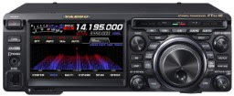
PRIZES: Yes - we’ll still offering the chance to win a popular HF rig (Yaesu FT DX-10) or a “handy” HT (FT-60R) - but we’ll also have prize drawings every half hour with hundreds of dollars in gift certificates to be given away so that you can pick up some nice “finds” at the Hamfest!
ONSITE HAM LICENSE TESTING: For the first time (at least in a very long time) we’re adding onsite, online, license testing. Pass your test on Saturday and have your license by Tuesday (typically). Find out more at www.FindlayRadioClub.org (There’s a $14 fee for license testing, but we’ll throw in free admission to the Hamfest.) So upgrade your license and/or bring along your yet-to-be licensed friends.
SPECIAL EVENT STATION: Come work our special event station. If you hold a Technician license, here’s your chance to make some HF contacts! Or bring along your unlicensed friends (or grandkids) and get them on the air for their first time. (And take home a nice certificate.)
ADDITIONAL FOOD VENDOR: We’re doubling our food vendors, and adding breakfast, to provide greater variety and faster service (and additional seating).
SAME ADMISSION PRICE AS LAST YEAR: We’re all faced with higher gasoline and diesel prices, but admission to the FINDLAY HAMFEST is still only $10 - with no additional parking fee. Admission for kids and youth under 18 years old is FREE! Likewise for Scout leaders in uniform. Bring along your kids, your grandkids, your neighbors, your Scout troop, your 4H club… Buy your tickets online at www.FindlayRadioClub.org or at the gate on the day of the event.
PERFECT WEATHER: Just kidding… but we had great weather in 2021! We’ll keep our fingers crossed.

Hancock County Fairground: 8AM – 2PM SUNDAY 11 Sept 2022
1017 East Sandusky, Street, Findlay, Ohio 45840

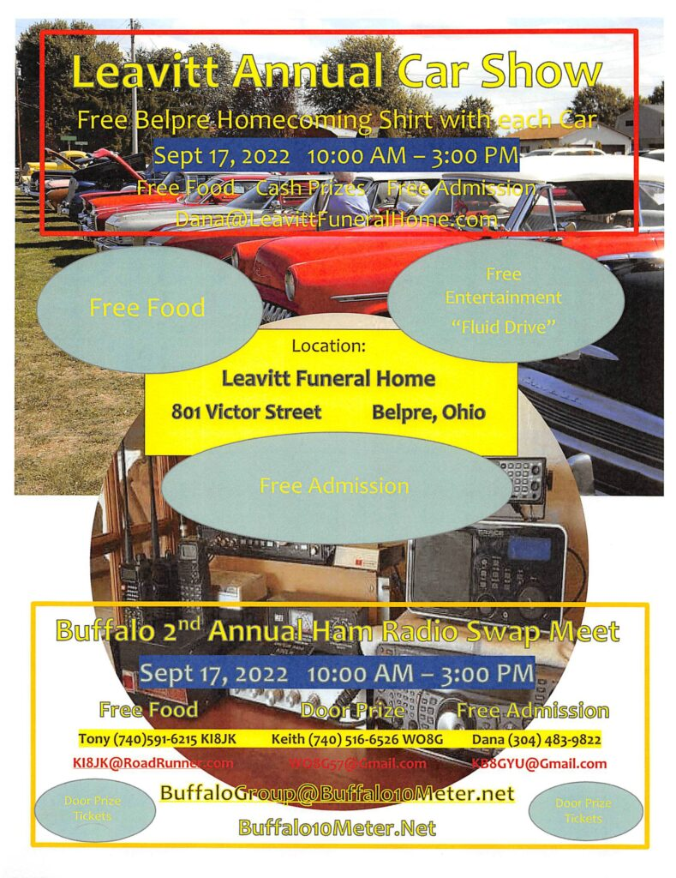
Massillon Hamfest
The Massillon Amateur Radio Club (MARC) is again proud to sponsor what has become on the nation's top hamfests. We are again inviting guests from all over the country to join us at MAPS air museum at the Canton-Akron Airport in Green, Ohio.

Date:10/30/2022
Location: Military Air Preservation Hangar (MAPS) 2260 International Parkway Green, OH 44232
Sponsor: Massillon Amateur Radio Club
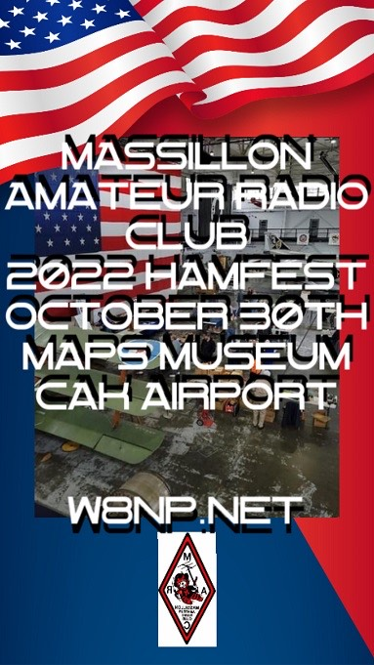
Look for more details in the weeks ahead. Attendees and Vendors:For a brochure or for further information please contact MARC at club@w8np.net. We Are looking forward to seeing you at MAPS this year! Tables are on sale on the website.

Fifteenth Annual Ohio State Parks On The Air – Amateur Radio Contest

Make sure to mark your calendar for the 2022 Ohio State Parks On The Air (OSPOTA) contest – September 10, 2022. The contest is always held on the first Saturday following the Labor Day holiday. Each year this event has grown and we anticipate another year of growth with even more participating Amateur Radio Operators.
Let me remind you that the OSPOTA contest was conceived with three main goals in mind:
- To promote public awareness of amateur radio and Ohio’s beautiful state parks system;
- To contribute to the recognition that Ohio has a very diverse and wonderful ecology;
- To promote camaraderie within the ranks of Ohio’s Amateur Radio Operators
Your participation has allowed these goals to be achieved. We agree it is a lot of fun to get out in a natural setting with your radio and see how well you can do at working operators in the beautiful Ohio State Parks.
This will be the 15th annual OSPOTA – Make plans now to be active in OSPOTA 2022.
Don’t forget – we have an OSPOTA E-mail Group located at: https://groups.io/g/OSPOTA
The OSPOTA IO Group page is used for messaging and sharing of information about OSPOTA for all the fans and participants in the OSPOTA contest. The E-mail Group is where the action is.
Since we do allow spotting to encourage more contacts during OSPOTA, Facebook is being used before and during the contest for instant updates and to share stories and photos.
As the contest draws near, we’ll be posting on the OSPOTA E-mail Group page the anticipated ‘who’s going to be at what Ohio State Park’ or ‘Planned Park’ list as we have in past years. Send your planned park activation information to PlannedParks@ospota.org . Please, include the call sign that will be used and the Ohio State Park you plan to be at. If your plans change, just let us know and we’ll update the list. Remember, more than one person or group can be at an Ohio State Park – there are no reserved State Parks.
Notes: Some Ohio State Parks are being managed by local park systems, but they are still listed and considered to be Ohio State Parks according to ODNR (Quail Hollow & Tinkers Creek).
So – pick a park and make your plans now for OSPOTA 2022 !!!!!! Take care & 73 from the entire OSPOTA contest Committee, KB8UUZ, WG8X, W8PT, W8KNO, KB8UHN
Tom, KB8UUZ OSPOTA Chairman OSPOTA
Questions? Email: INFO@ospota.org
When the OSPOTA contest is over, send Logs and Summary Sheets to: Logs@ospota.org

Print an Official or Unofficial Copy of Your Amateur Radio License
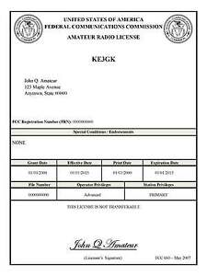
(By Anthony Luscre, K8ZT)

As of February 17, 2015, the FCC no longer routinely issues paper license documents to Amateur Radio applicants and licensees. The Commission has maintained for some time now that the official Amateur Radio license authorization is the electronic record that exists in its Universal Licensing System (ULS). The FCC will continue to provide paper license documents to all licensees who notify the Commission that they prefer to receive one.

Licensees also will be able to print out an official authorization — as well as an unofficial “reference copy” — from the ULS License Manager. I’ve created a set of instructions on how you can request an “official” printed copy of your license*

Click here to download the instructions

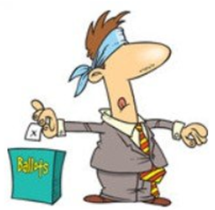
One Question Questionnaire

Hey Gang,

Last weeks question “If you had to pick one? DX’ing or contesting

Survey Says 45 (62.5%) DX’ing, 27 (37.5%) Contesting. The new question is:

where would you spend your money? a) better antenna system?
or B) More power?

You’ll find the “One Question” questionnaire on the Ohio Section Website! http://arrlohio.org It’s all for fun and it’s not a scientific survey in any way, but we are learning some things that we didn’t know from these questions. I hope that you are enjoying answering these “One Question” questionnaires.

V.E. Test Sessions

Many V.E.’s have decided to start testing once again, but with restrictions that need to be adhered to for sure. Here’s the link to find that V.E. Test session and what is expected of YOU before going. http://www.arrl.org/find-an-amateur-radio-license-exam-session

A 'Colonel' of truth to Hogan's Heroes
We all know the late '60's TV show Hogan's Heroes was somebody's imagination. But, in many unbelievable situations, there is a 'Colonel' of truth.

From the book I am reading, Most Secret War by R. V. Jones, comes this. RV Jones was the young PhD hired by the British government to bring some "science" to their War effort and analysis of what the Germans were doing with their science. Quickly, he was heavily involved in the "Battle of the Beams", the German use of radio beams (where they crossed) to pinpoint their targets at night accurately. He figured out the "what," "why," and "how" of the beams and and how to jam or 'pull' the beams off course.

He was one of the few in on the Enigma decodes, unable to tell anyone why he was having them (the radio/radar monitoring service, or even why he was requesting specific and high-risk to the pilots of photo recon missions) look for X or need to photograph an 'anti-aircraft gun' placement - right down their sites! (It was a (new) radar site, but he couldn't tell them how he knew what it was. He just needed a picture of 'it.')

To get some important information, one of 'his' Top Secret cleared (but not Enigma) Lab Assistants (Cundall) volunteered to ride a night bombing mission to get some critical SIGINT on German radars to figure how it worked in the German Night Defenses. The plane was shot down, all bailed out. ONE crew member made good his escape, so the Germans did not know they had 'one extra' crew to arouse their suspicions.

Pg 265, note the Stalag # (and see further below) "... While in Stalag Luft 3 he not only concealed his knowledge of our new radar devices, but built a radio transmitter with which he opened contact between camp and London, maintaining it even during the long march eastwards as the Germans pulled back the prisoners in the late stages of the war. In this way he provided information from captured air crew regarding their experiences with the German night defenses, and thus aided our offensive even from behind the barbed wire."

For those who don't know, I grew up close enough to Ft. Hunt (now a Park) in Alexandria, Virginia for it to be my play ground. Turns out there were multiple ultra secret operations going on there in WW II. So many aircrew were being shot down, they were teaching many how to write secret messages in their letters home. They were also building and shipping stuff (like radio receivers built into Mumbly Peg boards, maps, German money, cameras, film) under food stuffs (like 7 chocolate bars, or cans of condensed milk, or cigarettes) to bribe the German Inspectors with. They had to create two 'Good Samaritan' organizations to send this stuff through the Red Cross and Switzerland. They were SO successful they feared the POWs would be shot as spies with all those cameras, film, maps, and German money!

Nobody knew that 50 years later (~1992). A visitor on a tour there one day said "and right over there was ....." The Park Service thought he was lying, but they ran into a stone wall of silence from the Army. It took a bit, but after 50 years, they got it declassified, but also had to get new letters of authorization to each surviving member to talk about it, because not one would!!

So, as I said, a 'Colonel' of truth....

From the Ft. Hunt link, note the name of the Stalag:
From https://www.nps.gov/articles/forthuntww2.htm

"The Escape and Evasion Program
"Even more secret than the strategic interrogation program was Fort Hunt’s escape and evasion (E&E) program (MIS_X). Even the fort’s commandant was unaware of this mission to prepare U.S. servicemen to evade capture by the enemy and, if captured, to escape. This was particularly crucial for the Army Air Force. The Eighth Army Air Force flew daylight bombing raids over Nazi-controlled Europe and Germany itself, a hazardous undertaking in which numerous planes were shot down and survivors captured.

"The British had already discovered the need for such a program, having started such bombing before America entered the war. The P.O. Box 1142 program was modeled on the British one and began operations in February 1943. The nerve center of this program was located in the renovated old post hospital, the site of the current Picnic Pavilion A.

" One mission of the E&E program was to create maps of areas where bombers were going so downed airmen could use them to find their way back. Silk maps created at P.O. Box 1142 were distributed to the Air Force for that use. Also, 5 million uniform buttons were created containing hidden compasses.

" Codes created to enable captured airmen to communicate with P.O. Box 1142 were taught to selected airmen known as “code users” or “CU.” If captured, the CUs would send letters home to fictitious addresses, which the Post Office knew to send to P.O. Box 1142. The 14 cryptologists in the E&E program would decode the messages and send them through the chain of command. The information transfer was both to aid in escape activities and to convey to the U.S. military the intelligence that the prisoners gleaned in captivity.

" The E&E program created two fictitious prisoner relief organizations and used their names to send care packages to the POW camps. But those packages were a cover for smuggling escape and evasion materials into the camps. Letters to the CUs in the camps would inform them in advance of the incoming packages. The E&E program succeeded in hiding compasses, tissue paper maps, counterfeit German currency, radios and similar items in those packages. By 1944, the E&E program was sending between 80 and 120 packages each day to German POW camps.

" American companies were enlisted secretly to assist in this effort. For example, an electronics manufacturer made the four components of a specially designed miniature radio transmitter, placing each component in a separate capsule. The capsules were then shipped to a baseball manufacturer that wound each capsule into a color-coded baseball. At the prison camps, the components were extracted and assembled into transmitters. Another company inserted map segments between special peel-away outer layers in playing cards. Another donated cartons of cigarettes in which crystal radio receivers were hidden.

"In March 1944, 76 Allied POWs escaped from the North Compound of Stalag Luft III through one of the three long and deep tunnels that they had dug. For five months prior to the breakout, MIS-X had been sending escape aids to the camp. All but three of the escapees were captured, and Hitler had 50 of them put to death. None of the escapees were Americans, as they had all been transferred to the South Compound eight weeks before the escape. One and a half million German troops were diverted to catch the escapees. The 1963 movie “The Great Escape” chronicled this escape.

"During the war, the Germans captured 95,532 U.S. servicemen. Of those 737 escaped. It is not known how many managed to evade capture due to the E&E program. While the number of escapees was not large, the E&E program contributed to the morale of U.S. airmen sent on dangerous missions over enemy territory and of those captured. "

Arnal 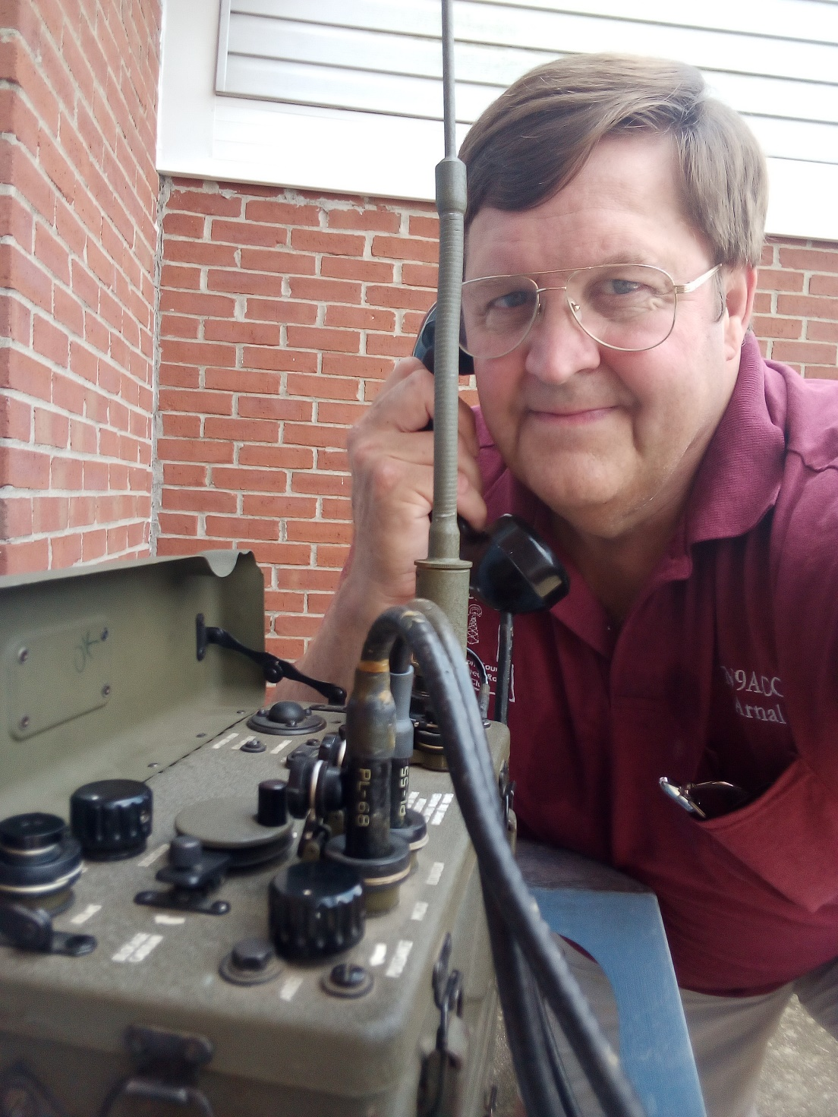
N9ACC

Final… Final

I’ve spent some time here this morning putting together this issue of the Ohio Section Journal and as I’m coming down to the end of it I’m thinking to myself, there’s an awful lot of “Stuff” going on in the Amateur Radio hobby! When you think about all the club meetings, activities both on air and off, zoom meetings, public service events, nets, Hamfests, things to be built and tested, studying to be done to pass the next test, or just remain up-to-date – it’s easy to get sucked in to where Amateur Radio becomes a defining aspect of your life! And there’s nothing wrong with that!

Some people have declared that Ham Radio is Dead. Yet, how many days in a week are there some HAM activity you could participate in available to you? How about those days where you have to choose between two (or more) Ham Radio activities? What a fantastic dilemma for those of us who are really engaged with this “dead hobby” to be confronted with!

HAM RADIO has had a positive impact on and has been intimately involved with much (most) of the advancements that mankind has made in the last 100 years in the areas of Science and Technology. For much of that time, Hams were recognized as “the cool kids” because of the things we were involved with. While we are still involved in those things today, society has come to take the advancements that have been made in Science and Technology for granted, and we have lost our “cool kid” status.

I see Science and Technology continuing to move forward and do so at a faster pace than it has in even the past 100 years. To put that in perspective, look at where we were in the early 1900’s to where we are today. Now compare the advances we made between 1922 and 1972 versus the advances we have made from 1972 to present. Pretty amazing. To keep that moving forward, society needs us. Ham Radio is a “gateway” to the future. It’s one of the last few places where we can teach, learn and apply some pretty advanced technology outside of a school on industrial setting, and have FUN doing it! Be a cool kid – even if everyone else just thinks you’re a nerd.

73, de
Tom WB8LCD OH Section Manager
WB8LCD@ARRL.ORG
330-554-4650

“Swap & Shop” on the website

Hey Gang,

Have you taken a look at the Swap & Shop page on the Ohio Section webpage yet?? Here’s a link that will take you there…
http://arrl-ohio.org/sm/s-s.html

Do you have equipment that you just don’t need or want anymore? Here’s a great venue to advertise it, and it’s FREE!!

Is your club doing a fund raiser to help raise money? After a lot of thought, it was decided that the Swap & Shop webpage could also contain these types of items as well.

The same rules will apply as do for the For Sales and Give-A-Ways and will only be posted for a month at a time. Please see the Terms & Conditions on the webpage.

If your club is doing a fund raiser and wants more exposure, please forward the information to me and I’ll advertise it on the Swap & Shop webpage for you. Now, I still want to remind you that it won’t be listed in this newsletter because it would take up way too much space, so your ad will only appear on the website. It is there for any individual to post equipment Wanted / For Sale or Give-Away as well as for Club Fund Raisers. No licensed vehicles/trailers or business advertising will be posted.

Postings are text only (no pictures or graphics) will be posted for a maximum of 1 month from date posting and require a contact phone number or email within the posting. Send your Wanted / For Sale or Give-Away post to: swap@arrlohio.org

Back Issues of the PostScript and Ohio Section Journal

Hey, did you know that PostScript and Ohio Section Journal (OSJ) are archived on the website? You can go back and look at any edition simply by clicking:
http://arrl-ohio.org/news/index.html

Ohio Section Cabinet
Section Manager – Tom Sly, WB8LCD | Section Emergency Coordinator – Stan Broadway, N8BHL
Technical Coordinator – Jeff Kopcak, K8JTK | Section Traffic Manager – David Maynard, WA3EZN
State Government Liaison – Bob Winston, W2THU | Affiliated Clubs Coordinator – Tom Sly, WB8LCD
Section Youth Coordinator – Anthony Lascre, K8ZT | Public Information Coordinator – John Ross, KD8IDJ

Chit – Chat, and All That!

Do you know someone that’s not getting these Newsletters? Please, forward a copy of this Newsletter over to them and have them “Opt-In” to start receiving them. Heck just have them send an email to: webmaster@arrl-ohio.org to be added.

We now have many thousands of readers receiving these newsletters weekly. Quite impressive, I’d say! I urge all of you to make sure that everyone, regardless of whether they are a League member or not, get signed up to receive these weekly Newsletters.

You can always “Opt-Out” at any time if you feel this is not what you were expecting. It’s fun and very informative. All of your favorite past newsletters are now archived too.
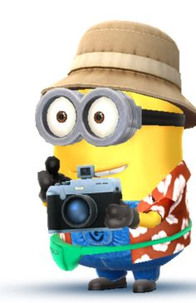
You can go back at any time and read them. Just go to: http://arrl-ohio.org/news/

The pictures on the front page and throughout this newsletter are from various newsletters, Facebook posts and/or were sent directly to me in recent weeks. Take a good look at them, you just might be in one of the pictures! “SMILE… you’re in the Ohio Section News!!”

The Ohio Section Journal (OSJ) is produced as a comprehensive look at all the programs within the Ohio Section. I sincerely hope that you have enjoyed this edition of the OSJ and will encourage your friends to join with you in receiving the latest news and information about the Ohio Section, and from around the world!

TOP^

