[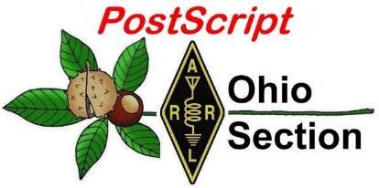](http://arrl-ohio.org/news/) ***“September 6th***

***Edition”***

🡪 National News 🡪 Club Corner

🡪 DX This Week 🡪 Contest Corner

🡪 Upcoming Hamfests 🡪 One Question Questionnaire

🡪 VE Testing 🡪 South 40

**[U.S. DEPARTMENT OF LABOR](https://www.dol.gov/)**

* MENU**History of Labor Day**

Observed the first Monday in September, Labor Day is an annual celebration of the social and economic achievements of American workers. The holiday is rooted in the late nineteenth century, when labor activists pushed for a federal holiday to recognize the many contributions workers have made to America’s strength, prosperity, and well-being.

**Early Adopters**

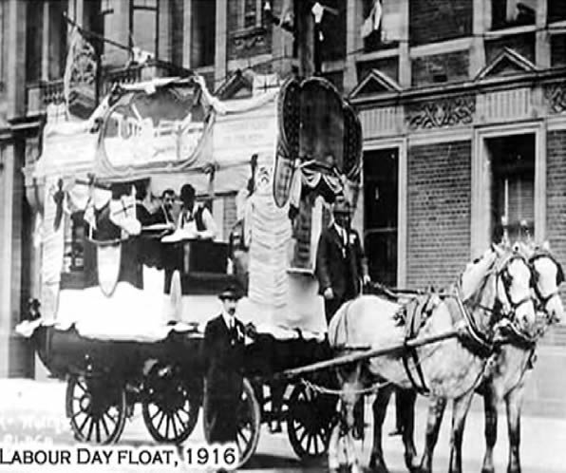Before it was a federal holiday, Labor Day was recognized by labor activists and individual states. After municipal ordinances were passed in 1885 and 1886, a movement developed to secure state legislation. New York was the first state to introduce a bill, but Oregon was the first to pass a law recognizing Labor Day, on February 21, 1887. During 1887, four more states – Colorado, Massachusetts, New Jersey and New York – passed laws creating a Labor Day holiday. By the end of the decade Connecticut, Nebraska and Pennsylvania had followed suit. By 1894, 23 more

states had adopted the holiday, and on June 28, 1894, Congress passed an act making the first Monday in September of each year a legal holiday.

**McGuire v. Maguire: Who Founded Labor Day?**

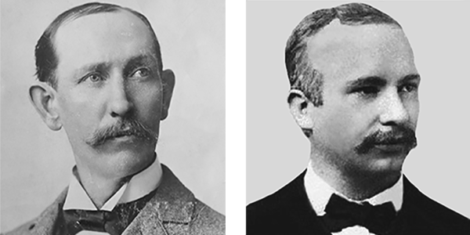

Who first proposed the holiday for workers? It’s not entirely clear, but two workers can make a solid claim to the Founder of Labor Day title.

Some records show that in 1882, Peter J. McGuire, general secretary of the Brotherhood of Carpenters and Joiners and a co-founder of the American Federation of Labor, suggested setting aside a day for a "general holiday for the laboring classes" to honor those "who from rude nature have delved and carved all the grandeur we behold."

But Peter McGuire's place in Labor Day history has not gone unchallenged. Many believe that machinist Matthew Maguire, not Peter McGuire, founded the holiday.

Recent research seems to support the contention that Matthew Maguire, later the secretary of Local 344 of the International Association of Machinists in Paterson, New Jersey, proposed the holiday in 1882 while serving as secretary of the Central Labor Union in New York.

According to the New Jersey Historical Society, after President Cleveland signed the law creating a national Labor Day, the *Paterson Morning Call* published an opinion piece stating that "the souvenir pen should go to Alderman Matthew Maguire of this city, who is the undisputed author of Labor Day as a holiday." Both Maguire and McGuire attended the country’s first Labor Day parade in New York City that year.

**The First Labor Day**

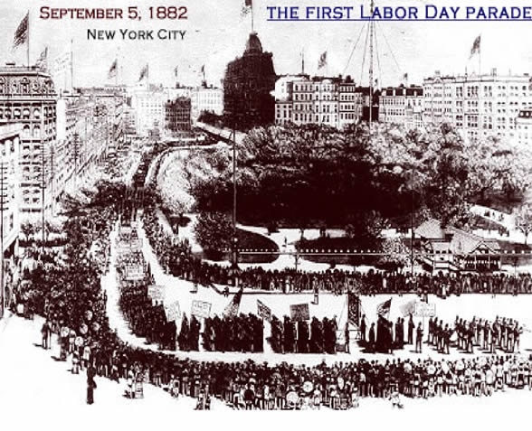

The first Labor Day holiday was celebrated on Tuesday, September 5, 1882, in New York City, in accordance with the plans of the Central Labor Union. The Central Labor Union held its second Labor Day holiday just a year later, on September 5, 1883.

By 1894, 23 more states had adopted the holiday, and on June 28, 1894, President Grover Cleveland signed a law making the first Monday in September of each year a national holiday.

**A Nationwide Holiday**

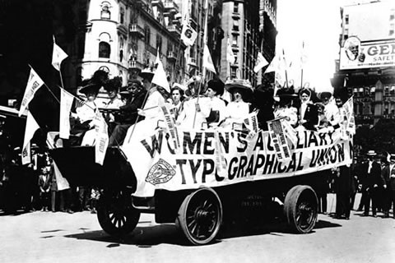Many Americans celebrate Labor Day with parades, picnics and parties – festivities very similar to those outlined by the first proposal for a holiday, which suggested that the day should be observed with – a street parade to exhibit "the strength and esprit de corps of the trade and labor organizations" of the community, followed by a festival for the recreation and amusement of the workers and their families. This became the pattern for the celebrations of Labor Day.

Speeches by prominent men and women were introduced later, as more emphasis was placed upon the economic and civic significance of the holiday. Still later, by a resolution of the American Federation of Labor convention of 1909, the Sunday preceding Labor Day was adopted as Labor Sunday and dedicated to the spiritual and educational aspects of the labor movement.

American labor has raised the nation’s standard of living and contributed to the greatest production the world has ever known and the labor movement has brought us closer to the realization of our traditional ideals of economic and political democracy. It is appropriate, therefore, that the nation pays tribute on Labor Day to the creator of so much of the nation's strength, freedom, and leadership – the American worker.

**CQ CQ CQ de WB8LCD**

I hope you will enjoy this long weekend off as much as I am planning to. Labor Day is one of those “holidays” that everyone looks forward to, but we never really talk too much about what the holiday is all about. I hope the article above, taken from the website of the US Department of Labor, gives you some insight. In my own opinion, LABOR has been, and will continue to be, one of the things that makes America Great! All labor is, at it’s core, honorable and should be respected. All honest labor is for the benefit of not only the laborer, but all his fellow citizens. Every laborer, whether the lowest in the organization up to and including the president, should be respected for his contribution to our national success.

Next weeks PostScript could be a day late. On Saturday, September 11th I’ll be at Punderson State Park with OHIO State Parks On The Air team K8IV – I hope you’ll all look for us and give us a Q! Sunday I’ll be travelling to the Findlay Hamfest. Please, stop by the ARRL table and say hello.

Mike Love – WB8YKS sent me the following: “In preparation for the (SOARA) Lake Vesuvius iron furnace special event station and Fox Hunt I encourage you to review the attached brochure from the US Department of Forestry.  As with any visit to a forested land there are safety issues. This brochure does an excellent job addressing the risks. We want to have a safe and enjoyable event for everyone!

<https://www.fs.usda.gov/Internet/FSE_DOCUMENTS/stelprdb5063216.pdf> “ I thought this might be interesting for anyone going to their event, and/or OSPOTA.

Our first Ohio Section technical session - “Beyond the Baofeng: Thoughts on Equipment Choices for New Hams” held on Thursday August 31 was an interesting and well attended ZOOM event. We had approximately 44 people signed in for the presentation. Most appeared to be either new hams, or soon to be new hams. Ohio Section Technical Specialist Jason McCormick– N8EI gave us all some useful information, and, I think he did an excellent job for the new hams as they start to look ahead at upgrading to General Class. Stay tuned, we’ll be doing more of these “Technical Sessions” as time rolls on.

Finally, I want to say “Thank you” to Michael Kalter – W8CI – who has been involved with OH State Legislators working on HB 283 – the OHIO distracted driving bill. Michael has introduced himself to his local state representative and from there has had the opportunity to “educate” our legislators on what Amateur Radio is and why it is important for us to have a “carve out” in their legislation.

From Michael: “Hello All,

Here is an update on HB 283. This bill is currently in the House Criminal Justice Committee where it has received its 2nd hearing in June 2021. Here is a link to the testimony.

<https://ohiohouse.gov/legislation/search>. Type in HB 283 into search box

Both sponsors of this bill have submitted an amendment to the Chairman’s Office that would exempt Amateur Radio Operators from HB 283.  State Representative Brian Lampton's offices requested that the amendment be considered at the next hearing on HB 283. While the next hearing is at the direction of the Chairman, committee meetings are scheduled to resume beginning the week of September 13.

Vy 73, Michael Kalter, W8CI”

There’s a TON of Stuff going on in the Amateur Radio world. I hope you are involved with our hobby and having fun! I also hope that you are taking part in the Public Service opportunities that come your way – they are an important piece to why we exist and have all the RF Spectrum allocations we do. Turn off your TV and turn on your Radio(s)!

Tom Sly – WB8LCD

ARRL OHIO Section Manager

330-554-4650

**___________________________________________________________**

***National News***

*(from arrl and other sources)*

*QSL Cards Missing Their Owners!*

8th Call District QSL Incoming Bureau

For those of you who have QSL cards coming in from the ARRL Incoming QSL Card Bureau here’s a quick note. All cards except the letter “S” were mailed out this week. The 8th Call District is now all caught up.

The number one issue that we are having is all of the unclaimed cards. There are literally thousands of them. We need your help with getting the lost owners to their cards. Please, if you haven’t checked with your specific card sorter, and you’ve worked some DX in the last year or so, you really need to check with them and see if you still have envelopes with them and if you have unclaimed cards. Here’s a picture of just some of cards, and there’s over 30 pounds of cards that aren’t even pictured here, waiting for their lost owners to claim them.

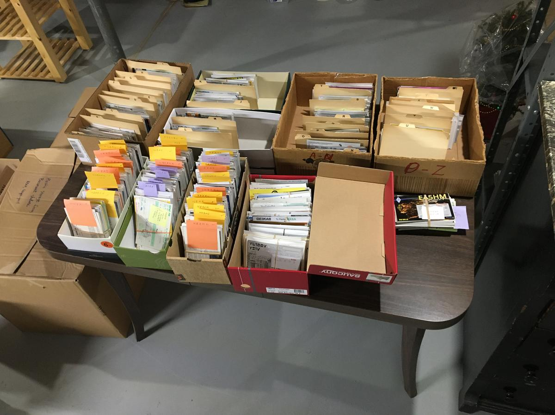

Now, you say you don’t know who your card sorter is? Well, here’s a link to each one of them.  <http://arrl-greatlakes.org/8th_bureau.htm>

73,

Jack, N8DX

8th Area Bureau Manager

[w8buro@gmail.com](mailto:w8buro@gmail.com)

The K7RA Solar Update

Tad Cook, K7RA, Seattle, reports: Solar activity has been on the upswing this week. Average daily sunspot numbers increased from 21.7 to 50.6, with a high of 77 on Saturday, September 28. Average daily solar flux rose from 78.5 to 88.

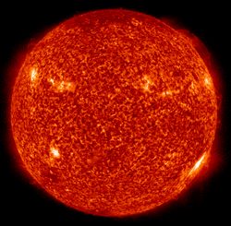Average daily planetary A index increased from 4.7 to 9.6, and average daily middle latitude A index went from 5.7 to 10.7. Geomagnetic activity peaked on August 27 - 28 due to a coronal mass ejection.

Predicted solar flux looks promising, at 84, 82, and 80 on September 2 - 4; 78 on September 5 - 6; 75 on September 7 - 9; 80 on September 10 - 14; 85 on September 15; 90 on September 16 - 30; 85 on October 1, and 80 on October 2 - 10.

Predicted planetary A index is 30 and 12 on September 2 - 3; 5 on September 4 - 5; 8 on September 6; 5 on September 7 - 10; 10 and 8 on September 11 - 12; 5 on September 13 - 20; 8 on September 21; 5 on September 22 - 25; a big jump to 25, 8, 18, 8, and 12 on September 26 - 30, and back to 5 on October 1 - 7.

Sunspot numbers for August 26 - September 1 were 47, 73, 77, 44, 41, 37, and 35, with a mean of 21.7. The 10.7-centimeter flux was 88.6, 89.5, 89.9, 88.7, 90.6, 84.4, and 84.2, with a mean of 78.5. Estimated planetary A indices were 6, 20, 14, 8, 7, 7, and 5, with a mean of 4.7. Middle latitude A index was 6, 19, 17, 9, 9, 9, and 6, with a mean of 5.7.

A comprehensive K7RA Solar Update is posted Fridays on the ARRL website. For more information concerning radio propagation, [visit](http://arrl.org/propagation-of-rf-signals) the ARRL Technical Information Service, [read](http://arrl.org/the-sun-the-earth-the-ionosphere) "What the Numbers Mean...," and [check out](http://k9la.us/) the Propagation Page of Carl Luetzelschwab, K9LA.

A propagation bulletin [archive](http://arrl.org/w1aw-bulletins-archive-propagation) is available. For customizable propagation charts, visit the [VOACAP Online for Ham Radio](https://www.voacap.com/hf/) website.

[Share](mailto:k7ra@arrl.net) your reports and observations.

__________________________________________________________________________________________

|  |
| --- |
|  |

Katherine Forson, KT5KMF, Receives the 2021 ARRL Hiram Percy Maxim Memorial Award

Increasing the interest and participation in amateur radio of those younger than 21 remains a primary effort of ARRL. Underscoring that focus is ARRL's annual bestowing of its premier award, the Hiram Percy Maxim Memorial Award, on a young member whose contributions to both amateur radio and her local community embody the ideals of the Amateur Radio Service.

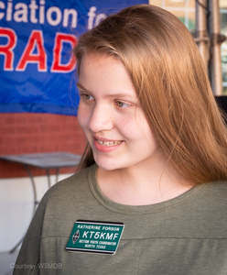The recipient of the 2021 Hiram Percy Maxim Memorial Award is Katherine M. Forson, KT5KMF, of Plano, Texas. A Technician in 2013 at the age of 9, a General in 2017, and an Amateur Extra in 2018, Katherine's enthusiasm resulted in her appointment as the North Texas Section Youth Coordinator in 2019.

She is an active member of the Plano Amateur Radio Klub and Collin County RACES, and a trained National Weather Service SKYWARN Storm Spotter; she has been profiled as a *QST* "Member Spotlight," participates as an amateur radio operator in public service events, such as the Plano Balloon Festival, and is currently working with several other female members of the ARRL North Texas Section to help build a female-friendly area of the ARRL NTX Section website.

When not on the radio, Katherine is active in her school and community. A senior at Plano West Senior High School, she carries a 4.46 grade-point average and is a member of the National Honor Society, the Spanish Honor Society, and her high school band. She won second place in the Dallas Regional Science and Engineering Fair, and placed second in the physics and astronomy category at the Texas State Science and Engineering Fair. She serves as a children's lector at her church, and is a Dallas Meals on Wheels volunteer.

The Hiram Percy Maxim Memorial Award consists of a $1,500 cash award and an engraved plaque. West Gulf Division Director John Robert Stratton, N5AUS, and North Texas Section Manager Steven Smith, KG5VK, will present Katherine with her award at the September 20, 2021 meeting of the Plano Amateur Radio Klub.

__________________________________________________________________________________________

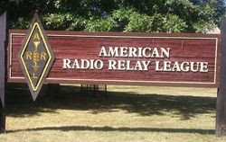**ARRL The National Association for Amateur Radio® has the following employment opportunities at ARRL Headquarters in Newington, Connecticut.** Qualified candidates are invited to [email](mailto:hr@arrl.org) a cover letter and resume to ARRL Human Resources. Visit the ARRL [Employment Opportunities](http://www.arrl.org/careers) page, [**www.arrl.org/careers**](http://www.arrl.org/careers), for more information.

* Acquisitions Editor
* Assistant Marketing Manager
* Director of Emergency Management
* Director of Information Technology
* Lab Engineer EMC/RFI Specialist
* Membership Manager
* Public Relations & Outreach Manager
* Social Media Strategist

ARRL is an equal opportunity employer.

**ARRL HQ has announced new member service hours.** To better serve our members, ARRL Member Services has extended telephone support service hours to 8 AM until 7 PM Eastern Time, Monday through Thursday. The Member Services team will be available at (860) 594-0200 to process address changes, online account support, new memberships, renewals, and publication and product orders. Inquiries for Logbook of The World (LoTW) will continue to be serviced via [email](mailto:LoTW-help@arrl.org), and the ARRL VEC department can be reached directly from 8 AM until 5 PM Eastern Time toll free at (800) 927-7583. We appreciate our members and hope that these new extended hours will make it easier for you to get answers to your membership and product questions.

__________________________________________________________________________________________

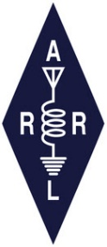

**ARRL** -- **Your One-Stop Resource for  
Amateur Radio News and Information**

* [Join or Renew Today!](http://www.arrl.org/join) Eligible US-based members can elect to receive [*QST*](http://www.arrl.org/qst) or [*On the Air*](http://www.arrl.org/on-the-air-magazine) magazine in print when they join ARRL or when they renew their membership. All members can access digital editions of all four ARRL magazines: *QST*, *On the Air, QEX*, and *NCJ*.
* Listen to [*ARRL Audio News*](http://www.arrl.org/arrl-audio-news), available every Friday.

**Subscribe to...**

* [*NCJ*-- *National Contest Journal*](http://www.ncjweb.com/). Published bimonthly, features articles by top contesters, letters, hints, statistics, scores, NA Sprint, and QSO parties.
* [*QEX*](http://www.arrl.org/qex)-- [*A Forum for Communications Experimenters*](http://www.arrl.org/qex). Published bimonthly, features technical articles, construction projects, columns, and other items of interest to radio amateurs and communications professionals.

**Free of charge to ARRL members...**

* [Subscribe](http://www.arrl.org/myarrl-account-management#%21/edit-info-email_subscriptions) to the *ARES Letter* (monthly public service and emergency communications news), the *ARRL Contest Update*(biweekly contest newsletter), Division and Section news alerts -- and much more!
* Find ARRL on [Facebook](https://www.facebook.com/ARRL.org/)! Follow us on [Twitter](https://twitter.com/arrl) and [Instagram](https://www.instagram.com/arrlhq)!

___________________________________________________________

***Club Corner***

This is YOUR cornner of the newsletter. Send me what your club is doing and I’ll make sure that it gets in. Got a special event or club project that you want everyone to know about? Send it to me! Need help with a project? Send it to me.

Let me know what you club is up to. Are you going to have a special guest at your meeting or are you having a special anniversary?

Just sent it to: [webmaster@arrl-ohio.org](mailto:webmaster@arrl-ohio.org)

******If you want me to publish your club information, or even an article you have written, please send it in WORD format (.docx). Please use Times New Roman font size 12 for the body of the aritcle. Any photos please include as a .jpg or .bmp – the time you save me in doing all the conversions will be greatly appreciated!

**___________________________________________________________**

**10/02/2021 | World's Largest Horseshoe Crab Roadside Attraction**

**Oct 2, 1400Z-2000Z, K8HO**, Hillsboro, OH. Highland Amateur Radio Association. 7.220 14.220. Certificate. Highland Amateur Radio Association, 21 Highland Drive, Hillsboro, OH 45133. [highlandara@gmail.com](mailto:)

**Herald Dispatch News Article SOARA Vesuvius Iron Furnace Special Event 9-18-21**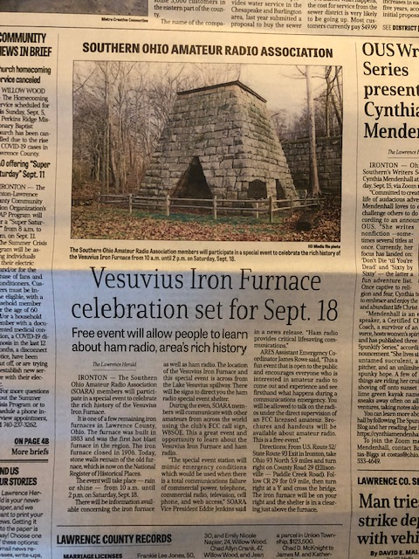

|  |
| --- |
| Great newspaper article by the Herald Dispatch Lawrence Herald about the Southern Ohio Amateur Radio Association (SOARA) Vesuvius Iron Furance Special Event Station September 18,2021.  Mike Love WB8YKS  SOARA / ARES  Ohio Section PIO  <https://www.herald-dispatch.com/news/ohio_news/southern-ohio-amateur-radio-association-to-celebrate-vesuvius-iron-furnace/article_fc42ef85-85f3-57a8-801e-be5fec08cb29.html> |

____________________________________________________________

QCWA Chapter 1 (Cleveland) was recently honored

Chapter 1 was honored at our April 2021 quarterly Zoom meeting, when QCWA President, Ken Oelke, VE6AFO, presented us with the 70 Year Longevity Award. This award not only recognized that we were first chartered on 1 June 1951, but that we have “maintained a membership of outstanding amateur radio operators who have contributed their services to their communities and their country.” Many thanks to President Oelke and the QCWA Board of Directors for this award.

[](https://highlandcountypress.com/)

**To Advertise Call (937) 840-9490**

|  |  |  |
| --- | --- | --- |
| |  | | --- | |  | |  | |

|  |  |  |
| --- | --- | --- |
| |  | | --- | |  | |  | |

Tuesday, August 31, 2021

 

[](https://highlandcountypress.com/Content/In-The-News/In-The-News/RSS/RSS/2/20/0)

Comments (1)

**Local Ham Radio Club to promote local state parks**

On Saturday, Sept. 11, dozens of Ohio amateur radio clubs and individuals will head to a nearby Ohio State Park to participate in the annual Ohio State Parks on the Air operating event.  
  
This event sponsored by the Portage Amateur Radio Club not only calls attention to Ohio’s great state park system, but most importantly serves as a training tool used by ham radio operators to prepare them for responding to calls from national, state or local government or other public officials or agencies that their communications assistance and expertise is needed. During the event hams will go to various state parks, erect temporary antennas and stations and communicate with similar stations operating from other Ohio State Parks.  
  
Additionally, they will make contact with other hams throughout the world who are trying to work parks throughout the world involved with the International Parks on the Air Program sponsored by Europe’s World Wide Flora and Fauna Organization. Currently, over 50 parks in the Ohio State Park system will be represented in the event.  
  
Locally, Highland County’s Highland Amateur Radio Association will operate stations at Paint Creek and Rocky Fork.  
  
According to Club President Pat Hagen, the station at Paint Creek will be located in the campground and the Rocky Fork station will operate either from the old concession stand at Fisherman’s Wharf or from the campgrounds. Additionally HARA member and Ohio University student Blake Gall will set up a station at nearby Lake Hope and a team of HARA members will operate as a "rover."  
  
That team will set up in one park, operate for a time and then tear down only to move to another park where they will again set up, operate, tear down before moving to another park where the procedure will be repeated.  
  
During the eight-hour event, they hope to activate five state parks in the Southern Ohio/Hocking Hills and Rocky Fork park clusters. Another Highland County ham team is expected to operate from Pike Lake.  
  
Hagen invites anyone interested in this activity or learning more about ham radio to visit either the Paint Creek and/or Rocky Fork location to learn more and view ham radio in operation. He says the equipment and antennas used will be of different designs at each location.  
  
The Highland Amateur Radio Association is a nationally recognized club of over 140 federally licensed amateur radio operators and others with an interest in electronics and radio communications living mostly within Highland County.  
  
Membership is open to anyone with a ham radio license or an interest in electronics or radio communications. Information about the club can be found at www.facebook.com/highlandk8ho, highlandara@gmail.com or by contacting HARA Information Officer John Levo at (937) 393-4951.

__________________________________________________________

**From PCARS member KB8UUZ - Parky**

Ran into this on YouTube"

2017 Field Day - K8BF 40 meter station - K8KSU operator  
"Some field day contest action on 40m with **young operator** working several stations in a crowded band."  
  
<https://www.youtube.com/watch?v=EoB6dmReiL4>

____________________________________________________________

**From Stan – N8BHU – Oh Section Emergency Coordinator**

The Ohio EMA is holding a series of planning committees beginning this year for a total solar eclipse that will affect northwest Ohio in April of 2024.  Because they expect hundreds of thousands of spectators, it’s an “all hands” event.

Ohio ARES as “OAR – Ohio Amateur Radio” has been included as a basic group in the overall project. Here’s a screenshot with cover agencies including the ARRL bug, just for your amusement.

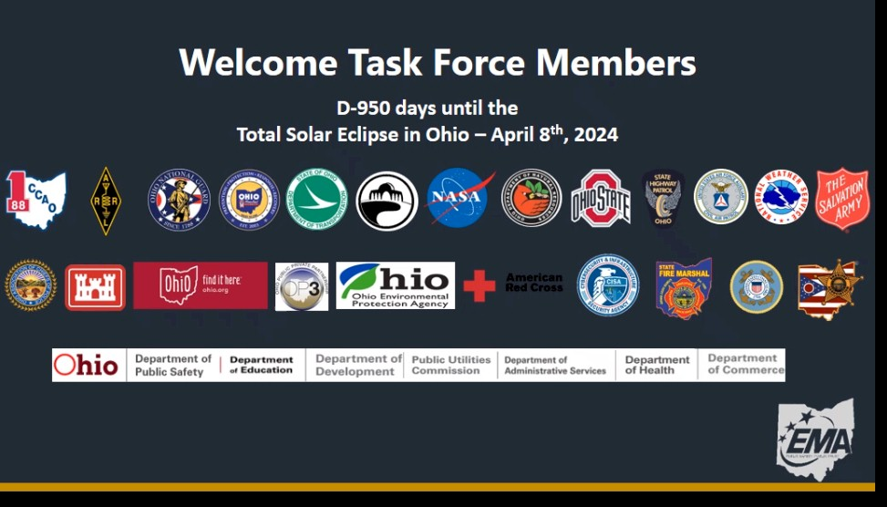

________________________________________________________________________________

VE Sessions

Dayton Amateur Radio Association (DARA) If you are interested in testing for a new or upgraded license, please come see us at the DARA Clubhouse. If you have questions about testing, please email [exams.w8bi@gmail.com](mailto:exams.w8bi@gmail.com)

Lake County Amateur Radio Association (LCARA)

Saturday October 2, Saturday December 4

All exams start at noon and are held at the Kirtland Library, 9267 Chillicothe Rd. Kirtland, OH

Portage County Amateur Radio Service (PCARS)

Starting on August 7th, PCARS will resume VE testing at the PCARS club site in Ravenna.

Please visit the PCARS web site and check out the information about VE testing in the latest newsletter at [www.portcars.org](http://www.portcars.org) .

If you have any questions, don’t hesitate to contact me at KB8UUZ@gmail,com

On behalf of the VE team at PCARS, we all look forward to getting the VE testing going again and look forward to seeing you there – August 7th -10 am – at the PCARS club site in Ravenna.

**Your Club news should be listed here!**

I know you’re out there doing things! Send me a write-up (MSWord please) and some photo’s (.jpg please) and we’ll get your club hi-lited here for the other OH Section Clubs to see! Send to [WB8LCD@ARRL.ORG](mailto:WB8LCD@ARRL.ORG)

__________________________________________________________________________________________

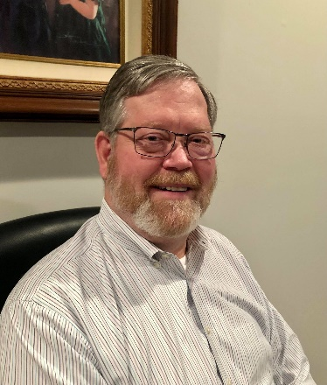DX This Week – W8DXCC Recap

Bill AJ8B (aj8b@arrl.net, @AJ8B, or www.aj8b.com)

CWOPs Member #1567

The Midwest DX Cluster spots included Andorra, Austria, Belgium, Bosnia-Herzegovina, Brazil, Bulgaria, Canada, Colombia, Corsica, Croatia, Czech Republic, Denmark, England, European Russia, Fed. Rep. of Germany, France, Greece, Hawaii, Hungary, Indonesia, Ireland, Italy, Kuwait, Martinique, Mauritania, Mexico, Netherlands, Norway, Poland, Puerto Rico, Romania, Slovenia, Spain, Ukraine, Uruguay, and Western Sahara. This brings the total number of entities spotted in the Midwest in 2021 to 192!

I received a beautiful card from LU8EU – Miguel in Argentina.

I also received a large box of QSL cards from the 8th area QSL manager, Jack, N8DX. Do you have your envelopes and postage in order with your letter manger? I will be getting cards out to those “N” letter hams that I received cards for over the next couple of weeks. If you aren’t sure about this, feel free to drop me an email and I can get you caught up to date.

DAH DIT DIT DIT DAH DAH DIT DIT DIT DAH

The last weekend in August was the W8DXCC convention. We really had an excellent line up of speakers and some excellent prizes to give away. Attendance we lighter that we had hoped for. I think this was due to Covid, Heat, and the Ohio QSO party. However, the folks in attendance really enjoyed the presentations and the DX Roundtable. Many attendees made comments like “If I would have known that the presentations were this good, I would have brought….” We are looking forward to the 2022 DX convention. If you would like more information, go to w8dxcc.com.

SWODXA added several members to our roster! We are excited to have new hams added to our roster as it adds to our pool of experience. If you are interested, you can go to swodxa.org. We have our next meeting on Thursday, September 9th at 6:30 at Marions Piazza in Mason, OH. Hope to see you there.

As I gather comments, I will pass them along here. However, below are some highlight pictures of the event.

|  |  |
| --- | --- |
|  | Tom, WB8LCD, and Scott, N8SY,  Review the days activities and put their plan together. |
| Carl, K9LA – Propagation Expert, his wife Vicky, AE9YL, discuss Tom and Scotts decisions with Bernie, W3UR editor of the How’s DX Column in QST as well as the DailyDX and the WeeklyDX. |  |
|  | The DX Roundtable was a spirited discussion amongst some top tier DXers. From left to right, W3UR – Bernie, W8HC – Hal, K9LA – Carl, K4ZLE – Jay, W8GEX – Joe, and W6IZT – Gregg. An attendee was heard to say that the roundtable alone was worth the price of admission. |
| The first presentation was by W8HC – Hal, and W6IZT – Gregg. The topic was “Radio in a Box” (RIB).  Hal explained the why – putting operators and operator support on an island for a DXPedtion is a huge amount of the effort and cost. What if they could remotely control and entire set of transmitters from the boat anchored a mile or so away? It meets the DXCC rules, so why not?  Gregg explained the How. Flex radios, special cooling, computer-controlled interfaces, network control etc.  This is the first time that a unit was available for public display. Some of the attendees took a few minutes to review it and ask questions.  Could be a game changer! |  |
|  | Joe, W8GEX, gave an excellent presentation on his DXPedition to Swains Island, NH8S, in 2012. Of all the DXpeditions Joe has been on, he said that this one has affected him to this day! (Heat, bugs, etc.)  Joe followed the presentation with a video of the local Samoans driving the 4-wheeler from the loading barge to the ship while at sea. Quite entertaining.  Bernie – W3UR, and Rob – W8MRL, look on. |
| K9LA, Carl, is giving an overview of Propagation basics, our previous cycles and the future for Cycle 25.  He did not answer the question “Why have sunspots aligned with contest weekends?” In other words, even at the bottom of the cycle, I hear that the bands are dead and then make a couple of hundred Qs on a contest weekend. Could it be that I need to call CQ on those non-contest weekends?  W3UR – Bernie looks on. I think he has the best seat in the house! |  |
|  | Finally, W3UR, Bernie, gets his chance. Bernie is the center of all DX knowledge and really gave us a fine overview of the top 25 most needed countries.  Bernie came over from Maryland and was a hit at the Cincinnati Hamfest and the DX convention. |
| K8DV, Dave, is receiving a plaque for being instrumental in bringing about the 2nd W8DXCC DX Convention. Dave is pivotal in SWODXA and the Milford Amateur Radio Club.  Thanks, Dave, for all of the effort! |  |
|  | The grand prize winner was Bob Shiflett, KC8GAE. The radio, an Icom IC-7300, was donated by Icom and DXEngineering. Thanks to both companies, as well as all of the other prize donors, for the great prizes. |

CQDX CQDX CQDX CQDX CQDX CQDX CQDX CQDX CQDX

Here is an update from Bernie, W3UR, of the DailyDX and the WeeklyDX, the best source for DX information. <http://www>.dailydx.com/. Bernie has this to report:

**HC8 - Galapagos Islands** **-** HD8R will be an international team for 14 days at the end of October, says EA5RM, Toni. For six meters, he says, it will be a five-element Yagi and a beacon, hoping for openings.

**PJ5 & PJ7 – St. Eustatius & Sint Martin -**PJ7JA is an expedition in October. W5JON, John, says it’s been several years since PJ5, St. Eustatius, has been on, but all the flights to PJ5 require a stop in Sint Maarten, PJ7, so he has decided to get on from there too, five days from there, then on to PJ5 for eight days. He says all the travel would have been less difficult to arrange if he had been able to start from St. Kitts, his V47JA QTH, but travel restrictions there have made that difficult. Instead, the travel starts from Houston, Texas. John plans on making 2-3 trips year to PJ5 and/or PJ7. In normal times there is a direct ferry from St. Kitts to both. He and his wife are usually on St. Kitts for a month. He would typically take a week out for those side trips.

**OE – Austria -** Celebrating the 120 years of the Nobel Prize and Austrian awardees are stations with the OE120 prefix.  This officially started yesterday and goes to the end of the year. The "OEVSV Landesverband Steiermark" is organizing it.  Here are callsigns on the air:   OE120AGD, OE120BKC, OE120DMT, OE120SGU, OE120TWA, OE120U, OE120WDR, OE120XFG, OE120XKJ, OE120XDX, OE120XGM, OE120XRC and OE120YXK.  Certificates for working them are available, with basic, master, basic-CW and master CW levels. Details on that are here:  [oe120bkc@a1.net](mailto:oe120bkc@a1.net)  
  
**I – Italy -** Special call II60ANT is part of the celebration of the 60 years of the Antarctic Treaty System, which was agreed to in 1961.  Stations all over the world are getting on the air with special commemorative callsigns like this one and hopefully some Antarctica stations will be on too.  II60ANT plans to be active October 1 to December 31.  [www.waponline.it](http://www.waponline.it).

**VK9/N - Norfolk Island -** VK2DX, Nick Hacko, says VK9DX (his upcoming new call) is not an expedition; he plans to settle on the island as a permanent resident.  Norfolk Island and New South Wales, VK2, are both currently in covid lockdown.  He and his wife are waiting for the travel restriction to lift and then they're moving there.  The new QTH is five acres with plenty of room for antennas.  He says, "I am looking forward to spending as much time as possible stretching wires and playing radio!"

**Press Release #5 from 3Y0J team   
3Y0J DXpedition to Bouvet Island, November 2022**

We are happy to announce that Northern California DX Foundation has voted to grant $100,000 to the upcoming 3Y0J DXPedition to Bouvet. This is an all-time high donation and matches the previous donation given to Bouvet projects. The 3Y0J team is very grateful and honored in the trust NCDXF has shown by supporting our project.

The DXPedition will be carried out by “Amateur Radio DXpeditions”, a Norwegian non-profit organization created for the purpose of conducting DXpeditions. With an overall budget of $650,000 this will be the most expensive DXPedition ever. With the NCDXF donation we hope to succeed in the fundraising as our first payment milestone for the vessel contract is approaching. By end October we will pay 30% of the vessel contract, and by that time we must have regained confidence that we can succeed financially. We critically need upfront donations to be able to make it. While we have a solid plan, a “young and strong team”, a dedicated crew and vessel Marama – we need your upfront support to go there and make 120,000 QSOs from Cape Fie at Bouvet.

Donations to the 3Y0J project can be done through paypal on our website or by bank wire transfer.

We wish to recognize and thank the Northern California DX Foundation as the Lead Sponsor for our 3Y0J DXPedition to Bouvet. Without the support of the NCDXF, operations to the world’s rarest entities would be difficult.   
  
You can follow our plans from our website and the 3Y0J Facebook pages:  
[http://www.3y0j.no](http://www.3y0j.no/)   
<https://www.facebook.com/groups/3093983840726129>  
   
Thank you,   
  
Ken Opskar LA7GIA, Co-Leader   
Rune Oye LA7THA, Co-Leader   
Erwann Merrien LB1QI, Co-Leader

DAH DIT DIT DIT DAH DAH DIT DIT DIT DAH

Below is a list of upcoming contests in the “Contest Corner”. I think this is important for someone who is trying to move up the DXCC ladder since entities that are on the rarer side and easiest to work in contests. Some of my best “catches” have been on the Sunday afternoon of a contest when the rarer entities are begging for QSOs. Of course, the gamble is that if you wait until Sunday, conditions may change, or they simply won’t be workable. However, it is not a bad gamble. Of course, why not work the contest and have some fun!  
Check out the WA7BNM Contest Calendar page (<https://www.contestcalendar.com/>) and CQ Magazine for more contests or more details.

The contests in red are those that I plan to spend some significant participation time on. PLEASE let me know if you are working contests and how you fared.

Thanks!

|  |  |  |
| --- | --- | --- |
| Sept. 8 | VHF-UHF FT8 Activity Contest | [www.ft8activity.eu/index.php/en](http://www.ft8activity.eu/index.php/en) |
| Sept. 11 | FOC QSO Party | [www.g4foc.org/qsoparty](http://www.g4foc.org/qsoparty) |
| Sept. 11-12 | Alabama QSO Party | [www.alabamaqsoparty.org](http://www.alabamaqsoparty.org) |
| Sept. 11-12 | SARL Field Day | <http://bit.ly/H0IqQf> |
| Sept. 11-12 | Russian Cup Digital Contest | [www.qrz.ru/contest/detail/86.html](http://www.qrz.ru/contest/detail/86.html) |
| Sept. 11-12 | Worked All Europe SSB Contest | <http://bit.ly/2vufgcb> |
| Sept. 11-13 | ARRL September VHF QSO Party | [www.arrl.org/september-vhf](http://www.arrl.org/september-vhf) |
| Sept. 12 | North American CW Sprint | <http://ncjweb.com/Sprint-Rules.pdf> |
| Sept. 15 | RSGB Autumn Series CW | <https://bit.ly/3p4eShW> |
| Sept. 16 | Bavarian Contest Club QSO Party | <https://bit.ly/2MDzviG> |
| Sept. 18-19 | ARRL 10 GHz and UP Contest | [www.arrl.org/10-ghz-up](http://www.arrl.org/10-ghz-up) |
| Sept. 18-19 | Iowa QSO Party | [www.w0yl.com/IAQP](http://www.w0yl.com/IAQP) |
| Sept. 18-19 | New Hampshire QSO Party | [www.w1wqm.org/nhqso](http://www.w1wqm.org/nhqso) |
| Sept. 18-19 | New Jersey QSO Party | <http://bit.ly/1nDlf8V> |
| Sept. 18-19 | QRP Afield | <http://bit.ly/2QACxFu> |
| Sept. 18-19 | SARL VHF/UHF Digital Contest | <http://bit.ly/H0IqQf> |
| Sept. 18-19 | Scandinavian CW Activity Contest | [www.sactest.net/blog](http://www.sactest.net/blog) |
| Sept. 18-19 | Texas QSO Party | <http://txqp.net> |
| Sept. 18-19 | Washington State Salmon Run | <http://salmonrun.wwdxc.org/rules> |
| Sept. 19 | BARTG Sprint PSK63 | <http://bartg.org.uk/wp/contests> |
| Sept. 19 | North American RTTY Sprint | <http://ncjweb.com/Sprint-Rules.pdf> |
| Sept. 20 | 144 MHz Fall Sprint | <http://svhfs.org/wp> |
| Sept. 23 | RSGB Autumn Series Data | <https://bit.ly/3p4eShW> |
| **Sept. 24 & 25** | **W4DXCC DX and Contest Convention** | [www.w4dxcc.com](http://www.w4dxcc.com) |
| Sept. 25 | AGCW UHF/VHF Contest | <https://bit.ly/3lw91PK> |
| Sept. 25-26 | CQWW RTTY DX Contest | [www.cqwwrtty.com](http://www.cqwwrtty.com) |
| Sept. 25-26 | Maine QSO Party | [www.ws1sm.com/MEQP.html](http://www.ws1sm.com/MEQP.html) |
| Sept. 28 | 222MHz Fall Sprint | <http://svhfs.org/wp> |
| Sept. 29 | UKEICC 80m Contests CW | <https://bit.ly/2SDPqQQ> |

***_____________________________________________________________________________***

***DX NEWS***

SB DX ARL ARLD035  
ARLD035 DX news  
  
This week's bulletin was made possible with information provided by The Daily DX, the OPDX Bulletin, 425 DX News, DXNL, Contest Corral from QST and the ARRL Contest Calendar and WA7BNM web sites.  Thanks to all.  
  
NIGER, 5U.  Adrien, F4IHM will be QRV as 5UAIHM from September 11 to October 22.  Look for him on 40 and 20 meter CW.  QSL via F4IHM, direct or via the Bureau.  
  
MALAWI, 7Q.  Vasco, 7Q7CT is active on 40, 20 and 15 meters.  QSL via JH1AJT.  
  
MONGOLIA, JU1.  Jaeseok, HL1WP is active as JU1WP from Ulanbator. Activity has been mainly on the LEO satellites.  QSL only via LoTW.  
  
THE GAMBIA, C5.  Operators Luc, F5RAV, Gerard, F5NVF and Abdel, M0NPT will be active as C5C from October 24 to November 19. Activity will be on various HF bands using CW, SSB, digital modes  
and the QO-100 satellite.  QSL via F5RAV.  
  
COLOMBIA, HK.  Lothar, DK8LRF be QRV as HK3JCL until end of May 2022.  Activity will be mainly on 20 meter SSB.  QSL via his home call sign via the Bureau.  
  
GUINEA, 3X.  Jean-Philippe, F1TMY will be QRV as 3X2021 starting in mid-September.  He plans to be active on 160 to 6 meters and on the QO-100 satellite.  He will also operate portable from the Los  
Islands (AF-051).  QSL via ClubLog.  
  
LITHUANIA, LY785.  Valerijus, LY2QT will be active as LY785QT during the month of September to celebrate 785th anniversary of the City of Siaulai.  Activity will be on various HF bands and modes.  QSL via LY2QT.  
  
UNITED STATES, N7.  Members of the American Legion Post 10 Amateur Radio Club (N7ALA) will be active using special event call sign N7F (Never7Forget) from September 9 to 12 to commemorate the 20th anniversary of the 9/11 attacks.  Activity will be on 40 and 20 meters using SSB, PSK-31 and CW.  QSL with SASE to N7F Never Forget, c/o American Legion Post 10, 1215 Pacific Blvd SE, Albany, OR 97321.  
  
SLOVENIA, S5030.  Alex, S50DX is active as S5030DX until December 31 to celebrate 30th anniversary of the independence of the Republic of Slovenia.  QSL via LoTW or eQSL.  
  
GREECE, SX021.  Operators Manos, SV1IW and Miroslav, YT7MPB will be active as SX021IEEE until September 15 to promote the 26th IEEE Symposium on Computers and Communications.  All contacts will be confirmed via LoTW.  For a paper QSL please send your QSL card to the SV Bureau via SV1IW.  
  
IRELAND, EI.  Charlie, EI8JB plans to operate from Bere Island (EU-121) as EJ8JB from September 16 to 19.  He will be using SSB, CW, RTTY and PSK on the HF bands and possibly on FM satellites.  QSL via LoTW and OQRS.  
  
SAUDI ARABIA, HZ.  Francisco, EA5VD is signing 7Z1VD on 20 meter CW and SSB.  QSL via EA5GL.  
  
LEICHTENSTEIN, HB0.  Tina, DL5YL and Fred, DL5YM will be on the air from September 5 to 28.  They will operate holiday style signing HB0/home calls on 160 to 6 meters using mostly CW and RTTY, and some SSB.  QSL via home calls (d/B).  
  
THAILAND and DENMARK, HS and OZ.  During September and October, special event stations HS400OZ and OZ400HS celebrate 400 years of friendly relations between Thailand and Denmark.  Operators are Lars, OZ1FJB, Carsten, OZ4CG, Allis, OZ1ACB, Henning, OZ2I, Jack,  
HS1FVL, and Champ, E21EIC.  QSL to HS400OZ via E21EIC, LoTW, ClubLog.  QSL to OZ400HS via ClubLog OQRS, LoTW, eQSL.  
  
UNITED STATES, K.  Members of the Alabama Contest Group (ACG)  
commemorate the attacks of 9/11 with the call sign K4A from September 5 to 12.  They will be QRV on 160 to 6 meters on CW, SSB, RTTY and FT8.  QSL via WA1FCN direct.  
  
TANZANIA, 5H.  Maurizio, IK2GZU will be active from September 25 to November 20 as 5H3MB on various HF bands using CW, SSB, RTTY and FT8.  QSL to IK2GZU direct, via the Bureau and ClubLog.  Also, QSL via LoTW, after his return home, and eQSL.  
  
CENTRAL AFRICA, TL.  The Italian DX Team plans to have seven operators working as TL8AA using CW, SSB, RTTY and TL8ZZ using FT8 on 160 to 6 meters during the Spring of 2022.  
  
Please see September QST, page 70 and the ARRL and  
WA7BNM Contest websites for details.

**___________________________________________________________________**

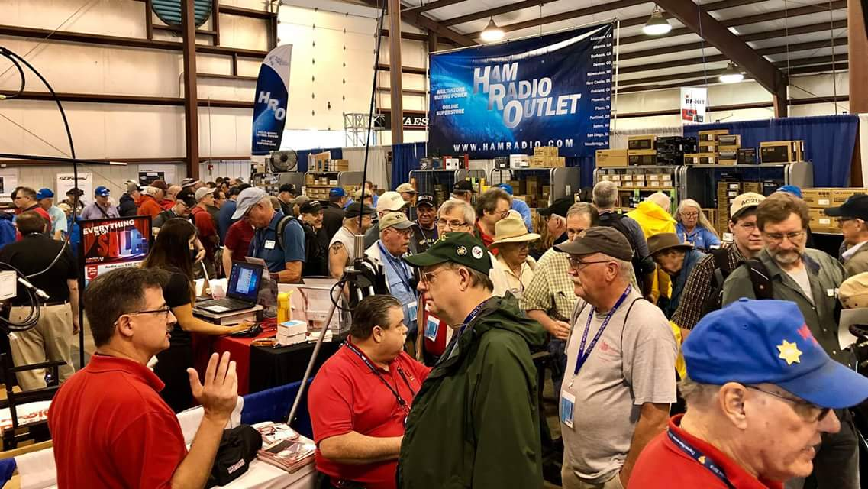[**Upcoming *Hamfests***](http://arrl-ohio.org/hamfests.html)

We **DO** have some hamfests scheduled for 2021!! Yes, take a good look at the list, it’s growing every day!

|  |
| --- |
|  |
| **09/12/2021 -**[**Findlay Hamfest**](http://www.arrl.org/hamfests/findlay-hamfest-8) Location: Findlay, OH Sponsor: Findlay Radio Club Website: <http://www.findlayradioclub.org/hamfest>  [**Learn More**](http://www.arrl.org/hamfests/findlay-hamfest-8) | **09/18/2021** - [**Miami County Swap Meet**](http://w8fw.org/)  **Location:**Troy, OH  **Sponsor:** Miami County Amateur Radio Club  **Website:** [http://w8fw.org](http://w8fw.org/)    [**Learn More**](http://w8fw.org/) |
| **09/18/2021 -**[**Mound Amateur Radio Assoc. Swap Meet**](http://www.arrl.org/hamfests/mound-amateur-radio-assoc-swap-meet)  **Location:**Miamisburg, OH **Sponsor:** MARA **Website:** [http://W8DYY.ORG](http://w8dyy.org/)  [**Learn More**](http://www.arrl.org/hamfests/mound-amateur-radio-assoc-swap-meet) | **09/26/2021 -**[**Cleveland Hamfest**](http://www.arrl.org/hamfests/cleveland-hamfest-1)  **Location:**Berea, OH **Sponsor:** Hamfest Association of Cleveland **Website:** [http://www.hac.org](http://www.hac.org/)  [**Learn More**](http://www.arrl.org/hamfests/cleveland-hamfest-1) |
|  |  |
| **10/02/2021 -**[**10th Annual Vette City Hamfest,**](http://www.arrl.org/hamfests/10th-annual-vette-city-hamfest-arrl-great-lakes-division-convention)  [**ARRL Great Lakes Division Convention**](http://www.arrl.org/hamfests/10th-annual-vette-city-hamfest-arrl-great-lakes-division-convention)  **Location:**Bowling Green , KY  **Sponsor:** Kentucky Colonels Amateur Radio Club  **Website:** [https://ky4bg.com](https://ky4bg.com/)  [**Learn More**](http://www.arrl.org/hamfests/10th-annual-vette-city-hamfest-arrl-great-lakes-division-convention) | |
| **10/09/2021 -**[**Northwest Ohio Amateur Radio Club (NWOARC) hamfest**](http://www.arrl.org/hamfests/northwest-ohio-amateur-radio-club-nwoarc-hamfest)  **Location:**Westminster, OH **Sponsor:** NWOARC, Northwest Ohio Amateur Radio Club **Website:** [http://www.nwoarc.com](http://www.nwoarc.com/)  [**Learn More**](http://www.arrl.org/hamfests/northwest-ohio-amateur-radio-club-nwoarc-hamfest) | **10/31/2021 -**[**Massillon (Ohio) Hamfest**](http://www.arrl.org/hamfests/massillon-ohio-hamfest)  **Location:**Green, OH **Sponsor:** Massillon Amateur Radio Club **Website:** [http://w8np.org](http://w8np.org/)  [**Learn More**](http://www.arrl.org/hamfests/massillon-ohio-hamfest) |
| **11/06/2021 -**[**GARC Hamfest**](http://www.arrl.org/hamfests/garc-hamfest-4) **Location:**Georgetown, OH **Sponsor:**Grant Amateur Radio Club  [**Learn More**](http://www.arrl.org/hamfests/garc-hamfest-4) | **12/04/2021 -**[**FCARC WinterFest**](http://www.arrl.org/hamfests/fcarc-winterfest-2)  **Location:**Delta, OH  **Sponsor:** Fulton County Amateur Radio Club  **Website:**<http://k8bxq.org/hamfest>    [**Learn More**](http://www.arrl.org/hamfests/fcarc-winterfest-2) |
|  | |
|  | |

This section is to report OH Section Hamfests, Division and National Events. I do want to put a plug in for a new Fest, just over the border in Kentucky. The Paintsville, KY Hamfest will be held on 9/25 from 8:00am until 2:00pm. You an get complete information at <http://www.ky4arc.com> .

Be sure to keep your eyes on this schedule as that when things start getting better and the vaccine rolls out to more and more, hamfests will surely get back to their normal schedule. Don’t see your hamfest listed?? Did anyone register it with ARRL? It’s really easy to do and you get a lot of FREE publicity if you do.

**___________________________________________________________________**

**OHIO’S** 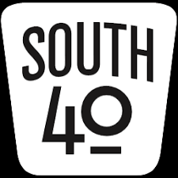

Welcome to the Labor Day edition when we honor the working women and men whose toil and labor has made this nation great. Did you know Ohio has a piece of the history of how Labor Day was founded? In fact that piece comes for our own South 40 region and you have to go no further than the Greene County village of Cederville’s corporation sign to see that the “Father of Labor Day-James H. Kyle” was born in that village in 1854. Several other communities and people claim to be Labor Day’s founder and even the Department of Labor gives credit to another, but we’ll support Cederville’s claim for their native son.

September is officially here and Summer has unofficially ended as it’s fair time in Highland County. So between the livestock shows, 4H projects and elephant ears it’s time to let you know what’s taking place radio-wise in the South 40.

The big news is the September 11 Ohio State Parks on the Air contest. It’s a time when many Southern Ohio clubs and/or individuals take to one of our great state parks, set up a temporary radio station and play radio for the day. The objective is to work as many other similar stations operating from other state parks thus making others aware of our great state park system. It’s also a good time to call attention through the media of the effort and let the public know what ham radio can do. Since a purpose of the contest is to promote the parks for recreation and visitor uses, have you let your county Chamber of Commerce or Convention and Visitor Center know of your efforts? Visit the [www.ospota.org](http://www.ospota.org) website and learn more about the event. Try it! You might like it!

A check of OSPOTA’s website indicate over 50 of Ohio’s 75 state parks will see activity. Although most Southern Ohio parks will have activity of some type, a handful are still up for grabs. Here are park activations the South 40 knows of. Three rovers (KD8MQ, K8RYU and W8KIW) are expected to be active at some unclaimed parks during the day. Charlie Vance, N8CEV, says the **Blanchester Radio Club** will be at Lake Cowan as will the **Clinton County ARC**. Will Baker, KC8OKJ, will be at Pike Lake. The **Highland ARA** will activate both Paint Creek and Rocky Fork while HARA member Blake Gall will work portable from Lake Hope. Shawnee will see action from the **Portsmouth RC** and Adams Lake will be activated by the **DeForest ARA**. The **Fayette ARA**’s K8FAY will be heard at Deer Creek and Steve Newland, N8TUW, will be at Great Seal. Jesse Stanley, KC8CHP, says the **Scioto Valley ARC** will set up at Tar Hollow. The **Athens County ARA** will venture into nearby Stroud’s Run while neighboring **Sunday Creek ARF** and **Hocking Valley ARC** will be at Burr Oak and Lake Logan. According to Lyn Alfman, the **Cambridge ARA** will set up W8VA at Blue Rock.

On Sunday, September 12, several Southern Ohio hams will make the trip to Findlay for one of Ohio’s best hamfests hosted by the **Findlay Radio Club** at the Hancock County Fairgrounds. Besides the usual inside and outside flea market vendors, there will be some seminars presented. Overnight camping is available to those wishing to go up early and catch the bargains before the gates open on Sunday morning. R & L Electronics tells us they will not be in attendance this year because of COVID. This hamfest is normally well worth attending.

Due to Labor Day the **Portsmouth Radio Club** changed their normal first Monday of the Month meeting date to the following Monday. Therefore they will meet in the first floor meeting room at the American Legion building on September 13. A Laurel VE test session will be held prior to the meeting. A delegation from the **Highland ARA** and perhaps the **Scioto Valley ARA** will be present to promote their upcoming special event stations.

On September 11 the **Greater Mason County ARA** will provide communications for the 13th Annual Limestone Cycling Tour. If past tours are any indication, the four routes starting in downtown Maysville will have over 800 cyclists participating in the event winding through the beautiful countryside around Maysville and surrounding areas.

Eastbound motorists entering Ironton/South Point on US 52 will be greeted by the Lawrence County Chamber of Commerce’s media panel telling of the upcoming **Southern Ohio ARA** special event “Iron Furnace on the Air” station on September 18. The event happens at the site of the historic iron furnace at the Vesuvius Recreation area. According to Mike Love, WB8YKS, the Ohio Department of Transportation indicates thousands of vehicles pass this location each day. Another neat resource SOARA uses to promote ham radio and club activities. On September 24-25 the **West Chester ARA** will observe the 77th anniversary of the Voice of America by operating special event station WC8VOA. Look for them on 40 and 20 meters.

October will see another couple of clubs conducting special event observations. On October 2 the **Highland ARA** will operate from the “World’s Largest Horseshoe Crab” site in Hillsboro and later in the month the **Scioto Valley ARA** will be at the spooky Moonville Tunnel in Vinton County. Stay tuned for additional information to come.

Jerry Lockhart, W8HIC, reminds all the **Portsmouth RC**’s test session has been changed because of the Labor Day holiday. It will start at 5:30 PM prior to the club’s meeting at the American Legion Post in Portsmouth. VE Team Leader Mike Boyle, WF8B, announces the **Clinton County ARA** will have a VE test session on September 26 at the Boyd Cancer Center in Wilmington. It will begin at 2 PM. **Highland ARA** VE Team Leader Tom Mongold, Jr., KD8LDS, says they have reserved space at the Highland County EOC for a November 20 exam session.

Past **Milford ARA** President and well-known DXer and ARRL QSL card checker Dave Vest, K8DV, will be a speaker at the October 2 ARRL Great Lakes Division Convention DX Forum. The Convention is at the Western Kentucky University Conference Center in Bowling Green, KY.

Speaking of testing, KD8LDS, reports a highly successful VE session was held at the **Milford ARC**’s Greater Cincinnati Hamfest. Twenty people set for at least one element with 16 passing. Seven earned their first license, eight upgraded to General and one is now an Amateur Extra.

Most were from the Greater Cincinnati area, but one young lady was from the Chicago area.

Tom states a number of people pre-registured, but did not show. As a courtesy, if you pre-register and later find you are unable to attend a test session-please attempt to let them know. That way the start of a test session won’t be held up awaiting your expected arrival.

The **Cambridge ARA** will have a “Picnic In The Park” on Saturday afternoon, September 18 in the Cambridge City Park. All the action starts at 1 PM in one of the small pavilions near Eighth Street. Those attending are asked to bring a covered dish, drinks and their appetites. Families and friends are also invited to attend. Table service will be provided. A radio will be monitored for providing information to those unsure of how to get to the location.

Over 20 years ago the **Highland ARA** held a series of RF tracking exercises we now call ‘Foxhunts’. That training became needed when a county police department needed help tracking someone intentionally interfering with their radio transmissions. That led to the person being located and appearing before a judge. Another call came from the FAA when they feared an airplane was down in a remote area, but could not confirm it. Unfortunately their fears were correct with a couple fatalities. Richie Hagen, N8CUB, will hold the first Foxhunt in many years on Saturday, October 9 starting in Hillsboro. However on September 18 an information session will be held for those interested in participating to become more familiar with what such an event is about.

The winner of the August 21 **Hocking Valley ARC** Foxhunt was Phil Stanley, KB8NZB. According to Bill Hopstetter, W8LGX, Phil is quickly becoming the champion foxhunter in Southern Ohio. He currently has wins in Athens and Hocking Counties. The **Hocking Valley ARC** will hold its next Foxhunt on Saturday, October 16.

Although roughly a month away, the **Athens County ARA** is putting out a call for assistance with providing communications support during two public service events on October 2. The Buckeye Trail Blue Blaze Half Marathon will begin at 9 AM from Shawnee, OH and the Bailey’s Gravel Challenge will start at Noon. If you can assist or want more information, please contact Jeff Slattery, N8SUZ, at 740-592-6124 or his cell at 740-541-0972.

Since it’s Labor Day, I guess it’s time to put those white slacks and shorts away for another year and prepare to dig out the flannel shirts and fleece lined jeans. It’s also time to start planning those fall and winter ham radio activities. One thing to remember is that now is the time to check out your antenna system while the weather is decent. Nothing does more to dampen a ham’s spirits than to look outside during an ice storm and discover your antenna on the ground. Most of us who have been around the block a few times know what repairing an antenna in freezing rain, snow or below freezing temperatures is like. It’s not fun! Special attention should be given to checking guy wires and antenna support lines going through trees and replacing them if necessary. A check of coax connections and lines for possible damage from summer lawn mowing is strongly suggested. Another thing to consider is that with deer hunting season in the not too distant future, it is wise to make sure any coax, antennas or control cables are high enough above the ground that a frightened Bambi is not going to run into them. I’ve heard stories of towers being brought down by a deer hitting a guy wire when escaping a hunter’s bullet.

Until next time, enjoy the final summer holiday for the year. Please be safe, healthy and ham radio active.

73, John, W8KIW

**Print an Official or Unofficial Copy of Your Amateur Radio License**

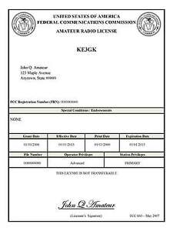*(By Anthony Luscre, K8ZT)*

As of February 17, 2015, the **FCC no longer routinely issues paper license documents** to Amateur Radio applicants and licensees. The Commission has maintained for some time now that the official Amateur Radio license authorization is the electronic record that exists in its Universal Licensing System (ULS). The FCC will continue to provide paper license documents to all licensees who notify the Commission that they prefer to receive one.

Licensees also will be able to print out an official authorization — as well as an unofficial “reference copy” — from the ULS License Manager. I’ve created a set of instructions on how you can request an **“official” printed copy of your license\***

[**Click here to download the instructions**](http://arrl-ohio.org/news/2020/print_your_license.pdf)

***One Question Questionnaire***

I consider this one of the most important questions I’ve put up here, so how about going to www.ARRL-OHIO.org and giving me a click? (It’s in the bottom left corner of the page) I’ll have more to say about this in the next OH Section Journal!

***“Have you ever climbed a tower to work on antennas?”***

From the last Poll: ***“Have you been to a hamfest yet this year?”***

Out of 62 responses: 50% YES 50% NO. We’ve got some coming up! Hope you make it to one.

Ohio Section Cabinet

|  |  |
| --- | --- |
| Section Manager – Tom Sly, WB8LCD | Section Traffic Manager – David Maynard, WA3EZN |
| Section Emergency Coordinator – Stan Broadway, N8BHL | Section Youth Coordinator – Anthony Luscre, K8ZT |
| Technical Coordinator – Jeff Kopcak, K8JTK | Affiliated Clubs Coordinator – Tom Sly, WB8LCD |
| State Government Liaison – Bob Winston, W2THU | Public Information Coordinator – John Ross, KD8IDJ |



Hey Gang,

Have you taken a look at the **Swap & Shop** page on the Ohio Section webpage yet?? Here’s a link that will take you there… <http://arrl-ohio.org/sm/s-s.html>

Do you have equipment that you just don’t need or want anymore? Here’s a great venue to advertise it, and it’s FREE!! Is your club doing a fund raiser to help raise money? After a lot of thought, it was decided that the Swap & Shop webpage could also contain these types of items as well. The same rules will apply as do for the For Sales and Give-A-Ways and will only be posted for a month at a time. Please see the Terms & Conditions on the webpage.

If your club is doing a fund raiser and wants more exposure, please forward the information to me and I’ll advertise it on the Swap & Shop webpage for you.

Now, I still want to remind you that it won’t be listed in this newsletter because it would take up way too much space, so your ad will only appear on the website. It is there for any individual to post equipment Wanted / For Sale or Give-Away as well as for Club Fund Raisers. No licensed vehicles/trailers or business advertising will be posted. Postings are text only (no pictures or graphics) will be posted for a maximum of 1 month from date posting and require a contact phone number or email within the posting. Send your Wanted / For Sale or Give-Away post to:  [swap@arrlohio.org](mailto:swap@arrlohio.org)

***Back Issues of the PostScript and Ohio Section Journal***

Hey, did you know that PostScript and Ohio Section Journal (OSJ) are archived on the website? You can go back and look at any edition simply by clicking:

<http://arrl-ohio.org/news/index.html>

***Want to Share your Club Newsletter With Others?***

We have a webpage where you can download and read all of the newsletters that I get from around the state and even other sections!

Here’s the link to the page…. <http://arrl-ohio.org/club_news/index.html>

Please, if you don’t see your club newsletter posted, it’s because I’m not receiving it. Just have your newsletter editor contact me and I’ll get your club’s newsletter listed on the site!!

We all learn and steal (I mean, share) from each other’s work. So, get me your newsletter!!! Send it to: [webmaster@arrl-ohio.org](mailto:webmaster@arrl-ohio.org)

***Chit – Chat, and All That!***

Do you know someone that’s not getting these Newsletters? Please, forward a copy of this Newsletter over to them and have them “[Opt-In](mailto:Opt-In)” to start receiving them. Heck, just have them send an email to: [webmaster@arrl-ohio.org](mailto:webmaster@arrl-ohio.org) and we’ll get them added to the Ohio Section Emailing list.

We now have many thousands of readers receiving these newsletters weekly. Quite impressive, I’d say! I urge all of you to make sure that everyone, regardless of whether they are a League member or not, get signed up to receive these weekly Newsletters.

You can always “Opt-Out” at any time if you feel this is not what you were expecting. It’s fun and very informative. All of your favorite past newsletters are now archived too.

You can go back at any time and read them.

Just go to: <http://arrl-ohio.org/news/>

The pictures on the front page and throughout this newsletter are from various newsletters, Facebook posts and/or were sent directly to me in recent weeks. Take a good look at them, you just might be in one of the pictures! “SMILE… you’re in the Ohio Section News!!”

*PostScript is produced as a weekly newsletter. I want to thank everyone that has contributed articles and ideas to make this an even better news source. I sincerely hope that you have enjoyed this edition and will encourage your friends to join with you in receiving the latest news and information about the Ohio Section, and news and events happening around the world!*