[](http://arrl-ohio.org/news/) ***“August 23rd***

***Edition”***

🡪 [National News](#national) 🡪 [Club Corner](#club)

🡪 [DX This Week](#dx) 🡪 [Contest Corner](#contest)

🡪 [Upcoming Hamfests](#hamfest) 🡪 [One Question Questionnaire](#one)

🡪 [VE Testing](#ve)

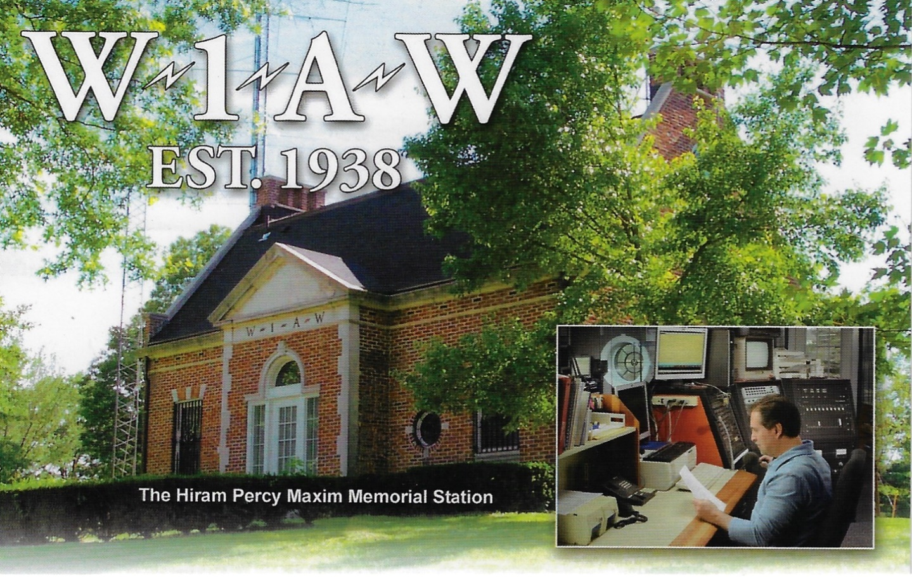

Check out this weeks “One Question Survey” and let us know if you have a card from W1AW!

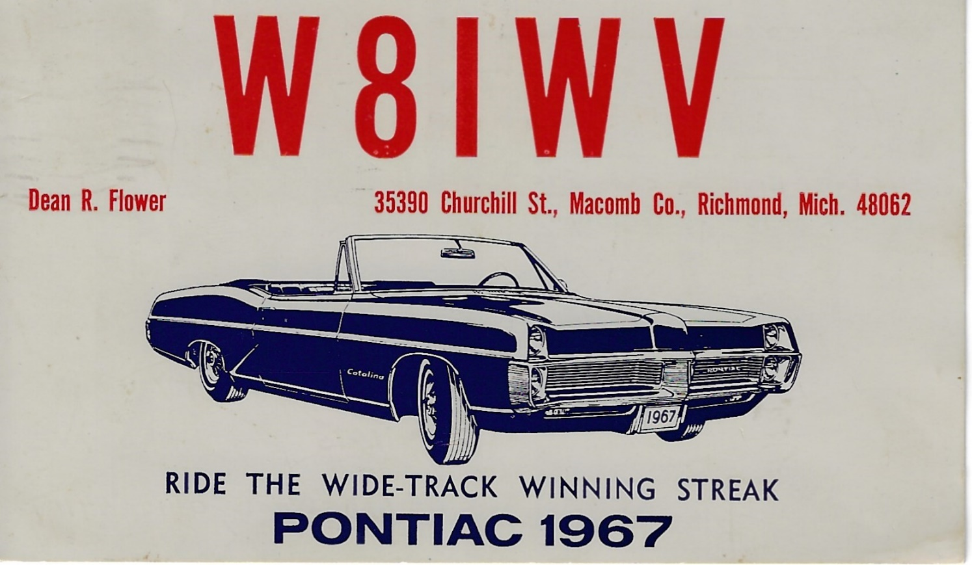

Another card off the wall in my shack. I received this card as an SWL the summer before I took my Novice test. I remember I was staying in my grand-parents attic using the metal bed springs as an antenna for my Hammarlund HQ-110. I did a lot of listening on the ham bands making sure my code speed was good for the test!

**CQ CQ CQ de WB8LCD**

This year has been one of my craziest ever. So far….

On January 1, 2021 I took over as OHIO Section Manager replacing Scott – N8SY. Stepping into Scott’s shoes, I want you to know, if you ever thought Scott wasn’t doing enough as SM – you are sadly mistaken! Believe me when I tell you that I have a new appreciation for all of the ARRL volunteers in all of the positions that they fill. All it takes is a change of perspective to see a lot of what was out of sight before. We owe everyone

serving in these positions our thanks and appreciation for all they do. Not that it always works out the way we would like to see it – remember you’ll never please everyone all at the same time. But without the volunteers that keep every thing moving, I’m sure our hobby would look quite different.

As I’ve gotten older, I’ve had a new appreciation for History. I’m fascinated to see and read about what went on before and what people thought about it and did about it. The History of Radio, and more specifically, Ham Radio, is pretty important not only to our hobby, but to our modern life as well. You would be amazed to find out about how the sinking of the Titanic is probably one of the most important incidents in the history of early radio!

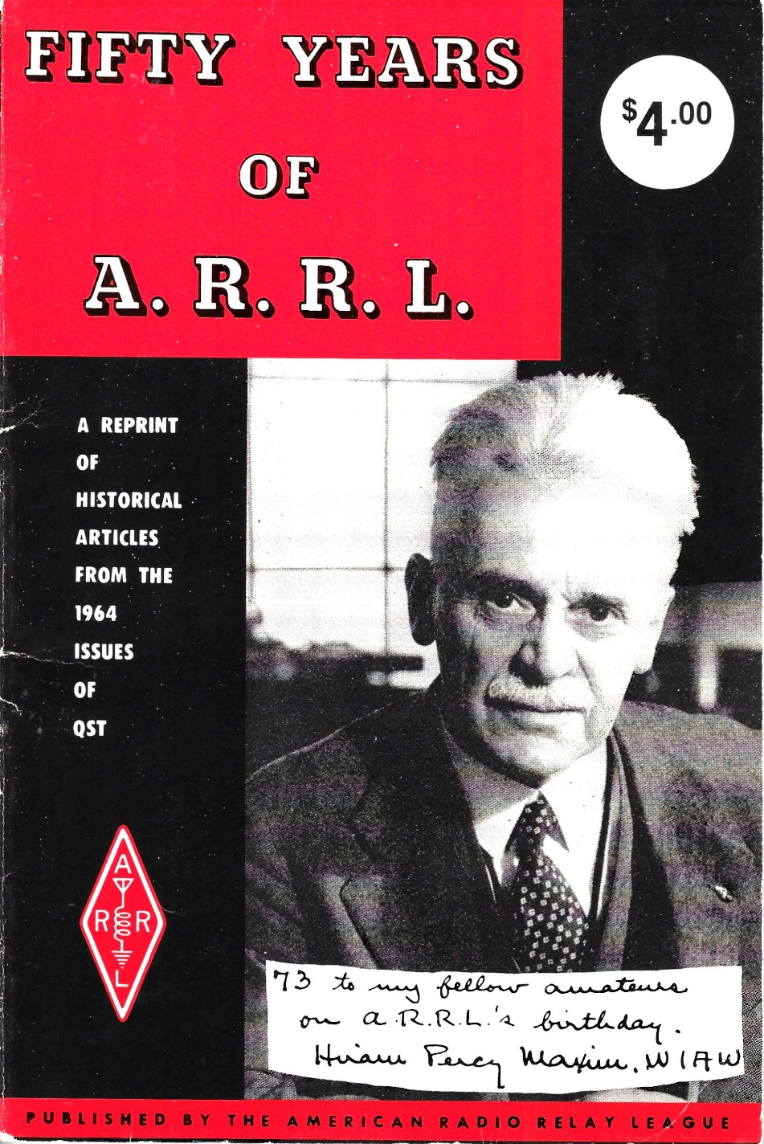This book is probably one of the most interesting books I’ve read on the early years of Amateur Radio, and the ARRL. As if Hiram Percy Maxim wasn’t interesting enough as he relates to the ARRL, all the other things he was involved in, along with his extended family are worth the time to read about. Referred to as “The Old Man”, HPM had a series of articles in earlier issues of QST titled “Rotten Radio”. Check them out – you can pick up old copies of QST at just about any hamfest. They might smell just a bit moldy, but they’re full of some very interesting reading! Just as an aside, at the Great Lakes Division Convention (Bowling Green, KY on October 2nd) you’ll have an opportunity to experience the Wouff Hong ceremony. I want to invite you, and encourage you to come and take part in this important piece of ARRL History. I’ll be at the Cincinnati Hamfest this coming weekend (August 28th) so stop by and let me know if you’ll be wanting to participate in the Wouff Hong ceremony in October.

New Ham? The OHIO Section is sponsoring learning and exploring sessions. Technical Specialist Jason – N8EI will be presenting one of those sessions on August 31st beginning at 7:30pm. His topic is “Beyond the Baofeng: Thoughts on Equipment Choices for New Hams.” You received

your license. Picked up a $20 Baofeng. Tried to reach some repeaters with it. Now what?

Thomas Sly is inviting you to a scheduled Zoom meeting.

Topic: Ohio Section - “Beyond the Baofeng: Thoughts on Equipment Choices for New Hams.”

Time: Aug 31, 2021 07:00 PM Eastern Time (US and Canada)

Join Zoom Meeting

https://us02web.zoom.us/j/89913057151?pwd=QU5qd3gzQUVOclN1VjhpRHIzdGV1UT09

Meeting ID: 899 1305 7151

Passcode: 241591

One tap mobile

+19292056099,,89913057151#,,,,\*241591# US (New York)

+13017158592,,89913057151#,,,,\*241591# US (Washington DC)

Dial by your location

+1 929 205 6099 US (New York)

+1 301 715 8592 US (Washington DC)

+1 312 626 6799 US (Chicago)

+1 669 900 6833 US (San Jose)

+1 253 215 8782 US (Tacoma)

+1 346 248 7799 US (Houston)

Meeting ID: 899 1305 7151

Passcode: 241591

Find your local number: <https://us02web.zoom.us/u/khV0AJOqd>

Don’t forget, I can’t be everywhere and do everything. I’ve been dealing with some unexpected business issues that came up – so I feel like I’m burning the candle at both ends, but I’m making progress… If it takes me a little longer to get back to you on something give me a “gentle nudge” and I’ll get it done. Let me know what your clubs are doing! Let me know what your VE schedule is, let me know about your Special Event stations. I’ll get it all listed here so everyone in the OH Section knows what’s going on. And here’s a hint I hope you’ll all take to heart: When most clubs have activities and events, they’re open to anyone who wants to participate with them! Go check out what the other clubs are doing, make some new friends, learn about an Amateur Radio topic you’ve always been interested in. You can also go to the OH Section website and read the newsletters of the other clubs in the section – there’s a wealth of knowledge there – tap into it!

Tom Sly – WB8LCD

ARRL OHIO Section Manager

330-554-4650

**\_\_\_\_\_\_\_\_\_\_\_\_\_\_\_\_\_\_\_\_\_\_\_\_\_\_\_\_\_\_\_\_\_\_\_\_\_\_\_\_\_\_\_\_\_\_\_\_\_\_\_\_\_\_\_\_\_\_\_**

***National News***

*(from arrl and other sources)*



|  |  |
| --- | --- |
| |  | | --- | | [**Launch Back to School with NASA**](https://r20.rs6.net/tn.jsp?f=0019capZXzrLKqBwjrk06crgevXEU_P9WU--P_8AaraFOnpvnx9CKi-GDALgpgh2AlYrdcsbAW03jwPhH3IjfoNhM-1u2J3_RTWCOmEQXivy1W6dFNViuj0tD8V3jB7tfLfzzJMnnIrq6je0C_trlhi9qqIkf1dsV4vzhJNTPfdihHpKRIV9Ip4niQGMa-L_gesqM1iveWLN08oAko9BGBAwYq4qIcyNqDwxtoWySEPvwnfukuGyIA13W3JeLZ6JPja68XBWOjI0CfBuaMV__3_LpATR_Alc6D-&c=xfWgvaOOqvgR6iG_Tkn7BYWvsvn5W_AlA_gYZtxUsufzLraCCpz-cw==&ch=QfDw89T-v5f-GKWJVk9RWbnFZdZQ_YSjS5cjEuyLJQ9fIAQ1IrsdCg==) | |

|  |
| --- |
|  |

|  |
| --- |
|  |

|  |  |
| --- | --- |
| |  | | --- | |  | |

As students across the country are saying goodbye to the summer and hello to a new school year, we’re gearing up to engage K-12 students in activities and challenges. [Check out our many resources](https://r20.rs6.net/tn.jsp?f=0019capZXzrLKqBwjrk06crgevXEU_P9WU--P_8AaraFOnpvnx9CKi-GDALgpgh2AlYxi8Y0KAtL9QK2_3QFoD2_tgjs5WtmTswNCp9u56BhGW6t-aceAP1TZYzrr4XAVq7529e91hSDSXGxYXvzUSFIMrx_flTbRjW0YKl6-J0uObIMwK11Wn77Pw3zsL8zCjG&c=xfWgvaOOqvgR6iG_Tkn7BYWvsvn5W_AlA_gYZtxUsufzLraCCpz-cw==&ch=QfDw89T-v5f-GKWJVk9RWbnFZdZQ_YSjS5cjEuyLJQ9fIAQ1IrsdCg==) to inspire the next generation of explorers, and help educators and students stay involved in NASA’s missions.

|  |
| --- |
|  |

|  |
| --- |
|  |

\_\_\_\_\_\_\_\_\_\_\_\_\_\_\_\_\_\_\_\_\_\_\_\_\_\_\_\_\_\_\_\_\_\_\_\_\_\_\_\_\_\_\_\_\_\_\_\_\_\_

See what Dr. Tamatha Skove has to say about Sunspot Activity!

https://youtu.be/GdI-itUhKec

Announcements

* The Intrepid-DX Group has announced its second annual Youth Essay Contest. The prize is an Icom IC-7300. The contest aims to gather views and suggestions of young people involved in amateur radio. The [Intrepid-DX Group Facebook page](https://www.facebook.com/The-Intrepid-DX-Group-180857615282553) has details.
* The Asheville Radio Museum in Asheville, North Carolina, which houses a ham and vintage radio collection, marks its 20th anniversary this summer. The museum will host a public celebration from 12 until 3 PM on Saturday, September 11. For details, visit the club's [anniversary page](https://www.avlradiomuseum.org/20th-anniversary-celebration).

Sailing Vessel with Ham Radio History Marks 100 Years

The schooner [*Bowdoin*](https://www.bowdoin.edu/arctic-museum/educational-resources/schooner-bowdoin.html) is a century old this year. Now owned by the Maine Maritime Academy ([MMA](https://mainemaritime.edu/)) as a training vessel, the ham radio history of the 88-foot (LOA) *Bowdoin* is often neglected. Constructed in Maine specifically for Arctic exploration, the vessel relied on amateur radio for communication during explorer Donald B. MacMillan's Arctic Expedition of 1923 and on the MacMillan-McDonald-Byrd Expedition of 1925 -- thanks in part to ARRL co-founder Hiram Percy Maxim, 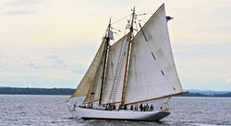W1AW. The venerable vessel, the official vessel of the State of Maine and the [flagship](http://mainemaritime.edu/waterfront/schooner-bowdoin/) of Maine Maritime Academy's Vessel Operations and Technology Program, recently underwent a complete hull restoration and refitting and has done a little touring to mark its centenary. Its home port is Castine, Maine.

The longwave transmitters MacMillan used on his earlier missions had proved "unable to penetrate the screen of the aurora borealis," ARRL historian Michael Marinaro, WN1M, explained in his article, "Polar Exploration," in the June 2014 issue of *QST*. In 1923, MacMillan turned to ARRL for help in outfitting his next expedition with better wireless gear. Marinaro recounted, "It was enthusiastically provided." Maxim and the ARRL Board recruited Donald H. Mix, 1TS, of Bristol, Connecticut, to accompany the crew as its radio operator.

M.B. West, an ARRL Board member, designed the gear, which was then built by amateurs at his firm, Zenith Electronics. The transmitter operated on the medium-wave bands of 185, 220, and 300 meters, running 100 W to a pair of Western Electric "G" tubes. Earlier exploratory missions had used gear that operated on longwave frequencies. The shipboard station on board the *Bowdoin* was given the call sign WNP -- Wireless North Pole.

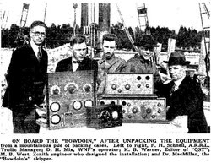"WNP transmitted weekly 500-word press releases and listings of stations worked and heard," Marinaro said. "Once received by amateur stations, these reports were delivered to local affiliated newspapers of the North American Newspaper Alliance; from there, they were distributed syndicate-wide by telegraph."

MacMillan's subsequent attempt at the North Pole centered around wireless. The objectives supported by the Navy and the National Geographic Society were to determine the full capabilities of radio north of the auroral belt and to explore the northern reaches by air. The outstanding accomplishment of the 1925 expedition was in the sphere of radio. Utilizing shortwaves, the expedition was in consistent contact with the outside world throughout the journey, to the delight of the amateurs who were able to work them. The phenomenal success proved to the Navy that shortwaves were definitely superior to the longwaves and ultra longwaves that fleets had been using.



**ARRL** -- **Your One-Stop Resource for  
Amateur Radio News and Information**

* [Join or Renew Today!](http://www.arrl.org/join) Eligible US-based members can elect to receive [*QST*](http://www.arrl.org/qst) or [*On the Air*](http://www.arrl.org/on-the-air-magazine) magazine in print when they join ARRL or when they renew their membership. All members can access digital editions of all four ARRL magazines: *QST*, *On the Air, QEX*, and *NCJ*.
* Listen to [*ARRL Audio News*](http://www.arrl.org/arrl-audio-news), available every Friday.

**Subscribe to...**

* [*NCJ*-- *National Contest Journal*](http://www.ncjweb.com/). Published bimonthly, features articles by top contesters, letters, hints, statistics, scores, NA Sprint, and QSO parties.
* [*QEX*](http://www.arrl.org/qex)-- [*A Forum for Communications Experimenters*](http://www.arrl.org/qex). Published bimonthly, features technical articles, construction projects, columns, and other items of interest to radio amateurs and communications professionals.

**Free of charge to ARRL members...**

* [Subscribe](http://www.arrl.org/myarrl-account-management#%21/edit-info-email_subscriptions) to the *ARES Letter* (monthly public service and emergency communications news), the *ARRL Contest Update*(biweekly contest newsletter), Division and Section news alerts -- and much more!
* Find ARRL on [Facebook](https://www.facebook.com/ARRL.org/)! Follow us on [Twitter](https://twitter.com/arrl) and [Instagram](https://www.instagram.com/arrlhq)!

\_\_\_\_\_\_\_\_\_\_\_\_\_\_\_\_\_\_\_\_\_\_\_\_\_\_\_\_\_\_\_\_\_\_\_\_\_\_\_\_\_\_\_\_\_\_\_\_\_\_\_\_\_\_\_\_\_\_\_

***Club Corner***

This is YOUR cornner of the newsletter. Send me what your club is doing and I’ll make sure that it gets in. Got a special event or club project that you want everyone to know about? Send it to me! Need help with a project? Send it to me.

Let me know what you club is up to. Are you going to have a special guest at your meeting or are you having a special anniversary?

Just sent it to: [webmaster@arrl-ohio.org](mailto:webmaster@arrl-ohio.org)

******If you want me to publish your club information, or even an article you have written, please send it in WORD format (.docx). Please use Times New Roman font size 12 for the body of the aritcle. Any photos please include as a .jpg or .bmp – the time you save me in doing all the conversions will be greatly appreciated!

**\_\_\_\_\_\_\_\_\_\_\_\_\_\_\_\_\_\_\_\_\_\_\_\_\_\_\_\_\_\_\_\_\_\_\_\_\_\_\_\_\_\_\_\_\_\_\_\_\_\_\_\_\_\_\_\_\_\_\_**

**10/02/2021 | World's Largest Horseshoe Crab Roadside Attraction**

**Oct 2, 1400Z-2000Z, K8HO**, Hillsboro, OH. Highland Amateur Radio Association. 7.220 14.220. Certificate. Highland Amateur Radio Association, 21 Highland Drive, Hillsboro, OH 45133. [highlandara@gmail.com](mailto:)

# \_\_\_\_\_\_\_\_\_\_\_\_\_\_\_\_\_\_\_\_\_\_\_\_\_\_\_\_\_\_\_\_\_\_\_\_\_\_\_\_\_\_\_\_\_\_\_\_\_\_\_\_\_\_\_\_\_\_\_

Get Set for SET: ARRL Simulated Emergency Test Ahead, Plan Now

The 2021 ARRL Simulated Emergency Test (SET) is just ahead. The primary ARRL-sponsored national emergency exercise is designed to assess the skills and preparedness of Amateur Radio Emergency Service® (ARES®) volunteers, as well as those affiliated with other organizations involved with emergency and disaster response. The primary SET weekend is October 2-3, but Local and Section-wide exercises may take place throughout the fall. The annual SET encourages maximum participation by all amateur radio operators, partner organizations, and national, state, and local officials who typically engage in emergency or disaster response.

In addition to ARES volunteers, radio amateurs active in the National Traffic System, Radio Amateur Civil Emergency Service (RACES), SKYWARN™, Community Emergency Response Team (CERT), and a variety of other allied groups and public service-oriented radio amateurs are needed to fulfill important roles in this nationwide exercise.

The SET allows volunteers to test equipment, modes, and skills under simulated emergency conditions and scenarios. Individuals can use the time to update a "go-kit" for use during deployments and to ensure their home station's operational capability in an emergency or disaster. To get involved, contact your local ARRL Emergency Coordinator or Net Manager. Check on upcoming planned activities through local, state, or Section-wide nets.

\_\_\_\_\_\_\_\_\_\_\_\_\_\_\_\_\_\_\_\_\_\_\_\_\_\_\_\_\_\_\_\_\_\_\_\_\_\_\_\_\_\_\_\_\_\_\_\_\_\_\_\_\_

[*Net Control Manager*](https://net-control.us/map.php?NetID=3818) is a free, online service reported now in use by 176 groups (many affiliated with ARES) with more than 3300 nets involved. The utility is not a QSO logger, but rather a net management system used by net control stations to document various net activity focused on weather emergencies, earthquakes, fires, club meetings, bike ride support and any other logging and/or reporting for intensive communications support and management needs. A variety of reports can be created including mapping station locations and solutions. -- [*Keith Kaiser, WA0TJT*](mailto:wa0tjt@gmail.com)*, Kansas City, MO*

\_\_\_\_\_\_\_\_\_\_\_\_

Tip: Here is an excellent, new 15-minute [video presentation on the ARES program for new and prospective ARES participants](http://www.youtube.com/watch?v=ICCf-qVK6EY), by ARRL Orange (California) Section Emergency Coordinator Bob Turner, W6RHK.

\_\_\_\_\_\_\_\_\_\_\_\_\_\_\_\_\_\_\_\_\_\_\_\_\_\_\_\_\_\_\_\_\_\_\_\_\_\_\_\_\_\_\_\_\_\_\_\_\_\_\_\_\_\_\_\_\_\_\_

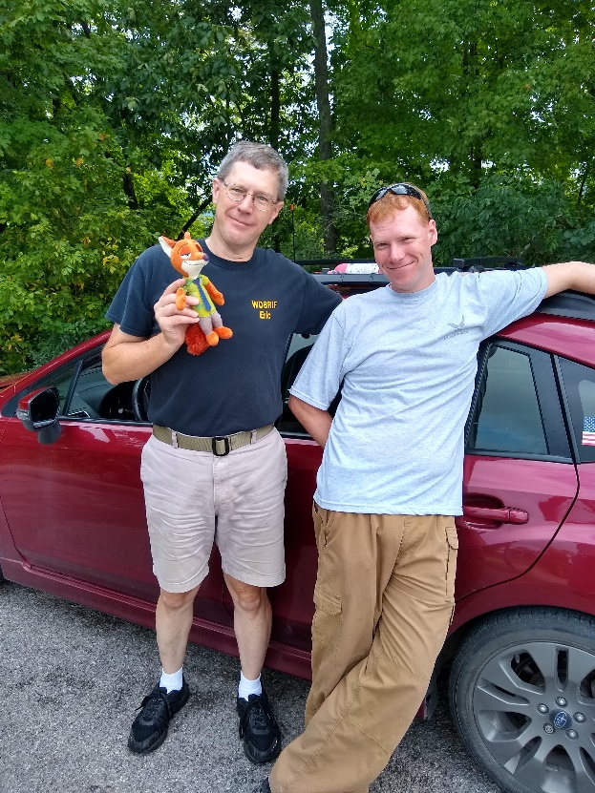

Fox-Hunt News from Athens County Amateur Radio Association

Congratulations to WD8RIF Eric McFadden and KD8KNC Miles McFadden on winning today’s (August 14) Athens County Amateur Radio Association foxhunt in a record 26 minute time!

As a result, WD8RIF will have the option of being the fox for the next hunt next month.

VE Sessions

Dayton Amateur Radio Association (DARA)

**The DARA License Exams scheduled for August 21st at 10:30am have been cancelled.**

 If you are interested in testing for a new or upgraded license, please come see us at the DARA Clubhouse. If you have questions about testing, please email [exams.w8bi@gmail.com](mailto:exams.w8bi@gmail.com)

Lake County Amateur Radio Association (LCARA)

Saturday October 2, Saturday December 4

All exams start at noon and are held at the Kirtland Library, 9267 Chillicothe Rd. Kirtland, OH

Portage County Amateur Radio Service (PCARS)

Starting on August 7th, PCARS will resume VE testing at the PCARS club site in Ravenna.

Please visit the PCARS web site and check out the information about VE testing in the latest newsletter – [https://portcars.org/files/newsletter/2021/PCARS-June-21.pdf](https://r20.rs6.net/tn.jsp?f=001DxdXS40dvzmbl9m9sfY5l9IIoAGYYsZIQIObAktg-wnnAu__YbvuVuV1_NQmLDKapbqCCYZK1L6epi1k5lVvuEtL_I1T0LMdgzjsNGvi1UnoIj7Lpv0RFoxS8h0YOCVVODgyzQI8xFTrmQ0pr6RXkQVvSx_cjGgR-DubSFhvF7CPVtMoPBph8tt8RpjGjyyBlRFHzo_VhR4=&c=Oi-83JMf17RlM94bujSYqqAwfNyIPWszQZKKkjp6BM5J7PHkAvaFrA==&ch=Kr1c-7rzal6CKkNUvSX-jLXK5eG9iU0tKZ5xoqUUqM21mzFnc1rE3w==)  – see pages 8, 9 and 10 for details.

If you have any questions, don’t hesitate to contact me at KB8UUZ@gmail,com

On behalf of the VE team at PCARS, we all look forward to getting the VE testing going again and look forward to seeing you there – August 7th -10 am – at the PCARS club site in Ravenna.

**Your Club news should be listed here!**

I know you’re out there doing things! Send me a write-up (MSWord please) and some photo’s (.jpg please) and we’ll get your club hi-lited here for the other OH Section Clubs to see! Send to [WB8LCD@ARRL.ORG](mailto:WB8LCD@ARRL.ORG)

\_\_\_\_\_\_\_\_\_\_\_\_\_\_\_\_\_\_\_\_\_\_\_\_\_\_\_\_\_\_\_\_\_\_\_\_\_\_\_\_\_\_\_\_\_\_\_\_\_\_\_\_\_\_\_\_\_\_\_\_\_\_\_\_\_\_\_\_\_\_\_\_\_\_\_\_\_\_\_\_\_\_\_\_\_\_\_\_\_\_

**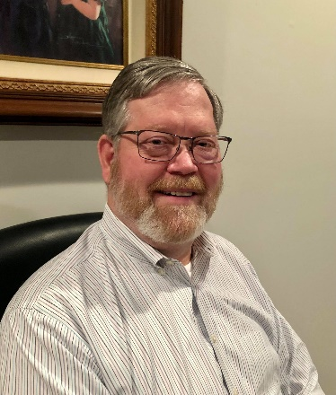DX This Week – Cincy Hamfest, W8DXCC, CWOPEN**

Bill AJ8B (aj8b@arrl.net, @AJ8B, or www.aj8b.com)

CWOPs Member #1567

The Midwest DX Cluster spots included Alaska, Argentina, Asiatic Turkey, Australia, Azores, Balearic Islands, Belarus, Belgium, Belize, Bermuda, Bolivia, Bosnia-Herzegovina, Brazil, Bulgaria, Colombia, Costa Rica, Croatia, Cuba, Czech Republic, Denmark, Dominican Republic, Ecuador, England, Estonia, European Russia, Fed. Rep. of Germany, Fiji, France, French Guiana, Greece, Hungary, Israel, Italy, Kazakhstan, Kuwait, Lebanon, Lithuania, Martinique, Mexico, Moldova, Northern Ireland, Norway, Panama, Peru, Philippines, Poland, Portugal, Puerto Rico, Romania, Samoa, Saudi Arabia, Slovak Republic, Slovenia, Spain, St. Kitts & Nevis, Suriname, Switzerland, Tunisia, Ukraine, United States, Uruguay, and Wales. This brings the total number of entities spotted in the Midwest in 2021 to 189!

Twice the past week there have been late night openings on 80M into Europe. Tuesday night was a CW opening that netted 10 QSOs and 6 countries. Wednesday night was some solid FT8 activity also yielding 10 QSOs. Make sure you keep an eye on 80 as we move towards fall. When I hear activity, I work it first and then I will spot it. Don’t just rely on the spotting clusters for openings. Spend some time in the chair!

*DAH DIT DIT DIT DAH DAH DIT DIT DIT DAH*

Coming up in September is one of my favorite CW contests for the year. It is sponsored by the CWOPS club. It is unique for several reasons. First, it is held in three different sessions to help you take advantage of propagation. Secondly, the multiplier is each different callsign you work during that session. So, if you work me three time, I will count for 3 points (1 point/QSO) and then 1 multiplier. This starts over for each session. There are prizes for each session and for a combined score. More details can be found at <https://cwops.org/cwops-tests/cw-open/> You don’t have to be a member to participate!

The session dates and times are below:

|  |  |  |
| --- | --- | --- |
| *Session* | *Date* | *Time* |
| *1* | *9/4/2021* | *0000Z – 0359Z* |
| *2* | *9/4/2021* | *1200Z – 1559Z* |
| *3* | *9/4/2021* | *2000Z – 2359Z* |

*DAH DIT DIT DIT DAH DAH DIT DIT DIT DAH*

By the time you read this, we will be days away from two events. The first is the Cincinnati Hamfest sponsored by the Milford Amateur Radio Club. (<https://cincinnatihamfest.org/>) This will be a great event at he Clermont County Fairgrounds on August 28. There is a Yaesu FTM-400XDR as the grand prize as well as many other prizes. I am most excited about the flea market as I am in need of some “goodies”. I love to wander from table to table in the “bone yard” (Thanks Dave, K8DV, for that!) Get out, get some fresh air, stretch your legs and stop by for the Ham activity, the flea market, the Food trucks, and Ice Cream.

The second event is the W8DXCC convention held at the same location after the Cincinnati Hamfest. There are some tickets still available – details at [www.w8dxcc.com](http://www.w8dxcc.com)

The speaker list has been finalized and it is:

|  |  |  |
| --- | --- | --- |
| Time | Speaker | Topic |
| 12 PM | DX Speaker Roundtable | K4ZLE, W8HC, W6IZT, W8GEX, K9LA & W3UR |
| 1PM | W8HC & W6IZT | DXPedtion in a Box |
| 2 PM | W8GEX | SWAINS Island revisited |
| 3 PM | K9LA | Cycle 25 & What’s in Store |
| 4 PM | W3UR – Bernie | The Daily DX & Weekly DX |
| 5 PM | Wrap Up & Drawing |  |

There are several prizes that can be reviewed on the webpage. Hope to see you there! Please grab me and let me know what you think of the weekly newsletter!

*DAH DIT DIT DIT DAH DAH DIT DIT DIT DAH*

CQDX CQDX CQDX CQDX CQDX CQDX CQDX CQDX CQDX

Here is an update from Bernie, W3UR, of the DailyDX and the WeeklyDX, the best source for DX information. <http://www>.dailydx.com/. Bernie has this to report:

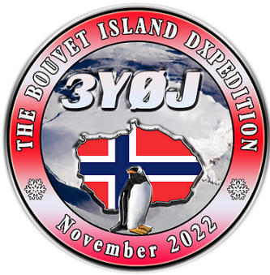

**3Y – Bouvet -** From the 3Y0J fourth press release on this planned

November 2022 operation, reporting on their continuing search for a replacement ship, they now have a contract for a replacement. The MARAMA is now booked and at

a significant reduction in cost compared to the Braveheart. They are beginning the fundraising now for

the 12 ops and 20 days of operating. The site on the island will be 150 by 800 feet for the camp and antennas. They note that Bouvet is known as “the world’s most remote island.” Landing permits from the Norway government and a helicopter permit were received in April, 2020. Their goal is 120,000 QSOs.

The new website address is: 3Y0J.NO, plus the “3Y0J Facebook Groupe.” LA7GIA, LA7THA and LB1QI are the expedition leaders.

**9X – Rwanda -** 4X1FV, Jan, says 4Z5MU, Slava, has been added to the 9X4X Holy Land DX Group DXPedition team, which will be in Rwanda from November 24 to  
December 1, 2021.

**SV5 – Dodecanese -** SV5/DL2AAZ, Reiner, plans to be on from here September 5-19, holiday style on 40-10, CW and SSB, and the QO-100 satellite.  QSL direct or  
bureau to the DL2AAZ address.

**C6A – Bahamas -** NN2T (C6AHB), Richard, says a "New Bimini DXpedition" will take place October 27 to November 3, including the CQ World Wide DX SSB Contest.  
He is looking for interested others to join him.

**SV5 - Dodecanese Islands -** HB9OAU, Claudio Tiziani, tells us he is heading to Karpathos Island (EU-001), where he will be QRV as SV5/HB9OAU from September 4-16. He'll be operating holiday style with a Yaesu FT-991A and an End Fed.  
Activity will be on SSB, RTTY, FT8 on 80, 40, 30, 20, 17, 15, 12 and  
10 meters. QSL via the bureau, LoTW, eQSL or direct with SAE and 3$US.  
  
**IS – Sardinia -** During this year's CQ Worldwide DX SSB Contest, October 30-31, OK8WW (aka OM2TW), Richard, will be operating 80 meters single band as  
IS0/OM2TW. QSL via OM2FY.

Video presentations from the **2021 Pacific Northwest DX Convention** are  
now available at [http://pacificnwdxconvention.com](http://pacificnwdxconvention.com/)

*DAH DIT DIT DIT DAH DAH DIT DIT DIT DAH*

Below is a list of upcoming contests in the “Contest Corner”. I think this is important for someone who is trying to move up the DXCC ladder since entities that are on the rarer side and easiest to work in contests. Some of my best “catches” have been on the Sunday afternoon of a contest when the rarer entities are begging for QSOs. Of course, the gamble is that if you wait until Sunday, conditions may change, or they simply won’t be workable. However, it is not a bad gamble. Of course, why not work the contest and have some fun!  
Check out the WA7BNM Contest Calendar page (<https://www.contestcalendar.com/>) and CQ Magazine for more contests or more details.

The contests in red are those that I plan to spend some significant participation time on. PLEASE let me know if you are working contests and how you fared.

Thanks!

|  |  |  |
| --- | --- | --- |
| Aug. 28-29 | Hawaii QSO Party | http://hawaiiqsoparty.org |
| Aug. 28-29 | Kansas 080 Party | www.ksqsoparty.org |
| Aug. 28-29 | YO DX HF Contest | www.yodx.ro/en |
| Aug. 28-29 | ALARA Contest | www.alara.org.au/contests |
| Aug. 28-29 | World Wide Digi DX Contest | https://ww-digi.com |
| Aug 28-29 | WNE Island 080 Party | https://usislands.org/qso-party-rules |
| Aug.29 | SARL HF CW Contest | http://bit.ly/HOlqQf |
| August 28 | **Ohio QSO Party** | <https://www.ohqp.org/> |
| August 28 | **W8DXCC** | <https://www.w8dxcc.com> |
| Sept. 1 | VHF-UHF FT8 Activity Contest | www.ft8activity.eu/index.php/en |
| Sept. 1 | UKEICC 80m Contests SSB | https://bit.ly/2SDPqQQ |
| Sept. 4 | AGCW Straight Key Party | https://bit.ly/3ngQSpB |
| Sept. 4 | Russian “Radio” RTTY WW Contest | https://bit.ly/3eWEtDl |
| Sept. 4 | **CWOPS CWOPEN 0000 – 0359Z** | https://cwops.org/cwops-tests/cw-open/ |
| Sept. 4 | **CWOPS CWOPEN 1200 – 1559Z** | https://cwops.org/cwops-tests/cw-open/ |
| Sept. 4 | **CWOPS CWOPEN 2000 – 2359Z** | https://cwops.org/cwops-tests/cw-open/ |
| Sept. 4-5 | All Asian DX Phone Contest | www.jarl.org/English/0-2.htm |
| Sept. 4-5 | Colorado QSO Party | http://ppraa.org/coqp |
| Sept. 4-5 | RSGB SSB Field Day | http://bit.ly/2OKdymu |
| Sept. 4-5 | PODXS 070 Club Jay Hudak Memorial 80M Sprint | http://bit.ly/2MkaaNt |
| Sept. 4-5 | Tennessee QSO Party | https://tnqp.org/rules |
| Sept. 6 | RSGB Autumn Series SSB | https://bit.ly/3p4eShW |
| Sept. 6-7 | MI QRP Labor Day CW Sprint | www.miqrp.net/contest |
| Sept. 8 | VHF-UHF FT8 Activity Contest | www.ft8activity.eu/index.php/en |
| Sept. 11 | **FOC QSO Party** | www.g4foc.org/qsoparty |
| Sept. 11-12 | Alabama QSO Party | www.alabamaqsoparty.org |
| Sept. 11-12 | SARL Field Day | http://bit.ly/H0IqQf |
| Sept. 11-12 | Russian Cup Digital Contest | www.qrz.ru/contest/detail/86.html |
| Sept. 11-12 | Worked All Europe SSB Contest | http://bit.ly/2vufgcb |
| Sept. 11-13 | ARRL September VHF QSO Party | www.arrl.org/september-vhf |
| Sept. 12 | North American CW Sprint | http://ncjweb.com/Sprint-Rules.pdf |
| Sept. 15 | RSGB Autumn Series CW | https://bit.ly/3p4eShW |
| Sept. 16 | Bavarian Contest Club QSO Party | https://bit.ly/2MDzviG |
| Sept. 18-19 | ARRL 10 GHz and UP Contest | www.arrl.org/10-ghz-up |
| Sept. 18-19 | Iowa QSO Party | www.w0yl.com/IAQP |
| Sept. 18-19 | New Hampshire QSO Party | www.w1wqm.org/nhqso |
| Sept. 18-19 | New Jersey QSO Party | http://bit.ly/1nDlf8V |
| Sept. 18-19 | QRP Afield | http://bit.ly/2QACxFu |
| Sept. 18-19 | SARL VHF/UHF Digital Contest | http://bit.ly/H0IqQf |
| Sept. 18-19 | Scandinavian CW Activity Contest | www.sactest.net/blog |
| Sept. 18-19 | Texas QSO Party | http://txqp.net |
| Sept. 18-19 | Washington State Salmon Run | http://salmonrun.wwdxc.org/rules |
| Sept. 19 | BARTG Sprint PSK63 | http://bartg.org.uk/wp/contests |
| Sept. 19 | North American RTTY Sprint | http://ncjweb.com/Sprint-Rules.pdf |
| Sept. 20 | 144 MHz Fall Sprint | http://svhfs.org/wp |
| Sept. 23 | RSGB Autumn Series Data | https://bit.ly/3p4eShW |
| Sept. 25 | AGCW UHF/VHF Contest | https://bit.ly/3lw91PK |
| **Sept. 25-26** | **CQWW RTTY DX Contest** | **www.cqwwrtty.com** |
| Sept. 25-26 | Maine QSO Party | www.ws1sm.com/MEQP.html |
| Sept. 28 | 222MHz Fall Sprint | http://svhfs.org/wp |
| Sept. 29 | UKEICC 80m Contests CW | https://bit.ly/2SDPqQQ |

***\_\_\_\_\_\_\_\_\_\_\_\_\_\_\_\_\_\_\_\_\_\_\_\_\_\_\_\_\_\_\_\_\_\_\_\_\_\_\_\_\_\_\_\_\_\_\_\_\_\_\_\_\_\_\_\_\_\_\_\_\_\_\_\_\_\_\_\_\_\_\_\_\_\_\_\_\_***

***DX NEWS***

**SB DX ARL ARLD033  
ARLD033 DX news**  
This week's bulletin was made possible with information provided by IK2DUW, The Daily DX, the OPDX Bulletin, 425 DX News, DXNL, ContestCorral from QST and the ARRL Contest Calendar and WA7BNM web sites. Thanks to all.  
  
TANZANIA, 5H.  Josep, EA3BT and Nuria, EA3WL are QRV as 5I3B and 5I3W, respectively, from Zanzibar Island, IOTA AF-032, until August 26.  Activity is holiday style on 40 to 10 meters using CW, SSB and  
FT8.  QSL via EA3BT.  
  
UGANDA, 5X.  Elvira, IV3FSG is QRV as 5X3R until September 2. Activity is in her spare time on 80 to 10 meters using SSB, RTTY andPSK31.  QSL via IK2DUW.  
  
AZORES, CU.  Giovanni, IZ2DPX is QRV as CT8/IZ2DPX from Faial Island, IOTA EU-175, until August 23.  Activity is on all HF bands using SSB and various digital modes.  QSL via IK2DUW.  
  
CAPE VERDE, D4.  Paco, EA7KNT will be QRV as D4SAL from Sal Island, IOTA AF-086, from August 23 to September 5.  Activity will be on 80 to 10 meters using CW, SSB, and various digital modes.  QSL via  
operator's instructions.  
  
FEDERAL REPUBLIC OF GERMANY, DA.  A large group of operators will be QRV as DL0MFK/LH from the Karnin Lighthouse, ILLW DE0013, on Usedom Island, IOTA EU-129, during the International Lighthouse/Lightship Weekend.  QSL via bureau.  
  
IRELAND, EI.  A group of operators will be QRV as EJ7NET from Gola Island, IOTA EU-121, from August 21 to 25.  Activity will be on 80 to 6 meters using CW, SSB, and FT8.  QSL direct to EI6FR.  
  
FRANCE, F.  A group of operators are QRV as TM0BSM from the lighthouse at Berck-sur-Mer until August 22.  Activity is on 80 to 10 meters using CW, SSB, and various digital modes.  QSL via DK5OPA.  
  
ENGLAND, G.  Look for station GB1PBL to be QRV from the Portland Bill Lighthouse, ILLW UK0073, the Portland Bill Old Lower Lighthouse, ILLW UK0020, and the Portland Bill Old Higher  
Lighthouse, ILLW UK0019, during the International Lighthouse/Lightship Weekend.  Activity will be on 80 to 6 meters using SSB and various digital modes.  QSL direct to GB1PBL.  
  
ITALY, I.  Members of the ARI section San Benedetto del Tronto will be QRV as IQ6SB/LT from the San Benedetto del Tronto Lighthouse, ILLW IT-0009, during the International Lighthouse/Lightship Weekend.  
QSL via IK6XEJ  
  
SARDINIA, IS0.  Alessio, IU5MOT is QRV as IS0/IU5MOT until August 26.  QSL via operator's instructions.  
  
ST. LUCIA, J6.  Bill, K9HZ will be QRV as J68HZ from August 21 to November 8.  Activity will be on the HF bands using CW, SSB and FT8. QSL direct to home call.  
  
OGASAWARA, JD1.  Takashi, JH1FFW will be QRV as JD1/JH1FFW from August 21 to 25.  Activity will be on 40 to 6 meters using SSB and FT8.  QSL to home call.  
  
MARKET REEF, OJ0.  Pasi, OH3WS will be QRV as OJ0WS from August 21 to 28.  Activity will be on the HF bands using only CW.  QSL to home call.  
  
DENMARK, OZ.  Members of the OZ4EDR club station will be QRV as OZ4HAM from Hammeren Lighthouse, ILLW DK0015, on Bornholm Island, IOTA EU-030, during the International Lighthouse/Lightship Weekend. Activity will be on 80, 40, and 20 meters using CW, SSB and FT8. QSL via bureau.  
  
BRAZIL, PY.  Mor, PT7ZT is QRV as ZW16ZT until September 5 in celebration of the XVI Paralympic Games held in Tokyo.  Activity is on the HF bands using SSB and various digital modes.  QSL direct to  
home call.  
  
TURKEY, TA.  Members of the Tango Alfa Ham Radio Club will be QRV as TC1LHS from the Rumeli Karaburun Lighthouse, ILLW TR0002, during the International Lighthouse/Lightship Weekend.  QSL via operators' instructions.  
  
EUROPEAN RUSSIA, UA.  Special event station R1221NN is QRV until August 29 to celebrate the 800th anniversary of the city of Nizhny Novgorod, formerly known as Gorky.  QSL via RJ3T.  
  
AUSTRALIA, VK.  A group of operators will be QRV as VK2FM from the Solitary Island Lighthouse, ILLW AU0054, during the International Lighthouse/Lightship Weekend.  Activity will be on 80, 40 and 20  
meters.  QSL direct to VK2FM.  
  
INDIA, VU.  A group of operators are QRV as AT8KLH from Kapu Lighthouse, ILLW IN0023, during the International Lighthouse/Lightship Weekend.  Activity will be on the HF bands using CW, SSB and FT8.  QSL via VU2JHM.  
  
INDONESIA, YB.  Members of the ORARI Daerah Bali are QRV as 8A63BALI from Bali Island, IOTA OC-022, until August 22 to celebrate the 63rd anniversary of the Bali Provincial Government.  Activity is on 80,  
40, and 2 meters using SSB and RTTY.  QSL via operators' instructions.  
  
The RTTYOPS Weeksprint and Worldwide Sideband Activity Contest are all scheduled for August 24.  
  
The CWops Mini-CWT Test, SKCC Sprint and Phone Fray are scheduled for August 25.  
  
Please see August QST, page 71, and the ARRL and WA7BNM contest websites for details

**\_\_\_\_\_\_\_\_\_\_\_\_\_\_\_\_\_\_\_\_\_\_\_\_\_\_\_\_\_\_\_\_\_\_\_\_\_\_\_\_\_\_\_\_\_\_\_\_\_\_\_\_\_\_\_\_\_\_\_\_\_\_\_\_\_\_\_**

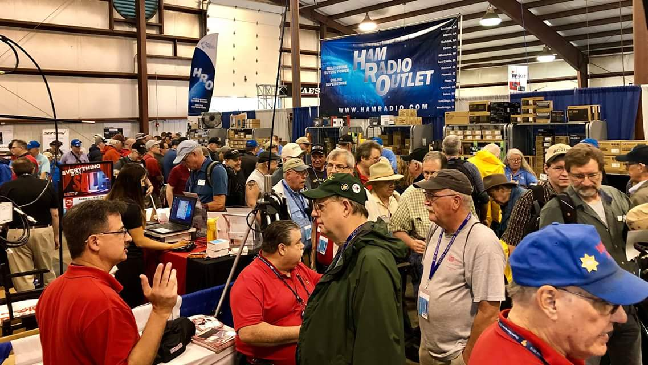[**Upcoming *Hamfests***](http://arrl-ohio.org/hamfests.html)

We **DO** have some hamfests scheduled for 2021!! Yes, take a good look at the list, it’s growing every day!

|  |
| --- |
| **08/28/2021 -**[**Cincinnati Hamfest℠**](http://www.arrl.org/hamfests/cincinnati-hamfest)  **Location:**Owensville, OH **Sponsor:** Milford ARC **Website:** [http://CincinnatiHamfest.org](http://cincinnatihamfest.org/)  [**Learn More**](http://www.arrl.org/hamfests/cincinnati-hamfest) |
| **09/12/2021 -**[**Findlay Hamfest**](http://www.arrl.org/hamfests/findlay-hamfest-8) Location: Findlay, OH Sponsor: Findlay Radio Club Website: <http://www.findlayradioclub.org/hamfest>  [**Learn More**](http://www.arrl.org/hamfests/findlay-hamfest-8) | **09/18/2021** - [**Miami County Swap Meet**](http://w8fw.org/)  **Location:**Troy, OH  **Sponsor:** Miami County Amateur Radio Club  **Website:** [http://w8fw.org](http://w8fw.org/)    [**Learn More**](http://w8fw.org/) |
| **09/18/2021 -**[**Mound Amateur Radio Assoc. Swap Meet**](http://www.arrl.org/hamfests/mound-amateur-radio-assoc-swap-meet)  **Location:**Miamisburg, OH **Sponsor:** MARA **Website:** [http://W8DYY.ORG](http://w8dyy.org/)  [**Learn More**](http://www.arrl.org/hamfests/mound-amateur-radio-assoc-swap-meet) | **09/26/2021 -**[**Cleveland Hamfest**](http://www.arrl.org/hamfests/cleveland-hamfest-1)  **Location:**Berea, OH **Sponsor:** Hamfest Association of Cleveland **Website:** [http://www.hac.org](http://www.hac.org/)  [**Learn More**](http://www.arrl.org/hamfests/cleveland-hamfest-1) |
|  |  |
| **10/02/2021 -**[**10th Annual Vette City Hamfest,**](http://www.arrl.org/hamfests/10th-annual-vette-city-hamfest-arrl-great-lakes-division-convention)  [**ARRL Great Lakes Division Convention**](http://www.arrl.org/hamfests/10th-annual-vette-city-hamfest-arrl-great-lakes-division-convention)  **Location:**Bowling Green , KY  **Sponsor:** Kentucky Colonels Amateur Radio Club  **Website:** [https://ky4bg.com](https://ky4bg.com/)  [**Learn More**](http://www.arrl.org/hamfests/10th-annual-vette-city-hamfest-arrl-great-lakes-division-convention) | |
| **10/09/2021 -**[**Northwest Ohio Amateur Radio Club (NWOARC) hamfest**](http://www.arrl.org/hamfests/northwest-ohio-amateur-radio-club-nwoarc-hamfest)  **Location:**Westminster, OH **Sponsor:** NWOARC, Northwest Ohio Amateur Radio Club **Website:** [http://www.nwoarc.com](http://www.nwoarc.com/)  [**Learn More**](http://www.arrl.org/hamfests/northwest-ohio-amateur-radio-club-nwoarc-hamfest) | **10/31/2021 -**[**Massillon (Ohio) Hamfest**](http://www.arrl.org/hamfests/massillon-ohio-hamfest)  **Location:**Green, OH **Sponsor:** Massillon Amateur Radio Club **Website:** [http://w8np.org](http://w8np.org/)  [**Learn More**](http://www.arrl.org/hamfests/massillon-ohio-hamfest) |
| **11/06/2021 -**[**GARC Hamfest**](http://www.arrl.org/hamfests/garc-hamfest-4) **Location:**Georgetown, OH **Sponsor:**Grant Amateur Radio Club  [**Learn More**](http://www.arrl.org/hamfests/garc-hamfest-4) | **12/04/2021 -**[**FCARC WinterFest**](http://www.arrl.org/hamfests/fcarc-winterfest-2)  **Location:**Delta, OH  **Sponsor:** Fulton County Amateur Radio Club  **Website:**<http://k8bxq.org/hamfest>    [**Learn More**](http://www.arrl.org/hamfests/fcarc-winterfest-2) |
|  | |

Be sure to keep your eyes on this schedule as that when things start getting better and the vaccine rolls out to more and more, hamfests will surely get back to their normal schedule. Don’t see your hamfest listed?? Did anyone register it with ARRL? It’s really easy to do and you get a lot of FREE publicity if you do.

**\_\_\_\_\_\_\_\_\_\_\_\_\_\_\_\_\_\_\_\_\_\_\_\_\_\_\_\_\_\_\_\_\_\_\_\_\_\_\_\_\_\_\_\_\_\_\_\_\_\_\_\_\_\_\_\_\_\_\_\_\_\_\_\_\_\_\_**

[K1USN Slow Speed Test](http://www.k1usn.com/sst.html), Aug 23, 0000z to Aug 23, 0100z; CW; Bands: 160, 80, 40, 20, 15, 10m; Maximum 20 wpm, Name + (state/province/country); Logs due: August 29.  
  
[Worldwide Sideband Activity Contest](https://wwsac.com/rules.html), Aug 24, 0100z to Aug 24, 0159z; SSB; Bands: 160, 80, 40, 20, 15, 10, **6m**; RS + age group (OM, YL, Youth YL or Youth); Logs due: August 25.  
  
[RTTYOPS Weeksprint](http://rttyops.com/), Aug 24, 1700z to Aug 24, 1900z; RTTY; Bands: 80, 40, 20m; [other station's call] + [your call] + [serial no.] + [your name]; Logs due: August 24.  
  
[SKCC Sprint](http://www.skccgroup.com/operating_activities/weekday_sprint/), Aug 25, 0000z to Aug 25, 0200z; CW; Bands: 160, 80, 40, 20, 15, 10, **6m**; RST + (state/province/country) + Name + (SKCC No./"NONE"); Logs due: August 27.  
  
[Phone Weekly Test - Fray](http://www.perluma.com/Phone_Fray_Contest_Rules.pdf), Aug 25, 0230z to Aug 25, 0300z; SSB; Bands: 160, 80, 40, 20, 15m; NA: Name + (state/province/country), non-NA: Name; Logs due: August 27.  
  
[CWops Mini-CWT Test](https://cwops.org/cwops-tests/), Aug 25, 1300z to Aug 25, 1400z; CW; Bands: 160, 80, 40, 20, 15, 10m; Member: Name + Member No./"CWA", non-Member: Name + (state/province/country); Logs due: August 28.  
  
[CWops Mini-CWT Test](https://cwops.org/cwops-tests/), Aug 25, 1900z to Aug 25, 2000z; CW; Bands: 160, 80, 40, 20, 15, 10m; Member: Name + Member No./"CWA", non-Member: Name + (state/province/country); Logs due: August 28.  
  
[CWops Mini-CWT Test](https://cwops.org/cwops-tests/), Aug 26, 0300z to Aug 26, 0400z; CW; Bands: 160, 80, 40, 20, 15, 10m; Member: Name + Member No./"CWA", non-Member: Name + (state/province/country); Logs due: August 28.  
  
[CWops Mini-CWT Test](https://cwops.org/cwops-tests/), Aug 26, 0700z to Aug 26, 0800z; CW; Bands: 160, 80, 40, 20, 15, 10m; Member: Name + Member No./"CWA", non-Member: Name + (state/province/country); Logs due: August 28.  
  
[RTTYOPS Weeksprint](http://rttyops.com/), Aug 26, 1700z to Aug 26, 1900z; RTTY; Bands: 80, 40, 20m; [other station's call] + [your call] + [serial no.] + [your name]; Logs due: August 31.  
  
[EACW Meeting](https://www.eacwspain.es/eacwmeeting/), Aug 26, 1900z to Aug 26, 2000z; CW; Bands: 80, 40m; EACW Member: RST + Member No. + Nickname, EA non-Member: RST + Nickname + EA province, non-EA: RST + Nickname + DXCC prefix; Logs due: August 28.  
  
[QRP Fox Hunt](http://www.qrpfoxhunt.org/summer_rules.htm), Aug 27, 0100z to Aug 27, 0230z; CW; Bands: 20m Only; RST + (state/province/country) + name + power output; Logs due: August 28.  
  
[NCCC RTTY Sprint](http://www.ncccsprint.com/rttyns.html), Aug 27, 0145z to Aug 27, 0215z; RTTY; Bands: (see rules); Serial No. + Name + QTH; Logs due: August 29.  
  
[NCCC Sprint Ladder](http://www.ncccsprint.com/rules.html), Aug 27, 0230z to Aug 27, 0300z; CW; Bands: 160, 80, 40, 20, 15m; Serial No. + Name + QTH; Logs due: August 29.  
  
[K1USN Slow Speed Test](http://www.k1usn.com/sst.html), Aug 27, 2000z to Aug 27, 2100z; CW; Bands: 160, 80, 40, 20, 15, 10m; Maximum 20 wpm, Name + (state/province/country); Logs due: August 29.  
  
[Hawaii QSO Party](http://www.hawaiiqsoparty.org/), Aug 28, 0400z to Aug 30, 0400z; CW, Phone, Digital; Bands: 160, 80, 40, 20, 15, 10m; HI: RS(T) + QTH, non-HI W/VE: RS(T) + (state/province), DX: RS(T); Logs due: September 13.  
  
[ALARA Contest](http://www.alara.org.au/contests/), Aug 28, 0600z to Aug 29, 0559z; CW, Phone; Bands: 80, 40, 20, 15, 10m; ALARA: RS(T) + Name, non-ALARA: RS(T) + Serial No. + Name + (whether YL/OM/club station); Logs due: September 30.  
  
[YO DX HF Contest](http://www.yodx.ro/en/), Aug 28, 1200z to Aug 29, 1200z; CW, SSB; Bands: 160, 80, 40, 20, 15, 10m; YO: RS(T) + county, non-YO: RS(T) + Serial No.; Logs due: September 5.  
  
[World Wide Digi DX Contest](https://ww-digi.com/), Aug 28, 1200z to Aug 29, 1200z; FT4/8; Bands: 160, 80, 40, 20, 15, 10m; 4-character grid square; Logs due: September 3.  
  
[W/VE Islands QSO Party](http://usislands.org/qso-party-rules/), Aug 28, 1200z to Aug 29, 0300z; CW, Phone, Digital; Bands: 160, 80, 40, 20, 15, 10, **6m**; Islands: RS(T) + USI/CISA Island Designation (see rules for digital), Non-Islands: RS(T) + (state/province/country)(see rules for digital); Logs due: September 30.  
  
[Kansas QSO Party](https://ksqsoparty.org/rules/KSQPRules2020.pdf?1), Aug 28, 1400z to Aug 29, 0200z and, Aug 29, 1400z to Aug 29, 2000z; CW, SSB, Digital; Bands: 80, 40, 20, 15, 10, **6m**; KS: RS(T) + county, non-KS: RS(T) + (state/province/"DX"); Logs due: October 1.  
  
[Ohio QSO Party](http://www.ohqp.org/index.php/rules/), Aug 28, 1600z to Aug 29, 0400z; CW, SSB; Bands: 160, 80, 40, 20, 15, 10m; OH: RS(T) + county, non-OH: RS(T) + (state/province/"DX"); Logs due: September 27.  
  
[CVA DX Contest, SSB](http://cvadx.org/regulamento/), Aug 28, 2100z to Aug 29, 2100z; SSB; Bands: 160, 80, 40, 20, 15, 10m; RS + type/UF(see rules); Logs due: September 15.  
  
[SARL HF CW Contest](http://www.sarl.org.za/public/contests/contestrules.asp), Aug 29, 1400z to Aug 29, 1700z; CW; Bands: 80, 40, 20m; RST + Serial No.; Logs due: September 3.  
  
[K1USN Slow Speed Test](http://www.k1usn.com/sst.html), Aug 30, 0000z to Aug 30, 0100z; CW; Bands: 160, 80, 40, 20, 15, 10m; Maximum 20 wpm, Name + (state/province/country); Logs due: September 5.  
  
[QCX Challenge](http://www.qrp-labs.com/party.html), Aug 30, 1300z to Aug 30, 1400z; CW; Bands: 160, 80, 40, 20, 15, 10m; RST + Name + (state/province/country) + Rig; Logs due: September 5.  
  
[QCX Challenge](http://www.qrp-labs.com/party.html), Aug 30, 1900z to Aug 30, 2000z; CW; Bands: 160, 80, 40, 20, 15, 10m; RST + Name + (state/province/country) + Rig; Logs due: September 5.  
  
[Worldwide Sideband Activity Contest](https://wwsac.com/rules.html), Aug 31, 0100z to Aug 31, 0159z; SSB; Bands: 160, 80, 40, 20, 15, 10, **6m**; RS + age group (OM, YL, Youth YL or Youth); Logs due: September 1.  
  
[QCX Challenge](http://www.qrp-labs.com/party.html), Aug 31, 0300z to Aug 31, 0400z; CW; Bands: 160, 80, 40, 20, 15, 10m; RST + Name + (state/province/country) + Rig; Logs due: September 5.  
  
[RTTYOPS Weeksprint](http://rttyops.com/), Aug 31, 1700z to Aug 31, 1900z; RTTY; Bands: 80, 40, 20m; [other station's call] + [your call] + [serial no.] + [your name]; Logs due: August 31.  
  
[Phone Weekly Test - Fray](http://www.perluma.com/Phone_Fray_Contest_Rules.pdf), Sep 1, 0230z to Sep 1, 0300z; SSB; Bands: 160, 80, 40, 20, 15m; NA: Name + (state/province/country), non-NA: Name; Logs due: August 20.  
  
[CWops Mini-CWT Test](https://cwops.org/cwops-tests/), Sep 1, 1300z to Sep 1, 1400z; CW; Bands: 160, 80, 40, 20, 15, 10m; Member: Name + Member No./"CWA", non-Member: Name + (state/province/country); Logs due: August 21.  
  
[VHF-UHF FT8 Activity Contest](http://www.ft8activity.eu/index.php/en/), Sep 1, 1700z to Sep 1, 2000z; FT8; Bands: (see rules); 4-character grid square; Logs due: September 6.  
  
[CWops Mini-CWT Test](https://cwops.org/cwops-tests/), Sep 1, 1900z to Sep 1, 2000z; CW; Bands: 160, 80, 40, 20, 15, 10m; Member: Name + Member No./"CWA", non-Member: Name + (state/province/country); Logs due: August 21.  
  
[UKEICC 80m Contest](https://www.ukeicc.com/80m-rules.php), Sep 1, 2000z to Sep 1, 2100z; ; Bands: 80m Only; 6-Character grid square; Logs due: September 1.  
  
[G3ZQS Memorial Straight Key Contest](http://www.fistsna.org/operating.html), Sep 1, 2300z to Sep 3, 2300z; CW; Bands: 80, 40, 20, 15, 10m; FISTS: RST + (state/province/country) + name + FISTS No., non-FISTS: RST + (state/province/country) + name + power; Logs due: October 3.

**OPERATING TIP**

**Have A Contest Operating Plan**

Be a "conscious contester" for bigger scores. If you're in it to do the best you can, make a plan for the times that you operate during the contest period. Make your plan in 30 minute or 1-hour intervals, taking into account past instances of this contest, the current sun spot cycle, and other factors such as past [3830scores.com](http://3830scores.com/) reports (e.g. "took advantage of a late night opening to Asia on 20 meters") to help you decide what bands to be on, where to point your beam, and where to look for needed multipliers. Plan to gather more information during the contest to help you make decisions. Think of it this way: If you had to write down instructions for someone that was operating your station on how to operate in the contest, those directions would be the plan. Write the plan down. Consult it during the contest. Take notes as necessary to modify it for the next time. Plan to have fun.

TECHNICAL TOPICS AND INFORMATION

These look like a lot of fun: "[Circuit Pattern Trading Cards](https://www.adafruit.com/product/1474)" - Like flash cards for various types of popular circuits. From the description: "brush up on techniques and discover time-tested patterns...Each card has a schematic and short description of a common circuit pattern in electronics. Topics covered include digital, analog, and power electronics. There are 32 cards in total, all unique."

Here's a project on Hackaday.IO: [an emulation of an analog panel meter using an LED Display](https://hackaday.io/project/181004-digital-vu-meter-with-analog-physics) and modest CPU. The key part is that the "needle" drawing "moves like an analog needle with mass and spring oscillations." Could be just the thing to add some style to your next project that has a display, and data that could be displayed this way.

Radiosonde launches can be observed and decoded using RTL-SDR hardware, and the *[radiosonde\_auto\_rx](https://github.com/projecthorus/radiosonde_auto_rx/releases/tag/v1.5.5" \t "_blank)*[repository by projectthorus](https://github.com/projecthorus/radiosonde_auto_rx/releases/tag/v1.5.5" \t "_blank). Radiosonde data is used in weather forecasting, and shared among nations by international agreement.

If your Microsoft *Windows 10*-based computer's drive failed and needed replacement, could you restore the OS quickly from your backups to the new drive? [This article shows how to use the Windows media creation tool](https://www.techrepublic.com/article/how-to-use-the-windows-media-creation-tool-to-create-a-windows-10-iso-file/) to make an [ISO file](https://en.wikipedia.org/wiki/Optical_disc_image) that can be "burned" to a DVD, or put onto a USB stick, to restore your legally licensed Windows 10 to your machine.

NEWS, PRESS RELEASES, AND GENERAL INTEREST

[Following Earthquake in Haiti, Radio Amateurs Asked to Keep Frequencies Clear](http://www.arrl.org/news/following-earthquake-in-haiti-radio-amateurs-asked-to-keep-frequencies-clear). Net-net: Please keep these frequencies clear in IARU Region 2: 3750 kHz, 7150 kHz and 14330 kHz.

The [Ohio QSO Party](https://www.ohqp.org/) is on August 28, from noon to midnight ET. Please note that some sources may have provided a different date, however August 28 is the date for 2021, confirmed by Jim, K8MR, the OhQP Chairman. (Jim, K8MR)

The [Kansas QSO Party](https://www.ksqsoparty.org/) during the August 28 weekend has added a Rover category for 2021. Work special 1x1 stations to spell KANSAS, QSOPARTY, SUNFLOWER, and YELLOWBRICKROAD to earn antique US postage stamps with radio/electronic themes. Collect all nine of the original stamps, and you can earn a KSQP T-shirt. There are even special awards for the highest scoring Ohio and Hawaii log entries. As always, see the rules for details.

When hunting down a pesky RFI noise source, remember that gear does not have to be on to generate RF noise. The switching power supplies that are part of today's electronics often continue to operate even when the device appears to be off. The only way to be *reasonably*sure a line-operated device's switching power supply is not operating is to unplug the device from the wall.

Like ripples in a three-dimension space-pond, [radio signals emanating from Earth since the inception of wireless broadcasting could have reached 75 other star systems](https://www.discovermagazine.com/planet-earth/our-radio-signals-have-now-reached-75-star-systems-that-can-see-us-too), according to *Discover Magazine*. There are that many star systems within 100 light years of Earth. It's unclear whether aliens would be listening for signals using AM. Perhaps they switched to FT8 years ago.

Frank Maynard, NF8M, recommended an article on *Guitar Magazine's*website about how [the global shortage of chips and other resources is affecting the supply of electronic tube equipment](https://guitar.com/news/gear-news/panic-on-availability-of-vacuum-tubes-mike-matthews-future-valve-amps/). Frank comments: "Not news to most hams who have been buying new-old-stock tubes for years. Fortunately, most of us are good at hoarding these things!"

[Cycle 25 could be big, and early](https://www.kb6nu.com/predictions-call-for-solar-cycle-25-to-be-big-early)! According to Spaceweather.com, "[Solar Cycle 25 is heating up faster than expected.](https://spaceweather.com/archive.php?view=1&day=03&month=08&year=2021)"

The [ARRL has a web page that will calculate RF exposure](http://www.arrl.org/news/view/arrl-now-provides-free-rf-exposure-calculator), per the new FCC rules. "Under the new FCC rules, some amateurs need to perform routine station evaluations to ensure that their stations comply with the RF exposure rules. This can be as simple as running an online calculator to determine the minimum safe distance between any part of your antenna and areas where people might be exposed to RF energy from your station. Although amateurs can make measurements of their stations, evaluations can also be done by calculation."

Peter, DF1LX, has written a tool for *N1MM Logger+* called [*n1mm\_toolbox*](https://df1lx.darc.de/n1mm/)*.*It's a 64-bit Microsoft *Windows* application that provides the following functionality:

* Warns when operating outside of designated "contest-preferred segments" for IARU Region 1
* "Call Sign Alert" - a file of call signs can be provided; if a spot is received with that call sign, it will be displayed in a small window, and that spot can be tune in the logger
* Time On/Off display in a window
* Countdown timer to contest start
* Record and play audio files

According to Joe Taylor, K1JT: "*WSJT-X* 2.5.0-rc4 has a bug that prevents normal use of messages that include compound or nonstandard call signs. For this reason we are making a public Release Candidate *WSJT-X* 2.5.0-rc5 after an unusually short interval. [The RC5 release candidate is now ready for download by beta testers](https://physics.princeton.edu/pulsar/k1jt/wsjtx.html). On Windows the installation package also includes *MAP65* 3.0.0-rc5."

[QRP Labs' August 2021 Newsletter](http://qrp-labs.com/newsaug2021.html) is available on their website. New products include the QCX-Mini, a refinement of their very popular QCX transceiver (over 15,000 shipped!), as well as upcoming new designs for their balloon transmitter.

Gary, ZL2IFB, suggested a follow-up to the last issue's operating tip of knowing when to change frequencies:

"It's worth taking a look at the DX Cluster before moving. In particular, if you are spotted, hold out for a few minutes longer to mop up anyone chasing your spot. The Info window in *N1MM Logger+* prominently displays any DX spots for your call sign, including comments that can be worthwhile too (for example: skimmer reports and notes such as "long path," "only sig on band," or "raspy auroral").

Another thing to do before moving is check your contest notes. Did you plan to be on a specific band around this time for a short opening?

As to where to move next, the choices include:

**Search and pounce** or perhaps look for a better CQ frequency, on the same band. You might just find another multiplier or bonus as the band dies and propagation swings away - for example Western Europeans and those North Atlantic islands may still be workable after the central and Eastern Europeans have dropped out.

**Check the number of spotted QSOs and multipliers available on other bands** for clues about where the points are. Normally we QSY one band LF or HF, but it may be worth moving two bands, especially towards the last third of the contest and around grayline when it is worth the investment of time and effort to chase multipliers.

**QSY to bed or take a comfort and coffee break** to get your energy levels up for the next session. If you're tired and flagging, now might be a good time to hand over to a keen fresh op with a new strategy and bags of enthusiasm.

**Print an Official or Unofficial Copy of Your Amateur Radio License**

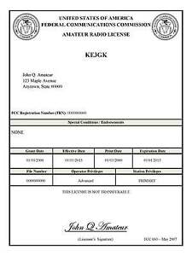*(By Anthony Luscre, K8ZT)*

As of February 17, 2015, the **FCC no longer routinely issues paper license documents** to Amateur Radio applicants and licensees. The Commission has maintained for some time now that the official Amateur Radio license authorization is the electronic record that exists in its Universal Licensing System (ULS). The FCC will continue to provide paper license documents to all licensees who notify the Commission that they prefer to receive one.

Licensees also will be able to print out an official authorization — as well as an unofficial “reference copy” — from the ULS License Manager. I’ve created a set of instructions on how you can request an **“official” printed copy of your license\***

[**Click here to download the instructions**](http://arrl-ohio.org/news/2020/print_your_license.pdf)

***One Question Questionnaire***

I consider this one of the most important questions I’ve put up here, so how about going to www.ARRL-OHIO.org and giving me a click? (It’s in the bottom left corner of the page) I’ll have more to say about this in the next OH Section Journal!

***“Have you got a QSL card for a QSO with W1AW?”***

From the last Poll: ***“Have you conducted the RF Exposure Calculations for your station yet?”***

Out of 45 responses: 60% YES 40% NO. I hope that you will take the time to do this. Make a record of it and keep it in your station. If questions ever come up it’s nice to know you’ve got the documentation that you are operating within the safety standards set for the Amateur Radio Service.

Ohio Section Cabinet

|  |  |
| --- | --- |
| Section Manager – Tom Sly, WB8LCD | Section Traffic Manager – David Maynard, WA3EZN |
| Section Emergency Coordinator – Stan Broadway, N8BHL | Section Youth Coordinator – Anthony Luscre, K8ZT |
| Technical Coordinator – Jeff Kopcak, K8JTK | Affiliated Clubs Coordinator – Tom Sly, WB8LCD |
| State Government Liaison – Bob Winston, W2THU | Public Information Coordinator – John Ross, KD8IDJ |



Hey Gang,

Have you taken a look at the **Swap & Shop** page on the Ohio Section webpage yet?? Here’s a link that will take you there… <http://arrl-ohio.org/sm/s-s.html>

Do you have equipment that you just don’t need or want anymore? Here’s a great venue to advertise it, and it’s FREE!! Is your club doing a fund raiser to help raise money? After a lot of thought, it was decided that the Swap & Shop webpage could also contain these types of items as well. The same rules will apply as do for the For Sales and Give-A-Ways and will only be posted for a month at a time. Please see the Terms & Conditions on the webpage.

If your club is doing a fund raiser and wants more exposure, please forward the information to me and I’ll advertise it on the Swap & Shop webpage for you.

Now, I still want to remind you that it won’t be listed in this newsletter because it would take up way too much space, so your ad will only appear on the website. It is there for any individual to post equipment Wanted / For Sale or Give-Away as well as for Club Fund Raisers. No licensed vehicles/trailers or business advertising will be posted. Postings are text only (no pictures or graphics) will be posted for a maximum of 1 month from date posting and require a contact phone number or email within the posting. Send your Wanted / For Sale or Give-Away post to:  [swap@arrlohio.org](mailto:swap@arrlohio.org)

***Back Issues of the PostScript and Ohio Section Journal***

Hey, did you know that PostScript and Ohio Section Journal (OSJ) are archived on the website? You can go back and look at any edition simply by clicking:

<http://arrl-ohio.org/news/index.html>

***Want to Share your Club Newsletter With Others?***

We have a webpage where you can download and read all of the newsletters that I get from around the state and even other sections!

Here’s the link to the page…. <http://arrl-ohio.org/club_news/index.html>

Please, if you don’t see your club newsletter posted, it’s because I’m not receiving it. Just have your newsletter editor contact me and I’ll get your club’s newsletter listed on the site!!

We all learn and steal (I mean, share) from each other’s work. So, get me your newsletter!!! Send it to: [webmaster@arrl-ohio.org](mailto:webmaster@arrl-ohio.org)

***Chit – Chat, and All That!***

Do you know someone that’s not getting these Newsletters? Please, forward a copy of this Newsletter over to them and have them “[Opt-In](mailto:Opt-In)” to start receiving them. Heck, just have them send an email to: [webmaster@arrl-ohio.org](mailto:webmaster@arrl-ohio.org) and we’ll get them added to the Ohio Section Emailing list.

We now have many thousands of readers receiving these newsletters weekly. Quite impressive, I’d say! I urge all of you to make sure that everyone, regardless of whether they are a League member or not, get signed up to receive these weekly Newsletters.

You can always “Opt-Out” at any time if you feel this is not what you were expecting. It’s fun and very informative. All of your favorite past newsletters are now archived too.

You can go back at any time and read them.

Just go to: <http://arrl-ohio.org/news/>

The pictures on the front page and throughout this newsletter are from various newsletters, Facebook posts and/or were sent directly to me in recent weeks. Take a good look at them, you just might be in one of the pictures! “SMILE… you’re in the Ohio Section News!!”

*PostScript is produced as a weekly newsletter. I want to thank everyone that has contributed articles and ideas to make this an even better news source. I sincerely hope that you have enjoyed this edition and will encourage your friends to join with you in receiving the latest news and information about the Ohio Section, and news and events happening around the world!*