[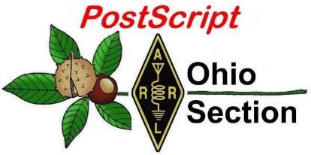](http://arrl-ohio.org/news/) ***“August 16th***

***Edition”***

🡪 National News 🡪 Club Corner

🡪 DX This Week 🡪 Contest Corner

🡪 Upcoming Hamfests 🡪 One Question Questionnaire

🡪 VE Testing 🡪 South 40

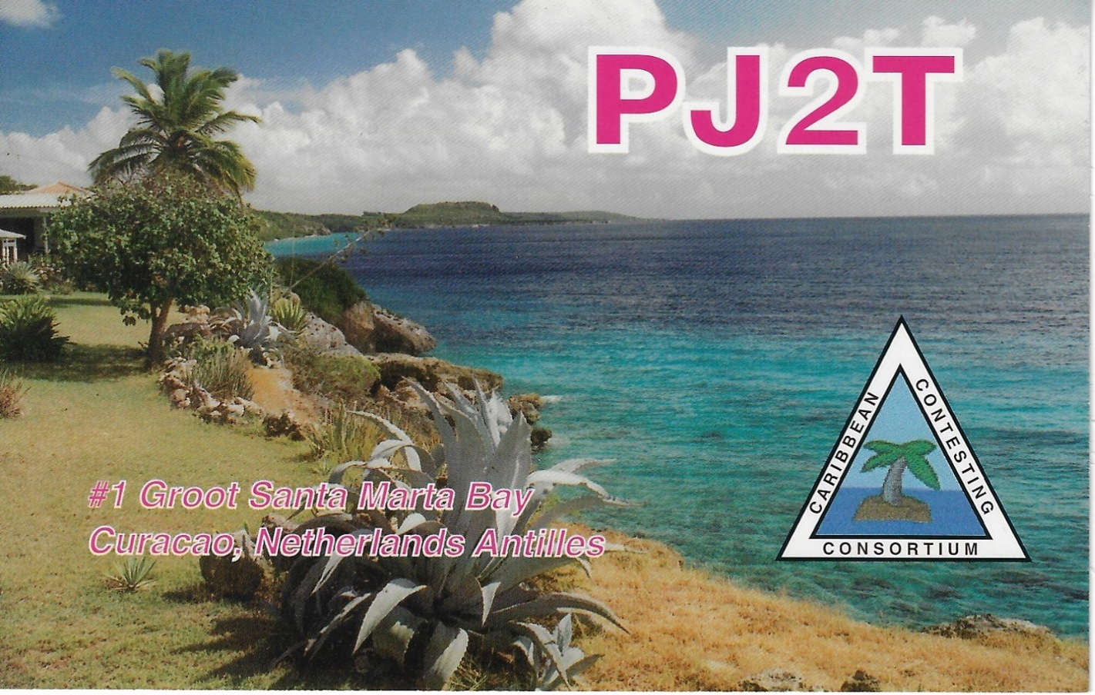

An *Extremely* successful contest station with roots in OHIO!

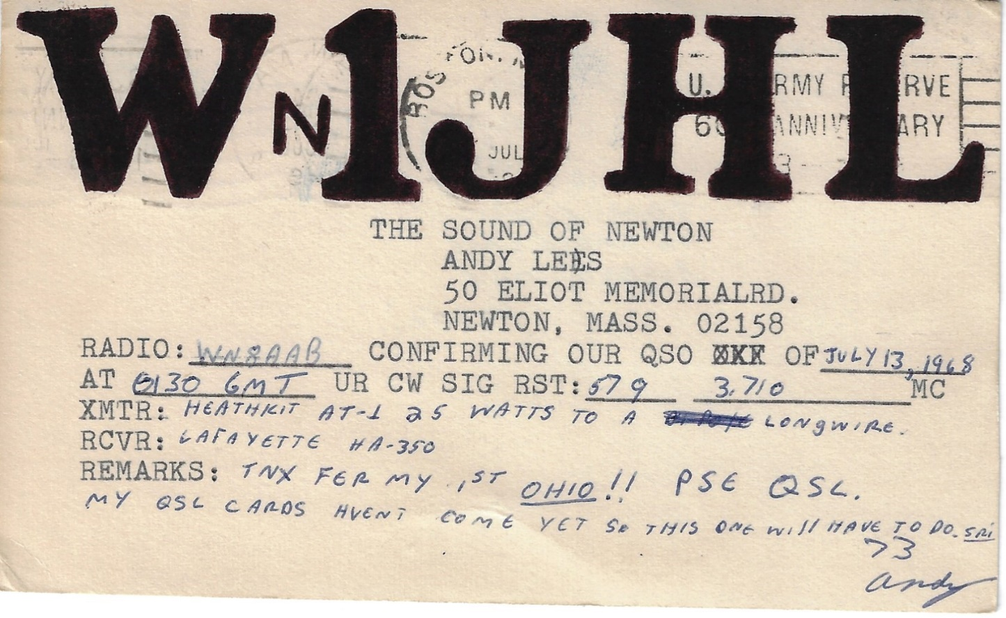

One of my personal favorites hanging on the wall in my radio room. They say that a QSL is the “final courtesy” of a successful QSO. Back in July of 1968 (at 15 years old) I was as thrilled to receive this card as I would ever be of any fancy multi-colored card I’ve ever received since. Thanks Andy!

**CQ CQ CQ de WB8LCD**

I’ve said it before, and I’ll certainly say it again – I hope you’re having fun with your hobby! First and foremost, Get On The Air. After all, that’s what the hobby is really all about. Cycle 25 is here. We won’t know till it’s over whether it will be the Greatest of All Time, or maybe just average, but it doesn’t really matter if you’re not getting your callsign out into the ether. Surely you can find *something* to do on air. There are contests galore. Special Event Stations all over the place. Nets and public service opportunities. New modes to try, old modes to go back to. If your idea of having FUN is sitting on the couch, watching things you’ve seen 100 times before (or worse yet, most of the modern drivel that’s out there) Then all I can say to you is WAKE UP! You’re missing out on some OUTSTANDING Amateur Radio opportunities.

Have you been to a hamfest yet? Check out the list of Hamfests in OH a bit further down in this newsletter – plenty of opportunities to get out there. I’ve been to a few already, and I’ve got to tell you, there’s lots of interesting stuff out there, some older and some newer, but plenty of supply. Prices are reasonable and Dollar$ are changing hands. The best part is meeting up with old friends and making some new ones. (disclaimer: I understand the angst that has been caused by COVID over the past two years. I don’t want anyone to do anything they are not comfortable with. Everyone needs to look at the information available to them and make a decision for themselves based on their comfort level.)

Next up – on Tuesday, August 10th – there will be an OH Section Zoom Conference for anyone interested in OHIO State Parks On The Air (OSPOTA). That contest is coming up soon on Saturday September 11th, so this will be an introduction and an overview on the contest, with a special section on both logging the contest and NVIS antennas for working the contest.

New Ham? The OHIO Section is sponsoring learning and exploring sessions. Technical Specialist Jason – N8EI will be presenting one of those sessions on August 31st beginning at 7:30pm. His topic is “Beyond the Baofeng: Thoughts on Equipment Choices for New Hams.” You received your license. Picked up a $20 Baofeng. Tried to reach some repeaters with it. Now what?

Thomas Sly is inviting you to a scheduled Zoom meeting.

Topic: Ohio Section

Time: Aug 31, 2021 07:00 PM Eastern Time (US and Canada)

Join Zoom Meeting

https://us02web.zoom.us/j/89913057151?pwd=QU5qd3gzQUVOclN1VjhpRHIzdGV1UT09

Meeting ID: 899 1305 7151

Passcode: 241591

One tap mobile

+19292056099,,89913057151#,,,,*241591# US (New York)

+13017158592,,89913057151#,,,,*241591# US (Washington DC)

Dial by your location

+1 929 205 6099 US (New York)

+1 301 715 8592 US (Washington DC)

+1 312 626 6799 US (Chicago)

+1 669 900 6833 US (San Jose)

+1 253 215 8782 US (Tacoma)

+1 346 248 7799 US (Houston)

Meeting ID: 899 1305 7151

Passcode: 241591

Find your local number: <https://us02web.zoom.us/u/khV0AJOqd>

Don’t forget, I can’t be everywhere and do everything. Let me know what your clubs are doing! Let me know what your VE schedule is, let me know about your Special Event stations. I’ll get it all listed here so everyone in the OH Section knows what’s going on. And here’s a hint I hope you’ll all take to heart: When most clubs have activities and events, they’re open to anyone who wants to participate with them! Go check out what the other clubs are doing, make some new friends, learn about an Amateur Radio topic you’ve always been interested in. You can also go to the OH Section website and read the newsletters of the other clubs in the section – there’s a wealth of knowledge there – tap into it!

Tom Sly – WB8LCD

ARRL OHIO Section Manager

330-554-4650

**___________________________________________________________**

***National News***

*(from arrl and other sources)*

July Volunteer Monitor Program Report Released

The July 2021 activity report of the Volunteer Monitor (VM) Program has been released. This program is a joint initiative between ARRL and the FCC to enhance compliance in the Amateur Radio Service.

* Technician-class licensees in Spring Valley, Smith River, and Nipomo, California; Oneonta, New York; Idaho Falls, Idaho, and Center, Texas, received *Advisory Notice*s concerning FT8 operation on frequencies not authorized to Technician licensees.
* General-class licensees in Marco Island and Arcadia, Florida, as well as in Maryland, received *Advisory Notice*s for operation in the Amateur Extra-class portion of the 20-meter band.
* A licensee in Parks, Arizona, received an *Advisory Notice* concerning failure to abide by a request to stay off a repeater. The matter will be referred to the FCC for enforcement action.
* A General-class licensee in Acworth, Georgia, received an *Advisory Notice* concerning failure to identify properly and for repeated communications with unlicensed stations on 3.895 MHz.
* An Amateur Extra-class licensee in Keansburg, New Jersey, received an *Advisory Notice* concerning on-the-air threats directed at another operator on 3.844 MHz.
* The final totals for VM monitoring in July were 1,736 hours on HF frequencies and 2,185 hours on VHF and UHF frequencies.

The IT staff at ARRL Headquarters has begun work on the automated system for Volunteer Monitors to report monthly monitoring hours and *Incident Reports*. *-- Thanks to Volunteer Monitor Program Administrator Riley Hollingsworth, K4ZDH*

|  |
| --- |
|  |

|  |
| --- |
|  |

__________________________________________________

ARRL Now Provides FREE RF Exposure Calculator

The FCC has adopted guidelines and procedures for evaluating environmental effects of RF emissions. The new guidelines incorporate two tiers of exposure limits based on whether exposure occurs in an occupational or "controlled" situation, or whether the general population is exposed or exposure is in an "uncontrolled" situation.

Under the new FCC rules, some amateurs need to perform routine 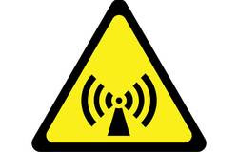station evaluations to ensure that their stations comply with the RF exposure rules. This can be as simple as running an online calculator to determine the minimum safe distance between any part of your antenna and areas where people might be exposed to RF energy from your station. Although amateurs can make measurements of their stations, evaluations can also be done by calculation.

To make this easy for amateurs, ARRL now provides an [RF exposure calculator](http://arrl.org/rf-exposure-calculator) on its RF Exposure page. To use the calculator, enter your transmit peak-envelope power (PEP) and operating mode, and answer the questions about the maximum amount of time you might be transmitting. The calculator will give you the minimum distance people must be from your antenna and human exposure.

You can print the results and keep them in your station records. There is no requirement to send your results to the FCC.



**ARRL** -- **Your One-Stop Resource for  
Amateur Radio News and Information**

* [Join or Renew Today!](http://www.arrl.org/join) Eligible US-based members can elect to receive [*QST*](http://www.arrl.org/qst) or [*On the Air*](http://www.arrl.org/on-the-air-magazine) magazine in print when they join ARRL or when they renew their membership. All members can access digital editions of all four ARRL magazines: *QST*, *On the Air, QEX*, and *NCJ*.
* Listen to [*ARRL Audio News*](http://www.arrl.org/arrl-audio-news), available every Friday.

**Subscribe to...**

* [*NCJ*-- *National Contest Journal*](http://www.ncjweb.com/). Published bimonthly, features articles by top contesters, letters, hints, statistics, scores, NA Sprint, and QSO parties.
* [*QEX*](http://www.arrl.org/qex)-- [*A Forum for Communications Experimenters*](http://www.arrl.org/qex). Published bimonthly, features technical articles, construction projects, columns, and other items of interest to radio amateurs and communications professionals.

**Free of charge to ARRL members...**

* [Subscribe](http://www.arrl.org/myarrl-account-management#%21/edit-info-email_subscriptions) to the *ARES Letter* (monthly public service and emergency communications news), the *ARRL Contest Update*(biweekly contest newsletter), Division and Section news alerts -- and much more!
* Find ARRL on [Facebook](https://www.facebook.com/ARRL.org/)! Follow us on [Twitter](https://twitter.com/arrl) and [Instagram](https://www.instagram.com/arrlhq)!

___________________________________________________________

***Club Corner***

This is YOUR cornner of the newsletter. Send me what your club is doing and I’ll make sure that it gets in. Got a special event or club project that you want everyone to know about? Send it to me! Need help with a project? Send it to me.

Let me know what you club is up to. Are you going to have a special guest at your meeting or are you having a special anniversary?

Just sent it to: [webmaster@arrl-ohio.org](mailto:webmaster@arrl-ohio.org)

******If you want me to publish your club information, or even an article you have written, please send it in WORD format (.docx). Please use Times New Roman font size 12 for the body of the aritcle. Any photos please include as a .jpg or .bmp – the time you save me in doing all the conversions will be greatly appreciated!

**___________________________________________________________**

**10/02/2021 | World's Largest Horseshoe Crab Roadside Attraction**

**Oct 2, 1400Z-2000Z, K8HO**, Hillsboro, OH. Highland Amateur Radio Association. 7.220 14.220. Certificate. Highland Amateur Radio Association, 21 Highland Drive, Hillsboro, OH 45133. [highlandara@gmail.com](mailto:)

# ___________________________________________________________

Black Swan 2021 Excercise

For the past four years, ARRL Ohio Section's ARES and NTS have joined the Ohio Military Reserve's BLACK SWAN exercises for SET. Exercise planners and controllers are grateful for the support that we've enjoyed during this time. We've all made significant strides forward in improving an understanding of the relationship between ARES and NTS, establishing communications between local and remote events, and interoperating between amateur and US Government stations.

BLACK SWAN 21 is making a major change in exercise control this year: only registered stations will be written into exercise play. We are not taking registrations for ARES clubs or NTS nets: Each station will be coordinated through exercise controllers. Furthermore, each registered station will operate as part of the exercise scenario without regard to ARRL offices or appointments. We expect that this will help to ensure rapid activations and keep players better connected to the exercise.

I understand that the Ohio Section ARES is building a scenario this year for SET operation on October 2. If you are an ARES member and your ARES organization is participating when your station will be in operation, I hope that you support that effort.

The fundamental reason for the change in BLACK SWAN exercise control is that we're focusing on quality of service issues, including questions of time-on-station, ordering of traffic transmission, and relays. (Hence the training here for the past few months on message precedence, various message formats, use of NBEMS and Winlink, and strict radiotelephone and radiotelegraph procedure. Consider especially how we've been watching time between message origination and delivery in the Weather Alert Project 21, and see how that is follow-up from the IPAWS-injected alerts from BLACK SWAN 20.)

As usual, BLACK SWAN will run over the course of a week, from September 28 to October 4 (Ohio time) that includes the Ohio ARES SET window. If your ARES group wishes to participate in the ARES scenario on October 2 and BLACK SWAN on October 3, you're welcome to do so. (You can improve your scores if you do; any activity your team or net conducts in a 48-hour window counts.) If you're looking to operate independently because you can't make the October 2 date, you're welcome to do so. To play, you'll need to register your station, where we ask about your station capability and availability. We'll write your station into the exercise plan and affirm those details as we get closer to the event. There's no reason that you can't do both if you're available.

In a further effort to avoid confusion between my efforts on behalf of my agency and any official opinion, policy, or activity of the ARRL Ohio Section, I will not be publishing in the Ohio Section newsletter at least until after the conclusion of BLACK SWAN 21. Meanwhile, remember that we're all on the same team, members of the same communities, and all providing valuable service as we can.

C. Matthew Curtin KD8TTE

<https://twitter.com/kd8tte>

_____________________________________________________

Highland Amateur Radio Association

Earlier this year HARA was presented a $100 DX Engineering gift certificate by the ARRL Ohio Section Manager Tom Sly.  The award was resulted from a challenge Sly made to the readers of the Ohio Section Journal regarding club public relations efforts.

Rather than holding on to the certificate and using it as a fund raiser at the annual Christmas party,

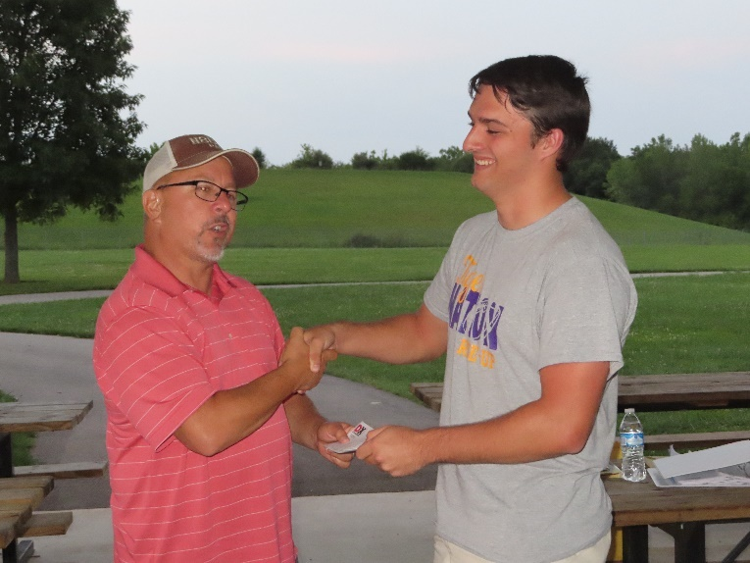club officers decided to use it as an incentive to increase the number of HARA members operating stations during the Field Day exercise.  Those who logged into the logging program and made a minimum of 5 contacts would be entered into a drawing to win the certificate grand prize or an ARRL Handbook donated by Great Lakes Division Vice Director Scott Yonally, N8SY.

Blake Gall, KE8PAQ, was the winner of the certificate and was presented with it at tonight's (8-10) HARA meeting by HARA President Pat Hagen, N8BAP.  The Handbook was won by Ken Lightner, KE8JEL, who was previously presented the prize and returned it to the Club for use as a future incentive.  Blake made the most contacts of all members during Field Day.

Blake is a resident of Greenfield and soon will be headed back to Athens and Ohio University where he is majoring in Computer Science.  He worked this summer as an intern for AEP.  Blake intends to activate either the Hocking Hills or Lake Hope State Parks during the upcoming September 11 Ohio State Parks on the Air contest.

Congratulations to Blake and Ken.

VE Sessions

Dayton Amateur Radio Association (DARA)

**The DARA License Exams scheduled for August 21st at 10:30am have been cancelled.**

 If you are interested in testing for a new or upgraded license, please come see us at the DARA Clubhouse. If you have questions about testing, please email [exams.w8bi@gmail.com](mailto:exams.w8bi@gmail.com)

Lake County Amateur Radio Association (LCARA)

Saturday October 2, Saturday December 4

All exams start at noon and are held at the Kirtland Library, 9267 Chillicothe Rd. Kirtland, OH

Portage County Amateur Radio Service (PCARS)

Starting on August 7th, PCARS will resume VE testing at the PCARS club site in Ravenna.

Please visit the PCARS web site and check out the information about VE testing in the latest newsletter – [https://portcars.org/files/newsletter/2021/PCARS-June-21.pdf](https://r20.rs6.net/tn.jsp?f=001DxdXS40dvzmbl9m9sfY5l9IIoAGYYsZIQIObAktg-wnnAu__YbvuVuV1_NQmLDKapbqCCYZK1L6epi1k5lVvuEtL_I1T0LMdgzjsNGvi1UnoIj7Lpv0RFoxS8h0YOCVVODgyzQI8xFTrmQ0pr6RXkQVvSx_cjGgR-DubSFhvF7CPVtMoPBph8tt8RpjGjyyBlRFHzo_VhR4=&c=Oi-83JMf17RlM94bujSYqqAwfNyIPWszQZKKkjp6BM5J7PHkAvaFrA==&ch=Kr1c-7rzal6CKkNUvSX-jLXK5eG9iU0tKZ5xoqUUqM21mzFnc1rE3w==)  – see pages 8, 9 and 10 for details.

If you have any questions, don’t hesitate to contact me at KB8UUZ@gmail,com

On behalf of the VE team at PCARS, we all look forward to getting the VE testing going again and look forward to seeing you there – August 7th -10 am – at the PCARS club site in Ravenna.

**OHIO SECTION TRAFFIC REPORT – JULY 2021**

**OHIO SECTION NETS – JULY 2021**

|  |  |  |  |  |  |
| --- | --- | --- | --- | --- | --- |
| NET | QNI | QTC | QTR | SESSIONS | N/M |
| BN(E) | 92 | 7 | 156 | 26 | WA3EZN De Facto |
| BN(L) | 46 | 22 | 152 | 28 | WB9LBI |
| OSN | 54 | 11 | 315 | 17 | W8MAL |
| OSSBN | 1461 | 340 | 1795 | 93 | KC8WH |

**OHIO SECTION PSHR REPORTS – JULY 2021**

|  |  |  |  |  |  |  |  |  |
| --- | --- | --- | --- | --- | --- | --- | --- | --- |
| WA3EZN | 40 | 40 | 30 | 345 | 0 | 20 | TOTAL | 475 |
| AD8CM | 37 | 33 | 10 | 260 | 0 | 0 | TOTAL | 340 |
| KM8V | 40 | 40 | 30 | 0 | 5 | 80 | TOTAL | 195 |
| KD8UUB | 40 | 35 | 10 | 80 | 10 | 0 | TOTAL | 175 |
| W8DJG | 40 | 40 | 30 | 5 | 25 | 20 | TOTAL | 160 |
| N8SY | 40 | 2 | 30 | 30 | 0 | 50 | TOTAL | 152 |
| N2LC | 40 | 40 | 10 | 20 | 0 | 20 | TOTAL | 130 |
| AC8NP | 40 | 40 | 10 | 15 | 0 | 20 | TOTAL | 125 |
| KD8KBX | 40 | 16 | 10 | 50 | 0 | 0 | TOTAL | 116 |
| AB8MW | 40 | 40 | 10 | 20 | 0 | 0 | TOTAL | 110 |
| N8CJS | 40 | 40 | 20 | 0 | 10 | 0 | TOTAL | 110 |
| KC8WH | 40 | 40 | 30 | 0 | 0 | 0 | TOTAL | 110 |
| K8MDA | 40 | 26 | 20 | 0 | 0 | 20 | TOTAL | 106 |
| AC8RV | 40 | 40 | 10 | 10 | 0 | 0 | TOTAL | 100 |
| WB8SIQ | 40 | 35 | 10 | 10 | 0 | 0 | TOTAL | 95 |
| KL7RF | 40 | 40 | 10 | 0 | 0 | 0 | TOTAL | 90 |
| K8KRA | 40 | 40 | 10 | 0 | 0 | 0 | TOTAL | 90 |
| N8MRS | 40 | 40 | 10 | 0 | 0 | 0 | TOTAL | 90 |
| KB8HJJ | 40 | 40 | 10 | 0 | 0 | 0 | TOTAL | 90 |
| WB8YYS | 40 | 19 | 20 | 0 | 0 | 10 | TOTAL | 89 |
| KV8Z | 27 | 7 | 0 | 30 | 10 | 10 | TOTAL | 84 |
| W8GSR | 40 | 40 | 0 | 0 | 0 | 0 | TOTAL | 80 |
| KA1G | 40 | 25 | 10 | 0 | 0 | 0 | TOTAL | 75 |
| KD8UOT | 40 | 25 | 0 | 0 | 0 | 0 | TOTAL | 65 |
| K3AUX | 13 | 37 | 10 | 0 | 0 | 0 | TOTAL | 60 |
| KE8ANW | 40 | 6 | 0 | 0 | 0 | 0 | TOTAL | 46 |
| K8OVO | 40 | 3 | 0 | 0 | 0 | 0 | TOTAL | 43 |
| NC8V | 11 | 7 | 0 | 5 | 0 | 0 | TOTAL | 23 |

**OHIO SECTION TRAFFIC REPORTS – JULY 2021**

|  |  |  |  |
| --- | --- | --- | --- |
| AB8MW-42 | K8OVO- 3 | KL7RF-40 | N8TNV-96 |
| AC8NP-43 | KB8HJJ- 48 | KM8V- 41 | NC8V-7 |
| AC8RV- 40 | KC8HTP-4 | KV8Z- 7 | W8DJG-97 |
| AD8CM-33 | KC8IDM-22 | N2LC- 61 | W8GSR-57 |
| KA1G-25 | KC8WH-93 | N8BV- 38 | W8MAL-13 |
| K3AUX- 37 | KD8HB- 60 | N8CJS-18 | WA3EZN-142 |
| K3RC- 43 | KD8GYI-35 | N8GBU- 38 | WB8HHP-4 |
| K8KRA- 82 | KD8KBX- 16 | N8MRS- 66 | WD8SDH-11 |
| K8MDA- 26 | KD8UOT- 25 | N8OD- 21 | WB8SIQ-35 |
| K8MWF- 30 | KD8UUB- 35 | N8SY-2 | WB8YYS-19 |
|  |  |  | WB9LBI-65 |
|  |  |  |  |
|  | TOTALS | 41/1620 |  |

**OHIO SECTION LOCAL NETS – JULY 2021**

|  |  |  |  |  |  |
| --- | --- | --- | --- | --- | --- |
| NET | QNI | QTC | QTR | SESSIONS | N/M |
| BRTN | 184 | 101 | 464 | 30 | W8DJG |
| COTN | 329 | 83 | 548 | 31 | KD8TTE |
| MVTN | 22 | 1 | 39 | 4 | KC8HTP |
| NWOH ARES | 273 | 115 | 476 | 31 | N8TNV |
| TATN | 397 | 74 | 350 | 31 | WG8Z |
| TCTTN | 147 | 15 | 339 | 13 | WB8YYS |

**OHIO SECTION TRAFFIC REPORT – JULY 2021**

**OHIO SECTION NETS** – **JULY 2021**

NET QNI QTC QTR SESSIONS N/M

BN(E) 92 7 156 26 WA3EZN De Facto

BN(L) 46 22 152 28 WB8LBI

OSN 54 11 315 17 W8MAL

OSSBN 1461 340 1795 93 KC8WH

**OHIO SECTION PSHR REPORTS – JULY 2021**

WA3EZN 40 40 30 345 0 20 TOTAL 475

AD8CM 37 33 10 260 0 0 TOTAL 340

KM8V 40 40 30 0 5 80 TOTAL 195

KD8UUB 40 35 10 80 0 0 TOTAL 175

W8DJG 40 40 30 5 25 20 TOTAL 160

N8SY 40 2 30 30 0 50 TOTAL 152

N2LC 40 40 10 20 0 20 TOTAL 130

AC8NP 40 40 10 15 0 20 TOTAL 125

KD8KBX 40 16 10 50 0 0 TOTAL 116

AB8MW 40 40 10 20 0 0 TOTAL 110

N8CJS 40 40 20 0 10 0 TOTAL 110

KC8WH 40 40 30 0 0 0 TOTAL 110

K8MDA 40 26 20 0 0 20 TOTAL 106

AC8RV 40 40 10 10 0 0 TOTAL 100

WB8SIQ 40 35 10 10 0 0 TOTAL 95

KL7RF 40 40 10 0 0 0 TOTAL 90

K8KRA 40 40 10 0 0 0 TOTAL 90

N8MRS 40 40 10 0 0 0 TOTAL 90

KB8HJJ 40 40 10 0 0 0 TOTAL 90

WB8YYS 40 19 20 0 0 10 TOTAL 89

KV8Z 27 7 0 30 10 10 TOTAL 84

W8GSR 40 40 0 0 0 0 TOTAL 80

KA1G 40 25 10 0 0 0 TOTAL 75

KD8UOT 40 25 0 0 0 0 TOTAL 65

K3AUX 13 37 10 0 0 0 TOTAL 60

KE8ANW 40 6 0 0 0 0 TOTAL 46

K8OVO 40 3 0 0 0 0 TOTAL 43

NC8V 11 7 0 5 0 0 TOTAL 23

**OHIO SECTION LOCAL NETS – JULY 2021**

NET QNI QTC QTR SESSIONS N/M

BRTN 184 101 464 30 W8DJG

COTN 329 83 548 31 KD8TTE

MVTN 22 1 39 4 KC8HTP

NWOH ARES 273 115 476 31 N8TNV

TATN 397 74 350 31 WG8Z

TCTTN 147 15 339 13 WB8YYS

**OHIO SECTION TRAFFIC REPORTS – JULY 2021**

AB8MW-42 K8OVO-3 KL7RF- 40 N8TNV-96

AC8NP-43 KB8HJJ-48 KM8V-41 NC8V-7

AC8RV-40 KC8HTP-4 KV8Z-7 W8DJG-97

AD8CM-33 KC8IDM-22 N2LC-61 W8GSR-57

KA1G-25 KC8WH-93 N8BV-38 W8MAL-13

K3AUX-37 KD8HB-60 N8CJS-18 WA3EZN-142

K3RC-43 KD8GYI-35 N8GBU-38 WB8HHP-4

K8KRA-82 KD8KBX-35 N8MRS-66 WD8SDH-11

K8MDA-26 KD8UOT-35 N8OD-21 WB8SIQ-35

K8MWF-30 KD8UUB-35 N8SY-2 WB8YYS-19

WB9LBI-65

TOTALS 41/1620

**OHIO HF TRAFFIC NETS**

BN(E) Buckeye Net Early - CW

BN(L) Buckeye Net Late – CW

OSN Ohio Slow Net - CW

OSSBN Ohio Single Sideband Net – Phone

**OHIO VHF TRAFFIC NETS**

BRTN Burning River Traffic Net serving Cleveland and North Central Ohio

COTN Central Ohio Traffic Net serving Columbus and Central Ohio

MVTN Miami Valley Traffic Net serving the Dayton area

NWOH ARES Northwest Ohio ARES Net serving Toledo and surrounding counties

TATN Tri-State Amateur Traffic Net

TCTTN Tri-County Traffic and Training Net serving North East Ohio

___________________________________________________________________________________________________________

**Your Club news should be listed here!**

I know you’re out there doing things! Send me a write-up (MSWord please) and some photo’s (.jpg please) and we’ll get your club hi-lited here for the other OH Section Clubs to see! Send to [WB8LCD@ARRL.ORG](mailto:WB8LCD@ARRL.ORG)

__________________________________________________________________________________________

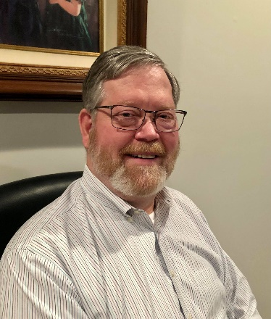DX This Week – OH QSO Party

Bill AJ8B (aj8b@arrl.net, @AJ8B, or www.aj8b.com)

CWOPs Member #1567

The Midwest DX Cluster spots included Albania, Argentina, Austria, Belize, Canada, Croatia, Czech Republic, European Russia, Georgia, Fed. Rep. of Germany, Hungary, Iceland, Italy, Kuwait, Lithuania, Mali, Mexico, Montenegro, Netherlands, North Macedonia, Poland, Puerto Rico, San Andres & Providencia, San Marino, Saudi Arabia, Scotland, Slovenia, St. Martin, Sweden, Ukraine, United Arab Emirates, and Uruguay. This brings the total number of entities spotted in the Midwest in 2021 to 187! I hope you are tracking this for your own DXCC records or the CQ Marathon.

My 5-week drought of receiving QSL cards ended this week. I received ZL2OK – David in New Zealand, 7Z1AL – Abdulaziz in Saudi Arabia and 9K2OW – Hamad in Kuwait. Let me know what you received.

|  |  |
| --- | --- |
|  |  |

*DAH DIT DIT DIT DAH DAH DIT DIT DIT DAH*

The end of August is fast approaching. Can You believe it? There are two activities that I want to remind you of. The first is the W8DXCC convention. I will have more on that next week, but tickets are moving pretty well. We have a limited number, and I don’t want anyone to be left out. You can visit ww.w8dxxx.com for more details. I will be leaving the convention as soon as it has completed and headed to the “shack” to take part in the next event described below.

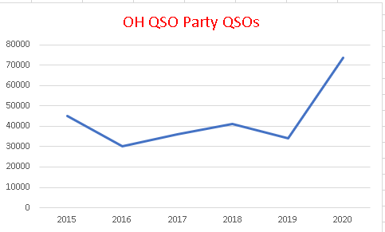 I try to participate in as many contests as I can during the year. I consider the contest season running from the fourth Saturday in August to Memorial Day weekend of the next year. The significance of August to May is that the Ohio QSO party (OQP) is held on the fourth weekend in August and the CQWW WPX CW contest is held during the last weekend in May. Although I do participate in as many state QSO parties (and other contests) as I can, my focus is on the Ohio QSO Party. The majority of the information presented here is from the Ohio QSO Party website and is used here courtesy of the Mad River Radio Club.

Why the Ohio QSO Party? The objective of the contest is for Amateurs inside the state of Ohio to contact as many Amateurs as possible both inside and outside of Ohio. For Amateurs outside the state of Ohio to contact as many Ohio stations as possible. Non-Ohio stations may work only Ohio stations, while Ohio stations may contact anyone.

The Ohio QSO Party is an opportunity for amateur radio operators around the world to celebrate the great state of Ohio.

What does this have to do with DX? Well, chasing DX requires operating skill, patience, and a solid knowledge of your equipment. Contests require all of this for an extended period. In the case of the OQP, this is a 12-hour long contest where one of the biggest factors is BITS. (Butt in the Seat – Thanks Dave, K8DV) In addition, it is really a lot of fun!

If you have any interest at all, please visit <https://www.ohqp.org/> and browse the links on the left-hand side and explore the site. You’ll find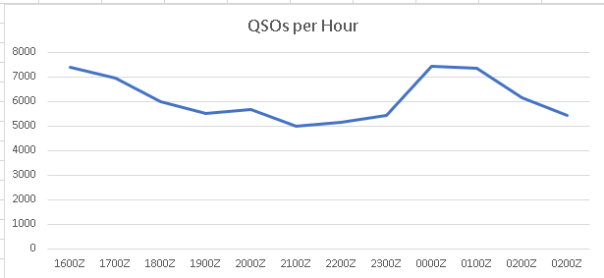 the rules, past scores, planned operations for this year’s event, scoring records and more.

If you review The first graph, you will see that there is a lot of activity during this contest. In fact, the 2020 results showed ***TWICE*** as many QSOs as in 2019. I hope that it is even busier this year.

**How can you get up to the minute info on OhQP, post questions or tell everyone about your OhQP experience…?**

OhQP has a mail list (reflector). You can subscribe (allowing you to post messages or to view the archives. This is the only place on the web to get “official” information on the Ohio QSO Party. We are not on Facebook, Twitter or anywhere else. Since 1999 the Mad River Radio Club has brought you the Ohio QSO Party.

*DAH DIT DIT DIT DAH DAH DIT DIT DIT DAH*

CQDX CQDX CQDX CQDX CQDX CQDX CQDX CQDX CQDX

Here is an update from Bernie, W3UR, of the DailyDX and the WeeklyDX, the best source for DX information. <http://www>.dailydx.com/. Bernie has this to report:

**Bouvet Update:**

Dear Global DX-Community,

On June 18th, we announced that we were continuing to seek new transportation to Bouvet in support of our Bouvet 2023 project. At the same time, we have refunded all donations as there was a high degree of uncertainty that we could move forward.

We are pleased to announce that we have found a suitable/affordable vessel willing to take us to Bouvet. We are negotiating the terms of that charter contract now.

* We have submitted a new application to the Norwegian Polar Institute.
* We have revised the Leadership of our team as follows:
  + David Jorgensen-WD5COV Co-Leader, Operations, Antennas.
  + Kevin Rowett-K6TD Co-Leader, Systems/Networks, Procurement, Logistics
  + Paul Ewing-N6PSE Co-Leader, Planning, Public Relations, Tents, Logistics.

Together, this leadership team will assemble 12 Operators to make this vision a reality. We are revising our website and soon, we will begin fundraising for this renewed effort. We are extremely grateful for all our past Sponsors and Donors and we hope that you can support this renewed effort.  
  
Sincerely,  
The Bouvet 2023 Team

**9X – Rwanda -** 9X4X will be November 24 to December 1 by the HDXG, Holy Land DX  
Group.  The op team is 4Z4KX, 4X6YA, 4Z5FI, 4Z5LA, 4Z1DZ and 4X1VF with three stations covering 160-10 CW, SSB, RTTY and FT8, and possibly satellite.  They will be in the CQWW CW weekend event in late November.  DF2WO has been helpful in making arrangements.  QSL to 4Z5FI.

**Z6 – Kosovo -** September 10-13 DL2JRM, OM Rene plans to have Z68XX on the air, mostly CW but including the weekend WAE SSB contest.  He says it is "not a big deal," he will be QRV with 100 watts to a vertical, a "limited equipment weekend trip." QSL via DL2JRM.   
  
**A3 – Tonga -**  A35JP will be on the air from late August 2021.  Operator Masa, JA0RQV, says he finally got to Tonga from New Zealand July 28 and is in a quarantine hotel in Nuku'alofa.  After the 21-day quarantine he will move to a seaside cottage and put up antennas.  He plans to be operational to November.  The QTH is on Tongatapu Island, OC-049.  Masa will be on 80-6 CW, SSB and FT8 with 100 watts from an ICOM IC- 7300 to a vertical.  He will also try to get to OC-191, OC-123, OC-064 and OC-169, details forthcoming.  For QSO confirmation it's LoTW or Club Log with 2 USD for a direct reply.  Or send through the bureau system via JA0RQV.  Paper QSLs will be sent after his return to Japan in November.  "Please do not send SASE to my home address."

**OA – Peru -**   
W9VNE, Jim, reminds everyone his good friend OA4SS (W9SI), Father Ed, "is extremely active in every major CW contest" including the ARRL, CQ WW, CQ WPX and ARRL 10 Meter. "Father Ed makes a point of giving everyone an OA multiplier", in the contests making "a good 2K QSOS per weekend or more" and producing "a good 10,000 QSOs a year on CW" so he is always "easy to find and work". QSLs for OA4SS go via KB6J.

*DAH DIT DIT DIT DAH DAH DIT DIT DIT DAH*

Below is a list of upcoming contests in the “Contest Corner”. I think this is important for someone who is trying to move up the DXCC ladder since entities that are on the rarer side and easiest to work in contests. Some of my best “catches” have been on the Sunday afternoon of a contest when the rarer entities are begging for QSOs. Of course, the gamble is that if you wait until Sunday, conditions may change, or they simply won’t be workable. However, it is not a bad gamble. Of course, why not work the contest and have some fun!  
Check out the WA7BNM Contest Calendar page (<https://www.contestcalendar.com/>) and CQ Magazine for more contests or more details.

The contests in red are those that I plan to spend some significant participation time on. PLEASE let me know if you are working contests and how you fared.

Thanks!

|  |  |  |
| --- | --- | --- |
| Aug. 21-22 | ARRL 10 GHz and Up Contest | www.arrl.org/10-ghz-up |
| Aug. 21-22 | CVA DX Contest SSB | http://cvadx.org/regulamento |
| Aug. 21-22 | SARTG RTTY Contest | www.sartg.com/index.html |
| Aug. 21-22 | North American SSB QSO Party | http://ncjweb.com/NAQP-Rules.pdf |
| Aug. 22 | ARRL Rookie Roundup RTTY | www.arrl.org/rookie-roundup |
| Aug. 28-29 | Hawaii QSO Party | http://hawaiiqsoparty.org |
| Aug. 28-29 | Kansas 080 Party | www.ksqsoparty.org |
| Aug. 28-29 | YO DX HF Contest | www.yodx.ro/en |
| Aug. 28-29 | ALARA Contest | www.alara.org.au/contests |
| Aug. 28-29 | World Wide Digi DX Contest | https://ww-digi.com |
| Aug 28-29 | WNE Island 080 Party | https://usislands.org/qso-party-rules |
| Aug.29 | SARL HF CW Contest | http://bit.ly/HOlqQf |
| August 28 | **Ohio QSO Party** | <https://www.ohqp.org/> |
| August 28 | **W8DXCC** | <https://www.w8dxcc.com> |
| Sept. 1 | VHF-UHF FT8 Activity Contest | www.ft8activity.eu/index.php/en |
| Sept. 1 | UKEICC 80m Contests SSB | https://bit.ly/2SDPqQQ |
| Sept. 4 | AGCW Straight Key Party | https://bit.ly/3ngQSpB |
| Sept. 4 | Russian “Radio” RTTY WW Contest | https://bit.ly/3eWEtDl |
| Sept. 4 | **CWOPS CWOPEN 0000 – 0359Z** | https://cwops.org/cwops-tests/cw-open/ |
| Sept. 4 | **CWOPS CWOPEN 1200 – 1559Z** | https://cwops.org/cwops-tests/cw-open/ |
| Sept. 4 | **CWOPS CWOPEN 2000 – 2359Z** | https://cwops.org/cwops-tests/cw-open/ |
| Sept. 4-5 | All Asian DX Phone Contest | www.jarl.org/English/0-2.htm |
| Sept. 4-5 | Colorado QSO Party | http://ppraa.org/coqp |
| Sept. 4-5 | RSGB SSB Field Day | http://bit.ly/2OKdymu |
| Sept. 4-5 | PODXS 070 Club Jay Hudak Memorial 80M Sprint | http://bit.ly/2MkaaNt |
| Sept. 4-5 | Tennessee QSO Party | https://tnqp.org/rules |
| Sept. 6 | RSGB Autumn Series SSB | https://bit.ly/3p4eShW |
| Sept. 6-7 | MI QRP Labor Day CW Sprint | www.miqrp.net/contest |
| Sept. 8 | VHF-UHF FT8 Activity Contest | www.ft8activity.eu/index.php/en |
| Sept. 11 | **FOC QSO Party** | www.g4foc.org/qsoparty |
| Sept. 11-12 | Alabama QSO Party | www.alabamaqsoparty.org |
| Sept. 11-12 | SARL Field Day | http://bit.ly/H0IqQf |
| Sept. 11-12 | Russian Cup Digital Contest | www.qrz.ru/contest/detail/86.html |
| Sept. 11-12 | Worked All Europe SSB Contest | http://bit.ly/2vufgcb |
| Sept. 11-13 | ARRL September VHF QSO Party | www.arrl.org/september-vhf |
| Sept. 12 | North American CW Sprint | http://ncjweb.com/Sprint-Rules.pdf |
| Sept. 15 | RSGB Autumn Series CW | https://bit.ly/3p4eShW |
| Sept. 16 | Bavarian Contest Club QSO Party | https://bit.ly/2MDzviG |
| Sept. 18-19 | ARRL 10 GHz and UP Contest | www.arrl.org/10-ghz-up |
| Sept. 18-19 | Iowa QSO Party | www.w0yl.com/IAQP |
| Sept. 18-19 | New Hampshire QSO Party | www.w1wqm.org/nhqso |
| Sept. 18-19 | New Jersey QSO Party | http://bit.ly/1nDlf8V |
| Sept. 18-19 | QRP Afield | http://bit.ly/2QACxFu |
| Sept. 18-19 | SARL VHF/UHF Digital Contest | http://bit.ly/H0IqQf |
| Sept. 18-19 | Scandinavian CW Activity Contest | www.sactest.net/blog |
| Sept. 18-19 | Texas QSO Party | http://txqp.net |
| Sept. 18-19 | Washington State Salmon Run | http://salmonrun.wwdxc.org/rules |
| Sept. 19 | BARTG Sprint PSK63 | http://bartg.org.uk/wp/contests |
| Sept. 19 | North American RTTY Sprint | http://ncjweb.com/Sprint-Rules.pdf |
| Sept. 20 | 144 MHz Fall Sprint | http://svhfs.org/wp |
| Sept. 23 | RSGB Autumn Series Data | https://bit.ly/3p4eShW |
| Sept. 25 | AGCW UHF/VHF Contest | https://bit.ly/3lw91PK |
| **Sept. 25-26** | **CQWW RTTY DX Contest** | **www.cqwwrtty.com** |
| Sept. 25-26 | Maine QSO Party | www.ws1sm.com/MEQP.html |
| Sept. 28 | 222MHz Fall Sprint | http://svhfs.org/wp |
| Sept. 29 | UKEICC 80m Contests CW | https://bit.ly/2SDPqQQ |

***_____________________________________________________________________________***

***DX NEWS***

ARLD032 DX news  
  
This week's bulletin was made possible with information provided by The Daily DX, the OPDX Bulletin, 425 DX News, DXNL, Contest Corral from QST and the ARRL Contest Calendar and WA7BNM web sites.  Thanks to all.  
  
UGANDA, 5X.  Elvira, IV3FSG will sign 5X3R from August 13 to September 2.  She will have 100 watts to a dipole, doing SSB, digital and CW.  QSL via IK2DUW or via the bureau.  
  
SPAIN, AM.  Members of the URE Burgos are active until August 18 with the special call sign AM1CCB to mark the 800th anniversary of the Burgos Cathedral.  In 1984, the Cathedral was declared a UNESCO  
World Heritage Site.  Operators include EA1FE, EA1BHB, EA1GLY, EA1JAI, EA1EC, EA1XY, EA1FGJ, EA1IUM and EA1ARW.  QSL via LoTW, via the Bureau, eQSL or direct to: UREBU, P.O. Box: 444, 09080 Burgos, Spain.  
  
TAIWAN, BX30.  Ken, JP1RIW will be active as BX30ARL from New Taipei City until the end of the year to celebrate the 30th anniversary of the Chinese Taipei Amateur Radio League.  Activity will be on 40 to 6 meters.  Ken operates mainly on the digital modes on weekends. QSL via BM2JCC.  
  
CAPE VERDE, D4.  Paco, EA7KNT will be active as EA7KNT/D4 or D4ASL from Sal Island (AF-086) from August 23 to September 5.  
  
KYRGYZSTAN, EX.  Andrea, HB9DUR is active as EX0DX from Bishkek. The length of his stay is unknown.  Activity will be as time permits on various HF bands.  QSL via his home call sign, LoTW, ClubLog's OQRS or eQSL.  
  
SAN ANDREAS ISLAND, HK0.  Pedro, HK3JJH is currently active as HK0/HK3X.  His length of stay is unknown.  Activity has been mainly on 20 meters using FT8 (F/H).  QSL via JH1AJT.  
  
SOUTH KOREA, HL.  Members of the Korean Amateur Radio League (KARL) Chungbuk HQ have activated special event station HL76V to celebrate 76th anniversary of South Korea's Liberation.  Activity will  
continue until August 31.  QSL via the Bureau.  
  
PERU, OA7.  Arno, DL1CW will be active as OA7/DL1CW until September 1.  Activity will be on 40 to 10 meters.  QSL via his home call sign, via the Bureau or LoTW.  
  
ARUBA, P4.  John, W2GD will be QRV as P40W from October 18 to 31. Activity will be on the various HF bands, with some focus on the 30, 17 and 12 meters and 160 meters using mostly CW.  His activity will  
also include an entry in the upcoming CQWW DX SSB Contest as a Single Op/All Band entry.  QSL via LoTW or N2MM.  No bureau cards.  
  
DODECANESE, SV5.  Mort, G2JL is QRV as SV5/G2JL from Lipsi Island for the next three months.  Activity will be on all bands and modes, propagation permitting.  Current operations have been on 20 meters  
CW.  QSL via his home call sign, direct or via the Bureau.  Also, Reiner, DL2AAZ will be active as SV5/DL2AAZ from Rhodes (EU-001) from September 5 to 19.  Activity will be holiday style on 40 to 10  
meters and the QO-100 satellite, using CW and SSB.  QSL via DL2AAZ, direct or via the Bureau.  
  
  
  
CORSICA, TK.  Frans, DJ0TP is now active as TK/DJ0TP from Linguizetta until September 14.  QSL via LoTW or via the Bureau.  
  
ALAND ISLANDS, OH0.  The SP1KRF Team will activate OH0KRF from August 23 to 29.  They plan to be on 80 to 10 meters using SSB, CW, FT8/4 and RTTY.  Ops include SP1EG, SP1F, SP1IVL, SP1VAX, SP1Z and SQ1WO.  QSL via SP1KRF.  
  
CAYMAN ISLANDS, ZF.  Pete, K8PGJ will be active as ZF2PG from August 15 to 21.  Activity will be on 160 to 10 meters.  This includes being an entry in the upcoming North American SSB QSO Party.  QSL  
via LoTW.  
  
CANADA, VE.  The Moncton Area Amateur Radio Club celebrates its 85th anniversary with the call sign VE9M85A until the end of August.  QSL via bureau or eQSL.  
  
RWANDA, 9X.  Members of the Holy Land DX Group (HDXG) will sign 9X4X from November 24 to December 1.  Operators include Mark, 4Z4KX, Hilik, 4X6YA, Ruben, 4Z5FI, Ruslan, 4Z5LA, Hanan, 4Z1DZ, Slava, 4Z5MU and Jan, 4X1VF.  They will run three stations on 160 to 10 meters using CW, SSB, RTTY and FT8, and maybe satellites also.  They will also participate in the CQWW DX CW Contest.  QSL via Ruben,  
4Z5FI.

**___________________________________________________________________**

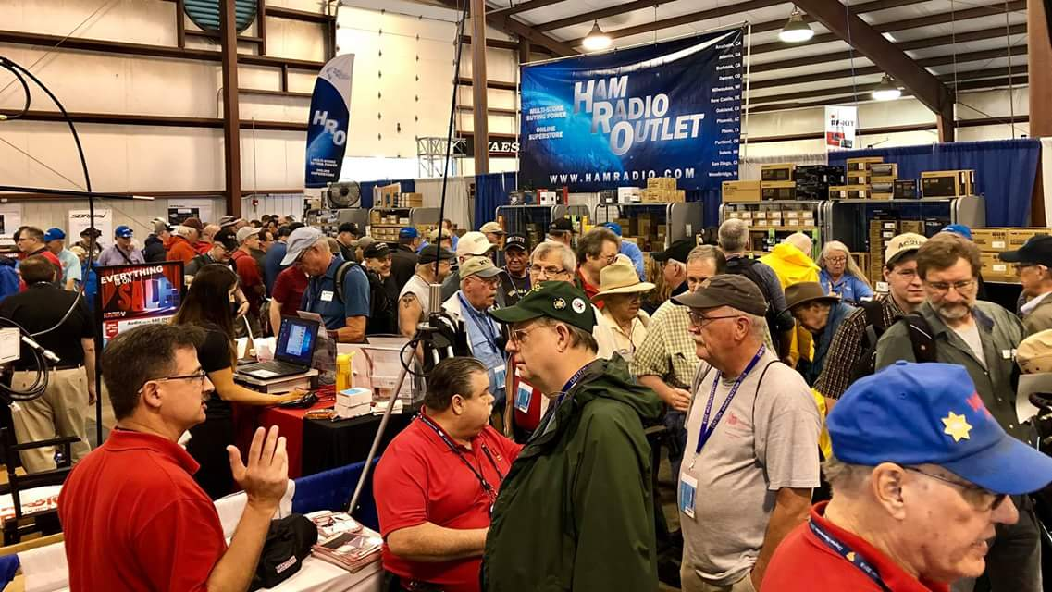[**Upcoming *Hamfests***](http://arrl-ohio.org/hamfests.html)

We **DO** have some hamfests scheduled for 2021!! Yes, take a good look at the list, it’s growing every day!

|  |  |
| --- | --- |
| **08/22/2021 -**[**Athens Trunkfest**](http://www.arrl.org/hamfests/athens-trunkfest)  **Location:**Athens, OH **Sponsor:** Athens County Amateur Radio Association **Website:** <http://ac-ara.org/>  [**Learn More**](http://www.arrl.org/hamfests/athens-trunkfest) | **08/28/2021 -**[**Cincinnati Hamfest℠**](http://www.arrl.org/hamfests/cincinnati-hamfest)  **Location:**Owensville, OH **Sponsor:** Milford ARC **Website:** [http://CincinnatiHamfest.org](http://cincinnatihamfest.org/)  [**Learn More**](http://www.arrl.org/hamfests/cincinnati-hamfest) |
| **09/12/2021 -**[**Findlay Hamfest**](http://www.arrl.org/hamfests/findlay-hamfest-8) Location: Findlay, OH Sponsor: Findlay Radio Club Website: <http://www.findlayradioclub.org/hamfest>  [**Learn More**](http://www.arrl.org/hamfests/findlay-hamfest-8) | **09/18/2021** - [**Miami County Swap Meet**](http://w8fw.org/)  **Location:**Troy, OH  **Sponsor:** Miami County Amateur Radio Club  **Website:** [http://w8fw.org](http://w8fw.org/)    [**Learn More**](http://w8fw.org/) |
| **09/18/2021 -**[**Mound Amateur Radio Assoc. Swap Meet**](http://www.arrl.org/hamfests/mound-amateur-radio-assoc-swap-meet)  **Location:**Miamisburg, OH **Sponsor:** MARA **Website:** [http://W8DYY.ORG](http://w8dyy.org/)  [**Learn More**](http://www.arrl.org/hamfests/mound-amateur-radio-assoc-swap-meet) | **09/26/2021 -**[**Cleveland Hamfest**](http://www.arrl.org/hamfests/cleveland-hamfest-1)  **Location:**Berea, OH **Sponsor:** Hamfest Association of Cleveland **Website:** [http://www.hac.org](http://www.hac.org/)  [**Learn More**](http://www.arrl.org/hamfests/cleveland-hamfest-1) |
|  |  |
| **10/02/2021 -**[**10th Annual Vette City Hamfest,**](http://www.arrl.org/hamfests/10th-annual-vette-city-hamfest-arrl-great-lakes-division-convention)  [**ARRL Great Lakes Division Convention**](http://www.arrl.org/hamfests/10th-annual-vette-city-hamfest-arrl-great-lakes-division-convention)  **Location:**Bowling Green , KY  **Sponsor:** Kentucky Colonels Amateur Radio Club  **Website:** [https://ky4bg.com](https://ky4bg.com/)  [**Learn More**](http://www.arrl.org/hamfests/10th-annual-vette-city-hamfest-arrl-great-lakes-division-convention) | |
| **10/09/2021 -**[**Northwest Ohio Amateur Radio Club (NWOARC) hamfest**](http://www.arrl.org/hamfests/northwest-ohio-amateur-radio-club-nwoarc-hamfest)  **Location:**Westminster, OH **Sponsor:** NWOARC, Northwest Ohio Amateur Radio Club **Website:** [http://www.nwoarc.com](http://www.nwoarc.com/)  [**Learn More**](http://www.arrl.org/hamfests/northwest-ohio-amateur-radio-club-nwoarc-hamfest) | **10/31/2021 -**[**Massillon (Ohio) Hamfest**](http://www.arrl.org/hamfests/massillon-ohio-hamfest)  **Location:**Green, OH **Sponsor:** Massillon Amateur Radio Club **Website:** [http://w8np.org](http://w8np.org/)  [**Learn More**](http://www.arrl.org/hamfests/massillon-ohio-hamfest) |
| **11/06/2021 -**[**GARC Hamfest**](http://www.arrl.org/hamfests/garc-hamfest-4) **Location:**Georgetown, OH **Sponsor:**Grant Amateur Radio Club  [**Learn More**](http://www.arrl.org/hamfests/garc-hamfest-4) | **12/04/2021 -**[**FCARC WinterFest**](http://www.arrl.org/hamfests/fcarc-winterfest-2)  **Location:**Delta, OH  **Sponsor:** Fulton County Amateur Radio Club  **Website:**<http://k8bxq.org/hamfest>    [**Learn More**](http://www.arrl.org/hamfests/fcarc-winterfest-2) |
|  | |

Be sure to keep your eyes on this schedule as that when things start getting better and the vaccine rolls out to more and more, hamfests will surely get back to their normal schedule. Don’t see your hamfest listed?? Did anyone register it with ARRL? It’s really easy to do and you get a lot of FREE publicity if you do.

**___________________________________________________________________**

**OHIO’S** 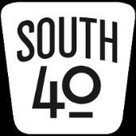

I recently mentioned about the Dog Daz of August’s early appearance in July this year. Well I can tell you that since August had officially arrived those Dog Daz have arrived in full force. Although most temperatures were in the lower 90s, it was humid and periodic afternoon rains appeared at random. On Thursday the Hillsboro heat index hit 106! Plus some schools already have their first days of classes in. So why not sit down in front of the air conditioner with your favorite cooling beverage and learn a bit about what the remainder of August brings to Ohio’s South Forty.

If the attendance of shoppers, browsers and vendors is anything like I experienced at the recent Columbus Hamfest, the August 28 turnout for the **Greater Cincinnati Hamfest** and **W8DXCC Convention** should be amazing. Working under most trying circumstances the **Milford ARC** and the **Southwestern Ohio DX Association** have put together an outstanding schedule of events for the entire morning and afternoon. So take a look at their websites and check each out. It promises to be a great day for one on the largest ham gathering events in this part of the state and features not only a flea market, but a test session, food and an array of outstanding speakers. It all gets underway at Owensville’s Clermont County Fairgrounds at 8 that morning. Admission to the hamfest is $8. A separate $8 admission ticket is needed for attendance at the 1 pm start of the DX convention. It should be a fun and educational day.

On August 22 the **Athens County ARA** will hold a **Trunkfest** on the Athens Masonic Centers parking lot. It starts at 8 am and will run until noon. The Masonic Center is located at 12 West Carpenter Street in Athens. According to President Eric McFadden, WD8RIF, there is no admission or set up charge. There will be drawings for cash, radios and other door prizes donated by R & L Electronics and DX Engineering.

Middletown’s **Dial Radio Club** this Wednesday, August 18. The 6 pm test will be conducted at St. John 23 XXlll Grade School, 3806 Manchester Road in Middletown. Walk-ins will be accepted. Call 513-617-6181 for additional information.

The **Highland ARA**’s VE Team is assisting the Cincinnati Hamfest by conducting the hamfest’s license testing. According to Tom Mongold, the test session will start at 9 am in the 4-H Building. Because the building is being used for the DX Convention, testing must be concluded by 11:45. Mongold requests those wishing to upgrade or test for a first time license pre-register through the [www.cincinnatihamfest.org](http://www.cincinnatihamfest.org/) website. A link on that site will take you to the registration page.

The **Athens County ARC** will hold two VE license sessions in the coming days. VE team leader Jeff Slattery, N8SUZ, says the regular quarterly session will be held August 16. Things get underway at 7 pm at the Red Cross Building. Then on August 22 another session will occur during the Club’s Trunkfest. Registration begins at 9:30 am with actual testing at 10. It will be at the Masonic Center trunkfest site. Walk-ins will be accepted at each session. These two sessions are subject to the ARRL test fees. Check out the [www.acorg/?page_id=1346](http://www.ac-org/?page_id=1346) for the needed information to bring to either test session.

Congratulations to the **Southwest Ohio DX Association** on receiving an Honorable Mention in the Ohio Section newsletter competition. Dave Vest, K8DV, accepted the award on behalf of ‘The Exchange’ in the absence editor Bill Salyer, AJ8B. Congrats for a well-deserved honor to an outstanding publication.

Our congratulations go to Scott and Jane Yonally (N8SY and KB8YPW) on their 50th anniversary. Scott celebrated the occasion by taking his bride to the Columbus Hamfest.

It is with sadness the **Highland ARA** reports it has lost a long-time member due to COVID issues. Tom Kessinger, KC8RZF, passed away Sunday evening. Tom was a former HARA trustee and a technology instructor for their license classes. He was employed as a technician at the Peebles GE Aviation Testing Ground facility.

Word has been received of the passing of Betty Kelly, the mother of **Scioto Valley ARC** member Dwight Kelly.

Also **Portsmouth RC** member Dave Baker recently lost both a brother and a sister within days of each other. Dwight is K4YJ and Dave is W8XDB. Services for each have been held.

On Saturday, August 21 the **Hocking Valley ARC** will hold their monthly Foxhunt. The fun begins with checkins starting at 9:45 and lasting until 10 using the 147.345 repeater. Following the check-in period the action will then change to 147.945 Mhz to try to find the Fox-Bill Hopstetter, W8LGX. Hopstetter says he will operate from some spot in Hocking County that is visible from a public street or roadway.

Recently David Coffey, N8RKC, conducted an Elmer Night at the **Scioto Valley ARC**’s clubhouse. Several members attended the session to learn more about Raspberry Pi ham radio applications. A similar program will be conducted by Jennifer and Mike Bailey (N8JEN and N8MRB) at a future **Portsmouth RC** gathering.

Because of Labor Day falling on their normal meeting night, the **Portsmouth RC** will meet at the Portsmouth American Legion Post on Monday evening, September 13. The business meeting will be held following the normal VE test session.

According to word from KC8CHP, Jesse Stanley, the **Scioto Valley ARC** will activate Ross County from their clubhouse during the Ohio QSO Party on August 28. He also says plans are underway for Club members to journey to Tar Hollow State Park to put it on the air during the September 11 Ohio State Parks on the Air Contest. They are looking at doing special event stations from the Moonville Tunnel and the Bainbridge Festival of the Leaves in October.

A tune across the bands on any given day will usually result in hearing at least one station operating from a Parks On The Air qualified park. A check of the POTA website on Tuesday showed 13 stations operating from POTA locations. Not only were they on SSB and CW, but there was a scattering on FT8 and FT4. And one even on 60 meters! A website check reveals several national, state and local parks, wildlife areas, lakes and forests in the Southern Ohio region qualified for activations and several more in the region will be added in the foreseeable future. It’s noted several area hams are not only collecting park numbers but also putting them out. Some of those known to be active in the program are W8SKJ, WA6WTF, WF8B, N8TUW, WD8RIF, KD8MQ and N8CUB. Some of the area’s parks showing recent activity are Stonelick, Cowan, Rocky Fork, Pike Lake, Adams Lake and Paint Creek. The number of contacts these stations report making is surprising, even with band conditions as they are. If you are one who is getting bored with day to day operating, the park challenge might be the key to putting some jump back into your ham step. The upcoming September 11 running of the Ohio State Parks on the Air contest will be an excellent time to start collecting parks. Not only is this a North American program but stations and parks throughout the world are involved. Check [www.parksontheair.com](http://www.parksontheair.com/) for more information.

Two people from Southern Ohio have entered the world of amateur licenses and now are members of our society. Please welcome David Canterbury and Bill Stevenson, Jr. David is now KE8SPS and he lives at Jackson while Bill becomes KE8SPT and calls Stout home. At Tuesday evenings **Highland ARA** meeting it was learned that Bainbridge’s Sam Johnson, W8SKJ, is the newest Extra Class holder and upgraded through an on-line ARRL test. Congratulations to each.

The **Southern Ohio ARA** will meet on Monday evening, August 16, at the Coal Grove EMA facility. The evening’s agenda starts with a VE session at 6 pm and will be followed by the regular business meeting at 7 pm. On the agenda are discussions of the upcoming September special event station at the Vesuvius Iron Furnace and holding a Fox Hunt.

The upcoming Ohio QSO Party is a much looked forward to operating and contest event by many amateurs. For those Southern Ohio amateurs living in counties with low populations of hams with HF privileges, it’s a fun time when you become rare DX, get spotted and suddenly become the chasee instead of the chaser. For those chasing counties, it’s another opportunity to put another not so common one in the log. So on August 28th why not make it a point to spend some time on the air and make your county available to those needing additional multipliers? Or even do a portable operation from one of those not so common counties.

It has been a rather hectic past couple months at the Levo Century Farm. The corn and bean crops are looking good, the garden is overflowing with produce and our commercial blueberry operation has ended for the season. In celebration N8ZNR, myself and the South 40 will take a break and hit the road for a few days. We planned on attending the Huntsville Hamfest, but with COVID raising its ugly head in that area we decided to cancel our reservations. So it’s off to visit some of Kathy’s family and Penn State friends in 3 Land.

Until we meet next time, be safe, healthy and remain radio-active. 73, John, W8KIW

**Print an Official or Unofficial Copy of Your Amateur Radio License**

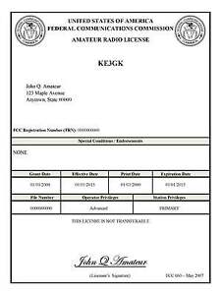*(By Anthony Luscre, K8ZT)*

As of February 17, 2015, the **FCC no longer routinely issues paper license documents** to Amateur Radio applicants and licensees. The Commission has maintained for some time now that the official Amateur Radio license authorization is the electronic record that exists in its Universal Licensing System (ULS). The FCC will continue to provide paper license documents to all licensees who notify the Commission that they prefer to receive one.

Licensees also will be able to print out an official authorization — as well as an unofficial “reference copy” — from the ULS License Manager. I’ve created a set of instructions on how you can request an **“official” printed copy of your license\***

[**Click here to download the instructions**](http://arrl-ohio.org/news/2020/print_your_license.pdf)

***One Question Questionnaire***

I consider this one of the most important questions I’ve put up here, so how about going to www.ARRL-OHIO.org and giving me a click? (It’s in the bottom left corner of the page) I’ll have more to say about this in the next OH Section Journal!

***“Have you conducted the RF Exposure Calculations for your station yet?”***

From the last Poll: ***“Have you ever sent a “contribution” to ARRL?”***

53% yes, 47% no.

Ohio Section Cabinet

|  |  |
| --- | --- |
| Section Manager – Tom Sly, WB8LCD | Section Traffic Manager – David Maynard, WA3EZN |
| Section Emergency Coordinator – Stan Broadway, N8BHL | Section Youth Coordinator – Anthony Luscre, K8ZT |
| Technical Coordinator – Jeff Kopcak, K8JTK | Affiliated Clubs Coordinator – Tom Sly, WB8LCD |
| State Government Liaison – Bob Winston, W2THU | Public Information Coordinator – John Ross, KD8IDJ |



Hey Gang,

Have you taken a look at the **Swap & Shop** page on the Ohio Section webpage yet?? Here’s a link that will take you there… <http://arrl-ohio.org/sm/s-s.html>

Do you have equipment that you just don’t need or want anymore? Here’s a great venue to advertise it, and it’s FREE!! Is your club doing a fund raiser to help raise money? After a lot of thought, it was decided that the Swap & Shop webpage could also contain these types of items as well. The same rules will apply as do for the For Sales and Give-A-Ways and will only be posted for a month at a time. Please see the Terms & Conditions on the webpage.

If your club is doing a fund raiser and wants more exposure, please forward the information to me and I’ll advertise it on the Swap & Shop webpage for you.

Now, I still want to remind you that it won’t be listed in this newsletter because it would take up way too much space, so your ad will only appear on the website. It is there for any individual to post equipment Wanted / For Sale or Give-Away as well as for Club Fund Raisers. No licensed vehicles/trailers or business advertising will be posted. Postings are text only (no pictures or graphics) will be posted for a maximum of 1 month from date posting and require a contact phone number or email within the posting. Send your Wanted / For Sale or Give-Away post to:  [swap@arrlohio.org](mailto:swap@arrlohio.org)

***Back Issues of the PostScript and Ohio Section Journal***

Hey, did you know that PostScript and Ohio Section Journal (OSJ) are archived on the website? You can go back and look at any edition simply by clicking:

<http://arrl-ohio.org/news/index.html>

***Want to Share your Club Newsletter With Others?***

We have a webpage where you can download and read all of the newsletters that I get from around the state and even other sections!

Here’s the link to the page…. <http://arrl-ohio.org/club_news/index.html>

Please, if you don’t see your club newsletter posted, it’s because I’m not receiving it. Just have your newsletter editor contact me and I’ll get your club’s newsletter listed on the site!!

We all learn and steal (I mean, share) from each other’s work. So, get me your newsletter!!! Send it to: [webmaster@arrl-ohio.org](mailto:webmaster@arrl-ohio.org)

***Chit – Chat, and All That!***

Do you know someone that’s not getting these Newsletters? Please, forward a copy of this Newsletter over to them and have them “[Opt-In](mailto:Opt-In)” to start receiving them. Heck, just have them send an email to: [webmaster@arrl-ohio.org](mailto:webmaster@arrl-ohio.org) and we’ll get them added to the Ohio Section Emailing list.

We now have many thousands of readers receiving these newsletters weekly. Quite impressive, I’d say! I urge all of you to make sure that everyone, regardless of whether they are a League member or not, get signed up to receive these weekly Newsletters.

You can always “Opt-Out” at any time if you feel this is not what you were expecting. It’s fun and very informative. All of your favorite past newsletters are now archived too.

You can go back at any time and read them.

Just go to: <http://arrl-ohio.org/news/>

The pictures on the front page and throughout this newsletter are from various newsletters, Facebook posts and/or were sent directly to me in recent weeks. Take a good look at them, you just might be in one of the pictures! “SMILE… you’re in the Ohio Section News!!”

*PostScript is produced as a weekly newsletter. I want to thank everyone that has contributed articles and ideas to make this an even better news source. I sincerely hope that you have enjoyed this edition and will encourage your friends to join with you in receiving the latest news and information about the Ohio Section, and news and events happening around the world!*