[](http://arrl-ohio.org/news/) ***“August 9th***

***Edition”***

🡪 National News 🡪 Club Corner

🡪 DX This Week 🡪 Contest Corner

🡪 Upcoming Hamfests 🡪 One Question Questionnaire

🡪 VE Testing

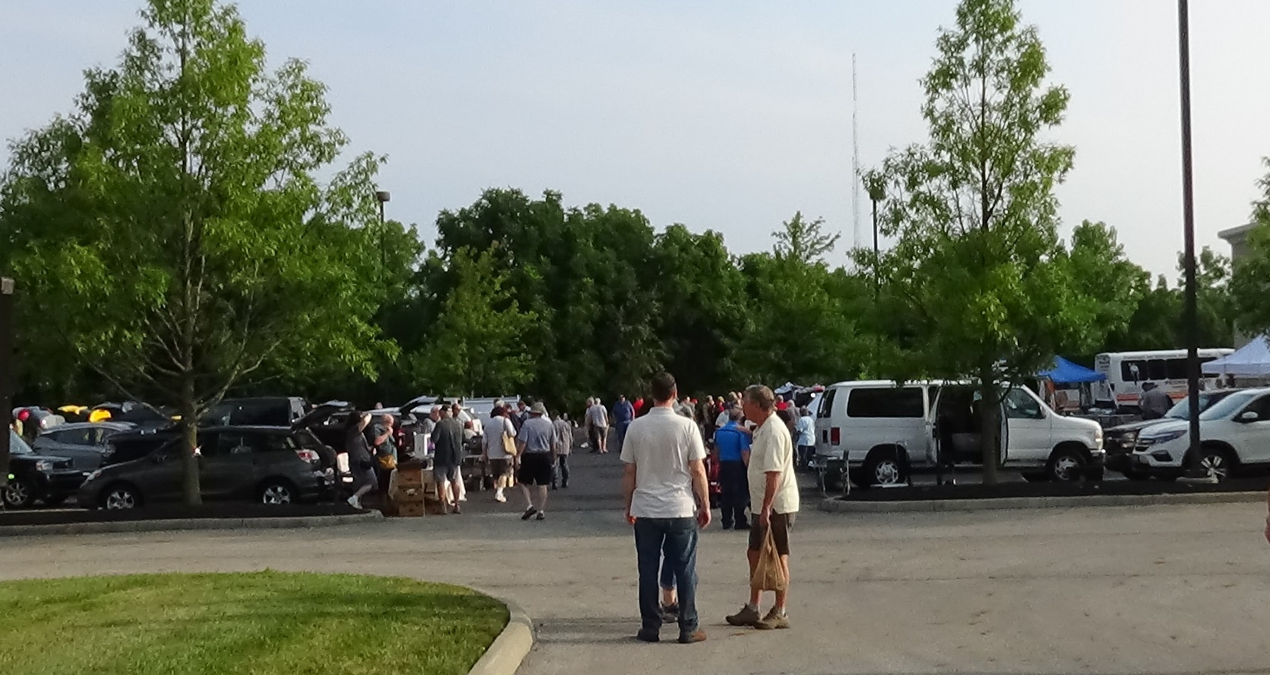

HamFests are Back!

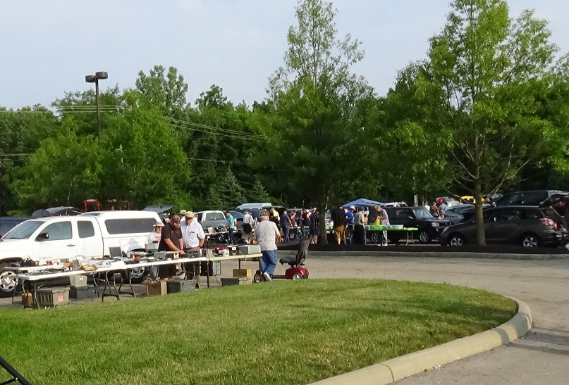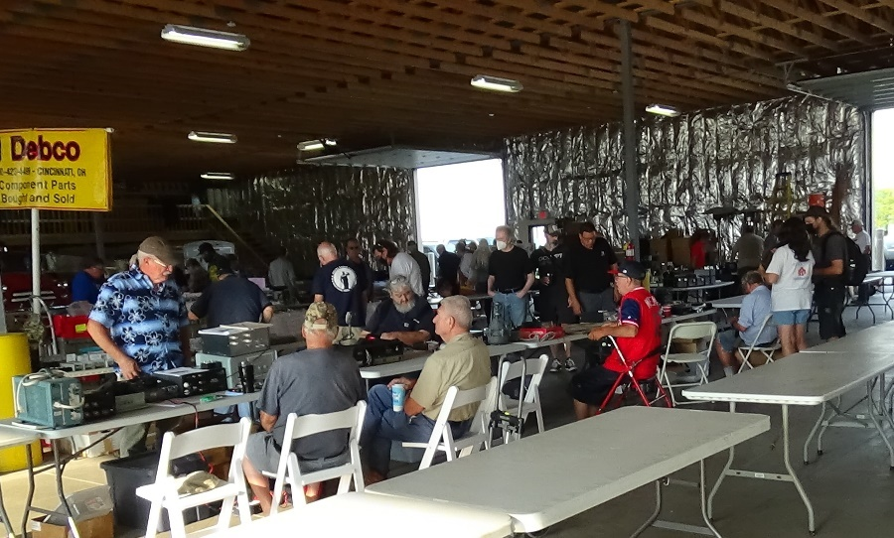

**CQ CQ CQ de WB8LCD**

Saturday was a perfect day for a HamFest! I hope you were able to get out to either the Columbus Hamfest in Grove City, or the MOCARC HamFest in Bidwell. I attended the Columbus Fest, and it was the *really* nice to see that things are coming back and the folks are coming out. I’ve always enjoyed HamFests, and in the past have spent the majority of my time either at my own table, or just walking around looking at all the gear available. In my new position I’m sticking pretty close to the ARRL table. There’s an old saying – “ If you’re lost, stay in one place and wait for them to find you” – and that’s pretty much how it’s been working out. I’ve been “found” by lots of friends, both new and old. I’ve had some pretty interesting conversations, too. I’m always interested in what people think, and why. Especially as it pertains to Amateur Radio and ARRL.

The winners of the Ohio Section Newsletter contest were announced at 11:00 AM. Per our Ohio Section Public Information Coordinator – John Ross, KD8IDJ, congratulations go to:

**1st Place…The RADIOGRAM**

Portage County Amateur Radio Service (PCARS)

**2nd Place…DELARANEWS**

Delaware County Amateur Radio Association

**3rd Place…NEWS BEACON**

Medina County Amateur Radio Club

**4th Place…The WAVEBNDER**

Western Reserve Amateur Radio Club

**Honorable Mention…the exchange**

Southwest Ohio DX Association

As always it was a fight to the finish.

From our judges…”ALL of the newsletters have great qualities and tremendous commitment from the editors and writers. The newsletters keeping the clubs informed, up-to-date on club activities and serve as a “window” to the many new and developing aspects of Amateur Radio.”

**CONGRATUALATIONS to all…great work !**

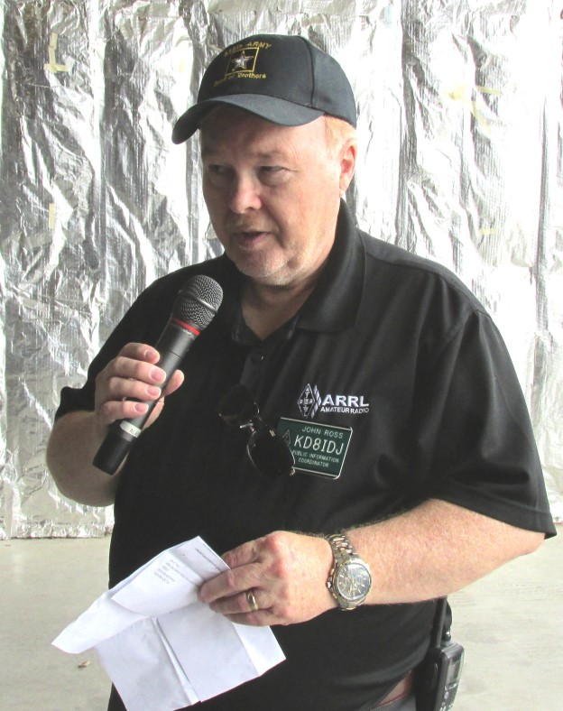

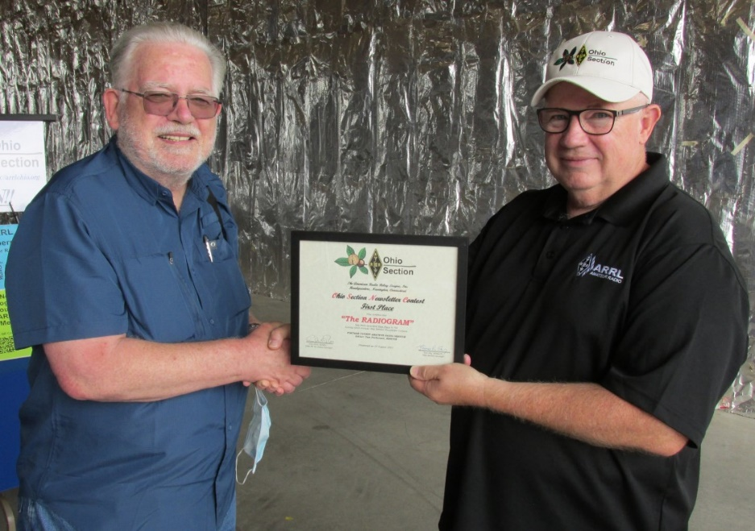

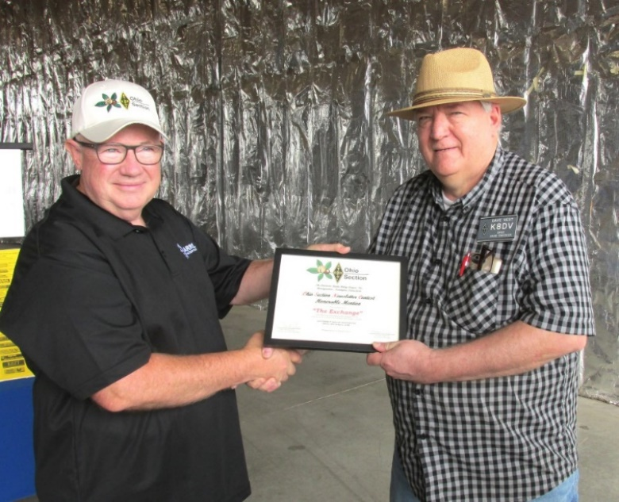

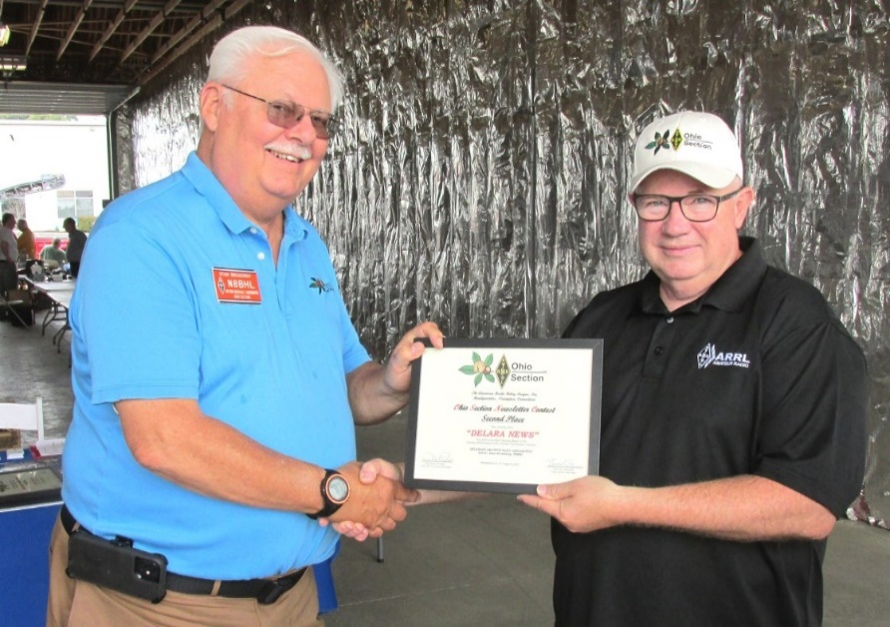

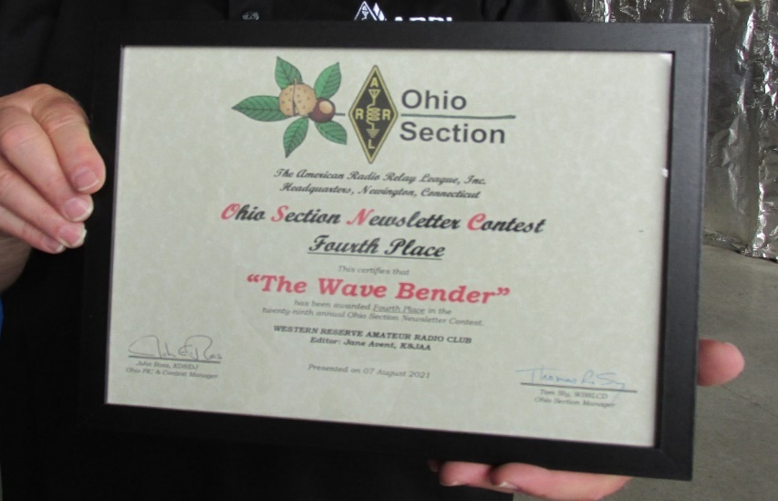

Next up – on Tuesday, August 10th – there will be an OH Section Zoom Conference for anyone interested in OHIO State Parks On The Air (OSPOTA). That contest is coming up soon on Saturday September 11th, so this will be an introduction and an overview on the contest, with a special section on both logging the contest and NVIS antennas for working the contest.

Time: Aug 10, 2021 07:30 PM Eastern Time (US and Canada)

Join Zoom Meeting

https://us02web.zoom.us/j/88055320136?pwd=bk81MXE3ellVTnAzZ3ptS0N3K2FOdz09

Meeting ID: 880 5532 0136

Passcode: 375951

One tap mobile

+13126266799,,88055320136#,,,,*375951# US (Chicago)

+19292056099,,88055320136#,,,,*375951# US (New York)

Dial by your location

+1 312 626 6799 US (Chicago)

+1 929 205 6099 US (New York)

+1 301 715 8592 US (Washington DC)

+1 346 248 7799 US (Houston)

+1 669 900 6833 US (San Jose)

+1 253 215 8782 US (Tacoma)

Meeting ID: 880 5532 0136

Passcode: 375951

Find your local number: https://us02web.zoom.us/u/kbIdDj9UhW

The OHIO Section is sponsoring more learning and exploring sessions. Technical Specialist Jason – N8EI will be presenting one of those sessions on August 31st. His topic is “Beyond the Baofeng: Thoughts on Equipment Choices for New Hams.” You received your license. Picked up a $20 Baofeng. Tried to reach some repeaters with it. Now what? Look for the zoom details right after the OSPOTA presentation.

Don’t forget, I can’t be everywhere and do everything. Let me know what your clubs are doing! Let me know what your VE schedule is, let me know about your Special Event stations. I’ll get it all listed here so everyone in the OH Section knows what’s going on. And here’s a hint I hope you’ll all take to heart: When most clubs have activities and events, they’re open to anyone who wants to participate with them! Go check out what the other clubs are doing, make some new friends, learn about an Amateur Radio topic you’ve always been interested in. You can also go to the OH Section website and read the newsletters of the other clubs in the section – there’s a wealth of knowledge there – tap into it!

Tom Sly – WB8LCD

ARRL OHIO Section Manager

330-554-4650

***National News***

*(from arrl and other sources)*

|  |
| --- |
|  |

|  |
| --- |
| **September 24th and 25th, 2021, Pigeon Forge, TN** |

|  |
| --- |
| *Hello Friends and Club Officials*  We are **EXCITED** to report that the W4DXCC DX and Contest Convention **WILL** hold it's 16th convention September 24-25th, 2021!!  Here is an **Update for August, 2021**.  **The Mainstay main Hotel is almost full, amazing how many want to return to the convention. If the Mainstay becomes full you have some choices, ask to be put on a waiting list for the Mainstay or choose another hotel close by the Mainstay. Other hotels are very close by.**  The **Main and Bootcamp programs** have been updated on the Website so have a look. We have some very interesting programs this year.  The Vendors page has been updated that will be attending. As a reminder these vendors will be setup in the lobby just outside of the convention hall. Be sure to stop by and twist the knobs and speak with the representatives.  We have some amazing **Special Raffle prizes** this year. These prizes are provided to us by the manufactures, all proceeds from the raffle are donated back to DX and Contest organizations.  We have posted who's attending Online. Have a Look to see who is scheduled to attend this year. We look forward to seeing everyone in person this year.  It is time to make your **Hotel Reservations** for this years convention. You can **NOT** make Online Hotel Reservations for this event you **MUST** call the Hotel directly at this number **865 428-8350**. When You Do, Tell them you are with **W4DXCC by SEDCO** for a special room rate, do it now.  **Online Convention Reservations are Up and Ready** for you to make your convention and banquet reservations. Go here [Online Reservations](https://sable.madmimi.com/c/41704?id=58261.491.1.92e892d84883c160e2e53d3c40f8dcbd)  **Friday** is the Ham Radio Bootcamp where we do our best to provide the knowledge to New and Experienced Hams alike. We have changed the Dutch Treat dinner Friday evening so check the Website for the new plan.  **Saturday** is the main convention where we have numerous well known presenters, giving you the inside scoop on what is going on in amateur radio. Following each presentation we have time for questions if you would like to know more.  We have the leading radio and equipment manufacturers setup in the lobby with the latest gear for you to twist the knobs. More importantly you can have a one on one to ask questions about the gear with the company representative in a relaxed environment.  We have a fully operational Ham Shack setup where you can come learn and make QSO's in different modes.  Check out the Website and learn about the W4DXCC DX and Contest Convention. Go Here [W4DXCC Convention](https://sable.madmimi.com/c/41704?id=58261.492.1.fcdaaa839904882dee2fc02c370d68f2)  Best 73 |

|  |
| --- |
| **See you soon,** **Dave Anderson, K4SV Convention leader** [**Dave@w4dxcc.com**](mailto:Dave@w4dxcc.com) |

________________________________________________________

ARRL Now Provides FREE RF Exposure Calculator

The FCC has adopted guidelines and procedures for evaluating environmental effects of RF emissions. The new guidelines incorporate two tiers of exposure limits based on whether exposure occurs in an occupational or "controlled" situation, or whether the general population is exposed or exposure is in an "uncontrolled" situation.

Under the new FCC rules, some amateurs need to perform routine 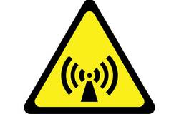station evaluations to ensure that their stations comply with the RF exposure rules. This can be as simple as running an online calculator to determine the minimum safe distance between any part of your antenna and areas where people might be exposed to RF energy from your station. Although amateurs can make measurements of their stations, evaluations can also be done by calculation.

To make this easy for amateurs, ARRL now provides an [RF exposure calculator](http://arrl.org/rf-exposure-calculator) on its RF Exposure page. To use the calculator, enter your transmit peak-envelope power (PEP) and operating mode, and answer the questions about the maximum amount of time you might be transmitting. The calculator will give you the minimum distance people must be from your antenna and human exposure.

You can print the results and keep them in your station records. There is no requirement to send your results to the FCC.

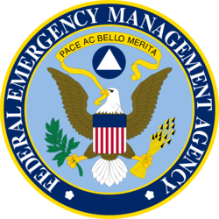**FEMA, in coordination with the FCC, will conduct a nationwide test of the Emergency Alert System (EAS) and Wireless Emergency Alerts (WEA) this month.** The national test will consist of two segments, to test EAS and WEA. Both tests are set to begin at 1820 UTC on Wednesday, August 11. The WEA portion of the test will be directed only to consumer cell phones where the subscriber has opted to receive test messages. The EAS portion of the test will be sent to radios and televisions. This will mark the sixth nationwide EAS test. The purpose of the August 11 test is to ensure that the EAS and WEA systems continue to be effective means of warning the public about emergencies.

___________________________________________________________

Bouvet Island DXpedition Negotiating with New Charter Vessel, Planning Begins Anew

The [Intrepid-DX Group](https://intrepid-dx.com/)'s plans for a 2023 DXpedition to Bouvet Island are on the front burner again. In a brief announcement to the "global DX community," DXpedition co-leader Paul Ewing, N6PSE, said this week that a new charter vessel contract is in the offing. The 3Y0J DXpedition has refunded all donations to its earlier announced plan, advanced before losing its contract with the charter vessel *Braveheart*, and 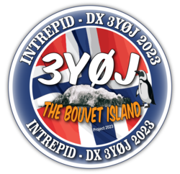Ewing conceded, "there was a high degree of uncertainty that we could move forward." *Braveheart* captain Nigel Jolly, K6NRJ, told the DXpedition in June that the *Braveheart* was being put up for sale, and he was canceling its contract for the 3Y0J voyage.

Ewing said this week that the team has found a suitable and affordable vessel whose skipper is willing to take a group of a dozen DXers to Bouvet, and they are negotiating the terms of that charter contract at present.

"We have submitted a new application to the Norwegian Polar Institute," Ewing said. The team leadership has been revised. David Jorgensen, WD5COV, will be a co-leader, responsible for operations and antennas, while Kevin Rowett, K6TD, will be a co-leader, responsible for systems/networks, procurement, and logistics, and Ewing as a third co-leader, will oversee planning, public relations, tents, and logistics.

"Together, this leadership team will assemble 12 operators to make this vision a reality," Ewing said. "We are revising our website, and soon, we will begin fundraising for this renewed effort." He expressed gratitude for all past sponsors of the Bouvet Island DXpedition initiative and said he hopes they can support the renewed effort as well. A new website is under construction.

A dependency of Norway, Bouvet is a subantarctic volcanic island in the South Atlantic.

___________________________________________________________

***Club Corner***



This is YOUR cornner of the newsletter. Send me what your club is doing and I’ll make sure that it gets in. Got a special event or club project that you want everyone to know about? Send it to me!. Need help with a project? Send it to me.

Let me know what you club is up to. Are you going to have a special guest at your meeting or are you having a special anniversary?

Just sent it to: [webmaster@arrl-ohio.org](mailto:webmaster@arrl-ohio.org)

From Gregg - WB8YYS - Portage County Skywarn Coordinator

July 22, 2021 - Severe thunderstorms can be life-threatening, but not all severe storms are the same. Hazardous conditions range from tornadoes, large hail storms, and widespread straight-line winds called derechoes, to cloud-to-ground lightning and flash flooding. [Starting August 2](https://www.weather.gov/media/notification/pdf2/scn21-22svr_ibwaab.pdf), the National Weather Service will better convey the severity and potential impacts from thunderstorm winds and hail by adding a “damage threat” tag to Severe Thunderstorm Warnings, similar to our Tornado and Flash Flood Warnings.

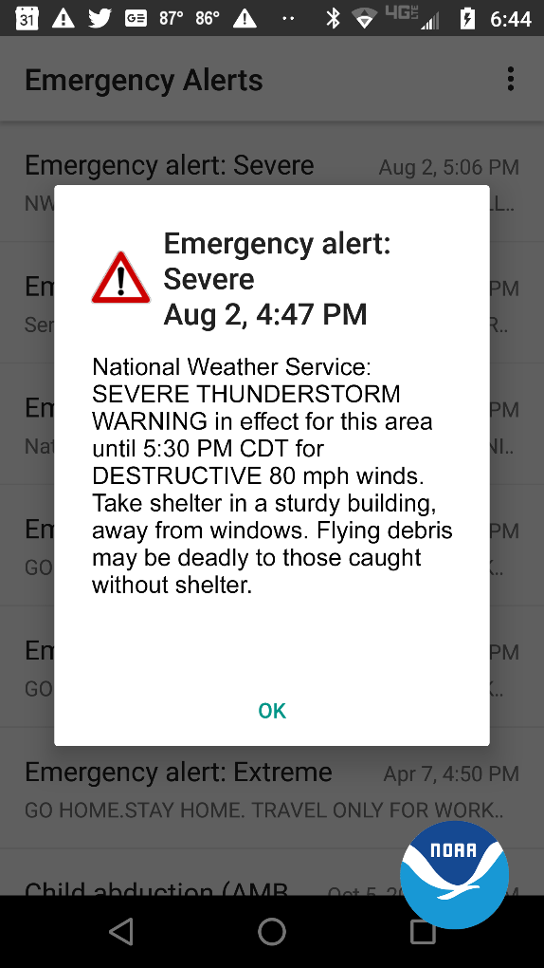**“Destructive” and “Considerable” Damage Threat Categories**

We developed three categories of damage threat for Severe Thunderstorm Warnings. The categories, in order of highest to lowest damage threat, are destructive, considerable, and base. These tags and additional messaging are designed to promote immediate action, based on the threats.

* The criteria for a **destructive** damage threat is at least 2.75 inch diameter (baseball-sized) hail and/or 80 mph thunderstorm winds. Warnings with this tag will automatically activate a Wireless Emergency Alert (WEA) on smartphones within the warned area.
* The criteria for a **considerable** damage threat is at least 1.75 inch diameter (golf ball-sized) hail and/or 70 mph thunderstorm winds. This will not activate a WEA.
* The criteria for a baseline or “base” severe thunderstorm warning remains unchanged, 1.00 inch (quarter-sized) hail and/or 58 mph thunderstorm winds. This will not activate a WEA. When no damage threat tag is present, damage is expected to be at the base level.

On average, only 10 percent of all severe thunderstorms reach the destructive category each year, nationwide. Most of these storms are damaging wind events such as derechoes and some of the larger, more intense thunderstorms, called “Supercell” storms that can typically produce very large hail in their path. The new destructive thunderstorm category conveys to the public urgent action is needed, a life-threatening event is occurring and may cause substantial damage to property. Storms categorized as destructive will trigger a [WEA](https://www.fema.gov/frequently-asked-questions-wireless-emergency-alerts) to your cell phone.

All National Weather Service Severe Thunderstorm Warnings will continue to be issued and distributed via [weather.gov](http://www.weather.gov/), [NOAA Weather Radio](https://www.nws.noaa.gov/nwr/index.php), [Emergency Alert System](https://www.weather.gov/NWR/eas_description) and through dissemination systems to our emergency managers and partners. The addition of damage threat tags are part of the broader [Hazard Simplification Project](https://www.weather.gov/hazardsimplification/repairprogress) to improve communication of watches and warnings to the public.

**___________________________________________________________**

# Preparing for BLACK SWAN 21

C. Matthew Curtin KD8TTE

Held on the first full weekend of October, the annual Simulated Emergency Test (SET) weekend is coming up soon and now is the time to begin preparations. This year, stations will have an opportunity to join in coordinated play in the BLACK SWAN exercise with other sites but it will be different from recent years. Register now to be sure that your station is written into the exercise plan and will be directly activated.

Last year several sites received late activation or none at all despite exercise controllers distributing the Exercise Plan and explicit activation instructions to registered teams. Measuring performance on that front was an objective of the exercise. We didn’t see a lot of work to address the issues of activation and management of volunteers in the months since then.

BLACK SWAN exercise isn’t going to have exercise volunteers left unmanaged and untasked again.

We’re addressing that problem by having each station register ahead of time. Exercise controllers will write each registered station into the exercise plan (ExPlan) that way, with operating activity tailored to that station’s availability and experience. We also will avoid problems with teams being registered through someone who didn’t read, understand, or relay activation instructions, as well as teams not being activated by other players that were supposed to call them in for support.

We’re also preparing operators for working in BLACK SWAN 21 through several efforts:

1. QTC Internet Email list. This is where we can discuss procedure, activities, and otherwise coordinate with one another. This is a collaborative effort rather than blast out through a hierarchy, and also gives people a chance to ask questions. <https://groups.io/g/QTC>
2. BLACK SWAN Net operations. Each Tuesday we release a training point on QTC and are able to discuss it. Then we practice on Saturday, Sunday, and Monday. Weekend operations are at 1300, giving us a chance to practice in daytime conditions and on 60m, then Monday’s operations are at 1900, where 75m voice is used to control the net, and 80m digital is used for traffic relay. <https://www.blackswancomex.org/net>
3. QSP radio newsletter. Each Sunday, we release a newsletter completely sourced and distributed through radio. Winlink, NBEMS (via BLACK SWAN), or even NTS radiogram works for sourcing. Distribution happens on BLACK SWAN, with missing participants filled in via Winlink. <https://www.blackswancomex.org/2021/qsp>
4. Weather Alert Project 21 (WAP21). This is an ongoing project where we’re capturing real-world alerts from the National Weather Service and originating them as radio messages. We’re using precedence, routing, and other real-world skills needed to handle loads of traffic in emergency mode operations. <https://www.blackswancomex.org/2021/weather-alert-project-21>
5. Small exercises. Worked into this operating schedule we also establish small exercises from time to time that give us a chance to put pieces together for different types of operating conditions. This past weekend (7-8 Aug), for example, we conducted a little exercise we called NEW YORKER 21. <https://www.blackswancomex.org/2021/new-yorker>

If your ARES group or net would like to be in operation, we’re happy to have you. Just be sure to have all of the participants register and as the plans are being written, we’ll need to confirm that you all intend to work together. If you’ve got an agency or other multioperator station that will be working for SET, be sure to register just once on behalf of the entire station, indicating the station’s hours of operation, etc. BLACK SWAN controllers don’t want to micromanage station operations; we want to be sure that we’ve got enough insight to activate stations to get everyone up and running. If you’re operating as a single home station, we’re also happy to have you and will build you into the plan as well to make sure that you’ll have a meaningful part to play. Register now at <https://www.blackswancomex.org/2021/register>.

Whatever your plans for SET, be sure that you’re preparing to operate in whatever capacity will help you to derive satisfaction from an important job well done when it matters most, improving the security and resilience of your community.

_____________________________________________________

VE Sessions

Dayton Amateur Radio Association (DARA)

**The DARA License Exams scheduled for August 21st at 10:30am have been cancelled.**

 If you are interested in testing for a new or upgraded license, please come see us at the DARA Clubhouse. If you have questions about testing, please email [exams.w8bi@gmail.com](mailto:exams.w8bi@gmail.com)

Lake County Amateur Radio Association (LCARA)

Saturday October 2, Saturday December 4

All exams start at noon and are held at the Kirtland Library, 9267 Chillicothe Rd. Kirtland, OH

Portage County Amateur Radio Service (PCARS)

Starting on August 7th, PCARS will resume VE testing at the PCARS club site in Ravenna.

Please visit the PCARS web site and check out the information about VE testing in the latest newsletter – [https://portcars.org/files/newsletter/2021/PCARS-June-21.pdf](https://r20.rs6.net/tn.jsp?f=001DxdXS40dvzmbl9m9sfY5l9IIoAGYYsZIQIObAktg-wnnAu__YbvuVuV1_NQmLDKapbqCCYZK1L6epi1k5lVvuEtL_I1T0LMdgzjsNGvi1UnoIj7Lpv0RFoxS8h0YOCVVODgyzQI8xFTrmQ0pr6RXkQVvSx_cjGgR-DubSFhvF7CPVtMoPBph8tt8RpjGjyyBlRFHzo_VhR4=&c=Oi-83JMf17RlM94bujSYqqAwfNyIPWszQZKKkjp6BM5J7PHkAvaFrA==&ch=Kr1c-7rzal6CKkNUvSX-jLXK5eG9iU0tKZ5xoqUUqM21mzFnc1rE3w==)  – see pages 8, 9 and 10 for details.

If you have any questions, don’t hesitate to contact me at KB8UUZ@gmail,com

On behalf of the VE team at PCARS, we all look forward to getting the VE testing going again and look forward to seeing you there – August 7th -10 am – at the PCARS club site in Ravenna.

**Your Club news should be listed here!**

I know you’re out there doing things! Send me a write-up (MSWord please) and some photo’s (.jpg please) and we’ll get your club hi-lited here for the othe OH Section Clubs to see! Send to [WB8LCD@ARRL.ORG](mailto:WB8LCD@ARRL.ORG)

_______________________________________________________________________________

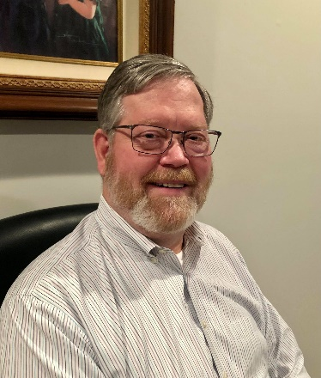DX This Week – K9LA

Bill AJ8B (aj8b@arrl.net, @AJ8B, or www.aj8b.com)

CWOPs Member #1567

The Midwest DX Cluster spots included Antarctica, Argentina, Asiatic Russia, Australia, Denmark, Dominican Republic, El Salvador, England, European Russia, Falkland Islands, Fiji, Hong Kong, India, Indonesia, Japan, Netherlands, New Zealand, Philippines, Poland, Puerto Rico, Republic of Korea, Reunion Island, South Africa, St, Martin, Taiwan, and Vietnam. This brings the total number of entities spotted in the Midwest in 2021 to 187!

*DAH DIT DIT DIT DAH DAH DIT DIT DIT DAH*

QSO Today Virtual Ham Expo

The next QSO Today Virtual Ham Expo is a month away, Live from August 14-15, 2021 and then on-demand for 30 days. It’s a great experience for those that want to improve their amateur radio knowledge and get exposed to new ideas, cutting edge ham radio technology, and practical techniques. And no need to travel - anyone can participate from their home or office! Information can be found at <https://www.qsotodayhamexpo.com> .

At the Expo, you can listen and engage with almost 100 internationally recognized ham radio luminaries on approximately 18 different topic areas - there is something for everyone.

Topics include: Antennas and Transmission Lines, Build-A-Thons, Contesting/DX, Controllers, Digital Voice Mode, Emergency Communications, Filters and Tuned Circuits, Future of Amateur Radio, Ham History, HF Digital Modes, New License - Now What? Power Amplifiers, Propagation, Radio Astronomy, Software and Services, Space and Satellites, Test and Measurement, and Youth in Amateur Radio.

Watch as many presentations as you want! A big limitation of in-person events is that you can’t watch many of the presentations (you can only be in one room at a time). At the Expo, return anytime within 30 days to view any of the presentations that you missed as well as explore exhibitor offerings. At our last Expo, our 7,500 attendees downloaded 100,000 presentations during the 30 day on-demand period.

Early Bird Tickets are just $10 and then $12.50 “at the door”. Access to only the Exhibitor area is free. And save thousands of dollars since you won’t spend on travel, food, and lodging. For more information, go to https://www.qsotodayhamexpo.com.

W8DXCC Convention

Tickets for the W8DXCC convention are on sale. Tickets are limited so get yours while they are available at [www.w8dxcc.com](http://www.w8dxcc.com) ($8) Why not combine it with the Cincinnati Hamfest? Great flea market and outdoor area. (cincinnatihamfest.org) Spend your Saturday, August 28th, with a great group of hams.

*DAH DIT DIT DIT DAH DAH DIT DIT DIT DAH*

This week is our monthly reprint from Carl, K9LA. Carl will be a speaker at the QSO today virtual Hamfest as well as the W8DXCC convention. He has many other articles at his website, K9LA.us. This is reprinted with Carl’s permission.

Digging Deep Into VOACAP With Respect to 6 Meters

Carl Luetzelschwab K9LA – July 2021

On May 25 of this year, Don Field, G3XTT, gave a great presentation about operating on 6 meters. He covered many aspects of the “magic band”, and finished up with a Q&A session. One of the questions that was asked came from Mike Zak, W1MU.

*After periods of elevated sunspot activity, we always see measures of smoothed activity. But are there spikes of activity that are implied by those smoother numbers and might we expect to see F2 on the next cycle peak even though the smoothed numbers might not be inspiring?*

Unfortunately, Don did not get to this question, so I sent an e-mail to Mike about monthly median values and the distribution about the median. Let’s look at this a bit deeper with respect to 6 meters to gain a better understanding of our knowledge of the F2 region of the ionosphere.

Let’s start with a path from W1MU in Maine (43.9oN/69.6oW) to Italy (42.0oN/12.7oE). This path is 6406 km, and we would expect two F2 hops (each assumed to be 3203 km) to cover this distance [note 1]. The image below depicts this path (from NS6T maps at [https://ns6t.net/azimuth/azimuth.html with](https://ns6t.net/azimuth/azimuth.html) some added annotations by me). W1MU is at the center of this azimuthal equidistant map (also known as a great circle map). The black **X** shows where the signal comes down after the first F2 hop and reflects back up from the ocean.

From Method 30 (Short/Long Smoothing) in VOACAP, let’s list the predicted monthly median F2 region MUFs (maximum usable frequencies) for a 3000 km hop [note 2] for this path to Italy at various smoothed sunspot numbers in the month of November at 1400 UTC (around the optimum time for this path in November).

|  |  |  |
| --- | --- | --- |
| smoothed sunspot number (V2) | mode | ordinary wave monthly median  MUF in MHz for a 3000 km path |
| 50 | 2 F2 hops | 26.1 |
| 70 | 2 F2 hops | 28.3 |
| 115 (similar to Cycle 24) | 2 F2 hops | 32.6 |
| 143 | 2 F2 hops | 35.2 |
| 215 (similar to Cycles 21 and 22) | 2 F2 hops | 41.0 |
| 286 (similar to Cycle 19) | 2 F2 hops | 46.1 |

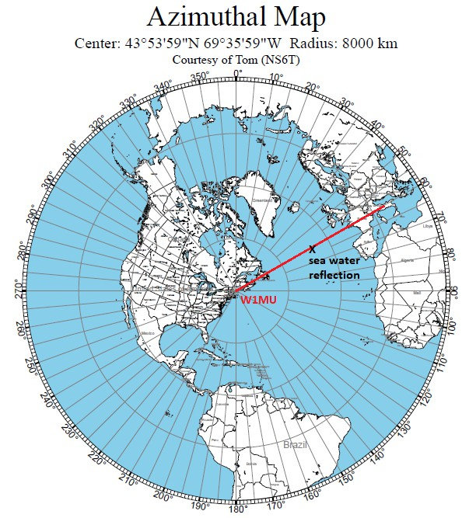

**Where Do These MUF Values Come From?**

Using a smoothed sunspot number of 143 (a Cycle 25 that would be somewhat bigger than Cycle

24) and VOACAP’s Method 1 (Ionospheric Parameters), we can retrieve the extraordinary wave critical frequency F2Z, the electron gyro-frequency FH and the M-factor [note 3] that lead to the MUF values in the above table. For this path length, VOACAP evaluates the ionosphere in five places: 1000 km from W1MU, 2000 km from W1MU, the midpoint of the path, 2000 km from Italy and 1000 km from Italy [note 4].

Here’s a side view of the path.

The three texts that are above the gray F2 region area give the pertinent F2 region data from Method 1 for 2000 km from W1MU, at the midpoint of the path and 2000 km from Italy. Each of the three texts give the ordinary wave MUF for a 3000 km path at those three points.

But the actual distance for this path for one hop is 3203 km, not 3000 km. Thus, the monthly median MUF for a 3203 km hop will be a bit higher (because it requires a lower elevation angle, which results in a lower grazing angle on the ionosphere). We can estimate these values by using Figure 7.3 (Logarithmic Transmission Curves for Curved Ionosphere) in IER 1-ITSA 1

*Predicting Statistical Performance Indexes for High Freq1uency Ionospheric Telecommunications Systems* by Donald Lucas and George Haydon (1966). After doing so, the lower of the three MUF values for the 3203 km path is 35.2 MHz – which is what is given in the table on page 2.

**The Distribution About the Median**

Now that we know the predicted monthly median MUF for the W1MU-to-Italy path in November at 1400 UTC at a smoothed sunspot number of 143 (V2), let’s look at the distribution about the median. We can do this by using Equation 10b on page 5 of the ITU/CCIR document *Supplement to Report 252-2* (1978). Equation 10b is for when the operating frequency is above the monthly median MUF. Doing this gives the following results for the monthly median MUF of 35.2 MHz

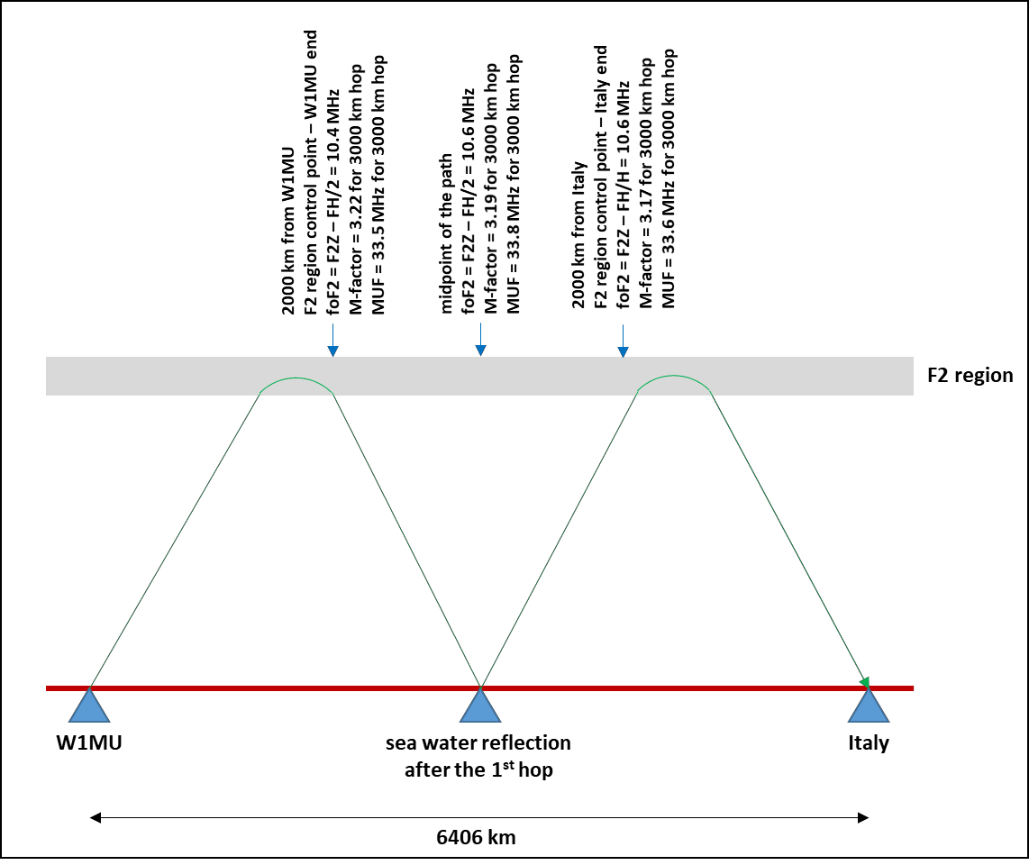

As expected, an operating frequency of 35.2 MHz gives a 50% probability as it is equal to the monthly median MUF frequency. The data in this tables say 6 meters shouldn’t be open at all. But the second peak of Cycle 24 offered 6 meter propagation via the F2 region, and this second peak (smoothed sunspot number of 116) was lower than the above analysis at a smoothed sunspot number of 143. So don’t give up hope.

One possibility for propagation still occurring on 6 meters is short-term ionospheric events that aren’t fully captured in our monthly median model. There is much research nowadays going on in this area to better understand the short-term variability of the F2 region.

A second possibility for propagation still occurring on 6 meters is a path longer than 4000 km. In general, the longer the distance the higher the MUF.

|  |  |  |  |
| --- | --- | --- | --- |
| monthly median  MUF in MHz | operating  frequency in MHz | probability  in percent | number of days of  the month |
| 35.2 | 35.2 | 50 | 15 |
| 37.5 | 26.8 | 8 |
| 40.0 | 13.2 | 4 |
| 43.0 | 3.5 | 1 |
| 44.0 | 1.2 | 0 |

A third possibility for propagation still occurring on 6 meters is the above-the-MUF mode (which I believe has an important role in FT8 QSOs), which we’ll review in the next section.

Before leaving this section, let’s look at data like that in the above table for a smoothed sunspot number of 215 (similar to Cycles 21 and 22).

|  |  |  |  |
| --- | --- | --- | --- |
| monthly median  MUF in MHz | operating  frequency in MHz | probability  in percent | number of days of  the month |
| 41.0 | 41.0 | 50 | 15 |
| 45.0 | 19.7 | 6 |
| 50.0 | 3.7 | 1 |

And here’s the data for a smoothed sunspot number of 286 (similar to Cycle 19 – the largest in recorded history).

|  |  |  |  |
| --- | --- | --- | --- |
| monthly median  MUF in MHz | operating  frequency in MHz | probability  in percent | number of days of  the month |
| 46.1 | 46.1 | 50 | 15 |
| 50 | 22.3 | 7 |

As the smoothed sunspot number increases, 6 meters is predicted to be open for more days of the month.

**Above-the-MUF Mode**

With ionospheric absorption inversely proportional to the square of frequency, there is little absorption on 6 meters when there is a sufficient amount of ionization to refract 6-meter RF back to earth. For example, ray tracing with Proplab Pro V3 shows only 1 dB of absorption at 50 MHz on the 2-hop W1MU-to-Italy path at a smoothed sunspot number of 200. Although the free space path loss increases as you go up in frequency, the less absorption at 6 meters more than compensates for this. In other words, ionospheric absorption is so low that there is extra room for additional loss at 50 MHz

With the above-the-MUF mode being tied to scatter instead of pure refraction when the operating frequency is above the MUF, additional loss is incurred with the above-the-MUF mode. This additional loss can be acceptable on 50 MHz, where absorption is extremely low. The exact amount of loss is not pinned down satisfactorily. Here’s an example when the MUF is 45 MHz, and the operating frequency is 50 MHz

|  |  |
| --- | --- |
| method | additional loss |
| Wheeler | 2 dB |
| ITU | 12 dB |

The two methods are quite different, so there are some important questions in order to

understand the difference and determine which one may be more accurate. The bottom line is the amount of additional loss may be tolerable due to the extremely low amount of absorption on 50 MHz. Now combine this with the SNR advantage that FT8 has over CW (about 6 dB), and this is a reasonable explanation for why SSB/CW ops hear nothing but FT8 ops are making QSOs.

**Summary**

Our understanding of the ionosphere is statistical in nature and is a correlation between monthly median ionospheric parameters (most of the time we want to know the MUF and the signal strength) and a smoothed sunspot number (or a smoothed solar flux number). We’ve seen how the monthly median MUF varies with sunspot number.

We’ve also looked at the distribution of the MUF about the monthly median value to calculate how many days of the month 6 meters should be open versus the smoothed sunspot number.

Cycle 25 may end up being a small cycle, but don’t give up on 6-meter F2 propagation in the fall and winter months around solar maximum. It happened with Cycle 24 and it can happen with Cycle 25.

A final comment – I remember one of Bob NM7M’s often-repeated sayings – *MUF is not enough*. That recognizes that ionospheric absorption needs to be considered – not just if there’s enough ionization to refract signals back to earth. On 6 meters, as mentioned earlier, absorption is minimal. But on the lower bands, it is all important.

Notes:

1) The literature usually says the maximum F2 region hop distance is 4000 km. This is a frequency dependent value and 4000 km is reasonable for frequencies at the higher end of our HF bands (10 meters and 12 meters). As we move down in frequency, 3000 km is a good value for 20 meters. At 160 meters, 2000 km is reasonable. On 6 meters, 4000-5000 km is possible – if there are enough sunspots.

2) This is the first column in the Method 30 output.

3) In Method 1, the ordinary wave critical frequency foF2 is the extraordinary wave critical frequency (F2Z column) minus one-half the electron gyro-frequency (FH/2 column). Multiply this by the 3000 km M-factor (M3000 column) to determine the MUF for a 3000 km hop for the ordinary wave.

4) The points at 1000 km from each end of the path are for evaluating the E region. The points at

2000 km from each end of the path are for evaluating the F2 region. These points are called control points, and are used in the control-point method of determining if ionospheric propagation

can occur. It has been found empirically that if these points can refract signals back to earth on

the desired frequency, then the path will be available.

CQDX CQDX CQDX CQDX CQDX CQDX CQDX CQDX CQDX

Here is an update from Bernie, W3UR, of the DailyDX and the WeeklyDX, the best source for DX information. <http://www>.dailydx.com/. Bernie has this to report:

**JD1/M - Minami Torishima -** As a reminder JG8NQJ, Take, is planning to return to Marcus Island in mid-September. He operates in his spare time as JG8NQJ/JD1 with 50 watts from an FT-450 into a two element HB9CV. Minami Torishima ranks number 26 world-wide on Club Log's DXCC Most Wanted List. QSOs are uploaded to LoTW and QSLs go via JA8CJY either direct or via the bureau.  
  
**HS – Thailand -** HS18IARU is a special event callsign for the 18th IARU Region 3 Conference being held in Bangkok between September 20-23, 2021. There is a lot of excitement with the opportunity of holding this innovative virtual conference. Listen for HS18IARU to be active from July 22 to September 30. QSL via E21EIC and LoTW. QSL will automatically be sent to all via the bureau. [https://www.iarur3conf2021.org](https://www.iarur3conf2021.org/)

**E5 - Couth Cook Islands -** ZL1AAO, Bruce, plans to be on from there August 7-19, a casual operation with 100 watts on SSB to a dipole.  He will start from Atiu Island then go to Rarotonga.  He will put his log online when he's back home.

**KH9 - Wake Island -** KK4WZI, Stacy, is going to the island to work, some weeks from now. He will have several days break from the job and wants to get on the air, and also expects to be back on Wake every six months or so.  He will have a Yaesu FT-891 and ATAS-25 portable antenna and may make a vertical to cover 40-10 also.  Saying his Morse skills are weak, he thinks he'll stick to FT8 and FT4.  With what he thinks will be a weak signal, he figures SSB will not be as effective.

**On The WWW -** "JW0W - Prins Karls Forland Island, Norway"   
<https://www.m0oxo.com/2021/07/28/jw0w-prins-karls-forland-island-norway/>

**Press Release by the Intrepid-DX Group**  
Sunday, August 1st, 2021.  
  
**Second Annual "Dream Rig" Youth Essay Contest.**  
The Intrepid-DX Group is a US based 501 C(3) nonprofit organization that promotes Amateur Radio activities in developing countries.  
  
Announcing our second annual Youth Essay Contest-Prize is a Dream Rig!

The Intrepid-DX Group recognizes the importance of including Youth in our great hobby because they are our future! We are establishing an annual Dream Rig Youth Essay Contest to gather the views and suggestions of young people involved in Amateur Radio.  
  
What is the Prize?

The prize is a factory fresh ICOM IC-7300!

Other prizes may be added as provided by sponsors.  
Contest Rules:  
  
1) Two-page Essay answering this question: How can Amateur Radio evolve and remain relevant in the age of the Internet?  
  
2) USA Amateur Radio License Holders Age 19 or younger.  
  
3) Promise to keep the radio for one year, not flip it, trade it or sell it, and to use it on the air.  
  
4) Send an essay in text or MS Word attachment to [intrepiddxgroup@gmail.com](mailto:intrepiddxgroup@gmail.com) by  
September 30,2021. Please no Google documents.  
  
5) You may alternatively mail it to: The Intrepid-DX Group, 3052 Wetmore Dr, San Jose, CA 95148, USA. Must be postmarked by September 30, 2021.  
  
6) Those that have previously submitted an essay may compete in this year's essay contest.  
  
7) The winner of the Essay Contest will be announced on our Website and Facebook page on October 30, 2021.  
  
All submissions become the property of the Intrepid-DX Group and may be published.  
Questions: Send an email to [pauln6pse@gmail.com](mailto:pauln6pse@gmail.com)  
  
You can follow our plans and receive updates via our Facebook page:  
  
<https://www.facebook.com/The-Intrepid-DX-Group-180857615282553>  
  
Good luck to everyone!  
  
Paul N6PSE  
President, The Intrepid-DX Group

*DAH DIT DIT DIT DAH DAH DIT DIT DIT DAH*

Below is a list of upcoming contests in the “Contest Corner”. I think this is important for someone who is trying to move up the DXCC ladder since entities that are on the rarer side and easiest to work in contests. Some of my best “catches” have been on the Sunday afternoon of a contest when the rarer entities are begging for QSOs. Of course, the gamble is that if you wait until Sunday, conditions may change, or they simply won’t be workable. However, it is not a bad gamble. Of course, why not work the contest and have some fun!  
Check out the WA7BNM Contest Calendar page (<https://www.contestcalendar.com/>) and CQ Magazine for more contests or more details.

The contests in red are those that I plan to spend some significant participation time on. PLEASE let me know if you are working contests and how you fared.

Thanks!

|  |  |  |
| --- | --- | --- |
| Aug. 11 | VHF-UHF FT8 Activity Contest | www.ft8activity.eu/index.php/en |
| Aug. 14 | ORP ARCl European Sprint | www.qrparci.org/contests |
| Aug. 14-15 | CVA DX Contest CW | http://cvadx.org/regulamento |
| Aug. 14-15 | Worked All Europe CW Contest | http://bit.ly/2vufgcb |
| Aug. 14-15 | Maryland-DC QSO Party | www.w3vpr.org/node/325 |
| Aug. 15 | FISTS Summer Sprint | http://fistsna.org/operating.html#sprints |
| Aug. 15 | SARL HF Digital Contest | http://bit.ly/HOlqQf |
| Aug. 21-22 | ARRL 10 GHz and Up Contest | www.arrl.org/10-ghz-up |
| Aug. 21-22 | CVA DX Contest SSB | http://cvadx.org/regulamento |
| Aug. 21-22 | SARTG RTTY Contest | www.sartg.com/index.html |
| Aug. 21-22 | North American SSB QSO Party | http://ncjweb.com/NAQP-Rules.pdf |
| Aug. 21-22 | KCJ Contest | www.kcj-cw.com/e_index.htm |
| Aug. 22 | ARRL Rookie Roundup RTTY | www.arrl.org/rookie-roundup |
| Aug. 28-29 | Hawaii QSO Party | http://hawaiiqsoparty.org |
| Aug. 28-29 | Kansas 080 Party | www.ksqsoparty.org |
| Aug. 28-29 | YO DX HF Contest | www.yodx.ro/en |
| Aug. 28-29 | ALARA Contest | www.alara.org.au/contests |
| Aug. 28-29 | World Wide Digi DX Contest | https://ww-digi.com |
| Aug 28-29 | WNE Island 080 Party | https://usislands.org/qso-party-rules |
| Aug.29 | SARL HF CW Contest | http://bit.ly/HOlqQf |
| August 28 | Ohio QSO Party | <https://www.ohqp.org/> |
| August 28 | W8DXCC | <https://www.w8dxcc.com> |
| Sept. 25-26 | CQWW RTTY DX Contest | www.cqwwrtty.com |

***_____________________________________________________________________________***

***DX News***   
ARLD031 DX news  
  
This week's bulletin was made possible with information provided by IK2DUW, The Daily DX, the OPDX Bulletin, 425 DX News, DXNL, ContestCorral from QST and the ARRL Contest Calendar and WA7BNM web sites.Thanks to all.  
  
TAIWAN, BV.  Kenichi, JP1RIW is QRV as BX30ARL until the end of 2021 to mark the 30th anniversary of the Chinese Taipei Amateur Radio League.  Activity is on 40 to 6 meters.  QSL via BM2JCC.  
  
MOROCCO, CN.  Bruno, IW5BBV is QRV as CN2BBV from various locations until August 30.  Activity is on 40 and 20 meters using SSB.  QSL to home call.  
  
AZORES, CU.  Look for Giovanni, IZ2DPX to be QRV as CT8/IZ2DPX from Terceira Island, IOTA EU-175, from August 14 to 19.  Activity will be on all HF bands using SSB and various digital modes.  QSL via IK2DUW.  
  
SOUTH COOK ISLANDS, E5.  Bruce, ZL1AAO is QRV as E51AAO from Atiu, IOTA OC-083, until August 9, and then from Rarotonga, IOTA OC-013, until August 19.  Activity is on 40 and 20 meters using SSB.  QSL to home call.  
  
  
DOMINICAN REPUPLIC, HI.  Max, HB9TUZ is QRV as HI9/HB9TUZ from Las Terrans during August.  He is active on 40 to 10 meters using SSB. QSL via operator's instructions.  
  
REPUBLIC OF KOREA, HL.  Special event station HL76V is QRV during August in celebration of Liberation Day which is held on August 15. QSL via 6K0MF.  
  
THAILAND, HS.  Special event station HS18IARU is QRV until September 30 to celebrate the 18th IARU Region 3 Conference in Bangkok.  QSL via E21EIC.  
  
SAUDI ARABIA, HZ.  Members of the Saudi Association of Radio Amateurs are QRV with special call sign HZ8FTDMC until August 15 while part of the FT8DMC Activity Days.  QSL via HZ1SAR.  
  
PERU, OA.  Alex, DD5ZZ is QRV as OA7/DD5ZZ from Cusco until September 17.  Activity is on 40 to 10 meters using SSB, FT8 and FT4, and possibly CW.  QSL via DD5ZZ.  
  
  
  
CORSICA, TK.  Frans, DJ0TP is QRV as TK/DJ0TP until August 14. Activity is holiday style on the HF bands.  QSL to home call.  
  
TURKS AND CAICOS ISLANDS, VP5.  Mario, I2HBW is QRV as VP5MA until the end of October.  QSL via Club Log.  
  
FALKLAND ISLANDS.  Matthew, M0ZMS is QRV as VP8ZMS until late August while active at the RAF station at Mount Pleasant.  Activity is on the HF bands using various digital modes, CW, and some SSB.  QSL via LoTW.  
  
MEXICO, XE.  Special event station 6E0D is QRV during August to commemorate 500 years since the fall of Tenochtitlan, the capital of the Aztec Empire.  QSL direct to XE1EE.  
  
NICARAGUA, YN.  Rafael, NN3RP is QRV as YN2RP until August 12. Activity is on 40, 20 and 10 meters using CW, SSB and FT8.  This may include some satellite activity as well.  QSL direct to home call.  
  
The RTTYOPS Weeksprint is scheduled for August 10.  
  
The VHF-UHF FT8 Activity Contest, CWops Mini-CWT Test, MMMonVHF/DUBUS 144 MHz Meteorscatter Sprint Contest, Phone Fray and NAQCC CW Sprint are scheduled for August 11.

**___________________________________________________________________**

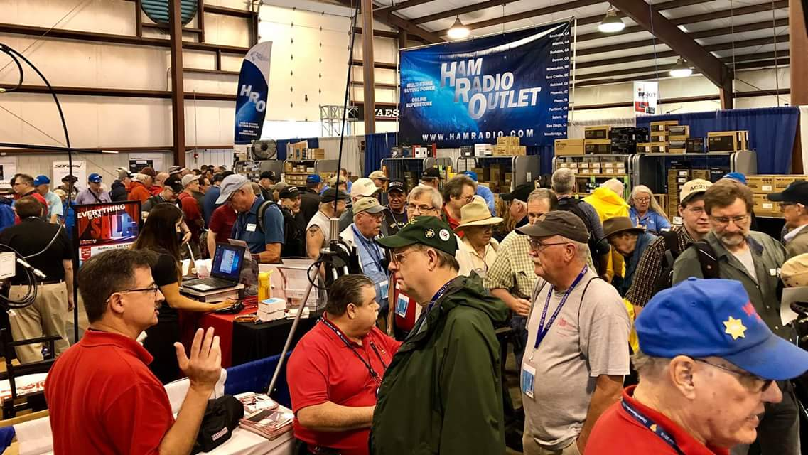[**Upcoming *Hamfests***](http://arrl-ohio.org/hamfests.html)

We **DO** have some hamfests scheduled for 2021!! Yes, take a good look at the list, it’s growing every day!

|  |  |  |  |  |  |  |  |  |  |  |  |  |  |  |  |  |  |  |  |  |  |  |  |  |  |  |  |
| --- | --- | --- | --- | --- | --- | --- | --- | --- | --- | --- | --- | --- | --- | --- | --- | --- | --- | --- | --- | --- | --- | --- | --- | --- | --- | --- | --- |
| |  |  | | --- | --- | | **08/15/2021 -**[**WARA Tailgate Swap Meet**](http://www.arrl.org/hamfests/wara-tailgate-swap-meet)  **Location:**Warren, OH **Sponsor:** Warren Amateur Radio Association **Website:** [http://w8vtd.com](http://w8vtd.com/)  [**Learn More**](http://www.arrl.org/hamfests/wara-tailgate-swap-meet) | **08/28/2021 -**[**Cincinnati Hamfest℠**](http://www.arrl.org/hamfests/cincinnati-hamfest)  **Location:**Owensville, OH **Sponsor:** Milford ARC **Website:** [http://CincinnatiHamfest.org](http://cincinnatihamfest.org/)  [**Learn More**](http://www.arrl.org/hamfests/cincinnati-hamfest) | | **09/12/2021 -**[**Findlay Hamfest**](http://www.arrl.org/hamfests/findlay-hamfest-8) Location: Findlay, OH Sponsor: Findlay Radio Club Website: <http://www.findlayradioclub.org/hamfest>  [**Learn More**](http://www.arrl.org/hamfests/findlay-hamfest-8) | **09/18/2021** - [**Miami County Swap Meet**](http://w8fw.org/)  **Location:**Troy, OH  **Sponsor:** Miami County Amateur Radio Club  **Website:** [http://w8fw.org](http://w8fw.org/)  [**Learn More**](http://w8fw.org/) | | **09/18/2021 -**[**Mound Amateur Radio Assoc. Swap Meet**](http://www.arrl.org/hamfests/mound-amateur-radio-assoc-swap-meet)  **Location:**Miamisburg, OH **Sponsor:** MARA **Website:** [http://W8DYY.ORG](http://w8dyy.org/)  [**Learn More**](http://www.arrl.org/hamfests/mound-amateur-radio-assoc-swap-meet) | **09/26/2021 -**[**Cleveland Hamfest**](http://www.arrl.org/hamfests/cleveland-hamfest-1)  **Location:**Berea, OH **Sponsor:** Hamfest Association of Cleveland **Website:** [http://www.hac.org](http://www.hac.org/)  [**Learn More**](http://www.arrl.org/hamfests/cleveland-hamfest-1) | | **10/02/2021 -**[**10th Annual Vette City Hamfest,**](http://www.arrl.org/hamfests/10th-annual-vette-city-hamfest-arrl-great-lakes-division-convention)  [**ARRL Great Lakes Division Convention**](http://www.arrl.org/hamfests/10th-annual-vette-city-hamfest-arrl-great-lakes-division-convention)  **Location:**Bowling Green , KY **Sponsor:** Kentucky Colonels Amateur Radio Club **Website:** [https://ky4bg.com](https://ky4bg.com/)  [**Learn More**](http://www.arrl.org/hamfests/10th-annual-vette-city-hamfest-arrl-great-lakes-division-convention) | | | **10/09/2021 -**[**Northwest Ohio Amateur Radio Club (NWOARC) hamfest**](http://www.arrl.org/hamfests/northwest-ohio-amateur-radio-club-nwoarc-hamfest)  **Location:**Westminster, OH **Sponsor:** NWOARC, Northwest Ohio Amateur Radio Club **Website:** [http://www.nwoarc.com](http://www.nwoarc.com/)  [**Learn More**](http://www.arrl.org/hamfests/northwest-ohio-amateur-radio-club-nwoarc-hamfest) | **10/31/2021 -**[**Massillon (Ohio) Hamfest**](http://www.arrl.org/hamfests/massillon-ohio-hamfest)  **Location:**Green, OH **Sponsor:** Massillon Amateur Radio Club **Website:** [http://w8np.org](http://w8np.org/)  [**Learn More**](http://www.arrl.org/hamfests/massillon-ohio-hamfest) | | **11/06/2021 -**[**GARC Hamfest**](http://www.arrl.org/hamfests/garc-hamfest-4) **Location:**Georgetown, OH **Sponsor:**Grant Amateur Radio Club  [**Learn More**](http://www.arrl.org/hamfests/garc-hamfest-4) | **12/04/2021 -**[**FCARC WinterFest**](http://www.arrl.org/hamfests/fcarc-winterfest-2)  **Location:**Delta, OH  **Sponsor:** Fulton County Amateur Radio Club  **Website:**<http://k8bxq.org/hamfest>    [**Learn More**](http://www.arrl.org/hamfests/fcarc-winterfest-2) | | |  |  | | --- | --- | | **08/07/2021 -** [**2021 Columbus Hamfest**](http://www.arrl.org/hamfests/2021-columbus-hamfest)  **Location:** Grove City, OH **Sponsor:**Aladdin Shrine Audio Unit **Website**: [http://columbushamfest.com](http://columbushamfest.com/)  [**Learn More**](http://www.arrl.org/hamfests/2021-columbus-hamfest) | 08/07/2021 - [MOVARC HAMFEST](http://www.arrl.org/hamfests/movarc-hamfest-6)  **Location:** Bidwell, OH **Sponsor:**Mid-Ohio Valley Amateur Radio Club    [**Learn More**](http://www.arrl.org/hamfests/movarc-hamfest-6) | | **08/15/2021 -**[**WARA Tailgate Swap Meet**](http://www.arrl.org/hamfests/wara-tailgate-swap-meet)  **Location:**Warren, OH **Sponsor:** Warren Amateur Radio Association **Website:** [http://w8vtd.com](http://w8vtd.com/)  [**Learn More**](http://www.arrl.org/hamfests/wara-tailgate-swap-meet) | **08/28/2021 -**[**Cincinnati Hamfest℠**](http://www.arrl.org/hamfests/cincinnati-hamfest)  **Location:**Owensville, OH **Sponsor:** Milford ARC **Website:** [http://CincinnatiHamfest.org](http://cincinnatihamfest.org/)  [**Learn More**](http://www.arrl.org/hamfests/cincinnati-hamfest) | | **09/12/2021 -**[**Findlay Hamfest**](http://www.arrl.org/hamfests/findlay-hamfest-8) Location: Findlay, OH Sponsor: Findlay Radio Club Website: <http://www.findlayradioclub.org/hamfest>  [**Learn More**](http://www.arrl.org/hamfests/findlay-hamfest-8) | **09/18/2021** - [**Miami County Swap Meet**](http://w8fw.org/)  **Location:**Troy, OH  **Sponsor:** Miami County Amateur Radio Club  **Website:** [http://w8fw.org](http://w8fw.org/)    [**Learn More**](http://w8fw.org/) | | **09/18/2021 -**[**Mound Amateur Radio Assoc. Swap Meet**](http://www.arrl.org/hamfests/mound-amateur-radio-assoc-swap-meet)  **Location:**Miamisburg, OH **Sponsor:** MARA **Website:** [http://W8DYY.ORG](http://w8dyy.org/)  [**Learn More**](http://www.arrl.org/hamfests/mound-amateur-radio-assoc-swap-meet) | **09/26/2021 -**[**Cleveland Hamfest**](http://www.arrl.org/hamfests/cleveland-hamfest-1)  **Location:**Berea, OH **Sponsor:** Hamfest Association of Cleveland **Website:** [http://www.hac.org](http://www.hac.org/)  [**Learn More**](http://www.arrl.org/hamfests/cleveland-hamfest-1) | | **10/02/2021 -**[**10th Annual Vette City Hamfest,**](http://www.arrl.org/hamfests/10th-annual-vette-city-hamfest-arrl-great-lakes-division-convention)  [**ARRL Great Lakes Division Convention**](http://www.arrl.org/hamfests/10th-annual-vette-city-hamfest-arrl-great-lakes-division-convention)  **Location:**Bowling Green , KY **Sponsor:** Kentucky Colonels Amateur Radio Club **Website:** [https://ky4bg.com](https://ky4bg.com/)  [**Learn More**](http://www.arrl.org/hamfests/10th-annual-vette-city-hamfest-arrl-great-lakes-division-convention) | | | **10/09/2021 -**[**Northwest Ohio Amateur Radio Club (NWOARC) hamfest**](http://www.arrl.org/hamfests/northwest-ohio-amateur-radio-club-nwoarc-hamfest)  **Location:**Westminster, OH **Sponsor:** NWOARC, Northwest Ohio Amateur Radio Club **Website:** [http://www.nwoarc.com](http://www.nwoarc.com/)  [**Learn More**](http://www.arrl.org/hamfests/northwest-ohio-amateur-radio-club-nwoarc-hamfest) | **10/31/2021 -**[**Massillon (Ohio) Hamfest**](http://www.arrl.org/hamfests/massillon-ohio-hamfest)  **Location:**Green, OH **Sponsor:** Massillon Amateur Radio Club **Website:** [http://w8np.org](http://w8np.org/)  [**Learn More**](http://www.arrl.org/hamfests/massillon-ohio-hamfest) | | **11/06/2021 -**[**GARC Hamfest**](http://www.arrl.org/hamfests/garc-hamfest-4) **Location:**Georgetown, OH **Sponsor:**Grant Amateur Radio Club  [**Learn More**](http://www.arrl.org/hamfests/garc-hamfest-4) | **12/04/2021 -**[**FCARC WinterFest**](http://www.arrl.org/hamfests/fcarc-winterfest-2)  **Location:**Delta, OH  **Sponsor:** Fulton County Amateur Radio Club  **Website:**<http://k8bxq.org/hamfest>    [**Learn More**](http://www.arrl.org/hamfests/fcarc-winterfest-2) | |

Be sure to keep your eyes on this schedule as that when things start getting better and the vaccine rolls out to more and more, hamfests will surely get back to their normal schedule. Don’t see your hamfest listed?? Did anyone register it with ARRL? It’s really easy to do and you get a lot of FREE publicity if you do.

**___________________________________________________________________**

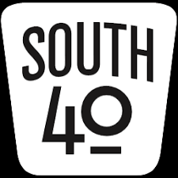

**OHIO’S**

Although it is early August, as this is written the weather makes it seem like it should be mid-September or later. However the weatherman assures us some of the usual August weather and temperatures are still to come-perhaps by the time you read this. So pull up that easy chair and take a few moments to see what your ham radio friends in the South 40 are up to in the coming weeks.

The **DeForest ARC** President Kim Paquette, N8YWX, reminds members and others in the Adams County area of the club’s August 10 meeting. On the same evening and just across the bridge from Adams County the **Greater Mason County ARC** meets at the Maysville/Mason County EOC Building, 668 Kenton Station Road in Maysville. Check out KY4MME on QRZ for more information. Another meeting that evening is when Adams County’s northern neighbor **Highland ARA** meets at 7 pm in the Harmony Lake shelter house at Hillsboro’s Liberty Park. President Pat Hagen, N8BAP, invites all area amateurs to not only that meeting, but also to the Club’s monthly Brunch Bunch gathering at the same location on Saturday, August 14. It begins at 10 AM.

The **Tri-State ARA** will hold their 58th annual hamfest on Saturday, August 14, at the New Baptist Church, 610 28 Street in Huntington, WV. All the buying, selling, trading and story-telling starts at 8:30 and continues until 1:30. A $6 admission fee will be charged for those over 18. A cash grand prize plus other neat prizes are to be awarded to those attending. More information is available on the Club’s <https://www.qsl.net/w8va/> website. All present state COVID guidelines will be followed.

When the usual **Athens County ARA** summer hamfest at the community center had to be cancelled this year the Club decided to hold a Trunkfest as a replacement. It will be on Sunday, August 22, on the Athens Masonic Center’s paved parking lot at 12 West Carpenter Street in Athens. It has an 8:00 starting time and will run until noon. There is no admission charge or fee to set up. There will be an ARRL VE test session.

Of course we can’t overlook the upcoming August 28 Greater Cincinnati Hamfest sponsored by the **Milford ARA**. All the fun starts when you enter the gates of the Clermont County Fairgrounds in Owensville beginning at 8 am. It features both inside and outside vendors and a VE test session. Admission is $8 per person. It will close at 4 pm.

In conjunction with the hamfest, the **Southwestern Ohio DX Association** will hold their second W8DXCC convention. Although it starts at 1 pm and continues until 6, an informal DX roundtable kicks things off at noon. The program features a wide variety of nationally known speakers. A separate $8 ticket apart from the hamfest is required to attend.

According to Jesse Stanley, KD8CHP, the **Scioto Valley ARA** will be active from the Club’s Scioto Trails clubhouse during the August 28 Ohio QSO Party and provide the often hard to get Ross County multiplier to the deserving. Several other individuals will activate their respective Southern Ohio counties from their home QTHs. Be on the lookout for the **Marietta RC**’s Ralph Matheny, K8RYU, as he ventures into some of the less active Southern Ohio counties. Last year all 88 Ohio counties had activity. The OQP is a fun event and provides an excellent opportunity to check out your station and antennas by working those close in counties. Participation in it has even hooked some people into county hunting.

John Myers, KD8MQ, tells us of an opportunity for those wanting to know more about the upcoming September 11 Ohio State Parks on the Air contest. On this Tuesday evening, August 10, there will be an informational Zoom Conference at 7:30 PM. Not only will it provide an overview of the contest, but will feature information about NVIS antennas and contest logging. For more information on how to be involved check out www.ospota@groups.io.

On August 14 the **Murray State University ARC** will sponsor the second Kentucky State Parks on the Air contest. It starts at 9 am CST and continues until 5. It’s interesting to learn that in addition to the 50 Kentucky State Parks, the nine national parks within Kentucky are considered state parks for the event. K4Y will operate as a special event station and be worth bonus points for each contact on each band. Our Kentucky correspondent Brent Wells, N4BDW, tells the South 40 the **Greater Mason County ARC** plan to operate from the Blue Licks Battlefield in rarely worked Nicholas County. Something tells me Brent will be testing the new portable antenna he built that uses the trailer hitch for the antenna mast mount.

Lyn Alfman, N8IMW, tells us the **Cambridge ARA** will display their communications van and have a booth at the upcoming Salt Fork Arts and Crafts Festival on August 13 through the 15th. The booth will be in the Heritage tent at the Festival. They will also be parking cars at the upcoming county senior citizens picnic on the 18th. Both events will be held at the Cambridge City Park.

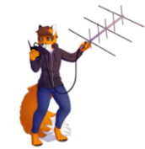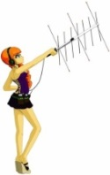Three area clubs will have Fox Hunts in the coming months. The **Hocking Valley ARC** will have their monthly event on Saturday, August 21 beginning with checkins on the 145.345 machine that morning between 9:45 and 10. The fox will be located in a visible from the road location in Hocking County. Amateurs will be roaming the back roads of Athens County on August 14 when the **Athens County ARC** holds their next fox hunt. It begins at 9:45 on the club repeater. It’s been a number of years since the **Highland ARA** held a fox hunt. But that will change on October 9 according to Richie Hagen, N8CUB with more information about the event forthcoming.

We wish success to two Southern Ohio area college students as they head back to campus. Greenfield’s Blake Gall, KE8PAQ, heads back to Ohio University to study computer science and Ashton Killen, KD8QII, heads to the Colorado School of Mining in Golden. Best wishes for a good and safe year to all other students heading back to a classroom.

According to their website the **Lancaster Fairfield County ARA** will hold a test session beginning at 7 pm on Thursday, August 12. It will be at the county EMA building, 240 Baldwin Drive, in Lancaster. The **Highland ARA** is assisting the **Milford ARC** during its August 28 Greater Cincinnati Hamfest in Owensville by conducting a VE session. Testing registration begins at 9 am in the 4-H Building and must conclude by 11:45 because the building is the site for the W8DXCC starting at noon.

Although walk-ins are welcome, preregistering through the cincinnatihamfest.org website would be appreciated. There is no fee to take a test according to team leader Tom Mongold, KD8LDS. The Huntington Hamfest flyer indicates there will be testing during the show. According to the **Tri-State** **ARC**’s Bud Cyr, KB8KMH, the ARRL test is at 11:30. Full information is on the www.qsl.net/w8va /events web site. The **Athens County ARA** will hold a VE session during their August 22 Trunkfest. Registration begins at 9:30 with the test at 10 am. They will also conduct a test session at the Athens Masonic Complex on August 16 at 7 pm. These are ARRL test sessions and require a $15 fee per test.

Several clubs and individuals in the region are gearing up for the September 11 running of the Ohio State Parks on the Air contest. Late word is the **DeForest ARC** will activate Adams Lake and Steve Newman, N8TUW, is planning to operate from Great Seal. The **Highland ARA** will activate stations at both Rocky Fork and Paint Creek. Be prepared to catch the **Portsmouth RC** on from Shawnee; the **Hocking Valley ARC** from Lake Logan; the **Sunday Creek ARF** from Burr Oak and the **Athens County ARC** from Strouds Run. The **Cambridge ARA** will be active from Blue Rock. Ralph Matheny, K8RYU, will operate as a rover and anticipates putting out some parks as time allows on his journey to the Findlay Hamfest. KD8MQ, John Myers, has an aggressive plan to active about 8 parks, including Deer Creek, Buck Creek and Madison Lake. Also joining the rover class this year, the team of N8ZNR and W8KIW will hit the road and venture into the Hocking Hills part of the state. Although plans may change, it looks like Lake White, Scioto Trails, Tar Hollow, Hocking Hills, Lake Hope and (pending no road closures this year) Lake Alma are targeted.

Adams County hams are reminded the **DeForest ARC** will resume face-to-face physical meetings this month. They will gather at 7 pm on Tuesday, August 10 at the Senior Nutrition Building in West Union. The site is directly across from the county courthouse.

Boy was it good to attend a hamfest on Saturday and get cured of a serious case of ‘Hamfest Withdrawal’. Although a bit warm, the folks at the **Aladdin Shrine Audio Unit-W8FEZ** could not have had a more perfect event as evidenced by the number of vendors and attendees. It was fun to again search the tables for treasures and see folks I haven’t seen in months-including N8SY, WB8LCD and W8CI. Folks from the **Clinton County ARA, Portsmouth RC, Grant RC, Scioto Valley ARC, Milford ARC** and **Highland ARA** were spotted and talked with. I suspect other clubs from the region were represented too. I even discovered and had a discussion with a young lady from another ham radio club in our region that I hope to hear more from-the **Cambridge Area Maker Group**. It was a good warm up for trips N8ZNR and I will be making to the Huntsville Hamfest and the Greater Cincinnati Hamfest later this month. If you missed it, you missed a great show. My hat is off to the sponsors.

Until next time remain safe, healthy and radio active.

John Levo – W8KIW

**___________________________________________________________________**

**Print an Official or Unofficial Copy of Your Amateur Radio License**

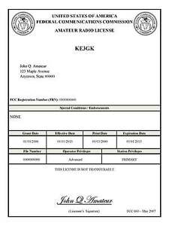*(By Anthony Luscre, K8ZT)*

As of February 17, 2015, the **FCC no longer routinely issues paper license documents** to Amateur Radio applicants and licensees. The Commission has maintained for some time now that the official Amateur Radio license authorization is the electronic record that exists in its Universal Licensing System (ULS). The FCC will continue to provide paper license documents to all licensees who notify the Commission that they prefer to receive one.

Licensees also will be able to print out an official authorization — as well as an unofficial “reference copy” — from the ULS License Manager. I’ve created a set of instructions on how you can request an **“official” printed copy of your license\***

[**Click here to download the instructions**](http://arrl-ohio.org/news/2020/print_your_license.pdf)

***One Question Questionnaire***

I consider this one of the most important questions I’ve put up here, so how about going to www.ARRL-OHIO.org and giving me a click? (It’s in the bottom left corner of the page) I’ll have more to say about this in the next OH Section Journal!

***“Have you ever sent a “contribution” to ARRL?”***

From the last Poll: ***“Do You Have All 50 States Confirmed?”***

60% yes, 40% no, this was out of a pretty small sample (26 votes)

Ohio Section Cabinet

|  |  |
| --- | --- |
| Section Manager – Tom Sly, WB8LCD | Section Traffic Manager – David Maynard, WA3EZN |
| Section Emergency Coordinator – Stan Broadway, N8BHL | Section Youth Coordinator – Anthony Luscre, K8ZT |
| Technical Coordinator – Jeff Kopcak, K8JTK | Affiliated Clubs Coordinator – Tom Sly, WB8LCD |
| State Government Liaison – Bob Winston, W2THU | Public Information Coordinator – John Ross, KD8IDJ |



Hey Gang,

Have you taken a look at the **Swap & Shop** page on the Ohio Section webpage yet?? Here’s a link that will take you there… <http://arrl-ohio.org/sm/s-s.html>

Do you have equipment that you just don’t need or want anymore? Here’s a great venue to advertise it, and it’s FREE!! Is your club doing a fund raiser to help raise money? After a lot of thought, it was decided that the Swap & Shop webpage could also contain these types of items as well. The same rules will apply as do for the For Sales and Give-A-Ways and will only be posted for a month at a time. Please see the Terms & Conditions on the webpage.

If your club is doing a fund raiser and wants more exposure, please forward the information to me and I’ll advertise it on the Swap & Shop webpage for you.

Now, I still want to remind you that it won’t be listed in this newsletter because it would take up way too much space, so your ad will only appear on the website. It is there for any individual to post equipment Wanted / For Sale or Give-Away as well as for Club Fund Raisers. No licensed vehicles/trailers or business advertising will be posted. Postings are text only (no pictures or graphics) will be posted for a maximum of 1 month from date posting and require a contact phone number or email within the posting. Send your Wanted / For Sale or Give-Away post to:  [swap@arrlohio.org](mailto:swap@arrlohio.org)

***Back Issues of the PostScript and Ohio Section Journal***

Hey, did you know that PostScript and Ohio Section Journal (OSJ) are archived on the website? You can go back and look at any edition simply by clicking:

<http://arrl-ohio.org/news/index.html>

***Want to Share your Club Newsletter With Others?***

We have a webpage where you can download and read all of the newsletters that I get from around the state and even other sections!

Here’s the link to the page…. <http://arrl-ohio.org/club_news/index.html>

Please, if you don’t see your club newsletter posted, it’s because I’m not receiving it. Just have your newsletter editor contact me and I’ll get your club’s newsletter listed on the site!!

We all learn and steal (I mean, share) from each other’s work. So, get me your newsletter!!! Send it to: [webmaster@arrl-ohio.org](mailto:webmaster@arrl-ohio.org)

***Chit – Chat, and All That!***

Do you know someone that’s not getting these Newsletters? Please, forward a copy of this Newsletter over to them and have them “[Opt-In](mailto:Opt-In)” to start receiving them. Heck, just have them send an email to: [webmaster@arrl-ohio.org](mailto:webmaster@arrl-ohio.org) and we’ll get them added to the Ohio Section Emailing list.

We now have many thousands of readers receiving these newsletters weekly. Quite impressive, I’d say! I urge all of you to make sure that everyone, regardless of whether they are a League member or not, get signed up to receive these weekly Newsletters.

You can always “Opt-Out” at any time if you feel this is not what you were expecting. It’s fun and very informative. All of your favorite past newsletters are now archived too.

You can go back at any time and read them.

Just go to: <http://arrl-ohio.org/news/>

The pictures on the front page and throughout this newsletter are from various newsletters, Facebook posts and/or were sent directly to me in recent weeks. Take a good look at them, you just might be in one of the pictures! “SMILE… you’re in the Ohio Section News!!”

*PostScript is produced as a weekly newsletter. I want to thank everyone that has contributed articles and ideas to make this an even better news source. I sincerely hope that you have enjoyed this edition and will encourage your friends to join with you in receiving the latest news and information about the Ohio Section, and news and events happening around the world!*