[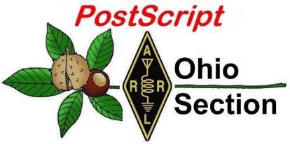](http://arrl-ohio.org/news/) ***“July 19th***

***Edition”***

🡪 National News 🡪 Club Corner

🡪 DX This Week 🡪 Contest Corner

🡪 Upcoming Hamfests 🡪 South 40

🡪 One Question Questionnaire 🡪 VE Testing

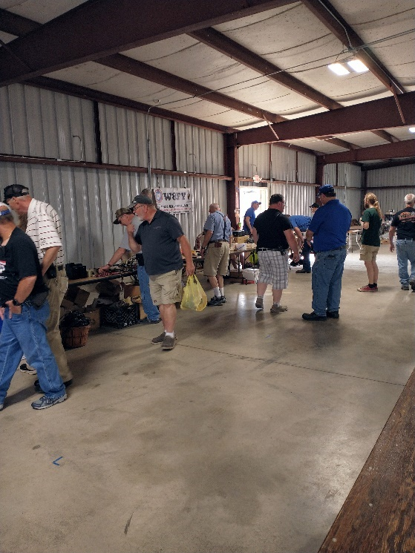

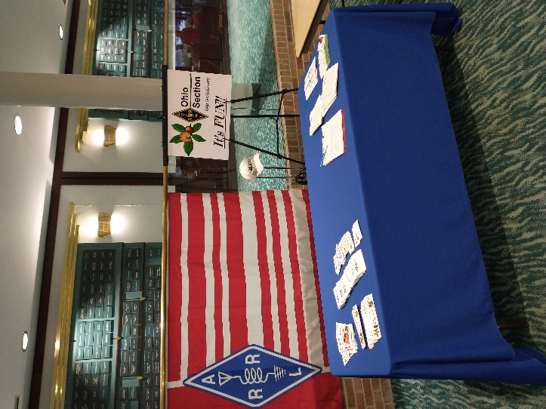

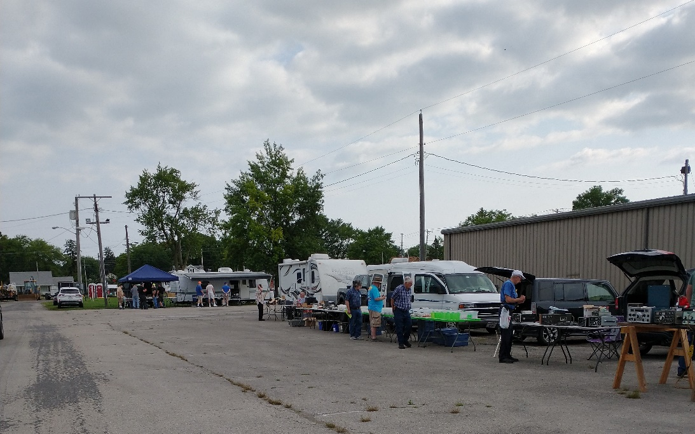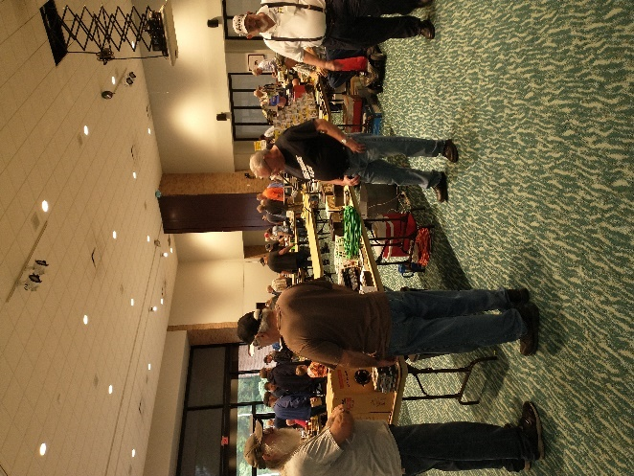

**CQ CQ CQ de WB8LCD**

Last week I took a trip to the Medina County Amateur Radio Club (MCARC). Nice group of Hams and a very good presentation by member Ed Eyerdon – K8NVR on the new FCC RF Exposure Regulations and how to do the calculations for your station. I was there to present the MCARC group with the renewal of their “Special Service Club” certificate. EVERY club in the Ohio Section should take a look at the requirements to become a Special Service Club and set a plan in action to qualify.

Per the ARRL website, “a club that exists to go above and beyond for their communities and for Amateur Radio is what defines a Special Service Club (SSC).  They are the leaders in their Amateur Radio communities who provide active training classes, publicity programs and actively pursue technical projects and operating activities.” If you read through the rest of the application, [SSC Application (arrl.org)](http://www.arrl.org/ssc-application) , you’ll pretty much find the recipe for building a successful club!

Your club officers can use this blueprint and put together programs, activities and events to include in the application. But the officers alone cannot make it happen. Each individual club member has a role in the success of their club. First and foremost – Show Up. You can’t imagine how disheartening it is for your officers to put a program together and only a small percentage of members show up. Sure, everyone has an excuse, but how about having a “priority”? Ham Radio, your club and your own personal experience as a Ham will be enhanced in ways you probably can’t even imagine when you make your chosen hobby a priority in your life! (disclaimer: you can still have other priorities in life, some that may even come before ham radio, just don’t let insignificant things rob you of the Joy of Ham Radio!)

Get along. It’s nice to get your own way, but it’s not prudent to think that things are *always* going to go the way you desire. Don’t be that kid who picks up his ball and goes home just because he didn’t get his way on something! Make sure everyone gets heard. I’ve found through my years as a Ham that most hams are pretty good people. That doesn’t mean we have to agree on everything, but we can work through our differences and move on towards a common goal. Sometimes you win, sometimes you lose, that’s just the way life works……

If your club is not a Special Service Club, please consider filling in the application to see which areas you excel in and which you might need just a little more work. Make a plan, involve everyone in your club and get it done! This is a true Win / Win. The OH Section looks good to ARRL by having a large number of our clubs qualified as Special Service Clubs. At the same time, you and all the other members of your club benefit from the activities and programs you participate in with your club. It’s worth the effort – make it a priority!

I also want to suggest that if Ham Radio is your priority, you might want to expand that beyond just your “immediate” world. Clubs other than your own are also doing some pretty spectacular things! Check out the other clubs in the OHIO Section, and beyond! Visit their meetings, in person if possible, or by zoom when available. Check out their other activities, visit their hamfest. Ham Radio is a pretty big world – there’s a lot to explore.

Speaking of which, I want to announce that on Tuesday, August 19, 2021, 7:30 till end, the OHIO Section will be sponsoring a ZOOM session on the topic of OHIO State Parks on the Air (OSPOTA). This will be an informative session on all things OSPOTA! Following is the ZOOM information you’ll need:

Topic: All Things OSPOTA

Time: Aug 10, 2021 07:30 PM Eastern Time (US and Canada)

Join Zoom Meeting

https://us02web.zoom.us/j/88055320136?pwd=bk81MXE3ellVTnAzZ3ptS0N3K2FOdz09

Meeting ID: 880 5532 0136

Passcode: 375951

One tap mobile

+13126266799,,88055320136#,,,,*375951# US (Chicago)

+19292056099,,88055320136#,,,,*375951# US (New York)

Dial by your location

+1 312 626 6799 US (Chicago)

+1 929 205 6099 US (New York)

+1 301 715 8592 US (Washington DC)

+1 346 248 7799 US (Houston)

+1 669 900 6833 US (San Jose)

+1 253 215 8782 US (Tacoma)

Meeting ID: 880 5532 0136

Passcode: 375951

Find your local number: https://us02web.zoom.us/u/kbIdDj9UhW

I hope you’ll be able to make it!

73, Tom wb8lcd

***National News***

*(from arrl and other sources)*

Most 2021 Field Day Participants Entered in Class D

In the second ARRL Field Day (FD) with rule waivers in place, some 4,815 entries were received at ARRL Headquarters by July 13 -- the majority 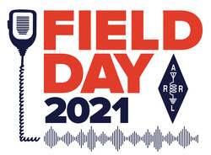in Class D (Home Stations). Last year saw more than 10,213 entries and 18,886 participants. Before the pandemic, in 2019, 3,113 entries were submitted, with 36,420 total participants.

"It appears that larger groups were more the norm in pre-pandemic times, as expected," ARRL Contest Program Manager Paul Bourque, N1SFE, observed. "From the discussions I've been having with participants, even though some groups gathered in larger numbers this year, many participants chose either to gather in smaller groups or to operate solo from home as Class D or Class E stations. Although I don't think we'll see the number of entries that we did last year, we're close in terms of the number of participants."

With about 2 weeks to go until the entry submission deadline, the tally of participants reported is 16,166. They made just north of 1 million

|  |
| --- |
| **Andy Goss, AA5JF, took part in the first Field Day for the Augusta University Amateur Radio Club (WA4AUG), which set up in the Georgia school's Critical Event Preparedness and Response (CEPaR) Center.** |

total contacts.

"FD was already a success on Saturday, with the stations working smoothly, and lots of local visitors dropping by," said Andy Goss, AA5JF, at Augusta University Amateur Radio Club's WA4AUG. "An hour after sunrise on Sunday, we were counting our points, when Darby, KK4PEQ, announced he had just worked a station on 6-meter phone -- just playing around on 50 MHz using the 20/15/10 tribander," Goss said. "He stayed on 6 [meters] for five QSOs, but we quickly [moved] to 10 and 15, finding those bands were open to just about everywhere, and we doubled our score in just 3 hours. What a rush!"

**FD Entries are Due Soon**

There's still time to submit your 2021 Field Day entry. Most of this year's Field Day entries have been submitted [via the online web app](http://field-day.arrl.org/fdentry.php) (worth 50 bonus points!), although some 50 paper logs have been mailed in. Participants can check the [Entries Received](http://field-day.arrl.org/fdentriesrcvd.php) page to make sure their entries were received and complete. If the entry status indicates "Pending documents," either the required dupe sheet (or in lieu of that, a Cabrillo log file), or supporting documentation of claimed bonus points is missing. Bourque said some 250 entries fall into that category right now. Participants can add documentation or edit their entries by following the link provided in the confirmation email sent to the email

|  |
| --- |
| **Scott Hanley, WA9STI, operated in the Los Padres National Forest from a site at 7,400 feet elevation.** |

address provided upon entry, up until the entry submission deadline. Field Day entries must be submitted online or postmarked no later than 2059 UTC on July 27, 2021.

The breakdown of Field Day entries by class, as of July 13, showed 4,815 total entries, with 613 in Class A, 582 in Class B, 57 in Class C (Mobile), 2,619 in Class D, 858 in Class E, and 86 in Class F.

For his 2021 Field Day, Scott Hanley, WA9STI, took to the woods -- the Los Padres National Forest -- at a site some 7,400 feet elevation in the mountains overlooking California's Central Valley. He operated as WA6LE in Class 1B. He put 358 contacts in the log on CW and phone -- short of his 400-contact goal. "Almost all activity was on 20, 40, and 75/80 meters to a G5RV or end-fed 20-meter dipole," Hanley said. "Six meters did not open, so I only had two local SSB contacts and only three contacts on 2-meter FM."

ARRL Headquarters Holds Rededication Ceremony

On Thursday, July 15, at 10 AM EDT, ARRL Headquarters in Newington, Connecticut, hosted a rededication ceremony, recognizing ARRL's commitment to all radio amateurs who enhance the communications capability and security of the nation. The event

|  |
| --- |
| **The ARRL ceremony was kicked off by 18-year-old Jacob Gionfriddo, KC1LYP, a 2021 ARRL Foundation Scholarship winner and recent graduate of Newington High School. He will be attending Central Connecticut State University this fall to study electronics and technology.** |

coincided with the attendance of ARRL's all-volunteer Board of Directors, who had traveled in from across the country for in-person committee and Board meetings this week.

"Associations advance America," ARRL President Rick Roderick, K5UR, said in his remarks. "Associations bring people together around a common purpose. For ARRL and our members, that purpose is amateur radio... Over the last year, I have witnessed the extraordinary dedication of ARRL members, our staff, and our Board of Directors. Without skipping a beat, we have worked together to equip our members with the opportunities they need to serve an active and vibrant Amateur Radio Service for our country." Roderick also recognized members of ARRL's Amateur Radio Emergency Service® (ARES®) for serving their communities with essential communications When All Else Fails®.

|  |
| --- |
| **US Congressman John B. Larson (left) presents ARRL CEO David Minster, NA2AA, with a Congressional Recognition for "the dedicated and phenomenal service that the ARRL and its members" provide.** |

In his remarks, ARRL CEO David Minster, NA2AA, reflected on the commitment made to maintain the organization's operations for the benefit of its members during the pandemic. "That we were able to continue proudly and passionately serving our members and our nation through these challenges speaks to the resilience of our organization, and the commitment of our volunteers and staff."

The event also included remarks by Connecticut District 1 US Congressman John B. Larson; Connecticut State Senator Matt Lesser, and Glenn A. Field, KB1GHX, Warning Coordination Meteorologist for the National Weather Service Boston/Norton office in Massachusetts. Also in attendance were representatives of the American Red Cross; the Connecticut Department of Emergency Services and Public Protection; the International Amateur Radio Union (IARU); Radio Amateurs of Canada; Connecticut General Assembly; the Town of Newington, and ARRL Officers, Board members, and staff.

A [video](https://youtu.be/9xF0Rh-wrN4) of the rededication ceremony is posted on ARRL's YouTube channel.

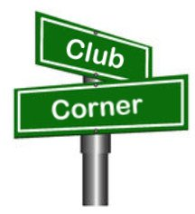***Club Corner***

This is YOUR cornner of the newsletter. Send me what your club is doing and I’ll make sure that it gets in. Got a special event or club project that you want everyone to know about? Send it to me!. Need help with a project? Send it to me.

Let me know what you club is up to. Are you going to have a special guest at your meeting or are you having a special anniversary?

Just sent it to: [webmaster@arrl-ohio.org](mailto:webmaster@arrl-ohio.org)

Hi Gents,

   Summit County ARES is looking for communication volunteers for the Goodyear Half-Marathon on August 14th from 6 AM until 2 PM.

   The race is a 13 mile run/walk starting at the Goodyear World Headquarters in East Akron, passing the Akron Airport and winding through the neighborhoods in Ellet before returning to The Goodyear complex.

   This is a major event that helps bring amateur radio to the forefront and we are looking for as many operators as possible to cover the various water and first aid stations effectively.

   While the race is an 8 hour event, operators are usually released after the last runner has passed their position so no one has to stay for the entire event unless they have volunteered for more than one location.

   If you could, talk this event up on your weekly nets or monthly club meetings as the event is about a month away and there's not a lot of time to work with..

   Sign-ups are on the Summit ARES website at [www.summitares.org](http://www.summttares.org/) and click on the events tab.

   Thanks in advance and

*73*

***​Gregg Gary - WB8YYS***

*Asst. EC - Summit County*

**Lucas County ARES**

We are looking for help with the Sylvania events. The Sylvania Superkids (kid’s triathlon) is Saturday, July 31st with a start time of 7:00 AM. We only cover the bike portion of this event, and they are using the same

course as last time. We are finished with this event by 10:30 AM. The Sylvania Triathlon is Sunday, August 1st with a start time of 7:30 AM. We cover all three events, and the course is open until 1:00 PM. The run

course is completely different this year and has some similarities with the kid’s bike course. If you'd like to volunteer or need more information, please contact me at [k8rks@arrl.net](mailto:k8rks@arrl.net) or 419-471-0573.

UPDATE:

We still in need of operators for the Sylvania event. The Sylvania Triathlon is Sunday, August 1st with a start time of 7:30 AM. We cover all three events and the course is open until 1:00 PM. The run course is

completely different this year and has some similarities with the kids bike course. If you'd like to volunteer or need more information please contact me at [k8rks@arrl.net](mailto:k8rks@arrl.net) or 419-471-0573.

VE Sessions

Dayton Amateur Radio Association (DARA)

Our next test session will be Wednesday July 21st at 7:00 PM. **Preregistration is no longer required.** If you are interested in testing for a new or upgraded license, please come see us at the DARA Clubhouse. If you have questions about testing, please email [exams.w8bi@gmail.com](mailto:exams.w8bi@gmail.com)

Lake County Amateur Radio Association (LCARA)

Saturday August 7, Saturday October 2, Saturday December 4

All exams start at noon and are held at the Kirtland Library, 9267 Chillicothe Rd. Kirtland, OH

Portage County Amateur Radio Service (PCARS)

Starting on August 7th, PCARS will resume VE testing at the PCARS club site in Ravenna.

Please visit the PCARS web site and check out the information about VE testing in the latest newsletter – [https://portcars.org/files/newsletter/2021/PCARS-June-21.pdf](https://r20.rs6.net/tn.jsp?f=001DxdXS40dvzmbl9m9sfY5l9IIoAGYYsZIQIObAktg-wnnAu__YbvuVuV1_NQmLDKapbqCCYZK1L6epi1k5lVvuEtL_I1T0LMdgzjsNGvi1UnoIj7Lpv0RFoxS8h0YOCVVODgyzQI8xFTrmQ0pr6RXkQVvSx_cjGgR-DubSFhvF7CPVtMoPBph8tt8RpjGjyyBlRFHzo_VhR4=&c=Oi-83JMf17RlM94bujSYqqAwfNyIPWszQZKKkjp6BM5J7PHkAvaFrA==&ch=Kr1c-7rzal6CKkNUvSX-jLXK5eG9iU0tKZ5xoqUUqM21mzFnc1rE3w==)  – see pages 8, 9 and 10 for details.

If you have any questions, don’t hesitate to contact me at KB8UUZ@gmail,com

On behalf of the VE team at PCARS, we all look forward to getting the VE testing going again and look forward to seeing you there – August 7th -10 am – at the PCARS club site in Ravenna.

Clark County Amateur Radio Association

The Clark County Amateur Radio Association will hold VE sessions on August 14, 2021, October 9, 2021, and December 11, 2021. The test session will be held at the Clark County EMA located at 3130 East Main Street, Springfield, Ohio 45503. Registration begins at 11:30am and walk-ins are welcome. Download the FCC form VE605 and fill out section 1 prior to exam. Please bring your original license, a copy of your license (if a licensed ham), a valid photo ID and $15.00 to the exam. Note you must have a FCC FRN before taking any exam. Additional details are available at https://w8og.org/

# **BLACK SWAN Updates: AUXCOMM Wanted!**

C. Matthew Curtin, KD8TTE

The multi-agency exercise BLACK SWAN 21 will be taking place on the usual schedule in October, with opportunities for amateur stations to participate. Exercise controllers will coordinate participating stations directly to ensure that they’re activated when available. More about this year’s exercise will follow.

Meanwhile, we have a few updates to report on the training front. We’ll continue conducting small exercises and activities that help everyone to brush up on old skills and develop new station capabilities and skills.

Hold the dates: We’ll have a small daytime exercise to be conducted in the afternoon hours of August 7 and 8. We’re calling the exercise NEW YORKER, and it will be focused on a few common tasks, combining both voice operations and relay of digital messages. The latest information is available at <https://www.blackswancomex.org/2021/new-yorker>.

Hold the dates: Another operation will be running September 13-15. Primary operations are expected to take place outside of amateur spectrum but we are anticipating a schedule of BLACK SWAN nets to be able to give AUXCOMM stations an opportunity to exercise with one another and for others to participate in the nets.

Hold the dates: After that, it’s already time for the Simulated Emergency Test (SET). It should be a busy time, with the BLACK SWAN 21 exercise beginning on September 28 and continue through the SET weekend October 2-3. Keeping things extra exciting the DOD COMEX 21-4 will be taking place at the same time.

We’ve got plenty happening to help you and your club to get up to speed on critical tasks, and to practice the capabilities and skills needed to succeed in these operations and real-world emergency communications needs. See the Prepare for BLACK SWAN 21 information online at <https://www.blackswancomex.org/2021/prepare>.

Our QTC Internet mailing list has about 50 subscribers and is where we’re coordinating our training activity. As I presented in the “Fourth of July Edition” of *PostScript* (pp. 4-5), each Tuesday we announce a weekly training task and give a few days to raise questions, discuss the topic, and prepare to execute the task. We hold a BLACK SWAN net at 1300 on Saturday and again on Sunday, then a third time on Monday at 1900.

The QSP radio-only newsletter is published weekly. Now with 17 participants from three states, we’ve seen everything from simple check-ins by Winlink and FLMSG to articles submitted with the FLMSG custom form Share With QSP. More information about that is available in last week’s *PostScript*, “July 12th Edition,” pp. 6-8. Tell us about your projects and training; we’re all here to learn from each other.

Looking into 2022, we’ve got the ARRL National Convention in Orlando. I’m happy to say that I’ve accepted an invitation to present on topics including what we’ve done with BLACK SWAN and making amateur radio a viable service for emergency communication, able to perform specific functions, more than being valuable in a vague or general sense.

Thank you for your ongoing efforts to improve your station capability and operating skill, and coordinating with us to do so. If you haven’t yet started, it’s not too late. Find us online at <https://www.blackswancomex.org/2021/prepare> and start preparing for operations. Got questions? QTC mailing list is here to help you! Looking for practice? BLACK SWAN nets and the QSP radio newsletter are there for you every week. Whatever your level of experience, you’ve got something to learn and something to share, and your engagement with others makes all of us better, and the amateur radio service more valuable to the public and the agencies serving the public.

**Your Club news should be listed here!**

I know you’re out there doing things! Send me a write-up (MSWord please) and some photo’s (.jpg please) and we’ll get your club hi-lited here for the othe OH Section Clubs to see! Send to [WB8LCD@ARRL.ORG](mailto:WB8LCD@ARRL.ORG)

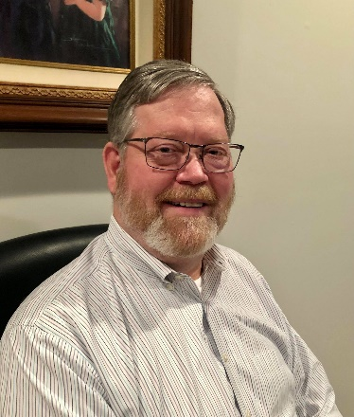**DX This Week – Cut Numbers**

DX This Week – Cut Numbers

Bill AJ8B (aj8b@arrl.net, @AJ8B, or www.aj8b.com)

CWOPs Member #1567

The Midwest DX Cluster spots included Alaska, Asiatic Russia, Azores, Balearic Islands, Belgium, Belize, Bulgaria, Canada, Canary Islands, Crete, Croatia, Czech Republic, Denmark, England, European Russia, France, Ireland, Isle of Man, Italy, Kaliningrad, Lithuania, Luxembourg, Mauritania, Mexico, North Macedonia, Northern Ireland, Portugal, Puerto Rico, Qatar, Sardinia, Scotland, Sicily, Spain, Ukraine, and Western Sahara. This brings the total number of entities spotted in the Midwest in 2021 to 184 !

I received a card from and CP1XRM, Centro in Bolivia and from SP1MGM, Krzysztof in Poland. What did you get?

|  |  |
| --- | --- |
|  |  |

# *DAH DIT DIT DIT DAH DAH DIT DIT DIT DAH*

This week, we have a few items to update you on. First, the tickets for the W8DXCC convention went on sale and were moving briskly the first two weeks. Ticket sales slowed a bit, but I am sure as the date gets closer, they will pick up. Remember, there are a limited number so get yours while they are available at [www.w8dxcc.com](http://www.w8dxcc.com) ($8) Why not combine it with the Cincinnati Hamfest? Great flea market and outdoor area. (cincinnatihamfest.org) Spend your Saturday, August 28th, with a great group of hams.

The W4DXCC convention is on for September 24th and 25th. This event is held in the Pigeon Forge area and is a lot of fun. Great speakers, great prizes, great food, and great company. Visit w4dxcc.com for more details.

Finally, the QSO Today virtual Ham Expo 2021 is on! The dates are August 14 and 15. This is a multi-day virtual event. There were some glitches last fall and Eric, 4Z1UG, has worked them out with his presentation vendors. Great value and a fantastic event. Visit <https://qsotoday.vfairs.com/> for more details.

Many of the Ohio Section amateurs will be participating in all of these events. DXEngineering will also play critical roles in all of them. When you get a chance, let the folks at DXEngineering know you appreciate how they support us.

If you spent last weekend working in the IARU HF Championship Contest (CW), you may have heard some unfamiliar CW characters, or questioned the usage of characters that you knew. More than likely, you heard an experienced operator using a “Cut” number, a “Prosign”, or an abbreviation. For instance, you may have worked someone who said that your signal was 5NN. You probably guess that they were sending 599 to you, however, they were using a Cut number, or an agreed upon shorthand for the number 9.

Cut Numbers – You may think that cutting the number 9 from “- - - - .” to “-.” is not a big deal, and you would be correct if you were just working a couple of folks. However, a DX station who may work 200 or more hams during an on the air session may disagree. Propagation doesn’t always stay open and is shifting all the time. If the DX station can save a bit of work per QSO, it adds up! Cut Numbers are used most during a contest where the DX station is focused on rate more than saving time. The stations who are trying to work him are not going to hang around for minutes and the more QSOs he can squeeze into a small timeframe, the better.

In addition to using Cut Numbers for RST, they are also common to use for the stations zone designation or power output. For instance, I worked OM2VL (Slovak Republic) in CQ Zone 15 during the recent contest. The exchange from Vegh was AJ8B TU 5NN AE K which combines Cut Numbers and abbreviations. Vegh sent my call, (AJ8B), Thanks (TU), my signal report – 599 (5NN), his CQ Zone 15 (AE) and the K to terminate the data sent. Then he would go on to the next station. Vegh has almost 300,000 QSOs to his credit, so, I am sure that he leans heavily on these concepts. You need to be careful when and where you use a cut number. The person copying you should be expecting a number, or they will treat what you send as a letter and will get confused. That is why Vegh sent the 5 in the 5NN sequence instead of the Cut Number equivalent. A table of cut numbers is below:

|  |  |  |  |  |  |  |  |  |  |  |
| --- | --- | --- | --- | --- | --- | --- | --- | --- | --- | --- |
| Number | 1 | 2 | 3 | 4 | 5 | 6 | 7 | 8 | 9 | 0 |
| Cut Number | A | U | V | 4 | E | 6 | G | D | N | T |

Prosigns: are symbols formed by running together two characters into one without the intercharacter space to make an abbreviation for the most common procedural signals. Prosigns are usually written with a BAR over the characters. For instance, I use BT frequently during a QSO. I use it as a pause to gather my thoughts or to switch to another topic. It would be sent as -…-, not -… -. (Dah DIT DIT DIT Dah not Dah DIT DIT DIT <Space> Dah) 1 character instead of two.

Don't neglect to learn these by sound. Knowing what they look like on paper is of little value when you are mystified by the sound of long CW characters. Knowing the rules of context that govern the use of Prosigns is also very helpful: AAA is the period. Use it at the end of a sentence when the following sentence will pertain to the same subject.

AR is used at the end of a transmission when calling a specific station before the two-way contact has been established. Use it in place of K or KN when answering a CQ, or calling someone for a sked.

AS means "Please stand by for a moment", usually used to let the other guy know that you have to talk to someone else in the room, answer the telephone, or fix some technical glitch and that the band didn't just fall out from under your QSO. You'll be back in just a minute.

BT is kind of like the period. Use it at the end of a sentence when the next sentence will pertain to a different topic.

DN is the slash (/). It is used to indicate mobile, QRP, or operation from a different call area than that indicated by your callsign.

IMI is the question mark.  
K is used at the end of a transmission means you are listening for an answer from any station. Use it when calling CQ. Once you have established contact with a station and you do not want to be interrupted by a third party, use KN instead.

KN is used at the end of a transmission when only the other party already in the QSO is invited to respond.

MIM is the comma.

R means "Roger" or "Received". Use it at the beginning of a transmission ONLY if you copied 100% of what was just sent to you. Don't use it if anything was missed. Use BK instead, and something like "FB on UR QTH but missed UR name". You can also start a transmission with BK even if something was not missed. High speed operators often use this method instead of KN and R.

SK is used at the end of your final transmission of a QSO. If the other station has not yet sent his "final" you may follow SK with KN.

Abbreviations: Below is a table of common abbreviations used in a typical CW QSO.

|  |  |  |  |  |  |
| --- | --- | --- | --- | --- | --- |
| Abbreviation | Meaning | Abbreviation | Meaning | Abbreviation | Meaning |
| 73 | Regards | GA | Good Afternoon | RCVR | Receiver |
| ABT | About | GB | God Bless | SIGS | Signals |
| ANT | Antenna | GE | Good Evening | SN | Soon |
| B4 | Before | GL | Good Luck | SRI | Sorry |
| BCNU | Be Seeing You | GM | Good Morning | TNX | Thanks |
| BK | Break | Gud | Good | TU | Thank You |
| BN | Been | HPE | Hope | TX | Transmit |
| CLDY | Cloudy | HV | Have | U | You |
| CLR | Clear | HW | How | UR | Your |
| CONDX | Conditions | NR | Number | VY | Very |
| CPY | Copy | NW | Now | WID | Width |
| CU | See you | OM | Old Man | WUD | Would |
| CUD | Could | OP | Operator | WX | Weather |
| CUL | See you Later | PSE | Please | XCVR | Transceiver |
| ES | And | PWR | Power | XMTR | Transmitter |
| FB | Fine Business | R | Are | XTAL | Crystal |

Did I forget any?

# *DAH DIT DIT DIT DAH DAH DIT DIT DIT DAH*

# CQDX CQDX CQDX CQDX CQDX CQDX CQDX CQDX CQDX

Here is an update from Bernie, W3UR, of the DailyDX and the WeeklyDX, the best source for DX information. <http://www>.dailydx.com/. Bernie has this to report:

K9CT, Craig, is the fourth DXer from Illinois to achieve DXCC 3000.  
Congratulations and welcome to the 3K Club Craig!

**T8 – Palau -** In January 2022 K0UU, Jeff, and his wife Carolyn are heading to T8. Per usual, [Carolyn] will be on a dive trip and I will schlep all the gear, which limits my ability to check QRO equipment", says Jeff. Plans are to take a Elecraft K2, powered by lithium battery along with a longwire and possibly "an extendible fiberglass pole". As with his previous trips (VR2, 3D2, ZF8, HR9, KH6, GJ, GU, VP5, etc.) he will be on CW only running low power. He will be on 40-10 meters only.  
  
**OY - Faroe Islands -** "I just booked the tickets and here's the info as promised", says LB5SH, Stian, who will be heading to Torshavn, Faroe Islands. Look for OY/LB5SH from September 17-20. Unless he is able to repair his amplifier, he will be running 100 watts and a multiband vertical. "I'll work whatever band that is open at the time", says Stian. He will be on SSB and FT8 and might try some CW in the SAC CW Contest. Listen for him on 1.8 through 50 MHz.

**HP – Panama -** In celebration of Panama's Bicentennial HP stations can operate using the 3F200 prefix. Activity will take place between June 1 and November 30.  
  
**OE – Austria -** To celebrate the 35th anniversary of the European DX Foundation OE6VIE, Jo, will be operating special event call OE35EUDXF from November 1-30. QSL via the bureau, LoTW or eQSL.

*DAH DIT DIT DIT DAH DAH DIT DIT DIT DAH*

Below is a list of upcoming contests in the “Contest Corner”. I think this is important for someone who is trying to move up the DXCC ladder since entities that are on the rarer side and easiest to work in contests. Some of my best “catches” have been on the Sunday afternoon of a contest when the rarer entities are begging for QSOs. Of course, the gamble is that if you wait until Sunday, conditions may change, or they simply won’t be workable. However, it is not a bad gamble. Of course, why not work the contest and have some fun!  
Check out the WA7BNM Contest Calendar page (<https://www.contestcalendar.com/>) and CQ Magazine for more contests or more details.

The contests in red are those that I plan to spend some significant participation time on. PLEASE let me know if you are working contests and how you fared.

Thanks!

|  |  |  |
| --- | --- | --- |
| July 24-25 | RSGB IOTA Contest | https://tinyurl.com/29m8jb3z |
| July 25 | ARS Flight of the Bumblebees | http://arsqrp.blogspot.com |
| July 26 | RSGB FT4 Contest Series | http://bit.ly/3mCNXXH |
| July 31-Aug. 1 | Missouri QSO Party | https://tinyurl.com/fbfcw8r3 |
| July 31- Aug. 1 | Russian WW Multi Mode Contest | http://bit.ly/2CMbWOM |
| Aug. 1 | SARL HF Phone Contest | http://bit.ly/HOlqQf |
| Aug.4 | VHF-UHF FT8 Activity Contest | www.ft8activity.eu/index.php/en |
| Aug. 7 | European HF Championship | http://bit.ly/H2eMg5 |
| Aug. 7 | FISTS Summer Sprint | http://fistsna.org/operating.html#sprints |
| Aug. 7 | WAB 144 MHz Low Power Phone | http://bit.ly/31 yE4kT |
| Aug. 7-8 | 10-10 lnt'I Summer Contest SSB | http://bit.ly/1 FrFeBc |
| Aug. 7-8 | ARAL 222 MHz and Up Distance Contest | http://bit.ly/21JZcy9 |
| Aug. 7-8 | Batavia FT8 Contest | https://batavia-ft8.com |
| Aug. 7-8 | North American CW 080 Party | http://ncjweb.com/NAQP-RRules.pdf |
|  |  | (Featured in this month's column) |
| Aug. 11 | VHF-UHF FT8 Activity Contest | www.ft8activity.eu/index.php/en |
| Aug. 14 | ORP ARCl European Sprint | www.qrparci.org/contests |
| Aug. 14-15 | CVA DX Contest CW | http://cvadx.org/regulamento |
| Aug. 14-15 | Worked All Europe CW Contest | http://bit.ly/2vufgcb |
| Aug. 14-15 | Maryland-DC QSO Party | www.w3vpr.org/node/325 |
| Aug. 15 | FISTS Summer Sprint | http://fistsna.org/operating.html#sprints |
| Aug. 15 | SARL HF Digital Contest | http://bit.ly/HOlqQf |
| Aug. 21-22 | ARRL 10 GHz and Up Contest | www.arrl.org/10-ghz-up |
| Aug. 21-22 | CVA DX Contest SSB | http://cvadx.org/regulamento |
| Aug. 21-22 | SARTG RTTY Contest | www.sartg.com/index.html |
| Aug. 21-22 | North American SSB QSO Party | http://ncjweb.com/NAQP-Rules.pdf |
| Aug. 21-22 | KCJ Contest | www.kcj-cw.com/e_index.htm |
| Aug. 22 | ARRL Rookie Roundup RTTY | www.arrl.org/rookie-roundup |
| Aug. 28-29 | Hawaii QSO Party | http://hawaiiqsoparty.org |
| Aug. 28-29 | Kansas 080 Party | www.ksqsoparty.org |
| Aug. 28-29 | YO DX HF Contest | www.yodx.ro/en |
| Aug. 28-29 | ALARA Contest | www.alara.org.au/contests |
| Aug. 28-29 | World Wide Digi DX Contest | https://ww-digi.com |
| Aug 28-29 | WNE Island 080 Party | https://usislands.org/qso-party-rules |
| Aug.29 | SARL HF CW Contest | http://bit.ly/HOlqQf |
| August 28 | Ohio QSO Party | <https://www.ohqp.org/> |
| August 28 | W8DXCC | <https://www.w8dxcc.com> |
| Sept. 25-26 | CQWW RTTY DX Contest | www.cqwwrtty.com |

***_____________________________________________________________________________***

***DX News***

**ARLD028 DX news**  
  
This week's bulletin was made possible with information provided by EA4R, W6PQL, The Daily DX, the OPDX Bulletin, 425 DX News, DXNL, Contest Corral from QST and the ARRL Contest Calendar and WA7BNM web sites.  Thanks to all.  
  
SENEGAL, 6W.  Dani, EA4ATI is QRV with his temporary call sign 6W1/EA4ATI and here for about three months.  He is active on 80 to 10 meters using mainly SSB.  QSL via EA4R.  
  
AZORES, CU.  Jim, W6PQL will be QRV as CT8/W6PQL from Pico Island, IOTA EU-175, from July 25 to September 4.  Activity will be on 40 to 15 meters using SSB and FT8, and EME and FT8 tropo on 2 meters.  QSL direct to home call.  
  
SPAIN, EA.  Special event station AM1ASX is QRV until July 30 to mark the Jacobean Holy Year 2021.  Activity is on the HF bands using SSB, FT8 and FT4.  QSL via EA1IQM.  
  
ECUADOR, HC.  Members of the Quito Radio Club will be QRV as HD1QRC90 from July 17 to 25 to celebrate the club's 90th anniversary.  QSL via EA5GL.  
  
PANAMA, HP.  Special event stations 3F200AT and 3F200NG are QRV until November 30 to celebrate Panama's Bicentennial anniversary of Independence.  QSL via LoTW.  
  
SVALBARD, JW.  Look for a group of operators to be QRV as JW0W from Prins Karls Forland, IOTA EU-063, from July 21 to 26.  Activity will be on the 80 to 10 meters using CW, SSB, and FT8 with four to five stations active.  QSL via M0OXO.  
  
BRAZIL, PY.  Mor, PT7ZT is QRV with special call ZV32ZT until August 13 to celebrate the XXXII Olympics.   Activity is on the HF bands using SSB and various digital modes.  QSL direct to home call.  
  
ASIATIC RUSSIA, UA0.  A group of operators are QRV as RI0FM from Moneron Island, IOTA AS-149, until July 31.  Activity is on the HF bands using CW, SSB and FT8 with two stations active.  QSL via UA3A.  
  
BRUNEI, V8.  In celebration of His Majesty Sultan Haji Hassanal Bolkiah Muizzaddin Waddaulah Ibni Al-Marhum, Sultan Haji Omar 'Ali Saifuddien Sa'adul Khairi Waddien, and the Yang Di-Pertuan Negara Brunei Darussalam 75th Royal Birthday, special event station V84SKP will be QRV from July 18 to 24.  Activity will be on 40, 20, 15 and 10 meters using SSB, CW and FT8.  QSL via operators' instructions.  
  
INDONESIA, YB.  Special event station 8B53BG is QRV to celebrate the 53rd anniversary of the Organisasa Amatir Radio Indonesia and ORARI Lokal Bogor.  The length of the activity is unknown.  QSL via operators' instructions.  
  
The K1USN Slow Speed CW Test is scheduled for July 19.  
  
The Worldwide Sideband Activity Contest and RTTYOPS Weeksprint are  
scheduled for July 20.  
  
The Phone Fray and CWops Mini-CWT Test are scheduled for July 21.  
  
Please see July QST, page 73, and the ARRL and WA7BNM contest  
websites for details.

**___________________________________________________________________**

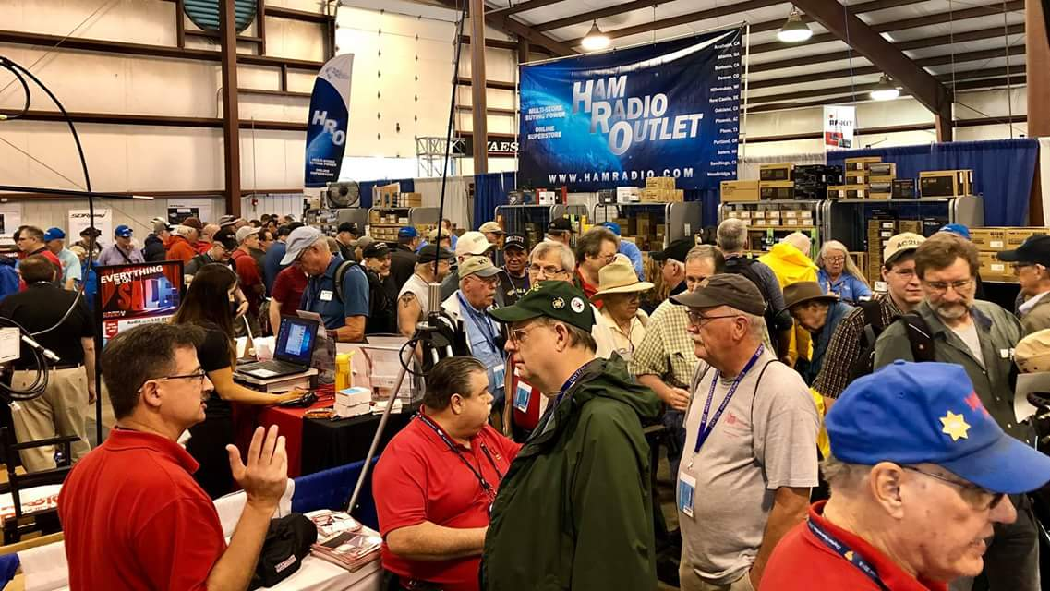[**Upcoming *Hamfests***](http://arrl-ohio.org/hamfests.html)

We **DO** have some hamfests scheduled for 2021!! Yes, take a good look at the list, it’s growing every day!

|  |  |
| --- | --- |
| ***2021*** | |
| **~~07/10/2021 - [Mansfiled Mid-Summer Trunkfest](http://www.arrl.org/hamfests/mansfiled-mid-summer-trunkfest" \o "Mansfiled Mid-Summer Trunkfest)~~**  **~~Location:~~**~~Mansfield, OH~~ **~~Sponsor:~~**~~InterCity Amateur Radio Club~~ **~~Website:~~**[~~http://iarc.club~~](http://iarc.club/)  [**~~Learn More~~**](http://www.arrl.org/hamfests/mansfiled-mid-summer-trunkfest) | **~~07/17/2021 -~~**[**~~NOARSFEST~~**](http://www.arrl.org/hamfests/noarsfest-8) **~~Location:~~**~~Elyria, OH~~ **~~Sponsor:~~**~~Northern Ohio Amateur Radio Society~~ **~~Website:~~**[~~http://noars.net~~](http://noars.net/)  [**~~Learn More~~**](http://www.arrl.org/hamfests/noarsfest-8) |
| **~~07/18/2021 -~~**[**~~Van Wert Hamfest~~**](http://www.arrl.org/hamfests/van-wert-hamfest-5)  **~~Location:~~**~~VAN WERT, OH~~ **~~Sponsor:~~**~~Van Wert Amateur Radio Club~~ **~~Website:~~**[~~http://W8FY.ORG~~](http://w8fy.org/)  [**~~Learn More~~**](http://www.arrl.org/hamfests/van-wert-hamfest-5) | **08/07/2021 -** [**2021 Columbus Hamfest**](http://www.arrl.org/hamfests/2021-columbus-hamfest)  **Location:** Grove City, OH **Sponsor:**Aladdin Shrine Audio Unit **Website**: [http://columbushamfest.com](http://columbushamfest.com/)  [**Learn More**](http://www.arrl.org/hamfests/2021-columbus-hamfest) |
| **08/07/2021 -**[**MOVARC HAMFEST**](http://www.arrl.org/hamfests/movarc-hamfest-6)  **Location:** Bidwell, OH **Sponsor:**Mid-Ohio Valley Amateur Radio Club    [**Learn More**](http://www.arrl.org/hamfests/movarc-hamfest-6) | **08/28/2021 -**[**Cincinnati Hamfest℠**](http://www.arrl.org/hamfests/cincinnati-hamfest)  **Location:**Owensville, OH**Sponsor:** Milford ARC **Website:** [http://CincinnatiHamfest.org](http://cincinnatihamfest.org/)  [**Learn More**](http://www.arrl.org/hamfests/cincinnati-hamfest) |
| **09/12/2021 -**[**Findlay Hamfest**](http://www.arrl.org/hamfests/findlay-hamfest-8) Location: Findlay, OH Sponsor: Findlay Radio Club Website: <http://www.findlayradioclub.org/hamfest>  [**Learn More**](http://www.arrl.org/hamfests/findlay-hamfest-8) | **09/18/2021 -**[**Mound Amateur Radio Assoc. Swap Meet**](http://www.arrl.org/hamfests/mound-amateur-radio-assoc-swap-meet)  **Location:**Miamisburg, OH **Sponsor:** MARA **Website:** [http://W8DYY.ORG](http://w8dyy.org/)  [**Learn More**](http://www.arrl.org/hamfests/mound-amateur-radio-assoc-swap-meet) |
| **09/18/2021** - [**Miami County Swap Meet**](http://w8fw.org/)  **Location:**Troy, OH  **Sponsor:** Miami County Amateur Radio Club  **Website:** [http://w8fw.org](http://w8fw.org/)    [**Learn More**](http://w8fw.org/) | **09/26/2021 -**[**Cleveland Hamfest**](http://www.arrl.org/hamfests/cleveland-hamfest-1)  **Location:**Berea, OH **Sponsor:** Hamfest Association of Cleveland **Website:** [http://www.hac.org](http://www.hac.org/)  [**Learn More**](http://www.arrl.org/hamfests/cleveland-hamfest-1) |
| **10/02/2021 -**[**10th Annual Vette City Hamfest,**](http://www.arrl.org/hamfests/10th-annual-vette-city-hamfest-arrl-great-lakes-division-convention)  [**ARRL Great Lakes Division Convention**](http://www.arrl.org/hamfests/10th-annual-vette-city-hamfest-arrl-great-lakes-division-convention)  **Location:**Bowling Green , KY  **Sponsor:** Kentucky Colonels Amateur Radio Club  **Website:** [https://ky4bg.com](https://ky4bg.com/)  [**Learn More**](http://www.arrl.org/hamfests/10th-annual-vette-city-hamfest-arrl-great-lakes-division-convention) | |
| **10/31/2021 -**[**Massillon (Ohio) Hamfest**](http://www.arrl.org/hamfests/massillon-ohio-hamfest)  **Location:**Green, OH **Sponsor:** Massillon Amateur Radio Club **Website:** [http://w8np.org](http://w8np.org/)  [**Learn More**](http://www.arrl.org/hamfests/massillon-ohio-hamfest) | **11/06/2021 -**[**GARC Hamfest**](http://www.arrl.org/hamfests/garc-hamfest-4) **Location:**Georgetown, OH **Sponsor:**Grant Amateur Radio Club  [**Learn More**](http://www.arrl.org/hamfests/garc-hamfest-4) |
| **12/04/2021 -**[**FCARC WinterFest**](http://www.arrl.org/hamfests/fcarc-winterfest-2)  **Location:**Delta, OH  **Sponsor:** Fulton County Amateur Radio Club  **Website:**<http://k8bxq.org/hamfest>    [**Learn More**](http://www.arrl.org/hamfests/fcarc-winterfest-2) | |

Be sure to keep your eyes on this schedule as that when things start getting better and the vaccine rolls out to more and more, hamfests will surely get back to their normal schedule. Don’t see your hamfest listed?? Did anyone register it with ARRL? It’s really easy to do and you get a lot of FREE publicity if you do.

**___________________________________________________________________**

OHIO’S 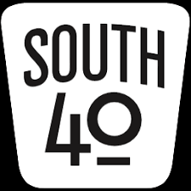

It seems Field Day was just held and it’s hard to believe the middle of July is already upon us. It also seems the Dog Daz of August are already here. Things seem to be rushing and Summer will be over before we know it. In the meantime, kick back with that cold beverage and take a look at what is going on throughout the South 40.

Prior to Memorial Day, members of the **Highland ARA** assisted the Hillsboro Cemetery Association with placing flags on the graves of veterans buried there. This coming Wednesday members will return to the cemetery to remove the flags for storage. Those wishing to assist are asked to report to the cemetery around 5 pm.

According to Mark Atwell, KD8DGH, the **Clinton County ARA** will have a tailgate ham gathering on July 24 at the Clinton County Fairgrounds in Wilmington. $5 admission includes set up. The starting time is 9 am.

Bud Cyr, KB8KMH, reminds all of the new location for the 58th **Tri-State ARA** Huntington Hamfest on August 14. The new location is the New Baptist Church, 610 28th Street in Huntington, WV. The gate opens at 8:30 and will run until 1:30. Admission is $6 and tables are $10 which includes an admission ticket. There will be a $200 cash grand prize plus other items awarded to lucky attendees. More information is available on the club website-https://www.qsl.net/w8va/ or by contacting Fred Herr, WD8AGH, at 304-736-2057. Fred asks members for assistance with the Friday afternoon set up and Saturday clean up.

Excitement is building up steam for the August 28 Greater Cincinnati Hamfest according to **Milford ARC** President Ron Brooks, AC8MA. He says requests for sales tables and spaces plus raffle ticket sales are already at unexpected levels. The event will be held at the Clermont County Fairgrounds in Owensville. It gets underway at 8 am. Admission is $8. Details about the event can be found at the event’s website [www.cincinnatihamfest.org](http://www.cincinnatihamfest.org). License tests will also be given that morning and candidates should pre-register on the website.

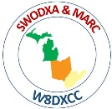Bill Salyer, ACJ8B, says excitement is also building for the second W8DXCC DX Convention sponsored by the **Southwest Ohio DX Association**. It’s being held during the afternoon of and in conjunction with the Greater Cincinnati Hamfest. The agenda for the afternoon features a number of interesting and well-known speakers and will take place in the separate 4-H Building on the fairgrounds. A roundtable discussion will kick things off at noon with the actual program beginning at 1. Admission to the event requires a separate $8 ticket from that of the hamfest. Tickets are limited and can be purchased on-line at [www.swodxa.org/w8dxcc/](http://www.swodxa.org/w8dxcc/). 2019 was the first W8DXCC held. If this year is anything like the 2019 edition, this will be a great event to attend even if you are not a DXer. There will be a lot of good basic information presented. Plus there are a couple nice prizes to be awarded.

While on the hamfest topic, **Grant RC** President Ken Klosterman, KD8FKU, announces things are proceeding with the popular November Georgetown Hamfest. Although final details with the school won’t be finalized until the school reopens, it is anticipated there will be no issues and the hamfest will proceed. But should there be an unexpected snag, all prizes will still be awarded to lucky ticket holders, including a $600 R & L gift certificate. Admission is $2 and Ken says members currently are selling tickets as is the **Highland ARA**.

Word comes of the passing of long-time **Athens County ARA** member M. Ron Chapman, N8HEK. The retired telephone company employee lived in The Plains. Services were held Friday in Athens. The ham community extends its thoughts and prayers to his family and friends.

The **Cambridge ARA** will operate a special event station on Saturday, July 24, from the Salt Fork State Park to observe the Park’s 61 anniversary. The station will be on the air from 10 until 5.

Congratulations to Lancaster’s Ralph Howes, W8BVH, for being awarded a lifetime **Lancaster Fairfield County ARA** membership. Ralph has been a member of the club for many years and presently serves as the editor of the club’s *Ragchewer* newsletter. Congrats also go to fellow member Jack Travis, AE8P, on observing his 80th birthday.

**Athens County ARA** President Eric McFadden, WD8RIF, has created an excellent recap of the Club’s Field Day activities that is worthy of a look/see. It can viewed at <http://wd8rif.com/fd_2021.htm>.

Speaking of Eric, about two years ago he and his wife visited Rocky Fork Lake. While in a business bordering the park a store employee noticed Eric’s call sign hat and commented about wanting to get a ham license. Eric not only let the young man know there was a local club in Highland County, but before he left the Hillsboro area, Eric hunted W8KIW up to let him know about the potential ham. Fast forward, this year that same young man showed up at HARA’s Field Day site and proceeded to let W8KIW know he was studying for his license and would soon be ready to take the test. He told John that his grandfather, Clarence Huff, was a long-time ham in the Chillicothe area. He said upon earning his license he intends to apply for his grandfather’s call sign, WA8ILM. He was also one of ten people who joined or renewed their membership to HARA during Field Day weekend. It was also during Field Day, a HARA member asked John to put him in contact with the **Athens County ARA** and/or **Ohio University RC** as he would be studying computer science at OU this coming year and wanted some ham contacts there. That was accomplished within days. There’s nothing like the feeling of a club helping other clubs!

A VE session will be held Monday, July 17 at the EMA building in Coal Grove. The **Southern Ohio ARA** conducted test will begin at 6 pm. The **Portsmouth RC** will hold a test session on Monday, August 2, at the Portsmouth American Legion Post. It starts at 5 pm. A VE test session will be held during the August 28 **Greater Cincinnati Hamfest**. It begins at 9 am and runs until 11:45. The testing site is at the Clermont County Fairgrounds in Owensville.

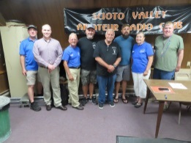

On July 10, a delegation from the **Scioto Valley ARC** attended the **Highland ARA**’s Brunch Bunch gathering in Hillsboro. In response a delegation from HARA attended the SVARC’s business meeting at the Scioto Trails clubhouse on Thursday the 15th.

The **Southern Ohio ARA** will hold their July 19 meeting at the new EMA building according to Information Officer Mike Love, WB8YKS. A VE test session will start the evening’s activities at 6 PM with the business meeting to begin at 7. The new facility is located at 715 Lane Street, Suite 300, in Coal Grove. All members are urged to attend as some important items are to be discussed.

It’s less than two months until the Ohio State Parks on the Air contest. According to John Myers, KD8MQ, as of July 11 it appears 25 parks will be activated. There are a good number of Southern Ohio state parks that are still open to activation. Rovers appreciate the advance listing of possible park activations because it makes their planning of routes to activate unspoken for parks much easier. Plus the Field Day like atmosphere is another great learning and social experience for club members.

If you wish to get tuned up for OSPOTA, Brent Wells, N4BDW, tells us of the Kentucky State Parks on the Air contest on Saturday, August 14, from 9 am until 5 CDT (1400 til 2200 UTC). Should bad weather or another event force the postponement it will be rescheduled for August 28. Besides the many Kentucky State Parks you may operate from or work, the nine Kentucky National Parks or Sites are included as Kentucky parks for the contest. Brent informs us the **Greater Mason County ARA** is planning to operate from the Blue Licks Battlefield State Park south of Maysville during the day.

On Saturday, the **Cambridge ARA** handled line-up and communications for the John Glenn Centennial Parade in Guernsey County. The parade route stretched nine miles from Cambridge to New Concord. They will also promote ham radio and the Club at the Salt Fork Arts and Crafts Festival in Cambridge on August 13-15.

We’re told the nightly **Portsmouth RC**’s .39 net has assumed a new starting time. It is now at 9 pm. It may revert to the old starting time when the time changes later in the year.

Wood County (WV) Emergency Communications will have a W5YI test session prior to the group’s monthly business meeting on August 3. The test session and meeting will be at the Lubeck Center, 295 Lubeck Road in Parkersburg.

With the excitement generated at this year’s Field Day events, several clubs are planning operating special event stations in the coming months to continue that excitement. The **Southern Ohio ARA** will further discuss their planned special operation from the Vesuvius Iron Furnace at Pedro at their July 19 meeting. The event is scheduled for September 18. The **Cambridge ARA** will operate a station from their communications van at the Salt Fork State Park on July 24 to mark the Park’s 61th anniversary. October 2 will find the **Highland ARA** operating from the World’ Largest Horseshoe Crab in Hillsboro. And the **Scioto Valley ARA** has applied to have a station at the historic Moonville Tunnel during Vinton County’s mid-October Halloween themed ‘Midnight at Moonville’. They are also thinking of operating from the mid-October Bainbridge Fall Festival of Leaves.

Thanks to the EMAs in Pike and Ross Counties, ham radio will have a presence at the upcoming county fairs in each county. Each EMA director has offered table space to promote the **Scioto Valley ARA** and ham radio.

The Lawrence County EMA Director, Mike Boster, recently asked **Southern Ohio ARA** President Tim Nicely, AC8VQ, if some club members would assist moving radio and associated equipment from the old EMA building in downtown Ironton to the new one in Coal Grove. Although the day proved to be one of the hottest yet this summer, six SOARA members responded to the request and the new radio room should be operational by the time this is read.

Despite threatening clouds and drizzle, the **Hocking Valley ARC’s** July Fox Hunt on Saturday morning went off without a hitch. Dave Brimmer, KB8OTU, was able to locate the fox north of Logan in 1 hour 11 minutes. The results might have been different if it were not for a broken connection and lack of a jumper on Kirk Groeneveld’s yagi. Even with that problem KC8JRV was able to make a second place finish just minutes behind Dave. Following the conclusion of the hunt, all adjourned to a local restaurant to rehash the event.

A last minute addition. The **Clinton County ARA** will hold a test session on Sunday, July 24 at the Cancer Center across from the hospital in Wilmington. Registration begins at 2 pm and walk-ins are welcome.

As previously stated, it appears Dog Daz, vacations, youth activities and lingering COVID concerns have taken the toll on the region’s ham radio activities. Even the area’s repeaters are more quiet than usual. Therefore there has not been much to report this time around. Here’s hoping all are keeping cool, healthy, safe and radio-active.

**___________________________________________________________________**

**Print an Official or Unofficial Copy of Your Amateur Radio License**

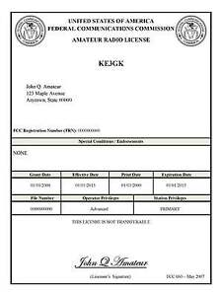*(By Anthony Luscre, K8ZT)*

As of February 17, 2015, the **FCC no longer routinely issues paper license documents** to Amateur Radio applicants and licensees. The Commission has maintained for some time now that the official Amateur Radio license authorization is the electronic record that exists in its Universal Licensing System (ULS). The FCC will continue to provide paper license documents to all licensees who notify the Commission that they prefer to receive one.

Licensees also will be able to print out an official authorization — as well as an unofficial “reference copy” — from the ULS License Manager. I’ve created a set of instructions on how you can request an **“official” printed copy of your license\***

[**Click here to download the instructions**](http://arrl-ohio.org/news/2020/print_your_license.pdf)

***One Question Questionnaire***

Hey Gang,

I’ve got a new question, so how about going to www.ARRL-OHIO.org and giving me a click? (It’s in the bottom left corner of the page)

***“Have you ever donated to a DXpedition?”***

From the last Poll: **“Do you check into at least 1 net every week?”**

68% said Yes and 32% said No. (out of 60 responses) Regularly checking into an Amateur Radio NET is an important, and can be an educational experience! Just as important – volunteer to be a Net Control Operator – it’s a fantastic way to get the names and callsigns of all the net members embedded in your head and most importantly it’s a good exercise to have done if something happens and YOU need to be pressed into service as the NCS station. During an emergency is not the time to learn the skill! (Always be Prepared)

Ohio Section Cabinet

|  |  |
| --- | --- |
| Section Manager – Tom Sly, WB8LCD | Section Traffic Manager – David Maynard, WA3EZN |
| Section Emergency Coordinator – Stan Broadway, N8BHL | Section Youth Coordinator – Anthony Luscre, K8ZT |
| Technical Coordinator – Jeff Kopcak, K8JTK | Affiliated Clubs Coordinator – Tom Sly, WB8LCD |
| State Government Liaison – Bob Winston, W2THU | Public Information Coordinator – John Ross, KD8IDJ |



Hey Gang,

Have you taken a look at the **Swap & Shop** page on the Ohio Section webpage yet?? Here’s a link that will take you there… <http://arrl-ohio.org/sm/s-s.html>

Do you have equipment that you just don’t need or want anymore? Here’s a great venue to advertise it, and it’s FREE!! Is your club doing a fund raiser to help raise money? After a lot of thought, it was decided that the Swap & Shop webpage could also contain these types of items as well. The same rules will apply as do for the For Sales and Give-A-Ways and will only be posted for a month at a time. Please see the Terms & Conditions on the webpage.

If your club is doing a fund raiser and wants more exposure, please forward the information to me and I’ll advertise it on the Swap & Shop webpage for you.

Now, I still want to remind you that it won’t be listed in this newsletter because it would take up way too much space, so your ad will only appear on the website. It is there for any individual to post equipment Wanted / For Sale or Give-Away as well as for Club Fund Raisers. No licensed vehicles/trailers or business advertising will be posted. Postings are text only (no pictures or graphics) will be posted for a maximum of 1 month from date posting and require a contact phone number or email within the posting. Send your Wanted / For Sale or Give-Away post to:  [swap@arrlohio.org](mailto:swap@arrlohio.org)

***Back Issues of the PostScript and Ohio Section Journal***

Hey, did you know that PostScript and Ohio Section Journal (OSJ) are archived on the website? You can go back and look at any edition simply by clicking:

<http://arrl-ohio.org/news/index.html>

***Want to Share your Club Newsletter With Others?***

We have a webpage where you can download and read all of the newsletters that I get from around the state and even other sections!

Here’s the link to the page…. <http://arrl-ohio.org/club_news/index.html>

Please, if you don’t see your club newsletter posted, it’s because I’m not receiving it. Just have your newsletter editor contact me and I’ll get your club’s newsletter listed on the site!!

We all learn and steal (I mean, share) from each other’s work. So, get me your newsletter!!! Send it to: [webmaster@arrl-ohio.org](mailto:webmaster@arrl-ohio.org)

***Chit – Chat, and All That!***

Do you know someone that’s not getting these Newsletters? Please, forward a copy of this Newsletter over to them and have them “[Opt-In](mailto:Opt-In)” to start receiving them. Heck, just have them send an email to: [webmaster@arrl-ohio.org](mailto:webmaster@arrl-ohio.org) and we’ll get them added to the Ohio Section Emailing list.

We now have many thousands of readers receiving these newsletters weekly. Quite impressive, I’d say! I urge all of you to make sure that everyone, regardless of whether they are a League member or not, get signed up to receive these weekly Newsletters.

You can always “Opt-Out” at any time if you feel this is not what you were expecting. It’s fun and very informative. All of your favorite past newsletters are now archived too.

You can go back at any time and read them.

Just go to: <http://arrl-ohio.org/news/>

The pictures on the front page and throughout this newsletter are from various newsletters, Facebook posts and/or were sent directly to me in recent weeks. Take a good look at them, you just might be in one of the pictures! “SMILE… you’re in the Ohio Section News!!”

*PostScript is produced as a weekly newsletter. I want to thank everyone that has contributed articles and ideas to make this an even better news source. I sincerely hope that you have enjoyed this edition and will encourage your friends to join with you in receiving the latest news and information about the Ohio Section, and news and events happening around the world!*