[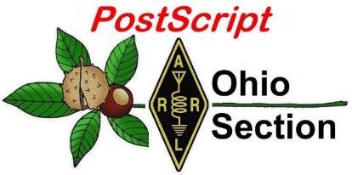](http://arrl-ohio.org/news/) ***“July 12th***

***Edition”***

🡪 National News 🡪 Club Corner

🡪 DX This Week 🡪 Contest Corner

🡪 Upcoming Hamfests 🡪 One Question Questionnaire

🡪 VE Testing

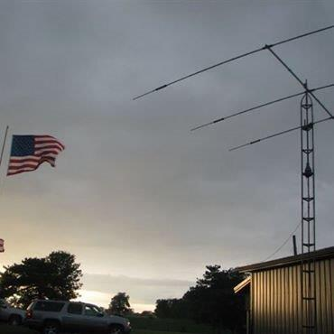

Dusk falls on the Highland ARA Field Day site.

**CQ CQ CQ de WB8LCD**

You’ll notice “VE Sessions” has been moved into the “Club News” section. I picked a few out of current newsletters to get us started – PLEASE send me your club’s information so I can get it listed here. Lots of folks are looking forward to getting their Tech license, and I want to encourage *everyone* who has a Tech license to move up to General. Make that your goal for year end 2021! Extra class might be just a bit tougher but definitely worth the effort – Go For It.

Send me your Amateur Radio News and your Club News – I’ll get it into the next PostScript. Want to write an article on an Amateur Radio topic? Send it in. All I ask is, if possible, send it to me in a MSWord format. Pictures should be sent in .JPG format – that’ll save me a lot of time, and I’ll certainly appreciate that.

It seems like **BOOM!** Just like that, Amateur Radio events and activities are back in full force. Ham Radio is the Greatest Hobby in the World! Get involved and get on the air. As cycle 25 heats up it’s going to be a fun time for those who are involved.

***National News***

*(from arrl and other sources)*

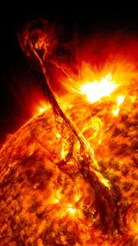**First X-Class Major Solar Flare of Solar Cycle 25 Blacks Out HF on July 3**

For a brief time on July 3, a lot of radio amateurs were wondering, "Where did the bands go?" as the first X-class solar flare in 4 years blacked out HF propagation for a time.

"I was on 20-meter FT8, and my waterfall display went from solid red signals to solid nothing in the blink of an eye," Scott Craig, WA4TTK, told "K7RA Solar Update" Editor Tad Cook, K7RA. "It lasted about 10 minutes." Craig was not alone.

"Many American radio amateurs reported sudden HF propagation blackouts on Saturday morning, July 3, when solar active region 12838 produced an X1.5 major solar flare that reached maximum intensity at 1429 UTC, the first X-class solar flare of Solar Cycle 25 and the first since 2017," said Frank Donovan, W3LPL. "HF propagation blackouts are caused when x-ray and extreme ultraviolet radiation from X-class solar flares strongly ionizes the absorbing D-region in the Earth's sun-facing dense lower ionosphere," he explained. Such a radio blackout occurs when a pulse of x-rays ionize the top layer of the atmosphere, the exosphere.

In this instance, it caused what NOAA's Space Weather Prediction Center ([SWPC](https://www.swpc.noaa.gov/sites/default/files/images/NOAAscales.pdf)) calls an R3-level or "strong" radio blackout (on a [scale](https://www.swpc.noaa.gov/sites/default/files/images/NOAAscales.pdf) of R1 - R5). An R3 incident can cause a "wide-area blackout of HF radio communication [and] loss of radio contact for about an hour on [the] sunlit side of Earth. Low-frequency navigation signals degraded for about an hour."

Donovan said that X-class major solar flares are necessary consequences of steadily increasing Solar Cycle 25 activity. "95% of all X-class solar flares occur when the solar flux index is 90 or greater. The remaining 5% can occur any time during the solar cycle," he points out. "X1-class major solar flares typically degrade HF propagation for only an hour or two at mid and high latitudes, only on Earth's sunlit side."

X-class major flares are measured on an open-ended scale. The strongest one ever recorded was an X28 flare in 2003, hundreds of times more powerful than the July 3 X1.5 solar flare. X10-class and stronger solar flares typically have effects that last for most of a day and affect the entire sunlit side of the Earth. Fortunately, X10-class solar flares occur only about once every 20 years or more.

"Much more severe and long-lasting HF propagation degradations are often caused by the coronal mass ejections (CMEs) often associated with -- but not caused by -- major solar flares," Donovan explained. "HF propagation degradation caused by CMEs typically begins about 2 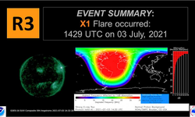days after the effects of the associated solar flare, the duration of the delay depending on interactions between the CME and the solar wind."

The CME associated with the July 3 X1.5 solar flare is likely to have little to no effect on HF propagation going forward, because the active region was very close to the western edge of the visible solar disk when the CME erupted. Region 12838 rotated off the visible disk on Sunday, July 4.

Solar flares have no significant effect on VHF ionospheric propagation, but can degrade satellite communications passing through the ionosphere. More frequent, less powerful M-class medium solar flares produce short-duration degradation at high latitudes. Very frequent, much weaker A-, B-, and C-class solar flares do not degrade HF propagation. *-- Thanks to Frank Donovan, W3LPL*

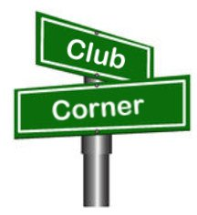***Club Corner***

This is YOUR cornner of the newsletter. Send me what your club is doing and I’ll make sure that it gets in. Got a special event or club project that you want everyone to know about? Send it to me!. Need help with a project? Send it to me.

Let me know what you club is up to. Are you going to have a special guest at your meeting or are you having a special anniversary?

Just sent it to: [webmaster@arrl-ohio.org](mailto:webmaster@arrl-ohio.org)

**KT8BSA is Active from Scouting Summer Camp**

Once again station KT8BSA is active from our Council's summer camp in northern Carroll county. Since 2011, a dedicated group of amateurs from the Canton ARC has volunteered to bring ham radio to youth and Scouting (including GSA). We have visited Scout activities in the woods, organized a Venturing Crew, supported Jamboree On The Air (JOTA), and taught many Radio Merit Badge classes. During JOTA weekend in 2020 at a district-wide event at Camp Tuscazoar, 97 RMB's were earned by youth members of Scouts BSA (both boys and girls). We obtained and used special callsign K8T for this event. During this large-scale action, adult members of other radio clubs in the area assisted. We have also presented at a branch of the county library and are looking forward to more such presentations.

The 2020 pandemic forced Buckeye Council's summer camp program at Seven Ranges Reservation to be curtailed, but this year it 's back with just a few restrictions. A new location in camp for KT8BSA was given and our station was reconstructed in the Seven Ranges STEM Lodge. At this location, Scouts may earn Electronics, Robotics, Engineering, Chemistry, Programing and more merit badges in addition to Radio MB. Of course, traditional badges related to outdoor skills, preparedness for life, first aid and nature study remain available.

The estate of Tim Whitehouse KA8TVI has generously donated a complement of gear to use with Canton ARC's youth outreach program. After summer camp season is over, the resources will be used at an upcoming October event at Camp Tuscazoar in Tuscarawas county. We will be offering the "Signs, Signals and Codes" merit badge with JOTA activity running simultaneously. Canton ARC is always eager to support ham radio and youth education. Educators and youth group leaders may contact the writer at [dalelamm@ieee.org](mailto:dalelamm@ieee.org) for more information.

Dale Lamm NX8J

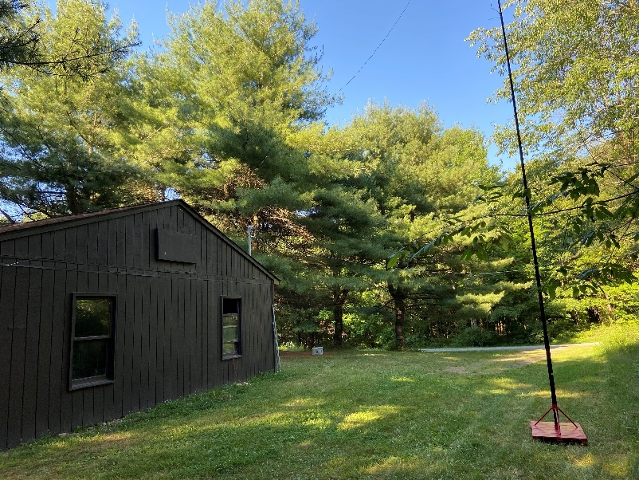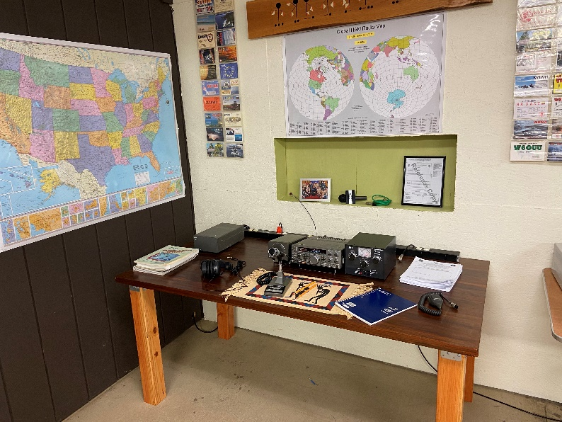

**Station KT8BSA**

**___________________________________________________________________**

**Subject: Sandusky County ARES Picnic, Fox Hunt and Mini Field Day- Open to All!  
To: The OHIO Section**

Greetings Everyone:

The Sandusky County ARES group is hosting a Fox Hunt (Directional Transmitter Finding) and a "Mini-Field" day. We also will be having some food as well. This event will take place on Sunday, July 18th, 2021 at 2PM at Birchard Park in Fremont.

We will be grilling and having Hamburgers, HotDogs, Soda, Chip and anything else that anyone would like to bring.

The day will start at 2PM with Food Served and then we will have a Fox Hunt or two depending on timing. Our goal is also to have the Sandusky County ARES Trailer in Attendance to set up some HF equipment to make some contacts as well as a "Mini-Field Day". Feel free to bring any equipment you may have to operate as well.

This event is free and open to anyone. If you would like to participate just let me know so I can have a count for food. I hope everyone can make it and I hope to see you there!

All the best,

Owen Fritz

KD8GSI

Emergency Coordinator

Skywarn Coordinator

Sandusky County, OH

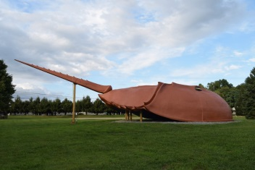**HARA Has Crabs--**or something like that. It appears Saturday, October 2 is the date set for HARA for a special event station activity from the ‘World’s Largest Horseshoe Crab’. This nationally known Roadside Attraction is located at the eastern edge of Hillsboro on SR 124. Publicity is now being prepared for promoting the event in QST, CQ and other amateur radio publications and should make for an interesting day on the radio. Anyone not familiar with “Crabbie” and its history can find an excellent video of it on YouTube.

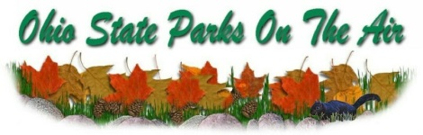HARA will have a presence at two Ohio State Parks during September’s Ohio State Parks on the Air contest. Pat, N8BAP, and Richie, N8CUB, will be at Paint Creek and Sam, W8SKJ; Doug, KE8ORQ and Travis, WA6WTF, will be at Rocky Fork. John and Kathy, W8KIW and N8ZNR, intend to do another roving operation and activate at least four other state parks. However their plans are not yet set. This is another Field Day type activity. All HARA members are urged to support this event through their attendance and putting in some ‘seat time’ during the afternoon. Anyone interested in doing their own operation from another state park is urged to pursue the idea. Contact John, W8KIW for assistance determining what might be a good one to activate.

VE Sessions

Dayton Amateur Radio Association (DARA)

Our next test session will be Wednesday July 21st at 7:00 PM. **Preregistration is no longer required.** If you are interested in testing for a new or upgraded license, please come see us at the DARA Clubhouse. If you have questions about testing, please email [exams.w8bi@gmail.com](mailto:exams.w8bi@gmail.com)

Lake County Amateur Radio Association (LCARA)

Saturday August 7, Saturday October 2, Saturday December 4

All exams start at noon and are held at the Kirtland Library, 9267 Chillicothe Rd. Kirtland, OH

Portage County Amateur Radio Service (PCARS)

Starting on August 7th, PCARS will resume VE testing at the PCARS club site in Ravenna.

Please visit the PCARS web site and check out the information about VE testing in the latest newsletter – [https://portcars.org/files/newsletter/2021/PCARS-June-21.pdf](https://r20.rs6.net/tn.jsp?f=001DxdXS40dvzmbl9m9sfY5l9IIoAGYYsZIQIObAktg-wnnAu__YbvuVuV1_NQmLDKapbqCCYZK1L6epi1k5lVvuEtL_I1T0LMdgzjsNGvi1UnoIj7Lpv0RFoxS8h0YOCVVODgyzQI8xFTrmQ0pr6RXkQVvSx_cjGgR-DubSFhvF7CPVtMoPBph8tt8RpjGjyyBlRFHzo_VhR4=&c=Oi-83JMf17RlM94bujSYqqAwfNyIPWszQZKKkjp6BM5J7PHkAvaFrA==&ch=Kr1c-7rzal6CKkNUvSX-jLXK5eG9iU0tKZ5xoqUUqM21mzFnc1rE3w==)  – see pages 8, 9 and 10 for details.

If you have any questions, don’t hesitate to contact me at KB8UUZ@gmail,com

On behalf of the VE team at PCARS, we all look forward to getting the VE testing going again and look forward to seeing you there – August 7th -10 am – at the PCARS club site in Ravenna.

**Lucas County ARES**

We are looking for help with the Sylvania events. The Sylvania Superkids (kid’s triathlon) is Saturday, July 31st with a start time of 7:00 AM. We only cover the bike portion of this event, and they are using the same

course as last time. We are finished with this event by 10:30 AM. The Sylvania Triathlon is Sunday, August 1st with a start time of 7:30 AM. We cover all three events, and the course is open until 1:00 PM. The run

course is completely different this year and has some similarities with the kid’s bike course. If you'd like to volunteer or need more information, please contact me at [k8rks@arrl.net](mailto:k8rks@arrl.net) or 419-471-0573.

# **___________________________________________________________________**

# **QSP Newsletter Update**

C. Matthew Curtin, KD8TTE

About a month ago I introduced *QSP*, a radio newsletter. (C. M. Curtin, “QSP: The Potluck Newsletter For Radio Messaging.” *PostScript.* June 7, 2021, p. 4.) What makes this newsletter unique? It’s not just a newsletter about radio or for emergency communications, but it is both sourced and distributed entirely by radio.

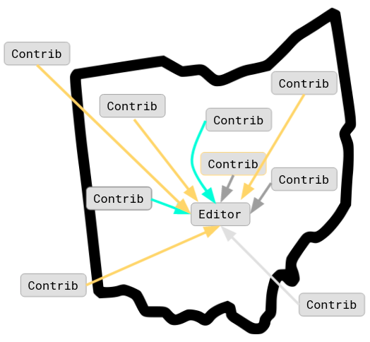

Amateur radio presents many ways to send and to receive messages. *QSP* takes advantage of that by offering four different paths for correspondents to contribute content, and three ways for readers to receive the finished product—all by radio. Not only is this a fun project but it also exercises the same skills needed for being an effective emergency communications station.

## Arbitrary Message Format

*QSP* doesn’t require content to be submitted in any particular format. The point is to get a message to the editor by radio. So far we’ve had participants throughout the state and even outside of Ohio. All of the messages for that week are compiled into the newsletter that gets distributed on Sunday. We’d like to know where you’re operating for the week, and something about what you’ve been doing on the radio: bands and modes you’ve been using. If you’ve got an article about building an antenna type or planning an exercise we’d love to hear that and include it as well.

You can write your message free-form, you can use an NTS radiogram, you can use a custom form in FLMSG, or you can also use a Winlink form for participating. Which one makes sense for you in any given week will depend on what you’ve done so far, what you’re looking to do next, and your overall capability goals.

If you’d like to send a structured message, you’ve got a couple of options. You can use FLMSG and use a Custom Form that we offer to create a k2s file that you’ll need to transmit to the editor. If you prefer, you can use a standard Winlink form, the Net Check In Form.

## Preparing For Transmission

To get your message delivered, you have several options. Which you choose will depend on what you’re transmitting.

1. NTS radiogram. If your message is to the point and brief, the radiogram will do the trick nicely. It’s a good opportunity to exercise your skill in originating and relaying a radio message, and with local traffic nets like Burning River Traffic Net, Central Ohio Traffic Net, and Ohio Single Sideband Net (to mention just three), there are plenty of opportunities to get the message injected and relayed to me. Be sure to include in the signature how you’d like to get your copy of the newsletter back since a whole newsletter won’t go via radiogram. (Make the last line of your signature include something like RETURN SERVICE VIA WINLINK AA1AAA or whatever makes sense to get a digital message back to you.) We’ve even got a template that you can use to make origination easier. <https://www.blackswancomex.org/2021/qsp/template-contribute-by-nts>
2. Packet BBS. If you’ve got a packet BBS system that can route a message to WX8OH@WX8OH.#EOH.OH.USA.NOAM, you can send a message for *QSP* by indicating your message is your QSP in the Subject line and sending your message. If you’re not sure that your BBS can reach WX8OH, contact your sysop for help. You can send either a free-form message or put the k2s file in the text of the message. Either will work just fine! You’ll get your copy of the newsletter back via packet unless you specify otherwise in the message.
3. NBEMS. If you’re within reach of the Central Ohio Traffic Net ([www.cotn.us](http://www.cotn.us)) or can get on the HF BLACK SWAN net ([www.blackswancomex.org/net](http://www.blackswancomex.org/net)) Saturday or Sunday (at 1300) or Monday (at 1900), you can send a radio message that includes the k2s file contents. If you use the 16-line standard message format, you’re not subject to the same restrictions of the NTS radiogram, but you’re limited to the circuits that can carry that message format. Both COTN and BLACK SWAN will do the trick. We’ve got a template to help with that, too. <https://www.blackswancomex.org/2021/qsp/template-contribute-by-16-line> We’ll send your copy of *QSP* back via NBEMS unless you direct othewise.
4. Winlink. With Winlink you’ve got two options. Either way, direct your message to the tactical address QSP. If you like, you can use the k2s file from the FLMSG QSP custom form. This will give you experience working with FLMSG and then moving the resulting file from one system to another. The other option is to use the Net Check In Form under General in Winlink’s Templates. We’ll send you your copy of *QSP* via Winlink unless you specify otherwise.

## Training Benefits

Yes, this project is a lot of fun. It’s cool to see your content going out by radio, hearing it be accepted, and then a few days later, seeing it as part of something bigger, with contributions from others as well. In our eight issues, we’ve seen contributions from around the state and out of state, with topics including technology, training, and operation. We have some historical references of interest and information from participants about their operations.

Fun or not, there are some real training benefits that come from participation. We’re practicing critical skills needed for emergency communications, including:

1. Message origination
2. Message routing
3. Message relay
4. Scheduled operation
5. Option: Net operation
6. Option: NTS procedure
7. Option: PBBS use
8. Option: NBEMS practice
9. Option: Winlink exercise

## Give It a Try!

The FLMSG custom form and the instructions needed to get you through the process are available at <https://www.blackswancomex.org/2021/qsp/join-the-party>.

**Your Club news should be listed here!**

I know you’re out there doing things! Send me a write-up (MSWord please) and some photo’s (.jpg please) and we’ll get your club hi-lited here for the othe OH Section Clubs to see! Send to [WB8LCD@ARRL.ORG](mailto:WB8LCD@ARRL.ORG)

__________________________________________________________________________________________

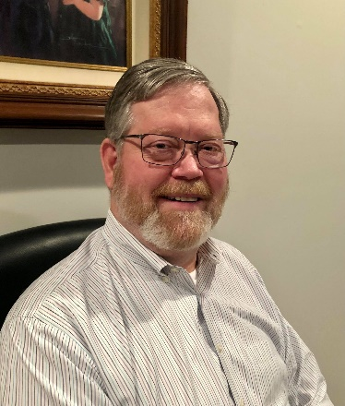**DX This Week – K9LA**

Bill AJ8B (aj8b@arrl.net, @AJ8B, or www.aj8b.com)

CWOPs Member #1567

The Midwest DX Cluster spots included Alaska, Australia, Belgium, Bulgaria, Canada, Canary Islands, China, Cuba, England, European Russia, Fed. Rep. of Germany, France, Hungary, Ireland, Italy, Japan, Kenya, Liberia, Mexico, New Zealand, Northern Ireland, Philippines, Poland, Scotland, Slovenia, and the United Arab Emirates. This brings the total number of entities spotted in the Midwest in 2021 to 184 !

I received a beautiful card from7Q7RU, The DXPedtion to Malawi, V51WW – Wynand in Namibia, and ZB2CM – Charlie on Gibraltar, and ZD7GWM – Garry on St. Helena Island. My original QSL was mailed to Garry on 7/14/2019, so almost 2 years to get a reply. What did you get?

|  |  |
| --- | --- |
|  |  |
|  |
|  |

*DAH DIT DIT DIT DAH DAH DIT DIT DIT DAH*

This week is another installment from Carl, K9LA. He has a monthly item on his website and he has graciously allowed me to reprint it here at month. I have received many positive comments from readers about Carl’s articles. He will be a speaker at the W8DXCC convention in August.

Space Weather Parameters and Propagation

By Carl Luetzelschwab, K9LA

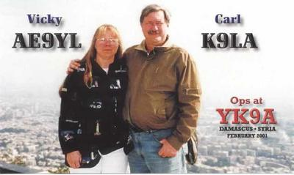

**Caution**

When talking about how space weather parameters affect HF propagation, we must realize that what we’re trying to do is reduce very complicated solar, atmospheric and ionospheric processes into simple statements. This doesn’t work all the time. For example, if today’s 10.7 cm solar flux is greater than yesterday’s 10.7 cm solar flux, does that mean that the higher bands (15m, 12m and 10m) will be better today.

Unfortunately, the answer is “not necessarily.” The reason is although solar radiation at extreme ultraviolet (EUV) and x-ray wavelengths instigates the ionization process (of which 10.7 cm solar flux is a proxy), geomagnetic field activity and events in the lower atmosphere coupling up to the ionosphere also come into play to determine the amount of ionization at any given point on Earth at any given time.

We have a decent understanding of solar radiation and geomagnetic field activity effects on the ionosphere, but we are lacking in our understanding of events in the lower atmosphere coupling up to the ionosphere. There’s much research going on in this latter area. The result of this is that our propagation predictions are not daily predictions – they are monthly median predictions.

**Where Do You Get Space Weather Data?**

As you’re probably aware, there are many sources of space weather data. Here are the ones that I usually mention in my presentations.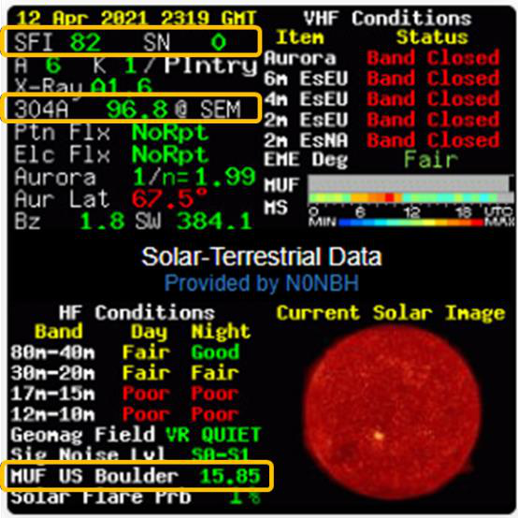a) The NØNBH banner at https://www.qrz.com/ (it shows up in many other places, too)

b) The https://spaceweather.com/ website by Dr. Tony Philips

c) The Space Weather Prediction Center (SWPC) website at   
https://www.swpc.noaa.gov/

d) VE3EN’s website at https://www.solarham.net/

e) WX6SWW videos by Dr. Tamitha Skov at <https://www.spaceweatherwoman.com/>

SFI is the daily 10.7 cm solar flux, SN is the daily sunspot number and 304A is the daily EUV radiation at 304 Angstroms (304 Angstroms is equivalent to 30.4 nm). It’s important to note that about 60% of the ionization in the F2 region is due to solar radiation between 26 and 34 nm. Thus, the 304A parameter is a good direct indication of how well the F2 region could be ionized.

The table below shows the rough values of SFI, SN and 304A that are needed to open the indicated bands for worldwide propagation on a daily basis (not just for a day or two during the entire month).

Note that the values are for many weeks. Ideally, they should be long-term smoothed values, but ‘many weeks’ is a reasonable compromise.

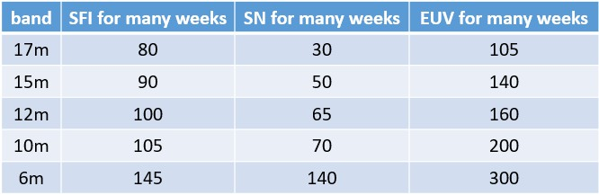 Now you have some ballpark values to assess which of the higher bands could be open on a daily basis. A final comment – the MUF US Boulder parameter is the maximum useable frequency (MUF) in MHz over the Boulder ionosonde assuming it is the midpoint of a 3000 km hop. It is not an assessment of what the ionosphere may be doing – it is an actual measurement of what the ionosphere is doing right now. And it takes into account what we’re going to talk about next.

**Parameters That Could Degrade the F2 Region**

Although the SFI, SN and 304A parameters indicate that the bands may be open, we have to know if there are any disturbances to propagation that may be degrading the F2 region in terms of the amount of ionization (the number of free electrons). The parameters that can help us are those that tell us if the Earth’s magnetic field is active (disturbed). These are K, A, Bz and SW in the gold boxes in the image below.

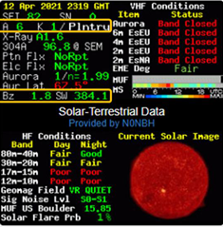 The K index is a 3-hour parameter on a logarithmic scale (0-9). The A index is the daily average of the eight 3-hour K indices and is on a linear scale (0-400). The ‘Plntry’ annotation is short for ‘planetary’, indicating that the K and A indices are averages of multiple worldwide observatories. To indicate planetary, a subscript ‘p’ is appended to K and A – thus the planetary K and A indices are Kp and Ap to distinguish them from observations from a single observatory.

Bz is the strength and magnitude of the interplanetary magnetic field (abbreviated IMF and roughly from -100 to +50 nT). The Bz component is perpendicular to the ecliptic – the plane in which the Earth rotates about the Sun. Thus, Bz is essentially the north-south component of the IMF, and Bz tells us how much the IMF is coupling into the Earth’s magnetic field.

SW is the solar wind speed in km per second. The quiet time value is around 400 km per second, and it can increase to around 2000 km per second when a big Earth-directed coronal mass ejection (CME) or when an Earth-directed coronal hole (CH) high speed stream occurs.

The higher the K and A indices, the more degraded the F2 region of the ionosphere can be. The more negative the Bz component, the more degraded the F2 region can be. And the higher the SW parameter, the more degraded the F2 region can be. Here’s a table of what we generally desire in terms of these parameters for an undisturbed F2 region.

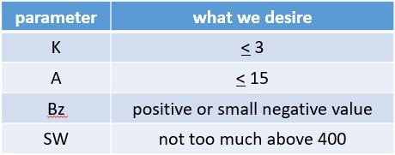

These four parameters can be considered to be bundled into the three categories of disturbances to propagation as defined by NOAA: geomagnetic storms (G), solar radiations storms (S) and radio blackouts (R). The scale for these three disturbances is from 1 (minor) to 5 (extreme). The details are at [https://www.swpc.noaa.gov/noaa-scales-explanation.](https://www.swpc.noaa.gov/noaa-scales-explanation) If you see any of the three at greater than 2 (at the top of the home page at [https://www.swpc.noaa.gov/, for](https://www.swpc.noaa.gov/) example), then you can be assured that the F2 region could be disturbed (lower MUFs) and there could be increased D region absorption in the polar cap (from energetic protons caused by a big M- or X- Class solar flare) and/or increased D region absorption on the daylight side of the Earth (from x- ray wavelength radiation caused by a big M- or X-Class solar flare).

**Real-Time Assessment of the Ionosphere**

All of these parameters (SFI, SN, 304A, K, A, Bz and SW) allow us to make an assessment of the ionosphere. But remember the caution at the beginning of this column. Sometimes interesting propagation can happen when we think propagation won’t be good.

The 2018 California QSO Party was a great example of this. I didn’t hear any W6s on 10 meters on Saturday. But the K index spiked up a bit Sunday and then there were many W6s on 10 meters. Looking at the Boulder ionosonde showed MUFs around 20 MHz until the K index spiked up on Sunday. Then the MUF went up to a bit higher than 30 MHz, allowing good propagation between W6 and the Midwest on 10 meters. So pay attention to when the K index initially spikes up a bit – if you’re in the right place at the right time, good things could happen. There are also many observations of improved 160-meter propagation across the high latitudes when the K index spikes up a bit [note 2].

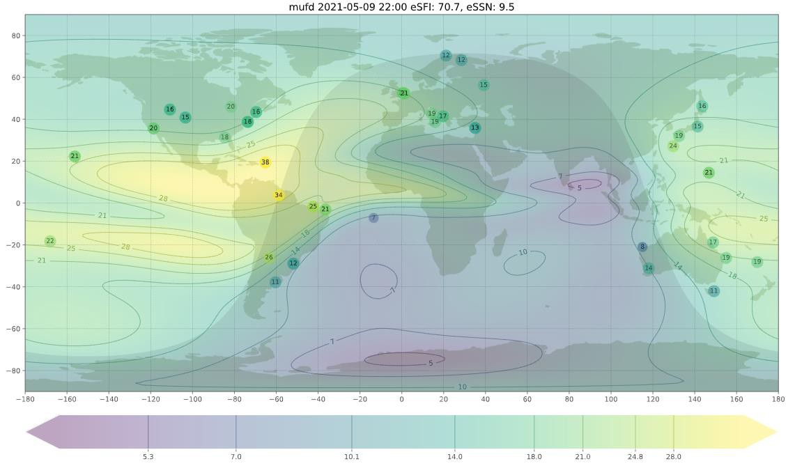

With so much information on the Internet, it’s also possible to bypass all those parameters to get a decent picture of what the ionosphere is doing right now. With respect to the ionosphere, visit [http://prop.kc2g.com/. I](http://prop.kc2g.com/)t will show you worldwide MUFs for 3000 km paths. Here’s a sample map at 2200 UTC on May 9. It uses ionosonde data (the numbers in circles) and adds contour lines. It’s updated every 15 minutes. From this you should be able to estimate what frequencies may be propagating anywhere in the world. Remember this includes all the aforementioned parameters.

To find out who everyone else is working right now, visit dxmaps.com. Select your view (North America, Worldwide, etc.) and the band. Here’s a sample display for 17 meters on May 9 between 2109 and 2209 UTC. As you can see, 17 meters was doing very well between North America and VK/ZL, South America and Europe. PSKreporter, WSPRnet, the Reverse Beacon Network (RBN), and the worldwide IARU/NCDXF beacons on 20m, 17m, 15m, 12m and 10m are similar applications that can tell you what’s going on right now

**Summary**

I hope I’ve given you some good guidelines to assess propagation. Just remember the caution on page 1.

It’s interesting to think about what the future holds. As mentioned in my September 2020 Monthly Feature titled “The Future of Propagation Predictions,” perhaps someday we’ll have all kinds of real-time propagation information displayed on our SDRs.

**Notes:**

1) Ionospheric absorption is also important, but there are no regular measurements of the D region (where most absorption occurs). So there isn’t a parameter that we can monitor. We have riometers (relative ionospheric opacity meters) that measure galactic noise as it passes through the ionosphere, but translating those measurements to absorption is tough. And the D-RAP (D Region Absorption Predictions) measurements (https://ww.swpc.noaa.gov/products/d-region-absorption-predictions-d-rap) only tell us about D region absorption in the polar cap or on the daylight side of the Earth when there is a big (M-Class or X-Class) solar flare.

2) And don’t forget that the Sun hiccups every once in a while, which might give us great propagation on the higher HF bands. Late last year was a good example. The EUV spiked up significantly, which resulted in great propagation for the CQ WW DX PH Contest in October, the CQ WW DX CW Contest in November and even the ARRL 10 Meter Contest in December. Unfortunately the EUV settled back down to solar minimum levels in early 2021. But it was a good look into the future when Cycle 25 gets going in earnest.

*DAH DIT DIT DIT DAH DAH DIT DIT DIT DAH*

CQDX CQDX CQDX CQDX CQDX CQDX CQDX CQDX CQDX

Here is an update from Bernie, W3UR, of the DailyDX and the WeeklyDX, the best source for DX information. <http://www>.dailydx.com/. Bernie has this to report:

**YJ – Vanuatu -** YJ8RN, Rod, plans a trip to Marae Village on Emae Island in the Shepherd Islands, IOTA OC-111, grid RH42ex50 during the RSGB IOTA Contest weekend, which is July 24-26 Vanuatu time.  Rod will be solar powered with a Yaesu FT-450 his main rig.  He expects to mostly stick to FT8 on the popular frequencies, possibly switch to F/H mode on those frequencies if there are a lot of callers.  If propagation is good he may do some SSB.  For antennas it'll be vertically polarized delta loops for 40, 30 and 20.  If 15 looks open he'll put a VDA up on 15, and if there's time a dipole for 80.  His arrival is currently scheduled for Wednesday, July 21, getting on the air by local afternoon the 22nd.  Tuesday, July 27 he'll take things apart, pack it and return to Vila Wednesday the 28th.  Rod notes he is "not a Morse Code person" but knows many would like to work him on CW.  He has run out of time, he says, but is considering a K3NG CW decoder.  With that, CW contacts would be possible.  He says the 22,000 lines of code in the keyer "will take a bit of working through."  He welcomes anyone sending him the setup so that he might be able to pull things together, if not for this trip then perhaps for Torres, OC-110, next year, with the "K3NG Arduino."  Here is what he would like help with:

* CW rx decoding
* Display 4 wire 2 line by 16 character LCD
* USB connection to the keyboard
* Audio output to the speaker
* CW practice mode
* Logging support, N1MM+ or others.

**JW – Svalbard -** LA6VM, LA7XK and LA9DL are arranging a JW5X operation for October 6-11 and the SAC contest  Immediately thereafter, LA6VDA will be there October 12 to November 1, at JW5E, the club station in Longyearbyen, and he will be on for the CQ WW DX SSB weekend.  <http://jw5e.com/>.  On the weekdays he will op holiday style SSB and FT8/4.  For a QSL use LoTW, eQSL, Club Log OQRS, QRZ.com log or bureau via LA6VDA.  
  
**3DA – Eswatini -** From the former "Swaziland," 3DA0RU will be on October 22 to November 7, with ops R7AL, RA1ZZ, RK8A, RW9JZ and OK8AU having several stations  
on 160-10 CW, SSB and FT8 F/H.  They prefer QSLs through Club Log OQRS, or use LoTW or go via R7AL. <https://dxpedition.wixsite.com/3da0ru>.

*DAH DIT DIT DIT DAH DAH DIT DIT DIT DAH*

Below is a list of upcoming contests in the “Contest Corner”. I think this is important for someone who is trying to move up the DXCC ladder since entities that are on the rarer side and easiest to work in contests. Some of my best “catches” have been on the Sunday afternoon of a contest when the rarer entities are begging for QSOs. Of course, the gamble is that if you wait until Sunday, conditions may change, or they simply won’t be workable. However, it is not a bad gamble. Of course, why not work the contest and have some fun!  
Check out the WA7BNM Contest Calendar page (<https://www.contestcalendar.com/>) and CQ Magazine for more contests or more details.

The contests in red are those that I plan to spend some significant participation time on. PLEASE let me know if you are working contests and how you fared.

Thanks!

|  |  |  |
| --- | --- | --- |
| July 14 | VHF-UHF FT8 Activity Contest | www.ft8activity.eu/index.php/en |
| July 17-18 | CQWW VHF Contest | www.cqww-vhf.com |
| July 17-18 | North American RTTY QSO Party | http://ncjweb.com/NAQP-Rules.pdf |
| July 18 | CQC Great Colorado Gold Rush | https://tinyurl.com/4accen2c |
| July 18 | RSGB International Low Power Contest | https://tinyurl.com/cy7u4ynp |
| July 24-25 | RSGB IOTA Contest | https://tinyurl.com/29m8jb3z |
| July 25 | ARS Flight of the Bumblebees | http://arsqrp.blogspot.com |
| July 26 | RSGB FT4 Contest Series | http://bit.ly/3mCNXXH |
| July 31-Aug. 1 | Missouri QSO Party | https://tinyurl.com/fbfcw8r3 |
| July 31- Aug. 1 | Russian WW Multi Mode Contest | http://bit.ly/2CMbWOM |
| August 28 | Ohio QSO Party | <https://www.ohqp.org/> |
| August 28 | W8DXCC | <https://www.w8dxcc.com> |
| Sept. 25-26 | CQWW RTTY DX Contest | www.cqwwrtty.com |
|  |  |  |

***_____________________________________________________________________________***

***DX News***

**ARLD027 DX news**  
  
This week's bulletin was made possible with information provided by The Daily DX, the OPDX Bulletin, 425 DX News, DXNL, Contest Corral from QST and the ARRL Contest Calendar and WA7BNM web sites.  Thanks to all.  
  
FRANCE, F.  Michel, F8GGZ operates as TM108TDF around the Tour de France.  See [qrz.com](http://qrz.com/) for an operating schedule.  He is QRV on 80 to 20 meters using CW and SSB.  QSL via F8GGZ (B).  
  
JAPAN, JA.  The Japan Amateur Radio League (JARL) takes part in the IARU Contest from several regions using the call signs 8N2HQ, 8N3HQ, 8N6HQ, 8N8HQ and 8N9HQ.  QSL via bureau.  
  
BRAZIL, PY.  Brazil's Liga de Amadores Brasileiros de Radio Emissao (LABRE) will be joining the IARU Contest as PX2HQ.  QSL via PY2KP.  
  
RUSSIA, RA.  Special event call sign R100KOMI celebrates the 100th anniversary of the Komi Republic until the end of September.  QSL via ClubLog OQRS and R1II.  
  
ARUBA, P4.  John, W2GD is active as P44W until July 13.  He will operate mainly CW and will participate in the IARU HF World Championship.  QSL via LoTW, or direct to N2MM.  
  
POLAND, SP.  Special event station SN88LOT commemorates the transatlantic flight of the Lithuanian pilots Steponas Darius and Stasys Girenas 88 years ago.  After crossing the Atlantic, their  
flight ended in a crash near the village of Pszczelnik.  QSL via SP1PMY (d/B).  
  
GUATEMALA, TG.  Steve, K4IM is in Guatemala City until August 15 and plans to use his TG9AWS call.  He operates CW, SSB and digital modes on 40 through 6 meters.  QSL via W3HNK or direct to K4IM.  
  
ALASKA, KL7.  Members of the North Pole Contest Group will be QRV as W1AW/KL7 until July 13.  Activity will be on all bands and modes with four stations active.  This includes being a HQ Station entry in the upcoming IARU HF World Championship.  QSL via W1AW.  
  
BOSNIA AND HERZEGOVINA, E7.  E7HQ will be active in the IARU HF World Championship as the Amateur Radio Association in Bosnia and Herzegovina (ARABH) headquarters multiplier station.  QSL via LoTW and E70ARA.  
  
SVALBARD, JW.  The JW0W team of EA3HSO, LB1QI, LA5GI, LA7GIA, LA7THA and LA8OM plans to be QRV from Prins Karls Forland (EU-063), from July 21 to 26.  QSL via M0OXO's OQRS and LoTW.

INDONESIA, YB.  7A2HQ will be the ORARI HQ station in the IARU HF World Championship this weekend.  Look for them on CW and SSB on all six contest bands.  QSL via LoTW.  
  
SPAIN, EA.  ON6ZK will be QRV holiday style as EA7/ON6ZK from San Juan de Los Terreros from July 15 to 23.  QSL via ON6ZK either direct or via the bureau.  
  
LUXEMBOURG, LX.  In an effort to promote portable activities in 2021 the Luxembourg Amateur Radio Union (LARU) will activate special call LX21P during the month of August.  QSL preferably via the bureau.  
  
NEW ZEALAND, ZL.  Jacky, ZL3CW will be operating SOAB CW HP in the IARU HF World Championship using his special event call sign ZL25NZ.  
  
CHINA, B.  The Chinese college student operator team of BD0DHQ, BI4MPY, BH5HYB, BG5GDP and BI6LQC are heading to Shengshan Island for an August 3 to 5 operation.  The BI4MPY/5 team will be active on 40, 20, 17, 15 and 6 meters using CW, SSB and FT8.  
  
ISRAEL, 4X.  Team 4X100AI will participate in the IOTA Contest on July 24 and 25 from the Achziv Islands (AS-100).  Outside the contest they will be QRV on FT8 and the QO-100 satellite.  QSL via  
LoTW, or direct to 4X6ZM.  
  
REPUBLIC OF KOREA, HL.  DS3BBC and others will be active as D70EXPO from Pukkyongnyolbi Island (AS-080) on from July 22 to 25.  They will be QRV on 80 to 6 meters, and will participate in the IOTA Contest.  QSL via LoTW, or via DS3BBC.  
  
CAPE VERDE, D4.  Paco, EA7KNT will be operating D4SAL from Sal Island from August 23 to September 5.  
  
THIS WEEKEND ON THE RADIO.  The IARU HF World Championship, K1USN Slow Speed Test, SKCC Weekend Sprintathon and QRP ARCI Summer Homebrew Sprint are on tap for this weekend.  The 4 States QRP Group Second Sunday Sprint is on July 12.

**___________________________________________________________________**

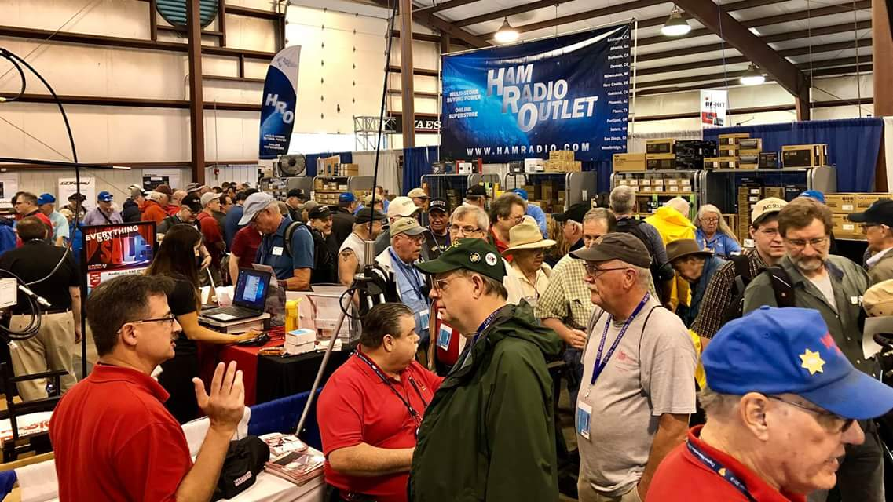[**Upcoming *Hamfests***](http://arrl-ohio.org/hamfests.html)

We **DO** have some hamfests scheduled for 2021!! Yes, take a good look at the list, it’s growing every day!

**07/17/2021 -**[**NOARSFEST**](http://www.arrl.org/hamfests/noarsfest-8) **Location:** Elyria, OH  
**Sponsor:**Northern Ohio Amateur Radio Society  
**Website:** [http://noars.net](http://noars.net/)

[**Learn More**](http://www.arrl.org/hamfests/noarsfest-8)

|  |  |
| --- | --- |
|  |  |
|  |  |
| **07/18/2021 -**[**Van Wert Hamfest**](http://www.arrl.org/hamfests/van-wert-hamfest-5)  **Location:**VAN WERT, OH **Sponsor:** Van Wert Amateur Radio Club **Website:** [http://W8FY.ORG](http://w8fy.org/)  [**Learn More**](http://www.arrl.org/hamfests/van-wert-hamfest-5) | **08/07/2021 -** [**2021 Columbus Hamfest**](http://www.arrl.org/hamfests/2021-columbus-hamfest)  **Location:** Grove City, OH **Sponsor:**Aladdin Shrine Audio Unit **Website**: [http://columbushamfest.com](http://columbushamfest.com/)  [**Learn More**](http://www.arrl.org/hamfests/2021-columbus-hamfest) |
| **08/07/2021 -**[**MOVARC HAMFEST**](http://www.arrl.org/hamfests/movarc-hamfest-6)  **Location:** Bidwell, OH **Sponsor:**Mid-Ohio Valley Amateur Radio Club    [**Learn More**](http://www.arrl.org/hamfests/movarc-hamfest-6) | **08/28/2021 -**[**Cincinnati Hamfest℠**](http://www.arrl.org/hamfests/cincinnati-hamfest)  **Location:**Owensville, OH **Sponsor:** Milford ARC **Website:** [http://CincinnatiHamfest.org](http://cincinnatihamfest.org/)  [**Learn More**](http://www.arrl.org/hamfests/cincinnati-hamfest) |
| **09/12/2021 -**[**Findlay Hamfest**](http://www.arrl.org/hamfests/findlay-hamfest-8) Location: Findlay, OH Sponsor: Findlay Radio Club Website: <http://www.findlayradioclub.org/hamfest>  [**Learn More**](http://www.arrl.org/hamfests/findlay-hamfest-8) | **09/18/2021 -**[**Mound Amateur Radio Assoc. Swap Meet**](http://www.arrl.org/hamfests/mound-amateur-radio-assoc-swap-meet)  **Location:**Miamisburg, OH **Sponsor:** MARA **Website:** [http://W8DYY.ORG](http://w8dyy.org/)  [**Learn More**](http://www.arrl.org/hamfests/mound-amateur-radio-assoc-swap-meet) |
| **09/18/2021** - [**Miami County Swap Meet**](http://w8fw.org/)  **Location:**Troy, OH  **Sponsor:** Miami County Amateur Radio Club  **Website:** [http://w8fw.org](http://w8fw.org/)    [**Learn More**](http://w8fw.org/) | **09/26/2021 -**[**Cleveland Hamfest**](http://www.arrl.org/hamfests/cleveland-hamfest-1)  **Location:**Berea, OH **Sponsor:** Hamfest Association of Cleveland **Website:** [http://www.hac.org](http://www.hac.org/)  [**Learn More**](http://www.arrl.org/hamfests/cleveland-hamfest-1) |
| **10/02/2021 -**[**10th Annual Vette City Hamfest,**](http://www.arrl.org/hamfests/10th-annual-vette-city-hamfest-arrl-great-lakes-division-convention)  [**ARRL Great Lakes Division Convention**](http://www.arrl.org/hamfests/10th-annual-vette-city-hamfest-arrl-great-lakes-division-convention)  **Location:**Bowling Green , KY **Sponsor:** Kentucky Colonels Amateur Radio Club **Website:** [https://ky4bg.com](https://ky4bg.com/)  [**Learn More**](http://www.arrl.org/hamfests/10th-annual-vette-city-hamfest-arrl-great-lakes-division-convention) | |
| **10/31/2021 -**[**Massillon (Ohio) Hamfest**](http://www.arrl.org/hamfests/massillon-ohio-hamfest)  **Location:**Green, OH **Sponsor:** Massillon Amateur Radio Club **Website:** [http://w8np.org](http://w8np.org/)  [**Learn More**](http://www.arrl.org/hamfests/massillon-ohio-hamfest) | **11/06/2021 -**[GARC Hamfest](http://www.arrl.org/hamfests/garc-hamfest-4) **Location:**Georgetown, OH **Sponsor:**Grant Amateur Radio Club  [**Learn More**](http://www.arrl.org/hamfests/garc-hamfest-4) |
|  |  |
| **12/04/2021 -**[**FCARC WinterFest**](http://www.arrl.org/hamfests/fcarc-winterfest-2)  **Location:**Delta, OH  **Sponsor:** Fulton County Amateur Radio Club  **Website:**<http://k8bxq.org/hamfest>    [**Learn More**](http://www.arrl.org/hamfests/fcarc-winterfest-2) | |

Be sure to keep your eyes on this schedule as that when things start getting better and the vaccine rolls out to more and more, hamfests will surely get back to their normal schedule. Don’t see your hamfest listed?? Did anyone register it with ARRL? It’s really easy to do and you get a lot of FREE publicity if you do.

**___________________________________________________________________**

**Print an Official or Unofficial Copy of Your Amateur Radio License**

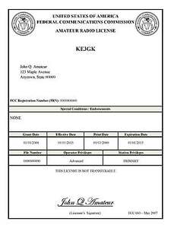*(By Anthony Luscre, K8ZT)*

As of February 17, 2015, the **FCC no longer routinely issues paper license documents** to Amateur Radio applicants and licensees. The Commission has maintained for some time now that the official Amateur Radio license authorization is the electronic record that exists in its Universal Licensing System (ULS). The FCC will continue to provide paper license documents to all licensees who notify the Commission that they prefer to receive one.

Licensees also will be able to print out an official authorization — as well as an unofficial “reference copy” — from the ULS License Manager. I’ve created a set of instructions on how you can request an **“official” printed copy of your license\***

[**Click here to download the instructions**](http://arrl-ohio.org/news/2020/print_your_license.pdf)

***One Question Questionnaire***

Hey Gang,

I’ve got a new question, so how about going to www.ARRL-OHIO.org and giving me a click? (It’s in the bottom left corner of the page)

***“Do you check into at least 1 net every week?”***

From the last Poll: **"Have you ever restored a “Boat Anchor” radio?"**

21 said NO and 20 said YES. (out of 41 responses) Restoring an old radio is a great way to learn about electronics and how radio works. Most are accessible enough that anyone can get into them and work on them. It’s a fun project, you *will* learn some new skills, you’ll end up with some really neat stuff to show off, and you’ll be restoring the traditions and history of our hobby! Give it a try, it’s a fantastic experience.

Ohio Section Cabinet

|  |  |
| --- | --- |
| Section Manager – Tom Sly, WB8LCD | Section Traffic Manager – David Maynard, WA3EZN |
| Section Emergency Coordinator – Stan Broadway, N8BHL | Section Youth Coordinator – Anthony Luscre, K8ZT |
| Technical Coordinator – Jeff Kopcak, K8JTK | Affiliated Clubs Coordinator – Tom Sly, WB8LCD |
| State Government Liaison – Bob Winston, W2THU | Public Information Coordinator – John Ross, KD8IDJ |



Hey Gang,

Have you taken a look at the **Swap & Shop** page on the Ohio Section webpage yet?? Here’s a link that will take you there… <http://arrl-ohio.org/sm/s-s.html>

Do you have equipment that you just don’t need or want anymore? Here’s a great venue to advertise it, and it’s FREE!! Is your club doing a fund raiser to help raise money? After a lot of thought, it was decided that the Swap & Shop webpage could also contain these types of items as well. The same rules will apply as do for the For Sales and Give-A-Ways and will only be posted for a month at a time. Please see the Terms & Conditions on the webpage.

If your club is doing a fund raiser and wants more exposure, please forward the information to me and I’ll advertise it on the Swap & Shop webpage for you.

Now, I still want to remind you that it won’t be listed in this newsletter because it would take up way too much space, so your ad will only appear on the website. It is there for any individual to post equipment Wanted / For Sale or Give-Away as well as for Club Fund Raisers. No licensed vehicles/trailers or business advertising will be posted. Postings are text only (no pictures or graphics) will be posted for a maximum of 1 month from date posting and require a contact phone number or email within the posting. Send your Wanted / For Sale or Give-Away post to:  [swap@arrlohio.org](mailto:swap@arrlohio.org)

***Back Issues of the PostScript and Ohio Section Journal***

Hey, did you know that PostScript and Ohio Section Journal (OSJ) are archived on the website? You can go back and look at any edition simply by clicking:

<http://arrl-ohio.org/news/index.html>

***Want to Share your Club Newsletter With Others?***

We have a webpage where you can download and read all of the newsletters that I get from around the state and even other sections!

Here’s the link to the page…. <http://arrl-ohio.org/club_news/index.html>

Please, if you don’t see your club newsletter posted, it’s because I’m not receiving it. Just have your newsletter editor contact me and I’ll get your club’s newsletter listed on the site!!

We all learn and steal (I mean, share) from each other’s work. So, get me your newsletter!!! Send it to: [webmaster@arrl-ohio.org](mailto:webmaster@arrl-ohio.org)

***Chit – Chat, and All That!***

Do you know someone that’s not getting these Newsletters? Please, forward a copy of this Newsletter over to them and have them “[Opt-In](mailto:Opt-In)” to start receiving them. Heck, just have them send an email to: [webmaster@arrl-ohio.org](mailto:webmaster@arrl-ohio.org) and we’ll get them added to the Ohio Section Emailing list.

We now have many thousands of readers receiving these newsletters weekly. Quite impressive, I’d say! I urge all of you to make sure that everyone, regardless of whether they are a League member or not, get signed up to receive these weekly Newsletters.

You can always “Opt-Out” at any time if you feel this is not what you were expecting. It’s fun and very informative. All of your favorite past newsletters are now archived too.

You can go back at any time and read them.

Just go to: <http://arrl-ohio.org/news/>

The pictures on the front page and throughout this newsletter are from various newsletters, Facebook posts and/or were sent directly to me in recent weeks. Take a good look at them, you just might be in one of the pictures! “SMILE… you’re in the Ohio Section News!!”

*PostScript is produced as a weekly newsletter. I want to thank everyone that has contributed articles and ideas to make this an even better news source. I sincerely hope that you have enjoyed this edition and will encourage your friends to join with you in receiving the latest news and information about the Ohio Section, and news and events happening around the world!*