[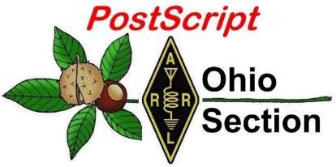](http://arrl-ohio.org/news/) ***“Fourth of July***

***Edition”***

🡪 National News 🡪 Club Corner

🡪 DX This Week 🡪 Contest Corner

🡪 Upcoming Hamfests 🡪 One Question Questionnaire

🡪 VE Testing 🡪 South 40

**CQ CQ CQ de WB8LCD**

I want to wish you all a Happy 4th of July, and I certainly hope you all have a safe and restful holiday. I’ve mentioned this before, but, when I was young, I did not have any interest in history, at all. Now that I’m a little older my interest has increased. I would like to suggest that today, or even tomorrow, might be a good time to re-read the Declaration of Independence. Maybe even read it to your family. Put it into the context of man’s experience with government up to that point and it becomes a very radical way of looking at things! Think about the men who signed that document and what it meant to them and their families as they were now traitors and outlaws.

In addition to world history, and especially American history, I’m also interested in the history of science and technology. Automotive history, the history of electricity and electronics which also leads to the history of Amateur Radio and the ARRL (one of my more favorite topics). I’m currently reading a book about the history of gangsters in America! It’s all fascinating to me.

So is family history. Unfortunately for me, I have boxes of 35mm slides with lots of images of my family’s history – but – nothing to tell me about who all the people in the pictures are and what their significance is. Sure, I can pick out some of it, but there’s more that’s a mystery than what I can remember or even was around for. Documenting your own history is important, maybe not so much to you, but it might mean a lot to your future generations.

And here’s one last item, and then I’ll get off this topic. You and I will not live forever. When we’re gone, our families will be tasked with getting rid of all the stuff we’ve accumulated through the years. I’ve talked to people who have told me that they had relatives who were hams and at their demise, no-one knew what all the stuff was, what it was worth or how to get rid of it. So, it all went into the dumpster! What a waste, not only to the family, but to the ham radio community that has lost those relics forever…. When you’re thinking about your final “signing off” from this planet, maybe even making a will, make a plan for your ham radio “stuff” too, and most importantly – tell someone about it! Make it a part of your estate plan. You might also want to include donations to ARRL and you favorite local club(s) in that plan too!

***National News***

*(from arrl and other sources)*

**Youth on the Air Camp 2021 to be On the Air and Streaming Selected Events Online**

The first Youth on the Air ([YOTA](http://www.youthontheair.org/)) camp for young radio amateurs in North, Central, and South America begins on July 11 in West Chester, Ohio. Among other activities, campers will be operating special event station W8Y from both the National Voice of America 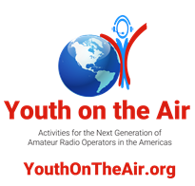Museum of Broadcasting in West Chester Township and from the camp hotel. The camp will run until July 16.

"We are at 23 campers," said Camp Director Neil Rapp, WB9VPG. "We are very excited to finally bring this program to the Americas. Our young people are bringing an incredible lineup of hands-on sessions for their peers. We hope this pilot gives us the information we need to replicate this camp over multiple locations for years to come. We also hope this brings a more robust community of young hams into amateur radio."

The long-awaited summer camp for up to 30 hams aged 15 through 25 had been set to take place in June 2020, but it had to be rescheduled until summer 2021 because of COVID-19 pandemic concerns. The camp for young hams in the Americas took its cue from the summer Youngsters on the Air camps held for the past few years in various IARU Region 1 countries.

W8Y will be on the air as campers complete projects, between sessions, and during free time. Dedicated operating times on HF will be Monday, July 12, 0100 - 0330 UTC; Tuesday, July 13, 0000 - 0330 UTC and 1800 - 2130 UTC. Dedicated satellite station operating times will be Thursday, July 15, 1400 - 1700 UTC, and Friday, July 16, 1500 - 1700 UTC.

An Amateur Radio on the International Space Station ([ARISS](http://www.ariss.org/)) contact is currently set for either Wednesday, July 14, at 1503 UTC, or

|  |
| --- |
|  |

Thursday, July 15, at 1416 UTC. It will be streamed live on the Youth on the Air YouTube channel. The camp opening observance on Sunday, July 11, 2100 - 2230 UTC, will feature keynote speaker Tim Duffy, K3LR. The hour-long closing ceremony on Friday, July 16, will get under way at 1700 UTC. The YouTube channel will also feature a daily video highlighting the activities of the previous day.

ARRL and The Yasme Foundation donated project kits for the campers. X Tronics provided temperature-controlled soldering stations. The brochure on the Youth on the Air website includes more details about the camp. For additional information, [contact](mailto:director@youthontheair.org) Camp Director Neil Rapp, WB9VPG.

**FCC Reaffirms Nearly $3 Million Fine for Marketing Unauthorized Drone Transmitters**

In a*Memorandum Opinion and Order* ([*MO&O*](https://docs.fcc.gov/public/attachments/FCC-21-76A1.pdf)) released June 17, the FCC denied a *Petition for Reconsideration* filed by HobbyKing of a $2,861,128 fine for marketing noncompliant RF equipment and for failing to respond to FCC orders in its investigation of the company's practices. In the same step, the FCC enforced its equipment marketing rules. The fine resulted from an FCC investigation initiated by ARRL's January [2017 complaint](http://www.arrl.org/news/arrl-drone-transmitters-complaint-spurs-proposed-2-8-million-fcc-penalty) that the HobbyKing equipment was "blatantly illegal at multiple levels."

A representative of the ARRL Electromagnetic Compatibility Committee (ECC) stated, "The *Forfeiture Order* is the final chapter of a story that started with a report to the ARRL Board by the EMC Committee in 2017, as a result of the discovery that aerial drone TV transmitting equipment was being imported and marketed without proper FCC authorization under FCC Part 15 rules."

The Electromagnetic Compatibility Committee was credited in the complaint with calling attention to the issue and prompting ARRL's action.

As spelled out in ARRL's 2017 complaint, the ARRL Laboratory had documented that the operating frequencies of these drone TV transmitters near the 1.3 GHz amateur band were dip-switch selectable for frequencies internationally assigned for use by Aeronautical Navigation, GPS, GLONASS L1, ATC Mode "S," as well as to both the interrogation and reply frequencies used for Air Traffic Control Air-Route Surveillance "transponder" radar systems.

ARRL's complaint noted that given the channel configuration, these units would not have a legitimate amateur radio use, and that the marketing was directed at drone enthusiasts and not to licensed radio amateurs. "ARRL Laboratory tests did prove that only one of the seven available channels was within the 1.3 GHz amateur band," the ECC representative said.

"This is another example of ARRL not only affirmatively acting to protect our members' interests, but also acting to protect the safety and security of vital services and the general public," the ECC representative said*.*

HobbyKing had denied that it was marketing its drone transmitters to US customers, but as the ARRL January 2017 complaint pointed out, ARRL Laboratory Manager Ed Hare, W1RFI, was able to purchase two drone transmitters from HobbyKing for testing in the ARRL Lab. "The FCC noted that amateur radio equipment used to telecommand model craft are limited to 1 W (1,000 mW), but three transmitters included in the FCC investigation operated at significantly higher power levels of 1,500 mW and 2,000 mW," ARRL said.

HobbyKing had told the FCC that it had no notice of the Commission's authorization requirements; that the Fifth Amendment relieved HobbyKing of its duty to respond; that the forfeiture amount was inappropriate because its parent company, Indubitably, Inc., lacked the ability to pay to the *Forfeiture Order*; and that the Commission was time-barred from taking action against ABC Fulfillment Services LLC because it was not part of HobbyKing's business.

"Upon review of HobbyKing's *Petition for Reconsideration* and the entire record, we find no basis for reconsideration because the petition fails to present new information warranting reconsideration," the FCC said in the *MO&O*.

***Club Corner***

This is YOUR cornner of the newsletter. Send me what your club is doing and I’ll make sure that it gets in. Got a special event or club project that you want everyone to know about? Send it to me!. Need help with a project? Send it to me.

Let me know what you club is up to. Are you going to have a special guest at your meeting or are you having a special anniversary?

Just sent it to: [webmaster@arrl-ohio.org](mailto:webmaster@arrl-ohio.org)

# **Farewell, Buckeye Net Mixed; Hello, BLACK SWAN Net!**

C. Matthew Curtin KD8TTE

When the BLACK SWAN 17 Exercise was announced, Buckeye Net Early Session Net Manager Steve Judd WB8YLO looked at the stated objectives and saw limitations in the traditional structure of the National Traffic System (NTS) net that prevented effective exercise play.

Fast-forward to 2020, and Steve launched Mixed-Mode (voice, digital, and CW) sessions of Buckeye Net, organized within NTS and specifically to support ARES operators. After many hours of development and experimentation, the first operations were held to support the Red Cross volunteers' Emergency Communication National Radio Simulation in May, and continued through additional exercises and events including BLACK SWAN 20, where it supported the in-state distribution of alert messages through the Federal Emergency Management Agency (FEMA) Integrated Public Alert & Warning System (IPAWS), delivering an IPAWS message entirely by radio for the first-time ever. The net was run by amateurs and joined by U.S. Government stations during BLACK SWAN and other exercises, and was given attention not only in the world of amateur radio but in the U.S. Military Auxiliary Radio System (MARS) and SHARES programs. Since Thanksgiving 2020, the net continued daily operations, providing significant training for operators and a valuable testing ground for modern messaging procedures and viability of amateur radio for new purposes.

We are grateful to all operators who have trained with us and participated in the development of Buckeye Net Mixed. Within a year, we went from the proverbial drawing board to making a contribution to the safety and security of our communities, the state of Ohio, and the United States of America.

Analysis of the net's use by amateur radio stations showed high utility among public service and emergency communications, with low adoption by ARES and NTS groups in the Ohio Section. Organizers of the net have opted to structure afresh with an agency-centric perspective. Friend to all but free to operate independently to support the missions required by agencies, the new net will take the lessons learned from Buckeye Net Mixed operations and move further to improve the emergency communications capabilities in and around Ohio.

The farewell session of Buckeye Net Mixed was held 30 June 2021 on 60 meters channel 4 at 1300 Ohio time.

Replacing Buckeye Net Mixed is the BLACK SWAN net. The initial schedule is Saturday and Sunday at 1300 (60 meters) and Monday at 1900 (75 meters). Nets will be controlled by voice when conditions allow, and traffic will by default move via NBEMS digital using FLAMP. Any station needing an outlet for message training or to support an operation is welcome to report into the net without regard to affiliation.

A critical feature is that BLACK SWAN training operations are scheduled weekly, with each training week starting on Tuesday. The idea is that by presenting foundational tasks first and in small pieces we can practice and tighten up the building blocks for more complex operations. The training week begins with introduction of the week’s training topic on Tuesday, with time for followup discussion via Internet email for the rest of the day and three days after. We then put the week’s training to work over the course of three days: Saturday and Sunday at 1300, and Monday at 1900.

The schedule allows for introduction and discussion of training to happen asynchronously so anyone can participate at any point over the course of four days. Three days of net operations at two times provide three opportunities for us to practice what we’ve discussed on-air in both daytime and evening conditions. Operators looking to work all sessions are welcome to do so; practice is critical to being smooth and confident on-air.

* Tuesday: Introduction of procedure, task, or objective on QTC email list (<https://groups.io/g/QTC>).
* Wednesday-Friday: Questions, comments, and discussion of the week’s training.
* Saturday-Sunday: On-air operations at 1300, exercising the training point of the week.
* Monday: On-air operation at 1900, exercising the training point of the week.

Information on the BLACK SWAN net, the supporting Internet email list, and ongoing radio communications projects (QSP, the radio-only newsletter; and the Weather Alert Project 21) can be found at the net's home online at <https://www.blackswancomex.org/net>.

**West Chester ARA QST – SDR Meeting Presentation**

If you were unable to attend the last meeting, here's the recording from Jack(W8TEE) & Al(AC8GY) presentation on their SDR Radio.  A big THANK YOU to Jack & AL for sharing their project with us.

The recording will be available for 60 days(September 2nd).

Topic: WCARA Presentation SDR

Meeting Recording:

<https://zoom.us/rec/share/urAtC4BHdguMQ0GmkQU9cNByKftIY0Go2806x16uyXPOcpyhWHH_Xi8h3VQQkyfg.7R_yAtSC_R5z8khl>

Access Passcode: WC8VOA@July

**NW8S Field Day 2021**

Please see the following for a write-up & video from the Black River Radio Ops NW8S Field Day.

<http://www.nw8s.com/news/nw8s-field-day-2021/>

**ARES Training Update 06-30-2021**

We are now in sight of 10,000 certificates registered in the database. Polish the Bell, tune up the howling and prepare for back slapping. We can do this.  The Ohio Section is good!

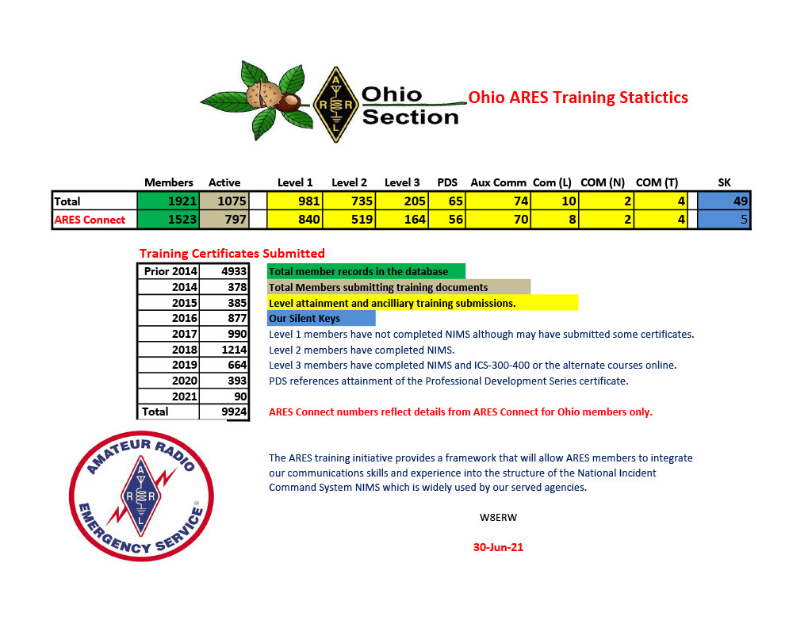

Jim W8ERW

**Your Club news should be listed here!**

I know you’re out there doing things! Send me a write-up (MSWord please) and some photo’s (.jpg please) and we’ll get your club hi-lited here for the othe OH Section Clubs to see! Send to [WB8LCD@ARRL.ORG](mailto:WB8LCD@ARRL.ORG)

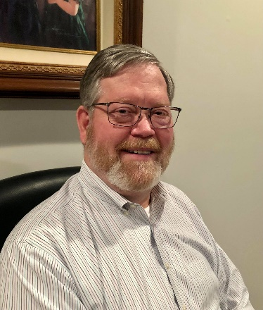**DX This Week – Grayline**

Bill AJ8B (aj8b@arrl.net, @AJ8B, or www.aj8b.com)

CWOPs Member #1567

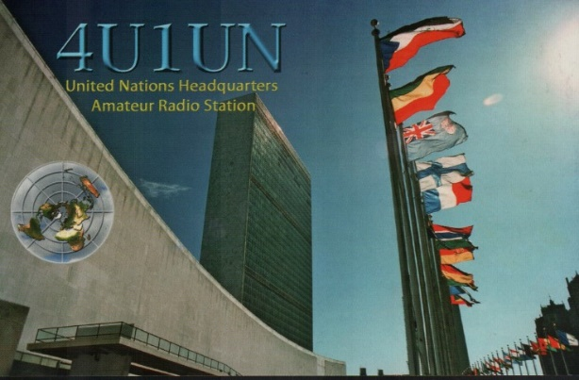The Midwest DX Cluster spots included Afghanistan, Algeria, Balearic Islands, Belgium, Belize, Bosnia-Herzegovina, Bulgaria, Canada, Crete, Croatia, Cuba, Czech Republic, England, European Russia, Faroe Islands, Fed. Rep. of Germany, France, Greece, Guernsey, Hungary, Ireland, Isle of Man, Italy, Mariana Islands, Mauritania, Mexico, Montenegro, Netherlands, Norway, Poland, Portugal, Puerto Rico, Sardinia, Saudi Arabia, Sicily, Spain, Sweden, and Wales.. This brings the total number of entities spotted in the Midwest in 2021 to 181!

I received a beautiful card from 4U1UN, the UN HQ in New York. What did you get?

*DAH DIT DIT DIT DAH DAH DIT DIT DIT DAH*

The first article this week is a reprint from a previous week. This article, written by Jay, K4ZLE, is about the greyline. This article generated as much emails as any other that I have published. I think this would be a good time to reprint this. Jay will be our emcee at the W8DXCC convention in August and you can ask follow-up questions at that time.

The second article this week pertains to the “13 Colonies” Special operating event. This is a fund event that has been held for over 10 years during our 4th of July weekend. Let em know if you participate in it.

*DAH DIT DIT DIT DAH DAH DIT DIT DIT DAH*

The Grey Line by Jay, K4ZLE.

This week we will review The Long Gray Line, otherwise known as the twilight zone or the terminator. Contrary to first impressions we will not be talking about the long line of West Point alumni, Rod Serling's old TV program or a movie by Arnold Swarzenegger. Our gray line is the band of transition from daylight to dark on one side of the earth and from dark to daylight on the other. Gray line conditions exist for 30 minutes each side of local sunrise and sunset and act as a conduit for radio signal propagation for frequencies below VHF. That gives us two hours per day for gray line communications. It is especially effective for work on 160, 80, and 40-meter DX. With the sunspots down and winter upon us, evening DX is most effective on these lower frequency bands.

In a column this short we do not have time to fully develop *why* gray line works[1] We will spend our time on *how* to predict coverage area. However, for those technically inclined, the short answer for why is that the D layer is absent in the twilight zone. The D layer absorbs MF/HF signals and is fading rapidly for the area in dusk and not yet formed for the area in dawn.

Generally speaking, for gray line work we should orient our antenna to radiate north south. Depending upon the date and whether it is sunrise or sunset, the actual gray line follows a path 23 degrees east or west of north, or 23 degrees east or west of south. The twilight zone actually extends completely around the earth and signals can travel in either direction. Unless you have a highly directional antenna, do not worry that there is a 46-degree wide path. The half power beam-width for a 1/2 wave dipole is 78 degrees[2] and a vertical radiates equally poorly in all directions. If you have a rotatable antenna, aim it according to the discussion below. Be sure to check both north and south paths to determine which has the strongest signal.

In order to determine which count ries lie on the gray line for a given date, we can use the following sunrise table:

|  |  |  |  |  |
| --- | --- | --- | --- | --- |
| **Month/Day** | **Angle** |  | **Month/Day** | **Angle** |
| Jan 1, Dec 12 | 23 E |  | Apr 5, Sep 8 | 5 W |
| Jan 21, Nov 22 | 20 E |  | Apr 19, Aug 25 | 10 W |
| Feb 8, Nov 3 | 15 E |  | May 5, Aug 9 | 15 W |
| Feb 23, Oct 20 | 10 E |  | May 26, Jul 19 | 20 W |
| Mar 8, Oct 6 | 5 E |  | Jn 21 | 23 W |

The table has been abridged in the name of space. For a given date extrapolate between the ones shown in the table.

Let's work through an example. For illustrative purposes we will assume it is Jan 10th and our location is Cincinnati, OH. From the chart above, we find the angle to be 21- or 22-degrees E. If you extend a great circle line starting at an angle of 22 degrees E you will find it passes through the following countries: Southern Greenland, W. European Russia, W. Kazakhstan, Uzbekistan, Turkmenistan, Afghanistan, Pakistan, Laccadives, Chagos, Easter Is. and Central America. That takes care of sunrise; how about sunset? For sunset swing the same number of degrees depicted in the chart, but to the other side of north. In the Jan 10th example, we swing 22 degrees *west* of north to circumscribe our circle (360 - 22 = 338). Such a line passes through the following countries: W. Asiatic Russia, Korea, Taiwan, Spratley, E. Malaysia, Brunei, and Indonesia.

Notice for dates near March 23rd and September 23rd, otherwise known as the equinox, the sunrise and sunset gray line paths are near identical since the angle is zero degrees. Countries on a north-south path from Cincinnati are Central Russia, Mongolia, Mynamar (Burma), Andaman, Cocos (Keeling), Cocos, San Felix, Juan Fernandez and Peter I.

To determine sunrise or sunset on the PacketCluster [3] use the command SH/SUN without a qualifier for local sunrise and sunset. Add the prefix for the desired country to find out sunrise and sunset times at a remote location; for example, SH/SUN VQ9 returns the times for the Chagos. If you suspect a given country is on today's gray line, you can check it on PacketCluster by first finding out your sunrise/sunset times and then finding the same for the country in question. If two of the times are within half hour of each other, a gray line path exists. Computer programs exist that do gray line calculations and provide visual presentations of the path for any day, sunrise and sunset. Look for ads in the various ham journals.

Gray line is easy and gray line is fun. It is possible to work very exotic DX at reasonable times of the day. Just make sure your low band dipole is oriented for a north-south path and be on the air a half hour each side of sunrise or sunset. Then Listen, Listen, Listen. You will be surprised what you can hear AND work.

*DAH DIT DIT DIT DAH DAH DIT DIT DIT DAH*

**13 Colonies Special Event to Mark 12th Anniversary this Year**

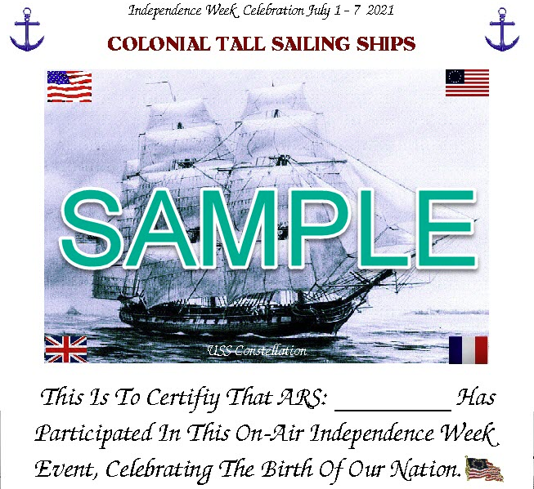The annual [**Original 13 Colonies Special Event**](http://www.13colonies.net/) will mark its 12th anniversary this year. The event gets under way on July 1 at 1300 UTC and runs through July 7 at 0400 UTC. Special event stations with 1 × 1 call signs will represent the original 13 US colonies, plus bonus stations K2Z, WM3PEN in Philadelphia and GB13COL in Durham, England.

Each special event station will have its own QRZ.com profile page. Participating stations try to contact all 13 Colony Stations plus the two bonus stations. Call signs and their respective states are K2A, New York; K2B, Virginia; K2C, Rhode Island; K2D, Connecticut; K2E, Delaware; K2F, Maryland; K2G, Georgia; K2H, Massachusetts; K2I, New Jersey; K2J, North Carolina; K2K, New Hampshire; K2L, South Carolina, and K2M, Pennsylvania.

*DAH DIT DIT DIT DAH DAH DIT DIT DIT DAH*

CQDX CQDX CQDX CQDX CQDX CQDX CQDX CQDX CQDX

Here is an update from Bernie, W3UR, of the DailyDX and the WeeklyDX, the best source for DX information. <http://www>.dailydx.com/. Bernie has this to report:

**T6 – Afghanistan -** T6AA, operator S53R, Robert, says radar type noise is completely wiping out the six meter band but there are little holes in the noise that shift around.  The best frequencies he's found are 50302-50305 and 50316.  He will announce his frequency on the DX Cluster Network if he is outside the standard 50313 or 50323 "FT" freqs.  Of course FT8/4 are the best possibilities of getting through.  Robert asks that we not ask him to go to other modes and your locator is not needed; just call directly with your report.  Once he sends you the "RR73" you're in the log.  And avoid calling directly on his transmit frequency; it creates "unnecessary mess and requires numerous repetitions with many stations calling at the same time on the same frequency."  Robert updates LoTW and his Club Log regularly, usually daily after he turns the radio off.  Paper QSLs are direct only. Check S53R on QRZ.com.  no bureau, no eQSL, no QRZ.com log, etc.

**4J – Azerbaijan -** 4J880M remembers writer/philosopher Nizami Ganjavi, born 880 years ago.  4J880M went on the air and goes to July 1.  This one will be from Mingechevir.  Others, starting with 4J880 and 4K880 will be from Baku.  QSL and further info is on the webpage: <http://www.qrz.com/db/4j880m>.  The Azerbaijan Central Radio Club headquarters station, 4K0HQ, will have a certificate available. European and Asian stations need at least five QSOs, at least one with one of those commemorative callsigns.  Other areas of the world need four QSOs, one with one of those "specials."  QSOs with 4J stations can be made throughout the year toward the award.

**J5 - Guinea-Bissau -** IDXT, the Italian DX Team, plans an operation October 7-18, callsigns J5T and J5HKT.  They're going to Bubaque Island, IOTA AF-020.  The op team includes I1HJT, I2PJA, I2YSB, IK2CIO, IK2CKR, IK2HKT and I1FQH.

The pilot station can be reached with English language inquires at [idtpilot@gmail.com](mailto:idtpilot@gmail.com).  With problems or questions with the online log, they say only contact the pilot at that email.  They will have four K3 rigs, four HAL "1200 Atlantic" amplifiers, six laptops, two 5-band Spiderbeams, a five-band Yagi, 6M 5-element, 30M loop, 160M, 80M and 40M verticals, a diamond loop for receive and "kilometers of radials" and a lot of coax.

For a QSL, for direct cards, OQRS will work, <http://win.i2ysb.com/logonline/>

**XW – Vietnam -** JP3HEU (JJ1LET), Takeshi Santo, has working in Xuan La, Tay Ho, Hanoi (grid locator OL21vb), since February 10, 2021. He is QRV as XV9HEU with an IC-7300 and FT-891 running about 50 watts into an all band mobile whips by Diamond Antenna for 80, 40, 30, 20, 17 and 15 meters as well as a homemade dual band whip for 10 and 6 meters. He can be found on SSB and digital modes. At the moment he is unable to operate CW "because the equipment has not arrived" however he expects it will "arrive soon" so CW should "start as soon as it arrives". His current activities are limited to weekends and holidays. "Due to the influence of COVID, golf has decreased and amateur radio has increased QRV time", says Takeshi. QSL via EA5GL and eQSL.

*DAH DIT DIT DIT DAH DAH DIT DIT DIT DAH*

Below is a list of upcoming contests in the “Contest Corner”. I think this is important for someone who is trying to move up the DXCC ladder since entities that are on the rarer side and easiest to work in contests. Some of my best “catches” have been on the Sunday afternoon of a contest when the rarer entities are begging for QSOs. Of course, the gamble is that if you wait until Sunday, conditions may change, or they simply won’t be workable. However, it is not a bad gamble. Of course, why not work the contest and have some fun!  
Check out the WA7BNM Contest Calendar page (<https://www.contestcalendar.com/>) and CQ Magazine for more contests or more details.

The contests in red are those that I plan to spend some significant participation time on. PLEASE let me know if you are working contests and how you fared.

Thanks!

|  |  |  |
| --- | --- | --- |
| June 28 | RSGB FT4 Contest Series | http://bit.ly/3mCNXXH |
| July 1 | RAC Canada Day Contest | www.rac.ca/contesting-results |
| July 2-4 | Original QRP Contest | www.qrpcc.de/contestrules/index.html |
| July 3-4 | Marconi Memorial HF Contest | www.arifano.it/contest_marconi.html |
| July 3-4 | DL-DX RTTY Contest | www.drcg.de |
| July 3-4 | PODXS 070 Club 40 Meter Firecracker Sprint | http://bit.ly/2FUmeOL |
| July 7 | VHF-UHF FT8 Activity Contest | www.ft8activity.eu/index.php/en |
| July 10-11 | 10-10 Int. Weak Signal QSO Party | http://bit.ly/1FrFeBc |
| July 10-11 | IARU HF Championship | www.arrl.org/iaru-hf-world-championship |
| July 11 | QRP ARCI Summer Homebrew Sprint | www.qrparci.org/contests |
| July 14 | VHF-UHF FT8 Activity Contest | www.ft8activity.eu/index.php/en |
| July 17-18 | CQWW VHF Contest | www.cqww-vhf.com |
| July 17-18 | North American RTTY QSO Party | http://ncjweb.com/NAQP-Rules.pdf |
| July 18 | CQC Great Colorado Gold Rush | https://tinyurl.com/4accen2c |
| July 18 | RSGB International Low Power Contest | https://tinyurl.com/cy7u4ynp |
| July 24-25 | RSGB IOTA Contest | https://tinyurl.com/29m8jb3z |
| July 25 | ARS Flight of the Bumblebees | http://arsqrp.blogspot.com |
| July 26 | RSGB FT4 Contest Series | http://bit.ly/3mCNXXH |
| July 31-Aug. 1 | Missouri QSO Party | https://tinyurl.com/fbfcw8r3 |
| July 31- Aug. 1 | Russian WW Multi Mode Contest | http://bit.ly/2CMbWOM |
| August 28 | Ohio QSO Party | <https://www.ohqp.org/> |
| August 28 | W8DXCC | <https://www.w8dxcc.com> |
| Sept. 25-26 | CQWW RTTY DX Contest | www.cqwwrtty.com |
|  |  |  |

***DX News***

**ARLD026 DX news**  
  
ARLD026 DX news  
  
This week's bulletin was made possible with information provided by SP8HPW, W2GD, The Daily DX, the OPDX Bulletin, 425 DX News, DXNL, Contest Corral from QST and the ARRL Contest Calendar and WA7BNM web sites.  Thanks to all.  
  
SINGAPORE, 9V.  Shuichi, JA0DKL is QRV as 9V1SH.  Activity is on various HF bands.  His length of stay is unknown.  QSL via LoTW.

URUGUAY, CX.  Special event station CW60ATS is QRV until December 31 to mark the 60th anniversary of the enactment of the Antarctic Treaty System.  QSL via LoTW.  
  
ITALY, I.  Special event station II0LXXV is QRV until December 31 to celebrate the 75th anniversary of ARI Roma.  QSL via bureau.  
  
JAPAN, JA.  Members of the Sendai Tuning DX Club are QRV with special call sign 8N7SPORT until October 31.  QSL via bureau.  
  
ALASKA, KL7.  Members of the North Pole Contest Group will be QRV as W1AW/KL7 from July 8 to 13.  Activity will be on all bands and modes with four stations active.  This includes being a HQ Station entry in the upcoming IARU HF World Championship.  QSL via W1AW.  
  
AUSTRIA, OE.  Alex, OE3DMA is QRV as OE60ANT to mark the 60th anniversary of the enactment of the Antarctic Treaty System.  QSL to home call.  
  
ARUBA, P4.  John, W2GD will be QRV as P44W from July 6 to 13. Activity will be as time permits on all bands.  This includes being a CW only entry in the upcoming IARU HF World Championship contest. QSL via N2MM.  
  
POLAND, SP.  Special event stations 3Z1980LL, HF1980LL, SN1980LL, SO1980LL, SP1980LL, SP1980LS and SQ1980LL are QRV until July 31 to commemorate the strike actions of 1980 in the Lublin region. Activity is on the HF bands.  QSL via operators' instructions.  
  
EUROPEAN RUSSIA, UA.  Special event call sign R100KOMI is QRV until September 30 to celebrate the 100th anniversary of the Komi Republic, created on August 22, 1921, as an Autonomous Oblast.  QSL via operators' instructions.  
  
UKRAINE, UR.  Special event station EM60KTS is QRV until December 31 to mark the 60th anniversary of the enactment of the Antarctic Treaty System.  QSL via IK2DUW.  
  
BRITISH VIRGIN ISLANDS, VP2V.  Frank, K3TRM will be QRV as VP2V/K3TRM from Tortola, IOTA NA-023, from July 4 to 17.  Activity will be on 40 to 6 meters, including some Satellite activity, using  
SSB, RTTY and FT8.  QSL to home call.  
  
ST. HELENA ISLAND, ZD7.  Gerry, G3WIP is QRV as ZD7GB from Jamestown until September 6.  Activity is in his spare time on 40 to 10 meters, including Satellite QO-100, using SSB, FT8 and FT4.  QSL via operator's instructions.  
  
THIS WEEKEND ON THE RADIO. The 13 Colonies Special Event, the QRP 20-Meter CW Fox Hunt, NCCC RTTY Sprint, NCCC CW Sprint, K1USN Slow Speed CW Test, Venezuelan Independence Day Contest, DL-DX RTTY Contest, Two-Meter Classic Sprint, Marconi Memorial HF Contest,  
Original QRP Contest, TA VHF/UHF Contest and the PODXS 070 Club 40-Meter Firecracker PSK31 Sprint are on tap for this weekend.  
  
The K1USN Slow Speed CW Test and RSGB 80-Meter Club CW Championship,  
are scheduled for July 5.

The RTTYOPS Weeksprint, ARS Spartan CW Sprint and Worldwide Sideband Activity Contest are scheduled for July 6.  
  
The VHF-UHF FT8 Activity Contest, Phone Fray and CWops Mini-CWT Test are scheduled for July 7.

Please see July QST, page 73, and the ARRL and WA7BNM contest web sites for details.

**___________________________________________________________________**

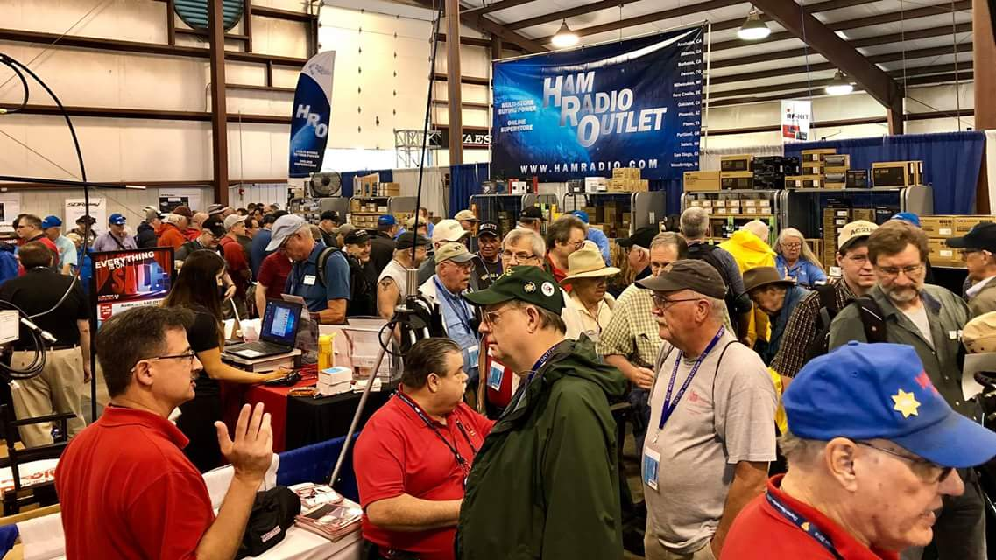[**Upcoming *Hamfests***](http://arrl-ohio.org/hamfests.html)

We **DO** have some hamfests scheduled for 2021!! Yes, take a good look at the list, it’s growing every day!

|  |  |
| --- | --- |
| **07/10/2021 - [Mansfiled Mid-Summer Trunkfest](http://www.arrl.org/hamfests/mansfiled-mid-summer-trunkfest" \o "Mansfiled Mid-Summer Trunkfest)**  **Location:**Mansfield, OH **Sponsor:**InterCity Amateur Radio Club **Website:**[http://iarc.club](http://iarc.club/)  [**Learn More**](http://www.arrl.org/hamfests/mansfiled-mid-summer-trunkfest) | **07/17/2021 -**[**NOARSFEST**](http://www.arrl.org/hamfests/noarsfest-8) **Location:** Elyria, OH **Sponsor:**Northern Ohio Amateur Radio Society **Website:** [http://noars.net](http://noars.net/)  [**Learn More**](http://www.arrl.org/hamfests/noarsfest-8) |
| **07/18/2021 -**[**Van Wert Hamfest**](http://www.arrl.org/hamfests/van-wert-hamfest-5)  **Location:**VAN WERT, OH **Sponsor:** Van Wert Amateur Radio Club **Website:** [http://W8FY.ORG](http://w8fy.org/)  [**Learn More**](http://www.arrl.org/hamfests/van-wert-hamfest-5) | **08/07/2021 -** [**2021 Columbus Hamfest**](http://www.arrl.org/hamfests/2021-columbus-hamfest)  **Location:** Grove City, OH **Sponsor:**Aladdin Shrine Audio Unit **Website**: [http://columbushamfest.com](http://columbushamfest.com/)  [**Learn More**](http://www.arrl.org/hamfests/2021-columbus-hamfest) |
| **08/07/2021 -**[**MOVARC HAMFEST**](http://www.arrl.org/hamfests/movarc-hamfest-6)  **Location:** Bidwell, OH **Sponsor:**Mid-Ohio Valley Amateur Radio Club    [**Learn More**](http://www.arrl.org/hamfests/movarc-hamfest-6) | **08/28/2021 -**[**Cincinnati Hamfest℠**](http://www.arrl.org/hamfests/cincinnati-hamfest)  **Location:**Owensville, OH **Sponsor:** Milford ARC **Website:** [http://CincinnatiHamfest.org](http://cincinnatihamfest.org/)  [**Learn More**](http://www.arrl.org/hamfests/cincinnati-hamfest) |
| **09/12/2021 -**[**Findlay Hamfest**](http://www.arrl.org/hamfests/findlay-hamfest-8) Location: Findlay, OH Sponsor: Findlay Radio Club Website: <http://www.findlayradioclub.org/hamfest>  [**Learn More**](http://www.arrl.org/hamfests/findlay-hamfest-8) | **09/18/2021 -**[**Mound Amateur Radio Assoc. Swap Meet**](http://www.arrl.org/hamfests/mound-amateur-radio-assoc-swap-meet)  **Location:**Miamisburg, OH **Sponsor:** MARA **Website:** [http://W8DYY.ORG](http://w8dyy.org/)  [**Learn More**](http://www.arrl.org/hamfests/mound-amateur-radio-assoc-swap-meet) |
| **09/18/2021** - [**Miami County Swap Meet**](http://w8fw.org/)  **Location:**Troy, OH  **Sponsor:** Miami County Amateur Radio Club  **Website:** [http://w8fw.org](http://w8fw.org/)    [**Learn More**](http://w8fw.org/) | **09/26/2021 -**[**Cleveland Hamfest**](http://www.arrl.org/hamfests/cleveland-hamfest-1)  **Location:**Berea, OH **Sponsor:** Hamfest Association of Cleveland **Website:** [http://www.hac.org](http://www.hac.org/)  [**Learn More**](http://www.arrl.org/hamfests/cleveland-hamfest-1) |
| **10/02/2021 -**[**10th Annual Vette City Hamfest,**](http://www.arrl.org/hamfests/10th-annual-vette-city-hamfest-arrl-great-lakes-division-convention)  [**ARRL Great Lakes Division Convention**](http://www.arrl.org/hamfests/10th-annual-vette-city-hamfest-arrl-great-lakes-division-convention)  **Location:**Bowling Green , KY **Sponsor:** Kentucky Colonels Amateur Radio Club **Website:** [https://ky4bg.com](https://ky4bg.com/)  [**Learn More**](http://www.arrl.org/hamfests/10th-annual-vette-city-hamfest-arrl-great-lakes-division-convention) | |
| **10/31/2021 -**[**Massillon (Ohio) Hamfest**](http://www.arrl.org/hamfests/massillon-ohio-hamfest)  **Location:**Green, OH **Sponsor:** Massillon Amateur Radio Club **Website:** [http://w8np.org](http://w8np.org/)  [**Learn More**](http://www.arrl.org/hamfests/massillon-ohio-hamfest) | **11/06/2021 -**[GARC Hamfest](http://www.arrl.org/hamfests/garc-hamfest-4) **Location:**Georgetown, OH **Sponsor:**Grant Amateur Radio Club  [**Learn More**](http://www.arrl.org/hamfests/garc-hamfest-4) |
| **2/04/2021 -**[**FCARC WinterFest**](http://www.arrl.org/hamfests/fcarc-winterfest-2)  **Location:**Delta, OH  **Sponsor:** Fulton County Amateur Radio Club  **Website:**<http://k8bxq.org/hamfest>    [**Learn More**](http://www.arrl.org/hamfests/fcarc-winterfest-2) | |

Be sure to keep your eyes on this schedule as that when things start getting better and the vaccine rolls out to more and more, hamfests will surely get back to their normal schedule. Don’t see your hamfest listed?? Did anyone register it with ARRL? It’s really easy to do and you get a lot of FREE publicity if you do.

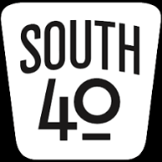 **THE SOUTH 40—July 4th Edition**

Today we celebrate our Nation’s Independence Day with the usual fireworks, ice cream, watermelon and family picnics. Although we have a lot of differences along a lot of topics, we still live in the greatest country in the world. Let us celebrate!

Today’s journey takes us to our final visit of an amateur radio club serving Southern Ohio and the Ohio River Valley-the **Parkersburg Amateur Radio Klub**. Thanks to Jerry Wharton, KA8NJW, for providing some of the history of the Club.

According to the late Mark Schauwecker the club was established in 1948 as the result of Parkersburg area hams traveling to West Virginia’s panhandle for Field Day. Their experience was so impressive all that could be talked about on the way home was forming a local club so they could have their own Field Day. They met several times and hammered out some by-laws resulting in the formation of the **Blennerhassett Amateur Radio Club**. The name was chosen because it was felt using a town name would be too localized with some potential out of town members not feeling welcome and the name of the historic Ohio River Island near Parkersburg would be more welcoming. There were nine original members. Later the Club changed its name to the **Parkersburg Amateur Radio Klub**.

The Club sponsors two repeaters--the N8NBL repeater on 146.97 and the W8CRW machine on 147.39. Besides coming off of a successful Field Day at Fort Boreman Hill they operate a special event station during the annual Cairo, WV Volcano Days celebration. Their website address is [www.w8par.org](http://www.w8par.org). They also publish a nice newsletter, the *Di-Dah-Dit*. Monthly meetings are held on the second Monday of the month at the Western Sizzling Restaurant in Ravenswood. PARK is an ARRL affiliated club.

Thanks to the **Parkersburg ARK** and Jerry for sharing a bit about them with us. And a big thanks to all the clubs that have participated in providing information for these visits during the past several weeks. It is really appreciated and we hope it shows amateur radio is alive and well in the Southern Ohio/Ohio River region.

As this column is prepared, Field Day has just concluded and it appears most Southern Ohio region clubs participated in some form. A lot of contacts were made and the perfect (but hot) weather allowed for a number of club picnics, good food and the social aspects of the hobby to be enjoyed by all. Now it’s just getting the paperwork done and submitted, stashing the equipment until next time and waiting for the final results to be published. But until then expect there to be a lot of Field Day stories, first impressions and experiences exchanged.

Late information was received from an additional club that participated in this year’s Field Day. The **Greater Mason County ARC** operated from a nature reserve near Maysville.

The **Scioto Valley ARA** held a test session Field Day morning. Although the turnout was small, according to John Hartmus, two people went away happy. Charles Wineka of Chillicothe is now KE8SJJ The **Athens County ARA** recently held a test session and had five happy folks-all with new tickets and two going on to General upgrades. Jeff Slattery, N8SUZ, and Ted Jacobson, W8KVK, report Glouster’s Jim Reed is now KE8SIQ; Nelsonville’s Mary Moffat is KE8SIR and Robert Pettit from Belpre is KE8SIT. Jeff Babcock from McConnelsville became KE8SIP and Albert Shubert from Athens is KE8SIS. Both went on to earn their General. Should you hear them on the air, please welcome them to the hobby.

Sad news from Scioto County is of the passing of long-time **Portsmouth RC** member Gilbert “Gib” Carver, K8GLC. In addition to his PRC membership, Gib served as the County Emergency Services Coordinator and assisted at the County EMA Center. Services were held Thursday in Wheelersburg.

The next **Hocking Valley ARC** Fox Hunt will be held on July 17 according to Bill Hopstetter, W8LGX. It will begin at 10 am; however check-ins will start at 9:45 on the K8LGN 147.345 repeater. As in the past, the Fox will be located at some visible from or adjacent to the roadway location in Hocking County. For additional information visit the Club’s [www.qsl.net/k8lgn/events](http://www.qsl.net/k8lgn/events) website.

Mark Atwell, KD8DGH, informs the South 40 the **Clinton County ARA** will hold a tailgate on July 24 at the Clinton County Fairgrounds in Wilmington. It starts at 9 am with a $5 admission. On August 14 the **Tri-State ARA** sponsors their 58th annual hamfest. This year it moves to a new location at the New Baptist Church in Huntington, WV. It starts at 8:30 am. **Milford ARA** President Ron Brooks and **Southwestern Ohio DX Association**’s Bill Salyer announce things are progressing nicely for the Cincinnati Hamfest/W8DXCC DX Convention on August 28 at the Clermont County Fairgrounds in Owensville. A limited number of tickets for the W8DXCC event are available on-line for $8 each - www.w8dxcc.com. **Grant RC** President Ken Klosterman states things are progressing for the popular November Georgetown Hamfest. Tickets are now available for $2 each and can be obtained by contacting any club member. The **Highland ARA** believes in helping neighboring clubs and is selling tickets for the event. You may contact this columnist at [highlandara@gmail.com](mailto:highlandara@gmail.com) if interested supporting the hamfest by the purchase of some tickets. Klosterman says that if the hamfest has to be cancelled, the $1000 of R & L gift certificates will still be awarded.

It’s unfortunate when a repeater leaves the air. But worse yet when the cause is intentional interference-especially when it is from a non-licensed source. That is the case for a Vinton County machine according to reliable sources. However the machine will be returned to the air when needed and for the Sunday evening net. Sounds like a good time to put those Fox Hunting skills to work?

Now that Field Day is in the rearview mirror, it’s time to start making plans for activating a state park during the upcoming Ohio State Parks on the Air event. With all the newly licensed ham interest shown during Field Day, this event is another way to get new hams involved and introduce them to HF operating and contesting. To see if a state park in your area is going to be activated, check the [www.plannedparks@ospota.org](http://www.plannedparks@ospota.org) website. As of July 1 there are 24 parks with announced activations.

The **Athens County ARA** succeeded making 585 contacts while operating from their Field Day county fairgrounds location. According to President Eric McFadden, WD8RIF, contacts were made on HF and six and two meters using CW, SSB, FM and satellite. The County 911 Center provided a crank-up tower for their use. Eric has an excellent recap and photos at http://wd8rif.com/fd_2021.htm. Over 500 contacts were logged by the **Highland ARA**’s W8O operation from their Clinton County operating site according to co-chairman Tom Mongold, KD8LDS. That number will increase once the GOTA contacts are considered. Fellow co-chair Richie Hagen, N8CUB, says 20 unique operators made contacts on HF and six and UHF/VHF using SSB, CW, satellite and digital modes. Club secretary Kathy Levo, N8ZNR, stated over 60 people visited the site with nine either renewing their membership or joining for the first time. A nice article and photos about the **Tri-State ARA**’s Field Day operation at the Tri-State Fire Training Academy appeared in the Huntington (WV) Herald-Dispatch.

That’s it for this week. Here’s hoping your Fourth of July was an enjoyable one as well as a safe one.

**___________________________________________________________________**

**Print an Official or Unofficial Copy of Your Amateur Radio License**

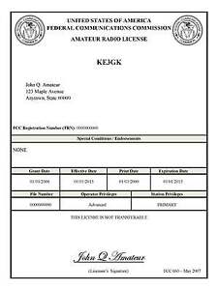*(By Anthony Luscre, K8ZT)*

As of February 17, 2015, the **FCC no longer routinely issues paper license documents** to Amateur Radio applicants and licensees. The Commission has maintained for some time now that the official Amateur Radio license authorization is the electronic record that exists in its Universal Licensing System (ULS). The FCC will continue to provide paper license documents to all licensees who notify the Commission that they prefer to receive one.

Licensees also will be able to print out an official authorization — as well as an unofficial “reference copy” — from the ULS License Manager. I’ve created a set of instructions on how you can request an **“official” printed copy of your license\***

[**Click here to download the instructions**](http://arrl-ohio.org/news/2020/print_your_license.pdf)

***One Question Questionnaire***

Hey Gang,

I’ve got a new question, so how about going to www.ARRL-OHIO.org and giving me a click? (It’s in the bottom left corner of the page)

***“Have you ever restored a “Boat Anchor” radio?”***

From the last Poll: **"Do You Ever Operate CW?"**

53.45 said NO. 46.55% said YES. (out of 116 responses)

*****V.E. Test Sessions***

Many V.E.’s have decided to start testing once again, but with restrictions that need to be adhered to for sure. Here’s the link to find that V.E. Test session and what is expected of YOU before going. <http://www.arrl.org/find-an-amateur-radio-license-exam-session>

Ohio Section Cabinet

|  |  |
| --- | --- |
| Section Manager – Tom Sly, WB8LCD | Section Traffic Manager – David Maynard, WA3EZN |
| Section Emergency Coordinator – Stan Broadway, N8BHL | Section Youth Coordinator – Anthony Luscre, K8ZT |
| Technical Coordinator – Jeff Kopcak, K8JTK | Affiliated Clubs Coordinator – Tom Sly, WB8LCD |
| State Government Liaison – Bob Winston, W2THU | Public Information Coordinator – John Ross, KD8IDJ |



Hey Gang,

Have you taken a look at the **Swap & Shop** page on the Ohio Section webpage yet?? Here’s a link that will take you there… <http://arrl-ohio.org/sm/s-s.html>

Do you have equipment that you just don’t need or want anymore? Here’s a great venue to advertise it, and it’s FREE!! Is your club doing a fund raiser to help raise money? After a lot of thought, it was decided that the Swap & Shop webpage could also contain these types of items as well. The same rules will apply as do for the For Sales and Give-A-Ways and will only be posted for a month at a time. Please see the Terms & Conditions on the webpage.

If your club is doing a fund raiser and wants more exposure, please forward the information to me and I’ll advertise it on the Swap & Shop webpage for you.

Now, I still want to remind you that it won’t be listed in this newsletter because it would take up way too much space, so your ad will only appear on the website. It is there for any individual to post equipment Wanted / For Sale or Give-Away as well as for Club Fund Raisers. No licensed vehicles/trailers or business advertising will be posted. Postings are text only (no pictures or graphics) will be posted for a maximum of 1 month from date posting and require a contact phone number or email within the posting. Send your Wanted / For Sale or Give-Away post to:  [swap@arrlohio.org](mailto:swap@arrlohio.org)

***Back Issues of the PostScript and Ohio Section Journal***

Hey, did you know that PostScript and Ohio Section Journal (OSJ) are archived on the website? You can go back and look at any edition simply by clicking:

<http://arrl-ohio.org/news/index.html>

***Want to Share your Club Newsletter With Others?***

We have a webpage where you can download and read all of the newsletters that I get from around the state and even other sections!

Here’s the link to the page…. <http://arrl-ohio.org/club_news/index.html>

Please, if you don’t see your club newsletter posted, it’s because I’m not receiving it. Just have your newsletter editor contact me and I’ll get your club’s newsletter listed on the site!!

We all learn and steal (I mean, share) from each other’s work. So, get me your newsletter!!! Send it to: [webmaster@arrl-ohio.org](mailto:webmaster@arrl-ohio.org)

***Chit – Chat, and All That!***

Do you know someone that’s not getting these Newsletters? Please, forward a copy of this Newsletter over to them and have them “[Opt-In](mailto:Opt-In)” to start receiving them. Heck, just have them send an email to: [webmaster@arrl-ohio.org](mailto:webmaster@arrl-ohio.org) and we’ll get them added to the Ohio Section Emailing list.

We now have many thousands of readers receiving these newsletters weekly. Quite impressive, I’d say! I urge all of you to make sure that everyone, regardless of whether they are a League member or not, get signed up to receive these weekly Newsletters.

You can always “Opt-Out” at any time if you feel this is not what you were expecting. It’s fun and very informative. All of your favorite past newsletters are now archived too.

You can go back at any time and read them.

Just go to: <http://arrl-ohio.org/news/>

The pictures on the front page and throughout this newsletter are from various newsletters, Facebook posts and/or were sent directly to me in recent weeks. Take a good look at them, you just might be in one of the pictures! “SMILE… you’re in the Ohio Section News!!”

*PostScript is produced as a weekly newsletter. I want to thank everyone that has contributed articles and ideas to make this an even better news source. I sincerely hope that you have enjoyed this edition and will encourage your friends to join with you in receiving the latest news and information about the Ohio Section, and news and events happening around the world!*

1. For those interested in a useful book on propagation, including a more detailed explanation of gray line propagation, I highly recommend *The Shortwave Propagation Handbook* by George Jacobs, W3ASK, and Theodore J. Cohen, N4XX, CQ Publishing, Inc.
2. *The ARRL Antenna Book*, ed. Gerald Hall, K1TD, 16th edition, (Newington: The American Radio Relay League, 1991), pp. 2-16
3. PacketCluster is a trademark of Pavillion Software, Marlborough, MA