[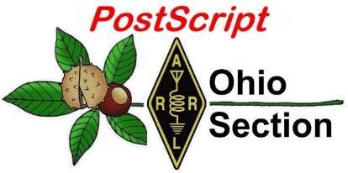](http://arrl-ohio.org/news/) ***“JUNE 7th***

***Edition”***

🡪 National News 🡪 Club Corner

🡪 DX This Week 🡪 Contest Corner

🡪 Upcoming Hamfests 🡪 South 40

🡪 One Question Questionnaire 🡪 VE Testing

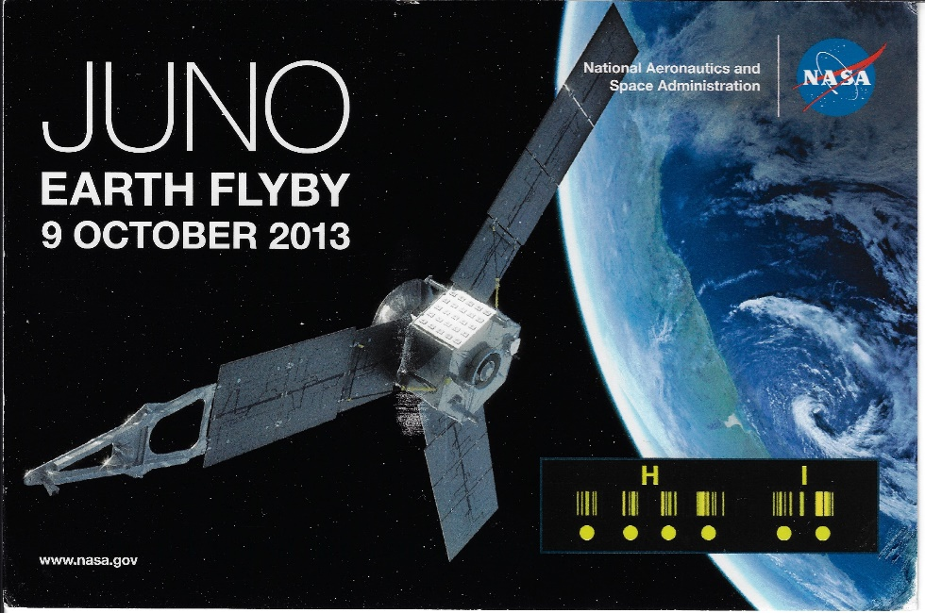

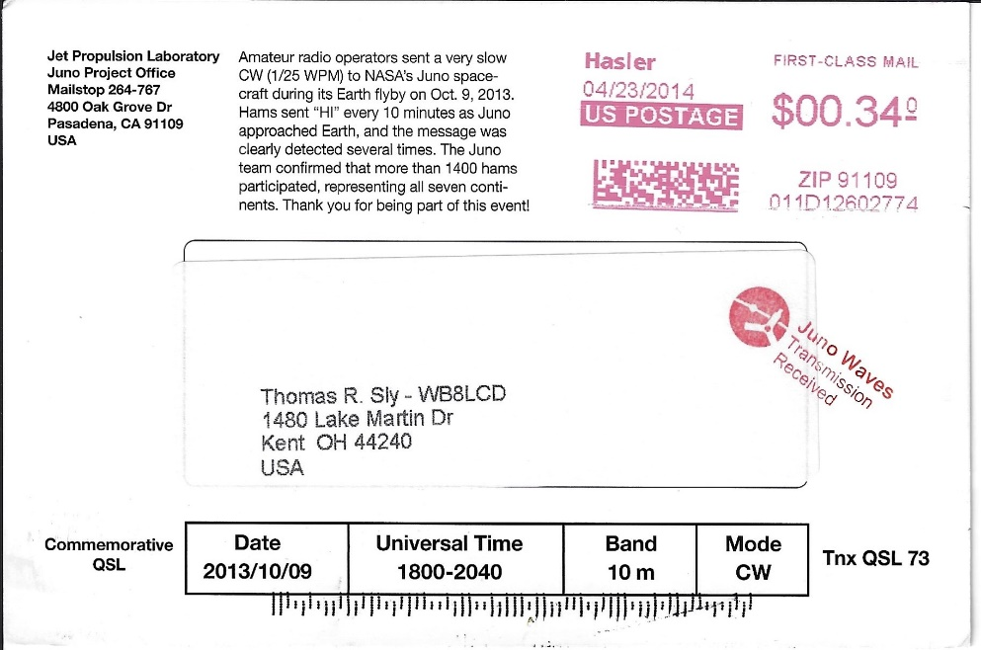

***National News***

*(from arrl and other sources)*

ARRL Learning Network Webinars

Visit the [ARRL Learning Network](http://www.arrl.org/arrl-learning-network) (a members-only benefit) to register, check on upcoming webinars, and view previously recorded sessions.

**Ask the Lab: How ARRL's Technical Information Service Can Help You -- ARRL Laboratory Manager Ed Hare, W1RFI / Tuesday, June 8, at 1 PM EDT (1700 UTC)**

Learn about the ARRL Technical Information Service (TIS) and the expert ARRL Laboratory staff, who answer thousands of questions each year from members. Get tips about projects, suggestions to address various station installations, and help for some of your most ****pressing ham radio questions. You'll discover how to search ARRL's extensive Periodicals Archive, find helpful articles, read test reports, access technical forums, and find answers to technical questions beyond the Lab.

**Improving Your Club's 2021 Field Day Score -- Paul Bourque, N1SFE, ARRL Contest Program Manager / Thursday, June 10, 8 PM EDT (0000 UTC on Friday, June 11).**

Learn how your club or group can take advantage of the 2021 ARRL Field Day rules waivers for operating as Class D or E from home. We'll discuss how individuals or groups can boost their scores by earning bonus points, review how to use the Field Day web applet to submit your score, and go over how to attribute your score to your club's aggregate score. This presentation highlights all you need to know to operate as a group for ARRL Field Day 2021.

**Antenna Zoning Part 1: Permitting in a Nutshell -- Fred Hopengarten, K1VR / Monday, June 14, 2 PM EDT (1800 UTC).**

This is the first webinar of a special six-part series being presented by Fred Hopengarten, K1VR, author of *Antenna Zoning for the Radio Amateur*. Don't let the confusing tangle of ordinances and bylaws keep you from installing the antenna you need in order to communicate effectively.

**Introduction to Remote HF Operation -- Davide Lanfranconi, W6DGE, and Kevin Shin-Wheeler, N7KSW, Cal Poly Amateur Radio Club / Tuesday, June 22, 1 PM EDT (1700 UTC).**

Lanfranconi and Shin-Wheeler will discuss the idea, process, and challenges encountered while getting their club's remote HF station on the air, as well as some methods and resources available for those with a similar interest. A Q&A session and live demo are included.

ARRL members may register for upcoming presentations and view previously recorded [Learning Network](http://www.arrl.org/arrl-learning-network) webinars. ARRL-affiliated radio clubs may also use the recordings as presentations for club meetings, mentoring new and current hams, and discussing amateur radio topics.

These Learning Network presentations are sponsored by PreppComm.

Radio Amateurs of Canada Invites Participation in the RAC Canada Day Contest

Help Canada celebrate its birthday on the air during the RAC [Canada Day Contest](https://www.rac.ca/wp-content/uploads/2021/05/CanadaDayContestRules2021_English.pdf) on Thursday, July 1 -- just a few days ahead of Independence Day in the US. Canada Day is the anniversary of Canada's confederation, when the three colonies of Canada, Nova Scotia, and New Brunswick united into the Dominion of Canada on July 1, 1867. The RAC Contest Committee is asking all participants in the 2021 Canada Day Contest to follow guidelines provided by the government and by health officials in their respective areas for any multioperator categories.

The Canada Day Contest begins on July 1, 0000 UTC (the evening of Wednesday, June 30, in North American time zones) and continues through 2359 UTC. Bands include 160, 80, 40, 20, 15, 10, 6, and 2 meters, CW and phone (SSB, FM, AM, etc.).

Stations in Canada send signal report plus province or territory. VE0s and stations outside Canada send a signal report and a serial number.

Stations may be worked once on each mode on each of the available bands. Canada's 10 provinces and three territories serve as multipliers for the event.

New Contest Hotel location for Hamvention 2022

Attention Contesters and DXers! Contest-related activities that have previously taken place at the Crowne Plaza Hotel during the Dayton Hamvention(R) are moving to the Hope Hotel beginning in 2022.

In May 2022, official Contesting activities will be at the Hope Hotel, including four nights of the Contest Super Suite, Contest University, The Top Band Dinner, The Contest Dinner and the KC DX Club CW copying competition. There may be additional related events as well.

The Hope Hotel is an excellent facility, well suited for Contesters and DXers. There is plenty of parking and it is located closer to the Hamvention than the downtown Dayton hotels. The Hope Hotel is adjacent to the Wright-Patterson Air Force Base. Guests do not go through the security gate.

We have spent almost two years working on this project and we believe you will enjoy the change of venue.

Room reservations will be taken by the Hope Hotel starting on Tuesday June 8, 2021 at 9 AM EDT. Do not call them before that time. You can get room reservations by phone only. If you try to book on line you will see that there are no rooms for those dates. Every room in the Hope Hotel has been blocked for Contesters and DXers for Hamvention week.  Starting Tuesday June 8, 2021 at 9 AM EDT, you can call 937-879-2696 and ask for a reservation in the Contest University 2022 room block. There is no minimum night commitment. The room rate is $143 per night plus tax and that includes a hot buffet breakfast each day of your stay. The room rate is the same for a single queen, two queens or a single king with a pull out.

If you have 2022 reservations at the Crowne Plaza (now the Radisson Hotel Dayton) you can contact the Radisson  at (937) 224-0800 to cancel and obtain any refunds. The Radisson is aware of the venue change for our activities.

Please spread the word to all Contest Club reflectors, etc.

We look forward to seeing you on Wednesday night, May 18, 2022, for the first night of the 2022 Contest Super Suite at the Hope Hotel.

<https://www.hopehotel.com/>

73,

Tim K3LR

For the Contest Hotel Committee

__________________________________________________________________________________________

QSP: The Potluck Newsletter For Radio Messaging

C. Matthew Curtin, KD8TTE

QSP is a newsletter about emergency radio communication built with the tools and skills needed for emergency radio communication. Your humble editor uses amateur radio for the receipt of contributions and distribution of the product. Once weekly, we issue the newsletter, and include contributed content from others with an interest in radio messaging. Our use of radio messaging to carry content, meet deadlines, and to distribute the product helps us to ensure that the systems we have in place for message relay are in good working order.

We're taking contributions as freeform text, NTS radiogram, 16-line radiogram, a custom FLMSG form, or any other means that you like. If it presents what's needed to carry the content, identify its source, and to show its destination, we'll handle it. We've got instructions for how to participate via NTS, BBS, NBEMS, Winlink, and even liaison in case you're not able to reach any of these systems.

We call it a “potluck newsletter” because it's distributed to those who brought something to the party. Your contribution need not be fancy: just a station identification and location will do the trick. If you'd like to add more, you're welcome to do so. We'd love to hear about your options for the week, special projects that you're working on, activities on your nets, or the events taking place in your county and district.

Pick any day of the week that works for you—just make sure to set the time aside ahead of time to participate. A few minutes of committed activity every week can go a long way to improving your operating capability.

There are two steps to take: compose your contribution and choose the path to send and receive your QSP content.

Get started at <https://www.blackswancomex.org/2021/qsp/join-the-party>.

____ _____ _____

/ __ \ / ____| | __ \ QSP: The Potluck Newsletter For Radio Messaging

| | | | | (___ | |__) | ...with focus on emergency communication.

| | _| | \___ \ | ___/

| |_\ | ____) | | | "If they're going to all the trouble to throw an

\___\_\ |_____/ |_| emergency, we should at least be ready to play."

We look forward to hearing from you.

***Club Corner***

This is YOUR cornner of the newsletter. Send me what your club is doing and I’ll make sure that it gets in. Got a special event or club project that you want everyone to know about? Send it to me!. Need help with a project? Send it to me.

Let me know what you club is up to. Are you going to have a special guest at your meeting or are you having a special anniversary?

Just sent it to: [webmaster@arrl-ohio.org](mailto:webmaster@arrl-ohio.org)

**Ham Radio Operators Provide Communications for the Ironton Lawrence County 153rd. Memorial Day Parade**

﻿

Monday, May 31, 2021, started out with a cool temperature of 48 degrees and a heavy dense fog.  However, as the day unfolded, the weather became perfect for a parade.  It was not just any parade. It was the 153rd Ironton Lawrence County Memorial Day Parade in downtown Ironton, Ohio.  It is the nation’s Oldest-Continuous Memorial Day Parade (since 1868), honoring our servicemen and women who have steadfastly protected America’s and the world’s freedom. Thousands of spectators lined the streets of Ironton to watch the parade with 10 divisions of floats, animals, marching bands, and special honorees.  A fantastic addition was a flyover of two Airforce fighter jets at low altitude. Vintage aircraft circled during the parade. This is a special time for families of multiple generations coming together for this long-standing tradition.

 However, the parade would not have been possible it were not for the hundreds of volunteers throughout the year and on parade day.  One special component of volunteers is communications which is provided by Tri-State Area Amateurs (Ham Radio Operators). Members of the Southern Ohio Amateur Radio Association (SOARA) and Lawrence County Amateur Radio Emergency Service (ARES) are joined by Hams from Kentucky and West Virginia. James Rowe N8TVO is the parade committee’s liaison for communications.

Tim Nicely AC8VQ, SOARA President said, “This is a great opportunity to get together as volunteers for this special event providing tactical point to point and emergency communications in a professional net-controlled manner”.

“What a fantastic training exercise”, said Jerry Lockhart, W8HIC, Lawrence County ARES Emergency Coordinator.  It is this type of an event that allows us to hone our skills for emergency communications.”

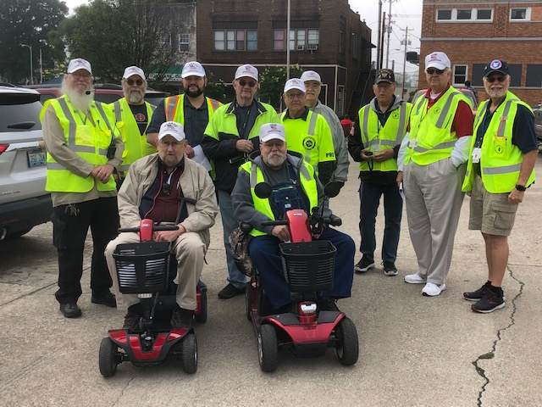James Rowe N8TVO, Parade Liaison, and the Parade Committee would like to thank each Ham Radio Operator and support staff (spouses/family) for their time and expertise providing vital communications for each of the 10 divisions.

The following 14 amateurs participated:

Keith Brooks, N8DKB (Net Control)

James Rowe, N8TVO

Faye Rowe, Assistant

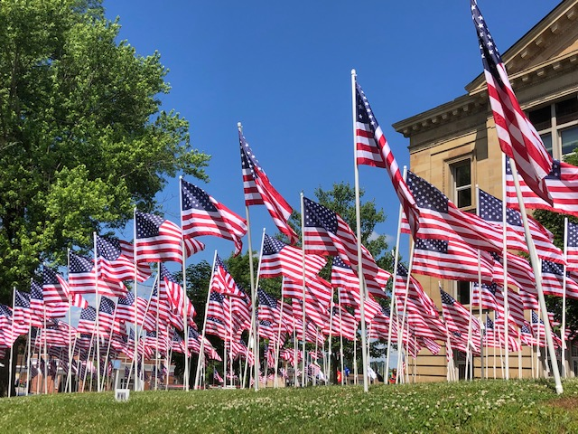A.J. Pierson, N8LRO

Tim Nicely, AC8VQ

Jerry Lockhart, W8HIC

Mike Love, WB8YKS

Don Kemper, KN4KSS

Gary Caldwell, WX8G

James Reneau, N4REN

Joe Thompson, KD8FPX

Chad Thompson, KE8SAO

Dave Bruce, KD8NYN

Jerry Huffman, N8YN

Fred Herr WD8AGH

The Ironton downtown 444.625 repeater worked seamlessly, and as a backup 147.570 simplex was established but was not required. There was a considerable amount of preplanning for the parade communications should an emergency occur.  I am glad to report there were no emergencies and the parade completed without incident.

Michael Love, WB8YKS

SOARA / ARES

Ohio Section PIO

Upcoming "CQ More Light" contest

I wanted to send along the upcoming contest information for our "CQ More Light" Masonic Lodges on the Air event.  The main landing page is <http://cqmorelight.com/> (links to facebook and twitter feeds are at the bottom of the page).

The first ever attempt at this contest will be September 25, 2021, 10am - 6pm EDT.  Future dates are on the Saturday of, or immediately following the Autumnal Equinox.

Once again, John Myers (KD8MQ) has been invaluable in helping us get this started.  No one in our radio club has ever attempted organizing a contest, so this might be a little rocky in it's first year.  We are attempting to build on the work of OSPOTA to make it as successful as possible.

Best Regards

Craig / KD8KBU

**From Cuyahoga County ARES**

It appears that 2021 is going to be an almost back to normal year as far as events go. For the complete list, please check the calendar at [https://n8esg.org/events/](https://n8esg.org/crm?civiwp=CiviCRM&q=civicrm/mailing/url&u=62&qid=768)

Please check the calendar frequently as new events are continuously being added, and updated.

* **June 26 Bike to the Bay Port Clinton**
  + [Sign Up](https://n8esg.org/crm?civiwp=CiviCRM&q=civicrm/mailing/url&u=63&qid=768) David Michl KE8ANJ contact person
* **July 22-25 Pan Ohio Hope Ride**
  + [Sign Up](https://n8esg.org/crm?civiwp=CiviCRM&q=civicrm/mailing/url&u=64&qid=768) Mat KC8NZJ contact person
* **August 7 MS150 Bike Ride**
  + [Sign Up](https://n8esg.org/crm?civiwp=CiviCRM&q=civicrm/mailing/url&u=65&qid=768) Jeff Garvas N8YNR contact person
* **August 28 ZERO Prostate Cancer 5k**
  + [Sign Up](https://n8esg.org/crm?civiwp=CiviCRM&q=civicrm/mailing/url&u=60&qid=768) Mat KC8NZJ contact person
* **August 29 Bike Cleveland Fundo**
  + [Contact Matt Welch](https://n8esg.org/crm?civiwp=CiviCRM&q=civicrm/mailing/url&u=66&qid=768) W8DEC
* **September 19 Sunday in June SAG Support (postponed from June 13)**
  + [Sign Up](https://n8esg.org/crm?civiwp=CiviCRM&q=civicrm/mailing/url&u=67&qid=768) Matt Welch W8DEC contact person
* **September 21 Hopkins Airport Drill**
  + [Sign Up](https://n8esg.org/crm?civiwp=CiviCRM&q=civicrm/mailing/url&u=68&qid=768) Mat KC8NZK contact person
* **September 26 Cleveland Hamfest Talk In Station and General Volunteers**
  + [Sign Up](https://n8esg.org/crm?civiwp=CiviCRM&q=civicrm/mailing/url&u=69&qid=768) Mat KC8NZJ contact person
* **October 23-24 Cleveland Marathon**
  + [Sign Up](https://n8esg.org/crm?civiwp=CiviCRM&q=civicrm/mailing/url&u=59&qid=768)Mat KC8NZJ contact person

**FCARC SummerFest**

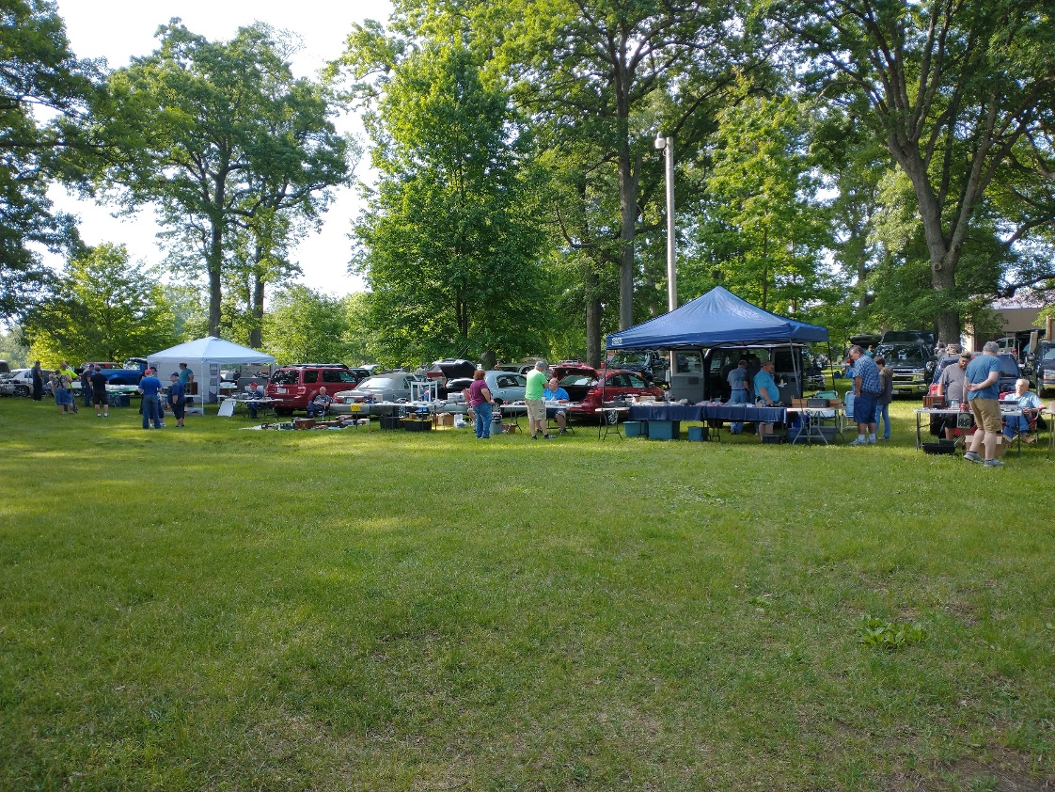

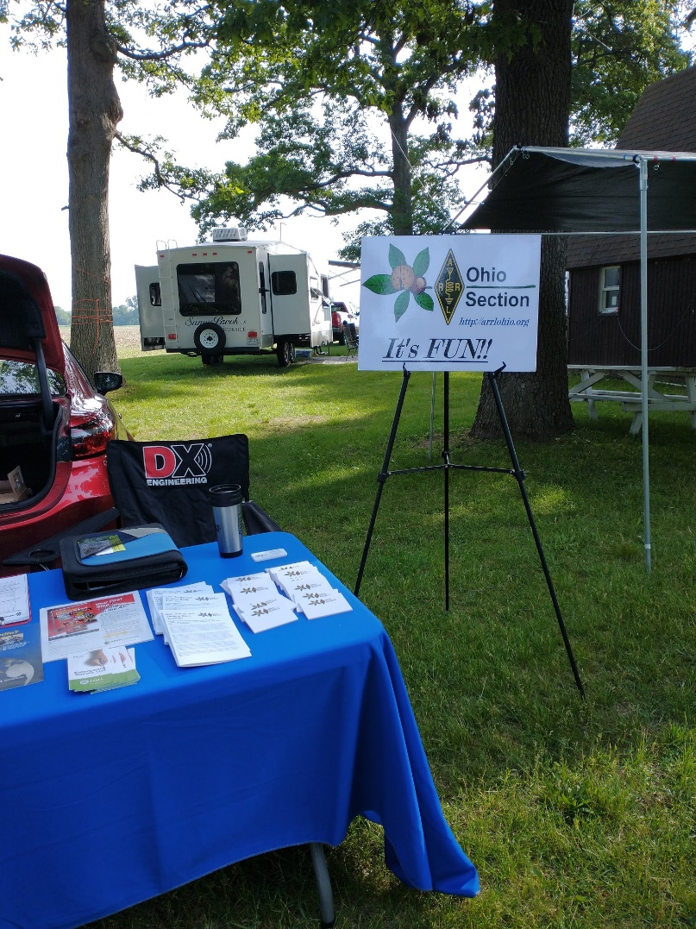

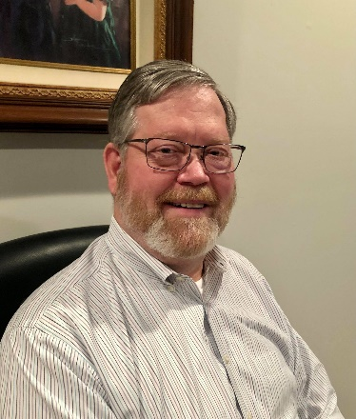

DX This Week – CE3CT

Bill AJ8B (aj8b@arrl.net, @AJ8B, or www.aj8b.com)

CWOPs Member #1567

I have breaking news…..The SouthWest Ohio DX Association has confirmed that Bernie, W3UR, will be the keynote speaker at the W8DXCC convention mentioned below. You probably recognize Bernie’s call from the QST DX column, the Daily DX, and the Weekly DX. Bernie also joined the exclusive 3,000 club of the DXCC Challenge in recent years. Among DXPeditions and numerous other achievements, Bernie earned DXCC Honor Roll by age 27. We are thrilled that Bernie will be our keynote speaker!

Now, back to the regularly scheduled program….

The Midwest DX Cluster spots included Anguilla, Asiatic Russia, Australia, Austria, Belize, Brunei Darussalam, Canada, Canary Islands, Cayman Islands, China, Christmas Island, Colombia, Cuba, Finland, Guyana, Hawaii, Japan, Kazakhstan, Mexico, New Zealand, Norway, Oman, Philippines, Portugal, Puerto Rico, Republic of Korea, Singapore, Spain, United States, Uruguay, US Virgin Islands, West Malaysia, and Western Sahara. This brings the total number of entities spotted in the Midwest in 2021to 179!

Are you working towards the CQDX Marathon? If so, how are you doing?

The three-week drought was ended by the post man. I received two great cards from HL3GOB, Lee in South Korea and a card from VK4ZD, Bill in Queensland, Australia.

|  |  |
| --- | --- |
|  |  |

*DAH DIT DIT DIT DAH DAH DIT DIT DIT DAH*

Have you noticed any changes in propagation? We had two nights last week where 15 meters was open until almost 10 PM. This was an example of simple “seat in the chair” operating. None of the stations I worked on 15 were rare so they weren’t spotted on the DX Cluster so no texts appeared on my cell phone! However, it was certainly fun to have CW QSOs with hams in Europe on 15 at 8 and 9 PM EST! Have not experienced that in years. Pick some off times and fire up the rig. You might be surprised at what you will hear!

*DAH DIT DIT DIT DAH DAH DIT DIT DIT DAH*

We are approaching the 90 days until the W8DXCC convention. I am so excited about all the speakers AND the DX roundtable that we are holding before the convention actually starts! If you haven’t done so, go to [www.w8dxcc.com](http://www.w8dxcc.com) and fill out the form at the bottom of the page. We will keep you informed as we move forward. Also, you can follow us on Facebook: (DXCC SWODXA), Instagram (W8DXCC), and twitter (@dxccw8) – Lots of ways to keep informed. We have a limited number of tickets and they will go on sale soon.

*DAH DIT DIT DIT DAH DAH DIT DIT DIT DAH*

This week I am reprinting another one of the interesting interviews that have appeared in the SouthWest Ohio DX Association newsletter. This time it is CE3CT, Roberto. He is a first-class operator with a great station. Thanks to SWODXA for permission to reprint.

Interview with Roberto—CE3CT

*I have worked Roberto many times, in and out of contests. He is an outstanding operator and has a very interesting story to tell. He immediately responded to my query about an interview. You can reach him at* [ce3ct.roberto@gmail.com](mailto:ce3ct.roberto@gmail.com)

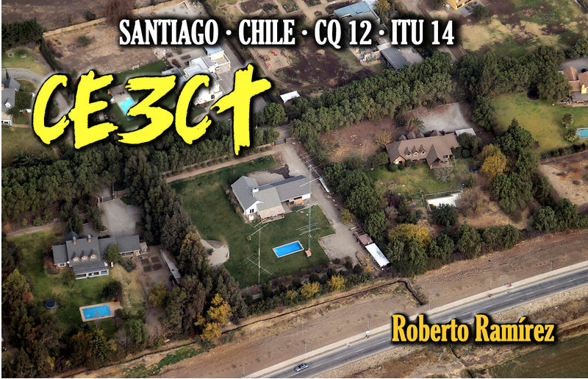AJ8B: How did you first get interested in amateur radio?  
CE3CT: My interest in radio started in 1987 when I was 15 years old and living in Talca. I began listening to FM broadcasting so that I could record music on cassette tapes to take to parties. The closest FM station was in Curico, 55 kms north of Talca, so I needed to install an outdoor hi-gain antenna to receive the station. I began to study various antenna designs and built several different antennas always with the desire to improve the received signal of the distant FM stations. I also discovered I was able to copy many other FM and short-wave stations and soon I was listening to signals from around the world. In early 1988 I received SWL license CE-064 and in late 1988 obtained the license as an aspiring amateur A-8304.

AJ8B: When did you get on the air?  
CE3CT: I obtained my Novice license, CE4PBB, in 1989 and a little time later passed the examination for extra class. My main interest was in DX and Contesting.

AJ8B: Do you have a favorite band or mode?  
CE3CT: In the beginning, my interest was Contests, I was part of the team of Radio Club of Talca, and for many years we have been one of the more active Chileans Club on DX Contesting. For many years Phone was my favorite mode but a few years ago CW became my favorite. Also, I work Digital modes and satellites.

AJ8B: What time of day and days do you like to operate?  
CE3CT: I have a medium Contest Stations with two big towers and mono bands, available for Multi Operators, and these require much work for maintenance. Every weekend I dedicate time to repair something and testing. We operate the major contests on Phone and CW Full time.

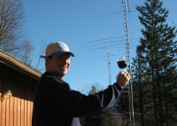AJ8B: Any secrets to your success?  
CE3CT: The only secrets is preparation and station maintenance. We have all Zone 12 records as Multi and Single Op. And our technical problems are minimum.

AJ8B: Any tips that you can share?  
CE3CT: The connectors are the principles problems. Few years ago I decided to use the crimp connectors and that was very significant to cancel any interactions (Interferences) between stations.  
 Another contesting tips, especially on Multi operations, are to form a good team with good friends.

AJ8B: What license levels do you have in Chile?  
CE3CT: General License, in Chile we have the following licenses, Aspiring (CD), Novice (CA), General (CE) and Superior (XQ). The last category requires a change for the prefix from CE to XQ. For me the XQ prefix is not a good prefix for phone contesting. This is my reason not apply for this category.

AJ8B: Describe what you are currently using:  
CE3CT: I have three identical positions using Elecraft K3 + Amplifiers Alpha 91B, 89A, and an Acom 1500.

The antennas are:

• 160m : Sloper 1/4 + Beverages to NE and NW

• 80m : K8UR Array + Dipole + Beverages to NE and NW

• 40m : 40M2L with kit coils Rotating @ 100 ft. M2

• 20m : 6 elements Rotating @ 130 ft, JVP Antennas

• 15m : LJ155 Rotating @ 100 ft. //  6 elements NA @ 50 ft, JVP Antennas

• 10m : 6 / 6 Elements @ 110 ft / 60 ft  rotating, JVP Antennas

• + 30m Dipole @ 60ft, 2 Elements WARC Bands @ 50 ft. , 5 elements 6m

Any station can use any antenna of the antenna farm.

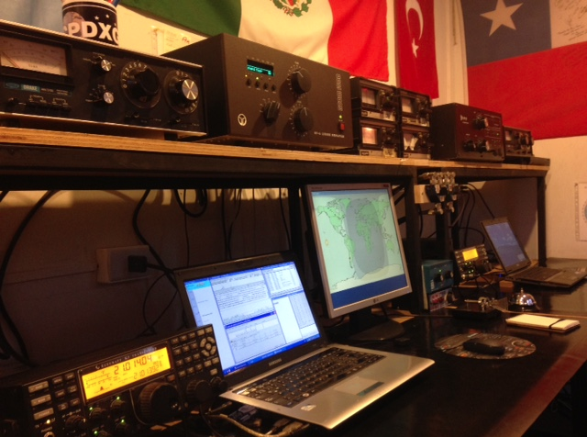Also, I Am hosting the AMSAT CE Satellite station CE3SSB in my home. This station has an FT-847 and array for U-VHF with high gain performance with elevation and azimuth rotator.

AJ8B: What advice do you have for those of us trying to break pileups to work DX?  
CE3CT: I think patience is the main recommendation.

You need to stay at your transmitting frequency as much as are possible to break the pile-up, you never know when the DX station can hear you.  
 Also, respect the others stations is important and don't call when the DX stations is listening to someone else!

AJ8B: Any QSLing hints?  
CE3CT: Now I'm LOTW user, it is a fantastic platform and safe. Thanks to ARRL-LOTW for this great job.

AJ8B: What coaching/advice would you give new amateurs?  
CE3CT: One of the most important things over the years on ham radio is that I have found  great friends, I think this is important to know for young amateur radio, this a special little world  with a great people. Ham radio is part of my life, I studied electronic engineering, the radio is my passion for my work and for my hobby. I love the radio.

AJ8B: Thanks for taking the time to answer my questions. Is there anything you would like to share with us?  
CE3CT: Many thanks to SouthWest OH DX Association for the interview, always is important to know hams for any place of the world.  It is an honor for me to see your interest in showing my passion for radio amateurs.

Many thanks  
CE3CT - Roberto  
[www.ce3ct.com](http://www.ce3ct.com)

*DAH DIT DIT DIT DAH DAH DIT DIT DIT DAH*

CQDX CQDX CQDX CQDX CQDX CQDX CQDX CQDX CQDX

Here is an update from Bernie, W3UR, of the DailyDX and the WeeklyDX, the best source for DX information. <http://www>.dailydx.com/. Bernie has this to report:

**HC8 - Galapagos Islands -** WB2REM, Jim, and his team are heading to HC8 in early March 2022. When you editor asked about 6 meters, as HC8 has not been QRV on the Magic Band since 2002, he said they are considering operating FT8 on 50 MHz. He's looking for suggestions for a small lightweight collapsible Six Meter antenna to take. Suggestions can be sent to his email, listed on QRZ.com. They are taking a KPA500. <http://www.hd8m.com>  
  
**OY - Faroe Islands -** LB5SH, Stian, is planning a one weekend activity from Torshavn as OY/LB5SH "sometime mid- to late Autumn 2021". This will be mainly on SSB and FT8. His band selection has not been decided yet as this will depend on what antennas he takes. "Dates will be announced in good time".  
  
**T7 - San Marino -** Members of the Associazione Radioamatori della Repubblica di San Marino (ARRSM) Radio Club (T70A) will be operating special call T71CC during the 17th Carabinieri On The Air (COTA) from May 21 to June 5. There is an award available with details at <https://www.cota.cc/diploma-cota.html>

**FJ - St. Barthelemy -** K2LIO, Phil, remains QRV daily making several contacts each day as K2LIO/FJ. He expects to remain on St. Barts until around August 5th.

**Z2 – Zimbabwe -** Z21DX is (ex PA3CPG, 9J2GS, 3D6CW, C30BBP), Gertjan, and his XYL are now working and living in Masvingo in southeastern Zimbabwe "for an undefined period", says PA2LO, Gert. Over the past 20 years they have lived in several African countries. He has a Yaesu FT-847 and Butternut 8 band vertical along with a Heathkit 800-watt amplifier. He will be QRV on SSB on 80 through 10 meters. Gertjan reports very poor receiving and has mostly been hearing stations from ZS, "almost nothing else". At the moment there is no QSL information. So, hold off on QSLing until he provides a QSL route.  
  
**LX – Luxembourg -** A Dutch team including PA0PIW, Gerard; PA2LO, Gert; PA3EYC, Maarten; and PA3GRM, Tijmen; plan to be in Troisvierges, Luxembourg signing LX/home calls from October 13-19. They will have three Elecraft K3S's, a 6 band Hexbeam (20-6M) and wire antennas (160, 80, 60 & 30M). The PA's plan to be on CW, SSB and Digital modes. Some of the team members also plan to be QRV from some of the Flora and Fauna parks (WWFF) from Belgium and Luxembourg. Then they are operating from WWFF they will sign /p. QSL via PA3EYC and LoTW. QSOs will be uploaded to Club Log.

FROM THE DESK OF SRAL, FINLAND  
Helsinki, May.28. 2021  
FOR IMMEDIATE RELEASE  
  
SRAL OF FINLAND IS PUTTING SIX OF THEIR TREASURES ON WPX  
  
This is part of SRAL’s 100th Anniversary.  
  
EARN THE HIGHEST RECOGNITION FROM YOUR OH FRIENDS

Just contact 100 (one hundred) of your OH friends during 2021 and 10 (ten) specially featured Finnish stations to earn the OH Northern Light 100-year certificate (OH-NL-100) and the featured story, explaining the magic of the OH-land and the Northern Lights;

Your 100 contact should include 50 OH stations and 50 OF stations, a total of 100. A special OF prefix will be launched to all OH stations on September15th, 2021. Your maximum point value can be 100. The number of your OF/OH contacts.

**TEN SPECIAL ACTIVITY MULTIPLIERS**

SRAL and its members are active in a wide range of Amateur Radio activities and each of the ten multipliers represent some of those activities. The multiplying stations are; OH100SRAL, OH2A, OH0W, OJ0C, OF2HQ, OH2YOTA, OG2B, OH6SRAL, OI3AX and OF9X.

WHAT IS THE STORY ON THESE TEN MULTIPLIERS? WE PUT SIX OF THEM QRV IN THE WPX

OH2A: This is the SRAL HQ station in our capital, Helsinki. It is rarely active internationally but to honor this special year you can catch it occasionally. Surely A is first in the alphabets. Here the station is activated by Radio Club of Pusula, OH9W; OH2BCI, OH5BQ and OH2KW

OH100SRAL: This is the official SRAL centennial jubilee station which is circulating all year throughout Finland and is activated by SRAL’s member societies (120) and special activity groups. This will be activated by OH1AJ & OH1NDA

OH0W: Aland Islands is Finland’s share in the DXCC program. But also, the most beautiful archipelago to visit and enjoy. It is home to three HF superstations and the historical battlefield of all OH contesters for once winning the world -- CQWW at OH0W 1982. Here the station is activated by BIG Group; OH2GEK, OH2TA and OH6KZP

OG2B: The IARU/NCDXF beacon network has been supported by the SRAL and its dedicated members for almost 40 years. While OH2B is busy at work, the alternative OG2B will be its substitute during this centennial jubilee. Here the station is activated by; OH7EA

OI3AX: Amateur Radio activity in the Finnish Signal Corps (OI prefix) have a brilliant history of cooperation with SRAL. Many well-known OHs have caught the bug while doing their service to their country. OI3AX will represent the country-wide network of 35 OI-locations. Here the station is activated by; OH5LLR.

OH6SRAL: Every Saturday at 3 PM SRAL transmits its radio news to its entire membership. OH6 is in the middle of the country and has a long history of such transmissions. The chief, Heikki, OH6ZS has done those transmissions for more than 40 years and his dedication to this duty continues. Here the station is activated by; OH6NVC.

You will find a special logging sheet handy during the hunt: <https://www.sral.fi/wp-content/uploads/2021/04/SRAL-100_Logging.pdf>

*DAH DIT DIT DIT DAH DAH DIT DIT DIT DAH*



Below is a list of upcoming contests in the “Contest Corner”. I think this is important for someone who is trying to move up the DXCC ladder since entities that are on the rarer side and easiest to work in contests. Some of my best “catches” have been on the Sunday afternoon of a contest when the rarer entities are begging for QSOs. Of course, the gamble is that if you wait until Sunday, conditions may change, or they simply won’t be workable. However, it is not a bad gamble. Of course, why not work the contest and have some fun!  
Check out the WA7BNM Contest Calendar page (<https://www.contestcalendar.com/>) and CQ Magazine for more contests or more details.

The contests in red are those that I plan to spend some significant participation time on. PLEASE let me know if you are working contests and how you fared.

Thanks!

|  |  |  |
| --- | --- | --- |
| June 12 | Asia-Pacific SSB Sprint | http://jsfc.org/apsprint |
| June 12 | AGCW VHF-UHF Contest | https://bit.ly/3lw91PK |
| June 12-13 | Portugal Day Contest | https://portugaldaycontest.rep.pt/rules.php |
| June 12-13 | GACW WWSA CW DX Contest | www.contest.com.ar/gacw-wwsa |
| June 12-13 | REF DDFM 6M Contest | http://concours.r-e-f.org/index.php |
| June 12-13 | DRCG Long Distance Contest (RTTY) | www.drcg.de |
| June 12-14 | ARRL June VHF QSO Party | www.arrl.org/june-vhf |
| June 16 | RSGB 80m Club Championship, CW | http://bit.ly/3avHbk3 |
| June 19 | FIRAC VHF Contest | www.fireac.de/index.html |
| June 19-20 | All Asian CW DX Contest | www.jarl.org/English/0-2.htm |
| June 19-20 | Stew Perry Topband Challenge | www.kkn.net/stew/stew_rules.html |
| June 19-20 | Ukrainian DX classic RTTY Contest | http://urdxc.org/rtty |
| June 19-20 | West Virginia QSO Party | https://tinyurl.com/54c7ajfp |
| June 24 | RSGB 80m Club Championship, SSB | http://bit.ly/3avHbk3 |
| June 26-27 | ARRL Field Day | www.arrl.org/field-day |
| June 26-27 | His Maj. King of Spain SSB Contest | http://bit.ly/1cKAR5V |
| June 26-27 | Ukrainian DX DIGI Contest | www.izmail-dx.com |
| June 28 | RSGB FT4 Contest Series | http://bit.ly/3mCNXXH |
| July 17-18 | CQWW VHF Contest | [www.cqww-vhf.com](http://www.cqww-vhf.com) |
| August 28 | Ohio QSO Party | <https://www.ohqp.org/> |
| August 28 | W8DXCC | <https://www.w8dxcc.com> |

***DX News***

ARLD022 DX news  
  
This week's bulletin was made possible with information provided by The Daily DX, the OPDX Bulletin, 425 DX News, DXNL, Contest Corral from QST and the ARRL Contest Calendar and WA7BNM web sites.  Thanks to all.  
  
NIGERIA, 5N.  Jean-Louis, ZS6AAG is now QRV as 5N9JLH while working with Doctors Without Borders in Abuja until September 15.  Activity is in his spare time currently on 20 and 15 meters using SSB.  QSL via operator's instructions.  
  
TONGA, A3.  Masa, JA0RQV is QRV as A35JP from Tongatapu Island, IOTA OC-049, until the end of October.  Activity is on 80 to 6 meters using CW, SSB and FT8.  He also plans to visit other islands in IOTA groups OC-191, OC-123, OC-064 and OC-169 during this time.  QSL to home call.  
  
SPAIN, EA.  Members of the Radio Club of Torrevieja will be QRV as EH5SUB in the Museum Ships Weekend 2021 from the Submarine S-61 Delfin in Torrevieja.  QSL via EA5GVJ.  
  
ENGLAND, G.  Special event station GB95QB will be QRV from June 6 to 13 to celebrate Queen Elizabeth II's 95th birthday.  Activity will be on the HF bands using CW, SSB, RTTY, PSK and FT8.  QSL via operators' instructions.  
  
REPUBLIC OF KOREA, HL.  Special event station D721LP is QRV until June 30 for IARU QRP Day.  QSL via LoTW.  
  
ITALY, I.  Members of the United Nations Global Service Centre ARC in Brindisi are QRV as 4U29MAY until June 30 to promote the International Day of UN Peacekeepers.  QSL via 9A2AA.  
  
DENMARK, OZ.  Volker, DJ8VW is QRV as 5P8VW from Romo Island, IOTA EU-125, until June 10.  Activity is on 160 to 6 meters, possibly including 4 meters, using CW, SSB and FT8.  QSL via LoTW.  
  
NETHERLANDS, PA.  Jan, PA7X, Ruud, PD0RH and Willem, PA3CNI will be QRV as PA827HGV during the Museum Ships Weekend 2021 from the Hoogeveen, a decommissioned minesweeper now moored in Den Helder. QSL via operators' instructions.  
  
SWEDEN, SM.  Lars, SM6CUK will be QRV as SA6G/7 from Ven Island, IOTA EU-137, from June 7 to 12.  Activity will be on 40 to 10 meters using CW.  QSL to home call.  
  
DODECANESE, SV5.  Wolf, DL3DRN is QRV as SV5/DL3DRN from Rhodes, IOTA EU-001, until June 21.  Activity is on the HF bands using CW, SSB and RTTY.  QSL to home call.  
  
BRITISH VIRGIN ISLANDS, VP2V.  Gary, NC3Z is QRV as VP2V/NC3Z until June 14.  Activity is holiday style on 40 to 6 meters using SSB and FT8 and FT4.  QSL direct to home call.  
  
CHRISTMAS ISLAND, VK9X.  Steve, VK6SJ is QRV as VK9XX until June 11. Activity is generally around 1100 to 1500z and 2200 to 0000z daily on the HF bands and possibly 6 meters using FT8 and some SSB.  QSL via EB7DX.  
  
VIET NAM, XV.  Jun, JH4RHF, is QRV as XV9RH from Hanoi until June 26 while on work assignment.  Activity is in his spare time on 20 to 10 meters using CW and FT8.  QSL via OE1JUN.  
  
The K1USN Slow Speed CW Test and RSGB 80-Meter Club Data Championship are scheduled for June 7.  
  
The RTTYOPS Weeksprint, ARS Spartan CW Sprint and Worldwide Sideband Activity Contest are scheduled for June 8.  
  
The VHF-UHF FT8 Activity Contest, CWops Mini-CWT Test, NAQCC CW Sprint and Phone Fray are scheduled for June 9.  
  
Please see June QST, page 72, and the ARRL and WA7BNM contest web sites for details.

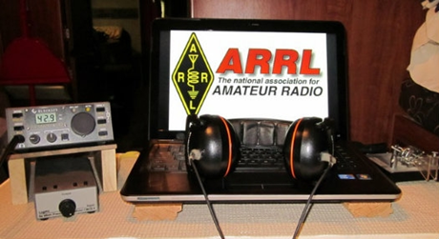**ARRL Contest Corner**

An expanded, downloadable version of *QST'*s’ [**Contest Corral**](http://www.arrl.org/contest-calendar) is available as a PDF. Check the sponsor’s ‘Website for information on operating time restrictions and other instructions.

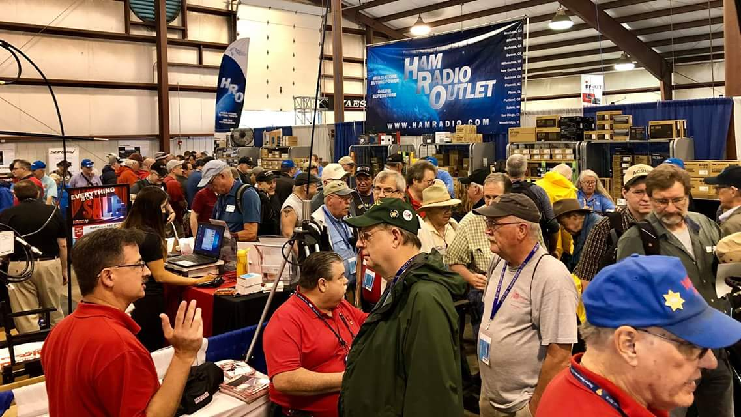[**Upcoming *Hamfests***](http://arrl-ohio.org/hamfests.html)

We **DO** have some hamfests scheduled for 2021!! Yes, take a good look at the list, it’s growing every day!

Be sure to keep your eyes on this schedule as that when things start getting better and the vaccine rolls out to more and more, hamfests will surely get back to their normal schedule. Don’t see your hamfest listed?? Did anyone register it with ARRL? It’s really easy to do and you get a lot of FREE publicity if you do.

HAMFEST/CONVENTION

**07/10/2021 -**[**Mansfield Mid-Summer Trunkfest**](http://www.arrl.org/hamfests/mansfield-mid-summer-trunkfest)

**Location:**Mansfield, OH  
**Type:** ARRL Hamfest  
**Sponsor:** Intercity Amateur Radio Club  
**Website:** [http://WWW.IARC.CLUB](http://www.iarc.club/)  
[**Learn More**](http://www.arrl.org/hamfests/mansfield-mid-summer-trunkfest)

HAMFEST/CONVENTION

**07/17/2021 -**[**NOARSFEST**](http://www.arrl.org/hamfests/noarsfest-8)

**Location:**Elyria, OH  
**Type:** ARRL Hamfest  
**Sponsor:** Northern Ohio Amateur Radio Society  
**Website:** [http://noars.net](http://noars.net/)  
[**Learn More**](http://www.arrl.org/hamfests/noarsfest-8)

HAMFEST/CONVENTION

**07/18/2021 -**[**Van Wert Hamfest**](http://www.arrl.org/hamfests/van-wert-hamfest-5)

**Location:**Van Wert, OH  
**Type:** ARRL Hamfest  
**Sponsor:** Van Wert Amateur Radio Club  
**Website:** [http://W8FY.ORG](http://w8fy.org/)  
[**Learn More**](http://www.arrl.org/hamfests/van-wert-hamfest-5)

HAMFEST/CONVENTION

**08/07/2021 -**[**2021 Columbus Hamfest**](http://www.arrl.org/hamfests/2021-columbus-hamfest)

**Location:**Grove City, OH  
**Type:** ARRL Hamfest  
**Sponsor:** Aladdin Shrine Audio Unit  
**Website:** [http://columbushamfest.com](http://columbushamfest.com/)  
[**Learn More**](http://www.arrl.org/hamfests/2021-columbus-hamfest)

HAMFEST/CONVENTION

**08/28/2021 -**[**Cincinnati Hamfest℠**](http://www.arrl.org/hamfests/cincinnati-hamfest)

**Location:**Owensville, OH  
**Type:** ARRL Hamfest  
**Sponsor:** Milford ARC  
**Website:** [http://CincinnatiHamfest.org](http://cincinnatihamfest.org/)  
[**Learn More**](http://www.arrl.org/hamfests/cincinnati-hamfest)

HAMFEST/CONVENTION

**09/26/2021 -**[**Cleveland Hamfest**](http://www.arrl.org/hamfests/cleveland-hamfest-1)

**Location:**Berea, OH  
**Type:** ARRL Hamfest  
**Sponsor:** Hamfest Association of Cleveland  
**Website:** [http://www.hac.org](http://www.hac.org/)  
[**Learn More**](http://www.arrl.org/hamfests/cleveland-hamfest-1)

HAMFEST/CONVENTION

**10/31/2021 -**[**Massillon (Ohio) Hamfest**](http://www.arrl.org/hamfests/massillon-ohio-hamfest)

**Location:**Green, OH  
**Type:** ARRL Hamfest  
**Sponsor:** Massillon Amateur Radio Club  
**Website:** [http://w8np.org](http://w8np.org/)  
[**Learn More**](http://www.arrl.org/hamfests/massillon-ohio-hamfest)

HAMFEST/CONVENTION

**12/04/2021 -**[**FCARC WinterFest**](http://www.arrl.org/hamfests/fcarc-winterfest-2)

**Location:**Delta, OH  
**Type:** ARRL Hamfest  
**Sponsor:** Fulton County Amateur Radio Club  
**Website:** <http://k8bxq.org/hamfest>  
[**Learn More**](http://www.arrl.org/hamfests/fcarc-winterfest-2)

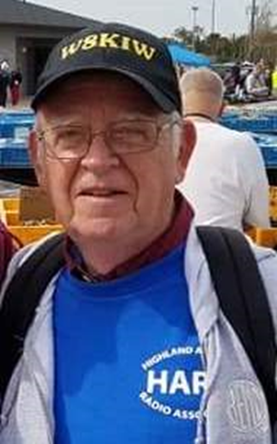

 SOUTH - FORTY

HAPPY JUNE

Here’s hoping everyone had a safe and pleasant Memorial Day weekend. Now that it’s June and most of the pandemic restrictions are gone, we anticipate somewhat of a return to our normal amateur radio activities as meetings, test sessions and who can overlook Field Day. During the month this column will also wrap up our visits to the many radio clubs in the Southern Ohio region with a visit to one of the most exciting ones-the **Cambridge ARA** in Guernsey County.

CARA traces its roots to 1913 and the founding of the **Wireless Association of Cambridge**. Thus the Club might be the oldest continuous existing one in the region. The first known licensed amateur in the area was Roy Waller, 8CL, in 1914. He went on to found WHIZ Radio in Zanesville. Another interesting fact is 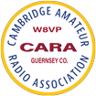that his sister Nellie Waller (8ACU) was a charter member of the Club and is acknowledged as the second licensed female amateur in Ohio and only the fourth in the United States. We often think of hamfests being something of a rather recent feature of ham radio, but in 1935 and again in 1937 Club sponsored hamfests were held at a hotel in Cambridge. Continuing with firsts, member Ron Rogers (WW8RR) developed the first computer controlled on-the-air repeater system in Ohio. Although perhaps not a first, but an unusual one for a local radio club is the publication of a book, “A Century of Radio”. The book covers the history of the Club from the days of spark gap to today’s solid state transceivers. It contains not only history, but photos and QSL card copies and is available on Amazon.

Information Officer Lyn Alfman, N8IMW, says Guernsey County amateurs have been active throughout the years, except for the years of WWl and WWll when radio silence was mandated. During the Korean Conflict and Vietnam, members were active traffic handlers. Since 1979 the Club has been active with assisting organizations sponsoring parades in the various Guernsey County communities. Over the years CARA has been involved with Civil Defense, ARES and other public service agencies and provided valuable assistance during local emergency situations as tornadoes, blizzards, ice storms and the 1998 floods. Several members are certified in the National Weather Service SkyWarn Program. The Club also holds frequent classes and administers VE examinations through the Laurel VE Program.

Over the years CARA and W8VP has participated in the ARRL Field Day operating event. This year they will be on the air from neighboring New Concord, OH. In recent years the Club has participated in the Ohio Covered Bridges and Courthouses On-the-Air special events. They often activate one of the neighboring state parks for the Ohio State Parks on the Air contest in early September. Many of the 50 members are active in the WAS, WAC, DXCC, IOTA, POTA and County Hunter award programs. Additionally members can be found not only on FM and SSB, but on UHF and VHF weak signal work as well as digital, satellite, television and ISS communication modes.

Needless to say, the **Cambridge ARA** is an outstanding club and very worthy being the ARRL Special Service Club it is. And their newsletter is an example of a well-produced product for their membership. No wonder it is an award winner.

But we must get back on the road before arriving at what might be the final visit to a Southern Ohio club. We realize there are some other clubs in the region. However information about them (or contacts) has been hard to track down. If you are in a club within the region that has not been acknowledged, please let me know at [jlevo@cinci.rr.com](mailto:jlevo@cinci.rr.com). But in the meantime, here is some news of events from the South 40.

**Southern Ohio ARA** Information Officer Michael Love, WB8YKS, reports that although Memorial Day along the Ohio River started out chilly and foggy, it didn’t stop 14 members of SOARA and the **Portsmouth Radio Club** from showing up in Ironton to help the 153rd Ironton/Lawrence County Memorial Day Parade wind its way through the downtown Ironton streets. In addition to the usual parade entries, many eyes turned skyward to watch vintage aircraft circle the parade route. Thousands of spectators were treated to a flyover by two Air Force Fighters. Another job well done!

Word from Jesse Stanley, President of the **Scioto Valley ARA**, is the Club will operate Field Day from their clubhouse at the edge of the Scioto Trails State Park. Prior to the start of the Field Day fun, they will conduct a license test session starting at 9 am. As seating is limited, pre-registration is requested at <https://ham.study/sessions/60a314749394716f61335e52/1>. At noon they will have a carry-in picnic.

Regretfully the **Highland ARA** Fox Hunt scheduled for Saturday had to be cancelled because of previously unseen circumstances. However Chief Foxhunter Richie Hagen, N8CUB, says it will be rescheduled. HARA President Pat Hagen, N8BAP, reminds area amateurs of the upcoming business meeting on Tuesday, June 8. It will begin at 7 pm at Hillsboro’s Liberty Park Harmony Lake shelter house. Pat also reminds us the location and time for the June 12 HARA Brunch Bunch has been changed. The June location is Stephanie’s Restaurant in New Vienna with a 9 am gathering time. Following the breakfast, a trip to the Levo Century Farm Field Day site at Snow Hill will be made in order to start Field Day planning. Any amateur in the area is invited to attend either or both events. An invitation is extended to any amateur without a Field Day home to contact the Club about how to participate in its activities.

**DeForest ARA** President Kim Paquette, N8YWX, tells us the Club will have its first in person meeting in over a year on Tuesday evening, June 8. It will get underway at the Club’s Field Day location at 7 PM at the Adams County Health Department, 923 Sunrise Avenue in West Union. The meeting is outdoors so those attending should bring a lawn chair.

Persistent interference is causing the **Athens County ARA** to move their Tuesday evening ten meter rag chew net to a new frequency. The 5 pm net will now meet on 28.375 according to Eric McFadden, WD8RIF.

We’re also told the **Athens County ARA** will hold a Fox Hunt on Saturday, June 12, from 10 am until noon. Participating stations should start checking in on the Athens 145.15 repeater at 9:45 am. A rain date has been set for the following week. You may indicate your participation interest or ask for more information from Kirk Groeneveld, KC8JRV, at [breathOair@hotmail.com](mailto:breathOair@hotmail.com).

The next meeting of the **SouthWest Ohio DX Association** will be Monday, June 10 at Marion’s Pizza, 8991 Kingsridge Drive, Miamisburg. It is near the Dayton Mall and will begin at 6:30 pm.

The sound of joy arose throughout the hills and valleys of Southern Ohio, Northern Kentucky and Southeastern Indiana this past week when it was announced Hamilton’s R & L Electronics was to reopen its showroom on Saturday, June 5. Although ordering things and having them shipped or picked up curbside is nice, there is nothing like being able to twist the knobs, push the buttons and actually first touch, feel and see something before laying out your hard earned cash for something to grace your shack.

The **Milford ARC** announces a new website for their club. It is [www.MilfordHamRadio.org](http://www.MilfordHamRadio.org). According to Club President Ron Brooks, AC8MA, it not only has information on their recently resumed VE test sessions, but also a blog for DX contests and interesting contacts. Ron also says the Club has resumed in-person meetings. They are on the third Thursday of the month at the Miami Township Civic Center and begin at 7 pm. Further details can be found on the website.

Also getting back to normal are the **Portsmouth Radio Club** meetings and test sessions. Jerry Lockhart, W8HIC, says a Laurel VE session will kick the evening off at 5 pm Monday evening with the meeting to begin at 6:30. Meetings and testing have returned to the American Legion Post 23 which is located near the Courthouse in Portsmouth.

Up the river a bit, the **Tri-State ARC** is getting things back to normal too. They will hold their Field Day operations at the normal Fire Academy location on Route 2. Club Secretary Bud Cyr, KB8KMH, the green light has been given to proceed with the 58th annual hamfest. It will be on August 14 at the New Baptist Church in Huntington, WV. See their website at <https://www.qsl.net/w8va/> for the flyer and details.

Officials of the **Milford ARC** and **SouthWest Ohio DX Association** have confirmed Bernie McClenny, W3UR, will be the keynote speaker at the W8DXCC Convention being held on August 28 in conjunction with the Cincinnati Hamfest. McClenny writes the monthly “How’s DX” column in QST and also contributes to the “Daily DX” and the “Weekly DX” newsletters. The two events are separate from each other and will require separate admissions. Information on each is available at the [www.w8dxcc.com](http://www.w8dxcc.com) and [www.CincinnatiHamfest.org](http://www.CincinnatiHamfest.org) websites. Both events will happen at the Clermont County Fairgrounds in Owensville. The combination of these two events should make this the largest hamfest in the Greater Cincinnati, Northern Kentucky and Southeastern Indiana area in years.

Word is another Ohio River Valley amateur radio club will be participating in Field Day this year. Parkersburg, WV’s **Parkersburg ARK** will operate from the Fort Boreman Hill.

Those wishing to get first licenses or upgrade existing ones prior to Field Day might want to check the following locations out. On Monday, June 7, the **Portsmouth RC** will test in Portsmouth. On June 12, there will be a test session in Huntington, WV conducted by the **Tri-State ARC**. The **Milford ARC** will hold a test at their new location on June 17. A test conducted by the **Athens County ARA** will be held on Monday, June 21. On Field Day Saturday, June 26, the **Scioto Valley ARC** will conduct a test at their Scioto Trails clubhouse near Chillicothe.

The **Athens County ARC** will hold their summer picnic on June 15 at the Athens Southside Park shelter house. They will gather at 5:30 pm. The picnic will take the place of the club’s normal monthly meeting.

Next time we hope to visit another South 40 club, but in the meantime that looks like it for another column. With the largest and most popular amateur radio event just around the corner and clubs meet to finalize their FD plans, I’m certain things will get even more lively in the coming days and weeks. Next time we hope to make a visit to one of our final known South 40 clubs, but in the meantime that looks like it for another column. Until then please keep that information coming in so we can share it with our readers.

Until next time, please be safe, healthy and radio active.

73, John, W8KIW

***Print an Official or Unofficial Copy of Your Amateur Radio License***

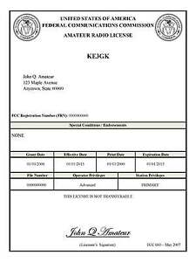*(By Anthony Luscre, K8ZT)*

As of February 17, 2015, the **FCC no longer routinely issues paper license documents** to Amateur Radio applicants and licensees. The Commission has maintained for some time now that the official Amateur Radio license authorization is the electronic record that exists in its Universal Licensing System (ULS). The FCC will continue to provide paper license documents to all licensees who notify the Commission that they prefer to receive one.

Licensees also will be able to print out an official authorization — as well as an unofficial “reference copy” — from the ULS License Manager. I’ve created a set of instructions on how you can request an **“official” printed copy of your license\***

[**Click here to download the instructions**](http://arrl-ohio.org/news/2020/print_your_license.pdf)

***One Question Questionnaire***

Hey Gang,

Survey Says….. I’ve got 57 responses and I know that this letter is sent to over 5000 recipients! How about going to www.ARRL-OHIO.org and giving me a click? (It’s in the bottom left corner of the page) Send your friends, too!

***“What is the main antenna used at your station?”***

*****V.E. Test Sessions***

Many V.E.’s have decided to start testing once again, but with restrictions that need to be adhered to for sure. Here’s the link to find that V.E. Test session and what is expected of YOU before going. <http://www.arrl.org/find-an-amateur-radio-license-exam-session>

Ohio Section Cabinet

|  |  |
| --- | --- |
| Section Manager – Tom Sly, WB8LCD | Section Traffic Manager – David Maynard, WA3EZN |
| Section Emergency Coordinator – Stan Broadway, N8BHL | Section Youth Coordinator – Anthony Luscre, K8ZT |
| Technical Coordinator – Jeff Kopcak, K8JTK | Affiliated Clubs Coordinator – Tom Sly, WB8LCD |
| State Government Liaison – Bob Winston, W2THU | Public Information Coordinator – John Ross, KD8IDJ |



Hey Gang,

Have you taken a look at the **Swap & Shop** page on the Ohio Section webpage yet?? Here’s a link that will take you there… <http://arrl-ohio.org/sm/s-s.html>

Do you have equipment that you just don’t need or want anymore? Here’s a great venue to advertise it, and it’s FREE!! Is your club doing a fund raiser to help raise money? After a lot of thought, it was decided that the Swap & Shop webpage could also contain these types of items as well. The same rules will apply as do for the For Sales and Give-A-Ways and will only be posted for a month at a time. Please see the Terms & Conditions on the webpage.

If your club is doing a fund raiser and wants more exposure, please forward the information to me and I’ll advertise it on the Swap & Shop webpage for you.

Now, I still want to remind you that it won’t be listed in this newsletter because it would take up way too much space, so your ad will only appear on the website. It is there for any individual to post equipment Wanted / For Sale or Give-Away as well as for Club Fund Raisers. No licensed vehicles/trailers or business advertising will be posted. Postings are text only (no pictures or graphics) will be posted for a maximum of 1 month from date posting and require a contact phone number or email within the posting. Send your Wanted / For Sale or Give-Away post to:  [swap@arrlohio.org](mailto:swap@arrlohio.org)

*** When something listed on the Swap & Shop page is sold – please notify us so we can remove it from the listings!

***Back Issues of the PostScript and Ohio Section Journal***

Hey, did you know that PostScript and Ohio Section Journal (OSJ) are archived on the website? You can go back and look at any edition simply by clicking:

<http://arrl-ohio.org/news/index.html>

***Welcome New Subscriber(s)***

***Want to Share your Club Newsletter With Others?***

We have a webpage where you can download and read all of the newsletters that I get from around the state and even other sections!

Here’s the link to the page…. <http://arrl-ohio.org/club_news/index.html>

Please, if you don’t see your club newsletter posted, it’s because I’m not receiving it. Just have your newsletter editor contact me and I’ll get your club’s newsletter listed on the site!!

We all learn and steal (I mean, share) from each other’s work. So, get me your newsletter!!! Send it to: [webmaster@arrl-ohio.org](mailto:webmaster@arrl-ohio.org)

***Chit – Chat, and All That!***

Do you know someone that’s not getting these Newsletters? Please, forward a copy of this Newsletter over to them and have them “[Opt-In](mailto:Opt-In)” to start receiving them. Heck, just have them send an email to: [webmaster@arrl-ohio.org](mailto:webmaster@arrl-ohio.org) and we’ll get them added to the Ohio Section Emailing list.

We now have many thousands of readers receiving these newsletters weekly. Quite impressive, I’d say! I urge all of you to make sure that everyone, regardless of whether they are a League member or not, get signed up to receive these weekly Newsletters.

You can always “Opt-Out” at any time if you feel this is not what you were expecting. It’s fun and very informative. All of your favorite past newsletters are now archived too.

You can go back at any time and read them.

Just go to: <http://arrl-ohio.org/news/>

The pictures on the front page and throughout this newsletter are from various newsletters, Facebook posts and/or were sent directly to me in recent weeks. Take a good look at them, you just might be in one of the pictures! “SMILE… you’re in the Ohio Section News!!”

*PostScript is produced as a weekly newsletter. I want to thank everyone that has contributed articles and ideas to make this an even better news source. I sincerely hope that you have enjoyed this edition and will encourage your friends to join with you in receiving the latest news and information about the Ohio Section, and news and events happening around the world!*