[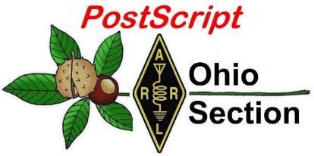](http://arrl-ohio.org/news/) ***“May 31st***

***Edition”***

🡪 National News 🡪 Club Corner

🡪 DX This Week 🡪 Contest Corner

🡪 Upcoming Hamfests 🡪 One Question Questionnaire

🡪 VE Testing

**My First QSO!**

(Note the 5 cent postcard stamp!)

**Field Day Notes:**

#1 – Get your Club’s FD Site listed on the ARRL FD Site Locator! [Field Day Station Locator (arrl.org)](http://www.arrl.org/field-day-locator) I’ll be using this to choreograph my travels across the state over the weekend, so, if you’re not listed, I won’t be there – and I really want to hit every OH Section FD site (if it’s physically possible without breaking the speed limit!)

#2 - If you can’t participate at your club’s Field Day site – operate from Home! Be sure to list your associated club so your club shows up in the “Aggregated Club” scores. Make sure everyone from your club lists the club *exactly* the same. “PCARS” does NOT equal “Portage County ARS” does not equal “Portage County Amateur Radio Service”.

#3 – Make sure Field Day is a FUN event for everyone in your club – especially new hams.

#4 – Let your community know you’re out there! (Public relations) I’ll have a media “Press Release” template coming out shortly.

#5 – Stay Safe!

Note: I reserve the right to add or delete from this list as Field Day gets closer.

Tom WB8LCD – OH Section Manager

PS: Thank you to Bob Winston – W2THU – Ohio Section State Government Liaison for working with the Governor’s office to obtain the Field Day Proclamation. Also, Thank you to Governor DeWine and Lieutenant Governor Husted for recognizing Amateur Radio as an important asset to the State of Ohio.

**From the OHIO Section Manager**

Last week in the OHIO Section Journal, I listed my three main goals for my term(s) as OSM. Number two on that list was: “I want every citizen of the State of Ohio to be aware that YES – Amateur Radio still exists and it’s as much fun and more exciting than ever. I also want every citizen in the State of Ohio to view Amateur Radio Operators in a positive manner, and as people who engage in their hobby with passion, a sense of service to their community, and as a group with a special bond of friendship and fraternalism.” In a nutshell – Public Image. Why, you ask, would an esteemed Hobby such as Amateur Radio need to work at improving it’s Public Image?

Here’s an example. I found this just this past week on a Facebook page. “ Here’s the best piece of advice when dealing with an HOA. If they ever start giving you trouble, just threaten to put up a radio tower in your backyard. Like let’s say you just got a trampoline for your kids to enjoy and your HOA tells you that you have to take it down. Send them a letter back saying “Okay, but with all of the extra room I’ll have in my yard, I’m planning to install a 40ft HAM radio tower. Due to the HAM Radio Parity Act, as well as the Local Community Radio Act, both issued by the FCC, it is entirely within my legal rights to install infrastructure on my property that aids in the use of private and public radio communications. The FCC’s jurisdictions take precedence over local and community policy, and a fine up to $300,000 can be charged towards any entity that attempts to impede on my right to install this tower. Because I don’t have the space for both, I was very split on whether I wanted a trampoline or a 40ft steel tower in my yard, but if I’m not allowed to have a trampoline due to the HOA’s guidelines, then I suppose it’s an easy decision. If there’s any input or concerns you have on my decision, please don’t hesitate to contact me.” This is basically the easiest way for you to tell your HOA to leave you alone. The best part is that if they try to call your bluff, you can apply with the FCC to get the construction of a HAM radio tower subsidized. They have absolutely no power or authority to stop you, so they’ll let just about anything slide if it means their property values don’t plummet as a result.”

Aside from the fact that way too much of this information is not factual (misinformation might better describe it), it portrays a very negative image of Amateur Radio and Amateur Radio operators. I would say it pretty much portrays us as a nuisance, nothing better. It portrays an image that has created for us by people who have no concept of who we are and what we do. If we want our hobby not only to continue, but to grow, we need to create our public image and disseminate it into our society for ourselves. Only by repeated exposure to positive portrayals of both Amateur Radio and Amateur Radio operators will we be able to create the public image we wish to be seen as.

Every Amateur Radio club needs to appoint a Public Information Officer (PIO). The PIO’s job then is to present the club, it’s members and their activities to the public on a regular basis and in a positive light so that the *public* will perceive us as a valuable asset in the community. It seems that most clubs are pretty good at announcing their activities, but then drop the ball on following up with a report on how those activities went. Make sure you document your events in the same way as you announced them, but now you can add photos and descriptions of all the ways your club members not only had fun, but either prepared for, or actually provided service to the community! We cannot afford to be “out of sight, out of mind” any more!

Tom WB8LCD

***National News***

*(from arrl and other sources)*

Ohio NVIS Antenna Day 2021 - the "Next Step"

Beginning in April 2014, Ohio ARES has sponsored "NVIS Antenna Day" in Ohio. (NVIS is Near Vertical Incidence Skywave).The activity has several goals: experiment with NVIS antenna construction, determine which is best for your location, and have fun. Stations (either groups or individuals) try different antenna configurations, and make contacts with other stations to test signal strength and coverage. Operators have been able to confirm coverage from the Ohio EOC to all areas of the state.

For [Ohio NVIS Antenna Day 2021](https://sites.google.com/site/cfarccal/qst/ohioaresnvisdayapril24), we took it one step further to answer the question, "When and how would we really use these antenna configurations?" Operators were instructed to operate their NVIS stations off the grid to simulate a wide-area power loss. In such a scenario, the 10 Ohio ARES Districts would spin up district level nets to coordinate with their counties. NVIS station operators were instructed to send a message to their District Net advising of their location and operation. They were also instructed to send a message to the Ohio EOC station, W8SGT, either by direct contact on the 75 meter net or by using digital messaging through either the [Ohio ARES Digital Emergency Net](https://arrl-ohio.org/SEC/ohden/index.html) (OHDEN) or the Buckeye Net's multi-mode operation. In this scenario, we would be able to prove our ability not only to simply make contact, but to actually transmit meaningful messaging from any county in Ohio to other counties or W8SGT at the state EOC.

Despite the traditional threat of rain on April 24, Ohio stations turned out, eager to participate. Fifty-four of Ohio's 88 counties were either in direct contact with W8SGT or were able to send a message successfully during the 6-hour period. Well over 100 messages were received. Band conditions wavered, but in general, signals were strong and messages could be transferred.

NVIS antennas were on average between 5 - 10 feet off of the ground, with most falling into the broad category of long-wire, inverted V, or the "2259" crossed-dipole types [The AS-2259/GR is basically a dipole antenna fed with a low-loss, foam-dielectric, coaxial mast that also serves as a support structure. The system uses a set of crossed sloping dipoles positioned at right angles to each other *-Ed*.] This was another fun day, showing that ARES can get the message through. -- *Stan Broadway, N8BHL, ARRL Ohio Section Emergency Coordinator*

Excellence in Training: Ohio ARES Training Update

I have been maintaining a database of ARES training for the ARRL Ohio Section for several years now and the data is impressive. We record the training that our members receive and complete from our served partner agencies such as FEMA, the Ohio EMA, Red Cross, and others. We also record all other local coursework that is relevant to ARES, as many of our members are involved with public safety -- Fire and EMS -- either as volunteers or professionals. However, the bulk of the training certificates submitted are from the popular and often required FEMA Independent Study (IS) courses on ICS and NIMS.

One of our members, Ron Hollas, K8RJH, has set the bar high for ARES training, with 324 FEMA Independent Study course certificates submitted to the database. Several other Ohio ARES members have more than 100 certificates on file. In Ohio, we now have 9,893 course completion certificates on file. As Assistant Section Emergency Coordinator, I along with Section Manager Tom Sly, WB8LCD, and Section Emergency Coordinator Stan Broadway, N8BHL, are appreciative and proud of the effort our Ohio radio amateurs have given to completing this critically significant training.

I encourage all ARES members to avail themselves of the [FEMA ICS/NIMS and other Independent Study (IS) training](https://training.fema.gov/is/crslist.aspx). FEMA has built this training with input from our public service agencies, industry, and business -- and trainees themselves -- to ensure the courses contain the most up to date and complete information available. It is essential training for those of us who will work alongside agency professionals in the NIMS and Incident Command System environment. Start with the four basic courses: ICS-100, ICS-200, ICS-700 and ICS-800. -- *Jim Yoder, W8ERW, Assistant Section Emergency Coordinator, ARRL Ohio Section*

ARES Resources

· [Download the ARES Manual [PDF]](http://www.arrl.org/files/file/Public%20Service/ARES/ARESmanual2015.pdf)

· [ARES Field Resources Manual [PDF]](http://www.arrl.org/files/file/ARES_FR_Manual.pdf)

· [ARES Standardized Training Plan Task Book [Fillable PDF]](http://www.arrl.org/files/file/Public%20Service/ARES/ARRL-ARES-FILLABLE-TRAINING-TASK-BOOK-V2_1_1.pdf)

· [ARES Standardized Training Plan Task Book [Word]](http://www.arrl.org/files/file/Public%20Service/ARES/ARRL-ARES-STANDARDIZED-TRAINING-TASK-BOOK-V1_2_2.doc)

· [ARES Plan](http://www.arrl.org/ares-plan)

· [ARES Group Registration](http://www.arrl.org/ares-group-id-request-form)

· [Emergency Communications Training](http://www.arrl.org/emergency-communications-training)

The Amateur Radio Emergency Service® (ARES) consists of licensed amateurs who have voluntarily registered their qualifications and equipment, with their local ARES leadership, for communications duty in the public service when disaster strikes. Every licensed amateur, regardless of membership in ARRL or any other local or national organization is eligible to apply for membership in ARES. Training may be required or desired to participate fully in ARES. Please inquire at the local level for specific information. Because ARES is an amateur radio program, only licensed radio amateurs are eligible for membership. The possession of emergency-powered equipment is desirable, but is not a requirement for membership.

How to Get Involved in ARES: Fill out the [ARES Registration form](http://www.arrl.org/files/file/Public%20Service/fsd98.pdf) and submit it to your local Emergency Coordinator.

***Club Corner***

This is YOUR cornner of the newsletter. Send me what your club is doing and I’ll make sure that it gets in. Got a special event or club project that you want everyone to know about? Send it to me!. Need help with a project? Send it to me.

Let me know what you club is up to. Are you going to have a special guest at your meeting or are you having a special anniversary?

Just sent it to: [webmaster@arrl-ohio.org](mailto:webmaster@arrl-ohio.org)

**Weather Alert Project 21 First Interim Report**

C. Matthew Curtin KD8TTE

Just over a month ago, I introduced the Weather Alert Project 21 (WAP21) in the April edition of the *Ohio Section Journal* and followed it up with a discussion with how efforts like WAP21 advance the ARES mission.

This article is our first report of operation. We’ve held a total of 14 drills between May 10 and May 26. Ten were conducted at NTS Cycle Two (13:00), with the remaining four being held at NTS Cycle Four (19:00). (All times in this article are local Ohio time.) So what have we learned?

1. Traffic comes in waves.
2. Messages are not always directed to a single county.
3. Messages for a particular county don’t always come from the same forecast office.
4. Ohio alerts don’t always come from the five NWS forecast offices that cover the state.
5. Operating conditions are not static.
6. Band agility is a requirement for service availability.

Let’s look at each one of these in more detail.

Traffic comes in waves. In some scheduled sessions, we would have no active alert in Ohio. At other times, NWS would issue as many as 15 messages per hour, as shown nearby. Going deeper into the picture, we see that these messages aren’t released on regular intervals throughout the hour. Focusing on the hour where the most released messages were observed and the hour immediately after, when only one message was released, we see a picture emerging: traffic is released in a bursty fashion, faster than relay circuits can carry them.

Analysis of these messages showed that moving them on a single-channel net at a rate seen with MT63-1kL or MFSK32 requires transmission times of about five minutes each, even without relays or fills. Placing the messages’ release and transmission time on a timeline shows alerts waiting for over 30 minutes to begin relay on the Section net.

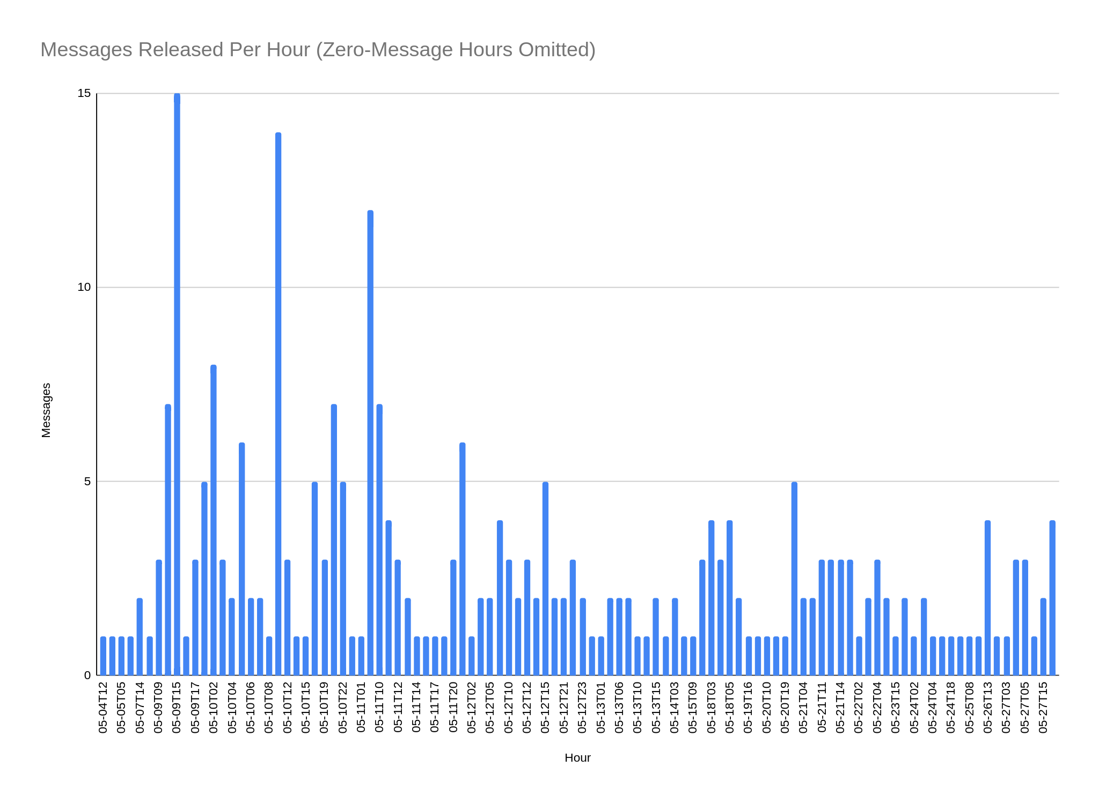

Messages are often not directed to a single county. We’ve observed messages directed to as many as 28 counties spread across five ARES districts. Even messages directed to a single district often have multiple counties, e.g., D6 often but not always has Holmes and Wayne both on the target list, and D7 often has Delaware and Marion on the target list.

This highlights the need for the design of a system of nets. A single net with enough stations to cover five ARES districts can be managed. Imagine trying to get 28 stations on a single-channel net to confirm the correct receipt of a formatted digital message that will be processed by software at the receiving agency. Even the five-minute transmission window used in the calculations above would not be achievable. Five stations, each representing a district, on the other hand, could receive the message, then leave the net to bring the message into their district’s net or for distribution through the district’s packet system.

Messages for a particular county don’t always come from the same forecast office. For example, messages headed to Delaware County come from Cleveland 65% of the time, with 35% coming from Wilmington. Fixed routes for moving messages will not be able to address surprises like messages coming from unexpected sources. What this shows us is that activation of ARES stations at the expected “sender” and “receiver” sides aren’t necessarily going to address the job at hand. A network, capable of routing messages to their destinations, wil be able to ensure that communication continues even along unexpected lines.

Ohio alerts don’t always come from the five NWS forecast offices that cover the state. We observed messages for 18 counties across three ARES districts coming from the NWS Storm Prediction Center in Norman, Oklahoma. Emergencies may be local but communications to support them may not be. Real agency traffic is showing us that even alert messages sometimes take long paths. Even routing throughout the state, without being able to work outside of the state, won’t completely cover the need.

Operating conditions are not static. Daytime operation has been much more difficult than evening operation. Conditions vary day to day; stations that can have the best path one day sometimes cannot hear each other at all at the same time on the next day. In the past month we have observed geomagnetic storms in the “moderate” (G2) category and even radio blackouts in the “minor” (R1) category on the NOAA space weather scales. The impact of these effects have been fading (increasing the need for fills), variation in propagation paths (increasing the need for relay), and noise (increasing the need for more robust, i.e., slower, modes). Combinations of effects have happened to the degree that control of the net by voice was not possible and all work had to be done digitally.

Working the evening nets doesn’t confirm the ability to work at other times of day, even if we’re most needed then. We need to work when the emergency circuits are needed, not just when 75-80m work best for in-state communication.

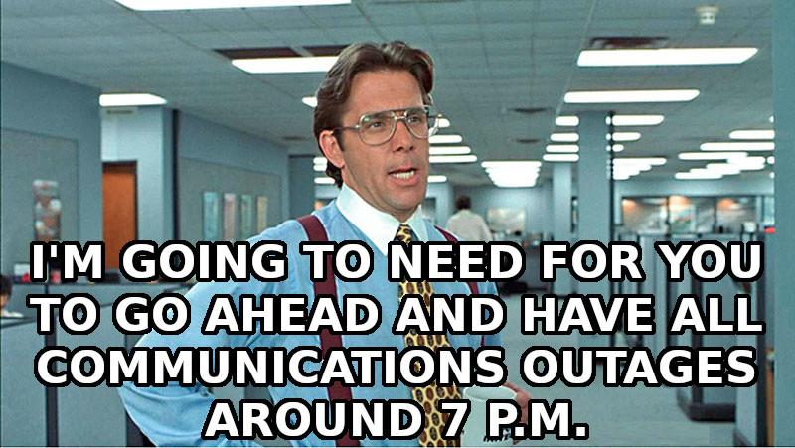

Band agility is a requirement for availability. In the mid-day, propagation in-state is much more effective at 5 MHz than 3.5 MHz. In the morning and evening, 3.5 MHz is much better. All of these observations have exceptions which are difficult to predict. Some early afternoon sessions have had to move the net to 3.5 MHz for effective operation.

Some of what we’re seeing probably isn’t a surprise, and perhaps some of it is. That’s the point of performing exercises like these drills, though. We get a better understanding of the problem, our ability to address it, and how to help one another perform well as a coordinated service.

More information is available including how to join the project at <https://www.blackswancomex.org/2021/weather-alert-project-21>.

**A New Yaesu FT-891 for $5.00?**

The Alliance Amateur Radio Club’s 2021 fundraiser is the raffle of a brand new Yaesu FT-891 HF/50MHz All Mode Transceiver

Tickets are on sale now. To learn more, or buy tickets online, you can go to <http://www.w8lky.org/about-us/2021-fundraiser/>

The winning ticket will be drawn on Wednesday, October 13th at our annual Fall fundraiser, or at our first club meeting after all tickets have been sold; whichever comes First.

Funds generated from this project help us to continue our public service projects in the Alliance area.

Proceeds from last year’s fundraiser enabled us to purchase, and outfit our club equipment trailer. One of our projects this year is some necessary upgrades for out 440 repeater.

Each year, we give back to our community with donations to local organizations, such as The Salvation Army, Relay for Life, and the local Police & fire Department programs for Children in the Alliance area

Only 600 chances will be sold for this radio. Tickets are $5 each, or 5 for $20. further details can be found at: http://www.w8lky.org/about-us/2021-fundraiser/

The Alliance Amateur Radio Club is a 501c3 non profit organization.

**Ohio ARES District 9 VHF/UHF Packet**

**and Winlink Interconnect Mapping Initiative**

Ted Jacobson - W8KVK

Ohio ARES District 9 is comprised of eleven counties in east central Ohio and is served

by a growing VHF/UHF packet network, providing ARES/AuxComm connectivity

throughout much of the district.  The network also provides VHF Winlink on-ramp service at several locations, plus a gateway to the large statewide West Virginia Digital Amateur Radio Emergency Network (DAREN). Access to this WV network allows enhanced coordination along both sides of the Ohio River during high-water events, including access to the AREDN 2.4 gHz HSMM Mesh Network serving parts of Washington Co. OH and Wood Co. WV.

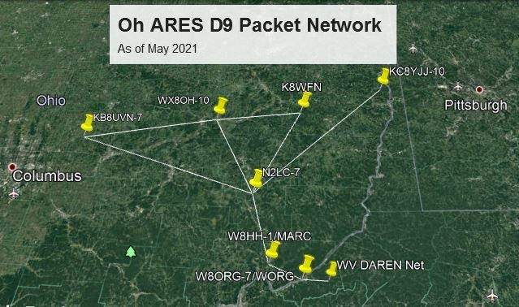

In preparation for the [BlackSwan 21 Communications Exercise](https://www.blackswancomex.org/2021/prepare), efforts are underway

to verify, inventory and catalog the nodes, paths and external services which make up

this network, with these objectives:

* Identify and verify all reliable full time nodes and paths
* Document callsigns, aliases, frequencies, and ports
* Document active Winlink RMS entry points
* Develop effective routing plans from D9 into Central Ohio,

      State of Ohio Emergency Management, and the Ohio EOC.

* Create a simple interactive KML based map to:

        (a)  Better visualize the Network coverage and layout

        (b)  Provide users and served entities detailed on-map navigation

              and information tools to help get from 'Point A to Point B'

              (c)  Support simple radio path terrain analysis approximations

                     for planning and implementing future nodes and routes

For more information on this project, please visit;:

<https://w8kvk.com/D9/D9-Packet-Map.pdf>

Special thanks to the following stations who have been instrumental in the

design, construction and ongoing maintenance of this important network:

KB8UVN, WX8OH, K8WFN (sk), KC8YJJ, N2LC, W8JTW, K8KHW

For additional comprehensive Ohio Packet information, including county-by-county

node listings, please visit: <https://ohiopacket.org/>   (courtesy: KB8UVN)

**Lucas County ARES Needs Help**

Lucas County ARES Needs Help with the Muddy Mini Half Marathon. I'm still in need of several operators for the Muddy Mini Half Marathon on June 19th. The race starts at 7:30 AM and runs from downtown Maumee

to 5/3 Field in downtown Toledo. There is also a quarter marathon course which starts a bit north of Maumee and finishes in the same place. Last time we did this race I believe we were all finished by 11:30. If you'd

like more information or to sign up to help please contact me at either [k8rks@arrl.net](mailto:k8rks@arrl.net) or 419-471-0573. Thanks!

Rick K8RKS

[k8rks@arrl.net](mailto:k8rks@arrl.net)

419-471-0573

**Your Club news should be listed here!**

I know you’re out there doing things! Send me a write-up (MSWord please) and some photo’s (.jpg please) and we’ll get your club hi-lited here for the othe OH Section Clubs to see! Send to [WB8LCD@ARRL.ORG](mailto:WB8LCD@ARRL.ORG)

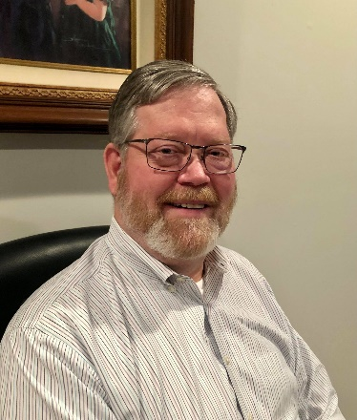**DX This Week – NAS**

Bill AJ8B (aj8b@arrl.net, @AJ8B, or www.aj8b.com)

CWOPs Member #1567

The Midwest DX Cluster spots included Austria, Canada, Canary Islands, Ceuta & Melilla, Cuba, Estonia, Fed. Rep. of Germany, Hungary, Ireland, Italy, Mali, Mexico, Netherlands, Oman, Poland, Portugal, Serbia, Slovenia, Spain, Ukraine, United Nations HQ. This brings the total number of entities spotted in the Midwest in 2021to 177!

Are you working towards the CQDX Marathon? If so, how are you doing?

*DAH DIT DIT DIT DAH DAH DIT DIT DIT DAH*

We are approaching the 90 days until the W8DXCC convention. I am so excited about all the speakers AND the DX roundtable that we are holding before the convention actually starts! If you haven’t done so, go to [www.w8dxcc.com](http://www.w8dxcc.com) and fill out the form at the bottom of the page. We will keep you informed as we move forward. Also, you can follow us on Facebook : (DXCC SWODXA), Instagram (W8DXCC), and twitter (@dxccw8) – Lots of ways to keep informed. We have a limited number of tickets and they will go on sale soon.

*DAH DIT DIT DIT DAH DAH DIT DIT DIT DAH*

This week I thought I would share with you a project that will soon appear in the National Contest Journal. I know that this is a “DX” column, but where would we be without computers and files? I hope you enjoy this, find it useful, and give it a try. Let me know! Also, if you are working on something, make sure you keep me in mind. (Reprinted with the permission of the NCJ)

Station Backup Practice 2 with a Raspberry Pi

**Bill Salyers, AJ8B**

The morning of the Ohio QSO Party (OhQSOP) arrived with a bit of a surprise. Due to COVID concerns, our team decided to work the OhQSOP from our own stations instead of at Dave’s (K8DV). This was somewhat of a last-minute decision and I was not really prepared at home. However, I knew it really would not take too much time to prepare. I had just installed a newly refurbished computer and just needed time to pull down my operating notes from years past. Dave had encouraged me to put together a contest plan every year that includes consideration for Rovers, propagation, bands, modes, times, lessons learned from over the years, plus his own secrets. Since I had backed all of that up to my Dropbox account in the cloud, how long could it possibly take?

Then, Murphy arrived! My wife informed me that our internet provider was going to be replacing equipment in the neighborhood and we would be without internet until approximately 2 PM. UGH! Now, all of those thoughts went through my head like “I should have just backed up to a USB drive”, “I should have waited until the week after the contest”, and “I bet Dave has a solid connection in his shack!”

Off I go to Panera to grab coffee and to connect to their WiFi. Using that, I could access my Dropbox account and transfer the needed files to my laptop. Then it is off to the shack to move those files from the USB thumb drive to the shack computer.

As soon as the contest was over, I started to form a plan that would circumvent this problem in the future. With hardware failure, cyber security issues, accidental deletions, and other issues, you must have at least one backup copy of anything that you would not want to be without.

The reward for this approach occurred a few months later when I chose to participate in the ARRL Winter Field Day. I was in a “cabin” without cell coverage. I had no internet and was using a laptop that I don’t normally use for logging. I was able to bring this device along with me and access all of my files. It worked very well!

One of the best descriptions of a correct backup process I have read was in the National Contest Journal1. WJ1B, Harold, described a 1-2-3 system. His system was

1. Local file residing on the disk drive of my PC/Laptop
2. Local copy that resides on another PC, server, or device on your home network. This local device should have some amount of hardware redundancy
3. Cloud based copy that should be safe and has various versions of files available

Do you NEED all of this? Maybe not, but if there are files you can’t live without, you need at least two layers. A third layer is really insurance that would have addressed my scenario described above.

Implementing the System

Layer 1 is a natural. The file already resides on your shack PC, so no work is needed.

Layer 3 is almost as simple. Signup for the service, download the client, “point” it to the necessary directories and off you go. The client takes care of managing which files have been updated and which need to be updated. Most of the leading services have a free version which allows for some storage and access. Storage can be purchased as needed and is very cost effective, typically between $5 and $15/month. Typically, the service you choose will keep versions of the files so that if it is deleted and can’t be recovered, you can retrieve a previous version.

Layer 2 is a bit of a challenge. If you have another PC on your home network, you can certainly backup to that. Just make sure it is turned on when you need to access it. You also need to take care if someone else uses that PC that they don’t delete your files or acquire a virus. It may also be important to have the storage PC physically distant from the source so that one event (lightning strike, power surge) doesn’t take out all of your devices.

If you don’t have a second PC, or you don’t want to risk someone wreaking havoc with the backed-up files from your PC, you might consider a Network Attached Storage device (NAS). As the name implies, the only function this device performs is to be available to store and retrieve files. It is a device without monitor, keyboard, and mouse and relies solely on a network connection for user file access.

There are NAS devices that you can purchase, and the cost is not too bad. OR…you can build a simple one using a Raspberry Pi 4 (RP4), free software, a powered USB hub, and external drives. We will call this project the NCJ-SAN. If this idea interests you, read on.

Before we begin, I must pass along a special “Thanks” to Rich Brereton. Rich published the article that I leaned on heavily to create the most straightforward “script” that I could create and graciously gave me permission to use as much of his excellent article as I wanted. 2

First, you need to have some idea of how much storage you need. In my case, I needed about 20G of storage, so I decided to repurpose some 2.5” hard drives from some e-Recycled laptops. These two laptops had 500G drives which allows for expansion.

One of the things that makes a SAN different than just a second PC is that it should have some sort of redundant hardware support. We can use the RAID concept (Redundant Array of Inexpensive Disks) for our data storage. There are various levels of RAID and we are going to implement RAID level 1. Level 1, also known as Mirrored Disks, will write the same information to both disks. (RAID Levels are shown in Table 1)

|  |  |  |  |
| --- | --- | --- | --- |
| Table 1 – RAID Types | | | |
| RAID Level | Description | Advantages | Disadvantages |
| 0 - Striping | Combines 2 or more hard drives together and treats them as one. | Fast reads and writes. | If either disk fails, the system fails. |
| 1 – Mirroring | Creates a duplicate of one disk on another. | Safest option for data. If one drive fails, the second still contains a complete copy. | Cost – each time you add storage, it must be added as two disks. |
| 5 - Parity Striping | Data can be spread across multiple drives where one is considered a “parity” drive. | If a drive fails, it can be replaced, and the system will rebuild the data. Better read/write speeds. | Cost – at least 3 drives are needed to get started. |
| 10 – RAID 1  and RAID 0 | Striping and mirroring of your data across 2 disks. | Fast and secure. | Complex algorithm takes CPU cycles. Not applicable for Raspberry PI (Yet). |

RAID 1 allows you to have one disk fail and the other will still contain a complete copy of your data. You can then add a replacement drive and the RAID software will take care of copying, or Syncing, the data onto the new disk. For the best performance, both disks should have the same amount of space. Since you are “mirroring” the two disks, the RAID software will create a file space that is equal to the smallest disk drive of the two.

The easiest way to allow the RP4 to access these two drives will be to “convert” them to USB drives. I located two 2.5-Inch SATA to USB External Hard Drive Enclosures. 3 (Fig. 1)

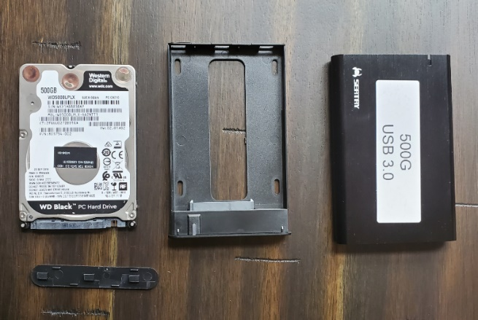

Figure 1 – SATA to USB Enclosure

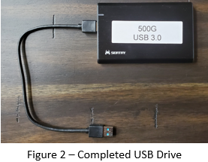This will allow you to use these two laptop drives as USB devices. These enclosures are handy even if you just want to repurpose them as external USB drives. (Figure 2)

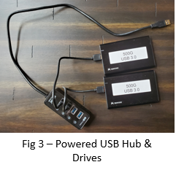As these are USB devices that require power, the Raspberry Pi series can’t supply enough power for them. Additionally, as the Pi only has 2 USB 3.0 connections, you may want to expand to 4 drives in the future. The best way to achieve both goals is to use a powered USB hub for both drives.4 (Figure 3)

Since we will be using RAID 1, mirroring, both 500G drives together will appear to be one 500G drive. The RAID software will take care of ensuring that any writes will occur to both devices.

Outside of the 2 disks, enclosures, and the powered USB hub, you will need nothing more than an RP4. Depending upon your skill level, you may want to use a monitor, keyboard, and mouse while setting this up. You can also use a PC to remotely login to the RP4 using Secure Shell. (SSH) Refer to step 3 below.

Once you have the RP4, the external drives, and the powered USB hub, you are ready to start. Here are the steps that you will need to execute.

#1 – Prepare the Memory card on the RP4 with the Raspberry Pi operating system. Refer to the paper “Preparing the OS” on my website.5

#2 – Put the drives into the USB enclosure. Plug them in to the Powered USB Hub and then into one of the USB 3.0 connections which are the 2 blue ones in the middle. Power on the RP4.

#3 - Connect to the RP4. Refer to the paper “Connecting to your RP4” on my website. 6

#4 – You should follow along using the “Programming the Shack SAN” document on my website.7

Now that we have the operating system created, the USB drives built, and the drives and the USB hub put together, we need to configure the RP4 operating system. Here is a 30,000-foot view of what we need to do to create the NCJ-SAN. The step by step details can be found in the Programming the Shack SAN document:

1. Check for software updates and load the required software.
   1. In addition to operating system updates, you will load support for “Windows” type disk drives.
   2. Install the RAID software.
   3. Install the SAMBA software (more on that later).
2. Preparing the external USB Drives.
   1. Since these were previously used and configured for laptop usage, we will have to remove any partitions that existed on the disk drives before and make sure that all storage is available to us on both devices.
   2. This will create a Linux File System on both disks
3. We will create the RAID array. This will be two 500 G drives that will seem to be one.
4. We will now create a directory, or mount point, that will act as the entry point into our RAID system.
5. We now have 2 - 500G disks that appear as one, mirroring each other, and available for the outside world to access. However, the typical outside world does not “speak” the Linux file system. We need to find a way to allow Windows machines to read and write to a Linux file system such as on the RP4.

The best definition of SAMBA can be found on the Samba.org website8 . “*Samba is the standard Windows interoperability suite of programs for Linux and Unix***.”**

This will allow all network users to access the files that are stored on the NAS device.

1. We need to decide who is going to access these files and set those users up.
2. We need to create the final directory that we want network users to access.

Refer to the document “Connecting to Windows” for the final touches.

**Acquiring the Parts**

The parts used to build this unit were acquired on amazon.com. There are other sources, but, I have been a big fan of one stop shopping. Below is a table of components and info:

|  |  |  |
| --- | --- | --- |
| **Component** | **Amazon Search Info** | **Price** |
| Raspberry Pi 4 | CanaKit Raspberry Pi 4G Kit | $99.99 |
| USB Disk Enclosures | Sata to USB Enclosure – 2 ($8.99 ea.) | $17.98 |
| Powered USB Hub | Powered 4 Port USB 3.0 Hub | $18.99 |
| Total => | | $136.96 |

Footnotes

1. <https://www.ricmedia.com/build-raspberry-pi3-raid-nas-server/>
2. <https://ncjweb.com/bonus-content/Kramber-backing-up.pdf>
3. Sabrent 2.5” SATA to USB 3.0 External Enclosure
4. Atolla 4-Port USB 3.0 Powered HUB
5. <https://www.aj8b.com/NCJ_NAS>
6. [https://www.aj8b.com/NCJ_NAS](https://www.ncjweb.com/features/)
7. [https://www.aj8b.com/NCJ_NAS](https://www.ncjweb.com/features/)
8. <https://samba.org>

*DAH DIT DIT DIT DAH DAH DIT DIT DIT DAH*

CQDX CQDX CQDX CQDX CQDX CQDX CQDX CQDX CQDX

Here is an update from Bernie, W3UR, of the DailyDX and the WeeklyDX, the best source for DX information. <http://www>.dailydx.com/. Bernie has this to report:

**VK9X - Christmas Island -** VK6SJ, Steve, updates us on his VK9XX activity starting on May 28th. He plans to be there "between two and three weeks" working and QRV in his spare time. He'll have a Yaesu FT-857D transmitting into either a Sotabeam or ATAS mobile vertical, running barefoot. Steve emphasizes he will be operating "mostly outside working hours and focused on the night time bands and mainly FT8". He is planning to be on one band each night, hoping there are conditions for that band as he does not want to "change the antenna at night!" If the band is dead and he is getting no callers then he "will change band rather than call into nothing". Most likely he will be operating between 1100 and 1500Z and then from 2200 to 0000Z daily. Steve says, "If I get ahead of schedule in my work, I may squeeze in a day off, in which I will see if I can tune up the dipole on 6m, 10m & 15m during the day". He has posted what band he will operate for each night along with a list of frequencies for SSB and FT8 activities on the VK9XX QRZ.com web page at <https://www.qrz.com/db/VK9XX>. Steve hopes "to have an icon on this page that shows when and where I'm on air". QSL this operation via EB7DX.

**OX – Greenland -** OZ1DJJ, Bo, is heading back to Greenland for another work assignment. He'll be there from June 8 to July 10 and plans to be QRV from several  
locations along the southwest coast of Greenland. This will include IOTA activities from NA-018, NA-220 and NA-151. He will be active as OX3LX in his spare time. Starting on June 8th he will be operating from grid locator GP60xr and later from GP70, GP80 and possible others. During this trip his Amateur Radio focus includes 4 and 6 meters, but he will also be on HF. On 6 meters he will have a six element Yagi, a four element Yagi on 4 meters and a fishing rod on HF. As a reminder this is not a DXpedition and he will only be QRV in his spare time, which is typically during his mornings around lunch time and after dinner. On weekends he will operate in both the mornings and nights. Greenland is 2 hours behind UTC.  
  
**C6A – Bahamas -** C6AHC is the call of K4KSW, Jack, who will be one of the C6AHA team members operating from Bimini Island from July 14-21.

*DAH DIT DIT DIT DAH DAH DIT DIT DIT DAH*



Below is a list of upcoming contests in the “Contest Corner”. I think this is important for someone who is trying to move up the DXCC ladder since entities that are on the rarer side and easiest to work in contests. Some of my best “catches” have been on the Sunday afternoon of a contest when the rarer entities are begging for QSOs. Of course, the gamble is that if you wait until Sunday, conditions may change, or they simply won’t be workable. However, it is not a bad gamble. Of course, why not work the contest and have some fun!  
Check out the WA7BNM Contest Calendar page (<https://www.contestcalendar.com/>) and CQ Magazine for more contests or more details.

The contests in red are those that I plan to spend some significant participation time on. PLEASE let me know if you are working contests and how you fared.

Thanks!

|  |  |  |
| --- | --- | --- |
| June 4-6 | PODXS 070 Club Three Day Weekend Contest | http://bit.ly/2Srdp8A |
| June 5-6 | 10-10 Open Season PSK Contest | http://bit.ly/1FrFeBc |
| June 5-6 | Kentucky QSO Party | www.kyqsoparty.org |
| June 5-6 | Liga Radio Boga (LRB) HF Contest | www.qrz.com/db/hk3lrb |
| June 5-6 | RSGB CW Field Day | http://bit.ly/2OKdymu |
| June 5-6 | Seanet Contest | www.seanet2019.com/seanet-contest |
| June 5-6 | Tisza Cup CW Contest | https://tinyurl.com/ar2kyr6p |
| June 7 | RSGB 80m Club Championship, Data | http://bit.ly/3avHbk3 |
| June 12 | Asia-Pacific SSB Sprint | http://jsfc.org/apsprint |
| June 12 | AGCW VHF-UHF Contest | https://bit.ly/3lw91PK |
| June 12-13 | Portugal Day Contest | https://portugaldaycontest.rep.pt/rules.php |
| June 12-13 | GACW WWSA CW DX Contest | www.contest.com.ar/gacw-wwsa |
| June 12-13 | REF DDFM 6M Contest | http://concours.r-e-f.org/index.php |
| June 12-13 | DRCG Long Distance Contest (RTTY) | www.drcg.de |
| June 12-14 | ARRL June VHF QSO Party | www.arrl.org/june-vhf |
| June 16 | RSGB 80m Club Championship, CW | http://bit.ly/3avHbk3 |
| June 19 | FIRAC VHF Contest | www.fireac.de/index.html |
| June 19-20 | All Asian CW DX Contest | www.jarl.org/English/0-2.htm |
| June 19-20 | Stew Perry Topband Challenge | www.kkn.net/stew/stew_rules.html |
| June 19-20 | Ukrainian DX classic RTTY Contest | http://urdxc.org/rtty |
| June 19-20 | West Virginia QSO Party | https://tinyurl.com/54c7ajfp |
| June 24 | RSGB 80m Club Championship, SSB | http://bit.ly/3avHbk3 |
| June 26-27 | ARRL Field Day | www.arrl.org/field-day |
| June 26-27 | His Maj. King of Spain SSB Contest | http://bit.ly/1cKAR5V |
| June 26-27 | Ukrainian DX DIGI Contest | www.izmail-dx.com |
| June 28 | RSGB FT4 Contest Series | http://bit.ly/3mCNXXH |
| July 17-18 | CQWW VHF Contest | [www.cqww-vhf.com](http://www.cqww-vhf.com) |
| August 28 | Ohio QSO Party | <https://www.ohqp.org/> |
| August 28 | W8DXCC | <https://www.w8dxcc.com> |

***DX News***

**ARLD019 DX news**  
  
ARLD019 DX news  
  
This week's bulletin was made possible with information provided by LU4AAO, The Daily DX, the OPDX Bulletin, 425 DX News, DXNL, Contest Corral from QST and the ARRL Contest Calendar and WA7BNM web sites. Thanks to all.  
  
MOROCCO, CN.  Special event station CN65FAR is QRV until May 16 to celebrate the 65th anniversary of the creation of the Royal Moroccan Armed Forces.  QSL via RW6HS.  
  
NORTHERN IRELAND, GI.  Members of the North West Group ARC are QRV with special event call sign GB0AEL until May 15 to commemorate Amelia Earhart's 1932 solo flight across the Atlantic.  Activity is on the HF bands using CW and SSB.  QSL via operators' instructions.  
  
ARGENTINA, LU.  Members of the Radio Club QRM Belgrano will be QRV as LU4AAO, LU4AAO/A and LU4AAO/D from May 18 to 25 to commemorate the anniversary related to the independence of Argentina.  Activity will be on the HF and V/UHF bands using CW, SSB, SSTV and FT8.  QSL  
direct to LU4AAO.  
  
AUSTRIA, OE.  Special event station OE60VHSC is QRV until June 7 to commemorate the 60th anniversary of the Very High Speed Club.  QSL via operators' instructions.  
  
DENMARK, OZ.  Special event station OZ60VHSC is QRV until June 7 to commemorate the 60th anniversary of the Very High Speed Club.  QSL via OZ1JHM.  
  
NETHERLANDS, PA.  Special call sign PD21EUROSONG is QRV until May 22 to celebrate the 65th edition of the Eurovision Song Contest being held in Rotterdam.  QSL via bureau.  In addition, special event stations PA60VHSC and PH60VHSC are QRV until June 7 to commemorate the 60th anniversary of the Very High Speed Club.  QSL via PA5V and PA0INA, respectively.

CRETE, SV9.  Station DD1GG will be QRV as SV9/DD1GG from May 15 to 24.  Activity will be holiday style on 40 to 10 meters using SSB and FT8.  QSL to home call.  
  
TURKEY, TA.  Special event station TC568FA is QRV until June 28 to commemorate the anniversary of the Fall of Constantinople on May 29, 1453.  Activity is on all bands and modes.  QSL via bureau.  
  
BENIN, TY.  Ian, ZS6JSI is QRV as TY5AB.  Activity has been on 20 meters using FT8.  QSL to home call.  
  
AUSTRALIA, VK.  Special event station VI50SG is QRV until December 31 to commemorate the 50 years of the St. George Amateur Radio Society.  QSL via bureau.  
  
VENEZUELA, YV.  Special event station YW200BC is QRV during 2021 to commemorate the Battle of Carabobo 200 years ago, which paved the way for Venezuela's independence.  Activity is on 80 to 10 meters using CW, SSB and various digital modes.  QSL via YV4KW.  
MACEDONIA, Z3.  Special event station Z360VHSC is QRV until June 7 to commemorate the 60th anniversary of the Very High Speed Club. QSL via operators' instructions.  
  
THIS WEEKEND ON THE RADIO.  The Kazakhstan DX Contest, NZART Sangster Shield Contest, His Majesty King of Spain CW Contest, NCCC RTTY Sprint, NCCC CW Sprint, K1USN Slow Speed CW Test, Feld Hell Sprint, FISTS Sunday Sprint and Run for the Bacon QRP CW Contest are  
all on tap for this upcoming weekend.  
  
The K1USN Slow Speed CW Test and OK1WC Memorial are scheduled for May 17.  
  
The RTTYOPS Weeksprint and Worldwide Sideband Activity Contest are scheduled for May 18.  
  
The RSGB 80-Meter Club Data Championship, Phone Fray and CWops Mini-CWT Test are scheduled for May 19.  
  
Please see May QST, page 71, and the ARRL and WA7BNM contest web sites for details.

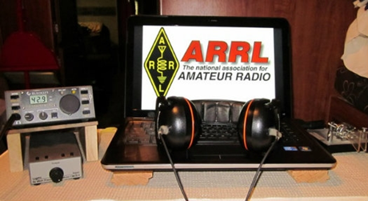**ARRL Contest Corner**

An expanded, downloadable version of *QST'*s’ [**Contest Corral**](http://www.arrl.org/contest-calendar) is available as a PDF. Check the sponsor’s ‘Website for information on operating time restrictions and other instructions.

**1 June - 9 Jun 2021**

An expanded, downloadable version of *QST'*s [Contest Corral](http://www.arrl.org/contest-calendar) is available as a PDF. Check the sponsors' website for information on operating time restrictions and other instructions.

**HF CONTESTS**  
  
[Worldwide Sideband Activity Contest](https://wwsac.com/rules.html), Jun 1, 0100z to Jun 1, 0159z; SSB; Bands: 160, 80, 40, 20, 15, 10, **6m**; RS + age group (OM, YL, Youth YL or Youth); Logs due: June 2.  
  
[QCX Challenge](http://www.qrp-labs.com/party.html), Jun 1, 0300z to Jun 1, 0400z; CW; Bands: 160, 80, 40, 20, 15, 10m; RST + Name + (state/province/country) + Rig; Logs due: June 6.  
  
[RTTYOPS Weeksprint](https://rttyops.wordpress.com/rtty-mini-contests/rttyops-weeksprint/), Jun 1, 1700z to Jun 1, 1900z; RTTY; Bands: 80, 40, 20m; [other station's call] + [your call] + [serial no.] + [your name]; Logs due: June 1.  
  
[Phone Weekly Test - Fray](http://www.perluma.com/Phone_Fray_Contest_Rules.pdf), Jun 2, 0230z to Jun 2, 0300z; SSB; Bands: 160, 80, 40, 20, 15m; NA: Name + (state/province/country), non-NA: Name; Logs due: May 28.  
  
[CWops Mini-CWT Test](https://cwops.org/cwops-tests/), Jun 2, 1300z to Jun 2, 1400z; CW; Bands: 160, 80, 40, 20, 15, 10m; Member: Name + Member No./"CWA", non-Member: Name + (state/province/country); Logs due: May 29.  
  
[VHF-UHF FT8 Activity Contest](http://www.ft8activity.eu/index.php/en/), Jun 2, 1700z to Jun 2, 2000z; FT8; Bands: (see rules) ; 4-character grid square; Logs due: June 7.  
  
[CWops Mini-CWT Test](https://cwops.org/cwops-tests/), Jun 2, 1900z to Jun 2, 2000z; CW; Bands: 160, 80, 40, 20, 15, 10m; Member: Name + Member No./"CWA", non-Member: Name + (state/province/country); Logs due: May 29.  
  
[Walk for the Bacon QRP Contest](https://qrpcontest.com/pigwalk40/), Jun 3, 0000z to Jun 3, 0100z and, Jun 4, 0200z to Jun 4, 0300z; CW; Bands: 40m Only; Maximum 13 wpm, RST + (state/province/country) + (Member No./power); Logs due: June 10.  
  
[CWops Mini-CWT Test](https://cwops.org/cwops-tests/), Jun 3, 0300z to Jun 3, 0400z; CW; Bands: 160, 80, 40, 20, 15, 10m; Member: Name + Member No./"CWA", non-Member: Name + (state/province/country); Logs due: May 29.  
  
[RTTYOPS Weeksprint](https://rttyops.wordpress.com/rtty-mini-contests/rttyops-weeksprint/), Jun 3, 1700z to Jun 3, 1900z; RTTY; Bands: 80, 40, 20m; [other station's call] + [your call] + [serial no.] + [your name]; Logs due: June 8.  
  
[NRAU 10m Activity Contest](https://nrrlcontest.no/index.php/nrrl-contests/nrau-nac/10m/nrau-nac-10m-english-rules/278-nrau-nac-10m-english-rules.html), Jun 3, 1700z to Jun 3, 1800z (CW) and, Jun 3, 1800z to Jun 3, 1900z (SSB) and, Jun 3, 1900z to Jun 3, 2000z (FM) and, Jun 3, 2000z to Jun 3, 2100z (dig); CW, SSB, FM, Digital; Bands: 10m Only; RS(T) + 6-character grid square; Logs due: June 17.  
  
[EACW Meeting](https://www.eacwspain.es/sample-page/eacwmeeting/), Jun 3, 1900z to Jun 3, 2000z; CW; Bands: 80, 40m; EACW Member: RST + Member No. + Nickname, EA non-Member: RST + Nickname + EA province, non-EA: RST + Nickname + DXCC prefix; Logs due: May 29.  
  
[SKCC Sprint Europe](http://www.skccgroup.com/operating_activities/skse/), Jun 3, 1900z to Jun 3, 2100z; CW; Bands: 160, 80, 40, 20, 15, 10, **6m**; RST + (state/province/country) + Name + (SKCC No./"NONE"); Logs due: June 10.  
  
[PODXS 070 Club Three Day Weekend Contest](http://www.podxs070.com/o7o-club-sponsored-contests/three-day-weekend), Jun 4, 0000z to Jun 6, 2359z; PSK31; Bands: 160, 80, 40, 20, 15, 10, **6m**; Name + RST + (state/province/country); Logs due: June 13.  
  
[NCCC RTTY Sprint](http://www.ncccsprint.com/rttyns.html), Jun 4, 0145z to Jun 4, 0215z; RTTY; Bands: (see rules); Serial No. + Name + QTH; Logs due: May 30.  
  
[NCCC Sprint](http://www.ncccsprint.com/rules.html), Jun 4, 0230z to Jun 4, 0300z; CW; Bands: (see rules); Serial No. + Name + QTH; Logs due: May 30.  
  
[HA3NS Sprint Memorial Contest](https://radioamator.honlapepites.hu/?p=1280), Jun 4, 1900z to Jun 4, 1929z (40m) and, Jun 4, 1930z to Jun 4, 1959z (80m); CW; Bands: 80, 40m; HACWG Members: RST + Membership No., non-Members: RST + NM; Logs due: June 11.  
  
[K1USN Slow Speed Test](http://www.k1usn.com/sst.html), Jun 4, 2000z to Jun 4, 2100z; CW; Bands: 160, 80, 40, 20m; Maximum 20 wpm, Name + (state/province/country); Logs due: May 30.  
  
[10-10 Int. Open Season PSK Contest](http://www.ten-ten.org/index.php/activity/2013-07-22-20-26-48/qso-party-schedule/2-uncategorised/51-open-season-rules), Jun 5, 0000z to Jun 7, 0000z; PSK31; Bands: 10m Only; Name + (state/province/country) + organization membership numbers; Logs due: June 14.  
  
[PVRC Reunion](http://pvrc.org/reunion/), Jun 5, 0000z to Jun 5, 0200z and, Jun 6, 0000z to Jun 6, 0200z; CW, SSB; Bands: 160, 80, 40, 20, 15, 10m; PVRC Member: 1st year of membership + name + (state/province/country) + callsign when joined PVRC, non-Member: name + (state/province/country); Logs due: June 20.  
  
[DigiFest](https://rigexpert.com/digifest/rules/), Jun 5, 0400z to Jun 5, 1200z and, Jun 5, 2000z to Jun 6, 0400z and, Jun 6, 1200z to Jun 6, 2000z; RTTY75, BPSK63, MFSK16, HELLSCHREIBER, OLIVIA; Bands: 80, 40, 20, 15, 10m; RST + 4-character grid square; Logs due: June 13.  
  
[KANHAM Contest](http://www.jarl.gr.jp/kanhamcontest/en/rules-of-the-10th-2020-kanham-contest-en), Jun 5, 0600z to Jun 6, 0600z; CW, Phone; Bands: 160, 80, 40, 20, 15, 10, **6, 2, UHF**; JA: RST + Prefecture No., JA Young or YL: RST + Prefecture No. + "Y", Non-JA: RST, Non-JA Young or YL: RST + "Y"; Logs due: June 30.  
  
[Wake-Up! QRP Sprint](http://qrp.ru/contest/wakeup/333-wakeup-eng), Jun 5, 0600z to Jun 5, 0629z and, Jun 5, 0630z to Jun 5, 0659z and, Jun 5, 0700z to Jun 5, 0729z and, Jun 5, 0730z to Jun 5, 0800z; CW; Bands: 40, 20m; RST + Serial No. + suffix of previous QSO ("QRP" for 1st QSO); Logs due: June 12.  
  
[Tisza Cup CW Contest](https://www.tiszacup.eu/index.php/en/contest-rules), Jun 5, 1200z to Jun 6, 1159z; CW; Bands: 160, 80, 40, 20, 15, 10m; RST + CQ Zone No.; Logs due: June 11.  
  
[Kentucky QSO Party](http://www.kyqsoparty.org/rules/), Jun 5, 1400z to Jun 6, 0200z; CW, SSB, Digital; Bands: 160, 80, 40, 20, 15, 10, **6, 2m**; KY: RS(T) + county, non-KY: RS(T) + (state/province/"DX"); Logs due: June 30.  
  
[RSGB National Field Day](https://www.rsgbcc.org/hf/rules/2021/rnfd.shtml), Jun 5, 1500z to Jun 6, 1500z; CW; Bands: 160, 80, 40, 20, 15, 10m; RST + Serial No.; Logs due: June 11.  
  
[FULL-LRB HF Contest](https://www.qrz.com/db/5K48LRB), Jun 5, 1800z to Jun 6, 1200z; SSB, FT8; Bands: 40, 20m; RS(T); Logs due: June 15.  
  
[Cookie Crumble QRP Contest](http://w3atb.com/cookie-crumble/), Jun 6, 1700z to Jun 6, 2200z; All; Bands: All, except WARC; RS(T) + (state/province/country) + cookie no. + name; Logs due: July 31.  
  
[K1USN Slow Speed Test](http://www.k1usn.com/sst.html), Jun 7, 0000z to Jun 7, 0100z; CW; Bands: 160, 80, 40, 20m; Maximum 20 wpm, Name + (state/province/country); Logs due: May 30.  
  
[RSGB 80m Club Championship, Data](https://www.rsgbcc.org/hf/rules/2021/r80mcc.shtml), Jun 7, 1900z to Jun 7, 2030z; RTTY, PSK; Bands: 80m Only; RST + Serial No.; Logs due: June 8.  
  
[Worldwide Sideband Activity Contest](https://wwsac.com/rules.html), Jun 8, 0100z to Jun 8, 0159z; SSB; Bands: 160, 80, 40, 20, 15, 10, **6m**; RS + age group (OM, YL, Youth YL or Youth); Logs due: June 9.  
  
[ARS Spartan Sprint](http://arsqrp.blogspot.com/2009/02/so-whats-spartan-sprint-and-how-do-i.html), Jun 8, 0100z to Jun 8, 0300z; CW; Bands: 80, 40, 20, 15, 10m; RST + (state/province/country) + Power; Logs due: June 10.  
  
[RTTYOPS Weeksprint](https://rttyops.wordpress.com/rtty-mini-contests/rttyops-weeksprint/), Jun 8, 1700z to Jun 8, 1900z; RTTY; Bands: 80, 40, 20m; [other station's call] + [your call] + [serial no.] + [your name]; Logs due: June 8.  
  
[NAQCC CW Sprint](http://naqcc.info/sprint/sprint202107.html), Jun 9, 0030z to Jun 9, 0230z; CW; Bands: (see rules) ; RST + (state/province/country) + (NAQCC No./power); Logs due: June 13.  
  
[Phone Weekly Test - Fray](http://www.perluma.com/Phone_Fray_Contest_Rules.pdf), Jun 9, 0230z to Jun 9, 0300z; SSB; Bands: 160, 80, 40, 20, 15m; NA: Name + (state/province/country), non-NA: Name; Logs due: May 28.  
  
[CWops Mini-CWT Test](https://cwops.org/cwops-tests/), Jun 9, 1300z to Jun 9, 1400z; CW; Bands: 160, 80, 40, 20, 15, 10m; Member: Name + Member No./"CWA", non-Member: Name + (state/province/country); Logs due: May 29.  
  
[VHF-UHF FT8 Activity Contest](http://www.ft8activity.eu/index.php/en/), Jun 9, 1700z to Jun 9, 2000z; FT8; Bands: (see rules); 4-character grid square; Logs due: June 14.  
  
[CWops Mini-CWT Test](https://cwops.org/cwops-tests/), Jun 9, 1900z to Jun 9, 2000z; CW; Bands: 160, 80, 40, 20, 15, 10m; Member: Name + Member No./"CWA", non-Member: Name + (state/province/country); Logs due: May 29.

**VHF+ CONTESTS**

[UKSMG Summer Contest](http://uksmg.org/summer-contest-rules.php), Jun 5, 1300z to Jun 6, 1300z; not specified; Bands: 6m Only; RST + Serial No. + 6-character grid square + (optional UKSMG member no.); Logs due: June 28.

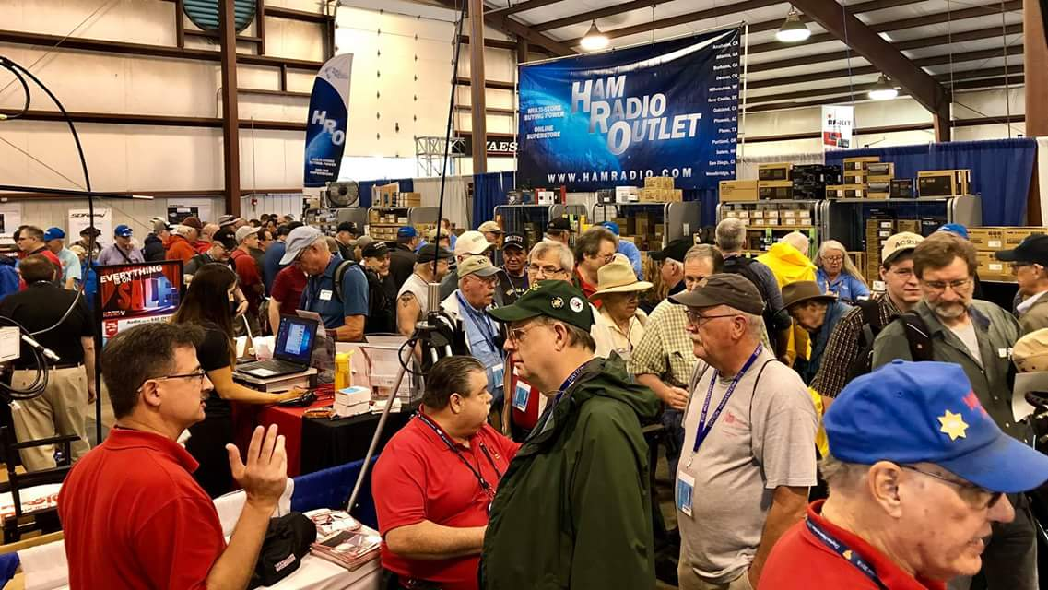[**Upcoming *Hamfests***](http://arrl-ohio.org/hamfests.html)

We **DO** have some hamfests scheduled for 2021!! Yes, take a good look at the list, it’s growing every day!

HAMFEST/CONVENTION

**06/05/2021 -**[**FCARC SummerFest**](http://www.arrl.org/hamfests/fcarc-summerfest)

**Location:**Wauseon, OH  
**Type:** ARRL Hamfest  
**Sponsor:** Fulton County Amateur Radio Club  
**Website:** <http://k8bxq.org/hamfest>  
[**Learn More**](http://www.arrl.org/hamfests/fcarc-summerfest)

HAMFEST/CONVENTION

**07/10/2021 -**[**Mansfield Mid-Summer Trunkfest**](http://www.arrl.org/hamfests/mansfield-mid-summer-trunkfest)

**Location:**Mansfield, OH  
**Type:** ARRL Hamfest  
**Sponsor:** Intercity Amateur Radio Club  
**Website:** [http://WWW.IARC.CLUB](http://www.iarc.club/)  
[**Learn More**](http://www.arrl.org/hamfests/mansfield-mid-summer-trunkfest)

HAMFEST/CONVENTION

**07/17/2021 -**[**NOARSFEST**](http://www.arrl.org/hamfests/noarsfest-8)

**Location:**Elyria, OH  
**Type:** ARRL Hamfest  
**Sponsor:** Northern Ohio Amateur Radio Society  
**Website:** [http://noars.net](http://noars.net/)  
[**Learn More**](http://www.arrl.org/hamfests/noarsfest-8)

HAMFEST/CONVENTION

**07/18/2021 -**[**Van Wert Hamfest**](http://www.arrl.org/hamfests/van-wert-hamfest-5)

**Location:**Van Wert, OH  
**Type:** ARRL Hamfest  
**Sponsor:** Van Wert Amateur Radio Club  
**Website:** [http://W8FY.ORG](http://w8fy.org/)  
[**Learn More**](http://www.arrl.org/hamfests/van-wert-hamfest-5)

HAMFEST/CONVENTION

**08/07/2021 -**[**2021 Columbus Hamfest**](http://www.arrl.org/hamfests/2021-columbus-hamfest)

**Location:**Grove City, OH  
**Type:** ARRL Hamfest  
**Sponsor:** Aladdin Shrine Audio Unit  
**Website:** [http://columbushamfest.com](http://columbushamfest.com/)  
[**Learn More**](http://www.arrl.org/hamfests/2021-columbus-hamfest)

HAMFEST/CONVENTION

**08/28/2021 -**[**Cincinnati Hamfest℠**](http://www.arrl.org/hamfests/cincinnati-hamfest)

**Location:**Owensville, OH  
**Type:** ARRL Hamfest  
**Sponsor:** Milford ARC  
**Website:** [http://CincinnatiHamfest.org](http://cincinnatihamfest.org/)  
[**Learn More**](http://www.arrl.org/hamfests/cincinnati-hamfest)

HAMFEST/CONVENTION

**09/26/2021 -**[**Cleveland Hamfest**](http://www.arrl.org/hamfests/cleveland-hamfest-1)

**Location:**Berea, OH  
**Type:** ARRL Hamfest  
**Sponsor:** Hamfest Association of Cleveland  
**Website:** [http://www.hac.org](http://www.hac.org/)  
[**Learn More**](http://www.arrl.org/hamfests/cleveland-hamfest-1)

HAMFEST/CONVENTION

**10/31/2021 -**[**Massillon (Ohio) Hamfest**](http://www.arrl.org/hamfests/massillon-ohio-hamfest)

**Location:**Green, OH  
**Type:** ARRL Hamfest  
**Sponsor:** Massillon Amateur Radio Club  
**Website:** [http://w8np.org](http://w8np.org/)  
[**Learn More**](http://www.arrl.org/hamfests/massillon-ohio-hamfest)

HAMFEST/CONVENTION

**12/04/2021 -**[**FCARC WinterFest**](http://www.arrl.org/hamfests/fcarc-winterfest-2)

**Location:**Delta, OH  
**Type:** ARRL Hamfest  
**Sponsor:** Fulton County Amateur Radio Club  
**Website:** <http://k8bxq.org/hamfest>  
[**Learn More**](http://www.arrl.org/hamfests/fcarc-winterfest-2)

 **News From the South 40—Memorial Day Edition**

Monday is Memorial Day also known by some of our older citizens as Decoration Day or Poppy Day. Its history is unclear but following the Civil War communities started paying tribute to those who died during that conflict. So on Monday let’s take a moment from ham radio to pay respect to all of our military people and others who have died defending our freedoms and the American way of life.

Last time we made a visit to the **Sunday Creek Amateur Radio Federation** in the Glouster/Nelsonville areas of Athens County. Today we hop the county line into Hocking County-the home of the **Hocking Valley ARA** and the K8LGN 147.345 repeater.

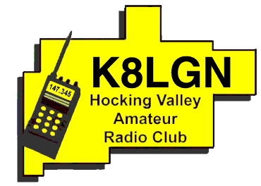Although there has been amateur activity in Hocking County for at least 30 years, the **Hocking Valley ARC** is a relative newcomer. According to Bill Hopstetter, W8LGX the club was organized in 1991 with Ray Webb, KB8GUN, as the first president. In order to help get the club started a Novice License class was held at the local hospital. For several years they met at the hospital and then in the back room of the Shake Shack until in when the County EMA acquired a facility for them. In 1999 the Club acquired the 147.345 repeater from a private individual and received the KC8EJZ call sign. In 2005 the call was changed to K8LGN. The Club annually participates in Field Day and activates Lake Logan during Ohio State Parks on the Air. In recent times it has been conducting monthly Fox Hunt tracking activities within Hocking County. In 2017 they ran a special event station using the N8H call sign and will use that same call for this year’s Field Day. Besides the previously mentioned two meter repeater, the Club also has repeaters on 223.460 and 443.125. A weekly net is held each Wednesday on the repeaters with a rag-chew net on Thursday evenings. Additionally they have full low band, two meter and 70 cm stations at the Hocking County EMA Operations Center. The Club holds a family Christmas dinner each year at a local church hall. Thanks to W8LGX for the information.

That’s it for our visit to the **Hocking Valley ARC** as we head our vehicle towards Fairfield County and a visit to the **Lancaster and Fairfield County ARA**. But in the meantime here are some of the things of interest happening in the South 40.

On Memorial Day, Monday, May 31, the **Southern Ohio ARA** and **Portsmouth RC** will team up to provide communications and other support for the annual Ironton/Lawrence County Memorial Day Parade. This event is said to be the oldest continuously running Memorial Day Parade in the nation. It traces its beginnings to 1868. The two clubs have provided support to the event for many years. Ken Massie, WN8F, says it will get underway at 10 am on Center Street near Sixth in Ironton.

Because of the Memorial Day Weekend the **Cambridge ARA** has postponed their May meeting. It has been rescheduled for June 5 at 10 am at the Guernsey County Administration Building, 627 Wheeling Avenue in Cambridge. The June meeting will be held at the Field Day site near New Concord.

Word from the **Cincinnati Hamfest** and the **W8DXCC** is although the August 28 **W8DXCC** does not officially start until 1 pm, a ‘DXPediton Roundtable’ will start at noon. During this 50 minute open forum several well-known Southwestern Ohio DXers will answer questions, tell stories and share information in an informal setting. Admission to the event is $8 and it will be held in the 4-H Building. Dave Vest, K8DV, will be on hand to check QSL cards for DXCC, WAS, WAC and other ARRL awards.

Recently two newly licensed Ross County hams from Bainbridge ventured into the popular Parks on the Air craze by activating Pike Lake State Park. Travis Holden, WA6WTF, and Sam Johnson, W8SKJ, became first time activators making 51 contacts throughout the US and Canada. They were planning to repeat their efforts at Rocky Fork during the Memorial Day weekend.

On Tuesday evening, June 1, the **Hocking Valley ARC** will hold an in-person meeting on the second floor of the historic Logan Theater in Logan. The meeting will be called to order at 7 pm. The **Highland ARA** will hold their June business meeting on the 8th at Liberty Park’s Harmony Lake shelter house at 7 pm.

Greenfield’s Jim Orebaugh, N8AXB, is in need of someone who can climb and do an antenna installation for him. If you can assist him, he can be reached at 937-763-1086.

Our neighbors south of the Ohio River are encouraged to get on the air during their individual state QSO parties. Kentucky’s will be on June 5-6 and West Virginia will be on June 19-20. Information on each can be found on either the www.kyqsoparty.org or [www.qsl.net/wvsarc/wvpp/wvap.html](http://www.qsl.net/wvsarc/wvpp/wvap.html) websites. Each contest affords those collecting counties to add new ones on their journey to earn the CQ Worked All Counties Award.

Add the **Hocking Valley ARC** to the growing list of Southern Ohio clubs that will be active during Field Day. They will be on the air from the KB8GUN QTH in Laurelville using the N8H call sign. Because they also like to eat and socialize they will hold a potluck dinner on Saturday evening at 6 pm.

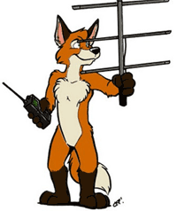The **Athens County ARC** will hold its first Fox Hunt on Saturday, June 12. Club officials say the ‘Fox’ will be located on a public thoroughfare somewhere in Athens County. Participants are to check in through the 145.15 repeater at 9:45 with the hunt to start at 10 am. There is no charge to participate. The event will last until all hunters have found the ‘Fox” or officially dropped out of the hunt. The winner will receive a traveling trophy and the right to be the following months ‘Fox’. Following the conclusion of the event, all will adjourn to a local restaurant or watering hole to relive the event.

The **Queen City Emergency Net** and the Cincinnati area **OHKYIN** club teamed up to conduct a remote-learning ham radio mentoring project. Each club provided mentors who were available to assist those working on licenses or upgrades through those rocky stages in understanding theory. The project wrapped up with license testing on the 22nd. Eight students and six mentors participated.

**Highland ARA** President Pat Hagen, N8BAP, invites any ham who does not have a local club participating in Field Day to visit their Club’s site near New Vienna. Information on the location can be found by viewing the ARRL’s Field Day Locator map or contacting highlandara@gmail.com.

In an effort to get more people licensed or upgraded prior to Field Day the **River Cities ARA** will hold a test session at the Bellefonte Italian Restaurant in Ashland, KY on June 8. The **Cambridge Maker Group** will test on June 12 at St. John’s Episcopal Church and the **Tri-State ARA** will also conduct a test at the Radio Museum in Huntington, WV that day. **Athens County ARA** will hold a session on June 21. It will be held in the Red Cross parking lot should the building not yet be open to the public. South 40 region readers will also have an opportunity to test in Morehead, KY on June 26. The **Morehead ARS** is having their test session at the Kentucky Fire Training Center. The link for details and other information for each can be found on the statewide license examination link shown elsewhere in this Section Journal.

**JUST IN**-A reliable source tells us the **Bluegrass ARC’**s hamfest in Lexington, KY has been cancelled. Also COVID concerns caused the change to the location of the Great Lakes ARRL Convention. We’ve learned the **Kentucky Colonels ARC** will host this year’s convention during their VetteCity Hamfest in Bowling Green, KY on October 2. The event had previously been scheduled to be held at the now cancelled DX Engineering Hamfest at Tallmadge, OH.

Upon heading to our Ohio Century Farm Saturday morning, N8ZNR and I decided to stop at the restaurant in New Vienna for breakfast. Upon entering we were surprised when greeted by some members of the **Clinton County ARA**. Prior to the pandemic, the CCARA held monthly Last Saturday breakfasts at the restaurant that attracted hams from throughout the area and occasionally beyond. Mark Atwell, KD8DGH, is attempting to get them restarted now that restrictions have been lifted. Although the next one is scheduled for the Saturday of Field Day, it is still going to occur prior to members heading to their Field Day site near Wilmington. While chatting with President Dave Gordley, K8DEG, we learned the CCARA will hold a trunk-fest at the Clinton County Fairgrounds on July 24. As Kathy and I had not seen some of these folks for over a year, running into them and having one of Stephanie’s famous Slum Gullies was a pleasant way to kick off the holiday weekend while delaying our getting to the farm to start the work projects that needed done.

Recently while looking through my original ARRL logbook (remember those?) I came across a mid-1960s six meter contact with K8QIK. A note indicated it was operating from the courthouse in Lancaster. That was my first contact with the club station for today’s final club visit-the **Lancaster and Fairfield County ARC.**

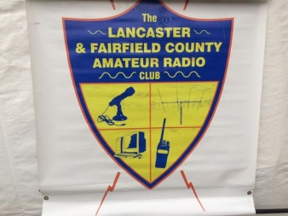Since the early days of radio, ham radio has been alive and well in the Lancaster area. But on June 3, 1959 twenty-one amateurs gathered to officially form the **Lancaster and Fairfield County ARA**. Since that time the Club has grown to around 100 members, prospered and not only works with the County EMA, Homeland Security, law enforcement and emergency response agencies, the Club has provided communications for local parades and other community events over the years. The Club’s first experimental repeater was put on the air in 1973 with the 147.03 repeater coordinated in 1977. It presently operates from a 160’ tower on Waterworks Hill. A privately owned 146.70 repeater (originally put on the air in 1978) was donated to the club and is located in Downtown Lancaster. Two other repeaters are maintained by the Club. One is on 443.875 and is a part of the 10 repeater Ohio Link Network. The other is one of few Ohio six meter machines and is found on 53.09. For several years the group held an annual hamfest at the county fairgrounds. For many years the Club had a station located in the county courthouse. Several years ago the Club obtained the use of property near the college owned by the County Commissioners as a meeting and station location and Field Day site. Following the county’s sale of the property and short term stays at other locations the Club now meets and has a station at the Fairfield Medical Center’s River Valley Campus in Lancaster. It has an active VE program with monthly testing. The Club has a monthly breakfast gathering and a weekly Monday night 9 pm Net. A highlight of the Club occurred in October 2018 when members of the Club successfully assisted Lancaster’s Tallmadge Elementary School’s participation in the ARISS and NASA program to contact the International Space Station via Amateur Radio. The event led to widespread publicity and recognition for the Club.

Thanks to former LFCARC newsletter editor Ralph Howes, W8BVH, for providing much of the above information. Although I’m certain that he and my long-time friends Dave and Diane Kennedy, WA8EUT and N8XEM, plus former Fairfield County Sheriff dispatcher Patrick Gilifillen, N8EWH, could tell a lot of stories about the events the Club has participated in over the years. But time’s getting late and we need to leave and get on towards our next destination-the **Cambridge ARA**. Until then, here’s hoping every reader has an enjoyable, safe and healthy Memorial Day. But please take a few moments from celebrating the first holiday of the Summer to give thanks to the military members who gave the ultimate so we can have the freedoms we have today letting us be able to play radio. Plus this year let’s include those first responders, law enforcement and public servants who also have died while serving our nation and its many individual communities.

73, John Levo, W8KIW

**___________________________________________________________________**

**Print an Official or Unofficial Copy of Your Amateur Radio License**

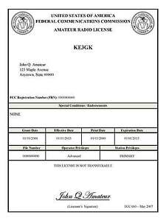*(By Anthony Luscre, K8ZT)*

As of February 17, 2015, the **FCC no longer routinely issues paper license documents** to Amateur Radio applicants and licensees. The Commission has maintained for some time now that the official Amateur Radio license authorization is the electronic record that exists in its Universal Licensing System (ULS). The FCC will continue to provide paper license documents to all licensees who notify the Commission that they prefer to receive one.

Licensees also will be able to print out an official authorization — as well as an unofficial “reference copy” — from the ULS License Manager. I’ve created a set of instructions on how you can request an **“official” printed copy of your license\***

[**Click here to download the instructions**](http://arrl-ohio.org/news/2020/print_your_license.pdf)

***One Question Questionnaire***

Hey Gang,

I’ve got a new question, so how about going to www.ARRL-OHIO.org and giving me a click? (It’s in the bottom left corner of the page)

***“What is the MAIN antenna used at your station?”***

From the last Poll: **"ARE YOU HAPPY ABOUT THE MASK MANDATES BEING RESINDED?"**

33.5% said NO. 14.5% said NOT SURE 50% said YES &/or OH HECK YES! (out of 122 responses)

*****V.E. Test Sessions***

Many V.E.’s have decided to start testing once again, but with restrictions that need to be adhered to for sure. Here’s the link to find that V.E. Test session and what is expected of YOU before going. <http://www.arrl.org/find-an-amateur-radio-license-exam-session>

Ohio Section Cabinet

|  |  |
| --- | --- |
| Section Manager – Tom Sly, WB8LCD | Section Traffic Manager – David Maynard, WA3EZN |
| Section Emergency Coordinator – Stan Broadway, N8BHL | Section Youth Coordinator – Anthony Luscre, K8ZT |
| Technical Coordinator – Jeff Kopcak, K8JTK | Affiliated Clubs Coordinator – Tom Sly, WB8LCD |
| State Government Liaison – Bob Winston, W2THU | Public Information Coordinator – John Ross, KD8IDJ |



Hey Gang,

Have you taken a look at the **Swap & Shop** page on the Ohio Section webpage yet?? Here’s a link that will take you there… <http://arrl-ohio.org/sm/s-s.html>

Do you have equipment that you just don’t need or want anymore? Here’s a great venue to advertise it, and it’s FREE!! Is your club doing a fund raiser to help raise money? After a lot of thought, it was decided that the Swap & Shop webpage could also contain these types of items as well. The same rules will apply as do for the For Sales and Give-A-Ways and will only be posted for a month at a time. Please see the Terms & Conditions on the webpage.

If your club is doing a fund raiser and wants more exposure, please forward the information to me and I’ll advertise it on the Swap & Shop webpage for you.

Now, I still want to remind you that it won’t be listed in this newsletter because it would take up way too much space, so your ad will only appear on the website. It is there for any individual to post equipment Wanted / For Sale or Give-Away as well as for Club Fund Raisers. No licensed vehicles/trailers or business advertising will be posted. Postings are text only (no pictures or graphics) will be posted for a maximum of 1 month from date posting and require a contact phone number or email within the posting. Send your Wanted / For Sale or Give-Away post to:  [swap@arrlohio.org](mailto:swap@arrlohio.org)

***Back Issues of the PostScript and Ohio Section Journal***

Hey, did you know that PostScript and Ohio Section Journal (OSJ) are archived on the website? You can go back and look at any edition simply by clicking:

<http://arrl-ohio.org/news/index.html>

***Want to Share your Club Newsletter With Others?***

We have a webpage where you can download and read all of the newsletters that I get from around the state and even other sections!

Here’s the link to the page…. <http://arrl-ohio.org/club_news/index.html>

Please, if you don’t see your club newsletter posted, it’s because I’m not receiving it. Just have your newsletter editor contact me and I’ll get your club’s newsletter listed on the site!!

We all learn and steal (I mean, share) from each other’s work. So, get me your newsletter!!! Send it to: [webmaster@arrl-ohio.org](mailto:webmaster@arrl-ohio.org)

***Chit – Chat, and All That!***

Do you know someone that’s not getting these Newsletters? Please, forward a copy of this Newsletter over to them and have them “[Opt-In](mailto:Opt-In)” to start receiving them. Heck, just have them send an email to: [webmaster@arrl-ohio.org](mailto:webmaster@arrl-ohio.org) and we’ll get them added to the Ohio Section Emailing list.

We now have many thousands of readers receiving these newsletters weekly. Quite impressive, I’d say! I urge all of you to make sure that everyone, regardless of whether they are a League member or not, get signed up to receive these weekly Newsletters.

You can always “Opt-Out” at any time if you feel this is not what you were expecting. It’s fun and very informative. All of your favorite past newsletters are now archived too.

You can go back at any time and read them.

Just go to: <http://arrl-ohio.org/news/>

The pictures on the front page and throughout this newsletter are from various newsletters, Facebook posts and/or were sent directly to me in recent weeks. Take a good look at them, you just might be in one of the pictures! “SMILE… you’re in the Ohio Section News!!”

*PostScript is produced as a weekly newsletter. I want to thank everyone that has contributed articles and ideas to make this an even better news source. I sincerely hope that you have enjoyed this edition and will encourage your friends to join with you in receiving the latest news and information about the Ohio Section, and news and events happening around the world!*