[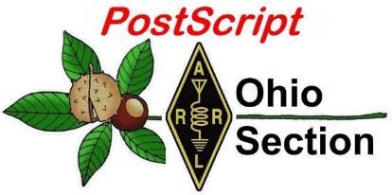](http://arrl-ohio.org/news/) ***“May 17th***

***Edition”***

🡪 [National News](#national) 🡪 [Club Corner](#club)

🡪 [DX This Week](#dx) 🡪 [Contest Corner](#contest)

🡪 [Upcoming Hamfests](#hamfest) 🡪 [One Question Questionnaire](#one)

🡪 [VE Testing](#ve)

**Cuyahoga Falls ARC 1993 Field Day**

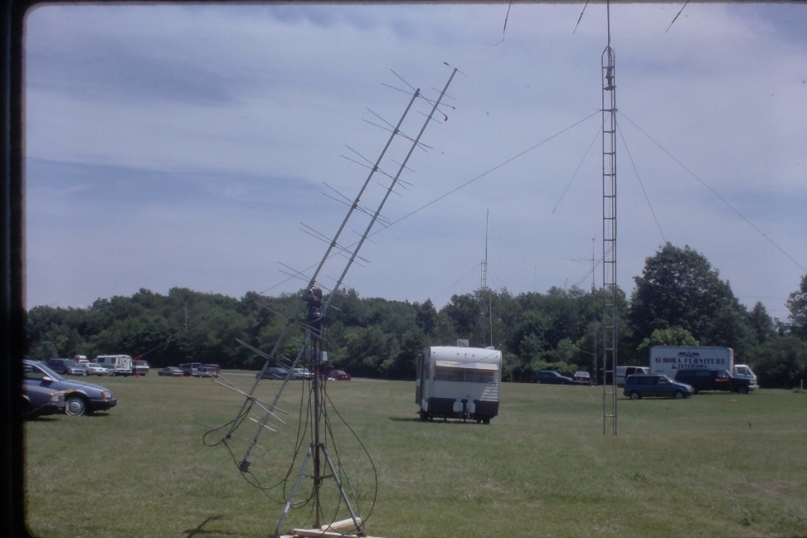

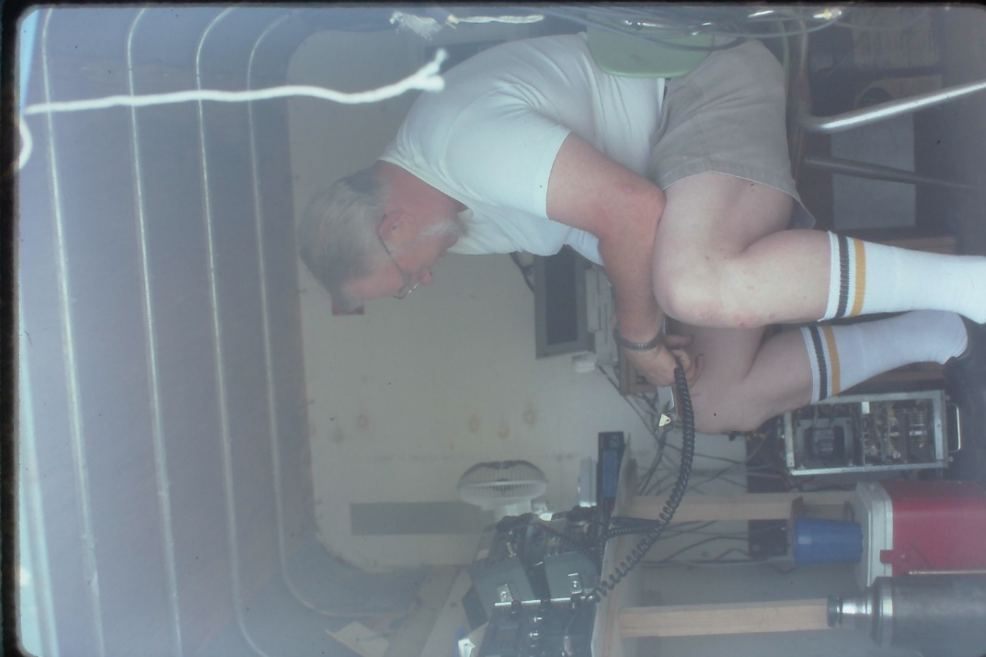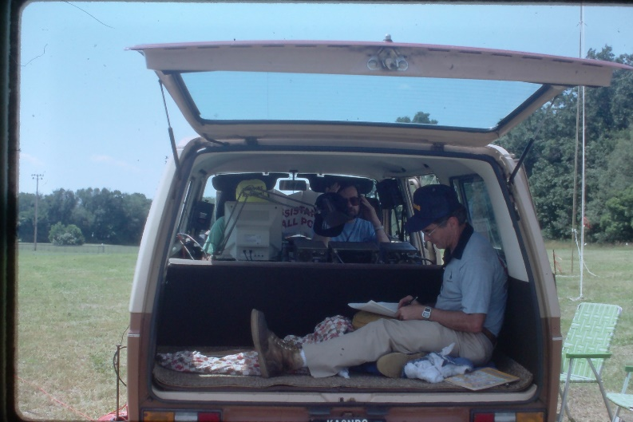

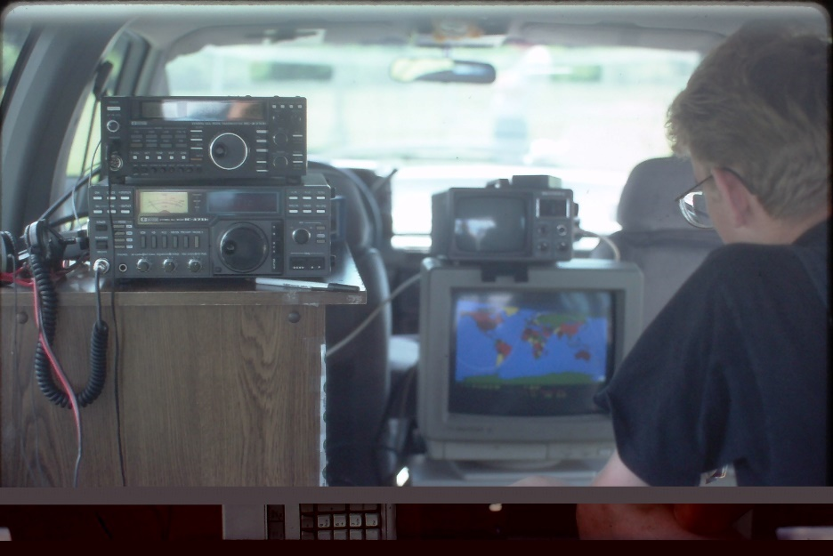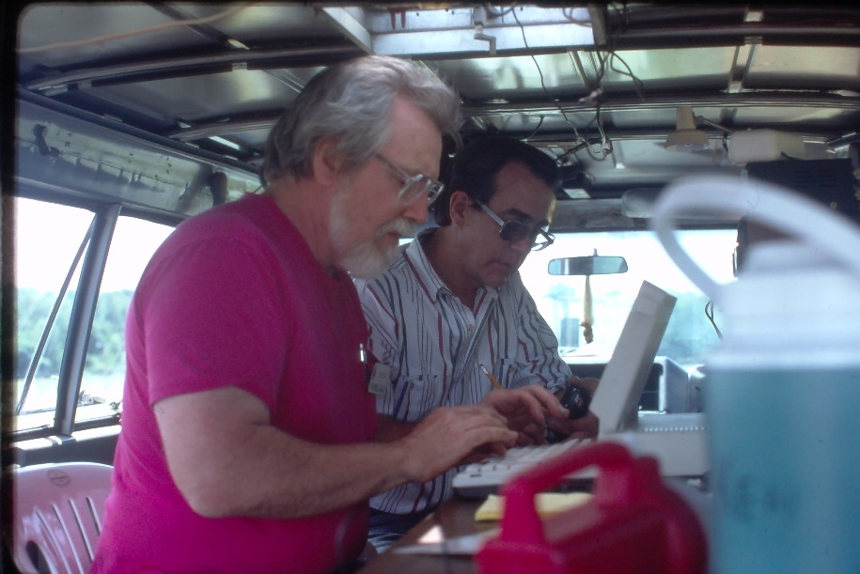

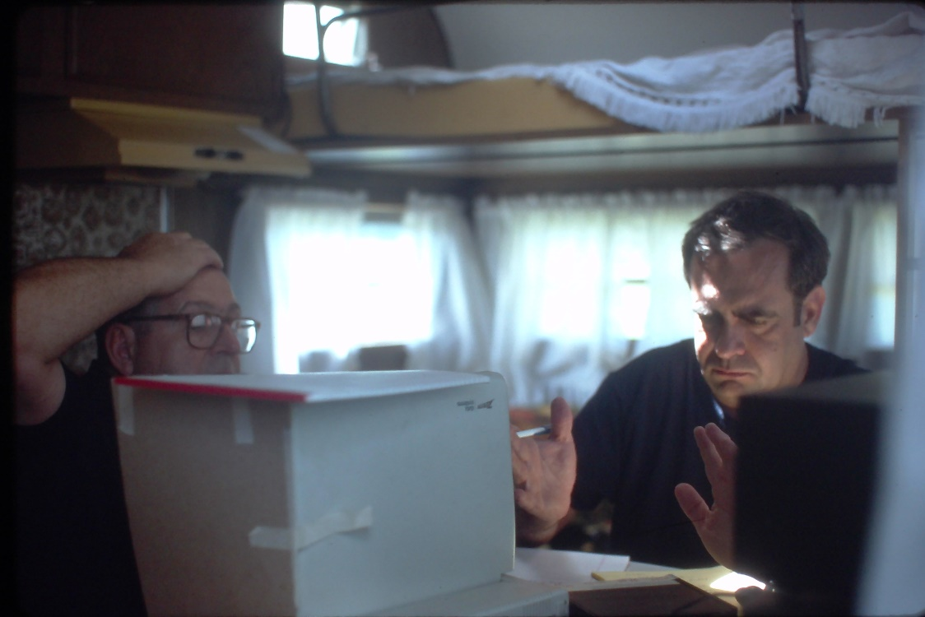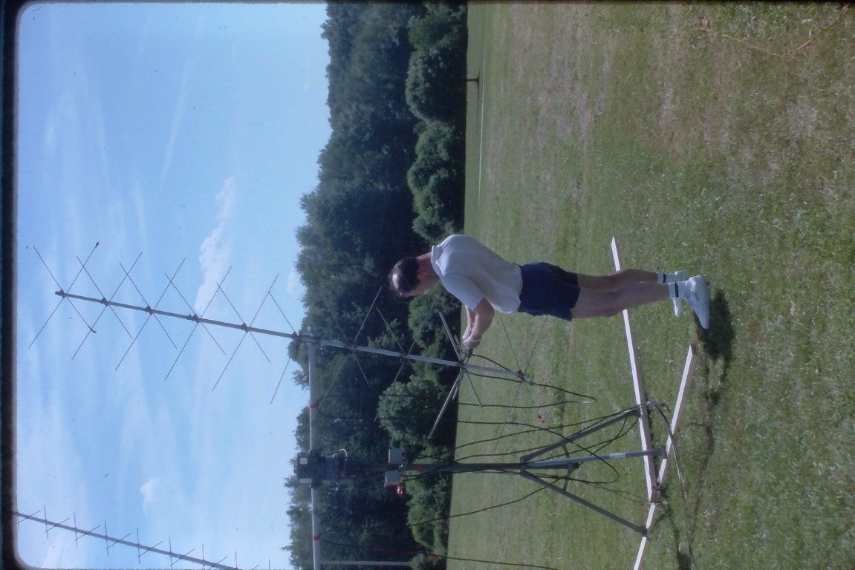

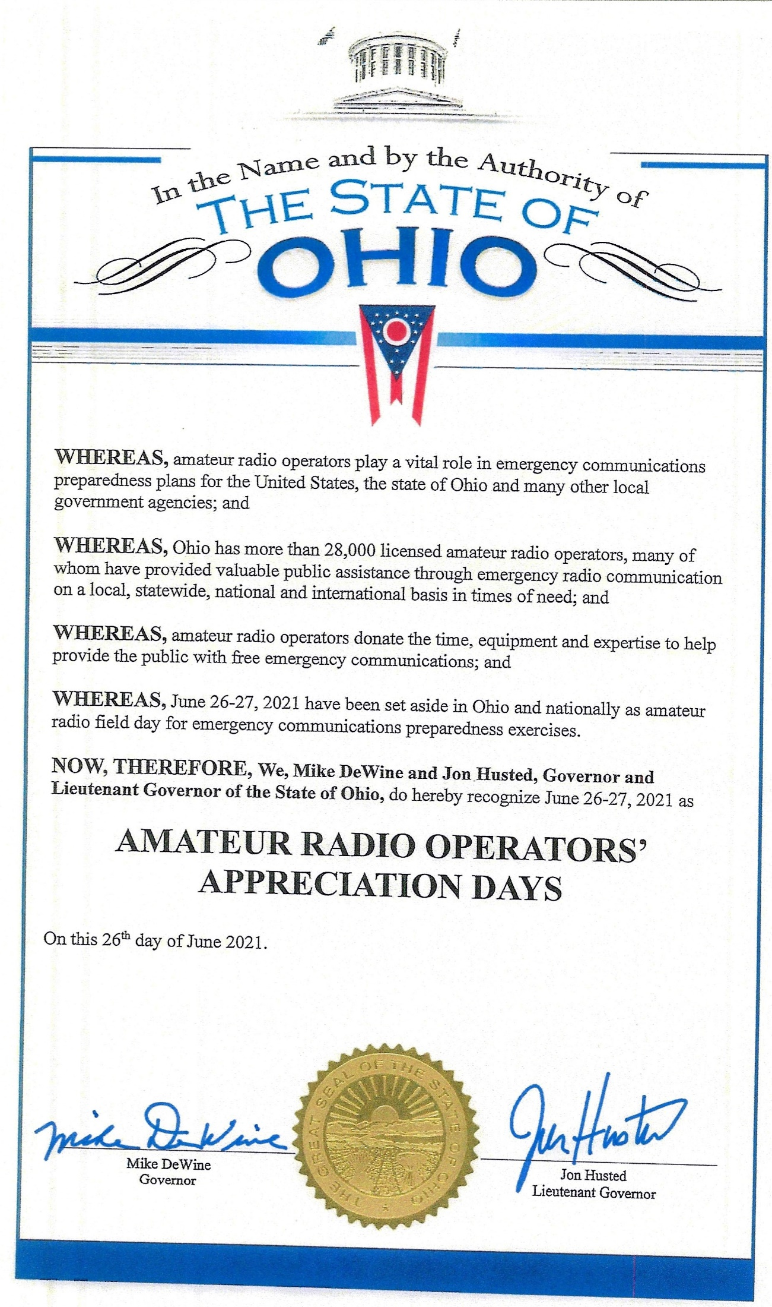

**Field Day Notes:**

#1 – Get your Club’s FD Site listed on the ARRL FD Site Locator! [Field Day Station Locator (arrl.org)](http://www.arrl.org/field-day-locator) I’ll be using this to choreograph my travels across the state over the weekend, so, if you’re not listed, I won’t be there – and I really want to hit every OH Section FD site (if it’s physically possible without breaking the speed limit!)

#2 - If you can’t participate at your club’s Field Day site – operate from Home! Be sure to list your associated club so your club shows up in the “Aggregated Club” scores. Make sure everyone from your club lists the club *exactly* the same. “PCARS” does NOT equal “Portage County ARS” does not equal “Portage County Amateur Radio Service”.

#3 – Make sure Field Day is a FUN event for everyone in your club – especially new hams.

#4 – Let your community know you’re out there! (Public relations) I’ll have a media “Press Release” template coming out shortly.

#5 – Stay Safe!

Note: I reserve the right to add or delete from this list as Field Day gets closer.

Tom WB8LCD – OH Section Manager



PS: Thank you to Bob Winston – W2THU – Ohio Section State Government Liaison for working with the Governor’s office to obtain the above Proclamation. Also, Thank you to Governor DeWine and Lieutenant Governor Husted for recognizing Amateur Radio as an important asset to the State of Ohio.

***National News***

*(from arrl and other sources)*

**From David Minster – NA2AA – ARRL CEO**

In a recent communication from David Minster to ARRL Section Managers David writes “through the efforts of our FCC Attorney in Washington DC, we have received confirmation from FCC that email addresses will NOT be viewable to the public. With the requirement of an email address coming up soon, some members were concerned that FCC data would be publicly viewable and expose them to Spam and other unwanted emails. This will not be something they will need to concern themselves with”.

####

**First-Time Exam Applicants Must Obtain FCC Registration Number Before Taking Exam**

Beginning May 20, 2021, all amateur examination applicants will be required to provide an FCC Registration Number ([FRN](https://www.fcc.gov/wireless/support/universal-licensing-system-uls-resources/getting-fcc-registration-number-frn/)) to the Volunteer Examiners (VEs) before taking an amateur exam. This is necessary due to changes the FCC has made to its licensing system.

Amateur candidates who already have an FCC license, whether for amateur radio or another service, and already have an FRN may use the same number. All prospective new FCC licensees, however, will be required to obtain an FRN *before* the examination and provide that number to the volunteer examiners on the Form 605 license application. An FCC [instructional video](https://www.fcc.gov/rofrn) provides step-by-step instructions on how to obtain an FRN through the FCC's COmmission REgistration System (CORES).

The FRN is required for all new applicants to take an amateur exam and is used afterward by the applicant to download the license document from the FCC Universal Licensing System ([ULS](https://www.fcc.gov/wireless/universal-licensing-system)), upgrade the license, apply for a vanity call sign, and to submit administrative updates (such as address and email changes) and renewal applications.

In addition, after June 29, all applications will be required to contain an email address for FCC correspondence. Applicants will receive an email directly from the FCC with a link to the official electronic copy of their license whenever a license is issued or changed. ARRL VEC suggests that those without access to email should use the email address of a family member or friend. Licensees will be able to log in to the ULS using their FRN and password to download the latest version of their license at any time. The FCC no longer provides paper license documents.

####

**April 2021 Volunteer Monitor Program Report Released**

The Volunteer Monitor (VM) Program is a joint initiative between ARRL and the FCC to enhance compliance in the Amateur Radio Service.

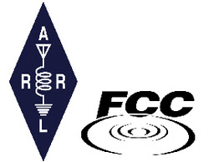A General-class renewal applicant withdrew his application after FCC notice that the renewal application would be held up pending review of Volunteer Monitor complaints. As a consequence, the Quakertown, Pennsylvania, applicant has no operating privileges.

Twenty-one operators in 14 states received *Advisories* because of their operation in the March CQ World Wide DX Contest. While making contacts with VC3T and VC2W, their LSB signals extended below 7.125 MHz, which is the lower limit of the 40-meter amateur phone band.

Volunteer Monitors participated in a nationwide training program on April 7 that was conducted by ARRL and the FCC.

Volunteer Monitors had two meetings in April with FCC Enforcement Bureau personnel.

The totals for VM monitoring in March were 1,394 hours on HF frequencies and 2,515 hours on VHF and above frequencies.

###

**Hamvention Weekend Virtual Activities**

**That magical weekend in May approaching.  With no Hamvention this year, due to continuing Coronavirus restrictions, we have been developing several activities to keep Hams busy and engaged in the hobby.**

**Thursday May 20. 2021**

**The Virtual Contest University will be held starting at 9 AM EDT 1300Z. The course outline will be available soon. This will be a free event!**

**Even if you are not a contester you will learn so much about Amateur Radio and hear the techniques and critiques of many of the world’s foremost Hams.**

**Hamvention is a proud sponsor along with Icom and DxEngineering. Plan on attending this amazing free event!**

**Several Icom radios will be given away during the all-day event. You must be registered on Zoom and present online at the time of the drawing to win the radios.**

****

****

[CONTEST UNIVERSITY REGISTRATION](https://zoom.us/webinar/register/WN_uFqLO-ZhQg-KtrH0zKaVjg)

**Friday May 21 Starting at 11 AM EDT 1500Z**

**We will have the 2021 Virtual Hamvention Forums.**

**The Hamvention Virtual Forums celebrates the 2021 Hamvention Award winners. Each awardee will give a 45 minute presentation followed by Q&A.**

**The Hamvention Forums will be presented via Zoom Webinar. Registration for the Zoom Webinar will start 30 days before the event – look for the registration information on the Hamvention Website. Several Icom radios will be given away during the 2021 Hamvention Forums. The winners will be selected at random.**

**The winner must have registered on Zoom for Hamvention Forums and be present during the drawing to win. Drawing times are random throughout the Virtual Forums event. Thanks to Hamvention, Icom and DX Engineering for their support of the 2021 Hamvention Virtual Forums.**

[HAMVENTION FORUM REGISTRATION](https://zoom.us/webinar/register/WN_jHSTZ6RlT3eOaM_ykZ4oVQ)

**Our presenters are:**

**Technical Achievement: WX6SWW – Tamitha Mulligan Skov is well known as the “Space Weather Woman”. Folks that have seen her space weather forecasting show will freely admit that she is full of energy and excited about her work. She is a real space pioneer.**

**Special Achievement: W3WL – Wesley Lamboley was nominated by his peers for his lifetime, high energy support for the science and art of amateur radio. Not only has Wesley supported youth coaching, membership recruiting and technical problem assistance, he always does it with a smile and great humor.**

**Amateur of the Year: WP3R – Angel M. Vazquez is known for being one of the principal support engineers for what was one of the greatest antennas in the world – the National Science Foundation’s Arecibo parabolic dish antenna. Angel’s award stems from his unswerving and diligent support of amateur radio throughout the entire territory of Puerto Rico and extends worldwide.**

**Club of the Year: K4HTA — The Vienna Wireless society was chosen this year for its 58 years of service to the amateur radio community. K4HTA with its 280 members focus on youth education, public service and promoting the overall growth of radio through the DC area and around the world.**

**Saturday May 22**

**Participate in the Hamvention QSO Party  8 AM to 8 PM EDST  (1200 May 22 to 0000 May 23 UTC)  
W8BI, the club call of the Dayton Amateur Radio Association, will be a bonus station scored at 10 points per band and mode.**

**Bands:  10M, 15M, 20M, 40M, 80M.  Typical call will be: CQ CQ HVQP (HamVention QSO Party) W8XX (Your call)**

**Typical exchange will be signal report and first year you attended Hamvention; eg on CW: KB8XXX 599 1998 W4XX**

**If you have never attended Hamvention, please send 2021 in place of the year.**

**Send your score (number of QSOs including bonus points) to 3830scores.com within 5 days of the event.**

**You will be able to print a certificate after the contest.**

**Please check the “**[**QSO Party 2021**](https://hamvention.org/qso-party-2021/)**” page for further details and updates.**

***Club Corner***

This is YOUR cornner of the newsletter. Send me what your club is doing and I’ll make sure that it gets in. Got a special event or club project that you want everyone to know about? Send it to me!. Need help with a project? Send it to me.

Let me know what you club is up to. Are you going to have a special guest at your meeting or are you having a special anniversary?

Just sent it to: [webmaster@arrl-ohio.org](mailto:webmaster@arrl-ohio.org)

**Highland Amateur Radio Association**

On a beautiful Friday evening, several members of the Highland Amateur Radio Association gathered at Hillsboro’s rolling tree covered cemetery to assist the cemetery board by placing flags on the graves of the 1,000 veterans whom are buried there. The Club was joined by three other civic minded organizations all wishing to honor those who served to protect our freedoms.

According to cemetery board member John Willis, KE8JEM, the project was completed in a record less than one hour time. HARA members will return to the cemetery after June 14’s Flag Day to remove the flags.

Friday marked the third year that HARA has assisted with the project.

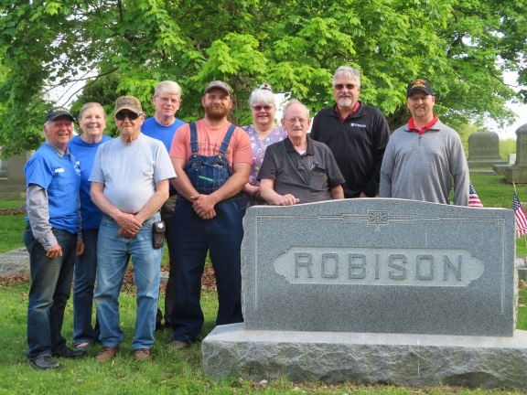

**Your Club news should be listed here!**

I know you’re out there doing things! Send me a write-up (MSWord please) and some photo’s (.jpg please) and we’ll get your club hi-lited here for the othe OH Section Clubs to see! Send to [WB8LCD@ARRL.ORG](mailto:WB8LCD@ARRL.ORG)

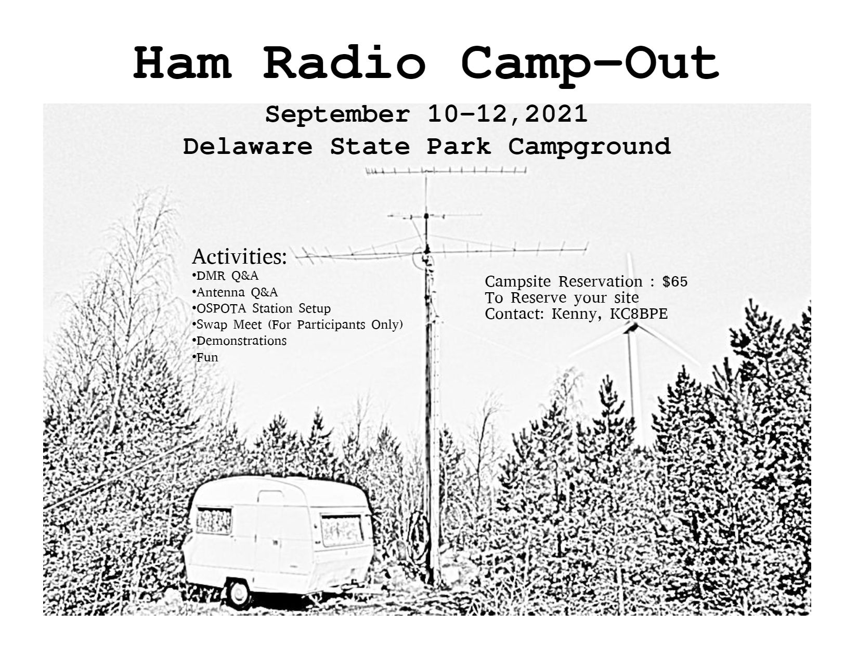

####

Who: Amateur radio operators

What: Camp-out

When: September 10-12, 2021

Where: Delaware State Park (Ohio)

Why: It is to be a fun weekend of ham activities, including but not limited to operating OSPOTA (Ohio State Parks on the Air), holding a swap fest only for those hams at the camp site, learning from each other, and just plain enjoying each other’s company.

How: Camp sites have already been reserved by Kenny, KC8BPE. You will need to send him $65.00 (less than Kenny’s out of pocket cost) for each site you want to reserve, as there is a limited number of sites all together. Sites have electric hookups, there is a watering station to fill your tank, and there is a dump station. You can camp with your recreational vehicle, trailer, or tent at these sites – your choice. The $65.00 covers only the cost of the site. You will need to plan for your other needs, such as food and fire. Reserve earlier, because the camp sites are available only on a first come first served basis. A station will be set up for operating OSPOTA.

Kenny: [snarekc8bpe@aol.com](mailto:snarekc8bpe@aol.com) cellular 740.223.9065

####

**Greetings from Tim Duffy, K3LR, CEO of DX Engineering!**

Our staff of active Hams at DX Engineering hope you and your club are adapting well to this challenging time. With so many events being canceled, we’ve shifted our focus to providing virtual educational opportunities to help Hams everywhere stay in touch with what’s happening in the hobby.

The best part is that it’s all free—our way of giving back to the operators who keep Ham Radio so vital in their communities.

**I’ll come to your meeting**—**virtually!**

I am available for free Zoom webinars on a range of topics to suit your club’s interests, from how to mitigate RFI to tips on improving your contesting scores. Contact Teri Grizer, K8MNJ, at [TGrizer@DXEngineering.com](mailto:TGrizer@DXEngineering.com) to schedule a presentation.

**You Can Get Tips, Hear Interviews, and Learn About Weekly Deals on DX Engineering’s Facebook Page**

·         Facebook Live with Tim, K3LR, and Jeff, KB8ZWT, airs every Tuesday at 1:15 pm Eastern (18:15 UTC). Jeff and I cover the gamut of Amateur Radio topics: upcoming contests, choosing coaxial cables, how to use ferrite, the benefits of antenna analyzers, and much more.

·         Tune in for our Manufacturer Showcase, live on Facebook Thursdays at 2:30 pm Eastern (19:30 UTC), for news and information from some of the biggest names in Ham Radio gear.

·         Join me and Hams from around the world for Facebook Live with Tim, K3LR, every Friday at 4:00 pm Eastern (21:00 UTC). Recent topics have included advice on 160M operating, the Reverse Beacon Network, and working satellites. Get live answers to your questions and save money with the DX Engineering Deal of the Week!

·         Like us on [Facebook](https://www.facebook.com/DXEngineering/) and enjoy tech articles, product updates, humor, and the hottest deals from DX Engineering!

**Visit DX Engineering’s blog, *[OnAllBands](https://www.onallbands.com/" \t "_blank)*, for news, expert tech advice, and updates on the latest equipment. We’re adding fresh content every weekday.**

**Check out our growing collection of instructional videos and interviews on**[**DX Engineering’s YouTube Channel**](https://www.youtube.com/user/DXEngineering)**.**

**Get Advice from Our Elmers!**

·         Talk with our staff of active operators—the best in the industry

·         Choose from more than 30,000 Amateur Radio products for EmComm, Contesting, DXing, and Satellite operation at [DXEngineering.com](https://www.dxengineering.com/)

·         Get the right equipment for your shack: rigs, amps, coaxial cable, rotators, antennas, towers, even stealthy solutions for your HOA antenna concerns

·         Enjoy friendly support during and after your purchase, whether you’re new to the hobby or a longtime operator

Thanks for your time today.

We’re looking forward to seeing you online and hearing you on the air.

73!

Tim Duffy, K3LR

DXEngineering.com  
800-777-0703  
Email support 24/7/365 at [DXEngineering@DXEngineering.com](mailto:DXEngineering@DXEngineering.com)

**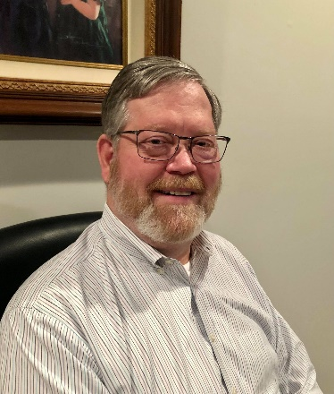**

**DX This Week – Incoming QSL Buro**

Bill AJ8B (aj8b@arrl.net, @AJ8B, or www.aj8b.com)

CWOPs Member #1567

The Midwest DX Cluster spots included Brunei Darussalam, Asiatic Russia, Australia, Austria, Bahrain, Belgium, Canada, Croatia, Czech Republic, Ecuador, European Russia, Fed. Rep. of Germany, Fiji, France, Haiti, India, Indonesia, Isle of Man, Italy, Japan, Kazakhstan, Lebanon, Netherlands, Philippines, Poland, Puerto Rico, Republic of Korea, Sardinia, Scotland, Slovenia, Sweden, Switzerland, Taiwan, Thailand, Ukraine, and Vietnam. This brings the total number of entities spotted in the Midwest in 2021to 176!

I received a few QSL cards including 9G5FI – Thomas in Ghana, ZL1HD – Peter in Tauranga, New Zealand and V31ZA – Keith in Belize. What did you get?

|  |  |
| --- | --- |
|  |  |
|  |  |
|  |  |

*DAH DIT DIT DIT DAH DAH DIT DIT DIT DAH*

Have you noticed a change in propagation? Last Tuesday I was tuning around the bottom end of 20M and heard a “watery” CQ. There was RP76UAI! The signal fading was unmistakable as the signals were coming over the pole. I had not heard this in a while so that was a great sign! Also, 10 meters was open until at least 9 PM twice this past week. In back-to-back QSOs, I worked Guatemala, Chile, and Alaska. Can’t wait for 10 to be consistent. If you have not been on 10 during the peak years of a cycle, it is unbelievable!

Where could you go to interact with 6 or more TOP DXPeditioners in a relaxed setting for a ridiculously low price? What if you could ask them questions, learn about the dangers, the highs, and the lows of the major DXPeditions? What if that was preceded by a most excellent Hamfest/flea market? What if there were major DX presentations after this roundtable? Next week you will have details about this…stay tuned!

*DAH DIT DIT DIT DAH DAH DIT DIT DIT DAH*

Last week, I gave details about the ARRL Outgoing QSL Bureau. This is a cost-effective way to get physical QSL cards from your station to the DX Station. The tradeoff is time. The process also works in reverse and here is how it happens.

(from <http://arrl-greatlakes.org/8th_bureau.htm> )

**General QSL Bureau Information -** The 8th call area bureau operates as part of the ARRL's volunteer QSL bureau system. As such, the operating expenses are paid by the league's members, although the bureau service is open to all US hams whether ARRL members or not. If you are not a league member, and use the incoming bureau, won't you consider joining today?

The bureau is 100% volunteer staffed. Each bureau worker forgoes their time to provide a service to you and we want to provide the best service possible within the bounds of reasonableness and fiscal responsibility. If you will follow the guidelines listed here, you will receive better service and our volunteers will have time to enjoy other aspects of our hobby, etc.

The 8th district central bureau is located at the Voice of America Museum in West Chester where it is one of the permanent displays. It is a work in progress, but if you have a chance to visit the VOA museum, be sure to look for the bureau. We do not encourage "just stopping by to pick up your cards" as there is no one there to release them to you. In addition, the only cards at the central bureau will be those that have not been forwarded to the individual letter managers. The best time to visit would be when the West Chester Amateur Radio Association (<http://www.wc8voa.org/> ) has their regular meeting, if you want a more detailed bureau visit. Specifically, the Bureau Address is: 8th Area QSL Bureau / P.O. Box 307 / West Chester, Ohio 45071-0307. The Bureau Manager is John (Jack) Shirley, N8DX (n8dx@arrl.net )

Overall, DX QSL bureaus sort cards based on call areas of the USA and regularly send boxes of QSL cards to the appropriate bureau. In our case, the 8th area bureau accepts the shipment of these boxes and then sorts them in to 26 groups, A through Z, based on the first letter after the number 8. At regular intervals, these 26 groups are delivered to the appropriate sorter who then furthers sorts them by call sign. For this to work, there are several things to pay attention to.

**+ Do Not Send Your Outgoing QSL Cards to Us** We cannot process them; they will be sent back to you in your bureau envelopes. Outgoing cards should be sent to ARRL HQ. This includes cards for non-8th area US stations from any source, including any you may pick up from DX stations or bureaus on your out of US travels. You cannot use the ARRL bureau system to send cards to other U.S stations within the 48 contiguous states--for contacts between U.S. stations. Any cards sent for U.S.-to-U.S. contacts will also be sent back to you using your bureau SASE. You may use the ARRL bureau system for DX stations who have a U.S. manager, such as VK0IR cards via W8XXX, or XE3/K8XXX via K8XYZ. If you send cards via the bureau to a manager, make sure you list the full call of the manager, not just via "W8 bureau." There is no way we can know who handle or manages cards for every DX station around the world.  
  
**+ Please Be Patient**

QSL cards are rarely received by the bureau for contacts less than four months old. Most cards are for contacts made between a year and two years prior. Some cards come through the system as much as five years or more after the QSO. Some foreign bureaus send out cards only a few times a year. Most come by boat, which is very slow mail, indeed. There was a survey done of all cards received over a two-month period. Of those cards that had "TNX QSL" checked, less than 5% were for contacts within a year of the QSO. This means if the station you worked waited for your card before returning one, the minimum turn-around will be a year or more. Many DXers who are relatively new to DXing tend to work "big gun" or loud stations. These stations work many U.S. stations, and in most cases, wait for your card before sending you one. Those DX stations who answer your CQ are much more likely to send their cards first, rather than those whose CQ you answer.

Keep Envelopes on File with the Bureau  
  
**+** If you work DX at all, you should expect to receive bureau cards, especially if you work any DX contest. Do not forget that most SWL's send via the bureau as well. Unclaimed cards are the bureau's biggest problem. Send NON-clasp-fastening, end-opening envelopes, between 5X7 and 6X9 inches in size. Unless you receive lots and lots of bureau cards DO NOT send more than three or four SASE (self-addressed stamped envelopes) at a time. DO NOT use envelopes smaller or larger that 5X7 or 6X9. Smaller envelopes will not hold some of the larger DX cards; larger envelopes won't fit in our files, are more likely to come apart in the mail process AND with current postage rates, cost more to use. Non-standard and padded envelopes may be returned to you empty.

Padded envelopes are larger than 1/4 inch and incur a higher fee just like envelope larger than 6 x 9. Several of the letter managers are moving to or have implemented a cash basis process for their letters. This has been done because of the frequent postage rate changes and the futility of trying to keep appropriate postage on the envelopes.

Most of our Managers have email access. If you have an email address, PLEASE INCLUDE IT whenever you write to the bureau or your Letter Manager. Make sure to include your email address when you send SASEs to the bureau or to your Manager as well. This will help us to communicate with you much more quickly than by conventional snail mail. If your email address changes, make sure you notify your Manager of the change.

Please DO NOT SEND USED ENVELOPES to the bureau. We will \*NOT\* attempt to use used envelopes. More than one trip through the postal system greatly increases the chance the envelope will come apart in the postal system, with the loss of your cards.

When you prepare envelopes for us, NEATLY print your call, in BLOCK LETTERS, in the upper left corner, in the place where a normal return address goes. Some people do such a poor job of writing their calls we need to look up the suspected call in the Callbook and match the name/address to make sure of the call. Certain letters can be especially troublesome -- like V and U, for instance. Take the time to make a very pointed V and a round or square bottom U. Keep this in mind when filling out cards to send via any bureau. It is a real headache for bureau workers trying to decide who the card really goes to; we don't want to guess which letter you really mean. Address each envelope to yourself in the center of the envelope. Remember, these are your cards. If we can't read your call or the postman can't read your address, you won't get them. If you have a change of address, send us address labels to cover your old address. Many people write so large, there is no room to write a change of address on their SASE.

If sending envelopes with stamps, affix enough postage to cover at least one ounce. currently, the post office is selling a "forever" stamp good for one unit of postage.   
 We do clear out all cards once a year. No matter how much postage on your SASE, and how few cards you have, once a year we will send you what you have. When postal rates go up, you should send extra stamps to cover the cost increase. Most people never think to send us extra postage when the rates go up.

**+** NEVER put more than one call on an envelope. We cannot cross-reference upgrades, vanity calls, and family calls. Some of the Letter Managers live many miles apart. There is no way to share an envelope between two Letter Managers. If you send an envelope with SASEs for more than one call, make sure you include a note saying you have done so. We don't take the time to look at each SASE you send us. If there is no note pointing out the fact you've sent SASE for multiple call, we simply pass them on to the Letter Manager for the first SASE we see. You may include a self-addressed postcard which we will return, letting you know your SASEs have arrived safely.

PLEASE NOTE: If you expect to receive cards under more than one call sign, please keep separate SASEs at all the Letters or 2Bureaus where you expect cards to be received. We will not "forward" cards for one call to another letter manager within our bureau or to another bureau unless you provide the SASE. It is/was your call and your QSO, if you want the cards, provide the SASE.

Again, the normal mailing cycle for the bureau is about every four to six weeks. If you don't worry about us wasting your postage, put "mail every cycle" on the bottom of each SASE and we will send you what you have each time, without the need to fill your SASE to the value of postage you've placed on it. If you are a big gun contester, DXPeditioner, or manager of a very active DX station, and get a pound or more a month, you may request your Letter Manager to box your cards to save on postage. Don't send money for this via the bureau. This MUST be between you and your Letter Manager, with the check made out in his name. If he does not want to take the time to do it, and requests you just send him SASE, that is the way it will be. The volunteer Letter Managers have enough of a job, and it is up to them if they want to do more. Any money for this extra service must be between you and your Letter Manager, not the bureau.

On the other hand, if you do not want to receive bureau cards, please advise your letter manager that you do not want them. If you are the manager for a DX station, including your own DX operations, and do not want bureau cards for those operations, but do want bureau cards for your US to DX contacts, we will not return the DX cards to the originator. We will destroy them. Also, be advised, if you elect to pursue this scenario, we will not be responsible for destroying cards you wanted to receive and were accidently destroyed. Remember, we are all volunteers and every special request takes volunteer time.

The Standard Operating Guidelines for ARRL QSL Bureaus states: "QSL cards on file which are unclaimed for a period longer than 90 days may be destroyed by the Bureau Manager (or Letter Manager) without further authority." PLEASE NOTE: Individual Letter Managers may elect to hold unclaimed QSL Cards for a longer period, at their discretion. Once we have made reasonable attempts to contact you that you have cards at the bureau and have received no correspondence (SASE) from you and destroyed your cards, we will make a note in our files and \*NOT\* contact you again. We will continue to destroy your cards on a continuing basis until we receive instructions to the contrary. You may consider this extreme but consider again that the biggest problem we have is unclaimed cards and the effort our volunteer letter managers expend trying to get them to the intended recipients. Before we destroy the cards, the following has occurred: A card has been sent, not at your expense, to your address of record, according to the FCC data base. (If that address is incorrect, you are not complying with the FCC regulations and are operating illegally!) In addition to the card, an email has been attempted using the address, <your-call>@arrl.net and/or any address in the various on-line callbooks.

1x1 calls: A new headache for the bureau are the new 1X1 calls being issued. You may do a good job of trying to tell each QSO to send the cards via N8???, but you can be sure some cards are going to come into the bureau with just the call N8?. There is no way for us to know who these cards go to if you don't supply SASE for these 1X1 special calls. It appears it is even more of a headache, since the same 1X1 calls will be re-issued to other special event stations, time-after-time. Make sure you list the time frame of the special event 1X1 on your SASE, so we will know who gets what cards. You had the 'FUN' of using the 1x1, you should follow through with the SASE.

**Bureau Operating Procedures** The mail is picked up at the PO Box on a regular basis, approximately once per week. There may be as little as five pounds to as much as 200 pounds in a week. You can visualize this by thinking of a stack of QSL cards ranging from 9 inches high, to over 29 feet high, each week. At the central bureau we sort the cards into 27 piles - one for each letter of the alphabet according to the first letter of the suffix and one for mis sorts from the other bureau, cards sent to the 8th area bureau that should go to the 9th area bureau, for example.

The cards are then conveyed to the individual Letter Managers. Some managers will personally pick the cards up from the central bureau every few weeks. Most are mailed via USPS or UPS every four to eight weeks, depending on volume. If you send a request for information to your Letter Manager via the Bureau address, it may have just missed the last pickup, requiring another six weeks to make it to your Letter Manager. It will save you time to check directly with your Letter Manager if you just want to check on the status of your cards and SASE.

Good cooperation between the DXer and the bureau is important to ensure a smooth flow of cards. Remember that the people who work at the bureau are all volunteers. At the peak of the last cycle, we handled over two tons of cards a year. In the trough of the cycle relatively few cards are received. We are on the downslide now. For that reason and with the implementation of Log Book of the World, you should expect card volume to begin to drop off.

**+** With that in mind, please pay close attention to the above information, and the following DO'S and DON'TS.  
 DO keep self-addressed 5X7 or 6X9 envelopes on file with your call in the upper left corner. Affix at least one ounce of postage to each. After checking the Letter Manager list above, you may send your SASE directly to your Letter Manager.

DO put your Call Sign on the outside of all envelopes containing SASEs or requests for information, sent to the Bureau or your Letter Manager. This will keep your envelope from having to be opened by Bureau Staff to determine where it should be forwarded.

DO keep envelopes at all Letters and Bureaus where you expect to receive Cards. If you have had a call sign change, we have no way of forwarding your old cards to your new Letter Manager, so please have an SASE waiting at both the old and new call sign Letter Managers Bureau.

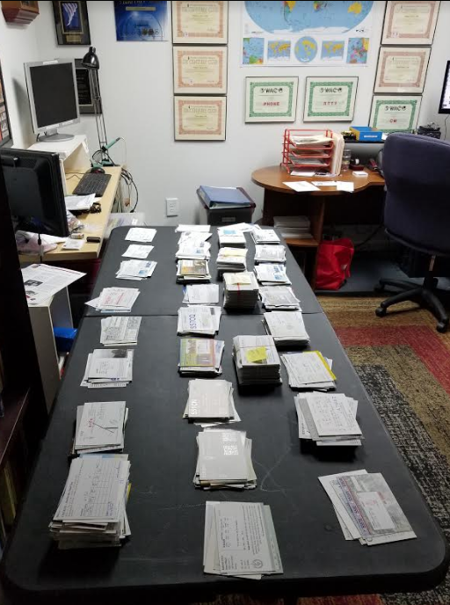 DO include your E-Mail address with all correspondence to the Bureau or your Letter Manager.

DO send the bureau enough postage to cover the SASE on file and enough to cover postal rate increases.

DO respond quickly to any bureau request for more SASE or additional postage. Remember, unclaimed cards are the bureau's single biggest problem.

DO include an SASE with any information request to the bureau.

DO notify the bureau in writing if you don't want your cards.

DON'T expect DX cards to arrive for at least a year after contact. Overseas delivery is very slow. Most cards are over a year old when received by the Bureau.

DON'T send your outgoing cards to this bureau.

This is a picture of my “sorting desk” after Caption Jack delivers a box of cards for me to sort and send to the recipients. I am the “N” letter sorter which mean that I process QSL cards for hams whose calls are between AA8N and WY8NZZ! It does take time, but it is also very rewarding. Please follow the directions I have provided above. If you have any questions about any callsign, you can drop me a line.

*DAH DIT DIT DIT DAH DAH DIT DIT DIT DAH*

CQDX CQDX CQDX CQDX CQDX CQDX CQDX CQDX CQDX

Here is an update from Bernie, W3UR, of the DailyDX and the WeeklyDX, the best source for DX information. <http://www>.dailydx.com/. Bernie has this to report:

**K9X - Christmas Island -** VK6SJ, Steve, has a trip planned to the island for May 25 to June 15.  He is taking his Yaesu FT-857D and Sotabeam antennas and an ATAS Yaesu HF mobile type antenna. He will get on the air outside of his work schedule, probably nighttime and mainly FT8.  His callsign will be VK9XX.  His first priority on Christmas is his work assignment.  Daytime operation will be limited if at all.  QSL via EB7DX.  
  
**3A – Monaco -** IW1RBI, Ennio, says his group's next 3A operation is coming up soon, sometime between the end of May and mid-June.  Travel restrictions are making it impossible for the team to meet in person.  They expect to do digital modes this time with one station dedicated to FT8 F/H, as much as 24 hours a day.  They realize not everyone, including themselves, are really savvy at FT8 yet.  They plan to put out good instructions.  A web page is in preparation.  They also plan to upload the log to LoTW.

**TA – Turkey -** TC568FA is a special callsign, slated to start up April 30 and go to June 28.  The ops are TA0TA, TA0APA, TA6CQ, TA3X, TA1C1, TA3LHH, TA2MN, TA1EF and TA3ST.  The operation commemorates the 568th anniversary of the conquest of Istanbul, which they say is the end of the medieval and start of the new, modern, era.  Look for them on 160-10 plus 2, SSB, CW and digital modes.  Certificates will be available:   <https://www.qrz.com/db/tc568fa>

**Lightning Protection for Amateur Radio Stations by W9EWZ, Bob Urban**"Lightning Protection for Amateur Radio Stations" was recently presented by Lloyd Berg, N9LB. Lloyd has 50 years of experience as a Broadcast Engineer, building and maintaining AM, FM and TV broadcast stations. Learn from a professional how to make your station as lightning resistant as possible. A video of the program and discussion is now available through the Madison DX Club website:[madisondxclub.org](http://madisondxclub.org/)

*DAH DIT DIT DIT DAH DAH DIT DIT DIT DAH*



Below is a list of upcoming contests in the “Contest Corner”. I think this is important for someone who is trying to move up the DXCC ladder since entities that are on the rarer side and easiest to work in contests. Some of my best “catches” have been on the Sunday afternoon of a contest when the rarer entities are begging for QSOs. Of course, the gamble is that if you wait until Sunday, conditions may change, or they simply won’t be workable. However, it is not a bad gamble. Of course, why not work the contest and have some fun!  
Check out the WA7BNM Contest Calendar page (<https://www.contestcalendar.com/>) and CQ Magazine for more contests or more details.

The contests in red are those that I plan to spend some significant participation time on. PLEASE let me know if you are working contests and how you fared.

Thanks!

|  |  |  |
| --- | --- | --- |
| May 19 | RSGB 80m Club Championship, Data | <http://bit.ly/3avHbk3> |
| May 15-16 | His Majesty King of Spain CW Contest | <http://concursos.ure.es/en> |
| May 22-23 | Baltic Contest | [www.lrsf.lt/en](http://www.lrsf.lt/en) |
| May 27 | RSGB 80m Club Championship, CW | <http://bit.ly/3avHbk3> |
| May 29-30 | CQWW WPX CW CONTEST | [www.cqwpx.com](http://www.cqwpx.com/) |
| June 4-6 | PODXS 070 Club Three Day Weekend Contest | http://bit.ly/2Srdp8A |
| June 5-6 | 10-10 Open Season PSK Contest | http://bit.ly/1FrFeBc |
| June 5-6 | Kentucky QSO Party | www.kyqsoparty.org |
| June 5-6 | Liga Radio Boga (LRB) HF Contest | www.qrz.com/db/hk3lrb |
| June 5-6 | RSGB CW Field Day | http://bit.ly/2OKdymu |
| June 5-6 | Seanet Contest | www.seanet2019.com/seanet-contest |
| June 5-6 | Tisza Cup CW Contest | https://tinyurl.com/ar2kyr6p |
| June 7 | RSGB 80m Club Championship, Data | http://bit.ly/3avHbk3 |
| June 12 | Asia-Pacific SSB Sprint | http://jsfc.org/apsprint |
| June 12-13 | Portugal Day Contest | https://portugaldaycontest.rep.pt/rules.php |
| June 12-13 | GACW WWSA CW DX Contest | www.contest.com.ar/gacw-wwsa |
| June 12-13 | DRCG Long Distance Contest (RTTY) | www.drcg.de |
| June 16 | RSGB 80m Club Championship, CW | http://bit.ly/3avHbk3 |
| June 19-20 | All Asian CW DX Contest | www.jarl.org/English/0-2.htm |
| June 19-20 | Stew Perry Topband Challenge | www.kkn.net/stew/stew\_rules.html |
| June 19-20 | Ukrainian DX classic RTTY Contest | http://urdxc.org/rtty |
| June 19-20 | West Virginia QSO Party | https://tinyurl.com/54c7ajfp |
| June 24 | RSGB 80m Club Championship, SSB | http://bit.ly/3avHbk3 |
| June 26-27 | ARRL Field Day | www.arrl.org/field-day |
| June 26-27 | His Maj. King of Spain SSB Contest | http://bit.ly/1cKAR5V |
| June 26-27 | Ukrainian DX DIGI Contest | www.izmail-dx.com |
| June 28 | RSGB FT4 Contest Series | http://bit.ly/3mCNXXH |
| August 28 | Ohio QSO Party | <https://www.ohqp.org/> |
| August 28 | W8DXCC | <https://www.w8dxcc.com> |

***DX News***

**ARLD019 DX news**  
  
ARLD019 DX news  
  
This week's bulletin was made possible with information provided by LU4AAO, The Daily DX, the OPDX Bulletin, 425 DX News, DXNL, Contest Corral from QST and the ARRL Contest Calendar and WA7BNM web sites. Thanks to all.  
  
MOROCCO, CN.  Special event station CN65FAR is QRV until May 16 to celebrate the 65th anniversary of the creation of the Royal Moroccan Armed Forces.  QSL via RW6HS.  
  
NORTHERN IRELAND, GI.  Members of the North West Group ARC are QRV with special event call sign GB0AEL until May 15 to commemorate Amelia Earhart's 1932 solo flight across the Atlantic.  Activity is on the HF bands using CW and SSB.  QSL via operators' instructions.  
  
ARGENTINA, LU.  Members of the Radio Club QRM Belgrano will be QRV as LU4AAO, LU4AAO/A and LU4AAO/D from May 18 to 25 to commemorate the anniversary related to the independence of Argentina.  Activity will be on the HF and V/UHF bands using CW, SSB, SSTV and FT8.  QSL  
direct to LU4AAO.  
  
AUSTRIA, OE.  Special event station OE60VHSC is QRV until June 7 to commemorate the 60th anniversary of the Very High Speed Club.  QSL via operators' instructions.  
  
DENMARK, OZ.  Special event station OZ60VHSC is QRV until June 7 to commemorate the 60th anniversary of the Very High Speed Club.  QSL via OZ1JHM.  
  
NETHERLANDS, PA.  Special call sign PD21EUROSONG is QRV until May 22 to celebrate the 65th edition of the Eurovision Song Contest being held in Rotterdam.  QSL via bureau.  In addition, special event stations PA60VHSC and PH60VHSC are QRV until June 7 to commemorate the 60th anniversary of the Very High Speed Club.  QSL via PA5V and PA0INA, respectively.

CRETE, SV9.  Station DD1GG will be QRV as SV9/DD1GG from May 15 to 24.  Activity will be holiday style on 40 to 10 meters using SSB and FT8.  QSL to home call.  
  
TURKEY, TA.  Special event station TC568FA is QRV until June 28 to commemorate the anniversary of the Fall of Constantinople on May 29, 1453.  Activity is on all bands and modes.  QSL via bureau.  
  
BENIN, TY.  Ian, ZS6JSI is QRV as TY5AB.  Activity has been on 20 meters using FT8.  QSL to home call.  
  
AUSTRALIA, VK.  Special event station VI50SG is QRV until December 31 to commemorate the 50 years of the St. George Amateur Radio Society.  QSL via bureau.  
  
VENEZUELA, YV.  Special event station YW200BC is QRV during 2021 to commemorate the Battle of Carabobo 200 years ago, which paved the way for Venezuela's independence.  Activity is on 80 to 10 meters using CW, SSB and various digital modes.  QSL via YV4KW.  
MACEDONIA, Z3.  Special event station Z360VHSC is QRV until June 7 to commemorate the 60th anniversary of the Very High Speed Club. QSL via operators' instructions.  
  
THIS WEEKEND ON THE RADIO.  The Kazakhstan DX Contest, NZART Sangster Shield Contest, His Majesty King of Spain CW Contest, NCCC RTTY Sprint, NCCC CW Sprint, K1USN Slow Speed CW Test, Feld Hell Sprint, FISTS Sunday Sprint and Run for the Bacon QRP CW Contest are  
all on tap for this upcoming weekend.  
  
The K1USN Slow Speed CW Test and OK1WC Memorial are scheduled for May 17.  
  
The RTTYOPS Weeksprint and Worldwide Sideband Activity Contest are scheduled for May 18.  
  
The RSGB 80-Meter Club Data Championship, Phone Fray and CWops Mini-CWT Test are scheduled for May 19.  
  
Please see May QST, page 71, and the ARRL and WA7BNM contest web sites for details.

**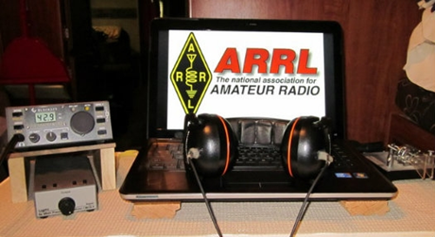ARRL Contest Corner**

An expanded, downloadable version of *QST'*s’ [**Contest Corral**](http://www.arrl.org/contest-calendar) is available as a PDF. Check the sponsor’s ‘Website for information on operating time restrictions and other instructions.

[K1USN Slow Speed Test](http://www.k1usn.com/sst.html), May 17, 0000z to May 17, 0100z; CW; Bands: 160, 80, 40, 20m; Maximum 20 wpm, Name + (state/province/country); Logs due: May 23.  
  
[OK1WC Memorial (MWC)](https://memorial-ok1wc.cz/index.php?page=rules2l), May 17, 1630z to May 17, 1729z; CW; Bands: 80, 40m; RST + Serial No.; Logs due: May 21.  
  
[Worldwide Sideband Activity Contest](https://wwsac.com/rules.html), May 18, 0100z to May 18, 0159z; SSB; Bands: 160, 80, 40, 20, 15, 10, **6m**; RS + age group (OM, YL, Youth YL or Youth); Logs due: May 19.

[RTTYOPS Weeksprint](https://rttyops.wordpress.com/rtty-mini-contests/rttyops-weeksprint/), May 18, 1700z to May 18, 1900z; RTTY; Bands: 80, 40, 20m; [other station's call] + [your call] + [serial no.] + [your name]; Logs due: May 18.  
  
[Phone Weekly Test - Fray](http://www.perluma.com/Phone_Fray_Contest_Rules.pdf), May 19, 0230z to May 19, 0300z; SSB; Bands: 160, 80, 40, 20, 15m; NA: Name + (state/province/country), non-NA: Name; Logs due: May 21.  
  
[CWops Mini-CWT Test](https://cwops.org/cwops-tests/), May 19, 1300z to May 19, 1400z; CW; Bands: 160, 80, 40, 20, 15, 10m; Member: Name + Member No./"CWA", non-Member: Name + (state/province/country); Logs due: May 22.  
  
[CWops Mini-CWT Test](https://cwops.org/cwops-tests/), May 19, 1900z to May 19, 2000z; CW; Bands: 160, 80, 40, 20, 15, 10m; Member: Name + Member No./"CWA", non-Member: Name + (state/province/country); Logs due: May 22.  
  
[RSGB 80m Club Championship, Data](https://www.rsgbcc.org/hf/rules/2021/r80mcc.shtml), May 19, 1900z to May 19, 2030z; RTTY, PSK; Bands: 80m Only; RST + Serial No.; Logs due: May 20.  
  
[NAQCC CW Sprint](http://naqcc.info/sprint/sprint202107.html), May 20, 0030z to May 20, 0230z; CW; Bands: (see rules); RST + (state/province/country) + (NAQCC No./power); Logs due: May 24.  
  
[CWops Mini-CWT Test](https://cwops.org/cwops-tests/), May 20, 0300z to May 20, 0400z; CW; Bands: 160, 80, 40, 20, 15, 10m; Member: Name + Member No./"CWA", non-Member: Name + (state/province/country); Logs due: May 22.  
  
[RTTYOPS Weeksprint](https://rttyops.wordpress.com/rtty-mini-contests/rttyops-weeksprint/), May 20, 1700z to May 20, 1900z; RTTY; Bands: 80, 40, 20m; [other station's call] + [your call] + [serial no.] + [your name]; Logs due: May 25.  
  
[EACW Meeting](https://drive.google.com/file/d/1ifD1n2GGSykXxQ9alx4JNIqvho7JGHvv/view), May 20, 1900z to May 20, 2000z; CW; Bands: 80, 40m; EACW Member: RST + Member No. + Nickname, EA non-Member: RST + Nickname + EA province, non-EA: RST + Nickname + DXCC prefix; Logs due: May 22.  
  
[NCCC RTTY Sprint](http://www.ncccsprint.com/rttyns.html), May 21, 0145z to May 21, 0215z; RTTY; Bands: (see rules); Serial No. + Name + QTH; Logs due: May 23.  
  
[NCCC Sprint](http://www.ncccsprint.com/rules.html), May 21, 0230z to May 21, 0300z; CW; Bands: (see rules); Serial No. + Name + QTH; Logs due: May 23.  
  
[K1USN Slow Speed Test](http://www.k1usn.com/sst.html), May 21, 2000z to May 21, 2100z; CW; Bands: 160, 80, 40, 20m; Maximum 20 wpm, Name + (state/province/country); Logs due: May 23.  
  
[YOTA Contest](https://www.ham-yota.com/contest/), May 22, 0800z to May 22, 1959z; CW, SSB; Bands: 80, 40, 20, 15, 10m; Single Op: age (on Jan 1 of year of contest), Multi-Op: average age of ops (on Jan 1 of year of contest); Logs due: May 29.  
  
[Hamvention QSO Party](https://hamvention.org/qso-party-2021/), May 22, 1200z to May 23, 0000z; CW, SSB; Bands: 80, 40, 20, 15, 10m; RS(T) + first year attended Hamvention or 2021; Logs due: May 27.  
  
[EU PSK DX Contest](https://eupsk.club/eupskdx/eupskdxrules.pdf), May 22, 1200z to May 23, 1200z; BPSK63; Bands: 80, 40, 20, 15, 10m; EU: RST + EU area code, non-EU: RST + QSO No.; Logs due: May 28.  
[Baltic Contest](http://www.lrsf.lt/en/balticcontestrules/), May 22, 2100z to May 23, 0200z; CW, SSB; Bands: 80m Only; RS(T) + Serial No.; Logs due: June 2.  
  
[K1USN Slow Speed Test](http://www.k1usn.com/sst.html), May 24, 0000z to May 24, 0100z; CW; Bands: 160, 80, 40, 20m; Maximum 20 wpm, Name + (state/province/country); Logs due: May 30.  
  
[QRP ARCI Hootowl Sprint](http://qrparci.org/contest/hoot-owl-sprint), May 24, 0000z to May 24, 0100z; CW; Bands: 160, 80, 40, 20, 15, 10m; RST + (state/province/country) + (ARCI no./power); Logs due: June 10.  
  
[OK1WC Memorial (MWC)](https://memorial-ok1wc.cz/index.php?page=rules2l), May 24, 1630z to May 24, 1729z; CW; Bands: 80, 40m; RST + Serial No.; Logs due: May 28.  
  
[Worldwide Sideband Activity Contest](https://wwsac.com/rules.html), May 25, 0100z to May 25, 0159z; SSB; Bands: 160, 80, 40, 20, 15, 10, **6m**; RS + age group (OM, YL, Youth YL or Youth); Logs due: May 26.  
  
[RTTYOPS Weeksprint](https://rttyops.wordpress.com/rtty-mini-contests/rttyops-weeksprint/), May 25, 1700z to May 25, 1900z; RTTY; Bands: 80, 40, 20m; [other station's call] + [your call] + [serial no.] + [your name]; Logs due: May 25.  
  
[SKCC Sprint](http://www.skccgroup.com/operating_activities/weekday_sprint/), May 26, 0000z to May 26, 0200z; CW; Bands: 160, 80, 40, 20, 15, 10, **6m**; RST + (state/province/country) + Name + (SKCC No./"NONE"); Logs due: May 28.  
  
[Phone Weekly Test - Fray](http://www.perluma.com/Phone_Fray_Contest_Rules.pdf), May 26, 0230z to May 26, 0300z; SSB; Bands: 160, 80, 40, 20, 15m; NA: Name + (state/province/country), non-NA: Name; Logs due: May 28.  
  
[CWops Mini-CWT Test](https://cwops.org/cwops-tests/), May 26, 1300z to May 26, 1400z; CW; Bands: 160, 80, 40, 20, 15, 10m; Member: Name + Member No./"CWA", non-Member: Name + (state/province/country); Logs due: May 29.  
  
[CWops Mini-CWT Test](https://cwops.org/cwops-tests/), May 26, 1900z to May 26, 2000z; CW; Bands: 160, 80, 40, 20, 15, 10m; Member: Name + Member No./"CWA", non-Member: Name + (state/province/country); Logs due: May 29.

**VHF+ CONTESTS**

See [Worldwide Sideband Activity Contest](https://wwsac.com/rules.html), [SKCC Sprint](http://www.skccgroup.com/operating_activities/weekday_sprint/), above.

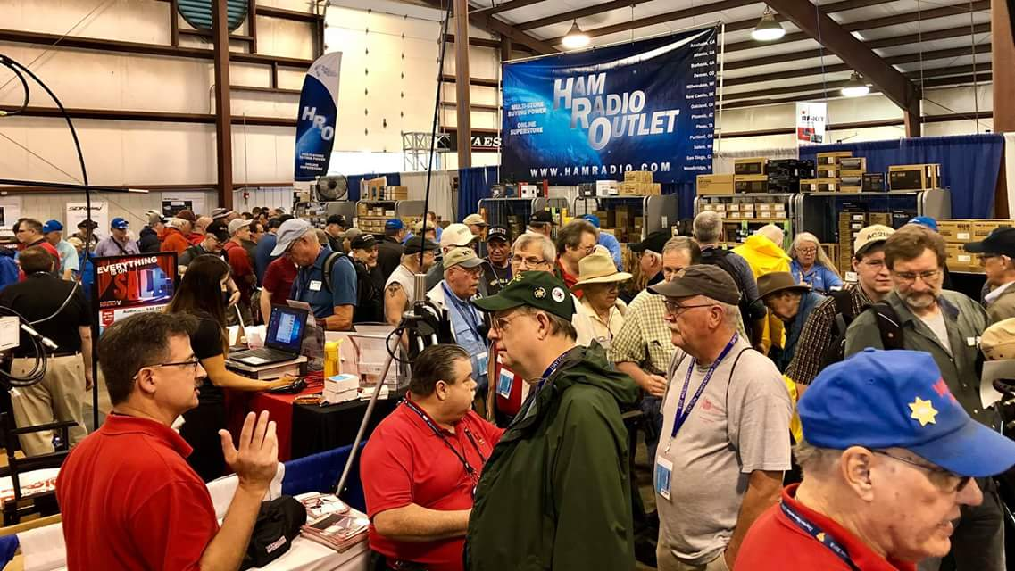[**Upcoming *Hamfests***](http://arrl-ohio.org/hamfests.html)

We **DO** have some hamfests scheduled for 2021!! Yes, take a good look at the list, it’s growing every day!

Be sure to keep your eyes on this schedule as that when things start getting better and the vaccine rolls out to more and more, hamfests will surely get back to their normal schedule. Don’t see your hamfest listed?? Did anyone register it with ARRL? It’s really easy to do and you get a lot of FREE publicity if you do.

|  |  |
| --- | --- |
| **06/05/2021 -**[**FCARC SummerFest**](http://www.arrl.org/hamfests/fcarc-summerfest)  **Location:**Wauseon, OH **Sponsor:**Fulton County Amateur Radio Club **Website:**[**http://k8bxq.org/hamfest**](http://k8bxq.org/hamfest)  [**Learn More**](http://www.arrl.org/hamfests/fcarc-summerfest) | **07/10/2021 - [Mansfiled Mid-Summer Trunkfest](http://www.arrl.org/hamfests/mansfiled-mid-summer-trunkfest" \o "Mansfiled Mid-Summer Trunkfest)**  **Location:**Mansfield, OH **Sponsor:**InterCity Amateur Radio Club **Website:**[http://iarc.club](http://iarc.club/)  [**Learn More**](http://www.arrl.org/hamfests/mansfiled-mid-summer-trunkfest) |
|  |  |
| **07/17/2021 -**[**NOARSFEST**](http://www.arrl.org/hamfests/noarsfest-8) **Location:** Elyria, OH **Sponsor:**Northern Ohio Amateur Radio Society **Website:** [http://noars.net](http://noars.net/)  [**Learn More**](http://www.arrl.org/hamfests/noarsfest-8) | **07/18/2021 -**[**Van Wert Hamfest**](http://www.arrl.org/hamfests/van-wert-hamfest-5)  **Location:**VAN WERT, OH **Sponsor:** Van Wert Amateur Radio Club **Website:** [http://W8FY.ORG](http://w8fy.org/)  [**Learn More**](http://www.arrl.org/hamfests/van-wert-hamfest-5) |
| **08/07/2021 -** [**2021 Columbus Hamfest**](http://www.arrl.org/hamfests/2021-columbus-hamfest)  **Location:** Grove City, OH **Sponsor:**Aladdin Shrine Audio Unit **Website**: [http://columbushamfest.com](http://columbushamfest.com/)  [**Learn More**](http://www.arrl.org/hamfests/2021-columbus-hamfest) | **08/28/2021 -**[**Cincinnati Hamfest℠**](http://www.arrl.org/hamfests/cincinnati-hamfest)  **Location:**Owensville, OH **Sponsor:** Milford ARC **Website:** [http://CincinnatiHamfest.org](http://cincinnatihamfest.org/)  [**Learn More**](http://www.arrl.org/hamfests/cincinnati-hamfest) |
| **09/26/2021 -**[**Cleveland Hamfest**](http://www.arrl.org/hamfests/cleveland-hamfest-1)  **Location:**Berea, OH **Sponsor:** Hamfest Association of Cleveland **Website:** [http://www.hac.org](http://www.hac.org/)  [**Learn More**](http://www.arrl.org/hamfests/cleveland-hamfest-1) | **12/04/2021 -**[**FCARC WinterFest**](http://www.arrl.org/hamfests/fcarc-winterfest-2)  **Location:**Delta, OH  **Sponsor:** Fulton County Amateur Radio Club  **Website:**<http://k8bxq.org/hamfest>    [**Learn More**](http://www.arrl.org/hamfests/fcarc-winterfest-2) |

**Print an Official or Unofficial Copy of Your Amateur Radio License**

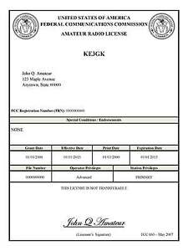*(By Anthony Luscre, K8ZT)*

As of February 17, 2015, the **FCC no longer routinely issues paper license documents** to Amateur Radio applicants and licensees. The Commission has maintained for some time now that the official Amateur Radio license authorization is the electronic record that exists in its Universal Licensing System (ULS). The FCC will continue to provide paper license documents to all licensees who notify the Commission that they prefer to receive one.

Licensees also will be able to print out an official authorization — as well as an unofficial “reference copy” — from the ULS License Manager. I’ve created a set of instructions on how you can request an **“official” printed copy of your license\***

[**Click here to download the instructions**](http://arrl-ohio.org/news/2020/print_your_license.pdf)

***One Question Questionnaire***

Hey Gang,

Survey Says”…..Well, it doesn’t matter now! I’ve got a new question, so how about going to www.ARRL-OHIO.org and giving me a click? (It’s in the bottom left corner of the page) Send your friends, send your kids and send your Mother!

***“Are you happy about the Mask Mandates being rescinded?”***

From the last Poll: 40% of you plan on operating Field Day with your club, 30% of you plan on operating from home, 9 % of you plan on operating “Other” and, 21% of you do not plan to operate for Field Day.

*****V.E. Test Sessions***

Many V.E.’s have decided to start testing once again, but with restrictions that need to be adhered to for sure. Here’s the link to find that V.E. Test session and what is expected of YOU before going. <http://www.arrl.org/find-an-amateur-radio-license-exam-session>

Ohio Section Cabinet

|  |  |
| --- | --- |
| Section Manager – Tom Sly, WB8LCD | Section Traffic Manager – David Maynard, WA3EZN |
| Section Emergency Coordinator – Stan Broadway, N8BHL | Section Youth Coordinator – Anthony Luscre, K8ZT |
| Technical Coordinator – Jeff Kopcak, K8JTK | Affiliated Clubs Coordinator – Tom Sly, WB8LCD |
| State Government Liaison – Bob Winston, W2THU | Public Information Coordinator – John Ross, KD8IDJ |



Hey Gang,

Have you taken a look at the **Swap & Shop** page on the Ohio Section webpage yet?? Here’s a link that will take you there… <http://arrl-ohio.org/sm/s-s.html>

Do you have equipment that you just don’t need or want anymore? Here’s a great venue to advertise it, and it’s FREE!! Is your club doing a fund raiser to help raise money? After a lot of thought, it was decided that the Swap & Shop webpage could also contain these types of items as well. The same rules will apply as do for the For Sales and Give-A-Ways and will only be posted for a month at a time. Please see the Terms & Conditions on the webpage.

If your club is doing a fund raiser and wants more exposure, please forward the information to me and I’ll advertise it on the Swap & Shop webpage for you.

Now, I still want to remind you that it won’t be listed in this newsletter because it would take up way too much space, so your ad will only appear on the website. It is there for any individual to post equipment Wanted / For Sale or Give-Away as well as for Club Fund Raisers. No licensed vehicles/trailers or business advertising will be posted. Postings are text only (no pictures or graphics) will be posted for a maximum of 1 month from date posting and require a contact phone number or email within the posting. Send your Wanted / For Sale or Give-Away post to:  [swap@arrlohio.org](mailto:swap@arrlohio.org)

***Back Issues of the PostScript and Ohio Section Journal***

Hey, did you know that PostScript and Ohio Section Journal (OSJ) are archived on the website? You can go back and look at any edition simply by clicking:

<http://arrl-ohio.org/news/index.html>

***Want to Share your Club Newsletter With Others?***

We have a webpage where you can download and read all of the newsletters that I get from around the state and even other sections!

Here’s the link to the page…. <http://arrl-ohio.org/club_news/index.html>

Please, if you don’t see your club newsletter posted, it’s because I’m not receiving it. Just have your newsletter editor contact me and I’ll get your club’s newsletter listed on the site!!

We all learn and steal (I mean, share) from each other’s work. So, get me your newsletter!!! Send it to: [webmaster@arrl-ohio.org](mailto:webmaster@arrl-ohio.org)

***Chit – Chat, and All That!***

Do you know someone that’s not getting these Newsletters? Please, forward a copy of this Newsletter over to them and have them “[Opt-In](mailto:Opt-In)” to start receiving them. Heck, just have them send an email to: [webmaster@arrl-ohio.org](mailto:webmaster@arrl-ohio.org) and we’ll get them added to the Ohio Section Emailing list.

We now have many thousands of readers receiving these newsletters weekly. Quite impressive, I’d say! I urge all of you to make sure that everyone, regardless of whether they are a League member or not, get signed up to receive these weekly Newsletters.

You can always “Opt-Out” at any time if you feel this is not what you were expecting. It’s fun and very informative. All of your favorite past newsletters are now archived too.

You can go back at any time and read them.

Just go to: <http://arrl-ohio.org/news/>

The pictures on the front page and throughout this newsletter are from various newsletters, Facebook posts and/or were sent directly to me in recent weeks. Take a good look at them, you just might be in one of the pictures! “SMILE… you’re in the Ohio Section News!!”

*PostScript is produced as a weekly newsletter. I want to thank everyone that has contributed articles and ideas to make this an even better news source. I sincerely hope that you have enjoyed this edition and will encourage your friends to join with you in receiving the latest news and information about the Ohio Section, and news and events happening around the world!*