[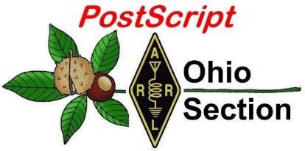](http://arrl-ohio.org/news/) ***“May 10th***

***Edition”***

🡪 National News 🡪 Club Corner

🡪 DX This Week 🡪 Contest Corner

🡪 Upcoming Hamfests 🡪 South 40

🡪 One Question Questionnaire 🡪 VE Testing

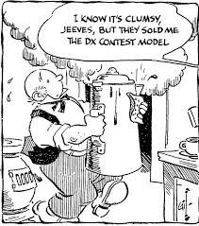

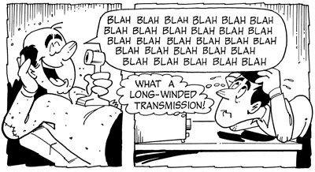

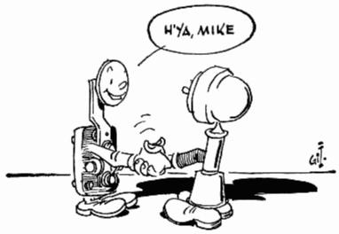

***National News***

*(from arrl and other sources)*

**First-Time Exam Applicants Must Obtain FCC Registration  
Number before Taking Exam**  
  
Beginning May 20, 2021, all amateur examination applicants will be required to provide an FCC Registration Number (FRN) to the Volunteer Examiners (VEs) before taking an amateur exam. This is necessary due to changes the FCC has made to its licensing system.  
  
Amateur candidates who already have an FCC license, whether for amateur radio or in another service, already have an FRN and can use the same number. All prospective new FCC licensees, however, will be required to obtain an FRN before the examination and provide that number to the volunteer examiners on the Form 605 license application. An FCC instructional video provides step-by-step instructions on how to obtain an FRN through the FCC's Commission REgistration System (CORES).  
  
The video is available at, <https://www.fcc.gov/rofrn> .  
  
The FRN is required for all new applicants to take an amateur exam and is used afterward by the applicant to download the license document from the FCC Universal Licensing System (ULS), upgrade the license, apply for a vanity call sign, and to submit administrative updates (such as address and email changes) and renewal  
applications.  
  
In addition, after June 29, all applications will be required to contain an email address for FCC correspondence. Applicants will receive an email direct from the FCC with a link to the official electronic copy of their license whenever a license is issued or changed. ARRL VEC suggests that those without access to email to use the email address of a family member or friend. Licensees will be able to log in to the ULS using their FRN and password to download the latest version of their license at any time. The FCC no longer provides paper license documents.

####

IEEE Committee Webinar "RF Exposure in the Time of Conspiracies"

Set for May 12

The IEEE Committee on Man and Radiation (COMAR) has issued an invitation to its webinar, "RF Exposure in the Time of Conspiracies." The 1-hour event is set to get under way at 1800 UTC on Wednesday, May 12. COMAR is a group of experts on health and safety issues related to electromagnetic fields, from power line through microwave frequency ranges. Its primary focus is on biological effects of non-ionizing electromagnetic radiation.

[[](https://ieeexplore.ieee.org/stamp/stamp.jsp?arnumber=9217549)](https://ieeexplore.ieee.org/stamp/stamp.jsp?arnumber=9217549)"The real idea behind the webinar is to highlight some of the news articles, comments, etc. that purport to declare the hazardous nature of exposure to weak RF fields, such as those posed by new 5G wireless communications base stations, explain how they are not scientifically based and, possibly, some ideas on how to better communicate what we *really* know about potential health effects," said COMAR chair Ric Tell, K5UJU.

Presenters are professional engineer Matt Butcher, KC3WD, and Jerrold Bushberg, a clinical professor of radiology and radiation oncology at the University of California-Davis School of Medicine. He is an expert on the biological effects, safety, and interactions of ionizing and nonionizing radiation; a specialist in risk communication, he holds multiple radiation detection technology patents. Both are COMAR members. Butcher and Tell are also members of the ARRL RF Safety Committee.

Tell said that Webex, the platform on which the webinar will be held, imposes a limit of 1,000 simultaneous connections. Those interested may [check in](https://ieeesa.webex.com/ieeesa/j.php?MTID=mfb635179277b903d7e890c511c06fc91) at 1730 UTC, a half-hour before the webinar is scheduled to start.

ARRL RF Safety Committee Chair Greg Lapin, N9GL, said the committee devotes a lot of time examining the science to help keep people safe, but, he added, "there remains considerable fear in our society about that exposure. It would be to our benefit to understand what people are thinking."

ARRL Lab Manager Ed Hare, W1RFI, said radio amateurs are often asked by neighbors about their stations -- either out of curiosity, or concern that the antennas may pose a safety hazard. "This webinar will help amateurs and the public understand why radio energy at exposure levels found in standards and regulations is safe," Hare said.

Topics on the COMAR webinar agenda include "What is RF?" and "What are the applicable exposure standards?" as well as discussing how to address concerns on the part of the general public, and how to improve communication.

COMAR is a technical committee of the IEEE Engineering in Medicine and Biology Society. The webinar is free.

####

Russian Robinson Club Announces Activation of Rare IOTA Islands in the Aleutians

The Russian Robinson Club ([RRC](https://www.na-234.com/)) has resumed its plans to activate rare Kiska Island (IOTA NA-070) and Adak Island (IOTA NA-039) in Alaska's Aleutian Islands chain in July for Islands On The Air 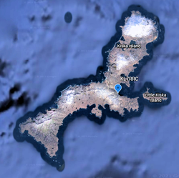([IOTA](https://iota-world.org/)) enthusiasts. Plans to activate these islands in 2020 were called off because of COVID-19 concerns.

The uninhabited Kiska Island (52.06° N, 177.57° E) lies in the North Pacific's treacherous Bering Sea, which RRC calls one of the most intense patches of ocean on Earth and where strong winds, freezing temperatures, and icy water are the norm. The island also features the prominent conical Kiska volcano. Kiska Island is a National Historic Landmark and part of the Aleutian Islands World War II National Monument and the Alaska Maritime National Wildlife Refuge (AMNWR). Permission to visit is required from both Alaska's Maritime National Wildlife Refuge and the US Fish and Wildlife Service.

The KL7RRC team plans to have a minimum of two stations on the air on 40 - 6 meters, SSB, CW, and FT8. Operators will place special emphasis on the difficult trans-polar path to Europe.

The 56-foot aluminum sailing vessel *Seal* will make the 1,000-mile journey along the Aleutians to Kiska with a stop at Dutch Harbor to pick up Tim, NL8F, and the gear sent in advance to his location. The team will continue sailing west to Adak Island, where some team members 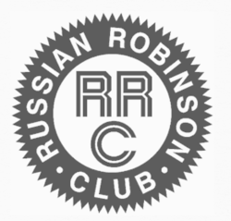will activate Adak Island on June 30 - July 3. The SV *Seal* will pick up the entire crew there, which will have flown in by July 3. Then, they hope to arrive at Kiska and be on the air as KL7RCC on July 7 - 12, before the return sail to Adak and flights home. Additional KL7RRC activity may take place from Adak July 14 - 16.

Donations are welcome. QSLs for KL7RRC (Kiska Island NA-070) and KL7RRC (Adak Island NA-039) are via N7RO. All donors will receive direct QSLs.

Updates will be posted on the Russian Robinson Club website. *-- Thanks to Hal Turley, W8HC, via*[The Daily DX](http://www.dailydx.com/)

A slot is open for a fifth operator. Contact team leader [Yuri, N3QQ](mailto:kl7rrc@gmail.com), if interested.

###

**Hamvention Weekend Virtual Activities**

**That magical weekend in May approaching.  With no Hamvention this year, due to continuing Coronavirus restrictions, we have been developing several activities to keep Hams busy and engaged in the hobby.**

**Thursday May 20. 2021**

**The Virtual Contest University will be held starting at 9 AM EDT 1300Z. The course outline will be available soon. This will be a free event!**

**Even if you are not a contester you will learn so much about Amateur Radio and hear the techniques and critiques of many of the world’s foremost Hams.**

**Hamvention is a proud sponsor along with Icom and DxEngineering. Plan on attending this amazing free event!**

**Several Icom radios will be given away during the all-day event. You must be registered on Zoom and present online at the time of the drawing to win the radios.**





[CONTEST UNIVERSITY REGISTRATION](https://zoom.us/webinar/register/WN_uFqLO-ZhQg-KtrH0zKaVjg)

**Friday May 21 Starting at 11 AM EDT 1500Z**

**We will have the 2021 Virtual Hamvention Forums.**

**The Hamvention Virtual Forums celebrates the 2021 Hamvention Award winners. Each awardee will give a 45 minute presentation followed by Q&A.**

**The Hamvention Forums will be presented via Zoom Webinar. Registration for the Zoom Webinar will start 30 days before the event – look for the registration information on the Hamvention Website. Several Icom radios will be given away during the 2021 Hamvention Forums. The winners will be selected at random.**

**The winner must have registered on Zoom for Hamvention Forums and be present during the drawing to win. Drawing times are random throughout the Virtual Forums event. Thanks to Hamvention, Icom and DX Engineering for their support of the 2021 Hamvention Virtual Forums.**

[HAMVENTION FORUM REGISTRATION](https://zoom.us/webinar/register/WN_jHSTZ6RlT3eOaM_ykZ4oVQ)

**Our presenters are:**

**Technical Achievement: WX6SWW – Tamitha Mulligan Skov is well known as the “Space Weather Woman”. Folks that have seen her space weather forecasting show will freely admit that she is full of energy and excited about her work. She is a real space pioneer.**

**Special Achievement: W3WL – Wesley Lamboley was nominated by his peers for his lifetime, high energy support for the science and art of amateur radio. Not only has Wesley supported youth coaching, membership recruiting and technical problem assistance, he always does it with a smile and great humor.**

**Amateur of the Year: WP3R – Angel M. Vazquez is known for being one of the principal support engineers for what was one of the greatest antennas in the world – the National Science Foundation’s Arecibo parabolic dish antenna. Angel’s award stems from his unswerving and diligent support of amateur radio throughout the entire territory of Puerto Rico and extends worldwide.**

**Club of the Year: K4HTA — The Vienna Wireless society was chosen this year for its 58 years of service to the amateur radio community. K4HTA with its 280 members focus on youth education, public service and promoting the overall growth of radio through the DC area and around the world.**

**Saturday May 22**

**Participate in the Hamvention QSO Party  8 AM to 8 PM EDST  (1200 May 22 to 0000 May 23 UTC)  
W8BI, the club call of the Dayton Amateur Radio Association, will be a bonus station scored at 10 points per band and mode.**

**Bands:  10M, 15M, 20M, 40M, 80M.  Typical call will be: CQ CQ HVQP (HamVention QSO Party) W8XX (Your call)**

**Typical exchange will be signal report and first year you attended Hamvention; eg on CW: KB8XXX 599 1998 W4XX**

**If you have never attended Hamvention, please send 2021 in place of the year.**

**Send your score (number of QSOs including bonus points) to 3830scores.com within 5 days of the event.**

**You will be able to print a certificate after the contest.**

**Please check the “**[**QSO Party 2021**](https://hamvention.org/qso-party-2021/)**” page for further details and updates.**

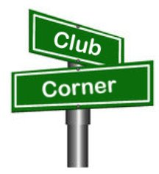***Club Corner***

This is YOUR cornner of the newsletter. Send me what your club is doing and I’ll make sure that it gets in. Got a special event or club project that you want everyone to know about? Send it to me!. Need help with a project? Send it to me.

Let me know what you club is up to. Are you going to have a special guest at your meeting or are you having a special anniversary?

Just sent it to: [webmaster@arrl-ohio.org](mailto:webmaster@arrl-ohio.org)

**Important Field Day News!**

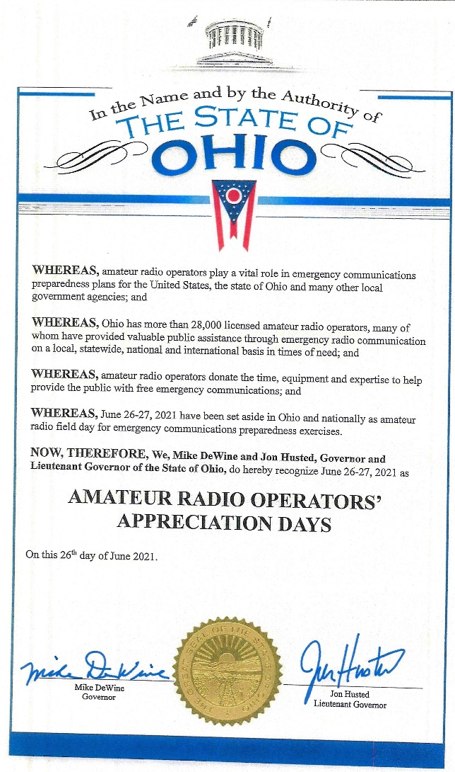

We have received from Governor DeWine a Proclomation that June 26-27 have been delcared “Amateur Radio Operators’ Appreciation Days” in the State of Ohio! A .pdf of this is available to you on the ARRL OH web site ( [www.arrl-ohio.org](http://www.arrl-ohio.org) ), you’ll want to reference this in any and all of your public press releases regarding your Field Day operations this year.

The Proclomation reads:

**WHEREAS,** amateur radio operators play a vital role in emergency communications preparedness plans for the United States, the state of Ohio and many other local govenrment agencies; and

**WHEREAS,** Ohio has more than 28,000 licensed amateur radio operators, many of whom have provided valuable public assistance through emergency radio communication on a local, statewide, national and international basis in time of need; and

**WHEREAS,** amateur radio operators donate the time, equipment and expertise to help provide the public with free emergency communications; and

**WHEREAS,** June 26-27 have been set aside in Ohio and nationally as amateur radio field day for emergency communications preparedness exercises.

**Now, THEREFORE, We, Mike DeWine and Jon Husted, Governeor and Lieutenant Governor of the State of Ohio,** do hereby recognize June 26-27, 2021 as

**AMATEUR RADIO OPERATORS’ APPRECIATION DAYS**

On this 26th day of June 2021.

####

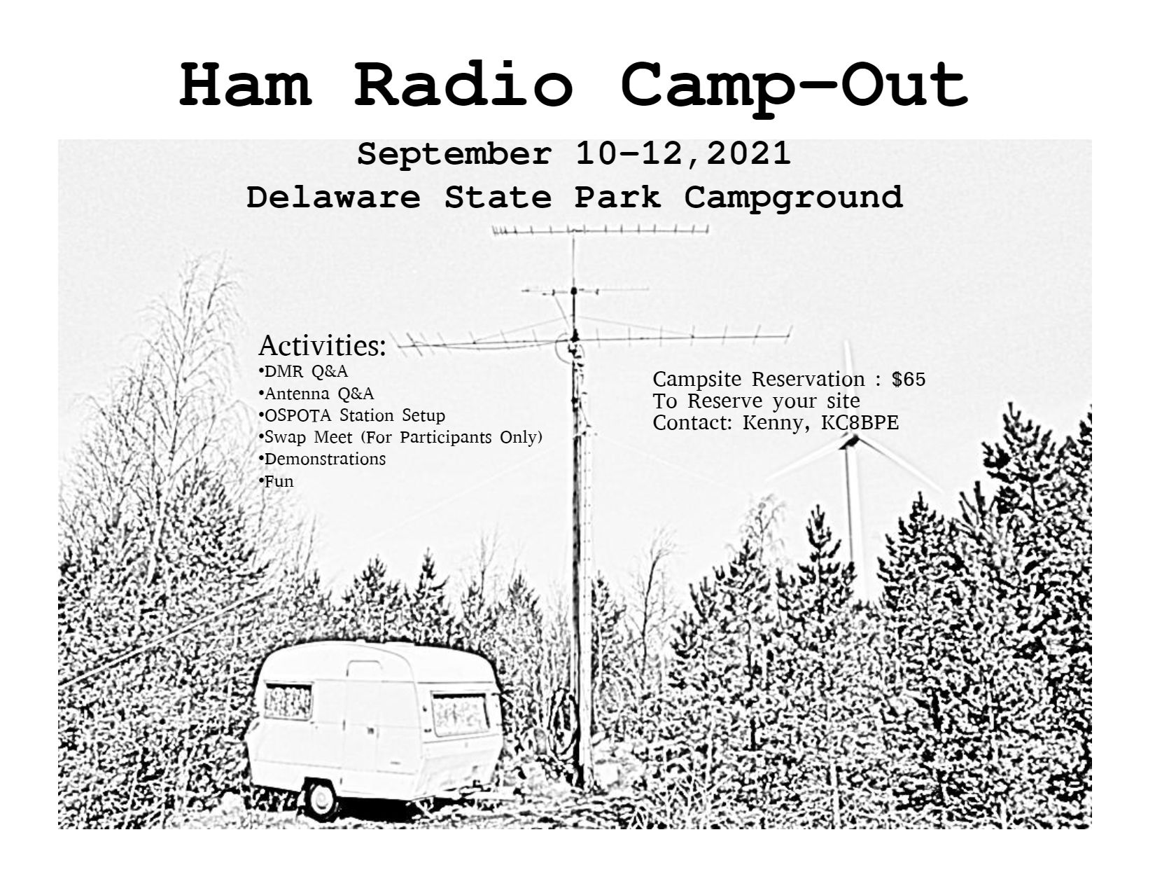

Who: Amateur radio operators

What: Camp-out

When: September 10-12, 2021

Where: Delaware State Park (Ohio)

Why: It is to be a fun weekend of ham activities, including but not limited to operating OSPOTA (Ohio State Parks on the Air), holding a swap fest only for those hams at the camp site, learning from each other, and just plain enjoying each other’s company.

How: Camp sites have already been reserved by Kenny, KC8BPE. You will need to send him $65.00 (less than Kenny’s out of pocket cost) for each site you want to reserve, as there is a limited number of sites all together. Sites have electric hookups, there is a watering station to fill your tank, and there is a dump station. You can camp with your recreational vehicle, trailer, or tent at these sites – your choice. The $65.00 covers only the cost of the site. You will need to plan for your other needs, such as food and fire. Reserve earlier, because the camp sites are available only on a first come first served basis. A station will be set up for operating OSPOTA.

Kenny: [snarekc8bpe@aol.com](mailto:snarekc8bpe@aol.com) cellular 740.223.9065

**County EMA Stations Wanted For Weather Alert Project 21**

**C. Matthew Curtin, KD8TTE**

Thank you for the questions and comments on the Weather Alert Project 21 (WAP21). Several agencies have expressed interest in the project and have offered some revisions to the manual, which have now been folded into the text. And thanks to the stations who have signed up for the project!

If you’re looking for a project for your ARES team or AUXCOMM unit, this is a good opportunity to participate in a means of handling electronic messages when infrastructure is unavailable. You don’t need to operate the actual county station to participate; the project is in the phase of establishing the means to originate, route, and deliver the messages.

The manual explaining the project and how to participate is available at <https://www.blackswancomex.org/2021/weather-alert-project-21>.

####

**Greetings from Tim Duffy, K3LR, CEO of DX Engineering!**

Our staff of active Hams at DX Engineering hope you and your club are adapting well to this challenging time. With so many events being canceled, we’ve shifted our focus to providing virtual educational opportunities to help Hams everywhere stay in touch with what’s happening in the hobby.

The best part is that it’s all free—our way of giving back to the operators who keep Ham Radio so vital in their communities.

**I’ll come to your meeting**—**virtually!**

I am available for free Zoom webinars on a range of topics to suit your club’s interests, from how to mitigate RFI to tips on improving your contesting scores. Contact Teri Grizer, K8MNJ, at [TGrizer@DXEngineering.com](mailto:TGrizer@DXEngineering.com) to schedule a presentation.

**You Can Get Tips, Hear Interviews, and Learn About Weekly Deals on DX Engineering’s Facebook Page**

·         Facebook Live with Tim, K3LR, and Jeff, KB8ZWT, airs every Tuesday at 1:15 pm Eastern (18:15 UTC). Jeff and I cover the gamut of Amateur Radio topics: upcoming contests, choosing coaxial cables, how to use ferrite, the benefits of antenna analyzers, and much more.

·         Tune in for our Manufacturer Showcase, live on Facebook Thursdays at 2:30 pm Eastern (19:30 UTC), for news and information from some of the biggest names in Ham Radio gear.

·         Join me and Hams from around the world for Facebook Live with Tim, K3LR, every Friday at 4:00 pm Eastern (21:00 UTC). Recent topics have included advice on 160M operating, the Reverse Beacon Network, and working satellites. Get live answers to your questions and save money with the DX Engineering Deal of the Week!

·         Like us on [Facebook](https://www.facebook.com/DXEngineering/) and enjoy tech articles, product updates, humor, and the hottest deals from DX Engineering!

**Visit DX Engineering’s blog,**[***OnAllBands***](https://www.onallbands.com/)**, for news, expert tech advice, and updates on the latest equipment. We’re adding fresh content every weekday.**

**Check out our growing collection of instructional videos and interviews on**[**DX Engineering’s YouTube Channel**](https://www.youtube.com/user/DXEngineering)**.**

**Get Advice from Our Elmers!**

·         Talk with our staff of active operators—the best in the industry

·         Choose from more than 30,000 Amateur Radio products for EmComm, Contesting, DXing, and Satellite operation at [DXEngineering.com](https://www.dxengineering.com/)

·         Get the right equipment for your shack: rigs, amps, coaxial cable, rotators, antennas, towers, even stealthy solutions for your HOA antenna concerns

·         Enjoy friendly support during and after your purchase, whether you’re new to the hobby or a longtime operator

Thanks for your time today.

We’re looking forward to seeing you online and hearing you on the air.

73!

Tim Duffy, K3LR

DXEngineering.com  
800-777-0703  
Email support 24/7/365 at [DXEngineering@DXEngineering.com](mailto:DXEngineering@DXEngineering.com)

**Using the "Lightning Activity Level" Forecast:**

Ted Jacobson W8KVK - (Athens Co. OH Skywarn/CoCoRaHS)

With better weather, and Covid improvements here in Ohio, many of us look forward to resuming Amateur Radio support of county fairs, festivals, marathons and charity walk events. One important element of this kind of public service is close monitoring of hazardous weather potential which may threaten vulnerable outdoor populations.

The National Weather Service now generates a relatively new tool called the "Lightning Activity Level" (LAL) forecast. Issued several days in advance, you can see what this looks like by visiting [https://w8kvk.com/AthensWX](https://w8kvk.com/AthensWX%20) and examining the bottom three graphs:

The six LAL levels are described at: <https://graphical.weather.gov/definitions/defineLAL.html>

To generate the LAL forecast for your own city/town/county:

(1) Go to [https://weather.gov](https://weather.gov/)/

(2) Input your City (comma) State in the search box upper left.

(3) On the resulting local forecast page for your town, scroll down below the large map to the

section labeled "Additional Resources",.... then click "Hourly Weather Forecast" (graphs)

(4) In the center "Fire Weather" pane, activate checkbox "Lightning Activity Level"

(5) Click the 'Submit" button below the Fire Weather pane

One important note: companion to the LAL graph, the "Thunder" graph is not the same

as "thunderstorm". This graph supports the important caution that "if you can *hear* thunder,

you *can* be struck by lightning."

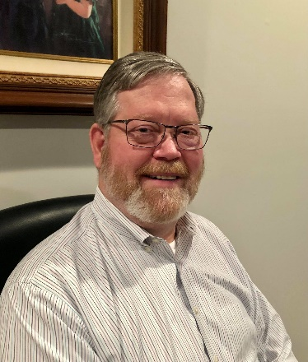**DX This Week – Outgoing QSL Buro**

Bill AJ8B (aj8b@arrl.net, @AJ8B, or www.aj8b.com)

CWOPs Member #1567

The Midwest DX Cluster spots included Alaska, Anguilla, Antarctica, Belgium, Brazil, Bulgaria, Canada, Canary Islands, Colombia, Costa Rica, Croatia, Cyprus, Ecuador, England, Estonia, European Russia, European Turkey, France, Ghana, Gibraltar, Greece, Iraq, Ireland, Isle of Man, Italy, Kenya, Kuwait, Mexico, Scotland, Serbia, Sicily, Slovak Republic, Slovenia, Spain, St. Helena, St. Martin, and Venezuela. This brings the total number of entities spotted in the Midwest in 2021to 174!

I received a few QSL cards V51WH – Gunter in Namibia and BG2AUE – Miao in Harbin, China. What did you get?

|  |  |
| --- | --- |
|  |  |

*DAH DIT DIT DIT DAH DAH DIT DIT DIT DAH*

I have received a couple of emails regarding QSL cards. Are people still sending them? What is the best way? I will be attempting to address these questions in the coming weeks. However, for this week, I thought that reviewing information on the QSL Bureau would be a good start.  
 There are a couple of reasons to collect QSL cards. There are a few awards that are not linked with LoTW, there are some hams who don’t use LoTW but will confirm via a paper card, there are some beautiful and creative QSL cards to be seen, and there is a tradition of exchanging cards. My first “DX” was with VE3FGO and I still have that card from 1970!

The information that is typically on a QSL card is both callsigns, the location of the station you are confirming as shown in the DXCC Entity list, the date and time (ALWAYS use UTC time), the frequency, and the mode used. The signal report is NOT required, but, is usually included. It is also helpful if the QSL displays the ITU and CQ Zones, grid square designation, and the US county. Most hams now include club affiliations and their email address as well. All this information, along with a bit of personalization, can fit on a standard 3.5” by 5.5” card. Many hams put their location information and callsign on the front and the QSO information on the back. If you are handwriting information on the card and you make a mistake, throw the card out and start over. The station receiving the card may not be able to use what appears to be an “altered” QSL card.   
There are several advantages to using the ARRL Outgoing QSL Bureau including a good percentage of returned cards, least expensive, and it can be used to send to foreign QSL managers. The disadvantages are that the bureau is not used by all DXers and it takes time. I have gotten cards for QSOs that were older than 5 years! I am hearing from some of the bureau volunteers that the volume of QSL cards processed has increased dramatically due largely to the use of FT8 by so many hams. More QSOs more QSLs!  
 The basic concept is that you bundle up your cards and send them to the ARRL. The cards are then sorted by entity and then, at some predetermined time interval, sent to the remote QSL bureaus.

Figure 1 ARRL Outgoing QSL Bureau

Of course, there are rules that you need to follow so that the ARRL Outgoing QSL Bureau can process the cards and get them added to the shipments to foreign QSL bureaus. (More details can be found at <http://www.arrl.org/outgoing-qsl-service> .)

I want to highlight a few critical points in this process:

* Send larger packages of card to the bureau. I usually send a hundred or so quarterly. At a minimum, I send a package yearly.
* Write the recipients call sign on the back of the card, use upper-left hand side; and flip cards forward facing the same direction. Business side up with no blank sides facing forward. This allows the sorter to quickly determine where the card needs to be sent without reading the front of the card. For instance, if 6Y1V uses OH3RB as the QSL manager, you would put OH3RB on the back-left hand side of the card along the edge. Print this CLEARLY!
* Sort cards in alphabetical order according to parent and alternate prefixes. This is important for slotting the cards and eliminates returns because cards went to the wrong bureau. Keep all country prefixes together. Example: The prefix 2E belong to England so these cards will go with your G cards for England. The prefix TM is for France, so these cards will go with your F cards.
* Do not separate the cards with slips of paper, rubber bands, etc. This only slows down handling of the cards.

When you prepare the package for the bureau, you must include:

* Proof of ARRL Membership
* Fees & Payment – There is a charge for this service that covers shipping costs. The charge is a $7 QSL Bureau fee and $1.15 per ounce. For example, a package containing 1.5 pounds of cards — 24 ounces, or about 225 cards — will cost $34.60. Please see the information below for additional pricing details. The minimum charge is $8.15 for one ounce or less. The same 200+ cards sent with an air mail stamp alone would cost $106 not counting return postage or the envelope. Quite the bargain!
* Pay by check or money order with your callsign written on the check. I include an SASE that the volunteers will put in the mail to let you know that the cards were received.
* Put all of this together (QSL Cards, Proof of Membership, Fee, and an SASE if desired) and ship it to:

ARRL Outgoing QSL Service

225 Main Street

Newington, CT 06111-1494.

As always, if you are having DX success just drop me a line and let me know what you are doing! If you have questions or recommendations for a topic, please send that along as well.

*DAH DIT DIT DIT DAH DAH DIT DIT DIT DAH*

CQDX CQDX CQDX CQDX CQDX CQDX CQDX CQDX CQDX

Here is an update from Bernie, W3UR, of the DailyDX and the WeeklyDX, the best source for DX information. <http://www>.dailydx.com/. Bernie has this to report:

**EW – Belarus -** EV76M will be a "special station celebrating [thee] 76th anniversary  
of the Victory in the World War II" from the "Hero City Minsk". Activity will take place during the month of May. All QSOs will be uploaded to LoTW, Club Log and eQSL. Please do not send QSLs via the bureau.

**Contest University and Hamvention forums - now OPEN to register**By K3LR, Tim Duffy

Registration is now OPEN for Virtual Contest University 2021 on May 20, 2021 and for 2021 Hamvention Forums on May 21, 2021. Both events are being held live through Zoom Webinar and are free. You must register to be included in the webinars. You need to register for each event separately. Four Icom radios will be given away at each virtual event. The drawing times are random and you must be registered and on Zoom at the time of the drawing to win. Both events will be recorded and available on YouTube at the conclusion of the events.  
For more information please go to:  
<https://www.contestuniversity.com/> or <https://hamvention.org/forums-2021/>

**Congratulations to K9LA, Carl Luetzelschwab, who won the April 2021  
QST Cover Plaque Award** - <http://www.arrl.org/news/carl-luetzelschwab-k9la-wins-the-april-2021-qst-cover-plaque-award>

**3D2 – Fiji -** 3D2DOM (3Z9DX), Dom, and his wife 3D2ZK, Joanna, are operating from  
their home in Nandi. Due to Covid cases on the island travel is currently curtailed. They are not operating from grid locator RH82XE but rather RH82rg. Joanna has been working on her CW using Morse Runner.  
  
**A3 – Tonga -** After a year of being QRT JA0RQV, Masa, will be back on Tongatapu  
Island (OC-049) and QRV as A35JP next month through October. "During the period, if possible, I will try to activate some outer islands again such as Niuatoputapu (OC-191), Niuafo'ou (OC-123), Vava'u (OC-064) and Ha'apai (OC-169)", says Masa. He will be running a 100 watt IC-7300 into a vertical for activity on 3.5 through 50 MHz on CW, SSB and FT8. QSOs will be uploaded to LoTW and Club Log. He will answer paper QSLs upon his return home to Japan beginning in November. Masa asks that you not send SASE's to his home address, while he is away.

**Press Release #2 from the Intrepid-DX Group  
3Y0J DXpedition to Bouvet Island, January/February 2023**  
By N6PSE, Paul Ewing, Co-leader & LA7GIA, Ken Opskar

Bouvet is like the Mount Everest of DXCC entities. It is among the most challenging entities to activate due to significant transportation costs and personal sacrifices required by the team to make the 42 day round trip. Fortunately, Bouvet is not our first mountain. We are well prepared for this challenge.

All plans are going well. We are researching polar quality tents and equipment. We are discussing antenna specifications with various manufacturers. We will make careful choices to help us meet the demand for Bouvet contacts.

We are delighted to add a second Physician to our team. Dr. Mike Crownover-AB5EB and Dr. Bill Straw-KO7SS are both seasoned Emergency Physicians and will help the team immensely with their expertise.

Our fundraising is going very well. We have received a significant donation from our longtime friend Y. Zorro Miyazawa JH1AJT. Zorro has always been an enthusiastic supporter of our missions and his generosity is greatly appreciated.

We are pleased to announce that we will receive the ARRL's Colvin Grant, as well as large donations from the Far East DX-ploiters Foundation, the German DX Foundation and the Twin Cities DX Association. We would love to add your Club or your Call to our sponsors pages.

This will be an arduous and expensive mission. Our budget is $764,000 USD and the 3Y0J team will fund much of this mission. We desperately need the global DX Community to support our mission and help us make this important activation of the #2 most wanted DXCC entity. It is only through this kind of support that we can achieve our mission of making 100,000 contacts or more from Bouvet.

In closing, we especially wish to thank our many Foundation, Club and Individual donors. Without this kind of support, operations to the world's rarest entities would not be possible. Please include your call sign, mailing address and email address with your PayPal submissions. We would not want to miss QSLing with you!  
  
You can follow our plans from our website and the 3Y0J Facebook:  
[http://www.3y0j.com](http://www.3y0j.com/)  
<https://www.facebook.com/groups/3y0jbouvet2023>

*DAH DIT DIT DIT DAH DAH DIT DIT DIT DAH*



Below is a list of upcoming contests in the “Contest Corner”. I think this is important for someone who is trying to move up the DXCC ladder since entities that are on the rarer side and easiest to work in contests. Some of my best “catches” have been on the Sunday afternoon of a contest when the rarer entities are begging for QSOs. Of course, the gamble is that if you wait until Sunday, conditions may change, or they simply won’t be workable. However, it is not a bad gamble. Of course, why not work the contest and have some fun!  
Check out the WA7BNM Contest Calendar page (<https://www.contestcalendar.com/>) and CQ Magazine for more contests or more details.

The contests in red are those that I plan to spend some significant participation time on. PLEASE let me know if you are working contests and how you fared.

Thanks!

|  |  |  |
| --- | --- | --- |
| May 16 | FISTS Spring Unlimited Sprint | <http://fistsna.org/operating.html> |
| May 19 | RSGB 80m Club Championship, Data | <http://bit.ly/3avHbk3> |
| May 15-16 | His Majesty King of Spain CW Contest | <http://concursos.ure.es/en> |
| May 15-16 | NZART Sangster Shield Contest | <http://bit.ly/3aviX6h> |
| May 22-23 | Baltic Contest | [www.lrsf.lt/en](http://www.lrsf.lt/en) |
| May 23-24 | QRP ARCI Hoot Owl Sprint | [www.qrparci.org/contests](http://www.qrparci.org/contests) |
| May 27 | RSGB 80m Club Championship, CW | <http://bit.ly/3avHbk3> |
| May 29-30 | CQWW WPX CW CONTEST | [www.cqwpx.com](http://www.cqwpx.com/) |
| August 28 | Ohio QSO Party | <https://www.ohqp.org/> |
| August 28 | W8DXCC | <https://www.w8dxcc.com> |

***DX News***

**ARLD018 DX news**  
  
  
ARLD018 DX news  
  
This week's bulletin was made possible with information provided by OA4DPM, The Daily DX, the OPDX Bulletin, 425 DX News, DXNL, Contest Corral from QST and the ARRL Contest Calendar and WA7BNM web sites.  
Thanks to all.  
  
NIGER, 5U.  Adrien, F4IHM will be QRV as 5UAIHM from Niamey from May 10 to June 15.  Activity will be on 40 and 20 meters using CW.  QSL to home call.  
  
MOROCCO, CN.  Stations in Morocco can use the special prefix CN18 until May 10 to celebrate the 18th birthday of Morocco's Crown Prince Moulay Hassan.  
  
FEDERAL REPUBLIC OF GERMANY, DA.  Special call sign DL65ESSEN is QRV until December 31 to celebrate the 65th anniversary of the DARC's Ortsverband Essen.  QSL via bureau.  
  
SPAIN, EA.  Members of the URE club Cullera and of Les Basores DX group will be QRV as AN5ITU from May 8 to 23 to celebrate the 76th anniversary of the ITU.  Activity is on the HF and V/UHF bands, and  
Satellite QO-100, using CW, SSB, RTTY and other digital modes.  QSL direct to EB5R.  
  
FRANCE, F.  Michel, F8GGZ and Serge, F6HFI are QRV with special event call sign TM200NB until May 15 to commemorate the death 200 years ago of Napoleon Bonaparte.  QSL via F5KOB.  
  
GUERNSEY, GU.  Members of the Guernsey Amateur Radio Society will be QRV as GB5LIB from May 8 to 14 to celebrate the liberation of Guernsey.  Activity will be on 160 to 10 meters and Satellite QO-100.  QSL via LoTW.  
  
REPUBLIC OF KOREA, HL.  Special call signs HL41GDM and D73M are QRV until May 31 to commemorate the 41st anniversary of the Gwangju Uprising, also known as the Gwangju Democratization Movement.  QSL via HL4CCM.  
  
JAPAN, JA.  Special event stations 8N1OLP, 8N2OLP, 8N3OLP, 8N4OLP, 8N5OLP, 8N6OLP, 8N7OLP, 8N8OLP, 8N9OLP and 8N0OLP are QRV until September 5 for the World Olympic and Paralympic Games.  QSL via bureau.  
  
LITHUANIA, LY.  Members of the Lithuanian Radio Sports Federation are QRV with special call sign LY57BC during May to promote and participate in the 57th edition of the Baltic Contest.  QSL via LoTW.  
  
PERU, OA.  Special event call sign OC200P is QRV during May to celebrate the Bicentennial of the independence of the Republic of Peru.  Activity is on 80 to 10 meters using SSB and FT8.  QSL via  
LoTW.

BELGIUM, ON.  Members of the radio club Noord Oost Limburg are QRV with special call sign OR40NOL until the end of 2021 to celebrate the club's 40th anniversary.  QSL via ON6NL.  
  
NETHERLANDS, PA.  Special event station PD21EUROSONG will be QRV from May 8 to 22 to bring attention to the 2021 Eurovision Song Contest taking place in Rotterdam.  QSL via bureau.  
  
SWEDEN, SM.  Members of the Hisingens Radio Club are QRV with special call sign SE400G until July 31 during the celebration of Gothenburg City's 400th anniversary.  Activity is on various HF bands and modes.  QSL via LoTW.  
  
TURKEY, TA.  Special event station TC568FA is QRV until June 28 to commemorate the conquest of Istanbul in 1453.  Activity is on 160 to 2 meters using CW, SSB and various digital modes.  QSL via op’s instructions.  
  
SOUTH SUDAN, Z8.  Sigfrido, IW9FMD is QRV as Z81S while working with the United Nations Mission.  Activity is in his spare time.  He has been active on 15 meters SSB so far.  QSL direct to IT9YVO.  
  
The OK1WC Memorial, RSGB 80-Meter Club SSB Championship, 4 States  
QRP Group Second Sunday Sprint and K1USN Slow Speed Test are  
scheduled for May 10.  
  
The RTTYOPS Weeksprint and Worldwide Sideband Activity Contest are scheduled for May 11.  
  
The VHF-UHF FT8 Activity Contest, Phone Fray and CWops Mini-CWT Test are scheduled for May 12.  
  
Please see May QST, page 71, and the ARRL and WA7BNM contest web sites for details.

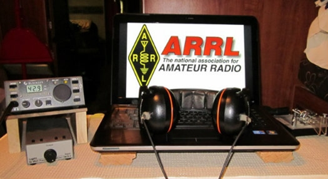**ARRL Contest Corner**

An expanded, downloadable version of *QST'*s’ [**Contest Corral**](http://www.arrl.org/contest-calendar) is available as a PDF. Check the sponsor’s ‘Website for information on operating time restrictions and other instructions.

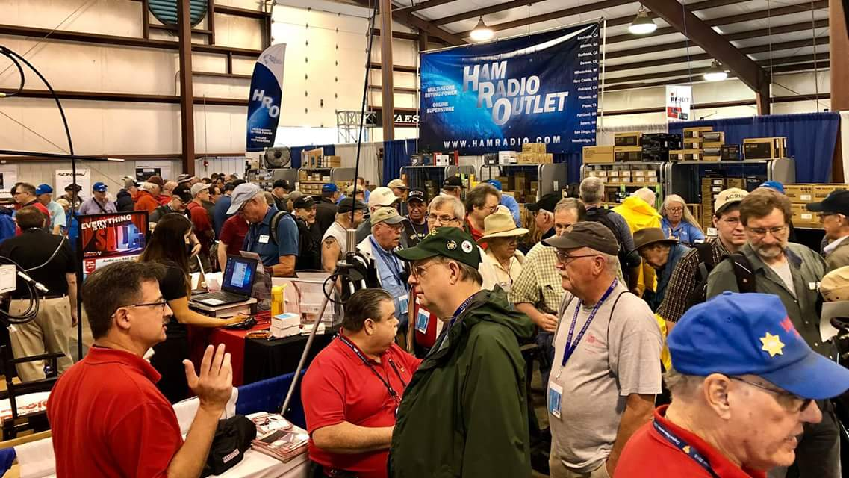[**Upcoming *Hamfests***](http://arrl-ohio.org/hamfests.html)

We **DO** have some hamfests scheduled for 2021!! Yes, take a good look at the list, it’s growing every day!

Be sure to keep your eyes on this schedule as that when things start getting better and the vaccine rolls out to more and more, hamfests will surely get back to their normal schedule. Don’t see your hamfest listed?? Did anyone register it with ARRL? It’s really easy to do and you get a lot of FREE publicity if you do.

|  |  |
| --- | --- |
| **06/05/2021 -**[**FCARC SummerFest**](http://www.arrl.org/hamfests/fcarc-summerfest)  **Location:**Wauseon, OH **Sponsor:**Fulton County Amateur Radio Club **Website:**[**http://k8bxq.org/hamfest**](http://k8bxq.org/hamfest)  [**Learn More**](http://www.arrl.org/hamfests/fcarc-summerfest) | **07/10/2021 -**[**Mansfiled Mid-Summer Trunkfest**](http://www.arrl.org/hamfests/mansfiled-mid-summer-trunkfest)  **Location:**Mansfield, OH **Sponsor:**InterCity Amateur Radio Club **Website:**[http://iarc.club](http://iarc.club/)  [**Learn More**](http://www.arrl.org/hamfests/mansfiled-mid-summer-trunkfest) |
|  |  |
| **07/17/2021 -**[**NOARSFEST**](http://www.arrl.org/hamfests/noarsfest-8) **Location:** Elyria, OH **Sponsor:**Northern Ohio Amateur Radio Society **Website:** [http://noars.net](http://noars.net/)  [**Learn More**](http://www.arrl.org/hamfests/noarsfest-8) | **07/18/2021 -**[**Van Wert Hamfest**](http://www.arrl.org/hamfests/van-wert-hamfest-5)  **Location:**VAN WERT, OH **Sponsor:** Van Wert Amateur Radio Club **Website:** [http://W8FY.ORG](http://w8fy.org/)  [**Learn More**](http://www.arrl.org/hamfests/van-wert-hamfest-5) |
| **08/07/2021 -** [**2021 Columbus Hamfest**](http://www.arrl.org/hamfests/2021-columbus-hamfest)  **Location:** Grove City, OH **Sponsor:**Aladdin Shrine Audio Unit **Website**: [http://columbushamfest.com](http://columbushamfest.com/)  [**Learn More**](http://www.arrl.org/hamfests/2021-columbus-hamfest) | **08/28/2021 -**[**Cincinnati Hamfest℠**](http://www.arrl.org/hamfests/cincinnati-hamfest)  **Location:**Owensville, OH **Sponsor:** Milford ARC **Website:** [http://CincinnatiHamfest.org](http://cincinnatihamfest.org/)  [**Learn More**](http://www.arrl.org/hamfests/cincinnati-hamfest) |
| **09/26/2021 -**[**Cleveland Hamfest**](http://www.arrl.org/hamfests/cleveland-hamfest-1)  **Location:**Berea, OH **Sponsor:** Hamfest Association of Cleveland **Website:** [http://www.hac.org](http://www.hac.org/)  [**Learn More**](http://www.arrl.org/hamfests/cleveland-hamfest-1) | **12/04/2021 -**[**FCARC WinterFest**](http://www.arrl.org/hamfests/fcarc-winterfest-2)  **Location:**Delta, OH  **Sponsor:** Fulton County Amateur Radio Club  **Website:**<http://k8bxq.org/hamfest>    [**Learn More**](http://www.arrl.org/hamfests/fcarc-winterfest-2) |

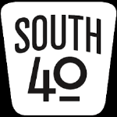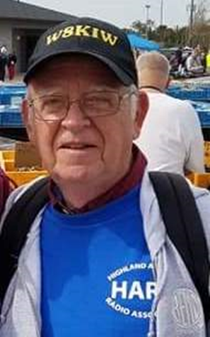

**NEWS FROM THE SOUTH FORTY**

Following last week’s trip up the Ohio River from Gallipolis to Pomeroy where we pick up US 33 to head to Athens, the home of Ohio University and the Athens County ARA.

According to their website, the Athens County ARA is the oldest of four clubs in Athens County. Ted Jacobson, W8KVK, provided us some information on the club’s early history as related by Bob Wheaton, W5XW in a letter sent Carl Denbow, N8VZ, in 2010. Although not licensed until December 1956, the 14 year old Wheaton was invited to the organizational meeting that spring. It seems his interest in trying to “re-invent radio” led to his being found in a field experimenting with a spark gap coil, batteries and a magnetic wire antenna and creating QRM on 75 meters while doing it. The first club project after its 1956 founding was a license class taught by two of the new club’s members that led to Wheaton receiving his Novice license. (Probably to get this kid legal?) The club quickly incorporated and the FCC granted them the K8EVB callsign. The club used space in a county owned building where they established a station using a war surplus ARC-5 75 meter AM transmitter and an SX-28A receiver.

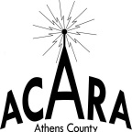Since those early days a lot has changed with the club, but a couple things that haven’t are the emphasis placed on license classes and testing. There is normally an annual class held and ARRL VE team leader Jeff Slattery, N8SUZ, holds quarterly test sessions, often in cooperation with the county’s Sunday Creek Amateur Radio Federation. Although the Lancaster Street ham station no longer exists, the Club meets at and has a station at the Athens Red Cross Building. The Club is well known for sponsoring an annual hamfest each April. Although COVID has curtailed the event for the past two years, they anticipate having some type of a swap fest later this year. As a club they are active during Field Day, Ohio Parks on the Air and the December 10 Meter contests. During the annual ARRL 10 meter contest the ACARA member with the highest score becomes the holder of the NC8V Memorial Trophy for a year. Individual members can also be found during the Ohio QSO Party and the ARRL November Sweepstakes. In 2016 they operated the special event station K8M as a part of a city celebration honoring the King Midget automobile that (until 1970) for 70 years was built in Athens. That single event resulted in hundreds of worldwide contacts. The club is also well known for providing communications for the many foot races, marathons and bike rides that take place in the various state and national forests and parks in the area. They were the first club in the region to start teleconferencing their meetings at the start of the pandemic. Eric McFadden, WD8RIF, is the current club president and trustee of the W8UKE repeater.

It’s time to say adieu to our Athens County ARA friends, but not without noting the South Central Ohio Chapter of the American Red Cross just recognized ACARA member Jeff Slattery, N8SUZ, for his ‘Exceptional Service in Disaster Cycle Services’. The Athens Messenger states Slattery has been a Red Cross volunteer for nearly 48 years. Jeff is also known in ham circles around Ohio as the Communications Director for the annual Great Ohio Bicycle Adventure.

Word from Fayette County is that meetings of the Fayette ARA will resume. According to Jim Scott, N8ORJ, and Jeff Dreher, KE8DVH, arrangements have been made for the club to meet on Thursday, May 20, at the First Baptist Church in Washington Court House. It will start at 6:30.

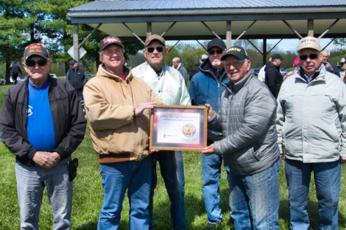Saturday morning was cool but sunny in Hillsboro as 44 hams from thoughout Southern Ohio gathered at Hillsboro’s Liberty Park to help the Highland ARA celebrate a crop of new hams and the receipt of an award from the ARRL designating the Club as Ohio’s newest Special Service Club. Presenting the award were Ohio Section Manager, Tom Sly, WB8LCD, with additional comments from Great Lakes Division Vice Director Scott Yonally, N8SY. The group was also addressed by past HamVention Chairman Michael Kalter, W8CI, and current Chairman Rick Allnutt, WS8G. They told about the upcoming on-line HamVention activities and the HamVention QSO Party. HamVention is the largest gathering of amateur radio enthusiasts in the world and normally is attended by 25,000 to 30,000 hams from all parts of the earth. This group of amateur radio operators would normally gather for three days later this month in Xenia, OH were it not for COVID precautions cancelling this year’s event

Chris Osborne, KE8RVJ, from the Sinking Spring area is a graduate of the HARA license class where he not only passed his Technician, but also walked away with his General. On May 1 he drove to Richmond, IN and walked out of the test session with his Amateur Extra. Now talk about dedicated to getting a license because I’m not certain you can get from Sinking Spring to Richmond. But he found the way and along that way he even applied for a vanity call sign. Congratulations Chris!

On Tuesday morning members of the Clinton County ARA and the Highland ARA participated in an amateur radio demonstration to the Wilmington Chapter of the Business Network International members. Using the CCARA 147.12 repeater they demonstrated how a handheld in the Wilmington meeting room could communicate with a mobile near Mason and a fixed station in Hillsboro. At the conclusion of the demonstration it was discovered a member of the BNI group has a ham license but is inactive. Newly licensed Joe Holdren, KE8RVL, led the demonstration with the assistance of Paul Jellison, K8IO, and John Levo, W8KIW.

This coming week will be a busy one for Highland ARA members. On Tuesday evening, May 11, they will gather at the home of Kathy and John Levo (N8ZNR and W8KIW) for an Elmer Antenna Night where new hams will see fixed and mobile HF and UHF/VHF antennas not only just displayed, but in use. They will also have a hands on experience with tuners, analyzers, SWR bridges, switches, rotors and other parts of an antenna system. Then on Friday evening, May 14, members will meet at the Hillsboro Cemetery to place flags on the graves of about 1,000 veterans who are buried there.

The Milford ARC announces it is resuming their monthly meetings and test sessions. However these happenings will take place at a new location and on a different date. According to their website, the Miami Township Civic Center will now host those events. It is located at 6101 Meijer Drive in the eastern part of Milford. The club will now meet on the third Thursday of each month at 7 pm. Test sessions are prior to the meeting. May 20 will be the next meeting.

On May 4, Robert Waugh of Jackson was issued the call sign KE8RZD by the FCC. He recently passed his Technician License at the Athens County ARC’s test session. Welcome Robert.

Speaking of test sessions, *QST* states there will be a test session in Lancaster on May 11 at the Grace Church and on May 15 the Cambridge Area Makers Group will test at the St. John Church. The Portsmouth RC will have a testing opportunity prior to their June business meeting at the Portsmouth American Legion Post.

Below the Mason-Dixon, the River Cities ARC will have a test on June 8 at the Bellfonte Italian Restaurant in Ashland, KY and the Tri-State ARA will test at the Huntington, WV Museum of Radio and Technology on the 12th. All sessions will require pre-registration with no walk-ins accepted. Check the ARRL website for details on each test session.

This past week, Ted Ruble, KQ4TL, was honored for his 50 years of service to the Mowrystown American Legion Post 694. He was presented a certificate from the Ohio State Senate by State Senator Bob Peterson. Ruble is a Navy veteran, a former police officer and worked for the Virginia State DOT as a Vehicle Inspector. He lived in the Shenandoah Region of Virginia before returning to his Southern Ohio roots upon his retirement. He is a member of the Highland ARA. He and wife Barbara have three daughters and live near Hillsboro. Congrats Ted.

Before leaving Athens we tried to find information on the amateur radio club at Ohio University. However since the academic year had just ended the trustee had already departed campus. It was confirmed the club does exist and the W8PZS station still occupies space in the Stocker Engineering Building with the antennas on the roof. Your column editor recalls stories Bob Mathews, K8TQK, told of the on the air antics while he was a student there in the 1960s and then after he was employed as an instructor at the campus radio station for many years following graduation. Athens High School reportedly has a ham club, but no information was able to be obtained.

Next time we hope to dig up some information on the Sunday Creek ARF and the Hocking Valley ARC.

Until then if you have a news item or a comment you would like to share, send it to [jlevo@cinci.rr.com](mailto:jlevo@cinci.rr.com). The news says there is a light at the end of the tunnel regarding COVID. Some clubs are rescheduling hamfests and other activities, plus returning to in person meetings. So perhaps we can get back to some form of the non on the air ham radio activities. In the meantime, here’s hoping everyone will keep safe, healthy and radio active.

73, John Levo, W8KIW

***Print an Official or Unofficial Copy of Your Amateur Radio License***

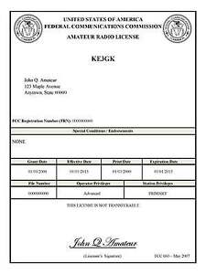*(By Anthony Luscre, K8ZT)*

As of February 17, 2015, the **FCC no longer routinely issues paper license documents** to Amateur Radio applicants and licensees. The Commission has maintained for some time now that the official Amateur Radio license authorization is the electronic record that exists in its Universal Licensing System (ULS). The FCC will continue to provide paper license documents to all licensees who notify the Commission that they prefer to receive one.

Licensees also will be able to print out an official authorization — as well as an unofficial “reference copy” — from the ULS License Manager. I’ve created a set of instructions on how you can request an **“official” printed copy of your license\***

[**Click here to download the instructions**](http://arrl-ohio.org/news/2020/print_your_license.pdf)

***One Question Questionnaire***

Hey Gang,

Survey Says”…..Well, it doesn’t matter now! I’ve got a new question, so how about going to www.ARRL-OHIO.org and giving me a click? (It’s in the bottom left corner of the page) Send your friends, send your kids and send your Mother! (That’s my subtle Mother’s Day reminder so no-one gets in any trouble this year…….)

***“What are your plans for Field Day this year?”***

*****V.E. Test Sessions***

Many V.E.’s have decided to start testing once again, but with restrictions that need to be adhered to for sure. Here’s the link to find that V.E. Test session and what is expected of YOU before going. <http://www.arrl.org/find-an-amateur-radio-license-exam-session>

Ohio Section Cabinet

|  |  |
| --- | --- |
| Section Manager – Tom Sly, WB8LCD | Section Traffic Manager – David Maynard, WA3EZN |
| Section Emergency Coordinator – Stan Broadway, N8BHL | Section Youth Coordinator – Anthony Luscre, K8ZT |
| Technical Coordinator – Jeff Kopcak, K8JTK | Affiliated Clubs Coordinator – Tom Sly, WB8LCD |
| State Government Liaison – Bob Winston, W2THU | Public Information Coordinator – John Ross, KD8IDJ |



Hey Gang,

Have you taken a look at the **Swap & Shop** page on the Ohio Section webpage yet?? Here’s a link that will take you there… <http://arrl-ohio.org/sm/s-s.html>

Do you have equipment that you just don’t need or want anymore? Here’s a great venue to advertise it, and it’s FREE!! Is your club doing a fund raiser to help raise money? After a lot of thought, it was decided that the Swap & Shop webpage could also contain these types of items as well. The same rules will apply as do for the For Sales and Give-A-Ways and will only be posted for a month at a time. Please see the Terms & Conditions on the webpage.

If your club is doing a fund raiser and wants more exposure, please forward the information to me and I’ll advertise it on the Swap & Shop webpage for you.

Now, I still want to remind you that it won’t be listed in this newsletter because it would take up way too much space, so your ad will only appear on the website. It is there for any individual to post equipment Wanted / For Sale or Give-Away as well as for Club Fund Raisers. No licensed vehicles/trailers or business advertising will be posted. Postings are text only (no pictures or graphics) will be posted for a maximum of 1 month from date posting and require a contact phone number or email within the posting. Send your Wanted / For Sale or Give-Away post to:  [swap@arrlohio.org](mailto:swap@arrlohio.org)

***Back Issues of the PostScript and Ohio Section Journal***

Hey, did you know that PostScript and Ohio Section Journal (OSJ) are archived on the website? You can go back and look at any edition simply by clicking:

<http://arrl-ohio.org/news/index.html>

***Welcome New Subscriber(s)***

**Diana, KJ7GVY**

***Want to Share your Club Newsletter With Others?***

We have a webpage where you can download and read all of the newsletters that I get from around the state and even other sections!

Here’s the link to the page…. <http://arrl-ohio.org/club_news/index.html>

Please, if you don’t see your club newsletter posted, it’s because I’m not receiving it. Just have your newsletter editor contact me and I’ll get your club’s newsletter listed on the site!!

We all learn and steal (I mean, share) from each other’s work. So, get me your newsletter!!! Send it to: [webmaster@arrl-ohio.org](mailto:webmaster@arrl-ohio.org)

***Chit – Chat, and All That!***

Do you know someone that’s not getting these Newsletters? Please, forward a copy of this Newsletter over to them and have them “[Opt-In](mailto:Opt-In)” to start receiving them. Heck, just have them send an email to: [webmaster@arrl-ohio.org](mailto:webmaster@arrl-ohio.org) and we’ll get them added to the Ohio Section Emailing list.

We now have many thousands of readers receiving these newsletters weekly. Quite impressive, I’d say! I urge all of you to make sure that everyone, regardless of whether they are a League member or not, get signed up to receive these weekly Newsletters.

You can always “Opt-Out” at any time if you feel this is not what you were expecting. It’s fun and very informative. All of your favorite past newsletters are now archived too.

You can go back at any time and read them.

Just go to: <http://arrl-ohio.org/news/>

The pictures on the front page and throughout this newsletter are from various newsletters, Facebook posts and/or were sent directly to me in recent weeks. Take a good look at them, you just might be in one of the pictures! “SMILE… you’re in the Ohio Section News!!”

*PostScript is produced as a weekly newsletter. I want to thank everyone that has contributed articles and ideas to make this an even better news source. I sincerely hope that you have enjoyed this edition and will encourage your friends to join with you in receiving the latest news and information about the Ohio Section, and news and events happening around the world!*