[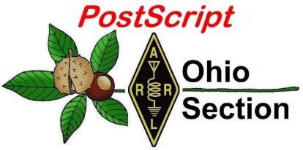](http://arrl-ohio.org/news/) ***“May 3rd***

***Edition”***

🡪 National News 🡪 Club Corner

🡪 DX This Week 🡪 Contest Corner

🡪 Upcoming Hamfests 🡪 South 40

🡪 One Question Questionnaire 🡪 VE Testing

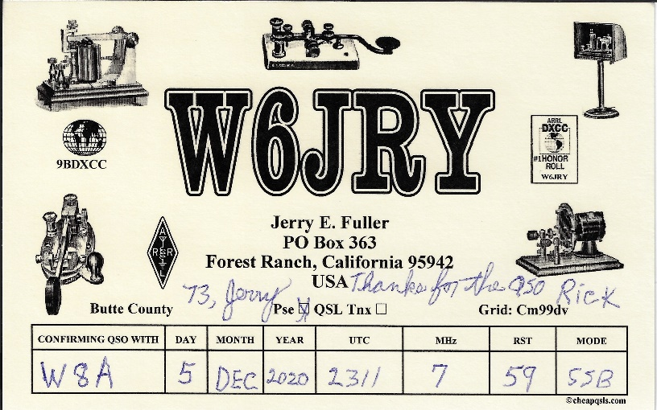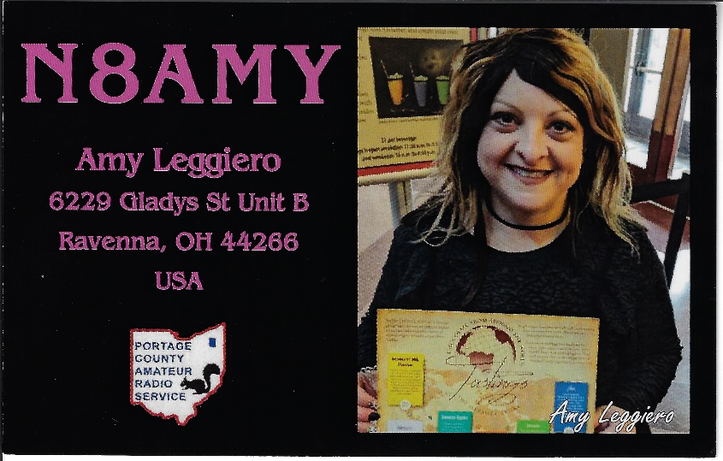

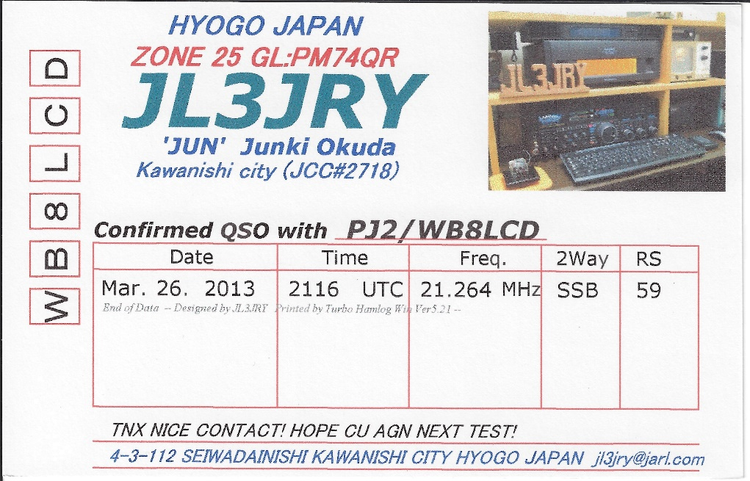

***National News***

*(from arrl and other sources)*

**Annual Armed Forces Day Cross-Band Test Set for May 7 - 8**

The US Department of Defense will host this year's Armed Forces Day (AFD) Cross-Band Test, Friday and Saturday, May 7 - 8, in recognition of Armed Forces Day on May 15. The event is open to all radio amateurs.

For more than 50 years, military and amateur stations have taken part in this exercise, designed to include amateur radio and government radio operators alike. The AFD Cross-Band Test is a unique opportunity to test two-way communications between military and amateur radio stations, as authorized under FCC Part 97 rules. These tests provide opportunities and challenges for radio operators to demonstrate individual technical skills in a tightly controlled exercise in which military stations will transmit on selected military frequencies and will announce the specific amateur radio frequencies being monitored.

The [schedule](http://www.dodmars.org/home/armed-forces-day-2021) of military/government stations taking part in the Armed Forces Day Cross-Band Test and information on the AFD message is available on the MARS website. [Complete](http://www.usarmymars.org/events) the request form to obtain a QSL card.*--Thanks to MARS*

####

**Nationwide Spring Drill Set for May 8, World Red** Cross Day The [Red Cross Emergency Communication Training Group](http://arc-emcomm-training.org/)is holding its nationwide Spring Drill on World Red Cross Day, Saturday, May 8, 2021. Individuals are invited to participate. Last year, more than 1,000 participated in the initial spring drill. The bar has been raised to [Winlink](https://winlink.org/) proficiency for this year's drill. Red Cross forms are integrated as templates in *Winlink* *Express*, and hams using Winlink can also send messages to non-hams. With this year's drill being held on World Red Cross Day, more international participation will be solicited. [Winlink Thursdays](http://arc-emcomm-training.org/Winlink_Thursdays.html) training sessions have been attracting more than 500 participants this year. *-- Thanks to the American Red Cross Emergency Communications Training Group*

####

**FCC Auto-Registration Feature for Exam Applicants to be Discontinued**  
  
Auto-registration in the FCC Commission Registration System (CORES) amateur radio exam for candidates using a Social Security number will be discontinued on May 20, 2021. Applicants must use an FCC  
Registration Number (FRN) for all license transactions with the FCC. Examinees must register in CORES and receive an FRN before exam day. Starting on May 20, electronic batch filed applications that do not  
include a candidate's FRN will be rejected. The Social Security/Licensee ID Field will be disabled.  
  
The CORES website can be accessed at:  
  
<https://apps.fcc.gov/cores/userLogin.do> .  
  
An instructional video provides step-by-step instructions on how to establish a CORES account, which is necessary for licensees to make administrative updates and download electronic license authorizations.  
  
The instructional video can be found at, <https://www.fcc.gov/rofrn> .  
  
After June 29, all filers must provide an email address on all applications. When an email is provided, applicants will receive an official electronic copy of their licenses once granted (allow  
incoming email from [authorizations@fcc.gov](mailto:authorizations@fcc.gov)). If no email is provided when filing on or after June 29, applications will be rejected. ARRL VEC suggests that those without access to email to use the email  
address of a family member or friend.  
  
Further information about providing an email address can be found at,  
  
<http://www.arrl.org/news/fcc-to-require-email-address-on-applications-starting-on-june-29-2021>  
.  
  
Licensees need to log in to the Universal Licensing System (ULS) to download their authorizations. The FCC no longer issues paper copies.

###

|  |  |  |
| --- | --- | --- |
| |  |  | | --- | --- | | |  | | --- | | **Virtual Teachers Institute 2021** | | |
| |  | | --- | | **Application & Fee Deadline is May 21st, 2021** | |
| |  | | --- | | ***ARRL's Virtual Teachers Institute will be offered during the week of July 12th, 2021. There will be a combinations of live and pre-recorded sessions providing instructions for classroom teachers on a variety of activities related to wireless technology and amateur radio. These activities will give teachers practical lessons that they can use in their classrooms. Pre-registration is required.***  As part of our educational outreach to schools through our Education & Technology Program, the ARRL offers the [**Teachers Institute on Wireless Technology**](http://www.arrl.org/teachers-institute-on-wireless-technology). Teachers Institute is an professional development program that provides teachers at all grade levels with tools and strategies to introduce basic electronics, the science of radio, space technology and satellite communications, as well as weather science, introduction to micro-controllers and basic robotics in their classrooms. Wireless radio technology can also be a useful tool with STEM (Science, Technology, Engineering and Math) project-based education.  The Teachers Institute curriculum is designed for motivated teachers and other school staff who want to learn more about wireless technology and bring that knowledge to their students. |  |  |  |  | | --- | --- | --- | | |  |  | | --- | --- | | |  | | --- | | **Summer 2021 Teachers Institute Agenda** | | |  |  |  | | --- | --- | | |  | | --- | | **Monday July 12**  ***Welcome to TI 2021!***  During this introduction to Teachers Institute 2021, you’ll hear a brief overview of this year’s event, meet your instructors for the week, and receive a brief welcome from ARRL CEO David Minster, NA2AA.  Presenter: Teachers Institute Team Time: 11:00am ET  ***A Quick Intro to Basic Electronics***  Explore the relationship between electricity and magnetism, the basis for all electronics. Learn the relationship between voltage, current, and resistance (Ohm's Law), and construct simple circuits to demonstrate the function of both passive and active electronic components.  Presenter: Larry Kendall, K6NDL Time: 12:00pm ET  ***Intro to Programming with Python - Part 1***  Join us for a beginner's introduction to programming with Python on the micro:bit platform. Learn how to write code, display values, and make a simple program.  Presenter: Tommy Gober, N5DUX Time: 2:00pm ET  ***Talking to Astronauts: An Elementary School’s Exciting ARISS Contact***  Overview of steps taken to initiate a contact via amateur radio (AR) between your school and the International Space Station (ISS). This will be an airing of a pre-recorded webinar and Q&A presented by Diana Warner, KE8HLD and followed by an additional 15 minutes of live Q&A.  Presenter: Ally Flynn, KM3ALF, and Diane Warner, KE8HLD Time: 3:00pm ET  ***Satellite Tracking Basics***  Use software to predict when satellites like the ISS will be overhead at your location. Learn the fundamentals and basic set up so you will find success with almost any tracking software available.  Presenter: Matt Severin, N8MS Time: 4:00pm ET  **Tuesday July 13**  ***Taking Radio on the Go***  Amateur Radio is more than having a shack at home. Radio makes for a great outdoor activity as well. Learn about some of the options for taking amateur radio with you on the go.  Presenter: Steve Goodgame, K5ATA Time: 11:00am ET  ***DIY 2-meter Yagi Antenna Building***  Using simple tools and materials, construct a 2-meter "tape measure" Yagi antenna suitable for fox hunting (hidden transmitter finding) and amateur satellite tracking.  Presenter: Larry Kendall, K6NDL Time: 12:00pm ET  ***Intro to Programming with Python - Part 2***  Join us as we continue to dive into programming with Python to build more complex programs to read sensors and solve problems.  Presenter: Tommy Gober, N5DUX Time: 1:00pm ET  ***Soldering as Art and Science***  Learn the basic materials, tools, and techniques of through-hole soldering, with an emphasis on quality and safety.  Presenter: Larry Kendall, K6NDL Time: 2:00pm ET  ***What is Morse Code and Why Do Kids Love It***  Morse Code was invented in the 1800s and became the backbone of international communications until the 1970s, when the advent of satellites, fax and then cell phones diminished its use. Come find out how it is still in use today in the amateur radio community and why kids love to learn it.  Presenter: Howard Bernstein WB2UZE, Jim Crites, W6JIM, and Robb Zarges K2MZ, from the Long Island CW Club Time: 3:00pm ET  **Wednesday July 14**  ***Sampling, from A to D***  It seems that everything today is going digital. How is information converted to digital format, and what are the advantages of doing so? We'll illustrate the process using simple pencil and paper (and spreadsheet) exercises that you can use with your students. Presenter: Larry Kendall, K6NDL Time: 11:00am ET  ***Getting Started with Weather Sensors***  Python and ADC in the real world: you have the skills, now let's build something! We'll use your micro:bit to begin collecting weather data: temperature and wind speed.  Presenter: Matt Severin, N8MS Time: 12:00 PM ET  ***Youth and School Club Licensing***  Interested in getting students licensed? Maybe you want to start a school club? Learn some strategies and tips about how to help make that happen.  Presenter: Steve Goodgame, K5ATA Time: 1:00pm ET  ***Learn How to Build a Working Radio from a Kit***  With this kit, you will build a tunable and volume-controlled radio receiver with an approximate frequency range of 40 MHz to 150 MHz. Pick up transmissions from nearby AM/FM radio stations, Air Traffic Control Towers, and similar transmitting sources. It has been featured at various amateur radio events such as Orlando HamCation and is now available to the public from ARRL. You'll get step-by-step instructions for building a kit that will help you and your students learn about radio electronics and related technology. Presenter: Paul Cianciolo, W1VLF, ARRL Laboratory RFI Engineer Time: 2:00pm ET  **Thursday July 15**  ***Radio Lingo***  When listening to amateur radio signals on the air, a new listener may hear several terms, letters, and numbers that seem confusing or cryptic. In this session we'll demystify the lingo heard on the air. Presenter: Tommy Gober, N5DUX Time: 11:00am ET  ***Software Defined Radio (SDR)***  Using only your computer, you'll be able to 'listen in' on radio signals across the electromagnetic spectrum. We'll walk you through the setup of a basic SDR to get you on the air. Presenter: Matt Severin, N8MS Time: 12:00pm ET  ***What's That Sound?***  What are all those other sounds you hear on radio frequencies? Learn to identify some of the common chirps, whistles, hums, and other types of radio signals you encounter as you tune across the radio spectrum.  Presenter: Larry Kendall, K6NDL Time: 1:00pm ET  ***Dual Servos***  Using the power of Python programming and the microbit, we will learn to control two small servos to track the position of a satellite as it passes overhead.  Presenter: Tommy Gober, N5DUX Time: 2:00 pm ET  ***Guided Tour of W1AW***  Maxim Memorial Station W1AW, located in Newington, Connecticut was established to honor the memory of ARRL’s co-founder and first president, Hiram Percy Maxim. Although the first radio station of the ARRL was actually located in Hartford, Connecticut and active as W1MK, W1AW in Newington is known worldwide and considered the radio station most associated with Hiram Percy Maxim.  Presenter: Joe Carcia, NJ1Q, W1AW Station Manager Time: 3:00pm ET | |  |  | | --- | | **The Teachers Institute is only the beginning of a participant's exploration with wireless technology.** The goal of the TI program is to equip each teacher with necessary foundational knowledge, and through hands-on learning, generate the inspiration for teachers to continue to explore wireless technology and adapt relevant content into their classroom instruction.  **To qualify,** applicants must be an active teacher at an elementary, middle, high school or at a community college or university, or in a leadership or enrichment instruction role in an after-school program.  An Amateur Radio license is NOT required.  **Cost:** There is a $50 enrollment fee to be submitted with the application.  "Ohio Section Youth Coordinator – Anthony Luscre, K8ZT will be happy to assist you in applying or answer questions about Teacher's Institiute." | |

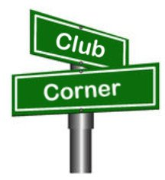***Club Corner***

This is YOUR cornner of the newsletter. Send me what your club is doing and I’ll make sure that it gets in. Got a special event or club project that you want everyone to know about? Send it to me!. Need help with a project? Send it to me.

Let me know what you club is up to. Are you going to have a special guest at your meeting or are you having a special anniversary?

Just sent it to: [webmaster@arrl-ohio.org](mailto:webmaster@arrl-ohio.org)

**From The Highland County Press:**

**Highland Amateur Radio Association concludes successful ‘Introduction to Amateur Radio’ class**

**Courtesy of John Levo**  
  
Recently, Highland County’s Highland Amateur Radio Association concluded its "Introduction to Amateur Radio" class with a highly successful Federal Communications Commission license examination session.  
  
The examination session not only saw students from HARA’s class, but also individuals from Dayton, Cincinnati, Chillicothe and Washington Court House were drawn to Hillsboro for the tests.  
  
According to Club President, Pat Hagen, N8BAP, recent wild fires, tornados, hurricanes, floods and other natural disasters have caused many Americans to look to alternatives to computer, land line and cell based communications should a disaster hit their area rendering local communications infrastructure unusable.  
  
Additionally civil unrest causing communications disruptions may also play into obtaining a license to use radio frequencies in time of need. Because of the number of local residents requesting information about how amateur radio can be used in times when "All Else Fails" the Club decided to hold an entry level license class leading students to their licenses following the completion of a Federal Communications Commission examination.  
  
Plus, many realize amateur radio can be an enjoyable way to communicate over the airwaves with other licensed individuals either across town or around the world.  
  
Hagen states the Amateur Radio Service is one of few services authorized by the federal government to test and issue licenses and police their own ranks on behalf of the government. He further said that previously when HARA conducted classes they relied on other amateur clubs to administer tests to their students.  
  
In 2020 the Club decided to form its own team of certified examiners and applied to administer and directly submit test results to the FCC for license issuance. Following the Commission’s authorization now successful license candidates receive their licenses and federally assigned call signs within hours instead of days or weeks and no longer have to travel to Detroit or other cities to be examined.  
  
It is an honor to be recognized with this authorization. Tom Mongold, Jr, KD8LSD, heads the HARA examination team consisting of 12 local amateur radio operators-most with the highest grade of the three FCC amateur radio license levels.  
  
Those successfully completing the course and receiving a license and call sign were:  
  
Kevin Fauber, Leesburg, KE8RVS  
Steve Frazier, Washington CH, KE8RVK  
Seth Hawthorn, New Vienna, KE8RVO  
Joe Holdren, Leesburg, KE8RVL  
Rindy Matthews, Leesburg, KE8RVP  
Chris Osborne, Hillsboro, KE8RVJ  
Stella Wardlow, Leesburg, KE8RVQ  
David Wolfenbarger, Hillsboro, KE8RVM  
  
Also receiving their first licenses were Larry Jones of Washington CH, KE8RVN, and Chad Houck of Cincinnati, KE8RVR.  
  
Currently licensed Jennifer Ritter, KE8QKX of Hillsboro, successfully upgraded her present license to the next highest grade and granted worldwide communications authorization. Osborne and Hawthorn also successfully earned their General class licenses in addition to their Technician Class entry license. Seaman’s Jared Schupert, KE8GAD, became the area’s latest holder of an Amateur Extra license which is the highest license granted by the Federal Communications Commission.  
  
The Highland Amateur Radio Association was officially formed in 1974 from a base of about 20 local amateurs who frequently met to discuss the radio and electronics hobby. Through the promotion of the amateur radio service the Club currently has grown to approximately 130 members from all corners of Highland County. They are members of a fraternity of approximately 800,000 fellow hams throughout the United States and 29,000 in Ohio. The local club has recently been recognized as one of the leading amateur radio clubs in the nation.  
  
More information regarding amateur radio and how to become involved can be found on the American Radio Relay League’s www.arrl.org website or by contacting HARA’s Information Officer John Levo at (937) 393-4951.

**Ohio NVIS Antenna Day 2021 – the “Next Step”**

Beginning in April of 2014, Ohio ARES has sponsored “NVIS Antenna Day” in Ohio. The activity has several goals: experiment with NVIS antenna construction, determine which is best for your location, have fun. Stations (either groups or individuals) tried different antenna configurations, made contacts with other stations to test signal strength and coverage. Operators of W8SGT, “The Sarge,” were able to confirm coverage from the Ohio EOC to all areas within the state.

For 2021 we took one step further to answer the question, “When and how would we really use these?” Stations were instructed to operate “off-grid” to simulate a wide-area power loss. In such a scenario, the ten Ohio ARES Districts would spin up district level nets to coordinate their counties. NVIS stations were instructed to send a message to their District Net advising of their location and operation. They were also instructed to send a message to the Ohio EOC station either by direct contact on the HF 75 meter net or by using digital messaging through either the Ohio Digital Emergency Net (OHDEN) or Buckeye Net’s multi-mode operation. In this scenario, we would be able to prove our ability not only to simply make contact, but to actually transmit meaningful messaging from any county in Ohio to other counties or the state EOC.

Despite the traditional threat of rain on April 24, Ohio stations turned out eager to participate. 54 of Ohio’s 88 counties were either in direct contact with The Sarge or were able to send a message successfully during the six-hour period. Well over 100 messages were received. Band conditions wavered but in general signals were strong and messages could be transmitted.

Antennas were on average between 5’ – 10’ high and most fell into the broad category of long-wire, inverted V, or the ‘2259’ crossed-dipole types. This was another fun day, showing that ARES can get the message through successfully.

-Stan Broadway, N8BHL

Ohio Section Emergency Coordinator

####

**Weather Alert Project 21 Is More Than Weather**

C. Matthew Curtin KD8TTE

In the April 2021 *Ohio Section Journal,* I introduced the Weather Alert Project 21 (WAP21). Questions about the project have ranged from “Isn’t this just another net?” to “Why focus on distribution of an agency’s product?” I’d like to answer those (and many other) questions by painting a clearer picture of not just this application, but of the system that we’re building.

We’re building a system that ties all Ohio ARES stations together. It’s not a radio net made up of every station in the Section. It’s not an automated system hardwired to particular stations or using particular pathways. It’s a system that makes it possible for any active station to become connected to a *network of nets*.

If this sounds familiar, that might be because this is how the Internet works. Any computer network using the Internet Protocol (IP) is *an internet*. Your home network is an internet, and it connects to a service provider through another internet, which connect to other internets. Collectively, the global system of connected IP networks is *the Internet*.

Your home computer systems can talk to each other and exchange information without activating routers and switches in New Hebrides. If, however, your local computer needs to access, say, a web site there, your network will carry the traffic to your provider’s network and so on until that job is done.

In addition, the system allows for *bulletins* and *alerts* to traverse the system from one station to a particular group of stations. The stations can be identified by description, e.g., role being played. Imagine a District Emergency Coordinator wanting to send a message congratulating every ARES station in the District on some achievement. Rather than have an enormous list of stations with corresponding local delivery instructions, the DEC could simply address ALL STATIONS in, for example, ARES OHIO D7. Likewise, incoming messages could be sent to event stations, or in an emergency, a station operating in the field, wherever it is. Routing and distribution is dynamic, based on where the need is and which stations are currently in operation.

Last year’s County Information Report Project 20 started development of this concept of moving messages along the structure that exists *within* the Ohio Section. FEMA’s Integrated Public Alert and Warning System (IPAWS) Research & Development group saw what we were doing and worked with us on a proof of concept project: local delivery of alerts routed through IPAWS when the usual pathways (which are Internet-dependent) aren’t available. FEMA was able to get an IPAWS message delivered to individual stations within a county for the first time ever by working with us in the BLACK SWAN 20 exercise.

Make no mistake: there is no special communications van, commercial site-on-wheels, satellite system, or government radio service that is going to be activated to solve these problems. Such assets do exist but they are very few in number, take time to activate, and can cover only so much at once. Amateur radio really is the means of emergency communication where infrastructure isn’t available.

WAP21 is a logical step forward from where we left off with BLACK SWAN 20, after building some capability with CIRP20. We’re not trying to solve all issues at once: we’re focusing on concepts and exercising them to see what works, what needs to be refined, and how to train around what works.

WAP21 is not imposing any requirements on local ECs, nor is it imposing requirements on DECs. We’re asking for volunteers who are interested in helping to originate alert messages (transmit stations) and those acting as outlets for local delivery (receive stations) to focus on a particular type of alert message that’s common, familiar, and relatively easy to understand. It doesn’t require commitment for daily operation, but to work with others on a schedule that builds understanding based on experience that helps us to establish the next layer of capability that’s part of building a unified messaging system for the Ohio Section.

Normal progression is for individual operators to start participating and entering the net for their scheduled “shift” to exchange messages as needed. This is where we try our procedures, make our mistakes, discuss the operation (off-air via Internet mailing list), make corrections, and operate better next time. As the number of stations grows within a District, operators within the District can organize how they will route messages among the stations in the District, and can send a representative of the District to the Section. As activity grows, the number of stations in a county will increase in the District net, such that the county can organize and send a representative of all of the county’s station to the District net.

There hasn’t ever been a better time to join the effort to build capability within the Ohio Section to be able to provide the service needed to support our communities and the agencies that serve them “when all else fails.” See the parts fit together with links to WAP21, the QTC Internet mailing list, along with a demonstration video and a training slide deck for Buckeye Net’s Mixed Mode operation at <https://www.blackswancomex.org/2021/prepare>.

If your station is HF capable (60 meters is a bonus, not a requirement), you’re willing to try new things, and you want to improve your operational capability, we want to work with you. When (not if) we make mistakes, we work through it and figure out what should have happened so we can all do better. Sometimes we follow an experimental procedure perfectly and discover that the procedure needs to be corrected. Sometimes we forget how to use the procedure or use it incorrectly and we talk about whether it’s too convoluted or counterintuitive and adjust. Sometimes we find that the procedure is right but we need to train ourselves to use it properly. Whatever the case, it’s regular operation in realistic conditions that in the end make the Ohio Section and us individually more capable and ready to operate in an emergency.

I’m happy to be training with everyone working with us, and look forward to working with more of you. Questions? You can send Internet email if you like. (I know some stuff about that, too.) [kd8tte@pm.me](mailto:kd8tte@pm.me).

C. Matthew Curtin KD8TTE

####

**Greetings from Tim Duffy, K3LR, CEO of DX Engineering!**

Our staff of active Hams at DX Engineering hope you and your club are adapting well to this challenging time. With so many events being canceled, we’ve shifted our focus to providing virtual educational opportunities to help Hams everywhere stay in touch with what’s happening in the hobby.

The best part is that it’s all free—our way of giving back to the operators who keep Ham Radio so vital in their communities.

**I’ll come to your meeting**—**virtually!**

I am available for free Zoom webinars on a range of topics to suit your club’s interests, from how to mitigate RFI to tips on improving your contesting scores. Contact Teri Grizer, K8MNJ, at [TGrizer@DXEngineering.com](mailto:TGrizer@DXEngineering.com) to schedule a presentation.

**You Can Get Tips, Hear Interviews, and Learn About Weekly Deals on DX Engineering’s Facebook Page**

·         Facebook Live with Tim, K3LR, and Jeff, KB8ZWT, airs every Tuesday at 1:15 pm Eastern (18:15 UTC). Jeff and I cover the gamut of Amateur Radio topics: upcoming contests, choosing coaxial cables, how to use ferrite, the benefits of antenna analyzers, and much more.

·         Tune in for our Manufacturer Showcase, live on Facebook Thursdays at 2:30 pm Eastern (19:30 UTC), for news and information from some of the biggest names in Ham Radio gear.

·         Join me and Hams from around the world for Facebook Live with Tim, K3LR, every Friday at 4:00 pm Eastern (21:00 UTC). Recent topics have included advice on 160M operating, the Reverse Beacon Network, and working satellites. Get live answers to your questions and save money with the DX Engineering Deal of the Week!

·         Like us on [Facebook](https://www.facebook.com/DXEngineering/) and enjoy tech articles, product updates, humor, and the hottest deals from DX Engineering!

**Visit DX Engineering’s blog,**[***OnAllBands***](https://www.onallbands.com/)**, for news, expert tech advice, and updates on the latest equipment. We’re adding fresh content every weekday.**

**Check out our growing collection of instructional videos and interviews on**[**DX Engineering’s YouTube Channel**](https://www.youtube.com/user/DXEngineering)**.**

**Get Advice from Our Elmers!**

·         Talk with our staff of active operators—the best in the industry

·         Choose from more than 30,000 Amateur Radio products for EmComm, Contesting, DXing, and Satellite operation at [DXEngineering.com](https://www.dxengineering.com/)

·         Get the right equipment for your shack: rigs, amps, coaxial cable, rotators, antennas, towers, even stealthy solutions for your HOA antenna concerns

·         Enjoy friendly support during and after your purchase, whether you’re new to the hobby or a longtime operator

Thanks for your time today.

We’re looking forward to seeing you online and hearing you on the air.

73!

Tim Duffy, K3LR

DXEngineering.com  
800-777-0703  
Email support 24/7/365 at [DXEngineering@DXEngineering.com](mailto:DXEngineering@DXEngineering.com)

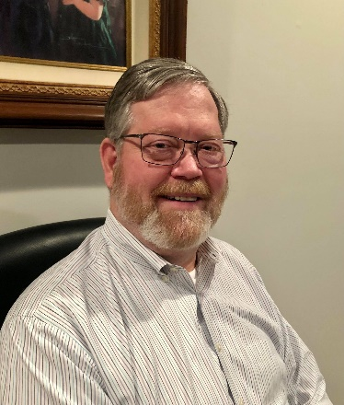***DX This Week – CWOps***

***Bill AJ8B (aj8b@arrl.net, @AJ8B, or www.aj8b.com)***

***CWOPs Member #1567***

The Midwest DX Cluster spots included Alaska, Bahrain, Belgium, Botswana, Bulgaria, Canada, Cuba, Dodecanese, England, France, Ghana, Guadeloupe, Indonesia, Isle of Man, Italy, Kuwait, Mongolia, Netherlands, New Zealand, Sardinia, Serbia, Sint Maarten, St. Helena, St. Martin, Thailand, US Virgin Islands, West Malaysia, and Zambia. This brings the total number of entities spotted in the Midwest in 2021to 160!

I received an email last week asking about the spots that I list each week as well as the total countries that have been spotted. I get asked this a couple of times a year so I thought I would update you on my thought process. A lot of hams think that DXCC is very difficult to achieve, you have to have elaborate equipment and a lot of aluminum in the air. I like to point out the countries that have been spotted to encourage budding DXers to pursue DXCC because it can be done with modest equipment and limited antennas. However, the one thing that you can’t skimp on is “time in the chair”. You must be at the rig listening! As you can see, there have been at least 160 different entities spotted already this year. Historically, there will be around 270 or so by the end of the year depending on travel restrictions. There are plenty of fish and the sea you just need to cast!

|  |
| --- |
|  |

*DAH DIT DIT DIT DAH DAH DIT DIT DIT DAH*

|  |  |  |
| --- | --- | --- |
| I received cards from VA3BXG – Robert in Toronto, 9J2BS – Jerry in Zambia. Let me know what you received.   |  |  | | --- | --- | |  |  | |
|  |

*DAH DIT DIT DIT DAH DAH DIT DIT DIT DAH*

CWOps Club - Many of us feared that with the advent of the “No Code” requirement in 2007, CW would start to fade as a medium for communication. However, in reviewing the number of logs submitted for the CQWW CW contest since 2007, we learn that while amateur radio licenses have increased 10.7%, log submission has increased EIGHTY-TWO percent! SSB Log submission also increased but by only 49.5% in the same time frame. Something was going on!

(From www.CWOPS.org – They can say it better than me)

“In late 2009 a small group of CW operators – ragchewers, contesters, and DXers – began talking about founding a new club. As these operators were from all three ITU regions, they decided from the outset that this club, unlike many, would be an international club from day one.

The CW Operators Club (CWops) was launched in January 2010. During those three years, the club grew from a handful, to a few hundred, to over 1000 members in over 70 countries. CWops, from the outset, was meant to be inclusive. Whether your preference was using CW for ragchewing, contesting or chasing DX, you would find kindred spirits among the club's members.

At first, we established monthly on-air activities (CWTs), but today CWTs are held weekly on Wednesday. There are three 60-minute sessions each Wednesday at times that favor different geographic areas. By 2011, we had also crafted a worldwide CW contest with many novel features (CW Open). The goal has been to stimulate worldwide weekly CW activity and to conduct an annual contest that could be won on a single band using modest power and wire antennas with a time commitment of only four hours! These events are open to CW operators whether members of the club or not.

We realized that there were a lot of hams who wanted to explore the joys of CW operating but felt overwhelmed. Some of them knew Morse but were only able to copy and send at low speeds. Others had not yet learned 'the code,' but were intrigued by the mode and sought ways to learn and practice it. In response to this demand, CWops created CW Academy in 2012, which uses a developed curriculum, proven method of teaching and Skype for a virtual classroom to teach Morse Code.

We truly believe that CW is far more than a nostalgic throwback to the early days of ham radio. It has relevance in many ways to our desire to do things that not everyone else can do; and to provide an efficient, effective mode for communicating with others around the globe. We invite you to explore our Website; to participate in our on-air activities; or if your goal is to learn or improve CW skills, to sign up for CW Academy and join the hundreds of hams who have already done so.”

There is a nomination process as well as a 25 WPM code requirement. Check www.cwops.org for more details! How do you get to 25 WPM? Stay tuned for the next installment!

*DAH DIT DIT DIT DAH DAH DIT DIT DIT DAH*

CQDX CQDX CQDX CQDX CQDX CQDX CQDX CQDX CQDX

Here is an update from Bernie, W3UR, of the DailyDX and the WeeklyDX, the best source for DX information. http://www.dailydx.com/. Bernie has this to report:

WB9MSM, Denny, takes a look at the many different Worked All States awards offered by the ARRL in this Video: https://www.youtube.com/watch?v=MnfkukCM7NQ

**S2 – Bangladesh -** S21DX with operators S21AM, S21RC and S21D, will be doing an island operation, Manpura Island, AS-140, scheduled for December 16-26, 2021. S21RC, Fazlay Rabby, says they will have a Yaesu FT-600 and FT-757GX2, 100 watts, to a three-band beam, a multiband dipole, and vertical for 40.  They plan to be on 40, 20, 15 and 10 SSB and FT8.

Fazlay says they will be on a remote part of the island with no commercial power, which will help avoid interference.  They will power their station with heavy duty batteries and a 2KW generator to top up the batteries. They will set up several small tents as their shelters.  QSL direct or bureau to EB7DX, who will also do a Logbook of the World upload.  They have a website:  htttps://s21dx.org.  They are asking for financial support because it is a huge expense, they say.  They also could use donation of bandpass filters so they can run two stations at the same time.  Support should go to EB7DX.

**VK9/L - Lord Howe Island -** VK9LF, Doug Speedy, is currently living on Lord Howe, where he has been coming and going, he says, since 1989.  He worked as a weather observer for the Australian government for 28 years and retired from that in 2016.  He has now gotten a permanent residence there.  His previous calls were VK3YQS, VK6TEN, VK9ZLH, VK0YQS and VK0DS, the various calls when he was posted by the weather service to various locations.  His current station is a Yaesu FT-840 to end fed wires for 30, 17, 12 and 10, supported by a pole at nine meters above the ground, the wires tied off to a palm tree.  He particularly listens to 18140 and 24950 kHz.  
  
**VK0 – Antarctica -**   
VK0PD, Paul, an "instrument electrician" and "trades supervisor," is at Casey Station.  His home callsign is VK2PAD.  The gear he has at the Antarctic base is ICOM, an IC-7300 and IC-705 to a 300 watt amplifier and three 10-meter fiberglass poles to support wire antennas, and he says he has "loads of wire" there.  Currently he has up a 40/20 dipole 10 meters above the ground and has made some contacts on 20.  A kilowatt ionosonde transmitter 200 meters away may cause issues, he says.  Back home at VK2PAD he likes Summits on the Air, "getting to those hard to reach peaks."

**GU – Guernsey -** Members of the Guernsey Amateur Radio Society (GARS) plan to activate special event station GB5LIB in celebration of the 76th anniversary of the Liberation of the islands in the Bailiwick of Guernsey. Activity will run from 0001Z May 8th through 2359Z on May 14th. Listen for them on 160 through 10 Meters and if conditions warrant 6 and 4 Meters. They could also do some satellite operation, including QO100. QSL preferably via LoTW and watch their QRZ.com page - https://www.qrz.com/db/GU8ITE

*DAH DIT DIT DIT DAH DAH DIT DIT DIT DAH*



Below is a list of upcoming contests in the “Contest Corner”. I think this is important for someone who is trying to move up the DXCC ladder since entities that are on the rarer side and easiest to work in contests. Some of my best “catches” have been on the Sunday afternoon of a contest when the rarer entities are begging for QSOs. Of course, the gamble is that if you wait until Sunday, conditions may change, or they simply won’t be workable. However, it is not a bad gamble. Of course, why not work the contest and have some fun!  
Check out the WA7BNM Contest Calendar page (https://www.contestcalendar.com/) for more contests or more details.

The contests in red are those that I plan to spend some significant participation time on. PLEASE let me know if you are working contests and how you fared.

Thanks!

|  |  |  |
| --- | --- | --- |
| Apr.10-11 | FT8 DX Contest 2021 | https://europeanft8club.wordpress.com |
| Apr. 10-11 | Georgia QSO Party | https://gaqsoparty.com |
| Apr. 10-11 | JIDX CW Contest | www.jidx.org |
| Apr. 10-11 | Nebraska QSO Party | www.nebraskaqsoparty.org |
| Apr. 10-11 | New Mexico QSO Party | www.newmexicoqsoparty.org/wp |
| Apr. 10-11 | North Dakota QSO Party | http://ndarrlsec.com |
| Apr. 10-11 | OK-OM DX SSB Contest | http://bit.ly/3ioS3Cl |
| Apr. 10-11 | Yuri Gagarin International DX Contest | http://gc.qst.ru/en/section/32 |
| Apr. 11 | RSGB RoLo SSB Contest | www.rsgbcc.org/hf/rules/2021/rolo.shtml |
| Apr. 12 | RSGB 80m Club Championship, CW | http://bit.ly/3avHbk3 |
| Apr. 17 | ES Open HF Championship | https://esopen.eu/ |
| Apr. 17-18 | Holyland DX Contest | www.iarc.org/iarc/#HolylandContest |
| Apr. 17-18 | CQ Manchester Mineira DX Contest | www.cqmmdx.com/rules |
| Apr. 17-18 | Michigan QSO Party | www.miqp.org/index.html |
| Apr. 17-18 | Ontario QSO Party | www.va3cco.com/oqp/rules.htm |
| Apr. 17-18 | Texas State Parks on the Air | www.tspota.org |
| Apr. 17-18 | Worked All Provinces of China DX Contest | https://bit.ly/3sDGs72 |
| Apr. 17-18 | YU DX Contest | http://yudx.yu1srs.org.rs |
| Apr. 19 | ARRL Rookie Roundup, SSB | www.arrl.org/rookie-roundup |
| Apr. 21 | RSGB 80m Club Championship, SSB | http://bit.ly/3avHbk3 |
| Apr. 29 | RSGB 80m Club Championship, Data | http://bit.ly/3avHbk3 |
| Apr. 24-25 | 10-10 Spring Digital Contest | http://bit.ly/1FrFeBc |
| Apr. 24-25 | Florida QSO Party | www.floridaqsoparty.org |
| Apr. 24-25 | Helvetia Contest | www.uska.ch |
| Apr. 24-25 | SP DX RTTY Contest | www.pkrvg.org/strona,spdxrttyen.html |
| Apr. 25 | BARTG Sprint75 Contest | http://bartg.org.uk/wp/contests |
| Apr. 28 | UKEICC 80m Contests CW | https://bit.ly/2SDPqQQ |
| May 29-30 | CQWW WPX CW CONTEST | www.cqwpx.com |
| August 28 | Ohio QSO Party | https://www.ohqp.org/ |
| August 28 | W8DXCC | https://www.w8dxcc.com |

***DX News***

***ARLD017 DX news***

This week's bulletin was made possible with information provided by K1CC, WB6Z, The Daily DX, the OPDX Bulletin, 425 DX News, DXNL, Contest Corral from QST and the ARRL Contest Calendar and WA7BNM web sites.  Thanks to all.  
  
FIJI, 3D2.  Dom, 3D2DOM and Joanne, 3D2ZK are QRV from Nandi.  QSL to home calls.  
  
AZERBAIJAN, 4J.  Special event station 4J880M is QRV to celebrate the 880th birthday of the writer and philosopher Nizami Ganjavi. QSL direct to 4J3DJ.  
  
TONGA, A3.  Masa, JA0RQV is QRV as A35JP from Tongatapu Island, IOTA OC-049, until October.  In addition, he will try to be QRV from some outer islands such as Niuatoputapu, IOTA OC-191, Niuafo'ou, IOTA OC-123, Vava'u, IOTA OC-064, and Ha'apai, IOTA OC-169.  Activity is on 80 to 6 meters using CW, SSB and FT8.  QSL direct to home call.  
  
BELARUS, EU.  Special event station EV76M is QRV during May to celebrate the 76th anniversary of the Victory in Minsk in World WarII.  QSL via LoTW.  
  
REUNION ISLAND, FR.  Phil, F5TRO and Ann, F5BSB will be QRV as FR8UA and FR8TZ, respectively, during May.  Activity will be on 80 to 6 meters using CW, SSB and various digital modes.  QSL direct to home calls.  
  
SWITZERLAND, HB.  Special event call sign HB90BERO is QRV until July 31 to celebrate the 90th anniversary of the Beromuenster medium wave AM broadcasting station.  Activity is on all bands using CW, SSB, AM, FM, and various digital modes.  This includes some activity on Satellite QO-100.  QSL via LoTW.  
  
REPUBLIC OF KOREA, HL.  Lee, HL1IWD is QRV as HL1IWD/4 from the Kogunsan Islands, IOTA AS-148, until May 3.  Activity is on 40 to 20 meters using CW and some FT8.  He will try to be active as HL1IWD/3 on Anmyon Island, IOTA AS-080.  QSL via EA5GL.  
  
JAPAN, JA.  Special event station 8J1ITU is QRV until May 31 to celebrate the anniversary of the founding of the International Telecommunications Union's World Telecommunication and Information  
Society Day on May 17.  QSL via bureau.  
  
OGASAWARA, JD1.  Harry, JG7PSJ is QRV as JD1BMH from Chichijima, IOTA AS-031, until May 7.  Activity is on 40 to 10 meters using CW, SSB and RTTY.  QSL direct to JG7PSJ.  
  
MONGOLIA, JT.  Members of the JTDXA Team are QRV with special event call sign JU100DX until July 10 to celebrate Mongolia's 100th anniversary of independence until July 10.  QSL via JT1CH.  
  
LITHUANIA, LY.  Special event call sign LY57BC will be QRV from May 1 to June 1 to celebrate the 57th Baltic Contest.  QSL via operators' instructions.  
  
POLAND, SP.  Members of the SP6PAZ radio club will be QRV with special event call SO100PS from May 1 to 31 to commemorate the 100th anniversary of the third Silesian Uprising.  Activity will be on 160 to 2 meters using CW, SSB, RTTY, FT8 and FT4.  QSL via SP6PAZ.  
  
KAZAKHSTAN, UN.  Special event call sign UP55L is QRV until May 20 to celebrate the 55th anniversary of the Youth School Radio Station in Kostanay.  QSL direct to RW6HS.  
  
FALKLAND ISLANDS, VP8.  Matthew, M0ZMS is QRV as VP8ZMS from the British Air Force Base in Mount Pleasant.  Activity is in his spare time on the HF bands using CW and various digital modes.  QSL to home call.

INDONESIA, YB.  Special event station 8A250GNR is QRV until May 2 to celebrate 250 years of Gianyar City.  Activity is on 80 and 40 meters using SSB, and 2 meters using FM.  QSL via operators'  
instructions.  
  
LATVIA, YL.  Hans, YL3JD is QRV with special call sign YL50AGCW during May in celebration of the 50th anniversary of the Telegraphy Working Group.  Activity is on 160, 80, 40, and 20 meters using CW. QSL via LoTW.  
  
The K1USN Slow Speed CW Test and OK1WC Memorial are scheduled for May 3.  
  
The MIE 33 Contest, RTTYOPS Weeksprint, ARS Spartan CW Sprint and Worldwide Sideband Activity Contest are scheduled for May 4.  
  
The RSGB FT4 Contest Series, VHF-UHF FT8 Activity Contest, Phone Fray and CWops Mini-CWT Test are scheduled for May 5.  
  
Please see April QST, page 75, May QST, page 71, and the ARRL and  
WA7BNM contest web sites for details.

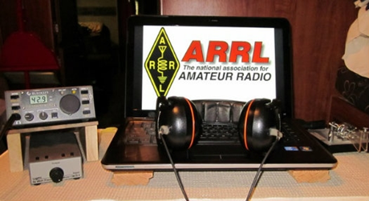**ARRL Contest Corner**

An expanded, downloadable version of *QST'*s’ [**Contest Corral**](http://www.arrl.org/contest-calendar) is available as a PDF. Check the sponsor’s ‘Website for information on operating time restrictions and other instructions.

**03 May - 12 May 2021**

An expanded, downloadable version of *QST'*s [Contest Corral](http://www.arrl.org/contest-calendar) is available as a PDF. Check the sponsors' website for information on operating time restrictions and other instructions.

**HF CONTESTS**

[K1USN Slow Speed Test](http://www.k1usn.com/sst.html), May 3, 0000z to May 3, 0100z; CW; Bands: 160, 80, 40, 20m; Maximum 20 wpm, Name + (state/province/country); Logs due: May 9.  
  
[OK1WC Memorial (MWC)](https://memorial-ok1wc.cz/index.php?page=rules2l), May 3, 1630z to May 3, 1729z; CW; Bands: 80, 40m; RST + Serial No.; Logs due: May 7.  
  
[Worldwide Sideband Activity Contest](https://wwsac.com/rules.html), May 4, 0100z to May 4, 0159z; SSB; Bands: 160, 80, 40, 20, 15, 10, **6m**; RS + age group (OM, YL, Youth YL or Youth); Logs due: May 5.  
  
[ARS Spartan Sprint](http://arsqrp.blogspot.com/2009/02/so-whats-spartan-sprint-and-how-do-i.html), May 4, 0100z to May 4, 0300z; CW; Bands: 80, 40, 20, 15, 10m; RST + (state/province/country) + Power; Logs due: May 6.  
  
[RTTYOPS Weeksprint](https://rttyops.wordpress.com/rtty-mini-contests/rttyops-weeksprint/), May 4, 1700z to May 4, 1900z; RTTY; Bands: 80, 40, 20m; [other station's call] + [your call] + [serial no.] + [your name]; Logs due: May 4.

[MIE 33 Contest](http://www.ztv.ne.jp/isoda/33/annual/43/43rule-e.html), May 4, 2300z to May 5, 0300z; CW, Phone; Bands: All, except WARC; Mie: RS(T) + age + "ME", non-Mie JA: RS(T) + age + "MEJ", non-Mie non-JA: RS(T) + age; Logs due: May 31.  
  
[Phone Weekly Test - Fray](http://www.perluma.com/Phone_Fray_Contest_Rules.pdf), May 5, 0230z to May 5, 0300z; SSB; Bands: 160, 80, 40, 20, 15m; NA: Name + (state/province/country), non-NA: Name; Logs due: April 30.  
  
[CWops Mini-CWT Test](https://cwops.org/cwops-tests/), May 5, 1300z to May 5, 1400z; CW; Bands: 160, 80, 40, 20, 15, 10m; Member: Name + Member No./"CWA", non-Member: Name + (state/province/country); Logs due: May 8.  
  
[RSGB FT4 Contest Series](https://www.rsgbcc.org/hf/rules/2021/r80m_ft4.shtml), May 5, 1900z to May 5, 2030z; FT4; Bands: 80, 40, 20m; 4-character grid square; Logs due: May 6.  
  
[CWops Mini-CWT Test](https://cwops.org/cwops-tests/), May 5, 1900z to May 5, 2000z; CW; Bands: 160, 80, 40, 20, 15, 10m; Member: Name + Member No./"CWA", non-Member: Name + (state/province/country); Logs due: May 8.  
  
[CWops Mini-CWT Test](https://cwops.org/cwops-tests/), May 6, 0300z to May 6, 0400z; CW; Bands: 160, 80, 40, 20, 15, 10m; Member: Name + Member No./"CWA", non-Member: Name + (state/province/country); Logs due: May 8.  
  
[RTTYOPS Weeksprint](https://rttyops.wordpress.com/rtty-mini-contests/rttyops-weeksprint/), May 6, 1700z to May 6, 1900z; RTTY; Bands: 80, 40, 20m; [other station's call] + [your call] + [serial no.] + [your name]; Logs due: May 11.  
  
[NRAU 10m Activity Contest](https://nrrlcontest.no/index.php/nrrl-contests/nrau-nac/10m/nrau-nac-10m-english-rules/278-nrau-nac-10m-english-rules.html), May 6, 1700z to May 6, 1800z (cw) and, May 6, 1800z to May 6, 1900z (SSB) and, May 6, 1900z to May 6, 2000z (FM) and, May 6, 2000z to May 6, 2100z (dig); CW, SSB, FM, Digital; Bands: 10m Only; RS(T) + 6-character grid square; Logs due: May 20.  
  
[EACW Meeting](https://drive.google.com/file/d/1ifD1n2GGSykXxQ9alx4JNIqvho7JGHvv/view), May 6, 1900z to May 6, 2000z; CW; Bands: 80, 40m; EACW Member: RST + Member No. + Nickname, EA non-Member: RST + Nickname + EA province, non-EA: RST + Nickname + DXCC prefix; Logs due: May 8.  
  
[SKCC Sprint Europe](http://www.skccgroup.com/operating_activities/skse/), May 6, 1900z to May 6, 2100z; CW; Bands: 160, 80, 40, 20, 15, 10, **6m**; RST + (state/province/country) + Name + (SKCC No./"NONE"); Logs due: May 13.  
  
[NCCC RTTY Sprint](http://www.ncccsprint.com/rttyns.html), May 7, 0145z to May 7, 0215z; RTTY; Bands: (see rules); Serial No. + Name + QTH; Logs due: May 9.  
  
[NCCC Sprint](http://www.ncccsprint.com/rules.html), May 7, 0230z to May 7, 0300z; CW; Bands: (see rules); Serial No. + Name + QTH; Logs due: May 9.  
  
[K1USN Slow Speed Test](http://www.k1usn.com/sst.html), May 7, 2000z to May 7, 2100z; CW; Bands: 160, 80, 40, 20m; Maximum 20 wpm, Name + (state/province/country); Logs due: May 9.  
  
[VOLTA WW RTTY Contest](http://www.contestvolta.com/rules.pdf), May 8, 1200z to May 9, 1200z; RTTY; Bands: 80, 40, 20, 15, 10m; RST + QSO No. + CQ Zone; Logs due: May 31.  
  
[SKCC Weekend Sprintathon](http://www.skccgroup.com/operating_activities/weekend_sprintathon/), May 8, 1200z to May 10, 0000z; CW; Bands: 160, 80, 40, 20, 15, 10, **6m**; RST + (state/province/country) + Name + (SKCC No./"NONE"); Logs due: May 16.  
[CQ-M International DX Contest](http://cqm.srr.ru/en-rules/), May 8, 1200z to May 9, 1159z; CW, SSB; Bands: 160, 80, 40, 20, 15, 10m; RS(T) + Serial No.; Logs due: May 19.  
  
[Arkansas QSO Party](https://arkqp.com/), May 8, 1400z to May 9, 0200z; CW, Phone, Digital (no FT8); Bands: 80, 40, 20, 15, 10, **2m**; AR: RS(T) + County, non-AR: RS(T) + (state/province/"DX"); Logs due: May 22.  
  
[WAB 7 MHz Phone/CW](http://wab.intermip.net/Contests.php), May 9, 1000z to May 9, 1400z; CW, SSB; Bands: 40m Only; British Isles: RS + serial no. + WAB square, Other: RS + serial no. + country; Logs due: May 19.  
  
[K1USN Slow Speed Test](http://www.k1usn.com/sst.html), May 10, 0000z to May 10, 0100z; CW; Bands: 160, 80, 40, 20m; Maximum 20 wpm, Name + (state/province/country); Logs due: May 16.  
  
[4 States QRP Group Second Sunday Sprint](http://www.4sqrp.com/SSS/sss_rules.pdf), May 10, 0000z to May 10, 0200z; CW, SSB; Bands: 160, 80, 40, 20, 15, 10m; Member: RS(T) + (State/Province/Country) + Member No., Non-member: RS(T) + (State/Province/Country) + Power; Logs due: May 12.  
  
[OK1WC Memorial (MWC)](https://memorial-ok1wc.cz/index.php?page=rules2l), May 10, 1630z to May 10, 1729z; CW; Bands: 80, 40m; RST + Serial No.; Logs due: May 14.  
  
[RSGB 80m Club Championship, SSB](https://www.rsgbcc.org/hf/rules/2021/r80mcc.shtml), May 10, 1900z to May 10, 2030z; SSB; Bands: 80m Only; RS + Serial No.; Logs due: May 11.  
  
[Worldwide Sideband Activity Contest](https://wwsac.com/rules.html), May 11, 0100z to May 11, 0159z; SSB; Bands: 160, 80, 40, 20, 15, 10, **6m**; RS + age group (OM, YL, Youth YL or Youth); Logs due: May 12.  
  
[RTTYOPS Weeksprint](https://rttyops.wordpress.com/rtty-mini-contests/rttyops-weeksprint/), May 11, 1700z to May 11, 1900z; RTTY; Bands: 80, 40, 20m; [other station's call] + [your call] + [serial no.] + [your name]; Logs due: May 11.  
  
[Phone Weekly Test - Fray](http://www.perluma.com/Phone_Fray_Contest_Rules.pdf), May 12, 0230z to May 12, 0300z; SSB; Bands: 160, 80, 40, 20, 15m; NA: Name + (state/province/country), non-NA: Name; Logs due: April 30.  
  
[CWops Mini-CWT Test](https://cwops.org/cwops-tests/), May 12, 1300z to May 12, 1400z; CW; Bands: 160, 80, 40, 20, 15, 10m; Member: Name + Member No./"CWA", non-Member: Name + (state/province/country); Logs due: May 15.  
  
[CWops Mini-CWT Test](https://cwops.org/cwops-tests/), May 12, 1900z to May 12, 2000z; CW; Bands: 160, 80, 40, 20, 15, 10m; Member: Name + Member No./"CWA", non-Member: Name + (state/province/country); Logs due: May 15.

**VHF+ CONTESTS**

[Araucaria World Wide VHF Contest](https://www.avhfc.com/rules/en.pdf), May 1, 0000z to May 2, 1600z; CW, SSB, FM; Bands: 6, 2m; RS(T) + 6-character grid square; Logs due: May 7.  
  
[SBMS 2.3 GHz and Up Contest and Club Challenge](http://www.n6nb.com/sbmsrules.htm), May 1, 0600 (local) to May 2, 2359 (local); Any; Bands: 2.3 GHz and up; 6-character Maidenhead locator; Logs due: May 23.  
  
[Microwave Spring Sprint](https://sites.google.com/site/springvhfupsprints/home/2021-information), May 1, 0800 (local) to May 1, 1400 (local); not specified; Bands: All above 902 MHz; 6-character grid square; Logs due: May 15.

[VHF-UHF FT8 Activity Contest](http://www.ft8activity.eu/index.php/en/), May 5, 1700z to May 5, 2000z; FT8; Bands: (see rules) ; 4-character grid square; Logs due: May 10.

[SARL VHF/UHF Digital Contest](http://www.sarl.org.za/Web3/Members/DoDocDownload.aspx?X=20210110202104ZmotwKkdor.PDF), May 8, 0500z to May 8, 0700z (6m) and, May 8, 0700z to May 8, 0900z (2m) and, May 8, 0900z to May 8, 1100z (70cm) and, May 9, 0500z to May 9, 0700z (6m) and, May 9, 0700z to May 9, 0900z (2m) and, May 9, 0900z to May 9, 1100z (70cm); Digital; Bands: 50 MHz, 70 MHz, 144 MHz, 432 MHz, 1296 MHz; RST + 6-character grid locator; Logs due: May 16.

[50 MHz Spring Sprint](https://sites.google.com/site/springvhfupsprints/home/2021-information), May 8, 2300z to May 9, 0300z; not specified; Bands: 6m Only; 4-character grid square; Logs due: May 22.  
  
[VHF-UHF FT8 Activity Contest](http://www.ft8activity.eu/index.php/en/), May 12, 1700z to May 12, 2000z; FT8; Bands: (see rules) ; 4-character grid square; Logs due: May 17.

Also, see [Worldwide Sideband Activity Contest](https://wwsac.com/rules.html), [SKCC Sprint Europe](http://www.skccgroup.com/operating_activities/skse/), [SKCC Weekend Sprintathon](http://www.skccgroup.com/operating_activities/weekend_sprintathon/), [Arkansas QSO Party](http://www.arkqp.com/), above.

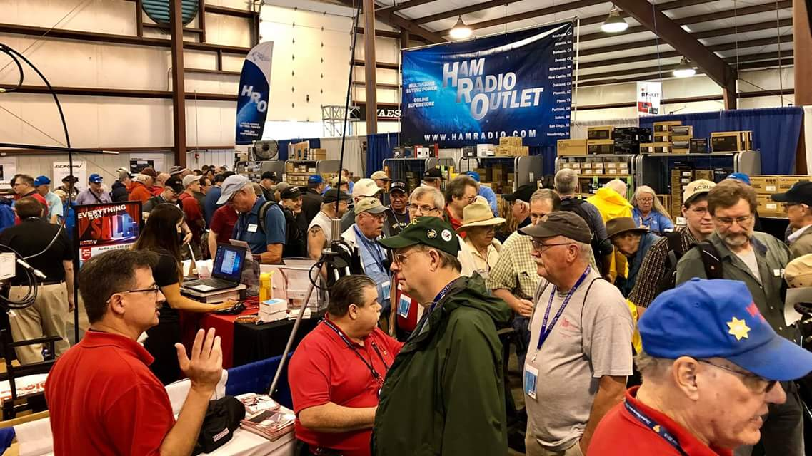[**Upcoming *Hamfests***](http://arrl-ohio.org/hamfests.html)

We **DO** have some hamfests scheduled for 2021!! Yes, take a good look at the list, it’s growing every day!

Be sure to keep your eyes on this schedule as that when things start getting better and the vaccine rolls out to more and more, hamfests will surely get back to their normal schedule. Don’t see your hamfest listed?? Did anyone register it with ARRL? It’s really easy to do and you get a lot of FREE publicity if you do.

|  |  |
| --- | --- |
| **06/05/2021 -**[**FCARC SummerFest**](http://www.arrl.org/hamfests/fcarc-summerfest)  **Location:**Wauseon, OH **Sponsor:**Fulton County Amateur Radio Club **Website:**[**http://k8bxq.org/hamfest**](http://k8bxq.org/hamfest)  [**Learn More**](http://www.arrl.org/hamfests/fcarc-summerfest) | **07/10/2021 -**[**Mansfiled Mid-Summer Trunkfest**](http://www.arrl.org/hamfests/mansfiled-mid-summer-trunkfest)  **Location:**Mansfield, OH **Sponsor:**InterCity Amateur Radio Club **Website:**[http://iarc.club](http://iarc.club/)  [**Learn More**](http://www.arrl.org/hamfests/mansfiled-mid-summer-trunkfest) |
|  |  |
| **07/17/2021 -**[**NOARSFEST**](http://www.arrl.org/hamfests/noarsfest-8) **Location:** Elyria, OH **Sponsor:**Northern Ohio Amateur Radio Society **Website:** [http://noars.net](http://noars.net/)  [**Learn More**](http://www.arrl.org/hamfests/noarsfest-8) | **07/18/2021 -**[**Van Wert Hamfest**](http://www.arrl.org/hamfests/van-wert-hamfest-5)  **Location:**VAN WERT, OH **Sponsor:** Van Wert Amateur Radio Club **Website:** [http://W8FY.ORG](http://w8fy.org/)  [**Learn More**](http://www.arrl.org/hamfests/van-wert-hamfest-5) |
| **08/07/2021 -** [**2021 Columbus Hamfest**](http://www.arrl.org/hamfests/2021-columbus-hamfest)  **Location:** Grove City, OH **Sponsor:**Aladdin Shrine Audio Unit **Website**: [http://columbushamfest.com](http://columbushamfest.com/)  [**Learn More**](http://www.arrl.org/hamfests/2021-columbus-hamfest) | **08/28/2021 -**[**Cincinnati Hamfest℠**](http://www.arrl.org/hamfests/cincinnati-hamfest)  **Location:**Owensville, OH **Sponsor:** Milford ARC **Website:** [http://CincinnatiHamfest.org](http://cincinnatihamfest.org/)  [**Learn More**](http://www.arrl.org/hamfests/cincinnati-hamfest) |
| **09/26/2021 -**[**Cleveland Hamfest**](http://www.arrl.org/hamfests/cleveland-hamfest-1)  **Location:**Berea, OH **Sponsor:** Hamfest Association of Cleveland **Website:** [http://www.hac.org](http://www.hac.org/)  [**Learn More**](http://www.arrl.org/hamfests/cleveland-hamfest-1) | **12/04/2021 -**[**FCARC WinterFest**](http://www.arrl.org/hamfests/fcarc-winterfest-2)  **Location:**Delta, OH  **Sponsor:** Fulton County Amateur Radio Club  **Website:**<http://k8bxq.org/hamfest>    [**Learn More**](http://www.arrl.org/hamfests/fcarc-winterfest-2) |

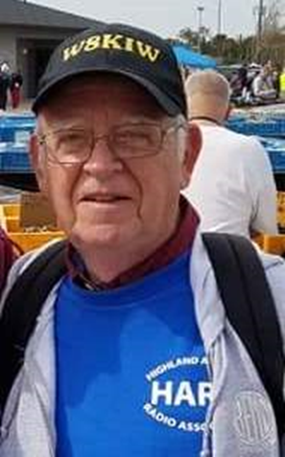

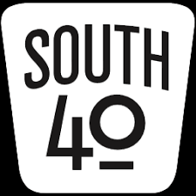 **It’s Finally May In The South 40 Edition**

Weather wise April has provided a most interesting month for our journey through Southern Ohio to meet some of the area’s clubs. We’ve seen below normal temperatures, unexpected record snow, heavy rains, strong winds and above normal temperatures in the lower 80s. But it’s time to get back on the next leg of what’s proven to be an enjoyable journey to date and see what adventures May brings.

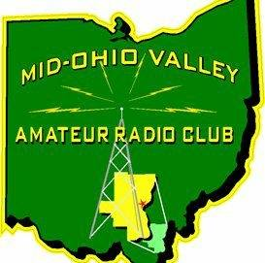After the layover in Jackson to learn more interesting facts about the Jackson County ARA, we journey south on US 35 with our sights set for Gallipolis and a visit to the Mid-Ohio Valley ARC where we meet Club President Bob Adkins, KE8EC. Bob tells us the Mid-Ohio Valley ARC was founded in the mid 1950’s essentially as an HF club. In the early 60’s a two meter repeater was obtained and after being located in various West Virginia and Ohio locations it settled on a monopole on high ground overlooking Gallipolis. The monopole also carried a very large lighted cross that used long neon tubes. The church owning the structure allowed the Club to use it in exchange for the Club maintaining the cross. The repeater has since been relocated to a City of Gallipolis site. In December 1967 Club members were called into action during the Silver Bridge collapse. For several weeks they operated in shifts from a room in the Gallia County Courthouse to provide communications during the disaster and the afterwards cleanup of bridge materials and the recovery of the vehicles that fell into the Ohio River. In the 1960’s the KKK planned a march in the City that coincided with Field Day weekend. Concerned local officials requested additional law enforcement support from other areas. The marshalling area happened to be at the repeater site where MOVAC was in the middle of Field Day operations. However it seems someone in charge of the law enforcement group forgot to make arrangements to feed the assisting officers. Realizing this, Club members shifted from operating radios and started preparing meals for the officers.

License classes are an important and continuing function of the Club. This year’s class will soon be ready to begin. Some years ago the Club started sponsoring an annual hamfest at the local Senior Center. Although not a large event, it is very popular as it provides a service to area hams as well as a much looked forward to social event. However this year’s event was cancelled because of COVID concerns. Besides its 147.06 two meter repeater, the club has a Fusion repeater on 442.275. Each bears the KC8ZAB call sign and a 74.4 tone.

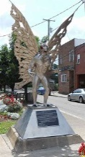

Thanks to Bob Adkins and the other MOVARC members who assisted with the information for this article. Now it’s time to get back on the road and make the next leg of the trip. But before doing so a trip across the river to Pt. Pleasant, WV is in order to see the famous Mothman statue and what remains of the historic Silver Bridge.

The Portsmouth RC’s VE Team Leader Jerry Lockhart, W8HIC, reminds us of the May 3 test session in Portsmouth. It will start at 5 pm in the Court Street American Legion Post #23 basement meeting room. The regular monthly meeting starts at 6:30. The Lancaster Fairfield County ARC will hold an exam session Lancaster on May 11. An exam will be held on May 15 in Cambridge.

The Clinton County ARA will meet on Thursday evening, May 6, at the Foster Boyd Cancer Center, 31 Farquhar Avenue, in Wilmington. The meeting begins at 7:30 with a program to follow.

Word from the Athens County and VE Team Captain Jeff Slattery, the joint Athens County ARA and Sunday Creek ARF April 25 VE session was very successful. Jeff says Joseph Sprague, KE8ROC, from Albany upgraded to Extra; James Young, Jr., KA8JEA, went back to Vienna, WV with a CSCE for General and Robert Waugh, Jr. from Jackson passed his Technician test and now is anxiously awaiting the posting of his license and call sign on the FCC data base. Congratulations to each. Normally the Athens County ARA conducts a test during their annual hamfest. But COVID caused the postponement of the hamfest this year. However it was decided to go ahead with the planned test session. Because of COVID the Athens Red Cross Building was closed to outside groups, but testing was successfully conducted in the building’s parking lot. The next test session will be Monday, June 21, at the Red Cross facility.

Highland ARA President Pat Hagen, N8BAP, invites the amateur community to join with the Club for a very special ‘Meet and Greet’ Brunch Bunch gathering on Saturday morning, May 8, in Hillsboro. The graduates of the recent Technician License Class will officially be introduced to the membership. Special guests for the morning will be Assistant Great Lakes Division Vice Director Scott Yonally, N8SY, and Ohio Section Manager Tom Sly, WB8LCD who will officially recognize HARA as Ohio’s newest Special Service Club. The event starts at 10 am at Liberty Park’s Harmony Lake Shelter House. More information can be obtained at [highlandara@gmail.com](mailto:highlandara@gmail.com), the Club’s Facebook page [www.Facebook.com/HighlandK8HO](http://www.Facebook.com/HighlandK8HO) or the Hillsboro 147.21/Greenfield 146.685 repeaters. The coffee pot will be on for the early arrivals.

A founding member of the Southern Ohio ARA and Lawrence County ARES has passed according to Michael Love, WB8YKS, and Ken Massie, WN8F. Bill Parsons (93), N8LCA, of South Point died on April 25 in Ashland, KY. Private military services for the retired Air Force Traffic Controller and postal worker are

to be held in Willow Wood, OH.

The newest editions of some Southern Ohio newsletters are out. Tom Delaney, W8WTD, passes along the Queen City Emergency Net’s *The Listening Post* and the Cambridge ARA’s *Communicator* editor Lyn Alfman, N8IMW, has just released the May edition. Lyn says the *Communicator* is now being published every two months instead of quarterly. Both are good reads with a lot of information.

Another interesting read is the specialty newsletter edited by Oxford’s Joe Pater, W8GEX. That newsletter (*60 Meter DX*) is dedicated to 60 meter operations and has news about what is happening on that band. Although not south of US 40, thanks to John Myers, KD8MQ, for forwarding a copy of the Alliance ARC’s *Zero Beat* newsletter. Another good read. It’s always interesting to see what various clubs are up to.

Ross County has another new ham according to Ted Jacobson, W8KVK, of Athens. The FCC has issued a new license to Charles Wade of Chillicothe. Should folks in that area hear KE8RYE on the air, be sure to give Charles a shout and welcome him into the amateur radio fold.

Once back on Ohio soil we head up State Route 7 following the scenic Ohio River to the joint communities of Middleport and Pomeroy to connect with US 33 to Athens. Brian Taylor, KZ8U, says that in the 90’s Meigs County had a RACES group that placed a repeater on the air. The group later dissolved. An active and effective AuxComm organization headed by EMA Deputy Director Robin Kinney, KG6DI, exists today. The FCC database lists a KC8LOE call sign assigned to the Meigs County ARC and appears on the area’s 146.865 repeater. Although no further information was able to be obtained it was confirmed several Meigs County hams are actively involved with the clubs in Athens and Gallipolis as well as in Wood County, WV.

Next time we will visit with our friends at the Athens County ARA and perhaps learn about the club at Ohio University. In the meantime you can contact me at [highllandara@gmail.com](mailto:highllandara@gmail.com) if you have any news relating to Southern Ohio area amateur radio activities. Until then, stay safe, healthy and radio active. And if I may offer a parting suggestion, if you want to remain safe, healthy and radio active don’t forget that special woman on Mother’s Day. In the meantime

73, John

***Print an Official or Unofficial Copy of Your Amateur Radio License***

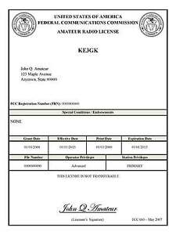*(By Anthony Luscre, K8ZT)*

As of February 17, 2015, the **FCC no longer routinely issues paper license documents** to Amateur Radio applicants and licensees. The Commission has maintained for some time now that the official Amateur Radio license authorization is the electronic record that exists in its Universal Licensing System (ULS). The FCC will continue to provide paper license documents to all licensees who notify the Commission that they prefer to receive one.

Licensees also will be able to print out an official authorization — as well as an unofficial “reference copy” — from the ULS License Manager. I’ve created a set of instructions on how you can request an **“official” printed copy of your license\***

[**Click here to download the instructions**](http://arrl-ohio.org/news/2020/print_your_license.pdf)

***One Question Questionnaire***

Hey Gang,

Survey Says”…..Well, it doesn’t matter now! I’ve got a new question, so how about going to www.ARRL-OHIO.org and giving me a click? (It’s in the bottom left corner of the page) Send your friends, send your kids and send your Mother! (That’s my subtle Mother’s Day reminder so no-one gets in any trouble this year…….)

***“What are your plans for Filed Day this year?”***

*****V.E. Test Sessions***

Many V.E.’s have decided to start testing once again, but with restrictions that need to be adhered to for sure. Here’s the link to find that V.E. Test session and what is expected of YOU before going. <http://www.arrl.org/find-an-amateur-radio-license-exam-session>

Ohio Section Cabinet

|  |  |
| --- | --- |
| Section Manager – Tom Sly, WB8LCD | Section Traffic Manager – David Maynard, WA3EZN |
| Section Emergency Coordinator – Stan Broadway, N8BHL | Section Youth Coordinator – Anthony Luscre, K8ZT |
| Technical Coordinator – Jeff Kopcak, K8JTK | Affiliated Clubs Coordinator – Tom Sly, WB8LCD |
| State Government Liaison – Bob Winston, W2THU | Public Information Coordinator – John Ross, KD8IDJ |



Hey Gang,

Have you taken a look at the **Swap & Shop** page on the Ohio Section webpage yet?? Here’s a link that will take you there… <http://arrl-ohio.org/sm/s-s.html>

Do you have equipment that you just don’t need or want anymore? Here’s a great venue to advertise it, and it’s FREE!! Is your club doing a fund raiser to help raise money? After a lot of thought, it was decided that the Swap & Shop webpage could also contain these types of items as well. The same rules will apply as do for the For Sales and Give-A-Ways and will only be posted for a month at a time. Please see the Terms & Conditions on the webpage.

If your club is doing a fund raiser and wants more exposure, please forward the information to me and I’ll advertise it on the Swap & Shop webpage for you.

Now, I still want to remind you that it won’t be listed in this newsletter because it would take up way too much space, so your ad will only appear on the website. It is there for any individual to post equipment Wanted / For Sale or Give-Away as well as for Club Fund Raisers. No licensed vehicles/trailers or business advertising will be posted. Postings are text only (no pictures or graphics) will be posted for a maximum of 1 month from date posting and require a contact phone number or email within the posting. Send your Wanted / For Sale or Give-Away post to:  [swap@arrlohio.org](mailto:swap@arrlohio.org)

***Back Issues of the PostScript and Ohio Section Journal***

Hey, did you know that PostScript and Ohio Section Journal (OSJ) are archived on the website? You can go back and look at any edition simply by clicking:

<http://arrl-ohio.org/news/index.html>

***Welcome New Subscriber(s)***

**Diana, KJ7GVY**

***Want to Share your Club Newsletter With Others?***

We have a webpage where you can download and read all of the newsletters that I get from around the state and even other sections!

Here’s the link to the page…. <http://arrl-ohio.org/club_news/index.html>

Please, if you don’t see your club newsletter posted, it’s because I’m not receiving it. Just have your newsletter editor contact me and I’ll get your club’s newsletter listed on the site!!

We all learn and steal (I mean, share) from each other’s work. So, get me your newsletter!!! Send it to: [webmaster@arrl-ohio.org](mailto:webmaster@arrl-ohio.org)

***Chit – Chat, and All That!***

Do you know someone that’s not getting these Newsletters? Please, forward a copy of this Newsletter over to them and have them “[Opt-In](mailto:Opt-In)” to start receiving them. Heck, just have them send an email to: [webmaster@arrl-ohio.org](mailto:webmaster@arrl-ohio.org) and we’ll get them added to the Ohio Section Emailing list.

We now have many thousands of readers receiving these newsletters weekly. Quite impressive, I’d say! I urge all of you to make sure that everyone, regardless of whether they are a League member or not, get signed up to receive these weekly Newsletters.

You can always “Opt-Out” at any time if you feel this is not what you were expecting. It’s fun and very informative. All of your favorite past newsletters are now archived too.

You can go back at any time and read them.

Just go to: <http://arrl-ohio.org/news/>

The pictures on the front page and throughout this newsletter are from various newsletters, Facebook posts and/or were sent directly to me in recent weeks. Take a good look at them, you just might be in one of the pictures! “SMILE… you’re in the Ohio Section News!!”

*PostScript is produced as a weekly newsletter. I want to thank everyone that has contributed articles and ideas to make this an even better news source. I sincerely hope that you have enjoyed this edition and will encourage your friends to join with you in receiving the latest news and information about the Ohio Section, and news and events happening around the world!*