[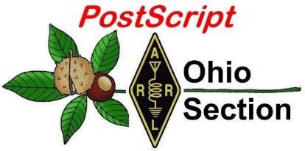](http://arrl-ohio.org/news/) ***“April 19th***

***Edition”***

🡪 National News 🡪 Club Corner

🡪 DX This Week 🡪 Contest Corner

🡪 Special Events 🡪 Upcoming Hamfests

🡪 From The South 40 🡪 Training

🡪 One Question Questionnaire 🡪 VE Testing

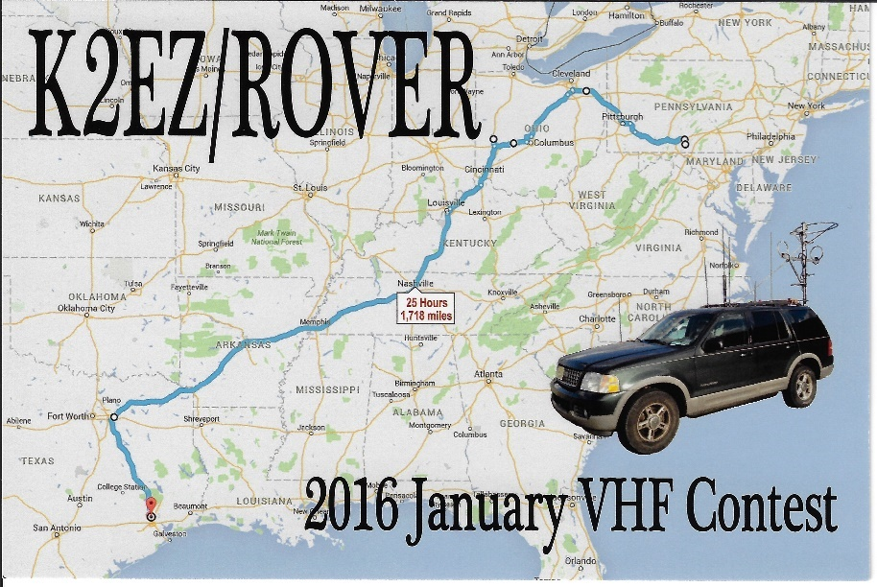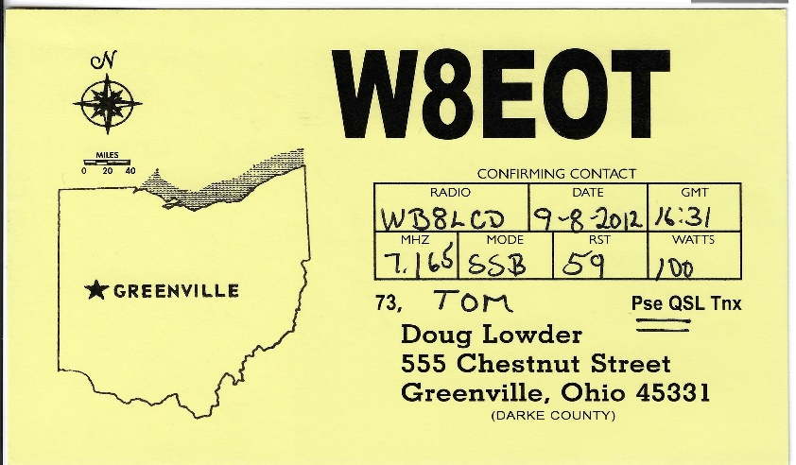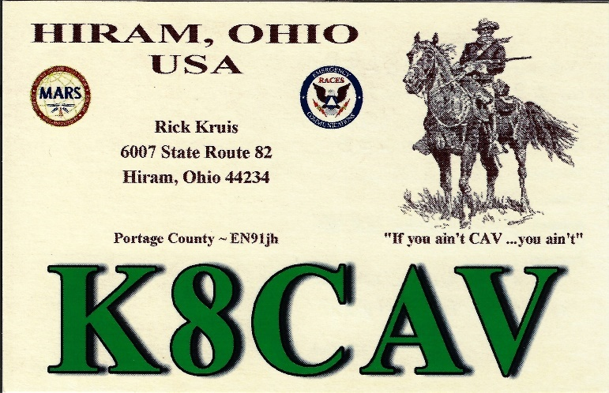

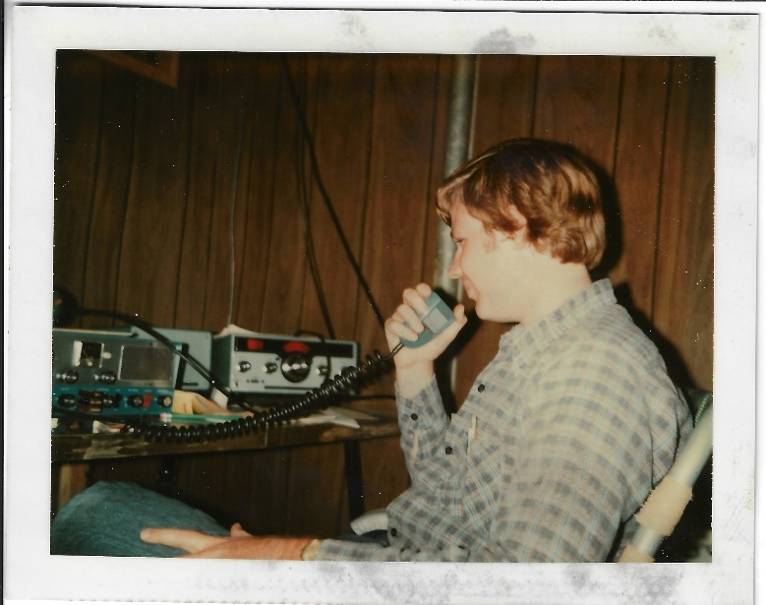

***National News***

*(from arrl and other sources)*

***Your NVIS Day Checklist***

Your NVIS Day Checklist

C. Matthew Curtin, KD8TTE

NVIS Day is this Saturday, April 24! Are you ready? If your plan is just to operate your NVIS antenna without any specific objectives, you’re not ready. Let’s run down the checklist and get you ready. We’re just under a week away!

Remember the concept with NVIS Day: get everyone operating during the same period of time so there are other participating stations with whom you can exchange signal reports, all for the purpose of understanding how different antennas and configurations work.

We return to the Section Emergency Coordinator column from the March issue of the *Ohio Section Journal* for the statement of goals.

• Goal 1: Construct a working NVIS antenna (or several) and try them out for performance.

Near-Vertical Incidence Skywave (NVIS) propagation isn’t difficult to achieve. In fact, unless you’ve specifically built your station for DX or otherwise have the antenna up high, that’s probably what you’re using most of the time, at least at frequencies of 5 MHz and lower.

Being an ARES event, NVIS Day is about operating for emergency and public service, which means not only making random contacts, but establishing the ability to make specific contacts. Working on behalf of an agency means you need to communicate with specific stations and nets. If your county EMA can’t effectively exchange messages (whether directly or through a relay net) with the state EMA, the job isn’t getting done, and the ability to talk to the Czech Republic isn’t a consolation prize for the agency’s boss.

Dale Hunt WB6BYU has some excellent information on how NVIS works, and the interplay among the antenna, its configuration (including height), and the critical frequency. As Dale writes, “Successful NVIS operation requires being able to change frequency to suit current conditions, rather than making assumptions and hoping the ionosphere will cooperate.” (D. Hunt, “Near Vertical Incident Skywave (NVIS) Antennas,” Practical Antennas. https://practicalantennas.com/applications/nvis/)

• Goal 2: Operate with a completely off-grid power source (battery, solar, generator, whatever)

Do you remember the excellent presentation from Eric Jessen N8AUC about solar power at the Ohio ARES Conference 2019? It’s a good time to watch it again. https://www.youtube.com/watch?v=MWobvAz-Kwk

TOP ^

What kind of battery might you use? Terry Russ N8ATZ has written about portable operation, most recently with his HAMMO CAN XL. While it’s a VHF-UHF station, it does need to bring its own power, so there could be some ideas there. (T. Russ. “ARES Rapid Response Equipment Boxes.” Stark County ARES. http://www.wd8aye.net/Projects.htm. See also, B. Darden, “Car and Deep Cycle Battery FAQ,” http://www.batteryfaq.org/)

• Goal 3: Make contact with your district net or DEC on HF (DEC’s make your info known!)

Will your ARES District net be in operation? How will you get a message to your DEC by radio? Your DEC should have published this information by now, and if you don’t know it, *contact your EC to get the information!* Do not passively wait for someone to do it for you: if you’ve got a station, plan your communication!

Stan added further in the Easter Edition of PostScript that District operations may take place on VHF and even with repeaters. http://arrl-ohio.org/news/2021/ps-04-05-21.pdf

District 7 net will be in operation. Has your county yet scheduled representatives to each of the hours for the duration? If not, have you volunteered to perform that duty for an hour? I wrote about what we’re doing in the April 12th Edition of PostScript. (http://arrl-ohio.org/news/2021/ps-04-12-21.pdf) The most current information is available for District 7 including the volunteer form is at https://www.cotn.us/nvis-day/21.

• Goal 4: Make contact with the Sarge on 3902

This is a goal that gets a lot of practice throughout the year, though through the winter of 2020-21, the net was not in operation, so some HF operators are just getting used to operating there again. The weekly practice in the early evening is great, but with an operation taking place in daylight hours (six hours starting at 10 A.M.), NVIS Day will be quite a bit different as the 75 meter band is sensitive to ionospheric changes throughout the day.

Have you practiced making in-state contacts during hours of operation recently? You’ve got a few days left to get ready. Try OSSBN, which operates a 10:30 A.M. session (NTS Cycle One). The next session is unfortunately not until 4:15 P.M. (NTS Cycle Three), by which time NVIS Day will be over. Nevertheless that session can also help be instructive for comparison of conditions against the morning session. (http://ossbn.org/)

Also, try Buckeye Net, which runs a mixed-mode session at 1 P.M. (NTS Cycle Two). The best band for in-state communication at that time of day has lately been 60 meters, listen for that on Channel 4, and if it’s not here listen on 75 meters. See the Signal Operating Instructions for more information. (https://buckeyenetweb.wordpress.com/reference/)

If you haven’t been operating during the day, you definitely want to spend some time preparing. I can tell you that it has been very difficult these past few weeks and especially if you want to use phone mode with sideband you’re going to need to be very patient and might have hours where you struggle to maintain a contact for long.

• Goal 5: Send a message to W8SGT

Messaging is a critical function for ARES. Compose a message for W8SGT with your callsign, the location of your operation, the antenna type(s) you’re using, and how many operators you have. Don’t send it by email!

TOP ^

Radio messaging is what we do, so the question becomes how you’ll get that message to W8SGT. Is your District Net capable of taking and relaying such a message? District 7 will be in operation precisely to do that.

Whether your district net needs relay to get the message to W8SGT or you don’t have one, the district net can send a rep or you can go directly to an Ohio Section net that will be in operation during NVIS Day.

Remember OSSBN? (Yeah, you checked into the 10:30 and maybe 4:15 sessions to get ready for NVIS Day!) Since OSSBN’s morning session will be during the event, you can get that message composed early and maybe handled in the 10:30 net. They’ll want an NTS radiogram to provide accountability for the message and to ensure good relay. If you’re not quite sure how to do it, just say you need help “originating” (use that word) your message to W8SGT and let net control get you some help.

Remember Buckeye Net? (You were also joining that net at the 1 P.M. sessions every day to practice early-afternoon operation before NVIS Day, right?) Buckeye Net is mixed-mode and can take messages in voice, digital, or CW as long as the band is there to support it. Buckeye Net can also take any format for which there is a relay procedure. Try NBEMS digital, FLDIGI, FLMSG, and FLAMP. You can compose your message with FLMSG but save it and try transmitting it with FLAMP, which is more likely to work well on HF even in poor conditions. See the Activation Warning 1 to get an idea of what’s happening and to find the link for coordinating. (https://groups.io/g/QTC/message/344) If you need help originating your message, just say so when you enter the net and net control will give you some help.

Check your other options, too. Other nets might be operating for NVIS Day. Check with them to see what they’re doing, and whether they will establish liaison with any of the nets known to be operating during NVIS Day to help get messages relayed to W8SGT. Maybe Winlink will work for you. Whatever you’re doing, remember it’s NVIS Day, so using 20 meters to get to a Texas Winlink RMS is better than not using radio at all, but best would be to find an RMS that you can work within about 300 miles of where you are and test out that NVIS antenna!

• Goal 6: Have fun; take a break for the grill and lunch!

Don’t forget to take pictures of your operation and share them. Yes, what we’re doing has a serious purpose and it can be difficult but that doesn’t mean that we don’t enjoy ourselves in the process.

***APRIL 24 IS OHIO NVIS DAY!***

A timely presentation from expert Tim K3LR of DX Engineering has an excellent presentation on NVIS antennas on this YouTube program. ”Part of the responsibility of being a good radio amateur is being prepared…”   Tim’s outline of the NVIS basics is very timely- since next Saturday is OHIO NVIS DAY!

<https://youtu.be/naRt-RqW5Y0>

We hope to hear from YOU on the air!!

-Stan N8BHL

TOP ^

***2021 Great Lakes Division Convention and DXE Hamfest!***

Hi There! I want to make sure that you’ve got Saturday, August 7th, 2021 marked on your calendar! Not only is that the day of the DXEngineering 2021 Hamfest, it’s also the day of the Great Lakes Division Conference. Details are still in the making, but I hope that you’ll put it in your plans to spend the day, and the evening with us. I’ll look forward to seeing you there. Full information to follow shortly!

73,

Tom WB8LCD

OH Section Manager

**\*\*\* April 18th update – You REALLY DO NO WANT TO MISS THIS! This may be one of the *Premier Amateur Radio Events* of the year! Stay tuned……..**

__________________________________________________________________________________________

|  |
| --- |
|  |
|  |

***Intrepid-DX Group Joins Forces with LA7GIA in Bouvet Island Attempt***

The Intrepid-DX Group has teamed with DXpeditioner Ken Opskar, LA7GIA, in its quest to activate Bouvet Island, the second-most-wanted DXCC entity according to Club Log. The [3Y0J DXpedition](http://www.3y0j.com/) is planned for January through February 2023. A dependency of Norway, Bouvet is a sub-Antarctic island in the South Atlantic. The last Bouvet activation was 3Y0E, during a scientific expedition over the winter of 2007 - 2008.

"There's a lot to do, and we have a big financial mountain to climb," DXpedition co-leader Paul Ewing, N6PSE, said in [a recent interview](https://www.youtube.com/watch?v=vHS8nr49rWA) [[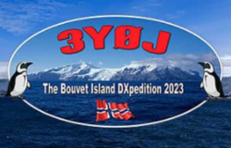](http://www.3y0j.com/)](http://www.3y0j.com/)with Tim Duffy, K3LR. Ewing will share leadership duties with Opskar in the amateur radio adventure.

"The cost of the *Braveheart* charter is enormous, but we've got some experience under our belt doing South Sandwich and South Georgia back in 2016. That was perfect preparation for Bouvet. We'll have a very difficult landing, so we're prepared for that."

A 2018 DXpedition to Bouvet was scuttled after severe weather and an engine problem forced the team -- with Bouvet already in view -- to turn back.

The plan calls for the 3Y0J team of 14 to board the marine vessel *Braveheart* in Capetown, South Africa, for "the treacherous voyage to Bouvet," Ewing said. "We will plan to spend 20 days at Bouvet and, weather permitting, we plan to have 14 to 16 good days of radio activity."

TOP ^

"This will be an arduous and expensive mission. Our budget is $764,000, and the 3Y0J team will fund much of this mission. We desperately need the global DX community to support our mission and help us make this important activation of the second-most-wanted DXCC entity. It is only through this kind of support that we can achieve our mission of making 100,000 contacts or more from Bouvet."

The Northern California DX Foundation and the International DX Association have already stepped up to the plate.

"We plan to make best use of propagation and modes on 10 - 160 meters," Ewing said in the announcement. Operation will be on SSB, CW, and digital modes. "But I want to make it clear," Ewing told Duffy. "There's no doubt. We *are* going!"

Follow the Intrepid-DX Group's 3Y0J plans via [Facebook](http://facebook.com/groups/3y0jbouvet2023/). Visit the [3Y0J website](http://www.3y0j.com/) for more information and to make a donation. Read [an expanded version](http://www.arrl.org/news/intrepid-dx-group-joins-forces-with-la7gia-in-bouvet-island-attempt).

___________________________________________________________

***Updated Radio Frequency Exposure Rules Become Effective on May 3***

The FCC has announced that rule changes detailed in a lengthy 2019 [*Report and Order*](https://docs.fcc.gov/public/attachments/FCC-19-126A1.pdf) *(R&O)* governing RF exposure standards go into effect on May 3, 2021. The new rules do not change existing RF exposure (RFE) limits but do require that stations in all services, including amateur radio, be evaluated against existing limits, unless they are exempted. For stations already in place, that evaluation must be completed by May 3, 2023. After May 3 of this year, any new station, or any existing station modified in a way that's likely to change its RFE profile -- such as different antennas or placement, or greater power -- will need to conduct an evaluation by the date of activation or change.

"In the RF *Report and Order*, the Commission anticipated that few parties would have to conduct reevaluations under the new rules and that such evaluations will be relatively straightforward," the FCC said in an April 2 *Public Notice*. "It nevertheless adopted a 2-year period for parties to verify and ensure compliance under the new rules."

The Amateur Service is no longer categorically excluded from certain aspects of the rules, as amended, and licensees can no longer avoid performing an exposure assessment simply because they are transmitting below a given power level.

"For most amateurs, the major difference is the removal of the categorical exclusion for amateur radio, which means that ham station owners must determine if they either qualify for an exemption or must perform a routine environmental evaluation," said Greg Lapin, N9GL, Chair of the ARRL RF Safety Committee and a member of the FCC Technological Advisory Council (TAC).

"Ham stations previously excluded from performing environmental evaluations will have until May 3, 2023, to perform these. After May 3, 2021, any new stations or those modified in a way that affects RF exposure must comply before being put into service," Lapin said.

TOP ^

The December 2019 RF *R&O* changes the methods that many radio services use to determine and achieve compliance with FCC limits on human exposure to RF electromagnetic fields. The FCC also modified the process for determining whether a particular device or deployment is exempt from a more thorough analysis by replacing a service-specific list of transmitters, facilities, and operations for which evaluation is required with new streamlined formula-based criteria. The *R&O* also addressed how to perform evaluations where the exemption does not apply, and how to mitigate exposure.

Amateur radio licensees will have to determine whether any existing facilities previously excluded under the old rules now qualify for an exemption under the new rules. Most will, but some may not.

[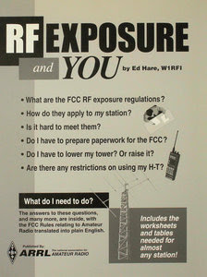](http://www.arrl.org/files/file/Technology/RFsafetyCommittee/28RFSafety.pdf)"For amateurs, the major difference is the removal of the categorical exclusion," Lapin said, "which means that every ham will be required to perform *some* sort of calculation, either to determine if they qualify for an exemption or must perform a full-fledged exposure assessment. For hams who previously performed exposure assessments on their stations, there is nothing more to do."

The ARRL Lab staff is available to help amateurs to make these determinations and, if needed, perform the necessary calculations to ensure their stations comply. ARRL Laboratory Manager Ed Hare, W1RFI, who helped prepare ARRL's *RF Exposure and You* book, explained it this way. "The FCC did not change any of the underlying rules applicable to amateur station evaluations," he said. "The sections of the book on how to perform routine station evaluations are still valid and usable, especially the many charts of common antennas at different heights." Hare said ARRL Lab staff also would be available to help amateurs understand the rules and evaluate their stations.

*RF Exposure and You* is [available for free download](http://www.arrl.org/files/file/Technology/RFsafetyCommittee/28RFSafety.pdf) from ARRL. ARRL also has an [RF Safety page](http://www.arrl.org/rf-exposure) on its website.

The ARRL RF Safety Committee is working with the FCC to update the FCC's aids for following human exposure rules -- *OET Bulletin 65* and *OET Bulletin 65 Supplement B for Radio Amateurs*. In addition, ARRL is developing tools that all hams can use to perform exposure assessments.

__________________________________________________________________________________________

***Club Corner***

This is YOUR cornner of the newsletter. Send me what your club is doing and I’ll make sure that it gets in. Got a special event or club project that you want everyone to know about? Send it to me!. Need help with a project? Send it to me.

Let me know what you club is up to. Are you going to have a special guest at your meeting or are you having a special anniversary?

Just sent it to: [webmaster@arrl-ohio.org](mailto:webmaster@arrl-ohio.org)

TOP ^

***Volunteers Needed!***

Lucas County ARES needs volunteers for the Glass City Marathon on April 25, 2021 starting time is 6:30 a.m. . We are still short of radio operators to fill the positions that need to be filled. If you would like to help or for more information, please contact Rick Sharpe K8RKS at K8RKS@ARRL.net or 419-471-0573. We thank all the volunteers that help out with events.

***Ham Radio Camp Out at Delaware State Park Camp Ground on September 10-12, 2021.***

Planned activities include the following.

   DMR Question and Answer

   Antenna Question and Answer

   Ohio State Parks on the Air (OSPOTA) station operation

   Swap meet for participants only

   Demonstrations

   Fun

Camp sites are already reserved, and each costs $65.00.  Reserve your spot by calling Kenny Snare, KC8BPE.  Telephone 740.223.9065 or e-mail: [snarekc8bpe@aol.com](mailto:snarekc8bpe@aol.com).

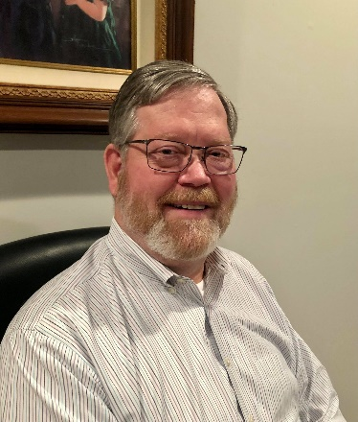***DX This Week – K9LA***

Bill AJ8B (aj8b@arrl.net, @AJ8B, or www.aj8b.com)

CWOPs Member #1567

The Midwest DX Cluster spots included Austria, Azerbaijan, Belgium, Brazil, Canada, Chile, Costa Rica, Cuba, Czech Republic, Dominica, England, Fed. Rep. of Germany, France, Greece, Greenland, Hawaii, Iceland, Ireland, Isle of Man, Italy, Kuwait, Liechtenstein, Madeira Islands, Mexico, Montenegro, Netherlands, North Macedonia, Puerto Rico, Scotland, Slovak Republic, Spain, St. Martin, Switzerland, Trinidad & Tobago, Wales and Zambia. This brings the total number of entities spotted in the Midwest in 2021to 161!

I received a few QSL cards and some great stamps from Japan. I have received many things like this over the years including coins, stamps, stickers, and decals. I also received QSL cards this week including WH7T – Mark in Honolulu, OK1CF – Karel in the Czech Republic (160M confirmation), and JD1BMH – Harry on Ogasawara Island. What did you get?

|  |  |
| --- | --- |
|  |  |

TOP ^

|  |  |
| --- | --- |
|  |  |
|  |  |

*DAH DIT DIT DIT DAH DAH DIT DIT DIT DAH*

This week is our monthly contribution from K9LA, Carl. Carl has monthly topics that are always interesting. His website is K9LA.us, and this is reprinted with his permission. Carl will be speaking at the W8DXCC convention in August. (Larger images and the original article can be found at http://k9la.us/Mar21_A_Very_Broad_Look_at_Propagation_vs_Location.pdf)

A Very Broad Look at Propagation versus Location

Carl Luetzelschwab K9LA March 2021

A recent thread on the Society of Midwest Contesters (SMC) reflector was about the geographical advantages of certain areas of the US with respect to propagation. There are lots of issues related to this: antenna gains, noise environment (especially important on the low bands), take-off angles due to favorable terrain and others.

TOP ^

Instead of diving into these specific issues, let’s take a very broad look at geographical advantages/disadvantages with respect to propagation. See the following figure. Let’s start with the East Coast and go clockwise.

**East Coast -** First, the East Coast has an advantage to Europe and Africa due to shorter distances than other geographical locations. This also translates to a second advantage – the amount of time a path is in daylight, which is important on the higher bands.

|  |  |
| --- | --- |
| path | duration that the short path is in daylight |
| East Coast to Italy in January | 3 hrs, 39 min |
| West Coast to Italy in January | 0 hrs, 43 min |

I chose January as it’s pretty much centered on the CQ WW DX contests, the ARRL 10 Meter contest, and the ARRL DX contests. Of course, you have to realize that ionization in the F2 region doesn’t decrease as fast after sunset as it does in the E and D regions. Thus, propagation won’t abruptly end after sunset on the Italian end. What it does is add the same constant to both paths – the East Coast still has an approximate 3-hour advantage over the West Coast.Third, the East Coast path to Europe and Africa is more over water than from the other geographical areas. This means less loss due to ground reflections. The disadvantage for the East Coast is a path through the auroral oval to Japan (and other countries in that area). The image (from the 1995 DOS program DXAID 4.5 by Peter Oldfield) shows this for the month of January at 3AM local on the East Coast. The center of the map is W2, and the thin white straight line to the northwest from W2 is a path to JA (JA is the circle with a + in it). The K index is 4.

With the path entirely in darkness, this would/should be a good opportunity on the low bands – except for the auroral oval likely messing things up.

**Southern Tier of States -** There are many times when I see (on PacketCluster) the southern tier of states working stuff I can’t even hear. Their advantage comes from the fact that the ionization increases as you move from the higher latitudes to the lower latitudes. The following image is for a January month at 1900 UTC at a smoothed sunspot number of 10 (solar minimum). The contour lines are the MUFs (maximum usable frequencies) for a 3000 km path with any point on the worldwide map being the midpoint of the 3000 km path.

TOP ^

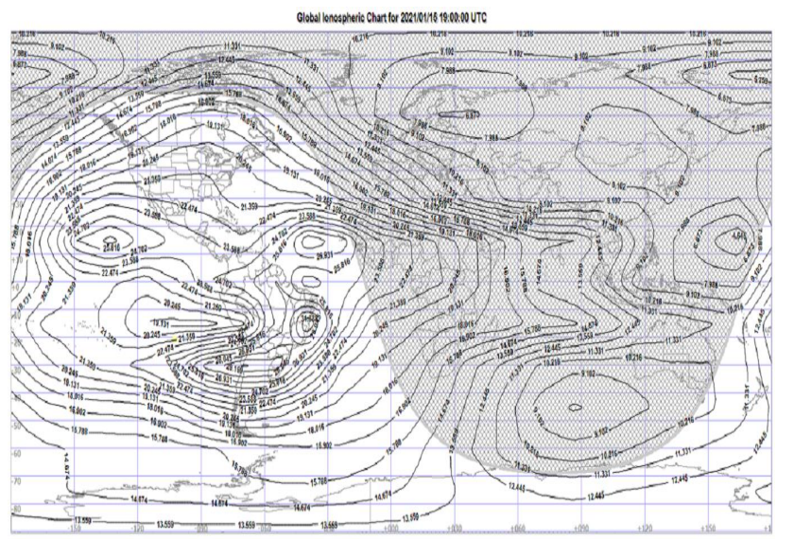It’s obvious that the amount of ionization in the daylight part of the ionosphere increases as we move from the poles to the equator. For this example, the MUF on a 3000 km path along the southern tier of states is around 22 MHz. For Fort Wayne, Indiana (where I am), the MUF on a 3000 km path is around 20.7 MHz. For those in the Upper Midwest, the MUF is around 20 MHz. Although the difference is only a couple MHz, those areas with the lower MUF could see up to 20 dB more loss if you’re operating just below the MUF (this comes from the above-the-MUF mode in VOACAP).

Additionally, geomagnetic disturbances to the ionosphere tend to be less extreme as you move down to lower latitudes.

One disadvantage for the southern tier of states is the possibility of more atmospheric noise from thunderstorms because they are nearer the equator. And if you’re in Texas, in the middle of the southern tier of states, you may suffer more loss from ground reflections.

**West Coast -** The West Coast has an advantage to the Pacific and Asia due to shorter distances than other geographical locations. Again, this translates to a longer duration (about 3 hours longer). And of course, the West Coast path to the Pacific and Asia is more over water than from the other geographical areas. This means less loss due to ground reflections. The disadvantage for the West Coast is a path through the auroral oval to Europe. The following image is for a path (thin white straight line) from W6 to Europe for the month of January at 0100 UTC (5PM local on the West Coast) at a K index of 4.

With the path entirely in darkness, this should be a good opportunity on the low bands – except for the auroral oval likely messing things up.

**Midwest/Upper Midwest** I had to scratch my head a bit to come up with some advantages of being in the Midwest/Upper Midwest. Propagation from the Midwest/Upper Midwest to Europe/Africa can be better than propagation from the West Coast to Europe/Africa. And propagation from the Midwest/Upper Midwest to the Pacific/Japan can be better than propagation from the East Coast to the Pacific/Japan. I readily admit these are advantages in the loosest of terms.

TOP ^

The biggest disadvantage for the Upper Midwest (northern Wisconsin, northern Minnesota, North Dakota and northern Michigan) is the auroral oval. The image is centered on northern Wisconsin with a path (thin white straight line) to Europe at 5PM local time in January.

Unfortunately, the most energetic electrons that precipitate into the auroral oval are at the equatorward edge of the oval – where the path from northern Wisconsin to Europe encounters the auroral oval.

For those at lower latitudes in the Midwest (those in Indianapolis, for example, or me in Fort Wayne), the auroral oval is pretty much out of the way – unless the K index gets really high.

The other disadvantage of the Upper Midwest is what was mentioned earlier – the lower ionization giving slightly lower MUFs. Again, being in Indianapolis or even Fort Wayne should help a bit. It would be nice to quote a dB difference, but I don’t think that’s possible – too many variables that are not well enough understood.

**Summary -** This has been a very broad look at propagation advantages and disadvantages for four areas of the US. As mentioned earlier, station specifics can also come into play – antenna gains, noise environment (especially important on the low bands), take-off angles due to favorable terrain and other issues.

The best advice given in this thread on the SMC reflector was that propagation isn’t fair with respect to your location. It is best to just compete with others in your local area.

*DAH DIT DIT DIT DAH DAH DIT DIT DIT DAH*

CQDX CQDX CQDX CQDX CQDX CQDX CQDX CQDX CQDX

Here is an update from Bernie, W3UR, of the DailyDX and the WeeklyDX, the best source for DX information. http://www.dailydx.com/. Bernie has this to report:

**3Y – Bouvet -** The "Intrepid-DX Group" breaks news on the planned 3Y0J expedition, noting their successful VP8STI, South Sandwich, and VP8SGI, South Georgia expeditions of 2016 and that Bouvet is the second most wanted DXCC entity.  LA7GIA has joined the team.  Now planning for January 2023 with 14 operators, they will leave Capetown aboard the Braveheart, then 20 days on Bouvet, with as many as 16 days of those on the air.  They are budgeting 764,000 USD, with ops, they say, paying most of that, though they say they are desperate for support from DX clubs and individuals.  They particularly thank the Northern California DX Foundation and International DX Association as their "premier donors. Their goal is 100,000 QSOs, on 160-10 meters. http://www.3y0j.com and https://www.facebook.com/groups/901378553769436.

TOP ^

NCDXF yesterday announced a $100,000 donation to the 3Y0J operation, noting in the last three years two DXpeditions have attempted to get to Bouvet but severe storms damaged the ships taking them there, even though they did get close to the island.  NCDXF has donated $1.3 million to "hundreds of DXpeditions" over the last 49 years.

**6O – Somalia -** EP3CQ, Ali, is going back to Mogadishu, Somalia on April 25 and expects to be operational after the end of the month due to being quarantined. Listen for him as 6O1OO in his spare time for a two-month period. He'll have a barefoot FT-450D transmitting into a Little Tarheel II and SE-360 on all bands, except 160 Meters. Activity will be mostly on FT8, "depending on the band condition[s]" he could also be on SSB and CW. All QSL cards received as of April 10 are expected to be answered by April 15. QSL cards received after April 10 will be replied in July 2021.  
  
**S7 – Seychelles -** Amateur Radio operators from the newly formed Seychelles Amateur Radio Association (SARA) will be celebrating World Amateur Radio Day (WARD), April 18. "I just confirmed with SARA Chairman" S79RP, Richard "Rick" Perks, "we will target to activate S77SARA Callsign for very first time in history of Seychelles Amateur Radio - First Local Club Station", says S79KW, Kamil. Activity is expected around 1100 to 1300Z on WARD. S79KW, Kamil; S79RP (VK4RC), Rick; S79VU, Ravi; are expected to be at this historic first-time operation. They are hopeful this introduction of the never used callsign will introduce new members of the island nation as they operate from new Mahe Island club station.  
  
**S7 – Seychelles -** For the longest time Amateur Radio operators from the Seychelles (S7)were restricted to operating on 40 meters between 7.050 to 7.100 MHz. As a result of the 2003 World Radio Conference (RC-03), which was finalized in 2009, broadcast stations were removed from 7.100 to 7.200 MHz and those frequencies were then allocated exclusively to Amateur Radio operators worldwide. In a recent proclamation from Seychelles Vice President's office announced, "SARA and the Seychelles Government have recently come to an agreement that the Seychelles be adjusted to suit i.e. reallocated from 7.05 - 7.1 MHz to the full 7.0 - 7.2 MHz." You can see the S79 Band Plan at  
http://www.ict.gov.sc/Documents/2020/Amateur%20Radio%20Band%20Plan.pdf

*DAH DIT DIT DIT DAH DAH DIT DIT DIT DAH*



Below is a list of upcoming contests in the “Contest Corner”. I think this is important for someone who is trying to move up the DXCC ladder since entities that are on the rarer side and easiest to work in contests. Some of my best “catches” have been on the Sunday afternoon of a contest when the rarer entities are begging for QSOs. Of course, the gamble is that if you wait until Sunday, conditions may change, or they simply won’t be workable. However, it is not a bad gamble. Of course, why not work the contest and have some fun!  
Check out the WA7BNM Contest Calendar page (https://www.contestcalendar.com/) and CQ Magazine for more contests or more details.

The contests in red are those that I plan to spend some significant participation time on. PLEASE let me know if you are working contests and how you fared. - Thanks!

TOP ^

|  |  |  |
| --- | --- | --- |
| Apr. 21 | RSGB 80m Club Championship, SSB | http://bit.ly/3avHbk3 |
| Apr. 29 | RSGB 80m Club Championship, Data | http://bit.ly/3avHbk3 |
| Apr. 24-25 | 10-10 Spring Digital Contest | http://bit.ly/1FrFeBc |
| Apr. 24-25 | Florida QSO Party | www.floridaqsoparty.org |
| Apr. 24-25 | Helvetia Contest | www.uska.ch |
| Apr. 24-25 | SP DX RTTY Contest | www.pkrvg.org/strona,spdxrttyen.html |
| Apr. 25 | BARTG Sprint75 Contest | http://bartg.org.uk/wp/contests |
| Apr. 28 | UKEICC 80m Contests CW | https://bit.ly/2SDPqQQ |
| 1-May | AGCW QRP / QRP Party | http://bit.ly/3bwH1aZ |
| 1-May | FISTS Spring Slow Speed Sprint | http://fistsna.org/operating.html |
| 1-May | RCC Cup | http://tinyurl.com/76rrphvc |
| May 1-2 | 7th Area QSO Party | https://tinyurl.com/yvmvtymd |
| May 1-2 | 10-10 Spring CW Contest | http://bit.ly/1FrFeBc |
| May 1-2 | ARI DX Contest | www.ari.it |
| May 1-2 | Delaware QSO Party | www.fsarc.org/qsoparty/rules.htm |
| May 1-2 | Indiana QSO Party | www.hdxcc.org/inqp/index.html |
| May 1-2 | New England QSO Party | www.neqp.org/rules.html |
| May 4-5 | MIE 33 Contest | https://tinyurl.com/8dekut84 |
| May 5 | RSGB FT4 Contest Series | http://bit.ly/3mCNXXH |
| May 8-9 | Arkansas QSO Party | https://arkqp.com/arkansas-qso-party-rules |
| May 8-9 | CQWW Foxhunting Weekend | www.homingin.com/joek0ov/nfw.htm |
| May 8-9 | CQ-M International DX Contest | http://cqm.srr.ru/en-rules |
| May 8-9 | Volta WW RTTY Contest | www.contestvolta.it |
| May 10 | RSGB 80m Club Championship, SSB | http://bit.ly/3avHbk3 |
| May 16 | FISTS Spring Unlimited Sprint | http://fistsna.org/operating.html |
| May 19 | RSGB 80m Club Championship, Data | http://bit.ly/3avHbk3 |
| May 15-16 | His Majesty King of Spain CW Contest | http://concursos.ure.es/en |
| May 15-16 | NZART Sangster Shield Contest | http://bit.ly/3aviX6h |
| May 22-23 | Baltic Contest | www.lrsf.lt/en |
| May 23-24 | QRP ARCI Hoot Owl Sprint | www.qrparci.org/contests |
| May 27 | RSGB 80m Club Championship, CW | http://bit.ly/3avHbk3 |

TOP ^

|  |  |  |
| --- | --- | --- |
| May 29-30 | CQWW WPX CW CONTEST | www.cqwpx.com |
| August 28 | Ohio QSO Party | https://www.ohqp.org/ |
| August 28 | W8DXCC | https://www.w8dxcc.com |

***DX News***

ARLD015 DX news  
  
SB DX ARL ARLD015  
ARLD015 DX news  
  
This week's bulletin was made possible with information provided by The Daily DX, the OPDX Bulletin, 425 DX News, DXNL, Contest Corral from QST and the ARRL Contest Calendar and WA7BNM web sites.  Thanks to all.  
  
SWAZILAND, 3DA0.  Look for 3DA0AQ to be QRV during the CQMM DX contest.  QSL via EA5GL.  
  
AZERBAIJAN, 4J.  Special event station 4J880M is QRV to commemorate the 880th anniversary of the birth of 12th century Persian Sunni Muslim poet Nizami Ganjavi.  QSL direct to 4J3DJ.  
  
ISRAEL, 4X.  Jan, 4X1VF and Ruben, 4Z5FI are QRV as 4X73T during the Holyland Contest and active from the rare Holyland Square L19BL. QSL via bureau.  In addition, special event calls 4X73XX and 4Z73XX are QRV until April 17 to commemorate 73 years of independence.  QSL  
via LoTW.  
  
BAHRAIN, A9.  Members of the Bahrain Amateur Radio Society are QRV as A91WARD until April 18 to celebrate World Amateur Radio Day.  QSL via EC6DX.  
  
CHILE, CE.  Members of the Radio Club de Chile will be QRV as XR3IARU on April 18 to celebrate World Amateur Radio Day.  QSL via CE3EE.  
  
ARMENIA, EK.  Look for EK6RL to be QRV during the CQMM DX contest. QSL direct to home call.  
  
NEW CALEDONIA, FK.  Look for FK8IK to be QRV during the CQMM DX contest.  QSL direct to home call.  
  
ENGLAND, G.  Special event station GB0DOE is QRV until May to honor the memory of the recently deceased Prince Philip, Duke of Edinburgh.  QSL via GB0DOE.  
  
HUNGARY, HA.  In celebration of the 230th anniversary of the birth of Samuel F. B. Morse, members of Hungary's Radio Amateur Society will be QRV with special event stations HA230MSE, HA230S, HA230A, HA230M, HA230U, HA230E, HA230L, HA230O, HA230R and HG230MSE from April 17 to 27.  Activity will be on the HF bands using CW and SSB. QSL via LoTW..

TOP ^

JAPAN, JA.  Special event station 8N1MORSE is QRV until February 28, 2022 to celebrate the 230th anniversary of the birth of Samuel F. B. Morse and the 120th anniversary of Guglielmo Marconi's first  
successful transatlantic radio communication by Morse Code.  QSL via bureau.  
  
ANTARCTICA.  Mark, W5MED is QRV as KC4USV from McMurdo Station on Ross Island, IOTA AN-011, until October.  He is active on 20 meters using SSB and FT8 at various times of the day.  QSL direct to K7MT.  
  
US VIRGIN ISLANDS, KP2.  Dan, K8RF will be QRV as NP2J in the CQMM DX contest as a Single Band/High Power entry on 40 meters.  QSL to home call.  
  
LUXEMBOURG, LX.  Special event station LX5WARD is QRV until April 25 to mark World Amateur Radio Day.  Activity is on the HF bands using CW, SSB, FT8 and FT4.  QSL via LX1JH.  
  
  
GREECE, SV.  Juergen, DK3SJ is QRV as SV8/DK3SJ from Lesbos Island,  
IOTA EU-049, until April 24.  Activity is on 80 to 10 meters using CW and SSB.  QSL to home call.  
  
FALKLAND ISLANDS, VP8.  Clint, VP8DKP is usually QRV on 40 meters using FT8 during his evenings.  QSL direct.  
  
The K1USN Slow Speed CW Test and OK1WC Memorial are scheduled for  
April 19.  
  
The RTTYOPS Weeksprint and Worldwide Sideband Activity Contest are  
scheduled for April 20.  
  
The 432 MHz Spring Sprint, RSGB 80-Meter Club SSB Championship,  
CWops Mini-CWT Test and Phone Fray are scheduled for April 21.  
  
Please see April QST, page 75, and the ARRL and WA7BNM contest web  
sites for details.

TOP ^

***Special Events***

* **04/24/2021 | 156th Anniversary of Sultana Disaster**

**Apr 24, 1500Z-2100Z, W5S**, West Memphis, AR. AG5QY. 14.240. QSL. Marc Gwin, 1402 Stratford Drive, West Memphis, AR 72301. <https://ag5qy9.wixsite.com/ag5qy>

* **04/24/2021 | OC&E Woods Line Last Train 31st Anniversary**

**Apr 24, 1600Z-2200Z, W7VW**, Klamath Falls, OR. Klamath Basin Amateur Radio Society. 14.074. Certificate & QSL. Jim English, 2602 Wiard Street, Klamath Falls, OR 97603. The Oregon, California, and Eastern Railway (OC&E) was a 64-mile (103 km) rail line between Klamath Falls and Bly in the US state of Oregon. After 70 years of bringing logs from nearby forests to local sawmills, the former railroad right of way was converted to the OC&E Woods Line State Trail. The last OC&E log train to Bly ran on Sunday, 29 April 1990. wo7v@arrl.net or <https://www.facebook.com/kfalls.radio>

* **04/24/2021 | San Jacinto Day Special Event**

**Apr 24-Apr 25, 1400Z-2359Z, K5T**, Nacogdoches, TX. Nacogdoches Amateur Radio Club. 7.216 14.260 21.350 28.350. QSL. Army Curtis, 167 CR 2093, Nacogdoches, TX 75965. All contacts will be confirmed via LOTW [https://w5nac.com](https://w5nac.com/)

* **04/24/2021 | W1BSA Birthday of Scouting Event**

**Apr 24, 1400Z-1930Z, W1BSA**, Fall River, MA. USTNE ne1pl.org. 14.259. QSL. Rick Emord, 135 Wareham St., Middleboro, MA 02346. The USTNR group will be activating on the USS Massachusetts this year at least 4 times for the following events. Except for the Museum ships on the air event, we will be on the air by 1000 EST or 1400 utc we will be shut down at 1530 EST or 1930 utc. We have a website to see the current QSL card for the events go to ne1pl.org. Look for the ticker tape for added events. Our first event for the year will be: W1BSA April 24th On the air by 1000 off the air around 1530 This event is for the Birthday of Scouting in America. The birthday is on February 8, 1910 because of the chilly weather in February we celebrate in April. Please visit battleshipcove.org for more information about the park and its equipment. Please visit us at [ne1pl.org](http://ne1pl.org/)

* **04/24/2021 | Woronoko Heights Outdoor Adventure**

**Apr 24, 1300Z-1900Z, W1M**, Russell, MA. Western Mass. Council--BSA. 14.290 14.060 10.115 7.190. QSL. Tom Barker, 329 Faraway Road, Whitefield, NH 03598. SES operating from the Horace Moses Scout Reservation in western Mass. SASE for QSL.

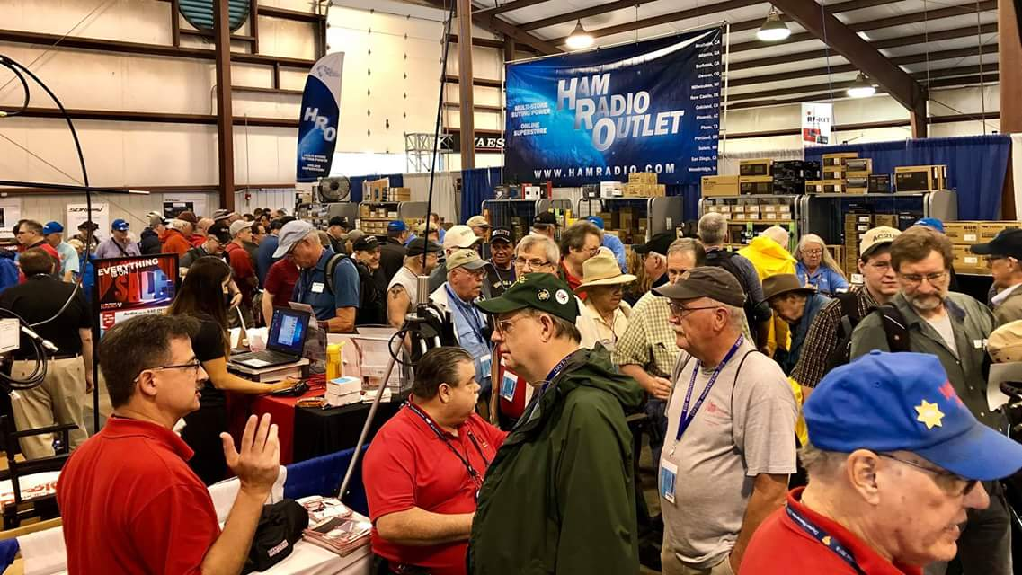[***Upcoming Hamfests***](http://arrl-ohio.org/hamfests.html)

We **DO** have some hamfests scheduled for 2021!! Yes, take a good look at the list, it’s growing every day!

TOP ^

Be sure to keep your eyes on this schedule as that when things start getting better and the vaccine rolls out to more and more, hamfests will surely get back to their normal schedule. Don’t see your hamfest listed?? Did anyone register it with ARRL? It’s really easy to do and you get a lot of FREE publicity if you do.

|  |  |
| --- | --- |
| **06/05/2021 -**[**FCARC SummerFest**](http://www.arrl.org/hamfests/fcarc-summerfest)  **Location:**Wauseon, OH **Sponsor:**Fulton County Amateur Radio Club **Website:**[**http://k8bxq.org/hamfest**](http://k8bxq.org/hamfest)  [**Learn More**](http://www.arrl.org/hamfests/fcarc-summerfest) | **07/10/2021 - [Mansfiled Mid-Summer Trunkfest](http://www.arrl.org/hamfests/mansfiled-mid-summer-trunkfest" \o "Mansfiled Mid-Summer Trunkfest)**  **Location:**Mansfield, OH **Sponsor:**InterCity Amateur Radio Club **Website:**[http://iarc.club](http://iarc.club/)  [**Learn More**](http://www.arrl.org/hamfests/mansfiled-mid-summer-trunkfest) |
| **07/17/2021 -**[**NOARSFEST**](http://www.arrl.org/hamfests/noarsfest-8) **Location:** Elyria, OH **Sponsor:**Northern Ohio Amateur Radio Society **Website:** [http://noars.net](http://noars.net/)  [**Learn More**](http://www.arrl.org/hamfests/noarsfest-8) | **07/18/2021 -**[**Van Wert Hamfest**](http://www.arrl.org/hamfests/van-wert-hamfest-5)  **Location:**VAN WERT, OH **Sponsor:** Van Wert Amateur Radio Club **Website:** [http://W8FY.ORG](http://w8fy.org/)  [**Learn More**](http://www.arrl.org/hamfests/van-wert-hamfest-5) |
| **08/07/2021**  [**DX Engineering Hamfest**](http://www.arrl.org/hamfests/dx-engineering-hamfest-1) **&** [**Great Lakes Division Convention**](http://www.arrl.org/hamfests/dx-engineering-hamfest-1) **Location:**Tallmadge, OH  **Sponsor:**DX Engineering  **Website:**[http://dxengineering.com](http://dxengineering.com/)  [Learn More](http://www.arrl.org/hamfests/dx-engineering-hamfest-1) | |
| **08/07/2021 -** [**2021 Columbus Hamfest**](http://www.arrl.org/hamfests/2021-columbus-hamfest)  **Location:** Grove City, OH **Sponsor:**Aladdin Shrine Audio Unit **Website**: [http://columbushamfest.com](http://columbushamfest.com/)  [**Learn More**](http://www.arrl.org/hamfests/2021-columbus-hamfest) | **08/28/2021 -**[**Cincinnati Hamfest℠**](http://www.arrl.org/hamfests/cincinnati-hamfest)  **Location:**Owensville, OH **Sponsor:** Milford ARC **Website:** [http://CincinnatiHamfest.org](http://cincinnatihamfest.org/)  [**Learn More**](http://www.arrl.org/hamfests/cincinnati-hamfest) |
| **09/26/2021 -**[**Cleveland Hamfest**](http://www.arrl.org/hamfests/cleveland-hamfest-1)  **Location:**Berea, OH **Sponsor:** Hamfest Association of Cleveland **Website:** [http://www.hac.org](http://www.hac.org/)  [**Learn More**](http://www.arrl.org/hamfests/cleveland-hamfest-1) | **12/04/2021 -**[**FCARC WinterFest**](http://www.arrl.org/hamfests/fcarc-winterfest-2)  **Location:**Delta, OH  **Sponsor:** Fulton County Amateur Radio Club  **Website:**<http://k8bxq.org/hamfest>    [**Learn More**](http://www.arrl.org/hamfests/fcarc-winterfest-2) |

TOP ^

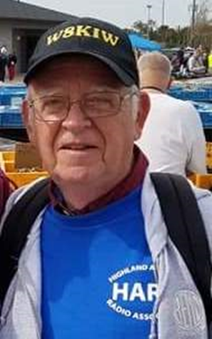

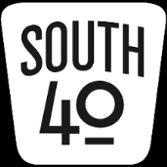 South 40—On the Road Edition

Last time we found ourselves visiting two very active Southern Ohio clubs-the Southern Ohio ARA and the Portsmouth RC. As we cruise northbound US 23 from Portsmouth, the car radio is playing Willie appropriately singing “On the Road Again” as we move into Pike County. Although I find no evidence of an actual ham radio in Pike County, I do seem to recall hearing of an attempt once to get an ARES group organized. However the subject matter of our next visit has the county well covered.

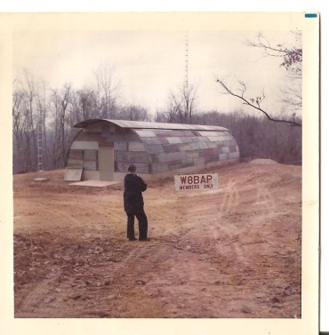Once in Chillicothe we’re greeted by the Scioto Valley ARC. The Club is one of less than a handful of Southern Ohio clubs with a clubhouse they can call home. It sets at the edge of the Scioto Trails State Park and according to Michael Mathuews, KC8WIW, its construction began in 1971. The site was also the home of the 25/85 repeater until last fall when a falling tree caused the repeater antenna tower to fall. The repeater has since been relocated to another location to the east with little change to the coverage footprint. Over the years the Club has been very active and visible in the community. For years they have served as the middle communications link for the annual Tour of the Scioto River Valley bicycle ride and recently became involved with communications provisions for some auto rallies through state forest lands. They also have had interesting fund raisers with selling candy and fruitcakes during the holiday season and even conducted several chicken barbeques at a local park. Until COVID hit they conducted an annual hamfest. Besides the previously mentioned repeater, they maintain others. One is the 146.925 machine located at a former military radar site near Bainbridge. It is said to be on the second highest point in Ohio. The VE Team headed by John Hartmus ll, WB8GRX, conducts at least an annual class and holds several test sessions throughout the year. Fifteen licenses resulted from their latest efforts. SVARC members can be heard on the air during the Ohio Parks on the Air, Field Day, the Ohio QSO Party and other similar operating activities. During the past National Parks on the Air Year they activated the nearby Hopewell National Park several times.

As one of Ohio’s oldest settled areas and Ohio’s first capital, the Chillicothe area has so much history one could spend days exploring its parks and sites and viewing the amazing buildings lining some of the uptown streets and historic district. However after some ribs and brisket at the Old Canal Smokehouse we need to get back on the road to our next destination. In the meantime here are some of the happenings in our area.

As recently mentioned, the Athens County ARA and Sunday Creek ARF teamed up to hold a ARRL VE session in Athens with an amazing 100% passing rate for the number of people taking tests. Thanks to Jeff Slattery, N8SUZ, and Ted Jacobson, W8KVK, for providing the call signs for those earning their first license. And the winners are: Jeremy Barnhouse of Coolville is now KE8ROB; Jonathan Denes from Stockport is KE8ROD; Charles Graham from Reedsville is KE8RNY; David Runkle of Glouster is KE8ROA; Joseph Sprague from Albany is KE8ROC and Reedsville’s Richard Terrell is KE8RNZ. Another five individuals upgraded their licenses at the same session.

TOP ^

WELCOME to the new comers and CONGRATS to those upgrading. And back pats go to the ACARA and SCARF for combining their efforts to make this happen. It’s great to see clubs working together and combining resources to achieve common goals.

Recent developments have caused the Clinton County ARA to no longer have the site for their proposed upcoming trunkfest available. Therefore Club President Dave Gordley, K8DEG, says it is being postponed (not cancelled) until a new location can be found and date set.

Although COVID concerns and weather may have caused smaller attendances than normal, the Highland ARA conducted their first physical Brunch Bunch and business meetings in many months this past week. The business meeting covered a lot of topics ranging from the current Technician Class to Field Day preparations to planning for the annual Christmas Dinner Party. It is evident members are anxious to get back to some form of normal as soon as possible.

After months of no face-to-face meetings, the Southern Ohio ARA will meet Monday evening, April 19, at the Lawrence County EMA/EOC Operations Center in Coal Grove. PIO Mike Love says the meeting will begin at 7 pm with a Laurel VE testing session prior to the meeting starting at 6 pm. All members and others with an interest are invited to attend.

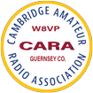As with a number of clubs the pandemic put a halt to physical Cambridge ARA club meetings. Therefore the election of 2021 officers had to be postponed. However in late March the Club was able to finally gather and conduct business and elect officers resulting in Jim Shaw, AB8P, being re-elected President. Other officers returned to office were Larry Dukes, KD8QYV, as Vice President; Evelyn Barton, KA8NZS, Secretary and Beverly Bunn, KD8MSL, to the Treasurer position. Trustees elected were Dick Wayt, WD8SDH and Steve Bunn, KD8MFC. Sonny Alfman, W8FHF, will serve as the Activity Chair and his XYL Lyn, N8IMW, will retain her Information Officer and Newsletter Editor spots.

According to the Queen City Emergency Net’s *Listening Post* newsletter, we learn the Red Cross Building will not be available until July. Therefore the Club’s Field Day activity will be held at the W8VND antenna site. We also learn that after an unexpected absence the Club’s website is now back up and running at www.qcen.org.

Prior to the ARRL test session on April 25, the Athens County ARC anticipates holding an hour-long builder’s program to make tape measure antennas for use in fox hunting and interference tracking. Kirk Groeneveld, KC8JRV, says if there is sufficient interest the activity will start in the Red Cross’s parking lot an hour prior to the 2 pm test start. There is a $15 charge for materials. He can be contacted at 740-541-2448.

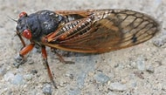Greenfield’s Greg Barr, KD8UVU, passes along something he recently heard or read on the Internet concerning Ohio’s forthcoming invasion of the 17 year locust. He says word is that each of the millions expected to emerge from Ohio soils in the coming weeks is rumored to be equipped with a miniature HF transmitter. Thus you now know what that frying noise you hear on the HF frequencies really is and it isn’t band conditions as long believed. If you learned it on the Internet it has to be true!

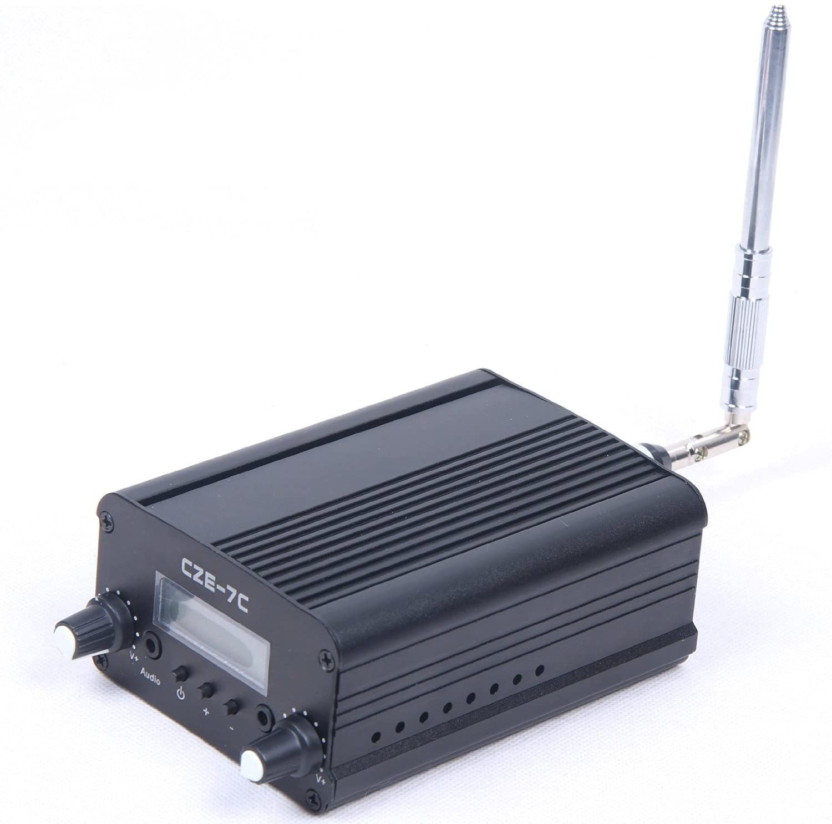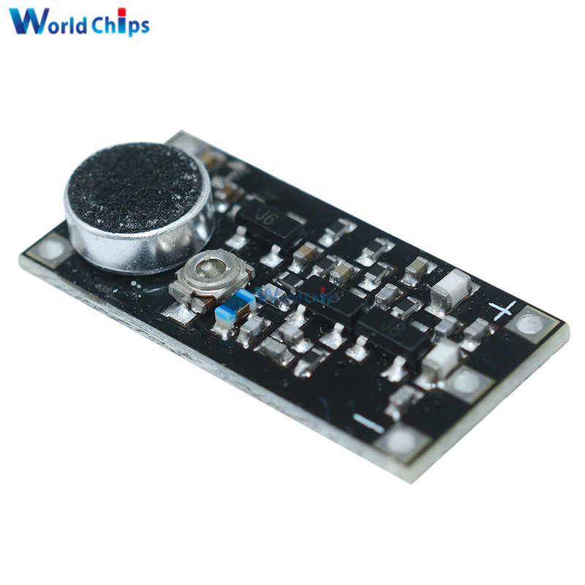

TOP ^

At Tuesday evening’s Highland ARA meeting, Richie Hagan, N8CUB, announced he is planning to conduct a Club Fox Hunt sometime in May. He stated HARA used to have them on a frequent basis, but they were discontinued around 20 years ago. Anyone interested in assisting him, participating or just learning more about what they are about is urged to contact him. It will be used as an additional Elmer teaching moment.

Our condolences go to the family of Scioto Valley ARC President Jess Stanley, KC8CHP, on the passing of his mother.

Lyn Alfman, N8IMW, tells us the Cambridge ARA had plans to conduct a special event station during the annual Zane Gray Family Fun Day at the Zane Gray/National Road Museum on May 1. However the Museum decided it to be in the best interests of public health to cancel the event for this year. Therefore the special event will not take place.

The Highland County EMA Office was expected to be abuzz on Saturday morning as students from the recent Highland ARA Technician Class were to take their license tests. They will be joined by some others from other Southern Ohio communities to also test. Another test session is to be conducted in Circleville that morning. Between the two, Southern Ohio should show another jump in the number of new hams in the region. Future tests will be in Ironton on April 19, Athens on April 25, Portsmouth on May 3 and on May 11 in Lancaster.

Ever have one of those “I wonder” moments? While filing the annual ARRL Affiliated Club report for HARA I was curious of the breakdown by license class of our members. HARA currently has 100 voting members. That breakdown is 31 Extras, 6 Advanced, 30 Generals, 30 Techs, 2 Novices and one SWL who has passed his Tech license but is hung up in FCC paperwork. Is this a typical breakout for a club?

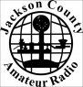Well, we’re back on the road again after hooking up with some old ham friends in the SVARC club. Our sights are now set for Jackson, Ohio. Not only is Jackson the home of the annual Jackson Apple Festival, but the home of the Jackson County ARC. The Club became affiliated with the ARRL 1980 but possibly was founded years before that. I seem to recall seeing the Club manning a ham radio booth at the Apple Festival many years ago. The Club works closely with the County EMA, fire and police departments, the county sheriff and other public agencies or civic organizations that might need communications assistance. Additionally though the years the Club has provided assistance to other neighboring ham clubs in need of manpower for large scale events. In 2008 the JCARC held its first hamfest and continued the tradition for many years. They were an early supporter of Saturday hamfests. For years they have run a highly successful VE program. Currently the Club considers itself “inactive” because of COVID concerns. However they still congregate on the Jackson 146.79 repeater in order to keep check on each other.

That’s it for another leg of our adventure to visit the varied amateur radio clubs calling Southern Ohio and the Ohio River Valley their home. Here’s hoping to catch some of you on the air during the upcoming April 24 Ohio NVIS Activity Day. It runs from 10 until 4. In the meantime, please stay healthy, safe and radio-active.

TOP ^

***Upcoming Training Opportunities***

Need to get those really hard to get NIMS ICS 300 and 400 classes to get to Level 3? They are now being offered with very limited virtual seating. Yes, these classes are being offered virtually now along with a lot of other classes that used to require in-class sessions. Want to see what and where these classes are being offered?

[**>> Click Here <<**](http://arrl-ohio.org/SEC/Ohio_EMA_Training_List_Feb_2021.pdf)

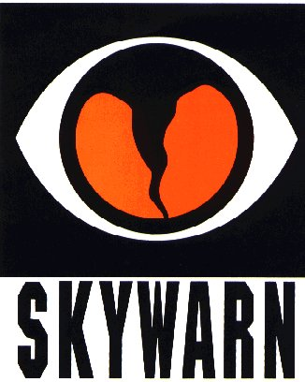***SKYWARN TRAINING***

The National Weather Service will not be able to conduct in person spotter training classes this winter and spring due to restrictions associated with COVID. Therefore, a number of field offices will be hold “virtual” spotter training classes. These classes will be open to the public and free of charge. Please feel free to promote to your staff, spotters, amateur radio operators and to publicize to the citizens in your community.

Since the Ohio Section is served by multiple NWS offices, listing all of the training opportunities for each of these offices would take a large amount of space and become very confusing. So, instead of trying to list the training, it would be better for you to choose which office you prefer to acquire your training from by providing you with a link to the offices surrounding Ohio <http://arrl-ohio.org/SEC/skywarn.html>

***Print an Official or Unofficial Copy of Your Amateur Radio License***

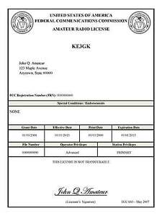*(By Anthony Luscre, K8ZT)*

As of February 17, 2015, the **FCC no longer routinely issues paper license documents** to Amateur Radio applicants and licensees. The Commission has maintained for some time now that the official Amateur Radio license authorization is the electronic record that exists in its Universal Licensing System (ULS). The FCC will continue to provide paper license documents to all licensees who notify the Commission that they prefer to receive one.

Licensees also will be able to print out an official authorization — as well as an unofficial “reference copy” — from the ULS License Manager. I’ve created a set of instructions on how you can request an **“official” printed copy of your license\***

[**Click here to download the instructions**](http://arrl-ohio.org/news/2020/print_your_license.pdf)

TOP ^

***One Question Questionnaire***

Hey Gang,

Survey Says”….. 88.35% of you who responded have HAD your COVID shot. (For full disclosure – I have had mine and I am included in that number.) Thank you to ALL who responded.

Ok, now on to the next question…

***“What Amateur Radio Activity would you most like to participate in this year as we begin to open up activities again?”***

You’ll find the “One Question” questionnaire on the Ohio Section Website! <http://arrlohio.org> It’s all for fun and it’s not a scientific survey in any way, but we are learning some things that we didn’t know from these questions. I hope that you are enjoying answering these “One Question” questionnaires.

*****V.E. Test Sessions***

Many V.E.’s have decided to start testing once again, but with restrictions that need to be adhered to for sure. Here’s the link to find that V.E. Test session and what is expected of YOU before going. <http://www.arrl.org/find-an-amateur-radio-license-exam-session>

Ohio Section Cabinet

|  |  |
| --- | --- |
| Section Manager – Tom Sly, WB8LCD | Section Traffic Manager – David Maynard, WA3EZN |
| Section Emergency Coordinator – Stan Broadway, N8BHL | Section Youth Coordinator – Anthony Luscre, K8ZT |
| Technical Coordinator – Jeff Kopcak, K8JTK | Affiliated Clubs Coordinator – Tom Sly, WB8LCD |
| State Government Liaison – Bob Winston, W2THU | Public Information Coordinator – John Ross, KD8IDJ |



Hey Gang,

Have you taken a look at the **Swap & Shop** page on the Ohio Section webpage yet?? Here’s a link that will take you there… <http://arrl-ohio.org/sm/s-s.html>

TOP ^

Do you have equipment that you just don’t need or want anymore? Here’s a great venue to advertise it, and it’s FREE!! Is your club doing a fund raiser to help raise money? After a lot of thought, it was decided that the Swap & Shop webpage could also contain these types of items as well. The same rules will apply as do for the For Sales and Give-A-Ways and will only be posted for a month at a time. Please see the Terms & Conditions on the webpage.

If your club is doing a fund raiser and wants more exposure, please forward the information to me and I’ll advertise it on the Swap & Shop webpage for you.

Now, I still want to remind you that it won’t be listed in this newsletter because it would take up way too much space, so your ad will only appear on the website. It is there for any individual to post equipment Wanted / For Sale or Give-Away as well as for Club Fund Raisers. No licensed vehicles/trailers or business advertising will be posted. Postings are text only (no pictures or graphics) will be posted for a maximum of 1 month from date posting and require a contact phone number or email within the posting. Send your Wanted / For Sale or Give-Away post to:  [swap@arrlohio.org](mailto:swap@arrlohio.org)

***Back Issues of the PostScript and Ohio Section Journal***

Hey, did you know that PostScript and Ohio Section Journal (OSJ) are archived on the website? You can go back and look at any edition simply by clicking:

<http://arrl-ohio.org/news/index.html>

***Welcome New Subscriber(s)***

**W8NET - Gene**

***Want to Share your Club Newsletter With Others?***

We have a webpage where you can download and read all of the newsletters that I get from around the state and even other sections!

Here’s the link to the page…. <http://arrl-ohio.org/club_news/index.html>

Please, if you don’t see your club newsletter posted, it’s because I’m not receiving it. Just have your newsletter editor contact me and I’ll get your club’s newsletter listed on the site!!

We all learn and steal (I mean, share) from each other’s work. So, get me your newsletter!!! Send it to: [webmaster@arrl-ohio.org](mailto:webmaster@arrl-ohio.org)

TOP ^

***Chit – Chat, and All That!***

Do you know someone that’s not getting these Newsletters? Please, forward a copy of this Newsletter over to them and have them “[Opt-In](mailto:Opt-In)” to start receiving them. Heck, just have them send an email to: [webmaster@arrl-ohio.org](mailto:webmaster@arrl-ohio.org) and we’ll get them added to the Ohio Section Emailing list.

We now have many thousands of readers receiving these newsletters weekly. Quite impressive, I’d say! I urge all of you to make sure that everyone, regardless of whether they are a League member or not, get signed up to receive these weekly Newsletters.

You can always “Opt-Out” at any time if you feel this is not what you were expecting. It’s fun and very informative. All of your favorite past newsletters are now archived too.

You can go back at any time and read them.

Just go to: <http://arrl-ohio.org/news/>

The pictures on the front page and throughout this newsletter are from various newsletters, Facebook posts and/or were sent directly to me in recent weeks. Take a good look at them, you just might be in one of the pictures! “SMILE… you’re in the Ohio Section News!!”

TOP ^

*PostScript is produced as a weekly newsletter. I want to thank everyone that has contributed articles and ideas to make this an even better news source. I sincerely hope that you have enjoyed this edition and will encourage your friends to join with you in receiving the latest news and information about the Ohio Section, and news and events happening around the world!*