[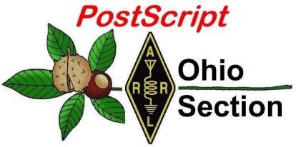](http://arrl-ohio.org/news/) ***“April 12th***

***Edition”***

🡪 National News 🡪 Club Corner

🡪 DX This Week 🡪 Contest Corner

🡪 Special Events 🡪 Upcoming Hamfests

🡪 From The South 40 🡪 Training

🡪 One Question Questionnaire 🡪 VE Testing

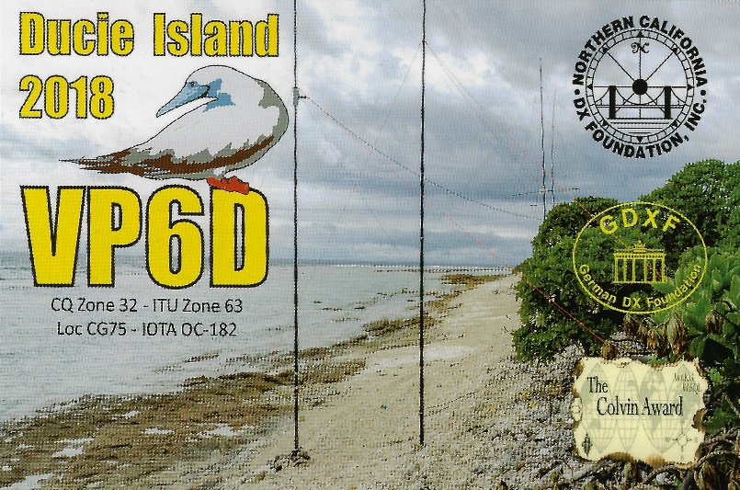

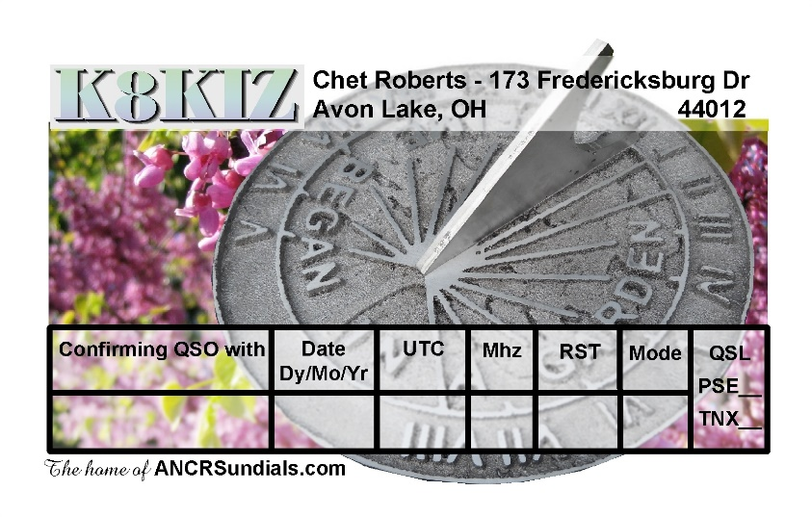

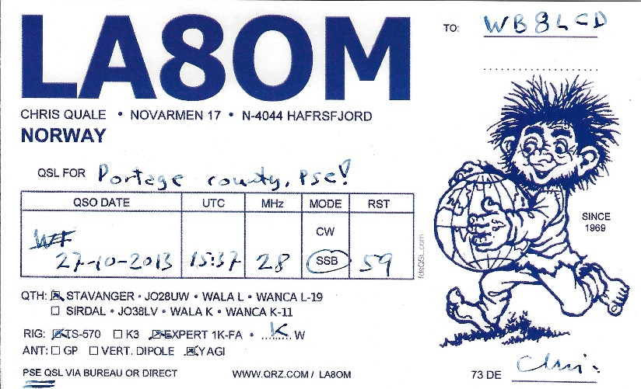

***National News***

*(from arrl and other sources)*

*3Y0J Dxpedition to Bouvet Island*

**3Y0J Dxpedition to Bouvet Island, January/February 2023**

As we completed our successful VP8STI-South Sandwich and VP8SGI-South Georgia DXpeditions in 2016, we began to plan for our next Dxpedition. Our target is the Norwegian Island Bouvet. This is the #2 most wanted DXCC entity.

At this time, it gives us great pleasure to announce that we have joined forces with Intrepid Norwegian DXpeditioner Ken Opskar-LA7GIA in our quest to activate Bouvet.

Together, in January 2023, 14 men will board the Braveheart in Capetown and make the treacherous voyage to Bouvet. We will plan to spend twenty days at Bouvet and weather permitting, we plan to have 14 to 16 good days of radio activity.

This will be an arduous and expensive mission. Our budget is $764,000 USD and the 3Y0J team will fund much of this mission. We desperately need the global DX Community to support our mission and help us make this important activation of the #2 most wanted DXCC entity. It is only through this kind of support that we can achieve our mission of making 100,000 contacts or more from Bouvet.

We plan to make best use of Propagation and Modes on 10-160 meters.

We pledge to assemble the strongest team possible and to use good operating practices to optimize your ability to reach our stations. We are confident that the Braveheart crew can get us there and back safely.

In closing, we especially wish to recognize and thank the **Northern California DX Foundation** and the**International DX Association**as our premier donors. Without the support of the **NCDXF** and **INDEXA**, operations to the world's rarest entities would not be possible. You can follow our plans from our website and the 3Y0J Facebook pages:

[http://www.3y0j.com](http://www.3y0j.com/)

<https://www.facebook.com/groups/901378553769436>

 Thank you,

Paul Ewing-N6PSE Co-Leader

Kenneth Opskar-LA7GIA Co-Leader

**INDEXA is a proud supporter of the 3Y0J DXpedition to Bouvet!**

73 - Bob Schenck, N2OO, INDEXA President

TOP ^

|  |
| --- |
|  |
|  |

*HV Activities from Michael W8CI*



|  |  |  |
| --- | --- | --- |
| |  | | --- | |  | |  |

**Hamvention Weekend Activities**

That magical weekend in May is approaching.  With no Hamvention this year, due to continuing Coronavirus restrictions, we have been developing several activities to keep Hams busy and engaged in the hobby.  We have a two day prize total of $15,000.

On Thursday May 20. 2021 the Virtual Contest University will be held starting at 9 AM EDT 1300Z. The course outline will be available soon. This will be a *free*event!

Even if you are not a contester you will learn so much about Amateur Radio and hear the techniques and critiques of many of the world’s foremost Hams.

Hamvention is a proud sponsor along with Icom and DxEngineering. Plan on attending this amazing free event!

Several Icom radios will be given away during the all-day event. You must be registered on Zoom and present online at the time of the drawing to win the radios.

Please check [http://contestuniversity.com](http://contestuniversity.com/) for updates.

On Friday May 21 Starting at 11 AM EDT 1500Z we will have the 2021 Virtual Hamvention Forums.

The Hamvention Virtual Forums celebrates the 2021 Hamvention Award winners. Each awardee will give a 45 minute presentation followed by Q&A.

The Hamvention Forums will be presented via Zoom Webinar. Registration for the Zoom Webinar will start 30 days before the event – look for the registration information on the Hamvention Website. Several Icom radios will be given away during the 2021 Hamvention Forums. The winners will be selected at random.

The winner must have registered on Zoom for Hamvention Forums and be present during the drawing to win. Drawing times are random throughout the Virtual Forums event. Thanks to Hamvention, Icom and DX Engineering for their support of the 2021 Hamvention Virtual Forums.

Our presenters are:

Technical Achievement: WX6SWW – Tamitha Mulligan Skov is well known as the “Space Weather Woman”. Folks that have seen her space weather forecasting show will freely admit that she is full of energy and excited about her work. She is a real space pioneer.

TOP ^

Special Achievement: W3WL – Wesley Lamboley was nominated by his peers for his lifetime, high energy support for the science and art of amateur radio. Not only has Wesley supported youth coaching, membership recruiting and technical problem assistance, he always does it with a smile and great humor.

Amateur of the Year: WP3R – Angel M. Vazquez is known for being one of the principal support engineers for what was one of the greatest antennas in the world – the National Science Foundation’s Arecibo parabolic dish antenna. Angel’s award stems from his unswerving and diligent support of amateur radio throughout the entire territory of Puerto Rico and extends worldwide.

Club of the Year: K4HTA -- The Vienna Wireless society was chosen this year for its 58 years of service to the amateur radio community. K4HTA with its 280 members focus on youth education, public service and promoting the overall growth of radio through the DC area and around the world.

On Saturday May 22, Participate in the Hamvention QSO Party  8 AM to 8 PM EDST  (1200 May 22 to 0000 May 23 UTC)

W8BI, the club call of the Dayton Amateur Radio Association, will be a bonus station scored at 10 points per band and mode.

Bands:  10M, 15M, 20M, 40M, 80M.  Typical call will be: CQ CQ HVQP (HamVention QSO Party) W8XX (Your call)

Typical exchange will be signal report and first year you attended Hamvention; eg on CW: KB8XXX 599 1998 W4XX

If you have never attended Hamvention, please send 2021 in place of the year.

Send your score (number of QSOs including bonus points) to [3830scores.com](http://3830scores.com/) within 5 days of the event.

You will be able to print a certificate after the contest.

####

Central Ohio Traffic Net / ARES District 7 Prepares for NVIS Day

C. Matthew Curtin, KD8TTE

How will you get a message to W8SGT and your ARES District Emergency Coordinator on NVIS Day, Saturday, April 24?

ARES operators are rightly known for being able to establish and operate field-expedient stations and operate in local nets, often used on behalf of local agencies and local public events. When the task at hand is not just to get tactical information but to provide a written report or other message to a station that is not on the local net, how is it done?

TOP ^

Central Ohio Traffic Net (COTN) is an NTS-affiliated message relay net supporting Ohio ARES District 7, which includes Franklin and all surrounding counties.

ARES District 7 stations with a message to send can simply enter COTN in operation and “list” the traffic by voice. Listing traffic is a simple procedure. Enter the net by stating your callsign, county, and saying “with traffic,” and wait for net control to answer you, after which you’ll restate your callsign and state the traffic destination and quantity. For example:

K3AUX (net control): Stations with or without traffic?

KD8TTE (station with traffic): KD8TTE Franklin County, with traffic.

KD8UUB (another station): KD8UUB Marion County, no traffic.

K3AUX: KD8UUB Roger. KD8TTE please list.

KD8TTE: This is KD8TTE with traffic W8SGT 1.

K3AUX: KD8TTE Roger. Wait. Further stations?

Net control will assign another station to make contact to KD8TTE to receive the traffic for W8SGT, where it can be relayed either to W8SGT directly or through another station or net. The station with the traffic, however, doesn’t need to worry about how to get the message all the way to W8SGT: once it has been received by the relay station, the relay station has accepted that responsibility. It’s a great example of how powerful even modest amateur stations can be when they work as part of a system.

COTN has been in regular operation since 1984 and moves messages to and from the area through liaison to NTS, independent nets, and systems such as NTSD and Winlink, operating locally by voice procedure with NTS radiograms. Lately we have also been operating with arbitrary-format messages moved via NBEMS (FLDIGI, FLMSG, etc.) It has been good practice for finding ways to get the messages through “when all else fails.”

Whether you’re in ARES District 7 and can use COTN directly or have another net that you’ll want to use in support of NVIS Day, you might be interested to see how the preparations are going to ensure that everyone can operate. Find out more at https://www.cotn.us/nvis-day/21.

***Club Corner***

This is YOUR cornner of the newsletter. Send me what your club is doing and I’ll make sure that it gets in. Got a special event or club project that you want everyone to know about? Send it to me!. Need help with a project? Send it to me.

Let me know what you club is up to. Are you going to have a special guest at your meeting or are you having a special anniversary?

Just sent it to: [webmaster@arrl-ohio.org](mailto:webmaster@arrl-ohio.org)

**Massillon ARC** Spring TailgateFest to be held at the MAPS Air Museum.  
Entrance at 5383 Massillon Road just inside the Stark/Summit County line.  
  
Date is Saturday, April 17 from 9 [a.m.to](http://a.m.to/) 4 p.m. Cost is $5 per vehicle.  
(for use of the facility)   No advance registration necessary. Bring your own tables.  
(no large trailers) No charge for visitors.

TOP ^

**OH-KY-IN** is hosting an 80m classic ARDF fox hunt next weekend, Saturday April 17th at 10:00 AM ET with setup at 9:30 AM ET at Stanbery Park in the Mount Washington neighborhood of Cincinnati.  
  
See our webpage for details -->  
<http://ohkyin.org/wp/2021/04/09/80m-ardf-practice-saturday-april-17th-at-stanbery-park/>  
  
If you're interested, please let Brian K4BRI know via email at  
[k4bribrian@gmail.com](mailto:k4bribrian@gmail.com).  
  
We hope you can make it! 73!

Hi There! I want to make sure that you’ve got Saturday, August 7th, 2021 marked on your calendar! Not only is that the day of the DXEngineering 2021 Hamfest, it’s also the day of the Great Lakes Division Conference. Details are still in the making, but I hope that you’ll put it in your plans to spend the day, and the evening with us. I’ll look forward to seeing you there. Full information to follow shortly!

73,

Tom WB8LCD

OH Section Manager

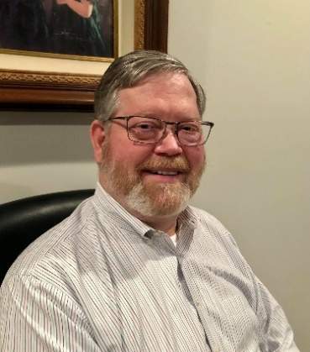**DDX This Week – CWA**

Bill AJ8B (aj8b@arrl.net, @AJ8B, or www.aj8b.com)

CWOPs Member #1567

The Midwest DX Cluster spots included Argentina, Australia, Botswana, Brazil, Canada, Ceuta & Melilla, China, Colombia, Cuba, Denmark, Ecuador, Fed. Rep. of Germany, Indonesia, Japan, Kazakhstan, Kuwait, Mali, New Zealand, Northern Ireland, Norway, Puerto Rico, Republic of Korea, St. Martin, Uruguay, US Virgin Islands, and Venezuela. This brings the total number of entities spotted in the Midwest in 2021to 160!

I hope you were able to work the A25RU group that was in Botswana. On March 28th they had eclipsed the 40,000 Q SO mark! The good news is that the team itself is not QRT but headed to Mozambique to operate as C92RU. They are scheduled to be active from 4/4/2021 through 4/13/2021. They will have to cross two borders to get to Mozambique, so nothing is certain. By the time you read this, we will know if they made it or not! Below is a note from the www.dx-world.net website, reprinted with permission of Col, MM0NDX. I am pretty sure that this is not a problem that I have ever encountered even with the hundreds of wire antennas I have put up since ’71. “A herd of animals walked by and broke the mast for the 80/160M vertical. Counterweights are in a heap. This is not the first “attack” on the low band antennas by such animals.” Keep an eye on www.dx-world.net and download the bi-weekly bulletins.

TOP ^

Speaking of DX-world.net, below is the monthly DXPedition Timeline.

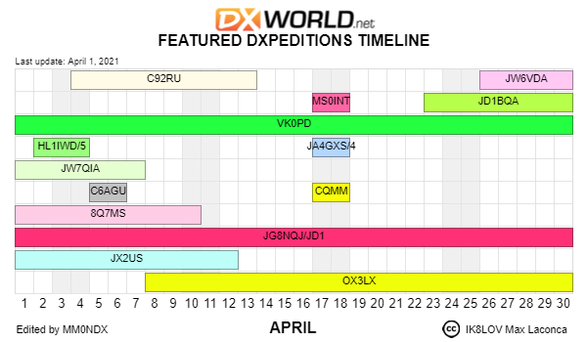

CW Academy

By Bill, AJ8B CWops ID #1567

CW Academy (CWA) is an internet-based Morse code training curriculum. CWA was formed to directly address growing problems including a lack of skilled advisors, lack of training in sending and the geographical dispersion of interested students. The solution was to organize a volunteer group of CW skilled advisors, provide training in sending AND copying and to use online video/audio conferencing for training. The results have been nothing short of amazing. We have been averaging over 80 students per semester and 80% of those complete the program. In addition, a growing number surpass the 25- wpm rate, and some become CW Academy advisors! Currently CWA is staffed by CWops and its members. There are well over 20 volunteer advisors. It is a unique training program that has three levels. The program is given three times per year with each semester lasting 8 weeks.

The 3 levels of training are broken out as Level 1 (beginners), Level 2(those with speed above 10 wpm and below 20 wpm and Level 3. (for those with speeds above 20 wpm) CWA is held three times per year – Jan-Feb, Apr -May and Sep-Oct. Each eight-week semester typically has groups of 5 students (or less) with an assigned advisor who meets ‘online’ two evenings per week for about 45 minutes per session. Level 1 spends 5 weeks learning all Morse characters, numbers, some punctuation, useful “Q” signs.

TOP ^

The remaining 3 weeks are spent doing simulated CW QSOing, contesting, and DX pile-up training.

The objective of Level 1 is to attain speeds above 10 wpm, to attain skill with QSO protocols, to get acquainted with CW contesting and DXing.

Level 2 is tailored to the aspirations of the students in each group. It stresses improved head copying skills, better sending, further training in QSOing, contesting, and DXing. The objective of level 2 is to attain speeds above 20-wpm, to attain skill with QSO protocols, to gain experience with CW contesting and DXing

Level 3 is also tailored to the aspirations of the students in each group. It stresses improved head copying skills, better sending, further training in QSOing, contesting, and DXing. The objective to Level 3 is basically the same as Level 2 but at 25 WPM and above, namely, to attain speeds above 25- wpm, to attain skill with QSO protocols, to gain experience with CW contesting and DXing. Check the cwops.org website for more information or to sign up.

***DAH DIT DIT DIT DAH DAH DIT DIT DIT DAH***

CQDX CQDX CQDX CQDX CQDX CQDX CQDX CQDX CQDX

Here is an update from Bernie, W3UR, of the DailyDX and the WeeklyDX, the best source for DX information. http://www.dailydx.com/. Bernie has this to report:

**OE – Austria -** OE130KUK, September 1 to October 30, will be the special callsign for  
the "JubilÑum 130 Jahre erster k. u. k. Telegraphistenkurs in der Franz Josef-Kaserne in Tulln."  
  
**UK – Uzbekistan -** The 5 MHz Newsletter passes word from UK9AA, Fedor, that "Category 1" Uzbek hams now have permission for 5351.5-5366.5, maximum power 100 watts.  Fedor got a special individual permit in 2014 and made his first QSO on 60 meters in 2015, apparently the first Uzbekistan activity on 60.  
  
**4X – Israel -** Israel previously had nine three-kHz channels in the 60M band between 5288.5-5407.0, 100 watts PEP max.  That is now changed to a secondary allocation, 15 kHz wide, 5351-5366.5, maximum 25 watts output.  
  
**JA – Japan -** Special callsign 8N1FT celebrates Futtsu-City's 50 years.  The operation starts today and goes through March 31 next year, 2022. They'll send out bureau cards when the whole thing is done.  They emphasize do not send your paper QSL to 8N1FT.

**T6 – Afghanistan -** W3ICM, Fred, (ex-YI3DX), has been following the T6AA activity by S53R, Robert. Robert told him by email the reason he has been so low in the

20M phone band is that "It is next to impossible to get through the EU wall above 150 and for working the 3-4 strongest US just does not make sense." Robert says the season is starting now and the band will be open to the US around 14-16 GMT and some VEs have been really strong in recent days. T6AA had been on 14102 at 1515Z with a good signal on the US East Coast.

TOP ^

ZL3IO notes a "**tool to visualize your contacts on a map**." It is developed by DL4MFM, with input to it an ADIF or Cabrillo file: http://tools.adventureradio.de/analyzer/

*DAH DIT DIT DIT DAH DAH DIT DIT DIT DAH*



Below is a list of upcoming contests in the “Contest Corner”. I think this is important for someone who is trying to move up the DXCC ladder since entities that are on the rarer side and easiest to work in contests. Some of my best “catches” have been on the Sunday afternoon of a contest when the rarer entities are begging for QSOs. Of course, the gamble is that if you wait until Sunday, conditions may change, or they simply won’t be workable. However, it is not a bad gamble. Of course, why not work the contest and have some fun!  
Check out the WA7BNM Contest Calendar page (https://www.contestcalendar.com/) for more contests or more details.

The contests in red are those that I plan to spend some significant participation time on. PLEASE let me know if you are working contests and how you fared.

|  |  |  |
| --- | --- | --- |
| Apr. 17 | ES Open HF Championship | https://esopen.eu/ |
| Apr. 17-18 | Holyland DX Contest | www.iarc.org/iarc/#HolylandContest |
| Apr. 17-18 | CQ Manchester Mineira DX Contest | www.cqmmdx.com/rules |
| Apr. 17-18 | Michigan QSO Party | www.miqp.org/index.html |
| Apr. 17-18 | Ontario QSO Party | www.va3cco.com/oqp/rules.htm |
| Apr. 17-18 | Texas State Parks on the Air | www.tspota.org |
| Apr. 17-18 | Worked All Provinces of China DX Contest | https://bit.ly/3sDGs72 |
| Apr. 17-18 | YU DX Contest | http://yudx.yu1srs.org.rs |
| Apr. 19 | ARRL Rookie Roundup, SSB | www.arrl.org/rookie-roundup |
| Apr. 21 | RSGB 80m Club Championship, SSB | http://bit.ly/3avHbk3 |
| Apr. 29 | RSGB 80m Club Championship, Data | http://bit.ly/3avHbk3 |
| Apr. 24-25 | 10-10 Spring Digital Contest | http://bit.ly/1FrFeBc |
| Apr. 24-25 | Florida QSO Party | www.floridaqsoparty.org |
| Apr. 24-25 | Helvetia Contest | www.uska.ch |
| Apr. 24-25 | SP DX RTTY Contest | www.pkrvg.org/strona,spdxrttyen.html |
| Apr. 25 | BARTG Sprint75 Contest | http://bartg.org.uk/wp/contests |
| Apr. 28 | UKEICC 80m Contests CW | https://bit.ly/2SDPqQQ |
| May 29-30 | CQWW WPX CW CONTEST | www.cqwpx.com |
| August 28 | Ohio QSO Party | https://www.ohqp.org/ |
| August 28 | W8DXCC | https://www.w8dxcc.com |

TOP ^

***DX News***



ARLD014 DX news  
  
This week's bulletin was made possible with information provided by  
The Daily DX, the OPDX Bulletin, 425 DX News, DXNL, Contest Corral  
from QST and the ARRL Contest Calendar and WA7BNM web sites.  Thanks  
to all.  
  
FIJI, 3D2.  Dom, 3Z9DX is QRV as 3D2DOM and has been active mainly on 20 meters using CW and SSB.  QSL to home call.  
  
SRI LANKA, 4S.  Nadika, 4S6NCH has been active on 17 meters using FT8 around 1800z.  QSL direct.  
  
CROATIA, 9A.  Members of the radio club Libertas are QRV with special event callsign 9A25RBM during April to commemorate the US Secretary of Commerce Ronald Harmon Brown and 34 other victims of a fatal plane crash in 1996 here.  QSL direct.  
  
MOZAMBIQUE, C9.  A group of operators are QRV as C92RU until April 12.  Activity is on 160 to 10 meters using CW, SSB and FT8 in DXpedition mode, with four stations active.  This includes activity  
on Satellite QO-100.  QSL via OQRS.  
  
PORTUGAL, CT.  Markus, DJ4EL is QRV as CT7/DJ4EL from Culatra, IOTA EU-145, until April 10.  Activity is on 40 to 10 meters using SSB.  QSL via LoTW.  
  
SOUTH SHETLAND ISLANDS. Lee, DS4NMJ is QRV as DT8A until December 31 while on work assignment from the King Se-Jong Korean Antarctic Base on King George Island, IOTA AN-010.  Activity is on various HF bands using CW, SSB and FT8 in DXpedition mode.  QSL via DS5TOS.  
  
SPAIN, EA.  Special event station EH4WRD will be QRV from April 12 to 18 while taking part in World Amateur Radio Day 2021 activities. QSL via EA4RCH.  
  
IRAN, EP.  Saeed, EP2LSH has been QRV using FT8 in DXpedition mode on 20 meters between 1645 and 2015z.  QSL via EA5GL.  
  
FRANCE, F.  Special event station TM1PSL will be QRV on April 10 and 11 from the town of Port Saint Louis du Rhone during the European FT8 DX Contest.  QSL direct.  
  
THAILAND, HS.  Jorge, AB6WP is QRV as HS0ZOK from Phuket Island, OTA AS-053.  Activity is on 20 to 10 meters using mostly SSB with some CW.  His length of stay is unknown.  QSL via LoTW.

TOP ^

JAPAN, JA.  Special event station 8J100CB is QRV until the end of March 2022 to celebrate the 100th anniversary of Chiba-City.  QSL via bureau.  
  
GREENLAND, OX.  Bo, OZ1DJJ is QRV as OX3LX from Kangerlussuaq, IOTA NA-018, until May 1.  Activity is in his spare time on the HF bands. QSL via LoTW.  
  
NETHERLANDS, PA.  Ruud, PG1R is QRV as PG96WARD from Leersum until April 30 to celebrate World Amateur Radio Day.  Activity is on the HF bands using SSB, RTTY and PSK.  QSL via PG1R.  
  
CURACAO, PJ2.  Jeff, K8ND will be QRV as PJ2ND from the Signal Point contest station from April 15 to May 3.  QSL to home call.  
  
EUROPEAN RUSSIA, UA.  Leonid, RA1WU is QRV as R800ANP until April 10 to celebrate the 800th anniversary of the birth of Alexander Nevsky, who was commonly regarded as a key figure of medieval Russia and is best known for the victory over the Teutonic Knights in the Battle  
on the Ice.  QSL via RA1WU.  
  
CANADA, VE.  Bill, VE3ES is QRV with special callsign VC3VACCINE during April to support COVID-19 vaccination efforts.  QSL to home call.  
  
THIS WEEKEND ON THE RADIO.  The Japan International DX CW Contest, NCCC RTTY Sprint, NCCC CW Sprint, K1USN Slow Speed CW Test, QRP ARCI Spring CW QSO Party, SKCC Weekend CW Sprintathon, OK/OM DX SSB Contest, European FT8 DX Contest, IG-RY World Wide RTTY Contest, DIG CW QSO Party, Nebraska QSO Party, New Mexico QSO Party, Georgia QSO  
Party, North Dakota QSO Party, Yuri Gagarin International DX CW Contest, International Vintage HF Contest, WAB 3.5/7/14 MHz Data Modes, Hungarian Straight Key CW Contest and RSGB RoLo 80-Meter SSB Contest are all on tap for this upcoming weekend.  
  
The RSGB 80-Meter Club CW Championship, OK1WC Memorial, 4 States QRP Group Second Sunday Sprint and K1USN Slow Speed Test are scheduled for April 12.  
  
The 222 MHz Spring Sprint, Worldwide Sideband Activity Contest and RTTYOPS Weeksprint are scheduled for April 13.  
  
The VHF-UHF FT8 Activity Contest, CWops Mini-CWT Test, Phone Fray and NAQCC CW Sprint are scheduled for April 14.  
  
Please see April QST, page 75, and the ARRL and WA7BNM contest web  
sites for details.

TOP ^

YOTA Announces New Three-Times-a-Year Contest

"Team YOTA" of Youngsters on the Air in IARU Region 1 has announced it will sponsor a new contest, the [YOTA Contest](https://ham-yota.com/contest). Open to all radio amateurs, it takes place three times a year and runs for just 12 hours. YOTA said the aim is to boost on-the-air activity by younger radio amateurs and to support YOTA. The contest will take place on different 12-hour windows on three Saturdays.

The opening event will be on May 22, 0800 - 1959 UTC. The other two in 2021 will be July 17, 1000 - 2159 UTC, and December 30, 1200 - 2359 UTC.

YOTA has established eight different operating categories, which include sub-categories for operators age 25 and younger, but operators of all ages may participate. Covering 80, 40, 20, 15, and 10 meters, the allowable modes will be CW and SSB.

The contest exchange will be the age of the participating operator. Different ages serve as score multipliers during the contest. Stations may work the same station once per band mode.

Contacts between the station's own continent are worth 1 point, while working DX is worth 3 points. The most points will be achieved by working the youngest operators. "The younger the operator, the more points one will get for the QSO," YOTA said.

The IARU Region 1 Youth Working Group is working with Hungary's IARU member-society MRASZ, the Hungarian Amateur Radio Society. MRASZ is providing a contest log robot, among other things.

[Submit](https://contest.ham-yota.com/) Cabrillo logs only. Contest winners will be announced once logs received have been checked in the various categories. Winners will be awarded with a YOTA Contest plaque.

The contest committee consists of the IARU Region 1 Youth Working Group: Philipp, DK6SP, chair; Markus, DL8GM, vice chair, and members Csaba, HA6PX, and Tomi, HA8RT.

[Contact](mailto:contest@ham-yota.com) the YOTA Contest Committee with any questions or further information.

***Special Events***

* **04/14/2021 | Maritime Radio Day 2021**

**Apr 14-Apr 22, 1200Z-2200Z, various**, various, GERMANY. Maritime Radio Day. CW only. Certificate & QSL. Rolf Marschner, Narzissenweg 10, 53359 Rheinbach, GERMANY. This is an operating event. Please see website for rules. [mrd.sfk-bremen.com](http://mrd.sfk-bremen.com/)

* **04/17/2021 | Celebrating the Louisiana Purchase**

**Apr 17-Apr 24, 0000Z-2359Z, W5L**, West Monroe, LA. NorthEast Louisiana Amateur Radio Club. 14.250 21.250 7.250 3.850. QSL. Jim Ragsdale, W5LA, 111 Eagle Lake Drive, West Monroe, LA 71291. <https://www.qrz.com/db/W5L>

TOP ^

* **04/17/2021 | Texas State Parks On the Air (TSPOTA)**

**Apr 17-Apr 19, 1400Z-0200Z, K5LRK**, The Colony, TX. Lake Area Amateur Radio Club. CW Phone VHF. QSL. See website, for, Information. Times are daily. K5LRK on as a special event station. Contest: Activate as many Texas parks as possible. www.k5lrk.com or [www.tspota.org](http://www.tspota.org/)

* **04/18/2021 | World Amateur Radio Day**

**Apr 18-Apr 19, 1300Z-0400Z, W7W**, Rochester, NY. W2JLD/Special event coordinator. Echolink *ROC-HAM* CONFERENCE 531091 Allstar 2585, 47620, 53130. QSL. John Derycke, W2JLD, 85 Amherst St #2, Rochester, NY 14607. This will be our 6th annual WORLD AMATEUR RADIO DAY celebration on the VOIP Echolink system We have a 16 hr net with net controllers from all over the world. A special event qsl card will be available Join us again for one of the LARGEST special events on Echolink@ 9AM EST TILL 12 MINDNIGHT EST we will have Allstar, DMR as well. [w2jld2@gmail.com](mailto:)

* **04/24/2021 | 156th Anniversary of Sultana Disaster**

**Apr 24, 1500Z-2100Z, W5S**, West Memphis, AR. AG5QY. 14.240. QSL. Marc Gwin, 1402 Stratford Drive, West Memphis, AR 72301. <https://ag5qy9.wixsite.com/ag5qy>

* **04/24/2021 | OC&E Woods Line Last Train 31st Anniversary**

**Apr 24, 1600Z-2200Z, W7VW**, Klamath Falls, OR. Klamath Basin Amateur Radio Society. 14.074. Certificate & QSL. Jim English, 2602 Wiard Street, Klamath Falls, OR 97603. The Oregon, California, and Eastern Railway (OC&E) was a 64-mile (103 km) rail line between Klamath Falls and Bly in the US state of Oregon. After 70 years of bringing logs from nearby forests to local sawmills, the former railroad right of way was converted to the OC&E Woods Line State Trail. The last OC&E log train to Bly ran on Sunday, 29 April 1990. wo7v@arrl.net or <https://www.facebook.com/kfalls.radio>

* **04/24/2021 | San Jacinto Day Special Event**

**Apr 24-Apr 25, 1400Z-2359Z, K5T**, Nacogdoches, TX. Nacogdoches Amateur Radio Club. 7.216 14.260 21.350 28.350. QSL. Army Curtis, 167 CR 2093, Nacogdoches, TX 75965. All contacts will be confirmed via LOTW [https://w5nac.com](https://w5nac.com/)

* **04/24/2021 | W1BSA Birthday of Scouting Event**

**Apr 24, 1400Z-1930Z, W1BSA**, Fall River, MA. USTNE ne1pl.org. 14.259. QSL. Rick Emord, 135 Wareham St., Middleboro, MA 02346. The USTNR group will be activating on the USS Massachusetts this year at least 4 times for the following events. Except for the Museum ships on the air event, we will be on the air by 1000 EST or 1400 utc we will be shut down at 1530 EST or 1930 utc. We have a website to see the current QSL card for the events go to ne1pl.org. Look for the ticker tape for added events. Our first event for the year will be: W1BSA April 24th On the air by 1000 off the air around 1530 This event is for the Birthday of Scouting in America. The birthday is on February 8, 1910 because of the chilly weather in February we celebrate in April. Please visit battleshipcove.org for more information about the park and its equipment. Please visit us at [ne1pl.org](http://ne1pl.org/)

* **04/24/2021 | Woronoko Heights Outdoor Adventure**

**Apr 24, 1300Z-1900Z, W1M**, Russell, MA. Western Mass. Council--BSA. 14.290 14.060 10.115 7.190. QSL. Tom Barker, 329 Faraway Road, Whitefield, NH 03598. SES operating from the Horace Moses Scout Reservation in western Mass. SASE for QSL.

TOP ^

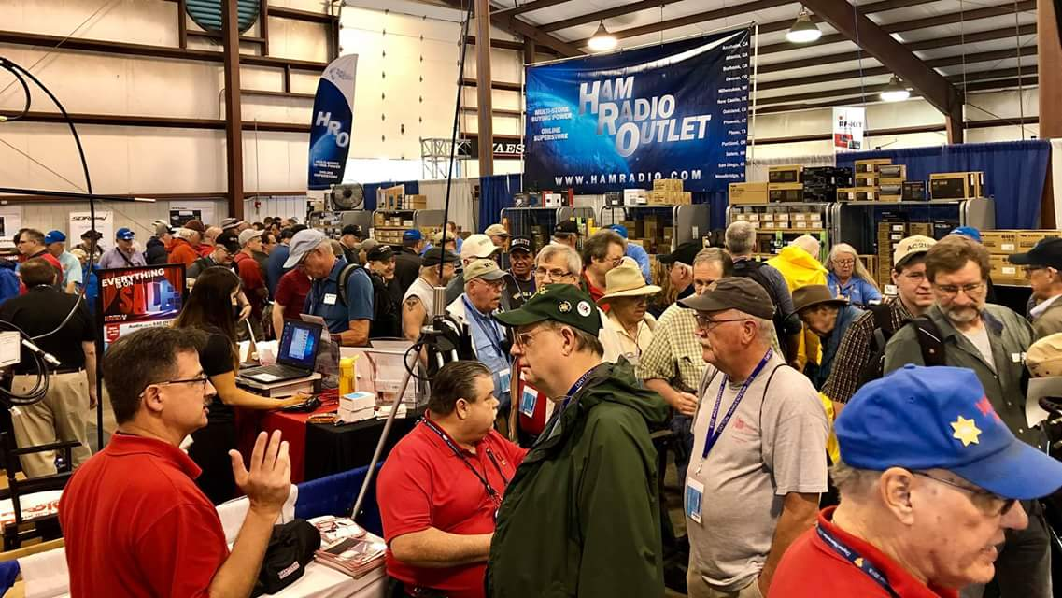[***Upcoming Hamfests***](http://arrl-ohio.org/hamfests.html)

We **DO** have some hamfests scheduled for 2021!! Yes, take a good look at the list, it’s growing every day!

Be sure to keep your eyes on this schedule as that when things start getting better and the vaccine rolls out to more and more, hamfests will surely get back to their normal schedule. Don’t see your hamfest listed?? Did anyone register it with ARRL? It’s really easy to do and you get a lot of FREE publicity if you do.

**Massillon ARC** Spring TailgateFest to be held at the MAPS Air Museum. Entrance at 5383 Massillon Road just inside the Stark/Summit County line. Date is Saturday, April 17 from 9 [a.m.to](http://a.m.to/) 4 p.m. Cost is $5 per vehicle. (for use of the facility)   No advance registration necessary. Bring your own tables. (no large trailers) No charge for visitors.

|  |  |
| --- | --- |
| **04/25/2021 -**[**Athens Hamfest**](http://www.arrl.org/hamfests/athens-hamfest-9)  *Canceled* | **06/05/2021 -**[**FCARC SummerFest**](http://www.arrl.org/hamfests/fcarc-summerfest)  Location: Wauseon, OH Sponsor: Fulton County Amateur Radio Club Website:<http://k8bxq.org/hamfest> [Learn More](http://www.arrl.org/hamfests/fcarc-summerfest) |
| **07/10/2021 - [Mansfiled Mid-Summer Trunkfest](http://www.arrl.org/hamfests/mansfiled-mid-summer-trunkfest" \o "Mansfiled Mid-Summer Trunkfest)**  Location: Mansfield, OH Sponsor: InterCity Amateur Radio Club Website:<http://iarc.club>[Learn More](http://www.arrl.org/hamfests/mansfiled-mid-summer-trunkfest) | **07/18/2021 –**[**Van Wert Hamfest**](http://www.arrl.org/hamfests/van-wert-hamfest-5)  Location: Van Wert, OH Sponsor: Van Wert Amateur Radio Club Website:[http://W8FY.ORG](http://w8fy.org/)[Learn More](http://www.arrl.org/hamfests/van-wert-hamfest-5) |

|  |  |
| --- | --- |
| **08/07/2021 -**[**DX Engineering Hamfest & Great Lakes Division Convention**](http://www.arrl.org/hamfests/dx-engineering-hamfest-1)  Location: Tallmadge, OH Sponsor: DX Engineering Website: [http://dxengineering.com](http://dxengineering.com/) [Learn More](http://www.arrl.org/hamfests/dx-engineering-hamfest-1)  TOP ^ | |
| **08/28/2021 -**[**Cincinnati Hamfest℠**](http://www.arrl.org/hamfests/cincinnati-hamfest)  Location: Owensville, OH Sponsor: Milford ARC Website: [http://CincinnatiHamfest.org](http://cincinnatihamfest.org/) [Learn More](http://www.arrl.org/hamfests/cincinnati-hamfest) | **09/26/2021 -**[**Cleveland Hamfest**](http://www.arrl.org/hamfests/cleveland-hamfest-1)  Location: Berea, OH Sponsor: Hamfest Association of Cleveland Website: [http://www.hac.org](http://www.hac.org/) [**Learn More**](http://www.arrl.org/hamfests/cleveland-hamfest-1) |
| **12/04/2021 -**[**FCARC WinterFest**](http://www.arrl.org/hamfests/fcarc-winterfest-2)  Location: Delta, OH  Sponsor: Fulton County Amateur Radio Club  Website:<http://k8bxq.org/hamfest>  [Learn More](http://www.arrl.org/hamfests/fcarc-winterfest-2) | |

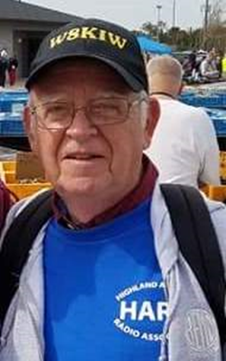

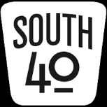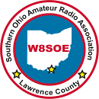Once back on to Ohio soil we make the short trip downstream to visit our friends at the Southern Ohio ARA. By most standards the club is a fairly newcomer, but what they have lacked in age they have made up with a large amount of activity and public awareness. According to Ken Massie, WN8F, Lawrence County had an early ham radio club that was more of a Civil Defense arm. That club ceased to exist in the late 60s or early 70s. The current Club came from a question when the State asked the Lawrence County EMA Director if he was taking advantage of the resources ham radio could play during an emergency in the county. Long story short, this 1990 question led to establishing a ARES/RACES organization and the Southern Ohio ARA. Soon thereafter the Club’s first 146.715 repeater was installed near Chesapeake. In addition to this repeater, the Club currently has 146.61 and 444.625 repeaters on the air. In 2005 the Club received the W8SOE call sign standing for:

W 8 Southern Ohio Emergency.

Information Officer Michael Love, WB8YKS states Ironton has the honor of holding America’s oldest running Memorial Day Parade and an outstanding Lions Club sponsored Christmas parade for which SOARA has provided communications to each for many years. According to Love the Club has an ongoing public awareness program which includes talks at local libraries, a billboard along US 52 and signs at the county line and past involvement with the Ohio Covered Bridge and Ohio Courthouse special events. They are also one of the more recent ARRL honored Special Services Club. We could have spent more time with the SOARA folks, but we

must get back on the road if we want to visit our next club. The next stop is into neighboring Scioto County and the crew at N8QA.

In a past column, we told of the Clinton County ARA’s exhibit station at a large flea market near Wilmington. Since that column was published, we understand the CCARA website indicates that partnership has ended, and the Club has removed the equipment and antennas from the property.

TOP ^

Two area clubs will hold their meetings this coming Tuesday evening, April 13. The DeForest ARC will hold its meeting over the air on the Cherry Fork 147.00 machine starting at 7 pm according to Club President Kim Paquette, N8YWX. If the weather cooperates, the Highland ARA will hold their meeting at Hillsboro’s Liberty Park Harmony Lake shelter house. Should the weather not cooperate, the meeting will be over the linked 146.685 and 147.21 repeaters.

OSJ reader and Highland County native Chris Colliver, WO8USA, is requesting assistance trying to locate people that knew the late Bill Geary, KA8FLX. Geary was one of the folks who got Chris interested in radio when Chris was a teen. That interest led to his later obtaining a degree in electrical engineering. Besides being an active ham, Geary was a well-known voice from 11 meters as ‘Turkey Bill’. Colliver is trying to document this now Silent Key and seriously wounded WWll veteran. He believes Geary moved to Highland County from Indiana in the 70s and lived in Hillsboro until his passing. Colliver can be contacted through his QRZ page.

 Because of the forthcoming license fees, the amount of interest in obtaining a ham license has increased. Upcoming license testing opportunities will be held in Circleville and Hillsboro this coming Saturday, April 17. Then on April 25 the Athens County ARA will conduct an ARRL session in Athens. On May 3 the Portsmouth RC will hold a Laurel session in Portsmouth. The Lancaster Fairfield County ARA will hold a test on May 11. More information on each can be obtained by a visit to the license testing section of this Ohio Section Journal or statewide information is available at www.arrl.org.

 Highland ARA Brunch Bunch Net Control Ken Lightner, KE8JEL, states the first physical face to face gathering was held at a Hillsboro park on Saturday morning with 19 in attendance. The attendance indicated the member’s desire to get things back to a ‘new normal’. Previously the Brunch Bunch met monthly at a local restaurant, but Lightner said it appears the members enjoy meeting at the park when the weather permits. “Over the air meetings are OK, but nothing like being able to look the person you are talking to in the face!”

Bill Hopstettler, W8LGX, reminds us March marked the restart of the Hocking Valley ARC’s monthly Fox Hunt. The next Hunt will take place on Saturday, April 17. Folks wishing to participate may start from anywhere in Hocking County but first need to check in on the W8LGN 147.345 repeater between 9:45 and 10 am. The event will move to simplex at 10. The event concludes at 1 pm.

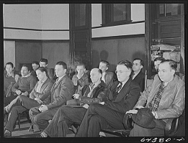As we continue on our adventure to visit as many Southern Ohio area amateur radio clubs as we can, we leave Lawrence County and enter Scioto County and the river city of Portsmouth. The County is known for being the boyhood home of Roy Rogers and the City for its outstanding Flood Wall Murals as well as the original home of the now Detroit Lions football team. The Murals by themselves are well worth a visit to the community. Additionally, there are a couple of well-known places to grab a steak or ribs or a brew from Ohio’s oldest brewery. But this stop is to visit the Portsmouth Radio Club. Throughout the region the Club is known as the host of an annual hamfest that originally started at a local fire hall but later moved to Portsmouth’s old National Guard Armory. They are also well known for an annual Christmas Party and auction that will leave you laughing and perhaps with a little less money than you had when you came through the door. Although the pandemic played havoc with each in 2020, expect them back this year. Jennifer Bailey, N8JEN, is currently working on the history of the Club. She says it was founded in 1939 and probably the result of the Ohio River Flood that hit the community hard. The Club has been an ARRL member since 1949 and is a Special Service Club honoree.

TOP ^

The Club’s mission statement is “to provide individuals who have an interest in amateur radio a means of learning, cooperating and exchanging information in various ways, all in a social setting”. The PRC has a very active VE team and provides test opportunities monthly. Not only does Jerry Lockhart, W8HIC, lead the local team, but he also conducts monthly exams for the neighboring Southern Ohio ARA. Jerry is also a Regional Manager for the national Laurel VE organization. Almost every evening at 8 pm you will find a net in operation on the Club’s 146.39 repeater, and it is often linked to other Ohio Valley machines. The Club is also active during Field Day weekend and usually activates nearby Shawnee State Park each September during the Ohio State Parks on the Air. They were also participants in past Covered Bridges on the Air and Ohio Courthouses events as well as the Ohio QSO Party. For a number of years, they handled communications for the Southern leg of the annual Tour of the Scioto River Valley bicycle rally.

As we wrap up our visit, we will agree the Portsmouth Radio Club carries out its mission 100%. Plus they are an enjoyable and good group of people to be around. A special thanks goes to Jennifer and Jerry for their assistance. Now after a quick view of the murals and indulging oneself at one of the mentioned eating establishments, it’s back on the road with our sights up US 23 and Ross County.

Until our paths cross next time, here’s wishing you all to be healthy, safe and enjoying this Springtime weather. However, in the meantime please take a few moments to spend a bit of time on the radio. Let’s keep our bands and local repeaters active.

***Upcoming Training Opportunities***

Need to get those really hard to get NIMS ICS 300 and 400 classes to get to Level 3? They are now being offered with very limited virtual seating. Yes, these classes are being offered virtually now along with a lot of other classes that used to require in-class sessions. Want to see what and where these classes are being offered?

[**>> Click Here <<**](http://arrl-ohio.org/SEC/Ohio_EMA_Training_List_Feb_2021.pdf)

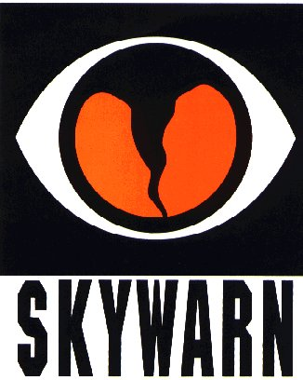***SKYWARN TRAINING***

The National Weather Service will not be able to conduct in person spotter training classes this winter and spring due to restrictions associated with COVID. Therefore, a number of field offices will be hold “virtual” spotter training classes. These classes will be open to the public and free of charge. Please feel free to promote to your staff, spotters, amateur radio operators and to publicize to the citizens in your community.

Since the Ohio Section is served by multiple NWS offices, listing all of the training opportunities for each of these offices would take a large amount of space and become very confusing. So, instead of trying to list the training, it would be better for you to choose which office you prefer to acquire your training from by providing you with a link to the offices surrounding Ohio <http://arrl-ohio.org/SEC/skywarn.html>

TOP ^

***Print an Official or Unofficial Copy of Your Amateur Radio License***

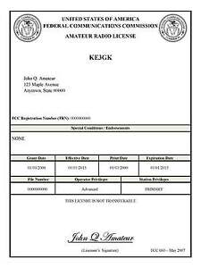*(By Anthony Luscre, K8ZT)*

As of February 17, 2015, the **FCC no longer routinely issues paper license documents** to Amateur Radio applicants and licensees. The Commission has maintained for some time now that the official Amateur Radio license authorization is the electronic record that exists in its Universal Licensing System (ULS). The FCC will continue to provide paper license documents to all licensees who notify the Commission that they prefer to receive one.

Licensees also will be able to print out an official authorization — as well as an unofficial “reference copy” — from the ULS License Manager. I’ve created a set of instructions on how you can request an **“official” printed copy of your license\***

[**Click here to download the instructions**](http://arrl-ohio.org/news/2020/print_your_license.pdf)

***One Question Questionnaire***

Hey Gang,

Survey Says”….. Just about 40% of you have your WAS Award and about 60% of you don’t. Two things to consider: We’re on the upswing of the sunspot cycle – HF is going to get a lot better, up to and including 10 and 6 meters! You should be able to get it even if you only have a Technician class license. AND – It’s not that tough to get your General class ticket – make plans to get that studying done and take the exam!

Ok, now on to the next question… ***DISCLAIMER – I do not have any motive for asking this other than curiosity, this information will have no purpose other than satisfying that curiosity …***

***“Have you had the COVID-19 vaccination yet?”***

You’ll find the “One Question” questionnaire on the Ohio Section Website! <http://arrlohio.org> It’s all for fun and it’s not a scientific survey in any way, but we are learning some things that we didn’t know from these questions. I hope that you are enjoying answering these “One Question” questionnaires.

*****V.E. Test Sessions***

Many V.E.’s have decided to start testing once again, but with restrictions that need to be adhered to for sure. Here’s the link to find that V.E. Test session and what is expected of YOU before going. <http://www.arrl.org/find-an-amateur-radio-license-exam-session>

TOP ^

Ohio Section Cabinet

|  |  |
| --- | --- |
| Section Manager – Tom Sly, WB8LCD | Section Traffic Manager – David Maynard, WA3EZN |
| Section Emergency Coordinator – Stan Broadway, N8BHL | Section Youth Coordinator – Anthony Lascre, K8ZT |
| Technical Coordinator – Jeff Kopcak, K8JTK | Affiliated Clubs Coordinator – Tom Sly, WB8LCD |
| State Government Liaison – Bob Winston, W2THU | Public Information Coordinator – John Ross, KD8IDJ |



Hey Gang,

Have you taken a look at the **Swap & Shop** page on the Ohio Section webpage yet?? Here’s a link that will take you there… <http://arrl-ohio.org/sm/s-s.html>

Do you have equipment that you just don’t need or want anymore? Here’s a great venue to advertise it, and it’s FREE!! Is your club doing a fund raiser to help raise money? After a lot of thought, it was decided that the Swap & Shop webpage could also contain these types of items as well. The same rules will apply as do for the For Sales and Give-A-Ways and will only be posted for a month at a time. Please see the Terms & Conditions on the webpage.

If your club is doing a fund raiser and wants more exposure, please forward the information to me and I’ll advertise it on the Swap & Shop webpage for you.

Now, I still want to remind you that it won’t be listed in this newsletter because it would take up way too much space, so your ad will only appear on the website. It is there for any individual to post equipment Wanted / For Sale or Give-Away as well as for Club Fund Raisers. No licensed vehicles/trailers or business advertising will be posted. Postings are text only (no pictures or graphics) will be posted for a maximum of 1 month from date posting and require a contact phone number or email within the posting. Send your Wanted / For Sale or Give-Away post to:  [swap@arrlohio.org](mailto:swap@arrlohio.org)

***Back Issues of the PostScript and Ohio Section Journal***

Hey, did you know that PostScript and Ohio Section Journal (OSJ) are archived on the website? You can go back and look at any edition simply by clicking:

<http://arrl-ohio.org/news/index.html>

***Want to Share your Club Newsletter With Others?***



We have a webpage where you can download and read all of the newsletters that I get from around the state and even other sections!

Here’s the link to the page…. <http://arrl-ohio.org/club_news/index.html>

TOP ^

Please, if you don’t see your club newsletter posted, it’s because I’m not receiving it. Just have your newsletter editor contact me and I’ll get your club’s newsletter listed on the site!!

We all learn and steal (I mean, share) from each other’s work. So, get me your newsletter!!! Send it to: [webmaster@arrl-ohio.org](mailto:webmaster@arrl-ohio.org)

***Chit – Chat, and All That!***

Do you know someone that’s not getting these Newsletters? Please, forward a copy of this Newsletter over to them and have them “[Opt-In](mailto:Opt-In)” to start receiving them. Heck, just have them send an email to: [webmaster@arrl-ohio.org](mailto:webmaster@arrl-ohio.org) and we’ll get them added to the Ohio Section Emailing list.

We now have many thousands of readers receiving these newsletters weekly. Quite impressive, I’d say! I urge all of you to make sure that everyone, regardless of whether they are a League member or not, get signed up to receive these weekly Newsletters.

You can always “Opt-Out” at any time if you feel this is not what you were expecting. It’s fun and very informative. All of your favorite past newsletters are now archived too.

You can go back at any time and read them.

Just go to: <http://arrl-ohio.org/news/>

The pictures on the front page and throughout this newsletter are from various newsletters, Facebook posts and/or were sent directly to me in recent weeks. Take a good look at them, you just might be in one of the pictures! “SMILE… you’re in the Ohio Section News!!”

TOP ^

*PostScript is produced as a weekly newsletter. I want to thank everyone that has contributed articles and ideas to make this an even better news source. I sincerely hope that you have enjoyed this edition and will encourage your friends to join with you in receiving the latest news and information about the Ohio Section, and news and events happening around the world!*