[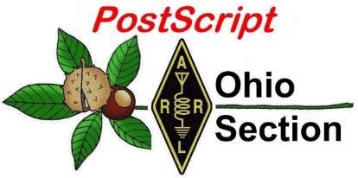](http://arrl-ohio.org/news/) ***“Easter***

***Edition”***

🡪 National News 🡪 Club Corner

🡪 DX This Week 🡪 Contest Corner

🡪 Special Events 🡪 Upcoming Hamfests

🡪 From The South 40 🡪 One Question Questionnaire

🡪 VE Testing

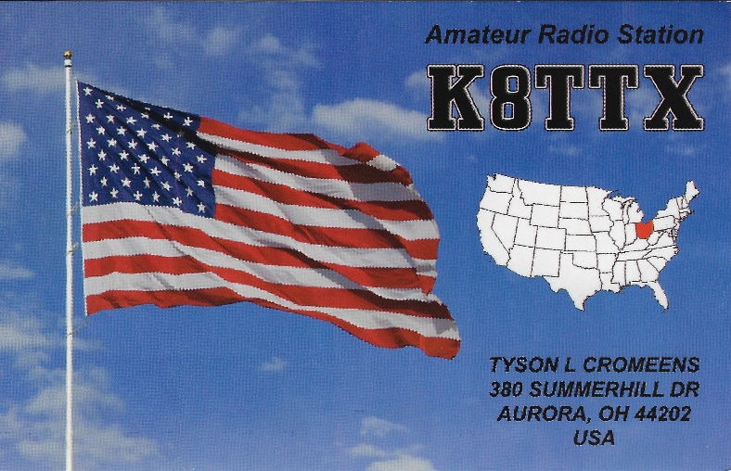 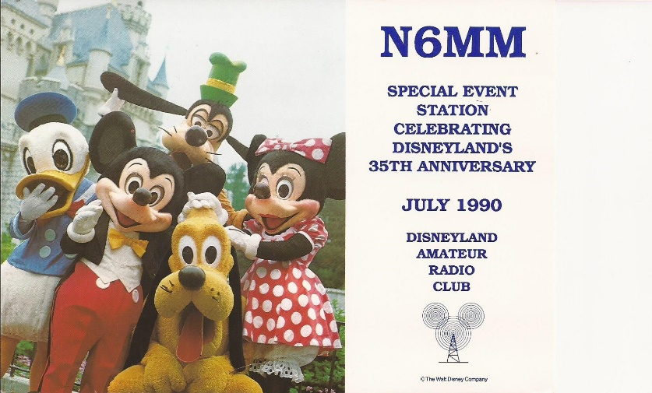

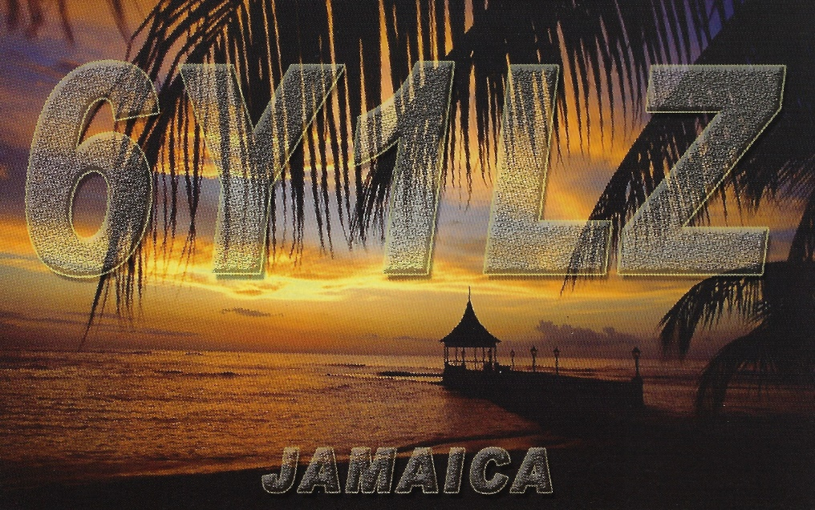

***National News***

*(from arrl and other sources)*

***New EchoLink Version Announced***

Thanks for using EchoLink!  
  
We wanted to let you know that a new version of EchoLink for Windows is now available, and you are encouraged to upgrade.  
  
Version 2.1.109 is now available for download from the EchoLink Web site ([www.echolink.org](http://www.echolink.org/)). This version supports Windows Vista, Windows 7, Windows 8/8.1, and Windows 10.  
  
This is first new Windows edition in many years, and it includes a number of updates and new features, including a Call CQ function that makes it easier to find a QSO (from both Single User and Sysop nodes), signficantly better audio quality, and automatic Public Proxy selection. For the full changelog, please see [echolink.org/news.htm](http://echolink.org/news.htm) .  
  
If you decide to upgrade, there is no need to un-install the existing version; the new installer will save your existing settings and automatically apply them to the updated software.

####

***Several satellites operating in bands allocated to the Amateur Satellite Service went into orbit on March 22.***

Most have been coordinated by the International Amateur Radio Union (IARU) Satellite Frequency Coordination Panel. They include BeeSats -5, -6, -7, and -8; FEES; SMOG; GRBAlpha; KSU Cubesat; DIY-1; STECCO; CubeSX-HSE; CubeSX-Sirius-HSE; Orbicraft-Zorkiy, and NanoSatC-BR2. Operating in Amateur Satellite spectrum without IARU frequency coordination is KMSL. Additional satellites may follow. The IARU Satellite Frequency Coordination Panel has declined coordination for UNISAT-7 and WildTrackCube-Simba. It's reported that the UNISAT-7 platform has deployed DIY-1 - Arduiqube, which is coordinated. [Further information](http://amsat.org.uk/iaru/), including IARU-coordinated frequencies, is on the IARU Amateur Satellite Frequency Coordination page.*-- Thanks to* AMSAT News Service

####

***Celebrate World Amateur Radio Day 2021 on April 18***

Sunday, April 18, is World Amateur Radio Day ([WARD](https://www.iaru.org/on-the-air/world-amateur-radio-day/)), with this year marking the 96th anniversary of the International Amateur Radio Union ( [IARU](http://www.iaru.org/)), which was founded at the 1925 International Radiotelegraph Conference in Paris. ARRL cofounder and first president Hiram Percy Maxim, 1AW, was there, and today ARRL is the International Secretariat of the IARU. ARRL has [resources](http://www.arrl.org/world-amateur-radio-day) members can use to celebrate World Amateur Radio Day, including graphics for social media posts and radio club websites, as well as a printable flyer.

IARU has chosen "Amateur Radio: Home but Never Alone" as the theme for World Amateur Radio Day 2021.

TOP ^

|  |
| --- |
| **ARRL member Anne Frank, KD9LRB, of Deer Park, Wisconsin, is featured on ARRL's World Amateur Radio Day poster.** |

The theme acknowledges that during our physical distancing to reduce the spread of COVID-19, amateur radio stands out as a welcome respite for its variety of activities and opportunities.

Amateur radio experimenters were the first to discover that the HF spectrum was not the wasteland experts of the time considered it to be, but a resource that could support worldwide communication. In the rush to use these shorter wavelengths, amateur radio was "in grave danger of being pushed aside," IARU history has noted, prompting the founding of the IARU. At the 1927 International Radiotelegraph Conference, amateur radio gained allocations still recognized today -- 160, 80, 40, 20, and 10 meters. Over the years, the IARU has worked to defend those allocations and to give all radio amateurs new bands at 136 kHz, 472 kHz, 5 MHz, 10 MHz, 18 MHz, 24 MHz, and 50 MHz.

The 25 countries that formed the IARU in 1925 have grown to include more than 160 member-societies in three regions. The International Telecommunication Union ( [ITU](https://www.itu.int/en/Pages/default.aspx)) has recognized the IARU as representing the interests of amateur radio.

On World Amateur Radio Day, all radio amateurs are invited to take to the airwaves to share global goodwill with other amateurs. ARRL encourages members to promote the value of amateur radio to family and friends, and in their communities. Many volunteer ARRL Public Information Officers and Public Information Coordinators throughout the US use the run-up to WARD as an opportunity to reach out to the media to share information about amateur radio.

"The amateur radio community has a great story to tell on the occasion of World Amateur Radio Day," ARRL Product Development Manager Bob Inderbitzen, NQ1R, said. "While the pandemic has kept many of us at home, radio amateurs have still been able to get on the air."

"Over the last year, many ARRL-affiliated radio clubs and in-person ham radio events have moved their group activities online. This has helped to keep radio amateurs active and involved in the common pursuit of skill, service, and discovery in radio communication and radio technology," Inderbitzen added.

Coincidentally, the SSB running of the [ARRL Rookie Roundup](http://www.arrl.org/rookie-roundup) falls on World Amateur Radio Day (1800 - 2359 UTC). The event is aimed at hams licensed for 3 years or less. Take the opportunity to wish participants "Happy World Amateur Radio Day 2021" on the air. Read [an expanded version](http://www.arrl.org/news/celebrate-world-amateur-radio-day-2021-on-april-18).

**Some WARD 2021 Activities Around the Globe**

* Bahrain: The Bahrain Amateur Radio Society will operate A91WARD April 14 - 18, 2021 using SSB, FT8, and DMR modes.
* Canada: Radio Amateurs of Canada are sponsoring a "[Get on the Air on World Amateur Radio Day](http://www.rac.ca/ward2021/)" special event.
* Germany: The Deutscher Amateur Radio Club is operating DA21WARD for World Amateur Radio Day through June 30. World Amateur Radio Day is April 18. WSL to DK5ON.
* New Jersey: The Fair Lawn (New Jersey) Amateur Radio Club will operate club station W2NPT on CW and phone throughout the day on April 18. In support of the theme of this year's event, the operators will share information about the Health and Welfare Net that the club is running during the pandemic.
* Alabama: The Disaster Communication Action Team will operate club station KD1CAT on April 18 in support of World Amateur Radio Day. Operation will be on all HF bands.

TOP ^

* VOIP/ECHOLINK *ROC-HAM* Conference node #531091, April 18 - 19, 1300 -- 0500 UTC via VOIP/ECHOLINK *ROC-HAM* Conference node #531091/Allstar #2585. W2JLD, VO1UKZ, GW8SZL, 2W0KYH will be net controllers. All stations from around the world are encouraged to check in. A QSL card will be available via SASE.

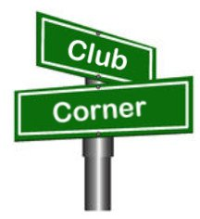***Club Corner***

This is YOUR cornner of the newsletter. Send me what your club is doing and I’ll make sure that it gets in. Got a special event or club project that you want everyone to know about? Send it to me!. Need help with a project? Send it to me.

Let me know what you club is up to. Are you going to have a special guest at your meeting or are you having a special anniversary?

Just sent it to: [webmaster@arrl-ohio.org](mailto:webmaster@arrl-ohio.org)

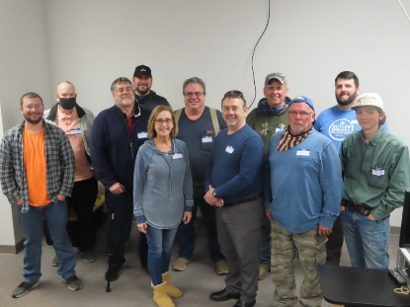***Highland ARA Technician Class***

Following their March “Introduction to Amateur Radio” program, the Highland ARA has a whole class full of students working towards their Techincian class Amateur Radio License. Good luck to all!

***Online Licensing / Upgrade Prep Offered***

Ham radio licensing: here’s a new approach using videoconference. The OHKYIN and QCEN clubs are collaborating to offer tutorials for test prep. The process will combine self-study (textbook) and prepared videos (YouTube) with tutorial sessions by local hams who will answer questions, clarify materials, and point out important concepts to help you successfully pass that exam. Sessions for Technician, General class and Extra class will be available. The plan is to meet on Monday evenings from mid-April to early May. A VE session will be planned for an outdoor (but covered) location using “social distancing” on May 22nd.

To sign up, or to get more information, send an email to hamtutor@ohkyin.org.

***Geauga Amateur Radio Association Technician Class Starting April 8th***

Beginning April 8th at 7:00PM – It will run for 6 total Thursdays on ZOOM. Anyone interested in getting their license is welcome to participate. For more information go to: [https://geaugaara.org/classes/technician/](https://geaugaara.org/crm?civiwp=CiviCRM&q=civicrm/mailing/url&u=335&qid=6316)

***OHIO ARES NVIS Day – April 24***

It’s coming! Ohio NVIS Day 2021 will be held April 24, Saturday, from 10AM until 4PM EDT.

The purpose of NVIS day is to construct and try various antenna ideas, all working as NVIS (Near Vertical Incident Skywave) antennas. These antennas are low to the ground and provide coverage generally within a 400 mile radius- extremely important for regional HF communications in an emergency.

TOP ^

This year, we take a big step forward and build upon the concept to answer the question, “How would we actually use these antennas?”

For 2021, we have added a couple operating scenarios that will make your day more fun and be a learning event for actual disaster communications. We propose a commercial power blackout, with the need to communicate within your ARES district and to ‘The Sarge” at the Ohio EOC in Columbus. Here’s the deal:

1. The event runs from 10 AM until 4 PM local time.
2. Stations will construct and test NVIS antennas.
3. Transmit power is limited to 100 watts.
4. Power for the station will be any form of “off-grid” supply: typically generator, battery or solar or whatever form you might have in an emergency setup.
5. Stations may test antenna coverage as in the past by contacting as many different locations as possible.
6. Stations will originate a message to their ARES District net and to W8SGT reporting their location.
   1. This message may take any form: ARRL message form or any other can be used, doesn’t matter. If you’re going to use the traffic system, ARRL message form is recommended.
   2. The message should contain the call sign, operating location (include county) and number of operators. Any other brief antenna information is optional but appreciated!
   3. Contact with the District net may take place on VHF or HF (Repeaters OK).
7. Operating frequencies are proposed to be in the 80 and 40 meter bands. Voice is preferred for testing. Digital messages may be passed to OHDEN or Buckeye Net as available.
   1. Optimum frequencies centered around but not limited to: 3.902 and 7.240
   2. Digital OHDEN frequency: 3585 (typical is Olivia 8/500)
   3. If additional exercise is desired, try 60 meters, Channel 5493.5 for voice and digital

You can create your own log (Excel preferred) or use the attached format.

( <http://arrl-ohio.org/SEC/nvis/NVIS%20Day%20scorecard%20(2).pdf> )

Be sure to include a photo of your group or your antenna! Submit your results to contest@k8es.org

Have fun! Take a lunch break! I hope to hear you!!

***Buckeye Net Mixed Operating In Support of NVIS Day 24***

C. Matthew Curtin, KD8TTE

I hope you’ll be on the air on Saturday, April 24. This year’s NVIS Day is a big step forward. For the past few years we’ve built field-expedient antenna systems and compared performance to understand which configurations work best for the task at hand and in the conditions we find ourselves. Reliable emergency communication requires this, but that’s not the entire problem.

Our Section Emergency Coordinator Stan Broadway N8BHL set forth a few additional goals for this year, including one that is application-oriented, and important for us to test and to demonstrate capability that served agencies need to see to rely on us: getting a message from one point to a specific other point.

TOP ^

Goal 5 is “Send a message to W8SGT,” in which participants indicate callsign in operation, location, antenna type, and number of operators. Neither format nor mode matter as long as they get the job done, and of course the message handling takes place by NVIS. No Internet, no mobile phones. It is NVIS Day, after all. The point is to show not just that we can make random contacts but that we can get a specific task done.

Buckeye Net Mixed will be operating on NVIS Day. In our mixed-mode configuration, we’re able to take messages by voice, CW, NBEMS, and even through Winlink, and can do so in any format. For the past ten months we’ve been in regular operation, and since November, we’ve operated every day of the year.

Even if you aren’t sure how to originate a message, you can enter the Buckeye Net and say you want to send a message to W8SGT but you want help originating it. Net control will send you with an experienced operator to another channel where you can talk through the process, either learning how to originate the message yourself, or just giving the critical information to the experienced operator to originate for you.

To get the most out of the operation, you’ll want to prepare well ahead of time and join at least a few of the daily sessions to practice. If you’ve got the FLDIGI, FLAMP, and FLMSG applications working on HF, you’ll be able to follow all of the action and handle messages yourself.

See our current training slide deck and demonstration video at https://www.blackswancomex.org/2021/prepare.

I look forward to working with you on NVIS Day, April 24!

***May 8th Red Cross Exercise Update***

To: Ohio ARES District 8 ECs, AECs, others interested  
Fr: Ted (W8KVK Athens Co.) and Ray (KB8GUN Hocking Co.)  
Dt: March 26, 2021  
Re: May 8 Red Cross Winlink Exercise Update  
  
*** Please Forward/Share if/as appropriate ***  
  
Planning for this event continues to pick up speed, including another successful ARC Winlink practice/training session on March 11, which attracted 470 checkins andparticipation by 8 ARC Clearinghouses.  Interestingand useful participation analytics map at:  
  
<https://www.qsl.net/kw4shp/ARES-ARC-Ex/WinlinkMap.html>  
  
We continue to encourage any Ohio ARES District 8 stations of any license class to monitor this planning by joining the other 1,727 subscribers on the ARC EmComm Training .io group,  
which is for announcements and information concerning the nationwide ARES/ARC Winlink training drills and exercises:  
  
<https://arc-emcomm-training.groups.io/g/main>  
  
Operators seriously interested in participating, and who do not already have a (free) Winlink account, should get set up soon.

TOP ^

There is a bit of a learning curve, and you will not be able to try to do this at the last minute. Although we encourage "over the air" (HF or VHF) Winlink capability for the upcoming exercise, use of the included Telnet (internet) software, ARC Forms, and messaging library is acceptable.  
  
Winlink Global Radio Email...  
  
...is a network of amateur radio and authorized government-licensed stations that provides worldwide  
radio email using radio pathways where the internet is not present.  (eg: recent Texas ice storm):  
  
<https://winlink.org/>  
  
UPCOMING DATES OF NOTE:  
  
April 08 - Next Exercise Winlink practice/training session  
            Details and your 'homework assignment' via your  
             Groups.io subscription.  
April 22 - (tentative) April Exercise Planning conference call  
May 08 - - EXERCISE 9am-4pm - Individual exercise segments,  
             with most Amateur Radio operations in the afternoon.  
  
CLARIFICATION/DISCLAIMER: Although this is being incorrectly referred to as a "Red Cross" exercise, it is actually a nationwide "Amateur Radio" EmComm/AuxComm exercise, not  
'officially' organized or sponsored by the American Red Cross. One of the goals is to demonstrate Amateur Radio and Winlink capabilities to the American Red Cross, especially in the  
aftermath of the Texas ice storms disaster. ARC does plan to 'participate' based on available ARC resources at the time.  
  
Thank you for your interest and support.  
73 for now,...

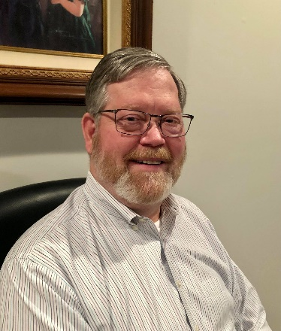***DX This Week – CWOps***

***Bill AJ8B (aj8b@arrl.net, @AJ8B, or www.aj8b.com)***

***CWOPs Member #1567***

The Midwest DX Cluster spots included Alaska, Bahrain, Belgium, Botswana, Bulgaria, Canada, Cuba, Dodecanese, England, France, Ghana, Guadeloupe, Indonesia, Isle of Man, Italy, Kuwait, Mongolia, Netherlands, New Zealand, Sardinia, Serbia, Sint Maarten, St. Helena, St. Martin, Thailand, US Virgin Islands, West Malaysia, and Zambia. This brings the total number of entities spotted in the Midwest in 2021to 160!

TOP ^

I received an email last week asking about the spots that I list each week as well as the total countries that have been spotted. I get asked this a couple of times a year so I thought I would update you on my thought process. A lot of hams think that DXCC is very difficult to achieve, you have to have elaborate equipment and a lot of aluminum in the air.

I like to point out the countries that have been spotted to encourage budding DXers to pursue DXCC because it can be done with modest equipment and limited antennas. However, the one thing that you can’t skimp on is “time in the chair”. You must be at the rig listening! As you can see, there have been at least 160 different entities spotted already this year. Historically, there will be around 270 or so by the end of the year depending on travel restrictions. There are plenty of fish and the sea you just need to cast!

|  |
| --- |
|  |

***DAH DIT DIT DIT DAH DAH DIT DIT DIT DAH***

|  |  |  |
| --- | --- | --- |
| I received cards from VA3BXG – Robert in Toronto, 9J2BS – Jerry in Zambia. Let me know what you received.   |  |  | | --- | --- | |  |  | |
|  |

***DAH DIT DIT DIT DAH DAH DIT DIT DIT DAH***

CWOps Club - Many of us feared that with the advent of the “No Code” requirement in 2007, CW would start to fade as a medium for communication. However, in reviewing the number of logs submitted for the CQWW CW contest since 2007, we learn that while amateur radio licenses have increased 10.7%, log submission has increased EIGHTY-TWO percent! SSB Log submission also increased but by only 49.5% in the same time frame. Something was going on!

(From www.CWOPS.org – They can say it better than me)

“In late 2009 a small group of CW operators – ragchewers, contesters, and DXers – began talking about founding a new club. As these operators were from all three ITU regions, they decided from the outset that this club, unlike many, would be an international club from day one.

The CW Operators Club (CWops) was launched in January 2010. During those three years, the club grew from a handful, to a few hundred, to over 1000 members in over 70 countries. CWops, from the outset, was meant to be inclusive.

TOP ^

Whether your preference was using CW for ragchewing, contesting or chasing DX, you would find kindred spirits among the club's members.

At first, we established monthly on-air activities (CWTs), but today CWTs are held weekly on Wednesday. There are three 60-minute sessions each Wednesday at times that favor different geographic areas. By 2011, we had also crafted a worldwide CW contest with many novel features (CW Open). The goal has been to stimulate worldwide weekly CW activity and to conduct an annual contest that could be won on a single band using modest power and wire antennas with a time commitment of only four hours! These events are open to CW operators whether members of the club or not.

We realized that there were a lot of hams who wanted to explore the joys of CW operating but felt overwhelmed. Some of them knew Morse but were only able to copy and send at low speeds. Others had not yet learned 'the code,' but were intrigued by the mode and sought ways to learn and practice it. In response to this demand, CWops created CW Academy in 2012, which uses a developed curriculum, proven method of teaching and Skype for a virtual classroom to teach Morse Code.

We truly believe that CW is far more than a nostalgic throwback to the early days of ham radio. It has relevance in many ways to our desire to do things that not everyone else can do; and to provide an efficient, effective mode for communicating with others around the globe. We invite you to explore our Website; to participate in our on-air activities; or if your goal is to learn or improve CW skills, to sign up for CW Academy and join the hundreds of hams who have already done so.”

There is a nomination process as well as a 25 WPM code requirement. Check [www.cwops.org](http://www.cwops.org) for more details! How do you get to 25 WPM? Stay tuned for the next installment!

***CQDX CQDX CQDX CQDX CQDX CQDX CQDX CQDX CQDX***

Here is an update from Bernie, W3UR, of the DailyDX and the WeeklyDX, the best source for DX information. http://www.dailydx.com/. Bernie has this to report:

WB9MSM, Denny, takes a look at the many different Worked All States awards offered by the ARRL in this Video: https://www.youtube.com/watch?v=MnfkukCM7NQ

**S2 – Bangladesh -** S21DX with operators S21AM, S21RC and S21D, will be doing an island operation, Manpura Island, AS-140, scheduled for December 16-26, 2021. S21RC, Fazlay Rabby, says they will have a Yaesu FT-600 and FT-757GX2, 100 watts, to a three-band beam, a multiband dipole, and vertical for 40.  They plan to be on 40, 20, 15 and 10 SSB and FT8.  Fazlay says they will be on a remote part of the island with no commercial power, which will help avoid interference.  They will power their station with heavy duty batteries and a 2KW generator to top up the batteries. They will set up several small tents as their shelters.  QSL direct or bureau to EB7DX, who will also do a Logbook of the World upload.  They have a website:  htttps://s21dx.org.  They are asking for financial support because it is a huge expense, they say.  They also could use donation of bandpass filters so they can run two stations at the same time.  Support should go to EB7DX.

**VK9/L - Lord Howe Island -** VK9LF, Doug Speedy, is currently living on Lord Howe, where he has been coming and going, he says, since 1989.  He worked as a weather observer for the Australian government for 28 years and retired from that in 2016.  He has now gotten a permanent residence there.

TOP ^

His previous calls were VK3YQS, VK6TEN, VK9ZLH, VK0YQS and VK0DS, the various calls when he was posted by the weather service to various locations.  His current station is a Yaesu FT-840 to end fed wires for 30, 17, 12 and 10, supported by a pole at nine meters above the ground, the wires tied off to a palm tree.  He particularly listens to 18140 and 24950 kHz.  
  
**VK0 – Antarctica -**   
VK0PD, Paul, an "instrument electrician" and "trades supervisor," is at Casey Station.  His home callsign is VK2PAD.  The gear he has at the Antarctic base is ICOM, an IC-7300 and IC-705 to a 300 watt amplifier and three 10-meter fiberglass poles to support wire antennas, and he says he has "loads of wire" there.  Currently he has up a 40/20 dipole 10 meters above the ground and has made some contacts on 20.  A kilowatt ionosonde transmitter 200 meters away may cause issues, he says.  Back home at VK2PAD he likes Summits on the Air, "getting to those hard to reach peaks."

**GU – Guernsey -** Members of the Guernsey Amateur Radio Society (GARS) plan to activate special event station GB5LIB in celebration of the 76th anniversary of the Liberation of the islands in the Bailiwick of Guernsey. Activity will run from 0001Z May 8th through 2359Z on May 14th. Listen for them on 160 through 10 Meters and if conditions warrant 6 and 4 Meters. They could also do some satellite operation, including QO100. QSL preferably via LoTW and watch their QRZ.com page - https://www.qrz.com/db/GU8ITE

***DAH DIT DIT DIT DAH DAH DIT DIT DIT DAH***



Below is a list of upcoming contests in the “Contest Corner”. I think this is important for someone who is trying to move up the DXCC ladder since entities that are on the rarer side and easiest to work in contests. Some of my best “catches” have been on the Sunday afternoon of a contest when the rarer entities are begging for QSOs. Of course, the gamble is that if you wait until Sunday, conditions may change, or they simply won’t be workable. However, it is not a bad gamble. Of course, why not work the contest and have some fun!

Check out the WA7BNM Contest Calendar page (https://www.contestcalendar.com/) for more contests or more details.

The contests in red are those that I plan to spend some significant participation time on. PLEASE let me know if you are working contests and how you fared.

Thanks!

|  |  |  |
| --- | --- | --- |
| Apr.10-11 | FT8 DX Contest 2021 | https://europeanft8club.wordpress.com |
| Apr. 10-11 | Georgia QSO Party | https://gaqsoparty.com |
| Apr. 10-11 | JIDX CW Contest | www.jidx.org |
| Apr. 10-11 | Nebraska QSO Party | www.nebraskaqsoparty.org |
| Apr. 10-11 | New Mexico QSO Party | www.newmexicoqsoparty.org/wp |
| Apr. 10-11 | North Dakota QSO Party | http://ndarrlsec.com |
| Apr. 10-11 | OK-OM DX SSB Contest | http://bit.ly/3ioS3Cl |

TOP ^

|  |  |  |
| --- | --- | --- |
| Apr. 10-11 | Yuri Gagarin International DX Contest | http://gc.qst.ru/en/section/32 |
| Apr. 11 | RSGB RoLo SSB Contest | www.rsgbcc.org/hf/rules/2021/rolo.shtml |
| Apr. 12 | RSGB 80m Club Championship, CW | http://bit.ly/3avHbk3 |
| Apr. 17 | ES Open HF Championship | https://esopen.eu/ |
| Apr. 17-18 | Holyland DX Contest | www.iarc.org/iarc/#HolylandContest |
| Apr. 17-18 | CQ Manchester Mineira DX Contest | www.cqmmdx.com/rules |
| Apr. 17-18 | Michigan QSO Party | www.miqp.org/index.html |
| Apr. 17-18 | Ontario QSO Party | www.va3cco.com/oqp/rules.htm |
| Apr. 17-18 | Texas State Parks on the Air | www.tspota.org |
| Apr. 17-18 | Worked All Provinces of China DX Contest | https://bit.ly/3sDGs72 |
| Apr. 17-18 | YU DX Contest | http://yudx.yu1srs.org.rs |
| Apr. 19 | ARRL Rookie Roundup, SSB | www.arrl.org/rookie-roundup |
| Apr. 21 | RSGB 80m Club Championship, SSB | http://bit.ly/3avHbk3 |
| Apr. 29 | RSGB 80m Club Championship, Data | http://bit.ly/3avHbk3 |
| Apr. 24-25 | 10-10 Spring Digital Contest | http://bit.ly/1FrFeBc |
| Apr. 24-25 | Florida QSO Party | www.floridaqsoparty.org |
| Apr. 24-25 | Helvetia Contest | www.uska.ch |
| Apr. 24-25 | SP DX RTTY Contest | www.pkrvg.org/strona,spdxrttyen.html |
| Apr. 25 | BARTG Sprint75 Contest | http://bartg.org.uk/wp/contests |
| Apr. 28 | UKEICC 80m Contests CW | https://bit.ly/2SDPqQQ |
| May 29-30 | CQWW WPX CW CONTEST | www.cqwpx.com |
| August 28 | Ohio QSO Party | https://www.ohqp.org/ |
| August 28 | W8DXCC | https://www.w8dxcc.com |

***DX News***

***ARLD010 DX news***

This week's bulletin was made possible with information provided by The Daily DX, the OPDX Bulletin, 425 DX News, DXNL, Contest Corral from QST and the ARRL Contest Calendar and WA7BNM web sites. Thanks to all.

ZAMBIA, 9J. Bodo, HB9EWU plans to be QRV as 9J2BG while spending one year on a humanitarian mission at the St. Paul's Mission General Hospital in Kashikishi. Activity will be in his spare time on 20

meters. QSL to home call.

ECUADOR, HC. Rick, NE8Z is QRV as HC1MD/2 from the Santa Elena province until May 15. Activity is on 40 to 6 meters using CW, SSB, FT8 and FT4. QSL via K8LJG.

TOP ^

MINAMI TORISHIMA, JD1. Take, JG8NQJ will be QRV as JG8NQJ/JD1 while on work assignment at the weather station here. Activity is in his spare time on the HF bands using CW. He is here for about three

months. QSL direct to JA8CJY.

EUROPEAN RUSSIA, UA. Special event stations R1934G, R108M, RG61PP and R1961G are QRV until April 30 from the Smolensk Oblast to commemorate the 87th anniversary of Yuri Gagarin's birth and the

60th anniversary of his historic 108-minute first flight. QSL via operators' instructions.

UZBEKISTAN, UJ. Bazarov, UK8FAV has been active using FT4 on 20

meters around 0200z. QSL direct to home call.

**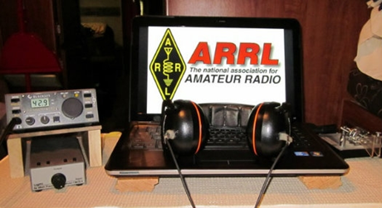*ARRL Contest Corner***

An expanded, downloadable version of *QST'*s’ [**Contest Corral**](http://www.arrl.org/contest-calendar) is available as a PDF. Check the sponsor’s ‘Website for information on operating time restrictions and other instructions.

[K1USN Slow Speed Test](http://www.k1usn.com/sst.html), Apr 5, 0000z to Apr 5, 0100z; CW; Bands: 160, 80, 40, 20m; Maximum 20 wpm, Name + (state/province/country); Logs due: April 11.  
  
[DARC Easter Contest](https://www.darc.de/der-club/referate/conteste/darc-ostercontest/en/), Apr 5, 1500z to Apr 5, 1730z; CW, SSB; Bands: 80, 40m; DL: RS(T) + DOK (or "NM" if not a DARC member), non-DL: RS(T) + QSO No.; Logs due: April 12.  
  
[OK1WC Memorial (MWC)](https://memorial-ok1wc.cz/index.php?page=rules2l), Apr 5, 1630z to Apr 5, 1729z; CW; Bands: 80, 40m; RST + Serial No.; Logs due: April 9.  
  
[Worldwide Sideband Activity Contest](https://wwsac.com/rules.html), Apr 6, 0100z to Apr 6, 0159z; SSB; Bands: 160, 80, 40, 20, 15, 10, **6m;** RS + age group (OM, YL, Youth YL or Youth); Logs due: March 31.

[ARS Spartan Sprint](http://arsqrp.blogspot.com/2009/02/so-whats-spartan-sprint-and-how-do-i.html), Apr 6, 0100z to Apr 6, 0300z; CW; Bands: 80, 40, 20, 15, 10m; RST + (state/province/country) + Power; Logs due: April 8.  
  
[RTTYOPS Weeksprint](https://rttyops.wordpress.com/rtty-mini-contests/rttyops-weeksprint/), Apr 6, 1700z to Apr 6, 1900z; RTTY; Bands: 80, 40, 20m; [other station's call] + [your call] + [serial no.] + [your name]; Logs due: April 6.  
  
[Phone Weekly Test - Fray](http://www.perluma.com/Phone_Fray_Contest_Rules.pdf), Apr 7, 0230z to Apr 7, 0300z; SSB; Bands: 160, 80, 40, 20, 15m; NA: Name + (state/province/country), non-NA: Name; Logs due: April 9.  
  
[CWops Mini-CWT Test](https://cwops.org/cwops-tests/), Apr 7, 1300z to Apr 7, 1400z; CW; Bands: 160, 80, 40, 20, 15, 10m; Member: Name + Member No./"CWA", non-Member: Name + (state/province/country); Logs due: April 10.

TOP ^

[VHF-UHF FT8 Activity Contest](http://www.ft8activity.eu/index.php/en/), Apr 7, 1700z to Apr 7, 2000z; FT8; Bands: (see rules); 4-character grid square; Logs due: April 12.  
  
[RSGB FT4 Contest Series](https://www.rsgbcc.org/hf/rules/2021/r80m_ft4.shtml), Apr 7, 1900z to Apr 7, 2030z; FT4; Bands: 80, 40, 20m; 4-character grid square; Logs due: April 8.  
  
[CWops Mini-CWT Test](https://cwops.org/cwops-tests/), Apr 7, 1900z to Apr 7, 2000z; CW; Bands: 160, 80, 40, 20, 15, 10m; Member: Name + Member No./"CWA", non-Member: Name + (state/province/country); Logs due: April 10.  
  
[UKEICC 80m Contest](https://www.ukeicc.com/80m-rules.php), Apr 7, 2000z to Apr 7, 2100z; ; Bands: 80m Only; 6-Character grid square; Logs due: March 31.  
  
[CWops Mini-CWT Test](https://cwops.org/cwops-tests/), Apr 8, 0300z to Apr 8, 0400z; CW; Bands: 160, 80, 40, 20, 15, 10m; Member: Name + Member No./"CWA", non-Member: Name + (state/province/country); Logs due: April 10.  
  
[RTTYOPS Weeksprint](https://rttyops.wordpress.com/rtty-mini-contests/rttyops-weeksprint/), Apr 8, 1700z to Apr 8, 1900z; RTTY; Bands: 80, 40, 20m; [other station's call] + [your call] + [serial no.] + [your name]; Logs due: April 13.  
  
[NCCC RTTY Sprint](http://www.ncccsprint.com/rttyns.html), Apr 9, 0145z to Apr 9, 0215z; RTTY; Bands: (see rules); Serial No. + Name + QTH; Logs due: April 11.  
  
[NCCC Sprint](http://www.ncccsprint.com/rules.html), Apr 9, 0230z to Apr 9, 0300z; CW; Bands: (see rules); Serial No. + Name + QTH; Logs due: April 11.  
  
[K1USN Slow Speed Test](http://www.k1usn.com/sst.html), Apr 9, 2000z to Apr 9, 2100z; CW; Bands: 160, 80, 40, 20m; Maximum 20 wpm, Name + (state/province/country); Logs due: April 11.  
  
[QRP ARCI Spring QSO Party](http://qrparci.org/contest/spring-qso-party), Apr 10, 0000z to Apr 10, 0600z; CW; Bands: 160, 80, 40, 20, 15, 10m; RS + (state/province/country) + (ARCI number/power); Logs due: April 28.  
  
[JIDX CW Contest](http://www.jidx.org/jidxrule-e.html), Apr 10, 0700z to Apr 11, 1300z; CW; Bands: 160, 80, 40, 20, 15, 10m; JA: RST + Prefecture No., non-JA: RST + CQ Zone No.; Logs due: May 11.

[DIG QSO Party, CW](https://diplom-interessen-gruppe.info/downloads/dig-qso-party-en/), Apr 10, 1200z to Apr 10, 1700z (20m-10m) and, Apr 11, 0700z to Apr 11, 0900z (80m) and, Apr 11, 0900z to Apr 11, 1100z (40m); CW; Bands: 80, 40, 20, 15, 10m; DIG Member: RST + Member No., non-Member: RST; Logs due: May 31.  
  
[IG-RY World Wide RTTY Contest](https://www.ig-ry.de/ig-ry-ww-contest), Apr 10, 1200z to Apr 11, 1800z; RTTY; Bands: 80, 40, 20, 15, 10m; RST + 4-digit year license first issued; Logs due: April 15.  
  
[SKCC Weekend Sprintathon](http://www.skccgroup.com/operating_activities/weekend_sprintathon/), Apr 10, 1200z to Apr 12, 0000z; CW; Bands: 160, 80, 40, 20, 15, 10, **6m**; RST + (state/province/country) + Name + (SKCC No./"NONE"); Logs due: April 18.  
  
[OK/OM DX Contest, SSB](http://okomdx.crk.cz/index.php?page=english-2), Apr 10, 1200z to Apr 11, 1200z; SSB; Bands: 160, 80, 40, 20, 15, 10m; OK/OM: RS + 3-letter county code, non-OK/OM: RS + Serial No.; Logs due: April 18.

TOP ^

[FTn DX Contest](https://europeanft8club.wordpress.com/), Apr 10, 1200z to Apr 11, 1200z; ; Bands: 80, 40, 20, 15, 10m; W: RST + state, VE: RST + province/territory, non-W/VE: RST + Serial No.; Logs due: April 18.  
  
[Nebraska QSO Party](http://www.nebraskaqsoparty.org/rules1.htm), Apr 10, 1300z to Apr 11, 0100z and, Apr 11, 1300z to Apr 11, 2200z; CW, Phone, Digital (non-FT8), FT8; Bands: 160, 80, 40, 20, 15, 10, **VHF/UHF;** NE (non-FT8): county, non-NE (non-FT8): (state/province/country), FT8: grid square; Logs due: April 25.  
  
[New Mexico QSO Party](http://www.newmexicoqsoparty.org/), Apr 10, 1400z to Apr 11, 0200z; CW, Phone, Digital; Bands: 160, 80, 40, 20, 15, 10, **6, 2m**; NM: Name + county, non-NM: Name + (state/province/country); Logs due: April 24.  
[North Dakota QSO Party](http://ndarrlsec.com/), Apr 10, 1800z to Apr 11, 1800z; CW, Phone, Digital (including FT4/8); Bands: 160, 80, 40, 20, 15, 10, **6, 2m**; ND: RS(T) + County, non-ND: RS(T) + (state/province/country); Logs due: May 15.  
  
[Georgia QSO Party](https://gaqsoparty.com/), Apr 10, 1800z to Apr 11, 0359z and, Apr 11, 1400z to Apr 11, 2359z; CW, SSB; Bands: 160, 80, 40, 20, 15, 10, **6m;** GA: RST + county, non-GA: RST + (state/province/"DX"); Logs due: April 25.  
  
[Yuri Gagarin International DX Contest](http://gc.qst.ru/en/section/32), Apr 10, 2100z to Apr 11, 2100z; CW; Bands: 160, 80, 40, 20, 15, 10, Satellites; RST + ITU Zone No.; Logs due: May 6.  
  
[WAB 3.5/7/14 MHz Data Modes](http://wab.intermip.net/Contests.php), Apr 11, 1000z to Apr 11, 1400z and, Apr 11, 1700z to Apr 11, 2100z; RTTY, PSK31; Bands: 80, 40, 20m; British Isles: RS + serial no. + WAB square, Other: RS + serial no. + country; Logs due: April 21.  
  
[Hungarian Straight Key Contest](http://hskc.ha8kux.com/), Apr 11, 1500z to Apr 11, 1600z; CW; Bands: 80m Only; RST + Serial No. + Power Code; Logs due: April 26.  
  
[RSGB RoLo SSB](https://www.rsgbcc.org/hf/rules/2021/rolo.shtml), Apr 11, 1900z to Apr 11, 2030z; SSB; Bands: 80m Only; RS + previous 6-character grid square received; Logs due: April 12.  
  
[K1USN Slow Speed Test](http://www.k1usn.com/sst.html), Apr 12, 0000z to Apr 12, 0100z; CW; Bands: 160, 80, 40, 20m; Maximum 20 wpm, Name + (state/province/country); Logs due: April 18.

[4 States QRP Group Second Sunday Sprint](http://www.4sqrp.com/SSS/sss_rules.pdf), Apr 12, 0000z to Apr 12, 0200z; CW, SSB; Bands: 160, 80, 40, 20, 15, 10m; Member: RS(T) + (State/Province/Country) + Member No., Non-member: RS(T) + (State/Province/Country) + Power; Logs due: April 14.  
  
[OK1WC Memorial (MWC)](https://memorial-ok1wc.cz/index.php?page=rules2l), Apr 12, 1630z to Apr 12, 1729z; CW; Bands: 80, 40m; RST + Serial No.; Logs due: April 16.  
  
[RSGB 80m Club Championship, CW](https://www.rsgbcc.org/hf/rules/2021/r80mcc.shtml), Apr 12, 1900z to Apr 12, 2030z; CW; Bands: 80m Only; RST + Serial No.; Logs due: April 13.  
  
[Worldwide Sideband Activity Contest](https://wwsac.com/rules.html), Apr 13, 0100z to Apr 13, 0159z; SSB; Bands: 160, 80, 40, 20, 15, 10, **6m**; RS + age group (OM, YL, Youth YL or Youth); Logs due: March 31.

TOP ^

[RTTYOPS Weeksprint](https://rttyops.wordpress.com/rtty-mini-contests/rttyops-weeksprint/), Apr 13, 1700z to Apr 13, 1900z; RTTY; Bands: 80, 40, 20m; [other station's call] + [your call] + [serial no.] + [your name]; Logs due: April 13.  
  
[NAQCC CW Sprint](http://naqcc.info/sprint/sprint202105.html), Apr 14, 0030z to Apr 14, 0230z; CW; Bands: (see rules); RST + (state/province/country) + (NAQCC No./power); Logs due: April 18.  
  
[Phone Weekly Test - Fray](http://www.perluma.com/Phone_Fray_Contest_Rules.pdf), Apr 14, 0230z to Apr 14, 0300z; SSB; Bands: 160, 80, 40, 20, 15m; NA: Name + (state/province/country), non-NA: Name; Logs due: April 16.  
  
[CWops Mini-CWT Test](https://cwops.org/cwops-tests/), Apr 14, 1300z to Apr 14, 1400z; CW; Bands: 160, 80, 40, 20, 15, 10m; Member: Name + Member No./"CWA", non-Member: Name + (state/province/country); Logs due: April 17.  
[CWops Mini-CWT Test](https://cwops.org/cwops-tests/), Apr 14, 1900z to Apr 14, 2000z; CW; Bands: 160, 80, 40, 20, 15, 10m; Member: Name + Member No./"CWA", non-Member: Name + (state/province/country); Logs due: April 17.

**VHF+ CONTESTS**

[144 MHz Spring Sprint](https://sites.google.com/site/springvhfupsprints/home/2021-information), Apr 5, 1900z to Apr 5, 2300z; Any; Bands: 2m Only; 4-character grid square; Logs due: April 19.

[222 MHz Spring Sprint](https://sites.google.com/site/springvhfupsprints/home/2021-information), Apr 13, 1900z to Apr 13, 2300z; (not specified); Bands: 222 Mhz; 4-character grid square; Logs due: April 27.

[VHF-UHF FT8 Activity Contest](http://www.ft8activity.eu/index.php/en/), Apr 14, 1700z to Apr 14, 2000z; FT8; Bands: (see rules); 4-character grid square; Logs due: April 19.

***Special Event Stations***

* **04/10/2021 | The Annual Nancy Kott Memorial KN0WCW Event**

**Apr 10-Apr 11, 0001Z-2359Z, KN0WCW**, Leonardo, NJ. FISTS North America. 10.058 7.058 10.118 3.558. Certificate. cody codianni, 413 Martin Court, Leonardo, NJ 07737. The Annual Nancy Kott Memorial KN0WCW Event! Nancy met Fists’ founder George, G3ZQS (SK) in a happenstance QSO in 1988, befriended him and shortly became the head of what is now The Americas Chapter of Fists. From then till her passing on 2 March of 2014, she worked tirelessly to promote our club and Morse Code, showing kindness to all and exemplifying our mottos of “courtesy at all times” and “accuracy transcends speed.” She is deeply missed by all, but not forgotten. Please help us honor Nancy’s work and dedication from 00:01 UTC April 10 2021 to 23:59 UTC April 11 2021. [fistsna.org/operating.html](http://fistsna.org/operating.html)

* **04/10/2021 | Celebration of the 155th Anniversary of Auburn University**

**Apr 10-Apr 11, 1200Z-2359Z, W4E**, Auburn University, AL. Auburn University. 7.060 7.074 and 7.047.5 14.074 and 14.080 7.070. QSL. Stew Schneller, 1869 Hillton Court, Auburn, AL 36830-2693. [www.qrz.com/db/k4jop](http://www.qrz.com/db/k4jop)

* **04/10/2021 | Spring has Sprung**

**Apr 10, 1700Z-2100Z, W4D**, Kodak, TN. Sevier County Emergency Radio Service. 14.280 +/- .020 USB 7.200 +/- .020 LSB 14.070 +/- .020 PSK31 7.070 +/- .020 PSK31 CW only on 7.060 +/- .010. QSL. Thomas P. Baxter W9TPB, 2054 James Rd., Sevierville, TN 37876. For additional information, please go to our website [www.eventqsl.webs.com](http://www.eventqsl.webs.com/)

TOP ^

* **04/10/2021 | USS Midway Museum Ship Special Event: Doolittle Raid**

**Apr 10, 1600Z-2300Z, NI6IW**, San Diego, CA. USS Midway (CV-41) Museum Ship. 7.250 14.320 14.070 (PSK31) DSTAR via PapaSystem repeaters. QSL. USS Midway CV-41 COMEDTRA NI6IW, 910 N Harbor Dr, San Diego, CA 92101. Please include SASE. [www.qrz.com/db/ni6iw](http://www.qrz.com/db/ni6iw)

* **04/14/2021 | Maritime Radio Day 2021**

**Apr 14-Apr 22, 1200Z-2200Z, various**, various, GERMANY. Maritime Radio Day. CW only. Certificate & QSL. Rolf Marschner, Narzissenweg 10, 53359 Rheinbach, GERMANY. This is an operating event. Please see website for rules. [mrd.sfk-bremen.com](http://mrd.sfk-bremen.com/)

* **04/17/2021 | Celebrating the Louisiana Purchase**

**Apr 17-Apr 24, 0000Z-2359Z, W5L**, West Monroe, LA. NorthEast Louisiana Amateur Radio Club. 14.250 21.250 7.250 3.850. QSL. Jim Ragsdale, W5LA, 111 Eagle Lake Drive, West Monroe, LA 71291. <https://www.qrz.com/db/W5L>

* **04/17/2021 | Texas State Parks On the Air (TSPOTA)**

**Apr 17-Apr 19, 1400Z-0200Z, K5LRK**, The Colony, TX. Lake Area Amateur Radio Club. CW Phone VHF. QSL. See website, for, Information. Times are daily. K5LRK on as a special event station. Contest: Activate as many Texas parks as possible. www.k5lrk.com or [www.tspota.org](http://www.tspota.org/)

* **04/18/2021 | World Amateur Radio Day**

**Apr 18-Apr 19, 1300Z-0400Z, W7W**, Rochester, NY. W2JLD/Special event coordinator. Echolink *ROC-HAM* CONFERENCE 531091 Allstar 2585, 47620, 53130. QSL. John Derycke, W2JLD, 85 Amherst St #2, Rochester, NY 14607. This will be our 6th annual WORLD AMATEUR RADIO DAY celebration on the VOIP Echolink system We have a 16 hr net with net controllers from all over the world. A special event qsl card will be available Join us again for one of the LARGEST special events on Echolink@ 9AM EST TILL 12 MINDNIGHT EST we will have Allstar, DMR as well. [w2jld2@gmail.com](mailto:)

* **04/24/2021 | 156th Anniversary of Sultana Disaster**

**Apr 24, 1500Z-2100Z, W5S**, West Memphis, AR. AG5QY. 14.240. QSL. Marc Gwin, 1402 Stratford Drive, West Memphis, AR 72301. <https://ag5qy9.wixsite.com/ag5qy>

* **04/24/2021 | OC&E Woods Line Last Train 31st Anniversary**

**Apr 24, 1600Z-2200Z, W7VW**, Klamath Falls, OR. Klamath Basin Amateur Radio Society. 14.074. Certificate & QSL. Jim English, 2602 Wiard Street, Klamath Falls, OR 97603.

The Oregon, California, and Eastern Railway (OC&E) was a 64-mile (103 km) rail line between Klamath Falls and Bly in the US state of Oregon. After 70 years of bringing logs from nearby forests to local sawmills, the former railroad right of way was converted to the OC&E Woods Line State Trail. The last OC&E log train to Bly ran on Sunday, 29 April 1990. wo7v@arrl.net or <https://www.facebook.com/kfalls.radio>

* **04/24/2021 | San Jacinto Day Special Event**

**Apr 24-Apr 25, 1400Z-2359Z, K5T**, Nacogdoches, TX. Nacogdoches Amateur Radio Club. 7.216 14.260 21.350 28.350. QSL. Army Curtis, 167 CR 2093, Nacogdoches, TX 75965. All contacts will be confirmed via LOTW [https://w5nac.com](https://w5nac.com/)

TOP ^

* **04/24/2021 | W1BSA Birthday of Scouting Event**

**Apr 24, 1400Z-1930Z, W1BSA**, Fall River, MA. USTNE ne1pl.org. 14.259. QSL. Rick Emord, 135 Wareham St., Middleboro, MA 02346. The USTNR group will be activating on the USS Massachusetts this year at least 4 times for the following events. Except for the Museum ships on the air event, we will be on the air by 1000 EST or 1400 utc we will be shut down at 1530 EST or 1930 utc. We have a website to see the current QSL card for the events go to ne1pl.org. Look for the ticker tape for added events. Our first event for the year will be: W1BSA April 24th On the air by 1000 off the air around 1530 This event is for the Birthday of Scouting in America. The birthday is on February 8, 1910 because of the chilly weather in February we celebrate in April. Please visit battleshipcove.org for more information about the park and its equipment. Please visit us at [ne1pl.org](http://ne1pl.org/)

* **04/24/2021 | Woronoko Heights Outdoor Adventure**

**Apr 24, 1300Z-1900Z, W1M**, Russell, MA. Western Mass. Council--BSA. 14.290 14.060 10.115 7.190. QSL. Tom Barker, 329 Faraway Road, Whitefield, NH 03598. SES operating from the Horace Moses Scout Reservation in western Mass. SASE for QSL.

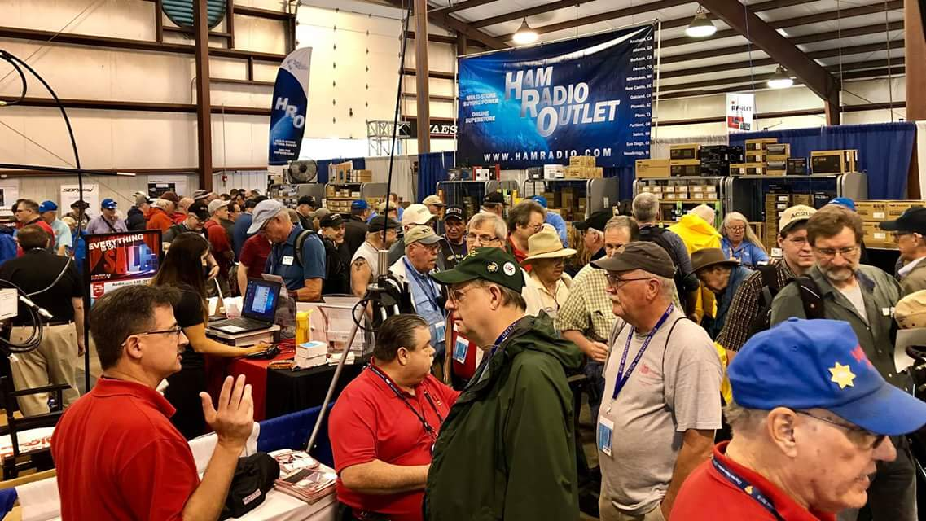[***Upcoming Hamfests***](http://arrl-ohio.org/hamfests.html)

We **DO** have some hamfests scheduled for 2021!! Yes, take a good look at the list, it’s growing every day!

Be sure to keep your eyes on this schedule as that when things start getting better and the vaccine rolls out to more and more, hamfests will surely get back to their normal schedule. Don’t see your hamfest listed?? Did anyone register it with ARRL? It’s really easy to do and you get a lot of FREE publicity if you do.

**Massillon ARC** Spring TailgateFest to be held at the MAPS Air Museum. Entrance at 5383 Massillon Road just inside the Stark/Summit County line. Date is Saturday, April 17 from 9 [a.m.to](http://a.m.to/) 4 p.m. Cost is $5 per vehicle. (for use of the facility)   No advance registration necessary. Bring your own tables. (no large trailers) No charge for visitors.

|  |  |
| --- | --- |
| **06/05/2021 -**[**FCARC SummerFest**](http://www.arrl.org/hamfests/fcarc-summerfest)  Location: Wauseon, OH Sponsor: Fulton County Amateur Radio Club Website:<http://k8bxq.org/hamfest> [Learn More](http://www.arrl.org/hamfests/fcarc-summerfest) | **07/10/2021 - [Mansfiled Mid-Summer Trunkfest](http://www.arrl.org/hamfests/mansfiled-mid-summer-trunkfest" \o "Mansfiled Mid-Summer Trunkfest)**  Location: Mansfield, OH Sponsor: InterCity Amateur Radio Club Website:<http://iarc.club>[Learn More](http://www.arrl.org/hamfests/mansfiled-mid-summer-trunkfest) |
| **07/17/2021 -**[**NOARSFEST**](http://www.arrl.org/hamfests/noarsfest-8)  Location:Elyria, OH Type: ARRL Hamfest Sponsor: Northern Ohio Amateur Radio Society Website: [http://noars.net](http://noars.net/) Learn More | **07/18/2021 –**[**Van Wert Hamfest**](http://www.arrl.org/hamfests/van-wert-hamfest-5)  Location: Van Wert, OH Sponsor: Van Wert Amateur Radio Club Website:[http://W8FY.ORG](http://w8fy.org/)[Learn More](http://www.arrl.org/hamfests/van-wert-hamfest-5) |

TOP ^

|  |  |
| --- | --- |
| **08/07/2021 -**[**DX Engineering Hamfest & Great Lakes Division Convention**](http://www.arrl.org/hamfests/dx-engineering-hamfest-1)  Location: Tallmadge, OH Sponsor: DX Engineering Website: [http://dxengineering.com](http://dxengineering.com/) [Learn More](http://www.arrl.org/hamfests/dx-engineering-hamfest-1) | |
| **08/28/2021 -**[**Cincinnati Hamfest℠**](http://www.arrl.org/hamfests/cincinnati-hamfest)  Location: Owensville, OH Sponsor: Milford ARC Website: [http://CincinnatiHamfest.org](http://cincinnatihamfest.org/) [Learn More](http://www.arrl.org/hamfests/cincinnati-hamfest) |
| **12/04/2021 -**[**FCARC WinterFest**](http://www.arrl.org/hamfests/fcarc-winterfest-2)  Location: Delta, OH  Sponsor: Fulton County Amateur Radio Club  Website:<http://k8bxq.org/hamfest>  [Learn More](http://www.arrl.org/hamfests/fcarc-winterfest-2) |

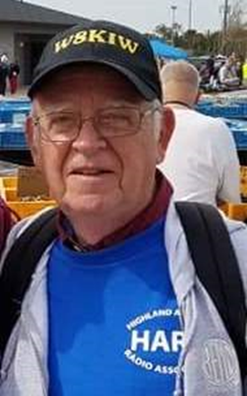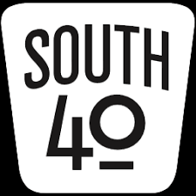Welcome back to our road trip to visit many of the radio clubs located South of US 40 and Interstate 70. This week we find ourselves heading South on SR 73 leaving Highland County’s Highland Amateur Radio Association with the objective of visiting some of the great clubs who call the Ohio River Valley home. However first we’ll take a stop to visit the internationally known Great Serpent Mound. I find it interesting it is not on the list of parks available for Parks On The Air activation.

When back on the road, we pass through the area that the Brushcreek Radio Club called home and now the location of HARA’s 146.745 repeater. We hate to see a club fold, but member’s radio interests, health and age issues, people moving away and declining membership infrequently causes it to happen, especially in a rural and low populated area. But we can’t dwell on the passing of this late and good club.

Let it go in peace with fond memories. Instead we have our sights set on visits to some really exciting and amazing clubs.

Once in the Portsmouth area we cross one of the bridges and head up the Kentucky side to Ashland where a visit to the River Cities ARA is made. Since 1979 the Club has served the interests of the local amateur radio community and proven to be a valued community partner. The Club is a general interest club with members involved with repeaters, satellite operation, nets and emergency operations to mention but a few. The Club is known throughout the Ohio Valley for its’ annual April Trunkfest in the parking lot of a local bank. The April 24 event is still scheduled, however the changing COVID situation may cause the Club to rethink the event. COVID has also caused the Club to change its normal meeting place from a city fire station to a local restaurant. For over 40 years the RCARA has hosted a weekly net on its 146.94 KG4DVE repeater. The Club has sponsored ham test sessions for many years.

TOP ^

A glance at the watch shows we must say our good byes and get back on the road. Our next stop is a bit further up the Ohio. Once we cross over the Big Sandy we will be in Huntington, WV and the home of Marshall University and the Tri-State ARA. But until we make that crossing, we will take a look at some of the news from throughout the Southern Ohio Region.

We recently announced the Hocking Valley ARA has restarted its series of monthly Fox Hunts. According to Bill Hopstetter, W8LGX, Phil Stanley, KB8NZB, was the winner and will have the bragging rights for the next month. Bill says the next hunt is scheduled for Saturday, April 17.

DeForest ARA President Kim Paquette reminds members of the next meeting. It will be an over-the-air meeting on the 147.00 repeater on Tuesday evening, April 13. See you at 7.

Congratulations are extended to Beverly Bunn, KD8MSL, on being named the Amateur of the Year by the Cambridge ARC.

If the weather permits the upcoming April 10 Highland ARA Brunch Bunch gathering will take place at the Harmony Lake shelter house at Hillsboro’s Liberty Park at 10 AM. Then on the evening of April 13 the Club’s business meeting will be held at the same place starting at 7 PM. The shelter house provides sufficient room to exercise social distancing. Masks are suggested. Should the weather for either event be less than desirable, things will take place over HARA’s repeaters. Both events are open to everyone whether you are a HARA member or not. It’s been said that some have attended their first HARA meeting as a stranger but go away as if they were a long- time friend.

One of the best known Ohio flea markets is the Caesar Creek Flea Market at SR 73 and I-71 near Wilmington. Should you visit it, you might check out the Clinton County ARA’s station during your visit. The station is open most weekends. Just look for the little red barn.

In February 2006 an old Russian spacesuit, outfitted with a ham radio transmitter, was set adrift from the International Space Station in an experiment called Suitcube. Many hams around the world listened to its transmissions until the batteries died and the experiment burned up on re-entering the Earth’s atmosphere. Or did it? The short Sci Fi film ‘Decommissioned’ used this actual event as the background for this video that some locals termed ‘weird’, ‘erie’ or ‘cool’ upon viewing it. It can be found on You Tube or Google. Thanks to WB8ZZR, Paul Gehringer, for calling this item to our attention.

On Saturday, April 10, the Cambridge ARC will conduct a free one day Technician License class. Sonny Alfman, W8FHF, will lead the instruction. It begins at 9 am and continues until 4 with a test session to follow. Pre-registration is requested via lynalfman@aol.com or 740-872-3888.

Hocking County has a new EMA director and he has informed the Hocking Valley ARC of his intent to use the club more frequently in the future. In fact, the ham radio room was relocated closer to the ‘EOC War Room’ in the EOC Building. It appears more Ohio EMA directors are involving ham radio in their disaster planning. About a year ago an EMA planning consultant told the Highland County planning committee “when ‘it’ hits the fan, you can count on these guys’. A ham now sits on the county EMA board.

During April several clubs will sponsor license testing sessions throughout the area. On Monday, April 5, the Portsmouth RC will conduct their monthly test. Contact Jerry Lockhart, W8HIC, for the time and location. April 10 looks to be a popular testing date with tests in Springfield and Huber Heights, plus Huntington, WV.

TOP ^

The Cambridge ARA will hold two sessions that day. One early in the day will be for present license holders to try upgrades and another at 4:15 to accommodate those taking the One Day Tech Class. On the 17th testing sites are in Hillsboro and Circleville. Then on the 25th the Athens County ARA will conduct an ARRL exam in Athens. Detailed information about each of these sessions can be found in the ‘test session’ section of this newsletter.

Concluding our River Cities ARA visit we continue up river and cross the bridge over Big Sandy River into Huntington, West Virginia- -the home of the Tri-State ARA and the West Virginia Museum of Radio and Technology. The Tri-State ARA has served the needs of the tri-state’s amateur radio population since 1924 and is one of the oldest we know of. I believe the first hamfest I ever attended was in the early 1970’s when their event was held at the Camden Amusement Park. Although now at a different location, that hamfest exists to this day. The Club is a general interest club and although not directly connected with the radio museum, it calls the facility at 1640 Florence Avenue home and maintains the W8VA exhibit station there. They use the museum as their meeting place and hold operating events from it. Presently they are erecting new antenna towers. The Museum and the nearby antique shops make Huntington a must visit location. One of the neat operating events the Club tries to conduct each year is to hold a ‘Santa On-The-Air’ evening when local children can talk to Santa over the Club’s 146.76 repeater. They are also well-known for some of the meals and other food gatherings they hold for the amateur community.

One could spend a lot more time inspecting all the exhibits at the Museum, but we must pull ourselves away and cross over the bridge into Ohio again and continue downstream towards our next visits. In the meantime, if you have any club news you would like to pass along, please send it to jlevo@cinci.rr.com. So until we meet again, stay healthy, safe and ‘radio active’.

***Print an Official or Unofficial Copy of Your Amateur Radio License***

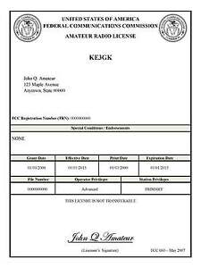*(By Anthony Luscre, K8ZT)*

As of February 17, 2015, the **FCC no longer routinely issues paper license documents** to Amateur Radio applicants and licensees. The Commission has maintained for some time now that the official Amateur Radio license authorization is the electronic record that exists in its Universal Licensing System (ULS). The FCC will continue to provide paper license documents to all licensees who notify the Commission that they prefer to receive one.

Licensees also will be able to print out an official authorization — as well as an unofficial “reference copy” — from the ULS License Manager. I’ve created a set of instructions on how you can request an **“official” printed copy of your license\***

[**Click here to download the instructions**](http://arrl-ohio.org/news/2020/print_your_license.pdf)

TOP ^

***One Question Questionnaire***

Hey Gang,

Survey Says”…..In the last week there have only been 62 responses to this. With over 25,000 licensed Hams in the OH Section that is statistically insignificant! How about going to www.ARRL-OHIO.org and giving me a click? (It’s in the bottom left corner of the page) Send your friends and send your Mother!

***“Do You Have the Worked All States Award?”***

*****V.E. Test Sessions***

Many V.E.’s have decided to start testing once again, but with restrictions that need to be adhered to for sure. Here’s the link to find that V.E. Test session and what is expected of YOU before going. <http://www.arrl.org/find-an-amateur-radio-license-exam-session>

Ohio Section Cabinet

|  |  |
| --- | --- |
| Section Manager – Tom Sly, WB8LCD | Section Traffic Manager – David Maynard, WA3EZN |
| Section Emergency Coordinator – Stan Broadway, N8BHL | Section Youth Coordinator – Anthony Lascre, K8ZT |
| Technical Coordinator – Jeff Kopcak, K8JTK | Affiliated Clubs Coordinator – Tom Sly, WB8LCD |
| State Government Liaison – Bob Winston, W2THU | Public Information Coordinator – John Ross, KD8IDJ |



Hey Gang,

Have you taken a look at the **Swap & Shop** page on the Ohio Section webpage yet?? Here’s a link that will take you there… <http://arrl-ohio.org/sm/s-s.html>

Do you have equipment that you just don’t need or want anymore? Here’s a great venue to advertise it, and it’s FREE!! Is your club doing a fund raiser to help raise money? After a lot of thought, it was decided that the Swap & Shop webpage could also contain these types of items as well. The same rules will apply as do for the For Sales and Give-A-Ways and will only be posted for a month at a time. Please see the Terms & Conditions on the webpage.

If your club is doing a fund raiser and wants more exposure, please forward the information to me and I’ll advertise it on the Swap & Shop webpage for you.

TOP ^

Now, I still want to remind you that it won’t be listed in this newsletter because it would take up way too much space, so your ad will only appear on the website. It is there for any individual to post equipment Wanted / For Sale or Give-Away as well as for Club Fund Raisers. No licensed vehicles/trailers or business advertising will be posted. Postings are text only (no pictures or graphics) will be posted for a maximum of 1 month from date posting and require a contact phone number or email within the posting. Send your Wanted / For Sale or Give-Away post to:  [swap@arrlohio.org](mailto:swap@arrlohio.org)

***Back Issues of the PostScript and Ohio Section Journal***

Hey, did you know that PostScript and Ohio Section Journal (OSJ) are archived on the website? You can go back and look at any edition simply by clicking:

<http://arrl-ohio.org/news/index.html>

***Want to Share your Club Newsletter With Others?***

We have a webpage where you can download and read all of the newsletters that I get from around the state and even other sections!

Here’s the link to the page…. <http://arrl-ohio.org/club_news/index.html>

Please, if you don’t see your club newsletter posted, it’s because I’m not receiving it. Just have your newsletter editor contact me and I’ll get your club’s newsletter listed on the site!!

We all learn and steal (I mean, share) from each other’s work. So, get me your newsletter!!! Send it to: [webmaster@arrl-ohio.org](mailto:webmaster@arrl-ohio.org)

***Chit – Chat, and All That!***

Do you know someone that’s not getting these Newsletters? Please, forward a copy of this Newsletter over to them and have them “[Opt-In](mailto:Opt-In)” to start receiving them. Heck, just have them send an email to: [webmaster@arrl-ohio.org](mailto:webmaster@arrl-ohio.org) and we’ll get them added to the Ohio Section Emailing list.

We now have many thousands of readers receiving these newsletters weekly. Quite impressive, I’d say! I urge all of you to make sure that everyone, regardless of whether they are a League member or not, get signed up to receive these weekly Newsletters.

TOP ^

You can always “Opt-Out” at any time if you feel this is not what you were expecting. It’s fun and very informative. All of your favorite past newsletters are now archived too.

You can go back at any time and read them.

Just go to: <http://arrl-ohio.org/news/>

The pictures on the front page and throughout this newsletter are from various newsletters, Facebook posts and/or were sent directly to me in recent weeks. Take a good look at them, you just might be in one of the pictures! “SMILE… you’re in the Ohio Section News!!”

TOP ^

*PostScript is produced as a weekly newsletter. I want to thank everyone that has contributed articles and ideas to make this an even better news source. I sincerely hope that you have enjoyed this edition and will encourage your friends to join with you in receiving the latest news and information about the Ohio Section, and news and events happening around the world!*