[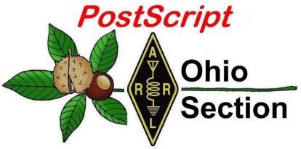](http://arrl-ohio.org/news/) ***“March 22nd***

***Edition”***

🡪 [National News](#national) 🡪 [Club Corner](#club)

🡪 [DX This Week](#dx) 🡪 [Contest Corner](#contest)

🡪 [Special Events](#special) 🡪 [Upcoming Hamfests](#hamfest)

🡪 [Training](#training) 🡪 [VE Testing](#ve)

🡪 [One Question Questionnaire](#one)

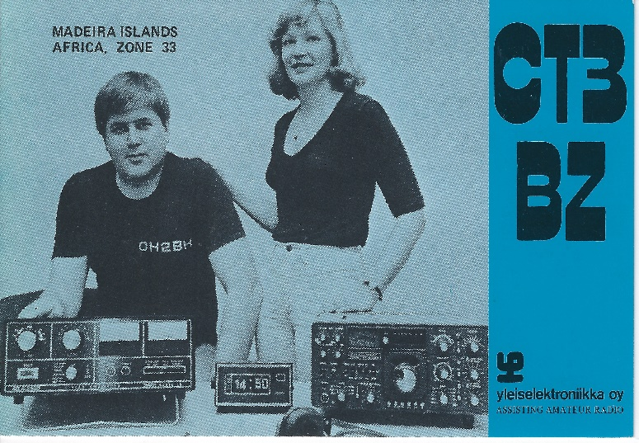

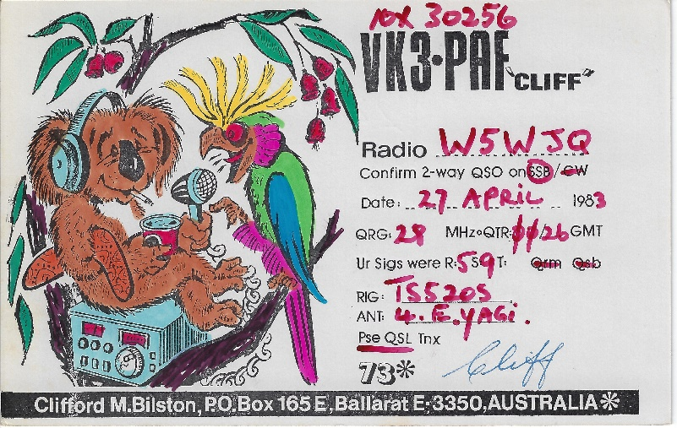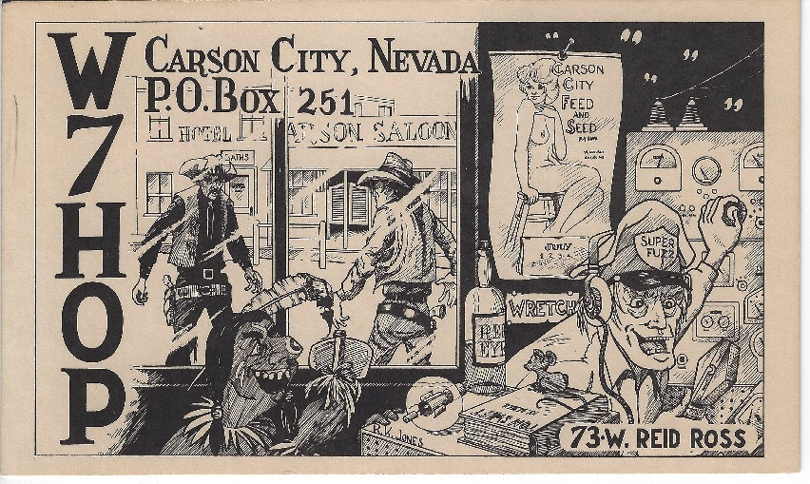

Send me some .JPG or .BMP’s of your favorite QSL cards, new or old – I’ll get them posted for you here!

***National News***

*(from arrl and other sources)*

|  |  |
| --- | --- |
| |  | | --- | | **Ohio's Spring Severe Weather Awareness Week**  **March 21 - 27, 2021**  ***Statewide Tornado Drill Wednesday, March 24, 2021 at 9:50 a.m.***  COLUMBUS – Franklin County Emergency Management and Homeland Security (FCEM&HS) will recognize Ohio’s Spring Severe Weather Awareness Week, March 21 – 27, 2021.  Residents are reminded to prepare for severe weather before it happens.  Hazardous conditions can occur anytime and anywhere without advance notice.  As part of Severe Weather Awareness Week, FCEM&HS urges the community to participate in the annual Statewide Tornado Drill on Wednesday, March 24, 2021 at 9:50 a.m. At that time, the Franklin County Outdoor Warning Sirens will be activated one time for three minutes, a longer tone than used during the regular Wednesday noon test. The test tone is the same “tornado warning” tone which would be used in an actual tornado warning.  “Severe weather season is just around the corner and I encourage everyone to take some time during Severe Weather Awareness Week to make a safety plan for family, friends, neighbors and co-workers,” said Jeffrey J. Young, Director, Franklin County Emergency Management & Homeland Security. “Being prepared and knowing what to do during an emergency is the key to staying safe.”  FCEM&HS encourages residents to be prepared for all types of severe weather by following these important safety procedures:  **Know the Risk** – Learn and understand the different types of weather hazards facing Franklin County.  The top hazards can be found on the agency website at [www.fcemhs.org](http://www.fcemhs.org).  **Know the Weather Terms** – Know the difference between storm watches and storm warnings. For example, a tornado watch is issued by the National Weather Service when conditions are favorable for the development of tornadoes in and close to the area. A tornado warning is issued by the NWS when a tornado has been detected by radar or sighted by storm spotters.  **Receive Notifications** - Register for ALERT Franklin County at [www.alertfranklincounty.org](https://gcc02.safelinks.protection.outlook.com/?url=https%3A%2F%2Flnks.gd%2Fl%2FeyJhbGciOiJIUzI1NiJ9.eyJidWxsZXRpbl9saW5rX2lkIjoxMDIsInVyaSI6ImJwMjpjbGljayIsImJ1bGxldGluX2lkIjoiMjAyMTAzMTUuMzY5OTYzNTEiLCJ1cmwiOiJodHRwOi8vd3d3LmFsZXJ0ZnJhbmtsaW5jb3VudHkub3JnLyJ9.b_nY_7cqnflhd0UnSVRvEPZGfjJGQkuo7FHBYLfj46k%2Fs%2F668973028%2Fbr%2F99913695076-l&data=04%7C01%7Cchriswilliams%40franklincountyohio.gov%7C0a466eaa74204118a07508d8e7c38c05%7C93c52ce10d7542639ab99c287e289e18%7C1%7C0%7C637514174373013203%7CUnknown%7CTWFpbGZsb3d8eyJWIjoiMC4wLjAwMDAiLCJQIjoiV2luMzIiLCJBTiI6Ik1haWwiLCJXVCI6Mn0%3D%7C1000&sdata=fES4gyh0iNobe57D6sYs9%2Bs8oMo6LvpodlgZfxneL%2F4%3D&reserved=0) to receive severe weather alerts and important information.  Residents are encouraged to have a NOAA Weather Radio and tune into TV or radio newscasts for up-to-date weather information.  **Have a Plan/Build a Kit** - Develop and practice an emergency plan with your family and include your pets. Know how to communicate and have a designated safe meeting place.  Build an emergency supply kit.  Be sure to include enough food, water and other supplies in sufficient quantity to last for at least 72 hours. | |

Thank you,  
Franklin County – CC

[TOP](#top) ^

ARISS Ham Station in Columbus Module Is Once Again Operational

Some 6 weeks after going silent following a spacewalk that installed new antenna cabling, the Amateur Radio on the International Space Station ([ARISS](http://www.ariss.org/)) ham station in the Columbus module is once again operational. The Columbus station, which typically uses the call sign NA1SS, is the primary ARISS amateur radio station used for school 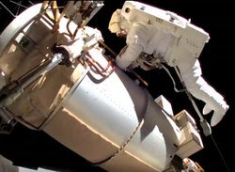contacts and other activities. The problem arose after a January 27 spacewalk replaced a coax feed line installed 11 years ago with another built by the European Space Agency (ESA) and Airbus.

While the specific cause of the problem has not yet been determined, a March 13 spacewalk that restored the antenna cabling to its original configuration provided the cure. The plan to return the ARISS cabling to its original configuration had been a "contingency task" for a March 5 spacewalk, but the astronauts ran out of time. The ARISS work was appended to the to-do list for astronauts Mike Hopkins, KF5LJG, and Victor Glover, KI5BKC, to complete a week later.

During the weekend spacewalk, Hopkins swapped out a cable for the [Bartolomeo](https://www.airbus.com/space/space-infrastructures/bartolomeo.html) commercial payload-handling platform that had been installed in series with the ARISS VHF-UHF antenna feed line, returning the ARISS system to its pre-January 27 configuration. Hopkins raised a question concerning a sharp bend in the cable near a connector, but no further adjustments were possible.

On March 14, ARISS was able to confirm the operation's success when Automatic Packet Reporting System (APRS) signals on 145.825 MHz were heard in California, Utah, and Idaho as the ISS passed overhead. ARISS team member Christy Hunter, KB6LTY, was able to digipeat through NA1SS during the pass. With additional confirmation from stations in South America and the Middle East, ARISS declared the radio system operational again.

Work during the March 13 spacewalk also made Bartolomeo operational. "Yesterday was a great day for all!" Bauer said. "Ad astra!" Read [an expanded version](http://www.arrl.org/news/ariss-ham-station-in-columbus-module-is-once-again-operational).

Dayton Hamvention® Announces 2021 Award Winners

Dayton Hamvention® has announced its 2021 award winners. Hamvention Awards Committee Co-Chairs Michael Kalter, W8CI, and Frank Beafore, WS8B, said that despite the COVID-19 pandemic, the Hamvention committee elected to go forward in announcing its selection of outstanding radio amateurs and predicted that Hamvention will return in 2022.

**Amateur of the Year**

Angel M. Vazquez, Jr., WP3R, the head of telescope operations and Puerto Rico Coordination Zone Spectrum Manager for Puerto Rico's famous Arecibo Observatory, was cited as Amateur of the Year for "his unswerving and diligent support of amateur radio throughout the entire territory of Puerto Rico and worldwide."

[TOP](#top) ^

Although he was born in Puerto Rico, Vazquez grew up in Brooklyn, New York, and returned to Puerto Rico after college in 1977, taking a job at the Arecibo Observatory. Vazquez earned his amateur radio license in 1993, and headed the 2010 moonbounce effort from the observatory, as well as multiple special events using the KP4AO club call sign.

Vazquez helped to provide communication support in the wake of Hurricane Maria. He was named Amateur of the Year in Puerto Rico in 2018 and received the Yasme Excellence Award in 2019. He's also a Volunteer Examiner and inaugurated the first virtual/online bilingual testing program as part of the Greater Los Angeles Amateur Radio Group (GLAARG) VEC.

**Technical Achievement**

****Tamitha Skov, WX6SWW, is well-known as the [Space Weather Woman](https://www.spaceweatherwoman.com/). Calling her "a real space pioneer," the Awards Committee said those who have seen her space weather forecasting shows will agree that she is energetic and excited about her work.

A credentialed space weather forecaster, Skov's forecasting work is widely known on social media and has been featured in publications and on TV. Her weekly space weather video podcasts are frequently featured on [www.qrz.com](http://www.qrz.com/). Skov said she specifically got her ham license in 2018 to better understand and serve the needs of the amateur radio community.

Professionally, Skov is a research scientist for The Aerospace Corporation. She also teaches the art of space weather forecasting to meteorologists at Millersville University and is working with ARRL and [HamSCI](http://www.hamsci.org/" \t "_blank) to create educational materials.

**Special Achievement**

**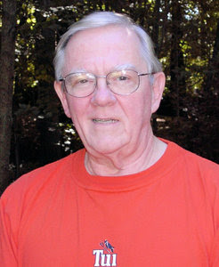**Wesley Lamboley, W3WL, was nominated by his peers for his lifelong, high-energy support for the science and art of amateur radio. "Not only has he supported youth coaching, membership recruiting, and technical problem assistance, he always does it with a smile and great humor," the Awards Committee said. Lamboley spent 40 years in the aerospace industry as a technical writer, electrical and systems engineer, and manager. Introduced to amateur radio in 1955 when a friend invited him to Field Day, Lamboley credits ham radio for much of his success.

"Many mentors helped me and I try to pay it forward as best I can, especially for young people," he said. He's also participated in several DXpeditions, and five SouthWest Ohio DX Association "DXpedition of the Year" plaques adorn his ham shack.

**Club of the Year**

****The Hamvention Awards Committee named the ARRL-affiliated Vienna Wireless Society (VWS), K4HTA, in Virginia as the Club of the Year. The committee noted that the club's 280 members focus on youth education and public service, and promote the growth of ham radio. The club is now the largest and most active in the Washington, DC, area.

[TOP](#top) ^

The club offers licensing classes, workshops, and four educational programs a month at its meetings, and these are archived for broader use. Their annual Winterfest is host to the ARRL Virginia Section Convention. The Vienna Wireless Society operates two repeaters in the DC area, and actively supports public service communications. Read [an expanded version](http://www.arrl.org/news/dayton-hamvention-announces-2021-award-winners).

\_\_\_\_\_\_\_\_\_\_\_\_\_\_\_\_\_\_\_\_\_\_\_\_\_\_\_\_\_\_\_\_\_\_\_\_\_\_\_\_\_\_\_\_\_\_\_\_\_\_\_\_\_\_\_\_\_\_\_\_\_\_\_\_\_\_\_\_\_\_\_\_\_\_\_\_\_\_\_

Want To Improve Your CW Skills?

If you want to get your CW Skills sharpened up, the best way to do it is to copy over the air. As long as you have a receiver, you should be able to pick up the W1AW code practice transmissions. Lots of options to fit everyone’s speed and time schedule. Listen to the W1AW Qualifying Runs and you can pick up a nice certificate. Check it out!

**W1AW Operating Schedule**

Updated March 15, 2021

|  |  |  |  |  |  |  |  |  |  |  |
| --- | --- | --- | --- | --- | --- | --- | --- | --- | --- | --- |
| **Pacific** | **Mtn** | **Cent** | **East** | **UTC** |  | **Mon** | **Tue** | **Wed** | **Thu** | **Fri** |
| 6 am | 7 am | 8 am | 9 am | 1300z |  |  | [Fast Code](http://www.arrl.org/w1aw-operating-schedule#Fast_Code) | [Slow Code](http://www.arrl.org/w1aw-operating-schedule#Slow_Code) | Fast Code | Slow Code |
| 7 - 9 am  10 am -12:45 pm | 8 - 10 am  11 am -1:45 pm | 9 - 11 am  Noon - 2:45 pm | 10 am - Noon  1 - 3:45 pm | 1400z to 1600z    1700z to 1945z |  | **Visiting Operator Time**  (Station closed from 1600z to 1700z - 12 PM to 1 PM ET) | | | | |
| 1 pm | 2 pm | 3 pm | 4 pm | 2000z |  | Fast Code | Slow Code | Fast Code | Slow Code | Fast Code |
| 2 pm | 3 pm | 4 pm | 5 pm | 2100z |  | [Code Bulletin](http://www.arrl.org/w1aw-operating-schedule#cw_info) | | | | |
| 3 pm | 4 pm | 5 pm | 6 pm | 2200z |  | [Digital Bulletin](http://www.arrl.org/w1aw-operating-schedule#digital) | | | | |
| 4 pm | 5 pm | 6 pm | 7 pm | 2300z |  | Slow Code | Fast Code | Slow Code | Fast Code | Slow Code |
| 5 pm | 6 pm | 7 pm | 8 pm | 0000z |  | Code Bulletin | | | | |
| 6 pm | 7 pm | 8 pm | 9 pm | 0100z |  | Digital Bulletin | | | | |
| 6:45 pm | 7:45 pm | 8:45 pm | 9:45 pm | 0145z |  | [Voice Bulletin](http://www.arrl.org/w1aw-operating-schedule#voice) | | | | |
| 7 pm | 8 pm | 9 pm | 10 pm | 0200z |  | Fast Code | Slow Code | Fast Code | Slow Code | Fast Code |
| 8 pm | 9 pm | 10 pm | 11 pm | 0300z |  | Code Bulletin | | | | |

**W1AW's transmitting schedule occurs at the same local Eastern time throughout the year.**

The schedule may change if your local time does not have seasonal adjustments.

[TOP](#top) ^

**Daily Morse Code Practice *QST* Source**

Code practice text is from the pages of *QST* magazine, the League's membership journal.  The source is given at the beginning of each practice session and alternate speeds within each session.  For example, "Text is from September *2019 QST*, pages 46" indicates that the practice session's plain text is from the article on page 46.

[Click here to see the table for each daily Morse Code Practice text.](http://www.arrl.org/code-practice-qst-source)

**Morse Code Transmissions**

**Frequencies** are 1.8025, 3.5815, 7.0475, 14.0475, 18.0975, 21.0675, 28.0675, 50.350, and 147.555 MHz.

**Slow Code** = practice sent at 5, 7-1/2, 10, 13 and 15 words per minute (wpm).

**Fast Code** = practice sent at 35, 30, 25, 20, 15, 13 and 10 wpm.

**Code bulletins** are sent at 18 wpm.

CW frequencies include code practices, Qualifying Runs and CW bulletins.

**World Wide Web:** You can also find [W1AW code practice](http://www.arrl.org/code-practice-files) here on *ARRLWeb*, in MP3 format. Other resources can be found on the *ARRLWeb* [Learn CW](http://www.arrl.org/Learning-Morse-Code) page.

[**W1AW Qualifying Runs**](http://www.arrl.org/qualifying-run-schedule) are sent on the same frequencies as the Morse code transmissions. West Coast Qualifying Runs are also transmitted monthly by K6KPH, K9JM or KH6TU on 3590 kHz, as well as 3581.5, 7047.5, 14047.5, 18097.5, and 21067.5 kHz.  At the beginning of each code practice session, the schedule for the next qualifying run is presented. Underline one minute of the highest speed you copied, certify that your copy was made without aid, and send it to ARRL for grading. Please include your name, call sign (if any) and complete mailing address. The initial certificate is available for a $10 fee. Subsequent endorsement stickers are available for a $7.50 fee.

**Digital Transmissions**

**Frequencies** are 3.5975, 7.095, 14.095, 18.1025, 21.095, 28.095, 50.350, and 147.555 MHz.

**Bulletins** are sent using 45.45-baud Baudot, PSK31 in BPSK mode and MFSK16 on a daily revolving schedule.  The actual daily schedule can be found [here](http://www.arrl.org/files/file/W1AW/W1AW%20Daily%20Digital%20Bulletin%20Schedule.pdf).

**Keplerian elements** for many amateur satellites will be sent on the regular digital frequencies on Tuesdays and Fridays at 6:30 PM Eastern Time using Baudot and PSK31.

**Voice Transmissions**

**Frequencies** are 1.855, 3.99, 7.29, 14.29, 18.16, 21.39, 28.59, 50.350, and 147.555 MHz.

Voice transmissions on 7.290 MHz are in AM, double-sideband full-carrier.

**W1AW EchoLink Conference Server - W1AWBDCT**

Audio from W1AW’s CW code practices and CW/digital/phone bulletins is available using EchoLink via the W1AW Conference Server “**W1AWBDCT**.”  The monthly W1AW Qualifying Runs are presented here as well.  The audio is sent in real-time and runs concurrently with [W1AW’s regular transmission schedule](http://www.arrl.org/w1aw-operating-schedule).

All users who connect to the conference server are muted. Please note that any questions or comments about this server should not be sent via the “*Text*” window in EchoLink. Please send any questions or comments to [w1aw@arrl.org](mailto:w1aw@arrl.org?subject=W1AW%20question). Please note that W1AW is also present on the list of active EchoLink stations.  However, W1AW is listed as "***BUSY***" since this connection is used for the conference server.

[TOP](#top) ^

***OH ARES HF Weekly Net Resumes***

The statewide OH ARES Weekly net was started again last week (16 March 2021) and will now be run on a weekly basis again. The net meets Tuesday evenings at 1900 (local) on 3.902 +/- QRM. First night on, the net had over 40 check-ins, mostly from OH but stations from some other states too. Check in, see what your 80 meter station can do if needed. Everyone is welcome!

***Get on the air with this wire antenna project!***

If you want to have a good signal, everyone knows your antenna is the most important piece of equipment in the system. (Opinions vary, but that’s mine. *wb8lcd*) The March issue of the MVARA newsletter – The Voice Coil – had a neat project in it for getting that wire antenna in the air. Following is Part 1 of the 3 part project, the other two parts will be in the April and May issues of The Voice Coil and I will present them here after they are published. The first part, presented here is for making a center insulator / balun. The other two parts will cover making a single band resonant dipole and making a multi-band wire antenna (w/tuner) to get you on the air in style. Thanks to Mark – K8MSH.

You’ll find a copy of the article here: <http://arrl-ohio.org/news/2021/MarkAntProject.pdf>

\_\_\_\_\_\_\_\_\_\_\_\_\_\_\_\_\_\_\_\_\_\_\_\_\_\_\_\_\_\_\_\_\_\_\_\_\_\_\_\_\_\_\_\_\_\_\_\_\_\_\_\_\_\_\_\_\_\_\_\_\_\_\_\_\_\_\_\_\_\_\_\_\_\_\_\_\_\_\_\_\_\_\_\_\_\_\_\_\_

***What Do You Know About ARRL, Ham Radio and Mars?***

Dr. Tamitha Skove was at the Carol Perry Youth Forum at the last Hamvention. (Seems like forever ago) In her talk she commented about young folks toady calling themselves “The Mars Generation”, because they claim that they will travel to Mars! With all of our talk about getting youth interested in Amateur Radio, one of our goals needs to be making the hobby relate to things that *they* are interested in. Well, Mars has certainly been in the news a lot lately. Ever heard of the “Elser-Mathes Cup”? It’s been tucked away in a display case at the ARRL Headquarters for almost 100 years now! Did you know that “The Old Man” (Hiram Percy Maxim) had a keen interest in Mars too? Check out this article from the ARRL website!

<http://arrl-ohio.org/news/2021/Schoenfeld.pdf>

|  |
| --- |
|  |

***One Question Survey***

Get yourself over to the OH Section website and answer this months “One Question Survey”. [The Ohio Section - Main Page (arrl-ohio.org)](http://arrl-ohio.org/)

***“Have you ever made a contact through one of the Amateur Radio Satellites?”***

[TOP](#top) ^

***Club Corner***

This is YOUR cornner of the newsletter. Send me what your club is doing and I’ll make sure that it gets in. Got a special event or club project that you want everyone to know about? Send it to me!. Need help with a project? Send it to me.

Let me know what you club is up to. Are you going to have a special guest at your meeting or are you having a special anniversary?

Just sent it to: [webmaster@arrl-ohio.org](mailto:webmaster@arrl-ohio.org)

Please make sure any documents you send to me for either PostScript or The Ohio Section Journal are in either .docx or .txt formats. If you’re sending photos, please make sure that they are in .jpg or .bmp formats. Thanks

**Massillon ARC** Spring TailgateFest to be held at the MAPS Air Museum.  
Entrance at 5383 Massillon Road just inside the Stark/Summit County line.  
  
Date is Saturday, April 17 from 9 [a.m.to](http://a.m.to/) 4 p.m. Cost is $5 per vehicle.  
(for use of the facility)   No advance registration necessary. Bring your own tables.  
(no large trailers) No charge for visitors.

***DX This Week – 2020 DXCC Year in Review – Part 1***

***Bill AJ8B (***[***aj8b@arrl.net***](mailto:aj8b@arrl.net)***, @AJ8B, or*** [***www.aj8b.com***](http://www.aj8b.com)***)***

***CWOPs Member #1567***

***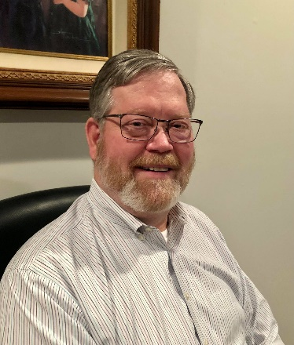***

The Midwest DX Cluster spots included African Italy, Austria, Balearic Islands, Belgium, Bosnia-Herzegovina, Canada, Colombia, Croatia, Czech Republic, Dominican Republic, England, European Russia, Fed. Rep. of Germany, France, Greece, Hungary, Italy, Kaliningrad, Latvia, Lithuania, Luxembourg, North Cook Islands, Peru, Portugal, Sardinia, Saudi Arabia, Serbia, Sicily, Slovenia, Spain, St. Lucia, and Wales. This brings the total number of entities spotted in the Midwest in 2021to 149!

***DAH DIT DIT DIT DAH DAH DIT DIT DIT DAH***

Every year, Bernie, W3UR publishes a summary of the previous year covering all major DX topics. Joe Reisert, W1JR, compiles this information. This is an excellent source of information for the previous year and is a great reference going forward. Bernie has given me permission to reprint this for you. The first half will be this week and the second will be next week.

[TOP](#top) ^



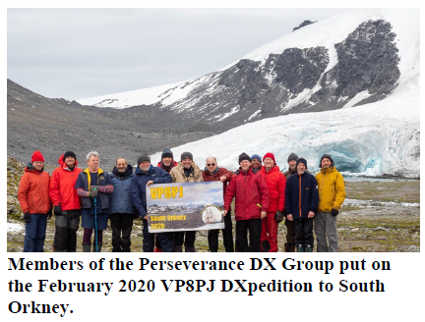**2020 Overview**: To say the least 2020 was a DX year like no others. The Orkney Islands DXPedition VP8PJ, one of the top 20 most needed entities came on the air in late February. Then the Covid-19 (CV) pandemic set in worldwide in March. It made travel difficult, especially to rare DXCC entities in Africa and Oceania. Dozens of planned DXpeditions after that date will either be rescheduled to a later date or cancelled altogether. Also, most conferences and DX gatherings worldwide were cancelled. Suddenly call signs with suffixes like StayHome or StaySafe became common.

On top of this, 2020 was also a difficult year for DXers since the solar flux hit rock bottom and band openings especially on 15 meters and above were all but non-existent. Then about mid-year it was announced that the solar scientists determined that solar cycle 24 finally ended statistically in December 2019 and solar cycle 25 began in January 2020. More on this later.

DX wise only about 265 entities were active during this year, far fewer than the usual 285 or so. January was very poor with only about 185 or so entities active versus a usual 225 in good DX years. For comparison, over the past thirty (30) plus years I try to work every available entity. My average is above 275 but in 2020 I only managed a meager 227! It will be interesting to see the CQ Marathon results this year.

The Bouvet DXPedition was delayed again due to CV. None of the top 10 most needed entities on the Club Log DXCC Most Wanted List were active this year and VP8PJ was the only one of the top 20 most needed. The pandemic caused many DXers to work from home. As a result, DX activity was high all year, especially in DX contests using CW, SSB and FT8 modes. CW was very active all year with many discovering the advantage of this mode under poor conditions. Likewise, FT8 was extremely active since it can often get through when propagation is poor.

In November it was sadly announced that John Devoldere, ON4UN, author and one of the top Low Band DXers worldwide had become a silent key at age of 79. John’s books on low band DXing were prized by many. His final book “Low-Band DXing-Fifth Edition” is a classic. He told me it would be his last as it takes to much effort to complete another edition. I dedicate the “2020 DXCC Year End Review” to John’s memory.

[TOP](#top) ^

**Radio Propagation:** As mentioned above, radio propagation was down most of this year. There were over 210 days (and some whole months) with zero sunspots through October. Typical solar flux during the first part of the year was 70-75 with a few small deviations until late October when solar flux abruptly soared to 88. Solar flux moving above 80 is a good indicator of improving DX on the upper HF bands. In late November the solar flux rose to 113. The increase greatly improved radio propagation especially during the CQ DX SSB and CW Contests.

As mentioned in last year’s review, there have been dozens and dozens of papers predicting that solar cycle 25 would be a real downer. Now a recent report by Dr. Scott W. Mcintosh et al from The National Center for Atmospheric Research is predicting solar cycle 25 to be one of the best in history. They used (discrete) Hilbert Transforms on more than 270 years of monthly sunspots. Most experts agree that solar cycle 25 will peak around 2025. Time will tell. Let’s fix those broken antennas and get on the air.

**Club Log**: This website is becoming the main place to check logs especially during DXpeditions. Their “DXCC Most Wanted List” is always up to date. The 10 most wanted 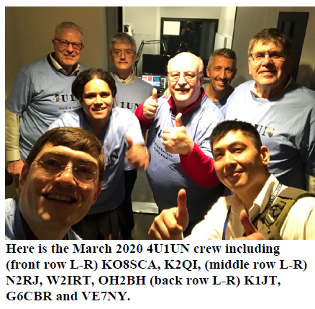DX entities in order or rarity are still P5, 3Y/B, FT5/W, BS7H, CE0X, BV9P, KH7K, KH3, 3Y0/P and FT5/X. Many other features are available such as O QRS (Online QSL Request Service), DXCC Charts, Log Search etc.

**Digital Operations**: Digital and especially FT8 took on more meaning in 2020. FT8 is known for its ability to copy very weak signals. Furthermore, it allows many smaller and low power stations to participate. During this low sunspot year, the higher bands were sometimes open for FT8 contacts when CW or SSB were too marginal. Lately I’m hearing many DXers on FT8.Note that FT8 has a learning curve and users are less likely to spot DX on the DX Clusters. FT4, a higher speed version of FT8 that is slightly less sensitive is now becoming popular.

Thanks to the help from my son Jim, AD1C, I finally got on FT8 late in 2019 hoping to work 3Y/Bouvet and any entities that were active only on FT8. It took only about three weeks to complete DXCC. In six months, I had worked 5BDXCC and by now 7BDXCC with DXCC 210 plus.

**Band by Band Activity (Frequencies in MHz):**

**160 Meters:** Activity was low to moderate on CW except during contests when activity filled the band. The cancellation of most of the planned DXpeditions due to CV really hurt 160 DX. FT8 activity is increasing around 1.840. In April, Japan received increased spectrum.

[TOP](#top) ^

Try to avoid frequencies divisible by 5 (e.g., 1.820, 1.825, 1.830 etc.) since broadcast birdies are often there.

**75/80 Meters:** DX activity was low except during contests and was also hurt by the cancellation of most DXpeditions due to CV. FT8 activity on the other hand is increasing around 3.573.

**60 Meters:** More entities have now received permission to operate on this band albeit they are often limited to 15 Watts and a dipole antenna. Well over 200 DXCC entities have been active on the band. Most DX activity is now concentrated around the third channel at 5.357 and almost entirely on FT8. The FCC is still looking at non-channelized operation near channel 3 for USA stations. The ARRL DXCC program still does not recognize 60-meter contacts for DXCC credit. Remember that USA stations are limited to 100 Watts output power and a dipole antenna. Use of gain antennas require reduced transmitter power.

**40 Meters:** This is the workhorse band especially during the night and in the winter local time. SSB activity is especially good during contests and above 7.100. Remember that USA stations cannot operate SSB below 7.125 but best to stay above 7.128 for safety. FT8 activity is now very popular around 7.074.

**30 Meters**: 30 meters is very popular especially for low power stations. The band is usually open for a few hours before and after sunrise and can be open almost all day during local winter. FT8 can be found 10.136.

**20 Meters:** 20 meters continues to be the go to DX band especially during daylight although some of the activity has moved to the digital modes near 14.074. SSB activity is still high. The CV has cancelled many DXpeditions that usually park on this band.

**17 Meters:** The lack of sunspots has really hurt the higher bands. 17 meters has been less affected and is often open shortly after 20 meters opens. There is lots of FT8 activity around 18.100. All modes seem to be doing OK on this band.

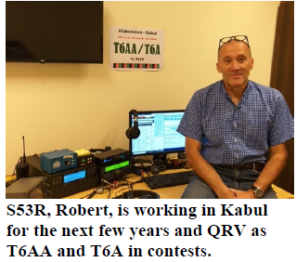**10-15 Meters:** 15 Meters and especially 12 and 10 Meters have been hit extremely hard by the lack of sunspots. Late in this year the solar flux increased slightly and vigilant DXers took advantage of improved radio propagation and openings on 15 through 10 Meters. There is occasional activity here during the summer months when sporadic E propagation occurs.

**6 Meters:** This band in recent years seems to have gone almost all digital. MSK144 is popular all year around 50.260 while FT8 is most popular around 50.313 during summer band openings. EME (Earth-Moon-Earth) DX using digital modes such as JT65 is becoming very popular during local moon rise and set.

Frank, W3LPL is now posting in The Daily DX solar updates on the HF bands based on NOAA/SWPC webpages.

Part 2 Will appear next week.

[TOP](#top) ^

***CQDX CQDX CQDX CQDX CQDX CQDX CQDX CQDX CQDX***

Here is an update from Bernie, W3UR, of the DailyDX and the WeeklyDX, the best source for DX information. [http://www](about:blank).dailydx.com/. Bernie has this to report:

**RAC “Get on the Air on World Amateur Radio Day”**

This special event is April 18.  RAC President VE3XRA, Glenn MacDonell notes “Amateur Radio:  Home But Never Alone!” or “à la maison, mais jamais seul!”  [https://www.rac.ca/ward2021/](about:blank).  April 18 is the annual date for this event because it was on that day in 1925 that the IARU, the International Amateur Radio Union, was formed.  RAC encourages everyone to get on and work the special “RAC” suffix stations.  Work one or more and you’re eligible for a certificate from RAC.  Any band and mode.  No need to send your log.  You will be able to put in your callsign on the RAC site to download your certificate.  VA3RAC will join the Ontario QSO Party from 00-05Z and 12-18Z.  Work VA3RAC then and send the exchange of state/province/country or your Ontario county. [https://www.rac.ca/operating/world-amateur-radio-day-april-18/](about:blank)

**C6 – Bahamas-** C6AHA on Bimini Island, NA-048 is a planned trip, July 14-21 with a team of four so far, N4RRR, K4KSW, N4QBS and NN2T.  They plan multiple radios, a TH3 tribander, MA5B Cushcraft beam, 40 and 80 delta loops, a Buddipole and verticals.  They plan to be on FT8, SSB and CW, trying to work Europe and Australia for those needing it, and other who want the grid or IOTA.  N4RRR, DJ, says he knows it’s not rare DX but is a rare grid and IOTA.  He says it’s a “great DXPedition for us Handi-hams and a vacation for the wives with the covid restrictions going on.”  They thank GigaParts and M&P coax for their help.

**DL – Germany -** DQ11WCA will be active until April 17 from castles and natural areas for the World Castle Award and Worldwide Flora [and] Fauna award.  You don’t need to send for a card if you get bureau cards in your country.  They plan to send you one if you work them.  For the German DARC DLD award it will be “DOK-WCA11,” and there will be logsearch at  [https://www.qrz.com/lookup/dq11wca](about:blank)

**VK9HR Willis Island News 10 March 2021**

(by VK2JI, Ed Durrant, Publicity Officer VK9HR Willis Island DX'Pedition.)

I am glad to report on behalf of the group, that all is going well, and all is on schedule for November. Please add this into your calendars.

* The boat is chartered to leave Australia on November 3rd returning November 13th.
* Plans are being made around what equipment to take.
* The team is growing, the latest new member being Allan VK6CQ representing Western Australia.
* Coverage is planned for 160m through 10m on SSB/CW/Digital (6 metres being considered if time & equipment allows).

Details about location:

* Willis Island is currently No. 38 on the Club Log most wanted list
* DXCC Country - Willis Islets
* WAZ zone - CQ 30.
* ITU Zone - 55.
* RSGB IOTA - OC-007.
* QTH Locator - QH43

[TOP](#top) ^

This DXPedition is being organised and run by the Hellenic Amateur Radio Association of Australia : HARAOA website: [www.haraoa.com](about:blank)

***DAH DIT DIT DIT DAH DAH DIT DIT DIT DAH***



Below is a list of upcoming contests in the “Contest Corner”. I think this is important for someone who is trying to move up the DXCC ladder since entities that are on the rarer side and easiest to work in contests. Some of my best “catches” have been on the Sunday afternoon of a contest when the rarer entities are begging for QSOs. Of course, the gamble is that if you wait until Sunday, conditions may change, or they simply won’t be workable. However, it is not a bad gamble. Of course, why not work the contest and have some fun!  
Check out the WA7BNM Contest Calendar page ([https://www.contestcalendar.com/](about:blank)) for more contests or more details.

The contests in red are those that I plan to spend some significant participation time on. PLEASE let me know if you are working contests and how you fared.

Thanks!

|  |  |  |
| --- | --- | --- |
| Mar. 20-21 | Virginia QSO Party | [https://bit.ly/2Khd2ul](about:blank) |
| Mar. 20-21 | Russian DX Contest | [www.rdxc.org/asp/pages/rulesg.asp](about:blank) |
| Mar. 20-22 | BARTG HF RTTY Contest | [http://bartg.org.uk/wp/contests](about:blank) |
| Mar. 21 | UBA Spring Contest 80m SSB | [http://bit.ly/2KKAtb9](about:blank) |
| Mar. 25 | RSGB 80m Club Championship, SSB | [http://bit.ly/3avHbk3](about:blank) |
| **Mar. 27-28** | **CQWW WPX SSB Contest** | [**www.cqwpx.com**](about:blank) |
| Mar. 31 | UKEICC 80m Contests CW | [https://bit.ly/2SDPqQQ](about:blank) |
| Mar. 27 | FOC QSO Party | [www.g4foc.org/qsoparty](about:blank) |
| Mar. 31 | UKEICC 80m Contests CW | [https://bit.ly/2SDPqQQ](about:blank) |
| Apr. 1 | SARL 80m QSO Party | [http://bit.ly/H0IqQf](about:blank) |
| Apr. 3-4 | EA RTTY Contest | [https://tinyurl.com/yxukvmbz](about:blank) |
| Apr. 3-4 | Louisiana QSO Party | [http://laqp.org](about:blank) |
| Apr. 3-4 | Mississippi QSO Party | [www.arrlmiss.org](about:blank) |
| Apr. 3-4 | SP DX Contest | [https://spdxcontest.pzk.org.pl/2020](about:blank) |
| Apr. 4 | DARC Easter Contest | [http://bit.ly/3bOk9pd](about:blank) |
| Apr. 4 | North American SSB Sprint | [https://ssbsprint.com/rules](about:blank) |
| Apr. 7 | RSGB FT4 Contest Series | [http://bit.ly/3mCNXXH](about:blank) |
| Apr. 7 | UKEICC 80m Contests SSB | [https://bit.ly/2SDPqQQ](about:blank) |
| Apr.10-11 | FT8 DX Contest 2021 | [https://europeanft8club.wordpress.com](about:blank) |
| Apr. 10-11 | Georgia QSO Party | [https://gaqsoparty.com](about:blank) |
| Apr. 10-11 | JIDX CW Contest | [www.jidx.org](about:blank) |
| Apr. 10-11 | Nebraska QSO Party | [www.nebraskaqsoparty.org](about:blank) |

[TOP](#top) ^

|  |  |  |
| --- | --- | --- |
| Apr. 10-11 | New Mexico QSO Party | [www.newmexicoqsoparty.org/wp](about:blank) |
| Apr. 10-11 | North Dakota QSO Party | [http://ndarrlsec.com](about:blank) |
| Apr. 10-11 | OK-OM DX SSB Contest | [http://bit.ly/3ioS3Cl](about:blank) |
| Apr. 10-11 | Yuri Gagarin International DX Contest | [http://gc.qst.ru/en/section/32](about:blank) |
| Apr. 11 | RSGB RoLo SSB Contest | [www.rsgbcc.org/hf/rules/2021/rolo.shtml](about:blank) |
| Apr. 12 | RSGB 80m Club Championship, CW | [http://bit.ly/3avHbk3](about:blank) |
| Apr. 17 | ES Open HF Championship | [https://esopen.eu/](about:blank) |
| Apr. 17-18 | Holyland DX Contest | [www.iarc.org/iarc/#HolylandContest](about:blank#HolylandContest) |
| Apr. 17-18 | CQ Manchester Mineira DX Contest | [www.cqmmdx.com/rules](about:blank) |
| Apr. 17-18 | Michigan QSO Party | [www.miqp.org/index.html](about:blank) |
| Apr. 17-18 | Ontario QSO Party | [www.va3cco.com/oqp/rules.htm](about:blank) |
| Apr. 17-18 | Texas State Parks on the Air | [www.tspota.org](about:blank) |
| Apr. 17-18 | Worked All Provinces of China DX Contest | [https://bit.ly/3sDGs72](about:blank) |
| Apr. 17-18 | YU DX Contest | [http://yudx.yu1srs.org.rs](about:blank) |
| Apr. 19 | ARRL Rookie Roundup, SSB | [www.arrl.org/rookie-roundup](about:blank) |
| Apr. 21 | RSGB 80m Club Championship, SSB | [http://bit.ly/3avHbk3](about:blank) |
| Apr. 29 | RSGB 80m Club Championship, Data | [http://bit.ly/3avHbk3](about:blank) |
| Apr. 24-25 | 10-10 Spring Digital Contest | [http://bit.ly/1FrFeBc](about:blank) |
| Apr. 24-25 | Florida QSO Party | [www.floridaqsoparty.org](about:blank) |
| Apr. 24-25 | Helvetia Contest | [www.uska.ch](about:blank) |
| Apr. 24-25 | SP DX RTTY Contest | [www.pkrvg.org/strona,spdxrttyen.html](about:blank) |
| Apr. 25 | BARTG Sprint75 Contest | [http://bartg.org.uk/wp/contests](about:blank) |
| Apr. 28 | UKEICC 80m Contests CW | [https://bit.ly/2SDPqQQ](about:blank) |
| May 29-30 | CQWW WPX CW CONTEST | [www.cqwpx.com](about:blank) |
| August 28 | Ohio QSO Party | [https://www.ohqp.org/](about:blank) |
| August 28 | W8DXCC | [https://www.w8dxcc.com](about:blank) |

\_\_\_\_\_\_\_\_\_\_\_\_\_\_\_\_\_\_\_\_\_\_\_\_\_\_\_\_\_\_\_\_\_\_\_\_\_\_\_\_\_\_\_\_\_\_\_\_\_\_\_\_\_\_\_\_\_\_\_\_\_\_\_\_\_\_\_\_\_\_\_\_\_\_\_\_\_\_\_\_\_\_\_\_\_\_

Great Lakes Area Winlink Net Started

A new Great Lakes Winlink Net has been started to promote the use of Winlink and training on the various facets of the hybrid amateur radio data/internet system. The net is open primarily to those states that border any of the Great Lakes: Minnesota, Wisconsin, Illinois, Indiana, Michigan, Ohio, Pennsylvania, and New York, and the Canadian province of Ontario. However, radio amateurs wishing to check in from other states or provinces anywhere are welcomed to participate. This net is modeled on the [Wisconsin ARES Winlink net.](http://wi-aresraces.org/)

The net check-in process is as follows: Send either a basic, plain text message, or use any of the forms templates on the Winlink Express platform available that will allow you to include the following line of text in the body of the message or in an appropriate part on the form you choose to send: FIRST NAME, CALLSIGN, CITY, COUNTY, STATE, COUNTRY. For example: RYAN, KB8RCR, REMUS, MECOSTA, MICHIGAN, USA.

[TOP](#top) ^

The net started on Wednesday, March 10, and each week on Wednesdays, amateurs may send their messages or forms any time during the day using Winlink in any mode available, RF or via Telnet. Send your message to KB8RCR as the recipient on Winlink. - *Ryan Lughermo, KB8RCR, ARRL Assistant Section Emergency Coordinator for Data Management/Special Projects, Michigan Section; and Official Relay Station*

ARES Resources

· [Download the ARES Manual [PDF]](http://www.arrl.org/files/file/Public%20Service/ARES/ARESmanual2015.pdf)

· [ARES Field Resources Manual [PDF]](http://www.arrl.org/files/file/ARES_FR_Manual.pdf)

· [ARES Standardized Training Plan Task Book [Fillable PDF]](http://www.arrl.org/files/file/Public%20Service/ARES/ARRL-ARES-FILLABLE-TRAINING-TASK-BOOK-V2_1_1.pdf)

· [ARES Standardized Training Plan Task Book [Word]](http://www.arrl.org/files/file/Public%20Service/ARES/ARRL-ARES-STANDARDIZED-TRAINING-TASK-BOOK-V1_2_2.doc)

· [ARES Plan](http://www.arrl.org/ares-plan)

· [ARES Group Registration](http://www.arrl.org/ares-group-id-request-form)

· [Emergency Communications Training](http://www.arrl.org/emergency-communications-training)

The Amateur Radio Emergency Service® (ARES) consists of licensed amateurs who have voluntarily registered their qualifications and equipment, with their local ARES leadership, for communications duty in the public service when disaster strikes. Every licensed amateur, regardless of membership in ARRL or any other local or national organization is eligible to apply for membership in ARES. Training may be required or desired to participate fully in ARES. Please inquire at the local level for specific information. Because ARES is an amateur radio program, only licensed radio amateurs are eligible for membership. The possession of emergency-powered equipment is desirable, but is not a requirement for membership.

How to Get Involved in ARES: Fill out the [ARES Registration form](http://www.arrl.org/files/file/Public%20Service/fsd98.pdf) and submit it to your local Emergency Coordinator

***DX News ARLD011 DX News***

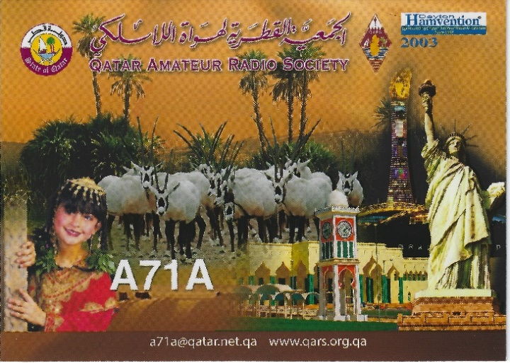

This week's bulletin was made possible with information provided by KK9A, The Daily DX, the OPDX Bulletin, 425 DX News, DXNL, Contest Corral from QST and the ARRL Contest Calendar and WA7BNM web sites.

Thanks to all.  
  
BOTSWANA, A2.  Operators Vasily, R7AL, Leo, UI8J, Vlad, R9LR and Mike, RU3UR are QRV as A25RU from Gaborone until March 26.  Activity is on 160 to 10 meters, using CW, SSB, and FT8 in DXpedtion mode, with four stations active.  This also includes activity on Satellite  
QO-100.  QSL via Club Log.

[TOP](#top) ^

BAHAMAS, C6.  Steve, KG4LJB is QRV as C6AJB from Eleuthera Island, IOTA NA-001, until March 27.  Activity is on 80 to 15 meters using some SSB, but mostly FT8 and FT4.  QSL via LoTW.  
  
MOROCCO, CN.  Special event station CN21JIF is QRV until March 21 to celebrate the United Nations International Day of Forests which is on March 21.  QSL via RW6HS.  
  
MADEIRA ISLANDS, CT3.  Helmut, DF7EE will be QRV as CT9/DF7EE from March 23 to 31.  This includes being active as either CQ3W or CR3W in the upcoming CQ World Wide WPX SSB contest.  QSL direct to home call.  
  
SPAIN, EA.  Special event station EH3DWN is QRV until April 1 to commemorate World Down Syndrome Day which is on March 21.  QSL via LoTW.  
  
GUADELOUPE, FG.  Philippe, F1DUZ is QRV as FG4KH until April 1. This includes being an entry in the upcoming CQ World Wide WPX SSB contest.  QSL direct to home call.  
  
SAINT MARTIN, FS.  Janusz, SP9FIH will be QRV as TO1K from Saint Martin from March 22 to April 5.  Activity will be on the HF bands. QSL to home call.  
  
WALES, GW.  John, MW1CFN will be QRV as GB1004FTS from Anglesey Island, IOTA EU-005, from March 25 to April 8 to celebrate the 100th anniversary of the Royal Air Force's Number 4 Flying Training School that opened on 1 April 1921.  Activity will be on the HF bands, including 6 and 2 meters, using SSB and various digital modes.  QSL direct to home call.  
  
ARUBA, P4.  John, KK9A will be QRV as P40A from March 24 to 28. Activity will be on 160 to 10 meters using CW and SSB.  This includes being an entry in the upcoming CQ World Wide WPX SSB  
contest.  QSL via WD9DZV.

ST. MAARTEN, PJ7.  Tom, AA9A is QRV as PJ7AA until March 27. Activity is on 80 to 10 meters using CW, SSB and FT8.  QSL via LoTW.  
  
BRAZIL, PY.  Special event stations ZZ5FLORIPA and ZZ5FLN are QRV until March 23 to celebrate the 348th anniversary of Florianopolis. QSL via bureau.  
  
MALI, TZ.  Jeff, TZ4AM has been active using CW on 40 meters around 0145z.  QSL via W0SA.  
  
COCOS (KEELING) ISLANDS, VK9C.  Station VK9CE is QRV until March 23. Activity is holiday style on 80 to 10 meters using CW, SSB and FT8. Some activity on 6 meters is possible depending on conditions.  QSL  
via EB7DX.  
  
PITCAIRN ISLAND, VP6.  Meralda, VP6MW has been active on 20 meters SSB around 1520z and 17 meters SSB around 1640z.  QSL via W0VTT.  
  
INDONESIA, YB.  A group of operators will be QRV as 7D5RI from Rupat Island, IOTA OC-245, from March 26 to 28.  Activity will be on 80 to 10 meters using CW, SSB and FT8.  QSL via LoTW.

[TOP](#top) ^

NICARAGUA, YN.  Myron, KN6GHM will be QRV as H7/KN6GHM from Guanacastillo from March 22 to 30.  Activity will be holiday style on 80 to 10 meters using SSB.  He and Trevis, YN7ZTR will be QRV as  
YN1YN in the upcoming CQ World Wide WPX SSB contest with two stations.  QSL via LoTW.  
  
KOSOVO, Z6.  Driton, Z61DX has been QRV on 20 meters using CW around 1500z.  QSL via Club Log.  
  
THIS WEEKEND ON THE RADIO.  The QRP 80-Meter CW Fox Hunt, NCCC RTTY Sprint, NCCC Sprint, K1USN Slow Speed CW Test, BARTG HF RTTY Contest, Russian DX Contest, AGCW VHF/UHF Contest, Virginia QSO Party, Feld Hell Sprint, UBA Spring SSB Contest, Run for the Bacon QRP CW Contest, OK1WC Memorial and Worldwide Sideband Activity Contest are all on tap for this weekend.   
  
The RTTYOPS Weeksprint is scheduled for March 23.  
  
The SKCC CW Sprint, CWops Mini-CWT Test, Phone Fray and QRP CW Fox Hunt are all scheduled for March 24.  
  
Please see March QST, page 72, and the ARRL and WA7BNM contest web sites for details.

**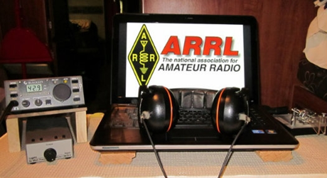*ARRL Contest Corner***

An expanded, downloadable version of *QST'*s’ [**Contest Corral**](http://www.arrl.org/contest-calendar) is available as a PDF. Check the sponsor’s ‘Website for information on operating time restrictions and other instructions.

CONTESTS

**18 Mar - 31 Mar 2021**

An expanded, downloadable version of *QST'*s [Contest Corral](http://www.arrl.org/contest-calendar) is available as a PDF. Check the sponsors' website for information on operating time restrictions and other instructions.

**HF CONTESTS**

[CLARA Chatter Party](https://clarayl.ca/chatter-party/), Mar 16, 1700z to Mar 17, 1700z and, Mar 20, 1700z to Mar 21, 1700z; CW, Phone; Bands: 80, 40, 20, 15, 10m; RS(T) + Name + (state/province/country); Logs due: April 15.  
  
[NAQCC CW Sprint](http://naqcc.info/sprint/sprint202105.html), Mar 18, 0030z to Mar 18, 0230z; CW; Bands: (see rules); RST + (state/province/country) + (NAQCC No./power); Logs due: March 21.  
  
[CWops Mini-CWT Test](https://cwops.org/cwops-tests/), Mar 18, 0300z to Mar 18, 0400z; CW; Bands: 160, 80, 40, 20, 15, 10m; Member: Name + Member No./"CWA", non-Member: Name + (state/province/country); Logs due: March 20.  
  
[RTTYOPS Weeksprint](https://rttyops.wordpress.com/rtty-mini-contests/rttyops-weeksprint/), Mar 18, 1700z to Mar 18, 1900z; RTTY; Bands: 80, 40, 20m; [other station's call] + [your call] + [serial no.] + [your name]; Logs due: March 23.  
  
[BCC QSO Party](http://www.bavarian-contest-club.de/contest/qso-partys2021/Rules-BCC-QSO-Parties-2021;art626,2399), Mar 18, 1930z to Mar 18, 2059z; CW, SSB, RTTY; Bands: 80m Only; RS(T) + T-shirt size (see rules); Logs due: March 18.

[TOP](#top) ^

[QRP Fox Hunt](http://www.qrpfoxhunt.org/winter_rules.htm), Mar 19, 0100z to Mar 19, 0230z; CW; Bands: 20m Only; RST + (state/province/country) + name + power output; Logs due: March 25.  
  
[NCCC RTTY Sprint](http://www.ncccsprint.com/rttyns.html), Mar 19, 0145z to Mar 19, 0215z; RTTY; Bands: (see rules); Serial No. + Name + QTH; Logs due: March 21.  
  
[NCCC Sprint](http://www.ncccsprint.com/rules.html), Mar 19, 0230z to Mar 19, 0300z; CW; Bands: (see rules); Serial No. + Name + QTH; Logs due: March 21.  
  
[K1USN Slow Speed Test](http://www.k1usn.com/sst.html), Mar 19, 2000z to Mar 19, 2100z; CW; Bands: 160, 80, 40, 20m; Maximum 20 wpm, Name + (state/province/country); Logs due: March 21.  
  
[BARTG HF RTTY Contest](http://www.bartg.org.uk/), Mar 20, 0200z to Mar 22, 0159z; RTTY; Bands: 80, 40, 20, 15, 10m; RST + Serial No. + 4-digit time (UTC); Logs due: March 29.  
  
[Russian DX Contest](http://www.rdxc.org/asp/pages/rulesg.asp), Mar 20, 1200z to Mar 21, 1200z; CW, SSB; Bands: 160, 80, 40, 20, 15, 10m; Ru: RS(T) + 2-character oblast, non-Ru: RS(T) + Serial No.; Logs due: April 4.  
  
[Virginia QSO Party](https://www.qsl.net/sterling/VA_QSO_Party/2021_VQP/2021_VQP_Main.html), Mar 20, 1400z to Mar 21, 0400z and, Mar 21, 1200z to Mar 22, 0000z; CW, Phone, Digital; Bands: All, except WARC; VA: Serial No. + county, non-VA: Serial No. + (state/province/"DX"); Logs due: April 19.  
  
[Feld Hell Sprint](https://sites.google.com/site/feldhellclub/Home/contests/sprints/full-day-of-hell-sprint), Mar 20, 2000z to Mar 20, 2159z; Feld Hell; Bands: ; (see rules); Logs due: March 24.

[UBA Spring Contest, SSB](http://www.uba.be/hf/contest-rules/spring-contest), Mar 21, 0700z to Mar 21, 1100z; SSB; Bands: 80m Only; ON: RS + Serial No. + UBA Section, non-ON: RS + Serial No.; Logs due: April 4.  
  
[Run for the Bacon QRP Contest](http://qrpcontest.com/pigrun/), Mar 21, 2300z to Mar 22, 0100z; CW; Bands: 160, 80, 40, 20, 15, 10m; RST + (state/province/country) + (Member No./power); Logs due: March 28.  
  
[K1USN Slow Speed Test](http://www.k1usn.com/sst.html), Mar 22, 0000z to Mar 22, 0100z; CW; Bands: 160, 80, 40, 20m; Maximum 20 wpm, Name + (state/province/country); Logs due: March 28.  
  
[OK1WC Memorial (MWC)](https://memorial-ok1wc.cz/index.php?page=rules2l), Mar 22, 1630z to Mar 22, 1729z; CW; Bands: 80, 40m; RST + Serial No.; Logs due: March 26.  
  
[Worldwide Sideband Activity Contest](https://wwsac.com/rules.html), Mar 23, 0100z to Mar 23, 0159z; SSB; Bands: 160, 80, 40, 20, 15, 10, **6m**; RS + age group (OM, YL, Youth YL or Youth); Logs due: March 24.  
  
[RTTYOPS Weeksprint](https://rttyops.wordpress.com/rtty-mini-contests/rttyops-weeksprint/), Mar 23, 1700z to Mar 23, 1900z; RTTY; Bands: 80, 40, 20m; [other station's call] + [your call] + [serial no.] + [your name]; Logs due: March 23.  
  
[SKCC Sprint](http://www.skccgroup.com/operating_activities/weekday_sprint/), Mar 24, 0000z to Mar 24, 0200z; CW; Bands: 160, 80, 40, 20, 15, 10, **6m**; RST + (state/province/country) + Name + (SKCC No./"NONE"); Logs due: March 26.  
  
[QRP Fox Hunt](http://www.qrpfoxhunt.org/winter_rules.htm), Mar 24, 0100z to Mar 24, 0230z; CW; Bands: 40m Only; RST + (state/province/country) + name + power output; Logs due: March 25.

[TOP](#top) ^

[Phone Weekly Test - Fray](http://www.perluma.com/Phone_Fray_Contest_Rules.pdf), Mar 24, 0230z to Mar 24, 0300z; SSB; Bands: 160, 80, 40, 20, 15m; NA: Name + (state/province/country), non-NA: Name; Logs due: March 26.  
  
[CWops Mini-CWT Test](https://cwops.org/cwops-tests/), Mar 24, 1300z to Mar 24, 1400z; CW; Bands: 160, 80, 40, 20, 15, 10m; Member: Name + Member No./"CWA", non-Member: Name + (state/province/country); Logs due: March 27.  
  
[CWops Mini-CWT Test](https://cwops.org/cwops-tests/), Mar 24, 1900z to Mar 24, 2000z; CW; Bands: 160, 80, 40, 20, 15, 10m; Member: Name + Member No./"CWA", non-Member: Name + (state/province/country); Logs due: March 27.  
  
[CWops Mini-CWT Test](https://cwops.org/cwops-tests/), Mar 25, 0300z to Mar 25, 0400z; CW; Bands: 160, 80, 40, 20, 15, 10m; Member: Name + Member No./"CWA", non-Member: Name + (state/province/country); Logs due: March 27.  
  
[RTTYOPS Weeksprint](https://rttyops.wordpress.com/rtty-mini-contests/rttyops-weeksprint/), Mar 25, 1700z to Mar 25, 1900z; RTTY; Bands: 80, 40, 20m; [other station's call] + [your call] + [serial no.] + [your name]; Logs due: March 30.  
  
[RSGB 80m Club Championship, SSB](https://www.rsgbcc.org/hf/rules/2021/r80mcc.shtml), Mar 25, 2000z to Mar 25, 2130z; SSB; Bands: 80m Only; RS + Serial No.; Logs due: March 26.  
  
[QRP Fox Hunt](http://www.qrpfoxhunt.org/winter_rules.htm), Mar 26, 0100z to Mar 26, 0230z; CW; Bands: 80m Only; RST + (state/province/country) + name + power output; Logs due: April 1.  
  
[NCCC RTTY Sprint](http://www.ncccsprint.com/rttyns.html), Mar 26, 0145z to Mar 26, 0215z; RTTY; Bands: (see rules); Serial No. + Name + QTH; Logs due: March 28.

[NCCC Sprint](http://www.ncccsprint.com/rules.html), Mar 26, 0230z to Mar 26, 0300z; CW; Bands: (see rules); Serial No. + Name + QTH; Logs due: March 28.  
  
[K1USN Slow Speed Test](http://www.k1usn.com/sst.html), Mar 26, 2000z to Mar 26, 2100z; CW; Bands: 160, 80, 40, 20m; Maximum 20 wpm, Name + (state/province/country); Logs due: March 28.  
  
[FOC QSO Party](http://g4foc.org/qsoparty/), Mar 27, 0000z to Mar 27, 2359z; CW; Bands: 160, 80, 40, 20, 15, 10, VHF; FOC-Member: RST + Name + Member No., non-Members: RST + Name; Logs due: April 3.  
  
[CQ WW WPX Contest, SSB](http://www.cqwpx.com/rules.htm), Mar 27, 0000z to Mar 28, 2359z; SSB; Bands: 160, 80, 40, 20, 15, 10m; RS + Serial No.; Logs due: April 2.  
  
[UBA Spring Contest, 6m](http://www.uba.be/hf/contest-rules/spring-contest), Mar 28, 0600z to Mar 28, 1000z; CW, Phone; Bands: 6m Only; ON: RS(T) + Serial No. + UBA Section, non-ON: RS(T) + Serial No.; Logs due: April 11.  
  
[K1USN Slow Speed Test](http://www.k1usn.com/sst.html), Mar 29, 0000z to Mar 29, 0100z; CW; Bands: 160, 80, 40, 20m; Maximum 20 wpm, Name + (state/province/country); Logs due: April 4.  
  
[QCX Challenge](http://www.qrp-labs.com/party.html), Mar 29, 1300z to Mar 29, 1400z; CW; Bands: 160, 80, 40, 20, 15, 10m; RST + Name + (state/province/country) + Rig; Logs due: April 5.  
  
[OK1WC Memorial (MWC)](https://memorial-ok1wc.cz/index.php?page=rules2l), Mar 29, 1630z to Mar 29, 1729z; CW; Bands: 80, 40m; RST + Serial No.; Logs due: April 2.

[TOP](#top) ^

[QCX Challenge](http://www.qrp-labs.com/party.html), Mar 29, 1900z to Mar 29, 2000z; CW; Bands: 160, 80, 40, 20, 15, 10m; RST + Name + (state/province/country) + Rig; Logs due: April 5.  
  
[Worldwide Sideband Activity Contest](https://wwsac.com/rules.html), Mar 30, 0100z to Mar 30, 0159z; SSB; Bands: 160, 80, 40, 20, 15, 10, 6m; RS + age group (OM, YL, Youth YL or Youth); Logs due: March 31.  
  
[QCX Challenge](http://www.qrp-labs.com/party.html), Mar 30, 0300z to Mar 30, 0400z; CW; Bands: 160, 80, 40, 20, 15, 10m; RST + Name + (state/province/country) + Rig; Logs due: April 5.  
  
[RTTYOPS Weeksprint](https://rttyops.wordpress.com/rtty-mini-contests/rttyops-weeksprint/), Mar 30, 1700z to Mar 30, 1900z; RTTY; Bands: 80, 40, 20m; [other station's call] + [your call] + [serial no.] + [your name]; Logs due: March 30.  
  
[QRP Fox Hunt](http://www.qrpfoxhunt.org/winter_rules.htm), Mar 31, 0100z to Mar 31, 0230z; CW; Bands: 20m Only; RST + (state/province/country) + name + power output; Logs due: April 1.  
  
[Phone Weekly Test - Fray](http://www.perluma.com/Phone_Fray_Contest_Rules.pdf), Mar 31, 0230z to Mar 31, 0300z; SSB; Bands: 160, 80, 40, 20, 15m; NA: Name + (state/province/country), non-NA: Name; Logs due: April 2.  
  
[CWops Mini-CWT Test](https://cwops.org/cwops-tests/), Mar 31, 1300z to Mar 31, 1400z; CW; Bands: 160, 80, 40, 20, 15, 10m; Member: Name + Member No./"CWA", non-Member: Name + (state/province/country); Logs due: April 3.  
  
[CWops Mini-CWT Test](https://cwops.org/cwops-tests/), Mar 31, 1900z to Mar 31, 2000z; CW; Bands: 160, 80, 40, 20, 15, 10m; Member: Name + Member No./"CWA", non-Member: Name + (state/province/country); Logs due: April 3.  
  
[UKEICC 80m Contest](https://www.ukeicc.com/80m-rules.php), Mar 31, 2000z to Mar 31, 2100z; ; Bands: 80m Only; 6-Character grid square; Logs due: March 31.

**VHF+ CONTESTS**

[AGCW VHF/UHF Contest](http://alt.agcw.de/index.php/en/contests-and-cw-activities/vhf-uhf-contest), Mar 20, 1400z to Mar 20, 1700z (144) and, Mar 20, 1700z to Mar 20, 1800z (432); CW; Bands: 144 MHz, 432 MHz; RST + "/" + Serial No. + "/" Power class + "/" + 6-character grid locator; Logs due: March 28.

Also, see [Worldwide Sideband Activity Contest](https://wwsac.com/rules.html), [SKCC Sprint](http://www.skccgroup.com/operating_activities/weekday_sprint/), above.

***Special Events***

* **03/23/2021 | Honoring World War II Gunners at Buckingham Airfield**

**Mar 23-Mar 25, 1400Z-2100Z, W4LX**, Fort Myers, FL. Fort Myers Amateur Radio Club. 28.360 21.360 14.270 146.685. Certificate. W4LX Fort Myers Amateur Radio Club, P.O. Box 61183, Fort Myers, FL 33906. [www.fmarc.net](http://www.fmarc.net/)

[TOP](#top) ^

* **04/10/2021 | The Annual Nancy Kott Memorial KN0WCW Event**

**Apr 10-Apr 11, 0001Z-2359Z, KN0WCW**, Leonardo, NJ. FISTS North America. 10.058 7.058 10.118 3.558. Certificate. cody codianni, 413 Martin Court, Leonardo, NJ 07737. The Annual Nancy Kott Memorial KN0WCW Event! Nancy met Fists’ founder George, G3ZQS (SK) in a happenstance QSO in 1988, befriended him and shortly became the head of what is now The Americas Chapter of Fists. From then till her passing on 2 March of 2014, she worked tirelessly to promote our club and Morse Code, showing kindness to all and exemplifying our mottos of “courtesy at all times” and “accuracy transcends speed.” She is deeply missed by all, but not forgotten. Please help us honor Nancy’s work and dedication from 00:01 UTC April 10 2021 to 23:59 UTC April 11 2021. [fistsna.org/operating.html](http://fistsna.org/operating.html)

* **04/10/2021 | Celebration of the 155th Anniversary of Auburn University**

**Apr 10-Apr 11, 1200Z-2359Z, W4E**, Auburn University, AL. Auburn University. 7.060 7.074 and 7.047.5 14.074 and 14.080 7.070. QSL. Stew Schneller, 1869 Hillton Court, Auburn, AL 36830-2693. [www.qrz.com/db/k4jop](http://www.qrz.com/db/k4jop)

* **04/10/2021 | Spring has Sprung**

**Apr 10, 1700Z-2100Z, W4D**, Kodak, TN. Sevier County Emergency Radio Service. 14.280 +/- .020 USB 7.200 +/- .020 LSB 14.070 +/- .020 PSK31 7.070 +/- .020 PSK31 CW only on 7.060 +/- .010. QSL. Thomas P. Baxter W9TPB, 2054 James Rd., Sevierville, TN 37876. For additional information, please go to our website [www.eventqsl.webs.com](http://www.eventqsl.webs.com/)

* **04/10/2021 | USS Midway Museum Ship Special Event: Doolittle Raid**

**Apr 10, 1600Z-2300Z, NI6IW**, San Diego, CA. USS Midway (CV-41) Museum Ship. 7.250 14.320 14.070 (PSK31) DSTAR via PapaSystem repeaters. QSL. USS Midway CV-41 COMEDTRA NI6IW, 910 N Harbor Dr, San Diego, CA 92101. Please include SASE. [www.qrz.com/db/ni6iw](http://www.qrz.com/db/ni6iw)

* **04/17/2021 | Celebrating the Louisiana Purchase**

**Apr 17-Apr 24, 0000Z-2359Z, W5L**, West Monroe, LA. NorthEast Louisiana Amateur Radio Club. 14.250 21.250 7.250 3.850. QSL. Jim Ragsdale, W5LA, 111 Eagle Lake Drive, West Monroe, LA 71291. <https://www.qrz.com/db/W5L>

* **04/17/2021 | Texas State Parks On the Air (TSPOTA)**

**Apr 17-Apr 19, 1400Z-0200Z, K5LRK**, The Colony, TX. Lake Area Amateur Radio Club. CW Phone VHF. QSL. See website, for, Information. Times are daily. K5LRK on as a special event station. Contest: Activate as many Texas parks as possible. www.k5lrk.com or [www.tspota.org](http://www.tspota.org/)

* **04/18/2021 | World Amateur Radio Day**

**Apr 18-Apr 19, 1300Z-0400Z, W7W**, Rochester, NY. W2JLD/Special event coordinator. Echolink \*ROC-HAM\* CONFERENCE 531091 Allstar 2585, 47620, 53130. QSL. John Derycke, W2JLD, 85 Amherst St #2, Rochester, NY 14607. This will be our 6th annual WORLD AMATEUR RADIO DAY celebration on the VOIP Echolink system We have a 16 hr net with net controllers from all over the world. A special event qsl card will be available Join us again for one of the LARGEST special events on Echolink@ 9AM EST TILL 12 MINDNIGHT EST we will have Allstar, DMR as well. [w2jld2@gmail.com](mailto:)

[TOP](#top) ^

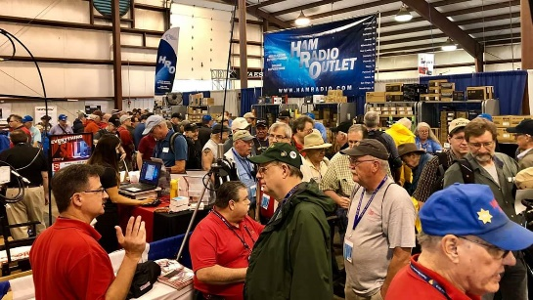[***Upcoming Hamfests***](http://arrl-ohio.org/hamfests.html)

We **DO** have some hamfests scheduled for 2021!! Yes, take a good look at the list, it’s growing every day!

Be sure to keep your eyes on this schedule as that when things start getting better and the vaccine rolls out to more and more, hamfests will surely get back to their normal schedule. Don’t see your hamfest listed?? Did anyone register it with ARRL? It’s really easy to do and you get a lot of FREE publicity if you do.

**Massillon ARC** Spring TailgateFest to be held at the MAPS Air Museum. Entrance at 5383 Massillon Road just inside the Stark/Summit County line. Date is Saturday, April 17 from 9 [a.m.to](http://a.m.to/) 4 p.m. Cost is $5 per vehicle. (for use of the facility)   No advance registration necessary. Bring your own tables. (no large trailers) No charge for visitors.

|  |  |
| --- | --- |
| **06/05/2021 -**[**FCARC SummerFest**](http://www.arrl.org/hamfests/fcarc-summerfest)  Location: Wauseon, OH Sponsor: Fulton County Amateur Radio Club Website:<http://k8bxq.org/hamfest> [Learn More](http://www.arrl.org/hamfests/fcarc-summerfest) | **07/10/2021 - [Mansfiled Mid-Summer Trunkfest](http://www.arrl.org/hamfests/mansfiled-mid-summer-trunkfest" \o "Mansfiled Mid-Summer Trunkfest)**  Location: Mansfield, OH Sponsor: InterCity Amateur Radio Club Website:<http://iarc.club>[Learn More](http://www.arrl.org/hamfests/mansfiled-mid-summer-trunkfest) |
| **07/17/2021 -**[**NOARSFEST**](http://www.arrl.org/hamfests/noarsfest-8)  Location:Elyria, OH Type: ARRL Hamfest Sponsor: Northern Ohio Amateur Radio Society Website: [http://noars.net](http://noars.net/) [Learn More](file:///F:\Websites\arrl-ohio\news\2021\Learn%20More) | **07/18/2021 –**[**Van Wert Hamfest**](http://www.arrl.org/hamfests/van-wert-hamfest-5)  Location: Van Wert, OH Sponsor: Van Wert Amateur Radio Club Website:[http://W8FY.ORG](http://w8fy.org/)[Learn More](http://www.arrl.org/hamfests/van-wert-hamfest-5) |
| **08/07/2021 -**[**DX Engineering Hamfest & Great Lakes Division Convention**](http://www.arrl.org/hamfests/dx-engineering-hamfest-1)  Location: Tallmadge, OH Sponsor: DX Engineering Website: [http://dxengineering.com](http://dxengineering.com/) [Learn More](http://www.arrl.org/hamfests/dx-engineering-hamfest-1) | |
| **08/28/2021 -**[**Cincinnati Hamfest℠**](http://www.arrl.org/hamfests/cincinnati-hamfest)  Location: Owensville, OH Sponsor: Milford ARC Website: [http://CincinnatiHamfest.org](http://cincinnatihamfest.org/) [Learn More](http://www.arrl.org/hamfests/cincinnati-hamfest) | **09/26/2021 -**[**Cleveland Hamfest**](http://www.arrl.org/hamfests/cleveland-hamfest-1)  Location: Berea, OH Sponsor: Hamfest Association of Cleveland Website: [http://www.hac.org](http://www.hac.org/) [**Learn More**](http://www.arrl.org/hamfests/cleveland-hamfest-1) |
| **12/04/2021 -**[**FCARC WinterFest**](http://www.arrl.org/hamfests/fcarc-winterfest-2)  Location: Delta, OH  Sponsor: Fulton County Amateur Radio Club  Website:<http://k8bxq.org/hamfest>  [Learn More](http://www.arrl.org/hamfests/fcarc-winterfest-2) |  |

[TOP](#top) ^

***Upcoming Training Opportunities***

Need to get those really hard to get NIMS ICS 300 and 400 classes to get to Level 3? They are now being offered with very limited virtual seating. Yes, these classes are being offered virtually now along with a lot of other classes that used to require in-class sessions. Want to see what and where these classes are being offered?

[**>> Click Here <<**](http://arrl-ohio.org/SEC/Ohio_EMA_Training_List_Feb_2021.pdf)

**####**

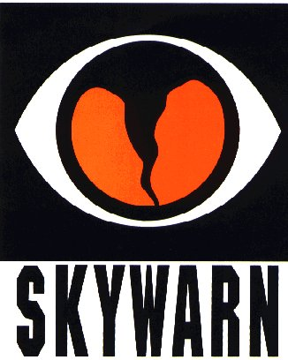***SKYWARN TRAINING***

The National Weather Service will not be able to conduct in person spotter training classes this winter and spring due to restrictions associated with COVID. Therefore, a number of field offices will be hold “virtual” spotter training classes. These classes will be open to the public and free of charge. Please feel free to promote to your staff, spotters, amateur radio operators and to publicize to the citizens in your community.

Since the Ohio Section is served by multiple NWS offices, listing all of the training opportunities for each of these offices would take a large amount of space and become very confusing. So, instead of trying to list the training, it would be better for you to choose which office you prefer to acquire your training from by providing you with a link to the offices surrounding Ohio <http://arrl-ohio.org/SEC/skywarn.html>

***Print an Official or Unofficial Copy of Your Amateur Radio License***

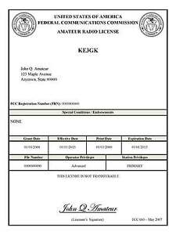*(By Anthony Luscre, K8ZT)*

As of February 17, 2015, the **FCC no longer routinely issues paper license documents** to Amateur Radio applicants and licensees. The Commission has maintained for some time now that the official Amateur Radio license authorization is the electronic record that exists in its Universal Licensing System (ULS). The FCC will continue to provide paper license documents to all licensees who notify the Commission that they prefer to receive one.

Licensees also will be able to print out an official authorization — as well as an unofficial “reference copy” — from the ULS License Manager. I’ve created a set of instructions on how you can request an **“official” printed copy of your license\***

[**Click here to download the instructions**](http://arrl-ohio.org/news/2020/print_your_license.pdf)

[TOP](#top) ^

*****V.E. Test Sessions***

Many V.E.’s have decided to start testing once again, but with restrictions that need to be adhered to for sure. Here’s the link to find that V.E. Test session and what is expected of YOU before going. <http://www.arrl.org/find-an-amateur-radio-license-exam-session>

Ohio Section Cabinet

|  |  |
| --- | --- |
| Section Manager – Tom Sly, WB8LCD | Section Traffic Manager – David Maynard, WA3EZN |
| Section Emergency Coordinator – Stan Broadway, N8BHL | Section Youth Coordinator – Anthony Lascre, K8ZT |
| Technical Coordinator – Jeff Kopcak, K8JTK | Affiliated Clubs Coordinator – Tom Sly, WB8LCD |
| State Government Liaison – Bob Winston, W2THU | Public Information Coordinator – John Ross, KD8IDJ |



Hey Gang,

Have you taken a look at the **Swap & Shop** page on the Ohio Section webpage yet?? Here’s a link that will take you there… <http://arrl-ohio.org/sm/s-s.html>

Do you have equipment that you just don’t need or want anymore? Here’s a great venue to advertise it, and it’s FREE!! Is your club doing a fund raiser to help raise money? After a lot of thought, it was decided that the Swap & Shop webpage could also contain these types of items as well. The same rules will apply as do for the For Sales and Give-A-Ways and will only be posted for a month at a time. Please see the Terms & Conditions on the webpage.

If your club is doing a fund raiser and wants more exposure, please forward the information to me and I’ll advertise it on the Swap & Shop webpage for you.

Now, I still want to remind you that it won’t be listed in this newsletter because it would take up way too much space, so your ad will only appear on the website. It is there for any individual to post equipment Wanted / For Sale or Give-Away as well as for Club Fund Raisers. No licensed vehicles/trailers or business advertising will be posted. Postings are text only (no pictures or graphics) will be posted for a maximum of 1 month from date posting and require a contact phone number or email within the posting. Send your Wanted / For Sale or Give-Away post to:  [swap@arrlohio.org](mailto:swap@arrlohio.org)

***Back Issues of the PostScript and Ohio Section Journal***

Hey, did you know that PostScript and Ohio Section Journal (OSJ) are archived on the website? You can go back and look at any edition simply by clicking:

<http://arrl-ohio.org/news/index.html>

[TOP](#top) ^

***Want to Share your Club Newsletter With Others?***

We have a webpage where you can download and read all of the newsletters that I get from around the state and even other sections!

Here’s the link to the page…. <http://arrl-ohio.org/club_news/index.html>

Please, if you don’t see your club newsletter posted, it’s because I’m not receiving it. Just have your newsletter editor contact me and I’ll get your club’s newsletter listed on the site!!

We all learn and steal (I mean, share) from each other’s work. So, get me your newsletter!!! Send it to: [webmaster@arrl-ohio.org](mailto:webmaster@arrl-ohio.org)

***Chit – Chat, and All That!***

Do you know someone that’s not getting these Newsletters? Please, forward a copy of this Newsletter over to them and have them “[Opt-In](mailto:Opt-In)” to start receiving them. Heck, just have them send an email to: [webmaster@arrl-ohio.org](mailto:webmaster@arrl-ohio.org) and we’ll get them added to the Ohio Section Emailing list.

We now have many thousands of readers receiving these newsletters weekly. Quite impressive, I’d say! I urge all of you to make sure that everyone, regardless of whether they are a League member or not, get signed up to receive these weekly Newsletters.

You can always “Opt-Out” at any time if you feel this is not what you were expecting. It’s fun and very informative. All of your favorite past newsletters are now archived too.

You can go back at any time and read them.

Just go to: <http://arrl-ohio.org/news/>

The pictures on the front page and throughout this newsletter are from various newsletters, Facebook posts and/or were sent directly to me in recent weeks. Take a good look at them, you just might be in one of the pictures! “SMILE… you’re in the Ohio Section News!!”

[TOP](#top) ^

*PostScript is produced as a weekly newsletter. I want to thank everyone that has contributed articles and ideas to make this an even better news source. I sincerely hope that you have enjoyed this edition and will encourage your friends to join with you in receiving the latest news and information about the Ohio Section, and news and events happening around the world!*