[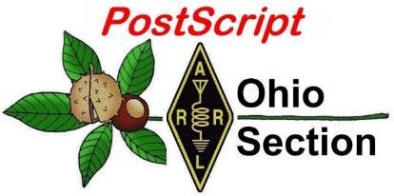](http://arrl-ohio.org/news/) ***“March 15th***

***Edition”***

🡪 National News 🡪 Club Corner

🡪 DX This Week 🡪 Contest Corner

🡪 Special Events 🡪 Upcoming Hamfests

🡪 From The South 40 🡪 Training

🡪 One Question Questionnaire 🡪 VE Testing

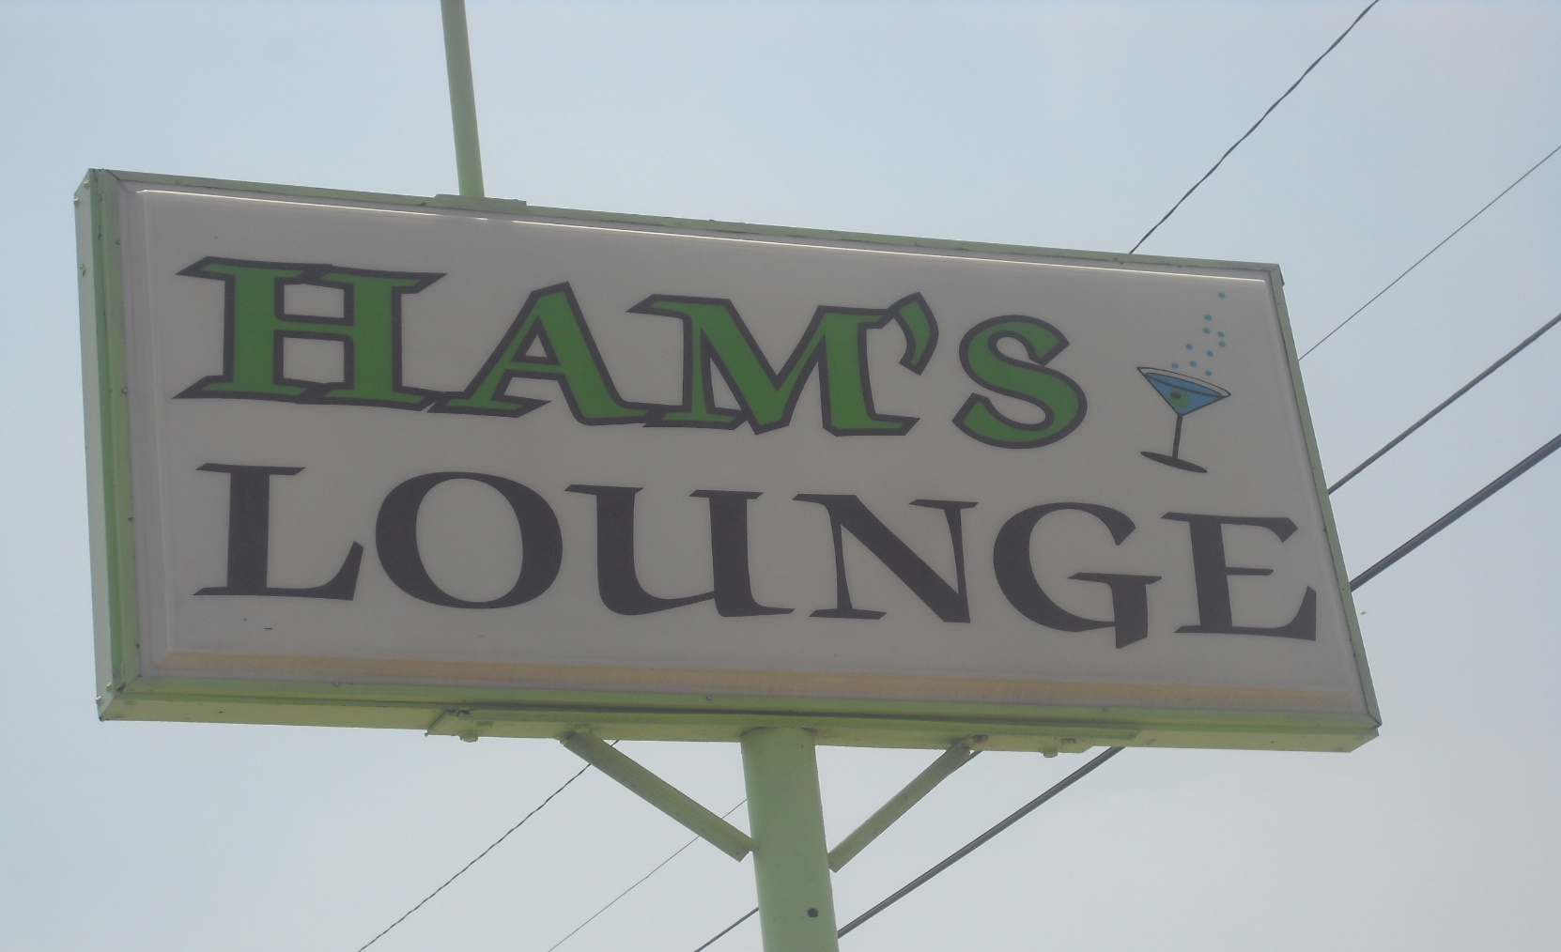

***National News***

*(from arrl and other sources)*

####

*(From the Internet)*

HISTORY OF THE CAR RADIO

Seems as if cars have always had radios, but they didn't.

Here's the story:  
  
One evening, in 1929, two young men named William Lear and Elmer Wavering   
drove their girlfriends to a lookout point high above the Mississippi River town of Quincy, Illinois, to watch the sunset. It was a romantic night to be sure, but one of the women observed that it would be even nicer if they could listen to music in the car.

Lear and Wavering liked the idea. Both men had tinkered with radios (Lear served as a radio operator in the US. Navy during World War I) and it wasn't long before they were   
taking apart a home radio and trying to get it to work in a car. But it wasn't easy: automobiles have ignition switches, generators, spark plugs, and other electrical equipment that generate noisy static interference, making it nearly impossible to listen to the radio when the engine was running.

One by one, Lear and Wavering identified and eliminated each source of electrical interference. When they finally got their radio to work, they took it to a radio convention in Chicago. There they met Paul Galvin , owner of Galvin Manufacturing Corporation. He made a product called a "battery eliminator", a device that allowed battery-powered radios to run on household AC current. But as more homes were wired for electricity, more radio manufacturers made AC-powered radios.

Galvin needed a new product to manufacture. When he met Lear and Wavering at the radio convention, he found it. He believed that mass-produced, affordable car radios had the potential to become a huge business.  
  
Lear and Wavering set up shop in Galvin's factory, and when they perfected their first radio, they installed it in his Studebaker. Then Galvin went to a local banker to apply for a loan. Thinking it might sweeten the deal, he had his men install a radio in the banker's Packard.

Good idea, but it didn't work – Half an hour after the installation, the banker's Packard caught on fire. (They didn't get the loan.)

Galvin didn't give up. He drove his Studebaker nearly 800 miles to Atlantic City to show off the radio at the 1930 Radio Manufacturers Association convention. Too broke to afford a booth, he parked the car outside the convention hall and cranked up the radio so that passing conventioneers could hear it.

That idea worked -- He got enough orders to put the radio into production.

TOP ^

WHAT'S IN A NAME

That first production model was called the 5T71. Galvin decided he needed to come up with something a little catchier.

In those days many companies in the phonograph and radio businesses used the suffix "ola" for their names -  Radiola, Columbiola, and Victrola were three of the biggest. Galvin decided to do the same thing, and since his radio was intended for use in a motor vehicle, he decided to call it the Motorola. But even with the name change, the radio still had problems:

When Motorola went on sale in 1930, it cost about $110 uninstalled, at a time when you could buy a brand-new car for $650, and the country was sliding into the Great Depression.

In 1930, it took two men several days to put in a car radio -- The dashboard had to be taken apart so that the receiver and a single speaker could be installed, and the ceiling had to be cut open to install the antenna. These early radios ran on their own batteries, not on the car battery, so holes had to be cut into the floorboard to accommodate them.

The installation manual had eight complete diagrams and 28 pages of instructions Selling complicated car radios that cost 20 percent of the price of a brand-new car wouldn't have been easy in the best of times, let alone during the Great Depression –Galvin lost money in 1930 and struggled for a couple of years after that. But things picked up in 1933 when Ford began offering Motorola's pre-installed at the factory.

In 1934 they got another boost when Galvin struck a deal with B.F. Goodrich tire company to sell and install them in its chain of tire stores. By then the price of the radio, with installation included, had dropped to $55. The Motorola car radio was off and running (The name of the company would be officially changed from Galvin Manufacturing to "Motorola" in 1947.) In the meantime, Galvin continued to develop new uses for car radios

In 1936, the same year that it introduced push-button tuning, it also introduced the Motorola Police Cruiser, a standard car radio that was factory preset to a single frequency to pick up police broadcasts. In 1940 he developed the first handheld two-way radio -- The Handy-Talkie – for the U. S. Army.  
  
A lot of the communications technologies that we take for granted today were born in Motorola labs in the years that followed World War II. In 1947 they came out with the first television for under $200. In 1956 the company introduced the world's first pager; in 1969 came the radio and television equipment that was used to televise Neil Armstrong's first steps on the Moon. In 1973 it invented the world's first handheld cellular phone. Today Motorola is one of the largest cell phone manufacturers in the world.

And it all started with the car radio.

Whatever happened to the two men who installed the first radio in Paul Galvin's car? Elmer Wavering and William Lear ended up taking very different paths in life. Wavering stayed with Motorola. In the 1950's he helped change the automobile experience again when he developed the first automotive alternator, replacing inefficient and unreliable generators.

TOP ^

The invention led to such luxuries as power windows, power seats, and, eventually, air-conditioning.  
Lear also continued inventing. He holds more than 150 patents. Remember eight-track tape players? Lear invented that. But what he's really famous for are his contributions to the field of aviation. He invented radio direction finders for planes, aided in the invention of the autopilot, designed the first fully automatic aircraft landing system, and in 1963 introduced his most famous invention of all, the Lear Jet, the world's first mass-produced, affordable business jet.

(Not bad for a guy who dropped out of school after the eighth grade.)

|  |  |
| --- | --- |
| |  | | --- | | From NASA: | |

|  |  |  |  |
| --- | --- | --- | --- |
| |  |  |  | | --- | --- | --- | | |  |  | | --- | --- | | |  | | --- | |  | | | |

|  |  |
| --- | --- |
| |  | | --- | | [‌](http://r20.rs6.net/tn.jsp?f=0013Snyz5RQh_ff9gXCzRTz5qfVPQxeJ2cmpwMFm0etkz5jASK8uHBAuF6rpZcJ3fAYEwiJbYy9NeYdI7fIsfTOrN78yYiqTU8jIS3UouMPa4g1TkqgX01HcOGCMrp19fZgEi8V5Ws3YB3C0AghB3XS4tl-4qcMT0oDa8PLXZsH2IIRYeDAKFBHPJrh2Cp4EFngWTe-RnwW-FaZM83Z6H5MGez6G5znIrY6&c=fz55R5VXAhrL0oAnJ1s_Ks0Kz0c59SWCG7qV9J92aV056W2VPsiW0w==&ch=60I2B5BlXiHYF9SsflFo6Cbes7ZalwacmpojkORrp_HWUSQGEMA6mg==)[‌](http://r20.rs6.net/tn.jsp?f=0013Snyz5RQh_ff9gXCzRTz5qfVPQxeJ2cmpwMFm0etkz5jASK8uHBAuF6rpZcJ3fAYDwBjZnb_hJzA6jxaCCf83X3PQuen-RpK19Z4Wfkxlp_pj9B4HYOOVKelGGDD8YGF4WFtEnQOkin_t2th5iYy1jc_gMc1gwlcyLyI9w8hFBnvvXoUm_r6O9n03WDyBnOJ1d50hwrz9X4XUAYk0Slb63Vhhg8UMmF6YA0VDvGV30bQXy1N3ha67tZJYdplPbZxuMbD0xUSGXf0PLD0TDWj3aHb7m8oH6Oto1PgqaxahEy5IHv7kWFRK7ub0l2JLMktXafLSepi5pewWy4QB1zmzkVbvCD22yLYzocFGyKQKiI4mWlbD4k5Fg==&c=fz55R5VXAhrL0oAnJ1s_Ks0Kz0c59SWCG7qV9J92aV056W2VPsiW0w==&ch=60I2B5BlXiHYF9SsflFo6Cbes7ZalwacmpojkORrp_HWUSQGEMA6mg==)[‌](http://r20.rs6.net/tn.jsp?f=0013Snyz5RQh_ff9gXCzRTz5qfVPQxeJ2cmpwMFm0etkz5jASK8uHBAuF6rpZcJ3fAYfs7zT5msVfjLC7h9bDghCLYZ_hmXdQGHx8GnxDngV8UX3_Z9itgBpEu1Gz_L9s3cTTkdSnOH52z1ufXI7DvXImwVwlBQh45hon0Xtqvfp6FIzmuNJpP-5HFjPuxtrMZo8NpCZXRAujBpMyLO4MvxQ88rb1bjsQK5UMw-i-JNTe0=&c=fz55R5VXAhrL0oAnJ1s_Ks0Kz0c59SWCG7qV9J92aV056W2VPsiW0w==&ch=60I2B5BlXiHYF9SsflFo6Cbes7ZalwacmpojkORrp_HWUSQGEMA6mg==) | |

|  |  |
| --- | --- |
| |  | | --- | |  | |

|  |  |
| --- | --- |
| |  | | --- | | **Get Ready for the Green Run Hot Fire Test** | |

|  |  |
| --- | --- |
| |  | | --- | | Join us Thursday, March 18, for the second “hot fire” of the [Space Launch System (SLS)](http://r20.rs6.net/tn.jsp?f=0013Snyz5RQh_ff9gXCzRTz5qfVPQxeJ2cmpwMFm0etkz5jASK8uHBAuKTiHt5xmETjIpSnlSn61zAicTFBU5wghFOjUBbnEAM7Egyj4tEj8Aj2hgjbsteBdVtPQBFrgt8KW51OhdaxrBsw_nmDCXobNG-hduZ99E_W9Sbm5l8Jzf4bQAuYz1BKvTlSv9da2ciE&c=fz55R5VXAhrL0oAnJ1s_Ks0Kz0c59SWCG7qV9J92aV056W2VPsiW0w==&ch=60I2B5BlXiHYF9SsflFo6Cbes7ZalwacmpojkORrp_HWUSQGEMA6mg==) rocket’s core stage at our Stennis Space Center near Bay St. Louis, Mississippi.  This hot fire is the last in our series of [Green Run tests](http://r20.rs6.net/tn.jsp?f=0013Snyz5RQh_ff9gXCzRTz5qfVPQxeJ2cmpwMFm0etkz5jASK8uHBAuF6rpZcJ3fAYqThEcL9CkzhpuJ9JCPSZRHgB1IQNIfa9Odjak8uleCOiCMf127NNSuoZp6jLw0zmzYHMvoNkhy-ybhZs2HnFKEgPafZm5KtWVfWUqAr1-Ak=&c=fz55R5VXAhrL0oAnJ1s_Ks0Kz0c59SWCG7qV9J92aV056W2VPsiW0w==&ch=60I2B5BlXiHYF9SsflFo6Cbes7ZalwacmpojkORrp_HWUSQGEMA6mg==). During the hot fire test, engineers will power up all the core stage systems, loaded with more than 700,000 gallons of cryogenic propellant, and all four engines will fire, just as they will during the Artemis I launch.  Following the test, the core stage will be shipped to the Kennedy Space Center, where engineers will assemble it with the other parts of the Artemis I rocket and the Orion spacecraft. Just this week, engineers [finished stacking the segments of the SLS’s twin solid-fueled booster rockets](http://r20.rs6.net/tn.jsp?f=0013Snyz5RQh_ff9gXCzRTz5qfVPQxeJ2cmpwMFm0etkz5jASK8uHBAuF6rpZcJ3fAYaYdcWkl-Lji-QJ2ZxcufXsoDIi5XNFGZCCOfrcdH6ffw0x86RUbzTHGSWP6sKwY7kjVflUGpinlZR-xsI2utElS8IFTlzrYngCjfeXsvkEDQv5eECdO3ZiJoCWTiROg8882fhUOA0qdF-xGSkFJc9KVWVfYmmjytwQPTU0CGP0Fq-duRo4ss9rAIw8BcaZGcHL9LLM5x5yA=&c=fz55R5VXAhrL0oAnJ1s_Ks0Kz0c59SWCG7qV9J92aV056W2VPsiW0w==&ch=60I2B5BlXiHYF9SsflFo6Cbes7ZalwacmpojkORrp_HWUSQGEMA6mg==). | |

|  |  |  |  |
| --- | --- | --- | --- |
| |  |  |  | | --- | --- | --- | | |  |  | | --- | --- | | |  | | --- | | [Get the Latest on Green Run](http://r20.rs6.net/tn.jsp?f=0013Snyz5RQh_ff9gXCzRTz5qfVPQxeJ2cmpwMFm0etkz5jASK8uHBAuF6rpZcJ3fAYqThEcL9CkzhpuJ9JCPSZRHgB1IQNIfa9Odjak8uleCOiCMf127NNSuoZp6jLw0zmzYHMvoNkhy-ybhZs2HnFKEgPafZm5KtWVfWUqAr1-Ak=&c=fz55R5VXAhrL0oAnJ1s_Ks0Kz0c59SWCG7qV9J92aV056W2VPsiW0w==&ch=60I2B5BlXiHYF9SsflFo6Cbes7ZalwacmpojkORrp_HWUSQGEMA6mg==) | | | |

Registration Now Open for HamSCI Workshop 2021

Registration is now open for the [2021 HamSCI Workshop](https://hamsci.org/hamsci2021), Friday and Saturday, March 19 - 20. The theme of this year's workshop is midlatitude ionospheric science. The University of Scranton will serve as host for the Zoom virtual event, sponsored by the National Science Foundation (NSF). The program will include guest speakers, poster presentations, and demonstrations.

The workshop will also serve as a team meeting for the [HamSCI Personal Space Weather Station project](https://hamsci.org/psws), funded by an NSF grant to University of Scranton physics and electrical engineering professor Nathaniel Frissell, W2NAF. The project seeks to harness the power of an amateur radio network to better understand and measure the effects of weather in the upper levels of Earth's atmosphere.

TOP ^

The workshop's keynote address on the "History of Radio" will be given by Elizabeth Bruton, curator of technology and engineering at the Science Museum of London. She will discuss the history, science, technology, and licensing of radio amateur communities from the early 1900s to the present, exploring how individuals and communities contributed to "citizen science" long before the term entered popular usage in the 1990s. Bruton has been a non-licensed member of Oxford and District Amateur Radio Society since 2014 and has served as the society's web manager since 2015.

J. Michael Ruohoniemi, a professor of electrical and computer engineering at Virginia Tech and principal investigator of the Virginia Tech SuperDARN Initiative, will review the physics of the midlatitude ionosphere and discuss ways in which the amateur radio community can contribute to advancing scientific understanding and technical capabilities.

Joe Dzekevich, K1YOW, will present "Amateur Radio Observations and The Science of Midlatitude Sporadic E." Read [an expanded version](http://www.arrl.org/news/registration-now-open-for-hamsci-workshop-2021). *-- University of Scranton news release*

News Conference Details ARISS Efforts to Return ISS Ham Station to the Air

At a March 10 news conference, Amateur Radio on the International Space Station ([ARISS](http://www.ariss.org/)) reported that, so far, all efforts to determine what's keeping the ham station in the ISS *Columbus* module off the air have been unsuccessful. It appears that the radio equipment is working, but no signal appears to be reaching the external ARISS antenna. The station, typically operated as NA1SS, has not been usable since new RF cables were installed during a January 27 spacewalk (EVA) to support the commissioning of the [Bartolomeo](https://www.airbus.com/space/space-infrastructures/bartolomeo.html) payload hosting platform installed last spring. During the January EVA, the coax feed line installed 11 years ago was replaced with another built by the European Space Agency (ESA) and Airbus. Responding to a question during the news conference, ARISS International Chair Frank Bauer, KA3HDO, did not rule out a fault in the radio equipment.

"There is still that possibility that there might be a problem with the radio," he said. Bauer listed three possible problem areas: The HMU-898 cable inside the cabin may have a break due to a previous tight turn, a connector may be installed improperly, or an HMU-601 cable installation or workmanship anomaly. During the January 27 EVA, the HMU-601 cable was installed in series with the ARISS antenna cable.

During a March 13 spacewalk (EVA), astronauts Mike Hopkins, KF5LJG, and Victor Glover, KI5BKC, plan to return the ARISS antenna feed line cabling to its configuration prior to the January 27 spacewalk.

TOP ^

The news conference covered details of the cable troubleshooting already conducted. Bauer said the ARISS team has been working closely with NASA and the ESA to identify what may have caused the "radio anomaly" keeping the ISS *Columbus* module ham station off the air. He thanked ARISS-Russia's Sergey Samburov, RV3DR, for allowing ARISS to use the ham station in the service module to 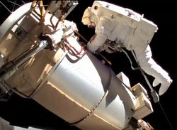continue its contact schedule.

This past week, astronauts on the ISS performed troubleshooting tests on all four new feed lines installed on the *Columbus* module. One cable was earmarked for the ARISS station, while the other three are for Bartolomeo. ARISS reported over the weekend, however, that it was unable to establish communication using any of the feed line cables connected to the ARISS radio system, which was tested in APRS mode.

The plan to return the ARISS cabling to its original configuration was a "contingency task" for a March 5 spacewalk, but the astronauts ran out of time.

ARISS became aware of the station problem after a contact with a school in Wyoming, between ON4ISS on Earth and Hopkins at NA1SS, had to abort when no downlink signal was heard. For the time being, ARISS school and group contacts with crew members have been conducted using the ham station in the ISS service module.

***Buckeye Net Supports Government Stations on 60 meters***

I've made a demo/training video that shows yesterday's Buckeye Net operating on 60m, interoperating with government stations to exchange messages in the MARS COMEX 21-1, as well as to move NTS radiogram traffic. <https://youtu.be/Fw8Jx4G0GJE>

Please do look to see how far we've been able to come in nine months of serious training on this and share. Really exciting stuff, but we need a lot more people to get up to speed and to be able to operate here if we're going to have a viable emergency service to support operations for more than a day or two.

C. Matthew Curtin KD8TTE

***Club Corner***

This is YOUR cornner of the newsletter. Send me what your club is doing and I’ll make sure that it gets in. Got a special event or club project that you want everyone to know about? Send it to me!. Need help with a project? Send it to me.

Let me know what you club is up to. Are you going to have a special guest at your meeting or are you having a special anniversary?

Just sent it to: [webmaster@arrl-ohio.org](mailto:webmaster@arrl-ohio.org)

TOP ^

**REALLY IMPORTANT STUFF!**

Does your club have a net(s)? If so, please go to the ARRL website and list your nets there so everyone will know about them.

**Net Registration**

Nets must be registered to be published in The ARRL Net Directory. To register a net through the web please go to this [page](http://www.arrl.org/resources/nets/client/snet1.html). As for the nets that are already listed, any information regarding updates or deletions is welcomed. Section and local nets should also be registered with the ARRL Section Traffic Manager. (ARRL HQ can refer you to your Section Traffic Manager.) Net Directory updates received via mail or email within the past few months will be merged into the directory this fall. New updates should be submitted using the [update form](http://www.arrl.org/resources/nets/client/update.html).

**Updating Your Club Record**

The club update area is now active.  This section allows you to edit information in your club record and also upload photos of your club activities.

The club update is your annual report.  You must update your club record at least once per year even if nothing changes.  The club update is how we know that the club is still in business and keeps the contact information current for ARRL and prospective hams to get in touch with your club.  Should two years pass without an update your club will be listed as inactive.

Follow this link for an instructional overview of how to use the editing system.

[Update your club information](http://www.arrl.org/files/file/Clubs/Club%20Update%20Online_20150806.pdf)

Note: You must be logged into the ARRL web site to use the editing system

[**Club Commission Program-**](http://www.arrl.org/affiliated-club-benefits)

**Commission Terms**

ARRL Affiliated Clubs receive a commission for every new ARRL membership and renewal they submit to ARRL Headquarters.

* Clubs retain a portion of the dues for each regular membership submitted to ARRL Headquarters:
  + Clubs retain **$15 for each new membership** OR lapsed membership (of two years or more). A NEW MEMBER is defined as any individual who has never been a member of ARRL or any individual who has not retained a membership for two or more calendar years prior to the application submission.
  + Clubs retain **$2 for each renewal**. A RENEWING MEMBER can renew at anytime, even before their current membership term expires.
* Family, Blind or 21-and-under discounted memberships are not applicable for any discount.
* **May not be combined with any other promotion or special offer.**

For more information, e-mail [**clubs@arrl.org**](mailto:clubs@arrl.org).

Follow the Go Now link for membership forms and reconcilation sheets.

####

**Massillon ARC** Spring TailgateFest to be held at the MAPS Air Museum.  
Entrance at 5383 Massillon Road just inside the Stark/Summit County line.  
  
Date is Saturday, April 17 from 9 [a.m.to](http://a.m.to/) 4 p.m. Cost is $5 per vehicle.  
(for use of the facility)   No advance registration necessary. Bring your own tables.  
(no large trailers) No charge for visitors.

TOP ^

Hi There! Yes, I’m still overwhelmed, but, I’m gaining on it! If I owe you something, send me an email to [wb8lcd@arrl.org](mailto:wb8lcd@arrl.org). Not that I’ve forgotten about it, but a kick in the pants will probably help. One thing I can say about the Pandemic, it certainly hasn’t slowed down Ham Radio activity. We’re doing some things differently, but we’ve made a huge jump into doing things on-line. And that has opened up lots of opportunities that we have certainly taken advantage of. To that end, I will be making additions to the “Speakers Bureau” on the website. Thanks to Zoom, getting a wide variety of speakers for your meetings has never been easier. In the past 2 ½ months, I’ve seen some pretty interesting presentations. As I’ve said many times, the OHIO SECTION is full of a lot of *really* talented and smart people. I appreciate your willingness to share with others. Tom WB8LCD

####

Decisions, Compromise and the Joy of Amateur Radio

I was asked a rather interesting question today. The specific question I will avoid mentioning to protect the innocent. It was though a valid question and I am sure most of us as amateurs have heard some version of it a few times. So, what do you tell someone just getting into the hobby when you are asked something like, “What radio should I buy”? My standard response is usually, buy what you want. But let me explain. There are decisions to be made.

Amateur Radio is not unlike the many other hobbies or ventures we might get into during our lives. It’s at best a compromise for most of us. Yes it is. There are four elements at least which have near unlimited possibilities or constraints. **Money**, we all, at least most of us will have some limits on what amount of our discretionary income is available. **Time**, here again we are all over the spectrum. No pun intended. Work, family life, church and other obligations do not magically go way when we take up a new interest. **Space**, how much do you have? Where is your radio room or area going to be? What kind of space do you have for antennas? Finally that fourth element that we joke about, have you gotten **your kitchen pass** before you proceed? I often hung out at Universal Radio on Saturday mornings. It was a great place to run into valued friends and many of those who enjoyed our hobby. I can remember more than once a fellow Ham entered the store and walked up to the counter with a box containing a new piece of equipment and with a sad face asked to return it, admitting his XYL had said **no** to the purchase. My friends, he had neglected to get that **kitchen pass** first. Don’t make this mistake. It’s embarrassing. Be ready to compromise in order to make this the best experience possible. And if your wife says, get whatever you want, please tell her that she is the best XYL in the world.

So, after considering all these above-mentioned variables and if you can sort that all out, you still must decide what you will eventually purchase. Other Hams will offer their recommendations. Honestly now, have you ever heard someone who just purchased a new car tell you that they absolutely hate it? Shoot no, they spent some time looking first probably in a showroom and after smelling that new car aroma, made up their mind. They are going to extol the virtues of that vehicle at least until they buy the next one.

TOP ^

But do ask. You can still get some pretty good ideas on features, price and other factors that will be important to you. Just ask the same questions of several Hams. Gather as much information as you can.

So how do we sum up the answer to the question? What rig do I buy? Again, I’ll say, “Buy what you want”. Take some time and gather information and if at all possible visit one of the vendors to get some hands on exposure. Tell them what you are interested in. Let them know you are a beginning Amateur. They can offer some excellent guidance and keep you from making an expensive mistake due to lack of knowledge. Many Amateurs would love to show you their rig(s), station setup and of course tell you about antennas and other goodies that will eventually fill your shack. Take advantage of this and any other sources you can find. Most of all, don’t hurry. Take your time and make your first investment one that can serve you for many years into the future of your Amateur Radio life. You will find that Joy if you apply the right effort to it up front.

73,

Jim W8ERW

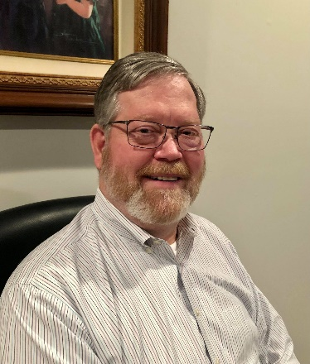

***DX This Week – 5W0GC – Part 2***

***Bill AJ8B (aj8b@arrl.net, @AJ8B, or www.aj8b.com)***

***CWOPs Member #1567***

The Midwest DX Cluster spots included Australia, Alaska, Belize, Bulgaria, Cayman Islands, China, Curacao, Dominican Republic, European Russia, Hawaii, Indonesia, Japan, Kazakhstan, Martinique, Mexico, Puerto Rico, Republic of Korea, Slovenia, and Wales. This brings the total number of entities spotted in the Midwest in 2021to 146! There was some major solar disruptions this past week and I am sure that contributed to the spots!

|  |
| --- |
|  |

# *DAH DIT DIT DIT DAH DAH DIT DIT DIT DAH*

I received cards from Enrico, I4GAD in Italy, and CN17SG and 5E7SG, both from Morocco. Let me know what you received.

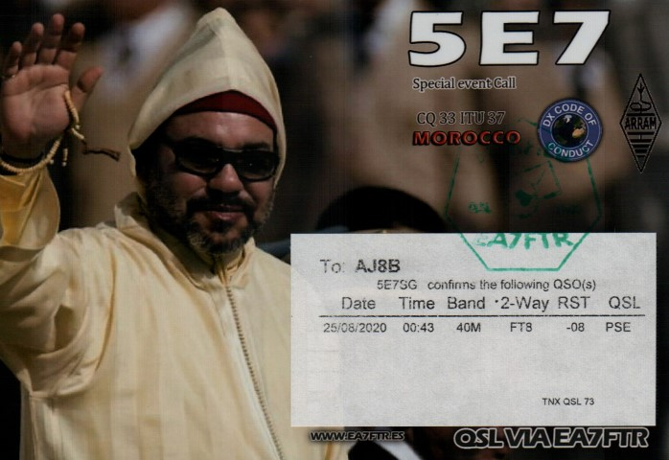

TOP ^

# *DAH DIT DIT DIT DAH DAH DIT DIT DIT DAH*

**Thanks to the Dean of 60 Meters, Joe Pater - W8GEX, for this update**

I hope this finds everyone safe. Let’s hope we can get some DXpeditions out this coming fall. As you all know, new ones are hard to come by on the 60m band. Iraq, Vietnam and the Mariana Islands by KH0/K0CW have been on but are hard to catch. With spring almost here they will become harder.  Enjoy the chase.  
   
**NEW COUNTRIES**  
   
**Iraq:** Hi Joe  
Just to let you know that YI9WS showed up on 60m SSB earlier today and worked a number of EU’s.

73 de Bo oz8abe

**8Q – Maldives:** G0VJG, Nobby, is “not allowed to travel” from the UK to 8Q so he must reschedule his March 5-22 8Q7CQ operation. He is now aiming for September 29, to October 13.

**So sorry to get this sad news from Tom 9A2AA**  
  I hate to inform you and all of the 60m community that Dragan, 9A6W, is SK.  He died on Jan. 22.  He was born in 1963 and he was very active on 60m and other bands.   He retired a few years ago.  He, as a representative of Croatian Army, was in UN mission in AP land and operated from club station AP2ARS.  He left 6 children and a wife.    
   
RIP Dragan  
   
73, Tom 9A2AA

**V4 – St. Kitts & Nevis - V47JA** - I will again be operating from our Calypso Bay, St. Kitts, West Indies vacation home, located 200 feet from the Caribbean Sea, from June 12 - July 10 and October 16 - Nov. 12, 2021 and active on 6-160m, (incl. 60m), SSB and FT8. Radio: Yaesu FT1000MP, FT450D and Elecraft KPA500 Amplifier. Antennas:  Mosley Mini32A 10/15/20m, 33' Vertical 10-40m,  35' Top Loaded 80m Vertical, 160m Vertical and 6m a 5el Yagi. ALL QSL's DIRECT or LoTW.   
  
**PJ5/W5JON** **- Saint Eustatius**. In the middle of my June/July and Oct/Nov trips to St. Kitts, I will be going to St. Eustatius, June 22 - June 28, and Oct 25 - Nov. 1, 2021.  Radio: Yaesu FT-450D, Elecraft KPA-500 and dipoles. Active on 6-40m, SSB and FT8. I will be extending the 40m Dipole to 60m, for a day or two while there and so I will see you 60M.     
   
ALL QSL's DIRECT or LoTW.   
PJ5/W5JON - Callsign Lookup by QRZ Ham Radio  
   
73, John V47JA - W5JON

**Recent Activity:** XV1X, 4U1A, E77DX, UT5ECZ, KH0/KC0, JW4PUA, ES6DO, 6W1TA, A71AE, HK6W, TI2LX, ZB2GI, C31CT, and 9K2HS.

TOP ^

# *DAH DIT DIT DIT DAH DAH DIT DIT DIT DAH*

## This week is part 2 of a 2-part article describing the 5W0GC & YJ0GC 2018 DXpeditions conducted by the 2018 DXPeditioner of the Year recipient, Stan—LG1GC. Thanks to SWODXA for permission to reprint this.

## Intro to Vanauatu

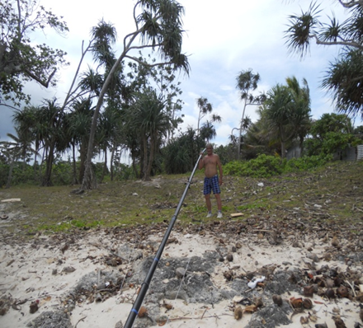Below is some brief information from Wikipedia about Samoa and Vanuatu.

*Officially, the Republic of Vanuatu is a Pacific nation island located in South Pacific Ocean. The archipelago, which is of volcano origin is 1750 km east from Australia (VK), 540 km northeast of New Caledonia (FK), east of New Guinea (P29), southeast of Solomon Islands (H44) and west of Fiji Republic (3D2). The fourteen Vanuatu islands that have surface areas of more than 100 square km are, from largest to smallest: Espiritu Santo, Malakula, Efate, Erromango, Ambrym, Tanna, Penfecost, Epi, Ambae (Aoba), Gaua, Vanua Lava, Maewo, Malo and Aneityum (Anatom).*

*The nation's largest towns are the capital, Port Vila, on Efate Island and Luganville on Espiritu Santo Island. Vanuatu has a population about 243,000. The inhabitants of Vanuatu are called Ni-Vanuatu. The Ni-Vanuatu are 98,5 % of Melanesian descent with the remainder made up of a mix of Europeans, Asians and other Pacific islanders.*

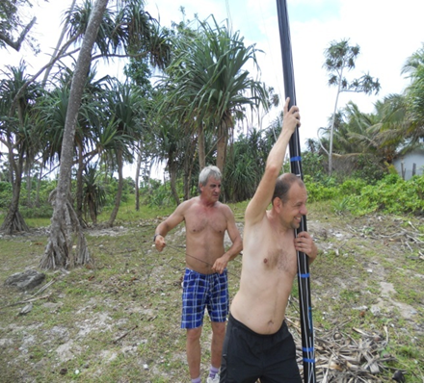Continued from Last Week: Finally, on October 17 and after a 2-hour flight I was in Port Vila, Vanuatu. After the usual customs check at Port Vila Airport, I took a taxi to the Blue Pango Motel where Lubo (OM5ZW) and Karel (OK2WM) were waiting for me. When I arrived at the motel, we immediately began preparing for the raising the two vertical antennas for 160m and 80m. It took three hours to get both antennas in place. That evening YJ0GC was on both 80 and 160 meters simultaneously with two transmitters.

The next day we also installed a multiband ground plane antenna to operate from 10 to 40 meters.

For the majority of the YJ0GC activity our team had 5 TX antennas and one RX antenna array, namely separate vertical antennas for 160 and 80 meters, 1 StepIR vertical antenna, 1 multiband GP antenna, and 1 vertical antenna for 10-40m for transmit and a AS-SAL-30-MK2-DX receiving antenna, kindly donated by Array Solutions. We used the receiving antenna on 160 meters.

TOP ^

We also had 3 operator positions, each one complete with a separate linear amplifier. Unfortunately, we could not use these resources to full potential due to the proximity of the antennas to each other. However, we did manage to work with two radios simultaneously during all of the activity. The third operating position was not used efficiently! In addition, to work efficiently on 160m we had to halt the other stations because of interference.

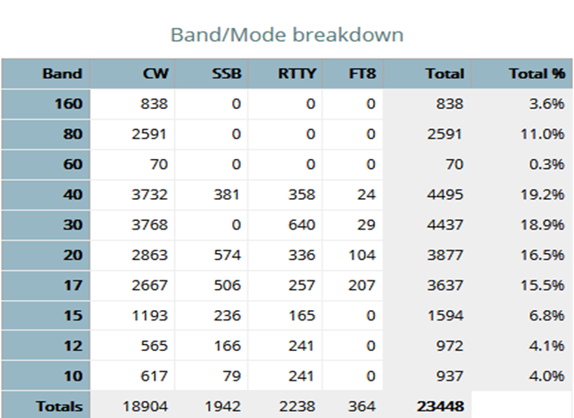However, I think that YJ0GC activity was good despite these operational issues! Many contacts were made on the low bands - 160, 80 and 40 meters, so that the mission of the DXpedition with a focus on low bands was fulfilled. At the same time many contacts were also made on high bands to hopefully satisfy many with ATNO’s.

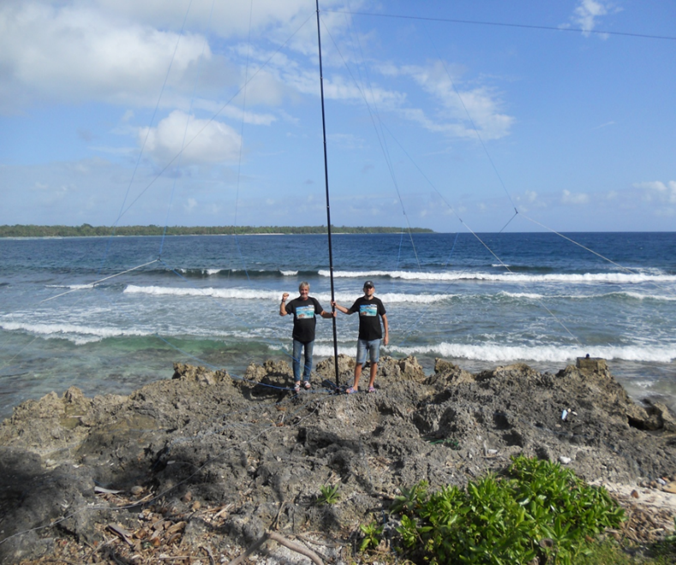

Stan, LZ1GC (L) and Lubo, OM5ZW (R) with Multiband GP antenna on the beach

Between October 15 and November 4, 2018, we made 23,448 QSOs with 129 different countries on CW, SSB, RTTY and FT8. The YJ0GC statistics from Club Log are shown in the table.

Do not think that during the YJ0GC DXpedition we went without problems. Because our vertical antennas for 160m and 80m were just outside of the motel, there were attacks on them! Several times we detected some of the radials and parts of the guy ropes for the verticals went missing. Apparently, some of the local residents caused us problems. Fortunately, I had packed spare radials and ropes, so these attacks did not significantly affect the YJ0GC activity.

An unexpected experience during the YJ0GC DXPedition was experiencing an earthquake with a magnitude 4.8 on the Richter scale. This was easily felt in Port Vila, Vanuatu at 20:33 local time on October 20. It was a strong horizontal quake lasting about 5 to 6 seconds. I had the feeling that the table on which the equipment was installed was moving. Despite the quake we continued our activity on the air non-stop!

From October 16 to October 27, 2018, YJ0GC activity was performed by 3 operators: OK2WM (Karel), LZ1GC (Stan), and OM5ZW (Lubo). On October 28, it was time for Lubo, OM5ZW to return to Slovakia. His work assignment did not allow him to stay until the end of the DXPedition. With Lubo’s departure the YJ0GC DXPedition continued to operate with two operators operating at full throttle.

TOP ^

At dawn on November 4, 2018, YJ0GC made its last QSO and went QRT. After nearly 5 hours of dismantling the antennas and packing up, Karel, OK2WM and I headed for the Port Vila airport to begin our long journey back to Europe. On our way back to Vienna we would travel through Nadi, Fiji and Seoul, South Korea. Our journey back to Europe went as planned without cancellation of any flights nor problems with customs.

For Karel and I an unforgettable experience was our pre-arranged meeting with Antoine, 3D2AG at the airport in Nadi, Fiji.

We gave as a gift to Antoine, 3D2AG part of the antenna equipment we used during our YJ0GC activity. We stayed at a local hotel, chatting away the night with Antoine, 3D2AG as we talked about all things amateur radio.

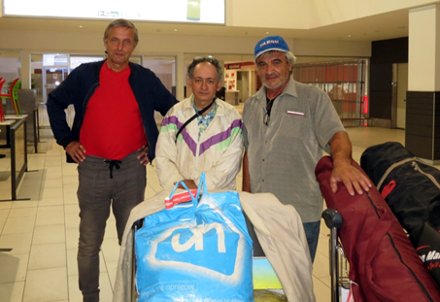

L to R:: Karel, OK2WM, Tony, 3D2AG and Stan, LZ1GC

The next day, November 5, after an 11-hour flight on Korean Airlines, we stopped in Seoul, South Korea. There, awaiting our arrival was Aves Kang, DS2AGH - a good friend of mine for many years, who as usual, entertained us during our short stay in Korea! I thank Aves Kang for his help and, of course, his hospitality.

On November 6, after another 11 hour flight on a Korean Airlines Boeing 777, we arrived at the international airport in Vienna, Austria where we were expecting Wolfgang, OE1WEU and Lubo, OM5ZW. Finally, my 43-day trip to the Pacific Ocean in 2018 ended successfully on November 7 after an hour’s flight from Vienna to Sofia, Bulgaria. So completed the 5W0GC & YJ0GC DXPedition 2018.

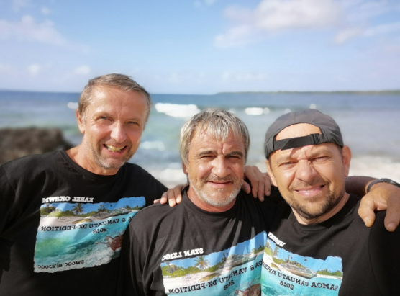

I want to express my gratitude for the support we have received from many radio amateur foundations, associations and clubs:

**GDXF, SDXF, EUDXF, LA DX GROUP, CDXC ( U.K. ), Mediterraneo DX Club, Clipperton DX Club, KC5WXA – Jake McClain Driver Memorial A.R.C., GM DX GROUP, SWODXA, WVDXA, GSDXA, Mile-HI DX Association, Willamette Valley DX Club, SWODXA, Thracian Rose Club and LYNX DX GROUP.**

I also want thank our corporate sponsors who supported this expedition:

**ACOM Ltd Bulgaria, SILPA Ltd Bulgaria, microHam, ARRAY SOLUTIONS, Spiderbeam Ltd and GES ELECTRONICS.**

**Thanks also to CLUB LOG, DXNEWS and all individual sponsors, before and after this expedition!**

**With respect and 73!**

**Stan, LZ1GC (5W0GC & YJ0GC)**

TOP ^

# *DAH DIT DIT DIT DAH DAH DIT DIT DIT DAH*

# CQDX CQDX CQDX CQDX CQDX CQDX CQDX CQDX CQDX

Here is an update from Bernie, W3UR, of the DailyDX and the WeeklyDX, the best source for DX information. <http://www>.dailydx.com/. Bernie has this to report:

**The Royal Australian Air Force - 100 Year Centenary. VK100AF & VI100AF**

By M0URX, Tim Beaumont

From our modest beginnings in 1921, Air Force has grown into a potent, World class Air Force which Australia relies upon in both conflict and peace. The men and women of the Royal Australian Air Force have achieved great success in serving Australia and its national interest over the past 100 years. The RAAF was formed on 31st March 1921, to mark this Centenary the Wireless Institute of Australia (WIA) will be celebrating with two call signs:

VK100AF 1st March to 31st August 2021, which will be used by a team of Radio Amateurs across the bands around Australia and VI100AF 1st March 2021 to 29th May 2021 will be used by Radio Amateurs that are either current or veteran military personnel and some activities may be from military bases.

Stuart Birkin. VK8NSB will be organizing the event that will be aired by many Radio Amateurs across Australia as we celebrate this centenary with you. A team of 40+ operators across Australia will operating over the next few months.

QSL Information: A commemorative 4-sided QSL will be printed for direct QSL requests.  OQRS Link for Direct & Bureau QSL VI100AF:

https://www.m0urx.com/oqrs/logsearch.php?dxcallsign=VI100AF

OQRS Link for Direct & Bureau QSL VK100AF:

https://www.m0urx.com/oqrs/logsearch.php?dxcallsign=VK100AF

Direct: QSL $2 Via M0URX  
Bureau: Please only use OQRS. No Bureau route for incoming Bureau  
LoTW: will be uploaded.

If you have any questions about the activity, please contact Stuart VK8NSB at: vk8nsb@hotmail.com Full information also on QRZ.com

For more information about Air Force 100: https://airforce2021.airforce.gov.au/

WIA info: nationalnews@wia.org.au

**PY0F - Fernando de Noronha -** The “PX0N Team” will have SA-003 on the air during May-June.  The group includes PY2RMZ, PU4MDO and likely other ops, planning to be on 80, 40, 20, 15 and 10.  QSL via EA7FTR.

TOP ^

**OMIK** **-** In her most recent video episode of “Ria’s Shack” N2RJ, Ria, gives an interesting history of the OMIK (Ohio, Michigan, Indiana, Kentucky) Amateur Radio Association, Inc. “The OMIK Amateur Radio Association, Inc. was founded on August 17, 1952, as the OMIK Electronic Communications Association by Black HAMs from the states of Ohio, Michigan, Indiana, and Kentucky to deal with discrimination in the dominant culture and to assist Black travelers with information on places where they could eat and lodge. Because membership in many other ham organizations was denied, a Black HAM organization, with its own nets and other activities, was clearly needed…Today, although still a predominantly African-American organization, OMIK is a multi-racial, multi-cultural organization with members from the United States as well as DX entities”.

*DAH DIT DIT DIT DAH DAH DIT DIT DIT DAH*



Below is a list of upcoming contests in the “Contest Corner”. I think this is important for someone who is trying to move up the DXCC ladder since entities that are on the rarer side and easiest to work in contests. Some of my best “catches” have been on the Sunday afternoon of a contest when the rarer entities are begging for QSOs. Of course, the gamble is that if you wait until Sunday, conditions may change, or they simply won’t be workable. However, it is not a bad gamble. Of course, why not work the contest and have some fun!  
Check out the WA7BNM Contest Calendar page (https://www.contestcalendar.com/) for more contests or more details.

The contests in red are those that I plan to spend some significant participation time on. PLEASE let me know if you are working contests and how you fared.

Thanks!

|  |  |  |
| --- | --- | --- |
| Mar. 20-21 | Virginia QSO Party | https://bit.ly/2Khd2ul |
| Mar. 20-21 | Russian DX Contest | www.rdxc.org/asp/pages/rulesg.asp |
| Mar. 20-22 | BARTG HF RTTY Contest | http://bartg.org.uk/wp/contests |
| Mar. 21 | UBA Spring Contest 80m SSB | http://bit.ly/2KKAtb9 |
| Mar. 25 | RSGB 80m Club Championship, SSB | http://bit.ly/3avHbk3 |
| Mar. 27 | FOC QSO Party | www.g4foc.org/qsoparty |
| **Mar. 27-28** | **CQWW WPX SSB Contest** | **www.cqwpx.com** |
| Mar. 31 | UKEICC 80m Contests CW | https://bit.ly/2SDPqQQ |
| May 29 – 30 | CQWW WPX CW | https://www.cqwpx.com/ |
| August 28 | Ohio QSO Party | https://www.ohqp.org/ |
| August 28 | W8DXCC | https://www.w8dxcc.com |

TOP ^

***DX News***

***ARLD010 DX news***

This week's bulletin was made possible with information provided by The Daily DX, the OPDX Bulletin, 425 DX News, DXNL, Contest Corral from QST and the ARRL Contest Calendar and WA7BNM web sites.  Thanks to all.  
  
ZAMBIA, 9J.  Bodo, HB9EWU plans to be QRV as 9J2BG while spending one year on a humanitarian mission at the St. Paul's Mission General Hospital in Kashikishi.  Activity will be in his spare time on 20 meters.  QSL to home call.  
  
BOTSWANA, A2.  Operators Vasily, R7AL, Leo, UI8J, Vlad, R9LR and Mike, RU3UR will be QRV as A25RU from Gaborone from March 15 to 26. Activity will be on 160 to 10 meters, using CW, SSB, and FT8 in DXpedtion mode, with four stations active.  This also includes activity on Satellite QO-100.  QSL via ClubLog.  
  
GUADELOUPE, FG.  Philippe, F1DUZ will be QRV as FG4KH from March 16 to April 1.  This includes being an entry in the upcoming CQ World Wide WPX SSB contest.  QSL direct to home call.  
  
ECUADOR, HC.  Rick, NE8Z is QRV as HC1MD/2 from the Santa Elena province until May 15.  Activity is on 40 to 6 meters using CW, SSB, FT8 and FT4.  QSL via K8LJG.  
  
MINAMI TORISHIMA, JD1.  Take, JG8NQJ will be QRV as JG8NQJ/JD1 while on work assignment at the weather station here.  Activity is in his spare time on the HF bands using CW.  He is here for about three months.  QSL direct to JA8CJY.  
  
LITHUANIA, LY.  Special event stations LY31A and LY11LY are QRV until March 31 to celebrate the 31st anniversary of the Act of the Re-Establishment of the State of Lithuania.  QSL via operators'  
instructions.  
  
AUSTRIA, OE.  Members of the VIC Amateur Radio Contest DX Club are QRV as C7A during March.  QSL via UA3DX.  
  
FINLAND, OH.  Members of the SSAB Raahe ARC are QRV as special event station OF60RR from Pattijoki until March 1, 2022 to celebrate the 60th anniversary of the start of the construction of the steel mill Rautaruukki in May 1961.  QSL direct to OH8DR.  
  
ST. MAARTEN, PJ7.  Tom, AA9A is QRV as PJ7AA until March 27. Activity is on 80 to 10 meters using CW, SSB and FT8.  QSL via LoTW.  
  
SEYCHELLES, S7.  Ravi, S79VU has been active on 20 meters using FT8 around 0200z.  QSL direct to N4GNR.

TOP ^

EUROPEAN RUSSIA, UA.  Special event stations R1934G, R108M, RG61PP and R1961G are QRV until April 30 from the Smolensk Oblast to commemorate the 87th anniversary of Yuri Gagarin's birth and the 60th anniversary of his historic 108-minute first flight.  QSL via operators' instructions.  
  
ASIATIC RUSSIA, UA0.  Look for RI0Q to be QRV from Bol'shoy Begichev Island, IOTA AS-152, beginning possibly March 17.  The start date may depend on weather conditions.  QSL via ClubLog.  
  
UZBEKISTAN, UJ.  Bazarov, UK8FAV has been active using FT4 on 20 meters around 0200z.  QSL direct to home call.  
  
COCOS (KEELING) ISLANDS, VK9C.  Look for VK9CE to be QRV from March 16 to 23.  Activity will be holiday style on 80 to 10 meters using CW, SSB and FT8.  They may also be active on 6 meters depending on conditions.  QSL via EB7DX.  
  
THIS WEEKEND ON THE RADIO.  The Stew Perry Top band Challenge, North American RTTY Sprint, NCCC RTTY Sprint, QRP 80-Meter CW Fox Hunt, NCCC CW Sprint, K1USN Slow Speed CW Test, YB DX RTTY Contest, SARL VHF/UHF Analogue Contest, SARL Field Day Contest, RSGB Commonwealth Contest, SKCC Weekend CW Sprintathon, F9AA SSB Cup, South America 10  
Meter Contest, The DIG QSO SSB Party, AGCW QRP CW Contest, Oklahoma QSO Party, EA PSK63 Contest, QCWA QSO Party, TESLA Memorial HF CW Contest, Idaho QSO Party, UBA Spring 2-Meter Contest, FIRAC HF Contest, Classic Phone Exchange, and Wisconsin QSO Party will  
certainly keep contesters busy this upcoming weekend.  
  
The OK1WC Memorial, Bucharest Digital Contest, RSGB FT4 Contest Series, 4 States QRP Group Second Sunday Sprint and K1USN Slow Speed CW Test are scheduled for March 15.  
  
The RTTYOPS Weeksprint, CLARA Chatter Party and Worldwide Sideband Activity Contest are scheduled for March 16.  
  
The CWops Mini-CWT Test, Phone Fray and QRP 40-Meter CW Fox Hunt are scheduled for March 17.  
  
Please see March QST, page 72, and the ARRL and WA7BNM contest web sites for details.

**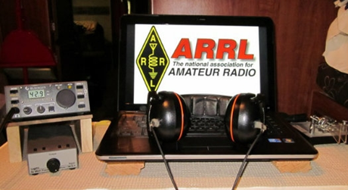*ARRL Contest Corner***

Start Planning Ahead! This listing is ARRL Contests only. By clicking the “Contest Corral” link at the bottom you will get a larger list including non-ARRL sponsored contests.

TOP ^

|  |
| --- |
| **April 2021 18**[**Rookie Roundup – Phone**](http://www.arrl.org/rookie-roundup) |
| **June 2021** 12-14    [**June VHF**](http://www.arrl.org/june-vhf)19     [**Kids Day**](http://www.arrl.org/kids-day)26-27  [**Field Day**](http://www.arrl.org/field-day) | **July 2021** 10-11  [**IARU HF World Championship**](http://www.arrl.org/iaru-hf-world-championship) |
| **August 2021** 7-8  [**222 MHz and Up Distance Contest**](http://www.arrl.org/222-mhz-and-up-distance-contest)21-22   [**10 GHz & Up – Round 1**](http://www.arrl.org/10-ghz-up)22       [**Rookie Roundup – RTTY**](http://www.arrl.org/rookie-roundup) | **September 2021** 11-13    [**September VHF**](http://www.arrl.org/september-vhf)   18-19    [**10 GHz & Up - Round 2**](http://www.arrl.org/10-ghz-up) |
| **October 2021** 18-22[**School Club Roundup**](http://www.arrl.org/school-club-roundup) 23-24   [**EME - 2.3 GHz & Up**](http://www.arrl.org/eme-contest) | **November 2021** 6-8   [**Nov. Sweepstakes – CW**](http://www.arrl.org/sweepstakes)20-22[**Nov. Sweepstakes – Phone**](http://www.arrl.org/sweepstakes)20-21   [**EME - 50 to 1296 MHz**](http://www.arrl.org/eme-contest) |
| **December 2021** 3-5      [**160 Meter**](http://www.arrl.org/160-meter)11-12[**10 Meter**](http://www.arrl.org/10-meter)19        [**Rookie Roundup–CW**](http://www.arrl.org/rookie-roundup) 18-19  [**EME - 50 to 1296 MHz**](http://www.arrl.org/eme-contest) |  |

An expanded, downloadable version of *QST'*s’ [**Contest Corral**](http://www.arrl.org/contest-calendar) is available as a PDF. Check the sponsor’s ‘Website for information on operating time restrictions and other instructions.

***Special Events***

* **03/14/2021 | Pi Day Special Event**

**Mar 14, 1400Z-2200Z, K2I**, Hamilton, NY. Genesee Radio Amateurs. 40, 20 and higher, depending on conditions. Certificate. email gramw2rcx@gmail.com, for PDF of, certificate. www.w2rcx.com, www.qrz.com/db/k2i, or [www.qrz.com/db/w2rcx](http://www.qrz.com/db/w2rcx)

* **03/20/2021 | Arrows from the Air**

**Mar 20-Mar 21, 1800Z-0300Z, K7SWI**, Middleton, ID. South West Idaho Amateur Radio Club. 28.427 14.227 7.227 3.827. Certificate & QSL. South West Idaho Amateur Radio Club, 332 West Dewey Ave, Nampa, ID 83686. What Are Those Giant Arrows Dotting the American Landscape? The arrows were part of a federal project to speed up communication across great distances. Transcontinental airmail service began in 1920, but even with this advancement over ground travel, service was slow. Pilots had no sophisticated instruments, so they couldn’t fly at night or in poor weather. The government built a path of 70-foot-long concrete arrows every few miles from coast to coast, each painted yellow and topped with a 51-foot steel tower that had a rotating beacon. Using the path, an airmail pilot needed only half the time to deliver a letter from New York to San Francisco, The SOUTH WEST IDAHO ARC will operate 14.327, 7.227, 3827 plus or minus traffic/qrm.. K7SWI will issue a Certificate and QSL to all requested please include SASE for QSL only and SASE with one green stamp for QSL and Certificate. Reply to address of K7SWI. 332 West Dewey Ave Nampa, ID 83686. [nq6s@att.net](mailto:)

TOP ^

* **03/20/2021 | Cherry Blossom Special Event Station**

**Mar 20, 1400Z-1700Z, W4BKM**, Macon, GA. Macon Amateur Radio Club. 14.240 7.225. Certificate. Macon Amateur Radio Club, P.O. Box 4862, Macon, GA 31208. [w4bkm.org](http://w4bkm.org/)

* **03/20/2021 | Woronoko Heights Outdoor Adventure**

**Mar 20, 1300Z-1900Z, W1M**, Russell, MA. Western Mass. Council-BSA. 7.190 10.115 14.060 14.290. QSL. Tom Barker, 329 Faraway Road, Whitefield, NH 03598.

**03/23/2021 | Honoring World War II Gunners at Buckingham Airfield**

**Mar 23-Mar 25, 1400Z-2100Z, W4LX**, Fort Myers, FL. Fort Myers Amateur Radio Club. 28.360 21.360 14.270 146.685. certificate. W4LX Fort Myers Amateur Radio Club, P.O. Box 61183, Fort Myers, FL 33906. [www.fmarc.net](http://www.fmarc.net/)

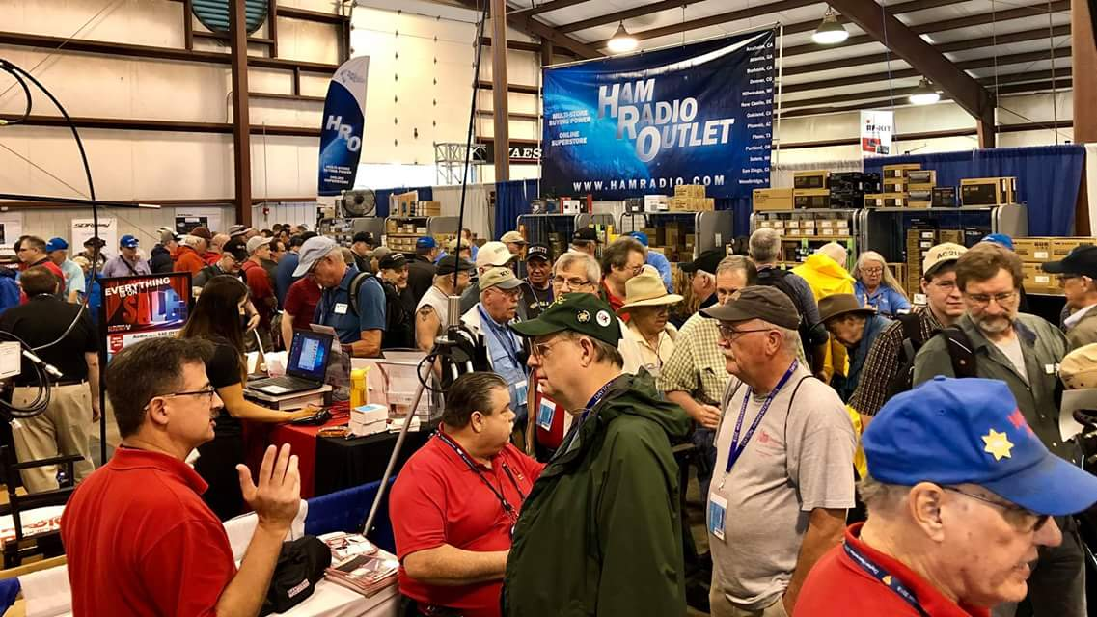[***Upcoming Hamfests***](http://arrl-ohio.org/hamfests.html)

We **DO** have some hamfests scheduled for 2021!! Yes, take a good look at the list, it’s growing every day!

Be sure to keep your eyes on this schedule as that when things start getting better and the vaccine rolls out to more and more, hamfests will surely get back to their normal schedule. Don’t see your hamfest listed?? Did anyone register it with ARRL? It’s really easy to do and you get a lot of FREE publicity if you do.

**Massillon ARC** Spring TailgateFest to be held at the MAPS Air Museum.  
Entrance at 5383 Massillon Road just inside the Stark/Summit County line.  
  
Date is Saturday, April 17 from 9 [a.m.to](http://a.m.to/) 4 p.m. Cost is $5 per vehicle.  
(for use of the facility)   No advance registration necessary. Bring your own tables.  
(no large trailers) No charge for visitors.

|  |  |
| --- | --- |
| **06/05/2021 -**[**FCARC SummerFest**](http://www.arrl.org/hamfests/fcarc-summerfest)  Location: Wauseon, OH Sponsor: Fulton County Amateur Radio Club Website:<http://k8bxq.org/hamfest> [Learn More](http://www.arrl.org/hamfests/fcarc-summerfest) | **07/10/2021 -**[**Mansfiled Mid-Summer Trunkfest**](http://www.arrl.org/hamfests/mansfiled-mid-summer-trunkfest)  Location: Mansfield, OH Sponsor: InterCity Amateur Radio Club Website:<http://iarc.club>[Learn More](http://www.arrl.org/hamfests/mansfiled-mid-summer-trunkfest) |
| **07/17/2021 -**[**NOARSFEST**](http://www.arrl.org/hamfests/noarsfest-8)  **Location:**Elyria, OH **Type:** ARRL Hamfest **Sponsor:** Northern Ohio Amateur Radio Society **Website:** [http://noars.net](http://noars.net/) [Learn More](Learn%20More) | **07/18/2021 –**[**Van Wert Hamfest**](http://www.arrl.org/hamfests/van-wert-hamfest-5)  Location: Van Wert, OH Sponsor: Van Wert Amateur Radio Club Website:[http://W8FY.ORG](http://w8fy.org/)[Learn More](http://www.arrl.org/hamfests/van-wert-hamfest-5) |

TOP ^

|  |  |
| --- | --- |
| **08/07/2021 -**[**DX Engineering Hamfest & Great Lakes Division Convention**](http://www.arrl.org/hamfests/dx-engineering-hamfest-1)  Location: Tallmadge, OH Sponsor: DX Engineering Website: [http://dxengineering.com](http://dxengineering.com/) [Learn More](http://www.arrl.org/hamfests/dx-engineering-hamfest-1) | |
| **08/28/2021 -**[**Cincinnati Hamfest℠**](http://www.arrl.org/hamfests/cincinnati-hamfest)  Location: Owensville, OH Sponsor: Milford ARC Website: [http://CincinnatiHamfest.org](http://cincinnatihamfest.org/) [Learn More](http://www.arrl.org/hamfests/cincinnati-hamfest) | **09/26/2021 -**[**Cleveland Hamfest**](http://www.arrl.org/hamfests/cleveland-hamfest-1)  Location: Berea, OH Sponsor: Hamfest Association of Cleveland Website: [http://www.hac.org](http://www.hac.org/) [**Learn More**](http://www.arrl.org/hamfests/cleveland-hamfest-1) |
| **12/04/2021 -**[**FCARC WinterFest**](http://www.arrl.org/hamfests/fcarc-winterfest-2)  Location: Delta, OH  Sponsor: Fulton County Amateur Radio Club  Website:<http://k8bxq.org/hamfest>  [Learn More](http://www.arrl.org/hamfests/fcarc-winterfest-2) | |

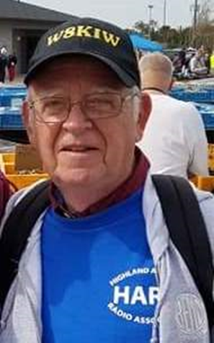***From The South 40***

*(from John Levo,* [*W8KIW@arrl.net*](mailto:W8KIW@arrl.net)*)*

Last time we ended our journey in one of Ohio’s first counties-Adams; the home of the DeForest ARC. This week we try to overcome getting up an hour earlier to head up the road to visit two clubs in Clinton County and perhaps find some green beer or shamrocks to celebrate St. Patrick’s Day with. Our first stop is in Blanchester, the home of the Blanchester ARC.

This small club was started not that long ago by some Blanchester area hams who wanted to gather to discuss amateur radio and to socialize. Because of their size, they don’t have the membership nor resources to undertake large events on their own, but the members are active and join in with the clubs in Wilmington, Georgetown, Milford and Hillsboro on large scale happenings like Field Day, Ohio Parks on the Air and other special event activities. Prior to COVID, they held a monthly “Date Night” where their spouses were treated to a dinner out with other club members and their spouses meeting at an area restaurant. Although the group does not have their own repeater, the Clinton County ARA provides them the opportunity to use their 147.12 machine for a weekly Wednesday gathering.

Although COVID has prevented the group from physically meeting this net provides a chance for them to check on the welfare of other members in the Blanchester area. That concludes our visit to the Blanchester ARC. Now it’s the short drive past Lake Cowan to the county seat and a visit to the Clinton County ARC. But in the meantime, here’s some of what is happening in the South 40 Region.

TOP ^

On March 6 the Scioto Valley ARA held what has to be considered the most amazing ham radio test session in 2021 to date. According to VE Team Leader John Hartmus ll, WB8GRX, two people with present licenses upgraded to General, 3 newbies made General and 10 others received their Technician License. We congratulate Keith Ackerman (KE8QYU of Springfield) and Douglas Nace (KE8QZE of Chillicothe) on their upgrades to General. Ricky Lear (KE8RGI of Circleville), Alan Beal (KE8RGM from Lewis Center) and Seth Cunningham (KE8RGJ of Wilmington) entered the session with no license and left with Generals.

New Technicians are: Robert Ward, KE8RGH-Germantown; Jan Collins, KE8RGL-Crown City; James Marable, KE8RGN-Orient; Tobias Cahall, KE8RGO-Georgetown; Todd Shiplett, KE8RGQClarksburg.

Chillicothe was well represented by a handful of new Technicians. They are: Daniel Hines, KE8RGK; Mike Short, KE8RGR; Kyle White, KE8RGS; Brandon Parker, KE8RGT and Patrick Kinsel, KE8RGU. Some are already looking at the April 17 test in Hillsboro to take their next step. Another amazing test session was held in late February by last week’s featured Greater Mason County ARC. According to Brent Wells, N4BDW, and Greg Taylor, KY4OD, the session resulted in several new licenses issued and four individuals earning upgrades.

FCC records show that of 215 new ham licenses issued on March 10 the Maysville area’s Christina Hunter (KO4NXB), Bill Calland (KO4NXC) and Rick Hughes (KO4NXD) are now new Technicians. Chris Crouch (KO4NXE) from Carlisle, KY earned his Technician as did Kelly Campbell (KO4NXF) from Winchester, KY and James Allen (KO4NYG) from Georgetown, KY. Buckeyes successfully making Technician were Marc Sorbello (KE8RIG) from Loveland and 11 year old Lauren Sterbling (KE8RIH) and her father Zachary (KE8RII) from Bethel. Charlie Hunter, KN4HFS, from Washington, KY became an Extra as did Cincinnati’s Ted Stratton, KE8KCB. Maysville’s Daniel Hughes, KO4JXW, and Ft. Thomas’ James Schroer, KO4HWJ, are now Generals. As an added surprise, Mike Mullins, KN4COE, presented each new Technician with a programmed HT.On

Thursday evening the DeForest ARC held a Laurel test session. Jason Paul, KB8SDF, of Manchester upgraded and now can work in the Extra portions of the bands. Adams County now has another new ham as Seaman’s Jeffrey Minnich earned his Technician license and is now KE8RJG. Congratulations are not only in store for those individuals who now have new licenses or upgraded ones, but also to the Scioto Valley ARC, the Greater Mason County ARC and the DeForest ARC for conducting outstanding and highly successful test sessions.

DeForest ARC President Kim Paquette, N8YWX, informs us the Kentucky Severe Weather Drill has been rescheduled for Tuesday March 16 at 10:15 AM. Although this is a Kentucky drill, the DeForest ARC 147.00 repeater will be available to relay Kentucky reports to the Wilmington NWS Office. According to Highland ARA President Pat Hagen, N8BAP, there was a good attendance at Sunday’s ‘Introduction to Ham Radio’ presentation in Hillsboro. The session consisted of Power Points and videos plus testimonials by the hams in attendance.

Between everything discussed, almost all aspects of ham radio were touched upon. Hagen states there was sufficient interest to start a class on March 21. Past HARA President Lee Bishop, N8YHU, stated the Club’s format of an introduction followed by a class and concluding with a test session has been very successful.

Over 50 brand new hams have increased the number of hams in rural Highland County and a good number of them have upgraded and become active and involved in the Club. John Levo, W8KIW, states he has been contacted by clubs from as far as Missouri, Tennessee and Michigan to determine what “Magic Dust” the Club has that is causing its rapid growth and enthusiasm.

TOP ^

If you are suffering from Cabin Fever and looking for a ham related reason to get into the great outdoors, the Hocking Valley ARC might have the perfect excuse for you. According to Kirk Groeneveld, KC8JRV, weather permitting, the first foxhunt of the year will be on Saturday, March 20. Because you may start anywhere in Hocking County, it’s asked that stations on the hunt check in on the Logan 147.345 repeater between 9:45 and 10 AM so an accurate count of stations participating is known. At 10 the Foxhunt will start with the ‘fox’ making its appearance on an announced simplex frequency. The ‘fox’ will be located within sight of a public street or highway within Hocking County and will make periodic transmissions. There will be a three hour limit for the event with ‘fox’ announcements and hints becoming more frequent as it gets closer to the 1 pm deadline. Prizes are bragging rights and the opportunity to become a ‘fox’ at a future event. Although the weather outlook is good, a March 27 rain date has been set.

The virtual NWS Severe Storm Spotting training classes have been well attended with a high percentage of people attending the training for the first time. If you haven’t attended a session, the two hour class is well worth your time. The Wilmington NWS Office has two classes remaining. They are on Tuesday, March 23 between 6 and 8 PM and then repeated on Saturday, March 27 between noon and 2. Those in the easternmost Southern Ohio Region counties are urged to check with the Pittsburgh or Charleston NWS offices to determine if there are any remaining webinars in their coverage areas.

Although there will no hamfest this spring in Athens, the Athens County ARA is still planning to conduct a license test session. It will be on April 25 at 10 AM. Web sites still indicate the test to be at the Athens Community Center, however that will change because of the hamfest postponement. Recent tests have been held at the Masonic Complex because the Red Cross Building is closed to groups. There is even a possibility for a parking lot test session. Contact Jeff Slattery, N8SUZ, at 740-541-0972 for details.

Other word from the ACARC is to be on the outlook for a hamfest type event to be held later this summer. Later this year hams in the western-most part of Southern Ohio will start seeing a newly re-designed Kentucky amateur radio plate appearing on vehicles throughout the area. Matt Kakaveli said he felt the old design was too outdated and didn’t call attention to ham radio enough. He says the new design displaying an antenna “Kind of serves as a billboard promoting ham radio” and the procedure to get the change was not overnight. In the end he proposed a change that was accepted by the Kentucky Transportation Cabinet. Now if Ohio hams can just get the Ohio Department of Motor Vehicles to do something with their records so we won’t have to provide the ODMV with a copy of our ham license each year when we renew our plates.

March 21 through the 27 marks the annual Ohio Spring Severe Storm Awareness Week. A statewide tornado drill is scheduled for Wednesday, March 24 at 9:50 AM. According to DeForest ARC President Kim Paquette, N8YWX, the club’s 147.00 repeater will serve as the Wilmington NWS’s Southern District’s control point and receive reports from all counties in the district. It’s expected some clubs will hold their individual nets and report those results to West Union.

After a pleasant drive from Blanchester, we arrive in Wilmington and the home of the Clinton County ARC. The Club traces its beginnings to the early 1960s when 15 county hams met to discuss forming an association of those interested in amateur radio. Sensing a growing interest in ham radio, one of their first projects was to hold a license class. The class was wildly successful and had a larger turnout than expected. Since its founding, the Club has been a Field Day participant and until 2020 teamed with a neighboring club in the annual event. Additionally, the Club has always had a high level of technical knowledge and was one of the first in the region involved with repeaters and digital communications.

TOP ^

Over the years the CCARA has given back to the community by providing communications for walks, health fairs and vaccination coordination to mention but a few. The Club not only uses Field Day for PR purposes but has held public displays of operating amateur radio stations during the county fair, the Ohio Covered Bridge and Courthouses on the Air events and at a local flea market. The Club is involved with the county EMA and is frequently involved with disaster training exercises. The Club’s 444.575 repeater at New Vienna (Snow Hill) is used by the Wilmington National Weather Service Office as Skywarn’s central control point for the Agency’s four district coverage area and several CCARA members serve as station operators during call ups and drills.

There’s a lot more that could be told about the Clinton County ARA and some its outstanding members, but we need to get back on the road and try to find a growler of green beer and some shamrocks before we point the buggy north towards our next stop. Until then, be safe and healthy. And may the luck of the Irish be with you as you try to get another new country, park, county, summit or state in the log.

**####**

***SKYWARN TRAINING***

The National Weather Service will not be able to conduct in person spotter training classes this winter and spring due to restrictions associated with COVID. Therefore, a number of field offices will be hold “virtual” spotter training classes. These classes will be open to the public and free of charge. Please feel free to promote to your staff, spotters, amateur radio operators and to publicize to the citizens in your community.

Since the Ohio Section is served by multiple NWS offices, listing all of the training opportunities for each of these offices would take a large amount of space and become very confusing. So, instead of trying to list the training, it would be better for you to choose which office you prefer to acquire your training from by providing you with a link to the offices surrounding Ohio <http://arrl-ohio.org/SEC/skywarn.html>

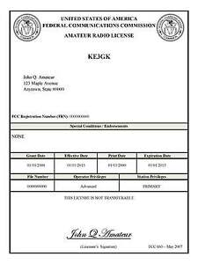***Print an Official or Unofficial Copy of Your Amateur Radio License***

*(By Anthony Luscre, K8ZT)*

As of February 17, 2015, the **FCC no longer routinely issues paper license documents** to Amateur Radio applicants and licensees. The Commission has maintained for some time now that the official Amateur Radio license authorization is the electronic record that exists in its Universal Licensing System (ULS). The FCC will continue to provide paper license documents to all licensees who notify the Commission that they prefer to receive one.

Licensees also will be able to print out an official authorization — as well as an unofficial “reference copy” — from the ULS License Manager. I’ve created a set of instructions on how you can request an **“official” printed copy of your license\***

[**Click here to download the instructions**](http://arrl-ohio.org/news/2020/print_your_license.pdf)

TOP ^

***One Question Questionnaire***

Hey Gang,

Survey Says”….. 48% of you are up-to-date on your First Aid training.. That’s really great!

Ok, now on to the next question… As that the time changed yesterday (Sunday), and your were supposed to move your clock UP one hour, did you remember to do that before you started out for that Sunday 10am event? So, here’s the next question…

***“Did you remember to move your clock up one hour Saturday night??”***

You’ll find the “One Question” questionnaire on the Ohio Section Website! <http://arrlohio.org> It’s all for fun and it’s not a scientific survey in any way, but we are learning some things that we didn’t know from these questions. I hope that you are enjoying answering these “One Question” questionnaires.

*****V.E. Test Sessions***

Many V.E.’s have decided to start testing once again, but with restrictions that need to be adhered to for sure. Here’s the link to find that V.E. Test session and what is expected of YOU before going. <http://www.arrl.org/find-an-amateur-radio-license-exam-session>

Ohio Section Cabinet

|  |  |
| --- | --- |
| Section Manager – Tom Sly, WB8LCD | Section Traffic Manager – David Maynard, WA3EZN |
| Section Emergency Coordinator – Stan Broadway, N8BHL | Section Youth Coordinator – Anthony Lascre, K8ZT |
| Technical Coordinator – Jeff Kopcak, K8JTK | Affiliated Clubs Coordinator – Tom Sly, WB8LCD |
| State Government Liaison – Bob Winston, W2THU | Public Information Coordinator – John Ross, KD8IDJ |



Hey Gang,

Have you taken a look at the **Swap & Shop** page on the Ohio Section webpage yet?? Here’s a link that will take you there… <http://arrl-ohio.org/sm/s-s.html>

Do you have equipment that you just don’t need or want anymore? Here’s a great venue to advertise it, and it’s FREE!! Is your club doing a fund raiser to help raise money? After a lot of thought, it was decided that the Swap & Shop webpage could also contain these types of items as well. The same rules will apply as do for the For Sales and Give-A-Ways and will only be posted for a month at a time. Please see the Terms & Conditions on the webpage.

TOP ^

If your club is doing a fund raiser and wants more exposure, please forward the information to me and I’ll advertise it on the Swap & Shop webpage for you.

Now, I still want to remind you that it won’t be listed in this newsletter because it would take up way too much space, so your ad will only appear on the website. It is there for any individual to post equipment Wanted / For Sale or Give-Away as well as for Club Fund Raisers. No licensed vehicles/trailers or business advertising will be posted. Postings are text only (no pictures or graphics) will be posted for a maximum of 1 month from date posting and require a contact phone number or email within the posting. Send your Wanted / For Sale or Give-Away post to:  [swap@arrlohio.org](mailto:swap@arrlohio.org)

***Back Issues of the PostScript and Ohio Section Journal***

Hey, did you know that PostScript and Ohio Section Journal (OSJ) are archived on the website? You can go back and look at any edition simply by clicking:

<http://arrl-ohio.org/news/index.html>

***Want to Share your Club Newsletter With Others?***

We have a webpage where you can download and read all of the newsletters that I get from around the state and even other sections!

Here’s the link to the page…. <http://arrl-ohio.org/club_news/index.html>

Please, if you don’t see your club newsletter posted, it’s because I’m not receiving it. Just have your newsletter editor contact me and I’ll get your club’s newsletter listed on the site!!

We all learn and steal (I mean, share) from each other’s work. So, get me your newsletter!!! Send it to: [webmaster@arrl-ohio.org](mailto:webmaster@arrl-ohio.org)

***Chit – Chat, and All That!***

Do you know someone that’s not getting these Newsletters? Please, forward a copy of this Newsletter over to them and have them “[Opt-In](mailto:Opt-In)” to start receiving them. Heck, just have them send an email to: [webmaster@arrl-ohio.org](mailto:webmaster@arrl-ohio.org) and we’ll get them added to the Ohio Section Emailing list.

We now have many thousands of readers receiving these newsletters weekly. Quite impressive, I’d say! I urge all of you to make sure that everyone, regardless of whether they are a League member or not, get signed up to receive these weekly Newsletters.

TOP ^

You can always “Opt-Out” at any time if you feel this is not what you were expecting. It’s fun and very informative. All of your favorite past newsletters are now archived too.

You can go back at any time and read them.

Just go to: <http://arrl-ohio.org/news/>

The pictures on the front page and throughout this newsletter are from various newsletters, Facebook posts and/or were sent directly to me in recent weeks. Take a good look at them, you just might be in one of the pictures! “SMILE… you’re in the Ohio Section News!!”



TOP ^

*PostScript is produced as a weekly newsletter. I want to thank everyone that has contributed articles and ideas to make this an even better news source. I sincerely hope that you have enjoyed this edition and will encourage your friends to join with you in receiving the latest news and information about the Ohio Section, and news and events happening around the world!*