[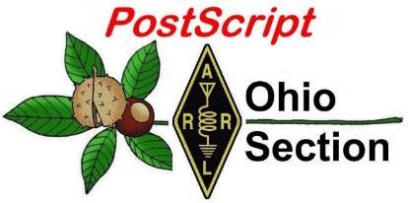](http://arrl-ohio.org/news/) ***“March 8th***

***Edition”***

🡪 [National News](#national) 🡪 [Club Corner](#club)

🡪 [DX This Week](#dx) 🡪 [Contest Corner](#contest)

🡪 [Special Events](#special) 🡪 [Upcoming Hamfests](#hamfest)

🡪 [From The South 40](#south40) 🡪 [Training](#training)

🡪 [One Question Questionnaire](#one) 🡪 [VE Testing](#ve)

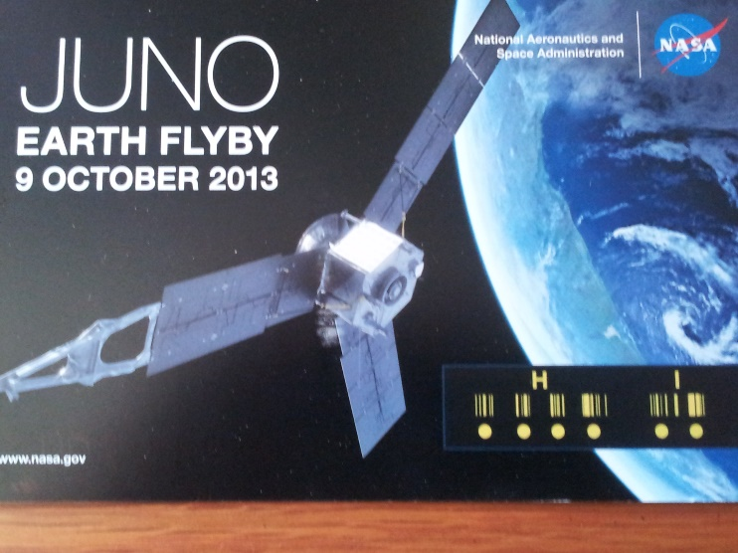

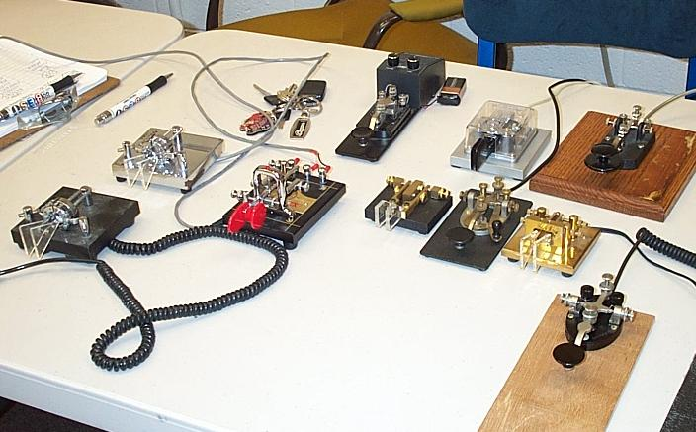

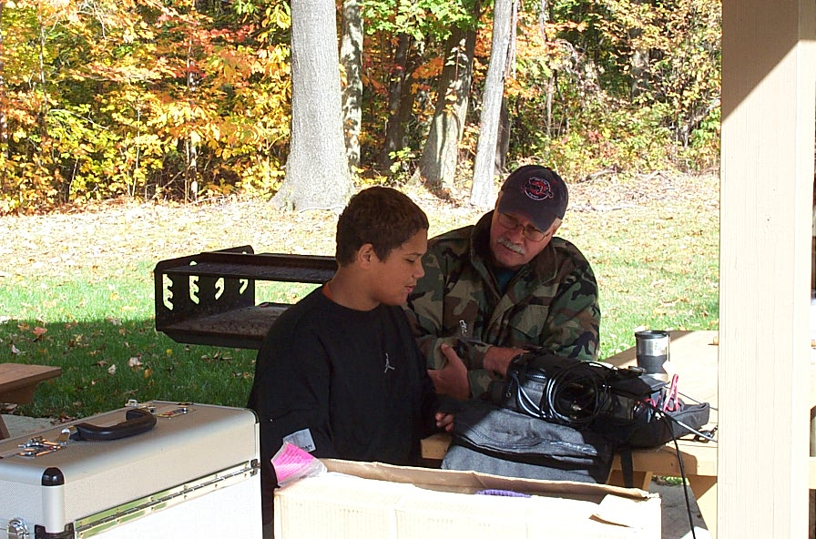

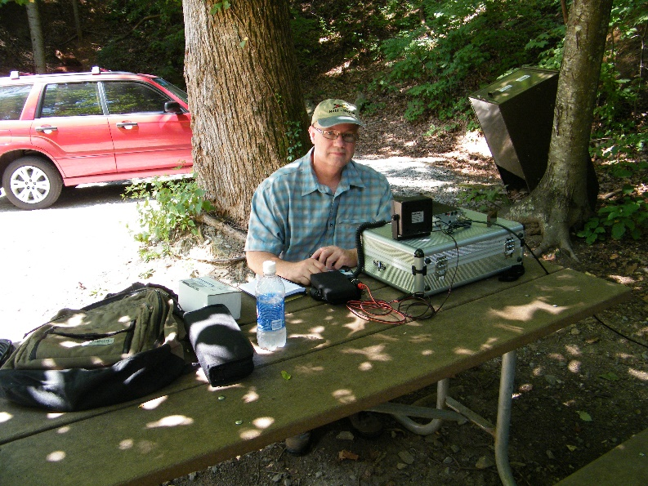

***National News***

*(from arrl and other sources)*

AMSAT-DL Operators Track Mars Probes

Members of Germany's AMSAT organization, AMSAT-DL, in cooperation with the Sternwarte Bochum Institute in Bochum, Nordrhein-Westfalen, Germany, have been using the institute's 20-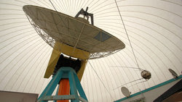meter (65.6-foot) diameter dish antenna to listen directly to signals from probes in Mars orbit. Signals have been copied from the Chinese Tianwen-1 and the Hope Emirates Mars Mission (EMM) spacecraft now orbiting Mars and transmitting in the 8.4 GHz band.

[Recordings](https://www.youtube.com/watch?v=413DdMua8ec&feature=emb_imp_woyt) of the signals can be heard on YouTube with regular updates by following **@amsatdl** on Twitter.

In 2003, radio amateurs added phase-locked receivers in the 2.3, 5.8, and 10.4 GHz amateur bands, as well as an 8.4 GHz receiver. There is also an S-band 2.4 GHz amateur transmitter running 250 W PEP (peak envelope power).

In 2006, the dish was used to copy signals from Voyager 1 at a distance of nearly 15 billion kilometers (9.3 billion miles). -- *Thanks to* AMSAT News Service

####

SIGHTS AND SOUNDS

Randy, K5ZD, presented "[Tips on How to Be a Better Contester](https://www.youtube.com/watch?v=ls54qbp30B8)" as part of [HAM-CON](http://www.ham-con.org/), the Vermont Ham Radio Convention. More HAM-CON videos can be found [here](https://www.youtube.com/channel/UCzbTaI87SG0-6i2lwlm9Vkw/videos).

Mike, VA3MW, of FlexRadio, presented a video on [how to set up *N1MM Logger+* with FlexRadio transceivers for RTTY contests using MMTTY](https://www.youtube.com/watch?v=QBmBlMaVJzc). Though his video was targeted to the CQ WPX, the radio setup information is applicable to any RTTY contest.

The [QSO Today Virtual Ham Expo](https://www.qsotodayhamexpo.com/) on March 12 - 14 includes a number of contest-relevant presentations, including:

"D4C - You Call, We Answer" - Marco, IK2LFF

"Underdog Contesting" - Fred, K4IU

"K9CT Tour and a Peek at 2021 Enhancements" - Craig, K9CT

"Low Band Receive Antennas for All Yards" - Gary, W9XT

"FlexRadio with IBM's Node-RED in the Ham Shack" - Dave, WO2X

"The State QSO Party Challenge" - Anthony, K8ZT

"Another Look At Verticals" - Tom, N6BT

"VHF Contesting" - Jim, K5ND

[TOP](#top) ^

[Check out the website](https://www.qsotodayhamexpo.com/" \t "_blank) for more information and the schedule of this event that starts at 1800 PST on March 12.

|  |
| --- |
| A message about the QSO Today Virtual Ham Expo, an ARRL Partner. |
|  |
| The next QSO Today Virtual Ham Expo is approaching fast, taking place on March 13-14, 2021. This Expo features many new speakers, kit-building workshops, panel discussions, booth prizes, and much more. Early Bird discount tickets are available for a limited time and include entry for the Live 2-day period plus the 30-day on-demand period. Register at [qsotodayhamexpo.com](http://www.qsotodayhamexpo.com/).   **At the Expo, there’s something for everyone:**   * Learn from a packed lineup of 80+ renowned ham radio speakers.  Use the new calendar features to download times directly to your calendar. See the full lineup at [qsotodayhamexpo.com/speakers](https://www.qsotodayhamexpo.com/speakers.html). * Take part in a Live Buildathon of kit-building workshops. Purchase kits now and have them delivered prior to the Expo so you can build from the convenience of your home. Learn more and order kits at [qsotodayhamexpo.com/build-a-thons](https://www.qsotodayhamexpo.com/build-a-thons.html). * Walk through the virtual exhibit hall filled with popular amateur radio suppliers. Watch live product demos of the latest equipment. New video technology will be used to provide a better experience for attendees to engage with exhibitors. * Visit the “Ask the ARRL Lab” and ARRL booths. ARRL Lab engineers will be available to answer questions and share tips about a project you’re working on or suggestions to overcome a problem with a station installation, antenna, or a piece of gear. * ARRL CEO David Minster, NA2AA, will keynote at 2000 UTC (3 PM EST) on March 13. |
| [TOP](#top) ^ |
| * Take advantage of the very cool virtual lounges, which allow you to meet up with fellow hams using the latest video technology.   A number of exhibitors will be doing drawings for some great prizes – including some exciting high-end items!  You can participate from the convenience of your home without spending a dime on travel! So if you’ve never been to an in-person hamfest, you can participate in the Expo and get the same benefits. The platform simulates a full convention experience.    **Come and join thousands of ham radio operators** – go to [qsotodayhamexpo.com](https://www.qsotodayhamexpo.com/) now to learn more and get registered!   We look forward to having you join us at Expo for an amazing and engaging experience. |
|  |
|  |

***Club Corner***

This is YOUR cornner of the newsletter. Send me what your club is doing and I’ll make sure that it gets in. Got a special event or club project that you want everyone to know about? Send it to me!. Need help with a project? Send it to me.

Let me know what you club is up to. Are you going to have a special guest at your meeting or are you having a special anniversary?

Just sent it to: [webmaster@arrl-ohio.org](mailto:webmaster@arrl-ohio.org)

**Massillon ARC** Spring TailgateFest to be held at the MAPS Air Museum.  
Entrance at 5383 Massillon Road just inside the Stark/Summit County line.  
  
Date is Saturday, April 17 from 9 [a.m.to](http://a.m.to/) 4 p.m. Cost is $5 per vehicle.  
(for use of  
the facility)   No advance registration necessary. Bring your own tables.  
(no large trailers) No charge for visitors.

This is from the **Case Amateur Radio Club** of Case Western Reserve University, published last week: <https://eos.org/features/ham-radio-forms-a-planet-sized-space-weather-sensor-network>

####

[TOP](#top) ^

Approaches to Tackle Noise Problems Vary, Remedies Elusive

RF noise is a frequent discussion topic among radio amateurs. A proliferation of electronics has 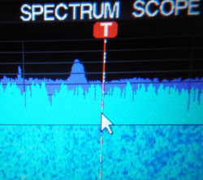cluttered and complicated the noise environment; it's not just power lines anymore. Unless isolated from civilization, most hams experience RF interference (RFI) and spectrum scopes on modern transceivers can make it much more apparent. Various approaches to address the apparently worsening noise floor have been taken around the world, some addressing lax regulation.

"We all want to enhance our ability to copy the weak ones by increasing our signal-to-noise ratio," Alan Higbie, K0AV, said in his March/April *NCJ* article, "Tracking RFI with an SDR One Source at a Time." He suggests practical methods for individual radio amateurs to improve their own noise environment. "We can do that by reducing the noise on each band that we operate. Lowering the noise floor increases the relative strength of weak signals. Those who live in typical residential environments find that locating and eliminating RFI sources is a never-ending process. It is much like weeding a garden."

The International Amateur Radio Union ([IARU](http://www.iaru.org/)) warns against complacency. "Radio amateurs cannot sit back, because even if the desired noise limits are agreed, there are many rogue manufacturers

|  |
| --- |
| **Small household "wall warts" are typically noisy switching power supplies.** |

and dealers who will happily sell noise-generating devices, leaving out filter circuits to cut costs," IARU said. The IARU has urged member-societies to get involved.

The FCC Technological Advisory Council ([TAC](https://www.fcc.gov/general/technological-advisory-council)) -- a Commission advisory group -- [initiated an inquiry](https://transition.fcc.gov/Daily_Releases/Daily_Business/2016/db0615/DA-16-676A1.pdf) in 2016 looking into changes and trends to the radio spectrum noise floor to determine whether noise is increasing and, if so, by how much. The TAC had encouraged the FCC to undertake a comprehensive noise study in 1998, and cautioned the FCC against implementing new spectrum management techniques or initiatives without first concluding one. In 2017, the FCC Office of Engineering and Technology (OET) invited comments on a series of (TAC) spectrum-management questions. ARRL, in its comments, took the opportunity to strongly urge the FCC to reinstate the 2016 TAC noise floor study, which, ARRL asserted, was terminated before it even got started. ARRL urged the FCC to "depart from the traditional regulatory model" that placed limits only on transmitters and called for "a 'holistic' approach to transmitter and receiver performance."

* ARRL offers a wide range of [information on RFI](http://www.arrl.org/radio-frequency-interference-rfi) on its website.
* Paul Giancolo, W1VLF, will offer "Finding and Fixing RFI" as part of the [ARRL Learning Network](http://www.arrl.org/arrl-learning-network) webinar series, on Tuesday, April 20, at 1700 UTC.
* ARRL Northwestern Division Director Mike Ritz, W7VO, will offer "HF Noise Mitigation" as part of the [ARRL Learning Network](http://www.arrl.org/arrl-learning-network) webinar series, on Thursday, April 22, at 1930 UTC.

[TOP](#top) ^

Greg Lapin, N9GL, represents ARRL on the TAC and chairs the ARRL RF Safety Committee. "Perhaps the best result that we obtained was an indication that illegal devices, mainly LED lights, were in circulation, and the Enforcement Bureau agreed to look into it," he told ARRL. "We never heard what they found out, but recently, I was buying some LED bulbs over the internet from a site in Texas, and they were selling non-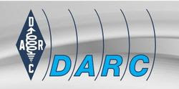FCC approved lights -- and didn't seem to care." Lapin said his complaint went nowhere, and the TAC's focus has been nudged in the direction of addressing 5G issues.

The Deutscher Amateur Radio Club ([DARC](http://www.darc.de/)) has been working on developing a noise-measurement system that approximates methods used by the International Telecommunications Union Radiocommunication Sector (ITU-R). DARC reported that 35 of these electrical noise area monitoring systems ([ENAMS](https://vienna.iaru-r1.org/wp-content/uploads/2019/05/VIE19-C7-datasheet-ENAMS-RX_2.pdf)) have been delivered, and it's seeking another 20 locations as part of the effort to monitor noise interference on the HF bands. DARC said the ENAMS can help to make scientifically reliable statements about interference levels.

IARU sees wireless power transmission (WPT) as an impending major noise threat, especially from WPT electric vehicle (WPT-EV) charging systems. "For the amateur service, given the planned density of WPT-EV systems, it is calculated that there will be a widespread and serious impact in the vicinity of WPT systems" from spurious emissions, said a 2019 *EE Publishers* [article](https://www.ee.co.za/article/amateur-radio-societies-concerned-about-the-hf-noise-floor.html), written by "Amateur radio societies concerned about the HF noise floor." The article also said, "To ensure a low probability of harmful interference to radiocommunication services, further study is required."

Hi There! I wanted to put in a few words of my own in this issue of PostScript. Being just a little over two months into my new position as OH Section Manager, I want to tell you that I am overwhelmed! Yeah, it’s pretty busy and involved, but that’s not exactly what I’m talking about. What I am talking about is the reception and response I have received as your new section manager. The Ham Radio Ops of the OH Section are Fantastic! Thank you all.

In just my second week as ARRL OH Section Manager, I received an email from Bud – W3IQ - stating that he had a new, in the box, Icom 7300 that he wanted to donate to some individual or organization that would put it to good use for younger hams that might not have the wherewithal to purchase a radio like this on their own. I immediately put him in touch with Jim Storms – AB8YK – who is certainly connected with youth and youth programs, and that radio now resides with the Green County 4H Club. So, less than two weeks into my new position I received the best affirmation possible of something I have always said: “The OH Section is comprised of some really smart, really friendly, and really considerate Hams!”

Many thanks also to Scott, N8SY, who not only has laid a strong foundation for the OH Section, but has gone *way over the top in every way* helping me get started with my transition to SM. As Scott has now moved into the Vice Director’s position for the Great Lakes Division, I know that he will continue to make the ARRL better for all of us.

[TOP](#top) ^

**QSO Today Virtual Ham Expo –** Tickets are now available to attend the QSO Today Virtual Ham Expo sponsored by the QSO Today Podcast, FlexRadio, Icon and Elecraft. Information can be found at <https://www.qsotodayhamexpo.com/> There are several hams from our area who will be speaking, and you can watch the presentations live, ask questions of the presenters, and well as visit the booths of many vendors. The dates are March 13th and 14th. Also, you will be able to access many of the presentations until April 12th.

Several contributors to the Ohio Section Journal will be giving presentations at this event. Check it out and let me know what you think!

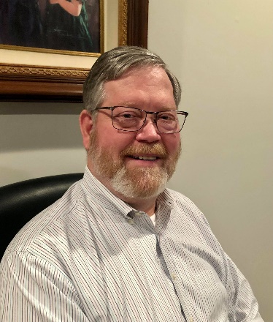

***DX This Week – 5W0GC***

***Bill AJ8B (***[***aj8b@arrl.net***](mailto:aj8b@arrl.net)***, @AJ8B, or*** [***www.aj8b.com***](http://www.aj8b.com)***)***

***CWOPs Member #1567***

The Midwest DX Cluster spots included Argentina, Azores, Brazil, Canada, Canary Islands, Ceuta & Melilla, Cuba, Curacao, Dominican Republic, DPR of Korea, England, Fed. Rep. of Germany, France, Greenland, Guatemala, Hawaii, Hungary, Iceland, Madeira Islands, Marshall Islands, Morocco, Panama, Portugal, Scotland, Spain, Suriname, Trinidad & Tobago, and US Virgin Islands. This brings the total number of entities spotted in the Midwest in 2021to 143!

|  |
| --- |
|  |

# *DAH DIT DIT DIT DAH DAH DIT DIT DIT DAH*

|  |  |  |  |  |  |  |  |  |
| --- | --- | --- | --- | --- | --- | --- | --- | --- |
| I received cards from JF1OCQ – Hiro in Maebashi, Japan, and TA5FA – Mehmet in Turkey, CB6P – Alto in Chile, EL2BG – Ishmael in Liberia, 7K4DHB – Yoshi in Japan, OH0Z – Aland Island, and ZM1A in New Zealand. I also updated my card and have it below. Let me know what you received.   |  |  | | --- | --- | |  |  | | [TOP](#top) ^ |  | |  |  | |  |  | |
|  |

# *DAH DIT DIT DIT DAH DAH DIT DIT DIT DAH*

## This week is part 1 of a 2-part article describing the 5W0GC & YJ0GC 2018 DXpeditions conducted by the 2018 DXPeditioner of the Year recipient, Stan—LG1GC.

## 

The idea of activating Samoa (5W) and Vanuatu (YJ) occurred to me immediately after the end of the H40GC DXpedition 2017. I had other plans, but in February, 2018, I decided to activate these two destinations. At that time, Samoa (5W) was 127th in the CLUBLOG ranking as the most wanted country among the amateur community and Vanuatu (YJ) was number 75 in the same ranking.

Below is some brief information from Wikipedia about Samoa and Vanuatu.

**5W - Samoa—**Samoa, know as Western Samoa consists two main islands Savai'i and Upolu, account for 99% of the total land area, and eight small islets. Samoa has total area 2842 square km. Samoa located south of the equator, about halfway between Hawaii and New Zealand in the Polenesian region of the Pacific Ocean. The capital city of Samoa is Apia, located on the main island of Upolu.

[TOP](#top) ^

Samoa has a population around 194,000. About three - quarters of population live on the main island of Upolu. 92% of the population are Samoans, 7% Euronesians - people of mixed European and Polynesian ancestry and 0.4% are Europeans.

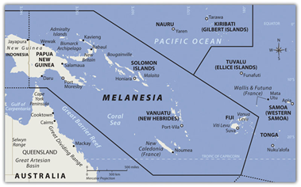The organization and preparation for the 5W0GC & YJ0GC DXPedition 2018 took 7 months - a time of hard work involving almost of all my spare time. After a successful initial research on these two destinations regarding travel, visas, and accommodation, I decided to carry on.

**5W0GC activity from September 28, 2018 to October 14, 2018, and YJ0GC activity from October 15 to November 4, 2018.**

In March 2018 after contacts with the government officials responsible for radio licenses at the Telecoms of Samoa and Vanuatu, I was able to get the necessary licenses quickly. I received permission to use the call sign 5W0GC from Samoa and YJ0GC from Vanuatu.

The next step in the preparing for this DXPedition was to buy the necessary airline tickets and make reservations for Samoa and Vanuatu accommodations. During this time, I received a nice invitation from Atsu, 5W1SA to visit him and activate 5W0GC from his home. His hospitality was most gracious and made it easier for me to optimize my station setup and location. I am grateful to Atsu for the invitation, hospitality and help which he provided me during my stay in Apia, Samoa. Thanks, Atsu!

For choosing a place to stay at Port Vila, Vanuatu, I received assistance from Chungki, VA7YM (YJ0YM). The proposed location was the Blue Pango Motel in Port Vila. I had another backup motel option, but it did not have to be used as the Blue Pango Motel turned out to be a very good place for YJ0GC activity.

In May 2018 I had a conversation with Lubo, OM5ZW, a good friend from our T2GC DXPedition in 2015. He expressed a desire to participate as an operator at YJ0GC. He further recommended Karel, OK2WM to join our team. Now, the composition of the upcoming DXPedition to Vanuatu grew to 3 operators.

The months from May to September 2018 passed with preparing and testing the radios and antennas to be used on the DXPedition. During these months I also sought sponsors for the upcoming 5W0GC (Samoa) and YJ0GC (Vanuatu) activities. To all the radio amateur Associations, Foundations, Club and Individual Sponsors who responded to my requests for support to this DXPedition, I give my wholehearted “Thank You”.

*The day is 26 September 2018*.

Again, I am on my way to the Pacific Ocean! Far from the Motherland. This time my goal is Samoa (5W) and Vanuatu (YJ) - two island countries located thousands of kilometers from Bulgaria.

After three flights, two of which were about 11 hours (each one!), I arrived in Nadi, Fiji, in the early morn of September 28. The same day at 13:40 local time followed another flight to Apia, Samoa.

[TOP](#top) ^

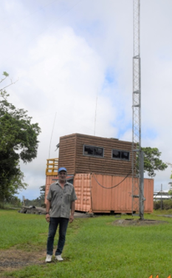According to plan, at about 5 PM local time, I was in the passenger arrival area of Faleolo International Airport (Apia), where Atsu, 5W1SA, was expected to meet me.

I was quickly recognized by Atsu, 5W1SA. With so much luggage and with an ACOM sign on one of my boxes it was impossible not to recognize me from the other arriving passengers. We met for the first time! After a short conversation we boarded his Jeep and headed to his house, Located near the highest point of a mountainous area and about 700 meters above sea level.

Arriving at Atsu's home, I immediately installed my radio equipment. It was dark outside when I began to work on the air with Atsu's dipole antennas at 40 and 80 meters.

During the first night I worked CW on both the 40 and 80 meter bands. The tempo was good, and I stayed committed to the big pile up. I was so energized I operated throughout the night. At dawn, I shut down the station and began to prepare for the raising the vertical antenna for the 160/80/40m bands. This is the same antenna I had successfully used on my prior DXpeditions.

Next to Atsu’s property, the 5W1SA QTH had plenty of empty space, and though overgrown with grass and other vegetation, it was possible to install numerous antennas without any problems.

About 11 АМ local time on September 29th, Atsu and I prepared and raised the 160m/80m vertical. That same day I began making 160m CW QSOs. During my time as 5W0GC, I tried to make the most of the windows of good propagation for the different continents. Despite the poor propagation, the rate of the contacts was good.

Samoa is known for its daily rains in October. Indeed, during my entire stay in Samoa, there was rain every day, often accompanied by a strong wind. This interfered with the installation of my second antenna – a multi-band GP, designed to work 10-40m. It was on the 3rd day of my arrival on Samoa that I successfully erected this antenna.

Although the focus of this DXPedition was on the low bands, I was very active on the other bands also, often including CW, SSB and RTTY.

5W0GC activity occurred from late afternoon on September 28 to early morning on October 14. During the night I was active at on 160/80/40m, and during the day on 30 to 10m. Daily pauses were no more than 3 to 4 hours for sleeping and antenna repair.

After two weeks, 14,094 QSOs were logged on all radio bands using CW, SSB and RTTY. I am delighted that from Samoa (5W) I gave a new one to many radio amateurs, not only on the low bands but also the high bands.

[TOP](#top) ^

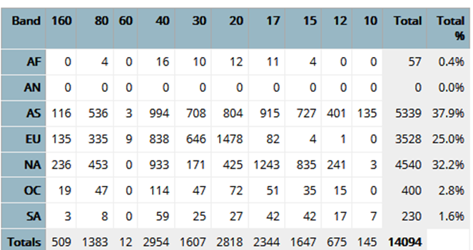To the right are the statistics from CLUB LOG for 5W0GC activity:

The 5W0GC operation by Stan, LZ1GC ended at 02:00 AM local time on October 14. After I went QRT, I disassembled and packed the technical equipment and prepared for a late afternoon departure. At dawn, I began dismantling and packing the antennas.

The flight to Nadi, Fiji was at 17:40 local time. However, on arriving at Apia’s Faleolo Airport with Atsu, 5W1SA, we found that the flight would have a delay of 2 hours. Due to the announced delay of my flight to Fiji, Atsu returned to his home, and I stayed at Faleolo Airport waiting for my upcoming flight.

Time was passing, and I was already thinking about the upcoming activity at Vanuatu. Then, just when I was expecting information on the flight departure to the intermediate stop in Fiji, I heard the announcement that flight FJ 254 from Apia, Samoa to Nadi, Fiji was canceled. This was very unpleasant news to say the least!

During the preparation of my DXpeditions, I always prepare for any problems. I usually have solutions for them, but in this case I was unpleasantly surprised and could do nothing. I had previously arranged with Lubo (OM5ZW) and Karel (OK2WM) to meet on October 15 at Nadi Airport, Fiji. They were to arrive at Nadi Airport at 08:35 local time on October 15. I would wait for them in the passenger arrival area, and then we would travel together in the early afternoon to Port Vila, Vanuatu.

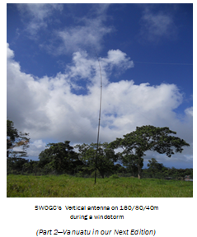Now, everything was messed up ... the meeting as planned was not possible! After an initial confusion among the passengers of the canceled flight, things started to work out - some of the passengers sought to rebook new round-trip flights. Others like me were informed that the next flight to Nadi, Fiji would depart the next day at 17:00 local time. So, that evening (on the 14th) I stayed at the Sheraton Hotel in Apia.

The first thing I did from the hotel was email Lubo (OM5ZW) and Karel (OK2WM) about my canceled fligh, and that our meeting would have to be rescheduled. Fortunately, they were traveling with their own equipment they could use to get on the air quickly – Two transceivers: a Yaesu FT 991 and an Elecraft K3 and two amplifiers: an ACOM 700S and a SPE Expert 1.5.

They traveled with extra luggage, which included two vertical antennas from 10-40m and a low frequency receiving antenna donated by Array Solutions. I asked them to activate the bands immediately on their arrival at the motel in Vanuatu

# *DAH DIT DIT DIT DAH DAH DIT DIT DIT DAH*

[TOP](#top) ^



Below is a list of upcoming contests in the “Contest Corner”. I think this is important for someone who is trying to move up the DXCC ladder since entities that are on the rarer side and easiest to work in contests. Some of my best “catches” have been on the Sunday afternoon of a contest when the rarer entities are begging for QSOs. Of course, the gamble is that if you wait until Sunday, conditions may change, or they simply won’t be workable. However, it is not a bad gamble. Of course, why not work the contest and have some fun!

Check out the WA7BNM Contest Calendar page ([https://www.contestcalendar.com/](about:blank)) for more contests or more details.

The contests in red are those that I plan to spend some significant participation time on. PLEASE let me know if you are working contests and how you fared.

Thanks!

|  |  |  |
| --- | --- | --- |
| Mar. 10 | RSGB 80m Club Championship, CW | [http://bit.ly/3avHbk3](about:blank) |
| Mar. 13 | AGCW QRP Contest | [http://bit.ly/2KKp3rY](about:blank) |
| Mar. 13 | YB DX RTTY Contest | https://rtty.ybdxcontest.com |
| Mar. 13-14 | Idaho QSO Party | [www.pocatelloarc.org/idahoqsoparty](about:blank) |
| Mar. 13-14 | Oklahoma QSO Party | [http://k5cm.com/okqp.htm](about:blank) |
| Mar. 13-14 | QCWA QSO Party | [www.qcwa.org/qcwa.php](about:blank) |
| Mar. 13-14 | North American RTTY Sprint | [http://ncjweb.com/north-american-sprint](about:blank) |
| Mar. 13-14 | RSGB Commonwealth CW Contest | [http://bit.ly/2KxebOr](about:blank) |
| Mar. 13-14 | South America 10 Meter Contest | [www.sa10m.com.ar/index.html](about:blank) |
| Mar. 13-14 | Stew Perry Topband Challenge | [www.kkn.net/stew](about:blank) |
| Mar. 14 | FIRAC HF Contest | [www.firac.de/html/contest.html](about:blank) |
| Mar. 14-15 | Wisconsin QSO Party | [www.warac.org/wqp/wqp.htm](about:blank) |
| Mar. 15 | RSGB FT4 Contest Series | [http://bit.ly/3mCNXXH](about:blank) |
| Mar. 20-21 | Virginia QSO Party | https://bit.ly/2Khd2ul |
| Mar. 20-21 | Russian DX Contest | [www.rdxc.org/asp/pages/rulesg.asp](about:blank) |
| Mar. 20-22 | BARTG HF RTTY Contest | [http://bartg.org.uk/wp/contests](about:blank) |
| Mar. 21 | UBA Spring Contest 80m SSB | [http://bit.ly/2KKAtb9](about:blank) |
| Mar. 25 | RSGB 80m Club Championship, SSB | [http://bit.ly/3avHbk3](about:blank) |
| Mar. 27 | FOC QSO Party | [www.g4foc.org/qsoparty](about:blank) |
| **Mar. 27-28** | **CQWW WPX SSB Contest** | [**www.cqwpx.com**](about:blank) |
| Mar. 31 | UKEICC 80m Contests CW | https://bit.ly/2SDPqQQ |
| May 29 – 30 | CQWW WPX CW | [https://www.cqwpx.com/](about:blank) |
| August 28 | Ohio QSO Party | [https://www.ohqp.org/](about:blank) |
| August 28 | W8DXCC | [https://www.w8dxcc.com](about:blank) |

[TOP](#top) ^

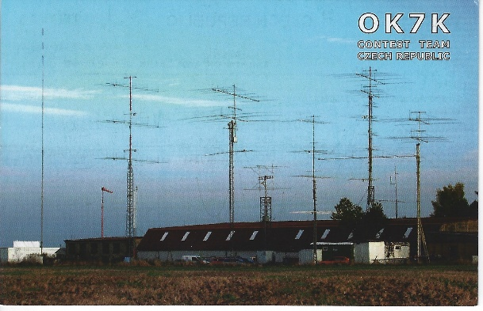***DX News***

***ARLD009 DX news***

This week's bulletin was made possible with information provided by The Daily DX, the OPDX Bulletin, 425 DX News, DXNL, Contest Corral from QST and the ARRL Contest Calendar and WA7BNM web sites.  Thanks to all.  
  
**ZAMBIA, 9J.**  Bodo, HB9EWU is QRV as 9J2BG while working on a humanitarian mission in the Luapula Province.  He is active in his spare time generally on 20 meters.  QSL to home call.  
  
**OMAN, A4.**  Operator A41CK will be QRV as A42K as a Single Op/All Band entry in the ARRL International SSB DX contest.  QSL via EA5GL.  
  
**UNITED ARAB EMIRATES, A6.** Greg, KD5ESG will be QRV as A65HH while on work assignment in Abu Dhabi.  QSL via operator's instructions.  
  
**SPAIN, EA.**  Special event stations AM3DIM and AM3YLD will be QRV from March 6 to 12 to commemorate International Women's Day on March 8.  QSL via operators' instructions.  
  
**CANARY ISLANDS, EA8.**  Miguel, EA1BP plans to be QRV as ED8W in the ARRL International SSB DX contest as a Single Op/All Band/High Power entry.  QSL via EA5GL.  
  
**MARTINIQUE, FM.**  Station FM5BH will be QRV as a Single Op/All Band/High Power entry in the ARRL International SSB DX contest.  QSL via W3HNK.  
  
**SCOTLAND, GM.**  Chris, GM3WOJ is QRV with special call sign GB2CR until March 18 to honor the legacy of the Collins Radio Company. Activity is on 80 to 10 meters using SSB and some CW.  QSL via LoTW.  
 **ECUADOR, HC,**  Rick, NE8Z is QRV as HC1MD/2 from Santa Elena Province until May 15.  Activity is on 40 to 6 meters.  QSL via K8LJG.  
  
**VATICAN, HV.**  Look for IK0FVC to be QRV as HV0A in the ARRL International SSB DX contest.  QSL via LoTW.  
  
**ST. LUCIA, J6.** Bill, K9HZ, Dan, W0CN and Kyle, WA4PGM are QRV as J68HZ, J68CN and J68PG, respectively, until March 11.  Activity is on the HF bands.  They will be active as J68HZ in the ARRL  
International SSB DX contest.  QSL direct to home calls.  
  
**PERU, OA.**  Ed, W9SI plans to be QRV as OA4SS in the ARRL International SSB DX contest as a Single Op/All Band/High Power/Unassisted entry.  QSL via KB6J.

[TOP](#top) ^

**CURACAO, PJ2.**  Don, AF4Z, Vince, K4JC, Dan, N1ZZ and Walt, WB5ZGA are QRV as PJ2/home calls until March 9.  Activity is on 160 to 10 meters.  They will be active as PJ2T in the ARRL International SSB DX contest.  QSL PJ2T via W3HNK and all others to home calls.  
  
**BONAIRE, PJ4.**  Marty, W1MD plans to be QRV as PJ4G in the ARRL International SSB DX contest as a Single Op/Single Band entry on either 20 or 15 meters depending on conditions.  QSL via LoTW.  
  
**POLAND, SP.**  Special event stations SN0ZOSP and SN100ZOSP are QRV until February 5, 2022 to celebrate the 100th anniversary of the Association of the Voluntary Fire Brigades of the Republic of  
Poland.  QSL SN0ZOSP via SP9ODM and SN100ZOSP via SP9SPJ.  
  
**BENIN, TY.**  Ian, ZS6JSI is QRV as ZS6JSI/TY from Parakou until June. Activity is in his spare time on 80, 40 and 20 meters using SSB and FT8.  QSL via EC6DX.  
  
**EUROPEAN RUSSIA, UA.**  Special event station R125PR is QRV during March to celebrate Alexander S. Popov's first wireless transmission 125 years ago.  QSL via R1AU.  
  
**MARSHALL ISLANDS, V7.** Paul, KA4WPX is QRV as V7/KA4WPX and V73AX from Kwajalein Atoll, IOTA OC-028.  Activity is at various times on 160 to 10 meters, and possibly 6 meters, using CW and SSB.  QSL direct.  
  
**ASCENSION ISLAND, ZD8.**  Tev, TA1HZ is QRV as ZD8HZ until mid-April. He plans to be active in the ARRL International SSB DX contest and the upcoming CQ World Wide WPX SSB contest.  QSL direct to home call.  
  
THIS WEEKEND ON THE RADIO.  The ARRL International SSB DX Contest, NCCC RTTY Sprint, QRP 80-Meter CW Fox Hunt, NCCC CW Sprint, K1USN Slow Speed CW Test, Novice Rig CW Roundup, Wake-Up QRP CW Sprint, Open Ukraine RTTY Championship, UBA Spring CW Contest, NSARA Contest, SARL Hamnet 40-Meter Simulated Emergency SSB Contest and the WAB 3.5 MHz Phone will certainly keep contesters busy this upcoming weekend. The OK1WC Memorial is scheduled for March 8.  
  
The Worldwide Sideband Activity Contest and RTTYOPS Weeksprint are scheduled for March 9.  
  
The RSGB 80-Meter Club CW Championship, AWA John Rollins Memorial DX CW Contest, VHF-UHF FT8 Activity Contest, CWops Mini-CWT Test, QRP 40-Meter CW Fox Hunt and Phone Weekly Test/Fray are scheduled for March 10.  
  
Please see March QST, page 72, and the ARRL and WA7BNM contest websites for details.

**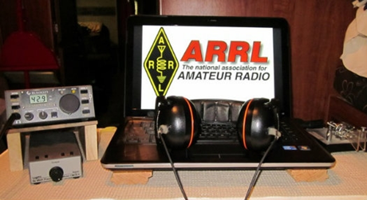*ARRL Contest Corner***

An expanded, downloadable version of *QST'*s’ [**Contest Corral**](http://www.arrl.org/contest-calendar) is available as a PDF. Check the sponsor’s ‘Website for information on operating time restrictions and other instructions.

[TOP](#top) ^

***Special Events***

* **03/11/2021 | Battleship Texas Birthday**

**Mar 11-Mar 14, 0000Z-0000Z, W5T**, Cleburne, TX. Club KC5NX. 14.255 14.045 7.240 7.235 . QSL. Club KC5NX, 9200 Summit Ct W , Cleburne, TX 76033-8212. Club KC5NX back on the air for the celebration of the 107th birthday of the Battleship TEXAS. jay.n.violet@gmail.com or check here to find us: https://www.dxwatch.com/dxsd1/dxsd1.php?f=0&c=w5t&t=dx <https://www.qrz.com/db/kc5nx>

* **03/13/2021 | USS Midway Museum Ship Special Event: Launching of USS Midway**

**Mar 13, 1700Z-2359Z, NI6IW**, San Diego, CA. USS Midway (CV-41) Museum Ship. 7.250 14.320 14.070 (PSK31) DSTAR vis PapaSystem repeaters. QSL. USS Midway CV-41 COMEDTRA NI6IW, 910 N Harbor Drive, San Diego, CA 92101. SASE please. [www.qrz.com/db/ni6iw](http://www.qrz.com/db/ni6iw)

* **03/14/2021 | PI Day - David Sarnoff Radio Club, Princeton, NJ**

**Mar 14, 0000Z-2359Z, N2RE**, Princeton, NJ. David Sarnoff Radio Club. 14.250 14.050 7.200 7.050. QSL. Bob Uhrik, 104 Knoll Way, Rocky Hill, NJ 08553. Famous Princetonian Albert Einstein was born on PI Day. [n2re.org](http://n2re.org/)

* **03/20/2021 | Arrows from the Air**

**Mar 20-Mar 21, 1800Z-0300Z, K7SWI**, Middleton, ID. South West Idaho Amateur Radio Club. 28.427 14.227 7.227 3.827. Certificate & QSL. South West Idaho Amateur Radio Club, 332 West Dewey Ave, Nampa, ID 83686. What Are Those Giant Arrows Dotting the American Landscape? The arrows were part of a federal project to speed up communication across great distances. Transcontinental airmail service began in 1920, but even with this advancement over ground travel, service was slow. Pilots had no sophisticated instruments, so they couldn’t fly at night or in poor weather. The government built a path of 70-foot-long concrete arrows every few miles from coast to coast, each painted yellow and topped with a 51-foot steel tower that had a rotating beacon. Using the path, an airmail pilot needed only half the time to deliver a letter from New York to San Francisco, The SOUTH WEST IDAHO ARC will operate 14.327, 7.227, 3827 plus or minus traffic/qrm.. K7SWI will issue a Certificate and QSL to all requested please include SASE for QSL only and SASE with one green stamp for QSL and Certificate. Reply to address of K7SWI. 332 West Dewey Ave Nampa, ID 83686. [nq6s@att.net](mailto:)

* **03/20/2021 | Woronoko Heights Outdoor Adventure**

**Mar 20, 1300Z-1900Z, W1M**, Russell, MA. Western Mass. Council-BSA. 7.190 10.115 14.060 14.290. QSL. Tom Barker, 329 Faraway Road, Whitefield, NH 03598.

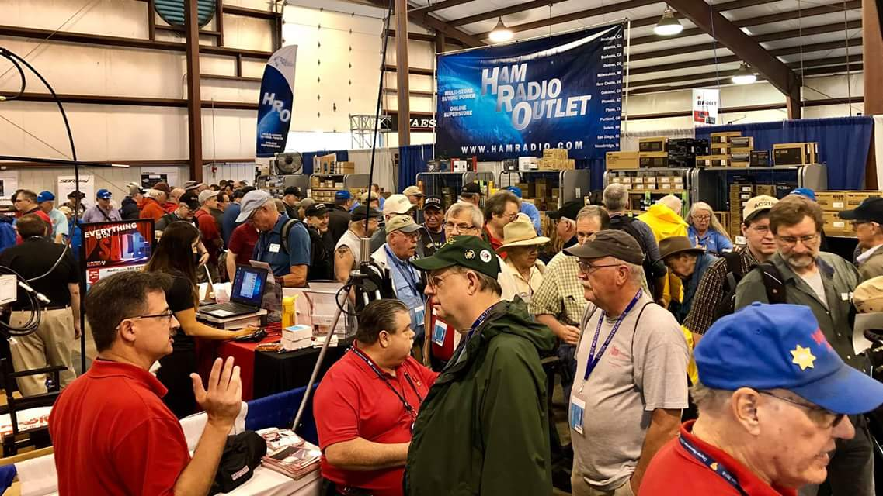[***Upcoming Hamfests***](http://arrl-ohio.org/hamfests.html)

We **DO** have some hamfests scheduled for 2021!! Yes, take a good look at the list, it’s growing every day!

[TOP](#top) ^

Be sure to keep your eyes on this schedule as that when things start getting better and the vaccine rolls out to more and more, hamfests will surely get back to their normal schedule. Don’t see your hamfest listed?? Did anyone register it with ARRL? It’s really easy to do and you get a lot of FREE publicity if you do.

|  |  |
| --- | --- |
| **04/25/2021 -**[**Athens Hamfest**](http://www.arrl.org/hamfests/athens-hamfest-9)  *Canceled* | **06/05/2021 -**[**FCARC SummerFest**](http://www.arrl.org/hamfests/fcarc-summerfest)  Location: Wauseon, OH Sponsor: Fulton County Amateur Radio Club Website:<http://k8bxq.org/hamfest> [Learn More](http://www.arrl.org/hamfests/fcarc-summerfest) |
| **07/10/2021 -**[**Mansfiled Mid-Summer Trunkfest**](http://www.arrl.org/hamfests/mansfiled-mid-summer-trunkfest)  Location: Mansfield, OH Sponsor: InterCity Amateur Radio Club Website:<http://iarc.club>[Learn More](http://www.arrl.org/hamfests/mansfiled-mid-summer-trunkfest) | **07/18/2021 –**[**Van Wert Hamfest**](http://www.arrl.org/hamfests/van-wert-hamfest-5)  Location: Van Wert, OH Sponsor: Van Wert Amateur Radio Club Website:[http://W8FY.ORG](http://w8fy.org/)[Learn More](http://www.arrl.org/hamfests/van-wert-hamfest-5) |
| **08/07/2021 -**[**DX Engineering Hamfest & Great Lakes Division Convention**](http://www.arrl.org/hamfests/dx-engineering-hamfest-1)  Location: Tallmadge, OH Sponsor: DX Engineering Website: [http://dxengineering.com](http://dxengineering.com/) [Learn More](http://www.arrl.org/hamfests/dx-engineering-hamfest-1) | |
| **08/28/2021 -**[**Cincinnati Hamfest℠**](http://www.arrl.org/hamfests/cincinnati-hamfest)  Location: Owensville, OH Sponsor: Milford ARC Website: [http://CincinnatiHamfest.org](http://cincinnatihamfest.org/) [Learn More](http://www.arrl.org/hamfests/cincinnati-hamfest) | **09/26/2021 -**[**Cleveland Hamfest**](http://www.arrl.org/hamfests/cleveland-hamfest-1)  Location: Berea, OH Sponsor: Hamfest Association of Cleveland Website: [http://www.hac.org](http://www.hac.org/) [**Learn More**](http://www.arrl.org/hamfests/cleveland-hamfest-1) |
| **12/04/2021 -**[**FCARC WinterFest**](http://www.arrl.org/hamfests/fcarc-winterfest-2)  Location: Delta, OH  Sponsor: Fulton County Amateur Radio Club  Website:<http://k8bxq.org/hamfest>  [Learn More](http://www.arrl.org/hamfests/fcarc-winterfest-2) | |

[TOP](#top) ^

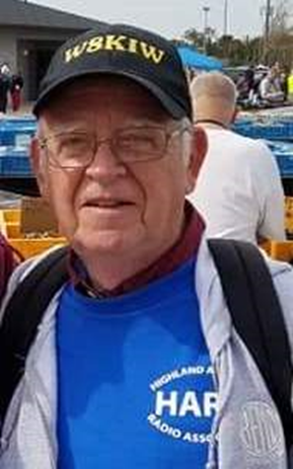***From The South 40***

*(from John Levo,* [*W8KIW@arrl.net*](mailto:W8KIW@arrl.net)*)*

Last week we ended our journey in the Village of Georgetown, the home of the Grant Radio Club. Today we turn on to US 68, head south and cross the Ohio River into historic Maysville, KY. Originally called Limestone, it is often referred to in history books when telling the tales of Daniel Boone, Mike Fink, Simon Kenton and other early pioneers. It’s also the birthplace of former Miss America Heather French and singer Rosemary Clooney. History is nice but we’re here with the purpose to visit the **Greater Mason County ARA.**

I’ve been unable to gather much of the early history of the Club. But what is known is there was a loose knit group of hams meeting prior to 2016 when some newer hams decided to make the club more active and visible. That group started meeting monthly, held frequent test sessions and helped with community events like the annual Two Bridge Walk, bicycle and auto rallies and became active Field Day participants from the local nature reserve. Although not a Club sponsored event, some members recently started a weekly “Lewis and Clark River Trail” net using a neighboring repeater. A February test session had 16 advance registrations. The Club has a lot of promise and even has a member drive from a Northern Kentucky Cincinnati suburb to attend meetings and functions.

So we get ready to take leave of this interesting Ohio neighbor and the **Greater Mason County ARC** to set our sights North to visit our next club. But in the meantime, here are some items of interest as provided by some of our Southern Ohio Region clubs.

Just a reminder that on the second Sunday of each March the annual change to Daylight Savings Time happens when clocks are to be advanced an hour. Although most net times do not change with Daylight Savings Time, the Highland ARA’s Monday evening net does. March co-net control Kathy Levo, N8ZNR, reminds all that starting on March 15 the Net will start at 9 PM on the Hillsboro 147.21 and Greenfield 146.685 repeaters. Kathy also suggests you check your smoke detector batteries.

Word from the Wilmington NWS Office announced the Kentucky EMA has postponed the Statewide Severe Weather Drill scheduled for this past Wednesday because of flooding problems throughout the State. It will be rescheduled. Ohio’s Spring Severe Weather Awareness Week will be March 21 through March 27 according to the Wilmington NWS Office and will include a tornado drill starting at 9:50 am on Wednesday. The NWS offices in Wilmington, Charleston and Pittsburgh remind us that all storm spotter classes are being done virtually this year because of COVID concerns. Check the website of the office serving your county for the dates and times of each remaining training session. The **Tri-State ARA’s** Bud Cyr, KB8KMH, lets us know that for those wanting a bit more advanced training, the Charleston NWS Office will hold two Advanced Training sessions this month. Contact Tony Edwards at the Charleston Office, 304-746-0180, for the dates and times. Around 160 logged into the March 4 Wilmington session. About 53% of those were first time attendees and 30% of those having attended several sessions over the past years. It was announced there will be no advanced training in the Wilmington coverage area this year.

[TOP](#top) ^

Some members of the Southern Ohio Region’s amateur radio community have recently decided to upgrade their licenses. The **Portsmouth RC’s** VE Team Leader Jerry Lockhart, W8HIC, informs us of the upgrade to Extra for Pike County’s Doug Broyles, KE8ORQ at their March 1 test session. Jerry states it took 17 minutes from when Doug completed his test and had it scored until the time the upgrade appeared on the FCC database. Amazing! From Maysville comes word that the recent **Greater Mason County ARC** test session had two people upgrade. According to VE Team Leader Greg Taylor, KY4OD, Daniel Hughes, KO4JXW, is now a General and Charles Hunter, KN4HFS, now holds an Extra ticket. Congrats to all.

The **Clinton County ARA’s** WB8ZZR repeater at New Vienna/Snow Hill has experienced issues and was replaced with a backup repeater this past Tuesday. The 444.575 machine is used by the National Weather Service as the central repeater for the Wilmington Office’s Sky Warn System and provides communications with their four section net control points.

It seemed no more than the ice caused electricity outages had been restored and most highways and roads reopened from downed trees than the area got hit with several inches of rain and the melting snow cover and travel again became difficult. Area repeaters and e-mail postings commonly referred to high water causing road closings throughout the region. Thanks to the **Tri-County ARA**, the **Southern Ohio ARA**, the **Portsmouth RC**, the **DeForest ARC**, the **River Cities ARC** and the **Highland ARA** for keeping their members abreast of travel conditions and road closings. I’m certain there are other clubs in the region that provided the same service to their members.

**Cambridge ARC** Information Officer Lyn Alfman, N8IMW, informs the South 40 that the Club’s newsletter, the CARA Communicator, is converting from a quarterly to a bi-monthly publication. The current 20 page edition is some great reading. Contact www.w8vp.org to find out how you can enjoy this outstanding newsletter.

The **Highland ARA** will conduct a public “Introduction to Amateur Radio” presentation on Sunday afternoon, March 14 at the Highland County EMA Office in Hillsboro. This will be an updated version of a presentation that has been most successful in the past and has led to over 50 new hams in the Highland County area. The program consists of power points and videos. Special presentations will be given by HARA members who will tell of what got them interested in ham radio, what their interests are and what they have gotten from the hobby. A question and answer period is also afforded as well as time for one-on-one discussions. If there is sufficient interest a class leading to a Technician License will start on March 21.

Interest in getting an amateur radio license is growing as indicated by the number of license manuals flying off the shelves at the various ham radio stores. Clubs too are reporting an increase in the number of inquiries about classes and test sessions. Several Southern Ohio area clubs have tests scheduled in the near future. Ones we are aware of are in Athens on March 15; Portsmouth on April 5; Springfield, Huber Heights, Cambridge and Huntington, WV on April 10 and Circleville and Hillsboro on April 17.

The **Hocking Valley ARC** anticipates clear sailing for the first Fox Hunt for 2021 on March 20. Participating stations should register between 9:45 and 10 that morning on the Logan 147.345. The actual hunt starts at 10. The ‘fox’ will be located somewhere within Hocking County and in plain sight along a public street, roadway or highway. Those concerned with COVID can operate as a loner, but it really is more fun to have a second person riding as co-pilot to share the experience with.

[TOP](#top) ^

On April 10 the **Cambridge ARA** will hold a Technician license class in Cambridge. It will start at 9 am and continue until 4 with breaks for lunch and other needs. Preregistrations are requested to either [lynalfman@aol.com](mailto:lynalfman@aol.com) or 740-872-3888. Following the class conclusion, those wishing to test will be given the opportunity at about 4:15. Those with existing licenses will be given the opportunity to try for upgrades at 1:30. Those wishing more information may contact Jim Shaw, AB8P, at 740-432-1077.

The **Highland ARA’s** past president Dave Tourtelot, KD8TUR, has received a major endorsement to his SKCC Rag Chew Award. The award is presented to CW operators who engage in on-theair conversations using conventional keying devices and lasting at least 30 minutes. Once 300 minutes of 30 minute conversations is achieved, the initial award may be applied for. In KD8TUR’s case, he is recognized for over 1800 minutes of ‘gabbing’. Having seen his station, he has to have had a number of sore fingers over the past few years. Quite an achievement!

We’re back on the road again and after viewing the Maysville floodwall murals we cross the Simon Kenton Memorial Bridge and climb from the Ohio River Valley into the rolling hills of Adams County-home of the DeForest ARC.

As previously told, this club traces its beginnings to 1974 when the Adams Brown Amateur Radio Corps was formed with one of their first projects to place a repeater on the air. In 1980 they separated into clubs serving their respective counties with the Adams County group choosing to honor the radio pioneer, DeForest. From its beginnings the Club has had a strong relationship with the local EMA through its participation in flood and other weather related emergencies. This is evidenced by some members sitting on the agency’s board. The Club serves the Wilmington NWS Office and through its 147.00 repeater is a Sky Warn Section Net Control Point for ten counties in the Southern Ohio and Northeastern Kentucky region. The Club was also the home club for Jerry Paquette, WB8IOW, who was the 1998 ARRL Instructor of the Year and an early Club leader until his passing. That concludes this week’s leg of our journey to visit clubs throughout the Southern Ohio Region. Until next time, here’s hoping everyone stays safe and well and has the opportunity to spend some time on the radio.

***Upcoming Training Opportunities***

Need to get those really hard to get NIMS ICS 300 and 400 classes to get to Level 3? They are now being offered with very limited virtual seating. Yes, these classes are being offered virtually now along with a lot of other classes that used to require in-class sessions. Want to see what and where these classes are being offered?

[**>> Click Here <<**](http://arrl-ohio.org/SEC/Ohio_EMA_Training_List_Feb_2021.pdf)

**####**

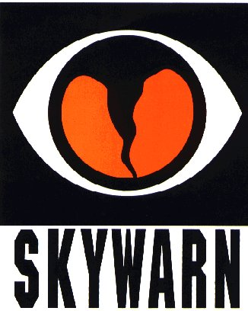***SKYWARN TRAINING***

The National Weather Service will not be able to conduct in person spotter training classes this winter and spring due to restrictions associated with COVID. Therefore, a number of field offices will be hold “virtual” spotter training classes. These classes will be open to the public and free of charge. Please feel free to promote to your staff, spotters, amateur radio operators and to publicize to the citizens in your community.

[TOP](#top) ^

Since the Ohio Section is served by multiple NWS offices, listing all of the training opportunities for each of these offices would take a large amount of space and become very confusing. So, instead of trying to list the training, it would be better for you to choose which office you prefer to acquire your training from by providing you with a link to the offices surrounding Ohio <http://arrl-ohio.org/SEC/skywarn.html>

***Print an Official or Unofficial Copy of Your Amateur Radio License***

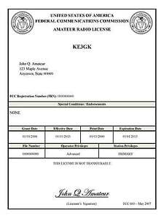*(By Anthony Luscre, K8ZT)*

As of February 17, 2015, the **FCC no longer routinely issues paper license documents** to Amateur Radio applicants and licensees. The Commission has maintained for some time now that the official Amateur Radio license authorization is the electronic record that exists in its Universal Licensing System (ULS). The FCC will continue to provide paper license documents to all licensees who notify the Commission that they prefer to receive one.

Licensees also will be able to print out an official authorization — as well as an unofficial “reference copy” — from the ULS License Manager. I’ve created a set of instructions on how you can request an **“official” printed copy of your license\***

[**Click here to download the instructions**](http://arrl-ohio.org/news/2020/print_your_license.pdf)

***One Question Questionnaire***

Hey Gang,

Survey Says”….. 51% of you are planning on doing Field Day at your homes. This does tell us that we still want to be safe and not gather in large groups yet!!

Ok, now on to the next question… Ok, with the weather starting to get better and better, this means that we’ll all be getting out and enjoying spring more. This also means that we will spend less time studying and taking those valuable classes. So, here’s the next question…

***“Are You Up-To-Date with your First Aid Training??”***

You’ll find the “One Question” questionnaire on the Ohio Section Website! <http://arrlohio.org> It’s all for fun and it’s not a scientific survey in any way, but we are learning some things that we didn’t know from these questions. I hope that you are enjoying answering these “One Question” questionnaires.

[TOP](#top) ^

*****V.E. Test Sessions***

Many V.E.’s have decided to start testing once again, but with restrictions that need to be adhered to for sure. Here’s the link to find that V.E. Test session and what is expected of YOU before going. <http://www.arrl.org/find-an-amateur-radio-license-exam-session>

Ohio Section Cabinet

|  |  |
| --- | --- |
| Section Manager – Tom Sly, WB8LCD | Section Traffic Manager – David Maynard, WA3EZN |
| Section Emergency Coordinator – Stan Broadway, N8BHL | Section Youth Coordinator – Anthony Lascre, K8ZT |
| Technical Coordinator – Jeff Kopcak, K8JTK | Affiliated Clubs Coordinator – Tom Sly, WB8LCD |
| State Government Liaison – Bob Winston, W2THU | Public Information Coordinator – John Ross, KD8IDJ |



Hey Gang,

Have you taken a look at the **Swap & Shop** page on the Ohio Section webpage yet?? Here’s a link that will take you there… <http://arrl-ohio.org/sm/s-s.html>

Do you have equipment that you just don’t need or want anymore? Here’s a great venue to advertise it, and it’s FREE!! Is your club doing a fund raiser to help raise money? After a lot of thought, it was decided that the Swap & Shop webpage could also contain these types of items as well. The same rules will apply as do for the For Sales and Give-A-Ways and will only be posted for a month at a time. Please see the Terms & Conditions on the webpage.

If your club is doing a fund raiser and wants more exposure, please forward the information to me and I’ll advertise it on the Swap & Shop webpage for you.

Now, I still want to remind you that it won’t be listed in this newsletter because it would take up way too much space, so your ad will only appear on the website. It is there for any individual to post equipment Wanted / For Sale or Give-Away as well as for Club Fund Raisers. No licensed vehicles/trailers or business advertising will be posted. Postings are text only (no pictures or graphics) will be posted for a maximum of 1 month from date posting and require a contact phone number or email within the posting. Send your Wanted / For Sale or Give-Away post to:  [swap@arrlohio.org](mailto:swap@arrlohio.org)

***Back Issues of the PostScript and Ohio Section Journal***

Hey, did you know that PostScript and Ohio Section Journal (OSJ) are archived on the website? You can go back and look at any edition simply by clicking:

<http://arrl-ohio.org/news/index.html>

[TOP](#top) ^

***Want to Share your Club Newsletter With Others?***

We have a webpage where you can download and read all of the newsletters that I get from around the state and even other sections!

Here’s the link to the page…. <http://arrl-ohio.org/club_news/index.html>

Please, if you don’t see your club newsletter posted, it’s because I’m not receiving it. Just have your newsletter editor contact me and I’ll get your club’s newsletter listed on the site!!

We all learn and steal (I mean, share) from each other’s work. So, get me your newsletter!!! Send it to: [webmaster@arrl-ohio.org](mailto:webmaster@arrl-ohio.org)

***Chit – Chat, and All That!***

Do you know someone that’s not getting these Newsletters? Please, forward a copy of this Newsletter over to them and have them “[Opt-In](mailto:Opt-In)” to start receiving them. Heck, just have them send an email to: [webmaster@arrl-ohio.org](mailto:webmaster@arrl-ohio.org) and we’ll get them added to the Ohio Section Emailing list.

We now have many thousands of readers receiving these newsletters weekly. Quite impressive, I’d say! I urge all of you to make sure that everyone, regardless of whether they are a League member or not, get signed up to receive these weekly Newsletters.

You can always “Opt-Out” at any time if you feel this is not what you were expecting. It’s fun and very informative. All of your favorite past newsletters are now archived too.

You can go back at any time and read them.

Just go to: <http://arrl-ohio.org/news/>

The pictures on the front page and throughout this newsletter are from various newsletters, Facebook posts and/or were sent directly to me in recent weeks. Take a good look at them, you just might be in one of the pictures! “SMILE… you’re in the Ohio Section News!!”

[TOP](#top) ^

*PostScript is produced as a weekly newsletter. I want to thank everyone that has contributed articles and ideas to make this an even better news source. I sincerely hope that you have enjoyed this edition and will encourage your friends to join with you in receiving the latest news and information about the Ohio Section, and news and events happening around the world!*