[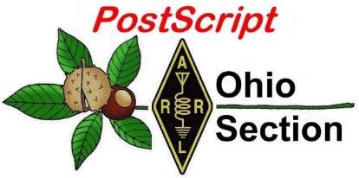](http://arrl-ohio.org/news/) ***“March 1st***

***Edition”***

🡪 National News 🡪 Club Corner

🡪 DX This Week 🡪 Contest Corner

🡪 Special Events 🡪 Upcoming Hamfests

🡪 From The South 40 🡪 Training

🡪 One Question Questionnaire 🡪 VE Testing

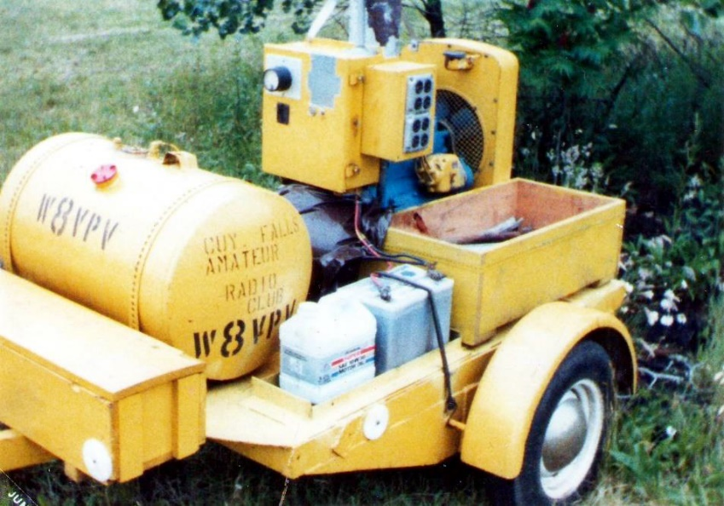

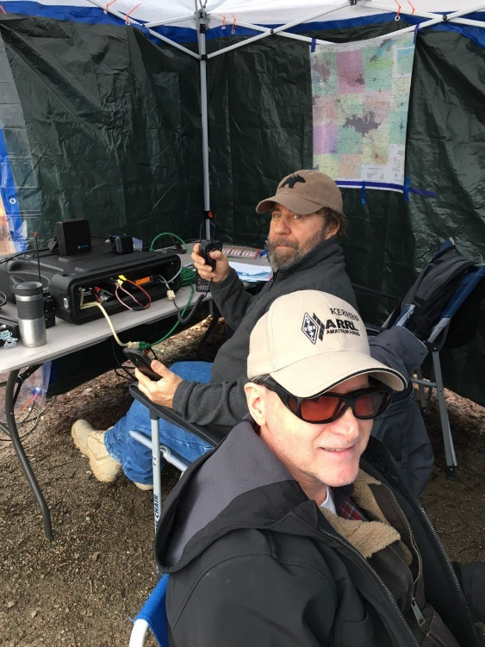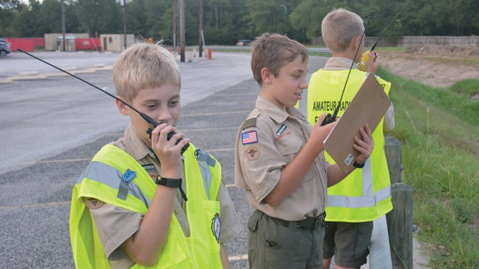

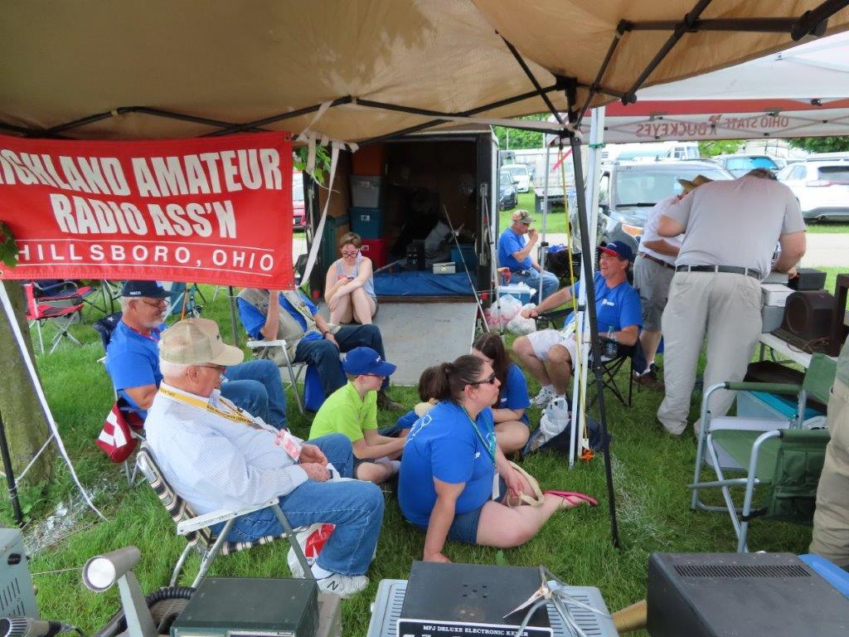

***National News***

*(from arrl and other sources)*

***Ham Radio in Friedrichshafen, Germany, Tentatively on for 2021***

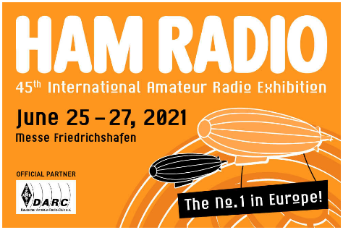[**Ham Radio**](https://www.hamradio-friedrichshafen.com/) in Friedrichshafen, Germany, was canceled last year because of the pandemic. Organizers for Europe’s International Amateur Radio Exhibition this week expressed optimism that the 45th Ham Radio, sponsored by the Deutscher Amateur Radio Club (DARC), will be able to take place June 25 – 27.

“We are watching the situation closely, of course,” a message from Friedrichshafen Fairgrounds CEO Klaus Wellmann said. “At the moment, we are assuming that we will be able to hold Ham Radio in accordance with an extensive, tried-and-proven safety and hygiene concept and are looking forward to seeing everyone again at Europe’s most important trade fair for amateur radio.”

####

***NW8S WPX RTTY 2021 Recap***

***(*** *by*[***Doug Dever***](http://www.nw8s.com/author/ab8m/) *and Black River Radio Ops)*

[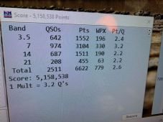](https://i0.wp.com/www.nw8s.com/wp-content/uploads/2021/02/150565101_10224457045076918_6526284314165331713_n.jpg)

Finally!  The WPX RTTY contest we’ve been trying to have!  In [2016](https://3830scores.com/showrumor.php?arg=pTaozEgamyyiL), KB8O, KM8V (then N8USK), and AB8M operated our first multi-op / 2 transmitter [CQ WPX RTTY](https://cqwpxrtty.com/) contest from KB8Os new QTH.  We ended up with a final score of 3.9 million and set the M/2 record for the 8th call area.  Every year after that (as NW8S in [2017](https://3830scores.com/showrumor.php?arg=BDakz4gmgimfO), AB8M in [2018](https://3830scores.com/showrumor.php?arg=EBaNzoiaqviqt), KB8O in [2019](https://3830scores.com/showrumor.php?arg=tNa0z1isafff0), and NW8S in [2020](https://3830scores.com/showrumor.php?arg=85ahzBmiaycid)) we’ve failed to meet the expectation we set with that first score.  In fact, the very next year (2017) we had less than half the score.  Only in 2019 did we come close.  So I’m rather pleased to state that 5 years later we [finally did it](https://3830scores.com/showrumor.php?arg=PnalzEqmfmmvb) – and in band conditions that were not nearly as favorable as in 2016.

**WPX as a Contest**

One of the important things to note about WPX RTTY is the point structure.

| **CQ WPX RTTY Points** | **80 & 40 Meters** | **20 / 15 / 10 Meters** |
| --- | --- | --- |
| Same Country | 2 | 1 |
| Diff Country, Same Continent | 4 | 2 |
| Different Continent | 6 | 3 |

TOP ^

**CQ WPX RTTY Scoring System**

This scoring system, coupled with the fact that this is NOT a DX contest, allows smaller stations to be competitive against even the “big guns.”  A lot of the big contest stations have sunk 6 figures (or more!) into tower systems and stacked/phased beams giving them 5-elements-over-5-elements-over-5-elements on 20 or 15 to Europe.  Yes, that extra gain gives them an advantage on the upper bands when conditions are marginal – but sometimes those same stations stay fixated on those upper bands because they’ve invested so much time and money into the upper band system and just have a couple of wires for the lower bands.

**[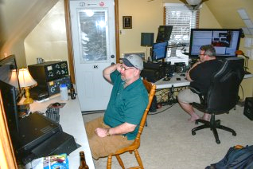](https://i0.wp.com/www.nw8s.com/wp-content/uploads/2021/02/JPP_1912_edited.jpg)**

In WPX you can use that to your advantage and bang out US and Canadian stations on 80 and 40 at a strong rate and with a point advantage that negates their 3 point contacts to Europe.  Looking at the results from the stations who have publicly reported results and their band breakdowns to the [Contest Online Scoreboard](https://contestonlinescore.com/), you can see that the stations with the highest scores took advantage of those low bands.

A side note on scores:  EU stations will, for the most part, have a higher score in this contest than US stations due to the extra points awarded for working a different country on the same continent.  Working between France and Germany is worth 4 points on 40m, but between Ohio and Indiana is only 2 points.  That is why you see breakdowns of scores by regions in results articles.  Likewise, different regions even in the US.

NQ8O and AB8M working WPX RTTY 2021

If you’re new to contesting, you may find some of those scores even in the U.S. as intimidating, but you have to remember that band conditions may be totally different between the West Coast and the East Coast and there will be a natural bias towards better conditions the farther south you are in the U.S.

**Band Conditions**

*“Son, I’m not sure what you just sent me, but you’re going to have to send it louder.” – AB8M*

To quote [WV4P](https://3830scores.com/showrumor.php?arg=LdaDzlqmfagyj), bands were “OK, not good, not bad… just usable.”  I’d echo that sentiment.  There were no mag storms or other badness to make it a painful slog, but there was no sunspot activity to help either.  10 meters was all but non-existent and 15 was slow.  20 meters was wall-to-wall with stations from about sunrise to early afternoon – as one would expect.  40 and 80 is where we spent more time than we’ve traditionally spent in a contest and they were busy.  80 turned out better rates than 40 did after 9pm and as much if not more DX.

| **CQ WPX RTTY QSO Count 2016 vs 2021** | **2016** | **2021** |
| --- | --- | --- |
| 80 Meters | 337 | 642 |
| 40 Meters | 518 | 974 |
| 20 Meters | 545 | 687 |
| 15 Meters | 539 | 208 |
| 10 Meters | 292 | 0 |

TOP ^

The short days this time of year lead to what I call the “after lunch nap.”  After about noon, as [greyline](https://dx.qsl.net/propagation/greyline.html) moved out of Europe into the Atlantic Ocean, the rate on 20 really dropped off.  “The early bird gets the worm” as the best time for Eastern Europe stations on 20 is right after the band opens.

Without any sunspot enhancement, a lot of the stations on 20 and 15 were just at or above the noise floor requiring a lot of back and forth to get them in the logbook.  The QSB on Saturday was more pronounced than normal – especially on 15.  A number of stations simply “disappeared” in the middle of an exchange only to come back 20-30 seconds later.

Overall everyone seemed patient – even the EU stations which tend to send you their exchange one time only were indulging us with their macros sending a serial number 2 or 3 times.  That had to be difficult for them to admit to do.

**Station Setup**

*“Yes, I know what my call is!  I know what your call is!  Why can’t this guy just send his number 4 times in a row instead of my callsign?” – AB8M*

[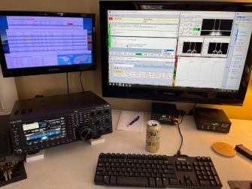](https://i2.wp.com/www.nw8s.com/wp-content/uploads/2021/02/IMG-1604-1-scaled.jpg)

Station 2 on 20 Meters

This might be the 2nd RTTY contest in a row where we ran high power, had a good score, and didn’t blow up equipment along the way.  At the risk of jinxing ourselves, I hope this is the start of a trend!  We fielded a team of 4 (KB8O, AB8M, NQ8O, KM8V) with the goal of keeping both stations on the air as much as possible.

**Friday:**  We avoided 20 meters at the start of the net (in the past we’ve tried to pick up some in the first 1-2 hours) and jumped into 80 and 40 with both feet and shut down at 2am.

**Saturday:** We kicked off again at 7am on 40 and 20.  Station 2 stayed on 20 for the majority of the day while Station 1 bounced between 40m and 15m – depending on condition on 15.  By evening we were back on 80 and 40.  We shut down at 3am.

**Sunday:** Again, we kicked off at 7am on 40 and 20 and had pretty much a rinse and repeat of Saturday until the contest ended at 7pm.

**Station 1:** Kenwood TS-890, Acom 2100, AT5K Tuner, FilterMax 4, 160m doublet (used on 40 meters).

**Station 2:** Kenwood TS-890, OM Power 2000+, FilterMax 4, 80m doublet (used on 80 meters).

**Shared equipment:** High power transmit band pass filters from Low Band Systems for each band.  Low Band Systems triplexer for 20/15/10. Optibeam OP9-5 at 45ft.

TOP ^

**NW8S 2021 CQ WPX RTTY Results**

*“Hey Dougie, you feel like making some contacts on 20 meters over there today?” – KB8O*

| **Band** | **QSOs** | **Points** | **WPX** |
| --- | --- | --- | --- |
| 80 | 642 | 1552 | 196 |
| 40 | 974 | 3104 | 330 |
| 20 | 687 | 1511 | 190 |
| 15 | 208 | 455 | 63 |
| **Total Score:**[**5,158,538**](https://3830scores.com/showrumor.php?arg=PnalzEqmfmmvb) | **2511** | **6622** | **779** |

If the logs hold up as they appear so far, this will be a new M/2 record for the 8th call area and a new WPX record across all categories for the 8th call area.

[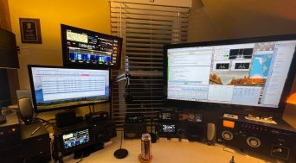](https://i0.wp.com/www.nw8s.com/wp-content/uploads/2021/02/IMG-1613-scaled-e1613534799598.jpg)Station 1 – 40 Meters

All-in-all we had a really good time, a lot of laughs, and probably too many 807s as the days went on.  One of the nice things about RTTY contests is they tend to be more social than CW or Phone, letting you give the other operator some good natured grief or listening to their outbursts while trying to pull a good contact out of the noise.  It was nice to get together after a year where the last time we probably all met up last was for [Field Day](http://www.nw8s.com/news/field-day-2020/).

Thanks to everyone we got in the log book.  Looking forward to doing it again next year!

On behalf of Jay (KB8O), Tom (NQ8O), and Jon (KM8V),

73 de AB8M

####

***ARRL CEO David Minster, NA2AA, to Keynote QSO Today Virtual Ham Expo***

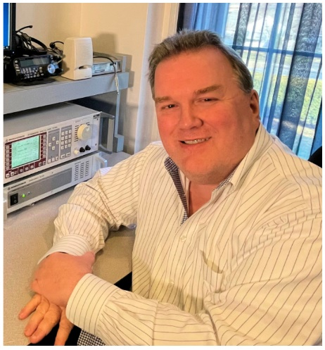

ARRL CEO David Minster, NA2AA, will keynote the [**QSO Today Virtual Ham Expo**](https://www.qsotodayhamexpo.com/) March 13 – 14 weekend. Minster’s talk — part of an **80+ speaker lineup** — will begin at 2000 UTC (3 PM EST) on March 13. His appearance will highlight ARRL’s featured role at the Expo, which also will include “Ask The ARRL Lab.” ARRL is a QSO Today Virtual Ham Expo Partner.

Minster, who assumed the ARRL Headquarters leadership position last September, has launched major projects and assembled teams to foster innovation and individual skill development in radio technology and communications.

TOP ^

In his keynote, Minster will share his enthusiasm for advancing amateur radio and highlight current ARRL initiatives to engage and inspire the current generation of hams. His presentation topics will include:

* ARRL’s digital transformation, which promises to bring new value to ARRL members. An all-in digital approach will improve the way members access and engage with content, programs, and systems.
* The ARRL Learning Center, a hub for members to discover the many facets of amateur radio and develop practical knowledge and skills.
* Increasing video content, opening opportunities for amateur radio content creators and member-volunteers to learn, stay informed, and keep connected.
* Improving training and tools to engage radio clubs, emergency communication volunteers, and students.

The ARRL Expo booth will feature “Ask the ARRL Lab,” where Lab staffers will answer questions live. Attendees can come into the booth lounge (featuring the Expo’s latest virtual meet-up and video technology), sit down at a virtual table, and ask ARRL Lab technical wizards for tips about projects or suggestions to address various station installations and problems. Attendees can also learn about Product Review equipment testing by the Lab, see a presentation on how the Lab can help hams with RFI problems, and tour W1AW — the Hiram Percy Maxim Memorial Station — virtually. ARRL booth staff will also point attendees to helpful resources from across membership benefits, services, and programs.

Representing the ARRL Lab will be Lab Manager Ed Hare, W1RFI; Test Engineer Bob Allison, WB1GCM; Senior Laboratory Engineer Zack Lau, W1VT; RFI Engineer Paul Cianciolo, W1VLF, and W1AW Station Manager Joe Carcia, NJ1Q. Between all of them, they have over 100 years of experience at ARRL Headquarters,

QSO Today Virtual Ham Expo Chairman Eric Guth, 4Z1UG, also announced four live group kit-building workshops. Workshop instructors will guide participants through building a variety of kits, which will be available for purchase and delivered prior to the Expo so attendees can build them at home. Attendees unable to participate during the live sessions can order and build kits by watching the workshop videos during the on-demand period that follows the Expo through April 12.

Workshop kits prices range from $15 to $30. Early-bird discount tickets and links to purchase kits can be found at the [**QSO Today Expo website**](https://www.qsotodayhamexpo.com/build-a-thons.html). These workshops will include:

* Building the NS-40 QRP Transmitter, a 14-component, 5 W transmitter for 7.030 MHz (with instructors David Cripe, NM0S, and Virginia Smith, NV5F).
* The Learn-to-Solder Workshop will introduce the basic tools and techniques of building electronic kits. Participants will build a 20-meter transmitter kit (with instructors Rex Harper, W1REX, and Stephen Houser, N1SH).
* Building the Cric-Key, a simple CW keyer with paddle, suitable for home and field use (with instructor Joe Eisenberg, K0NEB).
* The Mini-Sudden Receiver, a pocket-and-mint-tin friendly direct-conversion 20-meter receiver (with instructors Rex Harper, W1REX, and Stephen Houser, N1SH).

TOP ^

***Club Corner***

This is YOUR cornner of the newsletter. Send me what your club is doing and I’ll make sure that it gets in. Got a special event or club project that you want everyone to know about? Send it to me!. Need help with a project? Send it to me.

Let me know what you club is up to. Are you going to have a special guest at your meeting or are you having a special anniversary?

Just sent it to: [webmaster@arrl-ohio.org](mailto:webmaster@arrl-ohio.org)

####

*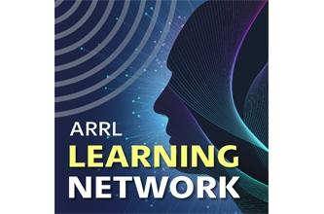****Talking to Astronauts: An Elementary School’s Exciting ARISS Contact*** *(Presented by Diane Warner, KE8HLD)*

This is a story about Tallmadge Elementary School's participation in a once-in-a-lifetime ARISS (Amateur Radio on the International Space Station) school contact. You'll learn about their amazing journey leading up to the amateur radio contact with an astronaut on the International Space Station.

The excitement of the entire experience was shared not just by the students, but included faculty, parents, community, and local amateur radio operators. You will also learn how to begin the process of submitting your own ARISS contact proposal.

**Tuesday, March 2, 2021 @ 1 pm EST (1800 UTC)**

Want to see some of the pictures and video of the contact made by Diane and their club. Here’s a link:

[ARISS - October 31 2018 (arrl-ohio.org)](http://arrl-ohio.org/ariss/ariss.html)

****

***HamSCI Workshop 2021: Midlatitude Science***

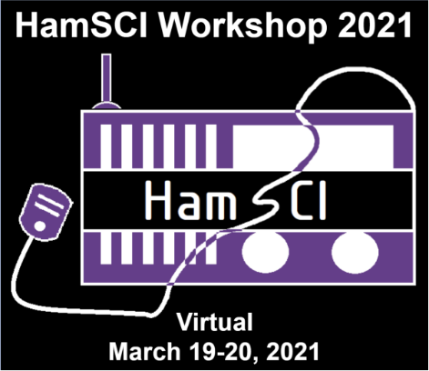[**March 19-20, 2021  
A Virtual Workshop Hosted by The University of Scranton**](http://scranton.edu/)

Come join HamSCI at its fourth annual workshop! Due to restrictions caused by COVID-19, this year's workshop will he held as a **free virtual workshop.**

The meeting will take place March 19-20, 2021 using Zoom hosted by The University of Scranton in Scranton, PA  and sponsored by the National Science Foundation. The primary objective of the HamSCI workshop is to bring together the amateur radio community and professional scientists.

TOP ^

The theme of the 2021 HamSCI Workshop is midlatitude ionospheric science. Invited speakers include Dr. J. Michael Ruohoniemi, Virginia Tech Professor and Principal Investigator of the Virginia Tech SuperDARN Initiative, and Joe Dzekevich K1YOW, an amateur radio citizen scientist who recently published his work in CQ Magazine. Dr. Elizabeth Bruton of the Science Museum of London will be the Keynote Speaker.

This workshop will also serve as a team meeting for the [**HamSCI Personal Space Weather Station**](https://hamsci.org/psws) project, an NSF-funded project to develop a citizen science instrument for studying space weather from your backyard. The PSWS is led by the University of Scranton, and includes participation from TAPR, Case Western Reserve University/W8EDU, the University of Alabama, the New Jersey Institute of Technology CSTR, MIT Haystack Observatory, Dartmouth College, and the amateur radio community at large.

####

***Opportunity To Learn About Ham Radio***

*(from Robb, KE8PYG and the Highland Amateur Radio Association)*

As most of you know, late last year I decided to get my license in ham radio. In hindsight, it was a great decision and the only thing I regret is having not done it sooner.

Soon after getting my license, I started looking for a local club that I could become involved in. I quickly found out that the best way to do this was to listen on the radio and find out which clubs were the most active. It didn’t take long to figure out that the Highland Amateur Radio Association, (HARA) was a seious presence in amateur radio. Amateur radio is somewhat of a mystery to the general public, and most people don’t really even know what it means.

The way I became interested was a complete accident. I frequently go on trips to remote locations where cell service is nonexistent. I was looking into getting what is known as an EPIRB, for emergencies. An EPIRB (Emergency Position Indicating Radio Beacon), is a device that when an emergency occurs, you literally push a button and it calls for help. The only problem with these things is that there is a serious monthly charge for this kind of service. So while I was researching, I kept telling myself that there had to be another way to get a signal out if I ever got into trouble. I was right. There was another way.

There exists in ham radio, a protocol called automatic packet reporting system or APRS. With aprs, you can take a radio and program it to send position reports, and any station in the area that is set up to receive these signals will put your position on a map that is accessible to the general public. That’s just the tip of the iceberg of what aprs can do. APRS can also be set up to send messages. You can even send a text message to a phone or to someones email.

So I had found my alternaitive to a monthly charge for an EPIRB. The only catch was that you had to have a Technician class ham operators license. How big of a hurdle would that be? It turns out that it was a very small hurdle to overcome. So next I started researching what it would take for me to get my ham radio license. Here are the steps:

1. Study for the element - 2 -- Ham Radio Operators test.  
   You’ll need to pass a 35 question exam which isn’t hard at all. If I can do it, anyone can. You only need to get a 74% or higher to pass. Taking a class would be a big plus for this. There are about a million resources online to help you study.

TOP ^

1. Schedule a test. You can find local radio clubs at the ARRL.org website where there is a way to search for exam sessions near you. Pass the test and you’re in!!

**The Highland Amateur Radio Association is holding a introduction to ham radio on March 14 at the Highland County EMA/EOC in Hillsboro at 2 pm.**

This is a fantastic way to find out all about amateur radio and ask any questions you may have. In addition to this introduction, if there is enough interest shown at this “introduction”, HARA will also be holding classes to help you get your technician license. The classes will tentatively start March 21 - April 11 at either 1:30 pm or 2:00 pm, and be held every Sunday.

**HARA is also holding a free license exam session Saturday morning, April 17, at the Highland County EOC.**

If you’ve decided to get your license, this is a fantastic opportunity. I was pretty much alone when I prepared for my exams, but with this opportunity, there will be plenty of help and guidance.

####

***Greetings, Great Lakes Section Managers***

I'm contacting you to invite folks from your Sections to consider joining Comm Academy 2021, a free online training and workshop event taking place on April 10 and 11. Comm Academy is for anyone with an interest in emergency communications techniques and technologies. Most folks who attend are part of an ARES, RACES, ACS, or similar organization, but it's entirely open to anyone interested in the subjects.

You can see the schedule of presentations at <https://www.commacademy.org/schedule>

And registration is at <https://www.commacademy.org/register>

Please feel free to distribute this info to your membership as you see fit!

73, **Tim Helming, WT1IM -** Vice President, Puget Sound Repeater Group PIO, Comm Academy PIO

####

***W8UA’s Antenna Journey***

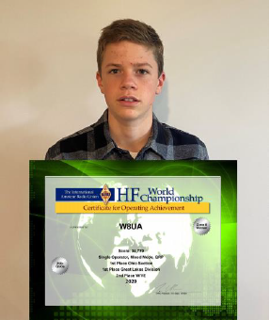*(By Javan Miller W8UA)*

W8UA and his most recent award: Single Operator, Mixed Mode, QRP: 1st Place Ohio Section; 1st Place Great Lakes Division; 2nd Place W/VE

After spending my first several months as a ham just lurking around 2m and 70cm, I participated in my local club’s Field Day event and decided it was time to move beyond only nets and such like and join the ranks of those on HF.

TOP ^

Following having numerous discussions with my friends about different radios, browsing through DX Engineering’s web catalog, and having nightly discussions with my Dad, we finally made the anticipated trip to the DX Engineering showroom and brought back an SDR desktop transceiver. Okay, we got the easy part over with (for me at least), purchasing a rig, but I could tune across the entire RF spectrum, and only receive two birdies. Oh, yeah, I may need an antenna as well!

Unfortunately for farmers of this breed, my parents’ medium sized lot has a total of five trees over the 20 feet mark but are about 400 feet away from the QTH. These are good for a different project, but I do not need a beverage antenna yet. At this point, it sounds like my best option is a tower, but no, due to the unsightliness, that is not an option either. So, welcome to my attic, which is the home of all antennas at this QTH.

**Choosing an antenna**

After my Dad and I researched different multiband antennas, we decided on a fan dipole. Since we had no experience with building antennas, a member of my local club suggested that although many are successful with fan dipoles, they can be a bit tricky to tune if they are confined in a small area. So, we decided on a 40m off-center-fed or simply OCF dipole. My Dad started to model different OCF’s with MMANA-GAL Basic, which is a very easy to use, free antenna modeling program.

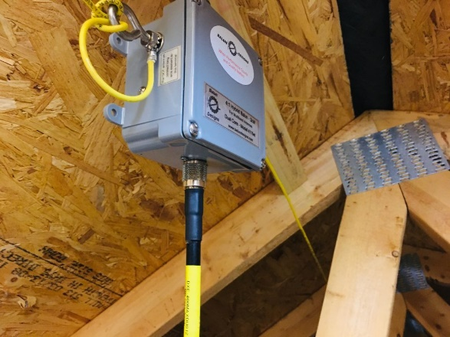Since we found out right away that the common 1/3 – 2/3 ratio used for OCF’s excluded the use of 15m unless a wide-range tuner is used, we discovered the 1/6 – 5/6 ratio which covers 40m, 20m, 15m, 10m, and 6m.

**Building and installing the antenna**

The local ham that recommended the OCF to us suggested that we follow his design and use the Balun Designs 4:1 current balun. Although the manufacturer reveals what is in the magic box to us: “this balun is a hybrid combination of a 4:1 voltage balun and a 1:1 current balun,” we went ahead and purchased it. After ordering a spool of wire, we decided that it was finally time to install our first HF antenna!

Balun Designs - current balun

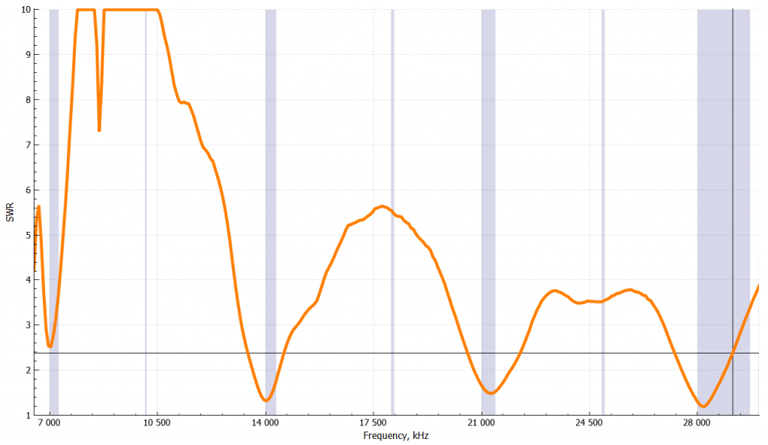

Unfortunately, we did not adhere to the adage of putting up antennas in the cold, and we picked a nice warm weekend in summer (the weekend of IARU HF World Championship) to do the install. After placing ½ inch PVC pipe between the rafters to support the wire, we strung the wire through holes we had drilled through the PVC tubing.

Measured 40-meter OCF SWR

TOP ^

I think we may have taken excessive measures to prevent sag and insulate the wire from the wood rafters, but we were just getting in the game of antenna building and had no experience with what was necessary.

I have found modeling to be quite beneficial for multiband antennas such as my OCF, as it can be useful to know at which angles I have gain, and at which I have nulls. Luckily, on 20m, I have quite a bit of gain to Europe, although there is little power heading south toward South America. [See picture for 20m pattern.] There are quite a few nulls on the higher frequency bands, but I have not found that to be too much of a problem so far. But of course, “if ya’ don’t hear ‘em, ya’ don’t work ‘em,” so I do not know what I am missing out on in the nulls. The OCF works well all the way up to 6m, and I have confirmed 42 states and several countries with FT8 on VHF.

**Designing and installing other antennas**

After I got a small amount of experience with contesting, I quickly found a desire for a beam for at least one HF band. I wanted to either select 20m towards Europe or 15m towards the South, but due to the orientation of my house, I decided to build a 15m beam.

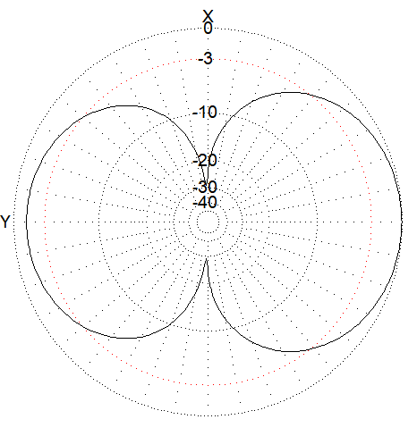After some antenna modeling, I found that a Moxon beam would be the best way to go for my situation due to the wide beamwidth and high front-to-back ratio they have, as well as taking up less space in my attic than would a traditional two-element Yagi. Significant gain over the OCF towards certain countries is quite evident.

Since the OCF only operates 40-6 meters, I quickly found a need for an 80m antenna. For several contest weekends in the summer, I put up an 80M dipole outside supported by a short mast constructed of PVC tubing, but that could not stay up long for structural and aesthetic reasons.  Okay, back to the drawing board with my modeling software. After learning about putting inductors in an antenna design, I started playing around with loaded 80m dipoles with the inductors in the middle of each leg, which proved to be a reasonable compromise between inductor size and placement efficiency.

20-Meter radiation pattern

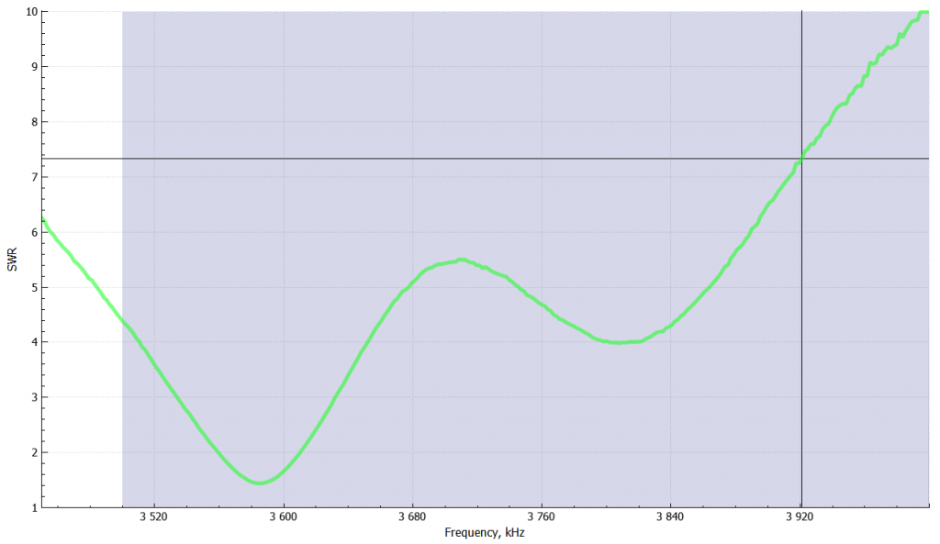Measured 80m dipole SWR

Utilizing the air-core inductor formula,  where L = inductance, d = coil diameter, *l* = coil length in inches, and n = number of turns; I wound two 50 µH coils and put them in the middle of each thirty-foot leg of the antenna.

Measured 80-meter dipole SWR

TOP ^

**What’s next?**

I am planning on installing a 130-foot-tall self-supporting tower next summer – umm, no. Let’s try it again. I am planning on installing several more antennas in my attic. As many others did, I enjoyed reading the article in QST written by N1LF on his attic VHF antenna system. I am planning on installing horizontal antennas for 2m and 70cm so I can explore the world of VHF beyond repeaters. Since my attic filled with rafters is not conducive to a rotatable beam, I am planning on making a stack of 2m dipoles for gain in the elevation pattern. I also want to get a permanent antenna up for 160m, but that will be a later project.

**How do they work?**

I guess this is the place where we are supposed to talk about how our antennas work. Overall, I have been very impressed with the results of my attic antenna farm. Clearly, my antennas do not compare favorably to the average participant of the “triband-wires” overlay, but I have finished second place in the QRP category for NAQP SSB and RTTY, as well as setting a record in the 8th call area for Rookies in the CQ WPX CW contest. My record for CWT has been 91 Q’s, although I am hoping next summer to be able to operate every CWT and reach 100 Q’s with more practice contesting, and of course, more antenna optimization.

***DX This Week***

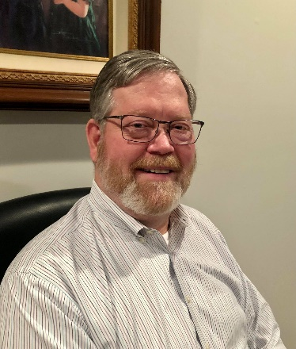

***DX This Week – Apps and Sites – Part 2***

***Bill AJ8B (aj8b@arrl.net, @AJ8B, or www.aj8b.com)***

***CWOPs Member #1567***

The Midwest DX Cluster spots included Alaska, Argentina, Aruba, Australia, Barbados, Belarus, Belgium, Belize, Bonaire, Brazil, Bulgaria, Canada, Canary Islands, Cape Verde, Cayman Islands, Chile, Colombia, Costa Rica, Croatia, Cuba, Curacao, Czech Republic, Dominican Republic, England, European Russia, Fed. Rep. of Germany, Finland, France, French Guiana, Guadeloupe, Guatemala, Haiti, Hawaii, Hungary, Italy, Kenya, Latvia, Madeira Islands, Mariana Islands, Martinique, Mexico, New Zealand, Oman, Panama, Peru, Poland, Portugal, Puerto Rico, Scotland, Serbia, Sicily, Slovak Republic, Slovenia, South Africa, Spain, St. Lucia, Sweden, Togo, Trinidad & Tobago, Turks & Caicos Islands, Uruguay, US Virgin Islands, Venezuela, Western Sahara. This brings the total number of entities spotted in the Midwest in 2021to 142!

|  |
| --- |
|  |

***DAH DIT DIT DIT DAH DAH DIT DIT DIT DAH***

I received cards from EW5Z – Serge in Belarus (My card was mailed to Serge on 7/18 of 2018!), UN7TB – Valentin in Kazakhstan and SM5EDX – John from Sweden confirming a 160M CW QSO! Let me know what you received.

TOP ^

|  |  |
| --- | --- |
|  |  |
|  | |

***DAH DIT DIT DIT DAH DAH DIT DIT DIT DAH***

I have six sources of information for DX that I use in varying degrees; Blogs, Podcasts, YouTube, Websites, Phone Apps, and books. Websites, Phone Apps, and Books will be reviewed in a future edition. We can focus on the other three.

This week, I wanted to mention Websites, Phone Apps, and books.

Websites **–** I know there are countless websites for all topics ham radio related. However, one of the challenges is to sort through all the data and find those sites that constantly deliver information. I have a couple that I always have open:

|  |  |
| --- | --- |
| Site | Comment |
| <https://www.qrz.com/> | Log search and Call Lookup |
| <https://www.Dxheat.com> | DX Spots & Call sign lookup |
| <https://cwops.org/> | Home for the CWOPs organization |
| <http://dxsummit.fi/#/> | Great site for researching spots on a global basis |
| <https://dx-world.net/> | Information on DXPeditions |
| <https://dxnews.com/articles/> | Information on DXPeditions |

TOP ^

|  |  |
| --- | --- |
| <http://www.dailydx.com/> | Home of the Daily DX – QSL Routes, managers and other information |
| <https://lotw.arrl.org/lotw/login> | ARRL LoTW |
| <http://www.dxmarathon.com/> | Home of the CQ DX Marathon |
| <https://www.contestcalendar.com/> | Most Comprehensive Contest Calendar |
| <https://www.3830scores.com/index.php> | 3830 Scores Summary Page – Preliminary Results for ALL contests |
| <http://arrl-greatlakes.org/8th_bureau.htm> | 8th Call Area QSL Buro |
| <http://www.arrl-ohio.org/> | Our OH Section Home! |
| <http://www.dxuniversity.com/> | DX University Home – Great articles & Info |
| [https://www.contestuniversity.com](https://www.contestuniversity.com/) | Contest University – Great Articles & Info |

Phone Apps – Although there are hundreds of phones apps that pertain to Ham radio, I have only utilized a few. I have listed those below. Let me know which ones I missed.

|  |  |
| --- | --- |
| App | Comment |
| Compass 360 Pro | Very useful for headings and direction |
| NKCCluster | On the phone DX Cluster – Watch the data charges! |
| QRZ Assistant | Useful for looking up callsigns |
| DX Pocket | DX Cluster monitor with a few more options |
| HamClock | Easy to use worldwide clock |
| Voice Recorder | I use this when operating Mobile as my logbook. |
| Music Player | I listen to CW Audio files to keep my speed up! |
| NCDXF Beacon | This is great to show what beacons are transmitting. You can then listen to quickly determine what band(s) are open. |
| Grid Square Locator | This is a great tool if you are travelling and operating. |

Books – I have a few books that I keep around as a reference or an inspiration. Please pass your list back to me!

|  |  |
| --- | --- |
| Title | Comment |
| ARRL: Propagation & Radio Science | Excellent coverage of electromagnetic waves |
| ARRL : Antenna Physics : An Introduction | Takes me back to my high school and college classes – I use this often |
| Low Band DXing – ON4UN | Widely considered the bible on Low band antennas and DXing |

TOP ^

|  |  |
| --- | --- |
| The Complete DXer – W9KNI | Excellent overall review of techniques and terms |
| A Year of DX – W9KNI | Review of Bob’s year attempting to win the CQ DX Marathon. I read this every other year for inspiration |
| AC6V’s Amateur Radio & DX Reference Guide | This complete book covers every aspect of ham radio pertaining to DX |
| DXA – The Real Time online radio log server – KK6EK | Bob goes in to great details the other side of the pileup and his creation of the DXA software. Great and informative read. |

***CQDX CQDX CQDX CQDX CQDX CQDX CQDX CQDX CQDX***

Here is an update from Bernie, W3UR, of the DailyDX and the WeeklyDX, the best source for DX information. <http://www>.dailydx.com/. Bernie has this to report:

**VK9/W – Willis Island** - The dates are now locked in, November 3-13, with the MV Alfred Wallace departing Cairns, Australia for the voyage.  The five ops currently signed on are VK2IR, VK3YP, VK2RF, VK2OK, VK2PN with others to be announced.  With time away from jobs a consideration for the ops, Mellish is being put off to 2022.  They are working with the license regulator, the Australian Maritime College, for the 2X1 VK9W callsign.  If they can’t get that, they plan to use VK9HR again.  The antennas are a full set of 20-10M VDAs, fullsize 30M vertical and fullsize 40M vertical and 160/80 inverted L.

**YU – Serbia -** For the 70th anniversary of the continuous use of callsign YU1ANO, the Serbian comm authorities have authorized callsign [YU51ANO](http://r20.rs6.net/tn.jsp?f=0010-h_-C8_OrAXQsNw5eqWsb0aKxWtGaqRg2X7ow8dK1KWHhunmrmJrB1WUGfwaeONmVJQUgzH6v-gVFXTVxt2UJeQt175c7MNB6xtUZJ80wSY6DtOxmChFwWr8WBadkOuxhOFoQDayacmeaR4SG9my0d_GbYyHppS&c=PJVxLTyicEAeUJg5yhY5dO9o4IlluA1ueKVVA2ftWINc6Ugk1-QOww==&ch=AR7j-rSfdff_CEg_ysF_PC8EEJ2BEC_TEE0Vc2DjTHe6LJcADmuQ_Q==) for the club to use starting today, February 15, going to June 15.  This is the “Belgrade Amateur Radio Club.”

**VK9CE – Cocos (Keeling) DXpedition March 16-23, 2021**

**(the following was posted on QRZ.com VK9CE listing)**

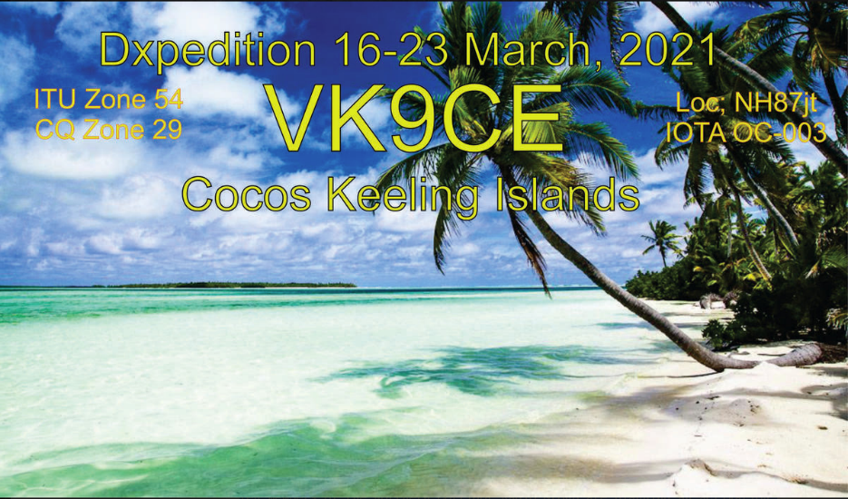Ten members of the Northern Corridor Radio Group are planning an activation of Cocos Keeling Islands - VK9C between March 16th and 23rd 2021. The operation is vacation style although having said that, with 10 of us on the team, we expect to be quite active, but possibly not 24/7. We also hope to have involvement of the sole resident amateur on Cocos and we would like also to get him set up on HF while we are there.

The callsign VK9CE has been issued for the DXpedition.

TOP ^

Flights and Accommodation are now booked, flights paid for and equipment largely assembled. Providing we have no more COVID scares between now and March 16th, the trip is now set in stone.

We plan to be active on 80 through to 10m (possibly 6 as well), with two radios operating on FT8, CW and SSB.

Antennas will be modest. We will have a Cushcraft vertical for 80-10m (including WARC bands), an Ultrabeam UB-V40 vertical for 40-10m and wire antennas for 40m and 80m. Radios will be a Flex 6700 and an Icom 7300; both with amplifiers up to 400W (the legal limit for VK).

Participants will be Steve VK6SJ, Wayne VK6EH, Stu VK6SSB, Gerald VK6XI, Chris VK6LOL, Brian VK6BMA, Tim VK6EI, Alex VK6KCC, John VK6NU and Brian VK6MIT.

We will not be doing paper QSLs. We have also agreed with the WIA QSL bureau that they will not be processing cards for this activation so any cards sent by this means will not make it to us, and will be a waste of your and our QSL bureau resources. Any direct QSL requests sent to us will also be ignored, and any money sent with cards donated to another DXpedition of our choice. We will be uploading to eQSL, Club Log and QRZ in real time, and daily to LoTW. No charge for this. The activation is funded by the members on the trip and we are just out to have some fun and create some noise on the bands.

**CQ Zone 23 -** By W3ICM, Fred Matos

Zone 23 consists of Mongolia, and parts of China and Russia.

The Russian part consists of Kyzyl, the capital city of the [Tuva Republic](http://r20.rs6.net/tn.jsp?f=0018XCTEHwHFt28PNqql0UCxDm6LFu4XLu9S1XcM0b7iR6oRtUspACIsxshYTeCdHGyPdn5tK3Grdl-_yR7p_do7PTceD_ulb0HaJoipyVpdZT9XILZmdQx3OEElR7elD1lECvdZTOMF08_ubDNFPRusscqhUP_a9bGWUwCCRZpRQY=&c=KOkF5zDA_S9lDerVVuED1Uw5m8-7RJtXutGrn1_mmhc6-WBdnkT4yg==&ch=Fd3U-v_tAckTvMjZOW-cw9HkHgTD5fzD-vu-izjt05PfkvJYbVY_2g==) and parts of the Tuva Republic. Russian hams in the area have a “Y” as the first letter in their suffix, as in UA0YAA.

The Tuvan Republic lies at the geographical center of Asia, in southern Siberia. The republic borders the Altai Republic, the Republic of Khakassia, Krasnoyarsk Krai, Irkutsk Oblast, and the Republic of Buryatia in Russia and Mongolia to the south. In the 2010 Russian census, the territory claimed a population of 307,930. Pavel, R9OK, currently in Novosibirsk, and formerly in the Tuva Republic with the call UA0YAY, reports that there are only two active stations in Tuva: UA0YAL and UA0YDB

After seeing W3ICM’s, Fred’s, nice write up on CQ Zone 23 K3RA, Rol, suggests “we add information on the Chinese part” of that rare CQ Zone. “I was amazed to see, looking at the map, that Zone 23 is bigger in area than Zone 24, or Zone 17, 18, or 19”, says Rol. The BY prefix (below) can be substituted with any of the other Chinese prefixes (i.e. BA, BB, BC, etc.).

Chinese prefixes in CQ Zone 23 are:

BY3G-L Nel Menggu (Inner Mongolia)

BY9G-L Gansa

BY9M-R Ningxia

BY9S-Z Qinghia

BY0A-F Zinjang (This is where the Uyghur predominately live

BY0G-Z Xizang (Tibet)

***DAH DIT DIT DIT DAH DAH DIT DIT DIT DAH***

TOP ^

**QSO Today Virtual Ham Expo –** Tickets are now available to attend the QSO Today Virtual Ham Expo sponsored by the QSO Today Podcast, FlexRadio, Icon and Elecraft. Information can be found at <https://www.qsotodayhamexpo.com/> There are several hams from our area who will be speaking, and you can watch the presentations live, ask questions of the presenters, and well as visit the booths of many vendors. The dates are March 13th and 14th. Also, you will be able to access many of the presentations until April 12th.

Several contributors to the Ohio Section Journal will be giving presentations at this event. Check it out and let me know what you think!

***DAH DIT DIT DIT DAH DAH DIT DIT DIT DAH***



Below is a list of upcoming contests in the “Contest Corner”. I think this is important for someone who is trying to move up the DXCC ladder since entities that are on the rarer side and easiest to work in contests. Some of my best “catches” have been on the Sunday afternoon of a contest when the rarer entities are begging for QSOs. Of course, the gamble is that if you wait until Sunday, conditions may change, or they simply won’t be workable. However, it is not a bad gamble. Of course, why not work the contest and have some fun!

Check out the WA7BNM Contest Calendar page (<https://www.contestcalendar.com/>) for more contests or more details.

The contests in red are those that I plan to spend some significant participation time on. PLEASE let me know if you are working contests and how you fared.

Thanks!

|  |  |  |
| --- | --- | --- |
| Mar. 1 | RSGB 80m Club Championship, Data | <http://bit.ly/3avHbk3> |
| Mar. 2 | AGCW YL-CW QSO Party | <http://bit.ly/3plBhpN> |
| Mar. 3 | UKEICC 80m Contests SSB | https://bit.ly/2SDPqQQ |
| Mar. 6-14 | Novice Rig Round-Up | [www.novicerigroundup.org](http://www.novicerigroundup.org/) |
| **Mar. 6-7** | **ARRL SSB DX Contest** | [**www.arrl.org/arrl-dx**](http://www.arrl.org/arrl-dx) |
| Mar. 6-7 | Open Ukraine RTTY Championship | <http://krs.ho.ua/openrtty> |
| Mar. 7 | SARL YL Sprint | <http://bit.ly/H0IqQf> |
| Mar. 7 | UBA Spring Contest 80m CW | <http://bit.ly/2KKAtb9> |
| Mar. 10 | RSGB 80m Club Championship, CW | <http://bit.ly/3avHbk3> |
| Mar. 13 | AGCW QRP Contest | <http://bit.ly/2KKp3rY> |

TOP ^

|  |  |  |
| --- | --- | --- |
| Mar. 13 | YB DX RTTY Contest | https://rtty.ybdxcontest.com |
| Mar. 13-14 | Idaho QSO Party | [www.pocatelloarc.org/idahoqsoparty](http://www.pocatelloarc.org/idahoqsoparty) |
| Mar. 13-14 | Oklahoma QSO Party | <http://k5cm.com/okqp.htm> |
| Mar. 13-14 | QCWA QSO Party | [www.qcwa.org/qcwa.php](http://www.qcwa.org/qcwa.php) |
| Mar. 13-14 | North American RTTY Sprint | <http://ncjweb.com/north-american-sprint> |
| Mar. 13-14 | RSGB Commonwealth CW Contest | <http://bit.ly/2KxebOr> |
| Mar. 13-14 | South America 10 Meter Contest | [www.sa10m.com.ar/index.html](http://www.sa10m.com.ar/index.html) |
| Mar. 13-14 | Stew Perry Topband Challenge | [www.kkn.net/stew](http://www.kkn.net/stew) |
| Mar. 14 | FIRAC HF Contest | [www.firac.de/html/contest.html](http://www.firac.de/html/contest.html) |
| Mar. 14-15 | Wisconsin QSO Party | [www.warac.org/wqp/wqp.htm](http://www.warac.org/wqp/wqp.htm) |
| Mar. 15 | RSGB FT4 Contest Series | <http://bit.ly/3mCNXXH> |
| Mar. 20-21 | Virginia QSO Party | https://bit.ly/2Khd2ul |
| Mar. 20-21 | Russian DX Contest | [www.rdxc.org/asp/pages/rulesg.asp](http://www.rdxc.org/asp/pages/rulesg.asp) |
| Mar. 20-22 | BARTG HF RTTY Contest | <http://bartg.org.uk/wp/contests> |
| Mar. 21 | UBA Spring Contest 80m SSB | <http://bit.ly/2KKAtb9> |
| Mar. 25 | RSGB 80m Club Championship, SSB | <http://bit.ly/3avHbk3> |
| Mar. 27 | FOC QSO Party | [www.g4foc.org/qsoparty](http://www.g4foc.org/qsoparty) |
| **Mar. 27-28** | **CQWW WPX SSB Contest** | [**www.cqwpx.com**](http://www.cqwpx.com/) |
| Mar. 31 | UKEICC 80m Contests CW | https://bit.ly/2SDPqQQ |
| May 29 – 30 | CQWW WPX CW | <https://www.cqwpx.com/> |
| August 28 | Ohio QSO Party | <https://www.ohqp.org/> |
| August 28 | W8DXCC | <https://www.w8dxcc.com> |

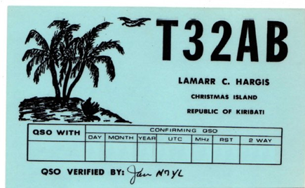***DX News***

***ARLD008 DX news***

This week's bulletin was made possible with information provided by LU4AAO, The Daily DX, the OPDX Bulletin, 425 DX News, DXNL, Contest Corral from QST and the ARRL Contest Calendar and WA7BNM web sites.

Thanks to all.

**UNITED ARAB EMIRATES, A6.** A number of special event stations are QRV to celebrate Kuwait National and Liberation Day. Look for stations A60KWT, and A60KWT/0 to /13 to be active until February 28.

QSL via operators' instructions.

TOP ^

**FEDERAL REPUBLIC OF GERMANY, DA.** Special event stations DQ100JL and DR100JL will be QRV from March 1 to May 31 to commemorate the founding 100 years ago of Junkers Luftverkehr, an early airline in Germany. QSL via bureau.

**MARTINIQUE, FM.** Romanic, W7ROM is QRV as FM4WDM from Le Morne-Vert. Activity is on 15 meters using FT8. QSL via operator's instructions.

**REPUBLIC OF KOREA, HL.** Special event station D90EXPO will be QRV from March 1 to October 17 to promote the 2021 World Military Culture Expo that will take place in the city of Gyeryong in October. QSL via DS3BBC.

**SARDINIA, IS0.** Special event station II0QSE will be QRV from Quartu Sant'Elena, IOTA EU-024, from February 28 to June 30 to celebrate the 40th anniversary of the local branch of the ARI. QSL via IS0AGY.

**ST. LUCIA, J6.** Operators K9HZ, W0CN and WA4PGM will be QRV as J68HZ, J68CN, and J68PG, respectively, from March 2 to 11. This includes being active as J68HZ as a Multi/Single/High Power entry in the upcoming ARRL International SSB DX contest. QSL via operators' instructions.

**WAKE ISLAND, KH9.** Thomas, NL7RR is QRV as KH9/NL7RR until April 2. Activity is in his spare time on 40 and 20 meters using SSB. QSL direct to AL7JX.

**ARGENTINA, LU.** Members of the Radio Club QRM Belgrano are QRV as LU4AAO, LU4AAO/A and LU4AAO/D until March 1 to commemorate the club's 53rd anniversary. Activity is on the HF and V/UHF bands using CW, SSB, SSTV and FT8. QSL direct to LU4AAO.

**CURACAO, PJ2.** Operators N1ZZ, AF4Z, WB5ZGA and K4JC will be QRV as PJ2/home calls from March 1 to 9. Activity will be on 160 to 10 meters using CW, SSB, RTTY and possibly FT8. They plan to be active as PJ2T in the upcoming ARRL International SSB DX contest. QSL to home calls and PJ2T via W3HNK.

**ST. MAARTEN, PJ7.** Thomas, AA9A will be QRV as PJ7AA from February 27 to March 28. Activity will be on 80 to 10 meters using CW, SSB and FT8. QSL direct to home call.

**GREECE, SV.** Members of the Radio Amateur Association of Western Peloponnese will be QRV with special call signs SZ21AD, SZ21GK, SZ21LB, SZ21PF, SZ21TK and SZ1821P from March 1 to 31 to commemorate the 100th anniversary of the Revolution of 1821. QSL via LoTW.

**AUSTRALIA, VK.** Special event stations VI100AF and VK100AF will be QRV from March 1 to May 29, and March 1 to August 31, respectively, to commemorate the founding of the Royal Australian Air Force 100 years ago. QSL via M0URX.

**CAMBODIA, XU.** Tad, JA1DFK is QRV as XU7AKU. Activity is on the HF bands, and possibly 6 meters, using CW. QSL via JA1DXA.

**INDONESIA, YB.** Heru, YG8VAS is now QRV from Ternate Island, IOTA OC-145. Activity of late has been on 80 and 40 meters using SSB. QSL to home call.

**SOUTH SUDAN, Z8.** Massimo, IZ0EGB is QRV as Z81B from Juba while working here. Activity is generally in his spare time on 20 meters using SSB. His length of stay is unknown. QSL to home call

TOP ^

THIS WEEKEND ON THE RADIO. The CQ 160-Meter SSB Contest, North American RTTY Party, North American Collegiate RTTY Championship, NCCC RTTY Sprint, QRP 80-Meter CW Fox Hunt, NCCC CW Sprint, K1USN Slow Speed CW Test, REF SSB Contest, FT4 DX Contest, UBA DX CW test, South Carolina QSO Party, Classic CW Exchange, High Speed Club CW Contest and North Carolina QSO Party are all on tap for this upcoming weekend.

The RSGB 80-Meter Club Data Championship, K1USN Slow Speed CW Test and OK1WC CW Memorial are scheduled for March 1.

The RTTYOPS Weeksprint, ARS Spartan CW Sprint and Worldwide Sideband Activity Contest are scheduled for March 2.

The UKEICC 80-Meter SSB Contest, VHF-UHF FT8 Activity Contest, CWops Mini-CWT Test, Phone Fray, and the 40-Meter QRP CW Fox Hunt are scheduled for March 3.

Please see February 2021 QST, page 73, March QST, page 72, and the ARRL and WA7BNM contest web sites for details.

**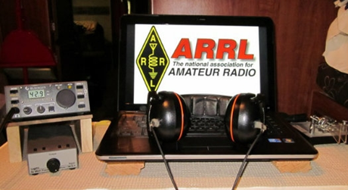*ARRL Contest Corner***

An expanded, downloadable version of *QST'*s’ [**Contest Corral**](http://www.arrl.org/contest-calendar) is available as a PDF. Check the sponsor’s ‘Website for information on operating time restrictions and other instructions.

***Special Events***

* **03/11/2021 | Battleship Texas Birthday**

**Mar 11-Mar 14, 0000Z-0000Z, W5T**, Cleburne, TX. Club KC5NX. 14.255 14.045 7.240 7.235 . QSL. Club KC5NX, 9200 Summit Ct W , Cleburne, TX 76033-8212. Club KC5NX back on the air for the celebration of the 107th birthday of the Battleship TEXAS. jay.n.violet@gmail.com or check here to find us: https://www.dxwatch.com/dxsd1/dxsd1.php?f=0&c=w5t&t=dx <https://www.qrz.com/db/kc5nx>

* **03/13/2021 | USS Midway Museum Ship Special Event: Launching of USS Midway**

**Mar 13, 1700Z-2359Z, NI6IW**, San Diego, CA. USS Midway (CV-41) Museum Ship. 7.250 14.320 14.070 (PSK31) DSTAR vis PapaSystem repeaters. QSL. USS Midway CV-41 COMEDTRA NI6IW, 910 N Harbor Drive, San Diego, CA 92101. SASE please. [www.qrz.com/db/ni6iw](http://www.qrz.com/db/ni6iw)

* **03/14/2021 | PI Day - David Sarnoff Radio Club, Princeton, NJ**

**Mar 14, 0000Z-2359Z, N2RE**, Princeton, NJ. David Sarnoff Radio Club. 14.250 14.050 7.200 7.050. QSL. Bob Uhrik, 104 Knoll Way, Rocky Hill, NJ 08553. Famous Princetonian Albert Einstein was born on PI Day. [n2re.org](http://n2re.org/)

TOP ^

* **03/20/2021 | Arrows from the Air**

**Mar 20-Mar 21, 1800Z-0300Z, K7SWI**, Middleton, ID. South West Idaho Amateur Radio Club. 28.427 14.227 7.227 3.827. Certificate & QSL. South West Idaho Amateur Radio Club, 332 West Dewey Ave, Nampa, ID 83686. What Are Those Giant Arrows Dotting the American Landscape? The arrows were part of a federal project to speed up communication across great distances. Transcontinental airmail service began in 1920, but even with this advancement over ground travel, service was slow. Pilots had no sophisticated instruments, so they couldn’t fly at night or in poor weather. The government built a path of 70-foot-long concrete arrows every few miles from coast to coast, each painted yellow and topped with a 51-foot steel tower that had a rotating beacon. Using the path, an airmail pilot needed only half the time to deliver a letter from New York to San Francisco, The SOUTH WEST IDAHO ARC will operate 14.327, 7.227, 3827 plus or minus traffic/qrm.. K7SWI will issue a Certificate and QSL to all requested please include SASE for QSL only and SASE with one green stamp for QSL and Certificate. Reply to address of K7SWI. 332 West Dewey Ave Nampa, ID 83686. [nq6s@att.net](mailto:)

* **03/20/2021 | Woronoko Heights Outdoor Adventure**

**Mar 20, 1300Z-1900Z, W1M**, Russell, MA. Western Mass. Council-BSA. 7.190 10.115 14.060 14.290. QSL. Tom Barker, 329 Faraway Road, Whitefield, NH 03598.

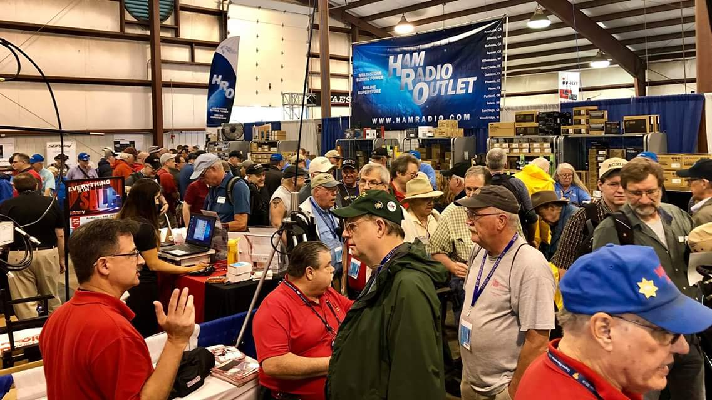[***Upcoming Hamfests***](http://arrl-ohio.org/hamfests.html)

We **DO** have some hamfests scheduled for 2021!! Yes, take a good look at the list, it’s growing every day!

Be sure to keep your eyes on this schedule as that when things start getting better and the vaccine rolls out to more and more, hamfests will surely get back to their normal schedule. Don’t see your hamfest listed?? Did anyone register it with ARRL? It’s really easy to do and you get a lot of FREE publicity if you do.

|  |  |
| --- | --- |
| **04/25/2021 -**[**Athens Hamfest**](http://www.arrl.org/hamfests/athens-hamfest-9)  *Canceled* | **06/05/2021 -**[**FCARC SummerFest**](http://www.arrl.org/hamfests/fcarc-summerfest)  Location: Wauseon, OH Sponsor: Fulton County Amateur Radio Club Website:<http://k8bxq.org/hamfest> [Learn More](http://www.arrl.org/hamfests/fcarc-summerfest) |
| **07/10/2021 - [Mansfiled Mid-Summer Trunkfest](http://www.arrl.org/hamfests/mansfiled-mid-summer-trunkfest" \o "Mansfiled Mid-Summer Trunkfest)**  Location: Mansfield, OH Sponsor: InterCity Amateur Radio Club Website:<http://iarc.club>[Learn More](http://www.arrl.org/hamfests/mansfiled-mid-summer-trunkfest) | **07/18/2021 –**[**Van Wert Hamfest**](http://www.arrl.org/hamfests/van-wert-hamfest-5)  Location: Van Wert, OH Sponsor: Van Wert Amateur Radio Club Website:[http://W8FY.ORG](http://w8fy.org/)[Learn More](http://www.arrl.org/hamfests/van-wert-hamfest-5) |

TOP ^

|  |  |
| --- | --- |
| **08/07/2021 -**[**DX Engineering Hamfest & Great Lakes Division Convention**](http://www.arrl.org/hamfests/dx-engineering-hamfest-1)  Location: Tallmadge, OH Sponsor: DX Engineering Website: [http://dxengineering.com](http://dxengineering.com/) [Learn More](http://www.arrl.org/hamfests/dx-engineering-hamfest-1) | |
| **08/28/2021 -**[**Cincinnati Hamfest℠**](http://www.arrl.org/hamfests/cincinnati-hamfest)  Location: Owensville, OH Sponsor: Milford ARC Website: [http://CincinnatiHamfest.org](http://cincinnatihamfest.org/) [Learn More](http://www.arrl.org/hamfests/cincinnati-hamfest) | **09/26/2021 -**[**Cleveland Hamfest**](http://www.arrl.org/hamfests/cleveland-hamfest-1)  Location: Berea, OH Sponsor: Hamfest Association of Cleveland Website: [http://www.hac.org](http://www.hac.org/) [**Learn More**](http://www.arrl.org/hamfests/cleveland-hamfest-1) |
| **12/04/2021 -**[**FCARC WinterFest**](http://www.arrl.org/hamfests/fcarc-winterfest-2)  Location: Delta, OH  Sponsor: Fulton County Amateur Radio Club  Website:<http://k8bxq.org/hamfest>  [Learn More](http://www.arrl.org/hamfests/fcarc-winterfest-2) | |

***Buckeye Net Mixed aligns with Ohio Section priorities***  
The new Ohio Section Manager Tom Sly WB8LCD has articulated three priorities for his activity as Section Manager, namely:  
  
  #1. Making sure that the Hams in the OH Section not only have but take advantage of all the opportunities that this hobby gives them to have FUN!  
  
  #2. Increase the number of licensed hams, increase the number of active hams, and increase the number of ARRL member hams in the OH Section.  
  
  #3. Increase and improve the public image of Amateur Radio to the general population of OH.  
  
I submit that the activity of Buckeye Net Mixed operation aligns clearly with Tom's priorities and we need to continue our activity, and encourage others to join us, at the Section Net level, at the ARES District level, and locally.  
  
Consider Tom's priority #3. The Ohio Section opened up a "black sky" delivery pathway for critical alert messages in the BLACK SWAN 20 exercise. This was one small but critical step in materially improving  
the safety and security of the United States. We didn't join a FEMA exercise: they saw what we were doing in Ohio and volunteered to join us. What a collaboration it was: FEMA was able to bring resources to bear that improved our capability in Ohio, when so requested, exactly as it should work!

TOP ^

To make the most out of this achievement, we need to follow through. That means more testing, which brings us to the IPAWS Test 2. It's not just one test, but a series to develop the skill and to get good at it.

As all of us can attest, operation in Buckeye Net Mixed has been a learning experience. We've learned not only which digital modes are most appropriate for various tasks at hand, but how to organize an effective Section traffic net that will operate no matter what conditions we find, how to work cross-band with 80/75, 60, and 40  
meters all active, and how to work cross-system with liaison to BBS and Winlink systems. We've also learned how to make use of the NBEMS suite, including formatting messages with FLMSG and relay with FLAMP.  
While we've had moments of bewilderment and frustration, we've pulled it off, and in the end, we can say that we've had fun. (See Tom's #1.)  
  
Finally, as we've been using the NBEMS technology to solve real-world problems in fulfillment of the first reason for the existence of Amateur Radio in the United States, we've discovered that we need more operators. The operators aren't needed just to listen passively but to be active in using their station in support of our public service mission. With BNM using NBEMS and voice in ways that others are not, that means training needs to take place. This activity has spawned tremendous training activity, with D9 and D10 in particular, with other activity in D1, D3, D5, D7, and D8. D2, D4, and D6 have seen rumbles where things are getting started. This, ladies and gentlemen, is the entirety of the Ohio Section.  
  
BNM is giving reason for these local activities to get up and running regularly, and capability for working across districts. All of this activity improves our capability, and our emphasis on tight and professional operation goes a long way into making us more useful to served agencies, more likely to be activated, and better able to serve the public. (See Tom's #2.)

This is work that is a result of several years of thought but only nine months of operation. NINE MONTHS! Furthermore, BNM has operated every single day since before Thanksgiving, with one exception:  
yesterday.  
  
What I learned from yesterday is that despite the amazing progress we've made in such little time, our success is not guaranteed. In the real world, we can be called to urgent duties, and if that happens to several of us at once, it can have a devastating impact on our capability. Hence the need for a deeper bench, for more operators  
trained and ready to go, better able to accomplish our mission. And here we are again, in alignment with the priorities for the Ohio Section.  
  
Congratulations to everyone who has been part of Buckeye Net Mixed. It's appropriate to celebrate -- and keep bringing your friends with you. They'll learn and have fun, get more active and help others to join, and improve our public image in the process.  
  
References:

  T. Sly. "Final.. Final.." Ohio Section Journal. Feb 2021,  
  pp. 40-42. <http://arrl-ohio.org/news/2021/OSJ-Feb-21.pdf>  
  
  C. M. Curtin. "IPAWS Test 2." BLACK SWAN COMEX Web site.  
  <https://www.blackswancomex.org/2021/ipaws-test-2>  
  
 

TOP ^

S. Judd. "Toward a Modern Buckeye Net." Buckeye Net Web site. Aug  2019.  
  <https://buckeyenetweb.wordpress.com/2019/08/28/toward-a-modern-buckeye-net/>

  Federal Communications Commission. "Amateur Radio Service." Code of  
  Federal Regulations. Title 47, Part 97.1.  
  <https://www.law.cornell.edu/cfr/text/47/97.1>  
  
BT

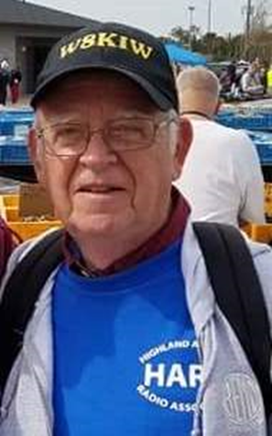***From The South 40***

*(from John Levo,* [*W8KIW@arrl.net*](mailto:W8KIW@arrl.net)*)*

***WELCOME TO THE SOUTH 40***



Last time we ended our column with a visit to the Milford Amateur Radio Club and briefly mentioned the rebranding of their annual hamfest to be known hereafter as the Cincinnati Hamfest.

Today we continue our journey visiting Southern Ohio area clubs with a stop with a niche club specializing in the pursuit of DX and contesting. I speak of no more than the internationally known Southwest Ohio DX Association. The Club was informally organized in 1977 but did not have an organizational meeting or election of officers until 1981. Although primarily a DX and contesting club, its members have a wide variety of radio interests and reside not only in Southern Ohio, but in other states and nations. SWODXA is known for conducting the annual Friday evening DX dinner during HamVention weekend as well as moderating HamVention’s DX forum. In 2019 SWODXA joined with the Milford ARC and sponsored the well-attended W8DXCC convention during the afternoon of the MARC hamfest. Additionally, the Club has mounted their own DXpeditions to various exotic locations around the world and helped provide funding for such other group’s adventures. The Club publishes an excellent monthly newsletter, The Exchange, which is edited by Bill Salyer, AJ8B who also writes the Ohio Section Journal’s DX column. More information about SWODXA can be found at [www.swodxa.org](http://www.swodxa.org)

Now it’s time to thank SWODXA for the visit and get back on the road to our next stop. So here to help pass the miles are some of the ham related news items taking place in our Southern Ohio region.

The recent weather conditions throughout the nation; pockets of civil unrest and the forthcoming FCC license fees are causing people to look at ham radio as a form of personal communications backup or for those already with licenses to work towards upgrading those licenses. In addition to a planned formal classroom course, there are a number of testing opportunities throughout the region in the coming weeks.

The Highland ARA will hold a public ham radio informational program at the Highland County EMA Office in Hillsboro on Sunday afternoon, March 14, at 2 pm. If the interest is there a weekly Technician license class will start on March 21 and run through April 11. There will be a VE session on Saturday morning, April 17. The class and test are free. More information is available from Club President Pat Hagen, N8BAP, at 937-218-6289, via [highlandara@gmail.com](mailto:highlandara@gmail.com) or in articles in either the Hillsboro Times-Gazette or the Highland County Press.

TOP ^

Regional testing opportunities will be in Portsmouth on Monday, March 1; Chillicothe-March 6; Lancaster-March 9 and in Athens-March 15. April 10 will see tests given in Springfield and Huber Heights as well as Huntington, WV. Tests will occur in Circleville and Hillsboro on April 17. For information on these and other test sessions check the VE Test Session section in the weekly Ohio Section Journal for a link to all registered test locations.

Because of COVID concerns, the traditional Athens County ARC February pot-luck dinner meeting has been cancelled. An attempt will be made to reschedule it for this September. The Club has also decided to postpone their April hamfest and try to reschedule it in late summer if an appropriate date and location can be arranged.

About the only club in this region conducting in person meetings is the Clinton County ARA. They will meet on Thursday evening, March 4, at the Foster Boyd Cancer Center in Wilmington. President Dave Gordley, K8DEG, states the meeting starts at 7:30. Because this is in a medical facility, all COVID safety requirements will be observed.

For several years the Highland ARA has conducted a series of special event stations operating from places as

Ohio’s oldest courthouse and from a covered bridge joining two counties. The events are used not only to expand the Field Day experience for new and non-HF operating members but used as a way to promote interesting places to visit and see in Highland County and as a way to promote amateur radio via public exposure. A most unusual one might be on tap to be the subject of this year’s exercise. How about a special event showcasing the world’s largest horseshoe crab? Although hundreds of miles from the ocean, this Roadside America attraction critter resides in Hillsboro and undoubtedly would be a novel special event theme. However, your column editor still thinks something to call attention to the final resting place of America’s first professional strip tease artist might catch some attention or perhaps raise some eyebrows.

It seems like the Southern Ohio region is no more than digging out from record snowfalls, a severe ice storm, heavy rains, low temperatures and whatever else Mother Nature could throw at them when the National Weather Service reminds us we are only weeks away from the start of the Spring Severe Storm season. In order to prepare us for it, the NWS Offices at Wilmington, Pittsburgh and Charleston are conducting a series of severe weather training sessions via the web in March. Please check with your appropriate NWS web site to determine the dates and times for the training sessions. Our counties east of the Scioto River are mostly in the areas served by either the Pittsburgh or Charleston NWS Offices while those west of the Scioto with some of the Kentucky Counties bordering the Ohio River totally served by the Wilmington Office. Sky Warn certifications need to be renewed each two years.

Dayton and other Southwestern Ohio media are reporting the upcoming creation of Ohio’s 76th State Park. The park would be located off US 68 north of Xenia at Oldtown which is thought to be the birthplace of the famous Shawnee Indian chief Tecumseh. The State Controlling Board has approved the Department of Natural Resources request to purchase the approximate half-acre property where the park would be established. Thus, it appears those participating in the annual Ohio State Parks on the Air contest and those involved with the International Parks on the Air Program will have something to look forward to. The last new Ohio State Park was created in 2018 when the Jesse Owens State Park opened in Southern Ohio’s Morgan County.

TOP ^

It’s time to make our next stop-Georgetown where the Grant ARC calls home. The club traces its beginnings to concerns raised from the 1974 Xenia tornado. Amateurs in Adams and Brown Counties formulated the first phases of creating the Adams/Brown County Emergency Radio Corps with the first meeting held in January 1975. In 1981 the group decided to split and form clubs serving their respective counties. Because Georgetown was the home of General U. S. Grant the group decided to name the club in his honor. Over the years the club has been involved with weather related matters regarding Ohio River flooding, blizzards and tornado activity. Since its earliest days the Grant ARC has been known for sponsoring one of the final hamfests in the Ohio hamfest season. Each November the event has hundreds of hams from several states converge on Georgetown for what is as much a social event as buying and selling radio and electronic equipment. The Club also sponsors a repeater on 146.73 and a Thursday evening net. They were one of the first clubs to embrace the System Fusion operating mode.

Well, that’s it for this week’s road trip to visit some of the amateur radio clubs in the Southern Ohio Region and learn a bit about them. If you know of a club that should be acknowledged, let me know at [jlevo@cinci.rr.com](mailto:jlevo@cinci.rr.com)

As there are some clubs I am unfamiliar with, any assistance would be appreciated. In the meantime be safe, be healthy and enjoy amateur radio to the fullest

73, John

***Upcoming Training Opportunities***

Need to get those really hard to get NIMS ICS 300 and 400 classes to get to Level 3? They are now being offered with very limited virtual seating. Yes, these classes are being offered virtually now along with a lot of other classes that used to require in-class sessions. Want to see what and where these classes are being offered?

[**>> Click Here <<**](http://arrl-ohio.org/SEC/Ohio_EMA_Training_List_Feb_2021.pdf)

**####**

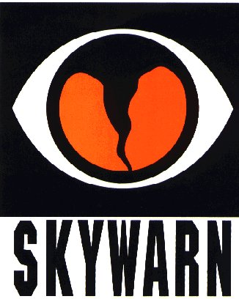***SKYWARN TRAINING***

The National Weather Service will not be able to conduct in person spotter training classes this winter and spring due to restrictions associated with COVID. Therefore, a number of field offices will be hold “virtual” spotter training classes. These classes will be open to the public and free of charge. Please feel free to promote to your staff, spotters, amateur radio operators and to publicize to the citizens in your community.

Since the Ohio Section is served by multiple NWS offices, listing all of the training opportunities for each of these offices would take a large amount of space and become very confusing. So, instead of trying to list the training, it would be better for you to choose which office you prefer to acquire your training from by providing you with a link to the offices surrounding Ohio <http://arrl-ohio.org/SEC/skywarn.html>

TOP ^

***Print an Official or Unofficial Copy of Your Amateur Radio License***

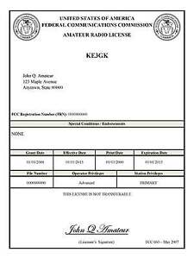*(By Anthony Luscre, K8ZT)*

As of February 17, 2015, the **FCC no longer routinely issues paper license documents** to Amateur Radio applicants and licensees. The Commission has maintained for some time now that the official Amateur Radio license authorization is the electronic record that exists in its Universal Licensing System (ULS). The FCC will continue to provide paper license documents to all licensees who notify the Commission that they prefer to receive one.

Licensees also will be able to print out an official authorization — as well as an unofficial “reference copy” — from the ULS License Manager. I’ve created a set of instructions on how you can request an **“official” printed copy of your license\***

[**Click here to download the instructions**](http://arrl-ohio.org/news/2020/print_your_license.pdf)

***One Question Questionnaire***

Hey Gang,

Survey Says”….. Just about 45% of you are planning on attending the DX Engineering / Great Lakes Division Convention in August. This is Fantastic!! If the rollout of the vaccine goes as they are now predicting, it will be a really fun time for everyone attending.

Ok, now on to the next question… Ok, with the announcement of the ARRL Field Day rules changes for this year, here’s the next question…

***“Are you planning on working Field Day from home?”***

You’ll find the “One Question” questionnaire on the Ohio Section Website! <http://arrlohio.org> It’s all for fun and it’s not a scientific survey in any way, but we are learning some things that we didn’t know from these questions. I hope that you are enjoying answering these “One Question” questionnaires.

*****V.E. Test Sessions***

Many V.E.’s have decided to start testing once again, but with restrictions that need to be adhered to for sure. Here’s the link to find that V.E. Test session and what is expected of YOU before going. <http://www.arrl.org/find-an-amateur-radio-license-exam-session>

TOP ^

Ohio Section Cabinet

|  |  |
| --- | --- |
| Section Manager – Tom Sly, WB8LCD | Section Traffic Manager – David Maynard, WA3EZN |
| Section Emergency Coordinator – Stan Broadway, N8BHL | Section Youth Coordinator – Anthony Lascre, K8ZT |
| Technical Coordinator – Jeff Kopcak, K8JTK | Affiliated Clubs Coordinator – Tom Sly, WB8LCD |
| State Government Liaison – Bob Winston, W2THU | Public Information Coordinator – John Ross, KD8IDJ |



Hey Gang,

Have you taken a look at the **Swap & Shop** page on the Ohio Section webpage yet?? Here’s a link that will take you there… <http://arrl-ohio.org/sm/s-s.html>

Do you have equipment that you just don’t need or want anymore? Here’s a great venue to advertise it, and it’s FREE!! Is your club doing a fund raiser to help raise money? After a lot of thought, it was decided that the Swap & Shop webpage could also contain these types of items as well. The same rules will apply as do for the For Sales and Give-A-Ways and will only be posted for a month at a time. Please see the Terms & Conditions on the webpage.

If your club is doing a fund raiser and wants more exposure, please forward the information to me and I’ll advertise it on the Swap & Shop webpage for you.

Now, I still want to remind you that it won’t be listed in this newsletter because it would take up way too much space, so your ad will only appear on the website. It is there for any individual to post equipment Wanted / For Sale or Give-Away as well as for Club Fund Raisers. No licensed vehicles/trailers or business advertising will be posted. Postings are text only (no pictures or graphics) will be posted for a maximum of 1 month from date posting and require a contact phone number or email within the posting. Send your Wanted / For Sale or Give-Away post to:  [swap@arrlohio.org](mailto:swap@arrlohio.org)

***Back Issues of the PostScript and Ohio Section Journal***

Hey, did you know that PostScript and Ohio Section Journal (OSJ) are archived on the website? You can go back and look at any edition simply by clicking:

<http://arrl-ohio.org/news/index.html>

***Welcome New Subscriber(s)***

**Blake, KE8PAQ; Susie, N8CGM**

TOP ^

***Want to Share your Club Newsletter With Others?***

We have a webpage where you can download and read all of the newsletters that I get from around the state and even other sections!

Here’s the link to the page…. <http://arrl-ohio.org/club_news/index.html>

Please, if you don’t see your club newsletter posted, it’s because I’m not receiving it. Just have your newsletter editor contact me and I’ll get your club’s newsletter listed on the site!!

We all learn and steal (I mean, share) from each other’s work. So, get me your newsletter!!! Send it to: [webmaster@arrl-ohio.org](mailto:webmaster@arrl-ohio.org)

***Chit – Chat, and All That!***

Do you know someone that’s not getting these Newsletters? Please, forward a copy of this Newsletter over to them and have them “[Opt-In](mailto:Opt-In)” to start receiving them. Heck, just have them send an email to: [webmaster@arrl-ohio.org](mailto:webmaster@arrl-ohio.org) and we’ll get them added to the Ohio Section Emailing list.

We now have many thousands of readers receiving these newsletters weekly. Quite impressive, I’d say! I urge all of you to make sure that everyone, regardless of whether they are a League member or not, get signed up to receive these weekly Newsletters.

You can always “Opt-Out” at any time if you feel this is not what you were expecting. It’s fun and very informative. All of your favorite past newsletters are now archived too.

You can go back at any time and read them.

Just go to: <http://arrl-ohio.org/news/>

The pictures on the front page and throughout this newsletter are from various newsletters, Facebook posts and/or were sent directly to me in recent weeks. Take a good look at them, you just might be in one of the pictures! “SMILE… you’re in the Ohio Section News!!”

TOP ^

*PostScript is produced as a weekly newsletter. I want to thank everyone that has contributed articles and ideas to make this an even better news source. I sincerely hope that you have enjoyed this edition and will encourage your friends to join with you in receiving the latest news and information about the Ohio Section, and news and events happening around the world!*