[](http://arrl-ohio.org/news/) ***“Presidents Day***

***Edition”***

🡪 National News 🡪 Club Corner

🡪 DX This Week 🡪 Contest Corner

🡪 Special Events 🡪 Upcoming Hamfests

🡪 One Question Questionnaire 🡪 VE Testing

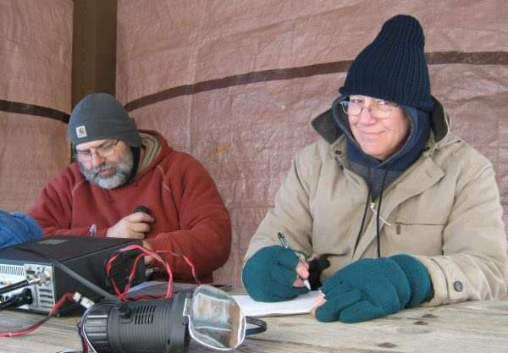

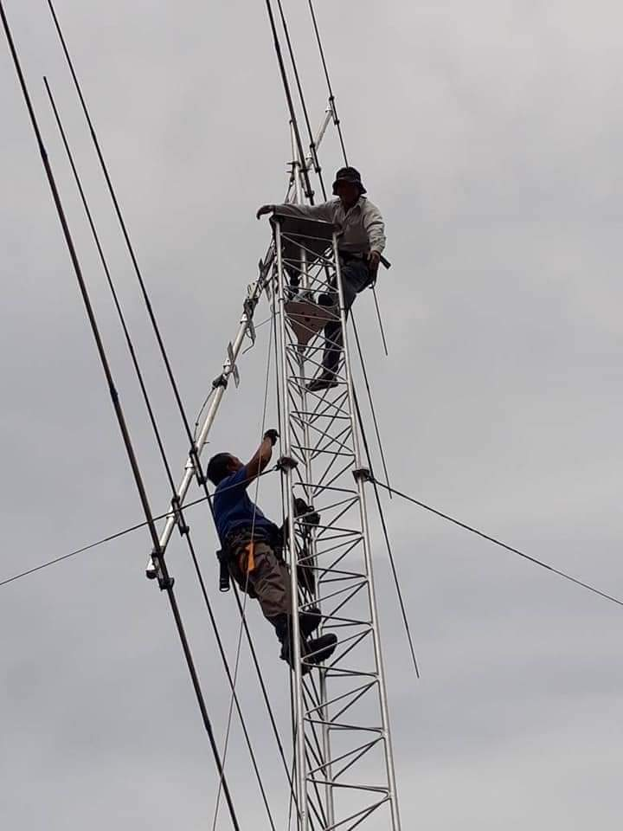



***National News***

*(from arrl and other sources)*

***ARRL to FCC: Additional Volunteer Examiner Coordinators Not Needed***

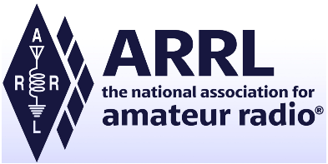ARRL has told the FCC that no additional Volunteer Examiner Coordinators (VEC) are needed to oversee the administration of amateur radio exams by Volunteer Examiners (VEs). Examination opportunities have continued to be widely available throughout the US — except for a couple of months during the onset of the COVID-19 pandemic — and adding VECs to the 14 now in place would “have no effect” on the number of available exams, ARRL said. ARRL’s [**comments**](https://ecfsapi.fcc.gov/file/1020574174238/ARRL20PN2021-2%2002_04_2021.pdf) on February 4 were in response to a January 5 FCC [***Public Notice***](https://docs.fcc.gov/public/attachments/DA-21-9A1.pdf) in WT Docket 21-2 seeking input on possible expansion of the VEC pool.

“In response to the Commission’s *Notice*, ARRL reviewed the amateur examination numbers for the past 5 years, including the COVID-19 pandemic period,” ARRL said in its comments. “We found that even though 10 of the 12 months for calendar year 2020 were times of severe disruption throughout the nation, including for FCC and ARRL headquarters staff, amateur examination opportunities and numbers were strong.”

Multiple web-based exam opportunities are available across the US, even on short notice, and in-person examinations are available in many areas where local regulation and special safety requirements allow.

“It has never been easier,” ARRL asserted, noting that exam sessions often are available within 2 days but rarely more than 7, if taking advantage of a remote, web-based exam opportunity.

“Instead of increasing the number of VECs, we would encourage volunteers to become accredited as VEs and to volunteer to help the current VECs wherever possible,” ARRL said. “Many of the VECs would welcome help.” ARRL said VEs, not VECs, are responsible for administering amateur radio exams.

ARRL VEC — the nation’s largest — has 30,000 accredited VEs, with 11,000 of them regularly participating in exam activities on a weekly or monthly basis.

The number of new and upgraded licenses has been in line with earlier years, “with noticeable increases in the 4 months following the lockdown that occurred in many areas in the early spring,” ARRL pointed out. New FCC licenses issued in January 2021 numbered 2,838, compared with 2,058 for a year earlier. Upgrades were also up significantly — 920 in January 2021 to 554 for the same month last year.

“The 14 separate and independent FCC-approved VECs readily accredit additional VEs whenever and wherever needed,” ARRL concluded. “Increasing the number of individual VECs would have no discernible benefit.”

Instead, ARRL said, increasing the number of VECs would expand the complexity of VEC coordination and management, increase demand on FCC resources to interface with additional organizations, and raise the potential for abuse and fraud.

####

TOP ^

***RadFxSat-2/Fox-1E Designated AMSAT-OSCAR 109 as Troubleshooting Continues***

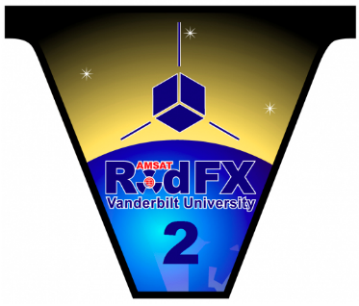

The RadFxSat-2/Fox-1E CubeSat has been designated as AMSAT-OSCAR 109 (AO-109). The satellite, which carries a telemetry beacon and a linear transponder, along with radiation effects experiments, is a joint mission of AMSAT and the Institute for Space and Defense Electronics at Vanderbilt University. While the telemetry beacon on 435.750 MHz has not yet been heard, the transponder is partially operational at reduced signal strength.

“Work continues to recover the telemetry beacon and characterize the transponder with the goal of opening it for general use,” AMSAT said this week. “Testing and characterization of RadFxSat-2/AO-109 continues.”

On January 27, a ham in Nevada reported weakly hearing his CW signal via the spacecraft’s transponder. AMSAT engineering and operations was able to confirm the reports from Brad Schumacher, W5SAT, and determined that RadFxSat-2 is partially functioning, although signals are extremely weak.

AMSAT engineering and operations teams made the official AO-109 designation after confirmation that the linear transponder functional, although with a low-level downlink signal. AMSAT was not positive which of the several suspect objects — D, C, and M — was actually RadFXSat-2/Fox-1E, with AMSAT’s Drew Glasbrenner, KO4MA, targeting object C as the most likely. “Recently, these satellites have sufficiently spread apart to allow testing to determine which object is RadFxSat-2/Fox-1E,” AMSAT said.

During passes on February 2, command station Mark Hammond, N8MH, compared objects D, C, and M for the “best fit” for received signals with Doppler correction on both uplink and downlink frequencies. Objects D and M were quickly eliminated from further consideration, due to poor frequency predictions of Doppler correction compared to observed signals.

“The clear best fit is Object C, which is known as OBJECT C, INTELDES 2021-002C, and NORAD CAT ID 47311,” AMSAT said. “Therefore, AMSAT is happy to identify Object C/2021-002C/47311U as RadFxSat-2/Fox-1E and make the designation AO-109. Thanks to Alan Biddle, WA4SCA, for support during the identification.”

AMSAT said its engineering and operations teams appreciate the satellite community’s cooperation to date and reiterated its request that users not attempt to use the transponder until further notice. “The proper identification will allow further characterization of the satellite’s condition through additional testing,” AMSAT concluded.

RadFXSat-2/Fox-1E was launched on January 17 on Virgin Orbit’s LauncherOne, which carried 10 other satellites into space. RadFXSat-2/Fox-1E carries an inverting linear transponder, with uplink at 145.860 MHz – 145.890 MHz, and downlink at 435.760 MHz – 435.790 MHz. Telemetry will downlink on 435.750 MHz.

— *Thanks to*AMSAT News Service *via Mark Hammond, N8MH*

####

TOP ^

***ARRL to Extend Field Day Rule Waivers from 2020, Add Class D and E Power Limit***

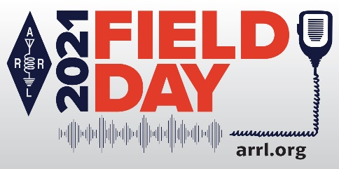The COVID-19 pandemic-modified [**ARRL Field Day**](http://www.arrl.org/field-day) rules from 2020 will continue this June with the addition of a power limit imposed on Class D (Home Stations) and Class E (Home Stations-Emergency Power) participants. The news from the ARRL Board’s Programs and Services Committee comes as many clubs and groups are starting preparations for Field Day in earnest. Field Day 2021 will take place June 26 – 27.

“This early decision should alleviate any hesitancy that radio clubs and individual Field Day participants may have with their planning for the event,” said ARRL Contest Program Manager Paul Bourque, N1SFE.

For Field Day 2021:

* Class D stations may work *all other* Field Day stations, including other Class D stations, for points. This year, however, Class D and Class E stations will be limited to 150 W PEP output.
* An *aggregate* club score will be published — just as it was done last year. The aggregate score will be a sum of all individual entries that attributed their score to that of a specific club.

ARRL Field Day is one of the biggest events on the amateur radio calendar. Last summer, a record 10,213 entries were received.

“With the greater flexibility afforded by the rules waivers, individuals and groups will still be able to participate in Field Day, while still staying within any public health recommendations and/or requirements,” Bourque said.

The preferred method of submitting entries after Field Day is via the web applet. The ARRL Field Day rules include instructions on how to submit entries, which must be submitted or postmarked by Tuesday, July 27, 2021.

The [**ARRL Field Day**](http://www.arrl.org/field-day) web page contains for complete rules and entry forms, as well as any updated information as it becomes available. Join the ARRL Field Day [**Facebook page**](https://www.facebook.com/groups/arrlfd).

Facebook

####

***Ham Radio Forms a Planet-Sized Space Weather Sensor Network***

The [**article**](https://eos.org/features/ham-radio-forms-a-planet-sized-space-weather-sensor-network) “Ham Radio Forms a Planet-Sized Space Weather Sensor Network,” appeared on February 9 in *Eos, Earth & Space Science News* — an American Geophysical Union (AGU) publication. It sprang from a project by the Ham Radio Science Citizen Investigation (**[HamSCI](http://www.hamsci.org/)**), founded by Nathaniel Frissell, W2NAF, of the University of Scranton, one of the paper’s authors. The others are David Kazdan, AD8Y, and Kristina Collins, both of Case Western Reserve University (W8EDU). The article says that with their experience dealing with ionosphere-influenced propagation, amateur radio operators have an empirical knowledge of space weather and offer a ready-made volunteer science community.

TOP ^

The article covers the method and research being used to monitor the effects of solar activity on Earth’s atmosphere, telecommunications, and electrical utilities — and the valuable data being crowdsourced from amateur radio signals.

“To fully understand variability on small spatial scales and short timescales, the scientific community will require vastly larger and denser sensing networks that collect data on continental and global scales,” the article asserts. “With open-source instrumentation cheaper and more plentiful than ever before, the time is ripe for amateur scientists to take distributed measurements of the ionosphere — and the amateur radio community is up for the challenge.” “The reach of these crowdsourced systems, and the support of the amateur community, offers tremendous opportunities for scientific measurements,” the article notes.

The research acknowledges a handful of HamSCI collaborators — from organizations and universities — and is supported by National Science Foundation grants. HamSCI’s Personal Space Weather Station initiative aims to develop a network of specially equipped amateur stations that will allow amateurs to collect useful data for space science researchers. As the article explains, ham radio operators and researchers, through HamSCI, are designing hardware for a distributed network of personal space weather stations.

November and December 2021 mark the 100th anniversary of the successful ARRL Transatlantic Tests, which took advantage of data gathered via university and individual amateur stations — an early example of citizen scientists leveraging amateur radio. **The 2021 HamSCI virtual workshop will take place March 19 - 20**.

***Club Corner***

This is YOUR cornner of the newsletter. Send me what your club is doing and I’ll make sure that it gets in. Got a special event or club project that you want everyone to know about? Send it to me!. Need help with a project? Send it to me.

Let me know what you club is up to. Are you going to have a special guest at your meeting or are you having a special anniversary?

Just sent it to: [webmaster@arrl-ohio.org](mailto:webmaster@arrl-ohio.org)

####

***MARC Tech and General Class***

Our friends over at [The Massillon Amateur Radio Club (MARC)](http://r20.rs6.net/tn.jsp?f=001BJtbefdTt4Nx8-coqfDPqKLikBQqLBbU_bvjGj5eRT1DwDBj03-4HbZ9ewsywHAiz5Ocwc0xcT7DeGzYIOaxFy7tryYKXSx7fcQZdySqUoGnM_6ZuuNmtGgCV2BSFqZ6kYwkwrzRhrc=&c=uLxA9CqzOcnooMZnBCN2IGw8sMuDHLcttxGQzPiA4NlGWlGdWl3WdA==&ch=EBa_sFdAuQLElzOmvR2FY-yI0PuZBJS38PjGFvGqGrzuTpXl_1wQrw==) are sponsoring a license class for both the Tech and General class.

Classes start on Friday, February 19th at 7:30 PM. Students must purchase the [ARRL License Manual](http://r20.rs6.net/tn.jsp?f=001BJtbefdTt4Nx8-coqfDPqKLikBQqLBbU_bvjGj5eRT1DwDBj03-4HZeH2UtDR9Ran5IjaLEb3RW9Ahu9YTDxEYEuvq8cIjeh0LP42GfNGA_DQezOdAA90WuX8V8bV0IEEoe85BNrVzJTOrVAk2KxQvS81kzE4EqH6p-WZogk6wvmw2lt7kiDkA==&c=uLxA9CqzOcnooMZnBCN2IGw8sMuDHLcttxGQzPiA4NlGWlGdWl3WdA==&ch=EBa_sFdAuQLElzOmvR2FY-yI0PuZBJS38PjGFvGqGrzuTpXl_1wQrw==). Each class will run for 2 hours and will be held at the [R.G. Klein Museum in Downtown Massillon](http://r20.rs6.net/tn.jsp?f=001BJtbefdTt4Nx8-coqfDPqKLikBQqLBbU_bvjGj5eRT1DwDBj03-4HZeH2UtDR9Ra1CQEZJ07QOYqadeXIe3ETL2bC_-dVLP4e038yd7LBp8HQzq7nRCrpPDtfSjUf6mI3-xlbdJf9isHTfUVOSqselvyK_7S0wHODdUzFXS6Za0=&c=uLxA9CqzOcnooMZnBCN2IGw8sMuDHLcttxGQzPiA4NlGWlGdWl3WdA==&ch=EBa_sFdAuQLElzOmvR2FY-yI0PuZBJS38PjGFvGqGrzuTpXl_1wQrw==) at the corner of Erie and Federal Avenue. Parking is available at the rear of the building. There’s still some spaces open yet.

**Contact Terry Russ, N8ATZ for additional details or to sign up.**

* **Email:** [truss@sssnet.com](mailto:truss@sssnet.com)
* **Phone:** 330-837-3091

####

TOP ^



Hello everyone,

The spring semester at Wayne College started without a hitch, marking our second full semester of operating in mixed online/in-person environments.  It is good to see students in classrooms again.  The recent freezing weather and sometimes difficult driving conditions are a good reasons to learn from home!

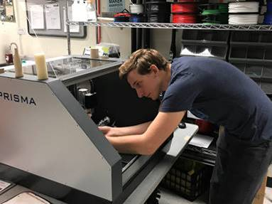While the 3D Lab continues to be open to students yet closed to the public due to COVID precaution, our staff has plenty of time to keep the equipment in good order.  We are currently repairing our first Makerbot 3D printer received back in 2014.  Amazingly, replacement parts are still available.  Our large-format Taz printer will receive a replacement controller board to correct a stuttering z-axis.  Thanks to the [Romich Makerspace](http://www.romichfoundation.org/) for troubleshooting help with that.

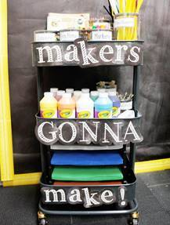

The 3D Lab continues to provide free services for the community with our digital fabrication equipment and materials.  Feel free to contact us below if you have a project that we can assist with!  [Click here](https://blogs.uakron.edu/waynec3/equipment/) for a complete list of equipment.

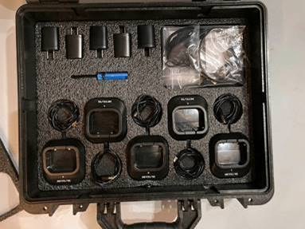John, one of our community members, discovered a surprising use of our laser cutter: tool shadowing!  Think of tools stored in padded suitcases with pockets shaped perfectly for each tool.  With this technique, a person uses a simple 2D art program such as CorelDRAW, InkScape, and others to draw shapes.  These are cut into thin layers of foam, then glued together to make three dimensional pockets.  The process is described on Epilog’s website [here](https://www.epiloglaser.com/resources/sample-club/tool-foam-shadowing.htm).

John need a way to safely store and transport numerous sets of two-way radios, so tool shading was a perfect “fit”.  He designed the cut-out patterns himself while 3D Lab staff lasered the foam.  The result is quite professional!

TOP ^

[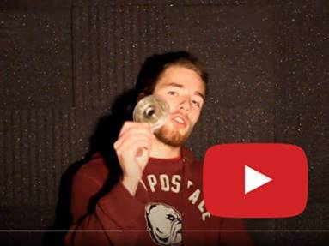](https://www.youtube.com/watch?v=RuFHF_RMUEw)Tristan is a Wayne College alumnus who frequents the 3D Lab and surprises us with interesting projects that he is into.  Last year he revealed the beginnings of a machine that would pluck guitar strings using pushbuttons.  [Check-out his exploration](https://www.youtube.com/watch?v=RuFHF_RMUEw) of using a laser cutter to build layers of acrylic to form bearings similar to John’s tool shadowing project!  The round discs were laser-cut as well and a 3D printer formed a frame to space them apart.

A couple of years ago, Tristan also set about to build an indestructible mail box (a.k.a  the “arm breaker”).  Check-out a video of this project [here](https://youtu.be/6qkqhnqmnrE).  It’s informative *and* entertaining!

The [Baden Powell Institute](https://www.leadscouting.org/) is the premiere training event for Scout leaders providing supplemental training that sparks innovation, imagination, and inspiration.  For more than 20 years, BPI has helped Scouters hone their leadership, develop new skills, and discover new resources.

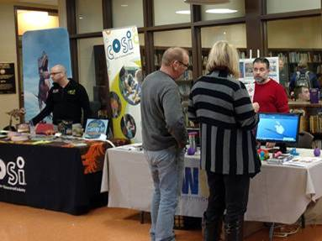Wayne College  has been a proud supporter of this event, though this year’s in-person event was not possible due to the pandemic.  Instead, last week BPI digitally delivered its entire course catalog as well as live interactives with fellow Scouters.  Want to learn more about their Virtual Campus?  [Click here](https://www.leadscouting.org/learn-more)!  Participants will be able to explore the entire campus beginning 2/6 and have access all spring long.

Stay tuned later this month as we introduce more interesting folks who participated in the latest Maker Faire!

Until then,

Tom

***DX This Week***

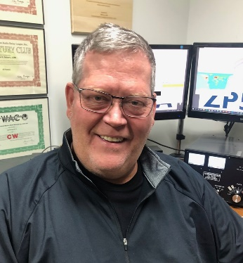

***DX This Week – FT8 Audio***

***Bill AJ8B (aj8b@arrl.net, @AJ8B, or www.aj8b.com)***

***CWOPs Member #1567***

The Midwest DX Cluster spots included Antarctica, Austria, Azores, Belgium, Belize, Bosnia-Herzegovina, Canada, Canary Islands, Ceuta & Melilla, Crete, Croatia, Cuba, Czech Republic, El Salvador, England, Faroe Islands, Fed. Rep. of Germany, France, Ghana, Honduras, Isle of Man, Israel, Italy, Japan, Mali, Malta, Netherlands, Northern Ireland, Norway, Poland, Portugal, San Marino, Serbia, Slovak Republic, Slovenia, Spain, Sweden, Switzerland, United States, Uruguay, Venezuela, and Wales.

This brings the total number of entities spotted in the Midwest in 2021to 126!

TOP ^

***DAH DIT DIT DIT DAH DAH DIT DIT DIT DAH***

Local DX News – From Bernie W3UR

***KH0 – Mariana Islands –****KH0/KC0W, Tom, reports he and our own, W8GEX, Joe, had the “Worlds First” 60 meter QSO from KH0. Congrats to Joe!*

***DAH DIT DIT DIT DAH DAH DIT DIT DIT DAH***

**160M Update –** I would love to tell you that I added significantly to my country count but work commitments and grand kids had me tied up the entire contest weekend. Suddenly we are approaching the halfway point of winter and 160 DX will be in the rear view mirror soon! Speaking of which, I came in to work after working a JA on 160M and I was pretty excited. Although technical in nature, the rest of my group just could not appreciate how I felt. THEN….one of the other guys in the building, who is on the verge of studying to get a ticket, came up with this analogy. He asked them if they could imagine going to Japan, turning on the car radio and listening to WCKY, 1530 on “your radio dial”. They said no. He then added that WCKY was running about 30X what I was running using a very tall tower on a hill in Cincinnati. It started to dawn on them that this was not something done with walkie-talkies! So, thanks to Chris for providing an analogy that got their attention.

***DAH DIT DIT DIT DAH DAH DIT DIT DIT DAH***

I received cards from 9G5FI – Tom in Ghana, VK3CWB – Moz in Victoria, Australia. Let me know what you’ve received.

|  |  |
| --- | --- |
|  |  |

***DAH DIT DIT DIT DAH DAH DIT DIT DIT DAH***

When I was first trying out FT8, I came across an article by Mike, W9MDB, and Eric, WA1SXK. I found it to be very helpful in setting up the sound card for FT8 and for other sound card-based modes. I am reprinting it with their permission.

**FT8 – Avoiding Harmonics and Audio Settings**

The FT8 sound card mode is an MFSK mode with redundancy and error checking. If you have been hearing about this new mode or have been using it, this article can aid you to set up and operate the FT8 data mode with good clean signals. FT8 allows you to view and decode dozens of signals at once with the waterfall display. This means your audio setup and bandpass settings will be of utmost importance while operating the FT8 sound card mode.

TOP ^

The settings in this article also work for other digital software (FLDigi, MMTTY, CWSkimmer, etc) but the other software will have to adjust their sensitivity levels for a lower audio signal than most people use. The settings in here maximize the dynamic range instead of what your ear hears. For example, Eric and I use FLDigi and WSJT-X interchangeably without changing any audio settings. For CW or phone, you will likely have to adjust rig levels for your ears.

FT8 is a very popular sound card mode thanks to the WSJT-X team's efforts. See [http://physics.princeton.edu/pulsar/K1JT/wsjtx.html](http://physics.princeton.edu/pulsar/K1JT/wsjtx.html%20) for the software and check out the references for lots of details. A sound card mode is what you might call a poor-person’s SDR (since the software is free you can be poor to enjoy it). All the FT8 relevant modulation/demodulation/bit-correction/error- checking is taking place in the WSJT-X software. During this process your FT8 messages (exchanges) are being encoded with additional information that allows for error detection and bit corruption correction which the receiving side can use to process and validate the received message. The WSJT-X software sound card modes can be used with any rig, new or old. FT8 can demodulate dozens of signals (50hz wide each) in up to 5000Hz of bandpass including overlapping signals. As you can see, many hams can operate at the same time in the same bandwidth. This approach allows new operating paradigms like FT8 Fox&Hound mode that DXCC teams are now using where they can process multiple QSOs simultaneously

(see <http://physics.princeton.edu/pulsar/k1jt/FT8_DXpedition_Mode.pdf).>

One of the areas that seems to be misunderstood while operating FT8 is the how the radio’s bandpass settings affect the operations of this mode. Many of the hams who operate some of the other modes like SSB and CW, use the default bandpass settings in their rig which are frequently too narrow for FT8. Note that most rigs can set the overall bandpass and not separate the Rx/Tx bandpass. Your rig’s bandpass is hopefully at least 200Hz-2400Hz and preferably 200Hz-3000Hz since there are quite a few operators who transmit above 2500 (see Figure 1 with 200Hz-3000Hz). You can view your bandpass in the WSJT-X waterfall by turning off “Flatten”, below that change the pulldown to “Current” and set “N Avg” to 3 or less and “Start 0 Hz” so we can see the changes more easily. What you should see is something like Figure 3, where you have a noise level signal rolling-off at lower and upper ends of the bandpass.

You should adjust the Bins/Pixel and window width, so you can see your entire FT8 signal bandwidth. Then you need to learn your bandwidth controls in your rig, so you can maximize both the low end and high-end cutoff points. Once you have your bandwidth set in your rig as wide as you can make it you can change the “Start 0 Hz” to “Start 200 Hz”. Then adjust the right side of graph until it is inside your upper bandwidth limit. Then turn on “Flatten”. Note that Flatten does not like having the edges of your bandpass in the waterfall and will not behave as well if you adjust this incorrectly. The signal bandpass area between the lower and upper limits of the waterfall window is where the FT8 signals will be displayed and decoded in the software. The frequency limits of the waterfall determine what gets decoded.

Remember your goal for FT8 is to adjust your rig for as much TX/RX bandwidth as possible…you can run it up to 5kHz for WSJT-X (as much as WSJT-X can do right now). Most rigs should do at least 2400Hz. Many rigs have bandwidth settings called NAR/MID/WID filters and the WID settings should always be used and it can usually be adjusted for the largest bandwidth. If you can’t find your rig’s bandwidth settings after consulting with your manual feel free to contact one of the authors.

Once you have your bandwidth set correctly you are now ready to set up your receive signal’s path:

TOP ^

**#1** Open the sound control panel on your computer, right-click your rig sound device, select Properties, and set the Level of your sound card Playback device (and Recording device) to 0dB. You can get to the sound control panel in Windows 10 by right clicking the speaker icon and select “Open Sound Settings” and find the “Sound Control Panel” entry and your audio is probably called “USB Audio CODEC”. Right click the device for your rig and select “Properties”. Select the Level tab and right-click in the level slider to set the scale to dB instead of the default percentage.

**#2** In the Advanced tab set your sample rate to 48kHz 16-bit. Also, ensure all enhancements or spatial sound effects are turned OFF. In WSJT-X set your Input and Output sound device to the left channel. If you do not see decoding, try the right channel. Same goes for transmitting. You may have to use Mono, but single-channel operation is preferred if it works.

**#3** As of the WSTJ-X 2.1.0 64-bit version the Windows Mixer is also in the audio chain. Search for “Mixer” and open the “Sound mixer options”. Select your output audio device for the rig and set the master level to 100% and, with WSJT-X running, set WSJT-X to 100%.

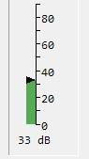**#4** You are now ready to adjust the level in the WSJT-X meter to minimum 30dB and not more than 40dB when you have your rigs VFO tuned on a quiet spot. You can adjust your external sound card knobs if you are using one, and your rigs output level to achieve this. Do NOT make this adjustment using sound controls on the computer…in most cases that is not necessary. The meter in WSJT-X should look something like the image to the right. Again, note this is on a quiet spot on the band with no signals present.

**Now let’s talk about your transmit signal path…**

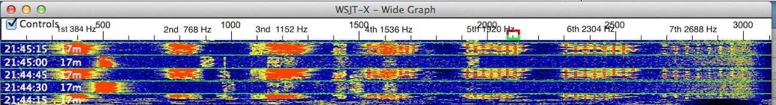A rig that has too much input audio will create a dirty tx signal with very significant harmonics that can disrupt a QSO and everybody can see on the waterfall…. but…here is the problem…you won’t know about it unless you can monitor your own transmitted signal. Any harmonics will show up at multiples of your Tx offset setting in the WSJT-X waterfall of everybody that receives your signal. For example, you can clearly see the noise bars at around 2480 in Figure 1 which is the 3rd harmonic of the signal at 829. In this screenshot, you can see an extreme example with multiple harmonics.

Running WSJT-X’s optional rig split mode or fake it mode will prevent harmonics from showing up in your transmitted signal since harmonics will show up above 3000Hz which is normally outside the transmit passband. But it’s better not to generate them in the first place as your signal also gets affect by the clipping. ALC (Automatic Level Control) is one indicator of clipping and is an easy, roundabout way to know if you are clipping your signal. Another way is to ensure that dB level controls in WSJT-X and your soundcard behave as they should.

TOP ^

To set your transmit levels use the procedure below. This procedure is designed to ensure your signal is just enough to drive the rig without any ALC taking place. Please note that ALC is not the cause of any harmonics but is the canary-in-the-coal-mine telling you that your levels are unnecessarily high. You MUST understand what your ALC meter is telling you and where “no ALC” is shown.

**Things you need to know to do this procedure:**

How much power your rig can transmit for FT8. Many rigs cannot use full power for this type of mode and some rigs can’t even do their rated power on a constant envelope signal without hitting the ALC.

How to read and understand your rig’s ALC meter. Anything above 0dB ALC (i.e. 0dB attenuation) is potentially bad for some rigs and FT8/digital modes (see exceptions in Table 1). The question is, how does your rig show 0dB ALC? For most older rigs 0dB is the left-hand side of the meter or just a red-light indicator when ALC is in effect. On newer SDR rigs you do want to see some ALC action as 0dB is not the left-hand side of the meter...read your manual. The procedure below will help you confirm how your meter behaves.

**How to set the rig output power level**

How to set rig audio input level (RAIL) – this is the audio level that the rig sees from the computer or the external sound card. We will also be adjusting any external sound card like a SoundBlaster or SignaLink (if you have one) and the RAIL together. To start make your rig’s audio level (MIC control or menu control for USB input audio level) zero. Many (most?) rigs want minimum gain at the rig as we will be feeding full-level audio to it.

**#1** Use a dummy load and set your rig power level to the maximum it can do for CW mode (look at the rig specs – could be anywhere from 30-100% of full power). We just need to ensure we have enough “room” in the rig setting so that we can feed a signal and not be any more than 50% of the rig’s power setting.

**#2** Set WSJT-X to full power on the Pwr slider

**#3** Confirm your sound card playback device is 0dB and 1-channel 48kHz sample rate. Recording should be the same 0dB, 1-channel 48kHz. Set WSJT-X to one channel (usually the left channel). Also ensure your sound card audio playback is NOT the default device. If you make it the default than all your windows sounds (beeps, YouTube, etc.) will playback through your rig. You need to right-click another audio device (like your real speakers) and select it as the default. If you have to use the line out or speaker out from your computer, you should listen to the audio and may have to reduce the playback level to avoid distortion from the computer.

**#4** Set your RAIL to minimum and your playback/outgoing/transmit sound card to minimum.

**#5** Set the TX offset to 1500 – we want to ensure the tone we generate is in this “sweet spot”.

**#6** Press "Tune" on WSJT-X -- at this point you should have no power being transmitted. If you see power, go check your settings again.

**#7** Set your external audio device (if you have one) to about 50% or 12 o’clock. This should be a moderate output level from most any external soundcard.

TOP ^

**#8** Increase RAIL SLOWLY until you get about 20W (assuming your rig is set at 100W or use 20-50% of whatever your rig power setting is). Whatever your ALC meter says at that point is probably what you want and is below 0dB. On most rigs the ALC meter won't even move or barely move. If your ALC is more than minimal at this setting, then you probably have an Elecraft K3 which wants 4 bars + tickling the 5th bar to operate at capacity. It’s important you understand what your ALC meter is telling you. You do not want any ALC on an FT8 signal (or any other digital signal). #7 Bring up RAIL until ALC starts increasing, then decrease gain back to where it was. For the K3 and such you should be able to put out max power without exceeding the K3’s 4bars+5th. Some rigs are very touchy and finding the right combination of rig gain and audio device gain takes some experimentation. We’ve found several rigs where mic gain is just above zero to give no ALC indication.

**#9** Sanity check – the Pwr slider on WSJT-X should show 50% power loss for every 3dB down. So, if you are 100W at full scale (0dB on the Pwr slider) then -3db should be 50W and -6dB should be 25W (linear behavior). If your power does not decrease close to that (give or take 10%), then your audio is still wrong. You could be overdriving the A/D in your rig which may also clip your signal. An example is the FT-450D which has a 60mV input with a SignaLink that provides up to 100mV. If you put over 60mV into the FT-450D your signal will clip. The Pwr slider in WSJT-X is an indicator when this is occurring since dropping from 100mV to 80mV won’t matter to the rig and the -3dB Pwr slider setting will still show 100W. Another example is the IC-7300 – the USB MOD LEVEL of 23 may be too high and lowering it to 22 or 21 may be needed to see 50W at -3db and 100W at 0dB.

**#10** Repeat #9 for the lower and upper limits of what you believe is your bandpass. You should see the same power level behavior for your entire bandpass. If you see the maximum power level reduce at any point, then your bandpass or notch filters may be the reason…double check them. If you run WSJT-X in either “Rig Split” or “Fake It” (in Settings/Radio) than your audio will always be 1500-2000Hz and actually allow you to work signals beyond your bandwidth (i.e. if you can decode them you can work them).

You should now be seeing maybe 80-100% of your rig's power level (depending on rig) with no ALC being tickled (or the 4bars+ as explained above). That's how you want to operate FT8 to ensure a clean signal. You can leave your rig power level at the maximum and adjust your transmitted power from WSJT-X (except for the K3 where you should adjust on the rig only due to the K3’s power hunting feature) and your signal will always be clean. Changing rig power on the rig or audio levels in the rig or sound card that you have already set may end up triggering the ALC again so be vigilant that the ALC is always where it should be.

Hope to see you on the bands with a clean signal!

Notes:

* The Playback device in Windows should have no “green checks” on it. You can right-click another playback device and click the two “Default” settings.
* Windows updates can and will change your audio devices and levels and need to be rechecked after every update.
* On all rigs if you do not get 50% power at -3dB then you are not in the linear range of your rig settings. Normally lowering the gain at the rig will fix this.
* For most rigs set the audio input device to the left channel and the output to the left channel too.
* IC-7300 – set the Input device to the left channel and the output to Mono. It seems the IC-7300 won’t operate on just the left channel.

TOP ^

***CQDX CQDX CQDX CQDX CQDX CQDX CQDX CQDX CQDX***

Here is an update from Bernie, W3UR, of the DailyDX and the WeeklyDX, the best source for DX information. <http://www>.dailydx.com/. Bernie has this to report:

**3W – Vietnam -** SP5FAR, Sebastian Burcicki, gives us more details on his February-March 2021 activity from Da Nang. “Due to the nature of my work, I am unable to provide exact hours of operation”, says Sebastian. On his days off he plans to “try to be active 2-5 UTC and 11-17UTC” as [3W9FAR](http://r20.rs6.net/tn.jsp?f=001cxshul2VawuFHquKD8FNJDtHg2IOrJIRc_S36sw8k6NckDXFpI0NRAjoz7fuSCX9WUkU4EFAsN-8tiWsgZL96DIt_22rrQPIOhQv2wo_peO7sxXEmrmAn46HtCuG4kM6OO8t30pT7dscs_FPr2serA==&c=evBZkX--HGQIw8OlfRQ7m7MLgSgdbEyvvCAKBVWDQbTvzIG-Wf-G8w==&ch=m5vCD0NiDLMx62QeOOCuhS8btZFL8eI12aaKl1FjI1EQXfBcJxCTTg==). He’ll be running 20 watts on SSB and 10 watts on Digital from a Xiegu 90, transmitting into an OM0ET Magnetic Loop located outside his window from the 7th floor. Activity will be on 40, 20, 15 and 10 meters SSB and Digital QSL via eQSL.

**HI – Dominican Republic -** HB9TUZ, Massimo, plans to operate as HI9/HB9TUZ from Las Terransa from August 1-30. Activity will be on SSB on 7 through 28 MHz. QSL only via eQSL.

**OH0W Aland Islands -** Here’s a drone aerial video of this past weekend’s OH0W Aland Islands operation by OH2BH and OH2GEK.  [https://www.youtube.com/watch?v=c4W5vfMStjQ](http://r20.rs6.net/tn.jsp?f=001ZlYfGv5tvF50FNiOFXiLVFW5GcfgyMgT7JlLS_TvQbGfo4_zQmFmFTSdTyzKpXajR-lbm2ybOjNzpdDYwKSrOKlwRvNtlHpF5yQgsKwyuCpOtjIKTCBR4HcmqH12npXrTX-XqHPkvhQn3wU56iJ_pokFUrt8Uu0q96JSKdOyXZ0-UYqXeZi8FA==&c=hhfGqjZ3WVWNXRE2Bal1bZ-nOK8TF1dIBYtLcUL_aGjdnaMSx6DSLw==&ch=a52heVn8CYa4zIdoAEPyhxtpiNf1qQK5JOD8p0cJRHnlsWRCc3HO_Q==)

**ARRL Outgoing QSL bureau - Thanks to Joe, W8GEX -** For those who have not been to the ARRL in Newington, Connecticut here is a four minute video on the ARRL Outgoing QSL bureau by KB1DMW, Rose-Anne Lawrence, Outgoing QSL Bureau Associate.

<https://www.youtube.com/watch?v=Vxgcn3sMVtU&feature=youtu.be>

***DAH DIT DIT DIT DAH DAH DIT DIT DIT DAH***

**QSO Today Virtual Ham Expo –** Tickets are now available to attend the QSO Today Virtual Ham Expo sponsored by the QSO Today Podcast, FlexRadio, Icon and Elecraft. Information can be found at <https://www.qsotodayhamexpo.com/> There are several hams from our area who will be speaking and you can watch the presentations live, ask questions of the presenters, and well as visit the booths of many vendors. The dates are March 13th and 14th. Also, you will be able to access many of the presentations until April 12th.

Several contributors to the Ohio Section Journal will be giving presentations at this event. Check it out and let me know what you think!

***DAH DIT DIT DIT DAH DAH DIT DIT DIT DAH***



Below is a list of upcoming contests in the “Contest Corner”. I think this is important for someone who is trying to move up the DXCC ladder since entities that are on the rarer side and easiest to work in contests. Some of my best “catches” have been on the Sunday afternoon of a contest when the rarer entities are begging for QSOs. Of course, the gamble is that if you wait until Sunday, conditions may change, or they simply won’t be workable. However, it is not a bad gamble. Of course, why not work the contest and have some fun!

TOP ^

Check out the WA7BNM Contest Calendar page (<https://www.contestcalendar.com/>) for more contests or more details.

The contests in red are those that I plan to spend some significant participation time on. PLEASE let me know if you are working contests and how you fared.

Thanks!

|  |  |  |
| --- | --- | --- |
| Feb. 21 | FISTS Winter Sunday Sprint | <http://www.fistsna.org/operating.html> |
| Feb. 20-21 | ARRL CW DX Contest | <http://www.arrl.org/arrl-dx> |
| Feb. 20-21 | Russian WW PSK Contest | <http://bit.ly/2MsppCr> |
| Feb. 24 | UKEICC 80m Contests CW | <https://bit.ly/2SDPqQQ> |
| Feb. 25 | RSGB 80m Club Championship, CW | [https://www.rsgbcc.org/hf/rules/2020/r80mcc.shtml](http://www.rsgbcc.org/hf/rules/2020/r80mcc.shtml) |
| **Feb. 26-28** | **CQ WW 160M SSB Contest** | [**http://www.cq160.com/rules.htm**](http://www.cq160.com/rules.htm) |
| Feb. 27-28 | REF SSB Contest | <http://concours.ref-union.org/contest/?page_id=2> |
| Feb. 28 | High Speed Club CW Contest | <http://www.highspeedclub.org/> |
| Feb. 27-28 | South Carolina QSO Party | <http://scqso.com/> |
| Feb. 27-28 | North American RTTY QSO Party | <http://ncjweb.com/naqp/> |
| Feb. 27-28 | UBA CW DX Contest | <http://bit.ly/W0gZiE> |
| Feb. 28-Mar.1 | North Carolina QSO Party | <http://ncqsoparty.org/rules/> |
| Mar. 1 | RSGB 80m Club Championship, Data | <http://bit.ly/3avHbk3> |
| Mar. 2 | AGCW YL-CW QSO Party | <http://bit.ly/3plBhpN> |
| Mar. 3 | UKEICC 80m Contests SSB | https://bit.ly/2SDPqQQ |
| Mar. 6-14 | Novice Rig Round-Up | [www.novicerigroundup.org](http://www.novicerigroundup.org/) |
| **Mar. 6-7** | **ARRL SSB DX Contest** | [**www.arrl.org/arrl-dx**](http://www.arrl.org/arrl-dx) |
| Mar. 6-7 | Open Ukraine RTTY Championship | <http://krs.ho.ua/openrtty> |
| Mar. 7 | SARL YL Sprint | <http://bit.ly/H0IqQf> |
| Mar. 7 | UBA Spring Contest 80m CW | <http://bit.ly/2KKAtb9> |
| Mar. 10 | RSGB 80m Club Championship, CW | <http://bit.ly/3avHbk3> |
| Mar. 13 | AGCW QRP Contest | <http://bit.ly/2KKp3rY> |

TOP ^

|  |  |  |
| --- | --- | --- |
| Mar. 13 | YB DX RTTY Contest | https://rtty.ybdxcontest.com |
| Mar. 13-14 | Idaho QSO Party | [www.pocatelloarc.org/idahoqsoparty](http://www.pocatelloarc.org/idahoqsoparty) |
| Mar. 13-14 | Oklahoma QSO Party | <http://k5cm.com/okqp.htm> |
| Mar. 13-14 | QCWA QSO Party | [www.qcwa.org/qcwa.php](http://www.qcwa.org/qcwa.php) |
| Mar. 13-14 | North American RTTY Sprint | <http://ncjweb.com/north-american-sprint> |
| Mar. 13-14 | RSGB Commonwealth CW Contest | <http://bit.ly/2KxebOr> |
| Mar. 13-14 | South America 10 Meter Contest | [www.sa10m.com.ar/index.html](http://www.sa10m.com.ar/index.html) |
| Mar. 13-14 | Stew Perry Topband Challenge | [www.kkn.net/stew](http://www.kkn.net/stew) |
| Mar. 14 | FIRAC HF Contest | [www.firac.de/html/contest.html](http://www.firac.de/html/contest.html) |
| Mar. 14-15 | Wisconsin QSO Party | [www.warac.org/wqp/wqp.htm](http://www.warac.org/wqp/wqp.htm) |
| Mar. 15 | RSGB FT4 Contest Series | <http://bit.ly/3mCNXXH> |
| Mar. 20-21 | Virginia QSO Party | https://bit.ly/2Khd2ul |
| Mar. 20-21 | Russian DX Contest | [www.rdxc.org/asp/pages/rulesg.asp](http://www.rdxc.org/asp/pages/rulesg.asp) |
| Mar. 20-22 | BARTG HF RTTY Contest | <http://bartg.org.uk/wp/contests> |
| Mar. 21 | UBA Spring Contest 80m SSB | <http://bit.ly/2KKAtb9> |
| Mar. 25 | RSGB 80m Club Championship, SSB | <http://bit.ly/3avHbk3> |
| Mar. 27 | FOC QSO Party | [www.g4foc.org/qsoparty](http://www.g4foc.org/qsoparty) |
| **Mar. 27-28** | **CQWW WPX SSB Contest** | [**www.cqwpx.com**](http://www.cqwpx.com/) |
| Mar. 31 | UKEICC 80m Contests CW | https://bit.ly/2SDPqQQ |
| May 29 – 30 | CQWW WPX CW | <https://www.cqwpx.com/> |
| August 28 | Ohio QSO Party | <https://www.ohqp.org/> |
| August 28 | W8DXCC | <https://www.w8dxcc.com> |

***DX News***

***ARLD006 DX news***

This week's bulletin was made possible with information provided by F8DVD, The Daily DX, the OPDX Bulletin, 425 DX News, DXNL, Contest Corral from QST and the ARRL Contest Calendar and WA7BNM web sites.

**TUNISIA, 3V.** Ash, KF5EYY plans to be QRV as 3V8SS during the CQ World Wide RTTY WPX contest as a Single Op/All Band/Low Power entry.

QSL via LX1NO.

**VIET NAM, 3W.** Sebastian, SP5FAR is QRV as 3W9FAR from Da Nang until March 21. Activity is in his spare time on the HF bands using SSB and various digital modes. QSL to home call.

TOP ^

**LIBYA, 5A.** Elham, 5A0YL has been QRV on 17 meters using FT8 around 1700z. She has also been active on 20 meters using FT8 around 1350z. QSL to home call.

**TOGO, 5V.** Daniel, HB9EHD is QRV as 5VDE until February 20. Activity is on 40 and 20 meters using FT8. This includes being active on Satellte QO-100. QSL direct to home call.

**MALDIVES, 8Q.** Sergei, RU3AN is now QRV as 8Q7SZ and is here until February 15. QSL via bureau.

**MOZAMBIQUE, C9.** Bruno, CS7AMN will be QRV as C91BVA from Maputo beginning February 18. Activity will be on 80, 40, 20, 15 and 10 meters using SSB and various digitial modes. QSL via LoTW.

**SPAIN, EA.** Members of the Radio Club Henares will be QRV as EH4WRD on February 13 as part of World Radio Day. QSL via EA4RCH.

**FRANCE, F.** Francois, F8DVD will be QRV as TM18AAW from Macon from February 14 to 28 in celebration of the 18th Antarctic Activity Week. QSL to home call.

**MARTINIQUE, FM.** Romaric, W7ROM is QRV as FM4WDM from Le Morne-Vert. Activity is on the HF bands. QSL to home call.

**ITALY, I.** Special event station IQ3DD is QRV until February 28 to recognize the FIS Alpine World Ski Championship being held in Cortina. Activity is on 160 meters to 23 centimeters, using CW, SSB, and various digital modes. This includes some activity on Satellite QO-100. QSL via bureau.

**JAN MAYEN, JX.** Erik, JX2US has been QRV on 20 meters using CW around 0930 to 1100z. QSL via LA2US.

**WAKE ISLAND, KH9.** Tom, NL7RR plans to be QRV as KH9/NL7RR beginning February 15 and will be here for 90 days. Activity will be in his spare time on 40 and 20 meters using SSB. Time permitting, he hopes to operate as KH9/NL7RR on 40 and 20 meters using SSB. QSL via AL7JX (d/B).

THIS WEEKEND ON THE RADIO. The CQ World Wide RTTY WPX Contest, Asia-Pacific Spring CW Sprint, SKCC Weekend CW Sprintathon, KCJ Topband CW Contest, Dutch PACC Contest, YLRL YL-OM Contest, OMISS SSB QSO Party, HamCation QSO Party, Feld Hell Sprint, RSGB 1.8 MHz CW Contest, AWA Amplitude Modulation QSO Party, PODXS 070 Club Valentine PSK31 Sprint and Balkan HF Contest will certainly keep contesters busy this upcoming weekend.

The RSGB FT4 Contest Series, 4 States QRP Group Second Sunday Sprint, OK1WC Memorial, K1USN Slow Speed Test and CQC Winter CW QSO Party are scheduled for February 15.

The Worldwide Sideband Activity Contest and RTTYOPS Weeksprint are scheduled for February 16.

The AGCW Semi-Automatic Key Evening, Phone Fray and CWops Mini-CWT Test are scheduled for February 17.

Please see February 2021 QST, page 73, and the ARRL and WA7BNM contest web sites for details.

TOP ^

**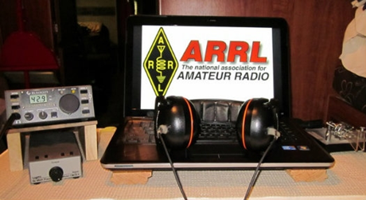*ARRL Contest Corner***

An expanded, downloadable version of *QST'*s’ [**Contest Corral**](http://www.arrl.org/contest-calendar) is available as a PDF. Check the sponsor’s ‘Website for information on operating time restrictions and other instructions.

***Special Events***

* **02/20/2021 | George Washington's Birthday**

**Feb 20-Feb 22, 2000Z-2000Z, WS7G**, George, WA. Columbia Basin DX Club. 14.322 7.222 3.855. QSL. Brian Nielson, 11650 Road 1 SE, Moses Lake, WA 98837. We will be commemorating George Washington's Birthday from the city of George, in the state of Washington. In February of 2021, our special event station will operate Saturday, February 20th, from 2000 Zulu through Monday, February 22nd at 2000 Zulu. You can find us on 14.322/14.255, 7.222/7.260, AND 3.855/3.960 plus/minus QRM. [cbn.homestead.com/WS7G.HTML](http://cbn.homestead.com/WS7G.HTML)

* **02/25/2021 | Copper dog 150 Dog sled race**

**Feb 25-Mar 2, 0000Z-0000Z, K9C**, Calumet, MI. Keweenaw County Repeater Assn.. 7.300. QSL. Jeffrey Stricker W9GY, 59624 Dextrom Rd, Calumet, MI 49913. [https://kcra-mi.net](https://kcra-mi.net/)

* **02/27/2021 | 17th Annual "Freeze Your Keys" Winter Operating Event**

**Feb 27, 1400Z-2200Z, W0EBB**, Leavenworth, KS. Kickapoo QRP Amateur Radio Club. 14.058 7.035 14.325 7.240. QSL. Gary Auchard, 34058 167th Street, Leavenworth, KS 66048. SASE please for return QSL cards. w0mna74@gmail.com or [www.qrz.com/db/w0ebb](http://www.qrz.com/db/w0ebb)

* **03/11/2021 | Battleship Texas Birthday**

**Mar 11-Mar 14, 0000Z-0000Z, W5T**, Cleburne, TX. Club KC5NX. 14.255 14.045 7.240 7.235 . QSL. Club KC5NX, 9200 Summit Ct W , Cleburne, TX 76033-8212. Club KC5NX back on the air for the celebration of the 107th birthday of the Battleship TEXAS. jay.n.violet@gmail.com or check here to find us: https://www.dxwatch.com/dxsd1/dxsd1.php?f=0&c=w5t&t=dx <https://www.qrz.com/db/kc5nx>

* **03/13/2021 | USS Midway Museum Ship Special Event: Launching of USS Midway**

**Mar 13, 1700Z-2359Z, NI6IW**, San Diego, CA. USS Midway (CV-41) Museum Ship. 7.250 14.320 14.070 (PSK31) DSTAR vis PapaSystem repeaters. QSL. USS Midway CV-41 COMEDTRA NI6IW, 910 N Harbor Drive, San Diego, CA 92101. SASE please. [www.qrz.com/db/ni6iw](http://www.qrz.com/db/ni6iw)

* **03/14/2021 | PI Day - David Sarnoff Radio Club, Princeton, NJ**

**Mar 14, 0000Z-2359Z, N2RE**, Princeton, NJ. David Sarnoff Radio Club. 14.250 14.050 7.200 7.050. QSL. Bob Uhrik, 104 Knoll Way, Rocky Hill, NJ 08553. Famous Princetonian Albert Einstein was born on PI Day. [n2re.org](http://n2re.org/)

TOP ^

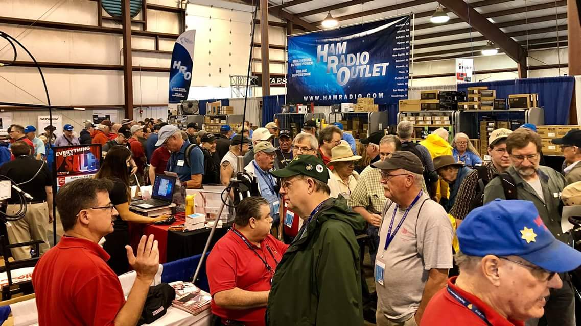[***Upcoming Hamfests***](http://arrl-ohio.org/hamfests.html)

We **DO** have some hamfests scheduled for 2021!! Yes, take a good look at the list, it’s growing every day!

Be sure to keep your eyes on this schedule as that when things start getting better and the vaccine rolls out to more and more, hamfests will surely get back to their normal schedule. Don’t see your hamfest listed?? Did anyone register it with ARRL? It’s really easy to do and you get a lot of FREE publicity if you do.

|  |  |
| --- | --- |
| **04/25/2021 -**[**Athens Hamfest**](http://www.arrl.org/hamfests/athens-hamfest-9)  **Location: Athens, OH Sponsor: Athens County Amateur Radio Association Website:**<http://ac-ara.org/>  [**Learn More**](http://www.arrl.org/hamfests/athens-hamfest-9) | **06/05/2021 -**[**FCARC SummerFest**](http://www.arrl.org/hamfests/fcarc-summerfest)  **Location:**Wauseon, OH **Sponsor:**Fulton County Amateur Radio Club **Website:**<http://k8bxq.org/hamfest>  [**Learn More**](http://www.arrl.org/hamfests/fcarc-summerfest) |
| **07/10/2021 - [Mansfiled Mid-Summer Trunkfest](http://www.arrl.org/hamfests/mansfiled-mid-summer-trunkfest" \o "Mansfiled Mid-Summer Trunkfest)**  **Location:**Mansfield, OH **Sponsor:**InterCity Amateur Radio Club **Website:**<http://iarc.club>  [**Learn More**](http://www.arrl.org/hamfests/mansfiled-mid-summer-trunkfest) | **07/18/2021 –**[**Van Wert Hamfest**](http://www.arrl.org/hamfests/van-wert-hamfest-5)  **Location:**Van Wert, OH **Sponsor:**Van Wert Amateur Radio Club **Website:**[http://W8FY.ORG](http://w8fy.org/)  [**Learn More**](http://www.arrl.org/hamfests/van-wert-hamfest-5) |
| **08/28/2021 -**[**Cincinnati Hamfest℠**](http://www.arrl.org/hamfests/cincinnati-hamfest)  **Location:**Owensville, OH **Sponsor:** Milford ARC **Website:** [http://CincinnatiHamfest.org](http://cincinnatihamfest.org/)  [**Learn More**](http://www.arrl.org/hamfests/cincinnati-hamfest) | **09/26/2021 -**[**Cleveland Hamfest**](http://www.arrl.org/hamfests/cleveland-hamfest-1)  **Location:**Berea, OH **Sponsor:** Hamfest Association of Cleveland **Website:** [http://www.hac.org](http://www.hac.org/)  [**Learn More**](http://www.arrl.org/hamfests/cleveland-hamfest-1) |
| **12/04/2021 -**[**FCARC WinterFest**](http://www.arrl.org/hamfests/fcarc-winterfest-2)  **Location:** Delta, OH  **Sponsor:** Fulton County Amateur Radio Club  **Website:** <http://k8bxq.org/hamfest>  [**Learn More**](http://www.arrl.org/hamfests/fcarc-winterfest-2) | |

TOP ^

***Upcoming NIMS Training Opportunities***

Need to get those really hard to get ICS 300 and 400 classes to get to Level 3? They are now being offered with very limited virtual seating. Yes, these classes are being offered virtually now along with a lot of other classes that used to require in-class sessions. Want to see what and where these classes are being offered?

[**>> Click Here <<**](http://arrl-ohio.org/SEC/Ohio_EMA_Training_List_Feb_2021.pdf)

***Print an Official or Unofficial Copy of Your Amateur Radio License***

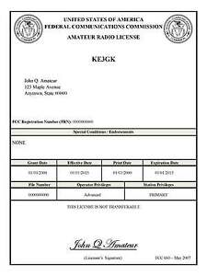*(By Anthony Luscre, K8ZT)*

As of February 17, 2015, the **FCC no longer routinely issues paper license documents** to Amateur Radio applicants and licensees. The Commission has maintained for some time now that the official Amateur Radio license authorization is the electronic record that exists in its Universal Licensing System (ULS). The FCC will continue to provide paper license documents to all licensees who notify the Commission that they prefer to receive one.

Licensees also will be able to print out an official authorization — as well as an unofficial “reference copy” — from the ULS License Manager. I’ve created a set of instructions on how you can request an **“official” printed copy of your license\***

[**Click here to download the instructions**](http://arrl-ohio.org/news/2020/print_your_license.pdf)

***One Question Questionnaire***

Hey Gang,

Survey Says”….. 74% of you have checked into a net within the last month. Fantastic!!.. Maybe I’ll hear you on one of those nets soon!

Ok, now on to the next question… With HamCation being virtual this year, the folks that produce this hamfest decided to at least hold virtual forums for those of us who just can’t get enough of them. So, here’s the next question for you.

***“Did you attend any of the On-line forums from HamCation?”***

You’ll find the “One Question” questionnaire on the Ohio Section Website! <http://arrlohio.org> It’s all for fun and it’s not a scientific survey in any way, but we are learning some things that we didn’t know from these questions. I hope that you are enjoying answering these “One Question” questionnaires.

TOP ^

*****V.E. Test Sessions***

Many V.E.’s have decided to start testing once again, but with restrictions that need to be adhered to for sure. Here’s the link to find that V.E. Test session and what is expected of YOU before going. <http://www.arrl.org/find-an-amateur-radio-license-exam-session>

***SPECIAL NOTIFICATION***



From the National Weather Service

As previously mentioned, we will not be able to conduct in person spotter training classes this winter and spring due to restrictions associated with COVID. Therefore, we will hold several virtual spotter training classes. These classes will be open to the public and free of charge. Please feel free to promote to your staff, spotters, amateur radio operators and to publicize to the citizens in your community.

All of our classes will be conducted as live webinars with live Q&A. We will use the GoToWebinar software, which can host up to 1000 people for each session. These webinars will not be recorded. 6 webinars are currently planned in February and March, with different days of the week and diverse times represented.

If the demand is high enough, we may consider a 7th webinar in April. All those who attend will need to register in advance. Below are the links to the 6 scheduled classes:

* Spotter Webinar 1: Friday, February 19, 2021 (1 PM - 3 PM):

<https://register.gotowebinar.com/register/8258577384418148110>

* Spotter Webinar 2: Wednesday, February 24, 2021 (7 PM - 9 PM):

<https://register.gotowebinar.com/register/4105945167168648206>

* Spotter Webinar 3: Thursday, March 4, 2021 (7 PM - 9 PM):

<https://register.gotowebinar.com/register/8790359481726954766>

* Spotter Webinar 4: Monday, March 8, 2021 (6 PM - 8 PM):

<https://register.gotowebinar.com/register/5017422714408992270>

* Spotter Webinar 5: Tuesday, March 23, 2021 (6 PM - 8 PM):

<https://register.gotowebinar.com/register/8257513057162542350>

* Spotter Webinar 6: Saturday, March 27, 2021 (12 PM - 2 PM):

<https://register.gotowebinar.com/register/5687758669980329230>

TOP ^

Ohio Section Cabinet

|  |  |
| --- | --- |
| Section Manager – Tom Sly, WB8LCD | Section Traffic Manager – David Maynard, WA3EZN |
| Section Emergency Coordinator – Stan Broadway, N8BHL | Section Youth Coordinator – Anthony Lascre, K8ZT |
| Technical Coordinator – Jeff Kopcak, K8JTK | Affiliated Clubs Coordinator – Tom Sly, WB8LCD |
| State Government Liaison – Bob Winston, W2THU | Public Information Coordinator – John Ross, KD8IDJ |



Hey Gang,

Have you taken a look at the **Swap & Shop** page on the Ohio Section webpage yet?? Here’s a link that will take you there… <http://arrl-ohio.org/sm/s-s.html>

Do you have equipment that you just don’t need or want anymore? Here’s a great venue to advertise it, and it’s FREE!! Is your club doing a fund raiser to help raise money? After a lot of thought, it was decided that the Swap & Shop webpage could also contain these types of items as well. The same rules will apply as do for the For Sales and Give-A-Ways and will only be posted for a month at a time. Please see the Terms & Conditions on the webpage.

If your club is doing a fund raiser and wants more exposure, please forward the information to me and I’ll advertise it on the Swap & Shop webpage for you.

Now, I still want to remind you that it won’t be listed in this newsletter because it would take up way too much space, so your ad will only appear on the website. It is there for any individual to post equipment Wanted / For Sale or Give-Away as well as for Club Fund Raisers. No licensed vehicles/trailers or business advertising will be posted. Postings are text only (no pictures or graphics) will be posted for a maximum of 1 month from date posting and require a contact phone number or email within the posting. Send your Wanted / For Sale or Give-Away post to:  [swap@arrlohio.org](mailto:swap@arrlohio.org)

***Back Issues of the PostScript and Ohio Section Journal***

Hey, did you know that PostScript and Ohio Section Journal (OSJ) are archived on the website? You can go back and look at any edition simply by clicking:

<http://arrl-ohio.org/news/index.html>

***Welcome New Subscriber(s)***

**Richard Reszler**

TOP ^

***Want to Share your Club Newsletter With Others?***

We have a webpage where you can download and read all of the newsletters that I get from around the state and even other sections!

Here’s the link to the page…. <http://arrl-ohio.org/club_news/index.html>

Please, if you don’t see your club newsletter posted, it’s because I’m not receiving it. Just have your newsletter editor contact me and I’ll get your club’s newsletter listed on the site!!

We all learn and steal (I mean, share) from each other’s work. So, get me your newsletter!!! Send it to: [webmaster@arrl-ohio.org](mailto:webmaster@arrl-ohio.org)

***Chit – Chat, and All That!***

Do you know someone that’s not getting these Newsletters? Please, forward a copy of this Newsletter over to them and have them “[Opt-In](mailto:Opt-In)” to start receiving them. Heck, just have them send an email to: [webmaster@arrl-ohio.org](mailto:webmaster@arrl-ohio.org) and we’ll get them added to the Ohio Section Emailing list.

We now have many thousands of readers receiving these newsletters weekly. Quite impressive, I’d say! I urge all of you to make sure that everyone, regardless of whether they are a League member or not, get signed up to receive these weekly Newsletters.

You can always “Opt-Out” at any time if you feel this is not what you were expecting. It’s fun and very informative. All of your favorite past newsletters are now archived too.

You can go back at any time and read them.

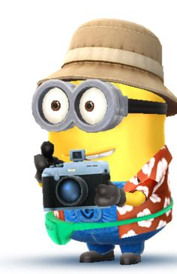Just go to: <http://arrl-ohio.org/news/>

The pictures on the front page and throughout this newsletter are from various newsletters, Facebook posts and/or were sent directly to me in recent weeks. Take a good look at them, you just might be in one of the pictures! “SMILE… you’re in the Ohio Section News!!”

TOP ^

*PostScript is produced as a weekly newsletter. I want to thank everyone that has contributed articles and ideas to make this an even better news source. I sincerely hope that you have enjoyed this edition and will encourage your friends to join with you in receiving the latest news and information about the Ohio Section, and news and events happening around the world!*