[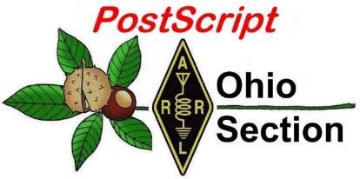](http://arrl-ohio.org/news/) ***“Valentine’s***

***Edition”***

🡪 National News 🡪 Club Corner

🡪 DX This Week 🡪 Contest Corner

🡪 Special Events 🡪 Upcoming Hamfests

🡪 One Question Questionnaire 🡪 From The South 40

🡪 VE Testing

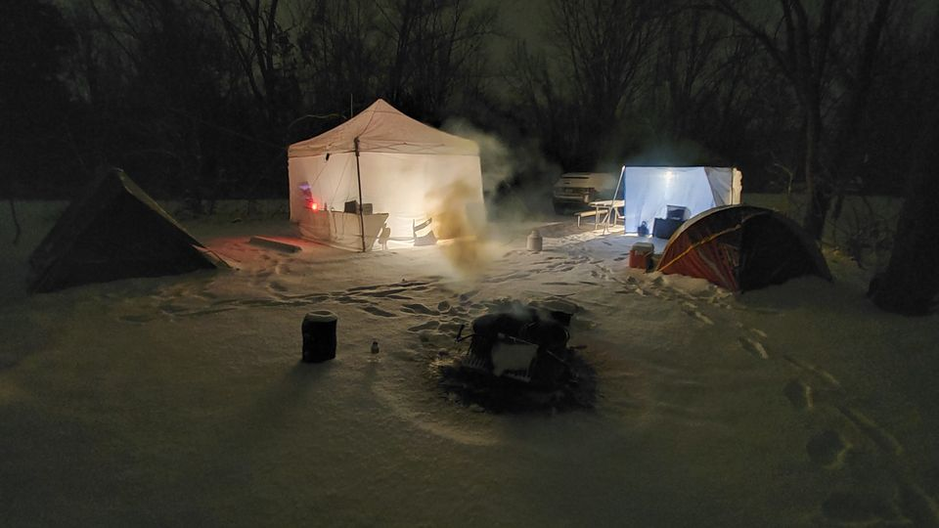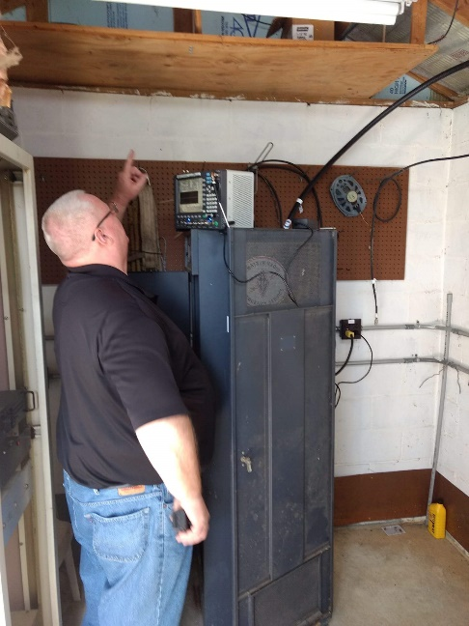

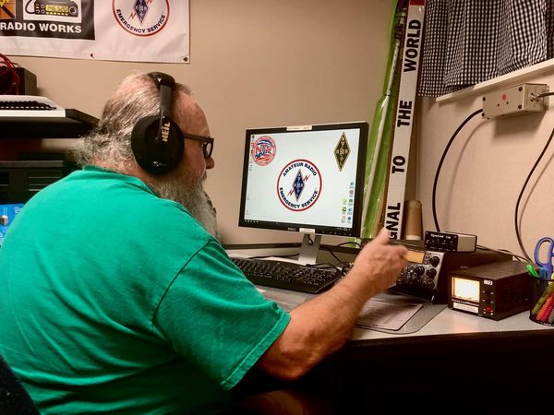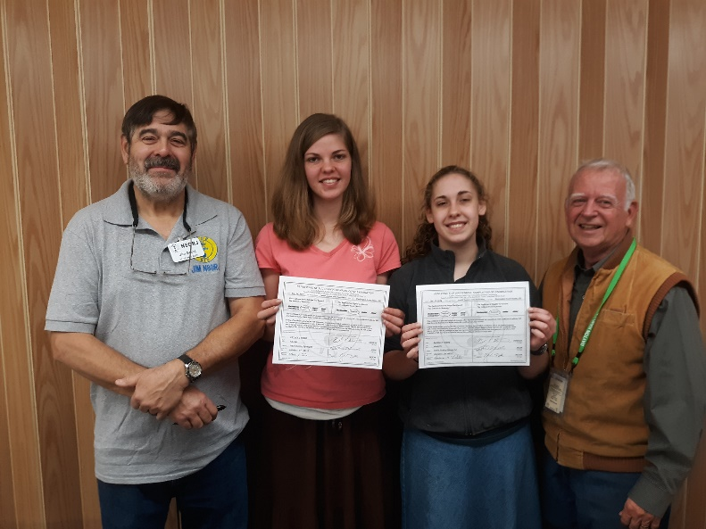

***National News***

*(from arrl and other sources)*

***A New Version of WSJT-X is Now Available***

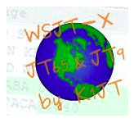

The *WSJT* Development Group has announced the general availability release of *WSJT-X* Version 2.3.0. A summary of new features can be found in the *WSJT-X 2.3* [***User Guide***](https://physics.princeton.edu/pulsar/k1jt/wsjtx-doc/wsjtx-main-2.3.0_en.html#NEW_FEATURES)*.* The [***Release Notes***](https://physics.princeton.edu/pulsar/k1jt/Release_Notes.txt) offer additional information, including a list of important program changes since the *WSJT-X 2.2*. Upgrading from earlier versions of *WSJT-X* should be seamless, and it’s not necessary to uninstall a previous version or move any files. [**Installation packages**](https://physics.princeton.edu/pulsar/k1jt/wsjtx.html) for Windows, Linux, and Macintosh are available.

A release candidate (i.e., beta version) *WSJT-X* version 2.4.0-rc will be available soon. Its main new feature is a mode called Q65, with unique capabilities for EME and scatter propagation modes.

####

***ARRL Board of Directors to Reconsider the Use of Electronic Balloting***

The ARRL Board of Directors will look into the use of electronic balloting systems “to augment paper balloting for ARRL elections.” The Board instituted a hybrid paper and electronic balloting process in the fall of 2012, which was popular among those who took advantage of it, but overall voter participation declined significantly, and the Board’s Ethics and Elections Committee decided in 2015 to return to using solely paper ballots. The Ethics and Elections panel said continuing changes in technology, the acceptance of remote meetings, and significant advancements in voting processes since then have made electronic balloting worth a second look.

“Electronic balloting is now in common use among professional organizations,” the Board said. “Using electronic balloting would be of benefit to members who find paper ballots difficult to use. Providing electronic balloting as an alternative to paper balloting may result in a cost savings to the organization and decrease delays and potential conflicts over delays of paper ballots. It is likely, also, that the use of online balloting will be attractive to younger members who are more accustomed to online transactions.”

The Board directed its Administration & Finance Committee to investigate the state, cost, and availability of commercial electronic balloting services as a member-selected alternative to paper ballots distributed and collected via the postal service. The committee will report back to the Board within a year.

####

TOP ^

***ARISS is Seeking Hosts for Ham Radio Contacts with the Space Station***

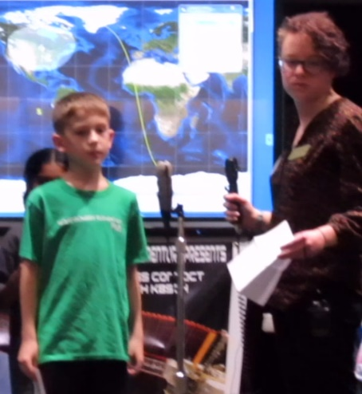Amateur Radio on the International Space Station ([**ARISS**](http://www.ariss.org/)) is seeking formal and informal educational institutions and organizations, individually or working together, to host amateur radio contacts with an International Space Station (ISS) crew member. Contacts would likely be scheduled between January 1 and June 30, 2022.

These voice radio contacts are approximately 10 minutes long and in a question-and-answer format. ARISS contacts afford participants the opportunity to learn firsthand what it’s like to live and work in space, and about space research conducted on the ISS. Students will also have an opportunity to learn about satellite communication, wireless technology, and radio science.

Crew scheduling and ISS orbits will determine the exact dates. ARISS is looking for organizations that can draw large numbers of participants and integrate the contact into a well-developed education plan. Organizations must demonstrate flexibility to accommodate changes in dates and times of the radio contact. The deadline for proposals is March 31, 2021.

Visit the [**ARISS website**](http://www.ariss.org/) for more details and a proposal form. ARISS has operated amateur radio from the ISS for 20 years, and scheduled ham radio contacts between ISS crew members and schools and student groups around the world are a hallmark of the ARISS program. The ham radio stations onboard also are available for crew members to use and serve as back-up communications capability. In the US, ARISS is sponsored by NASA, the ISS National Laboratory, ARRL, and AMSAT.

An ARISS introductory webinar will be held on February 25, 2021 at 8 PM EST (0100 UTC on February 26). Participants must [**register**](https://ariss-proposal-webinar-spring-2021.eventbrite.com/). [**Email**](mailto:ariss.us.education@gmail.com) with any questions.

****

***Talking to Astronauts: An Elementary School's Exciting ARISS Experience – Ohio’s own… Diane Warner, KE8HLD***

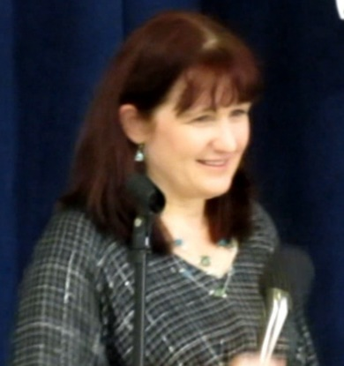

This is a story about Tallmadge Elementary School's participation in a once-in-a-lifetime Amateur Radio on the International Space Station ([ARISS](http://www.ariss.org)) school contact. Learn about their amazing journey leading up to the amateur radio contact with an astronaut on the International Space Station.

The excitement of the entire experience was shared not just by the students, but included faculty, parents, the community, and local amateur radio operators. You will also learn how to begin the process of submitting your own ARISS contact proposal.

**Tuesday, March 2, 2021 @ 1 PM EST (1800 UTC)** The [ARRL Learning Network](http://www.arrl.org/arrl-learning-network) schedule is subject to change.

TOP ^

***Club Corner***

This is YOUR cornner of the newsletter. Send me what your club is doing and I’ll make sure that it gets in. Got a special event or club project that you want everyone to know about? Send it to me!. Need help with a project? Send it to me.

Let me know what you club is up to. Are you going to have a special guest at your meeting or are you having a special anniversary?

Just sent it to: [webmaster@arrl-ohio.org](mailto:webmaster@arrl-ohio.org)

####

***October School Roundup scores***

The following are the top 5 scores in each category – Middle/Junior High, High School, College. The Great Lakes Division did very well this year posting in the top 5 of each of these categories.

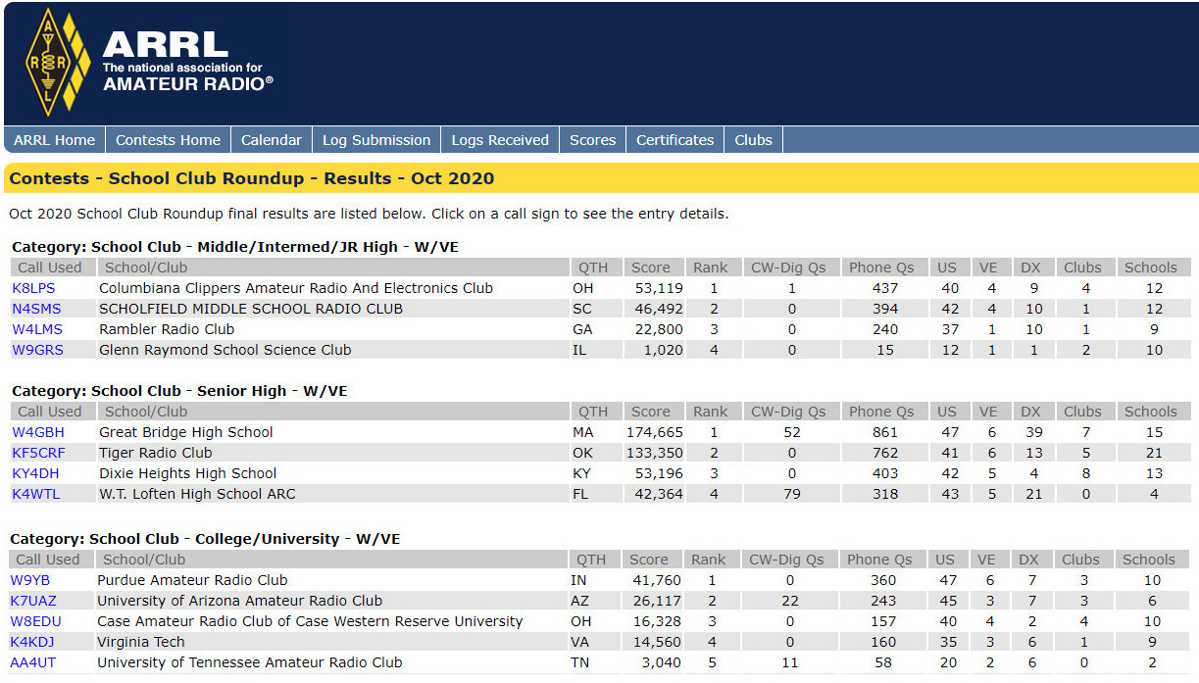

Columbiana Clippers placed 1st in their category, but actually came in 2nd for total scoring within the Division. The top score for the Division was Dixie Heights High School who came in 3rd within their category and rounding out the categories was Case Western Radio Club who also came in 3rd in their category as well as within the Great Lakes Division for total scores. All in all, I think you would have to consider this a clean sweep for the Great Lakes Division.

TOP ^

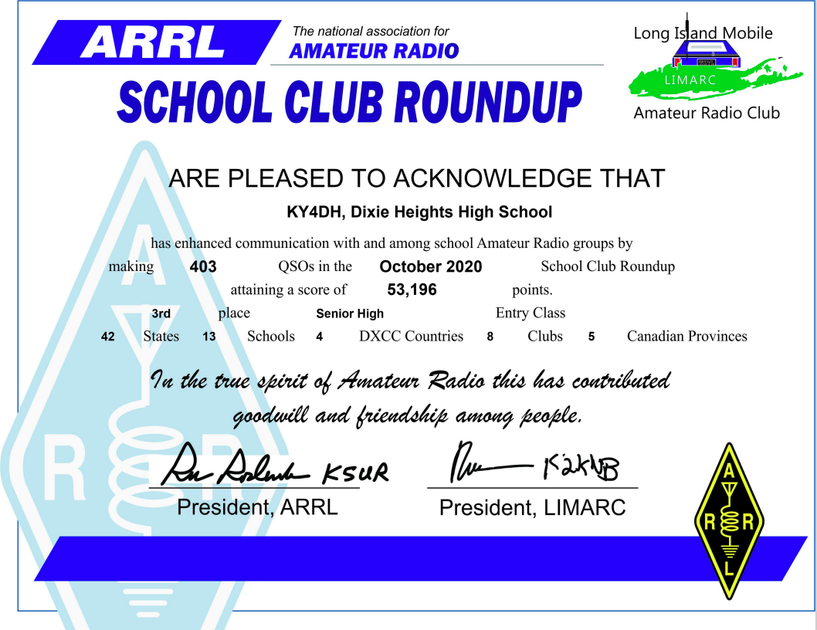

####

***20 Mile Drop***

All - I just received word from Lake County that the 20-mile drop is on for 2021! It'll take place on **April 11**. If you're interested in volunteering, please use the form below to sign up.

<https://docs.google.com/forms/d/e/1FAIpQLScuzbciZXdMo87nBr3bFAAtz0_fNZJIk4b3RtIGVb0cUAKxcQ/viewform?usp=sf_link>

TOP ^

***DX This Week***

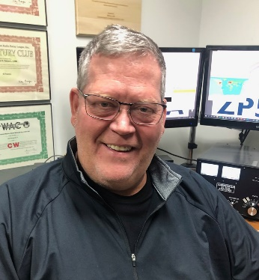

***DX This Week – K9LA***

***Bill AJ8B (aj8b@arrl.net, @AJ8B, or www.aj8b.com)***

***CWOPs Member #1567***

The Midwest DX Cluster spots included Asiatic Russia, Austria, Balearic Islands, Belgium, Bulgaria, Canada, Denmark, Djibouti, Dominican Republic, Ecuador, England, European Russia, Fed. Rep. of Germany, Fiji, France, Greece, Haiti, Indonesia, Italy, New Zealand, Panama, Puerto Rico, Thailand, Trinidad & Tobago, Ukraine, and Zambia. This brings the total number of entities spotted in the Midwest to 120!

A couple of readers have asked why I list these spots and why give a total. The reason is to encourage you to get on the air. Over the past several years we have been at the bottom of the sunspot cycle and DX has been more difficult to work. But it has been there! I like to list the entities that were heard in the Midwest to encourage others to get on the air.

I have also heard about how difficult it is to work 100 entities. However, based on the list that I print each week, you can see that there are more than the needed 100 available to be worked. So, “Jump Right In”.

Did you participate in the CQ DX Challenge last year? How did you do? I had a tough year, working 161 DX Entities and 37 Zones giving me a score of 198. My goal is to at least break 200. Close, but… However, January has really taken off with 83 countries and 27 zones for a current score of 110. Let me know how you are doing!

***DAH DIT DIT DIT DAH DAH DIT DIT DIT DAH***

I received cards from CN8KD – Mohamed in the Kingdom of Morocco, 9H1TX – David on the Island of Malta, two cards from Dino – LZ3DP in Bulgaria, and a card from Brian – EI8IU in Ireland. Let me know what you received.

|  |  |
| --- | --- |
|  |  |

TOP ^

|  |  |
| --- | --- |
|  |  |
|  |  |
|  |  |
|  | |

***DAH DIT DIT DIT DAH DAH DIT DIT DIT DAH***

Once a month I like to feature something from Carl, K9LA. Carl is a prolific writer, expert author, and all around “good guy”. I started on the project described below and will let you know how it turns out. I assumed that if I had an interest, you may have one as well. Thanks to Carl for permission to reprint this here.

KD9SV Reversible Beverage-On-Ground

Carl Luetzelschwab K9LA [k9la@arrl.net](mailto:k9la@arrl.net)

In the fall of 2013, I acquired a Shared Apex Loop array from Array Solutions to help with my contesting (and DXing) efforts on the low bands. I would have preferred to install four (or eight) long Beverages around the compass, but our property won’t allow that. So I settled for the SAL- 20 model (the model with a 20-foot horizontal length for each triangular loop) due to its small footprint (40-foot diameter). It was a compromise in RDF (Receiving Directivity Factor), but it fit our property and it opened up a new layer of QSOs for me.

Recently Beverages laying on the ground (BOGs) have gained popularity with the low band crowd due to the ease of installation, very respectable performance and shorter length. The shorter length aroused my interest, as I may be able to install a pair of two-direction Beverages to cover NE-SW and NW-SE on our property. So, when Gary Nichols KD9SV offered me his 200- foot long RBOG for evaluation, I jumped at the chance.

TOP ^

The KD9SV RBOG consists of a feed transformer, a reflection transformer, two-conductor wire and a control box. For two-direction performance, you need to provide two RG-6 coax feed lines that run from the feed transformer at the antenna to the control box in the shack. The control box (see Figure 1) includes a 160-Meter band pass filter, a 20-dB preamp and a termination for the coax on the unused direction. The preamp and filter are bypassed for operation on frequencies higher than 1.8 MHz. A 12 VDC source is also needed for the control box.

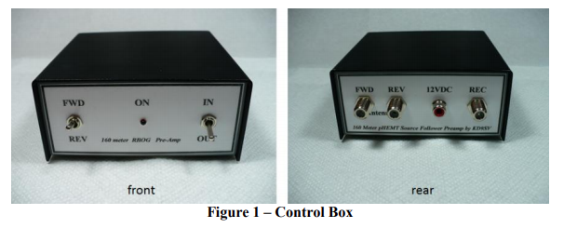

I originally planned to install the RBOG in our neighbor’s field to the west of us. But we had so much snow last winter that the pond in the field was considerably expanded. Thus I had to go to Plan B – install it along the north property line that runs partially along and partially in the woods. I cleared a path with the lawn tractor, raked the debris down to dirt level, and laid the two-conductor wire along an ENE-WSW line. The installation, with everything at (literally) ground level, was easy and went smoothly.

Prior to the installation, I measured the preamp compression characteristics and the response of the 160-Meter band pass filter. Figure 2 shows these results. The preamp has an input 1 dB compression point of -20 dBm (with a gain of about 20 dB, the output P1dB is around 0 dBm). The 160-Meter band pass filter has a typical response for a parallel-resonant LC circuit.

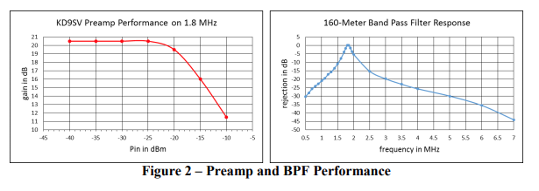

The measured P1dB of the preamp is about 20 dB lower than the specification on the FET data sheet. It is lower because the FET in the RBOG preamp is lightly biased (lower quiescent current) compared to the data sheet condition.

TOP ^

With 160-Meter aficionado John Goller K9UWA only 2.3 miles to the northeast of my QTH, I wondered if his transmit signal via ground wave could cause the preamp to go into compression. So we set up a test – when K9UWA keyed his radio at 1.0 kW, his signal on my inverted-L (maximum gain around 0 dBi in the main lobe) was around -23 dBm (that’s about S9 + 50 dB). With the maximum gain of the BOG in the main lobe around -20 dBi, I don’t expect any problems with the lower P1dB.

I had planned to do an extensive on-the-air evaluation of the RBOG system with European signals, but unfortunately 160-Meters has not been cooperative. My back-up plan was to listen to W1AW on 1802.5 KHz in the evenings (a path distance of around 1200 km). The signal-to-noise ratios (SNRs) of W1AW in Table 1 are representative for three different nights (with two nights at two different times) for my transmit inverted-L, the SAL-20 pointed NE and the 200-foot RBOG running ENE-WSW. I should point out that you must calibrate your S-meter to do these measurements.

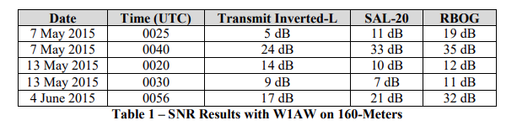

Note the interesting results on 13 May – at the early time the SNR was actually higher on the inverted-L than on both the SAL-20 and RBOG. I don’t believe I screwed up the measurements, as I’ve experienced the Inverted-L every once in a while, beating the SAL-20. I believe this is due to how noise arrives at your location in terms of azimuth and elevation angle – the directional characteristics of noise can vary day-to-day and hour-to-hour, as do the arrival elevation angles of the desired signal. In fact, I believe two antennas with the same RDF could perform differently because RDF assumes noise arrives from all directions – but it doesn’t.

In addition to the SNR measurements of Table 1 and listening at other times, the RBOG is impressive when using your ears and the signal is near the noise. Most of the time the RBOG beat the inverted-L and the SAL-20. Nothing against the SAL-20 – most of the time it beat the inverted-L. As stated earlier, the SAL-20 is a good choice for space-limited QTHs – it will offer QSOs that you may otherwise not be able to complete.

I’m really interested in seeing what happens to the performance of the RBOG this fall and winter. Since it’s on the ground and near many trees, it will be covered up with leaves – both dry leaves and wet leaves after a rain or snow. If the wet leaves introduce more loss, then the performance could suffer. The solution, as mentioned by several on the topband reflector, would be to keep the two-conductor wire clear of leaves (and other debris). Also, two other evaluators (K3UL and K2CUB) of the KD9SV RBOG report that snow last winter didn’t appear to affect the performance – that’s not too surprising as the density of snow can be low, and the conductivity and relative permittivity of not-too-dense snow at 1.8 MHz is not prohibitive.

I’m always interested in antenna modeling, so Jim Wolf KR9U and I modeled a BOG close to ground using NEC 4.1, which uses the GN2 ground code. This effort was spurred on by the work last spring (to eventually be published in QEX) of Rudy Severns N6LF. He used NEC 4.2, which uses a more complex ground code – GN3 – and compared simulated results to measured results of four antennas: a 300-foot center fed dipole that was moved from 4 feet above ground to 1 inch above ground in several steps, a 40-foot dipole buried 1 inch below ground, a tall vertical wire with one ground rod and his 450-foot long BOG.

TOP ^

With all four antennas, his simulated results agreed very well with measured results as long as he paid attention to the modeling rules in NEC, paid attention to the insulation on the wire and used measured values of his ground conductivity and permittivity (as opposed to the canned ‘poor’, ‘average’ and ‘good’ values).

Our first modeling exercise was to compare the NEC 4.1 results to N6LF’s NEC 4.2 results on the 300-foot dipole (remember, it was always above ground). The modeled results from 4 feet above ground to 1 inch above ground were extremely similar to Rudy’s results, giving us confidence to model a BOG at 0.25 inches above ground using NEC 4.1.

Some interesting trends we saw with our modeling efforts with BOGs:

1. Just like normal Beverages several feet above ground, BOGs appear to have preferential lengths for best F/B
2. BOGs can be too long – on 160-Meters, a good length appears to be 200 feet
3. The decreased BOG gain will benefit from the use of a preamp

Despite the limitations of the model (for example, how well does NEC model the transition from air to ground?), broad trends were discerned. Figure 3 shows the modeled results for a 200- foot long BOG at 0.25 inches above average ground (we used average ground as at the time of this writing we don’t know our ground characteristics) with a 240 ohm termination. These results should be regarded as PRELIMINARY. The RDF is decent (9.3 dB) for a “short” antenna, but the F/B at expected elevation angles (about 11 dB) isn’t spectacular.

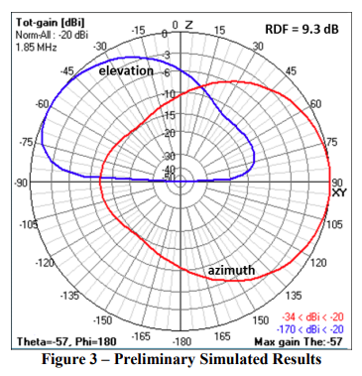

In summary, the KD9SV RBOG performed well under my limited evaluations, and most of the time it should give very respectable results. But the RBOG takes up more space and you need at least one more two-direction system to have the minimum “around-the-compass” coverage. Having said that, I have no plans to take down the SAL-20, as I believe in the adage “you can’t have too many antennas on 160-Meters”.

The KD9SV RBOG is sold through DX Engineering, and details about it can be found at <http://www.dxengineering.com>

When you visit the DX Engineering web site, do a search on KD9SV Products.

***CQDX CQDX CQDX CQDX CQDX CQDX CQDX CQDX CQDX***

Here is an update from Bernie, W3UR, of the DailyDX and the WeeklyDX, the best source for DX information. [http://www.dailydx.com/](http://www/dailydx.com). Bernie has this to report:

TOP ^

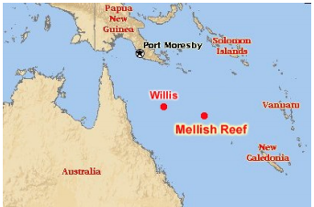**VK9/W & VK9/M–Willis Island & Mellish Reef -**  A team from the Hellenic Amateur Radio Association of Australia are planning an October 2021 DXpedition to both Willis Island (VK9HR) and Mellish Reef (VK9IR). Mellish Reef ranks number 36 while Willis ranks number 38 on the Club Log Most Wanted DXCC list.

The last time VK9/M was QRV was 2017 and the last activity from VK9/W was 2015. The seven operators will be from Australia and New Zealand. They are in the process of obtaining a permit from Parks Australia, which is “required to ‘camp’ at these Australian coral sea marine parks”. VK3YP, John, says the callsigns VK9HR is expected to be renewed in August and “VK9IR will be an additional callsign to be allocated”. The most important document is the landing permit, which comes from Parks Australia.

A permit is not “required to visit these coral sea islands for non-commercial purposes but a permit application is required to setup a camp site and to stay overnight on the island”. The seven operator team plan to use verticals on 160, 80, 40 and 30 Meters, while VDAs will be used on 20, 17, 15, 12 and 10 Meters. Activity is expected on SSB, CW and FT8 on 1.8 through 28 MHz. They expected to have two Kenwood TS-590S and two Icom IC-7300 with all SPE amplifiers. More details to follow.

**JD1/O – Ogasawara Islands -**  JH3QFL, Takio, tells us he plans to operate JD1BQA from Chichisima (AS-031) from May 1-7. He will have an FTdx101MP, IC-7300 and FT-857D running 200 watts into a ground plane, dipole and Yagi. He will be capable of running FT8 on 1.8 through 50 MHz. Seems he may concentrate on FT8 and FT4 on 160, 80, 40 and 6 Meters. He will do some CW on the RS-44 satellite. QSL direct to JH3QFL, Takio Hata, 921－25 Rokujio Yasu, Shiga 520-2412, JAPAN.

***DAH DIT DIT DIT DAH DAH DIT DIT DIT DAH***



**QSO Today Virtual Ham Expo –** Tickets are now available to attend the QSO Today Virtual Ham Expo sponsored by the QSO Today Podcast, FlexRadio, Icon and Elecraft. Information can be found at <https://www.qsotodayhamexpo.com/> There are several hams from our area who will be speaking, and you can watch the presentations live, ask questions of the presenters, and well as visit the booths of many vendors. The dates are March 13th and 14th. Also, you will be able to access many of the presentations until April 12th.

Several contributors to the Ohio Section Journal will be giving presentations at this event. Check it out and let me know what you think!

***DAH DIT DIT DIT DAH DAH DIT DIT DIT DAH***

TOP ^



Below is a list of upcoming contests in the “Contest Corner”. I think this is important for someone who is trying to move up the DXCC ladder since entities that are on the rarer side and easiest to work in contests. Some of my best “catches” have been on the Sunday afternoon of a contest when the rarer entities are begging for QSOs. Of course, the gamble is that if you wait until Sunday, conditions may change, or they simply won’t be workable. However, it is not a bad gamble. Of course, why not work the contest and have some fun!

Check out the WA7BNM Contest Calendar page <https://www.contestcalendar.com/> for more contests or more details.

The contests in red are those that I plan to spend some significant participation time on. PLEASE let me know if you are working contests and how you fared.

Thanks!

|  |  |  |
| --- | --- | --- |
| Feb.8-12 | ARRL School Club Roundup | <http://www.arrl.org/school-club-roundup> |
| Feb. 10 | RSGB 80m Club Championship, DATA | <https://www.rsgbcc.org/hf/rules/2020/r80mcc.shtml> |
| Feb. 13 | RSGB 1st 1.8 MHZ Contest CW | [https://www.rsgbcc.org/hf/](http://www.rsgbcc.org/hf/) |
| Feb. 13 | Asia-Pacific Spring Sprint (CW) | <http://jsfc.org/apsprint/> |
| **Feb. 13-14** | **CQ WW RTTY WPX Contest** | [**http://www.cqwpxrtty.com/**](http://www.cqwpxrtty.com/) |
| Feb. 13-14 | AWA Amplitude Modulation QSO Party | <https://bit.ly/2Io0u3e> |
| Feb. 13-14 Feb. 13-14 Feb. 13-14 | Dutch PACC Contest KCJ Topband Contest OMISS QSO Party | [http://pacc.veron.nl/  https://www.kcj-cw.com/e_index.htm http://www.omiss.net/Facelift/qsoparty.php](http://pacc.veron.nl/%20https:/www.kcj-cw.com/e_index.htm%20%20http:/www.omiss.net/Facelift/qsoparty.php) |
| Feb. 13-15 | YL OM Contest | <https://ylrl.org/wp/yl-om-contest/> |
| Feb. 14 | PODXS 070 Club Valentine Sprint | <http://bit.ly/2Rp8LTk> |
| Feb.15 | RSGB FT4 Contest Series | <http://bit.ly/38xg9V7> |
| Feb. 17 | AGCW Semi-Automatic Key Evening | <https://bit.ly/3ngQSpB> |
| Feb. 21 | FISTS Winter Sunday Sprint | <http://www.fistsna.org/operating.html> |
| Feb. 20-21 | ARRL CW DX Contest | <http://www.arrl.org/arrl-dx> |
| Feb. 20-21 | Russian WW PSK Contest | <http://bit.ly/2MsppCr> |
| Feb. 24 | UKEICC 80m Contests CW | <https://bit.ly/2SDPqQQ> |

TOP ^

|  |  |  |
| --- | --- | --- |
| Feb. 25 | RSGB 80m Club Championship, CW | [https://www.rsgbcc.org/hf/rules/2020/r80mcc.shtml](http://www.rsgbcc.org/hf/rules/2020/r80mcc.shtml) |
| **Feb. 26-28** | **CQ WW 160M SSB Contest** | [**http://www.cq160.com/rules.htm**](http://www.cq160.com/rules.htm) |
| Feb. 27-28 | REF SSB Contest | <http://concours.ref-union.org/contest/?page_id=2> |
| Feb. 28 | High Speed Club CW Contest | <http://www.highspeedclub.org/> |
| Feb. 27-28 | South Carolina QSO Party | <http://scqso.com/> |
| Feb. 27-28 | North American RTTY QSO Party | <http://ncjweb.com/naqp/> |
| Feb. 27-28 | UBA CW DX Contest | <http://bit.ly/W0gZiE> |
| Feb. 28-Mar.1 | North Carolina QSO Party | <http://ncqsoparty.org/rules/> |
| Mar. 27 – 28 | CQWW WPX SSB | <https://www.cqwpx.com/> |
| May 29 – 30 | CQWW WPX CW | <https://www.cqwpx.com/> |
| August 28 | Ohio QSO Party | <https://www.ohqp.org/> |
| August 28 | W8DXCC | <https://www.w8dxcc.com> |

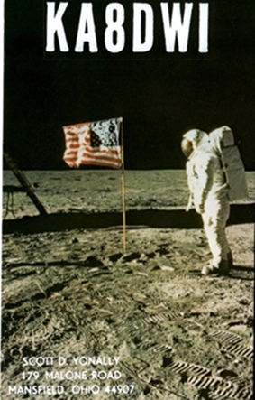***DX News***

***ARLD005 DX news***

This week's bulletin was made possible with information provided by The Daily DX, the OPDX Bulletin, 425 DX News, DXNL, Contest Corral from QST and the ARRL Contest Calendar and WA7BNM web sites. Thanks to all.

**KUWAIT, 9K.**  Members of the Kuwait Amateur Radio Society are QRV as 9K60NLD during all of February to celebrate Kuwait's independence.

All stations from Kuwait may also use the prefix 9K60 during this time. QSL 9K60NLD via 9K2RA.

**FEDERAL REPUBLIC OF GERMANY, DA.** Special event station DC220GERKE is QRV until the end of April to commemorate the 220th birthday of Clemens Gerke, a German pioneer of telegraphy who revised Morse Code to its present form. Activity is on the HF bands. QSL via DJ6SI.

**SCOTLAND, GM.**  Gareth, M0MOL is QRV as MM0MOL/p from the main island of Shetland, IOTA EU-012, until the end of March. Activity is on the HF bands using QRP power, after work, and mainly during his evenings. QSL to home call.

**REPUBLIC OF KOREA, HL.** Kang, DS4DRE is QRV as DS4DRE/4 from Komun Island, IOTA AS-060, until the end of January, 2022. Activity is on 80 to 10 meters using CW and SSB. QSL to home call.

TOP ^

**JAPAN, JA.** Special event station 8N0J is QRV until April 30, 2022 to celebrate the creation of the city of Joetsu, which was formed when the two cities of Takada and Naoetsu merged in 1971. QSL via bureau.

**MARIANA ISLANDS, KH0.** Tom, KC0W is QRV as KH0/KC0W and plans to be active on 160 meters using CW and FT8 in his spare time.

**ARGENTINA, LU.** Special event station L21RCA is QRV during all of 2021 to celebrate the 100th anniversary of IARU member society Radio Club Argentino. QSL via LU4AA.

**FINLAND, OH.** Members of the Finnish Amateur Radio League are QRV during all of 2021 with special event call OH100SRAL to celebrate their 100th anniversary. QSL via bureau.

**DENMARK, OZ.** Special event station OV0JUTLANDIA is QRV until the end of March 2021 to commemorate the humanitarian mission of the Danish hospital ship Jutlandia during the Korean War. Activity is on the HF bands using CW, SSB and various digital modes. QSL via LoTW.

**PITCAIRN ISLAND, VP6.** Meralda, VP6MW has been QRV on 20 meters using SSB from around 1530 to 1630z. QSL via W0VTT.

**VIET NAM, XV.** Eddy, XV1X has been QRV on 40 meters using FT8 around 1200z. QSL via special instructions on QRZ.COM.

**SERBIA, YT.** Members of the Serbian CW Club are QRV with special event station YT165TESLA during all of 2021 to commemorate the 165th anniversary of Nikola Tesla's birth. QSL via YU1MM.

THIS WEEKEND ON THE RADIO. The North American CW Sprint, AM Rally, NCCC RTTY Sprint, QRP 80-Meter CW Fox Hunt, NCCC Sprint CW Ladder, K1USN Slow Speed CW Test, Vermont QSO Party, 10-10 International SSB Winter Contest, EurAsia HF Championship, Mexico RTTY International Contest, F9AA CW Cup, Minnesota QSO Party, FYBO Winter QRP Sprint, AGCW Straight Key 80-Meter CW Party, British Columbia QSO Party, FISTS Saturday CW Sprint and the European Union DX Contest will certainly keep contesters busy this upcoming weekend.

The ARRL School Club Roundup runs from February 8 to 12.

The K1USN Slow Speed CW Test and OK1WC Memorial are scheduled for February 8.

The Worldwide Sideband Activity Contest and RTTYOPS Weeksprint are scheduled for February 9.

The Phone Fray, CWops Mini-CWT Test, RSGB 80-Meter Club Data Championship, VHF-UHF FT8 Activity Contest, NAQCC CW Sprint and QRP 40-Meter CW Fox Hunt are scheduled for February 10.

Please see February 2021 QST, page 73, and the ARRL and WA7BNM contest web sites for details.

####

TOP ^

**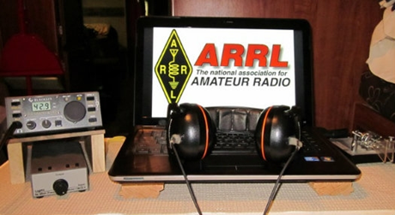*ARRL Contest Corner***

An expanded, downloadable version of *QST'*s’ [**Contest Corral**](http://www.arrl.org/contest-calendar) is available as a PDF. Check the sponsor’s ‘Website for information on operating time restrictions and other instructions.

***Special Events***

* **01/09/2021 | 2021 Daytona 500/Speedweeks**

**Jan 9-Feb 14, 0001Z-2359Z, N4DAB**, Daytona Beach, FL. Daytona Beach CERT ART. 14.255 14.070 7.255 7.070. Certificate & QSL. DB CERT ART/Steve Szabo, WB4OMM, License Trustee, 536 Central Park Blvd., Port Orange, FL 32127-1136. See Web Page for QSL and Certificate information. High Quality laser printed certificate and photo quality QSL Card. Operating hours dependent on propagation and availability. Phone, CW, and Digital modes scheduled. [www.n4dab.com](http://www.n4dab.com/)

* **01/15/2021 | Alaska "RST" QSO Party**

**Jan 15-Feb 15, 0000Z-2359Z, KL7RST**, various, AK. North Country DX Association. 28.450 21.350 14.250 7.250. QSL. John F. Reisenauer, Jr, 2573 Old Georgetown Rd. W., Kershaw, SC 29067. KL7RST, KL7RST/KL7, VY1RST/KL7, VE8RST/KL7 and VY0RST/KL7. Certificate by email for working any 3 of the above when you QSL. [www.qrz.com/db/k7ice](http://www.qrz.com/db/k7ice)

* **02/01/2021 | JY1 Special Event Memorial Station 2021**

**Feb 1-Feb 28, 0000Z-2359Z, N9SES**, Lake Station, IN. ArabQrz Club. 14.250 14.030 7.185 7.030. QSL. Ayman Azar, 2861 Decatur St, Lake Station, IN 46405. See website for participating stations from other countries. All HF/VHF/UHF, All Modes. Hamsphere Users can also participate in the event [www.n9ses.com/?page_id=18](http://www.n9ses.com/?page_id=18)

* **02/06/2021 | 100th Anniversary**

**Feb 6-Feb 27, 1800Z-2359Z, W6UW**, San Jose, CA. Santa Clara County Amateur Radio Association. 21.320 14.250 7.250. Certificate. Don Village, K6PBQ, 3290 Woody Lane, San Jose, CA 95132. w6uw@arrl.net or [www.qsl.net/sccara](http://www.qsl.net/sccara)

* **02/06/2021 | Ground Hog Day Special Event**

**Feb 6, 0900Z-1500Z, K3HWJ**, Punxsutawney, PA. Punxsutawney Amateur Radio Club. all modes, all bands. Certificate. Stephen Waltman, KB3FPN, 37 Clark St., Brookville, PA 15825. SASE for certificate. [www.punxyclub.com](http://www.punxyclub.com/)

* **02/06/2021 | Shuttle Columbia Special Event**

**Feb 6-Feb 7, 1400Z-2359Z, K5C**, Nacogdoches, TX. Nacogdoches ARC. 7.216 14.260 21.350 28.350. QSL. Army Curtis, 167 CR 2093, Nacogdoches, TX 75965. All contacts will be confirmed via LOTW. [https://w5nac.com](https://w5nac.com/)

TOP ^

* **02/07/2021 | Commemorating Howard E. Anthony, Father of Heathkit**

**Feb 7, 1200Z-2359Z, KD2FSI**, Randolph, NJ. KD2FSI. 21.300 14.300 7.300 3.900. QSL. David R. Hackett, 3 High Ridge Road, Randolph, NJ 07869. On Sunday February 7, 2021 from 1200Z -2359Z, Amateur Radio Station KD2FSI will operate as a special event station using a variety of vintage Heathkit gear to commemorate the life and legacy of Howard E. Anthony, the father of the Heathkit brand of electronic kits. Starting in the morning with 75 meter SSB, we will work our way up to the 40, 20, 15 and 10 meter bands and then back down again towards the evening. I will post additional information on my public Facebook page as the event draws near and the actual operating frequencies and modes in real time the day off. We hope all amateur radio operators with any type of equipment (new or old) will join us as we commemorate Mr. Anthony, the person responsible for starting Heathkit, the finest electronic kit company ever. 73, Dave Hackett KD2FSI davehackett@cs.com <https://www.facebook.com/dave.hackett.9085>

* **02/13/2021 | George Washington's Birthday at his Boyhood Home, Ferry Farm VA**

**Feb 13, 1400Z-2000Z, W4B**, Fredericksburg, VA. Stafford Amateur Radio Association (SARA). 14.225 7.195 447.275. QSL. Stafford Amateur Radio Association (SARA), PO Box 6331, Fredericksburg, VA 22403. SASE required for return of a QSL card. [https://www.ws4va.org](https://www.ws4va.org/)

* **02/13/2021 | George Washington's Birthday at Mount Vernon**

**Feb 13-Feb 14, 0800Z-1400Z, K4US**, Alexandria, VA. Mount Vernon Amateur Radio Club. 14.260 14.074 7.040. QSL. MVARC, P.O. Box 7234, Alexandria, VA 22307. MVARC will be hosting a modified special event station to commemorate our first president's 289th birthday. Members will be operating remote stations this year due to COVID, with many broadcasting from the original grounds of the former plantation of George Washington and his wife, Martha Washington. [k4us@mvarc.org](mailto:)

* **02/13/2021 | I ❤️ Pluto Special Event**

**Feb 13-Feb 21, 0000Z-2359Z, W7P**, Flagstaff, AZ. Northern Arizona DX Association. 14.290 21.290 7.290 14.090. Certificate & QSL. W7P - I ❤️ Pluto Special Event, % Bob Wertz, NF7E, 6315 Townsend Winona Rd., Flagstaff, AZ 86004-1493. This will be an annual countdown S. E. to the 100th anniversary of the discovery of PLUTO, held every February, up to and including 2030. We are celebrating this historic discovery of Pluto, in 1930, by Clyde Tombaugh, at Lowell Observatory in Flagstaff, Arizona. Please note the frequencies will be + or- 10, as to not interfere with any nets operating during that time period. [www.nadxa.com](http://www.nadxa.com/)

* **02/13/2021 | Ice-olation Station WØJH**

**Feb 13-Feb 15, 1400Z-2355Z, W0JH**, Stillwater, MN. Stillwater, MN Amateur Radio Association. 21.360 14.260 7.260 3.860. Certificate. Shel Mann, N0DRX, 1618 Pine St West, Stillwater, MN 55082. We will have multiple stations simultaneously operating on different bands and different modes. In keeping with COVID-19 social distancing protocols, we will operate from our individual QTHs this year. In a meager attempt to drive away the remainder of Minnesota winter, the Stillwater Amateur Radio Association will be generating as much RF as possible over the President's Day long weekend. Certificates will ONLY be sent via email in PDF format. (Send requests with standard QSL confirmation info via email to: Ice2021@radioham.org). There is no need to send a QSL card. Info: WØJH at www.QRZ.com & www.radioham.org. [www.radioham.org](http://www.radioham.org/)

* **02/13/2021 | USS Midway Museum Ship Special Event: Raising Mt Suribachi Flag**

**Feb 13, 1700Z-2359Z, NI6IW**, San Diego, CA. USS Midway (CV-41) Museum Ship. 7.250 14.320 14.070 (PSK31) DSTAR via PapaSystem repeaters. QSL. USS Midway CV-41 COMEDTRA NI6IW, 910 N Harbor Dr, San Diego, CA 92101. SASE please. [www.qrz.com/db/ni6iw](http://www.qrz.com/db/ni6iw)

TOP ^

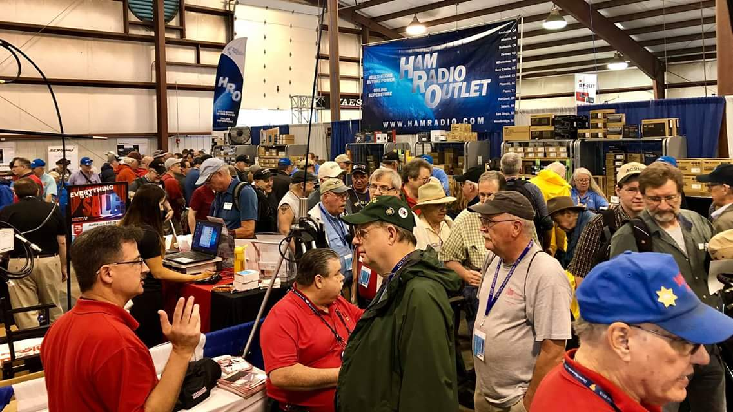[***Upcoming Hamfests***](http://arrl-ohio.org/hamfests.html)

We **DO** have some hamfests scheduled for 2021!! Yes, take a good look at the list, it’s growing every day!

Be sure to keep your eyes on this schedule as that when things start getting better and the vaccine rolls out to more and more, hamfests will surely get back to their normal schedule. Don’t see your hamfest listed?? Did anyone register it with ARRL? It’s really easy to do and you get a lot of FREE publicity if you do.

|  |  |
| --- | --- |
| **03/07/2021 -**[**WINTERHAMFEST**](http://www.arrl.org/hamfests/winterhamfest-3)  **Location: Elyria, OH**  ***Canceled***  Toledo Mobile Radio Association (TMRA) Hamfest normally scheduled in March is also  ***Canceled*** | **04/25/2021 -**[**Athens Hamfest**](http://www.arrl.org/hamfests/athens-hamfest-9)  **Location: Athens, OH Sponsor: Athens County Amateur Radio Association Website:**<http://ac-ara.org/>  [**Learn More**](http://www.arrl.org/hamfests/athens-hamfest-9) |
| **05/21/2021 - 05/23/2021** [**Dayton Hamvention, ARRL Operating Specialty Convention**](http://www.arrl.org/hamfests/dayton-hamvention-arrl-operating-specialty-convention)  ***Canceled*** | |
| **06/05/2021 -**[**FCARC SummerFest**](http://www.arrl.org/hamfests/fcarc-summerfest)  **Location:**Wauseon, OH **Sponsor:**Fulton County Amateur Radio Club **Website:**<http://k8bxq.org/hamfest>  [**Learn More**](http://www.arrl.org/hamfests/fcarc-summerfest) | **07/10/2021 - [Mansfiled Mid-Summer Trunkfest](http://www.arrl.org/hamfests/mansfiled-mid-summer-trunkfest" \o "Mansfiled Mid-Summer Trunkfest)**  **Location:**Mansfield, OH **Sponsor:**InterCity Amateur Radio Club **Website:**<http://iarc.club>  [**Learn More**](http://www.arrl.org/hamfests/mansfiled-mid-summer-trunkfest) |
| **07/18/2021 –**[**Van Wert Hamfest**](http://www.arrl.org/hamfests/van-wert-hamfest-5)  **Location:**Van Wert, OH **Sponsor:**Van Wert Amateur Radio Club **Website:**[http://W8FY.ORG](http://w8fy.org/)  [**Learn More**](http://www.arrl.org/hamfests/van-wert-hamfest-5) | **08/28/2021 -**[**Cincinnati Hamfest℠**](http://www.arrl.org/hamfests/cincinnati-hamfest)  **Location:**Owensville, OH **Sponsor:** Milford ARC **Website:** [http://CincinnatiHamfest.org](http://cincinnatihamfest.org/)  [**Learn More**](http://www.arrl.org/hamfests/cincinnati-hamfest) |

TOP ^

|  |  |
| --- | --- |
| **09/26/2021 -**[**Cleveland Hamfest**](http://www.arrl.org/hamfests/cleveland-hamfest-1)  **Location:**Berea, OH **Sponsor:** Hamfest Association of Cleveland **Website:** [http://www.hac.org](http://www.hac.org/)  [**Learn More**](http://www.arrl.org/hamfests/cleveland-hamfest-1) | **12/04/2021 -**[**FCARC WinterFest**](http://www.arrl.org/hamfests/fcarc-winterfest-2)  **Location:** Delta, OH  **Sponsor:** Fulton County Amateur Radio Club  **Website:** <http://k8bxq.org/hamfest>  [**Learn More**](http://www.arrl.org/hamfests/fcarc-winterfest-2) |

***Upcoming NIMS Training Opportunities***

Need to get those really hard to get ICS 300 and 400 classes to get to Level 3? They are now being offered with very limited virtual seating. Yes, these classes are being offered virtually now along with a lot of other classes that used to require in-class sessions. Want to see what and where these classes are being offered?

[**>> Click Here <<**](http://arrl-ohio.org/SEC/Ohio_EMA_Training_List_Feb_2021.pdf)

***Print an Official or Unofficial Copy of Your Amateur Radio License***

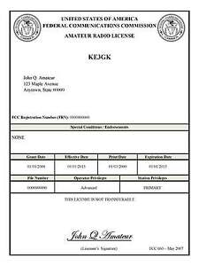*(By Anthony Luscre, K8ZT)*

As of February 17, 2015, the **FCC no longer routinely issues paper license documents** to Amateur Radio applicants and licensees. The Commission has maintained for some time now that the official Amateur Radio license authorization is the electronic record that exists in its Universal Licensing System (ULS). The FCC will continue to provide paper license documents to all licensees who notify the Commission that they prefer to receive one.

Licensees also will be able to print out an official authorization — as well as an unofficial “reference copy” — from the ULS License Manager. I’ve created a set of instructions on how you can request an **“official” printed copy of your license\***

[**Click here to download the instructions**](http://arrl-ohio.org/news/2020/print_your_license.pdf)

***One Question Questionnaire***

Hey Gang,

Survey Says”….. 72% are looking to purchase something at the next hamfest you attend. Wow… with the scarcity of hamfests, I thought this number would be out of sight for sure..

Ok, now on to the next question… I know that we’re all cooped up with this winter blast hitting all of us, so here’s the next question for you.

TOP ^

***“Have you checked into any Nets this past month?”***

You’ll find the “One Question” questionnaire on the Ohio Section Website! <http://arrlohio.org> It’s all for fun and it’s not a scientific survey in any way, but we are learning some things that we didn’t know from these questions. I hope that you are enjoying answering these “One Question” questionnaires.

*****V.E. Test Sessions***

Many V.E.’s have decided to start testing once again, but with restrictions that need to be adhered to for sure. Here’s the link to find that V.E. Test session and what is expected of YOU before going. <http://www.arrl.org/find-an-amateur-radio-license-exam-session>

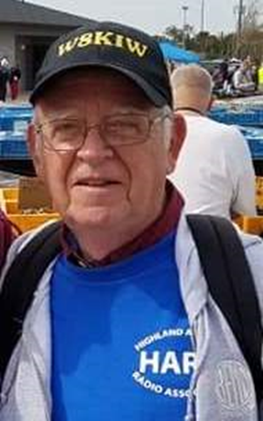***From The South 40***

*(from John Levo,* [*W8KIW@arrl.net*](mailto:W8KIW@arrl.net)*)*

***News From The South 40***

As I look out over the snow-covered vista that we call Southern Ohio I hope all readers are warm and safe and preparing for the extreme cold temperatures expected for the coming week. It sounds like a perfect opportunity to pour a cup of your favorite hot beverage and play radio. But in the meantime, here’s a bit of what’s happening in our Southern Ohio Region’s little part of the world.

It’s with sadness to inform our readers of the passing of another member of our amateur radio family. Larry Scott, KG8HF, of West Portsmouth died on January 26. He was a member of the Portsmouth RC and came from a family with a number of hams as siblings. Services have been held.

The Scioto Valley ARC will hold a Laurel VE test session on Saturday, March 6 according to John Hartmus ll, WB8GRX. Registration starts at 9 am at the Ross County Service Center, 475 Western Avenue, Chillicothe. All elements will be given. The Greater Mason County (KY) ARC will hold a test session on Saturday, February 27 at the county EMS office in Maysville. Because of COVID concerns it is a reservation only event and no walk-ins will be taken. Contact Brent Wells, N4BDW, at 606-301-1545 or Gregg Taylor, KY4OD, at 606-584-0014 to reserve your seat. The Athens County ARC will hold an ARRL VE test session at 7 pm on Monday, March 15 at the Athens Masonic Center, 12 West Carpenter Street. Contact Jeff Slattery, N8SUZ, for more information. 740-550-3774 or 740-541-0972.

The Hocking Valley ARC’s secretary Bill Hopstetter, W8LGX, reminds all that the Club holds a Winter Ragchew Net each Thursday evening on the 147.345 repeater starting at 8 pm. We’re reminded of the 9 pm Wednesday night net when the 147.345 and 443.15 repeaters are linked, and the net is also broadcast on 223.46 simplex. Bill tells us the Club’s popular Fox Hunts are set to resume-perhaps as soon as in mid-March depending on Hocking County road conditions.

TOP ^

A good number of Southern Ohio region hams were noted participating in last weekend’s Winter Field Day. Some call signs heard were noted as associated with the Athens County ARA, Clinton County ARA, Tri-State ARA, Queen City Emergency Net, DeForest ARA, the West Chester ARC or the Highland ARA. I’m certain members of other clubs were in action.

Through the efforts of some Athens County ARA members, their station at the Athens Red Cross Building is now back on the air. The station had been off for some time due to an antenna problem and members unable to get access to the building roof. The antenna was repaired and remounted in time for use during the above-mentioned Winter Field Day. Lance Groeneveld, KD8KMZ, even gave up his birthday to assist with making the repairs.

Jerry Lockhart, W8HIC, passes along the results of the Portsmouth RC VE test held this past Monday evening. Milan Eaton, Jr., KC4ZOZ, passed his test to upgrade to General. Quinton Brewer and Cameron Moffett are both from Vinton and each passed their Technician test. Quinton is now KE8QOM and Cameron is KE8QON. Congratulations to all.

The Queen City Emergency Net recently held their club elections. Bob Garfield, W8MRG, moved up from Vice President to become the 2021 President. Tom Delaney, W8WTD, was elected Vice President. Robert Blocher, N8JMV and Bob Bross, W8NFM, were re-elected to the Secretary and Treasurer positions. Long time Communications Manager Steve Lewis, N8TFD, and Director Mike Neihaus, KD8LZB remain in their posts while K8FR, Fred Ruszick, becomes a new Director.

Jeff McLaughlin, KB8DOT, tells the

S o u t h 4 0 that his Leesburg 444.0375 repeater has been placed in the AMS mode while tests are being performed.

Kudos go to Athens County ARA member John McCutcheon, N8XWO, for working 30 counties during the recent Ohio Simplex Test when 8 1/2 was the average any station worked. It’s also noted the ACARA group had the second highest number of members participating in the event with six stations submitting their logs. Outstanding showing!

Highland ARA President Pat Hagen, N8BAP, reminds members of the upcoming February 9 on-the-air meeting via the Club’s 147.21 and 146.685 repeaters. The roll call starts at 7 pm. Also DeForest ARC President Kim Paquette, N8YWX, will call their meeting to order over the 147.00 Cherry Fork repeater that same evening at 7 pm. They have some items to discuss so all members are urged to check in. Pat reminds all of the Saturday HARA Brunch Bunch gathering on Saturday morning, February 13 at 10 am on the linked Greenfield and Hillsboro machines. All amateurs within the sound of the machines are welcome.

The Scioto Valley ARC recently was treated with a falling tree taking down the tower at the Club’s Scioto Trail’s clubhouse. The tower hosted the W8BAP 146.85 repeater. However, the Club quickly made lemonade out of a lemon and relocated the repeater to available tower space near Londonderry. The repeater is back on the air and sounding as good as ever.

Although COVID put an end to most gatherings, the Lancaster Fairfield County ARA holds a weekly over the air Breakfast Net each Monday morning from 9 until 10. This Monday will find the group congregating on the 147.03 repeater.

TOP ^

Former WA8GBM and Clinton County ARA member Gary Page recalls that while he was a high school student the Sabin vaccine was given on a selected day with all Clinton County high schools serving as vaccination centers. Because this was in the days before cell and smart phones and the internet, the county health department needed a way to communicate between the sites. Thus, the newly formed CCARA was asked if they could assist. With only short order planning stations were set up in each of the various school buildings with six meter stations used to communicate between the sites. To my knowledge no requests have been received from any health department officials for ham radio assistance this time around. What a difference a pandemic makes!

Should COVID restrictions be eased, the Cambridge ARC will restart face-toface meetings on February 27 at the usual location in Cambridge. Stay tuned.

On Friday the Wilmington NWS Office released the schedule for six Storm Spotter Classes to be held during February and March. According to Highland County EMA Director Dave Bushelman because of the pandemic, this year all classes will be virtual webinars with live Q and A periods. More information regarding the dates and times is available through the Wilmington NWS website at [www.weather.gov/iln/spotter_training_schedule](http://www.weather.gov/iln/spotter_training_schedule) The free classes are open to all interested; however registration is limited to 1,000 per session.

The first session of the new Lewis and Clark River Trail Net happened on Friday night on the Vanceburg, KY 146.775 repeater and was called to order by N4BDW, Brent Wells. Several stations from Southern Ohio and Northeastern Kentucky made the check-ins. It will be held each Friday evening at 8 pm. The repeater has a 100 pl tone.

The Southern Ohio/Ohio River Valley weather forecast for this coming week looks to have less than desirable daily temperatures and the possibility of more of the white stuff. Several days are expected to experience high temperatures in the teens and perhaps lows in the single digits. Therefore, if you need to be out, please use caution. And K9DOG asks for your four-legged friends be given consideration too if they spend any amount of time outside.

Until next time, 73 John Levo [jlevo@cinci.rr.com](mailto:jlevo@cinci.rr.com)

***SPECIAL NOTIFICATION***

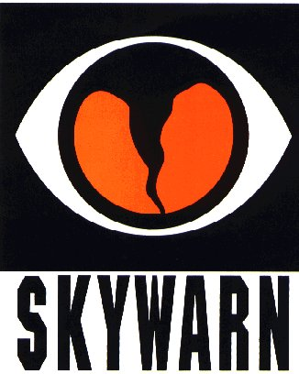

From the National Weather Service

As previously mentioned, we will not be able to conduct in person spotter training classes this winter and spring due to restrictions associated with COVID. Therefore, we will hold several virtual spotter training classes. These classes will be open to the public and free of charge. Please feel free to promote to your staff, spotters, amateur radio operators and to publicize to the citizens in your community.

All of our classes will be conducted as live webinars with live Q&A. We will use the GoToWebinar software, which can host up to 1000 people for each session. These webinars will not be recorded. 6 webinars are currently planned in February and March, with different days of the week and diverse times represented.

TOP ^

If the demand is high enough, we may consider a 7th webinar in April. All those who attend will need to register in advance. Below are the links to the 6 scheduled classes:

* Spotter Webinar 1: Friday, February 19, 2021 (1 PM - 3 PM):

<https://register.gotowebinar.com/register/8258577384418148110>

* Spotter Webinar 2: Wednesday, February 24, 2021 (7 PM - 9 PM):

<https://register.gotowebinar.com/register/4105945167168648206>

* Spotter Webinar 3: Thursday, March 4, 2021 (7 PM - 9 PM):

<https://register.gotowebinar.com/register/8790359481726954766>

* Spotter Webinar 4: Monday, March 8, 2021 (6 PM - 8 PM):

<https://register.gotowebinar.com/register/5017422714408992270>

* Spotter Webinar 5: Tuesday, March 23, 2021 (6 PM - 8 PM):

<https://register.gotowebinar.com/register/8257513057162542350>

* Spotter Webinar 6: Saturday, March 27, 2021 (12 PM - 2 PM):

<https://register.gotowebinar.com/register/5687758669980329230>

Ohio Section Cabinet

|  |  |
| --- | --- |
| Section Manager – Tom Sly, WB8LCD | Section Traffic Manager – David Maynard, WA3EZN |
| Section Emergency Coordinator – Stan Broadway, N8BHL | Section Youth Coordinator – Anthony Lascre, K8ZT |
| Technical Coordinator – Jeff Kopcak, K8JTK | Affiliated Clubs Coordinator – Tom Sly, WB8LCD |
| State Government Liaison – Bob Winston, W2THU | Public Information Coordinator – John Ross, KD8IDJ |



Hey Gang,

Have you taken a look at the **Swap & Shop** page on the Ohio Section webpage yet?? Here’s a link that will take you there… <http://arrl-ohio.org/sm/s-s.html>

Do you have equipment that you just don’t need or want anymore? Here’s a great venue to advertise it, and it’s FREE!! Is your club doing a fund raiser to help raise money? After a lot of thought, it was decided that the Swap & Shop webpage could also contain these types of items as well. The same rules will apply as do for the For Sales and Give-A-Ways and will only be posted for a month at a time. Please see the Terms & Conditions on the webpage.

If your club is doing a fund raiser and wants more exposure, please forward the information to me and I’ll advertise it on the Swap & Shop webpage for you.

TOP ^

Now, I still want to remind you that it won’t be listed in this newsletter because it would take up way too much space, so your ad will only appear on the website. It is there for any individual to post equipment Wanted / For Sale or Give-Away as well as for Club Fund Raisers. No licensed vehicles/trailers or business advertising will be posted. Postings are text only (no pictures or graphics) will be posted for a maximum of 1 month from date posting and require a contact phone number or email within the posting. Send your Wanted / For Sale or Give-Away post to:  [swap@arrlohio.org](mailto:swap@arrlohio.org)

***Back Issues of the PostScript and Ohio Section Journal***

Hey, did you know that PostScript and Ohio Section Journal (OSJ) are archived on the website? You can go back and look at any edition simply by clicking:

<http://arrl-ohio.org/news/index.html>

***Welcome New Subscriber(s)***

**Steve Leggans; Bruce, K8DGV; Adam Henson; Paul, N7PRT; Nikolay, K5NIK;**

**Andrew, AC8JR**

***Want to Share your Club Newsletter With Others?***

We have a webpage where you can download and read all of the newsletters that I get from around the state and even other sections!

Here’s the link to the page…. <http://arrl-ohio.org/club_news/index.html>

Please, if you don’t see your club newsletter posted, it’s because I’m not receiving it. Just have your newsletter editor contact me and I’ll get your club’s newsletter listed on the site!!

We all learn and steal (I mean, share) from each other’s work. So, get me your newsletter!!! Send it to: [webmaster@arrl-ohio.org](mailto:webmaster@arrl-ohio.org)

***Chit – Chat, and All That!***

Do you know someone that’s not getting these Newsletters? Please, forward a copy of this Newsletter over to them and have them “[Opt-In](mailto:Opt-In)” to start receiving them. Heck just have them send an email to: [webmaster@arrl-ohio.org](mailto:webmaster@arrl-ohio.org) and we’ll get them added to the Ohio Section Emailing list.

TOP ^

We now have many thousands of readers receiving these newsletters weekly. Quite impressive, I’d say! I urge all of you to make sure that everyone, regardless of whether they are a League member or not, get signed up to receive these weekly Newsletters.

You can always “Opt-Out” at any time if you feel this is not what you were expecting. It’s fun and very informative. All of your favorite past newsletters are now archived too.

You can go back at any time and read them.

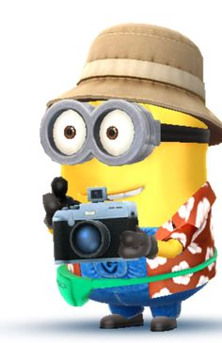Just go to: <http://arrl-ohio.org/news/>

The pictures on the front page and throughout this newsletter are from various newsletters, Facebook posts and/or were sent directly to me in recent weeks. Take a good look at them, you just might be in one of the pictures! “SMILE… you’re in the Ohio Section News!!”



TOP ^

*PostScript is produced as a weekly newsletter. I want to thank everyone that has contributed articles and ideas to make this an even better news source. I sincerely hope that you have enjoyed this edition and will encourage your friends to join with you in receiving the latest news and information about the Ohio Section, and news and events happening around the world!*