[](http://arrl-ohio.org/news/) ***“Ground Hog Day”***

 ***Edition***

🡪 National News 🡪 Club Corner

🡪 DX This Week 🡪 Contest Corner

🡪 Special Events 🡪 Upcoming Hamfests

🡪 One Question Questionnaire 🡪 VE Testing

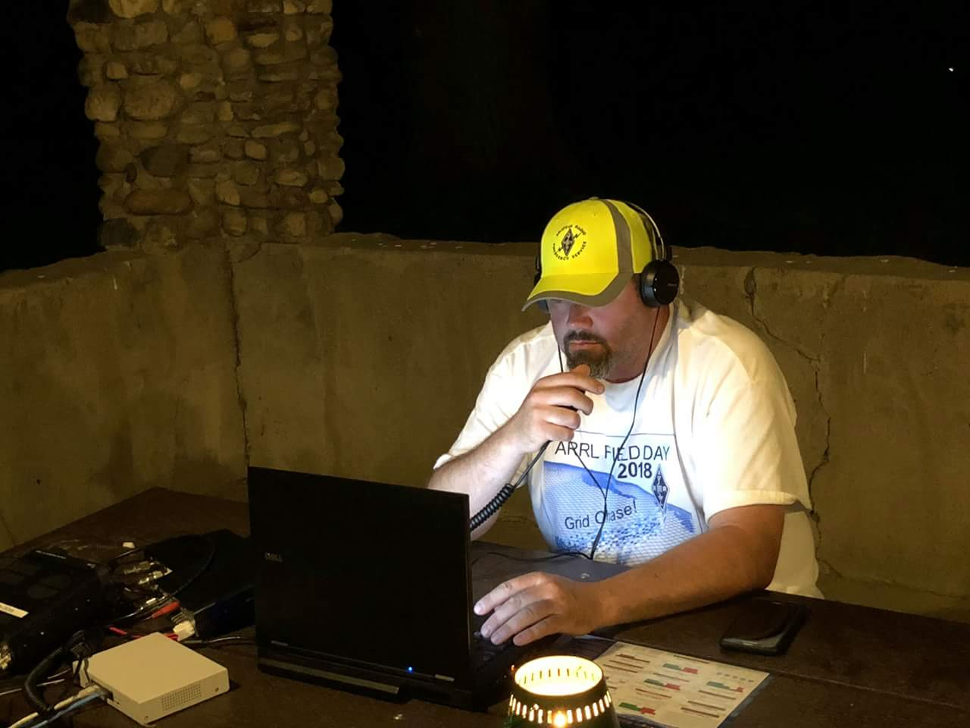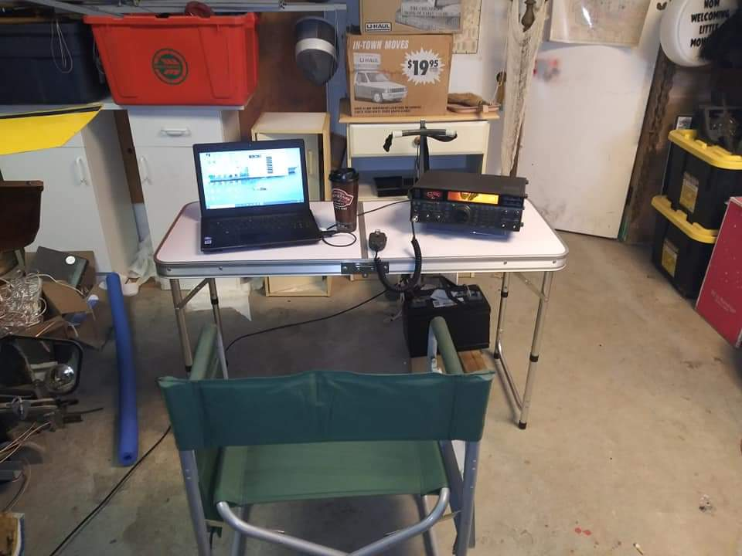



***National News***

*(from arrl and other sources)*

***Ham Radio’s SuitSat Returns in Short Horror Film***

SuitSat loses its innocence in a new [**video short**](https://vimeo.com/502018179) sci-fi thriller *Decommissioned*. “Inspired by true events,” the video short resurrects the 2006 spacesuit/satellite that transmitted messages on 2 meters as it circled Earth. The original SuitSat-1 project, conceived by an Amateur Radio on the International Space Station ([**ARISS**](http://www.ariss.org/)) team, repurposed a decommissioned Russian Orlan spacesuit to function as a free-floating amateur radio transmit-only satellite.

“ARISS designed and built an antenna and radio gear that got approved for installation into the suit, and cosmonaut Valeri Tokarev and Commander Bill McArthur, KC5ACR, put SuitSat-1 into orbit at the start of a spacewalk,” ARISS-US Delegate for ARRL Rosalie White, K1STO, recounted. SuitSat-1 transmitted a voice message, “This is SuitSat-1 RS0RS!” in several languages, plus telemetry and a slow-scan TV image on an 8-minute cycle as it orbited Earth.

In the 6-minute film, a SuitSat returns in the future to haunt International Space Station commander “Diaz,” played by Joey Vieira. Diaz is seen taking photos from inside an observation dome on the ISS when he spies some distant space debris and radios Houston to express concern.

“If there was any cause for alarm, you know we’d see it too,” Houston assures.

As the object closes in, an increasingly anxious Diaz recognizes the “debris” as SuitSat. “This is SuitSat,” comes a voice on the ham radio.

“Houston, you’re not gonna believe this. We’re picking up transmissions on the ham radio that sound identical to the SuitSat experiment,” he tells a skeptical mission control. “It’s SuitSat! I’m seeing SuitSat!”

“SuitSat re-entered the atmosphere and burned up years ago,” mission control responds. “It’s impossible.”

*Decommissioned* was produced by Perception Pictures and directed by Australian filmmaker Josh Tanner. He [**told**](https://io9.gizmodo.com/an-astronaut-has-an-unwelcome-and-possibly-undead-visit-1846085578/amp?utm_medium=sharefromsite&utm_source=_twitter&__twitter_impression=true)Gizmodo that he produced the video “using the *Unreal Engine* technology that *The Mandalorian* used, albeit old-school rear projection, as opposed to the fancy LED wall tech they used.”

SuitSat-1 — called *Radioskaf* or Radio Sputnik in Russian — was so successful that another unneeded Orlan spacesuit was subsequently refitted as SuitSat-2.

As an interesting sidebar with respect to the real SuitSat, White explained, “After the ARISS engineers calculated SuitSat-1’s orbit and spin characteristics, they knew the legs and arms would have to be filled with something, so they asked the crew to stuff dirty laundry inside.”

TOP ^

White said *Decommissioned* was a hit at a recent ARISS meeting. The original SuitSats were deorbited to burn up in Earth’s atmosphere after their useful lives ended.

ARRL is a partner in the ARISS program, which has kept amateur radio on the air from the International Space Station for 20 years. A hallmark of the ARISS program is the scheduled ham radio contacts made by astronaut crew members with schools and student groups around the world.

####

***CHESS CubeSat Constellation to Carry FUNcube Transponders***

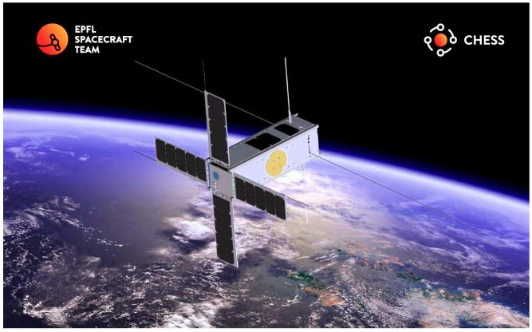In 2020, a project between AMSAT-UK, AMSAT-NL, and Swiss universities got under way with the aim of equipping two Swiss satellites — for now under the [**CHESS**](https://www.amsat-hb.org/funcube-chess/) name — with linear amateur radio transponders. Linear transponders permit several CW or SSB contacts to take place simultaneously within a prescribed passband. The satellites also include features for classroom demonstrations and experiments. The CHESS (Constellation of High Energy Swiss Satellites) project includes two satellites, which will be built simultaneously and later launched as a constellation.

“The main science objective is to improve the understanding of the upper atmosphere by in-situ measurements…taking advantage of a constellation of identical nanosatellites to study the composition of the terrestrial atmosphere and its density,” the CHESS website explains.

The first satellite will have a nearly circular orbit at an altitude of 400 kilometers. The second will have an elliptical orbit with an altitude of 350 × 1,000 kilometers.

The amateur radio payload is a joint project of AMSAT-UK and AMSAT-NL. A successful review of system requirements was completed in December. Launch will not take place until the fourth quarter of 2022.

The satellites themselves are a project of the École polytechnique fédérale de Lausanne ([**EPFL**](https://www.epflspacecraftteam.com/chess-1)), with support from several other schools.*— Thanks to* AMSAT News Service*via AMSAT-UK*

***Club Corner***

This is YOUR cornner of the newsletter. Send me what your club is doing and I’ll make sure that it gets in. Got a special event or club project that you want everyone to know about? Send it to me!. Need help with a project? Send it to me.

Let me know what you club is up to. Are you going to have a special guest at your meeting or are you having a special anniversary?

Just sent it to: [webmaster@arrl-ohio.org](mailto:webmaster@arrl-ohio.org)

####

TOP ^

***20 Mile Drop***

All - I just received word from Lake County that the 20-mile drop is on for 2021! It'll take place on April 11. If you're interested in volunteering, please use the form below to sign up.

<https://docs.google.com/forms/d/e/1FAIpQLScuzbciZXdMo87nBr3bFAAtz0_fNZJIk4b3RtIGVb0cUAKxcQ/viewform?usp=sf_link>

***DX This Week***

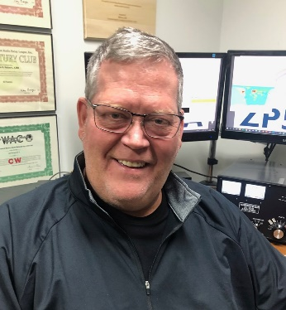

***DX This Week – UAAC***

***Bill AJ8B (aj8b@arrl.net, @AJ8B, or www.aj8b.com)***

***CWOPs Member #1567***

The Midwest DX Cluster spots included Alaska, Algeria, Andorra, Austria, Balearic Islands, Barbados, Belgium, Bonaire, Brazil, Bulgaria, Canada, Corsica, Costa Rica, Cuba, Cyprus, Denmark, England, Faroe Islands, Fed. Rep. of Germany, Finland, France, French Guiana, Gibraltar, Guatemala, Haiti, Honduras, Hungary, Iceland, Ireland, Isle of Man, Israel, Italy, Japan, Kaliningrad, Latvia, Luxembourg, Mexico, Morocco, Netherlands, New Caledonia, North Macedonia, Northern Ireland, Peru, Poland, Puerto Rico, Sardinia, Scotland, Sicily, Slovenia, Spain, Switzerland, Ukraine, United Nations HQ, United States, US Virgin Islands, and Wales. This brings the total number of entities spotted in the Midwest to 116!

***DAH DIT DIT DIT DAH DAH DIT DIT DIT DAH***

I received cards from XE1EE – Alejandro in Queretaro, Mexico, and Z66DX from the DXPedition to the Republic of Kosovo. Let me know what you received.

|  |  |
| --- | --- |
|  |  |
|  |  |

***DAH DIT DIT DIT DAH DAH DIT DIT DIT DAH***

TOP ^

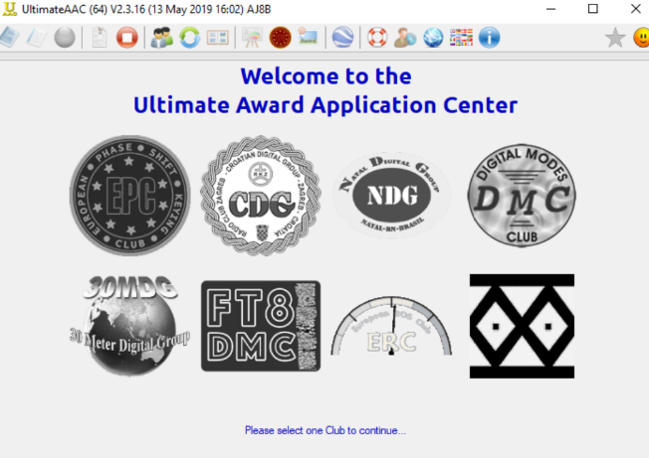Each year, there are several topics that generate interest or questions. I like to “run” them each year as I am assuming these topics are of a particular interest to you. The discussion regarding the UAAC, or the “Ultimate Award Application Center” is one of those that generated some questions.

I happen to be on a QRZ.com page of an avid FT8 DXers from Serbia and read about something called UAAC. UAAC is an abbreviation for the Ultimate Award Application Center. DK5UR has built a very easy to use and understand interface that submits the appropriate QSOs to various clubs that offer awards. Each of these awards has a very colorful certificate for reaching various levels. Once a month I load an adif of my logbook into the UAAC and it evaluates what awards I have become eligible for. The software then submits an application to the appropriate clubs and I am notified that I have indeed earned a certain level or a new award. The UAAC is a single interface for at least 8 different clubs that offer awards for activity.

These awards are downloadable as soon as you earn them. All of this is available at no cost. Since my interest in UAAC has started, I have joined the Digital Modes Club (DMC), European PSK Club (EPC), FT8 Digital Modes Club (FT8DMC), and the 30 Meters Digital Group. (30MDG). After you explore these options and then register for the ones that you are interested in, you will receive a membership number from each group. You can load that number in to the UAAC and then have the UAAC app evaluate your logbook. In my case, within a few hours, I received about 30 certificates from the organizations. The software can be accessed at <http://epc-mc.eu/index.php?option=com_phocadownload&view=category&id=1:ultimateaac&lang=en>

(This is not to brag, just to share!) Samples are below:

|  |  |
| --- | --- |
|  |  |
|  |  |

TOP ^

|  |  |
| --- | --- |
|  |  |
|  |  |
|  |  |

***DAH DIT DIT DIT DAH DAH DIT DIT DIT DAH***

**From our 60M Guru, Joe – W8GEX, we get the following update:**

January 23, 2021 - Joe Pater W8GEX

General Activity Update

**Thailand:** HS7KYV was spotted.

**Uzbekistan:** Information comes from Fedor, UK9AA, of the Radio Amateurs of Uzbekistan, to tell us that permission has been received for Category 1 Uzbek licensees to operate in the new WRC-15 Amateur 60m Secondary Allocation of 5351.5 – 5366.5 kHz with a Maximum Power of 100W.

TOP ^

Prior to this, Fedor was able to obtain a special individual permit from the regulator in 2014, making his first 5 MHz QSO in 2015. He believes he was the first in the CIS region to have received a license for 60m.

Radio Amateurs of Uzbekistan <http://hamradio.uz/>

**8Q – Maldives** - Updating our December 14th story, G0VJG, Nobby, due to the pandemic, has rescheduled his trip until March 6. He plans to be QRV on 60 meters as well as others. His 8Q7CQ activity is now set for March 6-22. QSL via M0OXO.

G0VJG, Nobby, who is headed to Reethi Fura Island early next year gives us an update. The “License next year should be 8Q7CQ from January 14-29. The world’s best QSL Manager”, M0OXO, Charles, will handle confirmations.

73 Nobby G0vjg/ 8Q7CQ

**JAPAN -** I see many cluster spots of people working Japan. The JA’s DO NOT have 60m permission.

**V4 – St. Kitts & Nevis -** John, W5JON, says he is sick of being stuck in Texas and can’t wait to get the vaccine shots and get “back in the DX loop.” His February 27 to March 27 trip to V47JA is still on and next year’s October-November V47JA and PJ5/W5JON trip is booked too.

**ZS – South Africa -** South Africa’s ham organization, SRAL, is asking regulator ICASA to permit use of 100 kHz on the 60 meter, 5 MHz, band with 400 watts output. A published international plan currently has three segments, 5351.5 to 5366.5, 15 watts EIRP, the most common allocation worldwide where 60M operation by hams is allowed at all.

The 60 meter WAZS challenge - In terms of the outcome of the World Radio Conference 2015 where radio amateurs gained access to the 60-metre band, ICASA published on 25 May 2018 in the National Radio Frequency Plan an allocation of 100 kHz of spectrum to South African Radio Amateurs. There are two separate footnotes in the plan, splitting access to the 60-metre band into three segments.

In footnote 5.133B there is an allocation of 5351.5 to 5366.5 kHz with a power limit of only 15W eirp. This is the most common allocation in countries where 60 meters is permitted.

In footnote NP 0, ICASA has allocated a full 100 kHz. The footnote reads: “The 5350 – 5430 and the channel 5290 kHz is allocated on a secondary basis to radio amateurs under Article 4.4 of the ITU regulations. The entire allocation is on a secondary basis which means radio amateurs may not cause interference.

ICASA has however not yet updated annexure I of the Frequency Spectrum regulations which stipulates power limits and modulation types. However, in the SARL’s motivation to have 100 kHz of 5 MHz spectrum allocated, the SARL requested a power limit of 26 dBW (400 Watts PEP) for ZS and ZR license holders and 20 dBW (100-watt PEP) for ZU license holders. These power limits are common in South Africa for all bands that are allocated on a secondary basis. On bands where amateur radio has a primary allocation, the power limit for ZS and ZR licensees is 30 dBW. The current situation is that these power limits for secondary allocations apply on 5 MHz except for the segment 5351.5 to 5366.5 where only 15-Watt eirp is permitted.

TOP ^

Work All ZS award - The SARL is challenging radio amateurs to use the 60-metre band and work towards the SARL Worked All ZS award. The Worked All ZS series of awards is available to all radio amateurs and short-wave listeners. Applicants must prove two-way contacts (or SWL reports) with at least 100 South African callsigns. The 60 M WAZS award will carry a special” worked on 5 MHZ” endorsement. The callsigns must represent the different call areas as per the WAZS rules as follows:

* ZS1 16 contacts
* ZS2 8 contacts
* ZS3 1 contact
* ZS4 6 contacts
* ZS5 13 contacts
* ZS6 56 contacts

“Radio Amateurs are encouraged to give genuine signal reports as the data will be processed and will make part of a study of propagation of the 60-metre band. Each application must show the date, time, frequency, power used, both callsigns, and the given and received accurate signal reports.

All applications for the special 60 Meter Worked All ZS award received by 31 March will participated in the draw for a 2021 ARRL handbook. For application details visit http://www.zs6p.com/SARL_Awards_Directory.pdf

**P4 – Aruba** - Next month DL4MM, Mathias, is heading to the P40L contest station on Aruba for the CQ WW 160 Meter CW Contest. During the contest he will be operating with the somewhat rare P44 prefix as P44A. Outside the contest, January 23 to February 3, he will be QRV as P4/DL4MM. He’ll be using a K3 and 1.5K amplifier. Antennas at the P40L contest station include multiple beams and carious Beverages. Activity will be on CW, FT4, FT8 and SSB on 1.8 through 50 MHz, including 60 meters. He will be uploading his QSOs to Club Log and LoTW. QSL via OQRS and the DARC QSL Bureau.

**60 METER CONDITIONS -** N5KO, Trey Garlough (creator of the Cabrillo software) and a renowned op at HC8N and others, notes both A45XR and T6AA have been heard on the West Coast of NA on 60, “with big signals” at 1500Z. Trey also worked BG3ISR in CQ Zone 23 at 1530Z, on 5357 kHz FT8.

Copyright © 2021. |60 meters newsletter, All rights reserved.

Our mailing address is:

W8GEX@aol.com

2419 Pierson Rd., Oxford, OH 45056 US

***CQDX CQDX CQDX CQDX CQDX CQDX CQDX CQDX CQDX***

Here is an update from Bernie, W3UR, of the DailyDX and the WeeklyDX, the best source for DX information. <http://www.dailydx.com/>

Bernie has this to report:

**SV – Greece -** Celebrating the 200th anniversary of the Hellenic War of Independence, aka the Greek Revolution, members of the Radio Amateur Association of Western Peloponnese (R.A.A.W.P) will be QRV with six special callsign during the month of March. The calls are:

TOP ^

* SZ1821R (General call for the Revolution)
* SZ21TK (Theodoros Kolokotronis)
* SZ21GK (George Karaiskakis)
* SZ21AD (Athanasios Diakos)
* SZ21PF (Papa Flessas)
* SZ21LB (Laskarina Bouboulina (YL))

QSL all of the Greek Revolution calls via LoTW, eQSL and QSZ.com

**8J – Antarctica -** The Japanese Antarctica Research Expedition (JARL) station 8J1RL will continue to be QRV from February 2021 to January 2022 with operator JG3PLH, Takumi, at the helm. This Antarctic station is located at the Japanese Syowa Station East Ongle Island, Lutzow-holm Bay, Dronning Maud Land (AN-015). At the station are an IC-7610 and IC-7300 capable of running 50 watts into a 4 element Yagi (20/15/10 Meters), 3 Element Yagi (30/17/12 Meters) and Wire (40 Meters). Activity will be on SSB, CW and FT8 on 7 through 28 MHz.

**3W – Vietnam -** XV5HS QSL manager EA5ZD, Miguel, tweets operator HS1JQP, Ardsiri (aka Apple), “has been out of the country for work reasons, but will soon return to Vietnam and be active again”.

***DAH DIT DIT DIT DAH DAH DIT DIT DIT DAH***

**Top Band Update –** My top band coaches, K8DV – Dave, and K8CR – Chuck, have been pushing the importance of working the gray line. Well, now I believe them. I was able to work Japan and Guam at 12:22 and 12:24 Saturday morning on 160M. There were also 4 other JA stations calling CQ, a KH6, and RM0F from Asiatic Russia. The amazing thing was that they were there, fairly strong, and then GONE in about a 15-minute window. I had gotten an email from Joe, W8GEX alerting me to the fact the JAs were there, but the were gone for him before I worked the JA and we are about 40 miles apart. K8DV mentioned that there have been many stations that either he could hear or K8CR could hear but not both and they are about 20 miles apart. Adds to the mystique of “Top Band”

***DAH DIT DIT DIT DAH DAH DIT DIT DIT DAH***

**QSO Today Virtual Ham Expo –** Tickets are now available to attend the QSO Today Virtual Ham Expo sponsored by the QSO Today Podcast, FlexRadio, Icon and Elecraft. Information can be found at <https://www.qsotodayhamexpo.com/>

There are several hams from our area who will be speaking and you can watch the presentations live, ask questions of the presenters, and well as visit the booths of many vendors. The dates are March 13th and 14th. Also, you will be able to access many of the presentations until April 12th.

Check it out and let me know what you think!

***DAH DIT DIT DIT DAH DAH DIT DIT DIT DAH***

TOP ^



Below is a list of upcoming contests in the “Contest Corner”. I think this is important for someone who is trying to move up the DXCC ladder since entities that are on the rarer side and easiest to work in contests. Some of my best “catches” have been on the Sunday afternoon of a contest when the rarer entities are begging for QSOs. Of course, the gamble is that if you wait until Sunday, conditions may change, or they simply won’t be workable. However, it is not a bad gamble. Of course, why not work the contest and have some fun!  
Check out the WA7BNM Contest Calendar page (<https://www.contestcalendar.com/>) for more contests or more details.

The contests in red are those that I plan to spend some significant participation time on. PLEASE let me know if you are working contests and how you fared.

Thanks!

|  |  |  |
| --- | --- | --- |
| Feb. 2 | RSGB 80m Club Championship, SSB | <https://www.rsgbcc.org/hf/rules/2020/r80mcc.shtml> |
| Feb. 3 | UKEICC 80m Contests SSB | <https://bit.ly/2SDPqQQ> |
| Feb. 6 | FISTS Winter Saturday Sprint | <http://www.fistsna.org/operating.html> |
| Feb. 6 | AGCW Straight Key Party | <https://bit.ly/3ngQSpB> |
| Feb. 6 | Minnesota QSO Party | <https://www.w0aa.org/mn-qso-party/> |
| Feb. 6-7 | 10-10 Int’l Winter Contest | <http://bit.ly/1FrFeBc> |
| Feb. 6-7 | British Columbia QSO Party | <http://www.orcadxcc.org/bcqp_rules.html> |
| Feb. 6-7 | Vermont QSO Party | <http://www.ranv.org/ranv.html> |
| Feb. 6-7 | Mexico RTTY International Contest | <https://bit.ly/35kiJ20> |
| Feb. 6-7 | North American CW Sprint | <http://ncjweb.com/north-american-sprint/> |
| Feb.8-12 | ARRL School Club Roundup | <http://www.arrl.org/school-club-roundup> |
| Feb. 10 | RSGB 80m Club Championship, DATA | <https://www.rsgbcc.org/hf/rules/2020/r80mcc.shtml> |
| Feb. 13 | RSGB 1st 1.8 MHZ Contest CW | [https://www.rsgbcc.org/hf/](http://www.rsgbcc.org/hf/) |
| Feb. 13 | Asia-Pacific Spring Sprint (CW) | <http://jsfc.org/apsprint/> |
| **Feb. 13-14** | **CQ WW RTTY WPX Contest** | [**http://www.cqwpxrtty.com/**](http://www.cqwpxrtty.com/) |
| Feb. 13-14 | AWA Amplitude Modulation QSO Party | <https://bit.ly/2Io0u3e> |
| Feb. 13-14 Feb. 13-14 Feb. 13-14 | Dutch PACC Contest KCJ Topband Contest OMISS QSO Party | [http://pacc.veron.nl/  https://www.kcj-cw.com/e_index.htm http://www.omiss.net/Facelift/qsoparty.php](http://pacc.veron.nl/%20https:/www.kcj-cw.com/e_index.htm%20%20http:/www.omiss.net/Facelift/qsoparty.php) |
| Feb. 13-15 | YL OM Contest | <https://ylrl.org/wp/yl-om-contest/> |

TOP ^

|  |  |  |
| --- | --- | --- |
| Feb. 14 | PODXS 070 Club Valentine Sprint | <http://bit.ly/2Rp8LTk> |
| Feb.15 | RSGB FT4 Contest Series | <http://bit.ly/38xg9V7> |
| Feb. 17 | AGCW Semi-Automatic Key Evening | <https://bit.ly/3ngQSpB> |
| Feb. 21 | FISTS Winter Sunday Sprint | <http://www.fistsna.org/operating.html> |
| Feb. 20-21 | ARRL CW DX Contest | <http://www.arrl.org/arrl-dx> |
| Feb. 20-21 | Russian WW PSK Contest | <http://bit.ly/2MsppCr> |
| Feb. 24 | UKEICC 80m Contests CW | <https://bit.ly/2SDPqQQ> |
| Feb. 25 | RSGB 80m Club Championship, CW | [https://www.rsgbcc.org/hf/rules/2020/r80mcc.shtml](http://www.rsgbcc.org/hf/rules/2020/r80mcc.shtml) |
| **Feb. 26-28** | **CQ WW 160M SSB Contest** | [**http://www.cq160.com/rules.htm**](http://www.cq160.com/rules.htm) |
| Feb. 27-28 | REF SSB Contest | <http://concours.ref-union.org/contest/?page_id=2> |
| Feb. 28 | High Speed Club CW Contest | <http://www.highspeedclub.org/> |
| Feb. 27-28 | South Carolina QSO Party | <http://scqso.com/> |
| Feb. 27-28 | North American RTTY QSO Party | <http://ncjweb.com/naqp/> |
| Feb. 27-28 | UBA CW DX Contest | <http://bit.ly/W0gZiE> |
| Feb. 28-Mar.1 | North Carolina QSO Party | <http://ncqsoparty.org/rules/> |
| Mar. 27 – 28 | CQWW WPX SSB | <https://www.cqwpx.com/> |
| May 29 – 30 | CQWW WPX CW | <https://www.cqwpx.com/> |
| August 28 | Ohio QSO Party | <https://www.ohqp.org/> |
| August 28 | W8DXCC | <https://www.w8dxcc.com> |

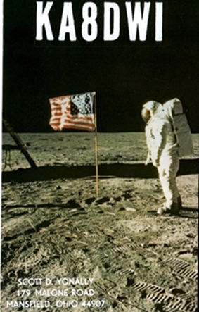***DX News***

ARLD004 DX news

This week's bulletin was made possible with information provided by I0IJ, The Daily DX, the OPDX Bulletin, 425 DX News, DXNL, Contest Corral from QST and the ARRL Contest Calendar and WA7BNM web sites. Thanks to all.

**KINGDOM OF ESWATINI, 3DA0.** Hans, 3DA0AQ has been active on 20 meters using CW around 2035z. QSL via EA5GL.

**TUNISIA, 3V.** Ash, KF5EYY will be QRV as 3V8SF from the Scout Radio Club of Sfax city club station during the CQ World Wide 160 Meter CW contest as a Single Op/Low Power entry. QSL via LX1NO.

TOP ^

**AZERBAIJAN, 4K.** Special event station 4K1AZI is QRV until February 2 in remembrance of Hazi Ahad oglu Aslanov, a major general of tank division. QSL via DC9RI.

**GEORGIA, 4L.** Look for 4L2M to be a Single Op entry in the CQ World Wide 160 Meter CW contest. QSL direct to EA7FTR.

**ISRAEL, 4X.** Special event station 4X0RMN will be QRV from January 30 to February 1 to recognize the Land of Craters programme from Ramon Crater. QSL via 4X6ZM.

**BARBADOS, 8P.** Charles, 8P6ET will QRV as 8P1W in the CQ World Wide 160 Meter CW contest. QSL via KU9C.

**FRANCE, F.** Special event station TM1CCA will be QRV from January 30 to March 20 to draw attention to a charity supporting research into pediatric cancers. Activity will be on the HF bands using CW, SSB, RTTY, FT8 and FT4. QSL via LoTW.

**ENGLAND, G.** Special call sign GB75ISWL is QRV during all of 2021 to celebrate the 75th anniversary of the International Short Wave League. Activity will be on most HF bands and modes. QSL via bureau.

**GUERNSEY, GU.** Look for GU4YOX to be QRV as a Single Op/High Power entry in the CQ World Wide 160 Meter CW contest. QSL direct to GU4YOX.

**ANTARCTICA.** Takumi, JG3PLH will be QRV as 8J1RL beginning in February as a member of the 62nd Japanese Antarctic Research Expedition team stationed at Syowa base on East Ongul Island, IOTA AN-015. He is here until January 2022. QSL via bureau.

**ARGENTINA, LU.** Special event station L21RCA is QRV during 2021 to celebrate the 100th anniversary of the Radio Club Argentino. QSL via bureau.

**BULGARIA, LZ.** Members of the Bulgarian Radio Club Blagovestnik will be QRV as LZ544SG during February to honor the memory of Orthodox saints. QSL via bureau.

**ALAND ISLANDS, OH0.** A group of operators will be QRV as OH0W in the CQ World Wide 160 Meter CW contest. They plan to be active a few days after the contest. QSL via operators' instructions.

**NETHERLANDS, PA.** Special event station PA21BP will be QRV during February to celebrate the Scouts' Thinking Day on the Air. QSL via PA3EFR.

**BONAIRE, PJ4.** Operator K4BAI will be QRV as PJ4A in the CQ World Wide 160 Meter CW contest. QSL to home call.

**POLAND, SP.** Special event station HF100LEM is QRV from Krakow during all of 2021 to mark the 100th birthday celebration of the Polish writer Stanislaw Lem. QSL via SP9PKZ.

**SOMALIA, T5.** Ali, 6O1OO has been QRV on 40 meters using FT8 around 1340 and 2230z. QSL via QRZ.com.

TOP ^

**INDONESIA, YB.** A large group of operators will be QRV as 7A1A as a Multi/Single entry in the CQ World Wide 160 Meter CW contest. QSL via EA7FTR direct or LoTW.

**IRAQ, YI.** Giorgio, IU5HWS is QRV as YI9WS until March while on assignment. Activity is in his spare time on 80 to 15 meters. QSL direct to home call.

**ST. HELENA ISLAND, ZD7.** Peter, ZD7FT has been QRV on 17 meters using SSB around 1440 to 1505z. Barrie, ZD7MY has been active on 15 meters using FT8 just after 1500z. QSL direct to home calls.

**CAYMAN ISLANDS, ZF.** Stan, K5GO plans to be QRV as ZF5T in the CQ World Wide 160 Meter CW contest. QSL to home call.

**NEW ZEALAND, ZL.** Members of the Christchurch Amateur Radio Club will be QRV as ZL100RSC during February to celebrate its 100th anniversary. QSL via bureau.

**ANTARCTICA.** Oleg, ZS1ANF plans to be QRV as ZS7ANF from Wolf's Fang Camp beginning in February. QSL via RK1PWA.

THIS WEEKEND ON THE RADIO. The CQ 160-Meter CW Contest, Winter Field Day, NCCC RTTY Sprint, QRP 80-Meter CW Fox Hunt, NCCC CW Sprint Ladder, Feld Hell Sprint, REF CW Contest, UBA DX SSB Contest and the RTTYOPS Weekend Sprint are all on tap for this weekend.

The RSGB 80-meter Club SSB Championship, K1USN Slow Speed CW Test and OK1WC Memorial are scheduled for February 1.

The RTTYOPS Weeksprint, Worldwide Sideband Activity Contest and ARS Spartan CW Sprint are scheduled for February 2.

The CWops Mini-CWT Test, UKEICC 80-Meter SSB Contest, VHF-UHF FT8 Activity Contest, QRP 40-Meter CW Fox Hunt and Phone Fray are scheduled for February 3.

**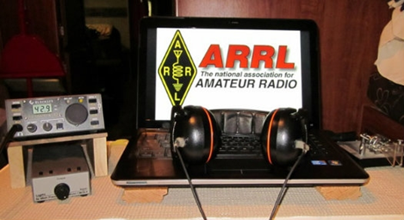*ARRL Contest Corner***

An expanded, downloadable version of *QST'*s’ [**Contest Corral**](http://www.arrl.org/contest-calendar) is available as a PDF. Check the sponsor’s ‘Website for information on operating time restrictions and other instructions.

***####***

|  |  |
| --- | --- |
| **February 1**   * [K1USN Slow Speed Test](http://www.k1usn.com/sst.html) * [OK1WC Memorial (MWC)](https://memorial-ok1wc.cz/index.php?page=rules2l) * [RSGB 80m Club Championship, SSB](https://www.rsgbcc.org/hf/rules/2021/r80mcc.shtml) | **February 2**   * [Worldwide Sideband Activity Contest](https://wwsac.com/rules.html) * [ARS Spartan Sprint](http://arsqrp.blogspot.com/2009/02/so-whats-spartan-sprint-and-how-do-i.html) * [RTTYOPS Weeksprint](https://rttyops.wordpress.com/rtty-mini-contests/rttyops-weeksprint/) |

TOP ^

|  |  |
| --- | --- |
| **February 3**   * [QRP Fox Hunt](http://www.qrpfoxhunt.org/winter_rules.htm) * [Phone Weekly Test - Fray](http://www.perluma.com/Phone_Fray_Contest_Rules.pdf) * [VHF-UHF FT8 Activity Contest](http://www.ft8activity.eu/index.php/en/) * [CWops Mini-CWT Test](https://cwops.org/cwops-tests/) * [UKEICC 80m Contest](https://www.ukeicc.com/80m-rules.php) |  |

***Special Events***

* **02/01/2021 | JY1 Special Event Memorial Station 2021**

**Feb 1-Feb 28, 0000Z-2359Z, N9SES**, Lake Station, IN. ArabQrz Club. 14.250 14.030 7.185 7.030. QSL. Ayman Azar, 2861 Decatur St, Lake Station, IN 46405. See website for participating stations from other countries. All HF/VHF/UHF, All Modes. Hamsphere Users can also participate in the event [www.n9ses.com/?page_id=18](http://www.n9ses.com/?page_id=18)

* **02/06/2021 | 100th Anniversary**

**Feb 6-Feb 27, 1800Z-2359Z, W6UW**, San Jose, CA. Santa Clara County Amateur Radio Association. 21.320 14.250 7.250. Certificate. Don Village, K6PBQ, 3290 Woody Lane, San Jose, CA 95132. w6uw@arrl.net or [www.qsl.net/sccara](http://www.qsl.net/sccara)

* **02/06/2021 | Ground Hog Day Special Event**

**Feb 6, 0900Z-1500Z, K3HWJ**, Punxsutawney, PA. Punxsutawney Amateur Radio Club. all modes, all bands. Certificate. Stephen Waltman, KB3FPN, 37 Clark St., Brookville, PA 15825. SASE for certificate. [www.punxyclub.com](http://www.punxyclub.com/)

* **02/06/2021 | Shuttle Columbia Special Event**

**Feb 6-Feb 7, 1400Z-2359Z, K5C**, Nacogdoches, TX. Nacogdoches ARC. 7.216 14.260 21.350 28.350. QSL. Army Curtis, 167 CR 2093, Nacogdoches, TX 75965. All contacts will be confirmed via LOTW. [https://w5nac.com](https://w5nac.com/)

* **02/07/2021 | Commemorating Howard E. Anthony, Father of Heathkit**

**Feb 7, 1200Z-2359Z, KD2FSI**, Randolph, NJ. KD2FSI. 21.300 14.300 7.300 3.900. QSL. David R. Hackett, 3 High Ridge Road, Randolph, NJ 07869. On Sunday February 7, 2021 from 1200Z -2359Z, Amateur Radio Station KD2FSI will operate as a special event station using a variety of vintage Heathkit gear to commemorate the life and legacy of Howard E. Anthony, the father of the Heathkit brand of electronic kits. Starting in the morning with 75 meter SSB, we will work our way up to the 40, 20, 15 and 10 meter bands and then back down again towards the evening. I will post additional information on my public Facebook page as the event draws near and the actual operating frequencies and modes in real time the day off. We hope all amateur radio operators with any type of equipment (new or old) will join us as we commemorate Mr. Anthony, the person responsible for starting Heathkit, the finest electronic kit company ever. 73, Dave Hackett KD2FSI davehackett@cs.com <https://www.facebook.com/dave.hackett.9085>

TOP ^

* **02/13/2021 | George Washington's Birthday at his Boyhood Home, Ferry Farm VA**

**Feb 13, 1400Z-2000Z, W4B**, Fredericksburg, VA. Stafford Amateur Radio Association (SARA). 14.225 7.195 447.275. QSL. Stafford Amateur Radio Association (SARA), PO Box 6331, Fredericksburg, VA 22403. SASE required for return of a QSL card. [https://www.ws4va.org](https://www.ws4va.org/)

* **02/13/2021 | George Washington's Birthday at Mount Vernon**

**Feb 13-Feb 14, 0800Z-1400Z, K4US**, Alexandria, VA. Mount Vernon Amateur Radio Club. 14.260 14.074 7.040. QSL. MVARC, P.O. Box 7234, Alexandria, VA 22307. MVARC will be hosting a modified special event station to commemorate our first president's 289th birthday. Members will be operating remote stations this year due to COVID, with many broadcasting from the original grounds of the former plantation of George Washington and his wife, Martha Washington. [k4us@mvarc.org](mailto:)

* **02/13/2021 | I ❤️ Pluto Special Event**

**Feb 13-Feb 21, 0000Z-2359Z, W7P**, Flagstaff, AZ. Northern Arizona DX Association. 14.290 21.290 7.290 14.090. Certificate & QSL. W7P - I ❤️ Pluto Special Event, % Bob Wertz, NF7E, 6315 Townsend Winona Rd., Flagstaff, AZ 86004-1493. This will be an annual countdown S. E. to the 100th anniversary of the discovery of PLUTO, held every February, up to and including 2030. We are celebrating this historic discovery of Pluto, in 1930, by Clyde Tombaugh, at Lowell Observatory in Flagstaff, Arizona. Please note the frequencies will be + or- 10, as to not interfere with any nets operating during that time period. [www.nadxa.com](http://www.nadxa.com/)

* **02/13/2021 | Ice-olation Station WØJH**

**Feb 13-Feb 15, 1400Z-2355Z, W0JH**, Stillwater, MN. Stillwater, MN Amateur Radio Association. 21.360 14.260 7.260 3.860. Certificate. Shel Mann, N0DRX, 1618 Pine St West, Stillwater, MN 55082. We will have multiple stations simultaneously operating on different bands and different modes. In keeping with COVID-19 social distancing protocols, we will operate from our individual QTHs this year. In a meager attempt to drive away the remainder of Minnesota winter, the Stillwater Amateur Radio Association will be generating as much RF as possible over the President's Day long weekend. Certificates will ONLY be sent via email in PDF format. (Send requests with standard QSL confirmation info via email to: Ice2021@radioham.org). There is no need to send a QSL card. Info: WØJH at www.QRZ.com & www.radioham.org. [www.radioham.org](http://www.radioham.org/)

* **02/13/2021 | USS Midway Museum Ship Special Event: Raising Mt Suribachi Flag**

**Feb 13, 1700Z-2359Z, NI6IW**, San Diego, CA. USS Midway (CV-41) Museum Ship. 7.250 14.320 14.070 (PSK31) DSTAR via PapaSystem repeaters. QSL. USS Midway CV-41 COMEDTRA NI6IW, 910 N Harbor Dr, San Diego, CA 92101. SASE please. [www.qrz.com/db/ni6iw](http://www.qrz.com/db/ni6iw)

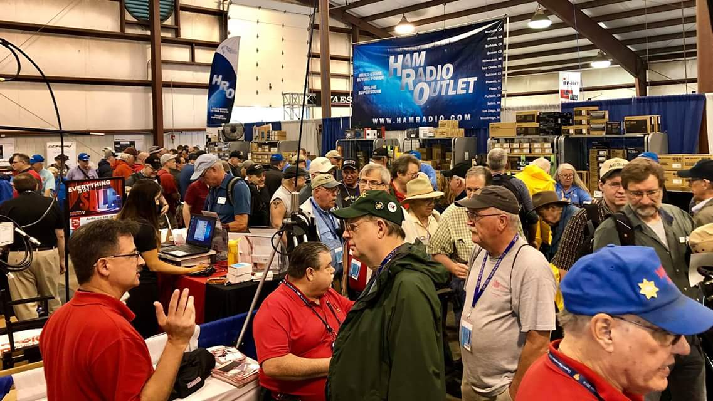[***Upcoming Hamfests***](http://arrl-ohio.org/hamfests.html)

We **DO** have some hamfests scheduled for 2021!! Yes, take a good look at the list, it’s growing every day!

TOP ^

Be sure to keep your eyes on this schedule as that when things start getting better and the vaccine rolls out to more and more, hamfests will surely get back to their normal schedule. Don’t see your hamfest listed?? Did anyone register it with ARRL? It’s really easy to do and you get a lot of FREE publicity if you do.

|  |  |
| --- | --- |
| **03/07/2021 -**[**WINTERHAMFEST**](http://www.arrl.org/hamfests/winterhamfest-3)  **Location: Elyria, OH**  ***Canceled***  Toledo Mobile Radio Association (TMRA) Hamfest normally scheduled in March is also  ***Canceled*** | **04/25/2021 -**[**Athens Hamfest**](http://www.arrl.org/hamfests/athens-hamfest-9)  **Location: Athens, OH Sponsor: Athens County Amateur Radio Association Website:**<http://ac-ara.org/>  [**Learn More**](http://www.arrl.org/hamfests/athens-hamfest-9) |
| **05/21/2021 - 05/23/2021** [**Dayton Hamvention, ARRL Operating Specialty Convention**](http://www.arrl.org/hamfests/dayton-hamvention-arrl-operating-specialty-convention)  ***Canceled*** | |
| **06/05/2021 -**[**FCARC SummerFest**](http://www.arrl.org/hamfests/fcarc-summerfest)  **Location:**Wauseon, OH **Sponsor:**Fulton County Amateur Radio Club **Website:**<http://k8bxq.org/hamfest>  [**Learn More**](http://www.arrl.org/hamfests/fcarc-summerfest) | **07/10/2021 - [Mansfiled Mid-Summer Trunkfest](http://www.arrl.org/hamfests/mansfiled-mid-summer-trunkfest" \o "Mansfiled Mid-Summer Trunkfest)**  **Location:**Mansfield, OH **Sponsor:**InterCity Amateur Radio Club **Website:**<http://iarc.club>  [**Learn More**](http://www.arrl.org/hamfests/mansfiled-mid-summer-trunkfest) |
| **07/18/2021 –**[**Van Wert Hamfest**](http://www.arrl.org/hamfests/van-wert-hamfest-5)  **Location:**Van Wert, OH **Sponsor:**Van Wert Amateur Radio Club **Website:**[http://W8FY.ORG](http://w8fy.org/)  [**Learn More**](http://www.arrl.org/hamfests/van-wert-hamfest-5) | **08/28/2021 -**[**Cincinnati Hamfest℠**](http://www.arrl.org/hamfests/cincinnati-hamfest)  **Location:**Owensville, OH **Sponsor:** Milford ARC **Website:** [http://CincinnatiHamfest.org](http://cincinnatihamfest.org/)  [**Learn More**](http://www.arrl.org/hamfests/cincinnati-hamfest) |
| **09/26/2021 -**[**Cleveland Hamfest**](http://www.arrl.org/hamfests/cleveland-hamfest-1)  **Location:**Berea, OH **Sponsor:** Hamfest Association of Cleveland **Website:** [http://www.hac.org](http://www.hac.org/)  [**Learn More**](http://www.arrl.org/hamfests/cleveland-hamfest-1) | **12/04/2021 -**[**FCARC WinterFest**](http://www.arrl.org/hamfests/fcarc-winterfest-2)  **Location:** Delta, OH  **Sponsor:** Fulton County Amateur Radio Club  **Website:** <http://k8bxq.org/hamfest>  [**Learn More**](http://www.arrl.org/hamfests/fcarc-winterfest-2) |

TOP ^

|  |  |  |  |  |
| --- | --- | --- | --- | --- |
|  | | **THE AMERICAN RADIO RELAY LEAGUE, INC.** |  | |
| Stan Broadway, N8BHL |
|  | ● OHIO SECTION EMERGENCY COORDINATOR  3677 Peel Rd Radnor, OH 43066  broadways@standi.com | | |  |

***Ohio Amateur Radio Annual Report – 2020***

The Ohio Auxcomm Team operates the amateur radio station W8SGT at the Ohio Emergency Operations Center. The purpose is to achieve and maintain communications with ARES (Amateur Radio Emergency Service) stations in every Ohio county, and with surrounding states, to provide a backup emergency communications system to our Ohio EMA partners.

**Bullet-point summary**

* ARES in Ohio contributed 76,212 hours of voluntary assistance in 2020. 934 volunteer operators donated $2.02 Million in volunteer assistance to our partner agencies and our communities.
* HF Net: over 2,400 contacts with 562 unique stations logged from 74 Ohio counties (many from surrounding states as well.)
* Ohio Digital Emergency Net maintains reliable contacts with the ability to send forms, text.
* We coordinate with the “Buckeye Net”, a dedicated “Message/Traffic” net for expanded digital service
* Major advances in Digital voice networking, bridging two large systems which allows us to key up over 200 repeaters across Ohio. This test replaced our annual Statewide ARES Conference (COVID cancelled).
* VHF “Contest” tests ability to relay messages regionally.
* Ohio “NVIS Antenna Day” a test of emergency antennas.
* ARES wrote and controlled the October SET which used IPAWS R&D headquarters, military including ONG/OHMR, SHARES and crossband connection between W8SGT/ARES and FEMA stations on 60 meters.
* ARES participated in nuclear plant exercises and tabletops
* National Red Cross digital messaging exercises
* Project: Adding 160 meter antenna

TOP ^

* Project: Adding VHF digital capability
* Project: Adding HF/VHF Winlink
* Biggest challenge: manpower is low. We are mounting a recruiting campaign, stalled by COVID.

***To view the full 16 page report*** [***>> Click Here <<***](http://arrl-ohio.org/SEC/reports/2020/Ohio_Amateur_Radio_2020_Report.pdf)

***Upcoming NIMS Training Opportunities***

Need to get those really hard to get ICS 300 and 400 classes to get to Level 3? They are now being offered with very limited virtual seating. Yes, these classes are being offered virtually now along with a lot of other classes that used to require in-class sessions. Want to see what and where these classes are being offered?

[**>> Click Here <<**](http://arrl-ohio.org/SEC/Ohio_EMA_Training_List_Feb_2021.pdf)

***Print an Official or Unofficial Copy of Your Amateur Radio License***

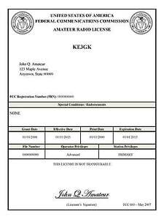*(By Anthony Luscre, K8ZT)*

As of February 17, 2015, the **FCC no longer routinely issues paper license documents** to Amateur Radio applicants and licensees. The Commission has maintained for some time now that the official Amateur Radio license authorization is the electronic record that exists in its Universal Licensing System (ULS). The FCC will continue to provide paper license documents to all licensees who notify the Commission that they prefer to receive one.

Licensees also will be able to print out an official authorization — as well as an unofficial “reference copy” — from the ULS License Manager. I’ve created a set of instructions on how you can request an **“official” printed copy of your license\***

[**Click here to download the instructions**](http://arrl-ohio.org/news/2020/print_your_license.pdf)

***One Question Questionnaire***

Hey Gang,

Survey Says”….. 83% are skilled at reading schematic diagrams. That’s fantastic! I guess I can bring my FT-920 over to any of you to help diagnose some issues I’m having!

Ok, now on to the next question… I know that we’re all getting very antsy to get back together and some of us are even making plans to attend any hamfest that happens along, so here’s the next question for you.

TOP ^

***“Are you looking to purchase anything at the next hamfest you attend?”***

You’ll find the “One Question” questionnaire on the Ohio Section Website! <http://arrlohio.org> It’s all for fun and it’s not a scientific survey in any way, but we are learning some things that we didn’t know from these questions. I hope that you are enjoying answering these “One Question” questionnaires.

*****V.E. Test Sessions***

Many V.E.’s have decided to start testing once again, but with restrictions that need to be adhered to for sure. Here’s the link to find that V.E. Test session and what is expected of YOU before going. <http://www.arrl.org/find-an-amateur-radio-license-exam-session>

Ohio Section Cabinet

|  |  |
| --- | --- |
| Section Manager – Tom Sly, WB8LCD | Section Traffic Manager – David Maynard, WA3EZN |
| Section Emergency Coordinator – Stan Broadway, N8BHL | Section Youth Coordinator – Anthony Lascre, K8ZT |
| Technical Coordinator – Jeff Kopcak, K8JTK | Affiliated Clubs Coordinator – Tom Sly, WB8LCD |
| State Government Liaison – Bob Winston, W2THU | Public Information Coordinator – John Ross, KD8IDJ |



Hey Gang,

Have you taken a look at the **Swap & Shop** page on the Ohio Section webpage yet?? Here’s a link that will take you there… <http://arrl-ohio.org/sm/s-s.html>

Do you have equipment that you just don’t need or want anymore? Here’s a great venue to advertise it, and it’s FREE!! Is your club doing a fund raiser to help raise money? After a lot of thought, it was decided that the Swap & Shop webpage could also contain these types of items as well. The same rules will apply as do for the For Sales and Give-A-Ways and will only be posted for a month at a time. Please see the Terms & Conditions on the webpage.

If your club is doing a fund raiser and wants more exposure, please forward the information to me and I’ll advertise it on the Swap & Shop webpage for you.

Now, I still want to remind you that it won’t be listed in this newsletter because it would take up way too much space, so your ad will only appear on the website. It is there for any individual to post equipment Wanted / For Sale or Give-Away as well as for Club Fund Raisers. No licensed vehicles/trailers or business advertising will be posted. Postings are text only (no pictures or graphics) will be posted for a maximum of 1 month from date posting and require a contact phone number or email within the posting. Send your Wanted / For Sale or Give-Away post to:  [swap@arrlohio.org](mailto:swap@arrlohio.org)

TOP ^

***Back Issues of the PostScript and Ohio Section Journal***

Hey, did you know that PostScript and Ohio Section Journal (OSJ) are archived on the website? You can go back and look at any edition simply by clicking:

<http://arrl-ohio.org/news/index.html>

***Welcome New Subscriber(s)***

**Wesley, KE8QLI; John, KE8MXX; Dennis, KD8TLL; Steven, N8SMH**

***Want to Share your Club Newsletter With Others?***

We have a webpage where you can download and read all of the newsletters that I get from around the state and even other sections!

Here’s the link to the page…. <http://arrl-ohio.org/club_news/index.html>

Please, if you don’t see your club newsletter posted, it’s because I’m not receiving it. Just have your newsletter editor contact me and I’ll get your club’s newsletter listed on the site!!

We all learn and steal (I mean, share) from each other’s work. So, get me your newsletter!!! Send it to: [webmaster@arrl-ohio.org](mailto:webmaster@arrl-ohio.org)

***Murphy's Laws***

*(You’ll just never know when he’ll strike!!)*

1. If the possibility exists of several things going wrong, the one that will go wrong is the one that will do the most damage.
2. Everything will go wrong at one time.
3. That time is always when you least expect it.
4. If nothing can go wrong, something will.
5. Nothing is as easy as it looks.

TOP ^

***Chit – Chat, and All That!***

Do you know someone that’s not getting these Newsletters? Please, forward a copy of this Newsletter over to them and have them “[Opt-In](mailto:Opt-In)” to start receiving them. Heck just have them send an email to: [webmaster@arrl-ohio.org](mailto:webmaster@arrl-ohio.org) and we’ll get them added to the Ohio Section Emailing list.

We now have many thousands of readers receiving these newsletters weekly. Quite impressive, I’d say! I urge all of you to make sure that everyone, regardless of whether they are a League member or not, get signed up to receive these weekly Newsletters.

You can always “Opt-Out” at any time if you feel this is not what you were expecting. It’s fun and very informative. All of your favorite past newsletters are now archived too.

You can go back at any time and read them.

Just go to: <http://arrl-ohio.org/news/>

The pictures on the front page and throughout this newsletter are from various newsletters, Facebook posts and/or were sent directly to me in recent weeks. Take a good look at them, you just might be in one of the pictures! “SMILE… you’re in the Ohio Section News!!”



TOP ^

*PostScript is produced as a weekly newsletter. I want to thank everyone that has contributed articles and ideas to make this an even better news source. I sincerely hope that you have enjoyed this edition and will encourage your friends to join with you in receiving the latest news and information about the Ohio Section, and news and events happening around the world!*