[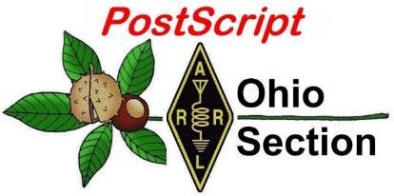](http://arrl-ohio.org/news/) ***“January 18th”***

***Edition***

🡪 National News 🡪 Club Corner

🡪 DX This Week 🡪 Contest Corner

🡪 Special Events 🡪 ARES Connect

🡪 Upcoming Hamfests 🡪 One Question Questionnaire

🡪 VE Testing 🡪 From The South 40

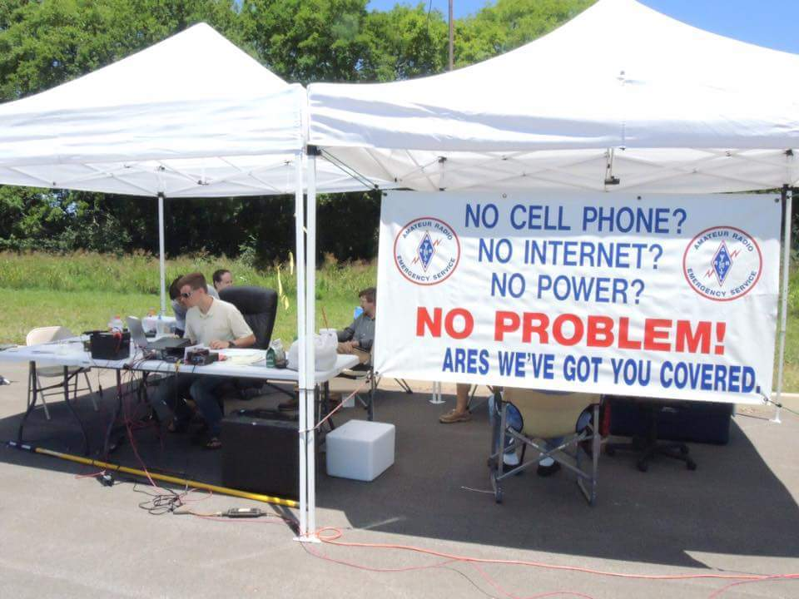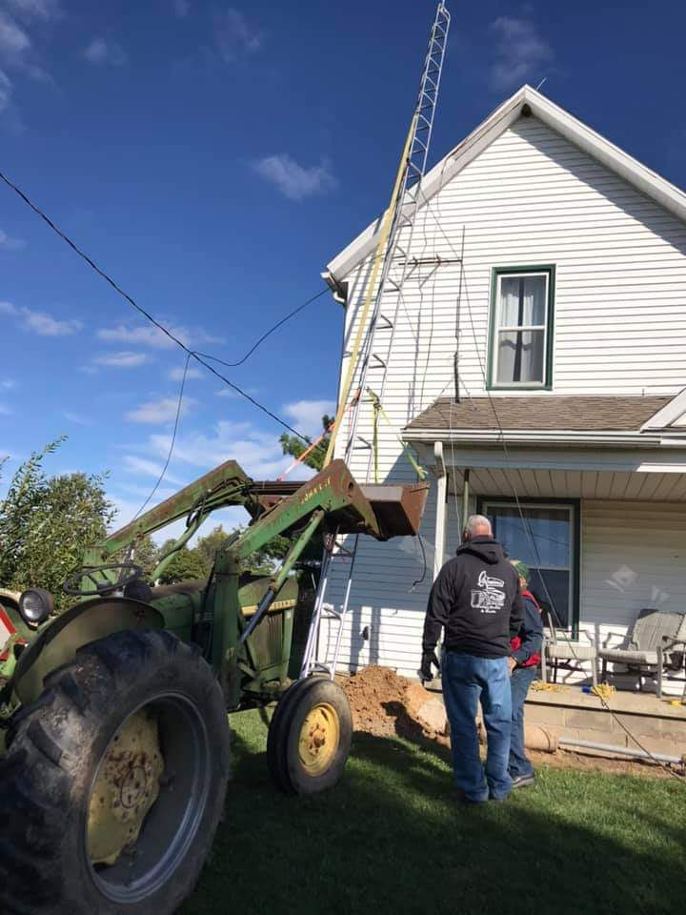

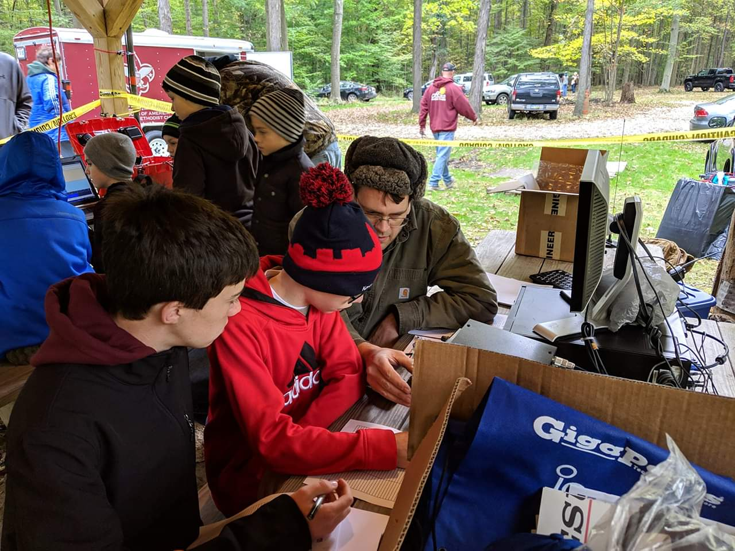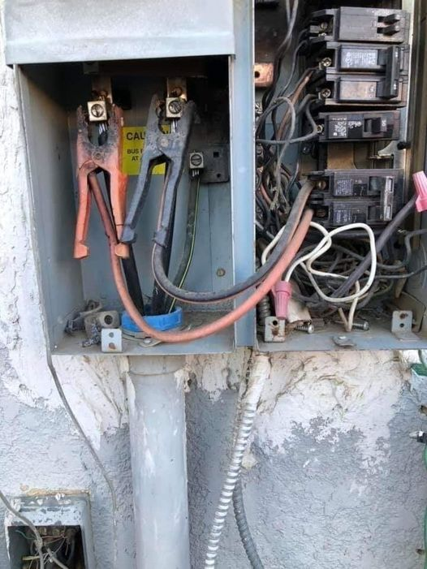

***National News***

*(from arrl and other sources)*

***FCC Warns on Use of Ham Radio for Illegal Acts***

*(Bloomberg News)*

Licensed amateur and personal radio services shouldn’t be used to coordinate criminal acts, the FCC’s Enforcement Bureau warned after reports that some people were looking to radios as an alternative to social media platforms, which are being monitored by law enforcement following the deadly Jan. 6 raid on the U.S. Capitol.

“The Bureau reminds amateur licensees that they are prohibited from transmitting ‘communications intended to facilitate a criminal act’ or ‘messages encoded for the purpose of obscuring their meaning,” the agency said in a statement Sunday.

The licensees, which would include Citizens Band radios, Family Radio Service walkie-talkies, and General Mobile Radio Service, would face fines, seizure of their equipment and possible criminal prosecution.

------

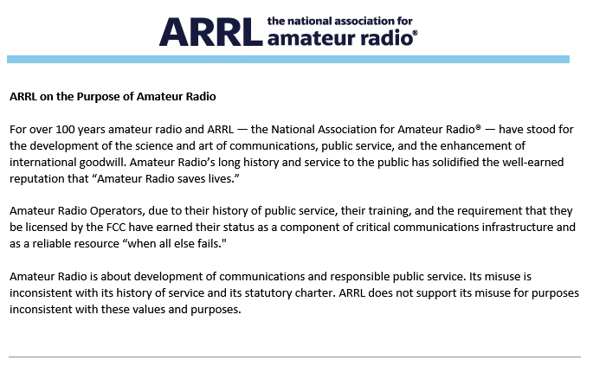

TOP ^

***New Amateur VLF Transatlantic Record Set***

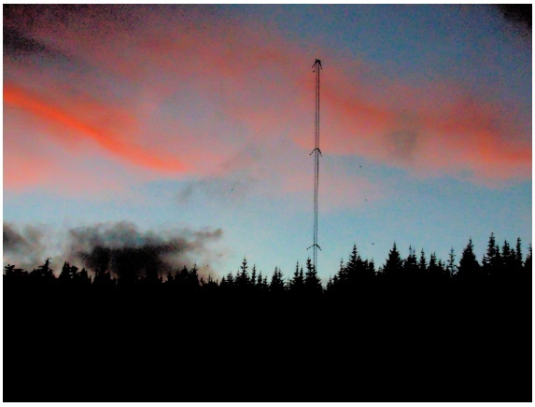Very low frequency (VLF) enthusiast Joe Craig, VO1NA, reports that Stefan Schaefer, DK7FC, copied his 50-character message transmitted from Newfoundland on 8.271 kHz, with a radiated power of 10 mW.

“This is a new record for amateur transatlantic VLF,” Craig told ARRL. “The mode used was ***[EbNaut](http://abelian.org/ebnaut/)*** by Paul Nicholson. *EbNaut* is a synchronous coherent BPSK mode for use at VLF and low LF. Craig’s tower supports a VLF RL (rotated L) 10-meter (33 feet) average height and 100 meters (328 feet) long. VLF is the ITU designation for radio spectrum in the range of 3 – 30 kHz, corresponding to wavelengths from 100 to 10 kilometers, respectively.

“Since VLF waves can penetrate at least 40 meters (131 feet) into saltwater, they are used for military communication with submarines,” Craig noted.

####

***International Amateur Radio Union Preparing for WRC-23***

Preparations continue on the part of the International Amateur Radio Union ([**IARU**](http://www.iaru.org/)) to represent the interests of the amateur and amateur-satellite services at World Radiocommunication Conference 2023 (WRC-23). The International Telecommunication Union (ITU) sponsors WRCs, typically every 4 years, to consider revisions to the international *Radio Regulations* that define frequency allocations for various radio services.

“As an incumbent radio service with allocations at intervals throughout the radio spectrum, the amateur service faces challenges at every WRC,” IARU Secretary David Sumner, K1ZZ, said. “Successfully defending our existing access to the spectrum is a significant accomplishment at any WRC, but sometimes it is possible also to improve our existing allocations. WRC-19 resulted in major improvements in 50 MHz allocations in Region 1. Without any doubt, this could not have happened without the concerted efforts of dozens of IARU volunteers over the course of several years.”

The next WRC is expected to be held in 2023. Under the direction of IARU Vice President Ole Garpestad, LA2RR, 20 IARU volunteers have been participating in virtual meetings of ITU working parties and preparatory committees of regional telecommunications organizations (RTOs) as they address WRC-23 agenda items of particular concern to amateur radio. Potentially affected bands are 50 – 54 MHz (a new service has been proposed in an adjacent band); 1240 – 1300 MHz; 3300 – 3400 MHz; 10.0 – 10.5 GHz, and 241 – 250 GHz. In addition, studies are being conducted to identify protection requirements for space weather sensors that operate in frequency bands from 13 kHz to at least 15 GHz.

The participation of IARU member-societies in preparations at the national level is an important contribution to amateur radio’s eventual success at a WRC, Sumner said.

TOP ^

The IARU Administrative Council has chosen “Amateur Radio: Home but Never Alone” as the theme for World Amateur Radio Day on Sunday, April 18, 2021. With the pandemic driving adoption of extreme physical isolation to reduce the spread of the virus, the worldwide amateur radio community has responded positively to overcome the resulting social isolation.

Local “wellness nets” have provided friendly voices and regular status checks to those, especially the elderly, who are confined to their homes. “Stay safe” special event stations in dozens of countries served as a reminder of the importance to limit the spread of the virus. On-air activity was at an unprecedented level throughout the remainder of 2020, with record-breaking numbers of entries in the major contests.

“While the development of effective vaccines offers hope for a return to some semblance of normality later in 2021, the pandemic will still be with us when we mark World Amateur Radio Day 2021,” Sumner said. “This theme offers the opportunity for our member-societies to tailor meaningful messages to the general public about the values of the global amateur radio community.”

####

***Club Corner***

This is YOUR cornner of the newsletter. Send me what your club is doing and I’ll make sure that it gets in. Got a special event or club project that you want everyone to know about? Send it to me!. Need help with a project? Send it to me.

Let me know what you club is up to. Are you going to have a special guest at your meeting or are you having a special anniversary?

Just sent it to: [webmaster@arrl-ohio.org](mailto:webmaster@arrl-ohio.org)

***DX This Week***

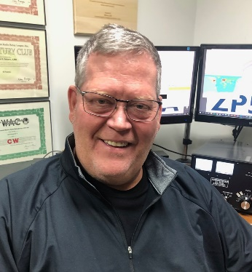*(from Bill, AJ8B)*

***DX This Week – Solar Numbers Part 1***

***Bill AJ8B (aj8b@arrl.net, @AJ8B, or www.aj8b.com)***

***CWOPs Member #1567***

As the new year begins, there was quite a bit of DX to work. I added Bulgaria to my 160M DXCC quest. The Midwest DX Cluster spots included Alaska, Aruba, Australia, Azores, Belize, Bosnia-Herzegovina, Brazil, Bulgaria, Canada, Ceuta & Melilla, Chile, Cuba, Cyprus, DPR of Korea, European Russia, France, French Guiana, Greenland, Guadeloupe, Hawaii, Ireland, Italy, Japan, Kenya, Liechtenstein, Malawi, Mali, Malta, Marshall Islands, Mexico, Moldova, Morocco, Namibia, Norway, Philippines, Poland, Portugal, Puerto Rico, San Andres & Providencia, Serbia, South Africa, Spain, Switzerland, Ukraine, Uruguay, and US Virgin Islands.

***DAH DIT DIT DIT DAH DAH DIT DIT DIT DAH***

TOP ^

I had worked W8F, the Special Event Station Commemorating the Forty-Fifth Anniversary of the Loss of the SS Edmund Fitzgerald. I received my certificate this past week and it was pretty cool. I hope you also received this sponsored by the Livonia Amateur Radio Club. Additionally, I received cards from C31MF – Manel in the Principal of Andorra, D2EB – Father Gabriel in Angola, JA1SJV – Solo in Japan, and G8BCG – Peter in England. Let me know what you received.

|  |  |
| --- | --- |
|  |  |

|  |  |
| --- | --- |
|  |  |

***DAH DIT DIT DIT DAH DAH DIT DIT DIT DAH***

Each year I like to start off with a review of what you need to know to work DX. This week and next we will review Solar Numbers. K9LA, Carl Luetzelschwab, a leading expert on the topic, crafted an article on Solar Numbers. I have reprinted it below with Carl’s permission.

Solar Numbers – What they Mean Part 1:

*By Carl Luetzelschwab, K9LA*

<http://k9la.us/Propagation_101_23Sep07.pdf>

The sun emits electromagnetic radiation and matter because of the nuclear fusion process. Electromagnetic radiation at wavelengths of 100 to 1000 Angstroms (ultraviolet) ionizes the F region, radiation at 10 to 100 Angstroms (soft X-rays) ionizes the E region, and radiation at 1 to 10 Angstroms (hard X- rays) ionizes the D region. Solar matter (which includes charged particles--electrons and protons) is ejected from the sun on a regular basis, and this comprises the solar wind. On a "quiet" solar day the speed of this solar wind heading toward Earth averages about 400 km per second.

TOP ^

The sun's solar wind significantly impacts Earth's magnetic field. Instead of being a simple bar magnet, Earth's magnetic field is compressed by the solar wind on the side facing the sun and is stretched out on the side away from the sun (the magnetotail, which extends tens of earth radii downwind). While the sun's electromagnetic radiation can impact the entire ionosphere that is in daylight, charged particles ejected by the sun are guided into the ionosphere along magnetic field lines and thus can only impact high latitudes where the magnetic field lines go into the Earth.

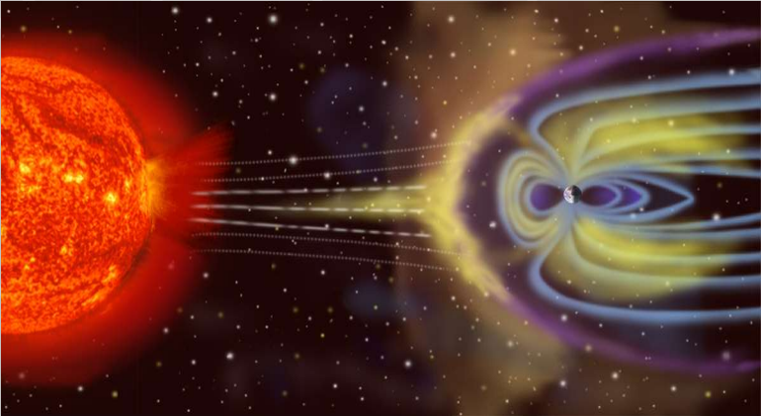  
Additionally, when electromagnetic radiation from the sun strips an electron off a neutral constituent in the atmosphere, the resulting electron can spiral along a magnetic field line (it spirals around the magnetic field line at the electron gyrofrequency). Thus, Earth's magnetic field plays an important and critical role in propagation.

The Sun's Magnetic Field Meets the Earth's Magnetic Field - Wikipedia

Variations in Earth's magnetic field are measured by magnetometers. There are two measurements readily available from magnetometer data--the daily A index and the three-hour K index. The A index is an average of the eight 3-hour K indices and uses a linear scale and goes from 0 (quiet) to 400 (severe storm). The K index uses a quasi-logarithmic scale (which essentially is a compressed version of the A index) and goes from 0 to 9 (with 0 being quiet and 9 being severe storm). Generally, an A index at or below 15 or a K index at or below 3 is best for propagation.

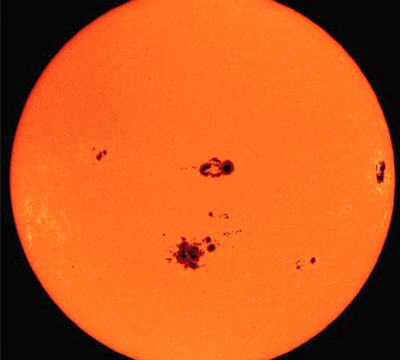  
Sunspots are areas on the sun associated with ultraviolet radiation. Thus, they are tied to ionization of the F region. The daily sunspot number, when plotted over a month time frame, is very spiky. Averaging the daily sunspot numbers over a month results in the monthly average sunspot number, but it is also rather spiky when plotted. Thus, a more averaged, or smoothed, measurement is needed to measure solar cycles. This is the smoothed sunspot number (SSN). The SSN is calculated using six months of data before and six months of data after the desired month, plus the data for the desired month. Because of this amount of smoothing, the official SSN is one-half year behind the current month. Unfortunately, this amount of smoothing may mask any short-term unusual solar activity that may enhance propagation.

Sunspots come and go in an approximate 11-year cycle. The rise to maximum (4 to 5 years) is usually faster than the descent to minimum (6 to 7 years). At and near the maximum of a solar cycle, the increased number of sunspots causes more ultraviolet radiation to impinge on the atmosphere. This results in significantly more F region ionization, allowing the ionosphere to refract higher frequencies (15, 12, 10, and even 6 meters) back to Earth for DX contacts. At and near the minimum between solar cycles, the number of sunspots is so low that higher frequencies go through the ionosphere into space.

**Sunspots**

TOP ^

Commensurate with solar minimum, though, is less absorption and a more stable ionosphere, resulting in the best propagation on the lower frequencies (160 and 80 meters).

Thus, in general, high SSNs are best for high-frequency propagation, and low SSNs are best for low-frequency propagation.

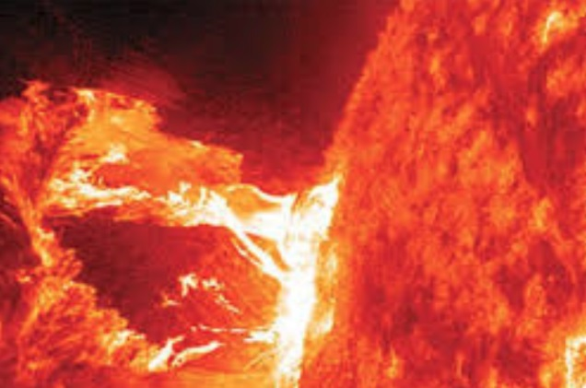Most of the disturbances to propagation come from solar flares and coronal mass ejections (CMEs). The solar flares that affect propagation are called X-ray flares due to their wavelength being in the 1 to 8 Angstrom range. X-ray flares are classified as C (the smallest), M (medium size), and X (the biggest). Class C flares usually have minimal impact to propagation. Class M and X flares can have a progressively adverse impact to propagation.

**Solar Flare**

The electromagnetic radiation from a class X flare in the 1 to 8 Angstrom range can cause the loss of all propagation on the sunlit side of Earth due to increased D region absorption. Additionally, big class X flares can emit very energetic protons that are guided into the polar cap by Earth's magnetic field. This can result in a polar cap absorption event (PCA), with high D-region absorption on paths passing through the polar areas of Earth.

***CQDX CQDX CQDX CQDX CQDX CQDX CQDX CQDX CQDX***

Here is an update from Bernie, W3UR, of the DailyDX and the WeeklyDX, the best source for DX information. <http://www>.dailydx.com/. Bernie has this to report:

**3Y – Bouvet Island -** Per the Rebel DX Group’s Facebook page they report “Some members of the Rebel DX Group have arrived in Cape Town, South Africa. After several Covid protocols we are in the good hands of our ZS friends and local supporters.

Just to remind you, the whole of our expedition equipment from the first Bouvet ''attack'' was secured at the QTH of Andre ZS1AN. What a great guy he is!! We will check again all our expedition gear during the coming days.

We had a very busy day yesterday with Shawn ZS1SBW, working on important paperwork for upcoming projects. More info on that soon.

The Bouvet (3Y0I) trip is on track. Still some budget is missing but we are hoping to get some of the missing $$$. Our last attempt cost us over $250K private money (donations were just 7%) and sadly that went to the ''vessel chimney'' (for fuel). Let's hope, this time we will be luckier.

Here is a link if you are willing to help. [https://www.gofundme.com/f/3yi-bouvet-island-expedition](http://r20.rs6.net/tn.jsp?f=001qK2zX07vn226ZBCSI1IhLGcvZWfYSagQmd4zcf5lRXMCEtHE5PkbGOZYIOeMTTXlxwQmn7w1dnS-CoNSdLy0IevJd7iArHC3HqbQbz-_Fz43skW7aAJ2tjejaOFhM-ZQRwDLLYGdxpQO243GlGXCFV-7RXhmy5w7Tq0io2Mk9p_F6yt3yETBSXY_A2ptyc8uxMBB_i7TOp1Qnuj5gs3T6XYLqymNt9a09hndABNcbSEPcuuDSFbPqhQuvhhlNMR2iDomDEinXdFFE0DHR0Gbfc6sLrBmrX5w&c=WkBKuSX9Cj04B3kup05WYrqq5-hiABaUb1NAhzqS_K1X2glPmYcg0g==&ch=hPV0Mo70GScVAJ8vrAW3WnL2UpQGRsNbLOhtlArKMNa8QmOgytidEA==)

TOP ^

For your information, we will not apply for financial support to any DX Foundation or big Clubs as their conditions are not acceptable to us for a trip to one of the most wanted DXCC entities; and one of hardest places to go on our planet.”

**YI – Iraq -** YI9/IU5HWS, Giorgio, was on the air October 29 through November 28, when he was able to use his new Iraqi callsign, YI9WS.  He expects to continue there until February 21.  IK5SRF, Paolo, is managing the LoTW uploads and has been uploading.  For direct to Giorgio, QSL with 3 USD to:

GIORGIO TOMA / Via Settembrini 5 / 57128 Livorno / ITALY

**3W – Vietnam -** AA5H, Brian, plans to put 3W9OK on the air in March and April.

[https://www.qrz.com/db/AA5H](http://r20.rs6.net/tn.jsp?f=001L9nsknohVLnISLNSrSuOPACEZfyqIxxKnCTKx9QUZmBaVIy8-ZE8USU4v_AjLeeyFtvu9uS4i-7Hb1c_y_bGF-P-V5fTd4braaEUXlqFs7v9-owNMBRdOiYtXv7k5a9zXOUz3xplIWN_FPssSpm26g==&c=i0yQvZqgq9-CqFLqWJNddvpmGip-GmDI_pbivEG6FJjgaAjb2GiRIA==&ch=s2Z2f_ZsX9D-4oMQpESCOVAEKAfTuunBouGsMUgK4SF7O9-yhtBDmg==) .

**I – Italy -** IB2ANT will be the special call used by IK2QPR, Paolo Fava, February 1-28.  This is for the 18thannual Antarctic Activity Week, “AAW.”

**JW – Svalbard -** JW/LB2PG, Erling, planned to go on the air three days ago and continue to June 1 from Bear Island, EU-027, 80M and 20M SSB.  JW1I is another callsign he will likely use.  It will be 100-400 watts to a three-element Yagi and dipoles.  QSL to his home QTH.

**OX – Greenland -** OX/SE3A is the callsign for Nils Norin when he is there.  He is otherwise known as SM3UQK.  He is 42 years old and says he answers all QSL requests “in due time”.  He is currently there, January 5-28, in Narsarsuaq, south Greenland.  This is his setup:  A 40/20 trap dipole, inverted V configuration, only 5 meters above ground and a 20M wire vertical with one radial, one meter above ground.  The antennas are supported by a portable fiberglass mast that can only handle one of those antennas at a time and only when the wind is calm.  It’s a windy QTH.  He also has a Buddistick multiband vertical and is considering getting a magnetic loop antenna.  He has no trees or other high things to help support antennas.  A helicopter pilot, he is working for Air Greenland, flying AS350B3+ helicopters all over Greenland.  His radios are an FT-857D and IC-7300.  Here is his direct QSL route: SM3UQK Nils Norin / Kungsnas 192 / 855 91 Sundsvall / SWEDEN

**3A – Monaco -** F4FRL, Mireille; and F5RBB, Patrick, will sign 3A/F4FRL and 3A/F5RBB when there, February 24 to March 2.  Look for them on 40 and SSB and digital modes.  For a QSL go through LoTW or eQSL.

***DAH DIT DIT DIT DAH DAH DIT DIT DIT DAH***



Below is a list of upcoming contests in the “Contest Corner”. I think this is important for someone who is trying to move up the DXCC ladder since entities that are on the rarer side and easiest to work in contests. Some of my best “catches” have been on the Sunday afternoon of a contest when the rarer entities are begging for QSOs. Of course, the gamble is that if you wait until Sunday, conditions may change, or they simply won’t be workable. However, it is not a bad gamble. Of course, why not work the contest and have some fun!  
Check out the WA7BNM Contest Calendar page (<https://www.contestcalendar.com/>) for more contests or more details.

The contests in red are those that I plan to spend some significant participation time on. PLEASE let me know if you are working contests and how you fared.

Thanks!

TOP ^

|  |  |  |
| --- | --- | --- |
| Jan 23-24 | BARTG RTTY Sprint | bartg.org.uk/wp/contests |
| Jan 23-24 | UK/EI DX Contest Rules | www.ukeicc.com/dx-contest-rules.php |
| Jan 27 | UKEICC 80 Meter Contest CW | bit.ly/2SDPqQQ |
| Jan 30-31 | REF CW Contest | concours.ref-union.org/contest/?page_id=2 |
| Jan 30-31 | UBA SSB Contest | https://bit.ly/W0gZiE |
| Jan 30-31 | Winter Field Day | [www.winterfieldday.com](http://www.winterfieldday.com) |
| Jan 29 – 31 | CQWW 160M | <https://cq160.com/> |
| Feb. 2 | RSGB 80m Club Championship, SSB | <https://www.rsgbcc.org/hf/rules/2020/r80mcc.shtml> |
| Feb. 3 | UKEICC 80m Contests SSB | <https://bit.ly/2SDPqQQ> |
| Feb. 6 | FISTS Winter Saturday Sprint | <http://www.fistsna.org/operating.html> |
| Feb. 6 | AGCW Straight Key Party | <https://bit.ly/3ngQSpB> |
| Feb. 6 | Minnesota QSO Party | <https://www.w0aa.org/mn-qso-party/> |
| Feb. 6-7 | 10-10 Int’l Winter Contest | <http://bit.ly/1FrFeBc> |
| Feb. 6-7 | British Columbia QSO Party | <http://www.orcadxcc.org/bcqp_rules.html> |
| Feb. 6-7 | Vermont QSO Party | <http://www.ranv.org/ranv.html> |
| Feb. 6-7 | Mexico RTTY International Contest | <https://bit.ly/35kiJ20> |
| Feb. 6-7 | North American CW Sprint | <http://ncjweb.com/north-american-sprint/> |
| Feb.8-12 | ARRL School Club Roundup | <http://www.arrl.org/school-club-roundup> |
| Feb. 10 | RSGB 80m Club Championship, DATA | <https://www.rsgbcc.org/hf/rules/2020/r80mcc.shtml> |
| Mar. 27 – 28 | CQWW WPX SSB | <https://www.cqwpx.com/> |
| May 21 | SWODXA DXDinner | [www.swodxaevents.org](http://www.swodxaevents.org) |
| May 29 – 30 | CQWW WPX CW | <https://www.cqwpx.com/> |
| August 28 | Ohio QSO Party | <https://www.ohqp.org/> |

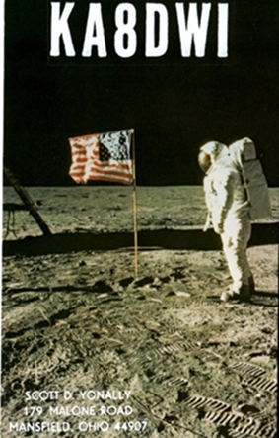***DX News***

***ARLD002 DX news***

This week's bulletin was made possible with information provided by LU5AG, The Daily DX, the OPDX Bulletin, 425 DX News, DXNL, Contest Corral from QST and the ARRL Contest Calendar and WA7BNM web sites.

Thanks to all.

**MALDIVES, 8Q.** Massimo, IZ5KID is QRV as 8Q7MM from Male and is here until around January 23 while on work assignment. Activity is in his spare time on 40, 30, 20 and 15 meters using FT8. QSL to home call.

**ZAMBIA, 9J.** Brian, 9J2BO is usually active on 40 meters using CW from 0330 to 0500z. QSL via EA5GL.

TOP ^

**ANDORRA, C3.** Joan, C31US is usually QRV on 40 meters using CW between 0700 and 0800z. QSL to home call.

**BOLIVIA, CP.** Antonio, EA5RM is QRV as CP1XRM from San Ignacio de Moxos until January 26. Activity is on the HF bands using SSB and various digital modes. QSL to home call.

**ANTARCTICA.** Operators Taka, JA1AGS and Hiro, JH7JCX are QRV as 8J1RL from Syowa Station, IOTA AN-015, until the end of January. Activity is on 40 to 15 meters using mainly FT8. QSL via bureau.

**SVALBARD, JW.** Erling, LB2PG is QRV as JW/LB2PG from Bear Island, IOTA EU-027, until June 1. Activity is on 80 to 20 meters using SSB. QSL to home call.

**ALASKA, KL7.** As part of the Alaska RST QSO Party 2021, stations K7ICE, KL7CCN, KL7JR, KL7RST, KL7RST/KL7, VE8RST/KL7, VY0RST/KL7, and VY1RST/KL7 are QRV until February 15 from various regions here. QSL via operators' instructions.

**ARGENTINA, LU.** Members of AMSAT Argentina will be QRV as LU7AA from January 16 to 24 to commemorate the 31st anniversary of the launch of Satellite LO-19. Activity will be on the HF bands and V/UHF bands using CW, SSB, various digital modes, SSTV, and FM on various satellites. QSL direct to LU7AA.

**BULGARIA, LZ.** Special event station LZ1340B is QRV to celebrate the 1340th anniversary of the First Bulgarian Empire. QSL via LZ3SM.

**NETHERLANDS, PA.** Special event station PC19HOPE is QRV until March 10 to support efforts in containing the COVID-19 pandemic. QSL via PA7HPH.

**SEYCHELLES, S7.** Ravi, S79VU has been QRV on 40 meters using FT8 around 0145z. QSL via N4NGR.

**POLAND, SP.**  Members of the SEDINA Contest Club are QRV with special event call sign SQ0MORSE from Szczecin until April 30 to celebrate the 230th anniversary of the birth of Samuel F. B. Morse. Activity is on various HF bands. QSL via SP1EG.

**WESTERN KIRIBATI, T30.** Jack, T30TM has been QRV on 20 meters using SSB around 0530z. QSL via VK1TX.

**GABON, TR.** Alain, TR8CA has been QRV using CW and RTTY on 20 meters between 1600 and 1730z. QSL via F6CBC.

**MALI, TZ.** Jeff, TZ4AM has been QRV on 30 and 17 meters using CW between 1745 and 2000z. QSL via W0SA.

**EUROPEAN RUSSIA, UA.** Special event station R170SG is QRV until the end of January to celebrate the founding 170 years ago of the province Samara. QSL via operators' instructions.

**INDIA, VU.** Members of the West Bengal Radio Club are QRV as AT2GSI from Sagar Island, IOTA AS-153, until January 16 recognizing a Hindu pilgrimage to the confluence of the river Ganges and the Bay of Bengal. QSL via operators' instructions.

TOP ^

**UK SOVEREIGN BASE AREAS ON CYPRUS, ZC4.** Garry, 2M1DHG is QRV as ZC4GR for the next few years. Activity is mainly on 40 to 10 meters using SSB and FT8, and possibly SSTV, PSK31 and WSPR in his spare time. QSL via EB7DX.

**CAYMAN ISLANDS, ZF.** Pete, K8PGJ is QRV as ZF2PG until January 17.

He is active using SSB and plans to be an entry in the North American SSB QSO Party. QSL to home call.

THIS WEEKEND ON THE RADIO. The ARRL January VHF Contest, North American SSB QSO Party, NCCC RTTY Sprint, QRP 80-Meter CW Fox Hunt, NCCC CW Sprint Ladder, Hungarian DX Contest, PRO Digi Contest, RSGB AFS SSB Contest, RTTYOPS Weekend Sprint, North America Collegiate SSB Championship, WAB 1.8 MHz Phone and the Run for the Bacon QRP CW Contest will certainly keep contesters busy this upcoming weekend.

The K1USN Slow Speed CW Test and OK1WC CW Memorial are scheduled for January 18.

The Worldwide Sideband Activity Contest and RTTYOPS Weeksprint are scheduled for January 19.

The CWops Mini-CWT Test, 40-Meter QRP CW Fox Hunt and Phone Weekly Test Fray are scheduled for January 20.

Please see January 2021 QST, page 75, and the ARRL and WA7BNM contest web sites for details.

NNNN

**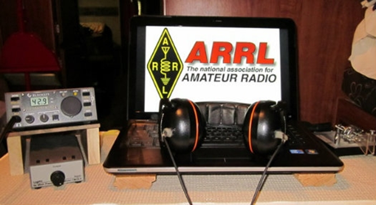*ARRL Contest Corner***

An expanded, downloadable version of *QST'*s’ [**Contest Corral**](http://www.arrl.org/contest-calendar) is available as a PDF. Check the sponsor’s ‘Website for information on operating time restrictions and other instructions.

***####***

***Ohio ARES VHF Contest Results***

All,

The contest results are up – <https://ohsimplex.org/scores/>. NE Ohio had a huge turnout again – a good third of participants. Had really good number of participants. I know in my area there were many QSOs with people who did not submit scores so the activity, at least in this aera, was far – far higher than the submitted scores would suggest. When I get a chance, I will go through my log and figure out what % of my QSOs actually submitted.

Jason, N8EI

####

TOP ^

***Contest University will host Propagation Summit on January 23, 2021.***

Several radio propagation experts will share their knowledge during a Propagation Summit via Zoom, sponsored by Contest University ([**CTU**](https://www.contestuniversity.com/)). The event is scheduled for January 23, 2021. The presentation schedule includes:

* “Update on the Personal Space Weather Station Project and HamSCI Activities for 2021” with Nathaniel Frissell, W2NAF, at 11 AM EST (1600 UTC)
* “Solar Cycle 25 Predictions and Progress” with Carl Luetzelschwab, K9LA, at noon (1700 UTC)
* “Maximizing Performance of HF Antennas with Irregular Terrain” with Jim Breakall, WA3FET, at 1 PM EST (1800 UTC)
* “HF Ionospheric Propagation” with Frank Donovan, W3LPL, at 2 PM EST (1900 UTC).

[**Registration**](https://zoom.us/webinar/register/WN_dfLvFDxaTyakOWd_C7_puw) is free. An Icom IC-705 will be raffled off as a “door” prize. The winner must be present on Zoom to win. — *Thanks to CTU Chair Tim Duffy, K3LR*

All times are USA EST.

11 AM - "Update on the Personal Space Weather Station Project & HamSCI activities for 2021" - Dr. Nathaniel Frissell, W2NAF Noon - "Solar Cycle 25 Predictions & Progress" - Carl Luetzelschwab, K9LA

1 PM - "Maximizing Performance of HF Antennas with Irregular Terrain" - Dr.

James Breakall, WA3FET

2 PM - "HF Ionospheric Propagation" - Frank Donovan, W3LPL Drawing for an Icom IC-705 donated by Icom America and DX Engineering - both CTU sponsors. Winner must be present on Zoom to win.

To register for this free CTU Propagation Summit Webinar please go to :

<https://zoom.us/webinar/register/WN_dfLvFDxaTyakOWd_C7_puw>

Stay tuned to Contest University: <https://www.contestuniversity.com/>

73, Tim K3LR - Contest University Chairman

***Special Events***

* **01/23/2021 | 1st Annual Lone Star Frozen POTA Event**

**Jan 23, 1700Z-2100Z, various**, various, TX. Deep East Texas Amateur Radio Club Inc.. all modes, all bands. QSL. Dayton Jones, KG5TKF, Email or see website for, , Information. www.parksontheair.com or [kg5tkg.radio@gmail.com](mailto:)

TOP ^

* **01/23/2021 | California Discovery of Gold**

**Jan 23-Jan 25, 1700Z-0000Z, AG6AU**, Placerville, CA. El Dorado County Amateur Radio Club. 21.348 14.248 7.248. QSL. El Dorado County ARC, P.O. Box 451, Placerville, CA 95667. [edcarc.net](http://edcarc.net/)

* **01/30/2021 | Kansas Day**

**Jan 30, 1600Z-2100Z, KS0KS**, Edgerton, KS. Santa Fe TRail Amateur Radio Club. 14.250 14.055 10.115 7.250. QSL. Santa Fe Trail Amatuer Radio Club, PO Box 3144, Olathe, KS 66063. The Kansas Day special event celebrates the day Kansas joined the Union. Kansas joined the union on January 29, 1861. Kansas is known as the Sunflower State and became the 34th state to be admitted into the Union. [https://sftarc.org](https://sftarc.org/)

* **02/01/2021 | JY1 Special Event Memorial Station 2021**

**Feb 1-Feb 28, 0000Z-2359Z, N9SES**, Lake Station, IN. ArabQrz Club. 14.250 14.030 7.185 7.030. QSL. Ayman Azar, 2861 Decatur St, Lake Station, IN 46405. See website for participating stations from other countries. All HF/VHF/UHF, All Modes. Hamsphere Users can also participate in the event [www.n9ses.com/?page_id=18](http://www.n9ses.com/?page_id=18)

* **02/06/2021 | 100th Anniversary**

**Feb 6-Feb 27, 1800Z-2359Z, W6UW**, San Jose, CA. Santa Clara County Amateur Radio Association. 21.320 14.250 7.250. Certificate. Don Village, K6PBQ, 3290 Woody Lane, San Jose, CA 95132. w6uw@arrl.net or [www.qsl.net/sccara](http://www.qsl.net/sccara)

* **02/06/2021 | Ground Hog Day Special Event**

**Feb 6, 0900Z-1500Z, K3HWJ**, Punxsutawney, PA. Punxsutawney Amateur Radio Club. all modes, all bands. Certificate. Stephen Waltman, KB3FPN, 37 Clark St., Brookville, PA 15825. SASE for certificate. [www.punxyclub.com](http://www.punxyclub.com/)

* **02/06/2021 | Shuttle Columbia Special Event**

**Feb 6-Feb 7, 1400Z-2359Z, K5C**, Nacogdoches, TX. Nacogdoches ARC. 7.216 14.260 21.350 28.350. QSL. Army Curtis, 167 CR 2093, Nacogdoches, TX 75965. All contacts will be confirmed via LOTW. [https://w5nac.com](https://w5nac.com/)

* **02/07/2021 | Commemorating Howard E. Anthony, Father of Heathkit**

**Feb 7, 1200Z-2359Z, KD2FSI**, Randolph, NJ. KD2FSI. 21.300 14.300 7.300 3.900. QSL. David R. Hackett, 3 High Ridge Road, Randolph, NJ 07869. On Sunday February 7, 2021 from 1200Z -2359Z, Amateur Radio Station KD2FSI will operate as a special event station using a variety of vintage Heathkit gear to commemorate the life and legacy of Howard E. Anthony, the father of the Heathkit brand of electronic kits. Starting in the morning with 75 meter SSB, we will work our way up to the 40, 20, 15 and 10 meter bands and then back down again towards the evening. I will post additional information on my public Facebook page as the event draws near and the actual operating frequencies and modes in real time the day off. We hope all amateur radio operators with any type of equipment (new or old) will join us as we commemorate Mr. Anthony, the person responsible for starting Heathkit, the finest electronic kit company ever. 73, Dave Hackett KD2FSI [davehackett@cs.com](mailto:davehackett@cs.com)  <https://www.facebook.com/dave.hackett.9085>

TOP ^

***“ARES Connect”***

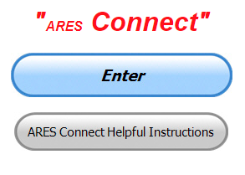

On Monday, January 11, 2021, 11:52:41 AM EST, Stan Broadway <[stan@standi.com](mailto:stan@standi.com)> wrote:

Everyone,  SEC’s around the country received an email this morning from Paul Gilbert, the new Emergency Management Director for the League.  In this email, he has announced that ARES CONNECT is being discontinued by the League on or before June of this year.  Ohio was one of several states which made excellent use of this product, and after all your work to get involved and track your events, I’m sorry to see it go away like this.  The League’s answer to monthly reporting from the state is the old “Form 4” paper form.

I have been talking with Scott about our website reporting, and we are immediately going to re-activate the online reporting form that we used to use.  However, there are major ramifications that will affect EVERY EC’s duties.  There are probably more, but here is a short list of duties you will need to resume on your local level:

1. EC’s will need to update and maintain your county’s ARES roster.
   1. The Ohio training database will continue (it’s separate from CONNECT) but you will have to keep track of your volunteer’s training level. This is important for deployment especially.
   2. You should keep emails/text numbers and other alerting information up to date
   3. You should already have a ‘short list’ of people who are deployable, and who could fill an ARESMAT request.
   4. We will be able to download your county (district) roster prior to June. Let me or Scott know of your request.  (You can do this yourself, I think, using the “reports” section.)
2. EC’s will need to TRACK YOUR ACTIVITIES
   1. Because we will no longer be tracking events and volunteer participation online, you will need to keep that information locally.
   2. It’s helpful to keep a record of volunteer participation in their different events; spreadsheet or database is a tool.
   3. Be prepared to enter your time totals in the arrl-ohio.org form 212
   4. We’ll need to go back to the ‘monthly narrative’ where you can document activities that you’ve undertaken.
3. EC’s will need to return to filing the MONTHLY REPORT on arrl-ohio.org as we did prior to CONNECT. (see above)
4. DEC’s will need to return to producing the District Report Narrative (where you take each of your county’s narratives and compile the monthly report for your district.

These are all routine things we each used to do prior to CONNECT. They don’t take a lot of your time, but they DO require you to resume accountability for your roster and event accounting.

TOP ^

Gang, I’m *really* disappointed in this. Nationally, there was a lot of misinformation and negative reaction to CONNECT, from its badly mishandled introduction, to lackluster promotion and encouragement from the League which resulted in people who refused to discover what it could do and just panned the whole thing. We in Ohio were fortunate to have Scott who is the national expert on CONNECT and whose hours of time invested into the program made our lives easier here.

Not only that, but there also seems to be no real plan for what to do in the future for ARES accounting. The new Director of Emergency Management Paul Gilbert, KE5ZW, did spend time inquiring around the country, and did a short online survey before making the decision to scrap the program.

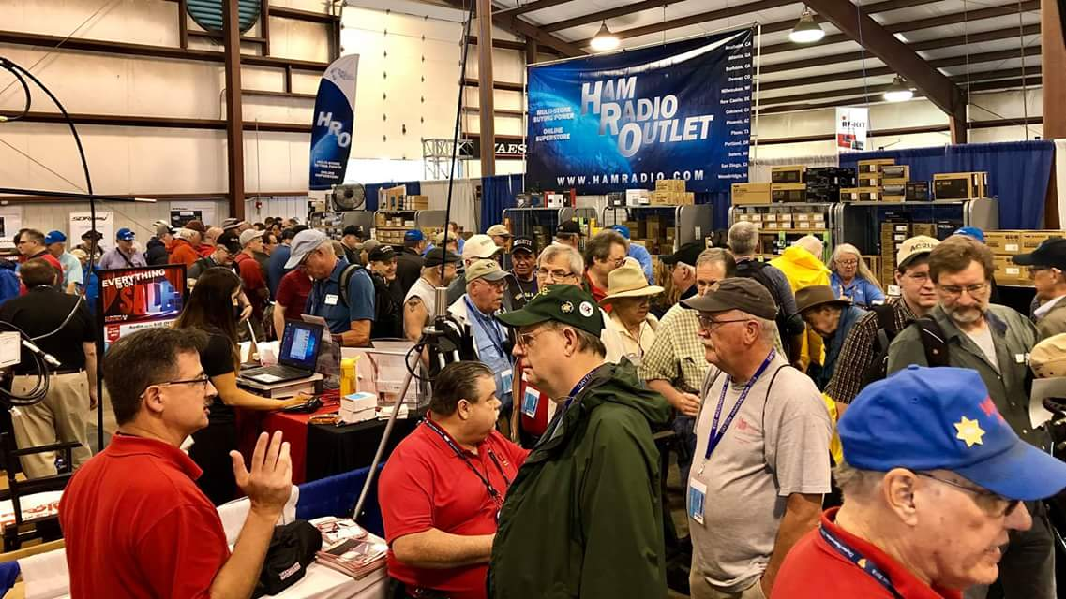[***Upcoming Hamfests***](http://arrl-ohio.org/hamfests.html)

We **DO** have some hamfests scheduled for 2021!! Yes, the first one out of the gate will be the NOARS Fest on March 7th.

[Ohio Hamfests](http://arrl-ohio.org/hamfests.html)

Be sure to keep your eyes on this schedule as that when things start getting better and the vaccine rolls out to more and more, hamfests will surely get back to their normal schedule. Don’t see your hamfest listed?? Did anyone register it with ARRL? It’s really easy to do and you get a lot of FREE publicity if you do.

|  |  |
| --- | --- |
| **03/07/2021 -**[**WINTERHAMFEST**](http://www.arrl.org/hamfests/winterhamfest-3)  **Location: Elyria, OH**  ***Canceled***  Toledo Mobile Radio Association (TMRA) Hamfest normally scheduled in March is also  ***Canceled*** | **04/25/2021 -**[**Athens Hamfest**](http://www.arrl.org/hamfests/athens-hamfest-9)  **Location: Athens, OH Sponsor: Athens County Amateur Radio Association Website:**<http://ac-ara.org/>  [**Learn More**](http://www.arrl.org/hamfests/athens-hamfest-9) |
| **05/21/2021 - 05/23/2021** [**Dayton Hamvention, ARRL Operating Specialty Convention**](http://www.arrl.org/hamfests/dayton-hamvention-arrl-operating-specialty-convention)  ***Canceled*** | |
| **06/05/2021 -**[**FCARC SummerFest**](http://www.arrl.org/hamfests/fcarc-summerfest)  **Location:**Wauseon, OH **Sponsor:**Fulton County Amateur Radio Club **Website:**<http://k8bxq.org/hamfest>  [**Learn More**](http://www.arrl.org/hamfests/fcarc-summerfest) | **07/18/2021 –**[**Van Wert Hamfest**](http://www.arrl.org/hamfests/van-wert-hamfest-5)  **Location:**Van Wert, OH **Sponsor:**Van Wert Amateur Radio Club **Website:**[http://W8FY.ORG](http://w8fy.org/)  [**Learn More**](http://www.arrl.org/hamfests/van-wert-hamfest-5) |

TOP ^

|  |  |
| --- | --- |
| **08/28/2021 -**[**Cincinnati Hamfest℠**](http://www.arrl.org/hamfests/cincinnati-hamfest)  **Location:**Owensville, OH **Sponsor:** Milford ARC **Website:** [http://CincinnatiHamfest.org](http://cincinnatihamfest.org/)  [**Learn More**](http://www.arrl.org/hamfests/cincinnati-hamfest) | **09/26/2021 -**[**Cleveland Hamfest**](http://www.arrl.org/hamfests/cleveland-hamfest-1)  **Location:**Berea, OH **Sponsor:** Hamfest Association of Cleveland **Website:** [http://www.hac.org](http://www.hac.org/)  [**Learn More**](http://www.arrl.org/hamfests/cleveland-hamfest-1) |
| **12/04/2021 -**[**FCARC WinterFest**](http://www.arrl.org/hamfests/fcarc-winterfest-2)  **Location:** Delta, OH  **Sponsor:** Fulton County Amateur Radio Club  **Website:** <http://k8bxq.org/hamfest>  [**Learn More**](http://www.arrl.org/hamfests/fcarc-winterfest-2) | |

***River Ice Spotter Training Scheduled***

Partners,

The National Weather Service will host a 45 min webinar for River Ice Spotters in the area on **January 26 at 10 AM.** The focus of this training will be on monitoring and reporting river ice. This information is used by the NWS, USACE, USGS, and local and state officials in our efforts to prepare and alert communities of threats posed by ice jam flooding. The training will be recorded if you are unable to attend at the scheduled time.

To register and find more information regarding this training please visit our website [www.weather.gov/cle/RiverIceSpotters](http://www.weather.gov/cle/RiverIceSpotters).

***Print an Official or Unofficial Copy of Your Amateur Radio License***

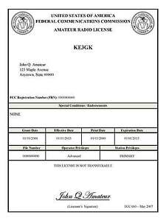*(By Anthony Luscre, K8ZT)*

As of February 17, 2015, the **FCC no longer routinely issues paper license documents** to Amateur Radio applicants and licensees. The Commission has maintained for some time now that the official Amateur Radio license authorization is the electronic record that exists in its Universal Licensing System (ULS). The FCC will continue to provide paper license documents to all licensees who notify the Commission that they prefer to receive one.

Licensees also will be able to print out an official authorization — as well as an unofficial “reference copy” — from the ULS License Manager. I’ve created a set of instructions on how you can request an **“official” printed copy of your license\***

[**Click here to download the instructions**](http://arrl-ohio.org/news/2020/print_your_license.pdf)

TOP ^

***One Question Questionnaire***

Hey Gang,

Survey Says”….. 75% of you own a soldering station. That’s fantastic, but I probably should have asked how many of you have actually USE it!!

Ok, now on to the next question… As most of us have rigs that depend on an external power supply to power them. With that, it leaves for a lot of room on whether we use that supply to power other devices as well. Now, this means that we have several connections made to the supply. And… that leads me to the next question.

***“Do you have your external power supply properly fused?”***

You’ll find the “One Question” questionnaire on the Ohio Section Website! <http://arrlohio.org> It’s all for fun and it’s not a scientific survey in any way, but we are learning some things that we didn’t know from these questions. I hope that you are enjoying answering these “One Question” questionnaires.

*****V.E. Test Sessions***

Many V.E.’s have decided to start testing once again, but with restrictions that need to be adhered to for sure. Here’s the link to find that V.E. Test session and what is expected of YOU before going. <http://www.arrl.org/find-an-amateur-radio-license-exam-session>

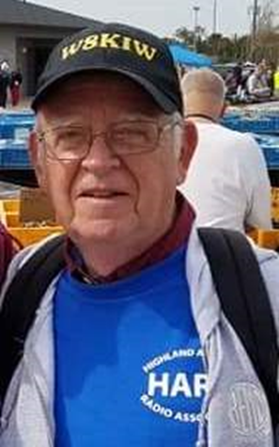***From The South 40***

*(from John Levo,* [*W8KIW@arrl.net*](mailto:W8KIW@arrl.net)*)*

***The South 40***

The recent start of vaccinations for the COVID-19 pandemic gave us hope the ‘light at the end of the tunnel’ would be renewed opportunities to restart local club face to face meetings, club activities, hamfests and Field Day as we remembered them up to about a year ago. However the ‘light at the end of the tunnel’ turned out to be a speeding freight train when last Monday the cancellation of HamVention© was announced. Although the cancellation is for very valid reasons, one ham was heard to say “I feel like someone died”. In the meantime, let’s follow suggested health guidelines and do everything we can to get through this thing so we can once again enjoy our hobby to its fullest.

TOP ^

On January 4 the **Portsmouth RC** held what may have been 2021’s first VE session in Ohio. According to team leader Jerry Lockhart, W8HIC, Peebles’ Rusty Huff passed his Technician license and became KE8QHK and possibly Ohio’s first new ham in the New Year.

Unfortunately three Southern Ohio clubs were greeted during the first week of the New Year with the passing of long-time members. Annabelle Jenkins, KB8TGI, of Pedro, OH was a 20 year member of the **Southern Ohio ARA** and became a silent key on January 9. She was the wife of Eddie Jenkins, N8URU, SOARA’s vice president. Members of the **Clinton County ARA** and the **Highland ARA** were saddened by the January 8 passing of Lynchburg’s Jim Hause, K8CUH. Jim was a former HARA president and had served CCARA as its secretary until his sickness. Both individuals will be greatly missed but their contributions to their respective clubs will be long remembered. Our thoughts and prayers go to their families and friends.

There’s a new 440 repeater on the air according to Pat Hagen, N8BAP. According to Hagen a machine operating on 444.0375 and bearing the KB8DOT/R call sign has been placed on the air in Leesburg. Hagen states the machine is operating in the System Fusion C4FM mode.

John Hartmus, WB8GRX, invites all within the sound of the Bainbridge 146.925 repeater to check into a Sunday evening **Scioto Valley ARC** net. The net is called to order by Bill French, KE8AAL, on Sunday evenings at 8 pm. The repeater requires a 74.4 tone.

My late start for the recent Ohio Simplex Test caused me to change plans and operate portable from N8ZNR and my Clinton County farm instead of our Highland County QTH. The farm is on the highest point in the county and some nice contacts resulted. Considering the portable arrangement was only a 3 element A270-6S beam at 12 feet and a 7250 were used, a not too shabby 112 mile contact with W8FHF in Muskingum County was made. Decent contacts into Scioto and Union Counties were also achieved with the same set up.

Michael Bailey, N8MRB, reports the **Portsmouth RC** will have a test session on Monday evening, February 1. The 5 pm session will be held at 711 Findlay Street in Portsmouth, across from the Portsmouth Schools Administrative Offices. All elements will be given during the Laurel session and no fees will be charged.

Kentucky’s **Greater Mason County ARA** announces an upcoming test session on February 27 at the Mason County EMA Office in the Maysville City Building. Because of health department requirements and building security, pre-registration will be required. More information and contacts will be forthcoming.

Tuesday, January 19 will be the next Zoom meeting of the **Athens County ARA** at 7 pm. According to Eric McFarland, WD8RIF, and Jeff Slattery, N8SUZ, all ACARA meetings will be via teleconference until further notice.

A meeting to nominate officers for the **Cambridge ARA** is scheduled for Saturday, January 30 if the meeting location is available. As a way to maintain club interest and activity Lyn Alfman, N8IMW, says the club has a nightly Trivia Net at 8 pm on the Cambridge 146.85 repeater. She says since its April 1, 2020 start only four nights have been missed.

The popular Winter Field Day is ready to go starting on January 30 and continuing through the 31st. One station rearing to go is the **Queen City Emergency Net**’s W8VND. Because of the pandemic they are unable to work from the Red Cross Building this year, but will work from their Shipp Shack Field Station instead. Although it’s not a formal club operating function, several members of the Adams County **DeForest ARC** plan to operate during the Winter Field Day event according to Club President Kim Paquette, N8YWX. For more information about the event visit www.winterfieldday.com.

TOP ^

Except for its Tuesday evening two-meter net, the **Fayette ARA** is “pretty much on hiatus for the time being” according to the Club’s Jim Scott, N8ORJ. Jim also reminds those who have licenses expiring this year they can renew the license as much as 90 days in advance of the expiration date. Although the FCC has not announced the date they will begin charging a $35 fee for a license renewal, an early renewal might be a way to beat the charge.

On Saturday morning the **Highland ARA** held their first test session for the year. According to VE Team Leader Tom Mongold, KD8LDS, Hillsboro’s Jennifer Ritter and Adams County’s Marlin Dennison each earned their Technician licenses. Robb Allen, KE8PYG, from Sabina upgraded to Extra with Wilmington’s Joe Salyer, KE8OJC, and Bainbridge’s Travis Holden, WA6WTF, each receiving their General privileges. Alan Eldridge, N4MTD, of Wilmington did the necessary paperwork to convert his Technician Plus License to a General.

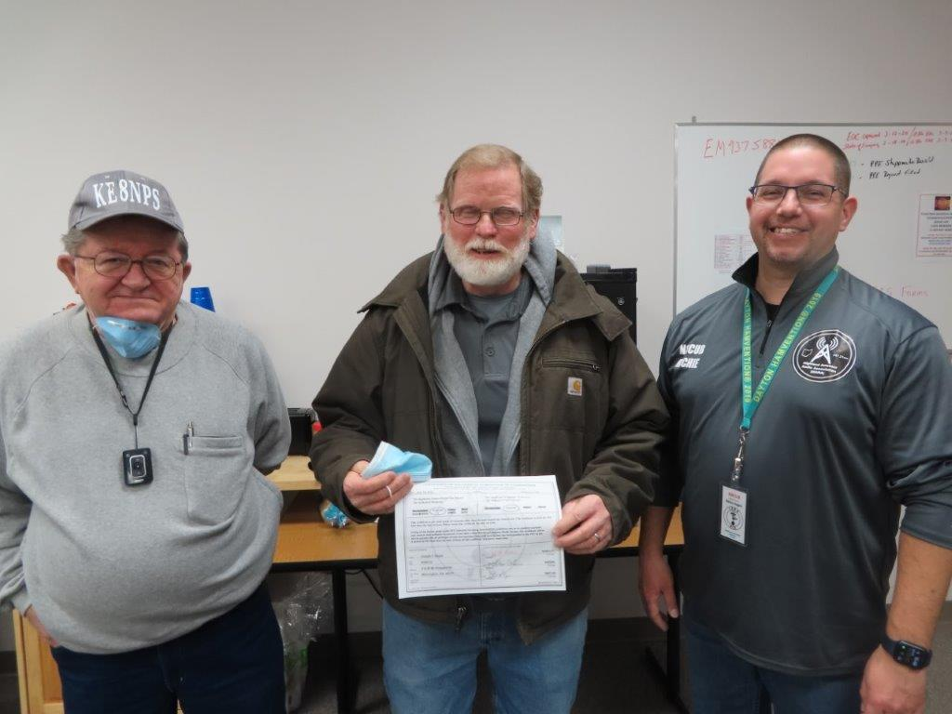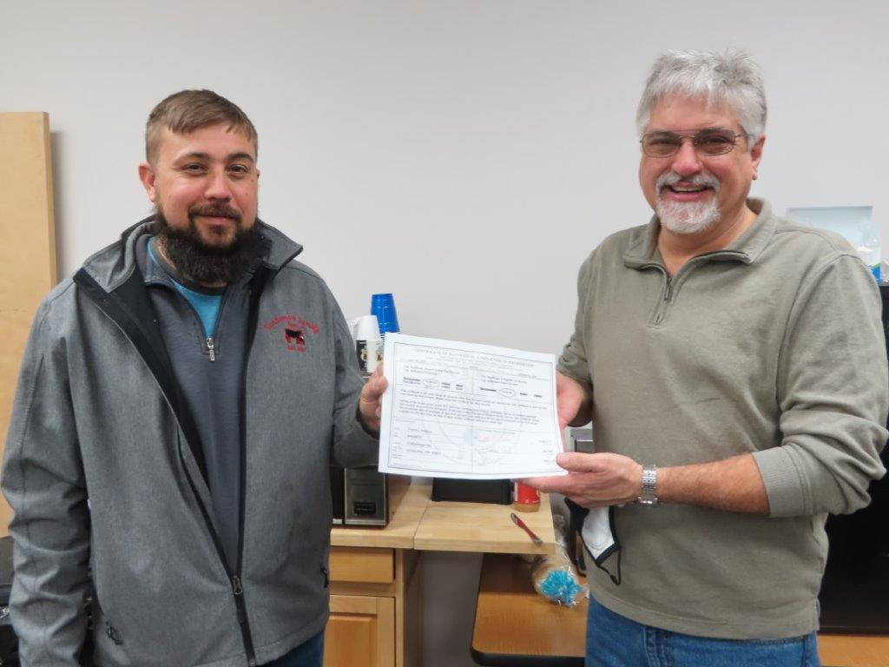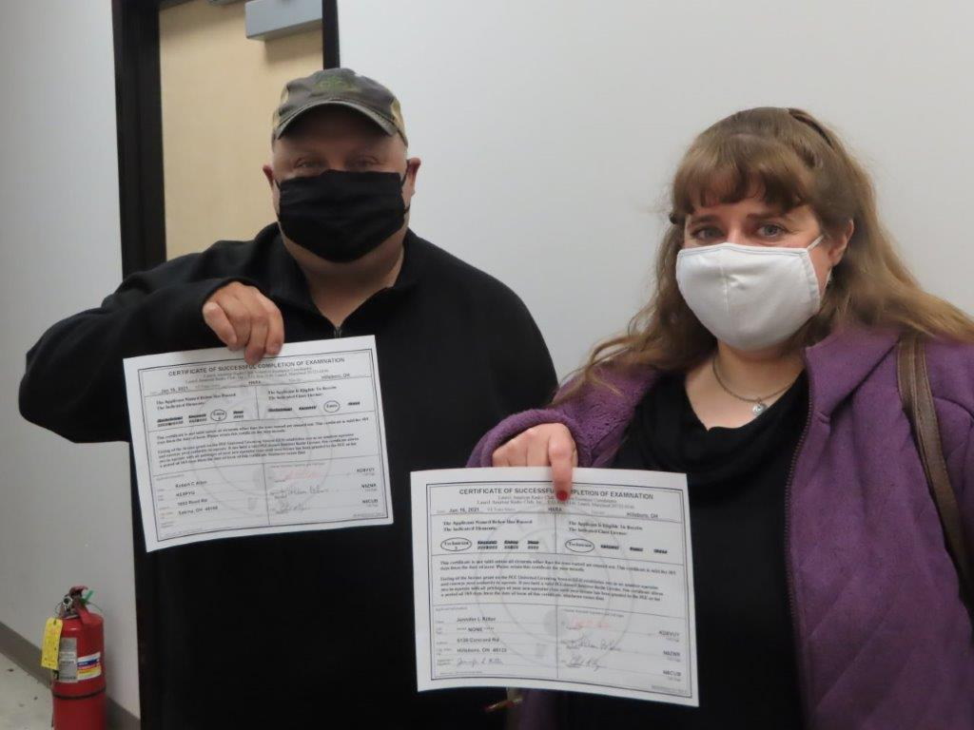

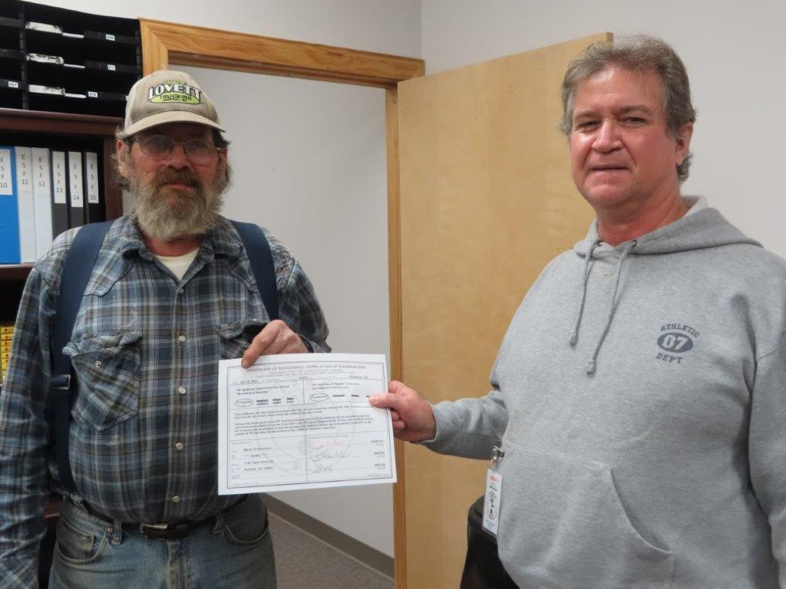

I enjoy reading other club’s newsletters and getting ideas that could be used by our local club. I especially enjoy Cincinnati’s QCEN ‘Listening Post’ edited by Tom Delaney, W8WTD. A question asked this month is ‘what can I do to increase my participation in ham radio?’

TOP ^

Article author Bob Bross, W8NFM, had some great suggestions that perhaps could serve as belated New Year’s Resolutions. (1)-One is for those with Novice, Technician, General or Advanced licenses to step up a grade. (ed note: YES, there are still people with valid Novice and Advanced licenses still in the FCC’s data base) (2)-Another is to explore a new mode and is one I intend to undertake to learn more about Fusion and FT8. (3)-Serving your local club as an Elmer, a VE or Net Control is a great way to pay back to our hobby and meet new friends. (4)-Yes there seem to be a lot of contests on the air.

But they provide an opportunity to improve our operating skills, propagation knowledge and how to set up stations under difficult conditions. Plus they can be fun if you give them a chance while using a positive attitude towards them. (5)-Participate in your local club’s nets and meetings. It’s another way to meet some great people sharing a mutual interest. I would add #6 as to attend a hamfest. However, it looks like it could be another year with them few and far between. Thanks again to the **Queen City Emergency Net**, W8WTD and W8NFM for the idea.

Until next time, 73 and good DX.

**Winter Safety Tips**

*(from Ohio Committee for Severe Weather Awareness)*

Hey Gang,



Here in Ohio, we’ve already experienced several significant snow falls. So, I thought that it would be a great idea to publish this great little checklist of items that we need to have with us as we drive in snowy conditions.

**For the Vehicle**

Winterize your vehicle. Get a tune-up and be sure to check the battery levels in your vehicle. Consider buying snow tires or chains for the tires, as your travel dictates. Chains work best on glare ice. Be sure to check with local authorities on tire chains. Some locales prohibit their use.

**Other vehicle care tips include:**

• Check radiator coolant and sturdiness of hoses and belts

• Refer to the vehicle’s manual to see if a lighter grade oil is recommended for winter driving

• Change burned out headlights, taillights and turn signals

• Check tire tread and wear – minimum tread is 1/16” for adequate traction

• Make sure brakes are in proper working order

• Keep spare window washer fluid in the trunk and make sure the washer blades are in good working condition

**Prepare a winter emergency kit for your vehicles. Supplies should include:**

• At least two blankets or a sleeping bag

• Flashlight or battery-powered lantern and extra batteries

• Booster (jumper) cables

• Emergency flares

TOP ^

• Extra clothing, particularly boots, hats and mittens

• A steel shovel and rope to use as a lifeline

• Bottled water or juice and nonperishable high-energy foods (granola bars, raisins, nuts, peanut butter or cheese crackers)

• First-aid kit and necessary medications

• Sand or non-clumping cat litter for tire traction, if your vehicle gets stuck in snow or ice

• A cell phone and car charger

**Winter-wise Driving Tips**

• Pay attention to weather reports on the radio. Allow time in your schedule for bad weather and/or traffic delays.

• Become familiar with your vehicle’s winter weather operating characteristics. Front-wheel-drive vehicles generally handle better than rear-wheel vehicles on slippery roads because the weight of the engine is on the drive wheels, improving traction.

• Keep your windows clear of snow and ice. Remember to clean head, tail and brake lights.

• If you need to turn on your wipers, turn on your headlights. Effective January 1, 2010, Ohio law requires drivers to turn on vehicle headlights whenever windshield wipers are in operation due to any precipitation. Failing to do so is a secondary offense, meaning motorists cannot be stopped solely for failing to have lights on with wipers. They must be stopped for another offense, such as speeding, before they can be ticketed and fined for not having headlights on. Fines start at $100. Click here to read ORC 4513.03.

• To prevent fuel line freeze-up, keep your gas tank at least half full. Fill your gas tank before your vehicle is parked for lengthy periods.

• Leave ample stopping time between you and the driver in front of you. Braking distance can be up to nine times greater on snowy, icy surfaces than on dry roads.

• If your vehicle is equipped with an Anti-lock Braking System (ABS), be sure to: STOMP - firmly depress the brake pedal. STAY on the brakes - do not pump the brakes. STEER where you want the vehicle to go.

• Gently pump non-ABS brakes to stop the vehicle. Take any corrective action gradually. You need to maintain full control of the vehicle. Refer to the vehicle operations manual for proper methods to correct skids.

• During winter travel, it is best to supply those at your destination with the following information: your cell phone number, departure time, travel route and anticipated arrival time.

• Lock your vehicle, even in bad weather. If locks freeze, heat the key. Do not pour hot water on the locks - they will refreeze.

• Drive with extreme caution on bridges and overpasses during freezing temperatures. Because bridge temperatures can be 5-6 degrees colder than roadways, they can become slick and icy before roads.

• Stay with your vehicle while warming it up. An unattended, running car invites theft.

**Survival Tips if you get Stranded**

The best advice is to remain with the vehicle. If nothing else, you are guaranteed shelter. Other helpful tips include:

• Tie a bright colored cloth (handkerchief, towel, etc.) to the vehicle’s antenna, driver door handle or outside mirror.

TOP ^

• Keep the exhaust pipe clear of snow. Poisonous gases can filter into the vehicle if the pipe is clogged.

• Run the engine and heater no more than 10 minutes every hour, leaving a downwind window slightly open for ventilation while the engine is running.

• Light a flare or turn on a flashlight to let others know you’re

stranded in the vehicle.

• Use floor mats, seat covers and blankets for added warmth. If you must leave your vehicle during a severe snowstorm or blizzard, secure a line of rope or cord to yourself and the vehicle to avoid becoming lost or disoriented.

• Keep bottled water in your emergency kit or vehicle. Never eat snow. It will chill you and lower your body temperature.

• Remain calm. Chances for rescue are better if you remain calm and in your vehicle.

Ohio Section Cabinet

|  |  |
| --- | --- |
| Section Manager – Tom Sly, WB8LCD | Section Traffic Manager – David Maynard, WA3EZN |
| Section Emergency Coordinator – Stan Broadway, N8BHL | Section Youth Coordinator – Anthony Lascre, K8ZT |
| Technical Coordinator – Jeff Kopcak, K8JTK | Affiliated Clubs Coordinator – Tom Sly, WB8LCD |
| State Government Liaison – Bob Winston, W2THU | Public Information Coordinator – John Ross, KD8IDJ |



Hey Gang,

Have you taken a look at the **Swap & Shop** page on the Ohio Section webpage yet?? Here’s a link that will take you there… <http://arrl-ohio.org/sm/s-s.html>

Do you have equipment that you just don’t need or want anymore? Here’s a great venue to advertise it, and it’s FREE!! Is your club doing a fund raiser to help raise money? After a lot of thought, it was decided that the Swap & Shop webpage could also contain these types of items as well. The same rules will apply as do for the For Sales and Give-A-Ways and will only be posted for a month at a time. Please see the Terms & Conditions on the webpage.

If your club is doing a fund raiser and wants more exposure, please forward the information to me and I’ll advertise it on the Swap & Shop webpage for you.

Now, I still want to remind you that it won’t be listed in this newsletter because it would take up way too much space, so your ad will only appear on the website. It is there for any individual to post equipment Wanted / For Sale or Give-Away as well as for Club Fund Raisers. No licensed vehicles/trailers or business advertising will be posted. Postings are text only (no pictures or graphics) will be posted for a maximum of 1 month from date posting and require a contact phone number or email within the posting. Send your Wanted / For Sale or Give-Away post to:  [swap@arrlohio.org](mailto:swap@arrlohio.org)

TOP ^

***Back Issues of the PostScript and Ohio Section Journal***

Hey, did you know that PostScript and Ohio Section Journal (OSJ) are archived on the website? You can go back and look at any edition simply by clicking:

<http://arrl-ohio.org/news/index.html>

***Welcome New Subscriber(s)***

**Alberto, IW5EIA**

***Want to Share your Club Newsletter With Others?***

We have a webpage where you can download and read all of the newsletters that I get from around the state and even other sections!

Here’s the link to the page…. <http://arrl-ohio.org/club_news/index.html>

Please, if you don’t see your club newsletter posted, it’s because I’m not receiving it. Just have your newsletter editor contact me and I’ll get your club’s newsletter listed on the site!!

We all learn and steal (I mean, share) from each other’s work. So, get me your newsletter!!! Send it to: [webmaster@arrl-ohio.org](mailto:webmaster@arrl-ohio.org)

***Chit – Chat, and All That!***

Do you know someone that’s not getting these Newsletters? Please, forward a copy of this Newsletter over to them and have them “[Opt-In](mailto:Opt-In)” to start receiving them. Heck just have them send an email to: [webmaster@arrl-ohio.org](mailto:webmaster@arrl-ohio.org) and we’ll get them added to the Ohio Section Emailing list.

We now have many thousands of readers receiving these newsletters weekly. Quite impressive, I’d say! I urge all of you to make sure that everyone, regardless of whether they are a League member or not, get signed up to receive these weekly Newsletters.

TOP ^

You can always “Opt-Out” at any time if you feel this is not what you were expecting. It’s fun and very informative. All of your favorite past newsletters are now archived too.

You can go back at any time and read them.

Just go to: <http://arrl-ohio.org/news/>

The pictures on the front page and throughout this newsletter are from various newsletters, Facebook posts and/or were sent directly to me in recent weeks. Take a good look at them, you just might be in one of the pictures! “SMILE… you’re in the Ohio Section News!!”



TOP ^

*PostScript is produced as a weekly newsletter. I want to thank everyone that has contributed articles and ideas to make this an even better news source. I sincerely hope that you have enjoyed this edition and will encourage your friends to join with you in receiving the latest news and information about the Ohio Section, and news and events happening around the world!*