[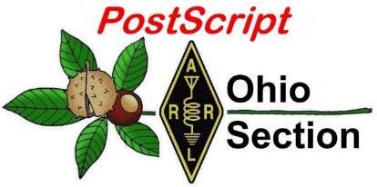](http://arrl-ohio.org/news/) ***“January 11th”***

***Edition***

🡪 National News 🡪 Club Corner

🡪 DX This Week 🡪 Contest Corner

🡪 Special Events 🡪 ARES Connect

🡪 Upcoming Hamfests 🡪 One Question Questionnaire

🡪 VE Testing

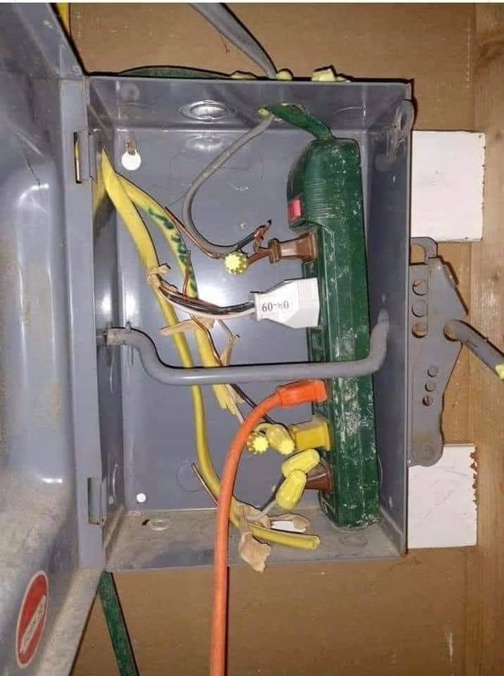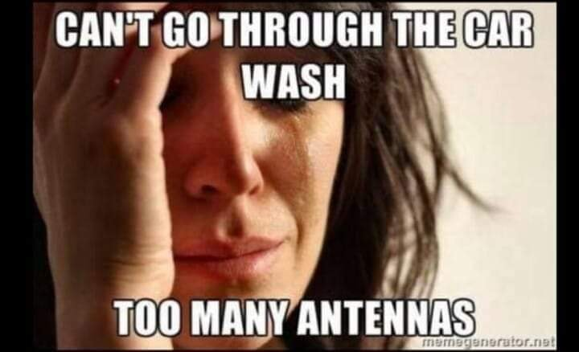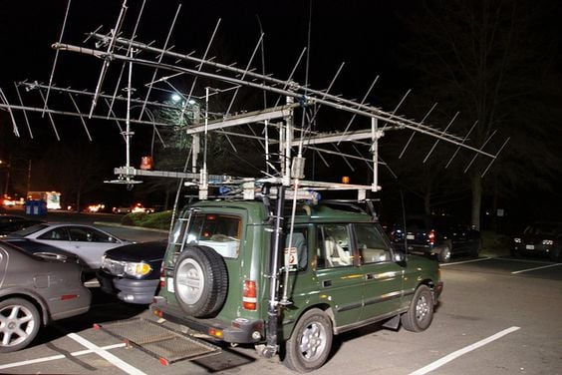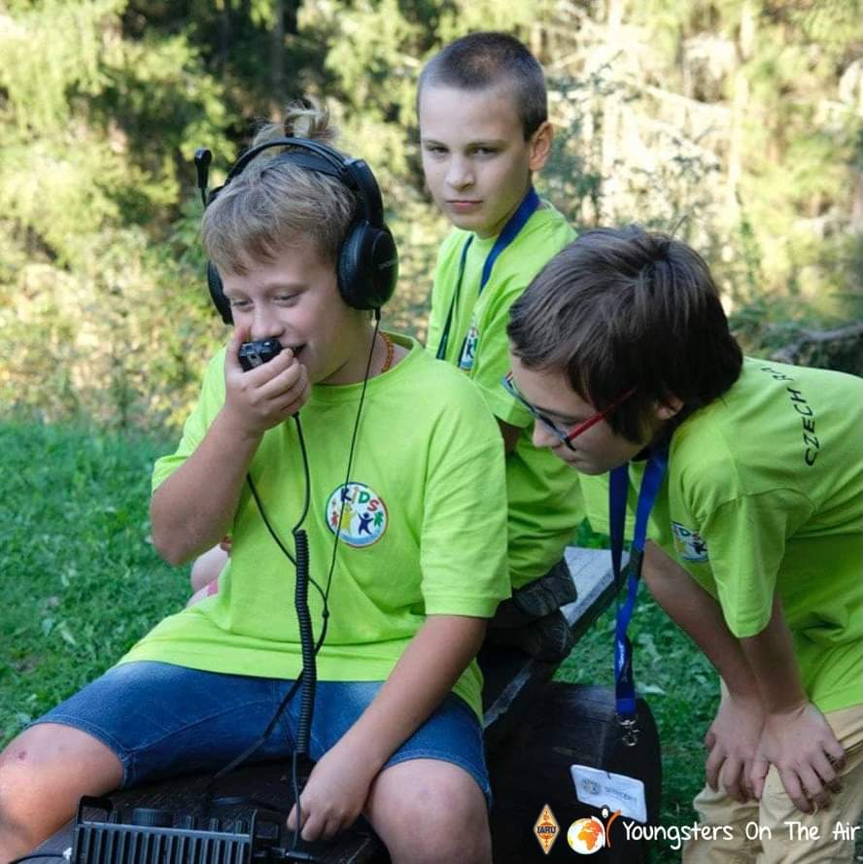

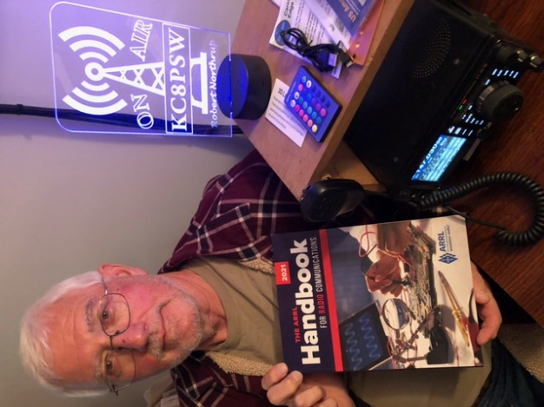

***National News***

*(from arrl and other sources)*

**QSO Today Virtual Ham Expo Returning in March**

The [**QSO Today Virtual Ham Expo**](http://www.qsotodayhamexpo.com/) will return March 13 – 14 for a full 48 hours, *QSO Today* host Eric Guth, 4Z1UG/WA6IGR, announced this week. [ARRL](http://www.arrl.org/) is a QSO Today Expo Partner. Guth said the inaugural QSO Today Expo last August attracted more than 16,000 attendees, and he anticipates that the March 2021 event will be even more successful.

The upcoming QSO Today Virtual Ham Expo will feature new speakers and presenters, panel discussions, and kit-building workshops among other activities. Guth pointed out that attendees can log in from anywhere. While he anticipates a good turnout by those who typically attend such ham radio events, the virtual Expo also offers an opportunity for those concerned about pandemic travel restrictions as well as for those who don’t typically attend in-person events.

“At our last Expo, we found that 60% of attendees don’t go to in-person national conferences, and 40% don’t attend state or local events,” Guth said, noting that distance and the high cost of travel and lodging were the most oft-cited reasons.

[**Registration**](http://www.qsotodayhamexpo.com/) is required, and to help cover the costs of staging this event, there will be a charge to attend. Advance tickets are $10 ($12.50 at the “door”) and include entry for the live, 2-day show as well to the 30-day on-demand period. At the Expo, visitors can:

Learn from a line-up of such well-known ham radio personalities as Bob Allphin, K4UEE, on “My Favorite DXpeditions to DXCC Top 10 Most Wanted;” Michael Foerster, W0IH, on “Using the Arduino in Your Shack,” and Ron Jones, K7RJ, on “3D Printer Basics.”

Take part in live virtual kit-building workshops. (Kits will be available for purchase and delivered to attendees in time for the Expo.)

Walk through the virtual exhibit hall to visit an array of amateur radio vendors and see live demonstrations of the latest equipment. This show will leverage newer video technology to provide a better experience for attendees to engage with exhibitors.

Those planning to attend the Expo may take advantage of new speaker calendar technology to create their own calendar of presentations in their time zones, which can be saved to a Google or Outlook calendar.

Registrants may return over the 30 days following the live event to catch speakers and presentations missed during the live period, as well as to explore and re-engage exhibitor offerings.

“The QSO Today Virtual Ham Expo has all of the familiar hallmarks of an in-person hamfest, including opportunities to connect and learn,” ARRL Product Development Manager Bob Inderbitzen, NQ1R, said.

TOP ^

“Expect to bump into friends and well-known experts and personalities from throughout our worldwide ham radio community!” He explained that attendees visiting an exhibit or virtual lounge will be able to interact with other attendees in those settings.

####

***ARRL Seeks Nominations for Six Awards***



ARRL invites nominations for awards that recognize excellence in amateur radio educational and technological pursuits. Nominations are also open for the Hiram Percy Maxim Award, ARRL’s premier award to honor a young licensee.

**The Hiram Percy Maxim Award**

The Hiram Percy Maxim Award is the premier honor for a radio amateur and ARRL member younger than 21 whose accomplishments and contributions are of the most exemplary nature within the framework of amateur radio activities. Nominations must be made through your ARRL Section Manager, who will forward nomination to ARRL Headquarters by March 31, 2021. Nomination forms and supporting information should document as thoroughly as possible the nominee’s amateur radio achievements and contributions during the previous calendar year.

**The ARRL Herb S. Brier Instructor of the Year Award**

This award honors an ARRL volunteer amateur radio instructor or professional classroom teacher who uses creative instructional approaches and reflects the highest values of the amateur radio community. The award highlights quality of — and commitment to — licensing instruction. Nominations are due by March 15, 2021.

**Technical Awards**

* The ARRL Microwave Development Award pays tribute to a radio amateur or group of radio amateurs who contribute to the development of the amateur radio microwave bands. The nomination deadline is March 31, 2021.
* The ARRL Technical Service Award recognizes a radio amateur or group of radio amateurs who provide amateur radio technical assistance or training to others. The nomination deadline is March 31, 2021.
* The ARRL Technical Innovation Award commends a radio amateur or group of radio amateurs who develop and apply new technical ideas or techniques in amateur radio. The nomination deadline is March 31, 2021.

**The Knight Distinguished Service Award**

The Knight Distinguished Service Award honors exceptional contributions by an ARRL Section Manager to the health and vitality of ARRL. The nomination deadline is April 30, 2021. It was named for Joe T. Knight, W5PDY (SK), who was commended for his exemplary service not only as ARRL New Mexico Section Manager for more than a quarter-century, but for his willingness to share his knowledge and leadership skills.

The ARRL Board of Directors selects recipients for these awards. Winners are typically announced following the Board’s July meeting. [More information](http://www.arrl.org/arrl-award-nominations) about these awards is on the ARRL website, or [**contact**](mailto:wv1x@arrl.org) Steve Ewald, WV1X, at ARRL Headquarters (telephone 860-594-0265).

####

TOP ^

***2021 AM Rally Set for First Weekend in February***

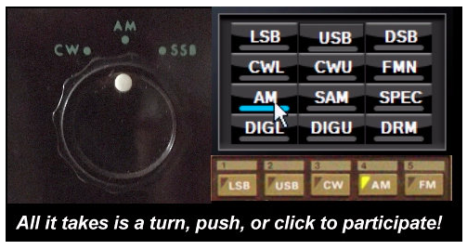

The 2021 running of the [**AM Rally**](http://www.amrally.com/) will take place from 0000 UTC on Saturday, February 6 to 0700 UTC on Monday, February 8. The annual AM Rally operating event encourages all operators to explore amateur radio’s original voice mode by showcasing the various types of amplitude modulation equipment in use today, ranging from early vacuum-tube radios to the latest SDR-based transceivers.

“Participation in the AM Rally has continued to grow over the past 5 years, as more operators explore the mode,” said Clark Burgard, N1BCG. “The AM Rally is a great way to beat the winter and COVID-19 blues.”

The AM Rally is open to all radio amateurs capable of operating on AM using any type of radio equipment from vintage to modern, vacuum tube to solid state. The AM Rally will use the 160-, 80-, 40-, 20-, 15-, 10-, and 6-meter bands.

“Those who have never tried AM mode will find plenty of help, if needed,” Burgard assured. An AM Rally 2021 [**promotional video**](https://www.youtube.com/embed/5aGAL1I0rbY) is available. [**Contact**](mailto:n1bcg@internetwork.com) Burgard for more information.

***Club Corner***

This is YOUR cornner of the newsletter. Send me what your club is doing and I’ll make sure that it gets in. Got a special event or club project that you want everyone to know about? Send it to me!. Need help with a project? Send it to me.

Let me know what you club is up to. Are you going to have a special guest at your meeting or are you having a special anniversary?

Just sent it to: [webmaster@arrl-ohio.org](mailto:webmaster@arrl-ohio.org)

####

***Seeking Volunteers to Support Vaccination Clinics in Montgomery County***

This is not a ham radio exercise. If that offends you, please stop reading and delete this message.

This is an important activity, and the organizers are in need of a lot more help, so I took the initiative to use a ham radio email list to spread the word. If you wish to complain, please direct your opinions to me—it is my fault that you are receiving this.

Vaccinations to prevent COVID-19 have begun in Montgomery County. Each clinic at which the vaccine is administered is a large-scale incident and is being managed per the National Incident Command System (NIMS).

TOP ^

Incident Command has contacted me and asked if there was a possibility that ham radio operators would be willing to help with traffic control. This message is to solicit volunteers to help with this effort.

The nature of the work is directing traffic in and around the Dayton Convention Center, particularly in the five-story garage. Note that traffic control is by request of the Dayton Police Department. Volunteers will be assigned to work in teams of two. Each team will be issued a CERT radio (Moto Talkabout FRS). Training will be provided as needed. Each assignment consists of a five-hour shift, with at least one break. The work requires spending time on your feet and most of the time will be outdoors.

**A requirement for volunteers is that they have had training in NIMS. Having been trained as CERT, being listed as ARES Level 2, or holding certificates of successful completion for IS-100, IS-200, IS-700, and IS-800 is sufficient. Note that this is an opportunity to witness the Incident Command System in operation.**

**DO NOT** show up to the incident and volunteer to help unless you are on the roster of expected volunteers.

The vaccine is being offered to groups in stages. Right now, it is available to first responders and health care workers, but it is expected that you will be eligible to receive the vaccine if you volunteer.

It is expected that the size of the operation will expand rapidly, so there will be many volunteer opportunities in the near future.

I have offered to collect the names and email addresses of people who would like to volunteer. A list of currently scheduled clinics is below. Please send me a message to [n8ado@arrl.net](mailto:n8ado@arrl.net) if you wish to volunteer.

List the clinics for which you are willing to support. Also tell me if you want to be included on future emails listing additional clinics after they are scheduled. I will be creating a new mail group, probably on Gmail to help manage this.

Currently Scheduled Clinics:

1/12/21 Tuesday 8a until 1p BADLY NEEDED 3 spots

1/16/21 Saturday 8a until 1p 3 spots available

1/19/21 Tuesday 8a until 1p 3 spots available

1/21/21 Thursday 1p until 6p 1 spot available

1/26/21 Tuesday 8a until 1p 1 spot available

1/30/21 Saturday 8a until 1p 2 spots available

Thank you for your kind attention - Bob Baker N8ADO [n8ado@arrl.net](mailto:n8ado@arrl.net)

####

TOP ^

***Highland Amateur Radio Association elects officers***

*(Courtesy of John Levo & The Highland County Press)*  
Although COVID-19 caused changes to the way the Highland Amateur Radio Association normally conducts its annual election of officers and trustees, the organization successfully found a way to elect those who will lead the club during 2021.  
  
Election Committee Chairman Patrick Gilfillen recently announced voting by club members will have Pat Hagen, N8BAP, serving as president, and Tom Mongold, Jr., KD8LDS, as vice president.  
  
Kathy Levo, N8ZNR, was re-elected secretary-treasurer and Ken Lightner, KE8JEL, will join Gilifillen, N8EWH and Richie Hagen, N8CUB, as trustees.  
  
The 2020 president, Jeff Collins, KD8VUY, will join the Executive Committee as a past president.  
  
As with a number of organizations, the pandemic created a trying year for the club. However, because amateur radio has been an original “social distancing” activity since its creation in the early 1900s, a large number of the normal club activities were able to proceed without concerns.  
  
Although the club exercised suggested health guidelines for a few events, most club meetings and other normal face-to-face activities were moved to over-the-air ones through the club’s system of amateur radio repeaters in Highland, Fayette and Pike counties.  
  
Late in 2020, amateur radio’s national organization, the American Radio Relay League, honored the Highland Amateur Radio Association with its highly respected Special Service Club Award.  
  
The award is presented to only those clubs that demonstrate their involvement in varied aspects of amateur radio for the greater good of their community, state, nation and members. Such clubs actively provide training classes and licensing opportunities, technical advancement and achievement and operating activities while serving their communities.  
  
Presently, there are only 10 other such clubs in Ohio.

The Highland Amateur Radio Association has grown its membership to well over 100 federally licensed amateur radio operators in Highland County since its 1974 founding. ARRL officials state it is highly unusual for a local club to be this size and to be in a rural area.  
  
Information about the club and its activities can be obtained by contacting the club’s information officer, John Levo, W8KIW, at (937) 393-4951. General information about amateur radio and the steps to earn a radio license can be obtained from Levo or by contacting the American Radio Relay League at [www.arrl.org](http://www.arrl.org) .

####

TOP ^

***DX This Week***

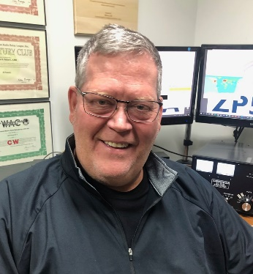*(from Bill, AJ8B)*

***DX This Week – Dates in 2021***

***Bill AJ8B (aj8b@arrl.net, @AJ8B, or www.aj8b.com)***

***CWOPs Member #1567***

Happy New Year! By the time you get this, most of us will be back to work, albeit in the Covid styles we have been developing. I have about a 50-minute drive from Waynesville to Cincinnati each morning. I miss the interaction with my group, but I don’t miss the traffic! Let me know if you received anything you want to share under the tree this year.

Solar conditions continue to slowly improve, and this is reflected in the cluster spots that were posted in the past week. The Midwest DX Cluster spots were Alaska, Andorra, Anguilla, Argentina, Asiatic Russia, Azores, Barbados, Belgium, Brazil, Brunei Darussalam, Bulgaria, Canada, Canary Islands, Cape Verde, Ceuta & Melilla, Chile, China, Croatia, Cuba, Czech Republic, Denmark, Dominica, Dominican Republic, England, Estonia, European Russia, Fed. Rep. of Germany, Finland, France, French Guiana, Hawaii, Hong Kong, Hungary, Iceland, Indonesia, Italy, Jan Mayen, Japan, Liechtenstein, Lithuania, Luxembourg, Mexico, Netherlands, New Zealand, Ogasawara, Panama, Paraguay, Philippines, Poland, Puerto Rico, Scotland, Serbia, Slovak Republic, Slovenia, Spain, St. Lucia, Switzerland, Taiwan, Thailand, Trinidad & Tobago, Ukraine, Uruguay, Venezuela, and Wales.

***DAH DIT DIT DIT DAH DAH DIT DIT DIT DAH***

I sent 122 cards to the Outgoing QSL bureau today. Have you checked with your letter sorter lately to make sure you have postage and envelopes on hand? If not, please do so and let them know how much you appreciate the volunteer work that they do.

QSL cards received this week included VA3BXG, Robert in Ontario Canada and a really nice laminated card from FR4OO, Paul on Reunion Island.

|  |  |
| --- | --- |
|  |  |

***DAH DIT DIT DIT DAH DAH DIT DIT DIT DAH***

TOP ^

There are some important dates you should make a note of. These include the State QSO Parties, international DX contests, and regional DX contests. I have worked many normally difficult entities during contests and found it very easy (sometimes) to get them in the log. I have about 90 dates that I would suggest that you keep in mind. However, you don’t need to write them down and I did not want to send N8SY, Scott, to editor purgatory while he tried to align and post all of these dates in this week’s journal. So, I have created two items to make it easy for you. The first is a .pdf copy of the dates. The second may be useful if you have slight computer skills. I have created a .csv of the dates that conforms to the Google calendar format. You can import this .csv and viola’, the dates are on your Google calendar. Both files can be found at [www.aj8b.com/files](http://www.aj8b.com/files). Let me know if you have any questions.

Finally, the latest edition of the SouthWest Ohio DX Association Newsletter is available for your reading. It can be accessed at <https://www.swodxa.org/newsletters/> Just click on “Current Newsletter”

Have a safe week and Gud Hunting

***CQDX CQDX CQDX CQDX CQDX CQDX CQDX CQDX CQDX***

Here is an update from Bernie, W3UR, of the DailyDX and the WeeklyDX, the best source for DX information. <http://www>.dailydx.com/. Bernie has this to report:

**LY – Lithuania** - Special call LY13LY with LY8O operating, is January 1-31 highlighting January 13th, Lithuania’s “Day of Defenders of Freedom” for the 30th year.  LY13LY will be a multi-op.  They hope to upload the log to Club Log.  QSL via LY8O or go LoTW or eQSL.  Here is more info on the event in history:  [https://en.wikipedia.org/wiki/January_Events_(Lithuania)](http://r20.rs6.net/tn.jsp?f=0010CH3woYUMPSzEI4M9m9shLvLUvhckPyvq6_lbC5DEJEHolYafwrtanzQ-Er57vI5NG3rG6mpiQsEJG9XbkXX-jxCFKFhXI3Mc5bwweU7iqjaxknfOeY459BhR2RdGx--iaOH3TjL_Gj4YgQhgW1kuGsqyibUP7iA9ZLKOvhiN_u_c4FM9LYMOuqmowJQgl70&c=3AGsyPUnLnBx62yHlmJn-9LEmSlhSKXWizOFSL2V-N9dR8YkmcjX2A==&ch=xEG2iwTmpKkWIyruox3C7dU4lS5G8IARV4lgPwEOGzjjdyuttByO7A==)

**SM – Sweden -** Special callsign 7S60BQ will be from the SK7BQ group in “the southernmost Swedish province of Scania.”  This is to celebrate the 60 years of the club.  They believe this is the first time the 7S60 prefix has been on the air.  Look for them on 160M through 70cm, possibly higher, throughout all of 2021.  QSL through LoTW or direct with three USD, “no IRCs.”  (Or three euros, adds AA7G, Gert).  You may also QSL through Club Log OQRS, “also only direct.”  They say don’t worry if you see AA7G’s mailing address on PayPal; he is a club member and handles their PayPal payments.  They note that their club members span the spectrum from world-class skilled ops to complete beginners, “so have patience with us.”  All the members are allowed the special callsign when they want to put it on the air.  They will have a special QSL.  Here is the mailing address for the manager:

SM7BHM Ewe Hakansson

Pilspetsvagen 4

SE-291 66 Kristianstad

SWEDEN

**OE – Austria -** The “Burgenland amateur radio operators” are celebrating 100 years of amateur radio in Austria with special prefix OE100.  This is allowed throughout all of this year.  Two of those planning to be on are OE100VNA and OE100BL.

**JX – Jan Mayen -** JX2US, Erik, has been on 80 CW in the 1000-1200Z range, looking for NA, sometimes earlier.  Listen for him on 3502 kHz plus or minus.

TOP ^

**SP – Poland -** SQ0MORSE is a special call now through April 30.  The ops are commemorating the 230th anniversary of Samuel Morse’s birth.  He lived from 1791 to 1872.  QSL via SP1EG.  The ops for this one are SP1DPA, SP1EG, SP1MGM, SQ1PSA and SQ3PMX.

**RI0 – Antarctica -** RI0IANT with RX6A, Alexey, continues his activity until May 30.  He is at the Russian Antarctic Progress and Vostok bases, 40-15M CW and FT8.  QSL to his home QTH in Russia.

***DAH DIT DIT DIT DAH DAH DIT DIT DIT DAH***

Below is a list of upcoming contests in the “Contest Corner”. I think this is important for someone who is trying to move up the DXCC ladder since entities that are on the rarer side and easiest to work in contests. Some of my best “catches” have been on the Sunday afternoon of a contest when the rarer entities are begging for QSOs. Of course, the gamble is that if you wait until Sunday, conditions may change, or they simply won’t be workable. However, it is not a bad gamble. Of course, why not work the contest and have some fun!  
Check out the WA7BNM Contest Calendar page (<https://www.contestcalendar.com/>) for more contests or more details.

The contests in red are those that I plan to spend some significant participation time on. PLEASE let me know if you are working contests and how you fared.

Thanks!

|  |  |  |
| --- | --- | --- |
| Jan 16-17 | Hungarian DX Contest | www.ha-dx.com/en/ |
| Jan 16-17 | North American SSB QSO Party | ncjweb.com/naqp |
| Jan 23-24 | BARTG RTTY Sprint | bartg.org.uk/wp/contests |
| Jan 23-24 | UK/EI DX Contest Rules | www.ukeicc.com/dx-contest-rules.php |
| Jan 27 | UKEICC 80 Meter Contest CW | bit.ly/2SDPqQQ |
| Jan 30-31 | REF CW Contest | concours.ref-union.org/contest/?page_id=2 |
| Jan 30-31 | UBA SSB Contest | bit.ly/W0gZiE |
| Jan 30-31 | Winter Field Day | www.winterfieldday.com |
| Jan 29 – 31 | CQWW 160M | <https://cq160.com/> |
| Mar. 27 – 28 | CQWW WPX SSB | <https://www.cqwpx.com/> |
| May 21 | SWODXA DXDinner | [www.swodxaevents.org](http://www.swodxaevents.org) |
| May 29 – 30 | CQWW WPX CW | <https://www.cqwpx.com/> |
| August 28 | Ohio QSO Party | <https://www.ohqp.org/> |
| August 28 | W8DXCC Convention | [www.w8dxcc.com](http://www.w8dxcc.com) |

####

TOP ^

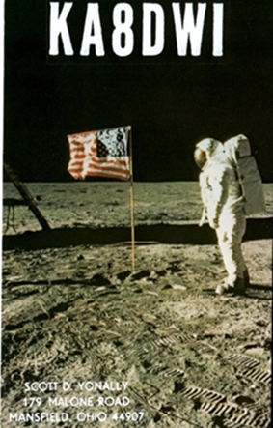***DX News***

***ARLD001 DX news***

This week's bulletin was made possible with information provided by The Daily DX, the OPDX Bulletin, 425 DX News, DXNL, Contest Corral from QST and the ARRL Contest Calendar and WA7BNM web sites. Thanks to all.

**GEORGIA, 4L.** Peter, G4ENL plans to be QRV as 4L1PJ from Svaneti while on work assignment. He expects to be here for the next few years. Activity is on various HF bands using SSB. QSL via N4GNR.

**NIGER, 5U.** Adrien, F5IHM is QRV as 5U4IHM until February 11.

Activity is on 40 and 20 meters using CW. QSL direct to home call.

**MALDIVES, 8Q.** Massimo, IZ5KID is QRV as 8Q7MM. Activity is on various HF bands using mainly digital modes and with low power. QSL to home call.

**PAKISTAN, AP.** Syed, AP2AM is QRV on 160 and 80 using FT8 at his sunrise. QSL to home call.

**ANGOLA, D2.** Paulo, CT1FJZ is QRV as D2FJZ from the Province of Cuando-Cubango until September 2021 while on work assignment. Activity is on 80 to 10 meters using SSB. QSL direct to home call.

**FEDERAL REPUBLIC OF GERMANY, DA.** Uwe, DO2PZ is QRV as DB100AVUS during all of 2021 to celebrate the 100th anniversary of the AVUS. Located in the southwest of Berlin and opened in 1921, it is the oldest controlled access motorway in Europe. QSL to home call.

**JAPAN, JA.** Special event call 8N1IZA is QRV until March 31 to celebrate the 50th anniversary of Niiza City.

**JAN MAYEN, JX.** Erik, JX2US has been QRV on 80 using CW from 1000 to 1200z. QSL via LA2US.

**CZECH REPUBLIC, OK.** Members of the radio club in Roznov pod Radhostem are QRV with special call sign OL70KRT to celebrate the club's 70th anniversary. The length of activity is unknown. QSL via OK2UYU.

**ASIATIC RUSSIA, UA0.** Special event station RJ30KR is QRV from region R9Y in CQ Zone 18 during January to mark the 30th anniversary of the Amateur Radio Club Kristall. QSL via bureau.

**AUSTRALIA, VK.** Grant, VK5GR will be QRV as VK5KI from Kangaroo Island, IOTA OC-139, from January 11 to 22. Activity will be holiday style on 80 to 6 meters using CW, SSB and FT8, and possibly with RTTY and PSK. QSL via M0OXO.

**ANTARCTICA.** Seba, SQ1SGB and Will, M0ZXA are QRV as either VP8/SQ1SGB or VP8HAL from Halley VI Research Station until February 4. They are active in their spare time on 40 and 20 meters using

JT65 and FT8. QSL via operators' instructions.

TOP ^

**INDIA, VU.** Special event station AT2YAR is QRV until March 1 to celebrate 100 years of amateur radio. QSL via VU3ZHA.

**INDONESIA, YB.** Ravie, YD7RV is QRV from Laut Island, IOTA OC-166, and is active almost daily around 1700z on 40 meters using FT8. QSL via EA5GL.

**CAYMAN ISLANDS, ZF.** Pete, K8PGJ will be QRV as ZF2PG from Grand Cayman, IOTA NA-016, from January 10 to 17. Activity will be on 160 to 10 meters. This includes being an entry in the upcoming North American SSB QSO Party. QSL via LoTW.

THIS WEEKEND ON THE RADIO. The North American CW QSO Party, NCCC RTTY Sprint, QRP 80-Meter CW Fox Hunt, NCCC Sprint CW Ladder, YB SSB DX Contest, Old New Year Contest, SKCC Weekend CW Sprintathon, UBA PSK63 Prefix Contest, NRAU-Baltic Contest, DARC 10-Meter Contest and RSGB AFS Data Contest are all on tap for this upcoming weekend.

The RSGB Hope QSO FT4 Party, OK1WC CW Memorial, K1USN Slow Speed CW Test and 4 States QRP Group Second Sunday Sprint are scheduled for January 11.

The RTTYOPS Weeksprint, Worldwide Sideband Activity Contest and RSGB Hope QSO CW Party are scheduled for January 12.

The RSGB Hope QSO RTTY Party, VHF-UHF FT8 Activity Contest, CWops Mini-CWT CW Test, Phone Fray and QRP 40-Meter CW Fox Hunt are scheduled for January 13.

Please see January 2021 QST, page 75, and the ARRL and WA7BNM contest web sites for details.

**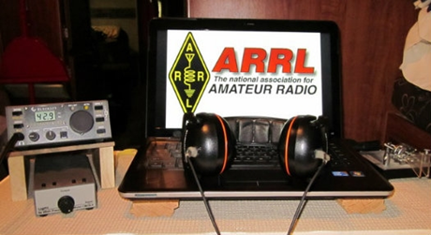*ARRL Contest Corner***

An expanded, downloadable version of *QST'*s’ [**Contest Corral**](http://www.arrl.org/contest-calendar) is available as a PDF. Check the sponsor’s ‘Website for information on operating time restrictions and other instructions.

***####***

***Contest University will host Propagation Summit on January 23, 2021.***

Several radio propagation experts will share their knowledge during a Propagation Summit via Zoom, sponsored by Contest University ([**CTU**](https://www.contestuniversity.com/)). The event is scheduled for January 23, 2021. The presentation schedule includes:

* “Update on the Personal Space Weather Station Project and HamSCI Activities for 2021” with Nathaniel Frissell, W2NAF, at 11 AM EST (1600 UTC)

TOP ^

* “Solar Cycle 25 Predictions and Progress” with Carl Luetzelschwab, K9LA, at noon (1700 UTC)
* “Maximizing Performance of HF Antennas with Irregular Terrain” with Jim Breakall, WA3FET, at 1 PM EST (1800 UTC)
* “HF Ionospheric Propagation” with Frank Donovan, W3LPL, at 2 PM EST (1900 UTC).

[**Registration**](https://zoom.us/webinar/register/WN_dfLvFDxaTyakOWd_C7_puw) is free. An Icom IC-705 will be raffled off as a “door” prize. The winner must be present on Zoom to win. — *Thanks to CTU Chair Tim Duffy, K3LR*

All times are USA EST.

11 AM - "Update on the Personal Space Weather Station Project & HamSCI activities for 2021" - Dr. Nathaniel Frissell, W2NAF Noon - "Solar Cycle 25 Predictions & Progress" - Carl Luetzelschwab, K9LA

1 PM - "Maximizing Performance of HF Antennas with Irregular Terrain" - Dr.

James Breakall, WA3FET

2 PM - "HF Ionospheric Propagation" - Frank Donovan, W3LPL Drawing for an Icom IC-705 donated by Icom America and DX Engineering - both CTU sponsors. Winner must be present on Zoom to win.

To register for this free CTU Propagation Summit Webinar please go to :

<https://zoom.us/webinar/register/WN_dfLvFDxaTyakOWd_C7_puw>

Stay tuned to Contest University: <https://www.contestuniversity.com/>

73, Tim K3LR - Contest University Chairman

***Special Events***

* **01/15/2021 | Alaska "RST" QSO Party**

**Jan 15-Feb 15, 0000Z-2359Z, KL7RST**, various, AK. North Country DX Association. 28.450 21.350 14.250 7.250. QSL. John F. Reisenauer, Jr, 2573 Old Georgetown Rd. W., Kershaw, SC 29067. KL7RST, KL7RST/KL7, VY1RST/KL7, VE8RST/KL7 and VY0RST/KL7. Certificate by email for working any 3 of the above when you QSL. [www.qrz.com/db/k7ice](http://www.qrz.com/db/k7ice)

* **01/16/2021 | Woronoco Heights Outdoor Adventure/SCOTA**

**Jan 16, 1300Z-1900Z, W1M**, Russell, MA. Western Mass. Council - BSA. 14.290 14.060 10.115 7.190. QSL. Tom Barker, 329 Faraway Road, Whitefield, NH 03598. All logging is done on paper and then uploaded to LoTW and eQSL. A QSL card can be had for a 4x6 SASE.

* **01/23/2021 | 1st Annual Lone Star Frozen POTA Event**

**Jan 23, 1700Z-2100Z, various**, various, TX. Deep East Texas Amateur Radio Club Inc.. all modes, all bands. QSL. Dayton Jones, KG5TKF, Email or see website for, , Information. www.parksontheair.com or [kg5tkg.radio@gmail.com](mailto:)

TOP ^

* **01/23/2021 | California Discovery of Gold**

**Jan 23-Jan 25, 1700Z-0000Z, AG6AU**, Placerville, CA. El Dorado County Amateur Radio Club. 21.348 14.248 7.248. QSL. El Dorado County ARC, P.O. Box 451, Placerville, CA 95667. [edcarc.net](http://edcarc.net/)

* **02/01/2021 | JY1 Special Event Memorial Station 2021**

**Feb 1-Feb 28, 0000Z-2359Z, N9SES**, Lake Station, IN. ArabQrz Club. 14.250 14.030 7.185 7.030. QSL. Ayman Azar, 2861 Decatur St, Lake Station, IN 46405. See website for participating stations from other countries. All HF/VHF/UHF, All Modes. Hamsphere Users can also participate in the event [www.n9ses.com/?page_id=18](http://www.n9ses.com/?page_id=18)

* **02/06/2021 | 100th Anniversary**

**Feb 6-Feb 27, 1800Z-2359Z, W6UW**, San Jose, CA. Santa Clara County Amateur Radio Association. 21.320 14.250 7.250. Certificate. Don Village, K6PBQ, 3290 Woody Lane, San Jose, CA 95132. w6uw@arrl.net or [www.qsl.net/sccara](http://www.qsl.net/sccara)

* **02/06/2021 | Ground Hog Day Special Event**

**Feb 6, 0900Z-1500Z, K3HWJ**, Punxsutawney, PA. Punxsutawney Amateur Radio Club. all modes, all bands. Certificate. Stephen Waltman, KB3FPN, 37 Clark St., Brookville, PA 15825. SASE for certificate. [www.punxyclub.com](http://www.punxyclub.com/)

* **02/06/2021 | Shuttle Columbia Special Event**

**Feb 6-Feb 7, 1400Z-2359Z, K5C**, Nacogdoches, TX. Nacogdoches ARC. 7.216 14.260 21.350 28.350. QSL. Army Curtis, 167 CR 2093, Nacogdoches, TX 75965. All contacts will be confirmed via LOTW. [https://w5nac.com](https://w5nac.com/)

* **02/07/2021 | Commemorating Howard E. Anthony, Father of Heathkit**

**Feb 7, 1200Z-2359Z, KD2FSI**, Randolph, NJ. KD2FSI. 21.300 14.300 7.300 3.900. QSL. David R. Hackett, 3 High Ridge Road, Randolph, NJ 07869. On Sunday February 7, 2021 from 1200Z -2359Z, Amateur Radio Station KD2FSI will operate as a special event station using a variety of vintage Heathkit gear to commemorate the life and legacy of Howard E. Anthony, the father of the Heathkit brand of electronic kits. Starting in the morning with 75 meter SSB, we will work our way up to the 40, 20, 15 and 10 meter bands and then back down again towards the evening. I will post additional information on my public Facebook page as the event draws near and the actual operating frequencies and modes in real time the day off. We hope all amateur radio operators with any type of equipment (new or old) will join us as we commemorate Mr. Anthony, the person responsible for starting Heathkit, the finest electronic kit company ever. 73, Dave Hackett KD2FSI davehackett@cs.com <https://www.facebook.com/dave.hackett.9085>

* **02/13/2021 | George Washington's Birthday at his Boyhood Home, Ferry Farm VA**

**Feb 13, 1400Z-2000Z, W4B**, Fredericksburg, VA. Stafford Amateur Radio Association (SARA). 14.225 7.195 447.275. QSL. Stafford Amateur Radio Association (SARA), PO Box 6331, Fredericksburg, VA 22403. SASE required for return of a QSL card. [https://www.ws4va.org](https://www.ws4va.org/)

* **02/13/2021 | George Washington's Birthday at Mount Vernon**

**Feb 13-Feb 14, 0800Z-1400Z, K4US**, Alexandria, VA. Mount Vernon Amateur Radio Club. 14.260 14.074 7.040. QSL. MVARC, P.O. Box 7234, Alexandria, VA 22307. MVARC will be hosting a modified special event station to commemorate our first president's 289th birthday. Members will be operating remote stations this year due to COVID, with many broadcasting from the original grounds of the former plantation of George Washington and his wife, Martha Washington. [k4us@mvarc.org](mailto:)

TOP ^

* **02/13/2021 | I ❤️ Pluto Special Event**

**Feb 13-Feb 21, 0000Z-2359Z, W7P**, Flagstaff, AZ. Northern Arizona DX Association. 14.290 21.290 7.290 14.090. Certificate & QSL. W7P - I ❤️ Pluto Special Event, % Bob Wertz, NF7E, 6315 Townsend Winona Rd., Flagstaff, AZ 86004-1493. This will be an annual countdown S. E. to the 100th anniversary of the discovery of PLUTO, held every February, up to and including 2030. We are celebrating this historic discovery of Pluto, in 1930, by Clyde Tombaugh, at Lowell Observatory in Flagstaff, Arizona. Please note the frequencies will be + or- 10, as to not interfere with any nets operating during that time period. [www.nadxa.com](http://www.nadxa.com/)

* **02/13/2021 | Ice-olation Station WØJH**

**Feb 13-Feb 15, 1400Z-2355Z, W0JH**, Stillwater, MN. Stillwater, MN Amateur Radio Association. 21.360 14.260 7.260 3.860. Certificate. Shel Mann, N0DRX, 1618 Pine St West, Stillwater, MN 55082. We will have multiple stations simultaneously operating on different bands and different modes. In keeping with COVID-19 social distancing protocols, we will operate from our individual QTHs this year. In a meager attempt to drive away the remainder of Minnesota winter, the Stillwater Amateur Radio Association will be generating as much RF as possible over the President's Day long weekend. Certificates will ONLY be sent via email in PDF format. (Send requests with standard QSL confirmation info via email to: Ice2021@radioham.org). There is no need to send a QSL card. Info: WØJH at www.QRZ.com & www.radioham.org. [www.radioham.org](http://www.radioham.org/)

* **02/13/2021 | USS Midway Museum Ship Special Event: Raising Mt Suribachi Flag**

**Feb 13, 1700Z-2359Z, NI6IW**, San Diego, CA. USS Midway (CV-41) Museum Ship. 7.250 14.320 14.070 (PSK31) DSTAR via PapaSystem repeaters. QSL. USS Midway CV-41 COMEDTRA NI6IW, 910 N Harbor Dr, San Diego, CA 92101. SASE please.

***“ARES Connect”***

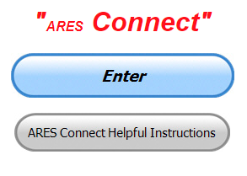

***Connecting Amateur Radio Volunteers with a Purpose***

Hey everyone… please make sure to go in and register your time to all of the events that you have signed up for. Be honest about the time spent. Don’t forget to get this done no later than **5 days** after the event has ended. I’m asking you to do this for our ability to run reports accurately.

**I want to remind all of you that you do not have to be an ARES or ARRL member to use this system. All licensed amateur radio operators throughout the country are welcome and strongly encouraged to use it.**

**Also,** Don’t forget to check out the “Frequently Asked Questions” area that has been added to the Ohio Section website as well. It’s there to help you through any difficulties that you may have with ARES Connect. Now, if you don’t any posts that relate to what you are having difficulties with, we now also have an on-line “Guru” area as well. This will allow you to ask any questions that you may have about ARES Connect.

**Let’s get everyone on “ARES Connect!!!”**

####

TOP ^

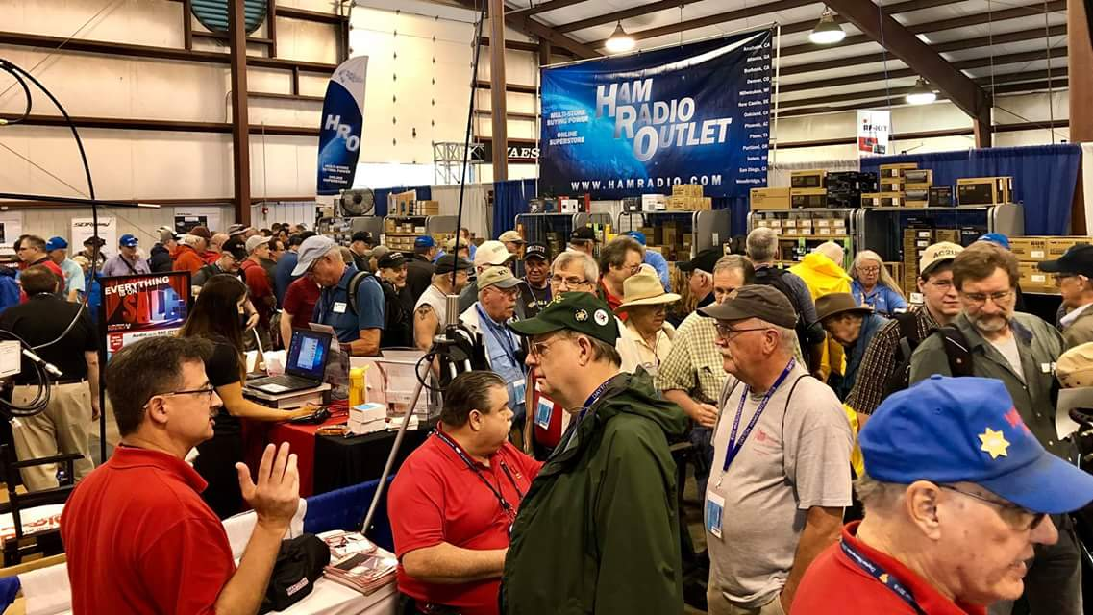[***Upcoming Hamfests***](http://arrl-ohio.org/hamfests.html)

We **DO** have some hamfests scheduled for 2021!! Yes, the first one out of the gate will be the NOARS Fest on March 7th.

[Ohio Hamfests](http://arrl-ohio.org/hamfests.html)

Be sure to keep your eyes on this schedule as that when things start getting better and the vaccine rolls out to more and more, hamfests will surely get back to their normal schedule. Don’t see your hamfest listed?? Did anyone register it with ARRL? It’s really easy to do and you get a lot of FREE publicity if you do.

Here’s a link to register your hamfest… [Hamfest/Convention Application Form](http://www.arrl.org/hamfest-convention-application)

|  |  |
| --- | --- |
| **03/07/2021 -**[**WINTERHAMFEST**](http://www.arrl.org/hamfests/winterhamfest-3)  **Location: Elyria, OH**  ***Canceled*** | **04/25/2021 -**[**Athens Hamfest**](http://www.arrl.org/hamfests/athens-hamfest-9)  **Location: Athens, OH Sponsor: Athens County Amateur Radio Association Website:**<http://ac-ara.org/>  [**Learn More**](http://www.arrl.org/hamfests/athens-hamfest-9) |
| **05/21/2021 - 05/23/2021** [**Dayton Hamvention, ARRL Operating Specialty Convention**](http://www.arrl.org/hamfests/dayton-hamvention-arrl-operating-specialty-convention)  **Location: Xenia, OH Sponsor: Dayton Amateur Radio Association Website:**[http://hamvention.org](http://hamvention.org/)  [**Learn More**](http://www.arrl.org/hamfests/dayton-hamvention-arrl-operating-specialty-convention) | |
| **06/05/2021 -**[**FCARC SummerFest**](http://www.arrl.org/hamfests/fcarc-summerfest)  **Location:**Wauseon, OH **Sponsor:**Fulton County Amateur Radio Club **Website:**<http://k8bxq.org/hamfest>  [**Learn More**](http://www.arrl.org/hamfests/fcarc-summerfest) | **07/18/2021 –**[**Van Wert Hamfest**](http://www.arrl.org/hamfests/van-wert-hamfest-5)  **Location:**Van Wert, OH **Sponsor:**Van Wert Amateur Radio Club **Website:**[http://W8FY.ORG](http://w8fy.org/)  [**Learn More**](http://www.arrl.org/hamfests/van-wert-hamfest-5) |
| **08/28/2021 -**[**Cincinnati Hamfest℠**](http://www.arrl.org/hamfests/cincinnati-hamfest)  **Location:**Owensville, OH **Sponsor:** Milford ARC **Website:** [http://CincinnatiHamfest.org](http://cincinnatihamfest.org/)  [**Learn More**](http://www.arrl.org/hamfests/cincinnati-hamfest) | **09/26/2021 -**[**Cleveland Hamfest**](http://www.arrl.org/hamfests/cleveland-hamfest-1)  **Location:**Berea, OH **Sponsor:** Hamfest Association of Cleveland **Website:** [http://www.hac.org](http://www.hac.org/)  [**Learn More**](http://www.arrl.org/hamfests/cleveland-hamfest-1) |

TOP ^

|  |
| --- |
| **12/04/2021 -**[**FCARC WinterFest**](http://www.arrl.org/hamfests/fcarc-winterfest-2)  **Location:** Delta, OH  **Sponsor:** Fulton County Amateur Radio Club  **Website:** <http://k8bxq.org/hamfest>  [**Learn More**](http://www.arrl.org/hamfests/fcarc-winterfest-2) |

***River Ice Spotter Training Scheduled***

Partners,

The National Weather Service will host a 45 min webinar for River Ice Spotters in the area on **January 26 at 10 AM.** The focus of this training will be on monitoring and reporting river ice. This information is used by the NWS, USACE, USGS, and local and state officials in our efforts to prepare and alert communities of threats posed by ice jam flooding. The training will be recorded if you are unable to attend at the scheduled time.

To register and find more information regarding this training please visit our website [www.weather.gov/cle/RiverIceSpotters](http://www.weather.gov/cle/RiverIceSpotters).

***Print an Official or Unofficial Copy of Your Amateur Radio License***

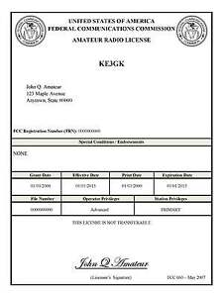*(By Anthony Luscre, K8ZT)*

As of February 17, 2015, the **FCC no longer routinely issues paper license documents** to Amateur Radio applicants and licensees. The Commission has maintained for some time now that the official Amateur Radio license authorization is the electronic record that exists in its Universal Licensing System (ULS). The FCC will continue to provide paper license documents to all licensees who notify the Commission that they prefer to receive one.

Licensees also will be able to print out an official authorization — as well as an unofficial “reference copy” — from the ULS License Manager. I’ve created a set of instructions on how you can request an **“official” printed copy of your license\***

[**Click here to download the instructions**](http://arrl-ohio.org/news/2020/print_your_license.pdf)

TOP ^

***One Question Questionnaire***

Hey Gang,

Survey Says”….. On the question of how old our hams are it very interesting. Here’s the results… 0 – 30 years - 3.14%; 31 – 50 years 10.06%; - 51 – 70 years 47.80% and finally the 71 years and over 38.99% ...

Ok, now on to the next question… Let’s see how well equipped your shack is for making repairs.

***“Do you own a soldering station???”***

You’ll find the “One Question” questionnaire on the Ohio Section Website! <http://arrlohio.org> It’s all for fun and it’s not a scientific survey in any way, but we are learning some things that we didn’t know from these questions. I hope that you are enjoying answering these “One Question” questionnaires.

*****V.E. Test Sessions***

Many V.E.’s have decided to start testing once again, but with restrictions that need to be adhered to for sure. Here’s the link to find that V.E. Test session and what is expected of YOU before going. <http://www.arrl.org/find-an-amateur-radio-license-exam-session>

***What is the difference between a fuse and a circuit breaker?***

Both the fuse and the circuit breaker are intended to open a circuit for excessive current. The traditional fuse is a circuit element that is a one-time use element. That is, excessive current will cause it to open and to restore the circuit the fuse must be replaced with a like element.



They are often cylindrical and come in holders for somewhat easy replacement but sometimes are soldered in place.

They usually use a fusing element that is metal with a low temperature melting point that literally melts under overcurrent conditions. The cylinder is often made of glass to allow inspection of the fuse element to see if it’s blown.

There are some self-resetting fuses that will heal after a certain amount of time. These are called PTC fuses and have a high resistance state when hot. If the heat was caused by overcurrent, then removing the overload will restore the fuse to operation mode.

A circuit breaker is a multiple use device. It is usually permanently installed in equipment. It generally has two mechanisms for breaking the current: a magnetic portion which opens with a large current and a thermal part that also opens under overcurrent...

TOP ^

The thermal part has a lag so these typically go slower than a fuse but with very high currents the magnetic part will open quickly. The circuit breaker usually has a button or handle to reset it after it has cooled down.

Circuit breakers are usually more costly and larger than fuses. Fuses are more likely to be abused because if blown and the user wants to return the equipment to operation AND if there’s not a spare fuse, then he will substitute a fuse of higher value, or short out the fuse holder in frustration and defeat the safety of the fuse.

***Website Stats…***

I think you’ll find these numbers very interesting for sure. It shows just how we’ve grown over the years!

2014

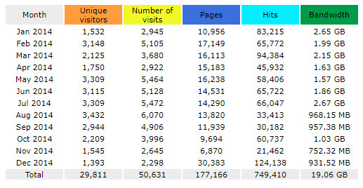

2020

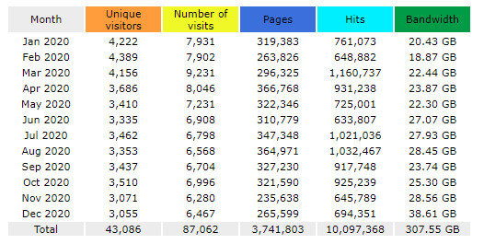

We’ve grown!!

TOP ^

Ohio Section Cabinet

|  |  |
| --- | --- |
| Section Manager – Tom Sly, WB8LCD | Section Traffic Manager – David Maynard, WA3EZN |
| Section Emergency Coordinator – Stan Broadway, N8BHL | Section Youth Coordinator – Anthony Lascre, K8ZT |
| Technical Coordinator – Jeff Kopcak, K8JTK | Affiliated Clubs Coordinator – Tom Sly, WB8LCD |
| State Government Liaison – Bob Winston, W2THU | Public Information Coordinator – John Ross, KD8IDJ |



Hey Gang,

Have you taken a look at the **Swap & Shop** page on the Ohio Section webpage yet?? Here’s a link that will take you there…

<http://arrl-ohio.org/sm/s-s.html>

Do you have equipment that you just don’t need or want anymore? Here’s a great venue to advertise it, and it’s FREE!! Is your club doing a fund raiser to help raise money? After a lot of thought, it was decided that the Swap & Shop webpage could also contain these types of items as well. The same rules will apply as do for the For Sales and Give-A-Ways and will only be posted for a month at a time. Please see the Terms & Conditions on the webpage.

If your club is doing a fund raiser and wants more exposure, please forward the information to me and I’ll advertise it on the Swap & Shop webpage for you.

Now, I still want to remind you that it won’t be listed in this newsletter because it would take up way too much space, so your ad will only appear on the website. It is there for any individual to post equipment Wanted / For Sale or Give-Away as well as for Club Fund Raisers. No licensed vehicles/trailers or business advertising will be posted. Postings are text only (no pictures or graphics) will be posted for a maximum of 1 month from date posting and require a contact phone number or email within the posting. Send your Wanted / For Sale or Give-Away post to:  [swap@arrlohio.org](mailto:swap@arrlohio.org)

***Back Issues of the PostScript and Ohio Section Journal***

Hey, did you know that PostScript and Ohio Section Journal (OSJ) are archived on the website? You can go back and look at any edition simply by clicking:

<http://arrl-ohio.org/news/index.html>

***Welcome New Subscriber(s)***

**Brad, KZ8BRD; Jeff, N8HKO; Gerry Champagne; Phil, K9HI**

TOP ^

***Want to Share your Club Newsletter With Others?***

We have a webpage where you can download and read all of the newsletters that I get from around the state and even other sections!

Here’s the link to the page…. <http://arrl-ohio.org/club_news/index.html>

Please, if you don’t see your club newsletter posted, it’s because I’m not receiving it. Just have your newsletter editor contact me and I’ll get your club’s newsletter listed on the site!!

We all learn and steal (I mean, share) from each other’s work. So, get me your newsletter!!! Send it to: [webmaster@arrl-ohio.org](mailto:webmaster@arrl-ohio.org)

***Chit – Chat, and All That!***

Do you know someone that’s not getting these Newsletters? Please, forward a copy of this Newsletter over to them and have them “[Opt-In](mailto:Opt-In)” to start receiving them. Heck just have them send an email to: [webmaster@arrl-ohio.org](mailto:webmaster@arrl-ohio.org) and we’ll get them added to the Ohio Section Emailing list.

We now have many thousands of readers receiving these newsletters weekly. Quite impressive, I’d say! I urge all of you to make sure that everyone, regardless of whether they are a League member or not, get signed up to receive these weekly Newsletters.

You can always “Opt-Out” at any time if you feel this is not what you were expecting. It’s fun and very informative. All of your favorite past newsletters are now archived too.

You can go back at any time and read them.

Just go to: <http://arrl-ohio.org/news/>

The pictures on the front page and throughout this newsletter are from various newsletters, Facebook posts and/or were sent directly to me in recent weeks. Take a good look at them, you just might be in one of the pictures! “SMILE… you’re in the Ohio Section News!!”

TOP ^

*PostScript is produced as a weekly newsletter. I want to thank everyone that has contributed articles and ideas to make this an even better news source. I sincerely hope that you have enjoyed this edition and will encourage your friends to join with you in receiving the latest news and information about the Ohio Section, and news and events happening around the world!*