[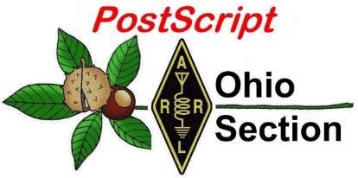](http://arrl-ohio.org/news/) ***“January 4th”***

***Edition***

🡪 National News 🡪 The Handbook Give Away

🡪 Club Corner 🡪 DX This Week

🡪 Contest Corner 🡪 Special Events

🡪 ARES Connect 🡪 Upcoming Hamfests

🡪 From The South 40 🡪 One Question Questionnaire

🡪 VE Testing

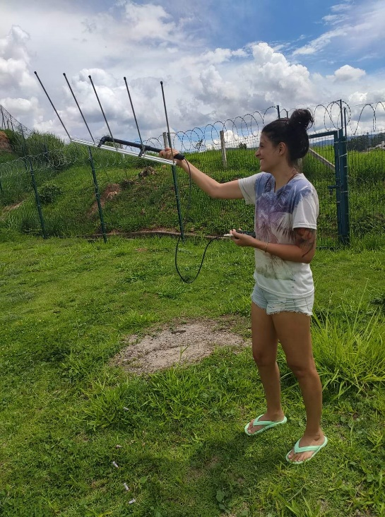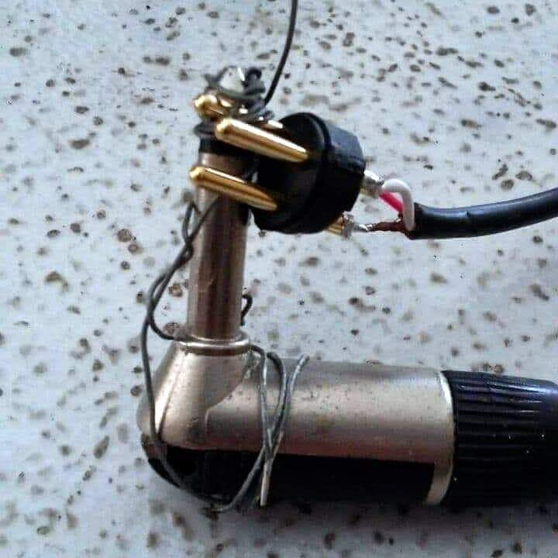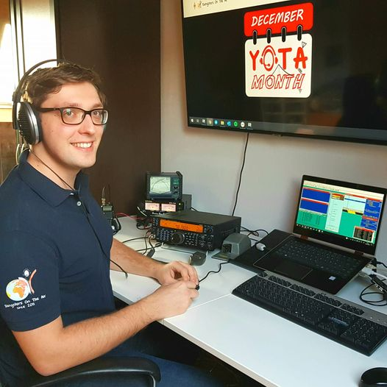

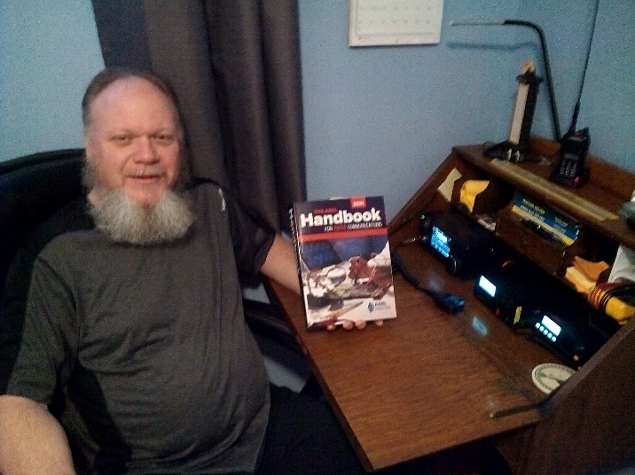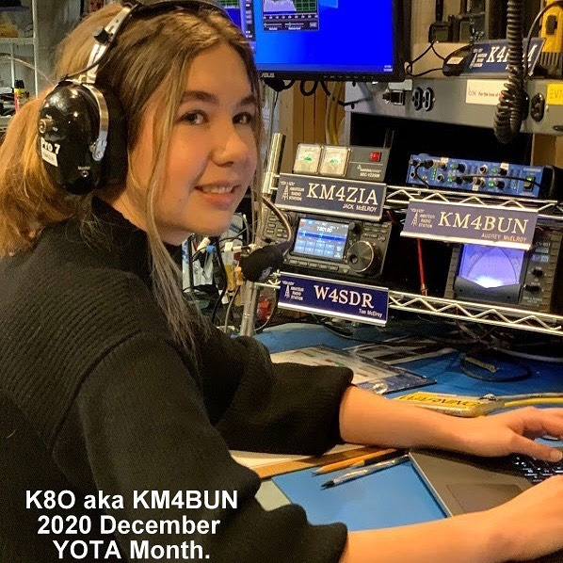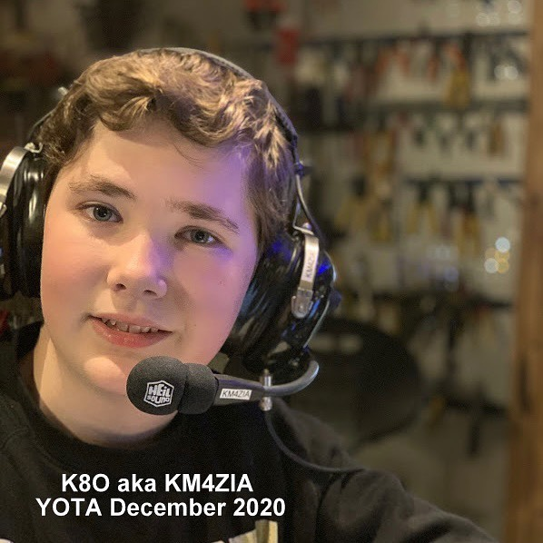

***National News***

*(from arrl and other sources)*

***FCC Reduces Proposed Amateur Radio Application Fee to $35***

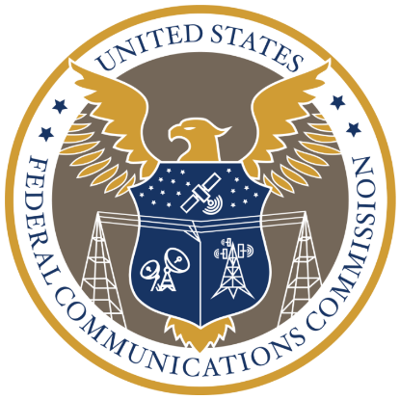The FCC has agreed with ARRL and other commenters that its proposed $50 fee for certain amateur radio applications was “too high to account for the minimal staff involvement in these applications.” In a *Report and Order* ([***R&O***](https://docs.fcc.gov/public/attachments/FCC-20-184A1.pdf)), released on December 29, the FCC scaled back to $35 the fee for a new license application, a special temporary authority (STA) request, a rule waiver request, a license renewal application, and a vanity call sign application. All fees are per application. There will be no fee for administrative updates, such as a change of mailing or email address.

This fall, ARRL filed comments in firm opposition to the FCC proposal to impose a $50 fee on amateur radio license and application fees and [**urged its members**](http://www.arrl.org/news/arrl-urges-members-to-join-in-strongly-opposing-fcc-s-application-fees-proposal) to follow suit.

As the FCC noted in its *R&O*, although some commenters supported the proposed $50 fee as reasonable and fair, “ARRL and many individual commenters argued that there was no cost-based justification for application fees in the Amateur Radio Service.” The fee proposal was contained in a *Notice of Proposed Rulemaking* ([***NPRM***](https://docs.fcc.gov/public/attachments/FCC-20-116A1.pdf)) in MD Docket 20-270, which was adopted to implement portions of the “Repack Airwaves Yielding Better Access for Users of Modern Services Act” of 2018 — the so-called “[**Ray Baum’s Act**](https://www.congress.gov/115/plaws/publ141/PLAW-115publ141.pdf).”

“After reviewing the record, including the extensive comments filed by amateur radio licensees and based on our revised analysis of the cost of processing mostly automated processes discussed in our methodology section, we adopt a $35 application fee, a lower application fee than the Commission proposed in the *NPRM*for personal licenses, in recognition of the fact that the application process is mostly automated,” the FCC said in the *R&O*. “We adopt the proposal from the *NPRM*to assess no additional application fee for minor modifications or administrative updates, which also are highly automated.”

The FCC said it received more than 197,000 personal license applications in 2019, which includes not only ham radio license applications but commercial radio operator licenses and General Mobile Radio Service (GMRS) licenses.

The FCC turned away the arguments of some commenters that the FCC should exempt amateur radio licensees. The FCC stated that it has no authority to create an exemption “where none presently exists.”

The FCC also disagreed with those who argued that amateur radio licensees should be exempt from fees because of their public service contribution during emergencies and disasters.

“[W]e we are very much aware of these laudable and important services amateur radio licensees provide to the American public,” the FCC said, but noted that specific exemptions provided under Section 8 of the so-called “Ray Baum’s Act” requiring the FCC to assess the fees do not apply to amateur radio personal licenses. “Emergency communications, for example, are voluntary and are not required by our rules,” the FCC noted.

TOP ^

“As we have noted previously, ‘[w]hile the value of the amateur service to the public as a voluntary noncommercial communications service, particularly with respect to providing emergency communications, is one of the underlying principles of the amateur service, the amateur service is not an emergency radio service.’”

The Act requires that the FCC switch from a Congressionally-mandated fee structure to a cost-based system of assessment. The FCC proposed application fees for a broad range of services that use the FCC’s Universal Licensing System (ULS), including the Amateur Radio Service, which had been excluded previously. The 2018 statute excludes the Amateur Service from annual *regulatory* fees, but not from *application* fees.

“While the Ray Baum’s Act amended Section 9 and retained the regulatory fee exemption for amateur radio station licensees, Congress did not include a comparable exemption among the amendments it made to Section 8 of the Act,” the FCC *R&O* explained.

The effective date of the fee schedule has not been established, but it will be announced at least 30 days in advance. The FCC has directed the Office of Managing Director, in consultation with relevant offices and bureaus, to draft a notice for publication in the *Federal Register* announcing when rule change(s) will become effective, “once the relevant databases, guides, and internal procedures have been updated.”

####

***Registration Is Open for Online Ham Radio University on January 9***

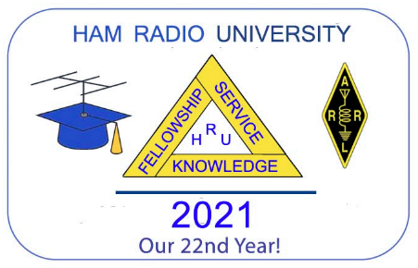With COVID-19 restrictions precluding an in-person gathering, the 22nd annual Ham Radio University (HRU) educational conference will be held as a virtual event on Saturday, January 9, 2021, from 8 AM to 4 PM EST (1300 – 2100 UTC) as a GoToWebinar online video conference.

Individual registration is now open for HRU’s 14 [**informational presentations**](http://www.hamradiouniversity.org/forums) covering a broad range of amateur radio activities. Topics include amateur radio emergency communications; the basics of HF operating; communicating through amateur radio Earth satellites; remote station operating over the internet; software defined radios; HF and UHF digital communications, and using Raspberry Pi computers in amateur radio.

HRU 2021 will also serve as the online convention of the ARRL NYC-Long Island Section. Participation in HRU 2021 will be free, with a suggested donation of $5. Advance registration is required for each presentation.

####



***Austria receives 60m and 630m privileges***

*(Submitted by Gregory Drezdzon, WD9FTZ)*

The Austrian National Amateur Radio Society, OeVSV, informs us that the Austrian regulator, BMVIT, has granted access to the 60m and 630m bands for all CEPT Class 1 licensees.

“It took some time (3 years) but we just got a nice present from the Austrian BMVIT. Please find attached the official document (please check page 6 for further details).”

TOP ^

60m/5 MHz is the WRC-15 Amateur Secondary Allocation of 5351.5 – 5366.5 kHz at 15W EIRP (5.133B)

630m is the MF Secondary Allocation from the previous WRC-12  of 472 – 479 kHz at 1W EIRP. Max bandwidth is per the provisions of the Austrian Amateur License (AFV).

Please view the OeVSV webpage at: <https://www.oevsv.at/home/>

####

***FCC to Require Email Address on Applications Starting on June 29, 2021***

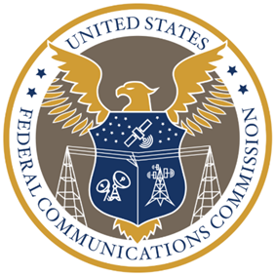Effective on June 29, 2021, amateur radio licensees and candidates must provide the FCC with an email address on all applications. If no email address is included, the FCC may dismiss the application as “defective.”

On September 16, the FCC adopted a *Report and Orde*r ([***R&O***](https://www.fcc.gov/document/fcc-adopts-electronic-licensing-report-and-order)) in WT Docket 19-212 on “Completing the Transition to Electronic Filing, Licenses and Authorizations, and Correspondence in the Wireless Radio Services.”

The *R&O* was [**published**](https://www.federalregister.gov/documents/2020/12/29/2020-28779/completing-the-transition-to-electronic-filing-licenses-and-authorizations-and-correspondence-in-the) on December 29 in the *Federal Register*. The FCC has already begun strongly encouraging applicants to provide an email address. Once an email address is provided, the FCC will email a link to an official electronic copy of the license grant. An official copy will also be available at any time by accessing the licensee’s password-protected Universal Licensing System (ULS) account.

Licensees can log into the ULS [**License Manager System**](https://wireless2.fcc.gov/UlsEntry/licManager/login.jsp) with their FRN and password at any time and update anything in their FCC license record, including adding an email address. For questions or password issues, call the CORES/FRN Help Line, (877) 480-3201 (Monday – Friday, 1300 – 2300 UTC) or [**reset the password**](https://www.fcc.gov/wireless/available-support-services) on the FCC website.

The only way to refrain from providing an email address on an application would be to submit a request to waive the new rule, providing justification for the request. (The FCC would not be obliged to grant such a request.)

Under Section 97.21 of the new rules, a person holding a valid amateur radio station license “must apply to the FCC for a modification of the license grant as necessary to show the correct mailing and email address, licensee name, club name, license trustee name, or license custodian name.” For a club or military recreation station license, the application must be presented in document form to a club station call sign administrator who must submit the information to the FCC in an electronic batch file.

Under new Section 97.23, each license must show the grantee’s correct name, mailing address, and email address. “The email address must be an address where the grantee can receive electronic correspondence,” the amended rule will state. “Revocation of the station license or suspension of the operator license may result when correspondence from the FCC is returned as undeliverable because the grantee failed to provide the correct email address.”

####

TOP ^

***Parks on the Air - Rapid Deployment Amateur Radio***

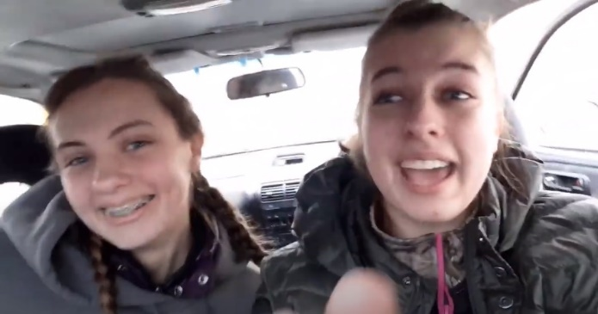*(Submitted by Gregory Drezdzon, WD9FTZ)*

These videos show how YLs Leah McGrane, KD9LFZ, and Becca Mc Grane, KD9POK, did a successful Parks On The Air (POTA) Rapid Deployment Amateur Radio (RaDAR) activation of both K-4270 and K-1477 in Wisconsin.   
  
The parks activated were Balsam Branch State Wildlife Area (K-4270) and Straight Lake State Park (K-1477), near Luck, Wisc., or about 47 miles northeast of Minneapolis, Minn.  
  
Watch DX Commander POTA RaDAR Part 1  <https://www.youtube.com/watch?v=OjXd8L2eEcE>  
Watch DX Commander POTA RaDAR Part 2 <https://www.youtube.com/watch?v=ZSs-CSdjG5g>

####

***WSJT-X 2.4.0 Introduces New Digital Protocol Q65***

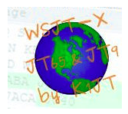*WSJT-X* version 2.4.0 has introduced a new digital protocol called Q65, which is designed for “minimal two-way QSOs over especially difficult propagation paths,” the [***Quick Start Guide***](https://physics.princeton.edu/pulsar/k1jt/Q65_Quick_Start.pdf) says.

“On paths with Doppler spread more than a few hertz, the weak-signal performance of Q65 is the best among all *WSJT-X* modes. Q65 is particularly effective for tropospheric scatter, ionospheric scatter, and EME on VHF and higher bands, as well as other types of fast-fading signals.”

The new protocol uses 65-tone frequency-shift keying and builds on the demonstrated weak-signal strengths of QRA64, introduced in 2016. User messages and sequencing are identical to those in FT4, FT8, FST4, and MSK144. Q65 employs a “unique tone” to sync time and frequency. “As with JT65, this ‘sync tone’ is readily visible on the waterfall spectral display,” the *Guide* said. “Unlike JT65, synchronization and decoding are effective even when meteor pings or other short signal enhancements are present.

Transmit/receive sequence lengths of 15, 30, 60, 120, and 300 seconds are available. According to the *Guide*, “Q65 will enable stations with a modest Yagi and 100 W or more and to work one another on 6 meters at distances up to ~1600 kilometers at most times, in dead band conditions.”

####

***Finland Radio Amateurs Seek Replacement Spectrum for 1240 – 1300 MHz***

Finnish International Amateur Radio Union (IARU) member-society [**SRAL**](http://sral.fi/) is asking for amateur radio privileges on 220 – 225 MHz as a replacement for the 1240 – 1300 MHz band, which was deleted last April 24, except for use by special permit. SRAL’s initial request for 902 – 928 MHz was turned down.

TOP ^

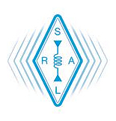The request is to provide spectrum for Amateur Television (ATV) operation. The special permits for the 1.2 GHz band will expire when the Galileo GNSS (GPS) constellation becomes fully operational. Concerns have arisen in Europe regarding the potential of amateur radio interference to one Galileo frequency.

The European Conference and Telecommunications Administrations (CEPT) [**Working Group SE 40**](https://cept.org/ecc/groups/ecc/wg-se/se-40/client/meeting-documents/?flid=28301) (Space Service compatibility issues) met in early December to discuss the 1240 – 1300 MHz frequency band. 1240 – 1260 MHz is used by the Global Navigation Satellite System (GLONASS) of the Russian Federation, and 1260 – 1300 MHz is used by Europe’s Galileo system, China’s **BeiDou** system, and Japan’s [**QZSS**](https://qzss.go.jp/en/), and is planned to be used by Korea’s [KPS](https://gnss.asia/new/korea-to-launch-its-own-satellite-positioning-system/). *— Thanks to*Southgate Amateur Radio News

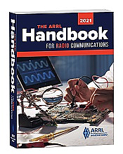***Handbook Give Away***

Hey Gang,

We had 2 drawings this month - one for Christmas, and the other one was for New Year’s Day. You already know the Christmas winner, so here’s the New Year’s Day winners for ya’.

***Robert Northrup, KC8PSW***

Many of you ask me just how do I know when the drawing is on? Well, that’s easy all you need to do is check in on the Ohio Section Website on a regular basis and watch for the big **RED** Arrow that will appear on the left side of the page. This is the sign that the drawing is on and you need to get registered. So, keep a sharp eye out on the website and check in often! <http://arrl-ohio.org/>

***Club Corner***

This is YOUR cornner of the newsletter. Send me what your club is doing and I’ll make sure that it gets in. Got a special event or club project that you want everyone to know about? Send it to me!. Need help with a project? Send it to me.

Let me know what you club is up to. Are you going to have a special guest at your meeting or are you having a special anniversary?

Just sent it to: [webmaster@arrl-ohio.org](mailto:webmaster@arrl-ohio.org)

####

TOP ^

***Online General License Course***

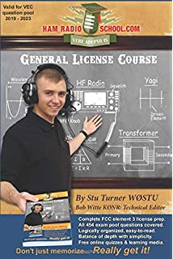

**The Cuyahoga Falls Amateur Radio Club is offering an online General Licensing Course** starting **10 January 2021**.

There is no fee, but the students are responsible for purchasing a copy of **Ham Radio School’s General License Course book**.

The six consecutive Sunday classes will start at 1:30 PM and go to 3:30 PM.

Most sessions will be followed by a demonstration of amateur radio activities.

To register, go to <https://cfarc-edu.org/course/>. For more details contact [education@cfarc.org](mailto:education@cfarc.org).

***DX This Week***

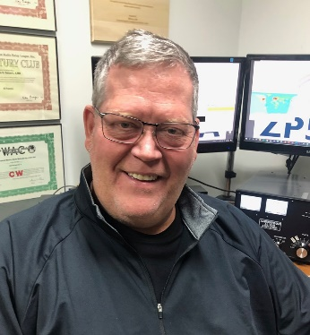*(from Bill, AJ8B)*

***DX This Week – 2020 Year in Review***

***Bill AJ8B (aj8b@arrl.net, @AJ8B, or www.aj8b.com)***

***CWOPs Member #1567***

The Midwest DX Cluster spots were Antarctica, Argentina, Australia, Belize, Brazil, Canada, Canary Islands, Croatia, Cuba, European Turkey, Fed. Rep. of Germany, Finland, Gabon, Hawaii, Indonesia, Isle of Man, Italy, Japan, Latvia, Liberia, Mexico, Moldova, Namibia, New Caledonia, New Zealand, Puerto Rico, Rep. of South Korea, Rotuma Island, San Marino, South Africa, Spain, St. Helena, St. Martin, Sudan, and West Malaysia.

***DAH DIT DIT DIT DAH DAH DIT DIT DIT DAH***

QSL cards received this week included S79VU – Ravi in the Seychelles Islands, UN7QF – Genna in Almaty Kazakhstan, JH6RKI – Shu in Oita, Japan, VA3RCX – Robert in Kitchener, Ontario, Canada.

|  |  |
| --- | --- |
|  |  |

TOP ^

|  |  |
| --- | --- |
|  |  |

|  |  |
| --- | --- |
|  |  |
|  |  |

***DAH DIT DIT DIT DAH DAH DIT DIT DIT DAH***

This past year is an easy one to review! It is far more difficult to list those DXPeditions that were cancelled versus those that were conducted. I did receive more email this past year that I did in 2019 with regards to what we print here. That might indicate we did a better job, or you had time in the shack!

There has been a significant increase in solar activity as well as an increase in DX on the bands and better propagation for longer periods of time. It is getting there!

There were several trends that appeared in 2020 due to the COVID outbreak. The biggest may have been the QSO Today Virtual Ham Expo that was presented by Eric, 4Z1UG. This was a virtual Ham Expo that had exhibitors and presentations on a variety of topics. I thought it was fantastic. Since I am not a person who is particularly fond of large crowds, I am hoping this is a trend that will continue. Eric has another session scheduled for March 13th and 14th. Check it out at <https://www.qsotodayhamexpo.com/>

Another trend that seems to continue to grow is the use of the low signal digital modes, specifically FT-4 and FT-8. I have heard passionate pleas both for and against the use of it. Some would argue that it is just one computer talking to another. I heard another ham say that those who use N1MM+ integrated into their shack during a contest are using just as much computer automation. In my humble opinion, anything that can get folks on the air (and is legal) is a good thing.

Ham vendors continue to develop new radios and get them to market. I am confident they would not be developing new radios if there was no demand! The other trend that I saw was the use of video conferencing for meetings. This is a long time in coming. As our population ages, this may be the preferred way for members to access club meetings and activities. What do you think?

To provide information to you that is useful, interesting, and timely we presented the following topics in 2020:

* Discussions of Zone 1 through 40
* 13 Interviews with DX hams
* 5 Discussions of solar activity
* 7 Discussions on Operating Topics
* 3 General Interest Articles
* 4 Articles on DXCC
* 4 Articles on QSLing.

TOP ^

I hope you enjoyed this information as much as I did presenting it. Now on to our 4th year!

***CQDX CQDX CQDX CQDX CQDX CQDX CQDX CQDX CQDX***

Here is an update from Bernie, W3UR, of the DailyDX and the WeeklyDX, the best source for DX information. <http://www>.dailydx.com/. Bernie has this to report:

For immediate release – from Yasme foundation Inc.  
Another Christmas gift to the scientific and amateur community

Launched December 22, 2020 -- the most northern RBN node in Europe

As part of the Yasme Foundation ([yasme.org](http://r20.rs6.net/tn.jsp?f=001jez01RLpxwS51r8JVSfFurrdiAVY7h52Bdz0dXSubBUTVzOh2XXNB3gwzSrPUs4c4wMWgbW1lDcL_44KE-uYATtu0T7xkhiuFGOuEPVkwQr7eUpPHpbMBndaWrDICoN2RWQs3roYkI0=&c=MRYVfG4Lu6rQma-kjkgcWNV8fkFgwHoT7n0PA1dzt1unV1BBv1fF8g==&ch=iqpZ2bfA6QsDsrShddadAu3CmQ_gtXHzHfyUZbO_xx3pWtmPJ0gJRA==)) project to provide additional Reverse Beacon Network ([reversebeacon.net](http://r20.rs6.net/tn.jsp?f=001jez01RLpxwS51r8JVSfFurrdiAVY7h52Bdz0dXSubBUTVzOh2XXNB3gwzSrPUs4cY-6tUcuX1t04SBLlMFoZ9M7E83acZr-_URMVJpxre1ydOpWsZNPgfzWYI3wl48PE0d2kDBiz2msNQgdSkR8WeQ==&c=MRYVfG4Lu6rQma-kjkgcWNV8fkFgwHoT7n0PA1dzt1unV1BBv1fF8g==&ch=iqpZ2bfA6QsDsrShddadAu3CmQ_gtXHzHfyUZbO_xx3pWtmPJ0gJRA==)) nodes in underserved areas, equipment has been provided to a team in northern Finland. The latest node to become active is currently hosted by Radio Arcala, OH8X, very close to the Lapland (OH9) Region.

Further study of the polar path – A mysterious propagation mode called Polar Path exists in Northern Europe during the winter season. At and above the Arctic Circle in the middle of the night this propagation offers a footprint covering the entire North American continent for many hours. This occurs in spite of the stations being within the Aurora Oval. Only 100 miles to the south, there is no such propagation at all. A few far-northern stations have taken advantage of this opportunity, such as SJ2W holding the 20-meter CQ WW record and OH8X winning CQ WW Europe on 20 meters ten times straight.

Carl Luetzelschwab, K9LA, has tentatively studied the Polar Path and expects that two independent propagation scenarios need to co-exist to create this interesting path. The OH8X RBN node would further help the study of the Polar Path in which Radio Arcala will be cooperating with the northern scientific community.

The RBN node receiver is currently located at the Radio Arcala station, OH8X; 65 11 03N & 26 14 53E, but may later move even farther north to be at the heart of this unique Auroral Region of the Arctic Circle.

***DAH DIT DIT DIT DAH DAH DIT DIT DIT DAH***



Below is a list of upcoming contests in the “Contest Corner”. I think this is important for someone who is trying to move up the DXCC ladder since entities that are on the rarer side and easiest to work in contests. Some of my best “catches” have been on the Sunday afternoon of a contest when the rarer entities are begging for QSOs. Of course, the gamble is that if you wait until Sunday, conditions may change, or they simply won’t be workable. However, it is not a bad gamble. Of course, why not work the contest and have some fun!  
Check out the WA7BNM Contest Calendar page (<https://www.contestcalendar.com/>) for more contests or more details.

The contests in red are those that I plan to spend some significant participation time on. PLEASE let me know if you are working contests and how you fared.

Thanks!

TOP ^

|  |  |  |
| --- | --- | --- |
| Jan. 6 | UKEICC 80 Meter Contest SSB | https://bit.ly/2SDPqQQ |
| Jan. 9 | YB DX Contest SSB | https://ybdxcontest.com |
| Jan. 9-10 | AWA Linc Cundall Memorial Contest | https://bit.ly/3iDUm34 |
| Jan. 9-10 | North American CW QSO Party | <http://ncjweb.com/naqp> |
| Jan. 9-10 | UBA PSK63 Prefix Contest | <http://bit.ly/2Oi8fsa> |
| Jan. 10 | DARC 10-Meter Contest | <http://bit.ly/2pCiRo1> |
| Jan. 10 | NRAU – Baltic SSB Contest | [www.nrau.net](http://www.nrau.net/) |
| Jan. 10 | NRAU – Baltic CW Contest | [www.nrau.net](http://www.nrau.net/) |
| Jan 16-17 | Hungarian DX Contest | www.ha-dx.com/en/ |
| Jan 16-17 | North American SSB QSO Party | ncjweb.com/naqp |
| Jan 23-24 | BARTG RTTY Sprint | bartg.org.uk/wp/contests |
| Jan 23-24 | UK/EI DX Contest Rules | www.ukeicc.com/dx-contest-rules.php |
| Jan 27 | UKEICC 80 Meter Contest CW | bit.ly/2SDPqQQ |
| Jan 30-31 | REF CW Contest | concours.ref-union.org/contest/?page_id=2 |
| Jan 30-31 | UBA SSB Contest | bit.ly/W0gZiE |
| Jan 30-31 | Winter Field Day | www.winterfieldday.com |
| Jan 29 – 31 | CQWW 160M | <https://cq160.com/> |
| Mar. 27 – 28 | CQWW WPX SSB | <https://www.cqwpx.com/> |
| May 21 | SWODXA DXDinner | [www.swodxaevents.org](http://www.swodxaevents.org) |
| May 29 – 30 | CQWW WPX CW | <https://www.cqwpx.com/> |
| August 28 | Ohio QSO Party | <https://www.ohqp.org/> |
| August 28 | W8DXCC Convention | [www.w8dxcc.com](http://www.w8dxcc.com) |

***DX News***

***ARLD052 DX news***

This week's bulletin was made possible with information provided by The Daily DX, the OPDX Bulletin, 425 DX News, DXNL, Contest Corral from QST and the ARRL Contest Calendar and WA7BNM web sites. Thanks to all.

**KENYA, 5Z.** Cato, LA9PF will be QRV as 5Z4/LA9PF from Malindi beginning in January, 2021 and active until May. Activity will be on 80 to 10 meters using SSB and various digital modes. QSL via operator's instructions.

**PORTUGAL, CT.** Valdemar, CT7AQD will be QRV as CQ750RSI during all of 2021 to commemorate the 750th birthday of Queen Elizabeth of Portugal. QSL to home call.

TOP ^

**FEDERAL REPUBLIC OF GERMANY, DA.** Special event station DB59FIRAC is QRV during all of 2021 to recognize the 59th International FIRAC. QSL via bureau.

**SWITZERLAND, HB9.** Special event station HB40POLICE is QRV during all of 2021 to celebrate the 40th anniversary of the International Police Association Radio Club. Activity is on all HF, VHF, UHF and SHF bands. QSL via bureau.

**THAILAND, HS.** Chris, GM8NMM is QRV as HS0ZJB from Bang Saray. Activity is on various HF bands. His length of stay is unknown. QSL via LoTW.

**FINLAND, OH.** Special event station OH100SRAL is QRV during all of 2021 to celebrate the centennial of the Finnish Amateur Radio League. QSL via bureau.

**BELGIUM, ON.** Special event stations OO7STAYHOME, OP19MSF, OQ5BECLEVER, R20STAYHOME, OT4LIFE and OT6SAFE are QRV until January 31, 2021. QSL via operators' instructions.

**ANTARCTICA.**  Alexei, RX6A is QRV as RI01ANT from Progress Station and Vostok Station until May 30, 2021. Activity is mainly on 40 meters and above using CW and FT8. QSL to home call.

**UKRAINE, UR.** Members of the 7-DX-Club will be QRV with special event call EN50WZA during January 2021 to celebrate the 50th anniversary of the founding of their club. QSL via UT7WZA.

**POLAND, SP.** Members of the SEDINA Contest Club will be QRV with special event station SQ0MORSE until the end of April 2021 to commemorate the 230th birthday of Samuel F. B. Morse. QSL via SP1EG.

**SOMALIA, T5.** Ali, EP3CQ is QRV as 6O1OO and is generally active on 40 meters using FT8 in DXpedition mode from 2200 and 0000z. QSL to home call.

**SOUTH SUDAN, Z8.** Diya, YI1DZ is QRV as Z81D from Juba. He is active on 80 to 6 meters using SSB and FT8 in his spare time. QSL via OM3JW.

THIS WEEKEND ON THE RADIO. ARRL Kids SSB Day, Straight Key Night, ARRL RTTY Roundup, AGB New Year Snowball Contest, NCCC RTTY Sprint, QRP 80-Meter CW Fox Hunt, NCCC CW Sprint, SARTG New Year RTTY Contest, AGCW Happy New Year CW Contest, AGCW VHF/UHF Contest, QRP ARCI New Years CW Sprint, PODXS 070 Club PSKFest, World Wide PMC Contest, RSGB AFS CW Contest, Original QRP Contest, Winter VHF Sprint and EUCW 160-Meter CW Contest will certainly keep contesters busy these next few days.

The OK1WC CW Memorial, K1USN Slow Speed CW Test and RSGB Hope RTTY QSO Party are scheduled for January 4, 2021.

The RSGB Hope SSB QSO Party, RTTYOPS Weeksprint, Worldwide Sideband Activity Contest and ARS Spartan CW Sprint are scheduled for January 5, 2021.

The RSGB Hope FT4 QSO Party, AWA Linc Cundall Memorial CW Contest, UKEICC 80-Meter SSB Contest, VHF-UHF FT8 Activity Contest, CWops Mini-CWT Test, Phone Fray and 40-Meter QRP CW Fox Hunt are scheduled for January 6, 2021.

TOP ^

**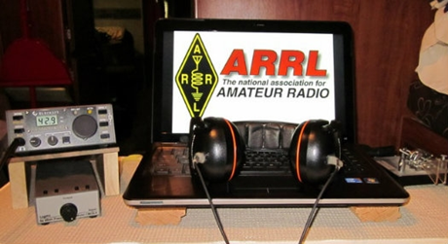*ARRL Contest Corner***

An expanded, downloadable version of *QST'*s’ [**Contest Corral**](http://www.arrl.org/contest-calendar) is available as a PDF. Check the sponsor’s ‘Website for information on operating time restrictions and other instructions.

***Ohio ARES VHF Simplex Contest - 2021***

***January 9 – 10AM through 4PM EDT.***



With Christmas behind us, it’s time for everyone to start thinking about their participation in the Ohio VHF+ Simplex Contest.

Sponsored by the ARRL Ohio Section and Ohio ARES, this event is a six-hour contest to inspire amateurs around Ohio to operate in simplex mode to simulate repeater-less emergency communications. 99% of the contest traffic is FM mode so it’s accessible even to HTs.

Additionally, since it’s VHF+ (i.e. 50Mhz and up), this contest is fully available to all Technician Class license holders.

Visit <https://ohsimplex.org> to read the rules, see who is operating, and announce your own planned operations.

For the old timers and to the new license holders, and everyone in between, this is a great way to get involved in a fun, local contest. If you have any questions about this event or how you can participate, please reach out to Jason N8EI ([jason@mfamily.org](mailto:jason@mfamily.org)).

Also, here are some tips on operating in this contest so you can see just how accessible this contest is even to a new ham with limited equipment or budget.

**General VHF+ Simplex Operating Tips**

Here are some general operating tips for working simplex stations on VHF, UHF, and up:

* Simplex operations are not like repeater operations. Leave the squelch wide open or only very very slightly closed so weak-signal stations can be heard.
* Ensure that PL/CTCSS and DCS are disabled and the radio is not doing an automatic repeater offset (i.e. shifting on transmit)
* Height is king. VHF, UHF, etc. are line-of-sight modes. If one doesn’t have a fixed station with a good antenna, consider erecting a temporary mast with a dual-band or tri-band vertical at the top. Since this is a short contest, consider going mobile or portable to high ground in your area.
* Consider building a c[heap J-Pole antenna](http://clackamasares.org/wp/wp-content/uploads/2018/12/MENTORFEST_ANTENNA.pdf) and get it up in the air on a temporary mast or even hanging it from a tree. This will be better than any HT and almost any mobile mount. You can use it even with your HT with the right feedline and 5W will go surprisingly far when properly elevated.

TOP ^

* Operation will go in spurts when a new station appears or when a rover station gets to their destination. Don’t get discouraged by long periods of static.
* Don’t be afraid to call CQ. Technician Class holders may not be familiar with this [classic HF concept](https://calcoara.com/calling-cq-on-amateur-radio-a-complete-guide/). Calling out “CQ CQ this is WW8TF in Summit County for the Ohio Simplex Contest” is all you need to do. As always, listen first before transmitting to ensure the frequency is not in use. With VHF+ simplex contesting, various hams will “take turns” on the common 2m and 70cm frequencies. Don’t be afraid to ask another ham who has been calling CQ without response if you can take a turn on the frequency. Most hams are glad to be accommodating.
* Unlike repeater operations or casual ragchew, you will need to keep a log. If this is an unfamiliar operation, do the log on paper. With the Ohio Simplex contest, you do not need to submit in the contesting-standard Cabrillo log format, so a software package is unnecessary. A simple sheet of paper with the headings of Time, Frequency, Callsign, County, and Bonuses will be all you need. The bonuses field is where one records the “extra” points such as communicating with an Emergency Operations Center (EOC) or an ARES official.

####

***Contest University will host Propagation Summit on January 23, 2021.***

Several radio propagation experts will share their knowledge during a Propagation Summit via Zoom, sponsored by Contest University ([**CTU**](https://www.contestuniversity.com/)). The event is scheduled for January 23, 2021. The presentation schedule includes:

* “Update on the Personal Space Weather Station Project and HamSCI Activities for 2021” with Nathaniel Frissell, W2NAF, at 11 AM EST (1600 UTC)
* “Solar Cycle 25 Predictions and Progress” with Carl Luetzelschwab, K9LA, at noon (1700 UTC)
* “Maximizing Performance of HF Antennas with Irregular Terrain” with Jim Breakall, WA3FET, at 1 PM EST (1800 UTC)
* “HF Ionospheric Propagation” with Frank Donovan, W3LPL, at 2 PM EST (1900 UTC).

[**Registration**](https://zoom.us/webinar/register/WN_dfLvFDxaTyakOWd_C7_puw) is free. An Icom IC-705 will be raffled off as a “door” prize. The winner must be present on Zoom to win. — *Thanks to CTU Chair Tim Duffy, K3LR*

All times are USA EST.

11 AM - "Update on the Personal Space Weather Station Project & HamSCI activities for 2021" - Dr. Nathaniel Frissell, W2NAF Noon - "Solar Cycle 25 Predictions & Progress" - Carl Luetzelschwab, K9LA

1 PM - "Maximizing Performance of HF Antennas with Irregular Terrain" - Dr.

James Breakall, WA3FET

TOP ^

2 PM - "HF Ionospheric Propagation" - Frank Donovan, W3LPL Drawing for an Icom IC-705 donated by Icom America and DX Engineering - both CTU sponsors. Winner must be present on Zoom to win.

To register for this free CTU Propagation Summit Webinar please go to :

<https://zoom.us/webinar/register/WN_dfLvFDxaTyakOWd_C7_puw>

Stay tuned to Contest University: <https://www.contestuniversity.com/>

73, Tim K3LR - Contest University Chairman

***Special Events***

* **01/08/2021 | 206th Anniversary of The Battle of New Orleans**

**Jan 8-Jan 9, 1800Z-0000Z, W5IR**, Metairie, LA. The Mystic Knights of The Louisiana Roundtable. 18.145 14.275 7.270 7.045 . QSL. Dale F. Budenski, 4713 Neyrey Dr, Metairie, LA 70002. FT8 on the usual freq. More details on QRZ.com. harry504@outlook.com or [www.qrz.com/db/w5ir](http://www.qrz.com/db/w5ir)

* **01/09/2021 | 120th Anniversary of the Lucas Gusher**

**Jan 9-Jan 10, 0900Z-1500Z, K5S**, Beaumont, TX. Beaumont Amateur Radio Club. 14.0025 14.250 7.025 7.250. Certificate. BARC, 4839 Hwy 326N, Kountze, TX 77625. Celebrate the discovery of oil in Texas. Look us up on QRZ for certificate instructions. k5s,lucasgusher@gmail.com or <https://www.qsl.net/w5rin>

* **01/09/2021 | 2021 Daytona 500/Speedweeks**

**Jan 9-Feb 14, 0001Z-2359Z, N4DAB**, Daytona Beach, FL. Daytona Beach CERT ART. 14.255 14.070 7.255 7.070. Certificate & QSL. DB CERT ART/Steve Szabo, WB4OMM, License Trustee, 536 Central Park Blvd., Port Orange, FL 32127-1136. See Web Page for QSL and Certificate information. High Quality laser printed certificate and photo quality QSL Card. Operating hours dependent on propagation and availability. Phone, CW, and Digital modes scheduled. [www.n4dab.com](http://www.n4dab.com/)

* **01/15/2021 | Alaska "RST" QSO Party**

**Jan 15-Feb 15, 0000Z-2359Z, KL7RST**, various, AK. North Country DX Association. 28.450 21.350 14.250 7.250. QSL. John F. Reisenauer, Jr, 2573 Old Georgetown Rd. W., Kershaw, SC 29067. KL7RST, KL7RST/KL7, VY1RST/KL7, VE8RST/KL7 and VY0RST/KL7. Certificate by email for working any 3 of the above when you QSL. [www.qrz.com/db/k7ice](http://www.qrz.com/db/k7ice)

* **01/16/2021 | Woronoco Heights Outdoor Adventure/SCOTA**

**Jan 16, 1300Z-1900Z, W1M**, Russell, MA. Western Mass. Council - BSA. 14.290 14.060 10.115 7.190. QSL. Tom Barker, 329 Faraway Road, Whitefield, NH 03598. All logging is done on paper and then uploaded to LoTW and eQSL. A QSL card can be had for a 4x6 SASE.

* **01/23/2021 | 1st Annual Lone Star Frozen POTA Event**

**Jan 23, 1700Z-2100Z, various**, various, TX. Deep East Texas Amateur Radio Club Inc.. all modes, all bands. QSL. Dayton Jones, KG5TKF, Email or see website for, , Information. www.parksontheair.com or [kg5tkg.radio@gmail.com](mailto:)

TOP ^

* **01/23/2021 | California Discovery of Gold**

**Jan 23-Jan 25, 1700Z-0000Z, AG6AU**, Placerville, CA. El Dorado County Amateur Radio Club. 21.348 14.248 7.248. QSL. El Dorado County ARC, P.O. Box 451, Placerville, CA 95667. [edcarc.net](http://edcarc.net/)

***“ARES Connect”***

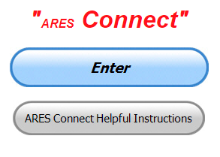

***Connecting Amateur Radio Volunteers with a Purpose***

Hey everyone… please make sure to go in and register your time to all of the events that you have signed up for. Be honest about the time spent. Don’t forget to get this done no later than **5 days** after the event has ended. I’m asking you to do this for our ability to run reports accurately.

**I want to remind all of you that you do not have to be an ARES or ARRL member to use this system. All licensed amateur radio operators throughout the country are welcome and strongly encouraged to use it.**

**Don’t forget to check out the “Frequently Asked Questions” area that has been added to the Ohio Section website.** It’s there to help you through any difficulties that you may have with ARES Connect. Now, if you don’t any posts that relate to what you are having difficulties with, we now also have an on-line “Guru” area as well. This will allow you to ask any questions that you may have about ARES Connect.

**Let’s get everyone on “ARES Connect!!!”**

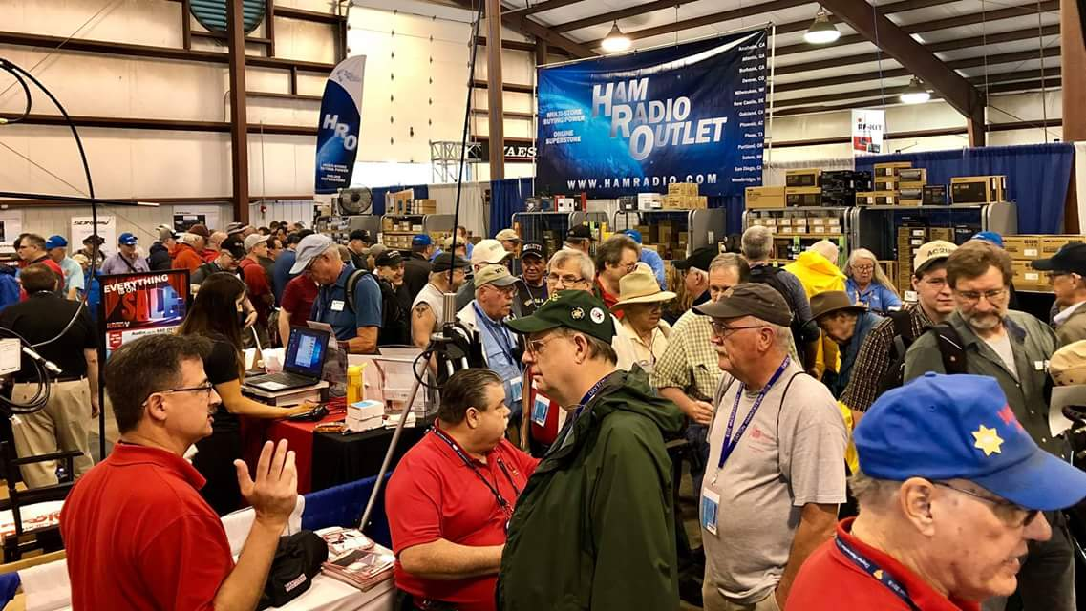[***Upcoming Hamfests***](http://arrl-ohio.org/hamfests.html)

We **DO** have some hamfests scheduled for 2021!! Yes, the first one out of the gate will be the NOARS Fest on March 7th.

[Ohio Hamfests](http://arrl-ohio.org/hamfests.html)

Be sure to keep your eyes on this schedule as that when things start getting better and the vaccine rolls out to more and more, hamfests will surely get back to their normal schedule. Don’t see your hamfest listed?? Did anyone register it with ARRL? It’s really easy to do and you get a lot of FREE publicity if you do.

Here’s a link to register your hamfest… [Hamfest/Convention Application Form](http://www.arrl.org/hamfest-convention-application)

|  |  |
| --- | --- |
| **03/07/2021 -**[**WINTERHAMFEST**](http://www.arrl.org/hamfests/winterhamfest-3)  **Location: Elyria, OH Sponsor: Northern Ohio Amateur Radio Society** [**Learn More**](http://www.arrl.org/hamfests/winterhamfest-3) | **04/25/2021 -**[**Athens Hamfest**](http://www.arrl.org/hamfests/athens-hamfest-9)  **Location:**Athens, OH **Sponsor:** Athens County Amateur Radio Association **Website:** <http://ac-ara.org/> [**Learn More**](http://www.arrl.org/hamfests/athens-hamfest-9) |

TOP ^

|  |  |
| --- | --- |
| **05/21/2021 - 05/23/2021** [**Dayton Hamvention, ARRL Operating Specialty Convention**](http://www.arrl.org/hamfests/dayton-hamvention-arrl-operating-specialty-convention)  **Location: Xenia, OH Sponsor: Dayton Amateur Radio Association Website:**[**http://hamvention.org**](http://hamvention.org/)[**Learn More**](http://www.arrl.org/hamfests/dayton-hamvention-arrl-operating-specialty-convention) | |
| **07/18/2021 -**[**VAN WERT HAMFEST**](http://www.arrl.org/hamfests/van-wert-hamfest-5)  **Location:**VAN WERT, OH **Sponsor:** VAN WERT AMATEUR RADIO CLUB **Website:** [http://W8FY.ORG](http://w8fy.org/) [**Learn More**](http://www.arrl.org/hamfests/van-wert-hamfest-5) | **08/28/2021 -**[**Cincinnati Hamfest℠**](http://www.arrl.org/hamfests/cincinnati-hamfest)  **Location:**Owensville, OH **Sponsor:** Milford ARC **Website:** [http://CincinnatiHamfest.org](http://cincinnatihamfest.org/) [**Learn More**](http://www.arrl.org/hamfests/cincinnati-hamfest) |
| **09/26/2021 -**[**Cleveland Hamfest**](http://www.arrl.org/hamfests/cleveland-hamfest-1)  **Location:**Berea, OH **Sponsor:** Hamfest Association of Cleveland **Website:** [http://www.hac.org](http://www.hac.org/) [**Learn More**](http://www.arrl.org/hamfests/cleveland-hamfest-1) | |

***River Ice Spotter Training Scheduled***

Partners,

The National Weather Service will host a 45 min webinar for River Ice Spotters in the area on **January 26 at 10 AM.** The focus of this training will be on monitoring and reporting river ice. This information is used by the NWS, USACE, USGS, and local and state officials in our efforts to prepare and alert communities of threats posed by ice jam flooding. The training will be recorded if you are unable to attend at the scheduled time.

To register and find more information regarding this training please visit our website [www.weather.gov/cle/RiverIceSpotters](http://www.weather.gov/cle/RiverIceSpotters).

***From The South 40***

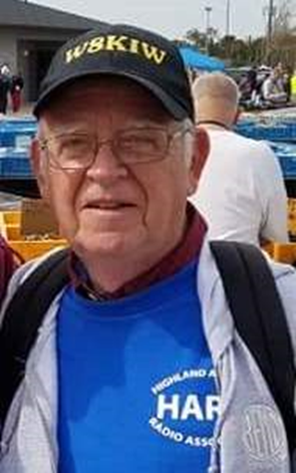*(from John Levo,* [*W8KIW@arrl.net*](mailto:W8KIW@arrl.net)*)*

***News From the South 40***

Before proceeding any further, here’s wishing each of this column’s readers a most Happy New Year. Let’s hope 2021 is not as wild of a ride as 2020 was and things get back to some form of normal within a reasonable time and we can restart hamfests and club activities. Let’s also hope your New Year’s resolutions haven’t already been dashed. As to ham radio resolutions, why not make one to upgrade, try some new mode, attend a hamfest, get more involved with your local ham club or just try to make it a point to get more time on the air?

TOP ^

Unfortunately, COVID played havoc in some way with almost every club in the region. However, every club found ways to still function. Clubs who no longer felt comfortable with in person gatherings met over the air or held virtual on-line meetings. Those that did meet observed mask and social distancing requirements and we’ve heard of no issues. Although most group operating activities had deceased participation, clubs still found ways to hold those activities and take advantage of the talents of those who could participate. The **Athens County ARC** even held an antenna building clinic in a parking lot! The big thing missed by almost all hams were the region’s hamfests. Here’s hoping we’ll see the return of the Ashland, Athens, Chillicothe, Gallipolis, Georgetown, Huntington, Milford and Nelsonville shows this year. And who can forget the biggie-HamVention-being cancelled for the first time in its long running history.

The one positive related to COVID is that local club nets had increased participation from not only their members, but others. The Portsmouth club’s Tuesday night net recently set a modern record and the Monday evening net on the Hillsboro 147.21 repeater had almost 40 this past week. Club officers in Brown, Clinton and Fayette Counties tell of new stations checking in almost every week. Speaking of a couple nets to note, Bill French, KE8AAL, calls a net on the **Scioto Valley ARC** 146.925 (pl 74.4) repeater on Sunday evenings at 8 and Ken Rowley, WD8PHL, calls the **Fayette ARA** net at 8 pm on Tuesday evenings on FARA’s 147.27 machine.

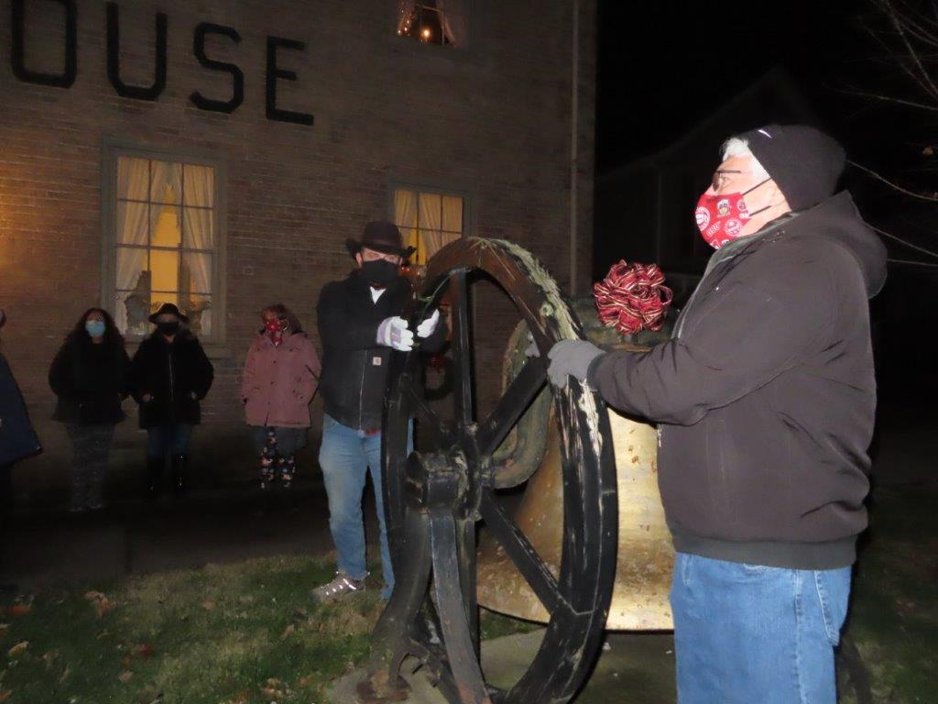

At the stroke of midnight, the large bell in front of Hillsboro’s Highland House Museum was rung welcoming the New Year. For the fourth year that greeting was transmitted on the **Highland ARA**’s 147.21 repeater and this year for the first time was linked with the Club’s 147.685 Greenfield repeater. Following the bell ringing an informal net was called with approximately 30 hams from as far as Kettering registering their call signs and wishing others best wishes for a better 2021. The event was coordinated with the Highland County Historical Society.

The **Tri-State ARA’s** Tim Hamilton, KE8MBW, has acquired a Western Union Model 3 ASR teletype terminal in anticipation of future RTTY use. He is looking for anyone with knowledge or information about these particular terminals. Anyone who can assist him should contact him at thamilton@shawnee.edu. Any assistance will be appreciated.

What would be a better way to start the New Year than getting your first license or doing an upgrade? On Saturday morning, January 16 the **Highland ARA** will conduct an all element VE session in Hillsboro starting at 9. It will be at the Highland County EMA office in Hillsboro. Pre-registration is required with signup at www.signupgenius.com/go/10C0D48ADAC23A7FEC16-hara3. So beat the proposed FCC $35 license fee and go for an upgrade or first license while a Laurel test is still free.

TOP ^

2021 brings a new slate of officers for the **Tri-State ARA**. The new officers who serve two-year terms will be led by Mark Killen, KD8QIG, the incoming President. Alan Washington, AB8AS, will serve as the Vice President with Judy Taylor, WD8EOP, returning as club Treasurer. Outgoing President Bud Cyr, KB8KMH, will become the club’s Recording Secretary.

We wish to take a moment to express a sincere note of appreciation and best wishes to Scott Yonally as he leaves the ARRL Ohio Section Manager position and becomes our Great Lakes Division Assistant Director. During his term as the Ohio Section Manager Scott became a familiar face to many Southern Ohio hams. He attended almost every hamfest in the Southern Ohio region, many club meetings, dinners and other special occasions. If he was this active in the other parts of Ohio, I can’t help but wonder how many sets of tires he wore out during his tenure. However, based upon his Ohio performance, the question is now how many will he go through as the new ASD? Plus, how often will he see his wife? Regardless, Kentucky and Michigan will be honored having this man serve them. The good news is that the ARRL isn’t losing his talent but will be sharing it with others.

The New Year also brings us a new Ohio Section Manager. In the coming days I’m certain we will hear from Tom Sly, WB8LCD, as he prepares to fill the shoes vacated by Scott and organizes his division cabinet. Let’s give him our region’s support and wish him nothing but success.

Until next time, HAPPY NEW YEAR!

***One Question Questionnaire***

Hey Gang,

Survey Says”….. around 38% of you are monitoring the public service frequencies...

Ok, now on to the next question… Let’s find out what your age grouping is. Your answer is not monitored so you can be honest here.

***“How old are you???”***

You’ll find the “One Question” questionnaire on the Ohio Section Website! <http://arrlohio.org> It’s all for fun and it’s not a scientific survey in any way, but we are learning some things that we didn’t know from these questions. I hope that you are enjoying answering these “One Question” questionnaires.

*****V.E. Test Sessions***

Many V.E.’s have decided to start testing once again, but with restrictions that need to be adhered to for sure. Here’s the link to find that V.E. Test session and what is expected of YOU before going. <http://www.arrl.org/find-an-amateur-radio-license-exam-session>

TOP ^

***Print an Official or Unofficial Copy of Your Amateur Radio License***

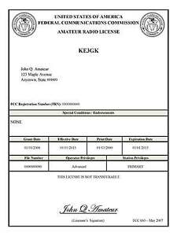*(By Anthony Luscre, K8ZT)*

As of February 17, 2015, the **FCC no longer routinely issues paper license documents** to Amateur Radio applicants and licensees. The Commission has maintained for some time now that the official Amateur Radio license authorization is the electronic record that exists in its Universal Licensing System (ULS). The FCC will continue to provide paper license documents to all licensees who notify the Commission that they prefer to receive one.

Licensees also will be able to print out an official authorization — as well as an unofficial “reference copy” — from the ULS License Manager. I’ve created a set of instructions on how you can request an **“official” printed copy of your license\***

[**Click here to download the instructions**](http://arrl-ohio.org/news/2020/print_your_license.pdf)



Hey Gang,

Have you taken a look at the **Swap & Shop** page on the Ohio Section webpage yet?? Here’s a link that will take you there…

<http://arrl-ohio.org/sm/s-s.html>

Do you have equipment that you just don’t need or want anymore? Here’s a great venue to advertise it, and it’s FREE!! Is your club doing a fund raiser to help raise money? After a lot of thought, it was decided that the Swap & Shop webpage could also contain these types of items as well. The same rules will apply as do for the For Sales and Give-A-Ways and will only be posted for a month at a time. Please see the Terms & Conditions on the webpage.

If your club is doing a fund raiser and wants more exposure, please forward the information to me and I’ll advertise it on the Swap & Shop webpage for you.

Now, I still want to remind you that it won’t be listed in this newsletter because it would take up way too much space, so your ad will only appear on the website. It is there for any individual to post equipment Wanted / For Sale or Give-Away as well as for Club Fund Raisers. No licensed vehicles/trailers or business advertising will be posted. Postings are text only (no pictures or graphics) will be posted for a maximum of 1 month from date posting and require a contact phone number or email within the posting. Send your Wanted / For Sale or Give-Away post to:  [swap@arrlohio.org](mailto:swap@arrlohio.org)

TOP ^

Ohio Section Cabinet

|  |  |
| --- | --- |
| Section Manager – Tom Sly, WB8LCD | Section Traffic Manager – David Maynard, WA3EZN |
| Section Emergency Coordinator – Stan Broadway, N8BHL | Section Youth Coordinator – Anthony Lascre, K8ZT |
| Technical Coordinator – Jeff Kopcak, K8JTK | Affiliated Clubs Coordinator – Tom Sly, WB8LCD |
| State Government Liaison – Bob Winston, W2THU | Public Information Coordinator – John Ross, KD8IDJ |

***Back Issues of the PostScript and Ohio Section Journal***

Hey, did you know that PostScript and Ohio Section Journal (OSJ) are archived on the website? You can go back and look at any edition simply by clicking:

<http://arrl-ohio.org/news/index.html>

***Welcome New Subscriber(s)***



**Ray, KB8GUN**

***Want to Share your Club Newsletter With Others?***



We have a webpage where you can download and read all of the newsletters that I get from around the state and even other sections!

Here’s the link to the page…. <http://arrl-ohio.org/club_news/index.html>

Please, if you don’t see your club newsletter posted, it’s because I’m not receiving it. Just have your newsletter editor contact me and I’ll get your club’s newsletter listed on the site!!

We all learn and steal (I mean, share) from each other’s work. So, get me your newsletter!!! Send it to: [webmaster@arrl-ohio.org](mailto:webmaster@arrl-ohio.org)

TOP ^

***Chit – Chat, and All That!***

Do you know someone that’s not getting these Newsletters? Please, forward a copy of this Newsletter over to them and have them “[Opt-In](mailto:Opt-In)” to start receiving them. Heck just have them send an email to: [webmaster@arrl-ohio.org](mailto:webmaster@arrl-ohio.org) and we’ll get them added to the Ohio Section Emailing list.

We now have many thousands of readers receiving these newsletters weekly. Quite impressive, I’d say! I urge all of you to make sure that everyone, regardless of whether they are a League member or not, get signed up to receive these weekly Newsletters.

You can always “Opt-Out” at any time if you feel this is not what you were expecting. It’s fun and very informative. All of your favorite past newsletters are now archived too.

You can go back at any time and read them.

Just go to: <http://arrl-ohio.org/news/>

The pictures on the front page and throughout this newsletter are from various newsletters, Facebook posts and/or were sent directly to me in recent weeks. Take a good look at them, you just might be in one of the pictures! “SMILE… you’re in the Ohio Section News!!”

***Stop!!! You’ve reached the end of another week’s edition.***



TOP ^

*PostScript is produced as a weekly newsletter. I want to thank everyone that has contributed articles and ideas to make this an even better news source. I sincerely hope that you have enjoyed this edition and will encourage your friends to join with you in receiving the latest news and information about the Ohio Section, and news and events happening around the world!*