***[](http://arrl-ohio.org) March***

***Edition***

|  |  |
| --- | --- |
| 🡪 From the Technical Coordinator | **🡪** From the Section Emergency Coordinator |
| **🡪** From the Public Information Coordinator | 🡪 From the Section Youth Coordinator |
| **🡪** From the Section Traffic Manager | 🡪 ARES Training Update |
| 🡪 National News | **🡪** Club Corner |
| 🡪 DX This Week | 🡪 Contest Corner |
| 🡪 Special Events | 🡪 One Question Questionnaire |
| 🡪 From The South 40 | 🡪 Final.. Final.. |

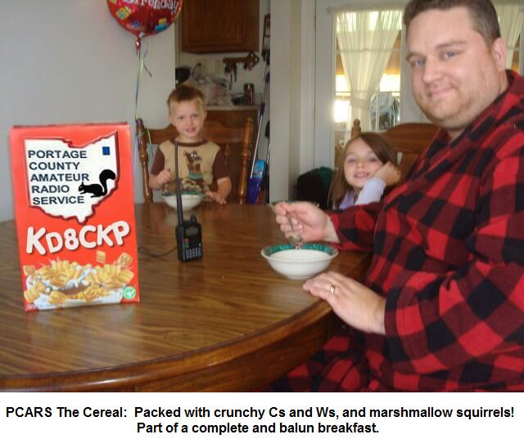

***From the Technical Coordinator***

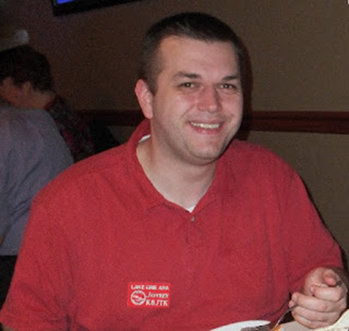***Jeff Kopcak – K8JTK TC***

[k8jtk@arrl.net](mailto:k8jtk@arrl.net)

Hey gang,

Not quite one year after the OpenSPOT 2 was released, the OpenSPOT 3 made an appearance on the SharkRF website. I suspected the OS2 was not selling very well. A quick look at the Brandmeister Dashboard shows 7.4% are using the OS1 and 2.5% are using the OS2. These are number of hotspots connected to the Brandmeister network on the evening of March 24th and does not include other networks.

Maybe low usage is a result of the six-month lag since stopping production of the blue box OpenSPOT 1 and when the OpenSPOT 2 arrived on the market. Maybe it was making the announcement to discontinue the OS1 right after Dayton (two years ago) upsetting customers who just spent money at the show on a now obsolete device. By obsolete, I mean can’t purchase the device new (no longer in production) and there’s been maybe a single firmware update since it was discontinued. I get it, they’re a small company out of Estonia but their business and design decisions upset customers.

Not to mention vendors. The blue box could be obtained from many ham retailers. They too probably felt burned after the OpenSPOT 1 to the point where I don’t see any retailers carrying the 2 or 3. Purchasing from a retailer meant users could forego the international transaction fees and shipping, or they were just included in the price.

I love the OpenSPOT 1 and think it’s a solid device. It beat all other offerings at the time and one of the first devices to offer cross mode support (DMR <-> YSF). At the time, Pi-STAR wasn’t a thing. The DV4Mini was one of the first multimode offerings but it stank-on-ice (it became usable recently with an MMDVM application). The DVMega and other devices around the same time were solid hardware but getting a working image (software) was a challenge. The problem with the OpenSPOT 1, it was wired Ethernet, didn’t offer a Wi-Fi option, and required USB power. A wireless bridge such as the TP-Link N300 made it Wi-Fi capable, via a wireless bridge, allowing the device to be paired with a cell phone hot spot or other Wi-Fi link. I was able to make a similar setup work on my Linux laptop acting as a NAT (network access translation – same as home Internet connections). Had a script to setup the DHCP server on wired Ethernet (where the OpenSPOT 1 would be connected) and iptables rules allowing communication from the wired Ethernet to the wireless interface (where the cell phone or hotel Wi-Fi would be connected). USB power could be a portable USB battery pack or plugged into the laptop USB. These setups worked but most found it not great for portability and keeping track of multiple devices.

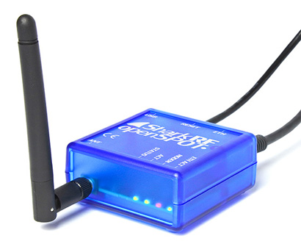

OpenSPOT 1

TOP^

I skipped the OpenSPOT 2. Shortly after release came reports of both Wi-Fi and radio range issues. To

improve on design, SharkRF internalized the 440 MHz antenna as well as adding Wi-Fi capability, also removed the wired Ethernet. Apparently, the device had to be very close to Wi-Fi access points and the digital radio couldn’t be very far away either. It would work great in small areas like a car but it wasn’t winning bonus points for range. Coming out with another successor in less than a year was likely an acknowledgment of these problems.

Picked up the OpenSPOT 3 on a Christmas special from SharkRF and had a few months to use it. The OpenSPOT 3 is probably the most advanced digital hotspot available for ham radio, and also the most expensive. Cost came to €243 EUR including shipping, $288 US. For what it is, it’s a great device. Comparing it to a device with an external antenna, you’ll be disappointed.

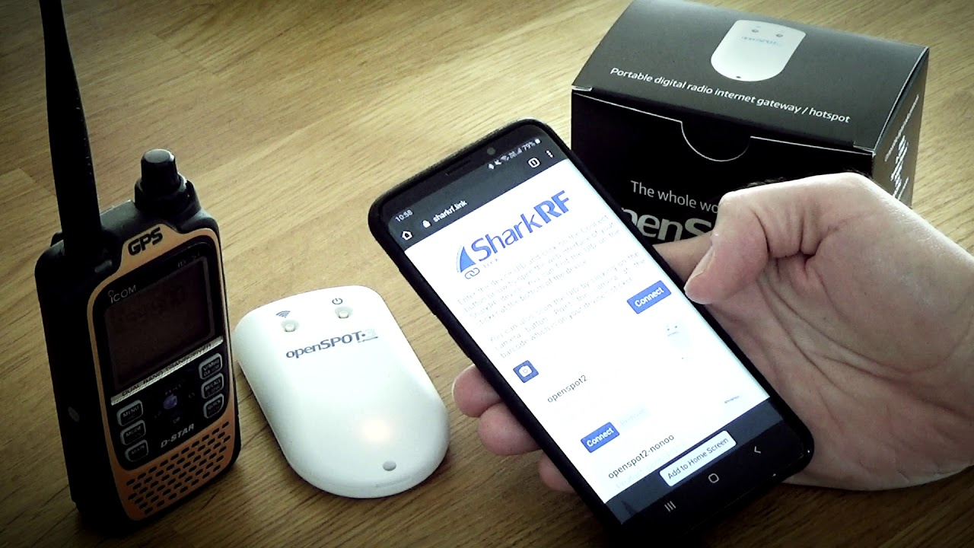

OpenSPOT 3 (sharkrf.com)

It comes with a built-in Lithium-ion battery, built in radio and Wi-Fi antenna, USB-C for fast charging (though battery life seemed short under heavy usage), it has the same solid web interface as the OS1 with some nicely added tweaks including the ability to play audio from the web interface. Overall, it is fast. The web interface doesn’t lag and time to connect from power off is under 10 seconds. In comparison, my Pi-STAR on a Raspberry Pi Zero-W takes a couple minutes to boot and nearly 50 seconds to save and change any settings. Setup was easy with any web browser, including mobile. It offers the ability to work all current digital modes: DMR, D-STAR, NXDN, P25, and YSF. Also offers POCSAG and APRS-IS forwarding.

For the ham-on-the-go, this is the best option for a digital hotspot. The OS3 features a built-in hardware AMBE chip for transcoding, including D-STAR to other network types. This is the first and only hotspot with D-STAR cross-mode functionality built in and was the most requested feature that I saw on the forums. That means a D-STAR radio can work on DMR, C4FM (YSF), and NXDN networks. Likewise, a DMR radio can access D-STAR, C4FM, and NXDN networks. This is the perfect option for a traveling ham that wants access to digital while on the road but doesn’t want to bring all the radios. Table below notes which radios will be able to work which networks.

|  |  |
| --- | --- |
| Radio/transceiver | Networks |
| **Hardware cross mode support** | |
| DMR | D-STAR, C4FM, NXDN |
| D-STAR | DMR, C4FM, NXDN |
| C4FM | DMR, D-STAR, NXDN |

TOP^

|  |  |
| --- | --- |
| NXDN | DMR, C4FM, D-STAR |
| **Software cross mode support** | |
| C4FM | P25 |
| P25 | C4FM |

I don’t know how bad the antenna issues were on the OS2 but I can’t imagine them being much worse than with the 3. I have always run hotspots on the lowest power setting because the lowest gave more range than I ever needed, however they all used external antennas. Depending on interference from nearby computers, I had some trouble with the device falling out of radio and Wi-Fi range. On average it would cover the footprint of the house. I bumped the power up to 20% and still have reliability issues of it hearing me or me to hearing it from out in the shack – with an external antenna. I’m a little disappointed by that. Another issue, P25 sounds better on the Pi-STAR for some reason – even after doing a calibration on the OpenSPOT.

Someone wanting a feature packed device for traveling, this is currently the best option. If you want range, stick with a hotspot that has an external antenna.

By the time the Section Journal goes to press, most of the event will be completed – but there’s still time! The Last Man Standing special event is well underway. It commemorates the last week of taping for the TV show Last Man Standing which is ending its 9-season run. The special event will cease operation 3/30/21 at 23:59 UTC, so you still have some time. This event is everywhere: SSB, CW, FT8, D-STAR, DMR, YSF, NXDN, P25, Hamshack Hotline, Echolink, Satellite, EME, AllStar, ATV and probably a few more I’ve forgotten. Everyone including Technicians can get on board. There are promo videos and an information site with details about call signs, log sheets, how to send QSL cards, and the certificate. Look for KA6LMS/1, 2, 3, 4, 5, 6, 7, 8, 9, and 0 as well as K6L, K6M, K6S, W6L, W6M, and W6S bonus stations. My multi-link system will be part of the event that happened on the 27th. I should have stats and info on how that activation played out next month. After the 30th, Last Man Standing will be QRT.

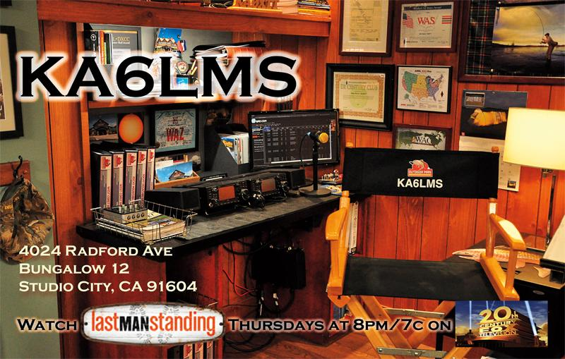

KA6LMS QSL card

Lastly, something I didn’t know existed. RFC 1149 defines an experimental standard to encapsulate IP traffic using avian carriers (IPoAC). That’s right, IP packets via carrier pidgins! It is really useful in Metropolitan Area Networks (MANs). Devices in your home are connected to a Local Area Network (LAN). These LANs would be connected to larger regional networks called MANs. “Avian carriers can provide high delay, low throughput, and low altitude service.” They also have collision avoidance systems increasing reliability. Unlike packet radio, these communications are not limited to line-of-sight. Format is very easy to understand and follow:

TOP^

The IP datagram is printed, on a small scroll of paper, in hexadecimal, with each octet separated by whitestuff and blackstuff. The scroll of paper is wrapped around one leg of the avian carrier. A band of duct tape is used to secure the datagram's edges. The bandwidth is limited to the leg length. The MTU is variable, and paradoxically, generally increases with increased carrier age. A typical MTU is 256 milligrams. Some datagram padding may be needed.

Upon receipt, the duct tape is removed and the paper copy of the datagram is optically scanned into a electronically transmittable form.

Wonder if I have to install a landing pad or birdhouse to have these messages delivered?

April fools! Emile - KE5QKR was talking about this after taping one of the Amateur Logic shows and I had to look it up. It really does exist but once I saw the April 1, 1990 date – I knew it was an April Fools’ prank. There’s your early April Fools’ joke for later this week!

That's about it for this month.

**Thanks for reading and 73… de Jeff – K8JTK**

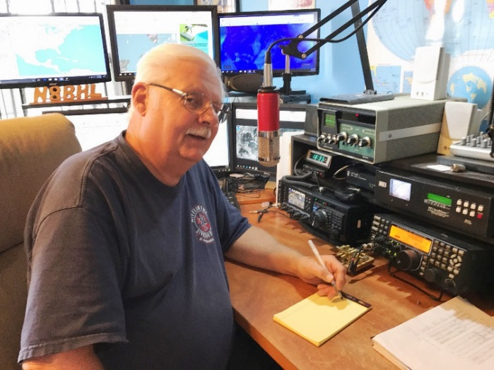***From the Section Emergency Coordinator***

***Stan Broadway, N8BHL - SEC***

[broadways@standi.com](mailto:broadways@standi.com)

The Texas Effect

I’m sure we all watched the unusual winter storm mangle the lives of our southern states recently. Extreme cold with significant snow and ice brought things to a halt… including the wind and solar generation plants. Rolling blackouts, loss of water from freezing and power outages and inability to travel all brought people down to the level of merely surviving until the storm passed.

Like many of you, I completely understand how the “normal Ohio winter” weather would paralyze the deep south, and I had sympathy for those fighting through. Like many of you, I wondered whether ARES or amateur radio in general would play a part in this situation. From as much as I can gather by talking with the STX Section and reading different accounts the answer to that was actually, “Not much.”

TOP^

I think that’s understandable considering how much better hardened the public safety radio systems are today and how much more dependable cell service and other commercial systems have become. After all, hurricanes have taught them many lessons about functioning in severe conditions and without normal power. Oh yes, given a “Michael” they would have been in much deeper trouble, but the storm was mercifully brief lasting only a few days. While amateurs were ready, and several nets were standing by, that’s pretty much all it required. So does that mean amateur radio isn’t a factor anymore?

The more recent emergency situations we have watched have not involved ARES in the historical template- a room full of hams passing life-and-death dispatches to guard helicopters or tracking the location of buried semi drivers under 15 feet of snow. Indeed, while our basic plans MUST revert back to a ‘dark sky’ scenario where power and communications cease to exist our new ‘normal’ finds that condition to be very rare. Like Texas and the southern states, our public safety comms are fairly sturdy. So should we be ready for the fabled “All else failed” scenario? Of course. It’s what we do.

But the continued development of public service communication makes that extremely rare. Is it then unrealistic to ask you to sit next to your door, go-bag in hand just waiting for the call? I think we need to keep a calm perspective. Sure, we need several things always at hand but they also do us service for our own survival even if we’re not deployed:

* Portable communications (radio, power, antenna)
* Provisions as required for 72 hours- food, medical, personal
* THE ABILITY TO BUILD ANTENNAS AND ACCESSORIES ON THE FLY
* The ability to take broken systems (towers, antennas, etc.) and make them work again

Experience has shown, however, that not everything is going to fail. Even with multiple tornado outbreaks, surprisingly the Internet service to those areas has remained intact. Even if local outages would occur in damaged areas, the rest of the state’s Internet and communications would remain. (A likely application for Winlink as a ‘last mile’ link to outside email, etc.!) So does all that mean we’re wasting our time? Nope- truth be told we’re already a part of the system.

Here in Ohio we already have a system in place and functioning that inserts amateur radio as a critical part of handling an emergency without waiting on system failure or deployment. After all, in Ohio we ***are already deployed***! Our homes are dispersed across the state in position to watch and report on what’s going on. It’s a level of penetration not available to any other emergency service. We call it the “WATCH DESK PROJECT”.

With the advent of unusual or emergency conditions (typically around here they would be severe weather aftermaths) we have secured both the Ohio DMR statewide Channel 3139 and the Ohio Link Fusion talk group which can be bridged together. This provides digital voice (storm-front static free) handheld coverage over most of the state. We also of course have 3902 HF to rely on. The choice would depend on band conditions, Internet dependability and manpower. So what do we do with this?

We are able to provide critical situation awareness by reporting our conditions to the Watch Desk at the Ohio EOC. This is the 24/7 Intel center which receives requests and activates the state resources. Is there damage, power, hazard in our specific location? Is there a liaison from the local weather net who can relay strikes,

TOP^

damage, or other severe events? (Of course, they should go to your local EMA as well!) Has snow depth closed your airport, brought a critical phase to your hospital? How has flooding depth affected your local area? While the state must wait on a request from local EMA before acting, the ability to understand the type and nature of aid to have ready can shortcut state response time and get help to your suffering community more quickly. We play a large part in that!

No, it’s not intended to be a statewide Skywarn net, and it doesn’t replace your local or regional emergency net which might be active for your local EMA. It’s intended to bring information from all those sources and from your front window, to the Ohio EOC where it will be a significant aid in making the decisions on the part of the Watch Desk. It has worked well the few times we have needed the service!

There are creative ways that your ARES group can provide specific services to keep amateur radio active and meaningful. Do you have MESH? Are your operators fluent in fldigi or Winlink to send forms to and from our agencies? Is there an active severe weather net for your location? As an EC, do you maintain contact with your Red Cross, hospital, and EMA?

NVIS Day is coming!

April 24, from 10AM until 4PM the Ohio NVIS Day activities will take place. And this year, boy do we have a twist!

By now, many of your groups have already figured out the best functioning portable antennas to deploy for emergencies. That’s the original purpose of NVIS day- to design and try different portable NVIS antennas and see which one work best for you. That’s still the main purpose- and it’s a GREAT opportunity for the ‘old heads’ to teach newer operators about measuring, cutting, soldering and hanging antennas- one of the most fun aspects of ham radio.

This year, we’re going to take a couple steps forward to make it more fun, and more challenging. Here’s what we’re thinking:

* Goal 1: Construct a working NVIS antenna (or several) and try them out for performance.
* Goal 2: Operate with a completely off-grid power source (battery, solar, generator, whatever)
* Goal 3: Make contact with your district net or DEC on HF (DEC’s make your info known!)
* Goal 4: Make contact with the Sarge on 3902
* Goal 5: Send a message to W8SGT:
  + Use ~any~ system possible- voice, fldigi, Winlink, CW, doesn’t matter just send us a note:
  + Your callsign is operational at your location using your antenna type with how many operators
  + You can use your local/district net with a normal message format (they can upload to Buckeye Net, OHDEN or voice contact with Sarge.
  + Lacking the above, you can send direct to Sarge while making your test contact above.
* Goal 6: Have fun; take a break for the grill and lunch!

While it’s a solid activity to just build and test antennas, we thought it would be fun to introduce the challenge

of actually doing something with them- getting a specific message out is much more of a challenge because you need to pre-arrange your local/district nets and you need to be able to find and make a solid contact with them and the Sarge!

TOP^

You can certainly test several antennas in that fashion, perhaps developing a new “best” antenna for your own area! We’ll have more information in the near future!

The Ohio ARES Conference

We’re still not able to hold an in-person event this year as you probably suspect. We are hoping to take advantage of Zoom to even expand our reach this year! Honestly, we don’t have our act together yet to provide a lot of specifics, but I can suggest this: Keep your calendars open for April 12 and 13. We are planning two evenings (two sessions each) to get together and present some information you can use! The good news is- it won’t involve travel for you, it allows far greater attendance so everyone can join, and you can attend in stocking feet!

I’m waiting on speaker confirmation, but look for sessions on emergency planning, messaging, and operations. Mark your calendars now!

The SARGE is back!

Our Tuesday evening nets have re-started with the time change. We’re holding our regular 3.902 HF nots starting at 7PM (a slight change- 7PM on the hour!) and we hope to hear from you!

Keeping in touch

I know other groups are doing the same across the state, but I am particularly proud of Delaware Amateur Radio Association (DELARA) for going above and beyond to do what ham radio does best- keep in touch! Ever since the entire population was sent to COVID jail a year ago, the Delaware group has kept in touch ~every night~ using several different resources. President Mike Huffman, W8MDC, started an informal net nearly every night at 7:30 just to provide a way for all to keep in touch. The club already had a Monday evening net, but this stretched it to all seven days! On Wednesdays, the net turns from the local repeater to Zoom, where participants can not only talk to each other but converse visually as well. The monthly club meeting is also Zoomed. On Tuesday and Thursday evenings, a digital sub-group further lights the airwaves both VHF and HF trying out different forms of message sending, including fldigi, flamp and Winlink. They are specifically concerned with sending forms for the EMA and emergency agencies so this keeps them well in practice while also experimenting with different digital modes.

**OHIO ARES DMR Net**

 The Ohio ARES DMR Net is still in operation and has moved to Monday nights at 830 PM   Th net is open to all amateurs and is for the passing of information and for training in DMR net operation.  We take check ins from the 10 ARES districts of Ohio. A map of these districts is available on the Ohio ARRL Section website, and also on the Richland County DMR group on Facebook.

Beginning in April the net name will change to Ohio DMR Net to better reflect our operation and sign up will be the same as always for the time being on ARES Connect under the new name.   Please join us on our new night and time on TG-3139

   73 - Gregg - WB8YYS - Net Manager

TOP^

**Wright brothers' wing fragment to take flight again on Mars**

*(By UPI News - Ben Hooper)*

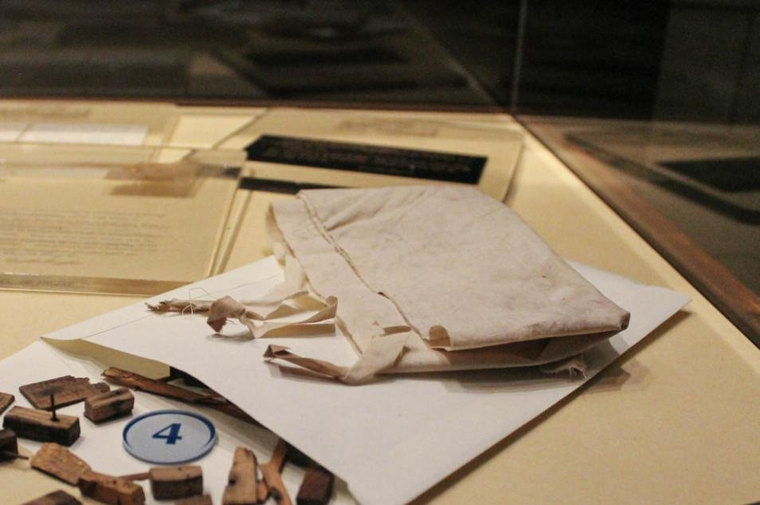A fragment of the wing covering from the Wright Flyer I, the plane used by Wilbur and Orville Wright for their first successful flight in 1903, is due to be a part of aviation history again when it is carried into the skies of Mars by NASA's Ingenuity helicopter. Photo courtesy of Carillon Historical Park

March 24 (UPI) -- A piece of cloth from the Wright brothers' first flight in 1903 is set to become part of aviation history again -- this time on Mars.

Carillon Historical Park, the Ohio home of the Wright Brothers National Museum, said NASA officials got in contact in 2019 about finding a way to connect Wilbur and Orville Wright's first successful flight in Kitty Hawk, N.C., with the first heavier-than-air flight on Mars.

The museum provided a small fragment of the Wright Flyer I's wing covering to be carried aboard Ingenuity, a small helicopter attached to the belly of NASA's Perseverance rover on the surface of the red planet.

NASA said Ingenuity is expected to take its first flight sometime after April 8. The flight will mark the first-ever powered, controlled flight of an aircraft on another planet, NASA said.

The use of the Wright Flyer I's wing covering for the mission received the blessing of Amanda Wright Lane and Stephen Wright, Wilbur and Orville's great grand-niece and nephew.

"Wilbur and Orville Wright would be pleased to know that a little piece of their 1903 Wright Flyer I, the machine that launched the Space Age by flying barely one quarter of a mile, is going to soar into history again on Mars," the family said in a statement.

A fragment from the Wright Flyer I's wing covering was previously carried to the moon by Neil Armstrong in 1969. Another fragment was taken into space by John Glenn during a trip on the space shuttle in 1998.

__________________________________________________________________________________________

TOP^

***From the Public Information Coordinator***

***John Ross, KD8IDJ - PIC***

[john.ross3@worldnet.att.net](mailto:john.ross3@worldnet.att.net)



**FROM THE PIC**

**COUNTDOWN TO 2021 NEWSLETTER CONTEST**

Just three months until the deadline to enter the Ohio Section 2021 Newsletter Contest! All entries need to be  in by midnight June 30th and the judges will begin their work right after the Fourth of July!

Remember… you will need copies of your newsletter from two different to months to make the entry complete… judging from past years… we have never had a problem!  You can email a link, email a newsletter or email a link for your club’s website where the newsletter can be accessed.

As of now, the judging will be electronic as it was last year. It really worked out well and it kept us safe and socially distant. If that changes I will let you know. However, as of now, the winners will be announced LIVE at the DX Engineering Hamfest & Great Lakes Division Convention in Talmadge, Ohio on August 7th.

I know this year’s contest will be a great one. Already entries are running ahead of last year and that’s because our newsletter contest is they biggest and the best!

Keep the entries coming and I’ll see you at the convention is August!



**HELP A HAM**

A couple of weeks ago I found out that a longtime friend was having trouble renewing his amateur license. While he’s pretty “ham-teckie” he just doesn’t have a computer or an email address.

With the move by the FCC to have all license activity moved to on-line only this presented a problem that many older hams are facing….so I decided to see what kind of help was available.

TOP^

As of right now you can still renew by filing  a paper copy of form 605 and mailing it to the FCC…kind of old school. The ARRL will help (you must be a member) just give them a call. They will take care of the application and get it filed….but IN ALL CASES THE OPERATOR WILL NEED AN EMAIL ADDRESS.

This doesn’t mean they need to have a computer or internet access…just that they have an email address and can retrieve mail at a friend’s house. They will need an email address to file and retrieve a copy of their license. Looks like there is plenty room to help these folks especially as they get older and if they have health or mobility issues. I would hate to see a ham lose their license when there are many ways to help!

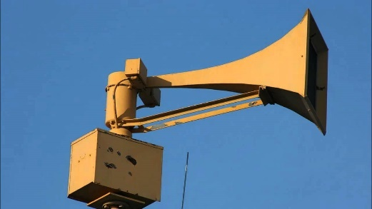

**WEATHER SPOTTERS BACK IN BUSINESS**

With Spring comes the return of weekly weather nets and already the weather spotters have been busy. It was good last week to hear the nets run through their check-in drills and it’s a good reminder of just how important amateur radio is to help keeping our communities safe and lending a hand to the National Weather Service.

This year all of the Ohio Spotter training will be virtual and all classes are free. Check with your local EMA or local Weather Service office for the times available.

These are good classes even if you have been to one before and a little refresher information never hurts.  Here’s a good link:

2021 Spotter Training Schedule (weather.gov)

It’s also a good idea to check your equipment…including antennas and feedlines to make sure you’re ready. You can use a handheld but most times heavy weather will play havoc with your signal. Base stations are the best route and you can add a TV or computer to your ham shack to help keep in touch with the additional weather information.

That’s it for this month….Keep talking!

73

John E. Ross

ARRL Ohio Section Public Information Coordinator

KD8IDJ

614-459-4292 Home

614-266-4292 Cell

TOP^

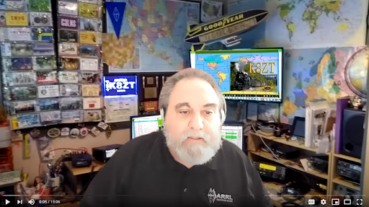***From the Section Youth Coordinator***

***Anthony Luscre, K8ZT - SYC***

[k8zt@arrl.net](mailto:k8zt@arrl.net)

**YOTA Summer Camp 2021**

YOTA (Youth On The Air) in the Americas currently sponsors two events for young hams each year:

* YOTA Summer Camp for ages 15-25
* 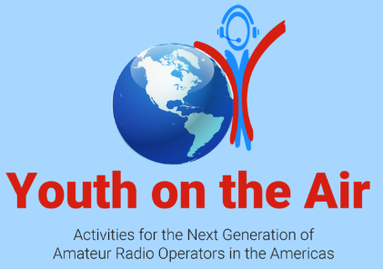December YOTA Month special event for ages 0-25

YOTA Summer Camp 2021 will be held at the National Voice of America Museum of Broadcasting in West Chester, Ohio (Cincinnati Metro-North) on July 11-16, 2021 (postponed from 2020). Of course, YOTA will monitor the COVID situation and adjust if necessary. More information from [YOTA website](https://youthontheair.org/cincinnati-2020/):

“Youth on the Air Camp is for already licensed amateur radio operators between the ages of 15 to 25. Have a license, but you don't know what to do next? Come to YOTA camp, and we'll teach you all kinds of cutting-edge technology that can be used with amateur radio and connect you to other young hams and mentors in North, Central, and South America. Already an expert? We're looking for young hams to take their knowledge to the next level and share their previous knowledge with other young hams.

The camp will focus on building strong relationships with peers and mentors, and developing new radio skills. The camp is being modeled closely after the popular Youngsters on the Air camps in IARU Region 1 (Europe/Africa/Middle East).

Some of the activities that are planned include workshops and hands-on activities about:

* Contesting - Learn how to operate from some of the top young contesters in the country, participate in an FM contest at an amusement park, and ways to practice with local contests
* Digital VHF/UHF Modes - D-STAR: Get a D-STAR radio to use for the week, plus insight into how it works - APRS: Learn how to track stations and gather data using APRS
* Kit building - Learn from world-renowned builders by making your own receiver

TOP^

* Direction finding and orienteering - Learn how to track down signals
* Antenna building - Learn how to make antennas from common household items
* Satellite operations - Learn how to chase the birds with some of the best youth satellite operators
* ...and more!
* Campers will operate a special event station, W8Y, featuring cutting-edge HF and VHF/UHF radios that many only dream of having a chance to use... and a wide array of antennas.”

If you do not qualify as a youth, you can donate to the cause- “If you're "age experienced", you can help us get youth more active in ham radio. [Click here to donate to YOTA](https://youthontheair.org/donate/) Camp via PayPal or GoFundMe at EARS, Inc, a 501c3 charitable organization that is sponsoring the inaugural camp located in the Americas.”

**Technicians, Life Beyond Repeaters (continued)**

Last month I talked about two new presentations I had put together to encourage a wider variety of activities for Technician licenses, both youth and non-youth. I have added a few more presentations:

* ***Technicians, Life Beyond Repeaters***
  + Slideshow- [tiny.cc/btech](http://tiny.cc/btech)
  + 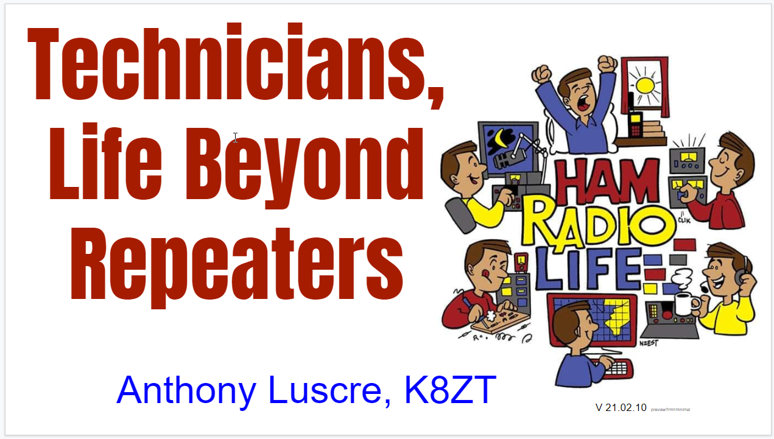There are also a few recordings of me presenting it online. I will be doing shortened versions of it for upcoming events- Vermont Ham-Con 2021- [link](http://ham-con.org/hamconon.html) and an ARRL Webinar, March 9, 2021- [link](http://www.arrl.org/arrl-learning-network).
* ***3 Stations for 100+ Mile Contacts With a Tech License for < $100-*** focuses on three projects discussed in ***Technicians, Life Beyond Repeaters-*** LEO Satellites, FT8 on 10M and 40 or 80M CW
  + Slideshow- [tiny.cc/100tech](http://tiny.cc/100tech)

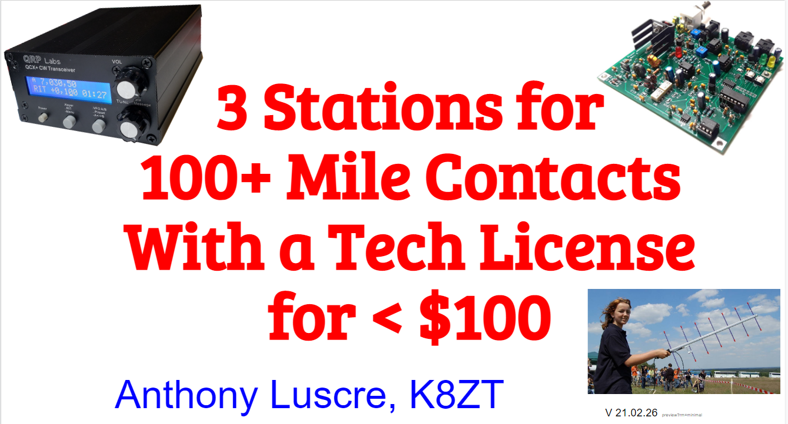

* ***Guide for Buying an Amateur Radio Transceiver***
  + Slideshow- [tiny.cc/buyar](http://tiny.cc/buyar)
  + Spreadsheet- [tiny.cc/buyar-ss](http://tiny.cc/buyar-ss)

For a list of my other presentations- [tiny.cc/k8zt-p](http://tiny.cc/k8zt-p) includes slideshows, video recordings and links. If you are interested in any of these for a live, online presentation for your local club, please email me.

73,

Anthony, K8ZT

TOP^

***From the Section Traffic Manager***

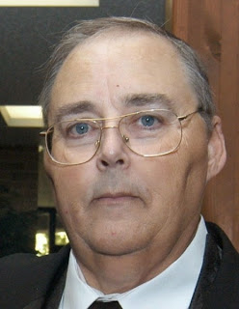***David Maynard, WA3EZN – STM***

[wa3ezn@att.net](mailto:wa3ezn@att.net)

**March 2021**

In case you missed it on March 14 the OSSBN returned to the 6:45 PM time for the evening net The coincided with the daylight savings time change and also pi day (pi = 3.14159265359 ....).

**OHIO SINGLE SIDEBAND NET ANNUAL ELECTION**

The affairs of the OSSBN shall be under the control of the net manager and an advisory board comprised of three members. The net manager and one advisory board member shall be elected each year.

On March 1ST the net manager will appoint a nomination committee of three members with the second year advisory board member as chairman. A slate of nominees for advisory board and net manager shall be presented on March 23. On March 22 the net manager shall appoint a teller who will call for nominations from March 23 through March 31. Nominees must be members of OSSBN and agree to serve if elected. The teller shall call for votes from the members of the net from April 1st through April 7th and shall on April 8th announce the results of the election. The winner in each case shall be that nominee who has received the most votes. Duties of the net manager shall commence on May 1st. Voting may be by radiogram.

OSSBN 2020/2021Net Manager – KC8WH

Assistant Net Manager – KD8MSZ

**Advisory Board Elected**

WD8SDH 2018

KA1G 2019

AC8NP 2020

OHIO SINGLE SIDEBAND NET

["Specializing in the first and last mile of NTS delivery in Ohio."](http://www.ossbn.org/)

|  |  |  |  |
| --- | --- | --- | --- |
| **Morning session** | **10:30 AM** | **3972.5 KHz** | **every day** |
| **Afternoon session** | **4:15 PM** | **3972.5 KHz** | **every day** |
| **Evening session** | **6:15 PM** | **3972.5 KHz** | **every day** |

TOP^

**OHIO HF CW TRAFFIC NETS**

|  |  |  |  |
| --- | --- | --- | --- |
| **HF CW NETS** | **NET TIMES** | **FREQUENCY** | **NET MANAGERS** |
| **Buckeye Early** | **6:45 PM** | **3.580** | **WB8YLO** |
| **Buckeye Late** | **10:00 PM** | **3.590** | **WB9LBI** |
| **Ohio Slow Net** | **6:00 PM** | **3.53535** | **W8MAL** |

All net frequencies plus or minus QRM. .

**OHIO LOCAL VHF TRAFFIC NETS**

|  |  |  |  |
| --- | --- | --- | --- |
| **VHF NETS** | **NET TIMES** | **FREQUENCY** | **NET MANAGERS** |
| **BRTN** | **9:30 PM DAILY** | **145.230 PL 110.9** | **W8DJG** |
| **COTN** | **7:15 PM DAILY** | **146.970** | **KD8TTE** |
| **MVTN** | **7:00 PM Mon** | **146.640** | **KC8HTP** |
| **NWOHARES** | **6:30 PM DAILY** | **147.375** | **N8TNV** |
| **TCTTN** | **9 PM Sun, Tues, Fri** | **146.94** | **WB8YYS** |
| **TATN** | **8:00 PM DAILY** | **146.670 PL123** | **WG8Z** |

These VHF net times and frequencies are those that have been reported to me by the net managers.

Also on March 14 the ARRL published its W1AW 2021 Spring/Summer Operating Schedule

QST de W1AW

ARRL Bulletin 4 ARLB004

From ARRL Headquarters

Newington CT March 14, 2021

To all radio amateurs

SB QST ARL ARLB004

ARLB004 W1AW 2021 Spring/Summer Operating Schedule

Morning Schedule:

Time Mode Days

------------------- ---- ---------

1300 UTC (9 AM ET) Cws Wed, Fri

1300 UTC (9 AM ET) Cwf Tue, Thu

TOP^

Afternoon/Evening Schedule:

Time Mode Days

------------------- ---- ---------

2000 UTC (4 PM ET) Cwf Mon, Wed, Fri

2000 UTC (4 PM ET) CWs Tue, Thu

2100 UTC (5 PM ET) CWb Daily

2200 UTC (6 PM ET) DIGITAL Daily

2300 UTC (7 PM ET) CWs Mon, Wed, Fri

2300 UTC (7 PM ET) CWf Tue, Thu

0000 UTC (8 PM ET) CWb Daily

0100 UTC (9 PM ET) DIGITAL Daily

0145 UTC (9:45 PM ET) VOICE Daily

0200 UTC (10 PM ET) CWf Mon, Wed, Fri

0200 UTC (10 PM ET) CWs Tue, Thu

0300 UTC (11 PM ET) CWb Daily

Frequencies (MHz)

-----------------

CW: 1.8025 3.5815 7.0475 14.0475 18.0975 21.0675 28.0675 50.350 147.555

DIGITAL: - 3.5975 7.095 14.095 18.1025 21.095 28.095 50.350 147.555

VOICE: 1.855 3.990 7.290 14.290 18.160 21.390 28.590 50.350 147.555

Notes:

CWs = Morse Code practice (slow) = 5, 7.5, 10, 13 and 15 WPM

CWf = Morse Code practice (fast) = 35, 30, 25, 20, 15, 13 and 10 WPM

CWb = Morse Code Bulletins = 18 WPM

CW frequencies include code practices, Qualifying Runs and CW bulletins.

DIGITAL = BAUDOT (45.45 baud), BPSK31 and MFSK16 in a revolving schedule.

Code practice texts are from QST, and the source of each practice is given at the beginning of each practice and at the beginning of alternate speeds.

On Tuesdays and Fridays at 2230 UTC (6:30 PM ET), Keplerian Elements for active amateur satellites are sent on the regular digital frequencies.

A DX bulletin replaces or is added to the regular bulletins between 0000 UTC (8 PM ET) Thursdays and 0000 UTC (8 PM ET) Fridays.

The complete W1AW Operating Schedule may be found on page 77 in the March 2021 issue of QST or on the web at, <http://www.arrl.org/w1aw-operating-schedule>.

TOP^

**Great Lakes Area Winlink Net Started**

A new Great Lakes Winlink Net has been started to promote the use of Winlink and training on the various facets of the hybrid amateur radio data/internet system. The net is open primarily to those states that border any of the Great Lakes: Minnesota, Wisconsin, Illinois, Indiana, Michigan, Ohio, Pennsylvania, and New York, and the Canadian province of Ontario. However, radio amateurs wishing to check in from other states or provinces anywhere are welcomed to participate. This net is modeled on the [Wisconsin ARES Winlink net.](http://wi-aresraces.org/)

The net check-in process is as follows: Send either a basic, plain text message, or use any of the forms templates on the Winlink Express platform available that will allow you to include the following line of text in the body of the message or in an appropriate part on the form you choose to send: FIRST NAME, CALLSIGN, CITY, COUNTY, STATE, COUNTRY. For example: RYAN, KB8RCR, REMUS, MECOSTA, MICHIGAN, USA.

The net started on Wednesday, March 10, and each week on Wednesdays, amateurs may send their messages or forms any time during the day using Winlink in any mode available, RF or via Telnet. Send your message to KB8RCR as the recipient on Winlink. - Ryan Lughermo, KB8RCR, ARRL Assistant Section Emergency Coordinator for Data Management/Special Projects, Michigan Section; and Official Relay Station

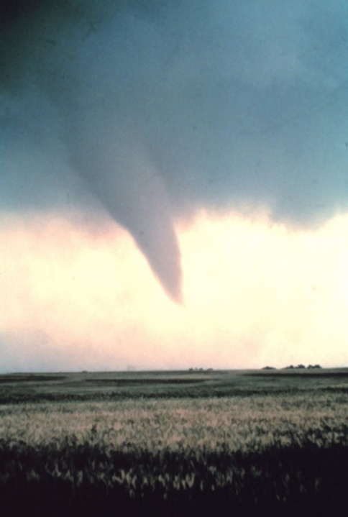

I hope we are all familiar with the volunteer opportunities of the ARES programs. Is a program like SKYWARN®, Weather Spotting Program, right for you?

The Skywarn® spotter program is a nationwide network of volunteers trained by the National Weather Service (NWS) to report significant weather. Anyone is welcome to participate.

**How does Skywarn® function?**  
Information is relayed to the NWS during tornadoes, severe thunderstorms, snow storms, flooding, and any other weather event that involves the use of volunteer storm spotters. If you observe rough weather, we want to know about it!

TOP^

**Who will activate Skywarn®?**  
A NWS office and/or emergency management authorities may activate the Skywarn® net, usually whenever there is a severe weather threat or the forecast office issues a severe thunderstorm watch, tornado watch or flood watch. In this case, information will be relayed through Skywarn’s amateur radio repeater. Also, the NWS’s Hazardous Weather Outlook gives severe weather information and forecasts and determines if Skywarn® activation is needed.

**Where are Skywarn® observations taken?**  
Skywarn® reports are relayed from wherever the weather spotter is - on the road, in the office, or at home. It is important, however, not to jeopardize your own safety while participating in Skywarn®. Spotters should give their reports once they are in a safe location, away from the hazardous weather.

**How are Skywarn® and Ham (amateur) radio operators related?**  
National Weather Service offices have Ham radio equipment on site. A Skywarn® net run by the volunteer amateur radio net control operators allow for reports from the field to be heard directly at the NWS office.

**Does it cost anything to join Skywarn®?**  
Absolutely not! All training that the NWS provides is for the benefit of the weather spotter and his/her community. There is even a toll-free number provided for Skywarn® weather spotters to call and give their reports.

**How can I join Skywarn®?**  
Attend one of the training sessions that take place in the spring and in the fall. The NWS will record your location and contact information and will provide you with the knowledge of what to report on and when to report.

The National Weather Service was not able to conduct in person spotter training classes this winter and spring due to restrictions associated with COVID. Therefore, they held several virtual spotter training classes. The 6 webinars were held in February and March.

Here are links to National Weather Service web pages.

* [NWS Cleveland Office](http://www.weather.gov/cle/SKYWARN)
* [NWS Wilmington Office](http://www.weather.gov/iln/spottertrainingschedule)
* [NWS Charleston, WV Office](http://www.weather.gov/rlx/Skywarn)
* [NWS Northern Indiana Office](http://www.weather.gov/iwx/iwxskywarn)
* [NWS Pittsburgh, PA Office](http://www.weather.gov/pbz/skywarn)

Points of contact for additional information on the Skywarn® program:

**Michael Lewis** (for Northwest Ohio)  
National Weather Service - Northern Indiana (574) 834-1104  
E-mail: [michael.lewis@noaa.gov](mailto:michael.lewis@noaa.gov)  
[www.weather.gov/iwx/](http://www.weather.gov/iwx/)

**Christine Riley** (for Northern Ohio)  
National Weather Service – Cleveland (216) 265-2382  
E-mail: [christine.riley@noaa.gov](mailto:christine.riley@noaa.gov)  
[www.weather.gov/cle/](http://www.weather.gov/cle/)

TOP^

**Brandon Peloquin** (for Central and Southwest Ohio)  
National Weather Service – Wilmington (937) 383-0031  
E-mail:[brandon.peloquin@noaa.gov](mailto:Brandon.Peloquin@noaa.gov)  
<http://www.weather.gov/iln>

**Tony Edwards**  (for Southeast Ohio)  
National Weather Service - Charleston, WV (304) 746-0175 x223  
E-mail: [tony.edwards@noaa.gov](mailto:tony.edwards@noaa.gov)  
[www.weather.gov/rlx/](http://www.weather.gov/rlx/)

**Fred McMullen** (East-Central Ohio)  
National Weather Service - Pittsburgh, PA (412) 262-1591  
E-mail:[fred.mcmullen@noaa.gov](mailto:fred.mcmullen@noaa.gov)  
[www.weather.gov/pbz/](http://www.weather.gov/pbz/)

<https://www.weathersafety.ohio.gov/SkyWarn.aspx>

SKYWARN® REPEATERS FOUND IN OHIO

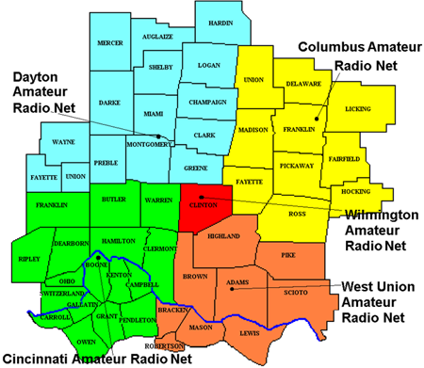According to the Repeater Book there are **34 SKYWARN® REPEATERS FOUND IN OHIO**. There are 88 counties in Ohio. So what gives? The answer is multiple counties are covered by the Skywarn® nets. For example southwestern Ohio Severe Weather Nets covers these counties,.

In the online Repeaterbook there is an interactive file called **34 SKYWARN® REPEATERS FOUND IN OHIO.** This is a very informative file with links to the34 SKYWARN® REPEATERS, there frequencies and contact information. Many attempts were made to include the chart/list in this article but I failed because it was more massive than I could handle. So you will have to go to the Repeaterbook website to use it at <https://www.repeaterbook.com/repeaters/feature_search.php?state_id=39&type=SKYWARN>

73

David WA3EZN

Ohio Section Traffic Manager

**You can view the STM’s monthly report on the website..** [**http://arrl-ohio.org/stm/stm.html**](http://arrl-ohio.org/stm/stm.html)

TOP^

*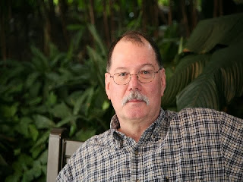****ARES Training Update***

***Jim Yoder, W8ERW – ARES Data Manager***

[w8erw@arrl.net](mailto:w8erw@arrl.net)

Could we be approaching some level or normalcy? I sure hope so. It’s been a long winter and after almost an entire year of cautious and planned avoidance, we might just see a Hamfest or two this year. I am not at all confident about our political situation and I am sure like me, most of you have had enough of the consternation throughout the last year and into this one.

I’ve almost forgotten how much fun it is to sit down for a Saturday breakfast with fellow Amateurs. I’m not giving in though. There is hope and on a very positive note, I am hearing from all directions, we are growing and new Hams are being made. License classes are in progress and I’m fielding questions from several perspective new Hams. My imagination wanders a bit as I contemplate a bunch of new voices on the air and new associations to be made.

Let’s all extend a warm welcome to these new folks as they join us in the greatest hobby. What a great time it is too for a new Ham. Propagation is on the upswing with Solar Cycle 25 showing it’s on the way. Perhaps this will indeed be a very positive time for making contacts and going after the DX. I well remember when I got my ticket back in late 1990. The solar cycle was peaking and I filled a logbook in just 3 months on 10 meters as a new technician. It has not been that good since, but it is coming back and it will be a thrilling experience for this newest crop of freshly minted Hams. We want to insure they get all the help they need to get on the air and experience the joy of making all those contacts. In a couple of days, the Seneca Radio club will be testing the recently completed Technician class. Let me congratulate everyone for another successful effort to prepare and make a fine group of new Amateur Radio Operators.

Personally, I am looking forward this year to the warmer weather and the chance to get out in nature a bit with the new RV trailer. Kim found one she liked and we went for it. I can see some evening in the

future with a campfire, the smell of the outdoors in the morning and breakfast with hot coffee as I set up a portable station away from the city noise in a perfectly relaxing environment. My dear XYL has been busily adding her touches to the RV and both of us are excited about the opportunity to take in some of the countryside and nature available. I bought a small trash can with an appropriate label on it, “Trailer Trash”.

We must continue to build our skills and be diligent in our effort to be prepared, trained and ready when our served agencies call for our service. Since we embarked on this program to establish a formal training requirement, the groups and agencies we serve have also gone forward and have progressively made FEMA NIMS a requirement. Emergency Operations Managers across the state recognize the importance of training and a readiness posture that will enable us to step in as communicators when asked to do so. ARES members are in a unique position to step into the role of communicator while supporting a disaster response. I encourage everyone who participates in our ARES program to consider the importance and benefit of completing NIMS training.

TOP^

NIMS is designed to provide the background and structure required to enable an organized and effective disaster response. Your ability to perform a valued service will be greatly enhanced and you will be a respected and vital part of the team our served agencies both need and require. Even if you participate from the rear in a more supportive role rather than directly, this training will equip and prepare you with the tools necessary to respond with the best of your ability. NIMS training will make you an asset rather than a burden to those who will need us most.

I am pleased again this month to report our training response continues to grow and improve. We have 1,910 Amateurs in the database. Level 2 members are at 732 and Level 3 at 204. Additionally, many have gone further and have completed the Professional Development Series of classes and others to meet specific requirements of our served agencies. The training database has registered 9,843 certificates from our ARES members. Although the momentum has slowed considerably as we are maturing in this effort, many still have not embraced initial NIMS training for Level 2. It is important to realize the significance of these numbers as we must also stand vigilant in protecting our access to spectrum. We must not become complacent in our effort and our ability to demonstrate through training, our commitment to public service as a vehicle to justify our access to spectrum.

Thank you all for your continued support of ARES. Our Ohio Amateurs are the best!

Thanks again and 73,

**Jim W8ERW**

[w8erw@arrl.net](mailto:w8erw@arrl.net)

##

**Amateur Radio Operating Class Starting April 15**

The National Electronics Museum is sponsoring its well-received Operating Course again starting April 15, 2021 and running each Thursday for 11 weeks from 6:30 to 9:30 EDST on Zoom.   There is no charge for participation.  The purpose of these classes is to provide information to help licensed radio amateurs to participate in the many on-the-air activities available in the hobby.  The presenters are very experienced in their topics—many are nationally known experts—and they will be available to answer your questions following the presentations.

The exact order of presentations will be determined and published in the next few weeks.   These are independent presentations, and participants are free to participate in any or all of the evenings.   Feel free to pass this announcement along to others, but we request that all prospective attendees register by emailing Tom Christovich at [tom.christovich@gmail.com](mailto:tom.christovich@gmail.com) . You will receive confirmation of enrollment and the Zoom link for attendance by reply email.  Here is a tentative list of topics:

TOP^

All About Operating-an Introduction

Amateur Radio Organizations: Local, National, and International clubs, societies and groups devoted to specific aspects of amateur radio

Ham Radio Operating Award Hunting—from working Lighthouses to the DXCC Challenge

DXing

QSLing

VHF/UHF Weak Signal Work

Remote Station Control Over Internet

CW in the No-code Era

Digital modes

Imaging Operating

Contesting

Logging Software

HF Propagation

Amateur Satellite Comms

Portable (backpacking) Operation, including Park and Summits

Setting Up an HF Station

Emergency and Public Service Communications (ARES and RACES)

Traffic Handling

Lightning Protection and Grounding

Hope to see you there!

73,

Rol Anders, K3RA

***National News***

*(from arrl and other sources)*

**ARLB009 NCVEC Question Pool Committee Seeks Input for Updated  
Technician Question Pool**

The National Conference of Volunteer Examiner Coordinators (NCVEC - <http://www.ncvec.org/> ) Question Pool Committee (QPC - <http://www.ncvec.org/page.php?id=333> ) is requesting input from the amateur radio community on new or modified questions for the 2022 - 2026 FCC Element 2 Technician Pool, which goes into effect on July 1, 2022. This may include suggestions for new questions, changes to current examination topic areas, or changes to existing questions in the current Technician Question Pool.  
  
The QPC offered guidelines that said it's seeking input that focuses on topics that enhance public interest, understanding, and use of amateur radio, or focus on STEM hands-on learning and education, as well as questions on new technology, digital modes, station setup and operation, antennas, and emergency and non-emergency operation.

TOP^

To submit suggested questions for QPC review, the committee asks that questions have no more than two 70-character lines, including spaces. Distractors should be no more than 70-character lines long, and shorter if possible. Each multiple-choice question must be accompanied by four possible distractors and only one correct  
answer. The answer choices may be in any order, but the correct answer must be indicated by the letters A, B, C, or D at the beginning of the question. Those submitting suggestions should provide the resource information that supports the correct answer or the FCC Part 97 rule.  
  
The QPC will accept question comments, revisions, and submissions from the amateur radio community via email through June 30, 2021.

This email address is a bulk forwarding mailbox, so no acknowledgement will be sent by return email. The NCVEC QPC will take all comments into consideration as it updates the Technician Question Pool for 2022 - 2026.  
  
The email address is, [QPCinput@ncvec.org](mailto:QPCinput@ncvec.org) .

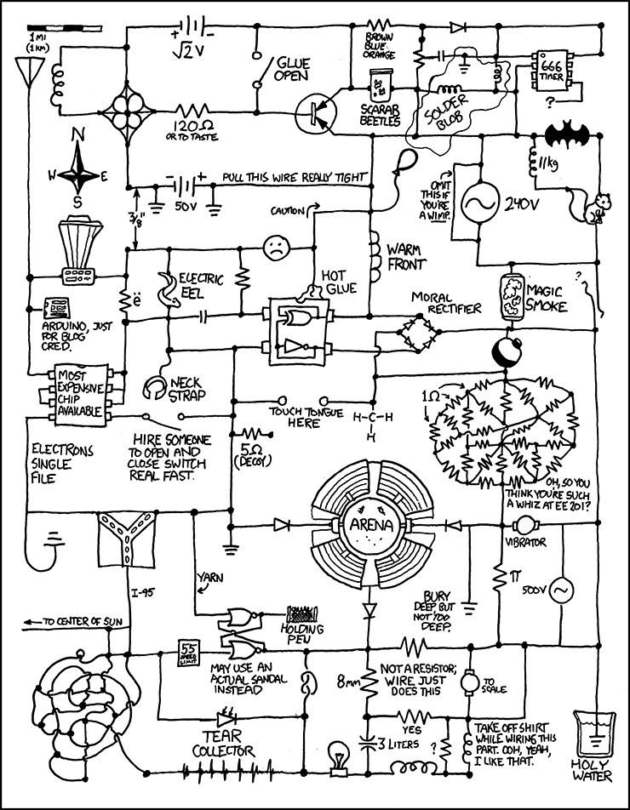

TOP^

**(Editor’s note: Please read this carefully and review all the links – this is news you can use!)**

**World Amateur Radio Day is Sunday, April 18, 2021 |**

[**www.arrl.org/world-amateur-radio-day**](http://www.arrl.org/world-amateur-radio-day)

Dear friends,

Get ready! **2021 World Amateur Radio Day is Sunday, April 18.** Members of the Public Relations Committee and ARRL Headquarters have created a Media Advisory Template for the express use of ARRL Public Information Officers (PIOs) and Public Information Coordinators (PICs) to support information sharing and promote participation. The Media Advisory is customizable by PIOs and PICs to inform traditional media and social media about World Amateur Radio Day. You can also spread-the-word among the radio clubs you know, and with friends and family.

[2021 World Amateur Radio Day backgrounder](http://www.arrl.org/files/file/Media%20&%20PR/World%20Amateur%20Radio%20Day/World%20Amateur%20Radio%20Day%202021%20ARRL%20Backgrounder.pdf) (PDF)

[2021 World Amateur Radio Day media advisory](http://www.arrl.org/files/file/Media%20&%20PR/World%20Amateur%20Radio%20Day/World%20Amateur%20Radio%20Day%202021%20ARRL%20Media%20Advisory.docx) (WORD template)

[Día Mundial de la Radioafición 2021 transfondo](http://www.arrl.org/files/file/Media%20&%20PR/World%20Amateur%20Radio%20Day/World%20Amateur%20Radio%20Day%202021%20ARRL%20Backgrounder%20Spanish-version.pdf) (PDF)

[Día Mundial de la Radioafición 2021 aviso a los medios](http://www.arrl.org/files/file/Media%20&%20PR/World%20Amateur%20Radio%20Day/World%20Amateur%20Radio%20Day%202021%20ARRL%20Media%20Advisory%20Spanish-version.docx) (WORD template)

World Amateur Radio Day, held annually on April 18, is celebrated by radio amateurs and their national associations which are organized as member-societies of the International Amateur Radio Union (IARU). It was on this day in 1925 that the IARU was formed in Paris, France. ARRL Co-Founder Hiram Percy Maxim was its first president. **On World Amateur Radio Day, all radio amateurs are invited to take to the airwaves to enjoy our global friendship with other amateurs, and to show our skills and capabilities to the public.**

You’ll find lots of ideas for planning your participation of World Amateur Radio Day at [www.arrl.org/world-amateur-radio-day](http://www.arrl.org/world-amateur-radio-day). And remember that [ARRL Field Day](http://www.arrl.org/field-day) is just around the corner – June 26-27 – so use World Amateur Radio Day to help shore up your contacts with local news and media outlets.

**Additional Resources…**

**IARU | World Amateur Radio Day**<https://www.iaru.org/on-the-air/world-amateur-radio-day>

**IARU Region 2: The Americas | World Amateur Radio Day**<https://www.iaru-r2.org/en/on-the-air/world-amateur-radio-day/>

TOP^

Article: “**Why World Amateur Radio Day is key to highlight crucial service**,” ITU News Magazine (No. 1, 2021)  
<https://www.itu.int/en/myitu/Publications/2021/02/02/15/24/ITU-News-Magazine-No-1-2021>

Social media hashtags (Facebook, Twitter, etc.)…  
**#WorldAmateurRadioDay  
#DíaMundialRadioaficion  
#HamRadio  
#AmateurRadio  
#ARRL**

We hope to see you on the air and in the media for World Amateur Radio Day! If you contribute to a media hit that mentions World Amateur Radio Day, share it with us: [newsmedia@arrl.org](mailto:newsmedia@arrl.org). Share it on this reflector too, [pr@reflector.arrl.org](mailto:pr@reflector.arrl.org).  
  
73 Bob NQ1R

***Club Corner***

This is YOUR corner of the newsletter. Send us what your club is doing, and we’ll make sure that it gets in. Got a special event or club project that you want everyone to know about? Send it to us!. Need help with a project? Send it to us.

Let us know what you club is up to. Are you going to have a special guest at your meeting or are you having a special anniversary?

Send it to: [webmaster@arrl-ohio.org](mailto:webmaster@arrl-ohio.org)

***From The Toledo Mobile Radio Association (TMRA)***

We're finally in need of help for an event! The Glass City Marathon is happening on Sunday, April 25th. Race start time will be 6:30 AM this year and we'll need about 30 volunteers to fill all the available spots. Volunteers will be required to wear a mask and practice social  
distancing. If you'd like to volunteer or have any questions please contact me at either [k8rks@arrl.net](mailto:k8rks@arrl.net) or 419-471-0573. Thanks!  
  
Rick K8RKS  
[k8rks@arrl.net](mailto:k8rks@arrl.net)  
419-471-0573

TOP^

***DX This Week***

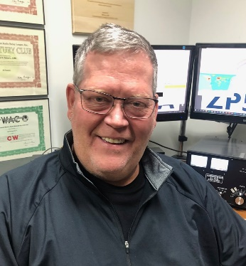

***DX This Week – Apps and Sites***

***Bill AJ8B (***[***aj8b@arrl.net***](mailto:aj8b@arrl.net)***, @AJ8B, or*** [***www.aj8b.com***](http://www.aj8b.com)***)***

***CWOPs Member #1567***

The Midwest DX Cluster spots included Asiatic Russia, Australia, Austria, Balearic Islands, Belarus, Belgium, Bosnia-Herzegovina, Botswana, Brazil, Bulgaria, Canada, China, Cocos (Keeling) Islands, Crete, Croatia, Curacao, Denmark, Dodecanese, Ecuador, England, European Russia, Fed. Rep. of Germany, France, French Guiana, Gibraltar, Greece, Hong Kong, Indonesia, Isle of Man, Italy, Japan, Jordan, Kenya, Latvia, Lithuania, Montenegro, Netherlands, Poland, Reunion Island, Romania, Singapore, Slovak Republic, South Africa, Spain, Sweden, US Virgin Islands, Wales, West Malaysia, and Zambia. This brings the total number of entities spotted in the Midwest in 2021to 155!

As I am putting this together, I am listening for both A25RU in Botswana and VK9CE on Cocos-Keeling. Both DXPeditions are good news as they are examples of travel restrictions being lessened. Hope you work them!

This was a solid week for QSL cards. I received the following confirming 160M QSOs: KH2L - Guam, JA8ISU – Kazuo confirming Japan, and OZ7YY – Finn confirming Denmark.

|  |  |
| --- | --- |
|  |  |
|  | |

TOP^

Did you attend the QSO Today Ham Expo? I know there were multiple technical issues, but Eric is pushing the envelope with what he is trying to offer, and I am looking forward to the next event. Please send me your thoughts!

Finally, there is a major announcement from the W8DXCC convention committee. The W8DXCC convention is held in conjunction with the Cincinnati Hamfest.

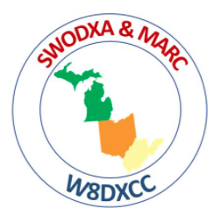The Hamfest is held in the morning and the W8DXCC convention in the afternoon. Each event requires a modestly priced ticket to attend.

Cincinnati Hamfest will be held at the Clermont Count fairgrounds on August 28th! Hamfest information can be found at www.cincinnatihamfest.org and W8DXCC information can be found at www.w8dxcc.com.

The W8DXCC committee will soon be announcing the speaker lineup and when tickets can be purchased. There will be a limited number of tickets available for the DX convention. You can go to the www.w8dxcc.com website and fill out the form at the bottom of the page to be kept informed of events.

**However, the big announcement is that Icom, in cooperation with DXEngineering, has agreed to donate an Icom IC-7300 as the door prize for the DX Convention. We are excited about this and thankful to both Icom and DXEngineering for their continued support of our DX activities.**

*DAH DIT DIT DIT DAH DAH DIT DIT DIT DAH*

Below is part 2 of the 2020 DXCC Year End Review created by W1JR, Joe Reisert. Bernie, W3UR, has given me permission to reprint this.



**2020 Month by Month DX Activity Sample:**

**January**: This is always a tough month especially being at the bottom of the solar cycle. This month had only 185-190 active entities, about 30 less than January 2019. Notable rare to semi-rare active stations S01WS, 4U1UN, TR8CA, T6AA, 9G2HO, and 5A0YL were active on and off all year. 3D2AG/P (Rotuma), ZC4UW (26KQ), E44RU (19.6K), 8Q7BS, 9L1YXJ, VK9NK (58K), C21NH, 9Q1C, XZ2B, HU1DL (60K) and JT5DX (mostly 160 meters) were active.

TOP^

**February**: Lots of DX contest activity plus TI9A (30K), 5I5TI (47K), 5I4CC (17K), E44CC, TZ1CE, 9N7AM, TN/UA9FGR, TU4PCT (29K), and VP8PJ (S. Orkney-83K) were active.

**March**: YJ0NC, 9J2LA (35K), T32AZ and VP2VB (18K) were all active.

**April**: Lots of STAYHOME like HZ1STAYHOME, 9K2STAYHOME, A60SH and STAYSAFE were active due to CV worldwide. Many planned DXpeditions started to cancel due to CV.

**May**: Lots of odd call signs. SV2RSG/A (Mt. Athos) made a brief appearance on CW.

**June**: OJ0A, OJ0JR (I love that call sign) plus 6O1OO were active.

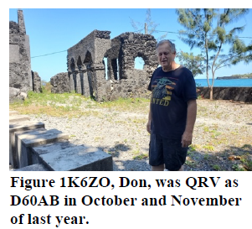**July** **and** **August**: KH9/WW6RG, XW2DX, OJ0s and ZL7DX (FT8) were active. VK9NK was finally allowed to return home due to CV travel restrictions.

**September**: TO0Z (FJ) and OJ0JR.

**October**: Activity picked up with VQ9T, 5U4IHM, E51WL (N. Cook), 7Q6M, JX2US, NL7RR/KH9, Z66DX (33K) and TX0T (FO from a New IOTA).

**November**: Solar flux increased and 15 Meters and up improved. 7Q7RU, JG8NQJ/JD1 (JD/M), TZ1CE, D60AB and 8Q7ZO were all active.

**December**: This month has been designated YOTA (Youngsters on the Air) month with many stations using call signs with YOTA in same plus several USA stations using 1X1 call signs like K8Y. Give them a call and encourage them to join the DX community. 3DA0AQ, JX2US, VP6MW, 6O1OO and 3D2AG/P (Rotuma) were all active

**Unauthorized Operations:** As usual, many fake stations including many DXpeditions (before activation) were active. This is why DXpeditions are reluctant to give out their call signs before commencing operation for fear that their call sign will be pirated. Some of the pirated call signs during this year included many JXs, CE0X, VU4R, VU7AAV, EZ8CQ (EZ operation is illegal since August 2006), D1DX, and ZD9XF to name a few. WFWL (work first, worry later) still applies but if you know it’s a pirate, don’t waste your time or $$ to support that activity. K9EL often lists pirate call signs on the CQ Magazine Marathon page.

Furthermore, please don’t spot rare DX on the DX Cluster unless you know it’s legit and surely don’t spot rare DX call signs for test purposes. It causes lots of bells to ring worldwide and unnecessary worry. Finally, don’t post rare calls to thank someone for receiving a QSL etc. No one who is watching cares or appreciates this type of boasting.

TOP^

**CTU and CWA**: Let’s not forget Contest University under the direction of Tim, K3LR. It is now in its 14th year having had over 7,500 students in 8 DXCC entities so far. CW Academy by CWops, a program to improve

CW skills. CWops just celebrated its 11th anniversary. “Improving Your CW” is another Morse Trainer by G4FON. Also, K1USN now has weekly slow speed CW activity for beginners.

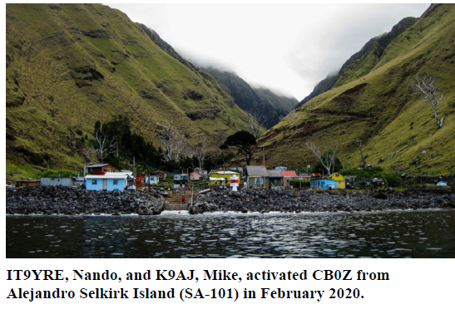

**IOTA:** Poor propagation and CV almost shut down many rare and new IOTA (Islands on the Air) activity worldwide with many DXpeditions cancelled. Ironically, IOTA became the name of one of the North American hurricanes in November. CB0Z (CE0Z) put this new IOTA (SA101) on in January, 6F3A (NA153), RI0B (AS068), R207RRC new (AS207) and TX0T new (OC298) beat the odds. The IOTA program website is www.iota-world.org. It is filled with info on the program Remember that QSLing can now be conducted for some IOTA operations using LOTW.

**DX Contesting**: DX contests were everywhere this year using CW, SSB and digital modes. Early reports are that it was a banner year with new record number of entries. Lots of operators worked from home instead of the large DX contest stations and of course lack of DXpeditions. Some larger stations sponsored smaller operations to YOTA operators. The WA7BNM Contest Calendar is a great source of contest activity. The ARRL Contest Update is a biweekly newsletter that often has interesting tidbits on operating etc.

**Equipment, Technology and Accessories:** This was a very poor year for Amateur Radio suppliers. At least one closed shop and others consolidated. The lack of DX gatherings due to CV surely took its toll on displaying new gear etc. There are new gadgets, gear and software but you’ll likely have to shop around perhaps on the internet.

**Safety**: This can never be stressed enough, especially when towers or antennas are involved. Professional expertise is highly recommended. There were some tower related deaths and at least one experienced tower specialist was seriously injured this past year.

Safety equipment is very important on tower or antenna work. Better yet, have a professional tower crew do the work. K1IR has a video showing “Tower Safety” and is well worth viewing www.maarc.ca/news/tower-safety video. Also Zero Falls Alliance. This reminds us that every tower climber injury or death is usually preventable.

TOP^

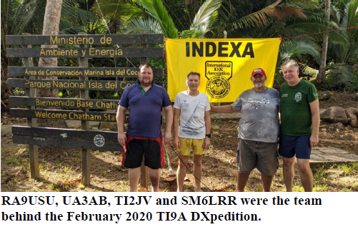**Ham Radio and the Internet:** The internet plays an important part in Ham Radio. Most DX clusters are now on the internet as well as LOTW (more on this shortly) and Club Log to mention a few. Also many contests require logs to be submitted via the internet within a few days after the contest. Please remember to show modes such as SSB, CW, FT8, FT8 F/H when spotting stations near band mode overlaps that can confuse operators.

**QSLing and DXpedition Costs**: QSLing is now becoming a lost art. Costs are skyrocketing. As a result of the CV, mail services were discontinued to over 50 countries at one time this year, some for long periods of time. As a result, LOTW (Logbook of the World) at ARRL has become very popular (see ARRL below). OQRS on Club Log is helping to obtain QSLs especially from DXpeditions and very active DX stations. See Note 1.

**Operating techniques**: This past year was a tough one worldwide. Needless to say, the RST report on CW is now almost always 599 and 59 on SSB! FT is more complex. Split frequency operation on rare DX stations is almost always a must. Unfortunately, many call right on the DX frequency and hence cause panic! Please don’t tune up your transmitter on the common DX frequencies. The old adage still applies: Always Listen Listen Listen before you start to transmit. Since poor operating procedures seem to be repeated over and over and to save space in this report, please refer to note 1.

**Silent Keys (SK)**: This is always a tough subject to write about and is even tougher with the CV pandemic. They meant so much to our great hobby. In the past years, they had grown to over 200 in each monthly issue of QST, but the recent lists have decreased below 150. Hopefully this is a good sign and not just under reporting. The following is a partial list of notable DXers, contesters, DXPedition operators, designers or officials in Amateur Radio that I have noted in no particular order who became SKs during 2020.

They include in no particular order: DK5DC, K8LEE, K9HMB, W8ILC, W3AZD, KV4FZ, K2RIW, KB8RQ, K1LPS, PY2NX, W9SR, W3YOZ, F2MA, DK3KR, K1LU, W4QM, HP1AC, W3NQN, 3W2LI, ZP6CW, W5FU, A41KT, OH3VV, N8PR, KN4F, YL2DX, PY0FF, W1AX, ON4UN, G3TEV, IK2DIA, DL9GFB, K2QBV, WF5E, K8CC and K4SSU.

**2020 DXCC and ARRL Matters**: Rumors in the news media tell us that Bougainville, an autonomous region in Papua New Guinea (P29), has voted to become an independent nation. This could take years to happen before it is added to the active DXCC list.

RA9USU, UA3AB, TI2JV and SM6LRR were the team behind the February 2020 TI9A DXPedition.

TOP^

The DXCC yearbook has been published mid-year for many years but now it only lists those who submitted DXCC updates during the prior year. If you want to see the latest DXCC standings, first go to www.arrl.org. Next click “on the air, and then DXCC Standings.” Of course, the ARRL runs LOTW and it is constantly being updated. The LOTW now has over 1.280 billion QSOs on file. New publications were published in 2020 which were primarily aimed at assisting newcomers to the hobby. The ARRL QSL bureau is another service for league members.

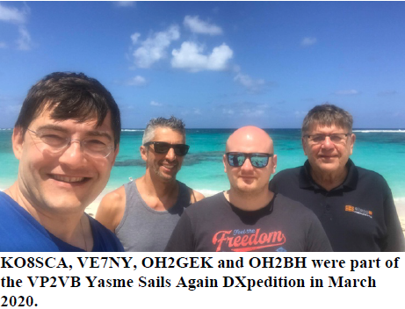

And now the Drum Roll: There were approximately 74 entities that are NOT believed to have been active during 2020. DX was severely affected by travel restrictions due to CV.*

**Africa (23):** 3B6, 3C, 3C0, 3X, 3Y/B, 5N, 7P, 9U, E3, FH, FT/G, FT/J, FT/T, FT/W, FT/X, FT/Z, J5, S9, TJ, TL, VK0H, ZD9 and ZS8.

**Antarctica (1):** 3Y0/P

**Asia (9):** 1S, 7O, A5, BS7H, BV9P, EZ, P5, VU4, and YK.

**Europe (2):** 1A0 and R1F

**North America (7)**: CY0, CY9, FO/C, KP1, KP5, XF4 and YV0.

**Oceania (25)**: 3D2 (Conway Reef), E6, FK/C, FO/A, FW, H40 (Temotu), KH1, KH3, KH5, KH7K, KH8, KH8/S, T2, T30, T31, T33, VK0M, VK9C, VK9M, VK9W, VK9X, VP6D, ZK3, ZL8 and ZL9.

**South America (7):** CE0/X, HC8, HK0/M, PY0/S, PY0/T, VP8 (S. Georgia), and VP8 (S. Sandwich).

*Please note that some rare entities may not be on this list for 2020 because some operations were short, set up schedules or only on VHF, EME (Earth-Moon-Earth) etc.

The DXCC entities that are not believed to have been activated in ten (10) or more years has increased and now includes: 3Y/B, 3Y/P, BV9P, BS7H, CE0X, EZ, FT/G, FT/W, KH7K, KH3, P5 and YV0. This means that an avid DXer working hard at DXCC may take over 13 years to make it to the DXCC Honor Roll. This list also serves as a guide to those planning DXpeditions to rare entities. As for me, the top of my need list for the DX Challenge has not changed in many years and not surprisingly goes to P5, BS7H, FT5/W and BQ9P in that order.

**Upcoming DXpeditions**: There is still a chance for 3Y0I to activate Bouvet Island late in 2021. Due to the CV, many DXpeditions planned for 2020 may be activated late in 2021 but that is very speculative. Unless CV comes more under controlled, it may be a dull DX year with less entities active like 2020. Stay tuned and check the www.ng3k.com/misc/adxo.html and Daily DX calendars at: http://www.dailydx.com/the-daily-dx-calendar/ for future operations.

TOP^

**Looking ahead to 2021 and Beyond**: As stated above, solar cycle 25 should be gearing up in 2021. DX has really changed in the last few years with FT8 and CV problems. Some DXers chase the DXCC Honor Roll, the DXCC Challenge or the DX Marathon. 1,625 DXers have confirmed all 340 entities on the present DXCC list including nearly one thousand DXers from outside the U.S. More than 200 DXers have now achieved the very difficult DXCC Challenge 3000 level. Fernando, EA8AK now has an amazing 3264 entities and still leads the DXCC Challenge.

It’s time to improve your 10 thru 15 meters as well as keeping your 80 and 160 meter antennas in repair. Then there are the never ending DX Contests, DX Marathon, DXCC Challenge and IOTA chasing. There are lots of things to do. KO8SCA, VE7NY, OH2GEK and OH2BH were part of the VP2VB Yasme Sails Again DXpedition in March 2020.

Don’t let the airways die for lack of activity. HF radio conditions on the upper HF bands are improving. Try to stay active and join the fun. Also don’t forget to support the various DX Foundations around the world that help make DXpeditions possible!

Finally: We hope this review has been informative especially for historical purposes. Using DX publications and the Internet are a great way to keeping us up to date on what is happening now and in the future. Once again, I am honored to be asked by Bernie, W3UR to write this review for the 16th year and for his valuable inputs and critique. Thanks also to John, K9EL, Michael, G7VJR and especially Frank, W3LPL for their valuable inputs as well as my son Jim, AD1C for his computer help! Previous reviews can be read on the K8CX Ham Gallery website.

73, Joe Reisert, W1JR

Note 1. To keep the size of this report under control, some additional information which may be repetitive has been in my 2019 or prior reports on the K8CX website especially on the Colvin QSLs.

NOTE: Obviously all the opinions etc. expressed are solely mine as are any errors that I have made. This End of Year Review is copyrighted. Therefore copies or use of this review MUST first be approved by Bernie, W3UR and then a courtesy copy of the reprint sent to Joe, W1JR. Best of DX to you in 2021. I’ll see you in the pile ups.

*DAH DIT DIT DIT DAH DAH DIT DIT DIT DAH*

CQDX CQDX CQDX CQDX CQDX CQDX CQDX CQDX CQDX

Here is an update from Bernie, W3UR, of the DailyDX and the WeeklyDX, the best source for DX information. http://www.dailydx.com/. Bernie has this to report:

**C6A – Bahamas -** C6AGU is planned from Water Cay, May 22 to May 30 including the CQWW WPX SSB weekend.  Operator AA7JV, George, says he will be testing a Dxpedition setup, trying to overcome resistance by environmental protection agencies who oppose camping on protected land, which has become a major obstacle, he says, to DXpeditions getting land permits.  The station will be an “RIB,” “radio in a box,” a weatherproof box with a Flex 6700 and kilowatt amp inside, plus cooling and control systems.

TOP^

The box, antennas, and generators will be on land, operated remotely from a boat nearby. George thinks this will become the standard in the future.  Funding support has been given by the Northern California DX Foundation and Flex Radio.  Operating this one will be W6IZT, W8HC, KN4EEI and AA7JV.  Signal reports are encouraged, via email, aa7jv@atlanticbb.net.  They have been testing this “RIB concept” for a year.  W8HC has done a PowerPoint of their November 2020 test operation. They note the cost of expeditions is currently not the biggest obstacle, but the landing permits are.  Often overnight stays are not allowed, hindering 160M operations particularly.  The “RIB” is seen as addressing that issue.

**YN – Nicaragua -** DM4AO is the new home callsign for DL7VOA, Rob.  He is already looking ahead to November 27-28, the CQWW CW event, to operate as YN5AO.  QSL through DM4AO.  The QTH is Guacalito de la Isla.

**4X – Israel -** Following up on our March 1st story of Israel celebrating their 73rd year of independence from April 14-17 we now know that 4X73T will be QRV during the HolyLand Contest. This will be a “first time 4XFF-019” activation “from the Dead sea area and will take place from a very rare HolyLand square L19BL”. The operators will be 4Z5FI, Ruben, and 4X1VF, Jan. QSLs will automatically be sent out for every QSO.

**Rebel DX Group – 3Y0I Bouvet Island and 3D2 Islands**

Hello folks,

Things are going slow during pandemic, but we are going forward with our plans. After visiting South Africa 2 months ago, we can confirm that all equipment is ready for this year 2021 (November - December) Bouvet operation part 2. We really hope this time wild ocean will cooperate with us.

In the meantime, we are finally going back to our Rebel vessel located in Fiji. Plans are to go back to Conway Reef for 3 weeks, Rotuma for 3 to 4 weeks and some very rare iotas around 3d2 zone. We will be testing some our new ideas to operate 5 different stations on FT8 (FOX & HUND) at the same time by 1 operator. (NO ROBOTS INVOLVED!!!!) This will be video recorded. Some stationary test went very promising.

This (HATE OR LOVE) mode will definitely help some small pistols to get rare DXCCs in to the log. Just to remind you, our last trip to Conway (operated by 2 ops. Tack JE1CKA and Dom 3z9dx) did over 33.828 QSO’s in less than 8 days. That is world record for QSO/DAY/Operator (2067 QSO’s /day/operator)

https://gdxf.de/megadxpeditions/qsosperday.php

It means we are going their to work DX not for party.

And now some very important words from the REBELS. "Sincere thanks to my OH friends; OH0XX, OH1MA and our Rebel Ambassador OH2BH, who promptly responded my urgent need of amplifiers and released three (3) pcs of Juma 1000 light-weight amplifiers." We had a plan to swap our amplifiers from heavy to light weight type. We got them in less than 3 days from Finland.

Thank you again guys

Rebel Dx Team

TOP^



Below is a list of upcoming contests in the “Contest Corner”. I think this is important for someone who is trying to move up the DXCC ladder since entities that are on the rarer side and easiest to work in contests. Some of my best “catches” have been on the Sunday afternoon of a contest when the rarer entities are begging for QSOs. Of course, the gamble is that if you wait until Sunday, conditions may change, or they simply won’t be workable. However, it is not a bad gamble. Of course, why not work the contest and have some fun!  
Check out the WA7BNM Contest Calendar page (https://www.contestcalendar.com/) for more contests or more details.

The contests in red are those that I plan to spend some significant participation time on. PLEASE let me know if you are working contests and how you fared.

Thanks!

|  |  |  |
| --- | --- | --- |
| Apr. 1 | SARL 80m QSO Party | http://bit.ly/H0IqQf |
| Apr. 3-4 | EA RTTY Contest | https://tinyurl.com/yxukvmbz |
| Apr. 3-4 | Louisiana QSO Party | http://laqp.org |
| Apr. 3-4 | Mississippi QSO Party | www.arrlmiss.org |
| Apr. 3-4 | SP DX Contest | https://spdxcontest.pzk.org.pl/2020 |
| Apr. 4 | DARC Easter Contest | http://bit.ly/3bOk9pd |
| Apr. 4 | North American SSB Sprint | https://ssbsprint.com/rules |
| Apr. 7 | RSGB FT4 Contest Series | http://bit.ly/3mCNXXH |
| Apr. 7 | UKEICC 80m Contests SSB | https://bit.ly/2SDPqQQ |
| Apr.10-11 | FT8 DX Contest 2021 | https://europeanft8club.wordpress.com |
| Apr. 10-11 | Georgia QSO Party | https://gaqsoparty.com |
| Apr. 10-11 | JIDX CW Contest | www.jidx.org |
| Apr. 10-11 | Nebraska QSO Party | www.nebraskaqsoparty.org |
| Apr. 10-11 | New Mexico QSO Party | www.newmexicoqsoparty.org/wp |
| Apr. 10-11 | North Dakota QSO Party | http://ndarrlsec.com |
| Apr. 10-11 | OK-OM DX SSB Contest | http://bit.ly/3ioS3Cl |
| Apr. 10-11 | Yuri Gagarin International DX Contest | http://gc.qst.ru/en/section/32 |
| Apr. 11 | RSGB RoLo SSB Contest | www.rsgbcc.org/hf/rules/2021/rolo.shtml |
| Apr. 12 | RSGB 80m Club Championship, CW | http://bit.ly/3avHbk3 |
| Apr. 17 | ES Open HF Championship | https://esopen.eu/ |
| Apr. 17-18 | Holyland DX Contest | www.iarc.org/iarc/#HolylandContest |
| Apr. 17-18 | CQ Manchester Mineira DX Contest | www.cqmmdx.com/rules |
| Apr. 17-18 | Michigan QSO Party | www.miqp.org/index.html |
| Apr. 17-18 | Ontario QSO Party | www.va3cco.com/oqp/rules.htm |

TOP^

|  |  |  |
| --- | --- | --- |
| Apr. 17-18 | Texas State Parks on the Air | www.tspota.org |
| Apr. 17-18 | Worked All Provinces of China DX Contest | https://bit.ly/3sDGs72 |
|  |  |  |
| Apr. 17-18 | YU DX Contest | http://yudx.yu1srs.org.rs |
| Apr. 19 | ARRL Rookie Roundup, SSB | www.arrl.org/rookie-roundup |
| Apr. 21 | RSGB 80m Club Championship, SSB | http://bit.ly/3avHbk3 |
| Apr. 29 | RSGB 80m Club Championship, Data | http://bit.ly/3avHbk3 |
| Apr. 24-25 | 10-10 Spring Digital Contest | http://bit.ly/1FrFeBc |
| Apr. 24-25 | Florida QSO Party | www.floridaqsoparty.org |
| Apr. 24-25 | Helvetia Contest | www.uska.ch |
| Apr. 24-25 | SP DX RTTY Contest | www.pkrvg.org/strona,spdxrttyen.html |
| Apr. 25 | BARTG Sprint75 Contest | http://bartg.org.uk/wp/contests |
| Apr. 28 | UKEICC 80m Contests CW | https://bit.ly/2SDPqQQ |
| May 29-30 | CQWW WPX CW CONTEST | www.cqwpx.com |
| August 28 | Ohio QSO Party | https://www.ohqp.org/ |
| August 28 | W8DXCC | https://www.w8dxcc.com |

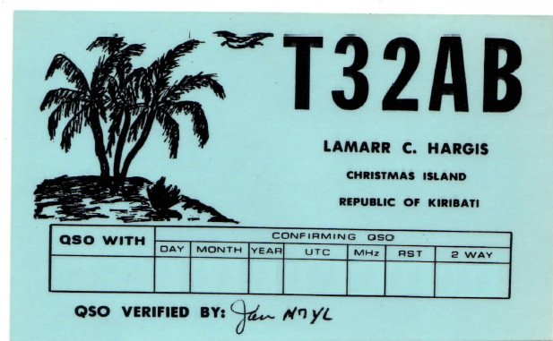***DX News***

***ARLD007 DX news***

This week's bulletin was made possible with information provided by F6AJA, W2GD, The Daily DX, the OPDX Bulletin, 425 DX News, DXNL, Contest Corral from QST and the ARRL Contest Calendar and WA7BNM web sites. Thanks to all.

**MONACO, 3A.** Mireille, F4FRL and Patrice, F5RBB will be QRV as home calls/3A from February 24 to March 2. Activity will be on 40 and 20 meters using SSB and various digital modes. QSL via LoTW.

**TUNISIA, 3V.** Ash, KF5EYY plans to be QRV as 3V8SS in the ARRL International DX CW contest as a Single Op/All Band/Low Power entry. QSL to home call.

TOP^

**TOGO, 5V.** Daniel, HB9EHD is QRV as 5V7DE until February 20. Activity is on 40 and 20 meters using FT8, and on Satellite QO-100. QSL direct to home call.

**CROATIA, 9A.**  Members of the Croatian Flora Fauna ARC are QRV with special event call 9A10FF during all of 2021 to celebrate the club's 10th anniversary. QSL via 9A2MF.

**ZAMBIA, 9J.** Brad, 9J2RS is currently QRV on 20, 17 and 15 meters. QSL direct.

**MOZAMBIQUE, C9.** Bruno, CS7AMN is QRV as C91BVA from Maputo. Activity is on the HF bands using SSB and various digital modes. QSL to home call.

**CHILE, CE.** Members of the Radio Club Melipulli are QRV as CB7FT from Tabon Island, IOTA SA-018, until February 21. This includes being active from the Lighthouse ARLHS CHI-049 during the American Lighthouses Weekend. Activity is on the HF bands using SSB and various digital modes. QSL via EA5GL.

**CUBA, CO.** Reinaldo, CO6RD is QRV from Lighthouse ARLHS CUB-045 on Cayo Blanco de Zaza, possibly IOTA NA-204, until February 21. Activity is on the HF bands using CW, RTTY, BPSK, FT8 and FT4. This includes being active during the American Lighthouses Weekend. QSL direct to EA5GL.

**MARTINIQUE, FM.** Look for FM5BH to be a Single Op/All Band/High Power entry in the ARRL International DX CW contest. QSL via W3HNK.

**HAITI, HH.** Bill, KO7SS will be QRV as HH2AA from Obleon as a Single Op/Low Power/Assisted entry in the ARRL International DX contest. QSL via LoTW.

**U.S. VIRGIN ISLANDS, KP2.** Dan, K8RF will be QRV as NP2J in the ARRL International DX CW contest as a Single Band on 160 meters entry. QSL direct to home call.

**PUERTO RICO, KP4.** A group of operators are QRV as NP4DX on 80 to 10 meters using CW. This includes being a Multi/Single/Low Power entry in the ARRL International DX CW contest. This activity will also count for the WLOTA as LH-2802. QSL via M0OXO.

**ARUBA, P4.** John, W2GD is QRV as P44W until February 23. He is active on all bands as time permits with a focus on the ARRL International DX CW contest. QSL via N2MM.

**BRAZIL, PY.** Members of the Grupo Escoteiro Marechal Rondon are QRV as ZW2I from Comprida Island, IOTA SA-024, and the Rio Claro Lighthouse, LH BRA-135, until February 22 during the American Lighthouses Weekend. QSL via operators' instructions.

**BENIN, TY.** Johannes, ZS6JSI is QRV as ZS6JSI/TY until June 2021. Activity is mobile on 80, 40 and 20 meters using SSB and FT8. QSL to home call.

**AUSTRALIA, VK.** Members of the Pride Radio Group are QRV as VI2021PRIDE until March 7 during Sydney Mardi Gras. QSL direct to VK3FUR.

TOP^

**TURKS AND CAICOS, VP5.** Jim, K4QPL plans to be QRV as VP5M during the ARRL International DX CW contest. QSL to home call.

**MEXICO, XE.** Members of the Radio Experimentadores of Campeche are QRV with special call sign 4A3G from Faro de Champolon until February 21 during the American Lighthouses Weekend. QSL via XE3AA.

**INDONESIA, YB.** Yohanes, YB2DX will be QRV in the ARRL International DX CW contest as a Single Op/All Band entry. QSL direct to home call.

**ROMANIA, YO.** Members of the Sport Club Pandurii Tirgu-Jiu are QRV with special call YP145B from Tirgu-Jiu until March 3 to celebrate the 145th anniversary of the birth of the great sculptor Constantin Brancusi. Activity is on the HF bands. QSL direct to YO7CKQ.

**CAYMAN ISLANDS, ZF.** Bruce, K0BJ will be QRV as ZF2BJ from Savannah, Grand Cayman, IOTA NA-016, from February 20 to March 5. Activity will be on the HF bands with a focus on the newer bands and CW. QSL to home call.

**NEW ZEALAND, ZL.** A group of operators will be QRV as ZL3X in the ARRL International DX CW contest as a Multi-2 entry. QSL via LoTW.

**PARAGUAY, ZP.** Manu, ZP9MCE plans to be QRV on 80 meters in the ARRL International DX CW contest. QSL via EA5ZD.

THIS WEEKEND ON THE RADIO. The ARRL International DX CW Contest, 13th American Lighthouses Weekend, NCCC RTTY Sprint, QRP 80-Meter CW Fox Hunt, NCCC CW Sprint, K1USN Slow Speed Test, Russian PSK World Wide Contest, RTTYOPS Weekend Sprint, Feld Hell Sprint, FISTS Sunday Sprint and the

Run for the Bacon QRP CW Contest will certainly keep contesters busy this upcoming weekend.

The QCX CW Challenge and OK1WC Memorial are scheduled for February 22.

The RTTYOPS Weeksprint and Worldwide Sideband Activity Contest are scheduled for February 23.

**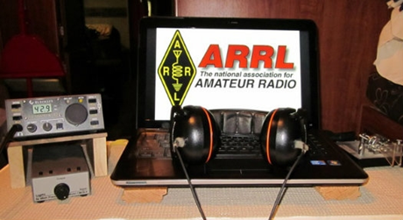*ARRL Contest Corner***

An expanded, downloadable version of *QST'*s’ [**Contest Corral**](http://www.arrl.org/contest-calendar) is available as a PDF. Check the sponsor’s ‘Website for information on operating time restrictions and other instructions.

TOP^

***Special Events***

* **04/10/2021 | The Annual Nancy Kott Memorial KN0WCW Event**

**Apr 10-Apr 11, 0001Z-2359Z, KN0WCW**, Leonardo, NJ. FISTS North America. 10.058 7.058 10.118 3.558. Certificate. cody codianni, 413 Martin Court, Leonardo, NJ 07737. The Annual Nancy Kott Memorial KN0WCW Event! Nancy met Fists’ founder George, G3ZQS (SK) in a happenstance QSO in 1988, befriended him and shortly became the head of what is now The Americas Chapter of Fists. From then till her passing on 2 March of 2014, she worked tirelessly to promote our club and Morse Code, showing kindness to all and exemplifying our mottos of “courtesy at all times” and “accuracy transcends speed.” She is deeply missed by all, but not forgotten. Please help us honor Nancy’s work and dedication from 00:01 UTC April 10 2021 to 23:59 UTC April 11 2021. [fistsna.org/operating.html](http://fistsna.org/operating.html)

* **04/10/2021 | Celebration of the 155th Anniversary of Auburn University**

**Apr 10-Apr 11, 1200Z-2359Z, W4E**, Auburn University, AL. Auburn University. 7.060 7.074 and 7.047.5 14.074 and 14.080 7.070. QSL. Stew Schneller, 1869 Hillton Court, Auburn, AL 36830-2693. [www.qrz.com/db/k4jop](http://www.qrz.com/db/k4jop)

* **04/10/2021 | Spring has Sprung**

**Apr 10, 1700Z-2100Z, W4D**, Kodak, TN. Sevier County Emergency Radio Service. 14.280 +/- .020 USB 7.200 +/- .020 LSB 14.070 +/- .020 PSK31 7.070 +/- .020 PSK31 CW only on 7.060 +/- .010. QSL. Thomas P. Baxter W9TPB, 2054 James Rd., Sevierville, TN 37876. For additional information, please go to our website [www.eventqsl.webs.com](http://www.eventqsl.webs.com/)

* **04/10/2021 | USS Midway Museum Ship Special Event: Doolittle Raid**

**Apr 10, 1600Z-2300Z, NI6IW**, San Diego, CA. USS Midway (CV-41) Museum Ship. 7.250 14.320 14.070 (PSK31) DSTAR via PapaSystem repeaters. QSL. USS Midway CV-41 COMEDTRA NI6IW, 910 N Harbor Dr, San Diego, CA 92101. Please include SASE. [www.qrz.com/db/ni6iw](http://www.qrz.com/db/ni6iw)

* **04/17/2021 | Celebrating the Louisiana Purchase**

**Apr 17-Apr 24, 0000Z-2359Z, W5L**, West Monroe, LA. NorthEast Louisiana Amateur Radio Club. 14.250 21.250 7.250 3.850. QSL. Jim Ragsdale, W5LA, 111 Eagle Lake Drive, West Monroe, LA 71291. <https://www.qrz.com/db/W5L>

* **04/17/2021 | Texas State Parks On the Air (TSPOTA)**

**Apr 17-Apr 19, 1400Z-0200Z, K5LRK**, The Colony, TX. Lake Area Amateur Radio Club. CW Phone VHF. QSL. See website, for, Information. Times are daily. K5LRK on as a special event station. Contest: Activate as many Texas parks as possible. www.k5lrk.com or [www.tspota.org](http://www.tspota.org/)

* **04/18/2021 | World Amateur Radio Day**

**Apr 18-Apr 19, 1300Z-0400Z, W7W**, Rochester, NY. W2JLD/Special event coordinator. Echolink *ROC-HAM* CONFERENCE 531091 Allstar 2585, 47620, 53130. QSL. John Derycke, W2JLD, 85 Amherst St #2, Rochester, NY 14607. A special event qsl card will be available Join us again for one of the LARGEST special events on Echolink@ 9AM EST TILL 12 MINDNIGHT EST we will have Allstar, DMR as well. [w2jld2@gmail.com](mailto:)

TOP^

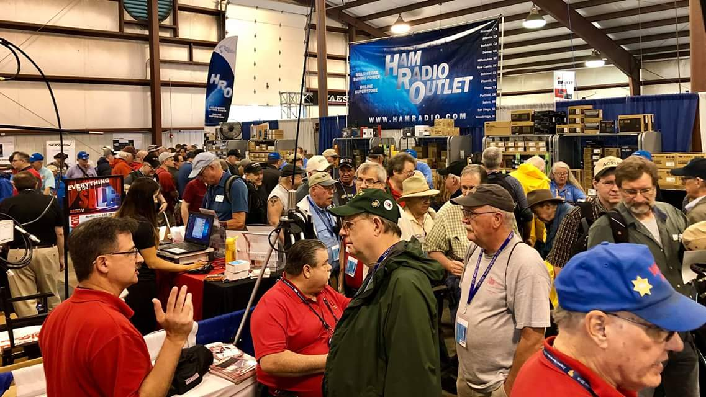[***Upcoming Hamfests***](http://arrl-ohio.org/hamfests.html)

We **DO** have some hamfests scheduled for 2021!! Yes, take a good look at the list, it’s growing every day!

Be sure to keep your eyes on this schedule as that when things start getting better and the vaccine rolls out to more and more, hamfests will surely get back to their normal schedule. Don’t see your hamfest listed?? Did anyone register it with ARRL? It’s really easy to do and you get a lot of FREE publicity if you do.

**Massillon ARC** Spring TailgateFest to be held at the MAPS Air Museum. Entrance at 5383 Massillon Road just inside the Stark/Summit County line. Date is **Saturday, April 17** from 9 [a.m.to](http://a.m.to/) 4 p.m. Cost is $5 per vehicle. (for use of the facility)   No advance registration necessary. Bring your own tables. (no large trailers) No charge for visitors.

|  |  |
| --- | --- |
| **06/05/2021 -**[**FCARC SummerFest**](http://www.arrl.org/hamfests/fcarc-summerfest)  Location: Wauseon, OH Sponsor: Fulton County Amateur Radio Club Website:<http://k8bxq.org/hamfest> [Learn More](http://www.arrl.org/hamfests/fcarc-summerfest) | **07/10/2021 -**[**Mansfiled Mid-Summer Trunkfest**](http://www.arrl.org/hamfests/mansfiled-mid-summer-trunkfest)  Location: Mansfield, OH Sponsor: InterCity Amateur Radio Club Website:<http://iarc.club>[Learn More](http://www.arrl.org/hamfests/mansfiled-mid-summer-trunkfest) |
| **07/17/2021 -**[**NOARSFEST**](http://www.arrl.org/hamfests/noarsfest-8)  Location:Elyria, OH Type: ARRL Hamfest Sponsor: Northern Ohio Amateur Radio Society Website: [http://noars.net](http://noars.net/) Learn More | **07/18/2021 –**[**Van Wert Hamfest**](http://www.arrl.org/hamfests/van-wert-hamfest-5)  Location: Van Wert, OH Sponsor: Van Wert Amateur Radio Club Website:[http://W8FY.ORG](http://w8fy.org/)[Learn More](http://www.arrl.org/hamfests/van-wert-hamfest-5) |
| **08/07/2021 -**[**DX Engineering Hamfest & Great Lakes Division Convention**](http://www.arrl.org/hamfests/dx-engineering-hamfest-1)  Location: Tallmadge, OH Sponsor: DX Engineering Website: [http://dxengineering.com](http://dxengineering.com/) [Learn More](http://www.arrl.org/hamfests/dx-engineering-hamfest-1) | |
| **08/28/2021 -**[**Cincinnati Hamfest℠**](http://www.arrl.org/hamfests/cincinnati-hamfest)  Location: Owensville, OH Sponsor: Milford ARC Website: [http://CincinnatiHamfest.org](http://cincinnatihamfest.org/) [Learn More](http://www.arrl.org/hamfests/cincinnati-hamfest) | **09/26/2021 -**[**Cleveland Hamfest**](http://www.arrl.org/hamfests/cleveland-hamfest-1)  Location: Berea, OH Sponsor: Hamfest Association of Cleveland Website: [http://www.hac.org](http://www.hac.org/) [**Learn More**](http://www.arrl.org/hamfests/cleveland-hamfest-1) |
| TOP^  **12/04/2021 -**[**FCARC WinterFest**](http://www.arrl.org/hamfests/fcarc-winterfest-2)  Location: Delta, OH  Sponsor: Fulton County Amateur Radio Club  Website:<http://k8bxq.org/hamfest>  [Learn More](http://www.arrl.org/hamfests/fcarc-winterfest-2) |  |

***Print an Official or Unofficial Copy of Your Amateur Radio License***

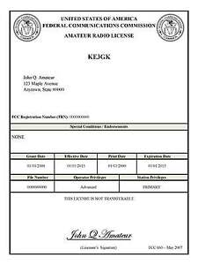*(By Anthony Luscre, K8ZT)*

As of February 17, 2015, the **FCC no longer routinely issues paper license documents** to Amateur Radio applicants and licensees. The Commission has maintained for some time now that the official Amateur Radio license authorization is the electronic record that exists in its Universal Licensing System (ULS). The FCC will continue to provide paper license documents to all licensees who notify the Commission that they prefer to receive one.

Licensees also will be able to print out an official authorization — as well as an unofficial “reference copy” — from the ULS License Manager. I’ve created a set of instructions on how you can request an **“official” printed copy of your license\***

[**Click here to download the instructions**](http://arrl-ohio.org/news/2020/print_your_license.pdf)

***One Question Questionnaire***

Hey Gang,

Survey Says”….. 27% of you have made a contact through one of the Amateur Radio Satellites. That means 73% of you (us) have something new to try! Get out there and have some fun (then send me some photos and a short story to include in a future OSJ).

Ok, now on to the next question…

***Do you have the “Worked all States” Award?***

You’ll find the “One Question” questionnaire on the Ohio Section Website! <http://arrlohio.org> It’s all for fun and it’s not a scientific survey in any way, but we are learning some things that we didn’t know from these questions. I hope that you are enjoying answering these “One Question” questionnaires.

TOP^

*****V.E. Test Sessions***

Many V.E.’s have decided to start testing once again, but with restrictions that need to be adhered to for sure. Here’s the link to find that V.E. Test session and what is expected of YOU before going. <http://www.arrl.org/find-an-amateur-radio-license-exam-session>

***Late Breaking News!***

**Hamvention Weekend Activities**

That magical weekend in May approaching.  With no Hamvention this year, due to continuing Coronavirus restrictions, we have been developing several activities to keep Hams busy and engaged in the hobby.  We have a two day prize total of $15,000.

On Thursday May 20. 2021 the Virtual Contest University will be held starting at 9 AM EDT 1300Z. The course outline will be available soon. This will be a *free*event!

Even if you are not a contester you will learn so much about Amateur Radio and hear the techniques and critiques of many of the world’s foremost Hams.

Hamvention is a proud sponsor along with Icom and DxEngineering. Plan on attending this amazing free event!

Several Icom radios will be given away during the all-day event. You must be registered on Zoom and present online at the time of the drawing to win the radios.

Please check http://contestuniversity.com/ for updates.

On Friday May 21 Starting at 11 AM EDT 1500Z we will have the 2021 Virtual Hamvention Forums.

The Hamvention Virtual Forums celebrates the 2021 Hamvention Award winners. Each awardee will give a 45 minute presentation followed by Q&A.

The Hamvention Forums will be presented via Zoom Webinar. Registration for the Zoom Webinar will start 30 days before the event – look for the registration information on the Hamvention Website. Several Icom radios will be given away during the 2021 Hamvention Forums. The winners will be selected at random.

The winner must have registered on Zoom for Hamvention Forums and be present during the drawing to win. Drawing times are random throughout the Virtual Forums event. Thanks to Hamvention, Icom and DX Engineering for their support of the 2021 Hamvention Virtual Forums.

TOP^

Our presenters are:

**Technical Achievement: WX6SWW** – Tamitha Mulligan Skov is well known as the “Space Weather Woman”. Folks that have seen her space weather forecasting show will freely admit that she is full of energy and excited about her work. She is a real space pioneer.

**Special Achievement: W3WL** – Wesley Lamboley was nominated by his peers for his lifetime, high energy support for the science and art of amateur radio. Not only has Wesley supported youth coaching, membership recruiting and technical problem assistance, he always does it with a smile and great humor.

**Amateur of the Year: WP3R** – Angel M. Vazquez is known for being one of the principal support engineers for what was one of the greatest antennas in the world – the National Science Foundation’s Arecibo parabolic dish antenna. Angel’s award stems from his unswerving and diligent support of amateur radio throughout the entire territory of Puerto Rico and extends worldwide.

**Club of the Year: K4HTA** -- The Vienna Wireless society was chosen this year for its 58 years of service to the amateur radio community. K4HTA with its 280 members focus on youth education, public service and promoting the overall growth of radio through the DC area and around the world.

On Saturday May 22, Participate in the Hamvention QSO Party  8 AM to 8 PM EDST  (1200 May 22 to 0000 May 23 UTC) W8BI, the club call of the Dayton Amateur Radio Association, will be a bonus station scored at 10 points per band and mode.  Bands:  10M, 15M, 20M, 40M, 80M.  Typical call will be: CQ CQ HVQP (HamVention QSO Party) W8XX (Your call)

Typical exchange will be signal report and first year you attended Hamvention; eg on CW: KB8XXX 599 1998 W4XX

If you have never attended Hamvention, please send 2021 in place of the year. Send your score (number of QSOs including bonus points) to [3830scores.com](http://3830scores.com/) within 5 days of the event. You will be able to print a certificate after the contest.

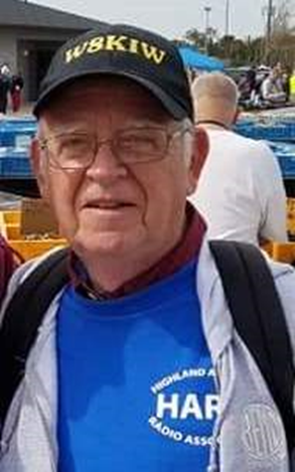***From The South 40***

*(from John Levo,* [*W8KIW@arrl.net*](mailto:W8KIW@arrl.net)*)*

***WELCOME TO THE SOUTH 40***

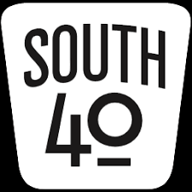

Last time we had just visited with the two clubs in Clinton County and set our sights to a visit with the Fayette ARA in neighboring Washington Court House.

TOP^

Once there we hook up with Ken Rowley, WD8PHL, and Jim Orebaugh, N8AXB, who tell us that one of the first two meter repeaters in this part of Ohio was placed on the air by Kenny Long (sk)-WB8NGX. It was around this repeater the idea of forming a local amateur radio club later arose. According to the club’s constitution approximately 20 hams signed the document on November 18, 1978. Following the formation of the club, Long donated the 147.27 repeater to the newly formed group. In its early days they formed an ARES group and were involved with the county’s emergency preparedness plans. To this day they still have operating HF and VHF stations, a separate radio room at the EMA’s operations center and are involved with the Sky Warn program. One highlight the club is especially proud of was when it arranged for the local high school to be the only Ohio school to participate in an amateur radio experiment with the space shuttle Endeavour. Over the years the Club has been very active in promoting ham radio through classes and testing and still frequently assists neighboring clubs with their test needs. They were one of the first Ohio clubs to embrace the Laurel VE program. For the past few years the Club has assisted the City of Washington with parking help for the annual community fireworks display. Like others the Club has fallen upon some hard times lately because of the pandemic. To offset that WD8PHL runs a Tuesday evening net that keeps the locals and some from neighboring counties in touch with each other.

And after thanking Jim and Ken we end our visit with the Fayette ARA and direct our car southward towards Ohio’s newest ARRL Special Service Club. As we travel down US 62 let’s take a few moments to find out what’s happening in the Southern Ohio region.

Jeff Slattery, N8SUZ, lets us know the recent joint Sunday Creek ARF and Athens County ARA test session was another of the highly successful test sessions held in the region during the past weeks. Jeff says a 100% passing rate was achieved by the 11 candidates who either earned a new license or an upgrade. James Clark, KC8VKQ, from Granville and Richard Rhoades, KE8QAA, from Lancaster each upgraded to General as did Brant Hysell, KE8OFW; Kevin Yute, KE8MHT and Douglas Fedder, KE8PHL, all of Athens. New Technician licenses were granted to Charles Graham and Richard Terrell of Reedsville, David Runkle from Glouster and Jeremy Barnhouse of Coolville. Not only did Jonathan Denes from Stockport and Albany’s Joseph Sprague earn their Technician, they also passed the element for General. Once the new call signs are known, they will be posted in the South 40. Congratulations to all.

Our daughter (who is studying for her license) lives in Central Oregon. Jenn is really into hiking and biking and subscribes to the *Outside* magazine. She said the March 14 online edition has an article titled “Inside the Summit Obsessed World of Ham Radio”. I never thought of hams being obsessed with summits so I read the article and found it interesting, informative and worthy of some further research. Although most of us think of summits being in our Western states or the Appalachians, but reference to the Summits on the Air website shows that starting in Highland County and continuing east there are several Southern Ohio summits assigned points for activations and working with many never have been activated. If you are into hiking this program might be of interest to you. Check out their www.sota.org.uk website for information about the program.

Because COVID restrictions on meetings, the Cambridge ARA has not been able to formally meet as often as normal. Therefore the 2020 officers lead by Jim Shaw, AB8P, are temporarily leading the Club. Hopefully restrictions will be eased soon allowing the group to meet, catch up on business and elect a slate of officers. In the meantime CARA has been holding a “W8VP Cabin Fever” net each evening on their repeater to discuss items of interest as well as trivia items. They are to be commended because the net has missed only four nights since last April 1.

TOP^

Athens County ARA President Eric McFadden, WD8RIF, reminds us the Club’s annual hamfest scheduled for April 25 has been postponed. The decision to postpone was made too late to get the event dropped from the April QST listing of hamfests and conventions. Because the Sunday Creek ARF’s annual Nelsonville hamfest was cancelled this year, Eric says there is a possibility of a joint event rescheduled for late summer or early fall.

No Fooling, but during the past few weeks, Southern Ohio has seen over 50 people earning their first license or upgrading a present one. During the recent Highland ARA ‘Introduction to Ham Radio’ the potential new hams were asked why they wanted to get licensed. As expected natural disaster, weather and civil emergency preparedness was a strong factor, but “It sounds neat” came in a close second. Some admitted wanting to beat having to pay a license fee. It was surprising how many had been interested in ham radio since their youth, but life and family got in the way. Earning a license was placed on the back burner until family was raised, financial concerns were no longer a major issue or retirement offered more time to pursue the hobby. One student had had a license in the 1960s and another’s father had been licensed. One told that his grandfather and grandmother as well as his great grandfather were hams. It would be expected these same reasons were behind the over 50 people from the region successfully completing one or more license elements. It’s expected upcoming license sessions in Portsmouth on April 5, in Springfield, Huber Heights and Huntington, WV on April 10, in Hillsboro and Circleville on April 17 and on April 25 in Athens will have the same reasons behind people trying to get a license.

JUST IN. At the Gettysburg, PA FCC Data Center spokespersons Dottie Ditt and April Phoyl announced the Commission has received and is seriously considering re-instating the sending and receiving of Morse Code as a requirement to hold an amateur radio license. Sometime this year the Commission will restart charging fees for licenses and license modifications. Therefore the Commission believes it would be appropriate to require a code test similar to that of years gone by when the Commission originally charged license fees. More information will be available at an April 1 briefing.

As we enter the original ‘Crossroads of America’ we note Ohio’s oldest operating courthouse sitting on the northwest corner of the intersection of the nation’s longest east/west federal highway (US50) and the longest north/south highway (US62). Not only does Hillsboro have these claims to fame, but in 1870 it was the Population Center of the United States. In more recent times, county native Johnnie Paycheck shot a fellow in a local bar and was sent to prison because of it. But enough County PR. We are here to learn about the Highland Amateur Radio Association.

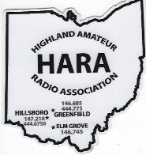Local wireless activity can be traced to well before licenses were required. In the 1950s a group of hams met on 6 meters each Sunday morning and called themselves the Rocky Fork Emergency Net. When a club was later formed in Clinton County, many journeyed across the county line to join in Field Day and other events with the CCARA. Noting the growing population of Highland County hams it was suggested they form their own club. Thus on April 17, 1977 twenty-four amateurs met and formed the Highland ARA. The success the club has had over the years is amazing for a small rural Appalachian county. By promoting club events and ham radio in general through the local print and radio media, classes and license sessions are usually filled to capacity. The club grew its’ 2020 membership to 131-with about 90% with licenses. The Club has a series of repeaters in Highland, Fayette and Pike Counties. In 2018 HARA’s idea of a special event calling attention to the historic Highland County Courthouse caught the fancy of other clubs and resulted in at least a dozen other courthouses appearing on the air. The Club also conducted a special event activity promoting the covered bridge in Lynchburg that joins Highland and Clinton Counties.

TOP^

It was so successful that it was repeated the following year with other Southern Ohio clubs joining the fun by activating bridges in their areas. In 2019 the club volunteered to assist the local historical society and cemetery association decorate graves of veterans. Although a non-radio event, it gave the Club an opportunity to pay back to the community and show appreciation to our veterans. In 2020 club members totally undertook the project. However the highlight of the year had to be the American Radio Relay League honoring HARA with its Special Service Club designation.

It’s time we say adieu to our Highland ARA friends and move on to our next destination. So until next time, stay healthy and safe. Plus play a little radio when outside duties allow some free time.

***Final… Final***

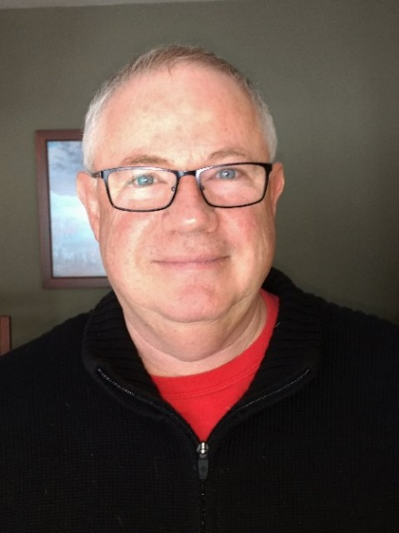

***This Ain’t No April Fools!***

I’ve heard it said that “Amateur Radio is Dead.” My response to that can only be “Not if you’re one of the one’s who are doing it!” I’ve always thought that I was pretty connected and involved in all that IS Amateur Radio. Well, these past 90 days have been a HUGE wake-up call. I never really thought we were even near dead, but now I can say with certainty, Amateur Radio is alive and well, and one of the most fascinating hobbies in the world! Our numbers might be small, but our activity level is off the charts. If you hold an amateur radio license, but you’re not an active ham, I’ve got a couple words of advice for you: Turn off your TV! Way too many hours are wasted with the mostly drivel that pours out of that box. Get off the couch. It’s just a coffin for those who aren’t dead yet. Have you *ever* heard of anyone’s GREAT ACCOMPLISHMENTS made while sitting on a couch? Me neither. Get active and get involved. Even if it’s not Amateur Radio, be involved in *something*. And, as long as you’re going to be involved in something, Amateur Radio has an awful lot of positive attributes that ought to interest you. It’s a social activity, yet you can always be busy with some part of it on your own. It’s an educational activity, if you stopped learning when you got out of High School or College, then you really didn’t learn the most important lesson of our human experience – we live in a fascinating world and there’s always more to learn about it. As an Amateur Radio operator, you can study and learn about electronics, communications, geography, language, history, computers, space travel, just to name a few. The things you can do are almost limitless – contesting, dxing, dxpeditioning, building, restoring, coding, DFing, - I could go on, but you get it.

Amateur Radio is the GREATEST HOBBY IN the WORLD!

Last month I told you that I have three main areas that I will be working on for the duration of my term(s) as OH Section Manager. #1. Making sure that the Hams in the OH Section not only have but take advantage of all the opportunities that this hobby gives them to have FUN! #2. Increase the number of licensed hams, increase the number of *active* hams, and increase the number of ARRL member hams in the OH Section. #3. Increase and improve the public image of Amateur Radio to the general population of OH.

TOP^

I offered a $100 DXE gift card to the club that got the word out in a local publication that Amateur Radio still exists. I have a winner, the Highland Amateur Radio Association. Their press release announced their upcoming Tech class.

<https://highlandcountypress.com/Content/In-The-News/In-The-News/Article/Highland-Amateur-Radio-Association-to-hold-entry-license-class-/2/20/65731>

Take a look at their release. The interesting twist that I saw here was that they were inviting people to a “Informational Meeting About Amateur Radio” that would include information on licensing and their upcoming class. Nice touch. If you are a typical person who knows nothing about Amateur Radio – why would you be interested in taking their license class? You probably wouldn’t. But here this is an opportunity to learn about what Amateur Radio is all about before you commit to taking a class. And it was tied in to all the current events that involved weather emergencies, something everyone is aware of. Congratulations, nicely done.

If you’ve read everything in this newsletter up to this point, you know that Sunday, April 18th is “World Amateur Radio Day”. That sounds to me like the kind of information that needs to get out so that the population begins to see that Amateur Radio IS NOT dead! Thanks to a new initiative at ARRL not only do we get this news, but, also included are press releases that you can modify to identify *your* club as the source of this information for the public! Please, go back and look at this information (page 25). Let’s make sure the population of the OH Section (aka the state of OHIO) knows about World Amateur Radio Day. The “heavy lifting” has been done for you. To provide feedback on this, please, after you submit your release(s), send me a copy of your release(s) along with the name and contact information of where it was sent. This is coming up soon – time is of the essence – get them in ASAP.

Spring is in the air. Not only that, pandemic cases are going down and we’re finding new and creative ways to get back to doing the things we’ve always done. How about sending me some photo’s and a little bit about what you’re doing and how you’re coping? Everyone is dealing with the same Pent Up demand for Amateur Radio Fun and I’m sure that if you have some good ideas someone else will find them useful too. I’ll get the word out.

In the February 22 edition of PostScript I had a link to an article from the MVARA Voice Coil. There will be two more additions to that article which will take you through the process of building a multi-band HF wire antenna system. For most of my years as a ham I’ve used wire antennas strung in the trees. I’ve made thousands of Q’s all over the world on the various wire antennas I’ve had up through the years. If you work 40, 80 or 160 it’s pretty much going to be on a wire due to the size. This is a fantastic way to “homebrew” a major component of your station. Give it a try and let me know how it works out for you. Over the next few months I’ll be concentrating on the FUN part of my 3 objectives and will be tossing out lots of projects and activities.

That’s it for me this month. Get on the air, build something, try something new! Have fun and let me know what you’re doing.

73, de Tom WB8LCD

[WB8LCD@ARRL.ORG](mailto:WB8LCD@ARRL.ORG)

330-554-4650

OH Section Manager

TOP^

***“Swap & Shop” on the website***

Hey Gang,

Have you taken a look at the **Swap & Shop** page on the Ohio Section webpage yet?? Here’s a link that will take you there…

<http://arrl-ohio.org/sm/s-s.html>

Do you have equipment that you just don’t need or want anymore? Here’s a great venue to advertise it, and it’s FREE!!

Is your club doing a fund raiser to help raise money? After a lot of thought, it was decided that the Swap & Shop webpage could also contain these types of items as well.

The same rules will apply as do for the For Sales and Give-A-Ways and will only be posted for a month at a time. Please see the Terms & Conditions on the webpage.

If your club is doing a fund raiser and wants more exposure, please forward the information to me and I’ll advertise it on the Swap & Shop webpage for you. Now, I still want to remind you that it won’t be listed in this newsletter because it would take up way too much space, so your ad will only appear on the website. It is there for any individual to post equipment Wanted / For Sale or Give-Away as well as for Club Fund Raisers. No licensed vehicles/trailers or business advertising will be posted.

Postings are text only (no pictures or graphics) will be posted for a maximum of 1 month from date posting and require a contact phone number or email within the posting. Send your Wanted / For Sale or Give-Away post to:  [swap@arrlohio.org](mailto:swap@arrlohio.org)

***Back Issues of the PostScript and Ohio Section Journal***

Hey, did you know that PostScript and Ohio Section Journal (OSJ) are archived on the website? You can go back and look at any edition simply by clicking:

<http://arrl-ohio.org/news/index.html>

Ohio Section Cabinet

|  |  |
| --- | --- |
| Section Manager – Tom Sly, WB8LCD | Section Emergency Coordinator – Stan Broadway, N8BHL |
| Technical Coordinator – Jeff Kopcak, K8JTK | Section Traffic Manager – David Maynard, WA3EZN |
| State Government Liaison – Bob Winston, W2THU | Affiliated Clubs Coordinator – Tom Sly, WB8LCD |
| Section Youth Coordinator – Anthony Lascre, K8ZT | Public Information Coordinator – John Ross, KD8IDJ |

TOP^

***Chit – Chat, and All That!***

Do you know someone that’s not getting these Newsletters? Please, forward a copy of this Newsletter over to them and have them “[Opt-In](mailto:Opt-In)” to start receiving them. Heck just have them send an email to: [webmaster@arrl-ohio.org](mailto:webmaster@arrl-ohio.org) to be added.

We now have many thousands of readers receiving these newsletters weekly. Quite impressive, I’d say! I urge all of you to make sure that everyone, regardless of whether they are a League member or not, get signed up to receive these weekly Newsletters.

You can always “Opt-Out” at any time if you feel this is not what you were expecting. It’s fun and very informative. All of your favorite past newsletters are now archived too.

You can go back at any time and read them. Just go to: <http://arrl-ohio.org/news/>

The pictures on the front page and throughout this newsletter are from various newsletters, Facebook posts and/or were sent directly to me in recent weeks. Take a good look at them, you just might be in one of the pictures! “SMILE… you’re in the Ohio Section News!!”

TOP^

*The Ohio Section Journal (OSJ) is produced as a comprehensive look at all the programs within the Ohio Section. I sincerely hope that you have enjoyed this edition of the* *OSJ and will encourage your friends to join with you in receiving the latest news and information about the Ohio Section, and from around the world!*