***[](http://arrl-ohio.org) February***

***Edition***

|  |  |
| --- | --- |
| 🡪 From the Technical Coordinator | **🡪** From the Section Emergency Coordinator |
| **🡪** From the Public Information Coordinator | 🡪 From the Section Youth Coordinator |
| **🡪** From the Section Traffic Manager | 🡪 ARES Training Update |
| 🡪 National News | **🡪** Club Corner |
| 🡪 DX This Week | 🡪 Contest Corner |
| 🡪 Special Events | 🡪 One Question Questionnaire |
| 🡪 From The South 40 | 🡪 Final.. Final.. |

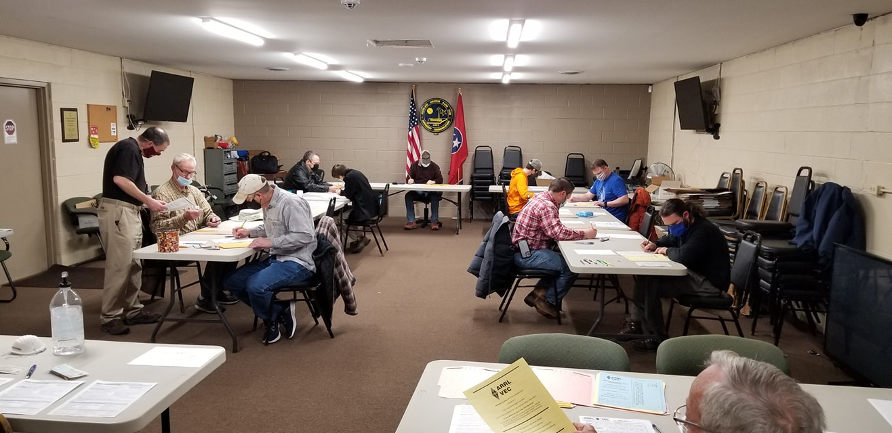

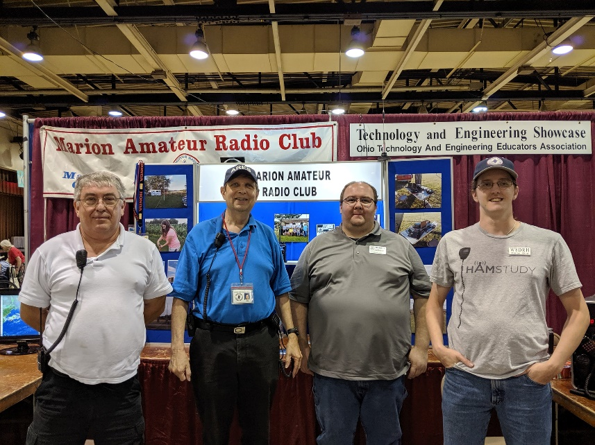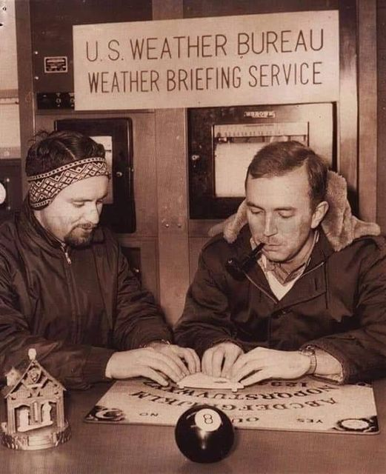

***From the Technical Coordinator***

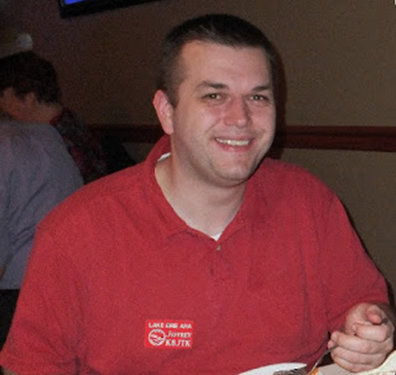***Jeff Kopcak – K8JTK TC***

[k8jtk@arrl.net](mailto:k8jtk@arrl.net)

Hey gang,

I don’t know about anyone else, since most of us have been told to cower-in-place, my productivity has gone through the roof! Must be that 10-foot commute between the work desk and home desk, might get the sun in my eyes on my way over. Finally tacking items on the perpetual “when I have loads of free time” list.

First cleaned out my data hard drive that had become a general dumping ground for downloads, pictures, data files, abandoned projects, and all other forms of miscellaneous files. Kept telling myself ‘I’ll organize this later.’ I figure accumulation started around the time I graduated with my undergrad (2008) and really got involved with ham radio. Go figure. Downloads had grown to 2,900 files at 16 GB and the general dumping ground was around 73,000 files at 314 GB. Much of that got deleted but enough was kept for reference or sentimental reasons.

After sorting, mutilating, and “organizing,” this led into another task to better utilize my NAS, or [Network Attached Storage](https://en.wikipedia.org/wiki/Network-attached_storage), functionality more than I currently was. NAS devices are a way to attach storage, like hard drives or SSDs, to the network for sharing data across devices on a local network or, in special cases, users on the Internet. NAS devices can be anything from a Raspberry Pi with USB hard drives attached, an old computer filled with spare hard drives running [FreeNAS](https://www.freenas.org/), to specifically designed devices from companies such as Synology, QNAP, or Asus. Many think “storage” when they think NAS because storage: it’s in the name. Consumer NAS devices offer packages that can be installed to add additional functionality commonly available through always-on devices. Functionality options such as a mail server, web server, git server, database server, docker virtualization, replication (mirroring, backup with another provider), network level authentication, VPN, IP camera DVR, chat, and document collaboration. I’m a loooong time Western Digital user. Their Red line of NAS drives are my choice, though they tried to pull some crap of [quietly introducing sub-par drives](https://www.anandtech.com/show/15878/western-digital-cleans-up-the-red-smr-nas-hdd-mess) (don’t use WD Red drives with “EFAX” in the model). Seagate is stepping up their game too with the IronWolf line, which is gaining popularity.

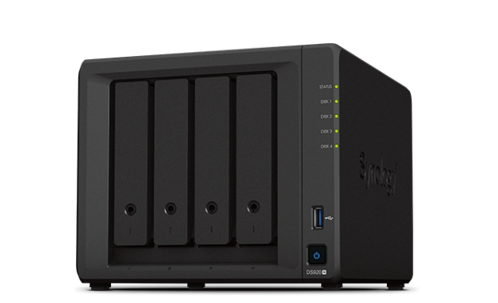

Synology NAS

My strategy is to move files I’m not actively using on a regular basis to the NAS. These types of files would be: digital pictures, Office documents, document scans, emails, news articles, previous taxes, internet downloads, audio/video clips, newsletters, ham projects, school work and projects, old programs that aren’t updated but are still useful. Unbeknownst to me when I started, this didn’t leave a whole lot left over on my desktop data drive. Maybe in the future, I’ll move all data to the NAS.

TOP^

For the remaining data left on my data drive, I still wanted to maintain a backup strategy in case something happened to those files. Anything from my own stupidity (accidental deletion, encrypted by a malware strain) to hardware failure. Previously, I used a cloud provider for remote backup, but they decided to exit the consumer market. With their change in business strategy, I was using my own scripts to keep things synced from the desktop to the NAS, whenever I remembered to run them. Not great because if I deleted something with a bunch of recent changes and the last backup I had was a week or two ago, that sucks. This syncing strategy also didn’t have file versioning.

When a file is changed, the backup system preserves a new copy of the file but keeps previous versions in case you wanted to go back in time to an earlier version. Real-world example: a computer becomes infected with a malware strain that encrypts all pictures and documents. A backup solution will still make a backup copy of the newly encrypted file, because it doesn’t know its user or user on the network did something stupid. Saving previous versions means you can recover the unencrypted version without paying Mr. Bad Guy’s ransom.

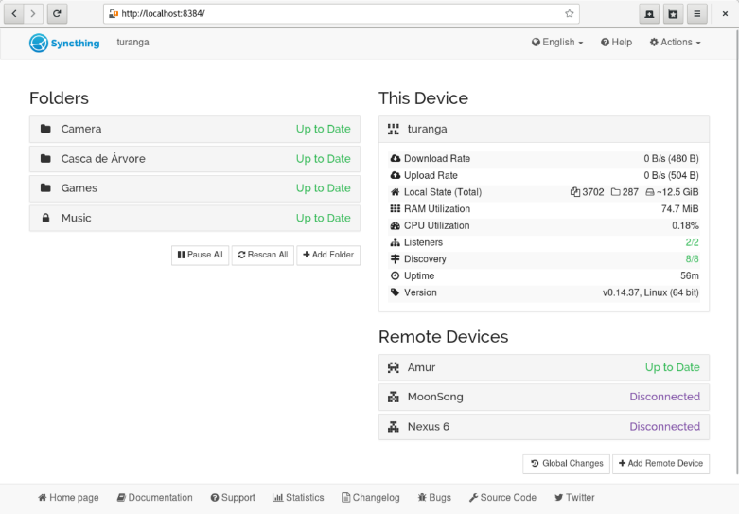

Syncthing web interface (wikipedia.org)

I tried solutions like rsnapshot but had serious issues getting systemd timers (supposed to replace cron, yeah, we’ll see) to work with persistence and waiting until the NAS was mounted before taking a snapshot. That was abandoned after a few months. I heard about [Syncthing](https://syncthing.net/) on a podcast. It met my requirements and more! It’s quite an amazing piece of free and open-source technology. I could run an instance on my NAS (or any computer), attach devices, those devices send file changes in real time, and the software takes care of preserving previous versions. “More” came in the form of Syncthing being available on every platform I use. Supported are: source code for manual compiling, Linux (many distributions and processor architectures), Windows, macOS, *BSD, and Solaris. There is an Android client allowing me to backup my phone to my NAS. Syncthing is exactly what I needed since I have some Windows machines (like the shack PC).

A couple warnings about Syncthing. Getting started will seem overwhelming with options and what they mean. Look at [good tutorials](https://www.youtube.com/watch?v=O5O4ajGWZz8) and in the [forums](https://forum.syncthing.net/) where there are lot of users willing to help. Even more important: **Syncthing IS NOT a backup tool**. *Wait, you said you are using it as a backup tool!* I’m syncing file changes to my NAS. Backup comes in the form of making images of the NAS drive and storing those off-site. Also acceptable is using a cloud backup service to backup the NAS off-site. Both are acceptable uses of Syncthing as a “backup” solution.

Another thing on the “to do when I have tons of free time” was digitize VHS tapes. In December & beginning of January, I was on a mission to digitize my high school and college video tapes as well as family home videos. Close to 100 tapes in total. Those that are not familiar with [my broadcast television past](https://www.jeffreykopcak.com/television/), I was involved with WHBS-TV in high school, a local cable access station.

TOP^

Schools from across the county came to visit us because we were doing 7 camera shoots with replay for all football games, 5 camera shoots for basketball, and competing in college level categories for regional Emmy awards. Worked at WBGU-TV in college. Did a ton of cool stuff including weekly productions for Fox Sports Ohio, a program that was distributed internationally, and lots of remote shoots in different parts of the state, to name a few. This was all before over-the-air digital was a thing. I recorded a lot of stuff on VHS tapes over those years and, of course, wanted to preserve them.

Most say “put it on DVD.” Like it or not, we’re being pushed to a streaming society so companies can control when and how you view content. Not only is physical media dead, but you now have to take care of, and store, a bunch of DVDs. There are services allowing you to roll-your-own streaming service, where you to make your own content library. There would be a server on your network containing your music, videos, TV shows, home movies, etc. making it accessible to smart TVs, streaming devices like Roku or Fire Stick, smart phones, tablets, or any modern web browser.

I used a [Hauppauge USB capture device](https://www.hauppauge.com/pages/products/data_hdpvr2.html) to digitize VHS tapes played from a VCR. [VideoReDo](https://www.videoredo.com/en/Products_TVSuite_V6.html) to fix errors in the data stream (some players have issues playing video streams with data errors) and cut recordings into smaller files. [HandBrake](https://handbrake.fr/) to encode the video and [Plex Media Server](https://www.plex.tv/) to make the video available to devices. Plex server runs on, you guessed it, the NAS! I’m glossing over how to use Plex, organize files, and produce files optimal for streaming as there are many support articles and forum posts covering these topics on the Plex or any other similar service’s site.

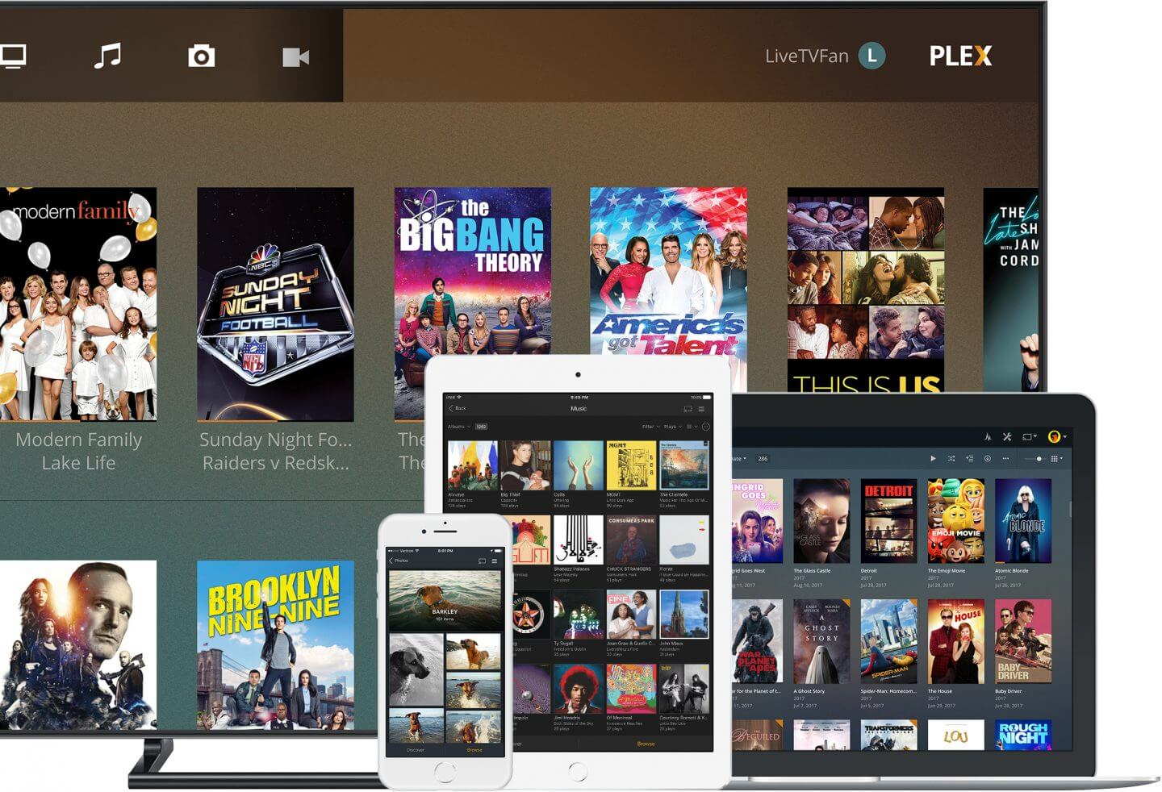

Plex media center (plex.tx)

Reading up on recommended practices to digitize VHS tapes, VCRs with newer Time-Based Correctors (TBC) were recommended. Looking online, those were $400 or more. Since it’s likely these videos will be watched a handful of times, I decided to forgo more expensive VCR options. TBC can correct timing issues, making 1 second = 1 second, no longer due to tape stretching. It aims to correct visual image jitter and “wiggling.” I did see those artifacts and re-recorded if the video was bad enough. The Hauppauge device captures video at about 13 mbps (2 hr is about 13 GB). “Lossless” 25 mpbs capture devices were recommended. Do you remember the quality of a VHS tape? Lossless is not going to lose much VHS quality! All tapes digitized weighed in at about 1 TB of storage. Sounds like a lot. Though, 4 TB drives are under $140.

Watching college videos from 2004 as they were being digitized, I came across one of the shows and said ‘that guy looks familiar.’ It was two shows on school funding in the state of Ohio. Our previous section SGL Nick Pittner – K8NAP was one of the guests. I happen to be working camera in the WBGU studio for that show and Nick was in Columbus coming in via satellite. Emailed Nick some screen grabs.

TOP^

He remembered the show, hosts, other guest, and said they are still fighting the same fight after the better part of two decades later. Sometimes you never know who you’re working with!

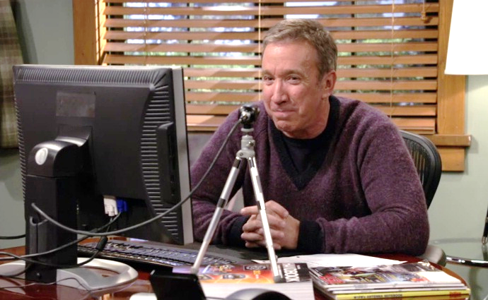

Mike Baxter, KA0XTT, played by Tim Allen (arrl.org)

On a commute a little longer than 10 feet, I’m planning to be in person at the [Portage County Amateur Radio Service](http://www.portcars.org/) (PCARS) meeting coming up March 8th. Meeting topic will be VoIP modes (Voice over IP), both analog and digital, and the [DVMIS](http://www.k8jtk.org/ham-radio/k8jtk-hub-digital-voip-mutimode-interlink-system/). Hope to see everyone. There should be a Zoom link posted on their site if you would like to attend virtually.

Speaking of the DVMIS, the Last Man Standing Amateur Radio Club – KA6LMS is sponsoring a special event starting at 00:00 UTC on March 24, 2021 and end at 23:59 UTC on March 30, 2021. This coincides with the last day of shooting for the show which is concluding its long, successful run. This event is going to be a multi-band, multi-mode, special event celebrating the show for its portrayal of amateur radio. AmateurLogic.TV is planning a net for March 27 from about 7 pm – 1 am eastern and the net will be carried on my system! I’m honored to be part of this event as Last Man Standing is one of my favorite shows. Mark your calendars and check the [KA6LMS](https://www.qrz.com/db/KA6LMS) QRZ page for details!

**Thanks for reading and 73… de Jeff – K8JTK**

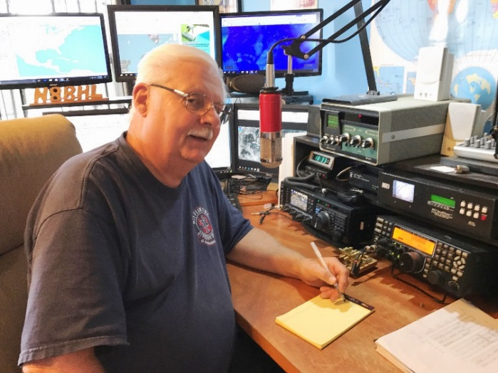***From the Section Emergency Coordinator***

***Stan Broadway, N8BHL - SEC***

[broadways@standi.com](mailto:broadways@standi.com)

**Ohio ARES ~ things are coming!**

Things are rolling along with the Ohio ARES organization. We had a very successful VHF contest- remember the main purpose is to plot your personal coverage pattern so if we have a “dark sky” event with no power and no repeaters you’ll have a head start on relaying important information. For many newer hams, it reinforces the need for a good outside antenna.

Speaking of… another important Ohio ARES event is NVIS Antenna Day. This year, NVIS Day is set for April 24. NVIS involves “cloud burner” antennas- low to the ground, with RF radiation going more or less straight up, bouncing down to areas within about 400 miles… just what we need for emergency HF communications in Ohio and elsewhere!

TOP^

It’s a great time to get together (yes! It’s outdoors!) and learn to build antennas, then try them out. Again, this is a fun way to stay prepared with functional, portable antennas in our go-boxes. And for many it’s the first time to actually solder together an antenna. Stay tuned for further details! We have been asked to present NVIS on a national ARES forum in the near future.

We are also working on the annual ARES Spring Conference. This has been a great success over the years, with well over 100 participants each year. The advent of Zoom leads us to consider using video conferencing to bring in experts from anywhere and present them to a much greater number! We’re working on potential breakout sessions and outside speakers for the session. We may be able to spread these out over a few weeknights. Easter is early (April 4) so will have to consider the week of the 11th. More to come!

I would encourage you all to participate in the Red Cross “Winlink Thursdays” as we move through Spring. The exercises are really easy, and the ability to quickly use Winlink to send forms for any agency is really important! The exercise takes place on the second Thursdays leading up to a large-scale exercise May 8. Check ARC EmComm Training on groups.io.

####

***Ohio ARES D10 2021 Messaging Exercise***

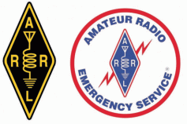District 10 will be running some lightweight, easy-to-follow activities throughout 2021 to help you s keep those messaging and digital muscles that they needed for SET in-shape.  As any potential activation may have different requirements, the objective is to keep a variety of messaging modalities fresh in people’s minds, ensuring we have as many tools in the toolbox as possible when needed.

We will also gamify this, keeping track of who participates in each county and how each county stacks up against each other within District 10.  We’ll come up with some sort of prize at the end of the year if people really get into it, but details to follow on that later.

[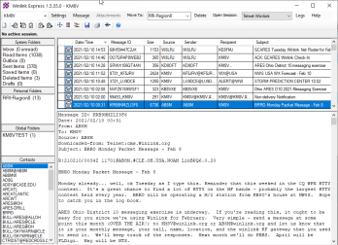](https://i2.wp.com/www.km8v.com/wp-content/uploads/2021/02/winlink-express-km8v.png?ssl=1)Each month, we’re asking you to send a message to AB8M or KM8V via a different method.  That’s it – one month, one message. 🙂

Winlink Express

**February & June – Winlink:**Send a message ***over the air*** to a winlink gateway addressed to AB8M or KM8V.  The message should include Callsign, Name, City, County, and the winlink gateway they used.

You can find local Winlink RMS Gateways [here](https://km8v.com/packet/), or look them up in [Winlink Express](https://winlink.org/WinlinkExpress).

TOP^

**March & July – Packet Radio:**Send a message to a ***packet node***addressed as a bulletin to ARES@CLE.  The bulletin should include Callsign, Name, City and County.

**[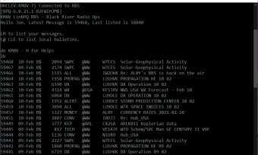](https://i0.wp.com/www.km8v.com/wp-content/uploads/2021/02/km8v-bbs.png?ssl=1)Packet BBS**

KM8V-1 is on the western edge of Cuyahoga County w/ coverage into Lorain County.  AB8M-1 is on the southern side of Cuyahoga County w/ coverage into Lorain and Medina counties.  W8HAC-1 is the eastern side of Cuyahoga County w/ coverage into Lake and Geauga counties.

(If other D10 counties want to link a packet node, or want training for your ARES team specific about using packet, let me know.) [Click here for info on Cleveland area packet nodes](https://km8v.com/packet).

FLMSG ICS-213

[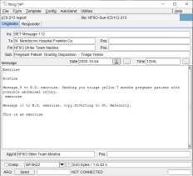](https://i2.wp.com/www.km8v.com/wp-content/uploads/2021/02/nbems-ics-213.png?ssl=1)

**April & August – NBEMS & ICS-213:**  Generate an ICS-213 message to be transmitted via [FLMSG](http://www.w1hkj.com/)addressed to AB8M or KM8V.  Each county EC should arrange for a contact person to collect the ICS-213’s from their county.

This should be done ***over the air*** via simplex or a local repeater.  District 10 will host a weekly net on the 147.015 repeater to collect the messages from these county liaison stations.  Stations outside of District 10 that want to participate should send their traffic to the Buckeye Net NBEMS HF net or the Ohio Digital Emergency Network.

TOP^

**May & September – NTS:**  Send a ***radiogram***addressed to AB8M, Broadview Heights OH 44147 or KM8V, Fairview Park OH 44126.  The radiogram should be less than 25 words.  There are multiple ways to inject a radiogram, including TWO local NTS nets within District 10:

**ARRL Radiogram**

* 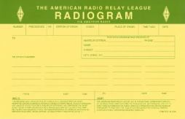[Tri-County Traffic & Training Net](http://tricountytraffic.net/) (Geauga County).  Meets every Tuesday, Friday, and Sunday at 9pm ET.
* [Burning River Traffic Net](https://www.qsl.net/brtn/) (Lorain County).  Meets every evening at 9:30pm ET.
* [Ohio Single Sideband Net](http://ossbn.org/).  Meets 3 times daily on 80 meters.
* Another amateur station can originate one on your behalf.
* As a *last resort*, generate a message via the radiogram form in winlink and it will send it to the region 8 mailbox for injection into NTS.

**October.**No planned D10 activity, normally when SET is, focus on that.

**November & December:**Happy holidays!

Each month a reminder will be sent to this distro with specifics around that month’s activities. I don’t know about the rest of you – but I can honestly say that after a few months of not using a mode I have to stop and shake some of the rust off (how did I do that on my radio again?).  Let me know if you have additional questions.

Thanks! -Doug, AB8M

***From the Public Information Coordinator***

***John Ross, KD8IDJ - PIC***

[john.ross3@worldnet.att.net](mailto:john.ross3@worldnet.att.net)



**FROM THE PIC**

**NEWSLETTER CONTEST DEADLINE IS FOUR MONTHS AWAY!**

As unbelievable as is seems the deadline for the entering the Ohio Section 2021 Newsletter Contest is just four months away….June 30th.

TOP^

****WOW! The entries are already coming in at a record pace and they are all look like winners! The judges will have a hard time picking the best and we would not have it any other way.

Believe me, each and every entry is great, lots of club news and detailed technical information. Keep them coming and remember **the deadline is June 30th**. We will announce the winners in late July or early August.

I have included the information below last month and it seemed to help speed up the entries so here is how to get your entries to us: [**webmaster@arrl-ohio.org**](mailto:webmaster@arrl-ohio.org) You can also send them directly to my home address and email address are below if you prefer…send any way you like. Good luck and keep the entries coming!

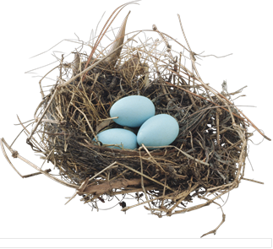

**A HAMSHACK BY ANOTHER NAME**

I am not kidding that the subject of Amateur Radio for me comes up in the strangest places…this week at the doctor’s office!!

For my yearly medical tune-up I wore a short sleeve ARRL branded shirt. So, when the doctor asked what the ARRL is I obliged with the standard ham radio definition about the organization, what it does and about ham radio in general. I also mentioned I had a room in the basement with all of my electronic equipment and it was a great place to relax and talk on the radio. “So you have a NEST then?” the doctor said without batting an eye. I thought for a second what a birdbrain thing to say but I realized he was right…I guess I have been “nesting” between the radios, video screens and wires. No more HAMSHACK…I have a HAMNEST!...minus any eggs to sit on.

The true definition of a nesting is pretty obvious…at least you would think so…but is usually defined for our Avian friends to hatch their young and teach them to eat worms. I found a better definition in the Collins dictionary:

**NOUN**

**…*the tendency  to arrange one’s immediate  surroundings, such as a work station, to create a place where one feels secure, comfortable or in control.***

So, I passed the medical exam but had a co-pay for the English lesson. Feel free to call your “room” a nest, a table, a HAMSHACK or a HAMNEST knowing whatever you’re doing there is helping Amateur Radio!

By the way, I think the ARRL has a lot of branded merchandise still on sale this month in case you want “live the experience” with me talking about ham radio!!!

That’s it for this month…remember to keep talking…and be safe.

73, John, KD8IDJ

[john.ross3@worldnet.att.net](mailto:john.ross3@worldnet.att.net)

TOP^

***From the Section Youth Coordinator***

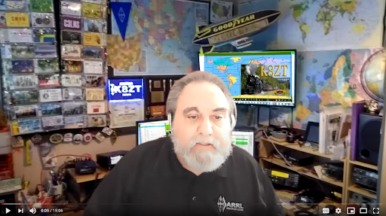***Anthony Luscre, K8ZT - SYC***

[k8zt@arrl.net](mailto:k8zt@arrl.net)

**Two Items for Technician Licensees and Other Newly Licensed or Upgraded Hams**

The Technician license as the entry-level of Amateur Radio is prevalent for both youth and others new to Ham Radio. It’s a great way to get started in the hobby, but it is considered somewhat limited in its privileges. Looking at current FCC Amateur Radio Licensing statistics, it is evident that the Technician Class makes up a majority of the total hams in the US.

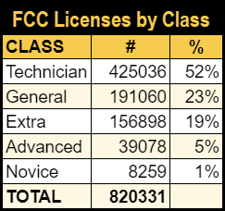Some hams look at this and say the answer is simple-- these hams need to upgrade! But this is a very short-sighted and highly oversimplified statement. There are actually a few reasons that the percentage of Technician licenses in the general ham population are and will remain high:

1. As the introductory level license, any hams that drop out after getting their license will appear in the statistics until their license expires, so part of the number is actually non-active hams.
2. Some new hams get into Amateur Radio only to participate in activities that only require a Tech level license (VHF/UHF Emergency Comm, Drone flying, etc.), so they have no incentive to upgrade.
3. Hams that lack mentors (Elmers) may not be aware of all the activities they can take part in or the advantages of upgrading.
   1. As evidence to this point, if we calculate percentages of each level of license of the members in a local radio club, we find it very different. Typically, in club members, the Technician percentage is more along the lines of <25%.
   2. Hams that are members of local clubs or national groups (ARRL) are typically more active in a wider variety of on-air activities than those that are not members.
   3. Is your club **actively** recruiting new members and providing continuing education opportunities, licensing upgrade classes, and mentoring?
4. For some Techs, learning and understanding the material to pass the General class license can be daunting. This is often the case for many youngsters (yes, I know of many young prodigies who pass their Extra exam with 100%, but they are exceptions, not the rule).

**Technicians, Life Beyond Repeaters**

So instead of complaining about them not upgrading, I would instead like to suggest a wide variety of activities that Techs can explore. This not only helps prevent ham dropouts but also encourages future upgrading. I have put the ideas into a presentation- ***“Technicians, Life Beyond Repeaters.”***

TOP^

The slideshow for the presentation is available at [tiny.cc/btech](http://tiny.cc/btech). There are also a few recordings of me presenting it online. I will be doing shortened versions of it for upcoming events- Vermont Ham-Con 2021- [link](http://ham-con.org/hamconon.html) and an ARRL Webinar, March 9, 2021- [link](http://www.arrl.org/arrl-learning-network). If your club is interested in a live online presentation, please contact me via email.

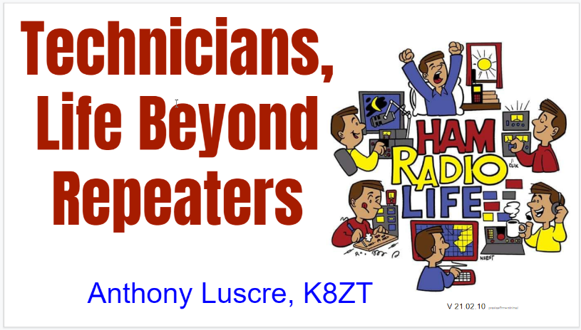

A short outline of the presentation:

* Band & Mode Privileges of Tech
* Proposed new privileges for Techs
* Myths about Tech privileges
* Ideas for
  + Exploring New Modes
    - SSB (10, 6, 2 & up)
    - CW (80, 40, 15 & 10)
    - FT8/FT4 (10 & 6 M)
    - Fast Scan TV (UHF/ microwave)
    - WiFi (ARDEN) (UHF/ microwave)
  + Exploring New Bands
    - HF (SSB- 10)
    - HF (CW- 80, 40, 15)
    - VHF (6 M)
    - 222
    - Microwaves
  + Exploring New Activities
    - Simplex (VHF/UHF)
    - Satellites (V/U)
    - Contesting (VHF/UHF, HF CW)
    - SOTA/POTA
    - DMR
    - EchoLink
    - APRS
    - Fox Hunting
* The presentation then digs deep into each of these
* Discussion of Elmers

**Guide for Buying an Amateur Radio Transceiver**

When teaching Amateur Radio Licensing classes, I often get a lot of questions on what equipment students should buy when they get their Tech license or upgrade. Recently, I decided to put together yet another presentation, “Buying an Amateur Radio Transceiver.” The slideshow is available at [tiny.cc/buyar](http://tiny.cc/buyar) along with a companion spreadsheet at [tiny.cc/buyar-ss](http://tiny.cc/buyar-ss). Again, if your club is interested in a live presentation, I am available, or feel free to use the slideshow and spreadsheet to present to your own licensing classes.

TOP^

A short outline of the presentation:

* 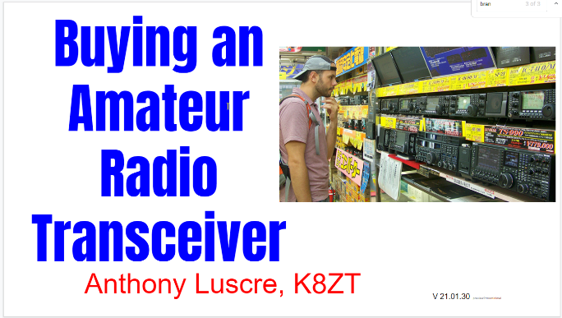Available as-
  + New
    - Assembled
    - Kits
  + Used
* Venues for Buying
  + Dealers (Ham Radio Specific)
    - In-Store
    - Online Ordering
  + Online General Merchandisers (Amazon, etc.)
  + 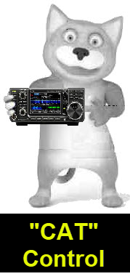Auction Sites (eBay, etc.)
  + Ham Only Online Private Listings (eHam, QRZ, etc.)
  + Hamfests
  + Private Sellers
* Myths about AR Transceivers
* A lot like buying Cars/Trucks
* New vs. Used
* Usee Equip Pricing
* Manufacturers (HF & VHF/UHF) and web links
* VHF/UHF Radio Decisions
  + Handheld (HT) vs. Mobile
  + Single Band (usually 2M) vs. Dual Band (2M/70 cm)
  + Analog vs. Digital
  + 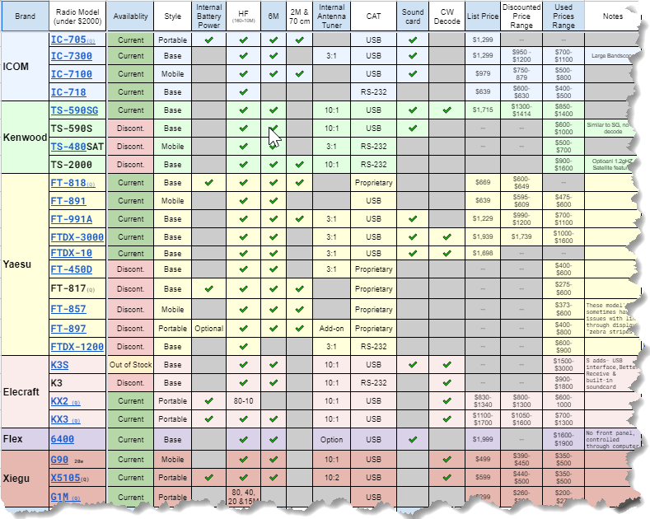Cheap vs. Traditional Brands/Models
  + New vs. Used
  + Accessories
  + FM vs. SSB
* HF Radio Decisions
  + Feature & Specifications
  + Base/Mobile/Portable
  + Accessories
  + Other Equipment Needed
* Computer Interfacing
  + CAT
  + Programming
  + Software
* Equipment Reviews & Testing
* Clones & Questionable Equipment
* Equipment to Avoid
* Used & Hamfest Shopping

TOP^

* Spreadsheet
  + HF - Current & Discontinued
  + Recent HF Rig Comparision Matrix
  + VHF/UHF - Current & Discontinued
    - HT
    - Mobile/Base
  + Manufacturer’s Websites
  + Vendor’s Websites

For a list of my other presentations- [tiny.cc/k8zt-p](http://tiny.cc/k8zt-p) includes slideshows, video recordings and links. If you are interested in any of these for a live, online presentation for your local club, please email me.

73,

Anthony, K8ZT

***From the Section Traffic Manager***

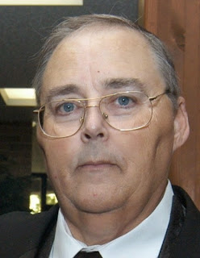***David Maynard, WA3EZN – STM***

[wa3ezn@att.net](mailto:wa3ezn@att.net)

**FEBRUARY 2021**

With the winter weather finding temperatures in the teens and single digit wind chill it is time to review some winter precautions. But first some safety tips abut heating your home.

Be alert to CARBON MONOXIDE. CARBON Carbon monoxide is an odorless, colorless gas created when fuels such as gasoline, wood, natural gas, propane or oil is burned incompletely. CO from these sources can build up in enclosed spaces ans sicken the people and animals in them. In some cases death has been the results.

Know the symptoms. Carbon monoxide may cause headaches, dizziness, nausea, vomiting, irregular breathing ans other symptoms. You may smell exhaust fumes or see a yellow/orange flame on gas burners, or see soot around the outside of the chimney, vent or fireplace.

If you think you may have symptoms, leave the area immediately and call 911.

Stay safe

* install carbon monoxide detectors. Some models double as smoke detectors
* Have all appliances checked by a professional
* Provide adequate ventilation in the house when using stoves, fireplaces and space heaters.
* Clean the chimney and check for blockages, especially if using wood burning stoves and fireplaces.
* Never burn charcoal or run a generator indoors or I an enclosed area such as a garage.
* Never leave your vehicle running in a garage, even with the garage door open.

TOP^

Learn a lot more at [www.cdc.gov/co](http://www.cdc.gov/co) While we are on the subject of safety in the home, what to do when you smell gas. If you suspect a gas leak: If you smell gas inside, get out fast.

**WINTER STORM SAFETY**

The winter storm will bring dangerous travel conditions and the Red Cross urges everyone to stay off the road if possible. If driving in winter weather is unavoidable, people are urged to follow these tips:

* In your vehicle keep a windshield scraper, small shovel, and small sack of sand or kitty litter for generating traction under wheels. Also carry an emergency supply kit, including warm clothing.
* Keep your vehicle’s gas tank full so you can leave right away in an emergency and to ensure you have enough fuel to keep warm if you get stuck. Make sure everyone has their seat belts on and give your full attention to the road.
* Don’t follow other vehicles too closely. Sudden stops are difficult on snowy roadways.
* Don’t use cruise control when driving in winter weather.
* Don’t pass snowplows.
* Ramps, bridges and overpasses freeze before roadways.
* If you become stranded, stay in the vehicle and wait for help. Do not leave the vehicle to search for assistance unless help is visible within 100 yards. You can quickly become disoriented and confused in blowing snow.
* Display a trouble sign to indicate you need help. Hang a brightly colored cloth (preferably red) on the vehicle.
* Run the engine occasionally to keep warm. Turn on the engine for about 10 minutes each hour (or five minutes every half hour). Running the engine for only short periods reduces the risk of carbon monoxide poisoning and conserves fuel. Use the heater while the engine is running. Keep the exhaust pipe clear of snow, and slightly open a downwind window for ventilation.
* Leave the overhead light on when the engine is running so that you can be seen.

2020 HF NET TOTALS

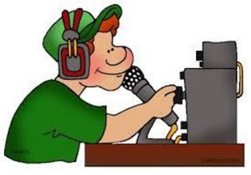

|  |  |  |  |  |
| --- | --- | --- | --- | --- |
| NET | QNI | QTC | QTR | NETS |
| OSSBN | 2121 | 4372 | 25853 | 1096 |
| BNE | 1235 | 327 | 3113 | 258 |
| BNL | 600 | 402 | 1787 | 268 |
| OSN | 1095 | 126 | 4081 | 233 |
| TOTAL | 2414 | 5227 | 34834 | 1855 |

Remember that the OSSBN is now starting at 6:15 due to poor band conditions. You are asked that if you have traffic be on frequency on time a prepared to pass your traffic. At this time an attempt will be made to pass all traffic prior to having role call and before the band goes long. Everyone should also be on frequency by 6:15 and prepared to take traffic. Those able to hear weak stations will be needed to relay traffic and thanks you all for doing so. As the band improves, we are able to have a role call and comments some evenings.

With the cancellation of the Mansfield Midwinter Hamfest the Ohio Single Sideband Net is once again going to have to find a way to hold their next meeting. Keep tuned in and checking into the OSSBN for discussions and updates on the next meeting. Maybe this will be fixed by the new Covid vaccinations.

TOP^

OHIO SINGLE SIDEBAND NET

["Specializing in the first and last mile of NTS delivery in Ohio."](http://www.ossbn.org/)

|  |  |  |  |
| --- | --- | --- | --- |
| **Morning session** | **10:30 AM** | **3972.5 KHz** | **every day** |
| **Afternoon session** | **4:15 PM** | **3972.5 KHz** | **every day** |
| **Evening session** | **6:15 PM** | **3972.5 KHz** | **every day** |

**OHIO HF CW TRAFFIC NETS**

|  |  |  |  |
| --- | --- | --- | --- |
| **HF CW NETS** | **NET TIMES** | **FREQUENCY** | **NET MANAGERS** |
| **Buckeye Early** | **6:45 PM** | **3.580** | **WB8YLO** |
| **Buckeye Late** | **10:00 PM** | **3.590** | **WB9LBI** |
| **Ohio Slow Net** | **6:00 PM** | **3.53535** | **W8MAL** |

All net frequencies plus or minus QRM. .

**OHIO LOCAL VHF TRAFFIC NETS**

|  |  |  |  |
| --- | --- | --- | --- |
| **VHF NETS** | **NET TIMES** | **FREQUENCY** | **NET MANAGERS** |
| **BRTN** | **9:30 PM DAILY** | **145.230 PL 110.9** | **W8DJG** |
| **COTN** | **7:15 PM DAILY** | **146.970** | **KD8TTE** |
| **MVTN** | **7:00 PM Mon** | **146.640** | **KC8HTP** |
| **NWOHARES** | **6:30 PM DAILY** | **147.375** | **N8TNV** |
| **TCTTN** | **9 PM Sun, Tues, Fri** | **146.94** | **WB8YYS** |
| **TATN** | **8:00 PM DAILY** | **146.670 PL123** | **WG8Z** |

These VHF net times and frequencies are those that have been reported to me by the net managers.

While on the subject of nets the West Virginia Mid Day Net meets daily at 11:45 AM Local Time 7.235 or 3.810 MHz. And the West Virginia Fone Net meets daily at 6:00 PM Local Time on 3.810 MHz. I mention this as a possible resource for them when there is no West Virginia representative on 8RN to take their traffic. Also, as a reminder there is no digital station for West Virginia traffic and seldom is there a representative on the Interstate Sideband Net ISBN

We are all familiar with the volunteer opportunities of the ARES programs. Is a program like CERT, Search & Rescue right for You?

TOP^

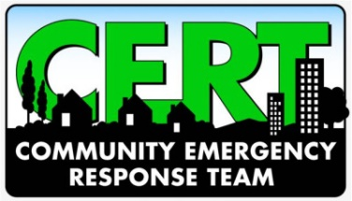**Ohio Community Emergency Response Team**

The Ohio Community Emergency Response Team (CERT) program educates volunteers about disaster preparedness and trains them in basic disaster response skills such as fire safety, light search and rescue, and disaster medical operations. CERT offers a consistent approach to volunteer training and organization that professional first responders can rely on during disaster situations, which in turn, allows responders to focus on more complex tasks.

The CERT program was designed as a grass root initiative and specifically structured so that local and state program managers have the flexibility to form their CERT programs in the way that best suits their communities.

* Citizen Corps works through a national network of state and local Citizen Corps Councils, if local communities choose this advisory option, then leaders from law enforcement, fire, emergency medical and other emergency management, volunteer organizations, local elected officials, the private sector, and other community stakeholders that serve as an advisory board.
* Local Citizen Corps Councils implement Citizen Corps programs. These programs may include CERT, Medical Reserve Corps, Neighborhood Watch, Volunteers in Police Service, Fire Corps and other affiliate programs that provide opportunities for special skills and interests. They also organize special projects and community events.
* For CERT programs not endorsed by a local Citizen Corps, the program must be sponsored by a local emergency response organization such as a local fire department or emergency management office.
* Citizen Corps affiliate programs expand the resources and materials available to states and local communities. They do this by partnering with programs and organizations that offer resources for public education, outreach and training; represent volunteers interested in helping to make their communities safer; or offer volunteer service opportunities to support first responders, disaster relief activities and community safety efforts. For more information check out these web pages:

<https://www.ema.ohio.gov/CERT.aspx>

<https://www.ready.gov/cert>

<https://ema.ohio.gov/CERT-socialmedia.aspx>



<https://www.cert-la.com/cert-ohio/>

Above all else stay safe, stay home and wear you mask if you go out. Until next time remember to obey the state 10PM curfew, don't assemble in large groups, wear you masks and try to have a good day.

73

David WA3EZN

Ohio Section Traffic Manager

**You can view the STM’s monthly report on the website..** [**http://arrl-ohio.org/stm/stm.html**](http://arrl-ohio.org/stm/stm.html)

TOP^

*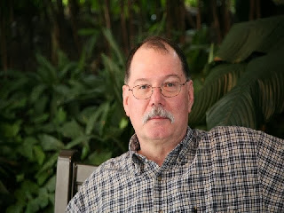****ARES Training Update***

***Jim Yoder, W8ERW – ARES Data Manager***

[w8erw@arrl.net](mailto:w8erw@arrl.net)

***ARES Training Update***

At present I would be happy to be mowing grass every day rather than shoveling snow. I am sure there are many reading this who would agree with that. Yes, come August when the humidity matches the temperature, I’ll be tired of mowing also. Right now I just came in from digging my vehicle out of nearly two feet of snow. I’m done with this winter and am quite ready to stroll through a Hamfest looking for something I might not need, but really want anyway. We just might be able accomplish that in a few months when it is warmer and more to all of our liking. One can hope.

On a more positive note, I’ve not had to contend with the loss of power like our friends in Texas have. I have a cousin in the Austin, TX area and at one point the temperature there was a couple of degrees colder than here in Fremont. What a colossal mess there with the power grid damaged and supposedly wind generation offline and problems with the natural gas supply. How do you prepare for something that has historically never happened? Texas has experienced tremendous growth and infrastructure has not kept up with demand. Native Texans also know not to attempt travel under the conditions recently observed while the recently relocated people wrongly assume Texas has the capability and equipment like we do to deal with snow, ice and abnormally low temperatures. They do not and a lot of folks are now wishing they did.

Being prepared is the ARES key word and we know how to do that. Our infrastructure is designed with the thought of these winter calamities in mind. Experience proves it necessary in our climate. We as Amateurs also know the importance of being ready to act and serve when called upon to do so. While we are restricted in our normal activities due to the pandemic and now the weather, it’s a good time to look over the go bag and our equipment to make sure it’s all-in good shape and ready to go to work. I discovered the antenna connector on my Ht was loose and I took care of that one evening recently along with some popcorn and one of those refreshments with foam on top. My batteries are charged, and I’ve inspected the many cords and other ancillary devices to insure they are all working.

Many of you have also taken advantage of the extra free time indoors to advance your training. We have been steadily adding to the courses completed and the numbers of Level 2 and 3 qualifications have continued to grow. We have added an impressive number of new people as well. If you have taken FEMA courses and other training and have not yet submitted your certificates, I encourage you to do so. FEMA will also send you a transcript that lists all of your training which in many cases will be the easiest way to submit your course completion.

To date, we have 1,905 Ohio Amateurs identified in the training database. Not all are active and a 47 have become silent keys over time. 1068 are currently active members who have submitted training documents. 837 have registered with ARES Connect while not having submitted any training documents.

TOP^

Overall, there are 1,511 ARES members now registered with ARES Connect. The total number of training certificates now numbers 9,812. Level attainment figures are 972 Level 1, 730 Level 2 and 203 Level 3.

These are impressive numbers and to be sure, our Ohio Amateurs have generously embraced ARES training once again showing the dedication of our Ohio Section Hams to supporting ARES and the mission we stand ready to perform. Thank you all again for this excellent effort.

So what next now that we understand ARES Connect will be going away as we know it? Our mission remains the same and we will be maintaining the database for ARES Training. I am sure there will be something new and better to perform what ARES Connect has done for us. In the interim, we will be reverting to the paper process to report hours and activities. Please be sure you inform your local ARES leadership of these hours and follow the procedures indicated.

Also, it helps considerably when you advise me of changes to your status including changes to your call and county affiliation with ARES. Please do include you call when corresponding. It was bound to happen, and it has on one instance where an amateur became a silent key and his call was re-issued as a vanity call to another Ham. Luckily with the help of QRZ.com and the FCC data, I was able to sort this out. It did however highlight the need to add another identifier to the database. I initiated the serialization of all those entered in the database which now is the key identifying field in the data.

Please keep those certificates coming. This is one very positive way to justify our retention of spectrum. It also impresses our Section Manager and the headquarters staff in Newington. Neither of those can hurt us but shows our strength and the quality of our Ohio Hams. Please also know that your Ohio Section officials are here to serve you and we welcome your comments and questions. For EC’s and DEC’s especially, I can provide you with all the training details for your people and am happy to do so. I can do the same for individuals also.

Thanks again and 73,

**Jim W8ERW**

[w8erw@arrl.net](mailto:w8erw@arrl.net)

##

***Training Opportunities***

Several NWS offices have already posted their upcoming virtual spotter training on their website under news headlines ([www.weather.gov](http://www.weather.gov) and click on local area). Please register if you are interested and check back if spotter training is not yet listed as some talks are still being finalized. Talks are also often times posted on NWS offices Facebook/Twitter pages as well.

If you are interested in learning more about flooding there is also an upcoming talk scheduled for

**February 23rd** and it’s dedicated just to flooding information: Although NWS Wilmington is giving the flood talk, anyone is welcome to attend: <https://register.gotowebinar.com/register/4181807071729004814>

TOP^

In addition to spotter training, there is also an upcoming virtual CoCoRaHS training on Tuesday March 9th at 6:30pm. If you would like a refresher on snowfall measurements or have other observing questions, this training is a great opportunity to review all of these aspects. Also, if you know someone who isn't currently a CoCoRaHS observer, but they are interested in learning more, please feel free to share the upcoming training session.

For more info and registration, you can go to: <https://www.weather.gov/media/iln/Volunteer/cocorahs.pdf>

**####**

**EMA-G272 WARNING COORDINATION**

**Hosted by: Ohio Emergency Management Agency March 15 – 16, 2021**

**Course Description:** This course is the latest in the hazardous weather series of courses produced in partnership with the National Weather Service (NWS). Every year, the United States experiences more severe weather than any other country in the world. In order to reduce deaths, injuries, and property losses, emergency managers must work closely with the NWS and the news media to provide effective warnings that can be received and understood by people at risk.

This course is intended to help facilitate that process. Course topics include: The Social Dimensions of Warning Response; Developing Effective Warning Messages; Developing an Effective Community Warning Process; and Working with the News Media to Create a Weather Warning Partnership. In addition to lecture and discussion, the course includes case studies, exercises, and an opportunity for interaction with representatives of the local news media. **\*\*This course is an Elective for the Advanced Professional Series\*\***

**Registration Deadline:** March 1, 2021

*Seats are limited so please register early

**Time of Course:** Registration: 7:30 am – 8:00 am (on day one) Course Time: 8:00 am – 2:30 pm

**Location:** Virtually via Microsoft Teams

**Recommended Participants:** Intended for local emergency managers.

**Recommended Prerequisite:** Please consider enrolling in the IS-271 Anticipating Hazardous Weather and Community Risk or IS-247 Integrated Public Alert and Warning System (IPAWS), before attending this course. The IS courses are available online by going to <http://training.fema.gov/IS/> and clicking on the "ISP Course List" link on the left side of the page.

**Enrollment:** Students must enroll via the Department of Public Safety Training Campus website: <https://trainingcampus.dps.ohio.gov/CourseMill/pstc/pstc.html> Course registration will generally close 10 working days prior to the course start date. You can check enrollment/approval status via the Department of Public Safety Training Campus website.

TOP^

**Microsoft Teams:** If you do not already have a Microsoft account, you will need to sign up for one. There is no cost associated with setting up an account. Please let the State Point of Contact know if the email you use is different from the email you have on file with you Public Safety Training Campus profile.

**Course Costs:** This course is free to participants.

**State Point of Contact:** Matt Jaksetic, Ohio EMA (614) 799-3666, [mtjaksetic@dps.ohio.gov](mailto:mtjaksetic@dps.ohio.gov)

***National News***

*(from arrl and other sources)*

***Club Gets Double Duty from Minnesota QSO Party 2021 Operation***

The Mississippi Valley Amateur Radio Association ([**MVARA**](https://mvara.net/)) fielded a team to the parking lot of a local TV station to take part in the Minnesota QSO Party over the February 7 – 8 weekend. Not only did the group get some emergency exercise training but garnered positive publicity for amateur radio from the station’s news team.

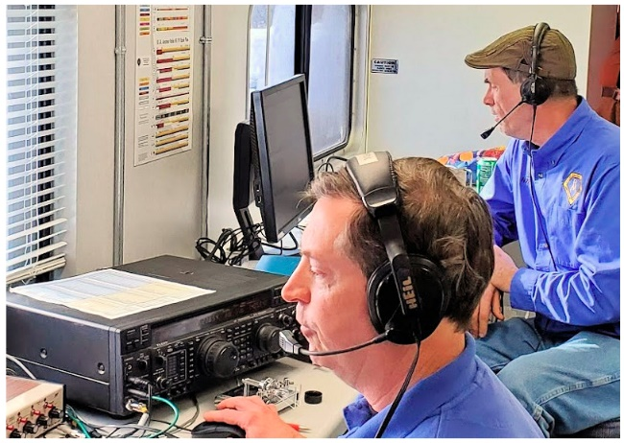Using special event call sign W0M, 10 radio amateurs — including one newly minted General-class ham who’s still awaiting his call sign — pitched in. The operation took place in an emergency communications bus, with everything set up like a Field Day operation, although in the Minnesota winter.

“MVARA recently acquired a full-sized emergency communications bus that needed some TLC,” said Scott Neader, KA9FOX — one of the operators. “The club has been refurbishing it over the last year and was looking for an opportunity to operate from the bus to test out some of the recent improvements, as well as to test our ability to set up a viable HF communications center in less-than-ideal conditions. Operating the Minnesota QSO party looked like a fun way to test things out.” Neader said the sub-zero weather didn’t make things easy, especially with respect to set-up and tear-down process.

A club member works at television station WXOW in LaCrosse, Wisconsin, which has its tower and studios at a high location in Houston County, Minnesota. That was the “in” to obtain permission to set up in the station’s parking lot. “As a bonus to operating at the TV station, the news department couldn’t resist checking out what we were doing, and we wound up being a part of the [**10 PM news broadcast**](https://wxow.com/2021/02/06/mississippi-valley-amateur-radio-holds-training-in-wxows-parking-lot/),” Neader said.

The group set up two operating positions, and given the cold temperatures, they went with dipoles for 80, 40, and 20 meters, up about 20 – 35 feet.

TOP^

The group experienced a few computer and radio issues that needed to be worked out after the contest started. “[T]his was expected and, of course, part of the reason for our participation, but it did cause us to be off the air for some brief periods.”

Judging from the statistics the club posted on **3830.com**, the operation was a great success. “We had a blast and are looking forward to more operations like this, as well as being able to use the communications bus as a mobile tool to educate students and the general public about amateur radio…and to support our communities with any emergency communication needs, as they may arise,” Neader said.

The W0M team claimed 203,392 points, with 908 (392 CW + 516 SSB) contacts in 57 US states and Canadian provinces and 54 out of 87 Minnesota counties in 10 hours of operating.

The team’s Bill Kleinschmidt, N9FDE, said an excursion for the Wisconsin QSO Party may be the club’s next adventure.

####

***ARLS003 CAPE-3 CubeSat Launched***

The University of Louisiana (UL) at Lafayette student-built CAPE-3 satellite was launched on January 17. A 1-U CubeSat, CAPE-3 includes a "digipeater and experimental UHF adaptive radio." An AX-25 telemetry downlink has been coordinated on 145.825 MHz and a 1k2 frequency-shift keying (FSK) downlink has been coordinated on 435.325 MHz, "which may burst to 100 kHz bandwidth," according to the IARU Amateur Satellite Coordination page.

CAPE-3 is the third cube satellite in the CAPE series. The primary educational mission is to allow grade-school classrooms to access the Smartphone CubeSat Classroom and run interactive experiments through an experimental smartphone ground-station grid. The secondary mission is to perform scientific experiments involving radiation detection and take pictures of Earth.

The solar-powered spacecraft, created by UL Lafayette's CAPE Satellite Team, was launched with nine other CubeSats as part of NASA's Educational Launch of Nanosatellites (ELaNa) program. A Virgin Orbit LauncherOne rocket attached beneath a wing of a customized Boeing 747 was dropped high above the Pacific Ocean. It climbed about 225 miles above Earth and then ejected the satellite.

Information on the ElaNa program can be found in PDF format at, <https://www.nasa.gov/sites/default/files/atoms/files/lsp_elana_20_fact_sheet.pdf>

The CAPE satellites are named for the university's Cajun Advanced Picosatellite Experiment program, designed to prepare students for careers in science, technology, engineering, and mathematics (STEM) fields.

####

TOP^

***ARRL Board Considers Plan to Cover New $35 FCC Fee for Some Young Applicants***

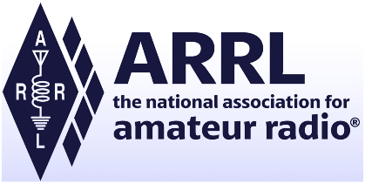At its Annual Meeting in January, the ARRL Board of Directors considered a motion to offer a new service that would pay the new but not-yet-implemented $35 FCC application fee for a limited number of new radio amateurs younger than age 18 who, at the time of testing, belonged to an ARRL Affiliated 501(c)(3) charitable organization and passed their tests through an ARRL VEC-sponsored exam session. The proposal called for reducing the VEC fee for these candidates to $5.

The initial proposal came from ARRL Southeastern Division Director Mickey Baker, N4MB. Other Board members offered subsidiary motions. Supporters said the purpose behind the motion was to ameliorate the potential financial hardship the pending FCC application fee posed on certain minors applying for their first license, and to encourage new youth membership.

Consideration of the motion, which was subject to considerable discussion, was deferred to an ad hoc committee composed of the members of the Administration & Finance Committee, two Members of the Programs & Services Committee, and ARRL CEO David Minster, NA2AA (or his designated representative). The Board directed the panel to review and more fully develop the proposal and report back to the Board by the end of March with a recommendation as to whether such a program should be adopted and, if adopted, how it should be implemented.

Supporters expressed the belief that recruitment and training of young radio amateurs “is a necessary and proper mission of the ARRL” and that subsidizing the $35 fee “will reduce the number of new amateurs that otherwise would be lost from these groups.”

In December, the FCC agreed with ARRL and other commenters that the initially proposed $50 fee for certain amateur radio applications was “too high to account for the minimal staff involvement in these applications.” In a *Report and Order* ([***R&O***](https://docs.fcc.gov/public/attachments/FCC-20-184A1.pdf)), the FCC scaled back to $35 the fee for a new license application, a special temporary authority (STA) request, a rule waiver request, a license renewal application, and a vanity call sign application. All fees are per application. There will be no fee for administrative updates, such as a change of mailing or email address.

As the FCC noted in its *R&O*, although some commenters supported the proposed $50 fee as reasonable and fair, “ARRL and many individual commenters argued that there was no cost-based justification for application fees in the Amateur Radio Service.”

“After reviewing the record, including the extensive comments filed by amateur radio licensees and based on our revised analysis of the cost of processing mostly automated processes discussed in our methodology section, we adopt a $35 application fee, a lower application fee than the Commission proposed in the *NPRM* for personal licenses, in recognition of the fact that the application process is mostly automated,” the FCC said in the *R&O*. No fee would apply to minor modifications or administrative updates, which, the FCC noted, “are highly automated.”

TOP^

The FCC turned away the arguments of some commenters that the FCC should exempt amateur radio licensees. The FCC stated that it has no authority to create an exemption “where none presently exists.” The FCC also disagreed with those who argued that amateur radio licensees should be exempt from fees because of their public service contribution during emergencies and disasters.

The FCC has directed the Office of Managing Director, in consultation with relevant offices and bureaus, to draft a notice for publication in the Federal Register announcing when rule change(s) will become effective, “once the relevant databases, guides, and internal procedures have been updated.”

####

***HAM RADIO SIGNALS FROM MARS***

*(from SpaceWeather.com)*

[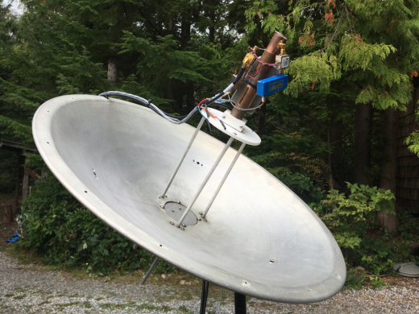](https://spaceweather.com/images2021/16feb21/dish.jpg)Ham radio operators are doing something that until recently only big Deep Space Networks could do. "We're monitoring spacecraft around Mars," says Scott Tilley of Roberts Creek, British Columbia, who listened to China's [Tianwen-1](https://en.wikipedia.org/wiki/Tianwen-1) probe go into orbit on **Feb. 10th**. The signal, which Tilley picked up in his own backyard, was "loud and audible." Click to listen:

The signal Tilley received from Tianwen-1 is dominated by a strong [X-band](https://en.wikipedia.org/wiki/X_band) carrier wave with weaker side bands containing the spacecraft's state vector (position and velocity). Finding this narrow spike of information among all the possible frequencies of deep space communication was no easy task.

"It was a treasure hunt," Tilley says. "Normally a mission like this would have its frequency published by the ITU (International Telecommunications Union). China did make a posting, but it was too vague for precise tuning. After Tianwen-1 was launched, observers scanned through 50MHz of spectrum and found the signal. Amateurs have tracked the mission ever since with great accuracy thanks to the decoded state vector from the probe itself."

So far, Tilley has picked up signals from China's Tianwen-1 spacecraft, NASA's [Mars Reconnaissance Orbiter](https://mars.nasa.gov/mro/), and the United Arab Emirates' [Hope probe](https://en.wikipedia.org/wiki/Emirates_Mars_Mission)--all orbiting Mars approximately 200 million kilometers away. How is such extreme DX'ing possible?

"It helps to have a big antenna," says Tilley, who uses a 60 cm dish, pictured above. "But the real key," he says, "is the advent of [Software Defined Radios](https://en.wikipedia.org/wiki/Software-defined_radio) (SDRs), which have become the norm for hams in the past decade or so."

In a Software Defined Radio, computers digitally perform the signal mixing and amplification functions of circuits that used to be analog; software has replaced hardware. SDRs are cheap, sensitive, and they give hams the kind of exquisite control over frequency required to tune into distant spacecraft.

TOP^

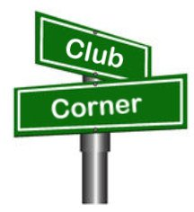***Club Corner***

This is YOUR corner of the newsletter. Send us what your club is doing, and we’ll make sure that it gets in. Got a special event or club project that you want everyone to know about? Send it to us!. Need help with a project? Send it to us.

Let us know what you club is up to. Are you going to have a special guest at your meeting or are you having a special anniversary?

Send it to: [webmaster@arrl-ohio.org](mailto:webmaster@arrl-ohio.org)

***DX This Week***

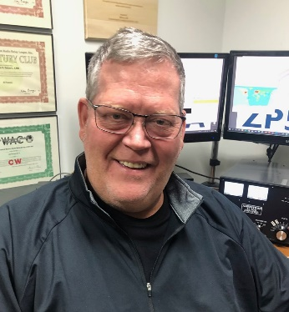

***DX This Week – Apps and Sites***

***Bill AJ8B (***[***aj8b@arrl.net***](mailto:aj8b@arrl.net)***, @AJ8B, or*** [***www.aj8b.com***](http://www.aj8b.com)***)***

***CWOPs Member #1567***

The Midwest DX Cluster spots included Alaska, Anguilla, Argentina, Ascension Island, Asiatic Russia, Azores, Barbados, Belize, Botswana, Brazil, Bulgaria, Canada, Cape Verde, Chile, Cuba, Dominican Republic, Ecuador, England, European Turkey, Faroe Islands, Fed. Rep. of Germany, Finland, France, Gibraltar, Greenland, Israel, Jersey, Kenya, Moldova, Montenegro, Namibia, Poland, Portugal, Puerto Rico, Senegal, Slovenia, Spain, St. Helena, St. Lucia, Switzerland, UK Base Areas on Cyprus, United Arab Emirates, Uruguay and Zambia.. This brings the total number of unique entities spotted in the Midwest in 2021to 133!

***DAH DIT DIT DIT DAH DAH DIT DIT DIT DAH***

I received cards from Z35T – Ozren in Macedonia, Z32ID – Igor, also in Macedonia, and L77D – Angel in Argentina. Let me know what you received.

|  |  |
| --- | --- |
|  |  |

TOP^



***DAH DIT DIT DIT DAH DAH DIT DIT DIT DAH***

I have six sources of information for DX that I use in varying degrees: Blogs, Podcasts, YouTube, Websites, Phone Apps, and books. Websites, Phone Apps, and Books will be reviewed in a future edition. We can focus on the other three.

**Blogs –** Blogs seem to have lost some popularity, but those that are followed are followed heavily. There are other blogs that I follow. The ones that I would recommend are:

|  |  |  |
| --- | --- | --- |
| Blog | Comment | Site |
| KB6NU | General Ham Radio Interest | <https://www.kb6nu.com/> |
| W2LJ | QRP Topics | <https://w2lj.blogspot.com/> |
| VE3WDM | QRP Topics | <https://ve3wdm.blogspot.com/> |
| K0NR | VHF/UHF, QRP, mountaintop operating and technical stuff | <http://www.k0nr.com/wordpress/> |
| WB3GCK | Field Day, Portable, QRP | <https://wb3gck.com/> |
| LA3ZA | All Topics HF | <https://la3za.blogspot.com/> |

**Podcasts –** There are literally thousands upon thousands of podcasts. If you have not tried a podcast, now is the time! There are various smart phone apps that can be used to access podcasts. The one that I use is Stitcher. Just go to the app store on your smart phone and search for Stitcher.

Once you have the app installed, you can search by topic or a specific podcast. I like to listen to information presented in a logical, conversational manner. What I don’t care for is the person who thinks he is on stage and must tell jokes, be funny, or attempt to be smarter than they are. That is the great thing about podcasts. If I don’t like the current guest or topic, just change to a different edition or podcast. Typically, once you have identified a podcast you are interested in, you have access to all the podcasts that had been created previously. In many cases, this gives you a full selection to choose from. Podcasts typically are monthly, bi-monthly or weekly. This also gives you a wide selection of episodes. I spend about 2 hours/day in the car, so, I have time to check podcasts out. My current list of podcasts is below:

TOP^

|  |  |
| --- | --- |
| Podcast | Comment |
| The ARRL – The Doctor is in | Bi-Monthly Ham talk |
| QSO Today | Ham Operator interviews with a wide range of amateurs |
| Ham Radio Workbench | Practical nuts and bolts discussion of building and construction topics |
| No Nonsense Amateur Radio Podcast | General Topis |
| ARRL Audio News | General information from the league |
| Linux in the Ham Shack | Using Linux for various programs and projects |
| This week in Amateur Radio | News and timely radio topics |
| So Now What | For Entry level hams – Curious what you think of this |

**YouTube** – From discussions I have had with hams, I am starting to believe that YouTube may be the best kept secret in our hobby. There are thousands of videos available for all topics! I even looked up my novice station and found several videos about the equipment from 1971. (Eico 720 and Hallicrafters SX-100) I have really begun to use YouTube as a reference and really suggest that you do as well! Before my first serious attempt at the Ohio QSO Party, I search YouTube on K8DV and reviewed Dave’s videos. I learned a tremendous amount!

We don’t all have time to just browse YouTube to see what is new. YouTube allows you to “subscribe” to a “channel” and you will be notified when a new video is posted that pertains to that channel.

One question that I get is how to find channels? Here are the steps you would use:

1. Go to Youtube
2. Type the topic in the Search Bar (i.e. Hallicrafters) and click the “search” magnifying glass.
3. Click the Filters button
4. Select Channel under the Results type. Find the desired YouTube profile in the search results. You should see the option to subscribe. Click it on you will be able to quickly view and sort by category.

The channels that I subscribe to include CWOps, DXEngineering, Yaesu, Dave Berstein (DXLabs), MFJ, Linux in the Ham Shack, Heil Radio, Ham Radio DX, QRZ Ham Radio, Ham Nation, Radio Ham Guy, ARRL HQ, Everything Ham Radio, and Raspberry Pi. Seems like a lot, but, I usually get a few updates per month.

***CQDX CQDX CQDX CQDX CQDX CQDX CQDX CQDX CQDX***

Here is an update from Bernie, W3UR, of the DailyDX and the WeeklyDX, the best source for DX information. <http://www.dailydx.com/>. Bernie has this to report:

**Sable Island DXpedition** - Target is October 2021

[The following is from the [CY0C DXpedition Website](http://r20.rs6.net/tn.jsp?f=001oKsPT7QBfrleyF6KSs_PF9D9A0YfqEaVfhQsj4-cCyPu5qNpyu4eiG4aXTaFZvFNNYnIBeQK_94m0QSqT4ZQKdy5gEob4OG18W-sBny43eA5d1vMVrS0l-HVkz5jRzkumDymQ2TmslTPvGvzL3EFg_AudSwSEwqn&c=nyIYRQ8RLBnhS1pxGSdurYMew2XAWjhox_iCm3QNIc0xmFhZsprm2A==&ch=L6m3njWnF6JI0TC4PbmC_WP700aGNCvvWvKzVoHMzSNpIZylajzWXQ==)]

As everyone knows, the planned 2020 DXPedition to Sable Island had to be postponed due to the worldwide Coronavirus. Since that time, we have been in regular contact with Parks Canada and Sable Aviation.

There are three issues that we are currently dealing with. These include the Canadian border being reopened, the province of Nova Scotia allowing US citizens entry and Parks Canada allowing our team onto Sable Island.

These are all issues completely out of our control.

TOP^

We are cautiously optimistic that our planned October DXPedition will take place at that time. Still some months away, the Coronavirus will (hopefully) be under control by that time. Time is on our side in this aspect!

The Sable Island DXPedition team remains committed and excited about this opportunity. Planning continues as we receive regular updates. This is a fluid situation and we will keep everyone updated as we receive additional information. We would like to thank all of the foundations, clubs and individuals for their support, understanding and patience.

***A new solar cycle 25 forecast***

*By W3LPL, Frank Donovan*

One of the great mysteries of the solar system is why is the solar cycle so firmly footed in an 11-year cycle? Countless scientific papers over more than 100 years have linked Jupiter's 11-year orbit to the solar cycle.

This recent scientific paper linking Jupiter to the solar cycle was published just a few weeks ago in the journal "Solar Physics."  The authors predict that solar cycle 25 maximum will occur in 2026.2 ± 1 year and reach an amplitude of 97.6 (± 7.8) similar to that of Solar Cycle 24. [link.springer.com/arti](http://r20.rs6.net/tn.jsp?f=001xKLi4Tlx8VupJiDaDnCAmnuX1PMGhSdXLxW-1Ccvoacf_7aFt-pUfahCMBnJfmGDYu3wt5MOjlFRYAlGcdeVLK2BqfZn75GuMzOZYo7MaVvNOyTXOWNZKF5PiweTZLk9lTX2r-HsB4_5JmMYvi9QOWQjwQj2j53b-Uqf0dQSSx-khyOq2LsJnTrja2Xav8lnc3j9KxOdyVc=&c=oTh0FdnIgJbDa5qHJL2Csoa0jt_uO0bJvdAxcfM734TFKq45wUsSxw==&ch=pFx2OUEje5qycOAQHCbBUaooQZXMaXbQ1bFp_nPLSJfZ7mJX6kDA-A==)

**9J - Zambia 9J2RS**, Brad, describes himself as a relative newbie. He is originally from Baltimore, Maryland, USA. 9J2BO, Brian Otter, has mentored him there in Lusaka and he is now operational on 20, 17 and 15 with a vertical on the roof, five meters above ground. He has 100 watts from a Yaesu System 600 marine transceiver loaned by 9J2BO. Brad says his first DX was N4GNR in Georgia.

**TZ – Mali-** TZ4AM, Jeff, had to cannibalize part of the boom to his six-meter antenna in order to make his 30-meter two element Yagi. Noting “that the 6m DX season is around the corner” Jeff plans to take down the 2- element 30-meter Yagi and then rebuild his 50 MHz Yagi in early May. Jeff plans to be in Bamako until at least early July for the 6-meter DX Season.

***DAH DIT DIT DIT DAH DAH DIT DIT DIT DAH***



**QSO Today Virtual Ham Expo –** Tickets are now available to attend the QSO Today Virtual Ham Expo sponsored by the QSO Today Podcast, FlexRadio, Icon and Elecraft. Information can be found at <https://www.qsotodayhamexpo.com/> There are several hams from our area who will be speaking and you can watch the presentations live, ask questions of the presenters, and well as visit the booths of many vendors. The dates are **March 13th and 14th**. Also, you will be able to access many of the presentations until April 12th.

Several contributors to the Ohio Section Journal will be giving presentations at this event. Check it out and let me know what you think!

***DAH DIT DIT DIT DAH DAH DIT DIT DIT DAH***

TOP^



Below is a list of upcoming contests in the “Contest Corner”. I think this is important for someone who is trying to move up the DXCC ladder since entities that are on the rarer side and easiest to work in contests. Some of my best “catches” have been on the Sunday afternoon of a contest when the rarer entities are begging for QSOs. Of course, the gamble is that if you wait until Sunday, conditions may change, or they simply won’t be workable. However, it is not a bad gamble. Of course, why not work the contest and have some fun!  
Check out the WA7BNM Contest Calendar page (<https://www.contestcalendar.com/>) for more contests or more details.

The contests in red are those that I plan to spend some significant participation time on. PLEASE let me know if you are working contests and how you fared.

Thanks!

|  |  |  |
| --- | --- | --- |
| Feb. 24 | UKEICC 80m Contests CW | <https://bit.ly/2SDPqQQ> |
| Feb. 25 | RSGB 80m Club Championship, CW | [https://www.rsgbcc.org/hf/rules/2020/r80mcc.shtml](http://www.rsgbcc.org/hf/rules/2020/r80mcc.shtml) |
| **Feb. 26-28** | **CQ WW 160M SSB Contest** | [**http://www.cq160.com/rules.htm**](http://www.cq160.com/rules.htm) |
| Feb. 27-28 | REF SSB Contest | <http://concours.ref-union.org/contest/?page_id=2> |
| Feb. 28 | High Speed Club CW Contest | <http://www.highspeedclub.org/> |
| Feb. 27-28 | South Carolina QSO Party | <http://scqso.com/> |
| Feb. 27-28 | North American RTTY QSO Party | <http://ncjweb.com/naqp/> |
| Feb. 27-28 | UBA CW DX Contest | <http://bit.ly/W0gZiE> |
| Feb. 28-Mar.1 | North Carolina QSO Party | <http://ncqsoparty.org/rules/> |
| Mar. 1 | RSGB 80m Club Championship, Data | <http://bit.ly/3avHbk3> |
| Mar. 2 | AGCW YL-CW QSO Party | <http://bit.ly/3plBhpN> |
| Mar. 3 | UKEICC 80m Contests SSB | https://bit.ly/2SDPqQQ |
| Mar. 6-14 | Novice Rig Round-Up | [www.novicerigroundup.org](http://www.novicerigroundup.org/) |
| **Mar. 6-7** | **ARRL SSB DX Contest** | [**www.arrl.org/arrl-dx**](http://www.arrl.org/arrl-dx) |
| Mar. 6-7 | Open Ukraine RTTY Championship | <http://krs.ho.ua/openrtty> |
| Mar. 7 | SARL YL Sprint | <http://bit.ly/H0IqQf> |

TOP^

|  |  |  |
| --- | --- | --- |
| Mar. 7 | UBA Spring Contest 80m CW | <http://bit.ly/2KKAtb9> |
| Mar. 10 | RSGB 80m Club Championship, CW | <http://bit.ly/3avHbk3> |
| Mar. 13 | AGCW QRP Contest | <http://bit.ly/2KKp3rY> |
| Mar. 13 | YB DX RTTY Contest | https://rtty.ybdxcontest.com |
| Mar. 13-14 | Idaho QSO Party | [www.pocatelloarc.org/idahoqsoparty](http://www.pocatelloarc.org/idahoqsoparty) |
| Mar. 13-14 | Oklahoma QSO Party | <http://k5cm.com/okqp.htm> |
| Mar. 13-14 | QCWA QSO Party | [www.qcwa.org/qcwa.php](http://www.qcwa.org/qcwa.php) |
| Mar. 13-14 | North American RTTY Sprint | <http://ncjweb.com/north-american-sprint> |
| Mar. 13-14 | RSGB Commonwealth CW Contest | <http://bit.ly/2KxebOr> |
| Mar. 13-14 | South America 10 Meter Contest | [www.sa10m.com.ar/index.html](http://www.sa10m.com.ar/index.html) |
| Mar. 13-14 | Stew Perry Topband Challenge | [www.kkn.net/stew](http://www.kkn.net/stew) |
| Mar. 14 | FIRAC HF Contest | [www.firac.de/html/contest.html](http://www.firac.de/html/contest.html) |
| Mar. 14-15 | Wisconsin QSO Party | [www.warac.org/wqp/wqp.htm](http://www.warac.org/wqp/wqp.htm) |
| Mar. 15 | RSGB FT4 Contest Series | <http://bit.ly/3mCNXXH> |
| Mar. 20-21 | Virginia QSO Party | https://bit.ly/2Khd2ul |
| Mar. 20-21 | Russian DX Contest | [www.rdxc.org/asp/pages/rulesg.asp](http://www.rdxc.org/asp/pages/rulesg.asp) |
| Mar. 20-22 | BARTG HF RTTY Contest | <http://bartg.org.uk/wp/contests> |
| Mar. 21 | UBA Spring Contest 80m SSB | <http://bit.ly/2KKAtb9> |
| Mar. 25 | RSGB 80m Club Championship, SSB | <http://bit.ly/3avHbk3> |
| Mar. 27 | FOC QSO Party | [www.g4foc.org/qsoparty](http://www.g4foc.org/qsoparty) |
| **Mar. 27-28** | **CQWW WPX SSB Contest** | [**www.cqwpx.com**](http://www.cqwpx.com/) |
| Mar. 31 | UKEICC 80m Contests CW | https://bit.ly/2SDPqQQ |
| May 29 – 30 | CQWW WPX CW | <https://www.cqwpx.com/> |
| August 28 | Ohio QSO Party | <https://www.ohqp.org/> |
| August 28 | W8DXCC | <https://www.w8dxcc.com> |

TOP^

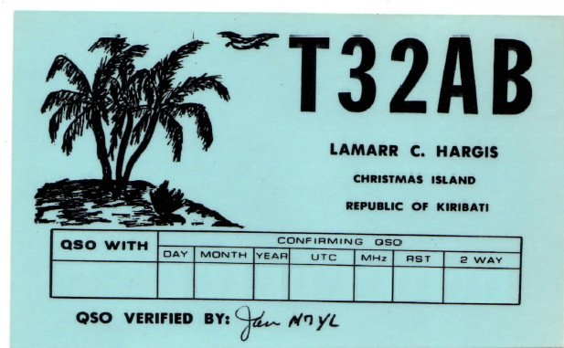***DX News***

***ARLD007 DX news***

This week's bulletin was made possible with information provided by F6AJA, W2GD, The Daily DX, the OPDX Bulletin, 425 DX News, DXNL, Contest Corral from QST and the ARRL Contest Calendar and WA7BNM web sites. Thanks to all.

**MONACO, 3A.** Mireille, F4FRL and Patrice, F5RBB will be QRV as home calls/3A from February 24 to March 2. Activity will be on 40 and 20 meters using SSB and various digital modes. QSL via LoTW.

**TUNISIA, 3V.** Ash, KF5EYY plans to be QRV as 3V8SS in the ARRL International DX CW contest as a Single Op/All Band/Low Power entry. QSL to home call.

**TOGO, 5V.** Daniel, HB9EHD is QRV as 5V7DE until February 20. Activity is on 40 and 20 meters using FT8, and on Satellite QO-100. QSL direct to home call.

**CROATIA, 9A.**  Members of the Croatian Flora Fauna ARC are QRV with special event call 9A10FF during all of 2021 to celebrate the club's 10th anniversary. QSL via 9A2MF.

**ZAMBIA, 9J.** Brad, 9J2RS is currently QRV on 20, 17 and 15 meters. QSL direct.

**MOZAMBIQUE, C9.** Bruno, CS7AMN is QRV as C91BVA from Maputo. Activity is on the HF bands using SSB and various digital modes. QSL to home call.

**CHILE, CE.** Members of the Radio Club Melipulli are QRV as CB7FT from Tabon Island, IOTA SA-018, until February 21. This includes being active from the Lighthouse ARLHS CHI-049 during the American Lighthouses Weekend. Activity is on the HF bands using SSB and various digital modes. QSL via EA5GL.

**CUBA, CO.** Reinaldo, CO6RD is QRV from Lighthouse ARLHS CUB-045 on Cayo Blanco de Zaza, possibly IOTA NA-204, until February 21. Activity is on the HF bands using CW, RTTY, BPSK, FT8 and FT4. This includes being active during the American Lighthouses Weekend. QSL direct to EA5GL.

**MARTINIQUE, FM.** Look for FM5BH to be a Single Op/All Band/High Power entry in the ARRL International DX CW contest. QSL via W3HNK.

**HAITI, HH.** Bill, KO7SS will be QRV as HH2AA from Obleon as a Single Op/Low Power/Assisted entry in the ARRL International DX contest. QSL via LoTW.

**U.S. VIRGIN ISLANDS, KP2.** Dan, K8RF will be QRV as NP2J in the ARRL International DX CW contest as a Single Band on 160 meters entry. QSL direct to home call.

TOP^

**PUERTO RICO, KP4.** A group of operators are QRV as NP4DX on 80 to 10 meters using CW. This includes being a Multi/Single/Low Power entry in the ARRL International DX CW contest. This activity will also count for the WLOTA as LH-2802. QSL via M0OXO.

**ARUBA, P4.** John, W2GD is QRV as P44W until February 23. He is active on all bands as time permits with a focus on the ARRL International DX CW contest. QSL via N2MM.

**BRAZIL, PY.** Members of the Grupo Escoteiro Marechal Rondon are QRV as ZW2I from Comprida Island, IOTA SA-024, and the Rio Claro Lighthouse, LH BRA-135, until February 22 during the American Lighthouses Weekend. QSL via operators' instructions.

**BENIN, TY.** Johannes, ZS6JSI is QRV as ZS6JSI/TY until June 2021. Activity is mobile on 80, 40 and 20 meters using SSB and FT8. QSL to home call.

**AUSTRALIA, VK.** Members of the Pride Radio Group are QRV as VI2021PRIDE until March 7 during Sydney Mardi Gras. QSL direct to VK3FUR.

**TURKS AND CAICOS, VP5.** Jim, K4QPL plans to be QRV as VP5M during the ARRL International DX CW contest. QSL to home call.

**MEXICO, XE.** Members of the Radio Experimentadores of Campeche are QRV with special call sign 4A3G from Faro de Champolon until February 21 during the American Lighthouses Weekend. QSL via XE3AA.

**INDONESIA, YB.** Yohanes, YB2DX will be QRV in the ARRL International DX CW contest as a Single Op/All Band entry. QSL direct to home call.

**ROMANIA, YO.** Members of the Sport Club Pandurii Tirgu-Jiu are QRV with special call YP145B from Tirgu-Jiu until March 3 to celebrate the 145th anniversary of the birth of the great sculptor Constantin Brancusi. Activity is on the HF bands. QSL direct to YO7CKQ.

**CAYMAN ISLANDS, ZF.** Bruce, K0BJ will be QRV as ZF2BJ from Savannah, Grand Cayman, IOTA NA-016, from February 20 to March 5. Activity will be on the HF bands with a focus on the newer bands and CW. QSL to home call.

**NEW ZEALAND, ZL.** A group of operators will be QRV as ZL3X in the ARRL International DX CW contest as a Multi-2 entry. QSL via LoTW.

**PARAGUAY, ZP.** Manu, ZP9MCE plans to be QRV on 80 meters in the ARRL International DX CW contest. QSL via EA5ZD.

THIS WEEKEND ON THE RADIO. The ARRL International DX CW Contest, 13th American Lighthouses Weekend, NCCC RTTY Sprint, QRP 80-Meter CW Fox Hunt, NCCC CW Sprint, K1USN Slow Speed Test, Russian PSK World Wide Contest, RTTYOPS Weekend Sprint, Feld Hell Sprint, FISTS Sunday Sprint and the Run for the Bacon QRP CW Contest will certainly keep contesters busy this upcoming weekend.

TOP^

The QCX CW Challenge and OK1WC Memorial are scheduled for February 22.

The RTTYOPS Weeksprint and Worldwide Sideband Activity Contest are scheduled for February 23.

**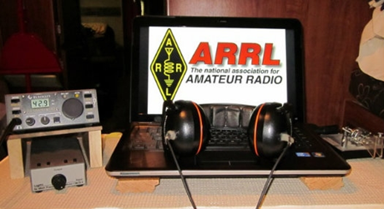*ARRL Contest Corner***

An expanded, downloadable version of *QST'*s’ [**Contest Corral**](http://www.arrl.org/contest-calendar) is available as a PDF. Check the sponsor’s ‘Website for information on operating time restrictions and other instructions.

***Special Events***

* **02/20/2021 | George Washington's Birthday**

**Feb 20-Feb 22, 2000Z-2000Z, WS7G**, George, WA. Columbia Basin DX Club. 14.322 7.222 3.855. QSL. Brian Nielson, 11650 Road 1 SE, Moses Lake, WA 98837. We will be commemorating George Washington's Birthday from the city of George, in the state of Washington. In February of 2021, our special event station will operate Saturday, February 20th, from 2000 Zulu through Monday, February 22nd at 2000 Zulu. You can find us on 14.322/14.255, 7.222/7.260, AND 3.855/3.960 plus/minus QRM. [cbn.homestead.com/WS7G.HTML](http://cbn.homestead.com/WS7G.HTML)

* **02/25/2021 | Copper dog 150 Dog sled race**

**Feb 25-Mar 2, 0000Z-0000Z, K9C**, Calumet, MI. Keweenaw County Repeater Assn.. 7.300. QSL. Jeffrey Stricker W9GY, 59624 Dextrom Rd, Calumet, MI 49913. [https://kcra-mi.net](https://kcra-mi.net/)

* **02/27/2021 | 17th Annual "Freeze Your Keys" Winter Operating Event**

**Feb 27, 1400Z-2200Z, W0EBB**, Leavenworth, KS. Kickapoo QRP Amateur Radio Club. 14.058 7.035 14.325 7.240. QSL. Gary Auchard, 34058 167th Street, Leavenworth, KS 66048. SASE please for return QSL cards. w0mna74@gmail.com or [www.qrz.com/db/w0ebb](http://www.qrz.com/db/w0ebb)

* **02/27/2021 | 1845 Florida Statehood Special Event**

**Feb 27-Mar 7, 1000Z-0300Z, W4F**, Winter Springs, FL. Lake Monroe Amateur Radio Society. 7038 CW 7238 SSB Phone 7074 FT8 7040 RTTY. Certificate. 1845 Florida Statehood Special Event C/O Orlando Amateur Radio Club, PO Box 574962, Orlando, FL 32857. [1845Florida.org](http://1845florida.org/)

* **03/11/2021 | Battleship Texas Birthday**

**Mar 11-Mar 14, 0000Z-0000Z, W5T**, Cleburne, TX. Club KC5NX. 14.255 14.045 7.240 7.235 . QSL. Club KC5NX, 9200 Summit Ct W , Cleburne, TX 76033-8212. Club KC5NX back on the air for the celebration of the 107th birthday of the Battleship TEXAS. [jay.n.violet@gmail.com](mailto:jay.n.violet@gmail.com) or check here to find us: <https://www.dxwatch.com/dxsd1/dxsd1.php?f=0&c=w5t&t=dx>  <https://www.qrz.com/db/kc5nx>

TOP^

* **03/13/2021 | USS Midway Museum Ship Special Event: Launching of USS Midway**

**Mar 13, 1700Z-2359Z, NI6IW**, San Diego, CA. USS Midway (CV-41) Museum Ship. 7.250 14.320 14.070 (PSK31) DSTAR vis PapaSystem repeaters. QSL. USS Midway CV-41 COMEDTRA NI6IW, 910 N Harbor Drive, San Diego, CA 92101. SASE please. [www.qrz.com/db/ni6iw](http://www.qrz.com/db/ni6iw)

* **03/14/2021 | PI Day - David Sarnoff Radio Club, Princeton, NJ**

**Mar 14, 0000Z-2359Z, N2RE**, Princeton, NJ. David Sarnoff Radio Club. 14.250 14.050 7.200 7.050. QSL. Bob Uhrik, 104 Knoll Way, Rocky Hill, NJ 08553. Famous Princetonian Albert Einstein was born on PI Day. [n2re.org](http://n2re.org/)

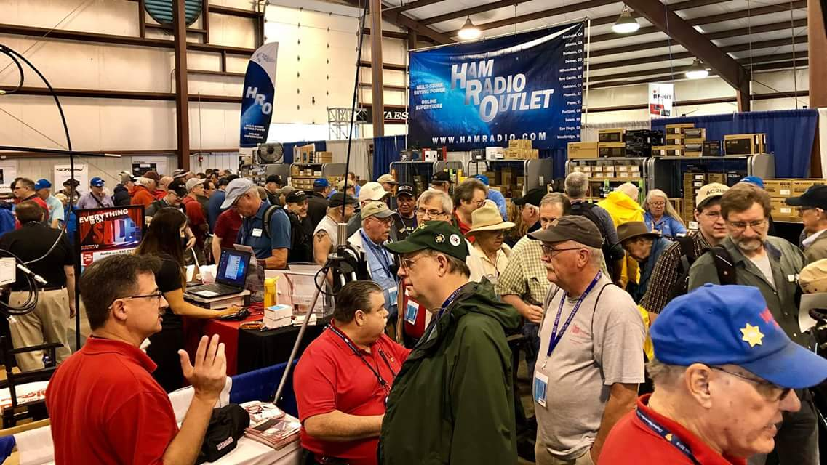[***Upcoming Hamfests***](http://arrl-ohio.org/hamfests.html)

We **DO** have some hamfests scheduled for 2021!! Yes, take a good look at the list, it’s growing every day!

|  |  |
| --- | --- |
| **04/25/2021 -**[**Athens Hamfest**](http://www.arrl.org/hamfests/athens-hamfest-9)  *Canceled* | **06/05/2021 -**[**FCARC SummerFest**](http://www.arrl.org/hamfests/fcarc-summerfest)  Location: Wauseon, OH Sponsor: Fulton County Amateur Radio Club Website:<http://k8bxq.org/hamfest> [Learn More](http://www.arrl.org/hamfests/fcarc-summerfest) |
| **07/10/2021 -**[**Mansfiled Mid-Summer Trunkfest**](http://www.arrl.org/hamfests/mansfiled-mid-summer-trunkfest)  Location: Mansfield, OH Sponsor: InterCity Amateur Radio Club Website:<http://iarc.club>[Learn More](http://www.arrl.org/hamfests/mansfiled-mid-summer-trunkfest) | **07/18/2021 –**[**Van Wert Hamfest**](http://www.arrl.org/hamfests/van-wert-hamfest-5)  Location: Van Wert, OH Sponsor: Van Wert Amateur Radio Club Website:[http://W8FY.ORG](http://w8fy.org/)[Learn More](http://www.arrl.org/hamfests/van-wert-hamfest-5) |
| **08/07/2021 -**[**DX Engineering Hamfest & Great Lakes Division Convention**](http://www.arrl.org/hamfests/dx-engineering-hamfest-1)  Location: Tallmadge, OH Sponsor: DX Engineering Website: [http://dxengineering.com](http://dxengineering.com/) [Learn More](http://www.arrl.org/hamfests/dx-engineering-hamfest-1) | |

TOP^

|  |  |
| --- | --- |
| **08/28/2021 -**[**Cincinnati Hamfest℠**](http://www.arrl.org/hamfests/cincinnati-hamfest)  Location: Owensville, OH Sponsor: Milford ARC Website: [http://CincinnatiHamfest.org](http://cincinnatihamfest.org/) [Learn More](http://www.arrl.org/hamfests/cincinnati-hamfest) | **09/26/2021 -**[**Cleveland Hamfest**](http://www.arrl.org/hamfests/cleveland-hamfest-1)  Location: Berea, OH Sponsor: Hamfest Association of Cleveland Website: [http://www.hac.org](http://www.hac.org/) [**Learn More**](http://www.arrl.org/hamfests/cleveland-hamfest-1) |
| **12/04/2021 -**[**FCARC WinterFest**](http://www.arrl.org/hamfests/fcarc-winterfest-2)  Location: Delta, OH  Sponsor: Fulton County Amateur Radio Club  Website:<http://k8bxq.org/hamfest>  [Learn More](http://www.arrl.org/hamfests/fcarc-winterfest-2) | |

Be sure to keep your eyes on this schedule as that when things start getting better and the vaccine rolls out to more and more, hamfests will surely get back to their normal schedule. Don’t see your hamfest listed?? Did anyone register it with ARRL? It’s really easy to do and you get a lot of FREE publicity if you do.

***Upcoming NIMS Training Opportunities***

Need to get those really hard to get ICS 300 and 400 classes to get to Level 3? They are now being offered with very limited virtual seating. Yes, these classes are being offered virtually now along with a lot of other classes that used to require in-class sessions. Want to see what and where these classes are being offered?

[**>> Click Here <<**](http://arrl-ohio.org/SEC/Ohio_EMA_Training_List_Feb_2021.pdf)

***Print an Official or Unofficial Copy of Your Amateur Radio License***

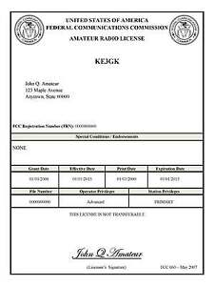*(By Anthony Luscre, K8ZT)*

As of February 17, 2015, the **FCC no longer routinely issues paper license documents** to Amateur Radio applicants and licensees. The Commission has maintained for some time now that the official Amateur Radio license authorization is the electronic record that exists in its Universal Licensing System (ULS). The FCC will continue to provide paper license documents to all licensees who notify the Commission that they prefer to receive one.

Licensees also will be able to print out an official authorization — as well as an unofficial “reference copy” — from the ULS License Manager. I’ve created a set of instructions on how you can request an **“official” printed copy of your license\***

[**Click here to download the instructions**](http://arrl-ohio.org/news/2020/print_your_license.pdf)

TOP^

***One Question Questionnaire***

Hey Gang,

Survey Says”….. 27% of you attended the “on-line” forums from HamCation. Not too surprising I guess. We’d all like to go back to attending live, I’m sure!

Ok, now on to the next question… Let’s see how many of you are optimists out there and are already planning on which hamfests you’re going to go to this summer.

***“Will you be attending the DX Engineering & Great Lakes Division Convention?”***

You’ll find the “One Question” questionnaire on the Ohio Section Website! <http://arrlohio.org> It’s all for fun and it’s not a scientific survey in any way, but we are learning some things that we didn’t know from these questions. I hope that you are enjoying answering these “One Question” questionnaires.

*****V.E. Test Sessions***

Many V.E.’s have decided to start testing once again, but with restrictions that need to be adhered to for sure. Here’s the link to find that V.E. Test session and what is expected of YOU before going. <http://www.arrl.org/find-an-amateur-radio-license-exam-session>

***SPECIAL NOTIFICATION***

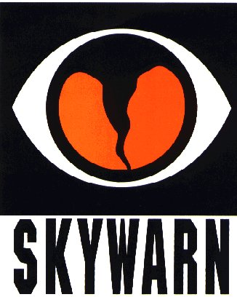

The National Weather Service will not be able to conduct in person spotter training classes this winter and spring due to restrictions associated with COVID. Therefore, we will hold several virtual spotter training classes. These classes will be open to the public and free of charge. Please feel free to promote to your staff, spotters, amateur radio operators and to publicize to the citizens in your community.

All of our classes will be conducted as live webinars with live Q&A. We will use the GoToWebinar software, which can host up to 1000 people for each session. These webinars will not be recorded. 6 webinars are currently planned in February and March, with different days of the week and diverse times represented.

If the demand is high enough, we may consider a 7th webinar in April. All those who attend will need to register in advance. Below are the links to the 6 scheduled classes:

TOP^

* Spotter Webinar 2: Wednesday, February 24, 2021 (7 PM - 9 PM):

<https://register.gotowebinar.com/register/4105945167168648206>

* Spotter Webinar 3: Thursday, March 4, 2021 (7 PM - 9 PM):

<https://register.gotowebinar.com/register/8790359481726954766>

* Spotter Webinar 4: Monday, March 8, 2021 (6 PM - 8 PM):

<https://register.gotowebinar.com/register/5017422714408992270>

* Spotter Webinar 5: Tuesday, March 23, 2021 (6 PM - 8 PM):

<https://register.gotowebinar.com/register/8257513057162542350>

* Spotter Webinar 6: Saturday, March 27, 2021 (12 PM - 2 PM):

<https://register.gotowebinar.com/register/5687758669980329230>

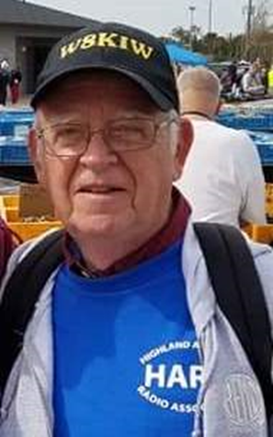***From The South 40***

*(from John Levo,* [*W8KIW@arrl.net*](mailto:W8KIW@arrl.net)*)*

***WELCOME TO THE SOUTH 40***

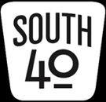Ohio has many good ham radio clubs, and the Southern Ohio Region is no exception. Some are large while others are small. Some are rather new while others have been around since the beginning of radio. A few are well-known, but the majority aren’t known beyond their respective communities. Some exist only to maintain a repeater, hold a hamfest or to participate in Field Day or another contest or event. In the coming weeks we will be taking a road trip to give these clubs some recognition and let our readers know that ham radio is alive and well in the Southern Ohio region. So, sit back in the passenger seat and get out the roadmap as we embark on our journey.

Although there are a number of well-respected clubs in Cincinnati, our journey starts with the Queen City Emergency Net. The QCEN traces its beginnings to the 1937 Ohio River Flood when Cincinnati realized it lacked an emergency communications plan and asked a group of ham operators to formulate the city’s first emergency radio plan. Thus, a plan was created and the QCEN formed. During WWll the Net worked with Civil Defense and some military communications systems and in 1943 affiliated with the Red Cross in a relationship that continues to this day. Since the end of the War the Club has provided communications for many community events where not only the community benefits, but members receive beneficial communication training and assistance with developing dependable stations. The Club not only has a complete station at the Cincinnati Red Cross Building, but also has a separate stand-alone station located in another section of the City. The station can reach the furthest parts of the area served by the Cincinnati Red Cross Chapter as was proven when the station was recently heard checking into local repeater nets in Adams, Clinton, Highland and Mason Counties.

TOP^

The station is also frequently heard participating in the various major HF and VHF contests during the year. The Club also sponsors the 147.24 W8VND repeater. The Club maintains an excellent website featuring a lot of beneficial information and resources at [www.qcen.org](http://www.qcen.org)

That concludes our visit to the Queen City. As we head east on US 50 to visit our next club, let’s take a time out to catch up on some of the happenings throughout the Southern Ohio Valley Region.

It’s been learned that Scioto County ARES member Randy Groves, KF8YO, suddenly passed away at his home on February 10. Randy was known on repeaters and HF throughout the region as ‘Rarden Randy’. Services have been held. Our thoughts and prayers go to his daughter, brother, other family members and friends.

Upcoming amateur radio license test sessions in the area are scheduled as follows:

* February 27 Maysville, KY, Mason County EOC Office, 212 Government Street, 10 am
* March 1 Portsmouth, 711 Findlay Street, 5:30 pm
* March 6 Chillicothe, Ross County Service Center, 475 Western Avenue, 9 am
* March 9 Lancaster, Grace Church, 7 pm
* March 15 Athens, Athens Masonic Complex, 12 West Carpenter Street, 7 pm
* April 17 Hillsboro, Highland County EMA Office, North High Street, 9 am
* April 17 Circleville, Pickaway County EOC, 11 am

Please Note---COVID caution requirements should cause those wishing to take test elements to contact each sponsoring club in advance of the test date to reserve a space and to determine what safety precautions are being exercised. Preregistrations are required at most locations and walk-ins are discouraged. According to Brent Wells, N4BDW, 16 are scheduled for the Greater Mason County session.



March 20th is the proposed date for the Hocking Valley ARA’s first Fox Hunt for 2021. Those participating are asked to ‘register’ between 9:45 and 10 that morning by a sign-in on the Club’s 147.345 repeater. The hunt will start at 10. Three hours will be allowed to locate the ‘fox’ that will be located along and within sight of a Hocking County roadway or street. Any amateur is welcome to participate. If the weather does not cooperate, a March 27 rain date has been set contact [hvarc.73@gmail.com](mailto:hvarc.73@gmail.com) for further information. The Athens County ARA anticipates holding some Fox Hunts later in the year. The Highland ARA is considering using a Fox Hunt as an Elmer session.

Queen sang “Another One Bites the Dust” as COVID concerns led the Mammoth Cave ARC to err on the side of caution and cancel next month’s ever popular Cave City Hamfest. Several amateurs from Southern Ohio and Northern Kentucky annually made the trip to Cave City for the well-attended event. But closer to home at this weeks’ Zoom teleconference meeting the Athens County ARA discussed the future of their planned April 25 ACARC Hamfest. It was felt there were too many unknowns regarding COVID issues, restrictions on large gatherings and the availability of facilities to hold the event. Therefore, the Club decided to postpone the event and possibly hold the event later in the year.

TOP^

A tip of the South 40 cap to Pike County’s Dwight Kelly in his Regional Leader results from last July’s IARU HF World Championship. Dwight placed fourth in the ARRL Central Region standings in the Single Operator, CW, Low Power class. Based on his score, a few more contacts would have put him in the top ten in North America. Regardless, it was a great effort and showing from Southern Ohio.



Because of COVID concerns, the Wilmington and Charleston National Weather Service Offices have each announced their annual series of Spring weather spotter training classes are now being held via webinars instead of in-person sessions throughout their districts. Information regarding the dates and times are available from each office by contacting [www.weather.gov/iln/spottertrainingschedule](http://www.weather.gov/iln/spottertrainingschedule) or [www.weather.gov/rlx/weather-spotter](http://www.weather.gov/rlx/weather-spotter)

Recent weather conditions across the nation have resulted in the loss of electricity, water, and communications for many communities. Because of this situation the Highland ARA has received several inquiries about ham radio and how it can be a benefit in such cases. Therefore, the Club has decided that there might be enough interest in a class leading to a Technician license. According to Club President Pat Hagen, N8BAP, an introduction will take place on March 14th and if there is sufficient interest, classes will begin on March 21st and continue through April 11th with license testing on April 17th. The class will be limited to 15 students and will be held at the Highland County EOC in Hillsboro. Registration is not limited to only Highland County residents. For more information contact Hagen at **937-218-6289**.

A rather new activity with a growing following is Winter Field Day. Word is that Ken Coughlin, N8KC, is putting together a Spring Winter Field Day Newsletter and is looking for WFD stories and other items of interest. If you have something WFD related to contribute, send it to him at [manitoumagic@aol.com](mailto:manitoumagic@aol.com)

The rules for the annual Ohio State Parks on the Air have had some minor revisions. The biggest is the introduction of a new category for “Rover” stations. According to Tom Parkinson, KB8UUZ, rovers must sign “/R” with their call sign, submit a separate entry for each park activated and make a minimum of 10 contacts from a park with at least four of those with other parks. During last year’s contest a number of Southern Ohio State Parks did not have any activity. This new category just might be an incentive to get a few more on the air during this year’s event. John Myers, KD8MQ, reminds us the contest is always the Saturday following Labor Day. The revised rules are now posted to the [www.ospota.org](http://www.ospota.org) website.

The newly formed Lewis and Clark River Trail Net had its third session this past Friday evening. Since the first session it has steadily grown in the number of stations checking in. It is an informal, non-club affiliated net on the Vanceburg, KY 146.775 at 8 pm each Friday evening. Besides stations in Kentucky and West Virginia, ones in Adams, Brown, Highland and Scioto have been noted calling in.

As we continue our journey through the eastern Cincinnati suburbs, we enter Clermont County, the home of the Milford ARC. Founded in 1974, the MARC is known for the sponsorship of their June hamfest which has grown to be the Cincinnati area’s largest. The event was first held in 1990 and its success has caused it to outgrow several locations over the years. In 2018 the Club joined with the Southwest Ohio DX Association and moved the event to the county fairgrounds at Owensville where a joint hamfest and well received DX convention were held. In order to more accurately reflect the size and scope of the event, Club President Ron Brooks, AC8MA, the Club has decided to rebrand the event as the Cincinnati Hamfest starting this year.

TOP^

Information about and tickets for the forthcoming event is available at [www.CincinnatiHamfest.org](http://www.CincinnatiHamfest.org) Not to be overshadowed by the hamfest is the Club’s commitment to the community. Over the years they have participated in and provided communications for bicycle tours, marathons, Milford’s Frontier Days and other community events including the Ohio State Champion Canoe Races. The Club placed one of the first wide coverage area repeaters on the air in the late 1970s and was especially beneficial during the Great Blizzard of 1978. Today they operate repeaters on 147.345 and 443.45 using both analog FM and C4FM with a 123 tone on each. Prior to COVID, the Club was well known for their monthly license testing program. In 2020 they conducted a neat special event station operation celebrating the 30th anniversary of the Cincinnati Red’s Wire to Wire World Series achievement. Additional information about this club is available at [www.w8mrc.com](http://www.w8mrc.com)

That concludes today’s road trip, but we will resume with visits to more clubs along with the latest news from the rolling hills of the Southern Ohio Region in upcoming columns. In the meantime, stay safe and think Spring.

***Weather Underground and Other Ham Weather Stations***

[](http://arrl-ohio.org/wus.html)

Hey Gang,

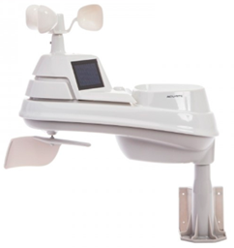This has really grown into a really cool area with reports literally coming in from all over the state!!

It’s really fun to see just how much the weather varies across the state and this gives you access to each individual station very quickly and easily.

Hey gang, if you haven’t looked at your Weather Underground dashboard lately you might want to. It seems that the nice folks there have taken the time to upgrade your dashboard.

The new design is still being worked on from what information that I could gather, but they have done a really nice job. The new design is really easy to view and contains the same information at before, but it’s laid out in a really professional manor.

Now, our list of stations is growing all the time. How’s about your station? Is it listed with us? It doesn’t necessarily have to be a Weather Underground reporting station.

I’d love to have any weather station that is connected to the internet available for all of us to view, especially when the weather gets bad out. The more stations reporting the better.

TOP^

Thanks to everyone who has contributed to this effort. If you haven’t, you really should take a look at the various weather stations around the state when we get bad weather coming in. You can really see just where the line of storms are as they cross through the state. It is very fascinating to watch it all unfold right you’re your easy chair, and all the data is real time! Here’s a link to all of those listed… <http://arrl-ohio.org/wus.html>

We’re got a really good collection of stations from all over and have tons of room to add more for sure. How’s about sharing your weather information with all of us! All that you need to do is send me your Weather Underground ID and your call sign and I’ll take it from there. Sent it to: [webmaster@arrl-ohio.org](mailto:webmaster@arrl-ohio.org)

***Final… Final***

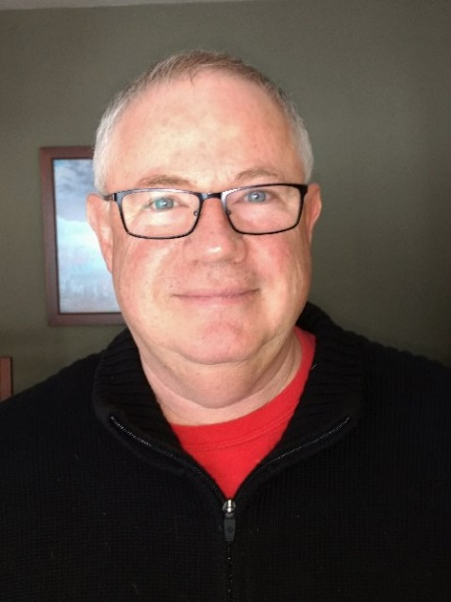

***Welcome to Winter in Ohio!***

While I am personally not a fan of winter, I do live in NE OHIO, so, I have to put up with it. The Good News: Spring is coming! It always does.

As the NEW OHIO Section Manager, I want to share with you my priorities in the OHIO Section for my term(s) in this position. While I have my own priorities, I think it important to point out, that none of my initiatives are to be pursued at the cost of any existing program. Those who have built the OH Section to what it is today have made an investment in excellence that I am not willing to sacrifice. I’ve inherited an OH Section Cabinet full of exceptional and talented people who are dedicated to the hobby. My personal goals in this position are based on the extremely sound foundation that has already been set, while being flexible enough to respond to changing conditions.

I have three main areas that I will be working on and hope that you will join me in. #1. Making sure that the Hams in the OH Section not only have but take advantage of all the opportunities that this hobby gives them to have FUN! #2. Increase the number of licensed hams, increase the number of *active* hams, and increase the number of ARRL member hams in the OH Section. #3. Increase and improve the public image of Amateur Radio to the general population of OH.

If you really think about it, if we work on all three of these items together, each one will feed off the success of the others. Now, if you personally, or “you” as a club, work on these concepts with *enthusiasm*, then that enthusiasm will spread to those around you. Once it reaches a certain level, it becomes a “self-fulfilling prophecy” much to the benefit of all of us. I hope you will join me in working to make Amateur Radio the Greatest Hobby in the World!

Now that we’ve had this little blast of cold, snowy weather, how about we do a little bit of Ham Radio PR? This would be a good time to write a small article for your local paper, explaining to them that as the storms blew through Ohio (and the rest of the country) Amateur Radio operators were prepared, willing and able to provide emergency communications for both public & private entities.

TOP^

To show you that I’m a “sporting” kind of guy, I’m offering (personally) a $100 DXEngineering gift certificate to the first club who can send me a copy of their article, in a local newspaper, naming their club by name, which is a PR piece for Amateur Radio and specifically the local club. In addition to the story, I would suggest sending along a photo or two of club members at their operating position. I would also suggest in your cover letter to the editor that you invite him to send a reporter and/or photographer out if they would rather make it an “interview” piece.

One of two different things will happen after your article is submitted: the story gets published, everyone is happy; or the story does not get printed, you may or may not receive a reason why. Don’t despair! About a month prior to Field Day this year, send them a “Press Release” noting that Field Day will be taking place, your club is participating, and visitors are welcome. A week or two prior to Field Day, send the editor an invitation to send a reporter / photographer to your Field day site on the day of the event. If that happens – Great! If not, write your own story about how Field Day went, include your own photos and submit it for publication. Once we start having meetings in person again, make sure you send a notice for every meeting, letting the community know you’re there and they are welcome to join you. If you have a particularly interesting meeting, with a “notable” expert on some facet of Amateur Radio, submit that article, include some photos.

Got a club member who just got WAS or DXCC? That’s newsworthy! Worked it via FT8 or some other digital mode? That makes it even more newsworthy. Got a club member who has been racking up contacts via satellites? Newsworthy. The whole point here is to keep submitting those articles and Press Releases! It’s what’s called “Drip Marketing” and the pros are doing it to you every day. We want to keep “dripping” information on that editor until he finally realizes that something exciting is happening and no one else is reporting on it! Once he picks up your stories, then you’ll be dripping on the general public where it can finally do some real good!

Two last things on this topic. First - always include the line “For More Information on Amateur Radio, go to [WWW.ARRL.org](http://WWW.ARRL.org) . When someone follows that link, they will land on the ARRL homepage where in the upper left of the main screen are the words: What is Amateur Radio or Ham Radio? This will immediately give readers the information about who we are and what we do. You don’t have to reinvent the wheel. Second – if you have any relationships with editors or program directors at either newspapers or radio stations in your local area, please, send me their name and contact information. I want to support your local PR efforts with information as a State level ARRL representative.

OH Section Nets are an important part of keeping us all connected to each other. I hope that you will all participate in the nets that are operating in the OH Section. Nets are a fantastic way to get involved, improve your skills and try different modes. I want to encourage you all to participate in nets. Everyone has checked into the “Social” nets, now I want to ask you to make a point of checking into some EmComm training nets and some Traffic nets. As an Amateur Radio Operator, it is assumed that you will be able to participate in these in times of an emergency. That’s *NOT* the time to be a “first timer” on these nets. I know that this is not everyone’s idea of fun, but, do it once or twice, so you at least have a basic understanding of how they operate and what they expect of their participants.

TOP^

From the ARRL Web Site: “The ARRL Online Net Directory shows Amateur Radio nets that have been registered with ARRL Headquarters net directory database. It primarily covers nets that are of interest to Amateur Radio operators in the United States and Canada. Worldwide coverage nets and maritime service nets are featured (as are National Traffic System Area and Region Nets) in the database. You can search the database for a particular net [here](http://www.arrl.org/resources/nets/client/netsearch.html).

One focus of the directory is toward public-service oriented nets that support the ARRL National Traffic System (NTS) and the Amateur Radio Emergency Service (ARES). Further information about NTS and ARES activity in your area may be obtained through your ARRL Field Organization leaders. (See page 12 of *QST* for the list of ARRL [Section Managers](http://www.arrl.org/sections).)

**Net Registration**

Nets must be registered to be published in The ARRL Net Directory. To register a net through the web please go to this [page](http://www.arrl.org/resources/nets/client/snet1.html). As for the nets that are already listed, any information regarding updates or deletions is welcomed. Section and local nets should also be registered with the ARRL Section Traffic Manager. (ARRL HQ can refer you to your Section Traffic Manager.) Net Directory updates received via mail or email within the past few months will be merged into the directory this fall. New updates should be submitted using the [update form](http://www.arrl.org/resources/nets/client/update.html). The registration deadline for the next issue of the Net Directory is announced in *QST* and appropriate [*ARRL Letter*s](http://www.arrl.org/arrlletter/). [Search for a Net](http://www.arrl.org/resources/nets/client/netsearch.html) | [Update an Existing Net](http://www.arrl.org/resources/nets/client/update.html) | [Submit a New Net](http://www.arrl.org/resources/nets/client/snet1.html)”

**IMPORTANT:**

If you are a net manager, club officer, or someone involved in running a net, please make sure your net is listed on the ARRL Web Site.

I received the following from Chris – KD2HCE in Medina:  New Worked All States nets on 40 and 80m (75m if you are old school...).

You can find our site at [USTAW.net](http://ustaw.net/). I am a co-founder, and the 80m band coordinator. We ***currently*** run 40m nets weekdays at 3PM Eastern (2100z) and 80m nets every day at 8PM Eastern (0100z). Our difference versus other nets, is in our award, it's not a paper certificate, but a Rosewood Plaque with a bronze engraved panel. Of course we charge a bit more for it, but the value is much better. We have a low cost membership, and there is no need to be a member to participate in any nets. Go look around the site.

We really have not advertised the nets yet, but we've been live on 80 since 11/12/20, and on 40 since the beginning of year. We're also recruiting NCSs who would be interested on either/both bands. You can check out our main site, or my QRZ for details. A QRZ subscription is required, and we use Netlogger. Experiece with NL usage is a big plus, but not as an NCS, just a few minutes training further as an NCS is needed.

That’s it for me this month. Get on the air, build something, try something new! Have fun and let me know what you’re doing.

73, de Tom WB8LCD

[WB8LCD@ARRL.ORG](mailto:WB8LCD@ARRL.ORG) 330-554-4650

OH Section Manager

TOP^

***“Swap & Shop” on the website***

Hey Gang,

Have you taken a look at the **Swap & Shop** page on the Ohio Section webpage yet?? Here’s a link that will take you there…

<http://arrl-ohio.org/sm/s-s.html>

Do you have equipment that you just don’t need or want anymore? Here’s a great venue to advertise it, and it’s FREE!!

Is your club doing a fund raiser to help raise money? After a lot of thought, it was decided that the Swap & Shop webpage could also contain these types of items as well.

The same rules will apply as do for the For Sales and Give-A-Ways and will only be posted for a month at a time. Please see the Terms & Conditions on the webpage.

If your club is doing a fund raiser and wants more exposure, please forward the information to me and I’ll advertise it on the Swap & Shop webpage for you. Now, I still want to remind you that it won’t be listed in this newsletter because it would take up way too much space, so your ad will only appear on the website. It is there for any individual to post equipment Wanted / For Sale or Give-Away as well as for Club Fund Raisers. No licensed vehicles/trailers or business advertising will be posted.

Postings are text only (no pictures or graphics) will be posted for a maximum of 1 month from date posting and require a contact phone number or email within the posting. Send your Wanted / For Sale or Give-Away post to:  [swap@arrlohio.org](mailto:swap@arrlohio.org)

***Welcome New Subscriber(s)***



**Brian King; Charles, N8RQT**

***Back Issues of the PostScript and Ohio Section Journal***

Hey, did you know that PostScript and Ohio Section Journal (OSJ) are archived on the website? You can go back and look at any edition simply by clicking:

<http://arrl-ohio.org/news/index.html>

TOP^

Ohio Section Cabinet

|  |  |
| --- | --- |
| Section Manager – Tom Sly, WB8LCD | Section Emergency Coordinator – Stan Broadway, N8BHL |
| Technical Coordinator – Jeff Kopcak, K8JTK | Section Traffic Manager – David Maynard, WA3EZN |
| State Government Liaison – Bob Winston, W2THU | Affiliated Clubs Coordinator – Tom Sly, WB8LCD |
| Section Youth Coordinator – Anthony Lascre, K8ZT | Public Information Coordinator – John Ross, KD8IDJ |

***Chit – Chat, and All That!***

Do you know someone that’s not getting these Newsletters? Please, forward a copy of this Newsletter over to them and have them “[Opt-In](mailto:Opt-In)” to start receiving them. Heck just have them send an email to: [webmaster@arrl-ohio.org](mailto:webmaster@arrl-ohio.org) to be added.

We now have many thousands of readers receiving these newsletters weekly. Quite impressive, I’d say! I urge all of you to make sure that everyone, regardless of whether they are a League member or not, get signed up to receive these weekly Newsletters.

You can always “Opt-Out” at any time if you feel this is not what you were expecting. It’s fun and very informative. All of your favorite past newsletters are now archived too.

You can go back at any time and read them. Just go to: <http://arrl-ohio.org/news/>

The pictures on the front page and throughout this newsletter are from various newsletters, Facebook posts and/or were sent directly to me in recent weeks. Take a good look at them, you just might be in one of the pictures! “SMILE… you’re in the Ohio Section News!!”

**Stop… We’ll be back next week with another exciting adventure for your reading pleasure!!**

TOP^

*The Ohio Section Journal (OSJ) is produced as a comprehensive look at all the programs within the Ohio Section. I sincerely hope that you have enjoyed this edition of the* *OSJ and will encourage your friends to join with you in receiving the latest news and information about the Ohio Section, and from around the world!*